May 27, 2015

Dear Quality Assurance Team:
Here is a question and some notes for you about Panchino:
Question: Genes 14 and 15 are “merged” in a programmed frameshift. Should we delete the first of these two genes (gene 14) since the second gene now covers both of them?
Notes:
- There are a couple of large gaps in the Panchino genome: 5’ to both gp 13, 14 and 16, as well as between 28 and 29. For the first three, it makes sense to leave the gaps, mainly because they are all between genes with well-known functions. Between 28 and 29 (255 bp gap) it is possible to fit another gene (26721-26906 reverse) but it generates no reasonable hits when blasted so we decided to leave it as a gap.

- Gene 28 encodes a restriction enzyme! This makes little sense, but it can’t be denied!

- For gene 64, the class voted to chose a start that is different from the start in Panchino’s closest relatives Butters, MichelleMyBelle,and Redi. We all agreed that even though other N-cluster annotaters have called an earlier start, the later start is more likely because it gives a shorter overlap. In the absence of empirical evidence, we stick to this start.
I have uploaded two annotated files: Panchino_Complete_Notes and Panchino_final as well as the CVS file with the author names.
Sincerely,
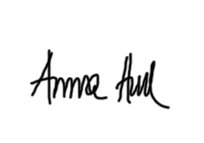
Anna Hull
Associate Professor

