Dear Phage Annotation Quality Control Team,

Thank you for reviewing the genome of Refuge. We request that you pay extra attention to the genes listed below.

- gp 2: Peptidase
- Blast alignment 77:77 to DarthPhader gp 2 seems odd
- Has large overlap with previous gene, but this is arrangement also occurs in DarthPhader Phamerator map

- gp 36: NKF
- Added ORF (not called by Glimmer or GeneMark)
- Does not show BLAST hit to DarthPhader, but does have nt alignment with EagleEye (A16), and has BLAST hit (but 38:38) to EagleEye gp 37.

- gp 57: DNA primase
- Added ORF (not called by Glimmer or GeneMark)
- Overlaps preceding DNA primase gene by 167 bp, yet both primases have different and strong Blastp alignments along full length
- DarthPhader has a DNA primase orpham at this location, but the alignment does not begin until residue 55 in Refuge, which corresponds to the second “M” in the product sequence.

- gp 91: NKF
- Last gene
- Not the longest ORF, but extending length does not improve BLAST alignment to DarthPhader gp 92
- Does not include all coding potential shown on GeneMark-Smeg output
- Did not find evidence of another ORF in this region

Best regards,

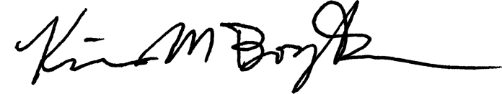
Kim M. Borges, Ph.D
Professor of Environmental Studies and Biology
University of Maine Fort Kent

