Dati Annotation Notebook
Gene 1, changed start from 10 to 1 on 1/4/2022
SSC: start 1, stop 567; CP: yes; SCS: Glimmer called start at 10, went with more conserved GeneMark start of 1; ST: SS; Blast Start: matches Yoshand_1 Query 1 to Subject 1 100% 1e⁻¹⁰⁷; Gap: 0; LO: yes; RBS: -4.642, 1.729, 68416, -6.387, yes; F: adenylate kinase; SIF-BLAST: adenylate kinase /PhageDB BLAST/Yoshand_1, JF937109/100%/1e⁻¹⁰⁷; SIF-HHPred: adenylate kinase, match with a probability of 99.72%; SIF-Syn: adenylate kinase
Notes: original start called by Glimmer was 10, but GeneMark called 1 and there is good coding potential here. Also, a start of 1 is more conserved in Starterator data. Function is supported by multiple lines of data and conserved in cluster.
Gene 2
SSC: start 564, stop 2351; CP: yes; SCS: both called this start; ST: SS; Blast Start: matches Weher20_2 Query 1 to Subject 1 100% 0.0; Gap: overlap 4; LO: yes; RBS: -2.121, 2.986, 15, -3.723, yes; F: terminase; SIF-BLAST: terminase /PhageDB BLAST/Weher20_2, MZ681520/100%/0.0; SIF-HHPred: terminase large subunit, match with a probability of 100%; SIF-Syn: terminase
Notes: This is pretty clear cut. The official notes say that if there are clearly two terminase proteins in the genome, you need to distinguish between large and small subunit. However, there is only one in other phage in this cluster so we can just call it terminase.
Gene 3
SSC: start 2435, stop 3650; CP: yes; SCS: Both called start at 2435; ST: SS; Blast Start: matches Zonia_3 Query 1 to Subject 1 100% 8e⁻³⁷; Gap: 83; LO: yes; RBS: -1.620, 3.236, 13, -2.666, yes; F: NKF; SIF-BLAST: NKF/PhageDB BLAST/Zonia_3, KM363597/100%/8e⁻³⁷; NKF: no matches with a probability above 90%; SIF-Syn: NKF
Notes: Start and function conserved in cluster and phamily. Space between preceding gene also conserved in Phamerator.
Gene 4
SSC: start 2647, stop 3009; CP: yes; SCS: Both called start at 2647; ST: SS; Blast Start: matches Windsor_4 Query 1 to Subject 1 100% 7e⁻⁶⁸; Gap: overlap of 4; LO: NA; RBS: -3.538, 2.280, 9, -4.313, no; F: KNF; SIF-BLAST: NKF/PhageDB BLAST/ Windsor_4, MT952849/100%/7e⁻⁶⁸; SIF-HHPred: NKF, no matches with a probability above 90%; SIF-Syn: NKF
Notes: nothing ambiguous about this gene.
Gene 5
SSC: start 3077, stop 3214; CP: yes; SCS:Both called start at 3077; ST: SS; Blast Start: matches Windsor_5 Query 1 to Subject 1 100% 7e⁻²³; Gap: 67; LO: yes; RBS: -4.297, 1.902, 10, -4.991, yes; F: NKF; SIF-BLAST: NKF/PhageDB BLAST/ Windsor_5, MT952849/100%/7e⁻⁶⁸; SIF-HHPred: NKF, no matches with a probability above 90%; SIF-Syn: NKF
Notes: nothing ambiguous
Gene 6 – reverse gene!
SSC: start 3915, stop 3361; CP: yes; SCS: Both called start at 3915; ST: SS; Blast Start: matches Weher20_6 Query 1 to Subject 1 100% e⁻¹⁰⁵; Gap: 46; LO: yes; RBS: -4.642, 1.729, 14, -5.989, no; F: RuvC-like resolvase; SIF-BLAST: RuvC-like resolvase /PhageDB BLAST/ Weher20_6, MZ681520/100%/ e⁻¹⁰⁵; SIF-HHPred: RuvC resolvase, several matches with a probability above 90%; SIF-Syn: RuvC-like resolvase
Notes: Reverse gene! Nothing ambiguous here; HHPred output:
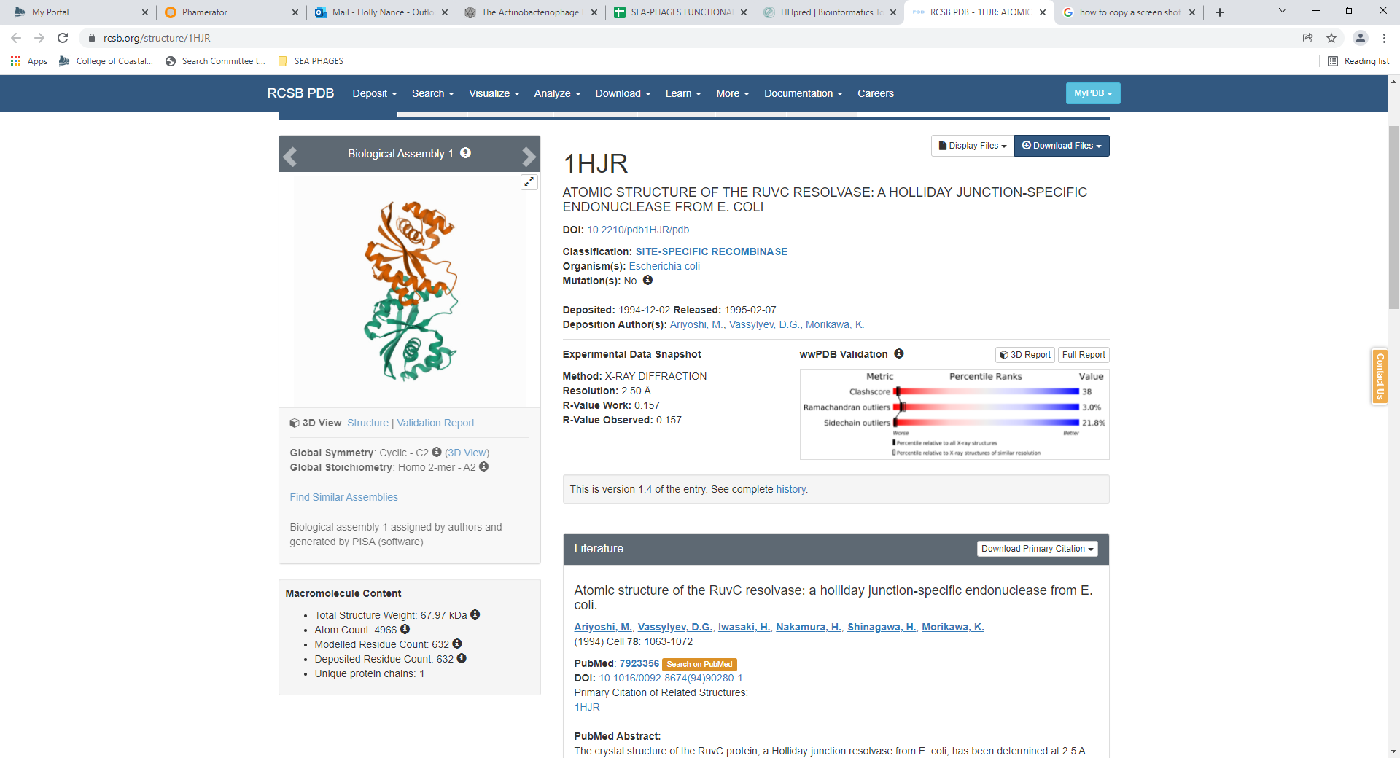

Gene 7
SSC: start 3962, stop 4408; CP: yes; SCS: both called start at 3962; ST: SS; Blast Start: matches Zelda_7 Query 1 to Subject 1 100% 2e⁻⁸¹; Gap: 46; LO: no; RBS: -3.810, 2.144, 14, -5.157, yes; F: NKF; SIF-BLAST: NKF /PhageDB BLAST/ Zelda_7, MK112555/100%/2e⁻⁸¹; SIF-HHPred: NKF, no matches with a function with a probability above 90%; SIF-Syn: NKF
Notes: Nothing ambiguous; here’s the HHPred output:
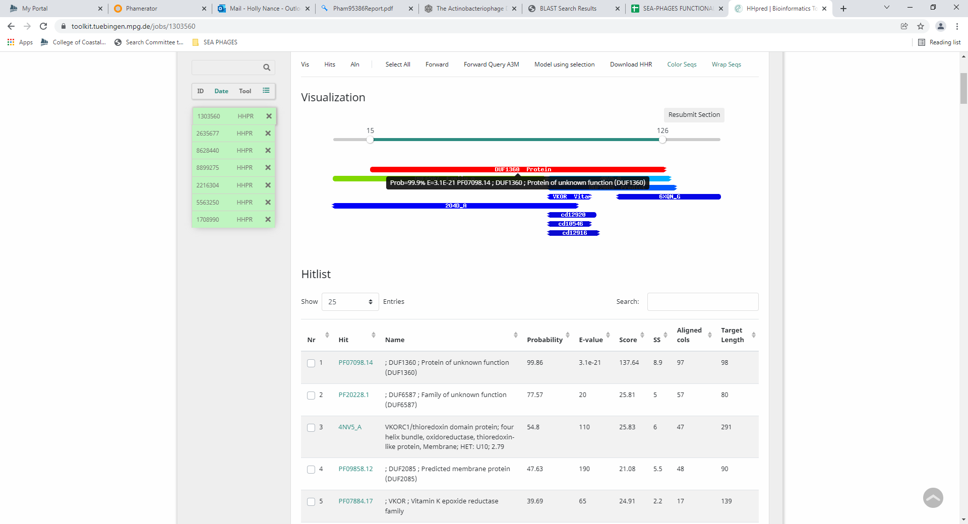
Gene 8 – changed start from 4549 to 4438 on 1/24/2022
SSC: start 4438, stop 6357; CP: yes; SCS: Both called this start at 4549, but changed to more conserved start of 4438; ST: SS; Blast Start: matches Xavier_8 Query 1 to Subject 1 100% 0.0; Gap: 29; LO: yes; RBS: -3.342, 2.378, 16, -5.138, no; F: portal protein; SIF-BLAST: portal protein/PhageDB BLAST/Xavier_8, MG944225/100%/0.0; SIF-HHPred: portal protein, several matches with a probability above 99%; SIF-Syn: portal protein
Notes: Both Glimmer and Gene Mark suggest a start of 4549. Starterator data shows this start is in 43% of phage in cluster. The most annotated start is 4438 is in 66% of phage and it was called 91% of the time when present. Phamerator synteny and BLAST data suggest 4438 is the most conserved start to select. This start also includes the most coding potential, however, the GeneMark output (all of them) don’t support coding potential starting at 4438:
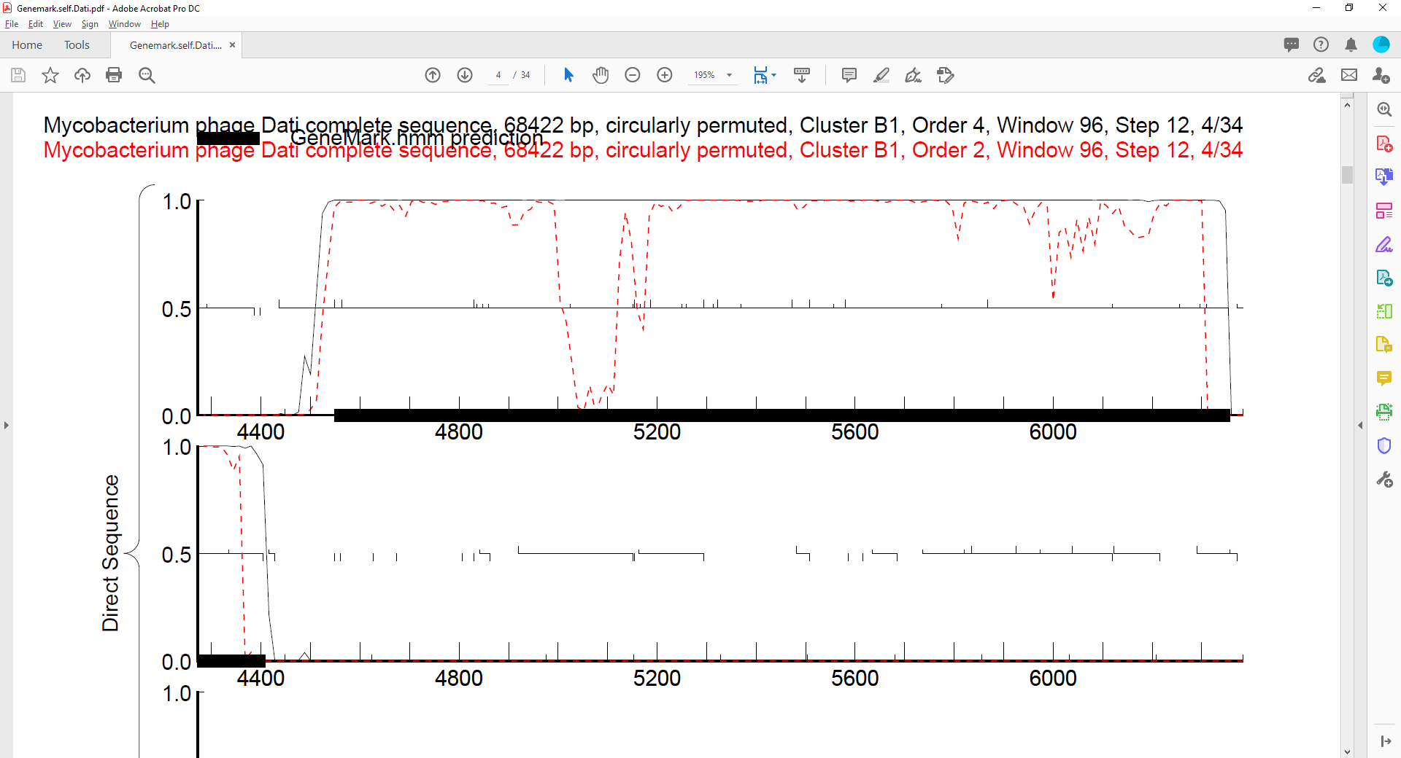
Given this is the only piece of data that does not support the 4438 start, I am going to change the start to 4438, as it is the most conserved and includes the most coding potential.
The function is portal protein. Regardless of the start, this is supported by much data.

Gene 9
SSC: start 6357, stop 8930; CP: yes; SCS: GeneMark called start at 6720, went with more conserved Glimmer start of 6357; ST: SS; Blast Start: matches Trypo_9 Query 1 to Subject 1 99% 0.0; Gap: overlap of 1; LO: NA; RBS: -3.985 2.057, 9, -4.759, yes; F: capsid maturation protease and MuF-like fusion protein; SIF-BLAST: capsid maturation protease and MuF-like fusion protein /PhageDB BLAST/ Trypo_9, MG944223/99%/0.0; SIF-HHPred: MuF-like fusion protein domain, a match with a probability of 98.85%; SIF-Syn: capsid maturation protease and MuF-like fusion protein
Notes: Start is clear-cut, but function seems odd. PhageDB BLAST, NCBI BLAST and synteny in phamerator all support the function being capsid maturation protease and MuF-like fusion protein. However, this specific protein isn’t on the Official Function List. Also, there is only HHPred support for the MuF-like domain of this fusion protein:
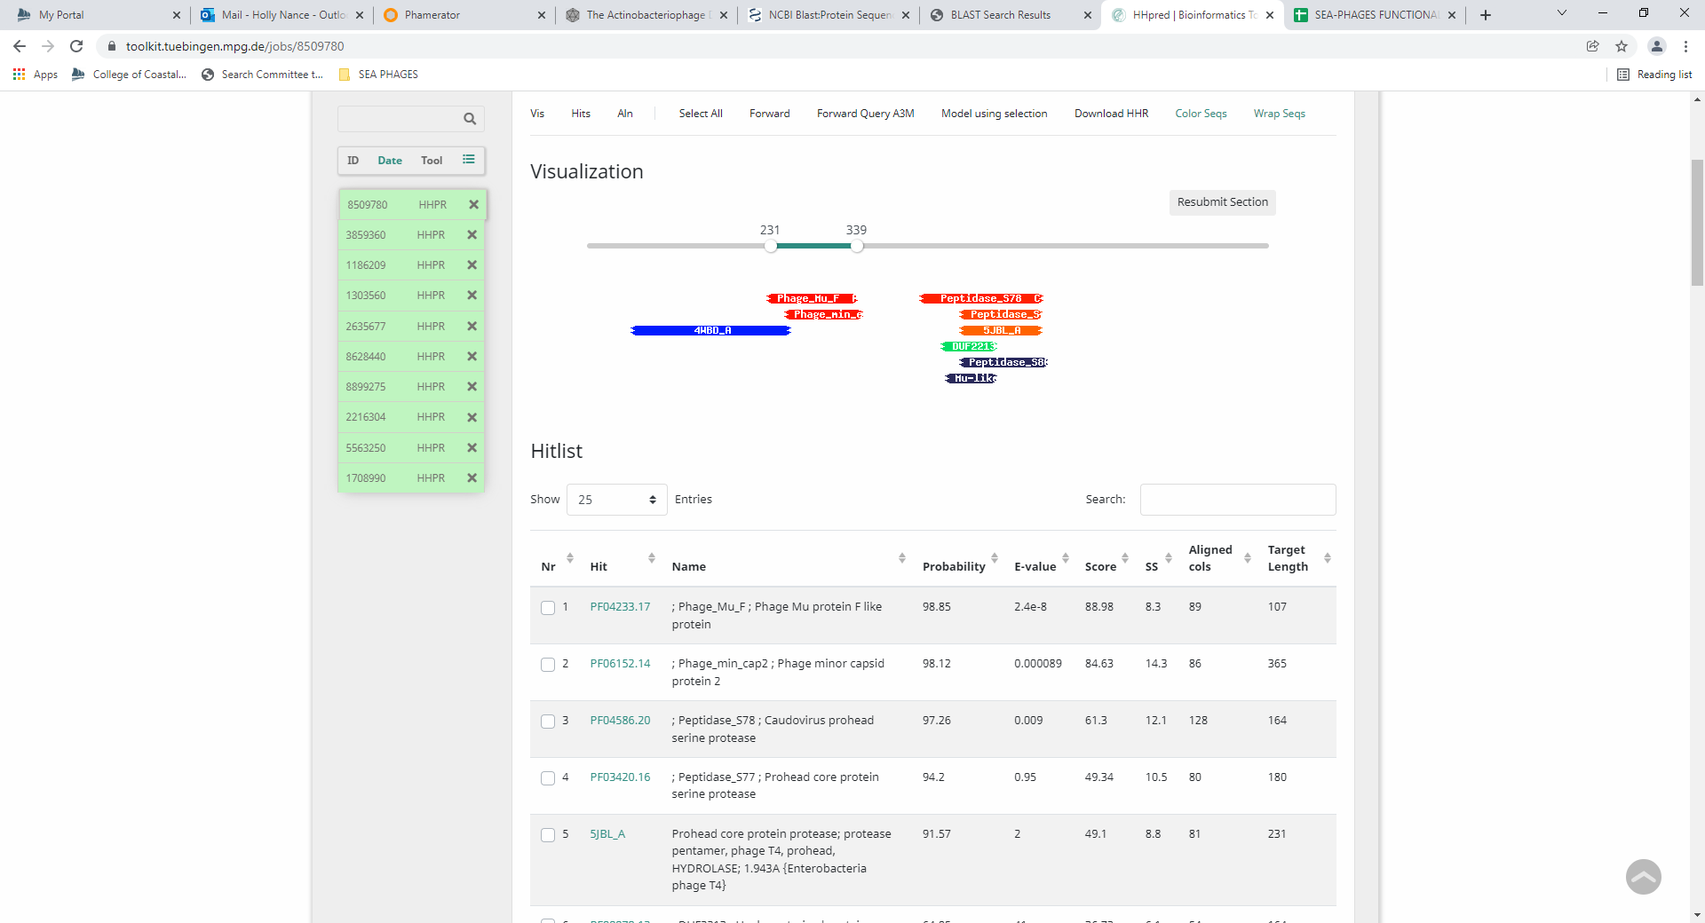
This protein is a think in Cluster B. Here is a reply from Welkin regarding this protein in the PhageDB forum:
UPDATED MARCH 2021 TO REFLECT DISCUSSION BELOW
Cluster B phages do not have a separate capsid maturation protease and scaffolding protein. instead, they have a great big long protein called a capsid morphogenesis protein. a capsid maturation protease and MuF-like fusion protein.
Edited 16 Mar, 2021 18:29
Link to this forum reply: https://seaphages.org/forums/topic/4516/
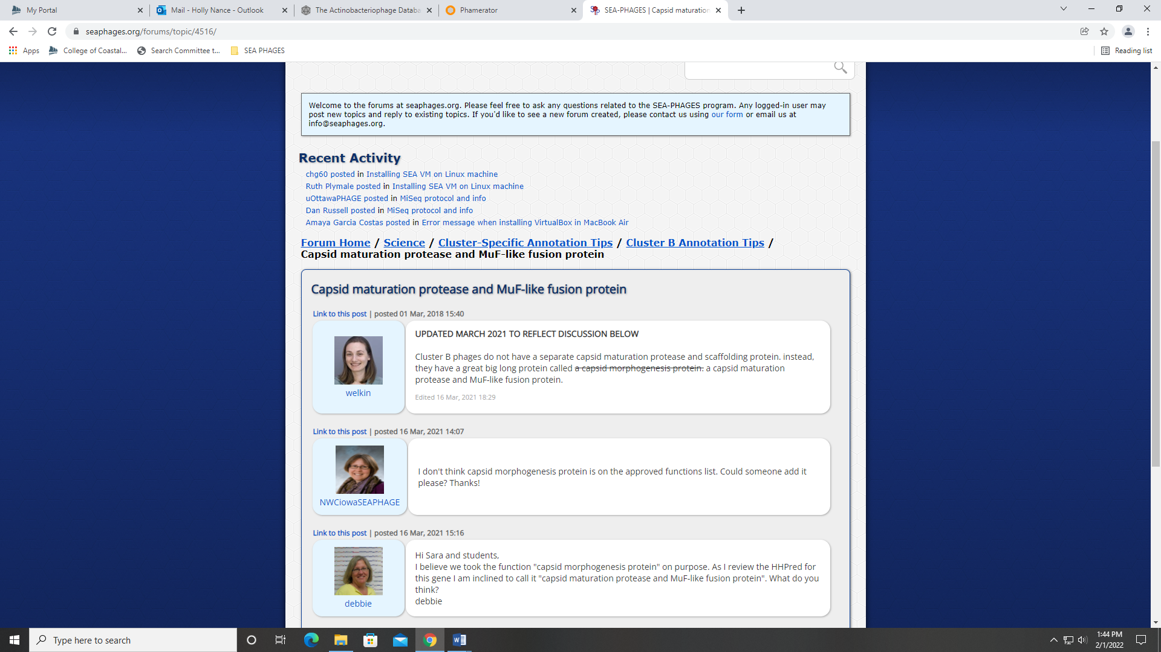
Gene 10
SSC: start 8923, stop 9081; CP: negligible; SCS: not called by Glimmer or GeneMark; ST: SS; Blast Start: matches Vortex_10 Query 1 to Subject 1 100% 3e⁻²⁵; Gap: overlap of 8; LO: N/A; RBS: -3.378, 2.360, 8, -4.600, yes; F: HNH endonuclease; SIF-BLAST: HNH Endonuclease/PhageDB BLAST/Squiggle_10, KM363597/100%/3e⁻²⁵; SIF-HHPred: NKF, no matches with a probability above 90%; SIF-Syn: HNH endonuclease

Notes (from Kayla): New Gene 10 Should be inserted between the current Gene 9 and Gene 10
- This gene is not called by Glimmer or GeneMark and has almost no coding potential
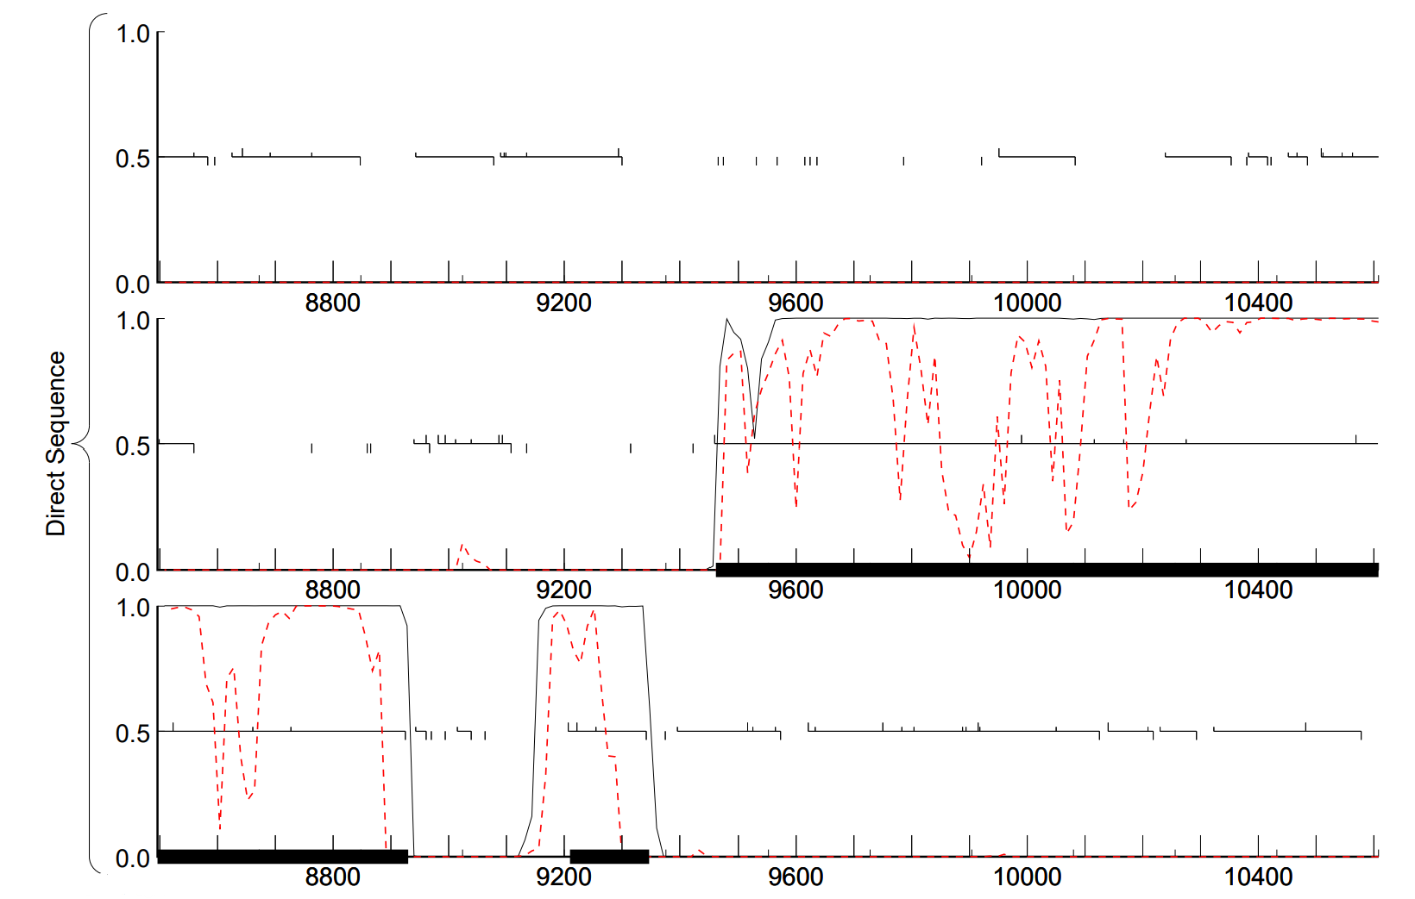

- However, synteny data from PhagesDB and Phamerator indicates that the gap between the current Gene 9 and Gene 10 is not conserved. 659 phages from multiple clusters possess a gene in this “gap”, and 511 of them (~78%) call the gene HNH endonuclease.

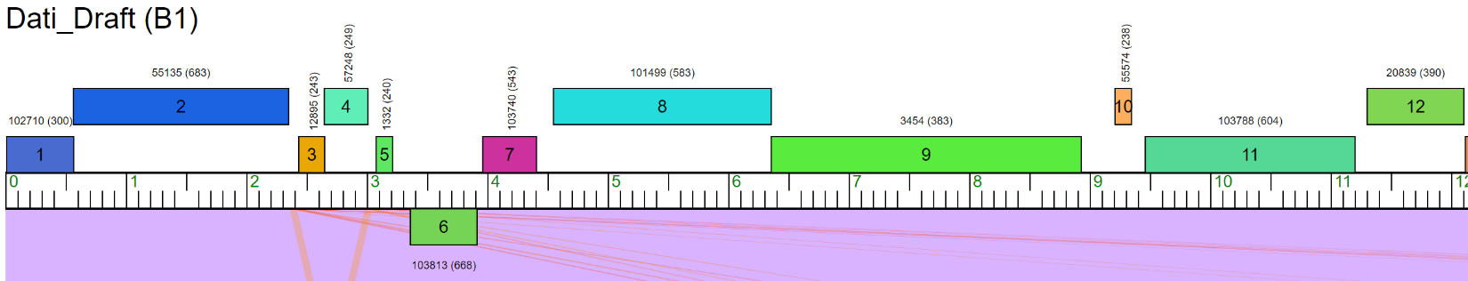
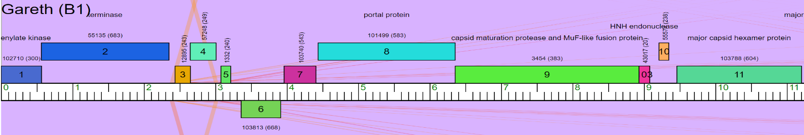
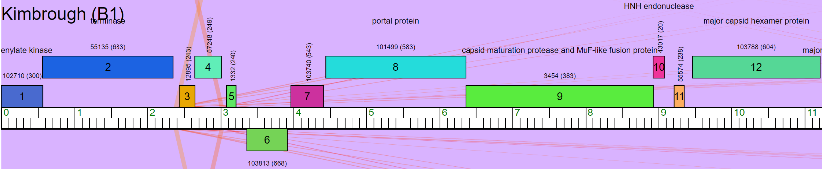
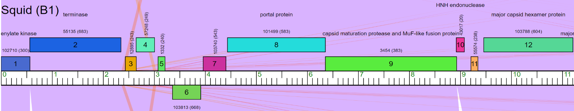
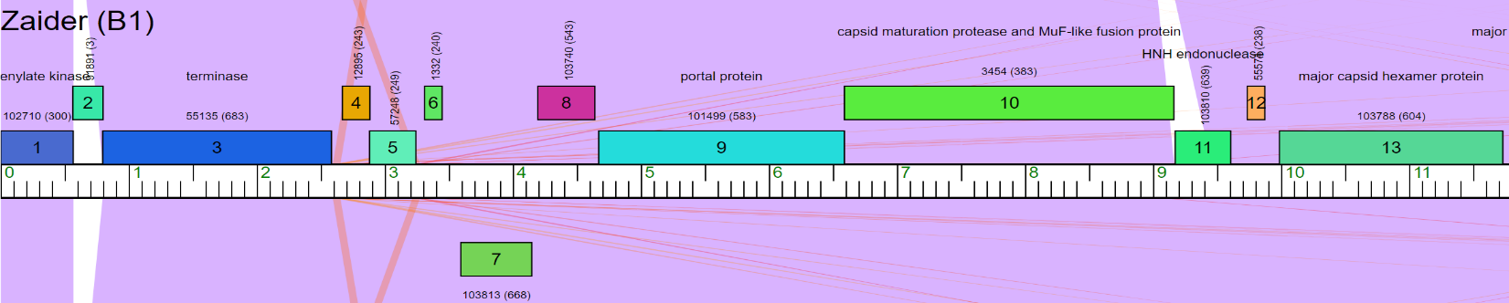
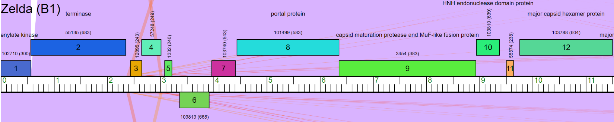
- I identified the best start for this gene out of 3 possible options by going to the Starterator page for a gene that gave a 1:1 match to the 53 amino acid sequence I entered into the PhagesDB BLAST
  - The most-conserved start position is a TTG start codon in Dati; however, 100% of the phages in the prospective phamily for this gene call the most annotated start position so I chose to stick with it. This start also had the best RBS values.

- HHPred indicated that this gene has NKF
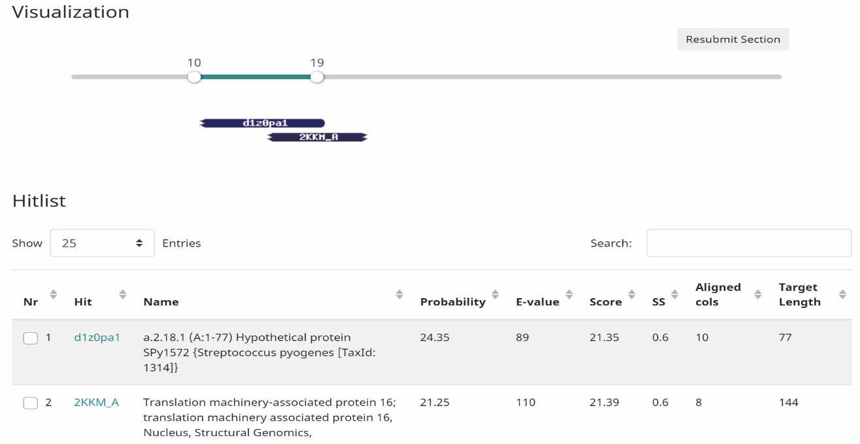

- NCBI BLAST indicated that this gene either has no known function or codes for HNH endonuclease
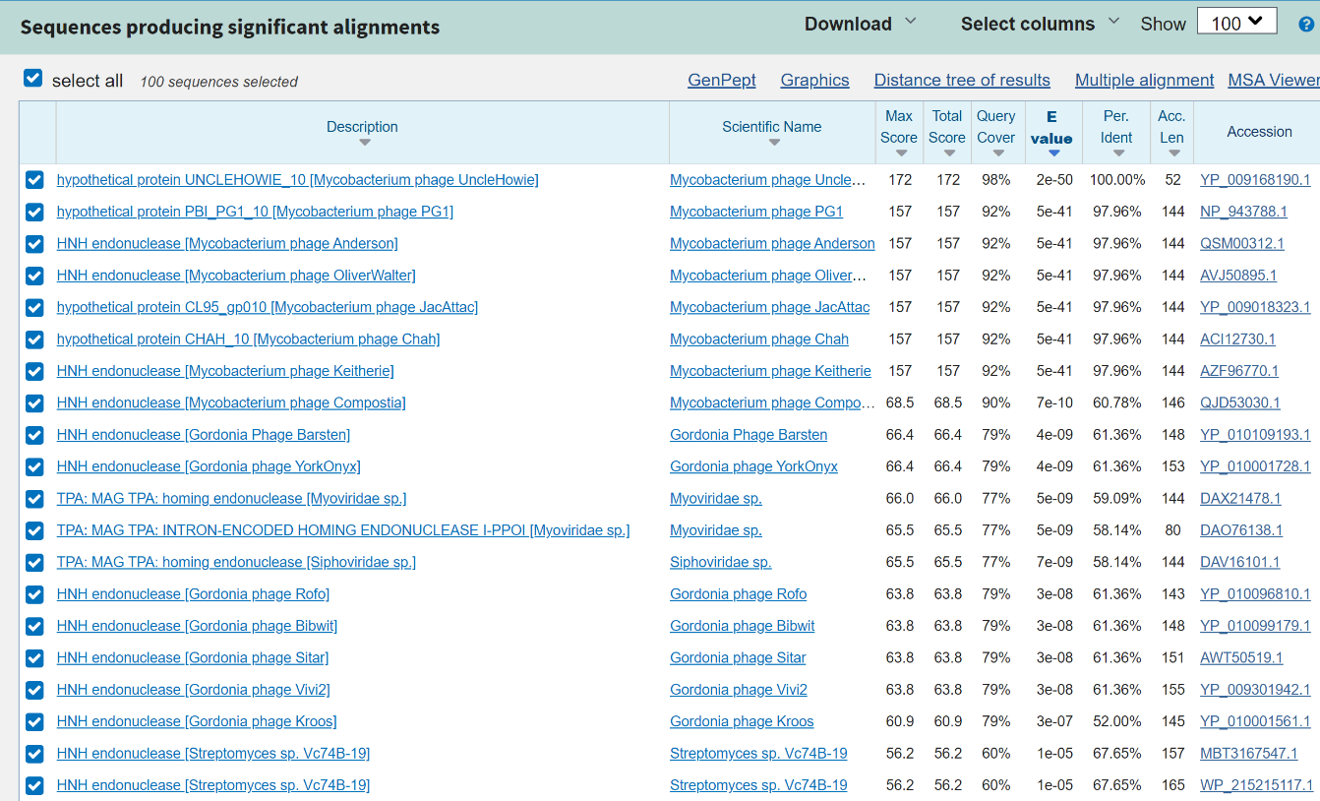
- SEA-PHAGES Functions present in (almost) all phage genomes list indicates that terminase-associated HNH endonucleases are often NOT predicted by Glimmer OR GeneMark, but are very highly conserved in phage genomes. They also can be located almost anywhere in the genome, but are most commonly either the first gene, the last gene, or adjacent to the terminase (Dati’s terminase is at Gene 6).

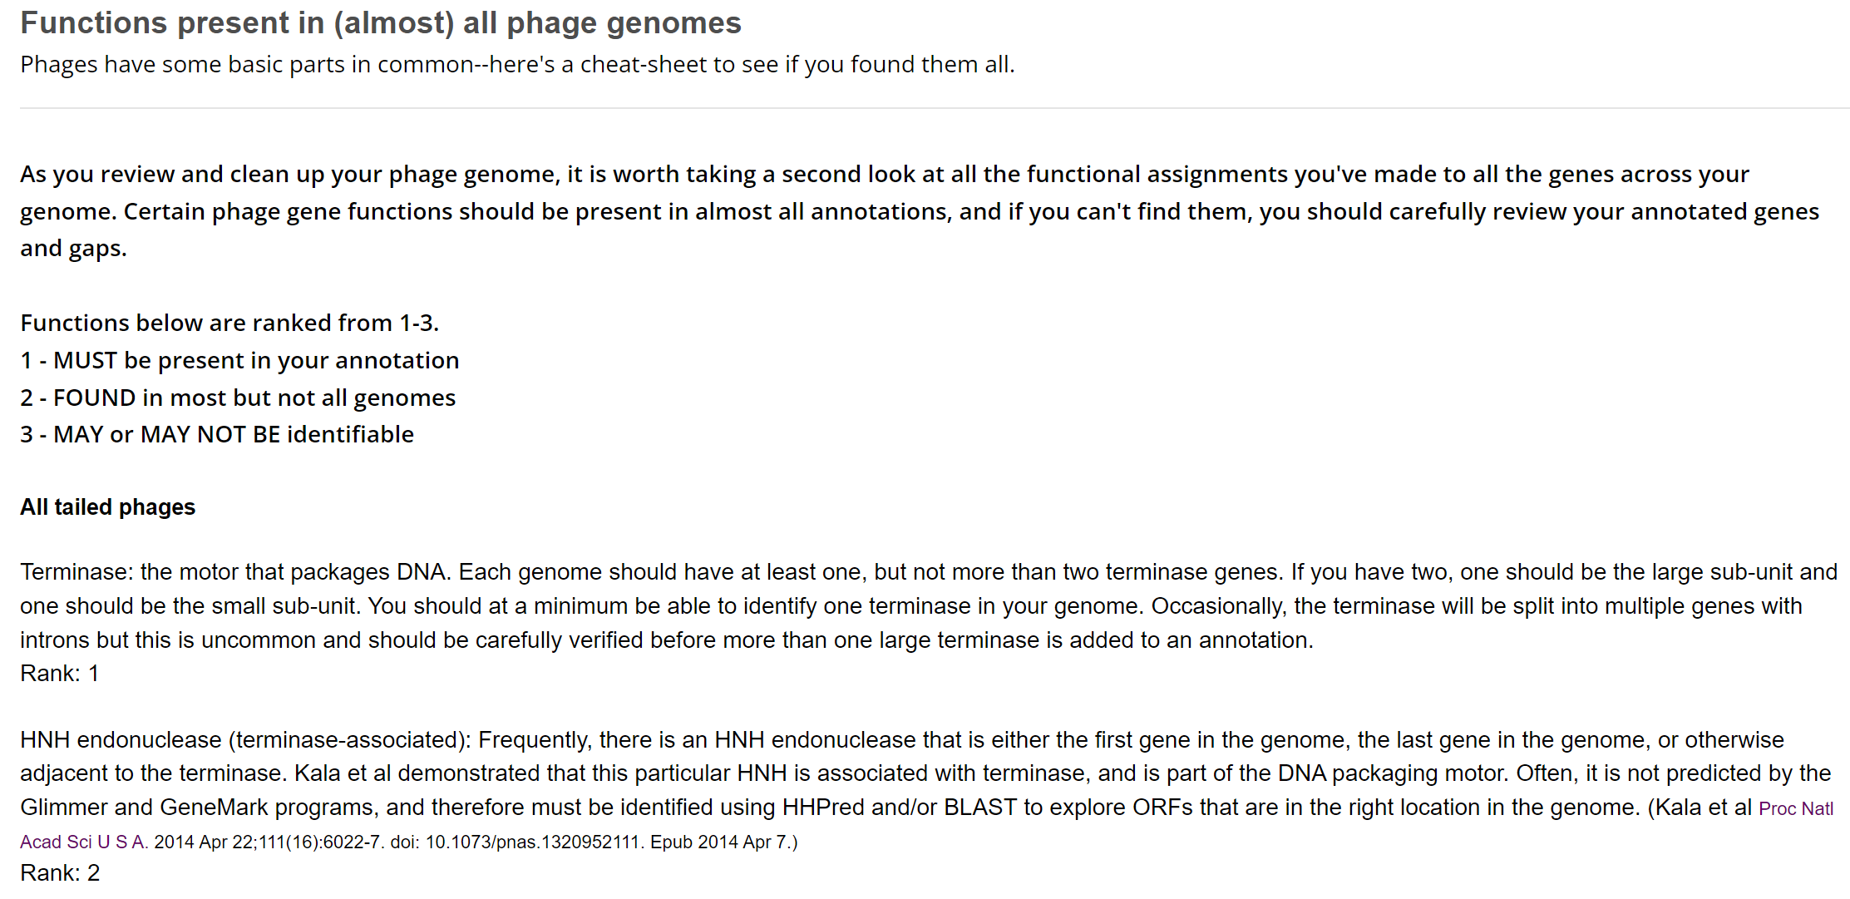

Gene 11
SSC: start 9210, stop 9347; CP: yes; SCS: both called start at 9210; ST: SS; Blast Start: matches Zonia_11 Query 1 to Subject 1 100% 7e⁻¹⁸; Gap: 128; LO: no RBS: -4.436, 1.819, 16, -6.259, no; F: NKF; SIF-BLAST: NKF/PhageDB BLAST/ Zonia_11, KM363597/100%/7e⁻¹⁸; SIF-HHPred: NKF, no matches with a probability above 90%; SIF-Syn: NKF
Notes: This gene’s start is highly conserved. It’s small, but there isn’t another start before this coding potential. However, there is a large gap (279 BP) before this gene. GeneMark output shows potential starts in this gap in different reading frames. A student could check to see if this sequence hits anything in NCBI? Potential poster? Synteny supports an additional gene here in some B1 phage…

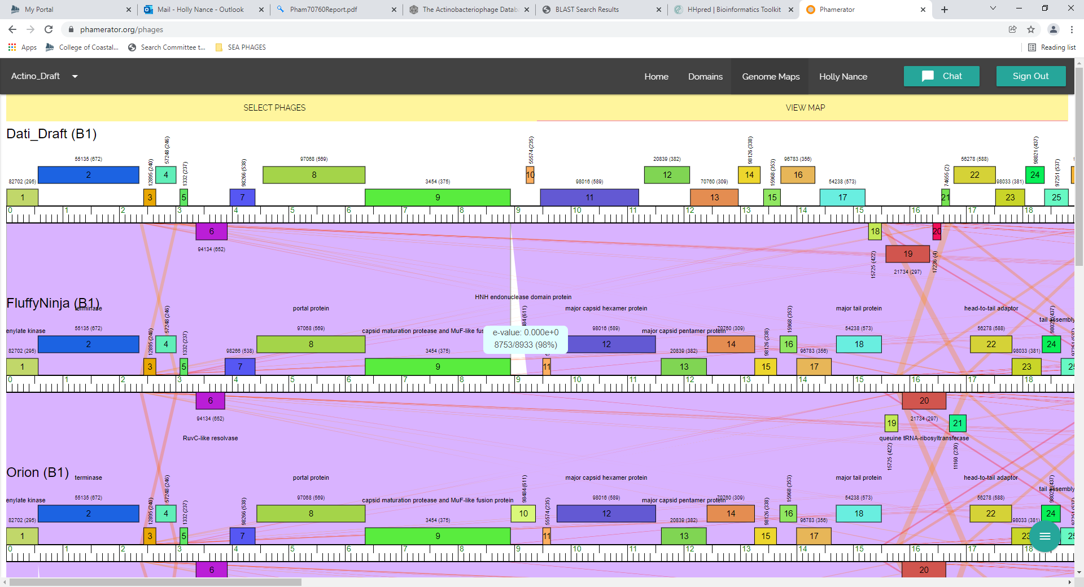
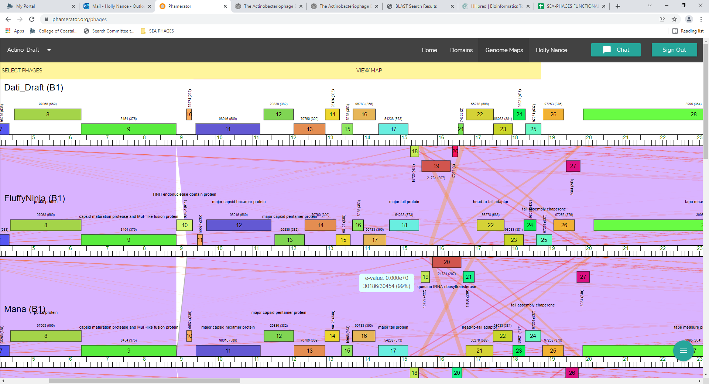

Gene 12
SSC: start 9461, stop 11203; CP: yes; SCS: Both called start at 9461; ST: SS; Blast Start: matches Schadenfreude_11 Query 1 to Subject 1 100% 0.0; Gap: 113; LO: yes; RBS: -1.748, 3.172, 13, -2.794, yes; F: major capsid hexamer protein; SIF-BLAST: major capsid hexamer protein /PhageDB BLAST/ Schadenfreude_11, MH926060/100%/0.0; SIF-HHPred: NKF, no matches with a probability above 90%; SIF-Syn: major capsid hexamer protein
Notes: BLAST and synteny all support the function being major capsid hexamer protein, but there are no hits in HHPred:
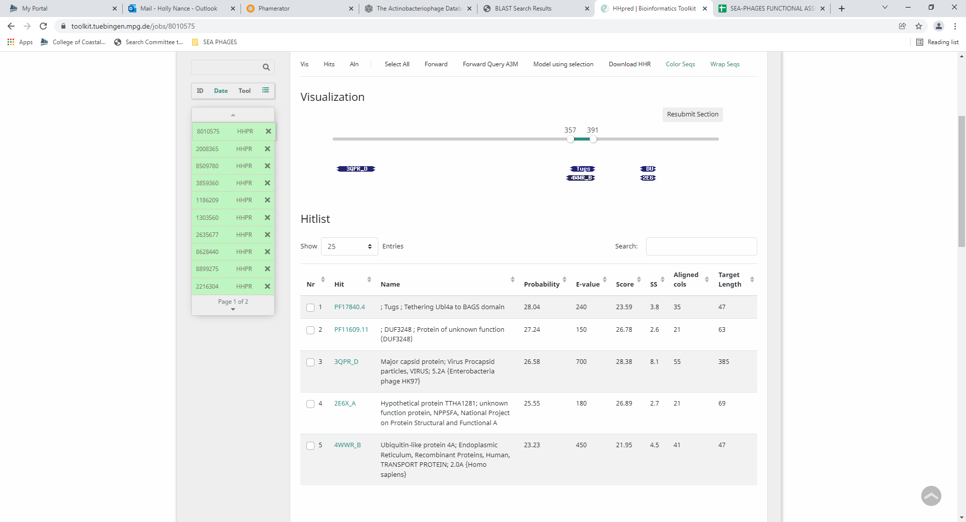
The large gap in front of this gene is conserved across other phage in B1:
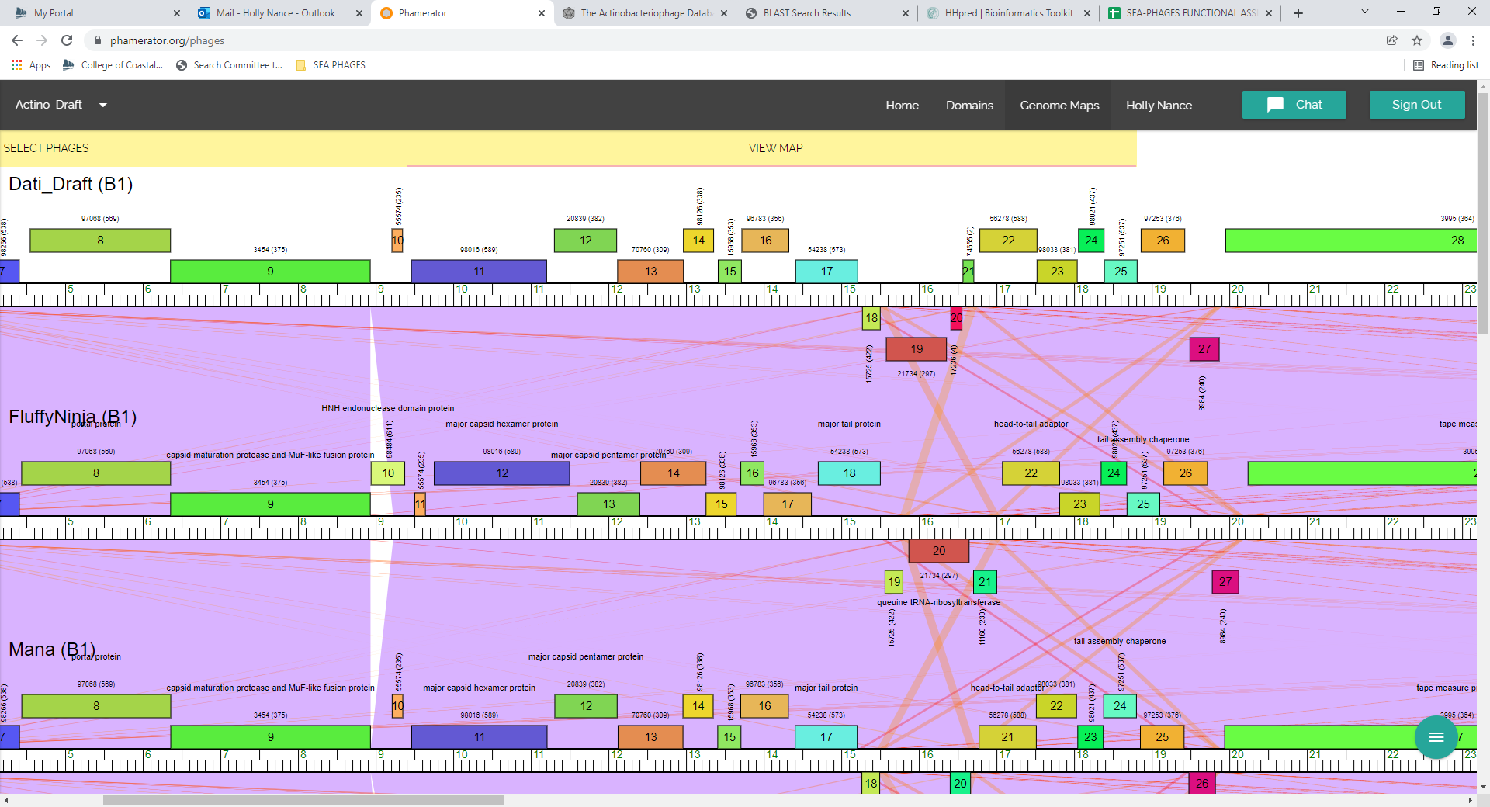

Gene 13
SSC: start 11303, stop 12106; CP: yes; SCS: GeneMark called start at 11324, went with more conserved Glimmer start of 11303 that includes more coding potential; ST: SS; Blast Start: matches Vaishali24_12 Query 1 to Subject 1 100% 1e⁻¹⁵⁸; Gap: 99; LO: yes; RBS: -2.590, 2.752, 11, -3.347, yes; F: major capsid pentamer protein; SIF-BLAST: major capsid pentamer protein /PhageDB BLAST/ Vaishali24_12, MN586058/100%/1e⁻¹⁵⁸; SIF-HHPred: NKF, no matches with a probability above 90%; SIF-Syn: major capsid pentamer protein
Notes: Nothing ambiguous about this. Went with Glimmer start, as it was more conserved across cluster and included more coding potential. Function is supported by all data but HHPred.

Gene 14
SSC: start 12118, stop 12966; CP: yes; SCS: Both called start at 12118; ST: SS; Blast Start: matches Xavier_13 Query 1 to Subject 1 100% 1e⁻¹⁶³; Gap: 11; LO: no; RBS: -3.631, 2.234, 12, -4.467, no; F: NKF; SIF-BLAST: NKF/PhageDB BLAST/ Xavier_13, MG944225/100%/1e⁻¹⁶³; SIF-HHPred: NKF, no matches with a probability above 90%; SIF-Syn: NKF
Notes: nothing ambiguous about this gene

Gene 15
SSC: start 12966, stop 13355; CP: yes; SCS: Both called start at 12966; ST: SS; Blast Start: matches Zonia_15 Query 1 to Subject 1 100% 2e⁻⁶⁶; Gap: overlap of 1; LO: NA; RBS: -2.699, 2.698, 12, -3.535, yes; F: NKF; SIF-BLAST: NKF/PhageDB BLAST/ Zonia_15, NM363597/100%/2e⁻⁶⁶; SIF-HHPred: NKF, one hit for phage holing with a probability above 90%, but partial with low % identity and high e value; SIF-Syn: NKF
Notes: Nothing ambiguous about this gene except HHPred hit; there was one hit for a partial match with a phage holin protein, but the e-value is high and the % identity is 19%:
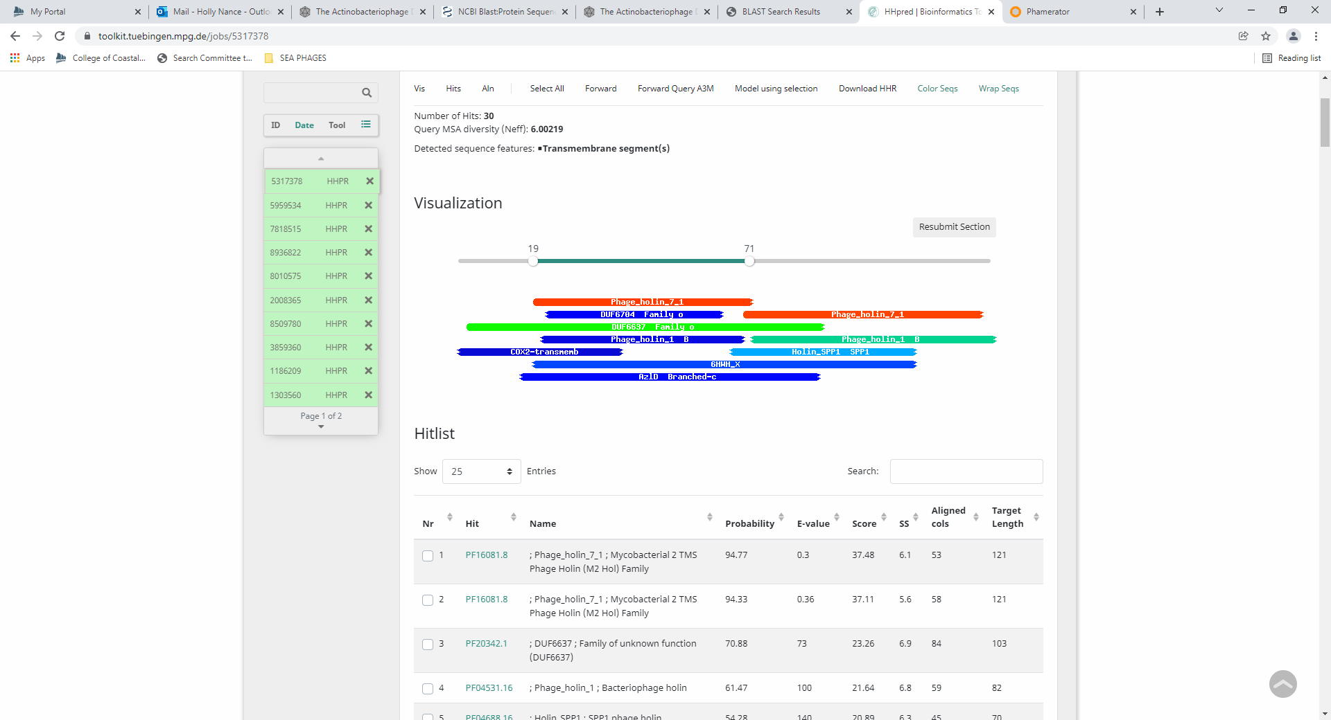

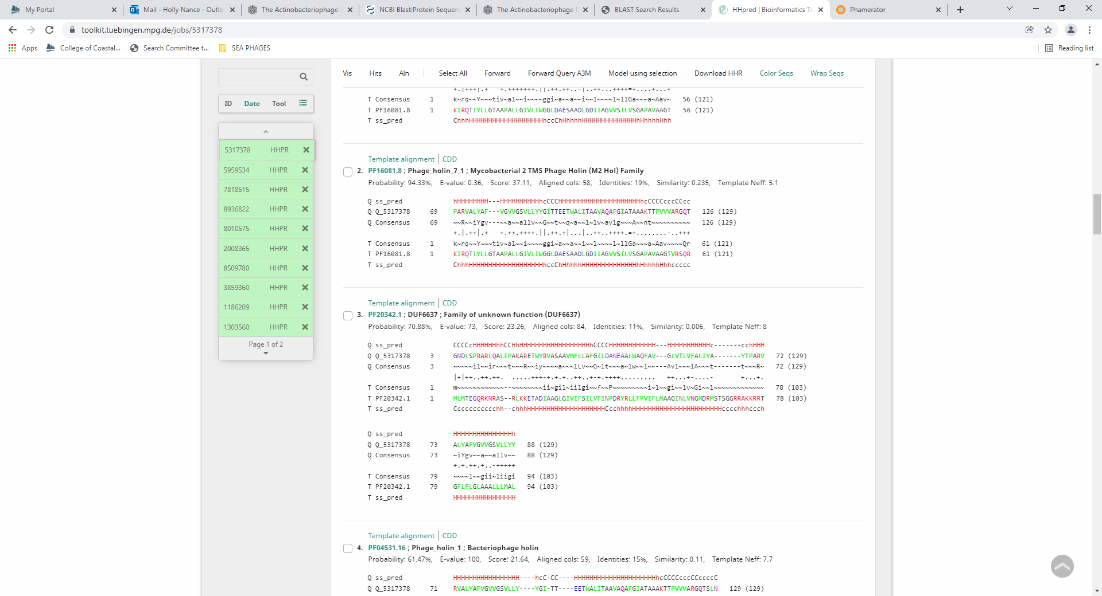
Also, NCBI BLAST hits suggest NKF (hypothetical protein):
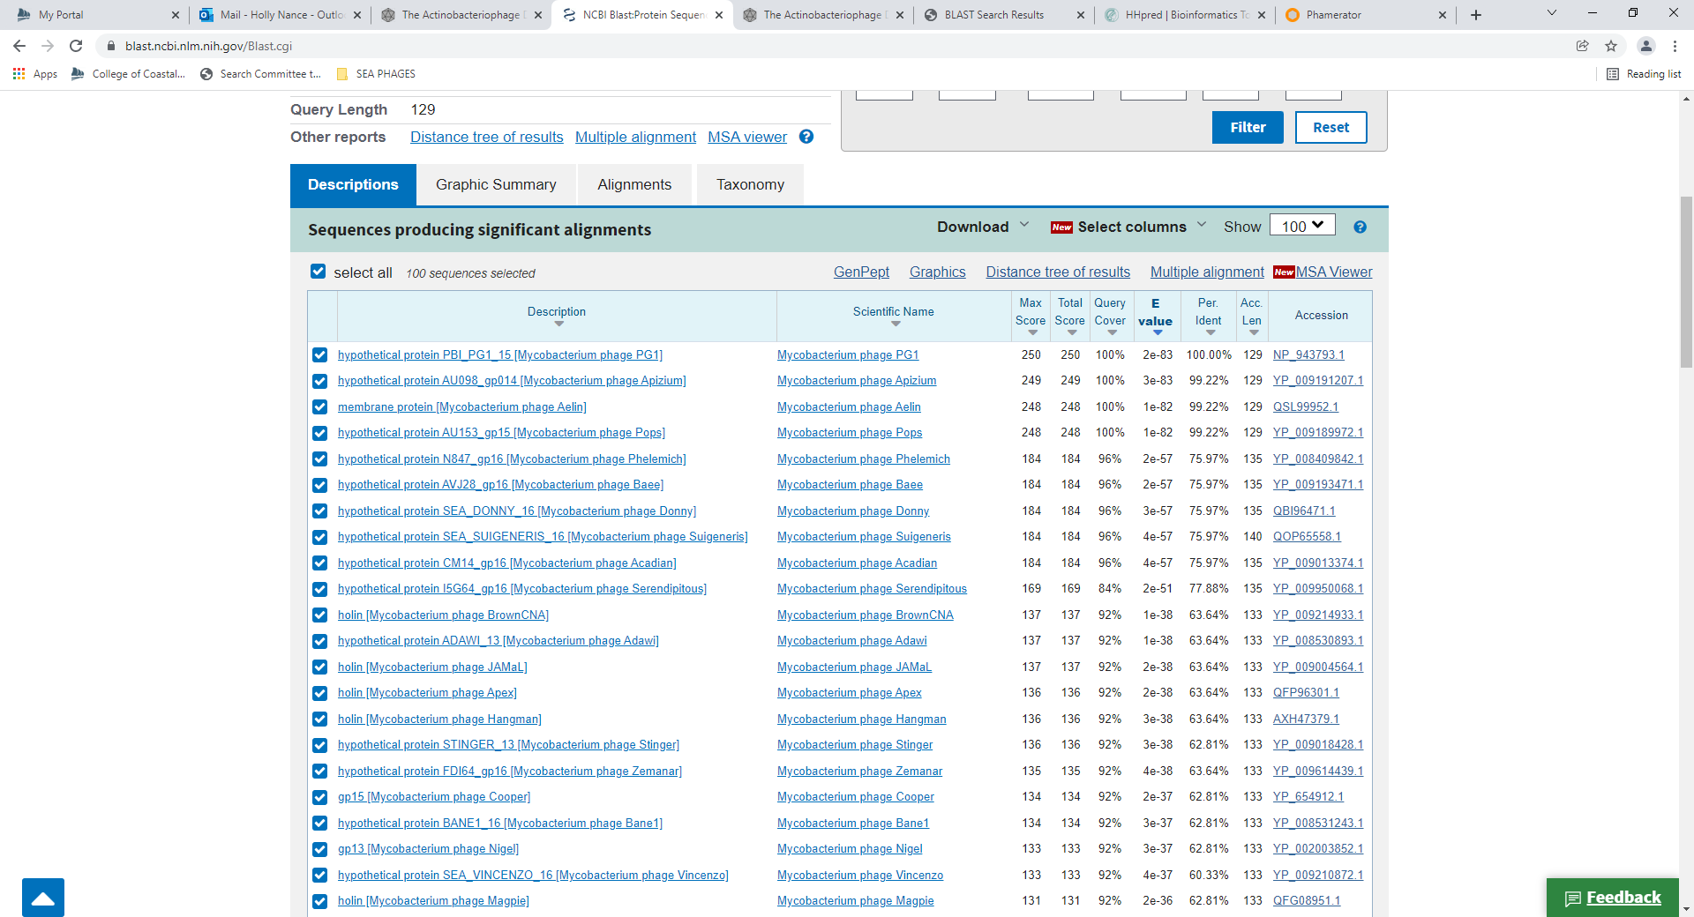
Gene 16 changed start from 13414 to 13363 on 1/31/2022!
SSC: start 13363 stop 13713; CP: yes; SCS: Both called start at 13414, went with more conserved start of 13363 which is longest ORF; ST: SS; Blast Start: matches Zonia_16 Query 1 to Subject 1 100% 8e⁻⁶²; Gap: 7; LO: NA; RBS: -2.624, 2.735, 7, -4.147, yes; F: NKF; SIF-BLAST: NKF/PhageDB BLAST/ Zonia_16, KM363597/100%/8e⁻⁶²; SIF-HHPred: NKF, one hit with probability of 90%, but only partial and domain not on official function list; SIF-Syn: NKF
Notes: Changed start to 13363 on 1/31 because this was the most conserved start based on BLAST data (goes from 1 to 18 subject/query to 1 to 1 subject/query with this change) and Starterator data. This start also makes the longest ORF, and it has the best RBS values. There isn’t support for this start in the GeneMark output, but all other signs support this as the start.
Regarding function, all data suggests NKF. There is a low probability hit in HHPred for a domain of a lipopolysaccharide assembly protein, but this protein or one like it is not on the official phage function list:
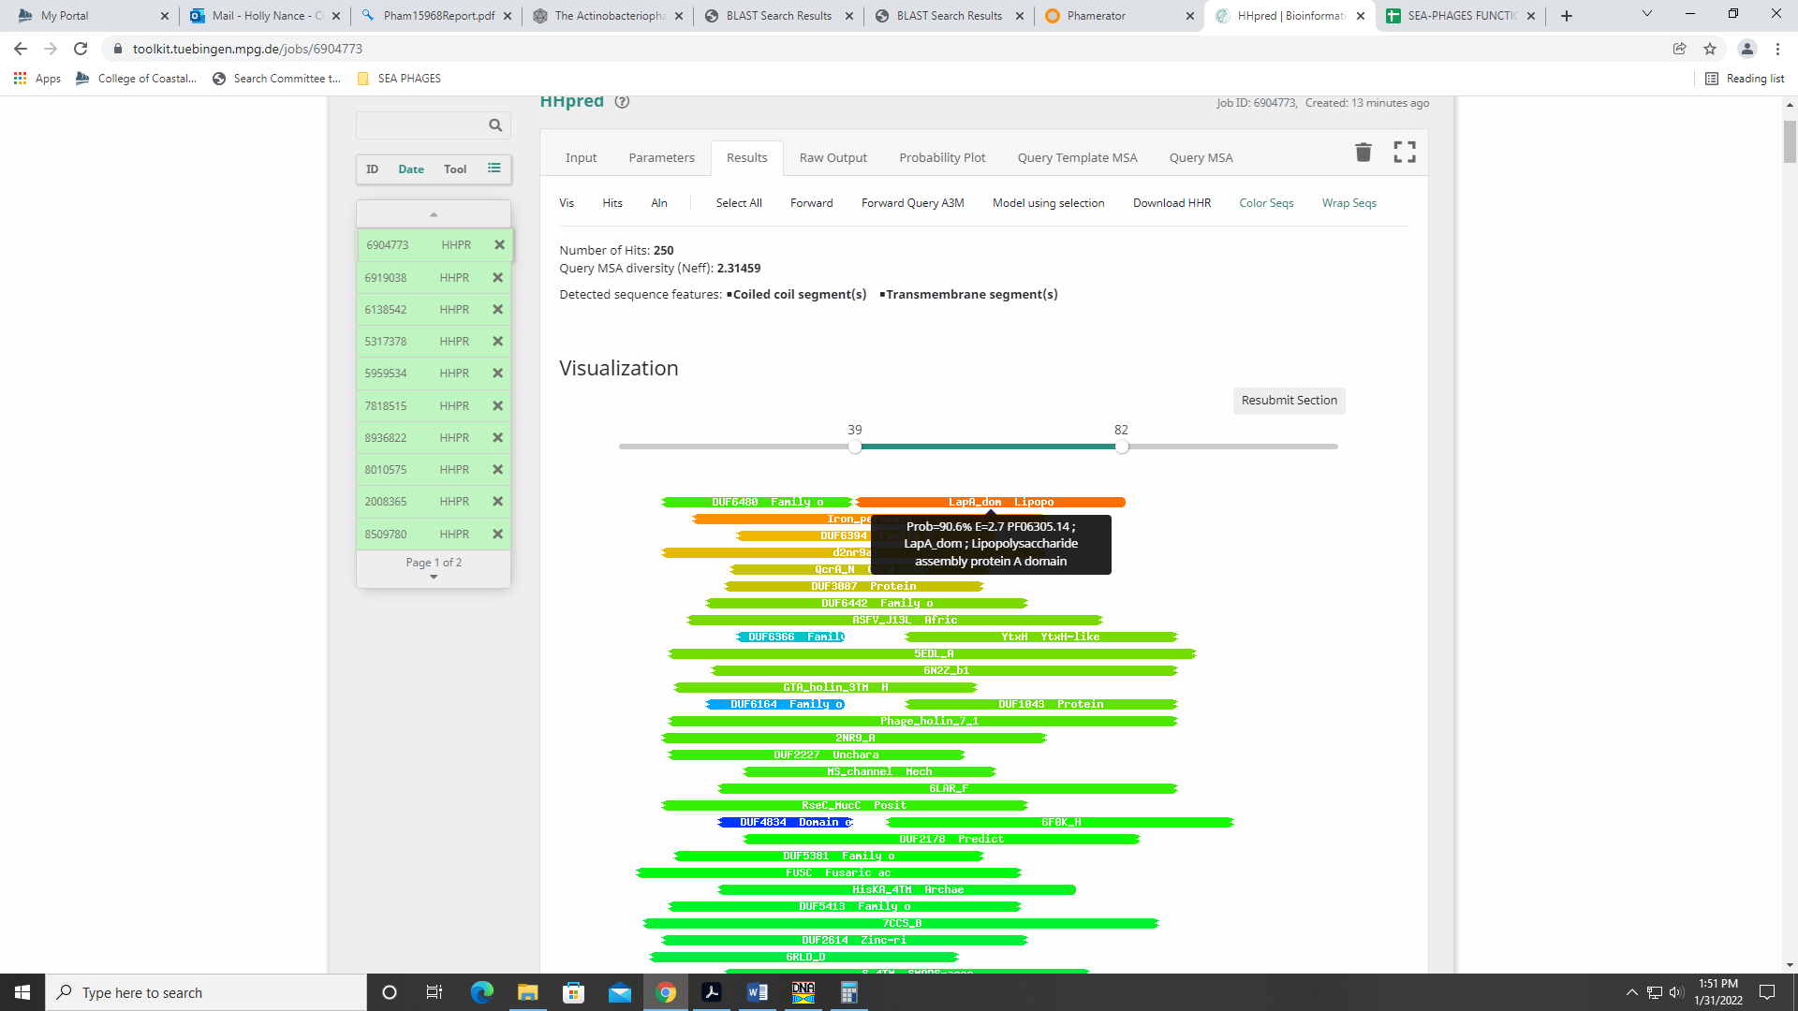

Gene 17 changed start from 13719 to 13710 on 1/31/2022!
SSC: start 13710, stop 14324; CP: yes; SCS: Glimmer called start at 13719, went with more conserved GeneMark start of 13710; ST: SS; Blast Start: matches JakeO_16 Query 1 to Subject 1 100% 1e⁻¹¹⁷; Gap: overlap of 4; LO: NA; RBS: -3.766, 2.166, 11, -4.523, yes; F: NKF; SIF-BLAST: NKF/PhageDB BLAST/ JakeO_16, MK279858/100%/1e⁻¹¹⁷; SIF-HHPred: NKF, no matches with a probability above 90% that have a function; SIF-Syn: NKF
Notes: Changed start to 13710, which is more conserved based on BLAST data (goes from 1:4 subject/query to 1:1subject/query) and in Starterator data. GeneMark suggested this start, as well (output supports it). RBS values are (marginally) best for this start.
Function is NKF, supported by all data. HHPred had a hit with 96.9% probability, but this hit is of a domain with unknown function:
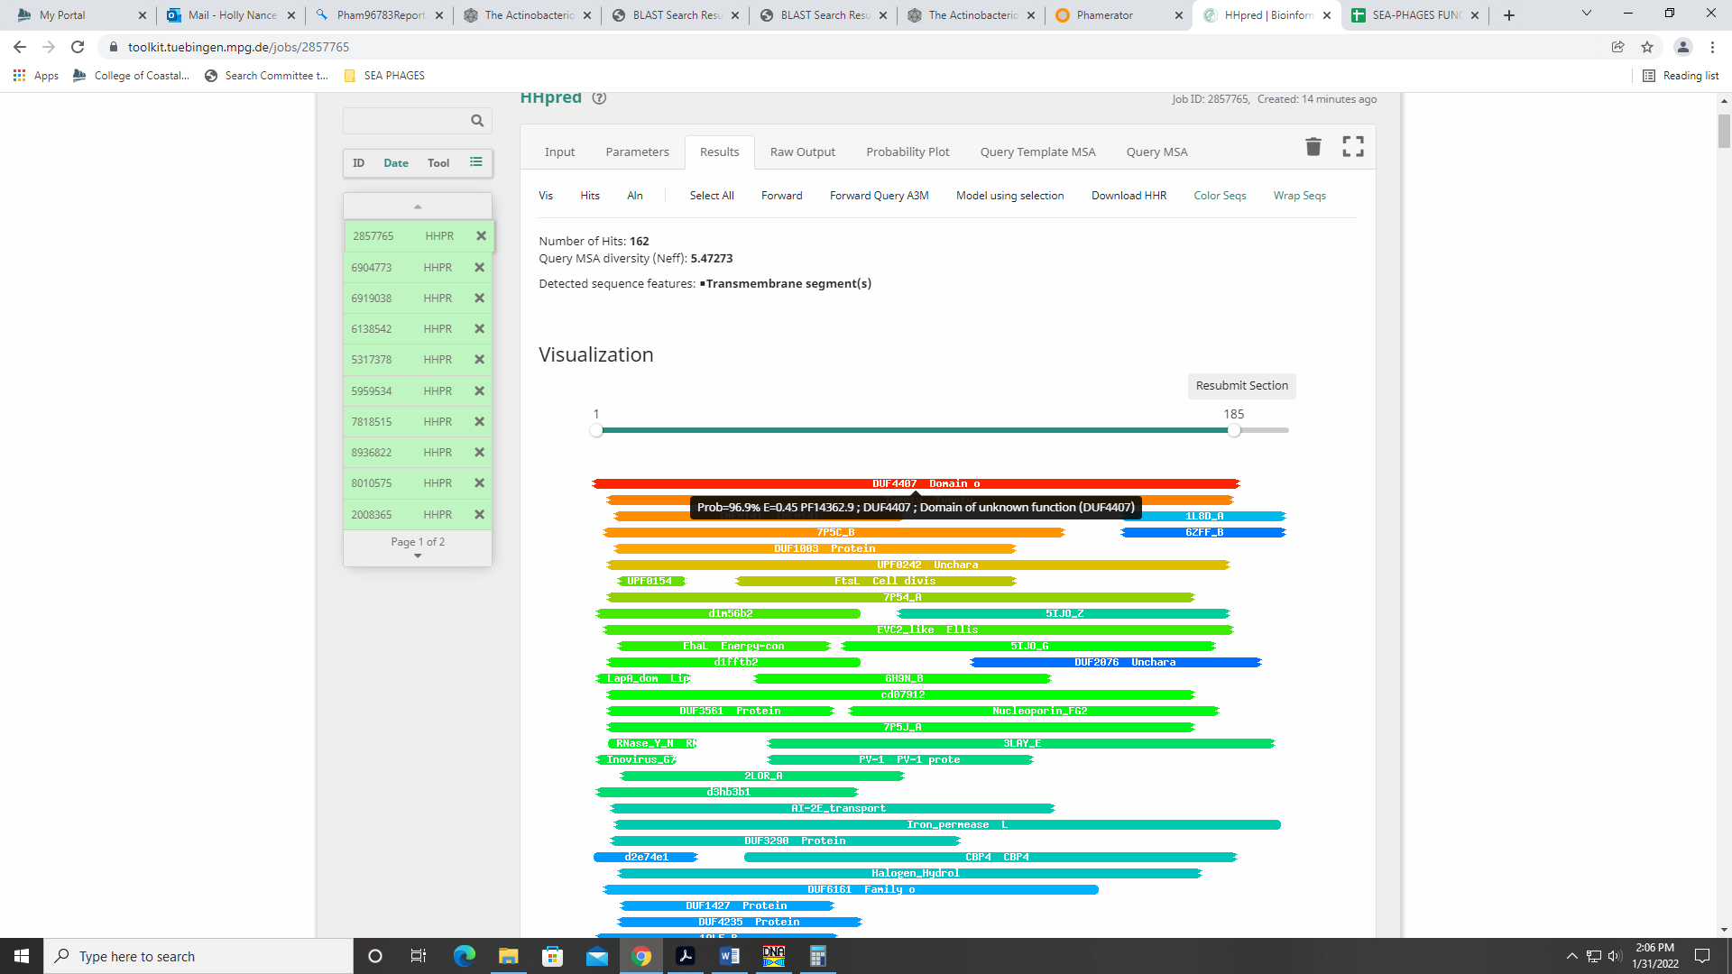

Gene 18
SSC: start 14412, stop 15212; CP: yes; SCS: Both called start at 14412; ST: SS; Blast Start: matches Zelda_18 Query 1 to Subject 1 100% 1e⁻¹⁵⁷; Gap: 87; LO: yes; RBS: -3.079, 2.509, 11, -3.836, yes; F: major tail protein; SIF-BLAST: major tail protein/PhageDB BLAST/ Zelda_18, MK112555/100%/1e⁻¹⁵⁷; SIF-HHPred: tail tube protein, one matche with a probability of 90%; SIF-Syn: major tail protein
Notes: Nothing ambiguous about start and coding potential.
For function, both Phage DB BLAST and NCBI BLAST support major tail protein:
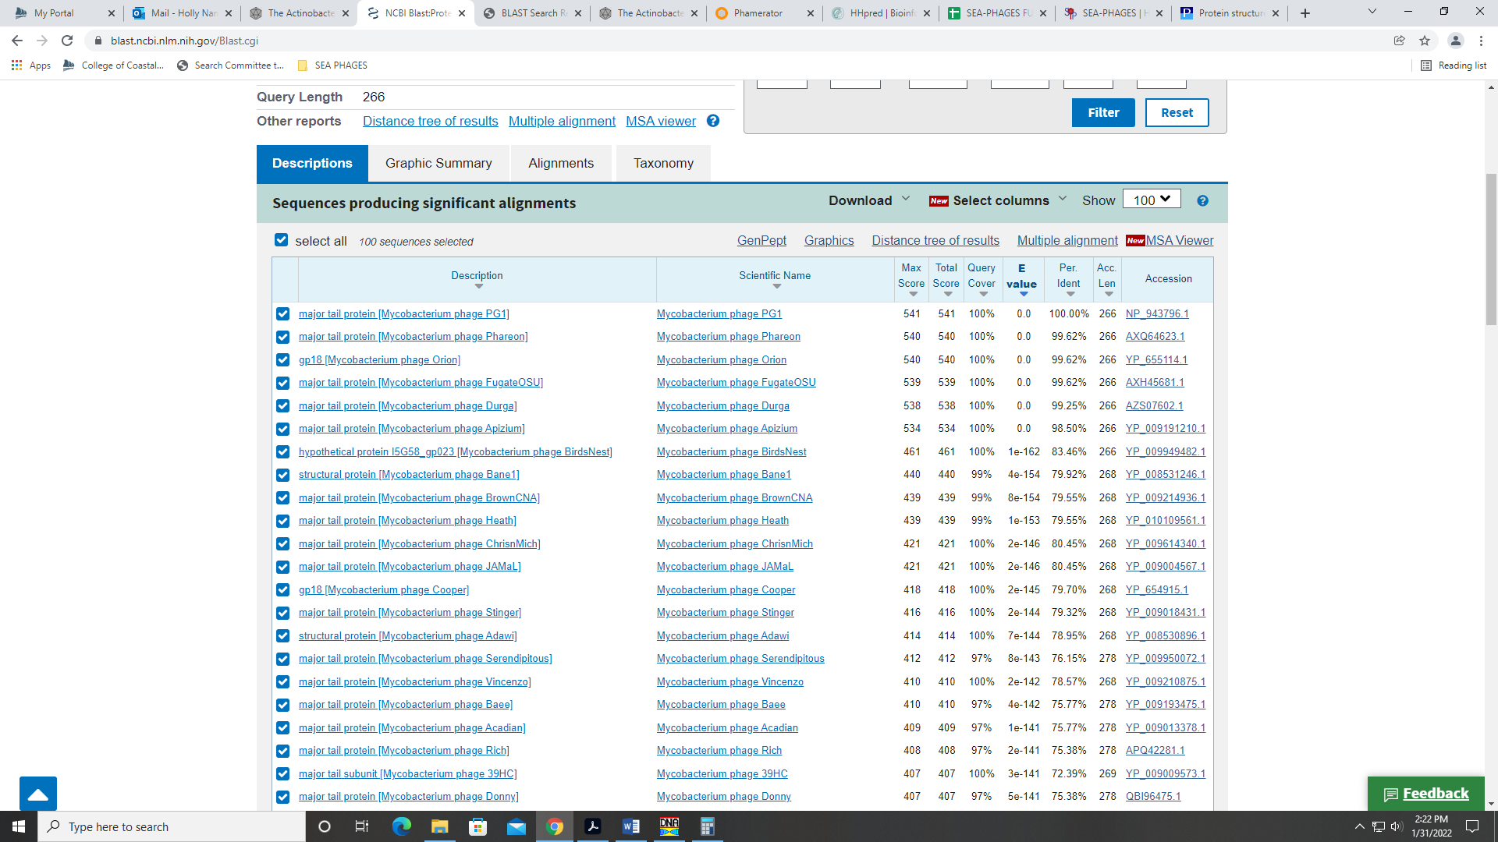
HHPred had only one hit with 90% probability for a phage tail tube protein:
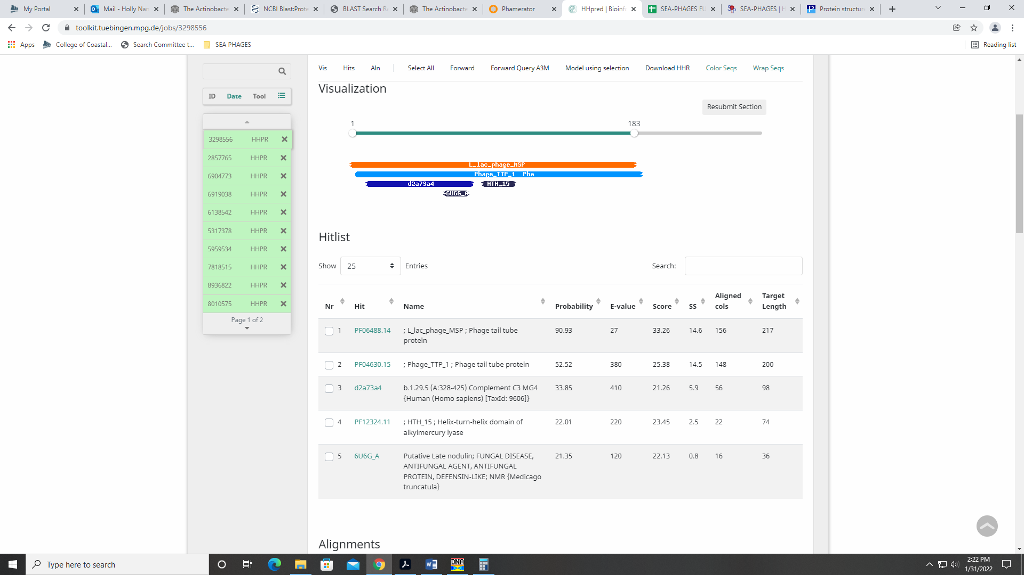
This protein is on the official phage function list, but it is only found in contractile tail phage (Myoviridae) and not Siphoviridae. Given the other databases that support this being a major tail protein, I’m going with that.
Gene 19 reverse gene!
SSC: start 15502, stop 15272; CP: yes; SCS: Both called start at 15502; ST: SS; Blast Start: matches Zonia_19 Query 1 to Subject 1 100% 7e⁻³⁶; Gap: 77; LO: yes; RBS: -1.784, 3.154, 7, -3.307, NA; F: NKF; SIF-BLAST: NKF/PhageDB BLAST/ Zonia_19, KM363597/100%/7e⁻³⁶; SIF-HHPred: NKF, no matches with a probability above 90%; SIF-Syn: NKF
Notes: Very easy call – nothing ambiguous!

Gene 20 reverse gene
SSC: start 16356, stop 15580; CP: yes; SCS: Both called start at 16356; ST: SS; Blast Start: matches Weher20_20 Query 1 to Subject 1 100% 1e⁻¹⁵⁵; Gap: 55; LO: yes; RBS: -2.757, 2.669, 11, -3.514, yes; F: queuine tRNA-ribosyltransferase; SIF-BLAST: queuine tRNA-ribosyltransferase /PhageDB BLAST/ Weher20_20, MZ681520/100%/1e⁻¹⁵⁵; SIF-HHPred: queuine tRNA-ribosyltransferase, several matches with a probability above 99%; SIF-Syn: queuine tRNA-ribosyltransferase
Notes: Reverse gene; start well supported. All databases support this function, though the name is not on the official phage functions list.
HHPred data:
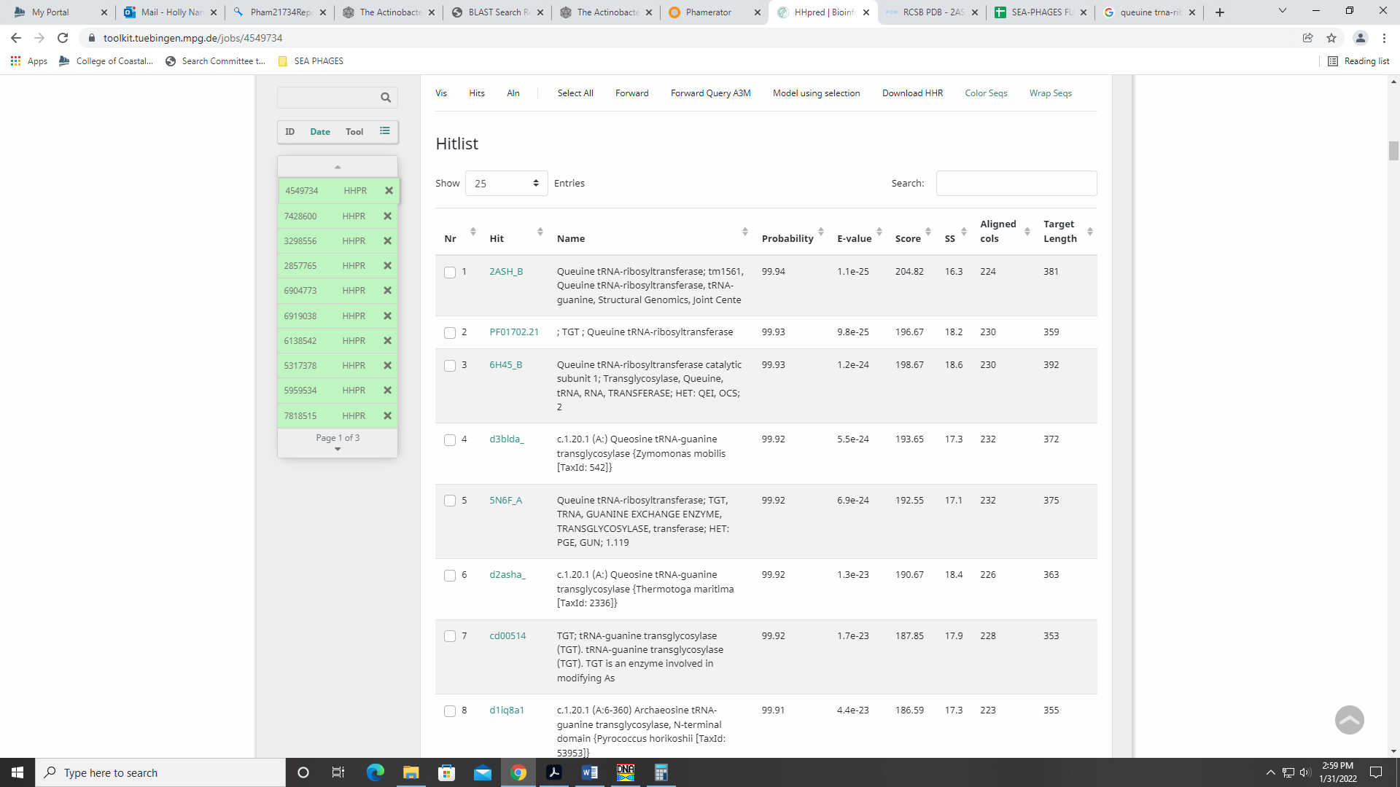
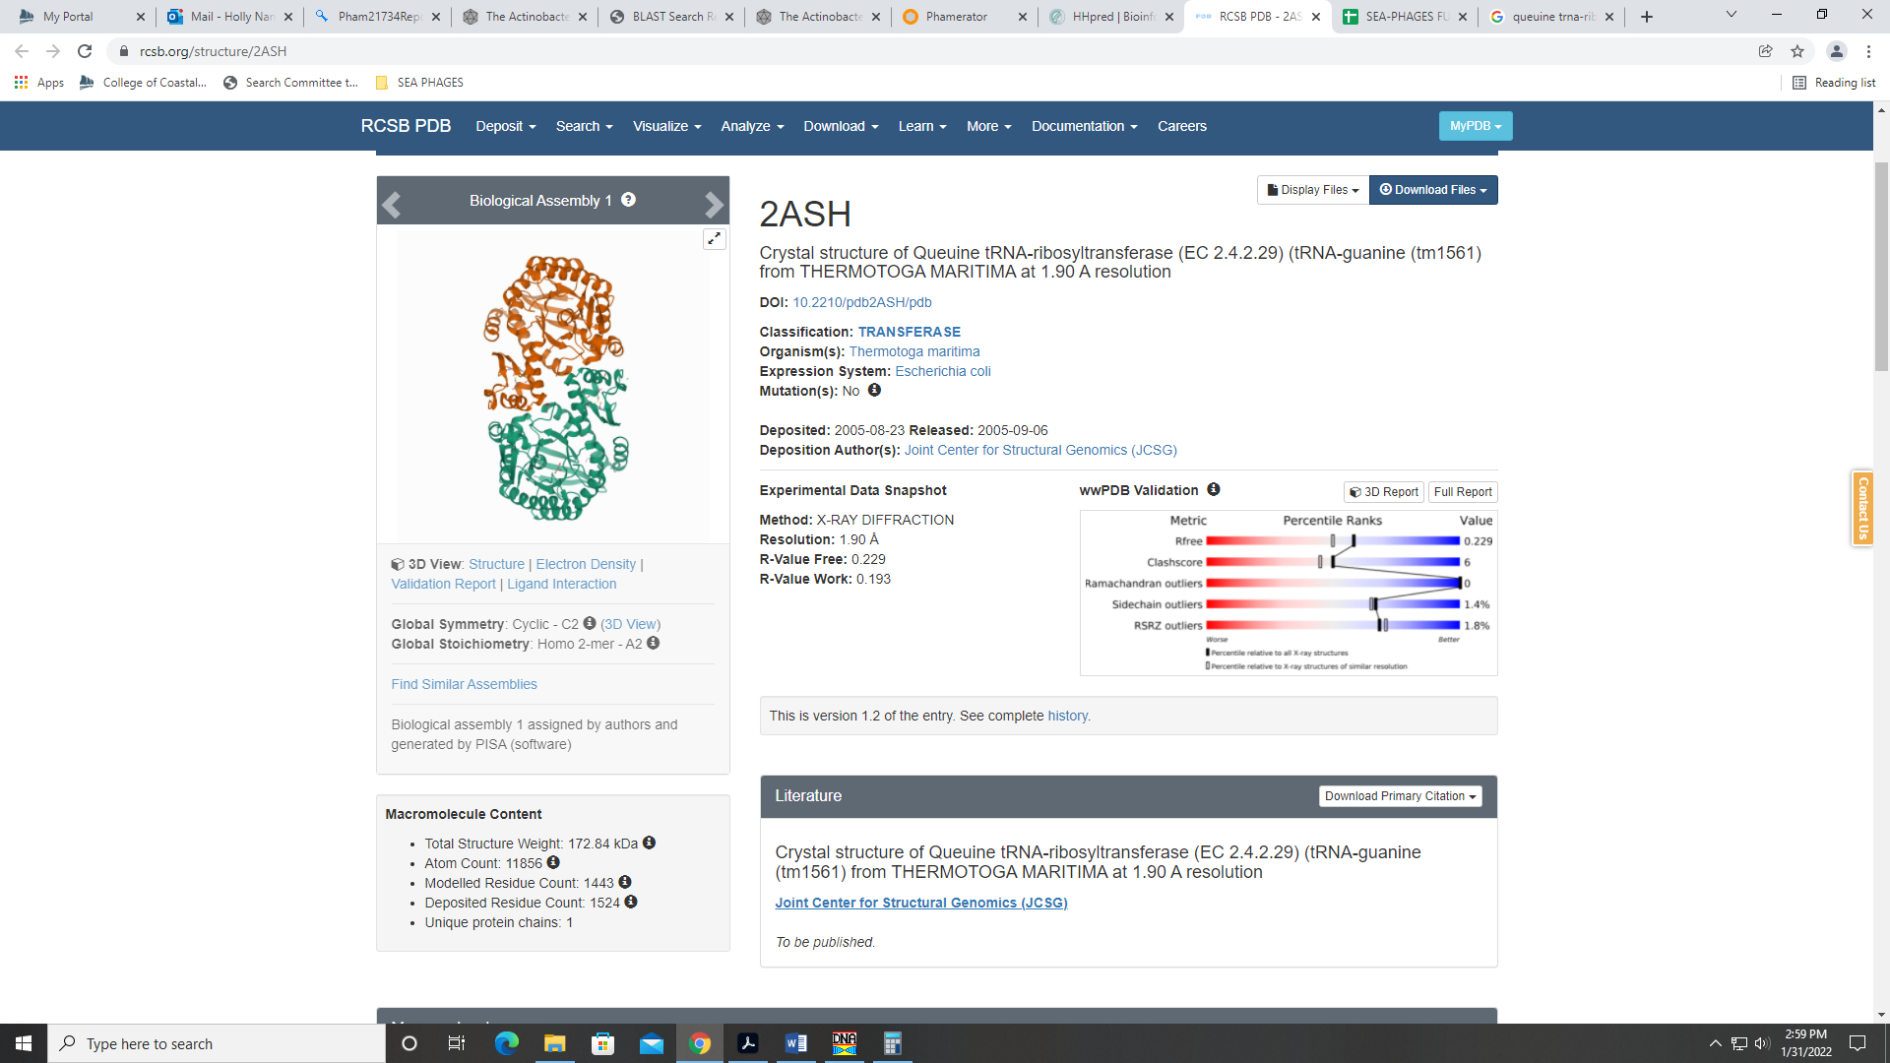
This gene encodes an enzyme:
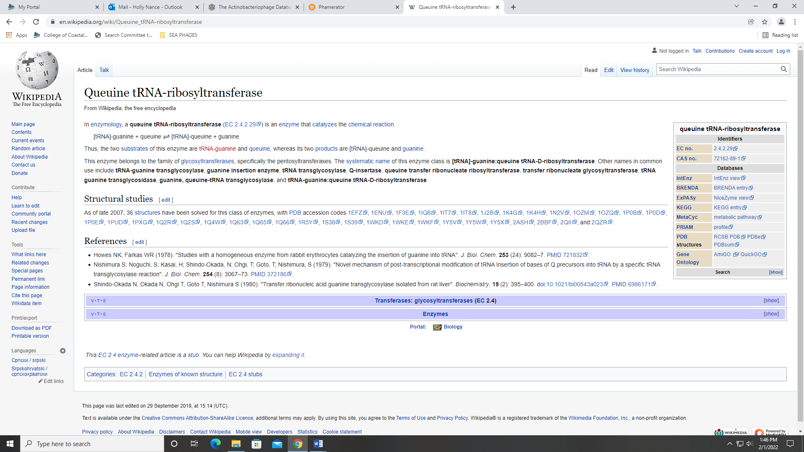
Gene 21 – reverse gene
SSC: start 16555, stop 16412; CP: yes; SCS: Original Glimmer call @bp 16555 has strength 13.31; GeneMark calls start at 16699; ST: SS, start 7; Blast Start: matches Zonia_21 Query 1 to Subject 41 100% 1e⁻¹⁹; Gap: 12; LO: no; RBS: -6.115, 0.995, 10, -6.809, no; F: NKF; SIF-BLAST: NKF/PhageDB BLAST/ Zonia_21, KM363597/100%/1e⁻¹⁹; SIF-HHPred: NKF, no matches with a probability above 90%; SIF-Syn: NKF
Notes (from Brandon): all other starts yield huge gaps. Despite lack of 1:1 correspondence, this appears to be the most likely start.

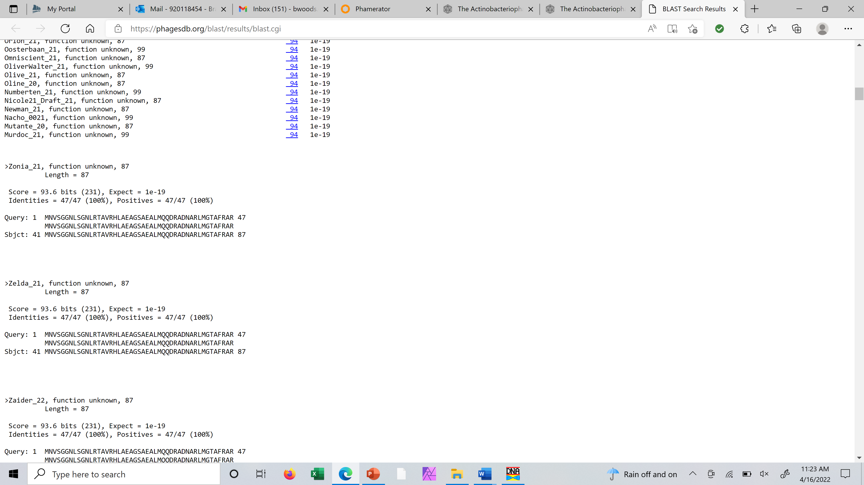

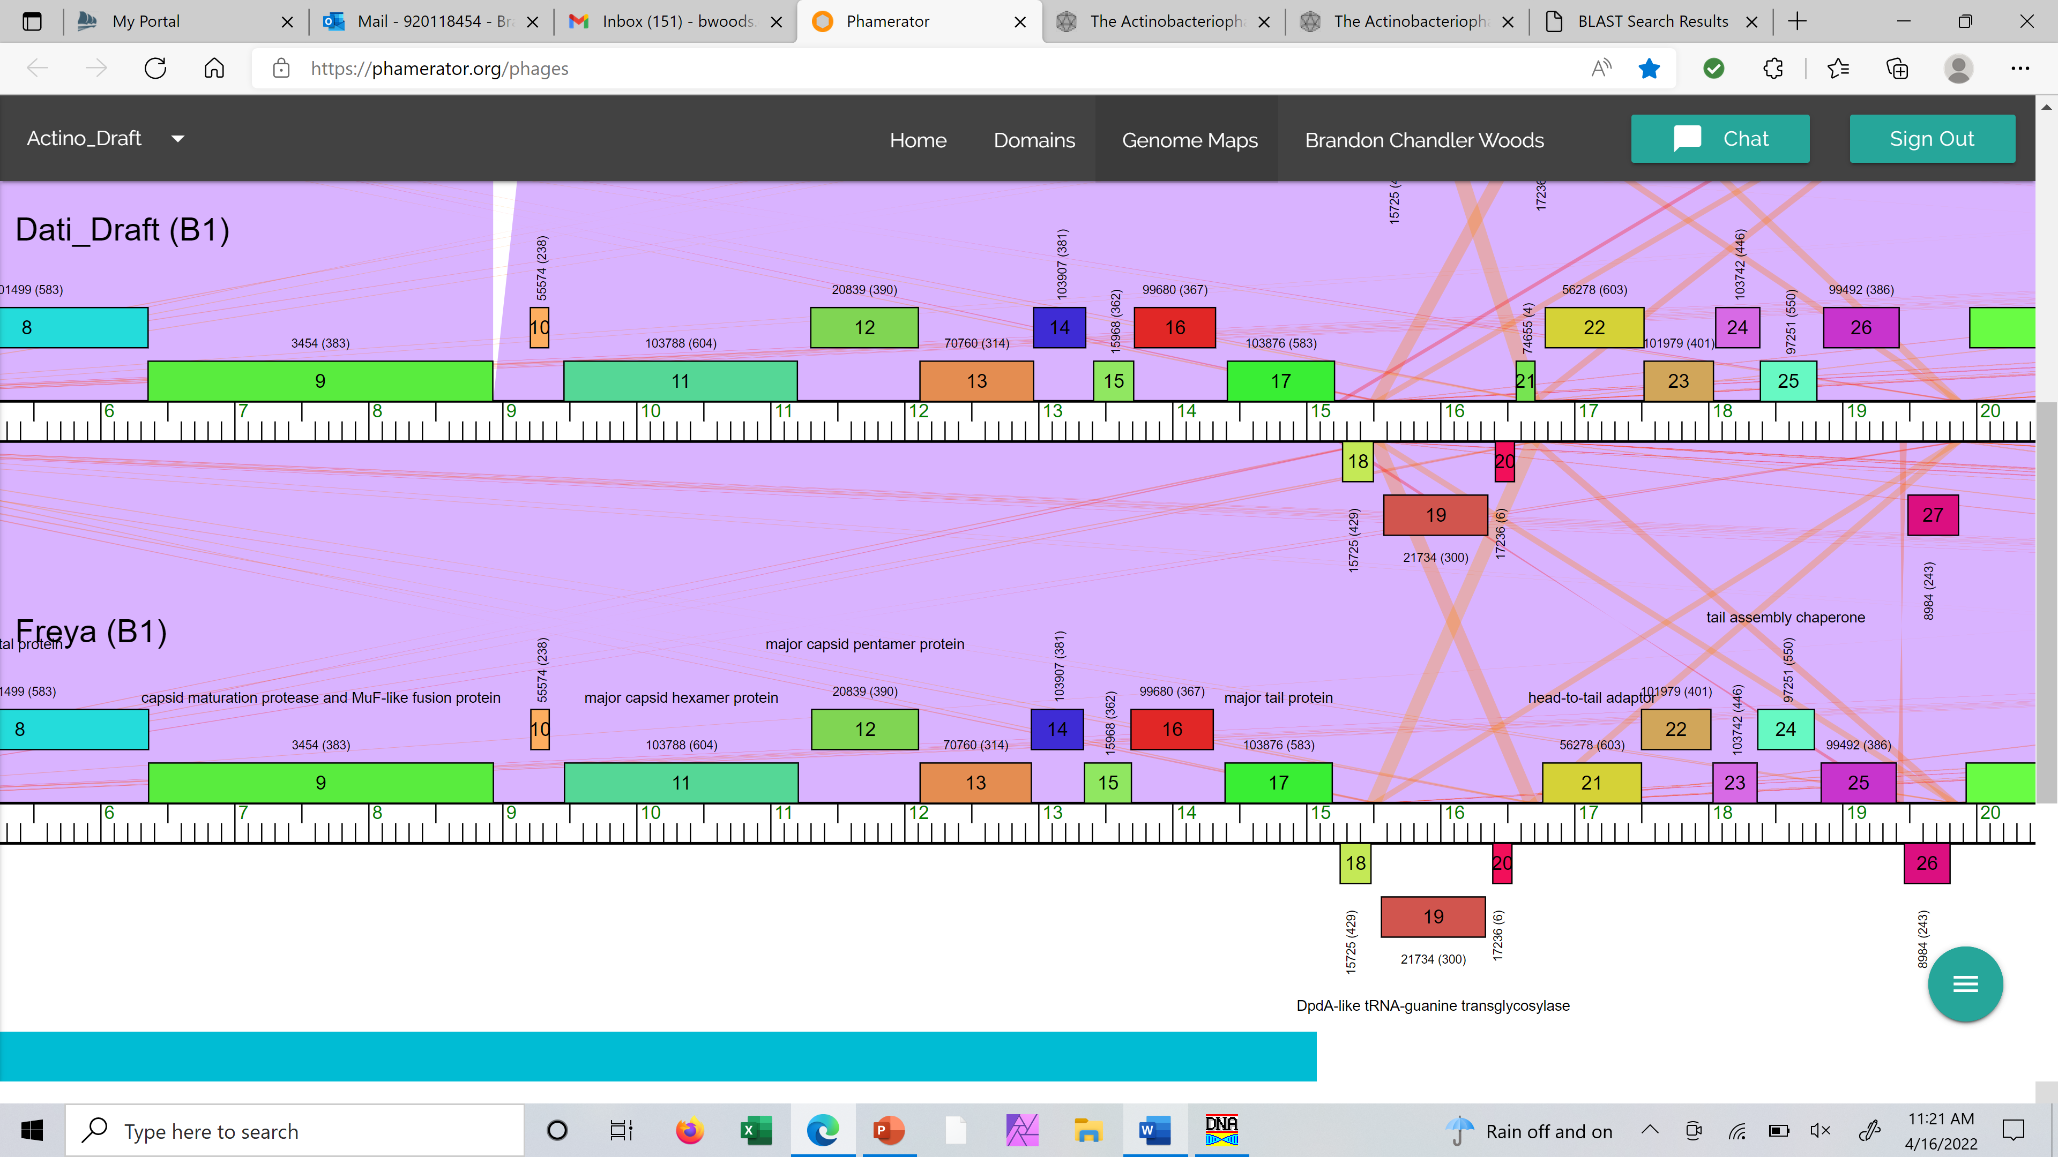

Notes: Not much Starterator data, but other phage in B1 have this gene (it’s just larger in other phage). Hmmm…This would require comparing all possible sequences in BLAST and seeing what may have the most support. Function is NKF, but start could use a lot of work.

Gene 22
SSC: start 16785, stop 17522; CP: yes; SCS: Both called start at 16785; ST: SS; Blast Start: matches Zonia_22 Query 1 to Subject 1 100% 1e⁻¹⁴⁶; Gap: 229; LO: no; RBS: -4.333, 1.884, 14, -5.680, no; F: head-to-tail adaptor; SIF-BLAST: head-to-tail adaptor /PhageDB BLAST/Zonia_22, KM363597/100%/1e⁻¹⁴⁶; SIF-HHPred: head-tail connector, match with a probability of 95.22%, and includes alignment to crystalline structure HKY97 gp6; SIF-Syn: head-to-tail adaptor
Notes: There is much support for this start, but before I can report on the gap, we need to figure out the start for gene 20. I don’t think gene 21 is a legit gene, and the start of gene 20 needs work. There will be a large gap, but this gap seems to be conserved in other B1 phage based on Phamerator data.
For function, BLAST hits and synteny support head-to-tail adaptor. The official phage function list says to call this function, the HHPred output must:
have an HHPRED alignment to one of the following crystal structures: SPP1 15 (5A21 chain C or D in the macromolecular complex) OR must have an HHPRED alignment to one of the following crystal structures: HK97 gp6 or or Bacillus protein yqbG
The HHPred hit with this alignment match is the crystalline structure of HKY97 gp6:
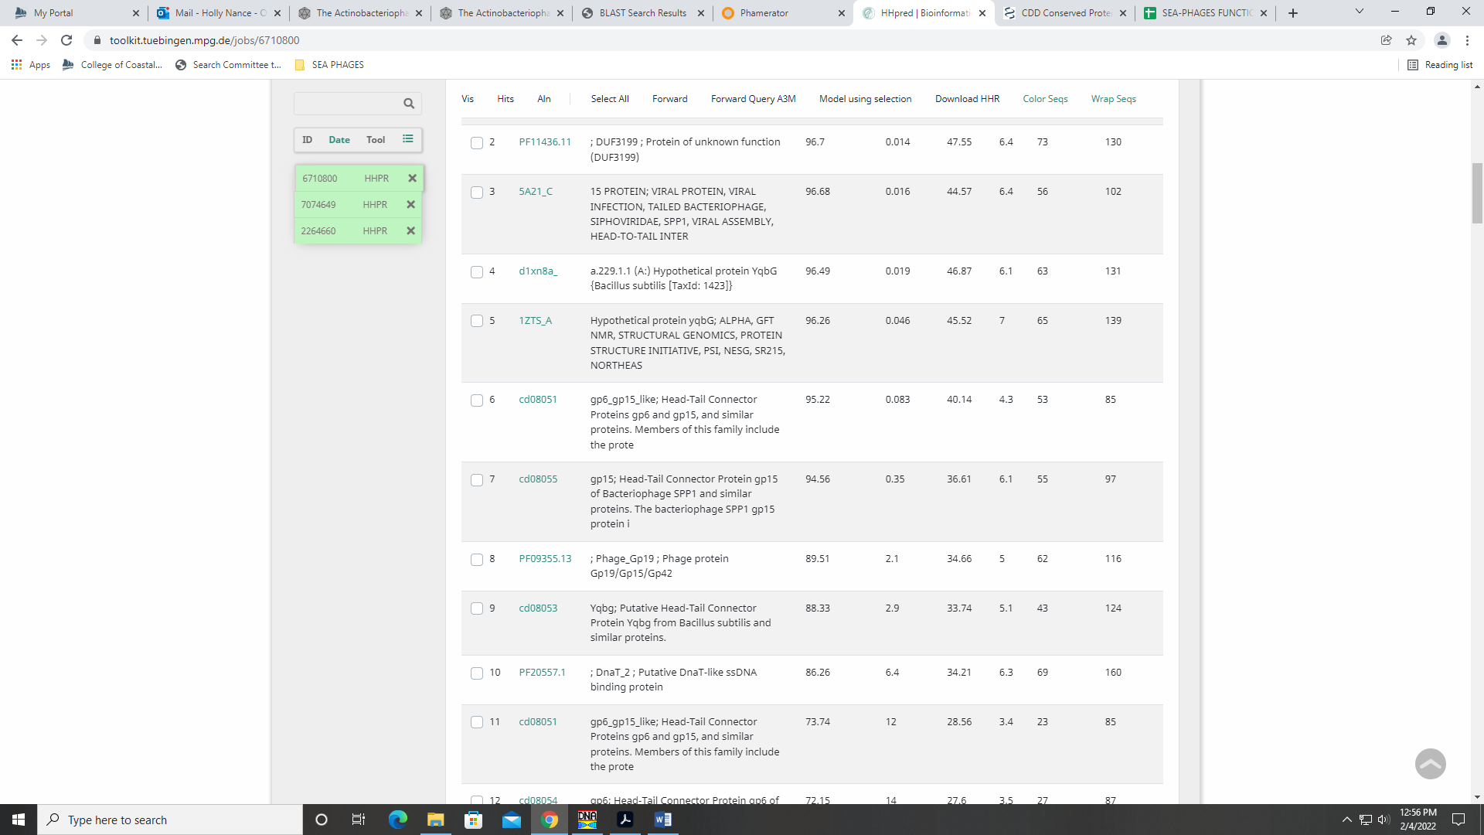

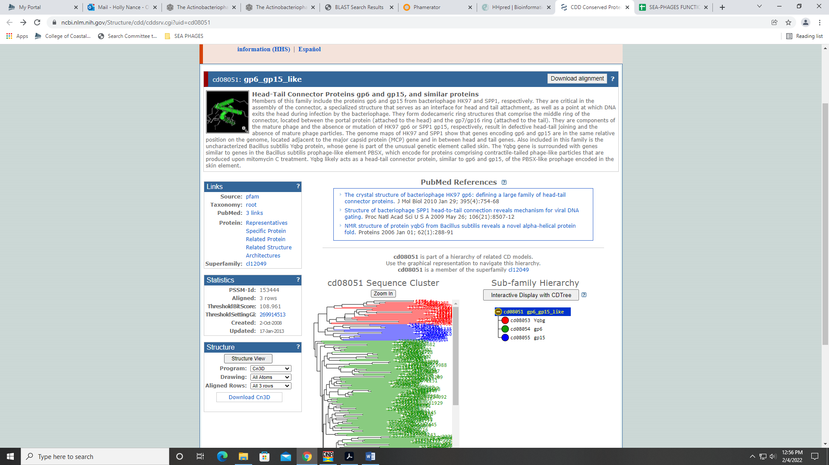
Gene 23
SSC: start 17522, stop 18040; CP: yes; SCS: Both called start at 17522; ST: SS; Blast Start: matches Zonia_23 Query 1 to Subject 1 100% 1e⁻¹⁰¹; Gap: overlap of 1; LO: NA; RBS: -3.808, 2.145, 9, -4.583, no; F: NKF; SIF-BLAST: NKF/PhageDB BLAST/Zonia_23, KM363597/100%/1e⁻¹⁰¹; SIF-HHPred: NKF, no matches with a probability above 90%; SIF-Syn: NKF
Notes: nothing ambiguous about this call!

Gene 24
SSC: start 18057, stop 18386; CP: yes; SCS: Both called start at 18057; ST: SS; Blast Start: matches Zonia_24 Query 1 to Subject 1 100% 1e⁻⁵⁸; Gap: 16; LO: yes; RBS: -3.142, 2.477, 12, -3.978, yes; F: NKF; SIF-BLAST: NKF/PhageDB BLAST/ Zonia_24, KM363597/100%/1e⁻⁵⁸; SIF-HHPred: NKF, a few matches with a probability above 90% with unknown functions; SIF-Syn: NKF
Notes: Start is conserved in the gene and yields the longest ORF.
For function, PhageDB and NCBI BLAST output support NKF. Synteny also supports NKF. The HHPred output yields a few matches with probabilities above 90%, but these matches also have no known function. For example, there is a match to protein in a flu bacterium:
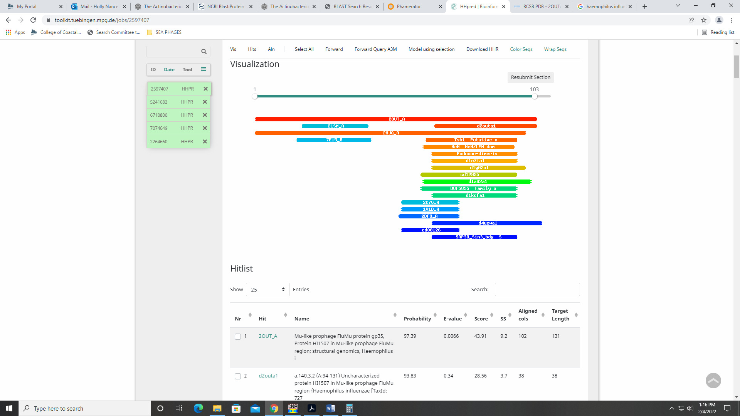
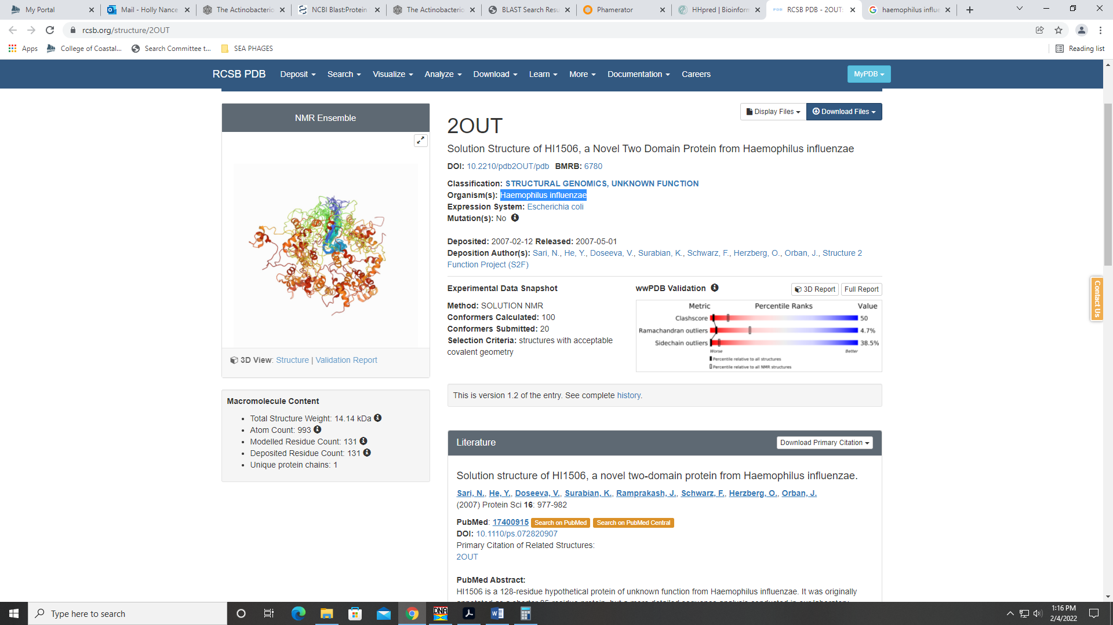

Gene 25
SSC: start 18390, stop 18812; CP: yes; SCS: Both called start at 18390; ST: SS; Blast Start: matches Zonia_25 Query 1 to Subject 1 100% 3e⁻⁷⁸; Gap: 3; LO: NA; RBS: -4.876, 1.613, 11, -5.633, no; F: tail assembly chaperone; SIF-BLAST: tail assembly chaperone /PhageDB BLAST/Zonia_25, KM363597/100%/3e⁻⁷⁸; SIF-HHPred: putative tail-component, match with a probability of 99%; SIF-Syn: tail assembly chaperone
Notes: Good coding potential and strong support for called start. Both PhageDB and NCBI BLAST support function as tail assembly chaperone:
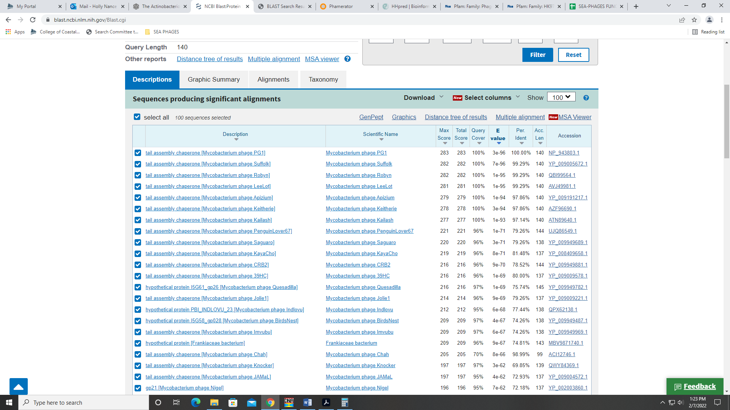
This name is on the official phage function list. HHPred output has only 4 hits with a probability above 90%, and while none are for a tail assembly chaperone, two are for phage tail components
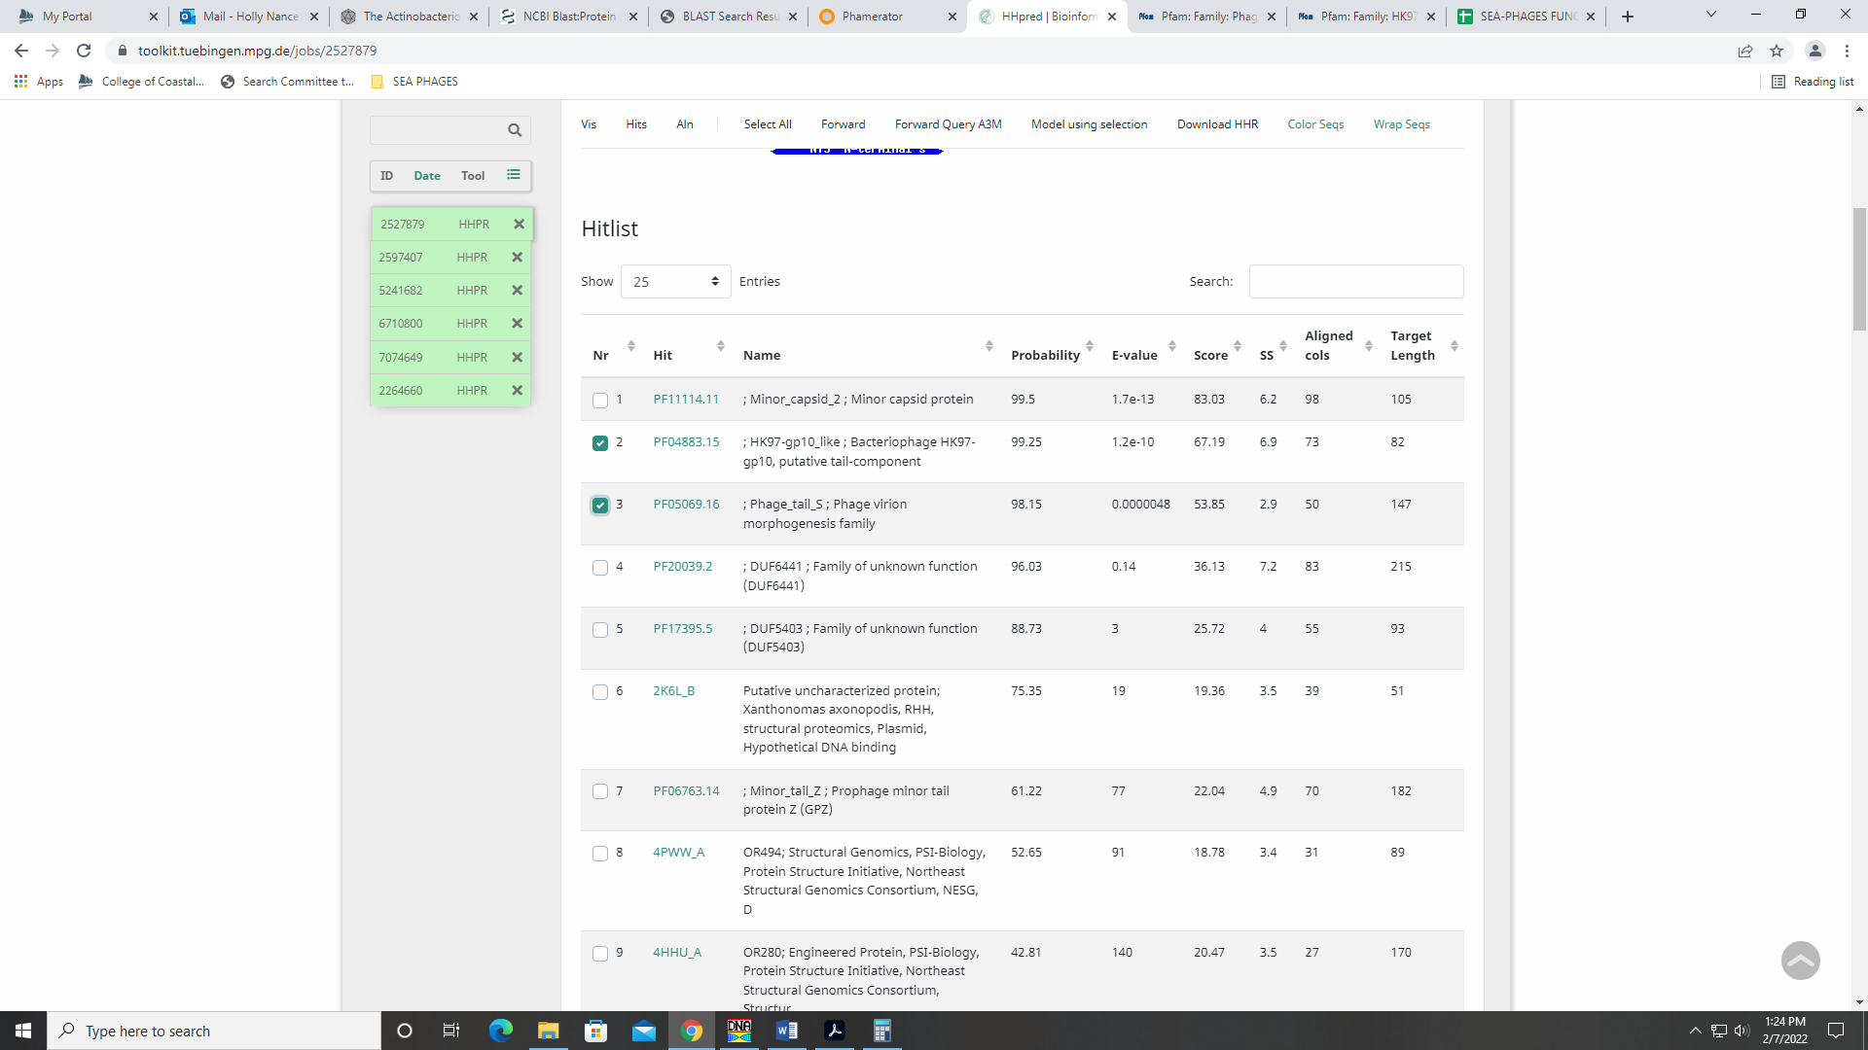
Synteny also supports this function.

Gene 26
SSC: start 18863, stop 19426; CP: yes; SCS: Both called start at 18863; ST: SS; Blast Start: matches YouGoGlencoco_26 Query 1 to Subject 1 100% 1e⁻¹⁰²; Gap: 50; LO: no; RBS: -2.273, 2.910, 11, -3.030, yes; F: NKF; SIF-BLAST: NKF/PhageDB BLAST/ YouGoGlencoco_26, MK279894/100%/1e⁻¹⁰²; SIF-HHPred: NKF, no matches with a probability above 90% for the entire sequence; SIF-Syn: NKF
Notes: Coding potential and start are supported by multiple lines of data.
For function, both NCBI and Phage DB BLAST support NKF:
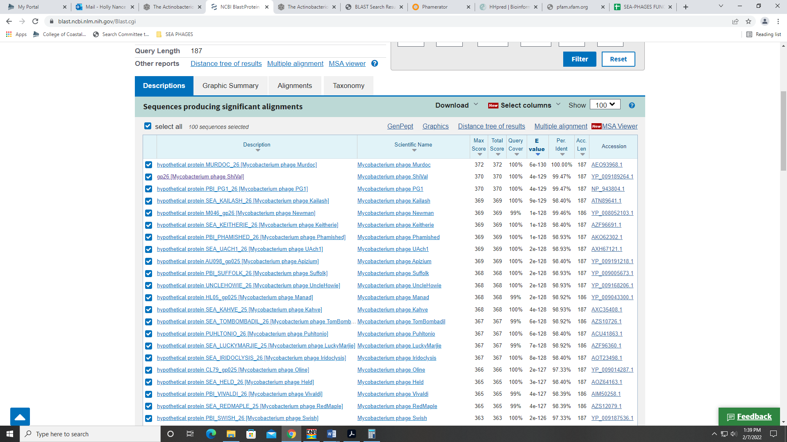
In HHPred, there are three hits with a probability above 90%, but only for a partial sequence (the hits are for 78 of 187 amino acids. These hits are for tail assembly chaperone or phage tail tube protein:
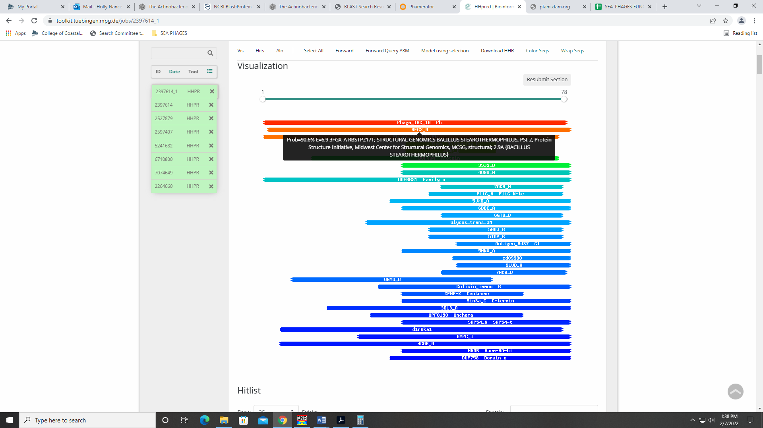
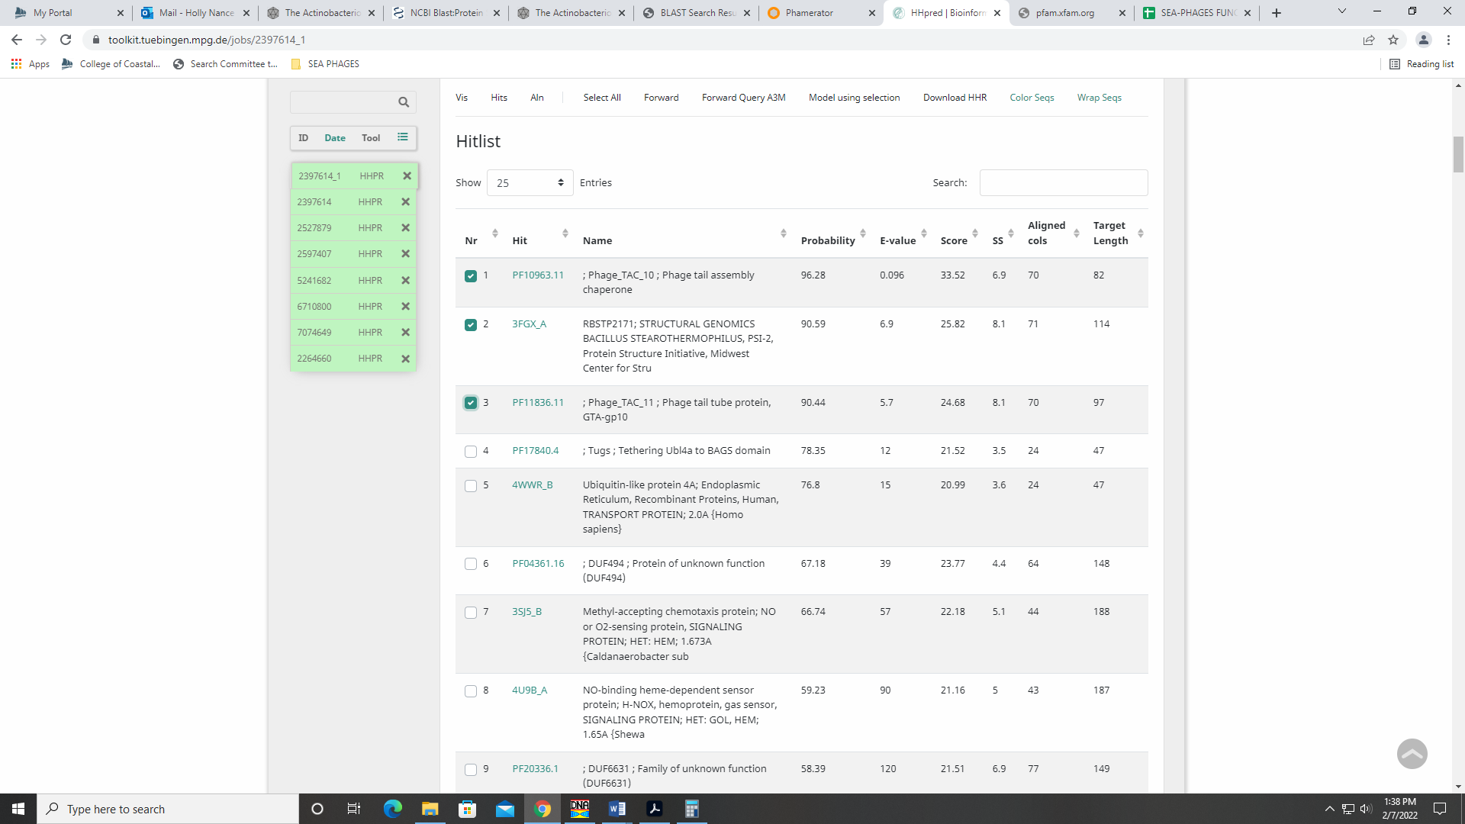
Given these are just partial hits and all other data support NKF, I’m going with that.
Gene 27 reverse gene – changed start to 19833 on 2.21
SSC: start 19833, stop 19492; CP: yes; SCS: Glimmer called start at 19869, GeneMark called start at 19833 that is most annotated in Starterator; ST: SS; Blast Start: matches Zelda_27 Query 1 to Subject 1 100% 4e⁻⁶³; Gap: 120; LO: no; RBS: -2.273, 2.910, 11, -3.030, yes; F: NKF; SIF-BLAST: NKF/PhageDB BLAST/ Zelda_27, MK112555/100%/4e⁻⁶³; SIF-HHPred: NKF, no matches with a probability above 90%; SIF-Syn: NKF
Notes: Students convinced me to change start to GeneMark call which is more conserved in Starterator data and still yields 1:1 hits in BLAST. It’s also the longer ORF. Changed start in class on 2.21!

Gene 28
SSC: start 19953, stop 25931; CP: yes; SCS: Both called start at 19953; ST: SS; Blast Start: matches Weher20_28 Query 1 to Subject 1 100% 0.0; Gap: 120; LO: yes; RBS: -6.214, 0.946, 14, -7.561, no; F: tape measure protein; SIF-BLAST: tape measure protein /PhageDB BLAST/ Weher20_28, MZ681520/100%/0.0; SIF-HHPred: tape measure protein, four matches with a probability above 90% for partial segments; SIF-Syn: tape measure protein
Notes: nothing ambiguous here, but the HHPred hits were only for partial segments:
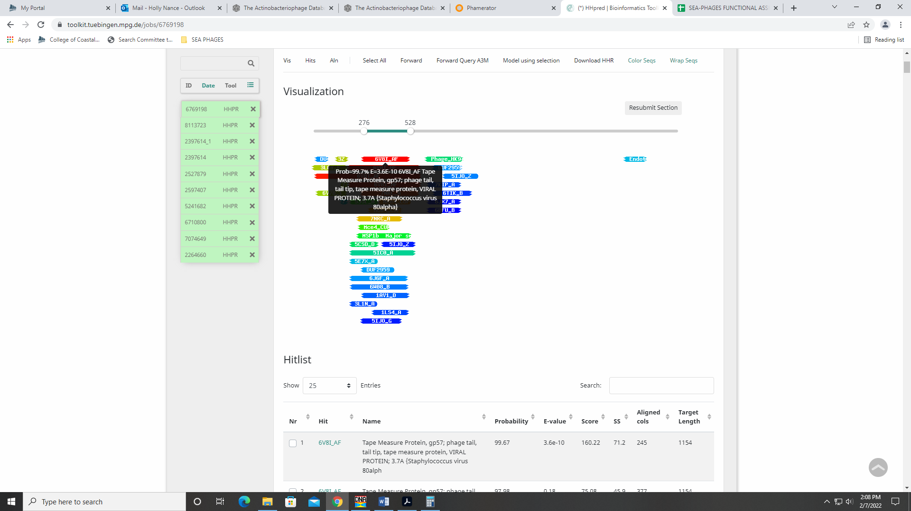
However, all other data suggest tape measure protein and this is by far the longest gene in the genome.
Gene 29
SSC: start 25941, stop 27374; CP: yes; SCS: Both called start at 25941; ST: SS; Blast Start: matches Inchworm_29 Query 1 to Subject 1 100% 0.0; Gap: 9; LO: NA; RBS: -3.119, 2.489, 10, -3.814, no; F: minor tail protein; SIF-BLAST: minor tail protein /PhageDB BLAST/Inchworm_29, MT889369/100%/0.0; SIF-HHPred: distal tail protein, two matches with a probability above 90%; SIF-Syn: minor tail protein
Notes: Start is conserved and yields longest ORF. Both PhageDB and NCBI BLAST support function as minor tail protein:
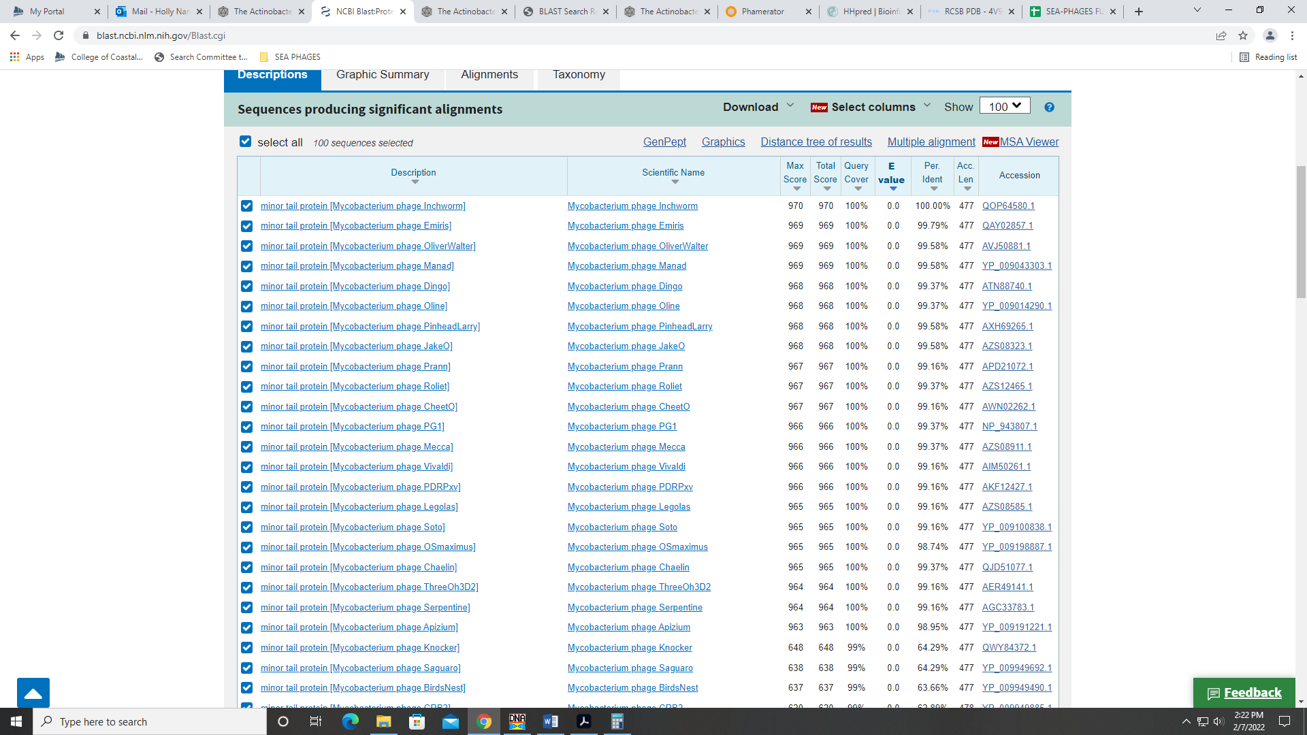
Synteny also supports among other phage in B1. HHPred had two hits for distal tail proteins:
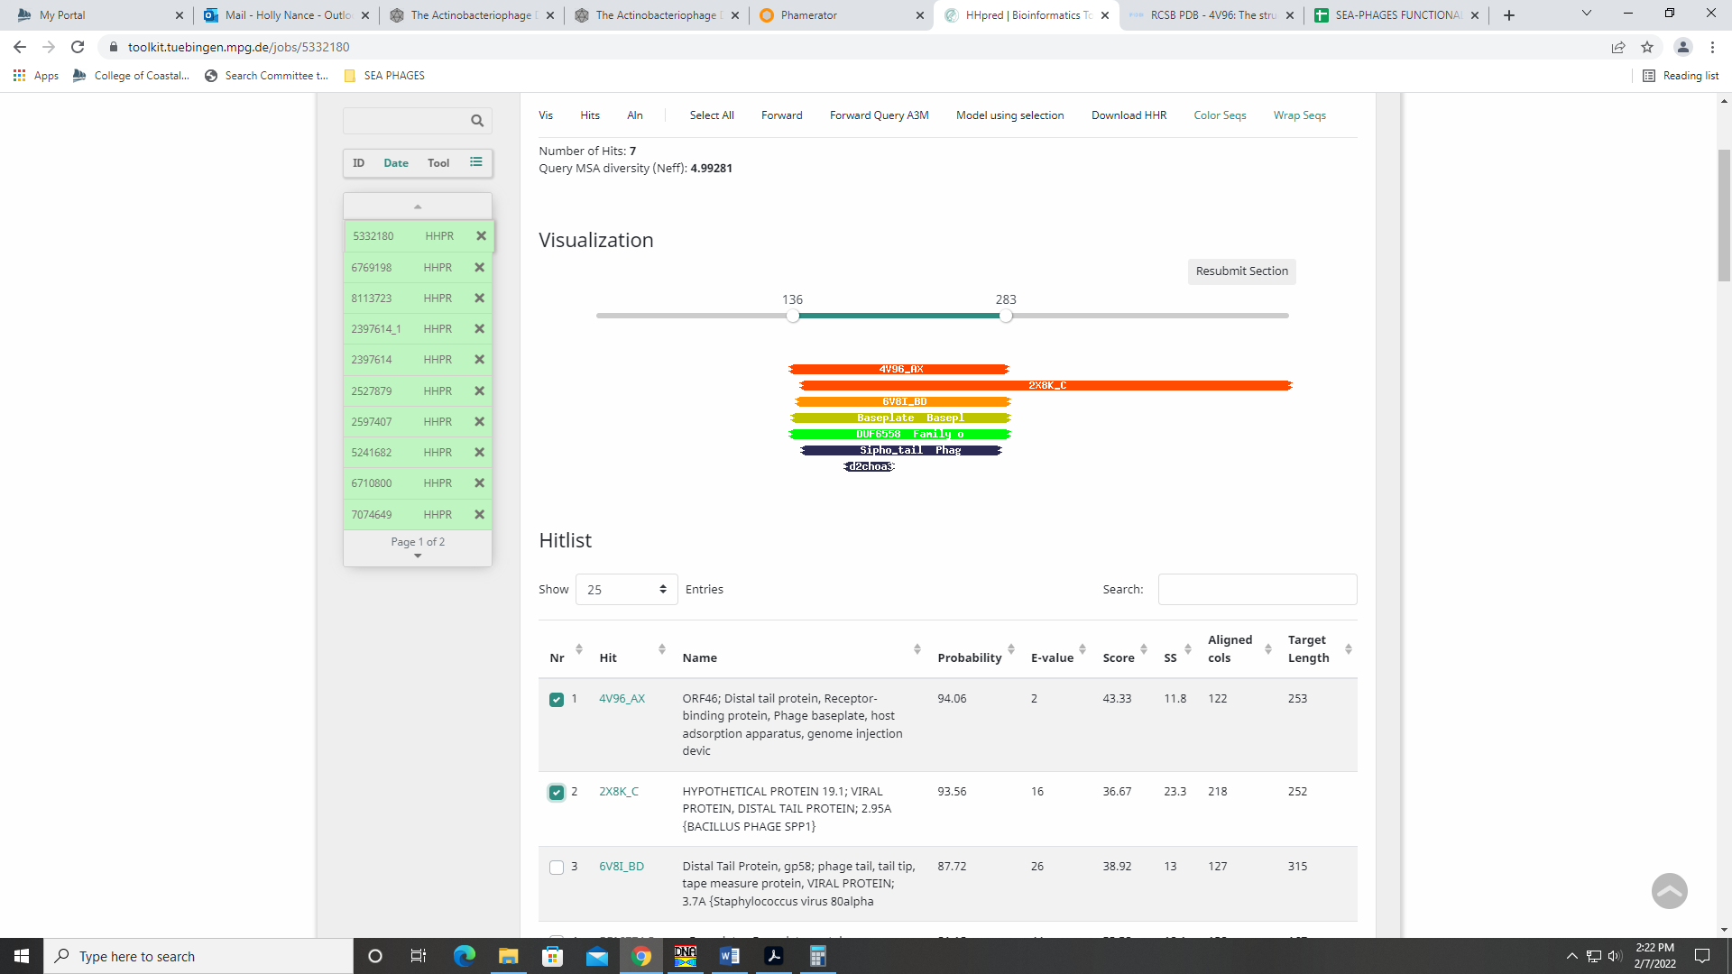
Given the other strong support for minor tail protein, I’m going with that.

Gene 30
SSC: start 27371, stop 28483; CP: yes; SCS: Both called start at 27371; ST: SS; Blast Start: matches Zelda_30 Query 1 to Subject 1 100% 0.0; Gap: overlap of 4; LO: NA; RBS: -3.531, 2.283, 12, -4.367, yes; F: minor tail protein; SIF-BLAST: minor tail protein /PhageDB BLAST/Zelda_30, MK112555/100%/0.0; SIF-HHPred: tail protein, several matches with a probability above 90% for tail protein; SIF-Syn: minor tail protein
Notes: Both PhageDB and NCBI BLAST support minor tail protein as the function, although not all hits call this (a few call it NKF):
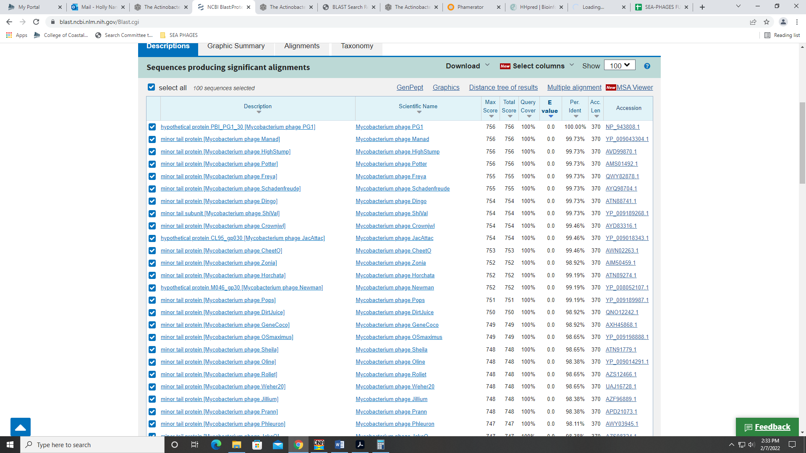
Phamerator synteny supports this function, as there can be several minor tail proteins after the tape measure protein. Finally, HHPred output yields several matches for a phage tail protein, though none call it exactly minor tail protein:
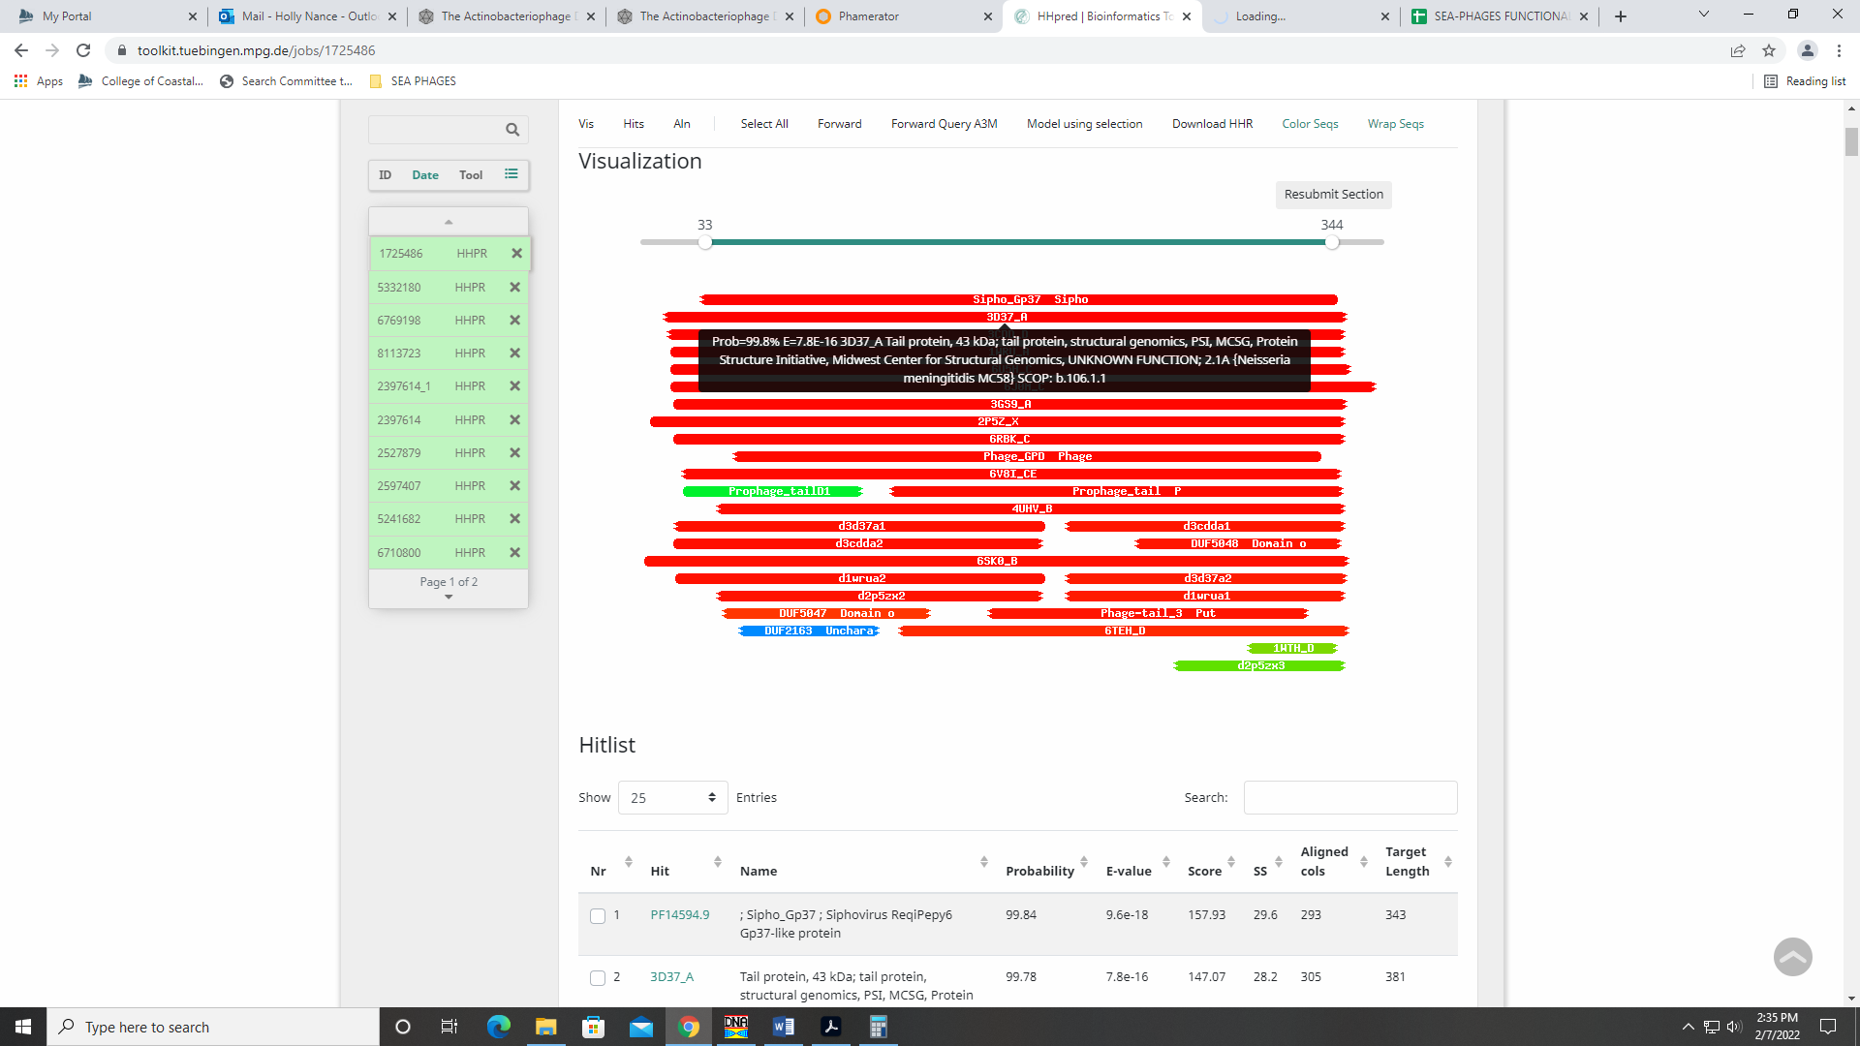
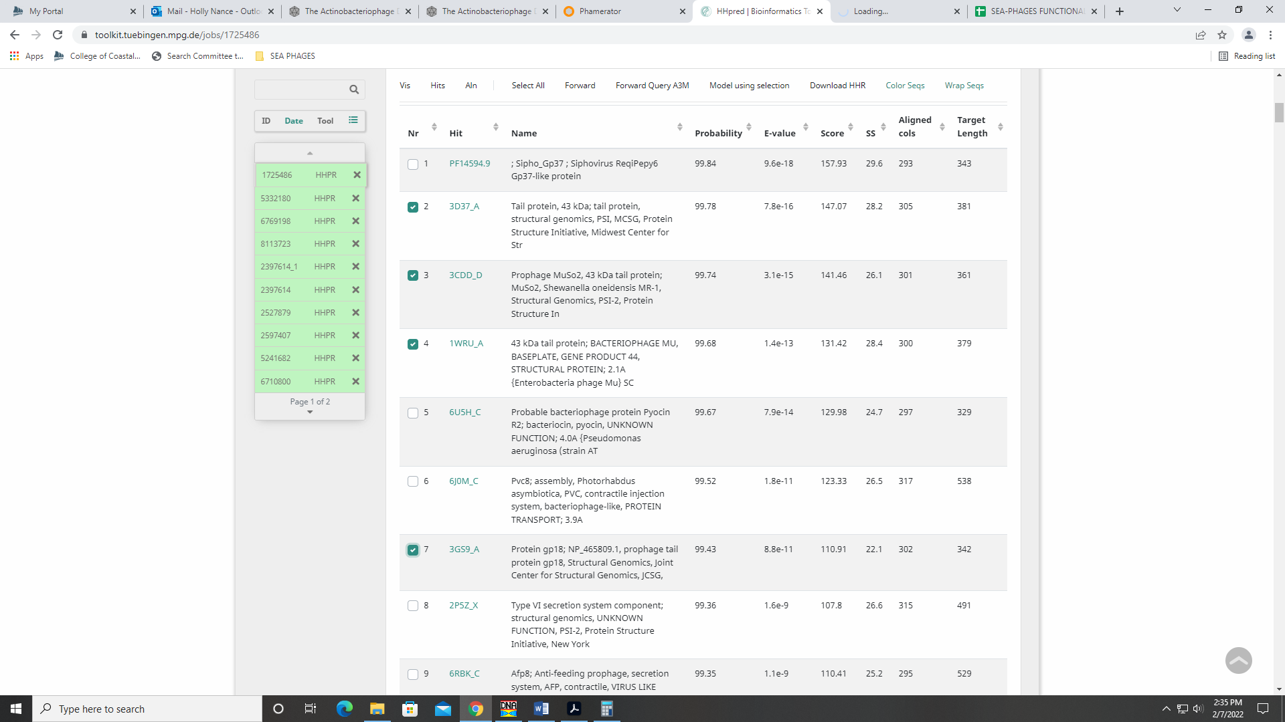
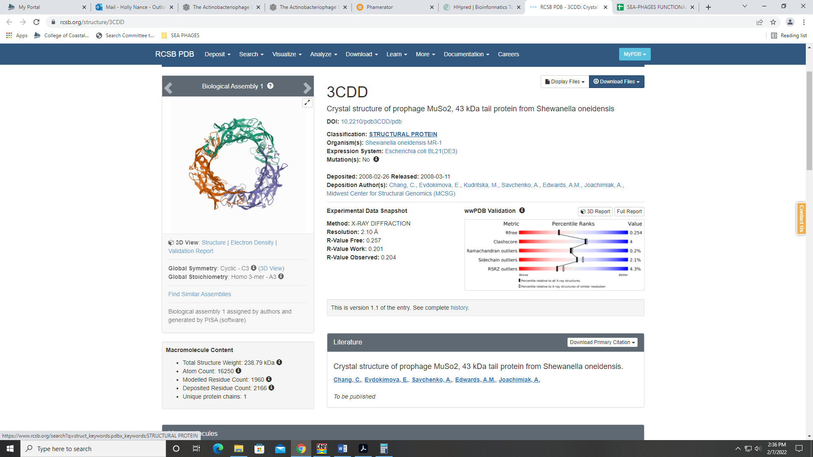

Gene 31
SSC: start 28480, stop 30735; CP: yes; SCS: Both called start at 130; ST: SS; Blast Start: matches YouGoGlencoco_31 Query 1 to Subject 1 100% 0.0; Gap: overlap of 4; LO: NA; RBS: -3.985, 2.057, 11, -4.742, yes; F: minor tail protein; SIF-BLAST: minor tail protein /PhageDB BLAST/Zaider_32, MK279895/99%/0.0; SIF-HHPred: Tail spike protein, several matches with a probability above 90% but only one that calls this function with probability of 98%. Most are for other various domains or NKF; SIF-Syn: minor tail protein
Notes: Start unambiguous and yields longest ORF. For function, both PhageDB and NCBI BLAST output support minor tail protein:
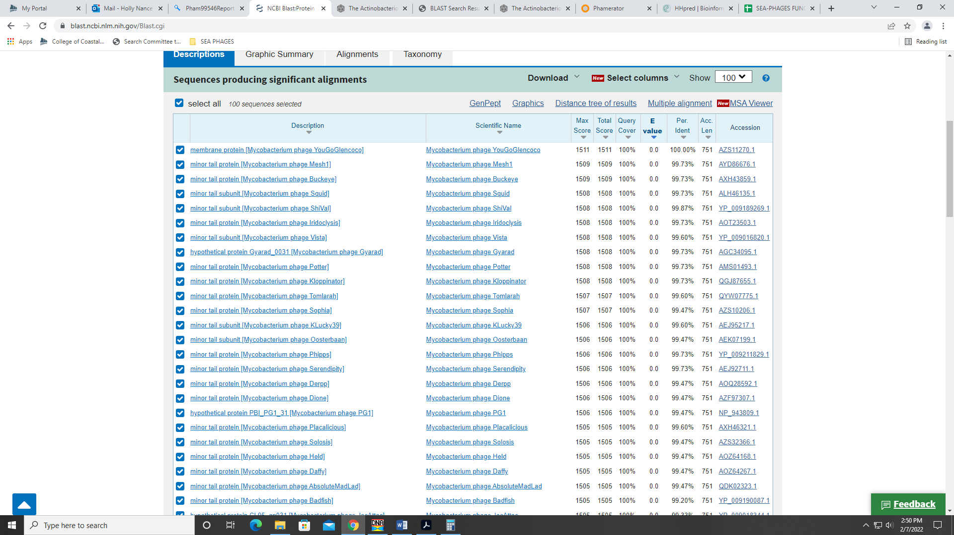
Like with the last gene, not all hits call it minor tail protein, but the majority do.
HHPred data had many hits above 90%, but the functions are varied.
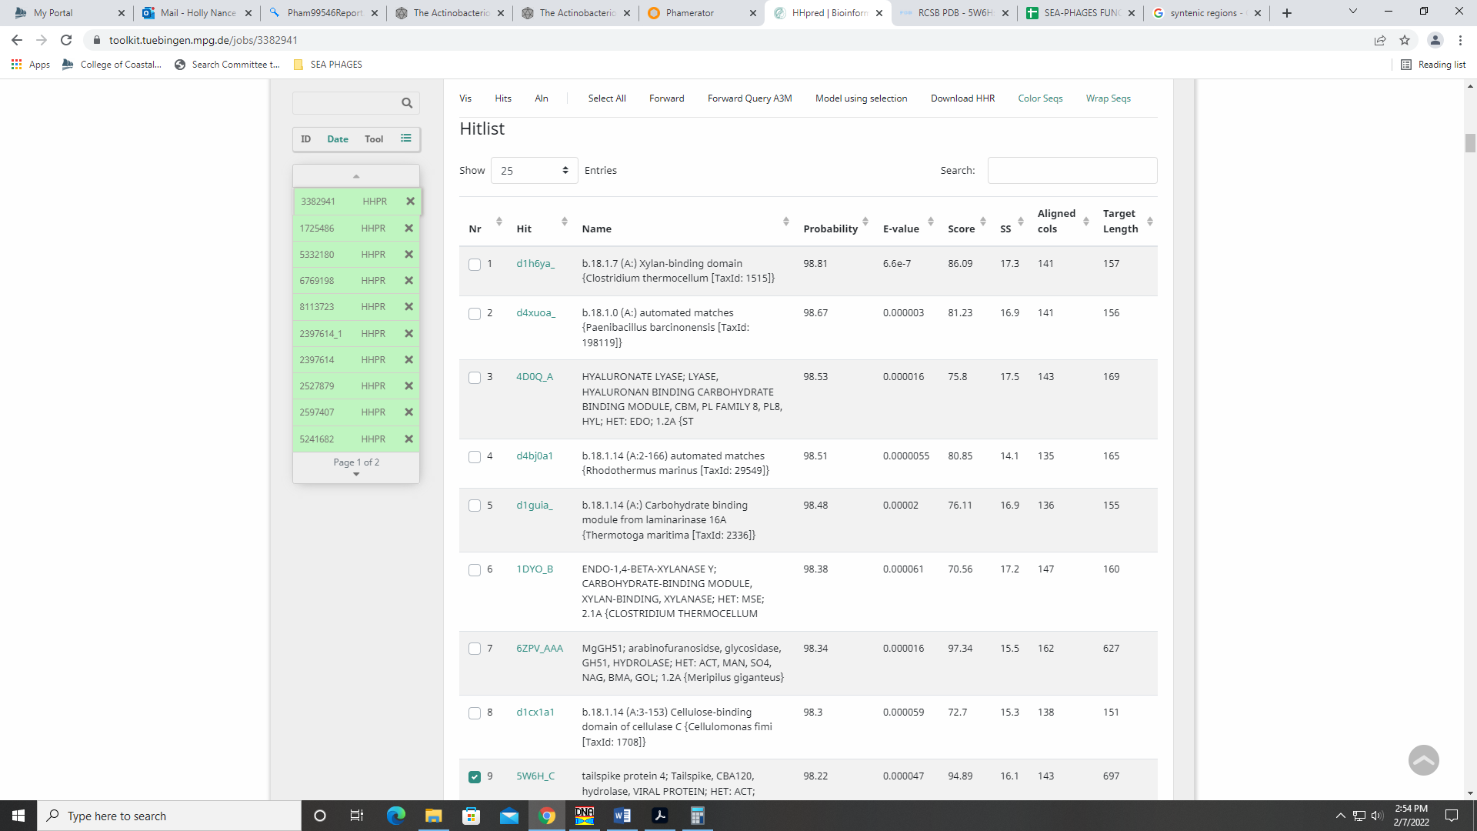
There was one hit with probability of 98% for a tail spike protein:
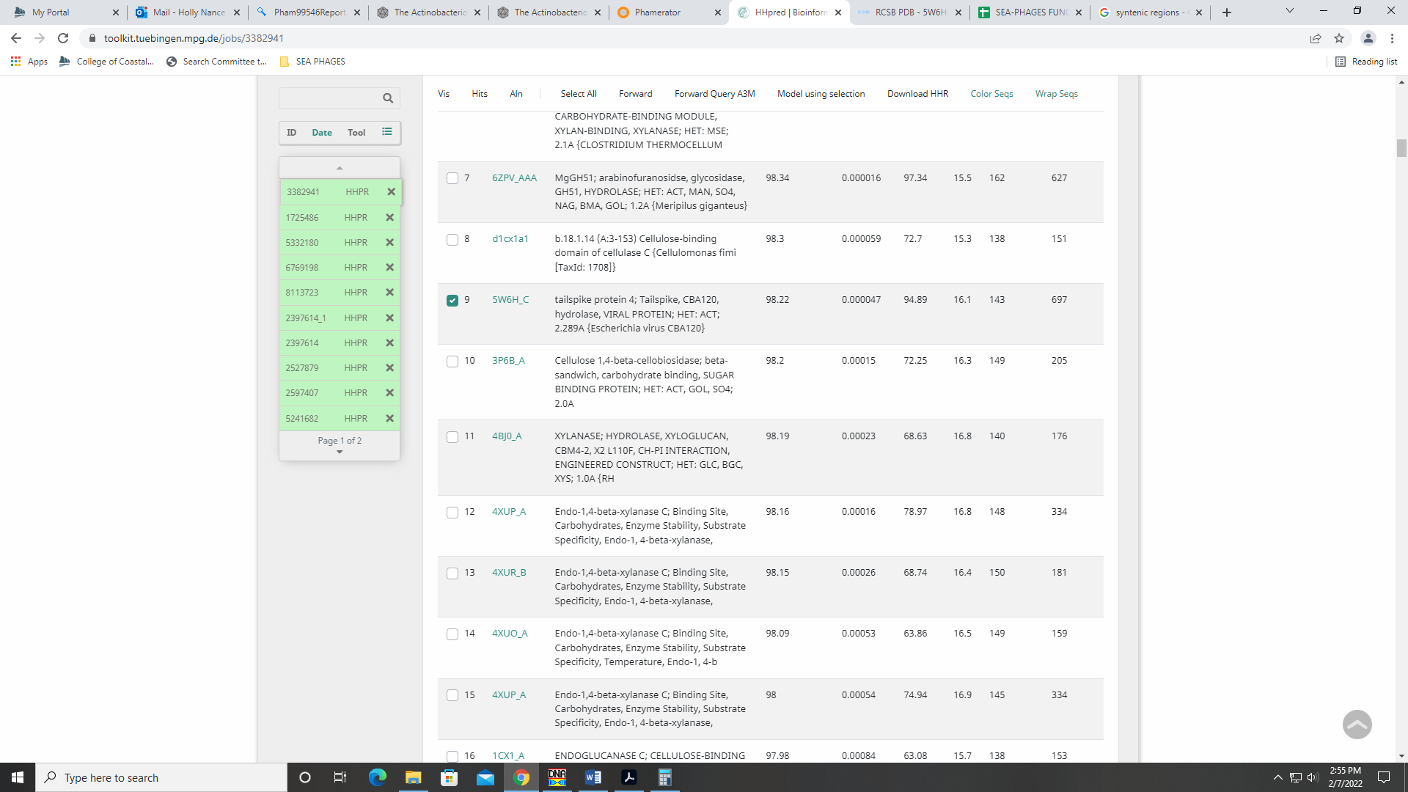
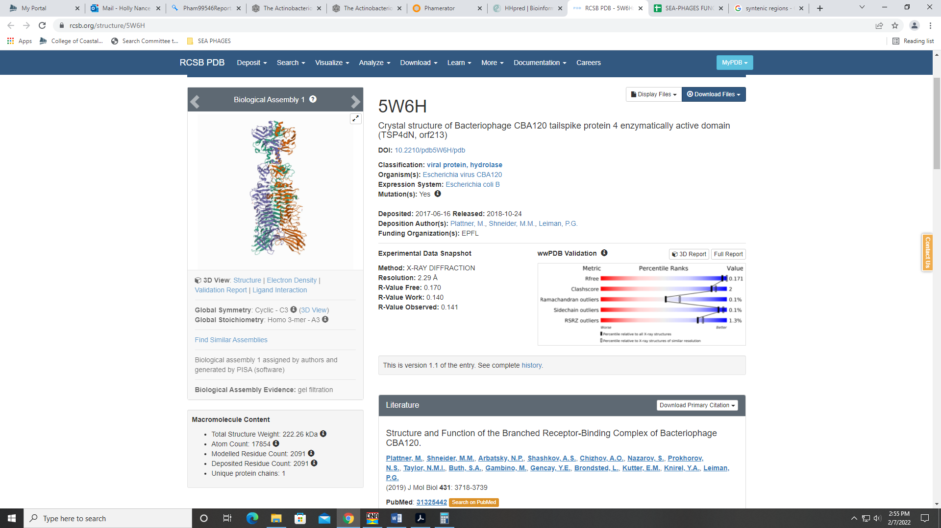
Given the majority of evidence suggests minor tail protein (including synteny), I’m going with that.
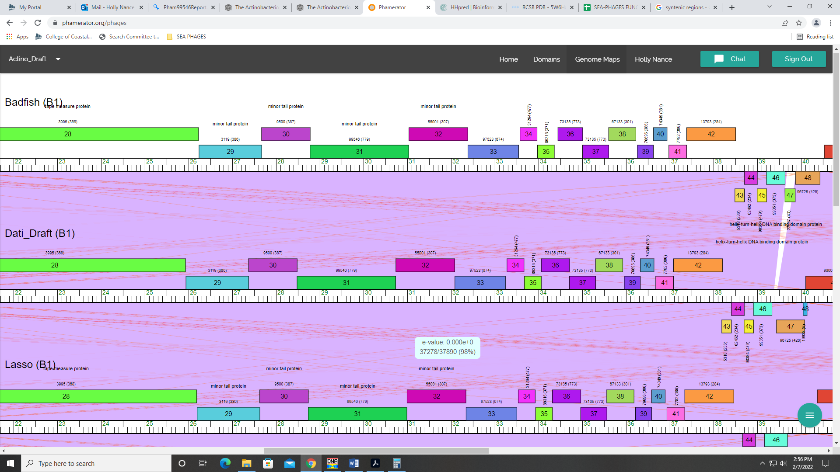

Gene 32
SSC: start 30739, stop 32085; CP: yes; SCS: Both called start at 30739; ST: SS; Blast Start: matches Zaider_33 Query 1 to Subject 1 100% 0.0; Gap: 3; LO: NA; RBS: -2.934, 2.581, 10, -3.628, yes; F: minor tail protein; SIF-BLAST: minor tail protein/PhageDB BLAST/Zaider_33, MK279895/100%/0.0; SIF-HHPred: NKF, no matches with a probability above 90%; SIF-Syn: minor tail protein
Notes: Start highly conserved across other genes in phamily. No probable hits on HHPred, but minor tail protein is supported by synteny, PhageDB BLAST and NCBI BLAST:
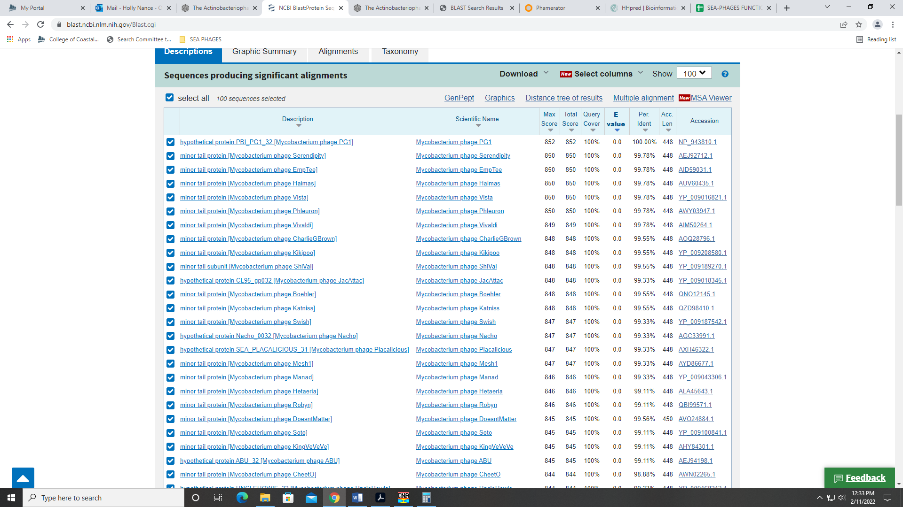

Gene 33
SSC: start 32088, stop 33248; CP: yes; SCS: Both called start at 32088; ST: SS; Blast Start: matches Weher20_33 Query 1 to Subject 1 100% 0.0; Gap: 2; LO: NA; RBS: -2.976, 2.560, 9, -3.751, yes; F: minor tail protein; SIF-BLAST: minor tail protein/PhageDB BLAST/ Weher20_33, MZ681520/100%/0.0; SIF-HHPred: NKF, no matches with a probability above 90%; SIF-Syn: minor tail protein
Notes: Nothing ambiguous. No matches in HHPred, but again, support for minor tail protein from synteny, PhageDB BLAST, and NCBI BLAST:
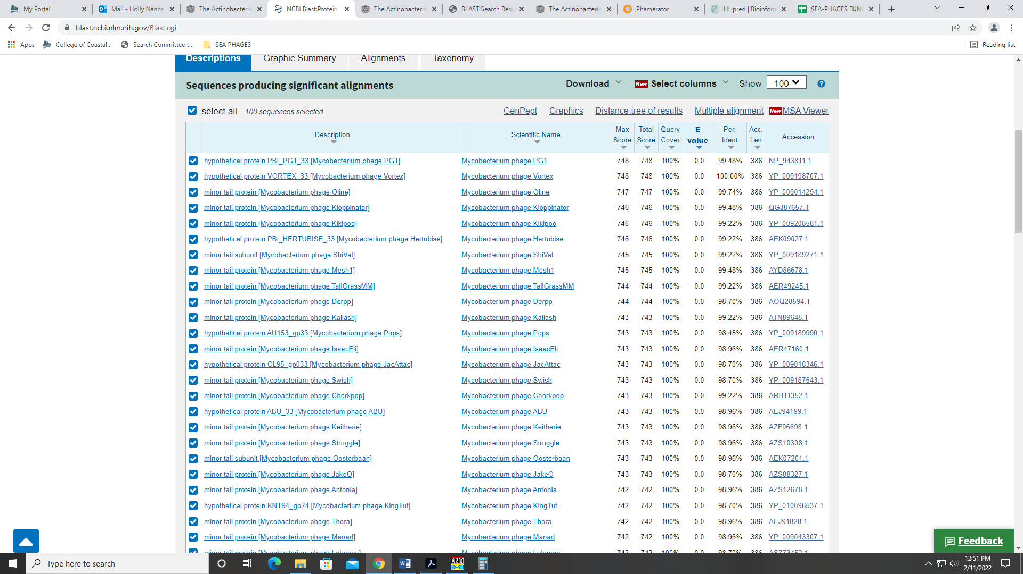
Though some hits call it NKF, there are more that call it minor tail protein.

Gene 34
SSC: start 33279, stop 33668; CP: yes; SCS: Both called start at 33279; ST: SS; Blast Start: matches Zonia_34 Query 1 to Subject 1 100% 8e⁻⁷⁰; Gap: 30; LO: yes; RBS: -4.918, 1.592, 15, -6.520, no; F: NKF; SIF-BLAST: NKF/PhageDB BLAST/ Zonia_34, KM363597/100%/8e⁻⁷⁰; SIF-HHPred: NKF, no matches with a probability above 90%; SIF-Syn: NKF
Notes: nothing ambiguous here!

Gene 35
SSC: start33677, stop 34063; CP: yes; SCS: GeneMark called start at 33716, went with more conserved Glimmer start of 33677; ST: SS; Blast Start: matches Zonia_35 Query 1 to Subject 1 100% 7e⁻⁷²; Gap: 8; LO: NA; RBS: -2.302, 2.896, 8, -3.524, yes; F: NKF; SIF-BLAST: NKF/PhageDB BLAST/ Zonia_35, KM363597/100%/7e⁻⁷²; SIF-HHPred: NKF, no matches with a probability above 90%; SIF-Syn: NKF
Notes: nothing ambiguous!

Gene 36
SSC: start 34063, stop 34710; CP: yes; SCS: Both called start at 34063; ST: SS; Blast Start: matches Zonia_36 Query 1 to Subject 1 100% 1e⁻¹²⁷; Gap: overlap of 1; LO: NA; RBS: -4.234, 1.933, 9, -5.009, no; F: NKF; SIF-BLAST: NKF/PhageDB BLAST/ Zonia_36, KM363597/100%/1e⁻¹²⁷; SIF-HHPred: NKF, no matches with a probability above 90%; SIF-Syn: NKF
Notes: Nothing ambiguous except the Starterator output has two genes (Dati_36 and Dati_37) in the same family. There are two genes for other phage in the same phamily and Starterator output. The Phamerator data shows these two genes in tandem and the same color. They must be very similar in sequence. Starterator gives both Dati_36 and Dati_37 start number 71, though these two starts are different BPs for the different genes.
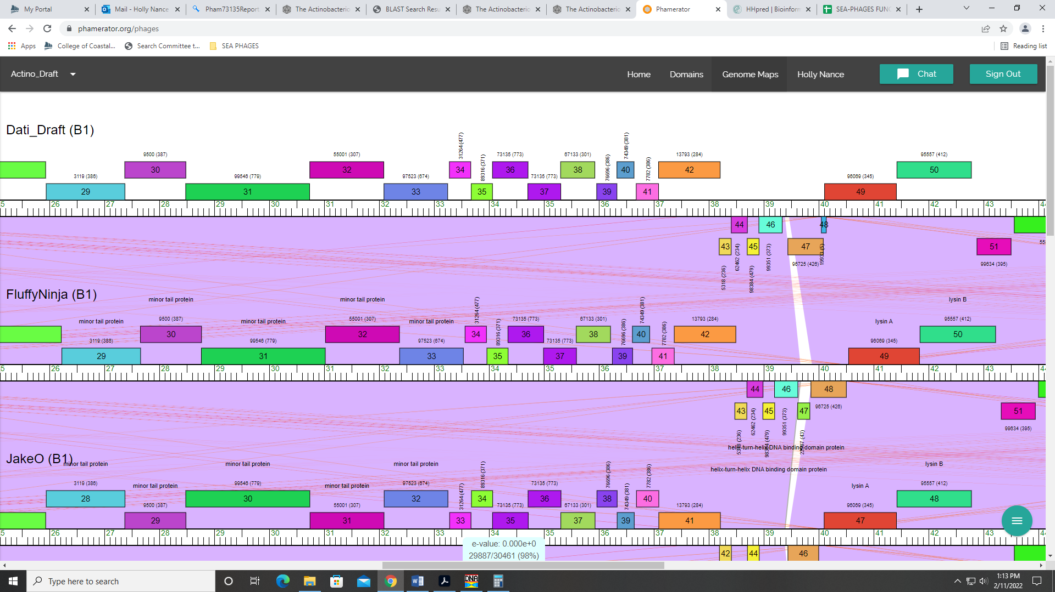

Gene 37
SSC: start 34707, stop 35306; CP: yes; SCS: Both called start at 34707; ST: SS; Blast Start: matches Zonia_37 Query 1 to Subject 1 100% 1e⁻¹¹⁵; Gap: overlap of 4; LO: NA; RBS: -2.654, 2.721, 12, -3.489, yes; F: NKF; SIF-BLAST: NKF/PhageDB BLAST/ Zonia_37, KM363597/100%/1e⁻¹¹⁵; SIF-HHPred: NKF, no matches with a probability above 90%; SIF-Syn: NKF
Notes: nothing ambiguous, but see above regarding Starterator data for Dati_36

Gene 38
SSC: start 35303, stop 35926; CP: yes; SCS: Both called start at 35303; ST: SS; Blast Start: matches Windsor_37 Query 1 to Subject 1 100% 1e⁻¹¹⁹; Gap: overlap of 4; LO: NA; RBS: -3.631, 2.234, 8, -4.853, no; F: NKF; SIF-BLAST: NKF/PhageDB BLAST/ Windsor_37, MT952849/100%/1e⁻¹¹⁹; SIF-HHPred: NKF, no matches with a probability above 90%; SIF-Syn: NKF
Notes: yawn… nothing ambiguous here!

Gene 39
SSC: start 35960, stop 35926; CP: yes; SCS: Both called start at 35960; ST: SS; Blast Start: matches Windsor_38 Query 1 to Subject 1 100% 5e⁻⁶⁶; Gap: 33; LO: no; RBS: -3.535, 2.282, 11, -4.292, no; F: NKF; SIF-BLAST: NKF/PhageDB BLAST/ Windsor_38, MT952849/100%/5e⁻⁶⁶; SIF-HHPred: phage tail assembly chaperone, one matches with a probability above 90%, but high e-value; SIF-Syn: NKF
Notes: nothing ambiguous here except function. Synteny, PhageDB BLAST and NCBI BLAST all support NKF:
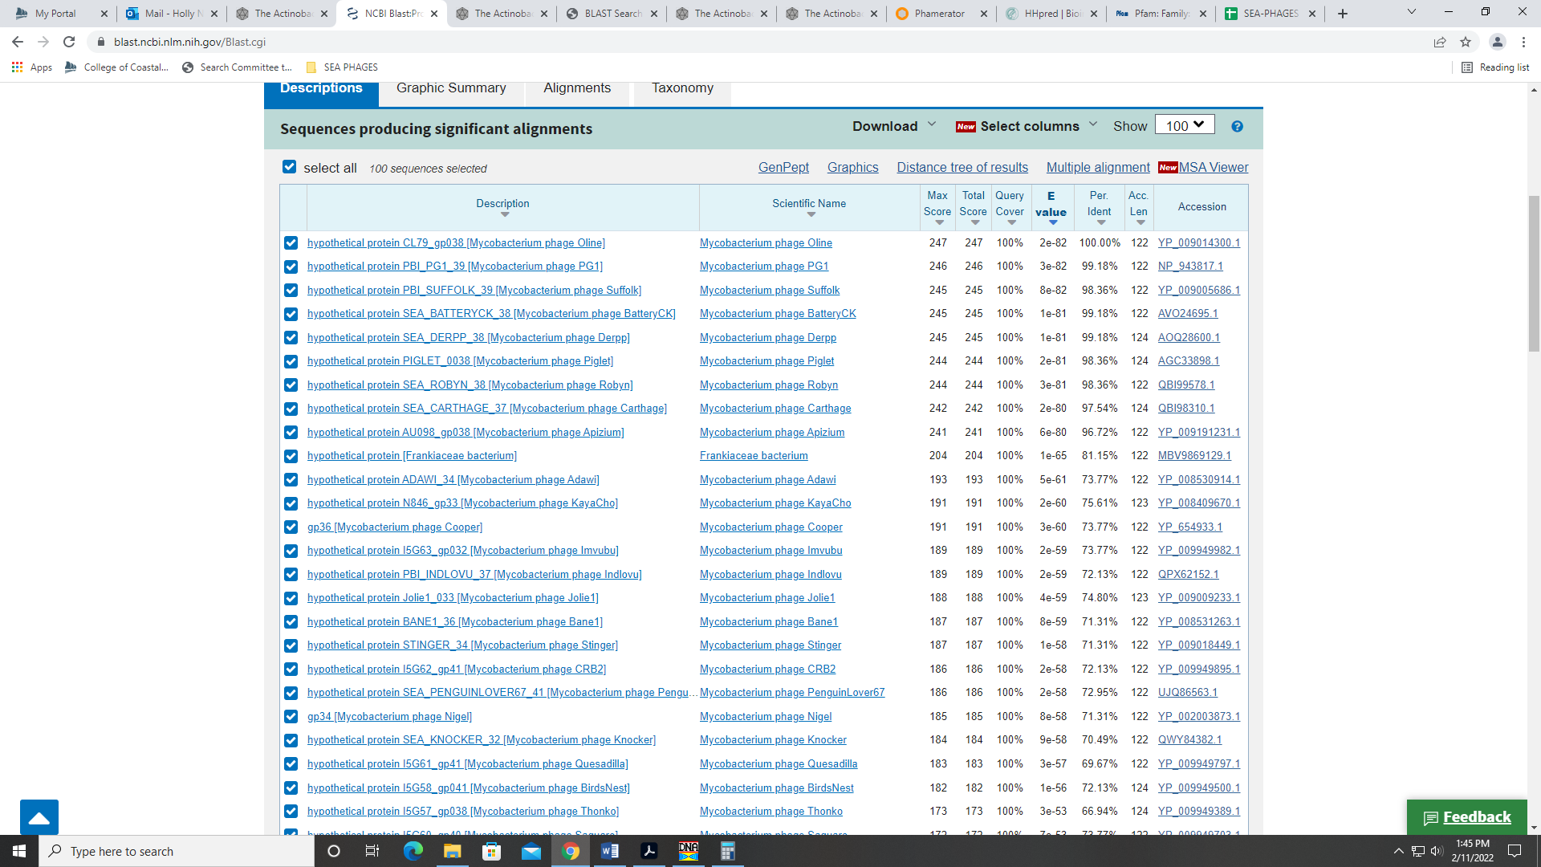
HHPred had one hit with 95% probability, but an e-value of 0.23. This hit for phage tail assembly chaperone makes sense, and is on the official phage function list, but given all other evidence suggests NKF, I’m going with that as the most conservative choice.

Gene 40
SSC: start 36328, stop 36639; CP: yes; SCS: Both called start at 36328; ST: SS; Blast Start: matches Zonia_40 Query 1 to Subject 1 100% 3e⁻⁵⁴; Gap: overlap of 1; LO: NA; RBS: -6.383, 0.862, 14, -7.729, no; F: NKF; SIF-BLAST: NKF/PhageDB BLAST/ Zonia_40, KM363597/100%/3e⁻⁵⁴; SIF-HHPred: NKF, no matches with a probability above 90%; SIF-Syn: NKF
Notes: nothing ambiguous about this gene!

Gene 41
SSC: start 36679, stop 37086; CP: yes; SCS: GeneMark called start at 36742, went with more conserved Glimmer start of 36679; ST: SS; Blast Start: matches Zonia_41 Query 1 to Subject 1 100% 1e⁻⁷⁰; Gap: 39; LO: yes; RBS: -6.164, 0.971, 7, -7.687, no; F: NKF; SIF-BLAST: NKF/PhageDB BLAST/ Zonia_41, KM363597/100%/1e⁻⁷⁰; SIF-HHPred: NKF, no matches with a probability above 90%; SIF-Syn: NKF
Notes: GeneMark and Glimmer differed on the start, but I went with Glimmers call because it was most conserved across other genes in the phamily, it yielded the longest gene in the ORF and the RBS values were very marginally better.

Gene 42
SSC: start 37086, stop 38207; CP: yes; SCS: Both called start at 37086; ST: SS; Blast Start: matches Zelda_42 Query 1 to Subject 1 100% 0.0; Gap: overlap of 1; LO: NA; RBS: -3.531, 2.283, 18, -5.832, no; F: NKF; SIF-BLAST: NKF/PhageDB BLAST/ Zelda_42, MK112555/100%/0.0; SIF-HHPred: hydrolase, one match with a probability above 90%, but high e-value of 11; SIF-Syn: NKF
Notes: All data suggest NKF, but HHPred had one hit with a probability above 90% (though e-value of 11). This hit was for hydrolase; the match was only for 165 of the 373 amino acids in the sequence. 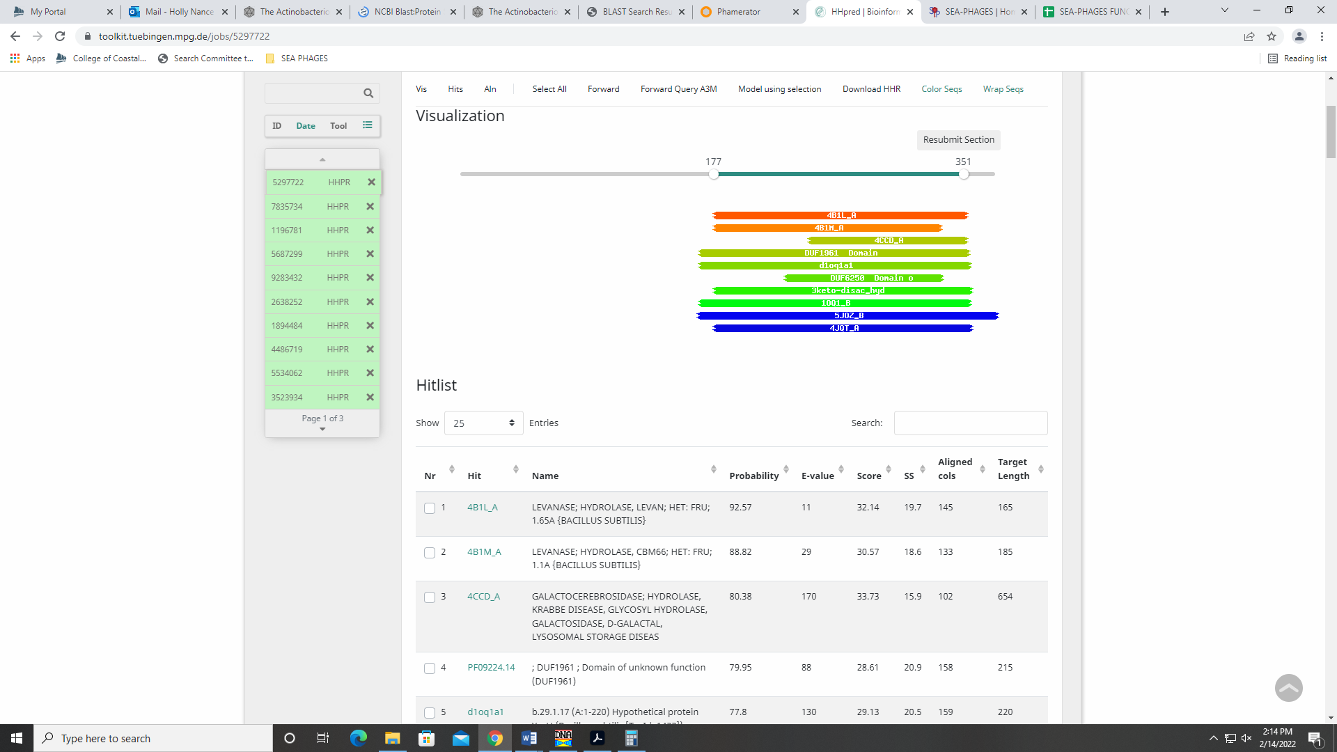
NCBI BLAST supports function as NKF; no hits for hydrolase:
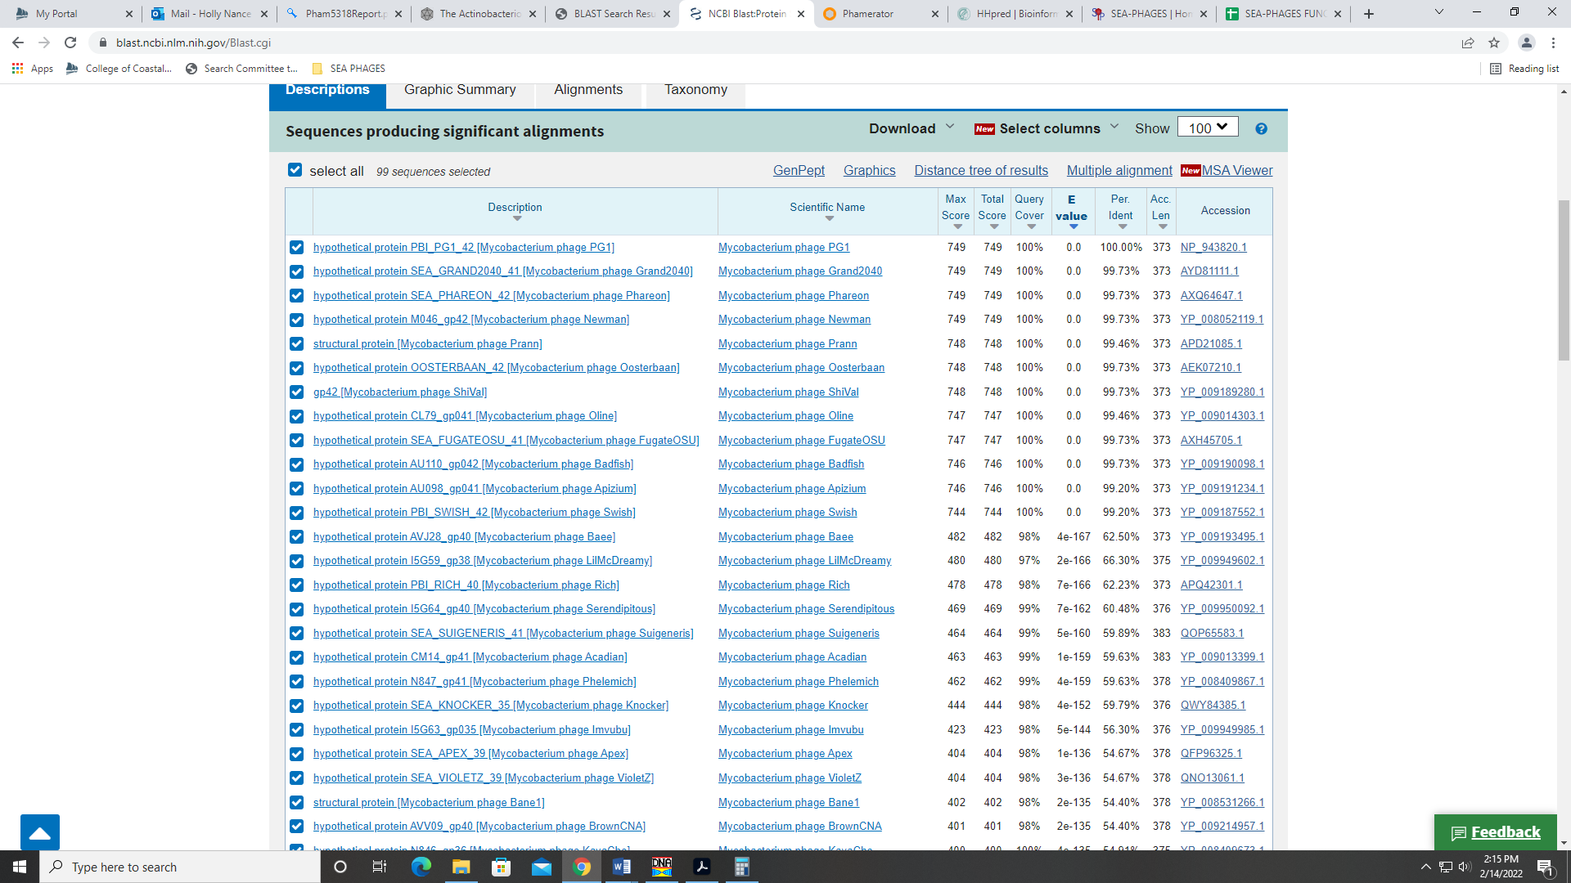
Also, hydrolase is on the Official Function List, but I don’t think this function applies to this gene.

Gene 43 – reverse gene
SSC: start 38407, stop 38189; CP: yes; SCS: Both called start at 38407; ST: SS; Blast Start: matches Zonia_43 Query 1 to Subject 1 100% 7e⁻³⁹; Gap: 1; LO: NA; RBS: -3.813, 2.143, 12, -4.649, yes; F: NKF; SIF-BLAST: NKF/PhageDB BLAST/ Zonia_43, KM363597/100%/7e⁻³⁹; SIF-HHPred: NKF, no matches with a probability above 90%; SIF-Syn: NKF
Notes: nothing ambiguous

Gene 44 – reverse gene
SSC: start 38702, stop 38409; CP: yes; SCS: GeneMark called start at 38714, went with more conserved Glimmer start of 38702; ST: SS; Blast Start: matches Zelda_44 Query 1 to Subject 1 100% 8e⁻⁵⁴; Gap: overlap of 4; LO: NA; RBS: -3.818, 2.140, 10, -4.513, no; F: NKF; SIF-BLAST: NKF/PhageDB BLAST/ Zelda_44, MK112555/100%/8e⁻⁵⁴; SIF-HHPred: NKF, no matches with a probability above 90%; SIF-Syn: NKF
Notes: The GeneMark start would yield a slightly longer gene, but because the Glimmer start is most conserved based on Starterator data and both PhageDB and NCBI BLAST hits:
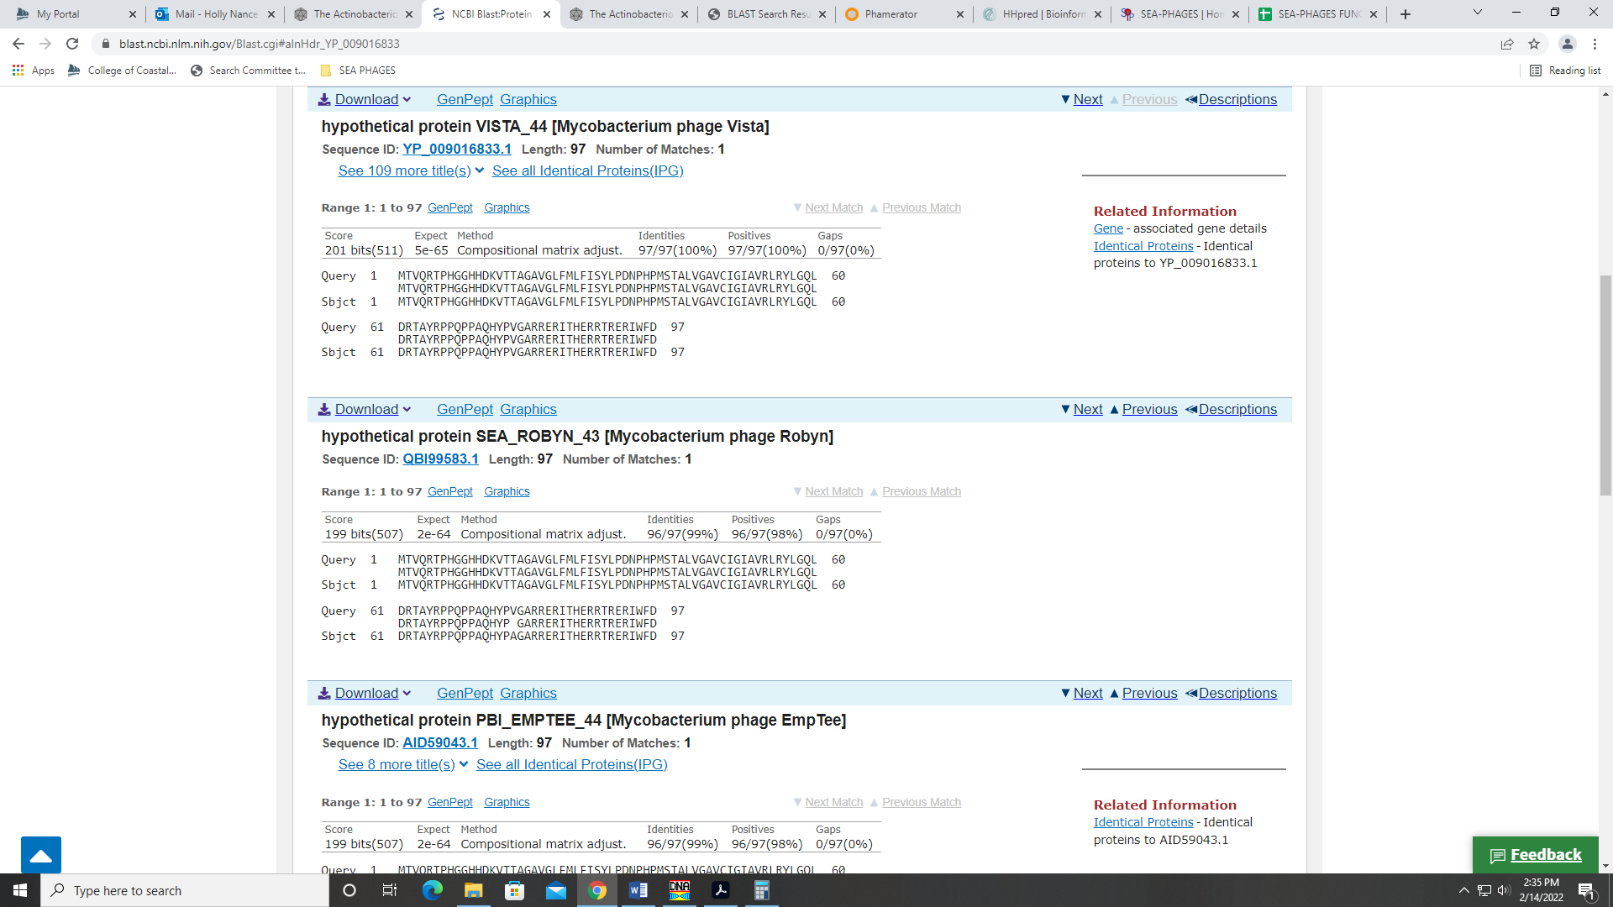
yielding 1 to 1 correspondence, I’m going with the Glimmer start. Also, the RBS values for the Glimmer start are slightly better than those for the GeneMark start.

Gene 45 – reverse gene
SSC: start 38914, stop 38699; CP: yes; SCS: Both called start at 38914; ST: SS; Blast Start: matches Zonia_45 Query 1 to Subject 1 100% 6e⁻³⁹; Gap: overlap of 4; LO: NA; RBS: -3.604, 2.247, 10, -4.299, yes; F: helix-turn-helix DNA binding domain protein; SIF-BLAST: helix-turn-helix DNA binding domain protein /PhageDB BLAST/ Zonia_45, KM363597/100%/6e⁻³⁹; SIF-HHPred: DNA binding protein, several matches with a probability above 90%; SIF-Syn: helix-turn-helix DNA binding domain protein
Notes: Synteny and BLAST support this function as helix-turn-helix DNA binding domain protein:
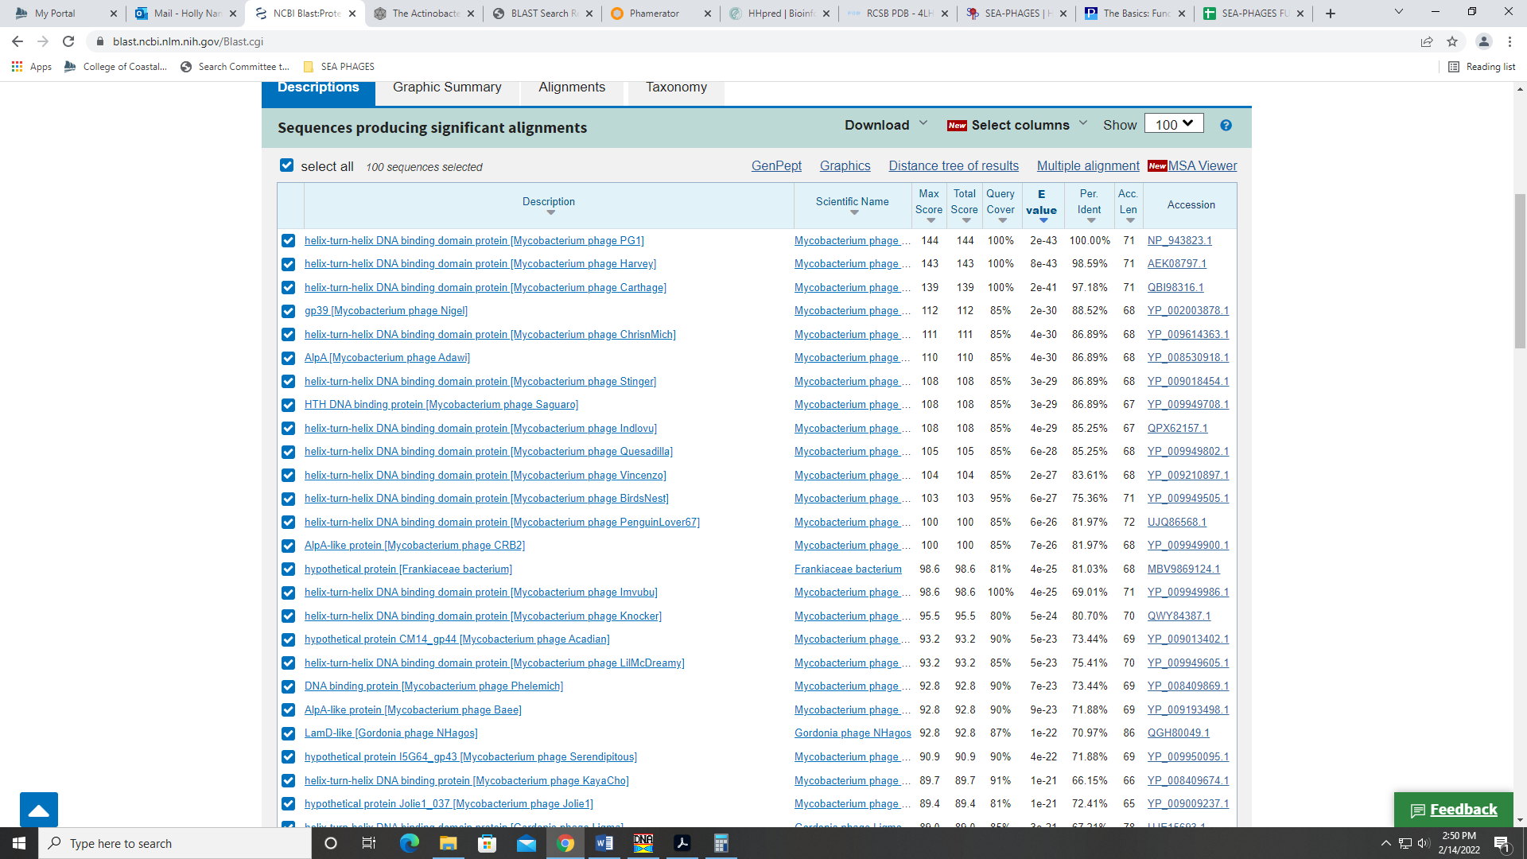
This name is on the official function list, and may be used specifically (as opposed to just DNA binding protein) when there is evidence for it. The BLAST and synteny data support this name.
HHPred has may hits with a probability above 90%, and many are for a DNA binding protein. One hit specifies a helix-turn-helix DNA binding protein with a probability of 98.17%:
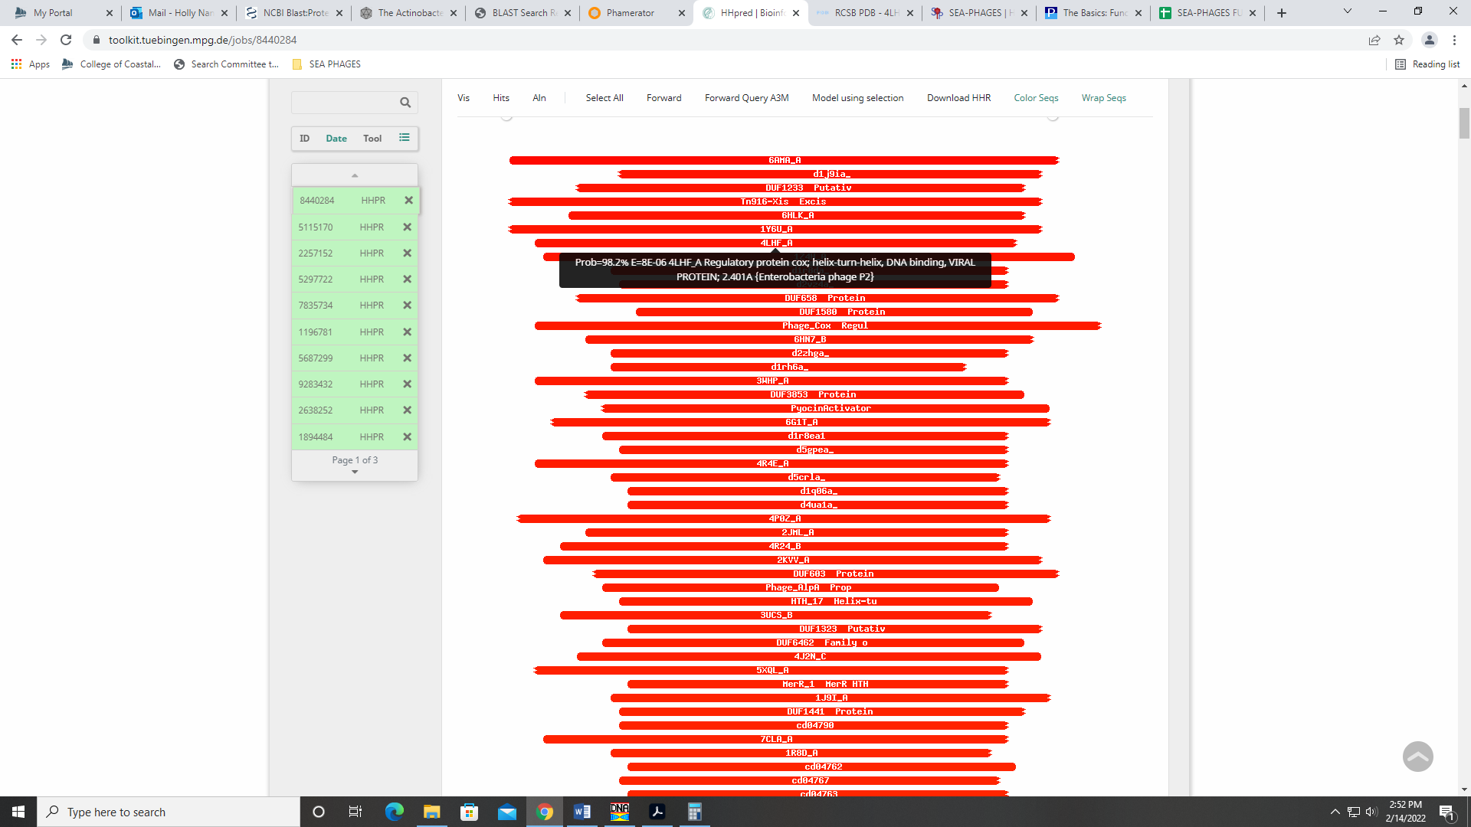
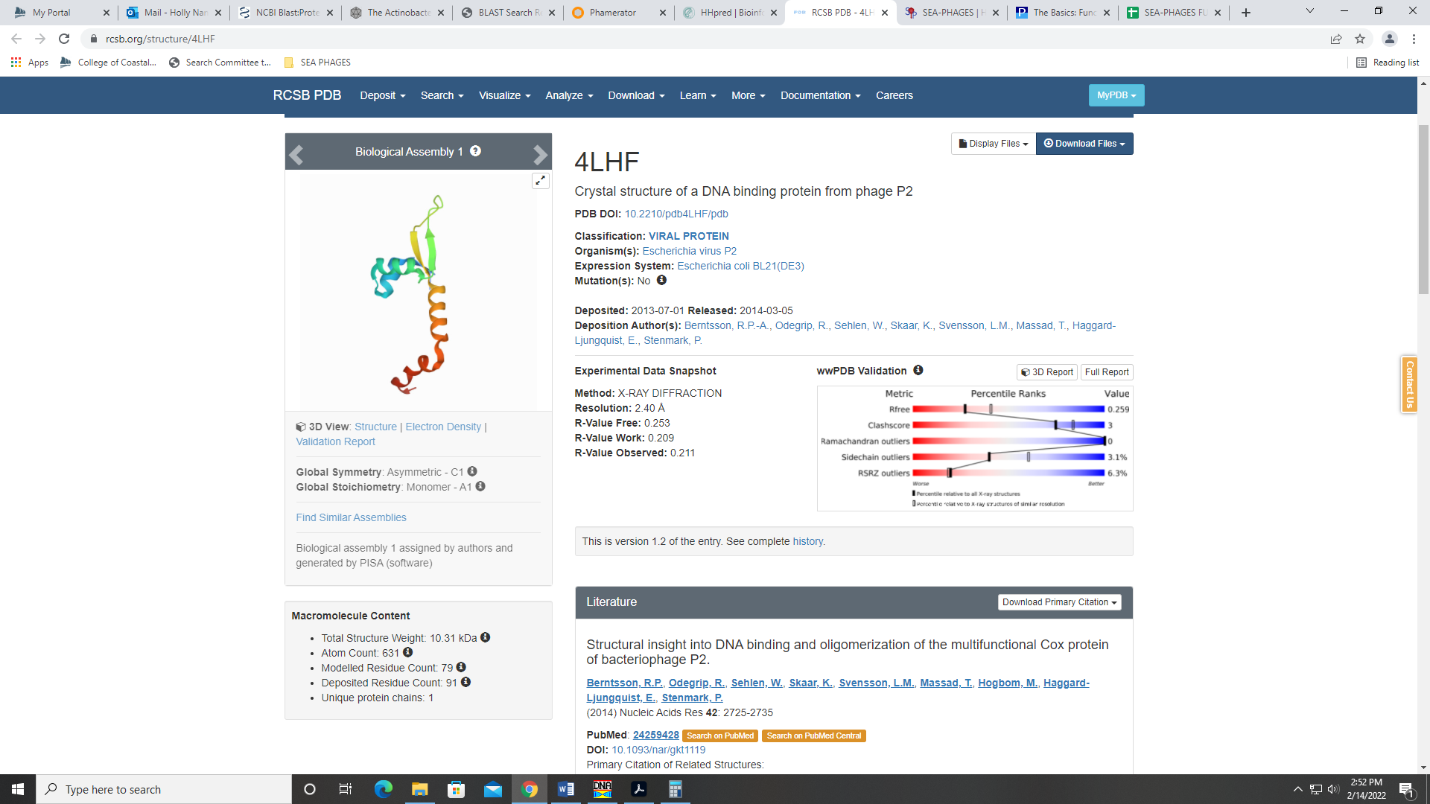
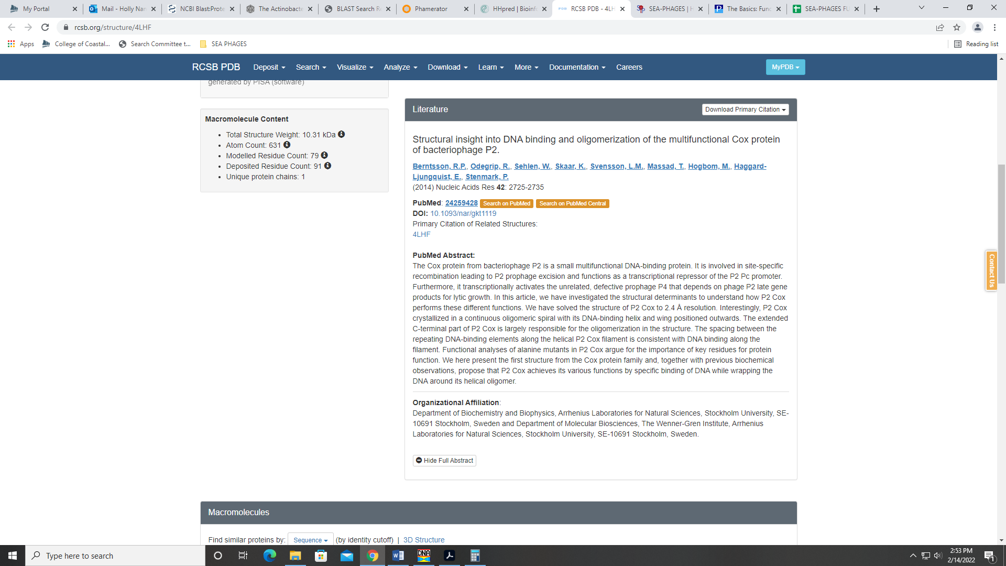

Gene 46 – reverse gene
SSC: start 39336, stop 38911; CP: yes; SCS: Both called start at 39336; ST: NI; Blast Start: matches Zonia_46 Query 1 to Subject 1 99% 1e⁻⁷⁵; Gap: 102; LO: no; RBS: -2.483, 2.806, 14, -3.830, yes; F: helix-turn-helix binding domain protein; SIF-BLAST: helix-turn-helix binding domain protein /PhageDB BLAST/ Zonia_46, KM363597/99%/1e⁻⁷⁵; SIF-HHPred: helix-turn-helix binding domain protein, several matches with a probability above 90%; SIF-Syn: helix-turn-helix binding domain protein
Notes: The start of this gene was tricky in that the start called by both Glimmer and GeneMark was not the most conserved based on BLAST hits and in Starterator. This start yields a 1:35 query to subject match with the first several hits. It does yield a 1:1 match with Zonia, though. However, I kept this start because there is no indication of coding potential for the most conserved start of 39438 and there are other phage that selected this start. One of those phage is Zonia, which is one of the most similar phage to Dati so far. This start also has the best RBS values. Like in Zonia, this start doesn’t yield the longest ORF, and there is a large gap between this and the next gene (102 BP); see conserved with Zonia in Phamerator:
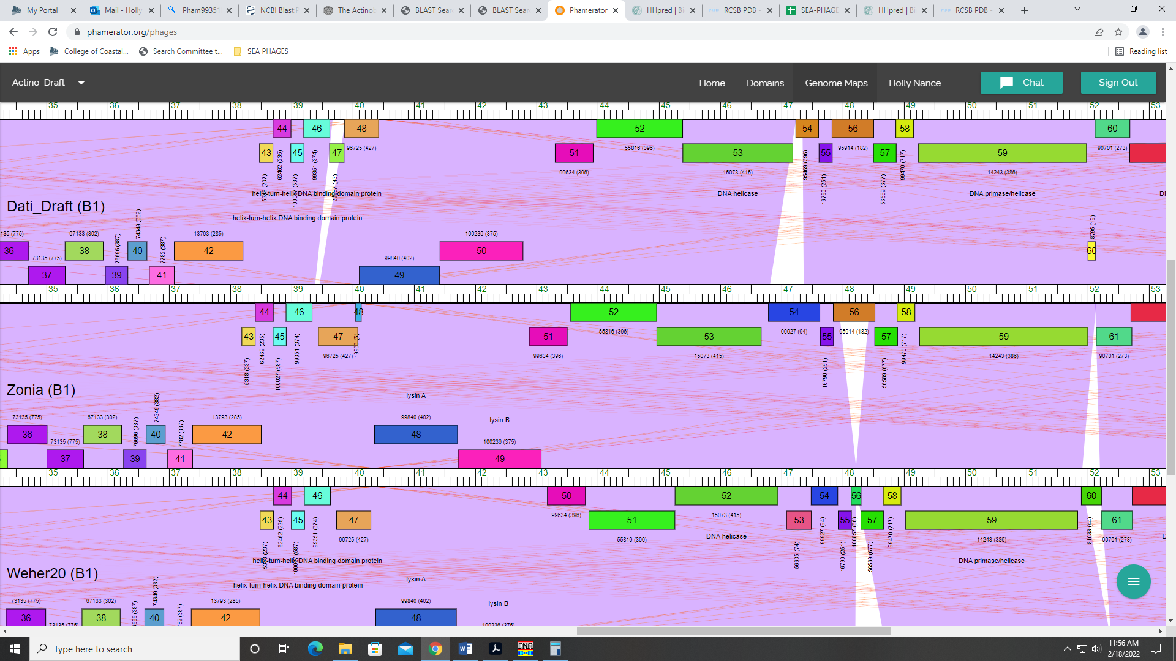
For function, there is support from both PhageDB and NCBI BLAST data for helix-turn-helix DNA binding domain protein:
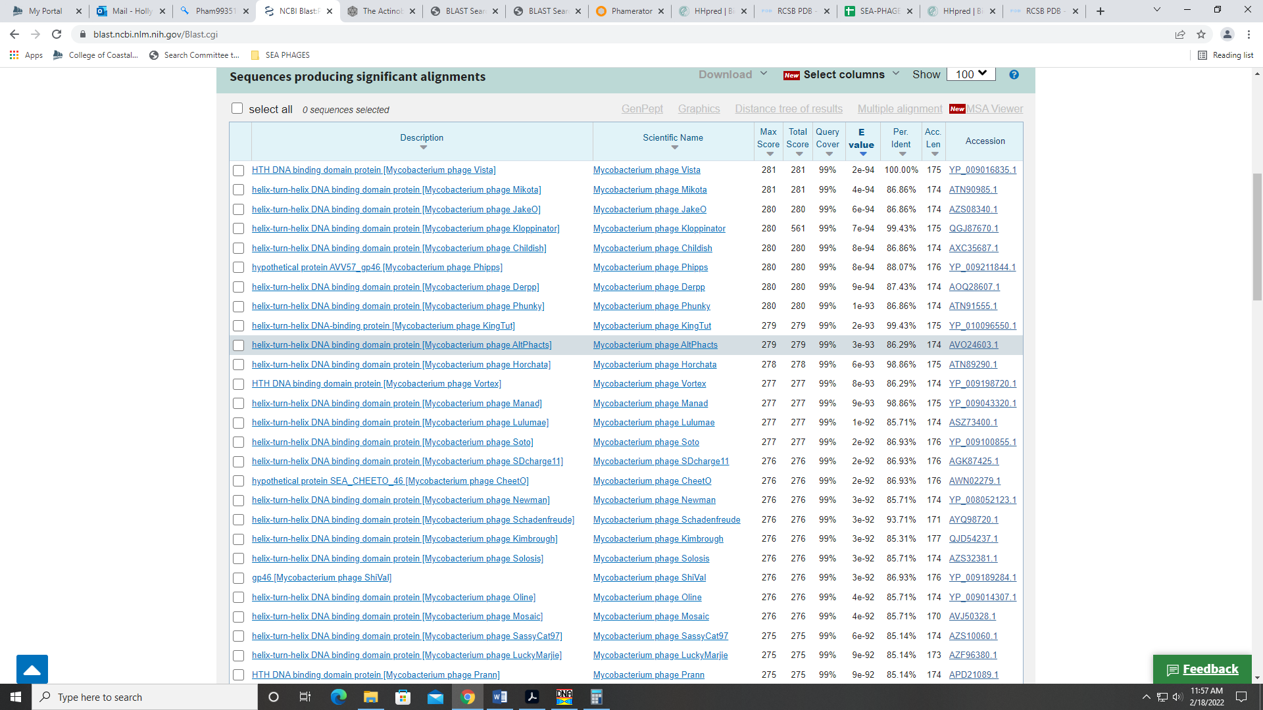
HHPred data also support this as the function:
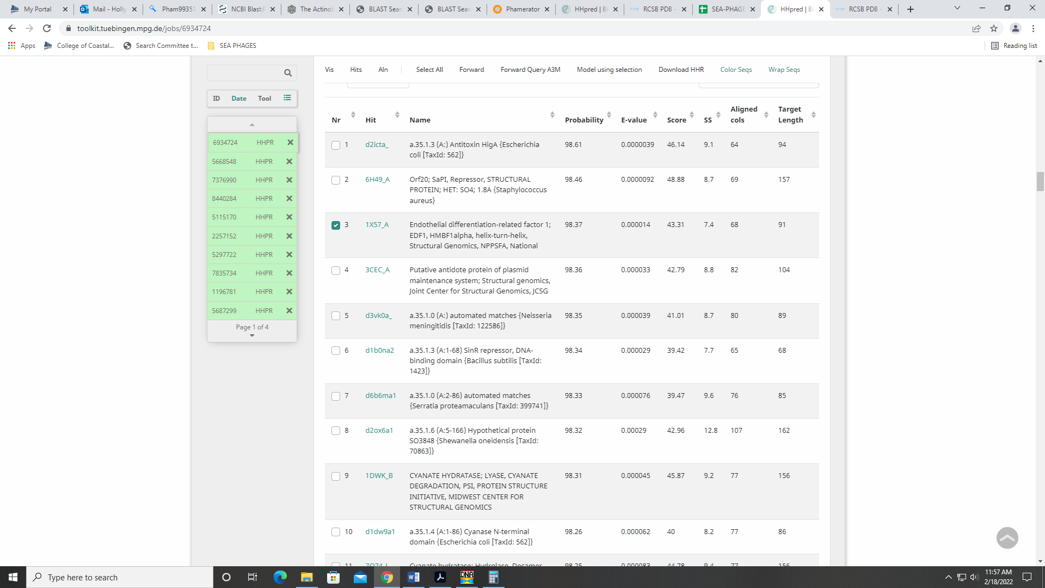
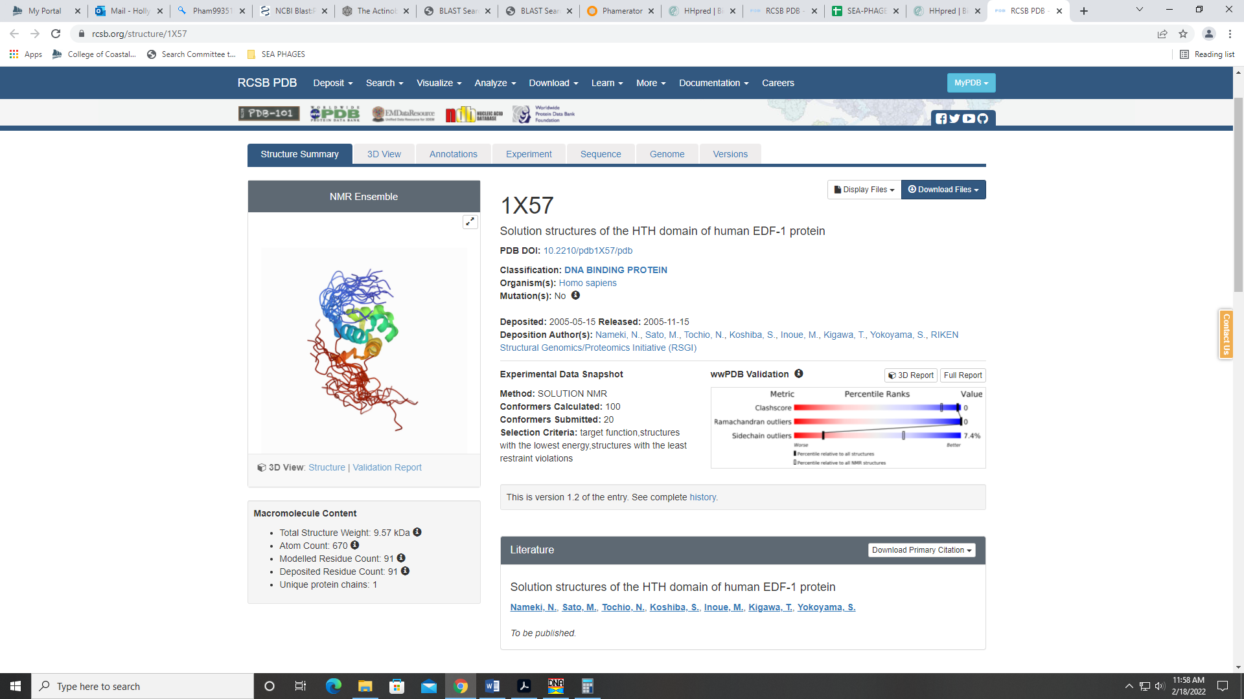

Gene 47 – reverse gene – changed start to 39999 per rest of class based on their analysis, 3.28.22
SSC: start 39999, stop 39439; CP: yes; SCS: Glimmer called start at 40083, went with more conserved GeneMark start of 39999; ST: SS; Blast Start: matches Weher20_47 Query 1 to Subject 1 100% 1e-103; Gap: 107; LO: no; RBS: -3.377, 2.859, 12, -3.212, yes; F: NKF; SIF-BLAST: NKF / PhageDB BLAST / Weher20_47, MZ681520 / 100% / 1e-103; SIF-HHPred: NKF, no matches with a probability above 90%; SIF-Syn: NKF
Notes: Changed because it was most annotated start in Starterator and had better RBS values.

Gene 48 – changed start from 40107 to 40098 on 2.28!
SSC: start 40098, stop 41414; CP: yes; SCS: GeneMark called start at 40125, Glimmer called start at 40107, went with most conserved start in Starterator of 40098; ST: SS; Blast Start: matches Weher20_48 1 Query 1 to Subject 1 100% 0.0; Gap: 14; LO: no; RBS: -5.856, 1.125, 12, -6.691, no; F: Lysin A; SIF-BLAST: Lysin A/PhageDB BLAST/ Weher20_48, MZ681520 /100%/0.0; SIF-HHPred: several domain hits with a probability above 90%; SIF-Syn: Lysin A
Notes: Changed the start to 40098, which is the most annotated start in Starterator and yields more 1:1 Q:S hits in PhageDB BLAST. This start also yields a longer ORF. Neither GeneMark or Glimmer called this start, but it differs only by 4 AAs from the Glimmer start.
For function, both PhageDB and NCBI BLAST support Lysin A:
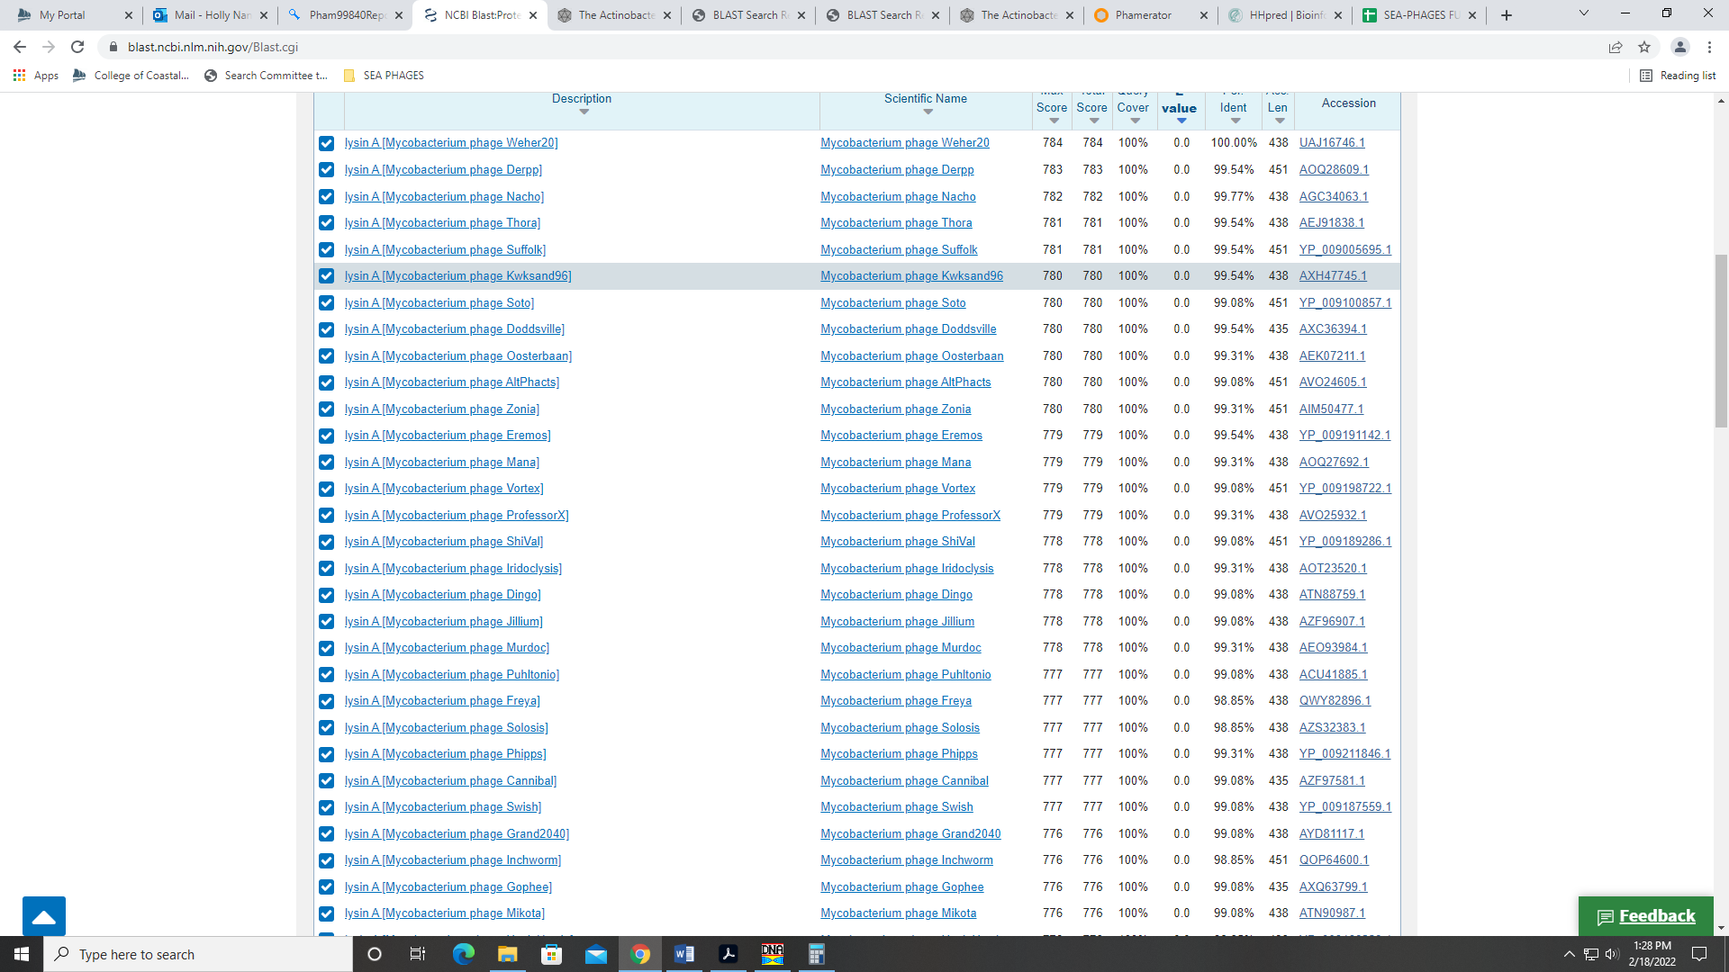
Synteny also supports this as the start. The HHPred output yields several hits with a probability above 90%, but these are mostly partial. They are for several of the domains found in this protein (amidase, ampD, :
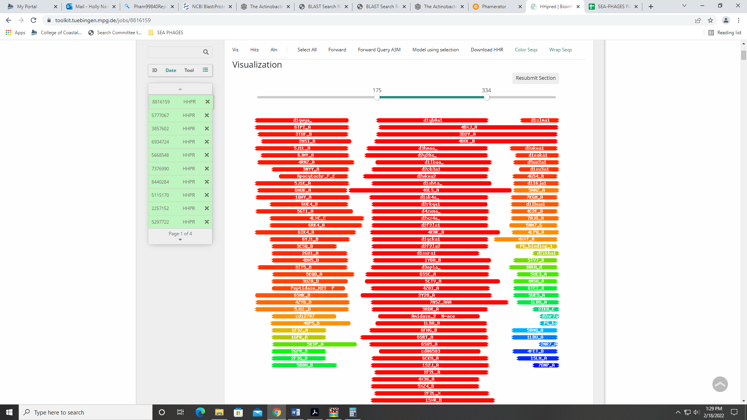
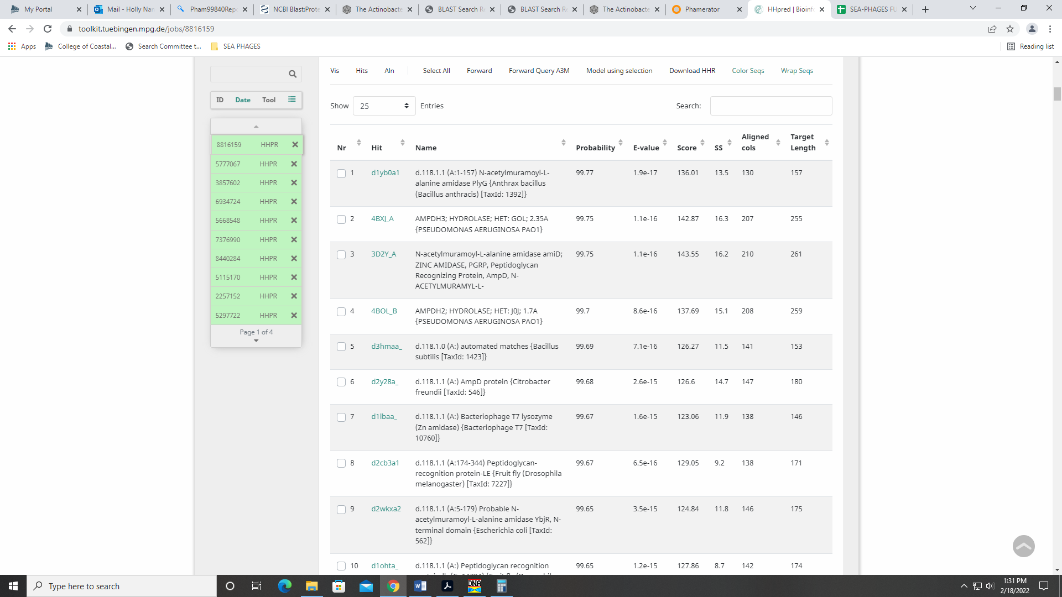
These domains and others are present in this protein:
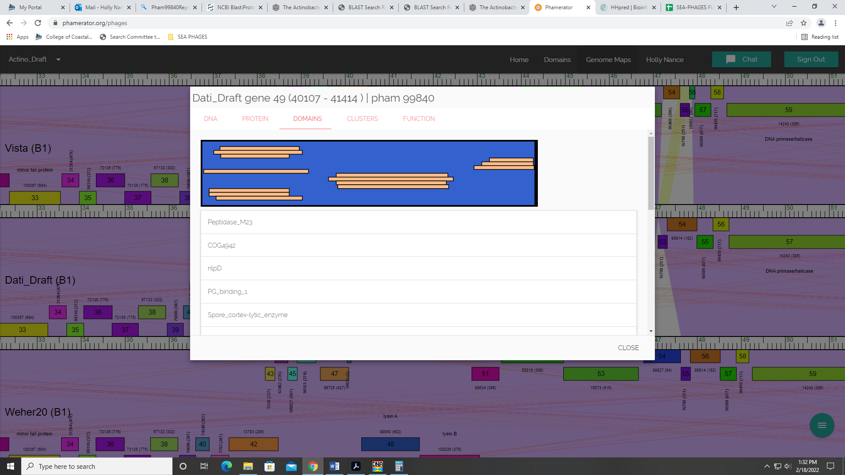
Lysin A is on the official phage function list and is the accepted name for phage with Mycobacterium hosts (like Dati).

Gene 49
SSC: start 41424, stop 42779; CP: yes; SCS: Both called start at 41424; ST: SS; Blast Start: matches Weher20_49 Query 1 to Subject 1 100% 0.0; Gap: 9; LO: NA; RBS: -3.631, 2.234, 10, -4.326, no; F: Lysin B; SIF-BLAST: Lysin B /PhageDB BLAST/ Weher20_49, MZ681520/100%/0.0; SIF-HHPred: hydrolase or esterase, several matches with a probability above 90%; SIF-Syn: Lysin B
Notes: Start unambiguous for this protein. For function, both PhageDB abd NCBI BLAST support Lysin B:
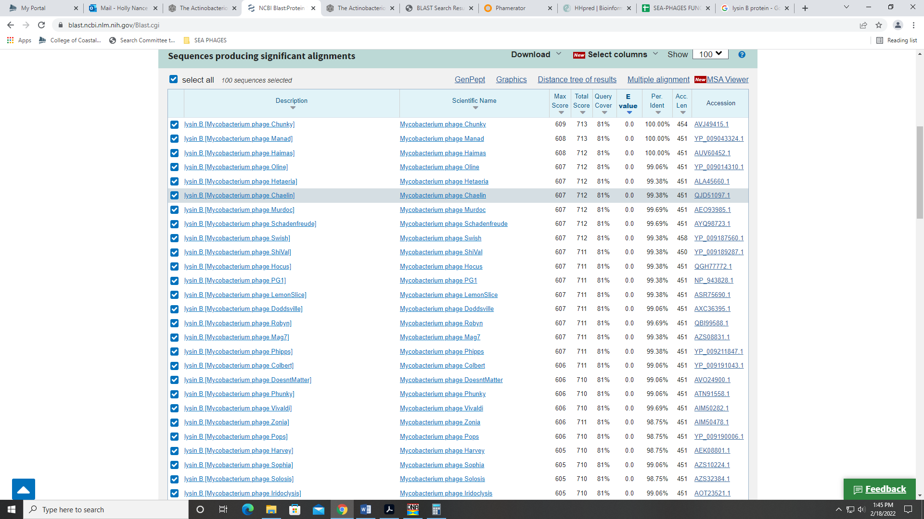
This function is also supported by synteny and is on the official phage function list. HHPred has many hits with a probability above 90%, but for hydrolases or esterases. Lysin B functions as a hydrolase or esterase, so these hits make sense:
http://d-scholarship.pitt.edu/9933/
https://www.ncbi.nlm.nih.gov/pmc/articles/PMC2774421/

Gene 50 – reverse gene
SSC: start 43501, stop 42881; CP: yes; SCS: Both called start at 43501; ST: SS; Blast Start: matches Zelda_50 Query 1 to Subject 1 100% 1e⁻¹¹⁸; Gap: 57; LO: yes; RBS: -1.259, 3.416, 13, -2.305, yes; F: NKF; SIF-BLAST: NKF/PhageDB BLAST/ Zelda_50, MK112555/100%/1e⁻¹¹⁸; SIF-HHPred: NKF, no matches with a probability above 90%; SIF-Syn: NKF
Notes: nothing ambiguous here. Start is most annotated in Starterator.

Gene 51 – reverse gene
SSC: start 44962, stop 43599; CP: yes; SCS: Both called start at 44962; ST: SS; Blast Start: matches Weher20_51 Query 1 to Subject 1 100% 0.0; Gap: 2; LO: NA; RBS: -2.377, 2.859, 16, -4.173, no; F: NKF; SIF-BLAST: NKF/PhageDB BLAST/ Weher20_51, MZ681520/100%/0.0; SIF-HHPred: several partial matches with a probability above 90%, but not enough evidence to call a function; SIF-Syn: NKF
Notes (from Drew): Regarding function, BLAST hits from both databases mostly call this NKF. However, there are a few who call is a helicase or exonuclease (ex. Squid 51) and these have 99% identities and e-values of 0.0. Also, the HHPred output has several hits (though all partial) for various genes. The two top hits are for mitochondrial genes (doesn’t make sense for a phage to have those). But the other partial hits are for genes in bacteria hosts like helicase, exonuclease, or CRISPR-related genes. There are also some hits that are NKF. Also, Phamerator shows this gene as a single domain with phamerator map. I decided that the function of this gene was NKF, and not enough data was present to support a function of this gene. More data supported that there was NKF.
Notes: Regarding function, BLAST hits from both databases mostly call this NKF. However, there are a few who call is a helicase or exonuclease (ex. Squid 51) and these have 99% identities and e-values of 0.0.
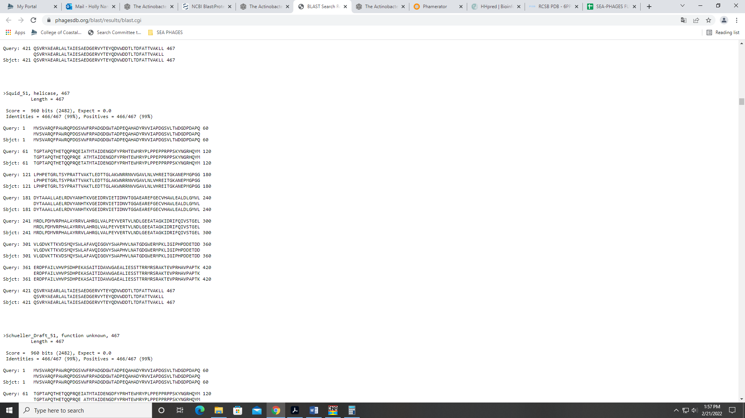
Same situation with NCBI BLAST; most are NKF, but there are some that called it exonuclease:
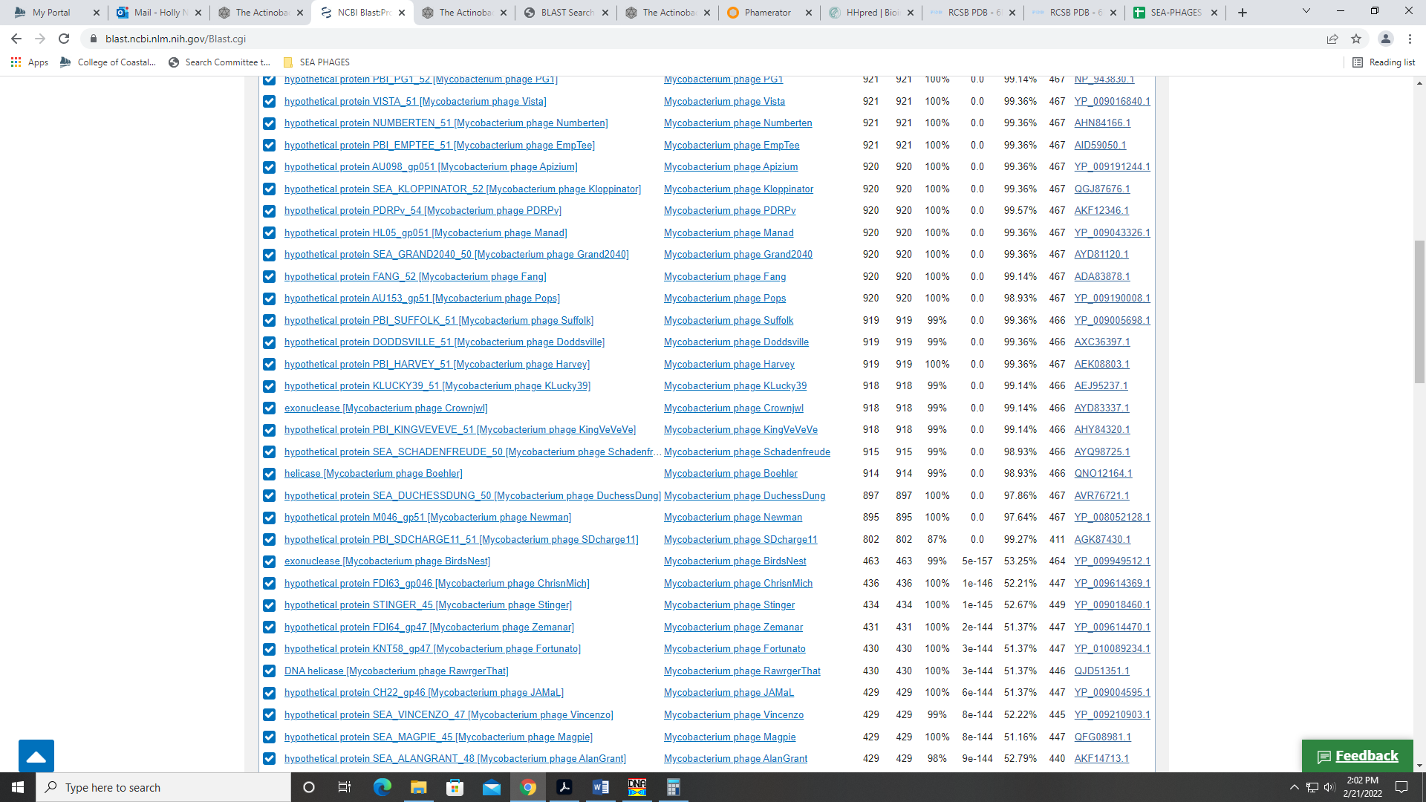
Also, the HHPred output has several hits (though all partial) for various genes. The two top hits are for mitochondrial genes (doesn’t make sense for a phage to have those). But the other partial hits are for genes in bacteria hosts like helicase, exonuclease or CRISPR-related genes. There are also some hits that are NKF.
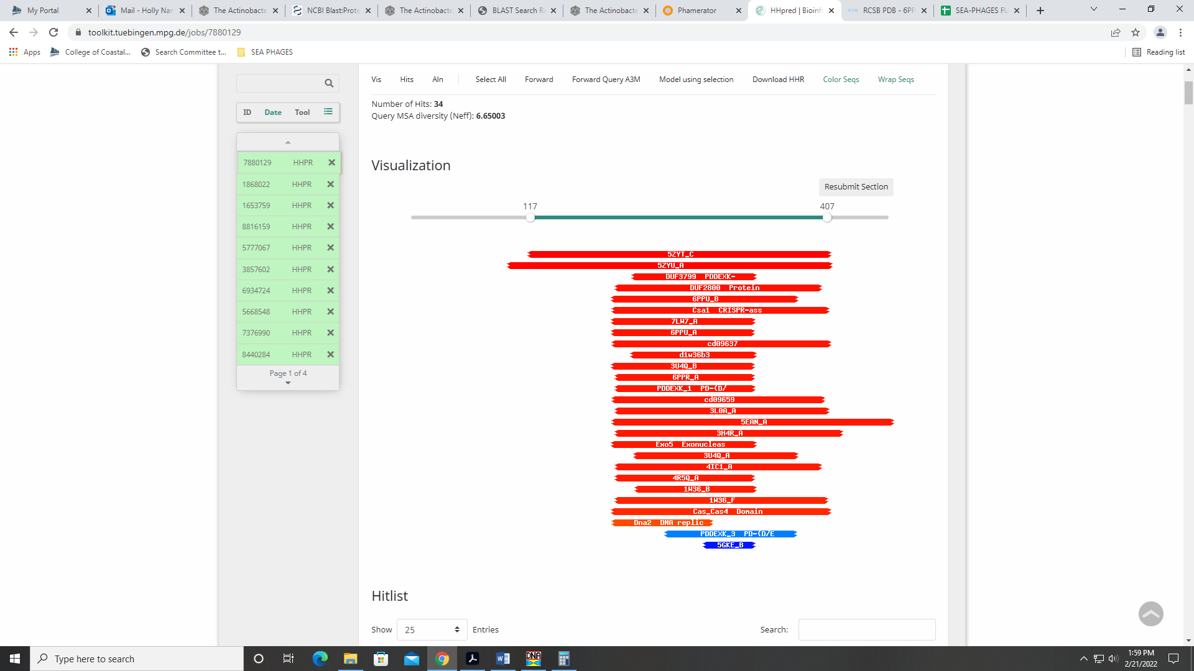
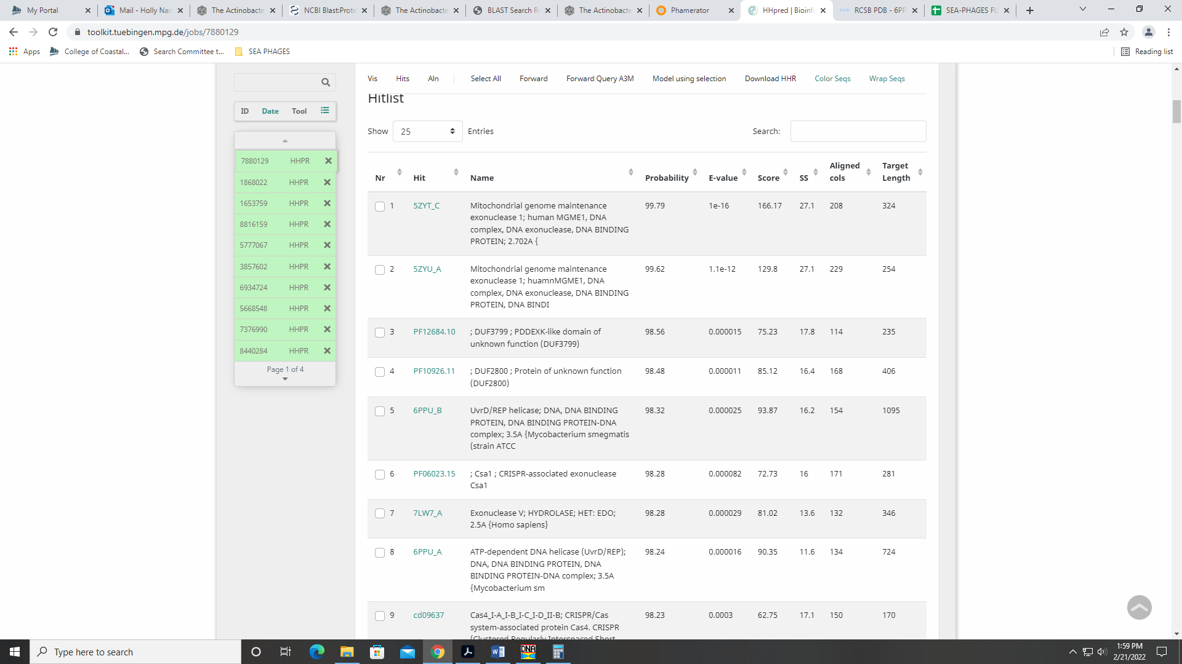
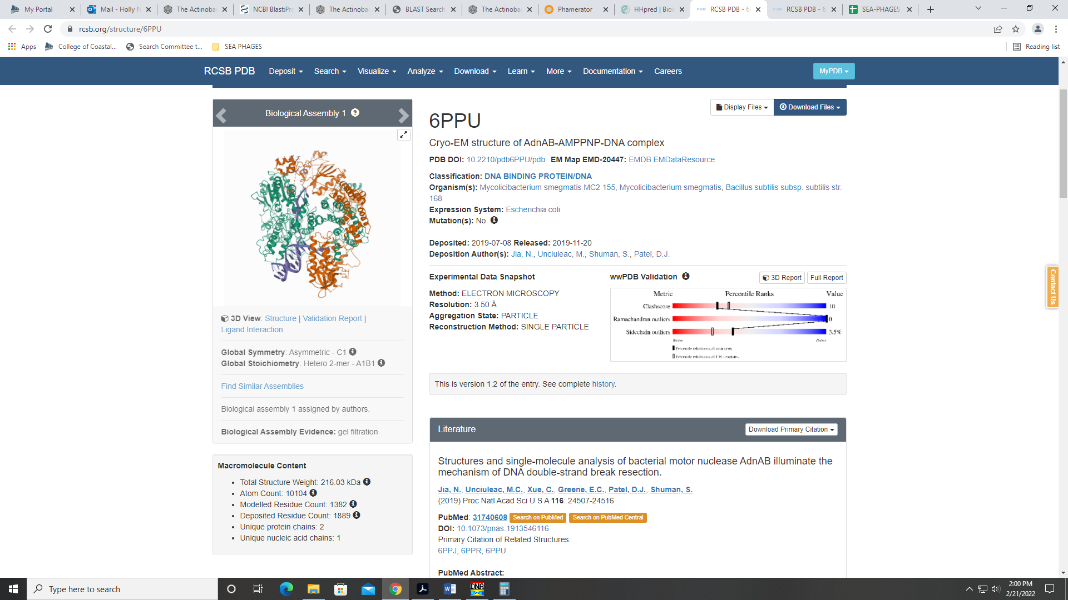
Also, Phamerator shows this gene as a single domain (Squid 50 shown):
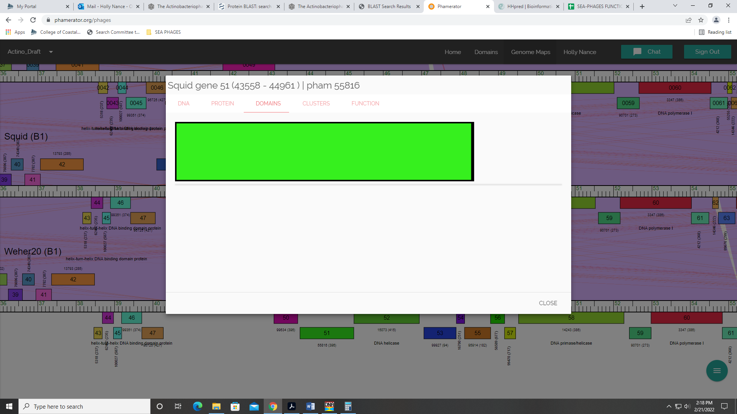
If we decide to call this a gene, we won’t be the first. It is only for a partial sequence (<290 of 467 AAs). But I could be convinced.

Gene 52 – reverse gene
SSC: start 46668, stop 44965; CP: yes; SCS: GeneMark called start at 46644, went with more conserved Glimmer start of 46668; ST: SS; Blast Start: matches Zelda_52 Query 1 to Subject 1 100% 0.0; Gap: 118; LO: yes; RBS: -4.661, 1.720, 10, -5.355, no; F: DNA Helicase; SIF-BLAST: DNA Helicase/PhageDB BLAST/ Zelda_52, MK112555/100%/0.0; SIF-HHPred: DNA Helicase, several matches with a probability above 90%; SIF-Syn: DNA Helicase
Notes: For the start, I went with the Glimmer start as this was the most annotated in the Starterator data and yielded the longest ORF for this gene.
For the function, PhageDB and NCBI BLAST data suggest DNA Heilcase:
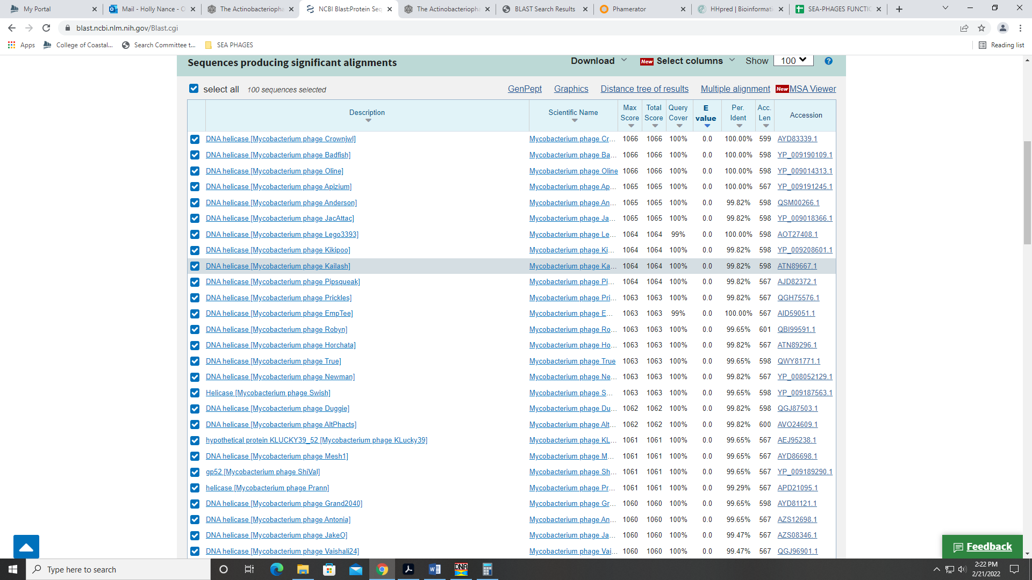
Also, HHPred output yields numerous hits for DNA helicase or helicase with 100% probability:
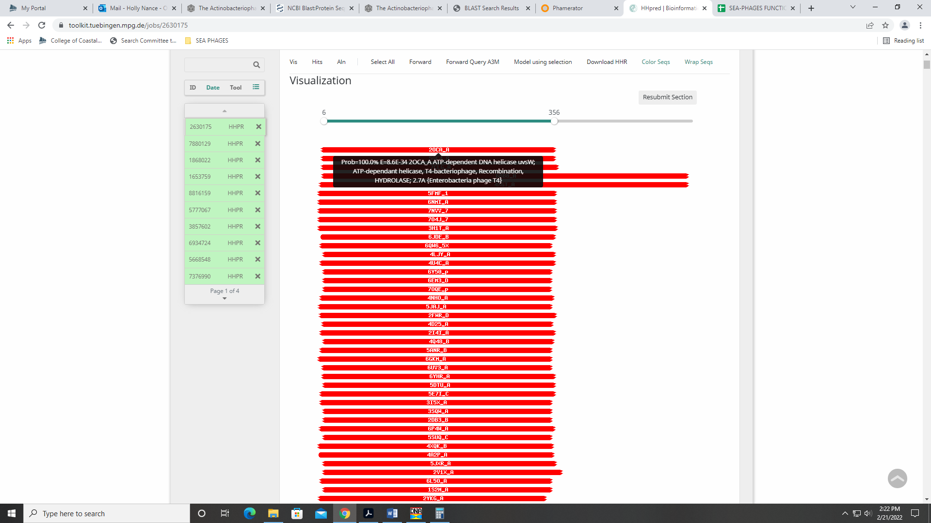
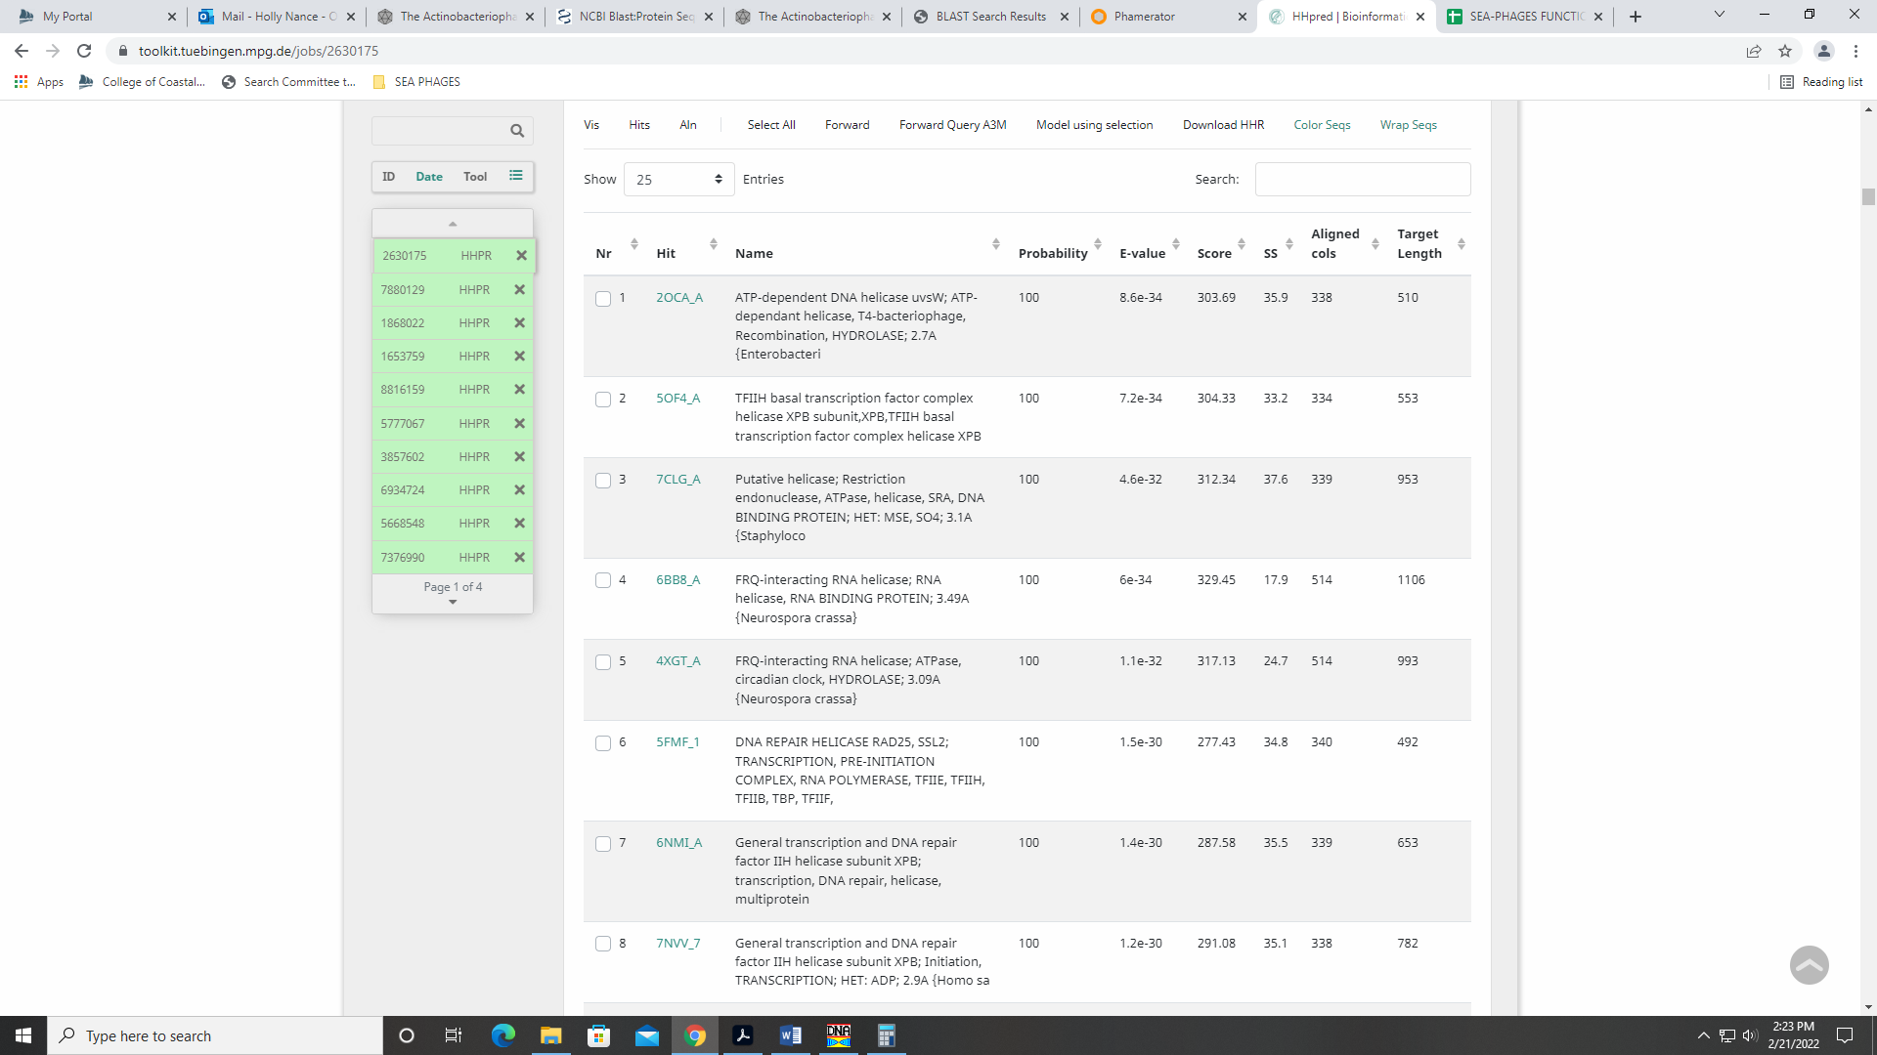

Gene 53 – reverse gene
SSC: start 47626, stop 46787; CP: yes; SCS: Only GeneMark called start at 47626, Glimmer did not identify coding potential here; ST: SS; Blast Start: matches Weher20_53 Query 1 to Subject 1 100% 1e⁻¹⁶⁶; Gap: 7; LO: NA; RBS: -4.394, 1.853, 13, -5.440, no; F: NKF; SIF-BLAST: NKF/PhageDB BLAST/ Weher20_53, MZ681520/100%/1e⁻¹⁶⁶; SIF-HHPred: NKF, no matches with a probability above 90%; SIF-Syn: NKF, where present in the genome
Notes: This start doesn’t yield the longest ORF, but it is the most annotated in Starterator. This start also prevents the gene from overlapping considerable with the transcriptionally upstream gene. Glimmer didn’t call this gene at all; only GeneMark. However, there are other phage in B1 that called this gene as there are several matches in PhageDB and NCBI BLAST:
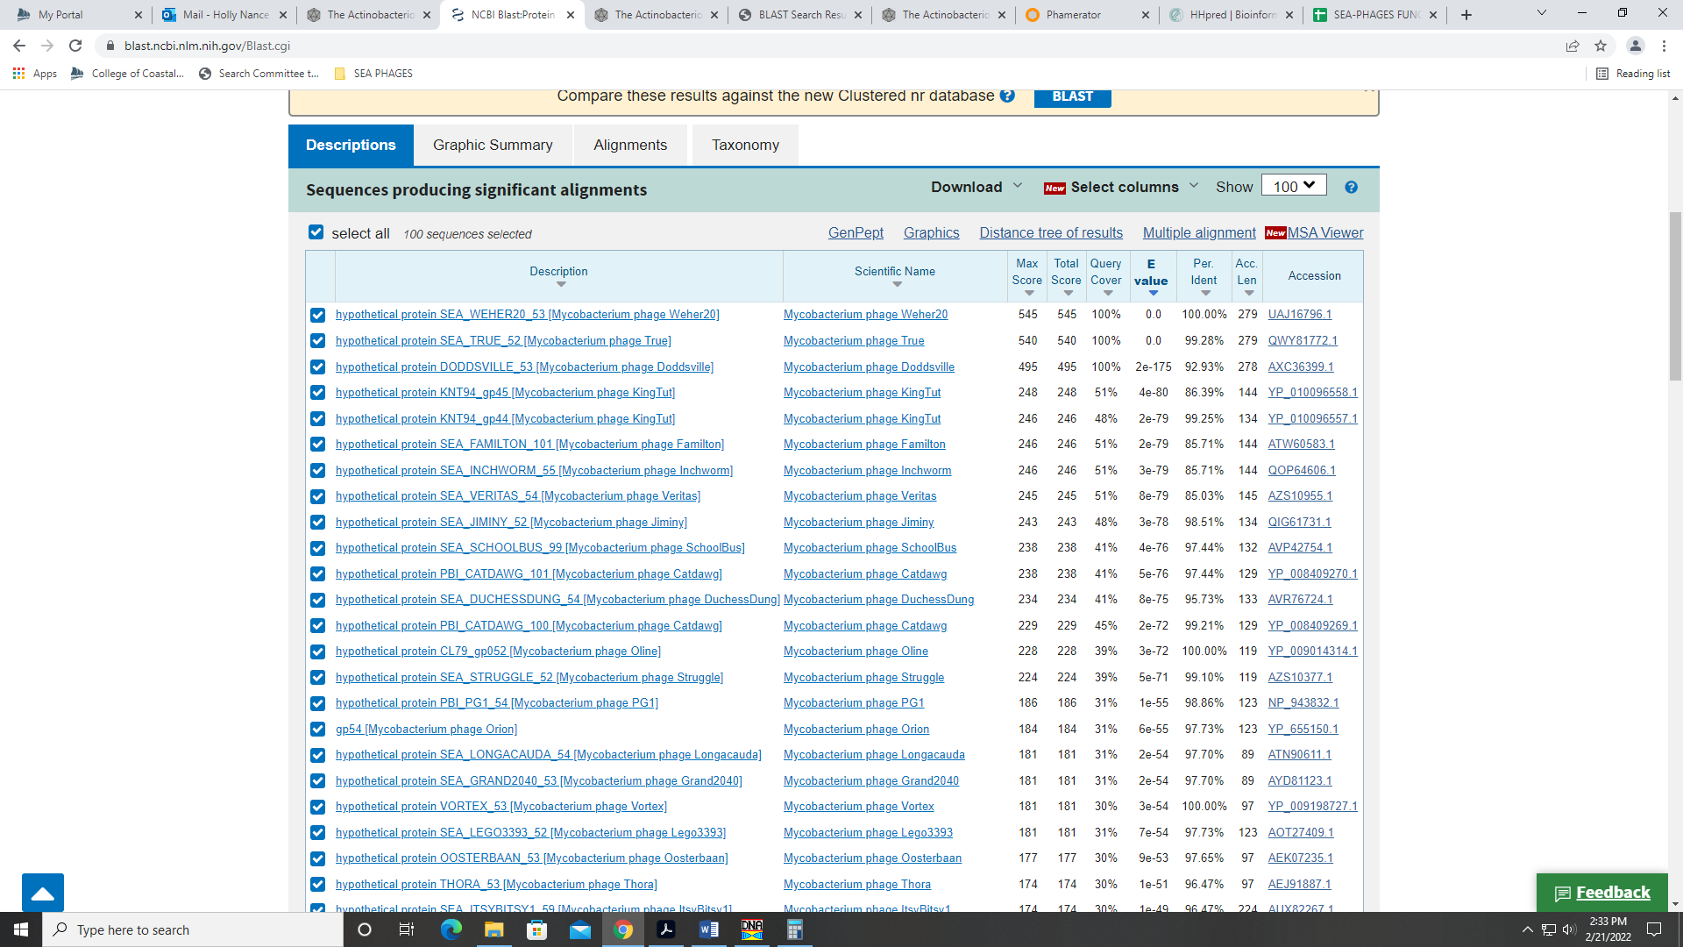
It’s definitely a gene – great coding potential in the GeneMark output. All databases support NKF.
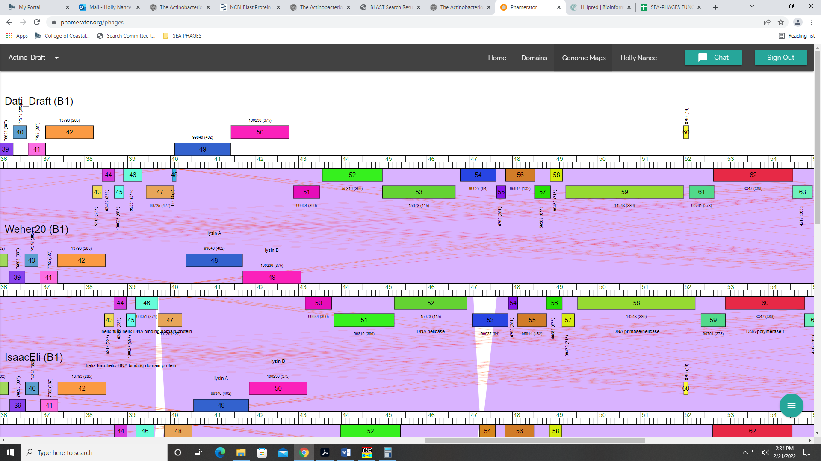
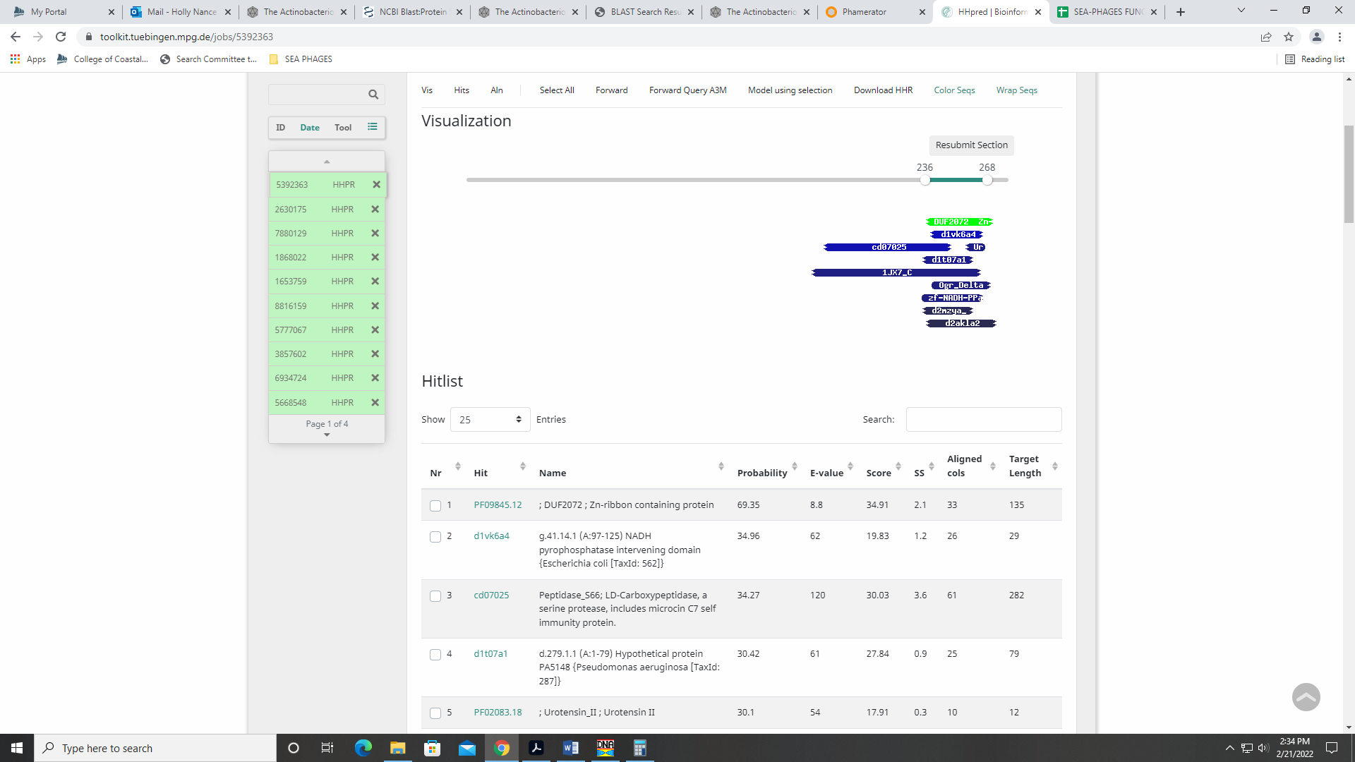

Gene 54 – reverse gene
SSC: start 47849, stop 47634; CP: yes; SCS: Both called start at 47849; ST: SS; Blast Start: matches Zelda_54 Query 1 to Subject 1 100% 1e⁻³⁴; Gap: overlap of 4; LO: NA; RBS: -1.620, 3.236, 11, -2.377, yes; F: NKF; SIF-BLAST: NKF/PhageDB BLAST/ Zelda_54, MK112555/100%/1e⁻³⁴; SIF-HHPred: NKF, no matches with a probability above 90%; SIF-Syn: NKF
Notes: Small gene, but called by both GeneMark and Glimmer. Start is most called in Starterator. NKF supported by both BLAST hits:
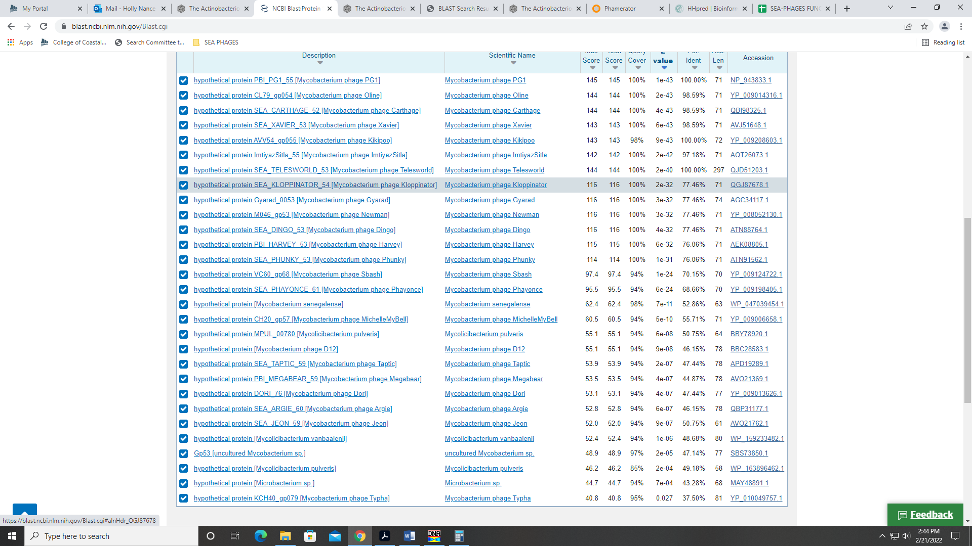
Also supported by HHPred and synteny in Phamerator:
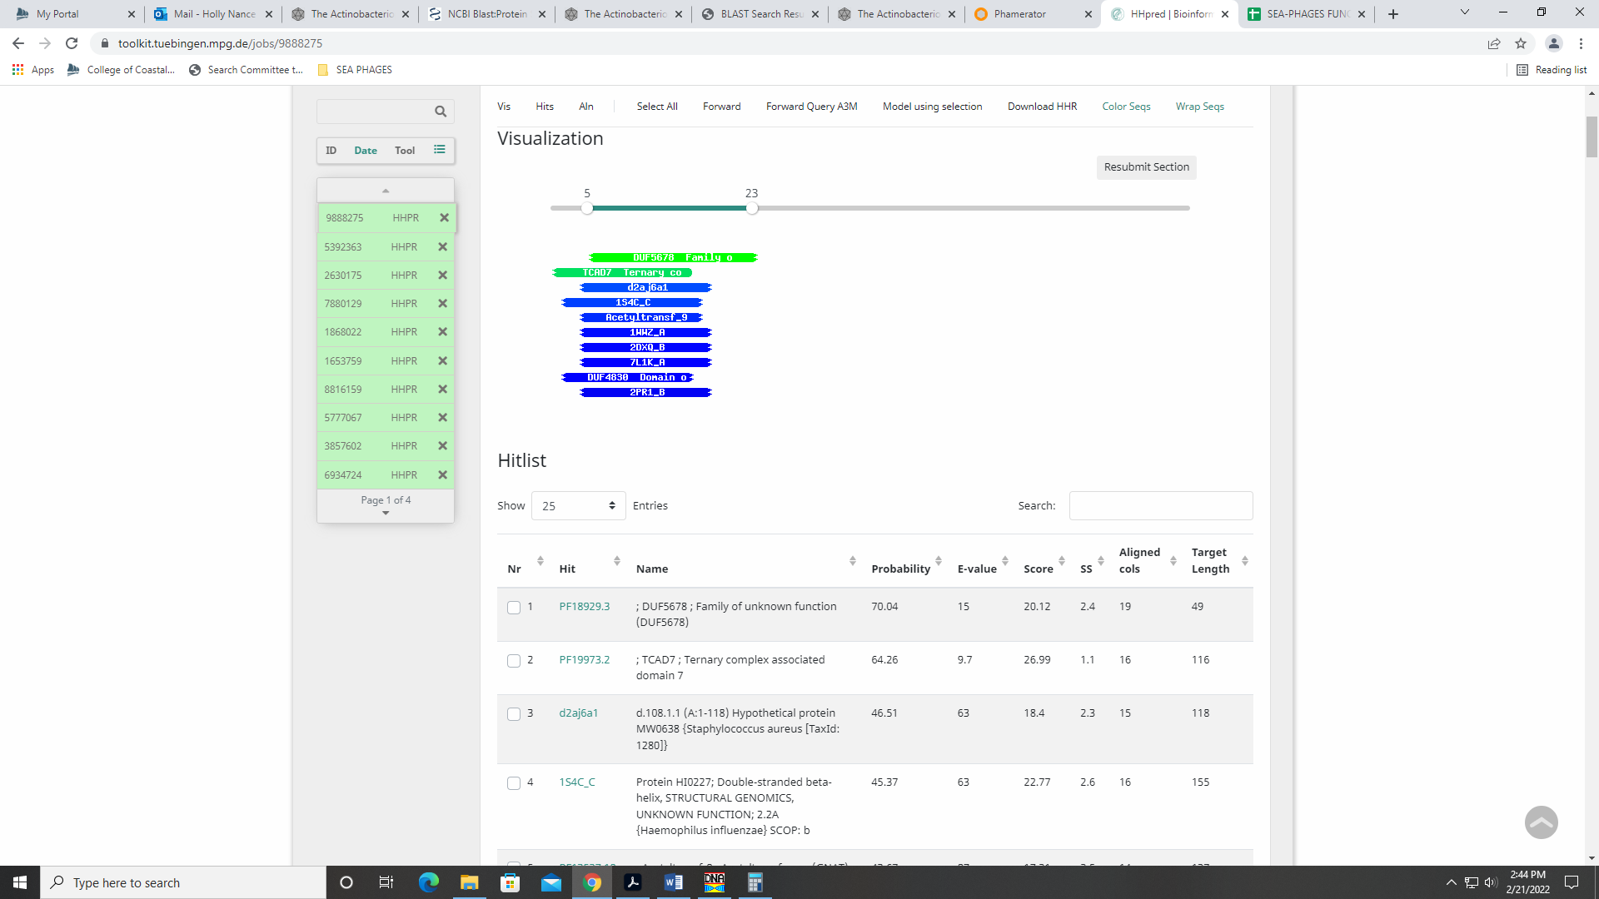
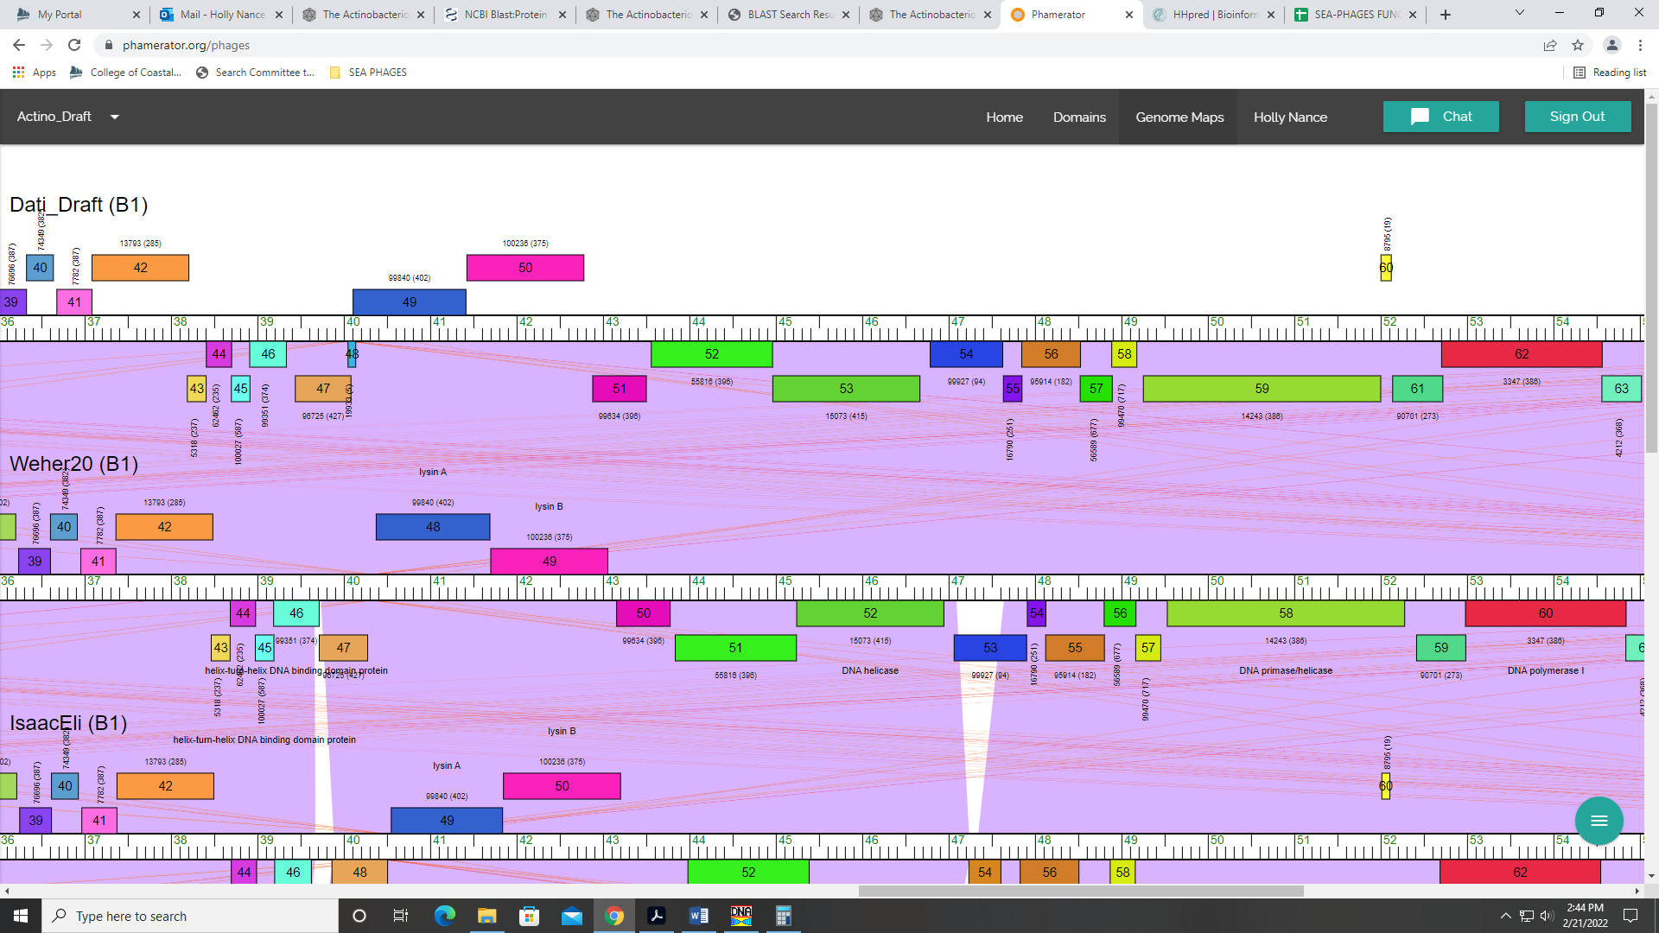

Gene 55 – reverse gene
SSC: start 48526, stop 47846; CP: yes; SCS: GeneMark called start at 48535, went with more conserved Glimmer start of 48526; ST: SS; Blast Start: matches Windsor_55 Query 1 to Subject 1 100% 1e⁻¹³⁵; Gap: overlap of 4; LO: NA; RBS: -3.924, 2.087, 12, -4.760, no; F: NKF; SIF-BLAST: NKF/PhageDB BLAST/ Windsor_55, MT952849/100%/1e⁻¹³⁵; SIF-HHPred: NKF, one match with a probability above 90%, but for NKF; rest of the hits below 90% probability; SIF-Syn: NKF
Notes: The Glimmer start doesn’t yield the longest ORF (the GeneMark start does), but the Glimmer start is the most annotated in Starterator and the best match in BLAST. Also, the Glimmer start yields a shorter overlap with the transcriptionally upstream gene.
For function, all data suggests NKF:
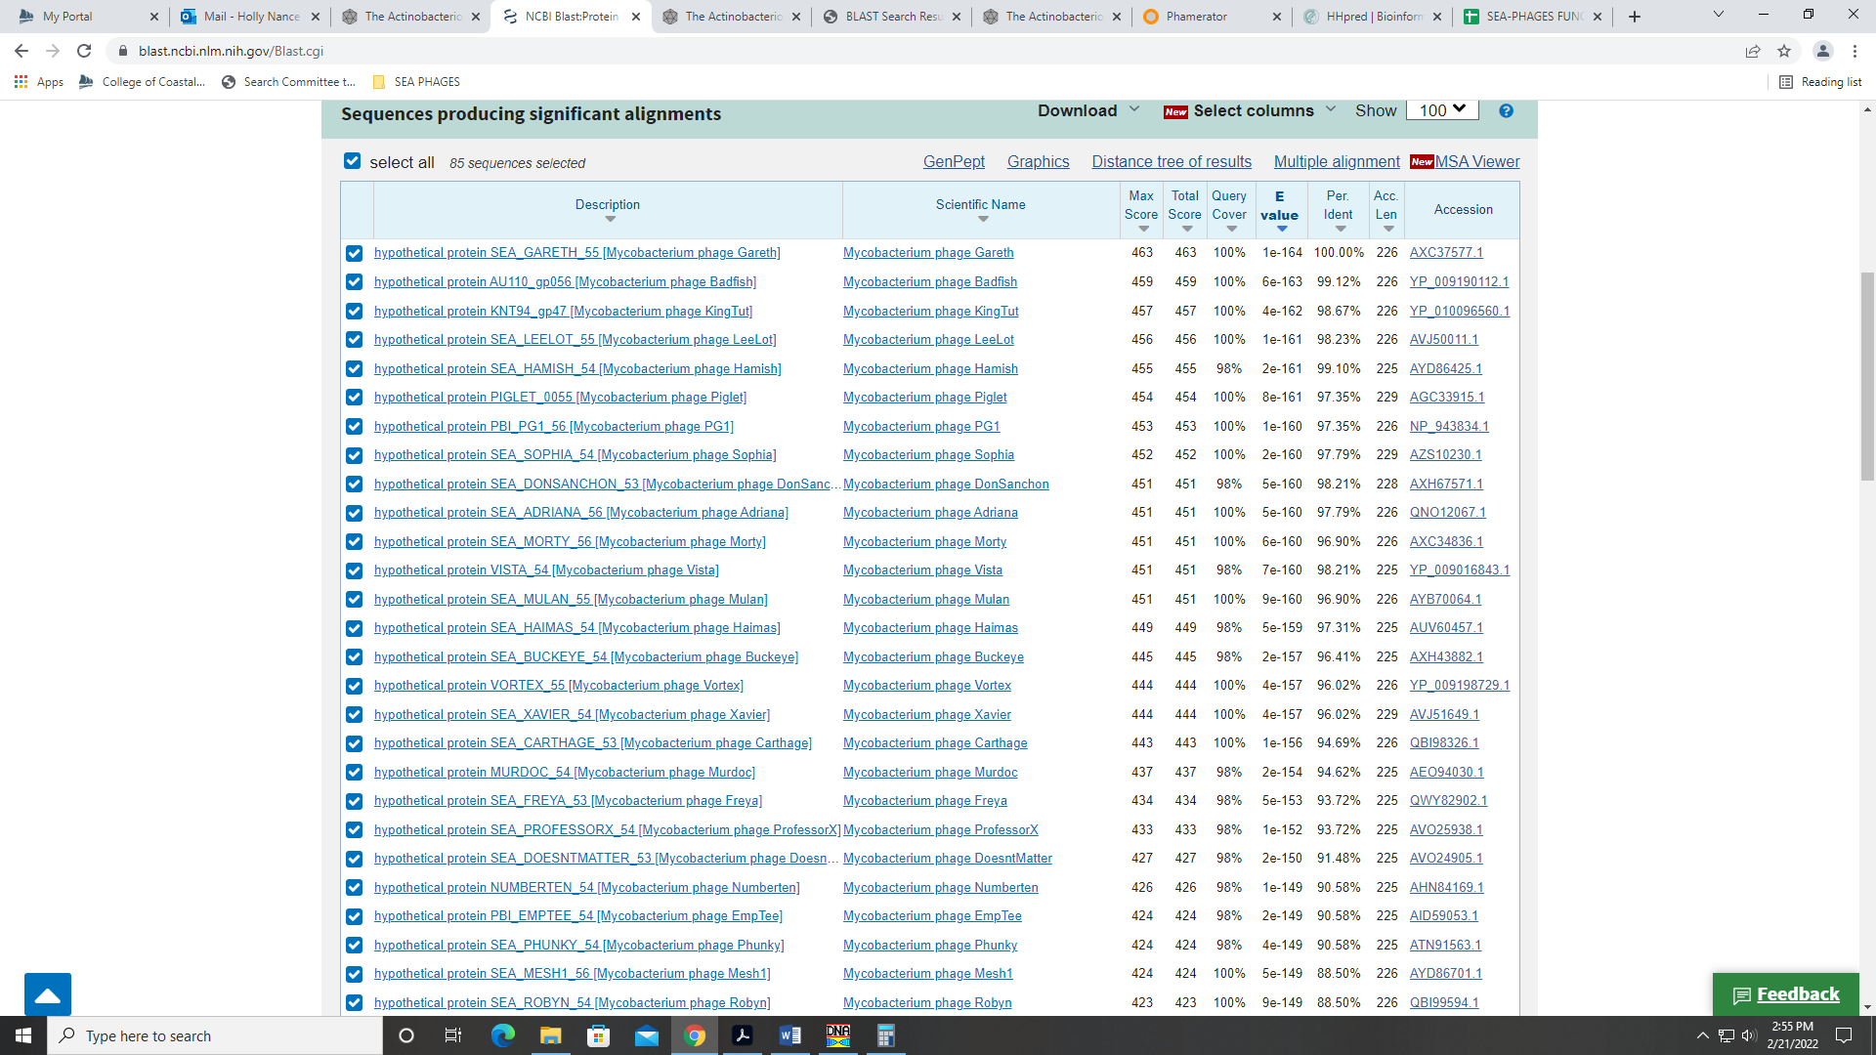
The only HHPred hit above 90% is for a protein of unknown function. All others are below 90%:
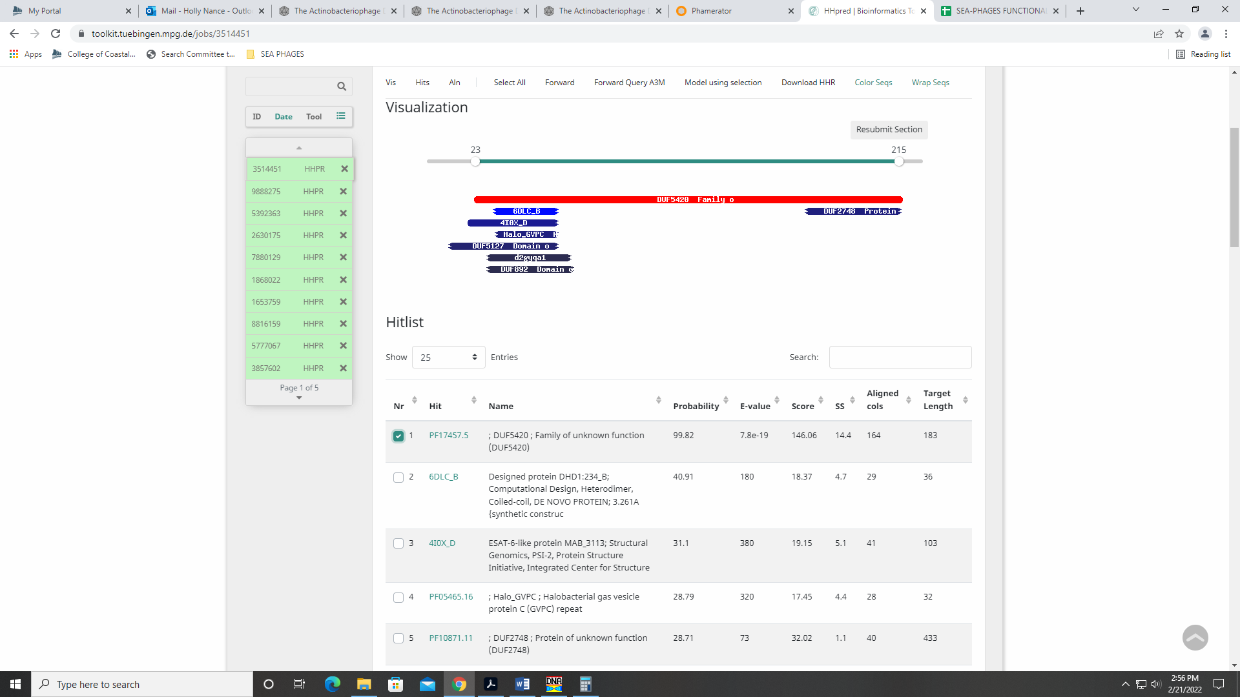

Gene 56 – reverse gene
SSC: start 48894, stop 48523; CP: yes; SCS: Both called start at 48894; ST: SS; Blast Start: matches Yoshand_57 Query 1 to Subject 1 100% 2e⁻⁷⁰; Gap: overlap of 7; LO: NA; RBS: -5.550, 1.277, 15, -7.153, no; F: NKF; SIF-BLAST: NKF/PhageDB BLAST/Yoshand_57, JF937109/100%/2e⁻⁷⁰; SIF-HHPred: NKF, no matches with a probability above 90%; SIF-Syn: NKF
Notes: nothing ambiguous.

Gene 57 – reverse gene
SSC: start 49178, stop 48888; CP: yes; SCS: Both called start at 49178; ST: SS; Blast Start: matches Weher20_57 Query 1 to Subject 1 100% 2e⁻⁵³; Gap: 75; LO: no; RBS: -1.259, 3.416, 11, -2.016, yes; F: NKF; SIF-BLAST: NKF/PhageDB BLAST/Weher20_57, MZ681520/100%/2e⁻⁵³; SIF-HHPred: NKF, no matches with a probability above 90%; SIF-Syn: NKF
Notes: nothing ambiguous. This start is most conserved across phamily, but doesn’t yield the longest ORF.

Gene 58 – reverse gene
SSC: start 52001, stop 49254; CP: yes; SCS: Both called start at 52001; ST: SS; Blast Start: matches Weher20_58 Query 1 to Subject 1 100% 0.0; Gap: 2; LO: NA; RBS: -2.426, 2.834, 9, -3.201, yes; F: DNA primase/helicase; SIF-BLAST: DNA primase/helicase /PhageDB BLAST/Weher20_58, MZ681520/100%/0.0; SIF-HHPred: DNA primase/helicase, several matches with a probability above 90%; SIF-Syn: DNA primase/helicase
Notes: Start supported by PhageDB BLAST and Starterator. For function, both PhageDB and NCBI BLAST support DNA helicase/primase:
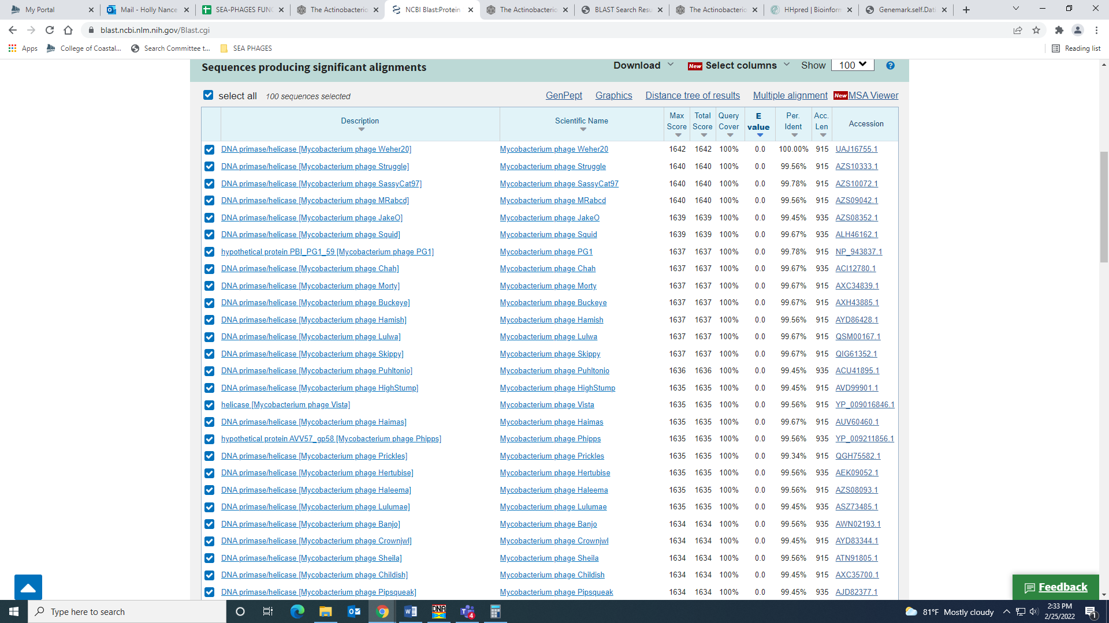
HHPred has several hits with either or both DNA primase or helicase:
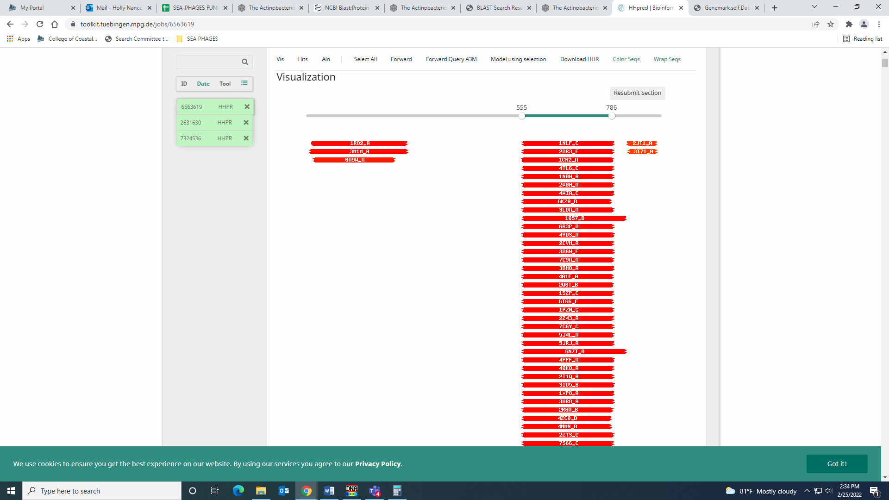
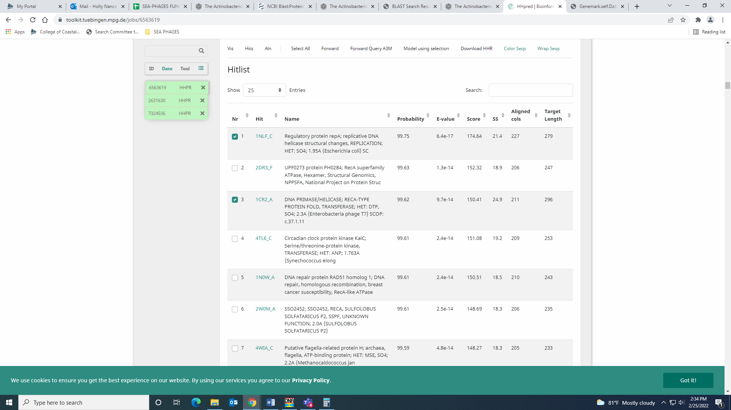
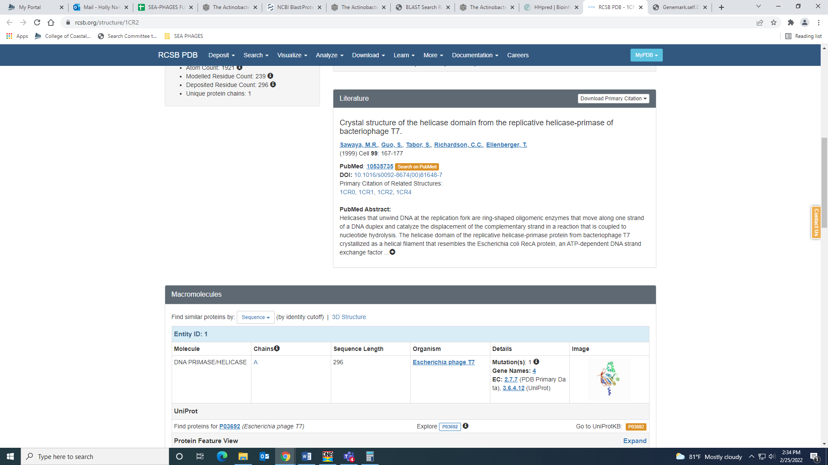
Several domains in this gene in Phamerator, including primase and helicase domains:
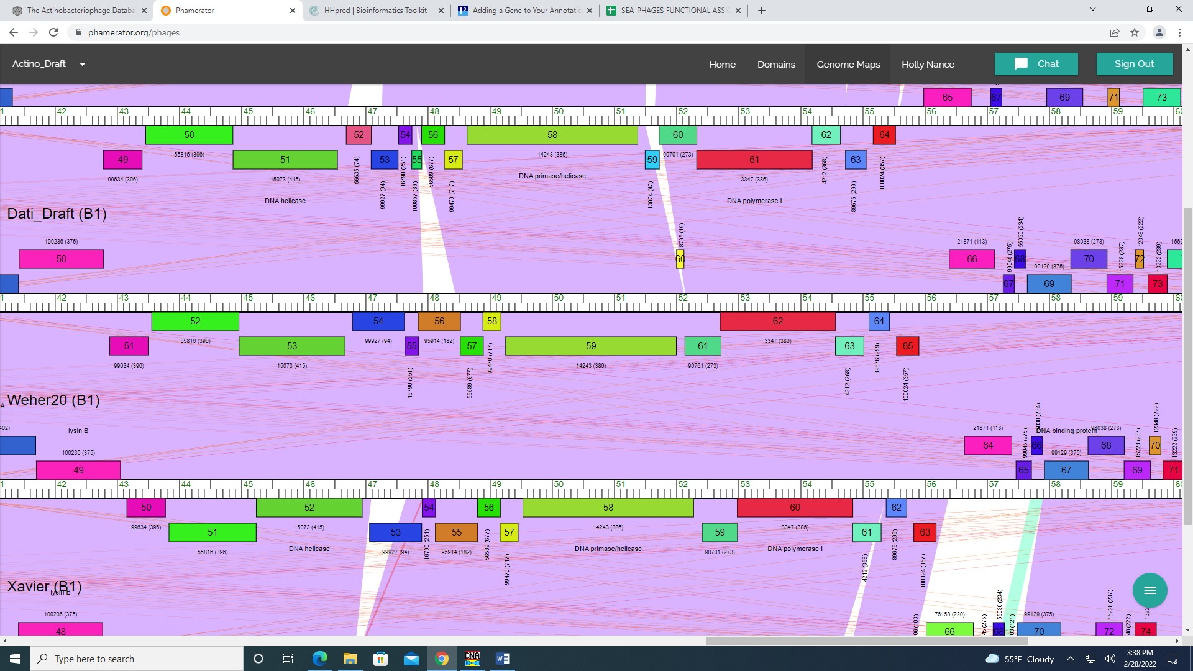

Gene 59 – reverse gene – Changed start to GeneMark start of 52708 per rest of class, 3.28.22
SSC: start 52708, stop 52139; CP: yes; SCS: Glimmer called start at 52720, went with GeneMark start of 52708 as this was consensus of the rest of the class; ST: SS; Blast Start: matches Weher20_59 Query 1 to
Subject 1 100% 1e-110; Gap: 137; LO: no; RBS: -4.891, 2.455, 9, -3.961, no; F: NKF; SIF-BLAST: NKF / PhageDB BLAST / Weher20_59, MZ681520 / 100% / 1e-110; SIF-HHPred: NKF, multiple matches with a probability above 90%; SIF-Syn: NKF
Notes (from Naomi and Team Purine): Starterator start 12 (original) is called 21.6% of the time, start 13 (changed) called 77.9% of the time. Changing start produces slightly better BLAST output (original 5:1, changed 1:1 for normal matches such as phages Weher20 and Zelda). 1 HHpred match for protein of unknown function. Original start had better RBS value.
Function was unambiguous; NKF:
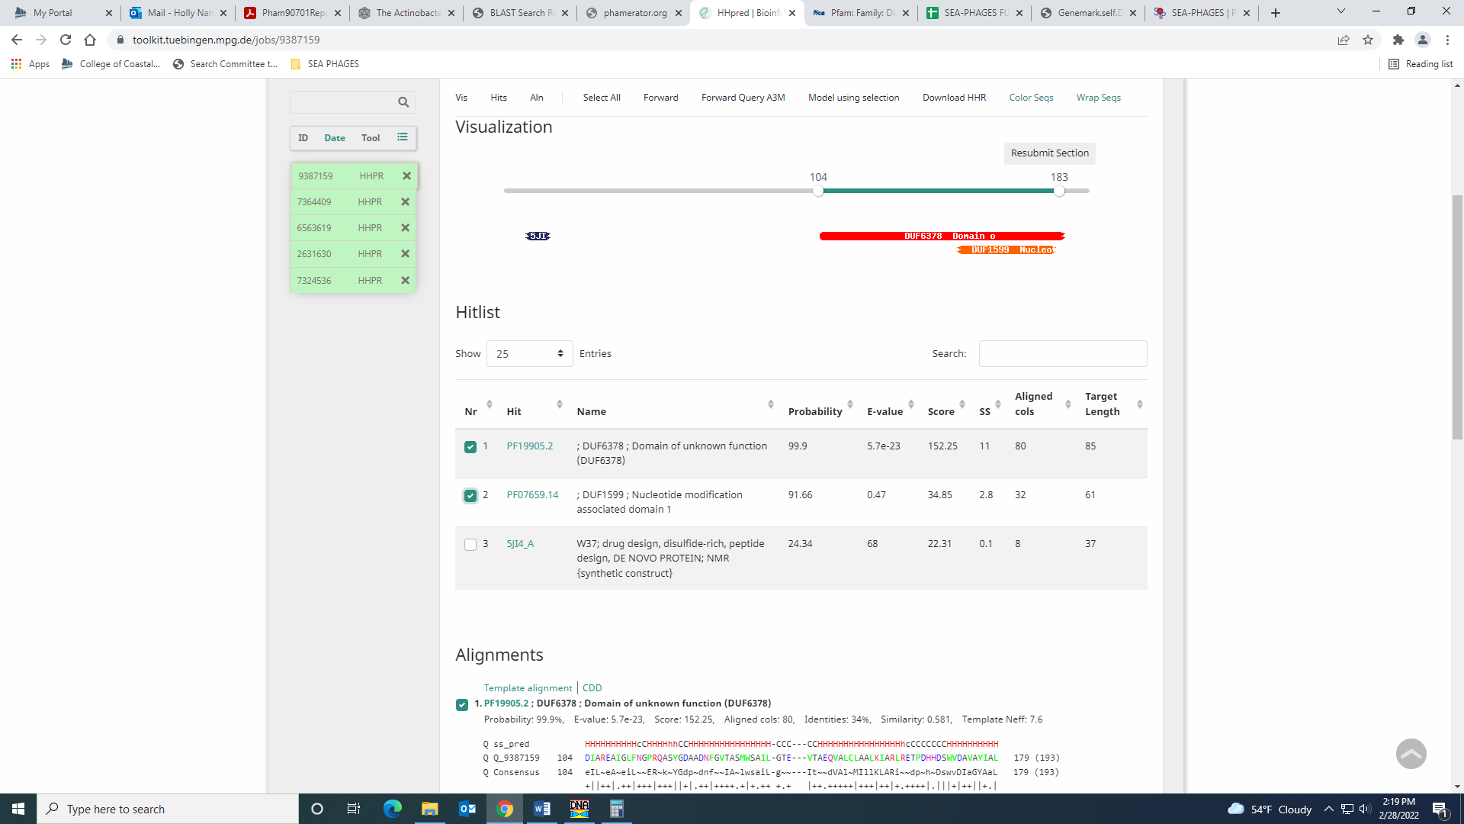

Gene 60 – reverse gene
SSC: start 54564, stop 52705; CP: yes; SCS: GeneMark called start at 54540, went with more conserved Glimmer start of 54564; ST: SS; Blast Start: matches Weher20_60 Query 1 to Subject 1 100% 0.0; Gap: overlap of 4; LO: NA; RBS: -4.131, 1.985, 11, -4.888, no; F: DNA polymerase I; SIF-BLAST: DNA polymerase I /PhageDB BLAST/ Weher20_60, MZ681520/100%/0.0; SIF-HHPred: DNA polymerase I, several matches with a probability of 100%; SIF-Syn: DNA polymerase I
Notes: Glimmer start is the most conserved and yields the longest ORF. Function is supported by PhageDB BLAST and HHPred, with several hits for either DNA polymerase I or a different kind of DNA polymerase:
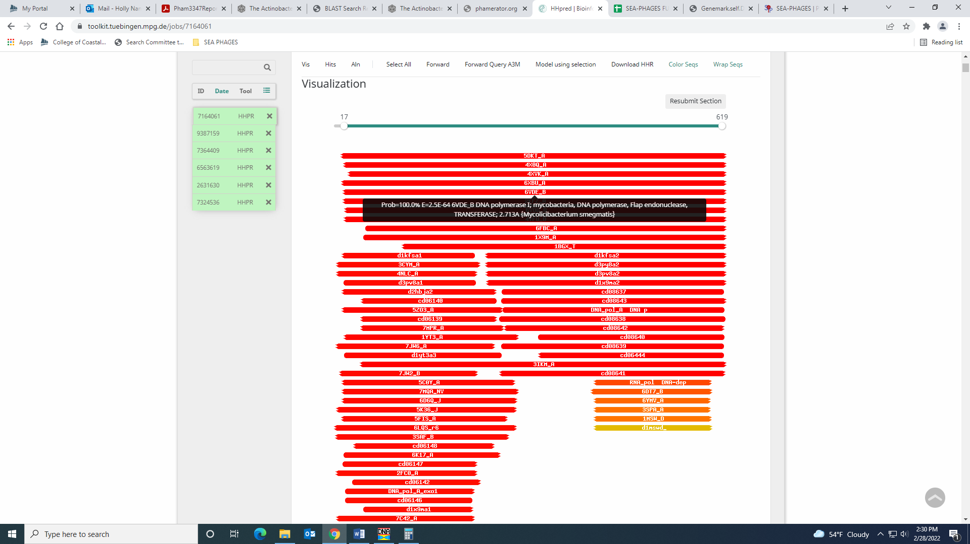
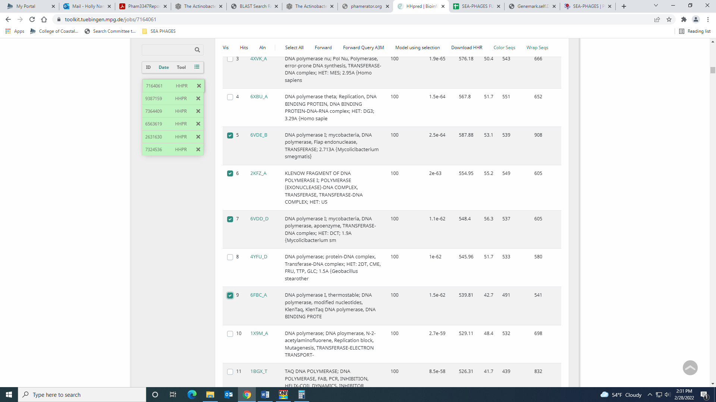
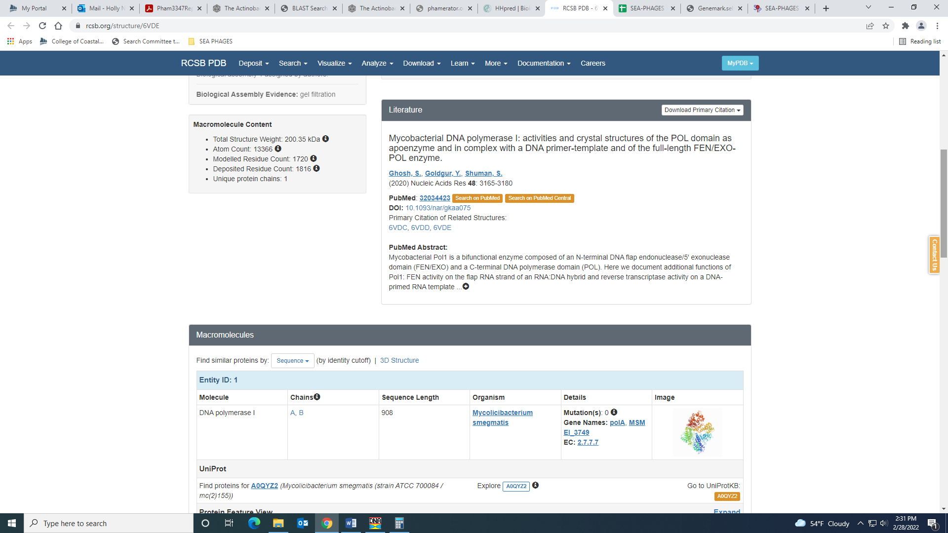

Gene 61 – reverse gene
SSC: start 55019, stop 54561; CP: yes; SCS: Both called start at 55019; ST: SS; Blast Start: matches Weher20_61 Query 1 to Subject 1 99% 5e⁻⁸⁵; Gap: 80; LO: yes; RBS: -4.853, 1.624, 12, -5.689, no; F: NKF; SIF-BLAST: NKF/PhageDB BLAST/ Weher20_61, MZ681520/99%/5e⁻⁸⁵; SIF-HHPred: NKF, no matches with a probability above 90%; SIF-Syn: NKF
Notes: nothing ambiguous here!

Gene 62 – reverse gene
SSC: start 55432, stop 55100; CP: yes; SCS: Both called start at 55432; ST: SS; Blast Start: matches Weher20_62 Query 1 to Subject 1 100% 8e⁻⁶²; Gap: 112; LO: no; RBS: -2.814, 2.641, 14, -4.161, yes; F: NKF; SIF-BLAST: NKF/PhageDB BLAST/ Weher20_62, MZ681520/100%/8e⁻⁶²; SIF-HHPred: NKF, no matches with a probability above 90%; SIF-Syn: NKF
Notes: There is a large gap between this gene and the next, but there is a lot of support for this start (best RBS values, most annotated start in Starterator, several 1:1 hits in BLAST and no indication of coding potential with other starts based on GeneMark output. Gap conserved in Phamerator.

Gene 63 – reverse gene
SSC: start 55904, stop 55545; CP: yes; SCS: Both called start at 55904; ST: SS; Blast Start: matches Weher20_63 Query 1 to Subject 1 100% 1e⁻⁶⁵; Gap: 487; LO: yes; RBS: -5.414, 1.345, 5, -7.414, no; F: NKF; SIF-BLAST: NKF/PhageDB BLAST/ Weher20_63, MZ681520/100%/1e⁻⁶⁵; SIF-HHPred: NKF, no matches with a probability above 90%; SIF-Syn: NKF
Notes: Nothing ambiguous here, EXCEPT there’s a huge gap after this gene and the next forward gene. This gap is also reflected in PhageDB (they didn’t call a gene that our auto annotation missed). Large gap conserved in Phamerator. There are some ORFs in the forward direction based on the GeneMark output, but no coding potential was recognized.
Soraya checked this gap: The 454 bp gap between genes 65 and 66 has no gene. The closest Blast match was 20 to 1 97% 2e-35 and NFK. There was no function called in HHpred or in the Phamerator on the phages that did call a gene on that gap. The gap was mostly conserved throughout the phages in cluster B1. The Genemark output also did not recognize any coding potential in the area where the gap was. From this information, we concluded that there is likely no gene in this gap.

Gene 64 – changed start from 56392 to 56359 on 3.9.22!
SSC: start 56359, stop 57123; CP: yes; SCS: Both called start at 56392, but went with more conserved Starterator start of 56359; ST: SS; Blast Start: matches Zonia_67 Query 1 to Subject 1 100% 1e⁻¹⁴⁸; Gap: 454; LO: no; RBS: -4.305, 1.898, 10, -5.000, no; F: NKF; SIF-BLAST: NKF/PhageDB BLAST/ Zonia_67, KM363597/100%/1e⁻¹⁴⁸; SIF-HHPred: NKF, no matches with a probability above 90%; SIF-Syn: NKF
Notes: Changed start to 56359 on 3.9 as this start yielded a longer ORF, it was the most annotated start in Starterator, and yielded more 1:1 query:subject hits on BLAST (including those phage that Dati seems most similar to). This start was not called by either Glimmer or GeneMark, and it doesn’t have the best RBS values, but there is already such a large gap between this gene and Gene 65 that a longer ORF is preferable here, especially if the start is the most annotated. (see large gap below)
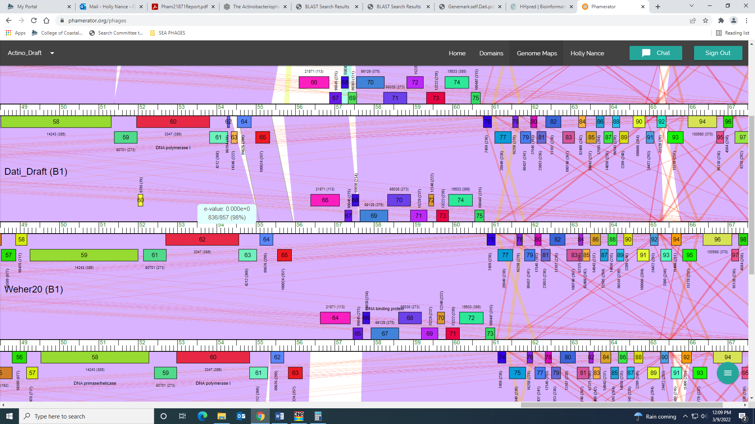
Function was NKF, and conserved across other phage in B1.

Gene 65
SSC: start 57259, stop 57438; CP: yes; SCS: Glimmer and Genemark called start at 57259 ST: SS; Blast Start: matches Sheila_64 Query 1 to Subject 1 100% 3e-28; Gap: 135 LO: no; --3.115, 2.491, 10, -3.810 yes F: ribbon-helix-helix DNA binding protein; SIF-BLAST: ribbon-helix-helix DNA bidning protein /PhageDB BLAST/Phareon_66/ MF919530/100%/3e-28/ SIF-HHPred: ribbon-helix-helix DNA binding protein with probability over 90% SIF-Syn: NKF

Notes: Grace researched this one and her final notes are above!
Calling this start was tricky. Both Glimmer and GeneMark called 57259, and this start was called 25% of the time in Starterator. The most annotated start was not present in this gene in Dati. Another start that would have yielded a longer ORF was only called 13% of the time when present in Starterator. Both of these starts yielded plenty of 1:1 Q:S hits in BLAST, so I went with the original start (though it leaves a much larger gap; 135 BP vs 66 BP). I don’t know… I maybe persuaded to change it?
Function was tricky for this gene, too! While most BLAST hits were NKF, there were several that called it ribbon-helix-helix DNA binding domain protein and this hit came up several times in HHPred:
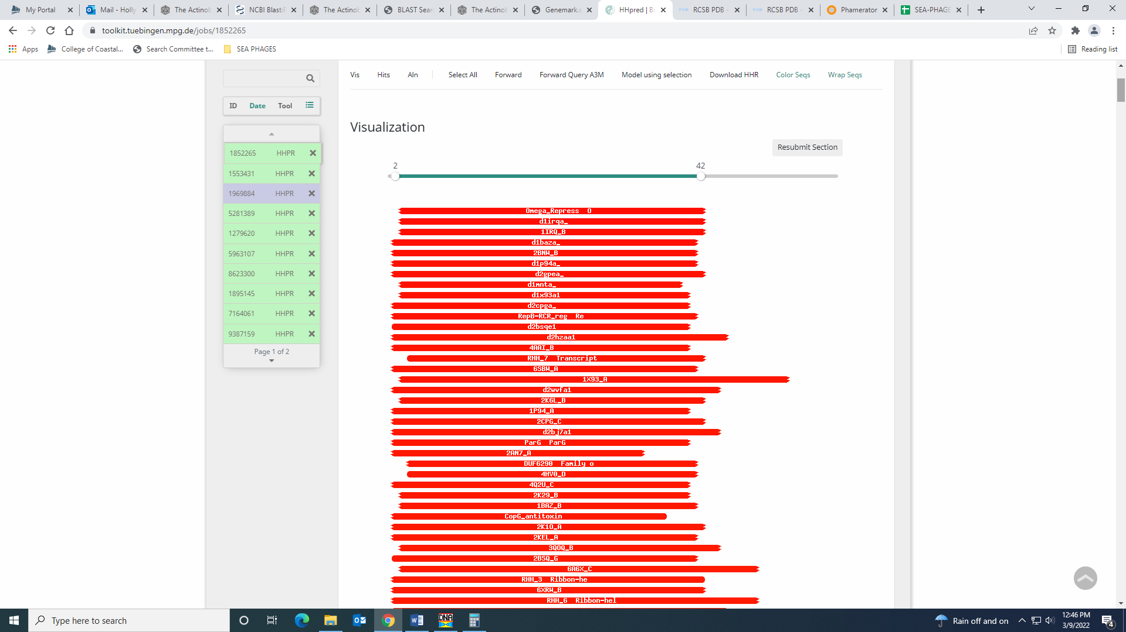
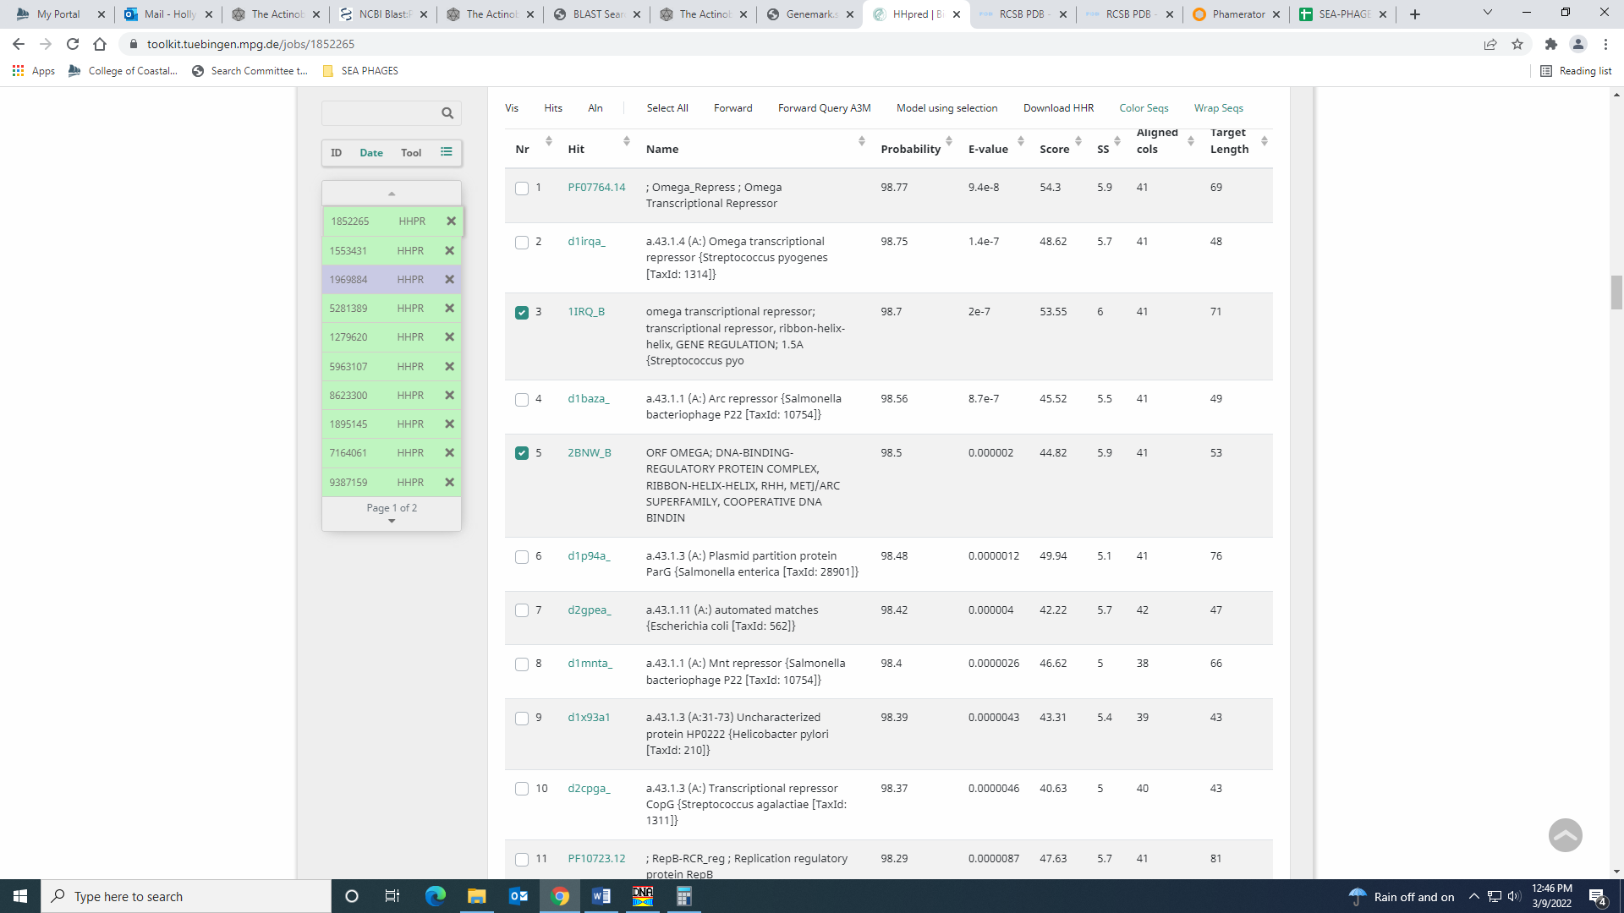
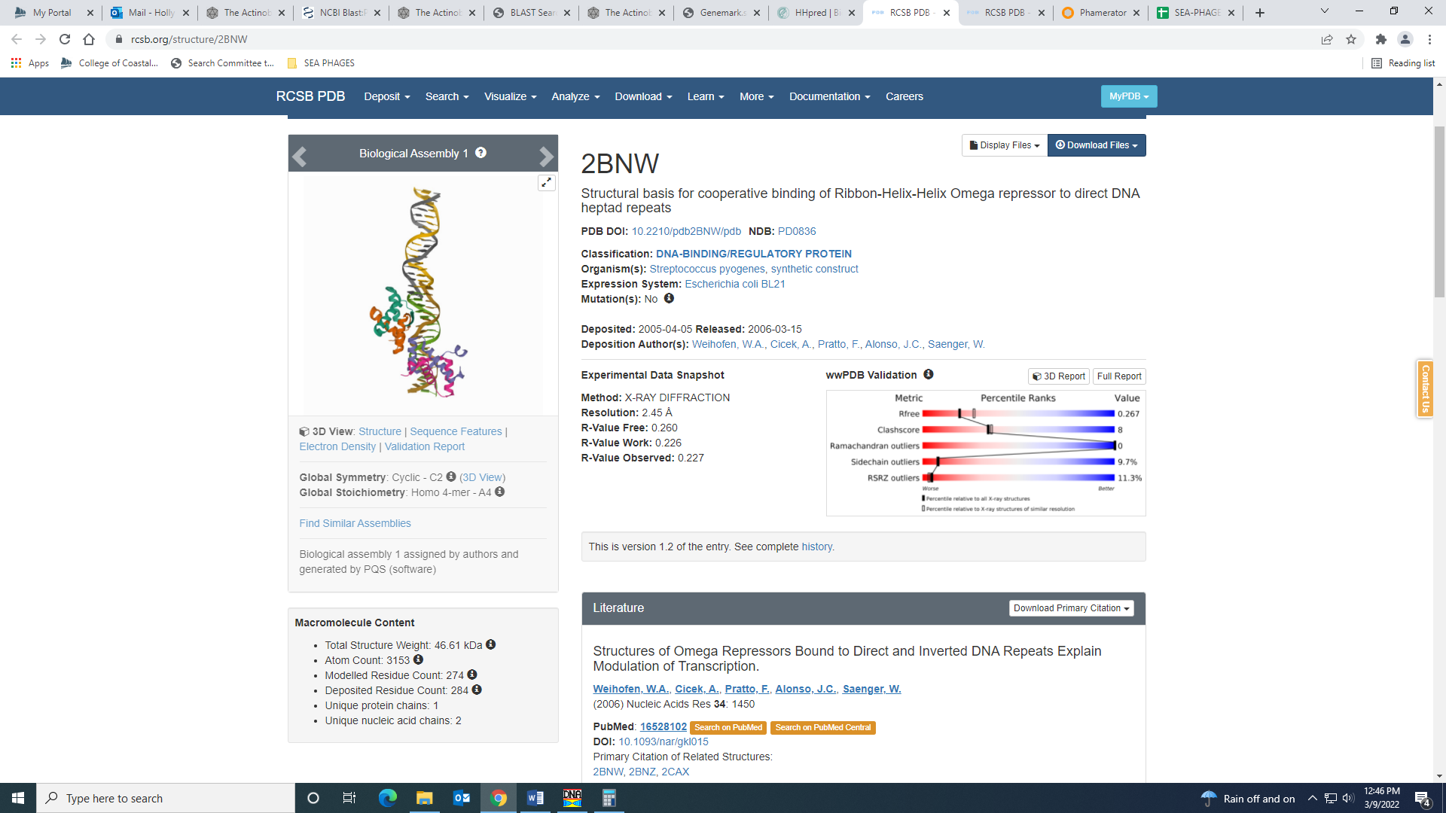
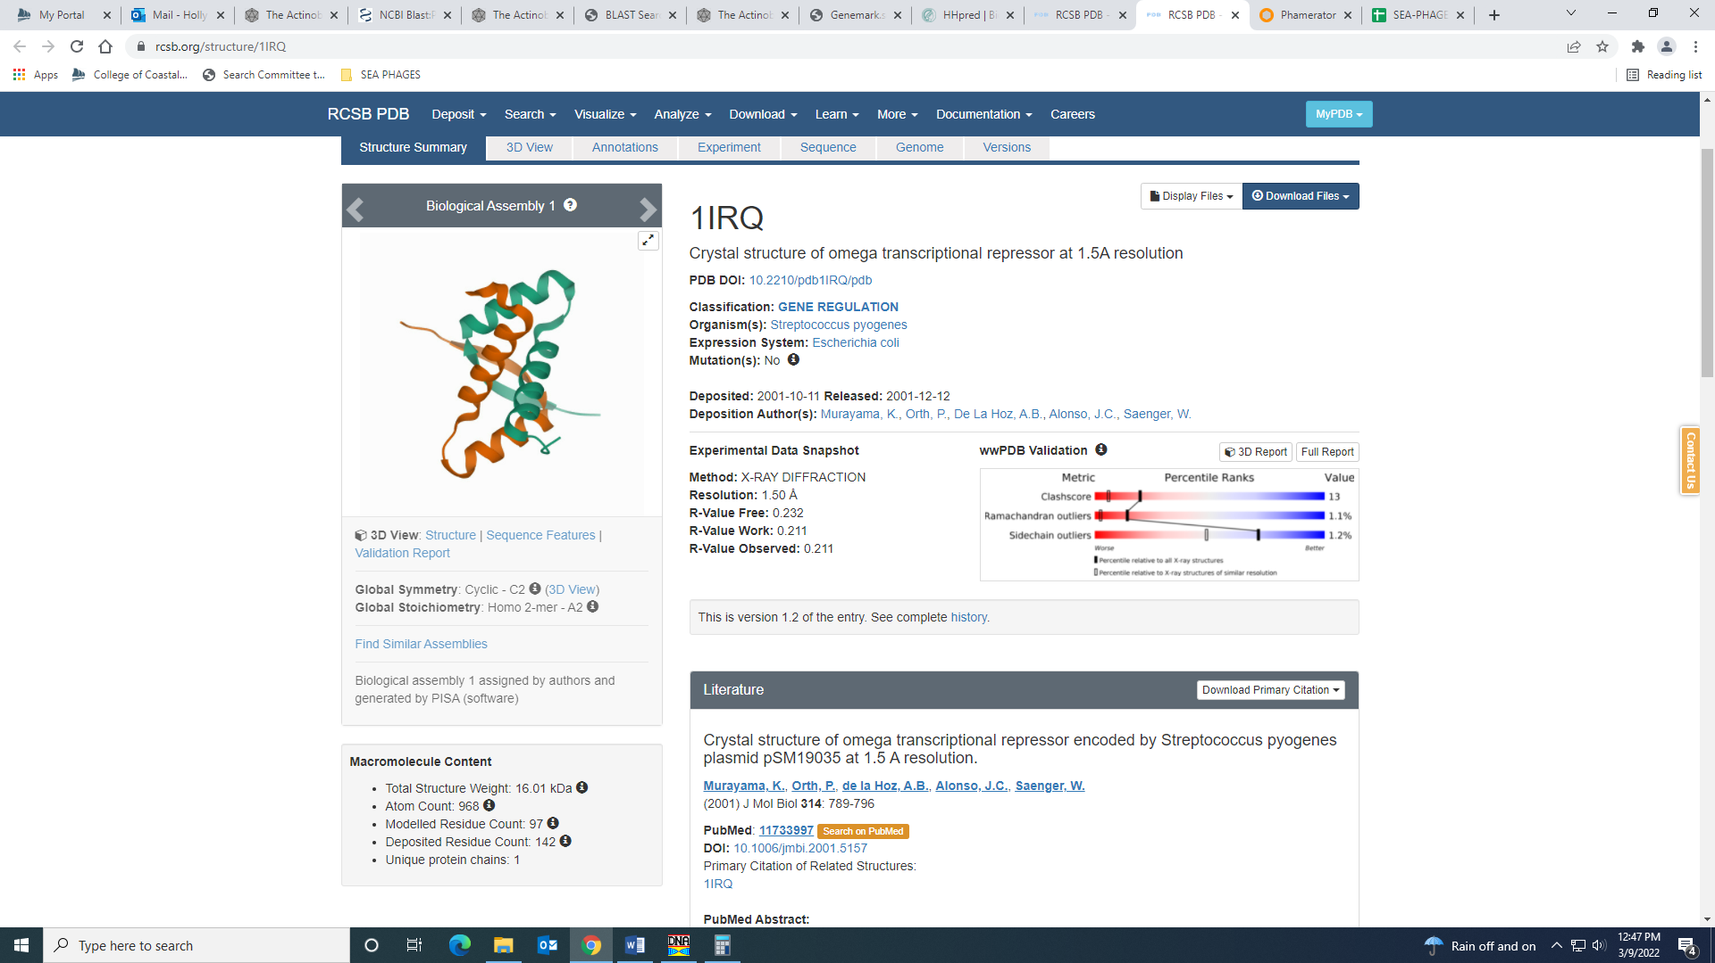
Both PhageDB abd NCBI BLAST has some hits for this function:
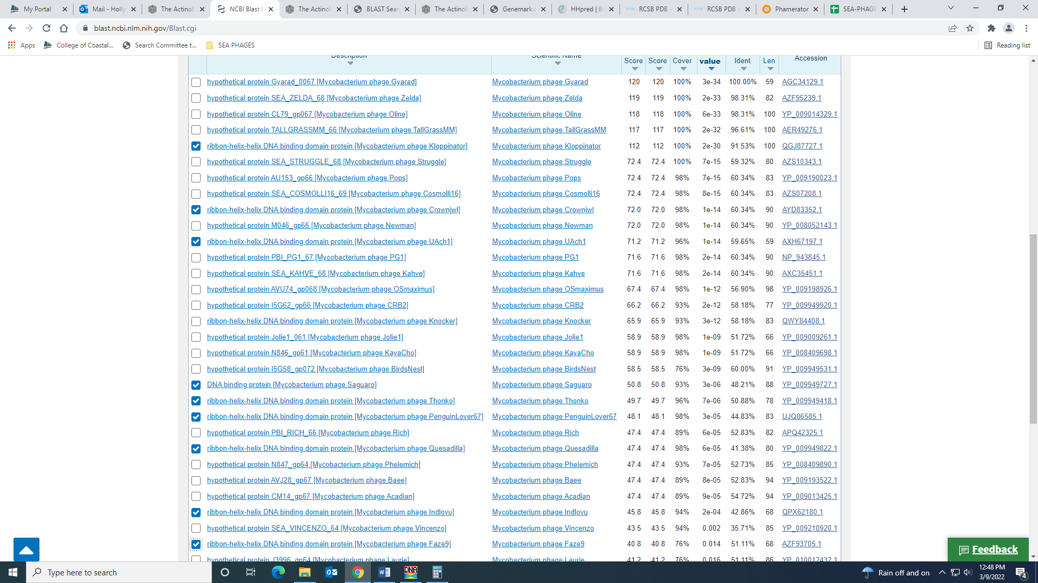
It wasn’t the most common function call, but there isn’t a good reason to not call it this.

Gene 66 – changed start from 57441 to 57435 on 9.3.22!
SSC: start 57435, stop 57617; CP: yes; SCS: Glimmer called start at 57441, went with more conserved GeneMark start of 57435; ST: SS; Blast Start: matches Zonia_69 Query 1 to Subject 1 100% 6e⁻³¹; Gap: overlap of 4; LO: NA; RBS: -3.652, 2.223, 8, -4.874, no; F: NKF; SIF-BLAST: NKF/PhageDB BLAST/ Zonia_69, KM363597/100%/6e⁻³¹; SIF-HHPred: NKF, no matches with a probability above 90%; SIF-Syn: NKF
Notes: The start I changed it to (57435 on 3.9.22) was called by GeneMark, yields a longer ORF and is the most annotated start in Starterator. The RBS values for this start and the one called by Glimmer are identical.

Gene 67
SSC: start 57648, stop 58355; CP: yes; SCS: Both called start at 57648; ST: SS; Blast Start: matches Veritas_69 Query 1 to Subject 1 100% 1e⁻¹³¹; Gap: 30; LO: yes; RBS: -3.079, 2.509, 14, -4.426, no; F: helix-turn-helix DNA binding domain protein; SIF-BLAST: helix-turn-helix DNA binding domain protein /PhageDB BLAST/Chaelin_71, MT310867/100%/1e⁻¹³¹; SIF-HHPred: DNA binding protein, a few matches with a probability above 90%; SIF-Syn: helix-turn-helix DNA binding domain protein
Notes: Naomi worked on this and determined the function is helix-turn-helix DNA binding domain protein.
Nothing ambiguous about this start – it is the most conserved and yields the longest ORF.
For function, there are hits for NKF, DNA binding protein and helix-turn-helix DNA binding protein. I went with DNA binding protein as there are several matches with this function in both PhageDB and NCBI BLAST:
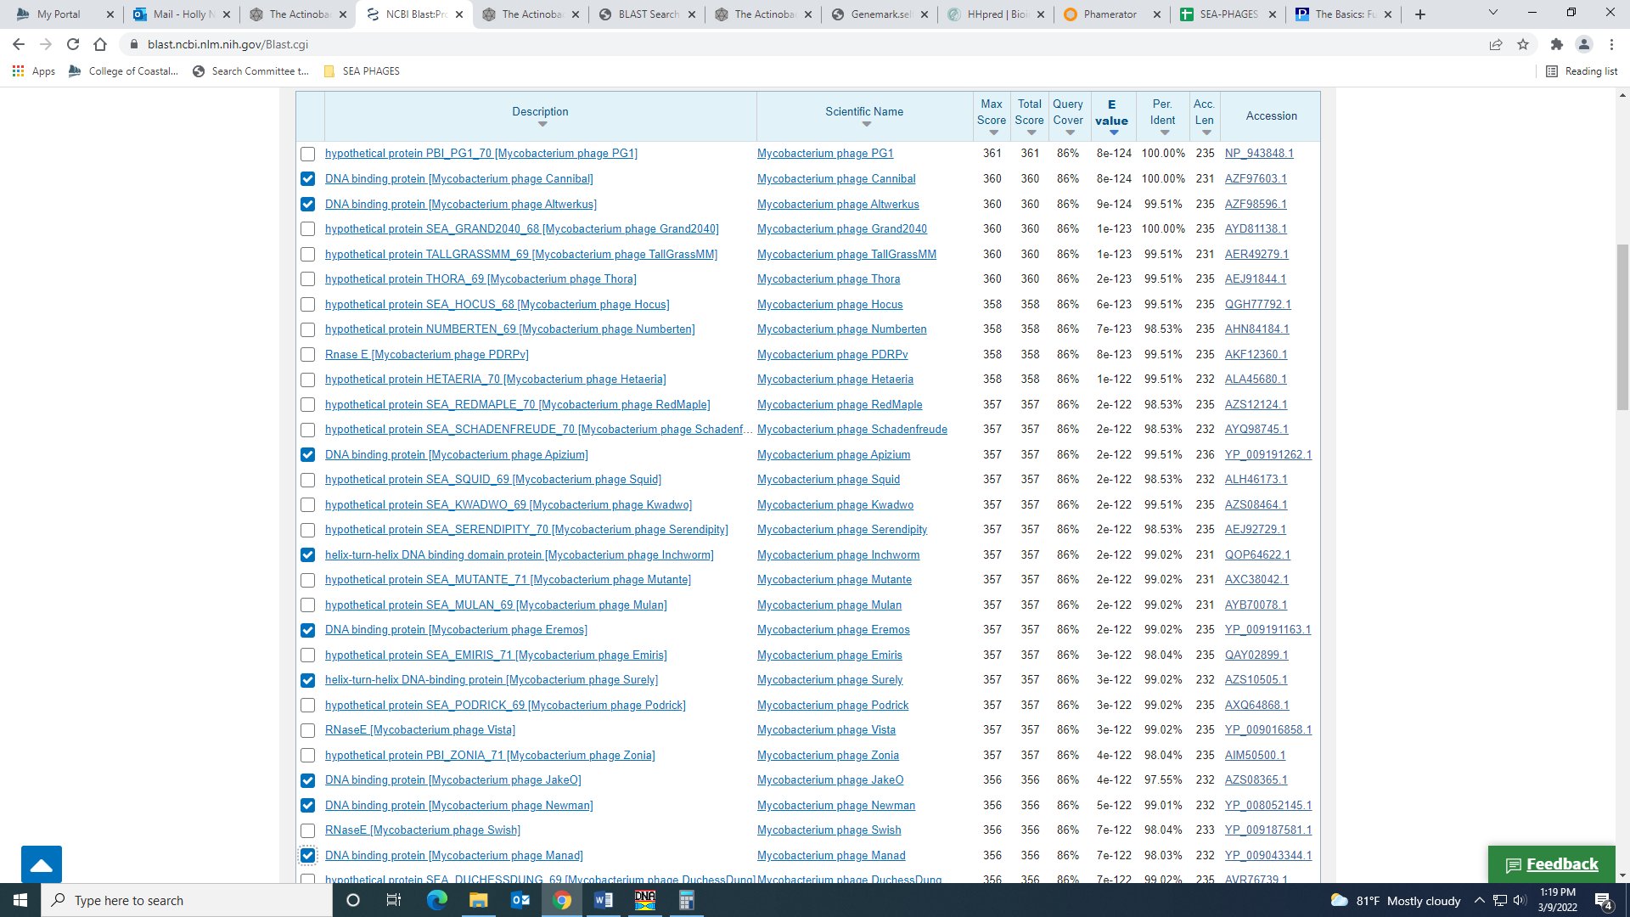
Also, there were several hits with a probability above 90% for a variety of functions in HHPred:
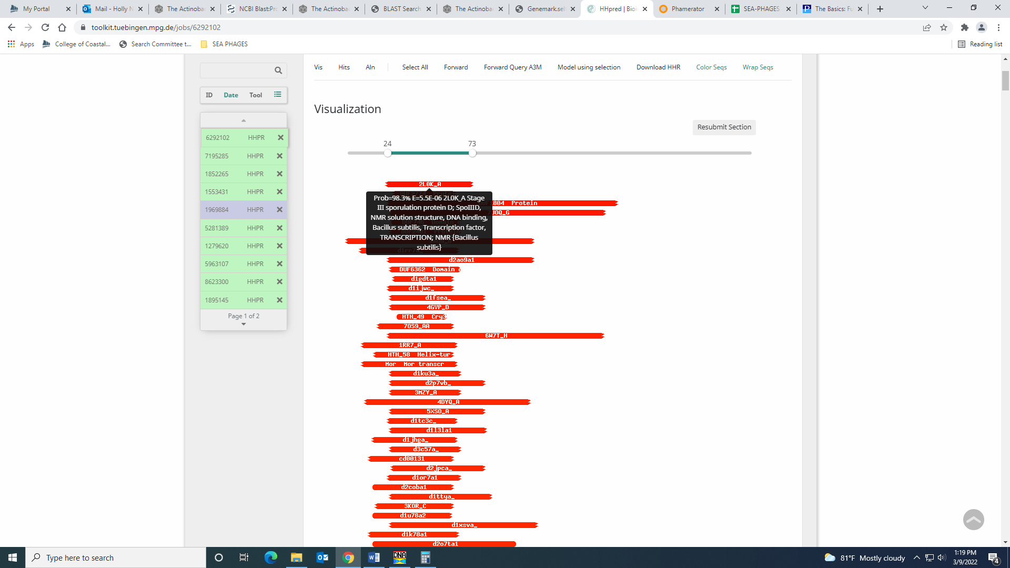
The top hit is a partial hit for a DNA binding protein:
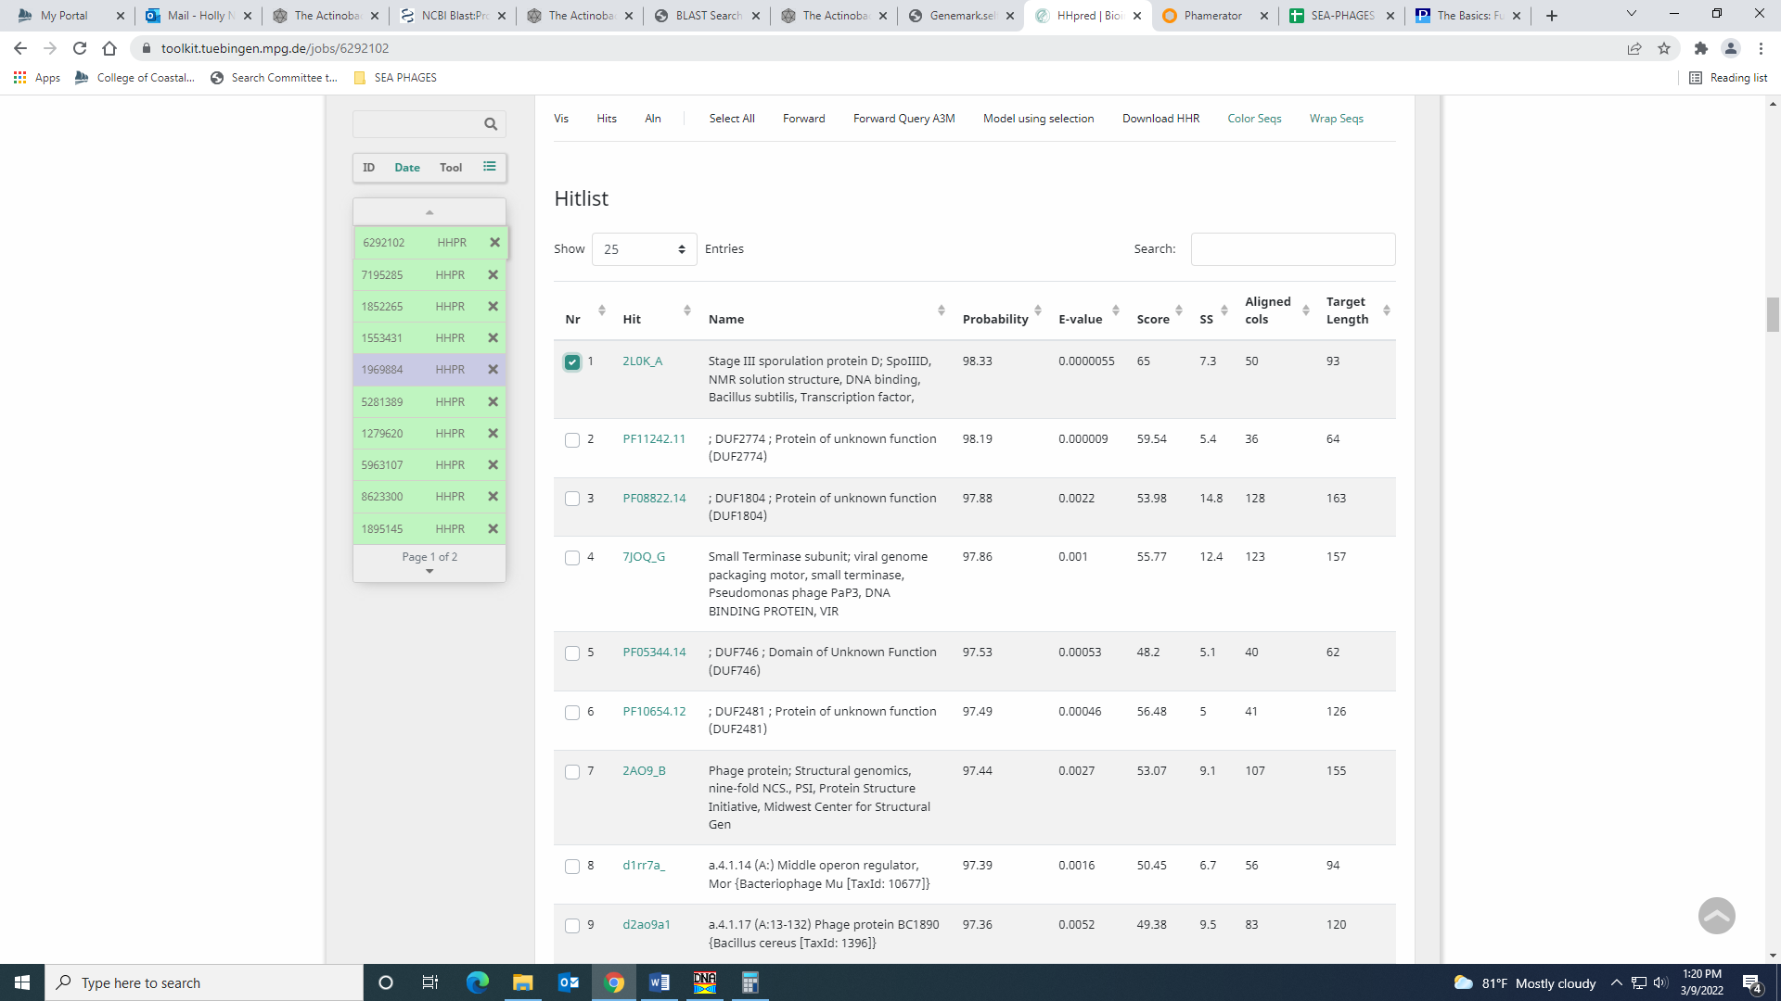
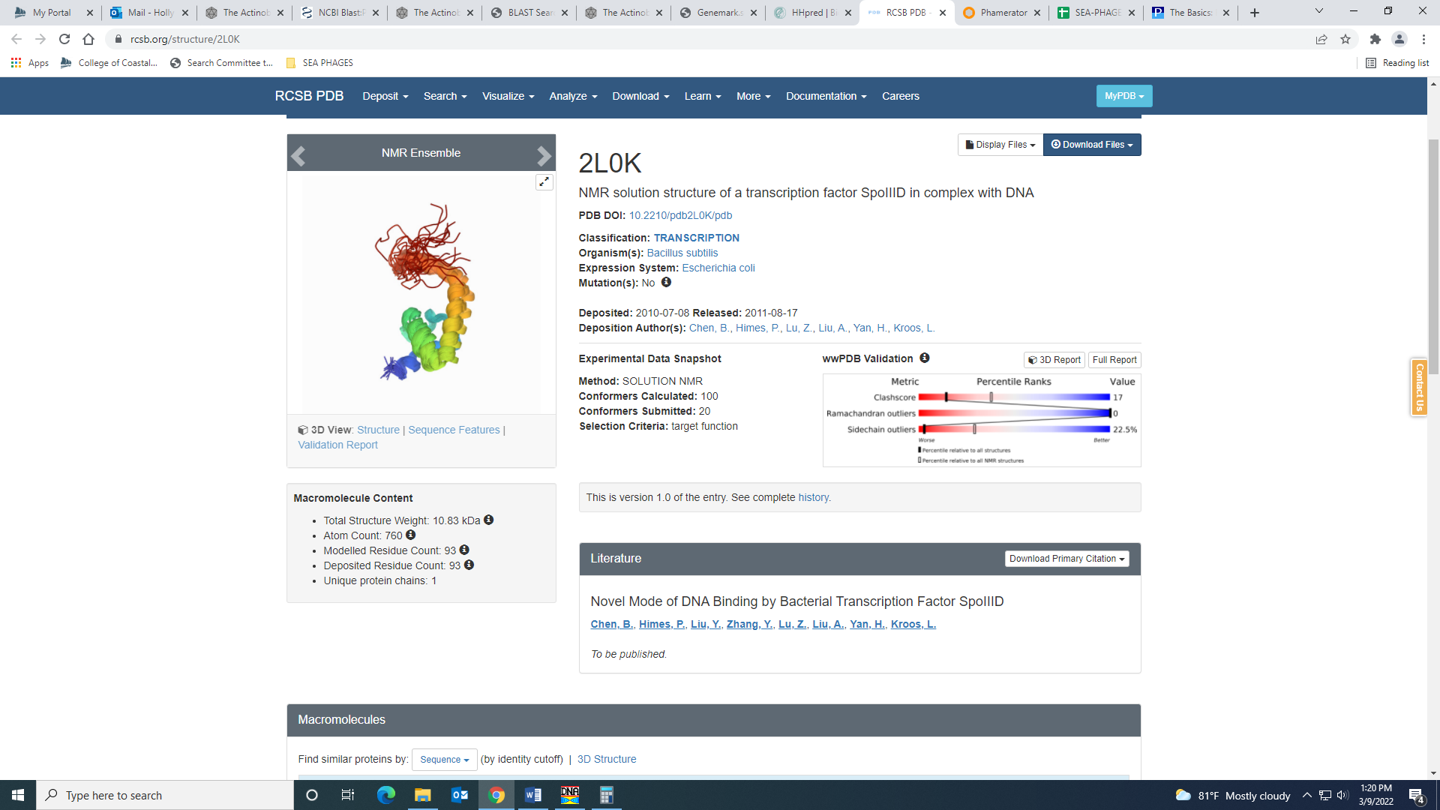
The e-values are not great for other high probability hits, and I can’t see a reason to call it something more specific (like helix-turn-helix) when the hit is partial anyway in HHPred. We’ll see what the rest of the class thinks…

Gene 68
SSC: start 58348, stop 58932; CP: yes; SCS: GeneMark called start at 58336, went with more conserved Glimmer start of 58348; ST: SS; Blast Start: matches Hamish_68 Query 1 to Subject 1 100% 1e⁻¹¹²; Gap: overlap of 8; LO: NA; RBS: -4.960, 1.571, 8, -6.182, no; F: NKF; SIF-BLAST: NKF/PhageDB BLAST/ Hamish_68, MH825702/100%/1e⁻¹¹²; SIF-HHPred: NKF, no matches with a probability above 90%; SIF-Syn: NKF
Notes: The Glimmer start is the most annotated in Starterator, though it yields a slightly shorter ORF. Also, this Glimmer start is the codon TTG (the rarest). This start results in an overlap, but the GeneMark start has an even longer overlap (19 bp). There is strong support for this start in both Starterator and BLAST, so I’m going with the Glimmer start.
Function is NKF – not ambiguous.

Gene 69
SSC: start 58929, stop 59351; CP: yes; SCS: Both called start at 58929; ST: SS; Blast Start: matches Zelda_72 Query 1 to Subject 1 100% 7e⁻⁷⁷; Gap: overlap of 4; LO: NA; RBS: -3.079, 2.509, 12, -3.915, no; F: NKF; SIF-BLAST: NKF/PhageDB BLAST/ Zelda_72, MK112555/100%/7e⁻⁷⁷; SIF-HHPred: NKF, no matches with a probability above 90%; SIF-Syn: NKF
Notes: nothing ambiguous here!

Gene 70 – changed start from 59392 to 55335 on 3.9.22!
SSC: start 59335 stop 59520; CP: yes; SCS: Both called start at 59392, but went with more conserved Starterator start of 59335 that yields a longer ORF; ST: SS; Blast Start: matches Zaider_74 Query 1 to Subject 1 100% 1e⁻³⁴; Gap: overlap of 17; LO: NA; RBS: -3.457, 2.321, 9, -4.231, no; F: NKF; SIF-BLAST: NKF/PhageDB BLAST/ Zaider_74, MK279895/100%/1e⁻³⁴; SIF-HHPred: NKF, no matches with a probability above 90%; SIF-Syn: NKF
Notes: Changed start to 59335 on 3.9.99. This start yields an overlap of 17 bp, whereas the original start yielded a gap of 40 bp. This start is the most annotated in Starterator, and has support in BLAST with several 1:1 Q:S hits. This start also looks like it has coding potential in GeneMark, and this gene looks longer in other phage in Phamerator:
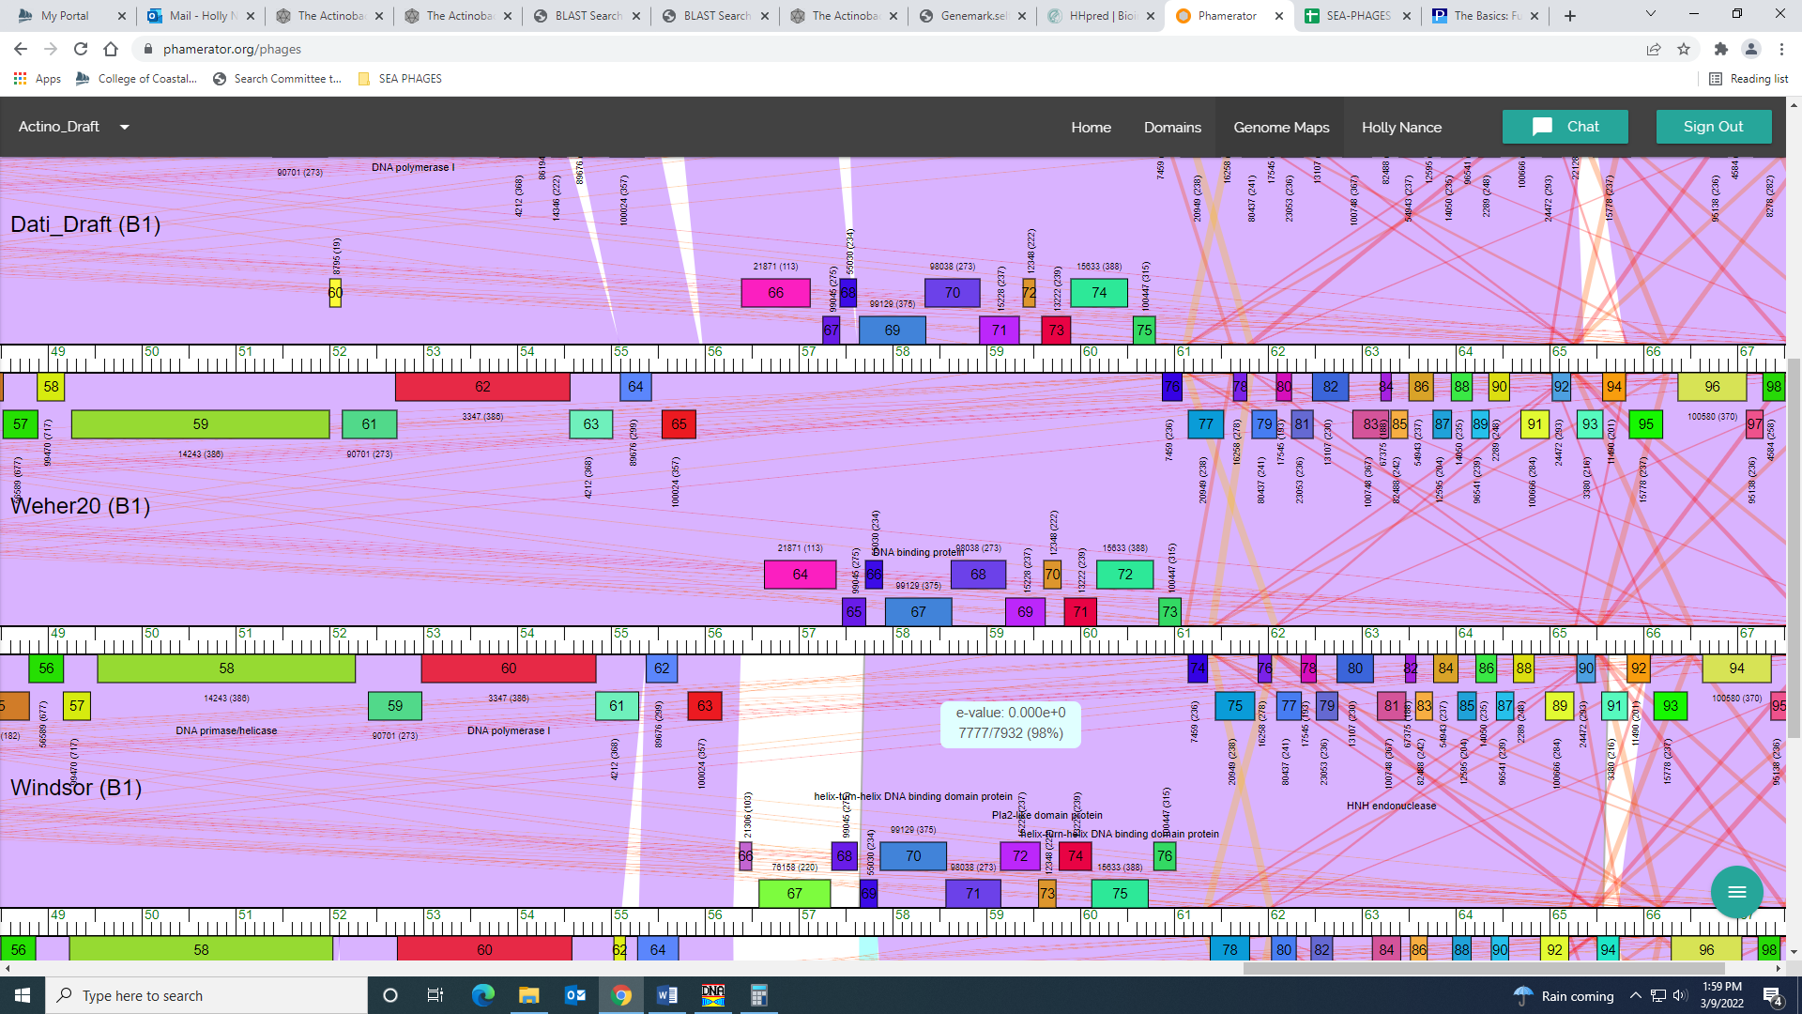

Gene 71 – changed start from 59591 to 59555 on 3.9.22!
SSC: start 59555, stop 59899; CP: yes; SCS: Both called start at 130, went with more conserved start of 59555 the yields a longer ORF; ST: SS; Blast Start: matches TomBombadil_74 Query 1 to Subject 1 100% 3e⁻⁶⁰; Gap: 34; LO: no; RBS: -4.286, 1.907, 11, -5.043, no; F: NKF; SIF-BLAST: NKF/PhageDB BLAST/ TomBombadil_74, MK279888/100%/3e⁻⁶⁰; SIF-HHPred: NKF, no matches with a probability above 90%; SIF-Syn: NKF
Notes: Changed start to most annotated in Starterator and most conserved in BLAST. This start yields a longer ORF than the one called by Glimmer and GeneMark. Also, this start looks like there is some coding potential in the GeneMark output:
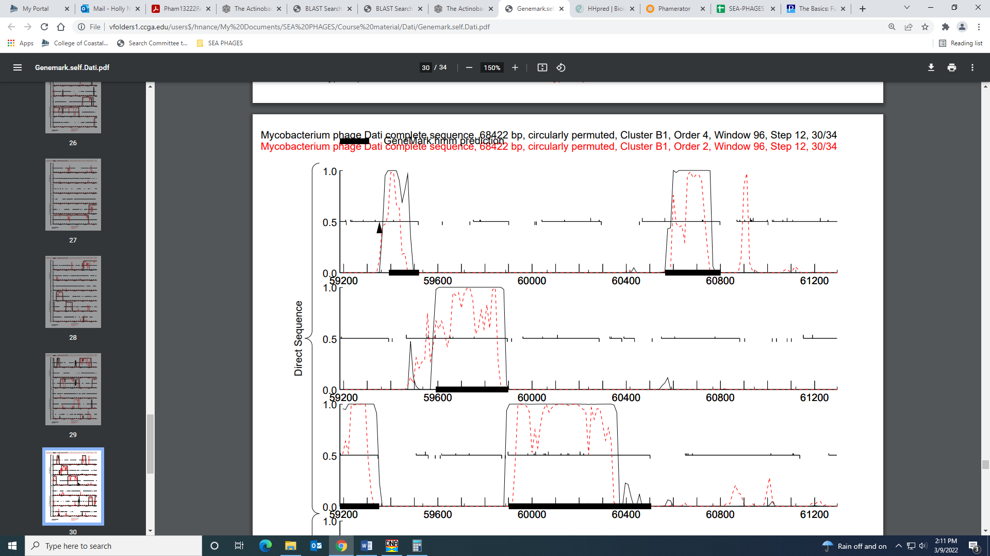

Gene 72
SSC: start 59901, stop 60506; CP: yes; SCS: Both called start at 59901; ST: SS; Blast Start: matches Xavier_75 Query 1 to Subject 1 100% 1e⁻¹¹⁴; Gap: 1; LO: NA; RBS: -5.097, 1.503, 16, -6.893, no; F: NKF; SIF-BLAST: NKF/PhageDB BLAST/ Xavier_75, MG944225/100%/1e⁻¹¹⁴; SIF-HHPred: NKF, several matches with a probability above 90% for sigma factor, but all partial hits with marginal e-values; SIF-Syn: NKF
Notes: For function, there are a few hits in both PhageDB and NCBI BLAST that call this gene something other than NKF – either HNH endonuclease or HTH DNA binding domain:
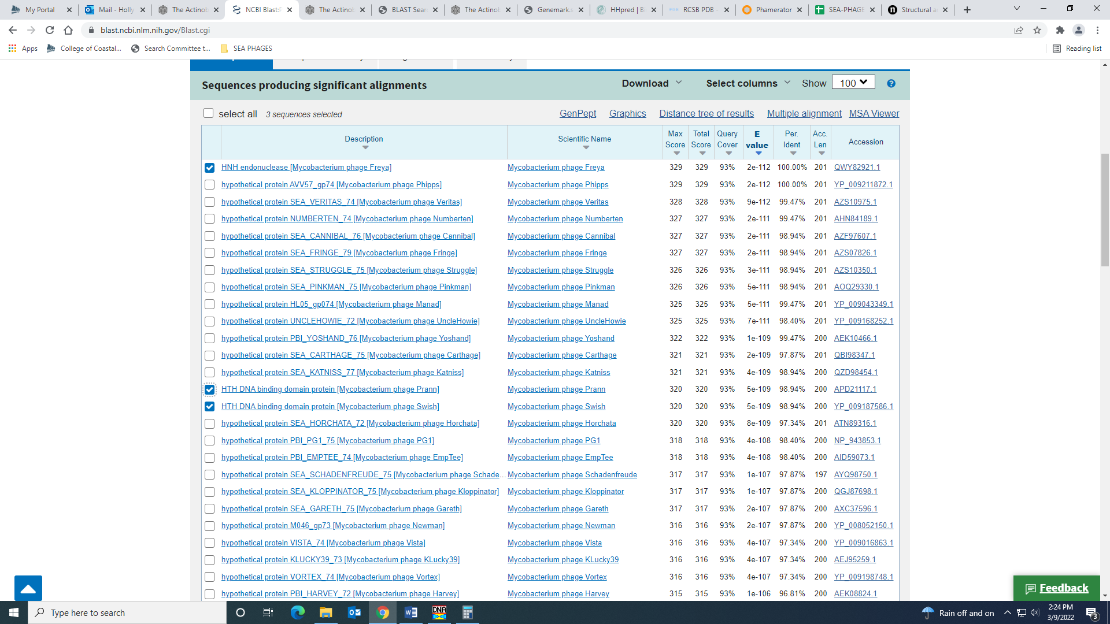
However, HNH endonucleases are usually found in phage genomes next to a terminase gene:
https://www.nature.com/articles/srep42542
And this gene is not nearby in the genome. The HHPred hits are mainly for sigma factor, which the official phage function list says to call a DNA binding protein:
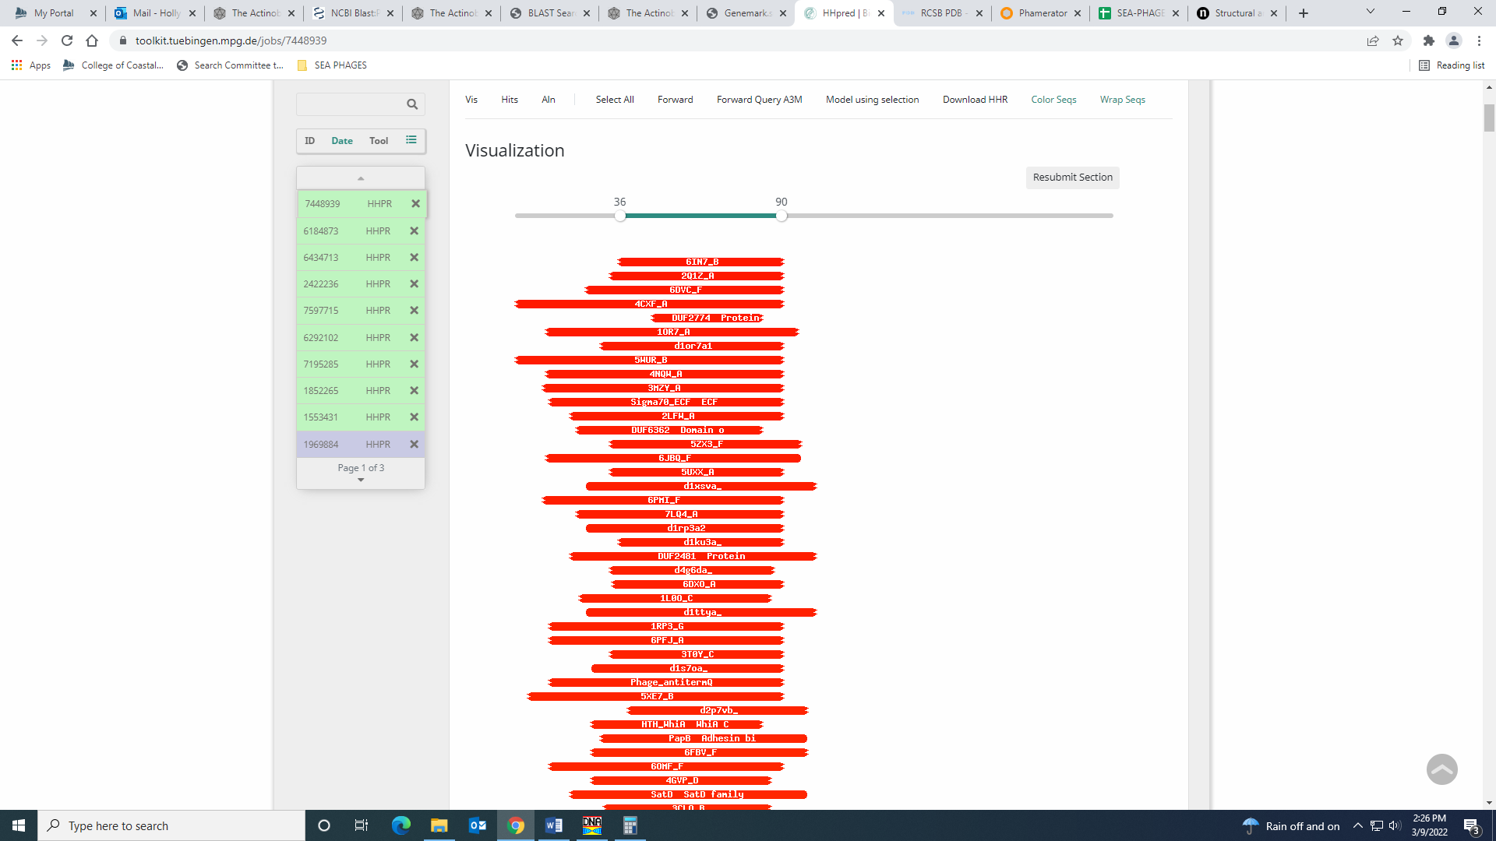
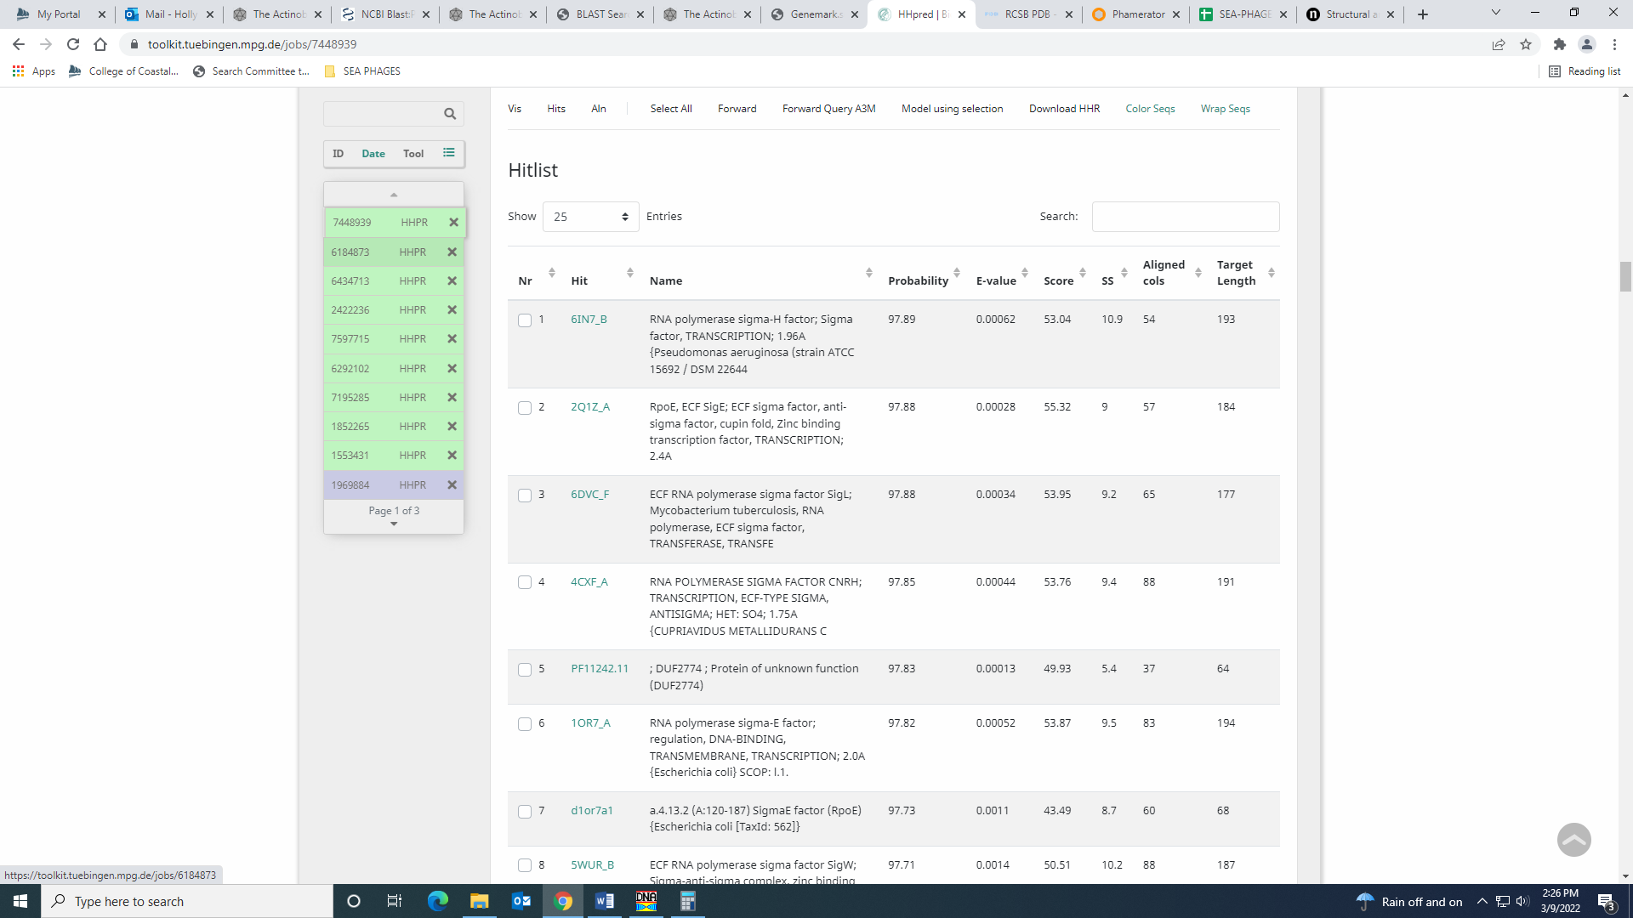
These hits are all partial with marginal e-values. I don’t think any of this evidence is compelling enough to call this protein anything other than NKF.

Gene 73
SSC: start 60565, stop 60801; CP: yes; SCS: Both called start at 60565; ST: SS; Blast Start: matches Xavier_76 Query 1 to Subject 1 100% 2e⁻⁴³; Gap: 58; LO: no; RBS: -5.276, 1.413, 12, -6.112, no; F: NKF; SIF-BLAST: NKF/PhageDB BLAST/ Xavier_76, MG944225/100%/2e⁻⁴³; SIF-HHPred: NKF, no matches with a probability above 90%; SIF-Syn: NKF
Notes: Start was most annotated in Starterator. NKF supported in both PhageDB and NCBI BLAST.

Gene 74 – reverse gene
SSC: start 61085, stop 60876; CP: yes; SCS: Both called start at 61085; ST: SS; Blast Start: matches Zonia_78 Query 1 to Subject 1 100% 6e⁻³⁵; Gap: 66; LO: yes; RBS: -3.974, 2.062, 11, -4.731, yes; F: NKF; SIF-BLAST: NKF/PhageDB BLAST/ Zonia_78, KM363597/100%/6e⁻³⁵; SIF-HHPred: elongation factor, several matches with a probability above 90% but high e-values; SIF-Syn: NKF
Notes: NKF supported by both BLAST outputs:
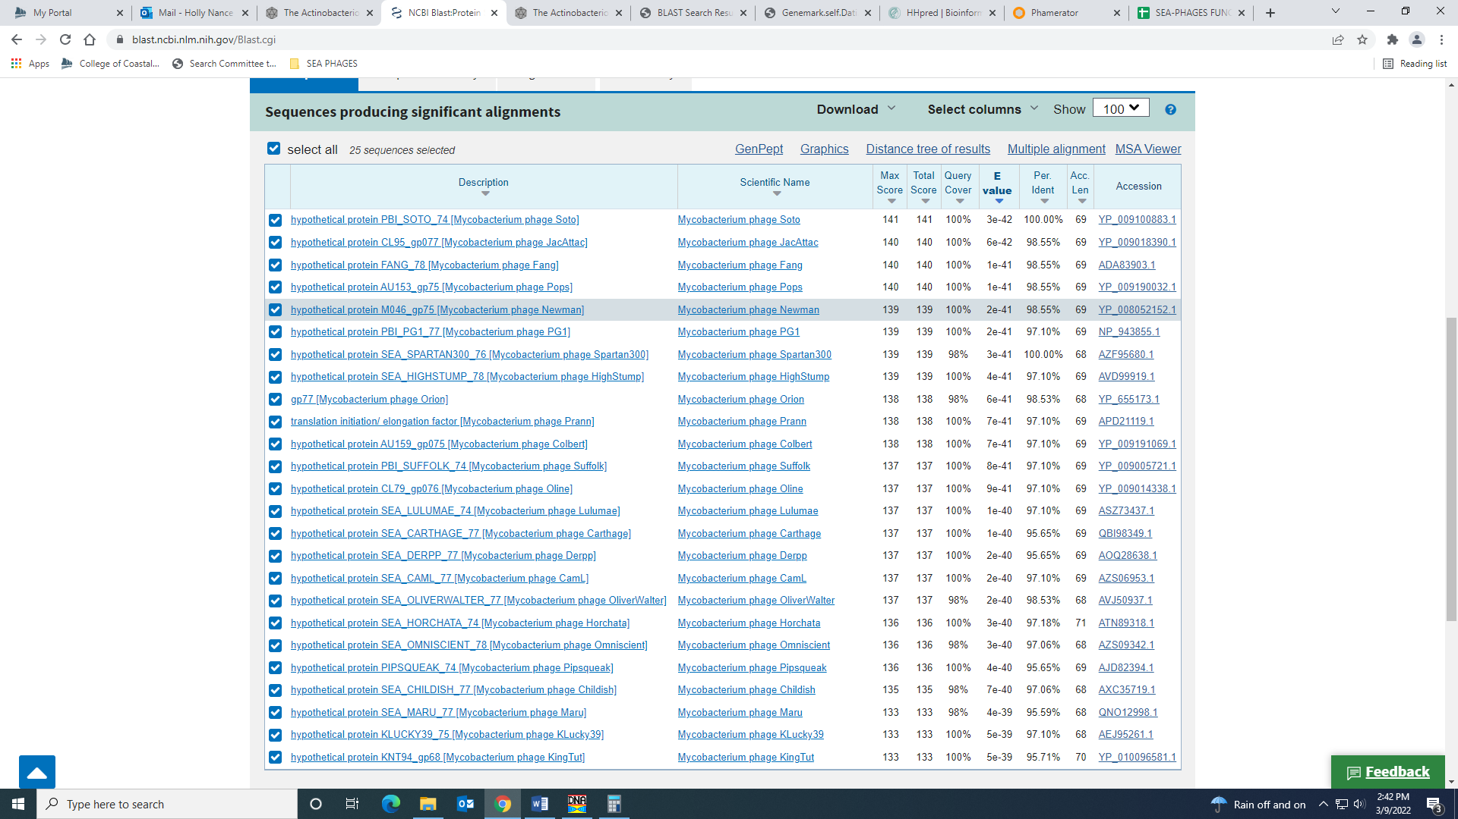
There are several matches in HHPred with a probability above 90% for elongation factor, but the e-values are all above e-4:
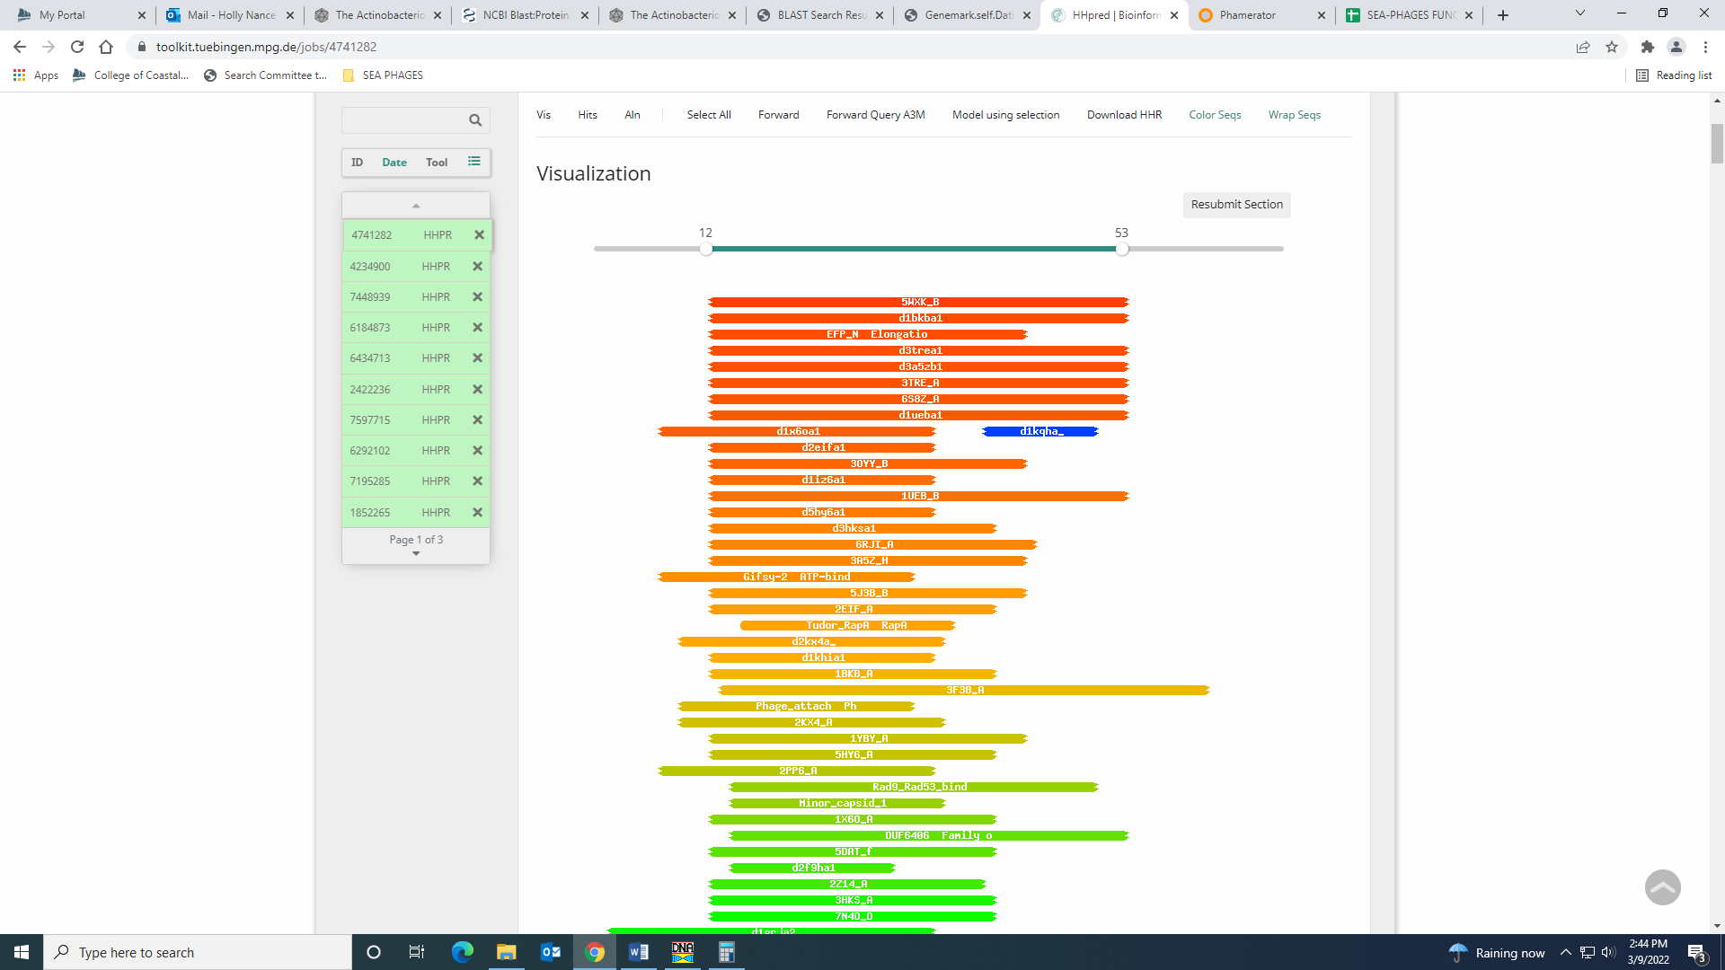
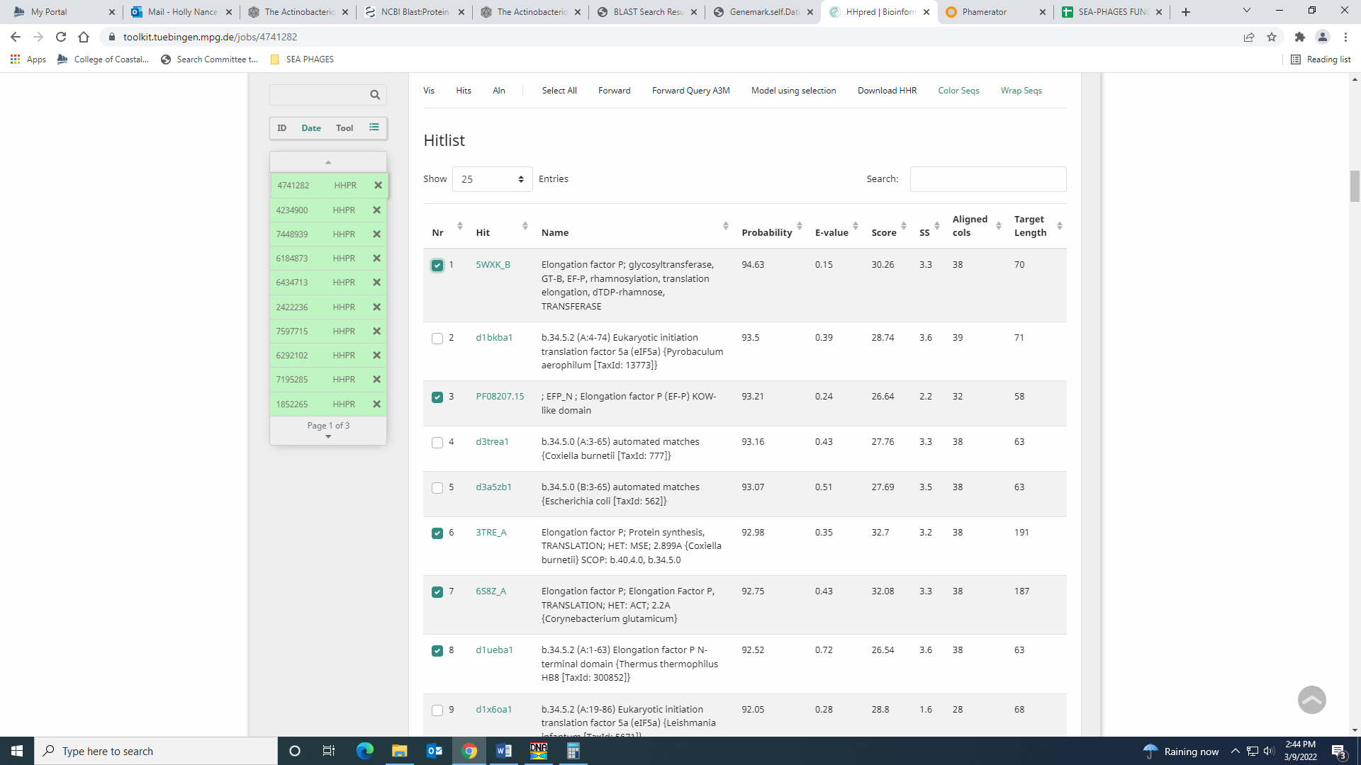
Also, elongation factor is not listed on the official phage function list. Given there is not support for this function anywhere else, I’m going with NKF.

Gene 75 – reverse gene
SSC: start 61529, stop 61152; CP: yes; SCS: Both called start at 61529; ST: SS; Blast Start: matches Mulan_77 Query 1 to Subject 1 100% 2e⁻⁷¹; Gap: 103; LO: no; RBS: -3.499, 2.300, 15, -5.101, no; F: NKF; SIF-BLAST: NKF/PhageDB BLAST/ Mulan_77, MH727555/100%/2e⁻⁷¹; SIF-HHPred: NKF, no matches with a probability above 90%; SIF-Syn: NKF
Notes: The most annotated start in Starterator is not present in Dati, and this start is the most annotated that is present in Dati. NKF supported by all data.

Gene 76 – reverse gene
SSC: start 61776, stop 61633; CP: yes; SCS: Both called start at 61776; ST: NA; Blast Start: matches Xavier _79 Query 1 to Subject 1 100% 6e⁻²⁰; Gap: 54; LO: yes; RBS: -3.974, 2.062, 10, -4.669, yes; F: NKF; SIF-BLAST: NKF/PhageDB BLAST/ Xavier _79, MG944225/100%/6e⁻²⁰; SIF-HHPred: phage integrase, one matches with a probability above 90%, but high e-value; SIF-Syn: NKF
Notes: This was the only start in this ORF.
Both BLAST databases support NKF:
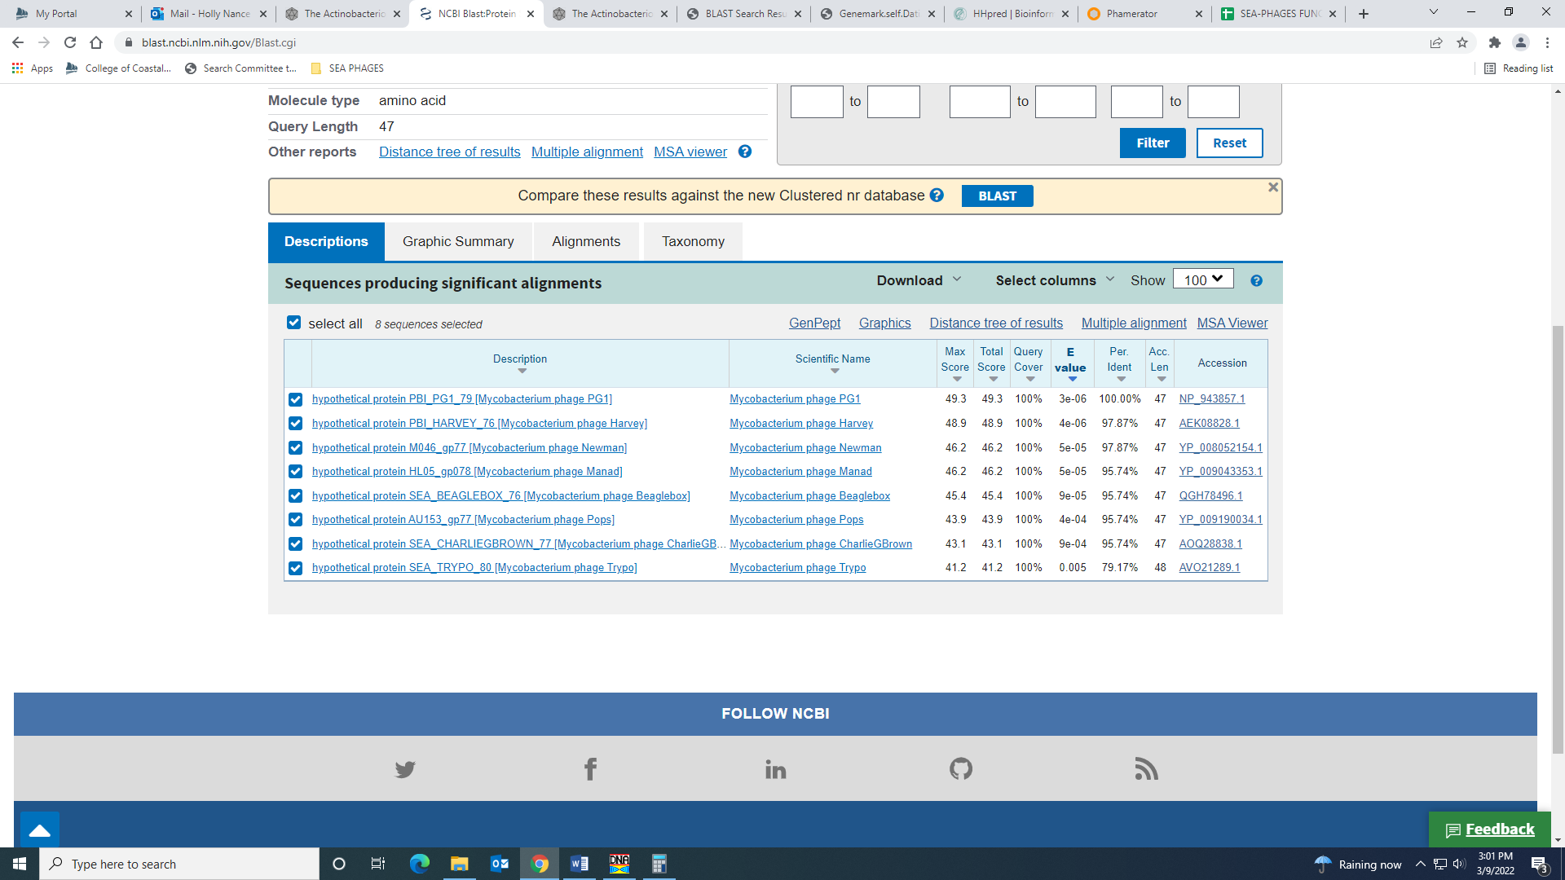
I HHPred, there is one match with a probability of 92.92% for an integrase protein (the e-value is greater than e-4, though).
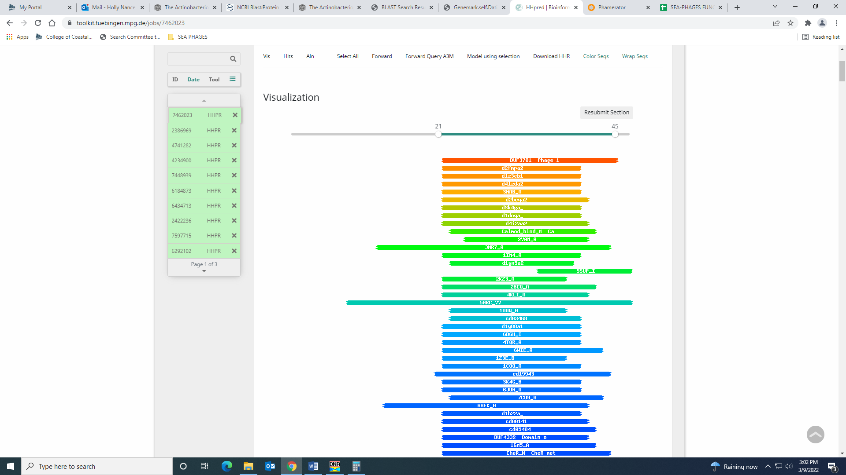
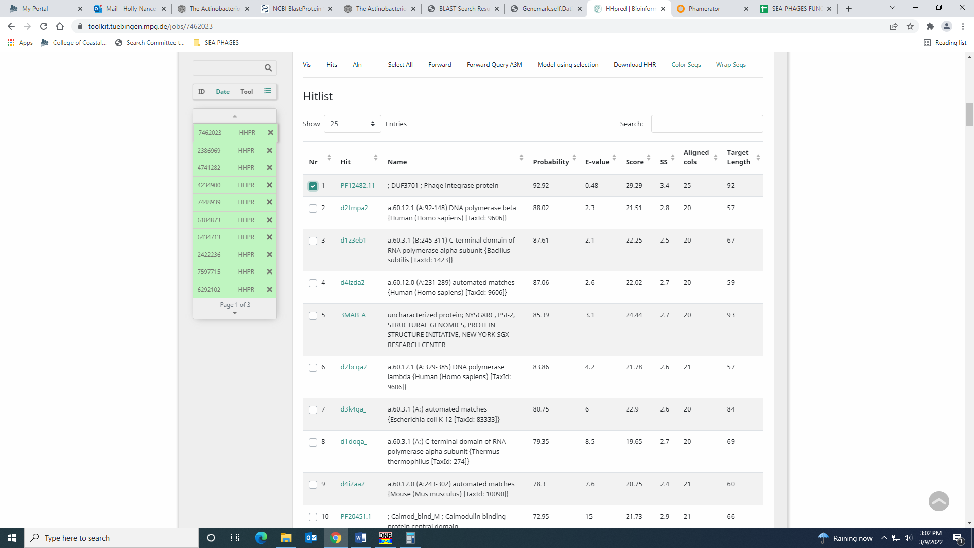
Also, an integrase protein is not on the Official phage function list, unless more specific. I’m sticking with NKF.

Gene 77 – reverse gene
SSC: start 62094, stop 61831; CP: yes; SCS: Both called start at 62094; ST: SS; Blast Start: matches Potter_76 Query 1 to Subject 1 100% 1e⁻⁴⁵; Gap: overlap of 4; LO: NA; RBS: -2.258, 2.918, 10, -2.953, yes; F: NKF; SIF-BLAST: NKF/PhageDB BLAST/ Potter_76, KU867907/100%/1e⁻⁴⁵; SIF-HHPred: NKF, no matches with a probability above 90%; SIF-Syn: NKF
Notes: nothing ambiguous here!

Gene 78 – reverse gene
SSC: start 62252, stop 62091; CP: yes; SCS: Both called start at 62252; ST: SS; Blast Start: matches Zonia_82 Query 1 to Subject 1 100% 1e⁻²⁴; Gap: overlap of 1; LO: NA; RBS: -4.131, 1.985, 9, -4.905, yes; F: NKF; SIF-BLAST: NKF/PhageDB BLAST/ Zonia_82, KM363597/100%/1e⁻²⁴; SIF-HHPred: NKF, no matches with a probability above 90%; SIF-Syn: NKF
Notes: nothing ambiguous here!

Gene 79 – reverse gene
SSC: start 62482, stop 62252; CP: yes; SCS: Both called start at 62482; ST: SS; Blast Start: matches Weher20_79 Query 1 to Subject 1 100% 7e⁻⁴⁰; Gap: overlap of 8; LO: NA; RBS: -2.976, 2.560, 8, -4.198, yes; F: NKF; SIF-BLAST: NKF/PhageDB BLAST/ Weher20_79, MZ681520/100%/7e⁻⁴⁰; SIF-HHPred: NKF, no matches with a probability above 90%; SIF-Syn: NKF
Notes: nothing ambiguous here!

Gene 80 – reverse gene
SSC: start 62861, stop 62475; CP: yes; SCS: Both called start at 62861; ST: SS; Blast Start: matches Zelda_83 Query 1 to Subject 1 100% 4e⁻⁶⁸; Gap: 43; LO: no; RBS: -3.050, 2.523, 16, -4.846, yes; F: NKF; SIF-BLAST: NKF/PhageDB BLAST/ Zelda_83, MK112555/100%/4e⁻⁶⁸; SIF-HHPred: NKF, no matches with a probability above 90%; SIF-Syn: NKF
Notes: All BLAST hits and HHPred support NKF

Gene 81 – reverse gene – changed start from 63288 to 63207 on 3.9.22!
SSC: start 63207, stop 62905; CP: yes; SCS: Glimmer called start at 63288, went with more conserved GeneMark start of 63207; ST: SS; Blast Start: matches Zelda_84 Query 1 to Subject 1 100% 5e⁻⁵⁶; Gap: overlap of 4; LO: NA; RBS: -6.627, 0.704, 11, -7.384, no; F: HNH endonuclease; SIF-BLAST: HNH endonuclease /PhageDB BLAST/ Zelda_84, MK112555/100%/5e⁻⁵⁶; SIF-HHPred: endonuclease, several matches with a probability above 90%; SIF-Syn: HNH endonuclease
Notes: I changed the start to what GeneMark called because this is the most annotated start and if you call the Glimmer start, there is too much overlap with gene 84. This next gene is present in some B1 phage, and called only my GeneMark. However, I think we should keep it and to do that, it makes more sense to change the start of gene 83 to the most annotated.
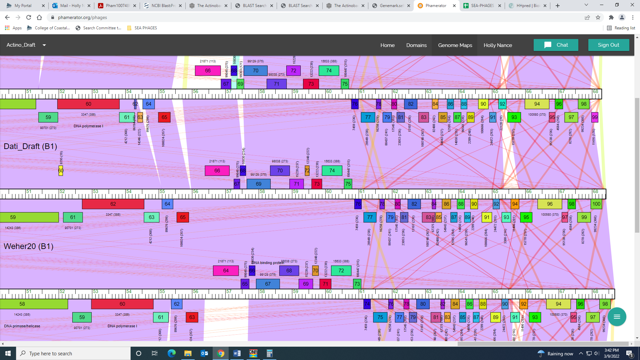
For function, both Phage DB and NCBI BLAST output support HNH endonuclease:
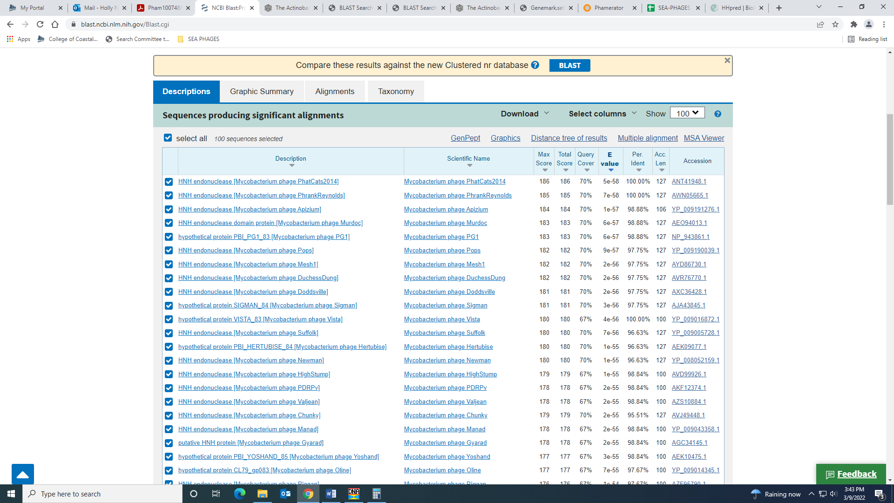
There are several matches with a probability above 90% in HHPred for an endonuclease:
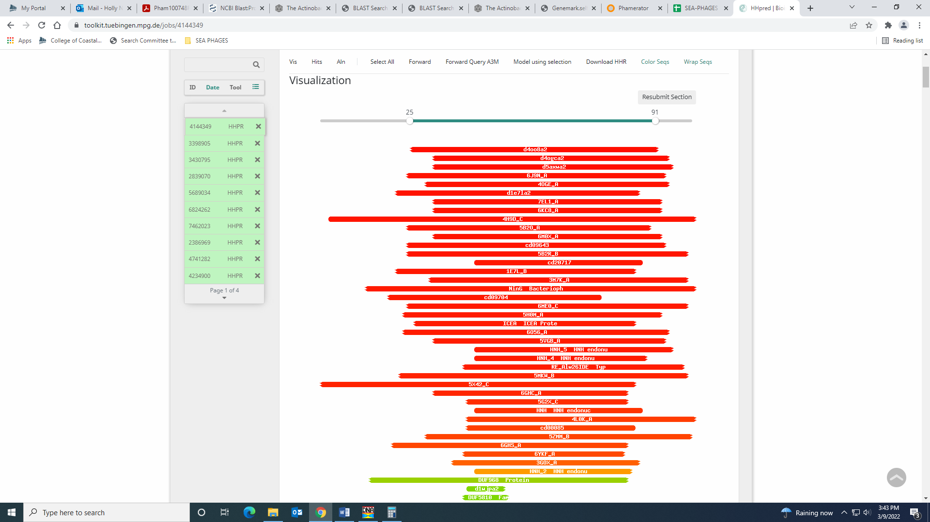
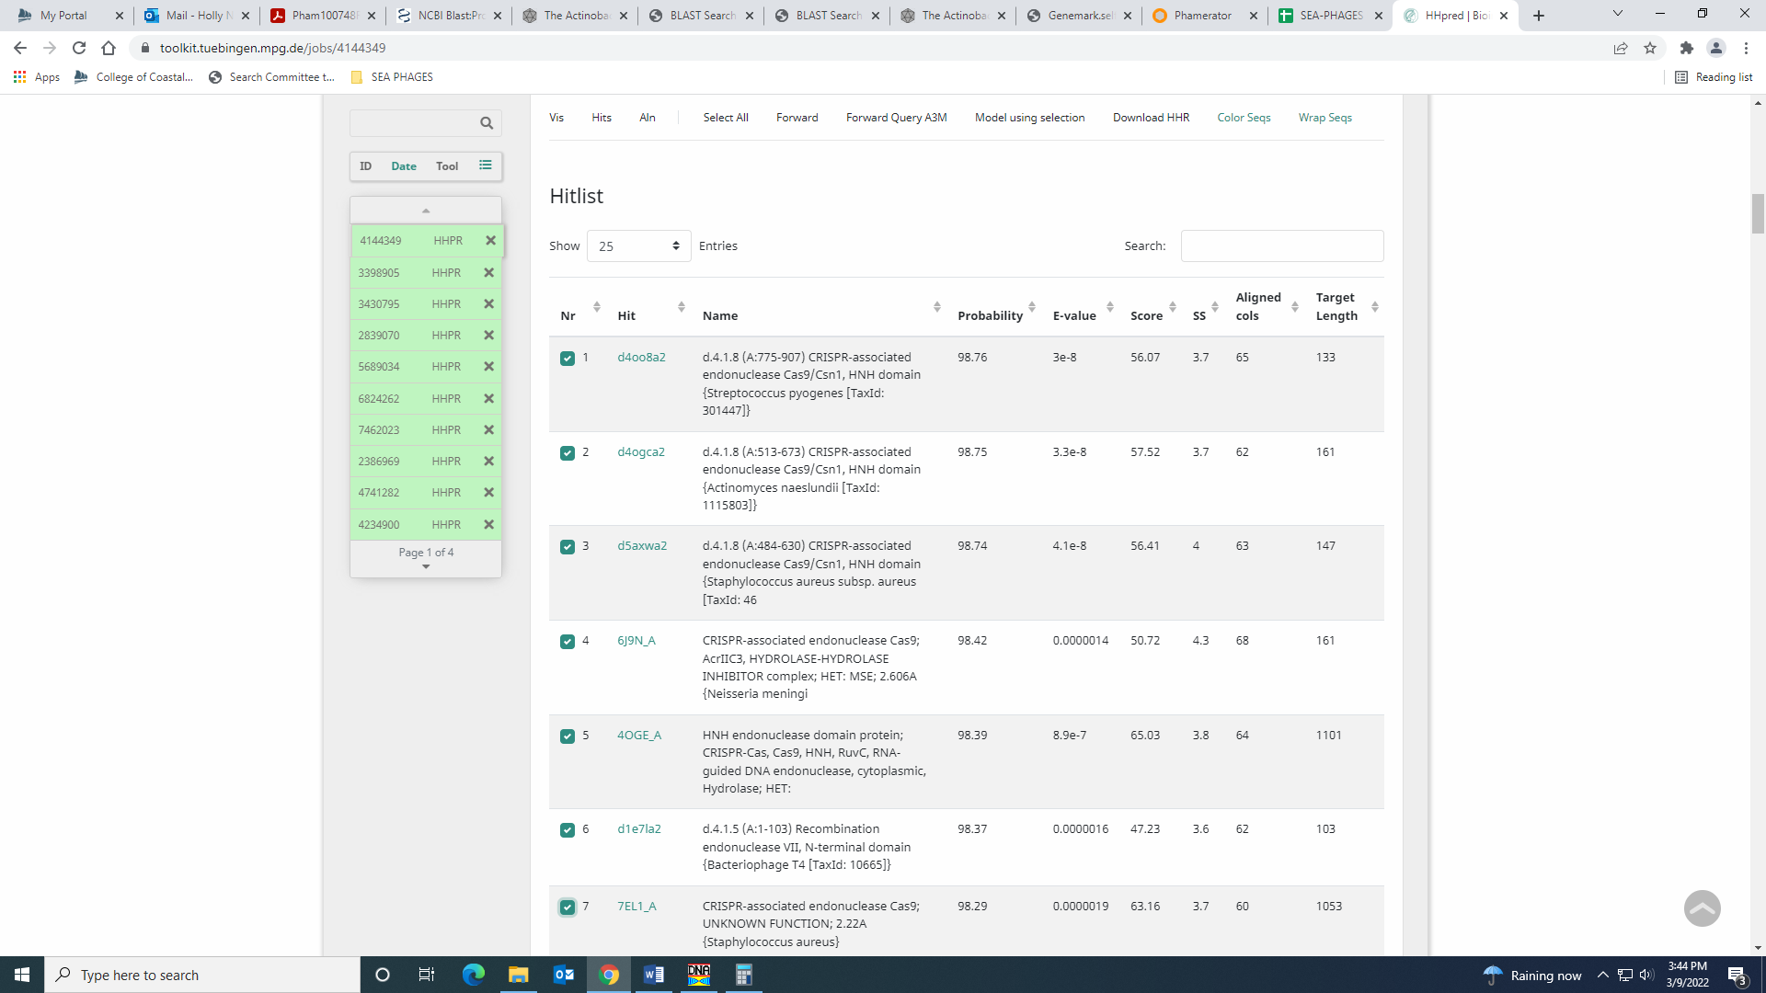

Gene 82– reverse gene
SSC: start 63314, stop 63204; CP: yes; SCS: Only GeneMark called start at 63314, Glimmer didn’t call this gene; ST: NA; Blast Start: matches Yoshand_86 Query 1 to Subject 1 100% 3e⁻¹⁵; Gap: overlap of 4; LO: NA; RBS: -3.861, 2.119, 12, -4.696, yes; F: NKF; SIF-BLAST: NKF/PhageDB BLAST/ Yoshand_86, JF937109/100%/3e⁻¹⁵; SIF-HHPred: NKF, no matches with a probability above 90%; SIF-Syn: NKF
Notes: This is the only possible start for this tiny gene. If students don’t think this is a gene, it could potentially be a poster? However, if not a gene, then perhaps change start to Glimmer call in Gene 83 above… Stephanie worked on this gene and decided to keep it in the annotation and adjust the start in Gene 83 to have the least amount of overlap.

Gene 83 – reverse gene
SSC: start 63490, stop 63311; CP: yes; SCS: Both called start at 63490; ST: SS; Blast Start: matches Vista_85 Query 1 to Subject 1 100% 7e⁻²⁸; Gap: 12; LO: yes; RBS: -2.856, 2.620, 11, -3.631, yes; F: NKF; SIF-BLAST: NKF/PhageDB BLAST/ Vista_85, JN699008/100%/7e⁻²⁸; SIF-HHPred: NKF, no matches with a probability above 90%; SIF-Syn: NKF
Notes: nothing ambiguous!

Gene 84 – reverse gene
SSC: start 63763, stop 63503; CP: yes; SCS: Both called start at 63763; ST: SS; Blast Start: matches Zonia_87 Query 1 to Subject 1 100% 1e⁻⁴⁷; Gap: overlap of 4; LO: NA; RBS: -3.562, 2.268, 10, -4.257, yes; F: NKF; SIF-BLAST: NKF/PhageDB BLAST/ Zonia_87, KM363597/100%/1e⁻⁴⁷; SIF-HHPred: NKF, one matches with a probability of 91.79%, but for a eukaryotic protein and high e-value; SIF-Syn: NKF
Notes: For function, HHPred had one match with a probability of 91.79%, e-value of 0.94. This match is for a eukaryotic protein:
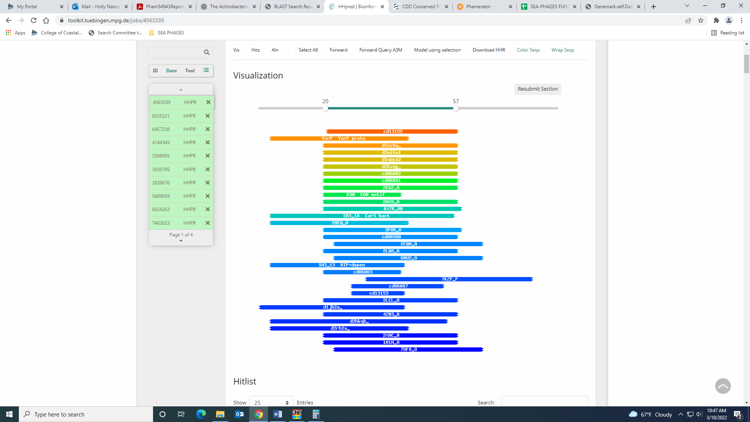
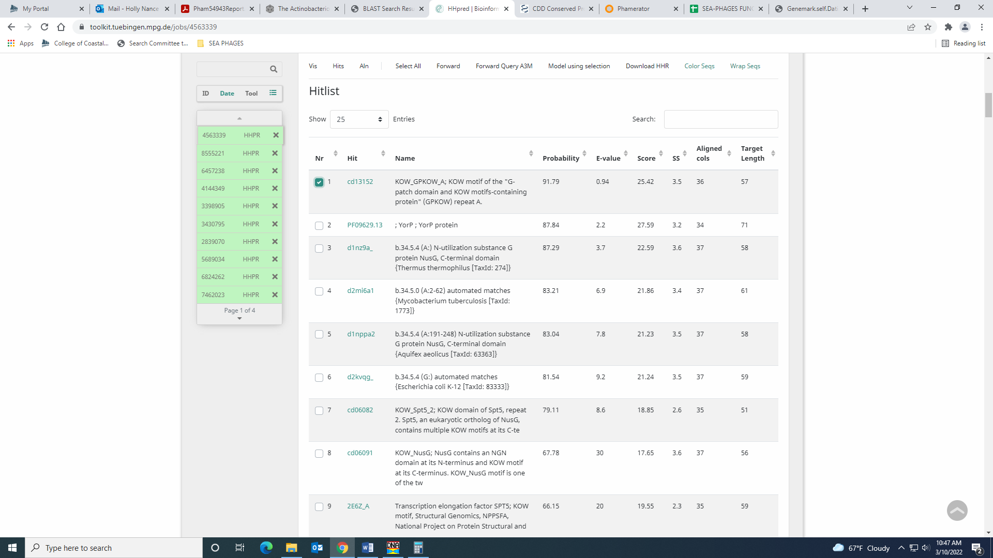
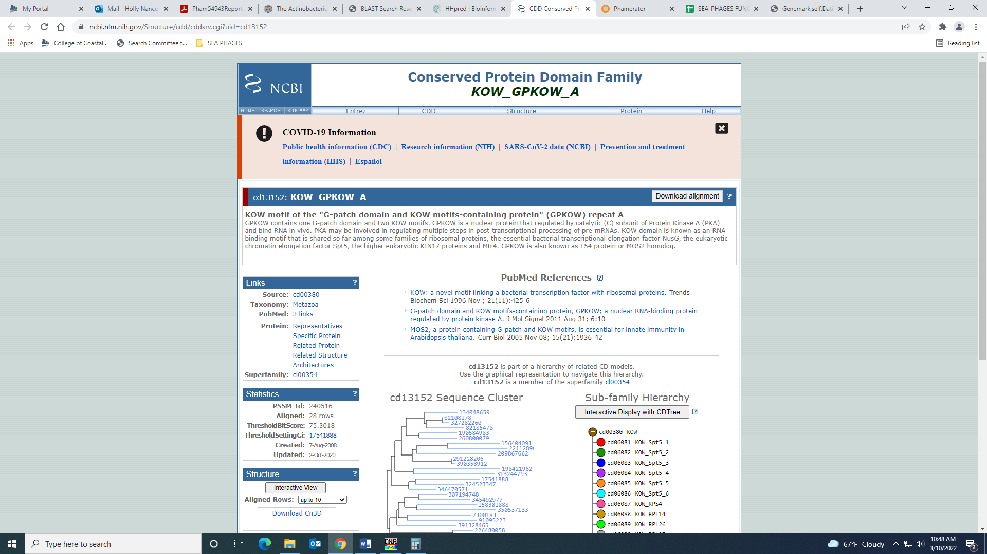
All other data suggests NKF.

Gene 85 – reverse gene
SSC: start 63957, stop 63760; CP: yes; SCS: Glimmer called start at 63957, GeneMark did not call this gene; ST: SS; Blast Start: matches Vista_87 Query 1 to Subject 1 100% 3e⁻³³; Gap: overlap of 4; LO: NA; RBS: -3.861, 2.119, 6, -5.605, yes; F: NKF; SIF-BLAST: NKF/PhageDB BLAST/ Vista_87, JN699008/100%/3e⁻³³; SIF-HHPred: NKF, no matches with a probability above 90%; SIF-Syn: NKF
Notes: Though not called by GeneMark, there is support for this being a gene. It is conserved in B1.

Gene 86 – reverse gene
SSC: start 64178, stop 63954; CP: yes; SCS: GeneMark called start at 64175, went with more conserved Glimmer start of 64178; ST: SS; Blast Start: matches Xavier_88 Query 1 to Subject 1 98% 3e⁻³⁹; Gap: overlap of 7; LO: NA; RBS: -4.131, 1.985, 8, -5.352, no; F: NKF; SIF-BLAST: NKF/PhageDB BLAST/ Xavier_88, MG944225/98%/3e⁻³⁹; SIF-HHPred: NKF, no matches with a probability above 90%; SIF-Syn: NKF
Notes: GeneMark and Glimmer differed on the start by 3 BP. The glimmer start is the most annotated in Starterator and yields a longer ORF.

Gene 87 – reverse gene
SSC: start 64357, stop 64172; CP: yes; SCS: Both called start at 64357; ST: SS; Blast Start: matches Zaider_91 Query 1 to Subject 1 100% 3e⁻³⁰; Gap: overlap of 4; LO: NA; RBS: -4.691, 1.705, 12, -5.526, no; F: NKF; SIF-BLAST: NKF/PhageDB BLAST/ Zaider_91, MK279895/100%/3e⁻³⁰; SIF-HHPred: NKF, no matches with a probability above 90%; SIF-Syn: NKF
Notes: nothing ambiguous here

Gene 88 – reverse gene
SSC: start 64575, stop 64354; CP: yes; SCS: Both called start at 64575; ST: SS; Blast Start: matches Waterdiva_92 Query 1 to Subject 1 100% 2e⁻³⁷; Gap: 120; LO: yes; RBS: -3.344, 2.376, 11, -4.101, no; F: NKF; SIF-BLAST: NKF/PhageDB BLAST/ Waterdiva_92, MH779516/100%/2e⁻³⁷; SIF-HHPred: NKF, no matches with a probability above 90%; SIF-Syn: NKF
Notes: There is a large gap between this gene and the next, but this gap is conserved throughout B1 phage. Also, this start yields the longest ORF. I don’t think it’s worth looking at this gap to see if there is a missed gene.
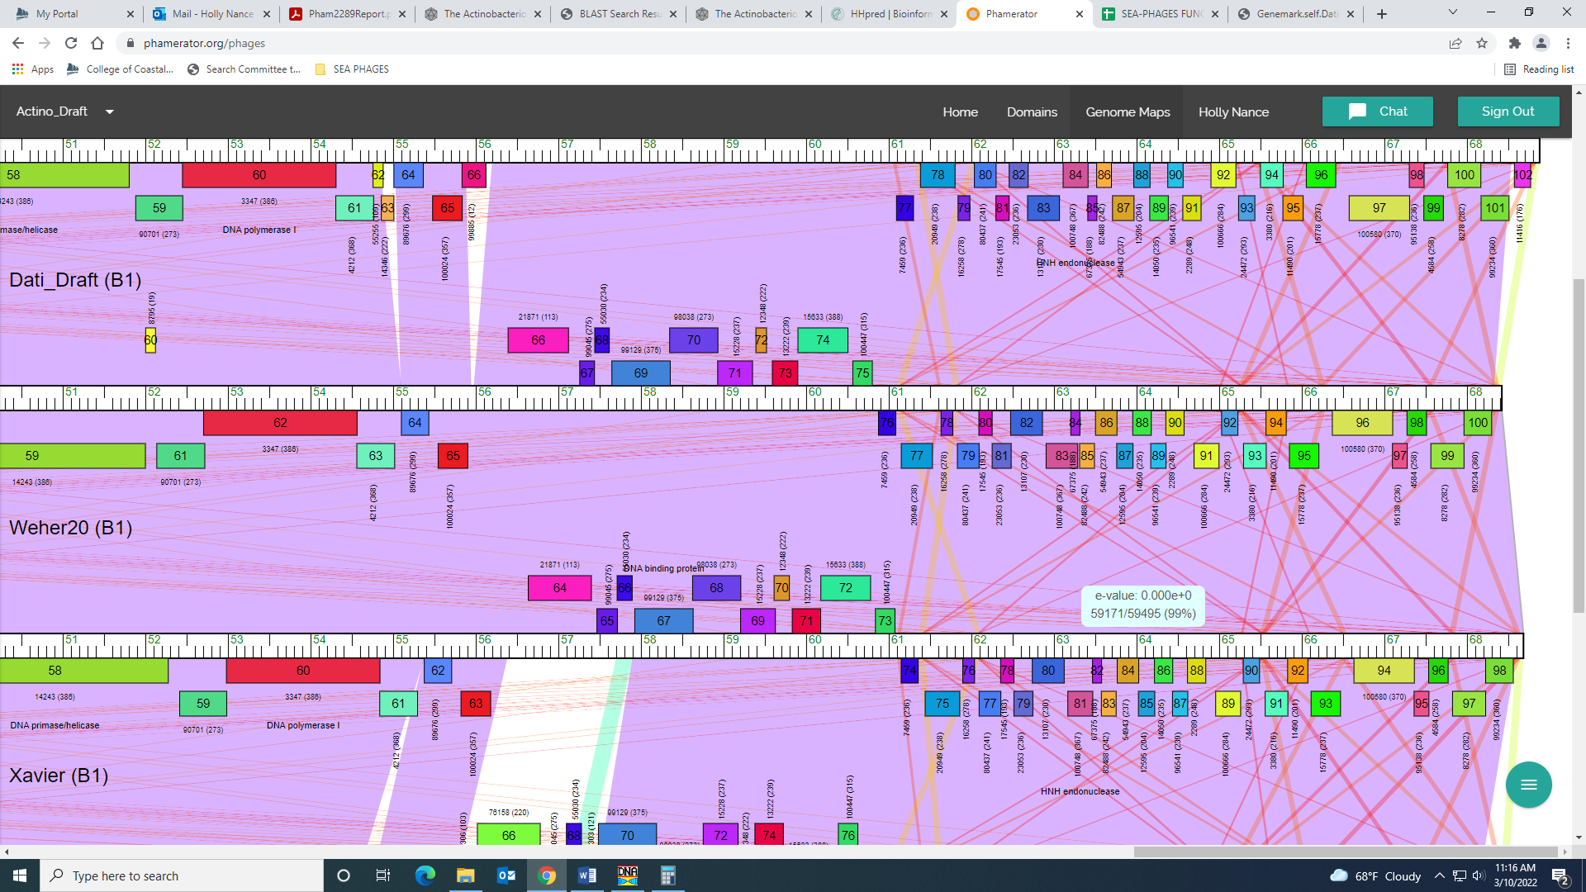

Gene 89 – reverse gene
SSC: start 64998, stop 64696; CP: yes; SCS: Both called start at 64998; ST: SS; Blast Start: matches Zelda_92 Query 1 to Subject 1 100% 2e⁻⁵³; Gap: 31; LO: yes; RBS: -2.109, 2.992, 10, -2.804, yes; F: NKF; SIF-BLAST: NKF/PhageDB BLAST/ Zelda_92, MK112555/100%/2e⁻⁵³; SIF-HHPred: Elongation factor P, a few matches with a probability above 90%; SIF-Syn: NKF
Notes (from Angel): HHpred gave several hits for Elongation factor P. All hits had probability above 97%. I looked at Phamerator to look at similar genes in this cluster, none of which gave any significant output that would identify that Elongation factor P would be the function for this gene. Being that Elongation Factor P are highly conserved in bacteria and this is a phage. I concluded that Gene 91 has no known function.

Notes: For function, PhageDB BLAST and synteny support NKF. NCBI BLAST also yields all NKF hits, except one, phage Prann…:
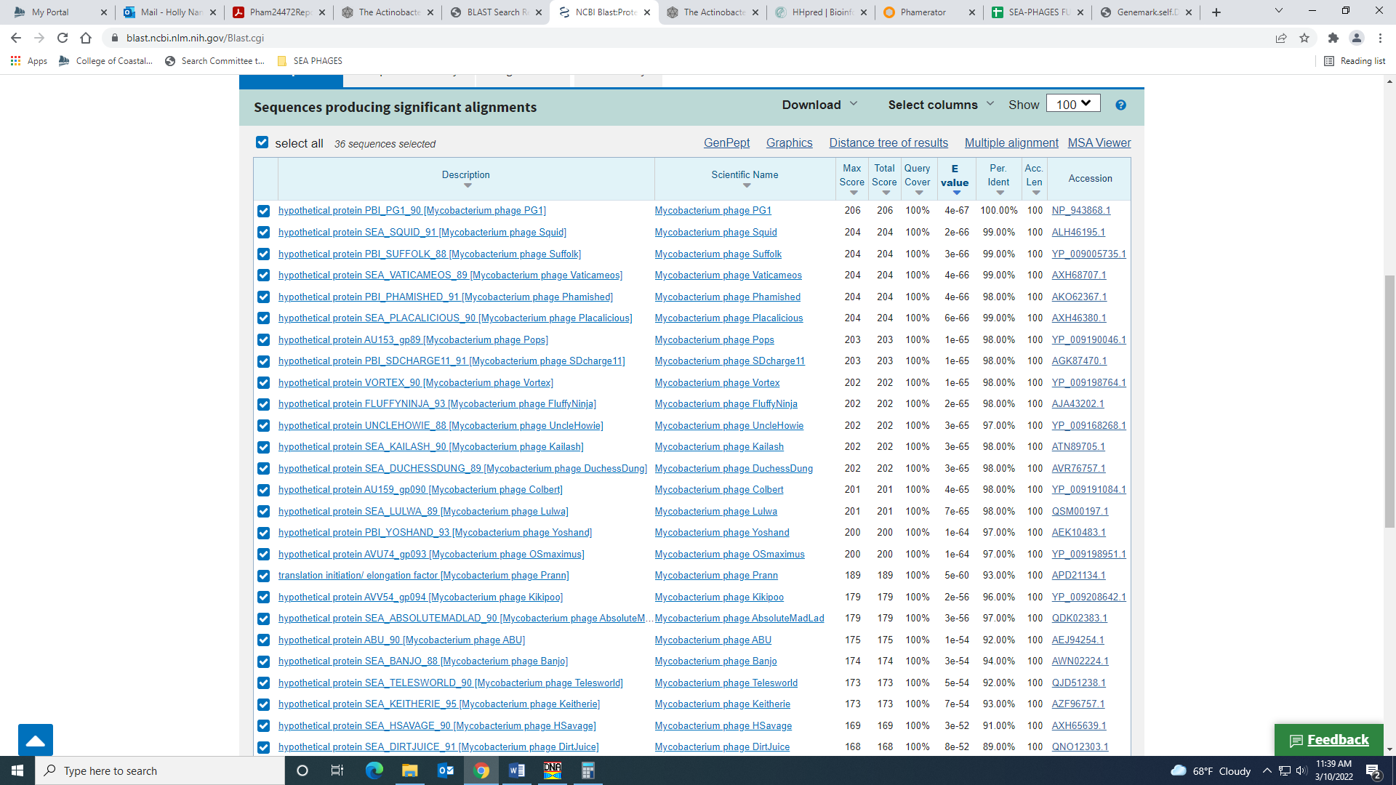
However, the HHPred output has several matches with high probabilities for a protein called Elongation Factor P. This protein is found in prokaryotes and is a tRNA synthetase paralog:
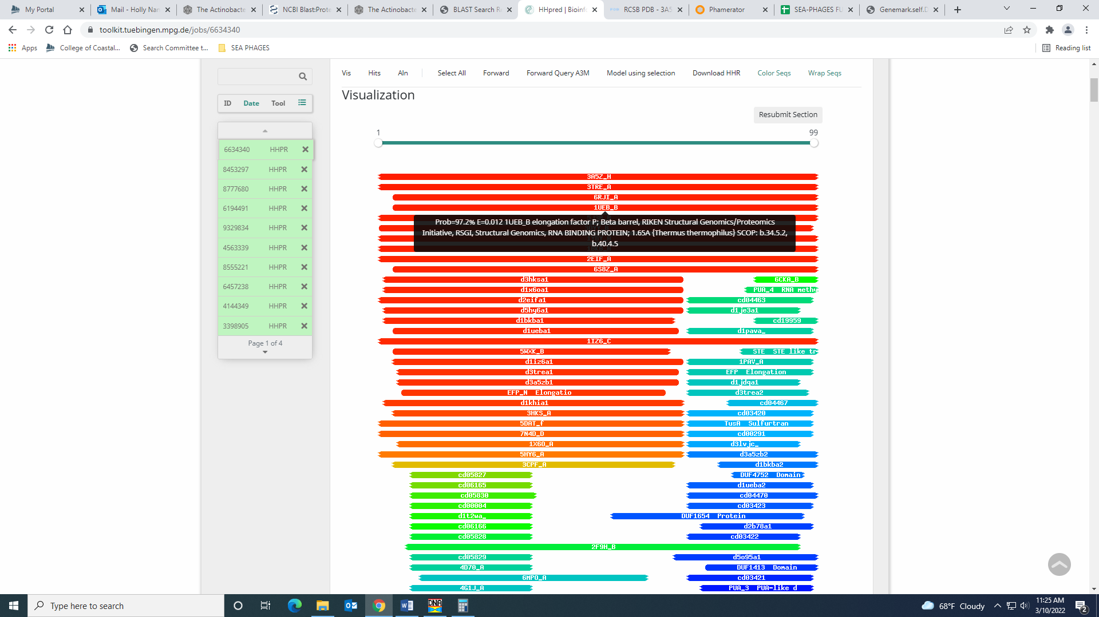
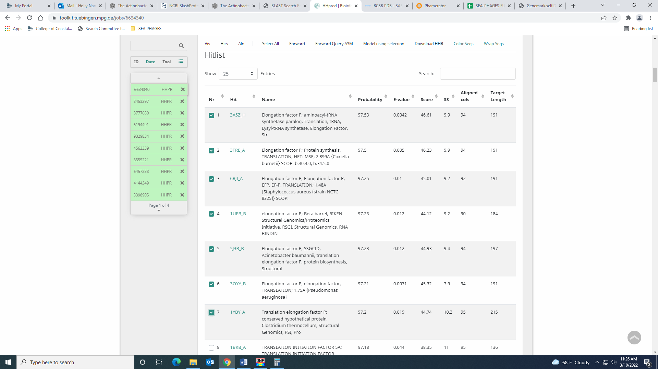
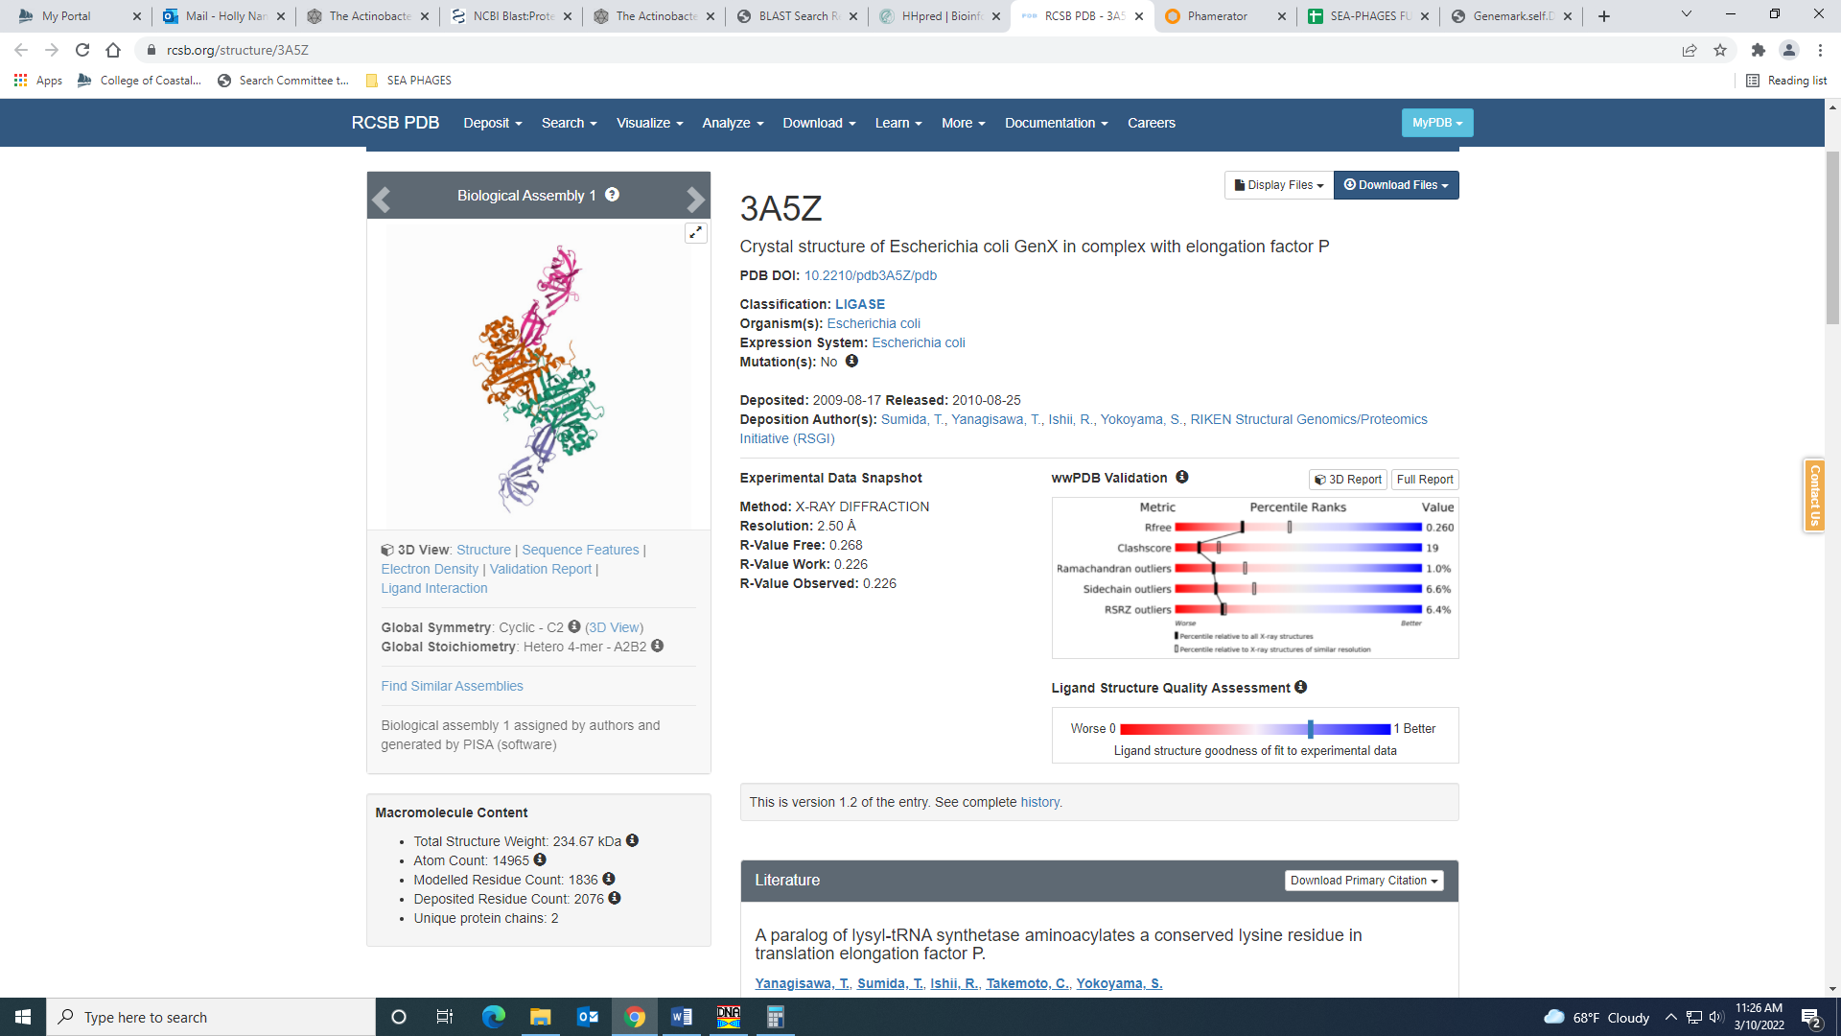
Maybe a student could look into this to see if the function is Elongation Factor P… Angel did this and determined NKF.

Gene 90 – reverse gene
SSC: start 65227, stop 65030; CP: yes; SCS: Both called start at 652275; ST: SS; Blast Start: matches Zelda_93 Query 1 to Subject 1 100% 2e⁻³²; Gap: 67; LO: yes; RBS: -1.888, 3.103, 8, -3.110, yes; F: NKF; SIF-BLAST: NKF/PhageDB BLAST/ Zelda_93, MK112555/100%/2e⁻³²; SIF-HHPred: NKF, no matches with a probability above 90%; SIF-Syn: NKF
Notes: There is a gap between this gene and the next, but this gap is conserved in the cluster. This start also yields the longest ORF.
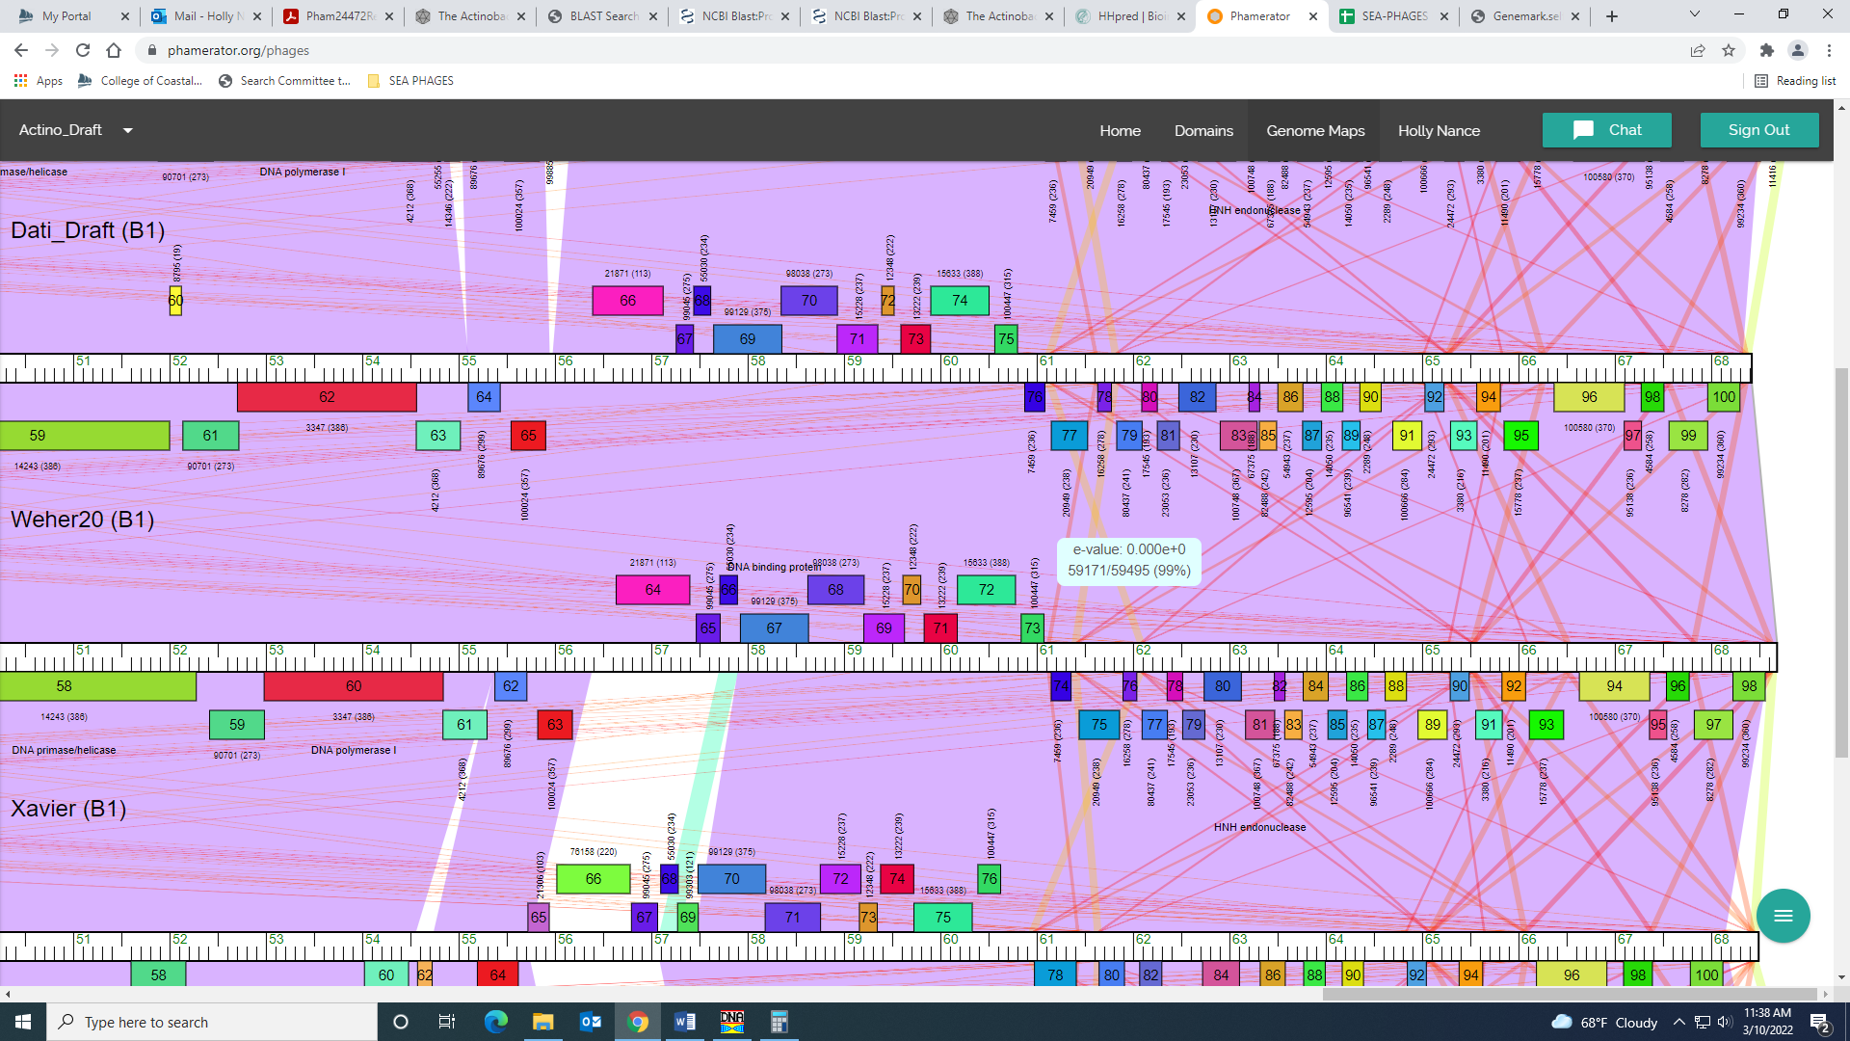

Gene 91 – reverse gene
SSC: start 65570, stop 65295; CP: yes; SCS: Both called start at 65570; ST: SS; Blast Start: matches Zonia_94 Query 1 to Subject 1 100% 2e⁻⁴⁹; Gap: overlap of 4; LO: NA; RBS: -3.810, 2.144, 16, -5.606, no; F: NKF; SIF-BLAST: NKF/PhageDB BLAST/ Zonia_94, KM363597/100%/2e⁻⁴⁹; SIF-HHPred: NKF, no matches with a probability above 90%; SIF-Syn: NKF
Notes: nothing ambiguous

Gene 92 – reverse gene
SSC: start 65812, stop 65567; CP: yes; SCS: Both called start at 65812; ST: SS; Blast Start: matches Zonia_95 Query 1 to Subject 1 100% 2e⁻³⁸; Gap: 38; LO: yes; RBS: -2.109, 2.992, 9, -2.884, yes; F: NKF; SIF-BLAST: NKF/PhageDB BLAST/ Zonia_95, KM363597/100%/2e⁻³⁸; SIF-HHPred: NKF, no matches with a probability above 90%; SIF-Syn: NKF
Notes: nothing ambiguous

Gene 93 – reverse gene
SSC: start 66207, stop 65851; CP: yes; SCS: Both called start at 66207; ST: SS; Blast Start: matches Zonia_96 Query 1 to Subject 1 100% 3e⁻⁶⁴; Gap: 162; LO: no; RBS: -1.462, 3.315, 12, -2.297, yes; F: NKF; SIF-BLAST: NKF/PhageDB BLAST/ Zonia_96, KM363597/100%/2e⁻³⁸; SIF-HHPred: NKF, no matches with a probability above 90%; SIF-Syn: NKF
Notes: There is another start that yields a longer ORF, but it’s TTG (the rarest). This start isn’t even reflected in the GeneMark output and has worse RBS values. There is a large gap between this and the next gene, but this large gap is conserved throughout the cluster:
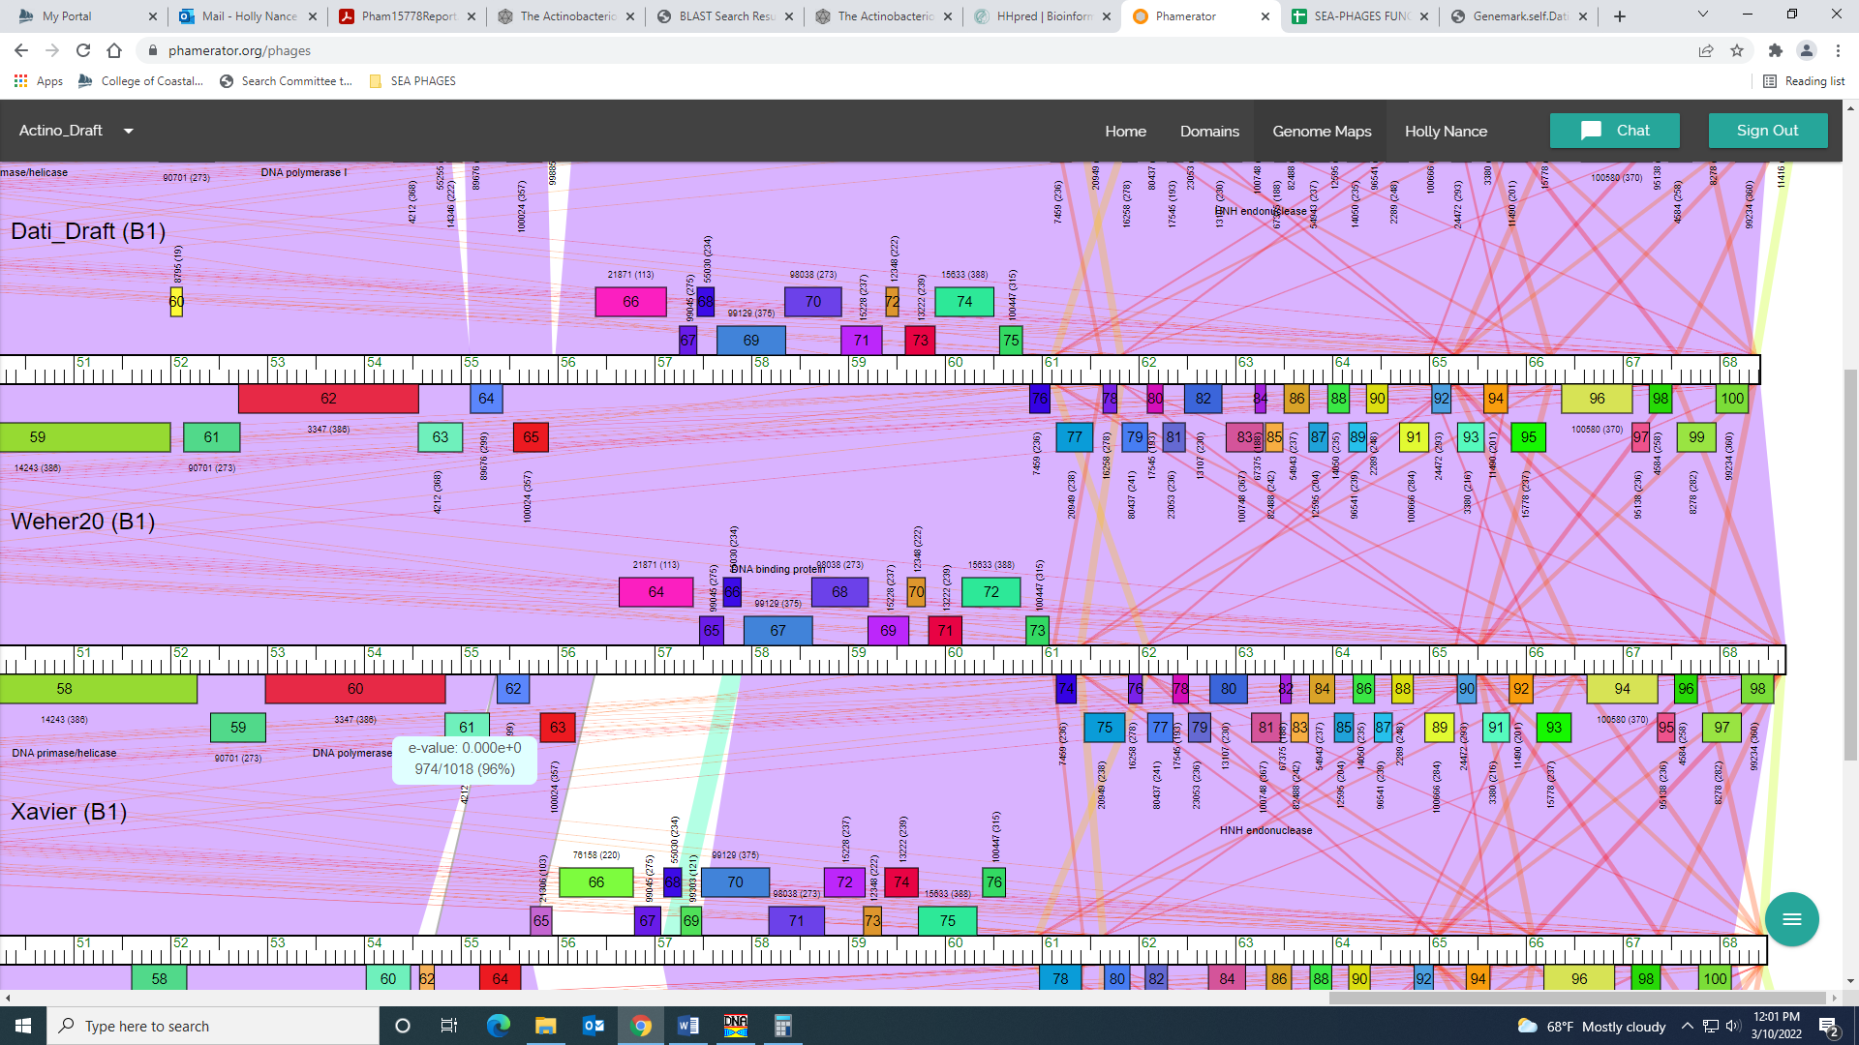

Gene 94 – reverse gene
SSC: start 67101, stop 66370; CP: yes; SCS: Both called start at 67101; ST: SS; Blast Start: matches Weher20_94 Query 1 to Subject 1 100% 1e⁻¹³⁷; Gap: overlap of 4; LO: NA; RBS: -4.131, 1.985, 9, -4.905, no; F: NKF; SIF-BLAST: NKF/PhageDB BLAST/ Weher20_94, MZ681520/100%/1e⁻¹³⁷; SIF-HHPred: NKF, no matches with a probability above 90%; SIF-Syn: NKF
Notes: nothing ambiguous

Gene 95 – reverse gene
SSC: start 67277, stop 67098; CP: yes; SCS: Both called start at 67277; ST: SS; Blast Start: matches Zelda_98 Query 1 to Subject 1 100% 4e⁻²⁶; Gap: overlap of 4; LO: NA; RBS: -5.198, 1.453, 9, -5.972, no; F: NKF; SIF-BLAST: NKF/PhageDB BLAST/ Zelda_98, MK112555/100%/4e⁻²⁶; SIF-HHPred: NKF, no matches with a probability above 90%; SIF-Syn: NKF
Notes: nothing ambiguous

Gene 96 – reverse gene
SSC: start 67510, stop 67274; CP: yes; SCS: Both called start at 67510; ST: SS; Blast Start: matches Zonia_99 Query 1 to Subject 1 100% 7e⁻⁴²; Gap: 52; LO: no; RBS: -1.620, 3.236, 15, -3.222, yes; F: NKF; SIF-BLAST: NKF/PhageDB BLAST/ Zonia_99 KM363597/100%/7e⁻⁴²; SIF-HHPred: NKF, one match with a probability above 90%, but for a ribosomal protein and high e-value; SIF-Syn: NKF
Notes: This start doesn’t yield the longest ORF (by a lot) but the next gene would overlap considerably if starts that do yield a longer ORF were used. This start is also the most conserved in Starterator and yields the best RBS values. The gap is conserved in the cluster, too.
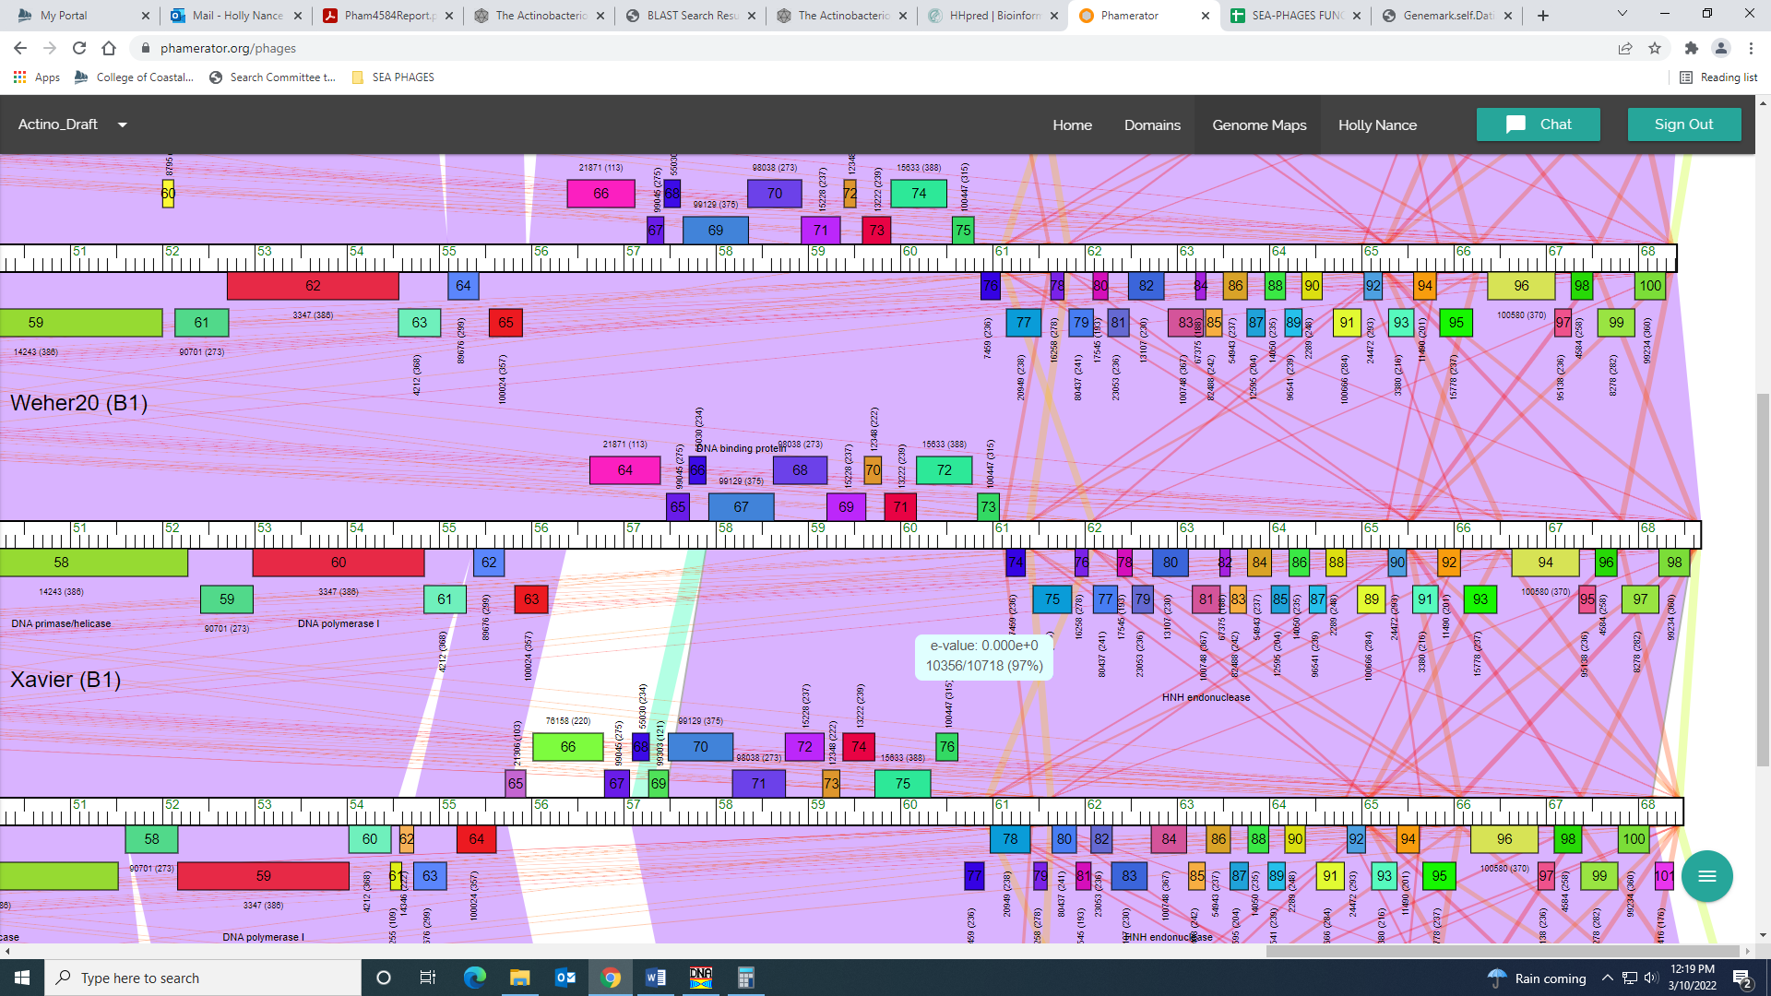
For function, all data supports NKF, though there was one hit above 90% in HHPred. It was for a ribosomal protein (not in phage) and had a high e-value. I’m sticking with NKF.
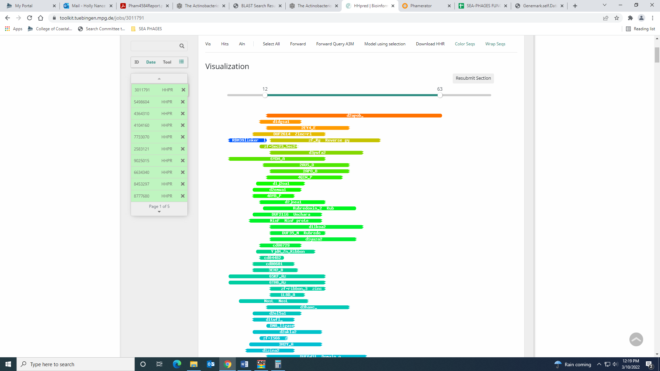
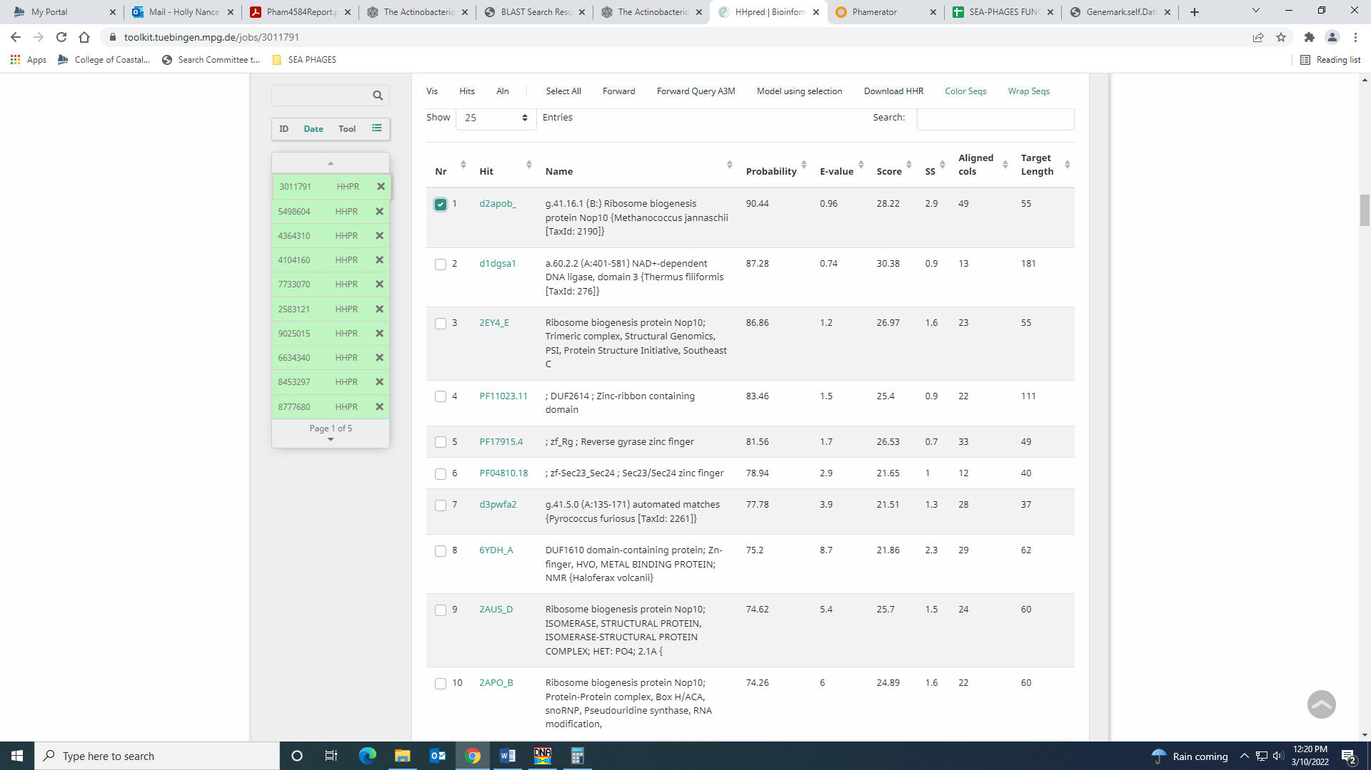

Gene 97 – reverse gene
SSC: start 67964, stop 67563; CP: yes; SCS: Both called start at 67964; ST: SS; Blast Start: matches Zelda_100 Query 1 to Subject 1 100% 5e⁻⁷⁵; Gap: overlap of 1; LO: NA; RBS: -2.483, 2.806, 12, -3.319, yes; F: NKF; SIF-BLAST: NKF/PhageDB BLAST/ Zelda_100, MK112555/100%/5e⁻⁷⁵; SIF-HHPred: NKF, no matches with a probability above 90%; SIF-Syn: NKF
Notes: nothing ambiguous here

Gene 98 – reverse gene
SSC: start 68299, stop 67964; CP: yes; SCS: Both called start at 68299; ST: SS; Blast Start: matches Weher20_98 Query 1 to Subject 1 100% 5e⁻⁶¹; Gap: 457; LO: no; RBS: -2.109, 2.992, 8, -3.331, yes; F: NKF; SIF-BLAST: NKF/PhageDB BLAST/ Weher20_98, MZ681520/100%/5e⁻⁶¹; SIF-HHPred: NKF, no matches with a probability above 90%; SIF-Syn: NKF
Notes: I calculated the gap by subtracting the total length of the genome (68422) from the start of gene 100 (68299). There is a pretty large gap, but large gaps at the end of the genome are conserved in the cluster.
