Gene Number: 1
Start Codon and source: 1 ATG
Stop Codon: 567
F/R: Forward
Coding Potential (y/n): yes
Starterator (SS, NA, NI): Starterator suggests start 30 at base 1
Blast Best Hit, Query:Subject Starts, Score, Evalue, or “no significant Blast alignments” if 10E-4 or higher
Program | Genbank | Phagesdb | DNA Master
Phage name (best match) | Vivaldi | Zelda | Vivaldi
Function | Adenylate Kinase | Adenylate Kinase | Adenylate Kinase
Query/Subject starts | 188/188 | 188/188 | 188/188
Max score/score | 387/387 | NA/384 | 994/994
e-value | 9e-139 | e-107 | 0.0e0
Gap: NA
Longest Orf? (Y/N/NA): Yes
RBS: Kibler6, Karlin Medium, start 1 Z score 1.731 Final Score -6.387
Proposed Function: Adenylate kinase
Function Evidence: Phamerator suggests the synteny aligns with phages Zelda and Vivaldi as adenylate kinase , as well as the top blast results from 3 separate sources pictured above. Hhpred suggests a 99.1% probability of Cytidylate kinase, but results vary.
Transmembrane Domain/Evidence

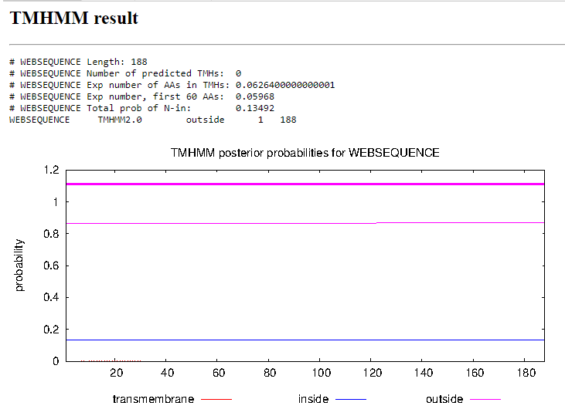
Gene Number:2
Start Codon and source: 564 ATG
Stop Codon: 2351
F/R: Forward
Coding Potential (y/n): yes
Starterator (SS, NA, NI): Suggested start 128 at base 564 has 231 MA’s
Blast Best Hit, Query:Subject Starts, Score, Evalue, or “no significant Blast alignments” if 10E-4 or higher
Program | Genbank | Phagesdb | DNA Master
Phage name (best match) | True | Zelda | True
Function | Terminase | Terminase | Terminase
Positives | 595/595 | 595/595 | 577/595
Max score/score | 1103/1103 | NA/1994 | 2852/2852
e-value | 0.0 | 0.0 | 0.0
Gap: -4 bp
Longest Orf? (Y/N/NA) No
RBS: Kibler6, Karlin Medium, start 5, Z score 2.989 final score -3.723. This is the best RBS documented in the Frames menu.
Proposed Function: Terminase
Function Evidence: Multiple blast sequences indicate that this gene could be terminase, and synteny suggests phages in similar phams possess the same location of the terminase being preceded by the adenylate kinase on the previous page. HHpred suggests several varying options, but the blast results are conclusive on terminase.
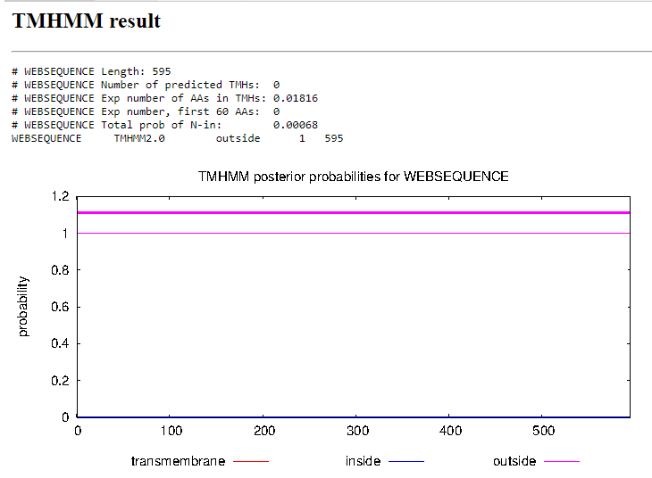
Transmembrane Domain/Evidence

Gene Number: 3
Start Codon and source: 2436 ATG
Stop Codon: 2651
F/R: Forward
Coding Potential (y/n): No
Starterator (SS, NA, NI): Start 6 at 2436 has 222 MA’s
Blast Best Hit, Query:Subject Starts, Score, Evalue, or “no significant Blast alignments” if 10E-4 or higher
Program | Genbank | Phagesdb | DNA Master
Phage name (best match) | PGI | YouGoGlencoco | PG1
Function | NKF | NKF | NKF
Positives | 71/71 | 71/71 | 71/71
Max score/score | 145/145 | NA/153 | 366/366
e-value | 9e-44 | 1e-37 | 9.1e-44
Gap: 279 bp
Longest Orf? (Y/N/NA) No
RBS: Kibler6, Karlin Medium, Start 1 Z score 3.239 Final score -2.666. This is the best proposed start of the data.
Proposed Function: NKF
Function Evidence: Several blast results indicate hypothetical proteins with no known function, as well as HHpred indicating nothing with a probability higher than 68.87% and having varied results. Synteny suggests that other B1 clusters possess this gene but similarly have no assigned function.
Transmembrane Domain/Evidence
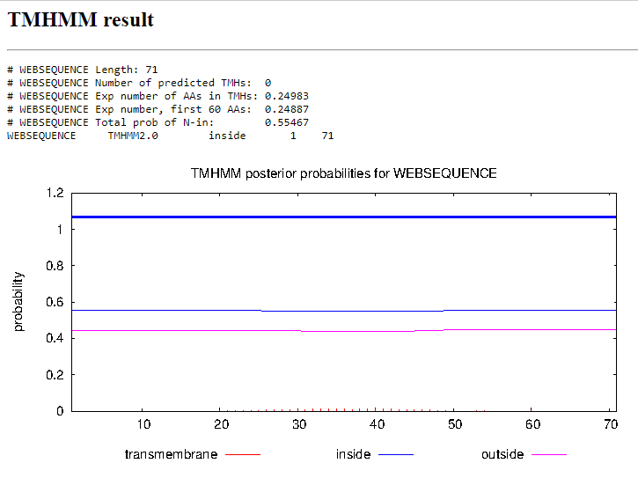
Gene Number: 4
Start Codon and source: 2648 GTG
Stop Codon: 3010
F/R: Forward
Coding Potential (y/n): yes
Starterator (SS, NA, NI): Start 4 at 2633 has 7 MA’s; Start 5 at 2648 has 215 MA’s
Blast Best Hit, Query:Subject Starts, Score, Evalue, or “no significant Blast alignments” if 10E-4 or higher
Program | Genbank | Phagesdb | DNA Master
Phage name (best match) | Soto | Soto | Soto
Function | NKF | NKF | NKF
Positives | 120/120 | 120/120 | 120/120
Max score/score | 246/246 | NA/152 | 627/627
e-value | 6e-82 | 3e-67 | 0.0
Gap: -4
Longest Orf? (Y/N/NA) No
RBS: Kibler6, Karlin Medium, Start 2, Z score -3.095, Final Score -4.140. This is the best start selected from the provided starts
Proposed Function: NKF
Function Evidence: The blast results indicate a strong resemblance to the phage Soto as well as other phages with hypothetical proteins listed. Phamerator suggests a strong synteny in the placement of this gene as the fourth gene among similar B1 phages. HHpred also has no relevant results, with all probabilities being under 30%
Transmembrane Domain/Evidence
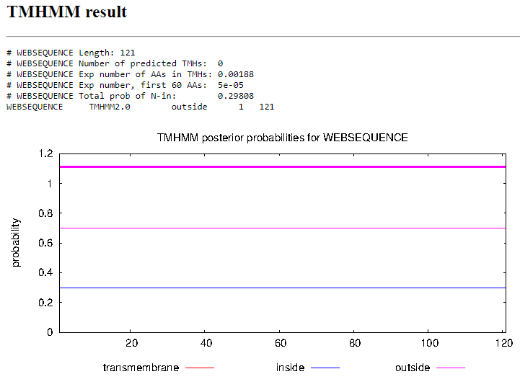
Gene Number: 5
Start Codon and source: 3078 ATG
Stop Codon: 3215
F/R: Forward
Coding Potential (y/n): yes
Starterator (SS, NA, NI): Start 2 at 3078 has 219 MA’s
Blast Best Hit, Query:Subject Starts, Score, Evalue, or “no significant Blast alignments” if 10E-4 or higher
Program | Genbank | Phagesdb | DNA Master
Phage name (best match) | KLucky | Zonia | KLucky
Function | NKF | NKF | NKF
Positives | 45/45 | 45/45 | 45/45
Max score/score | 99/99 | NA/104 | 245/245
e-value | 7e-26 | 7e-23 | 7.4e-26

Gap: 68
Longest Orf? (Y/N/NA) Yes
RBS: Kibler6, Karlin Medium, Start 1, Z score 1.903, Final score -4.297. This is the best provided start.
Proposed Function: NKF
Function Evidence:
Transmembrane Domain/Evidence
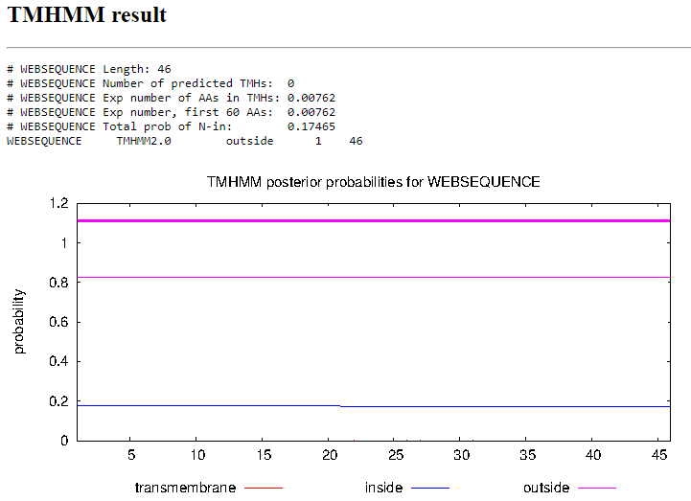
Gene Number: 6
Start Codon and source: 3916 ATG
Stop Codon: 3362
F/R: Reverse
Coding Potential (y/n): yes
Starterator (SS, NA, NI): Start 168 at 3916 has 321 MA’s
Blast Best Hit, Query:Subject Starts, Score, Evalue, or “no significant Blast alignments” if 10E-4 or higher
Program | Genbank | Phagesdb | DNA Master
Phage name (best match) | Apizium | Yoshand | Apizium
Function | RuvC-like Resolvase | RuvC-like Resolvase | RuvC-like Resolvase
Positives | 184/184 | 184/184 | 184/184
Max score/score | 377/377 | NA/379 | 968/968
e-value | 7e-132 | e-105 | 0.0

Gap: 47
Longest Orf? (Y/N/NA) Yes
RBS: Kibler6, Karlin Medium, Start 1, Z score 1.731, Final score -5.989. There are 3 scores that appear better than this start with start 5 having a higher Z score of 2.241 and Final score of -4.315 with similar results within .1 values of each other for the other two starts.
Proposed Function: RuvC-like Resolvase
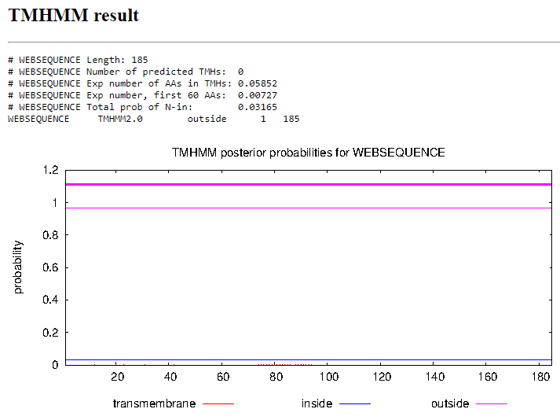
Function Evidence: Several BLASTp results as well as the analysis of HHpred suggest that this gene is RuvC-like Resolvase. The synteny displayed in the phamerator graph also shows a gene of similar length and placement in other phages of the B1 cluster.
Transmembrane Domain/Evidence
Gene Number: 7
Start Codon and source: 3963 ATG
Stop Codon: 4409
F/R: Forward
Coding Potential (y/n): Yes
Starterator (SS, NA, NI):
Blast Best Hit, Query:Subject Starts, Score, Evalue, or “no significant Blast alignments” if 10E-4 or higher
Program | Genbank | Phagesdb | DNA Master
Phage name (best match) | Newman | Serpentine | Newman
Function | NKF | NKF | NKF
Positives | 148/148 | 148/148 | 130/148
Max score/score | 199/199 | NA/298 | 506/506
e-value | 1e-62 | 3e-81 | 0.0e0

Gap: Is it to the start codon of the last reversed gene or is it to the stop codon of the reversed gene?
Longest Orf? (Y/N/NA) Yes
RBS: Kibler6, Karlin Medium, Start 2, Z score 2.146, Final Score -5.157. This is the best start provided
Proposed Function: NKF
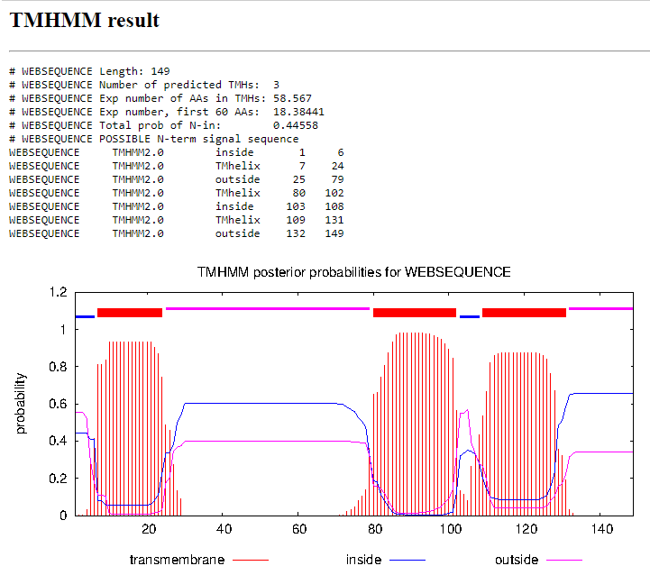
Function Evidence: Several blast results indicate the presence of this gene in other B1 phages though the function is not known. The synteny seen in phamerator also suggests that other B1 phages have the same 6th gene in the same location. HHpred also suggests that there are several different products that have no more than a 57% probability of being the case
Transmembrane Domain/Evidence

Gene Number: 8
Start Codon and source: 4439 ATG
Stop Codon: 6368
F/R: Forward
Coding Potential (y/n): yes
Starterator (SS, NA, NI): Start 22 at 4439 has 333 MA’s, Start 26 at 4454 has 4 MA’s
Blast Best Hit, Query:Subject Starts, Score, Evalue, or “no significant Blast alignments” if 10E-4 or higher
Program | Genbank | Phagesdb | DNA Master
Phage name (best match) | Soto | Soto | Soto
Function | Portal Protein | Portal Protein | Portal Protein
Positives | 634/634 | 634/634 | 634/634
Max score/score | 1225/1225 | NA/1242 | 3169/3169
e-value | 0.0 | 0.0 | 0.0

Gap: 39
Longest Orf? (Y/N/NA) Yes
RBS: Kibler6, Karlin Medium, Start 2, Z score 1.618, Final score -5.914. This is not the best proposed start, as start 1 has a higher Z value as well as a higher final score.
Proposed Function: Portal Protein
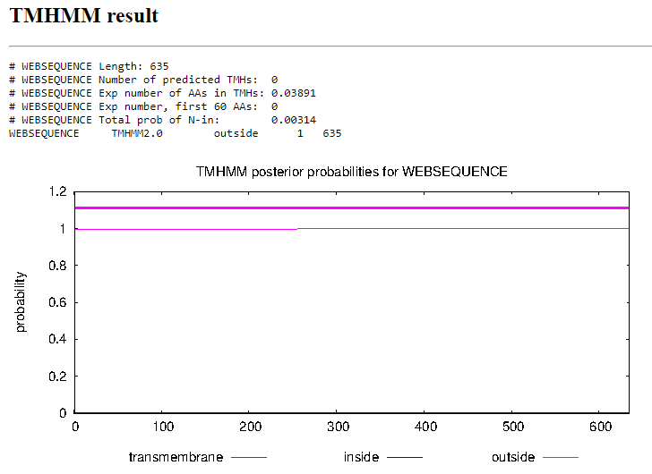
Function Evidence: Several blast results indicate a strong comparison between this protein and the portal proteins of other B1 phages. HHpred also suggests a 99.96% likelihood of this gene coding for a portal protein. The synteny present in phamerator suggests that this protein is in the correct location, however it also suggests an earlier start than what is called in DNA Master. I propose that this gene begins earlier at codon 4439 rather than at 4454.
Transmembrane Domain/Evidence

Gene Number: 9
Start Codon and source: 6358 ATG
Stop Codon: 8931
F/R: Forward
Coding Potential (y/n): yes
Starterator (SS, NA, NI): Start 26 at 6358 has 332 MA’s
Blast Best Hit, Query:Subject Starts, Score, Evalue, or “no significant Blast alignments” if 10E-4 or higher
Program | Genbank | Phagesdb | DNA Master
Phage name (best match) | Pops | Yoshand | Pops
Function | Capsid Maturation protease and MuF-like fusion protein | Capsid Maturation protease and MuF-like fusion protein | Capsid Maturation protease and MuF-like fusion protein
Positives | 857/857 | 857/857 | 857/857
Max score/score | 1527/1527 | NA/1695 | 3954/3954
e-value | 0.0 | 0.0 | 0.0

Gap: -1
Longest Orf? (Y/N/NA) No
RBS: Kibler6, Karlin Medium, Start 2 Z score 2.059, Final Score -4.759. This is the best proposed start.
Proposed Function: Capsid Maturation protease and MuF-like fusion protein
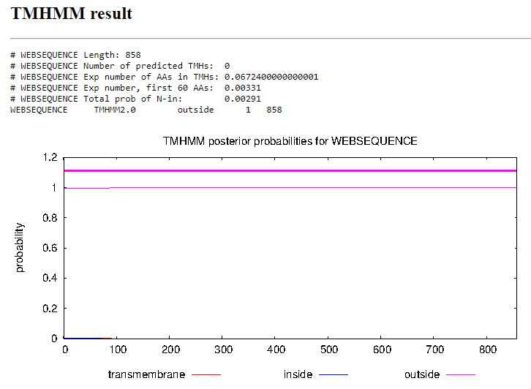
Function Evidence: Several blast results indicate that this gene codes for the Capsid maturation protease and MuF-like fusion protein with 100% positives across the board. HHpred suggests a 92.06% likelihood that this codes instead for prohead core protein protease, but the synteny with other B1 cluster phages suggests that this is the Capsid Maturation protease.
Transmembrane Domain/Evidence

Gene Number: 10
Start Codon and source: 8941 ATG
Stop Codon: 9375
F/R: Forward
Coding Potential (y/n): No
Starterator (SS, NA, NI): NA
Blast Best Hit, Query:Subject Starts, Score, Evalue, or “no significant Blast alignments” if 10E-4 or higher
Program | Genbank | Phagesdb | DNA Master
Phage name (best match) | PG1 | Zaider | NA
Function | NKF | HNH Endonuclease | NA
Positives | 144/144 | 144/144 | NA
Max score/score | 291/291 | NA/315 | NA
e-value | 1e-99 | 2e-86 | NA

Gap: 11
Longest Orf? (Y/N/NA) Yes
RBS: Kibler 6, Karlin Medium, Z value 0.620, Final score -7.915. This is the worst of the proposed starts, with all other scores being higher. However this start most closely matches with the BLAST data of other B1 phages.
Proposed Function: HNH Endonuclease
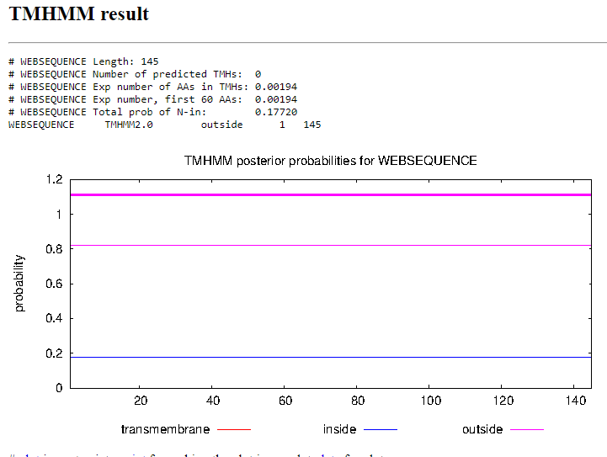
Function Evidence: Blast results are varied, with phagesDB suggesting that the function is HNH Endonuclease. Phamerator suggests the presence of this gene in the gap between called genes 9 and 10. Phamerator suggests that the gene contained there serves the function of HNH Endonuclease in several other B1 cluster phages. HHpred also suggests a 99.4% likelihood that the function is an endonuclease complex.
Transmembrane Domain/Evidence

Gene Number: 11
Start Codon and source: 9504 ATG
Stop Codon: 9641
F/R: Forward
Coding Potential (y/n): yes
Starterator (SS, NA, NI): Start 3 at 9504 has 197 MA’s
Blast Best Hit, Query:Subject Starts, Score, Evalue, or “no significant Blast alignments” if 10E-4 or higher
Program | Genbank | Phagesdb | DNA Master
Phage name (best match) | Surely | Zonia | Surely
Function | NKF | NKF | NKF
Positives | 45/45 | 45/45 | 45/45
Max score/score | 60.5/60.5 | NA/87.8 | 145/145
e-value | 9e-11 | 7e-18 | 9e-11

Gap: 128
Longest Orf? (Y/N/NA) YesRBS: Kibler6, Karlin Medium, Start 1, Z Score 1.173, Final Score -6.259. This is not the best proposed start, with start 3 at codon 9552 having marginally higher scores.
Proposed Function: NKF
Function Evidence: Several blasts indicate that there is no known function, as well HHpred suggesting a low probability for several theoretical proteins. The synteny present in Phamerator suggests the presence of this gene in other B1 cluster phages
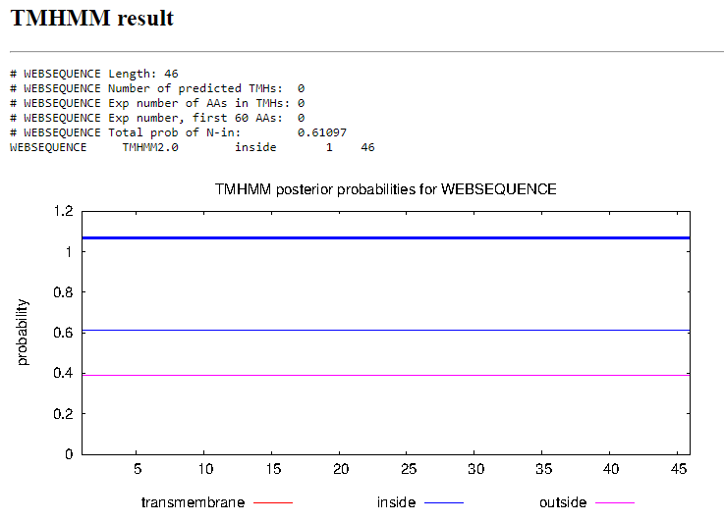
Transmembrane Domain/Evidence
Gene Number: 12
Start Codon and source: 9755 ATG
Stop Codon: 11503
F/R: Forward
Coding Potential (y/n): yes
Starterator (SS, NA, NI): Start: 66 at 9755 has 230 MA's
Blast Best Hit, Query:Subject Starts, Score, Evalue, or “no significant Blast alignments” if 10E-4 or higher
Program | Genbank | Phagesdb | DNA Master
Phage name (best match) | Khave | Yoshand | Khave
Function | Major capsid hexamer protein | Major capsid hexamer protein | Major capsid hexamer protein
Positives | 582/582 | 581/582 | 573/582
Max score/score | 952/952 | NA/1165 | 2460/2460
e-value | 0.0 | 0.0 | 0.0

Gap: 114
Longest Orf? (Y/N/NA) Yes
RBS: Kibler6, Karlin Medium, Start 1, Zvalue 3.175, final score -2.794. This is the best proposed start.
Proposed Function: Major capsid hexamer protein
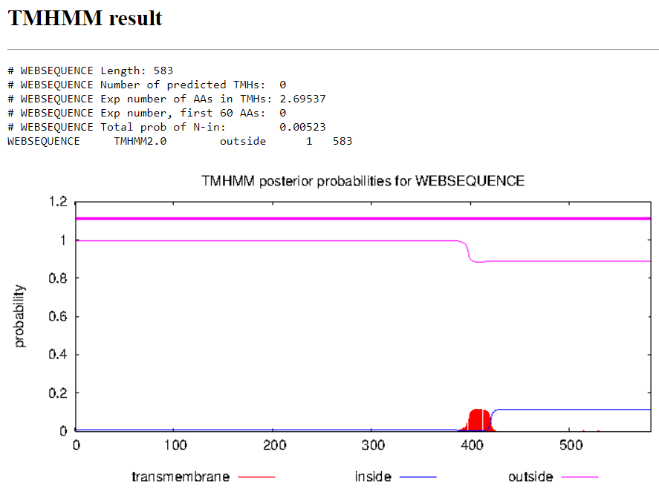
Function Evidence: Several BLAST results indicate that the function of this gene is the major capsid hexamer protein. HHpred suggests that it has a 38.67% likelihood of being a ubiquitin-like protein. The synteny shown in Phamerator also suggests that it is in the correct location relative to other B1 cluster phages.
Transmembrane Domain/Evidence

Gene Number: 13
Start Codon and source: 11603 ATG
Stop Codon: 12406
F/R: Forward
Coding Potential (y/n): yes
Starterator (SS, NA, NI): Start 8 at 11603 has 275 MA’s
Blast Best Hit, Query:Subject Starts, Score, Evalue, or “no significant Blast alignments” if 10E-4 or higher
Program | Genbank | Phagesdb | DNA Master
Phage name (best match) | Mulan | Robyn | Manad
Function | Major capsid pentamer protein | Major capsid pentamer protein | NKF
Positives | 265/267 | 267/267 | 247/267
Max score/score | 503/503 | NA/556 | 1297/1297
e-value | 3e-179 | e-158 | 0.0

Gap: 100
Longest Orf? (Y/N/NA) Yes
RBS: Kibler6, Karlin Medium, Start 1, Z value 2.755, Final score, -3.347. This is the best proposed start.
Proposed Function: Major capsid pentamer protein
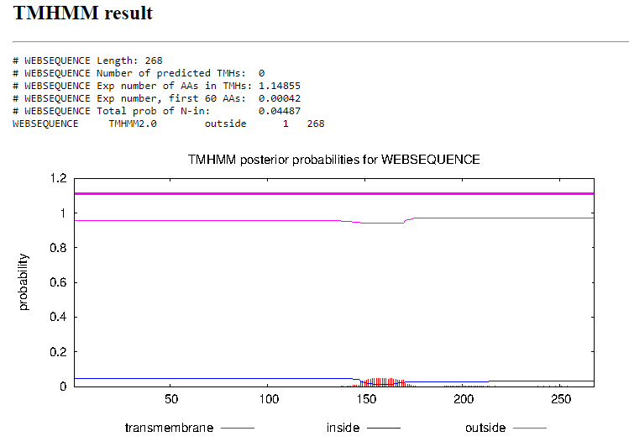
Function Evidence: Several blast results indicate that this gene either has no known function or the function is major capsid pentamer protein. Phamerator synteny with several similar phages (Soto, Zelda, and Vivaldi) suggests that the protein of similar length in the same position relative to other genes is the major capsid pentamer protein.
Transmembrane Domain/Evidence

Gene Number: 14
Start Codon and source: 12418 ATG
Stop Codon: 13258
F/R: Forward
Coding Potential (y/n): yes
Starterator (SS, NA, NI): Start 8 at 12418 has 288 MA’s
Blast Best Hit, Query:Subject Starts, Score, Evalue, or “no significant Blast alignments” if 10E-4 or higher
Program | Genbank | Phagesdb | DNA Master
Phage name (best match) | Pops | Mosaic | Pops
Function | NKF | NKF | NKF
Positives | 280/280 | 280/280 | 280/280
Max score/score | 454/454 | NA/566 | 1169/1169
e-value | 2e-159 | e-161 | 0.0

Gap: 11
Longest Orf? (Y/N/NA) Yes
RBS: Kibler6, Karlin Medium, Start 4, Z score 2.235, Final score -4.467. This is the best proposed score.
Proposed Function: NKF
Function Evidence: Several BLAST results indicate a 100% match to several hypothetical proteins, and HHpred also lists various proteins with no known function. The synteny present in phamerator suggests that the gene present in Tooj is also present in similar B1 cluster phages.
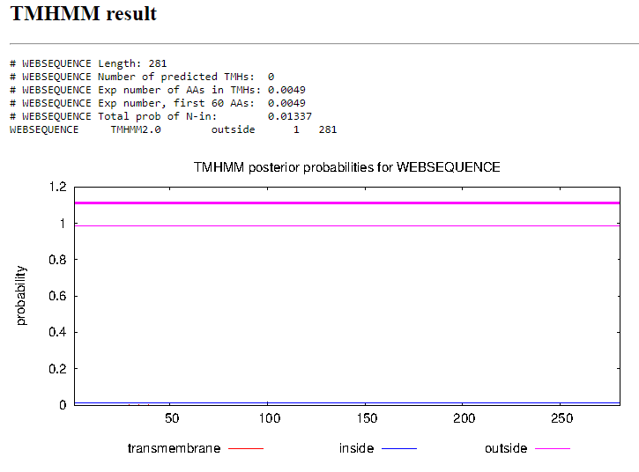
Transmembrane Domain/Evidence

Gene Number: 15
Start Codon and source: 13260 ATG
Stop Codon: 13649
F/R: Forward
Coding Potential (y/n): yes
Starterator (SS, NA, NI): Start 28 at 13260 has 244 MA’s
Blast Best Hit, Query:Subject Starts, Score, Evalue, or “no significant Blast alignments” if 10E-4 or higher
Program | Genbank | Phagesdb | DNA Master
Phage name (best match) | PG1 | Zonia | PG1
Function | NKF | NKF | NKF
Positives | 129/129 | 129/129 | 129/129
Max score/score | 196/196 | NA/249 | 499/499
e-value | 3e-62 | 2e-66 | 0.0

Gap: -1
Longest Orf? (Y/N/NA) No
RBS: Kibler6, Karlin Medium, Start 1, Z score 2.700, final score -3.535. This is the best proposed start
Proposed Function: Membrane Protein
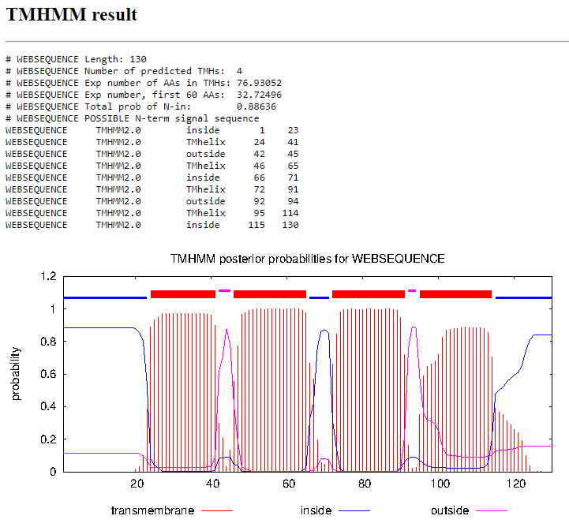
Function Evidence: Multiple BLAST results indicate the presence of this gene without a known function. HHpred suggests a 40.2% chance that this gene is cytochrome c. oxidase, but the synteny present in phamerator suggests that other B1 cluster phages have a similar gene with no known function. TMHMM suggests that this is a membrane protein.
Transmembrane Domain/Evidence

Gene Number: 16
Start Codon and source: 13657 GTG (original call at 13708 ATG)
Stop Codon:14005
F/R: Forward
Coding Potential (y/n): yes
Starterator (SS, NA, NI): Start 16 at 13708 has 66 MA’s. Start 14 at 13657 has 207 MA’s.
Blast Best Hit, Query:Subject Starts, Score, Evalue, or “no significant Blast alignments” if 10E-4 or higher
Program | Genbank | Phagesdb | DNA Master
Phage name (best match) | Oline | Zonia | NA
Function | NKF | NKF | NA
Positives | 116/117 | 116/116 | NA
Max score/score | 160/160 | NA/233 | NA
e-value | 2e-48 | 8e-62 | NA

Gap: 9
Longest Orf? (Y/N/NA) Yes
RBS: Kibler6, Karlin Medium, Start 1, Z score 2.738, Final score -4.147. This is the best proposed start.
Proposed Function: Membrane Protein
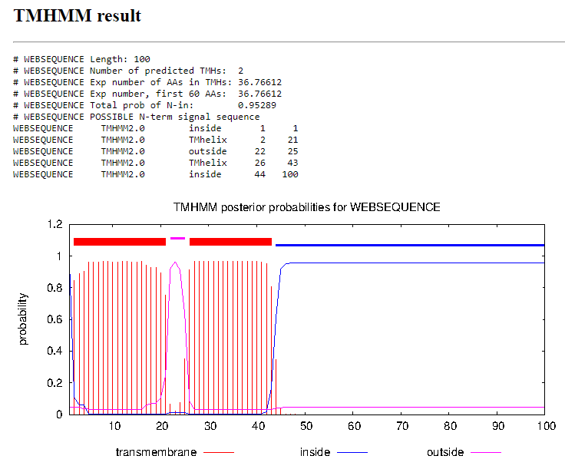
Function Evidence: Several BLAST results indicate this gene having no known function and HHpred suggests several differing protein results with a maximum of 67% probability. The original Glimmer call for this gene was at 13708, but evidence including a higher RBS score, better starterator results, and examining the similar genes on other B1 cluster phages, suggests that this gene begins with GTG earlier at 13657. Phamerator suggests that other genes start at this position and also have no known function. TMHMM suggests that this is a membrane protein.
Transmembrane Domain/Evidence

Gene Number: 17
Start Codon and source: 14004 ATG
Stop Codon: 14618
F/R: Forward
Coding Potential (y/n): yes
Starterator (SS, NA, NI): Start 6 at 14004 has 335 MA’s
Blast Best Hit, Query:Subject Starts, Score, Evalue, or “no significant Blast alignments” if 10E-4 or higher
Program | Genbank | Phagesdb | DNA Master
Phage name (best match) | FugateOSU | FugateOSU | FugateOSU
Function | NKF | NKF | NKF
Positives | 204/204 | 204/204 | 204/204
Max score/score | 420/420 | NA/420 | 1080/1080
e-value | 2e-148 | e-117 | 0.0

Gap: -4
Longest Orf? (Y/N/NA) Yes
RBS: Kibler6, Karlin Medium, Start 1, Z value 2.168, Final score -4.523. This is the best proposed start.
Proposed Function: Membrane Protein
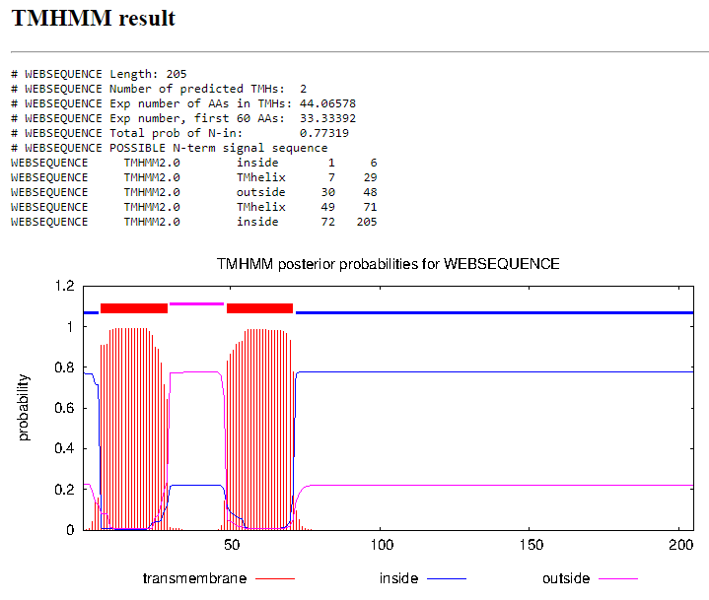
Function Evidence: Several BLAST results indicate the presence of this gene with no known function. All three sources for BLAST indicate 100% similarity to the same gene in FugateOSU. HHpred suggests an 88% probability of this gene being Protein tweety homolog. The synteny provided in Phamerator suggests a similar presence of this gene in other B1 Cluster phages with no assigned function. TMHMM suggests that this is a membrane protein.
Transmembrane Domain/Evidence

Gene Number: 18
Start Codon and source: 14706 ATG
Stop Codon: 15506
F/R: Forward
Coding Potential (y/n): yes
Starterator (SS, NA, NI): Start 24 at 14706 has 280 MA’s
Blast Best Hit, Query:Subject Starts, Score, Evalue, or “no significant Blast alignments” if 10E-4 or higher
Program | Genbank | Phagesdb | DNA Master
Phage name (best match) | PG1 | Zelda | PG1
Function | major tail protein | major tail protein | major tail protein
Positives | 266/266 | 266/266 | 266/266
Max score/score | 497/497 | NA/551 | 1280/1280
e-value | 9e-177 | e-157 | 0.0

Gap: 92
Longest Orf? (Y/N/NA) Yes
RBS: Kibler6, Karlin Medium, Start 1, Z score 2.511, Final score -3.836. This is the best proposed start.
Proposed Function: Major tail protein
Function Evidence: Several blast results indicate that there is a high probability of this being a major tail protein in similar phages. This is also indicated on phamerator with gene 18 on similar phages being assigned the function of major tail protein.
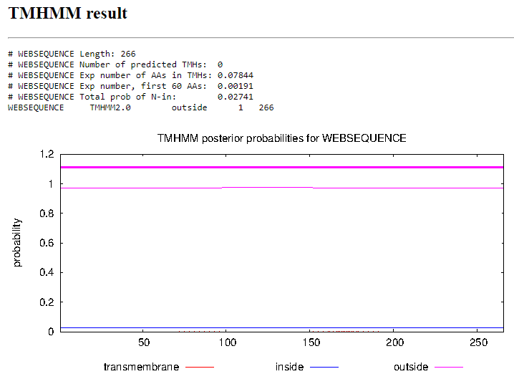
Transmembrane Domain/Evidence

Gene Number: 19
Start Codon and source: 15795 ATG
Stop Codon: 15565
F/R: Reverse
Coding Potential (y/n): yes
Starterator (SS, NA, NI): Start: 16 @15795 has 364 MA's
Blast Best Hit, Query:Subject Starts, Score, Evalue, or “no significant Blast alignments” if 10E-4 or higher
Program | Genbank | Phagesdb | DNA Master
Phage name (best match) | CharlieGBrown | Zelda | CharlieGBrown
Function | NKF | NKF | NKF
Positives | 75/76 | 76/76 | 75/76
Max score/score | 82.8/82.8 | NA/147 | 203/203
e-value | 9e-19 | 1e-35 | 9.3e-19

Gap: 59
Longest Orf? (Y/N/NA) Yes
RBS: Kibler6, Karlin Medium, Start 1, Z score 3.157, final score -3.307. This is the only suggested start.
Proposed Function: NKF
Function Evidence: Several BLAST results indicate a strong similarity to known genes with no assigned function, and HHpred provides no conclusive results above 40%. The synteny present in phamerator among similar B1 cluster phages suggests that other phages have a similar gene in a similar location.
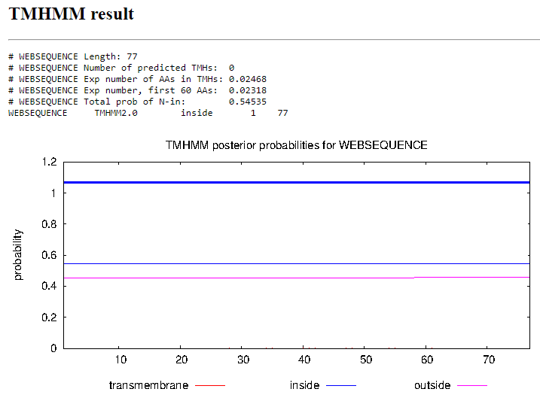
Transmembrane Domain/Evidence
Gene Number: 20
Start Codon and source: 16649 ATG
Stop Codon: 15875
F/R: Reverse
Coding Potential (y/n): Yes
Starterator (SS, NA, NI): Start: 34 @16649 has 279 MA's
Blast Best Hit, Query:Subject Starts, Score, Evalue, or “no significant Blast alignments” if 10E-4 or higher
Program | Genbank | Phagesdb | DNA Master
Phage name (best match) | PG1 | Vortex | PG1
Function | queuine tRNA-ribosyltransferase | queuine tRNA-ribosyltransferase | queuine tRNA-ribosyltransferase
Positives | 258/258 | 258/258 | 258/258
Max score/score | 535/535 | NA/564 | 1377/1377
e-value | 0.0 | e-155 | 0.0

Gap: 80
Longest Orf? (Y/N/NA) Yes
RBS: Kibler6, Karlin Medium, Start 3, Z score 2.672. Final score -3.514. This is the best proposed start.
Proposed Function: Queuine tRNA-ribosyltransferase
Function Evidence: BLAST results indicate a strong likelihood that this is queuine tRNA ribosyltransferase with 1:1 results and is also suggested by HHpred.
Transmembrane Domain/Evidence
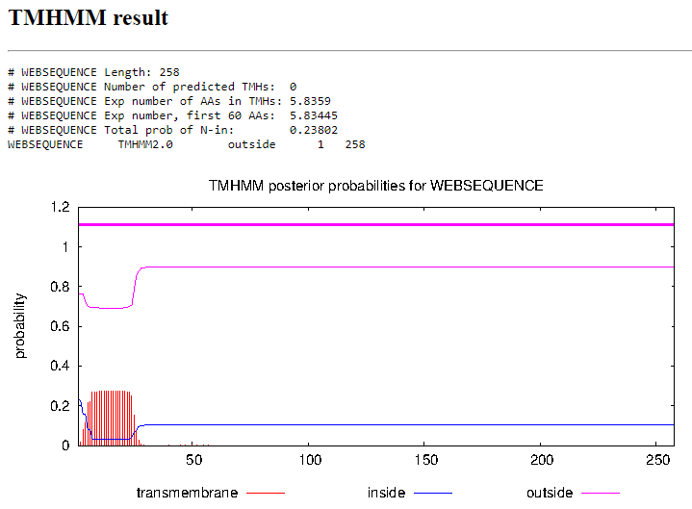

Gene Number: 21
Start Codon and source: 16966 ATG
Stop Codon: 16705
F/R: Reverse
Coding Potential (y/n): yes
Starterator (SS, NA, NI): Start: 3 @16966 has 127 MA's
Blast Best Hit, Query:Subject Starts, Score, Evalue, or “no significant Blast alignments” if 10E-4 or higher
Program | Genbank | Phagesdb | DNA Master
Phage name (best match) | Manad | Xavier | Manad
Function | NKF | NKF | NKF
Positives | 87/87 | 87/87 | 87/87
Max score/score | 171/171 | NA/169 | 433/433
e-value | 3e-53 | 2e-42 | 0.0

Gap: 54
Longest Orf? (Y/N/NA) Yes
RBS: Kibler6, Karlin Medium, Start 2, Z value 3.157, Final score -3.307. This is the best proposed start.
Proposed Function: NKF
Function Evidence: Several blast results indicate the presence of this gene in similar phages, with no known functions. Phamerator suggests that other similar phages have a gene of similar length in a similar location.
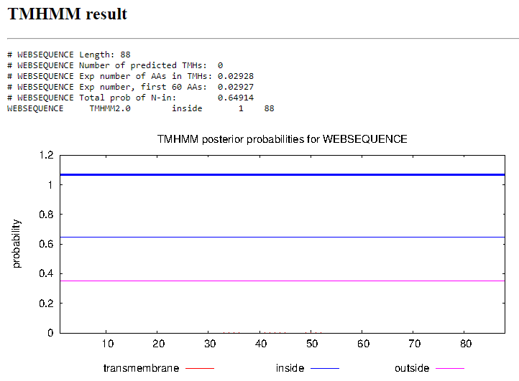
Transmembrane Domain/Evidence
Gene Number: 22
Start Codon and source: 17076 GTG
Stop Codon: 17813
F/R: Forward
Coding Potential (y/n): yes
Starterator (SS, NA, NI): Start: 95 @17076 has 270 MA's
Blast Best Hit, Query:Subject Starts, Score, Evalue, or “no significant Blast alignments” if 10E-4 or higher
Program | Genbank | Phagesdb | DNA Master
Phage name (best match) | PG1 | Zelda | PG1
Function | head-to-tail adaptor | head-to-tail adaptor | head-to-tail adaptor
Positives | 245/245 | 245/245 | 245/245
Max score/score | 492/492 | NA/514 | 1267/1267
e-value | 2e-175 | e-146 | 0.0

Gap: 110
Longest Orf? (Y/N/NA) Yes
RBS: Kibler6, Karlin Medium, Start 1, Z score 1.885, Final score -5.680. This is the best suggested start.
Proposed Function: Head-to-tail adaptor
Function Evidence: Several BLAST results indicate a high probability that this is the head-to-tail adaptor gene, as it is seen in several similar phages in a similar location as seen in Phamerator. HHpred suggests a 99% likelihood that this is some sort of adaptor protein, so the head-to-tail adaptor protein seems likely.
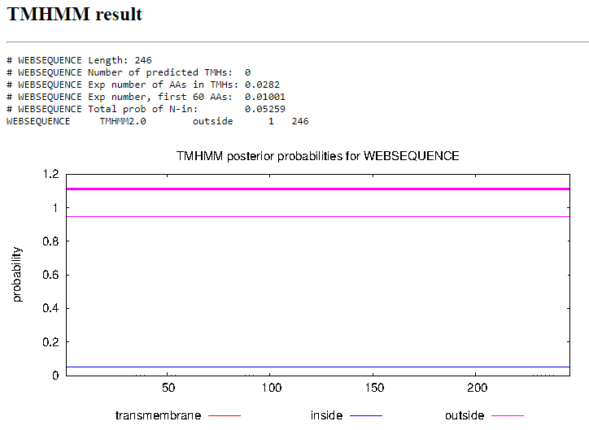
Transmembrane Domain/Evidence

Gene Number: 23
Start Codon and source: 17813 ATG
Stop Codon: 18331
F/R: Forward
Coding Potential (y/n): Yes
Starterator (SS, NA, NI): Start: 22 @17813 has 298 MA's
Blast Best Hit, Query:Subject Starts, Score, Evalue, or “no significant Blast alignments” if 10E-4 or higher
Program | Genbank | Phagesdb | DNA Master
Phage name (best match) | PG1 | Vivaldi | PG1
Function | NKF | NKF | NKF
Positives | 172/172 | 172/172 | 172/172
Max score/score | 354/354 | NA/365 | 908/908
e-value | 4e-123 | e-101 | 0.0

Gap: -1
Longest Orf? (Y/N/NA) Yes
RBS: Kibler6, Karlin Medium, Start 2, Z value 2.147, final score -4.583. This is the best proposed start.
Proposed Function: NKF
Function Evidence: Several BLAST results indicate a strong similarity between multiple phages of this gene having no known function, and HHpred results are only a 13.48% chance of the results being a nitrogen fixation protein.
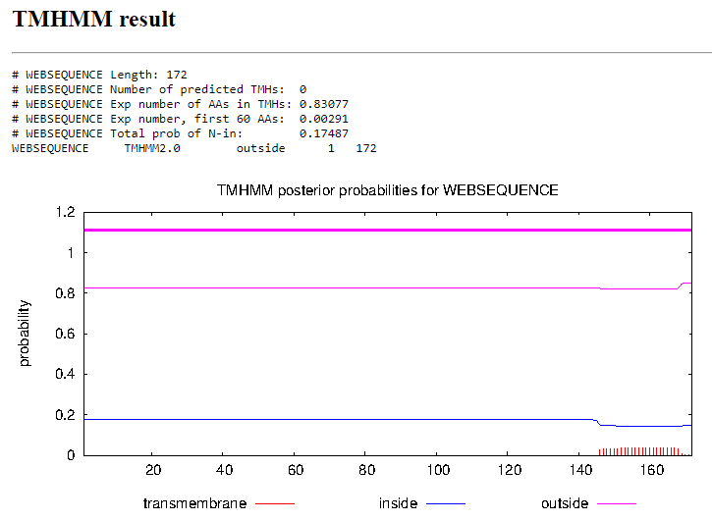
Transmembrane Domain/Evidence

Gene Number: 24
Start Codon and source: 18347 ATG (original start at 18341)
Stop Codon: 18676
F/R: Forward
Coding Potential (y/n): yes
Starterator (SS, NA, NI):(Start: 52 @18341 has 87 MA's; Start: 54 @18347 has 249 MA's
Blast Best Hit, Query:Subject Starts, Score, Evalue, or “no significant Blast alignments” if 10E-4 or higher
Program | Genbank | Phagesdb | DNA Master
Phage name (best match) | Suffolk | Yoshand | Suffolk
Function | NKF | NKF | NKF
Positives | 111/111 | 111/111 | 111/111
Max score/score | 226/226 | NA/226 | 575/575
e-value | 3e-74 | 1e-59 | 0.0

Gap: 10
Longest Orf? (Y/N/NA) Yes
RBS: Kibler6, Karlin Medium, Start 1, Z score 2.497, Final score -5.142. This is not the best proposed start, Start 2 has an identical Z score but the final score is -3.899. This is potential evidence for a later start than initially called. I’d check starterator but it’s down for the moment.
Proposed Function: NKF
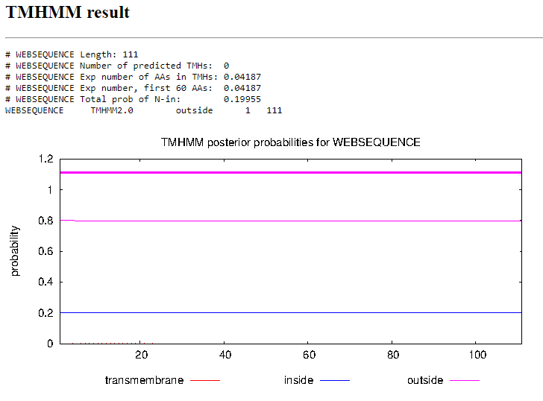
Function Evidence: Several BLAST results indicate a strong similarity between this and genes in similar phages with no known function. However, there may be a later start than the initial call due to a higher RBS call 6 base pairs upstream of the current called start. Starterator is currently down so I cannot further verify. HHpred suggests a 97.51% probability that the function is Mu-like prophage FluMu protein with a 0.00021 E-value.
Transmembrane Domain/Evidence

Gene Number: 25
Start Codon and source: 18681 TTG
Stop Codon: 19103
F/R: Forward
Coding Potential (y/n): yes
Starterator (SS, NA, NI): Start: 41 @20834 has 209 MA's
Blast Best Hit, Query:Subject Starts, Score, Evalue, or “no significant Blast alignments” if 10E-4 or higher
Program | Genbank | Phagesdb | DNA Master
Phage name (best match) | Suffolk | Surely | Suffolk
Function | Tail assembly chaperone | Tail assembly chaperone | Tail assembly chaperone
Positives | 140/140 | 140/140 | 120/140
Max score/score | 247/247 | NA/288 | 630/630
e-value | 8e-82 | 4e-78 | 0.0

Gap: 5
Longest Orf? (Y/N/NA) Yes
RBS: Kibler6, Karlin Medium, Start 2, Z value 1.820, final score -5.685. This is the best provided score.
Proposed Function: Tail assembly chaperone
Function Evidence: Several BLAST results indicate that this is the tail assembly chaperone. The synteny in Phamerator suggests that similar B1 Cluster phages have similar genes for tail assembly chaperone. HHpred also shows inconclusive results.
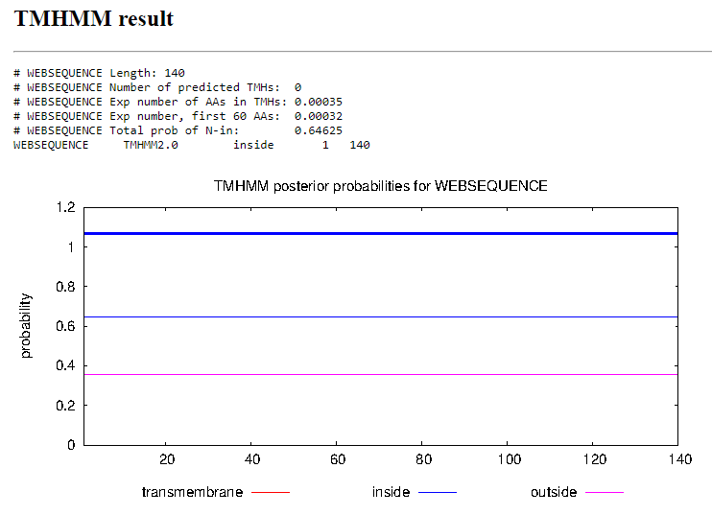
Transmembrane Domain/Evidence

Gene Number: 26
Start Codon and source: 19154 ATG
Stop Codon: 19717
F/R: Forward
Coding Potential (y/n): yes
Starterator (SS, NA, NI): Start: 30 @19154 has 223 MA's
Blast Best Hit, Query:Subject Starts, Score, Evalue, or “no significant Blast alignments” if 10E-4 or higher
Program | Genbank | Phagesdb | DNA Master
Phage name (best match) | ShiVal | Suffolk | ShiVal
Function | NKF | NKF | NKF
Positives | 186/187 | 187/187 | 186/187
Max score/score | 295/295 | NA/369 | 756/756
e-value | 2e-99 | e-102 | 0.0

Gap: 118
Longest Orf? (Y/N/NA) Yes
RBS: Kibler6, Karlin Medium, Z value 2.913, Final score -3.030. This is the best proposed start.
Proposed Function: NKF
Function Evidence: Several BLAST results indicate that several other B1 phages share this same sequence which has an unknown function. HHpred suggests that the function could be a protein structure initiative, however this is a gene present in the bacillus genus, which is not an actinobacteria.
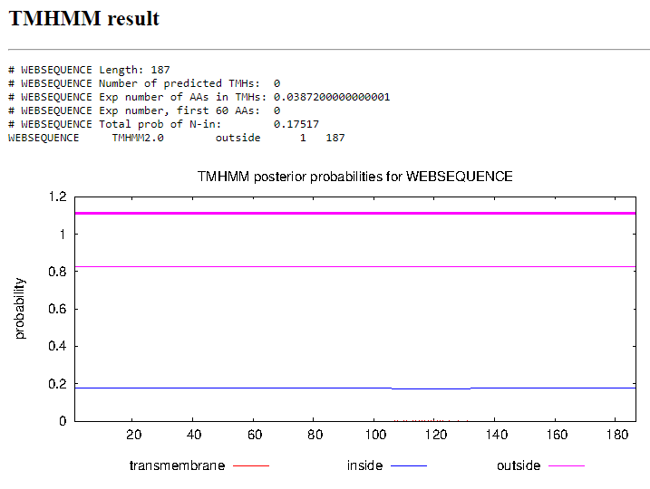
Transmembrane Domain/Evidence
Gene Number: 27
Start Codon and source: 20176 ATG
Stop Codon: 19835
F/R: Reverse
Coding Potential (y/n): yes
Starterator (SS, NA, NI): Start: 3 @20176 has 173 MA, Start: 1 @20212 has 48 MA's
Blast Best Hit, Query:Subject Starts, Score, Evalue, or “no significant Blast alignments” if 10E-4 or higher
Program | Genbank | Phagesdb | DNA Master
Phage name (best match) | PG1 | Zelda | PG1
Function | NKF | NKF | NKF
Positives | 113/113 | 113/113 | 113/113
Max score/score | 233/233 | NA/238 | 594/594
e-value | 4e-77 | 4e-63 | 0.0

Gap: 118
Longest Orf? (Y/N/NA) No
RBS: Kibler6, Karlin Medium, Z value 2.913, Final score -3.030. This is the best proposed start
Proposed Function: NKF
Function Evidence: Several BLAST results indicate a strong similarity between this gene and the 27th gene of multiple other phages. Phamerator also suggests a strong synteny between Tooj and other B1 cluster phages.
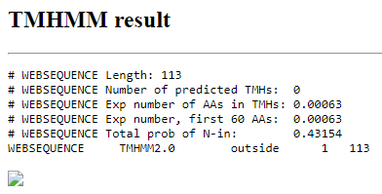
Transmembrane Domain/Evidence
Gene Number: 28
Start Codon and source: 20296 GTG
Stop Codon: 26274
F/R: Forward
Coding Potential (y/n): yes
Starterator (SS, NA, NI): Start: 1 @20296 has 269 MA's
Blast Best Hit, Query:Subject Starts, Score, Evalue, or “no significant Blast alignments” if 10E-4 or higher
Program | Genbank | Phagesdb | DNA Master
Phage name (best match) | KlimbOn | Prickles | KlimbOn
Function | Tape measure protein | Tape measure protein | Tape measure protein
Positives | 1970/1991 | 1992/1992 | 1970/1991
Max score/score | 2946/2946 | NA/3856 | 7638/7638
e-value | 0.0 | 0.0 | 0.0

Gap: 20
Longest Orf? (Y/N/NA) yes
RBS: Kibler6, Karlin Medium, Z value 0.947, Final score -7.561. This is not the best proposed start, but Starterator strongly suggests that several other phages share the start at 20296.
Proposed Function: Tape Measure protein
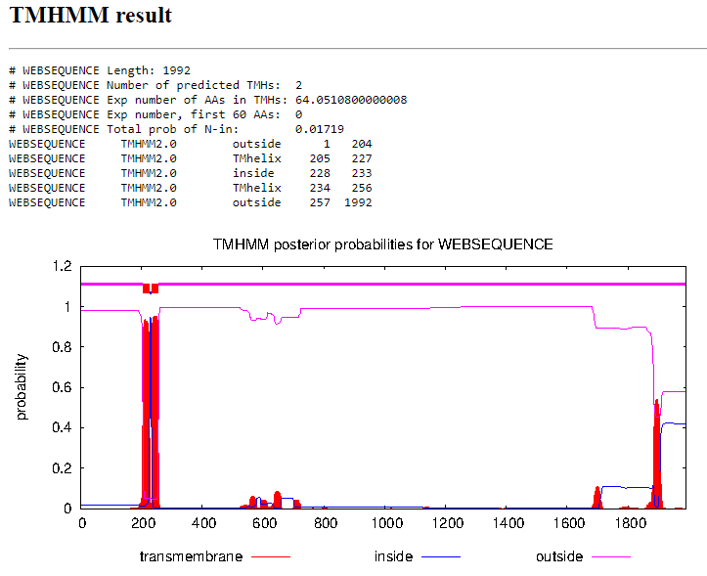
Function Evidence: Several BLAST results indicate that this is the tape measure protein for several other phages as well as a 99.53% probability of it being the tape measure protein.
Transmembrane Domain/Evidence
Gene Number: 29
Start Codon and source: 26284 GTG
Stop Codon: 27717
F/R: Forward
Coding Potential (y/n): yes
Starterator (SS, NA, NI): Start: 15 @26284 has 322 MA's
Blast Best Hit, Query:Subject Starts, Score, Evalue, or “no significant Blast alignments” if 10E-4 or higher
Program | Genbank | Phagesdb | DNA Master
Phage name (best match) | Manad | Prickles | Manad
Function | minor tail protein | minor tail protein | minor tail protein
Positives | 477/477 | 477/477 | 477/477
Max score/score | 932/932 | NA/990 | 2410/2410
e-value | 0.0 | 0.0 | 0.0

Gap: 10
Longest Orf? (Y/N/NA) yes
RBS: Kibler6, Karlin Medium, Z value 2.491, final score -3.814. This is the best proposed start.
Proposed Function: minor tail protein
Function Evidence: Several BLAST results indicate that this gene is the minor tail protein among similar phages, which is supported by the phamerator synteny results of several other B1 phages have the same gene in the same location.
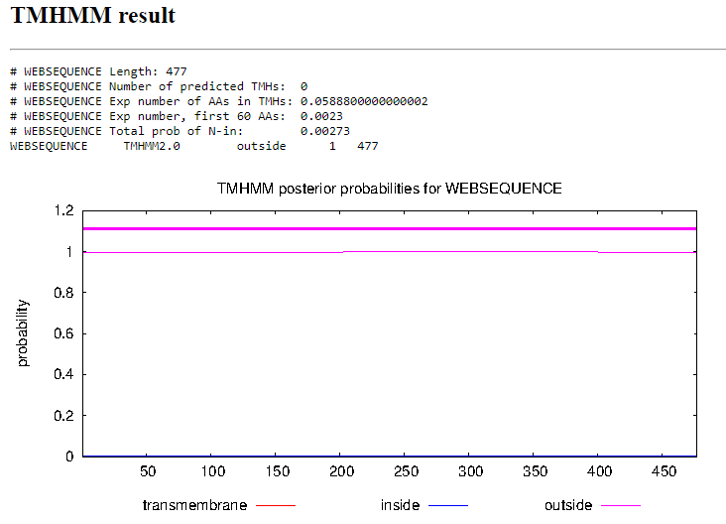
Transmembrane Domain/Evidence
Gene Number: 30
Start Codon and source: 27714 ATG
Stop Codon: 28826
F/R: Forward
Coding Potential (y/n): yes
Starterator (SS, NA, NI): Start: 44 @27714 has 215 MA's
Blast Best Hit, Query:Subject Starts, Score, Evalue, or “no significant Blast alignments” if 10E-4 or higher
Program | Genbank | Phagesdb | DNA Master
Phage name (best match) | PG1 | Zelda | PG1
Function | NKF | minor tail protein | NKF
Positives | 369/370 | 369/370 | 369/370
Max score/score | 754/754 | NA/742 | 1947/1947
e-value | 0.0 | 0.0 | 0.0

Gap: -4
Longest Orf? (Y/N/NA) yes
RBS: Kibler6, Karlin Medium, Z value 2.285, Final score -4.367. This is the best proposed start
Proposed Function: minor tail protein
Function Evidence: Several BLAST results indicate that this gene is either a minor tail protein or has no known function. This function is assigned as minor tail protein due to a majority of BLAST results having this as the assigned function, as well as a 99.79% likelihood on HHpred of this being a tail protein.
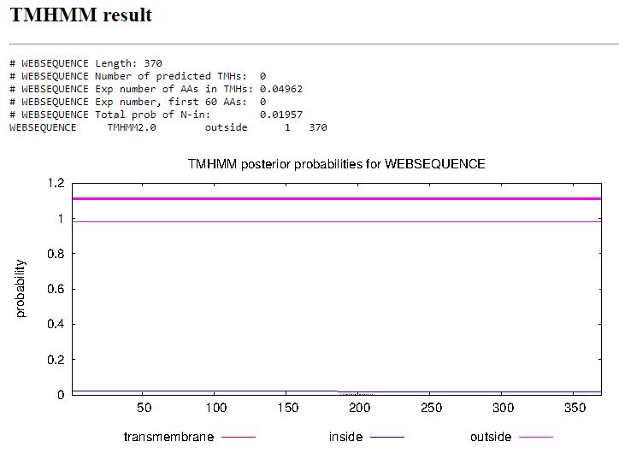
Transmembrane Domain/Evidence
Gene Number: 31
Start Codon and source: 28823 GTG
Stop Codon: 31081
F/R: Forward
Coding Potential (y/n): Yes
Starterator (SS, NA, NI): Start: 22 @28823 has 255 MA's
Blast Best Hit, Query:Subject Starts, Score, Evalue, or “no significant Blast alignments” if 10E-4 or higher
Program | Genbank | Phagesdb | DNA Master
Phage name (best match) | Chunky | Chunky | Chunky
Function | minor tail protein | minor tail protein | minor tail protein
Positives | 752/752 | 752/752 | 752/752
Max score/score | 1420/1420 | NA/1496 | 3675/3675
e-value | 0.0 | 0.0 | 0.0

Gap: -4
Longest Orf? (Y/N/NA) Yes
RBS: Kibler6, Karlin Medium, Z score 2.059, Final score -4.742. This is the best proposed score.
Proposed Function: minor tail protein
Function Evidence: Several BLAST results indicate that this gene is similar to a minor tail protein gene in multiple other B1 cluster phages, and several related phages in Phamerator share a similar gene in a similar location.
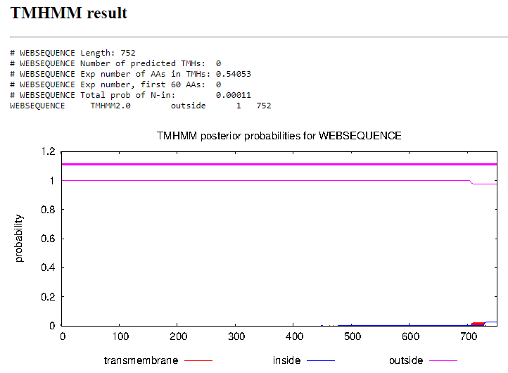
Transmembrane Domain/Evidence
Gene Number: 32
Start Codon and source: 31085 GTG
Stop Codon: 32431
F/R: Forward
Coding Potential (y/n): yes
Starterator (SS, NA, NI): Start: 2 @31085 has 287 MA's
Blast Best Hit, Query:Subject Starts, Score, Evalue, or “no significant Blast alignments” if 10E-4 or higher
Program | Genbank | Phagesdb | DNA Master
Phage name (best match) | PG1 | Vivaldi | PG1
Function | NKF | minor tail protein | NKF
Positives | 447/448 | 448/448 | 447/448
Max score/score | 472/472 | NA/911 | 1215/1215
e-value | 5e-161 | 0.0 | 0.0

Gap: 4
Longest Orf? (Y/N/NA) yes
RBS: Kibler6, Karlin Medium, Z value 2.583, Final score -3.628. This is the best proposed start.
Proposed Function: minor tail protein
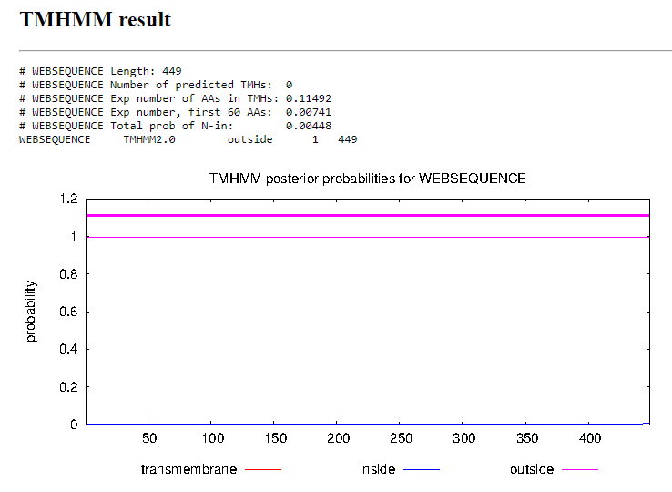
Function Evidence: The top BLAST results for both NCBI and DNA Master suggest that PG1 is the closest match with no assigned function, but several results below that indicate that this gene is for another minor tail protein. Several similar b1 Cluster phages have this gene listed as one in a series of minor tail proteins, so that is the function currently assigned.
Transmembrane Domain/Evidence
Gene Number: 33
Start Codon and source: 32434 GTG
Stop Codon: 33594
F/R: Forward
Coding Potential (y/n): yes
Starterator (SS, NA, NI): Start: 39 @32434 has 244 MA's
Blast Best Hit, Query:Subject Starts, Score, Evalue, or “no significant Blast alignments” if 10E-4 or higher
Program | Genbank | Phagesdb | DNA Master
Phage name (best match) | TomBombadil | Suffolk | TomBombadil
Function | minor tail protein | minor tail protein | minor tail protein
Positives | 384/386 | 386/386 | 384/386
Max score/score | 412/412 | NA/766 | 1059/1059
e-value | 3e-139 | 0.0 | 0.0

Gap: 3
Longest Orf? (Y/N/NA) yes
RBS: Kibler6, Karlin Medium, Z value 2.562, final score -3.751. This is the best proposed start.
Proposed Function: minor tail protein
Function Evidence: Several BLAST results indicate that this gene is a minor tail protein, with similar results among several similar phages in Phamerator. HHpred provides no significant results.
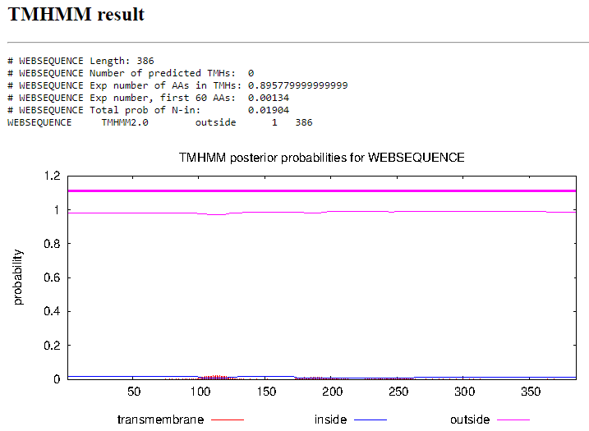
Transmembrane Domain/Evidence
Gene Number: 34
Start Codon and source: 33625 ATG
Stop Codon: 34014
F/R: Forward
Coding Potential (y/n): yes
Starterator (SS, NA, NI): Start: 38 @33625 has 404 MA's
Blast Best Hit, Query:Subject Starts, Score, Evalue, or “no significant Blast alignments” if 10E-4 or higher
Program | Genbank | Phagesdb | DNA Master
Phage name (best match) | PG1 | YouGoGlencoco | PG1
Function | NKF | NKF | NKF
Positives | 129/129 | 129/129 | 129/129
Max score/score | 234/234 | NA/261 | 596/596
e-value | 6e-77 | 4e-70 | 0.0

Gap: 31
Longest Orf? (Y/N/NA) Yes
RBS: Kibler6, Karlin Medium, Z value 2.166, Final score -4.527. This is the best proposed start.
Proposed Function: NKF
Function Evidence: Several BLAST results indicate that this gene has no known function, and this is corroborated in the synteny present among similar B1 cluster phages that show this same gene in the same position. HHpred provides no significant results.
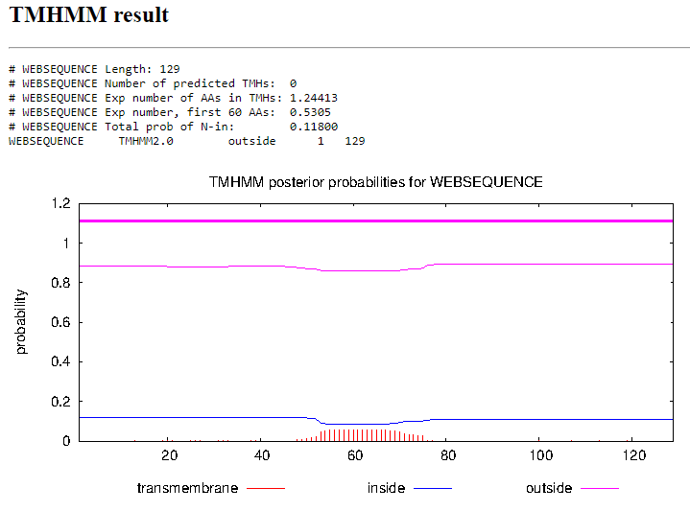
Transmembrane Domain/Evidence
Gene Number: 35
Start Codon and source: 34023 ATG
Stop Codon: 34409
F/R: Forward
Coding Potential (y/n): yes
Starterator (SS, NA, NI): Start: 37 @34023 has 252 MA's
Blast Best Hit, Query:Subject Starts, Score, Evalue, or “no significant Blast alignments” if 10E-4 or higher
Program | Genbank | Phagesdb | DNA Master
Phage name (best match) | Colbert | Grand2040 | Colbert
Function | NKF | NKF | NKF
Positives | 128/128 | 128/128 | 128/128
Max score/score | 259/259 | NA/268 | 661/661
e-value | 7e-87 | 4e-72 | 0.0

Gap: 10
Longest Orf? (Y/N/NA) Yes
RBS: Kibler6, Karlin Medium, Z value 2.899, Final score -3.524. This is the best proposed start
Proposed Function: NKF
Function Evidence: Several BLAST results indicate that several other phages have similar genes with no known functions which is supported by Phamerator results showing that several similar phages have a similar gene in the same location. HHpred also suggests a possibility of this being a pancreatic hormone, but this is unlikely due to the nature of the bacteriophage.
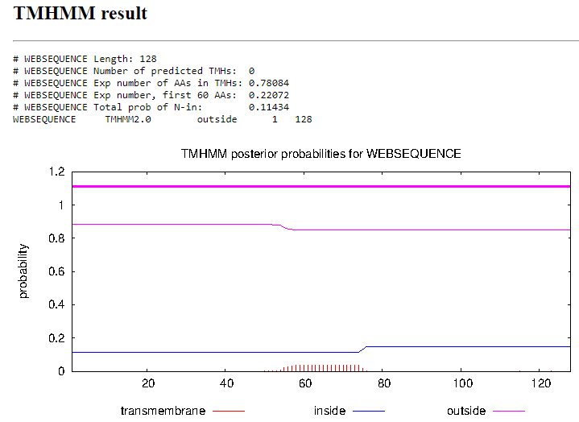
Transmembrane Domain/Evidence
Gene Number: 36
Start Codon and source: 34409 ATG
Stop Codon: 35056
F/R: Forward
Coding Potential (y/n): yes
Starterator (SS, NA, NI): Start: 73 @34409 has 493 MA's
Blast Best Hit, Query:Subject Starts, Score, Evalue, or “no significant Blast alignments” if 10E-4 or higher
Program | Genbank | Phagesdb | DNA Master
Phage name (best match) | Suffolk | Vortex | Suffolk
Function | NKF | NKF | NKF
Positives | 215/215 | 215/215 | 215/215
Max score/score | 434/434 | NA/453 | 1117/1117
e-value | 1e-153 | e-127 | 0.0

Gap: -1
Longest Orf? (Y/N/NA) No
RBS: Kibler6, Karlin Medium, Z value 1.935, Final score -5.009. This is not the best proposed start, but the better sites are several hundred base pairs ahead, and does not align with the 493 similar starts called in Starterator.
Proposed Function: NKF
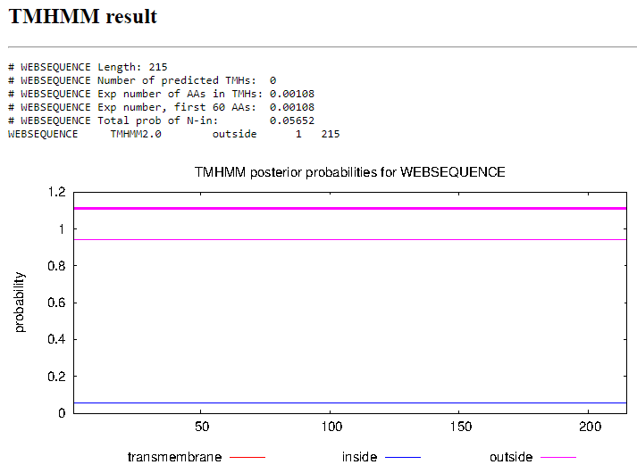
Function Evidence: Several BLAST results indicate strongly similar proteins with no known functions present in other similar phages. Phamerator suggests that this gene is present in several other similar B1 Cluster phages with no known function.
Transmembrane Domain/Evidence
Gene Number: 37
Start Codon and source: 35053 ATG
Stop Codon: 35652
F/R: Forward
Coding Potential (y/n): yes
Starterator (SS, NA, NI): Start: 73 @35053 has 493 MA's
Blast Best Hit, Query:Subject Starts, Score, Evalue, or “no significant Blast alignments” if 10E-4 or higher
Program | Genbank | Phagesdb | DNA Master
Phage name (best match) | PG1 | Zelda | PG1
Function | NKF | NKF | NKF
Positives | 199/199 | 199/199 | 199/199
Max score/score | 407/407 | NA/411 | 1047/1047
e-value | 2e-143 | e-115 | 0.0

Gap: -4
Longest Orf? (Y/N/NA) yes
RBS: Kibler6, Karlin Medium, Z value 2.723, final score -3.489. This is the best proposed start
Proposed Function: NKF
Function Evidence: Several BLAST results indicate that this protein is similar to a protein with no known function in other phages. There are no significant HHpred results, but Phamerator suggests that this same gene is present in other similar phages.
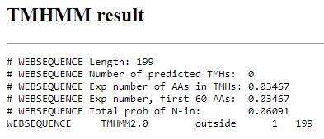
Transmembrane Domain/Evidence
Gene Number: 38
Start Codon and source: 35649 ATG
Stop Codon: 36272
F/R: Forward
Coding Potential (y/n): yes
Starterator (SS, NA, NI): Start: 15 @35649 has 269 MA's
Blast Best Hit, Query:Subject Starts, Score, Evalue, or “no significant Blast alignments” if 10E-4 or higher
Program | Genbank | Phagesdb | DNA Master
Phage name (best match) | Newman | Newman | Newman
Function | NKF | NKF | NKF
Positives | 207/207 | 207/207 | 207/207
Max score/score | 425/425 | NA/428 | 1093/1093
e-value | 4e-150 | e-120 | 0.0

Gap: -4
Longest Orf? (Y/N/NA) no
RBS: Kibler6, Karlin Medium, Z value 2.211, Final score -4.516. This is the best proposed start.
Proposed Function: NKF
Function Evidence: Several BLAST results indicate similar proteins in other phages with no known function. HHpred suggests a 45.49% likelihood that this protein is Aspergillopepsin, but this is not documented for any other phage.
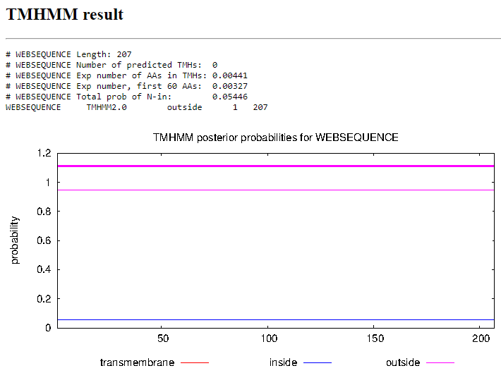
Transmembrane Domain/Evidence
Gene Number: 39
Start Codon and source: 36306 GTG
Stop Codon: 36673
F/R: Forward
Coding Potential (y/n): yes
Starterator (SS, NA, NI): Start: 16 @36306 has 252 MA's
Blast Best Hit, Query:Subject Starts, Score, Evalue, or “no significant Blast alignments” if 10E-4 or higher
Program | Genbank | Phagesdb | DNA Master
Phage name (best match) | PG1 | Zonia | PG1
Function | NKF | NKF | NKF
Positives | 122/122 | 122/122 | 122/122
Max score/score | 217/217 | NA/247 | 552/552
e-value | 2e-70 | 5e-66 | 0.0

Gap: 63
Longest Orf? (Y/N/NA) no
RBS: Kibler6, Karlin Medium, Z value 2.284, Final score -4.292. This is the best proposed start.
Proposed Function: NKF
Function Evidence: Several BLAST results indicate similar proteins in other phages with no known function. HHpred suggests that this protein has a 92.28% likelihood of being a protein structure initiative from the bacillus genus.
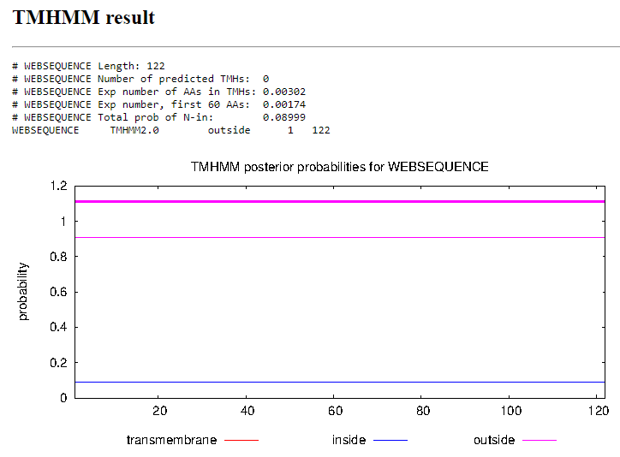
Transmembrane Domain/Evidence
Gene Number: 40
Start Codon and source: 36674 ATG
Stop Codon: 36985
F/R: Forward
Coding Potential (y/n): yes
Starterator (SS, NA, NI): Start: 7 @36674 has 193 MA's
Blast Best Hit, Query:Subject Starts, Score, Evalue, or “no significant Blast alignments” if 10E-4 or higher
Program | Genbank | Phagesdb | DNA Master
Phage name (best match) | PG1 | Zelda | PG1
Function | NKF | NKF | NKF
Positives | 103/103 | 103/103 | 102/102
Max score/score | 216/216 | NA/209 | 551/551
e-value | 5e-71 | 2e-54 | 0.0

Gap: -1
Longest Orf? (Y/N/NA) no
RBS: Kibler6, Karlin Medium, Z value 0.862, Final score -7.729. This is not the best proposed score, but it has the most matches in starterator. The TTG start 3 base pairs upstream has better RBS scores, but only 95 MA’s in starterator.
Proposed Function: NKF
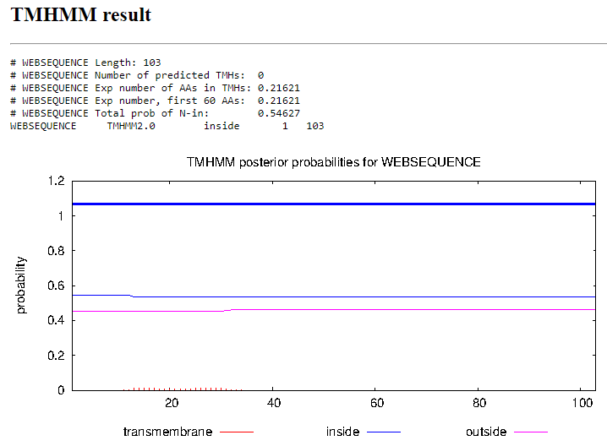
Function Evidence: Several BLAST results indicate similar proteins in other phages with no known function. HHpred suggests a 62.76% likelihood that this is a basal body protein of a centriole, but this function does not appear to be assigned to any other phages with this gene,
Transmembrane Domain/Evidence
Gene Number: 41
Start Codon and source: 37025 ATG
Stop Codon: 37432
F/R: Forward
Coding Potential (y/n): yes
Starterator (SS, NA, NI): Start: 16 @37025 has 305 MA's
Blast Best Hit, Query:Subject Starts, Score, Evalue, or “no significant Blast alignments” if 10E-4 or higher
Program | Genbank | Phagesdb | DNA Master
Phage name (best match) | Colbert | Colbert | Colbert
Function | NKF | NKF | NKF
Positives | 135/135 | 135/135 | 135/135
Max score/score | 267/267 | NA/263 | 683/683
e-value | 4e-90 | 1e-70 | 0.0e0

Gap: 30
Longest Orf? (Y/N/NA) yes
RBS: Kibler6, Karlin Medium, Z value 0.824, final score -7.705. This is not the best proposed start, having the lowest scores of all possible RBS, however evidence from starterator and phamerator suggest that similar phages have a gene that starts at 37025.
Proposed Function: NKF
Function Evidence: Other B1 cluster phages demonstrate this gene at the same start location with no known function or hypothetical protein listed. BLAST indicates close similarity to a product with no known function in the phage Colbert, and HHpred suggests no likely products.
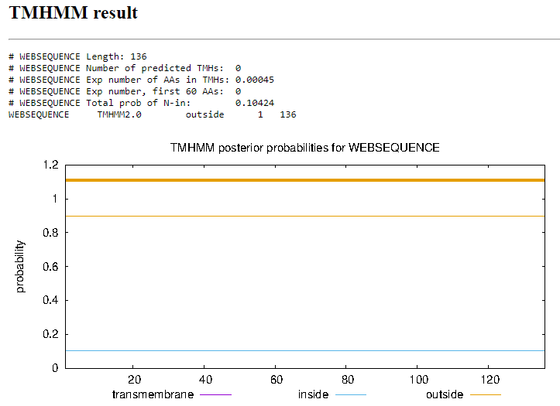
Transmembrane Domain/Evidence
Gene Number: 42
Start Codon and source: 37432 ATG
Stop Codon: 38554
F/R: Forward
Coding Potential (y/n): yes
Starterator (SS, NA, NI): Start: 3 @37432 has 257 MA's
Blast Best Hit, Query:Subject Starts, Score, Evalue, or “no significant Blast alignments” if 10E-4 or higher
Program | Genbank | Phagesdb | DNA Master
Phage name (best match) | Prann | Suffolk | Prann
Function | Structural protein | NKF | Structural protein
Positives | 373/373 | 373/373 | 373/373
Max score/score | 654/654 | NA/751 | 1687/1687
e-value | 0.0 | 0.0 | 0.0

Gap: -1
Longest Orf? (Y/N/NA) yes
RBS: Kibler6, Karlin Medium, Z value 2.285, Final score -5.832. This is not the best proposed start, the start proposed at 37588 TTG has a higher final score of -4.824, but starterator suggests that more phages have a start at 37432 instead.
Proposed Function: Structural protein
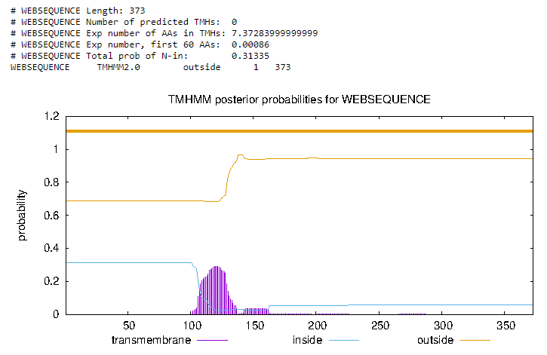
Function Evidence: Several similar phages have this protein listed as a protein with no known function, and one phage, Prann, has this function listed as being a structural protein. Starterator and phamerator both suggest that other phages have a similar gene which starts in a similar location within the genome with no listed function, so it is a tossup to whether this protein can be assigned the function of structural protein
Transmembrane Domain/Evidence
Gene Number: 43
Start Codon and source: 38753 ATG
Stop Codon: 38535
F/R: Reverse
Coding Potential (y/n): yes
Starterator (SS, NA, NI): Start: 11 @38753 has 218 MA's
Blast Best Hit, Query:Subject Starts, Score, Evalue, or “no significant Blast alignments” if 10E-4 or higher
Program | Genbank | Phagesdb | DNA Master
Phage name (best match) | FriarPreacher | Zonia | FriarPreacher
Function | NKF | NKF | NKF
Positives | 72/72 | 72/72 | 72/72
Max score/score | 153/153 | NA/157 | 382/382
e-value | 4e-46 | 7e-39 | 0.0

Gap: 2
Longest Orf? (Y/N/NA) No
RBS: Kibler6, Karlin Medium, Z value 2.145, Final score -4.649. This is the best proposed start
Proposed Function: NKF
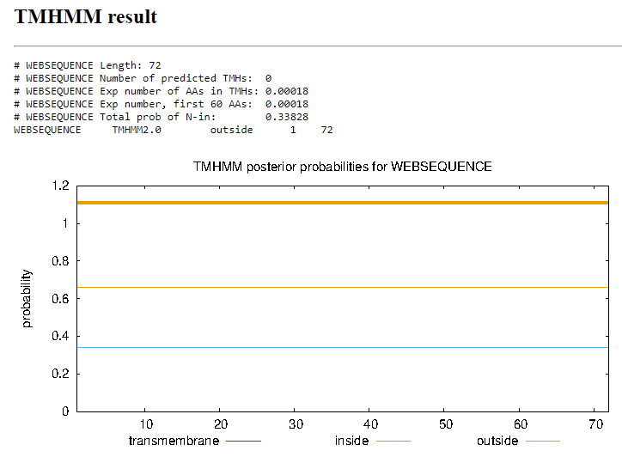
Function Evidence: BLAST results indicate a strong similarity between this sequence and the sequence of several other hypothetical proteins with no known function. Starterator suggests that multiple other phages have genes starting in a similar location which is corroborated by phamerator’s synteny results. HHpred results indicate some similarity to ran guanine nucleotide release factor with 69.47% probability.
Transmembrane Domain/Evidence
Gene Number: 44
Start Codon and source: 39048 GTG
Stop Codon: 38755
F/R: Reverse
Coding Potential (y/n): yes
Starterator (SS, NA, NI): Start: 5 @39048 has 184 MA's
Blast Best Hit, Query:Subject Starts, Score, Evalue, or “no significant Blast alignments” if 10E-4 or higher
Program | Genbank | Phagesdb | DNA Master
Phage name (best match) | PG1 | Zonia | PG1
Function | NKF | NKF | NKF
Positives | 96/97 | NA/207 | 96/97
Max score/score | 131/131 | 97/97 | 329/329
e-value | 2e-37 | 5e-54 | 2.5e-37

Gap: -4
Longest Orf? (Y/N/NA) No
RBS: Kibler6, Karlin Medium, Z value 2.142, Final score -4.513. This is the best proposed start.
Proposed Function: NKF
Function Evidence: BLAST results indicate similar sequences in this phage and other phages with the function assigned as a hypothetical protein. This is corroborated by the phamerator results of this protein being present in a similar location with no listed function and is supported by the starterator data with 184 other phages having a sequence with the same start position.
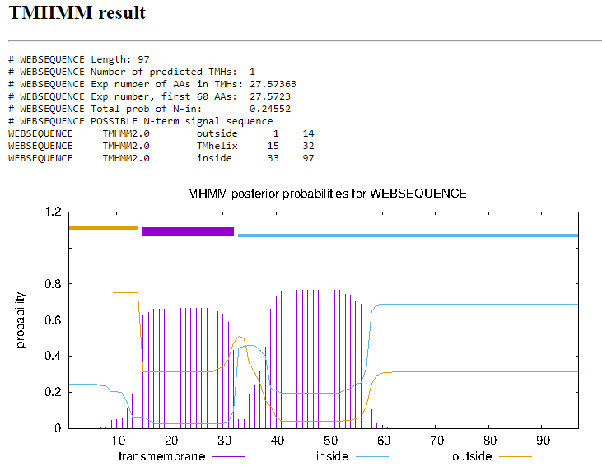
Transmembrane Domain/Evidence
Gene Number: 45
Start Codon and source: 39260 ATG
Stop Codon: 39045
F/R: Reverse
Coding Potential (y/n): yes
Starterator (SS, NA, NI): Start: 37 @39260 has 243 MA's
Blast Best Hit, Query:Subject Starts, Score, Evalue, or “no significant Blast alignments” if 10E-4 or higher
Program | Genbank | Phagesdb | DNA Master
Phage name (best match) | PG1 | Zonia | PG1
Function | helix-turn-helix binding domain protein | helix-turn-helix binding domain protein | helix-turn-helix binding domain protein
Positives | 71/71 | 71/71 | 71/71
Max score/score | 144/144 | NA/157 | 323/323
e-value | 2e-43 | 6e-39 | 4.0e-37

Gap: -4
Longest Orf? (Y/N/NA) yes
RBS: Kibler6, Karlin Medium, Z value 2.249, Final score -4.299. This is the best proposed start.
Proposed Function: helix-turn-helix binding domain protein
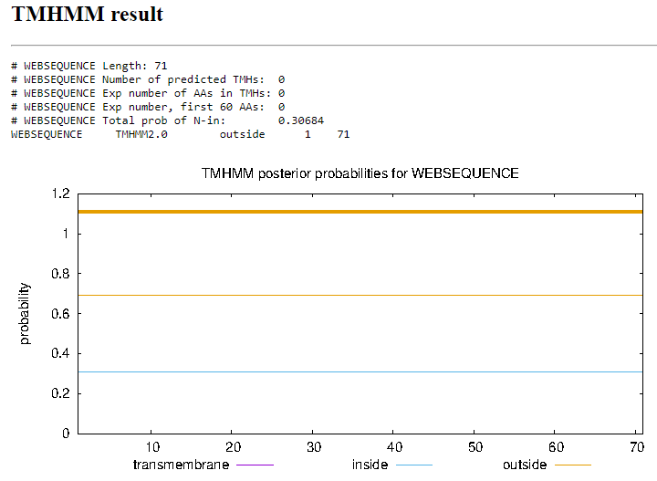
Function Evidence: BLAST results indicate that sequence is similar to the helix-turn-helix binding domain protein in other phages, several of which according to starterator and phamerator are in similar locations with the same start codons. HHpred suggests a strong likelihood that this is a putative DNA binding protein.
Transmembrane Domain/Evidence
Gene Number: 46
Start Codon and source: 39781 TTG
Stop Codon: 39257
F/R: Reverse
Coding Potential (y/n): yes
Starterator (SS, NA, NI): Start: 24 @39781 has 178 MA's), Start: 42 @39682 has 46 MA's
Blast Best Hit, Query:Subject Starts, Score, Evalue, or “no significant Blast alignments” if 10E-4 or higher
Program | Genbank | Phagesdb | DNA Master
Phage name (best match) | Suffolk | Usavi | Suffolk
Function | helix-turn-helix DNA binding protein | NKF | helix-turn-helix DNA binding protein
Positives | 174/174 | 174/174 | 174/174
Max score/score | 315/315 | NA/357 | 807/807
e-value | 1e-107 | 9e99 | 0.0e0

Gap: 0
Longest Orf? (Y/N/NA) yes
RBS: Kibler6, Karlin Medium, Z value 1.800, final Score -5.199. This is not the best proposed start, as the start at 39682 has a z value of 2.808 and a final score of -3.830.
Proposed Function: Helix-turn-helix DNA binding domain
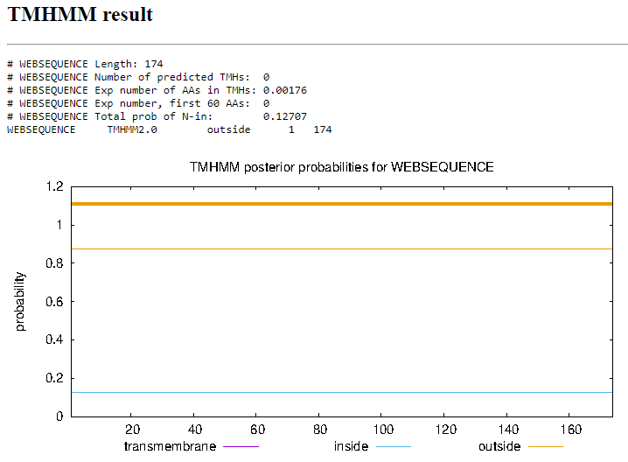
Function Evidence: BLAST results indicate a strong probability that this product produces an HTH binding protein which is supported by HHpred, which suggests that this is a structural protein with 98.52% probability. Phamerator synteny suggests that similar B1 cluster phages have a similar gene in a similar position to the first proposed start.
Transmembrane Domain/Evidence
Gene Number: 47
Start Codon and source:40342 ATG (changed from 40426 ATG)
Stop Codon: 39782
F/R: Reverse
Coding Potential (y/n): yes
Starterator (SS, NA, NI): Start: 12 @40342 has 170 MA's
Blast Best Hit, Query:Subject Starts, Score, Evalue, or “no significant Blast alignments” if 10E-4 or higher
Program | Genbank | Phagesdb | DNA Master
Phage name (best match) | Pops | Vaishali24 | Prann
Function | NKF | NKF | NKF
Positives | 186/187 | 185/185 | 212/214
Max score/score | 296/296 | NA/371 | 901/901
e-value | 8e-100 | e-103 | 0.0e0

Gap: 108
Longest Orf? (Y/N/NA) No
RBS: Kibler6, Karlin Medium, Z value 2.861, final score -3.212. This is the best proposed start.
Proposed Function: NKF
Function Evidence: BLAST results suggest that several other phages have a very similar hypothetical protein product with no known function. Starterator suggests that 170 other phages have a gene which starts in this position rather than at 40426 which was originally called. This is also supported by the RBS score which had the highest value in both Z and final scores.
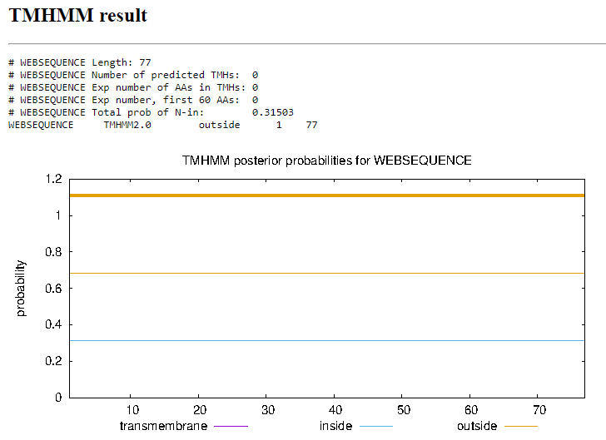
Transmembrane Domain/Evidence
Gene Number: 48
Start Codon and source: 40450 ATG
Stop Codon: 41769
F/R: Forward
Coding Potential (y/n): yes
Starterator (SS, NA, NI): Start: 28 @40441 has 121 MA's; Start: 30 @40450 has 9 MA's
Blast Best Hit, Query:Subject Starts, Score, Evalue, or “no significant Blast alignments” if 10E-4 or higher
Program | Genbank | Phagesdb | DNA Master
Phage name (best match) | Phamished | Chunky | Phamished
Function | Lysin A | Lysin A | Lysin A
Positives | 439/439 | 439/439 | 439/439
Max score/score | 785/785 | NA/939 | 2026/2026
e-value | 0.0e0 | 0.0e0 | 0.0e0

Gap: 108
Longest Orf? (Y/N/NA) No
RBS: Kibler6, Karlin Medium, Z value 1.209, Final score -6.384. This is not the best proposed start, but it aligns most closely with GeneMark’s coding potential graphic.
Proposed Function: Lysin A
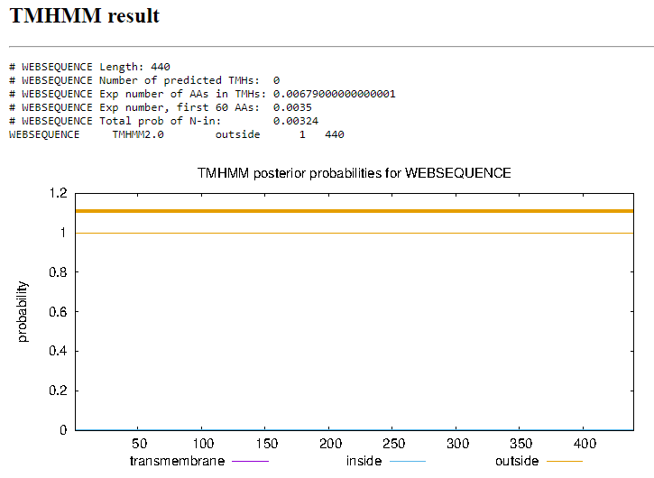
Function Evidence: BLAST results indicate that several other phages have this product listed as Lysin A within the pham. Phamerator corroborates this with several other B1 cluster phages having the same gene in the same location.
Transmembrane Domain/Evidence
Gene Number: 49
Start Codon and source: 41779 ATG
Stop Codon: 43134
F/R: Forward
Coding Potential (y/n): yes
Starterator (SS, NA, NI): Start: 60 @41779 has 225 MA's
Blast Best Hit, Query:Subject Starts, Score, Evalue, or “no significant Blast alignments” if 10E-4 or higher
Program | Genbank | Phagesdb | DNA Master
Phage name (best match) | Swish | ThreeOh3D2 | Swish
Function | Lysin B | Lysin B | Lysin B
Positives | 451/458 | 451/451 | 320/458
Max score/score | 608/708 | NA/914 | 1569/1569
e-value | 0.0 | 0.0 | 0.0

Gap: 9
Longest Orf? (Y/N/NA) yes
RBS: Kibler6, Karlin Medium, Z value 2.235, Final score, -4.326. This is the best proposed start.
Proposed Function: Lysin B
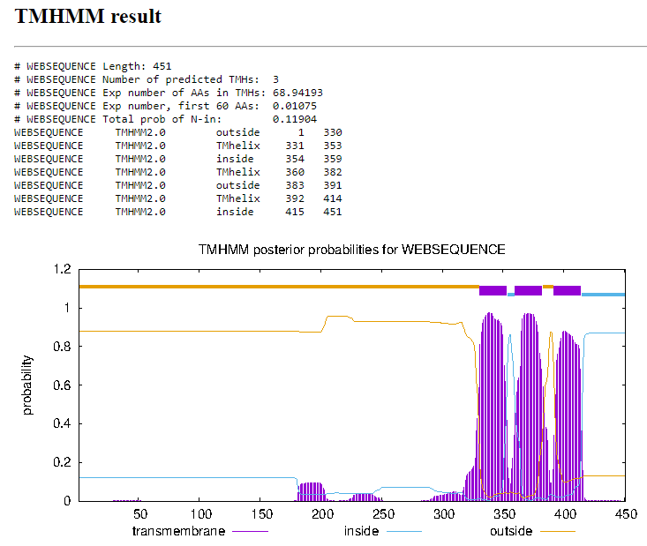
Function Evidence: Multiple BLAST results and phamerator synteny suggest that this protein is Lysin B, as multiple phages have this protein labeled as such in the same location following Lysin A. This start is also supported by the starterator results with 225 other phages having the same start coordinates.
Transmembrane Domain/Evidence
Gene Number: 50
Start Codon and source: 43856 ATG
Stop Codon: 43235
F/R: Reverse
Coding Potential (y/n): yes
Starterator (SS, NA, NI): Start: 20 @43856 has 253 MA's
Blast Best Hit, Query:Subject Starts, Score, Evalue, or “no significant Blast alignments” if 10E-4 or higher
Program | Genbank | Phagesdb | DNA Master
Phage name (best match) | PG1 | Zelda | PG1
Function | NKF | NKF | NKF
Positives | 206/206 | 206/206 | 206/206
Max score/score | 346/346 | NA/420 | 888/888
e-value | 5e-119 | e-118 | 0.0e0

Gap: 58
Longest Orf? (Y/N/NA) yes
RBS: Kibler6, Karlin Medium, Z value 3.419, final score -2.305. This is the best proposed start.
Proposed Function: NKF
Function Evidence: Multiple BLAST results indicate that this sequence is present in multiple other phages and as suggested by starterator, starts in the same position and is corroborated by the rbs results.
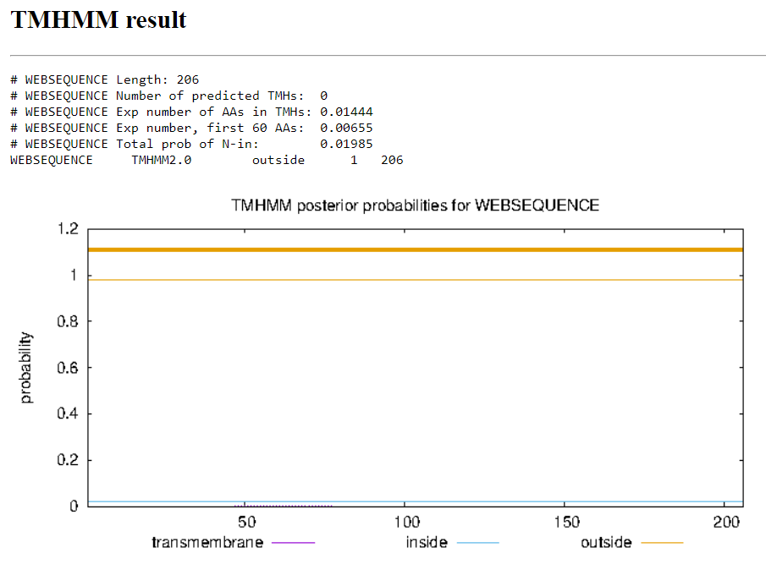
Transmembrane Domain/Evidence
Gene Number: 51
Start Codon and source: 45317 GTG
Stop Codon: 43914
F/R: Reverse
Coding Potential (y/n): yes
Starterator (SS, NA, NI):
Blast Best Hit, Query:Subject Starts, Score, Evalue, or “no significant Blast alignments” if 10E-4 or higher
Program | Genbank | Phagesdb | DNA Master
Phage name (best match) | JacAttac | YouGoGlencoco | JacAttac
Function | NKF | NKF | NKF
Positives | 467/467 | 467/467 | 467/467
Max score/score | 926/926 | NA/962 | 2392/2392
e-value | 0.0e0 | 0.0e0 | 0.0e0

Gap: 4
Longest Orf? (Y/N/NA) yes
RBS: Kibler6, Karlin Medium, Z value 2.861, Final score -4.173. This is the best proposed start
Proposed Function: NKF
Function Evidence:
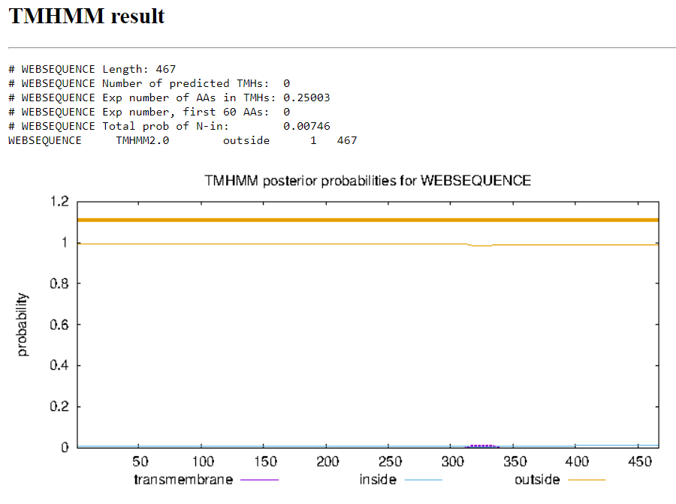
Transmembrane Domain/Evidence
Gene Number: 52
Start Codon and source: 47023 ATG
Stop Codon: 45320
F/R: Reverse
Coding Potential (y/n): yes
Starterator (SS, NA, NI): Start: 66 @47023 has 158 MA's
Blast Best Hit, Query:Subject Starts, Score, Evalue, or “no significant Blast alignments” if 10E-4 or higher
Program | Genbank | Phagesdb | DNA Master
Phage name (best match) | KLucky39 | Sheila | KLucky39
Function | NKF | DNA Helicase | NKF
Positives | 567/567 | 567/567 | 567/567
Max score/score | 1065/1065 | NA/1123 | 2753/2753
e-value | 0.0 | 0.0 | 0.0

Gap: 155
Longest Orf? (Y/N/NA) yes
RBS: Kibler6, Karlin Medium, Z value 2.045, Final score -5.360. This is the best proposed start.
Proposed Function: DNA Helicase
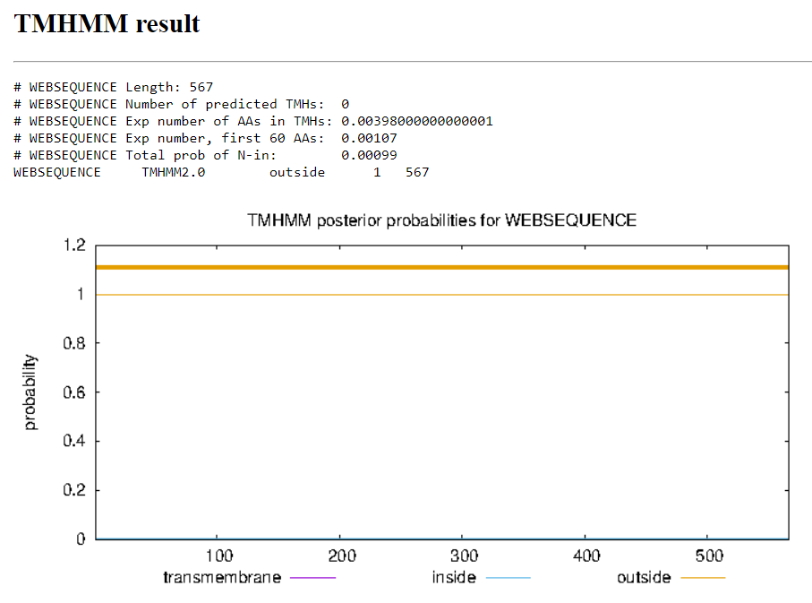
Function Evidence: Despite the best match for the blast result on NCBI and DNA master indicating no known function, several results below that indicated equally that other phages had this gene listed as DNA Helicase on both NCBI and the Actinobacteriophage Database. This is corroborated by observing other B1 cluster phages on phamerator with a gene in this location labeled as DNA Helicase.
Transmembrane Domain/Evidence
Gene Number: 53
Start Codon and source: 47393 GTG
Stop Codon: 47178
F/R: Reverse
Coding Potential (y/n): yes
Starterator (SS, NA, NI): Start: 31 @47393 has 211 MA's
Blast Best Hit, Query:Subject Starts, Score, Evalue, or “no significant Blast alignments” if 10E-4 or higher
Program | Genbank | Phagesdb | DNA Master
Phage name (best match) | Gyarad | Zaider | Gyarad
Function | NKF | NKF | NKF
Positives | 71/71 | 71/71 | 71/71
Max score/score | 146/146 | NA/144 | 368/368
e-value | 7e-44 | 5e-35 | 6.4e-44

Gap: 17
Longest Orf? (Y/N/NA) yes
RBS: Kibler6, Karlin Medium. Z value 3.175, Final score-2.584. This is the best proposed start
Proposed Function: NKF
Function Evidence: Multiple BLAST results indicate a strong match with other phages with this protein listed as having no known function. This start is also supported by starterator, and phamerator suggests that other B1 cluster phages have a similar gene in this location.
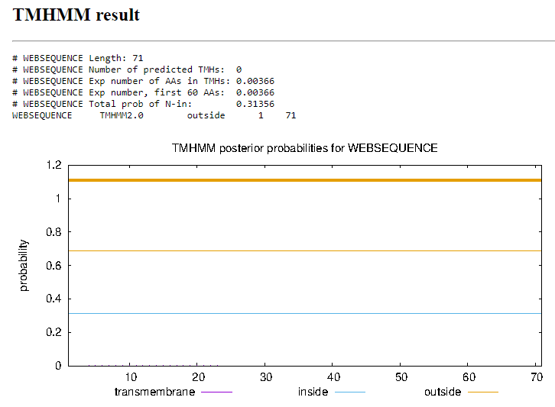
Transmembrane Domain/Evidence
Gene Number: 54
Start Codon and source: 47781 GTG
Stop Codon: 47410
F/R: Reverse
Coding Potential (y/n): yes
Starterator (SS, NA, NI):
Blast Best Hit, Query:Subject Starts, Score, Evalue, or “no significant Blast alignments” if 10E-4 or higher
Program | Genbank | Phagesdb | DNA Master
Phage name (best match) | Manad | Veritas | Manad
Function | NKF | NKF | NKF
Positives | 122/123 | 123/123 | 122/123
Max score/score | 202/202 | NA/261 | 513/513
e-value | 2e-64 | 4e-70 | 0.0e0

Gap: -7
Longest Orf? (Y/N/NA)
RBS: Kibler6, Karlin Medium, Z value 1.542, Final score -7.021. This is not the best proposed start, however the second Valine start codon has a worse start codon, so the first valine start is the better of the two.
Proposed Function: NKF
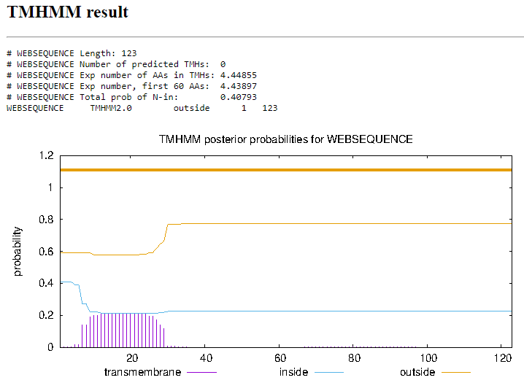
Function Evidence: Multiple BLAST results indicate a strong match with other phages with this protein listed as having no known function. This start is also supported by starterator, and phamerator suggests that other B1 cluster phages have a similar gene in this location.
Transmembrane Domain/Evidence
Gene Number: 55
Start Codon and source: 48065 ATG
Stop Codon: 47778
F/R: Reverse
Coding Potential (y/n): yes
Starterator (SS, NA, NI): Start: 34 @48065 has 159 MA's
Blast Best Hit, Query:Subject Starts, Score, Evalue, or “no significant Blast alignments” if 10E-4 or higher
Program | Genbank | Phagesdb | DNA Master
Phage name (best match) | Hetaeria | Zaider | Hetaeria
Function | NKF | NKF | NKF
Positives | 96/96 | 96/96 | 71/121
Max score/score | 155/155 | NA/206 | 391/391
e-value | 2e-46 | 1e-53 | 0.0e0

Gap: 76
Longest Orf? (Y/N/NA) No
RBS: Kibler6, Karlin Medium, Z value 3.419, Final score -2.016. This is the best proposed start.
Proposed Function: Membrane Protein
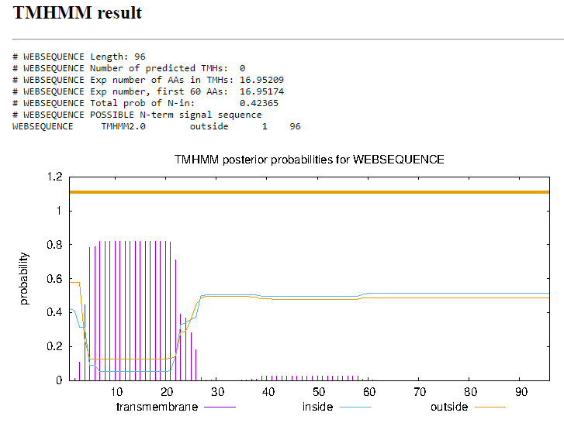
Function Evidence: Multiple BLAST results indicate a strong match with other phages with this protein listed as having no known function. This start is also supported by starterator, and phamerator suggests that other B1 cluster phages have a similar gene in this location.
Transmembrane Domain/Evidence
Gene Number: 56
Start Codon and source: 50888 GTG
Stop Codon: 48140
F/R: Reverse
Coding Potential (y/n): yes
Starterator (SS, NA, NI): Start: 37 @50888 has 248 MA's
Blast Best Hit, Query:Subject Starts, Score, Evalue, or “no significant Blast alignments” if 10E-4 or higher
Program | Genbank | Phagesdb | DNA Master
Phage name (best match) | CheetO | Zaider | CheetO
Function | DNA primase/helicase | DNA primase/helicase | DNA primase/helicase
Positives | 915/915 | 915/915 | 914/915
Max score/score | 1654/1654 | NA/1866 | 4283/4283
e-value | 0.0 | 0.0 | 0.0

Gap: -13
Longest Orf? (Y/N/NA) yes
RBS: Kibler6, Karlin Medium, Z value 2.837, Final score -3.201. This is the best proposed start.
Proposed Function: DNA primase/Helicase
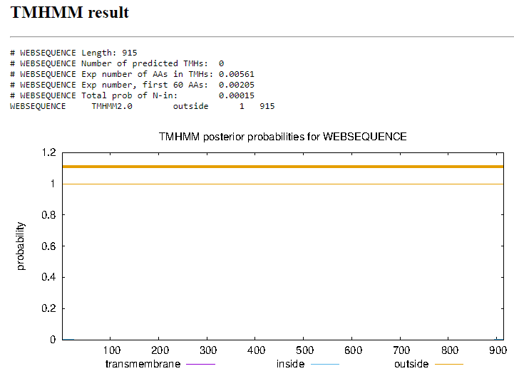
Function Evidence: Multiple BLAST results indicate that this product is identical to the DNA primase/helicase present in other mycobacteria phages. This is corroborated by HHpred, which shows a 99.64% probability that this is a DNA helicase regulatory protein.
Transmembrane Domain/Evidence
Gene Number: 57 - deleted
Start Codon and source: 50876 TTG
Stop Codon: 51010
F/R: Forward
Coding Potential (y/n): yes
Starterator (SS, NA, NI): Start: 1 @50876 has 3 MA's
Blast Best Hit, Query:Subject Starts, Score, Evalue, or “no significant Blast alignments” if 10E-4 or higher
Program | Genbank | Phagesdb | DNA Master
Phage name (best match) | AbsoluteMadLad | AbsoluteMadLad | AbsoluteMadLad
Function | NKF | NKF | NKF
Positives | 44/44 | 44/44 | 44/44
Max score/score | 92/92 | NA/93.6 | 227/227
e-value | 3e-23 | 1e-19 | 2.6e-23

Gap: -3
Longest Orf? (Y/N/NA) yes
RBS: Kibler6, Karlin Medium, Z value 1.989, Final score -4.888
Proposed Function: NKF
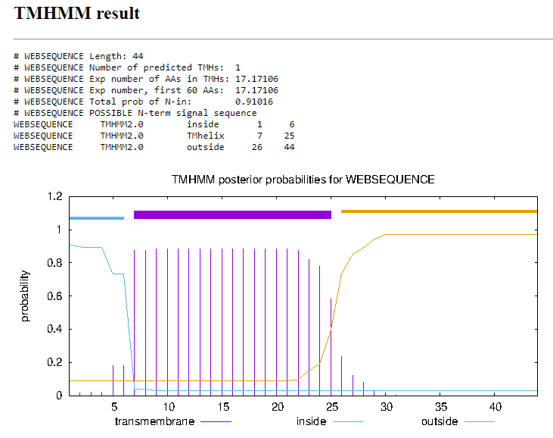
Function Evidence: BLAST results indicate that there are a few other phages with similar gene products, but there are results with similar products with no known function.
Transmembrane Domain/Evidence
Gene Number: 57 was 58
Start Codon and source: 51234 ATG
Stop Codon: 51007
F/R: Reverse
Coding Potential (y/n): yes
Starterator (SS, NA, NI): Start: 3 @51234 has 44 MA's
Blast Best Hit, Query:Subject Starts, Score, Evalue, or “no significant Blast alignments” if 10E-4 or higher
Program | Genbank | Phagesdb | DNA Master
Phage name (best match) | Soto | Soto | Soto
Function | NKF | NKF | NKF
Positives | 75/75 | 75/75 | 75/75
Max score/score | 157/157 | NA/169 | 397/397
e-value | 3e-48 | 1e-42 | 0.0

Gap: -11
Longest Orf? (Y/N/NA) yes
RBS: Kibler6, Karlin Medium, Z value 2.723, final score -3.411. This is the best proposed start.
Proposed Function: NKF
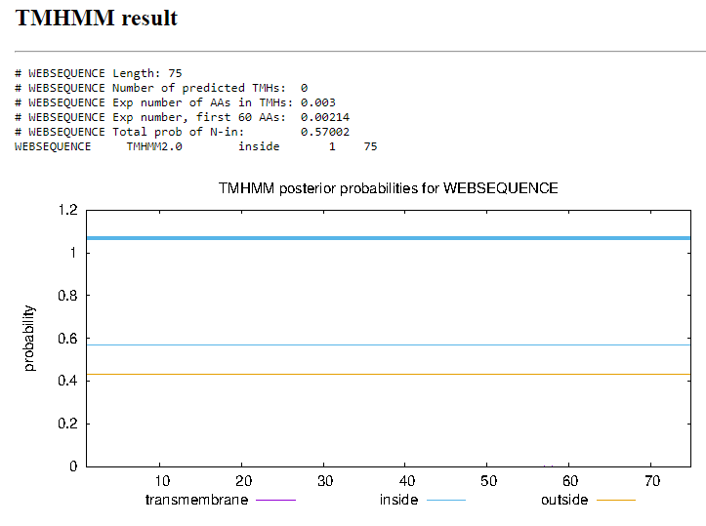
Function Evidence: Multiple BLAST results indicate that this product has an identical sequence to a product in the phage Soto which also has no known function. This is supported by phamerator which shows that several other B1 phages have a gene in this location with no known function.
Transmembrane Domain/Evidence
Gene Number: 58 was 59
Start Codon and source: 51838 ATG
Stop Codon: 51227
F/R: Reverse
Coding Potential (y/n): yes
Starterator (SS, NA, NI): Start: 13 @51838 has 177 MA's
Blast Best Hit, Query:Subject Starts, Score, Evalue, or “no significant Blast alignments” if 10E-4 or higher
Program | Genbank | Phagesdb | DNA Master
Phage name (best match) | Olive | Zaider | Olive
Function | NKF | NKF | NKF
Positives | 203/203 | 203/203 | 203/203
Max score/score | 418/418 | NA/427 | 1074/1074
e-value | 2e-147 | e-120 | 0.0e0

Gap: -4
Longest Orf? (Y/N/NA) no
RBS: Kibler6, Karlin Medium, Z value 1.607, final score -5.585. This is not the best proposed start. The start at 51850 has better scores, and would create 1:1 BLAST results with Olive on Genbank and Olive. However, starterator suggests that 177 phages have this gene’s start at 51838.
Proposed Function: NKF
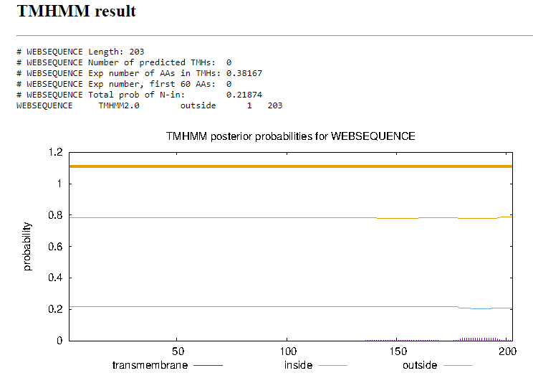
Function Evidence: BLAST results indicate similar products in other phages with no known function despite the start being variable.
Transmembrane Domain/Evidence
Gene Number: 59 was 60
Start Codon and source: 53694 ATG
Stop Codon: 51835
F/R: Reverse
Coding Potential (y/n): yes
Starterator (SS, NA, NI): Start: 131 @53694 has 228 MA's
Blast Best Hit, Query:Subject Starts, Score, Evalue, or “no significant Blast alignments” if 10E-4 or higher
Program | Genbank | Phagesdb | DNA Master
Phage name (best match) | Gyarad | Roscoe | Gyarad
Function | DNA polymerase | DNA polymerase | DNA polymerase
Positives | 619/619 | 619/619 | 619/619
Max score/score | 1268/1268 | NA/1225 | 3281/3281
e-value | 0.0 | 0.0 | 0.0

Gap: -4
Longest Orf? (Y/N/NA) no
RBS: Kibler6, Karlin Medium, Z value 1.986, Final score -4.888. This is the best proposed start
Proposed Function: DNA polymerase
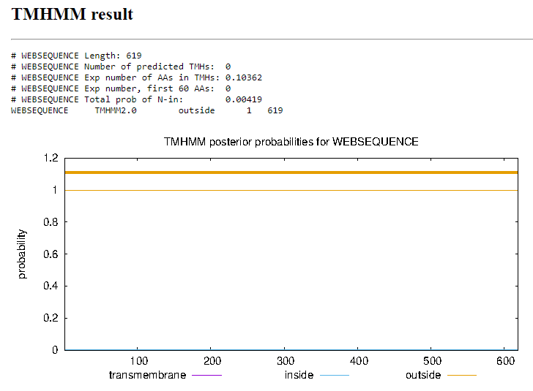
Function Evidence: Multiple BLAST results indicate a strong likelihood that this is a 1:1 match with the DNA polymerase of other phage products. This is also corroborated by HHpred with a 100% probability that this is DNA polymerase
Transmembrane Domain/Evidence
Gene Number: 60 was 61
Start Codon and source: 54149 ATG
Stop Codon: 53693
F/R: Reverse
Coding Potential (y/n): yes
Starterator (SS, NA, NI): Start: 40 @54149 has 252 MA's
Blast Best Hit, Query:Subject Starts, Score, Evalue, or “no significant Blast alignments” if 10E-4 or higher
Program | Genbank | Phagesdb | DNA Master
Phage name (best match) | Newman | Suffolk | Newman
Function | NKF | NKF | NKF
Positives | 152/152 | 152/152 | 152/152
Max score/score | 282/282 | NA/314 | 722/722
e-value | 2e-95 | 5e-86 | 0.0

Gap: 92
Longest Orf? (Y/N/NA) yes
RBS: Kibler6, Karlin Medium, Z value 1.405, Final score -6.053. This is not the best proposed start, but the BLAST results suggest a stronger likelihood that this start is more correct than the one with better RBS scores.
Proposed Function: NKF
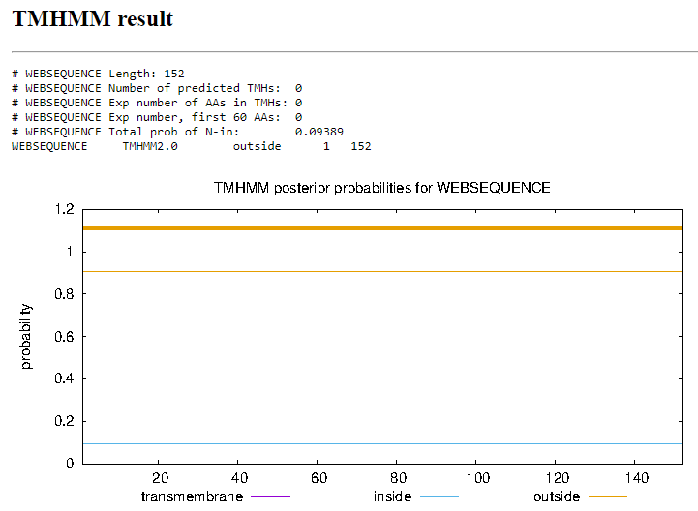
Function Evidence: Evidence: Multiple BLAST results indicate a strong match with other phages with this protein listed as having no known function. This start is also supported by starterator, and phamerator suggests that other B1 cluster phages have a similar gene in this location.
Transmembrane Domain/Evidence
Gene Number: 61 was 62
Start Codon and source: 54394 ATG
Stop Codon: 54242
F/R: Reverse
Coding Potential (y/n): yes
Starterator (SS, NA, NI): Start: 8 @54394 has 164 MA's
Blast Best Hit, Query:Subject Starts, Score, Evalue, or “no significant Blast alignments” if 10E-4 or higher
Program | Genbank | Phagesdb | DNA Master
Phage name (best match) | Solosis | Zaider | Solosis
Function | NKF | NKF | NKF
Positives | 49/50 | 49/50 | 49/50
Max score/score | 107/107 | NA/116 | 267/267
e-value | 8e-28 | 1e-26 | 8.2e-28

Gap: -1
Longest Orf? (Y/N/NA) no
RBS: Kibler6, Karlin Medium, Z value 2.562, Final score-3.751. This is the best proposed start.
Proposed Function: NKF
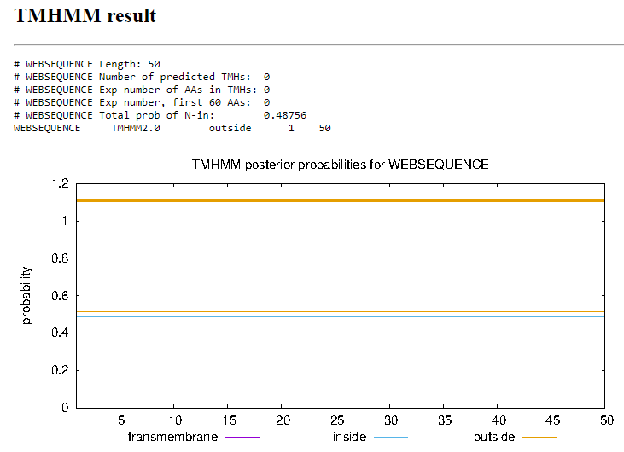
Function Evidence: Evidence: Multiple BLAST results indicate a strong match with other phages with this protein listed as having no known function. This start is also supported by starterator, and phamerator suggests that other B1 cluster phages have a similar gene in this location.
Transmembrane Domain/Evidence
Gene Number: 62 was 63
Start Codon and source: 54750 ATG
Stop Codon: 54394
F/R: Reverse
Coding Potential (y/n): yes
Starterator (SS, NA, NI): Start: 19 @54750 has 172 MA's
Blast Best Hit, Query:Subject Starts, Score, Evalue, or “no significant Blast alignments” if 10E-4 or higher
Program | Genbank | Phagesdb | DNA Master
Phage name (best match) | Oline | Windsor | Oline
Function | NKF | NKF | NKF
Positives | 118/118 | 118/118 | 118/118
Max score/score | 157/157 | NA/248 | 397/397
e-value | 5e-47 | 2e-66 | 0.0

Gap: 113
Longest Orf? (Y/N/NA) no
RBS: Kibler6, Karlin Medium, Z value 2.643, Final score -4.161. This is the best proposed start.
Proposed Function: Membrane protein
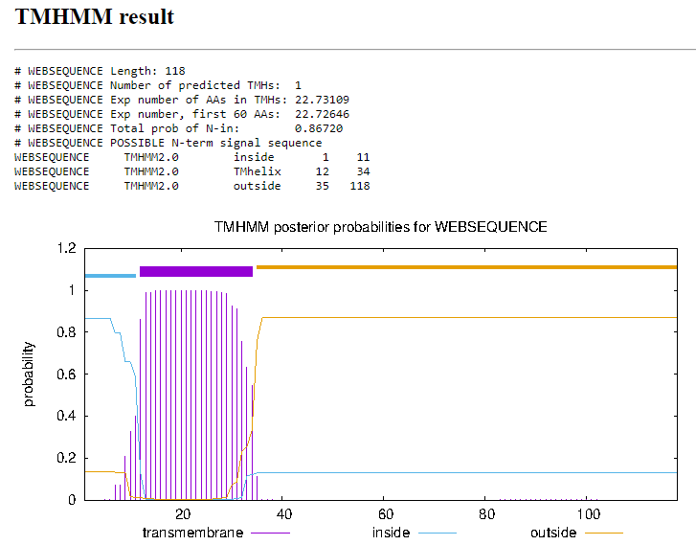
Function Evidence: Evidence: Multiple BLAST results indicate a strong match with other phages with this protein listed as having no known function. This start is also supported by starterator, and phamerator suggests that other B1 cluster phages have a similar gene in this location.
Notes: Two potential starts,
Transmembrane Domain/Evidence
Gene Number: 63 was 64
Start Codon and source: 55222 ATG
Stop Codon: 54863
F/R: Reverse
Coding Potential (y/n): yes
Starterator (SS, NA, NI): Start: 49 @55222 has 197 MA's
Blast Best Hit, Query:Subject Starts, Score, Evalue, or “no significant Blast alignments” if 10E-4 or higher
Program | Genbank | Phagesdb | DNA Master
Phage name (best match) | Childish | Childish | Childish
Function | NKF | NKF | NKF
Positives | 119/119 | 119/119 | 119/119
Max score/score | 241/241 | NA/246 | 615/615
e-value | 3e-80 | 1e-65 | 0.0

Gap: 273
Longest Orf? (Y/N/NA) yes
RBS: Kibler6, Karlin Medium, Z value 1.346, Final score -7.414. This is not the best proposed start, however many more phages have a product listed at the current start, and there is a 1:1 BLAST result at the current start.
Proposed Function: NKF
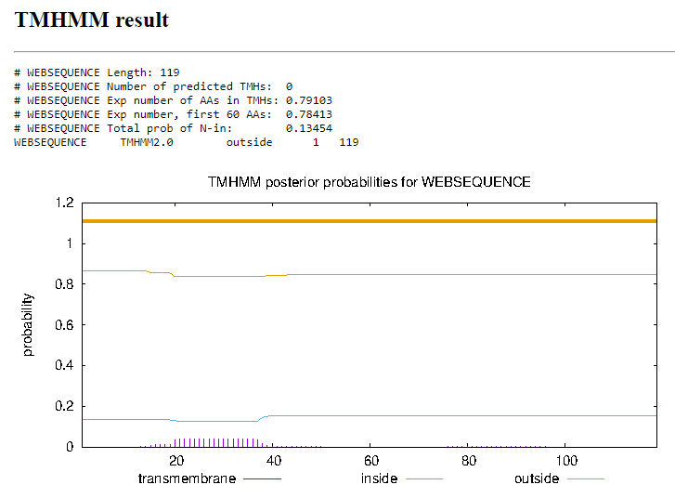
Function Evidence: Multiple BLAST results indicate a strong match with other phages with this protein listed as having no known function. This start is also supported by starterator, and phamerator suggests that other B1 cluster phages have a similar gene in this location.
Transmembrane Domain/Evidence
Gene Number: 64 was 65
Start Codon and source: 55483 ATG Changed from 55
Stop Codon: 55611
F/R: Forward
Coding Potential (y/n): yes
Starterator (SS, NA, NI): Start: 28 @55483 has 31 MA's
Blast Best Hit, Query:Subject Starts, Score, Evalue, or “no significant Blast alignments” if 10E-4 or higher
Program | Genbank | Phagesdb | DNA Master
Phage name (best match) | Suffolk | Suffolk | Newman
Function | NKF | NKF | NKF
Positives | 42/42 | 42/42 | 38/38
Max score/score | 87/87 | NA/92.8 | 190/190
e-value | 6e-21 | 2e-19 | 8.1E-18

Gap: 273
Longest Orf? (Y/N/NA) no
RBS: Kibler6, Karlin Medium, Z value 2.989, Final Score -3.644. This is the best proposed start
Proposed Function: NKF
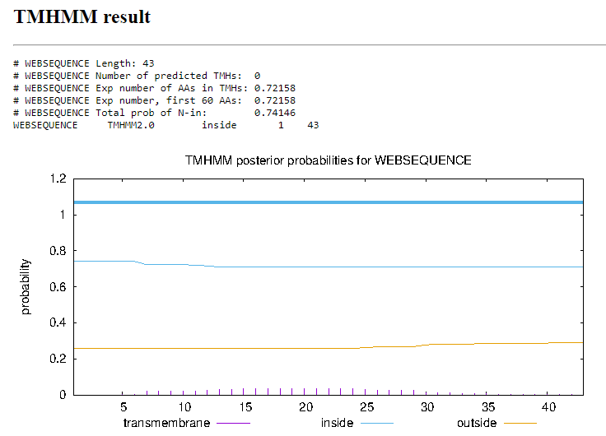
Function Evidence: Though there are many proposed starts for this gene, the start at 55483 consistently has the best results in BLAST and in RBS, and also has the most other phages with similar starts. Of these, none have listed functions.
Transmembrane Domain/Evidence
Gene Number: 65 was 66
Start Codon and source: 55690 ATG
Stop Codon: 56451
F/R: Forward
Coding Potential (y/n): yes
Starterator (SS, NA, NI): Start: 60 @55690 has 117 MA's
Blast Best Hit, Query:Subject Starts, Score, Evalue, or “no significant Blast alignments” if 10E-4 or higher
Program | Genbank | Phagesdb | DNA Master
Phage name (best match) | ShiVal | Colbert | ShiVal
Function | NKF | NKF | NKF
Positives | 253/253 | 253/253 | 253/253
Max score/score | 479/479 | NA/500 | 1233/1233
e-value | 5e-170 | e-141 | 0.0

Gap: 79
Longest Orf? (Y/N/NA) yes
RBS: Kibler6, Karlin Medium, Z value 1.461, Final score -6.707. This is not the best proposed start but due to the 1:1 BLAST results and 117 MA’s at this start, that seems to be the better option of the starts.
Proposed Function: NKF
Function Evidence: Multiple BLAST results indicate a strong match with other phages with this protein listed as having no known function. This start is also supported by starterator, and phamerator suggests that other B1 cluster phages have a similar gene in this location.
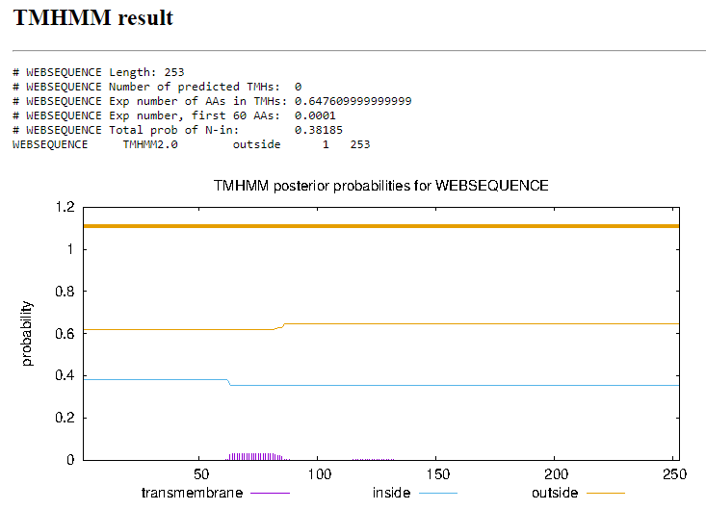
Transmembrane Domain/Evidence
Gene Number: 66
Start Codon and source: 56464 ATG
Stop Codon:56736
F/R: Forward
Coding Potential (y/n): no
Starterator (SS, NA, NI): Start: 11 @56464 has 94 MA's
Blast Best Hit, Query:Subject Starts, Score, Evalue, or “no significant Blast alignments” if 10E-4 or higher
Program | Genbank | Phagesdb | DNA Master
Phage name (best match) | PG1 | Xavier | PG1
Function | NKF | NKF | NKF
Positives | 90/90 | 90/90 | 90/90
Max score/score | 130/130 | NA/186 | 327/327
e-value | 3e-37 | 1e-47 | 3.0e-37

Gap: 13
Longest Orf? (Y/N/NA) yes
RBS: Kibler6, Karlin Medium, Z value 2.212, Final score -4.513. This is the best proposed start.
Proposed Function: ribbon-helix-helix DNA binding domain
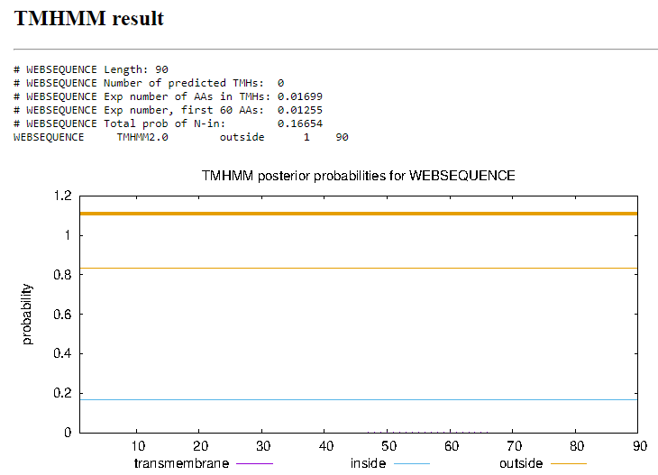
Function Evidence: Despite BLAST results having no listed function, HHpred suggests an 98.67% likelihood that this is the ribbon-helix-helix domain binding protein, as well as a select group of other phages including Crownjw that have this listed as the function.
Transmembrane Domain/Evidence
Gene Number: 67
Start Codon and source: 56768
Stop Codon: 56950
F/R:Forward
Coding Potential (y/n): yes
Starterator (SS, NA, NI): Start: 7 @56768 has 169 MA's
Blast Best Hit, Query:Subject Starts, Score, Evalue, or “no significant Blast alignments” if 10E-4 or higher
Program | Genbank | Phagesdb | DNA Master
Phage name (best match) | Suffolk | Virapocalypse | Suffolk
Function | NKF | NKF | NKF
Positives | 60/60 | 60/60 | 60/60
Max score/score | 92.8/92.8 | NA/130 | 229/229
e-value | 4e-23 | 8e-31 | 3.9e-23

Gap: 32
Longest Orf? (Y/N/NA) yes
RBS: Kibler6, Karlin Medium, Z value 2.225, Final score -4.874. This is the best proposed start
Proposed Function: NKF
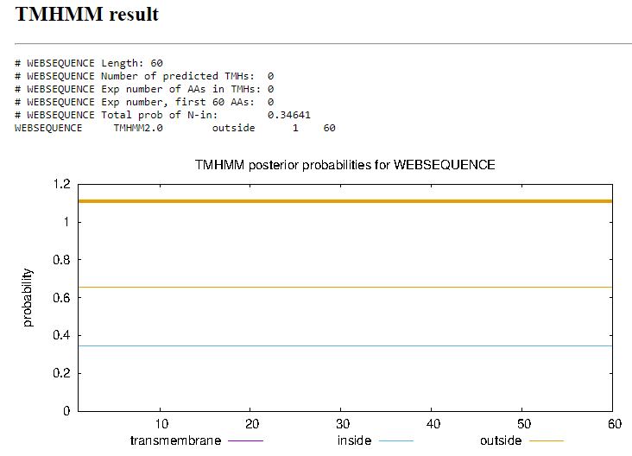
Function Evidence: Multiple BLAST results indicate a strong match with other phages with this protein listed as having no known function. This start is also supported by starterator, and phamerator suggests that other B1 cluster phages have a similar gene in this location.
Transmembrane Domain/Evidence
Gene Number: 68
Start Codon and source: 57011 ATG
Stop Codon: 57709
F/R: Forward
Coding Potential (y/n): yes
Starterator (SS, NA, NI): Start: 49 @57011 has 230 MA's
Blast Best Hit, Query:Subject Starts, Score, Evalue, or “no significant Blast alignments” if 10E-4 or higher
Program | Genbank | Phagesdb | DNA Master
Phage name (best match) | JakeO | Squid | JakeO
Function | DNA binding protein | NKF | DNA binding protein
Positives | 231/232 | 231/232 | 231/232
Max score/score | 397/397 | NA/456 | 1019/1019
e-value | 5e-138 | e-128 | 0.0e0

Gap: 61
Longest Orf? (Y/N/NA) yes
RBS: Kibler6, Karlin Medium, Z value 2.511, Final score -4.426. This is the best proposed start
Proposed Function: DNA binding protein
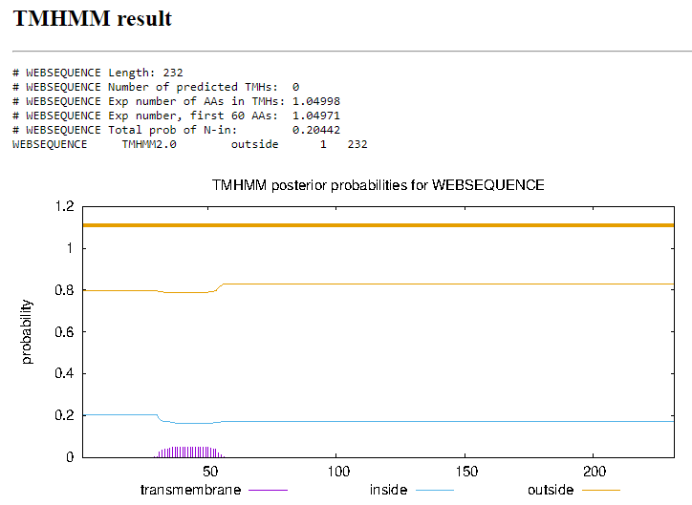
Function Evidence: Alongside the BLAST results indicating that the function is a DNA binding protein, HHpred also suggests a 98.28% probability that this is a DNA binding protein.
Transmembrane Domain/Evidence
Gene Number: 69
Start Codon and source: 57702 TTG
Stop Codon: 58286
F/R: Forward
Coding Potential (y/n): yes
Starterator (SS, NA, NI): Start: 17 @57702 has 173 MA's
Blast Best Hit, Query:Subject Starts, Score, Evalue, or “no significant Blast alignments” if 10E-4 or higher
Program | Genbank | Phagesdb | DNA Master
Phage name (best match) | Manad | Virapocalypse | Manad
Function | NKF | NKF | NKF
Positives | 193/194 | 193/194 | 193/194
Max score/score | 357/357 | NA/400 | 915/915
e-value | 2e-123 | e-112 | 0.0

Gap: -8
Longest Orf? (Y/N/NA) no
RBS: Kibler6, Karlin Medium, Z value 1.572, Final score -6.182. This is not the best proposed start, however it still has 173 MA’s as compared to the other start which do not have any.
Proposed Function: NKF
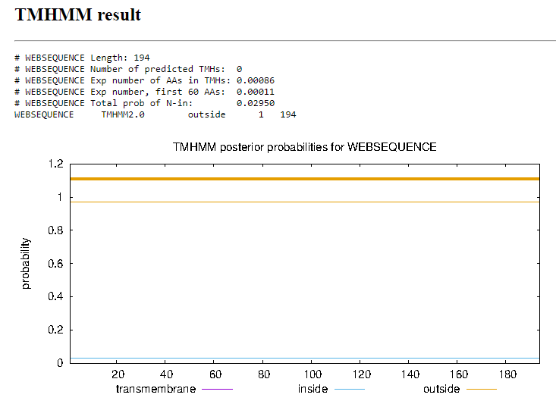
Function Evidence: Multiple BLAST results indicate a strong match with other phages with this protein listed as having no known function. This start is also supported by starterator, and phamerator suggests that other B1 cluster phages have a similar gene in this location
Transmembrane Domain/Evidence
Gene Number: 70
Start Codon and source: 58283 ATG
Stop Codon: 58705
F/R: Forward
Coding Potential (y/n): yes
Starterator (SS, NA, NI): Start: 1 @58283 has 224 MA's
Blast Best Hit, Query:Subject Starts, Score, Evalue, or “no significant Blast alignments” if 10E-4 or higher
Program | Genbank | Phagesdb | DNA Master
Phage name (best match) | Horchata | Horchata | Horchata
Function | NKF | NKF | NKF
Positives | 140/140 | 140/140 | 140/140
Max score/score | 260/260 | NA/283 | 664/664
e-value | 5e-87 | 9e-77 | 0.0e0

Gap: -4
Longest Orf? (Y/N/NA) yes
RBS: Kibler6, Karlin Medium, Z value 2.511. Final score -3.915. This is the best proposed start.
Proposed Function: NKF
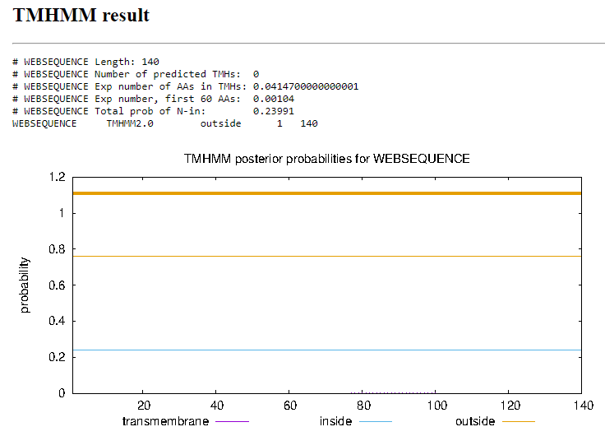
Function Evidence: Multiple BLAST results indicate a strong match with other phages with this protein listed as having no known function. This start is also supported by starterator, and phamerator suggests that other phages have a similar gene in this location
Transmembrane Domain/Evidence
Gene Number: 72 NOT CALLED
Start Codon and source: 58746 TTG
Stop Codon: 58874
F/R: Forward
Coding Potential (y/n): yes
Starterator (SS, NA, NI): Start: 9 @58746 has 27 MA's
Blast Best Hit, Query:Subject Starts, Score, Evalue, or “no significant Blast alignments” if 10E-4 or higher
Program | Genbank | Phagesdb | DNA Master
Phage name (best match) | ShiVal | Virgeve | ShiVal
Function | NKF | NKF | NKF
Positives | 41/42 | 41/42 | 41/42
Max score/score | 86.7/86.7 | NA/98.2 | 213/213
e-value | 3e-21 | 5e-21 | 3.4e-21

Gap: 40
Longest Orf? (Y/N/NA) yes
RBS: Kibler6, Karlin Medium, Z value 1.247, -6.780. This is not the best proposed start in terms of RBS, however it has the most MA’s of any other start within the pham.
Proposed Function: NKF
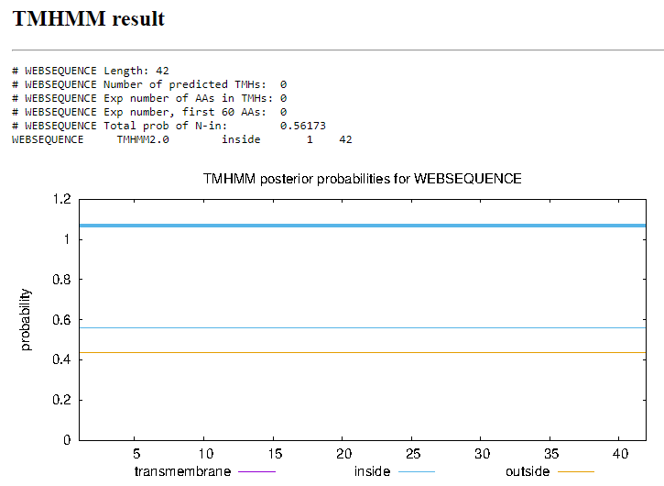
Function Evidence: Multiple BLAST results indicate a strong match with other phages with this protein listed as having no known function. This start is also supported by starterator, and phamerator suggests that other phages have a similar gene in this location
Transmembrane Domain/Evidence
Gene Number: 71 was 72
Start Codon and source: 58786 ATG ( original call at 58909 GTG)
Stop Codon: 59253
F/R: Forward
Coding Potential (y/n): yes
Starterator (SS, NA, NI): Start: 10 @58909 has 202 MA's (Start: 10 @58909 has 202 MA's)
Blast Best Hit, Query:Subject Starts, Score, Evalue, or “no significant Blast alignments” if 10E-4 or higher
Program | Genbank | Phagesdb | DNA Master
Phage name (best match)
Function
Positives
Max score/score
e-value

Gap:
Longest Orf? (Y/N/NA)
RBS: Kibler6, Karlin Medium,
Proposed Function: NKF
Function Evidence: Multiple BLAST results indicate a strong match with other phages with this protein listed as having no known function. This start is also supported by starterator, and phamerator suggests that other phages have a similar gene in this location
Transmembrane Domain/Evidence
Gene Number: 72 was 73
Start Codon and source: 59255
Stop Codon: 59857
F/R: Forward
Coding Potential (y/n): yes
Starterator (SS, NA, NI): Start: 30 @59255 has 225 MA's
Blast Best Hit, Query:Subject Starts, Score, Evalue, or “no significant Blast alignments” if 10E-4 or higher
Program | Genbank | Phagesdb | DNA Master
Phage name (best match) | Schadenfreude | Zaider | Schadenfreude
Function | NKF | NKF | NKF
Positives | 197/197 | 200/200 | 197/197
Max score/score | 329/329 | NA/406 | 843/843
e-value | 2e-112 | e-113 | 0.0e0

Gap: 2
Longest Orf? (Y/N/NA) yes
RBS: Kibler6, Karlin Medium, Z value 1.694. Final score -6.513. This is not the best proposed start, however this start does have significantly more MA’s than the better scoring start at 59305.
Proposed Function: NKF (Transferase? HHpred)
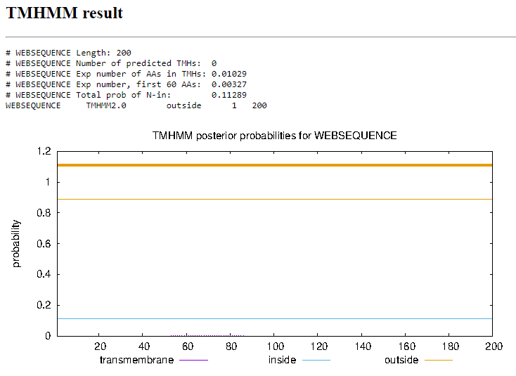
Function Evidence: Multiple BLAST results indicate a strong match with other phages with this protein listed as having no known function. This start is also supported by starterator, and phamerator suggests that other phages have a similar gene in this location. However, HHpred suggests a 97% likelihood that this product is transferase, which no other members of the pham have listed for this product.
Transmembrane Domain/Evidence
Gene Number: 73 was 74
Start Codon and source: 59916 ATG
Stop Codon: 60125
F/R: Forward
Coding Potential (y/n): yes
Starterator (SS, NA, NI): Start: 9 @59916 has 212 MA's
Blast Best Hit, Query:Subject Starts, Score, Evalue, or “no significant Blast alignments” if 10E-4 or higher
Program | Genbank | Phagesdb | DNA Master
Phage name (best match) | PG1 | Zelda | PG1
Function | NKF | NKF | NKF
Positives | 78/78 | 78/78 | 78/78
Max score/score | 100/100 | NA/171 | 248/248
e-value | 4e-25 | 4e-43 | 4.4e-25

Gap: 59
Longest Orf? (Y/N/NA) no
RBS: Kibler6, Karlin Medium, Z value 1.588, final score -6.150. This is not the best proposed start, however due to the 212 MA’s on starterator, this is a better candidate for the starting position
Proposed Function: NKF
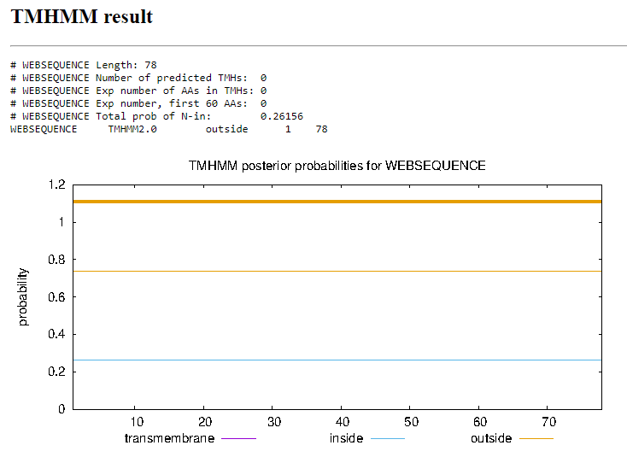
Function Evidence: Multiple BLAST results indicate a strong match with other phages with this protein listed as having no known function. This start is also supported by starterator, and phamerator suggests that other phages have a similar gene in this location
Transmembrane Domain/Evidence
Gene Number: 74 was 75
Start Codon and source: 60436 ATG
Stop Codon: 60227
F/R: Reverse
Coding Potential (y/n): yes
Starterator (SS, NA, NI): Start: 2 @60436 has 195 MA's
Blast Best Hit, Query:Subject Starts, Score, Evalue, or “no significant Blast alignments” if 10E-4 or higher
Program | Genbank | Phagesdb | DNA Master
Phage name (best match) | Soto | Zonia | Soto
Function | NKF | NKF | NKF
Positives | 68/69 | 68/69 | 68/69
Max score/score | 139/139 | NA/142 | 351/351
e-value | 2e-41 | 2e-34 | 1.6e-41

Gap: 67
Longest Orf? (Y/N/NA) yes
RBS: Kibler6, Karlin Medium, Z value 2.064, Final score -4.731. This is the best proposed start.
Proposed Function: NKF
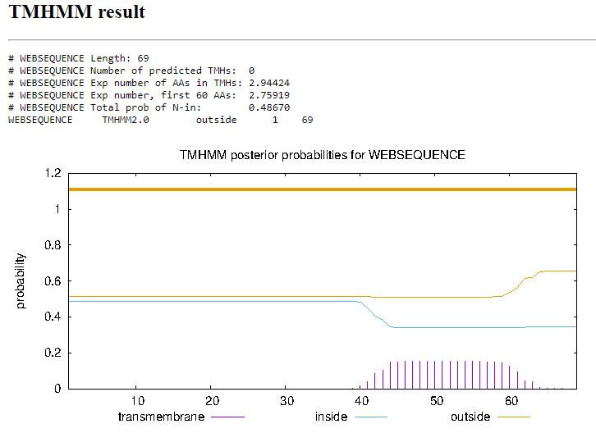
Function Evidence: Multiple BLAST results indicate a strong match with other phages with this protein listed as having no known function. This start is also supported by starterator, and phamerator suggests that other phages have a similar gene in this location. However, HHpred suggests a 95% likelihood that this product is transferase, which no other members of the pham have listed for this product.
Transmembrane Domain/Evidence
Gene Number: 75 was 76
Start Codon and source: 60937 TTG
Stop Codon: 60502
F/R: Reverse
Coding Potential (y/n): yes
Starterator (SS, NA, NI): Start: 5 @60937 has 172 MA's
Blast Best Hit, Query:Subject Starts, Score, Evalue, or “no significant Blast alignments” if 10E-4 or higher
Program | Genbank | Phagesdb | DNA Master
Phage name (best match) | PG1 | TyrionL | PG1
Function | NKF | NKF | NKF
Positives | 144/144 | 144/144 | 144/144
Max score/score | 297/297 | NA/302 | 761/761
e-value | 1e-101 | 1e-82 | 0.0

Gap: 39
Longest Orf? (Y/N/NA) yes
RBS: Kibler6, Karlin Medium, Z value 2.007, Final score -4.845. This is the best proposed start.
Proposed Function: NKF
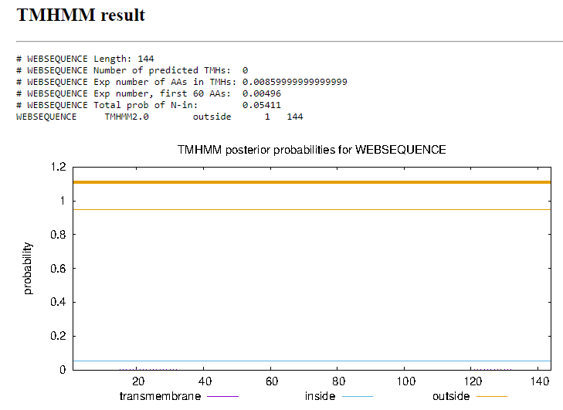
Function Evidence: Multiple BLAST results indicate a strong match with other phages with this protein listed as having no known function. This start is also supported by starterator, and phamerator suggests that other phages have a similar gene in this location
Transmembrane Domain/Evidence
Gene Number: 76 was 77
Start Codon and source: 61119 ATG
Stop Codon: 60976
F/R: Reverse
Coding Potential (y/n): yes
Starterator (SS, NA, NI): Start: 4 @61119 has 225 MA's
Blast Best Hit, Query:Subject Starts, Score, Evalue, or “no significant Blast alignments” if 10E-4 or higher
Program | Genbank | Phagesdb | DNA Master
Phage name (best match) | PG1 | Virgeve | PG1
Function | NKF | NKF | NKF
Positives | 47/47 | 47/47 | 47/47
Max score/score | 49.3/49.3 | NA/94.7 | 116/116
e-value | 3e-06 | 6e-20 | 3.2e-6

Gap: 55
Longest Orf? (Y/N/NA) yes
RBS: Kibler6, Karlin Medium, Z value 2.064, Final score -4.669. This is the only proposed start.
Proposed Function: NKF
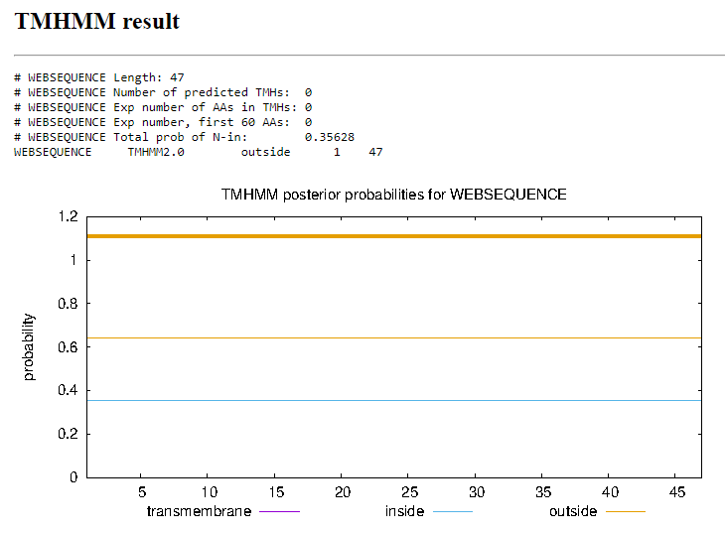
Function Evidence: There is only one candidate for start position at 61119, and there is also very few BLAST results, none of which have assigned function.
Transmembrane Domain/Evidence
Gene Number: 77 was 78
Start Codon and source: 61437 GTG
Stop Codon: 61174
F/R: Reverse
Coding Potential (y/n): yes
Starterator (SS, NA, NI): Start: 19 @61437 has 218 MA's
Blast Best Hit, Query:Subject Starts, Score, Evalue, or “no significant Blast alignments” if 10E-4 or higher
Program | Genbank | Phagesdb | DNA Master
Phage name (best match) | Eremos | Robyn | NA
Function | NKF | NKF | NA
Positives | 87/87 | 87/87 | NA
Max score/score | 178/178 | NA/179 | NA
e-value | 4e-56 | 2e-45 | NA

Gap: -4
Longest Orf? (Y/N/NA) yes
RBS: Kibler6, Karlin Medium, Z value 1.350, Final score -6.181. This is not the best proposed starts but it has the highest number of MA’s and the start at 61572 almost entirely overlaps with gene 80
Proposed Function: NKF
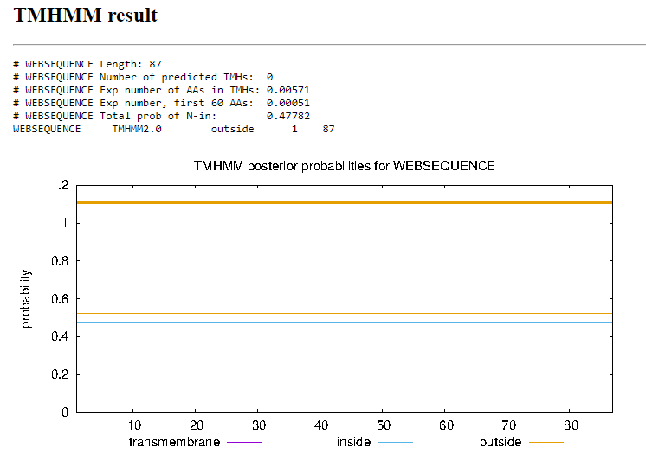
Function Evidence: Multiple BLAST results indicate a strong match with other phages with this protein listed as having no known function. This start is also supported by starterator, and phamerator suggests that other phages have a similar gene in this location
Transmembrane Domain/Evidence
Gene Number: 78 was 79
Start Codon and source: 61574 ATG
Stop Codon: 61434
F/R: Reverse
Coding Potential (y/n): yes
Starterator (SS, NA, NI): Start: 4 @61574 has 182 MA's
Blast Best Hit, Query:Subject Starts, Score, Evalue, or “no significant Blast alignments” if 10E-4 or higher
Program | Genbank | Phagesdb | DNA Master
Phage name (best match) | Haimas | Yoshand | Haimas
Function | NKF | NKF | NKF
Positives | 46/46 | 46/46 | 25/25
Max score/score | 52.8/52.8 | NA/94.7 | 125/125
e-value | 1e-07 | 6e-20 | 1.3e-7

Gap: -1
Longest Orf? (Y/N/NA) no
RBS: Kibler6, Karlin Medium, Z value 1.986, Final score -4.905. This is the best proposed start
Proposed Function: Membrane protein
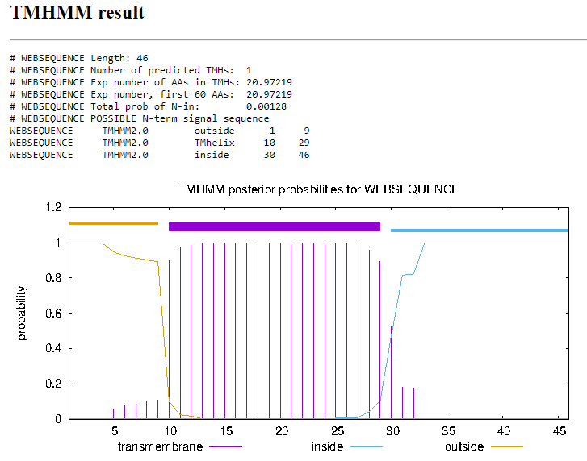
Function Evidence: Multiple BLAST results indicate a strong match with other phages with this protein listed as having no known function. This start is also supported by starterator, and phamerator suggests that other phages have a similar gene in this location
Transmembrane Domain/Evidence
Gene Number: 79 was 80
Start Codon and source: 61804 ATG
Stop Codon: 61574
F/R: Reverse
Coding Potential (y/n): yes
Starterator (SS, NA, NI): Start: 4 @61804 has 220 MA's
Blast Best Hit, Query:Subject Starts, Score, Evalue, or “no significant Blast alignments” if 10E-4 or higher
Program | Genbank | Phagesdb | DNA Master
Phage name (best match) | Chah | Chah | Chah
Function | NKF | NKF | NKF
Positives | 76/76 | 76/76 | 76/76
Max score/score | 155/155 | NA/163 | 393/393
e-value | 1e-47 | 1e-40 | 0.0e0

Gap: -8
Longest Orf? (Y/N/NA) yes
RBS: Kibler6, Karlin Medium, Z value 2.562, Final score -4.198. This is the best proposed start
Proposed Function: NKF
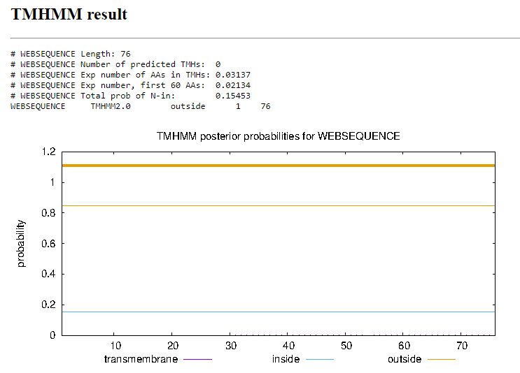
Function Evidence: Multiple BLAST results indicate a strong match with other phages with this protein listed as having no known function. This start is also supported by starterator, and phamerator suggests that other phages have a similar gene in this location
Transmembrane Domain/Evidence
Gene Number: 80 was 81
Start Codon and source: 62183 ATG
Stop Codon: 61797
F/R: Reverse
Coding Potential (y/n): yes
Starterator (SS, NA, NI): Start: 20 @62183 has 178 MA's
Blast Best Hit, Query:Subject Starts, Score, Evalue, or “no significant Blast alignments” if 10E-4 or higher
Program | Genbank | Phagesdb | DNA Master
Phage name (best match) | Sigman | Zonia | Sigman
Function | NKF | NKF | NKF
Positives | 128/128 | 128/128 | 128/128
Max score/score | 222/222 | NA/256 | 566/566
e-value | 3e-72 | 2e-68 | 0.0

Gap: 44
Longest Orf? (Y/N/NA) No
RBS: Kibler6, Karlin Medium, Z value 2.525, Final score -4.846. This is the best proposed start
Proposed Function: NKF
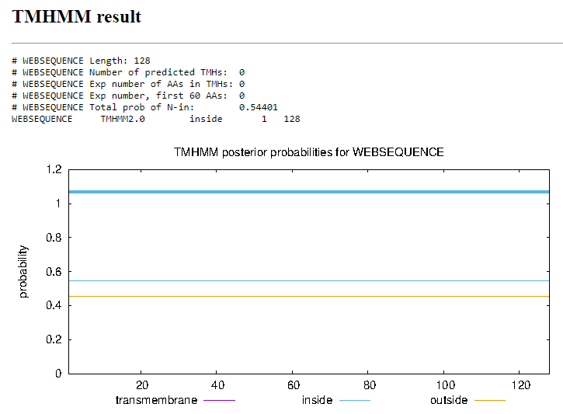
Function Evidence: Multiple BLAST results indicate a strong match with other phages with this protein listed as having no known function. This start is also supported by starterator, and phamerator suggests that other phages have a similar gene in this location
Transmembrane Domain/Evidence
Gene Number: 81 was 82
Start Codon and source: 62529 ATG
Stop Codon: 62227
F/R: Reverse
Coding Potential (y/n): yes
Starterator (SS, NA, NI): Start: 31 @62529 has 191 MA's
Blast Best Hit, Query:Subject Starts, Score, Evalue, or “no significant Blast alignments” if 10E-4 or higher
Program | Genbank | Phagesdb | DNA Master
Phage name (best match) | Pops | Xavier | NA
Function | HNH Endonuclease | HNH Endonuclease | NA
Positives | 100/100 | 100/100 | NA
Max score/score | 179/179 | NA/215 | NA
e-value | 3e-56 | 2e-56 | NA

Gap: -4
Longest Orf? (Y/N/NA) no
RBS: Kibler6, Karlin Medium, Z value 0.741, Final score -7.384. This is not the best suggested start, however the 1:1 BLAST results and starterator both strongly suggest this is the correct start.
Proposed Function: HNH endonuclease
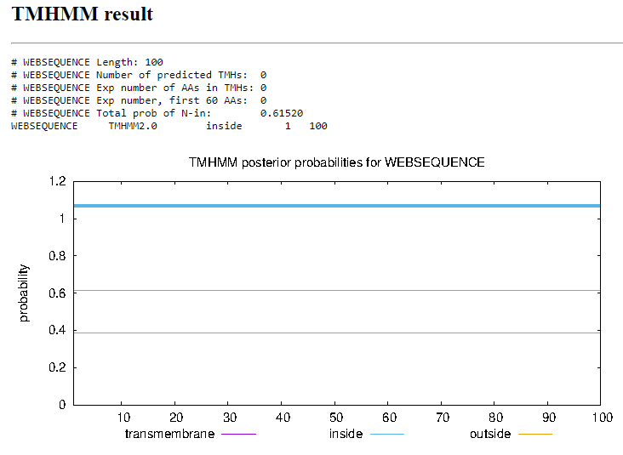
Function Evidence: Several BLAST results indicate a strong similarity between this product and the HNH endonuclease of other phages. This is corroborated by HHpred with a 98.38% probability that this is HNH endonuclease.
Transmembrane Domain/Evidence
Gene Number: 82 was 83
Start Codon and source: 62636 ATG
Stop Codon: 62526
F/R: Reverse
Coding Potential (y/n): yes
Starterator (SS, NA, NI): Start: 5 @62636 has 174 MA's
Blast Best Hit, Query:Subject Starts, Score, Evalue, or “no significant Blast alignments” if 10E-4 or higher
Program | Genbank | Phagesdb | DNA Master
Phage name (best match) | Vista | Vista | NA
Function | NKF | NKF | NA
Positives | 36/36 | 36/36 | NA
Max score/score | 73.2/73.2 | NA/79 | NA
e-value | 5e-16 | 3e-15 | NA

Gap: -4
Longest Orf? (Y/N/NA) yes
RBS: Kibler6, Karlin Medium, Z value 2.121, Final score -4.696. This is the only proposed start.
Proposed Function: NKF
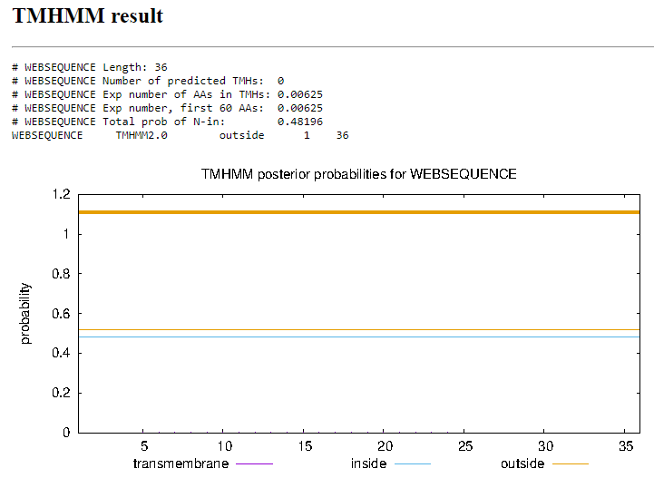
Function Evidence: Multiple BLAST results indicate a strong match with other phages with this protein listed as having no known function. This start is also supported by starterator, and phamerator suggests that other phages have a similar gene in this location
Transmembrane Domain/Evidence
Gene Number: 83 was 84
Start Codon and source: 62812 ATG
Stop Codon: 62633
F/R: Reverse
Coding Potential (y/n): yes
Starterator (SS, NA, NI): Start: 2 @62812 has 225 MA's
Blast Best Hit, Query:Subject Starts, Score, Evalue, or “no significant Blast alignments” if 10E-4 or higher
Program | Genbank | Phagesdb | DNA Master
Phage name (best match) | Suffolk | Vista | NA
Function | NKF | NKF | NA
Positives | 59/59 | 59/59 | NA
Max score/score | 119/119 | NA/120 | NA
e-value | 2e-33 | 8e-28 | NA

Gap: 13
Longest Orf? (Y/N/NA) yes
RBS: Kibler6, Karlin Medium, Z value 2.622, Final score -3.613. This is the best proposed start.
Proposed Function: NKF
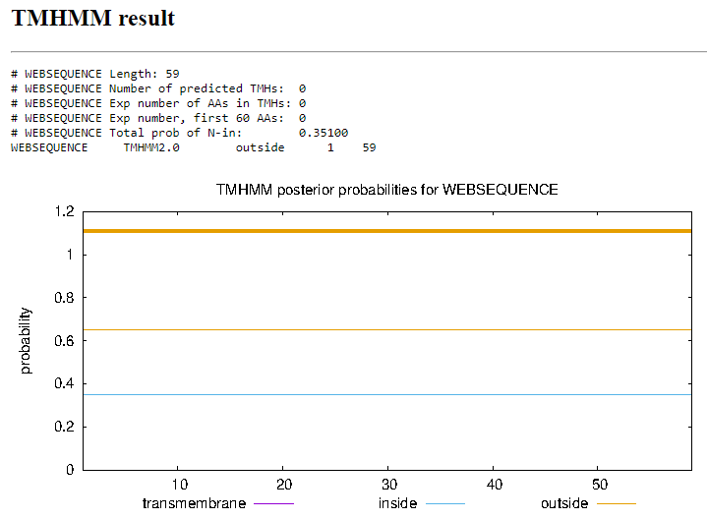
Function Evidence: Multiple BLAST results indicate a strong match with other phages with this protein listed as having no known function. This start is also supported by starterator, and phamerator suggests that other phages have a similar gene in this location
Transmembrane Domain/Evidence
Gene Number: 84 was 85
Start Codon and source: 63085 ATG
Stop Codon: 62827
F/R: Reverse
Coding Potential (y/n): yes
Starterator (SS, NA, NI): Start: 9 @63085 has 174 MA's
Blast Best Hit, Query:Subject Starts, Score, Evalue, or “no significant Blast alignments” if 10E-4 or higher
Program | Genbank | Phagesdb | DNA Master
Phage name (best match) | PG1 | Zaider | NA
Function | NKF | NKF | NA
Positives | 86/86 | 86/86 | NA
Max score/score | 175/175 | NA/186 | NA
e-value | 5e-55 | 1e-47 | NA

Gap: 190
Longest Orf? (Y/N/NA) no
RBS: Kibler6, Karlin Medium, Z value 2.270, Final score -4.257. This is the best proposed start.
Proposed Function: NKF
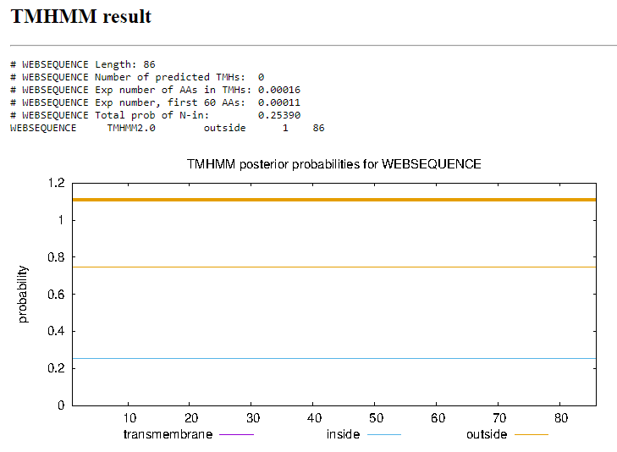
Function Evidence: Multiple BLAST results indicate a strong match with other phages with this protein listed as having no known function. This start is also supported by starterator, and phamerator suggests that other phages have a similar gene in this location
Transmembrane Domain/Evidence
Gene Number: 85
Start Codon and source: 63279 ATG
Stop Codon: 63082
F/R: Reverse
Coding Potential (y/n): yes
Starterator (SS, NA, NI): NA
Blast Best Hit, Query:Subject Starts, Score, Evalue, or “no significant Blast alignments” if 10E-4 or higher
Program | Genbank | Phagesdb | DNA Master
Phage name (best match) | Newman | Zonia | NA
Function | NKF | NKF | NA
Positives | 73/73 | 73/73 | NA
Max score/score | 151/151 | NA/152 | NA
e-value | 6e-46 | 3d-37 | NA

Gap: -2
Longest Orf? (Y/N/NA) yes
RBS: Kibler6, Karlin Medium, Z value 2.121, Final score -5.605. This is the best proposed start.
Proposed Function: NKF
Function Evidence: Multiple BLAST results indicate a strong match with other phages with this protein listed as having no known function. This start is also supported by starterator, and phamerator suggests that other phages have a similar gene in this location
Transmembrane Domain/Evidence
Gene Number: 86
Start Codon and source: 63500 ATG
Stop Codon: 63280
F/R:Reverse
Coding Potential (y/n): yes
Starterator (SS, NA, NI): Start: 6 @63500 has 146 MA's
Blast Best Hit, Query:Subject Starts, Score, Evalue, or “no significant Blast alignments” if 10E-4 or higher
Program | Genbank | Phagesdb | DNA Master
Phage name (best match) | Soto | Vivaldi | NA
Function | NKF | NKF | NA
Positives | 74/74 | 74/74 | NA
Max score/score | 149/149 | NA/162 | NA
e-value | 6e-45 | 2e-40 | NA

Gap: -6
Longest Orf? (Y/N/NA) no
RBS: Kibler6, Karlin Medium, Z value 1.968, Final score, -5.352. This is not the best proposed start but this start has more MA’s than the higher scoring start at 63497.
Proposed Function: NKF
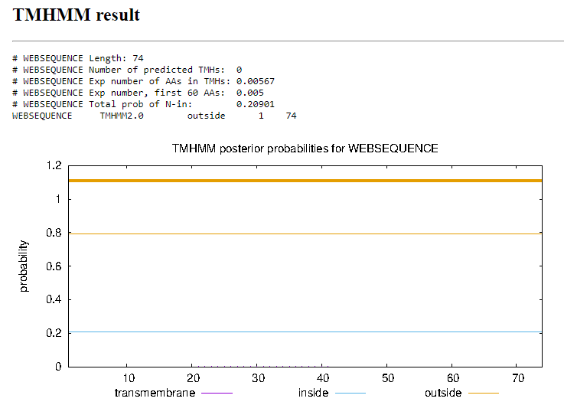
Function Evidence: Multiple BLAST results indicate a strong match with other phages with this protein listed as having no known function. This start is also supported by starterator, and phamerator suggests that other phages have a similar gene in this location
Transmembrane Domain/Evidence
Gene Number: 87
Start Codon and source: 63679 ATG
Stop Codon: 63494
F/R: Reverse
Coding Potential (y/n): yes
Starterator (SS, NA, NI): Start: 3 @63679 has 224 MA's
Blast Best Hit, Query:Subject Starts, Score, Evalue, or “no significant Blast alignments” if 10E-4 or higher
Program | Genbank | Phagesdb | DNA Master
Phage name (best match) | Swish | Vivaldi | NA
Function | NKF | NKF | NA
Positives | 61/61 | 61/61 | NA
Max score/score | 124/124 | NA/129 | NA
e-value | 2e-35 | 3e-30 | NA

Gap: -4
Longest Orf? (Y/N/NA) yes
RBS: Kibler6, Karlin Medium, Z value 1.707, Final score -5.526. This is the best proposed start
Proposed Function: NKF
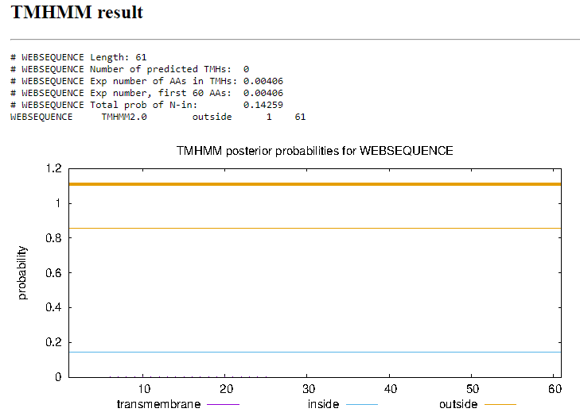
Function Evidence: Multiple BLAST results indicate a strong match with other phages with this protein listed as having no known function. This start is also supported by starterator, and phamerator suggests that other phages have a similar gene in this location
Transmembrane Domain/Evidence
Gene Number: 87
Start Codon and source: 63879 ATG (Changed from 63888 ATG)
Stop Codon: 63675
F/R: Reverse
Coding Potential (y/n): yes
Starterator (SS, NA, NI): Start: 4 @63897 has 223 MA's
Blast Best Hit, Query:Subject Starts, Score, Evalue, or “no significant Blast alignments” if 10E-4 or higher
Program | Genbank | Phagesdb | DNA Master
Phage name (best match) | Newman | Zonia | NA
Function | NKF | NKF | NA
Positives | 70/70 | 70/70 | NA
Max score/score | 145/145 | NA/146 | NA
e-value | 8e-44 | 2e-35 | NA

Gap: 120
Longest Orf? (Y/N/NA) no
RBS: Kibler6, Karlin Medium, Z value 2.378, Final Score -4.101. This is the best proposed start
Proposed Function: NKF
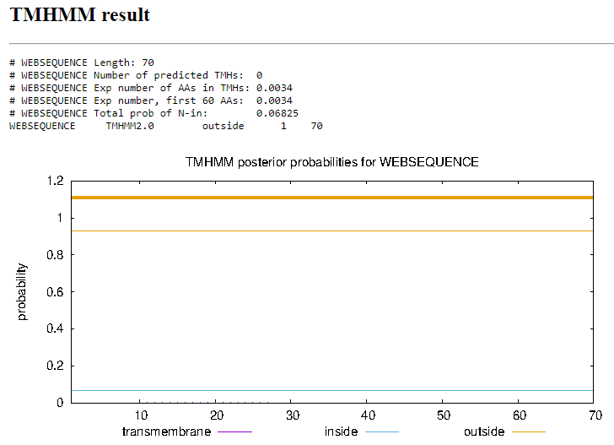
Function Evidence: Multiple BLAST results indicate a strong match with other phages with this protein listed as having no known function. This start is also supported by starterator, and phamerator suggests that other phages have a similar gene in this location
Transmembrane Domain/Evidence
Gene Number: 88 - after; small ORF not called
Start Codon and source: 64320 ATG
Stop Codon: 64018
F/R: Reverse
Coding Potential (y/n): yes
Starterator (SS, NA, NI): Start: 19 @64320 has 271 MA's
Blast Best Hit, Query:Subject Starts, Score, Evalue, or “no significant Blast alignments” if 10E-4 or higher
Program | Genbank | Phagesdb | DNA Master
Phage name (best match) | Placalicious | Weher20 | NA
Function | NKF | NKF | NA
Positives | 100/100 | 100/100 | NA
Max score/score | 186/186 | NA/207 | NA
e-value | 4e-59 | 8e-54 | NA

Gap: 32
Longest Orf? (Y/N/NA) yes
RBS: Kibler6, Karlin Medium, Z value 2.995, Final score -2.804. This is the best proposed start.
Proposed Function: NKF
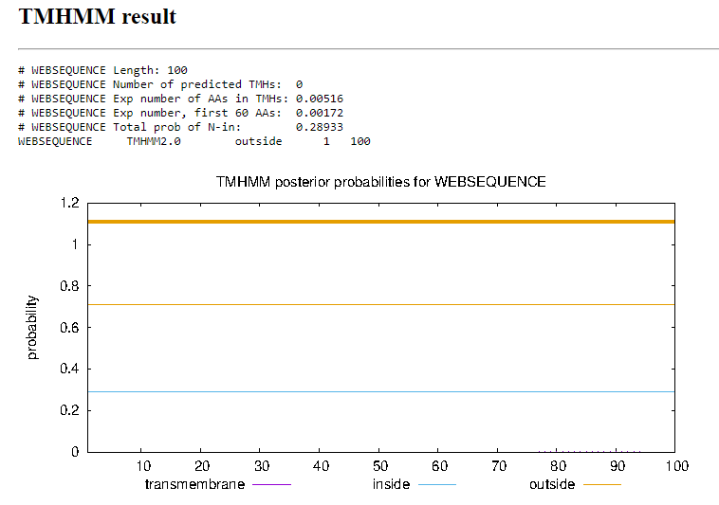
Function Evidence: Multiple BLAST results indicate a strong match with other phages with this protein listed as having no known function. This start is also supported by starterator, and phamerator suggests that other phages have a similar gene in this location
Transmembrane Domain/Evidence
Gene Number: 89
Start Codon and source: 64486 ATG
Stop Codon: 64353
F/R: Reverse
Coding Potential (y/n): yes
Starterator (SS, NA, NI): Start: 2 @64486 has 1 MA's
Blast Best Hit, Query:Subject Starts, Score, Evalue, or “no significant Blast alignments” if 10E-4 or higher
Program | Genbank | Phagesdb | DNA Master
Phage name (best match) | Hocus | Swish | NA
Function | NKF | NKF | NA
Positives | 44/44 | 44/44 | NA
Max score/score | 92/92 | NA/90.5 | NA
e-value | 5e-23 | 1e-18 | NA

Gap: 31
Longest Orf? (Y/N/NA) no
RBS: Kibler6, Karlin Medium, Z value 1.100, final score -7.429. This is not the best proposed start, however it is the only start with another phage with a matching start position in its pham.
Proposed Function: NKF
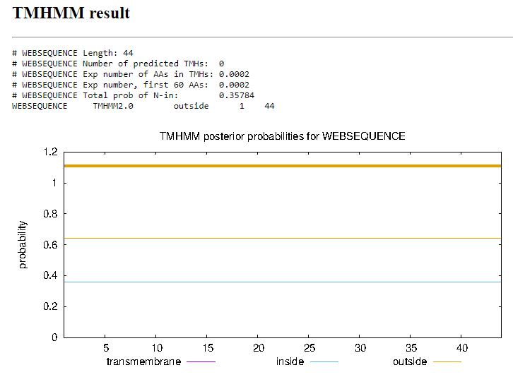
Function Evidence: Multiple BLAST results indicate a strong match with other phages with this protein listed as having no known function. This start is also supported by starterator, and phamerator suggests that other phages have a similar gene in this location
Transmembrane Domain/Evidence
Gene Number: 90
Start Codon and source: 64892 ATG (changed from 64877 TTG)
Stop Codon: 64617
F/R:Reverse
Coding Potential (y/n): yes
Starterator (SS, NA, NI): Start: 8 @64892 has 195 MA's
Blast Best Hit, Query:Subject Starts, Score, Evalue, or “no significant Blast alignments” if 10E-4 or higher
Program | Genbank | Phagesdb | DNA Master
Phage name (best match) | Swish | Vaishali24 | Swish
Function | NKF | NKF | NKF
Positives | 86/86 | 86/86 | 86/86
Max score/score | 139/139 | NA/182 | 350/350
e-value | 1e-40 | 2e-46 | 9.5e-41

Gap: -4
Longest Orf? (Y/N/NA) no
RBS: Kibler6, Karlin Medium, Z value 1.832, Final score -6.235. This is not the best proposed start, but does have more MA’s than the original call.
Proposed Function: NKF
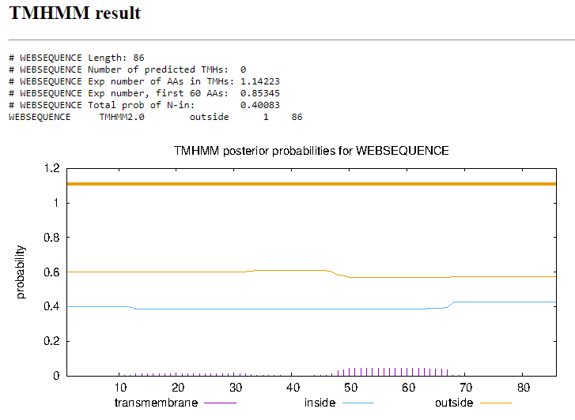
Function Evidence: Multiple BLAST results indicate a strong match with other phages with this protein listed as having no known function. This start is also supported by starterator, and phamerator suggests that other phages have a similar gene in this location
Transmembrane Domain/Evidence
Gene Number: 92
Start Codon and source: 65134 GTG
Stop Codon: 64889
F/R: Reverse
Coding Potential (y/n): yes
Starterator (SS, NA, NI): Start: 17 @65134 has 183 MA's
Blast Best Hit, Query:Subject Starts, Score, Evalue, or “no significant Blast alignments” if 10E-4 or higher
Program | Genbank | Phagesdb | DNA Master
Phage name (best match) | Colbert | Spartan300 | Colbert
Function | NKF | NKF | NKF
Positives | 81/81 | 81/81 | 81/81
Max score/score | 161/161 | NA/155 | 408/408
e-value | 9e-50 | 2e-38 | 0.0

Gap: 39
Longest Orf? (Y/N/NA) yes
RBS: Kibler6, Karlin Medium, Z value 2.995, Final score -2.884. This is the best proposed start
Proposed Function: NKF
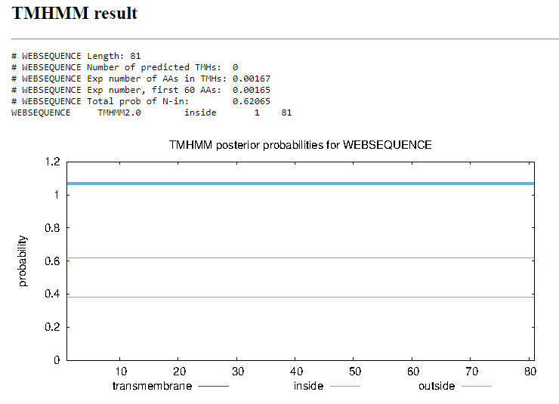
Function Evidence: Multiple BLAST results indicate a strong match with other phages with this protein listed as having no known function. This start is also supported by starterator, and phamerator suggests that other phages have a similar gene in this location
Transmembrane Domain/Evidence
Gene Number: 93
Start Codon and source: 65529 ATG
Stop Codon:65173
F/R: Reverse
Coding Potential (y/n): yes
Starterator (SS, NA, NI): Start: 2 @65529 has 154 MA's
Blast Best Hit, Query:Subject Starts, Score, Evalue, or “no significant Blast alignments” if 10E-4 or higher
Program | Genbank | Phagesdb | DNA Master
Phage name (best match) | Newman | Zonia | NA
Function | NKF | NKF | NA
Positives | 118/118 | 118/118 | NA
Max score/score | 245/245 | NA/241 | NA
e-value | 1e-81 | 3e-64 | NA

Gap: 163
Longest Orf? (Y/N/NA) no
RBS: Kibler6, Karlin Medium, Z value 3.318, Final score -2.297. This is the best proposed start.
Proposed Function: NKF
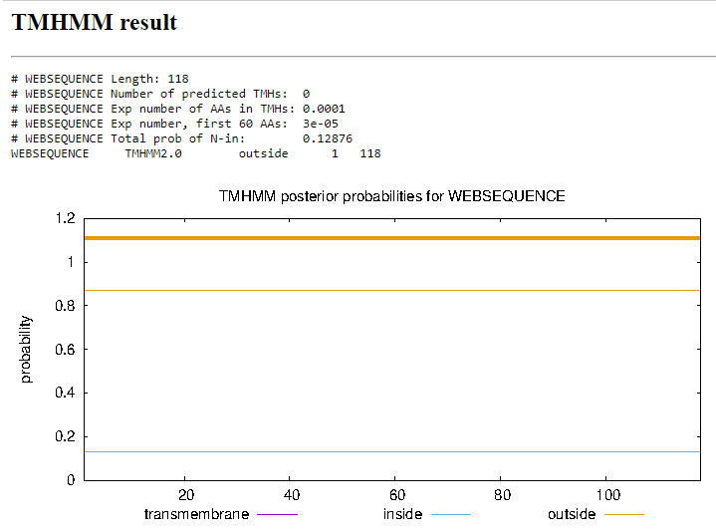
Function Evidence: Multiple BLAST results indicate a strong match with other phages with this protein listed as having no known function. This start is also supported by starterator, and phamerator suggests that other phages have a similar gene in this location
Transmembrane Domain/Evidence
Gene Number: 94
Start Codon and source: 66423 GTG
Stop Codon: 65692
F/R: Reverse
Coding Potential (y/n): yes
Starterator (SS, NA, NI): Start: 9 @66423 has 215 MA's
Blast Best Hit, Query:Subject Starts, Score, Evalue, or “no significant Blast alignments” if 10E-4 or higher
Program | Genbank | Phagesdb | DNA Master
Phage name (best match) | Suffolk | Suffolk | Suffolk
Function | NKF | NKF | NKF
Positives | 242/243 | 242/243 | 242/243
Max score/score | 375/375 | NA/481 | 963/963
e-value | 3e-129 | e-136 | 0.0e0

Gap: -4
Longest Orf? (Y/N/NA) no
RBS: Kibler6, Karlin Medium, Z value 1.986, final score -4.905. This is not the best proposed start, however it is the start with the highest number of matching starts in other phages.
Proposed Function: NKF
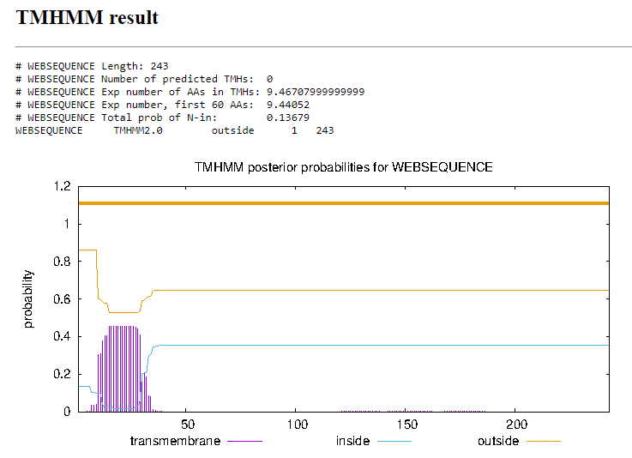
Function Evidence: Multiple BLAST results indicate a strong match with other phages with this protein listed as having no known function. This start is also supported by starterator, and phamerator suggests that other phages have a similar gene in this location
Transmembrane Domain/Evidence
Gene Number: 95
Start Codon and source: 66599 ATG
Stop Codon:66420
F/R: Reverse
Coding Potential (y/n): yes
Starterator (SS, NA, NI): Start: 2 @66599 has 224 MA's
Blast Best Hit, Query:Subject Starts, Score, Evalue, or “no significant Blast alignments” if 10E-4 or higher
Program | Genbank | Phagesdb | DNA Master
Phage name (best match) | Suffolk | Zonia | Suffolk
Function | NKF | NKF | NKF
Positives | 59/59 | 59/59 | 59/59
Max score/score | 87/87 | NA/115 | 214/214
e-value | 8e-21 | 4e-26 | 8.0e-21

Gap: -4
Longest Orf? (Y/N/NA) yes
RBS: Kibler6, Karlin Medium, Z value 1.454, Final score -5.972. This is not the best proposed start, but does have the highest number of matching starts in other phages.
Proposed Function: Membrane protein
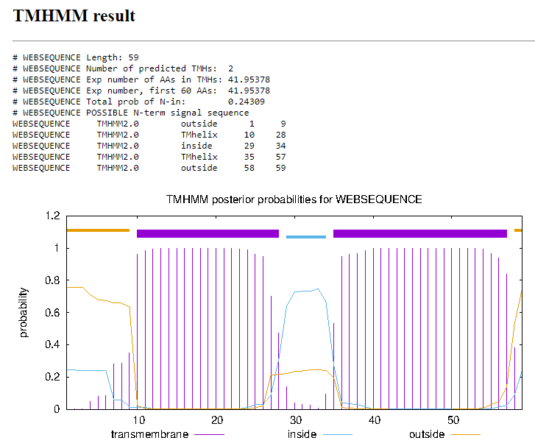
Function Evidence: Multiple BLAST results indicate a strong match with other phages with this protein listed as having no known function. This start is also supported by starterator, and phamerator suggests that other phages have a similar gene in this location
Transmembrane Domain/Evidence
Gene Number: 96
Start Codon and source: 66832 ATG
Stop Codon:66596
F/R: Reverse
Coding Potential (y/n): yes
Starterator (SS, NA, NI): Start: 25 @66832 has 179 MA's
Blast Best Hit, Query:Subject Starts, Score, Evalue, or “no significant Blast alignments” if 10E-4 or higher
Program | Genbank | Phagesdb | DNA Master
Phage name (best match) | Swish | Zonia | NA
Function | NKF | NKF | NA
Positives | 78/78 | 78/78 | NA
Max score/score | 144/144 | NA/167 | NA
e-value | 7e-43 | 7e-42 | NA

Gap: 54
Longest Orf? (Y/N/NA) no
RBS: Kibler6, Karlin Medium, Z value 3.239, Final score -3.222. This is the best proposed start.
Proposed Function: NKF
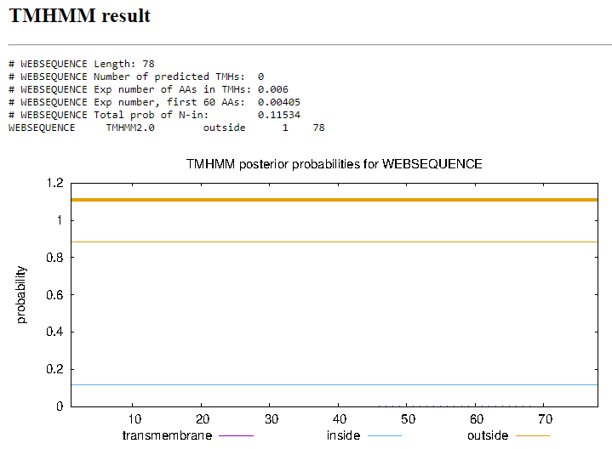
Function Evidence: Multiple BLAST results indicate a strong match with other phages with this protein listed as having no known function. This start is also supported by starterator, and phamerator suggests that other phages have a similar gene in this location
Transmembrane Domain/Evidence
Gene Number: 97
Start Codon and source: 67287 atg
Stop Codon: 68886
F/R: Reverse
Coding Potential (y/n): yes
Starterator (SS, NA, NI): Start: 31 @67287 has 262 MA's
Blast Best Hit, Query:Subject Starts, Score, Evalue, or “no significant Blast alignments” if 10E-4 or higher
Program | Genbank | Phagesdb | DNA Master
Phage name (best match) | PG1 | Zelda | NA
Function | NKF | NKF | NA
Positives | 133/133 | 133/133 | NA
Max score/score | 275/275 | NA/277 | NA
e-value | 5e-93 | 5e-75 | NA

Gap: 3
Longest Orf? (Y/N/NA) no
RBS: Kibler6, Karlin Medium, Z value 2.583, Final score -3.768. This is the best proposed start
Proposed Function: NKF
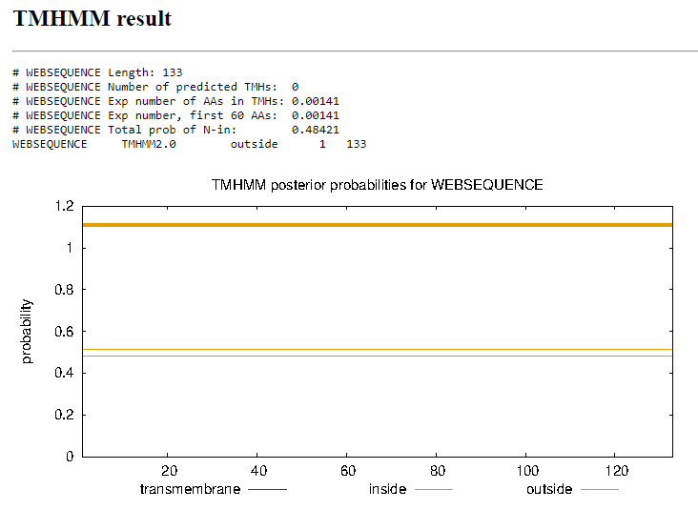
Function Evidence: Multiple BLAST results indicate a strong match with other phages with this protein listed as having no known function. This start is also supported by starterator, and phamerator suggests that other phages have a similar gene in this location
Transmembrane Domain/Evidence
Gene Number: 98
Start Codon and source: 67628 ATG
Stop Codon:67290
F/R: Reverse
Coding Potential (y/n): yes
Starterator (SS, NA, NI): Start: 19 @67628 has 201 MA's
Blast Best Hit, Query:Subject Starts, Score, Evalue, or “no significant Blast alignments” if 10E-4 or higher
Program | Genbank | Phagesdb | DNA Master
Phage name (best match) | KLucky39 | KLucky39 | KLucky39
Function | NKF | NKF | NKF
Positives | 111/112 | 111/112 | 111/112
Max score/score | 229/229 | NA/231 | 585/585
e-value | 7e-76 | 4e-61 | 0.0

Gap: 66
Longest Orf? (Y/N/NA) yes
RBS: Kibler6, Karlin Medium, Z value 2.995, Final score -3.632. This is the best proposed start.
Proposed Function: NKF
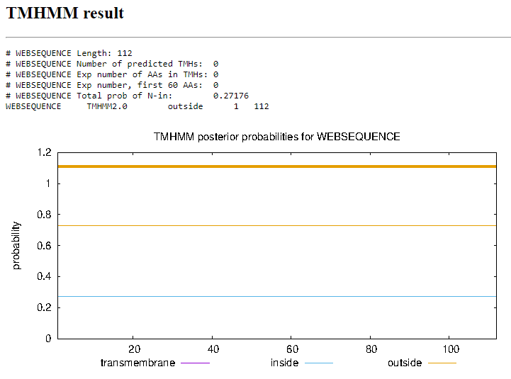
Function Evidence: Multiple BLAST results indicate a strong match with other phages with this protein listed as having no known function. This start is also supported by starterator, and phamerator suggests that other phages have a similar gene in this location
Transmembrane Domain/Evidence
Gene Number: 99
Start Codon and source: 67891 ATG
Stop Codon: 67694
F/R: Reverse
Coding Potential (y/n): yes
Starterator (SS, NA, NI): Start: 5 @67891 has 143 MA's
Blast Best Hit, Query:Subject Starts, Score, Evalue, or “no significant Blast alignments” if 10E-4 or higher
Program | Genbank | Phagesdb | DNA Master
Phage name (best match) | KLucky39 | Suffolk | NA
Function | NKF | NKF | NA
Positives | 65/65 | 65/65 | NA
Max score/score | 114/114 | NA/138 | NA
e-value | 2e-31 | 4e-33 | NA

Gap: NA
Longest Orf? (Y/N/NA) yes
RBS: Kibler6, Karlin Medium, Z value 2.827, Final score -3.729. This is the best proposed start.
Proposed Function: NKF
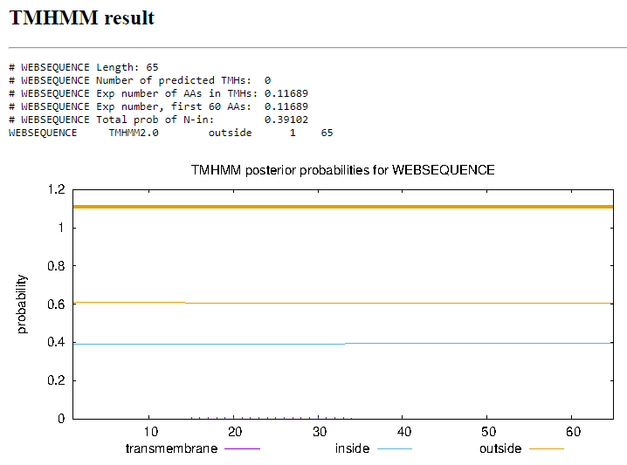
Function Evidence: Multiple BLAST results indicate a strong match with other phages with this protein listed as having no known function. This start is also supported by starterator, and phamerator suggests that other phages have a similar gene in this location
Transmembrane Domain/Evidence

