Mycobacterium phage Totinger – 57540 bp including 10-base 3' overhang (CGATGGGGAT), Cluster F1
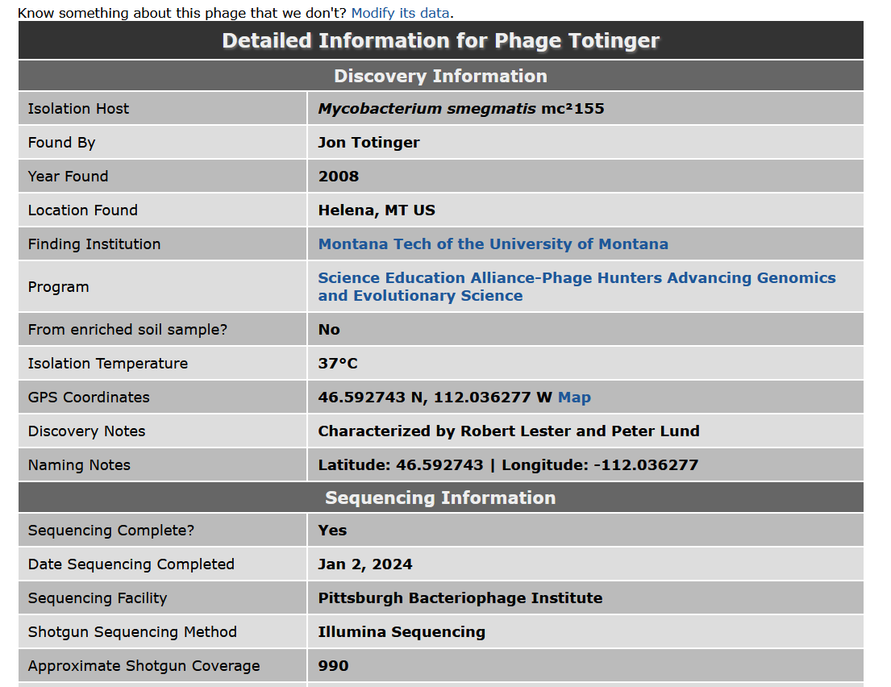
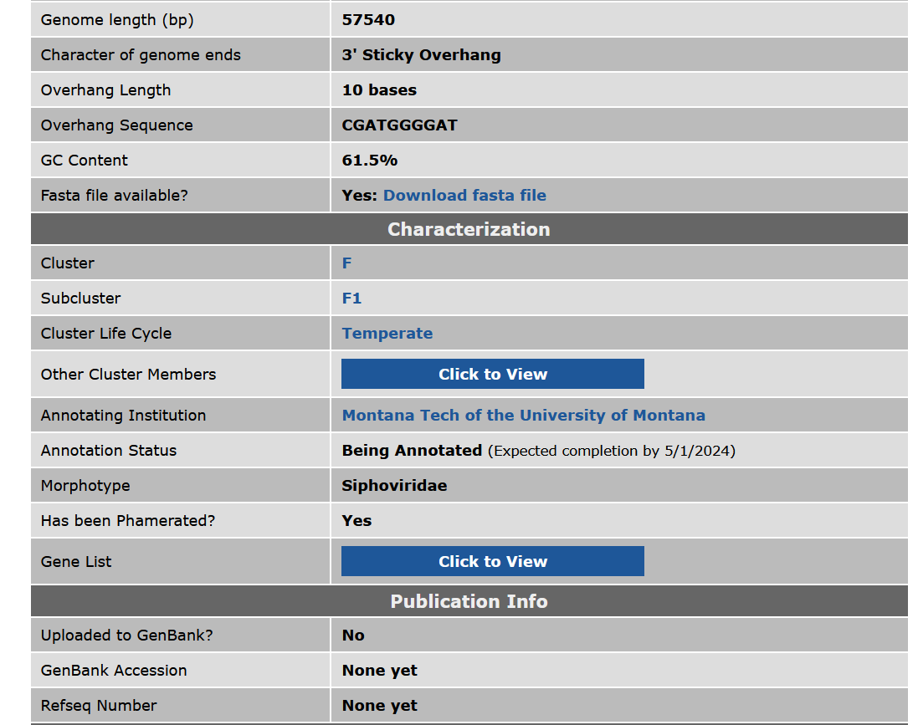
According to phagesdb.org (1/12/2023), 106 genes in Draft annotation.
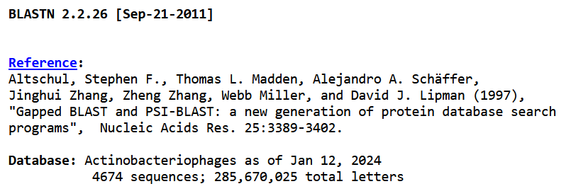
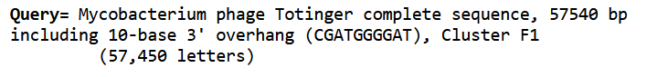
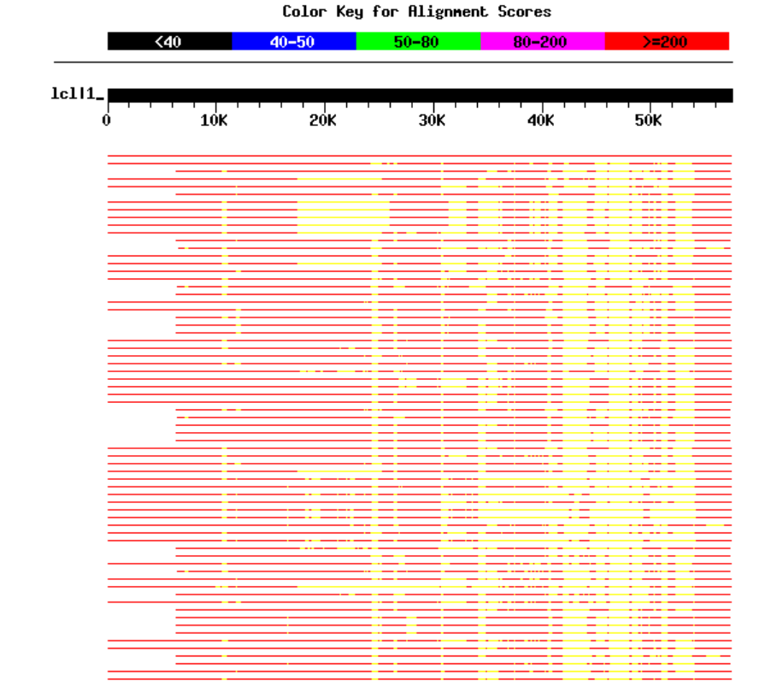
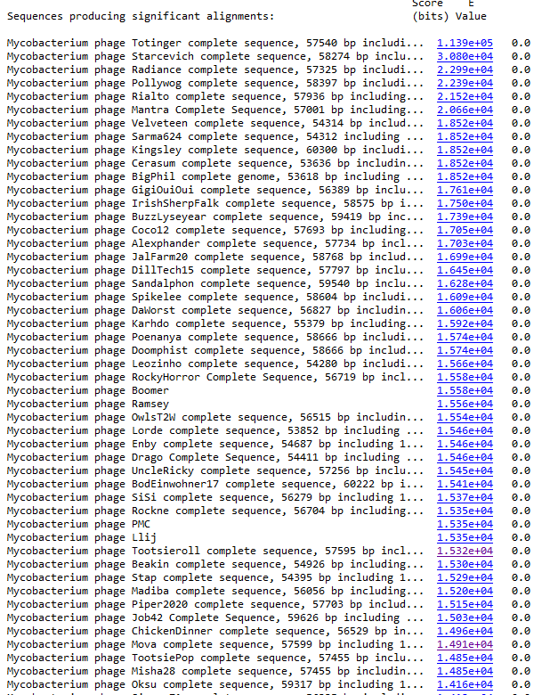
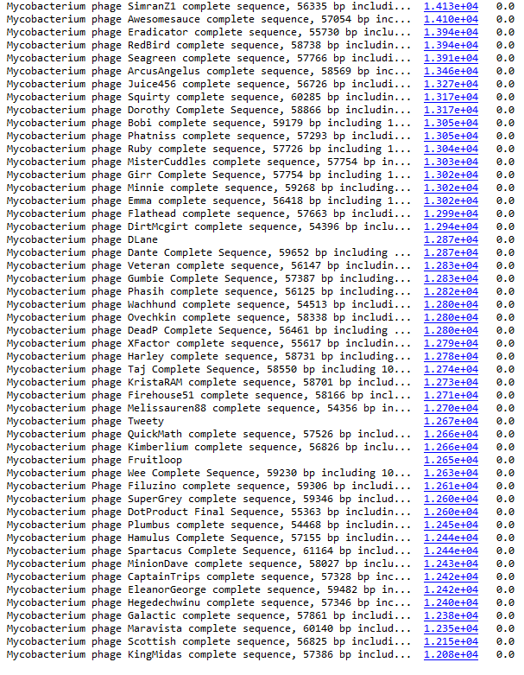

Three Genemark Files Obtained: Self-Trained, Vs TB and Vs Smeg. The TB and Smeg graphs did not look as “good” as the self-trained model, which displayed clear gene predictions, and genes were unclear.
Several Mycobacterium species (leprae, abscessus, and bovis) compared using http://exon.gatech.edu/GeneMark/genemarks2.cgi. all of which appeared similarly to TB and Smeg. An E. Coli Genemark model was obtained to compare to Mycobacterium sp. and displayed a strangely more coherent graph with more clearly found genes than than any of the Mycobacterium sp. models.

DNA MASTER
- 103 Genes Predicted.
Six-Frame Translation Obtained.

TRNA GENES
- DNA Master: No tRNA Genes Found
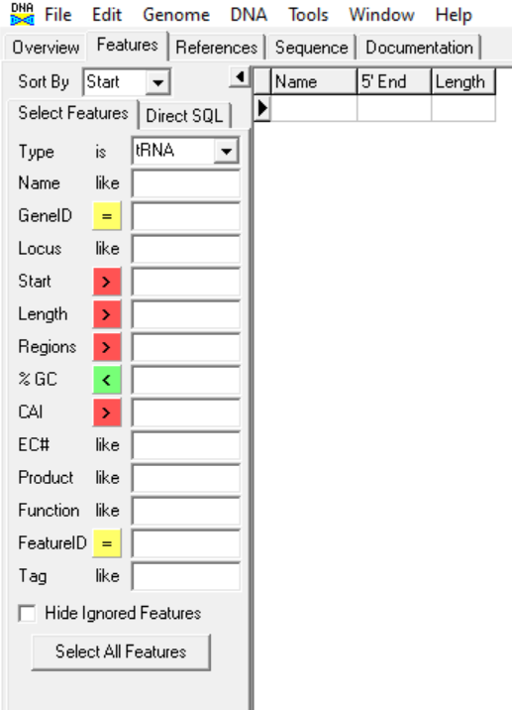

- ARAGORN (http://www.ansikte.se/ARAGORN/): No tRNA Genes Found
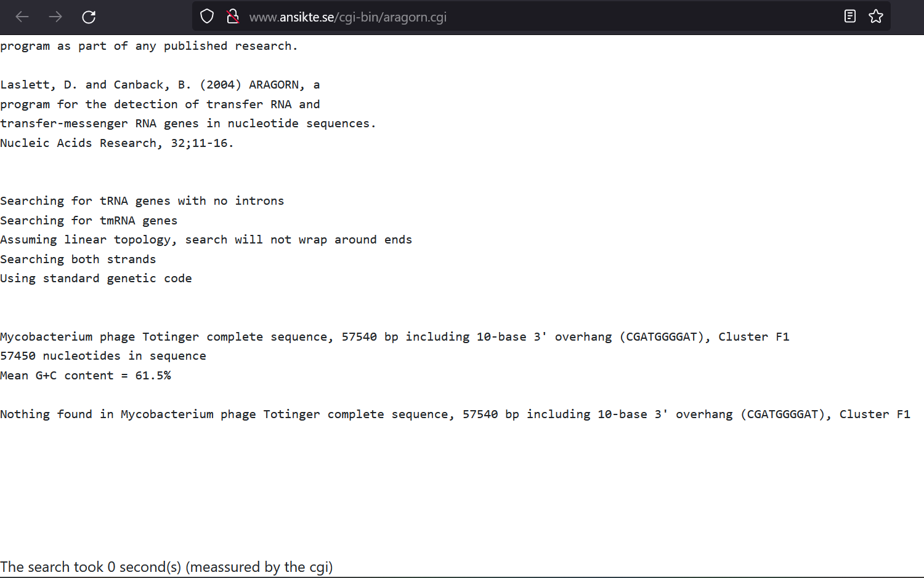

- tRNAScan-SE (http://trna.ucsc.edu/cgi-bin/tRNAscan-SE2.cgi): One Match to Mycobacterium tRNA type Lys.
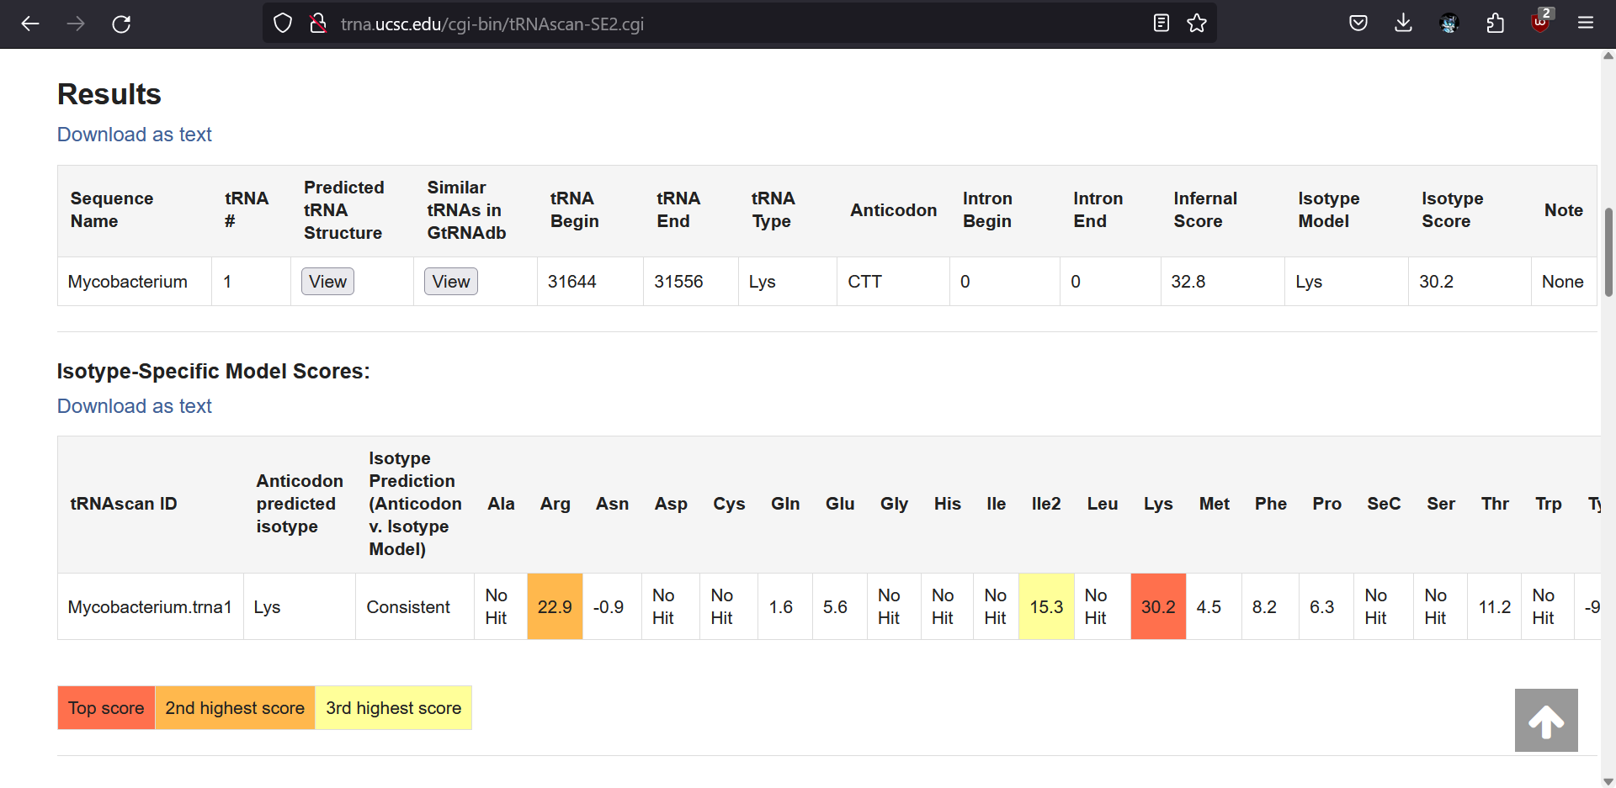
Conclusion: Since phage Totinger is a temperate phage, these results can imply a partial tRNA gene that matches with a Mycobacteria host gene. This gene would serve as a point for the lysogenic phage genome to align with the host genome for integration.

GENES

Gene Number: 1
Pham133467
Blasted on PhagesDB (https://phagesdb.org/blastp/Totinger_CDS_1/) using longest ORF.
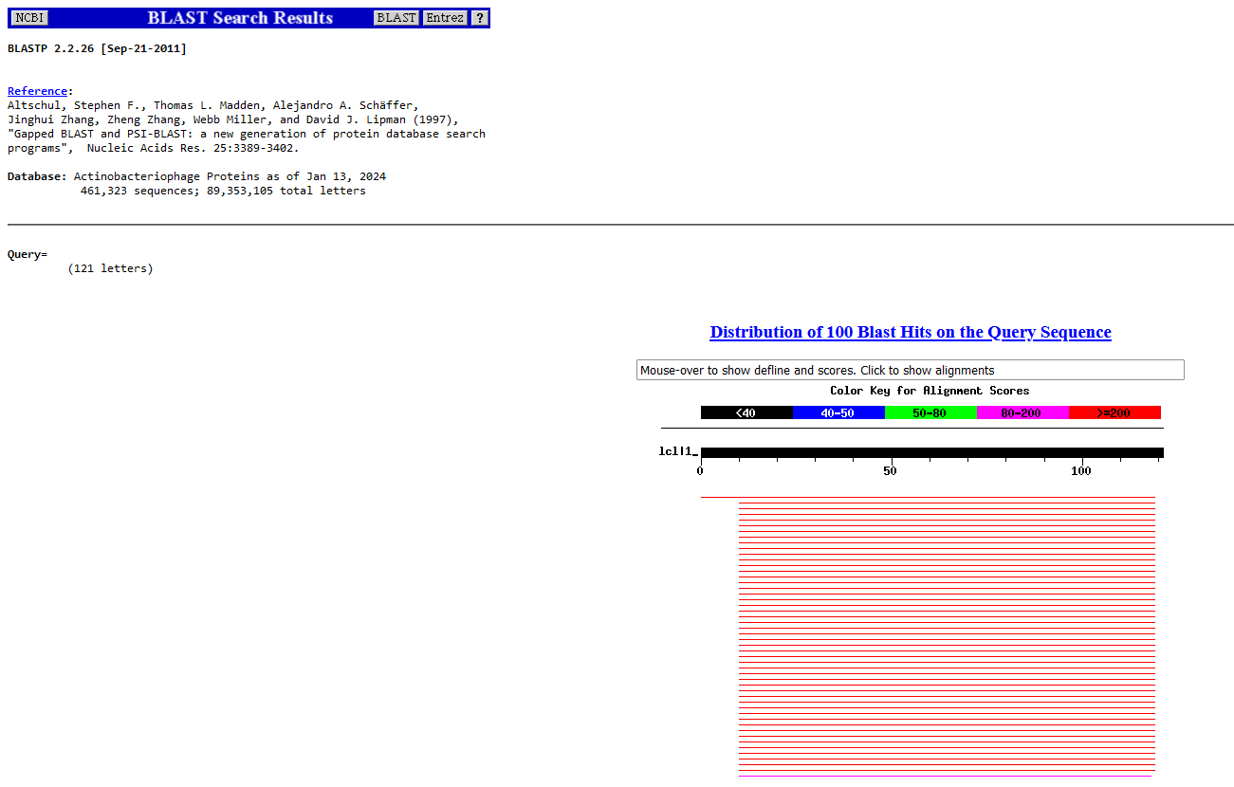
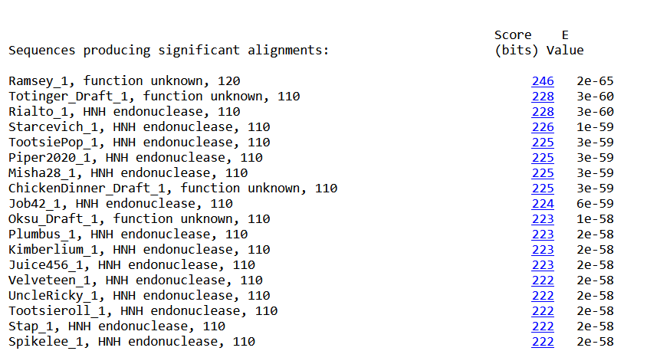

Blasted using NCBI (https://blast.ncbi.nlm.nih.gov/Blast.cgi?PAGE=Proteins)
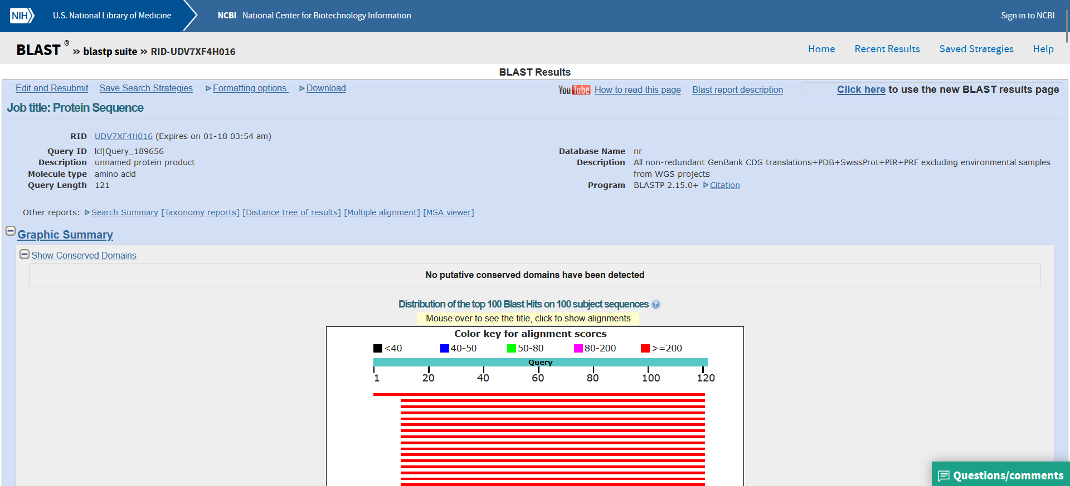
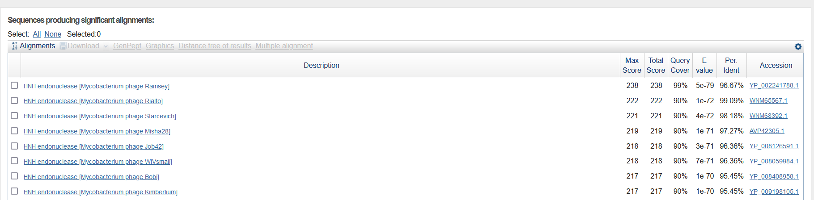
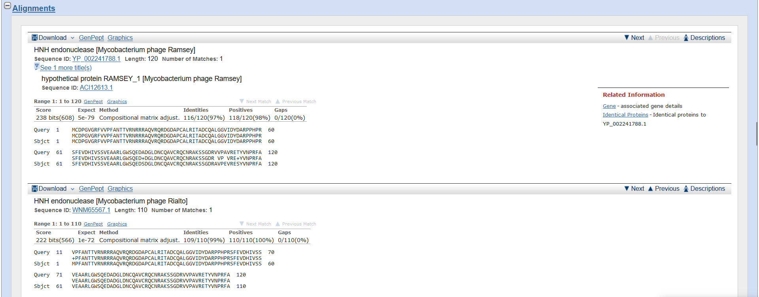
Start Codon and source: 41, GTG, Original Glimmer call, not called by Genemark
Stop Codon: 373, TAG
F/R: F
Coding Potential (y/n): y
Starterator (SS, NA, NI): Most annotated start is this (41)
Blast Best Hit using NCBI:
HNH endonuclease Mycobacterium phage Ramsey YP_002241788.1, 1:1, Score 238, Evalue, 5E-79
Gap with previous gene: N/A, first gene
Longest Orf? Y

RBS:
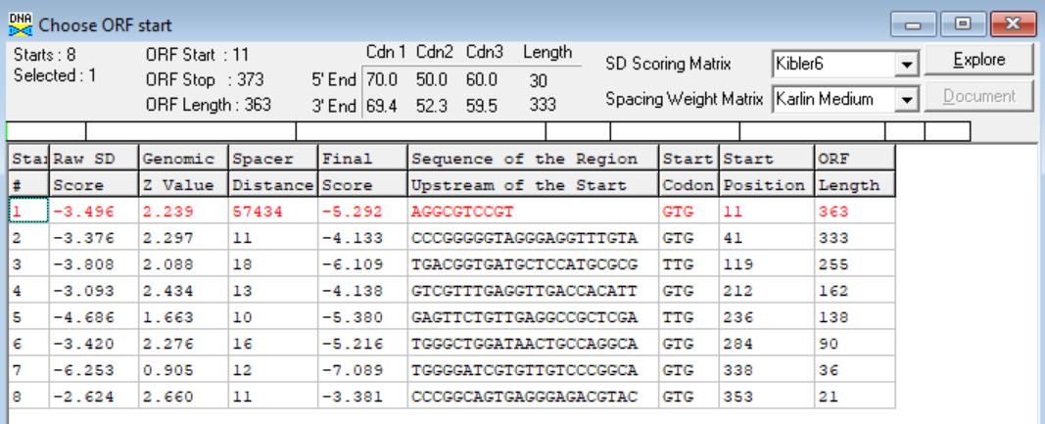

(https://toolkit.tuebingen.mpg.de/tools/hhpred) HHPRED vs PDB, SCOPe, pFam, and M. Tuberculosis.
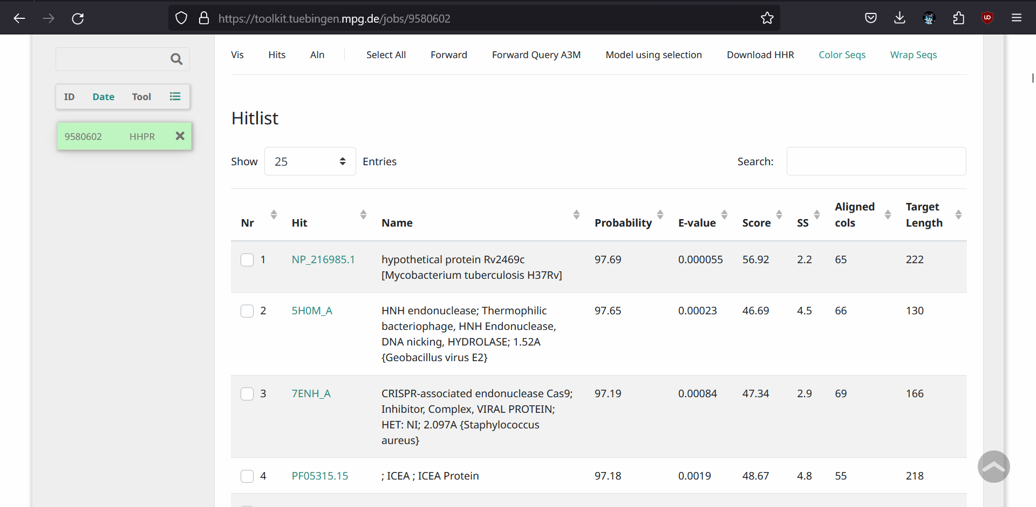
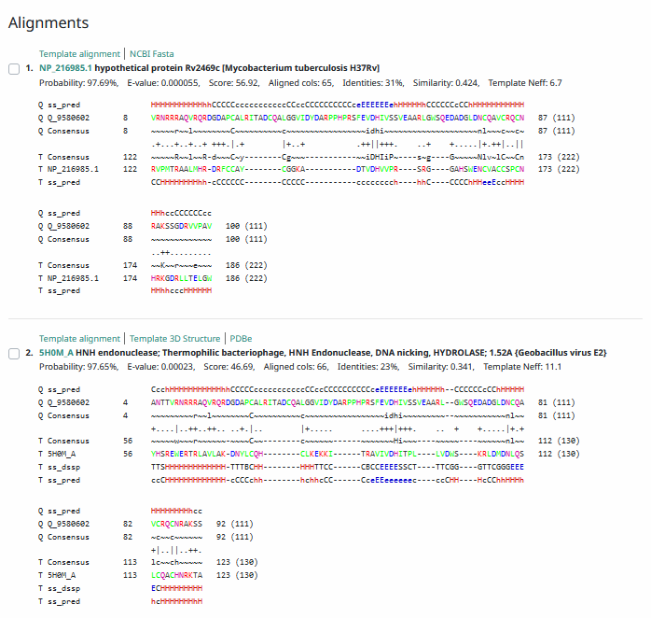
Phamerator Totinger Vs. Tootsieroll (https://phamerator.org/phages) Genes 1-3
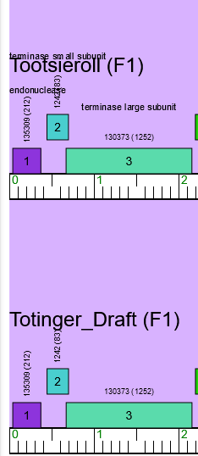
Proposed Function: HNH endonuclease
Function Evidence: The most consistent match among similar phages from performed BLASTs is an HNH endonuclease.

Transmembrane Domain/Evidence: No, Intracellular Properties (https://dtu.biolib.com/DeepTMHMM)
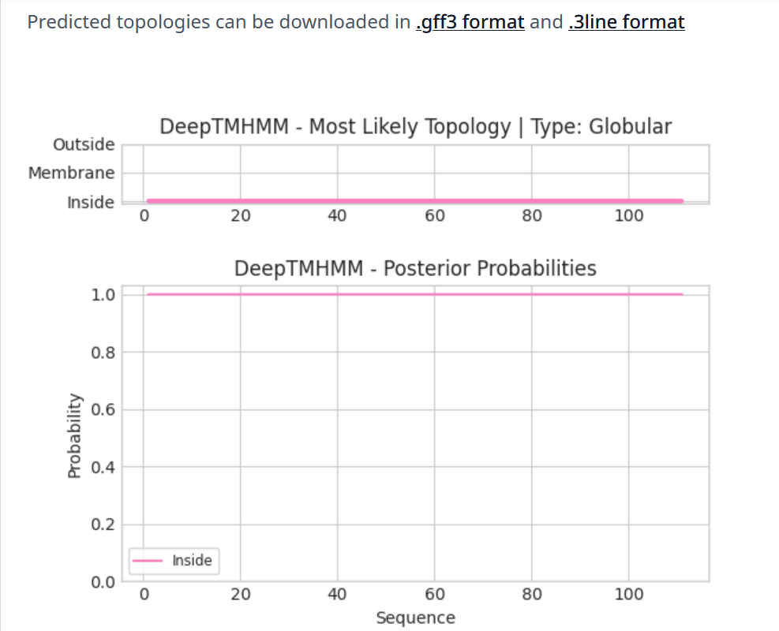

Gene Number: 2
Pham1242
BLAST from PhagesDB. (https://phagesdb.org/blastp/) Using Longest ORF
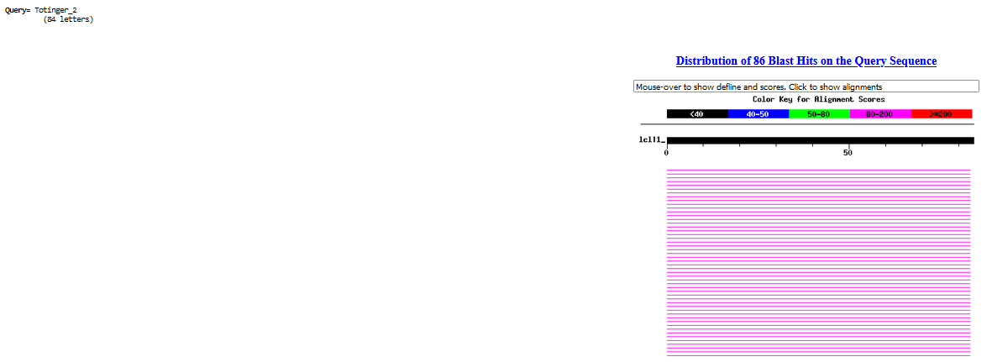
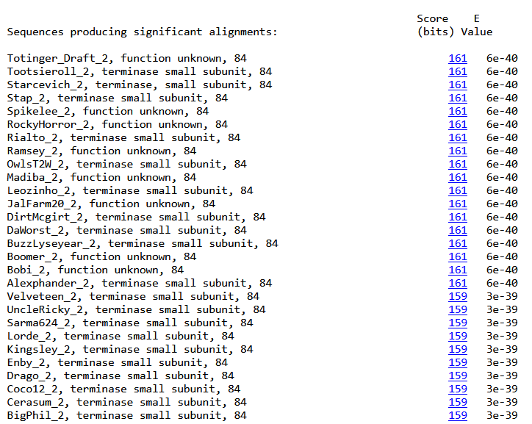

BLAST from NCBI (https://blast.ncbi.nlm.nih.gov/Blast.cgi?PAGE=Proteins) using Longest ORF
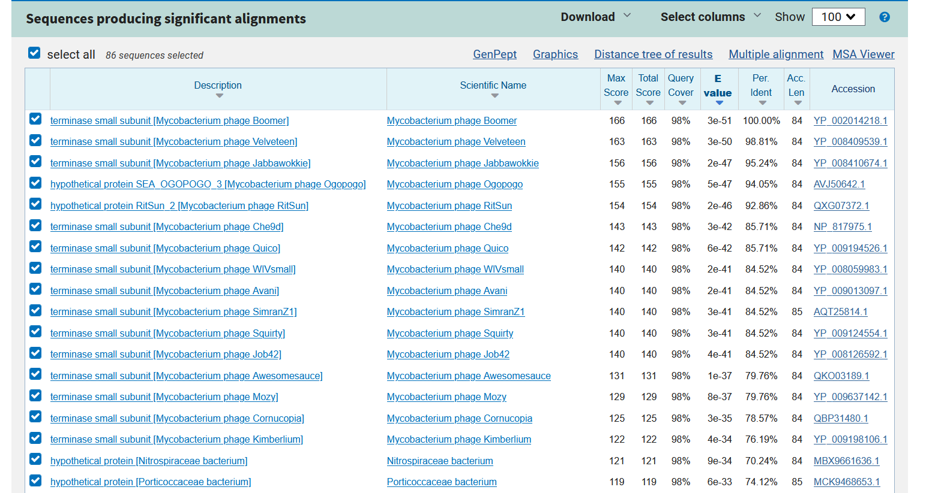
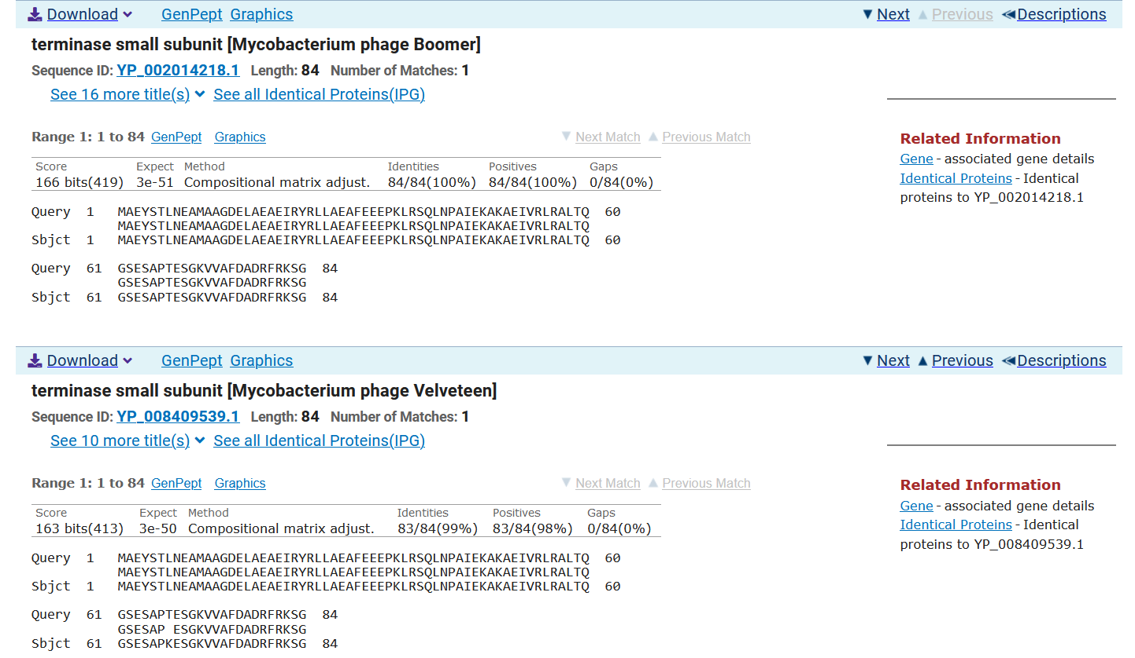
ATG Start at 446. Original Glimmer Call.
TAA Stop at 700
F/R: F
Coding Potential (y/n): Y
Starterator (SS, NA, NI): Most annotated start is this (446)
Blast Best Hit, Query:Subject Starts, Score, Evalue, or “no significant Blast alignments” if 10E-4 or higher
Terminase small subunit Mycobacterium phage Boomer YP_002014218.1, 1:1, Score 166, Evalue, 3E-51
Gap with previous gene: 73
Longest Orf? (Y/N/NA) Y
RBS: 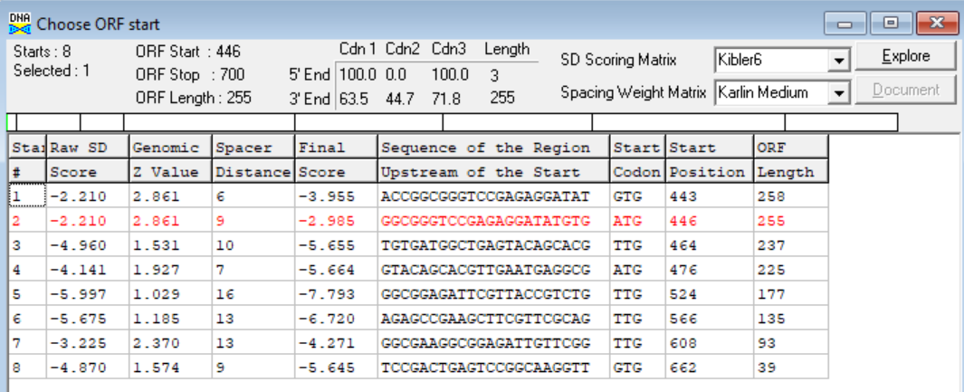

(https://toolkit.tuebingen.mpg.de/tools/hhpred) HHPRED vs PDB, SCOPe, pFam, and M. Tuberculosis. No significant (>95%) hits.
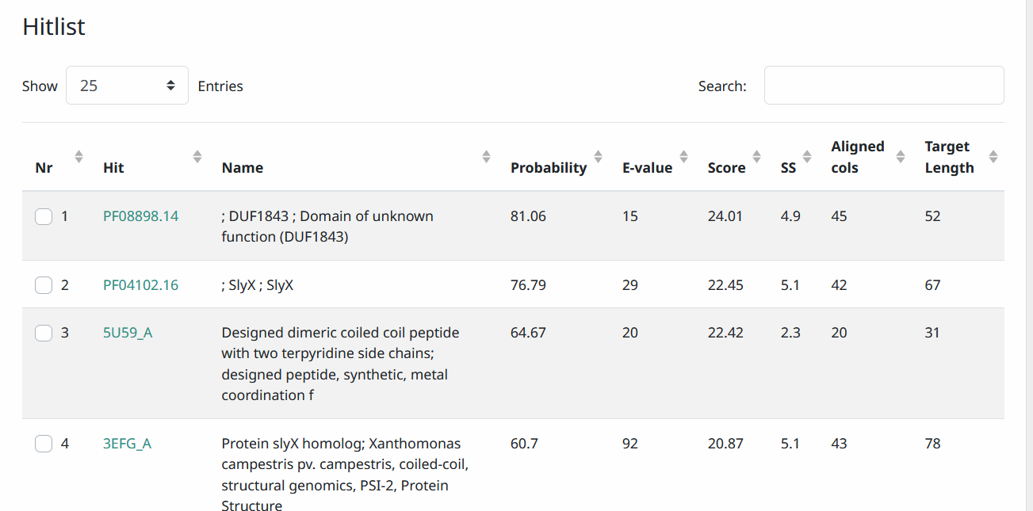
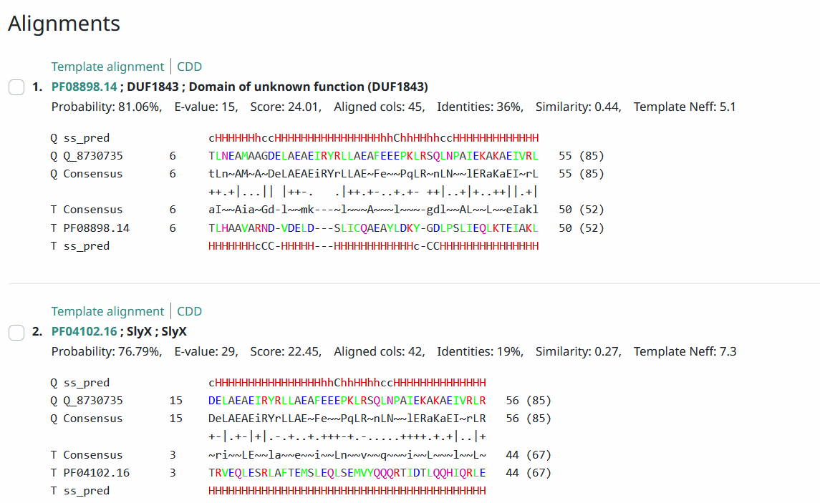
Phamerator Totinger Vs. Tootsieroll (https://phamerator.org/phages) Genes 1-3
Proposed Function: terminase, small subunit
Function Evidence: BLASTs from PhagesDB and NCBI both match up the most consistently with a terminase small subunit gene in similar phages.
Transmembrane Domain/Evidence: No, Intracellular Properties (https://dtu.biolib.com/DeepTMHMM)
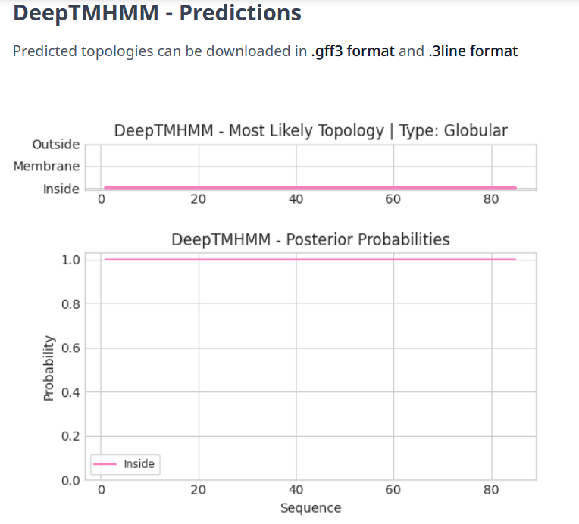

Gene Number: 3
Pham130373
BLAST from PhagesDB. (https://phagesdb.org/blastp/) Using Longest ORF
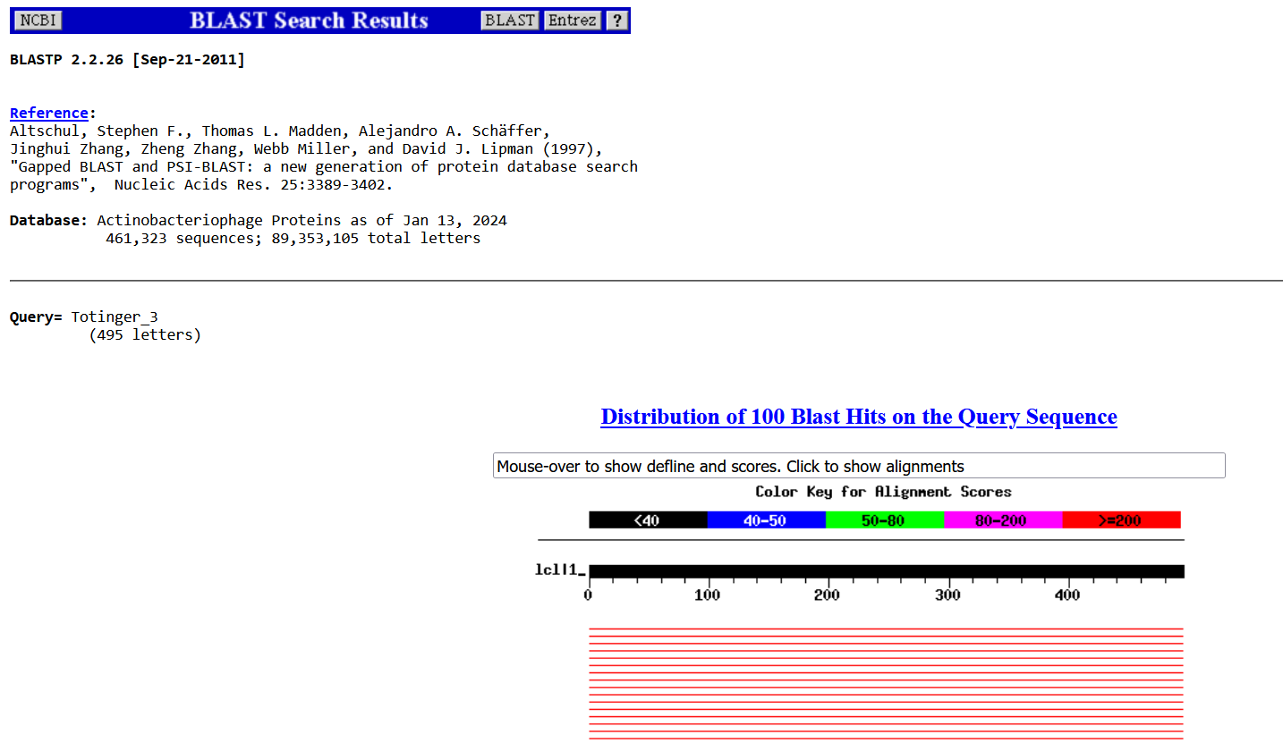
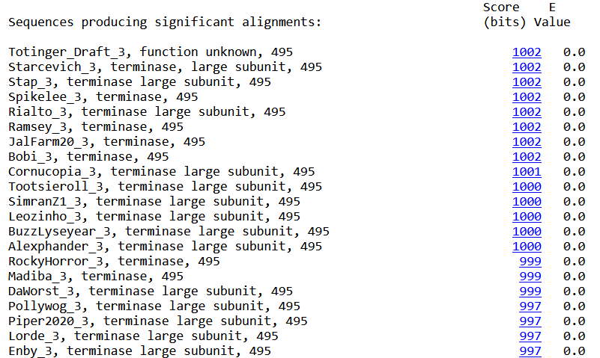

BLAST from NCBI (https://blast.ncbi.nlm.nih.gov/Blast.cgi?PAGE=Proteins) Using Longest ORF
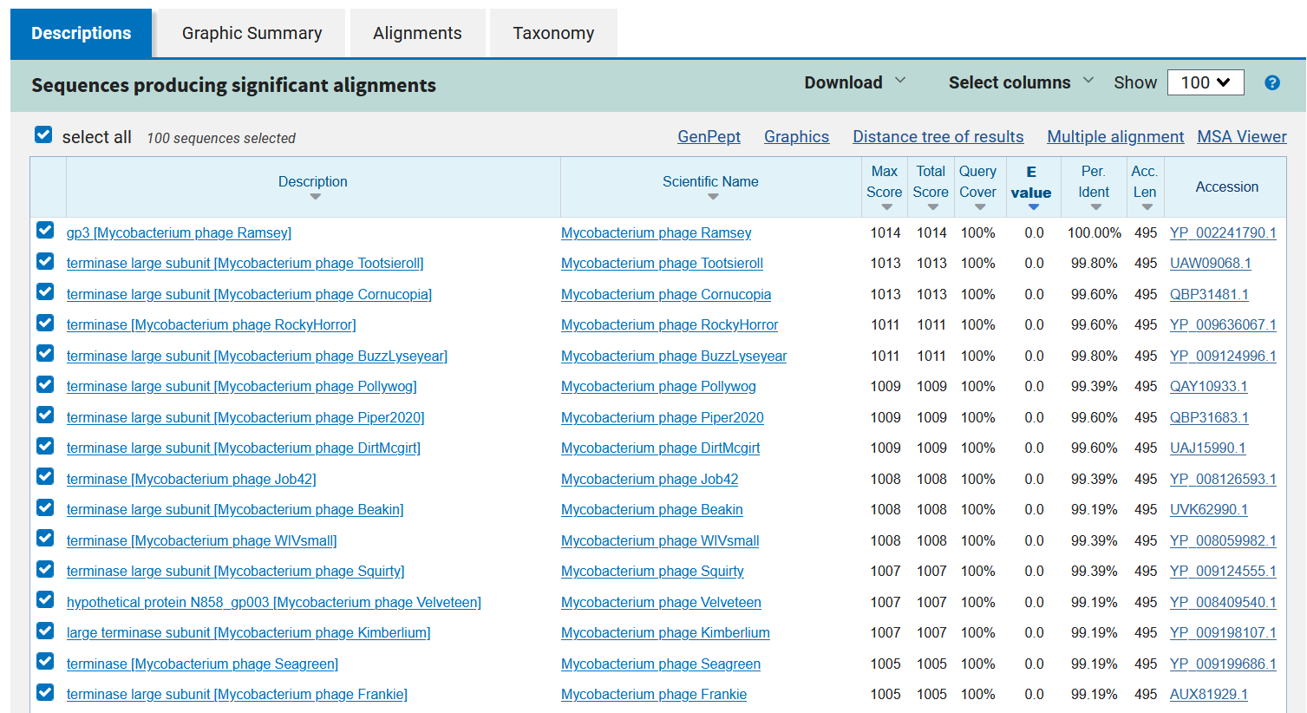
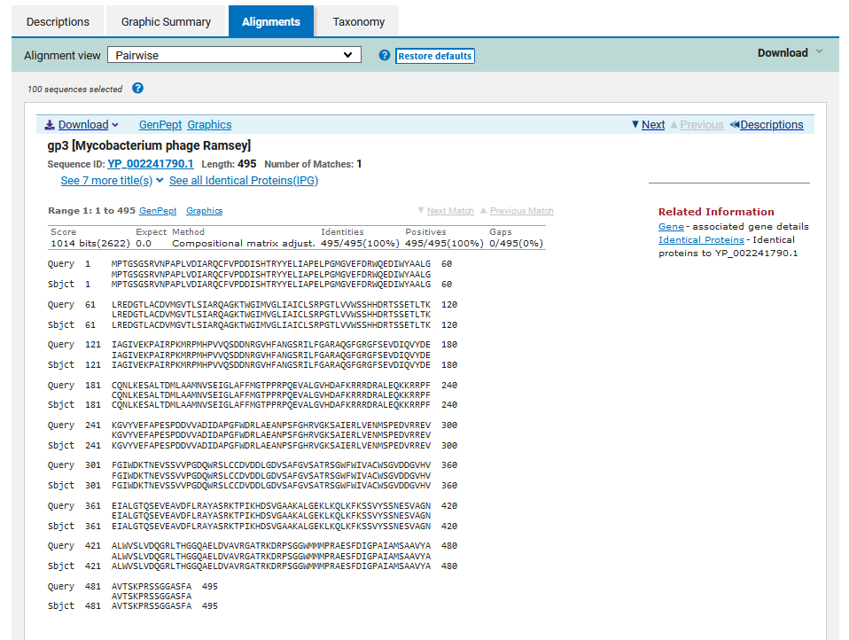
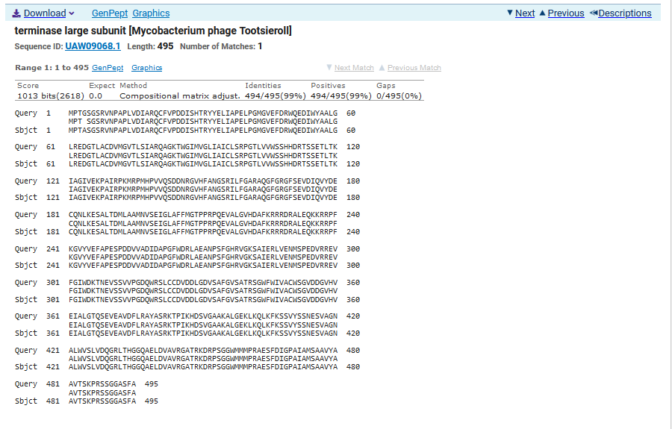
ATG Start at 672. Original Glimmer Call. GeneMark calls start at 798.
TGA Stop at 2159
F/R: F
Coding Potential (y/n): Y
Starterator (SS, NA, NI): Most annotated start is this (672)
Blast Best Hit, Query:Subject Starts, Score, Evalue, or “no significant Blast alignments” if 10E-4 or higher
Gp3 Mycobacterium phage Ramsey YP_002241790.1, 1:1, Score 1014, Evalue, 0
Gap with previous gene: -28
Longest Orf? (Y/N/NA) Y
RBS:
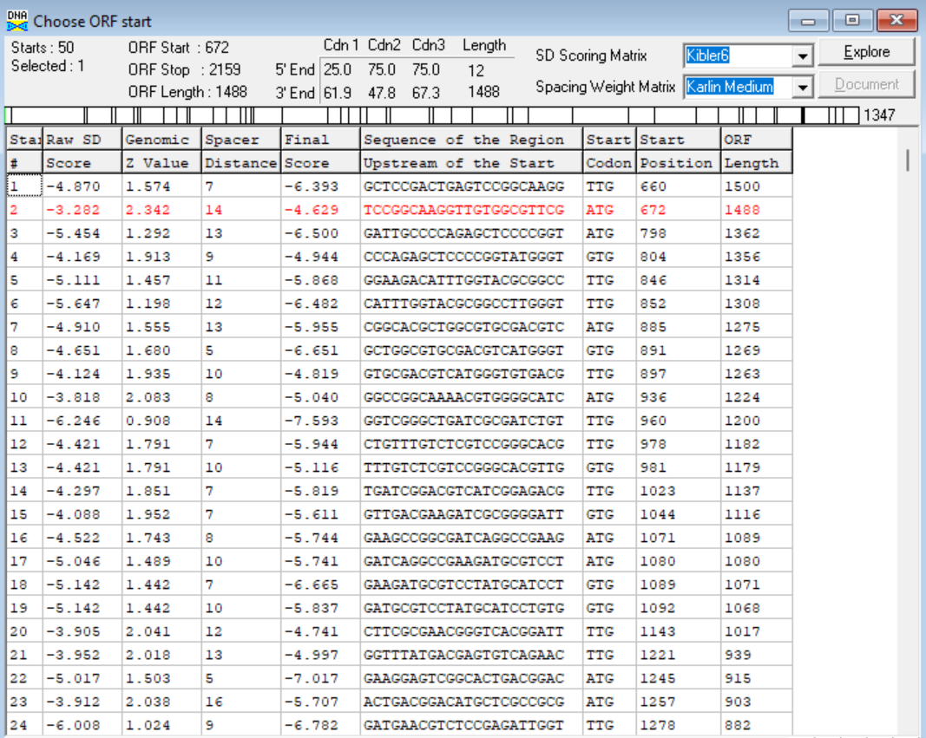
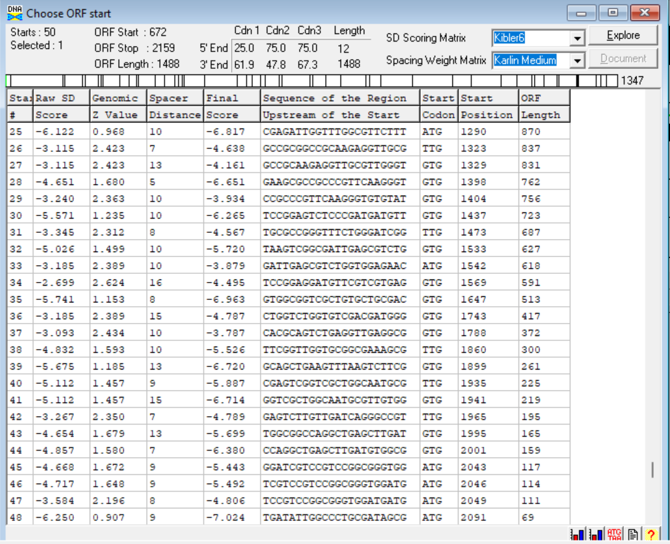

(https://toolkit.tuebingen.mpg.de/tools/hhpred) HHPRED vs PDB, SCOPe, pFam, and M. Tuberculosis.
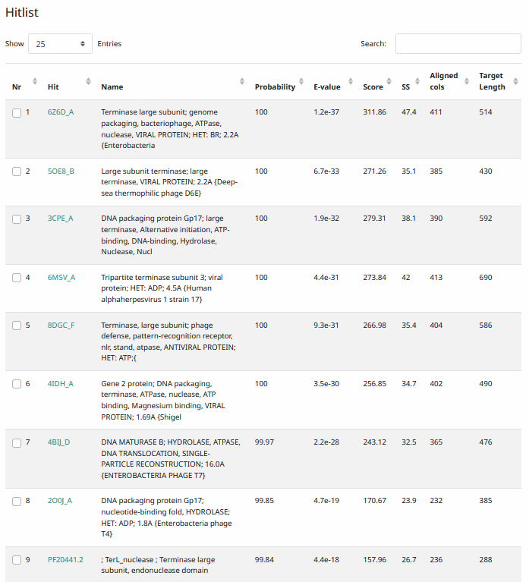
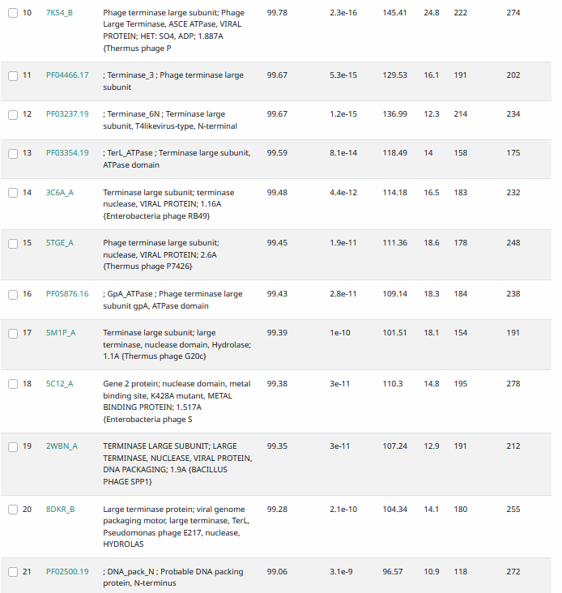

Phamerator Totinger Vs. Tootsieroll (https://phamerator.org/phages) Genes 1-3
Proposed Function: terminase, large subunit.
Function Evidence: The most consistent match in similar phages between all BLASTs was the large subunit of a terminase, and it matches Tootsieroll’s known terminase large subunit according to Phamerator. While M. Ramsey called a gp3 gene instead, this result was not as consistent between all BLASTs as a large terminase subunit.
Transmembrane Domain/Evidence: No, Intracellular Properties (https://dtu.biolib.com/DeepTMHMM)
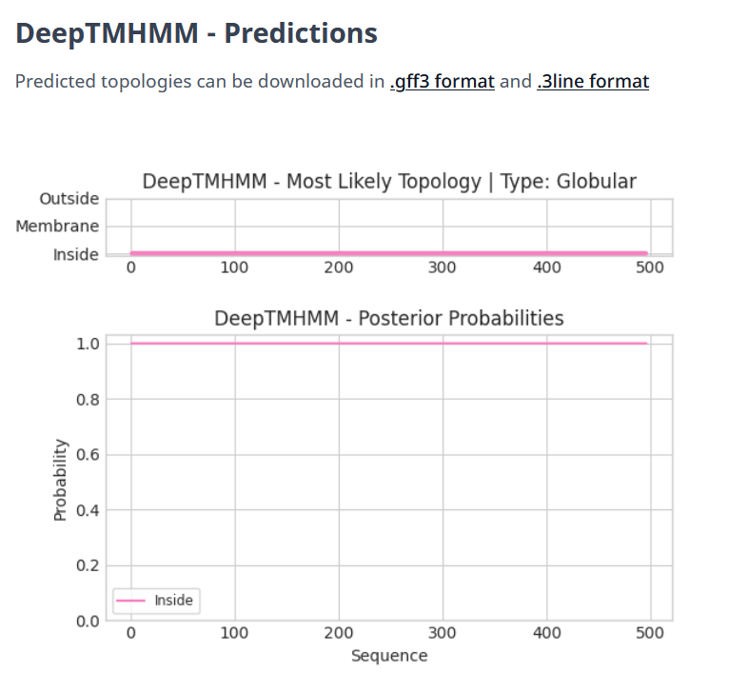

Gene Number: 4
Pham131677
BLAST from PhagesDB. (https://phagesdb.org/blastp/) Using Longest ORF
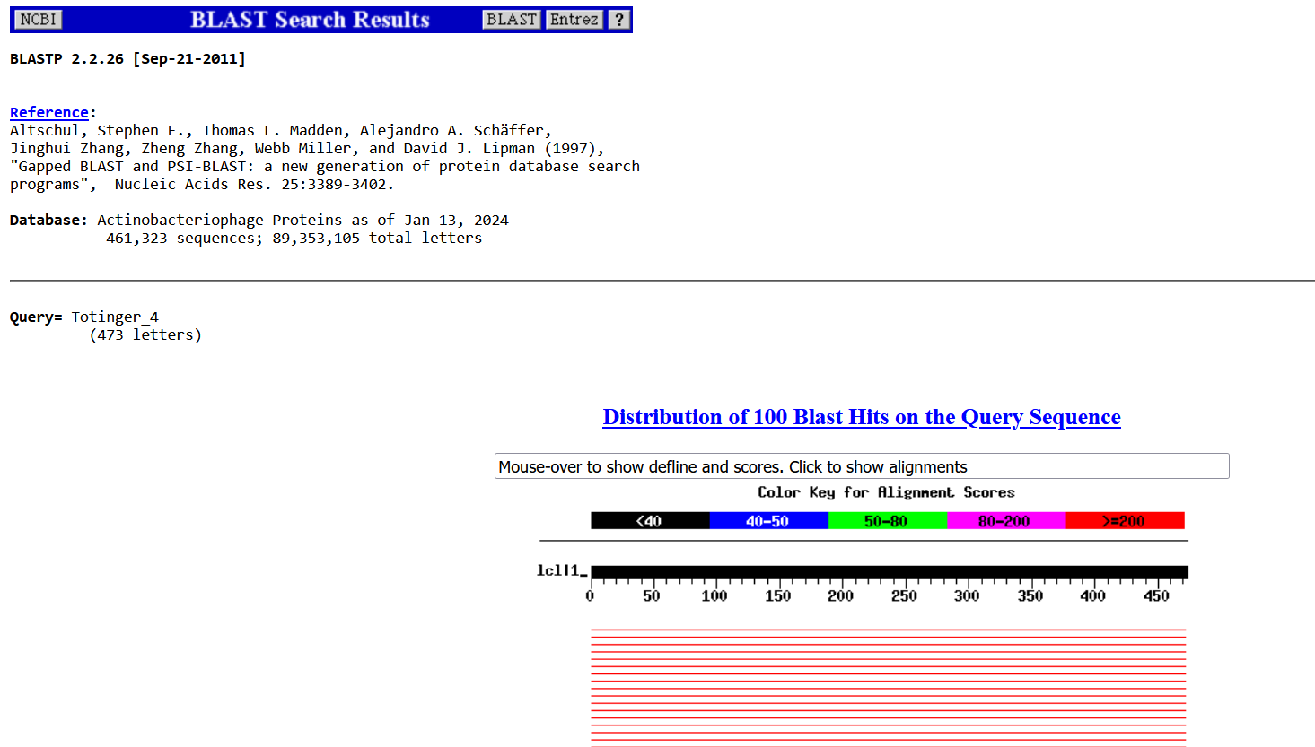
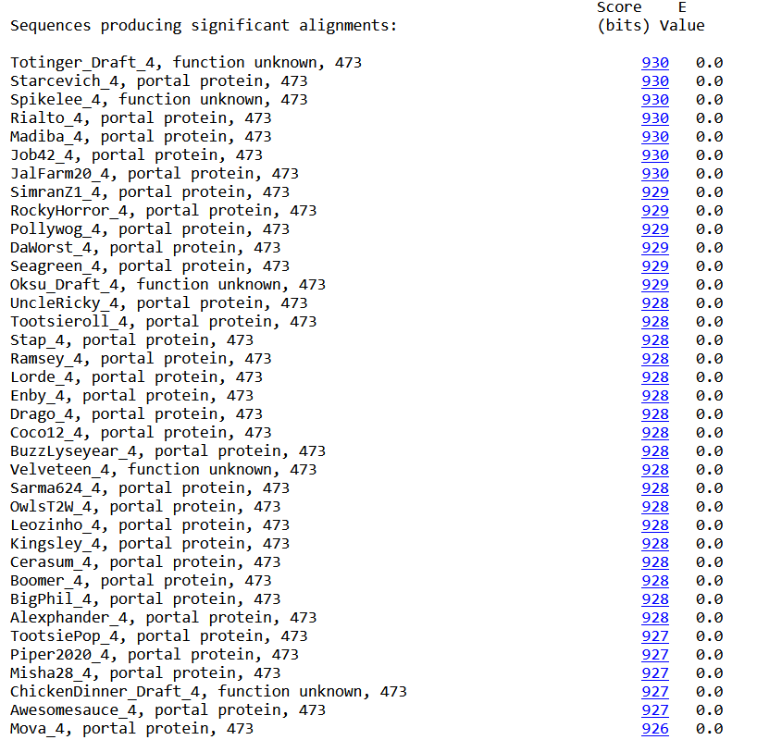

BLAST from NCBI (https://blast.ncbi.nlm.nih.gov/Blast.cgi?PAGE=Proteins) Using Longest ORF
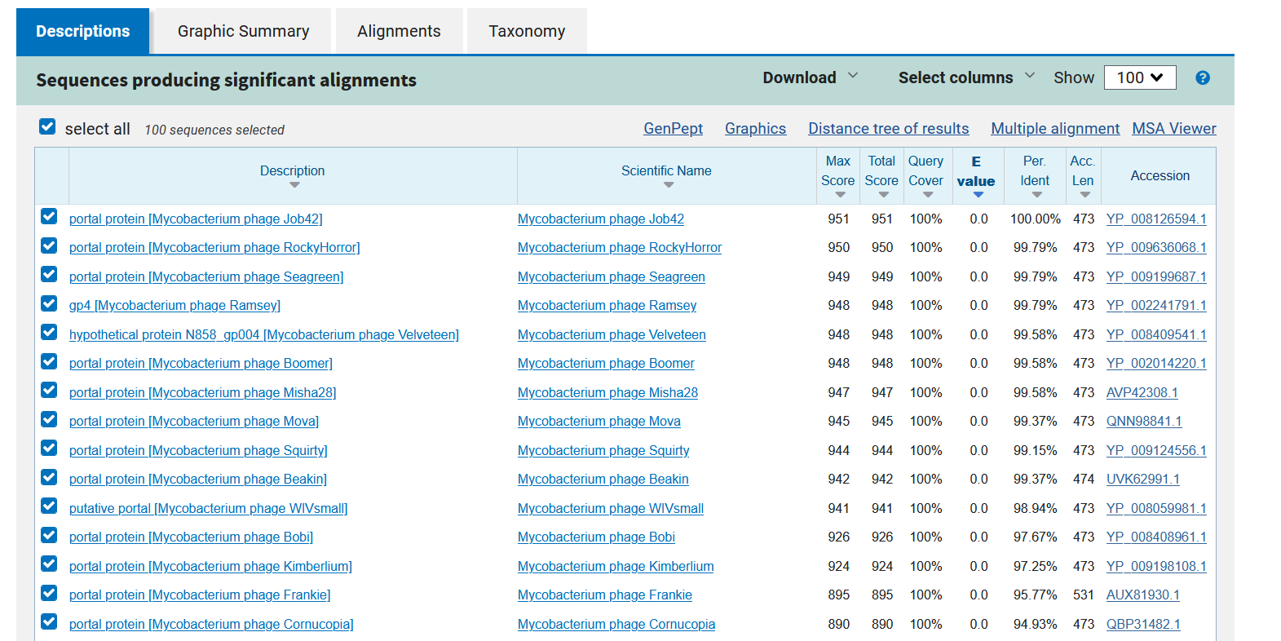
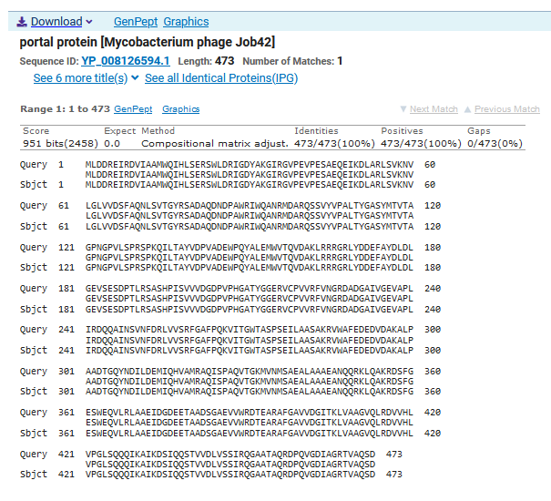
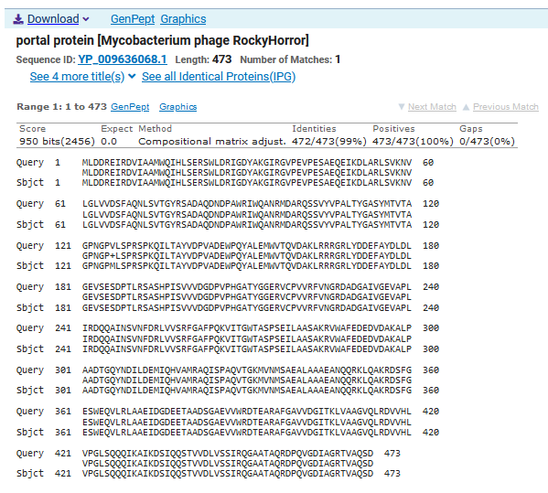
ATG Start at 2200. Original Glimmer call.
TGA Stop at 3621
F/R: F
Coding Potential (y/n): Y
Starterator (SS, NA, NI): Most annotated start is this (2200)
Blast Best Hit, Query:Subject Starts, Score, Evalue, or “no significant Blast alignments” if 10E-4 or higher
Portal protein Mycobacterium phage Job42 YP_008126594.1, 1:1, Score 951, Evalue, 0
Gap with previous gene: 41
Longest Orf? (Y/N/NA) Y
RBS:
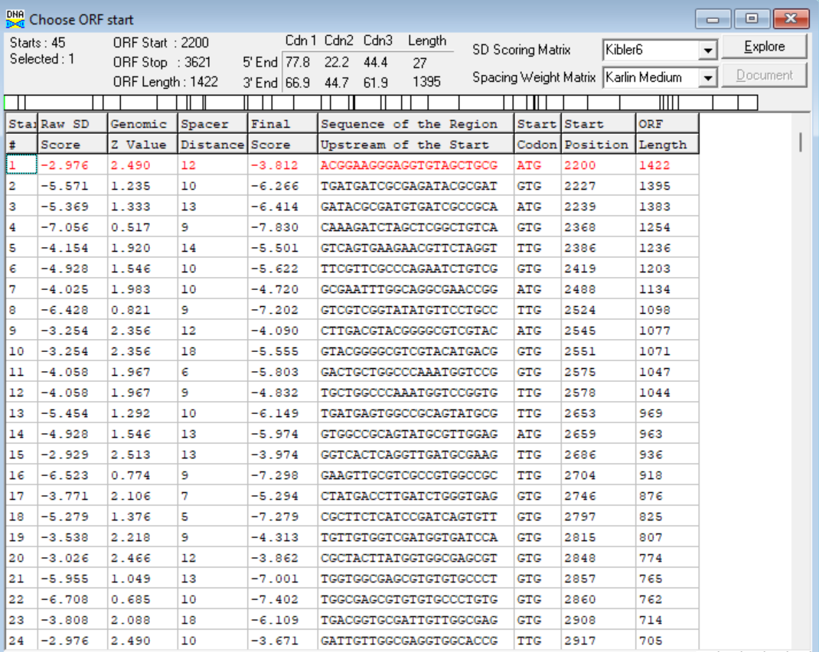
(https://toolkit.tuebingen.mpg.de/tools/hhpred) HHPRED vs PDB, SCOPe, pFam, and M. Tuberculosis.
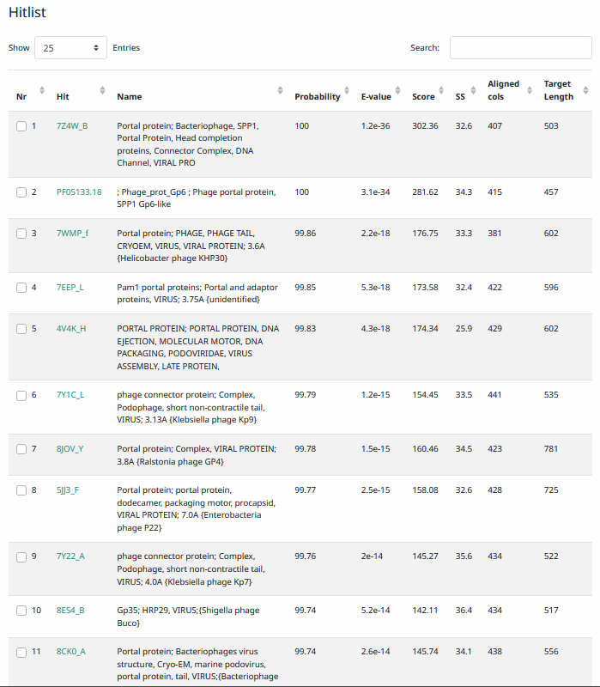

Phamerator Totinger Vs. Tootsieroll (https://phamerator.org/phages) Genes 4-14
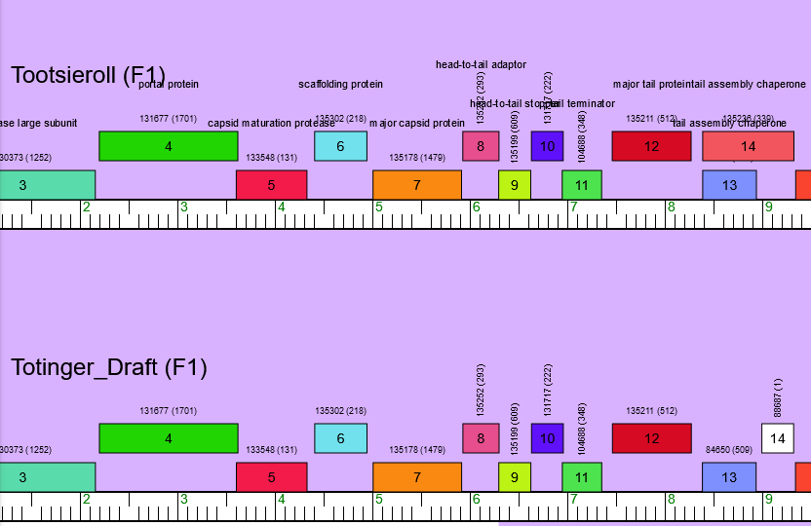
Proposed Function: portal protein
Function Evidence: this gene has a 100% match on multiple BLASTs to the portal protein gene from similar phages.
Transmembrane Domain/Evidence: No, Intracellular Properties (https://dtu.biolib.com/DeepTMHMM)
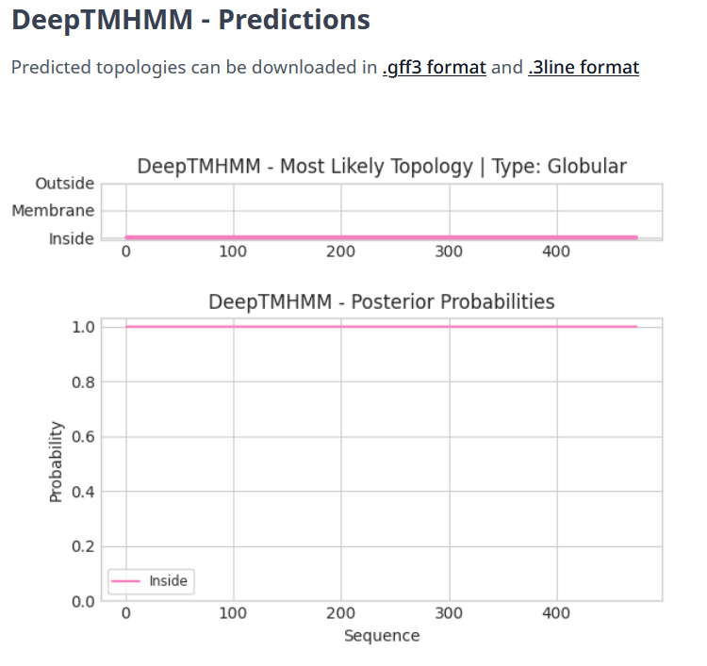

Gene Number: 5
Pham133548
BLAST from PhagesDB. (https://phagesdb.org/blastp/) Using Longest ORF
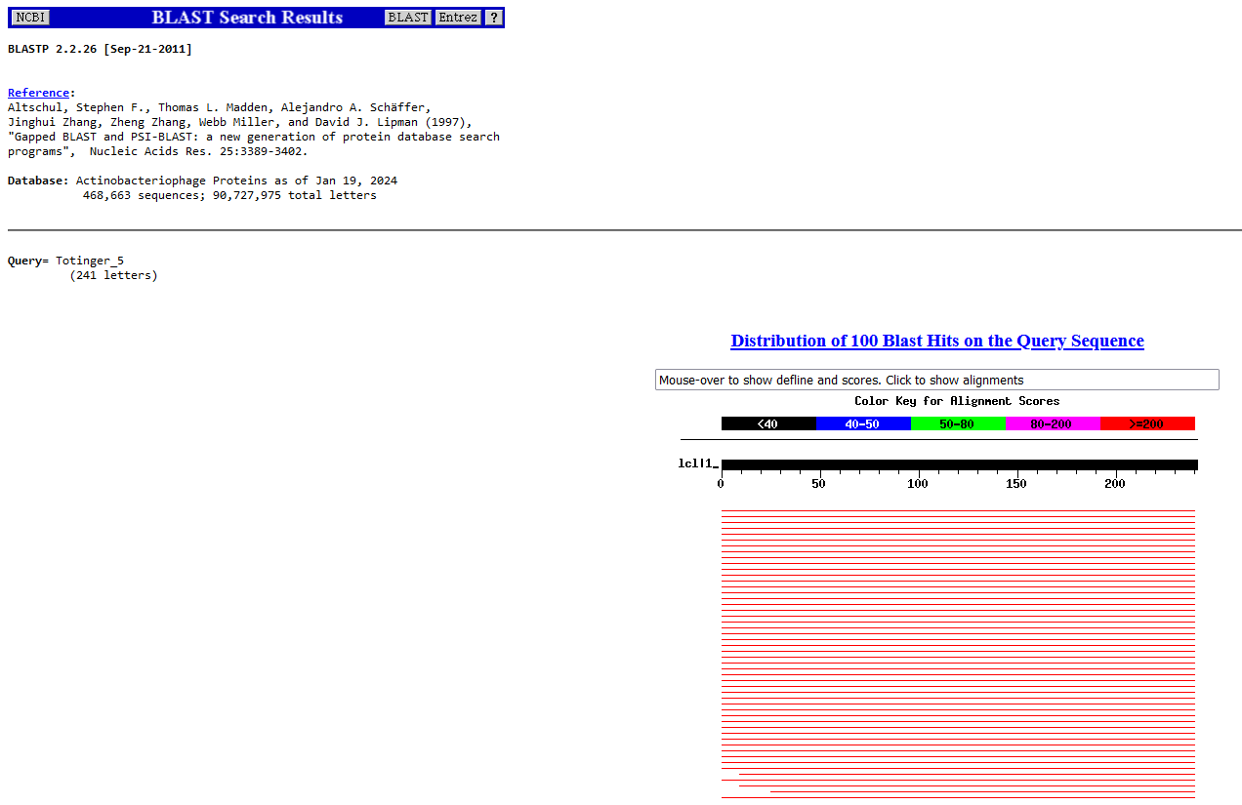
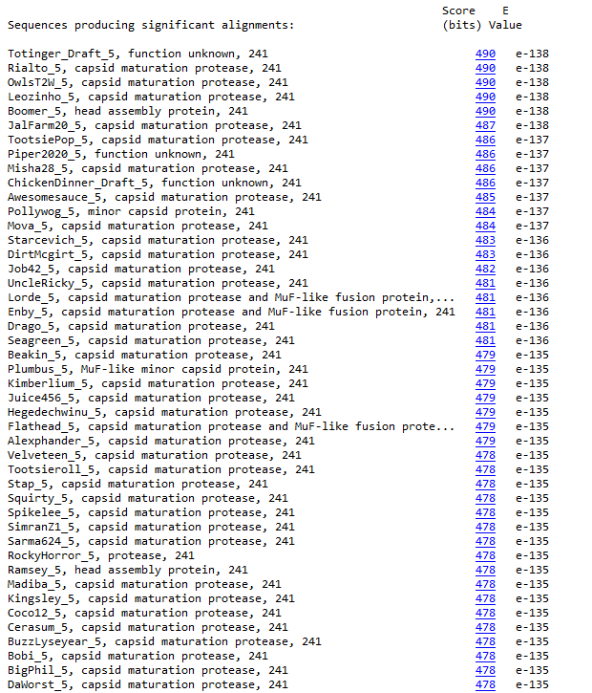
BLAST from NCBI (https://blast.ncbi.nlm.nih.gov/Blast.cgi?PAGE=Proteins) Using Longest ORF
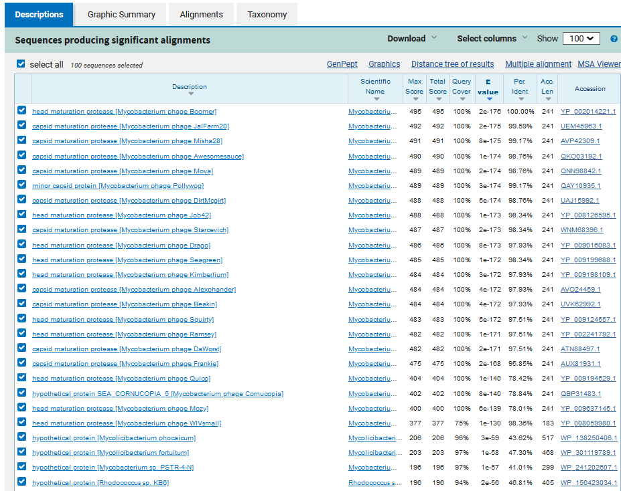
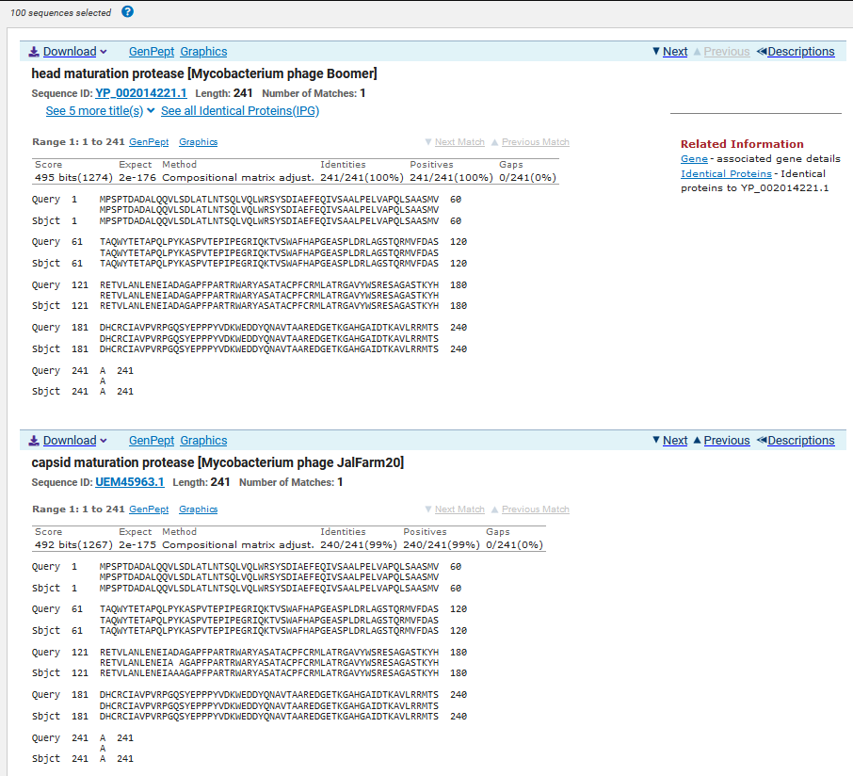
TTG Start at 3605. Original Glimmer call.
TGA Stop at 4330
F/R: F
Coding Potential (y/n): Y
Starterator (SS, NA, NI): Most annotated start is this (3605)
Blast Best Hit, Query:Subject Starts, Score, Evalue, or “no significant Blast alignments” if 10E-4 or higher
Head maturation protease Mycobacterium phage Boomer YP_002014221.1, 1:1, Score 495, Evalue, 0
Gap with previous gene: -16
Longest Orf? (Y/N/NA) Y
RBS:
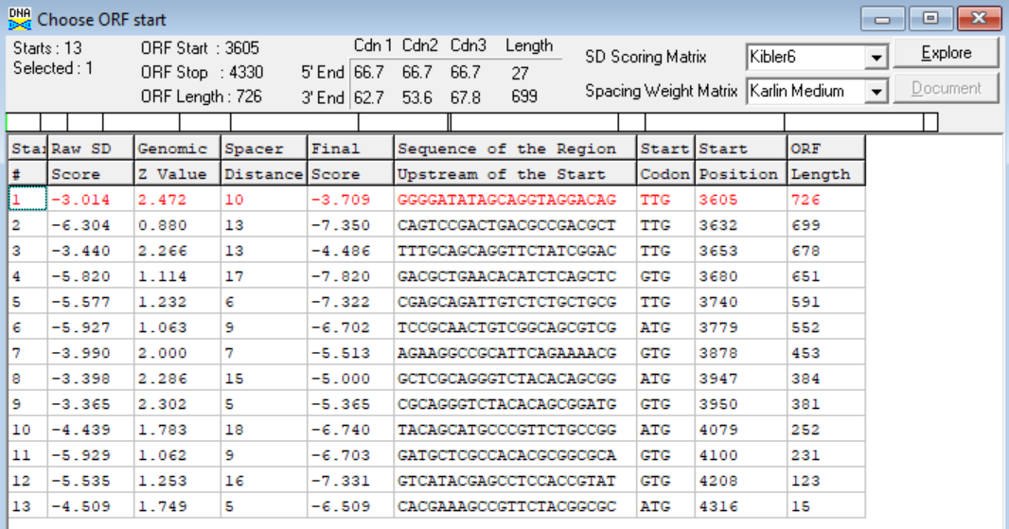
(https://toolkit.tuebingen.mpg.de/tools/hhpred) HHPRED vs PDB, SCOPe, pFam, and M. Tuberculosis.
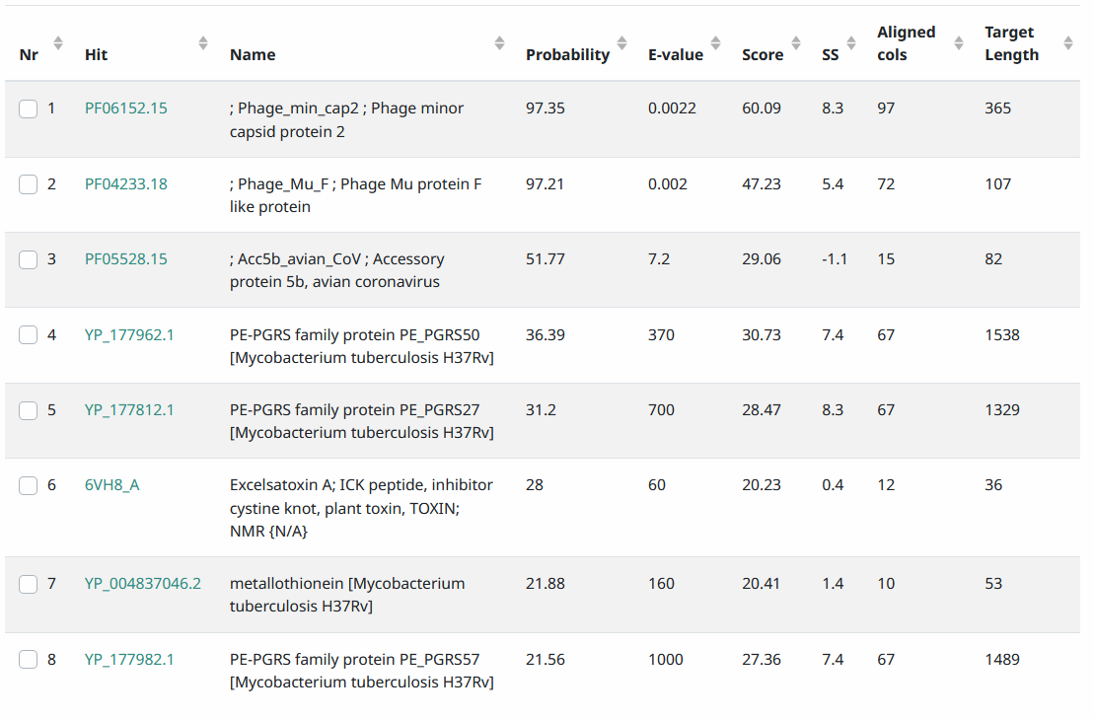
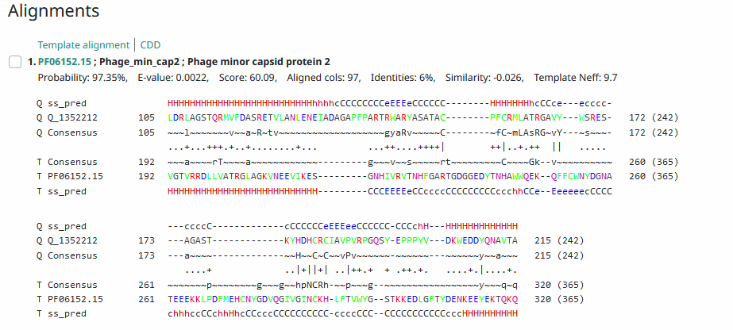
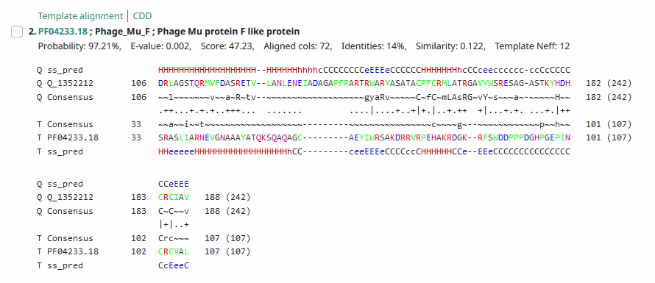
Phamerator Totinger Vs. Tootsieroll (https://phamerator.org/phages) Genes 4-14
Proposed Function: capsid maturation protease
Function Evidence: the most consistent hits from all BLASTs and matches from Phamerator are capsid maturation proteases.
Transmembrane Domain/Evidence: No, Intracellular Properties (https://dtu.biolib.com/DeepTMHMM)
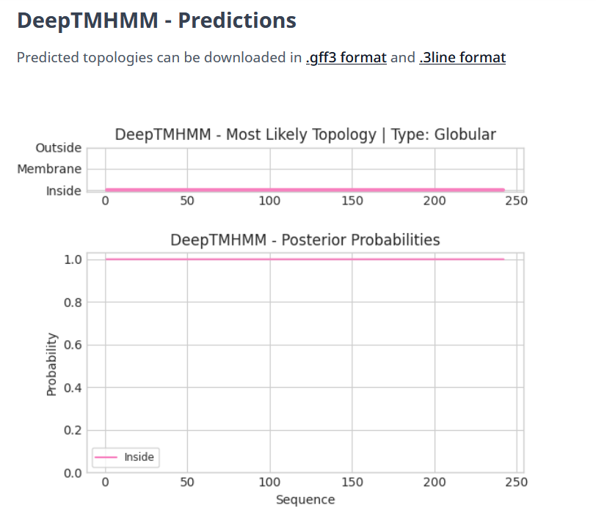

Gene Number: 6
Pham135302
BLAST from PhagesDB. (https://phagesdb.org/blastp/) Using Longest ORF
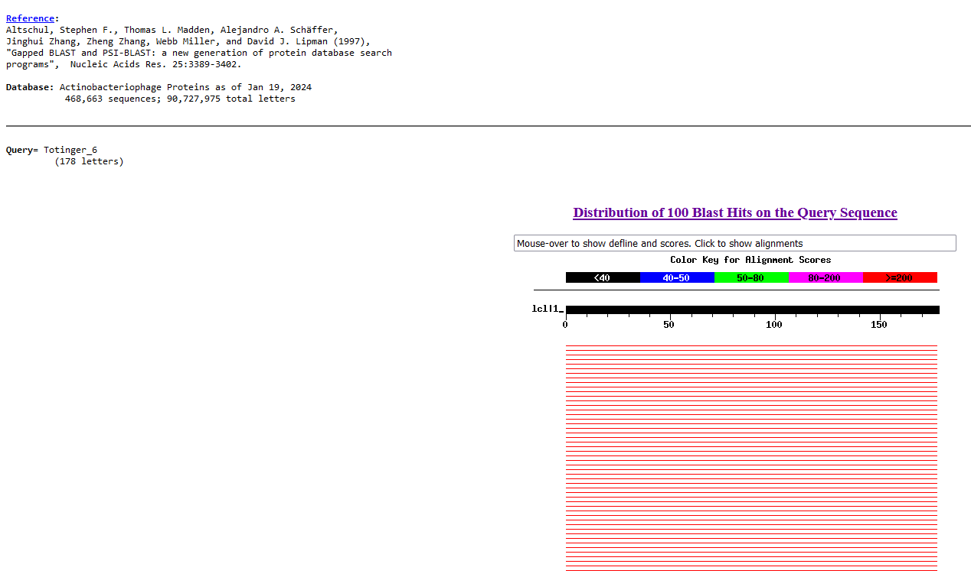
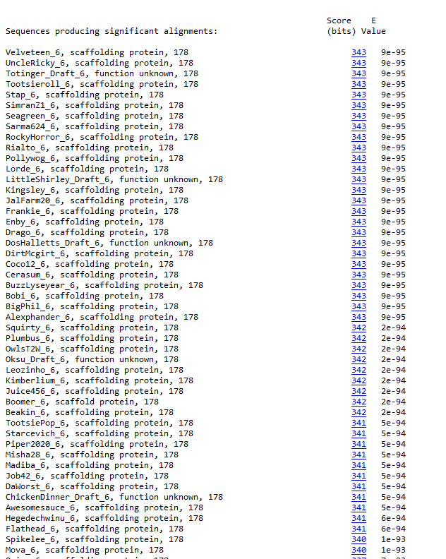
BLAST from NCBI (https://blast.ncbi.nlm.nih.gov/Blast.cgi?PAGE=Proteins) Using Longest ORF
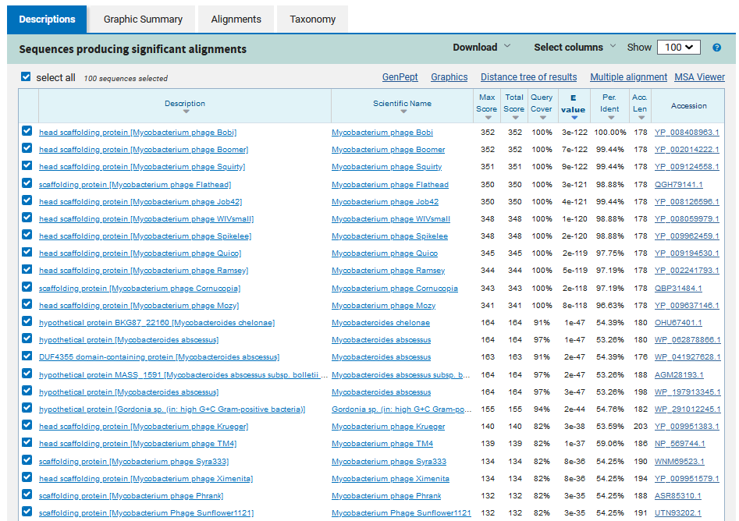
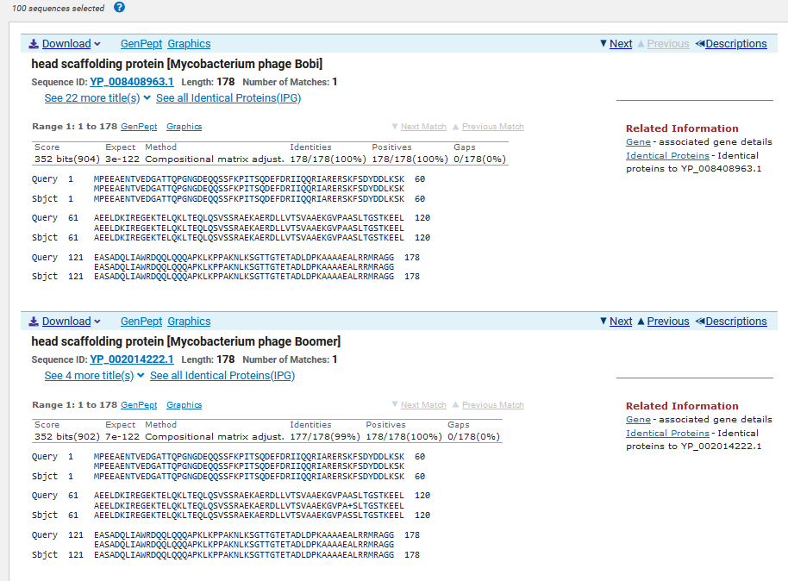
ATG Start at 4409. Original Glimmer call.
TGA Stop at 4945
F/R: F
Coding Potential (y/n): Y
Starterator (SS, NA, NI): Not the most annotated start
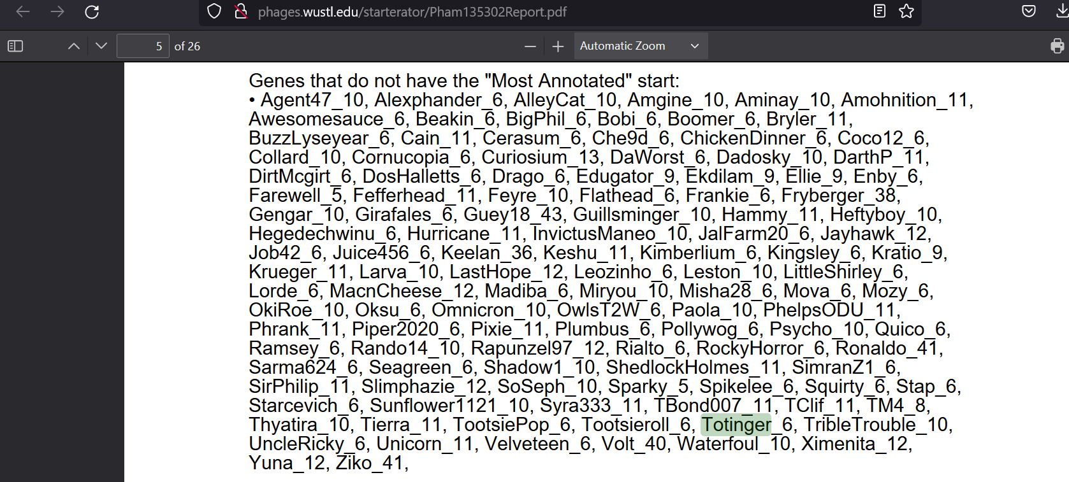
Blast Best Hit, Query:Subject Starts, Score, Evalue, or “no significant Blast alignments” if 10E-4 or higher
Head scaffolding protein Mycobacterium phage Bobi YP_008408963.1, 1:1, Score 352, Evalue, 0
Gap with previous gene: 79
Longest Orf? (Y/N/NA) Y
RBS:
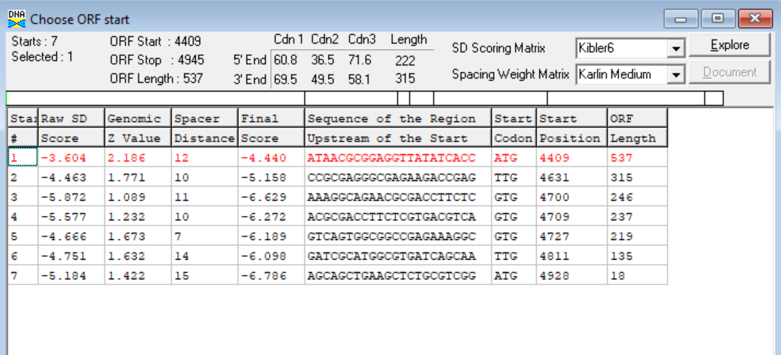
(https://toolkit.tuebingen.mpg.de/tools/hhpred) HHPRED vs PDB, SCOPe, pFam, and M. Tuberculosis.
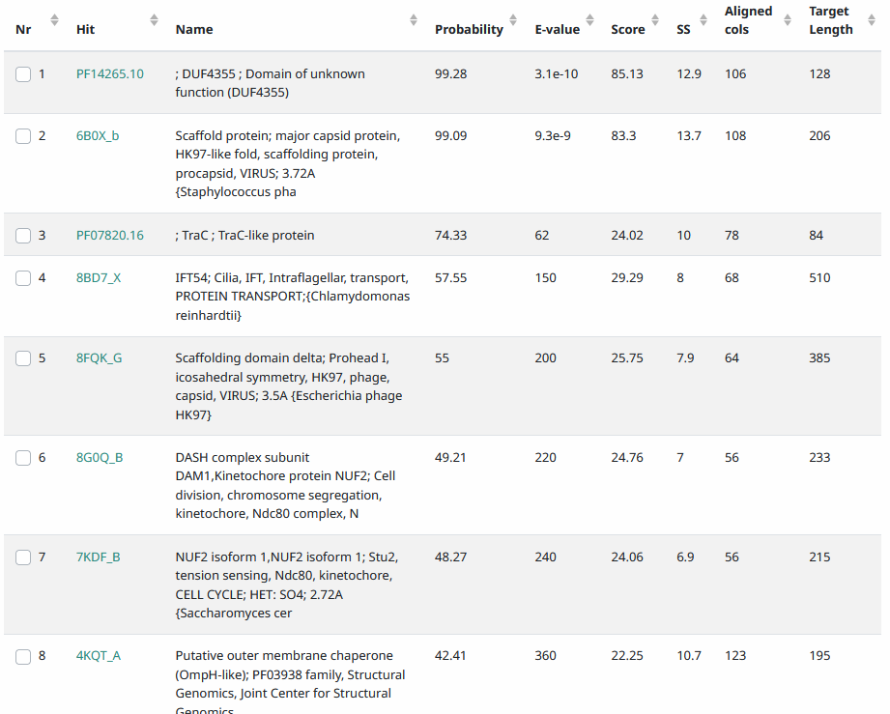
Phamerator Totinger Vs. Tootsieroll (https://phamerator.org/phages) Genes 4-14
Proposed Function: scaffolding protein
Function Evidence: This gene matches the most consistently with scaffolding proteins from other phages, and it is identical to the scaffolding protein gene in phage Tootsieroll.
Transmembrane Domain/Evidence: No, Intracellular Properties (https://dtu.biolib.com/DeepTMHMM)
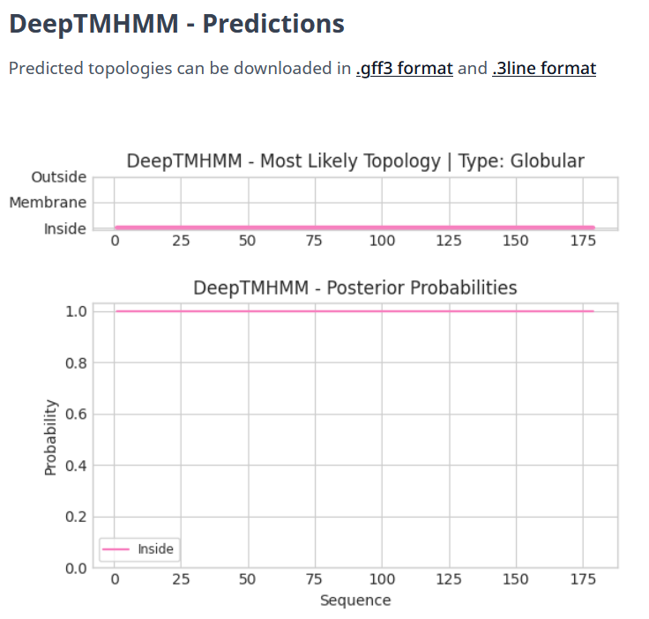

Gene Number: 7
Pham135178
BLAST from PhagesDB. (https://phagesdb.org/blastp/) Using Longest ORF
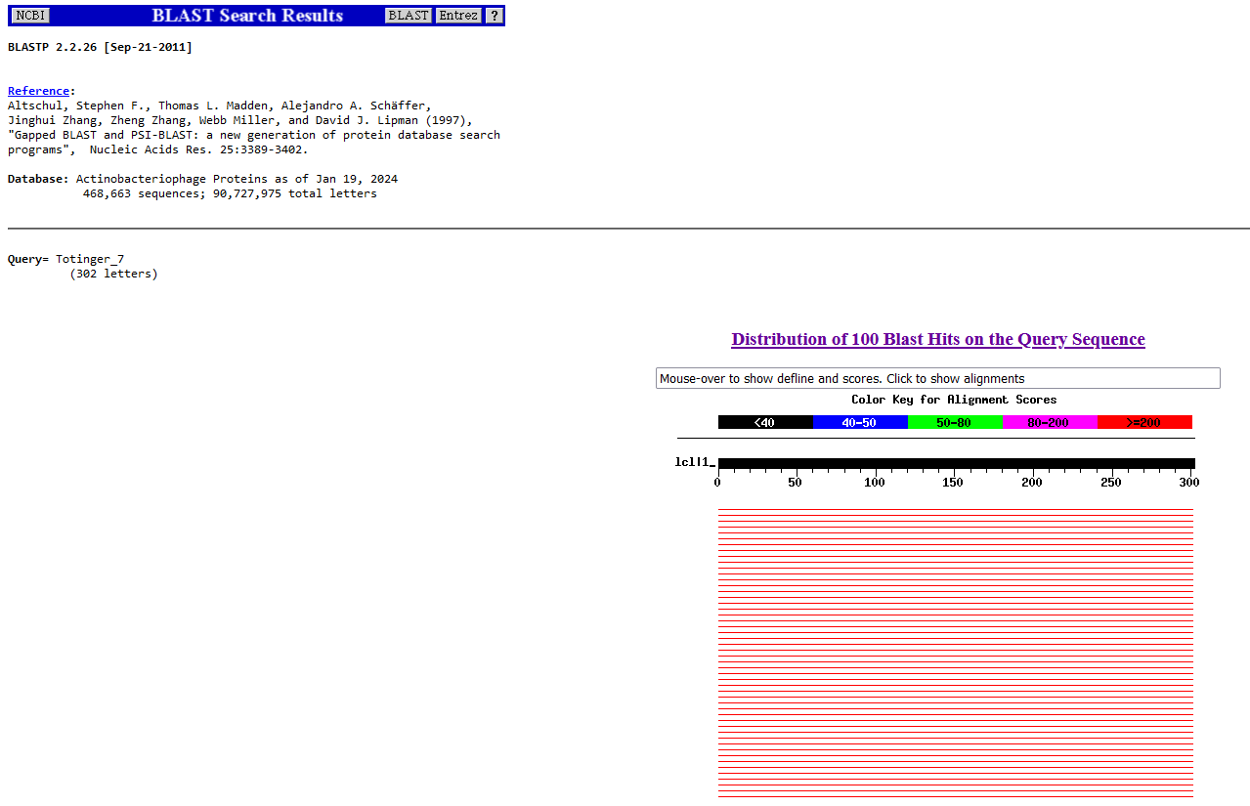
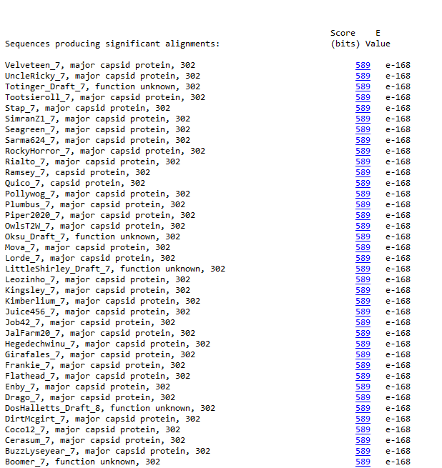
BLAST from NCBI (https://blast.ncbi.nlm.nih.gov/Blast.cgi?PAGE=Proteins) Using Longest ORF
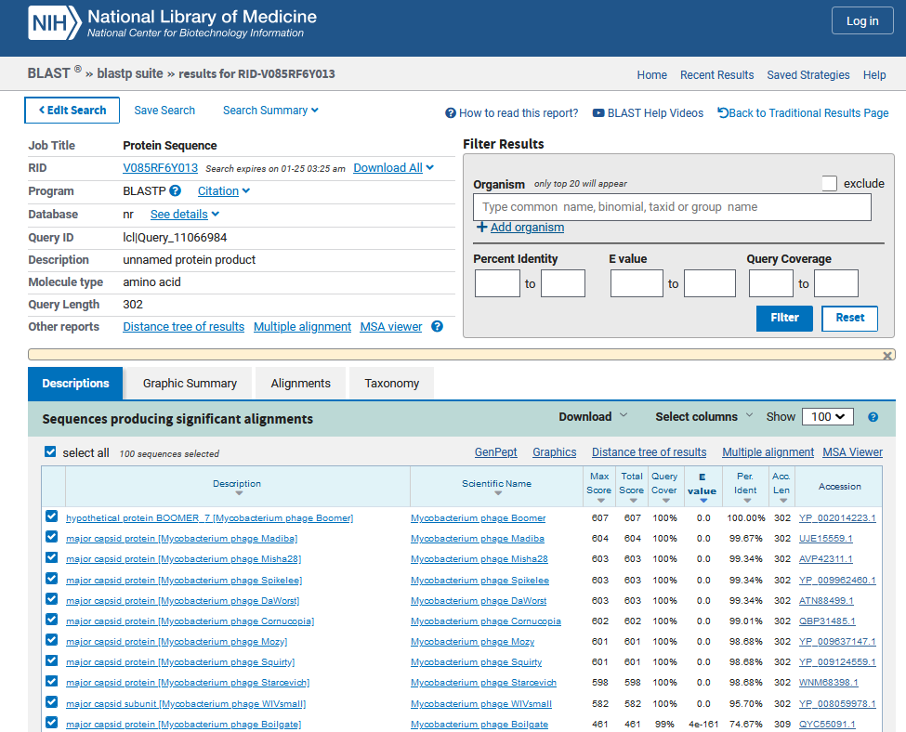
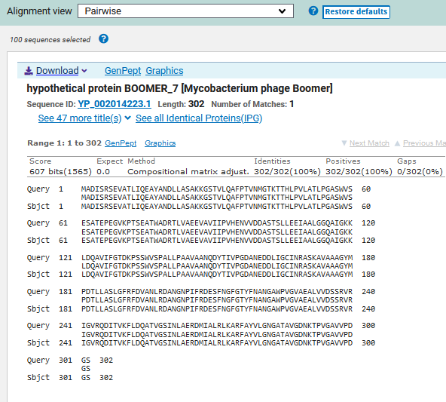
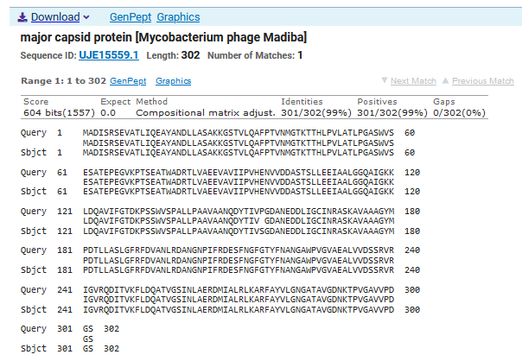
ATG Start at 5008. Original Glimmer call.
TAA Stop at 5916
F/R: F
Coding Potential (y/n): Y
Starterator (SS, NA, NI): Not the Most Annotated Start, but called 100.0% of the time when present.
Blast Best Hit, Query:Subject Starts, Score, Evalue, or “no significant Blast alignments” if 10E-4 or higher
Hypothetical protein BOOMER-7 Mycobacterium phage Boomer YP_002014223.1, 1:1, Score 607, Evalue, 0
Gap with previous gene: 63
Longest Orf? (Y/N/NA) Y
RBS:
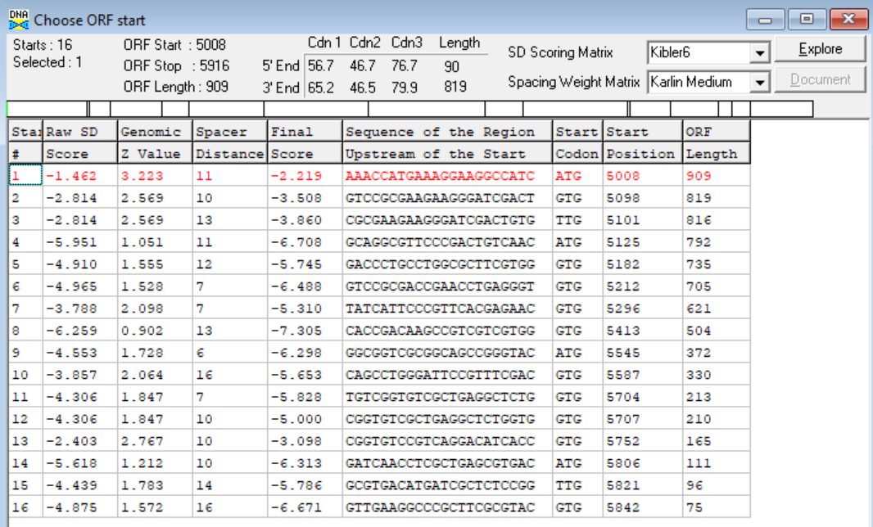
(https://toolkit.tuebingen.mpg.de/tools/hhpred) HHPRED vs PDB, SCOPe, pFam, and M. Tuberculosis.
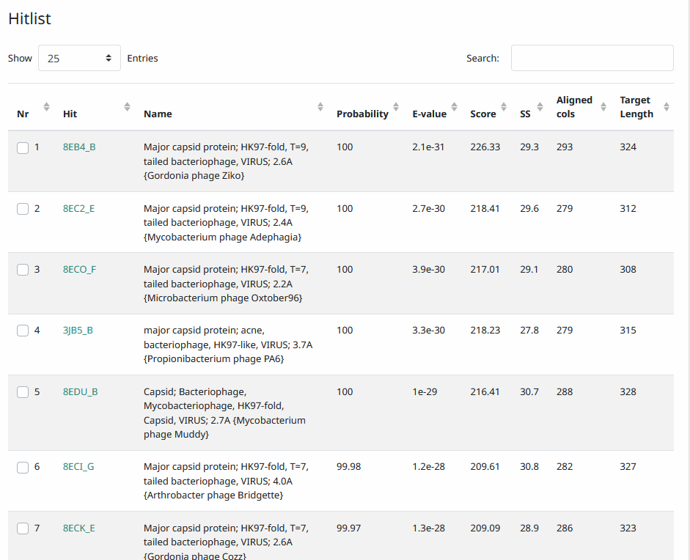
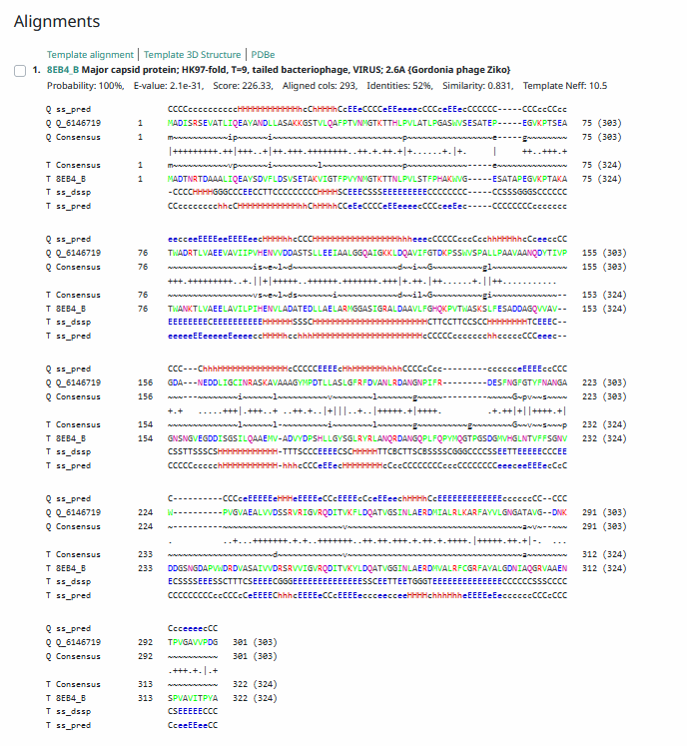

Phamerator Totinger Vs. Tootsieroll (https://phamerator.org/phages) Genes 4-14
Proposed Function: major capsid protein
Function Evidence: Despite the best BLAST match using NCBI being a hypothetical one with unknown function, the most consistent matches other than it are major capsid protein genes from other phages. Additionally, the gene is identical to phage Tootsieroll’s major capsid gene according to Phamerator.
Transmembrane Domain/Evidence: No, Extracellular Properties (https://dtu.biolib.com/DeepTMHMM)
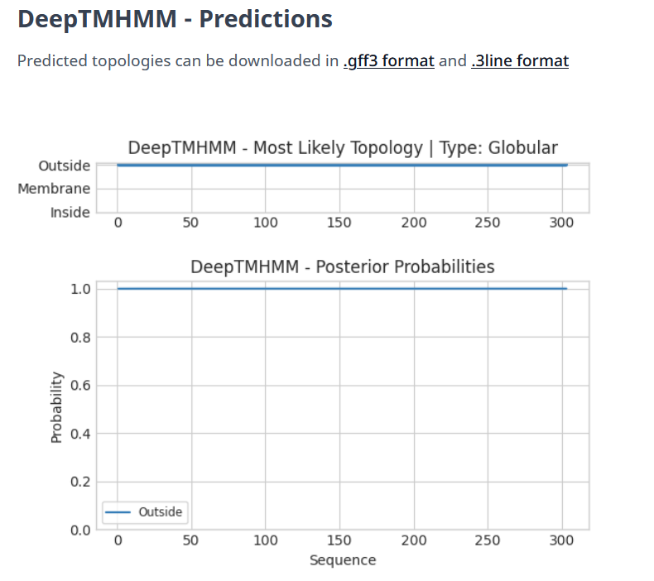
This protein shows results for an extracellular protein, which is unlike the previous six genes.

Gene Number: 8
Pham135252
BLAST from PhagesDB. (https://phagesdb.org/blastp/) Using Longest ORF
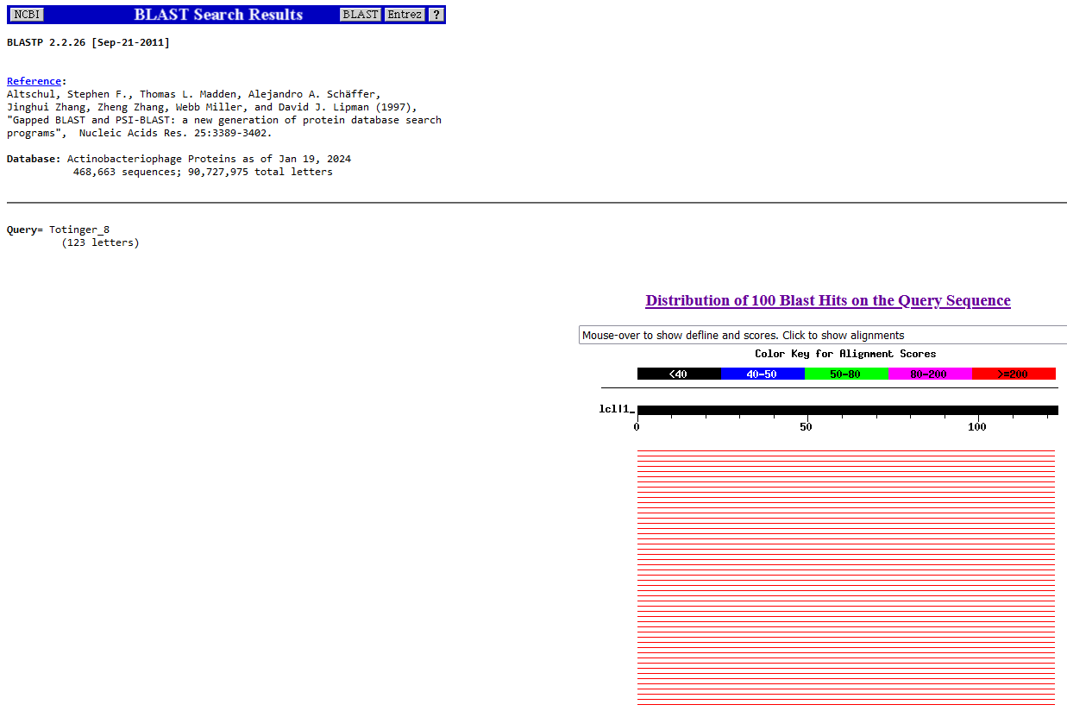
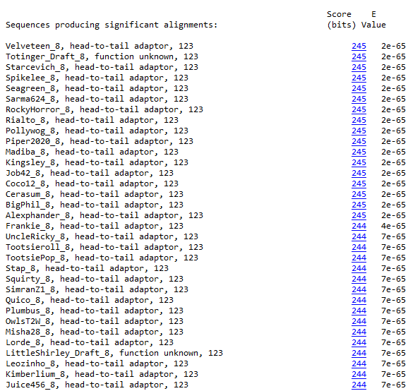
BLAST from NCBI (https://blast.ncbi.nlm.nih.gov/Blast.cgi?PAGE=Proteins) Using Longest ORF
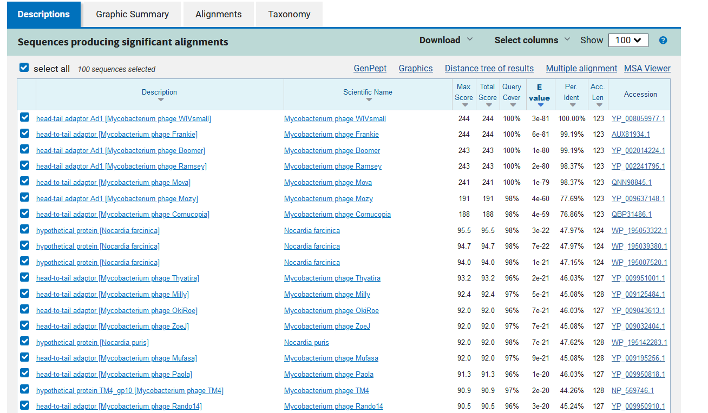
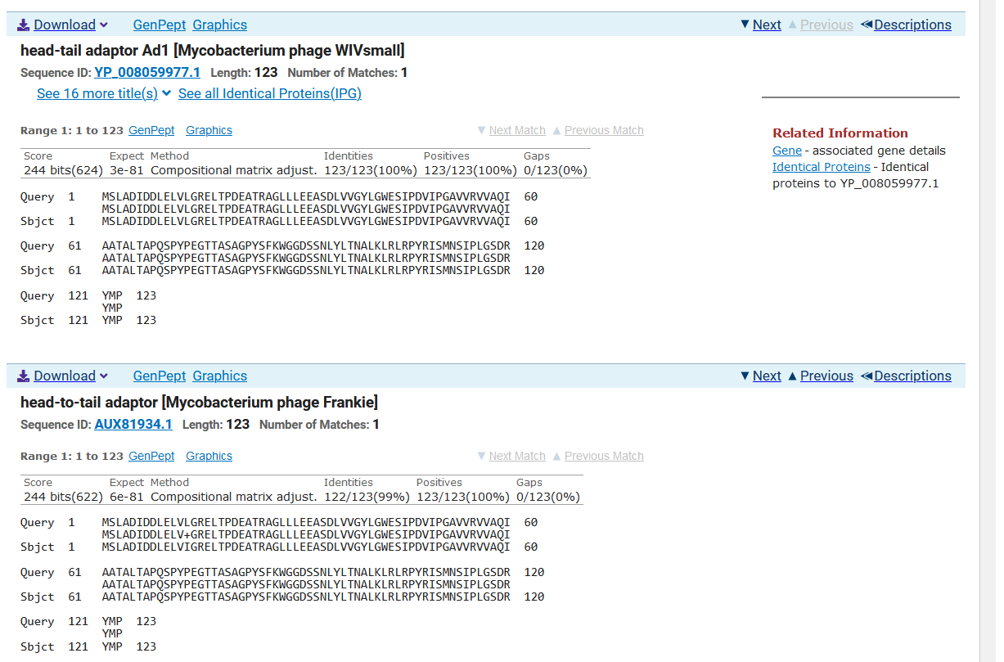
ATG Start at 5929. Original Glimmer call.
TGA Stop at 6300.
F/R: F
Coding Potential (y/n): Y
Starterator (SS, NA, NI): Not the Most Annotated Start, but called 97.0% of the time when present.
Blast Best Hit, Query:Subject Starts, Score, Evalue, or “no significant Blast alignments” if 10E-4 or higher
Head-tail adapter aD1 Mycobacterium phage WIVsmall YP_008126594.1, 1:1, Score 244, Evalue, 3E-81
Gap with previous gene: 13
Longest Orf? (Y/N/NA) Y
RBS:
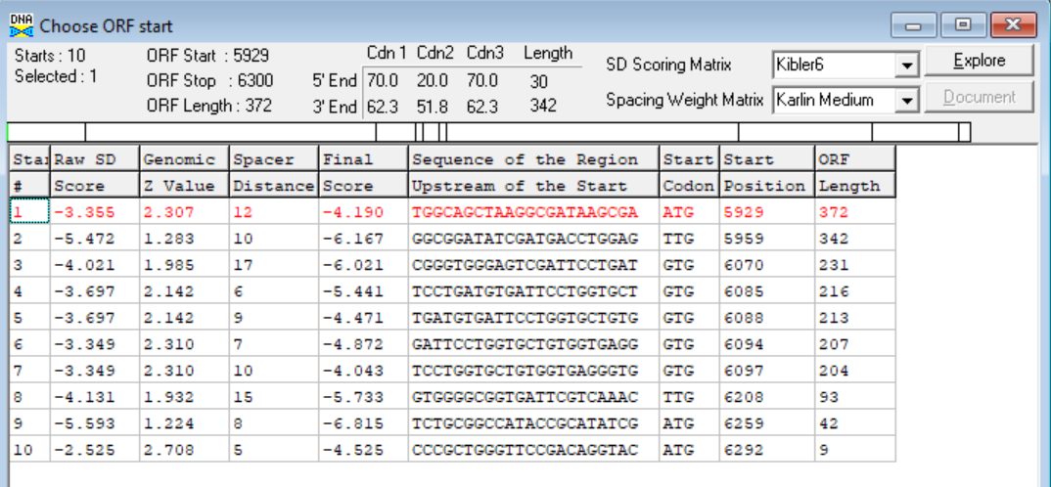

(https://toolkit.tuebingen.mpg.de/tools/hhpred) HHPRED vs PDB, SCOPe, pFam, and M. Tuberculosis.
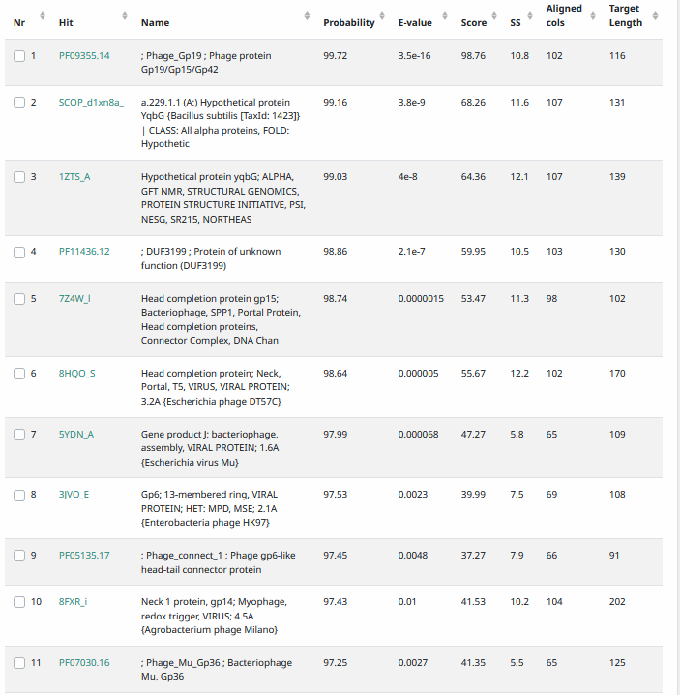
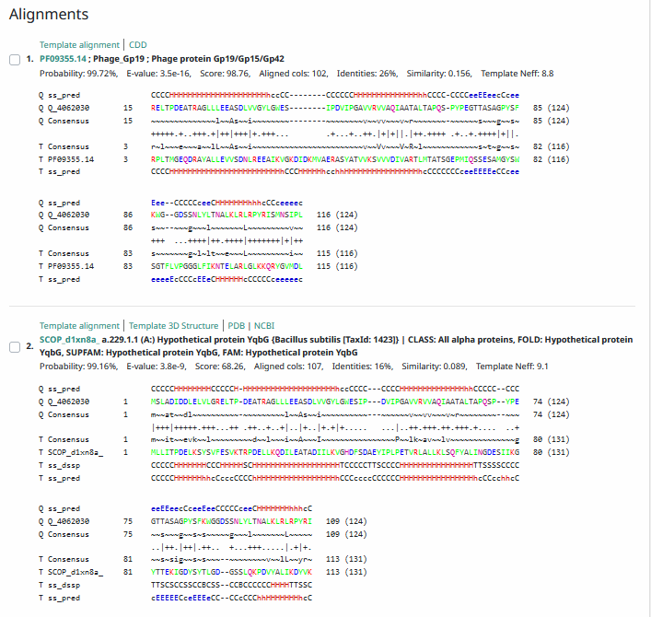
Phamerator Totinger Vs. Tootsieroll (https://phamerator.org/phages) Genes 4-14
Proposed Function: head-to-tail adapter
Function Evidence: BLASTS match a head-to-tail adapter from other phages most consistently, and it is an identical match to phage Tootsieroll’s head-to-tail adapter.
Transmembrane Domain/Evidence: No, Intracellular Properties (https://dtu.biolib.com/DeepTMHMM)
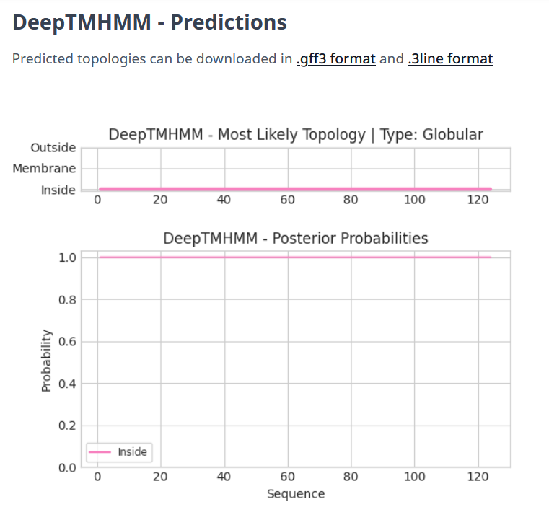

Gene Number: 9
Pham135199
BLAST from PhagesDB. (https://phagesdb.org/blastp/) Using Longest ORF
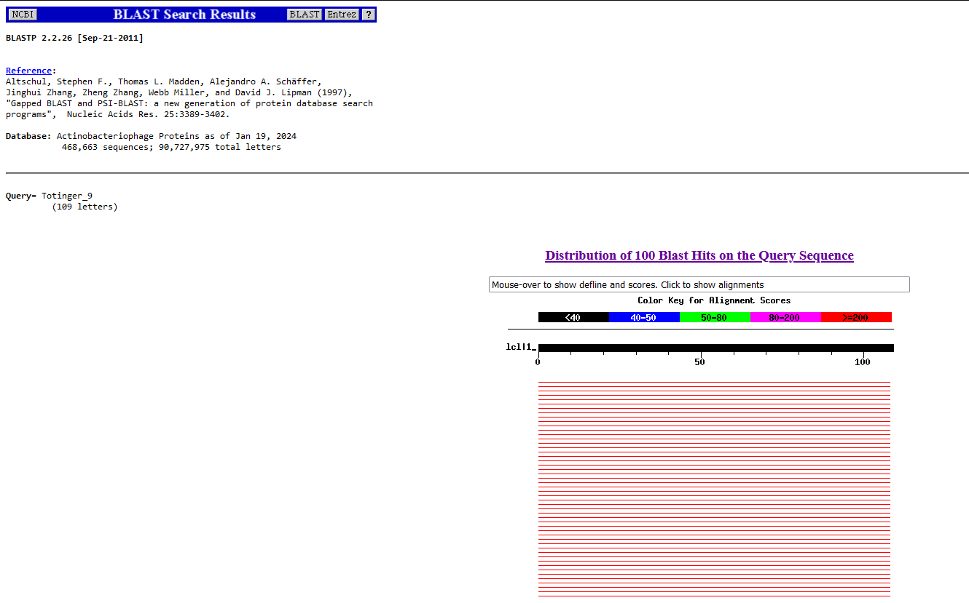
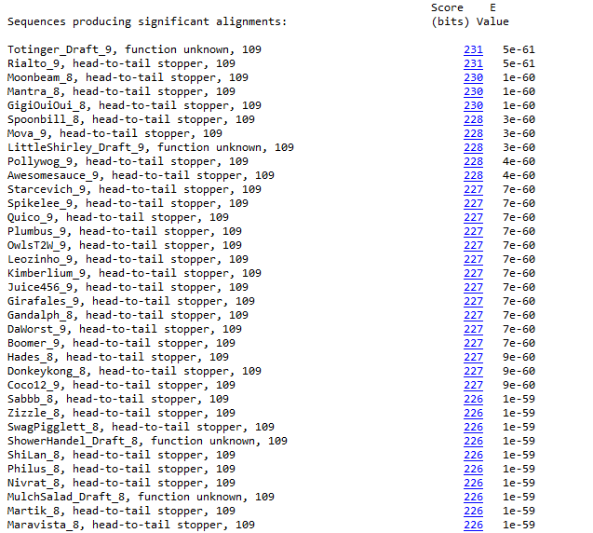
BLAST from NCBI (https://blast.ncbi.nlm.nih.gov/Blast.cgi?PAGE=Proteins) Using Longest ORF
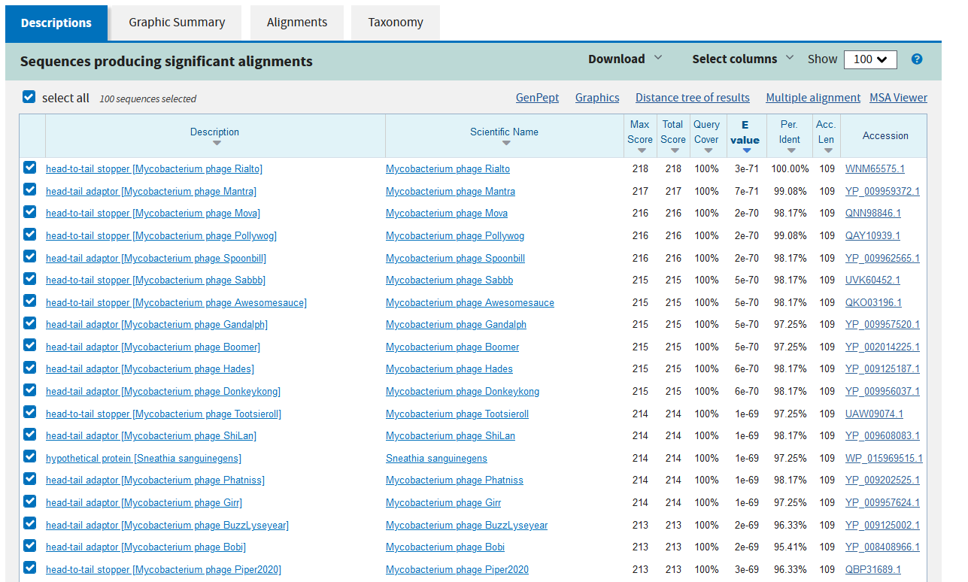
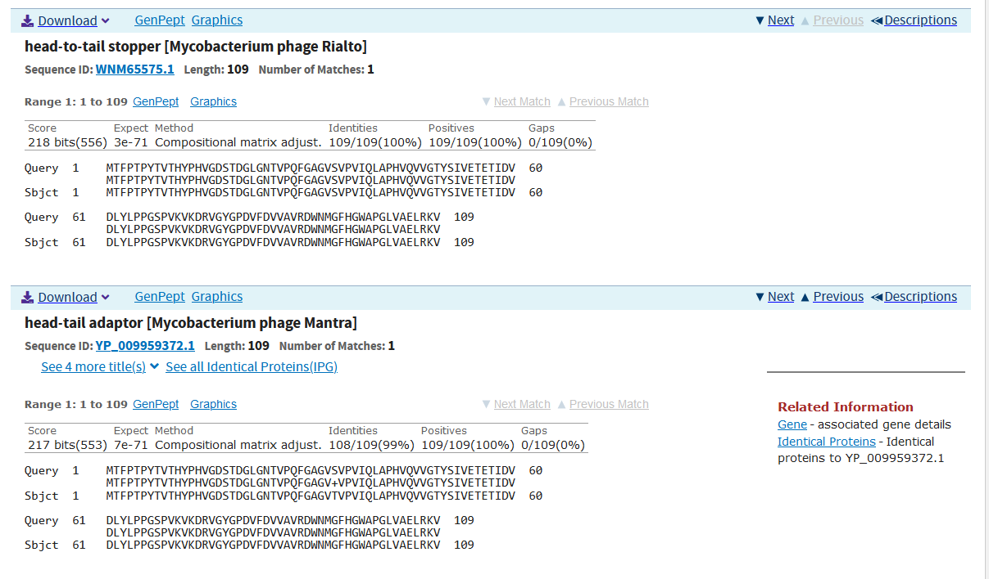
GTG Start at 6297. Original Glimmer call.
TGA Stop at 6626
F/R: F
Coding Potential (y/n): Y
Starterator (SS, NA, NI): Most annotated start is this (6297)
Blast Best Hit, Query:Subject Starts, Score, Evalue, or “no significant Blast alignments” if 10E-4 or higher
Head-to-tail stopper Mycobacterium phage Rialto WNM65575.1, 1:1, Score 216, Evalue, 3E-71
Gap with previous gene: -3
Longest Orf? (Y/N/NA) Y
RBS:
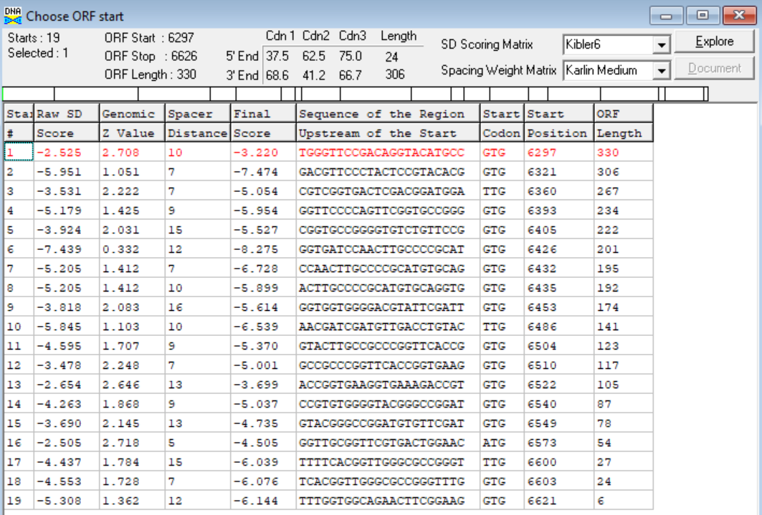
(https://toolkit.tuebingen.mpg.de/tools/hhpred) HHPRED vs PDB, SCOPe, pFam, and M. Tuberculosis.
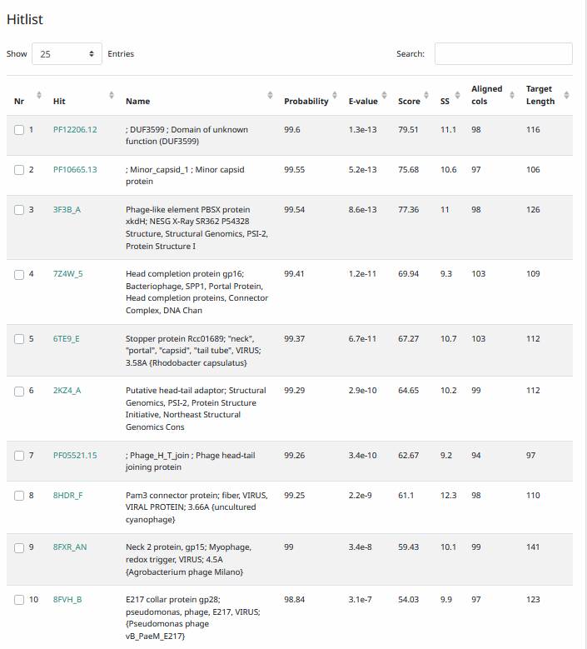
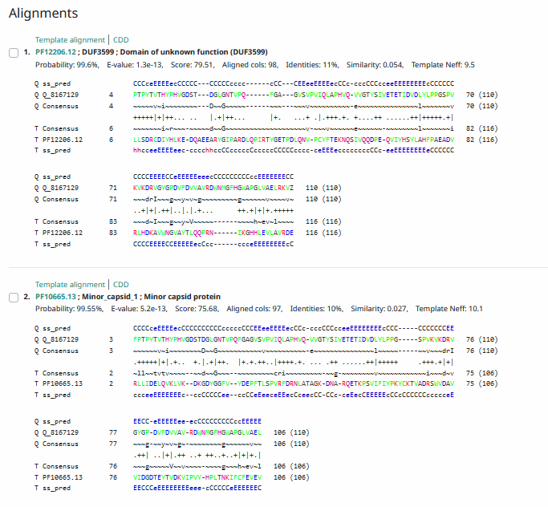
Phamerator Totinger Vs. Tootsieroll (https://phamerator.org/phages) Genes 4-14
Proposed Function: head-to-tail stopper
Function Evidence: According to Phamerator and the performed BLASTs, the most consistent matches with other phages is a head-to-tail stopper protein.
Transmembrane Domain/Evidence: No, Extracellular Properties (https://dtu.biolib.com/DeepTMHMM)
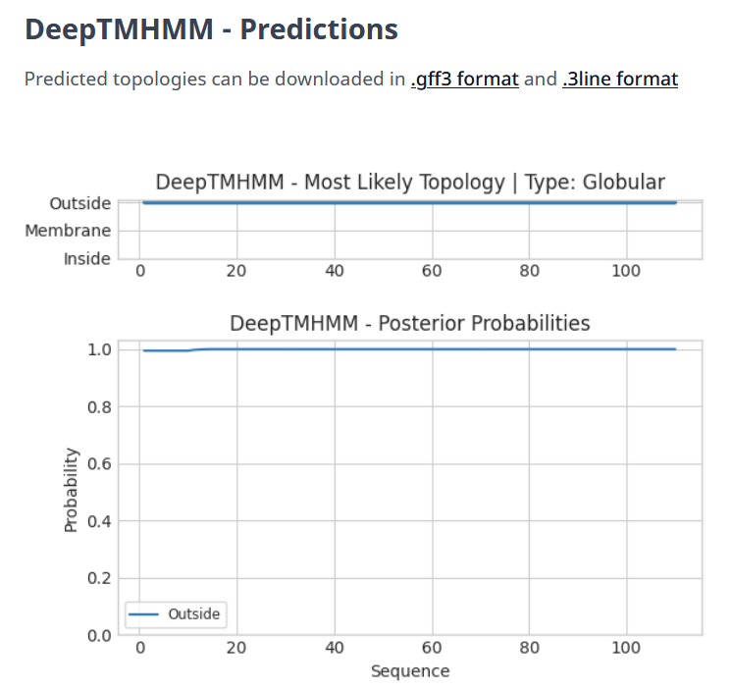

Gene Number: 10
Pham131717
BLAST from PhagesDB. (https://phagesdb.org/blastp/) Using Longest ORF
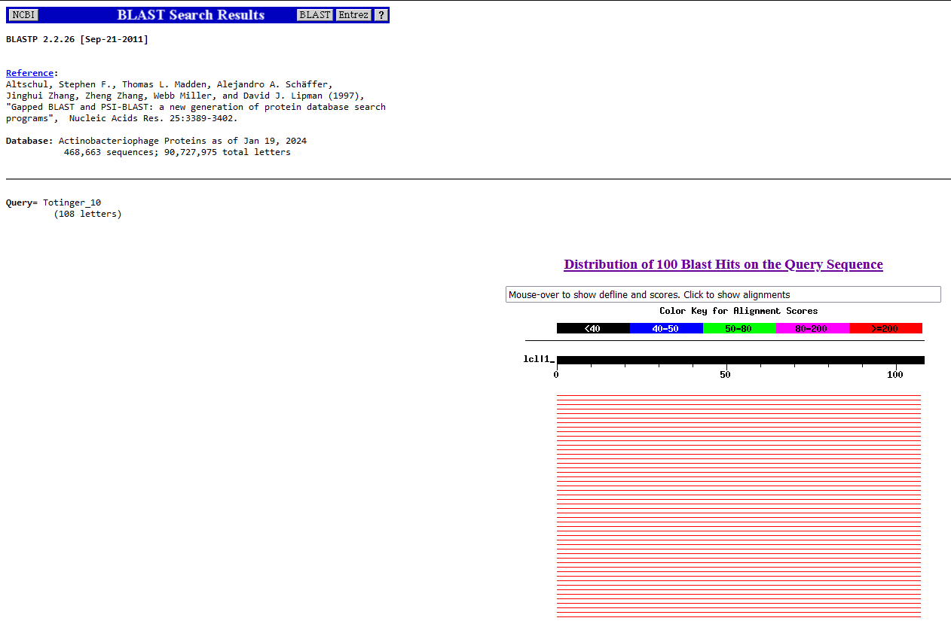
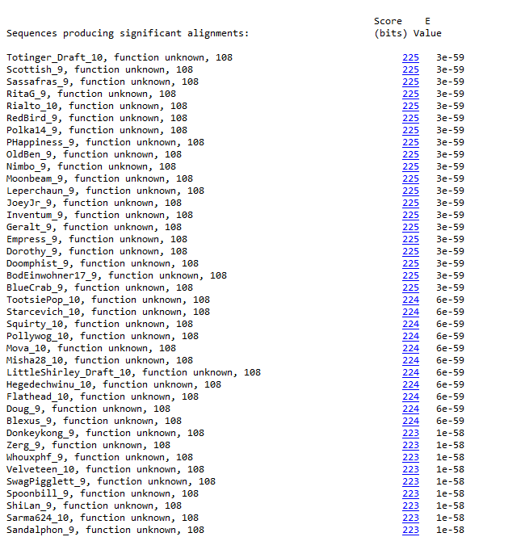
Unlike previous phagesdb Blasts, the most common result is an unknown function. However, this gene is common among other phages and likely has a known or putative function in other databases.
BLAST from NCBI (https://blast.ncbi.nlm.nih.gov/Blast.cgi?PAGE=Proteins) Using Longest ORF
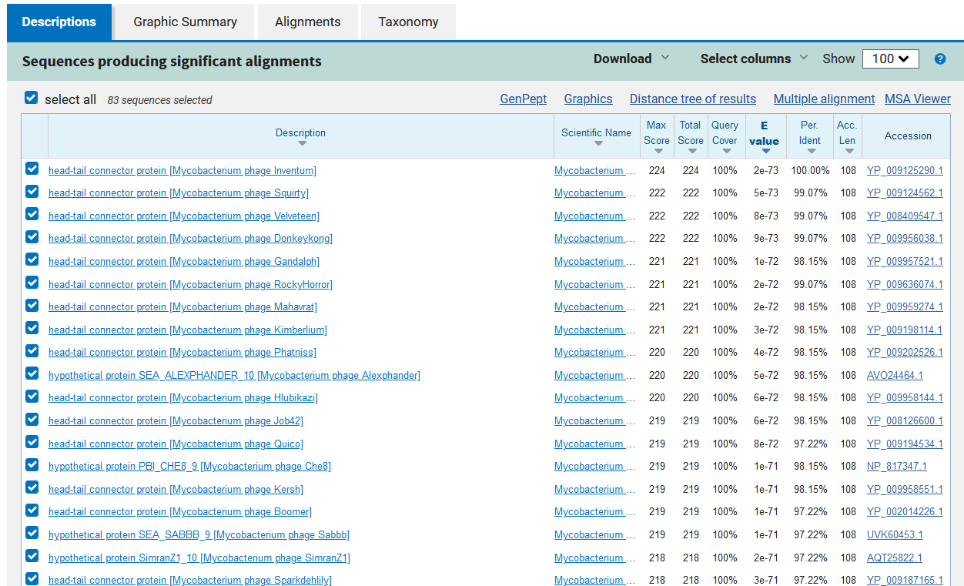
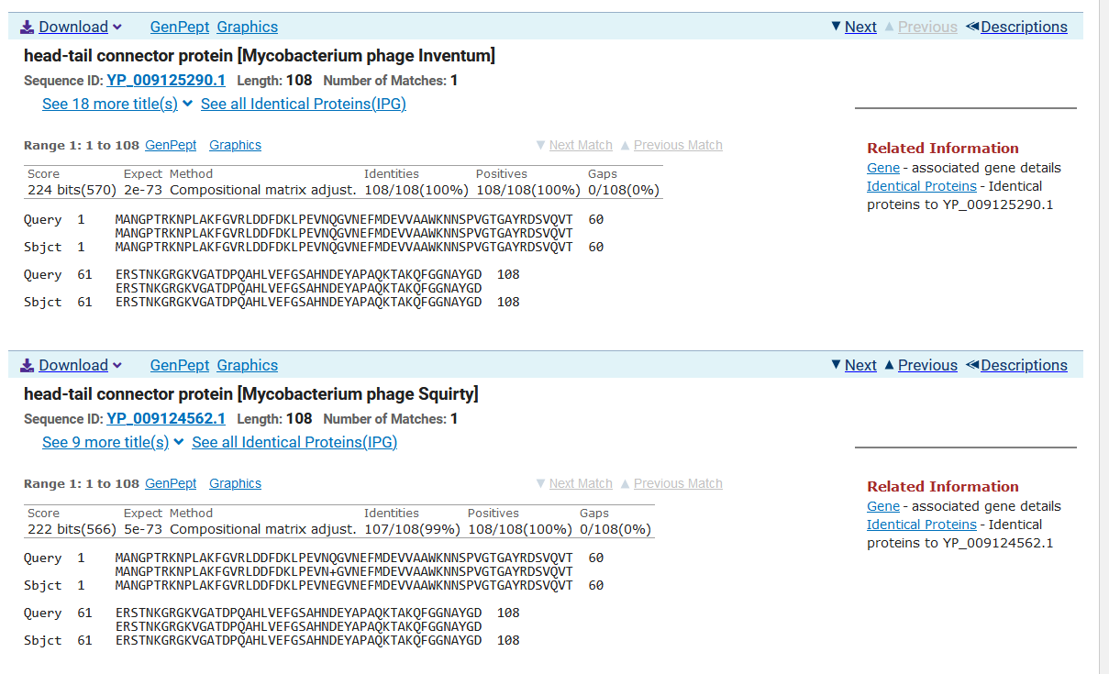
GTG Start at 6633. Original Glimmer call.
TGA Stop at 6959
F/R: F
Coding Potential (y/n): Y
Starterator (SS, NA, NI): Most annotated start is this (6633)
Blast Best Hit, Query:Subject Starts, Score, Evalue, or “no significant Blast alignments” if 10E-4 or higher
Head-tail connector protein Mycobacterium phage Inventum YP_009125290.1, 1:1, Score 224, Evalue, 2E-73
Gap with previous gene: 7
Longest Orf? (Y/N/NA) Y
RBS:
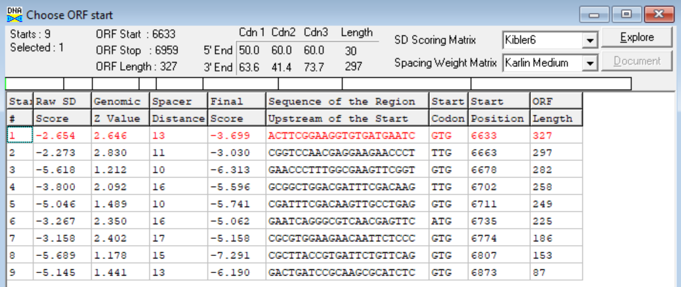
(https://toolkit.tuebingen.mpg.de/tools/hhpred) HHPRED vs PDB, SCOPe, pFam, and M. Tuberculosis.
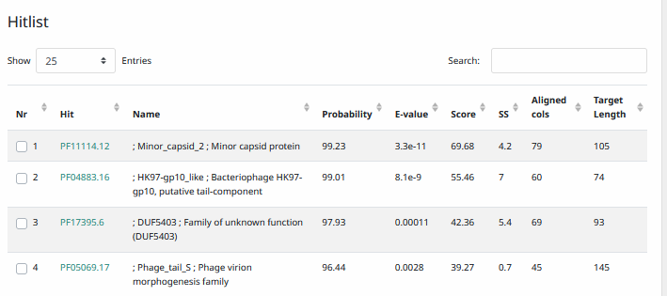
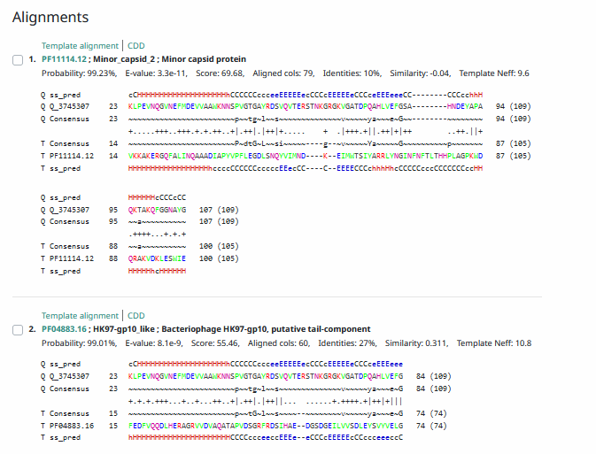
Phamerator Totinger Vs. Tootsieroll (https://phamerator.org/phages) Genes 4-14
Proposed Function: Hypothetical protein
Function Evidence: BLAST results and Phamerator comparisons are too scattered to make a decently confident call.
Transmembrane Domain/Evidence: No, Extracellular Properties (https://dtu.biolib.com/DeepTMHMM)
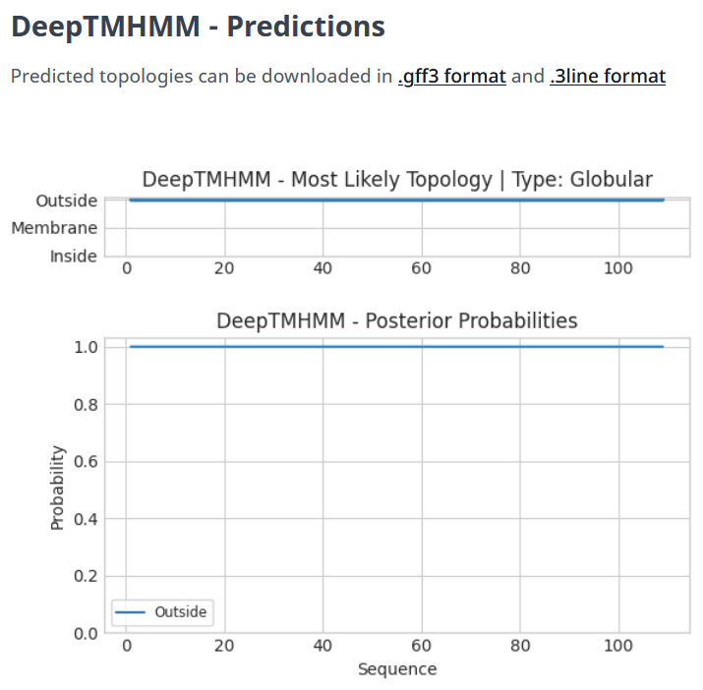

Gene Number: 11
Pham104688
BLAST from PhagesDB. (https://phagesdb.org/blastp/) Using Longest ORF
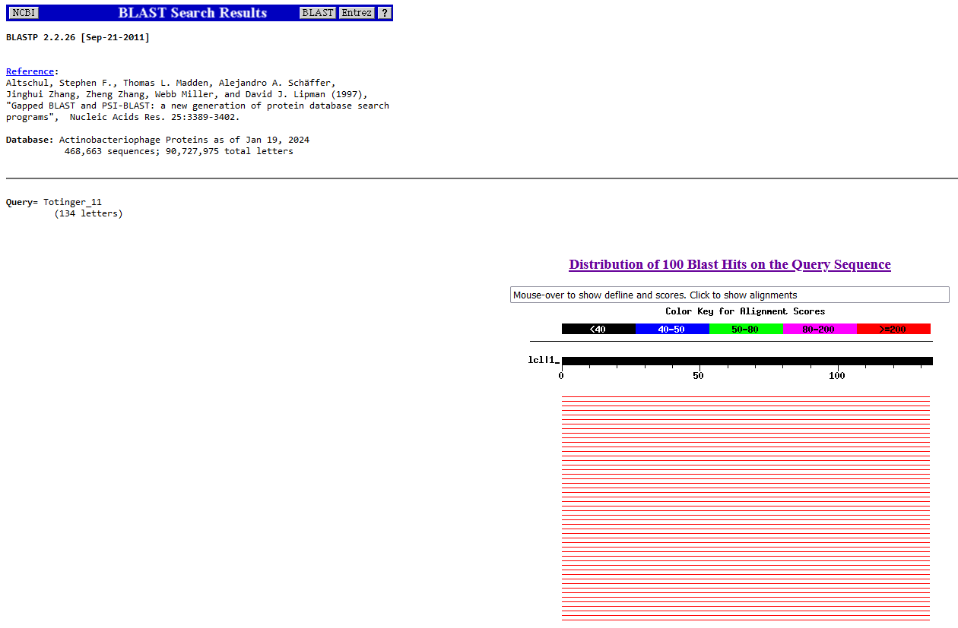
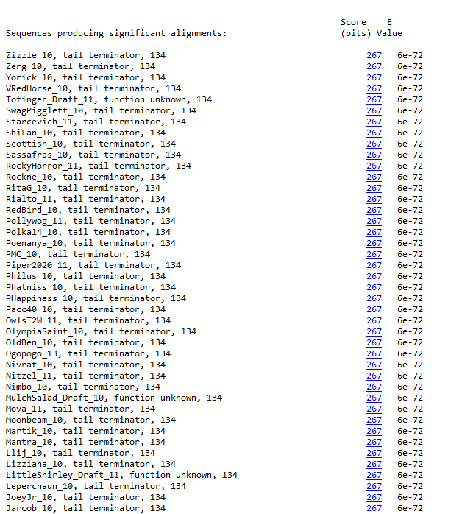
BLAST from NCBI (https://blast.ncbi.nlm.nih.gov/Blast.cgi?PAGE=Proteins) Using Longest ORF
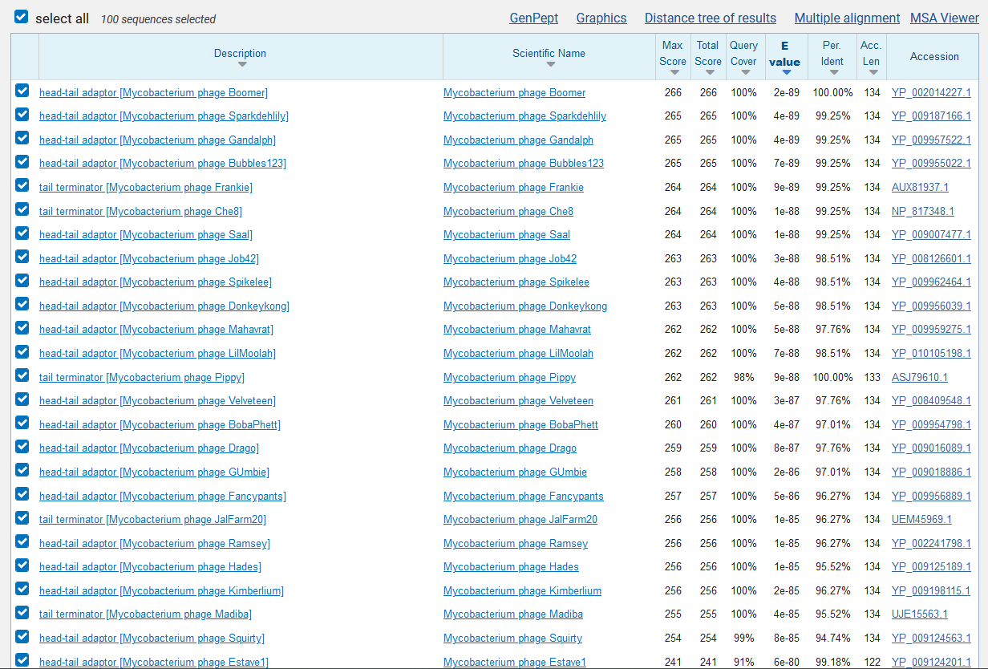
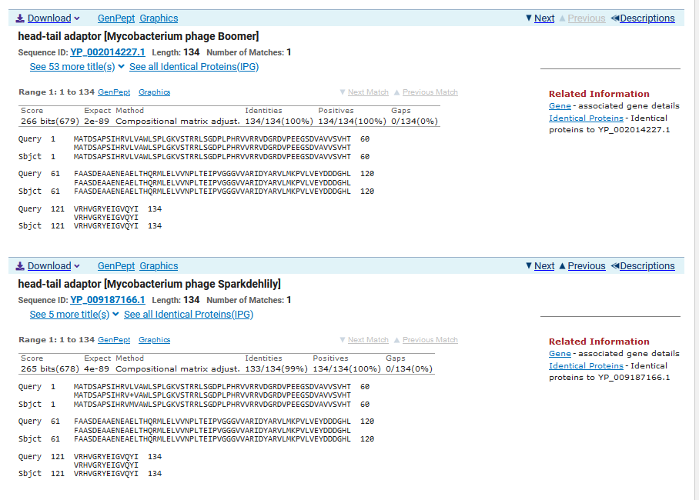
ATG Start at 6949. Original Glimmer call.
TAG Stop at 7353
F/R: F
Coding Potential (y/n): Y
Starterator (SS, NA, NI): Most annotated start is this (6949)
Blast Best Hit, Query:Subject Starts, Score, Evalue, or “no significant Blast alignments” if 10E-4 or higher
Head-tail adapter Mycobacterium phage Boomer YP_002014227.1, 1:1, Score 266, Evalue, 2E-89

Gap with previous gene: -10

Longest Orf? (Y/N/NA) Y

RBS:
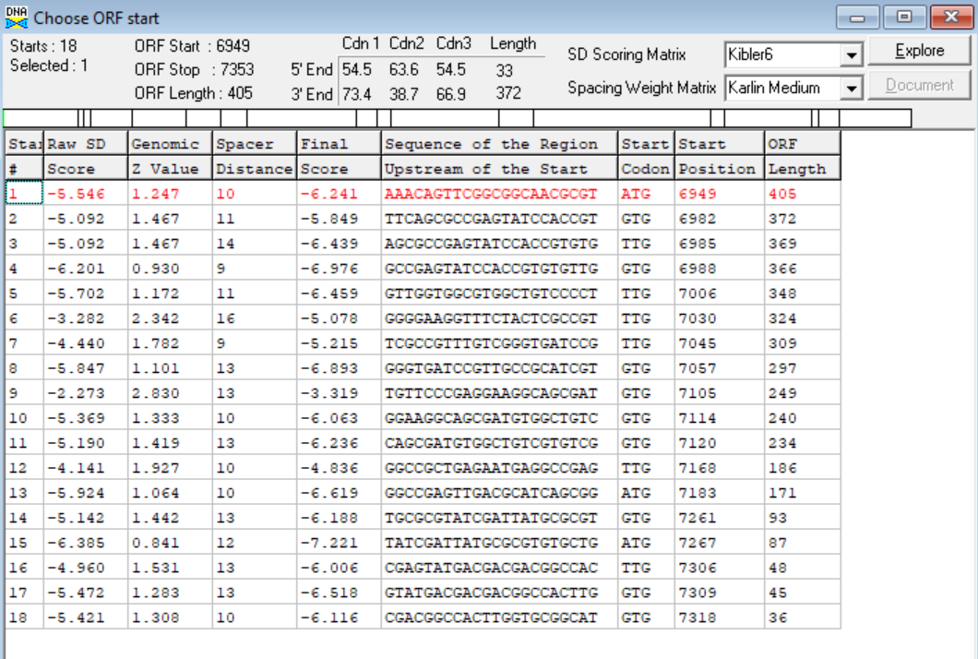
(https://toolkit.tuebingen.mpg.de/tools/hhpred) HHPRED vs PDB, SCOPe, pFam, and M. Tuberculosis.
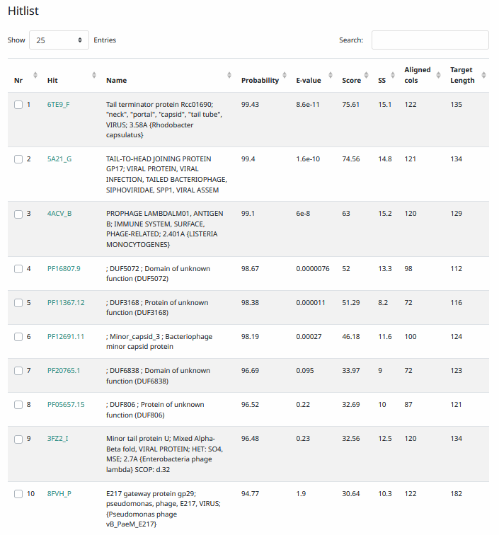
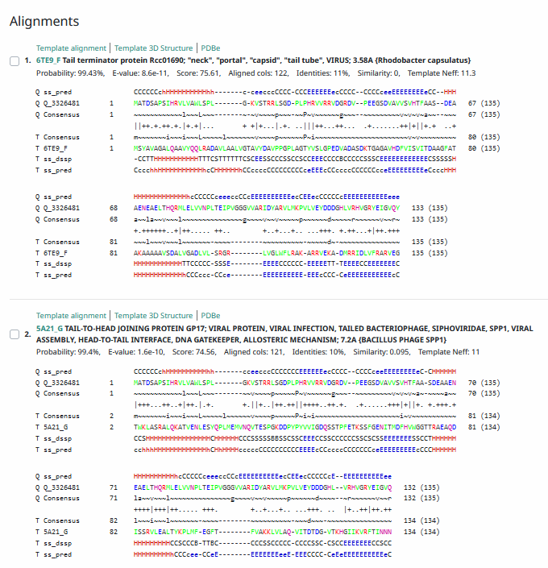

Phamerator Totinger Vs. Tootsieroll (https://phamerator.org/phages) Genes 4-14
Proposed Function: tail terminator

Function Evidence: BLASTS most consistently aligned with a tail terminator protein or a head-to-tail adapter protein. A head-to-tail adapter was previously called as Gene 8, and Gene 11 matches nearly identically to the tail terminator gene of phage Tootsieroll.

Transmembrane Domain/Evidence: No, Intracellular Properties (https://dtu.biolib.com/DeepTMHMM)
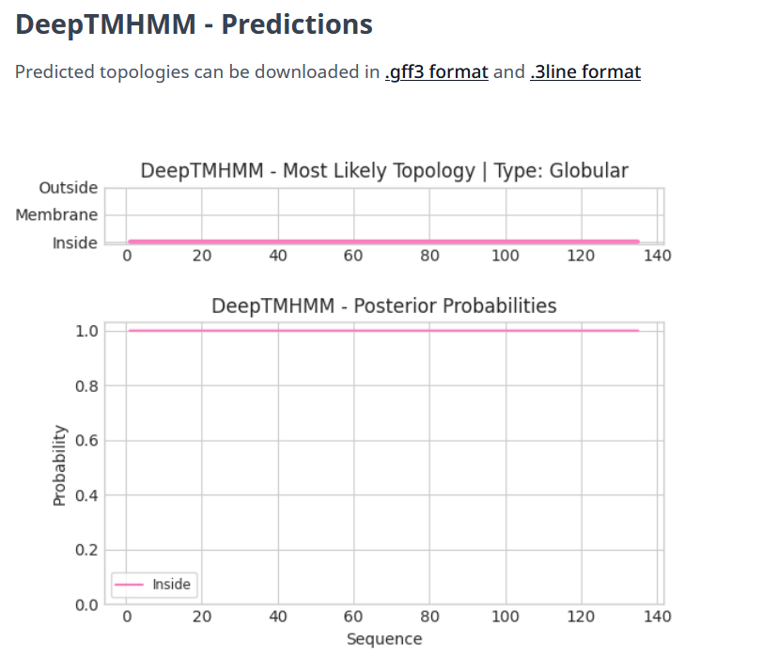

Gene Number: 12
Pham135211
BLAST from PhagesDB. (https://phagesdb.org/blastp/) Using Longest ORF
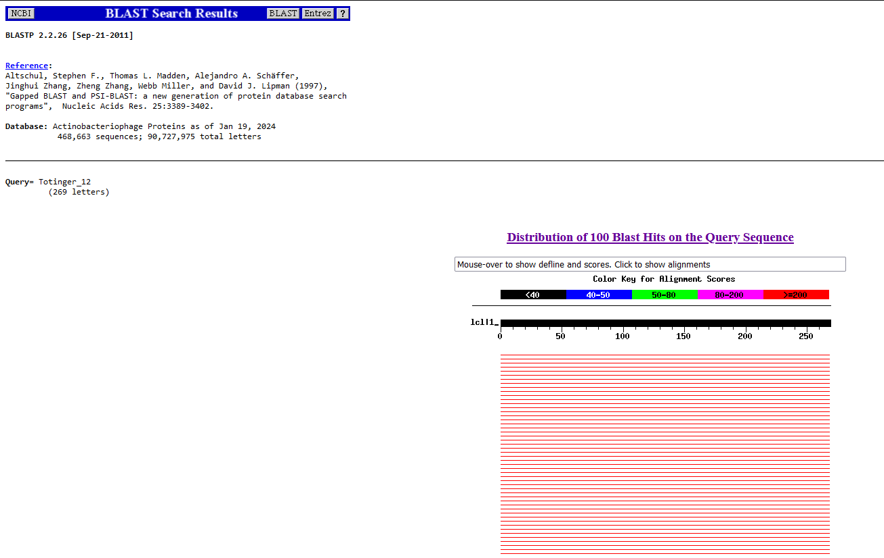
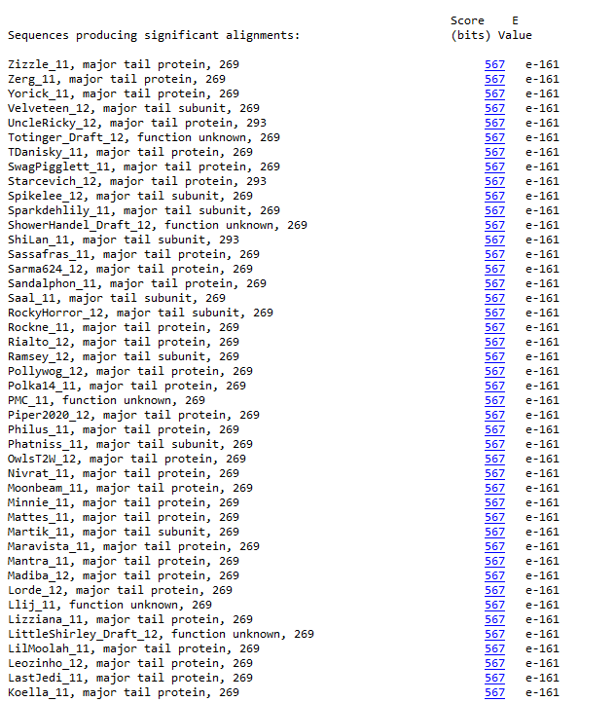
BLAST from NCBI (https://blast.ncbi.nlm.nih.gov/Blast.cgi?PAGE=Proteins) Using Longest ORF
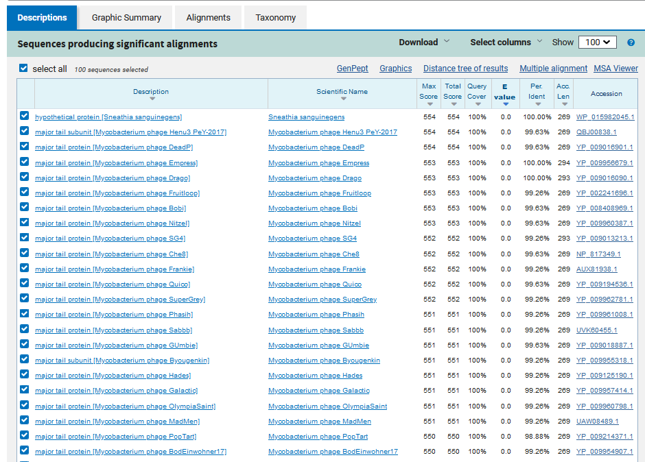
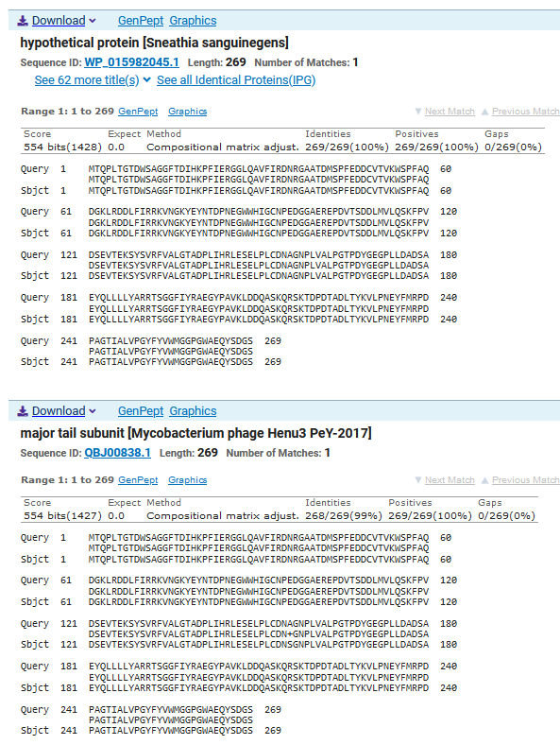
ATG Start at 7463. Original Glimmer call.
TAG Stop at 8272
F/R: F
Coding Potential (y/n): Y
Starterator (SS, NA, NI): Most annotated start is this (7463)
Blast Best Hit, Query:Subject Starts, Score, Evalue, or “no significant Blast alignments” if 10E-4 or higher
Hypothetical protein Sneathia sanguinegens WP_015982045.1, 1:1, Score 554, Evalue, 0
Gap with previous gene: 110
Longest Orf? (Y/N/NA) Y
RBS:
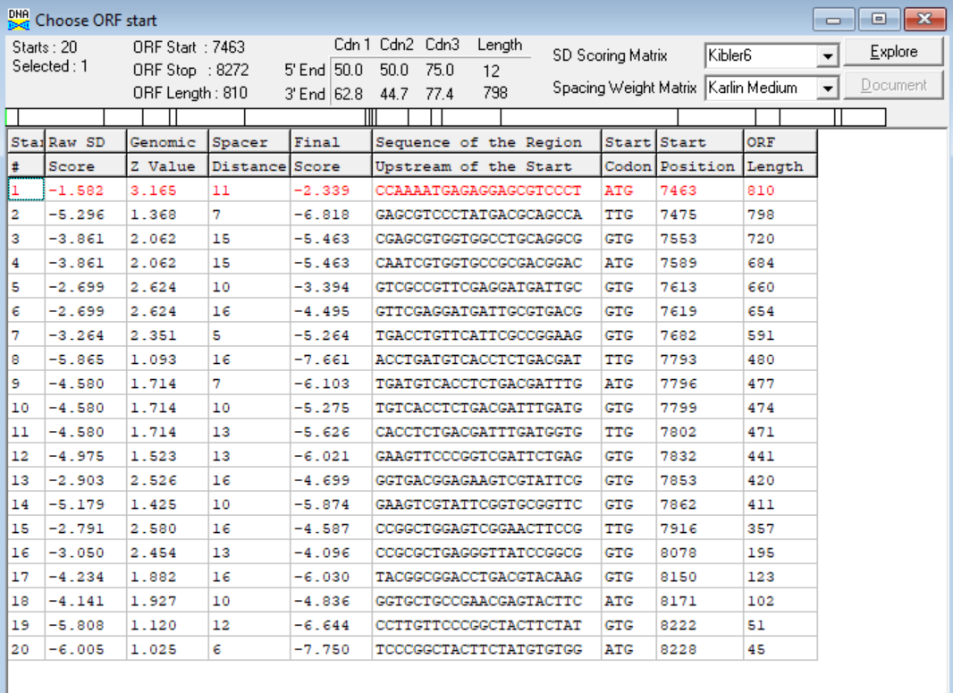
(https://toolkit.tuebingen.mpg.de/tools/hhpred) HHPRED vs PDB, SCOPe, pFam, and M. Tuberculosis.
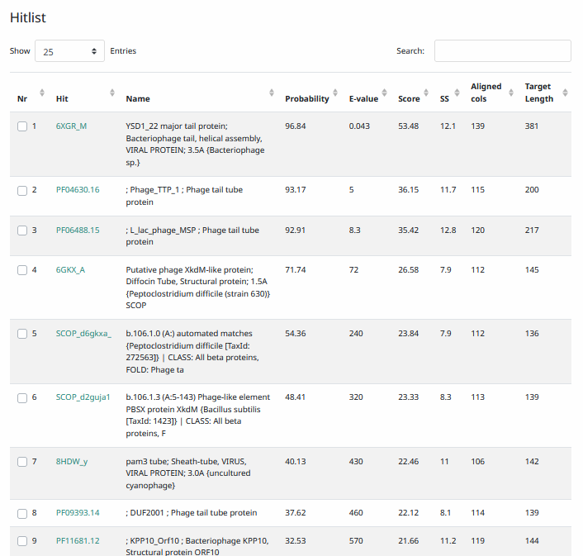
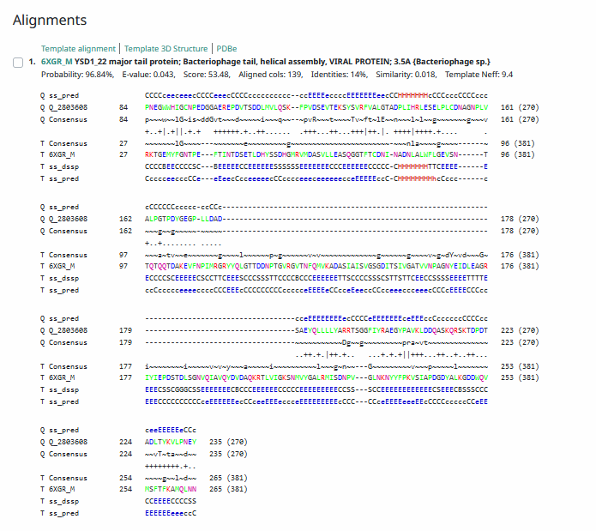
Phamerator Totinger Vs. Tootsieroll (https://phamerator.org/phages) Genes 4-14
Proposed Function: major tail protein
Function Evidence: While BLAST results for this gene were relatively inconsistent, this gene is identical to phage Tootsieroll’s major tail protein gene and showed strong matches to major tail protein genes from other phages.
Transmembrane Domain/Evidence: No, Extracellular Properties (https://dtu.biolib.com/DeepTMHMM)
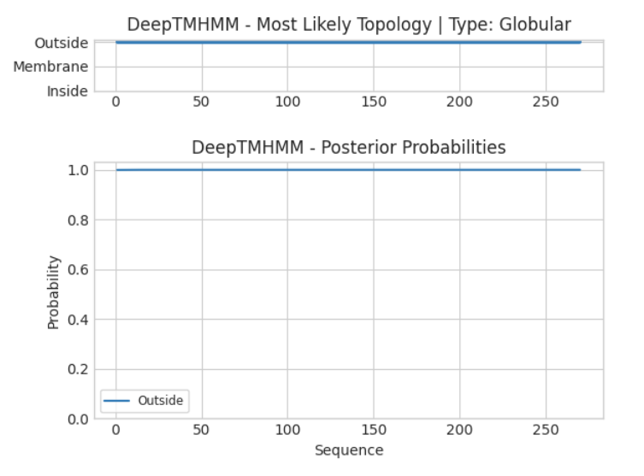

Gene Number: 13
Pham84650
BLAST from PhagesDB. (https://phagesdb.org/blastp/) Using Longest ORF
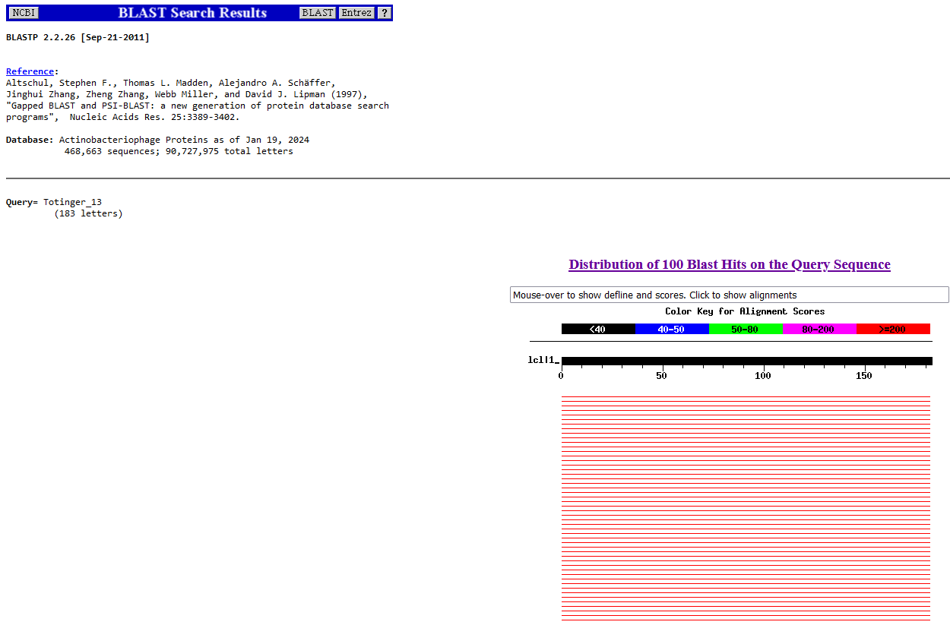
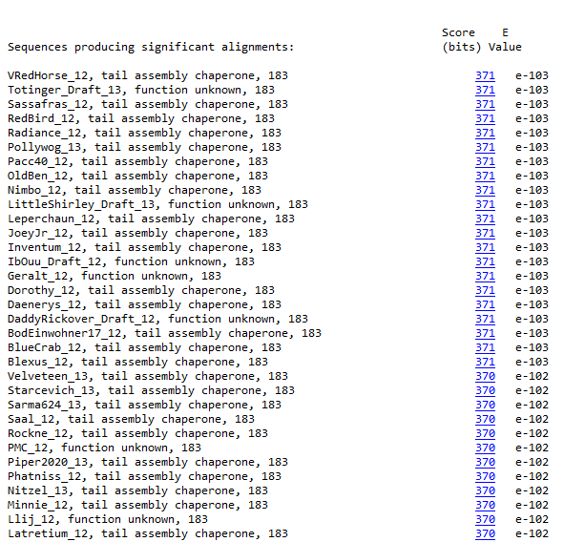

BLAST from NCBI (https://blast.ncbi.nlm.nih.gov/Blast.cgi?PAGE=Proteins) Using Longest ORF
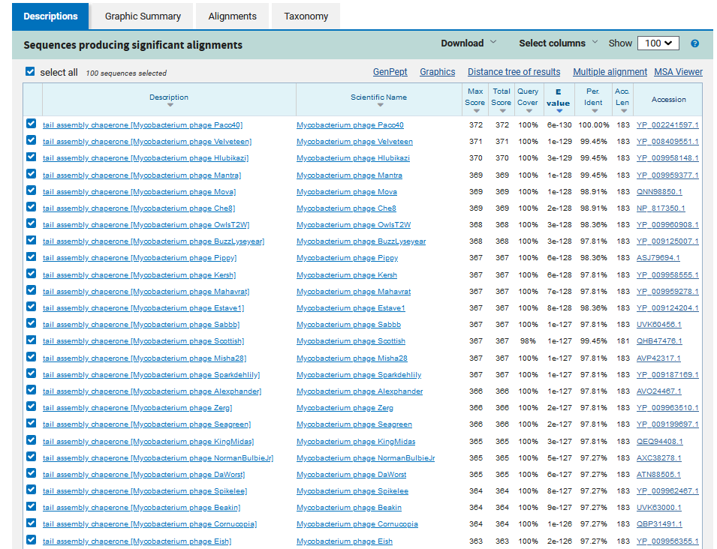
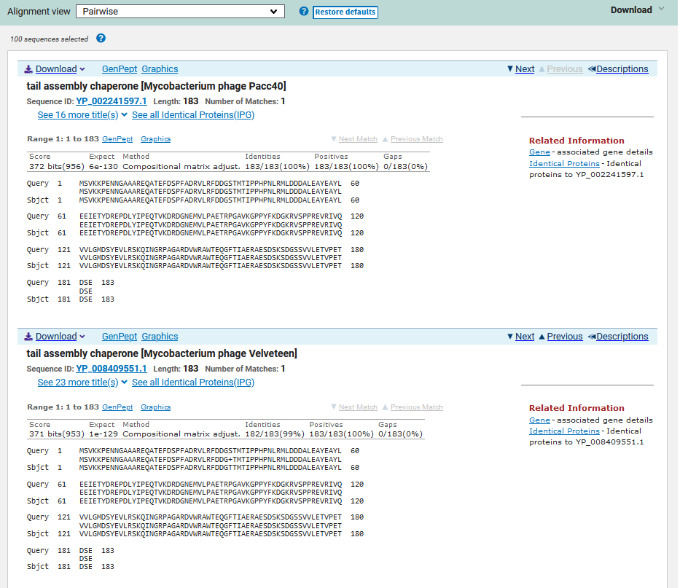
ATG Start at 8386. Original Glimmer call.
TGA Stop at 8937
F/R: F
Coding Potential (y/n): Y
Starterator (SS, NA, NI): Most annotated start is this (8386)
Blast Best Hit, Query:Subject Starts, Score, Evalue, or “no significant Blast alignments” if 10E-4 or higher
Tail assembly chaperone Mycobacterium phage Pacc40 YP_002241597.1, 1:1, Score 372, Evalue, 6e-130
Gap with previous gene: 114
Longest Orf? (Y/N/NA) Y
RBS:
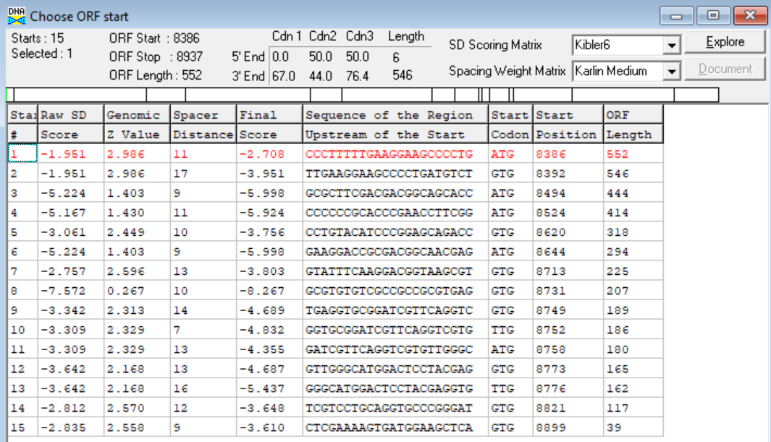
(https://toolkit.tuebingen.mpg.de/tools/hhpred) HHPRED vs PDB, SCOPe, pFam, and M. Tuberculosis.
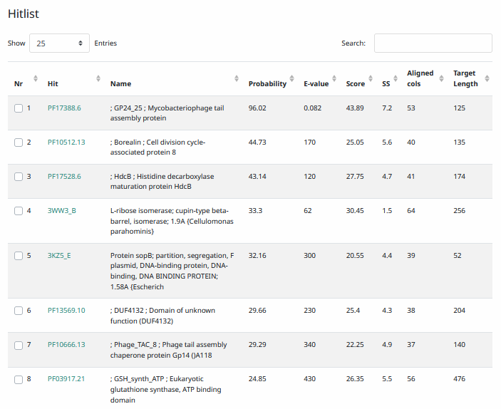
Phamerator Totinger Vs. Tootsieroll (https://phamerator.org/phages) Genes 4-14
Proposed Function: tail assembly chaperone
Function Evidence: BLAST results and Phamerator comparisons best match tail assembly chaperone genes from similar phages. The gene is near identical to phage Tootsieroll’s tail assembly chaperone gene and a frameshift for gene 14 is very likely.
Transmembrane Domain/Evidence: No, Intracellular Properties (https://dtu.biolib.com/DeepTMHMM)
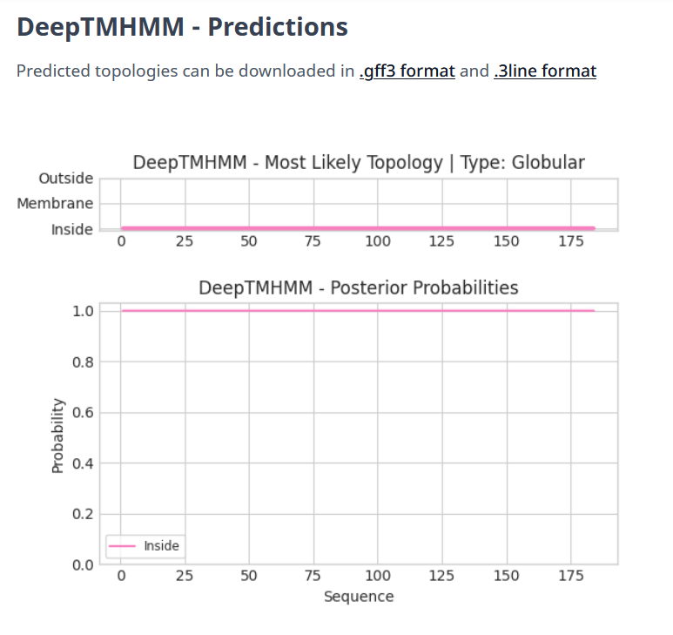

Gene Number: 14
Pham88687
BLAST from PhagesDB. (https://phagesdb.org/blastp/) Using DNA Master’s Predicted ORF
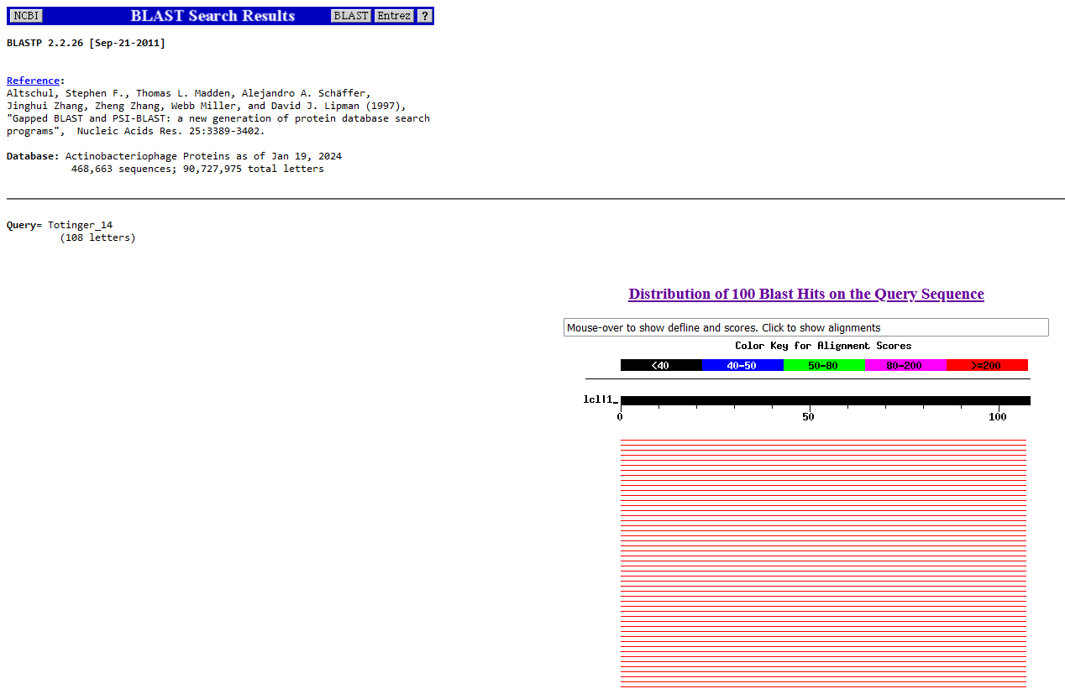
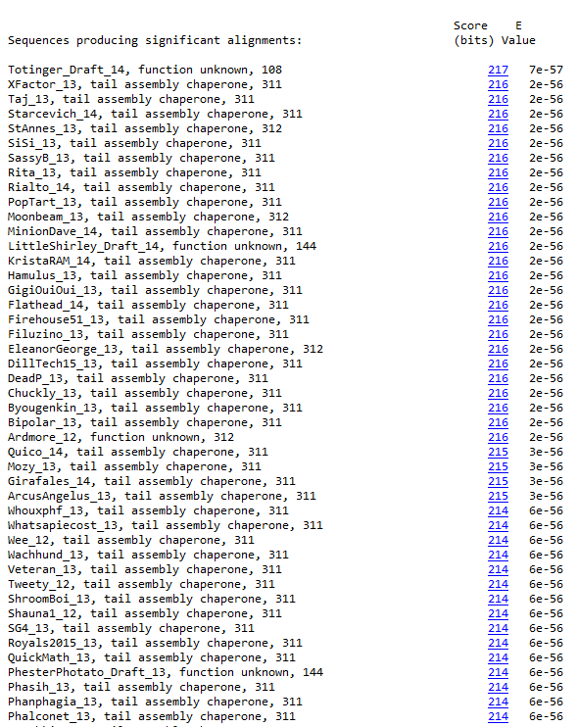
BLAST from PhagesDB. (https://phagesdb.org/blastp/) Using Hypothetical Frameshift ORF (8386-9322)
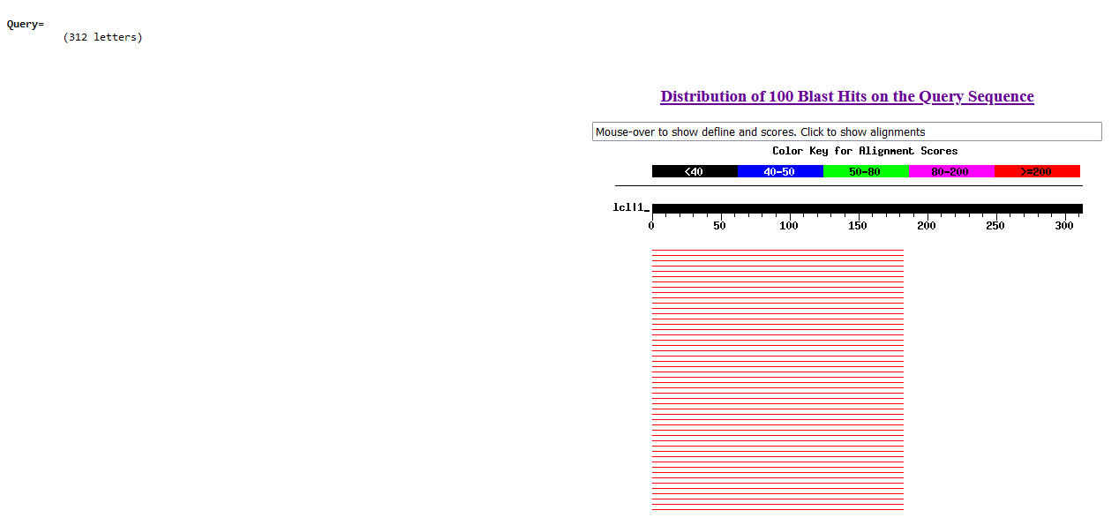
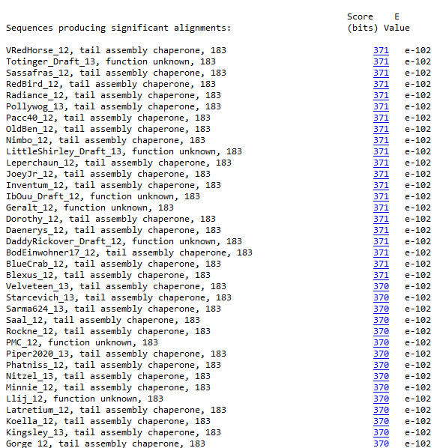
BLAST from NCBI (https://blast.ncbi.nlm.nih.gov/Blast.cgi?PAGE=Proteins) Using DNA Master’s Predicted ORF
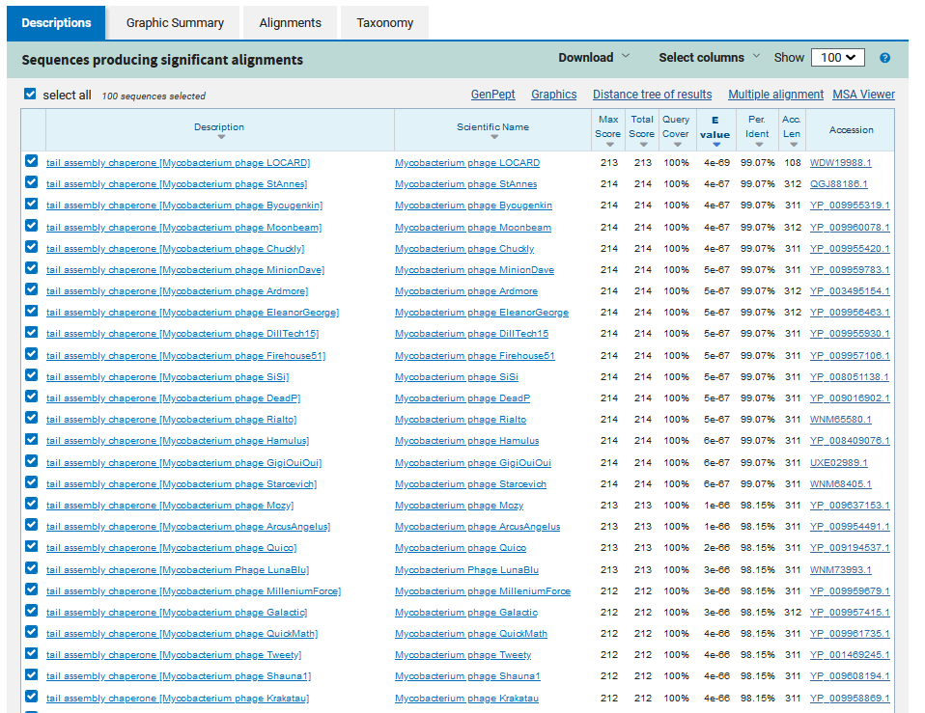
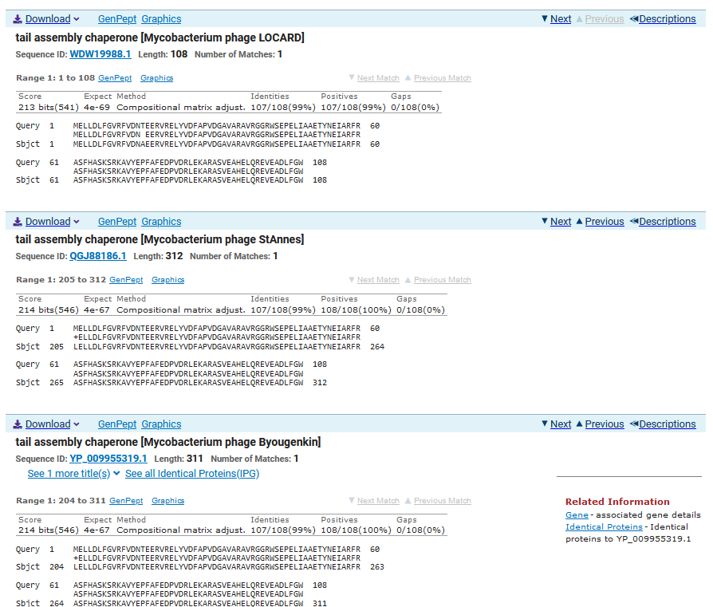

BLAST from NCBI (https://blast.ncbi.nlm.nih.gov/Blast.cgi?PAGE=Proteins) Using Hypothetical Frameshift ORF (8386-9322)
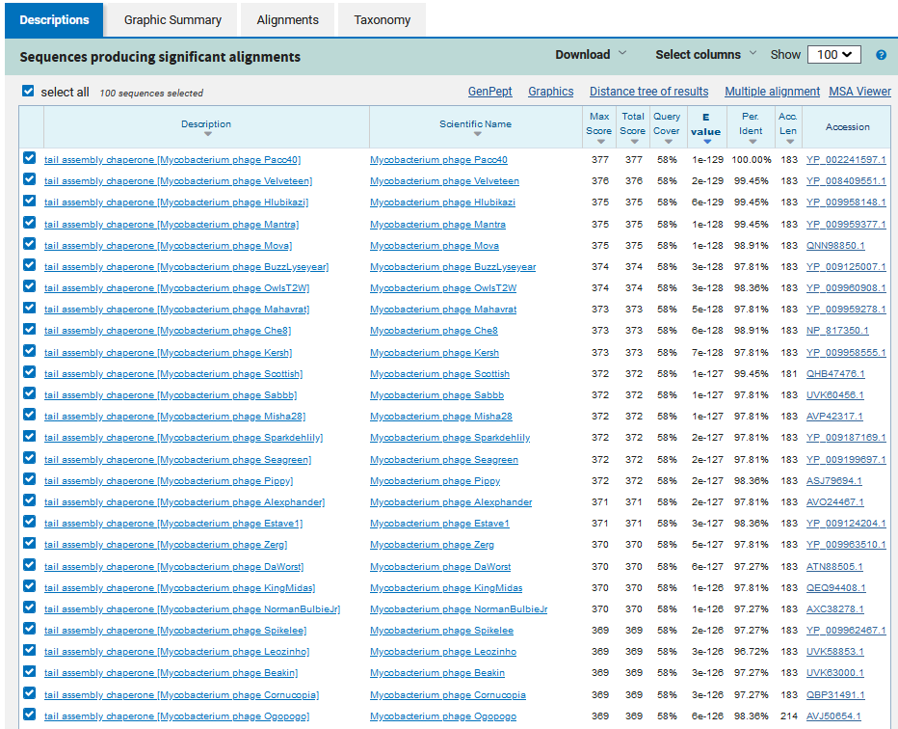
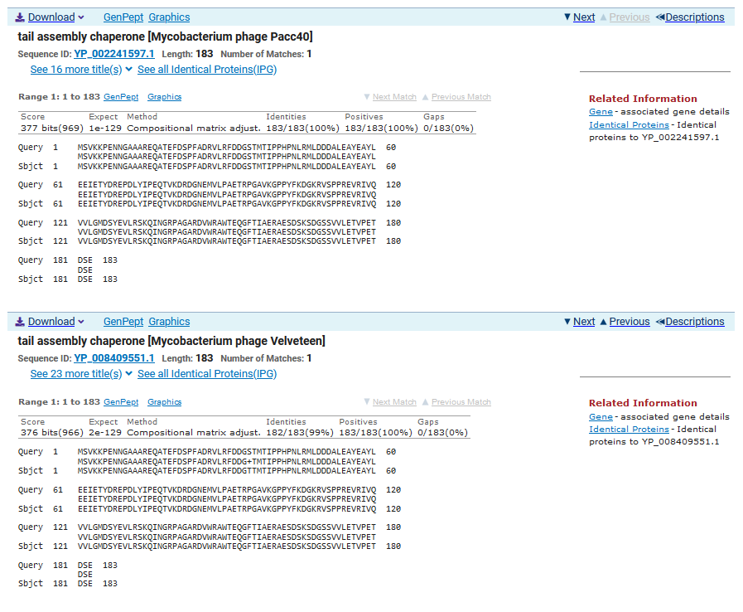
CALLED GENE:
ATG Start at 8386. Original Glimmer call for Gene 13, not Gene 14. Putative +1 Frameshift at 8882.
TGA Stop at 9322
F/R: F
Coding Potential (y/n): Y for both ORFs.
Starterator (SS, NA, NI) For DNA Master’s Predicted ORF: No Starterator File on phagesdb for this ORF.
Blast Best Hit, Query:Subject Starts, Score, Evalue, or “no significant Blast alignments” if 10E-4 or higher
The best BLAST hit was using the Hypothetical Frameshift ORF, instead of DNA Master’s predicted ORF.
Tail assembly chaperone Mycobacterium phage Pacc40 YP_002241597.1, 1:1, Score 377, Evalue, 1e-129
Gap with previous gene: 0
Longest Orf? (Y/N/NA) Y
RBS (DNA Master’s Predicted ORF):
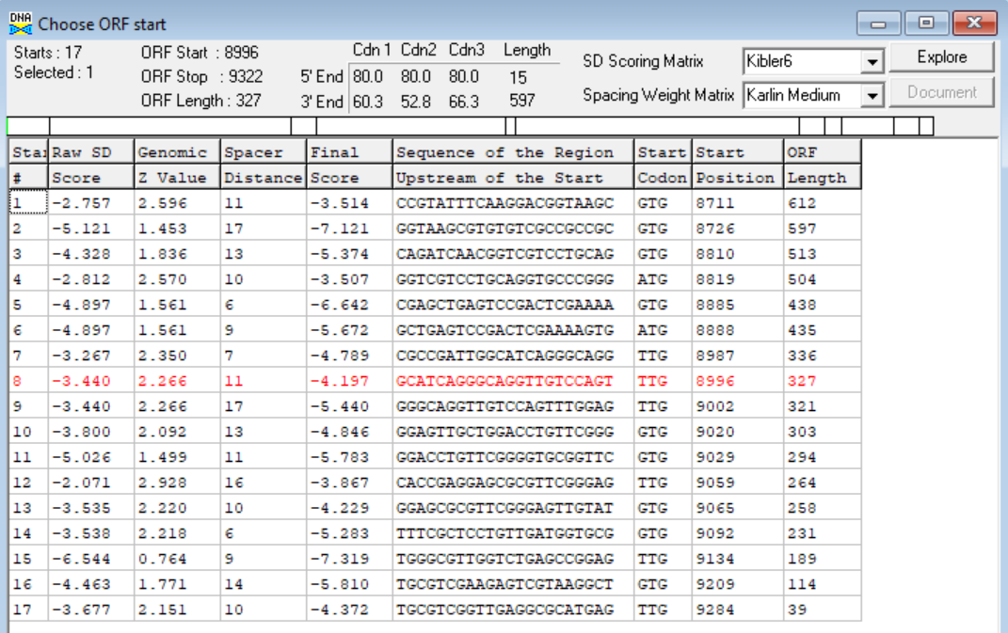
No RBS values given from the Hypothetical Frameshift ORF.
(https://toolkit.tuebingen.mpg.de/tools/hhpred) HHPRED vs PDB, SCOPe, pFam, and M. Tuberculosis. DNA Master’s predicted ORF.
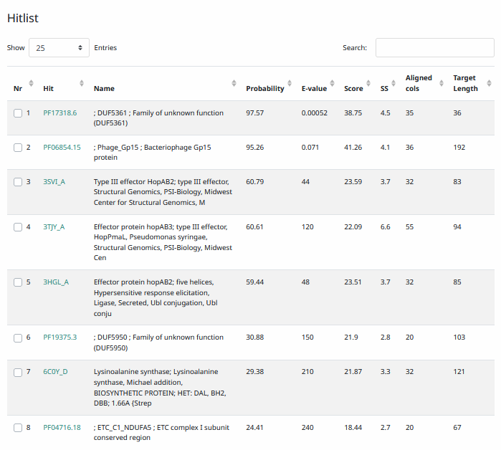
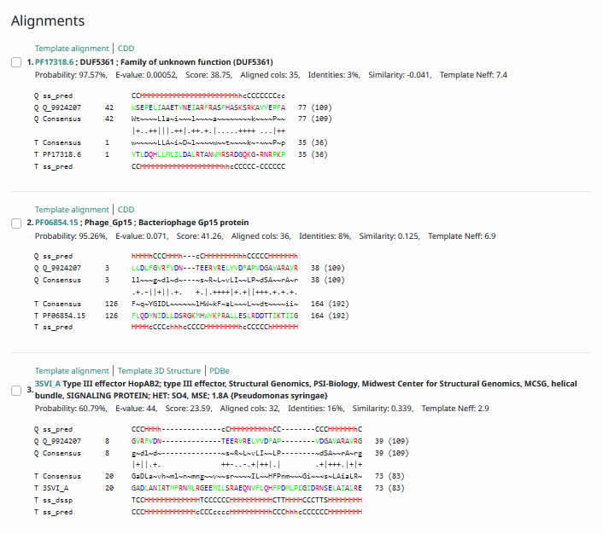
(https://toolkit.tuebingen.mpg.de/tools/hhpred) HHPRED vs PDB, SCOPe, pFam, and M. Tuberculosis.
Hypothetical Frameshift ORF.
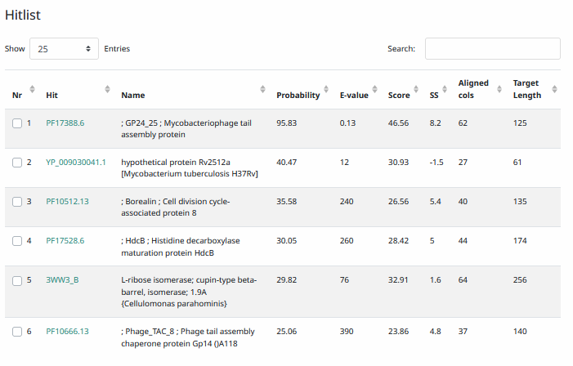
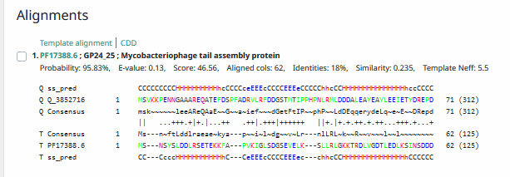
Phamerator Totinger Vs. Starcevich Vs. Tootsieroll (https://phamerator.org/phages) Genes 1-15
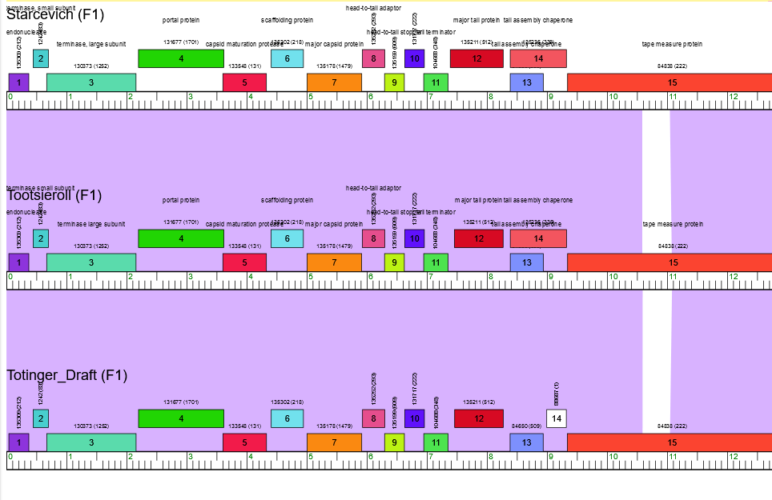
Proposed Function: tail assembly chaperone
Function Evidence: While HHPRED results were weak hits in both trials, the most consistent match among other BLASTs was the frameshift version of a tail assembly chaperone protein in other phages. Comparing Totinger’s gene to similar phages, Starcevich and Tootsieroll, the sequence is almost identical to these well-documented phages that are known to have the frameshift version of the gene.
Transmembrane Domain/Evidence (DNA Master): No, Intracellular Properties (https://dtu.biolib.com/DeepTMHMM)
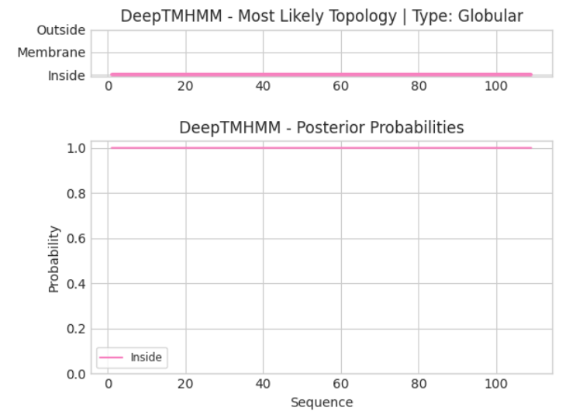
Transmembrane Domain/Evidence (Frameshift): No, Intracellular Properties (https://dtu.biolib.com/DeepTMHMM)
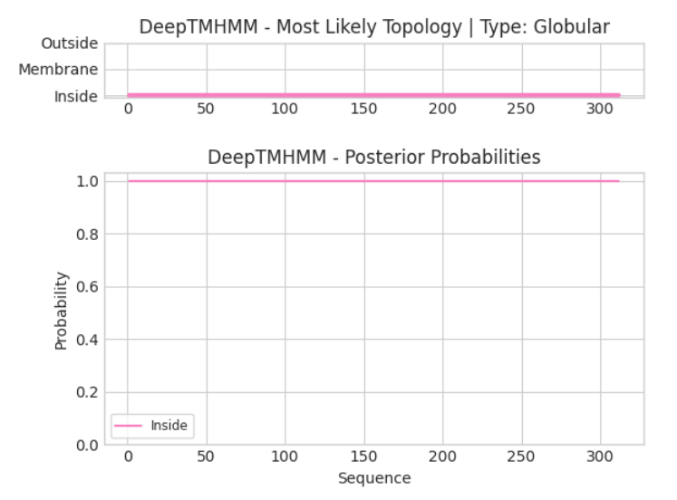

Gene Number: 15
Pham84838
BLAST from PhagesDB. (https://phagesdb.org/blastp/) Using Longest ORF
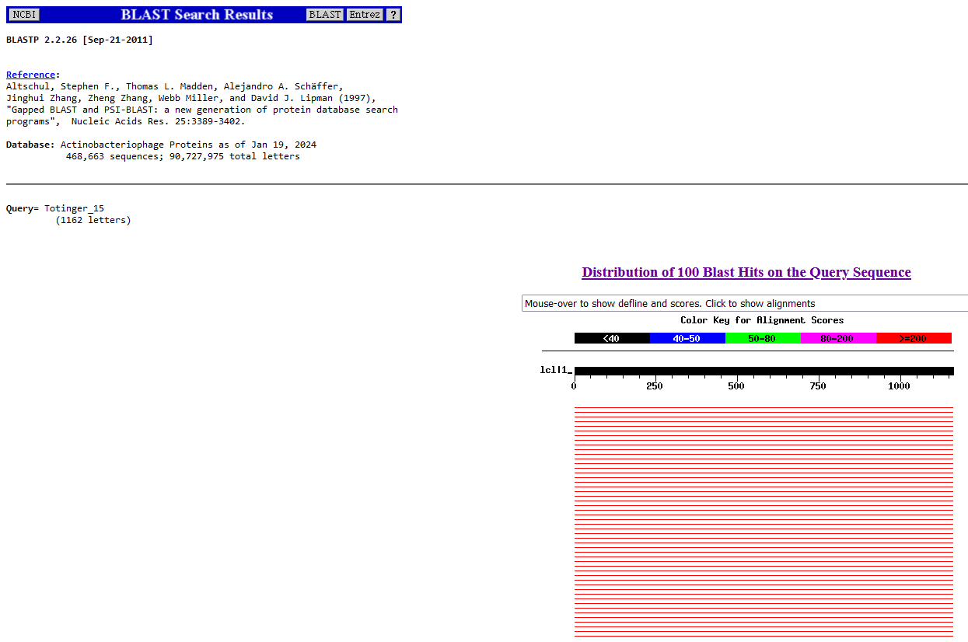
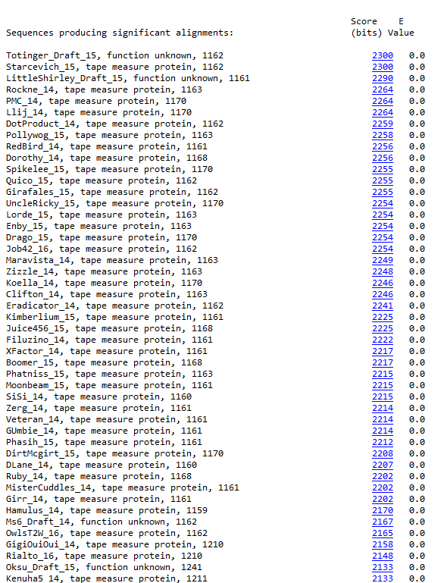
BLAST from NCBI (https://blast.ncbi.nlm.nih.gov/Blast.cgi?PAGE=Proteins) Using Longest ORF
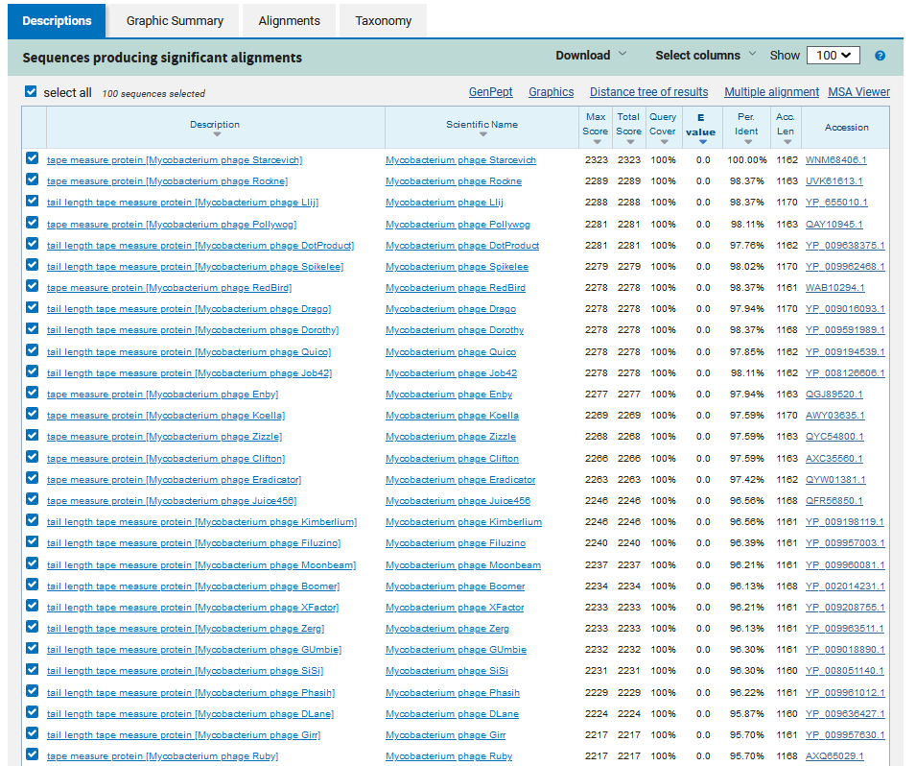
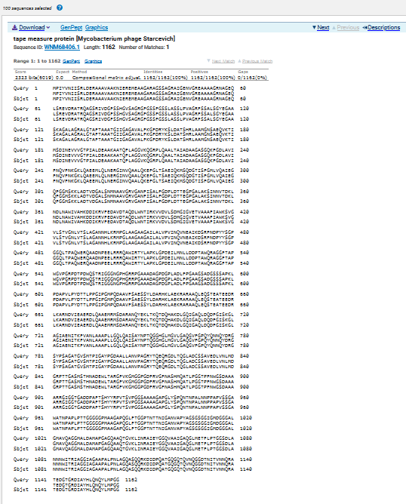
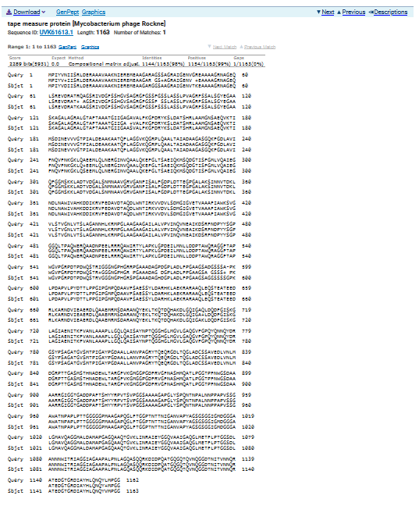
ATG Start at 9341. Original Glimmer call.
TAA Stop at 12829
F/R: F
Coding Potential (y/n): Y
Starterator (SS, NA, NI): Most annotated start is this (9341)
Blast Best Hit, Query:Subject Starts, Score, Evalue, or “no significant Blast alignments” if 10E-4 or higher
Tape measure protein Mycobacterium phage Starcevich WNM68406.1, 1:1, Score 2323, Evalue, 0
Gap with previous gene: 19
Longest Orf? (Y/N/NA) Y
RBS:
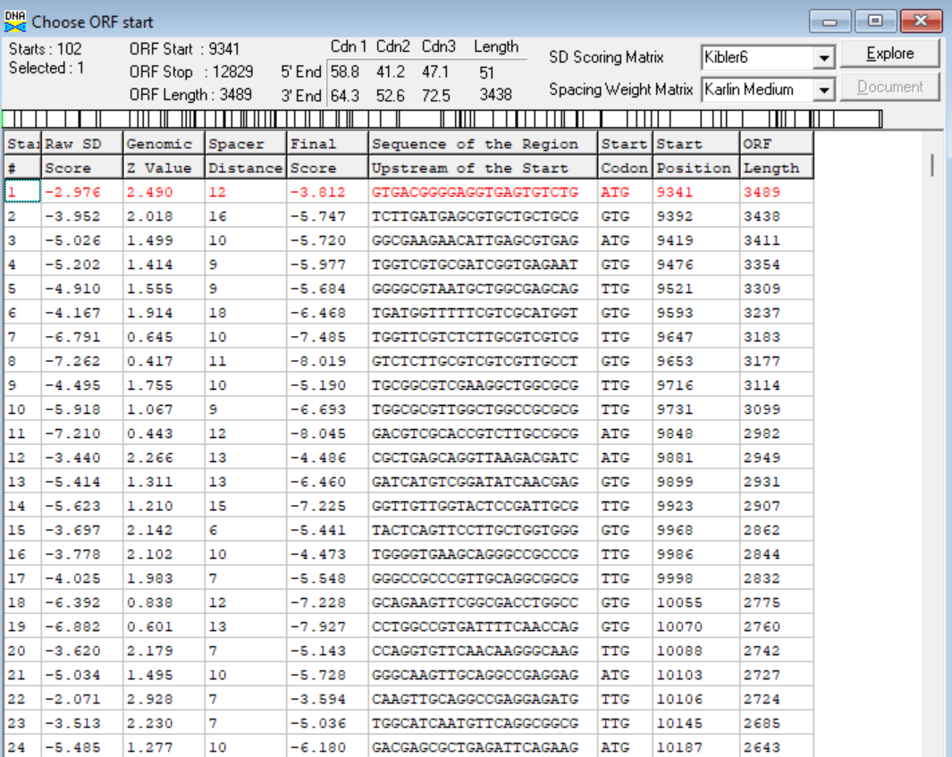
(https://toolkit.tuebingen.mpg.de/tools/hhpred) HHPRED vs PDB, SCOPe, pFam, and M. Tuberculosis. No significant hits (>95%).
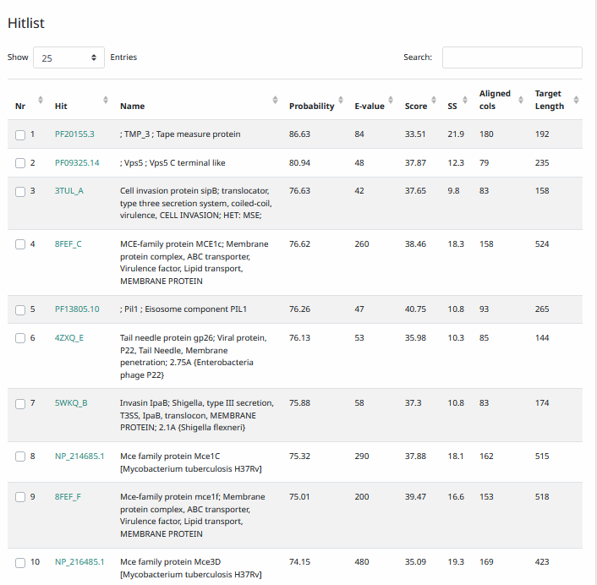
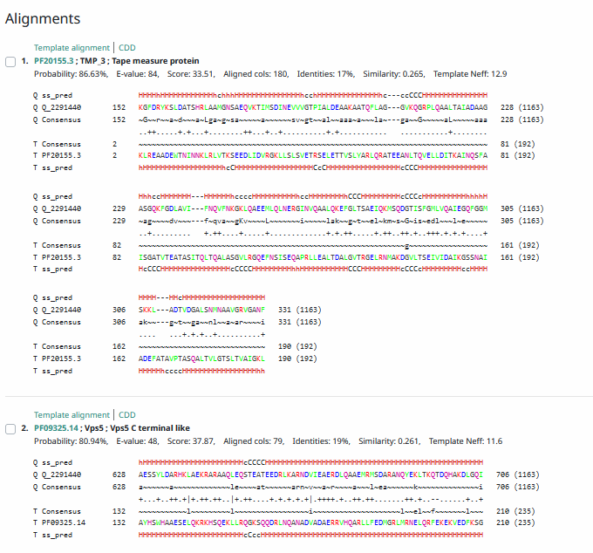
Phamerator Totinger Vs Starcevich (https://phamerator.org/phages) Genes 15-24
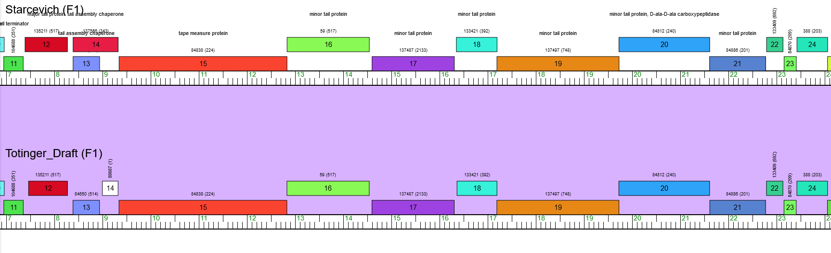
Proposed Function: tape measure protein
Function Evidence: BLAST results and Phamerator display near identical matches to tape measure proteins from other similar phages such as phage Starcevich.
Transmembrane Domain/Evidence: Yes, Membrane Properties at AA ~ 450 (https://dtu.biolib.com/DeepTMHMM)
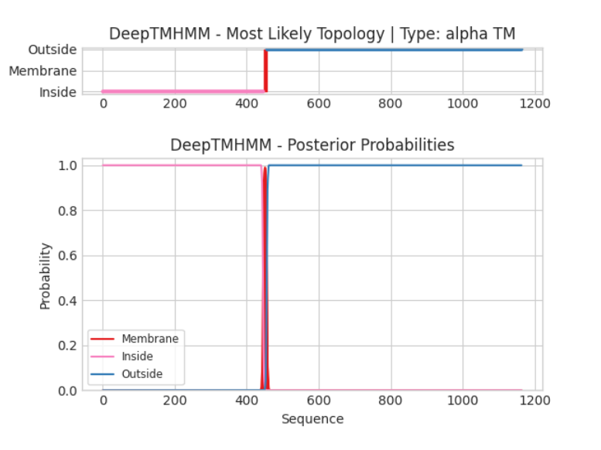

Gene Number: 16
Pham59
BLAST from PhagesDB. (https://phagesdb.org/blastp/) Using Longest ORF
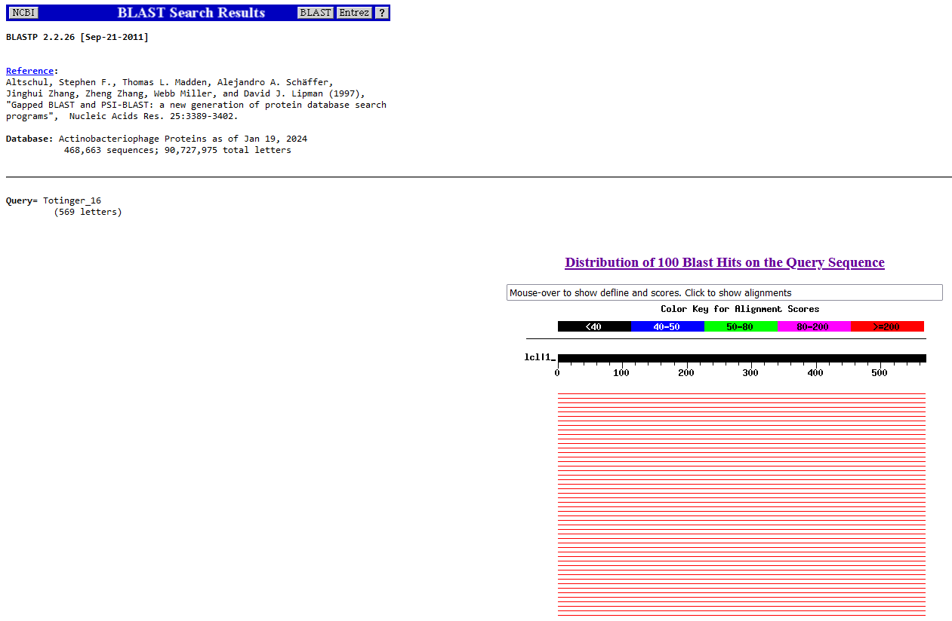
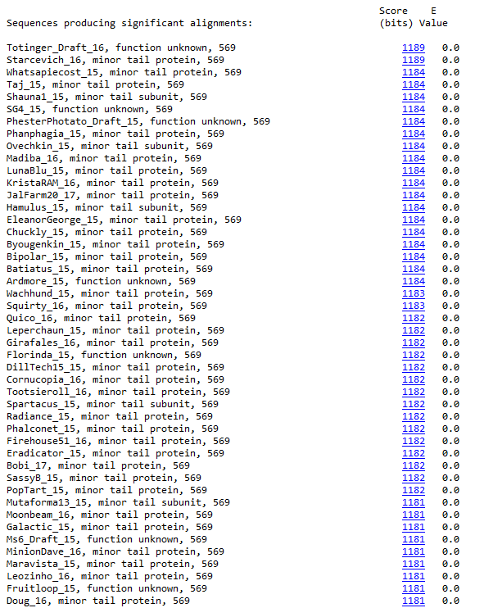
BLAST from NCBI (https://blast.ncbi.nlm.nih.gov/Blast.cgi?PAGE=Proteins) Using Longest ORF
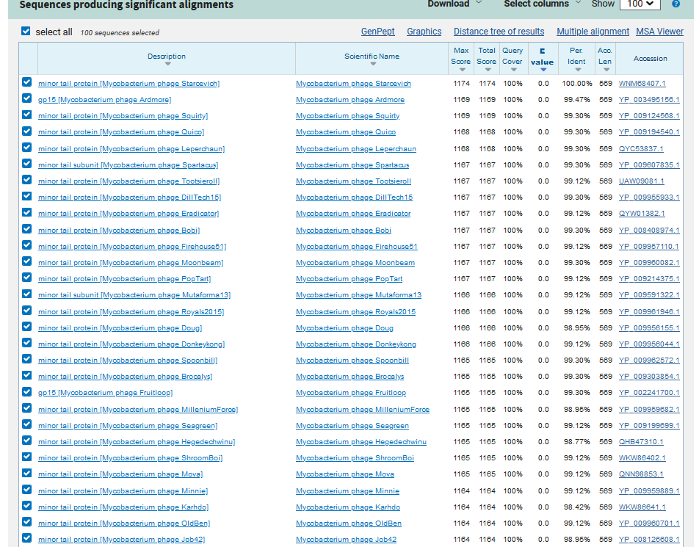
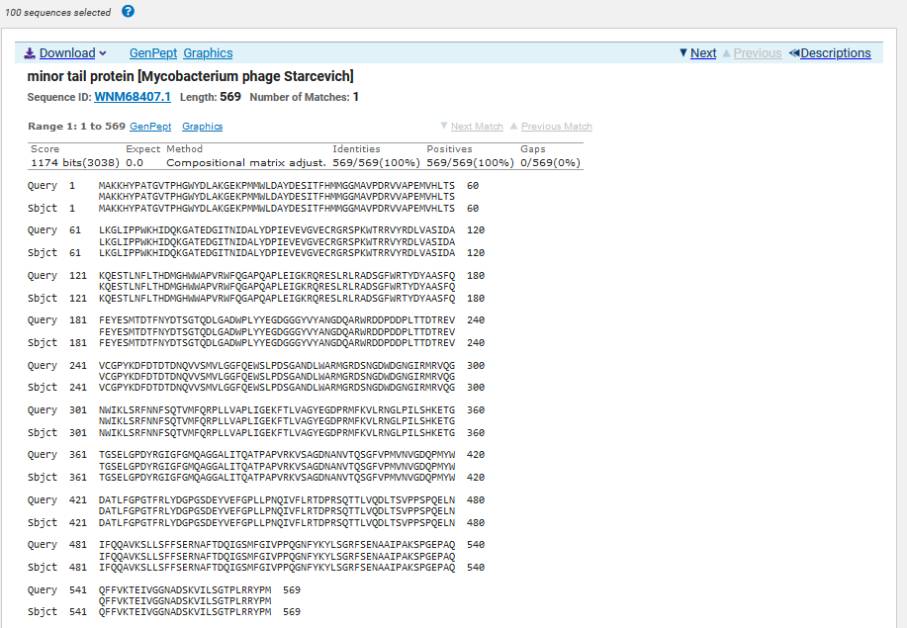
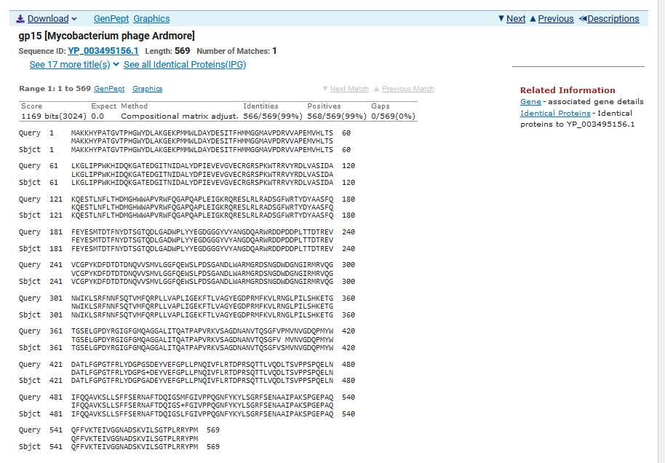
ATG Start at 12830. Original Glimmer call.
TAG Stop at 14539
F/R: F
Coding Potential (y/n): Y
Starterator (SS, NA, NI): Most annotated start is this (12830)
Blast Best Hit, Query:Subject Starts, Score, Evalue, or “no significant Blast alignments” if 10E-4 or higher
Minor tail protein Mycobacterium phage Starcevich YP_003495156.1, 1:1, Score 1169, Evalue, 0
Gap with previous gene: 1
Longest Orf? (Y/N/NA) Y
RBS:
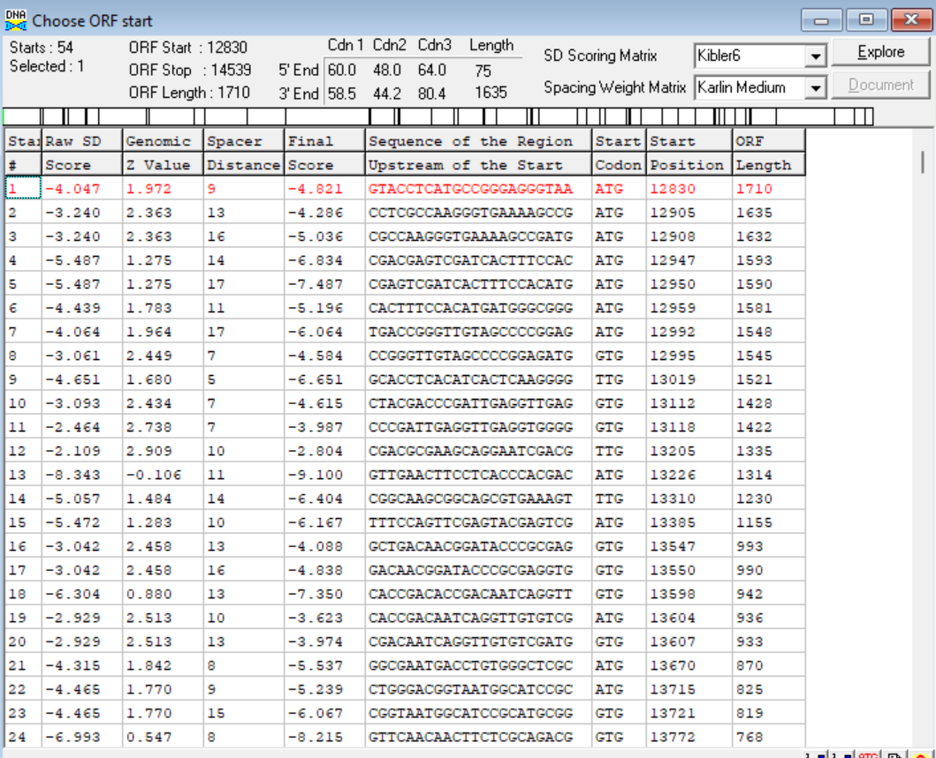
(https://toolkit.tuebingen.mpg.de/tools/hhpred) HHPRED vs PDB, SCOPe, pFam, and M. Tuberculosis.
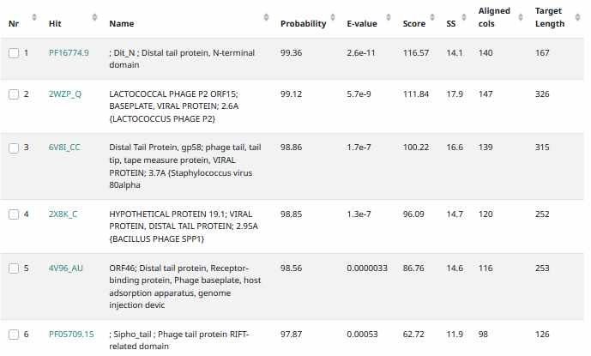
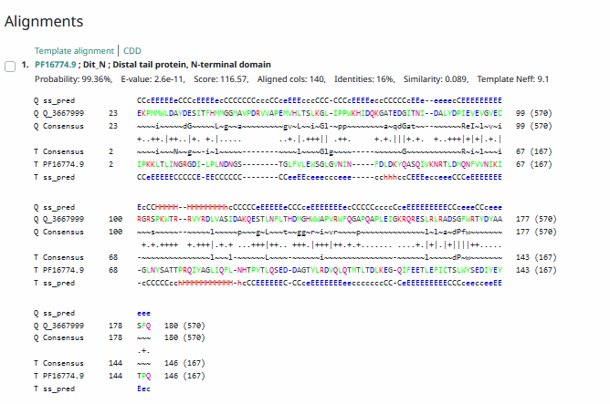
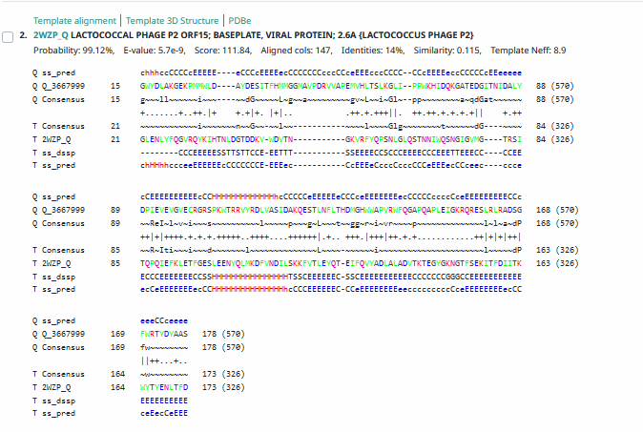
Phamerator Totinger Vs. Starcevich (https://phamerator.org/phages) Genes 15-24
Proposed Function: minor tail protein
Function Evidence: The most consistent match between BLASTs and Phamerator are minor tail proteins from similar phages. Additionally, the protein has glycine-rich areas that are expected from a minor tail protein.
Transmembrane Domain/Evidence: No, Extracellular Properties (https://dtu.biolib.com/DeepTMHMM)
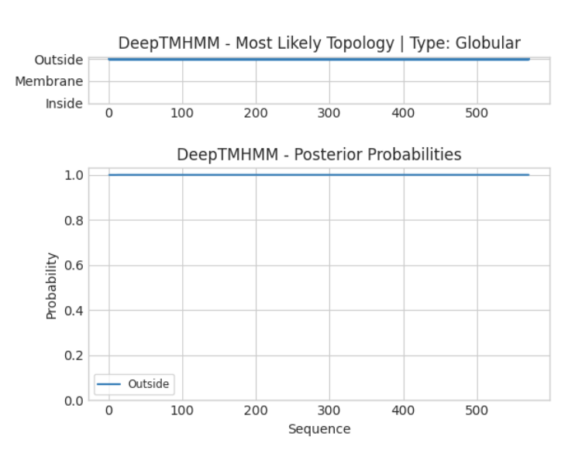

Gene Number: 17
Pham137487
BLAST from PhagesDB. (https://phagesdb.org/blastp/) Using Longest ORF
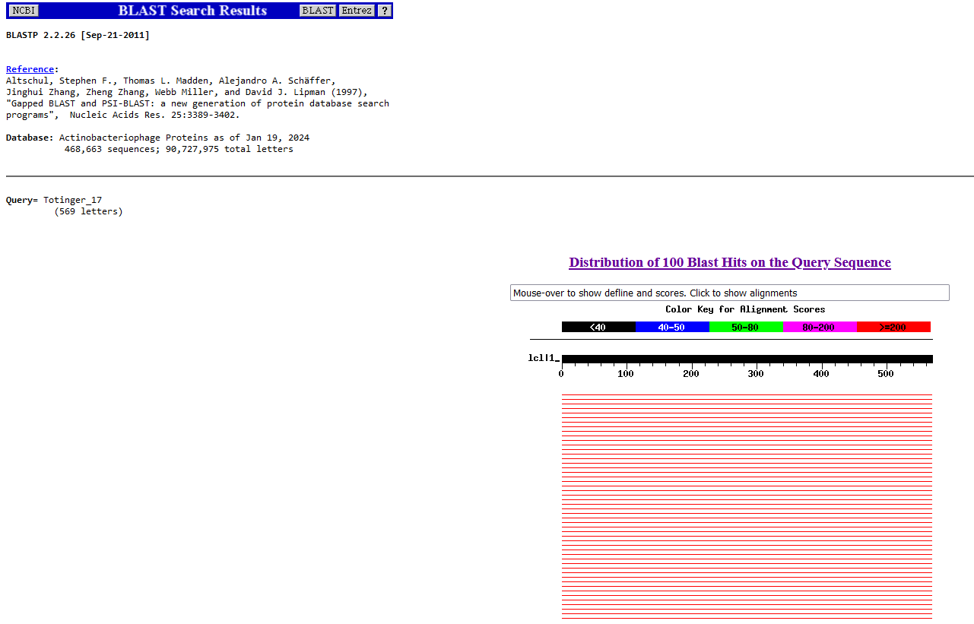
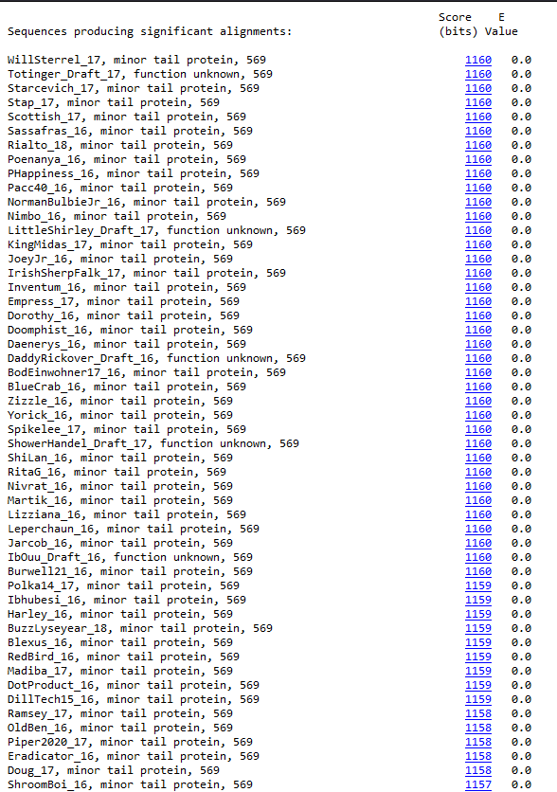
BLAST from NCBI (https://blast.ncbi.nlm.nih.gov/Blast.cgi?PAGE=Proteins) Using Longest ORF
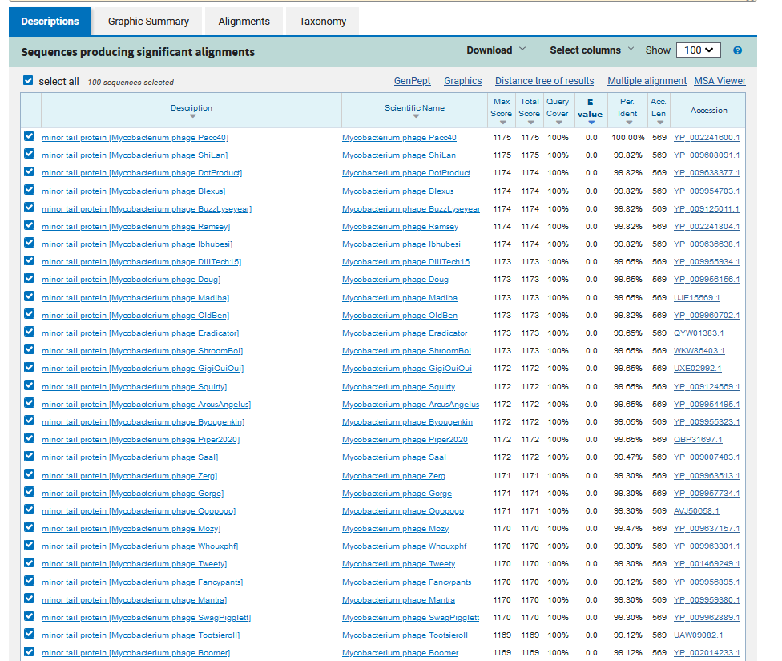
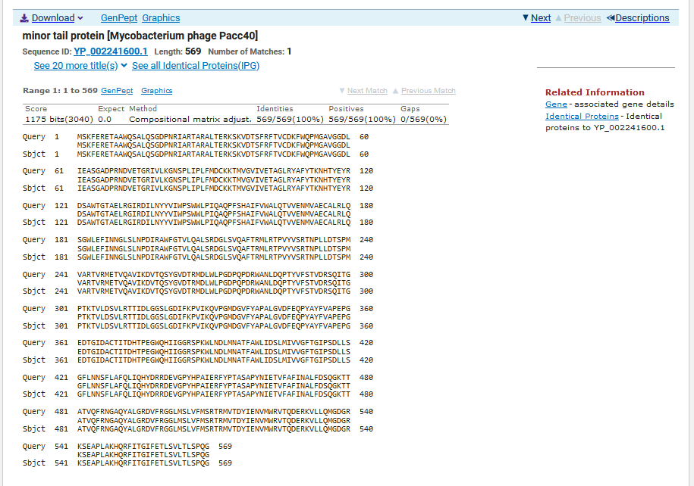
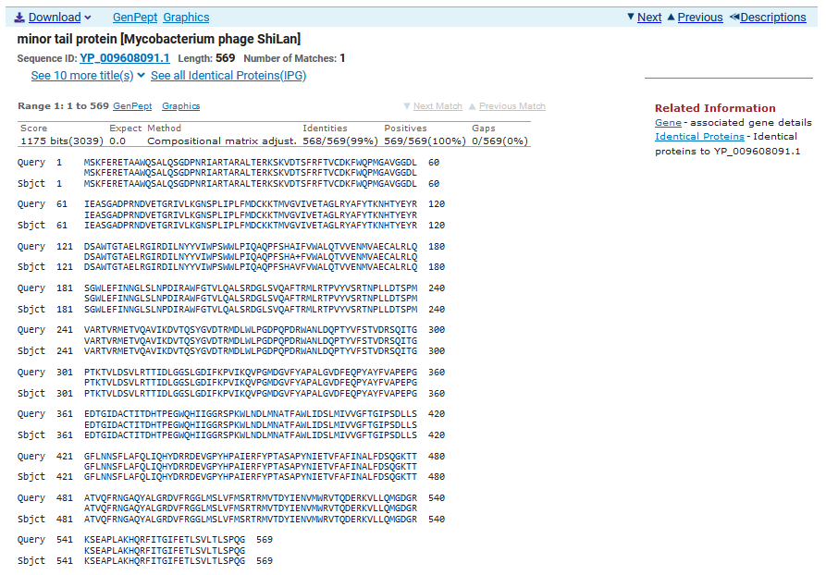
TTG Start at 14596. Original Glimmer call.
TGA Stop at 16305
F/R: F
Coding Potential (y/n): Y
Starterator (SS, NA, NI): Not the Most Annotated Start.
Blast Best Hit, Query:Subject Starts, Score, Evalue, or “no significant Blast alignments” if 10E-4 or higher
Minor tail protein Mycobacterium phage Pacc40 YP_002241600.1, 1:1, Score 1175, Evalue, 0
Gap with previous gene: 57
Longest Orf? (Y/N/NA) Y
RBS:
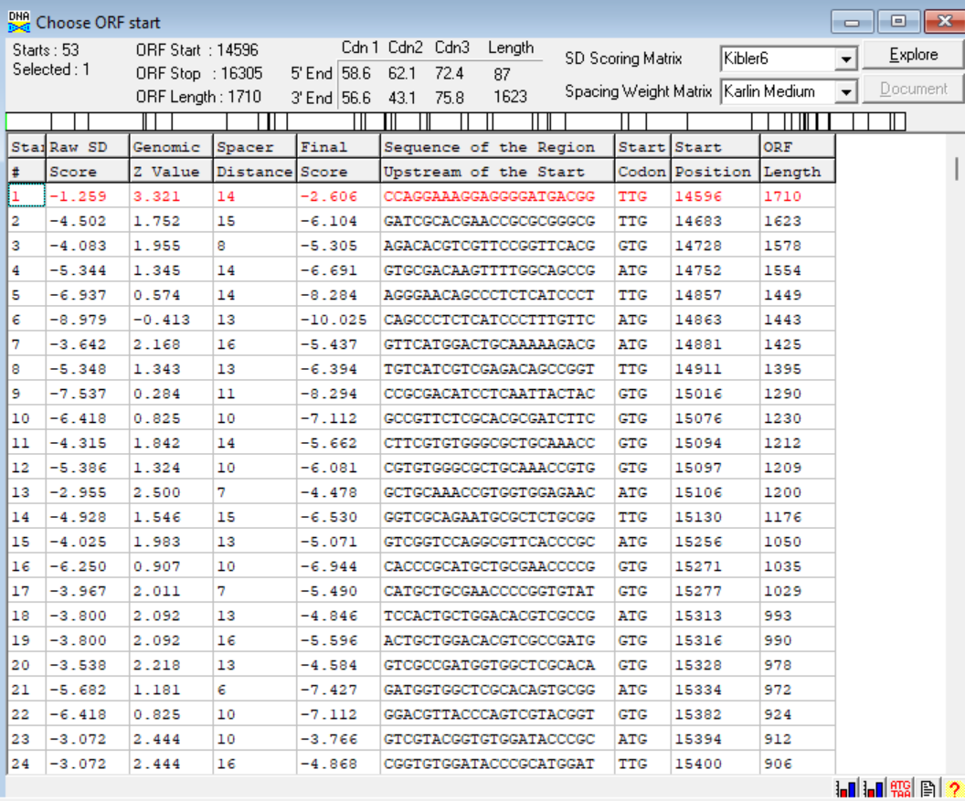
(https://toolkit.tuebingen.mpg.de/tools/hhpred) HHPRED vs PDB, SCOPe, pFam, and M. Tuberculosis.
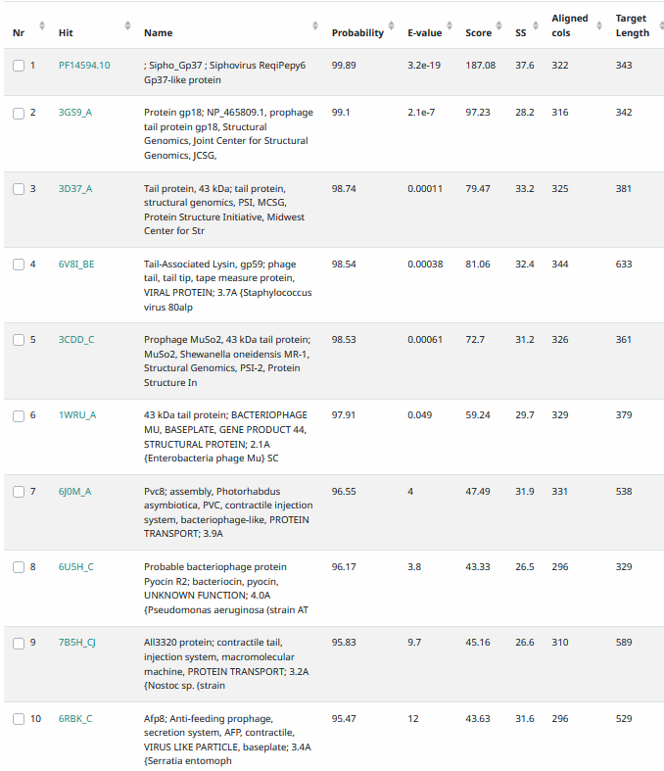
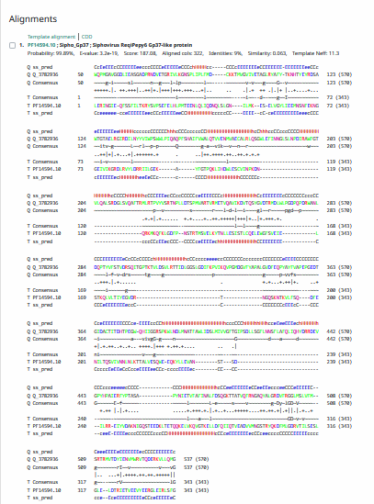
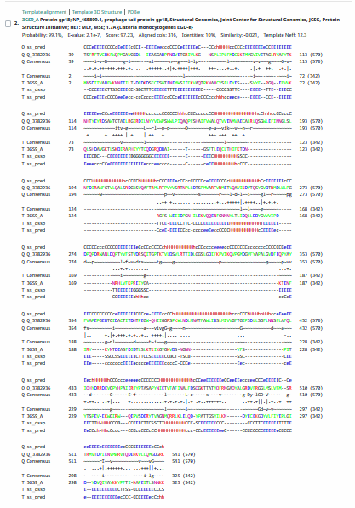
Phamerator Totinger Vs. Tootsieroll and Starcevich (https://phamerator.org/phages) Genes 15-24
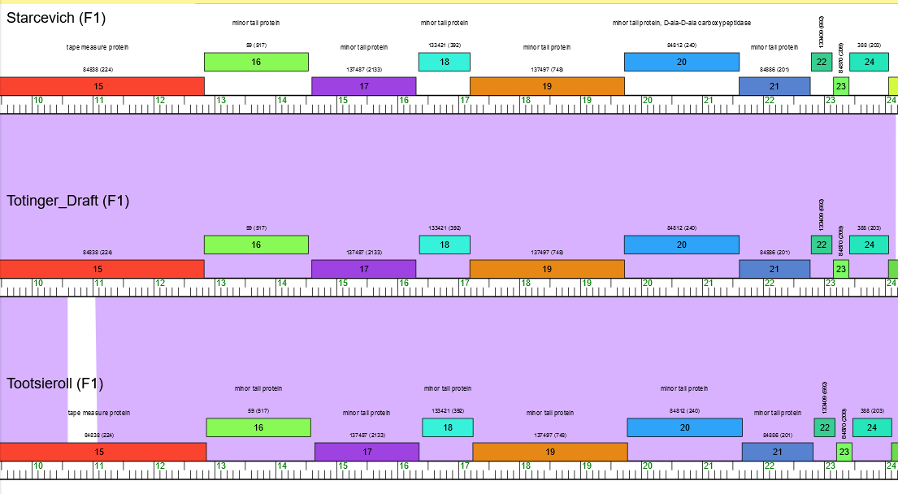
Proposed Function: minor tail protein
Function Evidence: this gene is identical to minor tail protein genes from other phages, and most consistently matched in BLASTs to other minor tail protein genes. It also matches the expected HHPRED results from a minor tail protein.
Transmembrane Domain/Evidence: No, Extracellular Properties (https://dtu.biolib.com/DeepTMHMM)
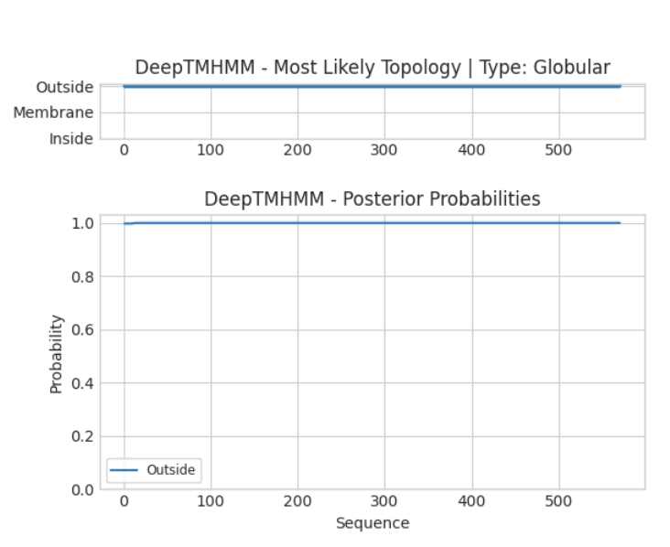

Gene Number: 18
Pham133421
BLAST from PhagesDB. (https://phagesdb.org/blastp/) Using Longest ORF
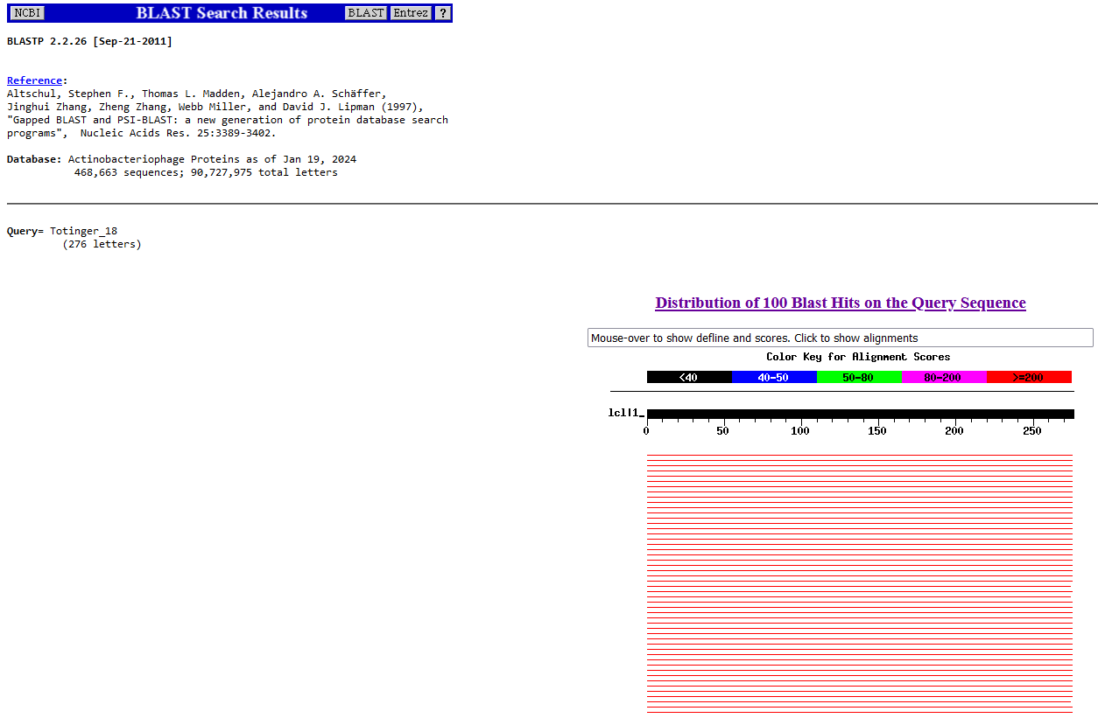
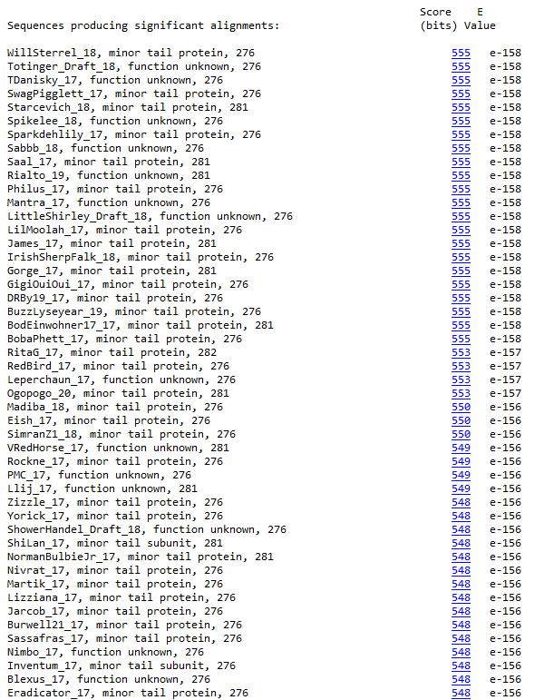
BLAST from NCBI (https://blast.ncbi.nlm.nih.gov/Blast.cgi?PAGE=Proteins) Using Longest ORF
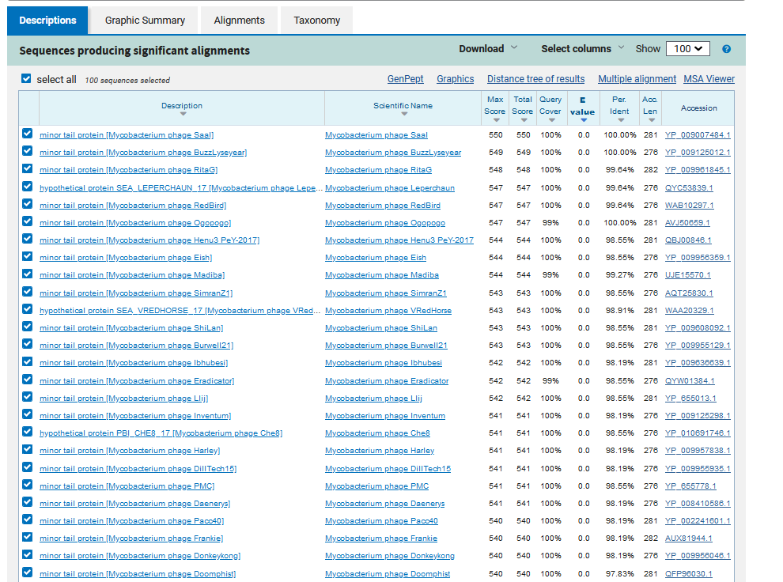
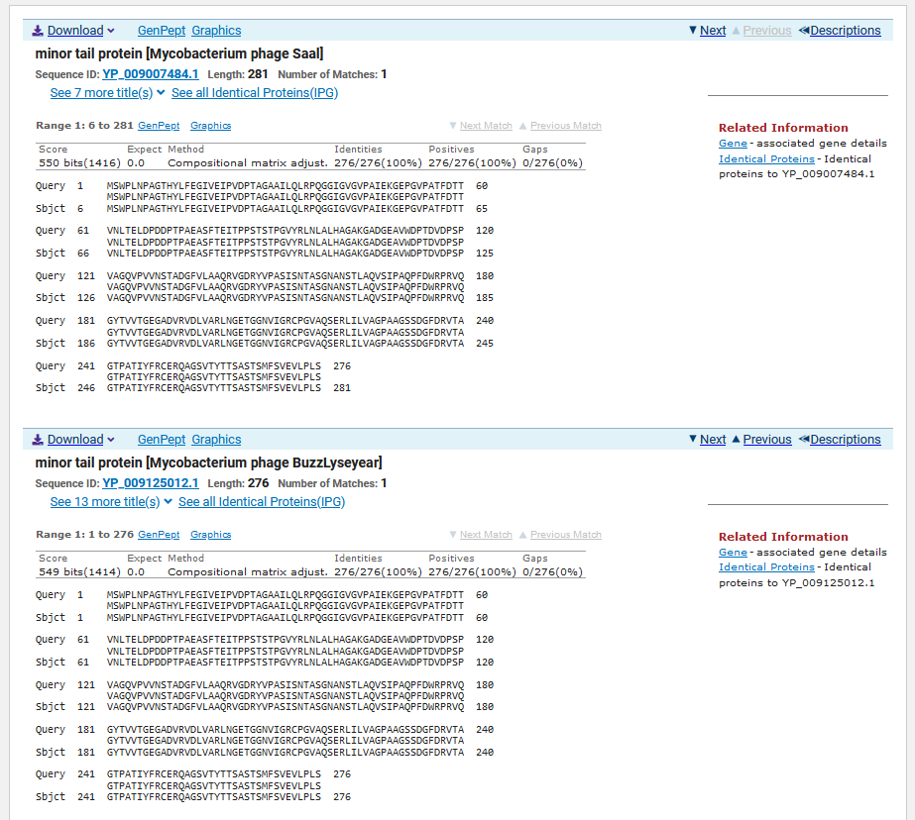
ATG Start at 16362. Original Glimmer call.
TGA Stop at 17192
F/R: F
Coding Potential (y/n): Y
Starterator (SS, NA, NI): Most annotated start is this (16362)
Blast Best Hit, Query:Subject Starts, Score, Evalue, or “no significant Blast alignments” if 10E-4 or higher
Minor tail protein Mycobacterium phage Saal YP_009007484.1, 1:1, Score 550, Evalue, 0
Gap with previous gene: 57
Longest Orf? (Y/N/NA) Y
RBS:
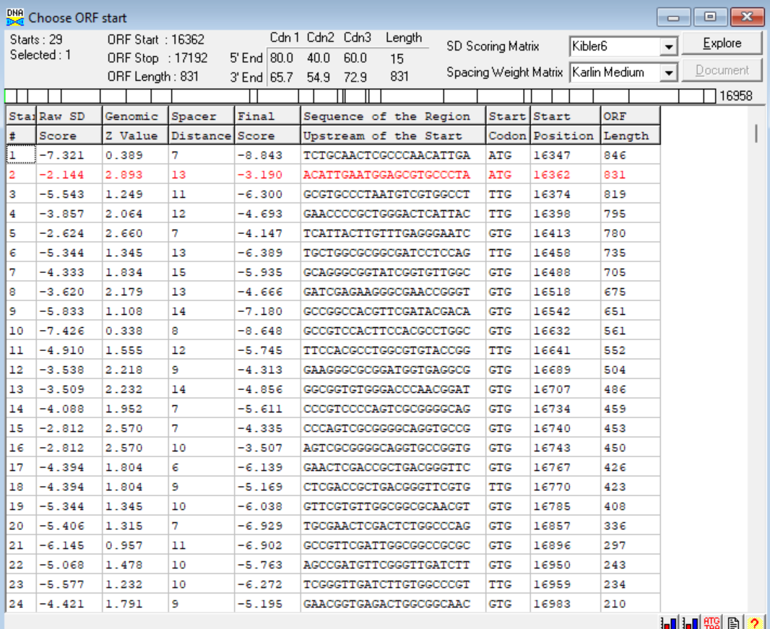
(https://toolkit.tuebingen.mpg.de/tools/hhpred) HHPRED vs PDB, SCOPe, pFam, and M. Tuberculosis. No Major (>95%) Hits.
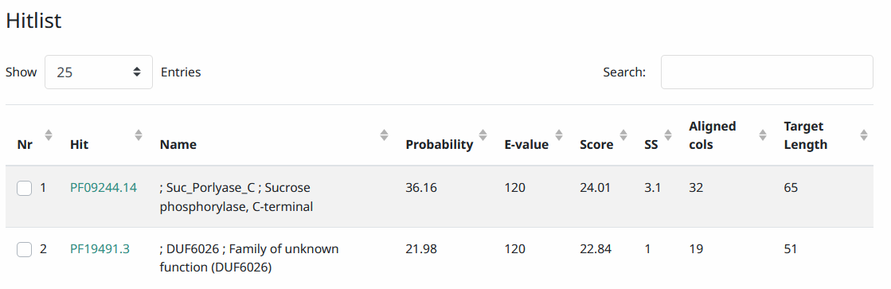
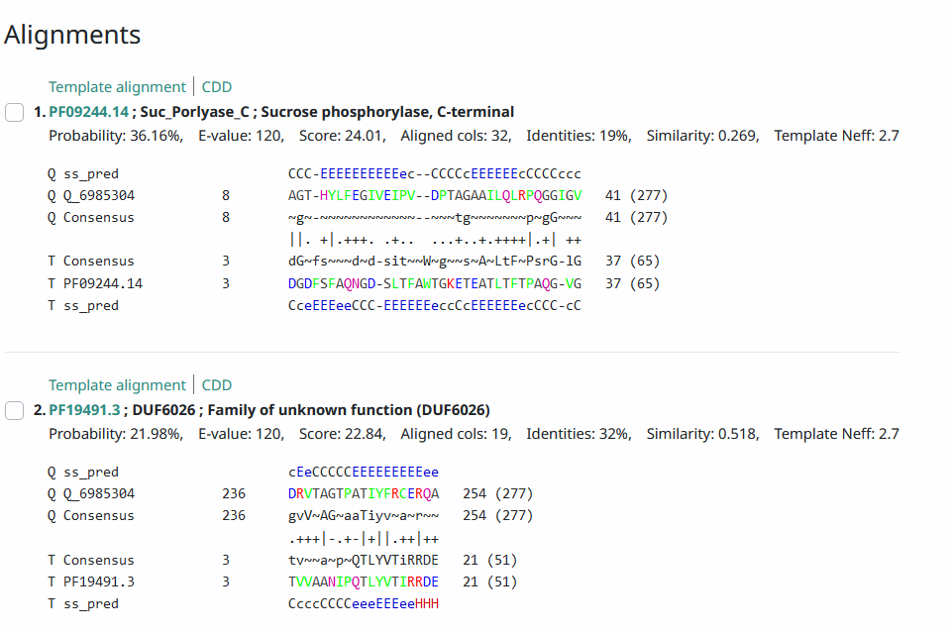
Phamerator Totinger Vs. Tootsieroll and Starcevich (https://phamerator.org/phages) Genes 15-24
Proposed Function: minor tail protein
Function Evidence: Despite HHPRED results not matching SEA PHAGES expectations, the most consistent BLAST hit and Phamerator match is a minor tail protein.
Transmembrane Domain/Evidence: No, Extracellular Properties (https://dtu.biolib.com/DeepTMHMM)
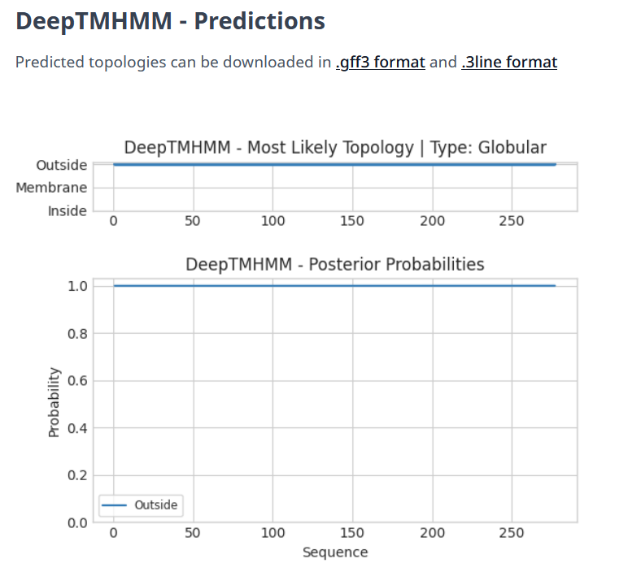

Gene Number: 19
Pham137497
BLAST from PhagesDB. (https://phagesdb.org/blastp/) Using Longest ORF
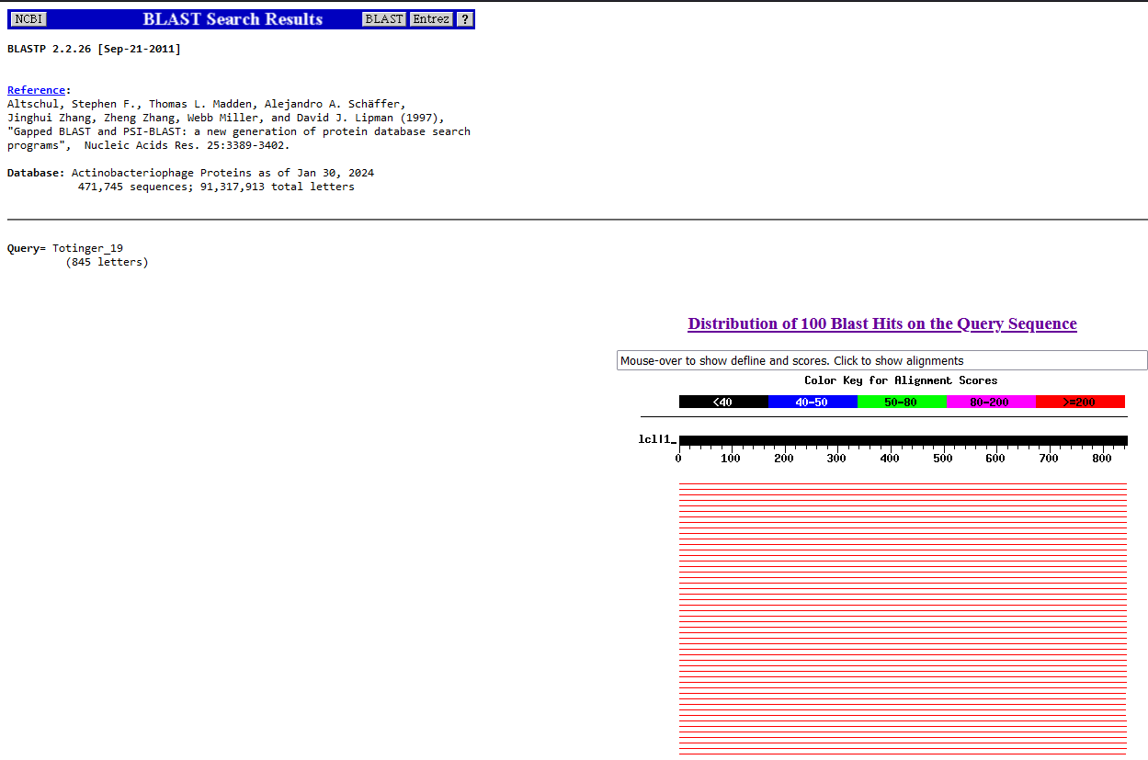
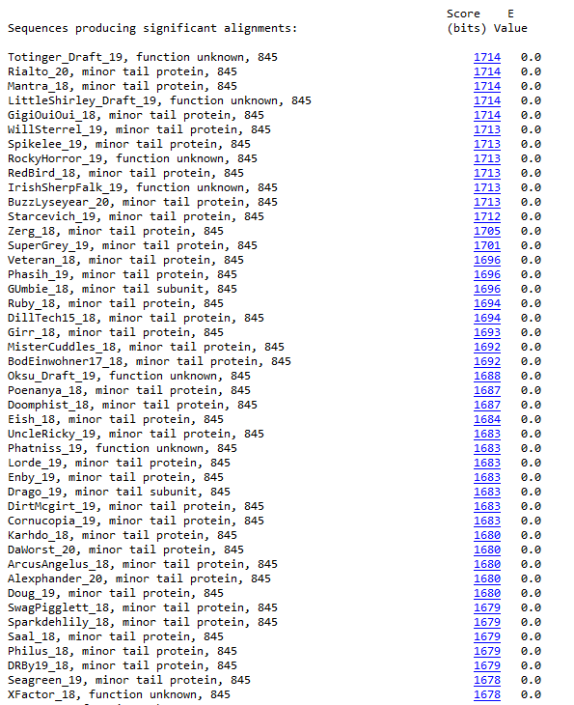
BLAST from NCBI (https://blast.ncbi.nlm.nih.gov/Blast.cgi?PAGE=Proteins) Using Longest ORF
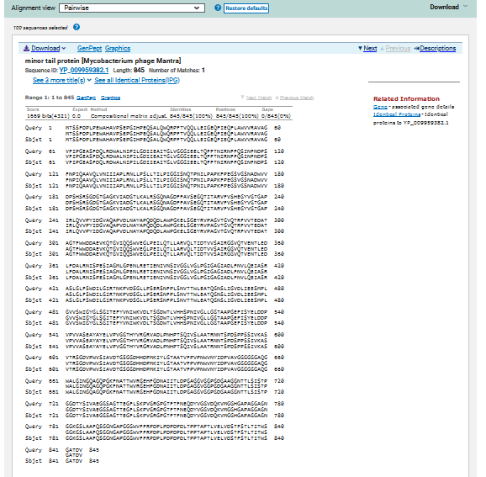
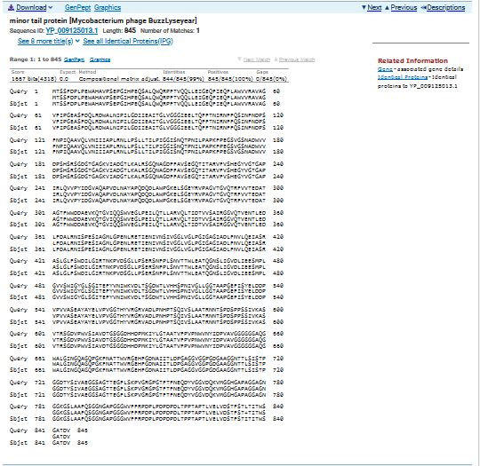
ATG Start at 17189. Original Glimmer call.
TGA Stop at 19726
F/R: F
Coding Potential (y/n): Y
Starterator (SS, NA, NI): Most annotated start is this (17189)
Blast Best Hit, Query:Subject Starts, Score, Evalue, or “no significant Blast alignments” if 10E-4 or higher
Minor tail protein Mycobacterium phage Mantra YP_009959382.1, 1:1, Score 1669, Evalue, 0
Gap with previous gene: -3
Longest Orf? (Y/N/NA) Y
RBS:
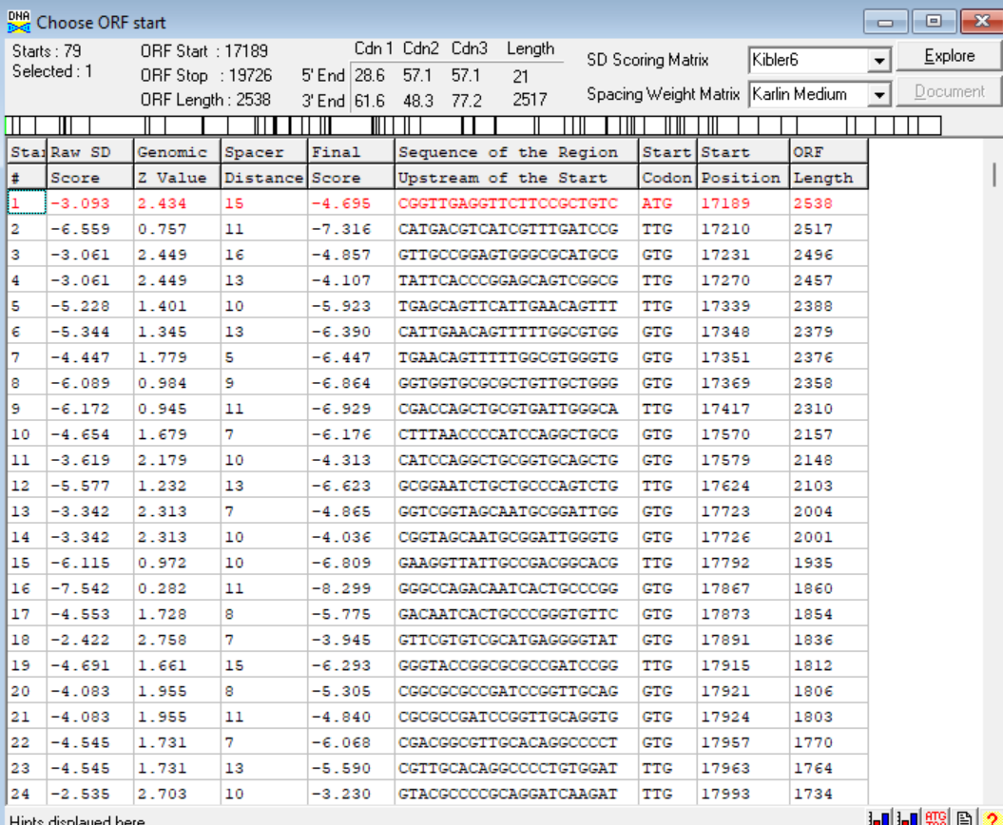
(https://toolkit.tuebingen.mpg.de/tools/hhpred) HHPRED vs PDB, SCOPe, pFam, and M. Tuberculosis.
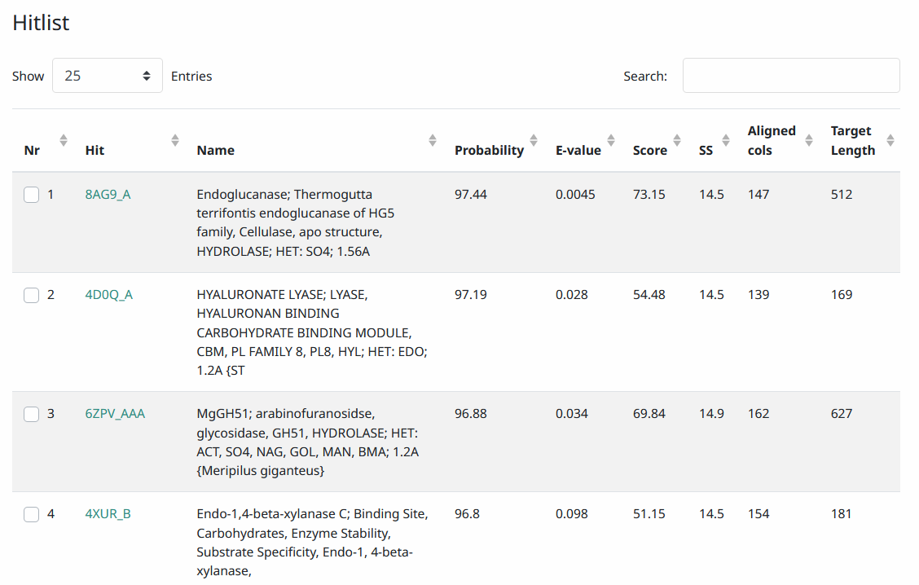
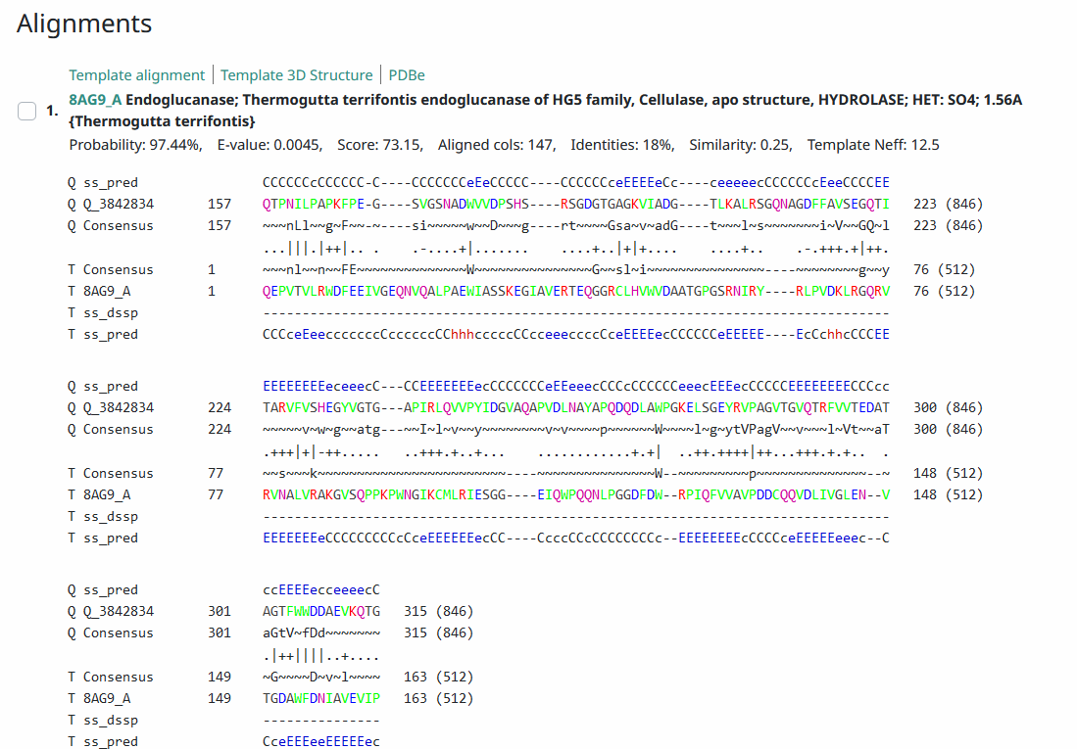
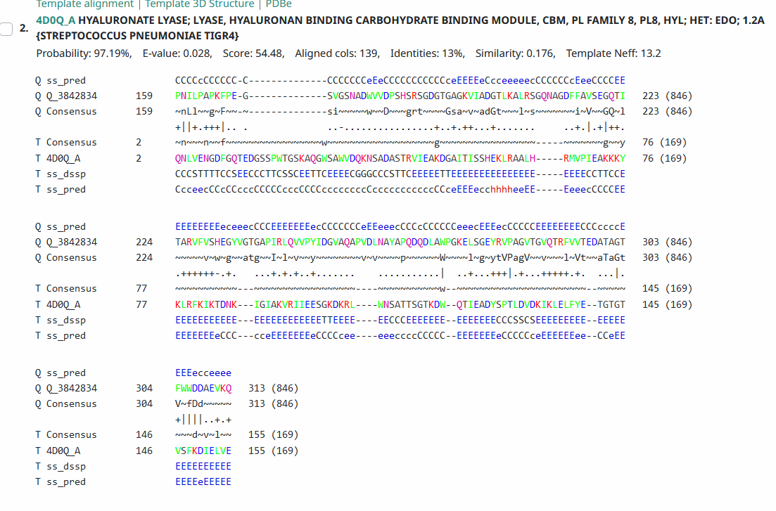
Phamerator Totinger Vs. Tootsieroll and Starcevich (https://phamerator.org/phages) Genes 15-24
Proposed Function: minor tail protein
Function Evidence: this gene is near identical to phage Tootsieroll’s and phage Starcevich’s known minor tail protein genes. Additionally, BLAST results most consistently match with minor tail proteins from other phages.
Transmembrane Domain/Evidence: Yes, Signaling Properties at AA 1-30 (https://dtu.biolib.com/DeepTMHMM)
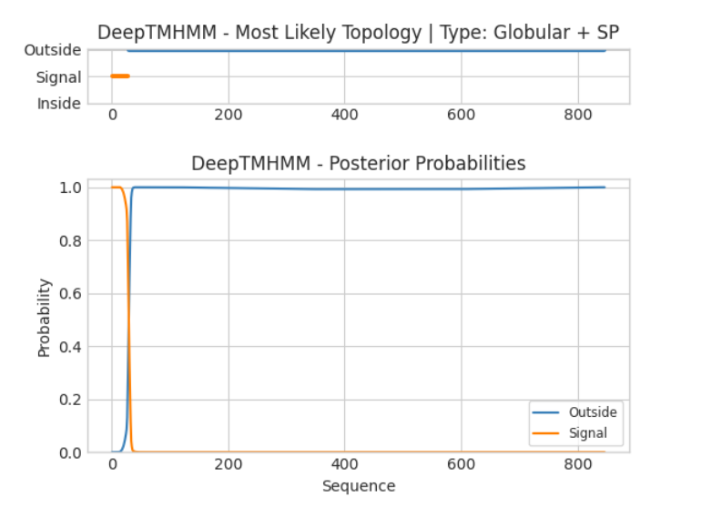

Gene Number: 20
Pham84812
BLAST from PhagesDB. (https://phagesdb.org/blastp/) Using Longest ORF
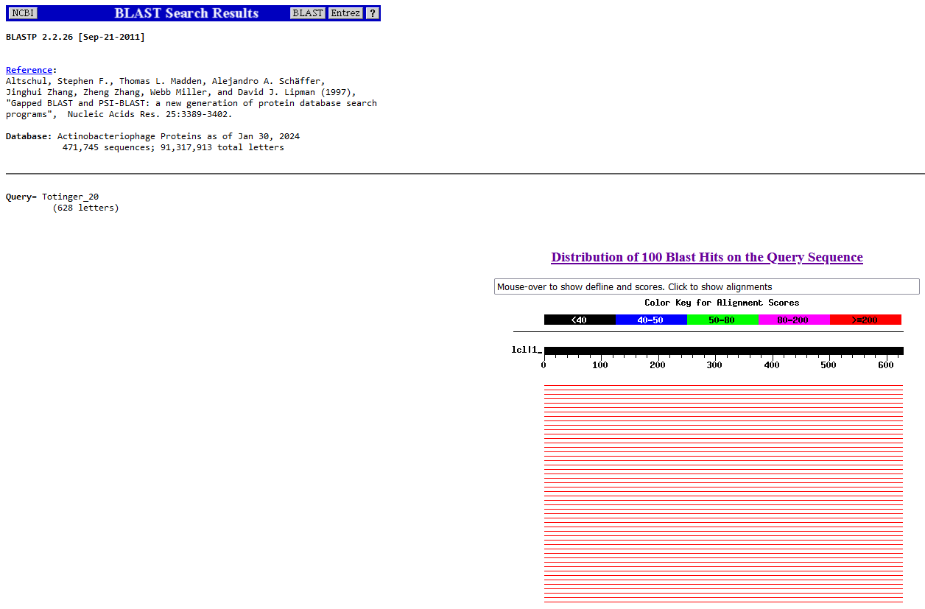
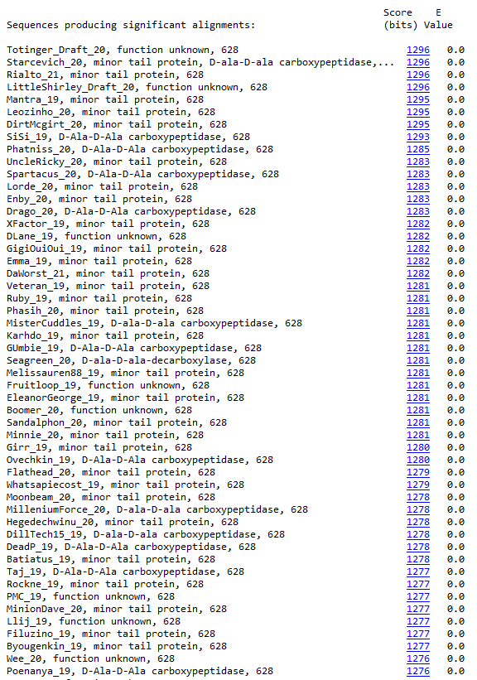
BLAST from NCBI (https://blast.ncbi.nlm.nih.gov/Blast.cgi?PAGE=Proteins) Using Longest ORF
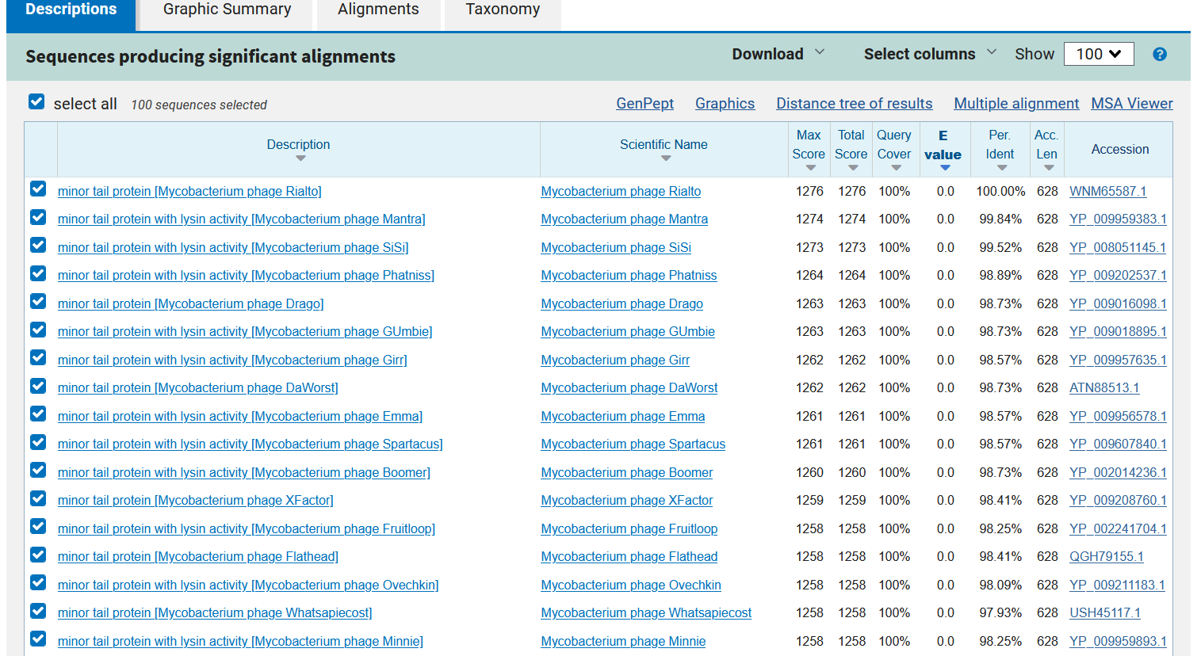
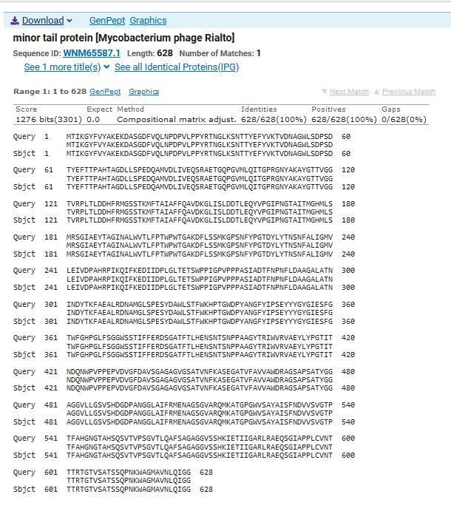
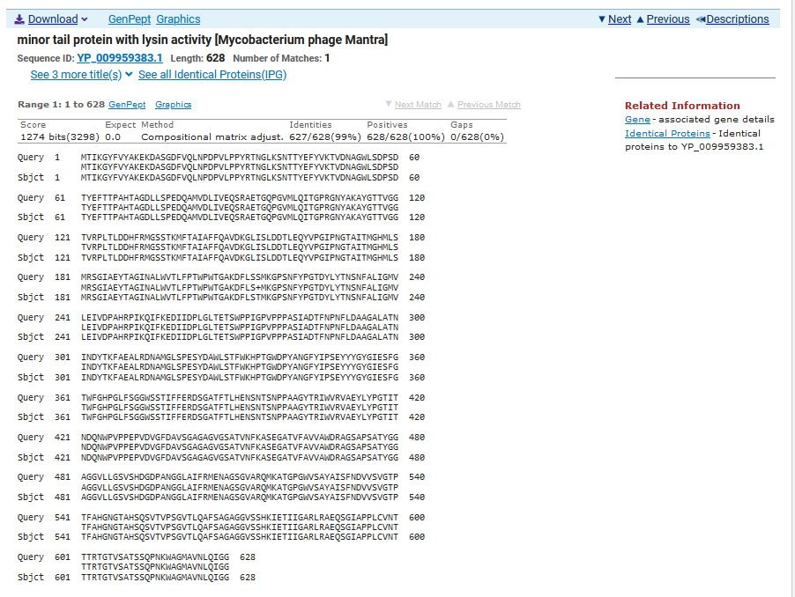
ATG Start at 19723. Original Glimmer call.
TGA Stop at 21609
F/R: F
Coding Potential (y/n): Y
Starterator (SS, NA, NI): Most annotated start is this (19723)
Blast Best Hit, Query:Subject Starts, Score, Evalue, or “no significant Blast alignments” if 10E-4 or higher
Minor tail protein Mycobacterium phage Rialto WNM65587.1, 1:1, Score 1276, Evalue, 0
Gap with previous gene: -3
Longest Orf? (Y/N/NA) Y
RBS:
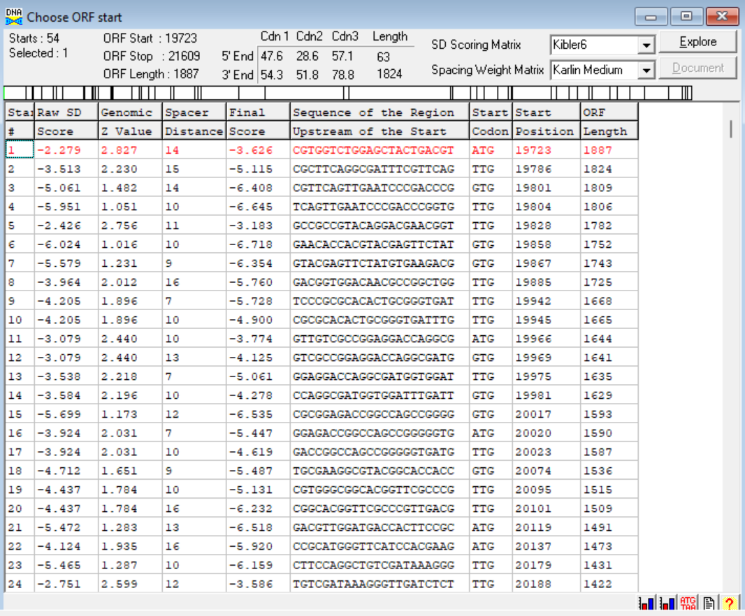
(https://toolkit.tuebingen.mpg.de/tools/hhpred) HHPRED vs PDB, SCOPe, pFam, and M. Tuberculosis.
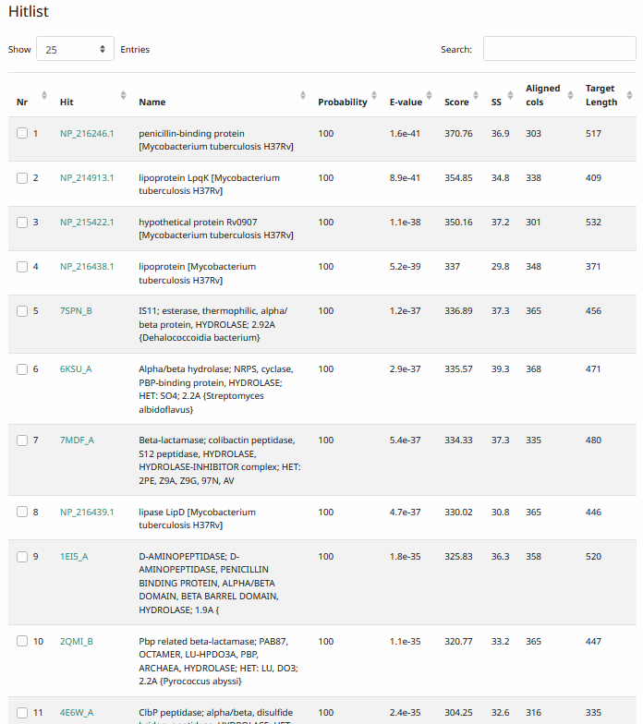
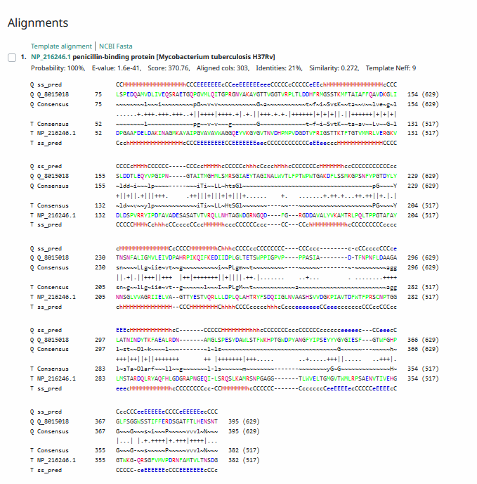
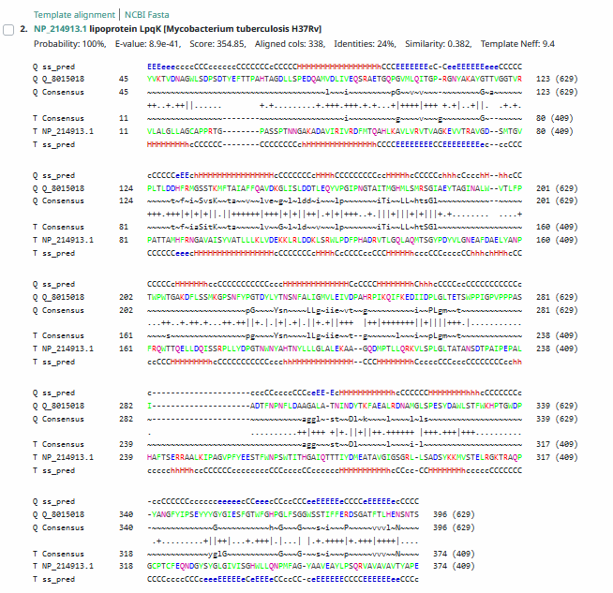
Phamerator Totinger Vs. Tootsieroll and Starcevich (https://phamerator.org/phages) Genes 15-24
Proposed Function: minor tail protein, D-ala-D-ala carboxypeptidase
Function Evidence: This gene had a couple of consistent BLAST results; it was either hit as a minor tail protein, or hit as D-ala-D-ala carboxypeptidase. HHPRED displayed that this protein has penicillin-binding properties, consistent with the properties of D-ala-D-ala carboxypeptidase.
Transmembrane Domain/Evidence: No, Extracellular Properties (https://dtu.biolib.com/DeepTMHMM)
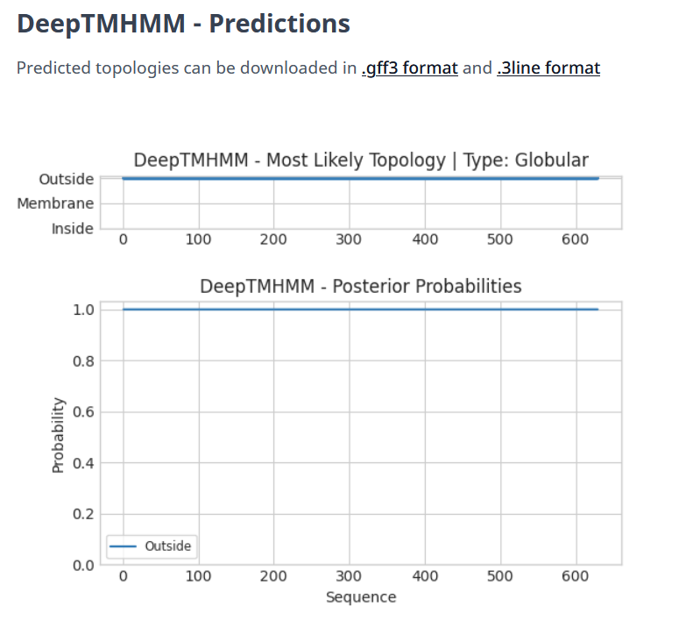

Edited Next Gene from DNA Master’s original call.
Gene Number: 21
Pham84886
BLAST from PhagesDB. (https://phagesdb.org/blastp/) Using Longest ORF
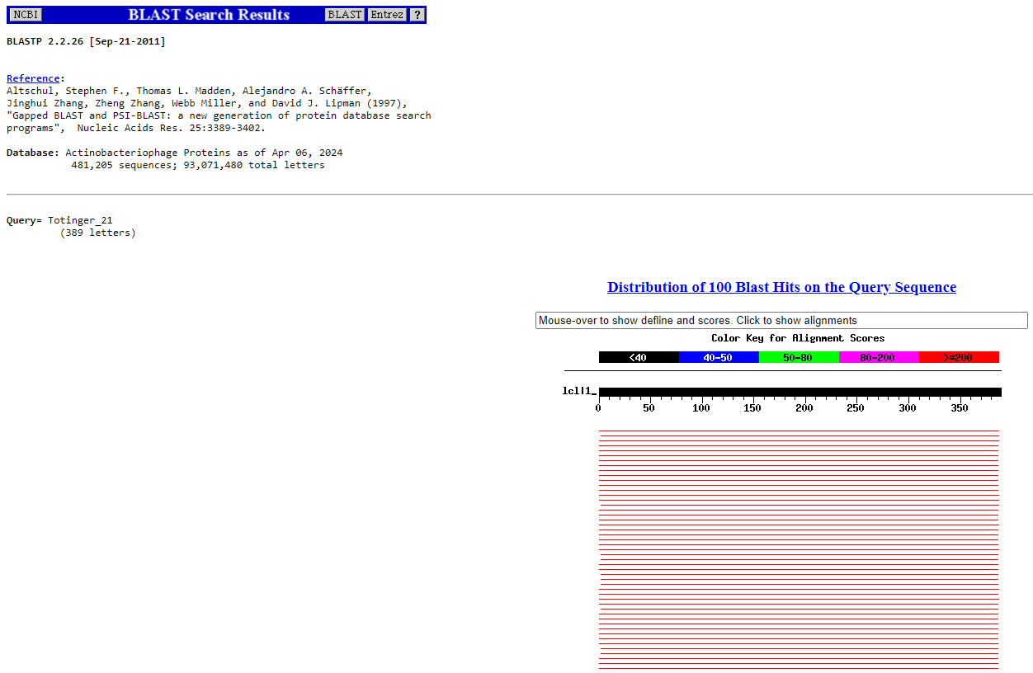
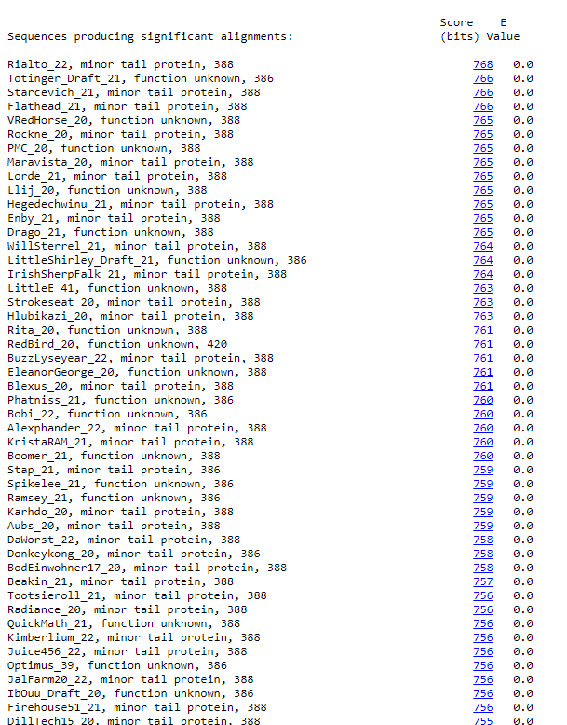
BLAST from NCBI (https://blast.ncbi.nlm.nih.gov/Blast.cgi?PAGE=Proteins) Using Longest ORF
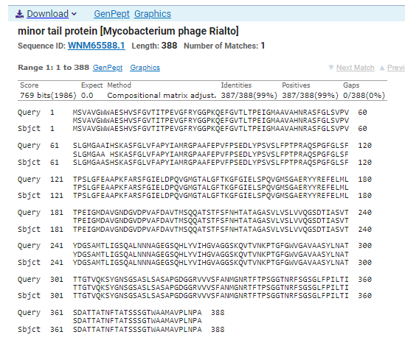
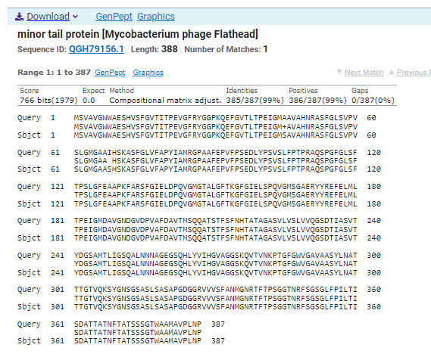
ATG Start at 21606. Original Genemark call. Glimmer calls start at 21612.
TAA Stop at 22772
F/R: F
Coding Potential (y/n): Y
Starterator (SS, NA, NI): Most Annotated Start is This (21606).
Blast Best Hit, Query:Subject Starts, Score, Evalue, or “no significant Blast alignments” if 10E-4 or higher
Minor tail protein Mycobacterium phage Rialto WNM65588.1, 1:1, Score 769, Evalue, 0
Gap with previous gene: -3
Longest Orf? (Y/N/NA) Y
RBS:
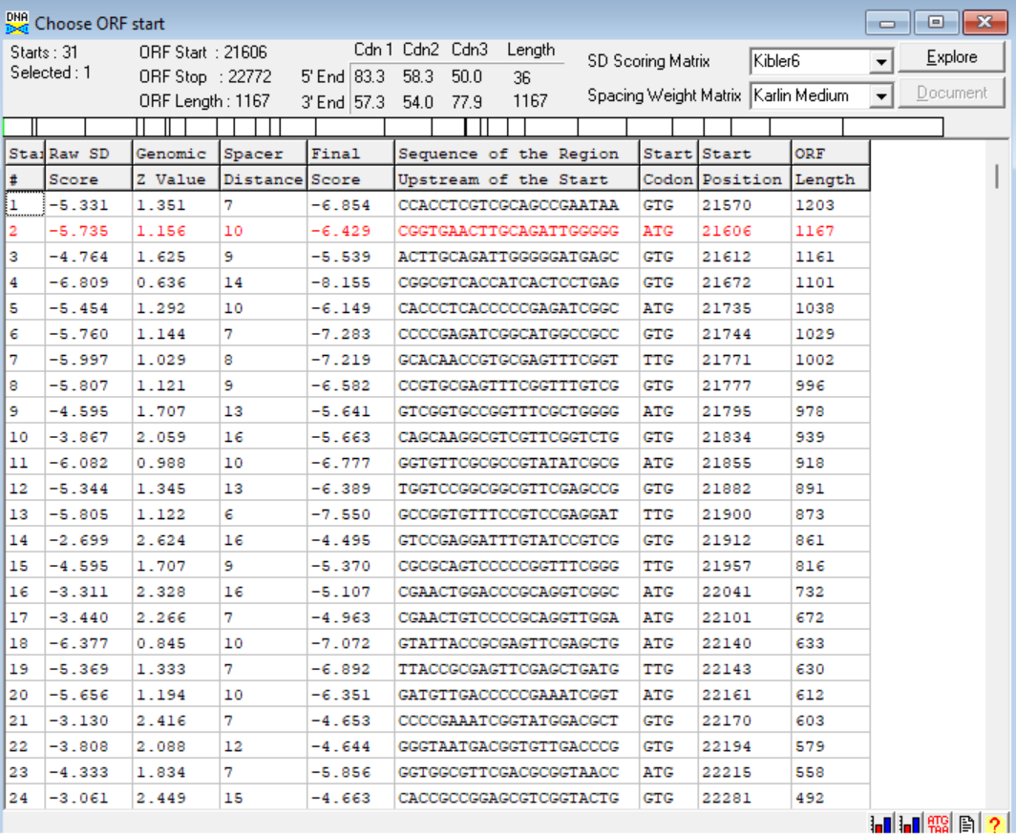
(https://toolkit.tuebingen.mpg.de/tools/hhpred) HHPRED vs PDB, SCOPe, pFam, and M. Tuberculosis. No significant (>95%) hits.
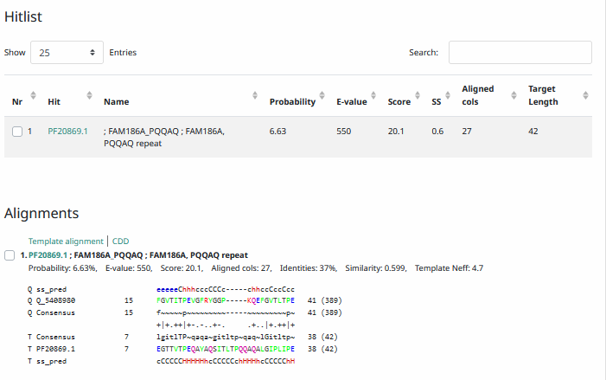
Phamerator Totinger Vs. Tootsieroll and Starcevich (https://phamerator.org/phages) Genes 15-24
Proposed Function: minor tail protein
Function Evidence: Despite HHPRED not showing any significant hits to match a minor tail protein call, this gene is near identical to both phage Tootsieroll and phage Starcevich, which are both called as minor tail proteins. Additionally, the most common functional BLAST result was a minor tail protein.
Transmembrane Domain/Evidence: No, Extracellular Properties (https://dtu.biolib.com/DeepTMHMM)
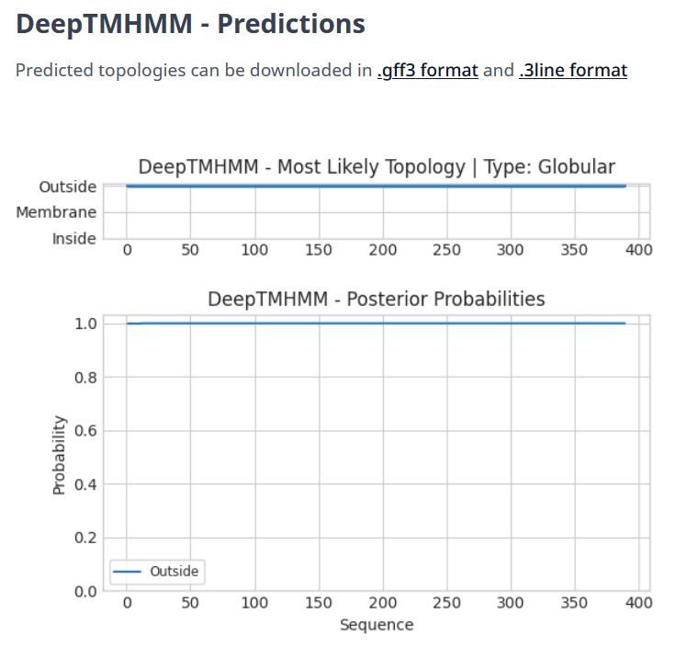

Gene Number: 22
Pham133409
BLAST from PhagesDB. (https://phagesdb.org/blastp/)
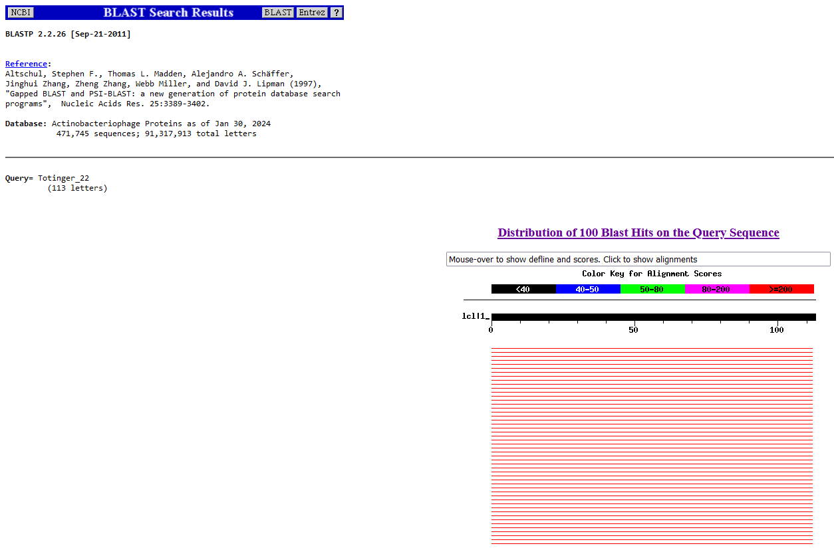
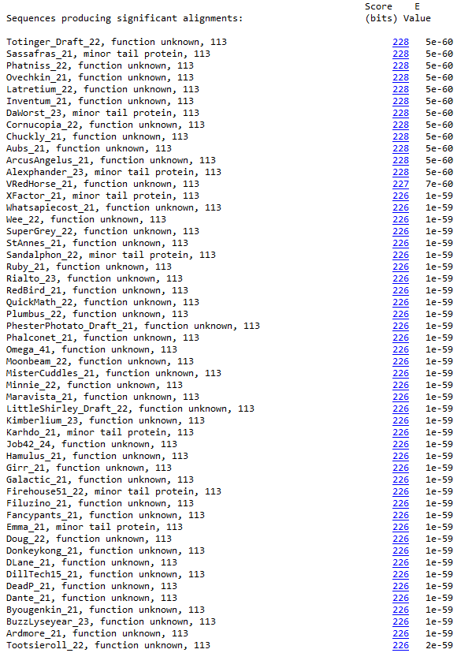
BLAST from NCBI (https://blast.ncbi.nlm.nih.gov/Blast.cgi?PAGE=Proteins)
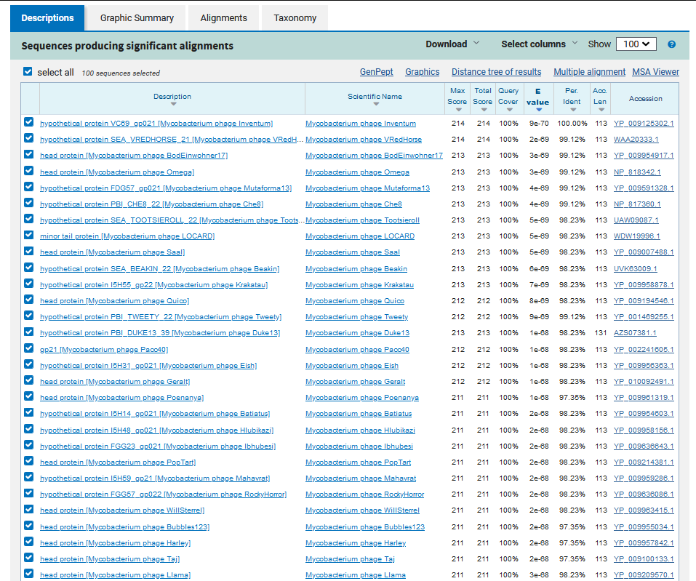
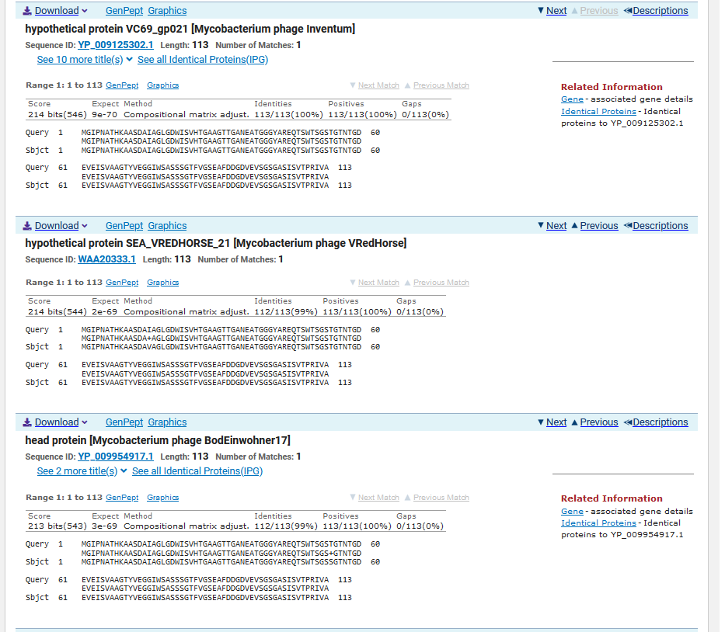
ATG Start at 22790. Original Glimmer call.
TGA Stop at 23131
F/R: F
Coding Potential (y/n): Y
Starterator (SS, NA, NI): Most annotated start is this (22790)
Blast Best Hit, Query:Subject Starts, Score, Evalue, or “no significant Blast alignments” if 10E-4 or higher
hypothetical protein VC69_gp021 Mycobacterium phage Inventum YP_009125302.1, 1:1, Score 214, Evalue, 9e-70
Gap with previous gene: 18
Longest Orf? (Y/N/NA) N
RBS:
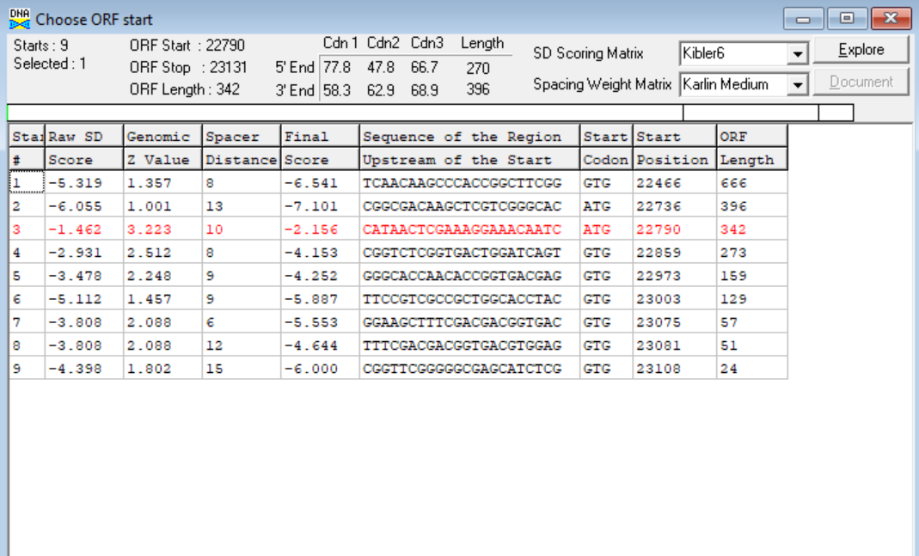
(https://toolkit.tuebingen.mpg.de/tools/hhpred) HHPRED vs PDB, SCOPe, pFam, and M. Tuberculosis. No significant (>95%) hits.
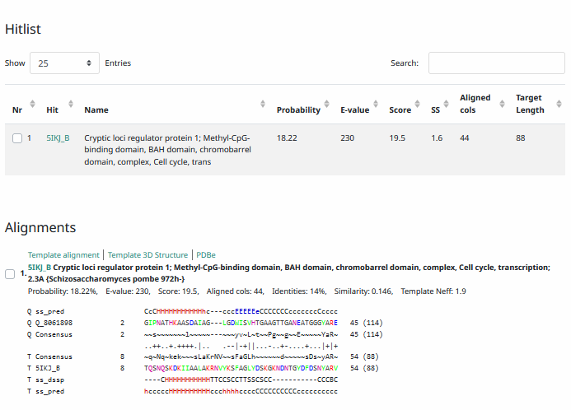
Phamerator Totinger Vs. Tootsieroll and Starcevich (https://phamerator.org/phages) Genes 15-24
Proposed Function: hypothetical protein
Function Evidence: BLAST results are too inconsistent to make a confident function call. Additionally, in similar phages that share the gene, this gene does not have a called function.
Transmembrane Domain/Evidence: No, Extracellular Properties (https://dtu.biolib.com/DeepTMHMM)
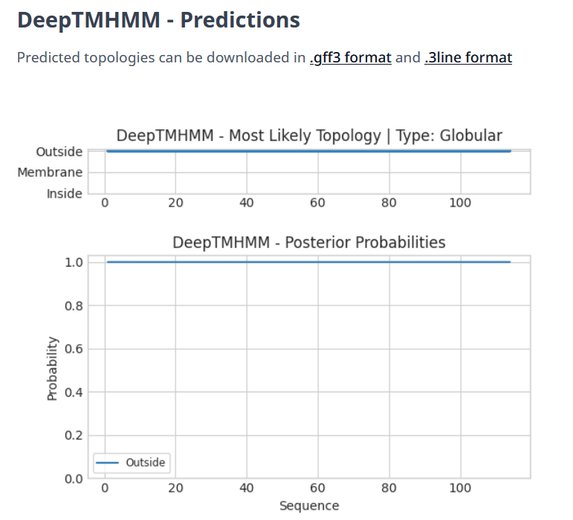

Gene Number: 23
Pham84870
BLAST from PhagesDB. (https://phagesdb.org/blastp/) Using Longest ORF
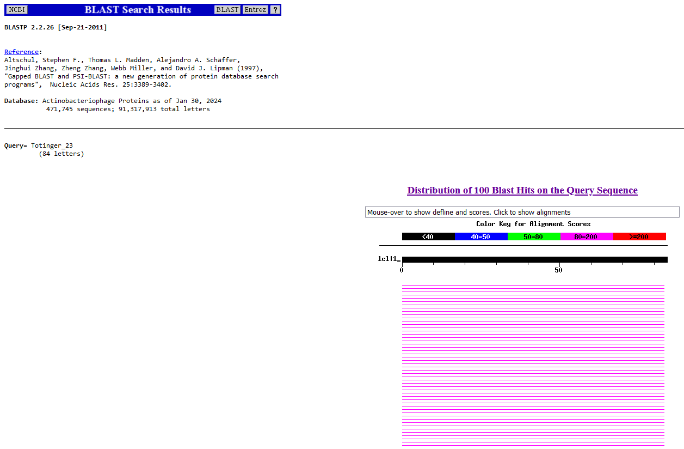
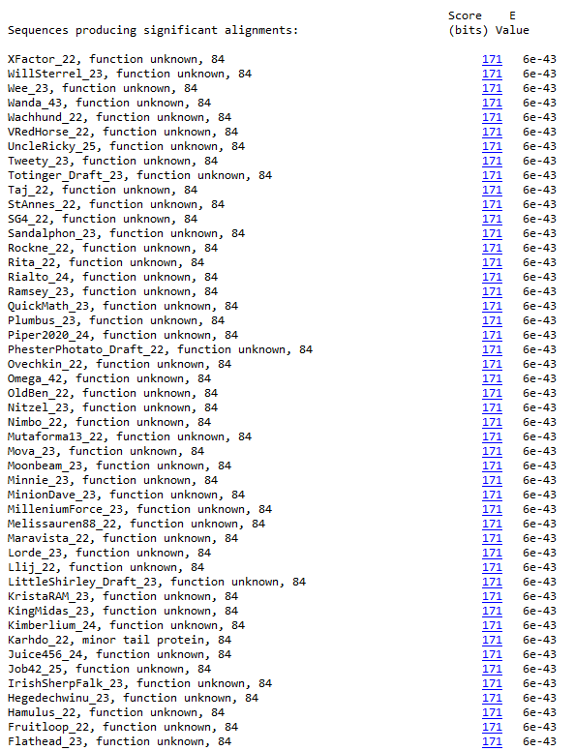
BLAST from NCBI (https://blast.ncbi.nlm.nih.gov/Blast.cgi?PAGE=Proteins) Using Longest ORF
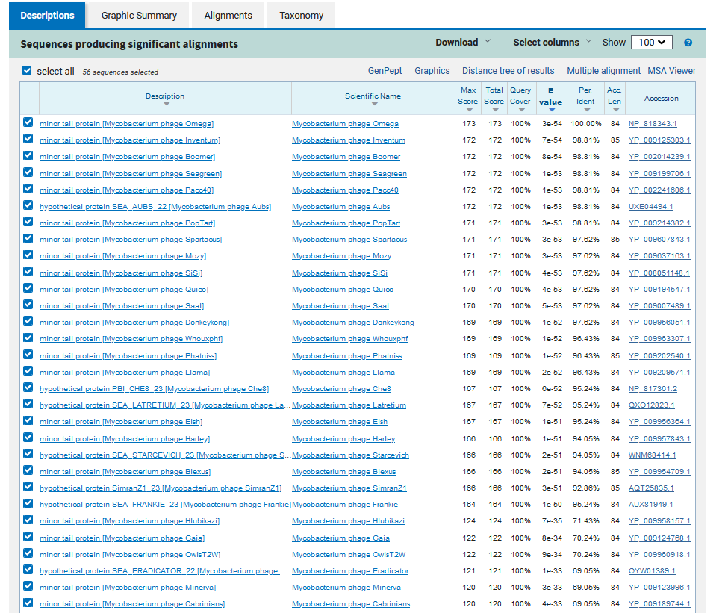
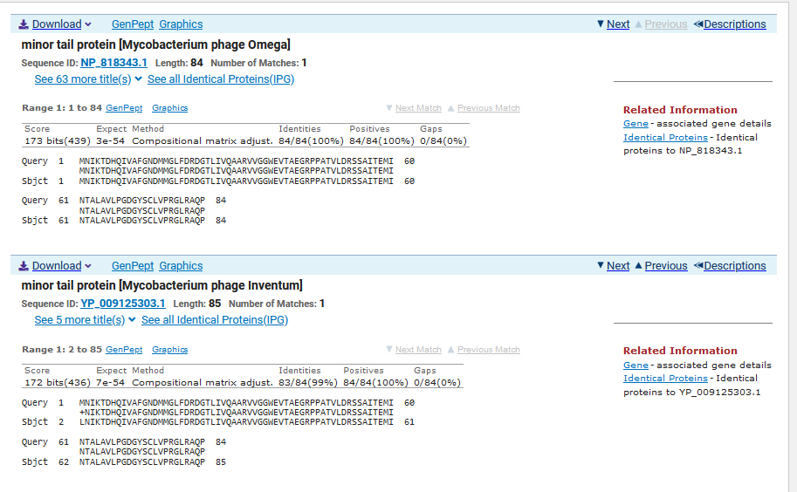
TTG Start at 23154. Original Glimmer call.
TAG Stop at 23408
F/R: F
Coding Potential (y/n): Y
Starterator (SS, NA, NI): Most annotated start is this (23154)
Blast Best Hit, Query:Subject Starts, Score, Evalue, or “no significant Blast alignments” if 10E-4 or higher
Minor tail protein Mycobacterium phage Omega NP_818343.1, 1:1, Score 173, Evalue, 3e-54
Gap with previous gene: 23
Longest Orf? (Y/N/NA) Y
RBS:
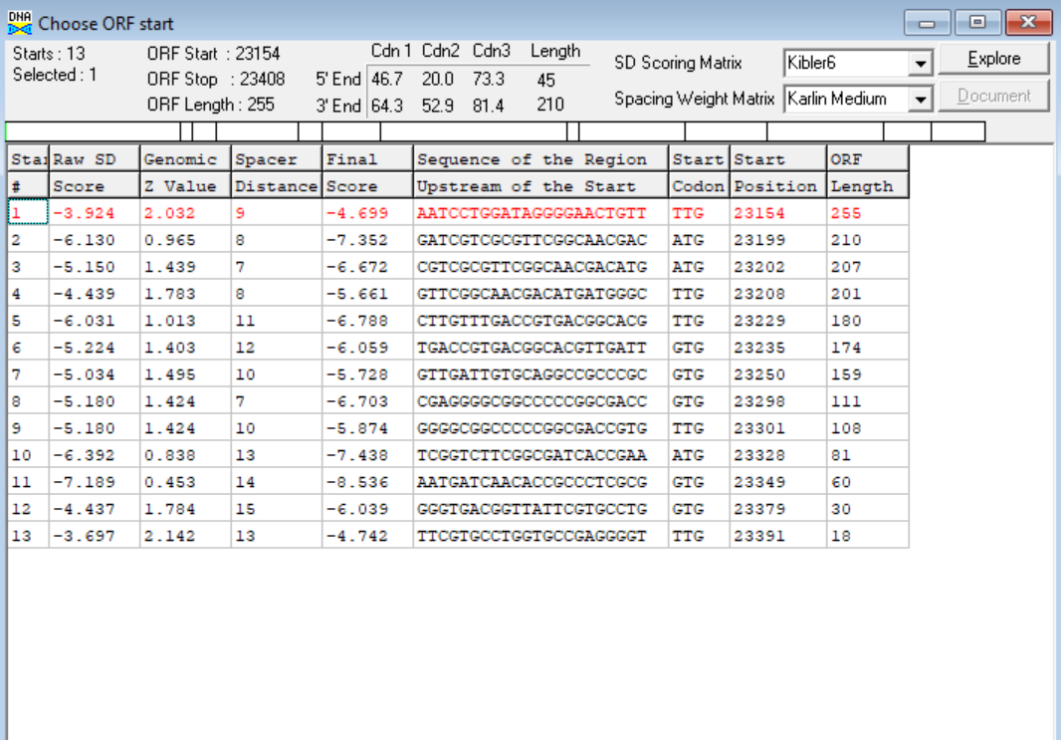
(https://toolkit.tuebingen.mpg.de/tools/hhpred) HHPRED vs PDB, SCOPe, pFam, and M. Tuberculosis. No Significant (>95%) Hits.
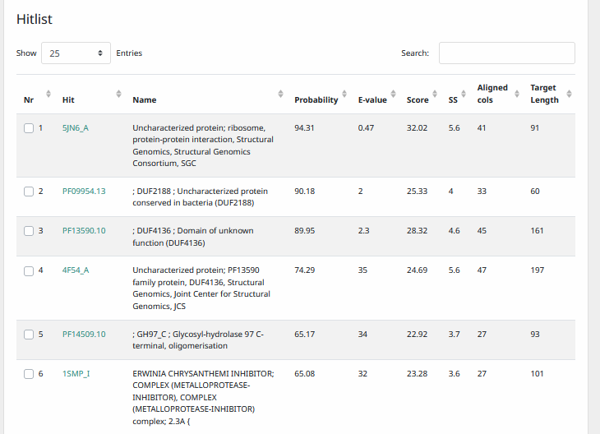
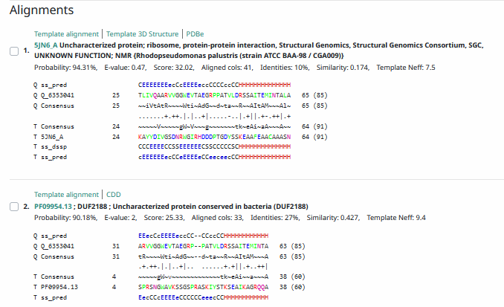
Phamerator Totinger Vs. Tootsieroll and Starcevich (https://phamerator.org/phages) Genes 15-24
Proposed Function: hypothetical protein
Function Evidence: Similar phages do not call a function for this protein. Additionally, the most common BLAST hit between all databases was proteins of unknown function.
Transmembrane Domain/Evidence: No, Intracellular Properties (https://dtu.biolib.com/DeepTMHMM)
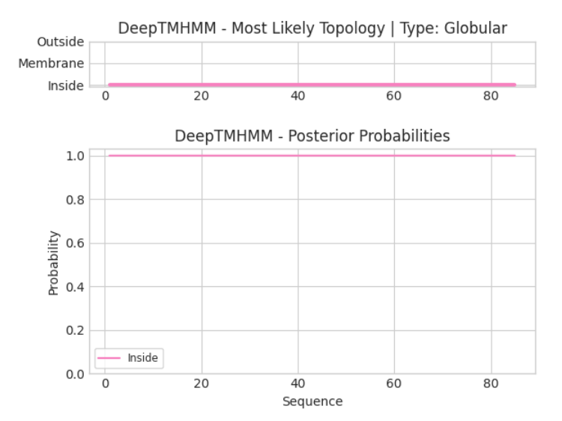

Gene Number: 24
Pham388
BLAST from PhagesDB. (https://phagesdb.org/blastp/) Using Longest ORF
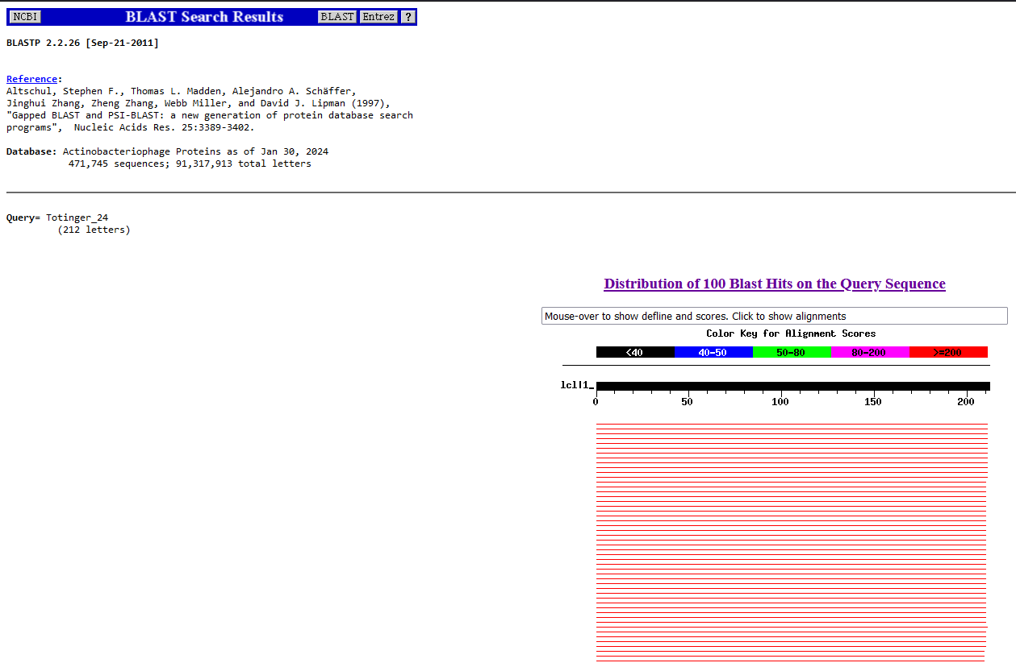
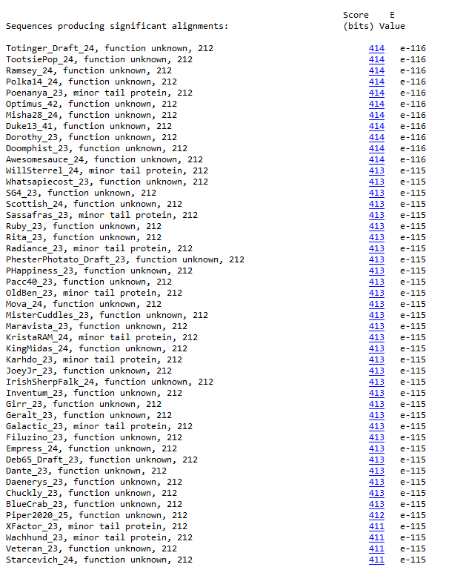
BLAST from NCBI (https://blast.ncbi.nlm.nih.gov/Blast.cgi?PAGE=Proteins) Using Longest ORF
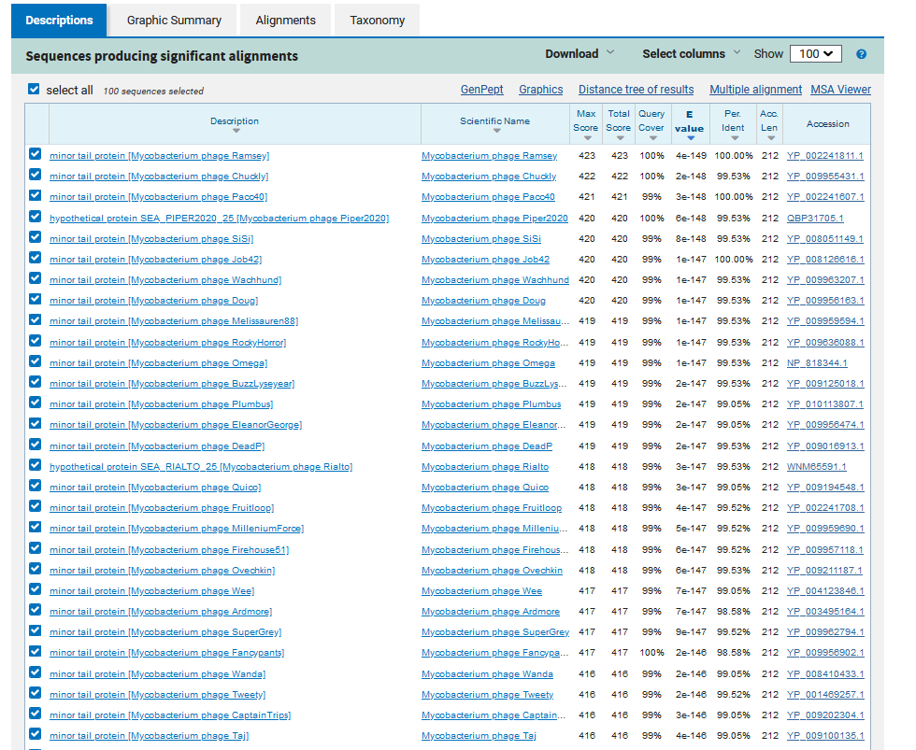
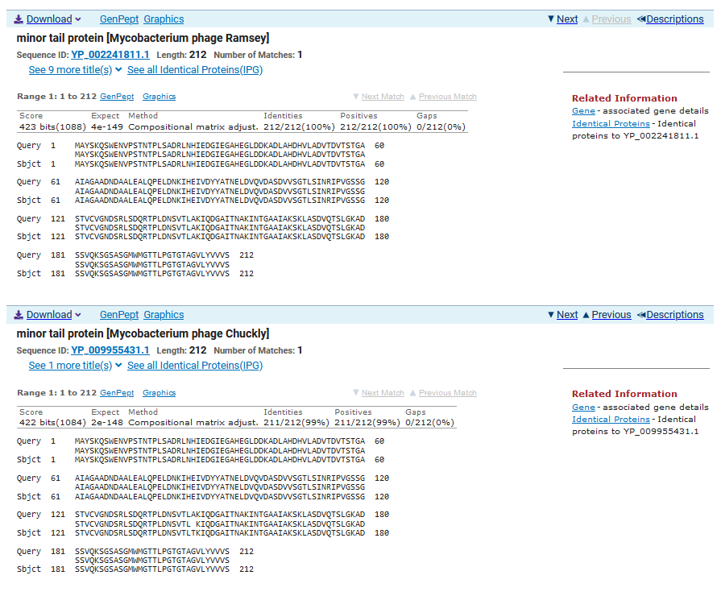
ATG Start at 23421. Original Glimmer call.
TGA Stop at 24059
F/R: F
Coding Potential (y/n): Y
Starterator (SS, NA, NI): Most annotated start is this (23421)
Blast Best Hit, Query:Subject Starts, Score, Evalue, or “no significant Blast alignments” if 10E-4 or higher
Minor tail protein Mycobacterium phage Ramsey YP_002241811.1, 1:1, Score 423, Evalue, 4e-149
Gap with previous gene: 13
Longest Orf? (Y/N/NA) Y
RBS:
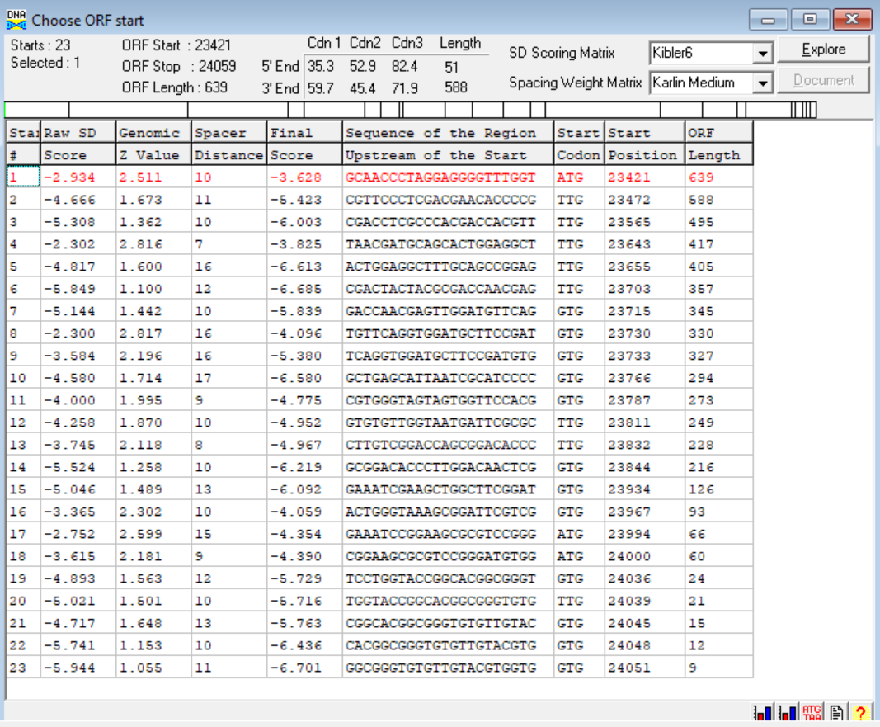
(https://toolkit.tuebingen.mpg.de/tools/hhpred) HHPRED vs PDB, SCOPe, pFam, and M. Tuberculosis. No Significant (>95%) Hits.
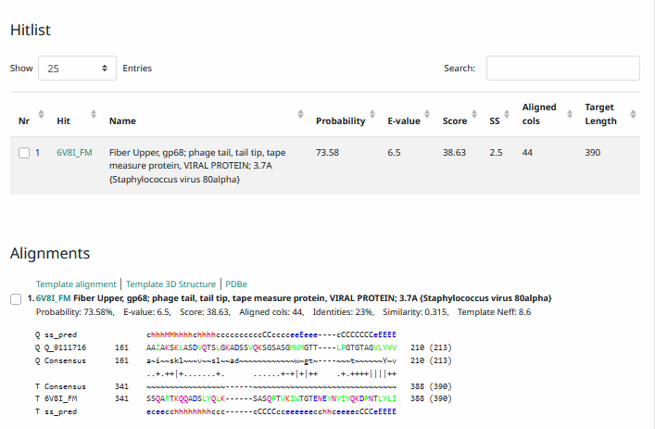
Phamerator Totinger Vs. Tootsieroll and Starcevich (https://phamerator.org/phages) Genes 15-24
Proposed Function: hypothetical protein
Function Evidence: BLAST Results from all databases most commonly hit this protein as one with an unknown function. Additionally, homologous genes from phage Starcevich and phage Tootsieroll do not have a called function.
Transmembrane Domain/Evidence: No, Extracellular Properties (https://dtu.biolib.com/DeepTMHMM)
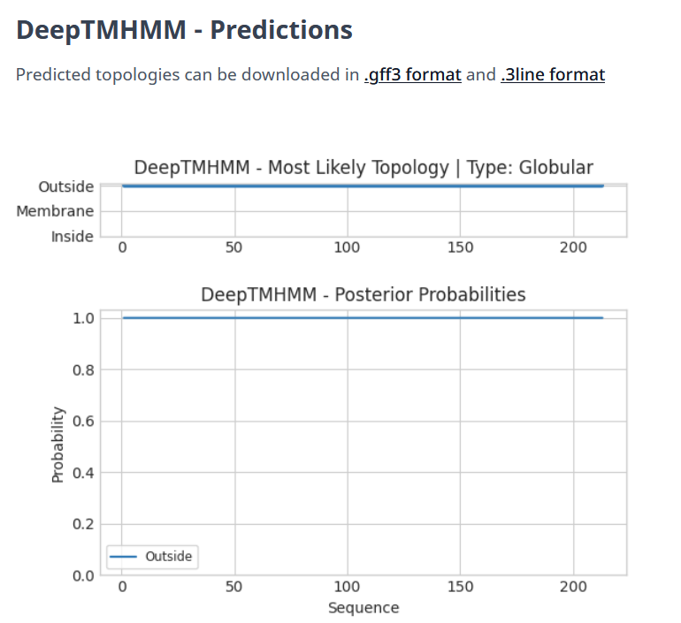
Gene Number: 25
Pham139490
BLAST from PhagesDB. (https://phagesdb.org/blastp/) Using Longest ORF
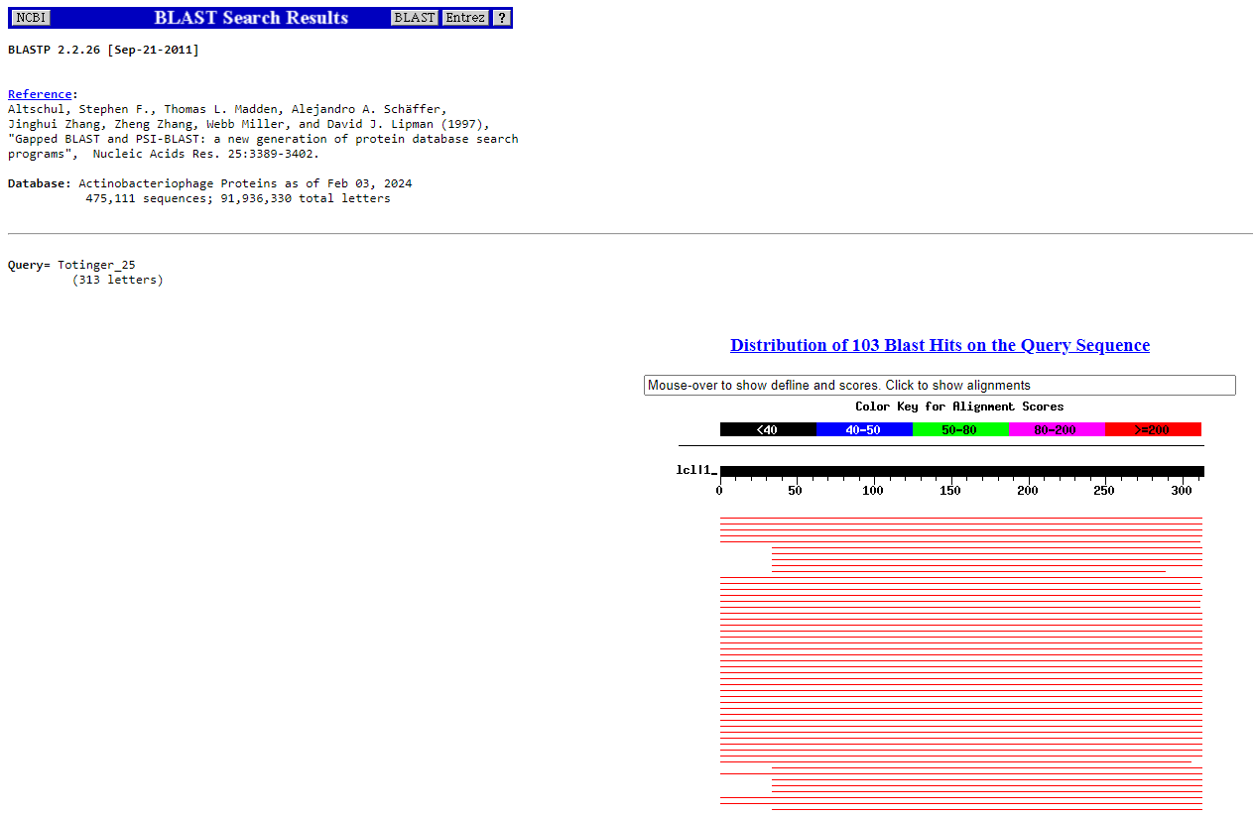
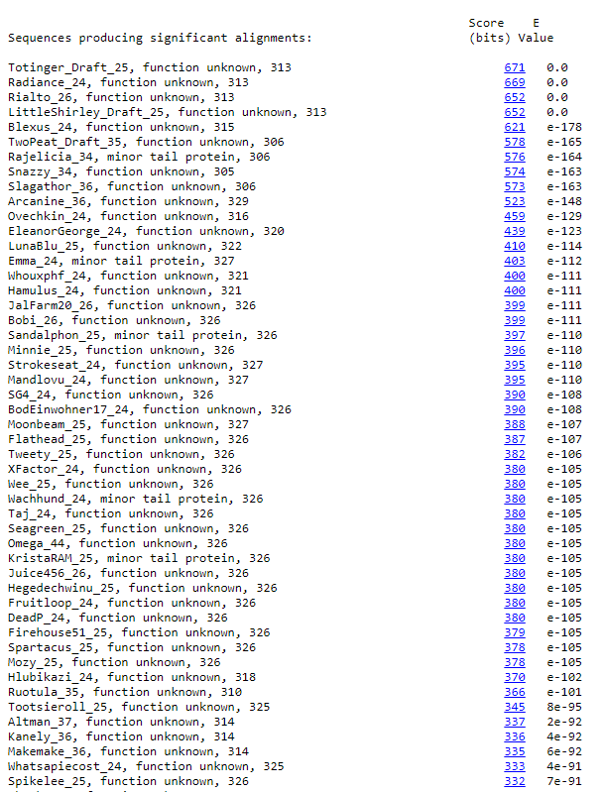
BLAST from NCBI (https://blast.ncbi.nlm.nih.gov/Blast.cgi?PAGE=Proteins) Using Longest ORF
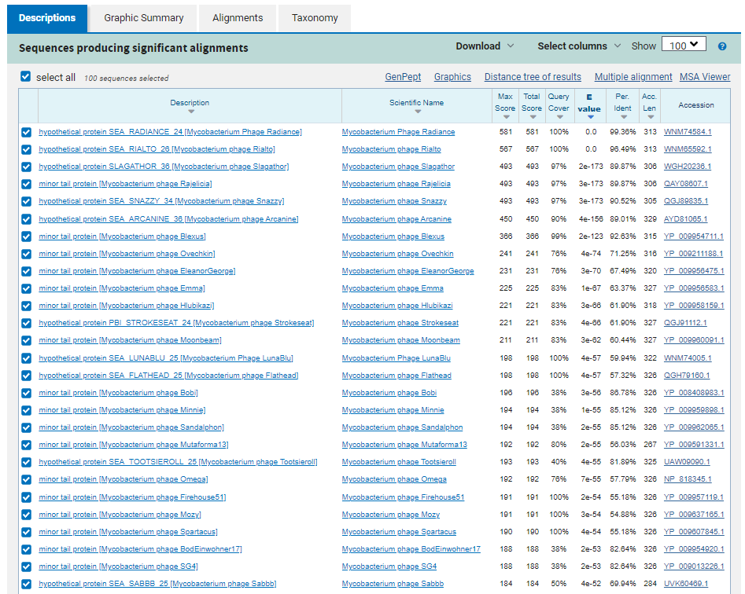
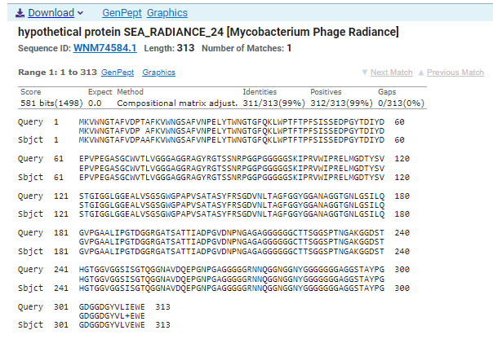
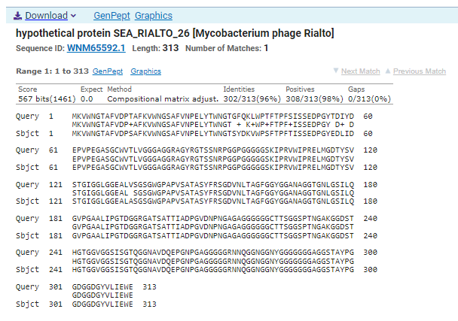
GTG Start at 24056. Original Genemark call.
TAA Stop at 24997
F/R: F
Coding Potential (y/n): Y
Starterator (SS, NA, NI): Not the Most Annotated Start
Blast Best Hit, Query:Subject Starts, Score, Evalue, or “no significant Blast alignments” if 10E-4 or higher
Hypothetical protein SEA_RADIANCE_24 Mycobacterium phage Radiance WNM74584.1, 1:1, Score 581, Evalue, 0
Gap with previous gene: -3
Longest Orf? (Y/N/NA)
RBS:
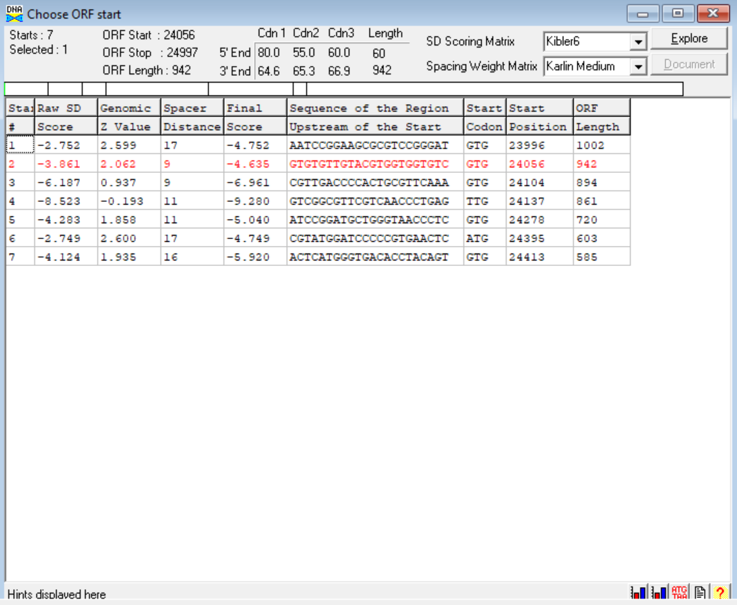
(https://toolkit.tuebingen.mpg.de/tools/hhpred) HHPRED vs PDB, SCOPe, pFam, and M. Tuberculosis. No Significant (>95%) Hits.
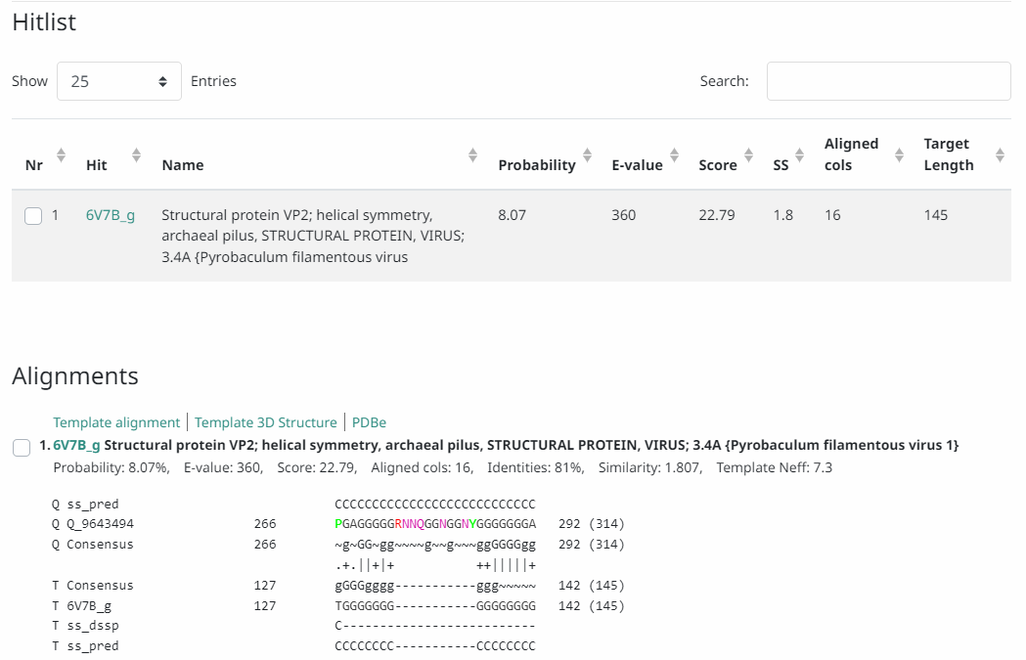
Phamerator Totinger Vs. Tootsieroll Vs. Starcevich (https://phamerator.org/phages) Genes 21-43
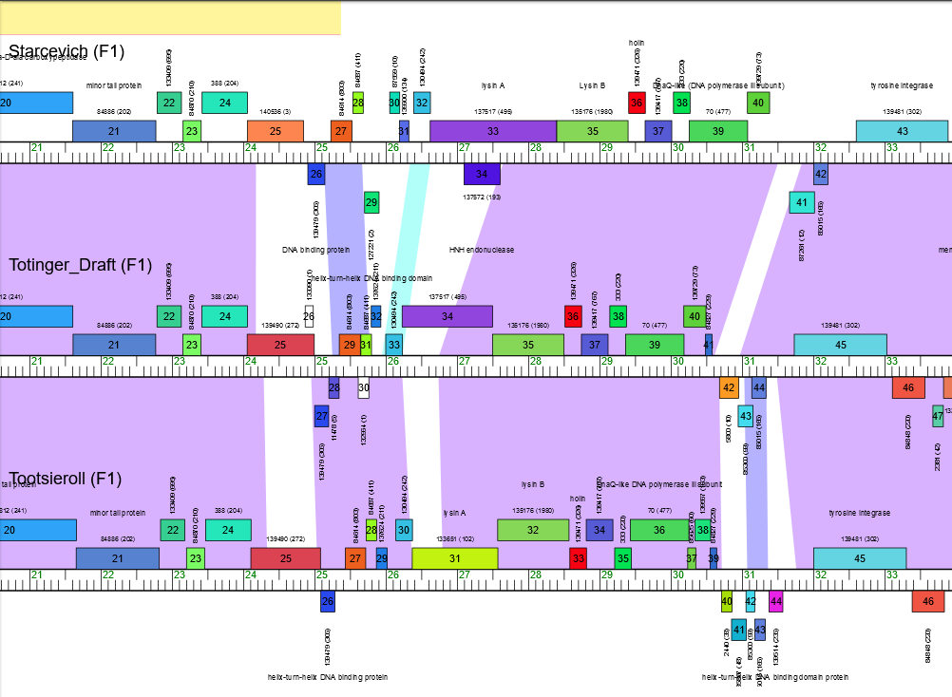
Proposed Function: hypothetical protein
Function Evidence: BLAST Results and HHPRED results did not give conclusive evidence to make a confident function call. Additionally, the analogous genes in phage Starcevich and phage Tootsieroll do not have called functions.
Transmembrane Domain/Evidence: No, Extracellular Properties. (https://dtu.biolib.com/DeepTMHMM)
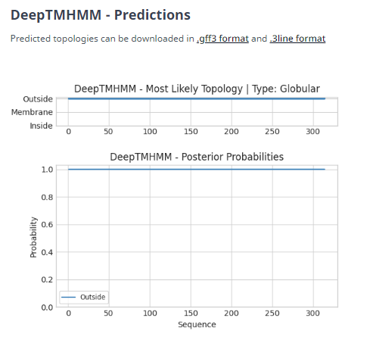

REMOVED DNA MASTER’S PREDICTED GENE 26 (Totinger_Draft_26 on Phagesdb), Information As Follows
GTG Start at 24870 – TGA Stop at 24983. Called by Glimmer, not called by Genemark.
No Coding Potential
No Significant HHPRED Hits
One Consistent Significant BLAST Hit from all sources: Anglerfish_37.
No analogous genes in Phamerator.

Gene Number: 26
Documented in PhagesDB as Totinger_27
Pham
BLAST from PhagesDB. (https://phagesdb.org/blastp/) Using Longest ORF
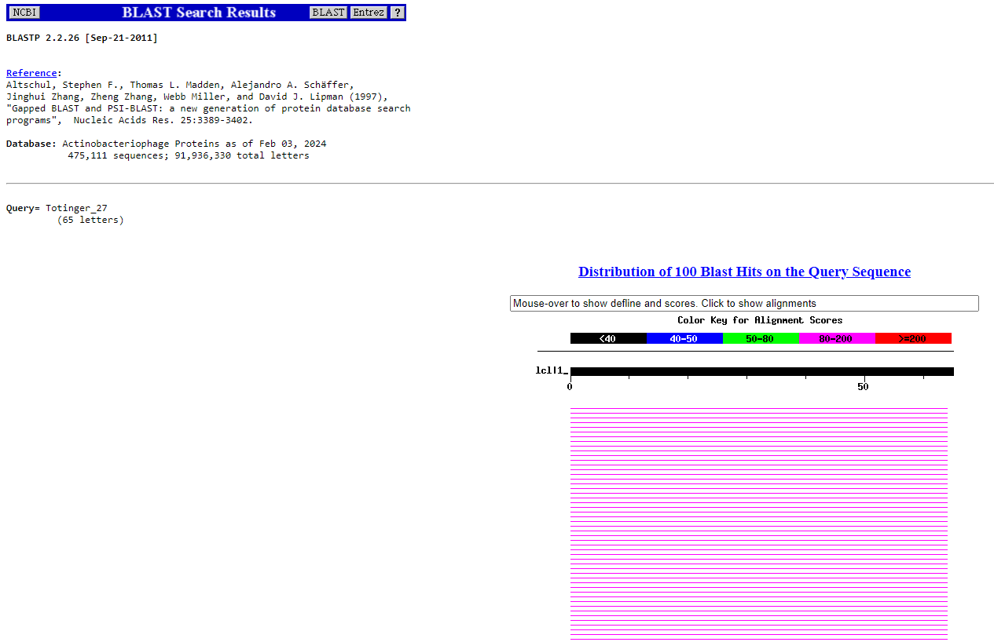
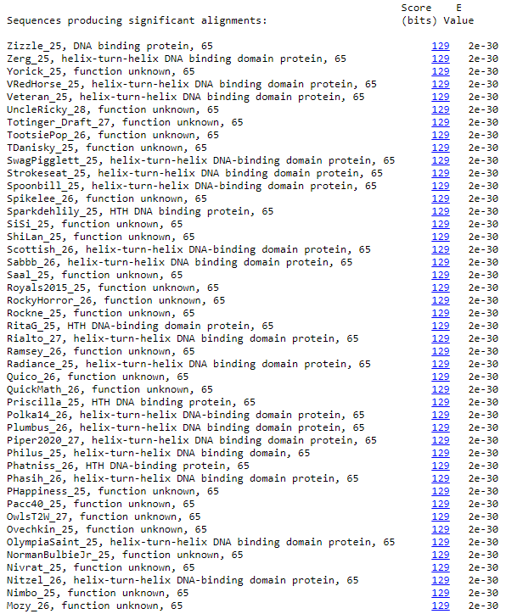
BLAST from NCBI (https://blast.ncbi.nlm.nih.gov/Blast.cgi?PAGE=Proteins) Using Longest ORF
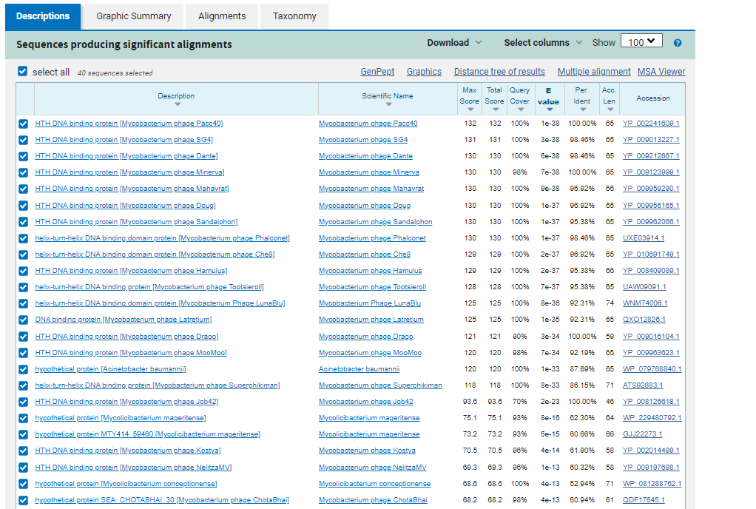
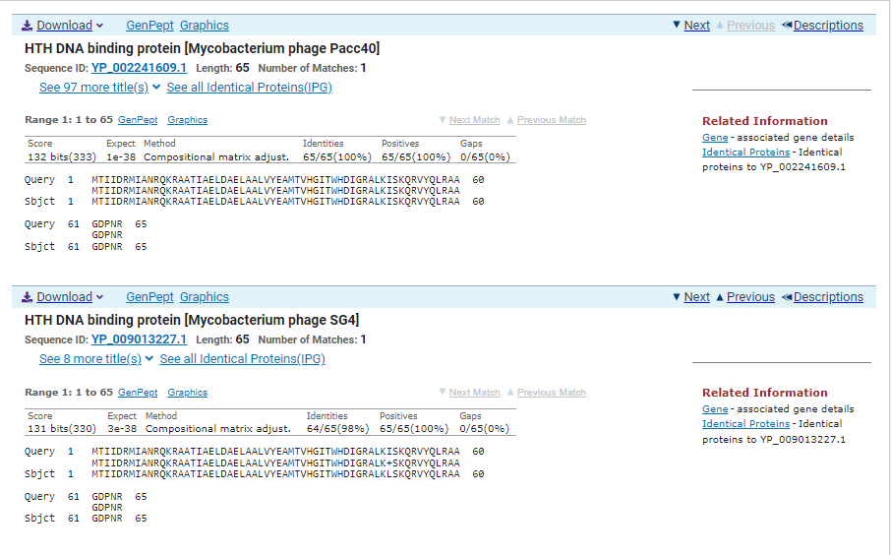
GTG Start at 25199. Original Glimmer call. Genemark calls start at 25181.
TAG Stop at 25002
F/R: R
Coding Potential (y/n): Y
Starterator (SS, NA, NI): Most annotated start is this (25199)
Blast Best Hit, Query:Subject Starts, Score, Evalue, or “no significant Blast alignments” if 10E-4 or higher
HTH DNA Binding protein Mycobacterium phage Pac40 YP_002241609.1, 1:1, Score 132, Evalue, 0
Gap with previous gene: 5
Longest Orf? (Y/N/NA) Y
RBS:
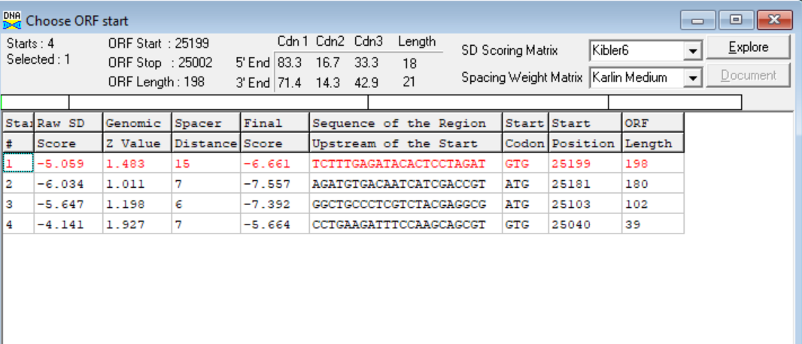
(https://toolkit.tuebingen.mpg.de/tools/hhpred) HHPRED vs PDB, SCOPe, pFam, and M. Tuberculosis.
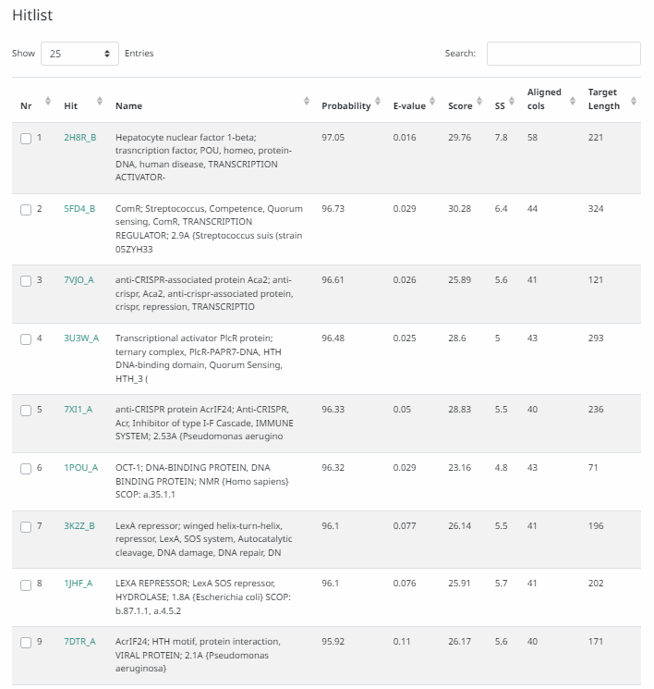
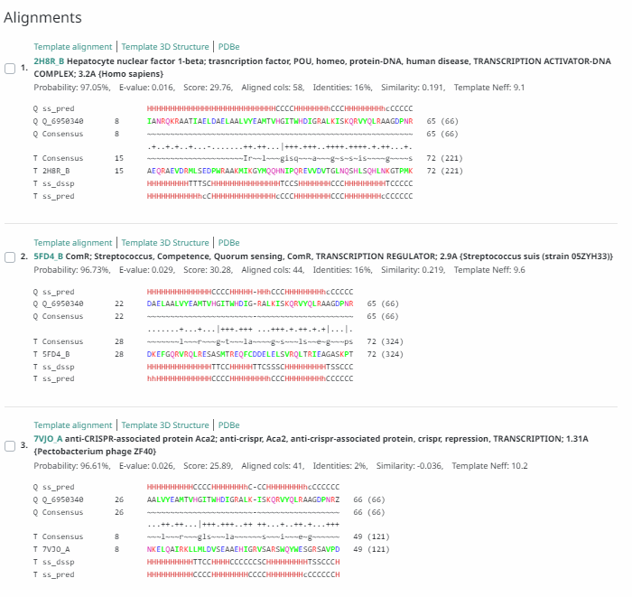
Phamerator Totinger Vs. Tootsieroll Vs. Starcevich (https://phamerator.org/phages) Genes 21-43
Proposed Function: helix-turn-helix DNA binding protein
Function Evidence: In Phamerator, similar genes in phage Tootsieroll and phage Starcevich are called as a helix-turn-helix DNA bindng protein. Additionally, BLAST and HHPRED results aligned most consistently with a helix-turn-helix DNA binding protein. Tyrosine Integrase was not distinguished.
Transmembrane Domain/Evidence: No, Intracellular Properties (https://dtu.biolib.com/DeepTMHMM)
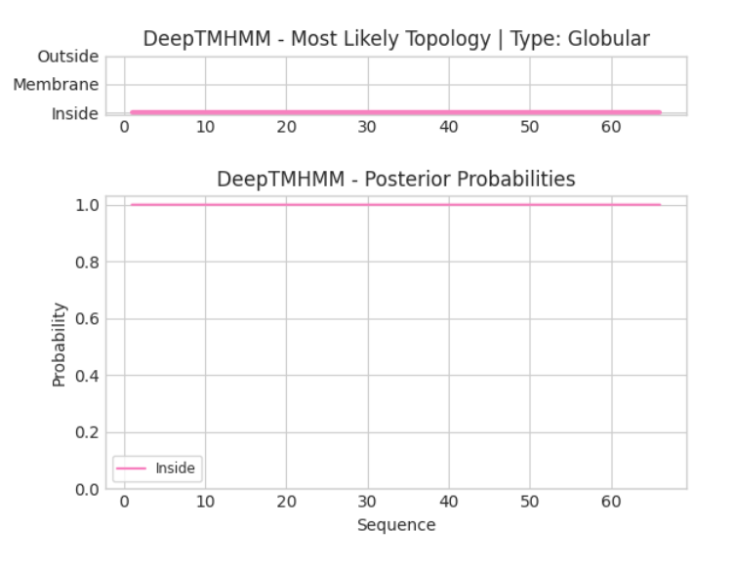

Gene Number: 27
Totinger_Draft_29 on PhagesDB
Pham84614
BLAST from PhagesDB. (https://phagesdb.org/blastp/) Using Longest ORF
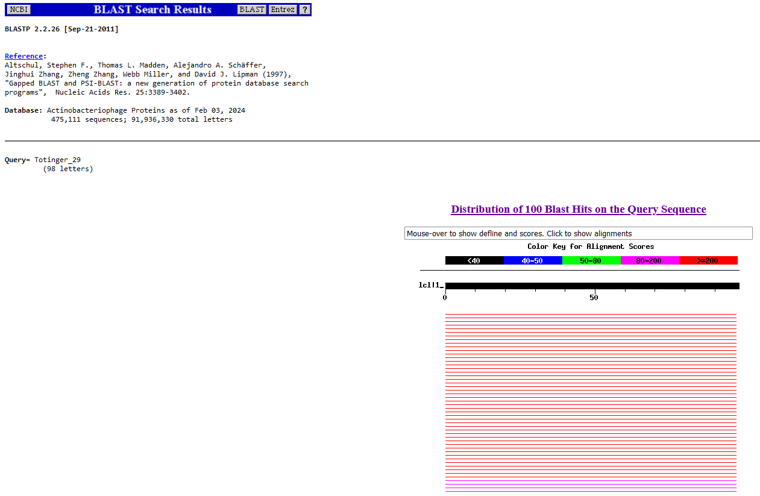
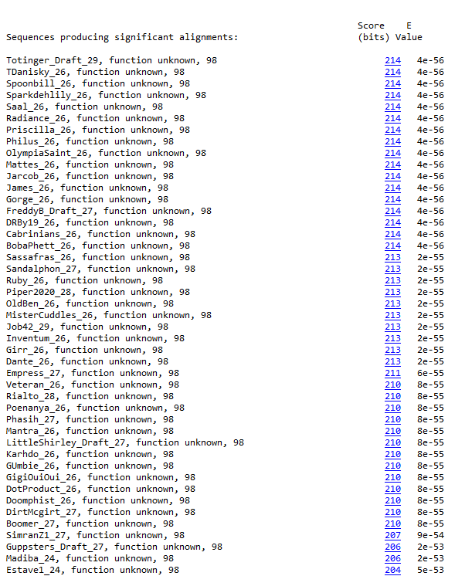
BLAST from NCBI (https://blast.ncbi.nlm.nih.gov/Blast.cgi?PAGE=Proteins) Using Longest ORF
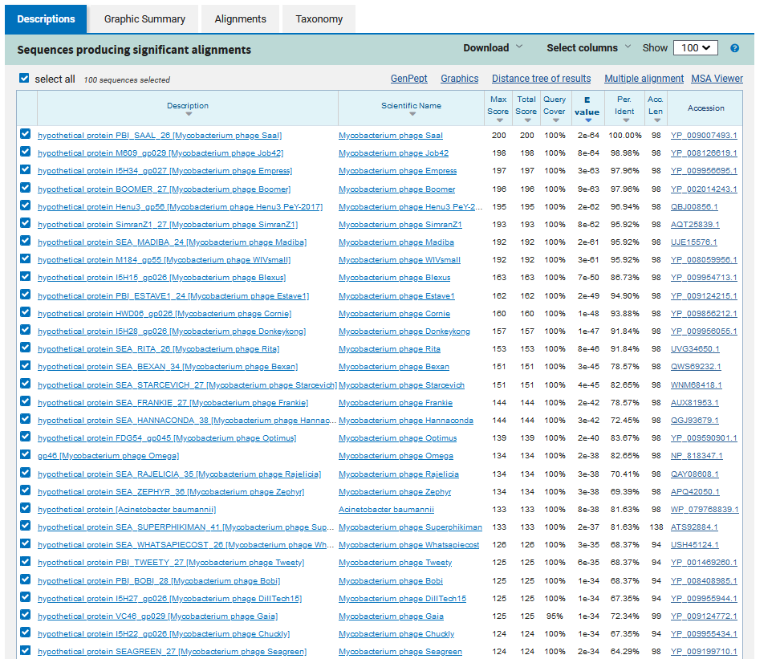
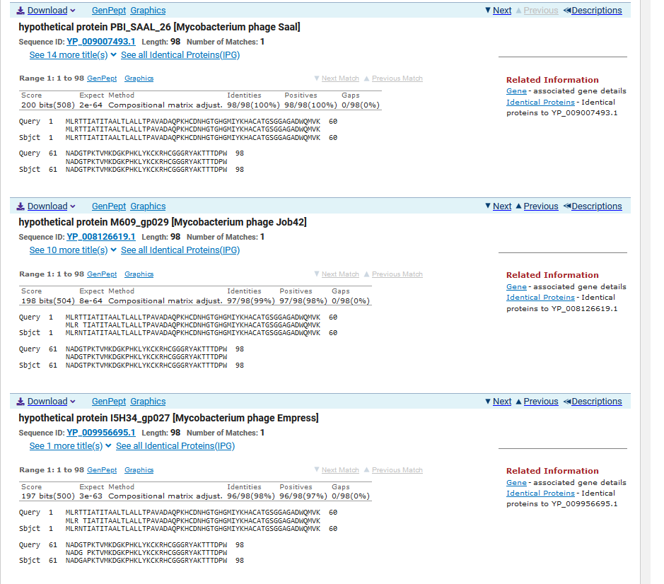
ATG Start at 25348. Original Glimmer call.
TGA Stop at 25644
F/R: F
Coding Potential (y/n): Y
Starterator (SS, NA, NI): Most annotated start is this (25348)
Blast Best Hit, Query:Subject Starts, Score, Evalue, or “no significant Blast alignments” if 10E-4 or higher
hypothetical protein PBI_SAAL_26 Mycobacterium phage Saal YP_009007493.1, 1:1, Score 200, Evalue, 2e-64
Gap with previous gene: 149
Longest Orf? (Y/N/NA) Y
RBS:
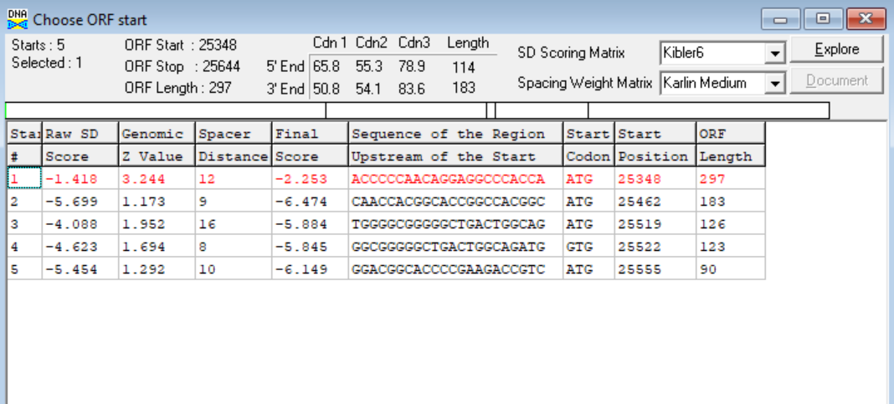
(https://toolkit.tuebingen.mpg.de/tools/hhpred) HHPRED vs PDB, SCOPe, pFam, and M. Tuberculosis. No Significant (>95%) Hits
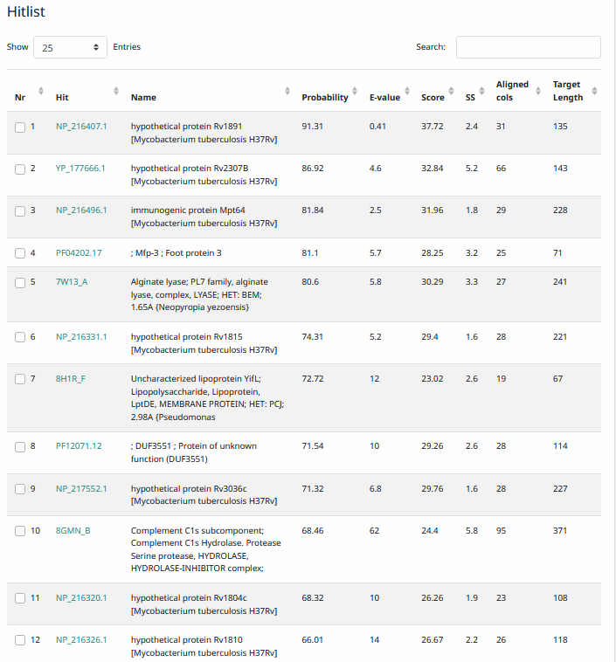
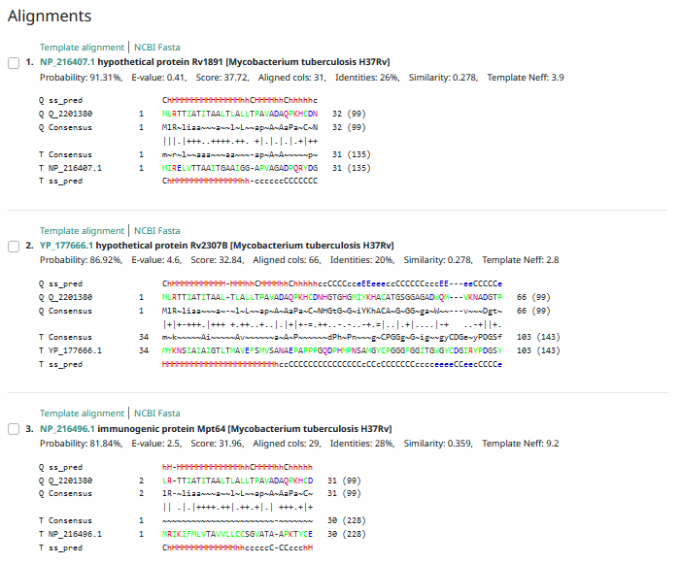
Phamerator Totinger Vs. Tootsieroll Vs. Starcevich (https://phamerator.org/phages) Genes 21-43
Proposed Function: hypothetical protein
Function Evidence: Similar genes in similar phages (Starcevich and Tootsieroll) have no called function, and results from BLASTs and HHPRED indicate an unknown function.
Transmembrane Domain/Evidence: Yes, Signaling Properties at AA 1-25 (https://dtu.biolib.com/DeepTMHMM)
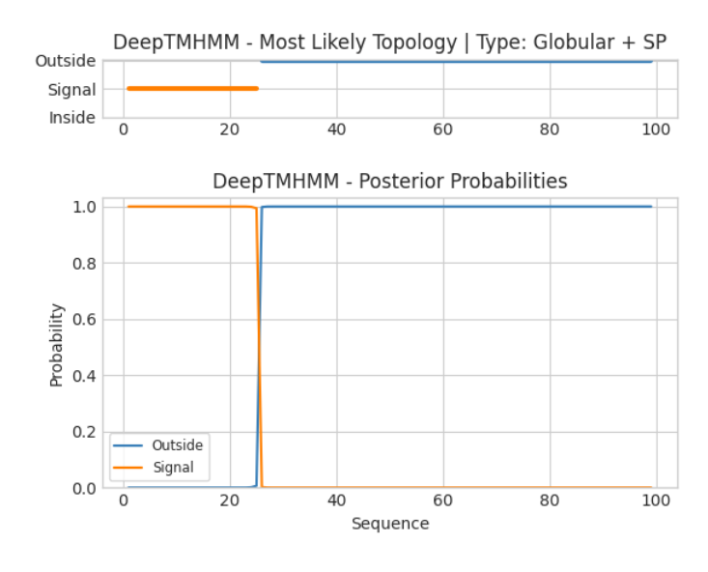
REMOVED DNA MASTER’S PREDICTED GENE 28 (Totinger_Draft_30 on phagesdb), Information As Follows
ATG Start at 25614 – TAG Stop at 25763. Called by Glimmer, not called by Genemark.
No Coding Potential
No Credible BLAST hits
No analogous genes in Phamerator.

- ADDED NEW GENE NOT CALLED BY DNA MASTER. Information as follows.

Gene Number: 28
Pham – No Data for start, gene added in manually
BLAST from PhagesDB. (https://phagesdb.org/blastp/) Using Longest ORF
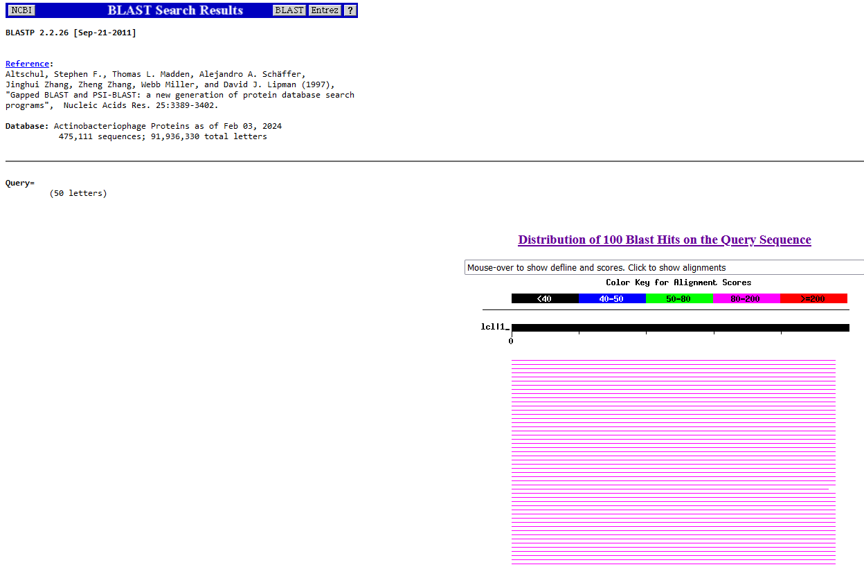
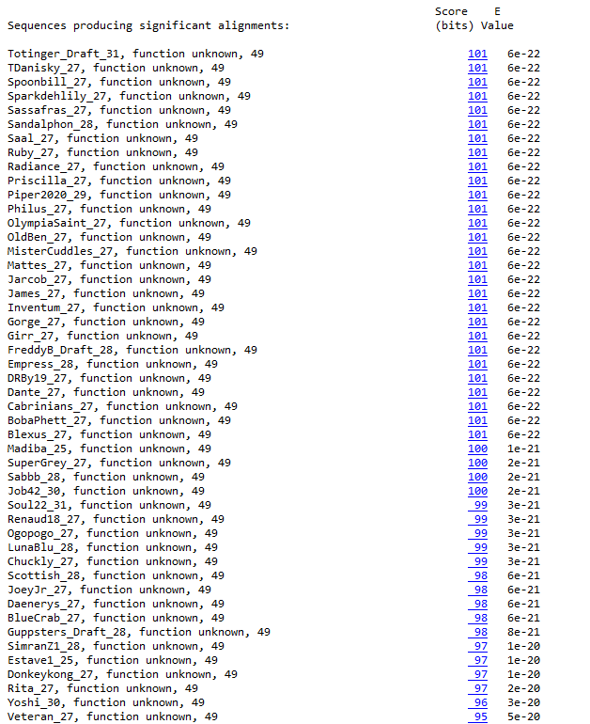
BLAST from NCBI (https://blast.ncbi.nlm.nih.gov/Blast.cgi?PAGE=Proteins) Using Longest ORF
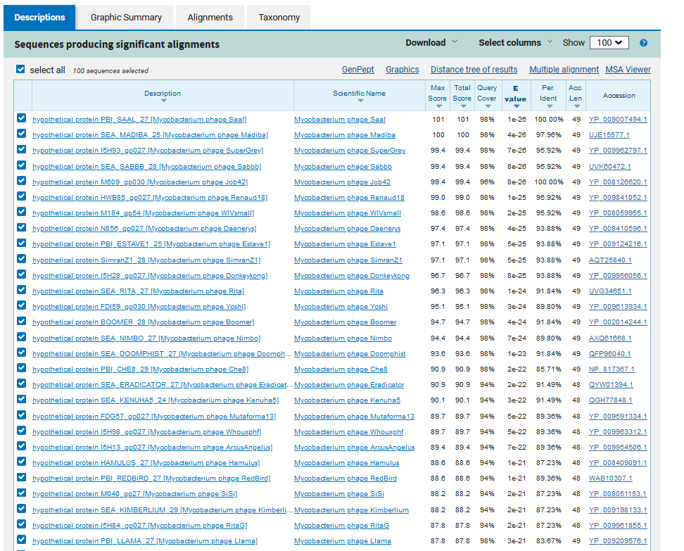
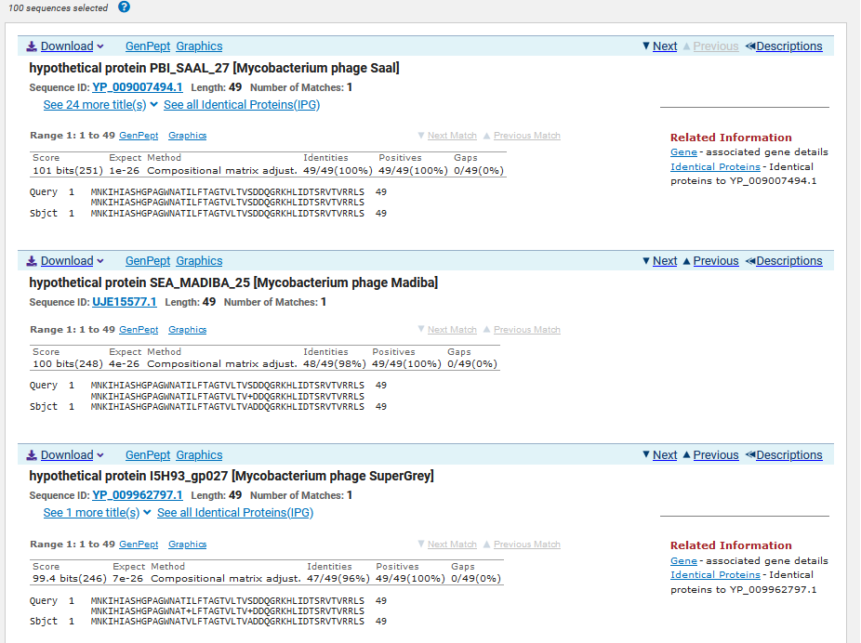
ATG Start at 25651. Not Called by Glimmer. Called by Genemark
TGA Stop at 25800
F/R: F
Coding Potential (y/n): Y
Starterator (SS, NA, NI): No Data for start, gene added in manually
Blast Best Hit, Query:Subject Starts, Score, Evalue, or “no significant Blast alignments” if 10E-4 or higher
hypothetical protein PBI_SAAL_27 Mycobacterium phage Saal YP_009007494.1, 1:1, Score 101, Evalue, 1e-26
Gap with previous gene: 7
Longest Orf? (Y/N/NA) Y
RBS:
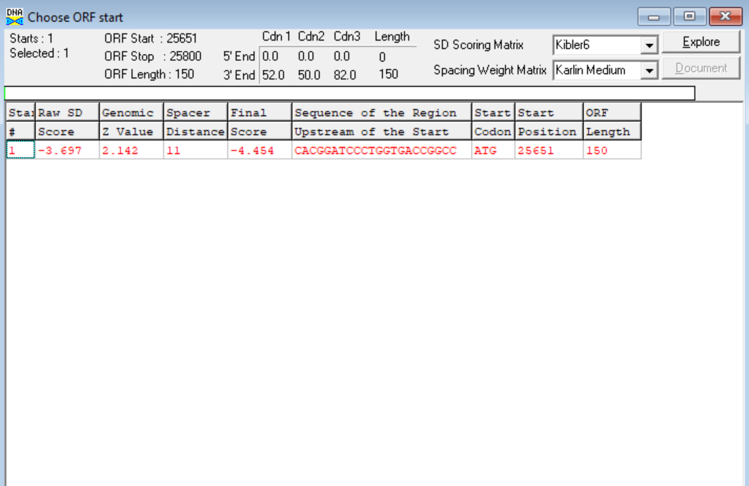
(https://toolkit.tuebingen.mpg.de/tools/hhpred) HHPRED vs PDB, SCOPe, pFam, and M. Tuberculosis. No Significant (>95%) Hits
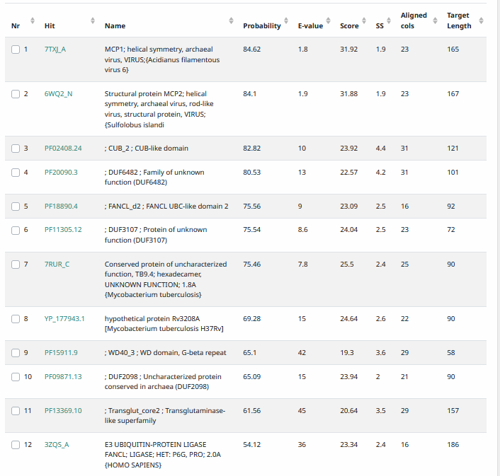
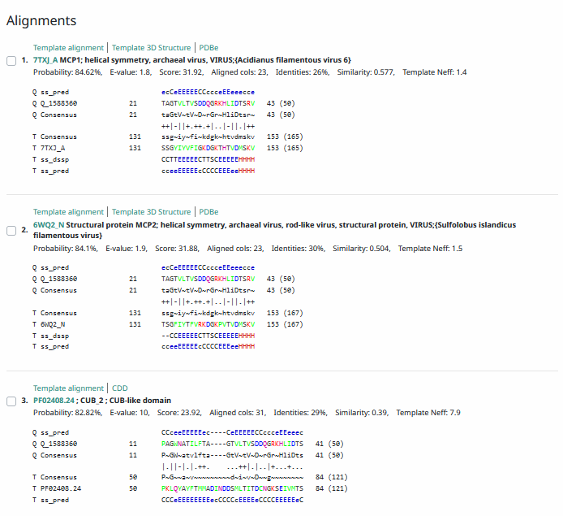
Phamerator Totinger Vs. Tootsieroll Vs. Starcevich (https://phamerator.org/phages) Genes 21-43
Proposed Function: hypothetical protein
Function Evidence: BLAST and HHPRED results most consistently call this gene as a hypothetical protein. Similar genes from other phages in Phamerator additionally do not assign a function for this gene.
Transmembrane Domain/Evidence: No, Intracellular Properties (https://dtu.biolib.com/DeepTMHMM)
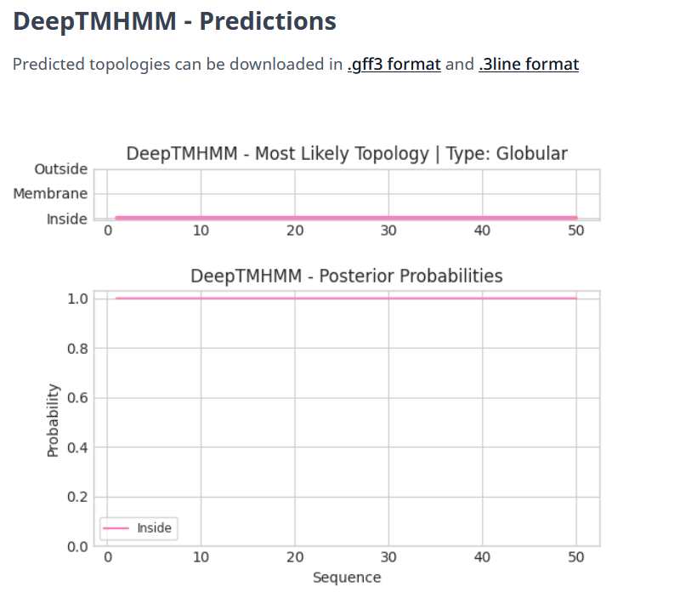
Gene Number: 29
Totinger_Draft_32 on Phagesdb
Pham156082
BLAST from PhagesDB. (https://phagesdb.org/blastp/) Using Longest ORF
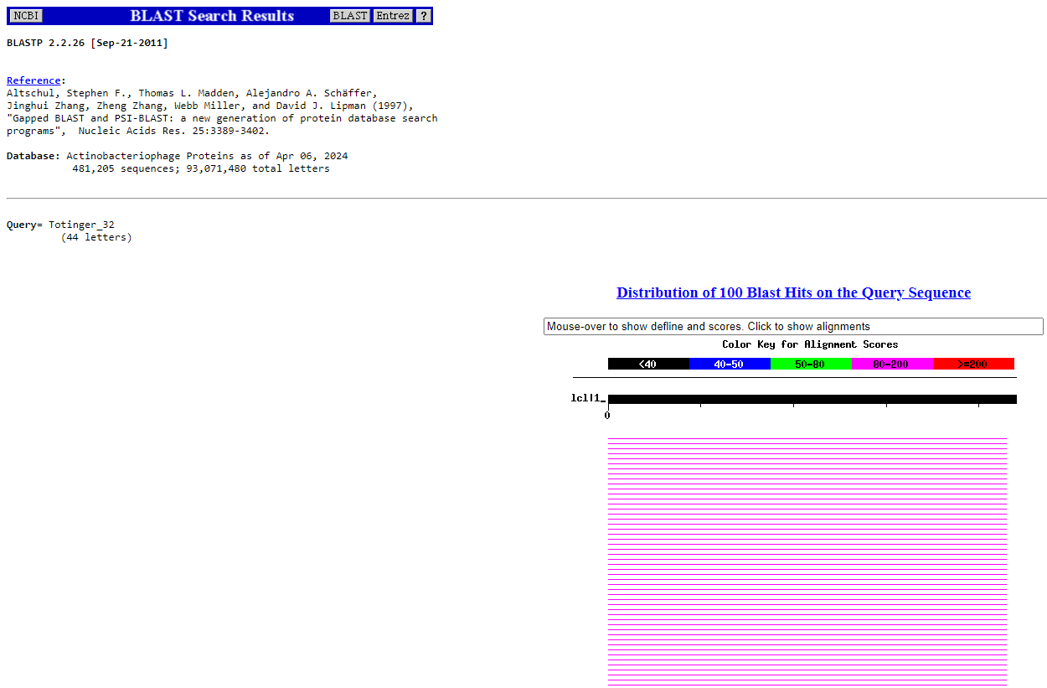
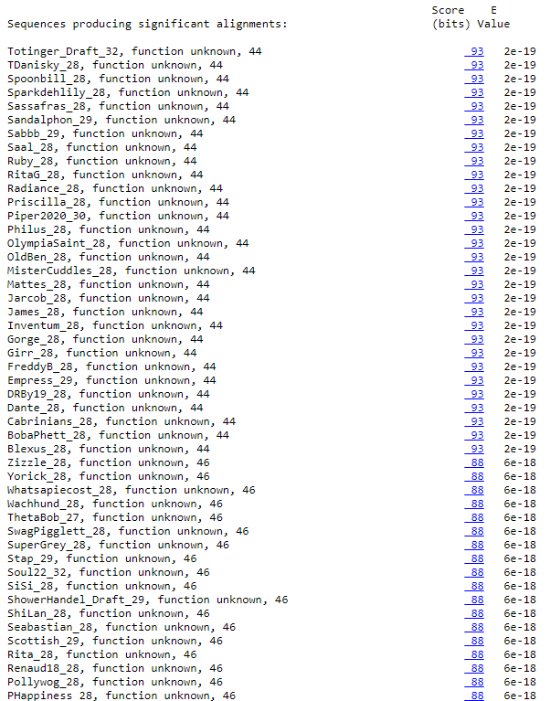
BLAST from NCBI (https://blast.ncbi.nlm.nih.gov/Blast.cgi?PAGE=Proteins) Using Longest ORF
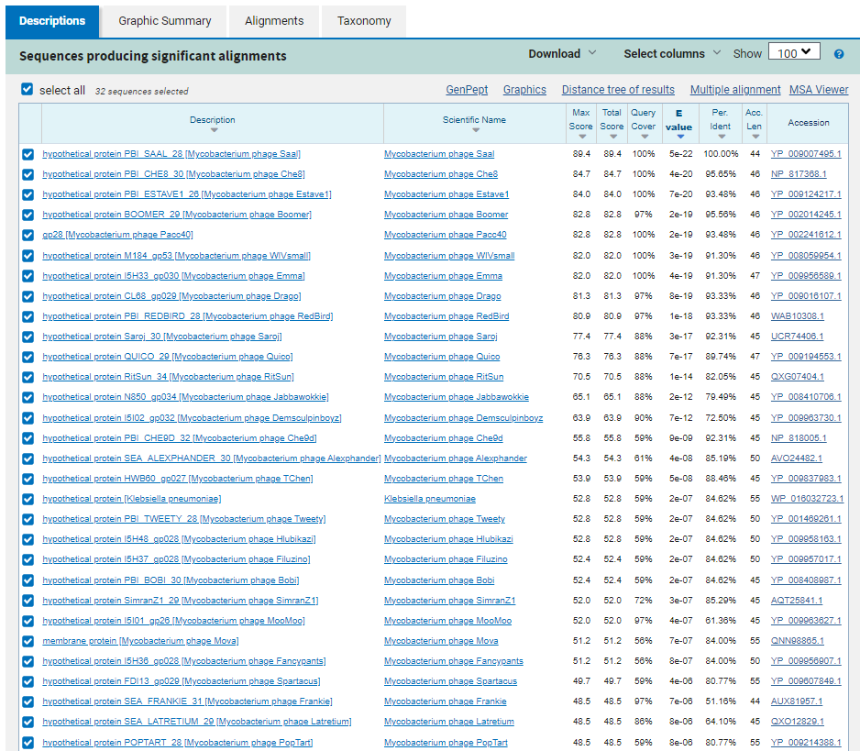
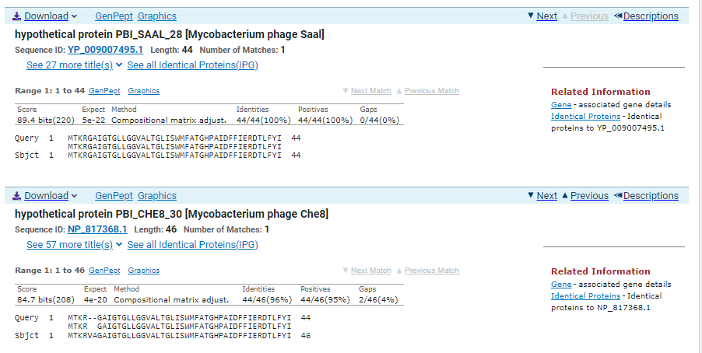
ATG Start at 25797. Original Glimmer call.
TGA Stop at 25931
F/R: F
Coding Potential (y/n): Y
Starterator (SS, NA, NI): Most annotated start is this (25797)
Blast Best Hit, Query:Subject Starts, Score, Evalue, or “no significant Blast alignments” if 10E-4 or higher
hypothetical protein PBI_SAAL_28 Mycobacterium phage Saal YP_009007495.1, 1:1, Score 89.4, Evalue, 5e-22
Gap with previous gene: -3
Longest Orf? (Y/N/NA) Y
RBS:
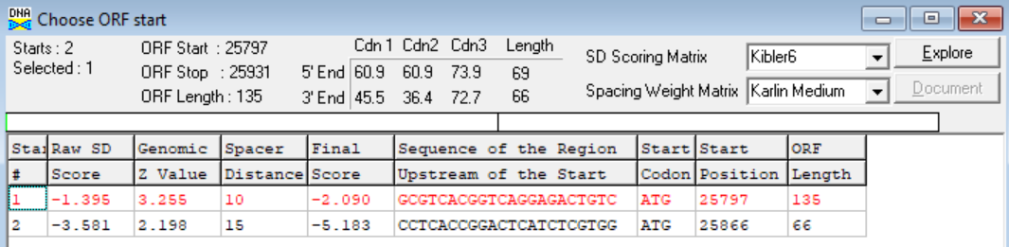
(https://toolkit.tuebingen.mpg.de/tools/hhpred) HHPRED vs PDB, SCOPe, pFam, and M. Tuberculosis. No Significant (>95%) Hits
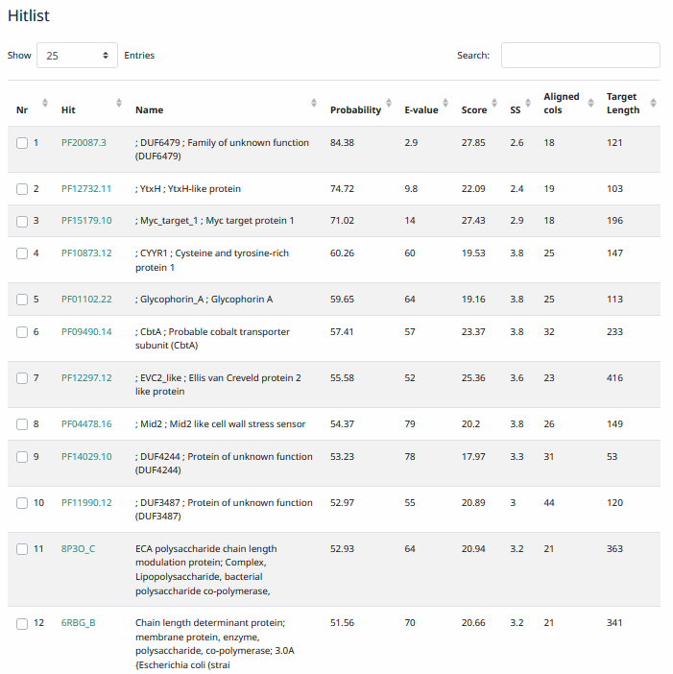
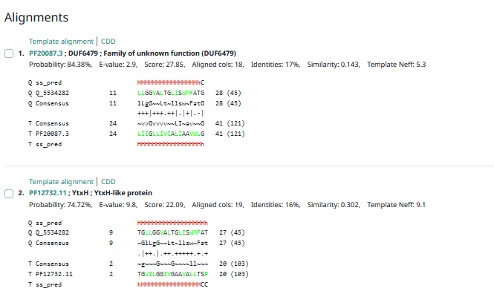
Phamerator Totinger Vs. Tootsieroll Vs. Starcevich (https://phamerator.org/phages) Genes 21-43
Proposed Function: hypothetical protein
Function Evidence: In Phamerator, phage Tootsieroll calls the same gene from an identical sequence, also labeling it as a hypothetical protein. BLASTs additionally hit this gene most commonly as a hypothetical protein.
Transmembrane Domain/Evidence: No, Signaling Properties between ~AA 1-27 (https://dtu.biolib.com/DeepTMHMM)
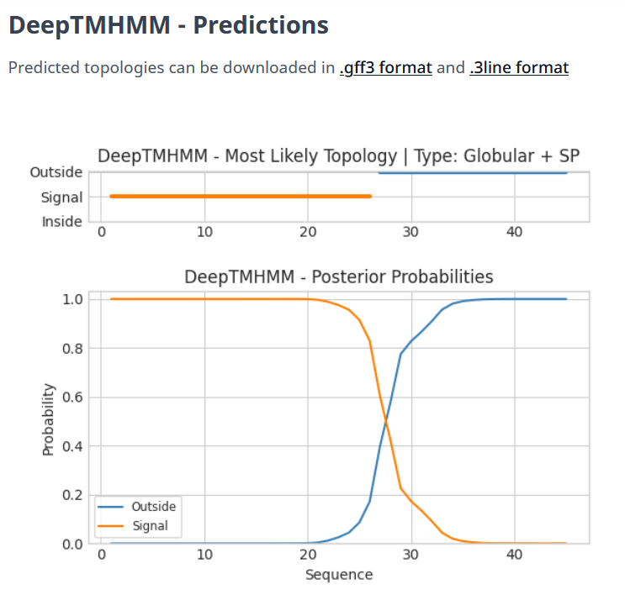

Gene Number: 30
Totinger_Draft_33 on Phagesdb
Pham130494
BLAST from PhagesDB. (https://phagesdb.org/blastp/) Using Longest ORF
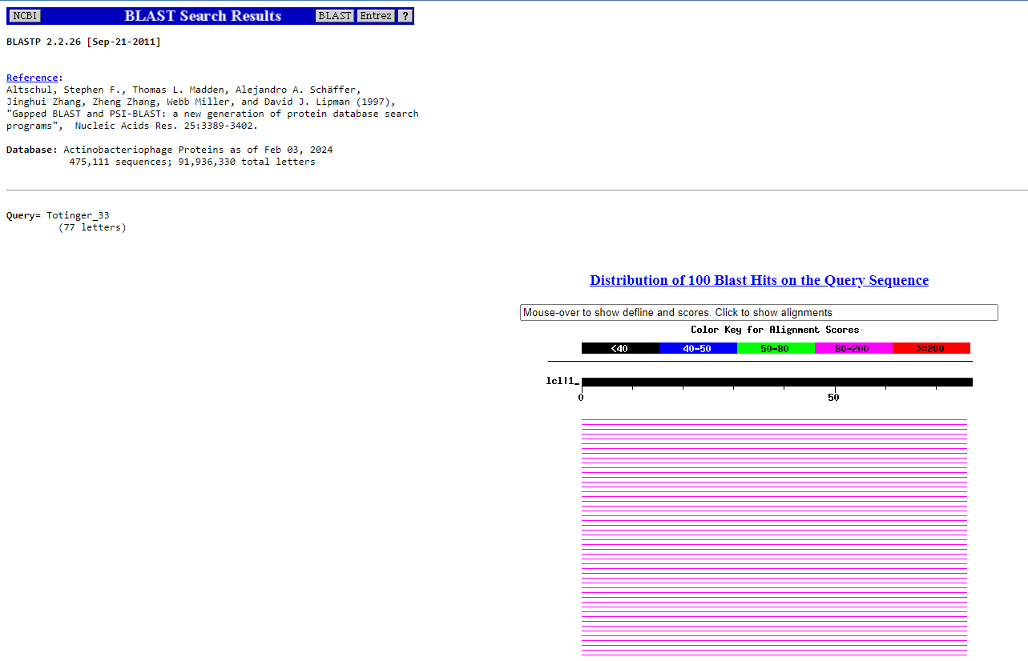
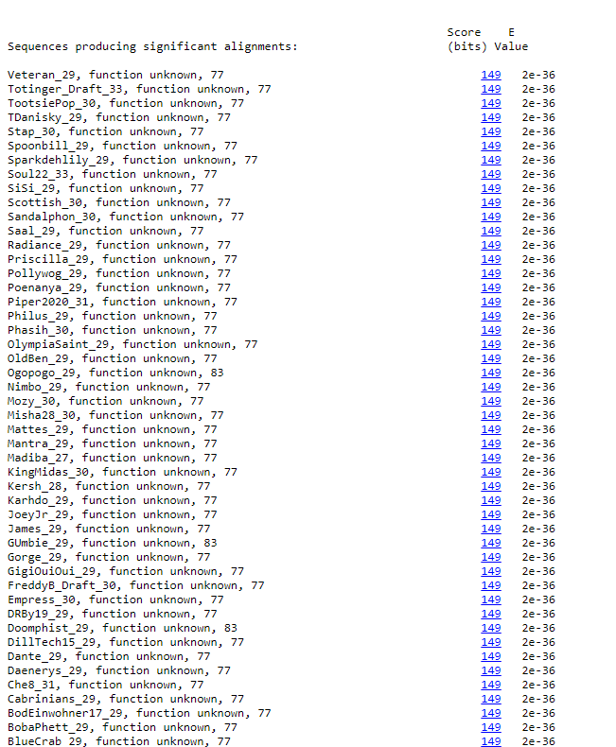
BLAST from NCBI (https://blast.ncbi.nlm.nih.gov/Blast.cgi?PAGE=Proteins) Using Longest ORF
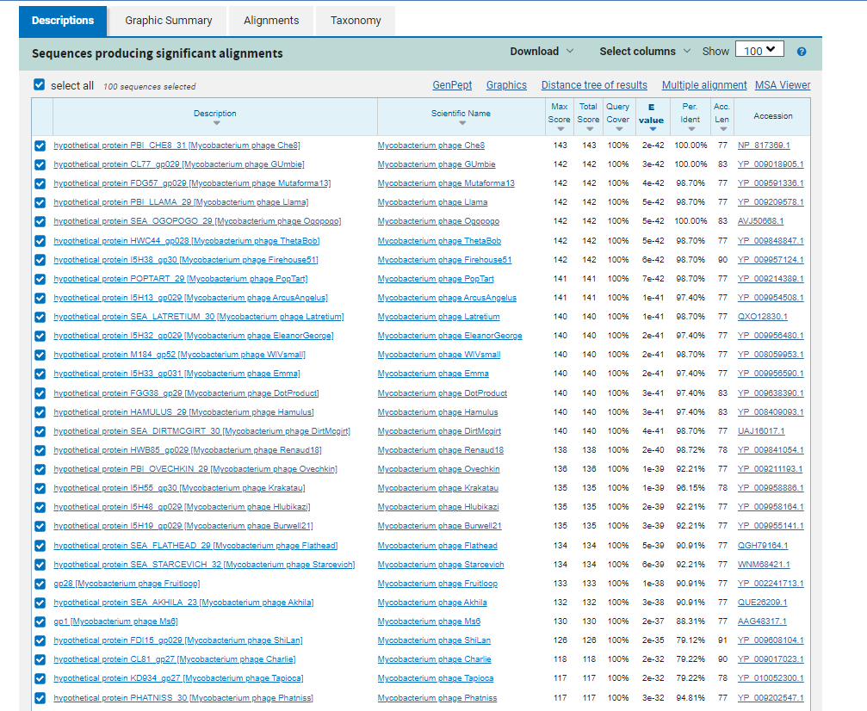
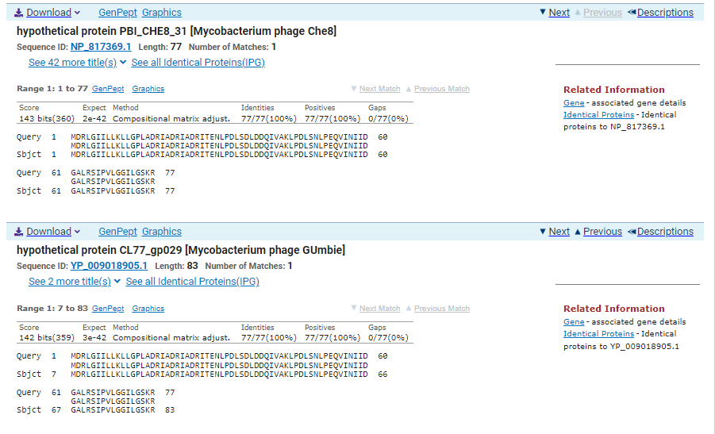
ATG Start at 26000. Original Glimmer call.
TGA Stop at 26233
F/R: F
Coding Potential (y/n): Y
Starterator (SS, NA, NI): Most annotated start is this (26000)
Blast Best Hit, Query:Subject Starts, Score, Evalue, or “no significant Blast alignments” if 10E-4 or higher
Hypothetical protein PBI_CHE8_31 Mycobacterium phage Che8, NP_817369.1, 1:1, Score 143, Evalue, 2e-42
Gap with previous gene: 69
Longest Orf? (Y/N/NA) Y
RBS:
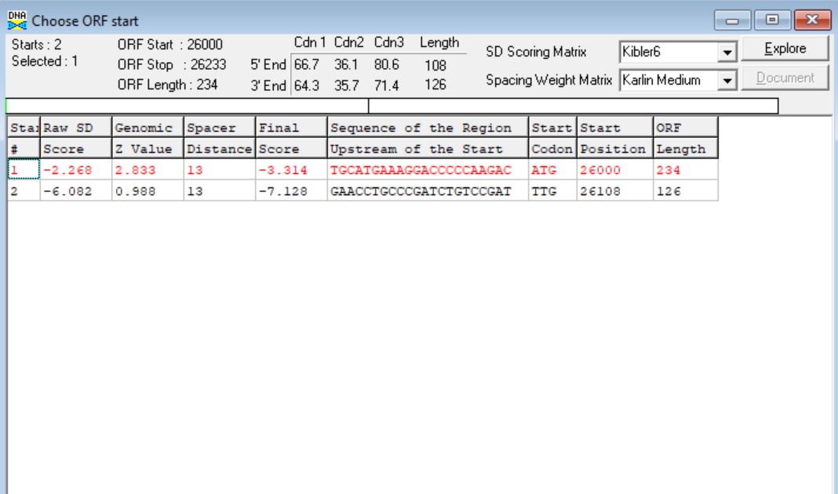
(https://toolkit.tuebingen.mpg.de/tools/hhpred) HHPRED vs PDB, SCOPe, pFam, and M. Tuberculosis.
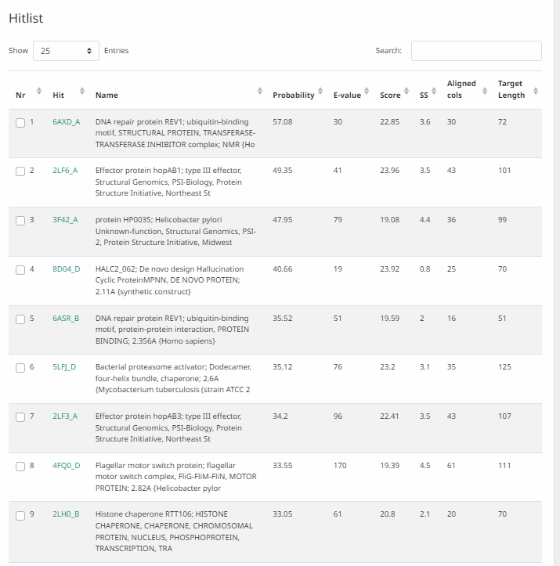
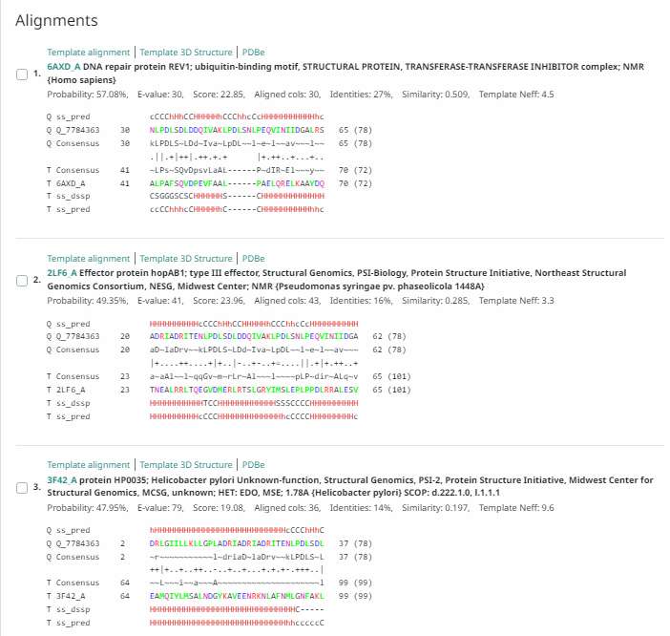
Phamerator Totinger Vs. Tootsieroll Vs. Starcevich (https://phamerator.org/phages) Genes 21-43
Proposed Function: hypothetical protein
Function Evidence: BLAST results all have their best hits being hypothetical proteins or proteins of unknown functions. Similar phages (phage Starcevich and phage Tootsieroll) in Phamerator also do not call this gene as any specific function.
Transmembrane Domain/Evidence: No, Intracellular Properties (https://dtu.biolib.com/DeepTMHMM)
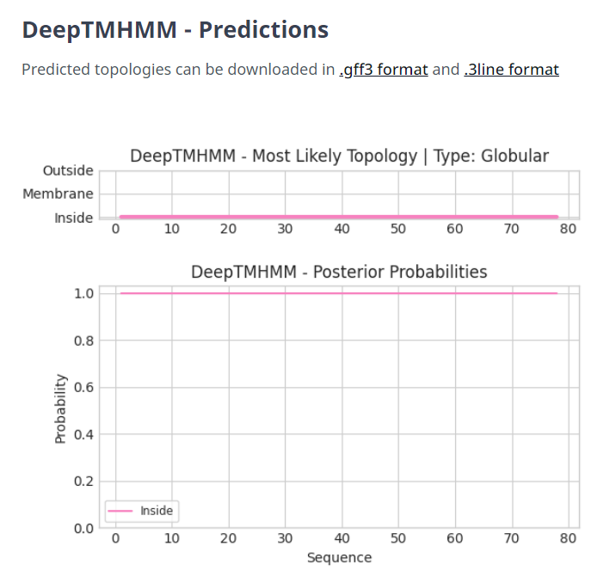

Gene Number: 31
Totinger_Draft_34 in Phagesdb
Pham137517
BLAST from PhagesDB. (https://phagesdb.org/blastp/) Using Longest ORF
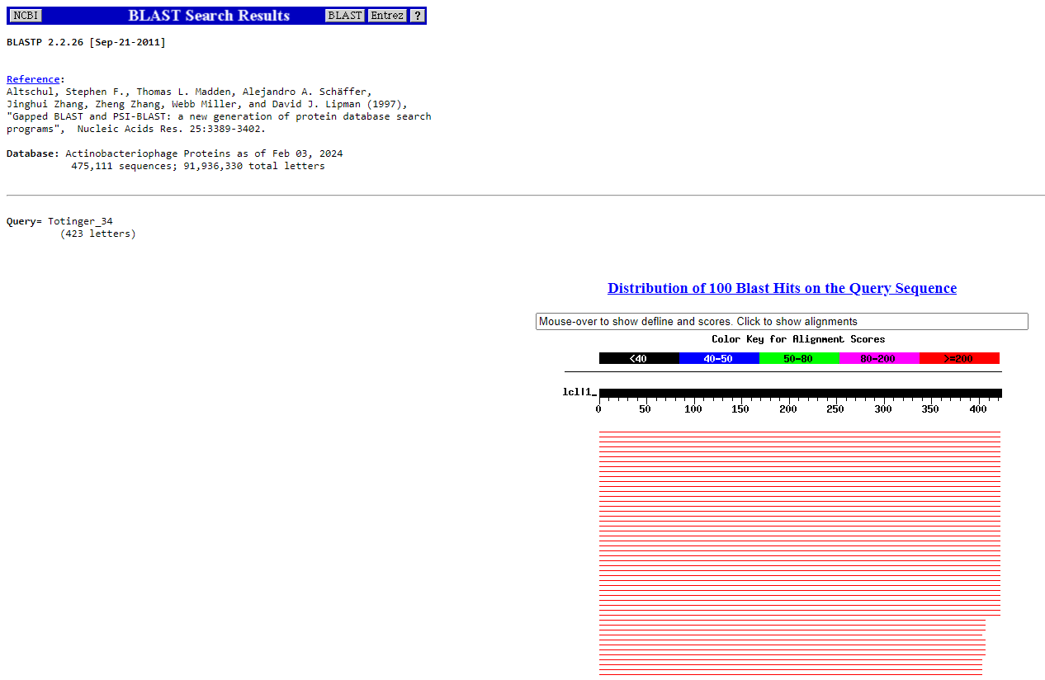
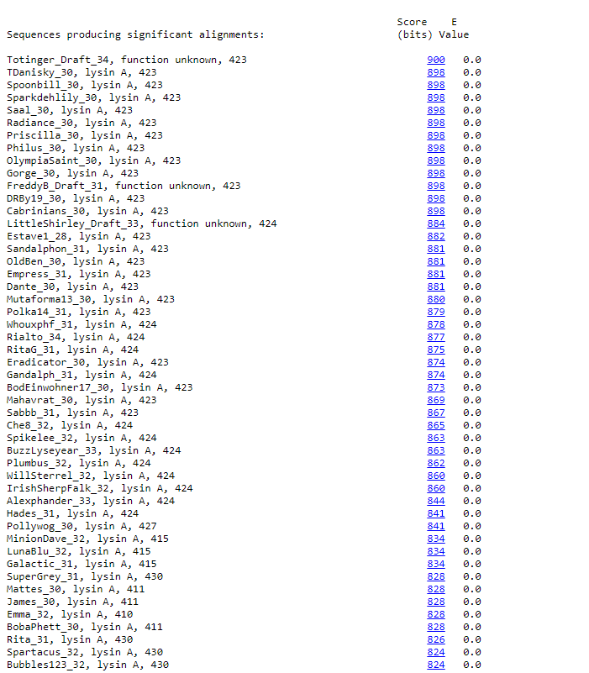
BLAST from NCBI (https://blast.ncbi.nlm.nih.gov/Blast.cgi?PAGE=Proteins) Using Longest ORF
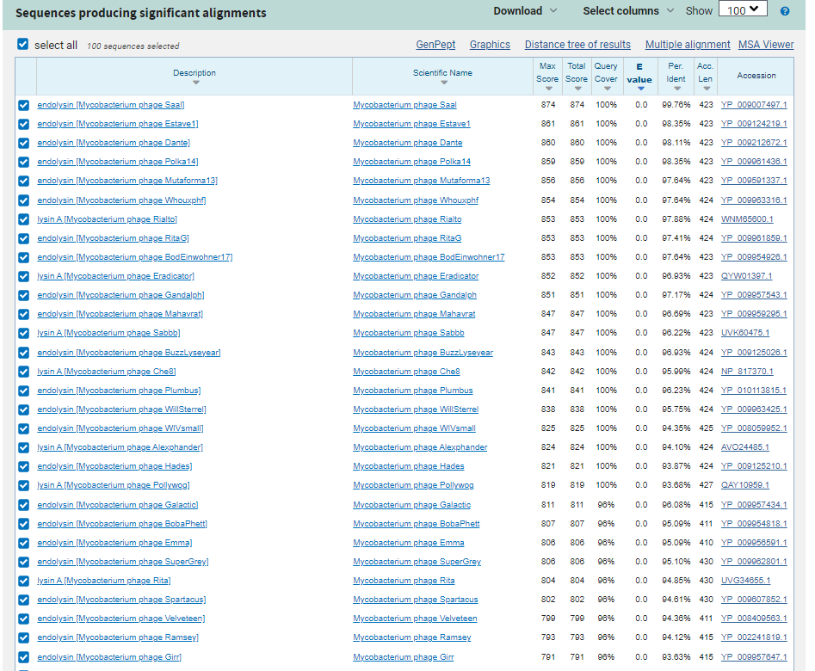
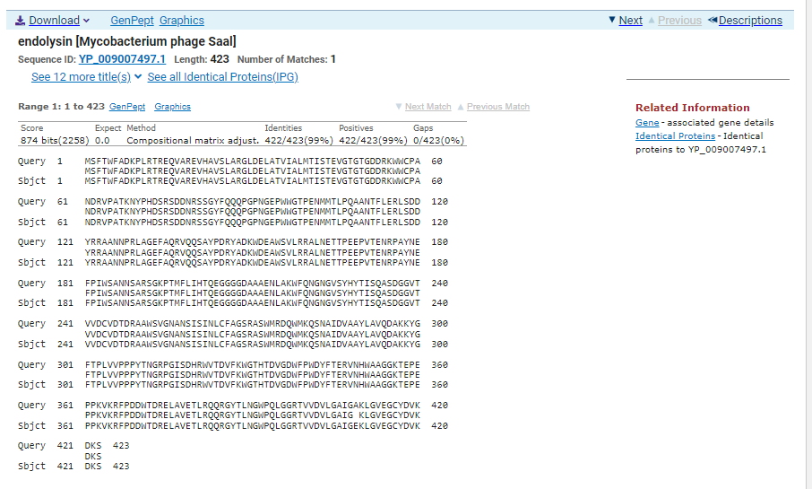
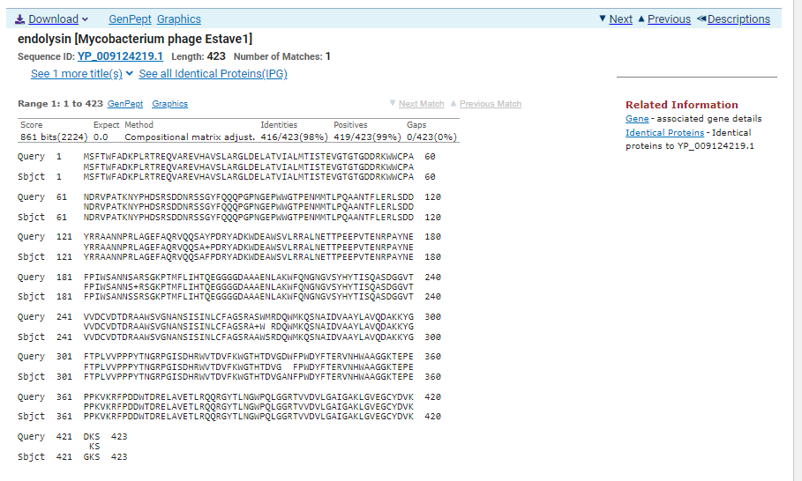
ATG Start at 26230. Original Glimmer call.
TGA Stop at 27501
F/R: F
Coding Potential (y/n): Y
Starterator (SS, NA, NI): Does not have the Most Annotated Start
Blast Best Hit, Query:Subject Starts, Score, Evalue, or “no significant Blast alignments” if 10E-4 or higher
Endolysin Mycobacterium phage Saal YP_008126594.1, 1:1, Score 861, Evalue, 0
Gap with previous gene: -3
Longest Orf? (Y/N/NA) Y
RBS:
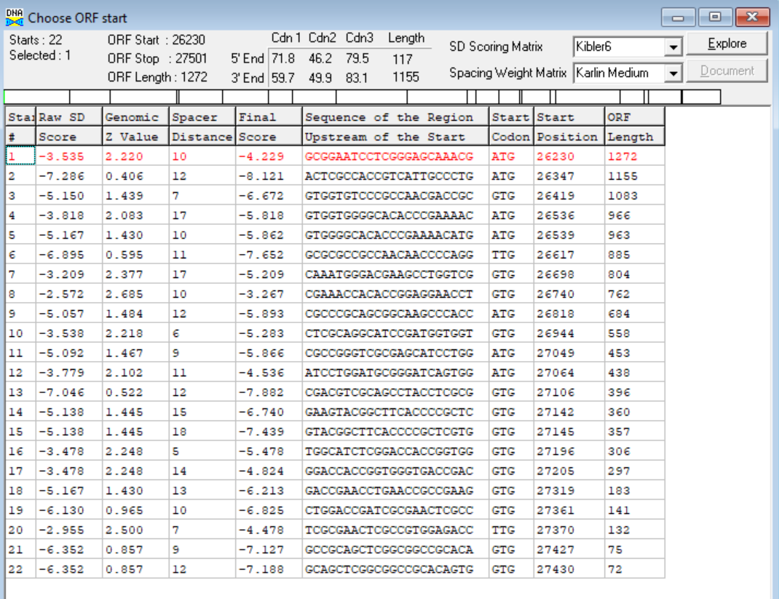
(https://toolkit.tuebingen.mpg.de/tools/hhpred) HHPRED vs PDB, SCOPe, pFam, and M. Tuberculosis.
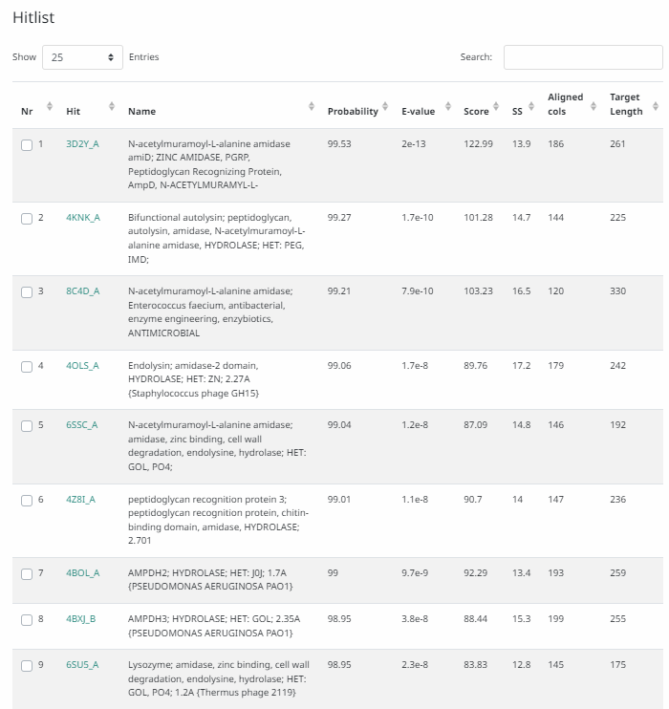
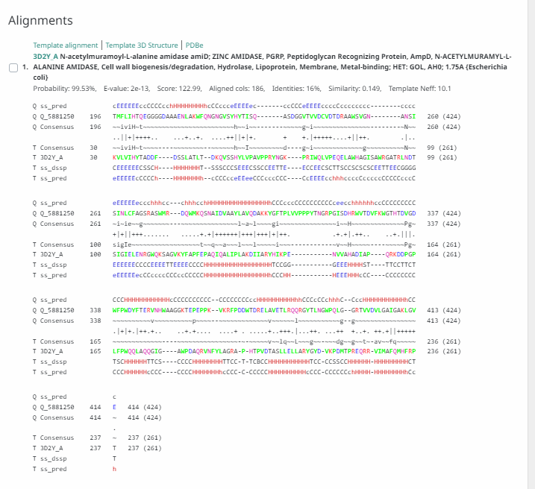
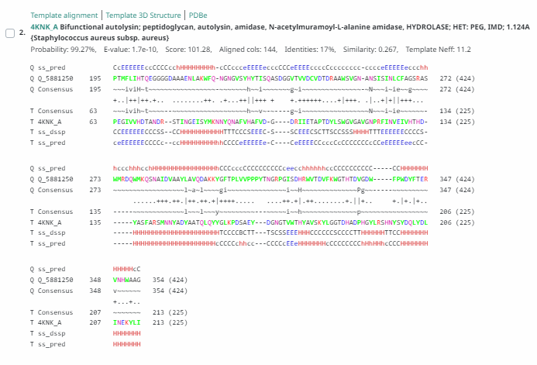
Phamerator Totinger Vs. Tootsieroll Vs. Starcevich (https://phamerator.org/phages) Genes 21-43
Proposed Function: Lysin A
Function Evidence: Most consistently, this gene aligned with lysin proteins in BLASTs. Additionally, similar phages (phage Starcevich and phage Tootsieroll) in Phamerator call similar genes as lysin A.
Transmembrane Domain/Evidence: No, Extracellular Properties. (https://dtu.biolib.com/DeepTMHMM)
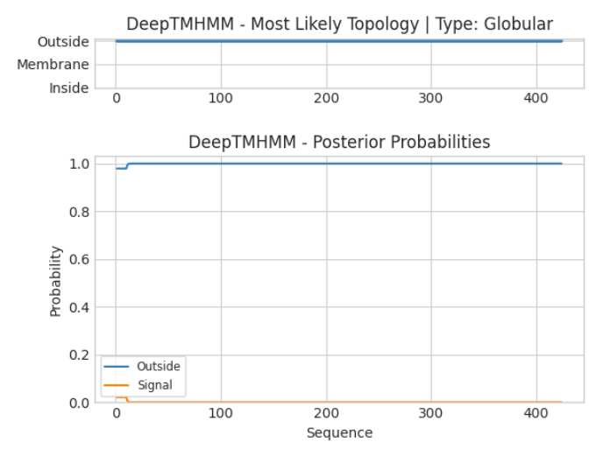

Gene Number: 32
Totinger_Draft_35 on Phagesdb
Pham135176
BLAST from PhagesDB. (https://phagesdb.org/blastp/) Using Longest ORF
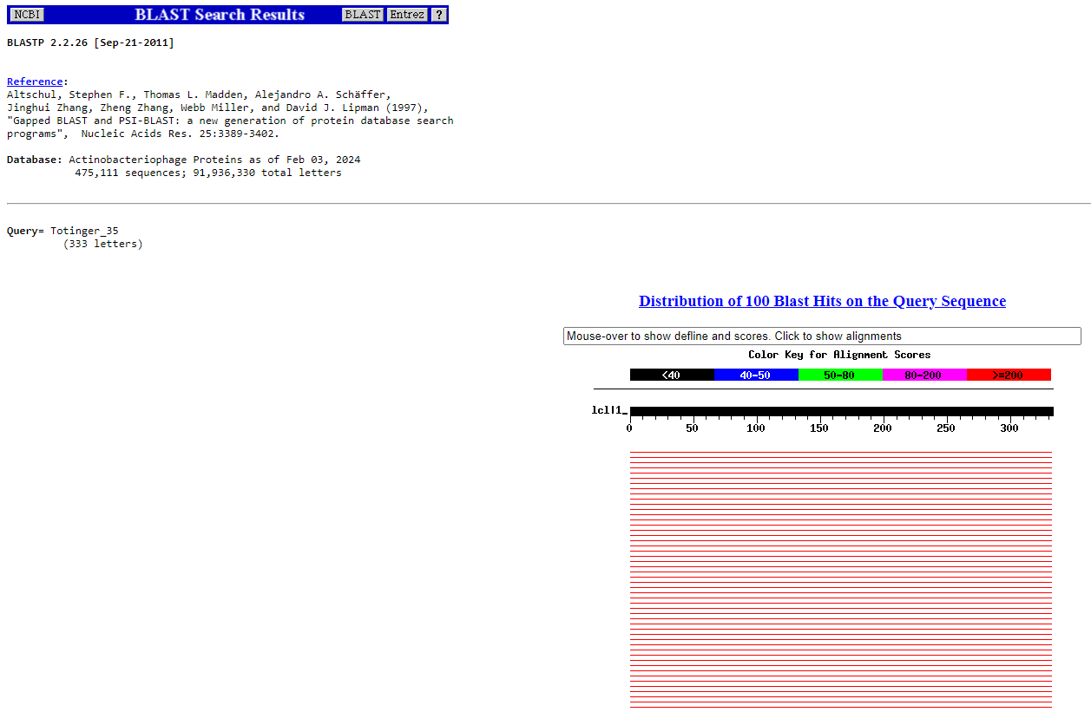
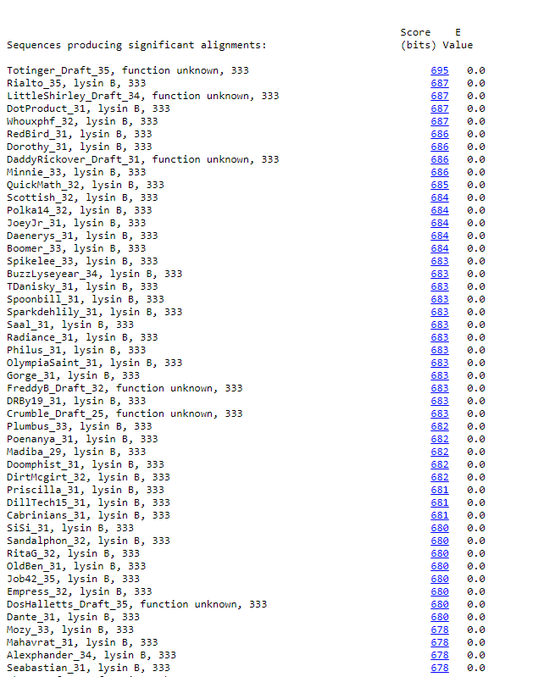
BLAST from NCBI (https://blast.ncbi.nlm.nih.gov/Blast.cgi?PAGE=Proteins) Using Longest ORF
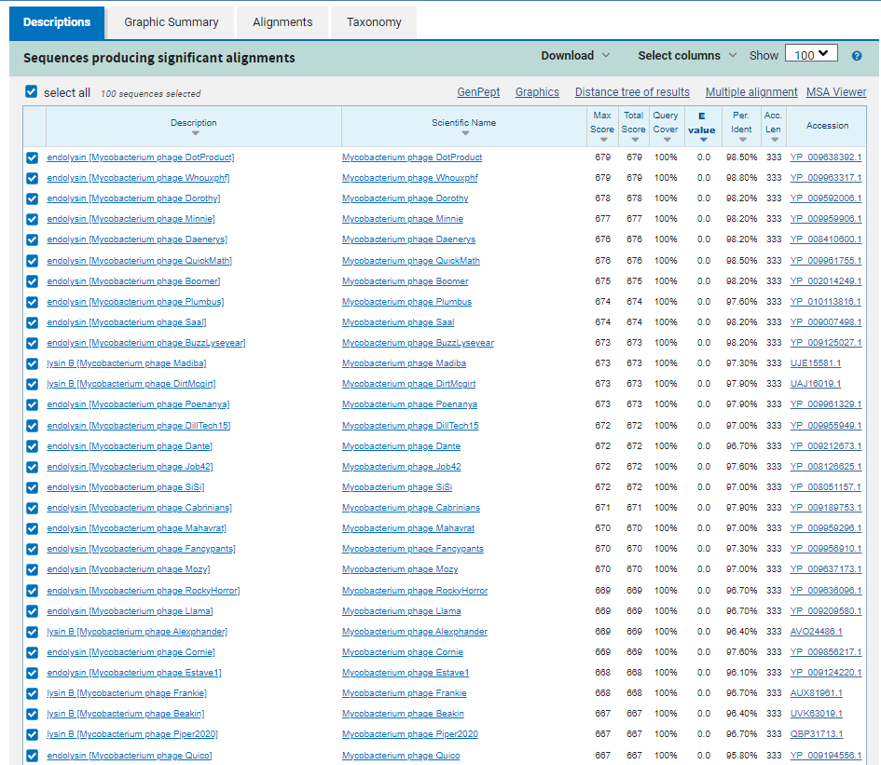
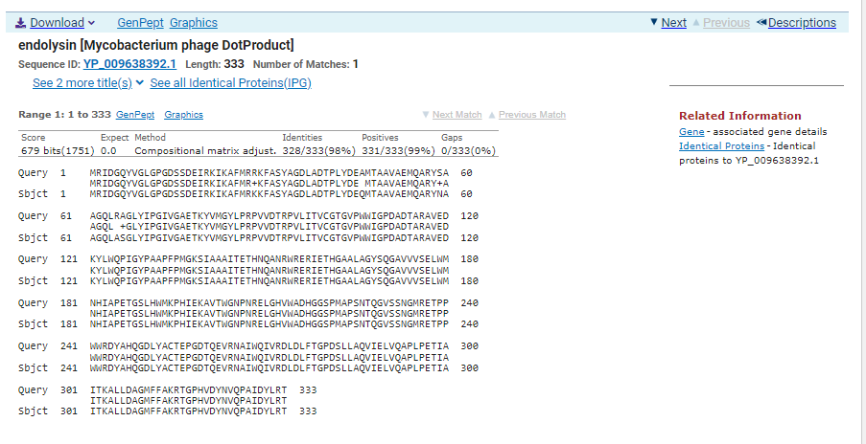
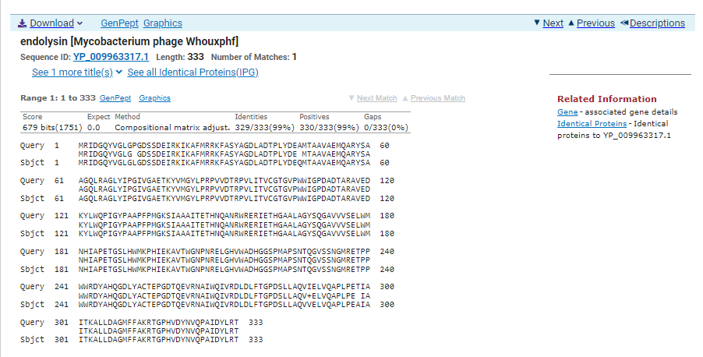
ATG Start at 27501. Original Glimmer call.
TAA Stop at 28502.
F/R: F
Coding Potential (y/n): Y
Starterator (SS, NA, NI): Most annotated start is this (27501)
Blast Best Hit, Query:Subject Starts, Score, Evalue, or “no significant Blast alignments” if 10E-4 or higher
Endolysin Mycobacterium phage Dotproduct YP_009638392.1, 1:1, Score 679, Evalue, 0
Gap with previous gene: 0
Longest Orf? (Y/N/NA) Y
RBS:
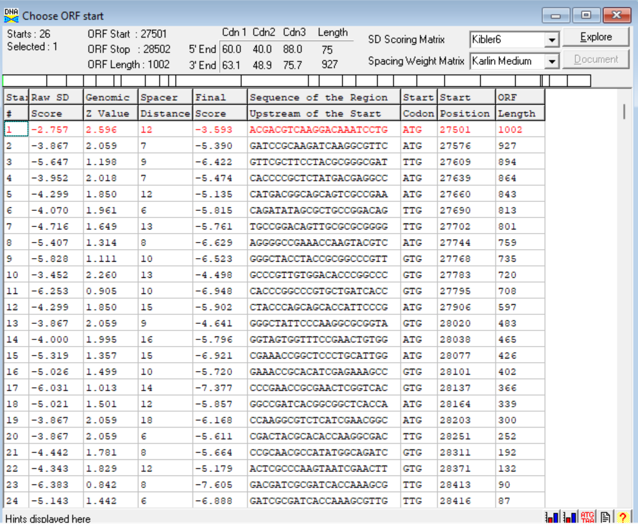
(https://toolkit.tuebingen.mpg.de/tools/hhpred) HHPRED vs PDB, SCOPe, pFam, and M. Tuberculosis.
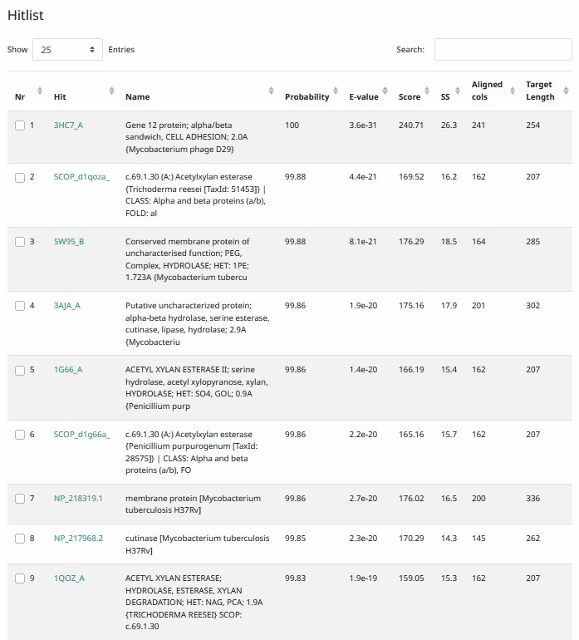
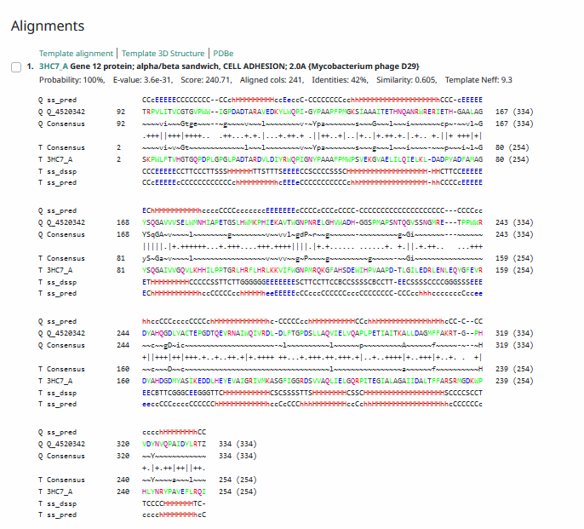
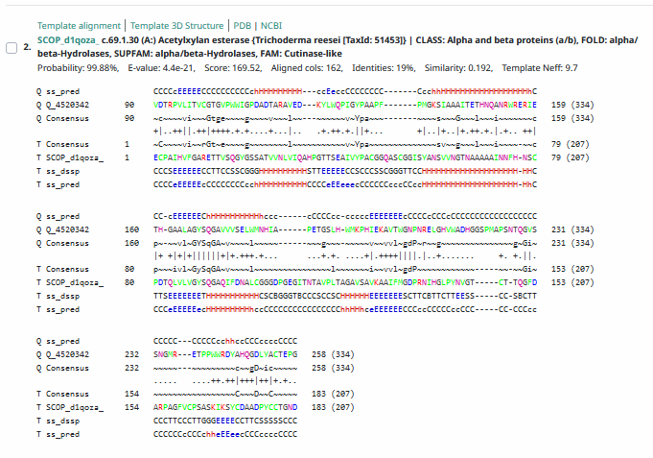
Phamerator Totinger Vs. Tootsieroll Vs. Starcevich (https://phamerator.org/phages) Genes 21-43
Proposed Function: Lysin B
Function Evidence: Homologous genes in other phages are called as Lysin B. In addition, BLAST results from all databases and HHPRED results aligned with Lysin B.
Transmembrane Domain/Evidence: No, Extracellular Properties (https://dtu.biolib.com/DeepTMHMM)
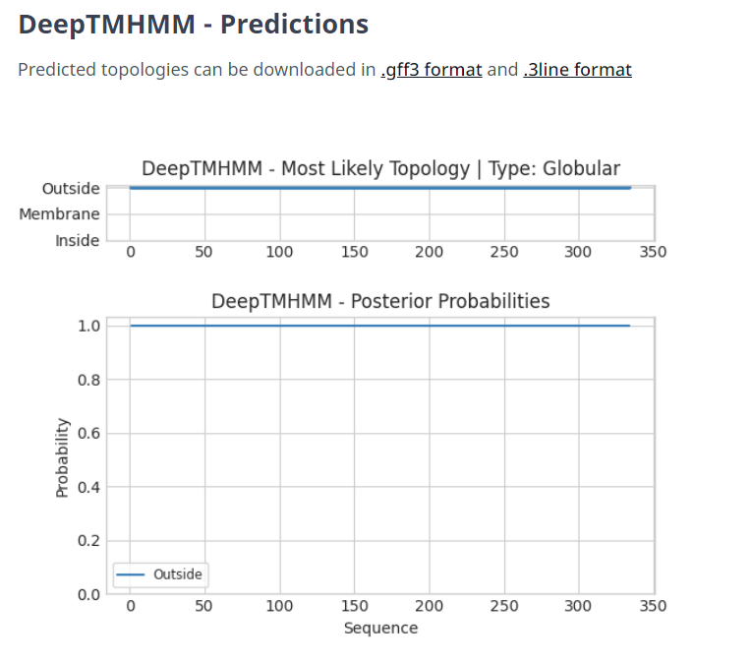

Gene Number: 33
Totinger_Draft_36 on Phagesdb
Pham139471
BLAST from PhagesDB. (https://phagesdb.org/blastp/) Using Longest ORF
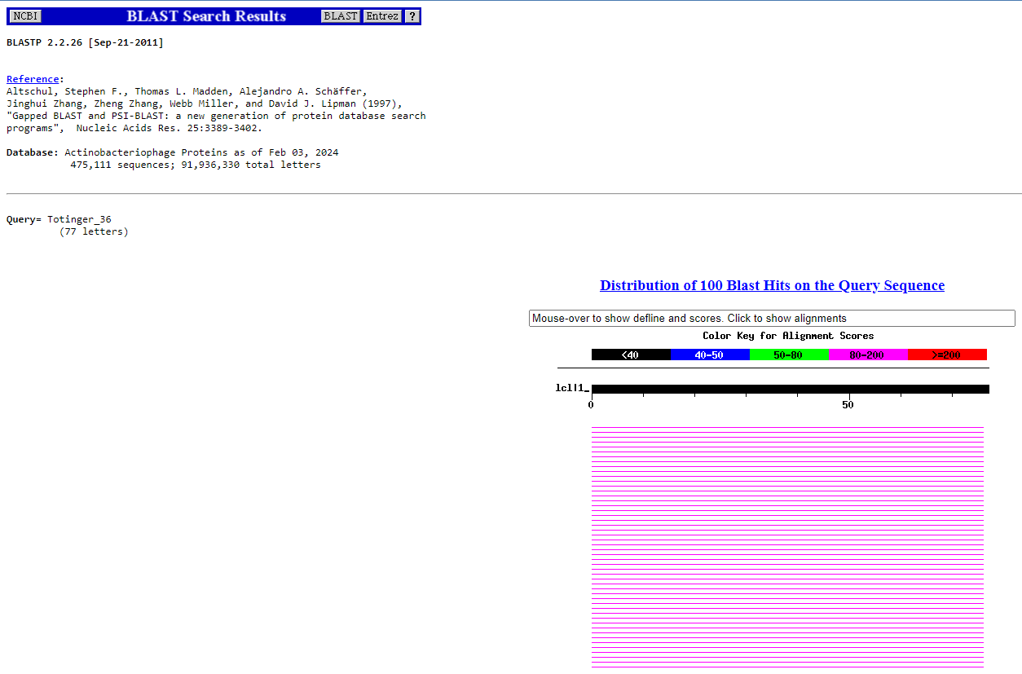
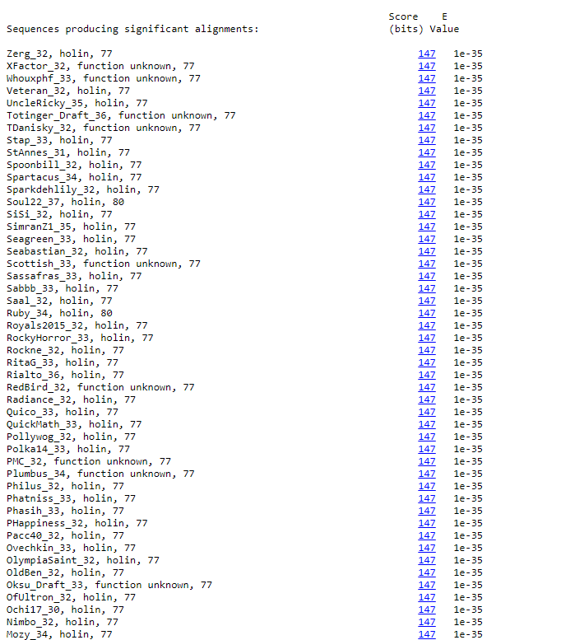
BLAST from NCBI (https://blast.ncbi.nlm.nih.gov/Blast.cgi?PAGE=Proteins) Using Longest ORF
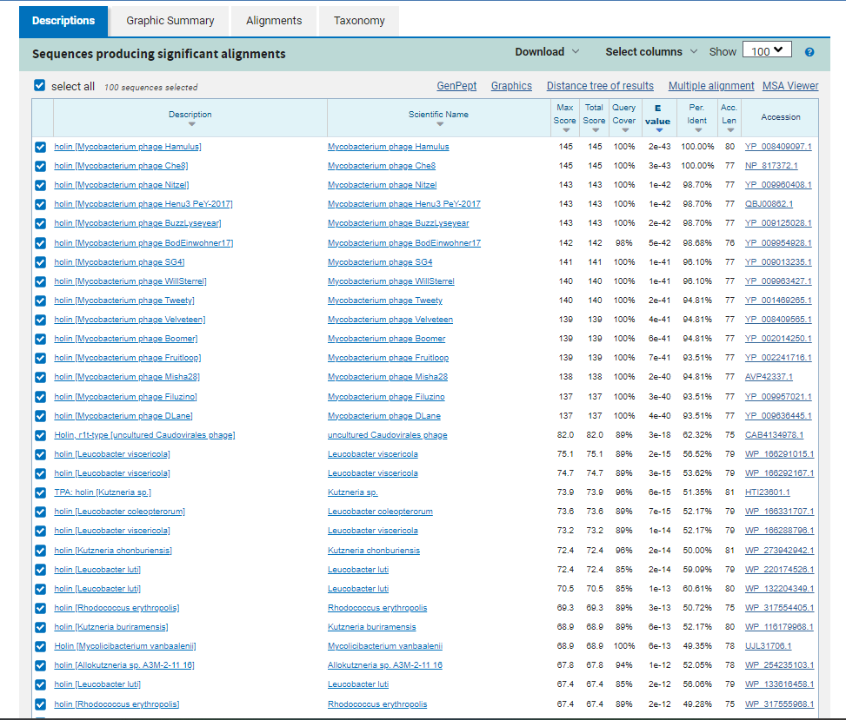
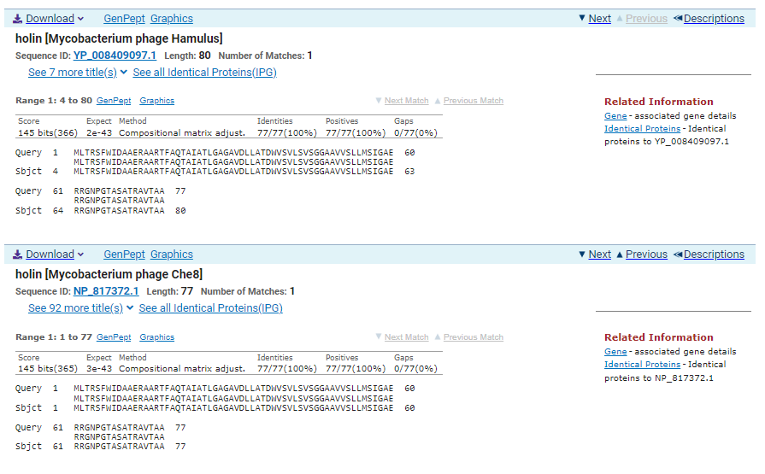
ATG Start at 28516. Original Glimmer call.
TGA Stop at 28749
F/R: F
Coding Potential (y/n): Y
Starterator (SS, NA, NI): Most annotated start is this (28516)
Blast Best Hit, Query:Subject Starts, Score, Evalue, or “no significant Blast alignments” if 10E-4 or higher
Holin Mycobacterium phage Hamulus YP_008409097.1, 4:80, Score 145, Evalue, 2e-43
Gap with previous gene: 14
Longest Orf? (Y/N/NA) Y
RBS:
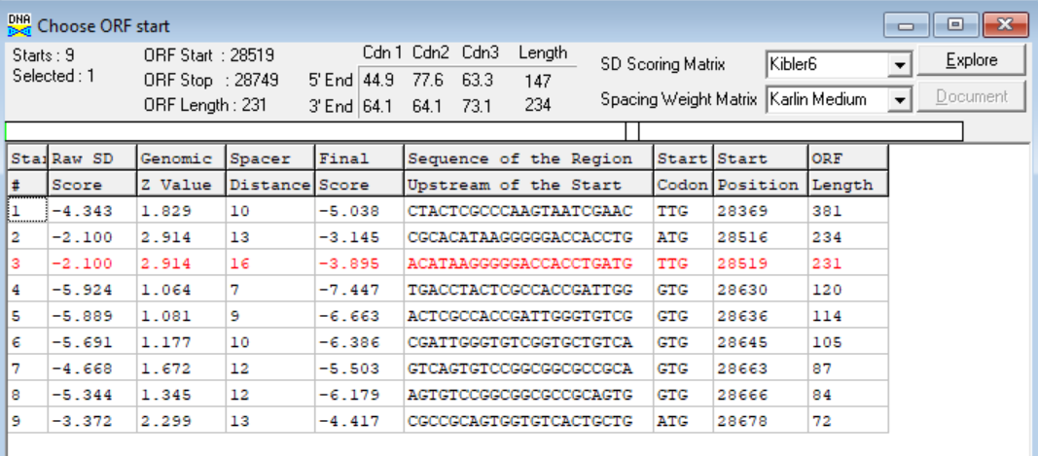
(https://toolkit.tuebingen.mpg.de/tools/hhpred) HHPRED vs PDB, SCOPe, pFam, and M. Tuberculosis.
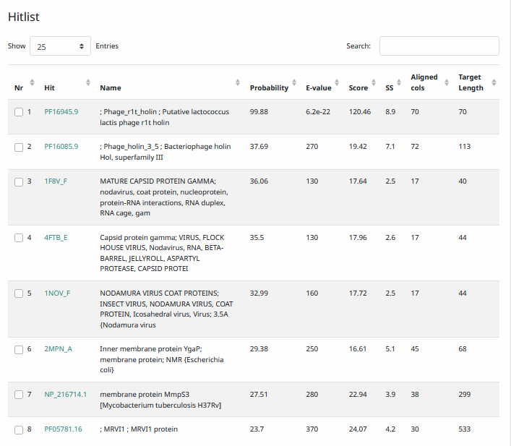
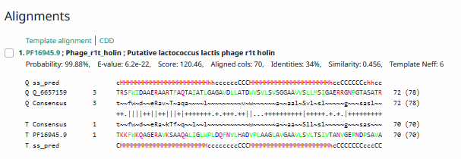
Phamerator Totinger Vs. Tootsieroll Vs. Starcevich (https://phamerator.org/phages) Genes 21-43
Proposed Function: holin
Function Evidence: This gene’s product has the expected transmembrane domains that a holin would have, and HHPRED had its only significant hit match with a holin. Furthermore, similar genes in other phages (phage Starcevich and phage Tootsieroll) call this gene as a holin and BLAST results most consistently aligned with one in all databases.
Transmembrane Domain/Evidence: Yes, Transmembrane domains at AA 14-31 and 38-58 (https://dtu.biolib.com/DeepTMHMM)
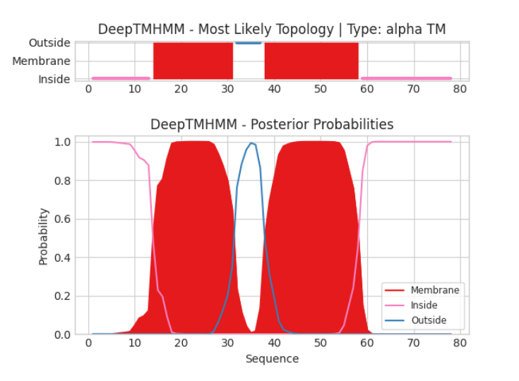

Gene Number: 34
Totinger_Draft_37 on Phagesdb
Pham139417
BLAST from PhagesDB. (https://phagesdb.org/blastp/) Using Longest ORF
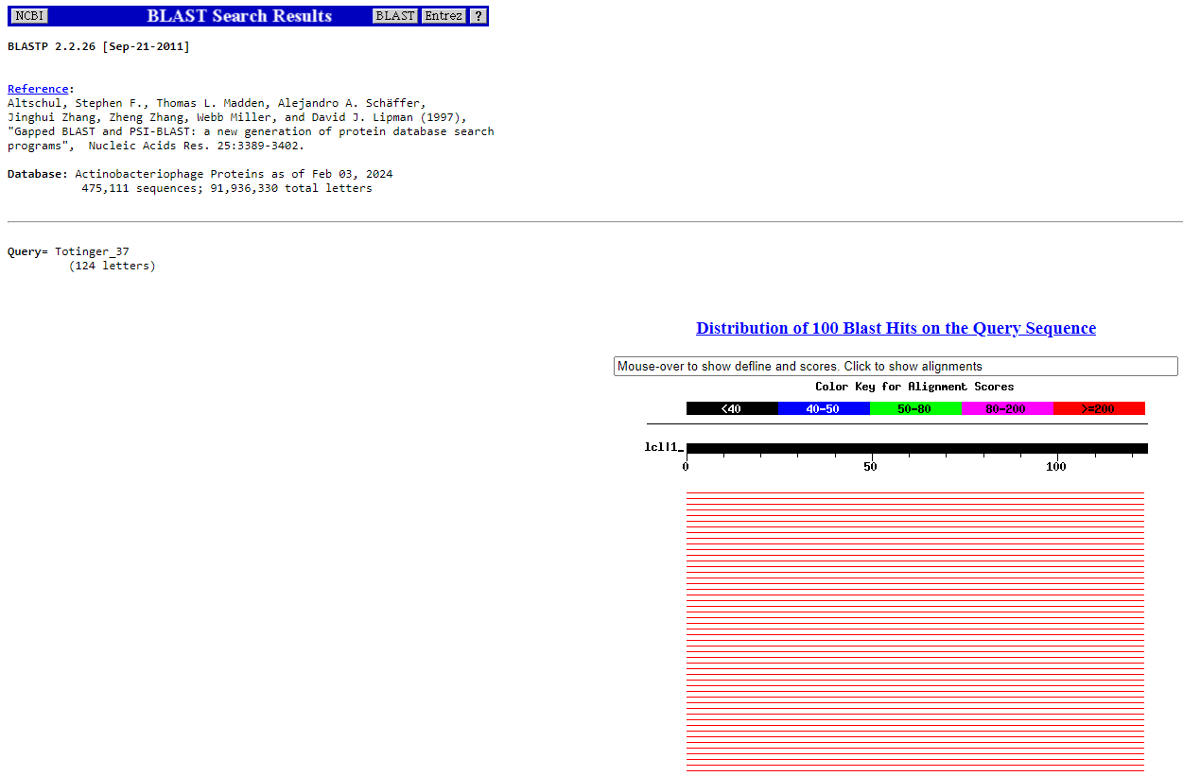
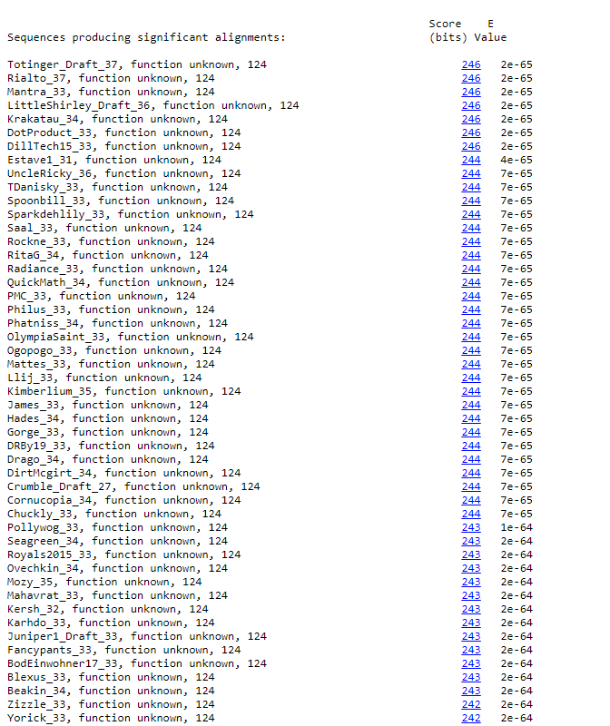
BLAST from NCBI (https://blast.ncbi.nlm.nih.gov/Blast.cgi?PAGE=Proteins) Using Longest ORF
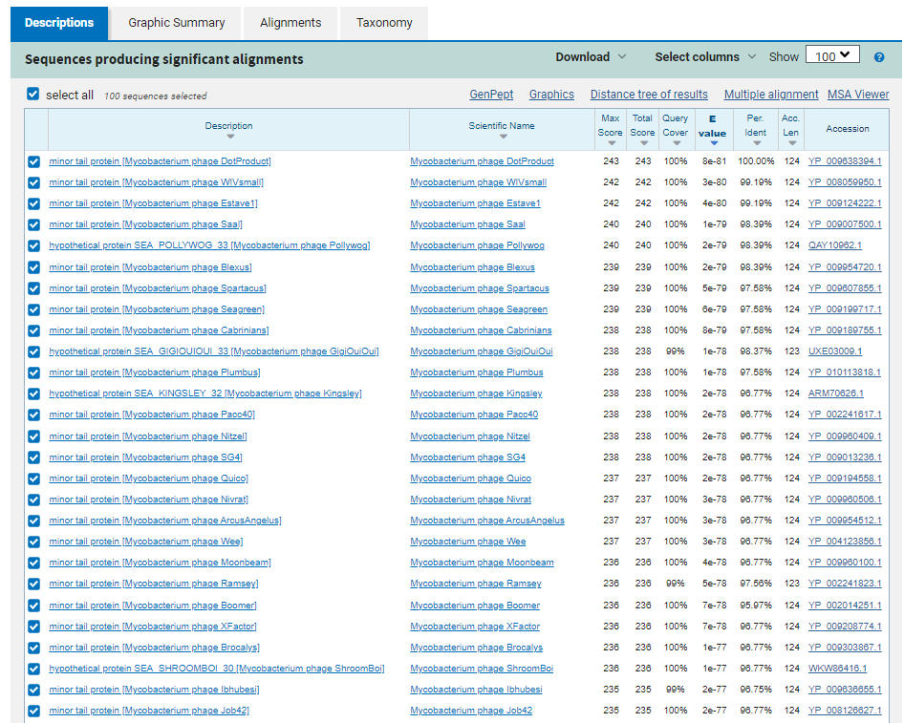
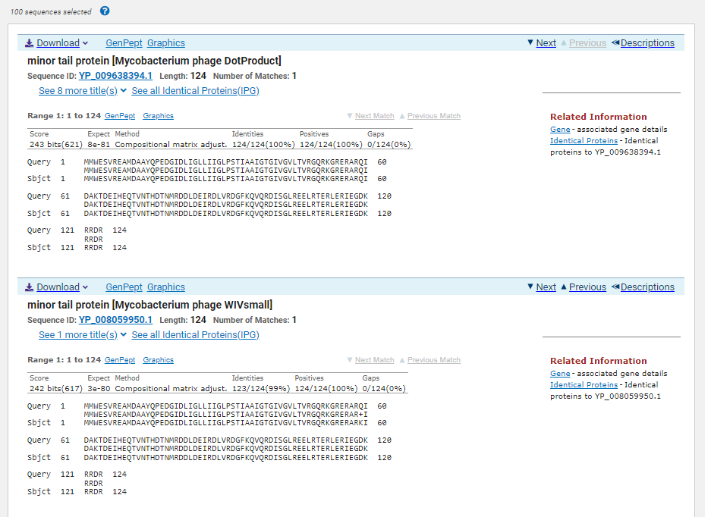
ATG Start at 28746. Original Glimmer call. GeneMark calls start at 28749
TAA Stop at 29120
F/R: F
Coding Potential (y/n): Y
Starterator (SS, NA, NI): Most annotated start is this (28746)
Blast Best Hit, Query:Subject Starts, Score, Evalue, or “no significant Blast alignments” if 10E-4 or higher
Minor tail protein Mycobacterium phage Dotproduct YP_009638394.1, 1:1, Score 243, Evalue, 8e-81
Gap with previous gene: -3
Longest Orf? (Y/N/NA) Y
RBS:
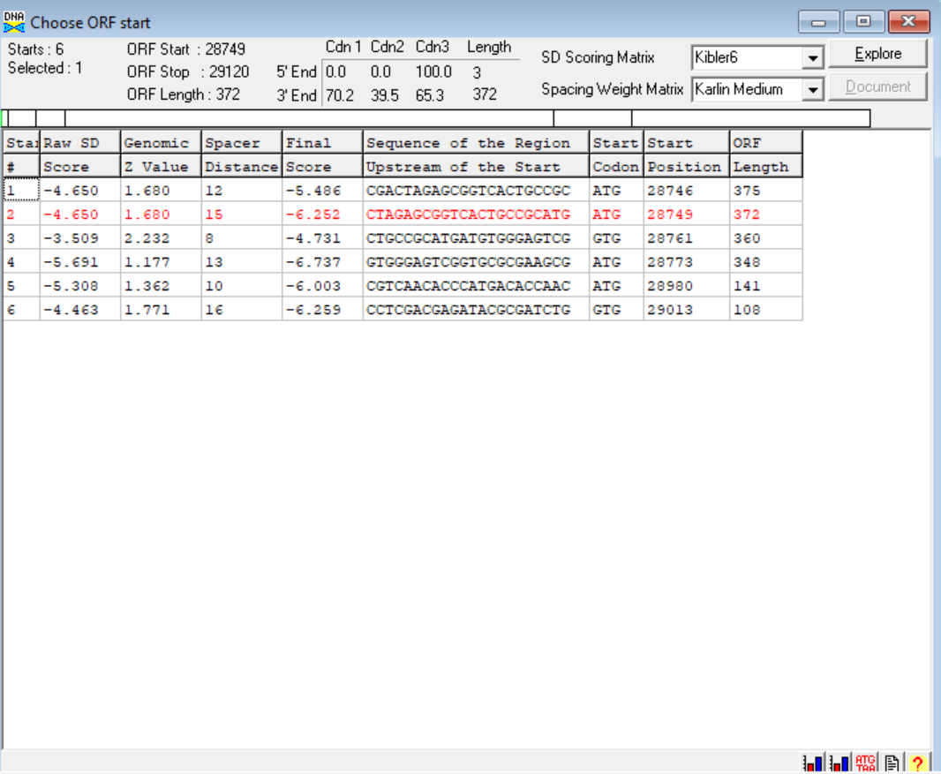
(https://toolkit.tuebingen.mpg.de/tools/hhpred) HHPRED vs PDB, SCOPe, pFam, and M. Tuberculosis.
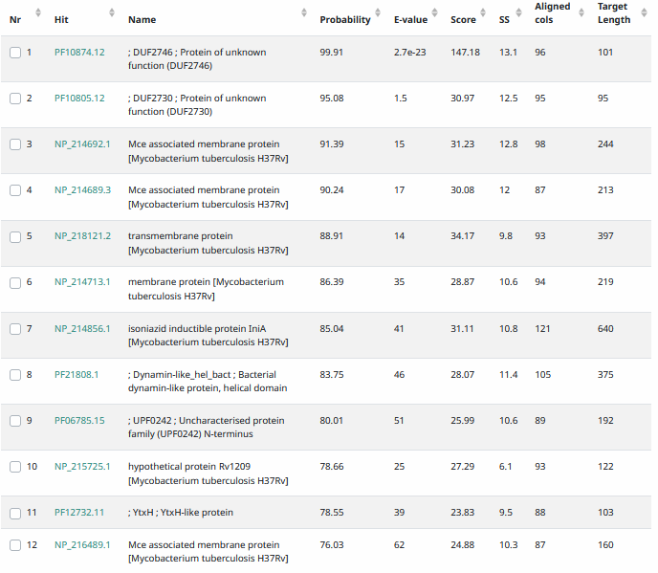
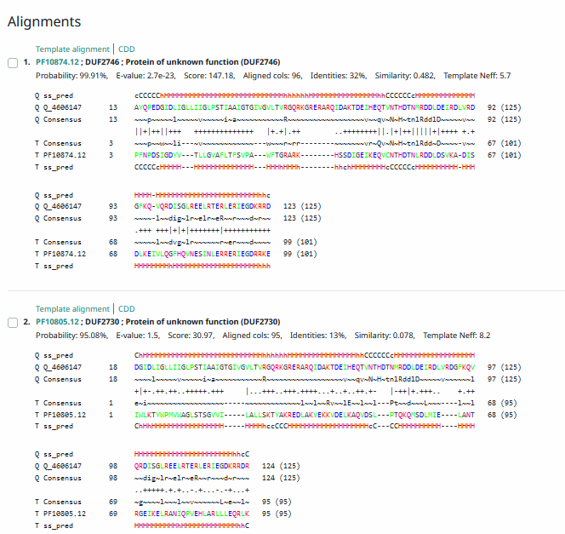
Phamerator Totinger Vs. Tootsieroll Vs. Starcevich (https://phamerator.org/phages) Genes 21-43
Proposed Function: hypothetical protein
Function Evidence: While several minor tail proteins matched with this one, BLAST results and HHPRED results were too inconsistent to make a confident function call. Additionally, similar genes do not have functions called in similar phages (phage Tootsieroll and phage Starcevich).
Transmembrane Domain/Evidence: Yes, Transmembrane Properties at ~AA 22-47 (https://dtu.biolib.com/DeepTMHMM)
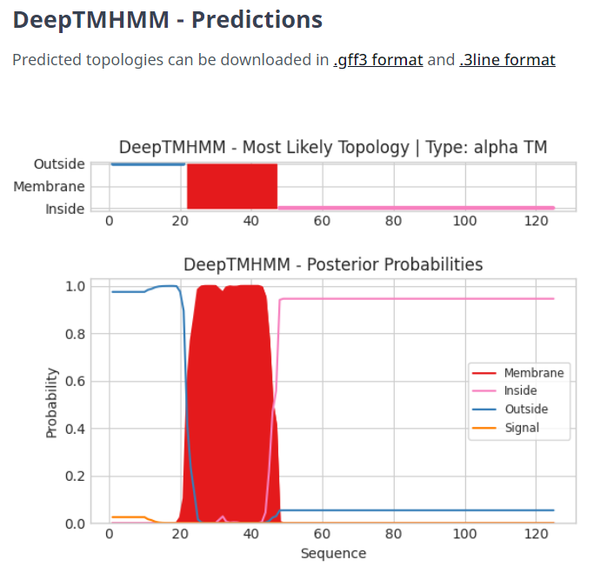

Gene Number: 35
Totinger_Draft_38 on phagesdb
Pham333
BLAST from PhagesDB. (https://phagesdb.org/blastp/) Using Longest ORF
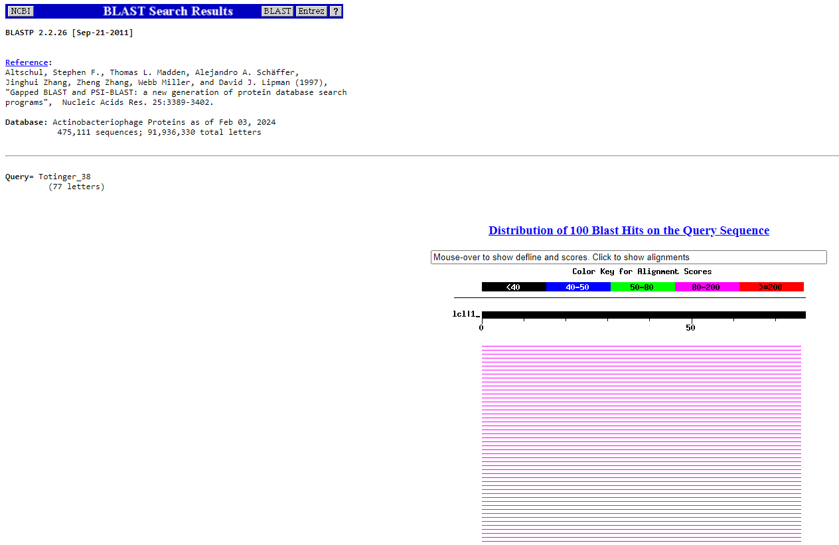
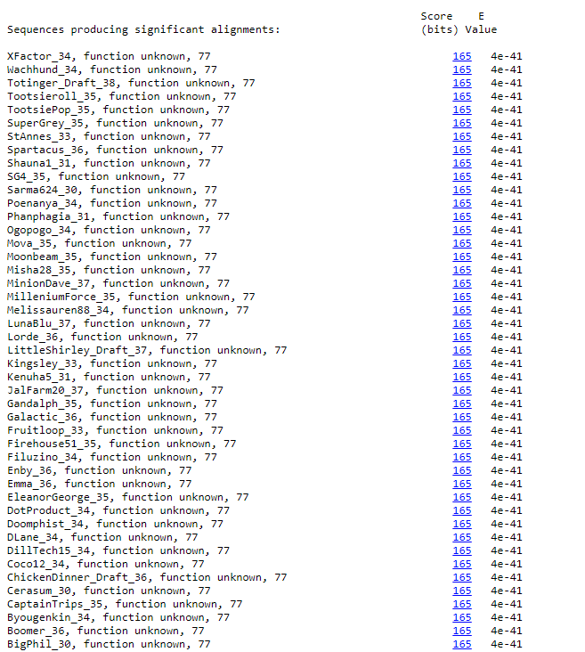
BLAST from NCBI (https://blast.ncbi.nlm.nih.gov/Blast.cgi?PAGE=Proteins) Using Longest ORF
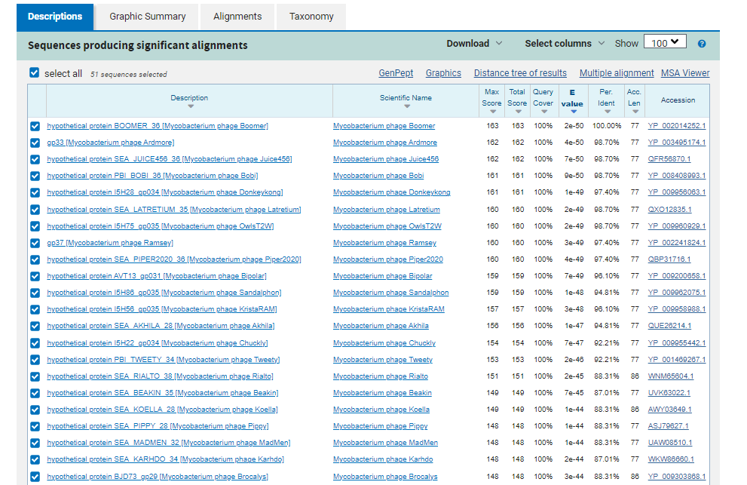
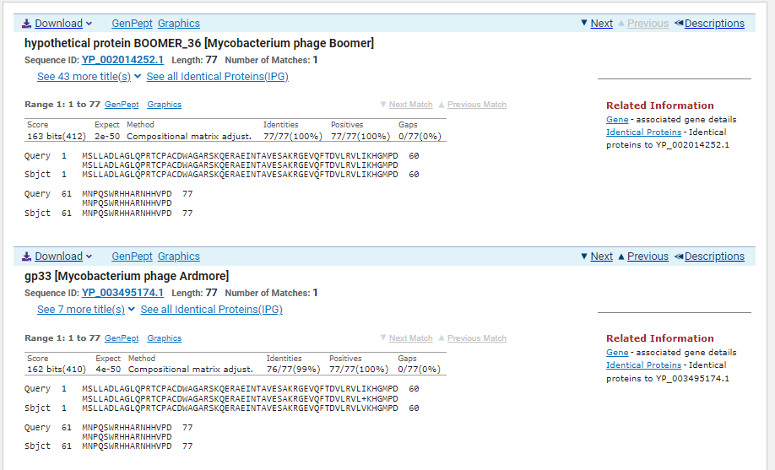
ATG Start at 29145. Original Glimmer call.
TAG Stop at 29378
F/R: F
Coding Potential (y/n): Y
Starterator (SS, NA, NI): Most annotated start is this (29145)
Blast Best Hit, Query:Subject Starts, Score, Evalue, or “no significant Blast alignments” if 10E-4 or higher
Hypothetical protein BOOMER_36 Mycobacterium phage Boomer YP_002014252.1, 1:1, Score 163, Evalue, 2e-50
Gap with previous gene: 25
Longest Orf? (Y/N/NA) Y
RBS:
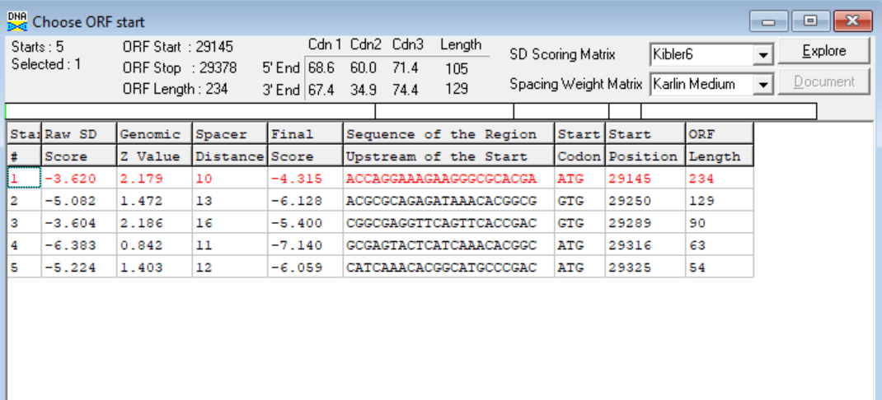
(https://toolkit.tuebingen.mpg.de/tools/hhpred) HHPRED vs PDB, SCOPe, pFam, and M. Tuberculosis.
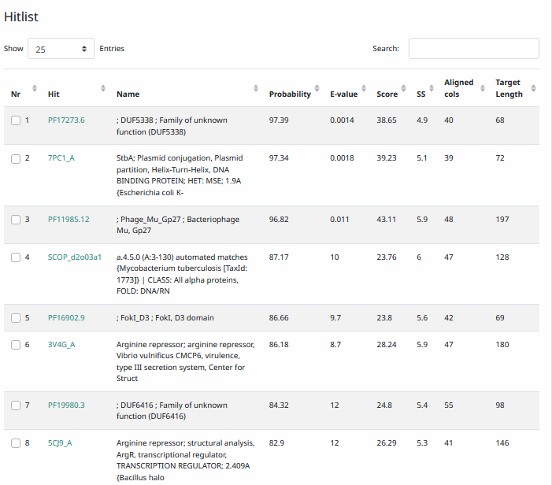
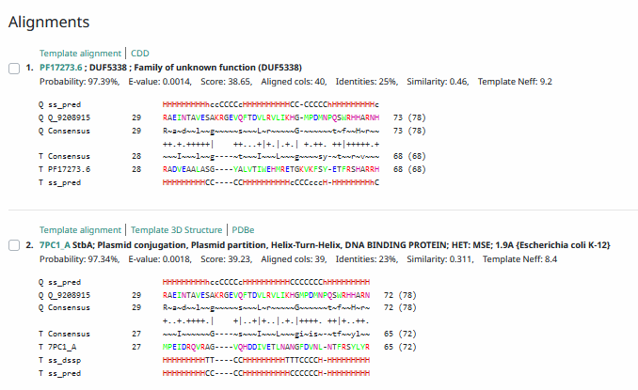
Phamerator Totinger Vs. Tootsieroll Vs. Starcevich (https://phamerator.org/phages) Genes 21-43
Proposed Function: hypothetical protein
Function Evidence: Similar phages on Phamerator (phage Starcevich and phage Tootsieroll) do not call similar genes as having a specific function. Furthermore, BLAST results and HHPRED most consistently hit this protein as one with unknown function.
Transmembrane Domain/Evidence: No, Intracellular Properties (https://dtu.biolib.com/DeepTMHMM)
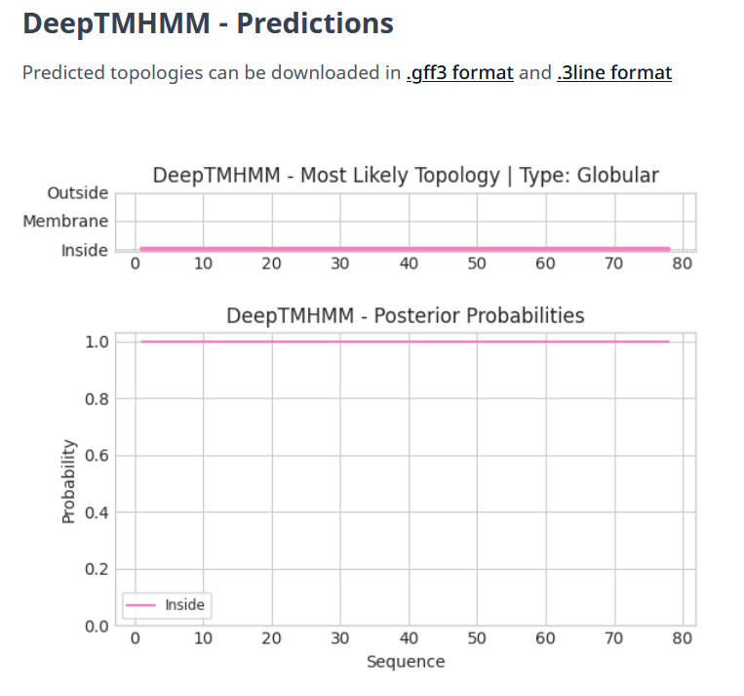

Gene Number: 36
Totinger_Draft_39 on Phagesdb
Pham70
BLAST from PhagesDB. (https://phagesdb.org/blastp/) Using Longest ORF
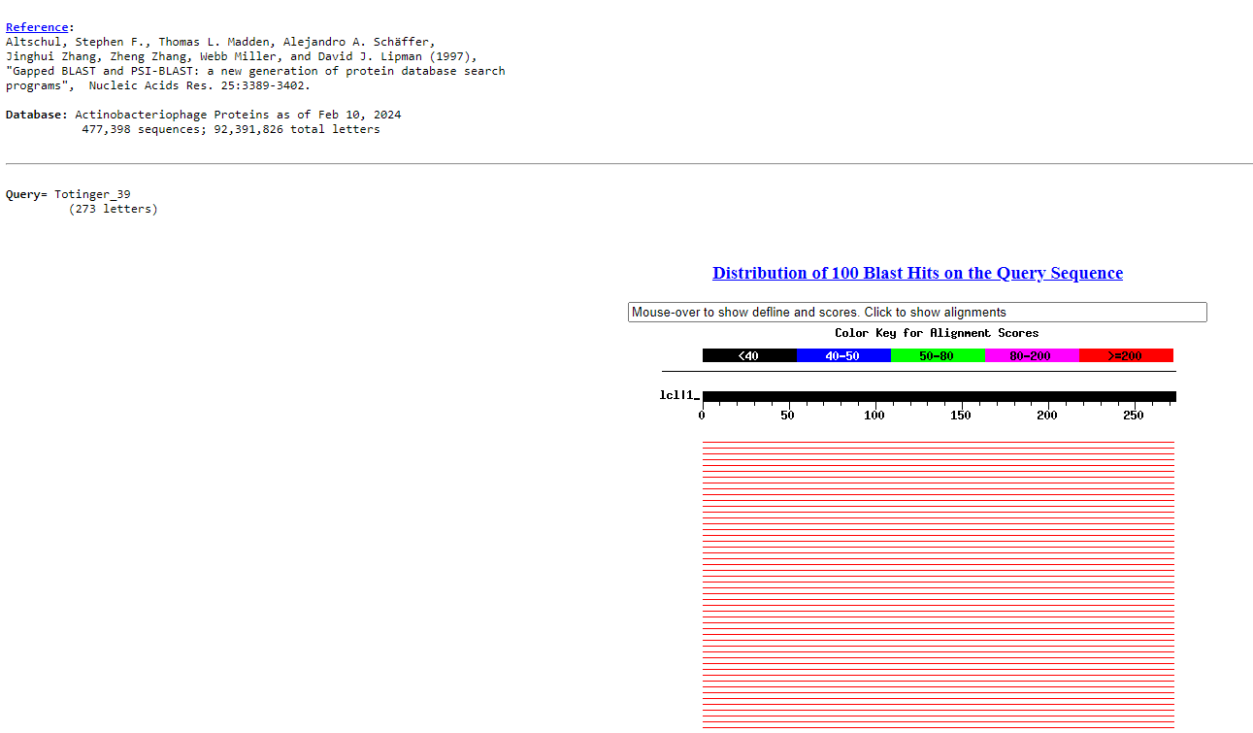
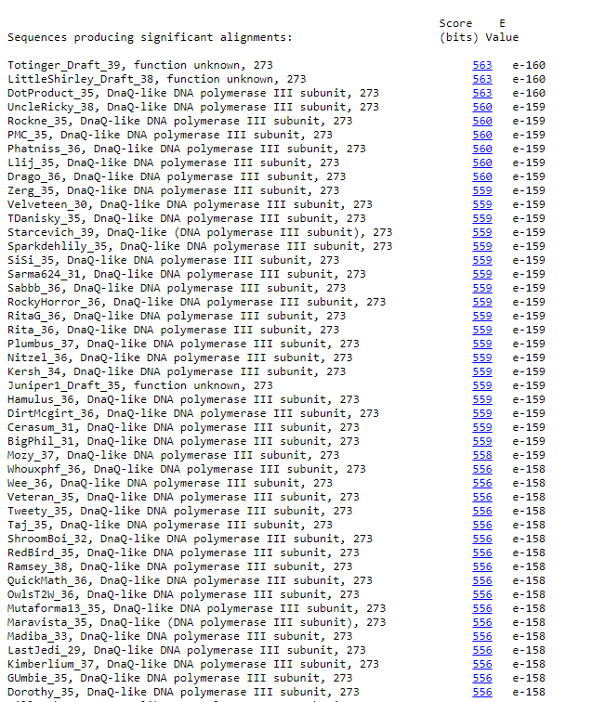
BLAST from NCBI (https://blast.ncbi.nlm.nih.gov/Blast.cgi?PAGE=Proteins) Using Longest ORF
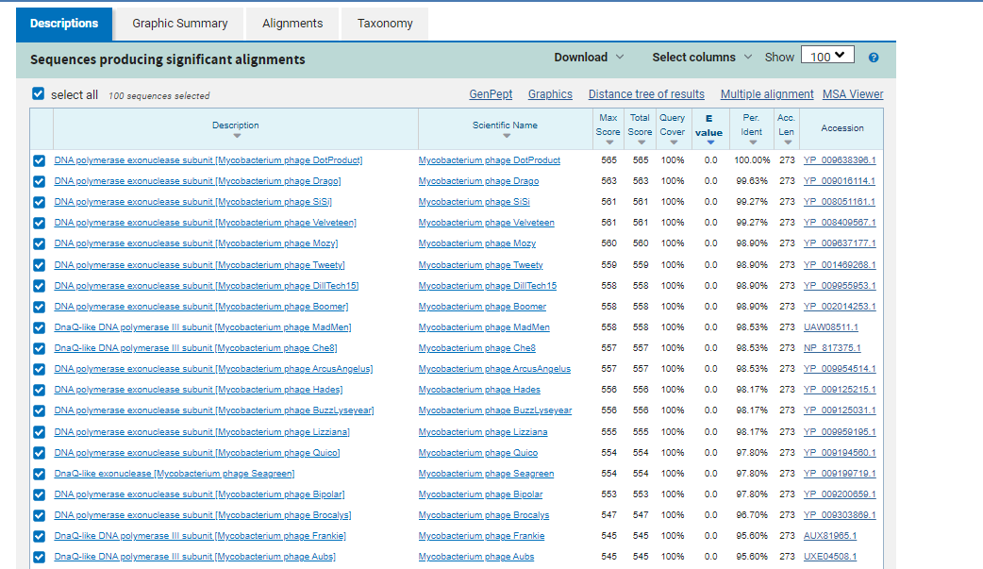
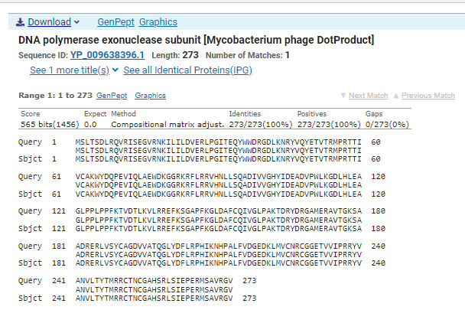
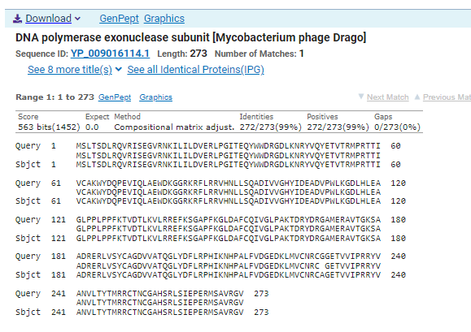
ATG Start at 29365. Original Glimmer call. GeneMark calls start at 29410
TGA Stop at 30186
F/R: F
Coding Potential (y/n): Y
Starterator (SS, NA, NI): Most annotated start is this (29365)
Blast Best Hit, Query:Subject Starts, Score, Evalue, or “no significant Blast alignments” if 10E-4 or higher
DNA Polymerase exonuclease subunit Mycobacterium phage Dotproduct YP_009638396.1, 1:1, Score 565, Evalue, 0
Gap with previous gene: -13
Longest Orf? (Y/N/NA) Y
RBS:
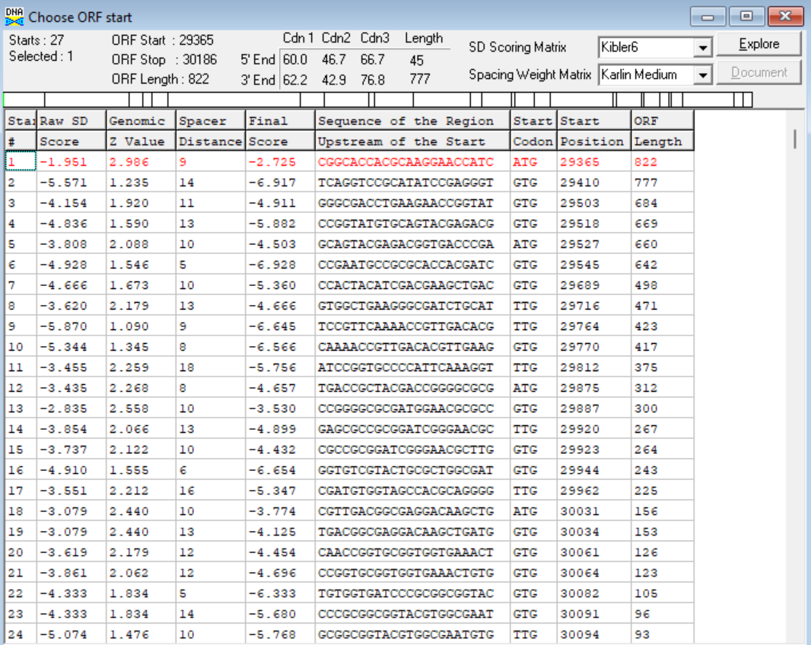
(https://toolkit.tuebingen.mpg.de/tools/hhpred) HHPRED vs PDB, SCOPe, pFam, and M. Tuberculosis.
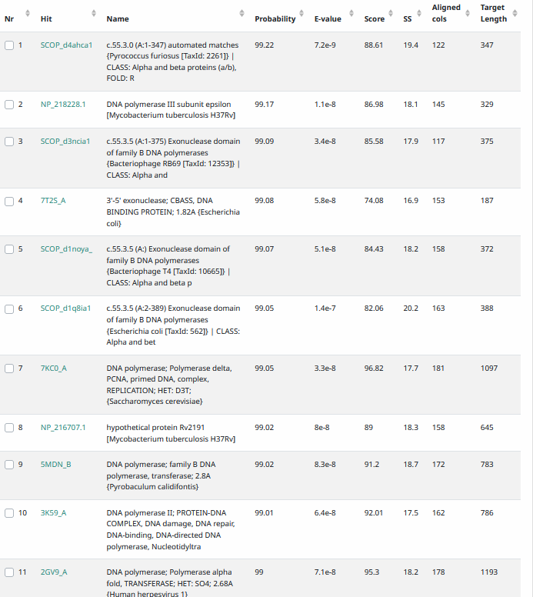
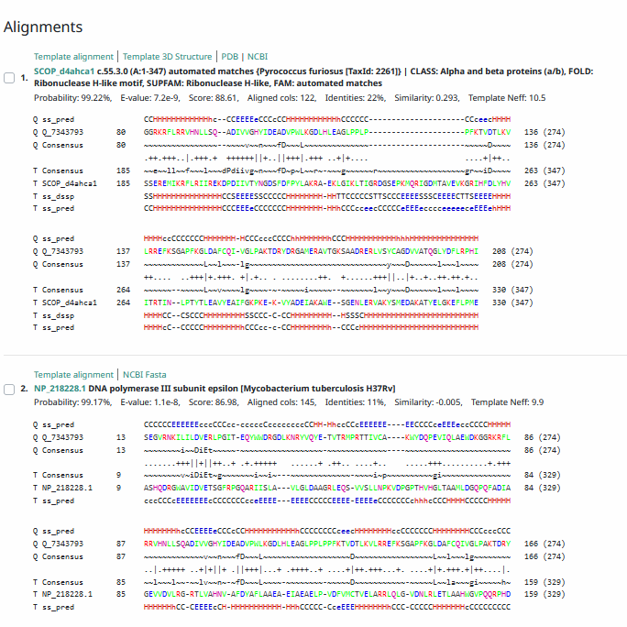
Phamerator Totinger Vs. Tootsieroll Vs. Starcevich (https://phamerator.org/phages) Genes 21-43
Proposed Function: DnaQ-like DNA Polymerase III Subunit
Function Evidence: BLASTs and HHPRED for this gene align with this function. Additionally, similar genes in similar phages (phage Tootsieroll and phage Starcevich) call the same function.
Transmembrane Domain/Evidence: No, Intracellular Properties (https://dtu.biolib.com/DeepTMHMM)
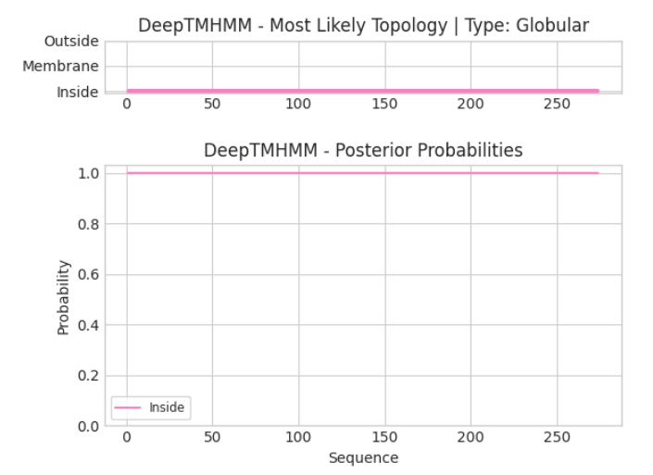

Gene Number: 37
Pham142497
BLAST from PhagesDB. (https://phagesdb.org/blastp/) Using Longest ORF
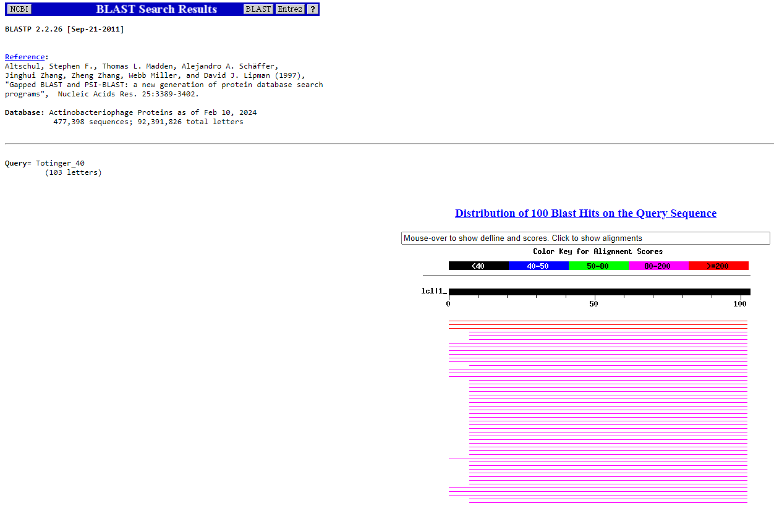
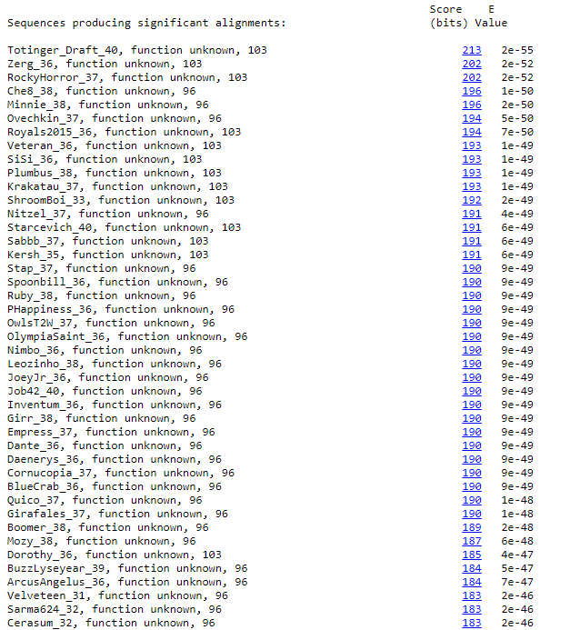
BLAST from NCBI (https://blast.ncbi.nlm.nih.gov/Blast.cgi?PAGE=Proteins) Using Longest ORF
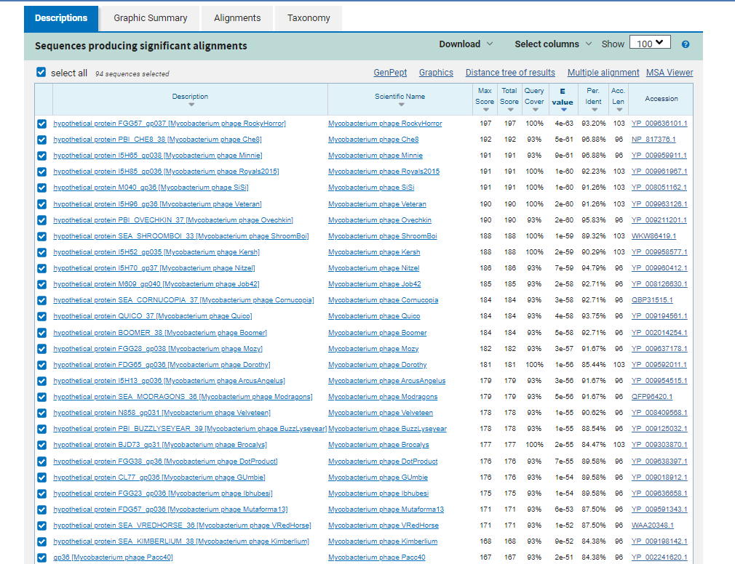
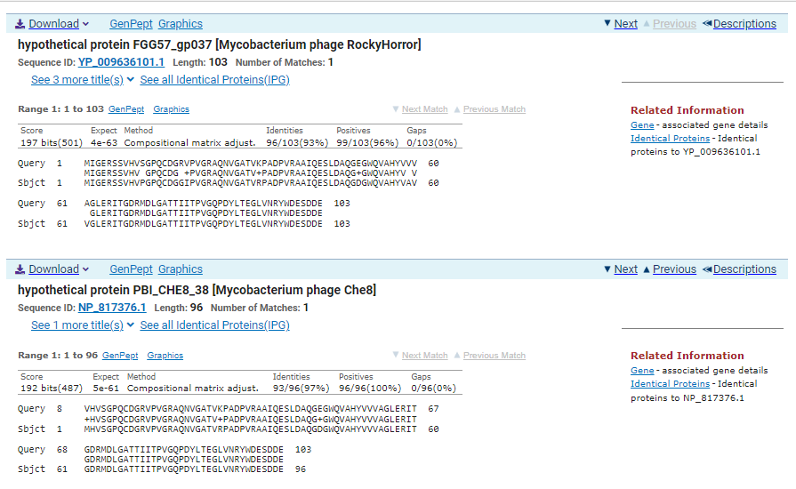
TTG Start at 30183. Original Glimmer call. GeneMark calls start at 30261
TGA Stop at 30494
F/R: F
Coding Potential (y/n): Y
Starterator (SS, NA, NI): Does not call the Most Annotated Start
Blast Best Hit, Query:Subject Starts, Score, Evalue, or “no significant Blast alignments” if 10E-4 or higher
hypothetical protein FGG57_gp037 Mycobacterium phage RockyHorror YP_009636101.1, 1:1, Score 197, Evalue, 4e-63
Gap with previous gene: -3
Longest Orf? (Y/N/NA) Y
RBS:
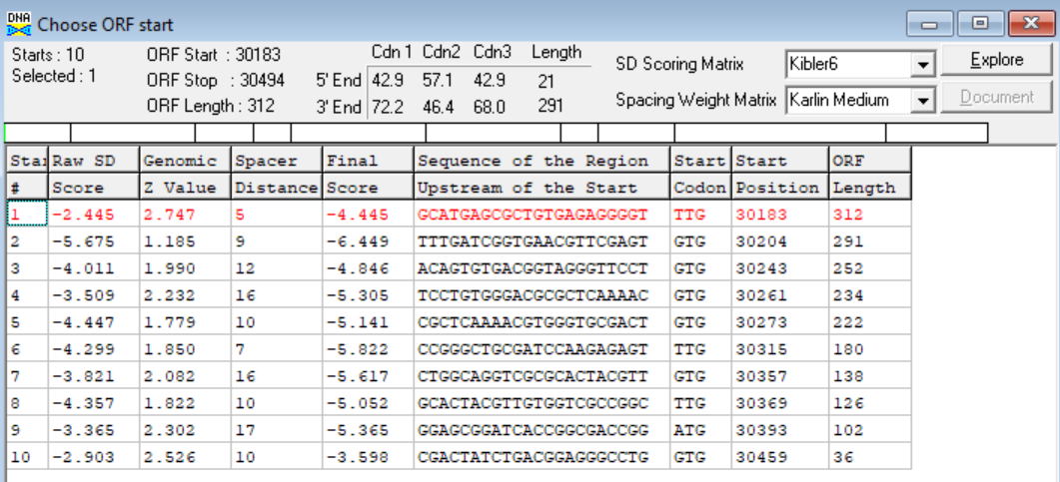
(https://toolkit.tuebingen.mpg.de/tools/hhpred) HHPRED vs PDB, SCOPe, pFam, and M. Tuberculosis. No Significant (>95%) Hits.
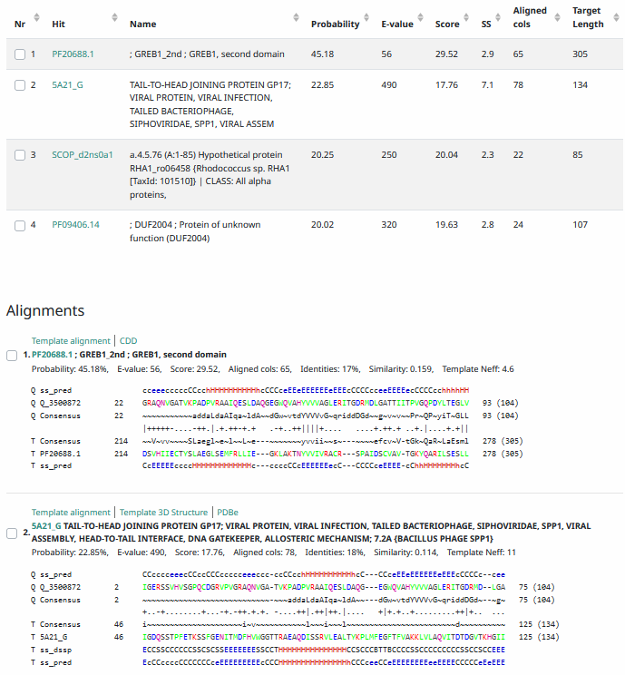
Phamerator Totinger Vs. Tootsieroll Vs. Starcevich (https://phamerator.org/phages) Genes 21-43
Proposed Function: hypothetical protein
Function Evidence: In Phamerator, similar genes do not have called functions in other phages (phage Starcevich and phage Tootsieroll). Additionally, the most consistent BLAST result was a protein of no known function.
Transmembrane Domain/Evidence: No, Intracellular Properties (https://dtu.biolib.com/DeepTMHMM)
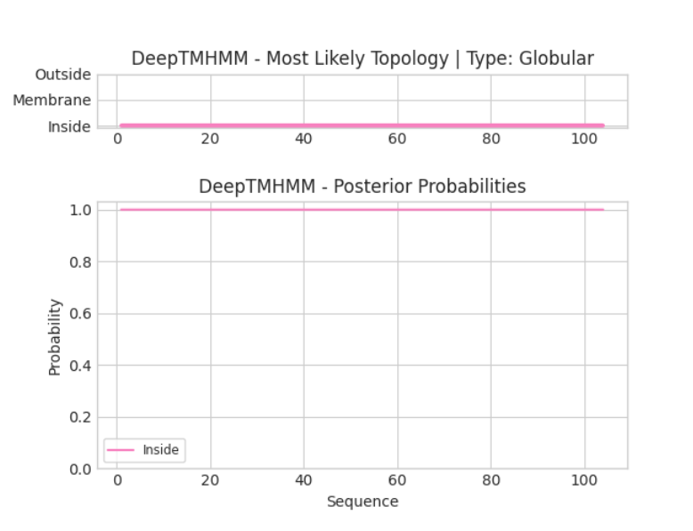
Gene Number: 38
Totinger_Draft_41 on Phagesdb
Pham84827
BLAST from PhagesDB. (https://phagesdb.org/blastp/) Using Longest ORF
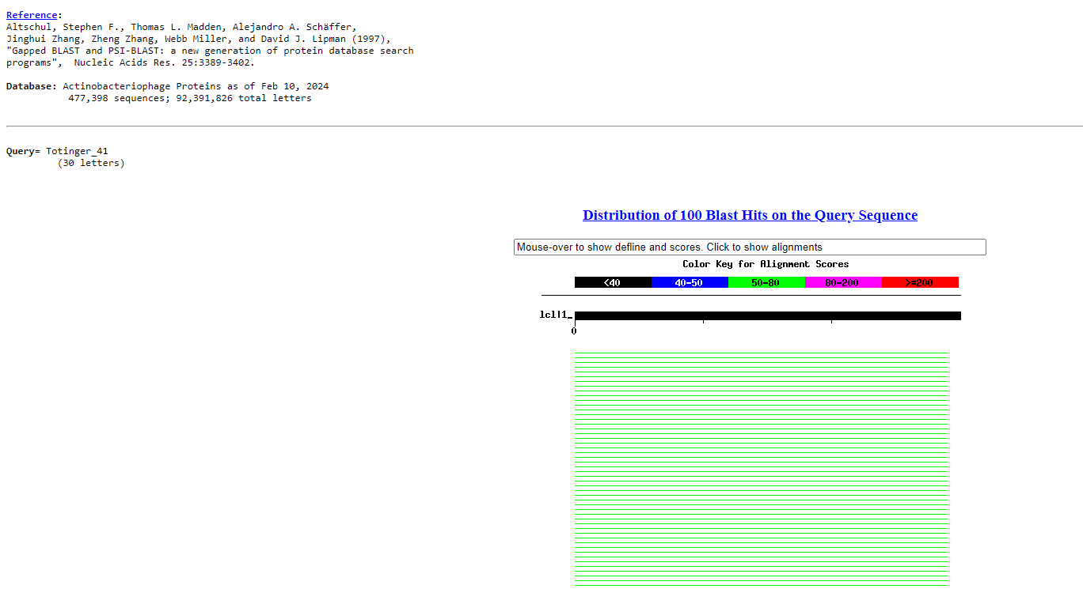
BLAST from NCBI (https://blast.ncbi.nlm.nih.gov/Blast.cgi?PAGE=Proteins) Using Longest ORF
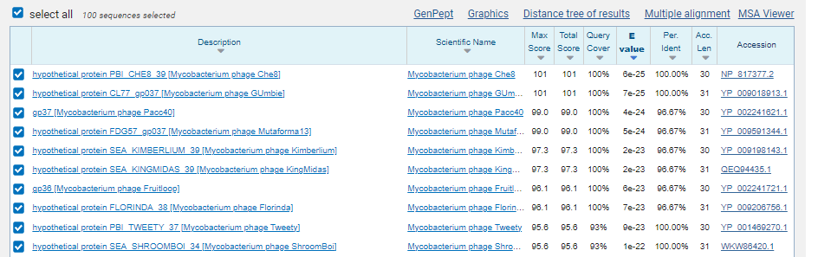
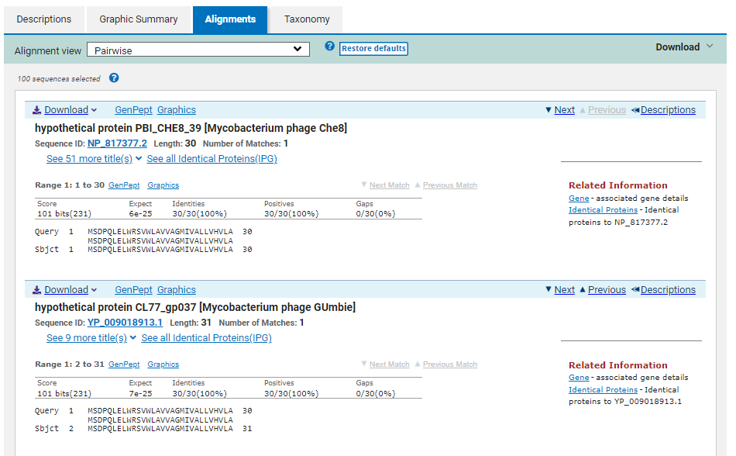
ATG Start at 30487. Original Genemark call. Not called by Glimmer.
TAA Stop at 30579
F/R: F
Coding Potential (y/n): Y
Starterator (SS, NA, NI): Most annotated start is this (30487)
Blast Best Hit, Query:Subject Starts, Score, Evalue, or “no significant Blast alignments” if 10E-4 or higher
Hypothetical protein PBI_CHE8_39 Mycobacterium phage Che8 NP_817377.2, 1:1, Score 101, Evalue, 6e-25
Gap with previous gene: -7
Longest Orf? (Y/N/NA) Y
RBS:
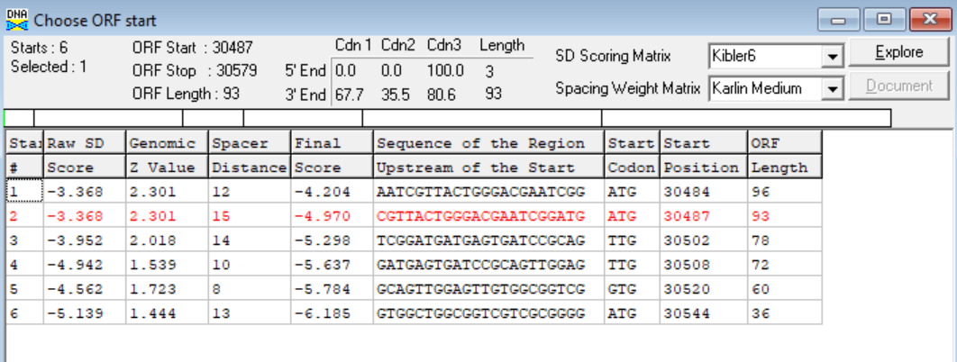
(https://toolkit.tuebingen.mpg.de/tools/hhpred) HHPRED vs PDB, SCOPe, pFam, and M. Tuberculosis. No Significant (>95%) Hits.
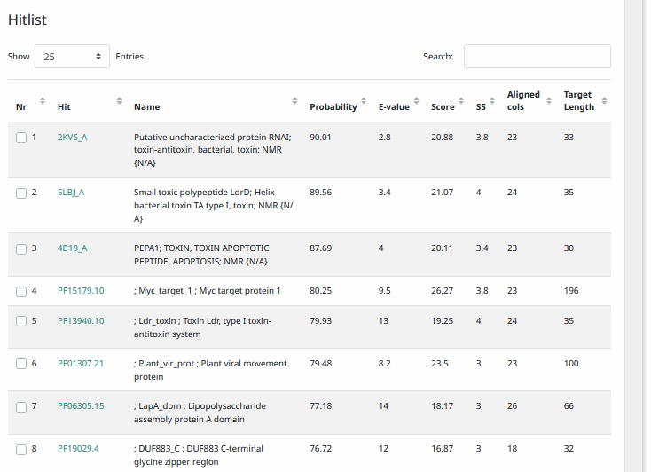
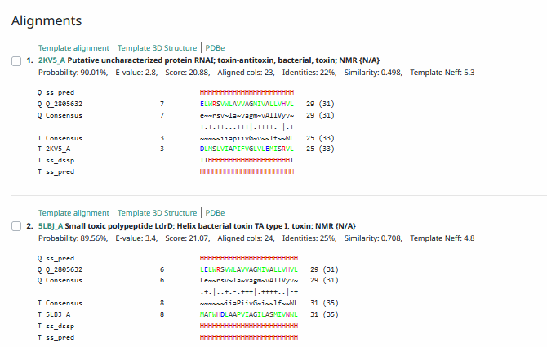
Phamerator Totinger Vs. Tootsieroll Vs. Starcevich (https://phamerator.org/phages) Genes 21-43
Proposed Function: hypothetical protein
Function Evidence: coding potential was found, but comparison results were too weak or inconsistent to make a confident function call. Additionally, the gene is mixed in similar phages (phage Starcevich and phage Tootsieroll). Tootsieroll calls the gene, but Starcevich does not, and the sequences are very similar.
Transmembrane Domain/Evidence: Yes, Transmembrane Properties at AA 12-26. (https://dtu.biolib.com/DeepTMHMM)
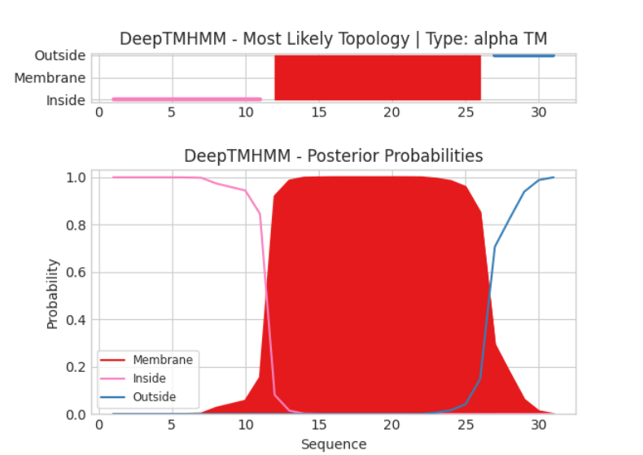

Gene Number: 39
Totinger_Draft_42 on PhagesDB
Pham5800
BLAST from PhagesDB. (https://phagesdb.org/blastp/) Using Longest ORF
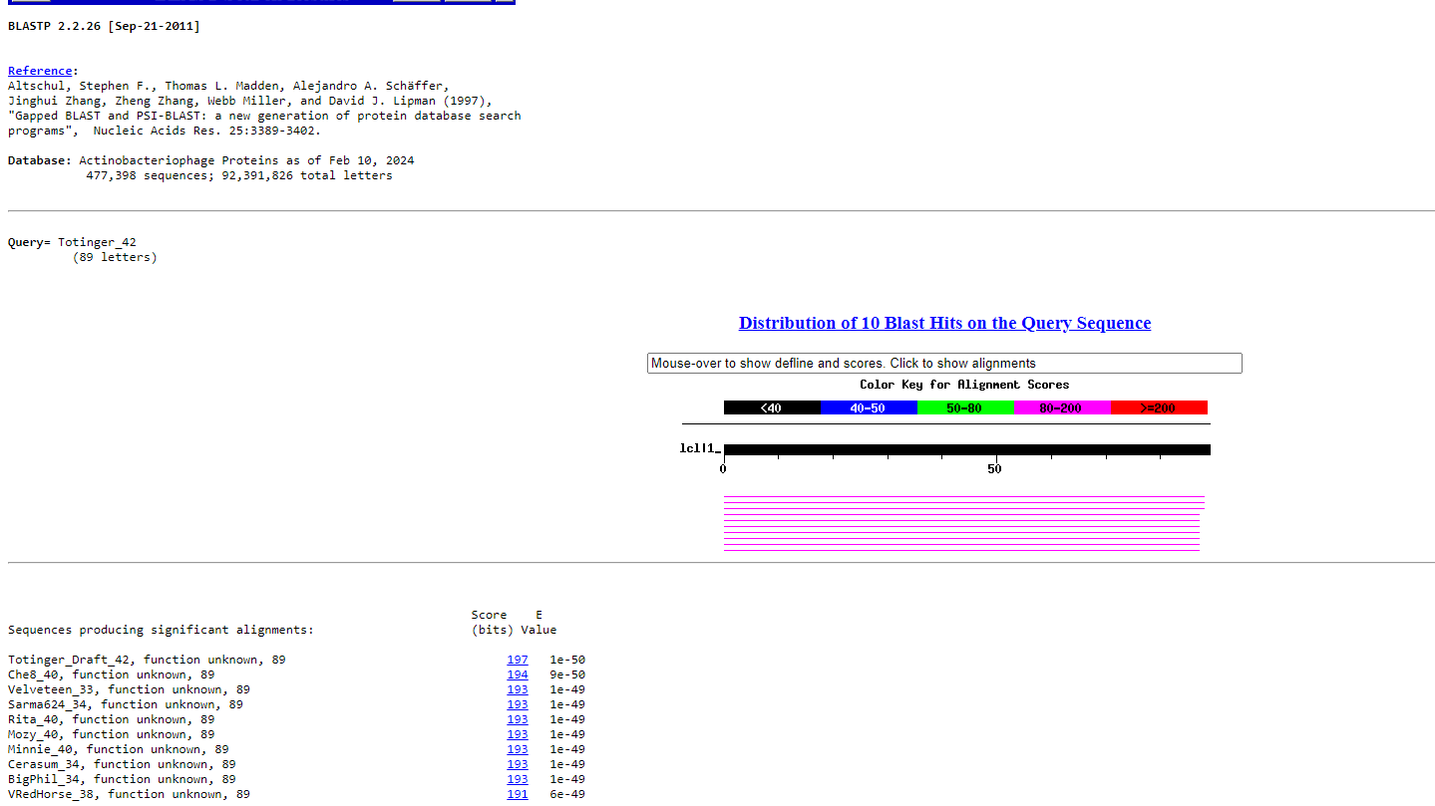
BLAST from NCBI (https://blast.ncbi.nlm.nih.gov/Blast.cgi?PAGE=Proteins) Using Longest ORF
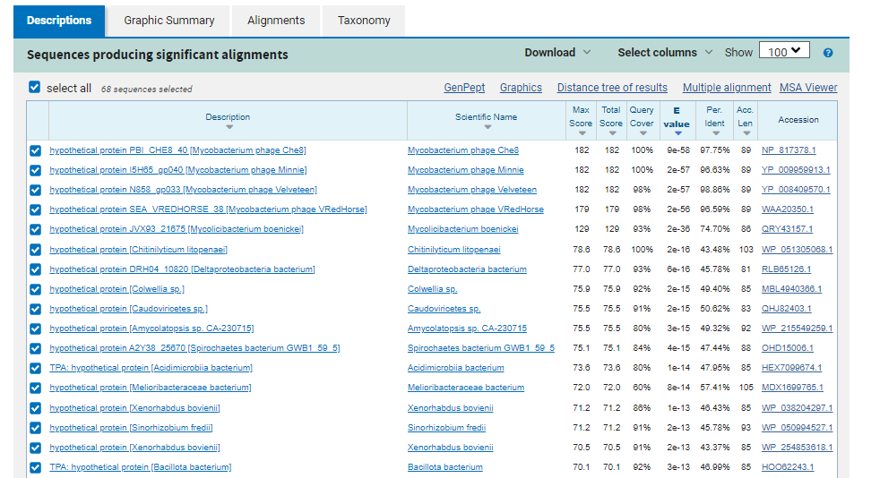
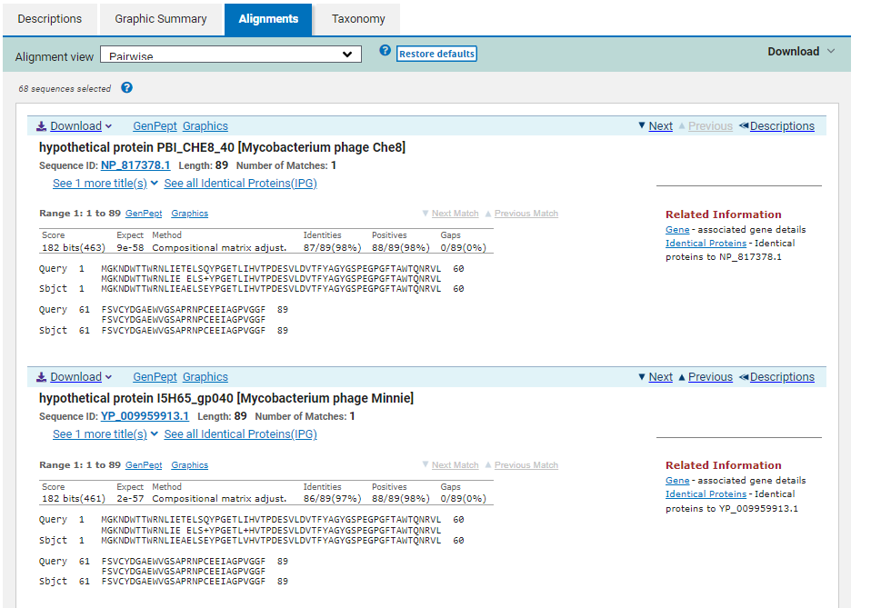
ATG Start at 30953. Original Glimmer call.
TGA Stop at 30684
F/R: R
Coding Potential (y/n): N
Starterator (SS, NA, NI): Most annotated start is this (2200)
Blast Best Hit, Query:Subject Starts, Score, Evalue, or “no significant Blast alignments” if 10E-4 or higher
hypothetical protein PBI_CHE8_40 Mycobacterium phage Che8 NP_817378.1, 1:1, Score 182, Evalue, 9e-58
Gap with previous gene: 105
Longest Orf? (Y/N/NA) Y
RBS:
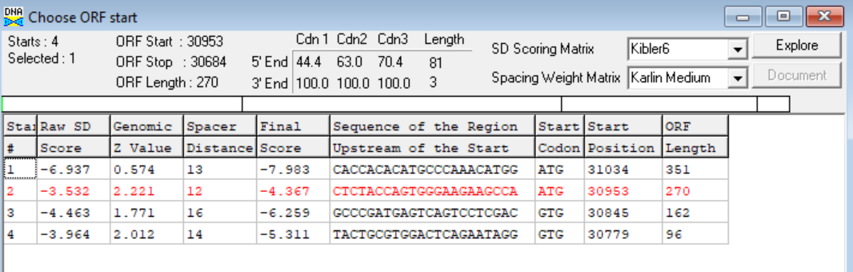
(https://toolkit.tuebingen.mpg.de/tools/hhpred) HHPRED vs PDB, SCOPe, pFam, and M. Tuberculosis. No Significant (>95%) Hits.
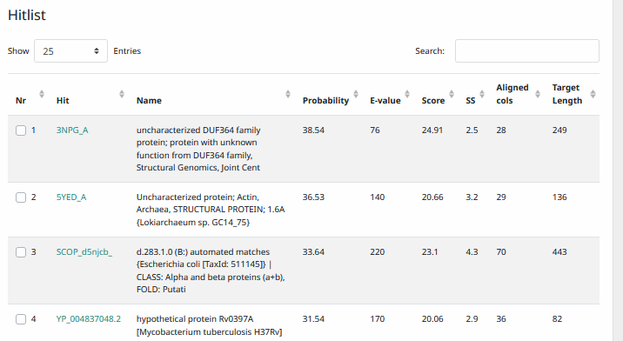
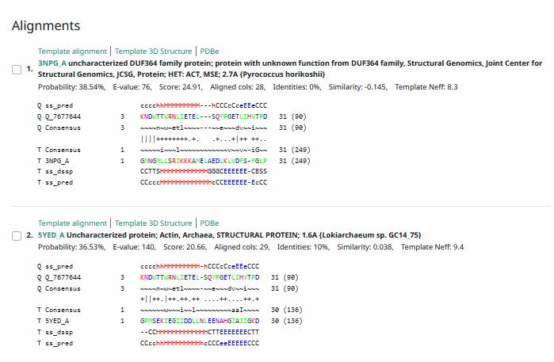
Phamerator Totinger Vs. Tootsieroll Vs. Starcevich (https://phamerator.org/phages) Genes 21-43
Proposed Function: hypothetical protein
Function Evidence: BLAST results from all databases are too weak and inconsistent to make a confident function call. Phamerator is not useful in finding a function, as similar phages do not have this gene’s sequence at all.
Transmembrane Domain/Evidence: No, Intracellular Properties (https://dtu.biolib.com/DeepTMHMM)
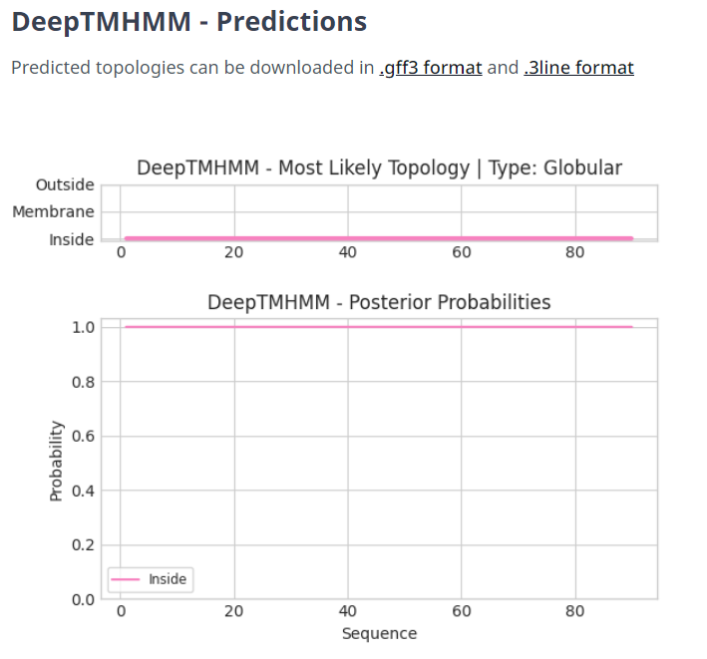
Gene Number: 40
Pham85300
BLAST from PhagesDB. (https://phagesdb.org/blastp/) Using Longest ORF
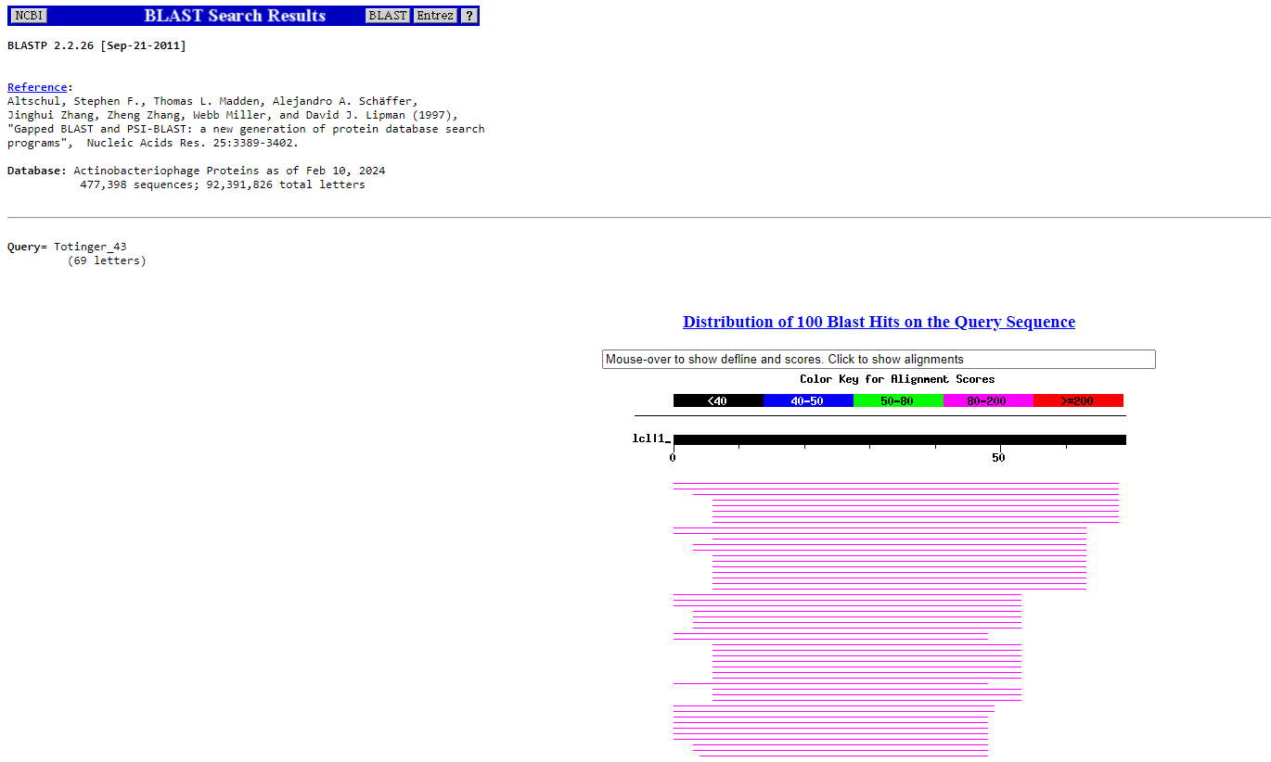
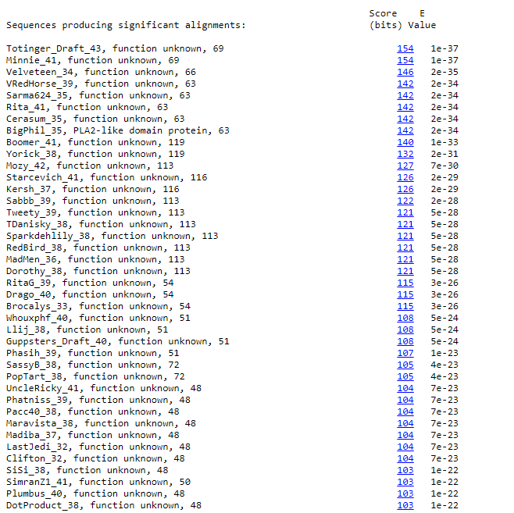
BLAST from NCBI (https://blast.ncbi.nlm.nih.gov/Blast.cgi?PAGE=Proteins) Using Longest ORF
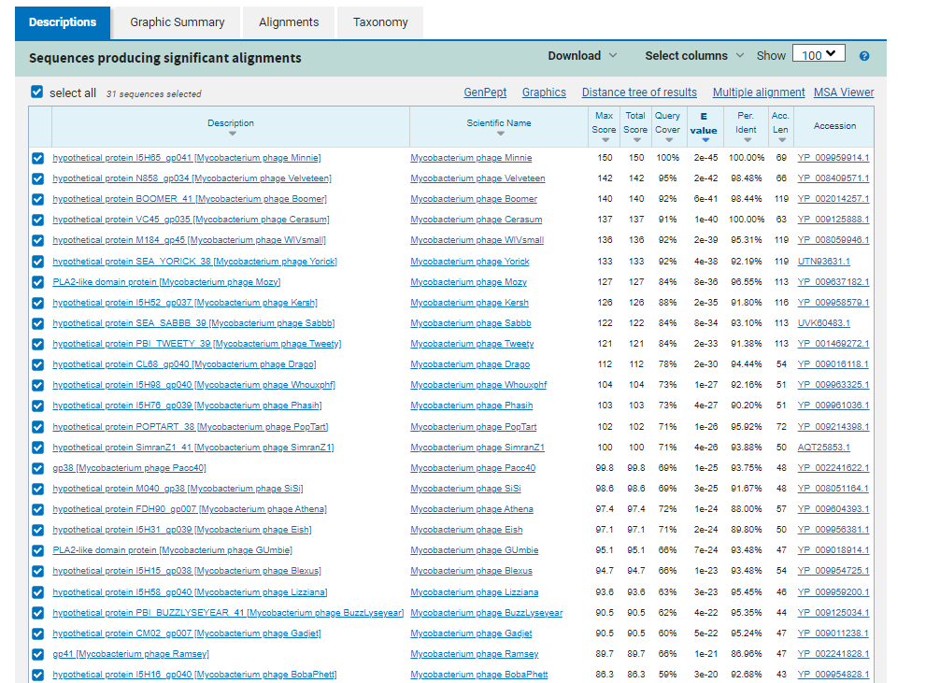
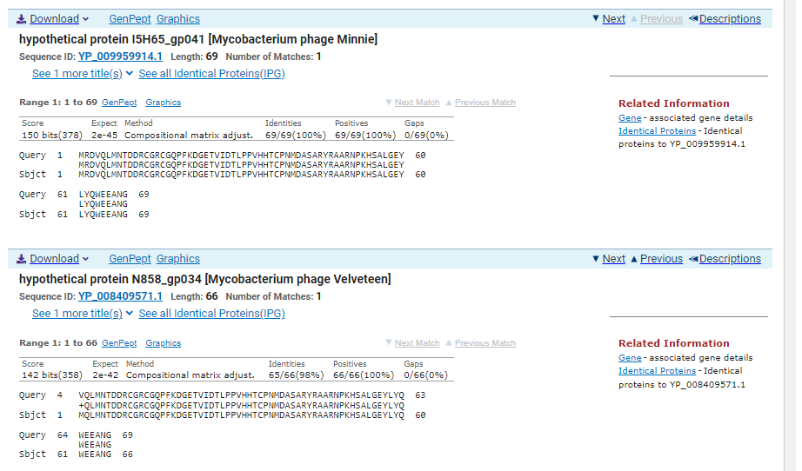
ATG Start at 31155. Original Glimmer call. Not called by Genemark, but coding potential present in the area.
TAA Stop at 30946
F/R: R
Coding Potential (y/n): Y
Starterator (SS, NA, NI): Most annotated start is present but not called.
Blast Best Hit, Query:Subject Starts, Score, Evalue, or “no significant Blast alignments” if 10E-4 or higher
hypothetical protein I5H65_gp041 Mycobacterium phage Minnie YP_009959914.1, 1:1, Score 150, Evalue, 2e-45
Gap with previous gene: -7
Longest Orf? (Y/N/NA) Y
RBS:
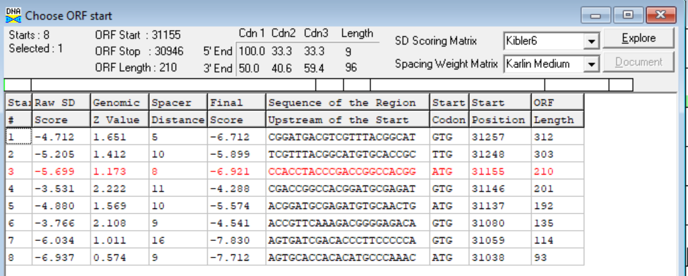
(https://toolkit.tuebingen.mpg.de/tools/hhpred) HHPRED vs PDB, SCOPe, pFam, and M. Tuberculosis.
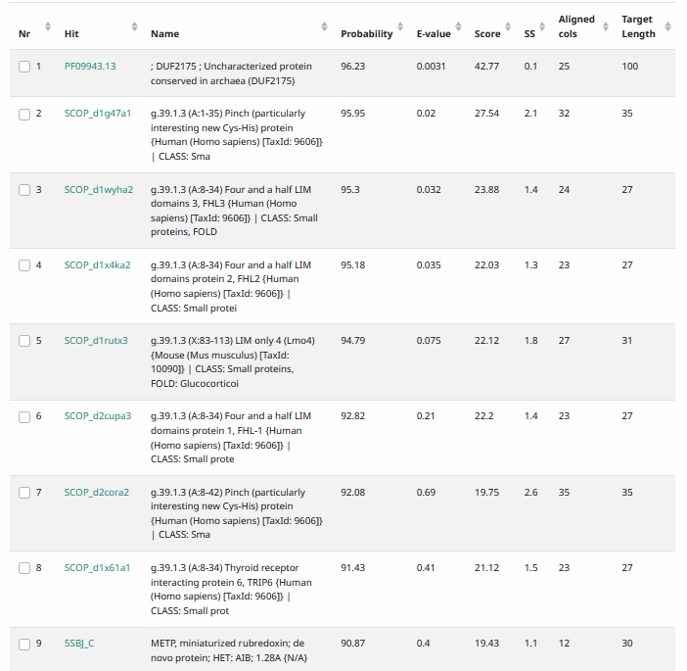
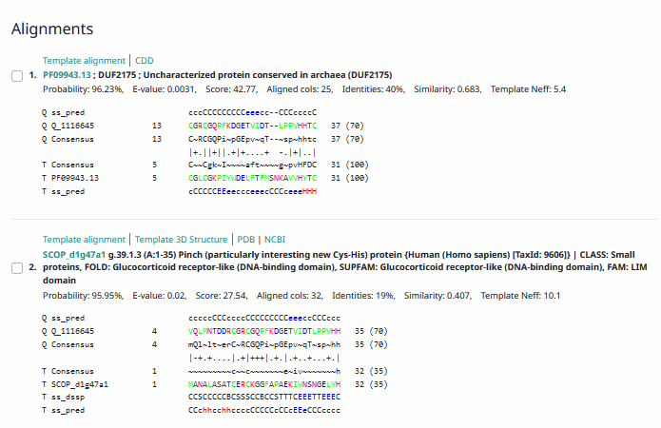
Phamerator Totinger Vs. Tootsieroll Vs. Starcevich (https://phamerator.org/phages) Genes 21-43
Proposed Function: hypothetical protein
Function Evidence: BLAST and HHPRED results are too inconsistent to make a confident function call. Additionally, this sequence does not match well with similar phages and the gene is not called in them.
Transmembrane Domain/Evidence: No, Intracellular Properties (https://dtu.biolib.com/DeepTMHMM)
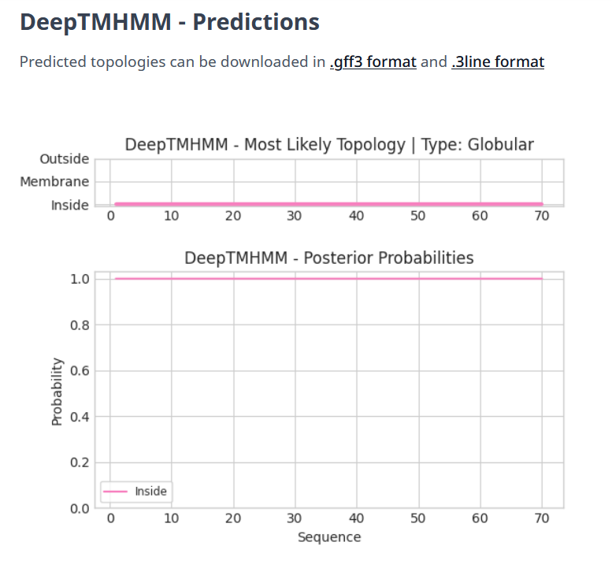

Gene Number: 41
Totinger_Draft_44 in Phagesdb
Pham85015
BLAST from PhagesDB. (https://phagesdb.org/blastp/) Using Longest ORF
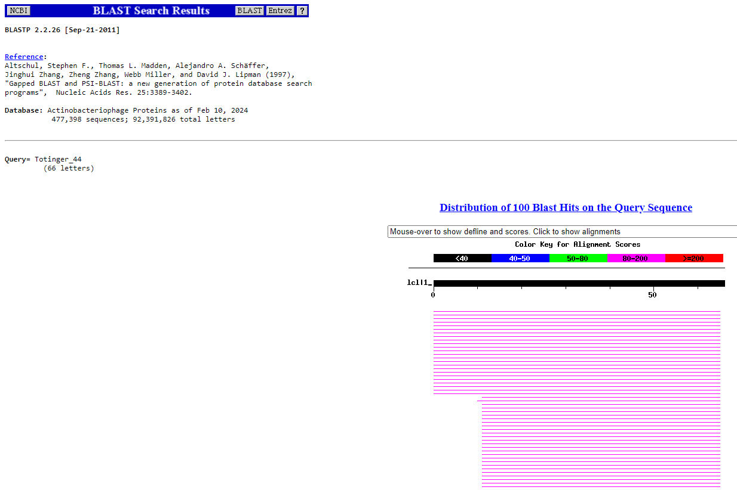
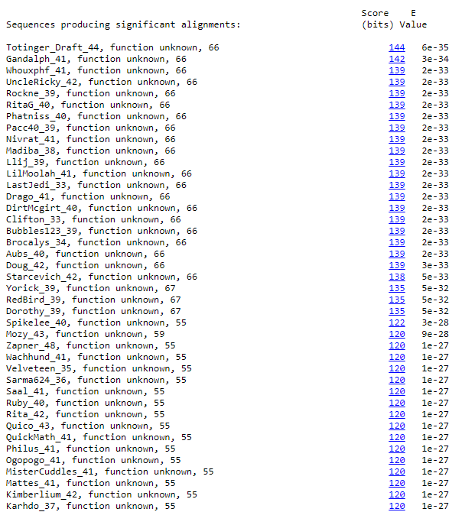
BLAST from NCBI (https://blast.ncbi.nlm.nih.gov/Blast.cgi?PAGE=Proteins) Using Longest ORF
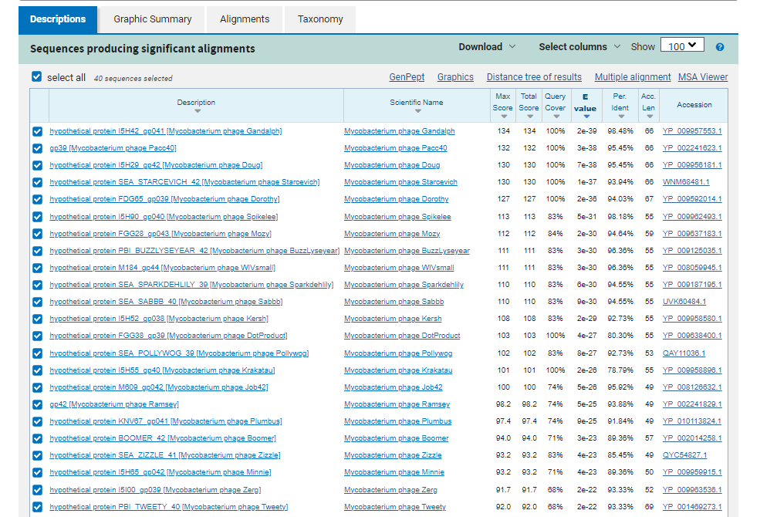
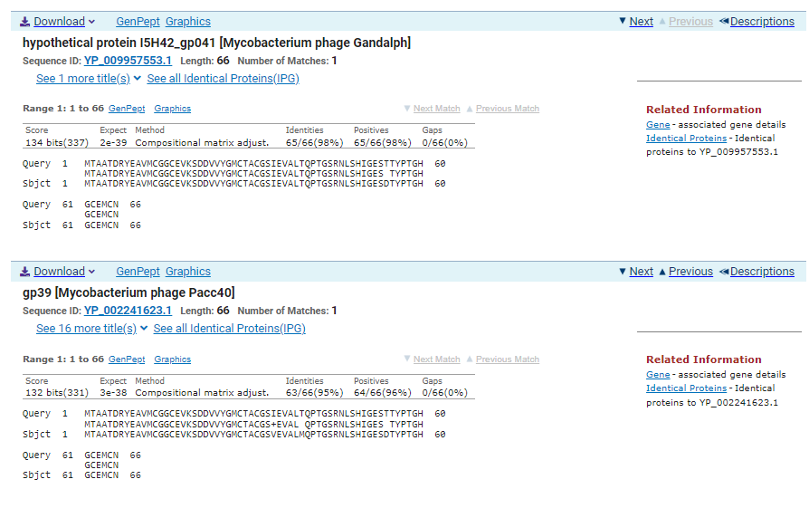
ATG Start at 31337. Original Glimmer call.
TGA Stop at 31137
F/R: R
Coding Potential (y/n): Y
Starterator (SS, NA, NI): Does not have the most annotated start.
Blast Best Hit, Query:Subject Starts, Score, Evalue, or “no significant Blast alignments” if 10E-4 or higher
hypothetical protein I5H42_gp041 Mycobacterium phage Gandalph YP_009957553.1, 1:1, Score 134, Evalue, 2e-39
Gap with previous gene: -18
Longest Orf? (Y/N/NA) Y
RBS:
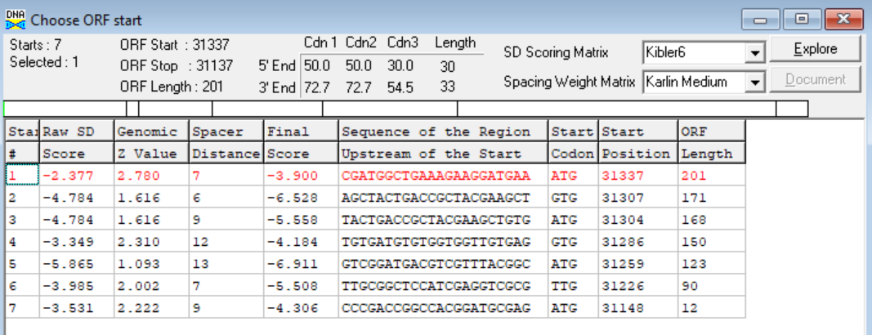
(https://toolkit.tuebingen.mpg.de/tools/hhpred) HHPRED vs PDB, SCOPe, pFam, and M. Tuberculosis. No Significant (>95%) Hits
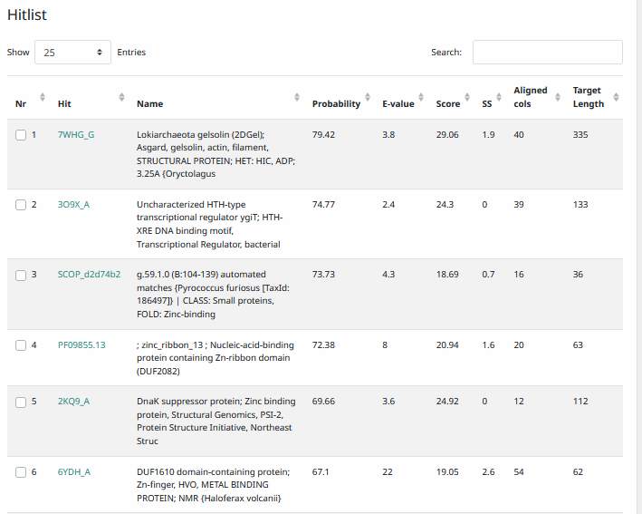
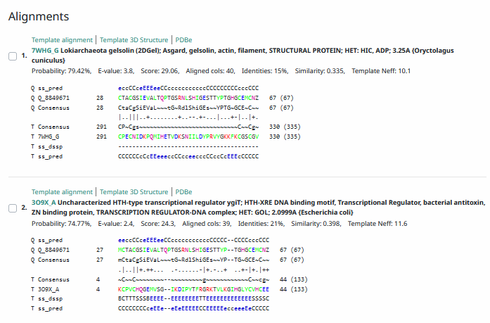
Phamerator Totinger Vs. Tootsieroll Vs. Starcevich (https://phamerator.org/phages) Genes 21-43
Proposed Function: hypothetical protein
Function Evidence: In similar phages (phage Starcevich and phage Tootsieroll), this gene does not have a called function. Additionally, the most consistent BLAST hit were proteins of unknown function.
Transmembrane Domain/Evidence: No, Intracellular Properties (https://dtu.biolib.com/DeepTMHMM)

Gene Number: 42
Totinger_Draft_45 on Phagesdb
Pham142222
BLAST from PhagesDB. (https://phagesdb.org/blastp/) Using Longest ORF
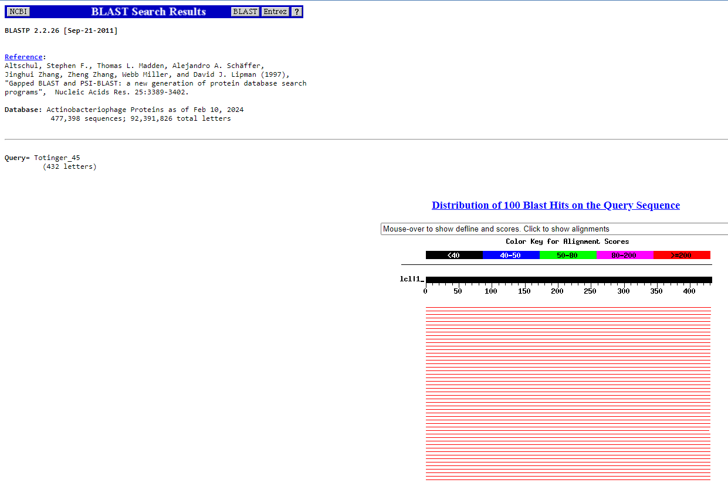
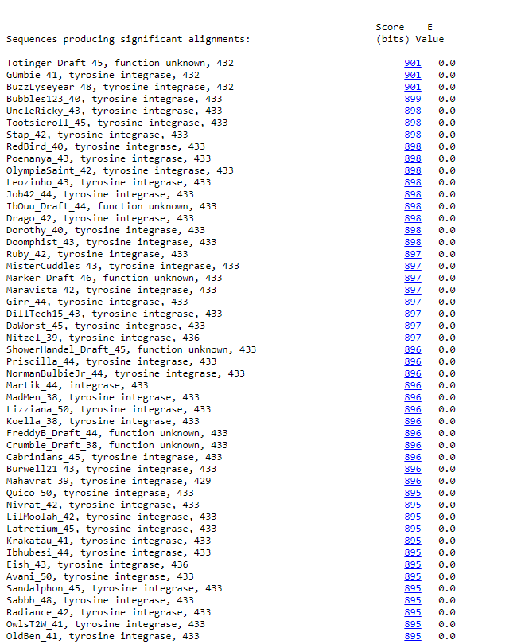
BLAST from NCBI (https://blast.ncbi.nlm.nih.gov/Blast.cgi?PAGE=Proteins) Using Longest ORF
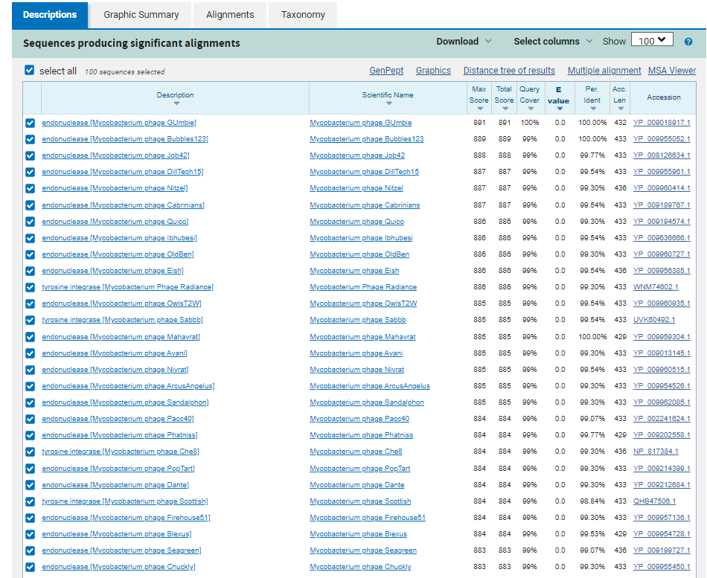
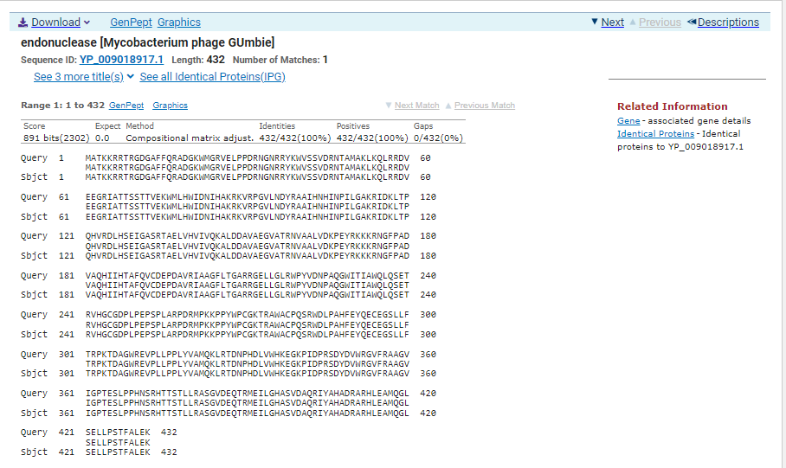
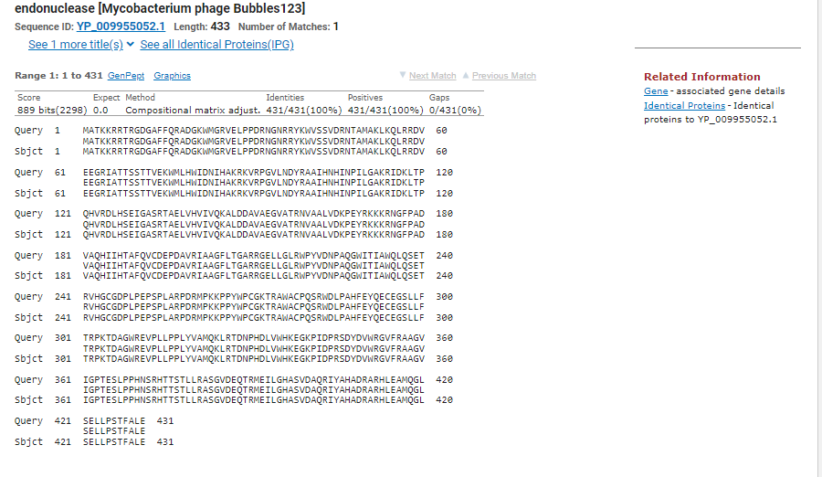
ATG Start at 31733. Original Glimmer call.
TAA Stop at 33031
F/R: F
Coding Potential (y/n): Y
Starterator (SS, NA, NI): Most annotated start is this (31733)
Blast Best Hit, Query:Subject Starts, Score, Evalue, or “no significant Blast alignments” if 10E-4 or higher
endonuclease Mycobacterium phage GUmbie YP_009018917.1, 1:1, Score 891, Evalue, 0
Gap with previous gene: 396
Longest Orf? (Y/N/NA) Y
RBS:
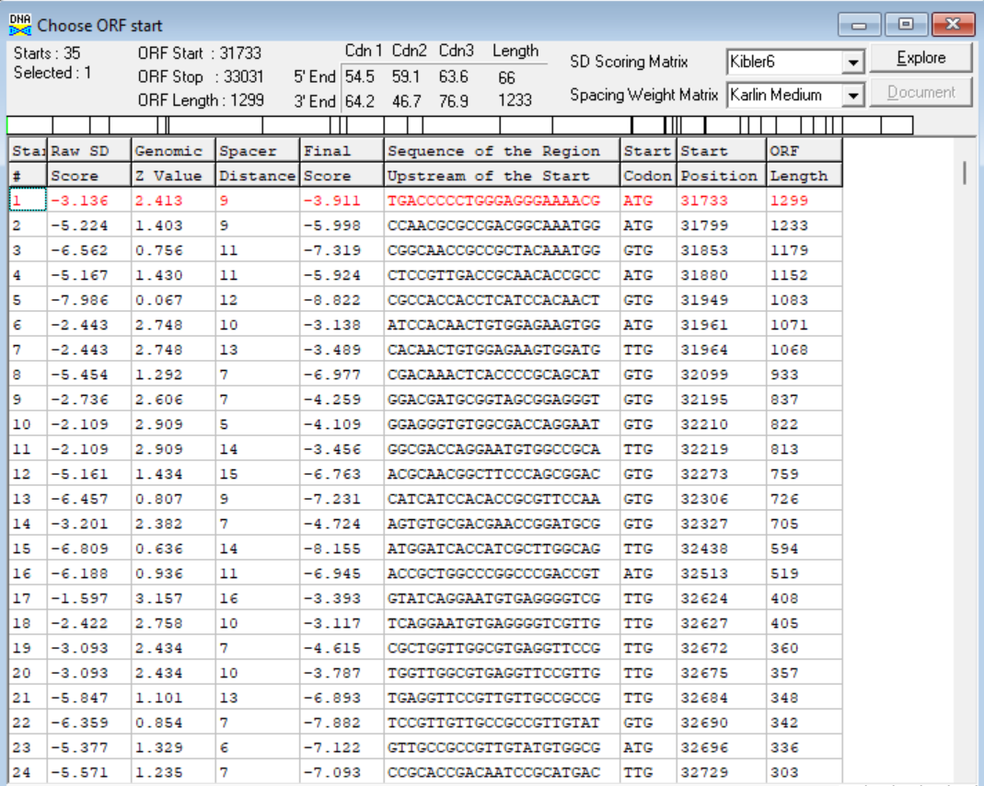
(https://toolkit.tuebingen.mpg.de/tools/hhpred) HHPRED vs PDB, SCOPe, pFam, and M. Tuberculosis.
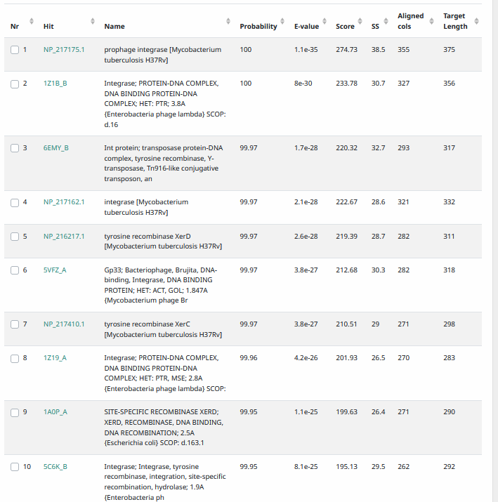
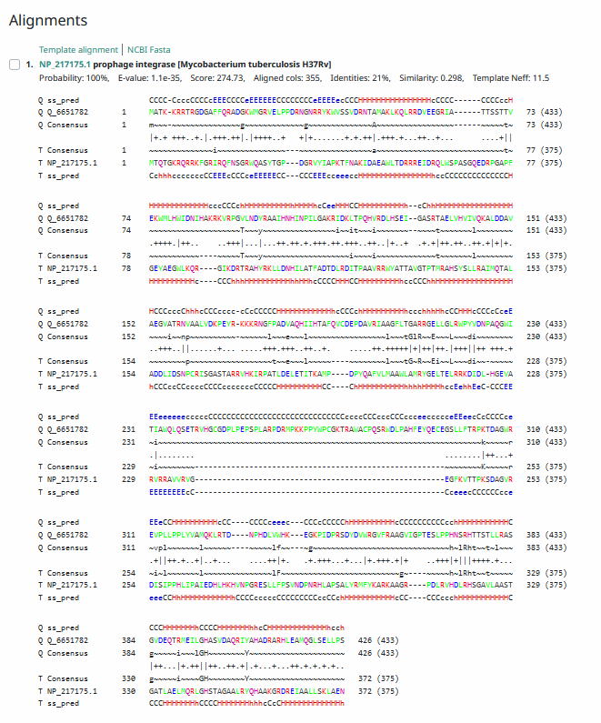
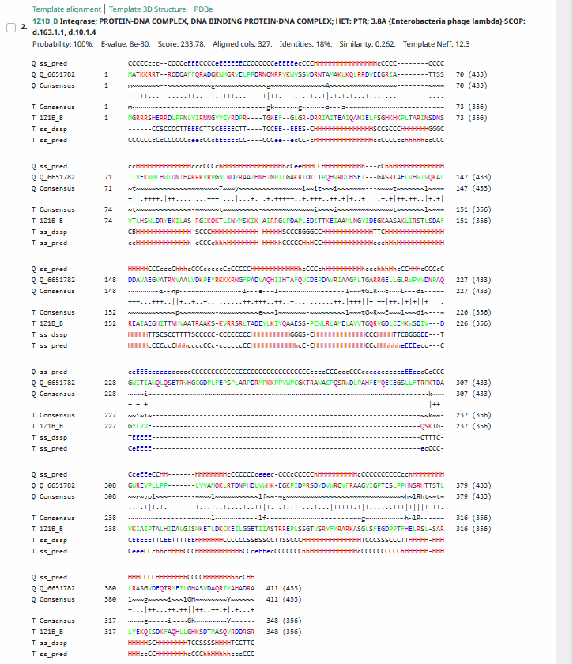
Phamerator Totinger Vs. Tootsieroll Vs. Starcevich (https://phamerator.org/phages) Genes 21-43
Proposed Function: tyrosine integrase
Function Evidence: BLAST and HHPRED results align most consistently with tyrosine integrase. Additionally, similar phages (phage Starcevich and phage Tootsieroll) call similar genes as a tyrosine integrase.
Transmembrane Domain/Evidence: No, Intracellular Properties (https://dtu.biolib.com/DeepTMHMM)
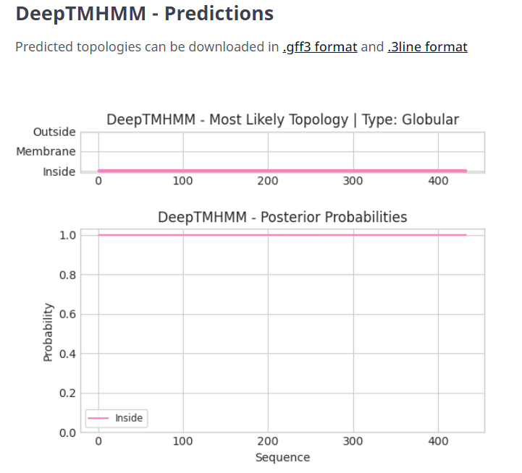

Gene Number: 43
Totinger_Draft_46 on phagesdb
Pham84848
BLAST from PhagesDB. (https://phagesdb.org/blastp/) Using Longest ORF
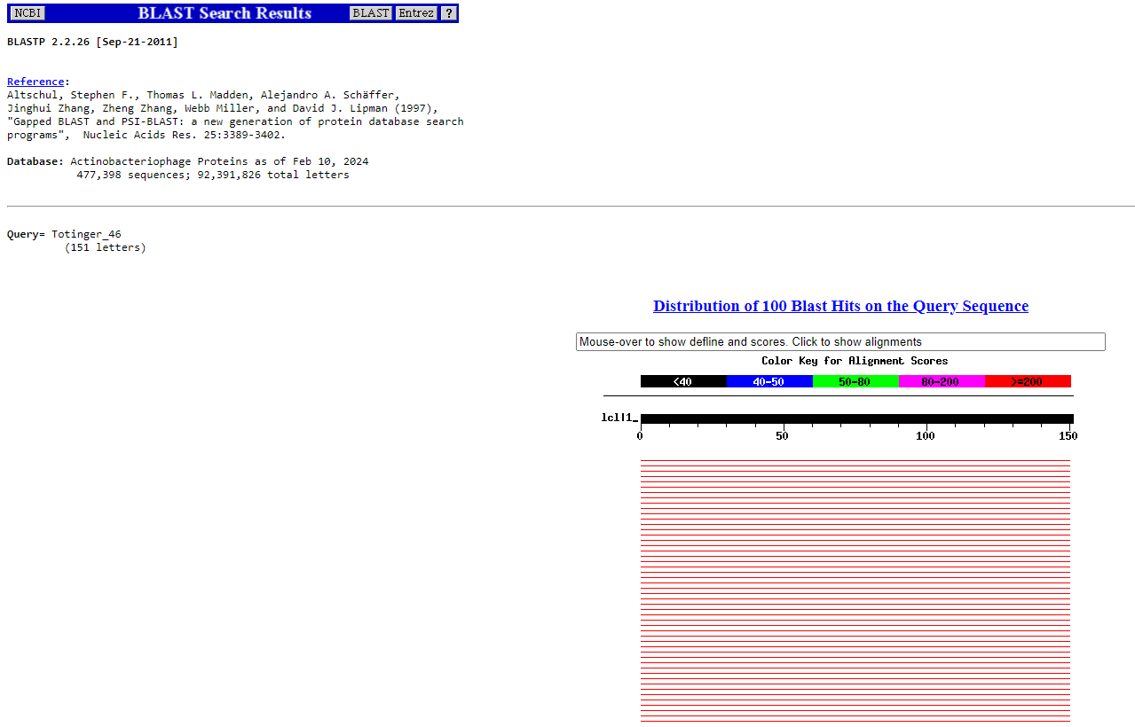
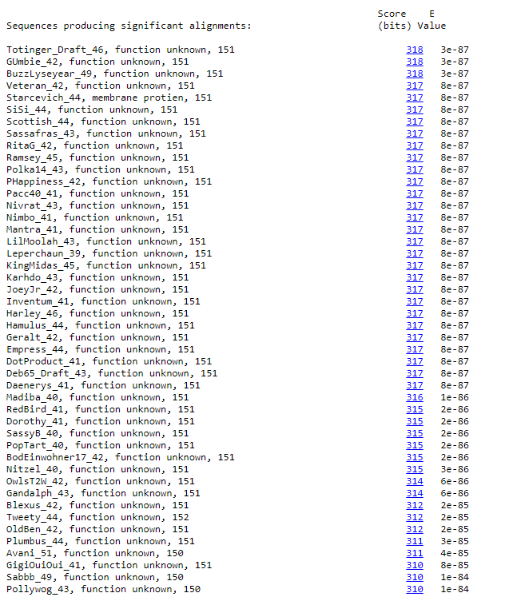
BLAST from NCBI (https://blast.ncbi.nlm.nih.gov/Blast.cgi?PAGE=Proteins) Using Longest ORF
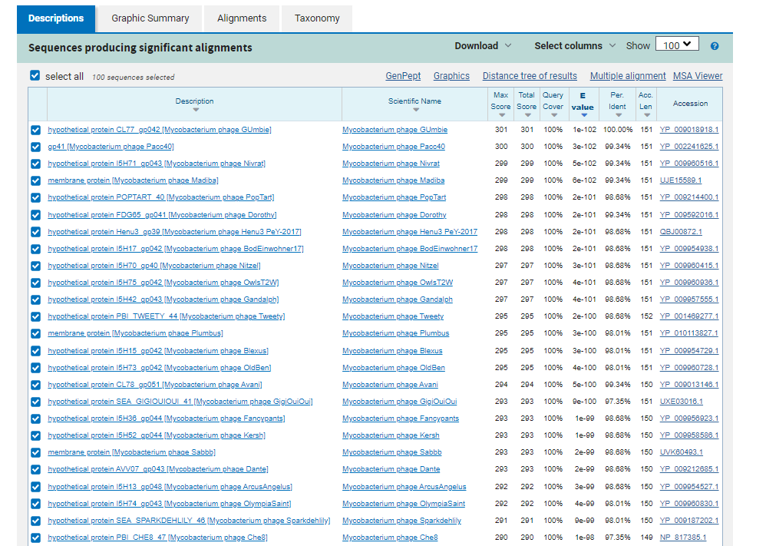
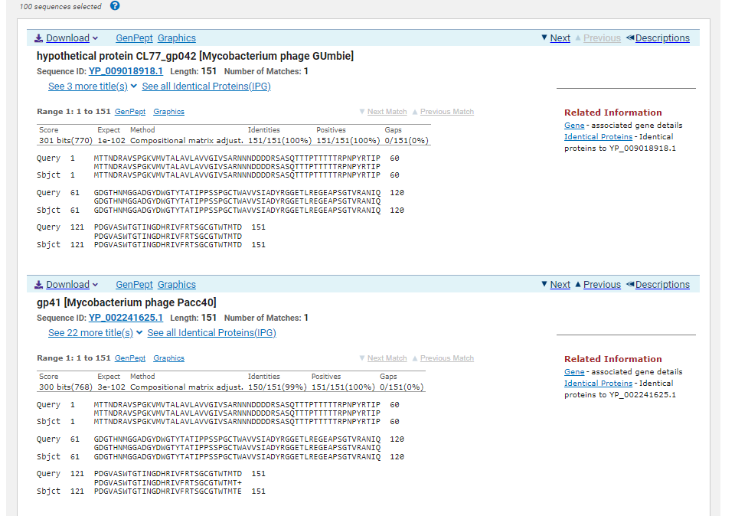
ATG Start at 33565. Original Glimmer call.
TGA Stop at 33110
F/R: R
Coding Potential (y/n): Y
Starterator (SS, NA, NI): Most annotated start is this (33565)
Blast Best Hit, Query:Subject Starts, Score, Evalue, or “no significant Blast alignments” if 10E-4 or higher
hypothetical protein CL77_gp042 Mycobacterium phage GUmbie YP_009018918.1, 1:1, Score 301, Evalue, 1e-102
Gap with previous gene: 79
Longest Orf? (Y/N/NA) Y
RBS:
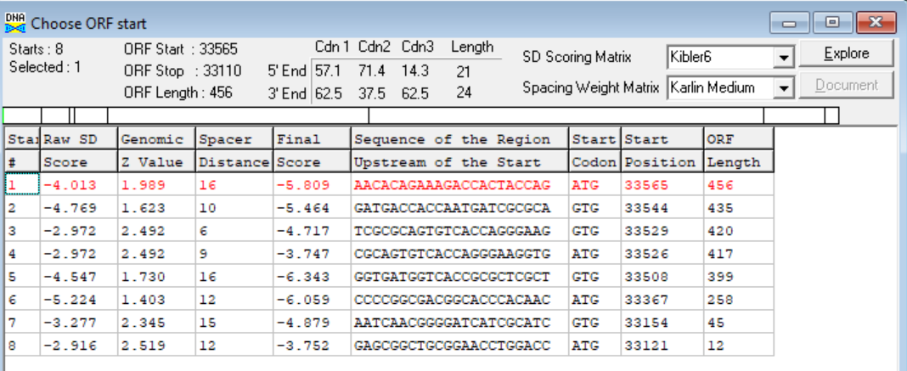
(https://toolkit.tuebingen.mpg.de/tools/hhpred) HHPRED vs PDB, SCOPe, pFam, and M. Tuberculosis.
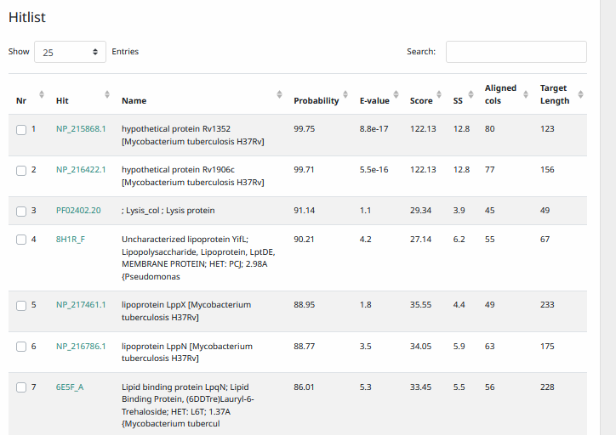
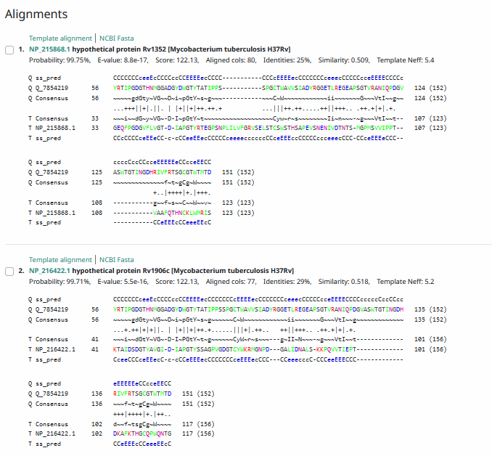
Phamerator Totinger Vs. Tootsieroll Vs. Starcevich (https://phamerator.org/phages) Genes 46-73
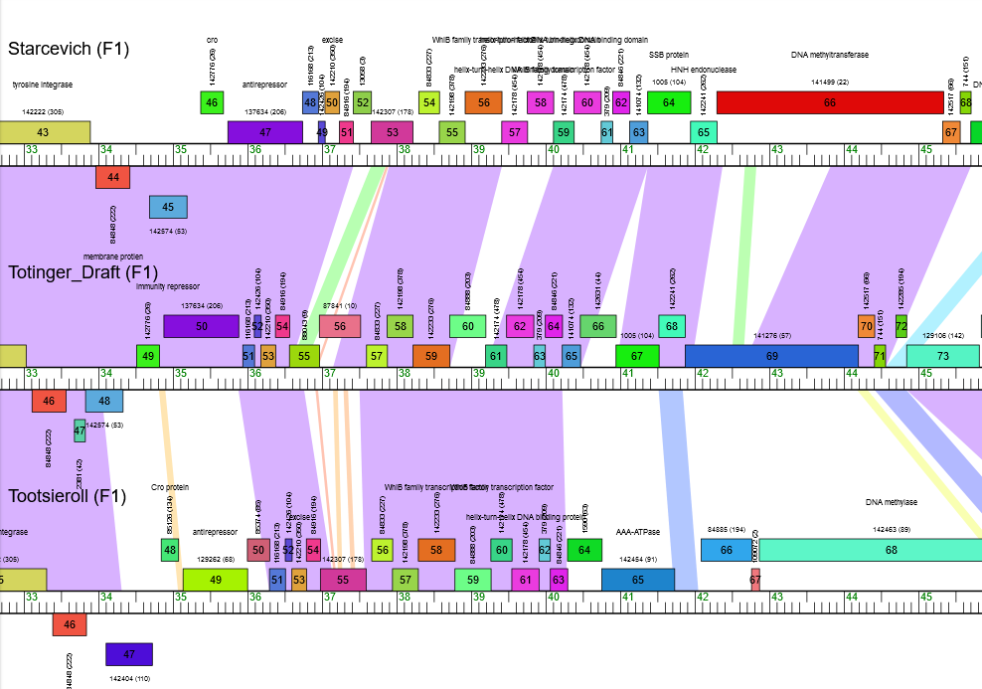
Proposed Function: hypothetical protein
Function Evidence: In similar phages (phage Starcevich and phage Tootsieroll), similar genes either have no called function or are called as a membrane protein. BLASTs and HHPRED most consistently hit proteins with an unknown function instead of membrane proteins.
Transmembrane Domain/Evidence: No (https://dtu.biolib.com/DeepTMHMM)
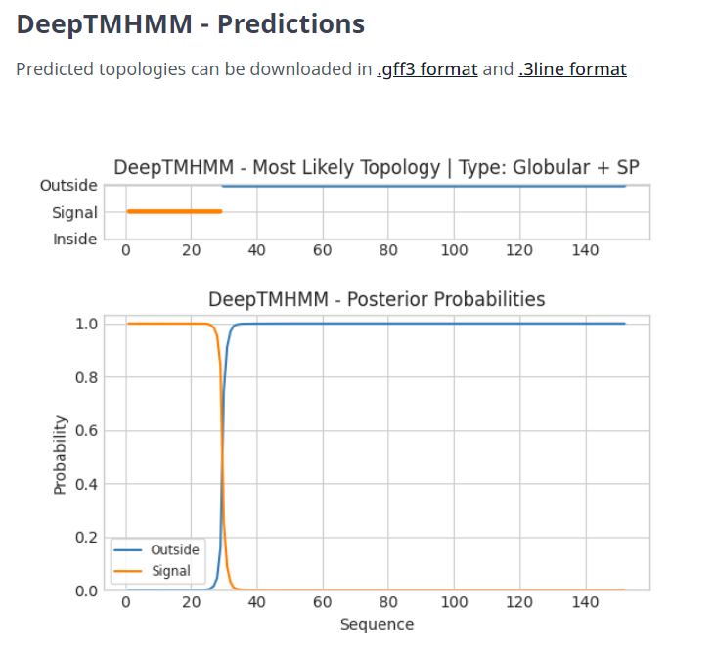

Gene Number: 44
Totinger_Draft_47 on Phagesdb
Pham2381
BLAST from PhagesDB. (https://phagesdb.org/blastp/) Using Longest ORF
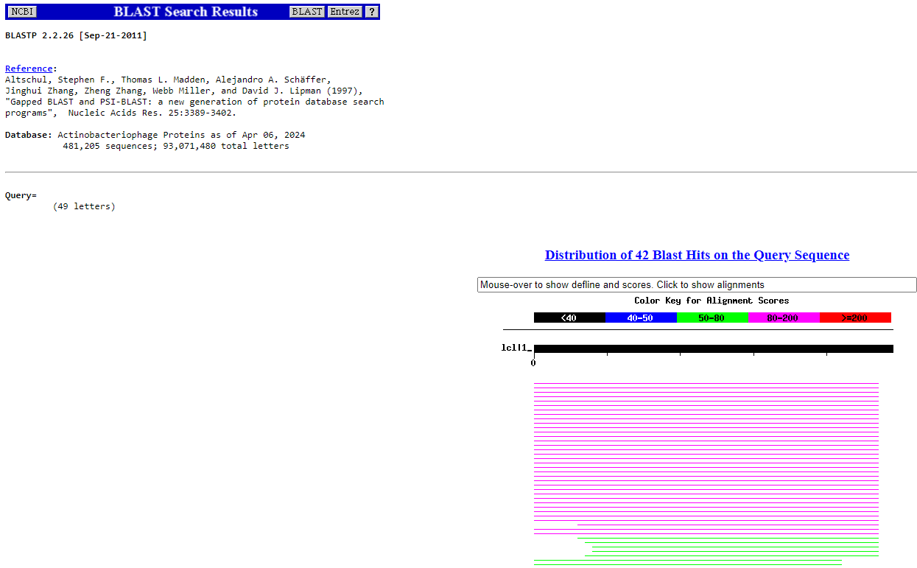
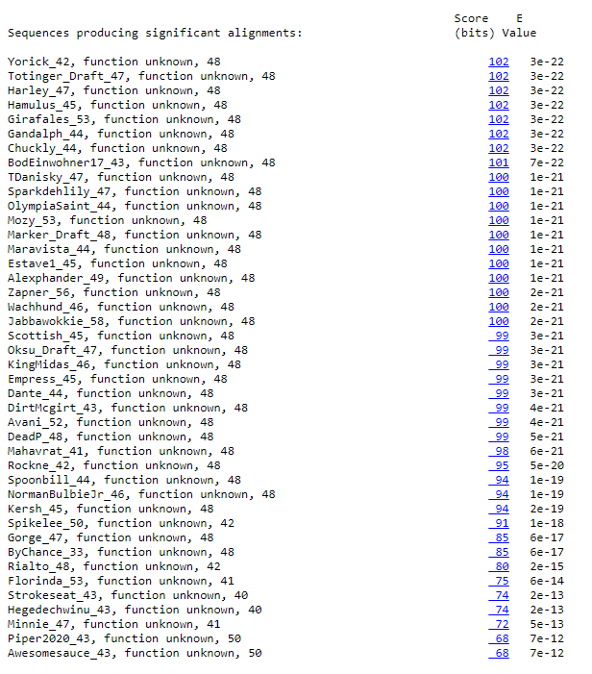
BLAST from NCBI (https://blast.ncbi.nlm.nih.gov/Blast.cgi?PAGE=Proteins) Using Longest ORF
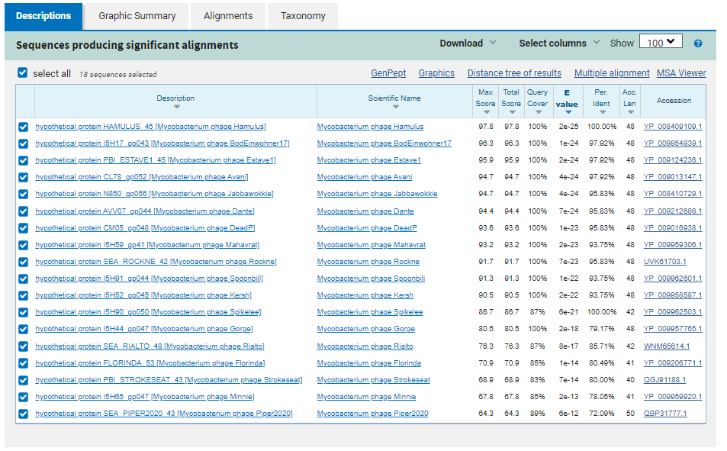
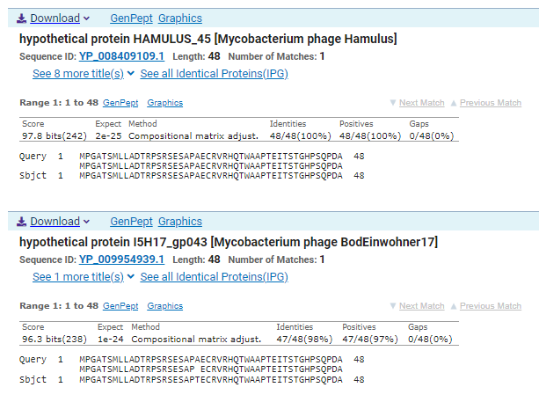
GTG Start at 33825. Original Glimmer call, not called by Genemark.
TAG Stop at 33679.
F/R: R
Coding Potential (y/n): Y
Starterator (SS, NA, NI): Most annotated start is this (33825)
Blast Best Hit, Query:Subject Starts, Score, Evalue, or “no significant Blast alignments” if 10E-4 or higher
hypothetical protein HAMULUS_45 Mycobacterium phage Hamulus YP_008409109.1, 1:1, Score 97.8, Evalue, 2e-25
Gap with previous gene: 114
Longest Orf? (Y/N/NA) Y
RBS:
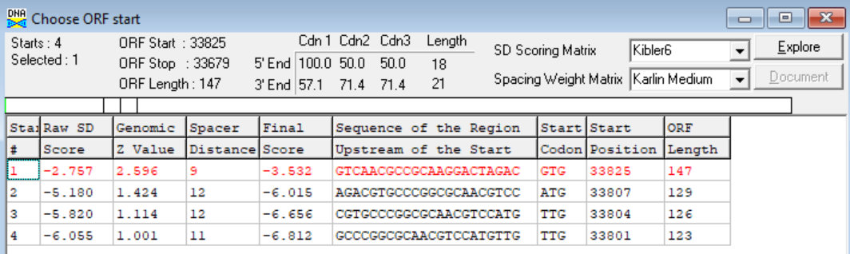
(https://toolkit.tuebingen.mpg.de/tools/hhpred) HHPRED vs PDB, SCOPe, pFam, and M. Tuberculosis. No Significant (>95%) Hits.
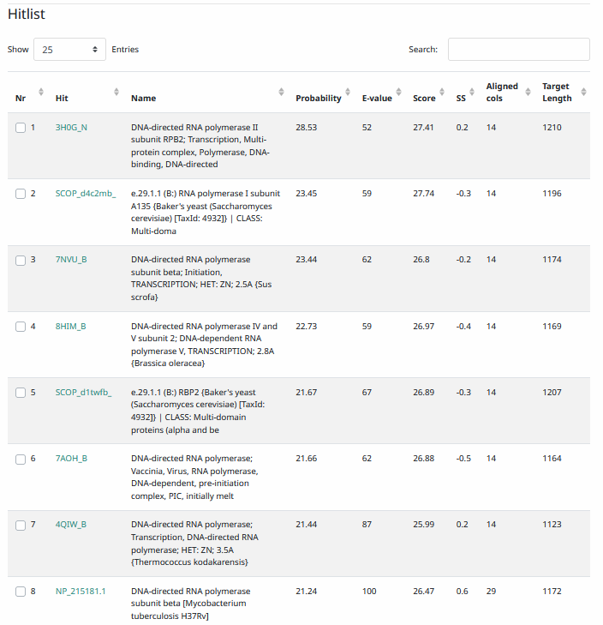
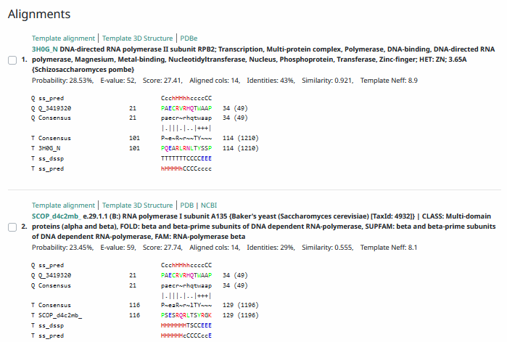
Phamerator Totinger Vs. Tootsieroll Vs. Starcevich (https://phamerator.org/phages) Genes 46-73
Proposed Function: hypothetical protein
Function Evidence: While the gene is not called by similar phages in Phamerator, BLAST results most consistently hit this gene as one that has no known function. Coding potential indicates the gene is real.
Transmembrane Domain/Evidence: No, Intracellular Properties (https://dtu.biolib.com/DeepTMHMM)
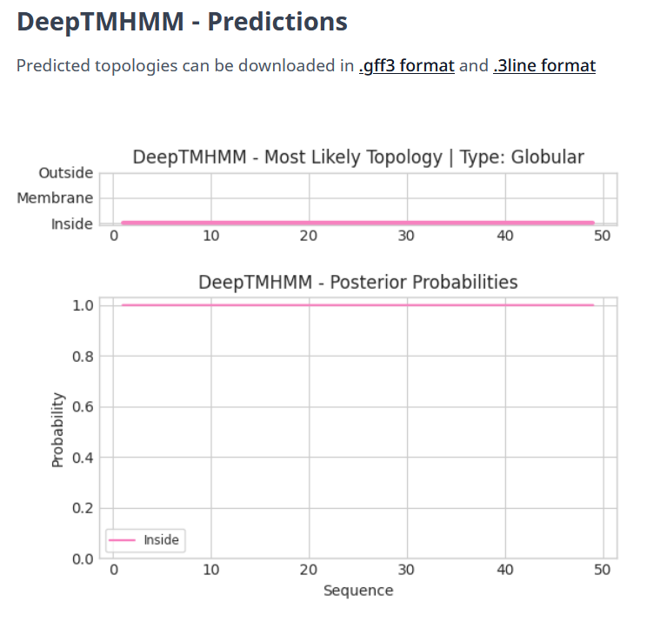

Gene Number: 45
Totinger_Draft_48 in Phagesdb
Pham142574
BLAST from PhagesDB. (https://phagesdb.org/blastp/) Using Longest ORF
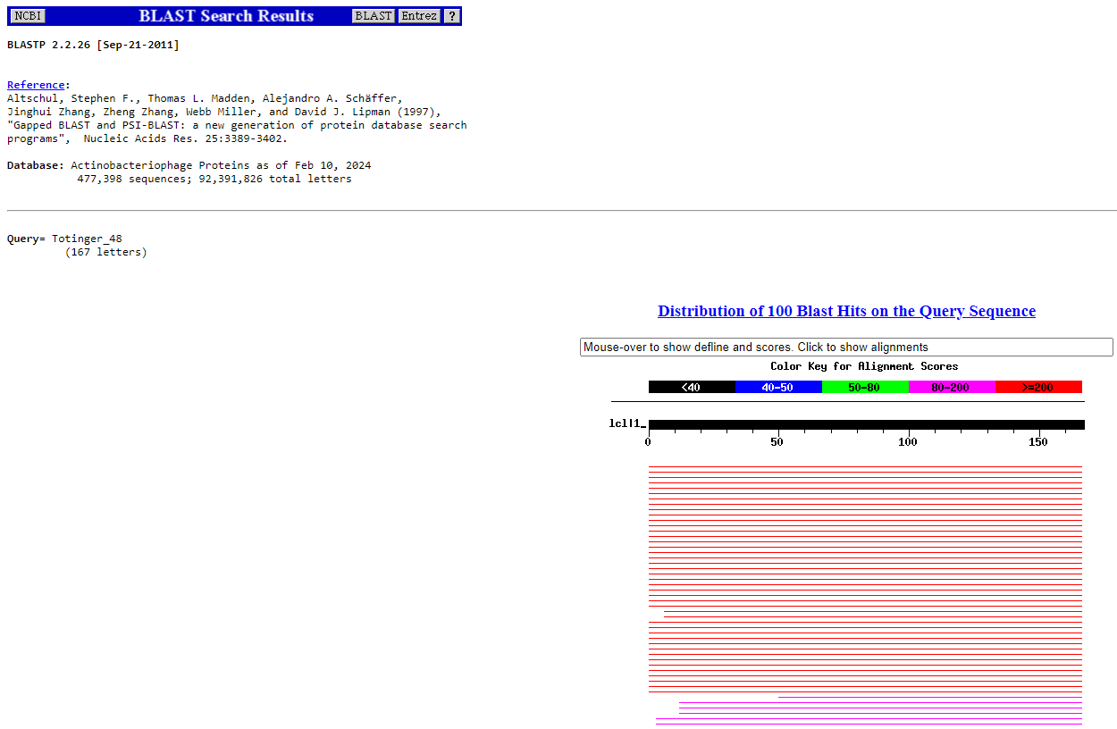
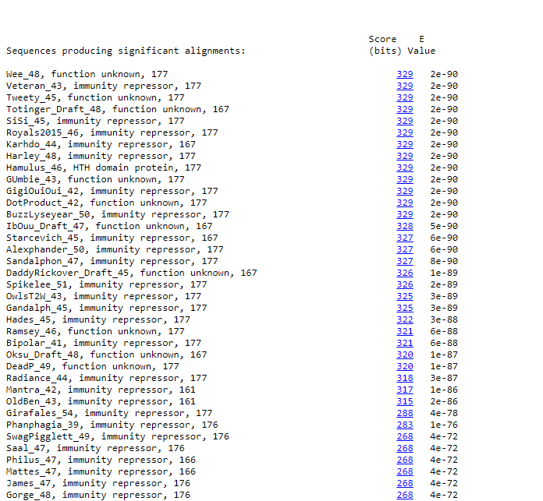
BLAST from NCBI (https://blast.ncbi.nlm.nih.gov/Blast.cgi?PAGE=Proteins) Using Longest ORF
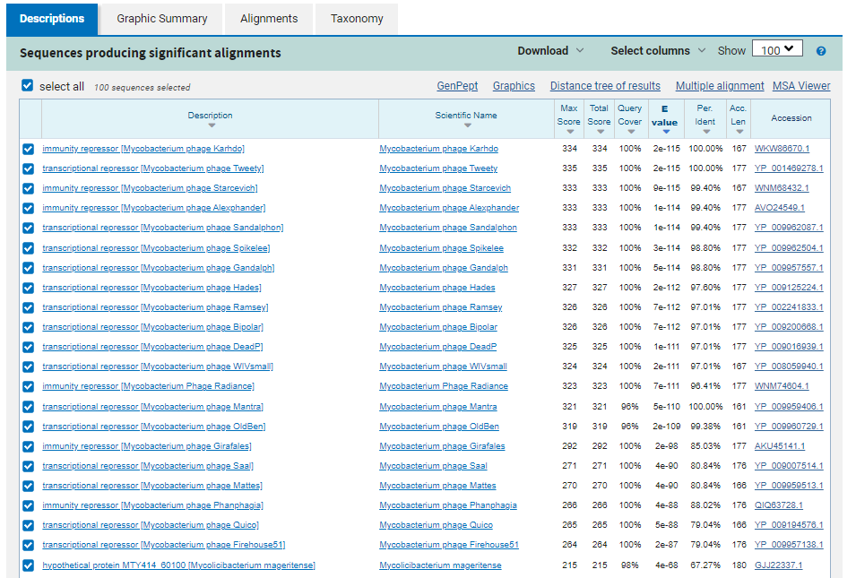
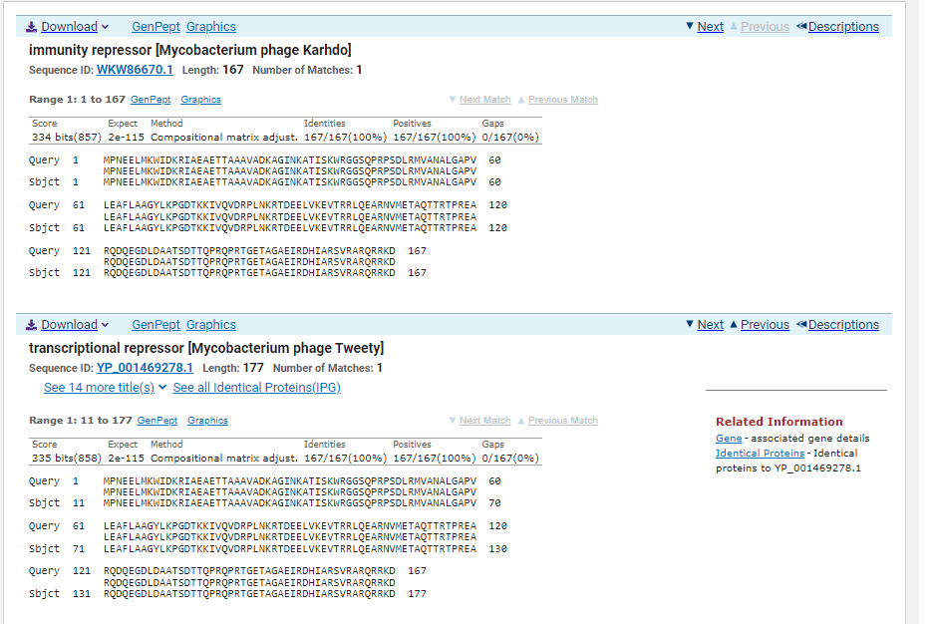
ATG Start at 34331. Original Glimmer call.
TAG Stop at 33828
F/R: F
Coding Potential (y/n): Y
Starterator (SS, NA, NI): Most annotated start is not called.
Blast Best Hit, Query:Subject Starts, Score, Evalue, or “no significant Blast alignments” if 10E-4 or higher
Immunity repressor Mycobacterium phage Karhdo WKW86670.1, 1:1, Score 334, Evalue, 2e-115
Gap with previous gene: 3
Longest Orf? (Y/N/NA) Y
RBS:
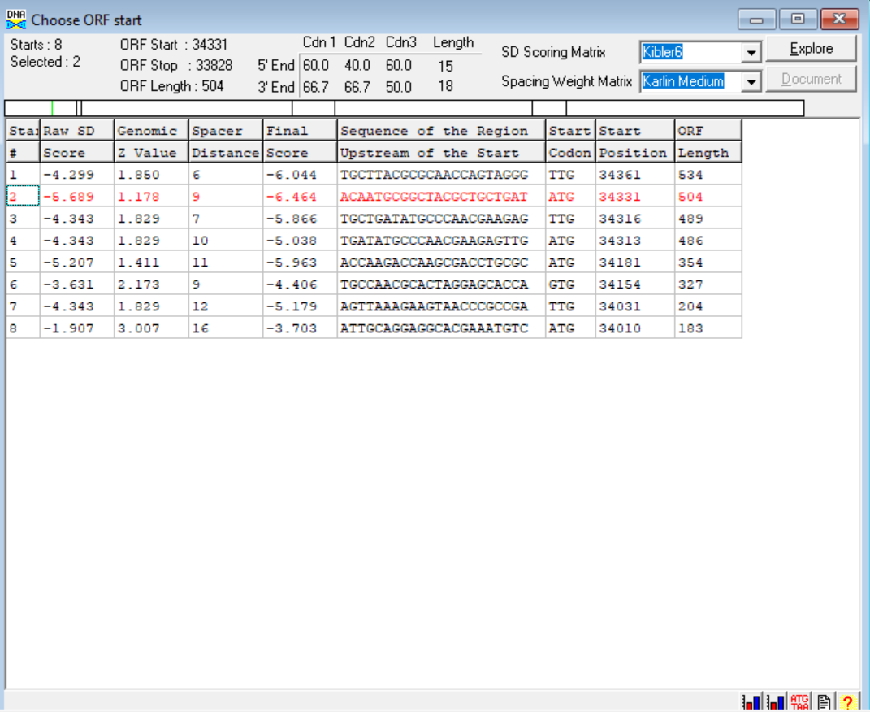
(https://toolkit.tuebingen.mpg.de/tools/hhpred) HHPRED vs PDB, SCOPe, pFam, and M. Tuberculosis.
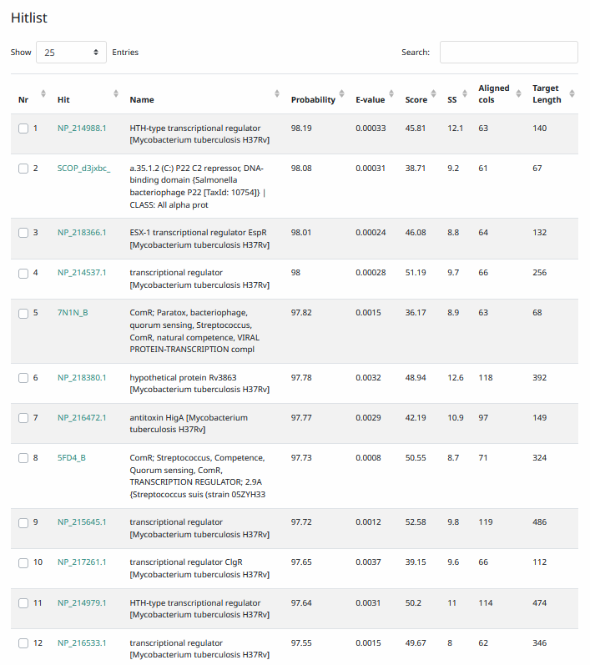
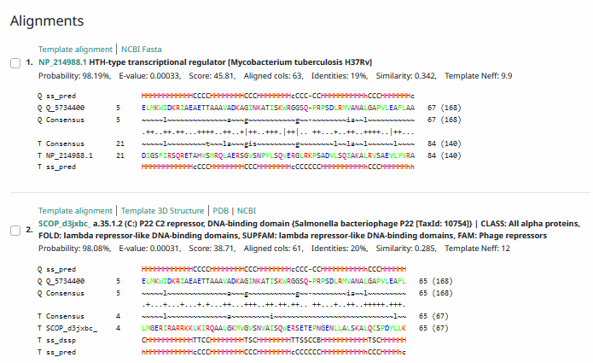
Phamerator Totinger Vs. Tootsieroll Vs. Starcevich (https://phamerator.org/phages) Genes 46-73
Proposed Function: immunity repressor
Function Evidence: A similar gene in phage Starcevich was called as an immunity repressor. Additionally, BLAST and HHPRED results align most consistently with immunity repressors from other phages.
Transmembrane Domain/Evidence: No, Intracellular Properties (https://dtu.biolib.com/DeepTMHMM)
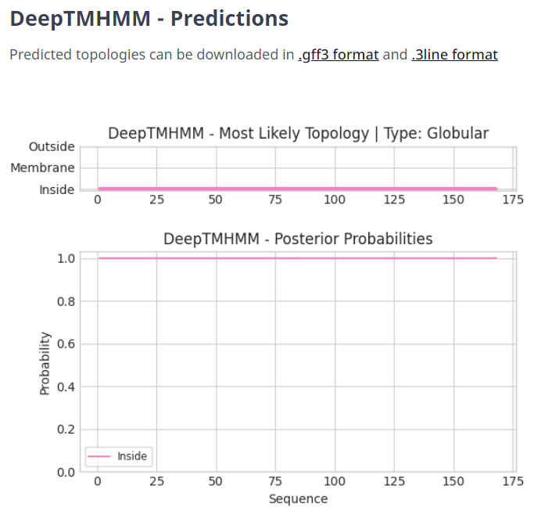

Gene Number: 46
Totinger_draft_49 on phagesdb
Pham144355
BLAST from PhagesDB. (https://phagesdb.org/blastp/) Using Longest ORF
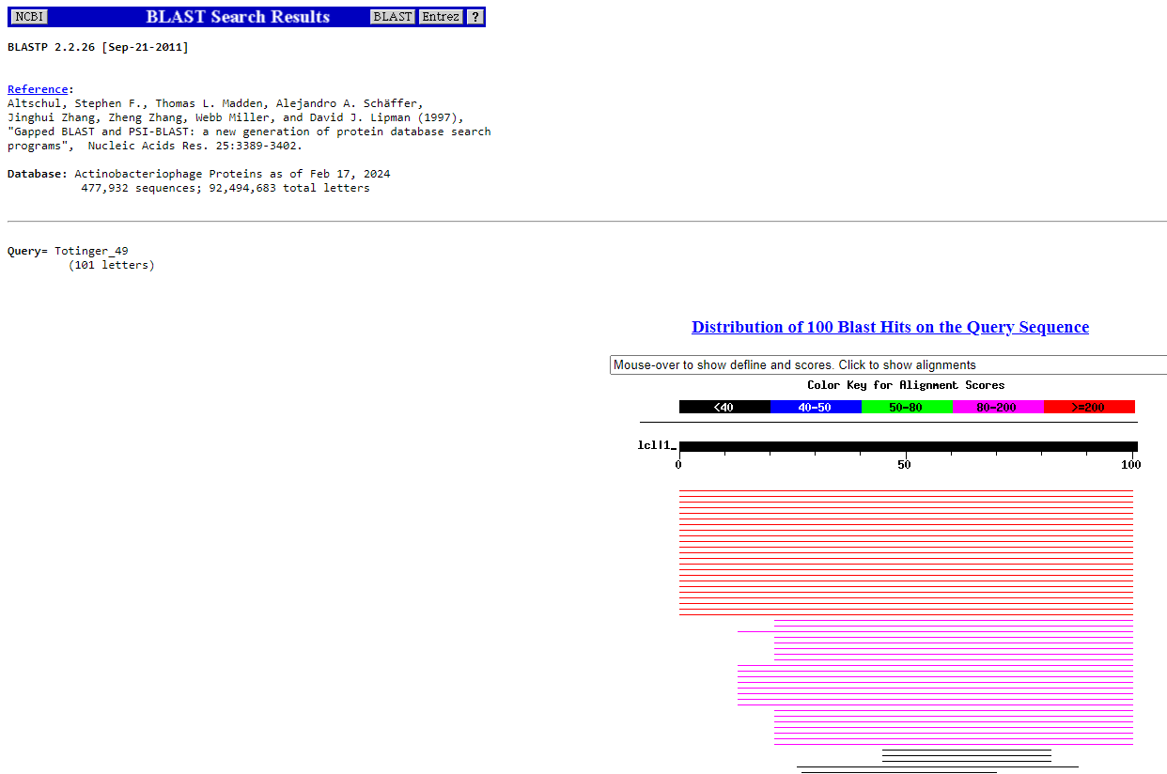
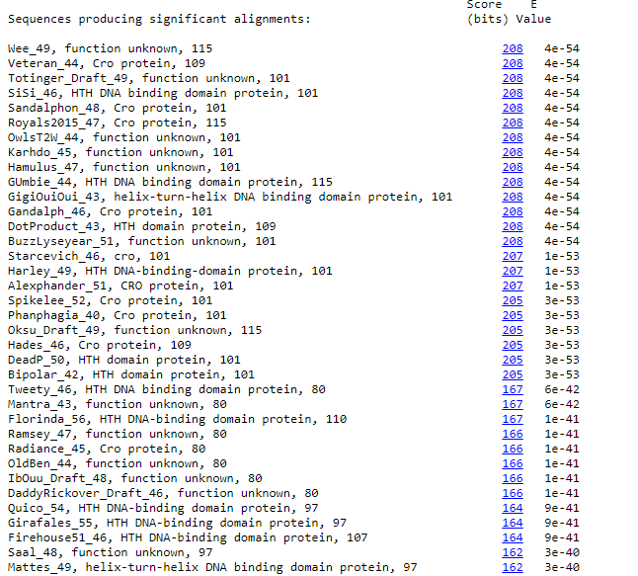
BLAST from NCBI (https://blast.ncbi.nlm.nih.gov/Blast.cgi?PAGE=Proteins) Using Longest ORF
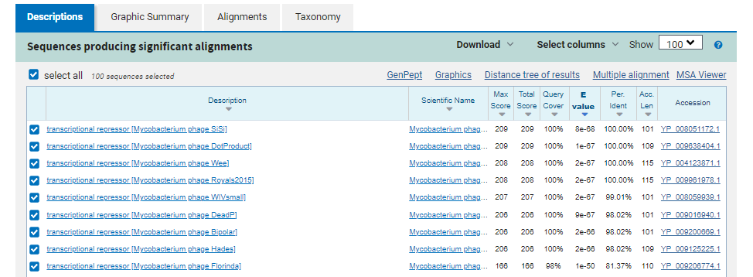
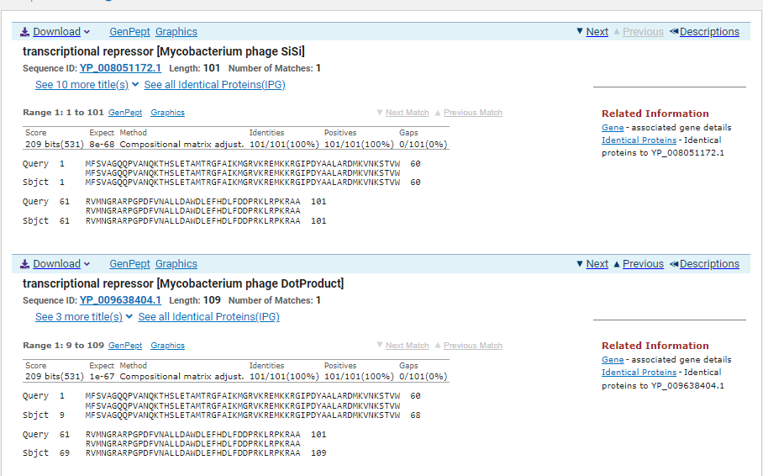
ATG Start at 34515. Original Glimmer call.
TAG Stop at 34820
F/R: F
Coding Potential (y/n): Y
Starterator (SS, NA, NI): Most annotated start is this (34515)
Blast Best Hit, Query:Subject Starts, Score, Evalue, or “no significant Blast alignments” if 10E-4 or higher
Transcriptional repressor Mycobacterium Phage Sisi YP_008051172.1, 1:1, Score 209, Evalue, 8e-68
Gap with previous gene: 184
Longest Orf? (Y/N/NA) Y
RBS:
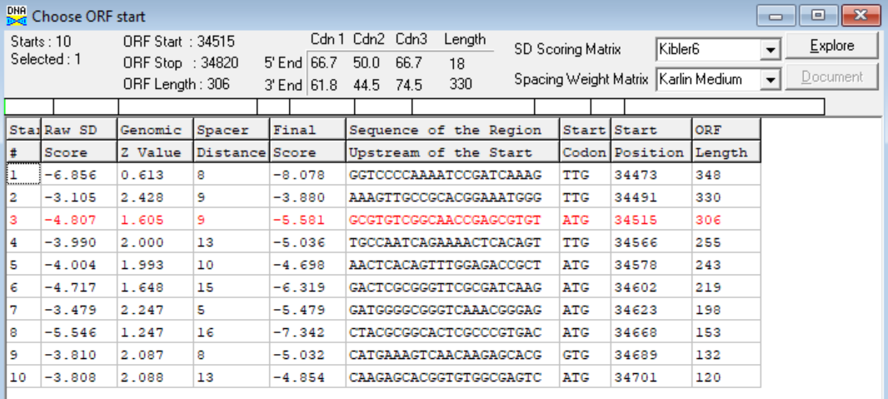
(https://toolkit.tuebingen.mpg.de/tools/hhpred) HHPRED vs PDB, SCOPe, pFam, and M. Tuberculosis.
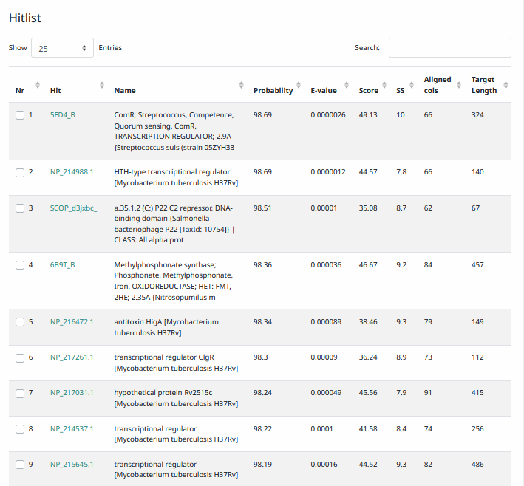
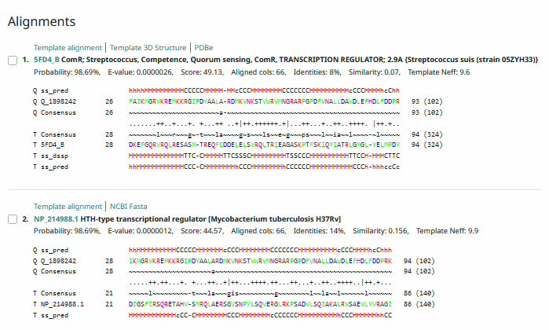
Phamerator Totinger Vs. Tootsieroll Vs. Starcevich (https://phamerator.org/phages) Genes 46-73
Proposed Function: Cro
Function Evidence: Both an integrase and an immunity suppressor are called in this phage, which is necessary to call Cro. Additionally, phage Starcevich calls a near identical gene as Cro and BLAST / HHPRED results most consistently called it a transcription repressor or Cro.
Transmembrane Domain/Evidence: No, Intracellular Properties (https://dtu.biolib.com/DeepTMHMM)
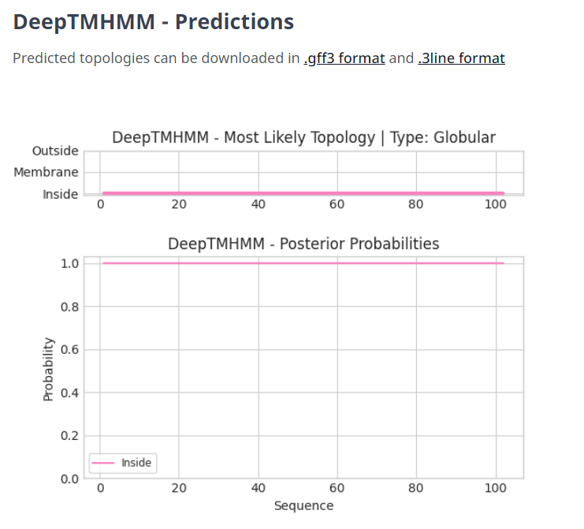

Gene Number: 47
Totinger_Draft_50 on Phagesdb
Pham143869
BLAST from PhagesDB. (https://phagesdb.org/blastp/) Using Longest ORF
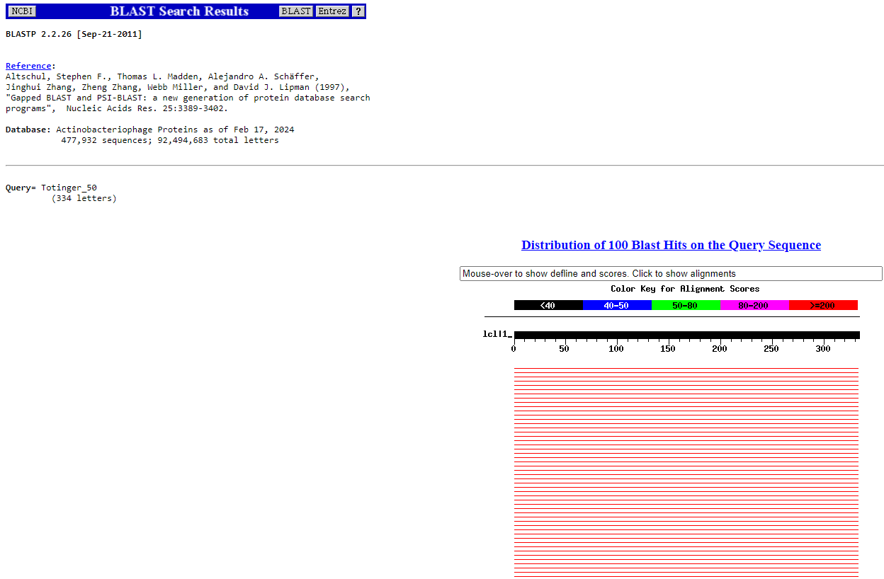
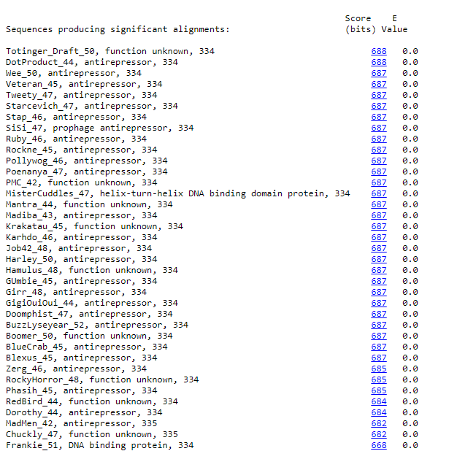
BLAST from NCBI (https://blast.ncbi.nlm.nih.gov/Blast.cgi?PAGE=Proteins) Using Longest ORF
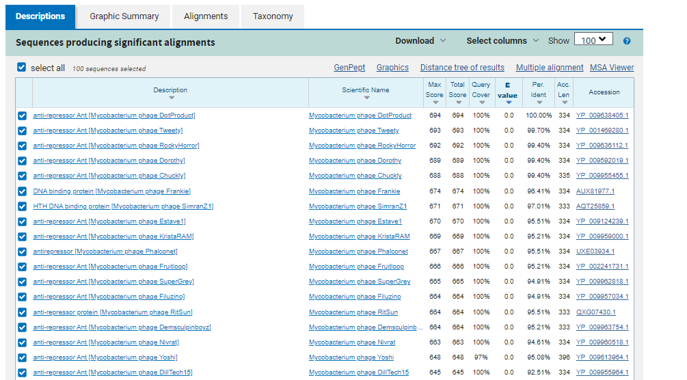
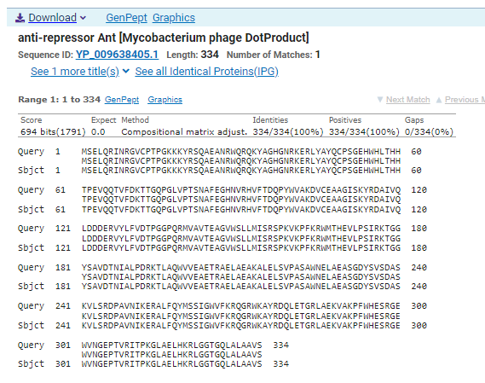
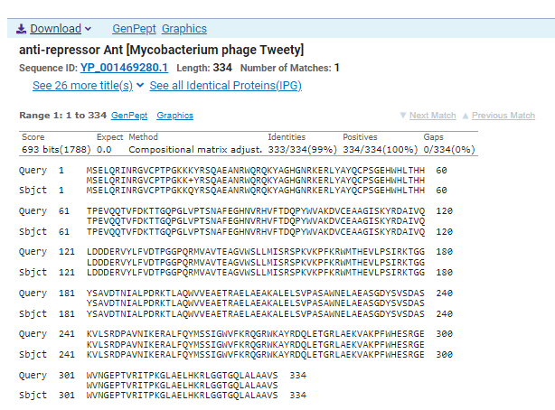
ATG Start at 34879. Original Glimmer call.
TGA Stop at 35883
F/R: F
Coding Potential (y/n): Y
Starterator (SS, NA, NI): Most annotated start is this (34879)
Blast Best Hit, Query:Subject Starts, Score, Evalue, or “no significant Blast alignments” if 10E-4 or higher
Anti-repressor Ant Mycobacterium phage DotProduct YP_009638405.1, 1:1, Score 694, Evalue, 0
Gap with previous gene: 59
Longest Orf? (Y/N/NA) Y
RBS:
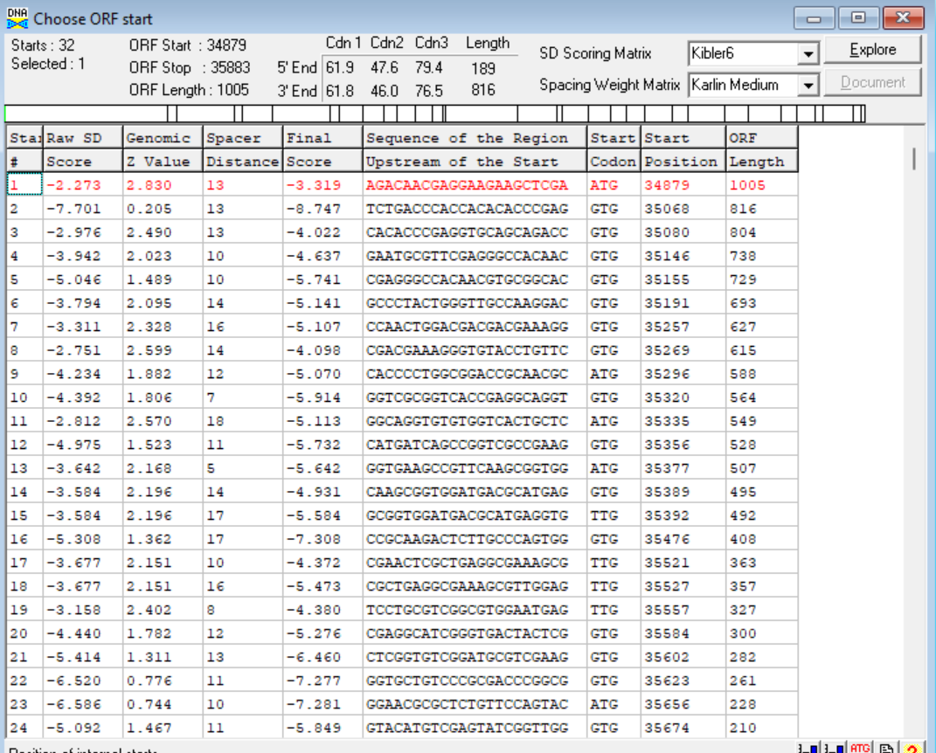
(https://toolkit.tuebingen.mpg.de/tools/hhpred) HHPRED vs PDB, SCOPe, pFam, and M. Tuberculosis.
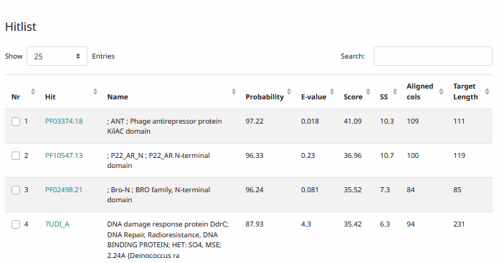
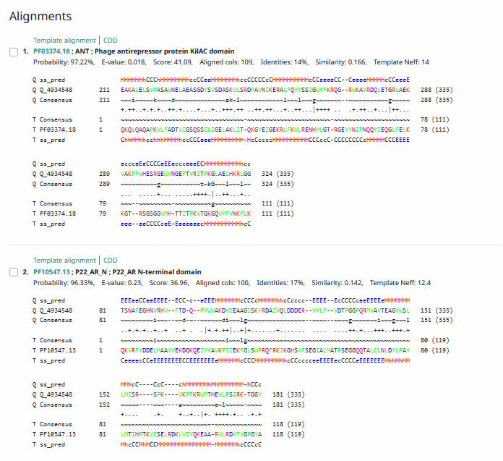
Phamerator Totinger Vs. Tootsieroll Vs. Starcevich (https://phamerator.org/phages) Genes 46-73
Proposed Function: antirepressor
Function Evidence: BLAST and HHPRED results most consistently aligned with antirepressor genes. Additionally, in Phamerator, similar phages (phage Starcevich and phage Tootsieroll) call their similar genes as an antirepressor.
Transmembrane Domain/Evidence: No, Intracellular Properties (https://dtu.biolib.com/DeepTMHMM)
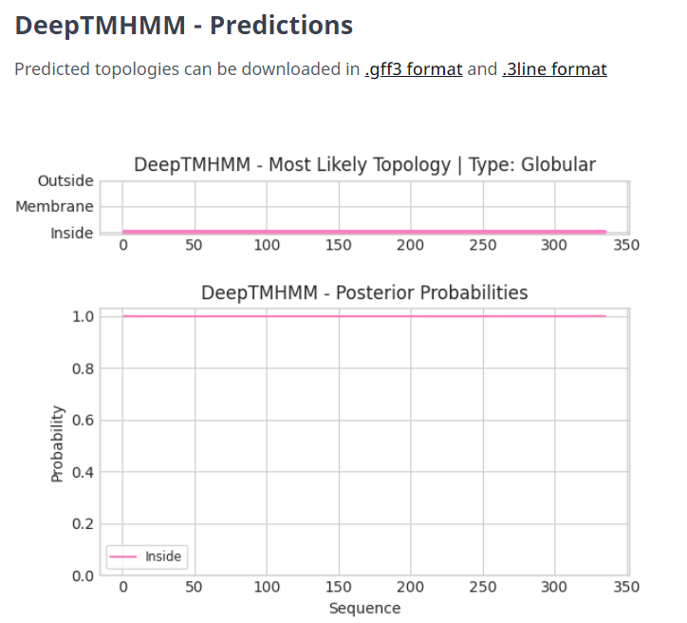
Gene Number: 48
Totinger_Draft_51
Pham116168
BLAST from PhagesDB. (https://phagesdb.org/blastp/) Using Longest ORF
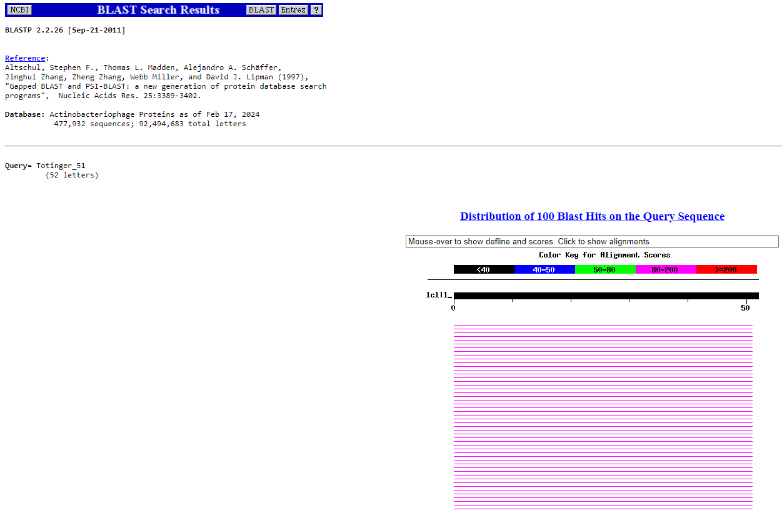
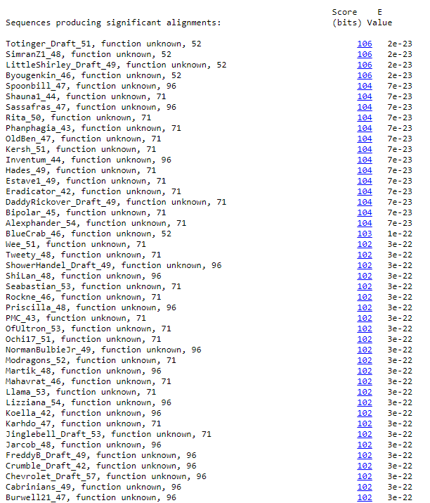
BLAST from NCBI (https://blast.ncbi.nlm.nih.gov/Blast.cgi?PAGE=Proteins) Using Longest ORF
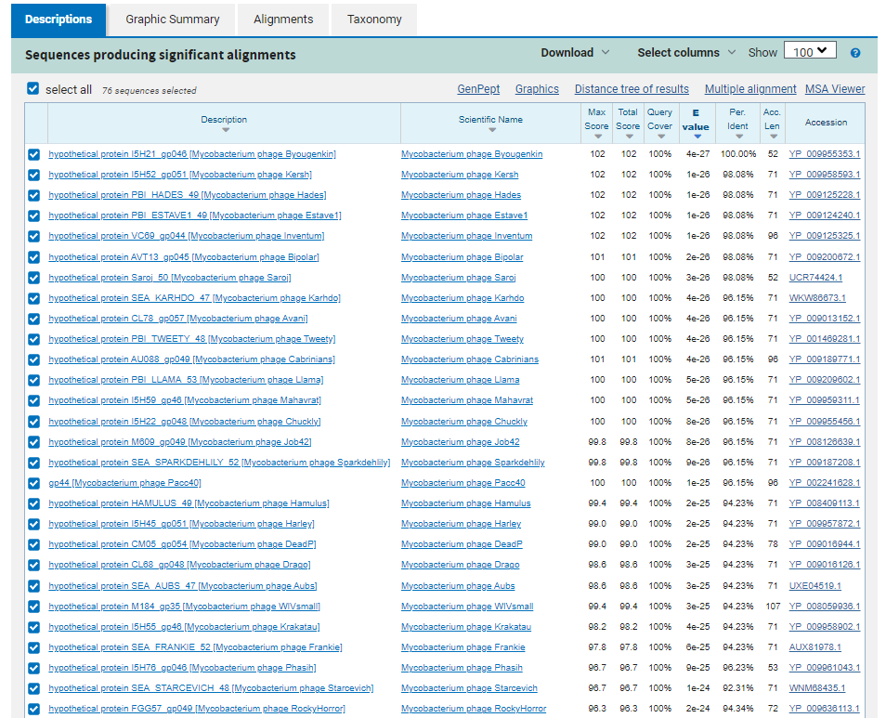
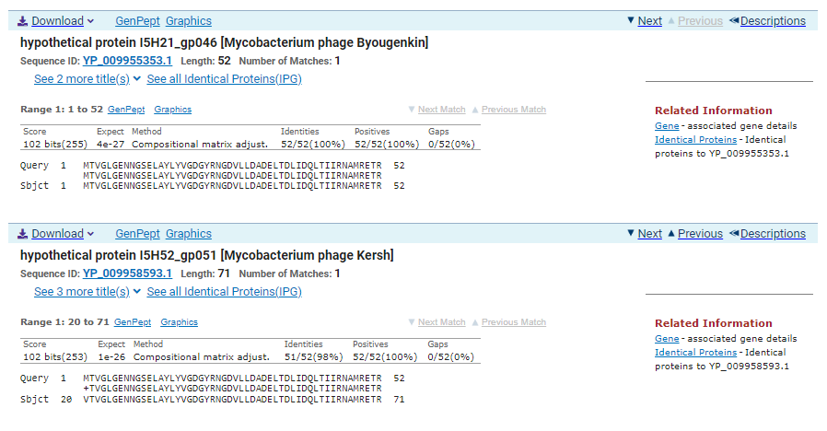
GTG Start at 35937. Original Glimmer call.
TGA Stop at 36095
F/R: F
Coding Potential (y/n): Y
Starterator (SS, NA, NI): Most annotated start is present but not called.
Blast Best Hit, Query:Subject Starts, Score, Evalue, or “no significant Blast alignments” if 10E-4 or higher
hypothetical protein I5H21_gp046 Mycobacterium phage Byougenkin YP_008126594.1, 1:1, Score 102, Evalue, 4e-27
Gap with previous gene: 54
Longest Orf? (Y/N/NA) Y
RBS:
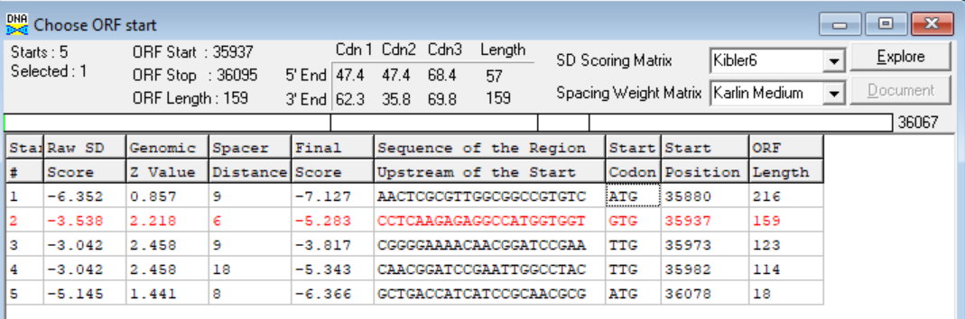
(https://toolkit.tuebingen.mpg.de/tools/hhpred) HHPRED vs PDB, SCOPe, pFam, and M. Tuberculosis. No Significant (>95%) Hits.
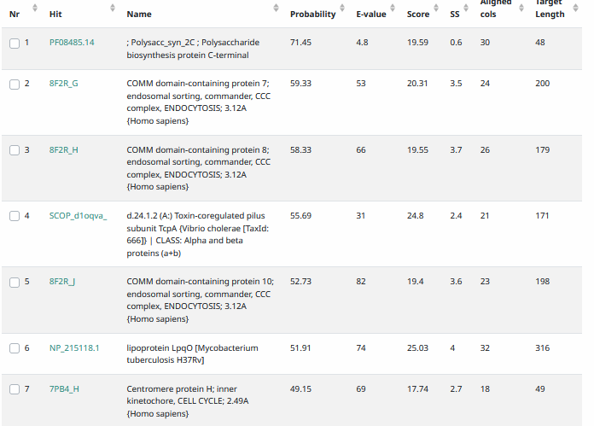
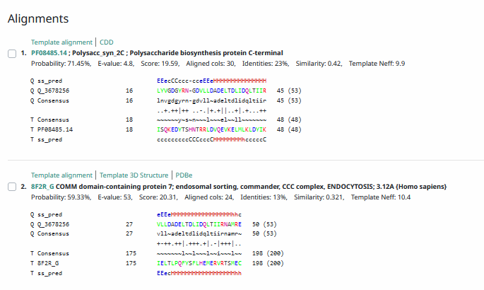
Phamerator Totinger Vs. Tootsieroll Vs. Starcevich (https://phamerator.org/phages) Genes 46-73
Proposed Function: hypothetical protein
Function Evidence: Similar genes are called in similar phages (phage Starcevich and phage Tootsieroll), but do not have a called function. Additionally, BLAST results most consistently aligned with hypothetical proteins from other phages.
Transmembrane Domain/Evidence: No, Intracellular Properties (https://dtu.biolib.com/DeepTMHMM)
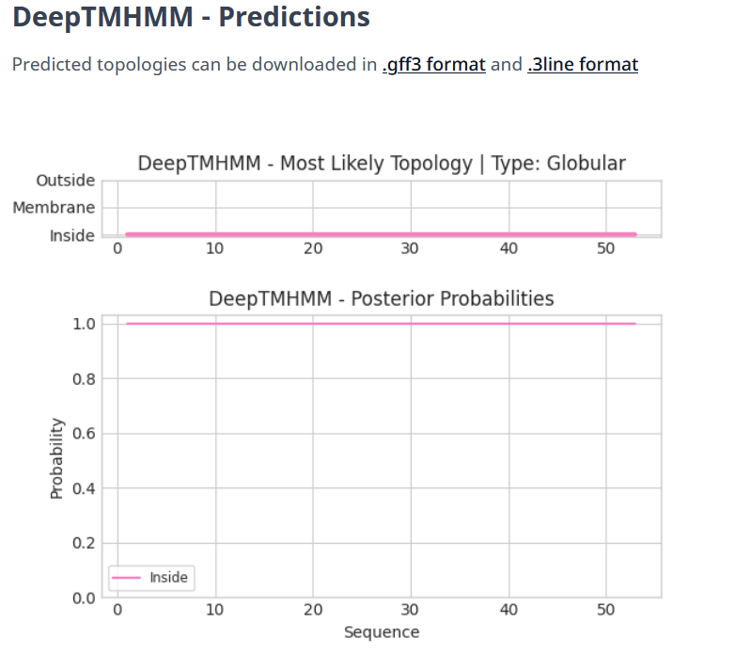

ADDED NEW GENE NOT CALLED BY DNA MASTER. Information as follows.

Gene Number: 49
Totinger_Draft 52 on Phagesdb
Pham143947
BLAST from PhagesDB. (https://phagesdb.org/blastp/) Using Longest ORF
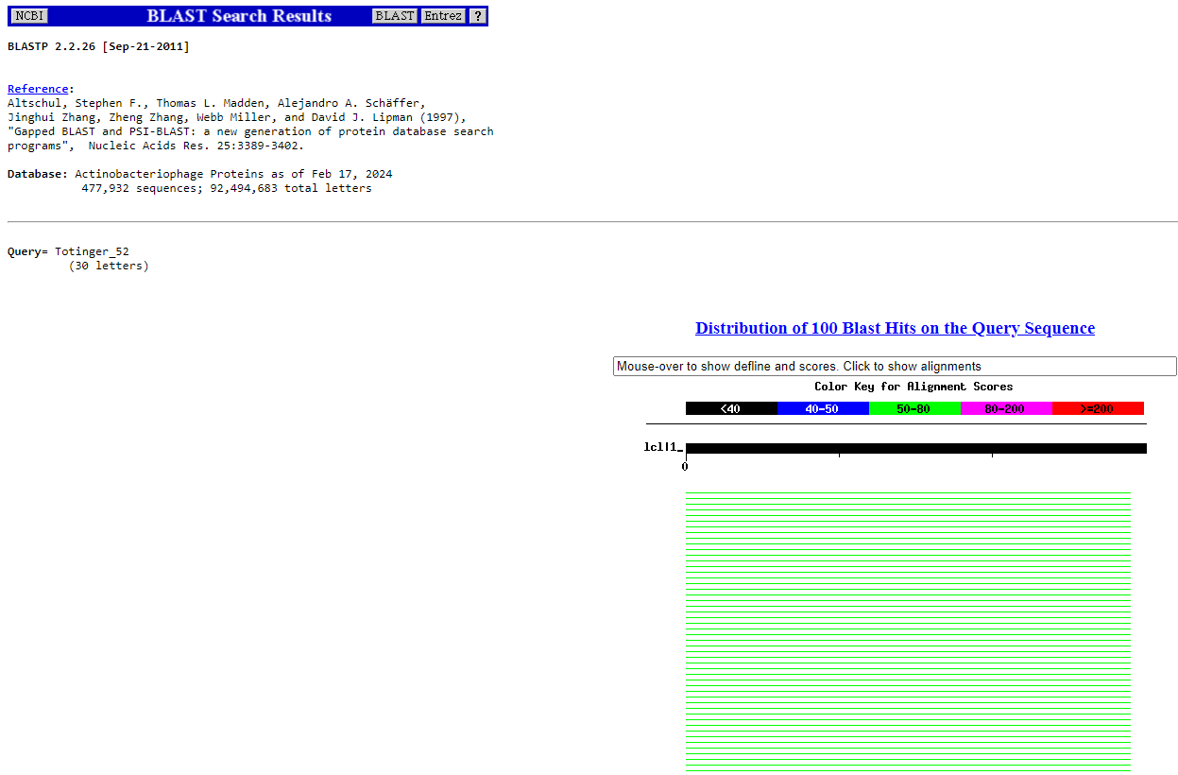
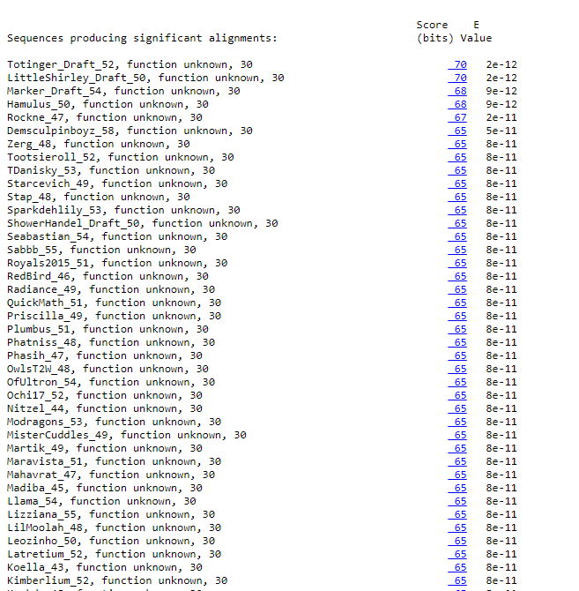
BLAST from NCBI (https://blast.ncbi.nlm.nih.gov/Blast.cgi?PAGE=Proteins) Using Longest ORF
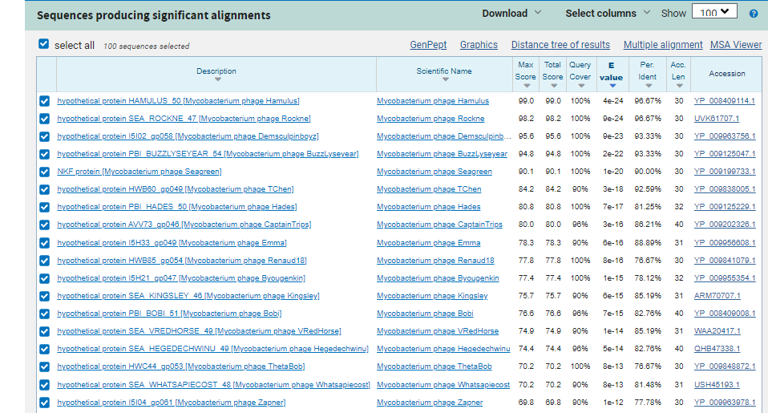
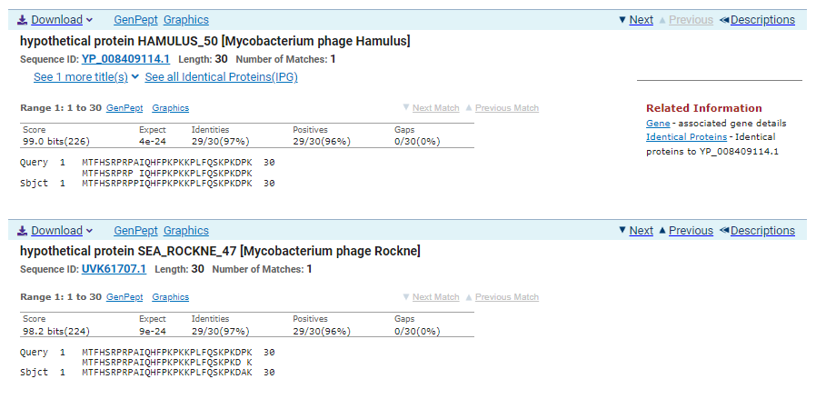
ATG Start at 36092. Not called by Glimmer, called by GenemarkS Self-Trained model.
TGA Stop at 36184
F/R: F
Coding Potential (y/n): Y
Starterator (SS, NA, NI): Most annotated start is this (36092)
Blast Best Hit, Query:Subject Starts, Score, Evalue, or “no significant Blast alignments” if 10E-4 or higher
hypothetical protein HAMULUS_50 Mycobacterium phage Hamulus YP_008409114.1, 1:1, Score 99, Evalue, 4e-24
Gap with previous gene: -3
Longest Orf? (Y/N/NA) Y
RBS:
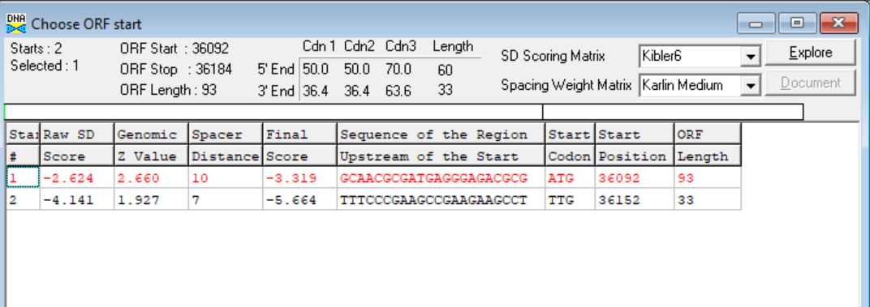
(https://toolkit.tuebingen.mpg.de/tools/hhpred) HHPRED vs PDB, SCOPe, pFam, and M. Tuberculosis. No significant (>95%) hits.
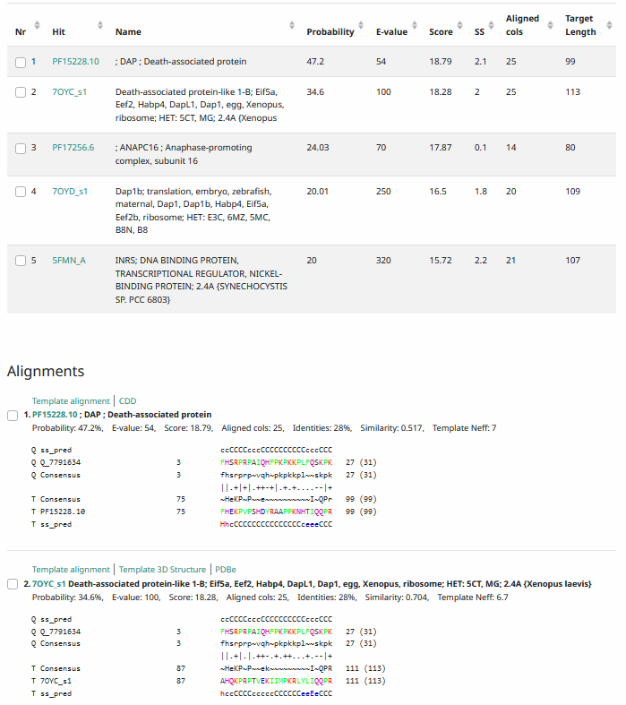
Phamerator Totinger Vs. Tootsieroll Vs. Starcevich (https://phamerator.org/phages) Genes 46-73
Proposed Function: hypothetical protein
Function Evidence: similar phages (phage Starcevich and phage Tootsieroll) have a very similar if not identical sequence, and both call the gene but do not call a function. BLAST results also most consistently call this protein as a hypothetical protein.
Transmembrane Domain/Evidence: No, Intracellular Properties (https://dtu.biolib.com/DeepTMHMM)
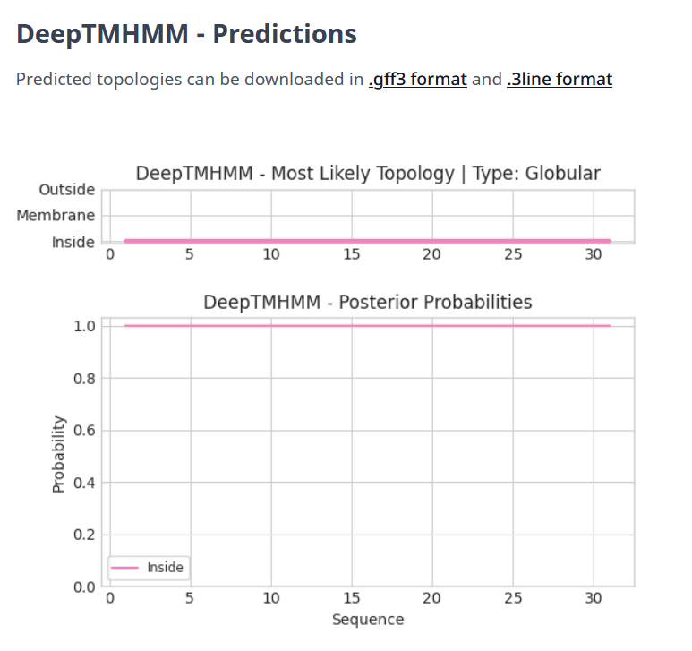

Gene Number: 50
Totinger_53_Draft on Phagesdb
Pham143947
BLAST from PhagesDB. (https://phagesdb.org/blastp/) Using Longest ORF
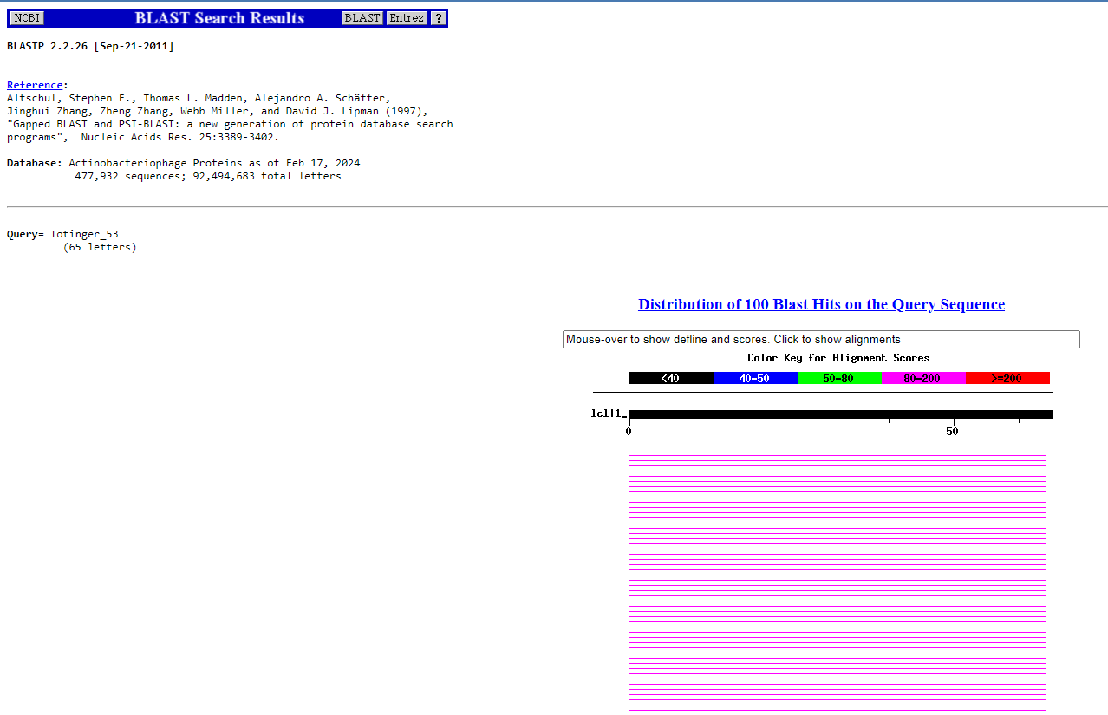
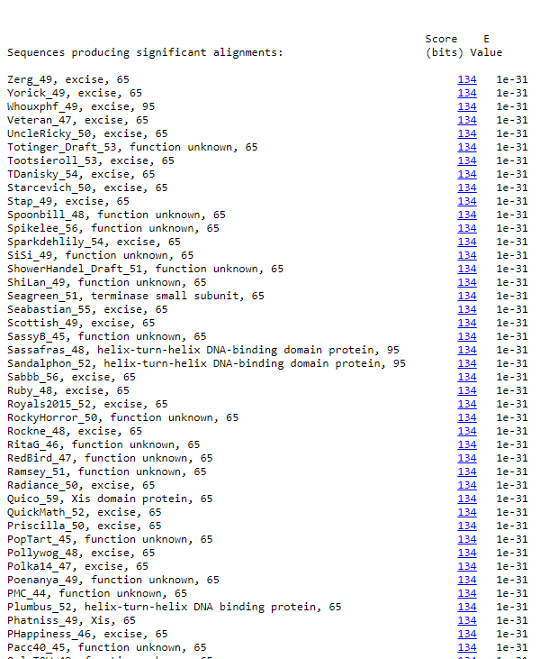
BLAST from NCBI (https://blast.ncbi.nlm.nih.gov/Blast.cgi?PAGE=Proteins) Using Longest ORF
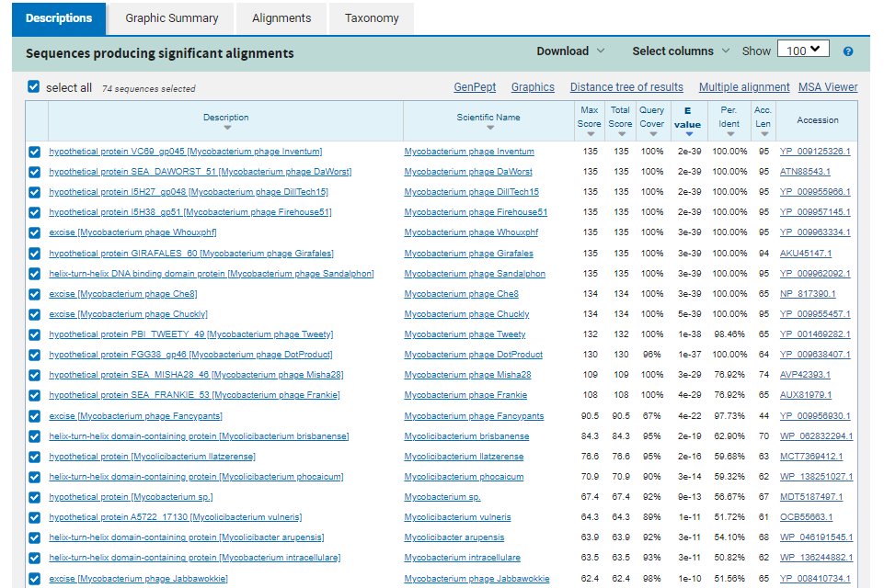
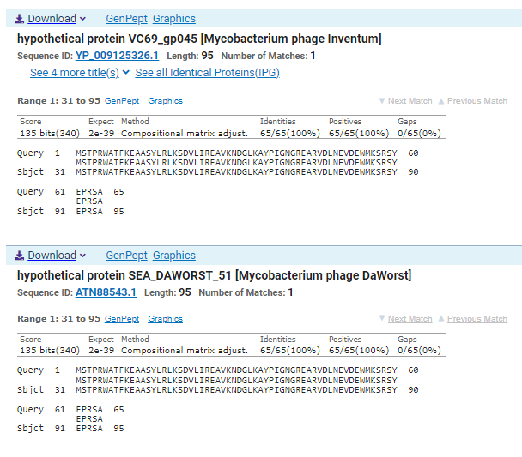
ATG Start at 36181. Original Glimmer call.
TGA Stop at 36378
F/R: F
Coding Potential (y/n): Y
Starterator (SS, NA, NI): Most annotated start is this (36181)
Blast Best Hit, Query:Subject Starts, Score, Evalue, or “no significant Blast alignments” if 10E-4 or higher
hypothetical protein VC69_gp045 Mycobacterium phage Inventum YP_009125326.1, 31:95, Score 135, Evalue, 2e-35
Gap with previous gene: -3
Longest Orf? (Y/N/NA) Y
RBS:
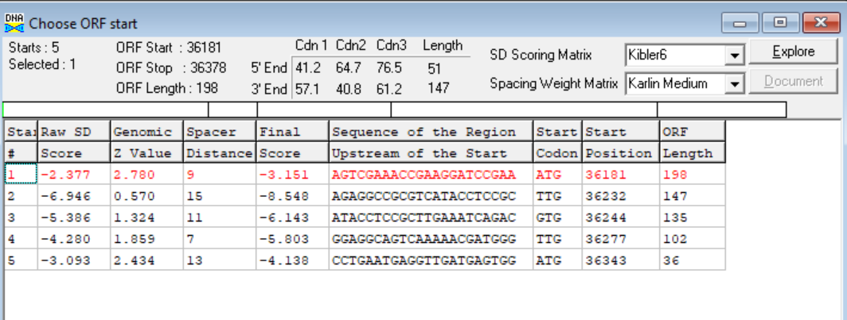
(https://toolkit.tuebingen.mpg.de/tools/hhpred) HHPRED vs PDB, SCOPe, pFam, and M. Tuberculosis.
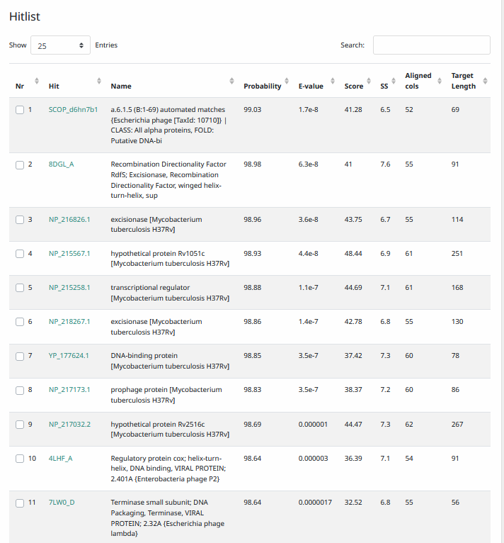
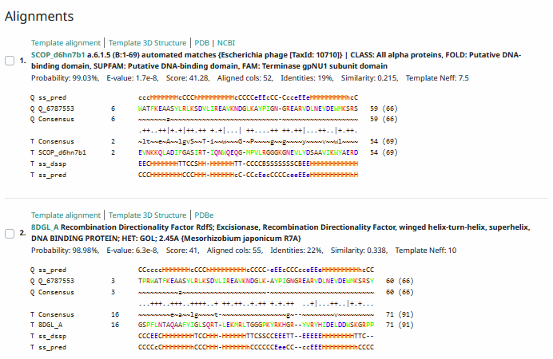
Phamerator Totinger Vs. Tootsieroll Vs. Starcevich (https://phamerator.org/phages) Genes 46-73
Proposed Function: excise
Function Evidence: Similar phages (phage Starcevich and phage Tootsieroll) call their similar genes excises. Additionally, BLAST results and HHPRED most consistently align with an excise.
Transmembrane Domain/Evidence: No, Intracellular Properties (https://dtu.biolib.com/DeepTMHMM)
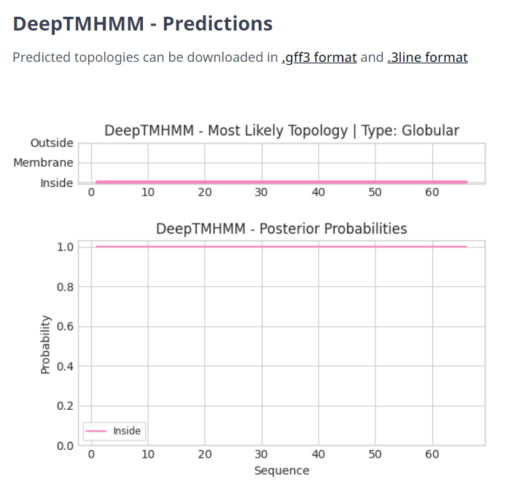

Gene Number: 51
Totinger_54_Draft on Phagesdb
Pham84916
BLAST from PhagesDB. (https://phagesdb.org/blastp/) Using Longest ORF
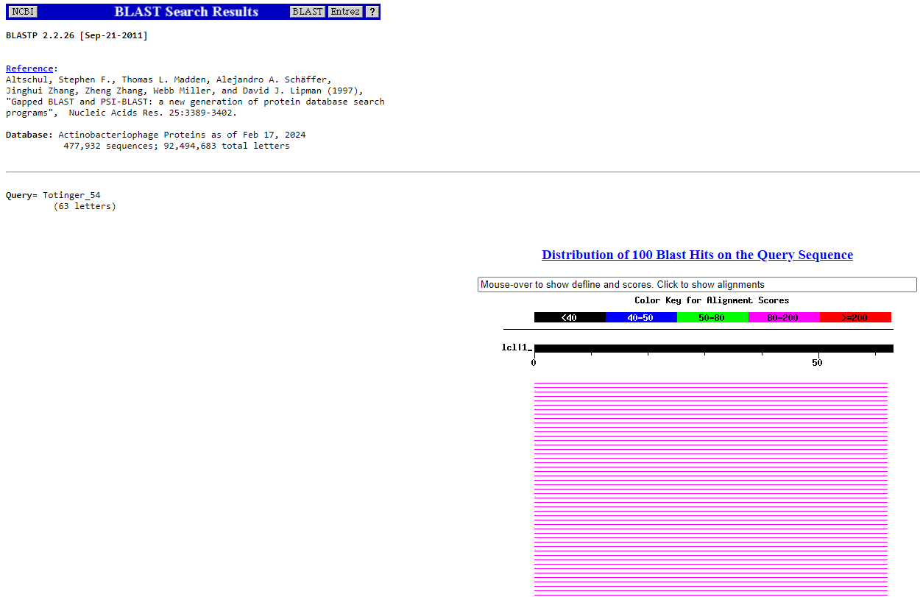
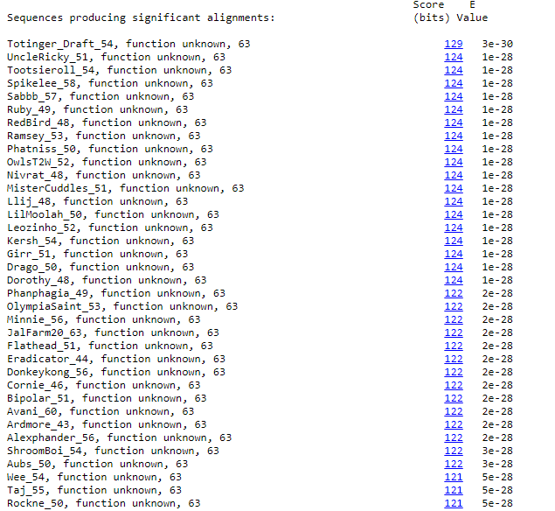
BLAST from NCBI (https://blast.ncbi.nlm.nih.gov/Blast.cgi?PAGE=Proteins) Using Longest ORF
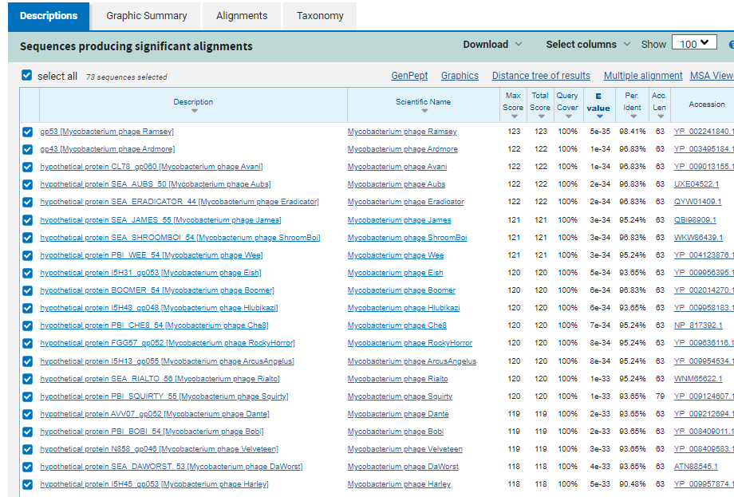
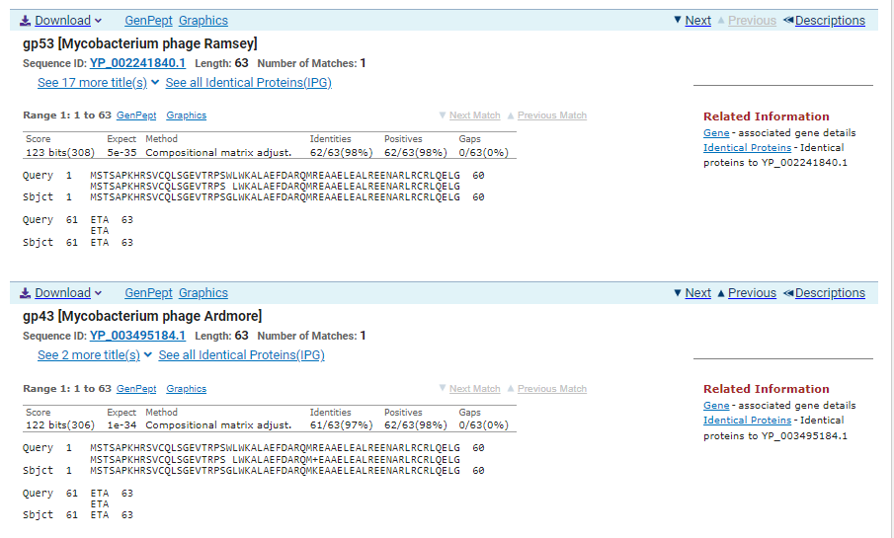
GTG Start at 36375. Original Glimmer call.
TGA Stop at 36566
F/R: F
Coding Potential (y/n): Y
Starterator (SS, NA, NI): Most annotated start is this (36375)
Blast Best Hit, Query:Subject Starts, Score, Evalue, or “no significant Blast alignments” if 10E-4 or higher
Gp53 Mycobacterium phage Ramsey YP_002241840.1, 1:1, Score 123, Evalue, 5e-35
Gap with previous gene: -3
Longest Orf? (Y/N/NA) Y
RBS:
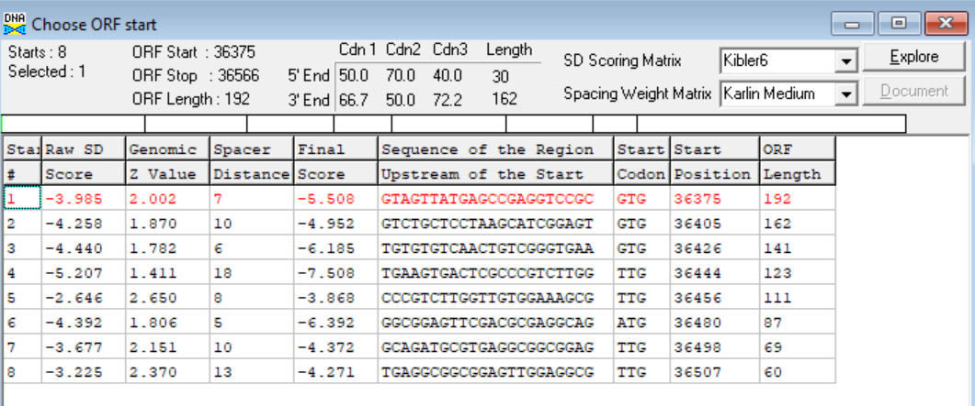
(https://toolkit.tuebingen.mpg.de/tools/hhpred) HHPRED vs PDB, SCOPe, pFam, and M. Tuberculosis.
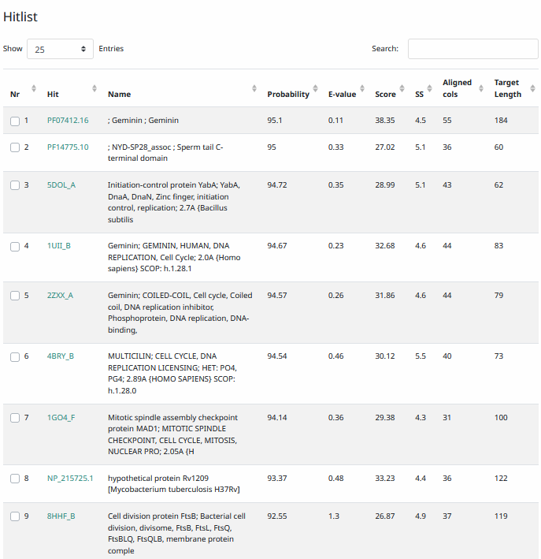
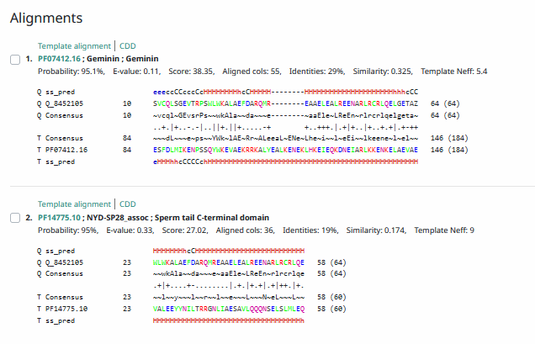
Phamerator Totinger Vs. Tootsieroll Vs. Starcevich (https://phamerator.org/phages) Genes 46-73
Proposed Function: hypothetical protein
Function Evidence: This gene matches most consistently in BLASTs is of proteins with unknown function or hypothetical proteins. Additionally, similar phages (phage Starcevich and phage Tootsieroll) call similar genes but do not call functions for them.
Transmembrane Domain/Evidence: No, Intracellular Properties (https://dtu.biolib.com/DeepTMHMM)
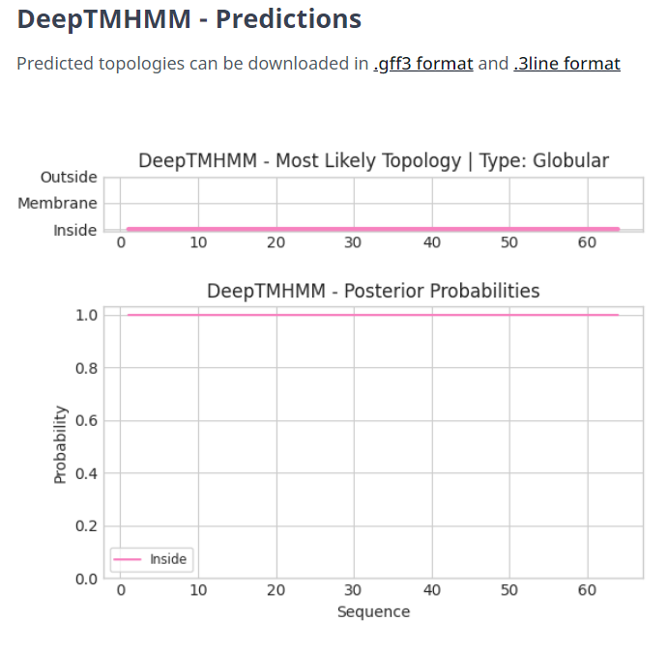

Gene Number: 52
Totinger_55_Draft in Phagesdb
Pham88043
BLAST from PhagesDB. (https://phagesdb.org/blastp/) Using Longest ORF
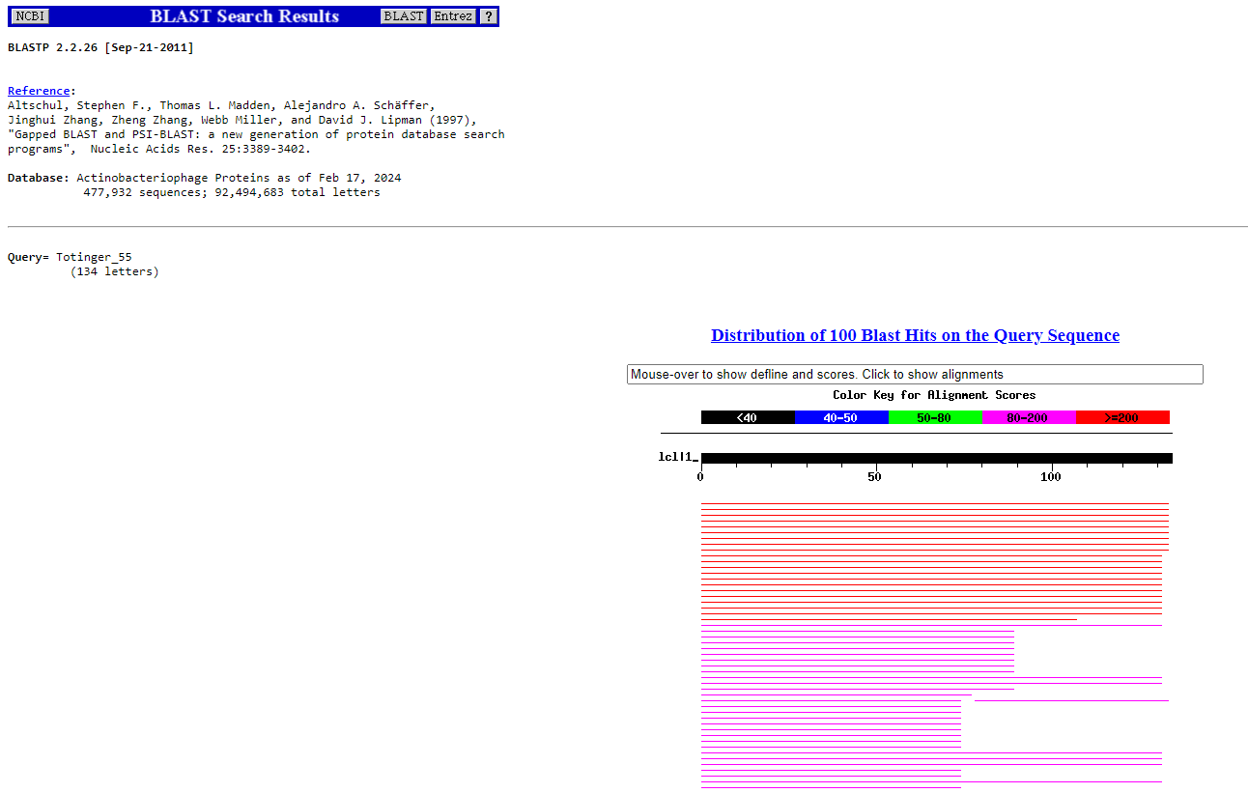
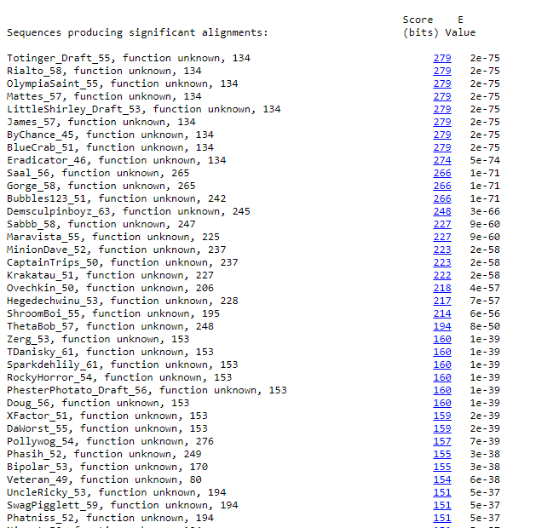
BLAST from NCBI (https://blast.ncbi.nlm.nih.gov/Blast.cgi?PAGE=Proteins) Using Longest ORF
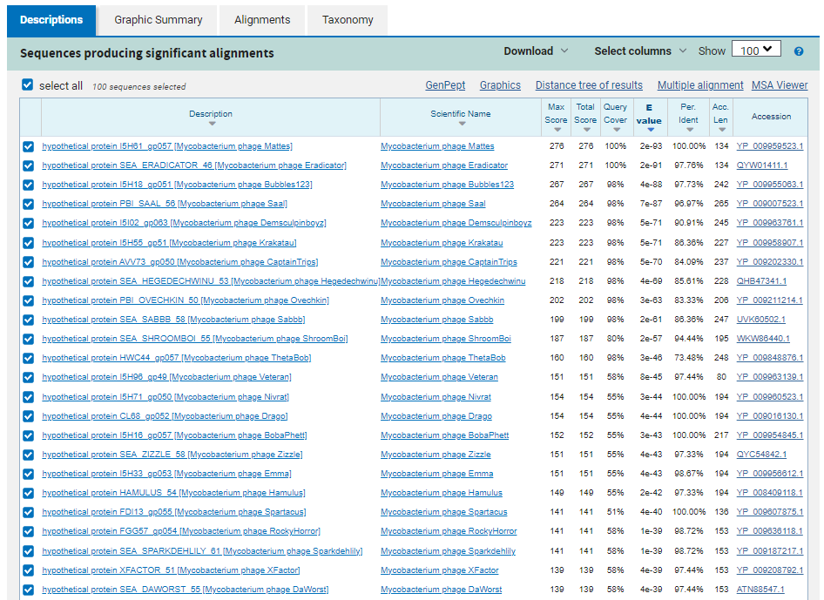
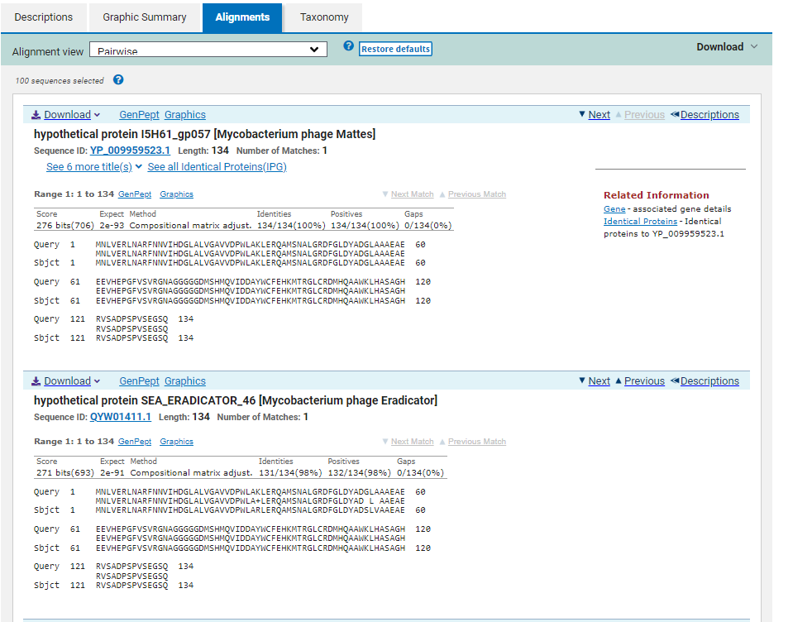
GTG Start at 36563. Original Glimmer call.
TGA Stop at 36967
F/R: F
Coding Potential (y/n): Y
Starterator (SS, NA, NI): Most annotated start is this (36563)
Blast Best Hit, Query:Subject Starts, Score, Evalue, or “no significant Blast alignments” if 10E-4 or higher
hypothetical protein I5H61_gp057 Mycobacterium phage Mattes YP_009959523.1, 1:1, Score 276, Evalue, 2e-93
Gap with previous gene: -3
Longest Orf? (Y/N/NA) N
RBS:
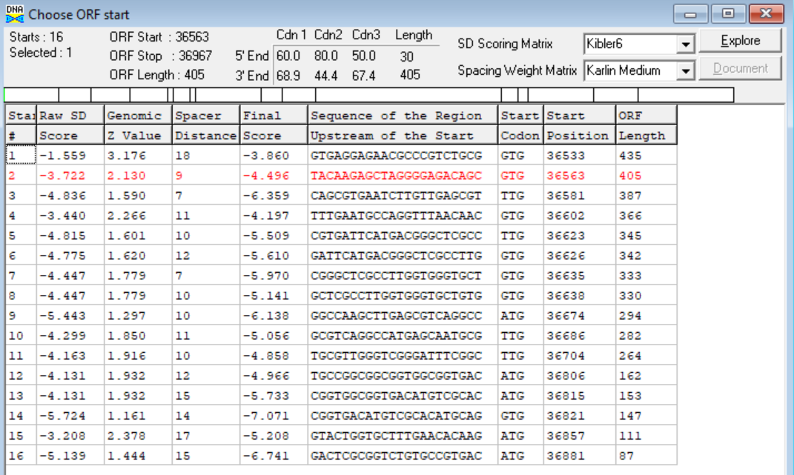
(https://toolkit.tuebingen.mpg.de/tools/hhpred) HHPRED vs PDB, SCOPe, pFam, and M. Tuberculosis. No significant (>95%) hits.
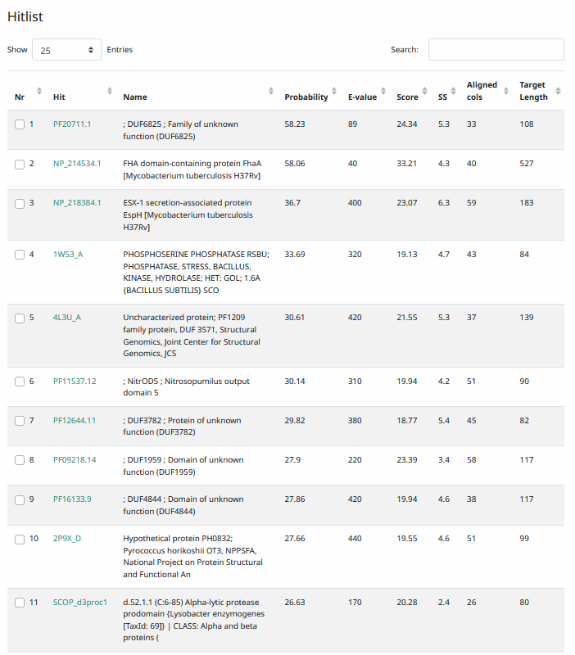
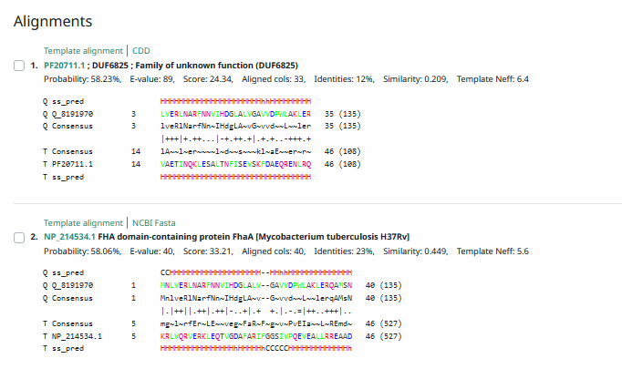
Phamerator Totinger Vs. Tootsieroll Vs. Starcevich (https://phamerator.org/phages) Genes 46-73
Proposed Function: hypothetical protein
Function Evidence: In similar phages (phage Starcevich and phage Tootsieroll), this gene is called but does not have a called function. Additionally, BLAST results most consistently align with proteins of unknown function.
Transmembrane Domain/Evidence: No, Intracellular Properties (https://dtu.biolib.com/DeepTMHMM)
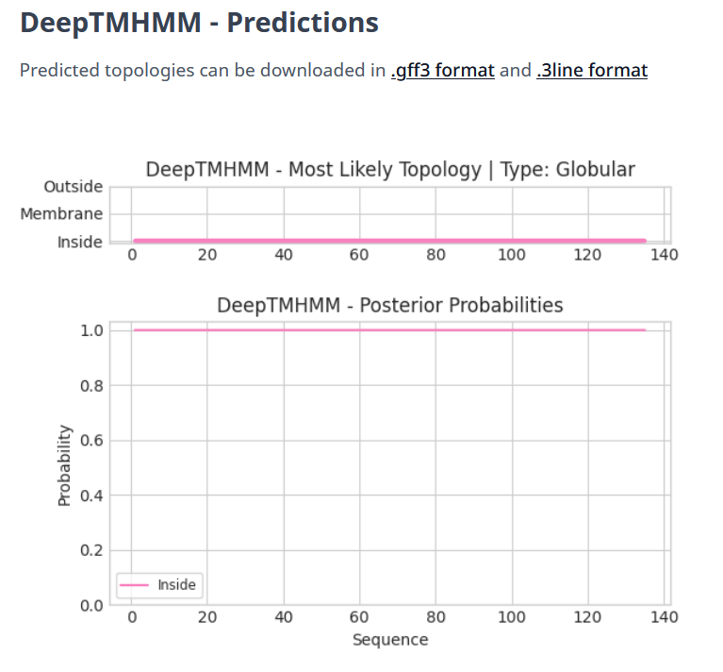

Gene Number: 53
Totinger_Draft_56 on PhagesDb
Pham87841
BLAST from PhagesDB. (https://phagesdb.org/blastp/) Using Longest ORF
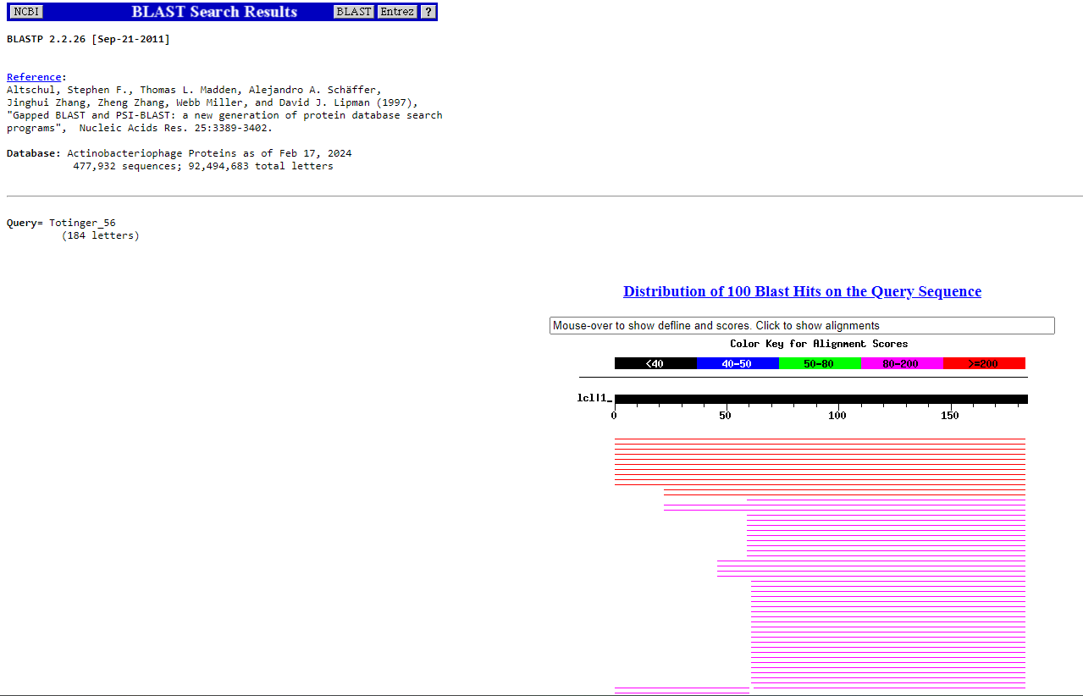
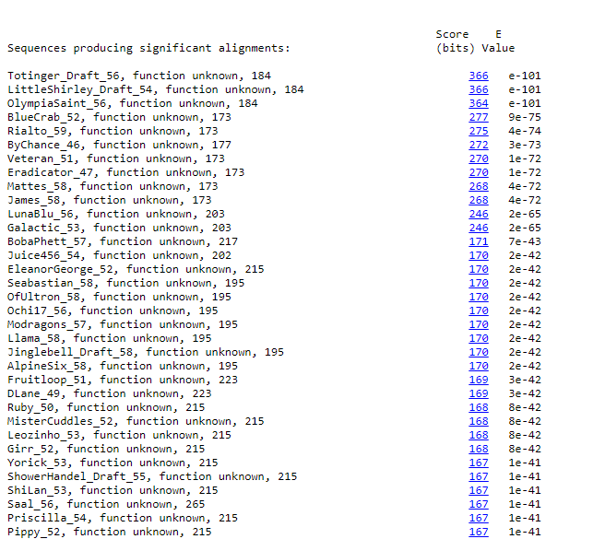
BLAST from NCBI (https://blast.ncbi.nlm.nih.gov/Blast.cgi?PAGE=Proteins) Using Longest ORF
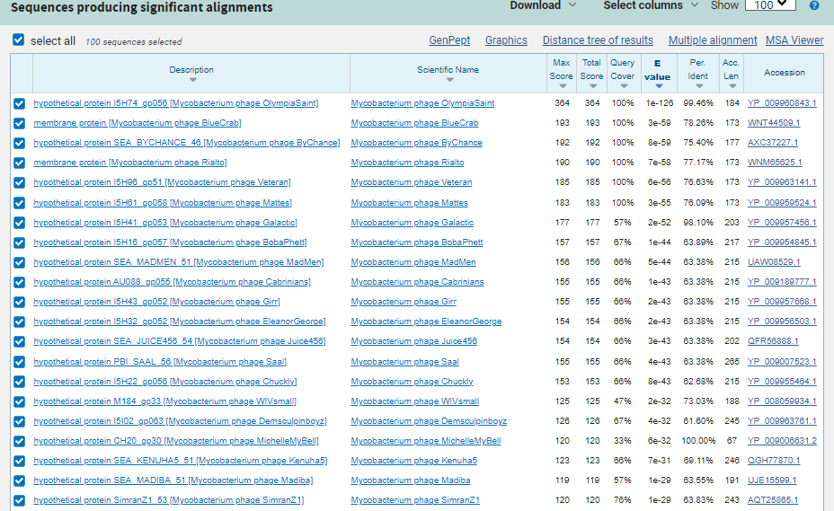
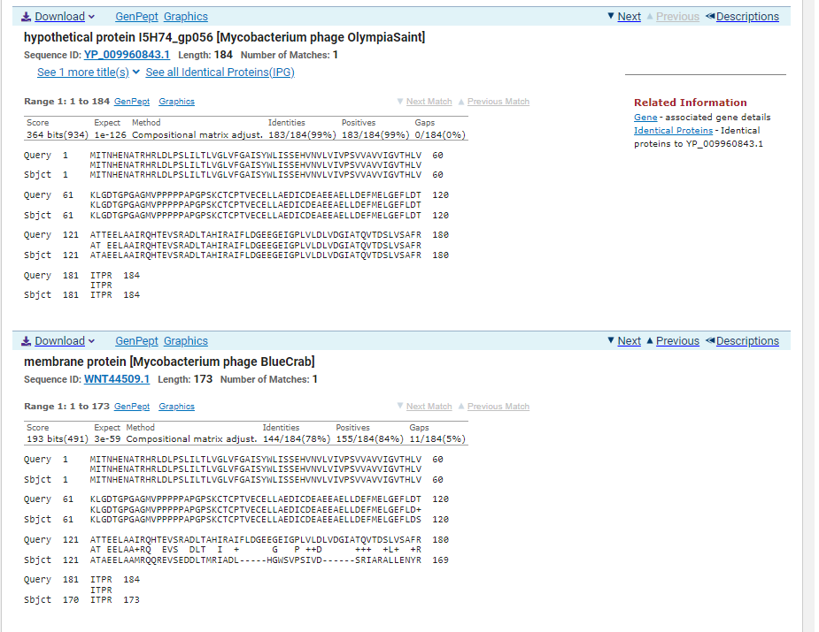
GTG Start at 36964. Original Glimmer call.
TAG Stop at 37518
F/R: F
Coding Potential (y/n): Y
Starterator (SS, NA, NI): Most annotated start is this (36964)
Blast Best Hit, Query:Subject Starts, Score, Evalue, or “no significant Blast alignments” if 10E-4 or higher
hypothetical protein I5H74_gp056 Mycobacterium phage OlympiaSaint YP_009960843.1, 1:1, Score 364, Evalue, 1e-126
Gap with previous gene: -3
Longest Orf? (Y/N/NA) Y
RBS:
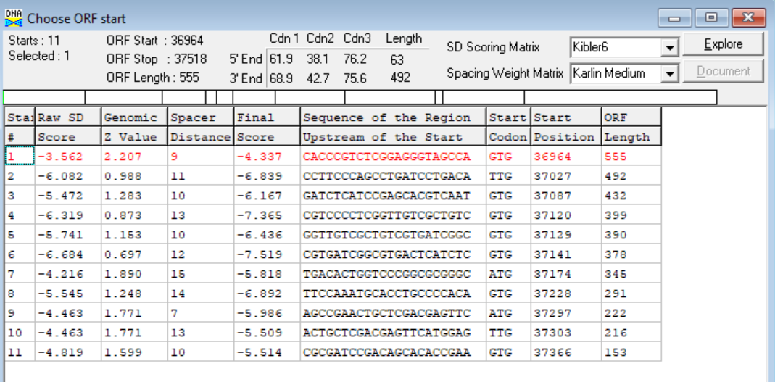
(https://toolkit.tuebingen.mpg.de/tools/hhpred) HHPRED vs PDB, SCOPe, pFam, and M. Tuberculosis. No Significant (>95%) Hits
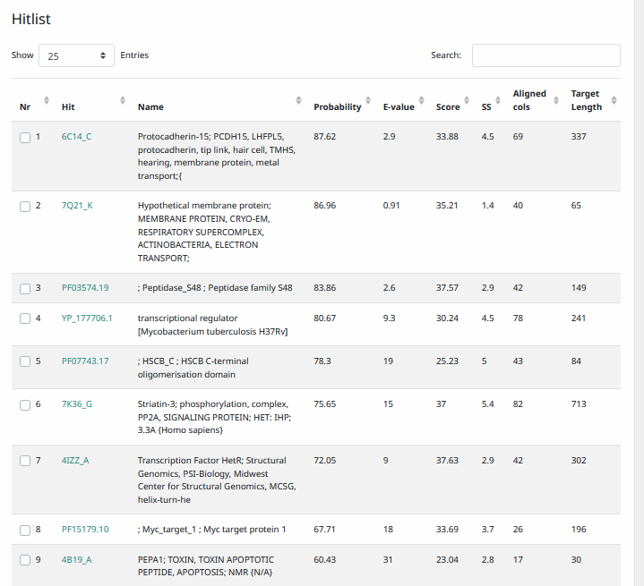
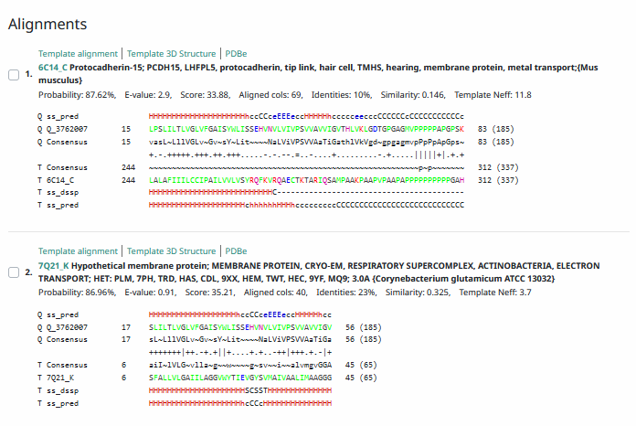
Phamerator Totinger Vs. Tootsieroll Vs. Starcevich (https://phamerator.org/phages) Genes 46-73
Proposed Function: hypothetical protein
Function Evidence: BLAST results most consistently hit this gene as a protein that has no known function. Additionally, similar (but not identical) genes in similar phages (phage Starcevich and phage Tootsieroll) do not call a function for their versions of the gene.
Transmembrane Domain/Evidence: Yes, Transmembrane Properties at AA~ 18-35 and AA~ 42-60 (https://dtu.biolib.com/DeepTMHMM)
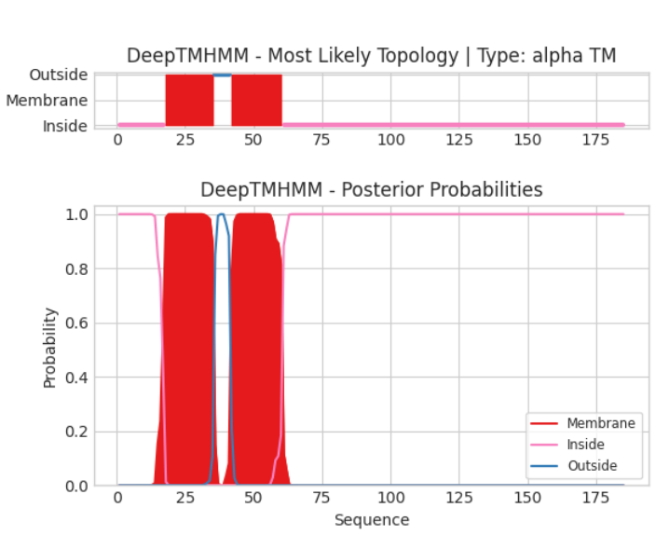

Gene Number: 54
Totinger_Draft_57 on Phagesdb
Pham84833
BLAST from PhagesDB. (https://phagesdb.org/blastp/) Using Longest ORF
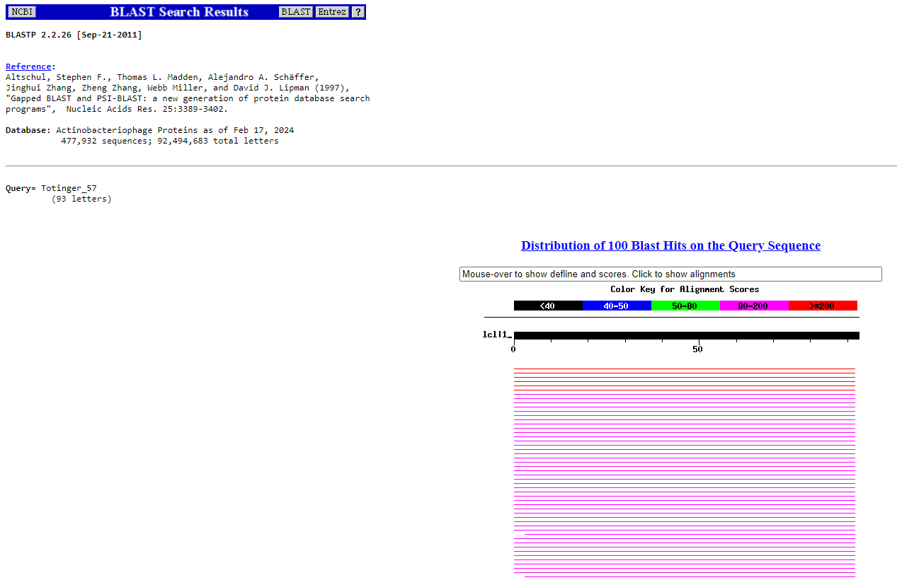
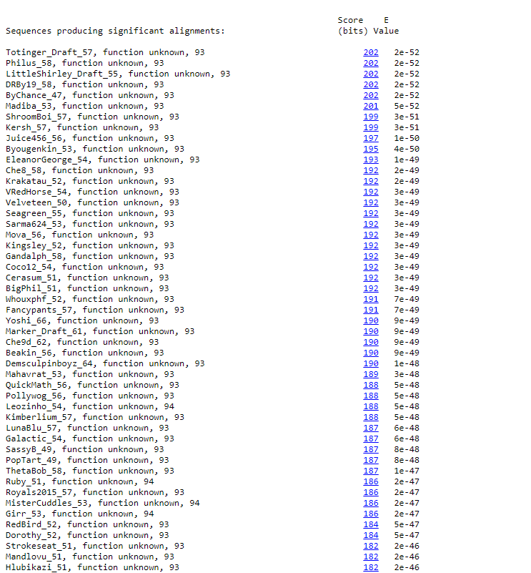
BLAST from NCBI (https://blast.ncbi.nlm.nih.gov/Blast.cgi?PAGE=Proteins) Using Longest ORF
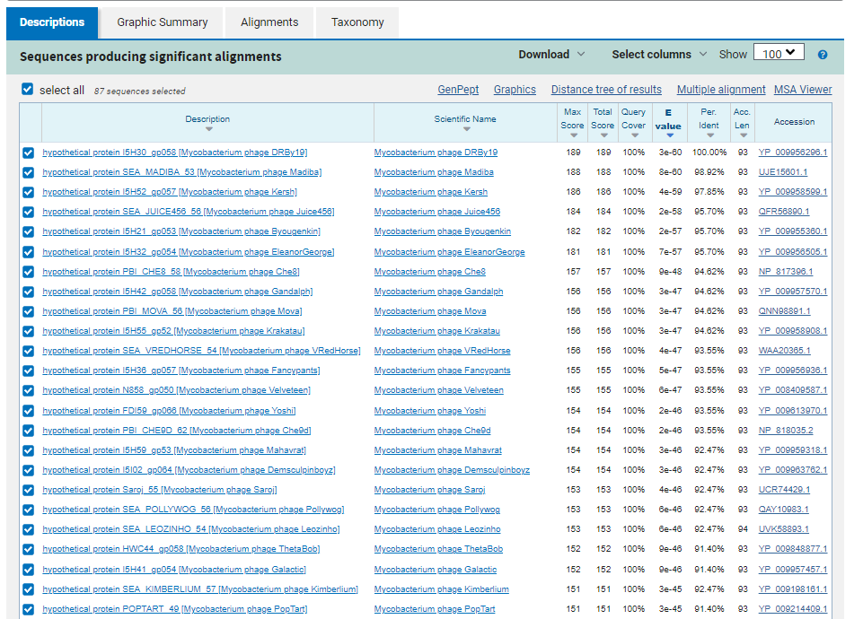
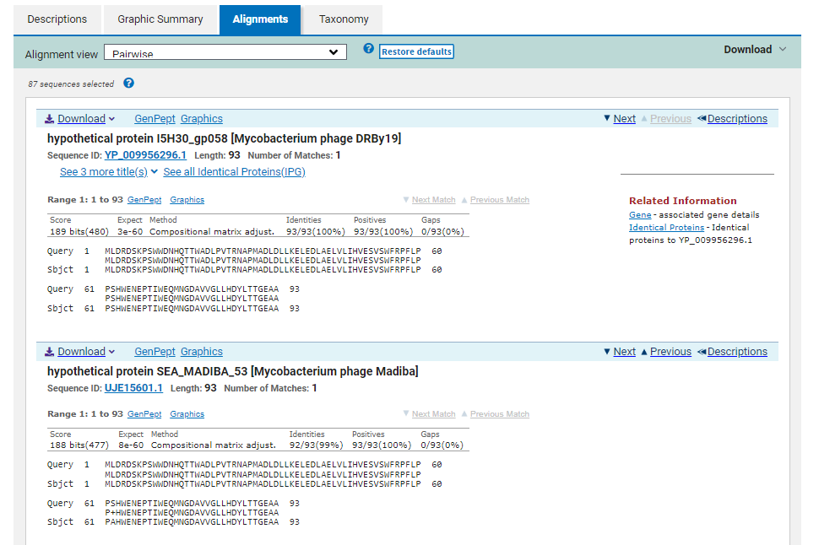
ATG Start at 37597. Original Glimmer call.
TGA Stop at 37878
F/R: F
Coding Potential (y/n): Y
Starterator (SS, NA, NI): Most annotated start is this (37597)
Blast Best Hit, Query:Subject Starts, Score, Evalue, or “no significant Blast alignments” if 10E-4 or higher
hypothetical protein I5H30_gp058 Mycobacterium phage DRBy19 YP_009956296.1, 1:1, Score 189, Evalue, 3e-60
Gap with previous gene: 79
Longest Orf? (Y/N/NA) Y
RBS:
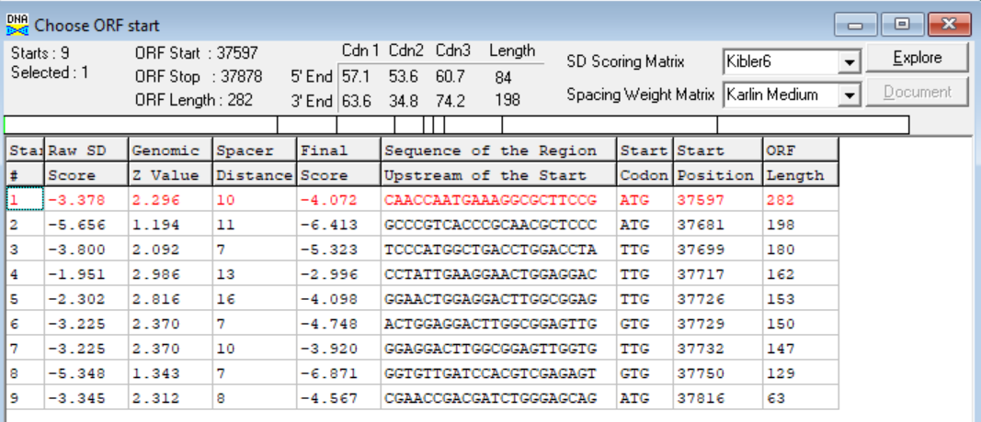
(https://toolkit.tuebingen.mpg.de/tools/hhpred) HHPRED vs PDB, SCOPe, pFam, and M. Tuberculosis. No Significant (>95%) Hits
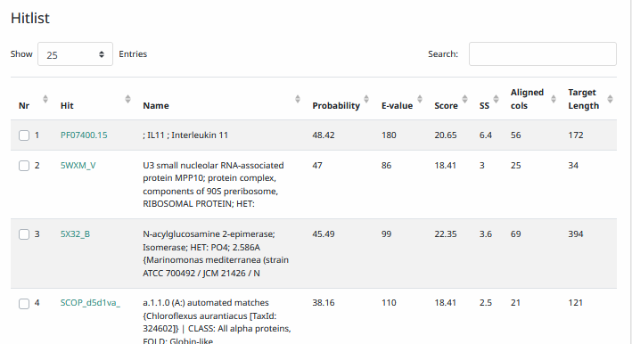
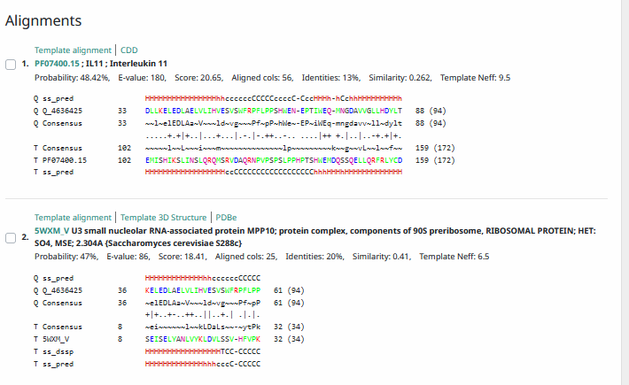
Phamerator Totinger Vs. Tootsieroll Vs. Starcevich (https://phamerator.org/phages) Genes 46-73
Proposed Function: hypothetical protein
Function Evidence: Similar phages (Phage Starcevich and phage Tootsieroll) have an almost identical sequence in Phamerator and call a gene, but not a function. Additionally, BLAST results most consistently hit this protein as a protein with no known function.
Transmembrane Domain/Evidence: No, Intracellular Properties (https://dtu.biolib.com/DeepTMHMM)
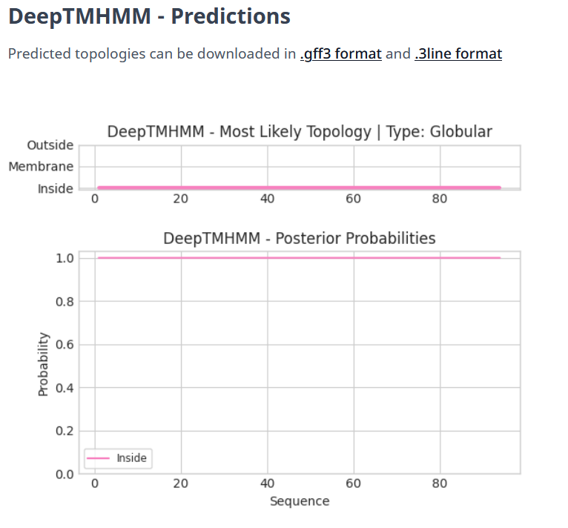
Gene Number: 55
Totinger_Draft_58 on Phagesdb
Pham143733
BLAST from PhagesDB. (https://phagesdb.org/blastp/) Using Longest ORF
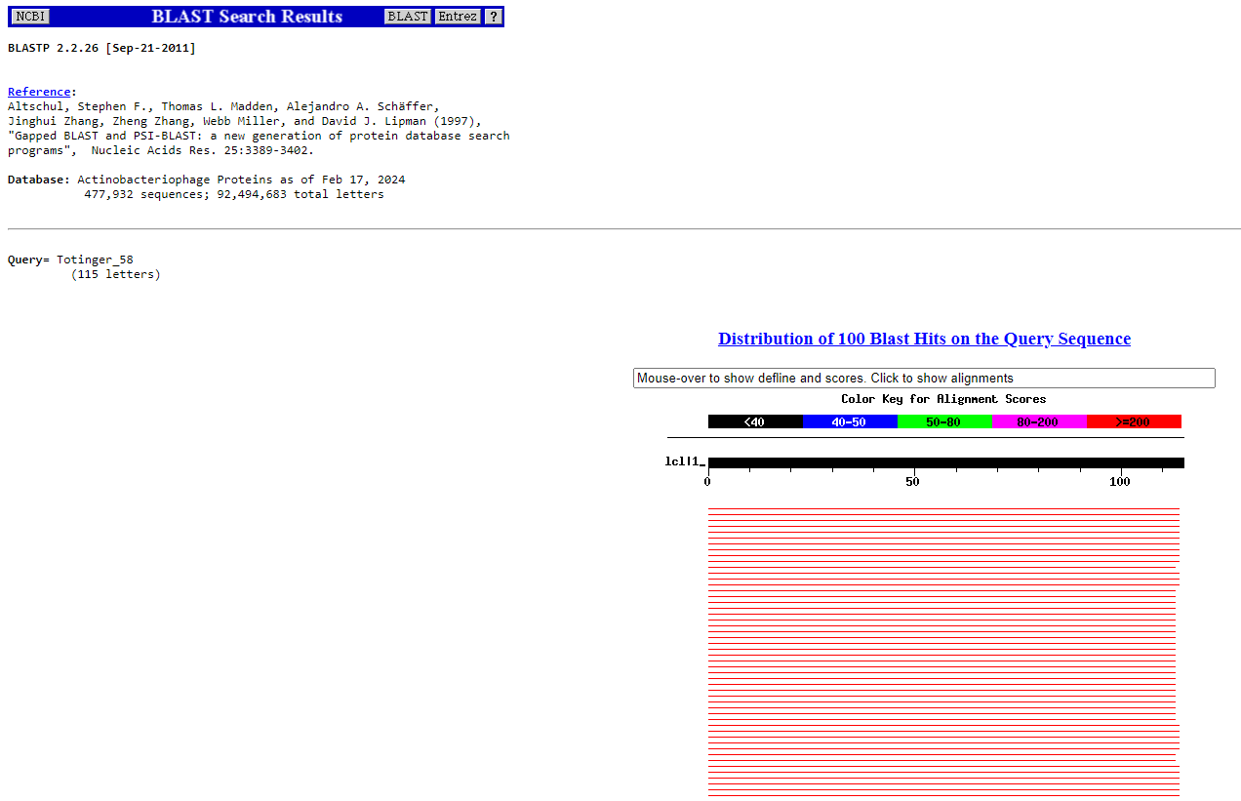
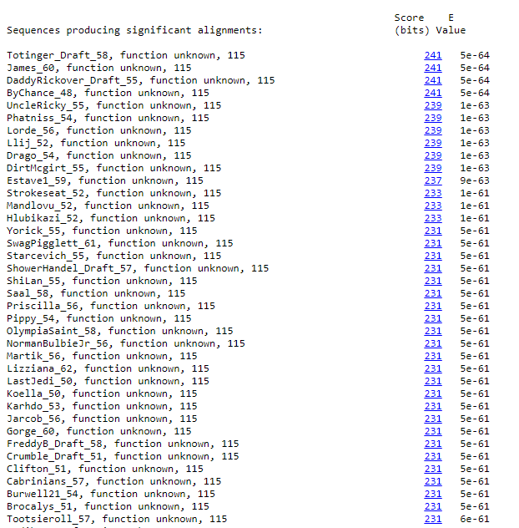
BLAST from NCBI (https://blast.ncbi.nlm.nih.gov/Blast.cgi?PAGE=Proteins) Using Longest ORF
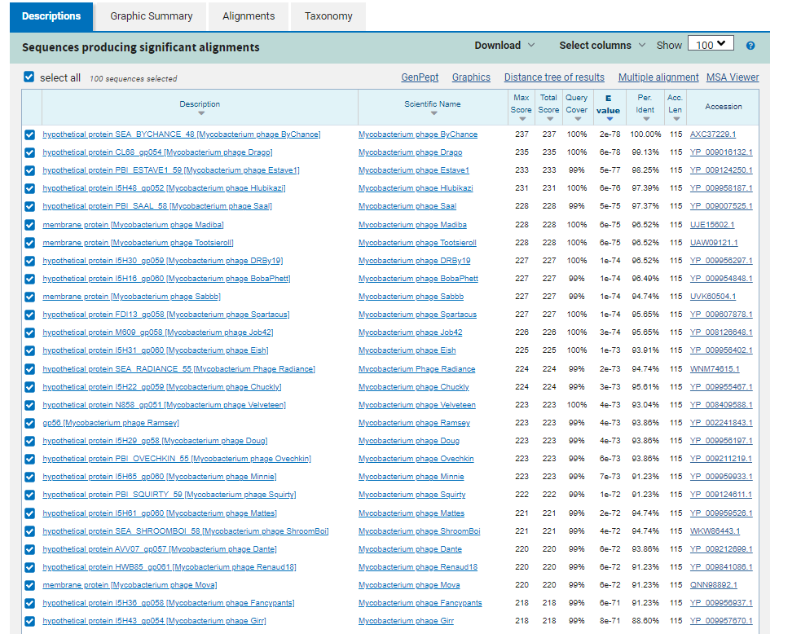
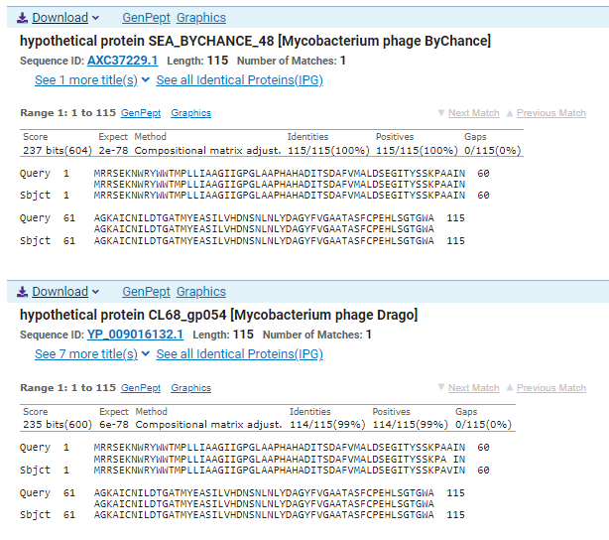
ATG Start at 37875. Original Glimmer call.
TGA Stop at 38222
F/R: F
Coding Potential (y/n): Y
Starterator (SS, NA, NI): Most annotated start is this (37875)
Blast Best Hit, Query:Subject Starts, Score, Evalue, or “no significant Blast alignments” if 10E-4 or higher
hypothetical protein SEA_BYCHANCE_48 Mycobacterium phage ByChance AXC37229.1, 1:1, Score 237, Evalue, 2e-78
Gap with previous gene: -3
Longest Orf? (Y/N/NA) Y
RBS:
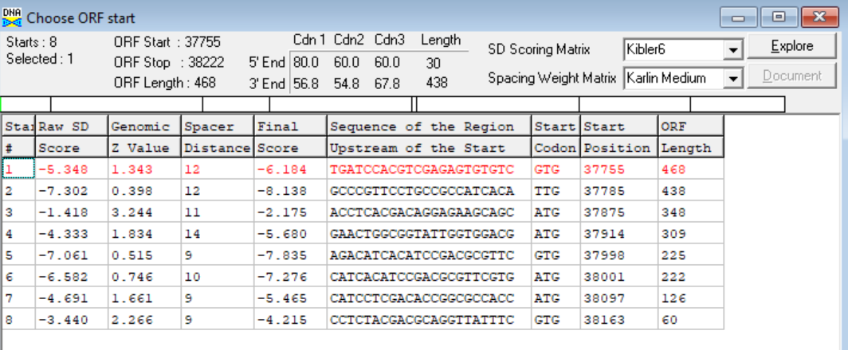
(https://toolkit.tuebingen.mpg.de/tools/hhpred) HHPRED vs PDB, SCOPe, pFam, and M. Tuberculosis.
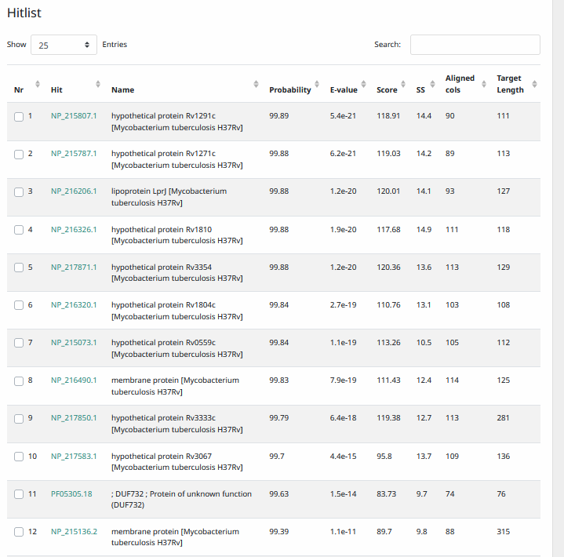
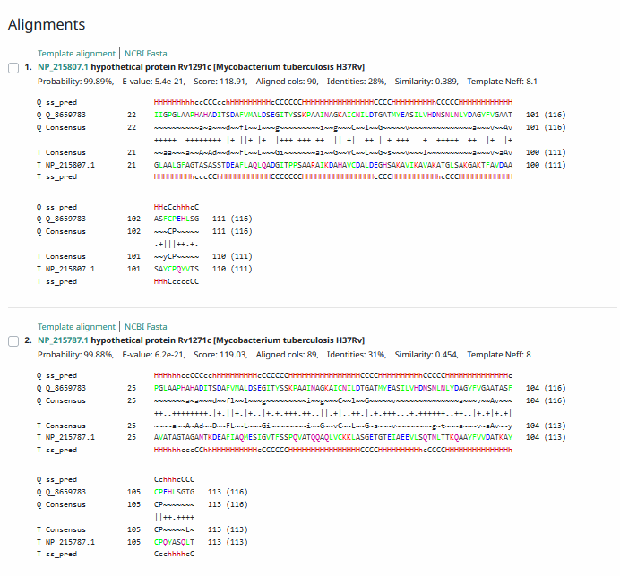
Phamerator Totinger Vs. Tootsieroll Vs. Starcevich (https://phamerator.org/phages) Genes 46-73
Proposed Function: hypothetical protein
Function Evidence: BLAST results most consistently hit this protein as one with an unknown function. Additionally, similar phages (phage Starcevich and phage Totinger) have a near identical sequence and also call a similar gene there, without calling a function.
Transmembrane Domain/Evidence: No, Signaling Properties at ~AA 1-34 (https://dtu.biolib.com/DeepTMHMM)
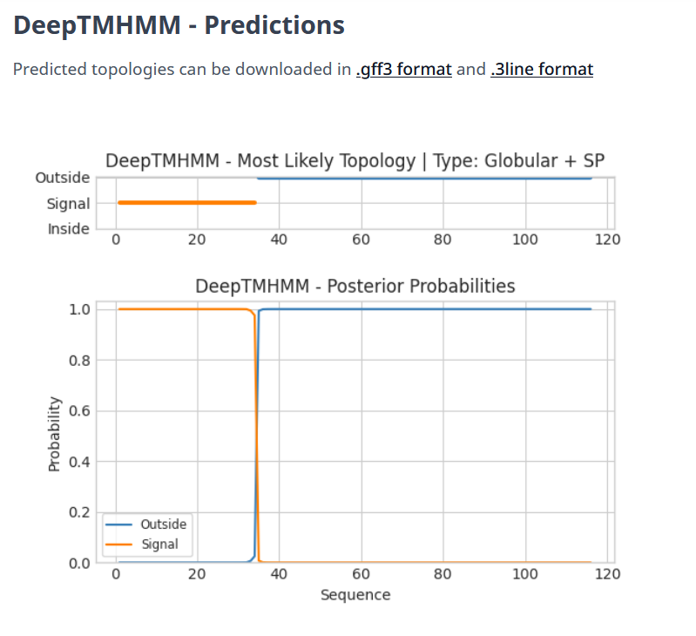
Gene Number: 56
Totinger_Draft_59 on Phagesdb
Pham146804
BLAST from PhagesDB. (https://phagesdb.org/blastp/) Using Longest ORF
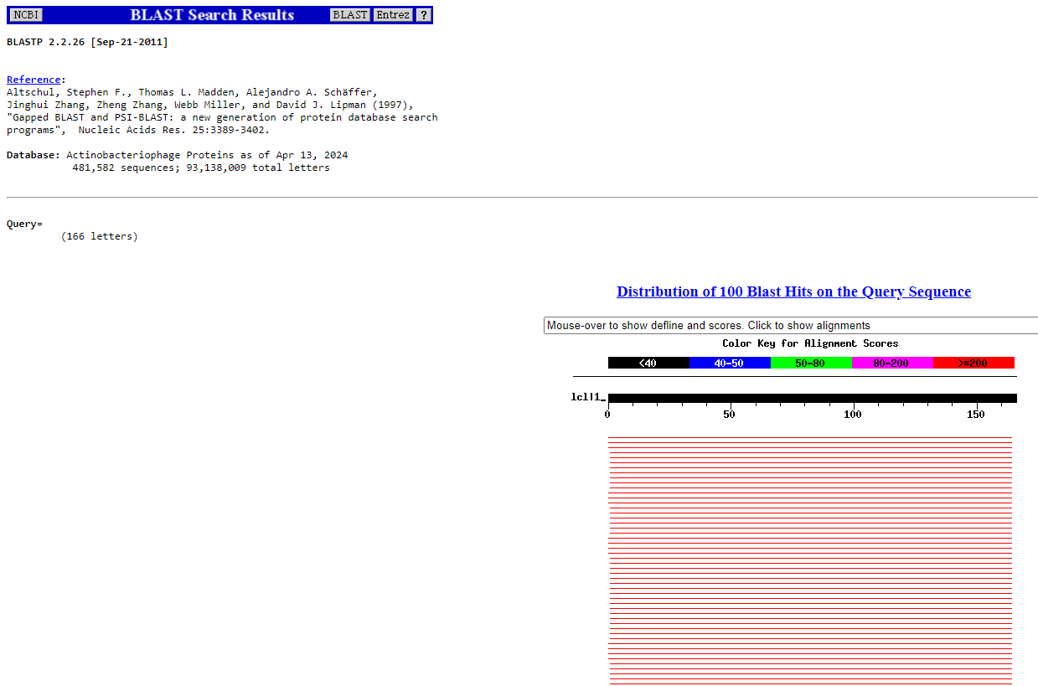
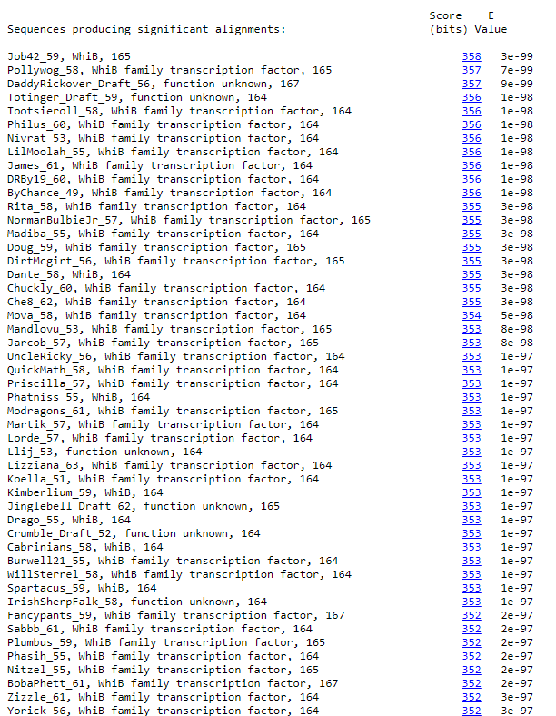
BLAST from NCBI (https://blast.ncbi.nlm.nih.gov/Blast.cgi?PAGE=Proteins) Using Longest ORF
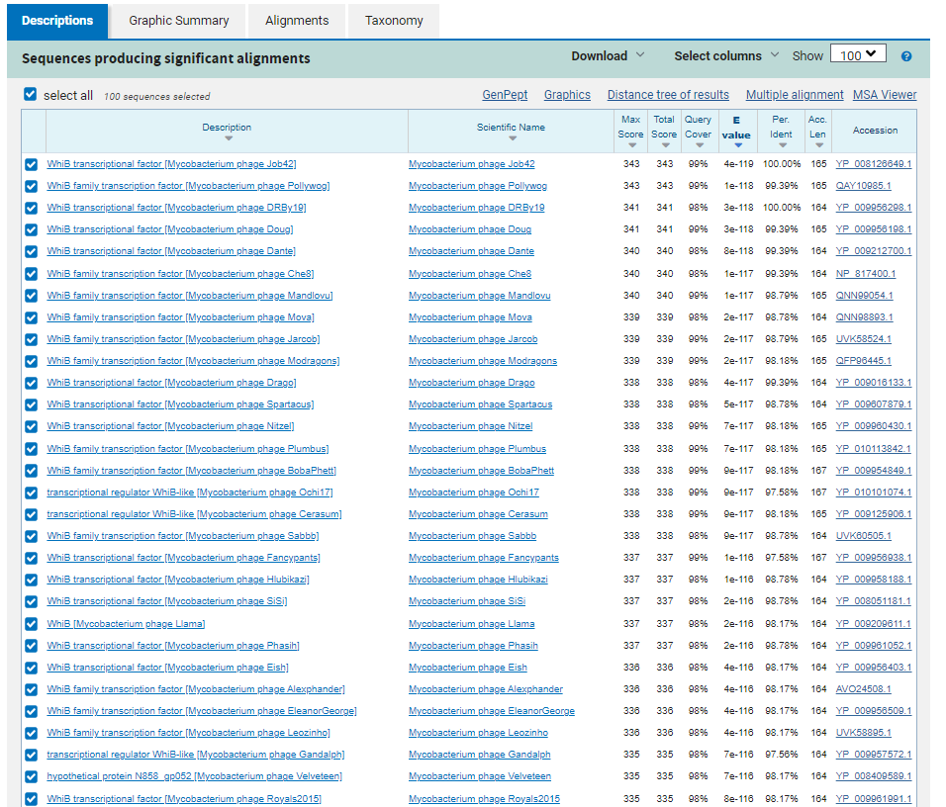
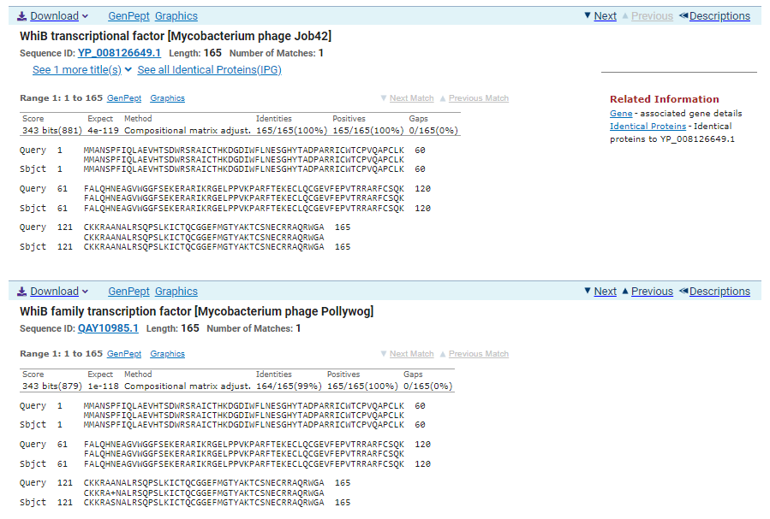
GTG Start at 38219. Glimmer calls start at 38222.
TGA Stop at 38716
F/R: F
Coding Potential (y/n): Y
Starterator (SS, NA, NI): Most annotated start is this (38222)
Blast Best Hit, Query:Subject Starts, Score, Evalue, or “no significant Blast alignments” if 10E-4 or higher
WhiB transcriptional factor Mycobacterium phage Job42 YP_008126649.1, 1:1, Score 341, Evalue, 4e-119
Gap with previous gene: -3
Longest Orf? (Y/N/NA) N
RBS:
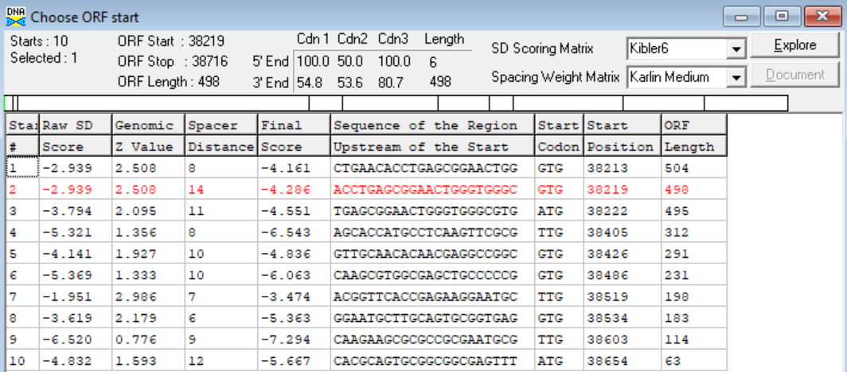
(https://toolkit.tuebingen.mpg.de/tools/hhpred) HHPRED vs PDB, SCOPe, pFam, and M. Tuberculosis.
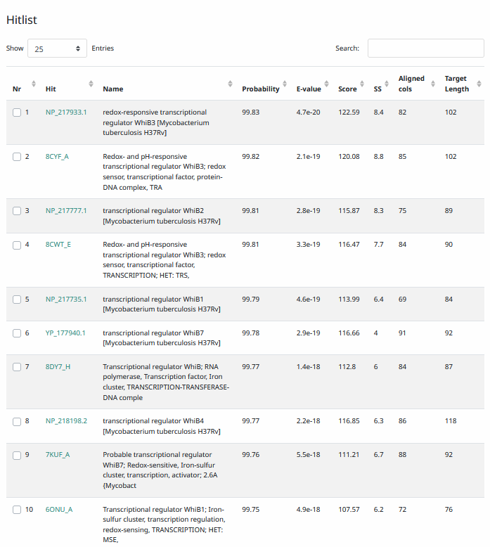
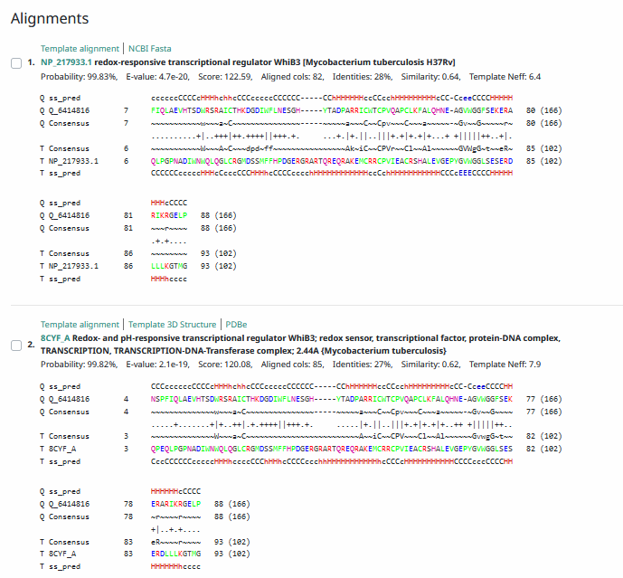
Phamerator Totinger Vs. Tootsieroll Vs. Starcevich (https://phamerator.org/phages) Genes 46-73
Proposed Function: WhiB family transcription factor
Function Evidence: BLAST and HHPRED results most consistently align with WhiB family transcription factors. Additionally, in Phamerator, similar phages (phage Starcevich and phage Tootsieroll) have a near identical gene that is also called as a WhiB family transcription factor.
Transmembrane Domain/Evidence: No, Intracellular Properties (https://dtu.biolib.com/DeepTMHMM)
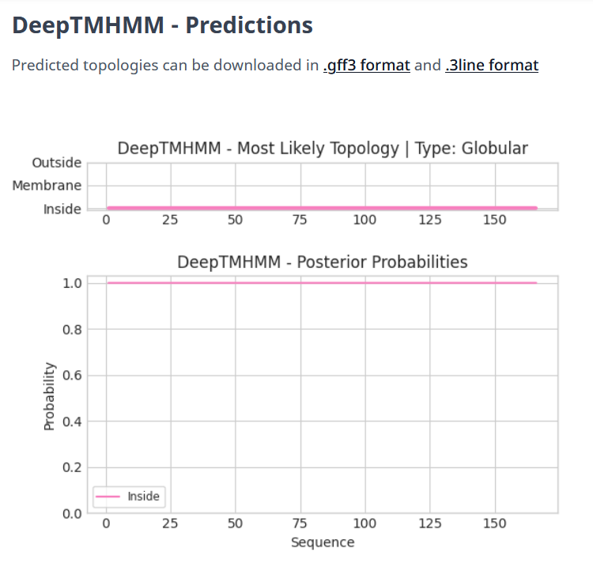

Gene Number: 57
Totinger_Draft_60 on Phagesdb
Pham84888
BLAST from PhagesDB. (https://phagesdb.org/blastp/) Using Longest ORF
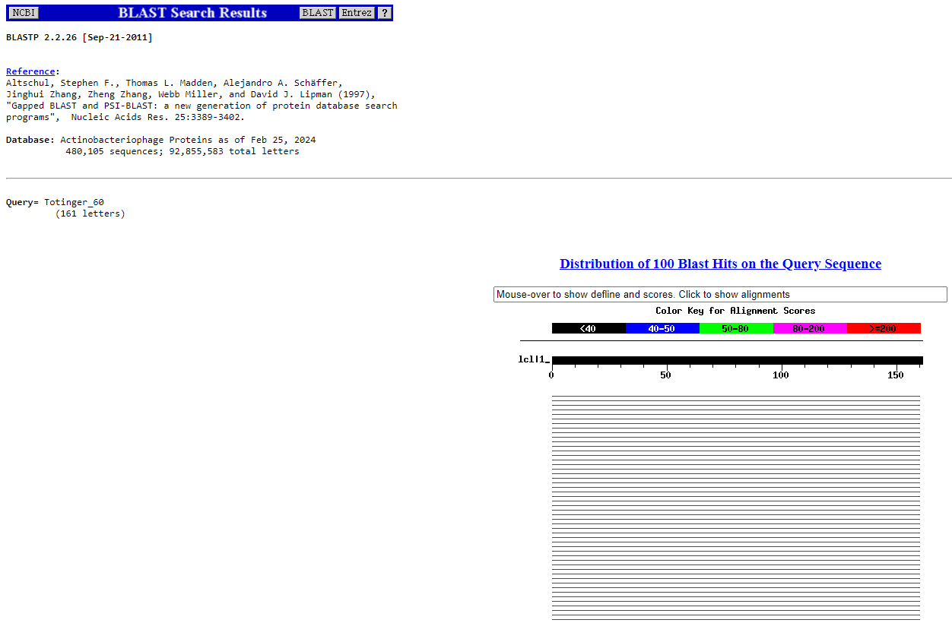
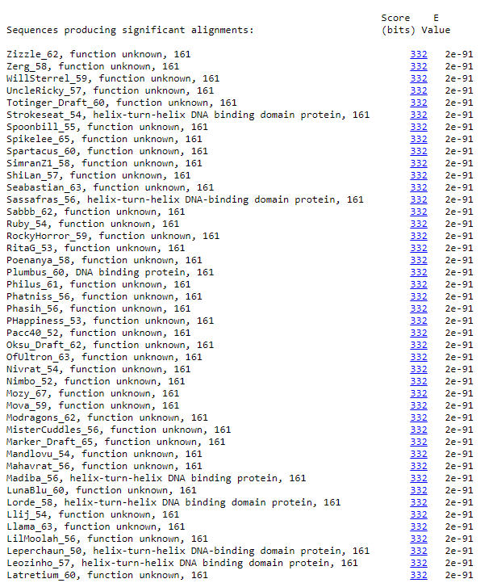
BLAST from NCBI (https://blast.ncbi.nlm.nih.gov/Blast.cgi?PAGE=Proteins) Using Longest ORF
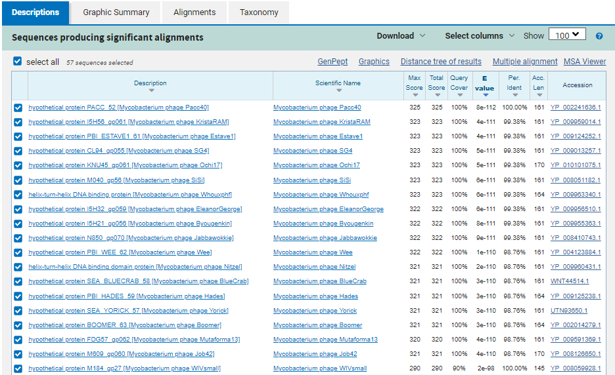
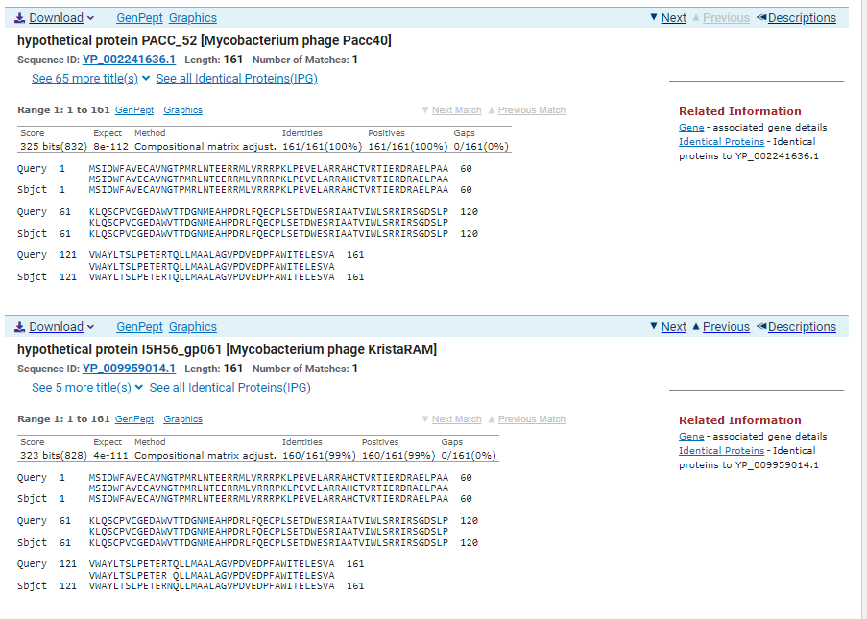
ATG Start at 38713. Original Glimmer call. Genemark calls start at 38686
TGA Stop at 39198
F/R: F
Coding Potential (y/n): Y
Starterator (SS, NA, NI): Most annotated start is this (38713)
Blast Best Hit, Query:Subject Starts, Score, Evalue, or “no significant Blast alignments” if 10E-4 or higher
hypothetical protein PACC_52 Mycobacterium phage Pacc40 YP_002241636.1, 1:1, Score 325, Evalue, 8e-112
Gap with previous gene: -6
Longest Orf? (Y/N/NA) N
RBS:
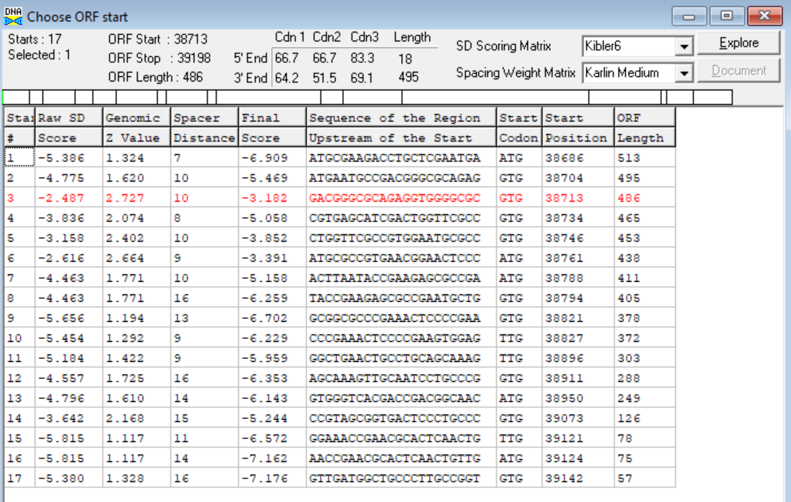
(https://toolkit.tuebingen.mpg.de/tools/hhpred) HHPRED vs PDB, SCOPe, pFam, and M. Tuberculosis.
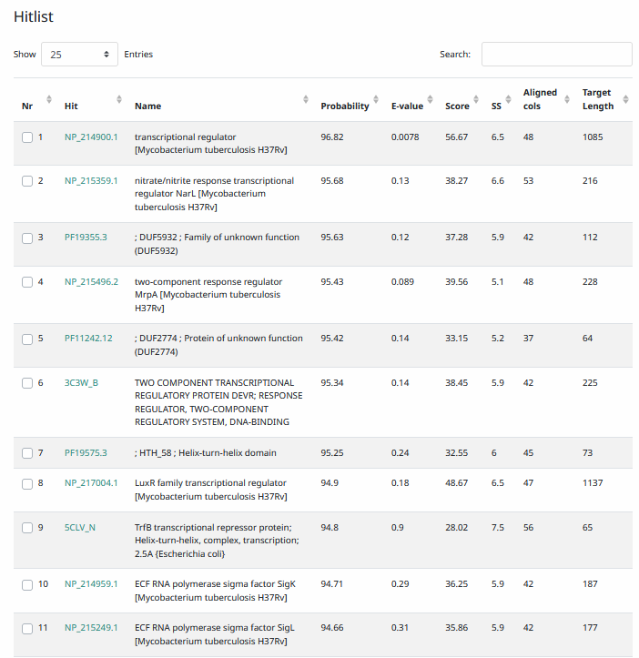
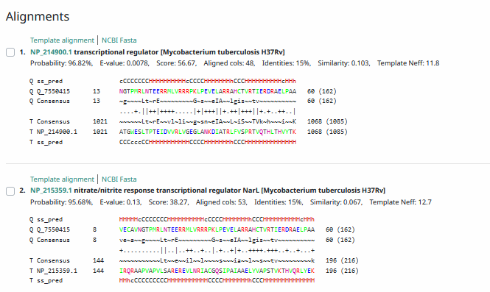
Phamerator Totinger Vs. Tootsieroll Vs. Starcevich (https://phamerator.org/phages) Genes 46-73
Proposed Function: hypothetical protein
Function Evidence: phage Tootsieroll has a near identical gene, but does not call a function. Additionally, BLAST results most commonly aligned with a protein of unknown function.
Transmembrane Domain/Evidence: No, Intracellular Properties (https://dtu.biolib.com/DeepTMHMM)
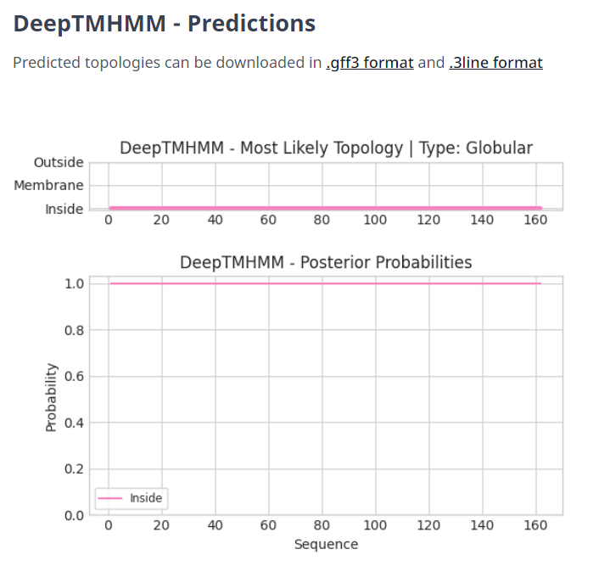

Gene Number: 58
Totinger_Draft_61 on Phagesdb
Pham146726
BLAST from PhagesDB. (https://phagesdb.org/blastp/) Using Longest ORF
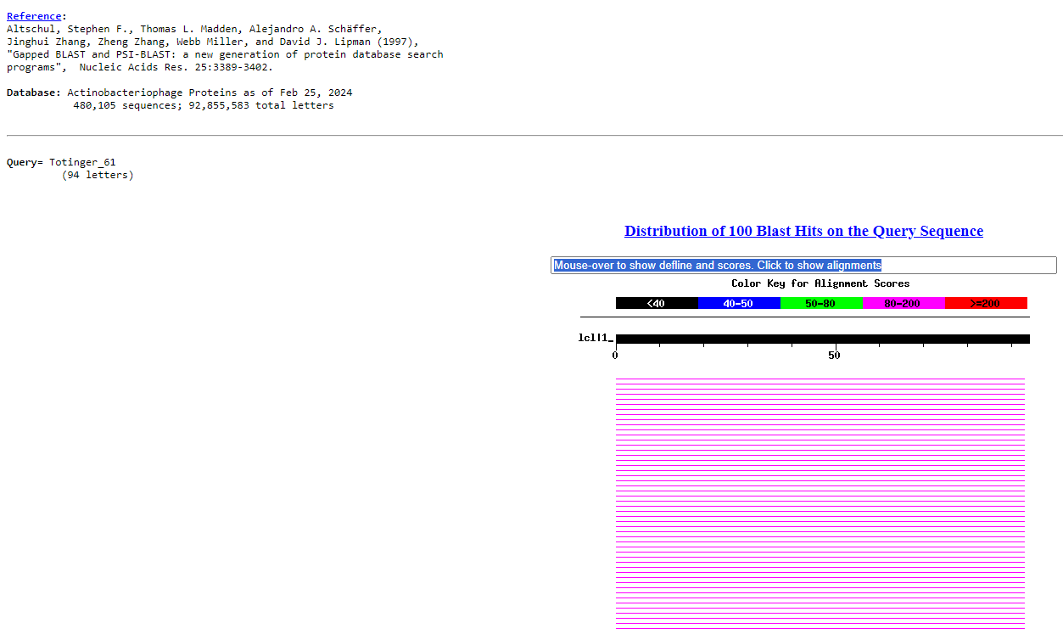
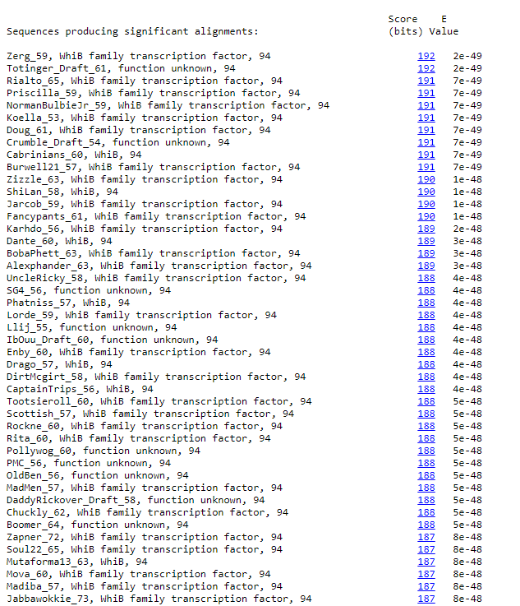
BLAST from NCBI (https://blast.ncbi.nlm.nih.gov/Blast.cgi?PAGE=Proteins) Using Longest ORF
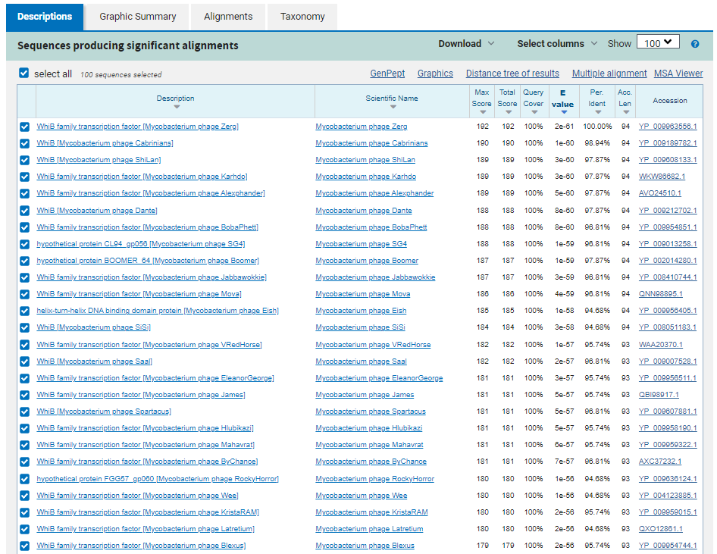
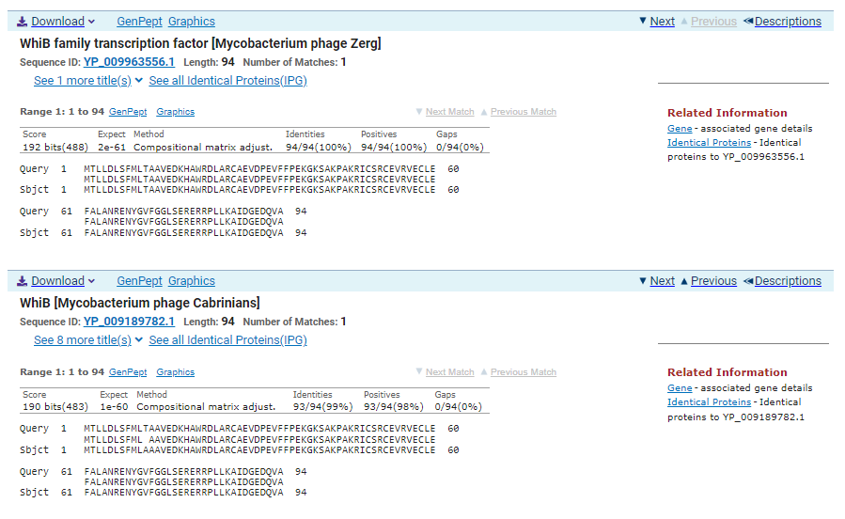
ATG Start at 39195. Original Glimmer call.
TGA Stop at 39479
F/R: F
Coding Potential (y/n): Y
Starterator (SS, NA, NI): Most annotated start is this (39195)
Blast Best Hit, Query:Subject Starts, Score, Evalue, or “no significant Blast alignments” if 10E-4 or higher
WhiB family transcription factor Mycobacterium phage Zerg YP_009963556.1, 1:1, Score 192, Evalue, 2e-61
Gap with previous gene: -3
Longest Orf? (Y/N/NA) N
RBS:
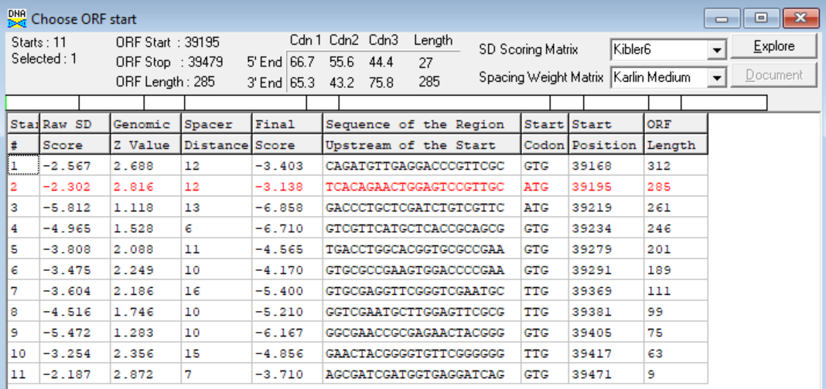
(https://toolkit.tuebingen.mpg.de/tools/hhpred) HHPRED vs PDB, SCOPe, pFam, and M. Tuberculosis.
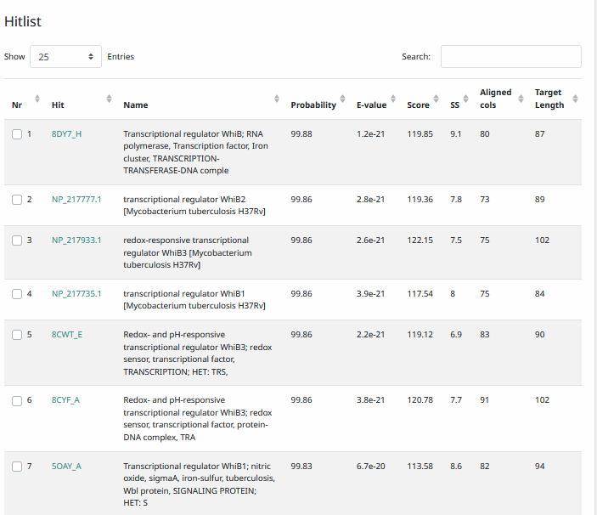
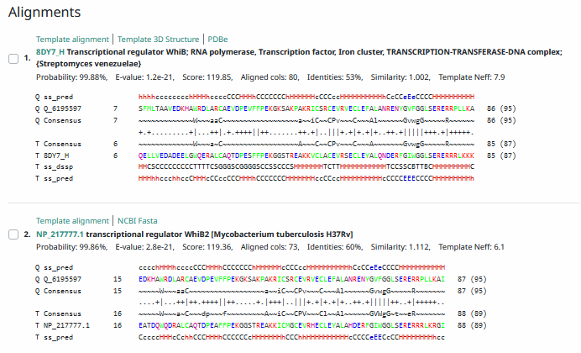
Phamerator Totinger Vs. Tootsieroll Vs. Starcevich (https://phamerator.org/phages) Genes 46-73
Proposed Function: WhiB family transcription factor
Function Evidence: Similar phages (phage Starcevich and phage Tootsieroll) call a similar gene a WhiB family transcription factor. Additionally, BLAST and HHPRED results align most consistently with a WhiB family transcription factor.
Transmembrane Domain/Evidence: No, Intracellular Properties (https://dtu.biolib.com/DeepTMHMM)
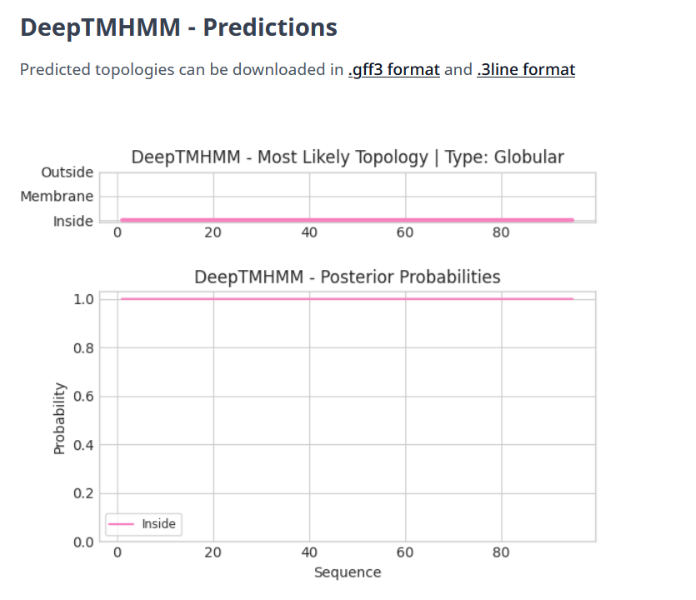

Gene Number: 59
Totinger_Draft_62 on Phagesdb
Pham146790
BLAST from PhagesDB. (https://phagesdb.org/blastp/) Using Longest ORF
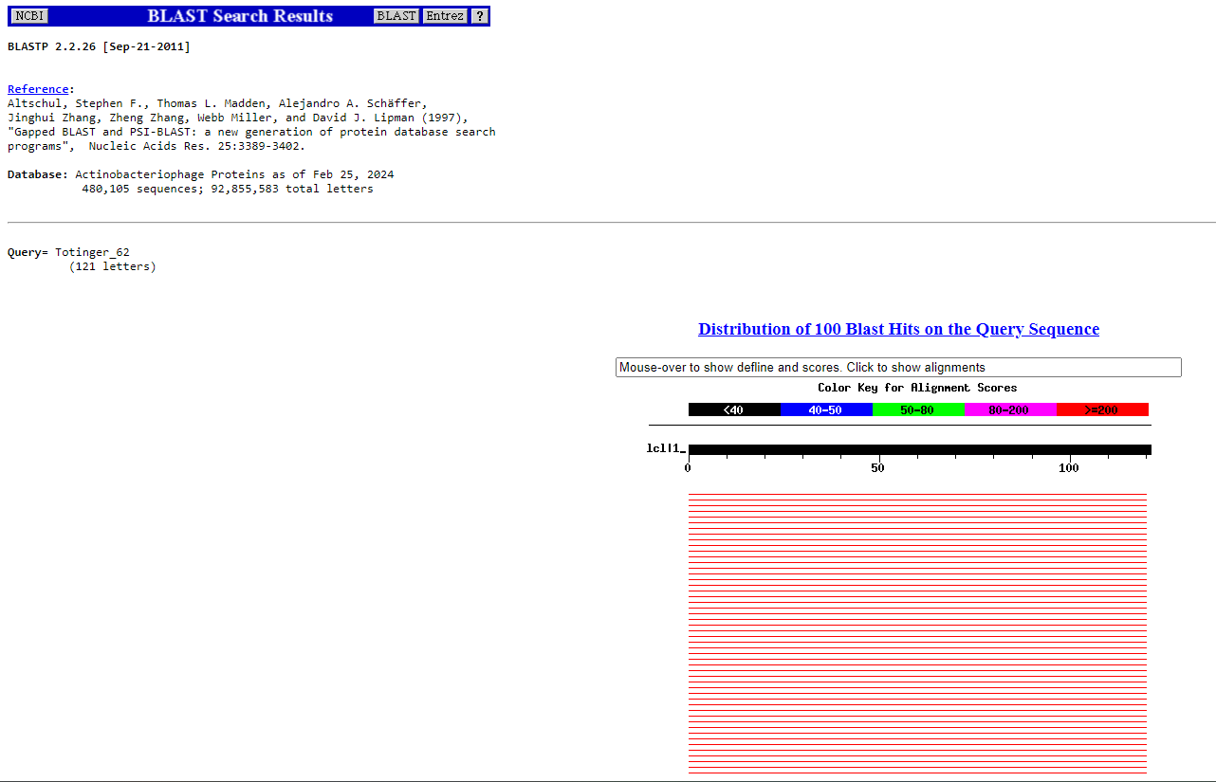
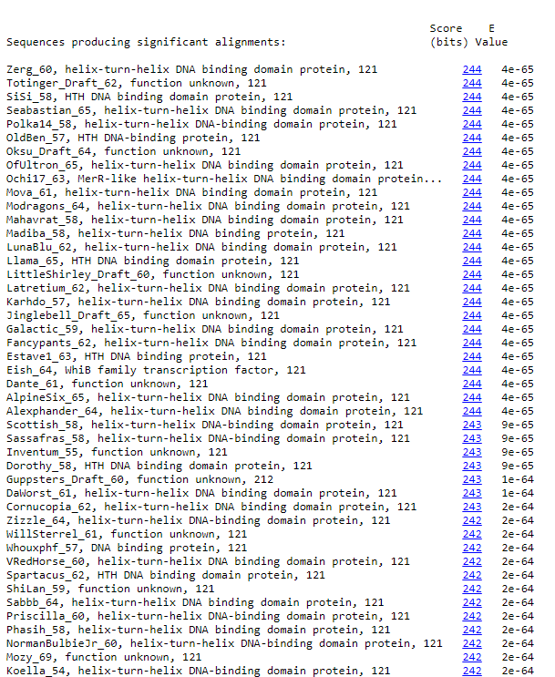
BLAST from NCBI (https://blast.ncbi.nlm.nih.gov/Blast.cgi?PAGE=Proteins) Using Longest ORF
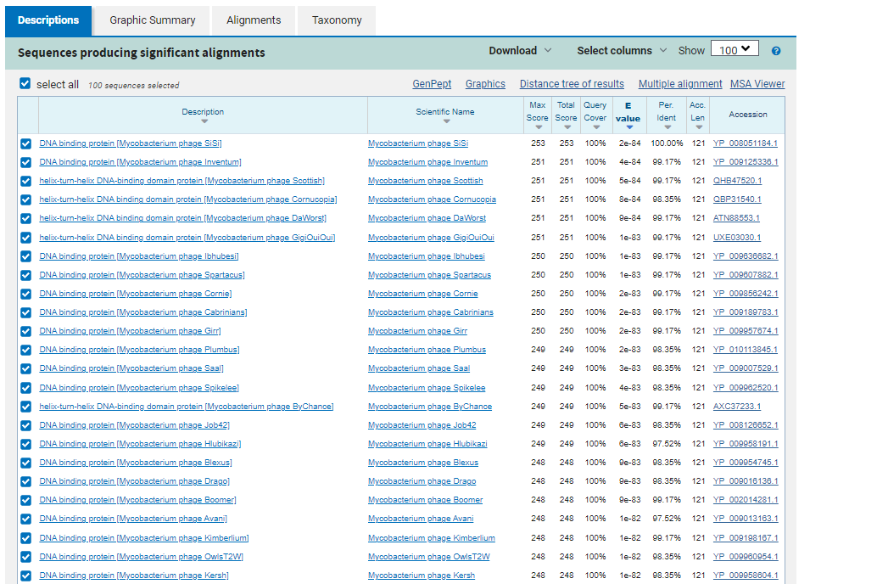
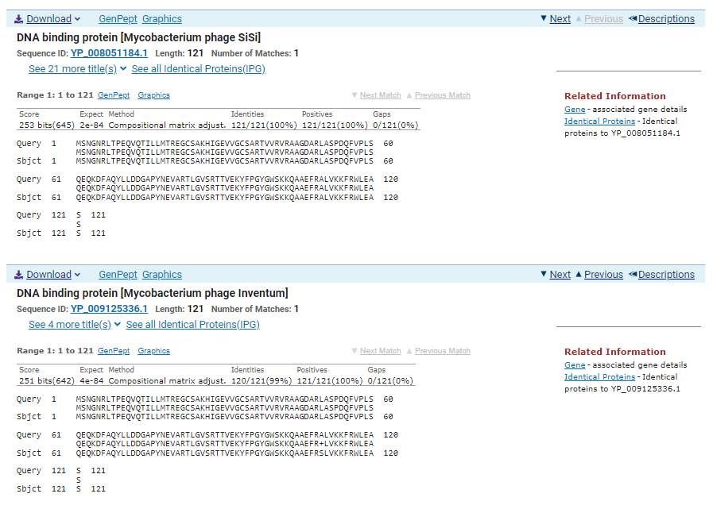
ATG Start at 39476. Original Glimmer call.
TGA Stop at 39841
F/R: F
Coding Potential (y/n): Y
Starterator (SS, NA, NI): Most annotated start is this (39841)
Blast Best Hit, Query:Subject Starts, Score, Evalue, or “no significant Blast alignments” if 10E-4 or higher
DNA binding protein Mycobacterium phage SiSi YP_008051184.1, 1:1, Score 253, Evalue, 2e-84
Gap with previous gene: -3
Longest Orf? (Y/N/NA) Y
RBS:
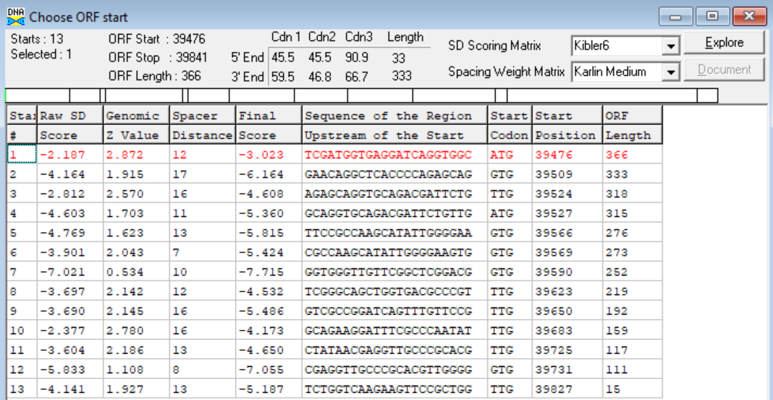
(https://toolkit.tuebingen.mpg.de/tools/hhpred) HHPRED vs PDB, SCOPe, pFam, and M. Tuberculosis.
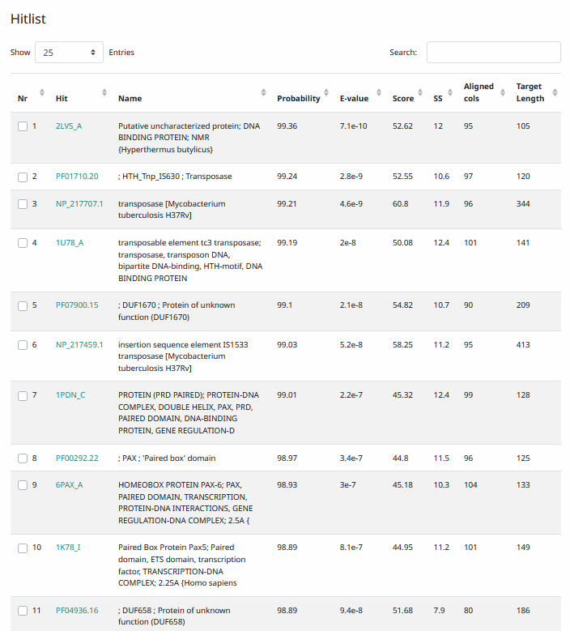
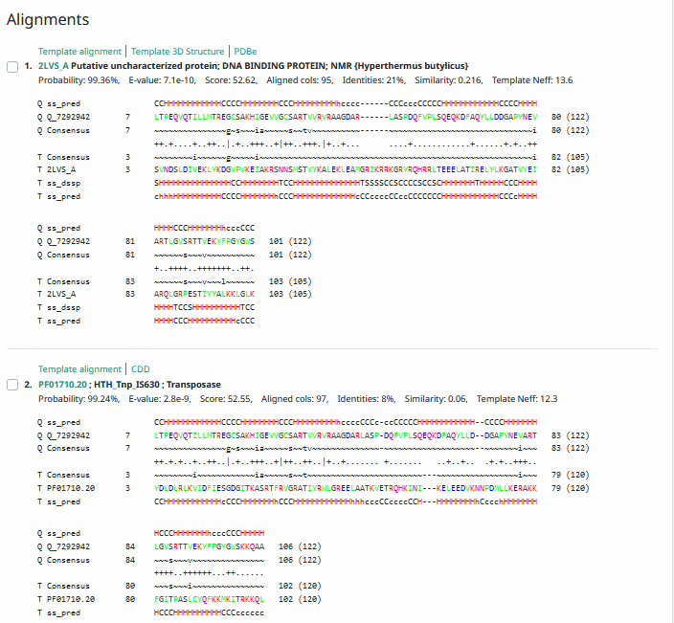
Phamerator Totinger Vs. Tootsieroll Vs. Starcevich (https://phamerator.org/phages) Genes 46-73
Proposed Function: helix-turn-helix DNA binding protein
Function Evidence: This protein was most consistently aligned with other phages’ helix-turn-helix DNA binding proteins according to BLASTs and HHPRED. Additionally, similar phages in Phamerator (phage Tootsieroll and phage Starcevich) have similar genes and also call them as helix-turn-helix DNA binding proteins.
Transmembrane Domain/Evidence: No, Intracellular Properties (https://dtu.biolib.com/DeepTMHMM)
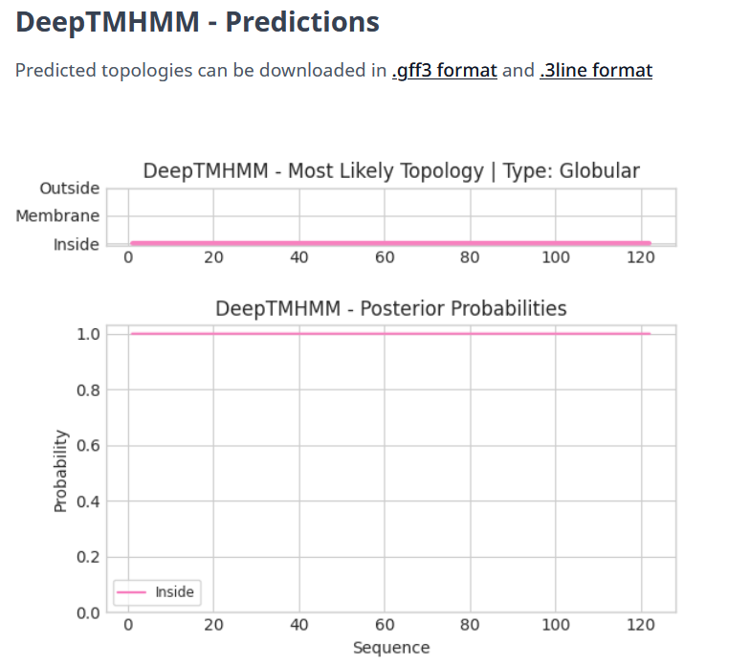
Gene Number: 60
Totinger_Draft_63 on Phagesdb
Pham379
BLAST from PhagesDB. (https://phagesdb.org/blastp/) Using Longest ORF
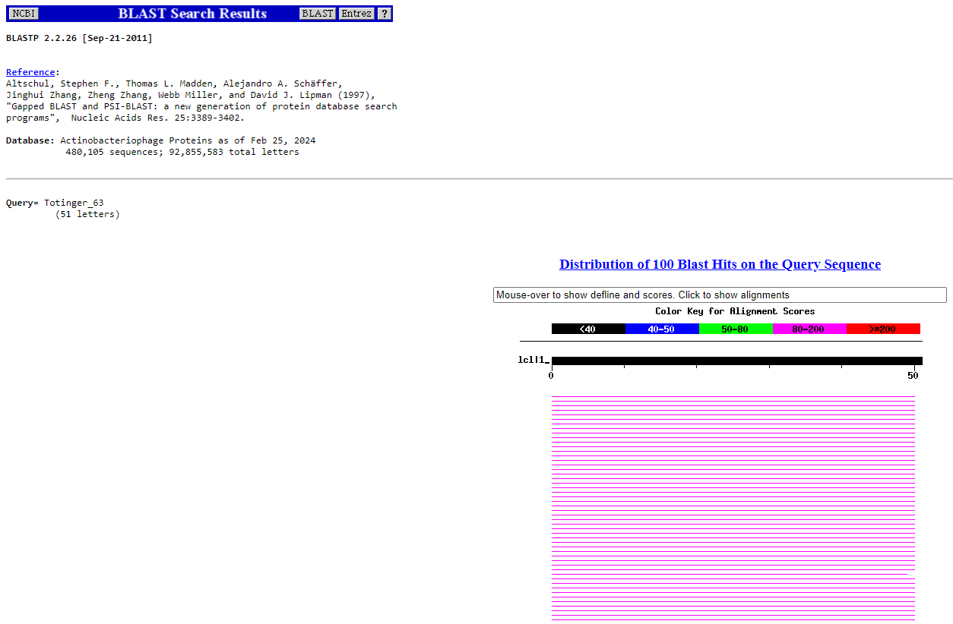
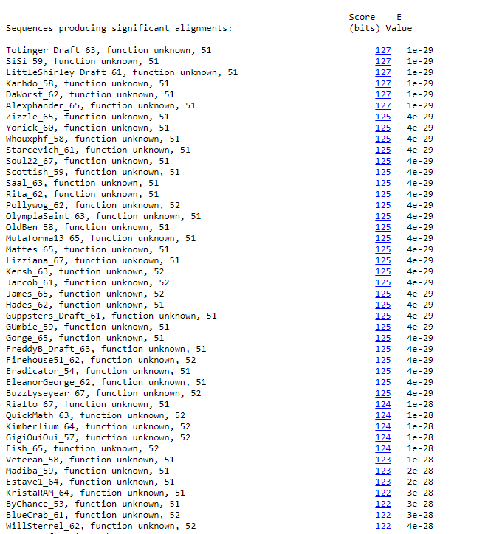
BLAST from NCBI (https://blast.ncbi.nlm.nih.gov/Blast.cgi?PAGE=Proteins) Using Longest ORF
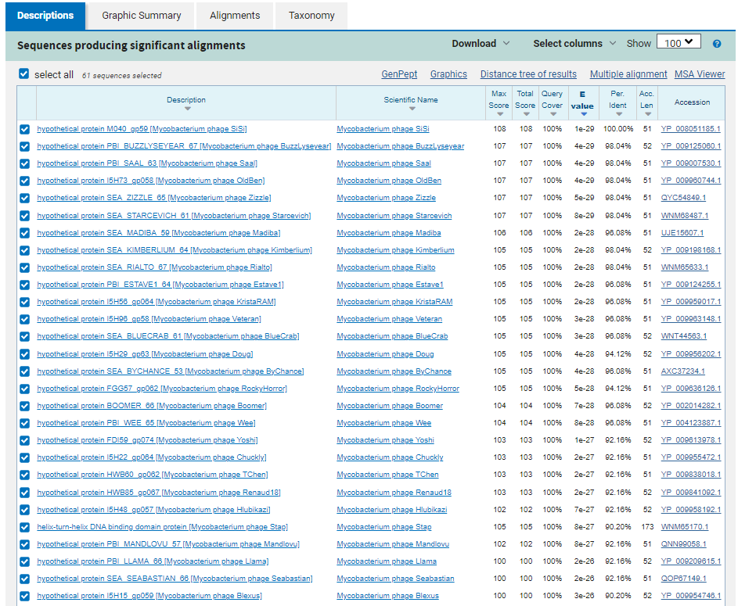
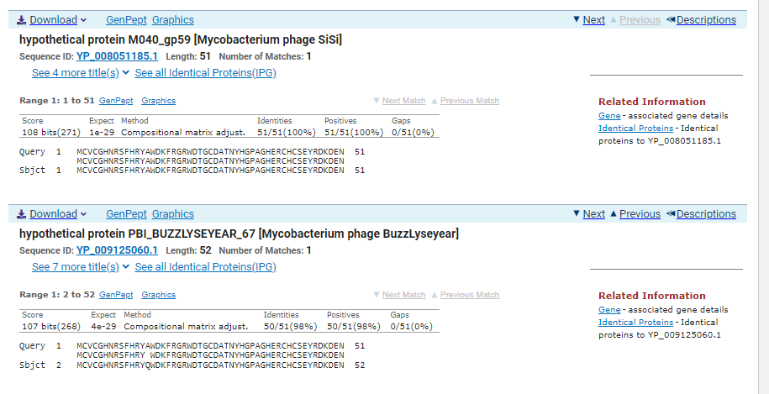
ATG Start at 39841. Original Glimmer call, not called by Genemark.
TGA Stop at 39996
F/R: F
Coding Potential (y/n): N, but a similar gene is called in other phages with near identical sequences.
Starterator (SS, NA, NI): Most annotated start is this (39841)
Blast Best Hit, Query:Subject Starts, Score, Evalue, or “no significant Blast alignments” if 10E-4 or higher
hypothetical protein M040_gp59 Mycobacterium phage SiSi YP_008051185.1, 1:1, Score 108, Evalue, 1e-29
Gap with previous gene: 0
Longest Orf? (Y/N/NA) N
RBS:
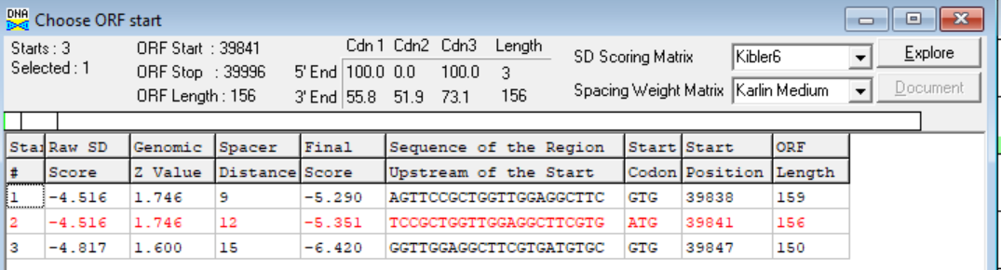
(https://toolkit.tuebingen.mpg.de/tools/hhpred) HHPRED vs PDB, SCOPe, pFam, and M. Tuberculosis. No Significant (>95%) Hits
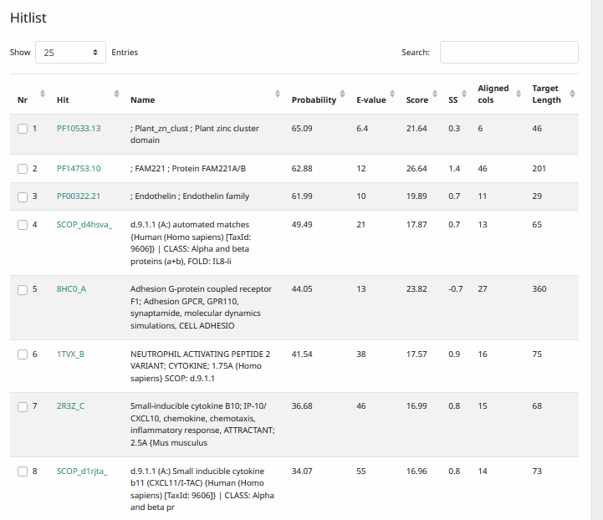
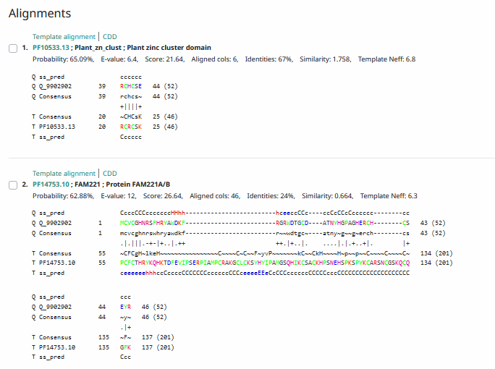
Phamerator Totinger Vs. Tootsieroll Vs. Starcevich (https://phamerator.org/phages) Genes 46-73
Proposed Function: hypothetical protein
Function Evidence: In similar phages (phage Starcevich and phage Tootsieroll), a near identical sequence is shared and the called genes have no called function. Additionally, BLAST and HHPRED results were most conclusive towards a protein with no known function.
Transmembrane Domain/Evidence: No, Intracellular Properties (https://dtu.biolib.com/DeepTMHMM)
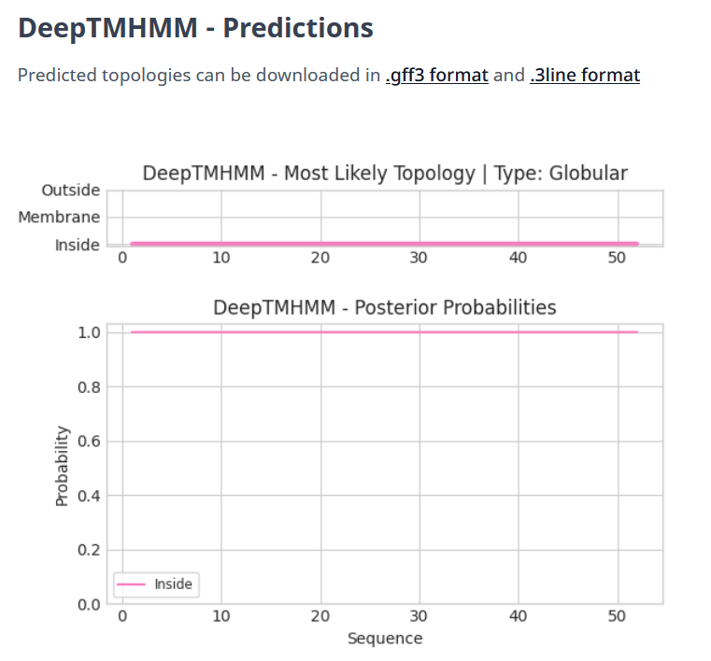
Gene Number: 61
Totinger_Draft_64 on Phagesdb
Pham84846
BLAST from PhagesDB. (https://phagesdb.org/blastp/) Using Longest ORF
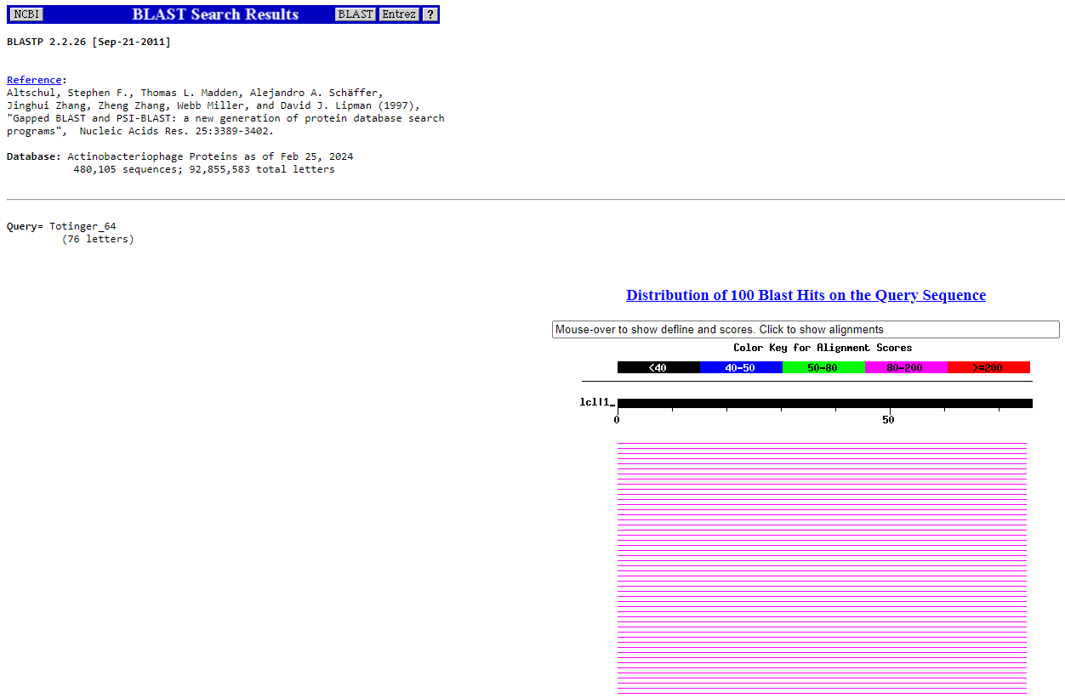
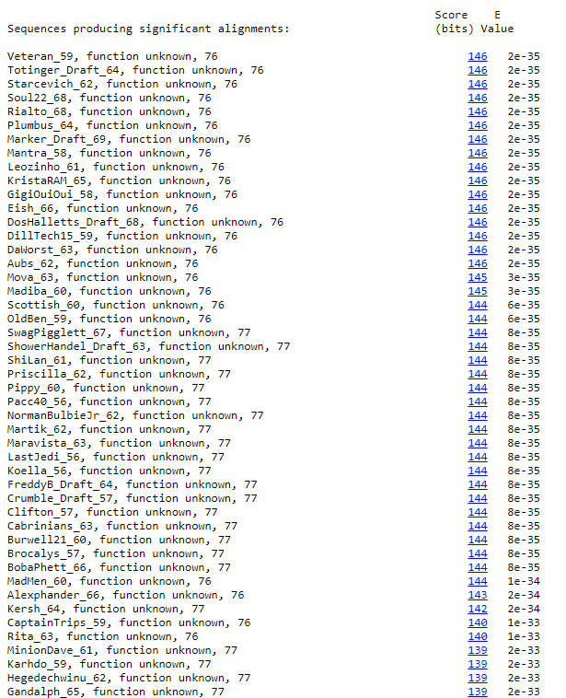
BLAST from NCBI (https://blast.ncbi.nlm.nih.gov/Blast.cgi?PAGE=Proteins) Using Longest ORF
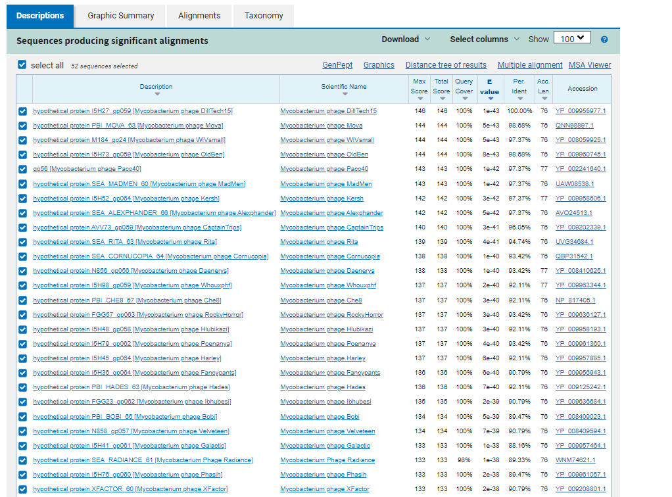
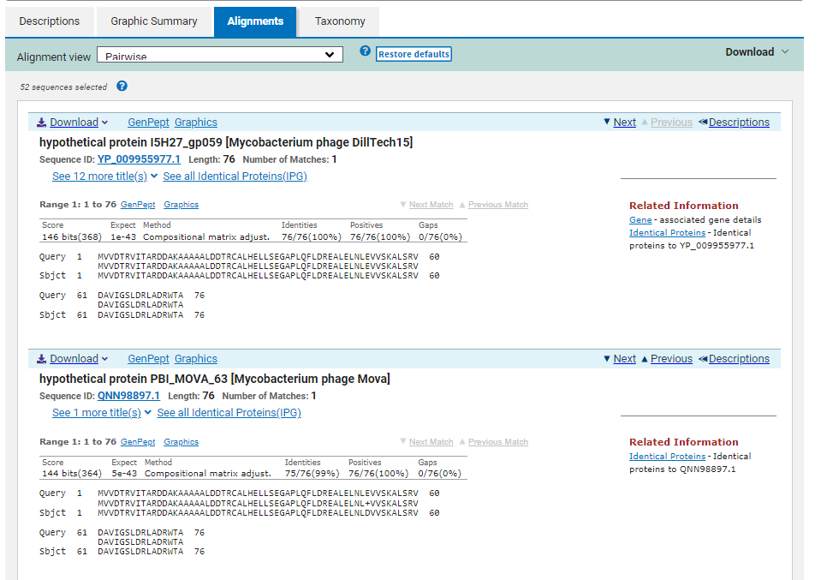
ATG Start at 39996. Original Glimmer call.
TGA Stop at 40226
F/R: F
Coding Potential (y/n): Y
Starterator (SS, NA, NI): Most annotated start is this (39996)
Blast Best Hit, Query:Subject Starts, Score, Evalue, or “no significant Blast alignments” if 10E-4 or higher
hypothetical protein I5H27_gp059 Mycobacterium phage DillTech15 YP_009955977.1, 1:1, Score 146, Evalue, 1e-43
Gap with previous gene: 0
Longest Orf? (Y/N/NA) Y
RBS:
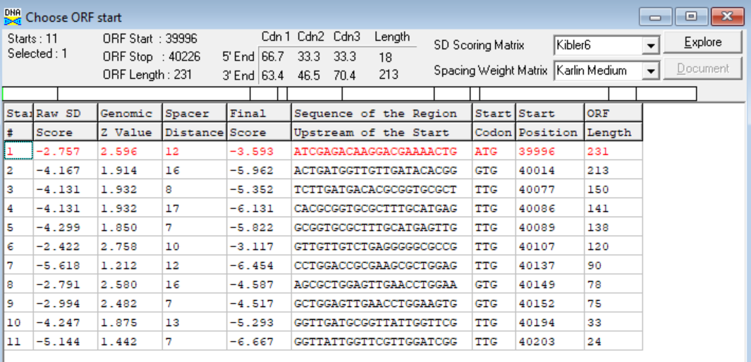
(https://toolkit.tuebingen.mpg.de/tools/hhpred) HHPRED vs PDB, SCOPe, pFam, and M. Tuberculosis. No Significant (>95%) Hits
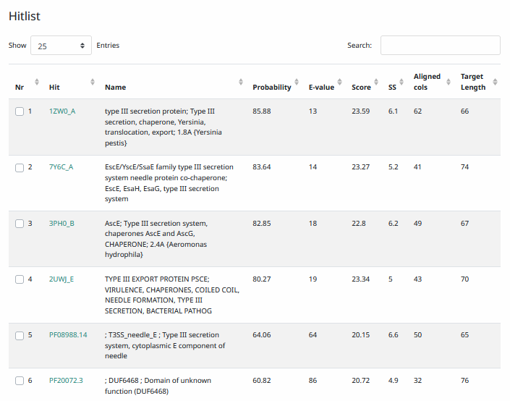
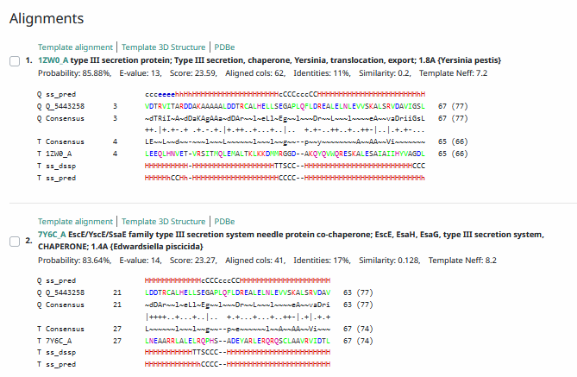
Phamerator Totinger Vs. Tootsieroll Vs. Starcevich (https://phamerator.org/phages) Genes 46-73
Proposed Function: hypothetical protein
Function Evidence: Most consistently, BLAST results and HHPRED indicated this protein to have no known function. In similar phages (phage Starcevich and phage Tootsieroll), a similar gene is called and also has no known function.
Transmembrane Domain/Evidence: No, Intracellular Properties (https://dtu.biolib.com/DeepTMHMM)
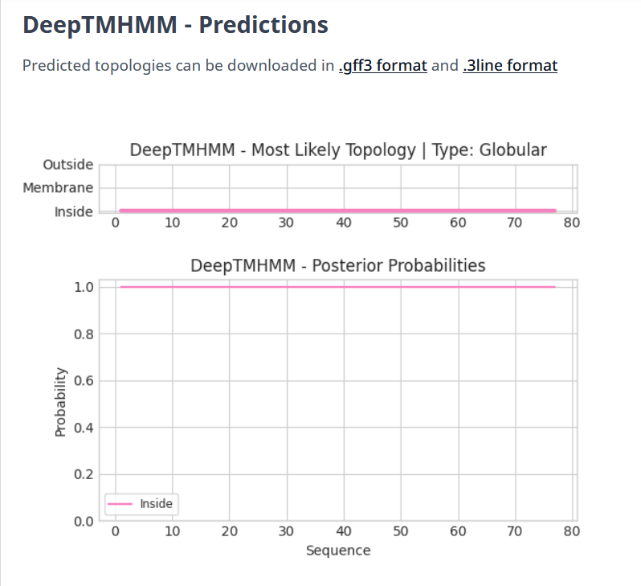

Gene Number: 62
Totinger_Draft_65 on Phagesdb
Pham141074
BLAST from PhagesDB. (https://phagesdb.org/blastp/) Using Longest ORF
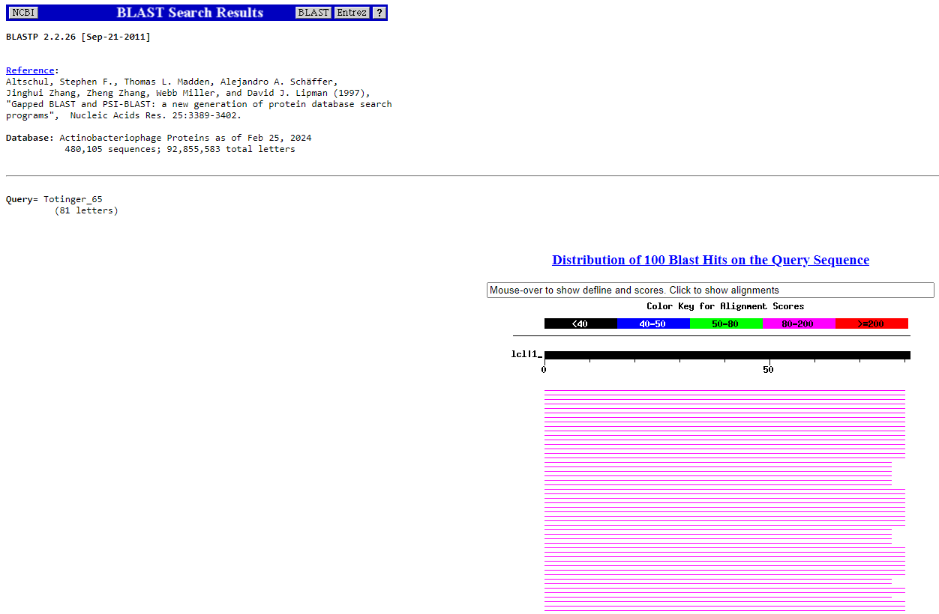
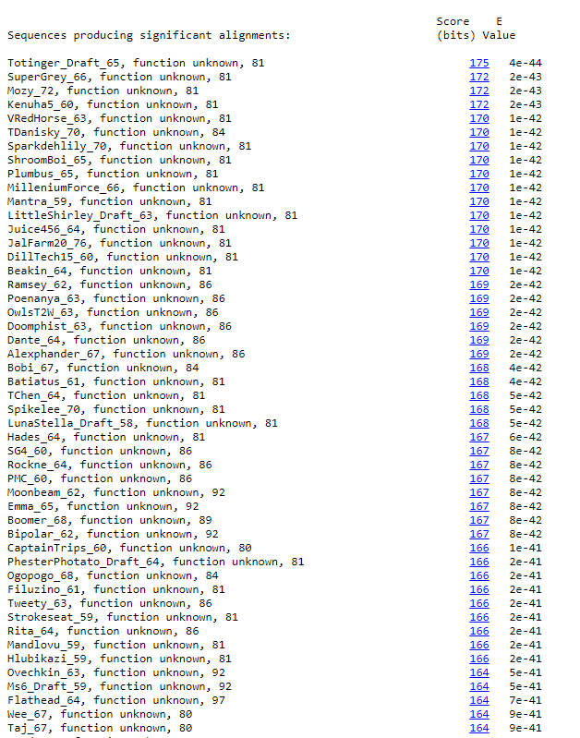
BLAST from NCBI (https://blast.ncbi.nlm.nih.gov/Blast.cgi?PAGE=Proteins) Using Longest ORF
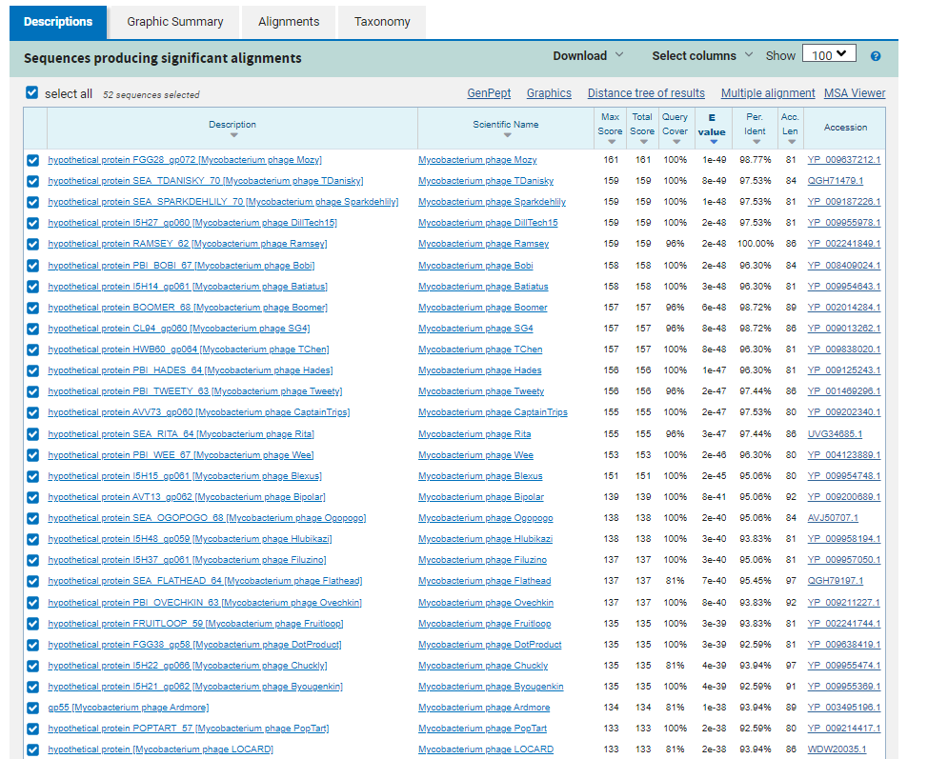
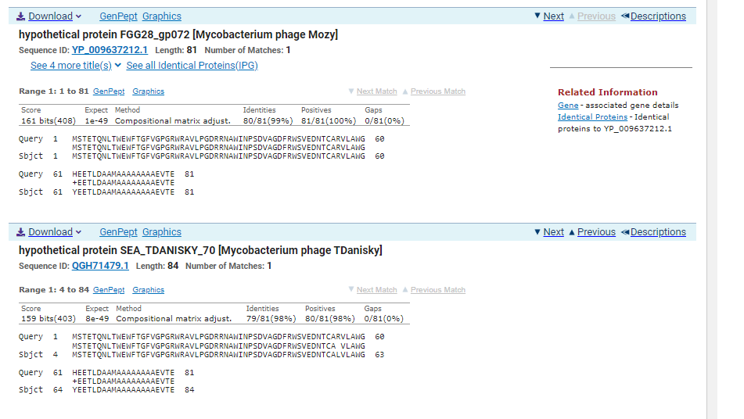
ATG Start at 40223. Original Glimmer call.
TGA Stop at 40468
F/R: F
Coding Potential (y/n): Y
Starterator (SS, NA, NI): Most annotated start is this (40223)
Blast Best Hit, Query:Subject Starts, Score, Evalue, or “no significant Blast alignments” if 10E-4 or higher
hypothetical protein FGG28_gp072 Mycobacterium phage Mozy YP_009637212.1, 1:1, Score 161, Evalue, 1e-49
Gap with previous gene: -3
Longest Orf? (Y/N/NA) N
RBS:
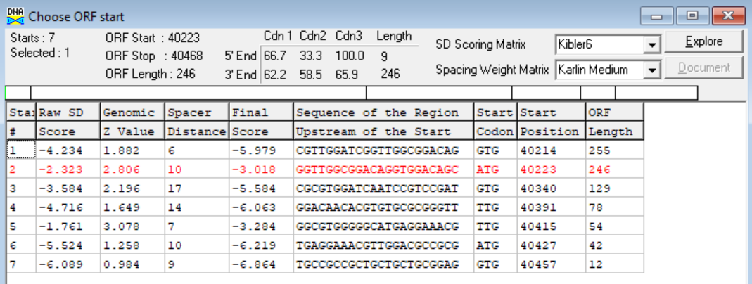
(https://toolkit.tuebingen.mpg.de/tools/hhpred) HHPRED vs PDB, SCOPe, pFam, and M. Tuberculosis. No Significant (>95%) Hits.
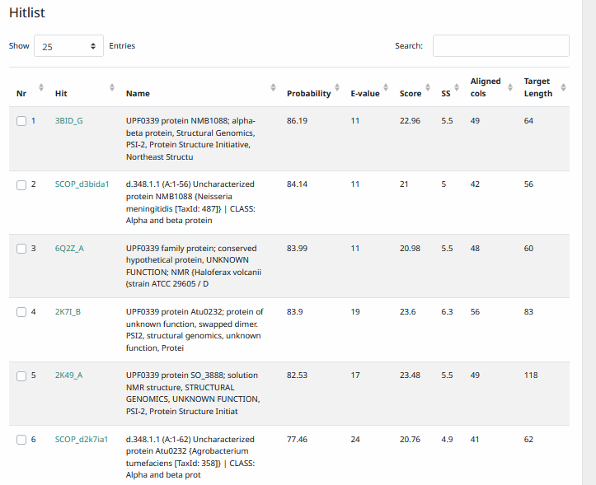
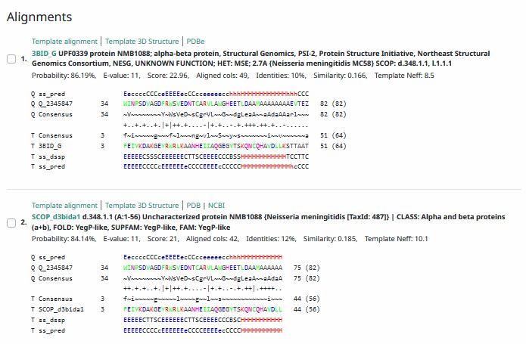
Phamerator Totinger Vs. Tootsieroll Vs. Starcevich (https://phamerator.org/phages) Genes 46-73
Proposed Function: hypothetical protein
Function Evidence: in BLASTs, results most commonly aligned with proteins of unknown function. In Phamerator, phage Starcevich calls a near identical gene but does not call a function for it.
Transmembrane Domain/Evidence: No, Intracellular Properties (https://dtu.biolib.com/DeepTMHMM)
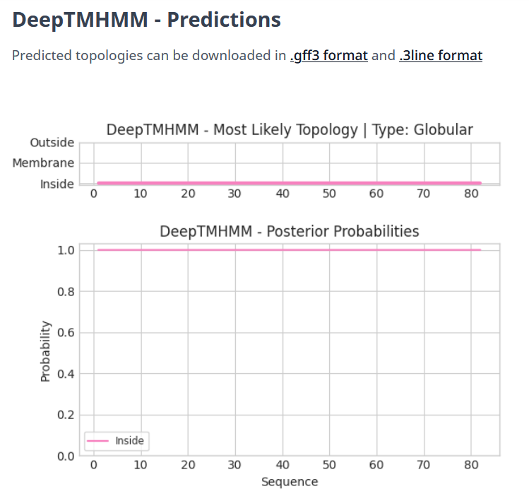

Gene Number: 63
Totinger_Draft_66 on Phagesdb
Pham147304
BLAST from PhagesDB. (https://phagesdb.org/blastp/) Using Longest ORF
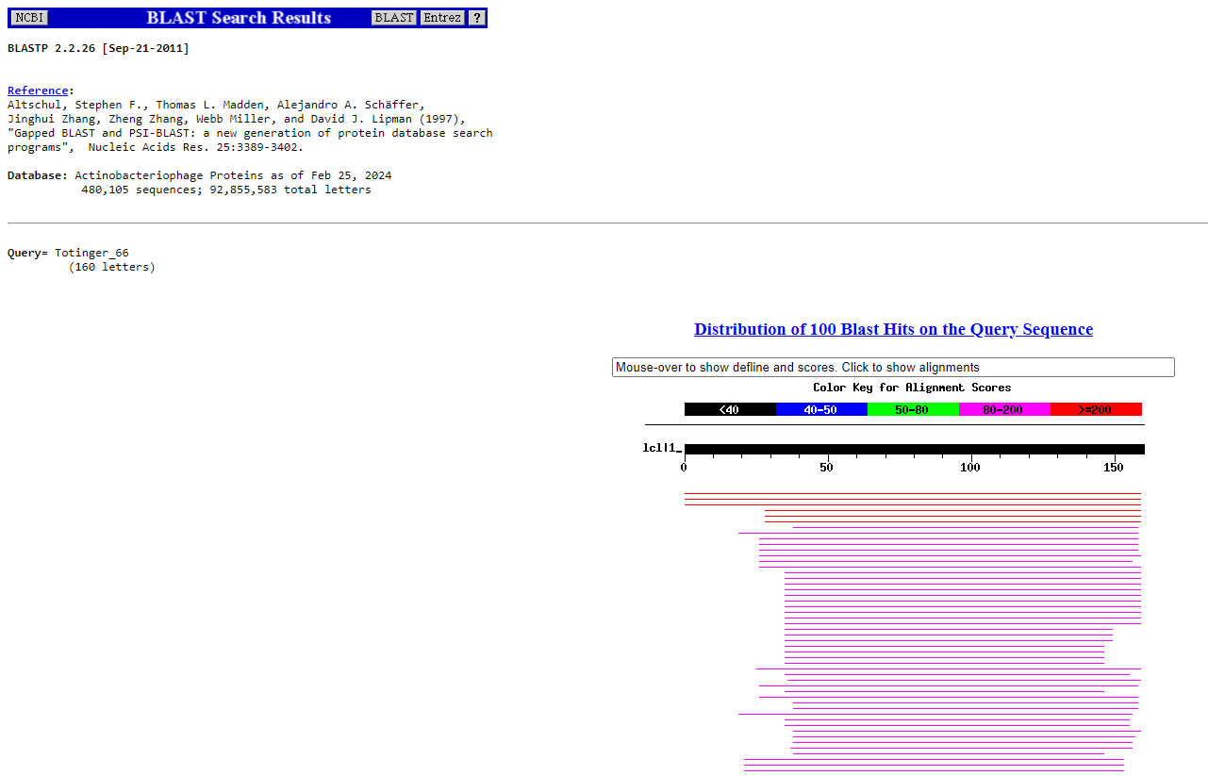
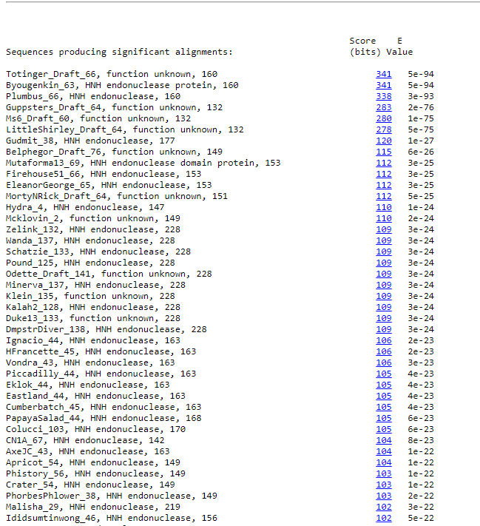
BLAST from NCBI (https://blast.ncbi.nlm.nih.gov/Blast.cgi?PAGE=Proteins) Using Longest ORF
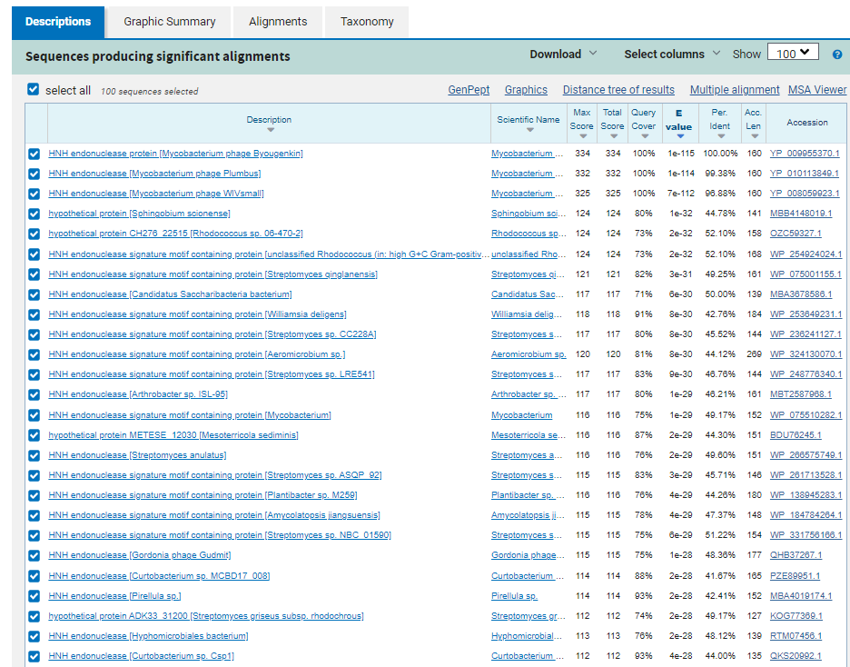
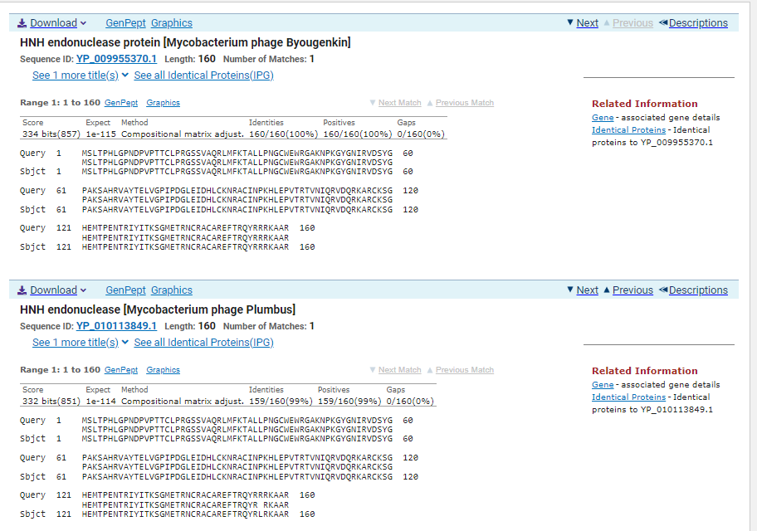
ATG Start at 40465. Original Glimmer call, Genemark Calls Start at 40549.
TGA Stop at 3621
F/R: F
Coding Potential (y/n): Y
Starterator (SS, NA, NI): Does not have the Most Annotated Start
Blast Best Hit, Query:Subject Starts, Score, Evalue, or “no significant Blast alignments” if 10E-4 or higher
HNH endonuclease Mycobacterium phage Byougenkin YP_009955370.1, 1:1, Score 334, Evalue, 1e-115
Gap with previous gene: -3
Longest Orf? (Y/N/NA) Y
RBS:
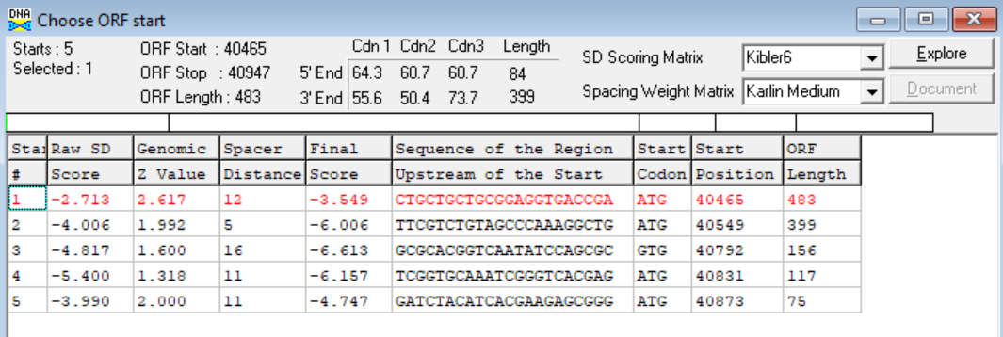
(https://toolkit.tuebingen.mpg.de/tools/hhpred) HHPRED vs PDB, SCOPe, pFam, and M. Tuberculosis.
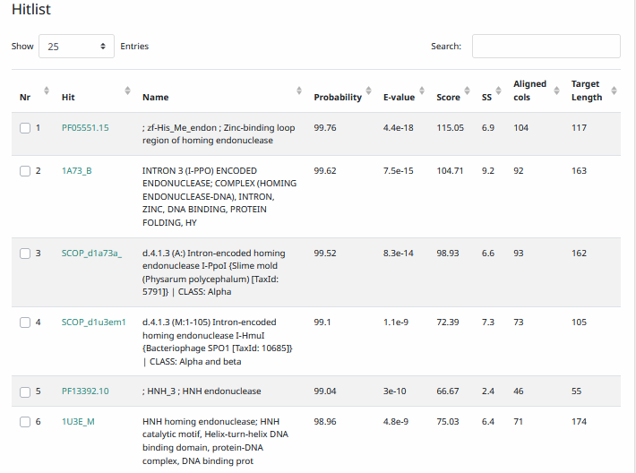
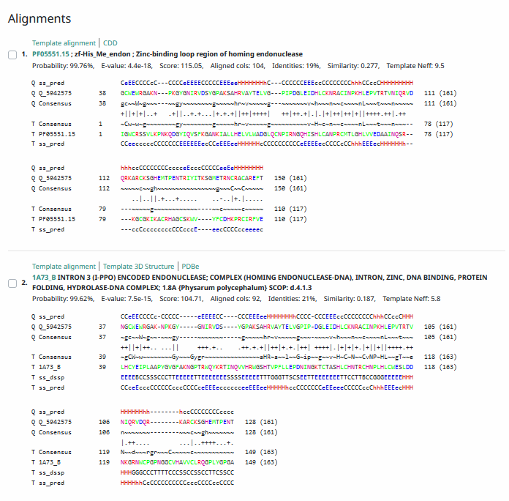
Phamerator Totinger Vs. Tootsieroll Vs. Starcevich (https://phamerator.org/phages) Genes 46-73
Proposed Function: HNH endonuclease
Function Evidence: This protein has near identical matches to HNH endonucleases from other phages according to BLASTs. Additionally, HHPRED very strongly hits this protein as having properties of an HNH endonuclease.
Transmembrane Domain/Evidence: No, Intracellular Properties (https://dtu.biolib.com/DeepTMHMM)
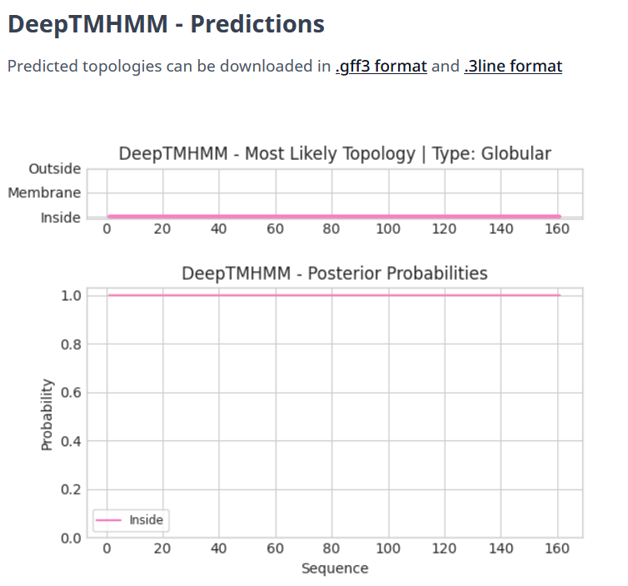

Gene Number: 64
Totinger_Draft_67 on Phagesdb
Pham1005
BLAST from PhagesDB. (https://phagesdb.org/blastp/) Using Longest ORF
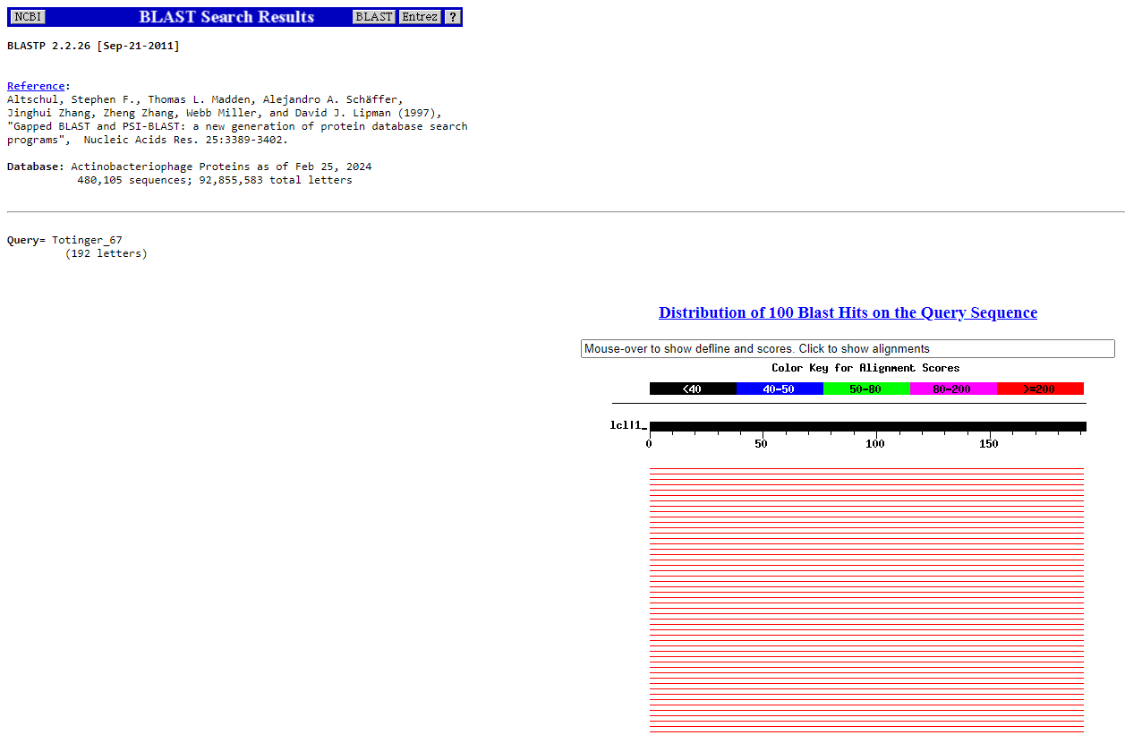
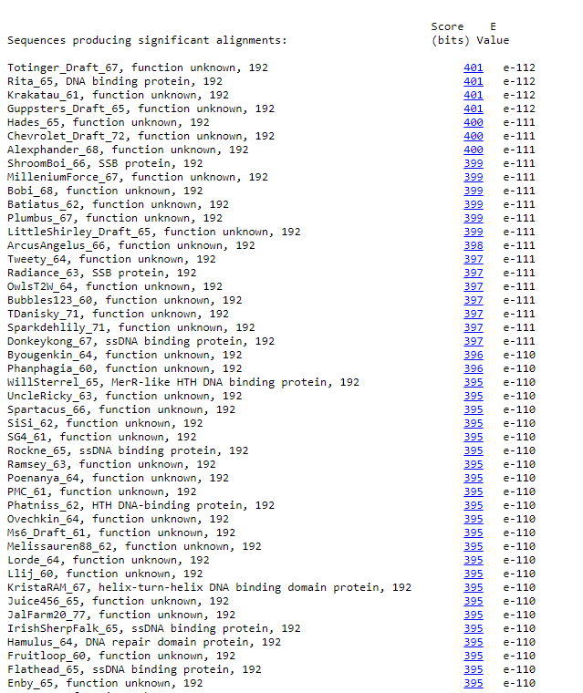
BLAST from NCBI (https://blast.ncbi.nlm.nih.gov/Blast.cgi?PAGE=Proteins) Using Longest ORF
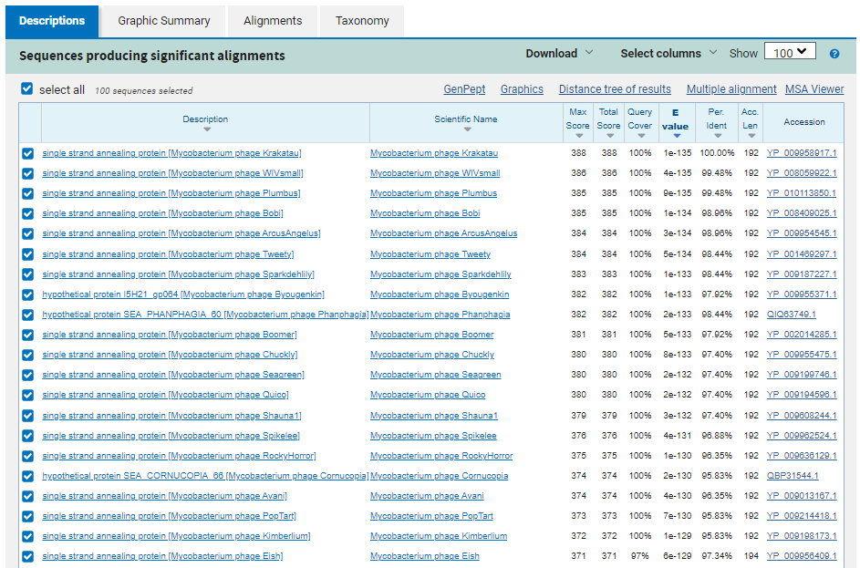
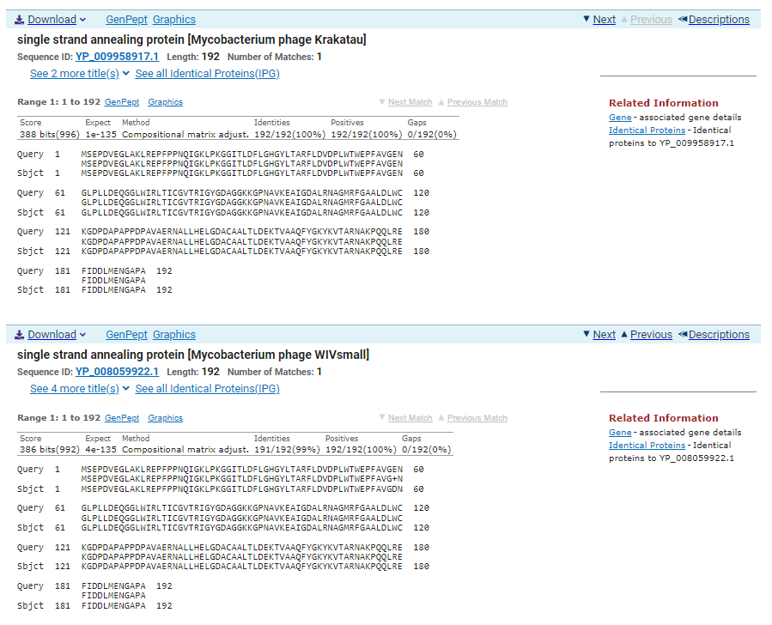
ATG Start at 40944. Original Glimmer call.
TGA Stop at 41522
F/R: F
Coding Potential (y/n): Y
Starterator (SS, NA, NI): Most annotated start is this (40944)
Blast Best Hit, Query:Subject Starts, Score, Evalue, or “no significant Blast alignments” if 10E-4 or higher
single strand annealing protein Mycobacterium phage Krakatau YP_009958917.1, 1:1, Score 388, Evalue, 1e-135
Gap with previous gene: -3
Longest Orf? (Y/N/NA) N
RBS:
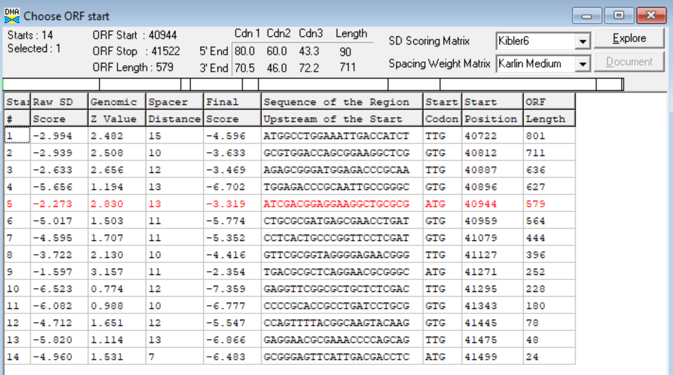
(https://toolkit.tuebingen.mpg.de/tools/hhpred) HHPRED vs PDB, SCOPe, pFam, and M. Tuberculosis.
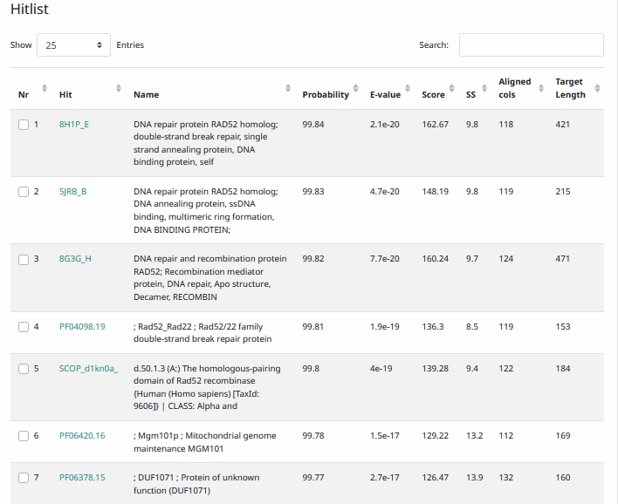
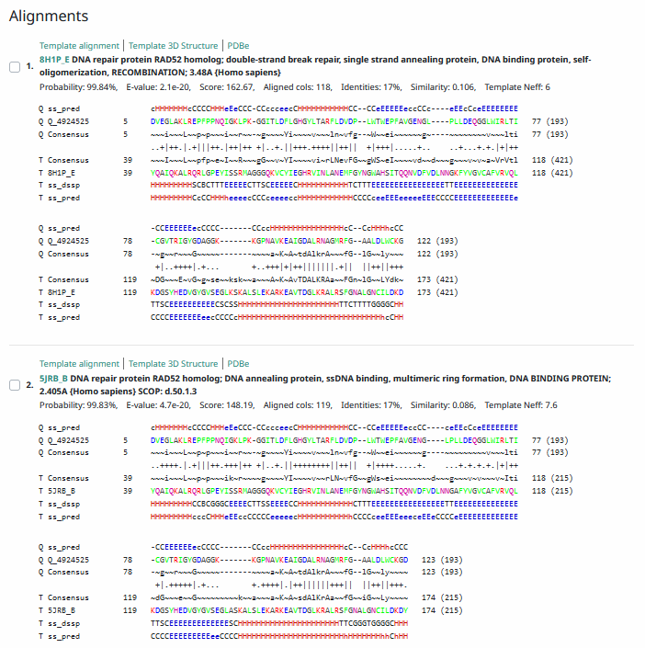
Phamerator Totinger Vs. Tootsieroll Vs. Starcevich (https://phamerator.org/phages) Genes 46-73
Proposed Function: SSB protein
Function Evidence: BLAST and HHPRED hits most consistently align with SSB proteins. Additionally, phage Starcevich has a near identical gene that is called as an SSB protein.
Transmembrane Domain/Evidence: No, Intracellular Properties (https://dtu.biolib.com/DeepTMHMM)
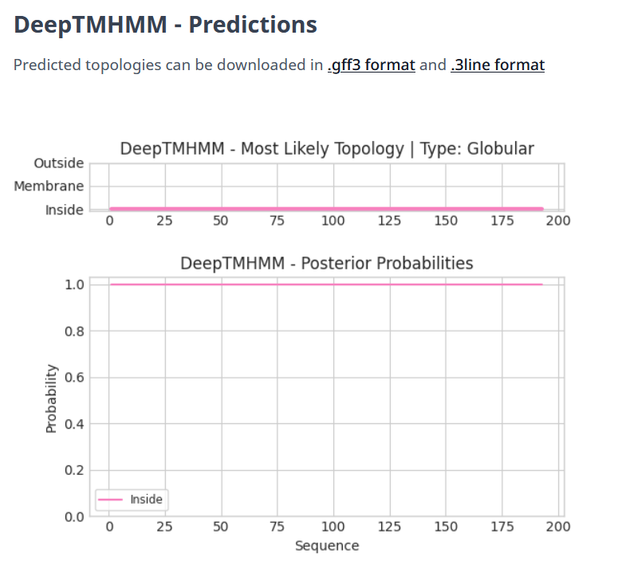

Gene Number: 65
Totinger_Draft_68 on Phagesdb
Pham146731
BLAST from PhagesDB. (https://phagesdb.org/blastp/) Using Longest ORF
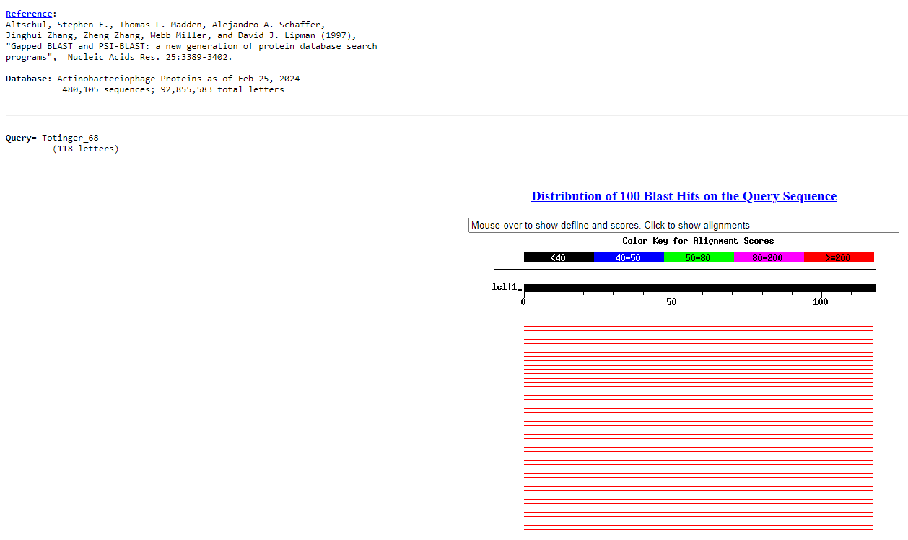
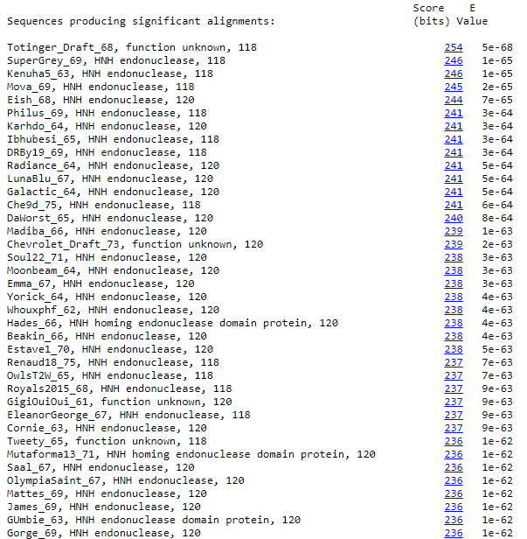
BLAST from NCBI (https://blast.ncbi.nlm.nih.gov/Blast.cgi?PAGE=Proteins) Using Longest ORF
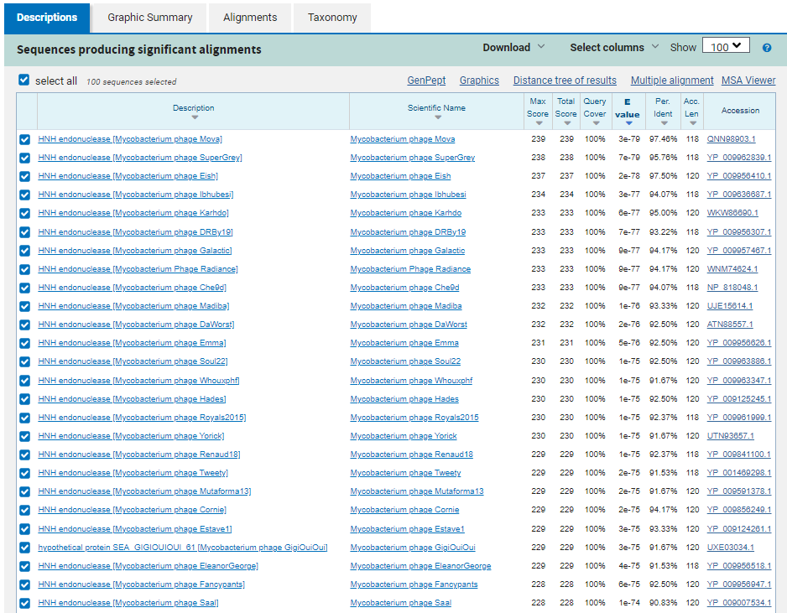
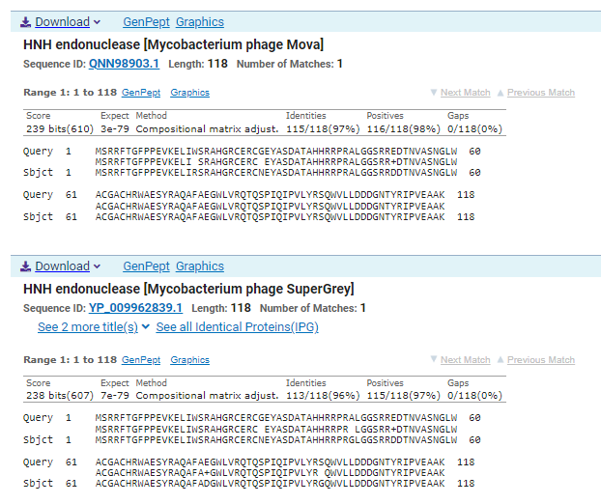
ATG Start at 41519. Original Glimmer call; not called by Genemark.
TGA Stop at 41875
F/R: F
Coding Potential (y/n): Weak, but present. Gene is called due to close BLAST hits and a near identical sequence being called as a gene in phage Starcevich.
Starterator (SS, NA, NI): Most annotated start is this (41519)
Blast Best Hit, Query:Subject Starts, Score, Evalue, or “no significant Blast alignments” if 10E-4 or higher
HNH endonuclease Mycobacterium phage Mova QNN98903.1, 1:1, Score 239, Evalue, 3e-79
Gap with previous gene: -3
Longest Orf? (Y/N/NA) Y
RBS:
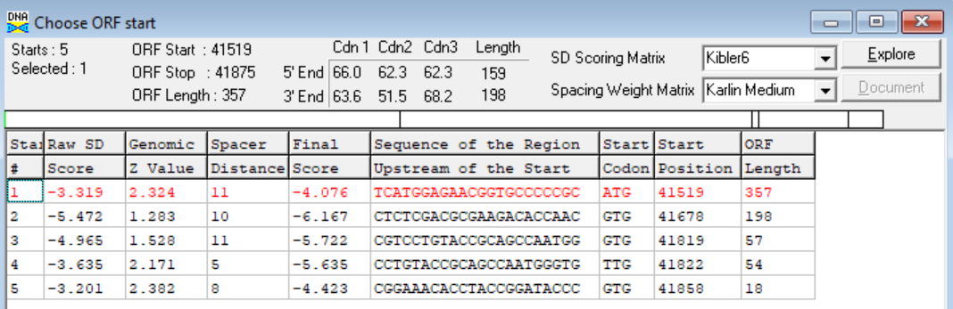
(https://toolkit.tuebingen.mpg.de/tools/hhpred) HHPRED vs PDB, SCOPe, pFam, and M. Tuberculosis.
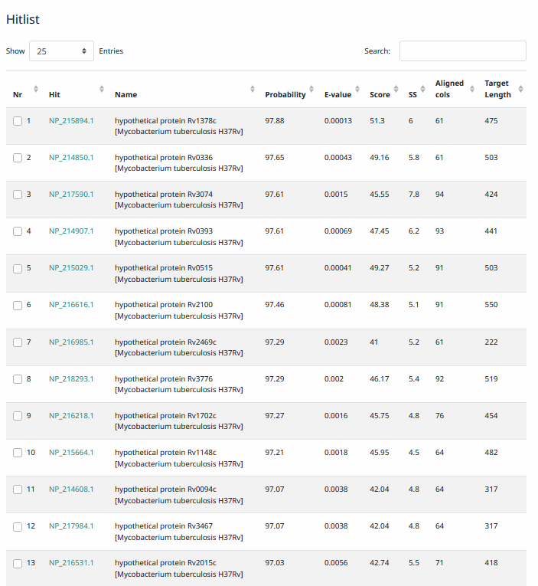
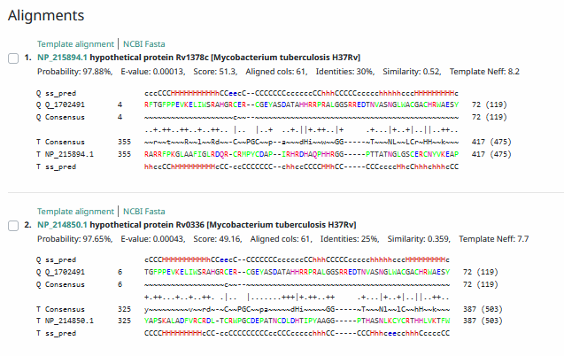
Phamerator Totinger Vs. Tootsieroll Vs. Starcevich (https://phamerator.org/phages) Genes 46-73
Proposed Function: HNH endonuclease
Function Evidence: in Phamerator, phage Starcevich calls a near identical gene from a near identical sequence that is an HNH endonuclease. BLAST results also align most consistently with an HNH endonuclease.
Transmembrane Domain/Evidence: No, Intracellular Properties (https://dtu.biolib.com/DeepTMHMM)
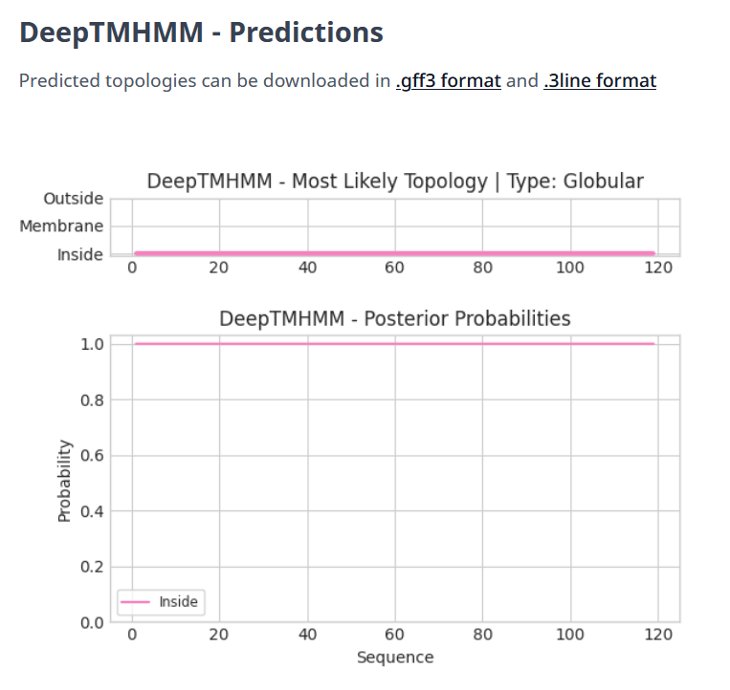

Gene Number: 66
Totinger_Draft_69 on Phagesdb
Pham147160
BLAST from PhagesDB. (https://phagesdb.org/blastp/) Using Longest ORF
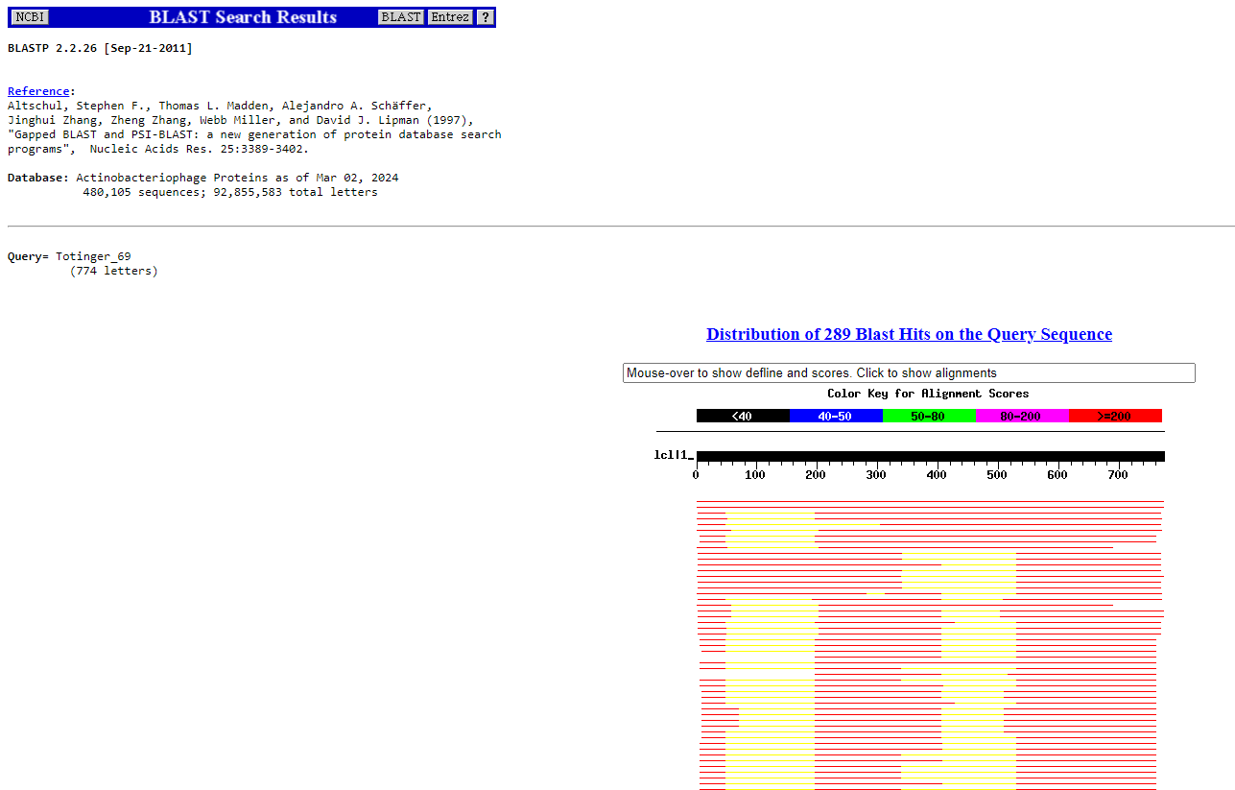
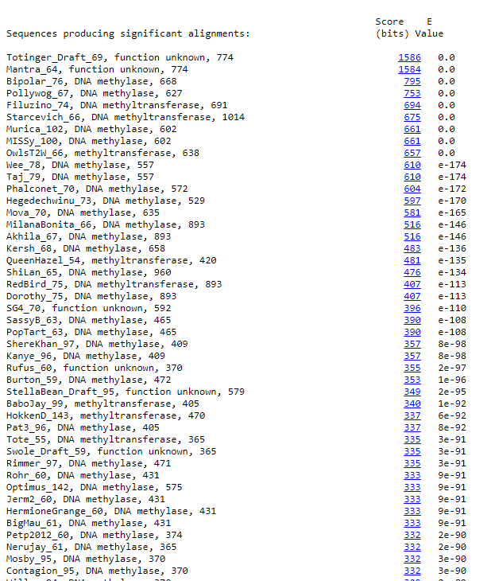
BLAST from NCBI (https://blast.ncbi.nlm.nih.gov/Blast.cgi?PAGE=Proteins) Using Longest ORF
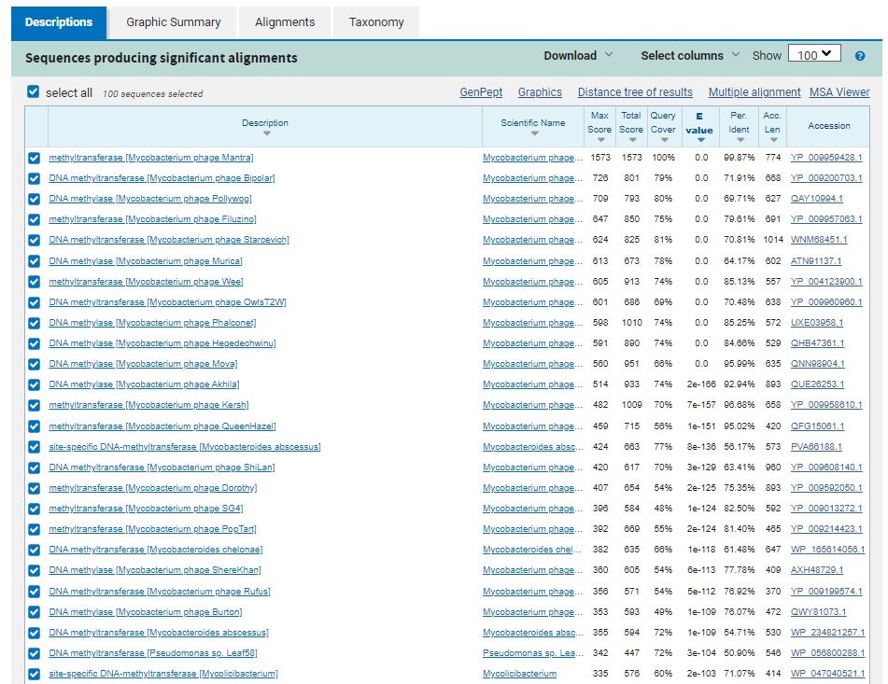
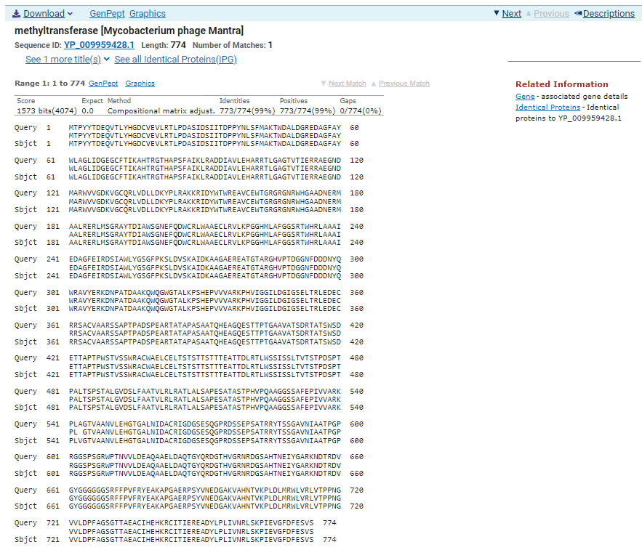
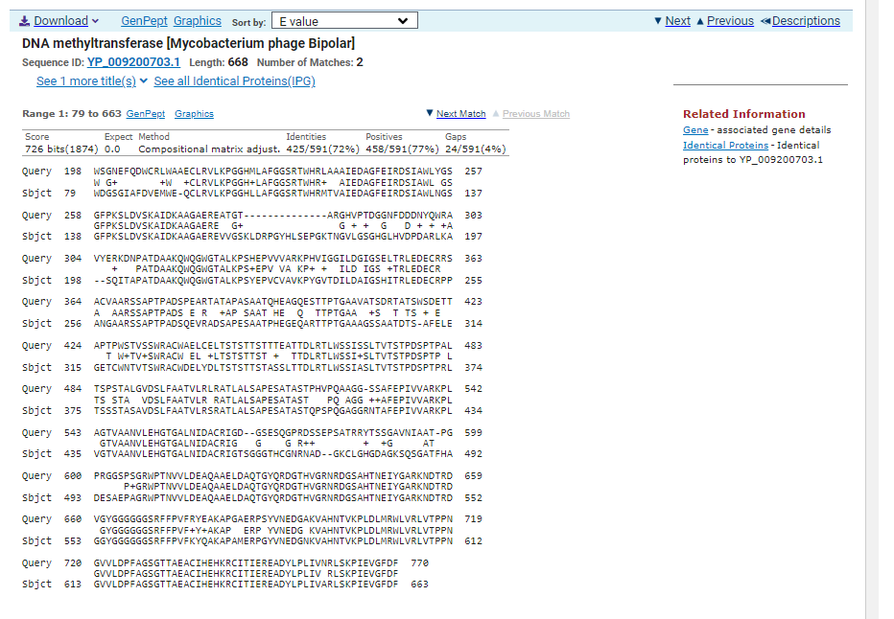
ATG Start at 41872. Original Glimmer call.
TGA Stop at 44196
F/R: F
Coding Potential (y/n): Y
Starterator (SS, NA, NI): Does not have the Most Annotated Start
Blast Best Hit, Query:Subject Starts, Score, Evalue, or “no significant Blast alignments” if 10E-4 or higher
methyltransferase Mycobacterium phage Mantra YP_009959428.1, 1:1, Score 1573, Evalue, 0
Gap with previous gene: -3
Longest Orf? (Y/N/NA) N
RBS:
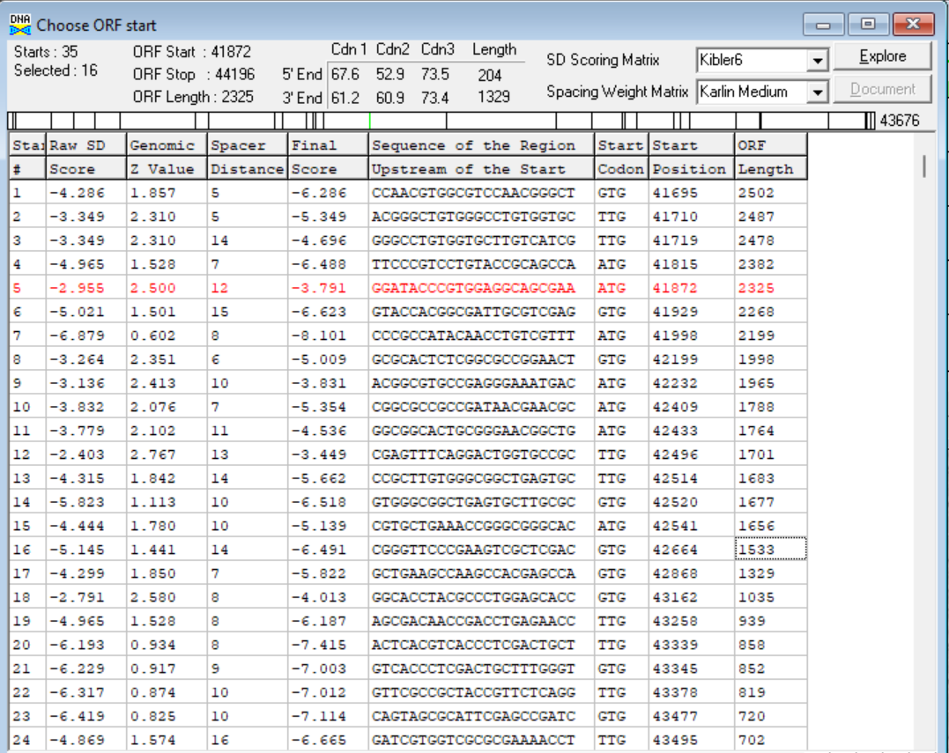
(https://toolkit.tuebingen.mpg.de/tools/hhpred) HHPRED vs PDB, SCOPe, pFam, and M. Tuberculosis.
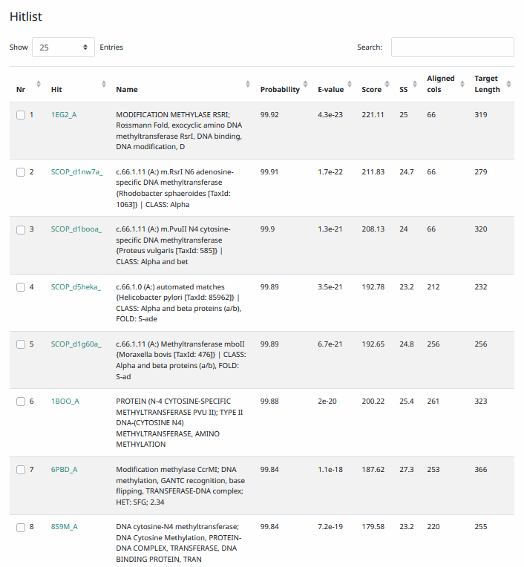
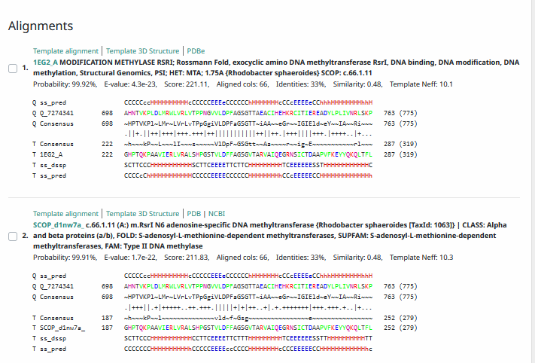
Phamerator Totinger Vs. Tootsieroll Vs. Starcevich (https://phamerator.org/phages) Genes 46-73
Proposed Function: DNA-methyltransferase
Function Evidence: BLAST and HHPRED results most consistently call this gene as a DNA-methyltransferase. While phamerator comparisons are minimal, similar phages (phage Starcevich and phage Tootsieroll) have similar genes in similar locations that are also called as DNA-methyltransferases.
Transmembrane Domain/Evidence: No, Intracellular Properties (https://dtu.biolib.com/DeepTMHMM)
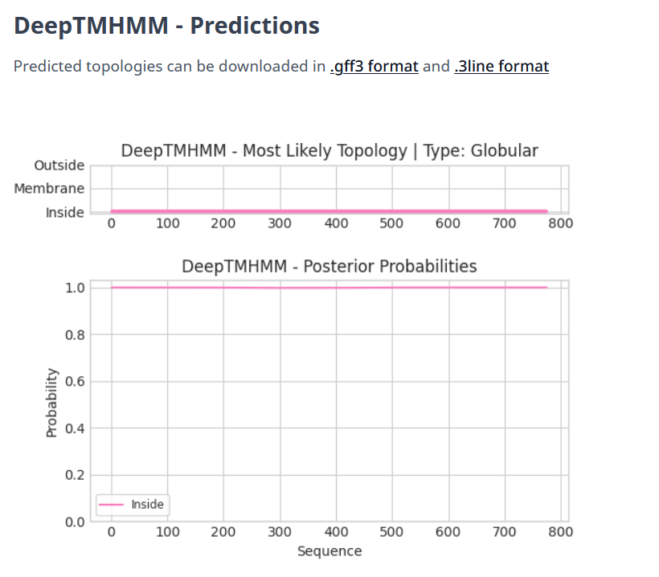

Gene Number: 67
Totinger_Draft_70 on Phagesdb
Pham147281
BLAST from PhagesDB. (https://phagesdb.org/blastp/) Using Longest ORF
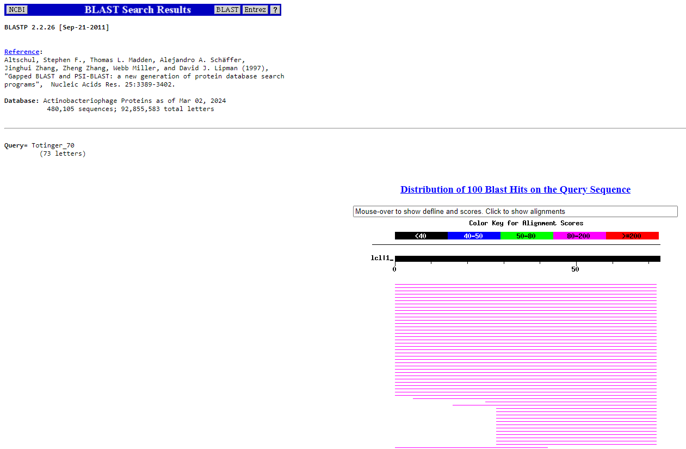
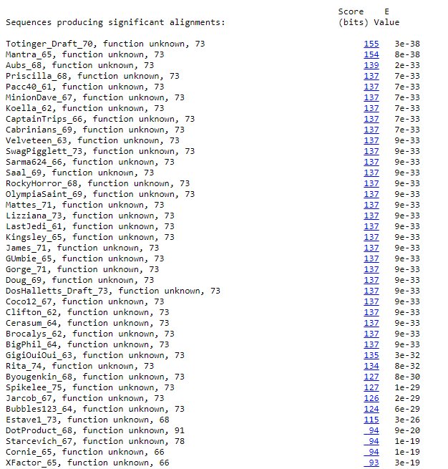
BLAST from NCBI (https://blast.ncbi.nlm.nih.gov/Blast.cgi?PAGE=Proteins) Using Longest ORF
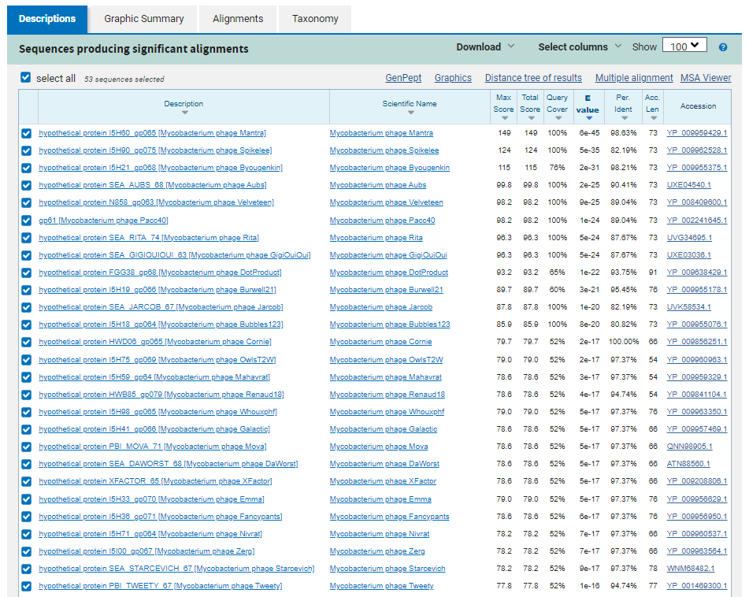
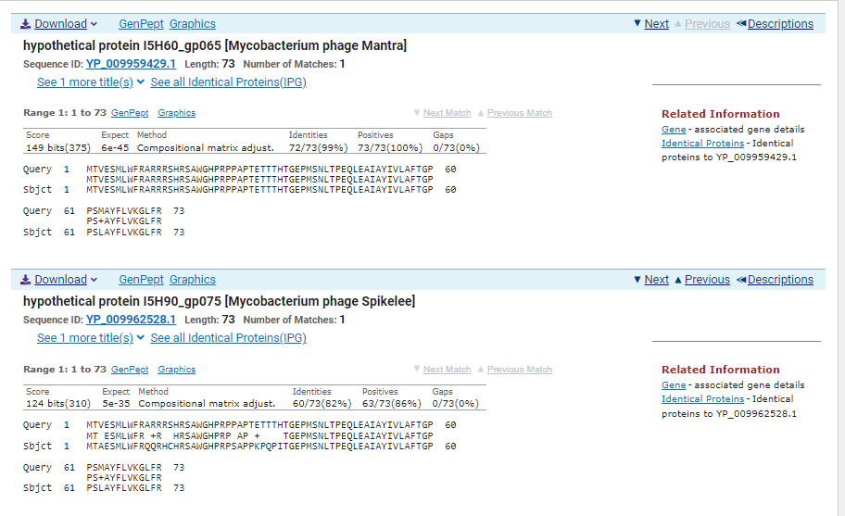
ATG Start at 44193. Original Glimmer call. GeneMark calls start at 44307.
TGA Stop at 44414
F/R: F
Coding Potential (y/n): Y
Starterator (SS, NA, NI): Most annotated start is this (44193)
Blast Best Hit, Query:Subject Starts, Score, Evalue, or “no significant Blast alignments” if 10E-4 or higher
hypothetical protein I5H60_gp065 Mycobacterium phage Mantra YP_009959429.1 1:1, Score 149, Evalue, 6e-45
Gap with previous gene: -3
Longest Orf? (Y/N/NA) N
RBS:
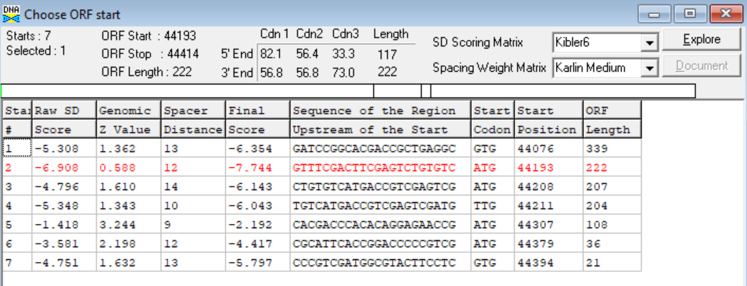
(https://toolkit.tuebingen.mpg.de/tools/hhpred) HHPRED vs PDB, SCOPe, pFam, and M. Tuberculosis. No Significant (>95%) Hits
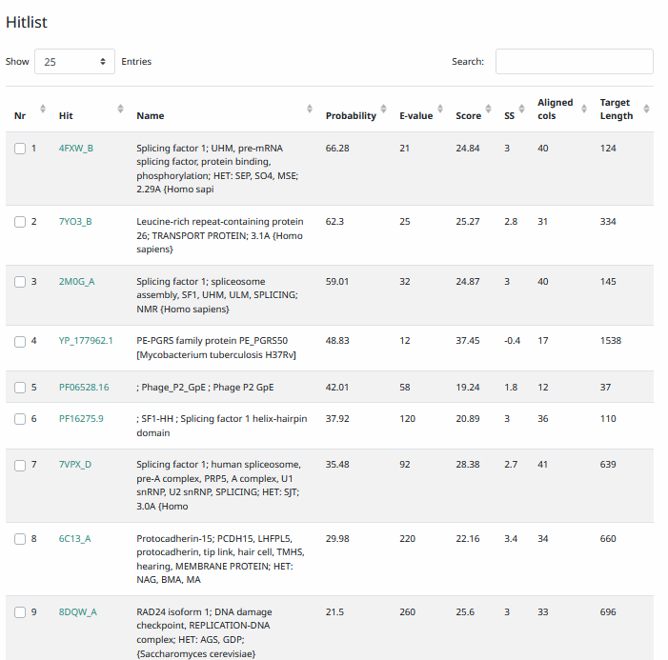
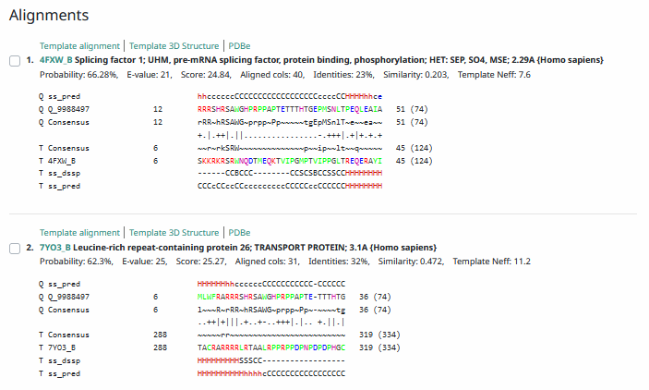
Phamerator Totinger Vs. Tootsieroll Vs. Starcevich (https://phamerator.org/phages) Genes 46-73
Proposed Function: hypothetical protein
Function Evidence: in Phamerator, phage Starcevich has an identical gene called from an identical sequence, and it is called as a hypothetical protein. Additionally, BLAST and HHPRED results most consistently align with hypothetical proteins.
Transmembrane Domain/Evidence: Yes, transmembrane properties at ~AA 49-66. (https://dtu.biolib.com/DeepTMHMM)
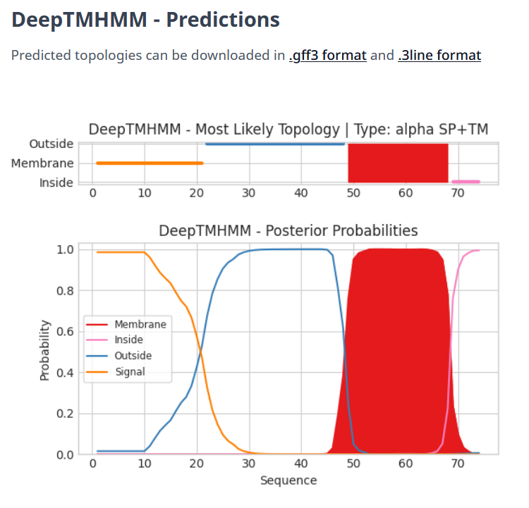

Gene Number: 68
Totinger_Draft_71 on Phagesdb
Pham744
BLAST from PhagesDB. (https://phagesdb.org/blastp/) Using Longest ORF
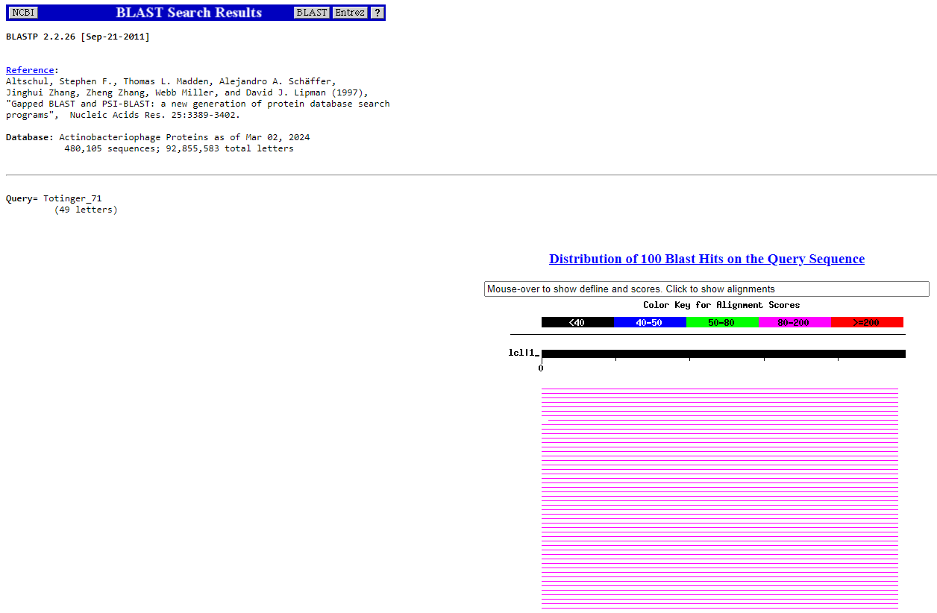
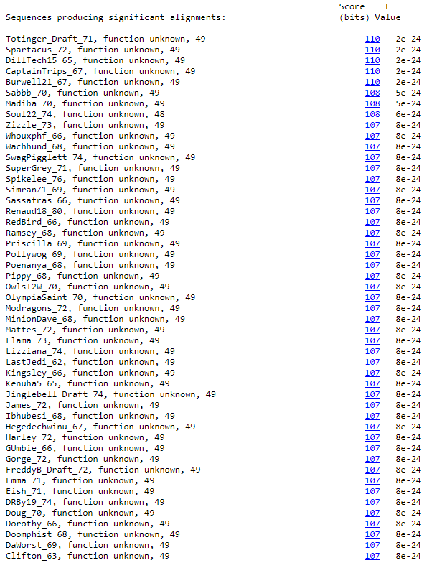
BLAST from NCBI (https://blast.ncbi.nlm.nih.gov/Blast.cgi?PAGE=Proteins) Using Longest ORF
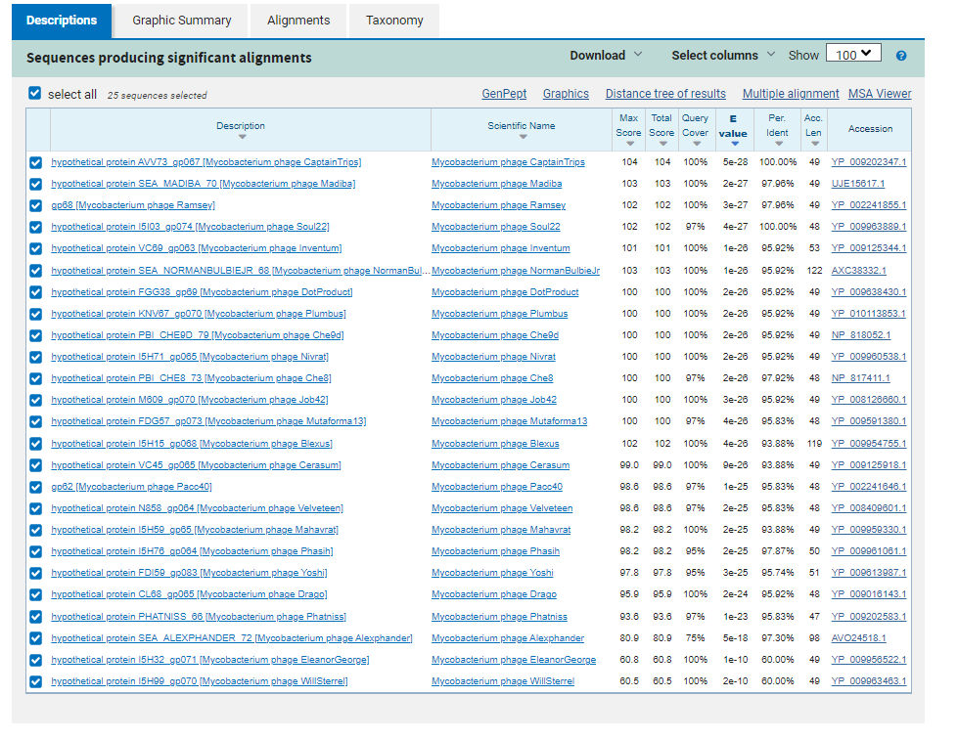
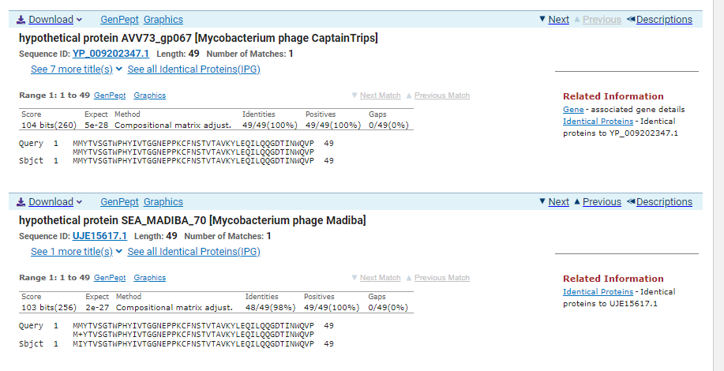
ATG Start at 44411. Original Glimmer call; Genemark calls Start at 44414.
TGA Stop at 44560
F/R: F
Coding Potential (y/n): Y
Starterator (SS, NA, NI): Most annotated start is this (44411)
Blast Best Hit, Query:Subject Starts, Score, Evalue, or “no significant Blast alignments” if 10E-4 or higher
hypothetical protein AVV73_gp067 Mycobacterium phage CaptainTrips YP_009202347.1, 1:1, Score 104, Evalue, 5e-28
Gap with previous gene: -3
Longest Orf? (Y/N/NA) N
RBS:
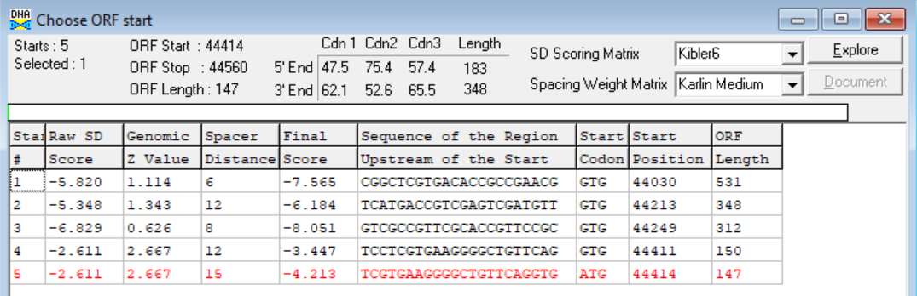
(https://toolkit.tuebingen.mpg.de/tools/hhpred) HHPRED vs PDB, SCOPe, pFam, and M. Tuberculosis.
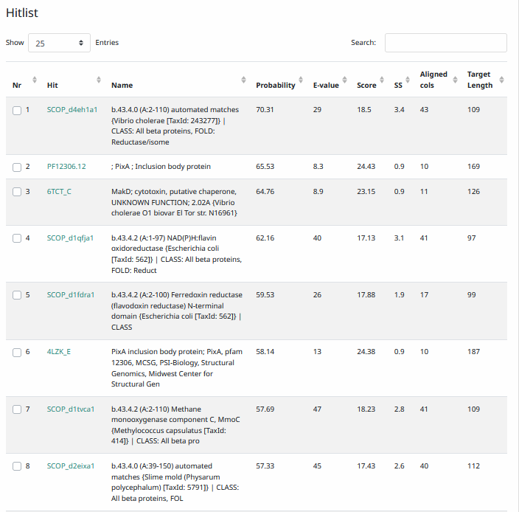
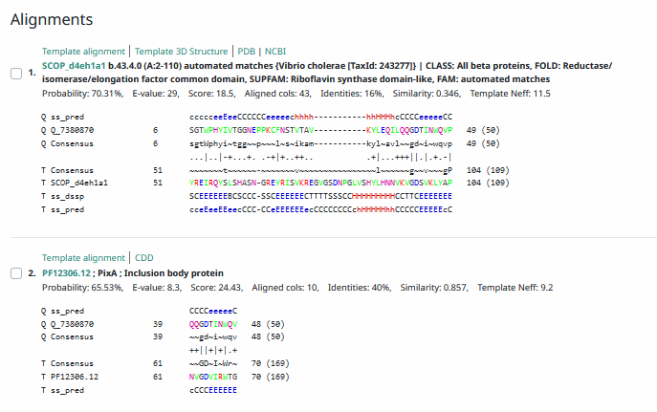
Phamerator Totinger Vs. Tootsieroll Vs. Starcevich (https://phamerator.org/phages) Genes 46-73
Proposed Function: hypothetical protein
Function Evidence: In Phamerator, phage Starcevich has an identical sequence and calls a gene of an unknown function in the same area. Additionally, BLAST and HHPRED results align most consistently with a protein of unknown function from similar phages.
Transmembrane Domain/Evidence: No, Intracellular Properties (https://dtu.biolib.com/DeepTMHMM)
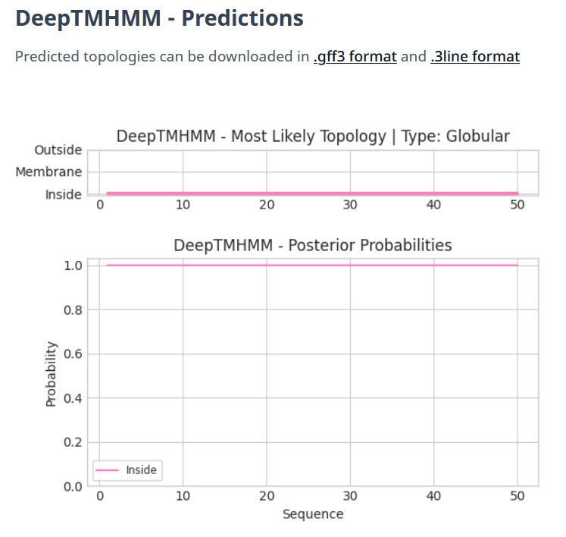

- ADDED NEW GENE NOT CALLED BY DNA MASTER. Information as follows.

Gene Number: 69
Pham N/A
BLAST from PhagesDB. (https://phagesdb.org/blastp/) Using Longest ORF
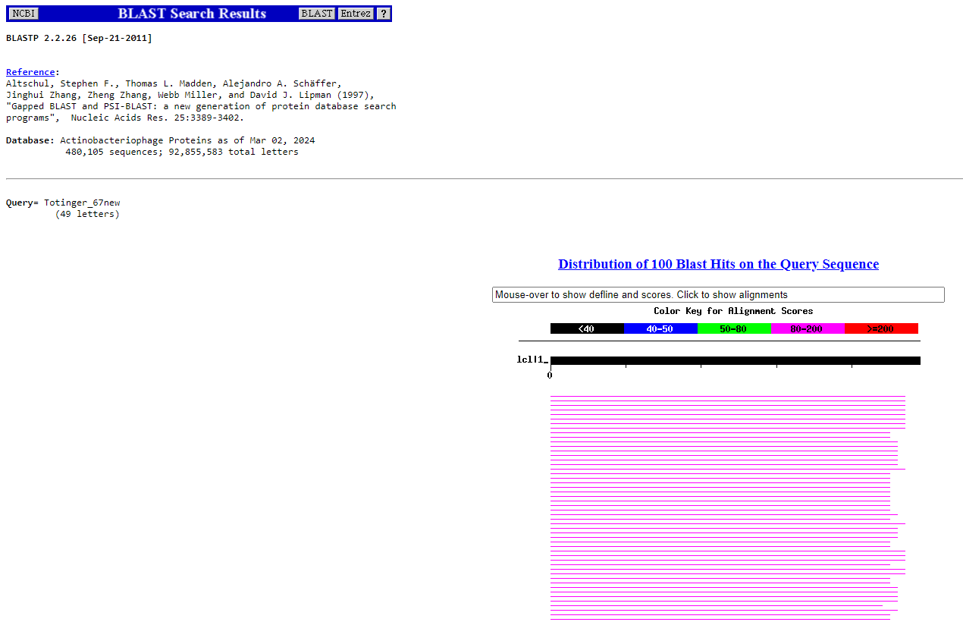
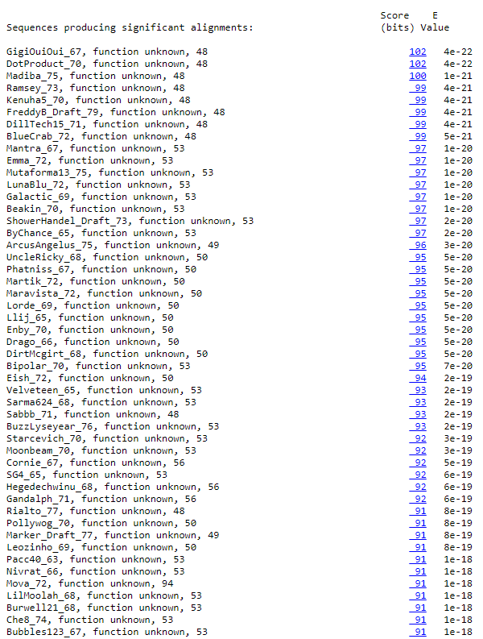
BLAST from NCBI (https://blast.ncbi.nlm.nih.gov/Blast.cgi?PAGE=Proteins) Using Longest ORF
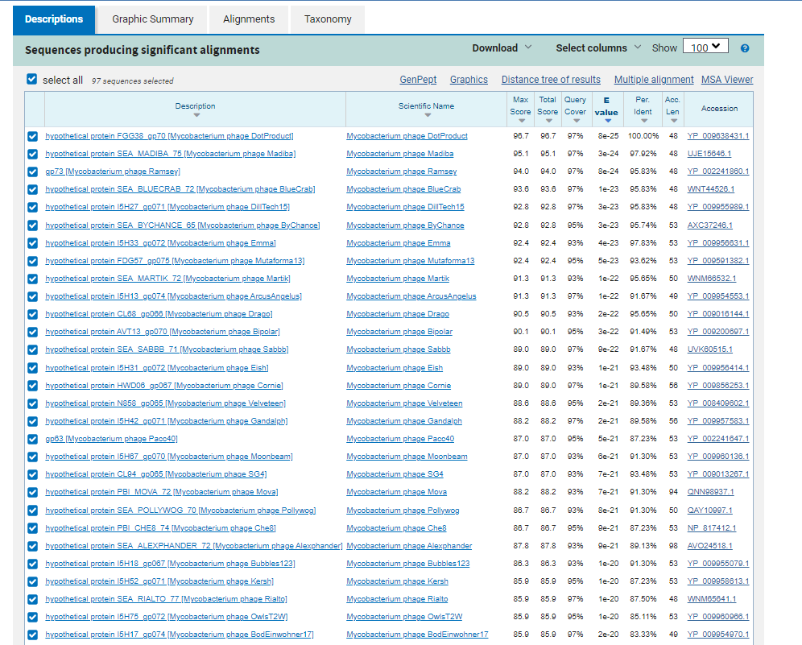
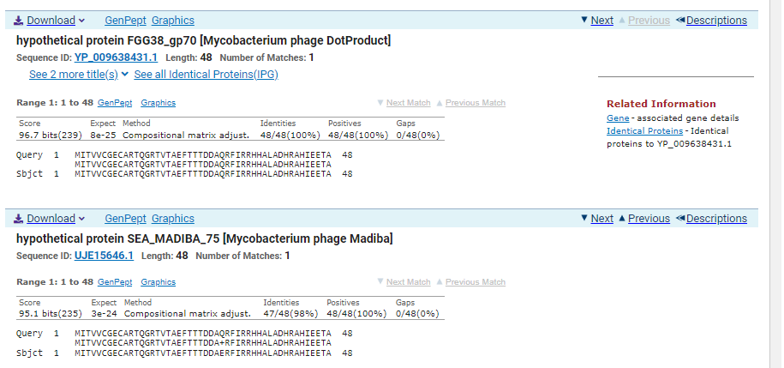
ATG Start at 44557. Not called by Glimmer or Genemark.
TGA Stop at 44703
F/R: F
Coding Potential (y/n): Y
Starterator (SS, NA, NI): No Starterator Data
Blast Best Hit, Query:Subject Starts, Score, Evalue, or “no significant Blast alignments” if 10E-4 or higher
hypothetical protein FGG38_gp70 Mycobacterium phage DotProduct YP_009638431.1, 1:1, Score 96.7, Evalue, 8e-25
Gap with previous gene: -3
Longest Orf? (Y/N/NA) N
RBS:
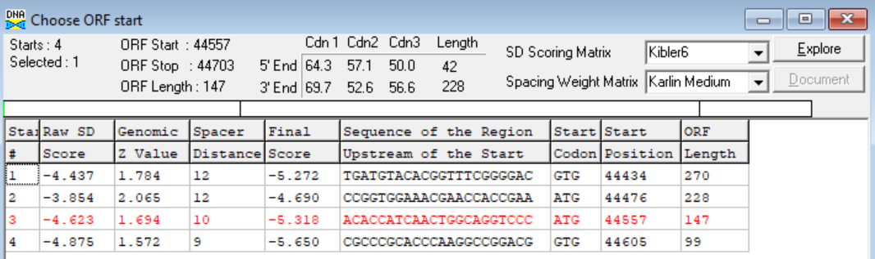
(https://toolkit.tuebingen.mpg.de/tools/hhpred) HHPRED vs PDB, SCOPe, pFam, and M. Tuberculosis. No Significant (>95%) Hits.
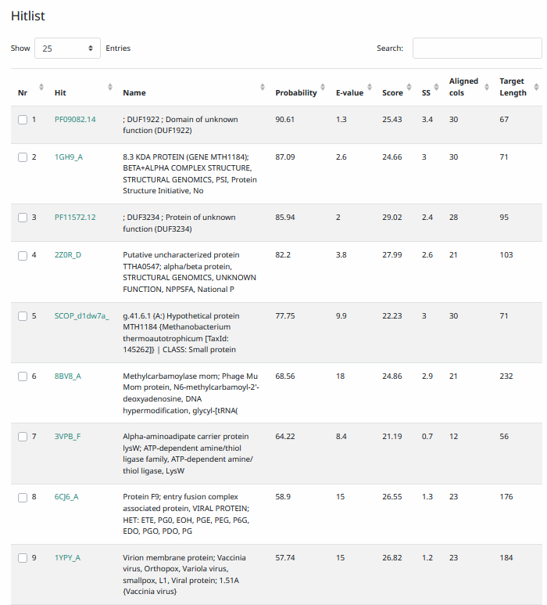
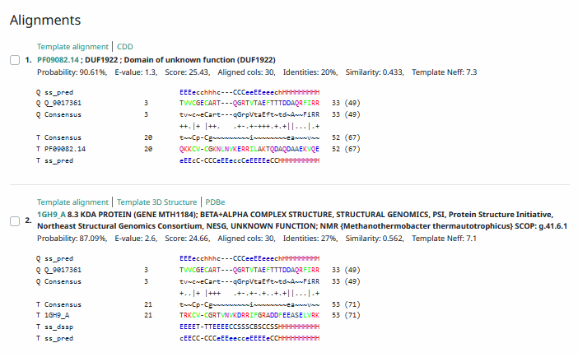
Phamerator Totinger Vs. Tootsieroll Vs. Starcevich (https://phamerator.org/phages) Genes 46-73
Proposed Function: hypothetical protein
Function Evidence: BLAST and HHPRED results align most consistently with proteins that exist, but do not have known functions.
Transmembrane Domain/Evidence: No, Intracellular Properties (https://dtu.biolib.com/DeepTMHMM)

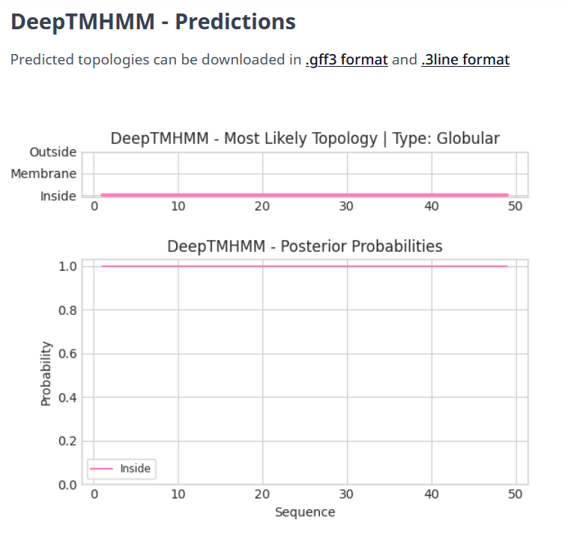

Gene Number: 70
Totinger_Draft_72 on Phagesdb
Pham146927
BLAST from PhagesDB. (https://phagesdb.org/blastp/) Using Longest ORF
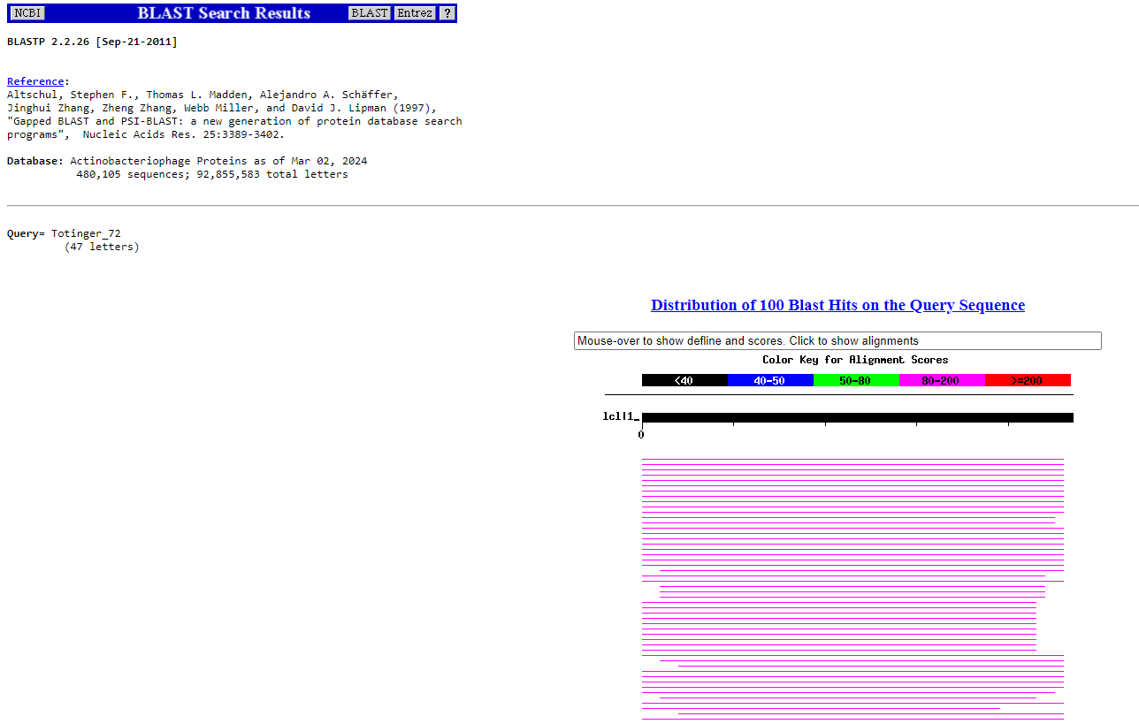
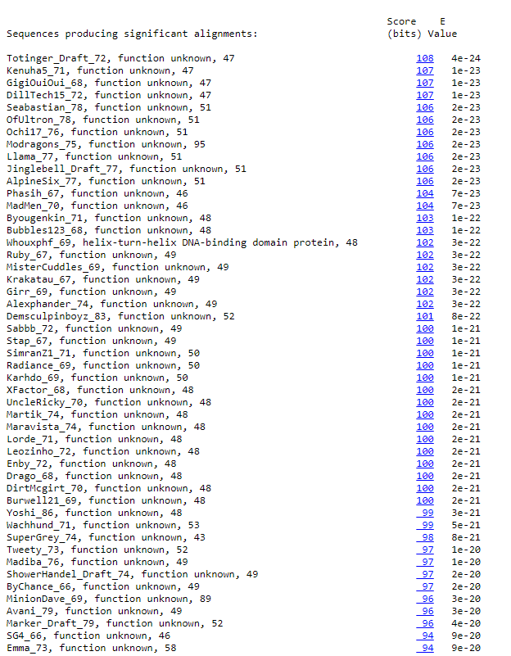
BLAST from NCBI (https://blast.ncbi.nlm.nih.gov/Blast.cgi?PAGE=Proteins) Using Longest ORF
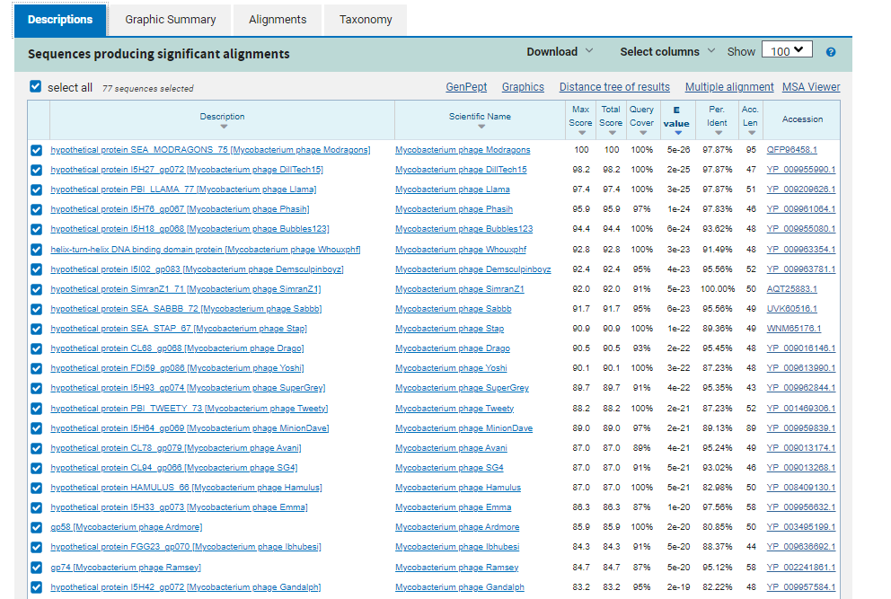
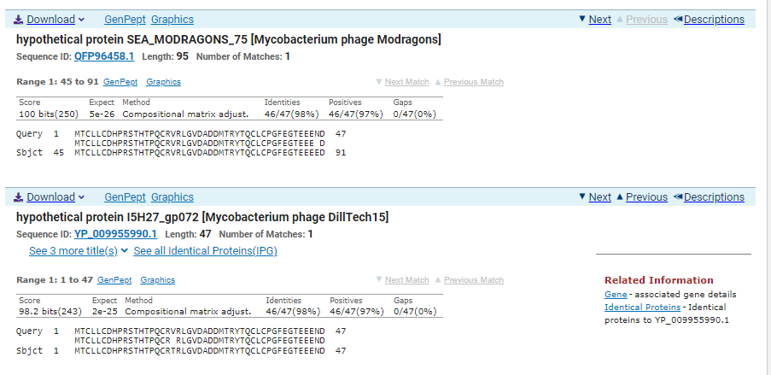
ATG Start at 44700. Original Glimmer call, not called by Genemark.
TGA Stop at 44843
F/R: F
Coding Potential (y/n): Weak but present.
Starterator (SS, NA, NI): Most annotated start is this (44700)
Blast Best Hit, Query:Subject Starts, Score, Evalue, or “no significant Blast alignments” if 10E-4 or higher
hypothetical protein SEA_MODRAGONS_75 Mycobacterium phage Modragons QFP96458.1, 45:91, Score 100, Evalue, 5e-26
Gap with previous gene: -3
Longest Orf? (Y/N/NA) Y
RBS:
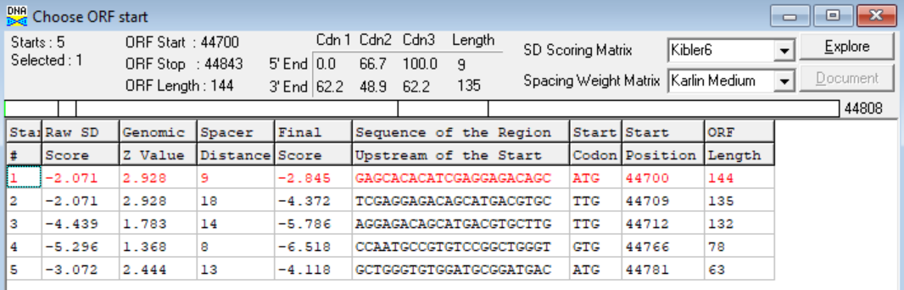
(https://toolkit.tuebingen.mpg.de/tools/hhpred) HHPRED vs PDB, SCOPe, pFam, and M. Tuberculosis. No Significant (>95%) Hits
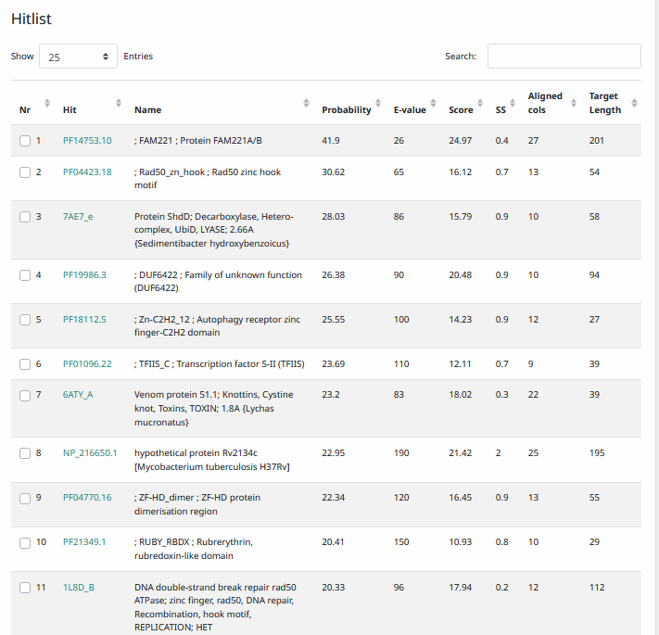
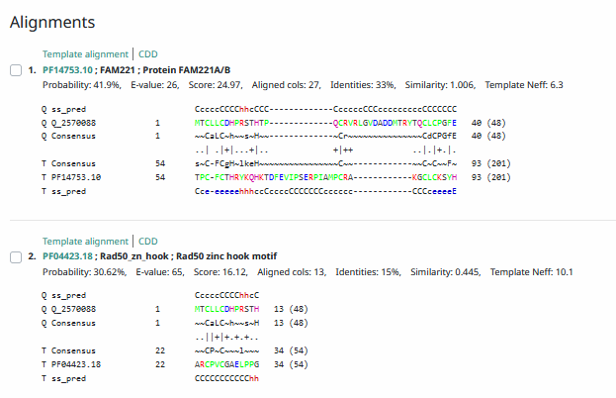
Phamerator Totinger Vs. Tootsieroll Vs. Starcevich (https://phamerator.org/phages) Genes 61-106
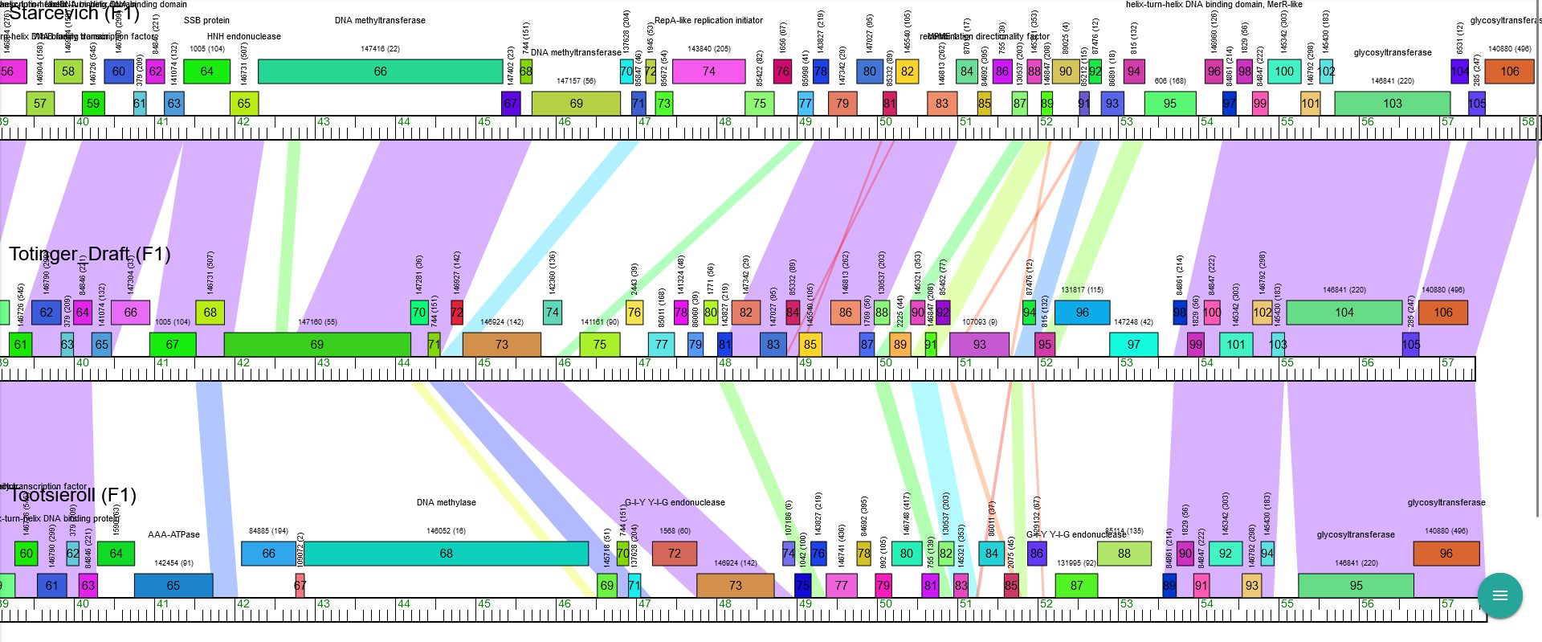
Proposed Function: hypothetical protein
Function Evidence: BLAST and HHPRED results do not provide evidence towards a consistent function call. While not near identical, phage Tootsieroll encodes a gene of a different Pham in a location sharing a similar sequence that also has no known function.
Transmembrane Domain/Evidence: No, Intracellular Properties (https://dtu.biolib.com/DeepTMHMM)
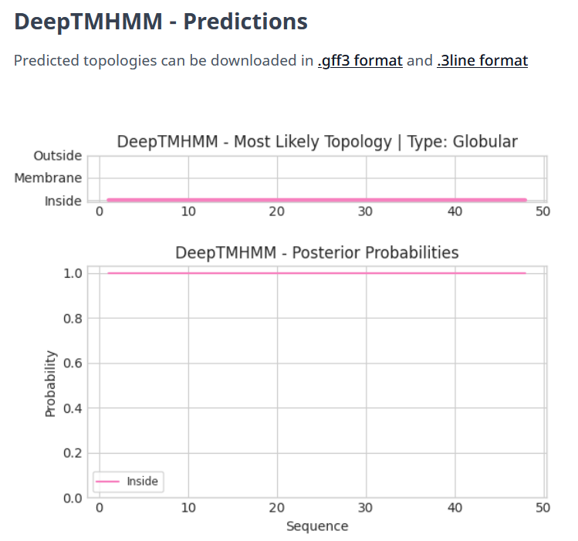

Gene Number: 71
Totinger_Draft_73 on Phagesdb
Pham146924
BLAST from PhagesDB. (https://phagesdb.org/blastp/) Using Longest ORF
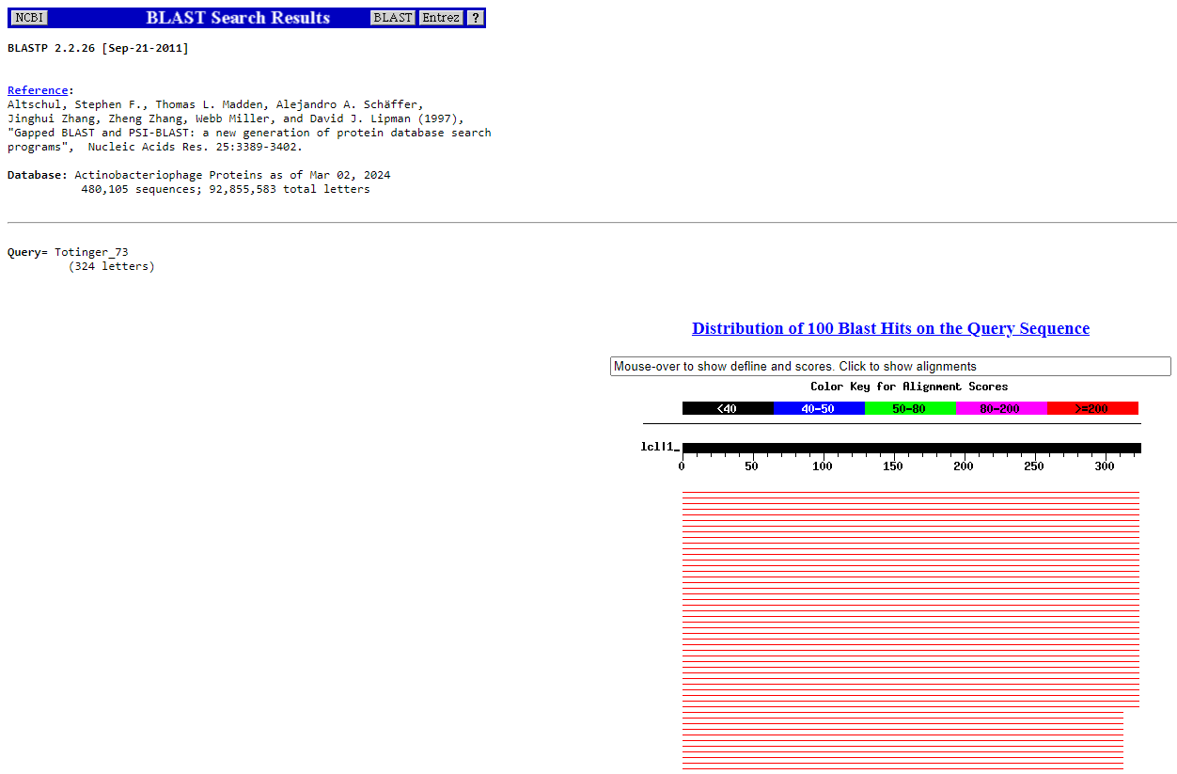
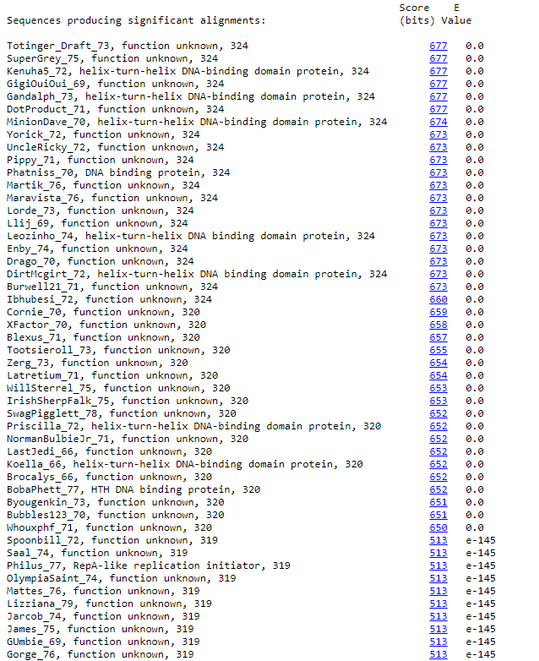
BLAST from NCBI (https://blast.ncbi.nlm.nih.gov/Blast.cgi?PAGE=Proteins) Using Longest ORF
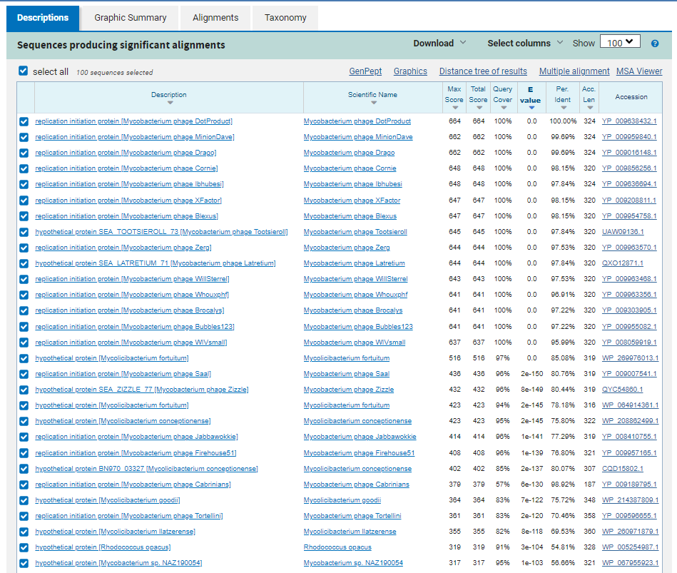
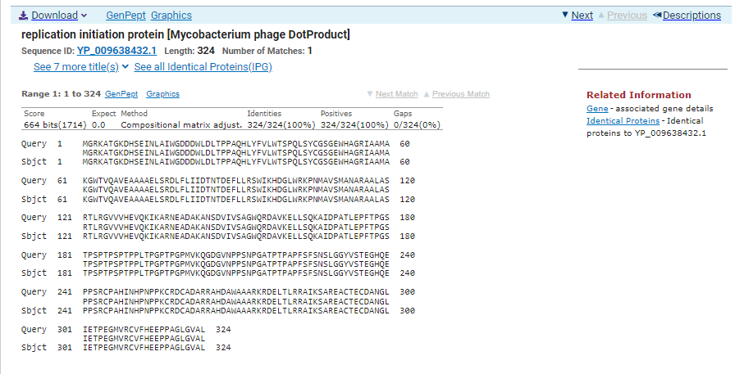
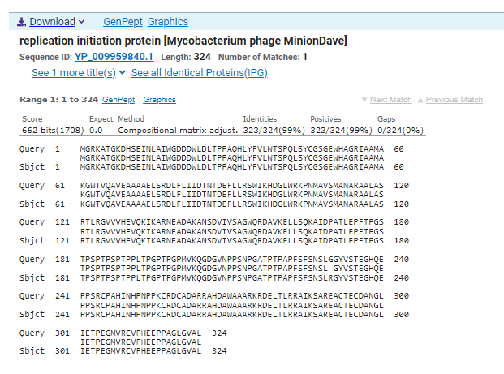
ATG Start at 44843. Original Glimmer call.
TGA Stop at 45817
F/R: F
Coding Potential (y/n): Y
Starterator (SS, NA, NI): Most annotated start is this (44843)
Blast Best Hit, Query:Subject Starts, Score, Evalue, or “no significant Blast alignments” if 10E-4 or higher
Replication initiation protein Mycobacterium phage DotProduct YP_009638432.1, 1:1, Score 664, Evalue, 0
Gap with previous gene: 0
Longest Orf? (Y/N/NA) N
RBS:
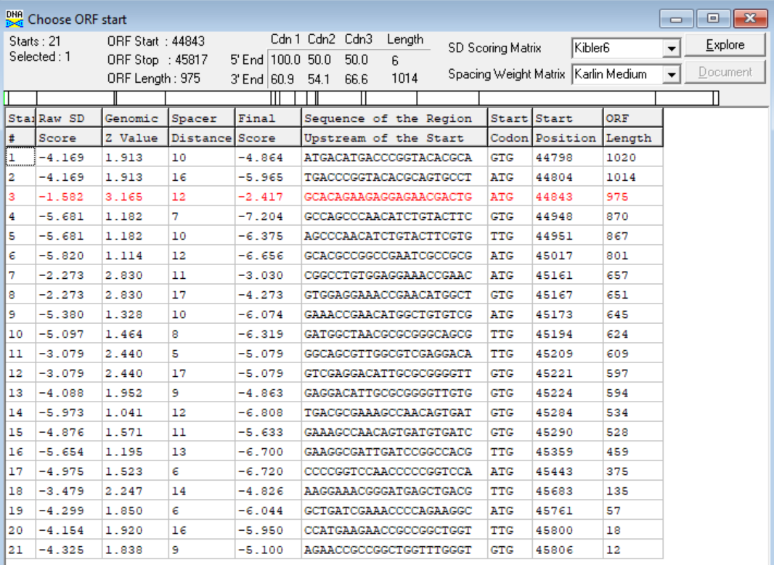
(https://toolkit.tuebingen.mpg.de/tools/hhpred) HHPRED vs PDB, SCOPe, pFam, and M. Tuberculosis.
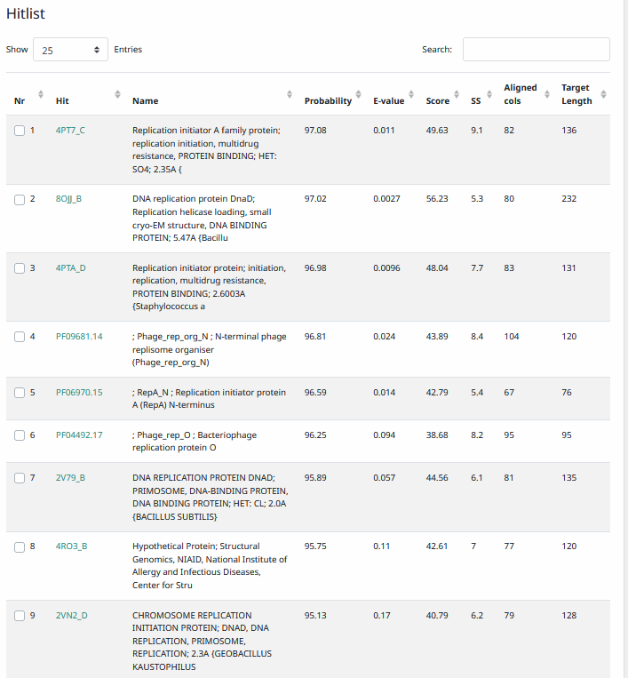
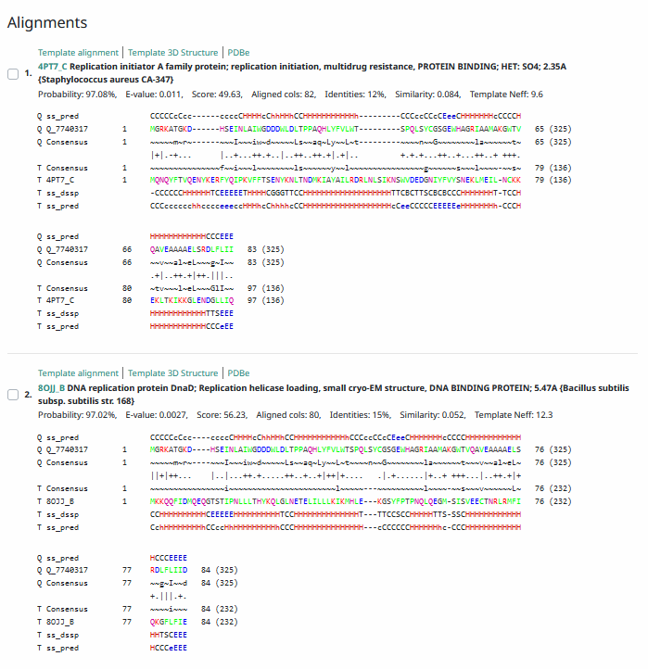
Phamerator Totinger Vs. Tootsieroll Vs. Starcevich (https://phamerator.org/phages) Genes 61-106
Proposed Function: helix-turn-helix DNA binding protein
Function Evidence: HHPRED and BLASTs most consistently called this protein as a helix-turn-helix DNA binding protein. Some most consistently called it as a replication initiator, but not enough evidence is present to call this specific function.
Transmembrane Domain/Evidence: No, Intracellular Properties (https://dtu.biolib.com/DeepTMHMM)
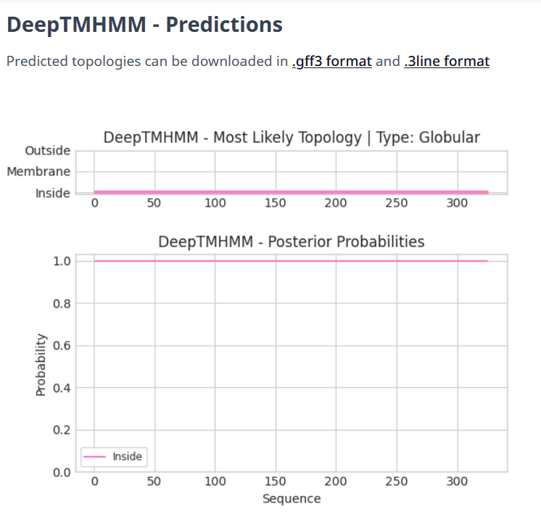

Gene Number: 72
Lengthened from Totinger_Draft_74 on Phagesdb
Pham142360
BLAST from PhagesDB. (https://phagesdb.org/blastp/) Using DNA Master’s Called ORF
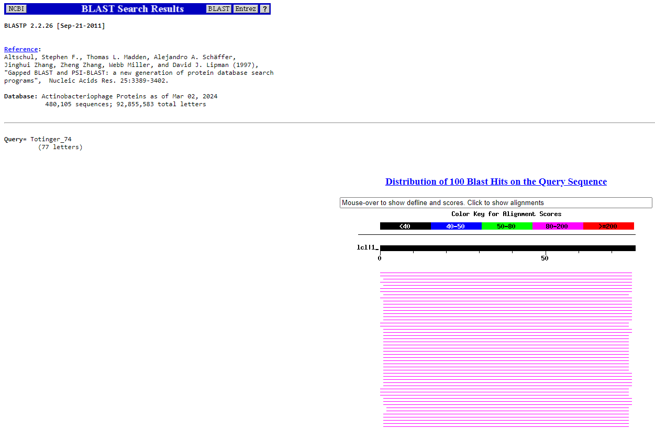
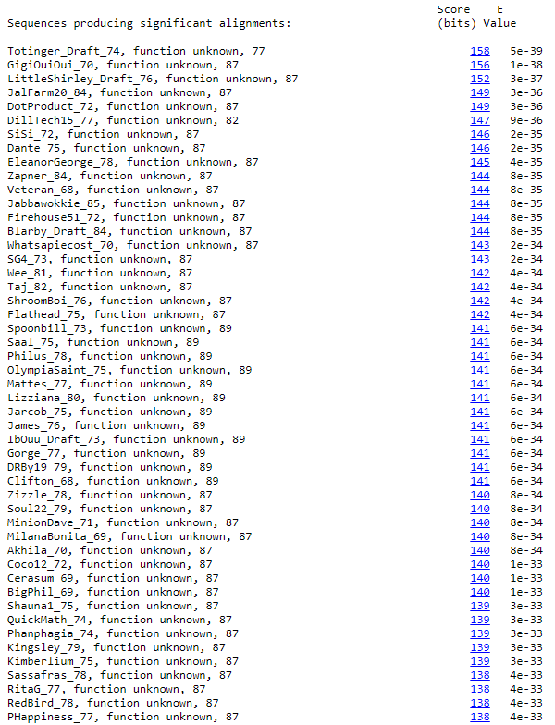
BLAST from PhagesDB. (https://phagesdb.org/blastp/) Using Longest ORF
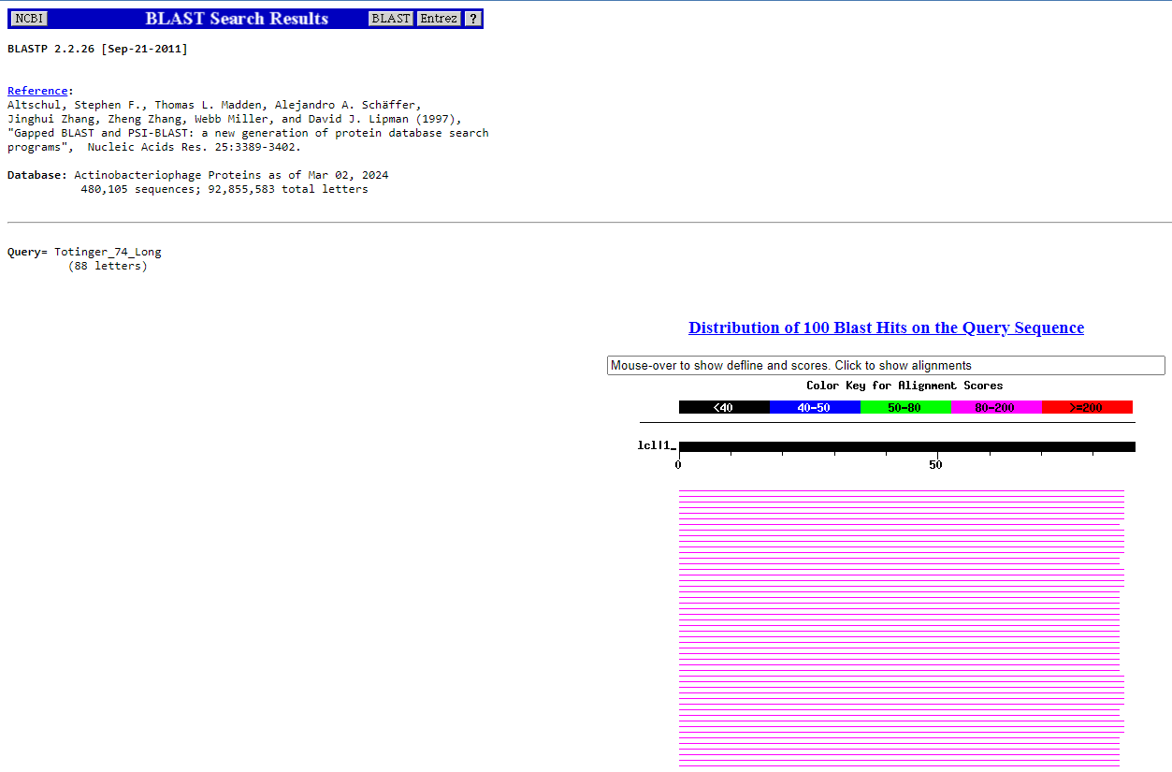
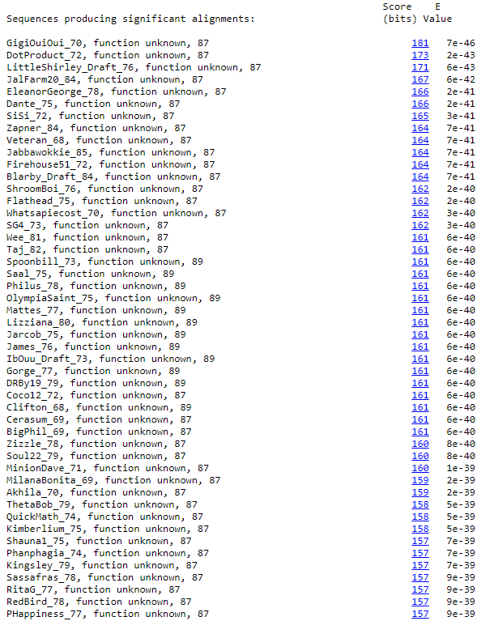
BLAST from NCBI (https://blast.ncbi.nlm.nih.gov/Blast.cgi?PAGE=Proteins) Using DNA Master’s Called ORF
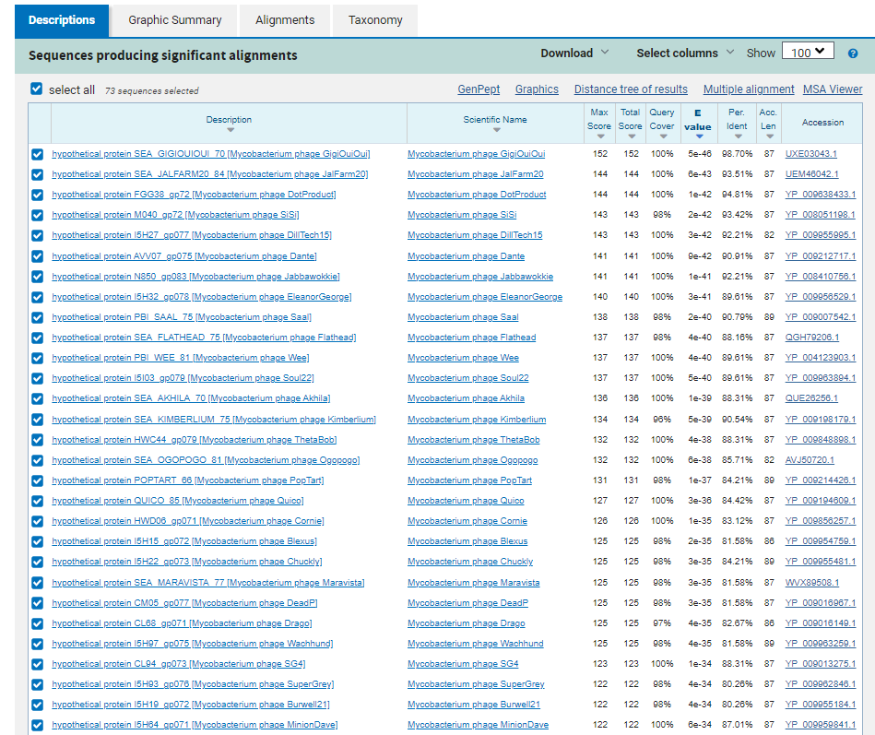
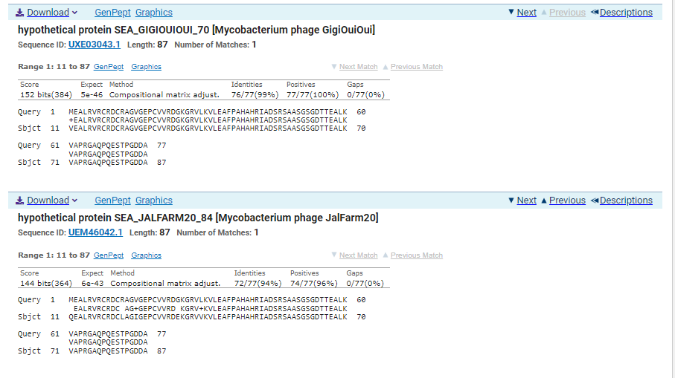
BLAST from NCBI (https://blast.ncbi.nlm.nih.gov/Blast.cgi?PAGE=Proteins) Using Longest ORF
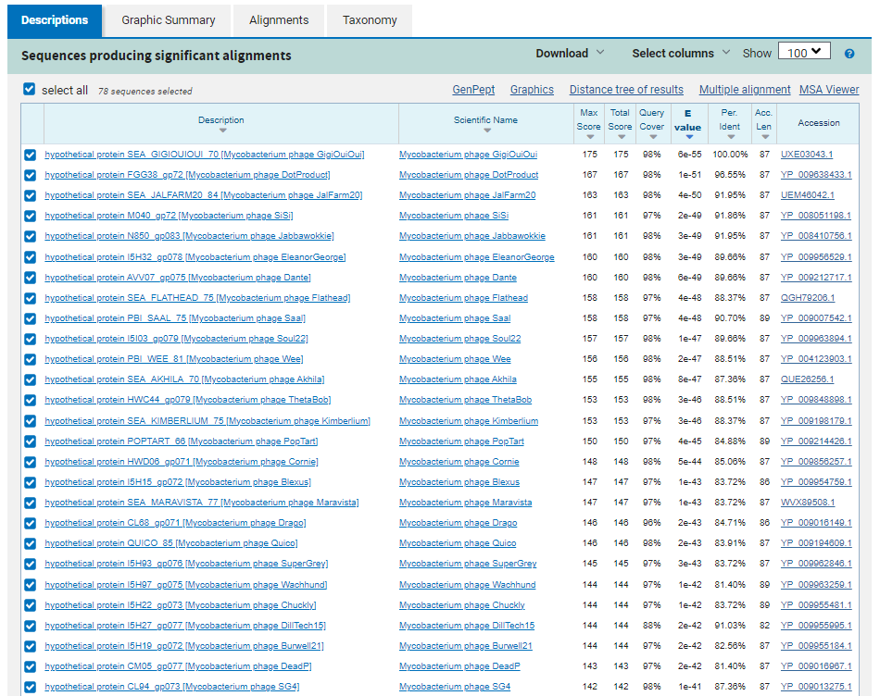
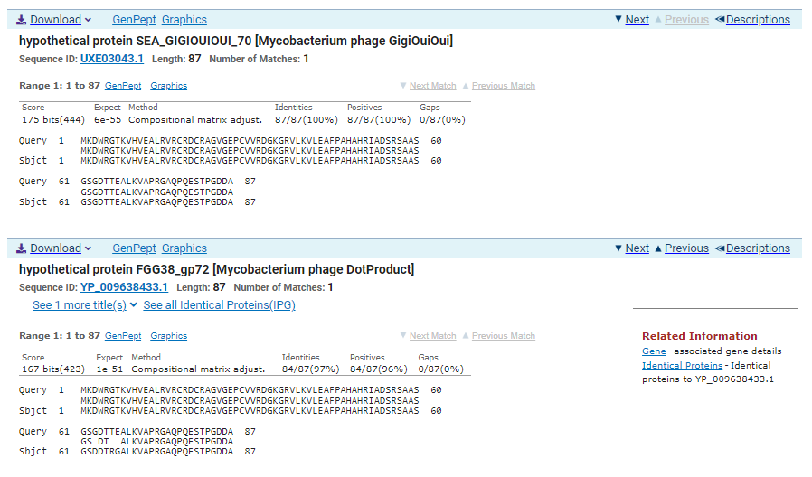
ATG Start at 45814. Glimmer Calls Start at 45844. Not called by Genemark.
TGA Stop at 46077
F/R: F
Coding Potential (y/n): Y
Starterator (SS, NA, NI): Does not have the Most Annotated Start
Blast Best Hit, Query:Subject Starts, Score, Evalue, or “no significant Blast alignments” if 10E-4 or higher
hypothetical protein SEA_GIGIOUIOUI_70 Mycobacterium phage GigiOuiOui UXE03043.1, 1:1, Score 175, Evalue, 6e-55
Gap with previous gene: -3
Longest Orf? (Y/N/NA) Y
RBS:
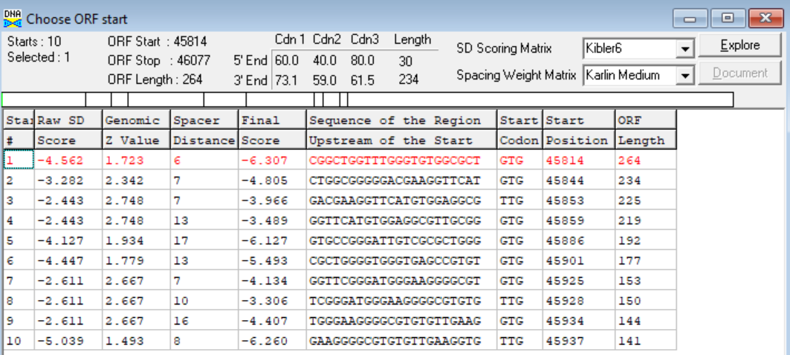
(https://toolkit.tuebingen.mpg.de/tools/hhpred) HHPRED vs PDB, SCOPe, pFam, and M. Tuberculosis. No Significant (>95%) Hits
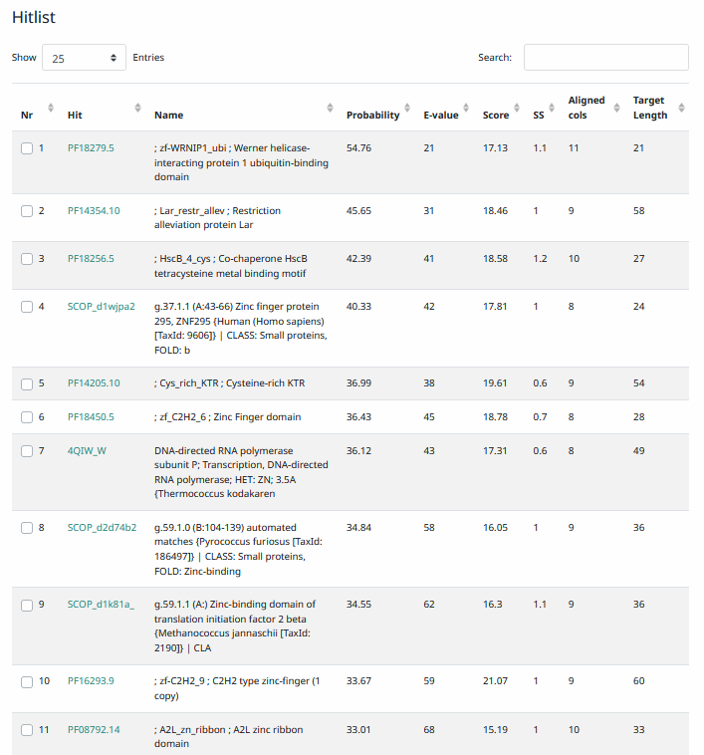
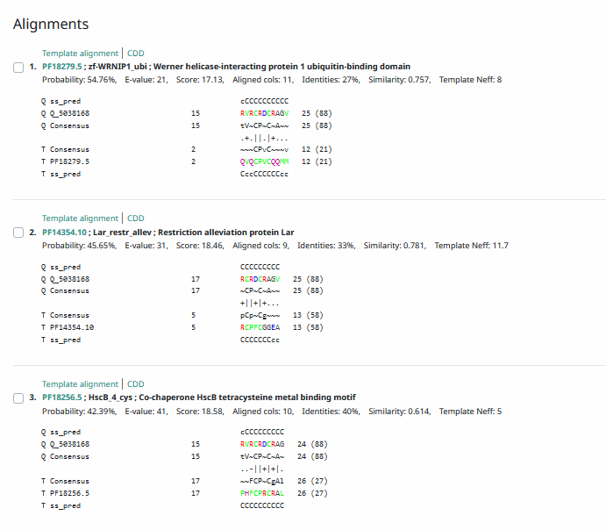
Phamerator Totinger Vs. Tootsieroll Vs. Starcevich (https://phamerator.org/phages) Genes 61-106
Proposed Function: hypothetical protein
Function Evidence: in Phamerator, similar phages (phage Tootsieroll and phage Starcevich) do not share the sequence but have hypothetical proteins called in this area. BLAST and HHPRED results most consistently hit this protein as one with an unknown function.
Transmembrane Domain/Evidence: No, Intracellular Properties (https://dtu.biolib.com/DeepTMHMM)
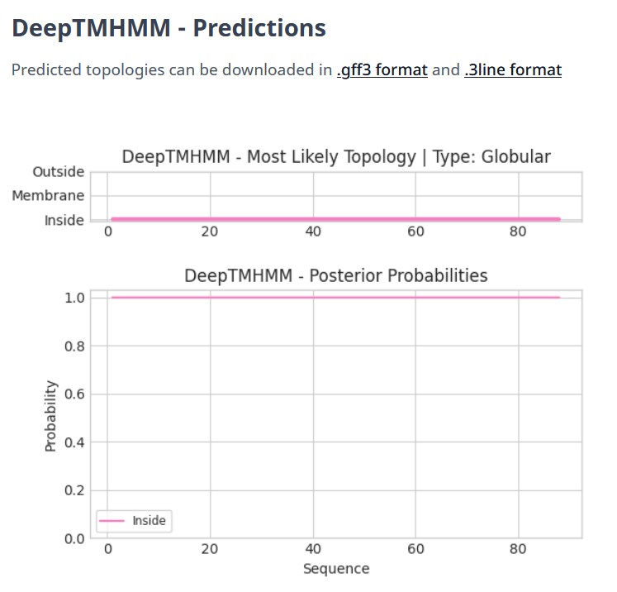

- ADDED NEW GENE NOT CALLED BY DNA MASTER. Information as follows.

Gene Number: 73
Pham – No Data for Start, Gene Added Manually
BLAST from PhagesDB. (https://phagesdb.org/blastp/) Using Longest ORF
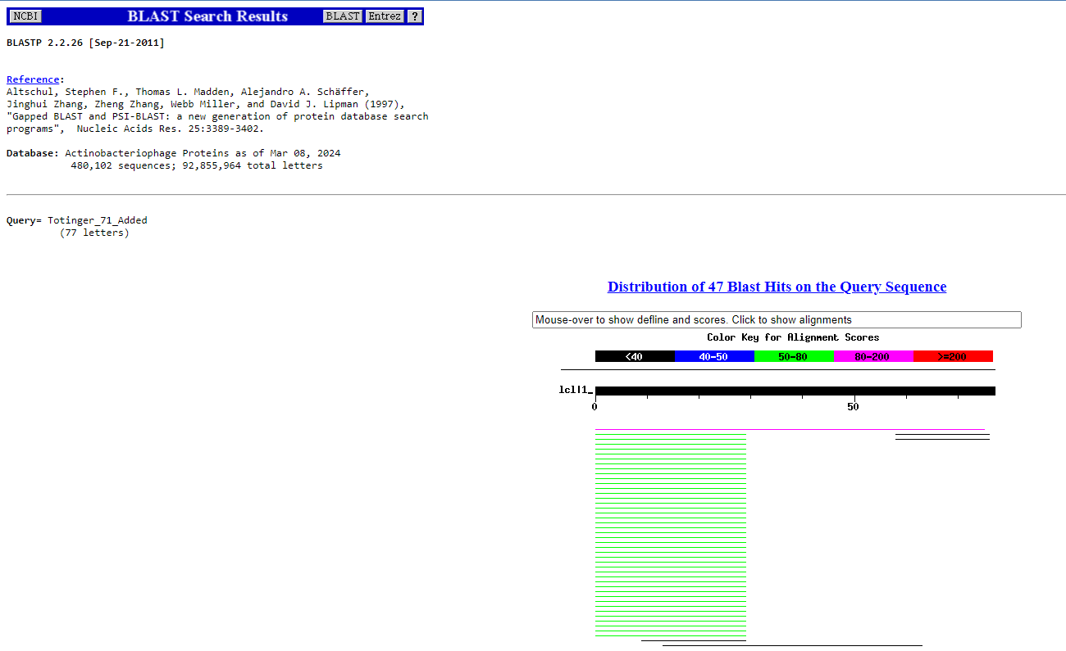
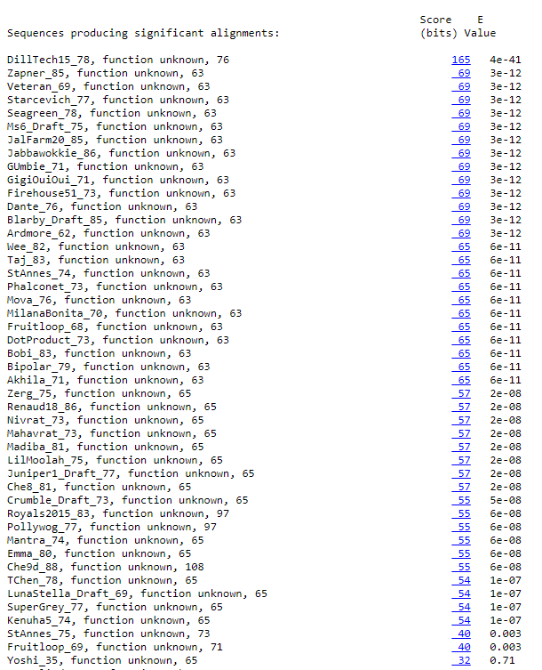
BLAST from NCBI (https://blast.ncbi.nlm.nih.gov/Blast.cgi?PAGE=Proteins) Using Longest ORF
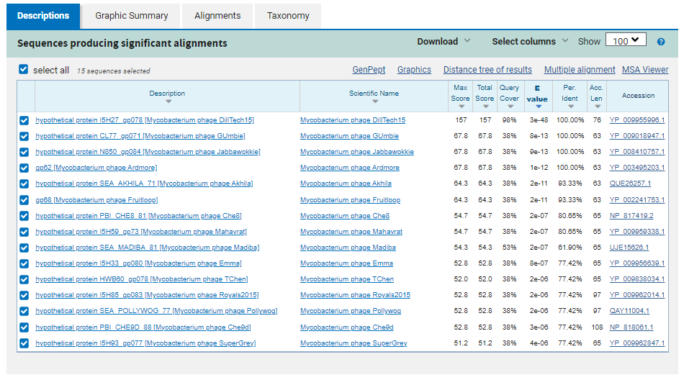
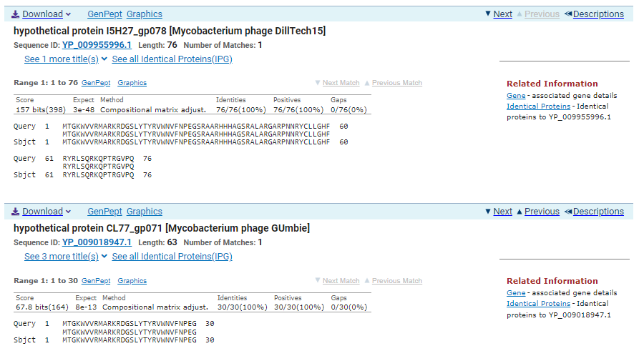
ATG Start at 46074. Original Genemark call, not called by Glimmer.
TGA Stop at 46374
F/R: F
Coding Potential (y/n): Y
Starterator (SS, NA, NI): No Data for Start, Gene added in Manually
Blast Best Hit, Query:Subject Starts, Score, Evalue, or “no significant Blast alignments” if 10E-4 or higher
hypothetical protein I5H27_gp078 Mycobacterium phage DillTech15 YP_009955996.1, 1:1, Score 157, Evalue, 3e-48
Gap with previous gene: -3
Longest Orf? (Y/N/NA) Y
RBS:
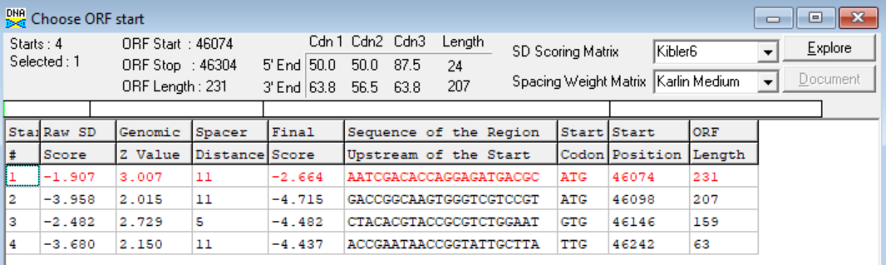
(https://toolkit.tuebingen.mpg.de/tools/hhpred) HHPRED vs PDB, SCOPe, pFam, and M. Tuberculosis.
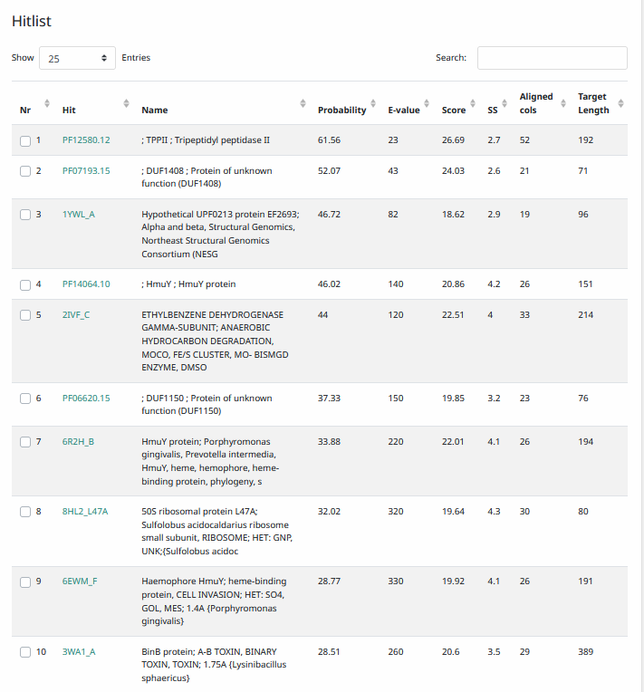
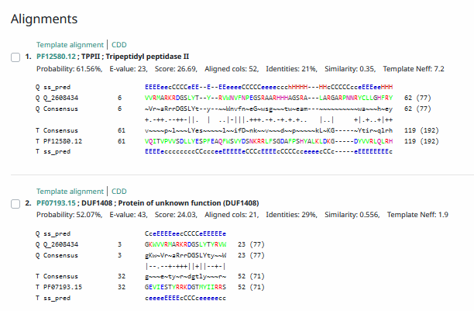
Phamerator Totinger Vs. DillTech15 (https://phamerator.org/phages) Genes 60-72
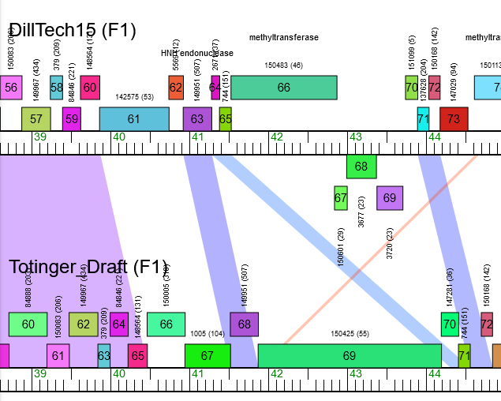
Proposed Function: hypothetical protein
Function Evidence: In Phamerator, phage Dilltech has a very similar sequence and calls a gene between Totinger’s now Gene 70 and Totinger’s now Gene 72. Additionally, BLAST and HHPRED results most consistently indicated a protein with unknown function.
Transmembrane Domain/Evidence: No, Intracellular Properties (https://dtu.biolib.com/DeepTMHMM)
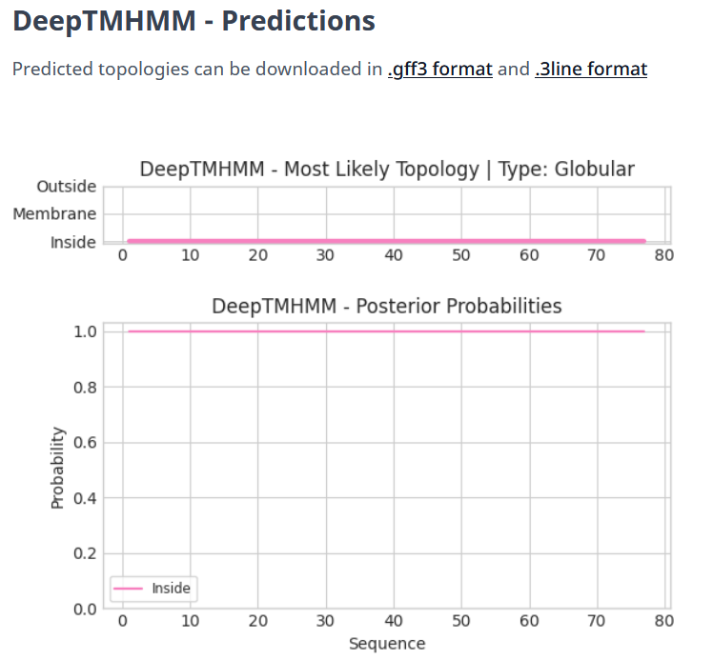

Gene Number: 74
Totinger_Draft_75 on Phagesdb
Pham141161
BLAST from PhagesDB. (https://phagesdb.org/blastp/) Using Longest ORF
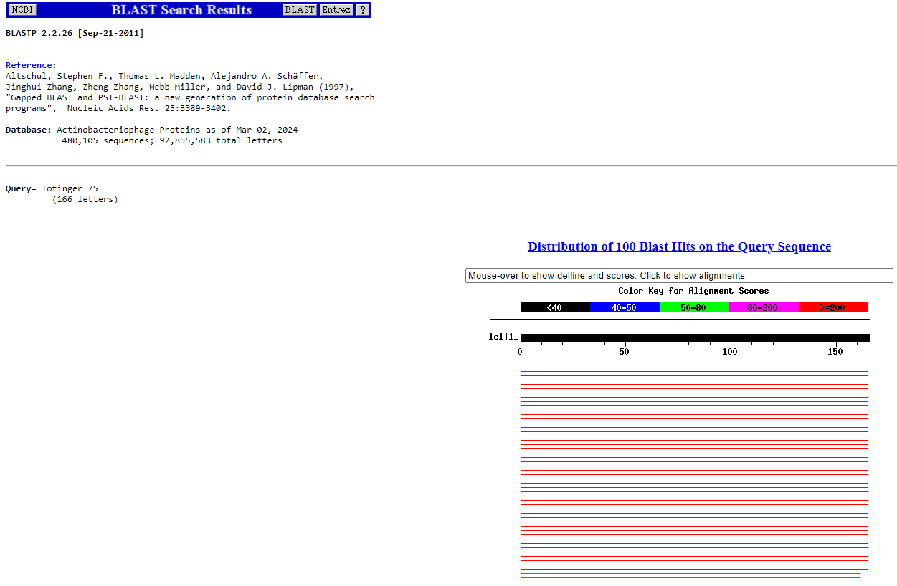
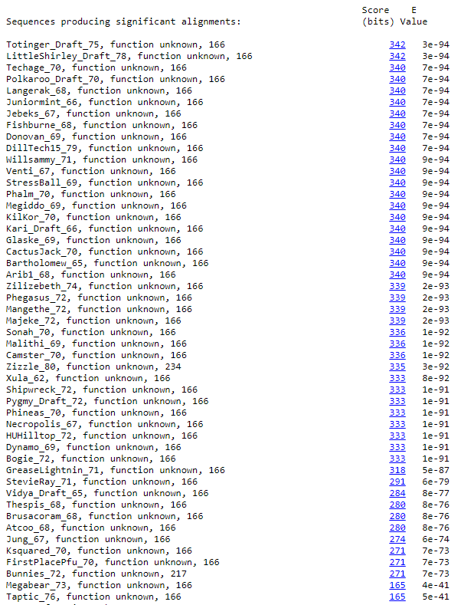
BLAST from NCBI (https://blast.ncbi.nlm.nih.gov/Blast.cgi?PAGE=Proteins) Using Longest ORF
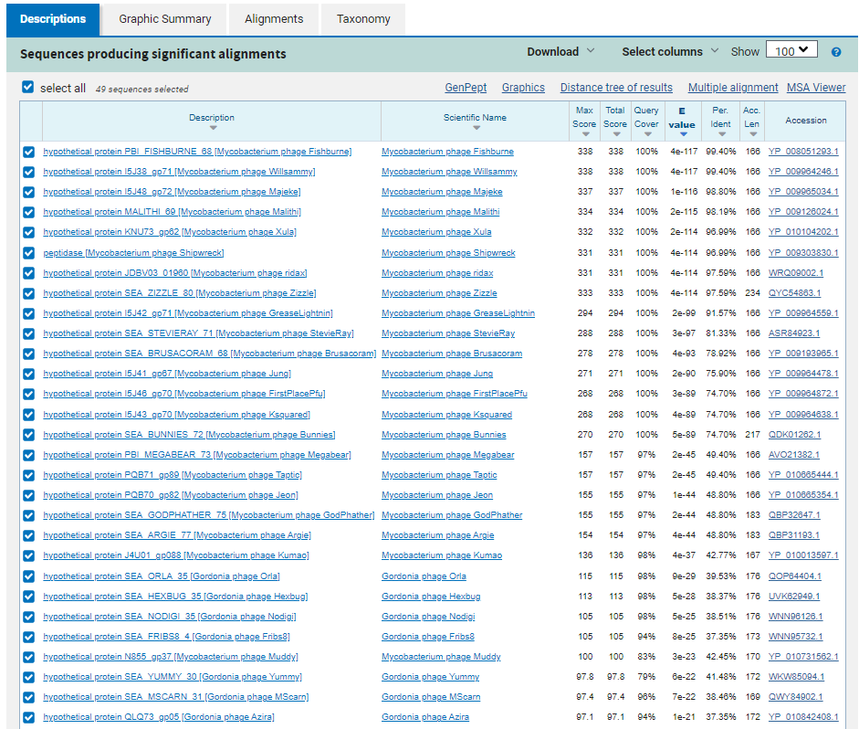
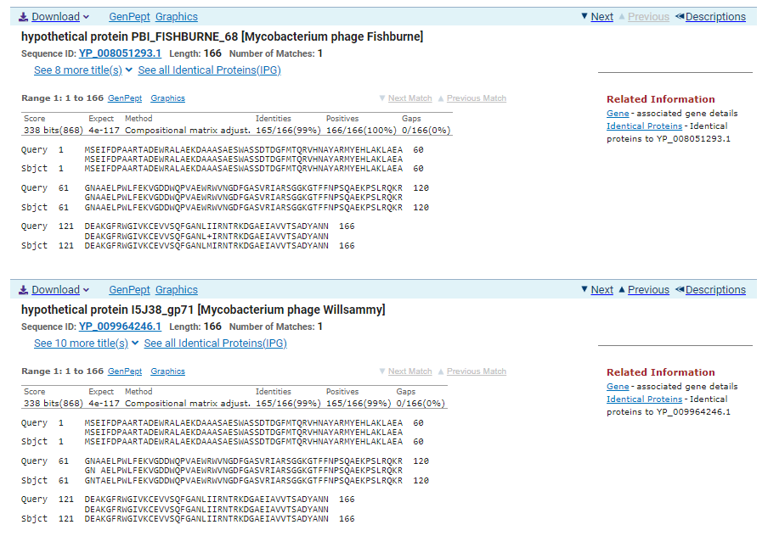
ATG Start at 46301. Original Glimmer call.
TGA Stop at 46801.
F/R: F
Coding Potential (y/n): Y
Starterator (SS, NA, NI): Most annotated start is this (46301)
Blast Best Hit, Query:Subject Starts, Score, Evalue, or “no significant Blast alignments” if 10E-4 or higher
hypothetical protein PBI_FISHBURNE_68 Mycobacterium phage Fishburne YP_008051293.1, 1:1, Score 338, Evalue, 4e-117
Gap with previous gene: 224
Longest Orf? (Y/N/NA)
RBS:
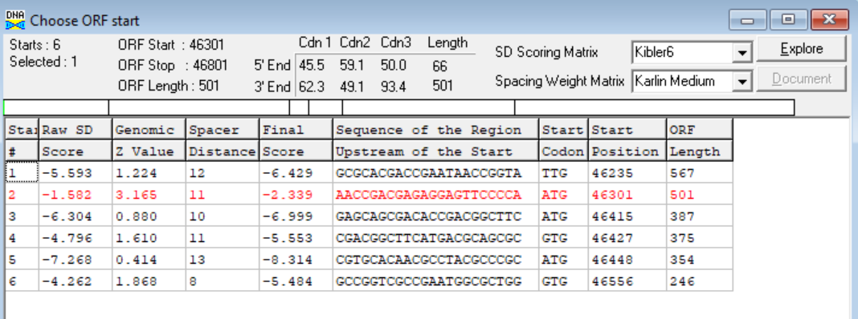
(https://toolkit.tuebingen.mpg.de/tools/hhpred) HHPRED vs PDB, SCOPe, pFam, and M. Tuberculosis. No Significant (>95%) Hits
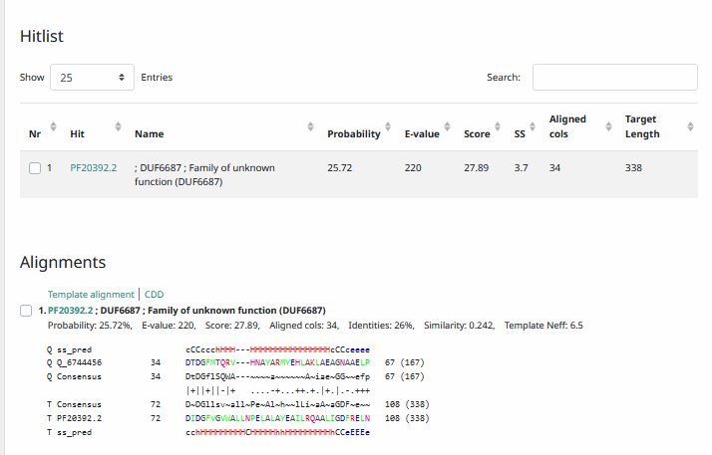
Phamerator Totinger Vs. Tootsieroll Vs. Starcevich (https://phamerator.org/phages) Genes 61-106
Proposed Function: hypothetical protein
Function Evidence: BLAST and HHPRED results most consistently align with proteins of unknown function in other phages. Similar genes (but not identical) in Phamerator also have no called function.
Transmembrane Domain/Evidence: No, Intracellular Properties (https://dtu.biolib.com/DeepTMHMM)
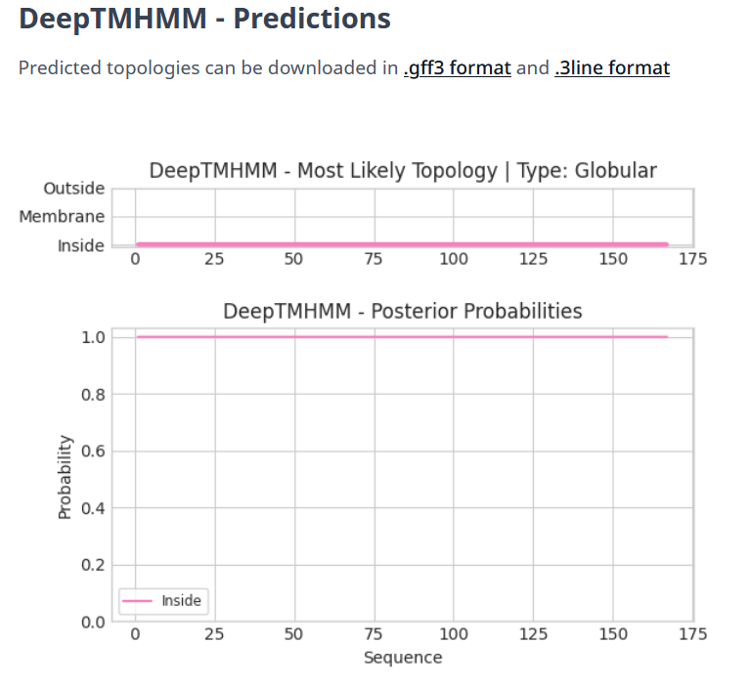

Gene Number: 75
Totinger_Draft_76 on Phagesdb
Pham2443
BLAST from PhagesDB. (https://phagesdb.org/blastp/) Using Longest ORF
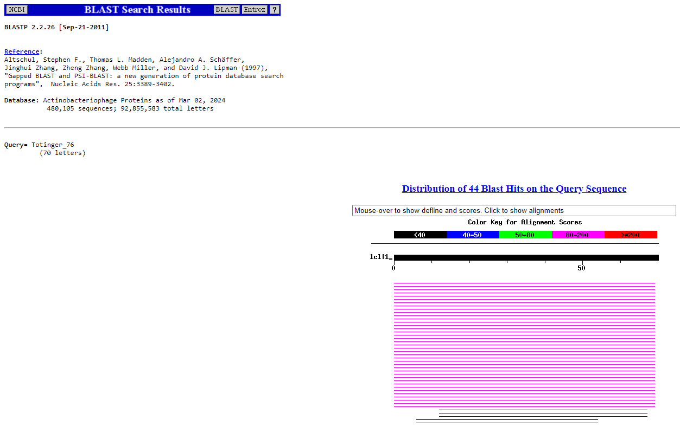
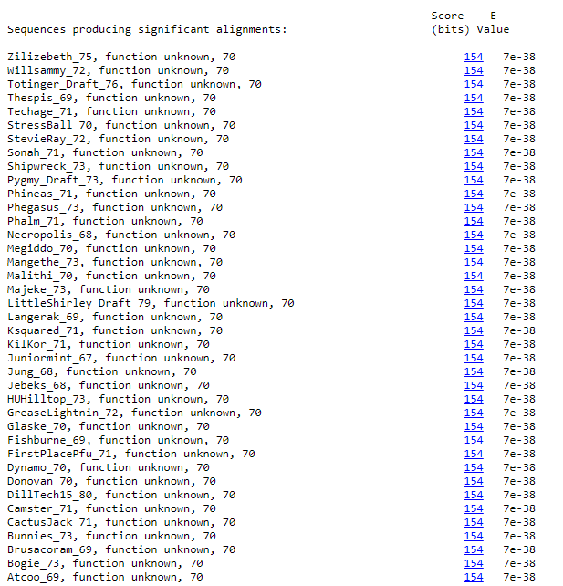
BLAST from NCBI (https://blast.ncbi.nlm.nih.gov/Blast.cgi?PAGE=Proteins) Using Longest ORF
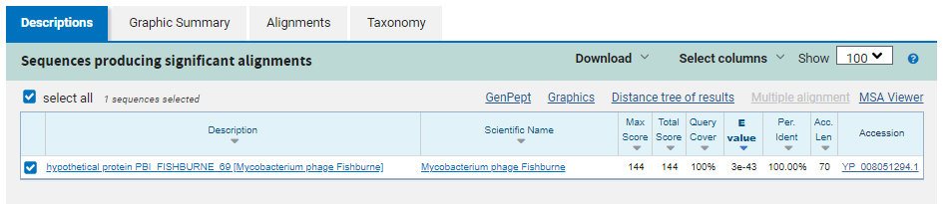
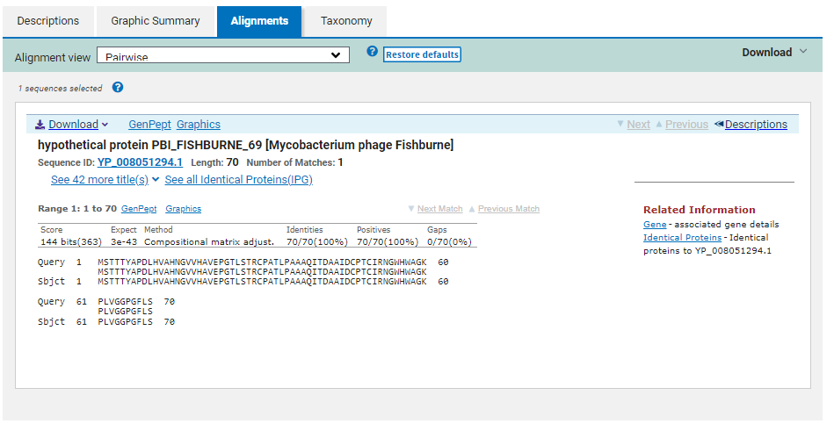
ATG Start at 46877. Original Glimmer call.
TGA Stop at 47089
F/R: F
Coding Potential (y/n): Y
Starterator (SS, NA, NI): Most annotated start is this (46877)
Blast Best Hit, Query:Subject Starts, Score, Evalue, or “no significant Blast alignments” if 10E-4 or higher
Hypothetical protein PBI_FISHBURNE_69 Mycobacterium phage Fishburne YP_008051294.1, 1:1, Score 144, Evalue, 3e-43
Gap with previous gene: 76
Longest Orf? (Y/N/NA) Y
RBS:
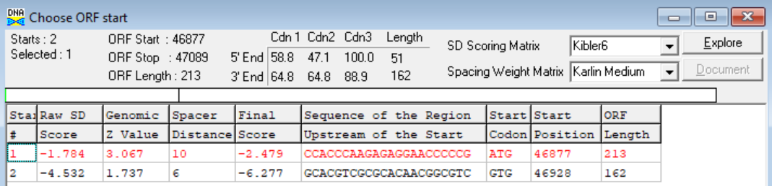
(https://toolkit.tuebingen.mpg.de/tools/hhpred) HHPRED vs PDB, SCOPe, pFam, and M. Tuberculosis. No Significant (>95%) Hits
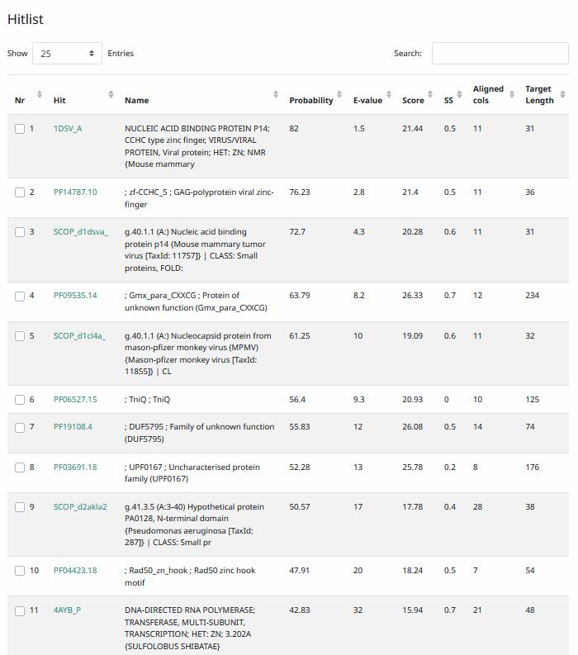
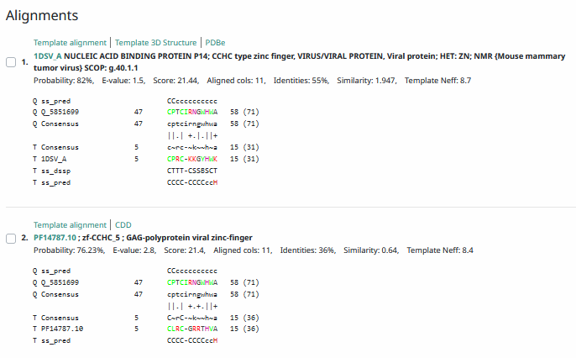
Phamerator Totinger Vs. Tootsieroll Vs. Starcevich (https://phamerator.org/phages) Genes 61-106
Totinger vs Fishburne Genes 59-82
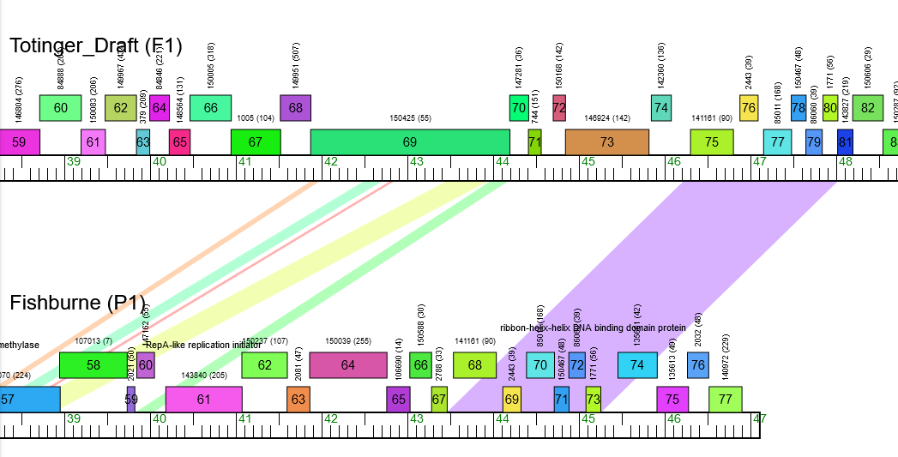
Proposed Function: hypothetical protein
Function Evidence: BLAST and HHPRED results indicate a protein that is there, but functions are not known. While the standard two selected phages in Phamerator (phage Starcevich and phage Tootsieroll) do not have a shared sequence, phage Fishburne has an identical gene called that also shares an unknown function.
Transmembrane Domain/Evidence: No, Intracellular Properties (https://dtu.biolib.com/DeepTMHMM)
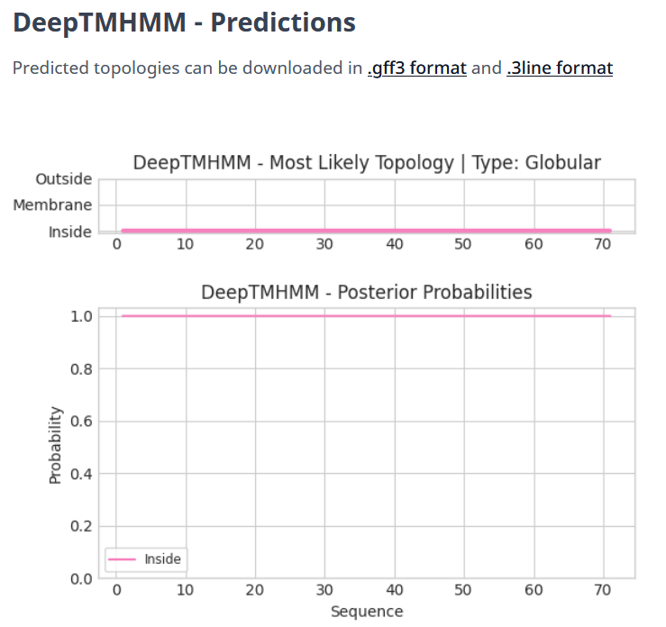

Gene Number: 76
Totinger_Draft_77 on Phagesdb
Pham85011
BLAST from PhagesDB. (https://phagesdb.org/blastp/) Using Longest ORF
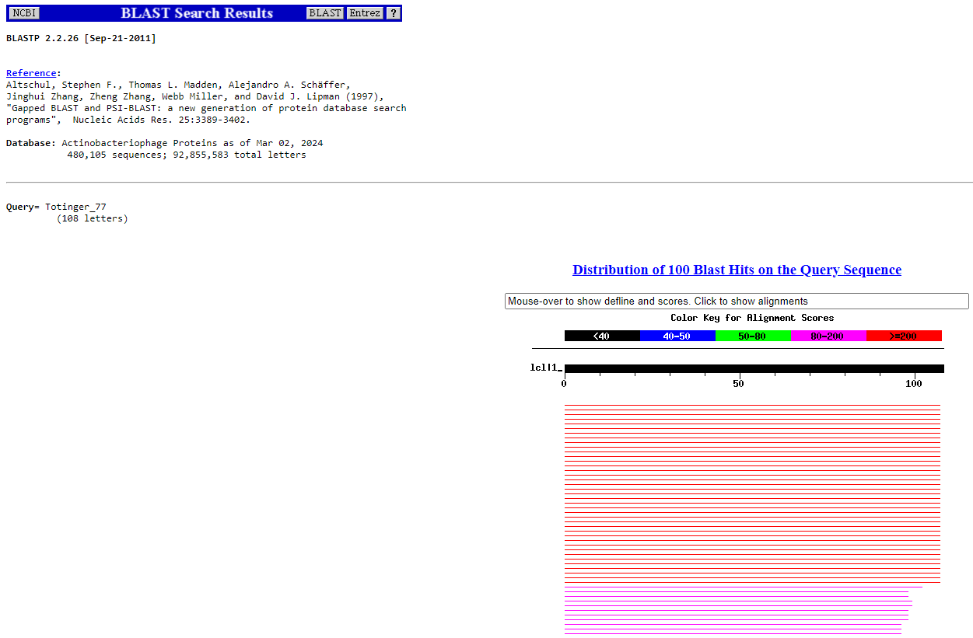
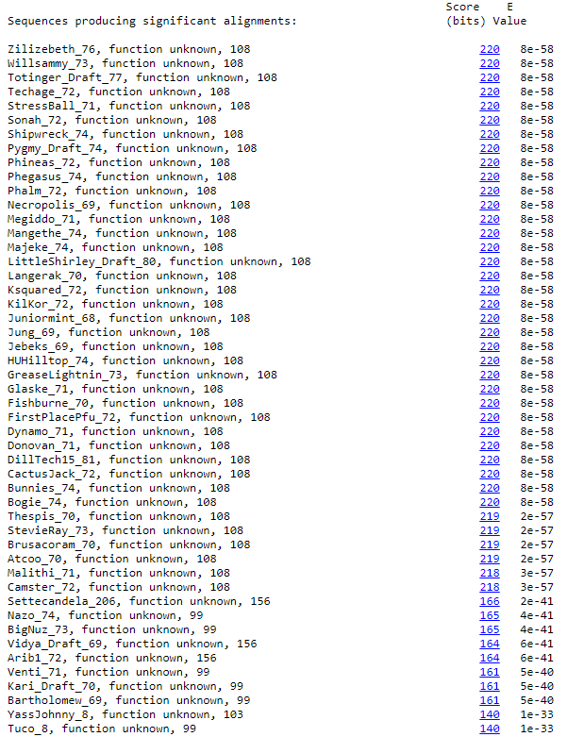
BLAST from NCBI (https://blast.ncbi.nlm.nih.gov/Blast.cgi?PAGE=Proteins) Using Longest ORF
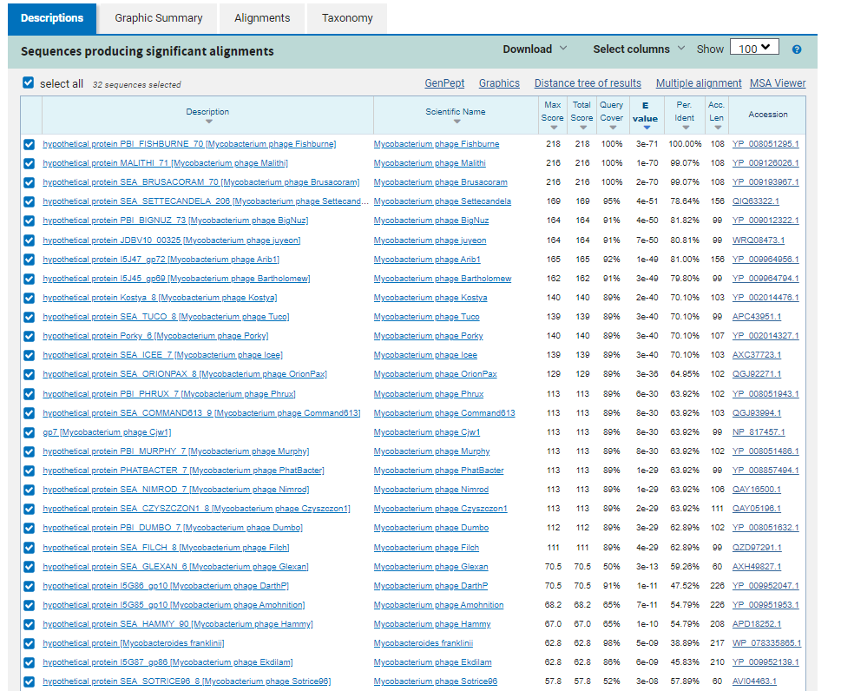
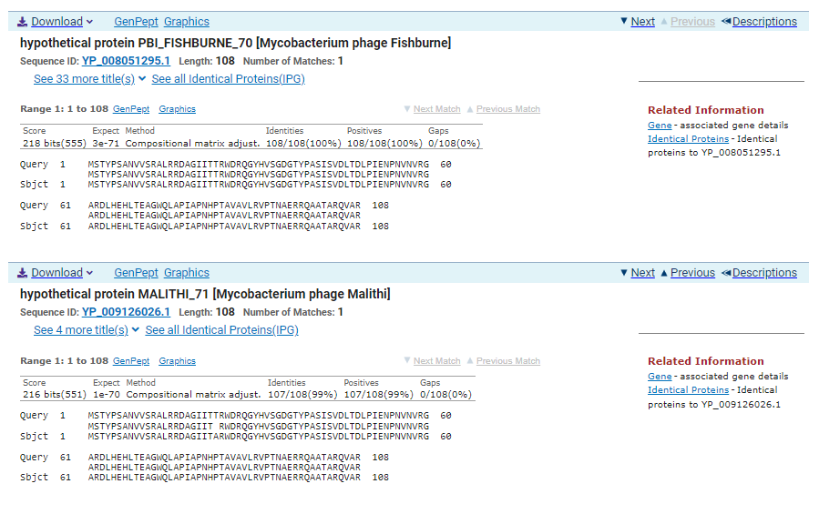
ATG Start at 47153. Original Glimmer call.
TGA Stop at 47479
F/R: F
Coding Potential (y/n): Y
Starterator (SS, NA, NI): Most annotated start is this (47153)
Blast Best Hit, Query:Subject Starts, Score, Evalue, or “no significant Blast alignments” if 10E-4 or higher
Portal protein Mycobacterium phage Job42 YP_008126594.1, 1:1, Score 2458, Evalue, 0
Gap with previous gene: 64
Longest Orf? (Y/N/NA) Y
RBS:
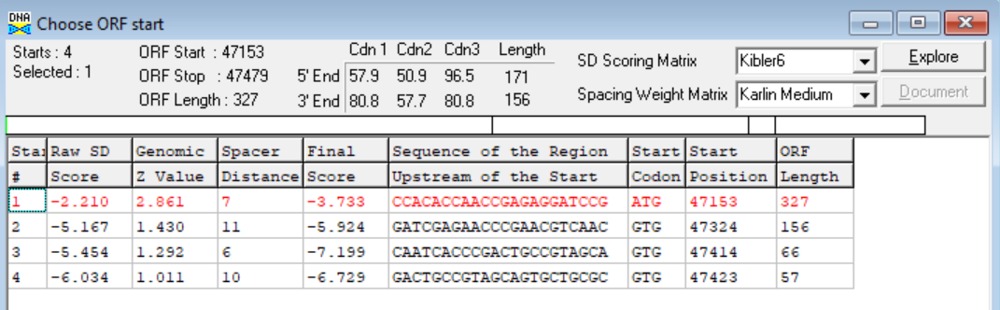
(https://toolkit.tuebingen.mpg.de/tools/hhpred) HHPRED vs PDB, SCOPe, pFam, and M. Tuberculosis.
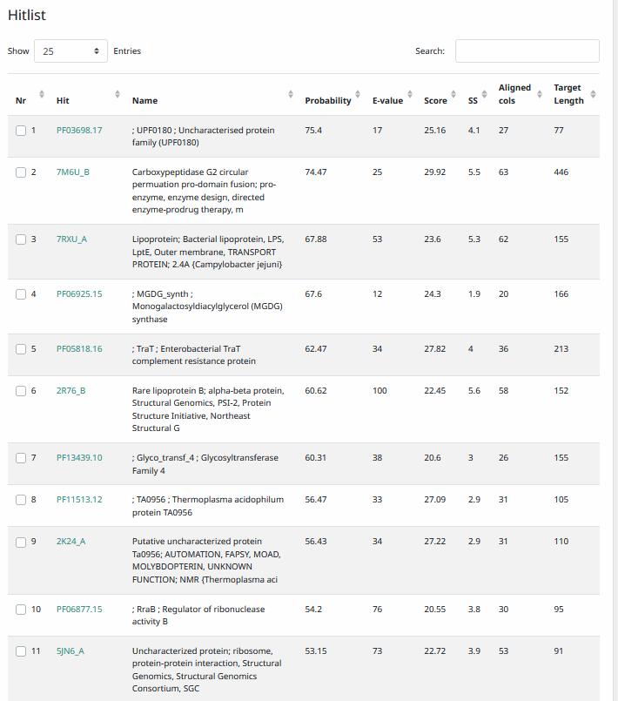
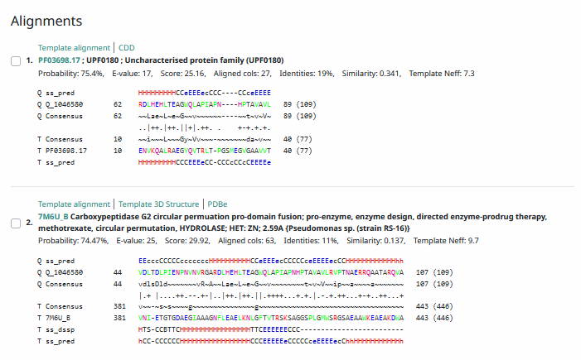
Phamerator Totinger Vs. Tootsieroll Vs. Starcevich (https://phamerator.org/phages) Genes 61-106
Totinger vs Fishburne Genes 59-82
Proposed Function: hypothetical protein
Function Evidence: In Phamerator, phage Fishburne calls an identical gene that has an unknown function. Additionally, BLAST and HHPRED results most consistently call this gene as a protein with unknown function.
Transmembrane Domain/Evidence: No, Intracellular Properties (https://dtu.biolib.com/DeepTMHMM)
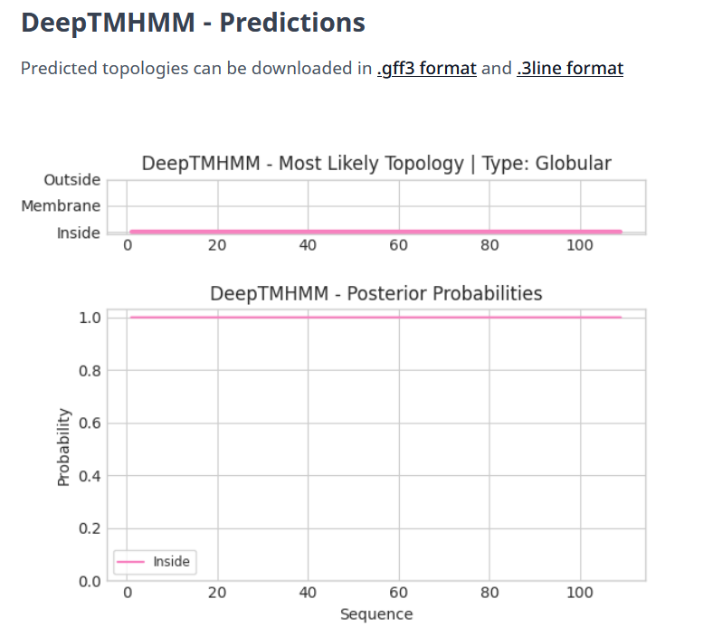

Gene Number: 77
Totinger_Draft_78 on Phagesdb
Pham150467
BLAST from PhagesDB. (https://phagesdb.org/blastp/) Using Longest ORF
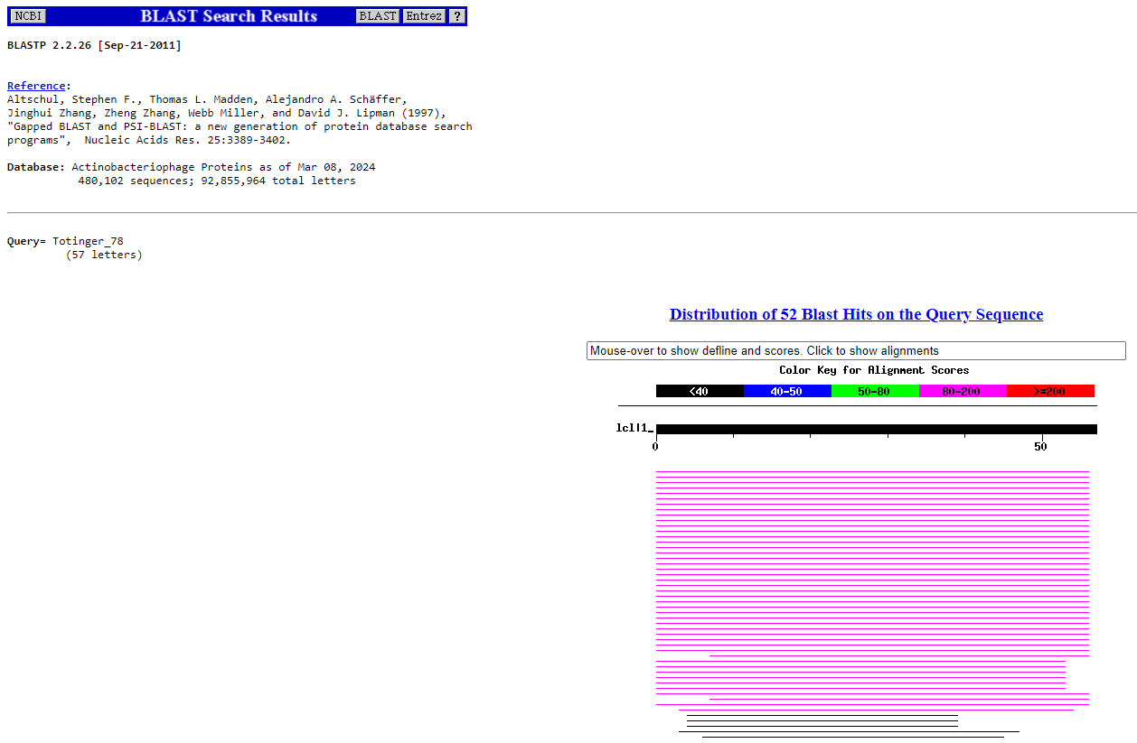
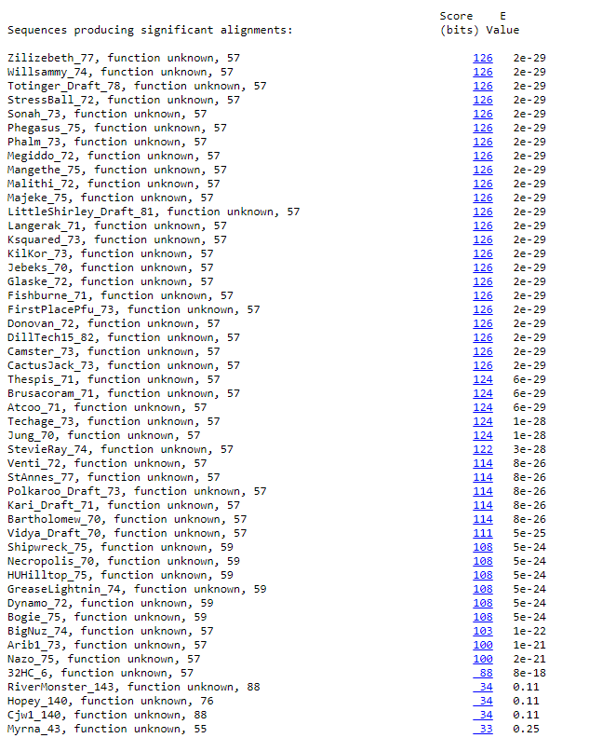
BLAST from NCBI (https://blast.ncbi.nlm.nih.gov/Blast.cgi?PAGE=Proteins) Using Longest ORF
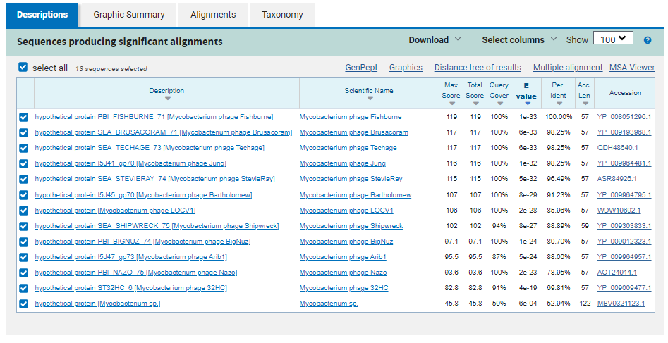
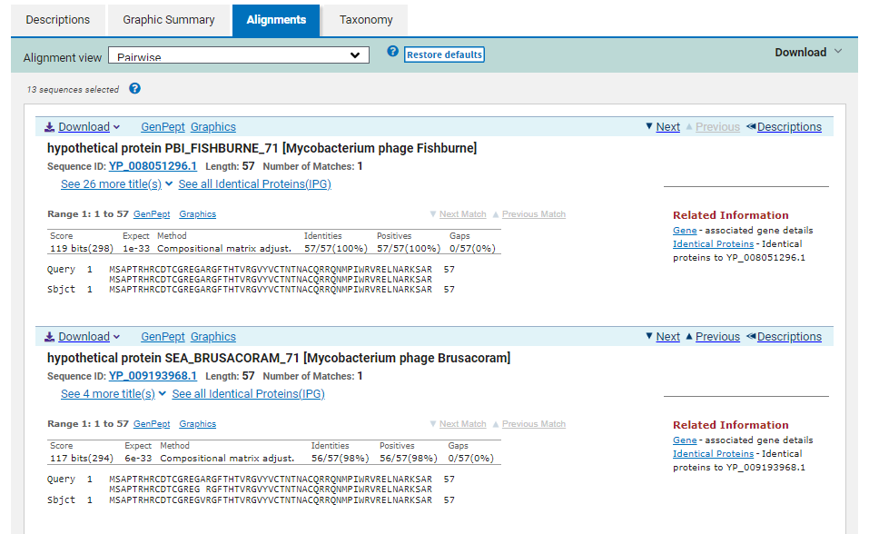
ATG Start at 47476. Original Glimmer call, not called by Genemark.
TGA Stop at 47649
F/R: F
Coding Potential (y/n): Y
Starterator (SS, NA, NI): Most annotated start is this (47476)
Blast Best Hit, Query:Subject Starts, Score, Evalue, or “no significant Blast alignments” if 10E-4 or higher
hypothetical protein PBI_FISHBURNE_71 Mycobacterium phage Fishburne YP_008051296.1, 1:1, Score 119, Evalue, 1e-33
Gap with previous gene: -3
Longest Orf? (Y/N/NA) N
RBS:
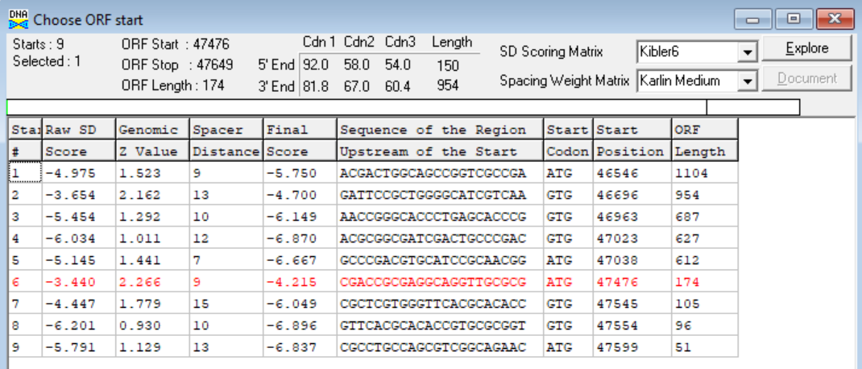
(https://toolkit.tuebingen.mpg.de/tools/hhpred) HHPRED vs PDB, SCOPe, pFam, and M. Tuberculosis. No Significant (>95%) Hits
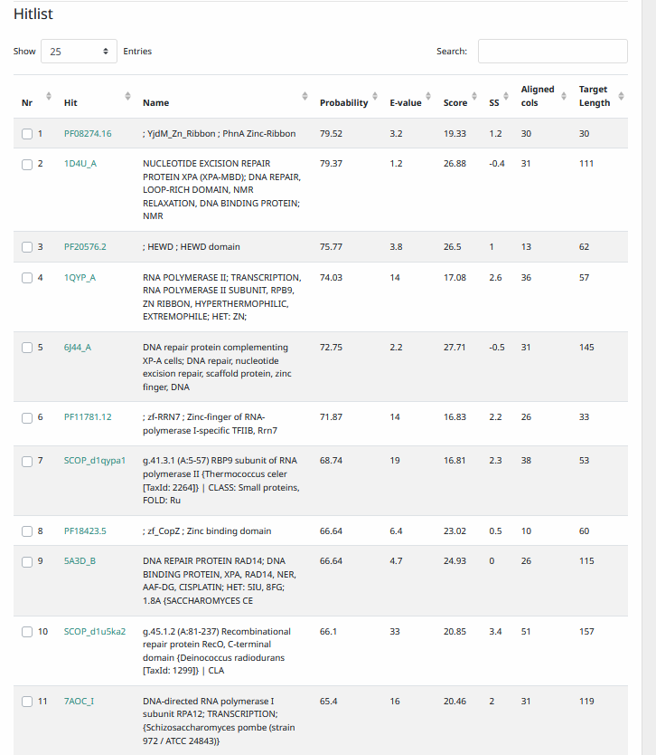
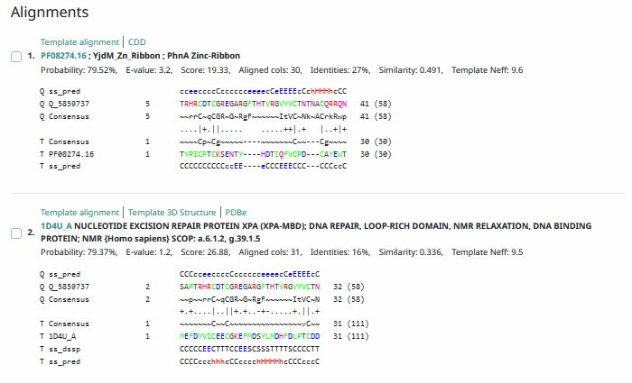
Phamerator Totinger Vs. Tootsieroll Vs. Starcevich (https://phamerator.org/phages) Genes 61-106
Totinger vs Fishburne Genes 59-82
Proposed Function: hypothetical protein
Function Evidence: In Phamerator, phage Fishburne calls an identical gene while having a near identical sequence, calling it as a hypothetical protein. Additionally, BLAST and HHPRED results most consistently align with proteins of unknown function in other phages.
Transmembrane Domain/Evidence: No, Intracellular Properties (https://dtu.biolib.com/DeepTMHMM)
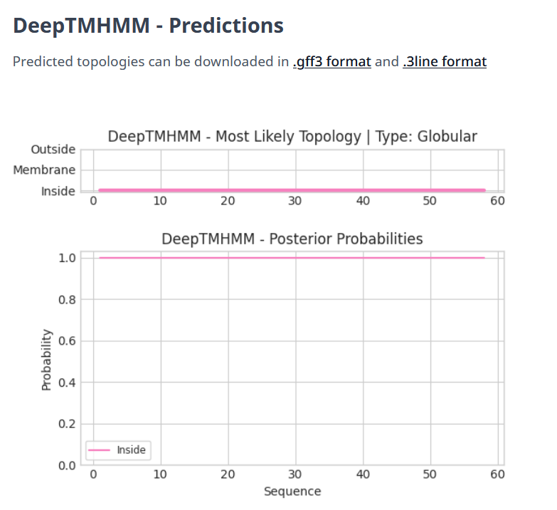

Gene Number: 78
Totinger_Draft_79 on Phagesdb
Pham86060
BLAST from PhagesDB. (https://phagesdb.org/blastp/) Using Longest ORF
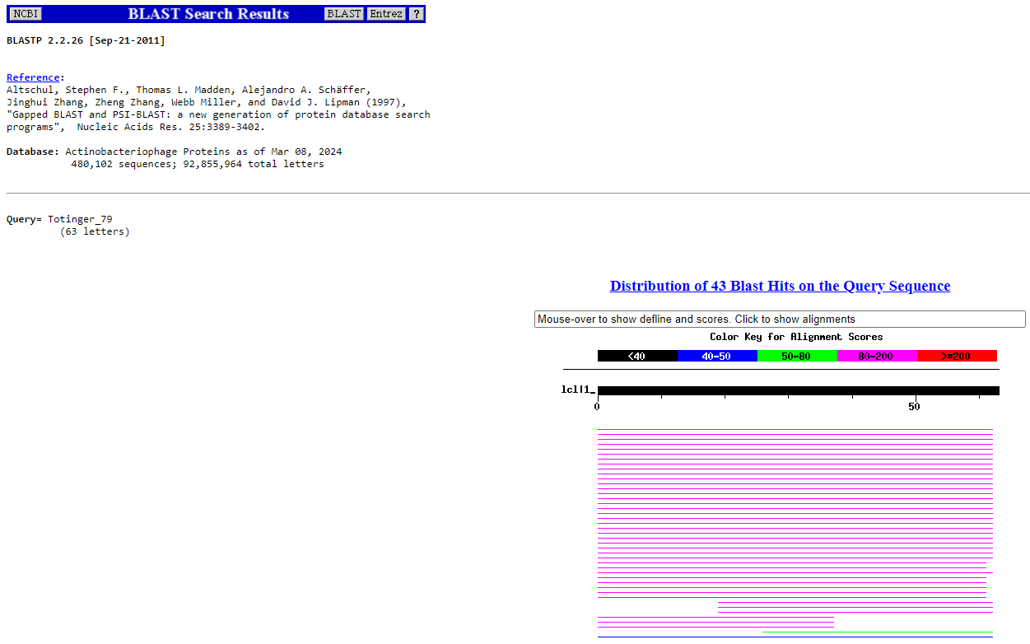
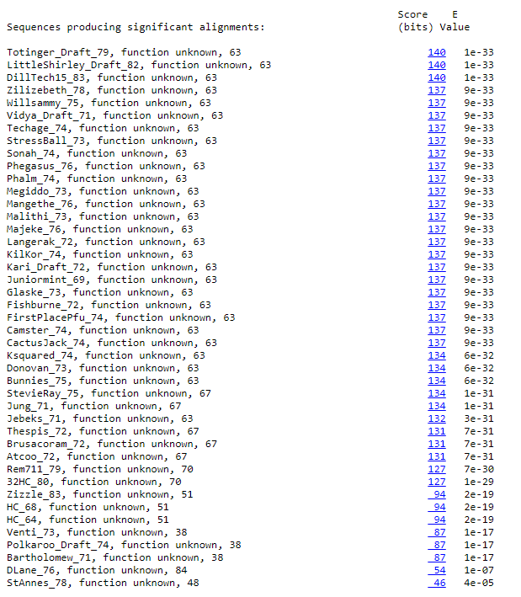
BLAST from NCBI (https://blast.ncbi.nlm.nih.gov/Blast.cgi?PAGE=Proteins) Using Longest ORF
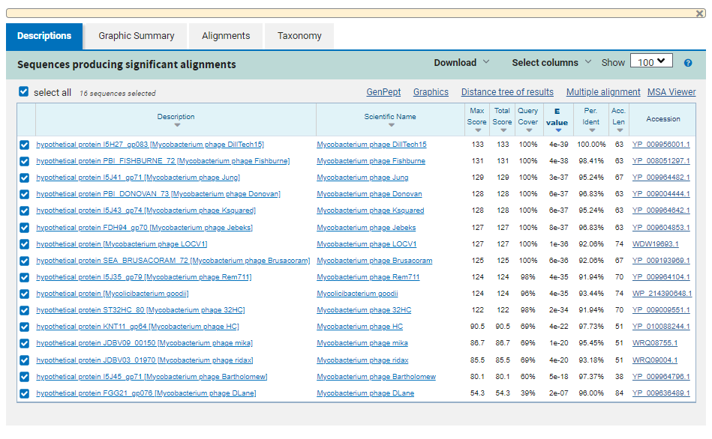
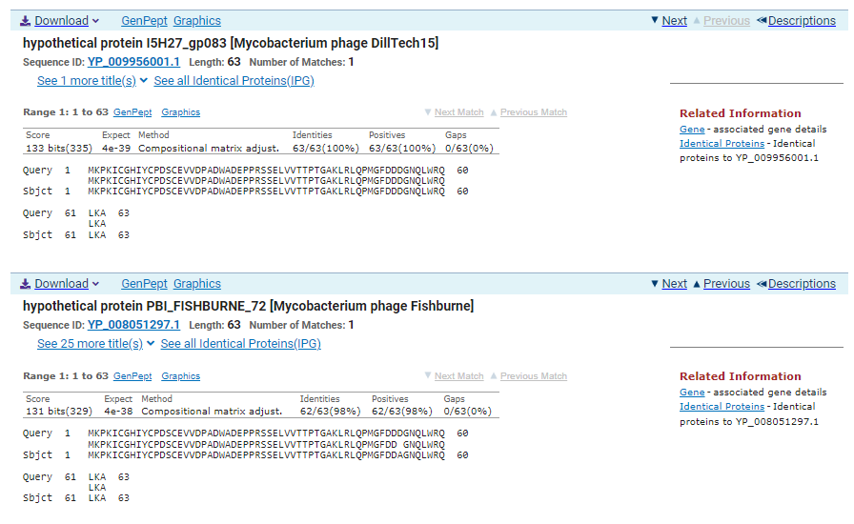
ATG Start at 47646. Original Glimmer call.
TGA Stop at 47837
F/R: F
Coding Potential (y/n): Y
Starterator (SS, NA, NI): Most annotated start is this (47646)
Blast Best Hit, Query:Subject Starts, Score, Evalue, or “no significant Blast alignments” if 10E-4 or higher
hypothetical protein I5H27_gp083 Mycobacterium phage DillTech15 YP_009956001.1, 1:1, Score 133, Evalue, 4e-39
Gap with previous gene: -3
Longest Orf? (Y/N/NA) N
RBS:
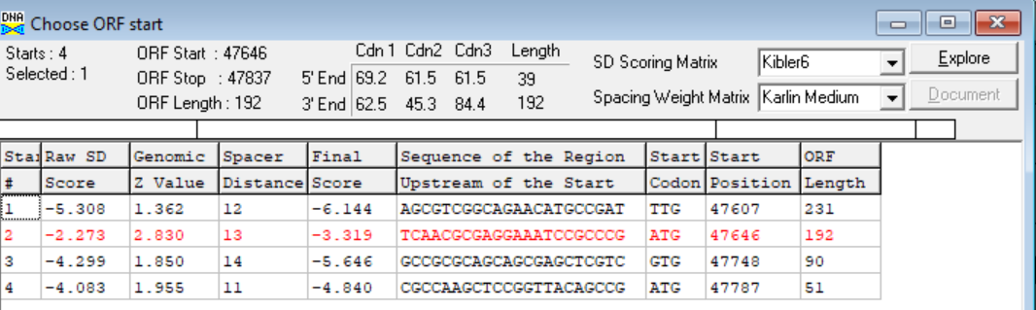
(https://toolkit.tuebingen.mpg.de/tools/hhpred) HHPRED vs PDB, SCOPe, pFam, and M. Tuberculosis. No Significant (>95%) Hits
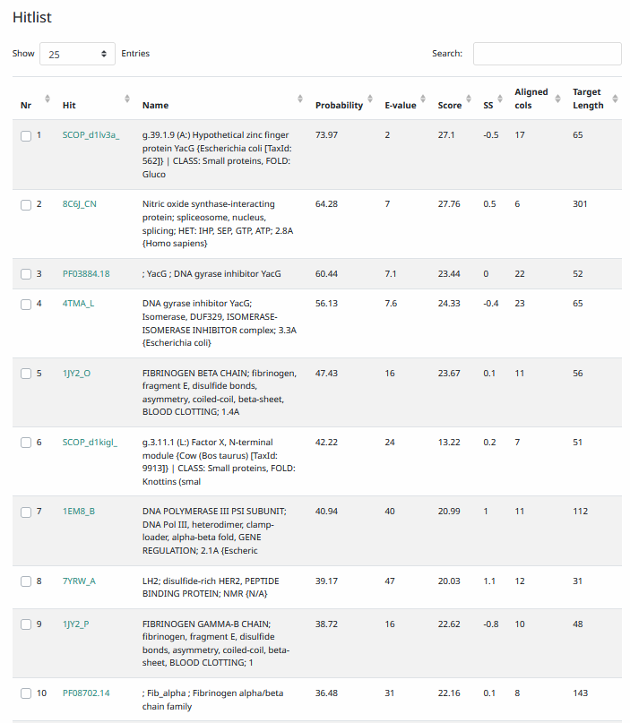
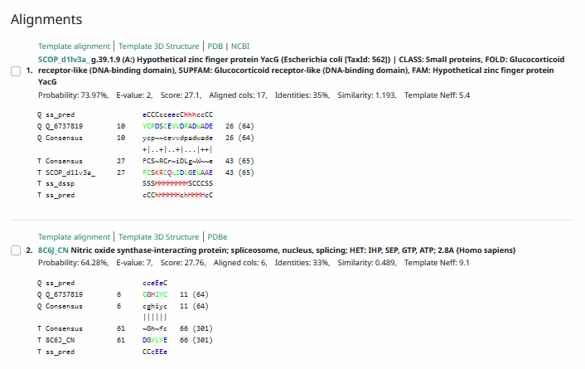
Phamerator Totinger Vs. Tootsieroll Vs. Starcevich (https://phamerator.org/phages) Genes 61-106
Totinger vs Fishburne Genes 59-82
Proposed Function: hypothetical protein
Function Evidence: BLASTs and HHPRED call this gene as a hypothetical protein most consistently. In Phamerator, phage Fishburne also calls this gene but does not call a function for it.
Transmembrane Domain/Evidence: No, Intracellular Properties (https://dtu.biolib.com/DeepTMHMM)
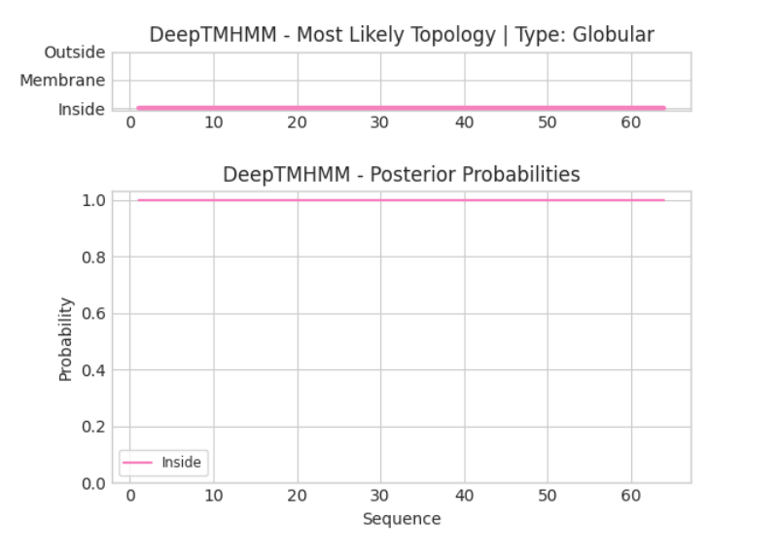

Gene Number: 79
Totinger_Draft_80 on Phagesdb
Pham1771
BLAST from PhagesDB. (https://phagesdb.org/blastp/) Using Longest ORF
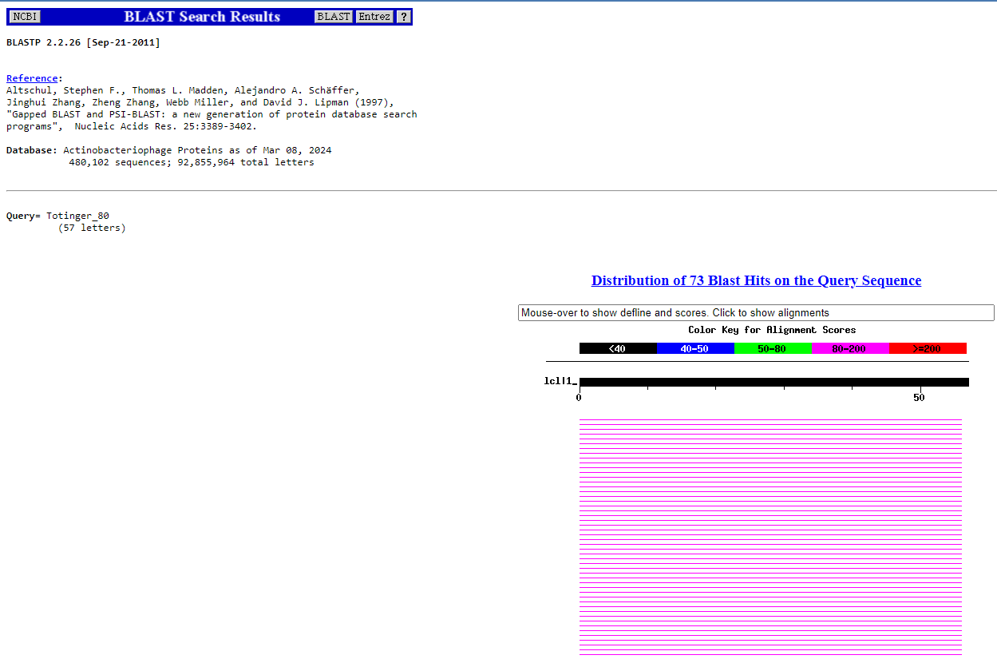
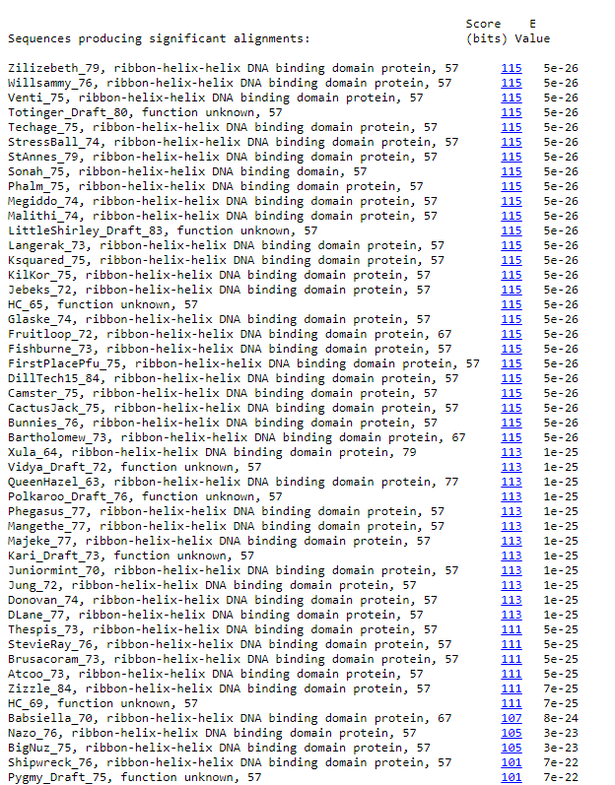
BLAST from NCBI (https://blast.ncbi.nlm.nih.gov/Blast.cgi?PAGE=Proteins) Using Longest ORF
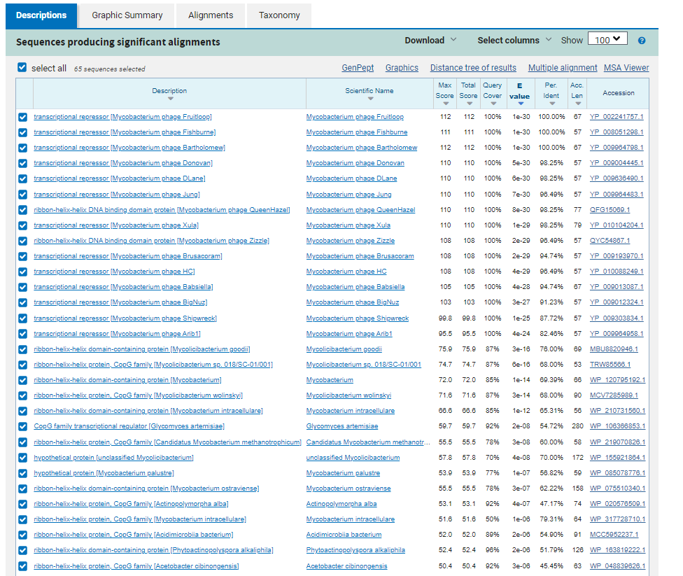
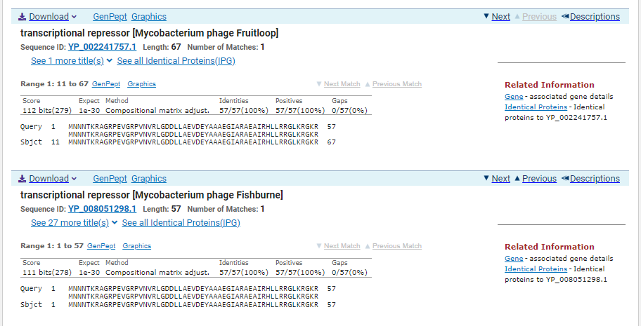
ATG Start at 47846. Original Glimmer call.
TGA Stop at 48019
F/R: F
Coding Potential (y/n): Y
Starterator (SS, NA, NI): Most annotated start is this (47846)
Blast Best Hit, Query:Subject Starts, Score, Evalue, or “no significant Blast alignments” if 10E-4 or higher
transcriptional repressor Mycobacterium phage Fruitloop YP_002241757.1, 11:67, Score 112, Evalue, 1e-30
Gap with previous gene: 9
Longest Orf? (Y/N/NA) N
RBS:
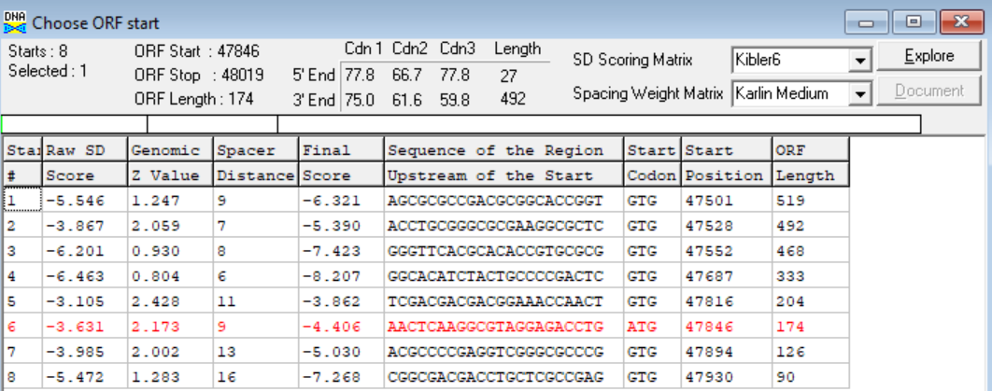
(https://toolkit.tuebingen.mpg.de/tools/hhpred) HHPRED vs PDB, SCOPe, pFam, and M. Tuberculosis.
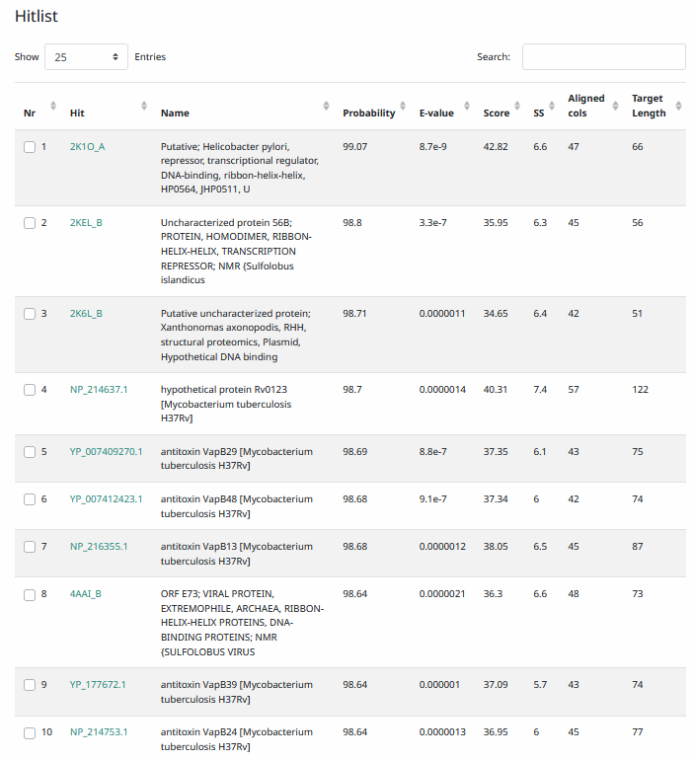
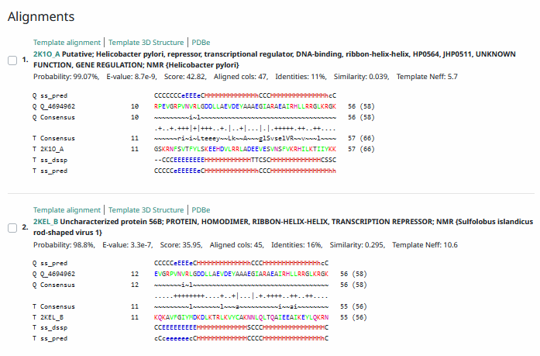
Phamerator Totinger Vs. Tootsieroll Vs. Starcevich (https://phamerator.org/phages) Genes 61-106
Totinger vs Fishburne Genes 59-82
Proposed Function: helix-turn-helix DNA binding protein
Function Evidence: In Phamerator, phage Fishburne has an identical gene called from an identical sequence, and it is called as a ribbon-helix-helix DNA binding domain protein. BLASTs and HHPRED most consistently called this protein as a helix-turn-helix DNA binding protein, or a transcriptional repressor.
Transmembrane Domain/Evidence: No, Intracellular Properties (https://dtu.biolib.com/DeepTMHMM)
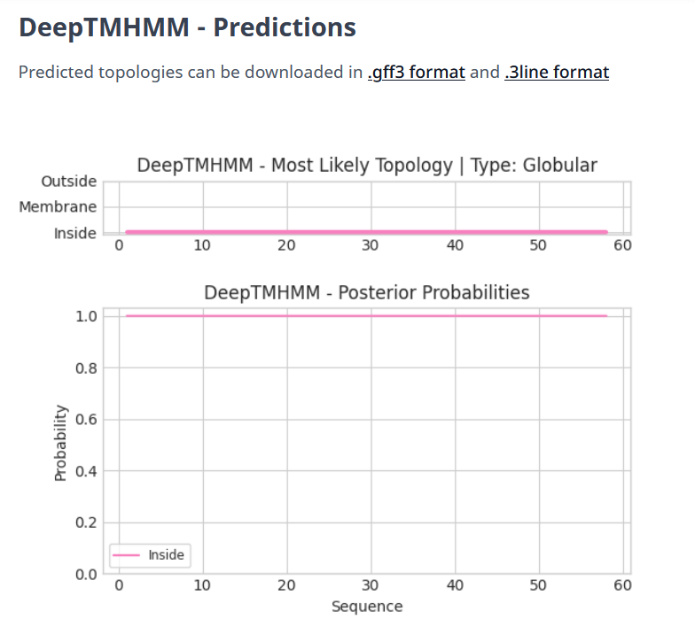

Gene Number: 80
Totinger_Draft_81 on Phagesdb
Pham143827
BLAST from PhagesDB. (https://phagesdb.org/blastp/) Using Longest ORF
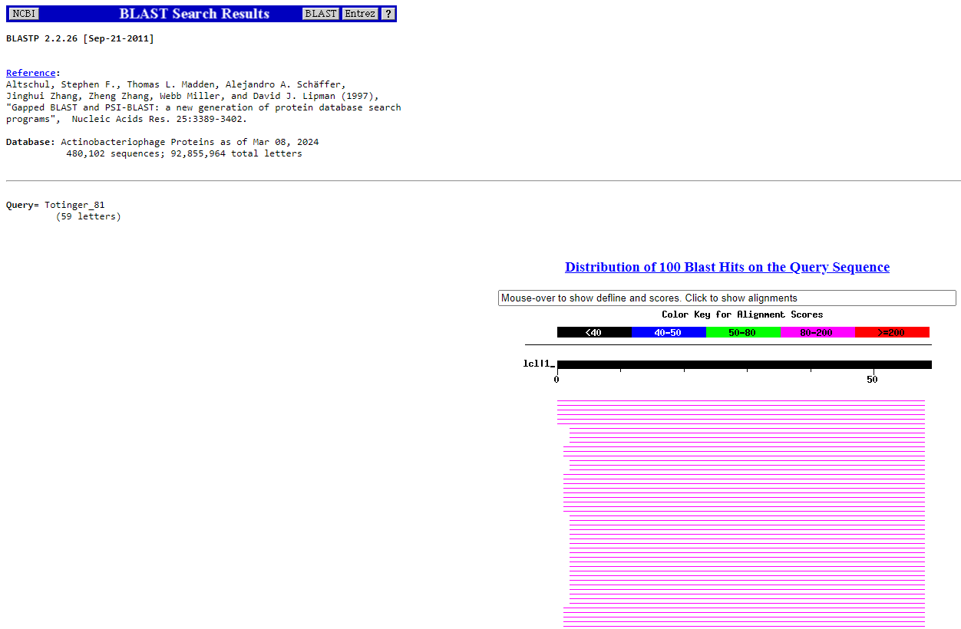
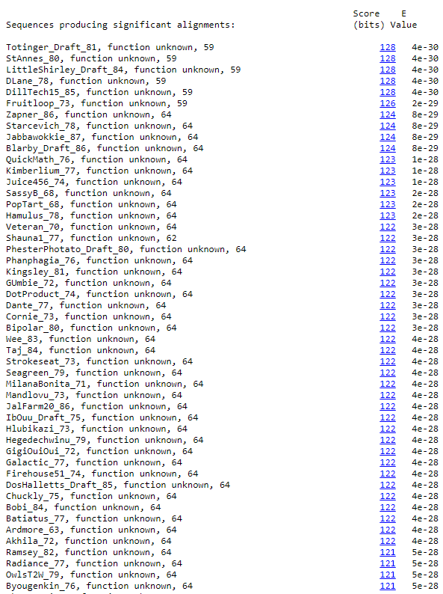
BLAST from NCBI (https://blast.ncbi.nlm.nih.gov/Blast.cgi?PAGE=Proteins) Using Longest ORF
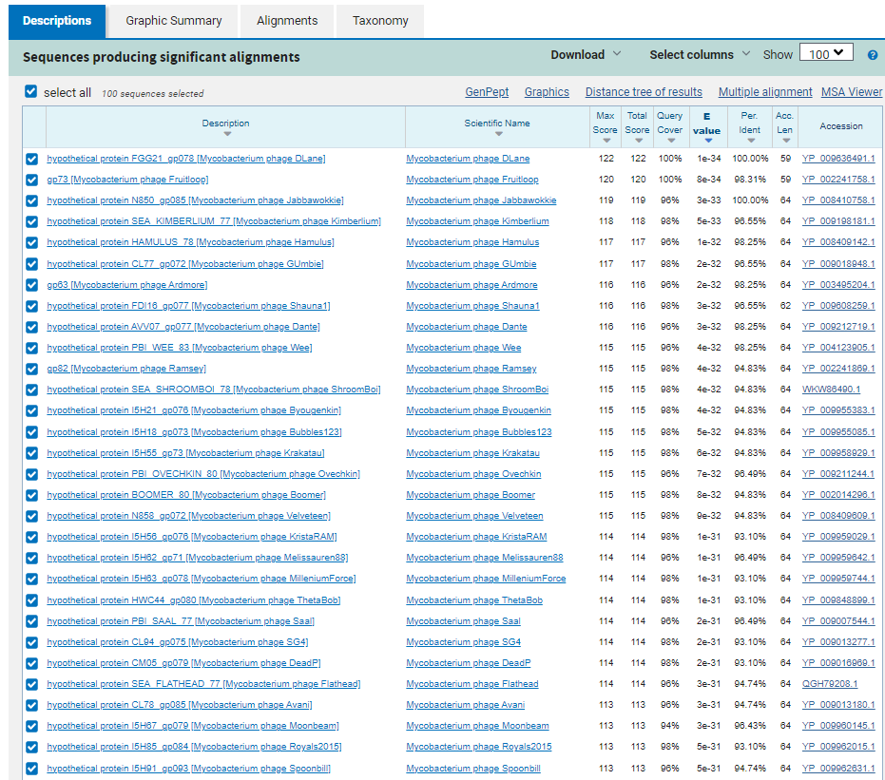
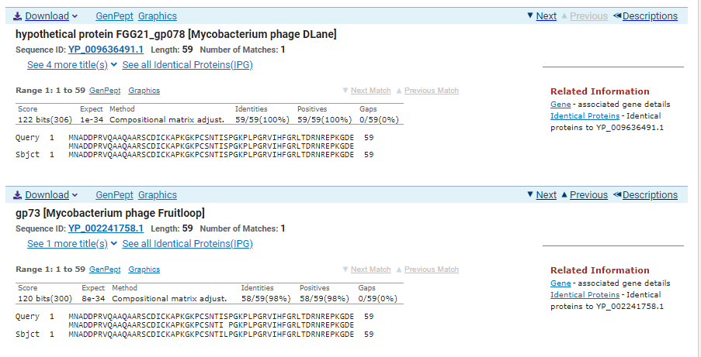
ATG Start at 48016. Original Glimmer call, not called by Genemark.
TGA Stop at 48195
F/R: F
Coding Potential (y/n): Y
Starterator (SS, NA, NI): Does not have the Most Annotated Start.
Blast Best Hit, Query:Subject Starts, Score, Evalue, or “no significant Blast alignments” if 10E-4 or higher
hypothetical protein FGG21_gp078 Mycobacterium phage DLane YP_009636491.1, 1:1, Score 122, Evalue, 1e-34
Gap with previous gene: -3
Longest Orf? (Y/N/NA) Y
RBS:
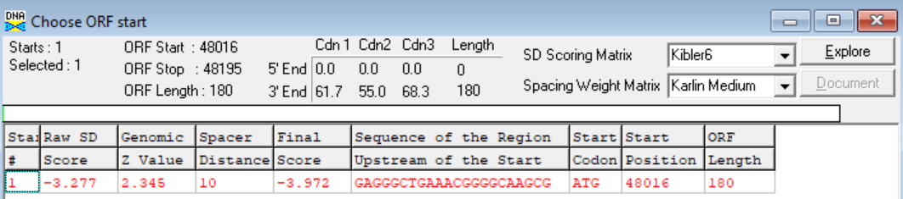
(https://toolkit.tuebingen.mpg.de/tools/hhpred) HHPRED vs PDB, SCOPe, pFam, and M. Tuberculosis. No Significant (>95%) Hits
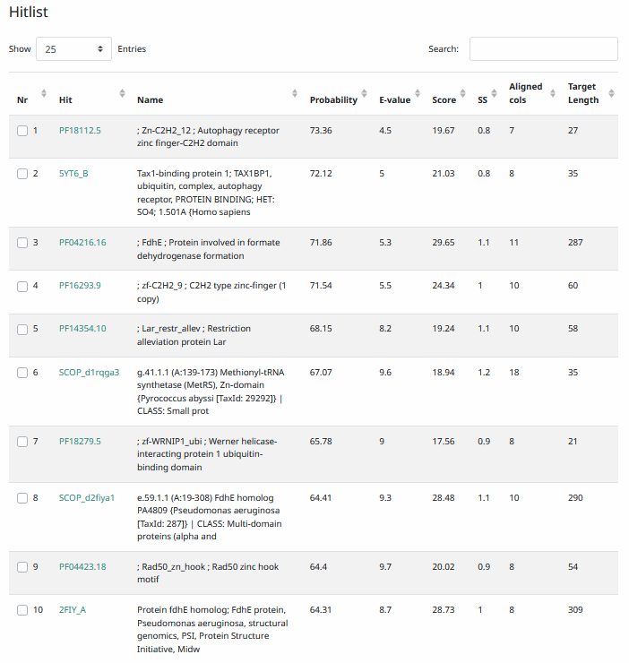
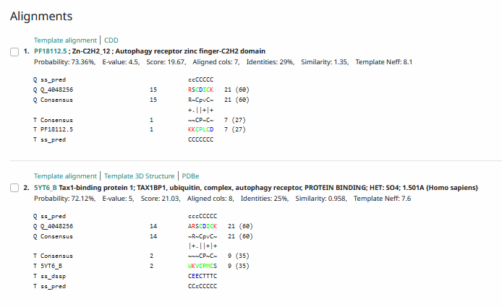
Phamerator Totinger Vs. Tootsieroll Vs. Starcevich (https://phamerator.org/phages) Genes 61-106
Proposed Function: hypothetical protein
Function Evidence: BLAST and HHPRED most consistently indicate this protein as one with no known function. In Phamerator, phage Starcevich has an identical sequence and calls a similar gene. It also calls it as a protein with no known function.
Transmembrane Domain/Evidence: No, Intracellular Properties (https://dtu.biolib.com/DeepTMHMM)
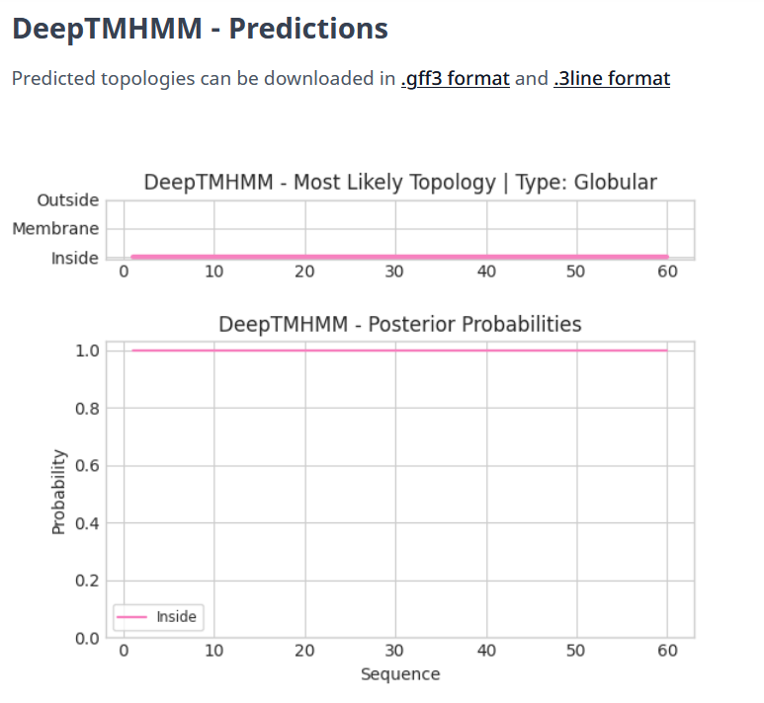

Gene Number: 81
Totinger_Draft_82 on Phagesdb
Pham150606
BLAST from PhagesDB. (https://phagesdb.org/blastp/) Using Longest ORF
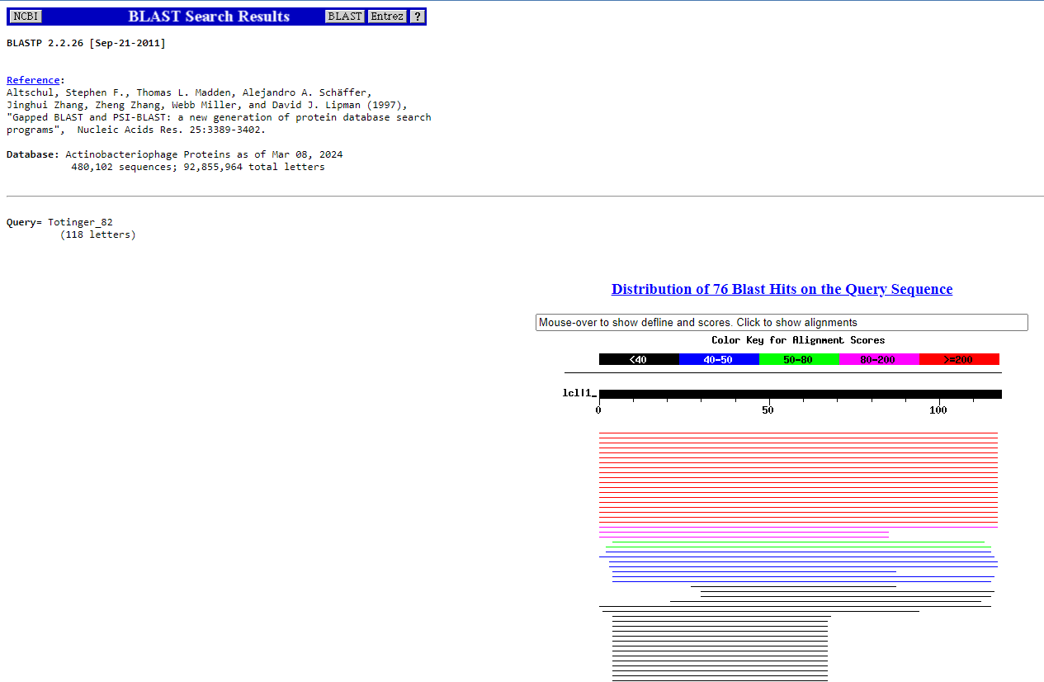
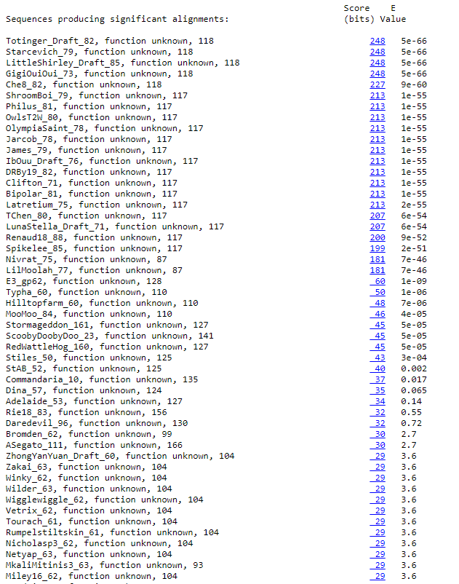
BLAST from NCBI (https://blast.ncbi.nlm.nih.gov/Blast.cgi?PAGE=Proteins) Using Longest ORF
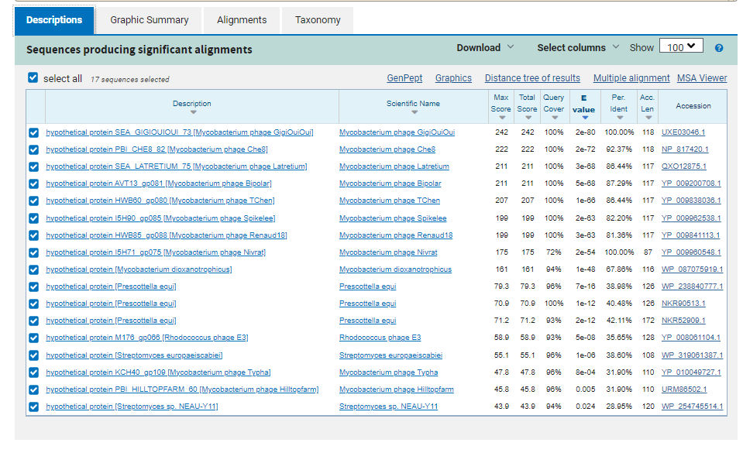
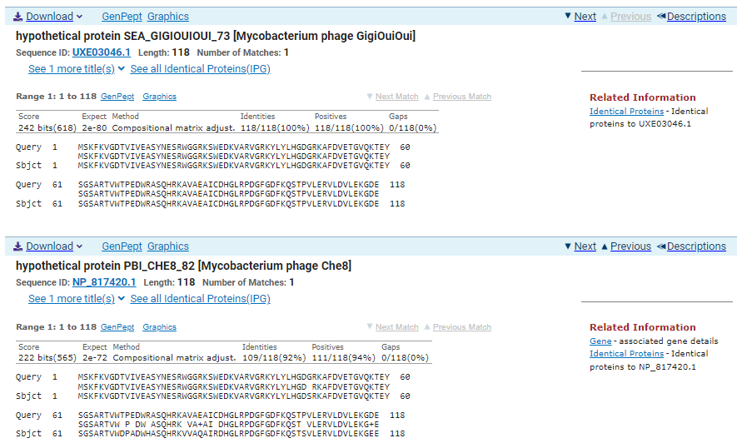
ATG Start at 48192. Original Glimmer call.
TGA Stop at 48548
F/R: F
Coding Potential (y/n): Y
Starterator (SS, NA, NI): Most annotated start is this (48192)
Blast Best Hit, Query:Subject Starts, Score, Evalue, or “no significant Blast alignments” if 10E-4 or higher
hypothetical protein SEA_GIGIOUIOUI_73 Mycobacterium phage GigiOuiOui UXE03046.1, 1:1, Score 242, Evalue, 2e-80
Gap with previous gene: -3
Longest Orf? (Y/N/NA) Y
RBS:
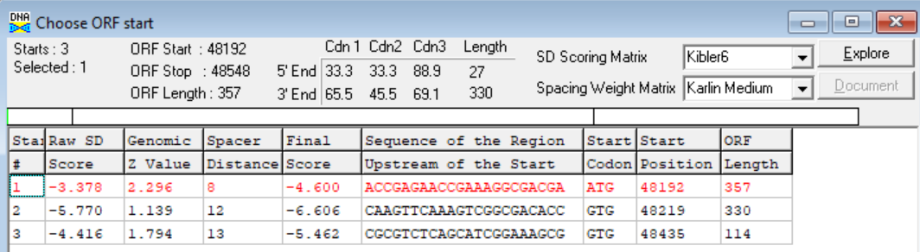
(https://toolkit.tuebingen.mpg.de/tools/hhpred) HHPRED vs PDB, SCOPe, pFam, and M. Tuberculosis. No Significant (>95%) Hits.
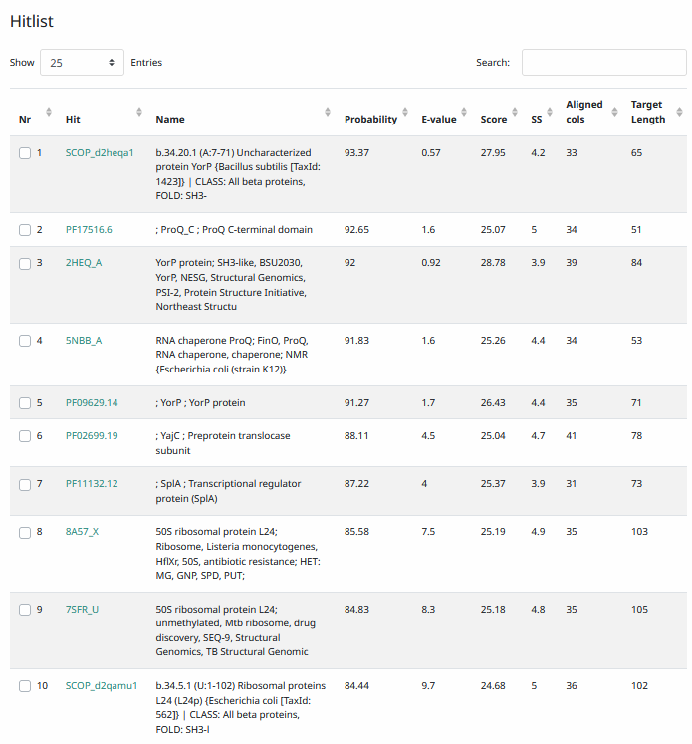
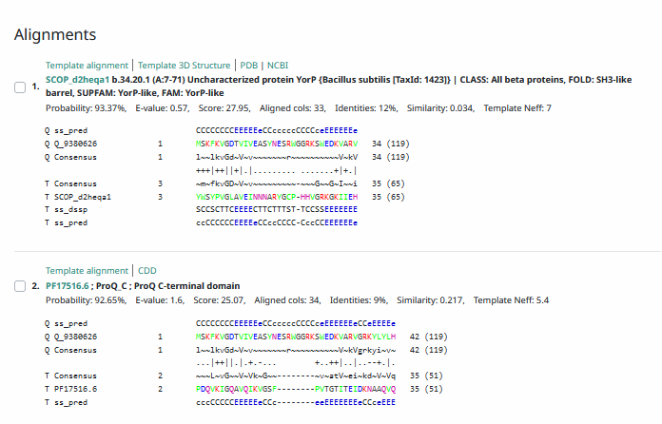
Phamerator Totinger Vs. Tootsieroll Vs. Starcevich (https://phamerator.org/phages) Genes 61-106
Proposed Function: hypothetical protein
Function Evidence: BLAST and HHPRED results most consistently hit this protein as one with an unknown function. Additionally, in Phamerator, phage Starcevich calls an identical gene from an identical sequence and also calls it as a protein with no known function.
Transmembrane Domain/Evidence: No, Intracellular Properties (https://dtu.biolib.com/DeepTMHMM)
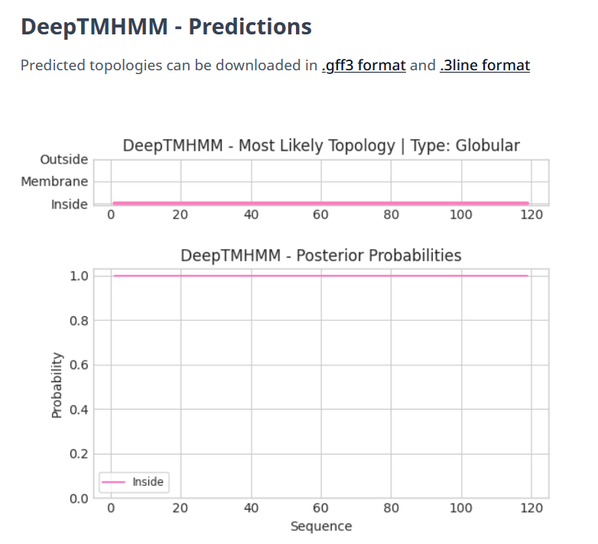

Gene Number: 82
Totinger_Draft_83 on Phagesdb
Pham150287
BLAST from PhagesDB. (https://phagesdb.org/blastp/) Using Longest ORF
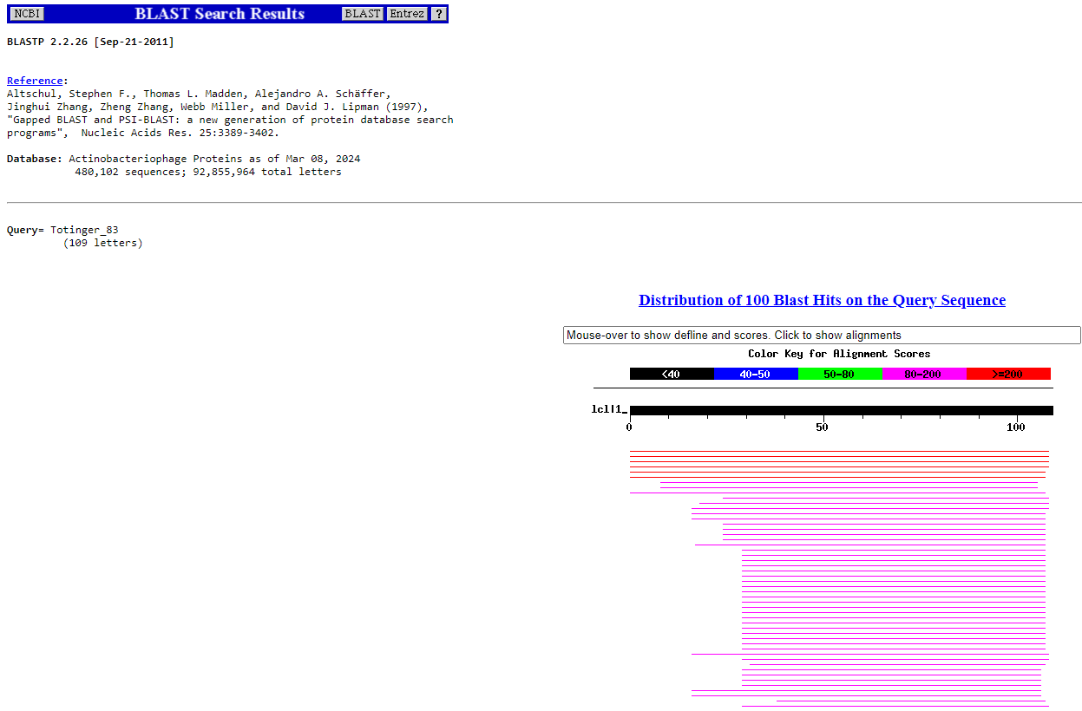
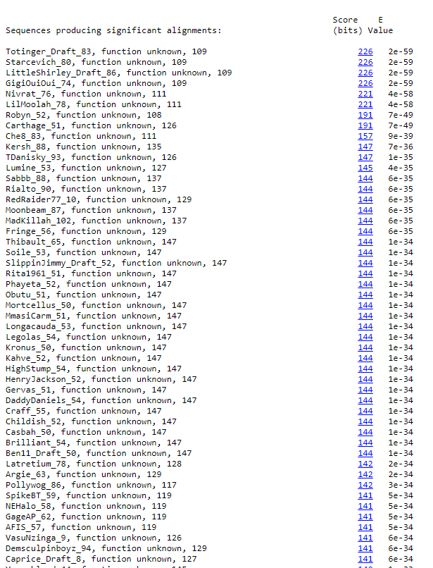
BLAST from NCBI (https://blast.ncbi.nlm.nih.gov/Blast.cgi?PAGE=Proteins) Using Longest ORF
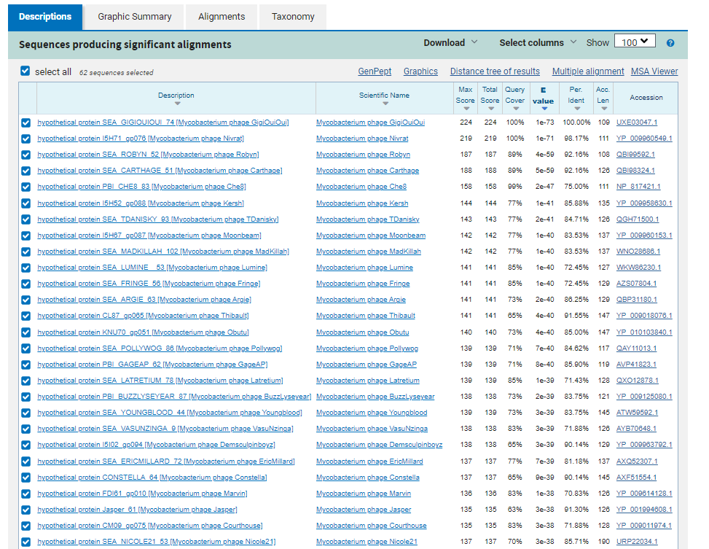
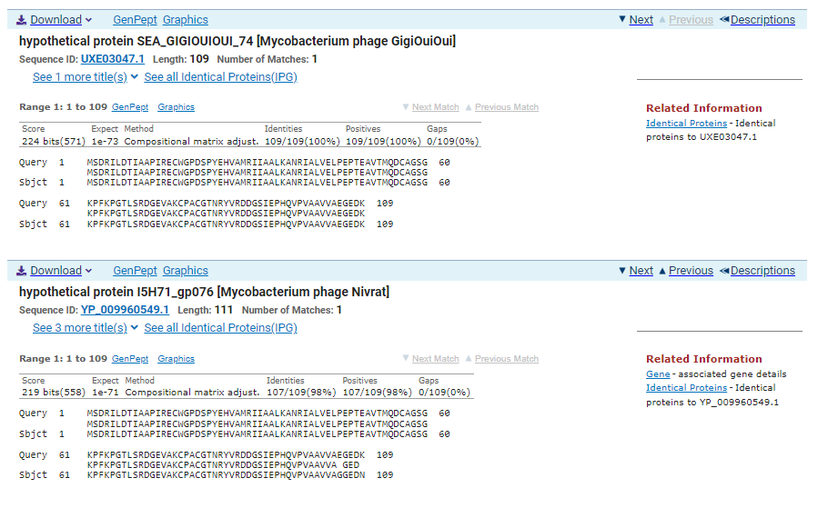
ATG Start at 48545. Original Glimmer call.
TGA Stop at 48874
F/R: F
Coding Potential (y/n): Y
Starterator (SS, NA, NI): Does not have the Most Annotated Start
Blast Best Hit, Query:Subject Starts, Score, Evalue, or “no significant Blast alignments” if 10E-4 or higher
hypothetical protein SEA_GIGIOUIOUI_74 Mycobacterium phage GigiOuiOui UXE03047.1, 1:1, Score 224, Evalue, 1e-73
Gap with previous gene: -3
Longest Orf? (Y/N/NA) Y
RBS:
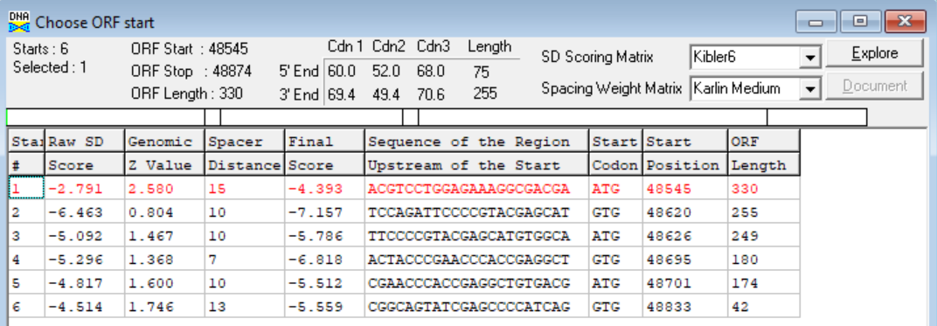
(https://toolkit.tuebingen.mpg.de/tools/hhpred) HHPRED vs PDB, SCOPe, pFam, and M. Tuberculosis.
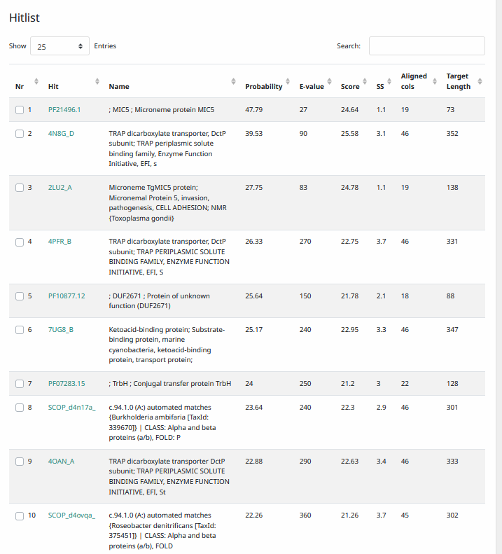
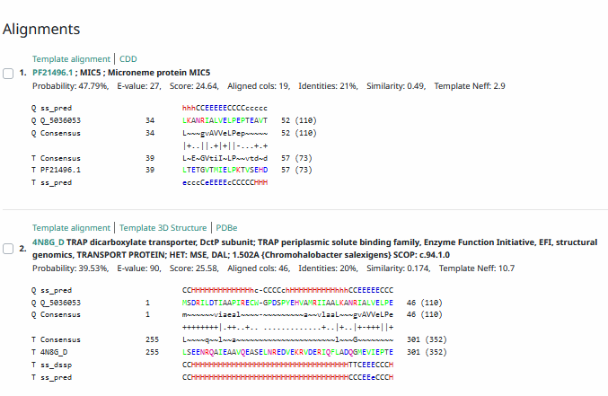
Phamerator Totinger Vs. Tootsieroll Vs. Starcevich (https://phamerator.org/phages) Genes 61-106
Proposed Function: hypothetical protein
Function Evidence: In Phamerator, phage Starcevich has the same gene called as a hypothetical protein. Additionally, BLASTs and HHPRED most consistently line up with proteins of no known function from other phages.
Transmembrane Domain/Evidence: No, Intracellular Properties (https://dtu.biolib.com/DeepTMHMM)
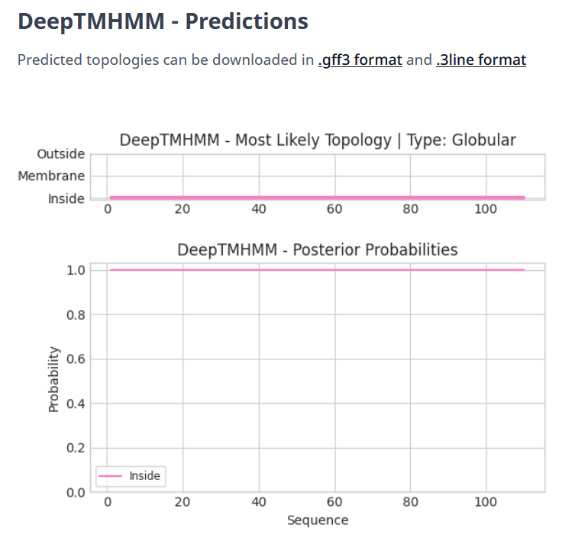

Gene Number: 83
Totinger_Draft_84 on Phagesdb
Pham85332
BLAST from PhagesDB. (https://phagesdb.org/blastp/) Using Longest ORF
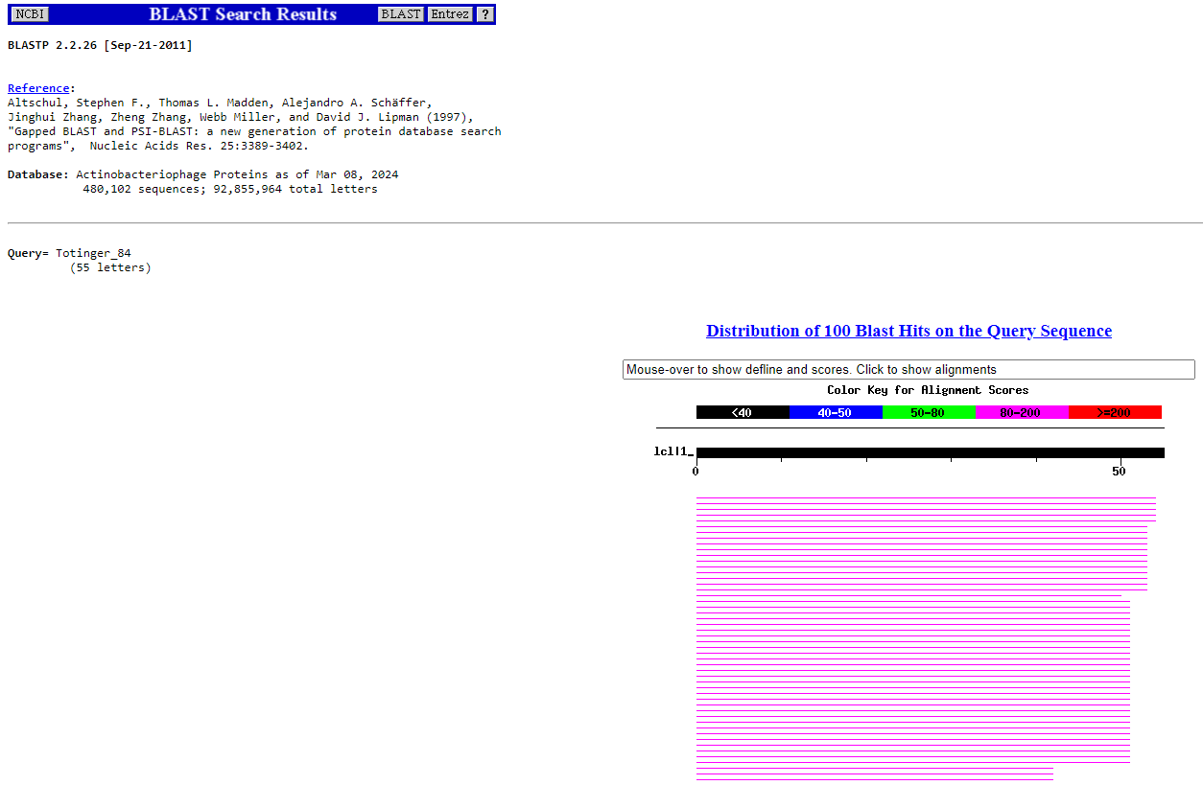
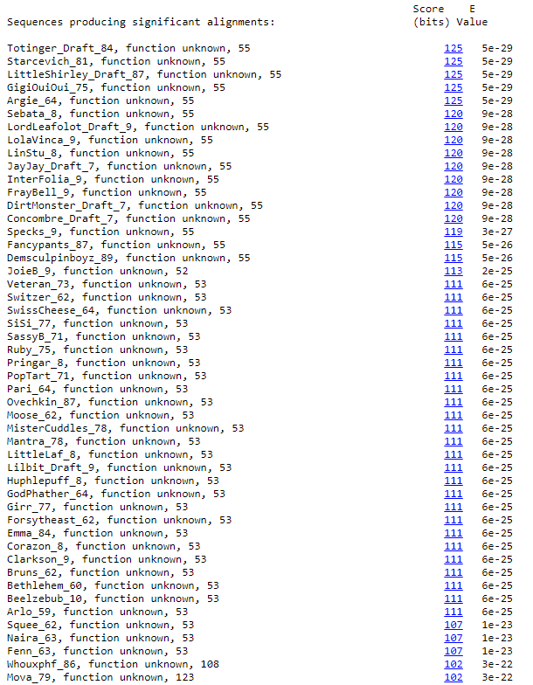
BLAST from NCBI (https://blast.ncbi.nlm.nih.gov/Blast.cgi?PAGE=Proteins) Using Longest ORF
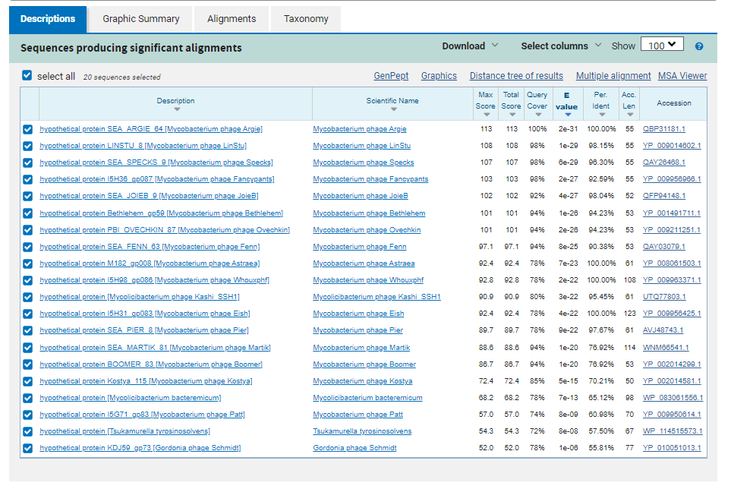
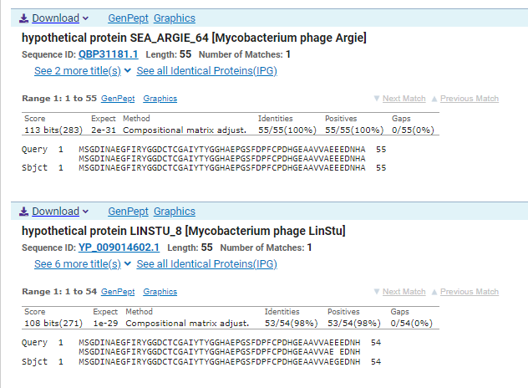
GTG Start at 48871. Original Glimmer call.
TGA Stop at 49038
F/R: F
Coding Potential (y/n): Y
Starterator (SS, NA, NI): Most annotated start is this (48871)
Blast Best Hit, Query:Subject Starts, Score, Evalue, or “no significant Blast alignments” if 10E-4 or higher
hypothetical protein SEA_ARGIE_64 Mycobacterium phage Argie QBP31181.1, 1:1, Score 113, Evalue, 2e-31
Gap with previous gene: -3
Longest Orf? (Y/N/NA) Y
RBS:
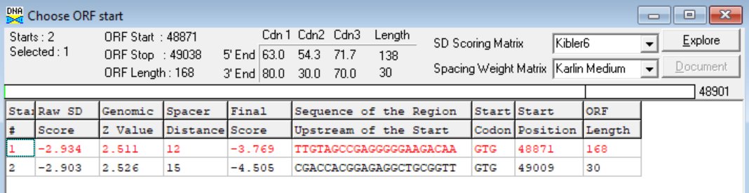
(https://toolkit.tuebingen.mpg.de/tools/hhpred) HHPRED vs PDB, SCOPe, pFam, and M. Tuberculosis. No Significant (>95%) Hits
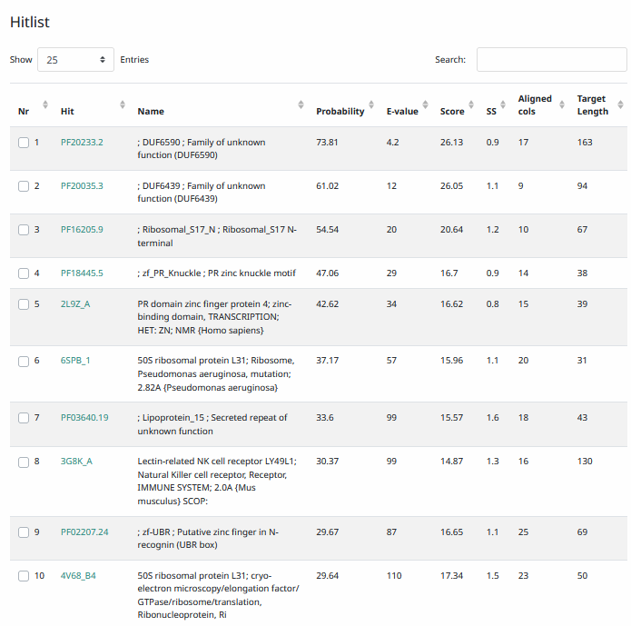
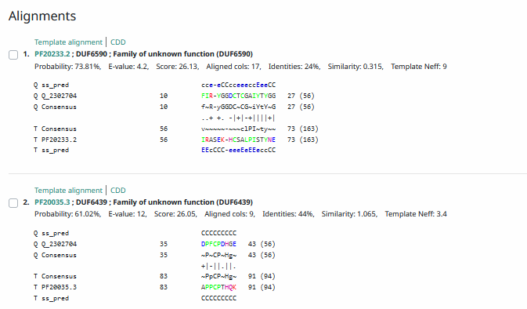
Phamerator Totinger Vs. Tootsieroll Vs. Starcevich (https://phamerator.org/phages) Genes 61-106
Proposed Function: hypothetical protein
Function Evidence: BLASTs and HHPRED most consistently call this protein as one with know known function. Additionally, phage Starcevich has the same sequence and calls the same gene in Phamerator.
Transmembrane Domain/Evidence: No, Intracellular Properties (https://dtu.biolib.com/DeepTMHMM)
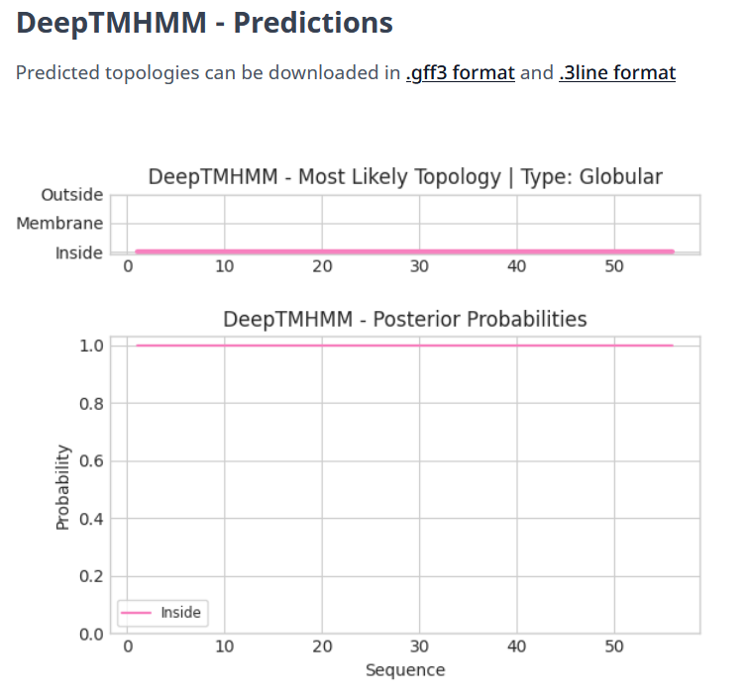
Gene Number: 84
Totinger_Draft_85 on Phagesdb
Pham150242
BLAST from PhagesDB. (https://phagesdb.org/blastp/) Using Longest ORF
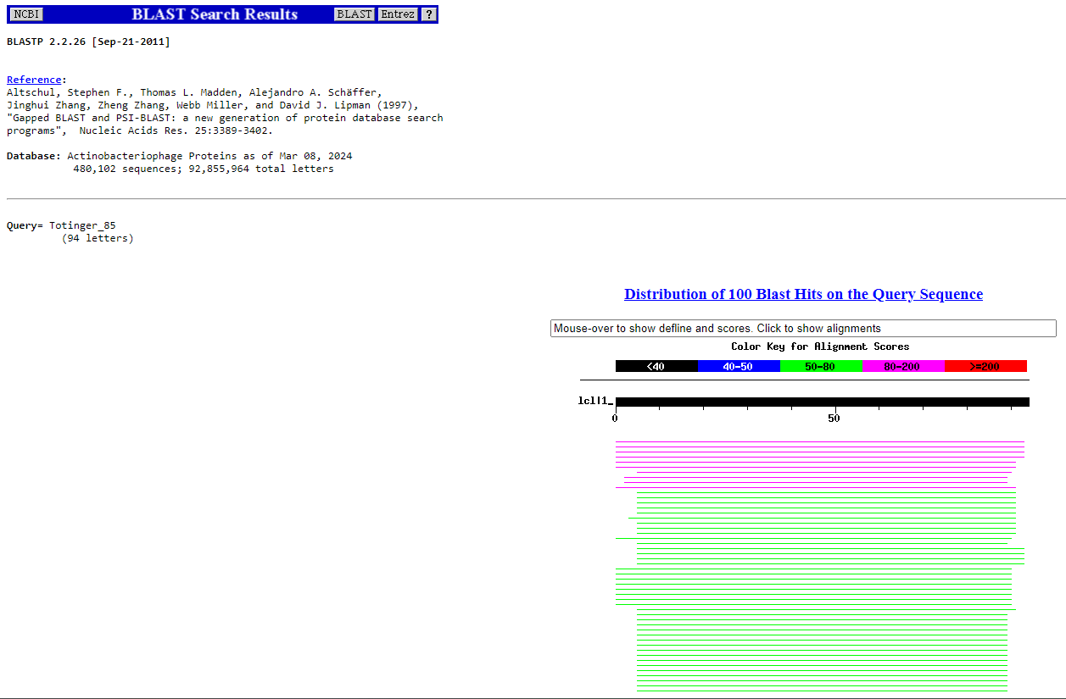
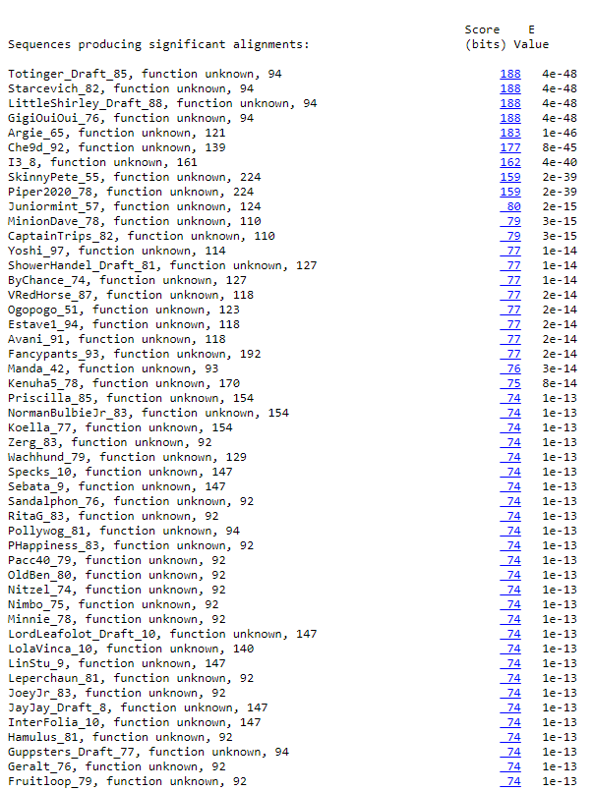
BLAST from NCBI (https://blast.ncbi.nlm.nih.gov/Blast.cgi?PAGE=Proteins) Using Longest ORF
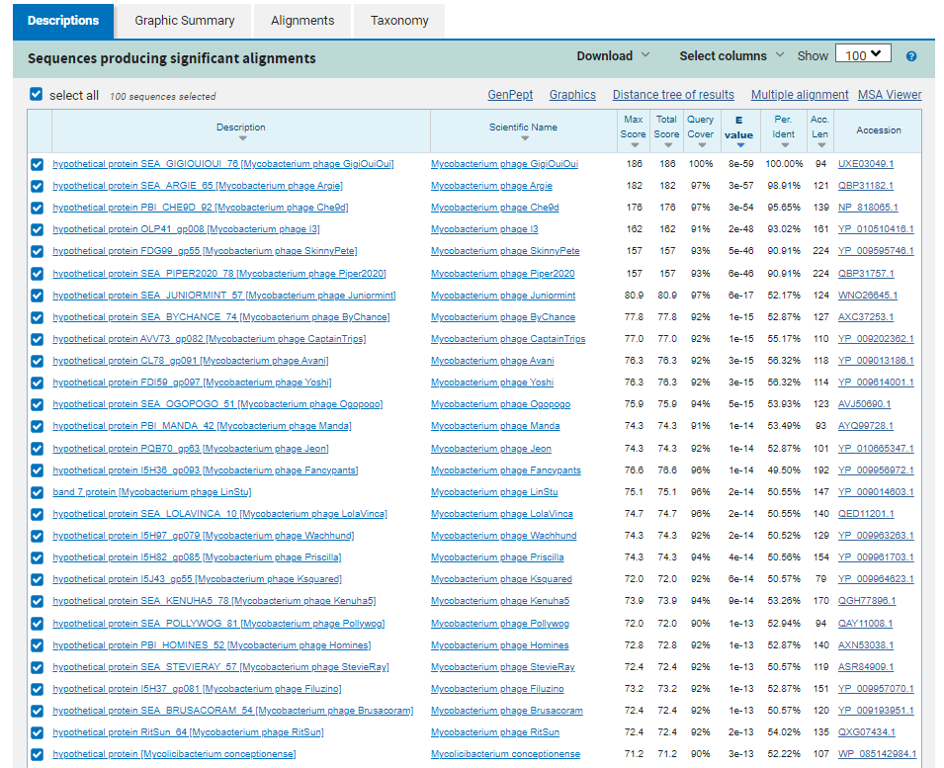
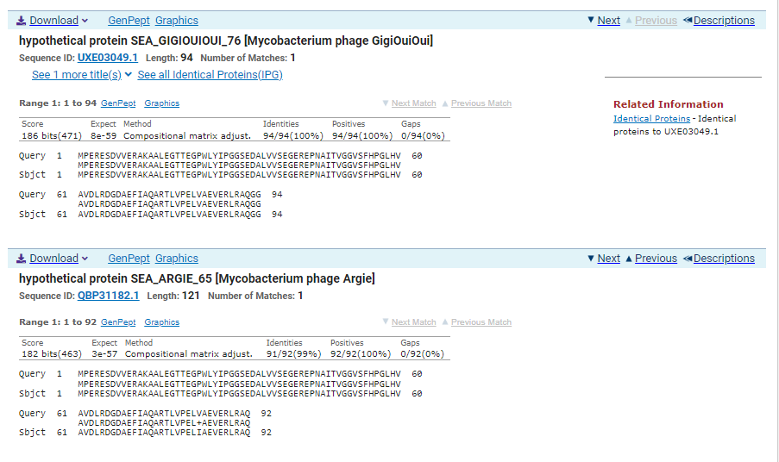
ATG Start at 49031. Original Glimmer call.
TGA Stop at 49315
F/R: F
Coding Potential (y/n): Y
Starterator (SS, NA, NI): Does not have the Most Annotated Start
Blast Best Hit, Query:Subject Starts, Score, Evalue, or “no significant Blast alignments” if 10E-4 or higher
hypothetical protein SEA_GIGIOUIOUI_76 Mycobacterium phage GigiOuiOui UXE03049.1, 1:1, Score 186, Evalue, 8e-59
Gap with previous gene: -7
Longest Orf? (Y/N/NA) N
RBS:
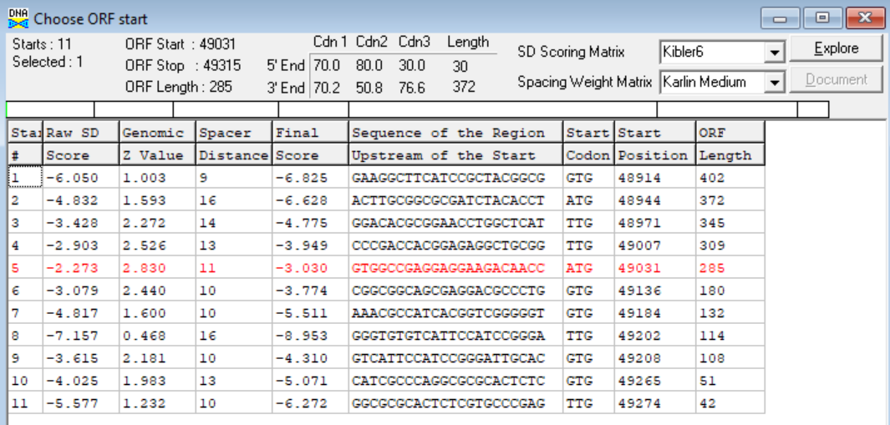
(https://toolkit.tuebingen.mpg.de/tools/hhpred) HHPRED vs PDB, SCOPe, pFam, and M. Tuberculosis. No Significant (>95%) Hits
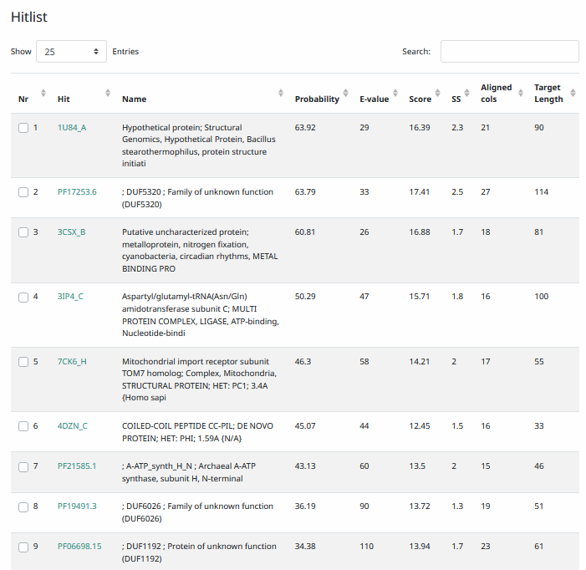
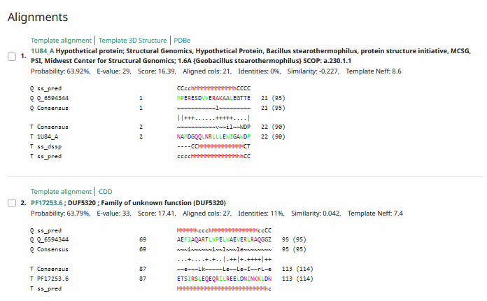
Phamerator Totinger Vs. Tootsieroll Vs. Starcevich (https://phamerator.org/phages) Genes 61-106
Proposed Function: hypothetical protein
Function Evidence: In Phamerator, phage Starcevich calls the same gene from the same sequence. Additionally, BLASTs and HHPRED align most consistently with hypothetical proteins from other phages.
Transmembrane Domain/Evidence: No, Intracellular Properties (https://dtu.biolib.com/DeepTMHMM)
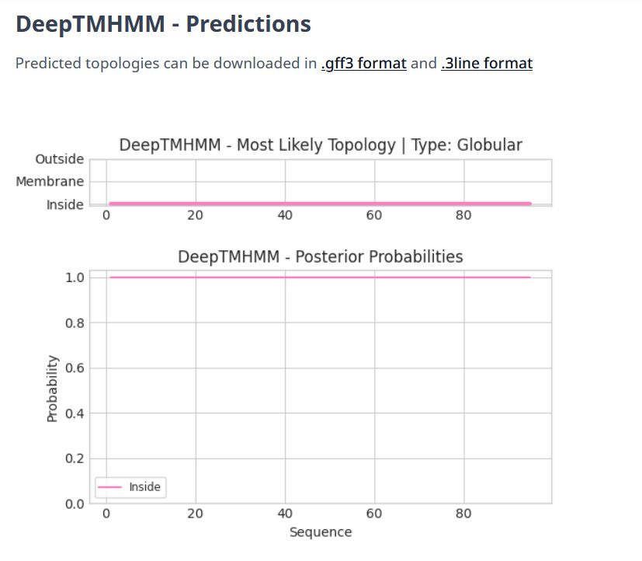

Gene Number: 85
Totinger_Draft_86 on Phagesdb
Pham150031
BLAST from PhagesDB. (https://phagesdb.org/blastp/) Using Longest ORF
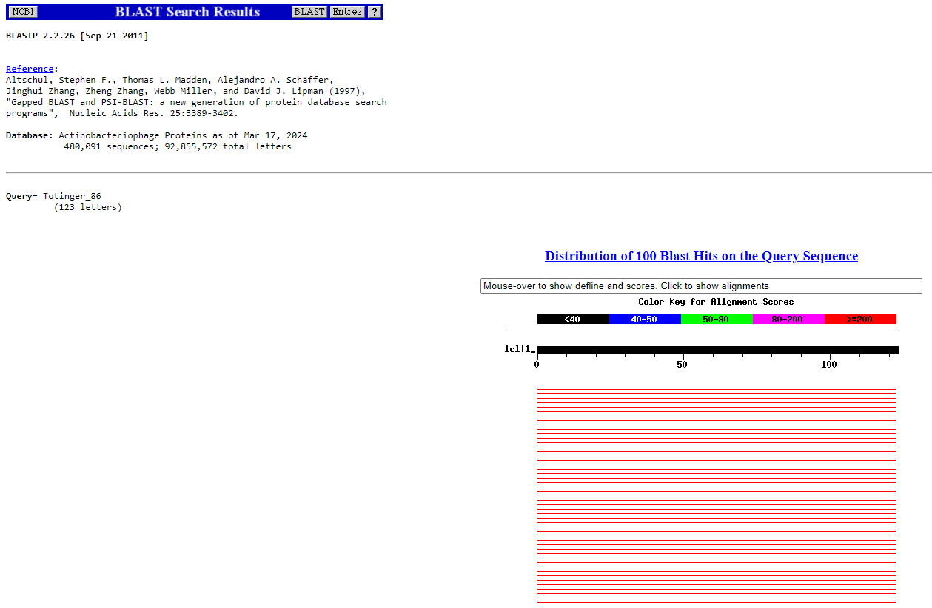
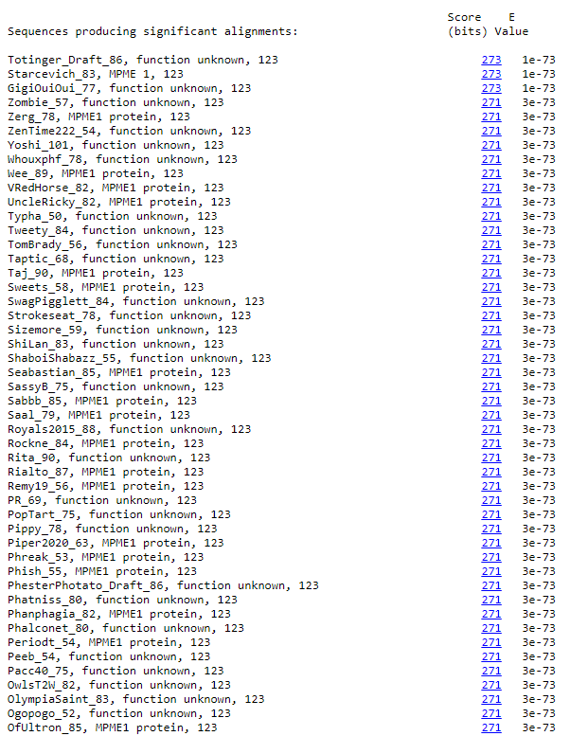
BLAST from NCBI (https://blast.ncbi.nlm.nih.gov/Blast.cgi?PAGE=Proteins) Using Longest ORF
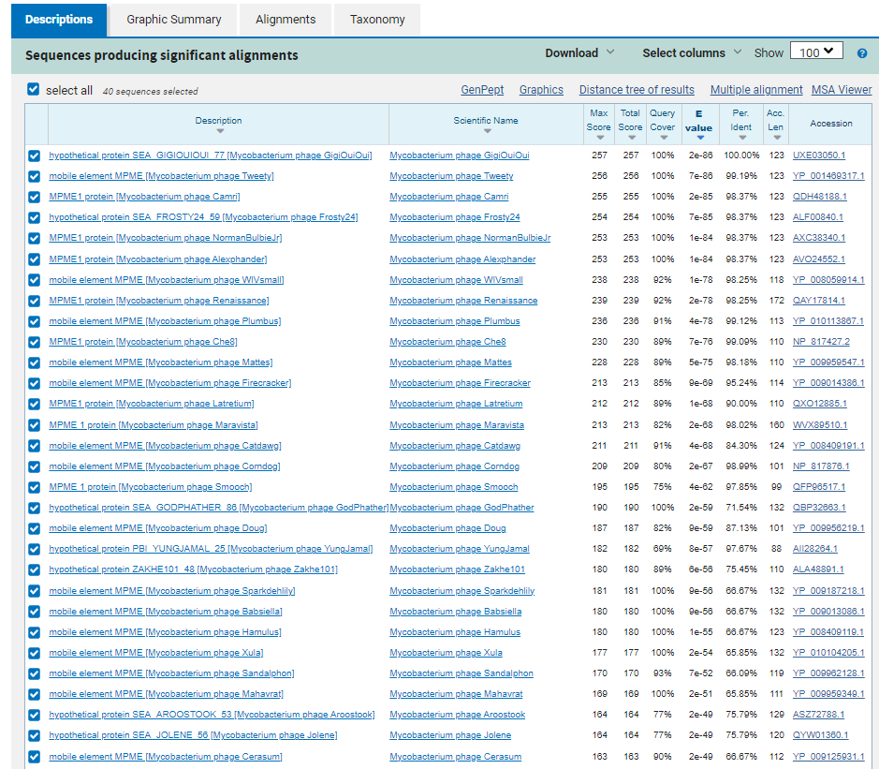
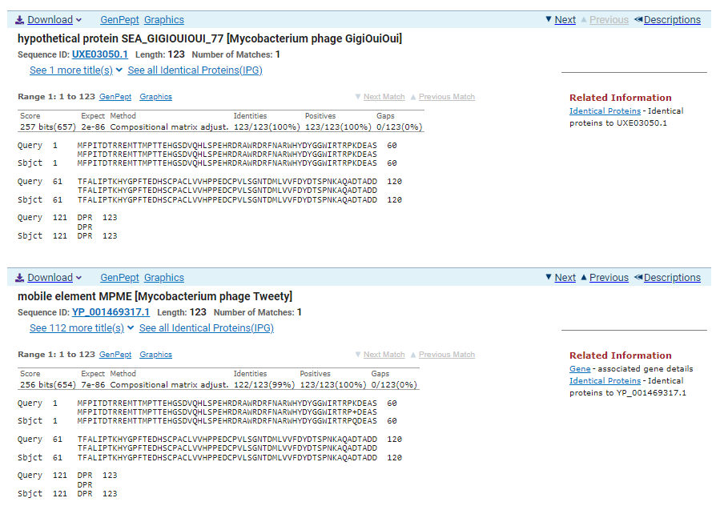
ATG Start at 49425. Original Glimmer call.
TAA Stop at 49786
F/R: F
Coding Potential (y/n): Y
Starterator (SS, NA, NI): Most annotated start is this (49425)
Blast Best Hit, Query:Subject Starts, Score, Evalue, or “no significant Blast alignments” if 10E-4 or higher
hypothetical protein SEA_GIGIOUIOUI_77 Mycobacterium phage GigiOuiOui UXE03050.1, 1:1, Score 257, Evalue, 2e-86
Gap with previous gene: 110
Longest Orf? (Y/N/NA) Y
RBS:
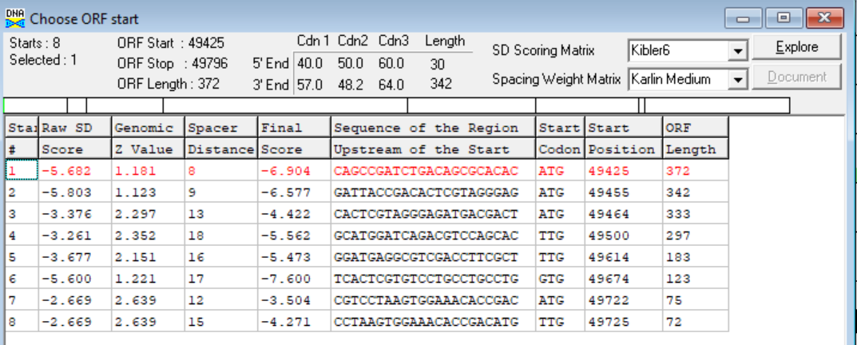
(https://toolkit.tuebingen.mpg.de/tools/hhpred) HHPRED vs PDB, SCOPe, pFam, and M. Tuberculosis. No Significant (>95%) Hits
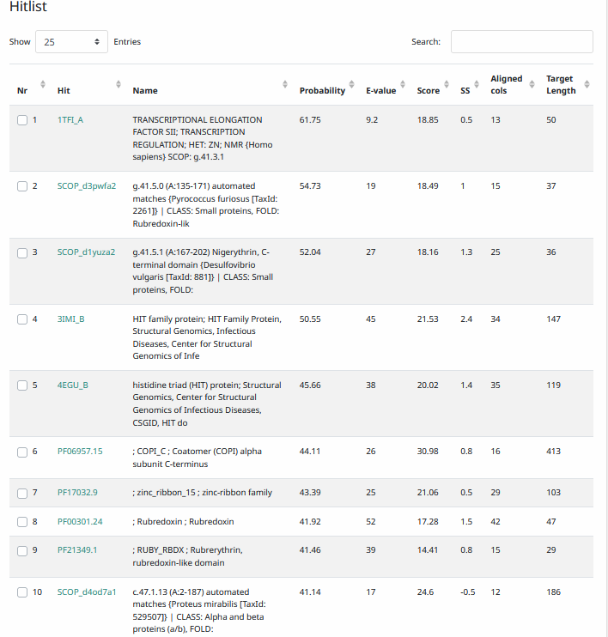
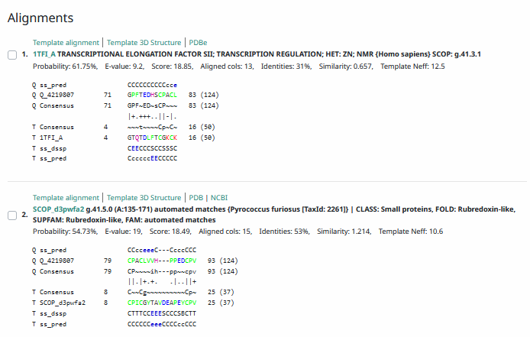
Phamerator Totinger Vs. Tootsieroll Vs. Starcevich (https://phamerator.org/phages) Genes 61-106
Proposed Function: MPME 1
Function Evidence: In Phamerator, phage Starcevich calls an identical gene as MPME 1. Additionally, BLAST results most consistently call this protein MPME 1.
Transmembrane Domain/Evidence: No, Intracellular Properties (https://dtu.biolib.com/DeepTMHMM)
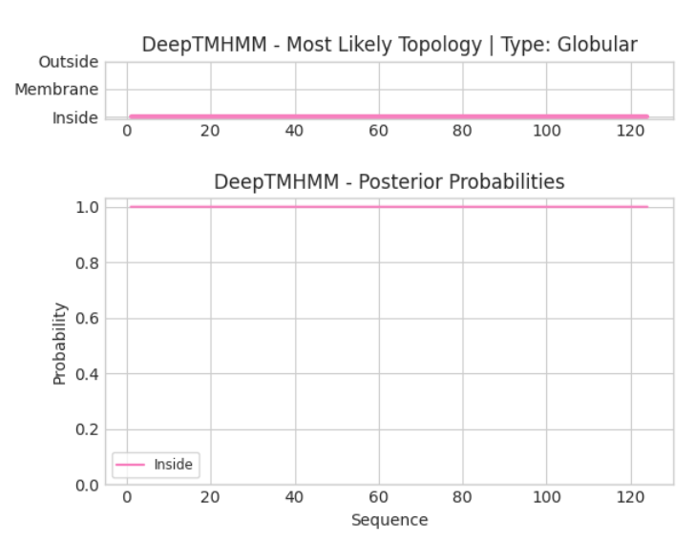
Gene Number: 86
Totinger_Draft_87 on Phagesdb
Pham1769
BLAST from PhagesDB. (https://phagesdb.org/blastp/) Using Longest ORF
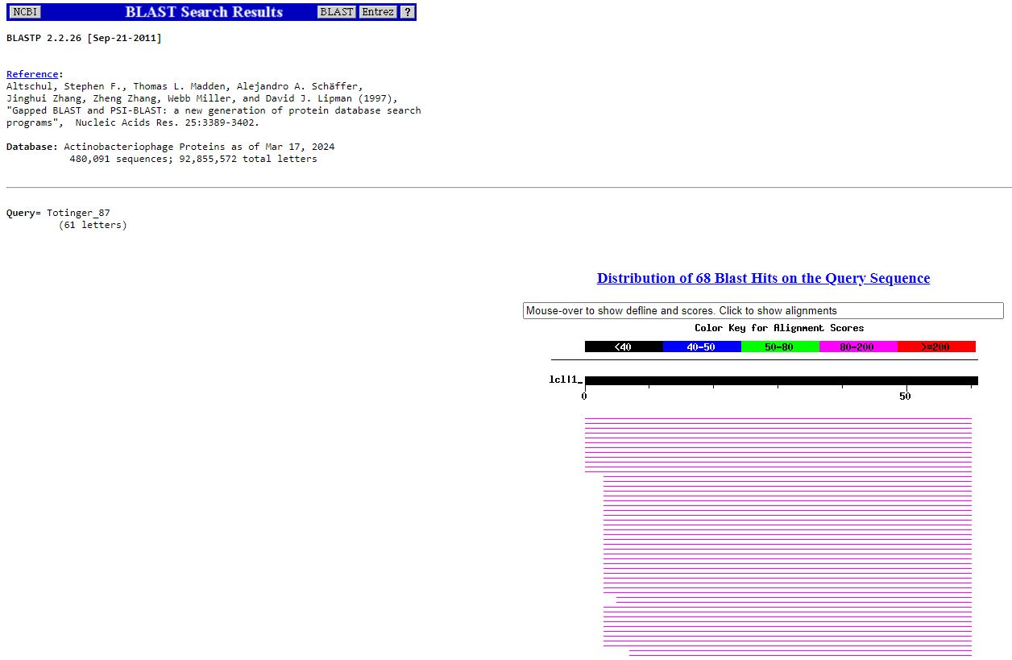
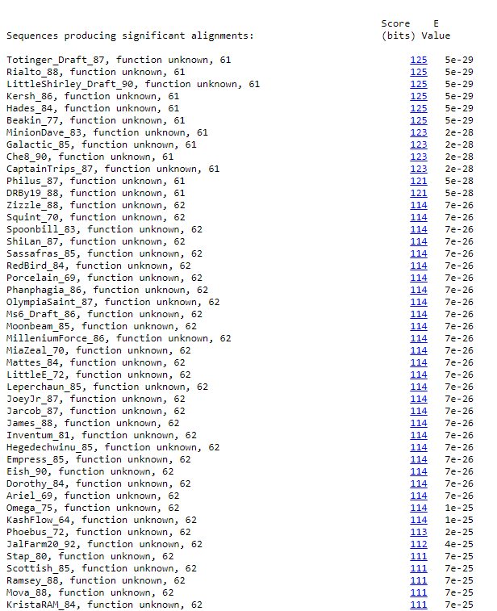
BLAST from NCBI (https://blast.ncbi.nlm.nih.gov/Blast.cgi?PAGE=Proteins) Using Longest ORF
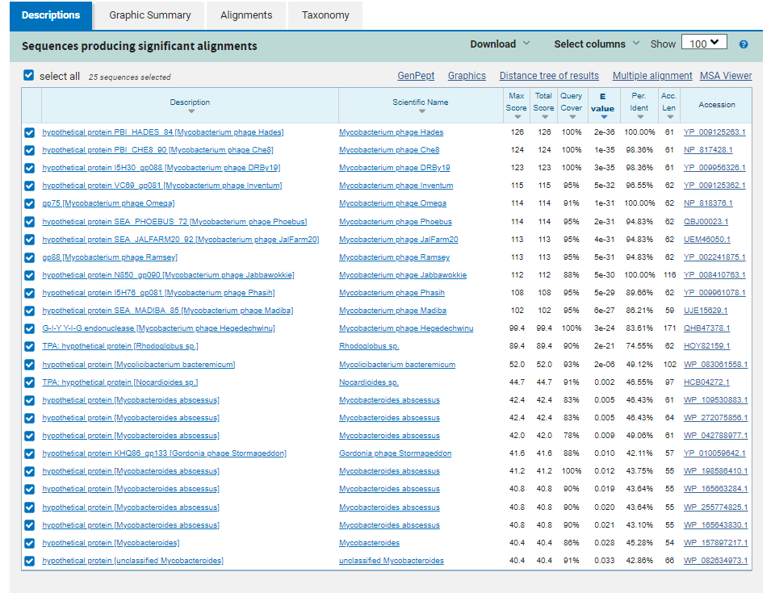
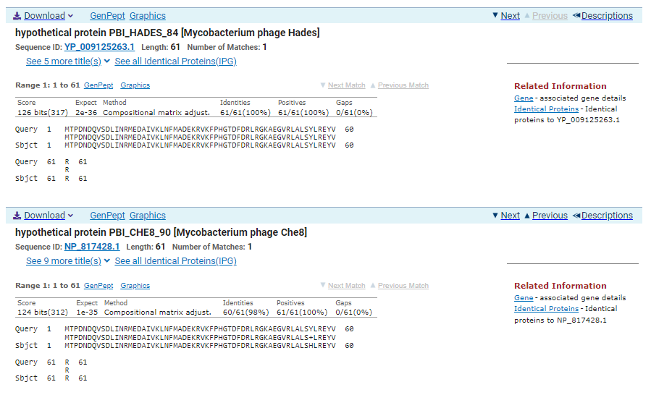
ATG Start at 49783. Original Glimmer call.
TGA Stop at 49986
F/R: F
Coding Potential (y/n): Y
Starterator (SS, NA, NI): Does Not Have the Most Annotated Start
Blast Best Hit, Query:Subject Starts, Score, Evalue, or “no significant Blast alignments” if 10E-4 or higher
hypothetical protein PBI_HADES_84 Mycobacterium phage Hades YP_009125263.1, 1:1, Score 126, Evalue, 2e-36
Gap with previous gene: -13
Longest Orf? (Y/N/NA) N
RBS:
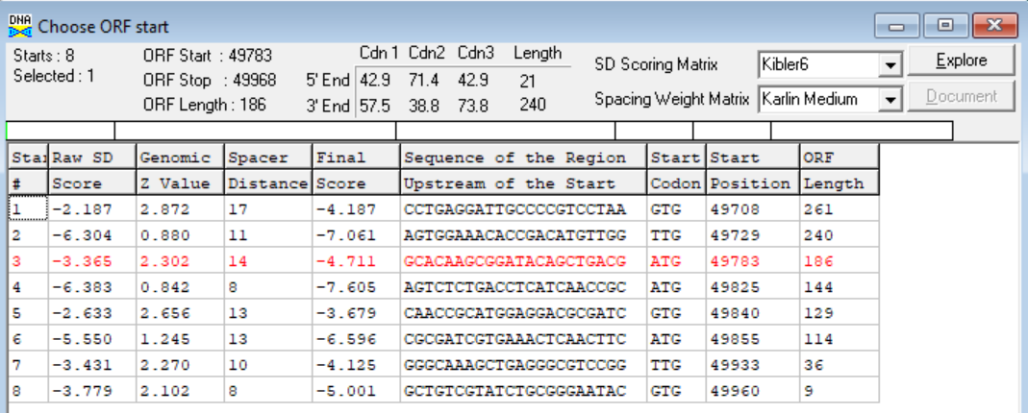
(https://toolkit.tuebingen.mpg.de/tools/hhpred) HHPRED vs PDB, SCOPe, pFam, and M. Tuberculosis. No Significant (>95%) Hits
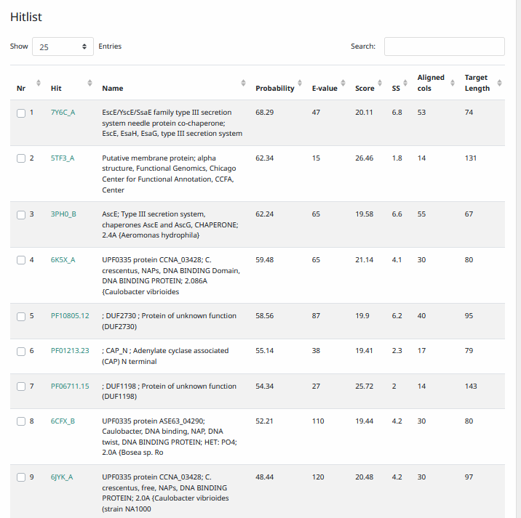
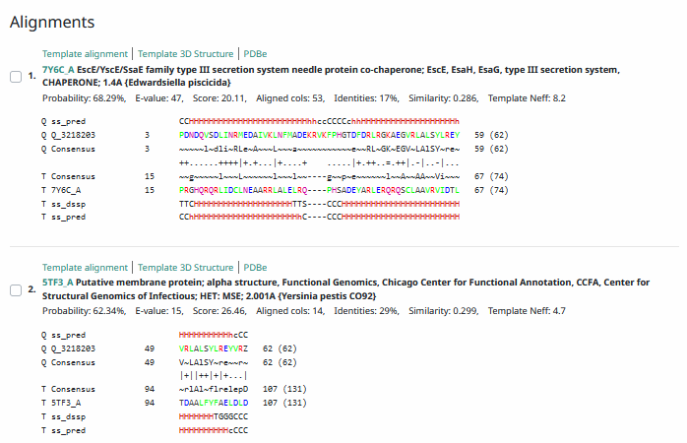
Phamerator Totinger Vs. Tootsieroll Vs. Starcevich (https://phamerator.org/phages) Genes 61-106
Proposed Function: hypothetical protein
Function Evidence: BLASTs and HHPRED most consistently align with proteins in other phages that have no known function. While phage Starcevich and phage Tootsieroll do not share the same sequence, coding potential indicates a protein is there.
Transmembrane Domain/Evidence: No, Intracellular Properties (https://dtu.biolib.com/DeepTMHMM)
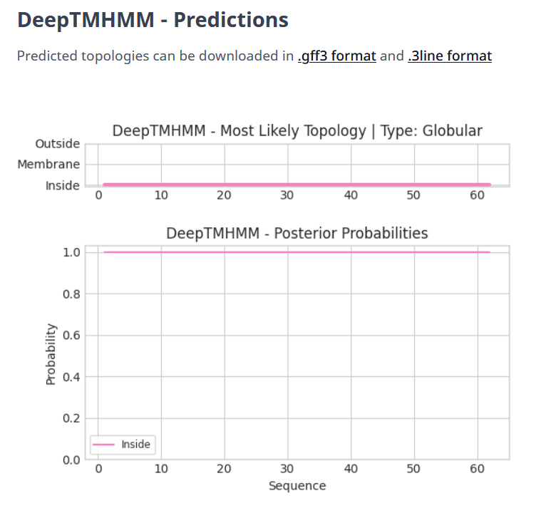

Gene Number: 87
Totinger_Draft_88 on Phagesdb
Pham130537
BLAST from PhagesDB. (https://phagesdb.org/blastp/) Using Longest ORF
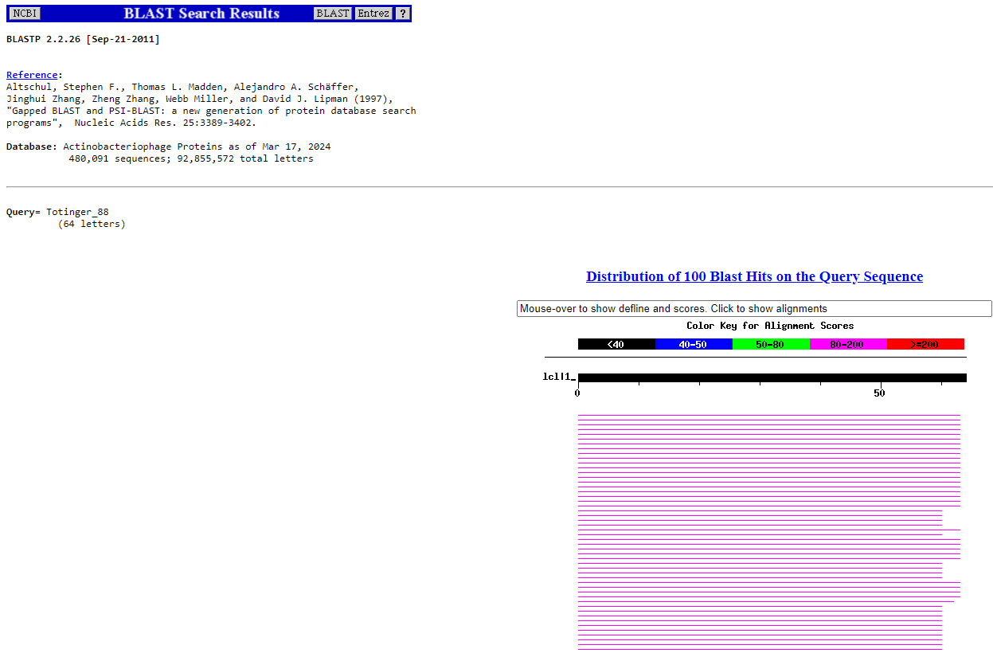
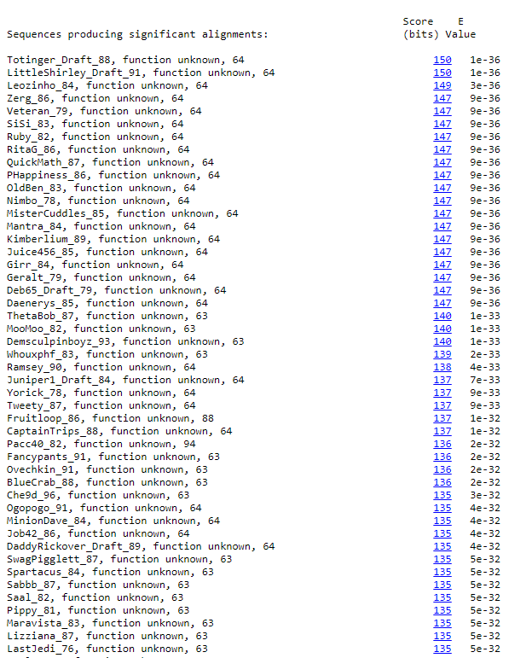
BLAST from NCBI (https://blast.ncbi.nlm.nih.gov/Blast.cgi?PAGE=Proteins) Using Longest ORF
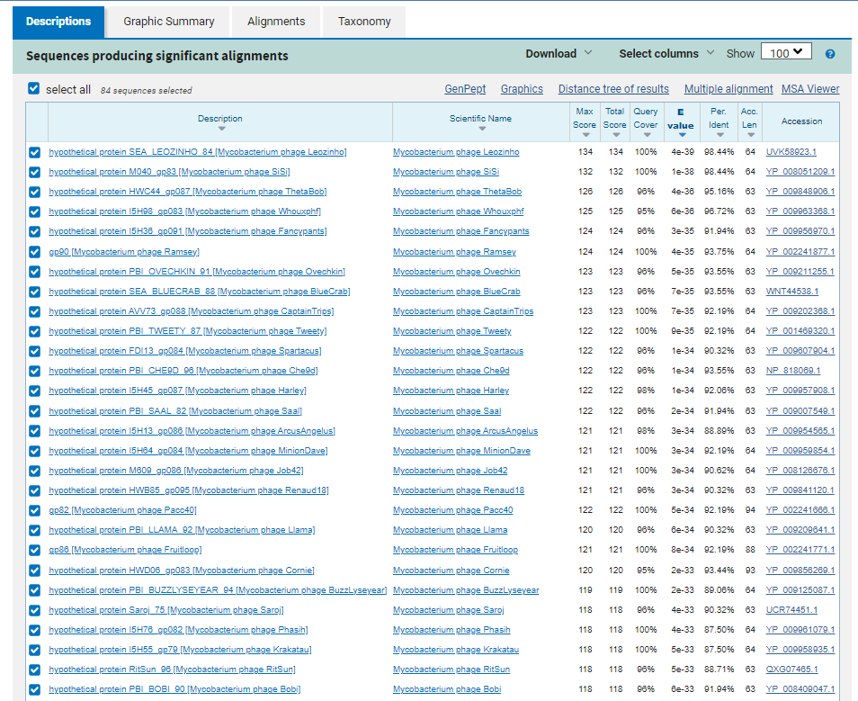
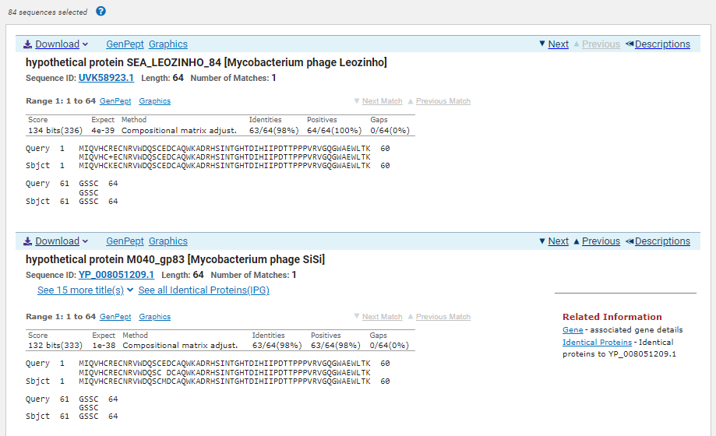
GTG Start at 49965. Original Glimmer call, not called by GeneMark.
TGA Stop at 50159
F/R: F
Coding Potential (y/n): Y
Starterator (SS, NA, NI): Most annotated start is this (49965)
Blast Best Hit, Query:Subject Starts, Score, Evalue, or “no significant Blast alignments” if 10E-4 or higher
hypothetical protein SEA_LEOZINHO_84 Mycobacterium phage Leozinho UVK58923.1, 1:1, Score 134, Evalue, 4e-39
Gap with previous gene: -3
Longest Orf? (Y/N/NA) Y
RBS:
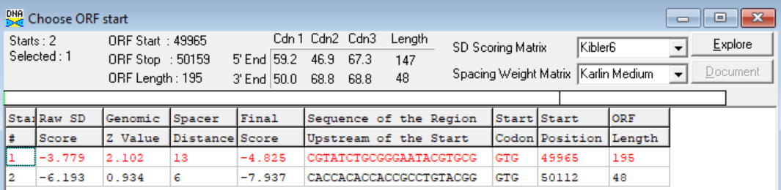
(https://toolkit.tuebingen.mpg.de/tools/hhpred) HHPRED vs PDB, SCOPe, pFam, and M. Tuberculosis. No Significant (>95%) Hits
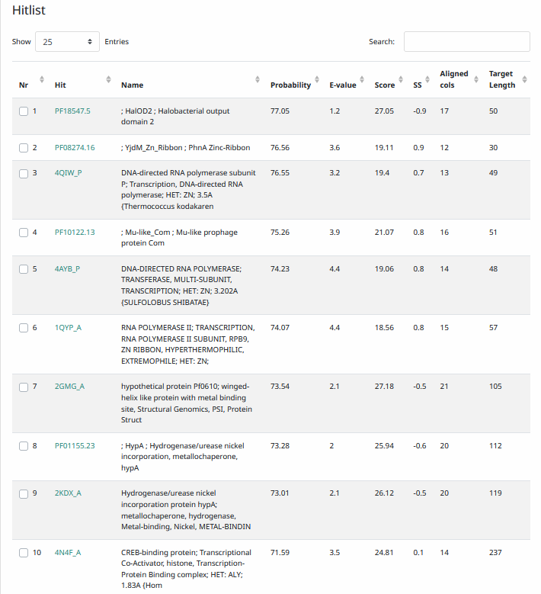
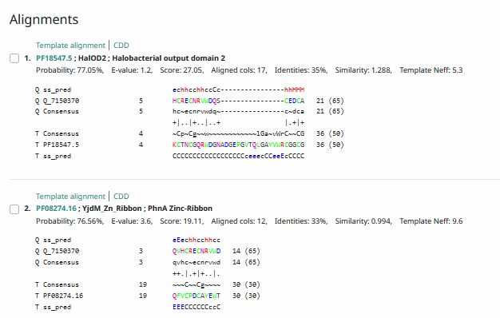
Phamerator Totinger Vs. Tootsieroll Vs. Starcevich (https://phamerator.org/phages) Genes 61-106
Proposed Function: hypothetical protein
Function Evidence: in Phamerator, similar phages (phage Starcevich and phage Tootsieroll) do not share this sequence, but coding potential indicates that this protein exists. Additionally, BLASTs and HHPRED most consistently aligned with a protein that has no known function.
Transmembrane Domain/Evidence: No, Intracellular Properties (https://dtu.biolib.com/DeepTMHMM)
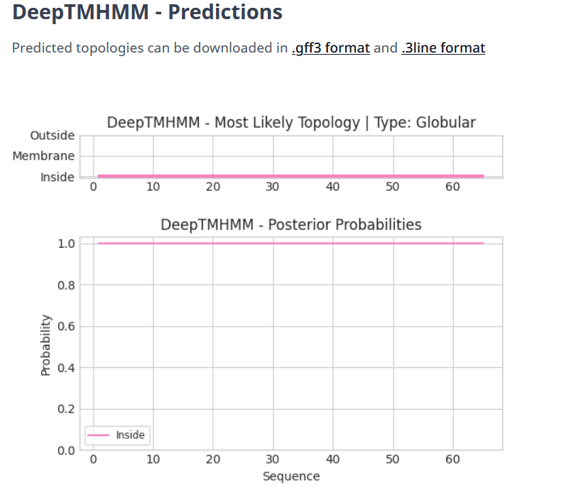
Gene Number: 88
Totinger_Draft_89 on Phagesdb
Pham2225
BLAST from PhagesDB. (https://phagesdb.org/blastp/) Using Longest ORF
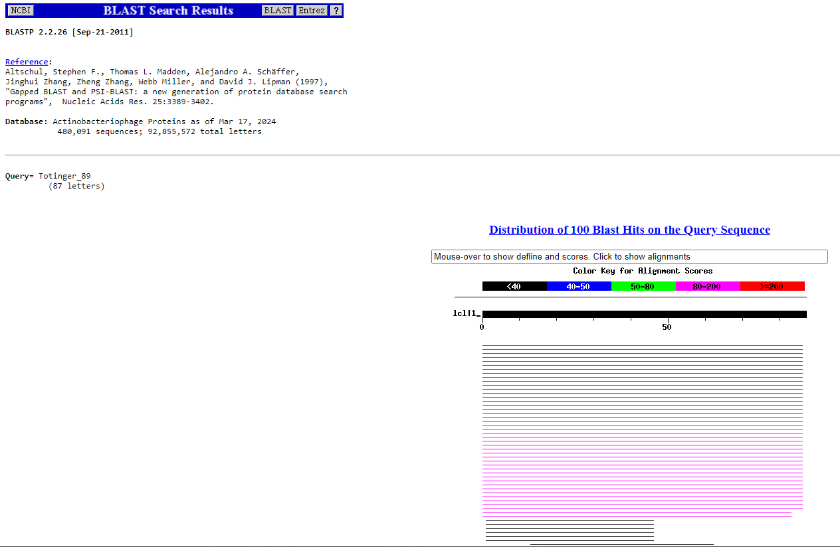
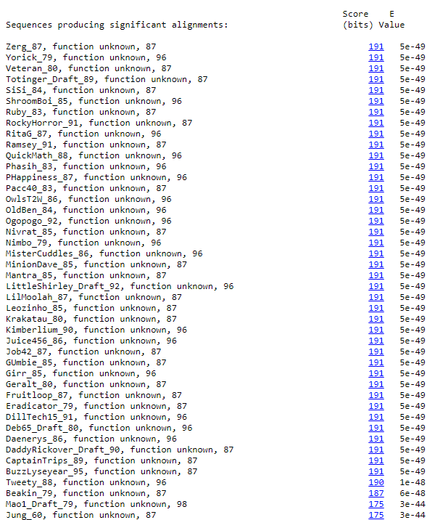
BLAST from NCBI (https://blast.ncbi.nlm.nih.gov/Blast.cgi?PAGE=Proteins) Using Longest ORF
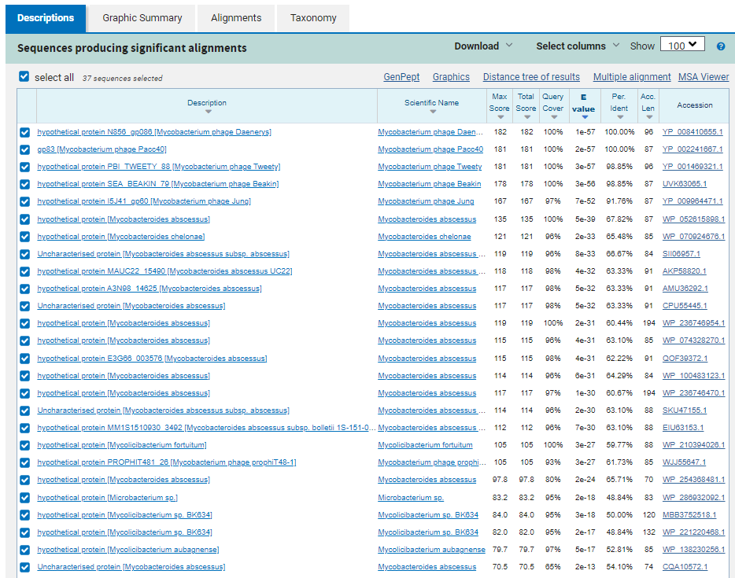
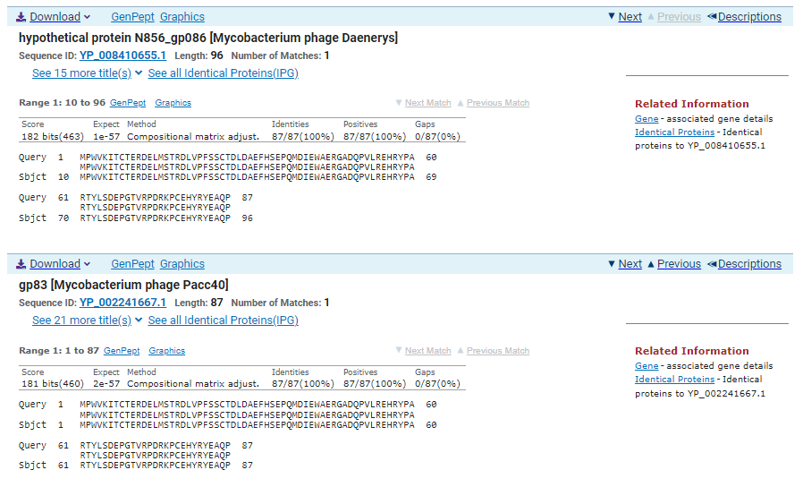
ATG Start at 50159. Original Glimmer call.
TGA Stop at 50422
F/R: F
Coding Potential (y/n): Y
Starterator (SS, NA, NI): Most annotated start is this (50159)
Blast Best Hit, Query:Subject Starts, Score, Evalue, or “no significant Blast alignments” if 10E-4 or higher
hypothetical protein N856_gp086 Mycobacterium phage Daenerys YP_008410655.1, 10:96, Score 182, Evalue, 1e-57
Gap with previous gene: 0
Longest Orf? (Y/N/NA) N
RBS:
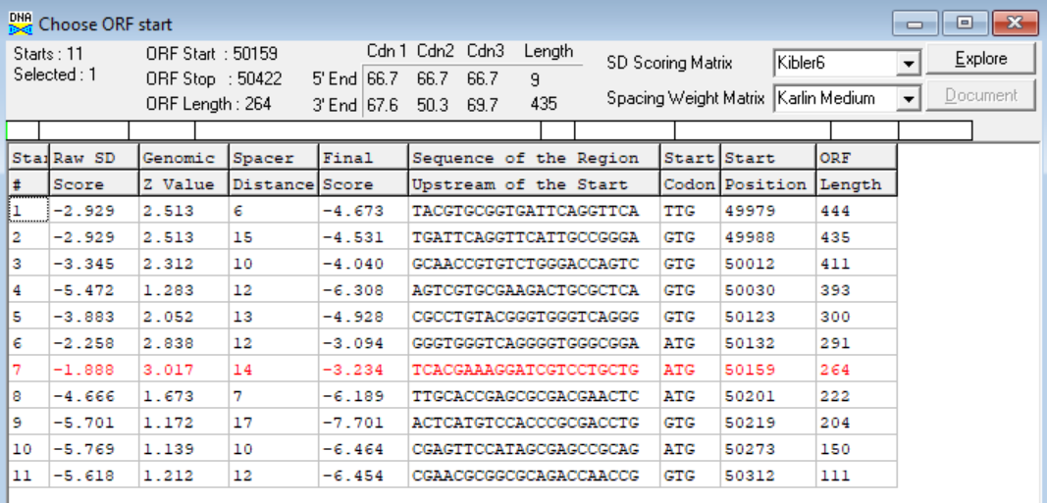
(https://toolkit.tuebingen.mpg.de/tools/hhpred) HHPRED vs PDB, SCOPe, pFam, and M. Tuberculosis. No Significant (>95%) Hits
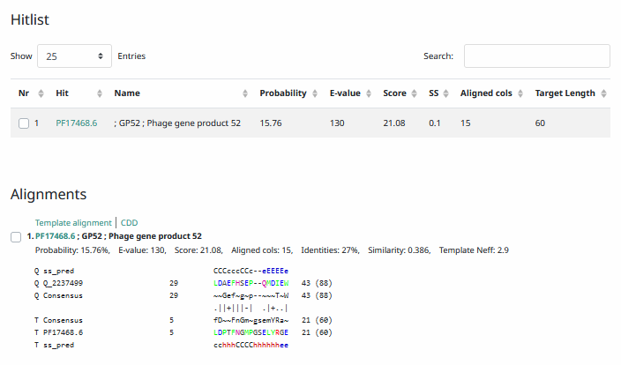
Phamerator Totinger Vs. Tootsieroll Vs. Starcevich (https://phamerator.org/phages) Genes 61-106
Proposed Function: hypothetical protein
Function Evidence: BLASTs most consistently hit this protein as one with no known function. While phage Starcevich and phage Tootsieroll do not share the same sequence, coding potential indicates that this protein is real.
Transmembrane Domain/Evidence: No (https://dtu.biolib.com/DeepTMHMM)
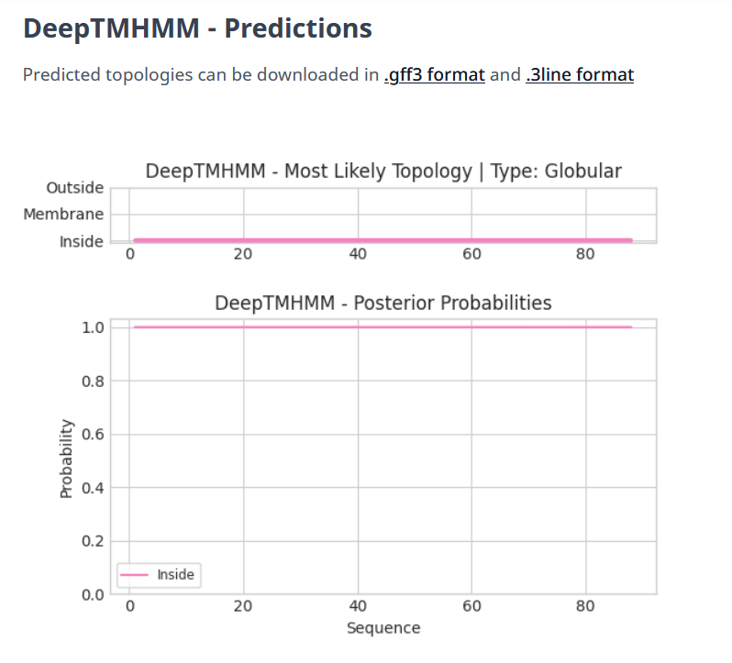

Gene Number: 89
Totinger_Draft_90 on Phagesdb
Pham152823
BLAST from PhagesDB. (https://phagesdb.org/blastp/) Using Longest ORF
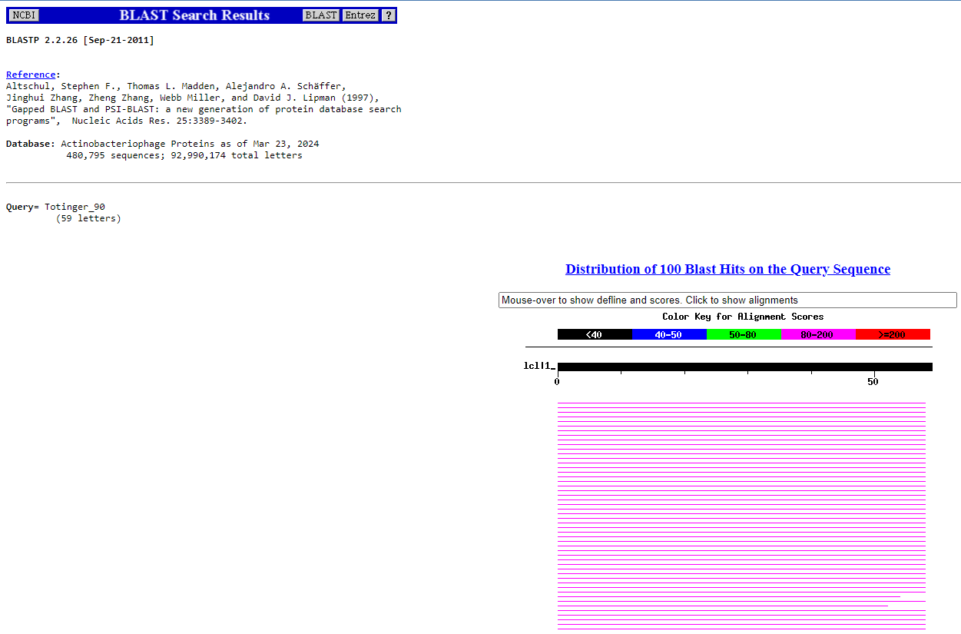
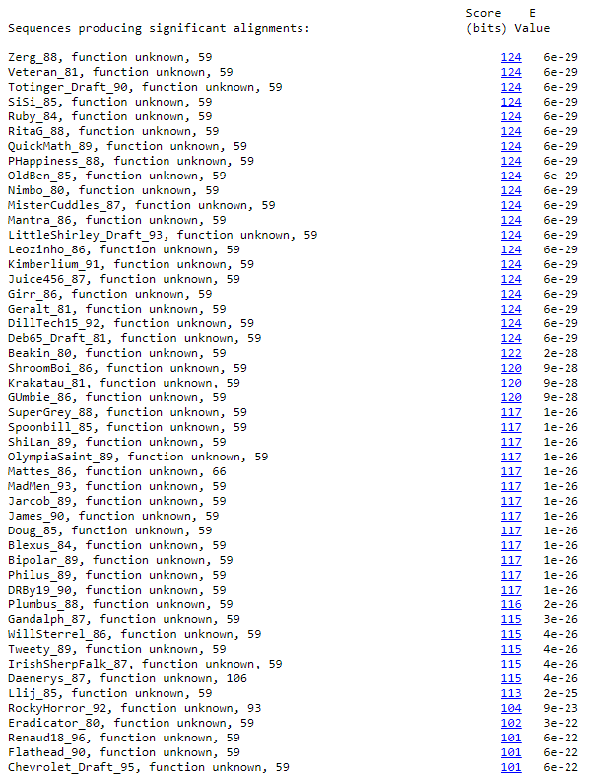
BLAST from NCBI (https://blast.ncbi.nlm.nih.gov/Blast.cgi?PAGE=Proteins) Using Longest ORF
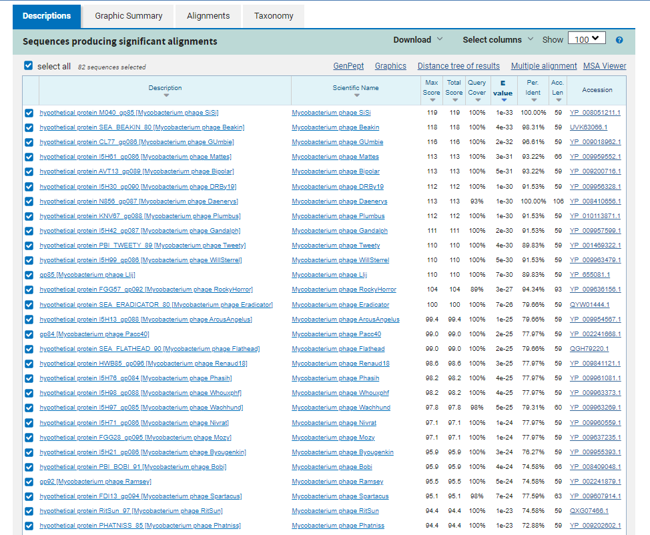
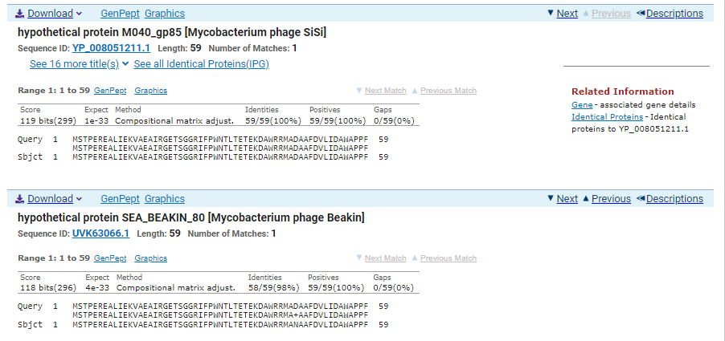
ATG Start at 50419. Original Glimmer call.
TAG Stop at 50598
F/R: F
Coding Potential (y/n): Y
Starterator (SS, NA, NI): Most annotated start is this (50419)
Blast Best Hit, Query:Subject Starts, Score, Evalue, or “no significant Blast alignments” if 10E-4 or higher
hypothetical protein M040_gp85 Mycobacterium phage SiSi YP_008051211.1, 1:1, Score 119, Evalue, 1e-33
Gap with previous gene: -3
Longest Orf? (Y/N/NA) Y
RBS:
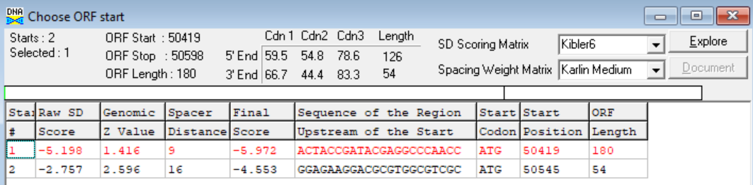
(https://toolkit.tuebingen.mpg.de/tools/hhpred) HHPRED vs PDB, SCOPe, pFam, and M. Tuberculosis. No Significant (>95%) Hits
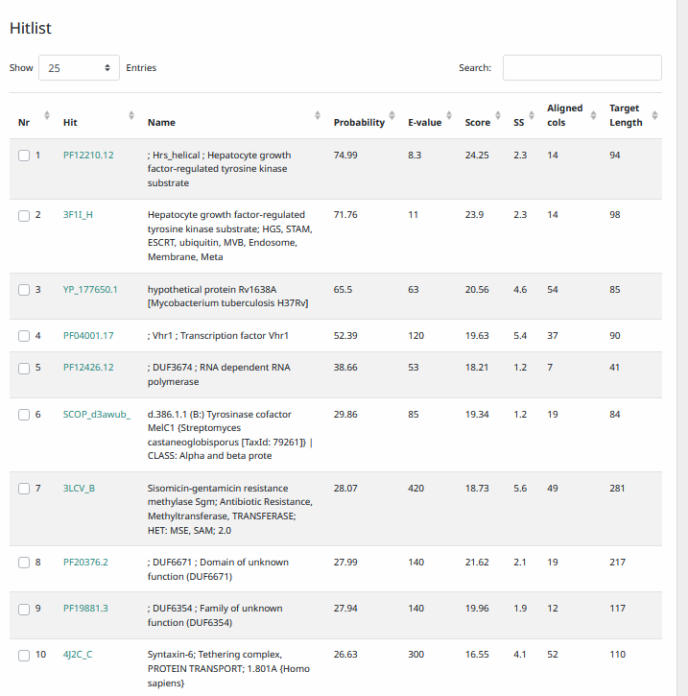
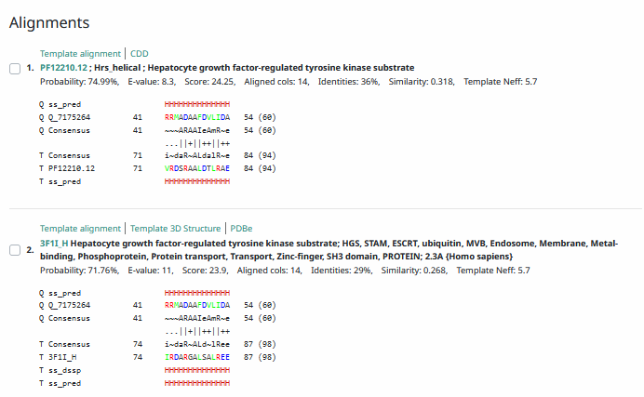
Phamerator Totinger Vs. Tootsieroll Vs. Starcevich (https://phamerator.org/phages) Genes 61-106
Proposed Function: hypothetical protein
Function Evidence: Coding potential and matches to other genes in BLASTs indicate that this is a real gene, but there is no evidence of a possible function for this protein.
Transmembrane Domain/Evidence: No, Intracellular Properties (https://dtu.biolib.com/DeepTMHMM)
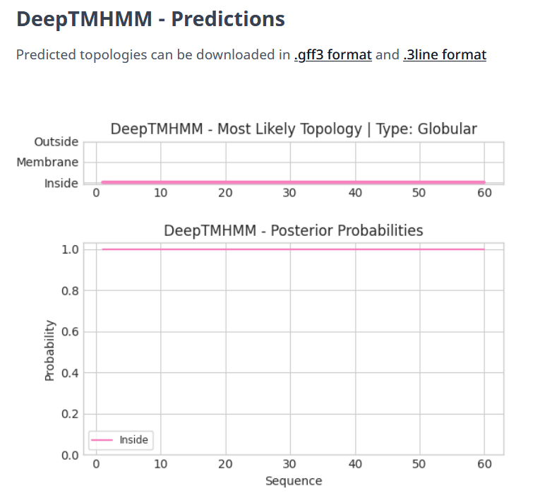

Gene Number: 90
Totinger_Draft_91 on Phagesdb
Pham150080
BLAST from PhagesDB. (https://phagesdb.org/blastp/) Using Longest ORF
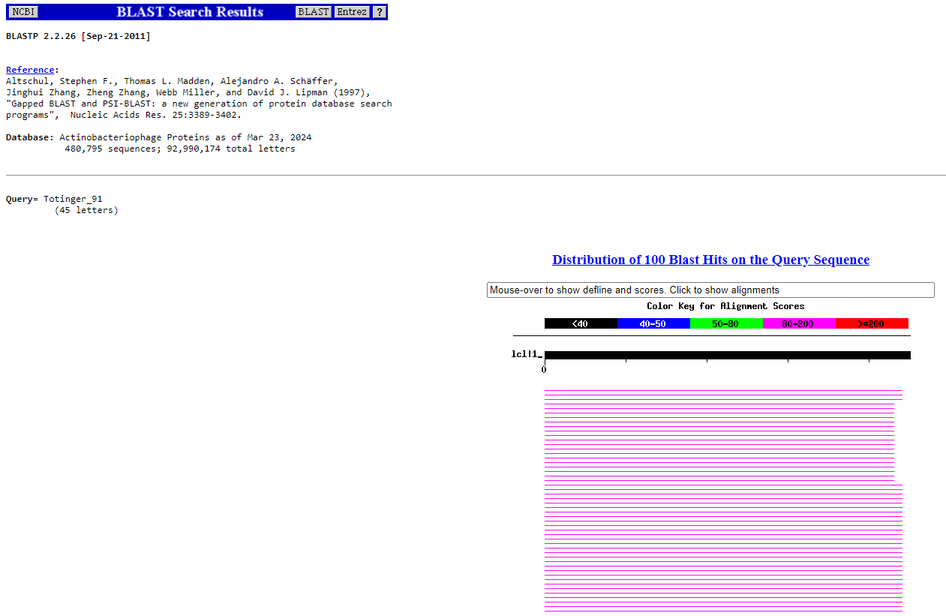
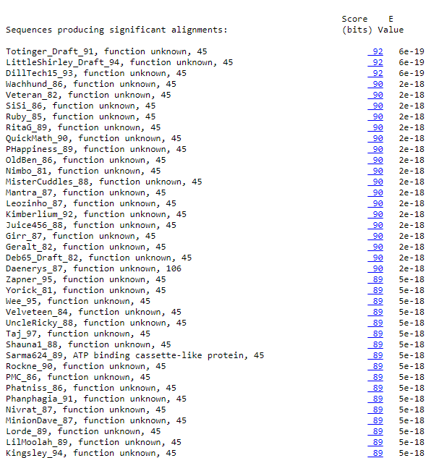
BLAST from NCBI (https://blast.ncbi.nlm.nih.gov/Blast.cgi?PAGE=Proteins) Using Longest ORF
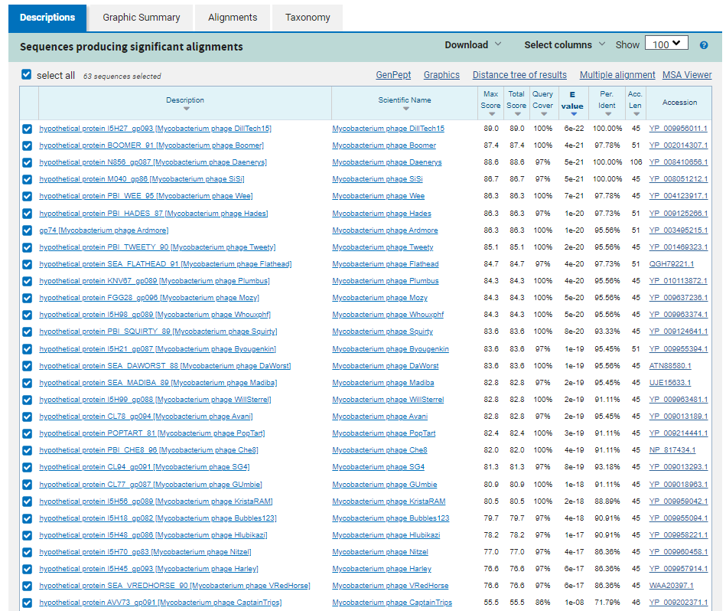
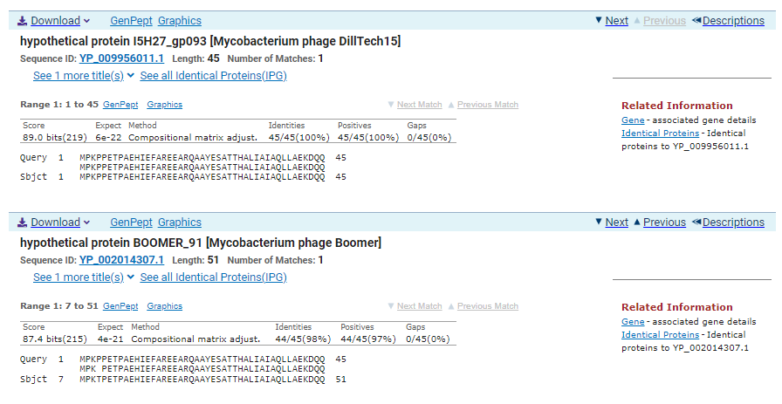
ATG Start at 50603. Original Glimmer call, Not called by Genemark.
TGA Stop at 50740
F/R: F
Coding Potential (y/n): Y
Starterator (SS, NA, NI): Most annotated start is this (50603)
Blast Best Hit, Query:Subject Starts, Score, Evalue, or “no significant Blast alignments” if 10E-4 or higher
hypothetical protein I5H27_gp093 Mycobacterium phage DillTech15 YP_009956011.1, 1:1, Score 89, Evalue, 6e-22
Gap with previous gene: 5
Longest Orf? (Y/N/NA) N
RBS:
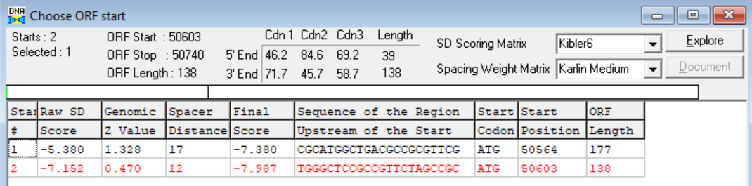
(https://toolkit.tuebingen.mpg.de/tools/hhpred) HHPRED vs PDB, SCOPe, pFam, and M. Tuberculosis. No Significant (>95%) Hits
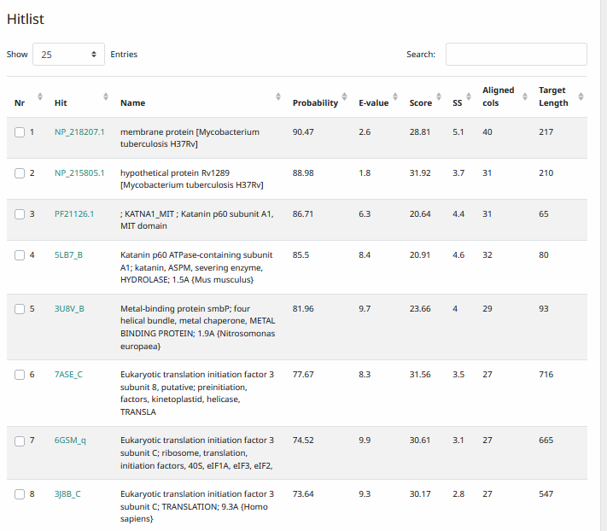
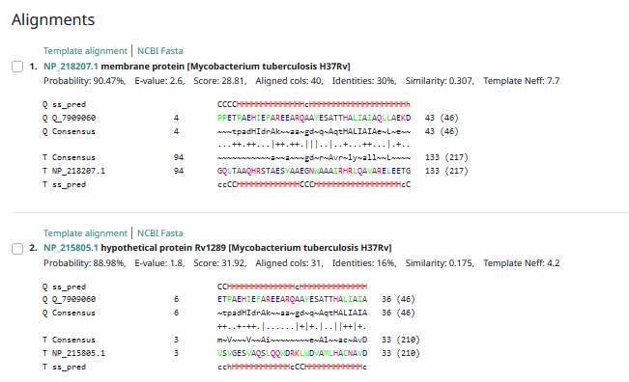
Phamerator Totinger Vs. Tootsieroll Vs. Starcevich (https://phamerator.org/phages) Genes 61-106
Proposed Function: hypothetical protein
Function Evidence: BLASTs most consistently indicate that this protein is one with no known function. Phage Starcevich shares a similar sequence in Phamerator and also calls the same Pham.
Transmembrane Domain/Evidence: No, Intracellular Properties (https://dtu.biolib.com/DeepTMHMM)
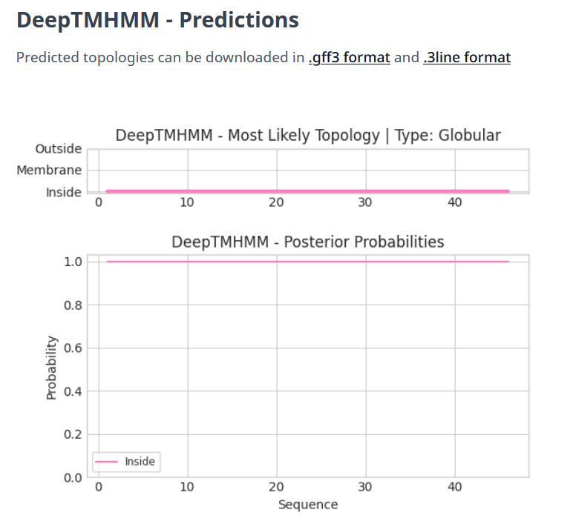

Gene Number: 91
Totinger_Draft_92 on Phagesdb
Pham85452
BLAST from PhagesDB. (https://phagesdb.org/blastp/) Using Longest ORF
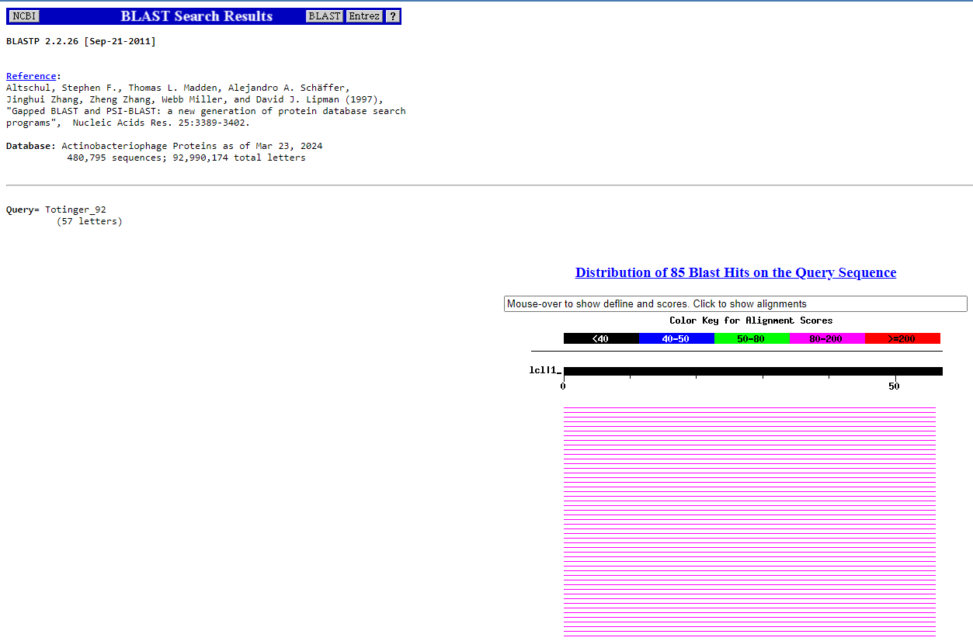
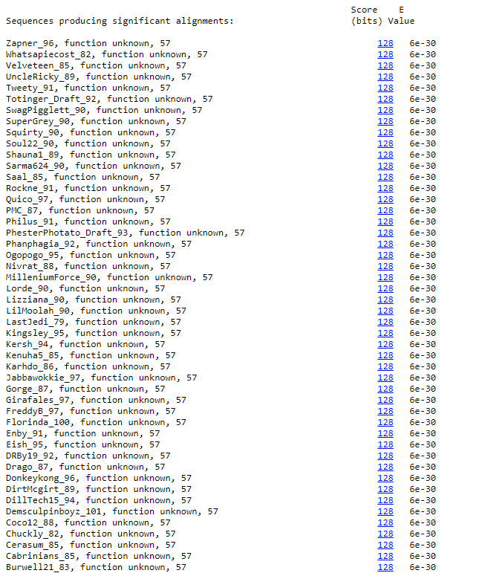
BLAST from NCBI (https://blast.ncbi.nlm.nih.gov/Blast.cgi?PAGE=Proteins) Using Longest ORF
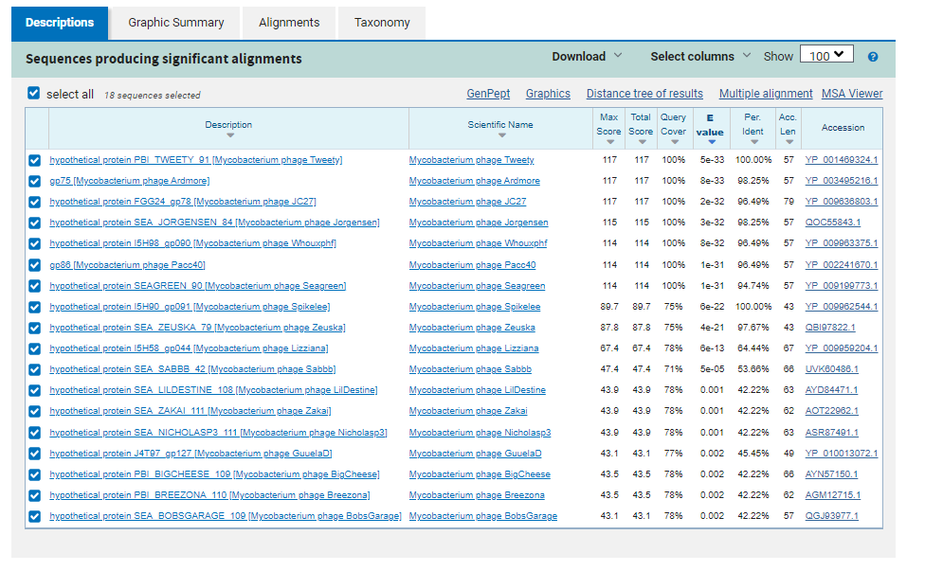
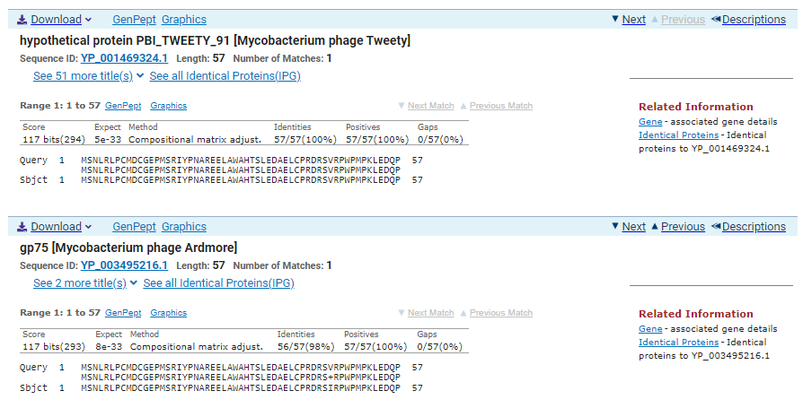
ATG Start at 50737. Original Glimmer call, not called by Genemark.
TGA Stop at 50910
F/R: F
Coding Potential (y/n): Y
Starterator (SS, NA, NI): Most annotated start is this (50737)
Blast Best Hit, Query:Subject Starts, Score, Evalue, or “no significant Blast alignments” if 10E-4 or higher
hypothetical protein PBI_TWEETY_91 Mycobacterium Phage Tweety YP_001469324.1, 1:1, Score 117, Evalue, 5e-33
Gap with previous gene: -3
Longest Orf? (Y/N/NA) Y
RBS:
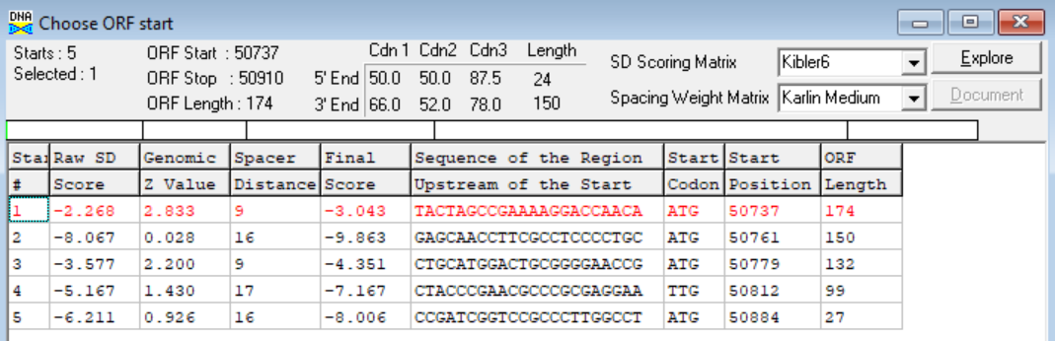
(https://toolkit.tuebingen.mpg.de/tools/hhpred) HHPRED vs PDB, SCOPe, pFam, and M. Tuberculosis. No Significant (>95%) Hits.
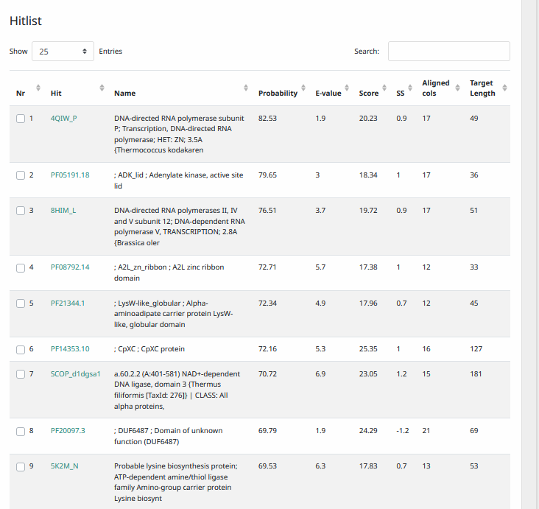
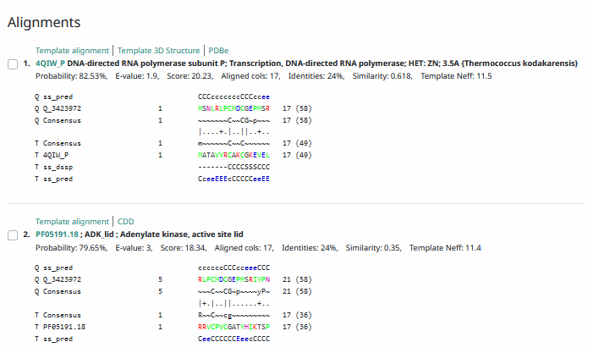
Phamerator Totinger Vs. Tootsieroll Vs. Starcevich (https://phamerator.org/phages) Genes 61-106
Proposed Function: hypothetical protein
Function Evidence: BLASTs most consistently call this protein as one with no known function. While neither phage Starcevich or phage Tootsieroll have a similar sequence, phage Tweety does and calls an identical gene without a function.
Transmembrane Domain/Evidence: No, Intracellular Properties (https://dtu.biolib.com/DeepTMHMM)
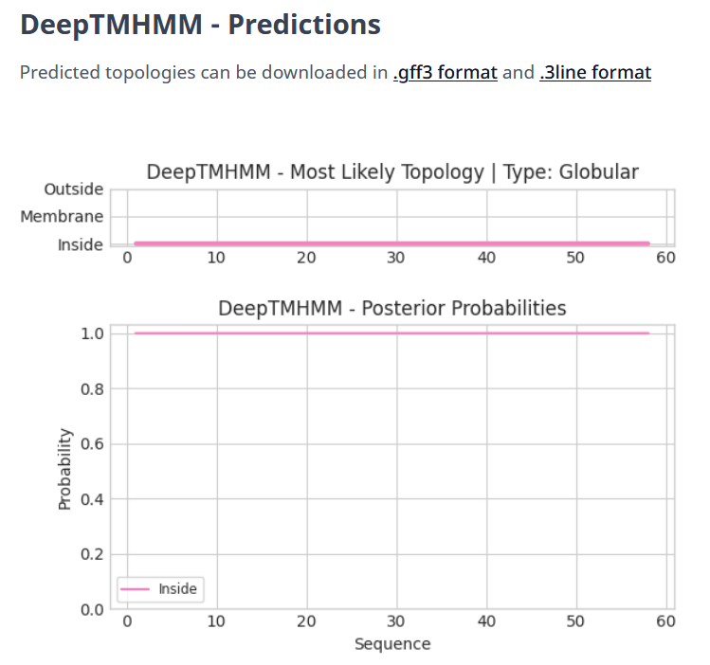

Gene Number: 92
Totinger_Draft_93 on Phagesdb
Pham107093
BLAST from PhagesDB. (https://phagesdb.org/blastp/) Using Longest ORF
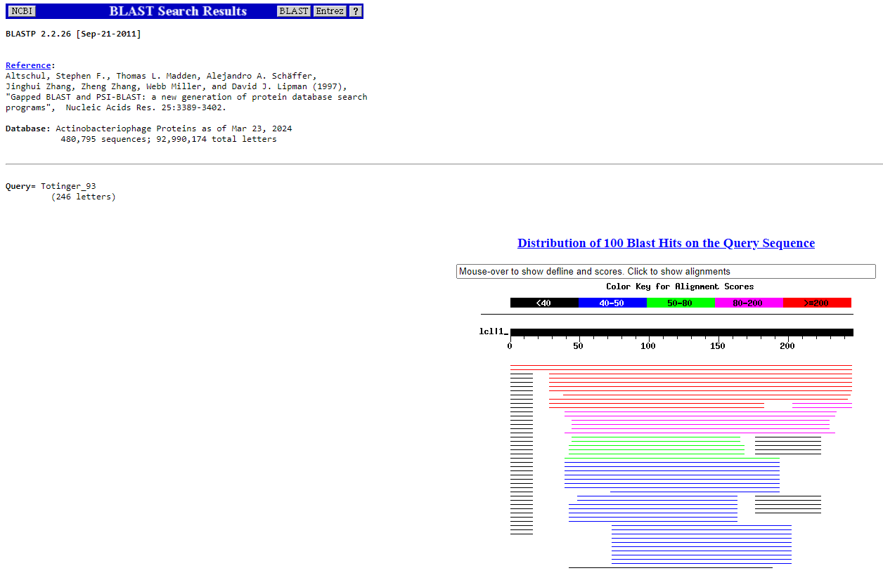
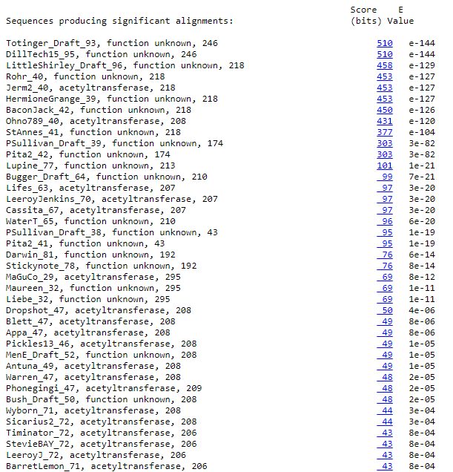
BLAST from NCBI (https://blast.ncbi.nlm.nih.gov/Blast.cgi?PAGE=Proteins) Using Longest ORF
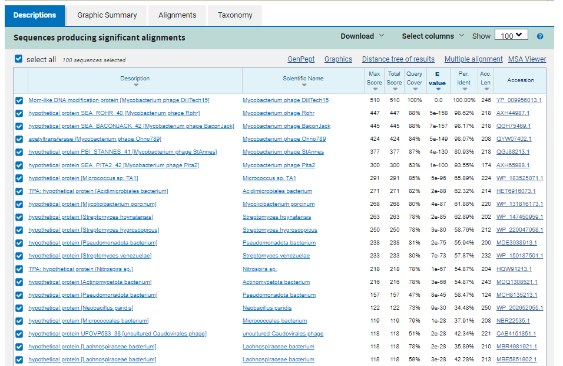
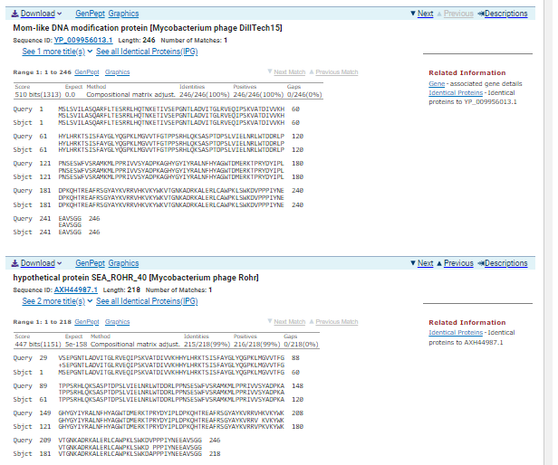
TTG Start at 50907. Original Glimmer call. Genemark calls start at 50991.
TAA Stop at 51647
F/R: F
Coding Potential (y/n): Y
Starterator (SS, NA, NI): Most annotated start is this (50907)
Blast Best Hit, Query:Subject Starts, Score, Evalue, or “no significant Blast alignments” if 10E-4 or higher
Mom-like DNA modification protein Mycobacterium phage DillTech15 YP_009956013.1, 1:1, Score 510, Evalue, 0
Gap with previous gene: -3
Longest Orf? (Y/N/NA) N
RBS:
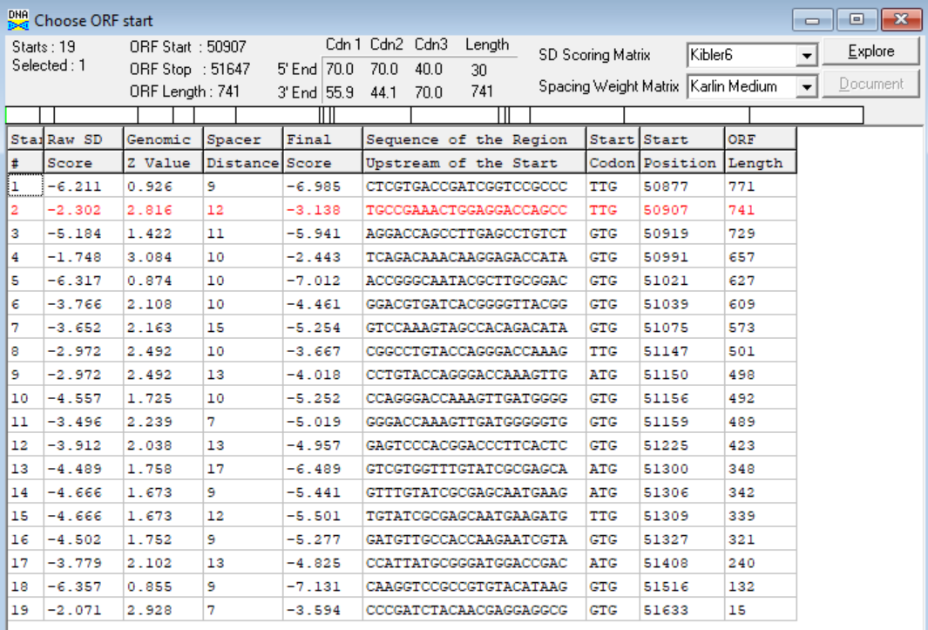
(https://toolkit.tuebingen.mpg.de/tools/hhpred) HHPRED vs PDB, SCOPe, pFam, and M. Tuberculosis.
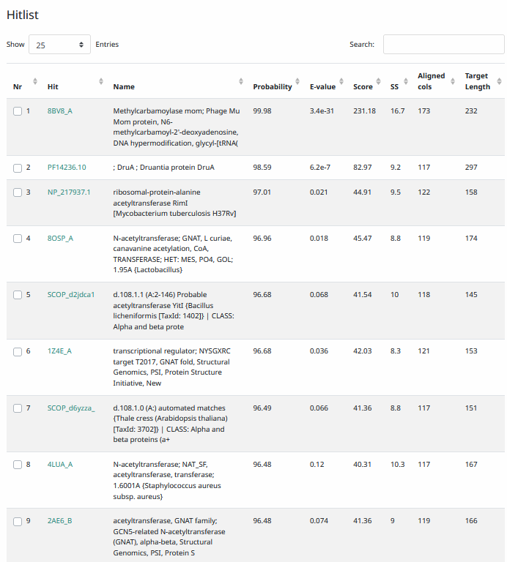
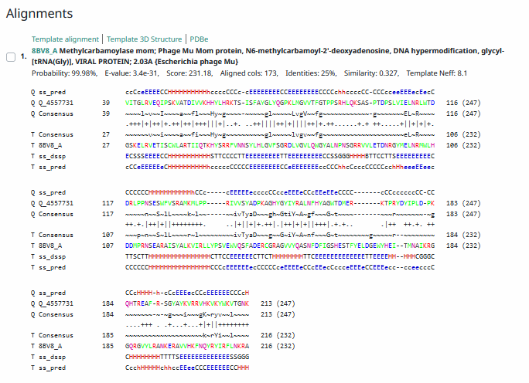
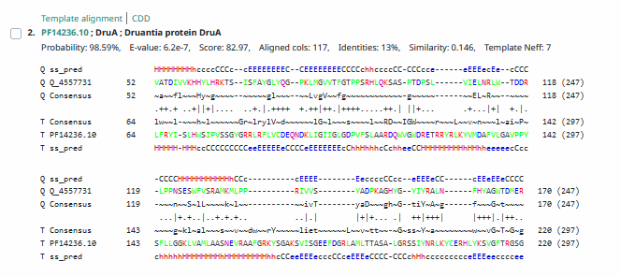
Phamerator Totinger Vs. Tootsieroll Vs. Starcevich (https://phamerator.org/phages) Genes 61-106
Phamerator Totinger (Bottom) Vs. DillTech15 (Top) (https://phamerator.org/phages) Genes 84-95
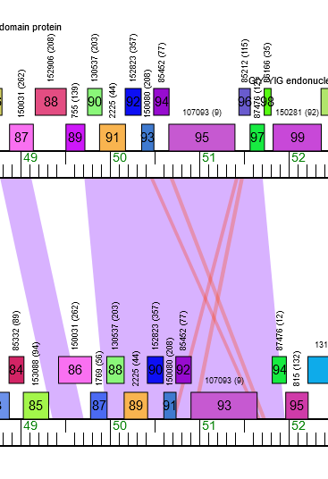
Proposed Function: hypothetical protein
Function Evidence: In Phamerator, phage DillTech15 calls an identical gene from an identical sequence and also calls no known function. Additionally, BLASTs and HHPRED most consistently hit this protein as one with no known function.
Transmembrane Domain/Evidence: No, Intracellular Properties (https://dtu.biolib.com/DeepTMHMM)
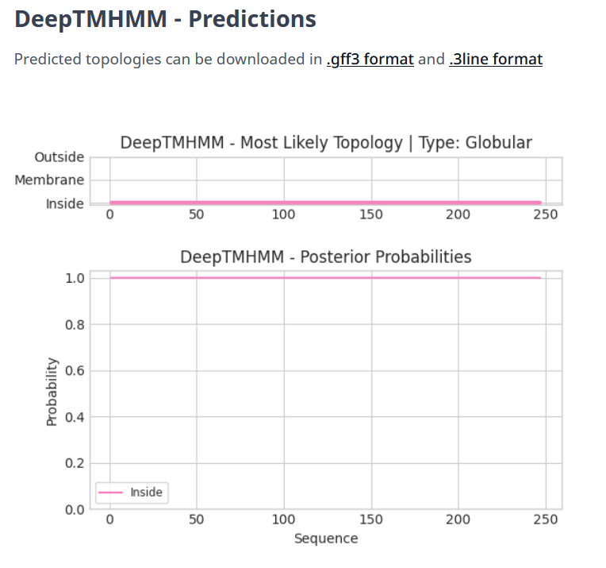

- Added New Gene Not Initially called by DNA Master. Information as Follows.

Gene Number: 93
Pham: No Data for Start, Gene added Manually
BLAST from PhagesDB. (https://phagesdb.org/blastp/) Using Longest ORF
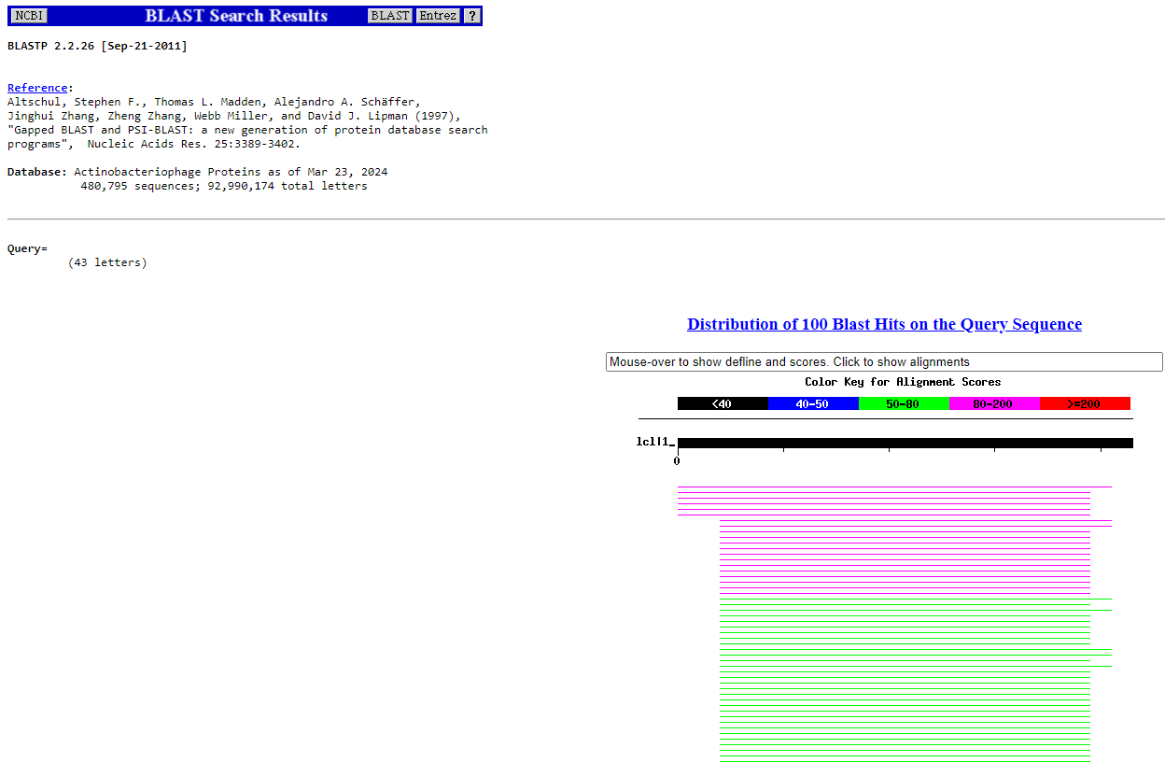
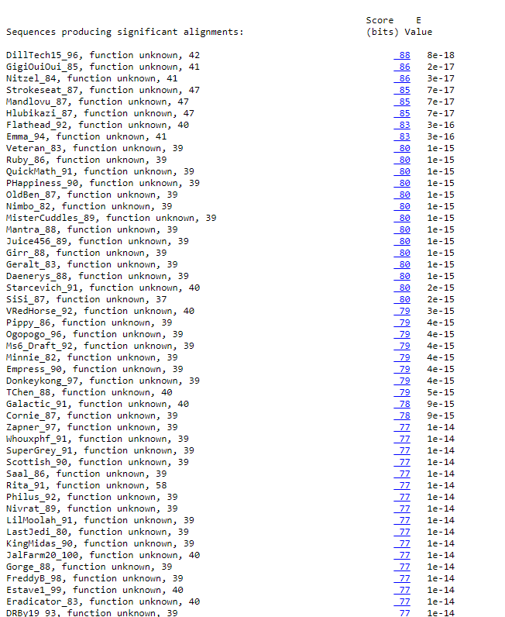
BLAST from NCBI (https://blast.ncbi.nlm.nih.gov/Blast.cgi?PAGE=Proteins) Using Longest ORF
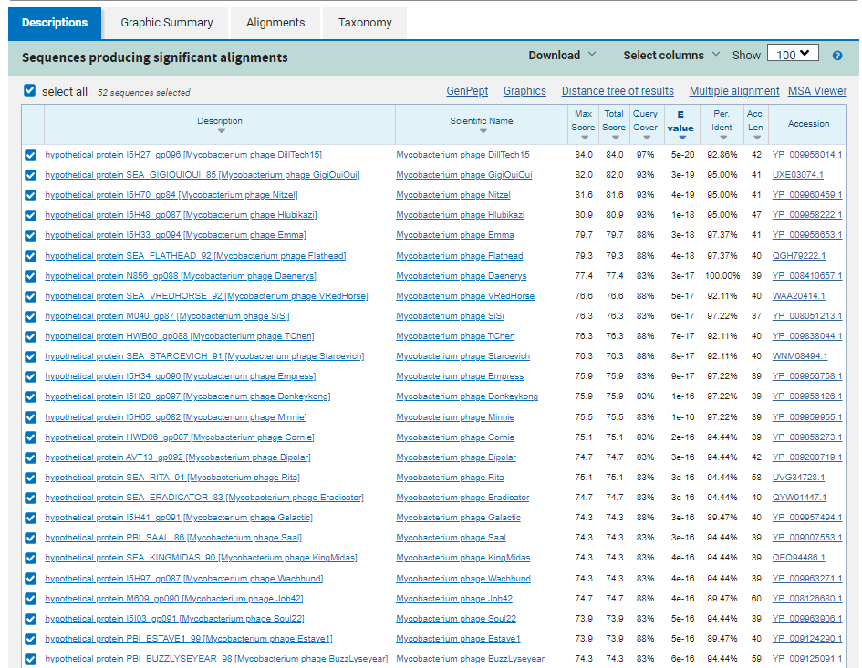
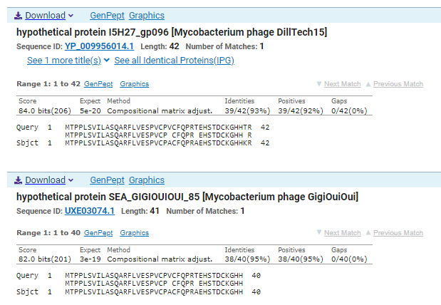
GTG Start at 51691. Not called by Glimmer.
TGA Stop at 58119.
F/R: F
Coding Potential (y/n): Weak, but Present. Y
Starterator (SS, NA, NI): No Data for Start, Gene Added Manually.
Blast Best Hit, Query:Subject Starts, Score, Evalue, or “no significant Blast alignments” if 10E-4 or higher
hypothetical protein I5H27_gp096 Mycobacterium phage DillTech15 YP_009956014.1, 1:1, Score 84, Evalue, 5e-20
Gap with previous gene: 44
Longest Orf? (Y/N/NA) N
RBS:
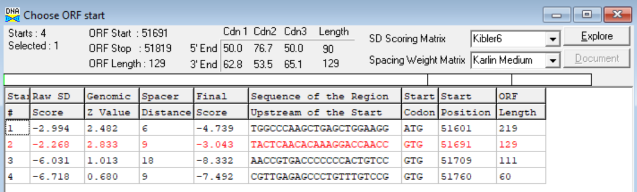
(https://toolkit.tuebingen.mpg.de/tools/hhpred) HHPRED vs PDB, SCOPe, pFam, and M. Tuberculosis. No Significant (>95%) Hits.
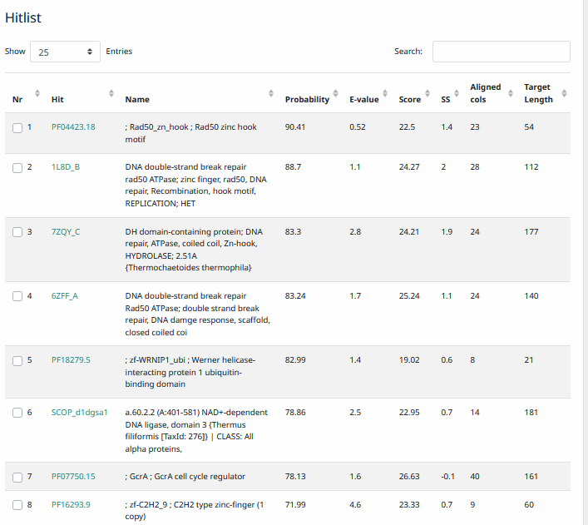
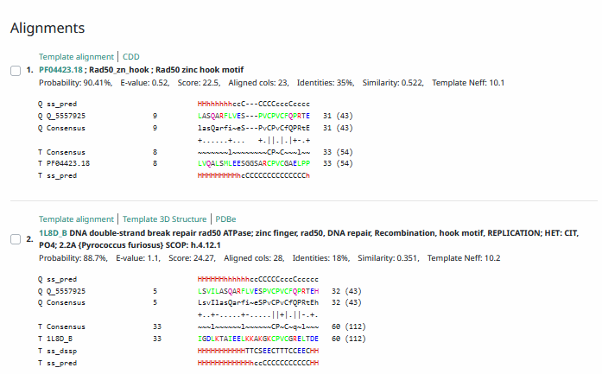
Phamerator Totinger (Bottom) Vs. DillTech15 (Top) (https://phamerator.org/phages) Genes 84-95
Proposed Function: hypothetical protein
Function Evidence: Phage DillTech15 shares an identical sequence with Totinger and calls an undocumented gene in this gene’s area. DillTech15 does not call a function. BLASTs also most consistently hit this gene as one with unknown function.
Transmembrane Domain/Evidence: No, Intracellular Properties (https://dtu.biolib.com/DeepTMHMM)
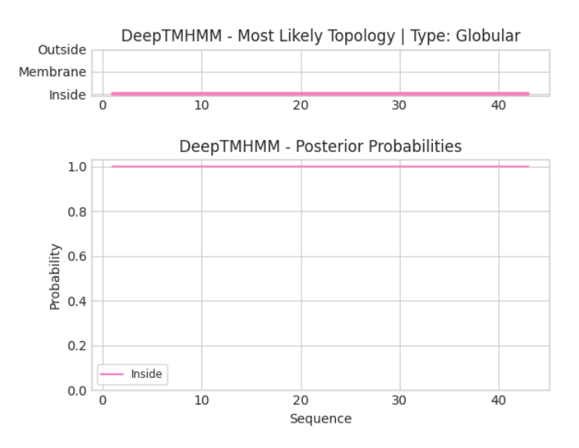

Gene Number: 94
Totinger_Draft_94 on Phagesdb
Pham87476
BLAST from PhagesDB. (https://phagesdb.org/blastp/) Using Longest ORF
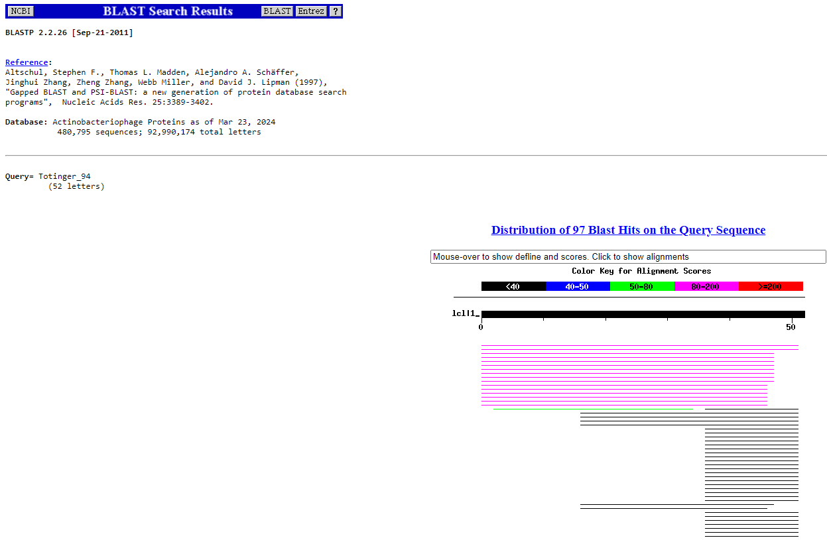
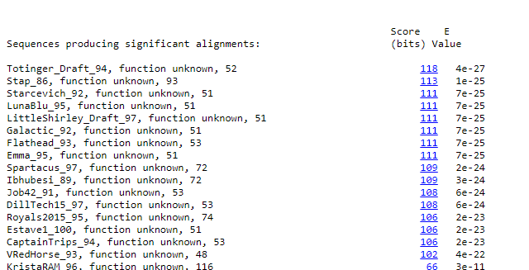
BLAST from NCBI (https://blast.ncbi.nlm.nih.gov/Blast.cgi?PAGE=Proteins) Using Longest ORF
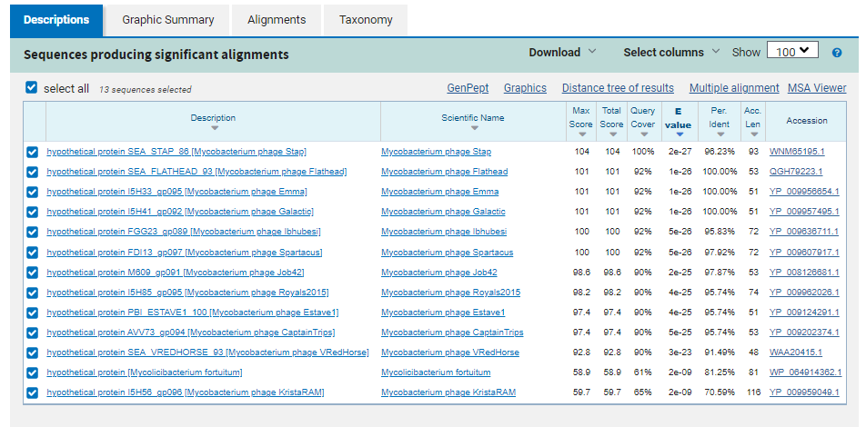
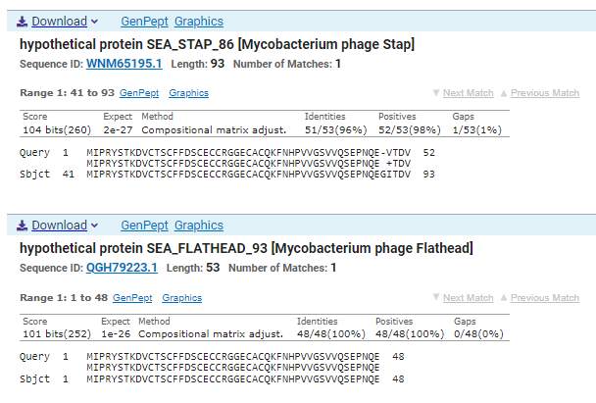
ATG Start at 51816. Original Glimmer call, Not called by Genemark.
TGA Stop at 51974
F/R: F
Coding Potential (y/n): Weak, but present. Y
Starterator (SS, NA, NI): Most annotated start is this (51816)
Blast Best Hit, Query:Subject Starts, Score, Evalue, or “no significant Blast alignments” if 10E-4 or higher
hypothetical protein SEA_STAP_86 Mycobacterium phage Stap WNM65195.1, 41:93, Score 104, Evalue, 2e-27
Gap with previous gene: -3
Longest Orf? (Y/N/NA) N
RBS:
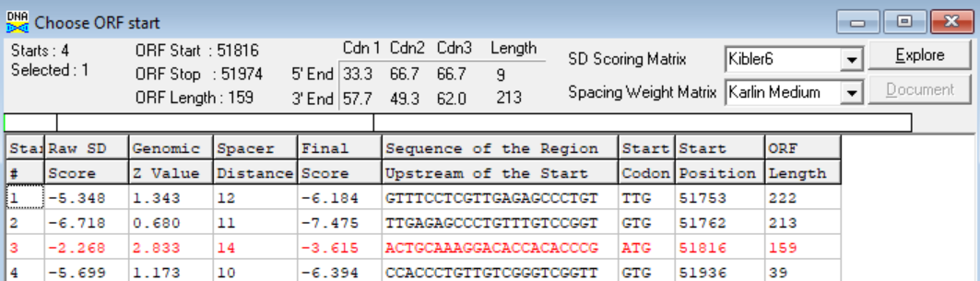
(https://toolkit.tuebingen.mpg.de/tools/hhpred) HHPRED vs PDB, SCOPe, pFam, and M. Tuberculosis. No Significant (>95%) Hits.
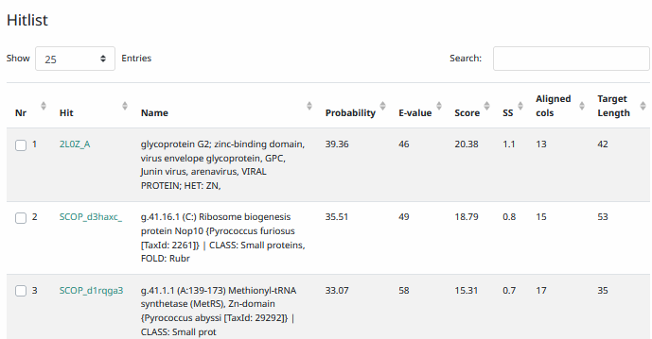
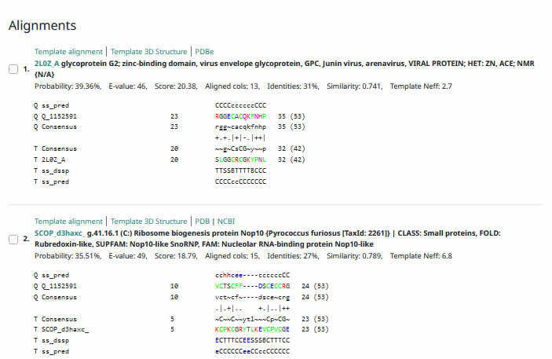
Phamerator Totinger Vs. Tootsieroll Vs. Starcevich (https://phamerator.org/phages) Genes 61-106
Proposed Function: hypothetical protein
Function Evidence: BLASTs most commonly hit this protein as one that has no known function. Additionally, phage Starcevich calls an identical gene from a near identical sequence but does not call a function with it.
Transmembrane Domain/Evidence: No, Intracellular Properties (https://dtu.biolib.com/DeepTMHMM)
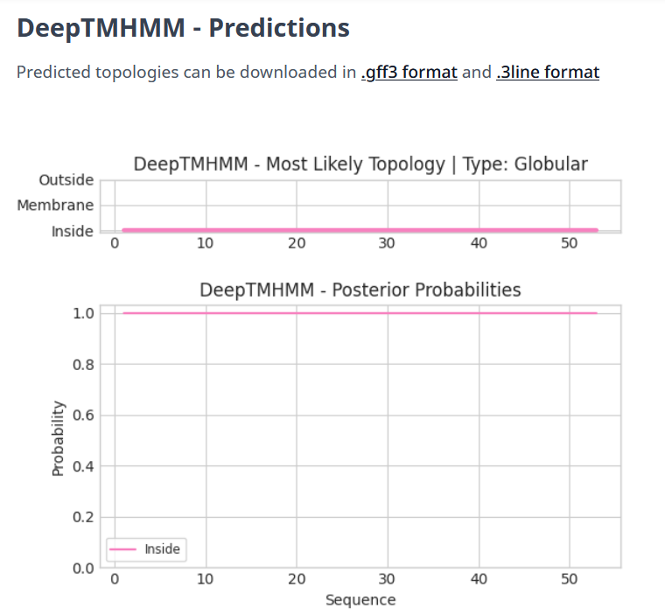

Gene Number: 95
Totinger_Draft_95 on Phagesdb
Pham815
BLAST from PhagesDB. (https://phagesdb.org/blastp/) Using Longest ORF
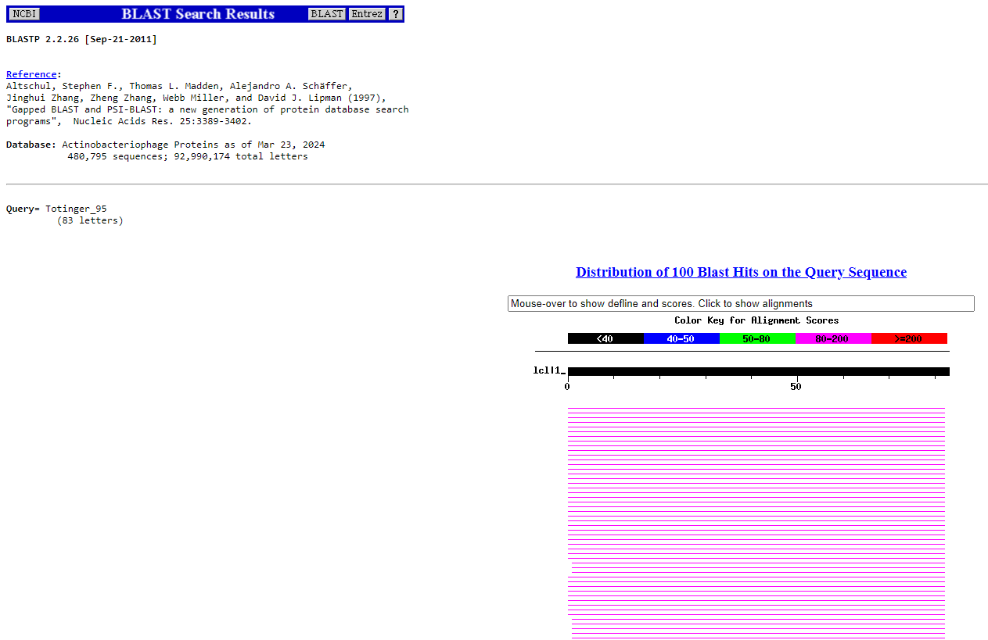
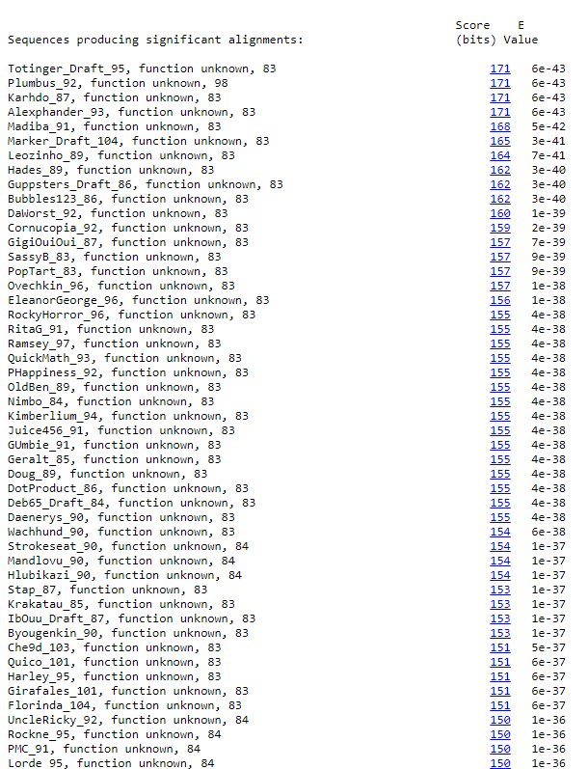
BLAST from NCBI (https://blast.ncbi.nlm.nih.gov/Blast.cgi?PAGE=Proteins) Using Longest ORF
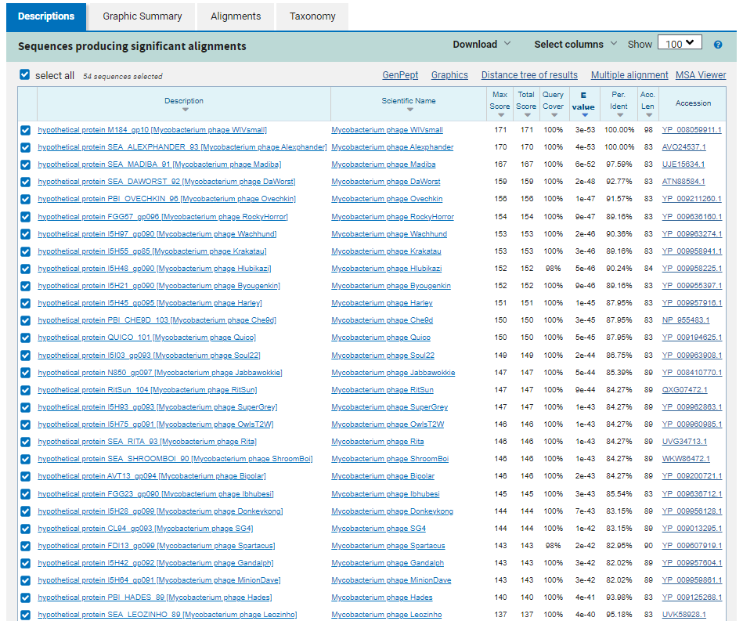
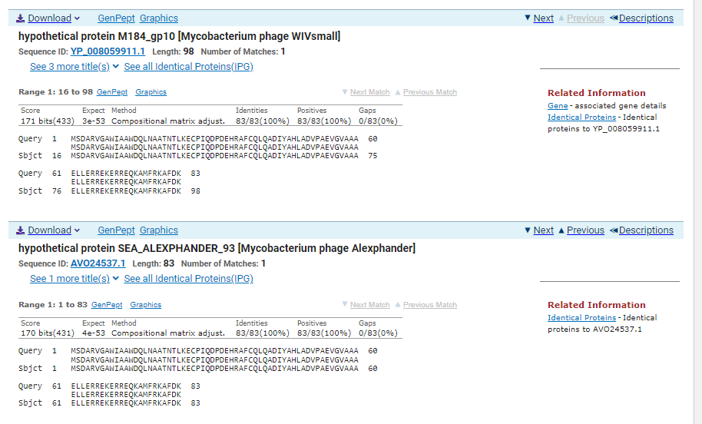
ATG Start at 51967. Original Glimmer call.
TGA Stop at 52218
F/R: F
Coding Potential (y/n): Y
Starterator (SS, NA, NI): Does not have the Most Annotated Start
Blast Best Hit, Query:Subject Starts, Score, Evalue, or “no significant Blast alignments” if 10E-4 or higher
hypothetical protein M184_gp10 Mycobacterium phage WIVsmall YP_008059911.1, 16:98, Score 171, Evalue, 3e-53
Gap with previous gene: -7
Longest Orf? (Y/N/NA) N
RBS:
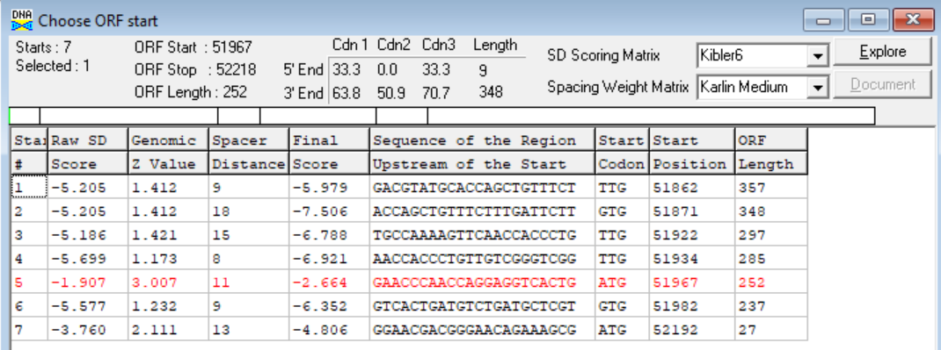
(https://toolkit.tuebingen.mpg.de/tools/hhpred) HHPRED vs PDB, SCOPe, pFam, and M. Tuberculosis. No Significant (>95%) Hits.
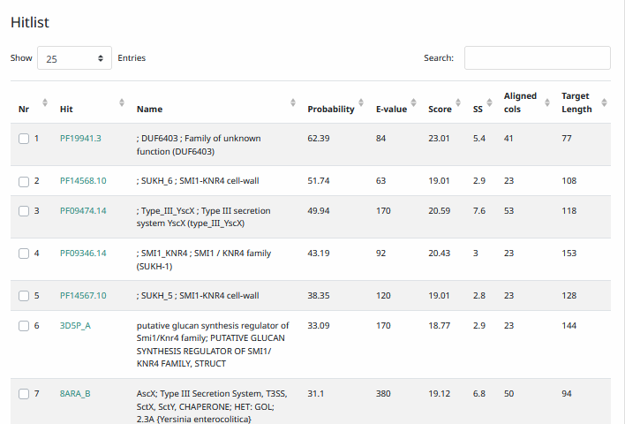
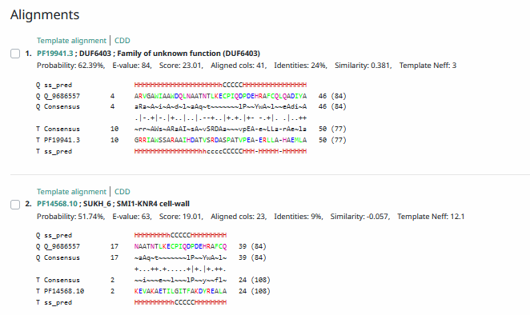
Phamerator Totinger Vs. Tootsieroll Vs. Starcevich (https://phamerator.org/phages) Genes 61-106
Proposed Function: hypothetical protein
Function Evidence: BLASTs most commonly hit this protein as one with no known function. In Phamerator, phage Starcevich calls the same gene from a similar sequence but also notes no known function.
Transmembrane Domain/Evidence: No, Intracellular Properties (https://dtu.biolib.com/DeepTMHMM)
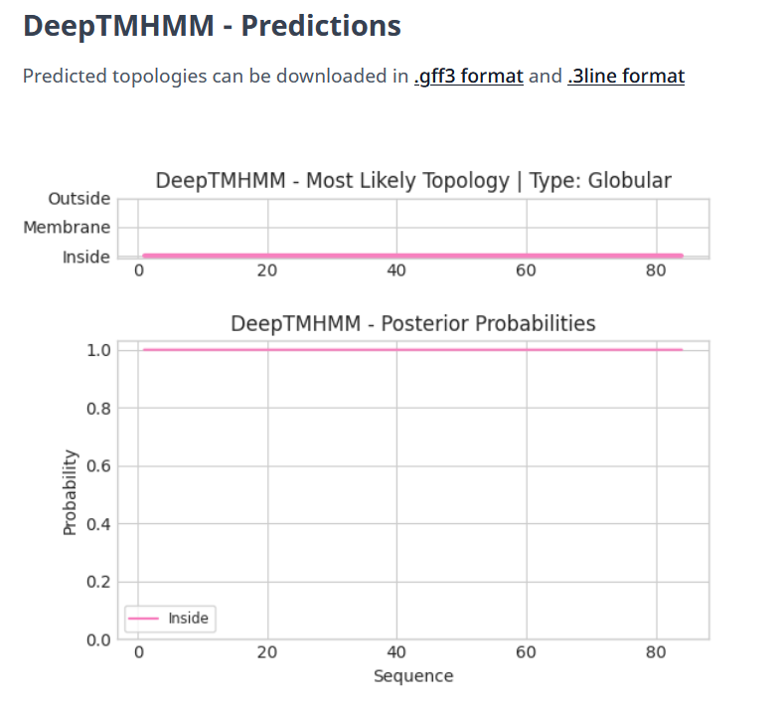

Gene Number: 96
Totinger_Draft_96 on Phagesdb
Pham131817
BLAST from PhagesDB. (https://phagesdb.org/blastp/) Using Longest ORF
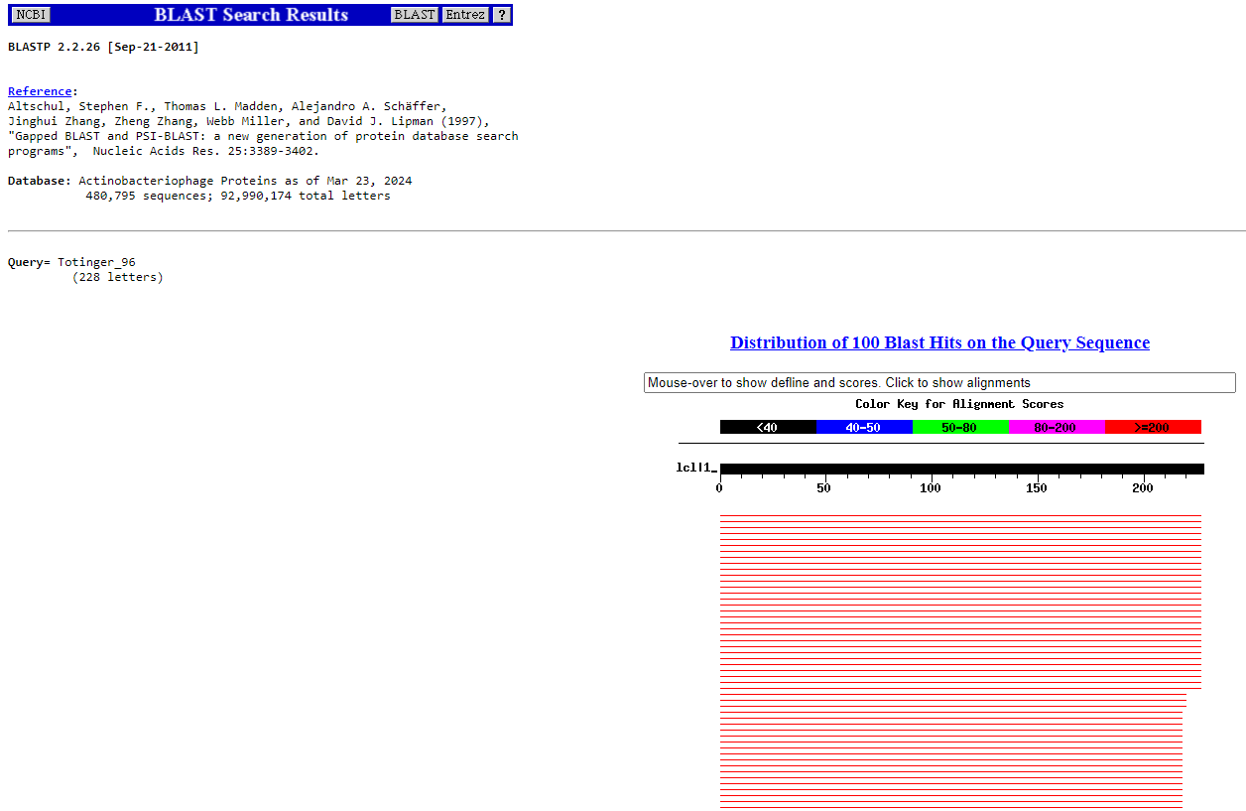
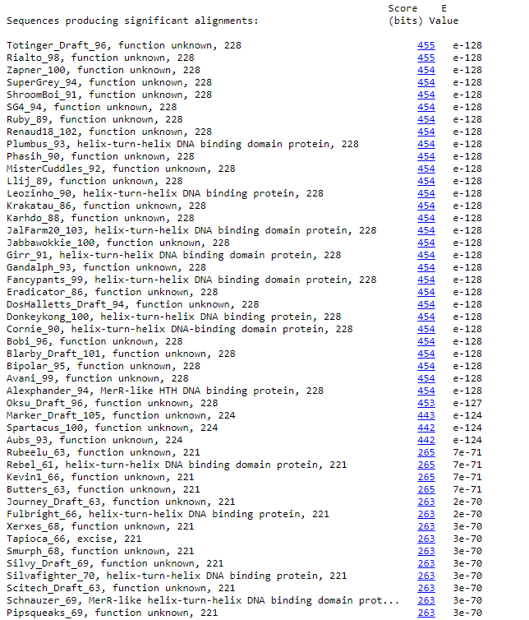
BLAST from NCBI (https://blast.ncbi.nlm.nih.gov/Blast.cgi?PAGE=Proteins) Using Longest ORF
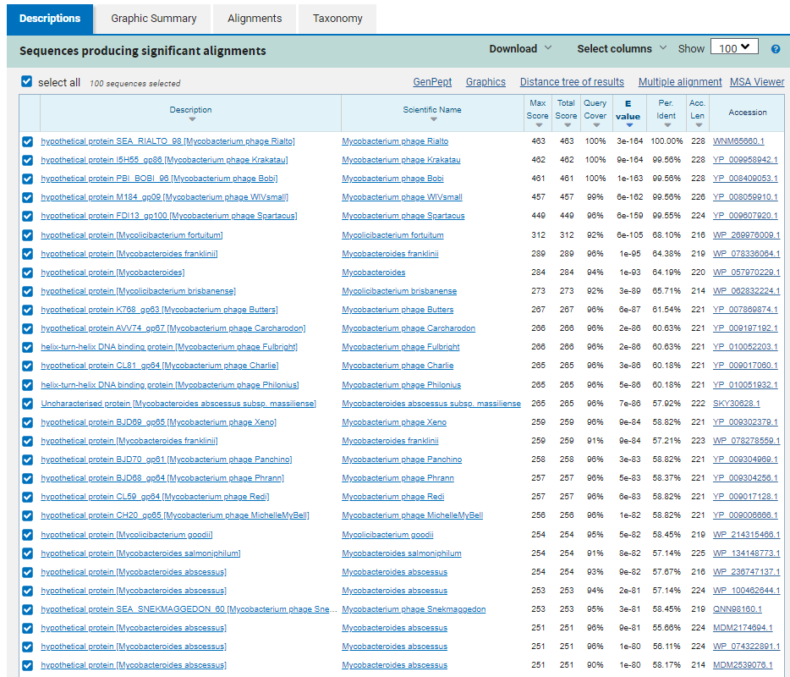
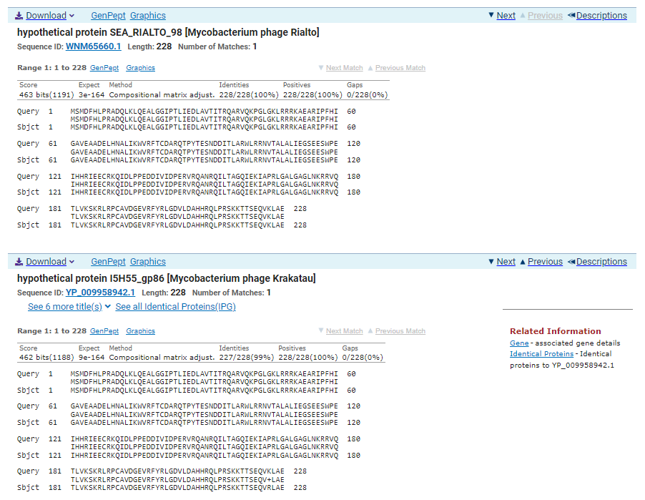
GTG Start at 52215. Original Glimmer call, Genemark calls start at 52221.
TGA Stop at 52901
F/R: F
Coding Potential (y/n): Y
Starterator (SS, NA, NI): Most annotated start is this (52215)
Blast Best Hit, Query:Subject Starts, Score, Evalue, or “no significant Blast alignments” if 10E-4 or higher
hypothetical protein SEA_RIALTO_98 Mycobacterium phage Rialto WNM65660.1, 1:1, Score 463, Evalue, 3e-164
Gap with previous gene: -3
Longest Orf? (Y/N/NA) Y
RBS:
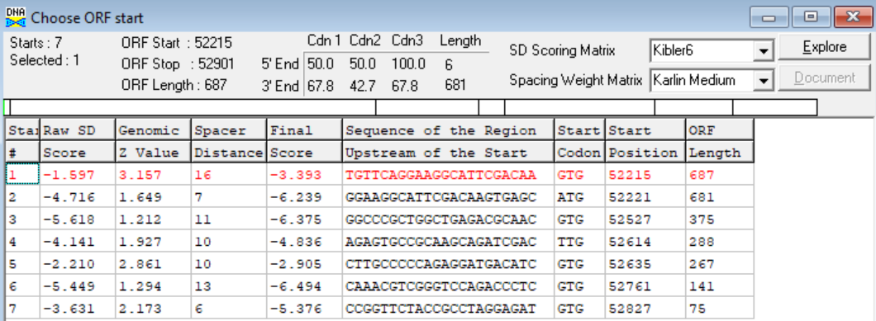
(https://toolkit.tuebingen.mpg.de/tools/hhpred) HHPRED vs PDB, SCOPe, pFam, and M. Tuberculosis.
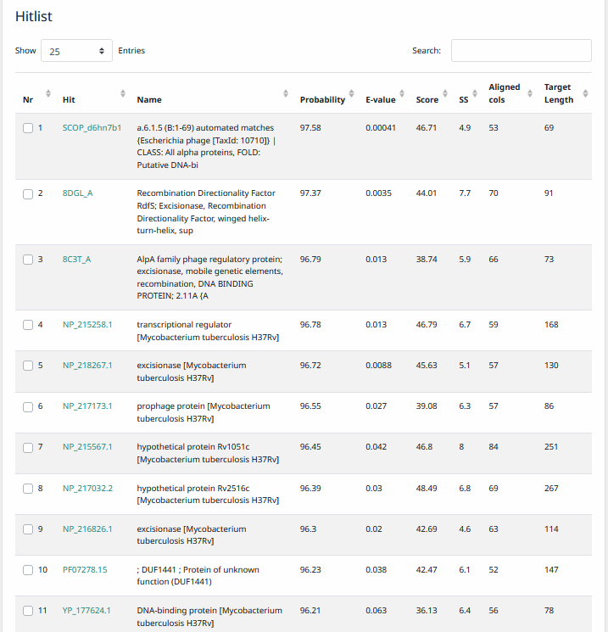
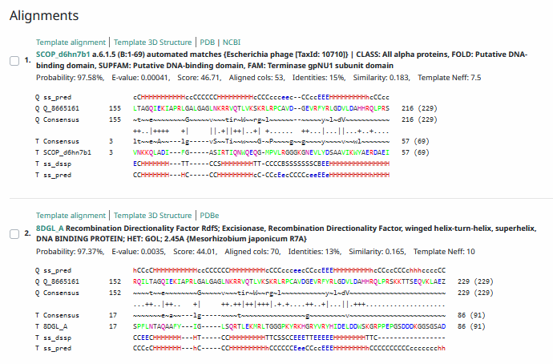
Phamerator Totinger Vs. Tootsieroll Vs. Starcevich (https://phamerator.org/phages) Genes 61-106
Phamerator Totinger (Bottom) Vs. Rialto (Top) (https://phamerator.org/phages) Genes 96-106
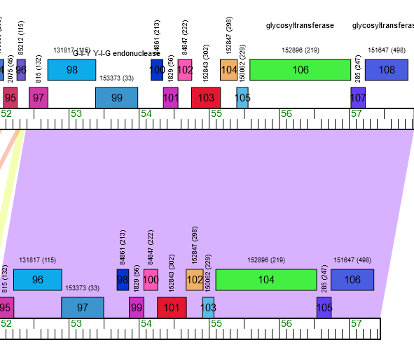
Proposed Function: hypothetical protein
Function Evidence: In Phamerator, phage Rialto calls an identical gene from an identical sequence, but does not call a function. Additionally, BLASTs most consistently hit this protein as one that has no known function.
Transmembrane Domain/Evidence: No, Intracellular Properties (https://dtu.biolib.com/DeepTMHMM)
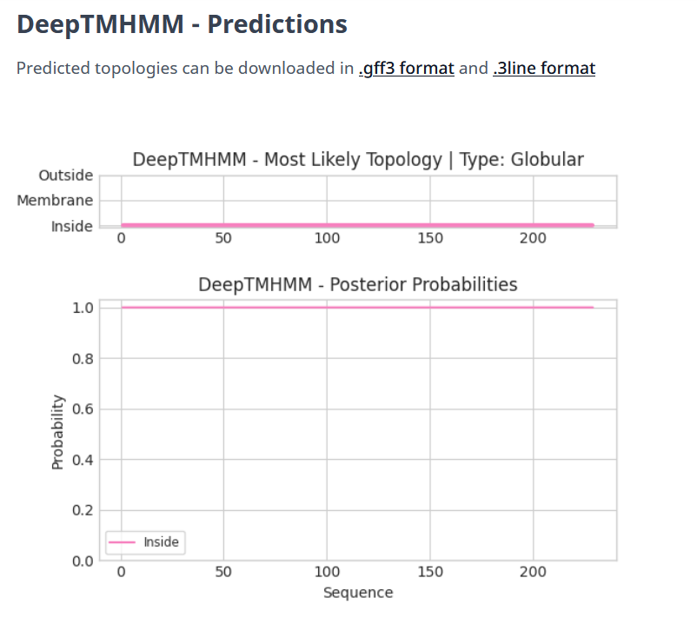

Gene Number: 97
Totinger_Draft_97 on Phagesdb
Pham153373
BLAST from PhagesDB. (https://phagesdb.org/blastp/) Using Longest ORF
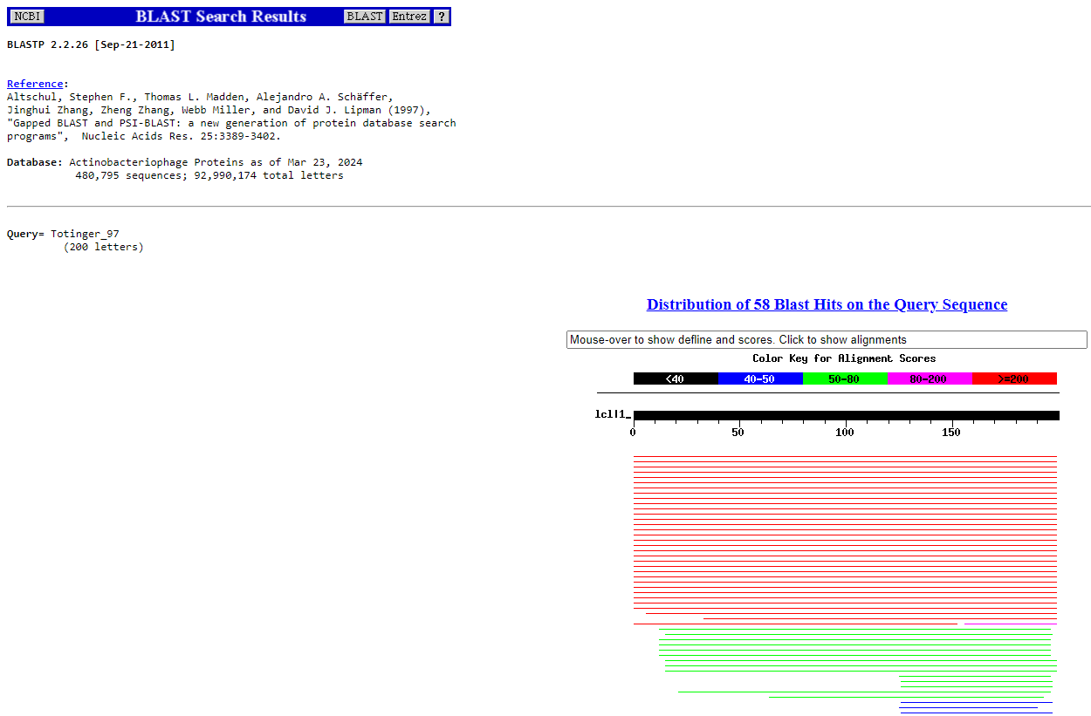
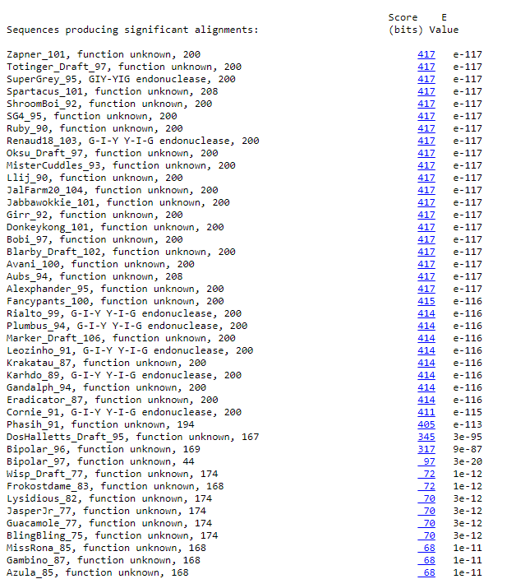
BLAST from NCBI (https://blast.ncbi.nlm.nih.gov/Blast.cgi?PAGE=Proteins) Using Longest ORF
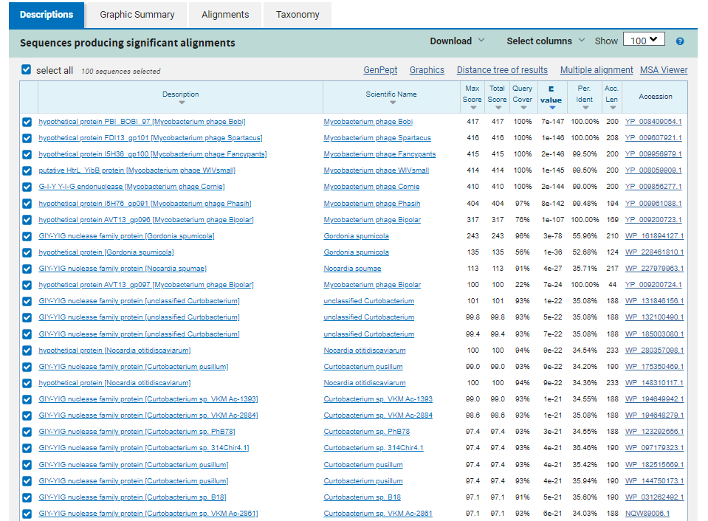
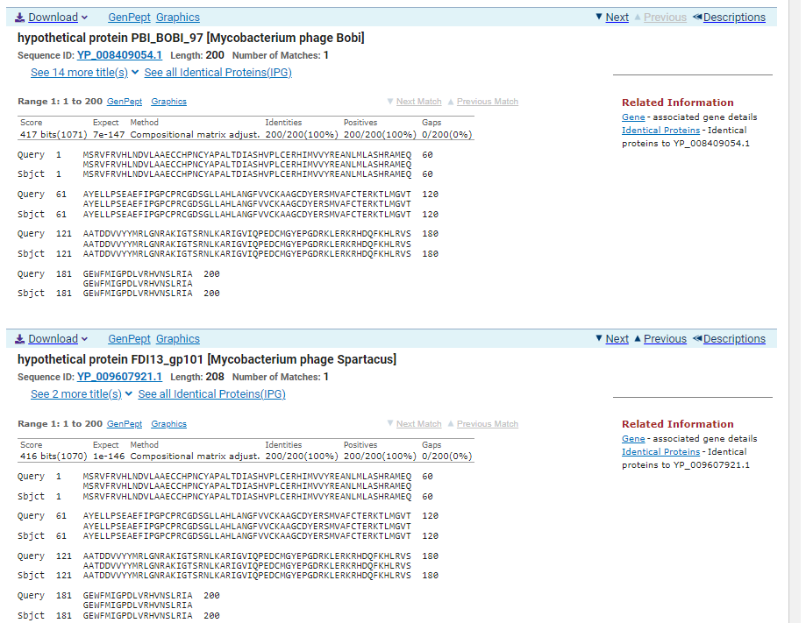
ATG Start at 52898. Original Glimmer call, GeneMark calls start at 53213.
TGA Stop at 53500
F/R: F
Coding Potential (y/n): Y
Starterator (SS, NA, NI): Most annotated start is this (52898)
Blast Best Hit, Query:Subject Starts, Score, Evalue, or “no significant Blast alignments” if 10E-4 or higher
hypothetical protein PBI_BOBI_97 Mycobacterium phage Bobi YP_008409054.1, 1:1, Score 417, Evalue, 7e-147
Gap with previous gene: -3
Longest Orf? (Y/N/NA) Y
RBS:
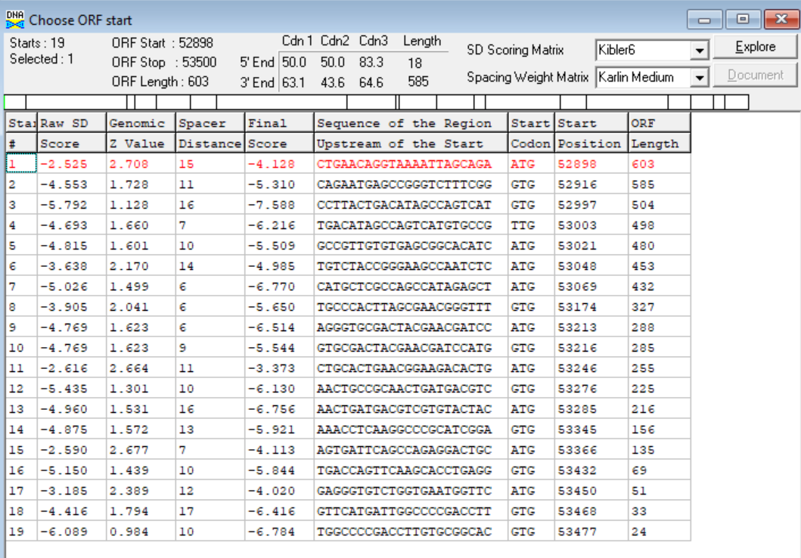
(https://toolkit.tuebingen.mpg.de/tools/hhpred) HHPRED vs PDB, SCOPe, pFam, and M. Tuberculosis.
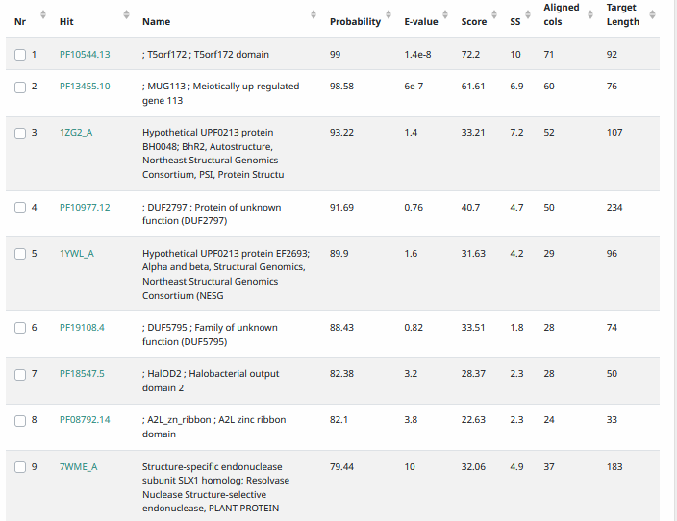
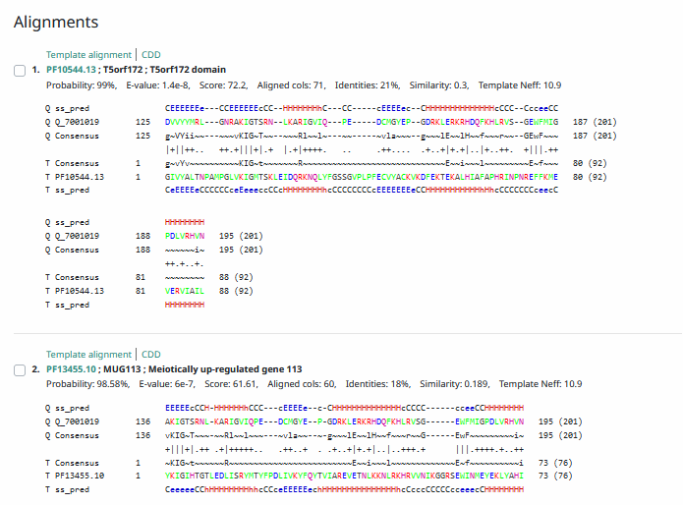
Phamerator Totinger Vs. Tootsieroll Vs. Starcevich (https://phamerator.org/phages) Genes 61-106
Phamerator Totinger (Bottom) Vs. Rialto (Top) (https://phamerator.org/phages) Genes 96-106
Proposed Function: hypothetical protein
Function Evidence: In Phamerator, phage Rialto calls an identical gene but calls it as a G-I-Y Y-I-G endonuclease. This function is likely, but not enough evidence from BLASTs and HHPRED are present to make a confident call in this gene’s function.
Transmembrane Domain/Evidence: No, Intracellular Properties (https://dtu.biolib.com/DeepTMHMM)
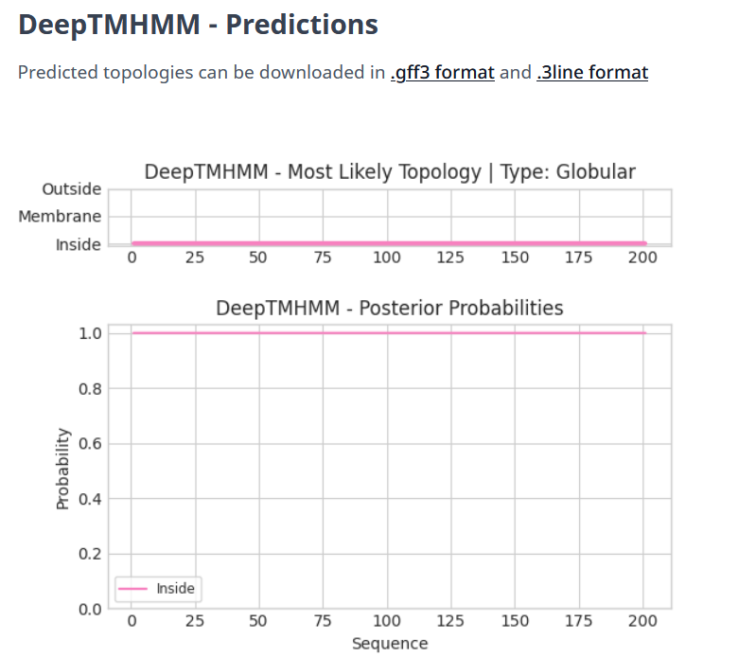

Gene Number: 98
Totinger_Draft_98 on Phagesdb
Pham84861
BLAST from PhagesDB. (https://phagesdb.org/blastp/) Using Longest ORF
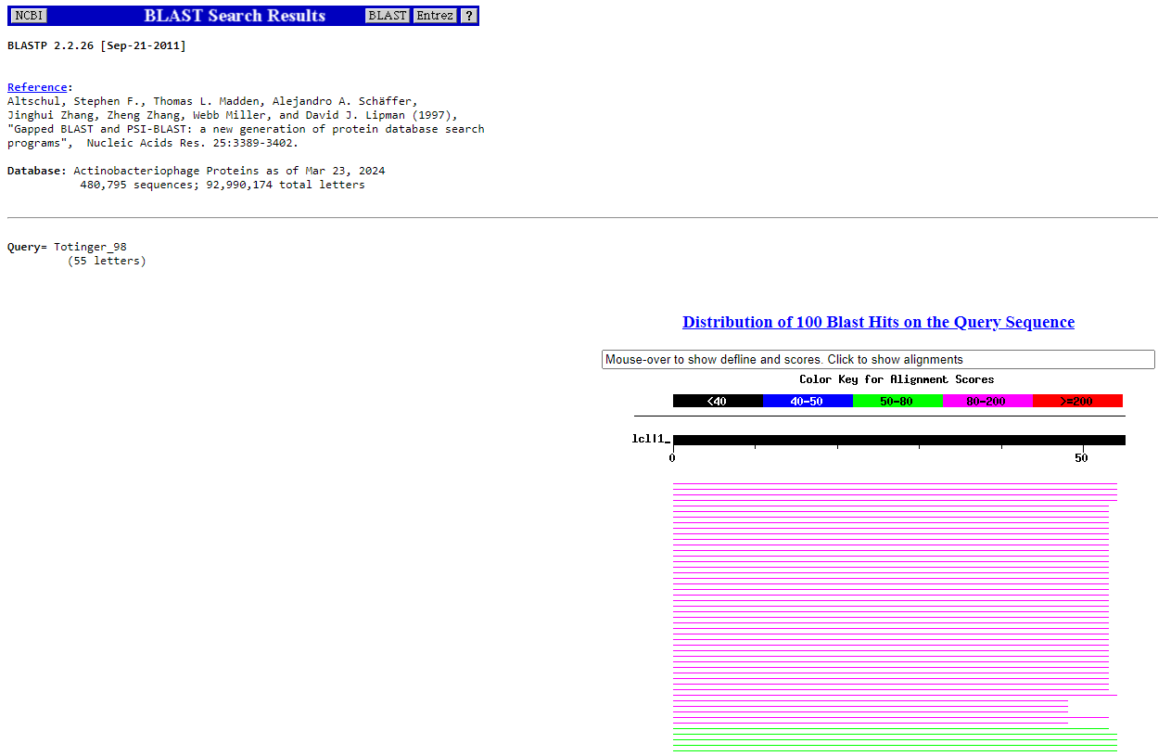
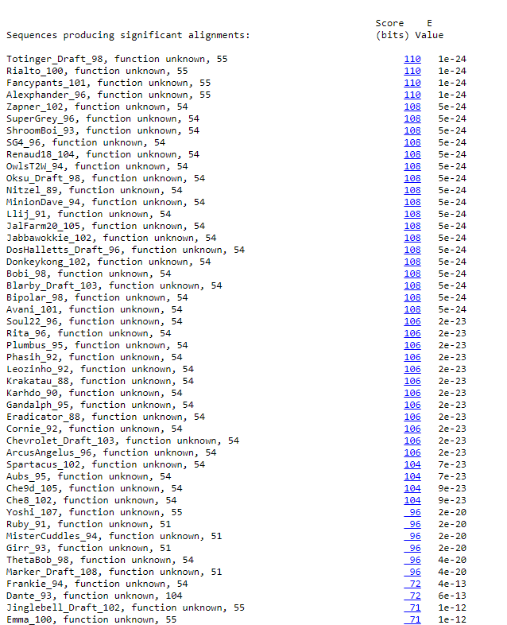
BLAST from NCBI (https://blast.ncbi.nlm.nih.gov/Blast.cgi?PAGE=Proteins) Using Longest ORF
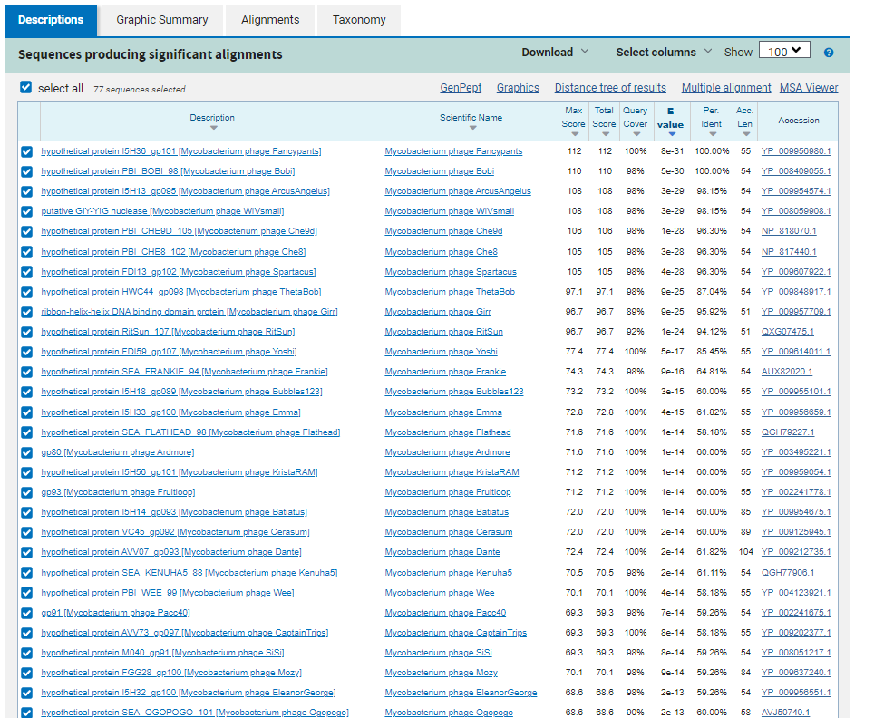
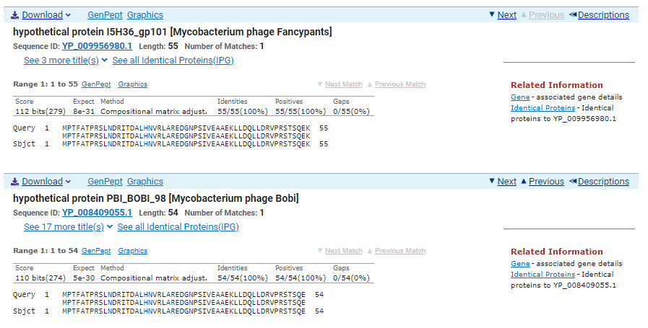
TTG Start at 53691. Original Glimmer call.
TAG Stop at 53858
F/R: F
Coding Potential (y/n): Y
Starterator (SS, NA, NI): Does not have the Most Annotated Start
Blast Best Hit, Query:Subject Starts, Score, Evalue, or “no significant Blast alignments” if 10E-4 or higher
hypothetical protein I5H36_gp101 Mycobacterium phage Fancypants YP_009956980.1, 1:1, Score 112, Evalue, 8e-31
Gap with previous gene: 191
Longest Orf? (Y/N/NA) Y
RBS:
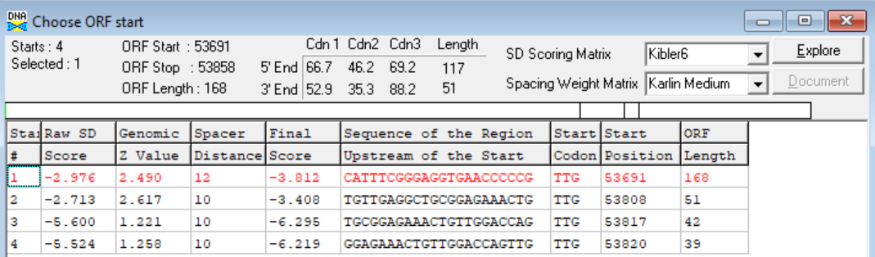
(https://toolkit.tuebingen.mpg.de/tools/hhpred) HHPRED vs PDB, SCOPe, pFam, and M. Tuberculosis. No Significant (>95%) Hits.
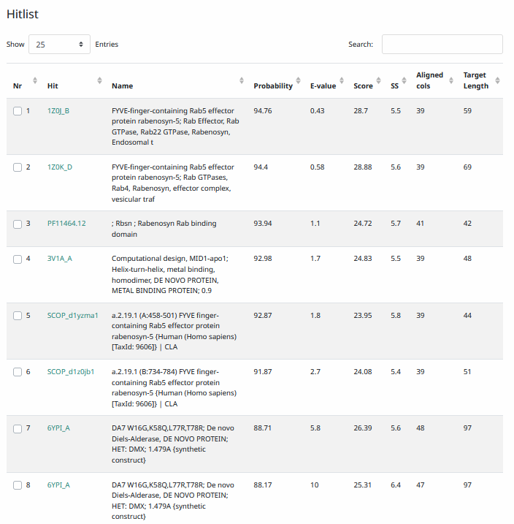
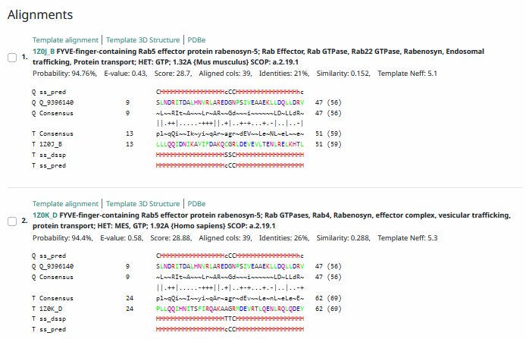
Phamerator Totinger Vs. Tootsieroll Vs. Starcevich (https://phamerator.org/phages) Genes 61-106
Phamerator Totinger (Bottom) Vs. Rialto (Top) (https://phamerator.org/phages) Genes 96-106
Proposed Function: hypothetical protein
Function Evidence: BLASTs and HHPRED indicate this gene most commonly to be a protein with no known function. Additionally, phage Rialto calls the same gene from a near identical sequence in Phamerator.
Transmembrane Domain/Evidence: No, Intracellular Properties (https://dtu.biolib.com/DeepTMHMM)
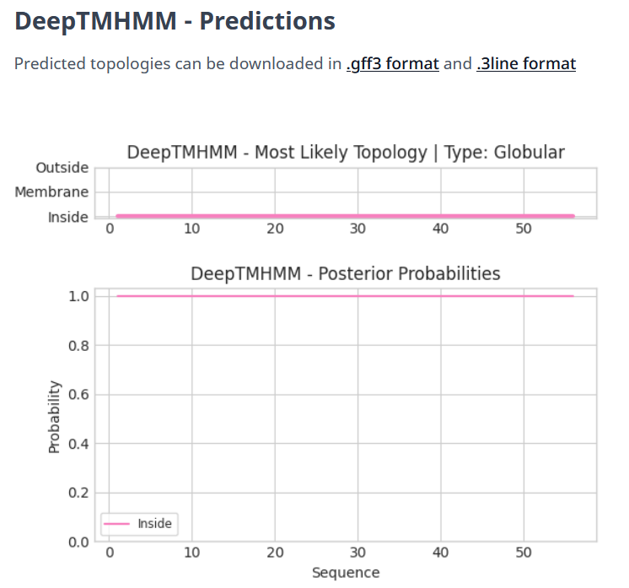

Gene Number: 99
Totinger_Draft_99 on Phagesdb
Pham1829
BLAST from PhagesDB. (https://phagesdb.org/blastp/) Using Longest ORF
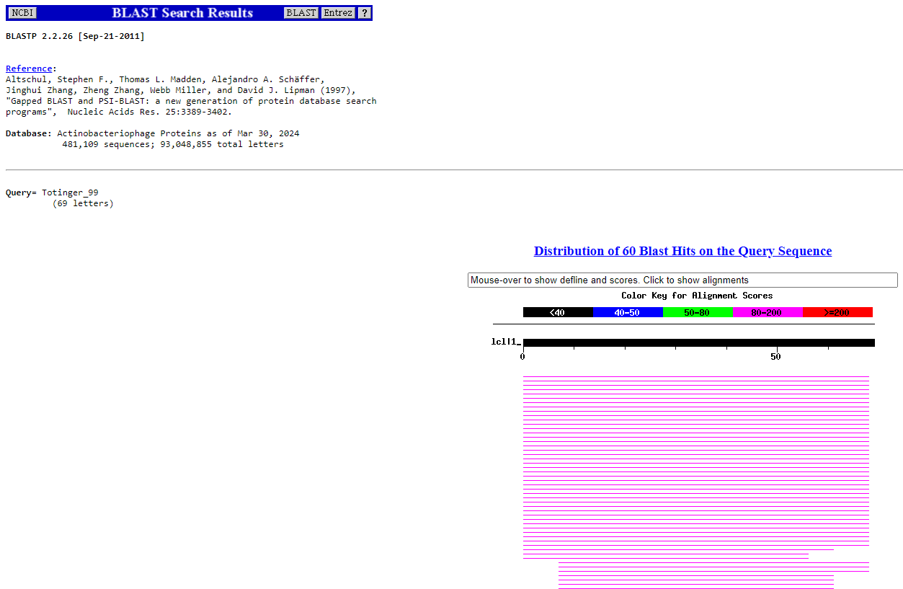
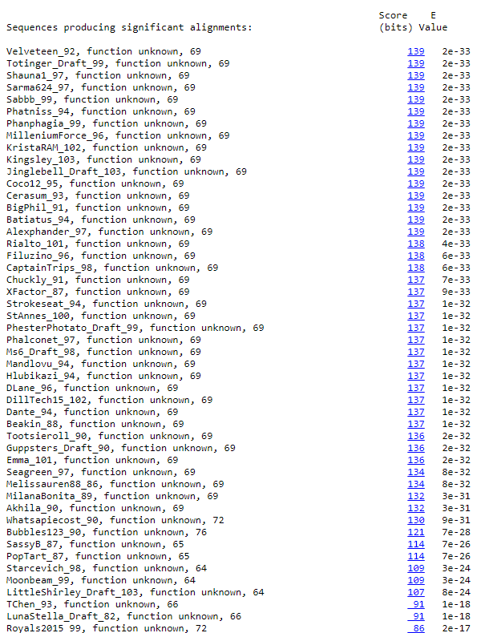
BLAST from NCBI (https://blast.ncbi.nlm.nih.gov/Blast.cgi?PAGE=Proteins) Using Longest ORF
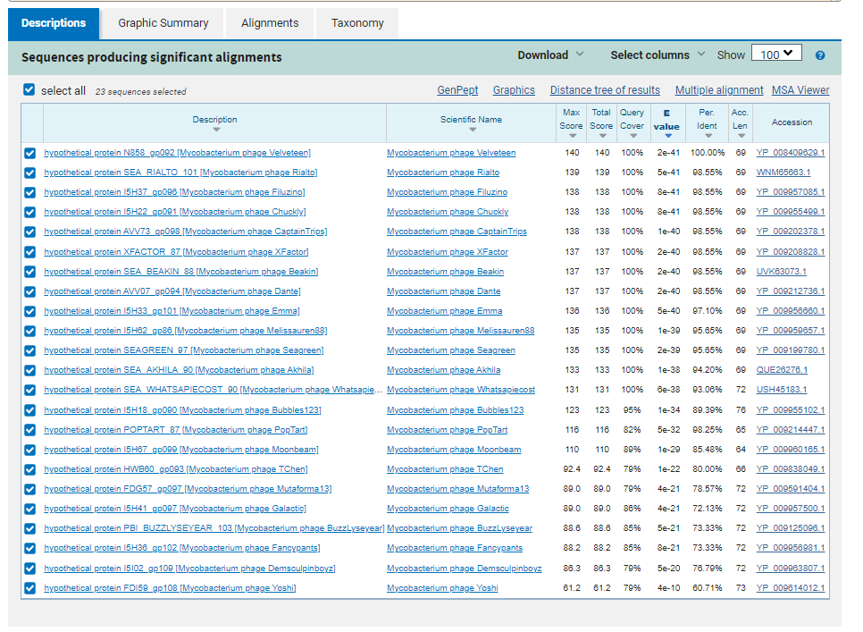
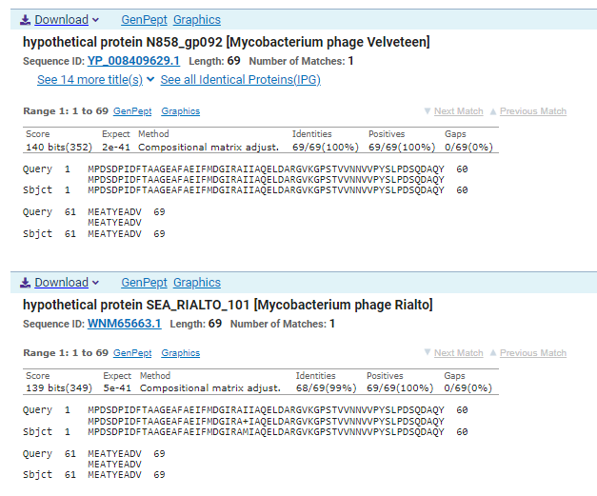
ATG Start at 53865. Original Glimmer call.
TGA Stop at 54074
F/R: F
Coding Potential (y/n): Y
Starterator (SS, NA, NI): Most annotated start is this (53865)
Blast Best Hit, Query:Subject Starts, Score, Evalue, or “no significant Blast alignments” if 10E-4 or higher
hypothetical protein N858_gp092 Mycobacterium phage Velveteen YP_008409629.1, 1:1, Score 140, Evalue, 2e-41
Gap with previous gene: 7
Longest Orf? (Y/N/NA) Y
RBS:
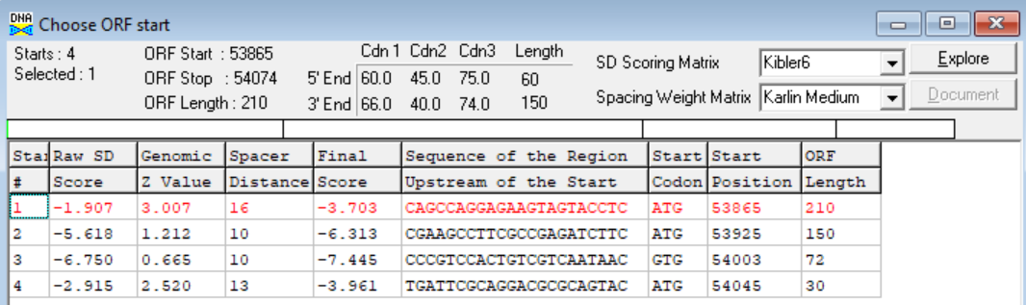
(https://toolkit.tuebingen.mpg.de/tools/hhpred) HHPRED vs PDB, SCOPe, pFam, and M. Tuberculosis. No Significant (>95%) Hits
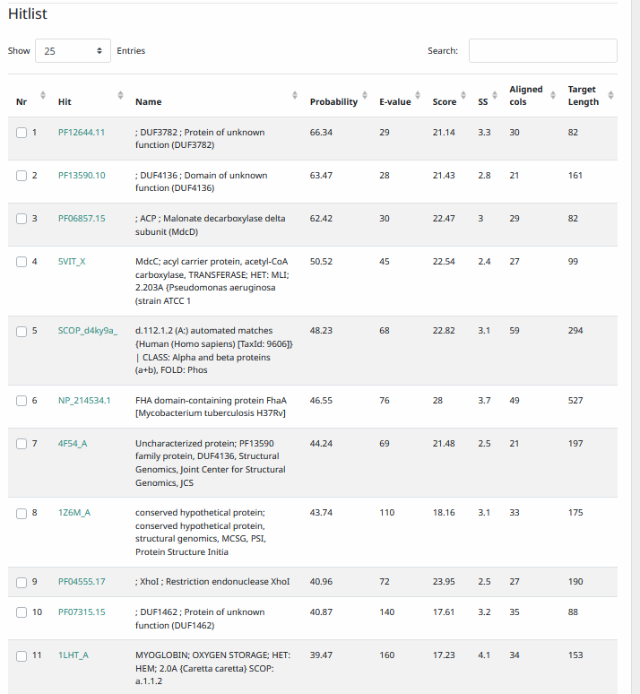
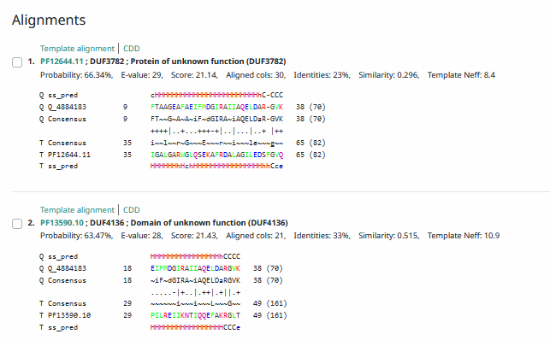
Phamerator Totinger Vs. Tootsieroll Vs. Starcevich (https://phamerator.org/phages) Genes 61-106
Phamerator Totinger (Bottom) Vs. Rialto (Top) (https://phamerator.org/phages) Genes 96-106
Proposed Function: hypothetical protein
Function Evidence: In Phamerator, three similar phages (phage Tootsieroll, phage Starcevich, and phage Rialto) all call the same hypothetical protein gene from a very similar sequence. BLASTs most consistently align with a hypothetical protein with no known function.
Transmembrane Domain/Evidence: No (https://dtu.biolib.com/DeepTMHMM)
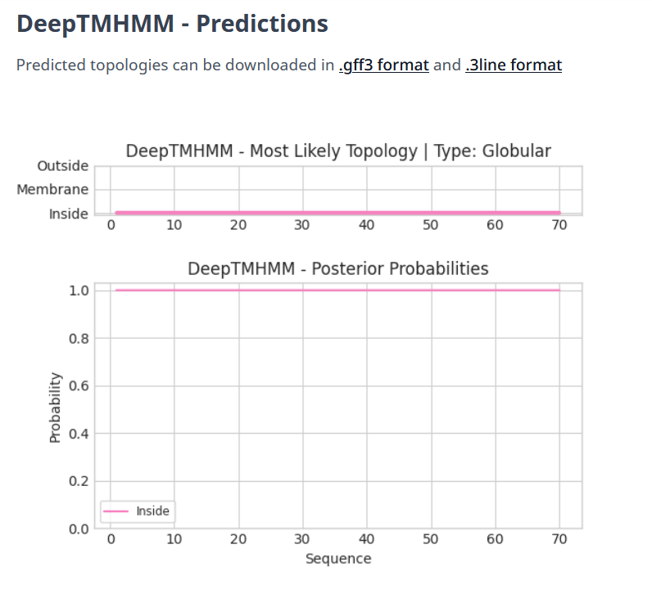

Gene Number: 100
Totinger_Draft_100 on Phagesdb
Pham84847
BLAST from PhagesDB. (https://phagesdb.org/blastp/) Using Longest ORF
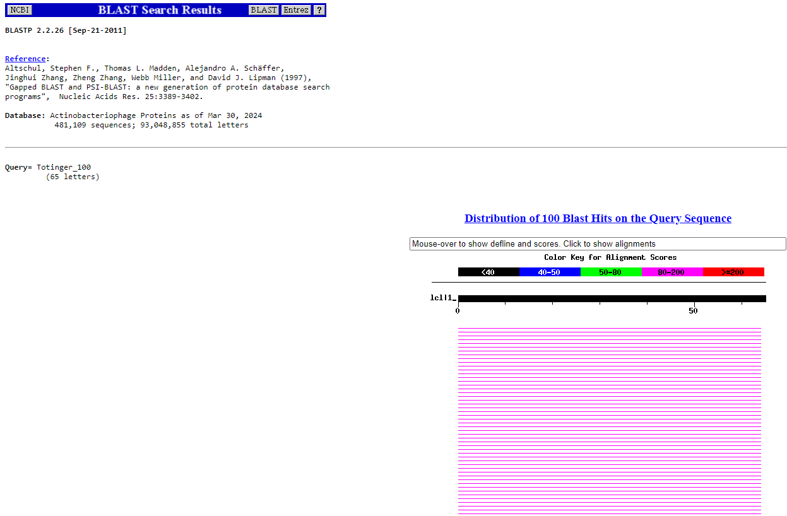
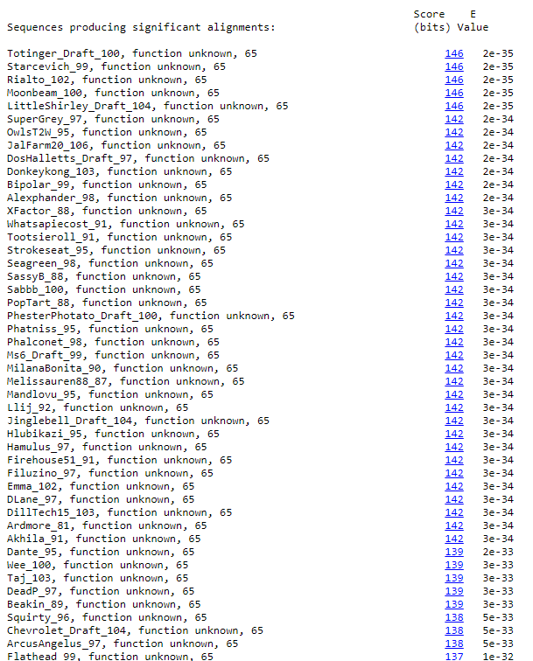
BLAST from NCBI (https://blast.ncbi.nlm.nih.gov/Blast.cgi?PAGE=Proteins) Using Longest ORF
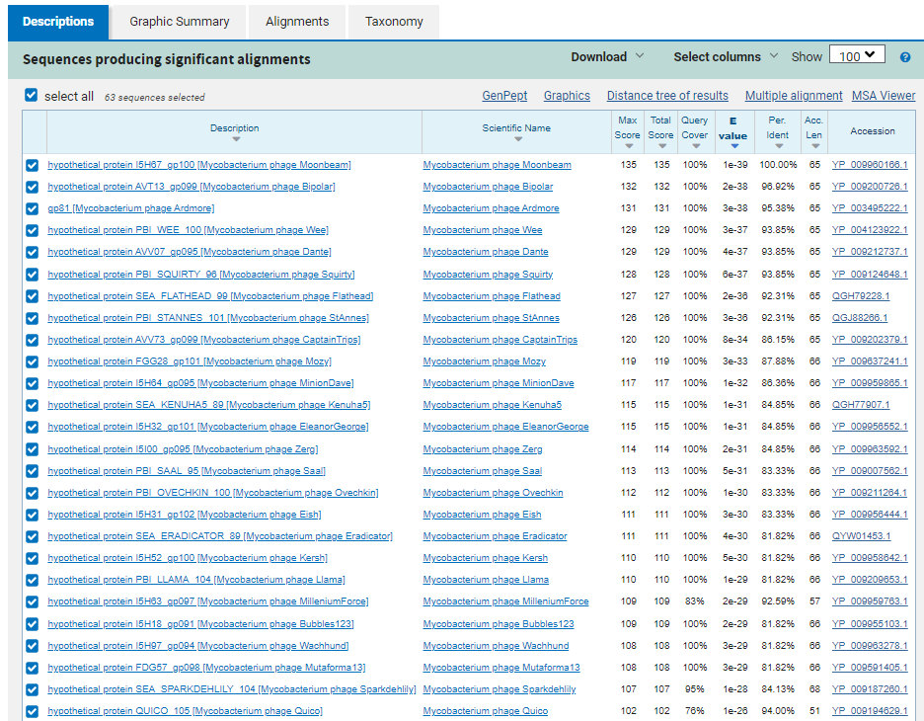
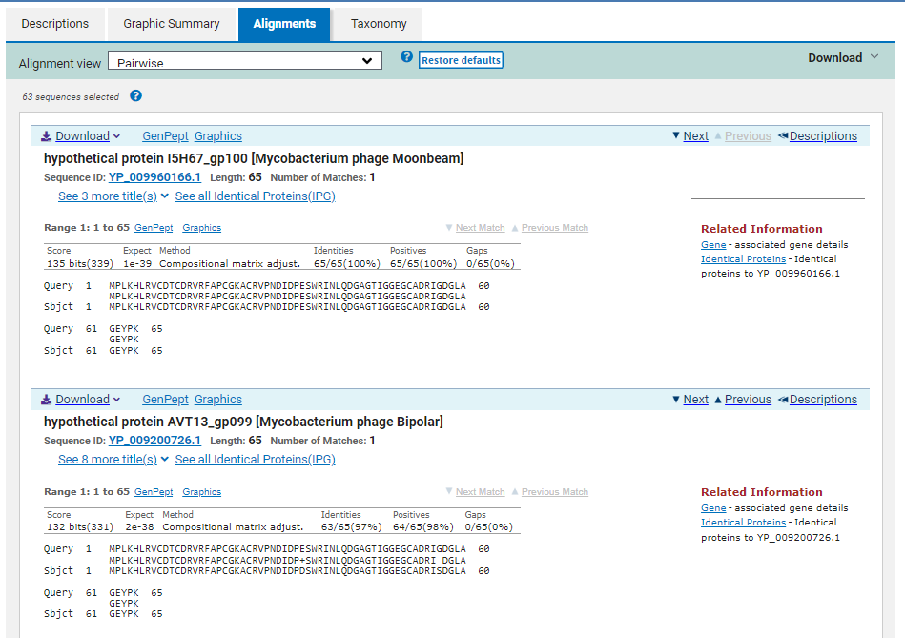
ATG Start at 54074. Original Glimmer call, not called by Genemark.
TGA Stop at 54271.
F/R: F
Coding Potential (y/n): Y
Starterator (SS, NA, NI): Most annotated start is this (54074)
Blast Best Hit, Query:Subject Starts, Score, Evalue, or “no significant Blast alignments” if 10E-4 or higher
hypothetical protein I5H67_gp100 Mycobacterium phage Moonbeam YP_009960166.1, 1:1, Score 135, Evalue, 1e-39
Gap with previous gene: 0
Longest Orf? (Y/N/NA) Y
RBS:
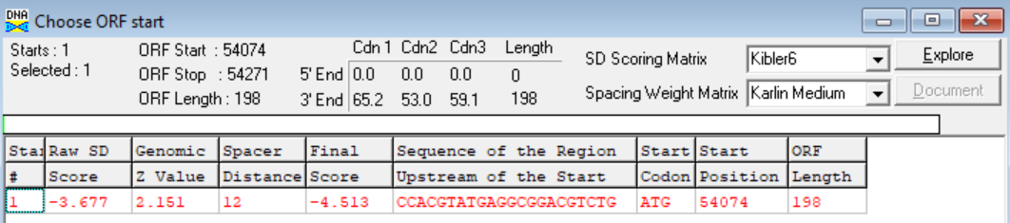
(https://toolkit.tuebingen.mpg.de/tools/hhpred) HHPRED vs PDB, SCOPe, pFam, and M. Tuberculosis. No Significant (>95%) Hits
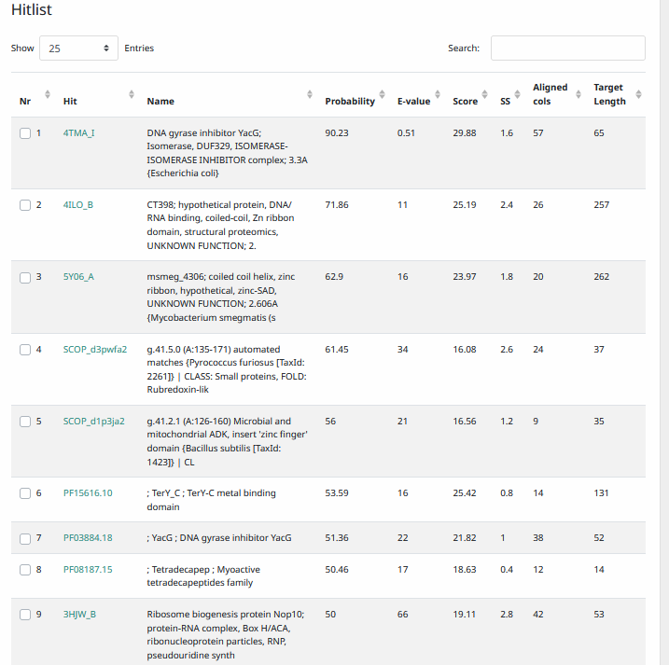
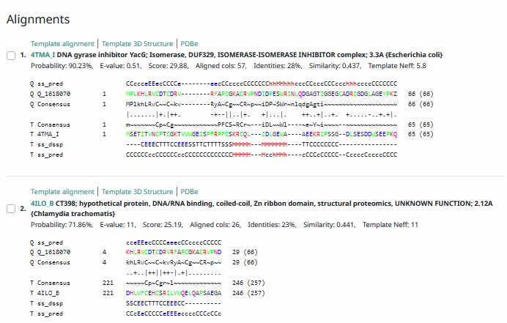
Phamerator Totinger Vs. Tootsieroll Vs. Starcevich (https://phamerator.org/phages) Genes 61-106
Phamerator Totinger (Bottom) Vs. Rialto (Top) (https://phamerator.org/phages) Genes 96-106
Proposed Function: portal protein
Function Evidence: BLASTs most commonly align with proteins that have no known function in other phages. Additionally, in Phamerator, an identical gene is called from an identical sequence in phage Tootsieroll, phage Starcevich, and phage Rialto.
Transmembrane Domain/Evidence: No, Intracellular Properties (https://dtu.biolib.com/DeepTMHMM)
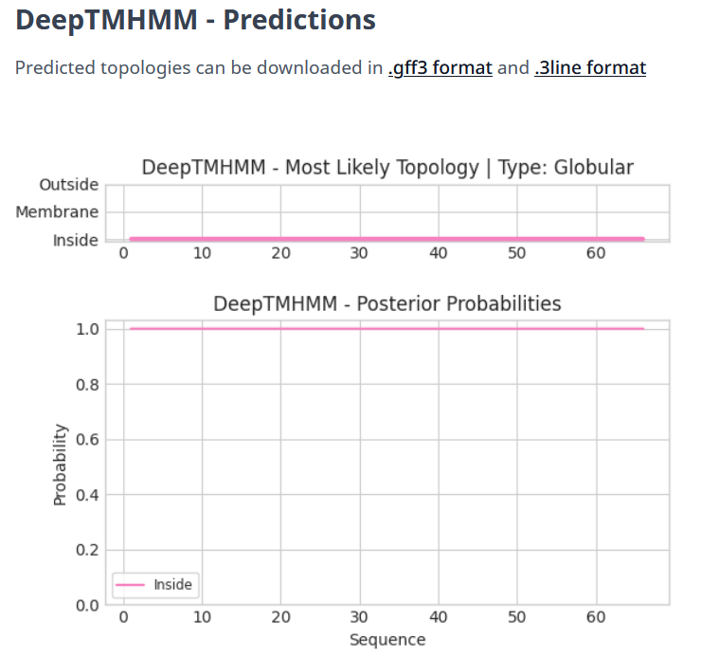

Gene Number: 101
Totinger_Draft_101 on Phagesdb
Pham152843
BLAST from PhagesDB. (https://phagesdb.org/blastp/) Using Longest ORF
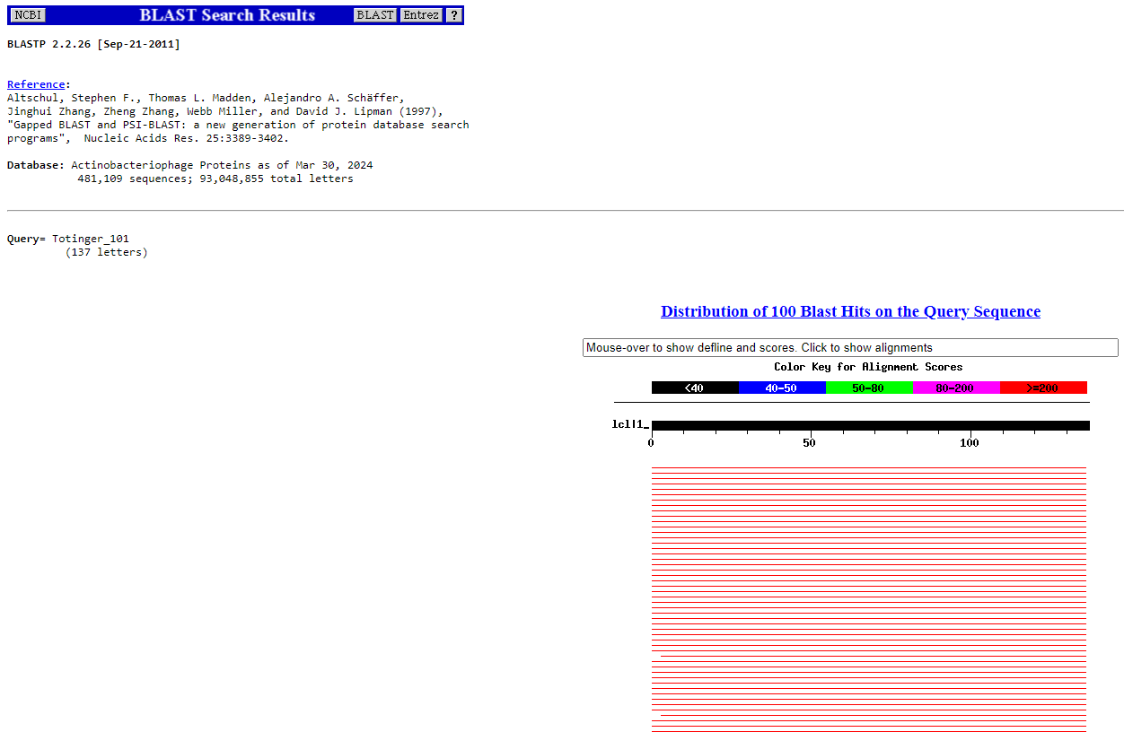
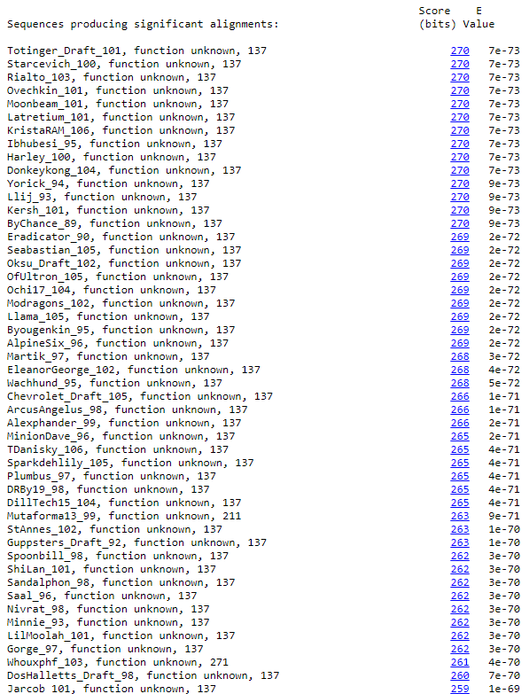
BLAST from NCBI (https://blast.ncbi.nlm.nih.gov/Blast.cgi?PAGE=Proteins) Using Longest ORF
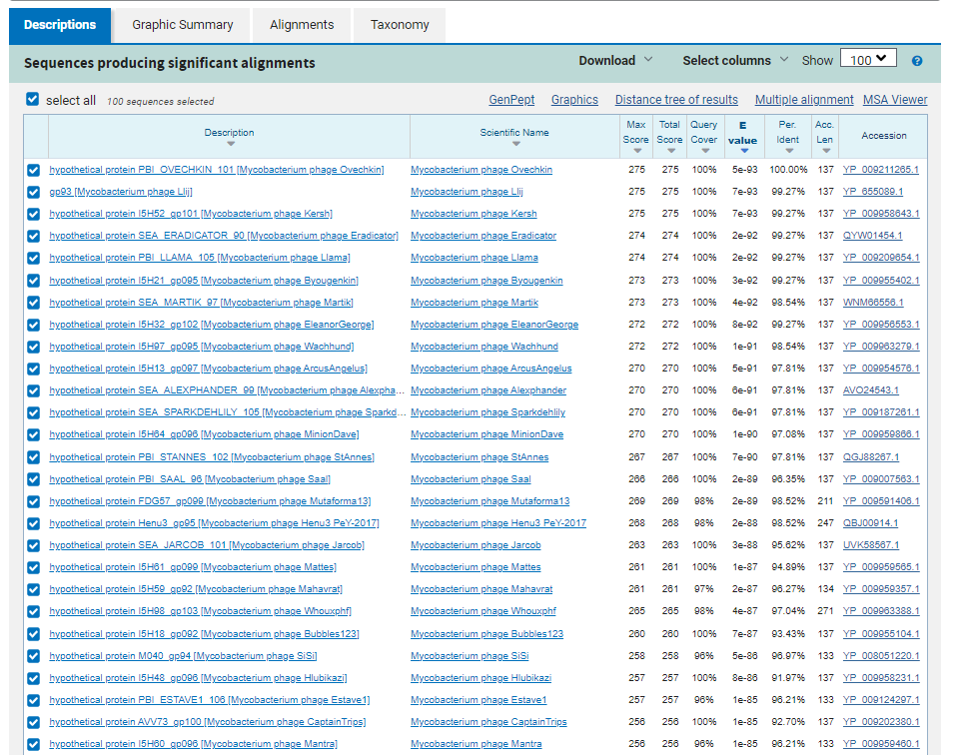
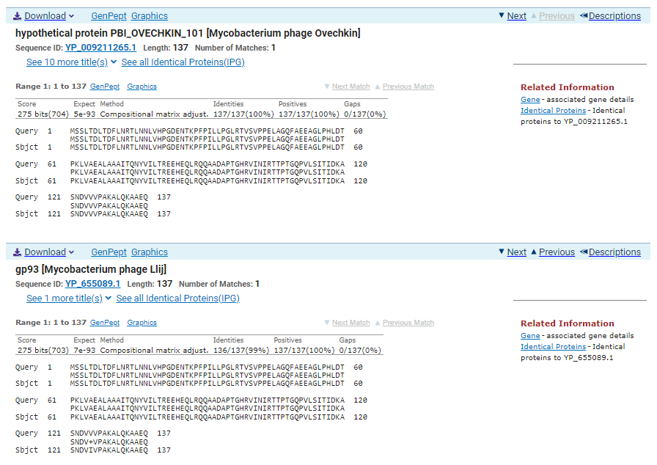
ATG Start at 54268. Original Glimmer call.
TGA Stop at 54681
F/R: F
Coding Potential (y/n): Y
Starterator (SS, NA, NI): Most annotated start is this (54268)
Blast Best Hit, Query:Subject Starts, Score, Evalue, or “no significant Blast alignments” if 10E-4 or higher
hypothetical protein PBI_OVECHKIN_101 Mycobacterium phage Ovechkin YP_009211265.1, 1:1, Score 257, Evalue, 5e-93
Gap with previous gene: -3
Longest Orf? (Y/N/NA) Y
RBS:
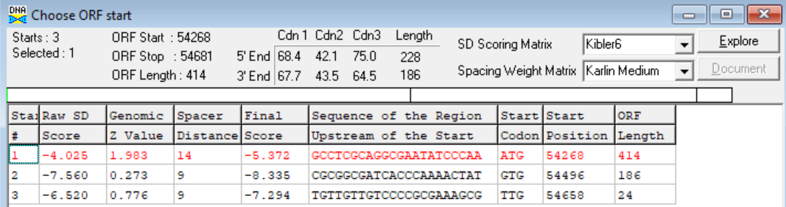
(https://toolkit.tuebingen.mpg.de/tools/hhpred) HHPRED vs PDB, SCOPe, pFam, and M. Tuberculosis. No Significant (>95%) Hits
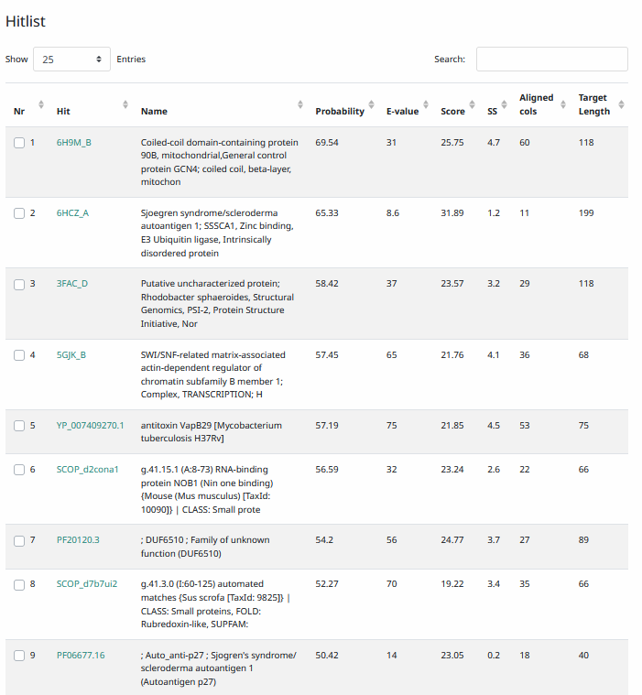
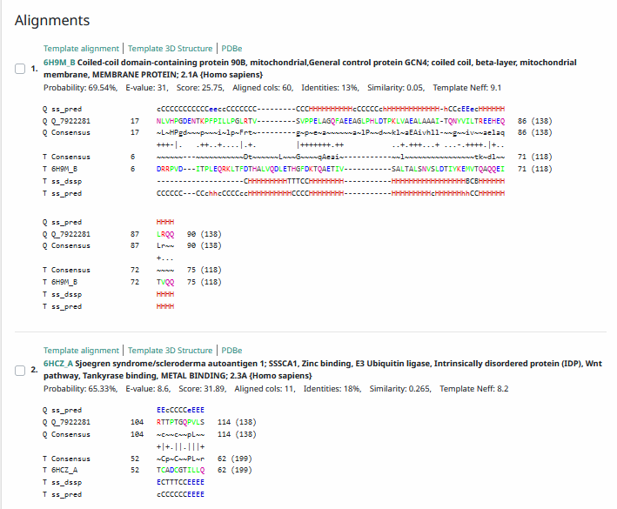
Phamerator Totinger Vs. Tootsieroll Vs. Starcevich (https://phamerator.org/phages) Genes 61-106
Phamerator Totinger (Bottom) Vs. Rialto (Top) (https://phamerator.org/phages) Genes 96-106
Proposed Function: hypothetical protein
Function Evidence: In Phamerator, three similar phages (phage Rialto, phage Starcevich, and phage Tootsieroll) callthe same gene from a near identical sequence and label it as a protein with no known function. BLASTs also most consistently hit this protein as one with an unknown function.
Transmembrane Domain/Evidence: No, Intracellular Properties (https://dtu.biolib.com/DeepTMHMM)
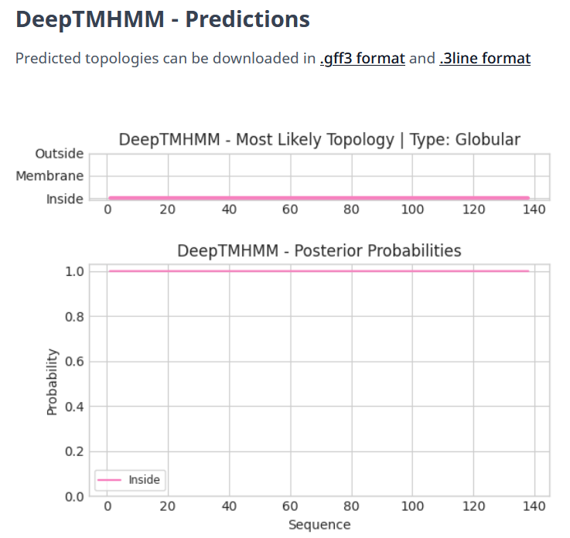

Gene Number: 102
Totinger_Draft_102 on Phagesdb
Pham152847
BLAST from PhagesDB. (https://phagesdb.org/blastp/) Using Longest ORF
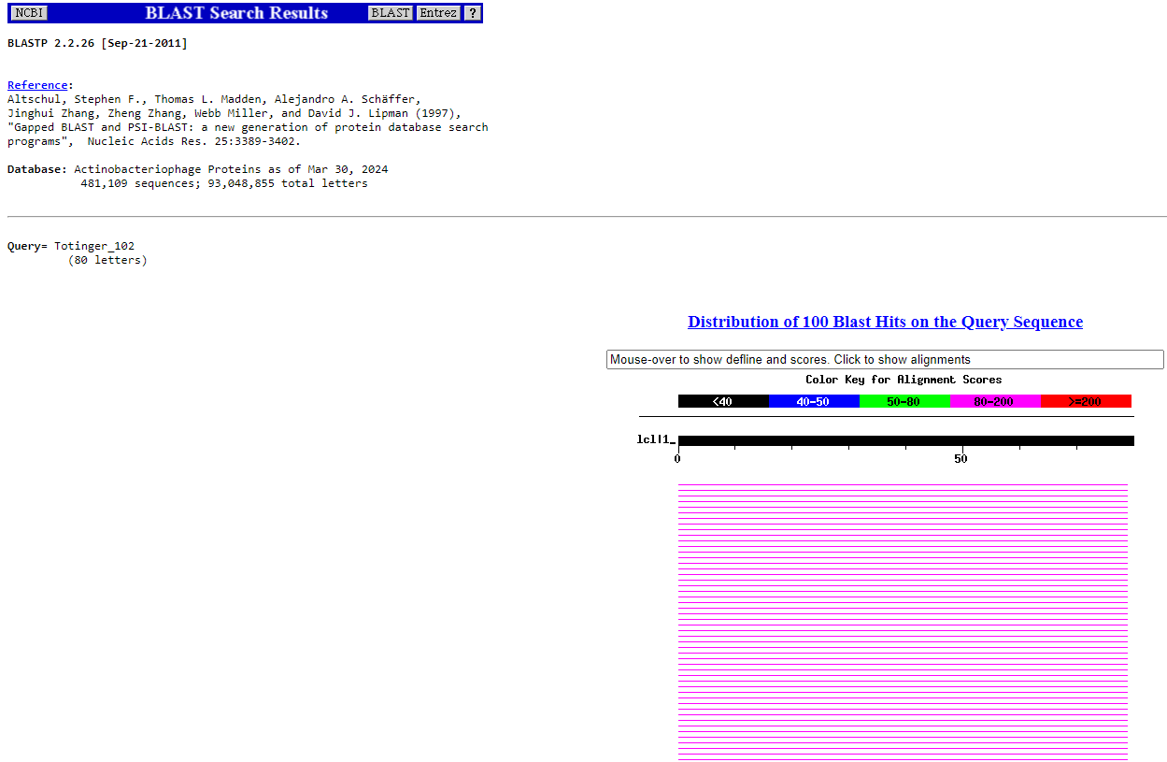
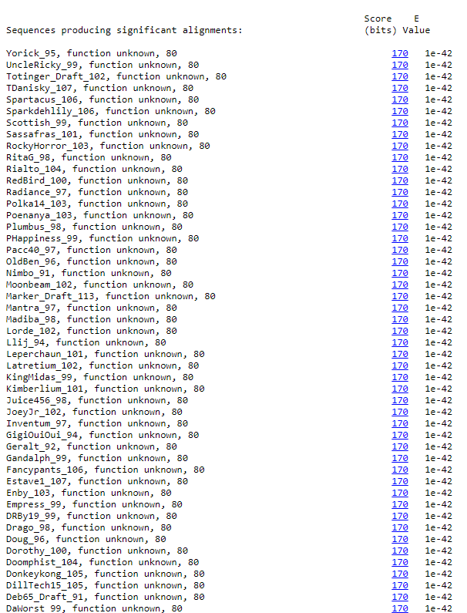
BLAST from NCBI (https://blast.ncbi.nlm.nih.gov/Blast.cgi?PAGE=Proteins) Using Longest ORF
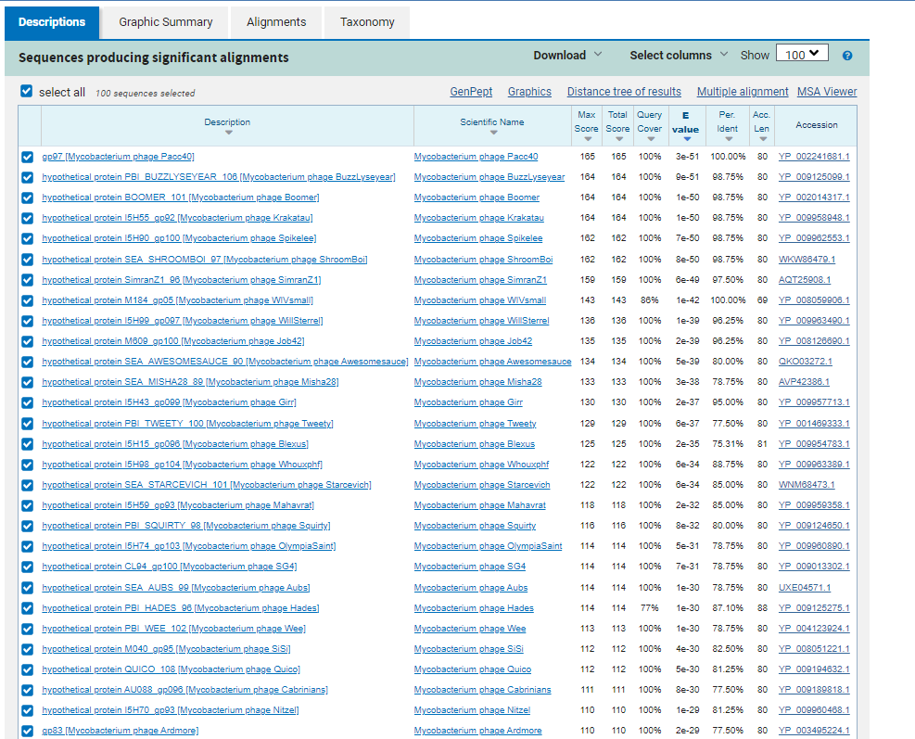
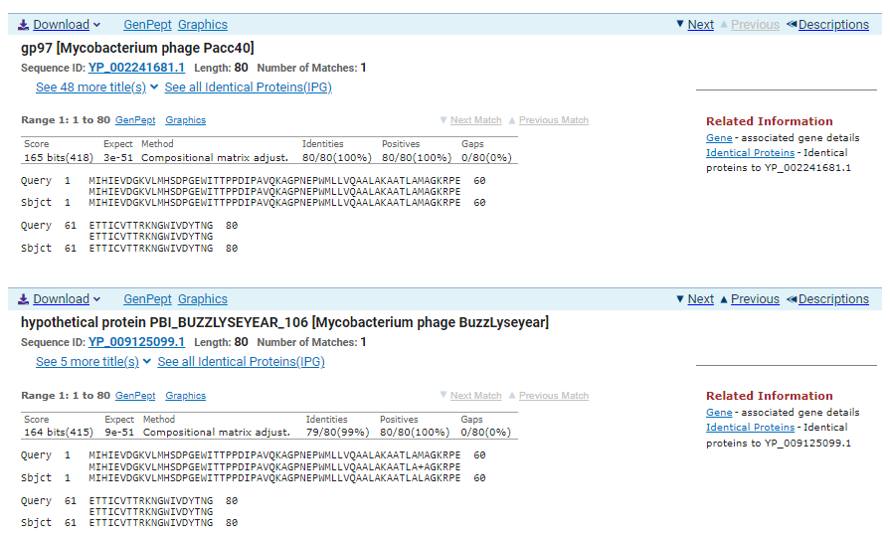
GTG Start at 54678. Original Glimmer call.
TGA Stop at 54920
F/R: F
Coding Potential (y/n): Y
Starterator (SS, NA, NI): Most annotated start is this (54678)
Blast Best Hit, Query:Subject Starts, Score, Evalue, or “no significant Blast alignments” if 10E-4 or higher
gp97 Mycobacterium phage Pacc40 YP_002241681.1, 1:1, Score 165, Evalue, 5e-31
Gap with previous gene: -3
Longest Orf? (Y/N/NA) Y
RBS:
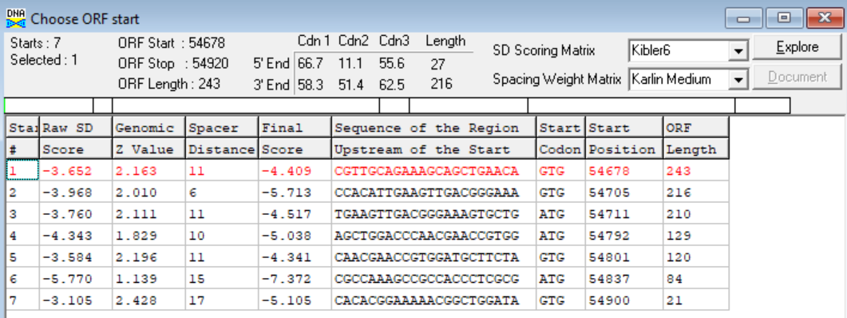
(https://toolkit.tuebingen.mpg.de/tools/hhpred) HHPRED vs PDB, SCOPe, pFam, and M. Tuberculosis. No Significant (>95%) Hits.
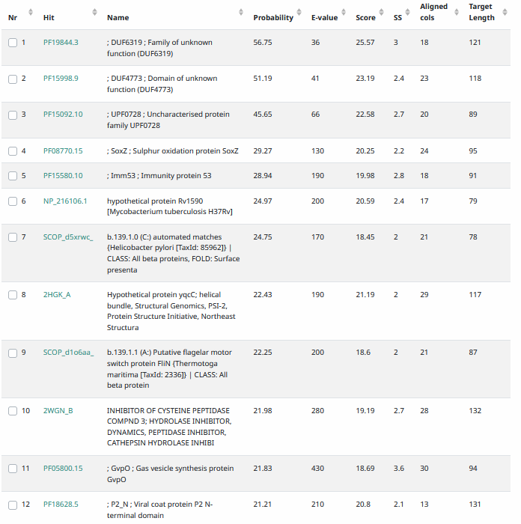
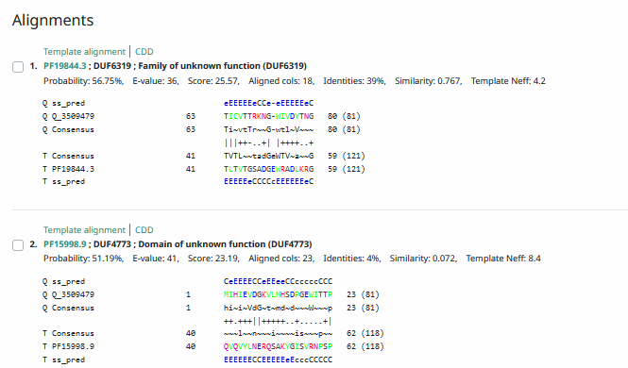
Phamerator Totinger Vs. Tootsieroll Vs. Starcevich (https://phamerator.org/phages) Genes 61-106
Phamerator Totinger (Bottom) Vs. Rialto (Top) (https://phamerator.org/phages) Genes 96-106
Proposed Function: hypothetical protein
Function Evidence: BLASTs most commonly hit this protein as one with no known function. Additionally, phage Rialto, phage Starcevich, and phage Tootsieroll call the same gene from a near identical sequence.
Transmembrane Domain/Evidence: No, Intracellular Properties (https://dtu.biolib.com/DeepTMHMM)
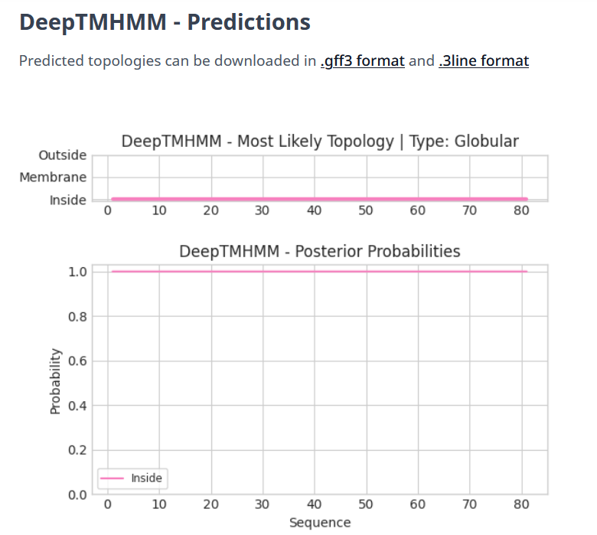

Gene Number: 103
Totinger_Draft_103 on Phagesdb
Pham150062
BLAST from PhagesDB. (https://phagesdb.org/blastp/) Using Longest ORF
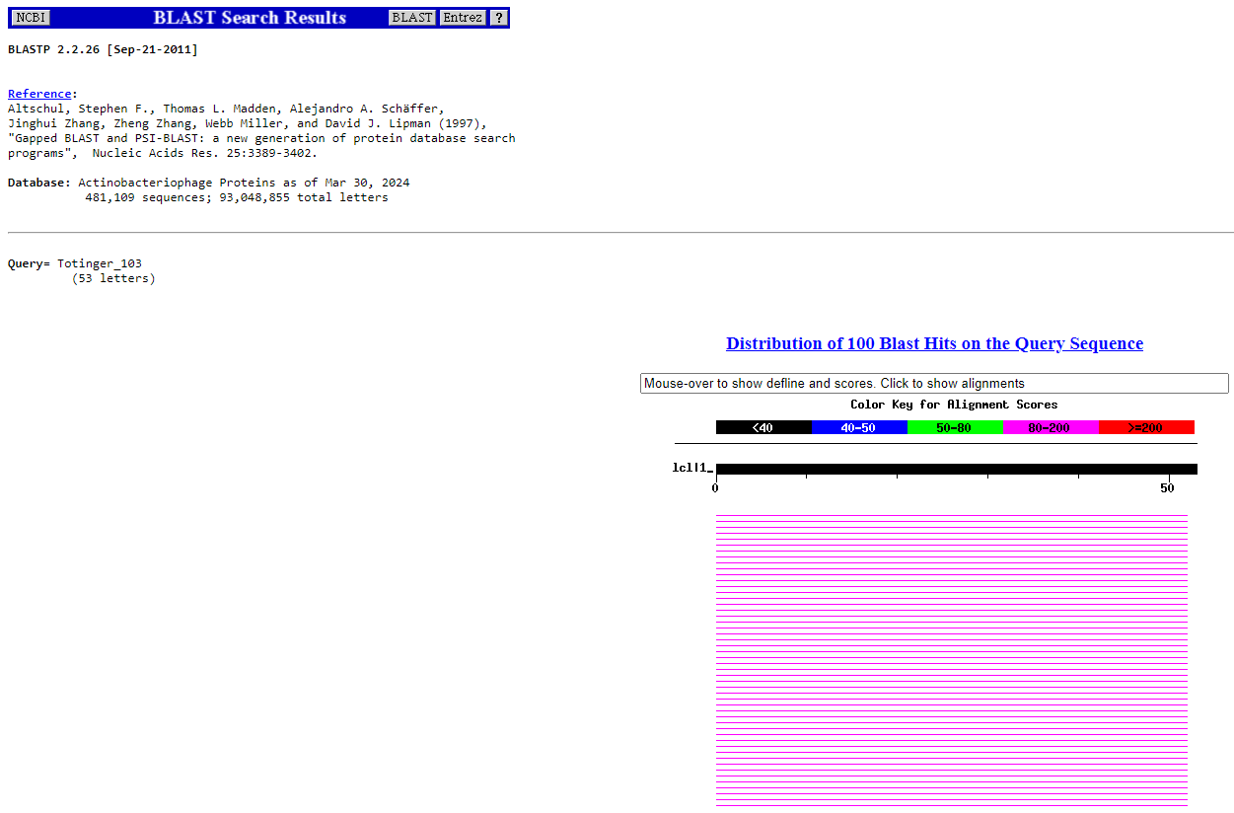
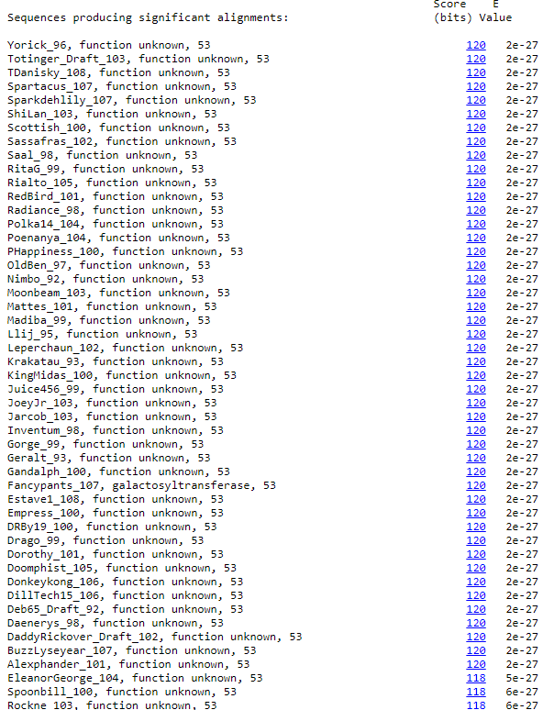
BLAST from NCBI (https://blast.ncbi.nlm.nih.gov/Blast.cgi?PAGE=Proteins) Using Longest ORF
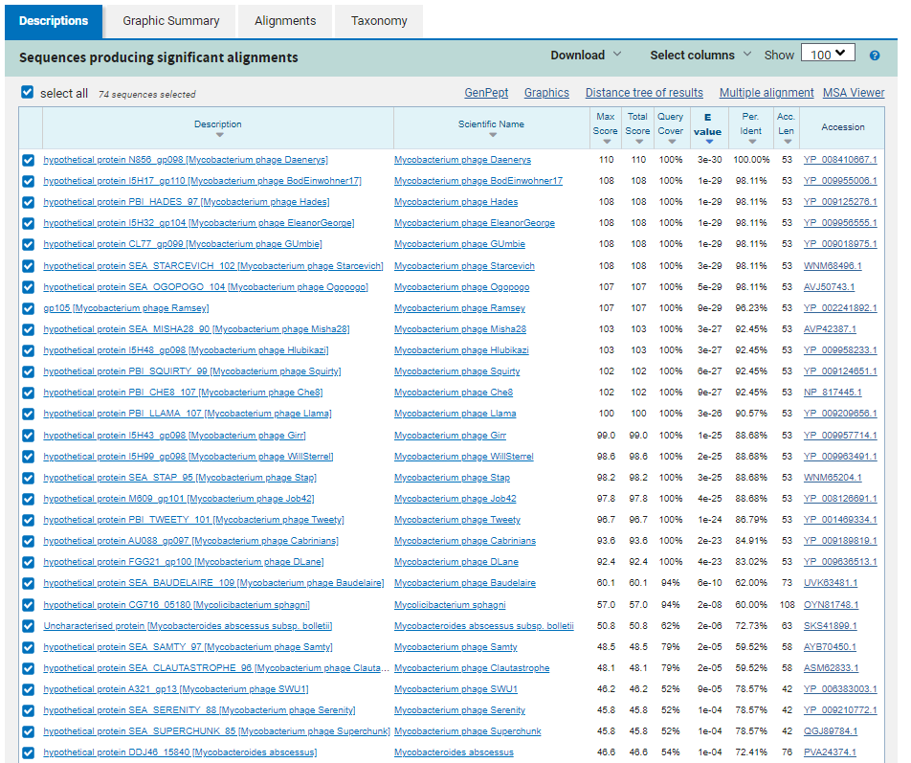
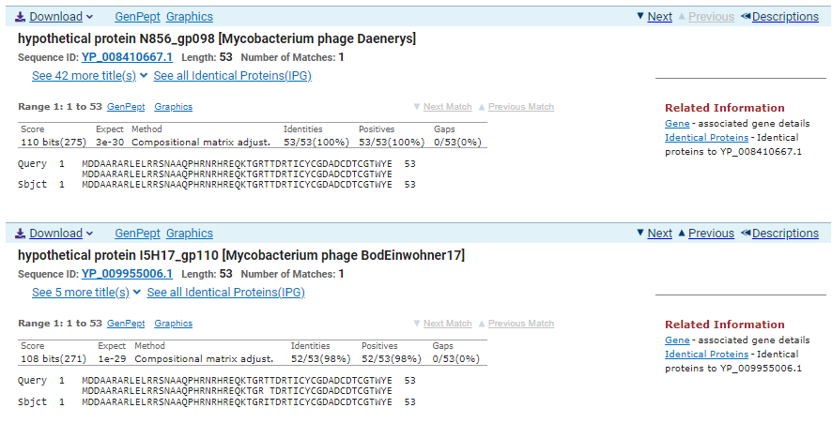
ATG Start at 54913. Original Glimmer call, not called by Genemark.
TAA Stop at 55074
F/R: F
Coding Potential (y/n): Weak, but Present
Starterator (SS, NA, NI): Most annotated start is this (54913)
Blast Best Hit, Query:Subject Starts, Score, Evalue, or “no significant Blast alignments” if 10E-4 or higher
hypothetical protein N856_gp098 Mycobacterium phage Daenerys YP_008410667.1, 1:1, Score 110, Evalue, 3e-30
Gap with previous gene: -7
Longest Orf? (Y/N/NA) Y
RBS:
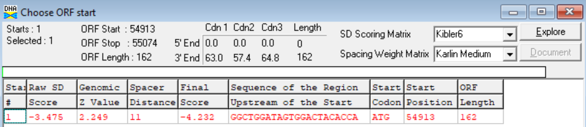
(https://toolkit.tuebingen.mpg.de/tools/hhpred) HHPRED vs PDB, SCOPe, pFam, and M. Tuberculosis. No Significant (>95%) Hits.
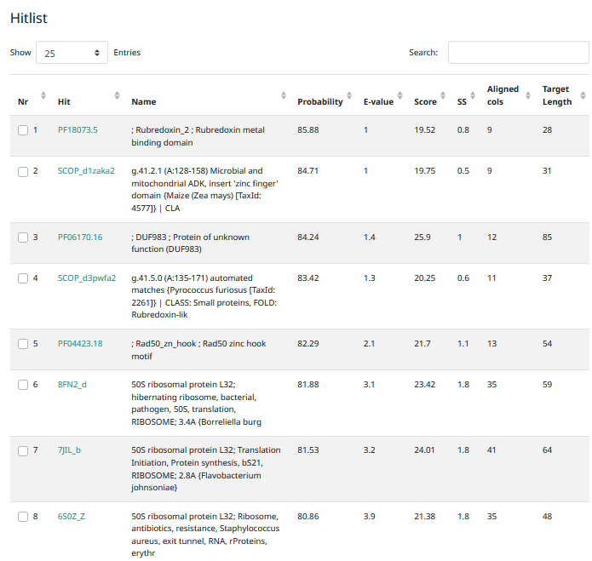
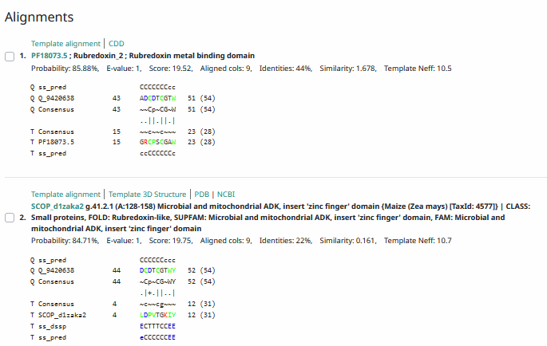
Phamerator Totinger Vs. Tootsieroll Vs. Starcevich (https://phamerator.org/phages) Genes 61-106
Phamerator Totinger (Bottom) Vs. Rialto (Top) (https://phamerator.org/phages) Genes 96-106
Proposed Function: hypothetical protein
Function Evidence: BLASTs most consistently call this gene as a protein with no known function. Additionally, all three similar phages checked (phage Starcevich, phage Tootsieroll, and phage Rialto) call the same gene from a near identical sequence and also label it as a hypothetical protein.
Transmembrane Domain/Evidence: No, Intracellular Properties (https://dtu.biolib.com/DeepTMHMM)
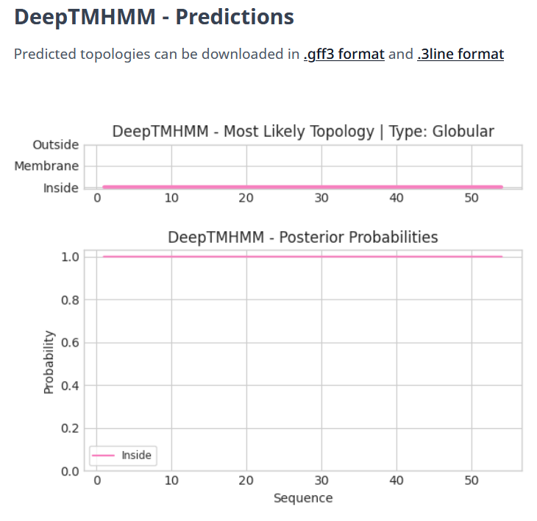

Gene Number: 104
Totinger_Draft_104 on Phagesdb
Pham
BLAST from PhagesDB. (https://phagesdb.org/blastp/) Using Longest ORF
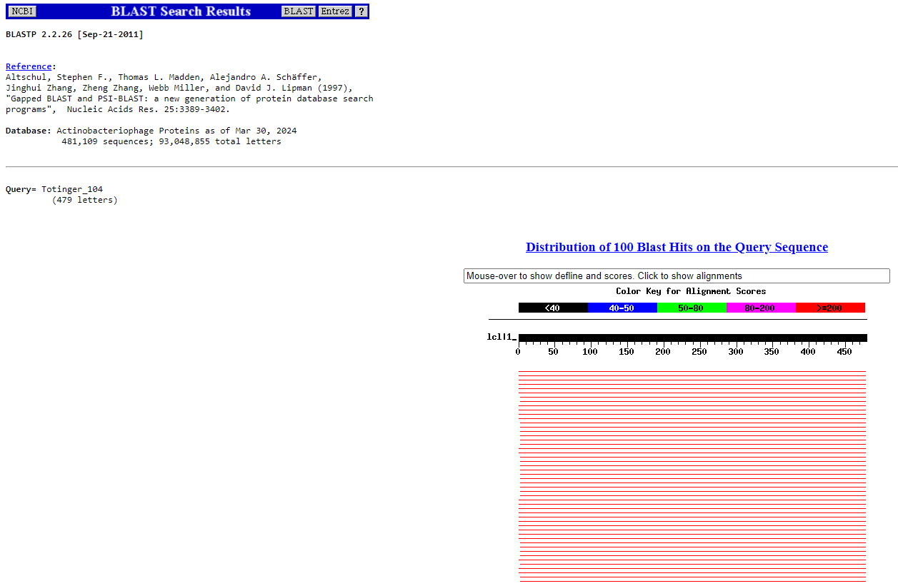
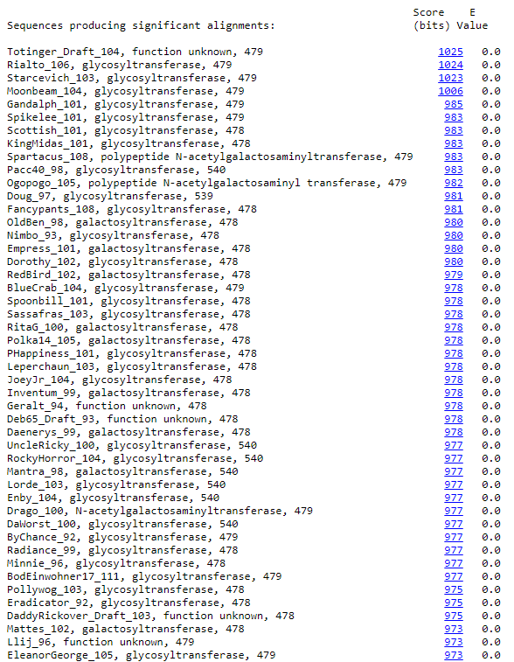
BLAST from NCBI (https://blast.ncbi.nlm.nih.gov/Blast.cgi?PAGE=Proteins) Using Longest ORF
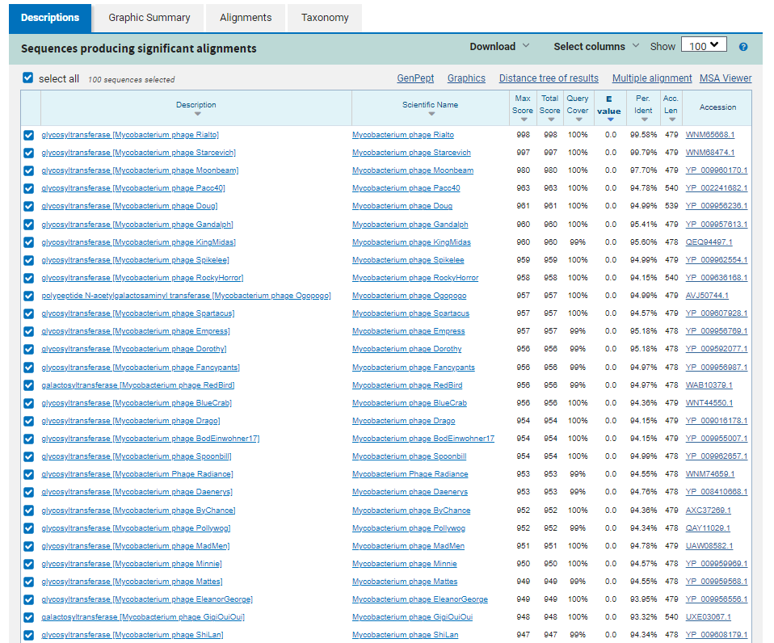
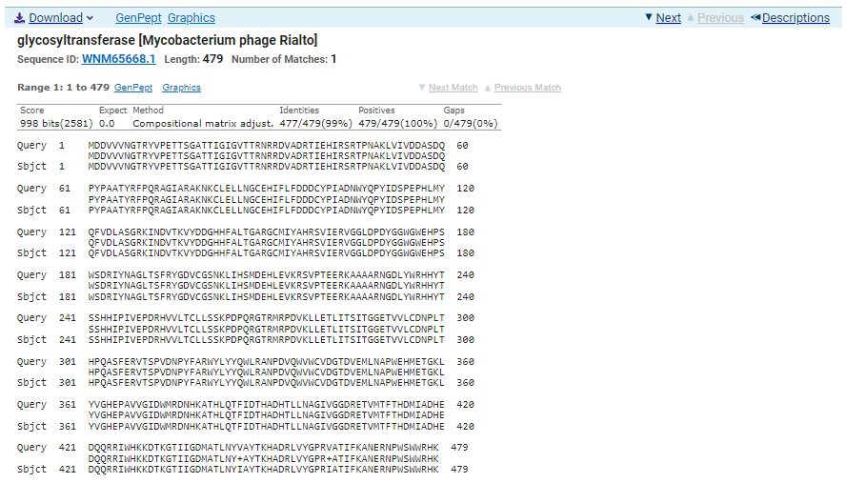
ATG Start at 55101. Original Glimmer call.
TAA Stop at 56540
F/R: F
Coding Potential (y/n): Y
Starterator (SS, NA, NI): Most annotated start is this (55101)
Blast Best Hit, Query:Subject Starts, Score, Evalue, or “no significant Blast alignments” if 10E-4 or higher
glycosyltransferase Mycobacterium phage Rialto WNM65668.1, 1:1, Score 998, Evalue, 0
Gap with previous gene: 27
Longest Orf? (Y/N/NA) Y
RBS:
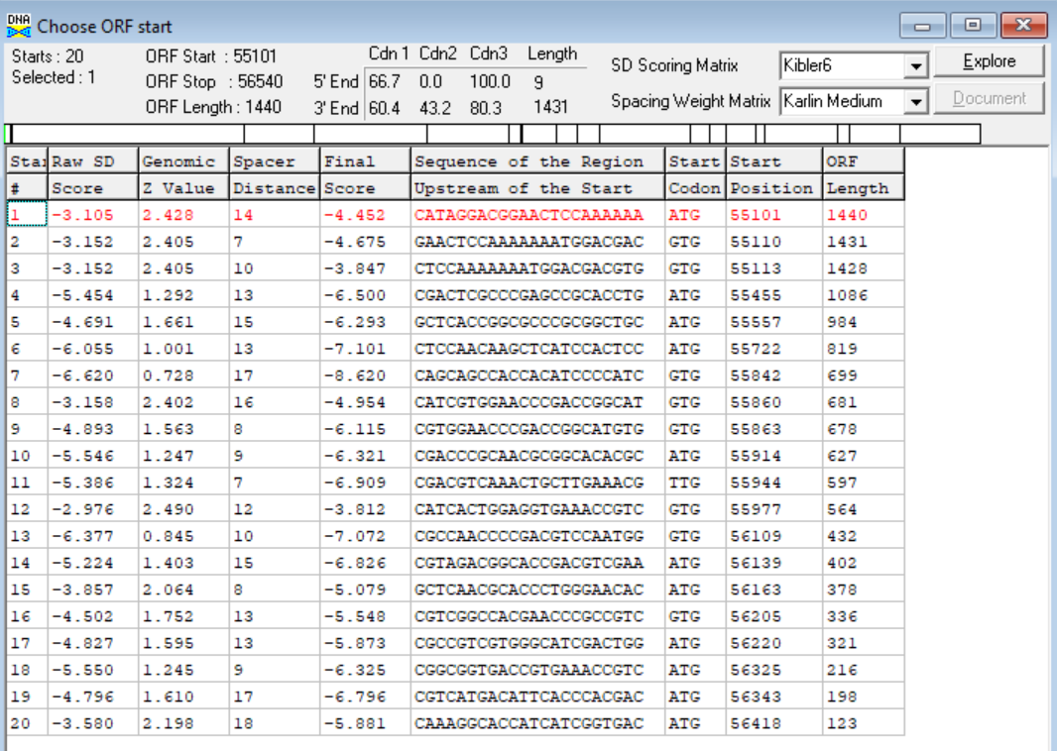
(https://toolkit.tuebingen.mpg.de/tools/hhpred) HHPRED vs PDB, SCOPe, pFam, and M. Tuberculosis.
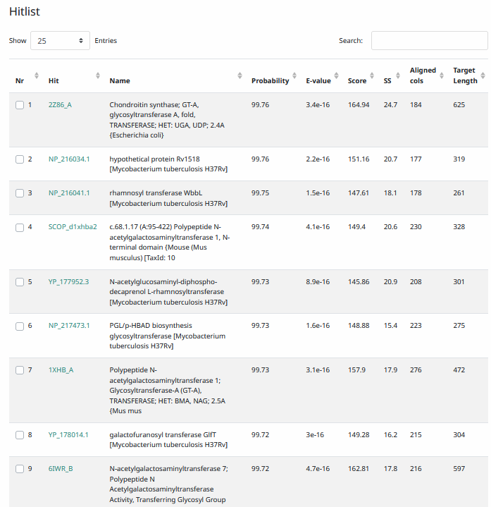
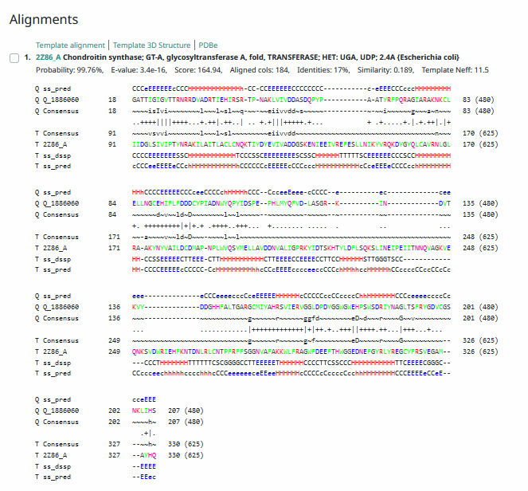
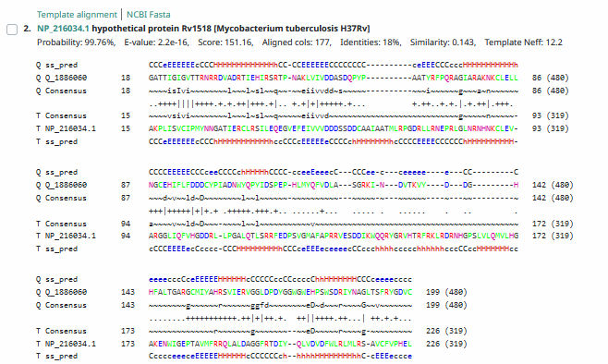
Phamerator Totinger Vs. Tootsieroll Vs. Starcevich (https://phamerator.org/phages) Genes 61-106

Phamerator Totinger (Bottom) Vs. Rialto (Top) (https://phamerator.org/phages) Genes 96-106
Proposed Function: glycosyltransferase
Function Evidence: in Phamerator, phage Starcevich, phage Tootsieroll and phage Rialto all call the same gene with a near identical sequence as a glycosyltransferase. Additionally, BLAST and HHPRED results most consistently align with glycosyltransferase proteins from other phages.
Transmembrane Domain/Evidence: No, Intracellular Properties (https://dtu.biolib.com/DeepTMHMM)
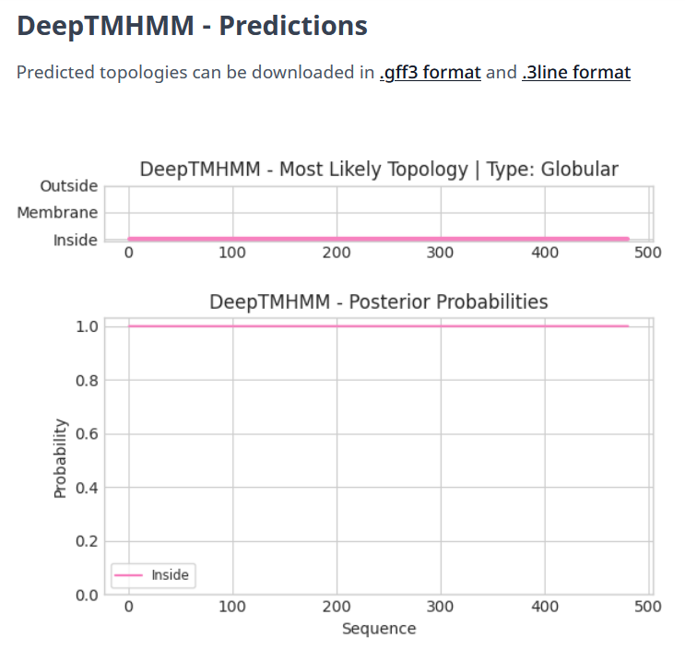

Gene Number: 105
Totinger_Draft_105 on Phagesdb
Pham285
BLAST from PhagesDB. (https://phagesdb.org/blastp/) Using Longest ORF
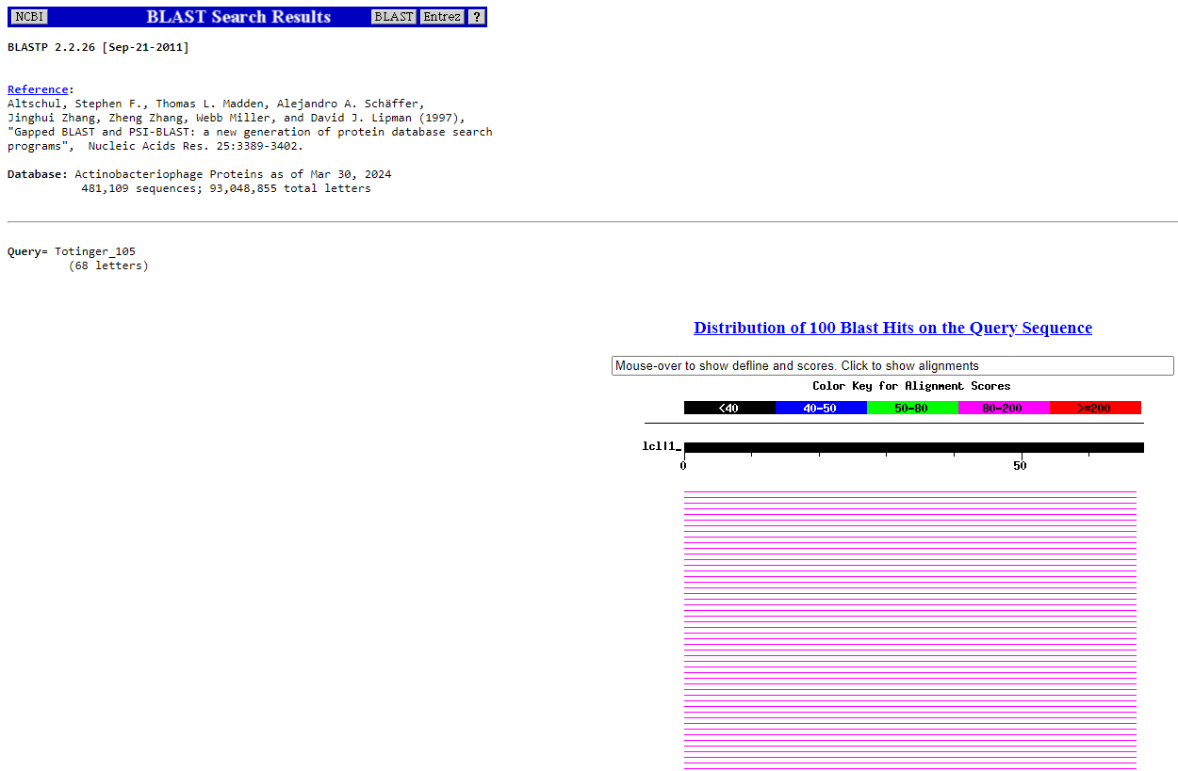
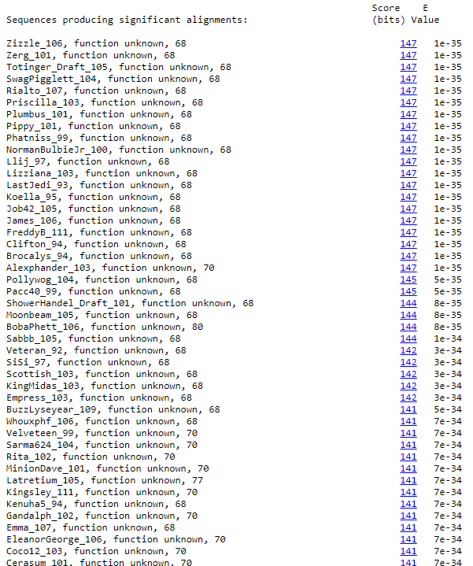
BLAST from NCBI (https://blast.ncbi.nlm.nih.gov/Blast.cgi?PAGE=Proteins) Using Longest ORF
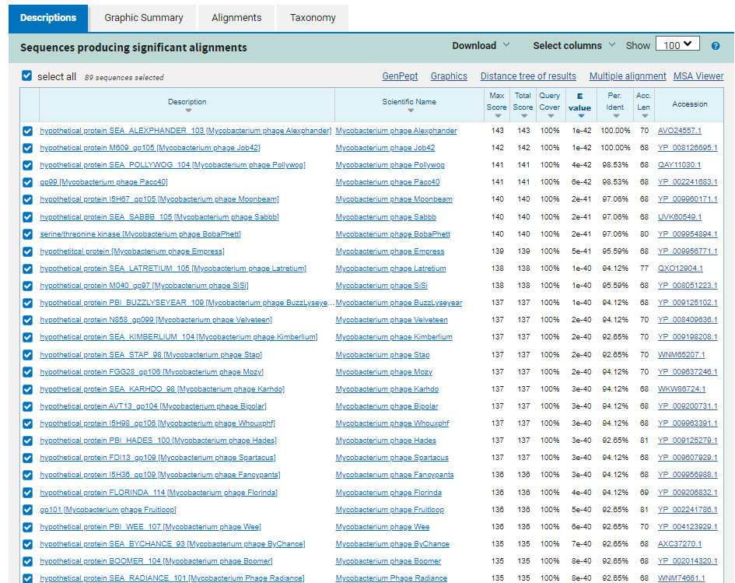
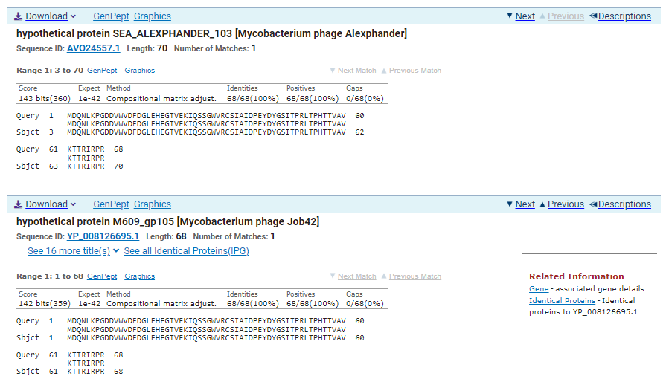
ATG Start at 56543. Original Glimmer call.
TGA Stop at 56749
F/R: F
Coding Potential (y/n): Y
Starterator (SS, NA, NI): Most annotated start is this (56543)
Blast Best Hit, Query:Subject Starts, Score, Evalue, or “no significant Blast alignments” if 10E-4 or higher
hypothetical protein SEA_ALEXPHANDER_103 Mycobacterium phage Alexphander AVO24557.1, 3:70, Score 143, Evalue, 1e-42
Gap with previous gene: 3
Longest Orf? (Y/N/NA) N
RBS:
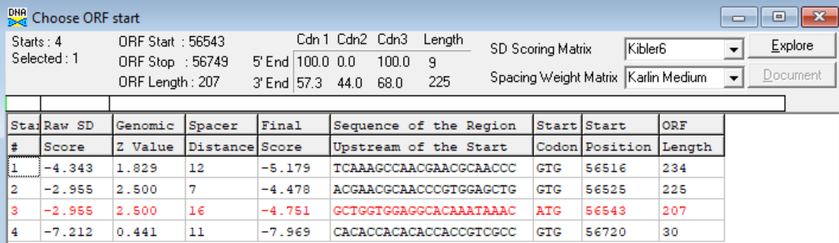
(https://toolkit.tuebingen.mpg.de/tools/hhpred) HHPRED vs PDB, SCOPe, pFam, and M. Tuberculosis.
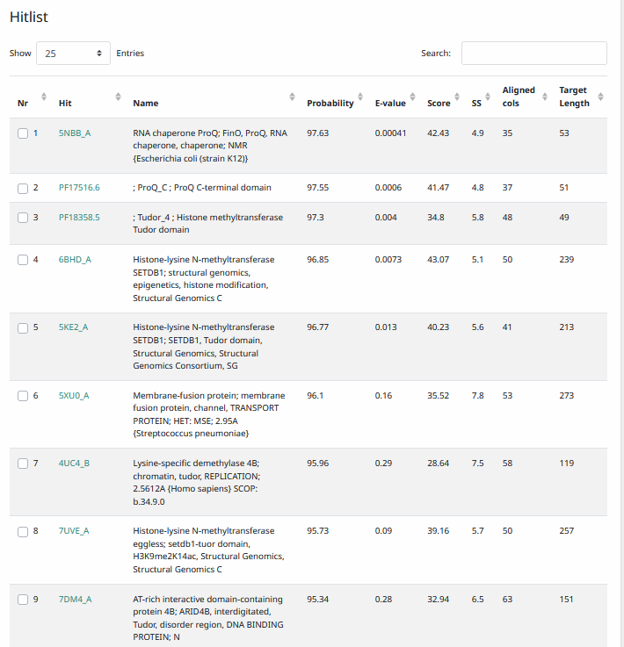
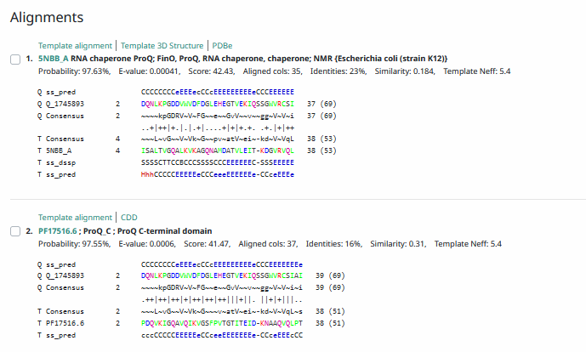
Phamerator Totinger Vs. Tootsieroll Vs. Starcevich (https://phamerator.org/phages) Genes 61-106
Phamerator Totinger (Bottom) Vs. Rialto (Top) (https://phamerator.org/phages) Genes 96-106
Proposed Function: hypothetical protein
Function Evidence: in Phamerator, phage Rialto and phage Starcevich call the same gene from a near identical sequence, and both are labeled as hypothetical proteins. BLASTs also most consistently call this protein as one with no known function.
Transmembrane Domain/Evidence: No, Intracellular Properties (https://dtu.biolib.com/DeepTMHMM)
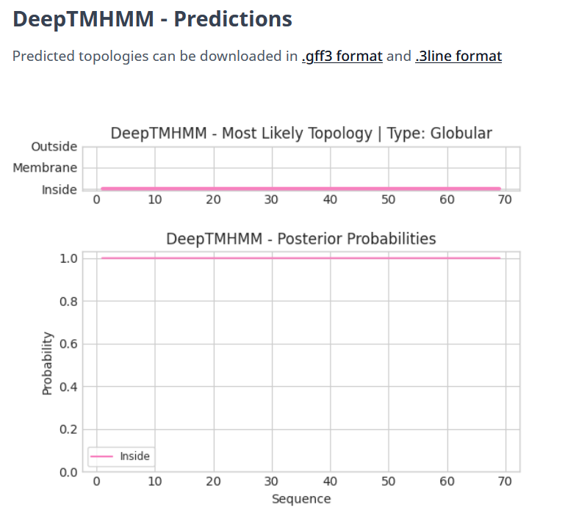

Gene Number: 106
Totinger_Draft_106 on Phagesdb
Pham151647
BLAST from PhagesDB. (https://phagesdb.org/blastp/) Using Longest ORF
BLAST from NCBI (https://blast.ncbi.nlm.nih.gov/Blast.cgi?PAGE=Proteins) Using Longest ORF
ATG Start at 56746. Original Glimmer call.
TGA Stop at 57357
F/R: F
Coding Potential (y/n): Y
Starterator (SS, NA, NI): Does not have the Most Annotated Start
Blast Best Hit, Query:Subject Starts, Score, Evalue, or “no significant Blast alignments” if 10E-4 or higher
glycosyltransferase Mycobacterium phage Rialto WNM65670.1, 1:1, Score 417, Evalue, 9e-147
Gap with previous gene: -3
Longest Orf? (Y/N/NA) N
RBS:
(https://toolkit.tuebingen.mpg.de/tools/hhpred) HHPRED vs PDB, SCOPe, pFam, and M. Tuberculosis.
Phamerator Totinger Vs. Tootsieroll Vs. Starcevich (https://phamerator.org/phages) Genes 61-106

Phamerator Totinger (Bottom) Vs. Rialto (Top) (https://phamerator.org/phages) Genes 96-106
Proposed Function: glycosyltransferase
Function Evidence: BLASTs and HHPRED most consistently call this protein as a glycosyltransferase. In addition, phage Starcevich and phage Rialto called the exact same gene from the same sequence and both called it as a glycosyltransferase.
Transmembrane Domain/Evidence: No, Intracellular Properties (https://dtu.biolib.com/DeepTMHMM)

3’ end region of DNA (57358 – 57540) was examined, there are no putative genes in this area.

Changes From Auto-Annotation Summary

- Edited Starts
  - Auto-Annotated Gene 14 (F, Start 8996; Original Glimmer Call) was changed to start at 8386 (frameshift).
  - Auto-Annotated Gene 21 (F, Start 21612; Original Glimmer Call) was changed to start at 21606.
  - Auto-Annotated Gene 56 (F, Start 38222; Original Glimmer Call) was changed to start at 38219.
  - Auto-Annotated Gene 71 (F, Start 45844; Original Glimmer Call, Not called by Genemark) was changed to start at 45814.

- Deletions
  - Auto-Annotated Gene 26 (F, 24870-24983; Original Glimmer Call, Not called by Genemark)
  - Auto-Annotated Gene 29 (R, 25763-25614; Original Glimmer Call, Not called by Genemark)

- Additions
  - TOTINGER_28 (F, 25651-25800)
  - TOTINGER_49 (F, 36092-36184)
  - TOTINGER_69 (F, 44557-44703)
  - TOTINGER_73 (F, 46074-46304)
  - TOTINGER_93 (F, 51691-51819)

