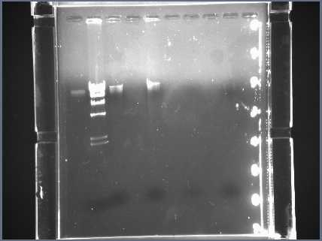
Lane 3
Whole DNA
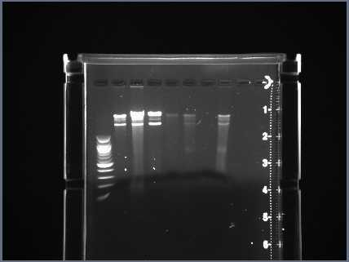
Lane 2
EcoRI restriction digest
Lane 2
HaeIII restriction digest
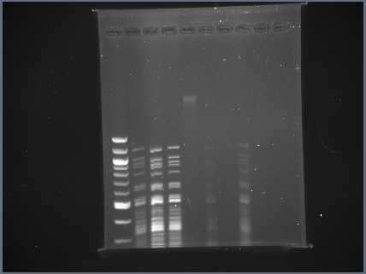
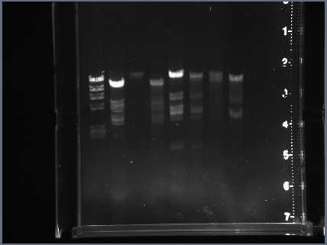
Lane 6
BamHI restriction digest
Lane 4
HindIII restriction digest
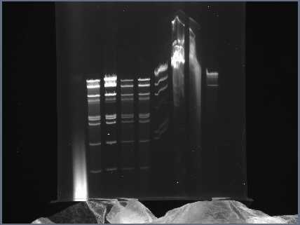
Lane 4
ClaI restriction digest

