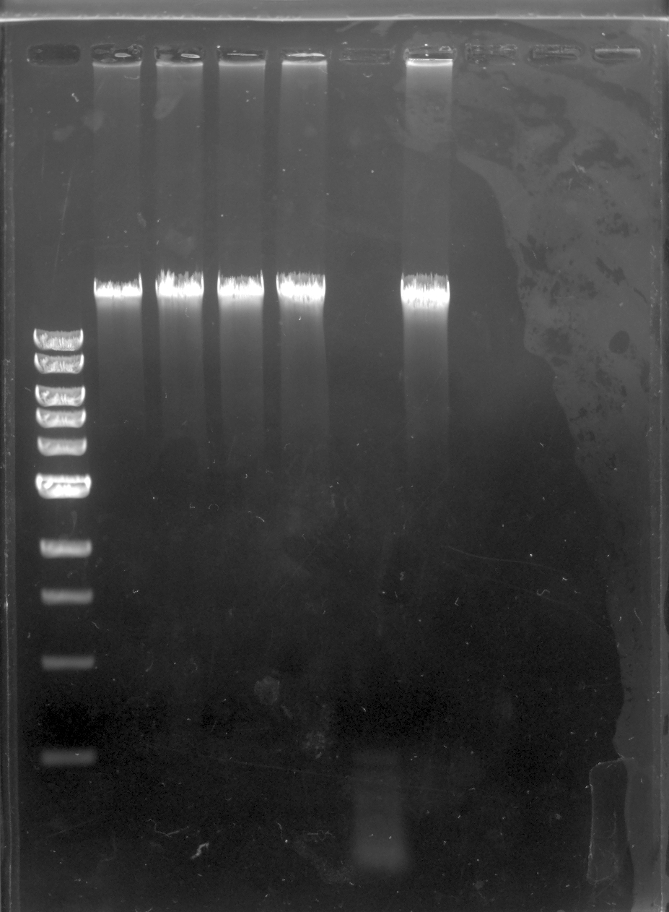

LEGEND

1: DNA Ladder

2: Control

3: BamHI

4: ClaI

5: EcoRI

6: HaeIII

7: HindIII

5

2

7

6

4

3

1

0.5

1

1.5

2

3

4

5

6

8

10kb