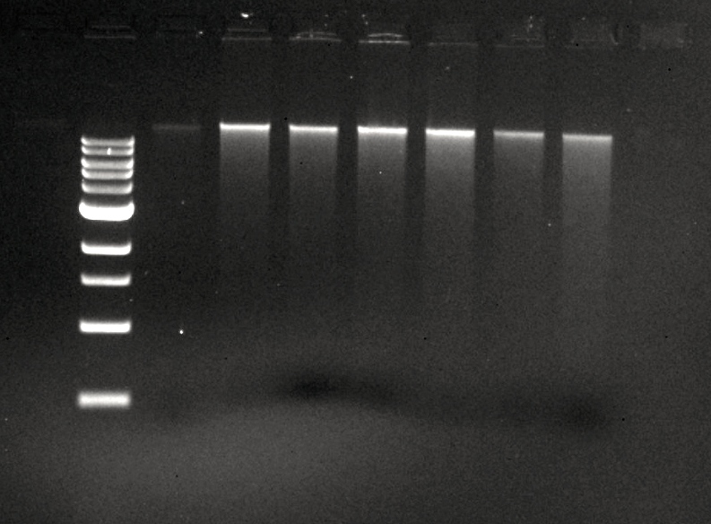

Ladder

Undigested

BamHI

ClaI

EcoRI

HaeIII

HindIII

SaII