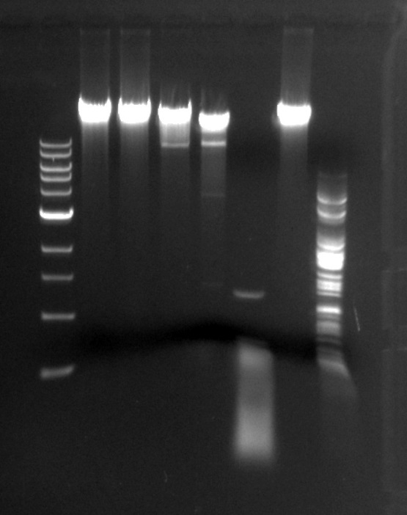
Greta’s Restricted Endonucleases- DNA digested
Ladder Undigested BamH1 Cla1 EcoR1 Hae111 Hind111 Sal1
- Gel Electrophoresis Picture

