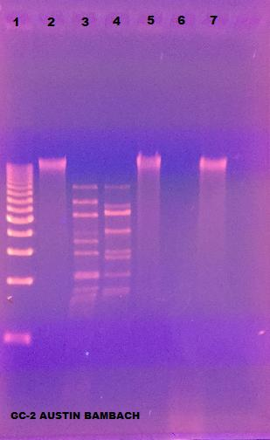

**Lane 1 – 1 kb ladder**

**Lane 2 – Undigested DNA**

**Lane 3 – BamHI**

**Lane 4 – ClaI**

**Lane 5 – EcoRI**

**Lane 6 – HaeIII**

**Lane 7 - HindIII**