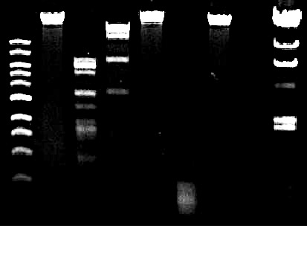

1. Kb ladder 6. HaeIII
2. Uncut DNA 7. HindIII
3. BamHI 8. Empty well
4. ClaI 9. Lambda ladder
5. EcoRI