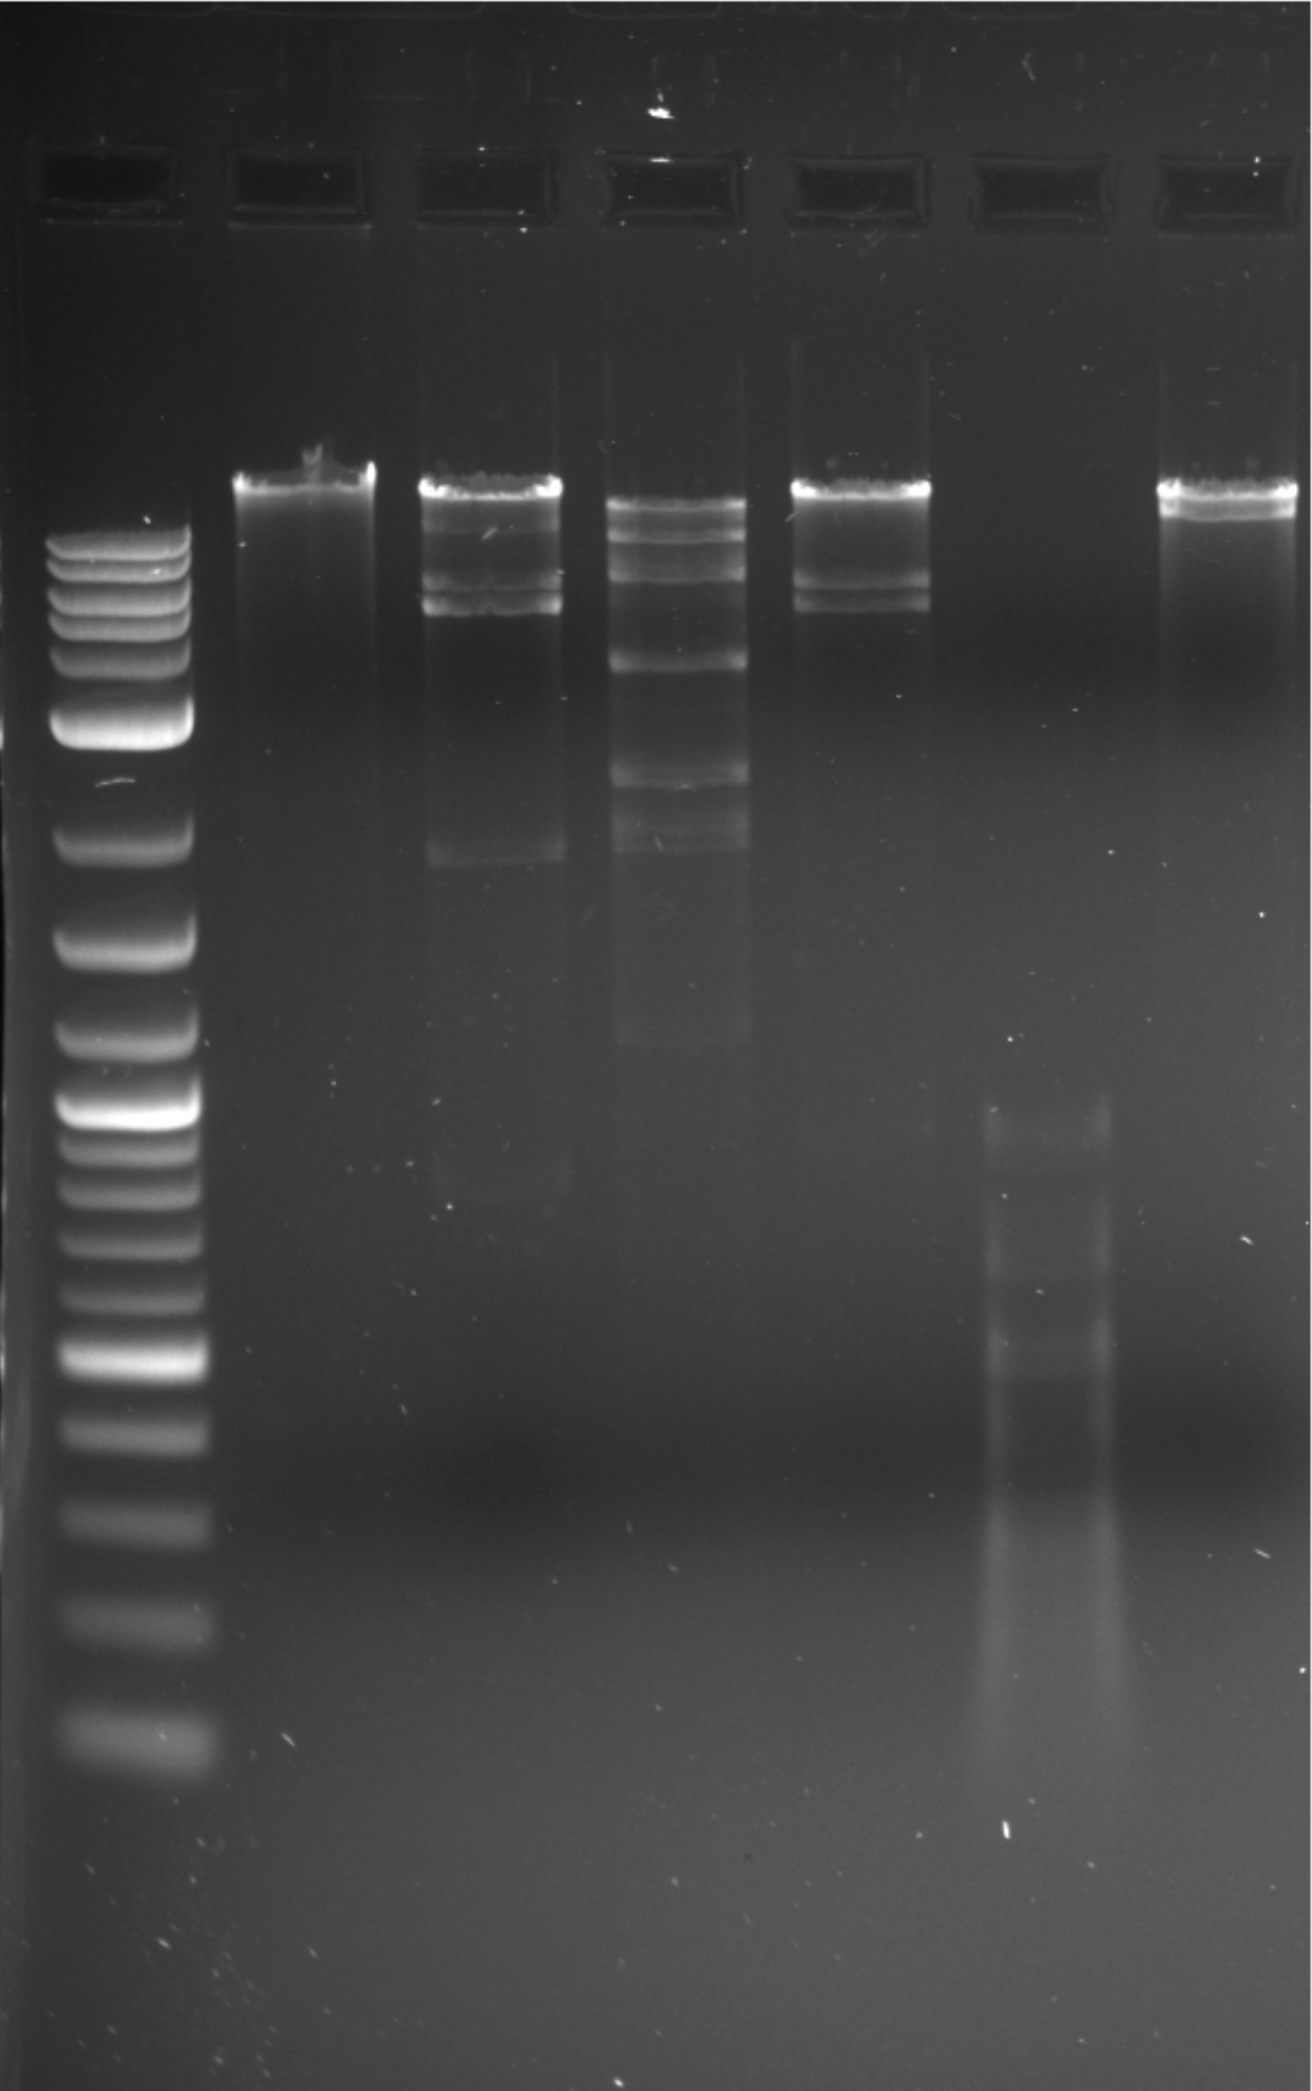

uncut

EcoRI

ClaI

BamHI

HaeIII

HindIII