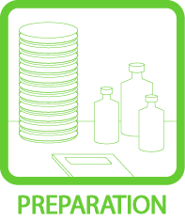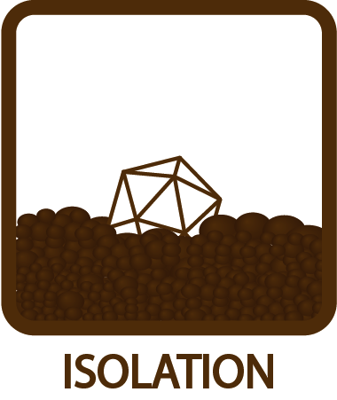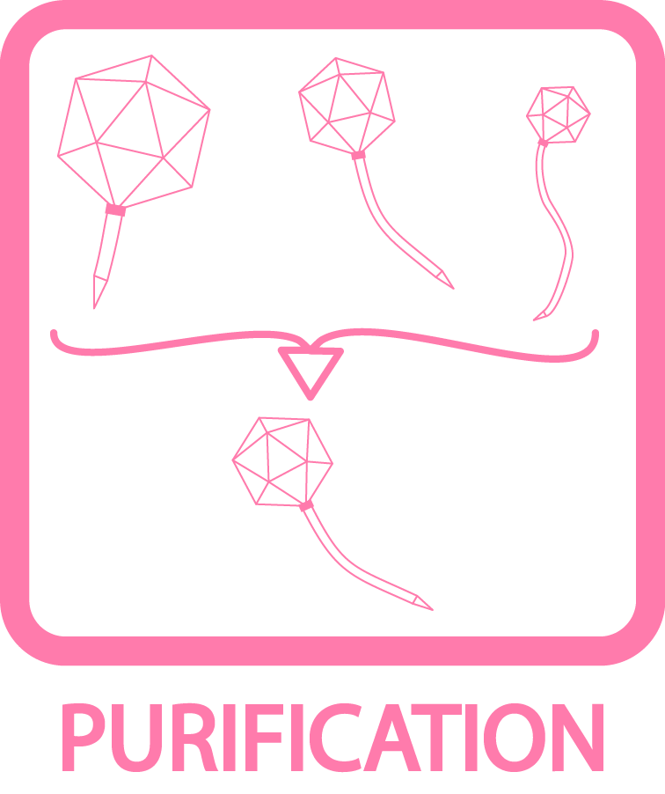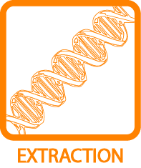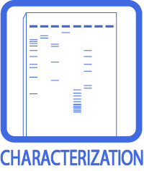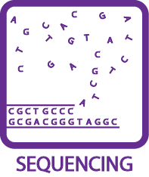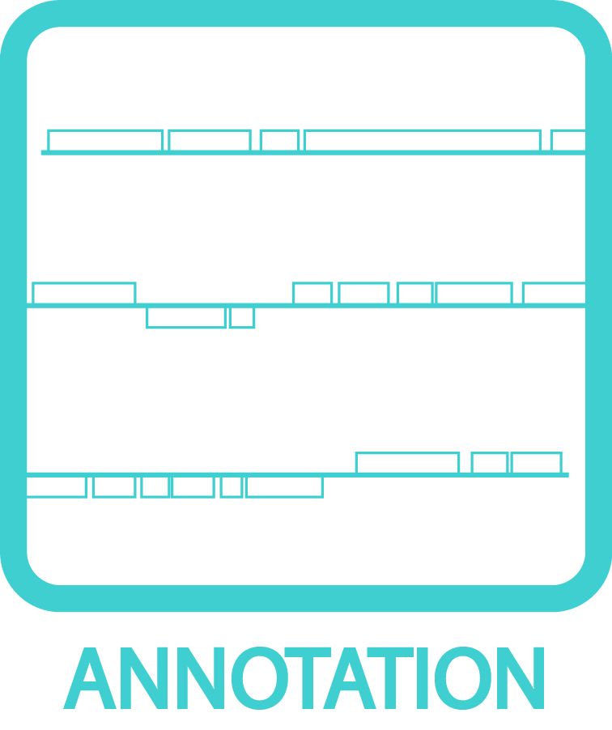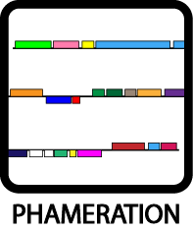
Electron Microscopy Grid Sample Preparation
OBJECTIVE
To prepare (glow-discharge) grids for sample application.
BACKGROUND
The grids electron microscopy needs to have little or NO charge, so that the EM stain (uranyl acetate) behaves correctly.
APPROXIMATE TIME NEEDED
~20 minutes
MATERIALS NEEDED
Equipment
- EM forceps (Reverse N4-style)
- Tube rack
- P10, P20, and P200 Micropipettors

Consumables/Reagents (See online media preparation guides)
- 400 Mesh, support film, carbon coated EM grids (Ted Pella # 01814-F)
- 1% uranyl acetate solution, filtered through 0.2 μm syringe filter to remove precipitates
- HPLC water (or other extremely clean water)
- Whatmann filter paper cut into wedges
- Phage buffer
- Eppendorf tubes
- Appropriate pipette tips
HELPFUL TIPS
- This protocol outlines procedures that are specific to the labs at the University of Pittsburgh.

PROCEDURES

- Glow-discharge grids (should be performed immediately before applying sample).

- In Genome Center: Tighten the leak screw on the side of the vacuum chamber. Place grids, carbon (dark and shiny) side up, on a pertri dish on a strip of parafilm.

- Place dish on the center of the pedestal and cover.

- Turn on vacuum pump.

- Set T joint to pump out chamber. Pump down for 45 seconds.

- Plug in high voltage power supply. Touch the end of the probe to the screw in the top of the chamber for 45 – 60 seconds

- Unplug supply.

- Set T joint to hold vacuum in chamber and pump air from the room to the pump. Switch pump off.

- Open leak valve a little, wait until the sound of air hissing into the chamber ceases.

- Apply sample and stain.

- Obtain phage sample, ddH₂O, and 1% – 2% uranyl acetate (or another appropriate EM stain); as well as wedges of Whatmann filter paper.

- Lay out a lab wipe on the bench to work over as a precaution measure in case the grid is dropped. Use the reverse grip forceps to pick up a grid (they stay closed when untouched).

- Set the forceps down on lab wipe, with the carbon-side up on the grid.

- Apply 5 µL of your sample for 30 seconds (this is a good length of time for a 10¹⁰ pfu/mL sample from a CsCl banded phage sample. For a more diluted sample, longer wait times may be necessary (5 or even 10 minutes).

- Aspirate 5 µL of stain into P10 or P20 micropipettor. Take stain from the top of the tube without mixing the tube. Uranyl acetate makes precipitates that will sink to the bottom of the tube that will show up as big black marks on grid that should be avoided. Carefully lay the pipettor down on the bench without dispensing the stain.

- Aspirate 30 µL of ddH₂O into the P200 pipettor.

- Use the forceps to turn the grid to 45-degree angle from the bench. Carefully and slowly expel the water in pipet-tip across the grid face (should be 5 or 6 drops that should run across the grid face and drip off the other side onto the lab wipe. Try not to get the water on the back of the grid. If using an undialyzed CsCl banded sample, more water may be needed to wash away all salts.

- Immediately set the forceps back down on the lab wipe and put 5 µL of stain onto the carbon/sample side. Do not wait; all the buffer haave been washed off the grid and the pure water could denature the phage particles. The stain is a fixative and will preserve the structures.

- Use a Whatmann paper wedge to soak up the stain on the grid by only touching the outer copper ring of the grid. Keep drying the grid until the surface looks like a shiny oil slick.

- Leave grids along for another few minutes to finish air-drying, then place in a grid box.

- Grids should be looked at immediately—water absorbed from the air can ruin samples. If it isn’t possible to look at samples immediately, place grid box in a container with desiccant.

