Actinobacteria: Gordonia terrae

Source
- ATCC
- Catalogue #: 25594

Growth Parameters
Note: The condition(s) tested below is not necessarily optimal for growth of this host. Rather, it represents a “basic” growth medium on which this host can grow.

- Growth media: PYCa media,
[4.5 mM CaCl₂ supplemented to top agar]
- Temperature tested: 30˚C
- Streak Plate Time: 5 days
- Liquid Culture Time: 3-4 days
- Lawn Growth Time: 2 day
- Colony Color: orange. Color deepens with time. Lawns are
typically pinkish-orange.
- Colony Morphology: Round, convex, slightly raised, slightly rough,
and dry. Size varies between 1 - 3 mm.

Additional Notes:
Start fresh cultures every 7 – 14 days. May need to amplify phage titers in liquid culture. More testing is needed.

Streak Plate Image

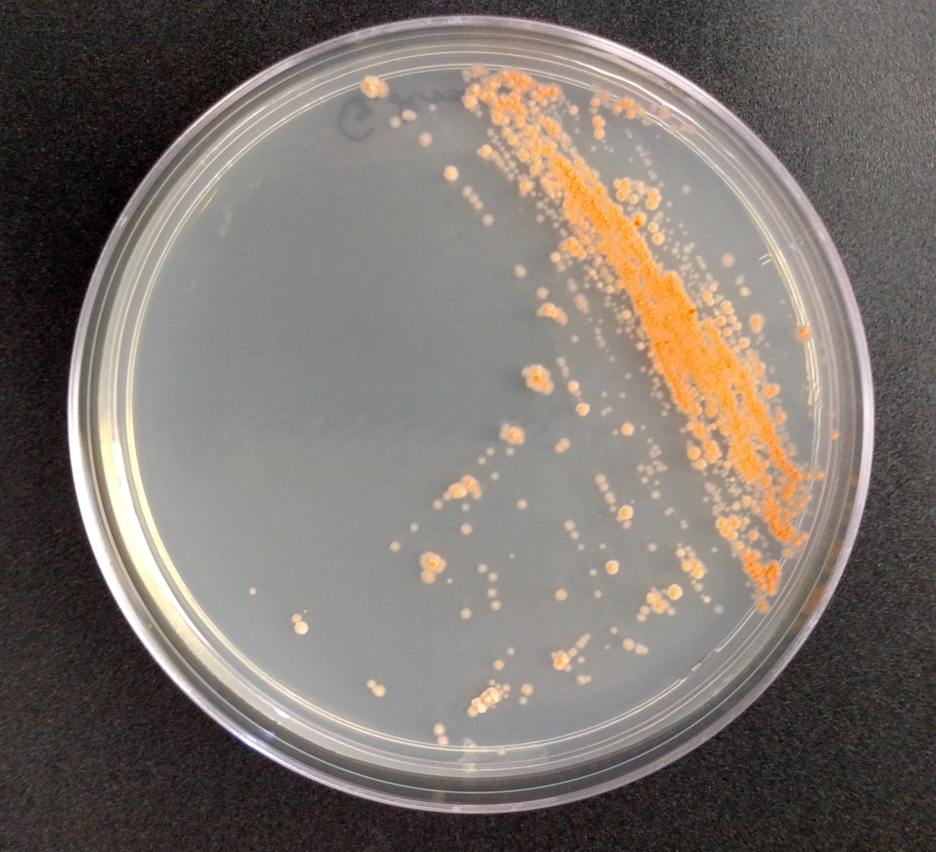

Background
Gordonia terrae is a non-motile Gram positive Actinobacterium in the family Gordoniaceae. The ATCC strain 25594 is G. terrae C-6 and is sequenced. It is a benzothiophen-desulfuring bacterium isolated from oil-contaminated soil of the GuDao Oile filed, China. An overview of recently research on Gordonia species is available in References.

Host Information
- BSL1
- Found in soil

References
Draft Genome Sequence of a Benzothiophene-Desulfurizing Bacterium, Gordona terrae Strain C-6. Wang W, et al. Genome Announc 2013 Jun 20

Arenskotter, M.; Broker, D.; Steinbuchel, A. (2004). "Biology of the Metabolically Diverse Genus Gordonia". Applied and Environmental Microbiology 70 (6): 3195–3204. doi:10.1128/AEM.70.6.3195-3204.2004.

