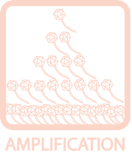
Identifying & Verifying Putative Plaques (Spot Tests)
OBJECTIVE
Determine whether a putative plaque is due to phage or artifact (such as an air bubble).
BACKGROUND
A spot test is a quick way to check whether a phage sample can infect a bacterium by placing a small drop or “spot” of phage onto a plate inoculated with the bacterium. This test will determine if the putative plaque will propagate phage.
APPROXIMATE TIME NEEDED
Pouring Plates: ~15 minutes
Waiting for Plates to Cool: ~15 – 30 minutes
Spotting Samples: ~5 minutes
Waiting for Spots to Dry: ~30 minutes
Overnight Growth: ~16 – 24 hours (for M. smegmatis, other bacteria may take longer)
Checking for Plaques on Day 2: ~5 minutes
MATERIALS NEEDED
Equipment
- Pipettors, micro- and serological
- Microwave
- 37°C Incubator

Consumables/Reagents (See online media preparation guides)
- 15 mL conical tubes
- Mycobacterium smegmatis plating stock (0.5 mL/plate)
- Top agar/MBTA plating mix (4.5 mL/plate)
- Serological pipettes
- Appropriate micropipette tips
- Agar plates
HELPFUL TIPS
- If you are sure you have plaques, skip the spot test and immediately begin your first round of purification.

- Up to 10 samples may be tested on a single plate. Simply use a marker to draw sections on the bottom of the plate, and then spot the samples into appropriate regions.

- Do not use the spots to begin the purification process of any confirmed phages. Movement of the phage on the plate is by simple diffusion. Just because lysis is not observed does not mean that a particle is not present in any given area of the plate.
- Positive spot tests are NOT a plaque; no morphologies are associated. Rather, they are many plaques that fused together and destroy all bacterium in their wake.

- A single plaque in a spot test is not confirmatory since there is no way to be sure of its origin.

- The plate for spotting can be prepared the same day that environmental samples are processed. Place the solidified top agar plate in the refrigerator instead of the incubator. This saves time on day two.

- To ensure that the top agar dries as one smooth surface, it is helpful to bring the plates to room temperature before using. This will also help to rid any condensation that has accumulated on the agar surface.

- Top agar/MBTA plating mixture is prepared by mixing 7H9 (w/ CaCl₂ and other host-specific additives) and stock MBTA in a 1:1 ratio.
PROCEDURES

- Obtain a liquid page sample by picking a plaque (See TOOLBOX: Picking a Plaque).

- Label the agar plate clearly. If performing more than one spot test, divide the plate with a marker and label each section.

- Aseptically aliquot 0.5 mL (500 μL) of the M. smegmatis culture to a sterile test tube.

- Prepare the top agar:

- Heat the MBTA in a microwave, interrupting and shaking periodically, until it bubbles and no visible solid chunks remain.

- Add an equal volume of room temperature 7H9 w/ + 2 mM CaCl₂ (and any other host-specific additives) to the hot MBTA. Mix until well combined. This will dilute the CaCl₂ to an appropriate final concentration (1 mM) as well as cool the MBTA to a usable temperature. Use the top agar immediately to prevent chunking.

- While the top agar is still very warm, use a serological pipette to add ~4.5 mL of it to the tube containing M. smegmatis.

- Immediately, but gently, swirl the plate in a circular motion to spread the agar across the surface of the plate.

- Allow the plates to cool and solidify (~15 minutes).

- Using a micropipettor, transfer 10 μL of liquid phage sample onto the plate in the appropriate place. Try not to physically touch the pipette tip to the agar, as this will interfere with even lawn growth. Also avoid making bubbles, as these will scatter the sample across the plate.
- As a negative control, spot 10 μL of phage buffer in an appropriate place.

- Allow the liquid from the spots to absorb into the agar (generally 30 minutes).

- Incubate inverted plates at 37°C for ~16 – 24 hours, or until a visible bacterial lawn grows.

- The next day, check spots for clearing. A positive spot test will appear as complete obliteration of the entire drop area, whereas a negative spot test will result in the bacterial lawn growing normally in the region of the spot (see Figure 1). Typically, the concentration of phage allows plaques to “grow” together to form a bacterial death zone the size of the drop area.

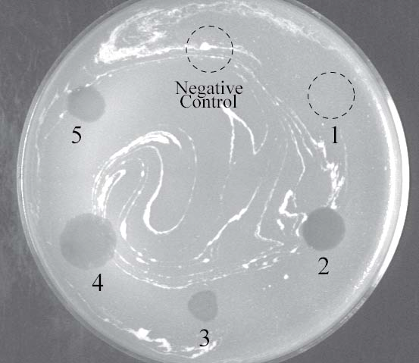

Figure 1: A spot test checking 5 samples. The negative control and sample 1 show normal lawn growth, and are therefore negative. Samples 2¬5 cleared the bacterial lawn and are therefore positive.

