Picking a Plaque
OBJECTIVE
To obtain a liquid sample of phage from a plaque (or putative plaque) on a lawn of bacteria.
BACKGROUND
When phages successfully propagate among bacteria growing in a lawn, plaques are formed. These are areas of clearing where phages have infected and lysed cells. Plaques can range in size, turbidity, and morphology. Often, it is necessary to collect a sample of the phages that have made a particular plaque (or putative plaque) to perform further experiments with them (such as spot tests or further purification rounds). This protocol describes how to “pick” the plaque and obtain a liquid sample of phage.

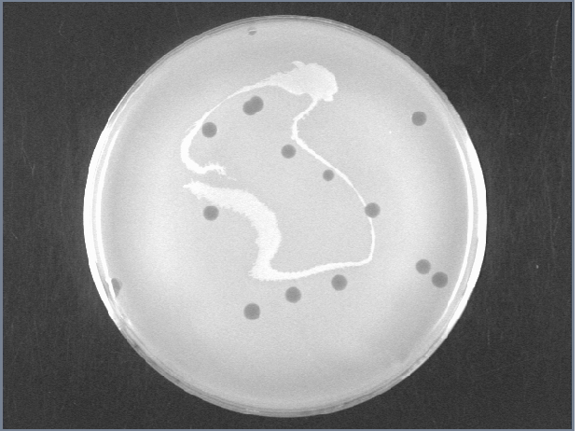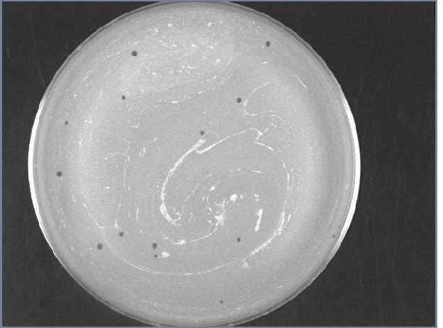
D29 Rosebush

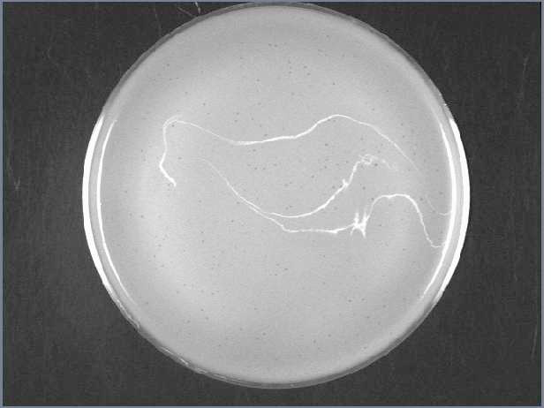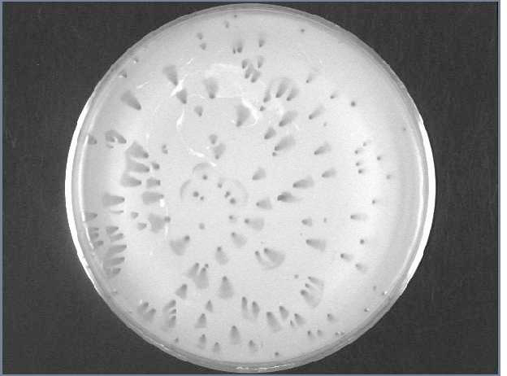
Adjutor Wildcat
Figure 1: Examples of plaque morphologies for D29, Rosebush, Adjutor, and Wildcat.

APPROXIMATE TIME NEEDED
~10 minutes
MATERIALS NEEDED
Equipment
- Micropipettor
- Vortex

Consumables/Reagents (See online media preparation guides)
- Mycobacterium smegmatis plating stock (0.5 mL/plate)
- Appropriate micropipette tips
- Phage buffer with 1 mM CaCl₂ (100 μL/pick)
- Sterile microcentrifuge tubes
- A plate with plaque or putative plaques
HELPFUL TIPS
- This is one of the MOST CRITICAL stages to be aware of potential contamination. Wipe pipettors down with ethanol before and between samples, use only sterile buffer, and work in an area where no other phage samples are present.

- Resist the temptation to plunge the pipet tip into the agar more than once, or to plunge it into more than one plaque. As long as proper procedures are followed, tens or hundreds of thousands of phage particles will stick to the tip on the first attempt.

- When purifying a phage, pick from a plate with a low number (2 – 30) of plaques. The more isolated the plaque, the better the chances are picking only one type of phage.

- Similarly, don’t wait too long (>20 hours with smeg) to pick after plating. The longer the plate sits, the more phage diffuse through the agar, and the less truly isolated each plaque will be.

- For purification, it’s useful to have several dilutions plated. Plates with higher numbers (100+) of plaques are useful to check for low-concentration contaminants in the sample. Plates with low numbers (2 – 20) of plaques are useful for picking isolated samples.

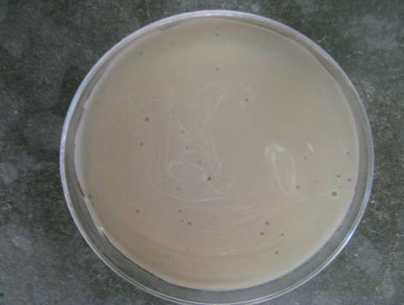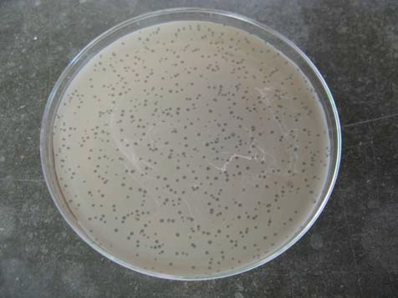
Figure 2: A plate for picking (Left) and a plate for checking for contaminates (Right)

- Avoid picking up the bacteria surrounding the plaque.

PROCEDURES
- Look carefully at the plate and select a well‐isolated plaque to pick (see Helpful Tips, above). Use a lab marker to draw a circle on the bottom of the plate around the selected plaque. Label the circles as needed.

- Aseptically aliquot 100 μL Phage Buffer w/ 1mM CaCl₂ into a sterile, labeled microcentrifuge tube. Make one aliquot for each “pick” (each plaque to be isolated).

- Wipe down the micropipettor using with 70% ethanol.

- Attach a tip to the micropipettor. (The micropipettor does not have to be set to any particular value.)

- Using aseptic technique, touch the center of the plaque once with the tip. The idea is to penetrate the top agar layer, but not go all the way through to the bottom agar. The angle of the pipette tip is not critical, although with small plaques, approach the plaque perpendicularly seems to work best)

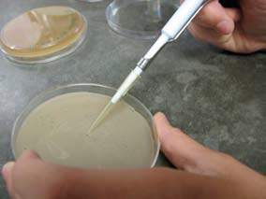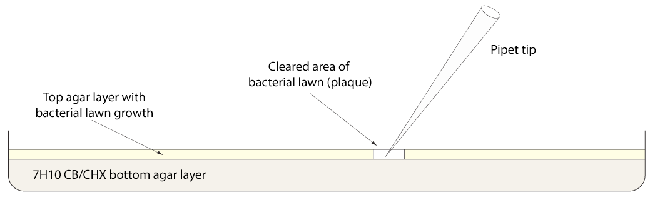
Figure 3: Visual instructions for picking a plaque.

- Move the tip to the prepared tube of Phage Buffer, lower the point under the level of the liquid, and shake moderately from side to side to release phages into the buffer. It’s also a good idea to pipet up and down several times to “wash” any phages from inside the tip into the buffer.

- Discard the tip, close the tube, and vortex briefly to mix. Label the tube with the phage name, date, and initials.

- The pick is now ready to be serially diluted and plated or used in a spot test. Store at 4˚C until ready to use.

- Make sure to record all relevant data in the notebook: pictures/descriptions of the plaque morphology, the plaque selected for picking, sample name, etc.

