|  |  |
| --- | --- |
|  | |
| Macintosh HD:Users:Enoch:Desktop:New Protocols:Logos and Graphics:Workflow:PreparationPNG.png Macintosh HD:Users:Enoch:Desktop:New Protocols:Logos and Graphics:Workflow:IsolationPNG2.png C:\Users\Owner\Desktop\Protocol\pictures\Purification.jpg C:\Users\Owner\Desktop\Protocol\picture\AmplificationWorkFlowgray.png Macintosh HD:Users:Enoch:Desktop:New Protocols:Logos and Graphics:Workflow:ExtractionPNG.png Macintosh HD:Users:Enoch:Desktop:New Protocols:Logos and Graphics:Workflow:CharacterizationPNG.png Macintosh HD:Users:Enoch:Desktop:New Protocols:Logos and Graphics:Workflow:SequencingPNG.png Macintosh HD:Users:Enoch:Desktop:New Protocols:Logos and Graphics:Workflow:AnnotationPNG.png Macintosh HD:Users:Enoch:Desktop:New Protocols:Logos and Graphics:Workflow:PhamerationPNG.png Macintosh HD:Users:Enoch:Desktop:New Protocols:Logos and Graphics:Workflow:FurtherDiscoveryPNG.png | |
| **Plaque Purification** | |
| **OBJECTIVE** | |
|  | To obtain a lysate of phage derived from one genetic clone. |
| **BACKGROUND** | |
|  | Three rounds of purification are recommended to obtain a pure lysate for each individual phage. There are two methods to purify a plaque:   * Purification by serial dilutions * Purification by streak plating |
| **APPROXIMATE TIME NEEDED** | |
|  | Small-plate Infections   * Serial dilutions: **~5min** * Infection: **~15-30min** * Plating: **~10min** * Drying: **~10-30min** * Incubation: **>18hr**   Purification and Isolation by Streaking   * Streaking: **~10min** * Plating: **~10min** * Drying: **~10-30min** * Incubation: **>18hr** |
| **MATERIALS NEEDED** | |
|  | Equipment   * Sterile pipette tips, wooden sticks, cotton swabs, or toothpicks   Consumables/Reagents (See online media preparation guides)   * Agar plates: 7H10/CB/CHX/ADC/CaCl2 Plates * *Mycobacterium smegmatis* plating stock * Top Agar (MBTA plating mixture) * Phage pick, lysate, or plaque. |
| **HELPFUL TIPS** | |
|  | * Pick as soon as possible. The longer the phage is on the plate, the further it diffuses and crosses into adjacent plaques. * Check plates with low dilutions (or the first streak) for uniform plaque morphology. Low frequency mutants or contaminants may only be visible when a high concentration of phage are present. * Check plates with high dilutions (or the third streak) for uniform plaque morphology and to pick your plaque. With 2 - 30 plaques on a plate, you will be most able to pick an isolated plaque. * When streaking, sterile swabs or toothpicks can also be used. * Adsorption time is variable and phage dependent. If your yield is adequate, adsorption time can be shortened. Too much time for adsorption can lyse all cells before plating. |

**PROCEDURES**

**Serial Dilution Purification**

The purpose of plaque purification is so that you have only one clone in your sequencing reactions. A pure lysate is the objective. The information gained from this preferred method of purification is that you get to see individual plaques when there are few plaques on the plate AND the uniformity (or lack there of) of the plaque morphology when a high concentration of phage are present on a plate.

1. Have your liquid phage sample ready. (See **TOOLBOX: Picking a Plaque**.)
2. Serially dilute phage samples to 10–2, 10–3, and 10–4 in phage buffer with CaCl2 (See **TOOLBOX: Making Serial Dilutions**.)
3. Infect 0.5 ml bacteria with 10 μL of 10–2, 10–3, and 10–4 dilutions. Incubate at room temperature for 10 – 30 minutes.
4. Add 4.5 mL top agar (MBTA +calcium mix).
5. Pour on agar plates, mix by swirling the plates. Allow the plates to cool until the top agar has solidified.
6. Incubate at 37°C overnight. The next day, many plaques will be visible and the number of phages will reflect each plate’s respective dilution.
7. If done properly, three rounds of purification will produce a pure lysate. It is of utmost importance that the final plaque purification contains only a single phage. By using plaque morphology to purify, some caveats exist. Standardization of procedure, such as incubation time and concentration of phage to cells is critical to ensure successful purification. Thoroughly record your observations. Document with photographs when necessary.

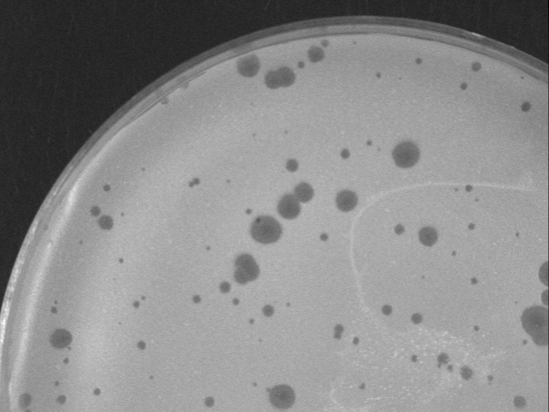

A B C

**Figure 1:** A. Impure sample with 2 distinct plaque morphologies. B. large plaque purified C. small plaque purified.

**Streak Plate Purification**

The benefits of the streak plate method of purification is most likely focused on cost. You only need one plate, while the full plate method requires 3 -5 plates. Note that this method may not work well for all phages (Examples include Myrna and Barnyard).

1. Pick and label plaques from original sample plate OR obtain a lysate. (See **TOOLBOX: Picking a Plaque**)

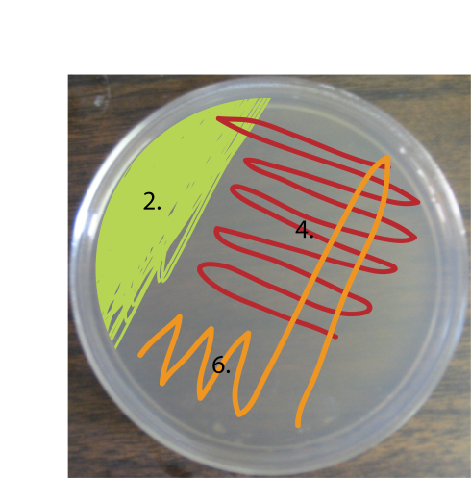

Figure 2: Standard T-streak pattern. Numbers refer to the step numbers in the procedure.

1. For picks, swirl the sterile pipet tip you used to pick the plaque into the buffer, and on a labeled, **COLD** agar plate, streak back and forth across the top 20% portion of the plate, as shown to the right. For a lysate, swirl a sterile pipet tip in the lysate and follow the same procedure (Figure 2).
2. Discard the pipet tip.
3. Obtain a new, sterile pipet tip. Starting from the opposite side of the plate from step 2, streak into and out of the original confluent area, and then streak the adjacent area (~40%) of the plate, overlapping only the first 1 – 2 strokes (Figure 2). Unlike the first streak, do not allow strokes to overlap at the corners. See illustration below for clarification (Figure 3).
4. 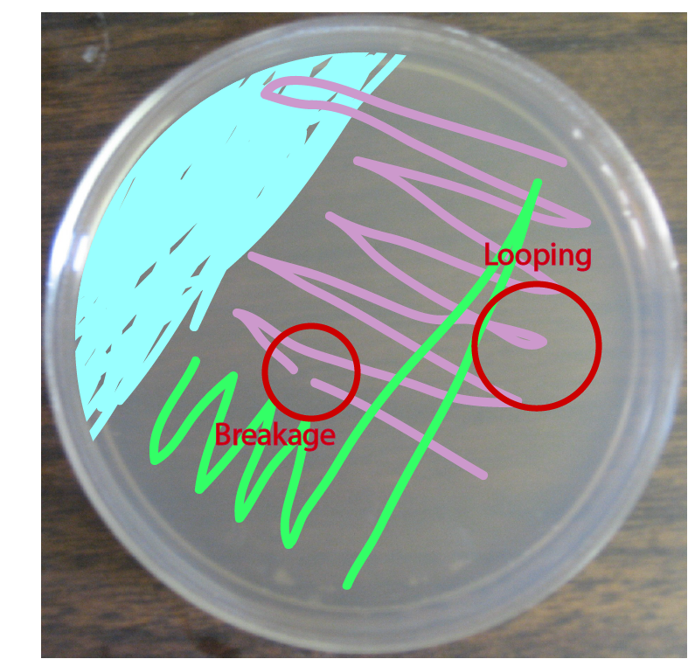Discard the pipet tip.
5. With a new, sterile pipet tip, repeat #4 for the remaining 40% of the plate, as illustrated in Figure 2. Do not allow the tip to touch the area of the first streak (the top 20% of the plate).
6. Mark the most diluted portion (the mid-point of the last strike) of the plate with a marker.
7. After the plate has reached room temperature, add 4.5 mL of warm MBTA/7H9/CaCl2 to 0.5 mL aliquot of host bacteria.

Figure 3: Common streaking mistakes.

1. Dispense mixture onto the most diluted (marked) spot of the plate. Make sure the pipet is perfectly vertical (i.e. not slanted or tilted). **DO NOT SWIRL**.
2. Allow the mixture to slowly spread across the plate by slightly tilting or gently tapping. **DO NOT SWIRL**.
3. Perform a negative control using the same procedures. However, instead of using a pick, swirl the pipet tip into plain buffer and begin streaking.

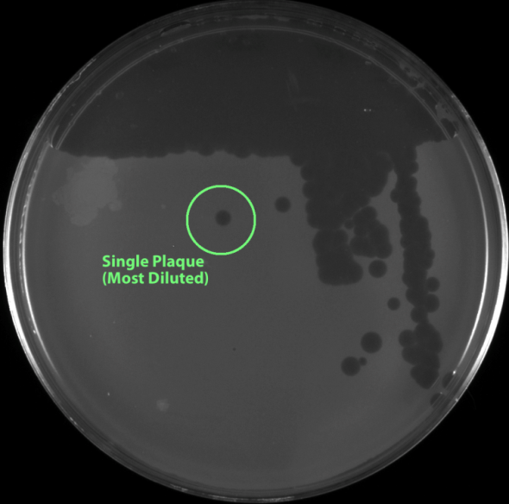

Figure 4: A plate showing a phage with uniform morphology and single plaques for picking.

1. Allow the top agar to solidify. This usually takes about 15 – 20 minutes. Incubate at 37°C for 24 hours. If nothing appears, incubate for another 24 hours.
2. Identify single plaques on the plate (Figure 4), pick and repeat the process of purification for 2 more times or until plaque morphology is uniform.