Taking Plaque Pictures
OBJECTIVE
To keep a visual record of findings.
BACKGROUND
Properly documenting progress and results is a cornerstone of good scientific technique. For this reason, it is imperative that pictures documenting plaque morphology are taken throughout the process of purification to track progress and report findings.

Different laboratory equipment is available to take pictures of plaques, but in settings where such equipment are not available, plaque pictures can also be taken with a modern digital camera. Detailed instructions about how to use GelDocs or other common imaging instruments used in laboratories vary and should accompany the specific instruments, hence only details regarding how to take a good picture and tips for obtaining one with a digital camera are outlined in this protocol.
HELPFUL TIPS
- Allowing the lawn to reach maturity (>30 hours) provides a better definition of the plaque morphology.

- Take additional pictures at 48 hours if possible.

- This protocol outlines procedures for taking pictures with a digital camera. If a Gel-Doc camera is available, please see TOOLBOX: Using a Gel-Doc Camera to Take Plaque Pictures.

PROCEDURES

- The ideal plate for a picture contains about 20 – 40 plaques, depending on the size of plaques. At this concentration, individual plaques are clearly visible and features (such as formation of halos) are clear.

- Remove the lid. The agar side should be facing the lens of the camera regardless of apparatus used.

- The plate should be placed on top of a dark surface. Slide a black sheet of paper or a black binder underneath the plate if necessary.

- The field of view should capture the entire area of the plate with little to no space around it.

- Make sure the picture is in focus. Edges of plaques should not be blurry.

- If using a digital camera, do not use the flash. Take the picture under good lighting conditions to avoid glare.

EXAMPLES
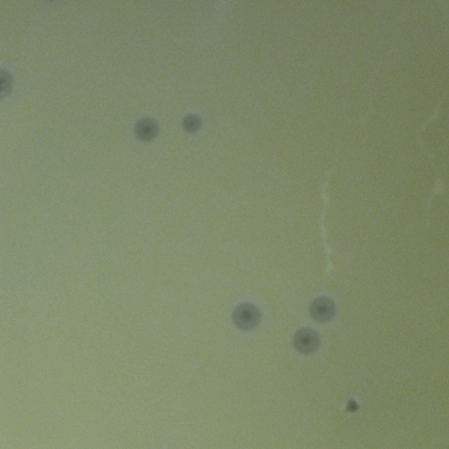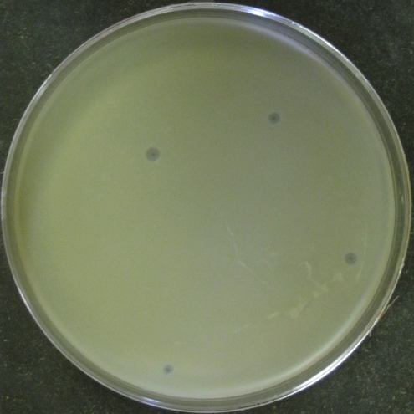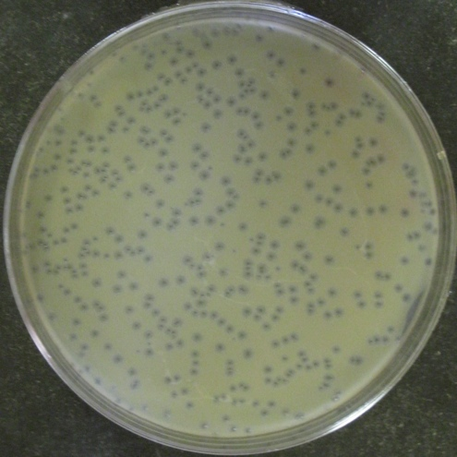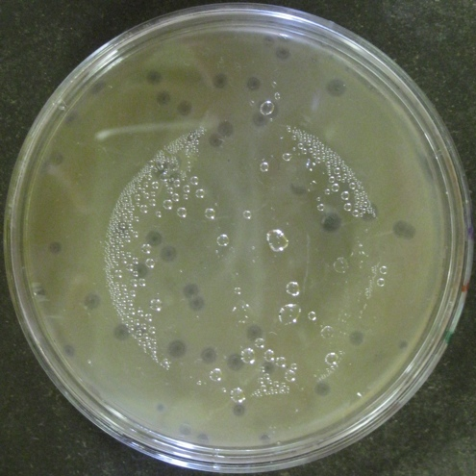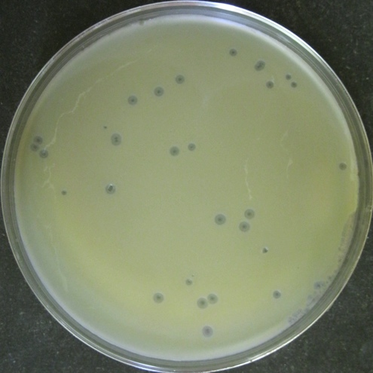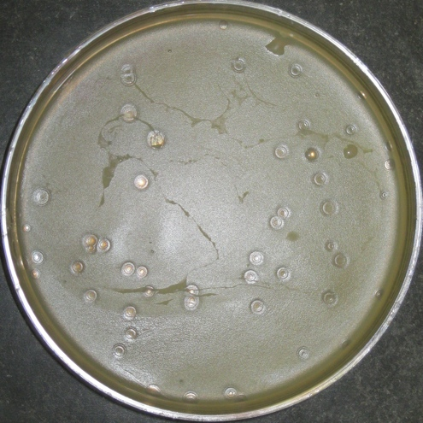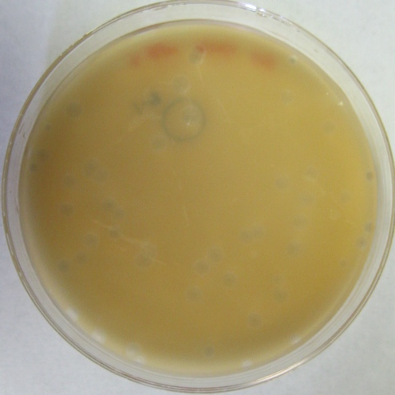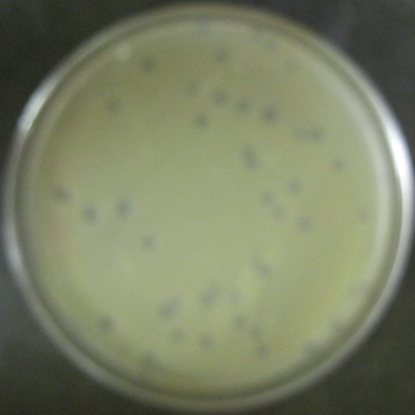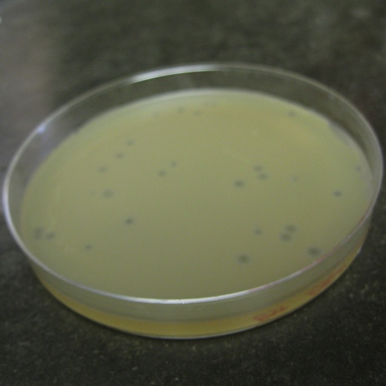
Light Background Blurry Picture Incorrect Angle
Lid Still On Acceptable Flash/Reflection
Too Zoomed In Too Few Plaques Too Many Plaques

