This is a strange genome. No evidence found for a Lysin B, but presence of Lysin A noted. Terminase split into obvious small (gp2) and large (gp9) subunits. May not follow traditional synteny.
Gp6 (3130-3258) has lysin-like matches on HHPred but was called NKF to be safe.

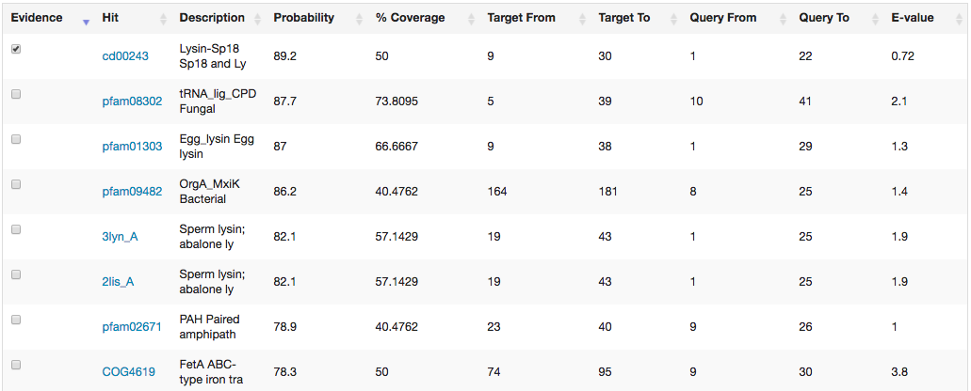
Gp73 (42375-41872) annotated via strong HHPred matches as immunity repressor but consider changing to helix-turn-helix DNA binding domain

Gp89 (48286-48041) has somewhat weak HHPred matches to toxin-like functions (see below) but called as NKF. Pham has three members, two in cluster DL. Further investigation needed.

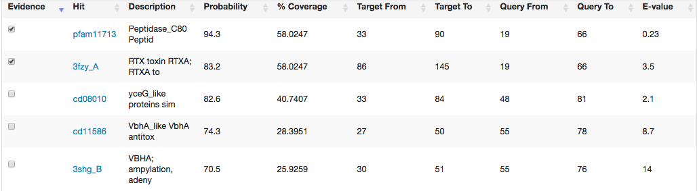
The following gaps were investigated, but no significant evidence of uncalled genes was found:

Idx Length Description
1 1135 Idx_1_49380_to_50514
2 376 Idx_2_1_to_376
3 359 Idx_3_42376_to_42734
4 120 Idx_4_44575_to_44694
5 117 Idx_5_13171_to_13287
6 104 Idx_6_24664_to_24767
7 101 Idx_7_47061_to_47161
8 101 Idx_8_3029_to_3129

