LilTerminator Annotation Notebook

Gene 1
SSC: start 1, stop 519; CP: yes; SCS: Both called start at 1; ST: SS; Blast Start: matches Zepp_1 Query 1 to Subject 1 100% 7e⁻⁹²; Gap: NA; LO: yes; RBS: -4.299, 1.792, 39945, -6.600, no; F: NKF; SIF-BLAST: NKF/PhageDB BLAST/Zepp_1, MN908686/100%/7e⁻⁹²; SIF-HHPred: NKF, no matches with a probability above 90%; SIF-Syn: NKF
Notes: Most annotated start not found in LilTerminator. Other phage call start 1 in Starterator, and there is strong evidence form the GeneMark output. All evidence suggests NKF and no membrane domains.
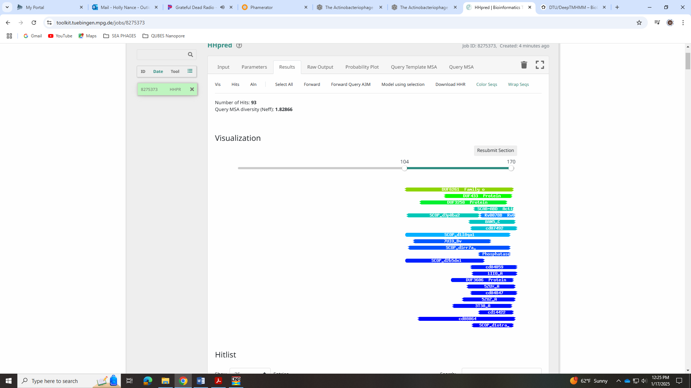
Gene 2
SSC: start 512, stop 1960; CP: yes; SCS: Glimmer called more conserved start of 512, GeneMark called start at 521; ST: SS; Blast Start: matches QuadZero_2 Query 1 to Subject 1 100% 0.0; Gap: overlap of 8; LO: NA; RBS: -2.976, 2.413, 11, -3.733, no; F: terminase; SIF-BLAST: terminase/PhageDB BLAST/ QuadZero_2, /100%/0.0; SIF-HHPred: terminase, large subunit, several matches with a probability of 100%; SIF-Syn: terminase
Notes: Went with more conserved Glimmer start of 512 as it yields a longer ORF was called more frequently than the GeneMark start in Starterator.
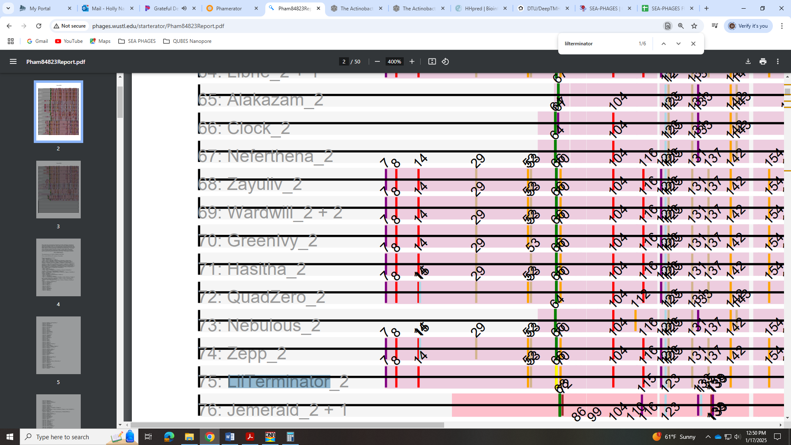
It also yielded more 1:1 in BLAST. Terminase for function is well supported by all data, though HHPred calls it Terminase large subunit.
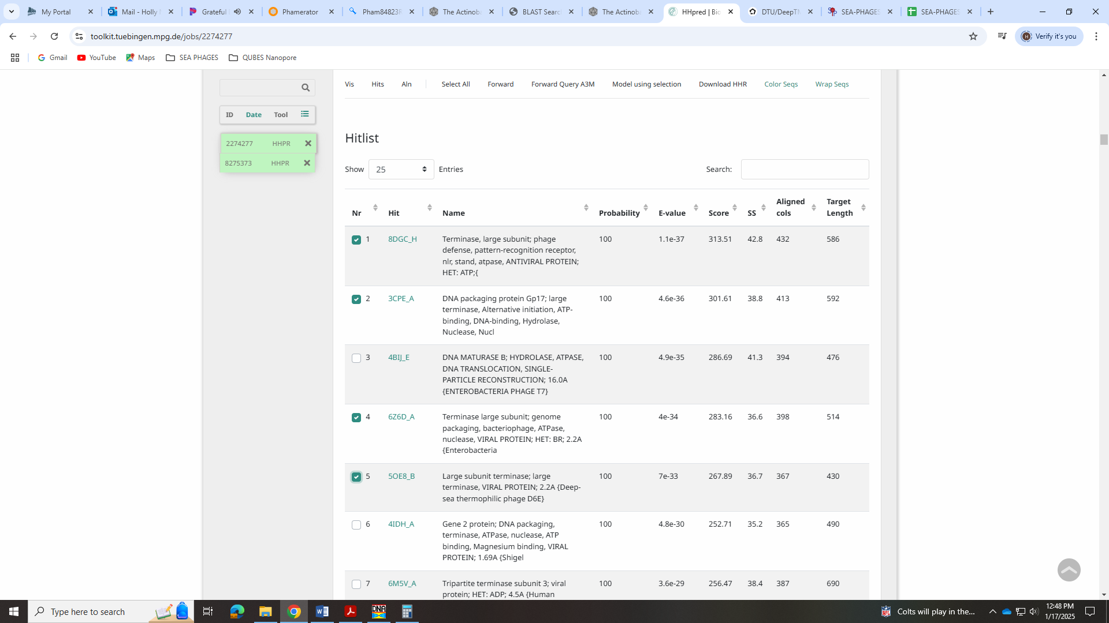
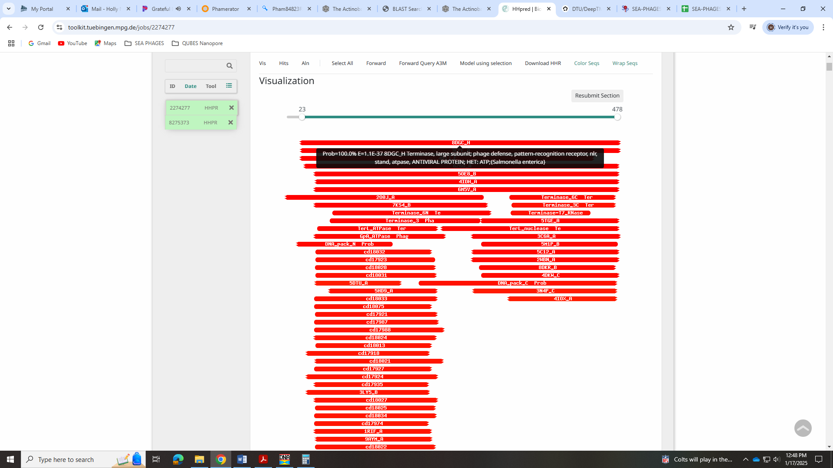
The Official Function list says to call it large subunit only if there is also a small subunit, so we’ll have to wait to see if we find that. However, other EA5 phage only have terminase.
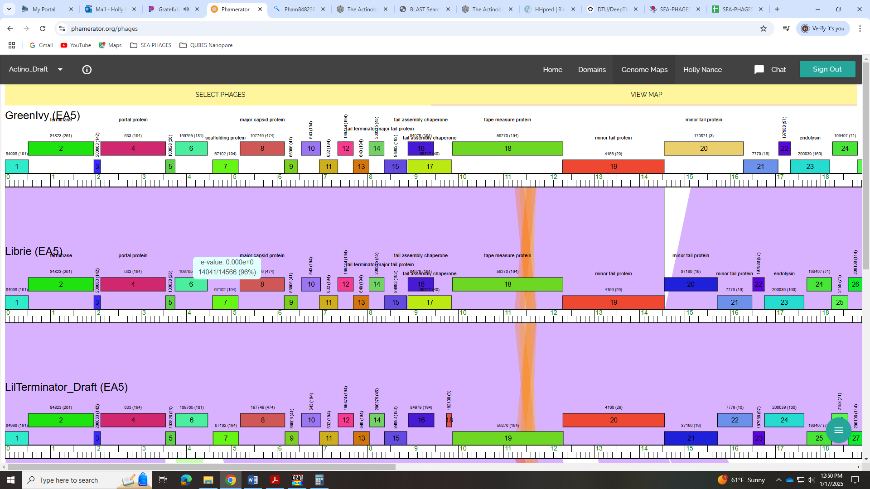
Gene 3
SSC: start 1963, stop 2109; CP: yes; SCS: Both called start at 1963; ST: SS; Blast Start: matches Zepp_3 Query 1 to Subject 1 100% 3e⁻²²; Gap: 2; LO: NA; RBS: -2.984, 2.409, 12, -3.820, yes; F: NKF; SIF-BLAST: NKF/PhageDB BLAST/ Zepp_3, MN908686/100%/3e⁻²²; SIF-HHPred: NKF, no matches with a probability above 90%; SIF-Syn: NKF
Notes: Small gene with nothing ambiguous.
Gene 4
SSC: start 2113, stop 3543; CP: yes; SCS: Both called start at 2113; ST: SS; Blast Start: matches GreenIvy_4 Query 1 to Subject 1 99% 0.0; Gap: 3; LO: yes; RBS: -1.559, 3.077, 13, -2.605, yes; F: portal protein; SIF-BLAST: portal protein/PhageDB BLAST/ GreenIvy_4, PP978818/99%/0.0; SIF-HHPred: portal protein, several matches with a probability above 99%; SIF-Syn: portal protein
Notes: Start is conserved, has best RBS values and yields longest ORF. Function well supported as portal protein.
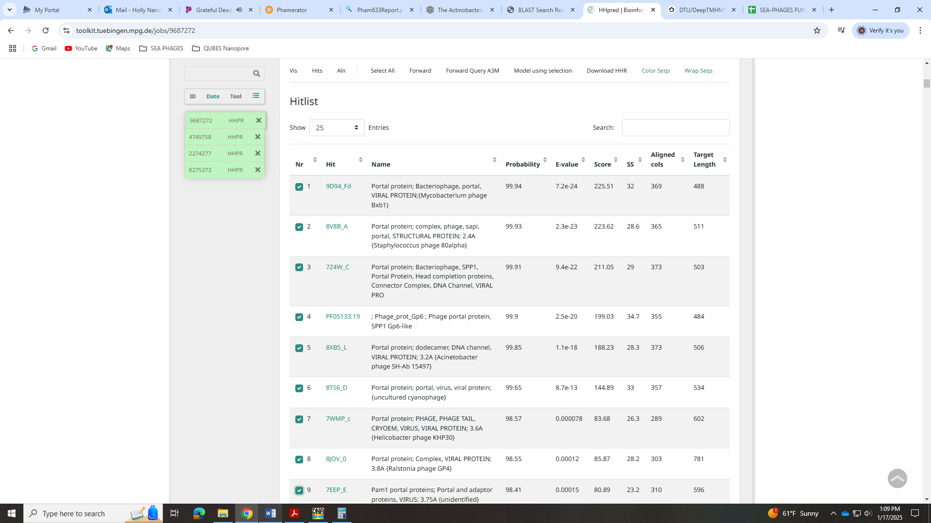
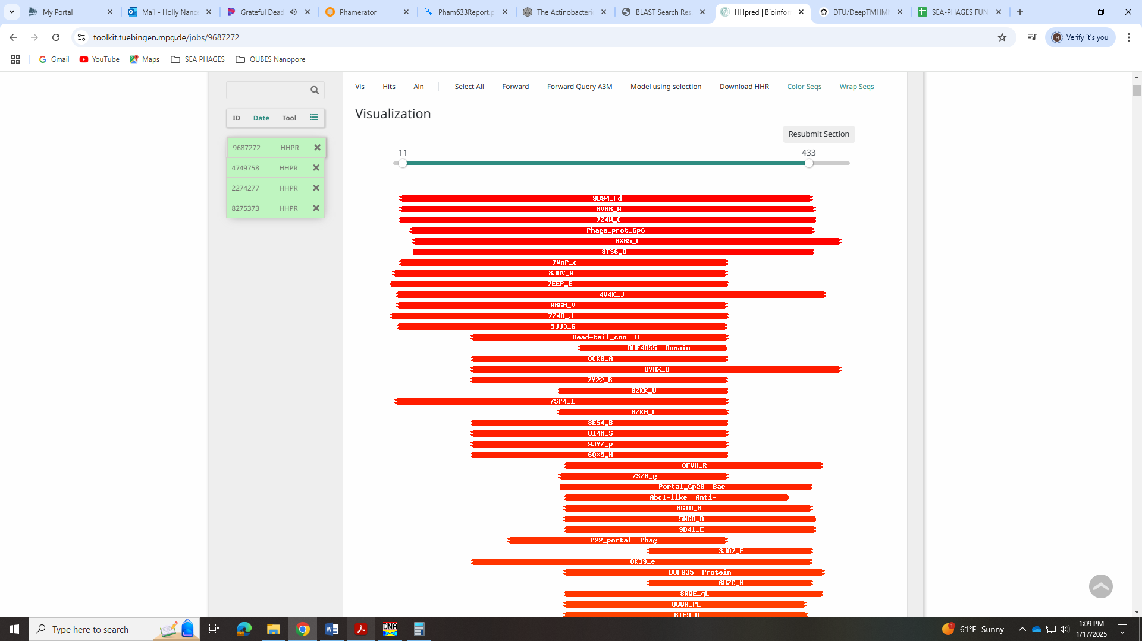
Gene 5
SSC: start 3546, stop 3764; CP: yes; SCS: Both called start at 3546; ST: SS; Blast Start: matches QuadZero_5 Query 1 to Subject 1 100% 8e⁻⁴¹; Gap: 2; LO: yes; RBS: -4.875, 1.522, 9, -5.650, no; F: NKF; SIF-BLAST: NKF/PhageDB BLAST/ QuadZero_5, MZ150787/100%/8e⁻⁴¹; SIF-HHPred: NKF, one partial match for zinc ribbon with a probability of 91%; SIF-Syn: NKF
Notes: Start is not most annotated but called 100% of time when present and in many EA5 phages. For function, there is one partial hit (38 of 477 AAs) for a zinc ribbon.
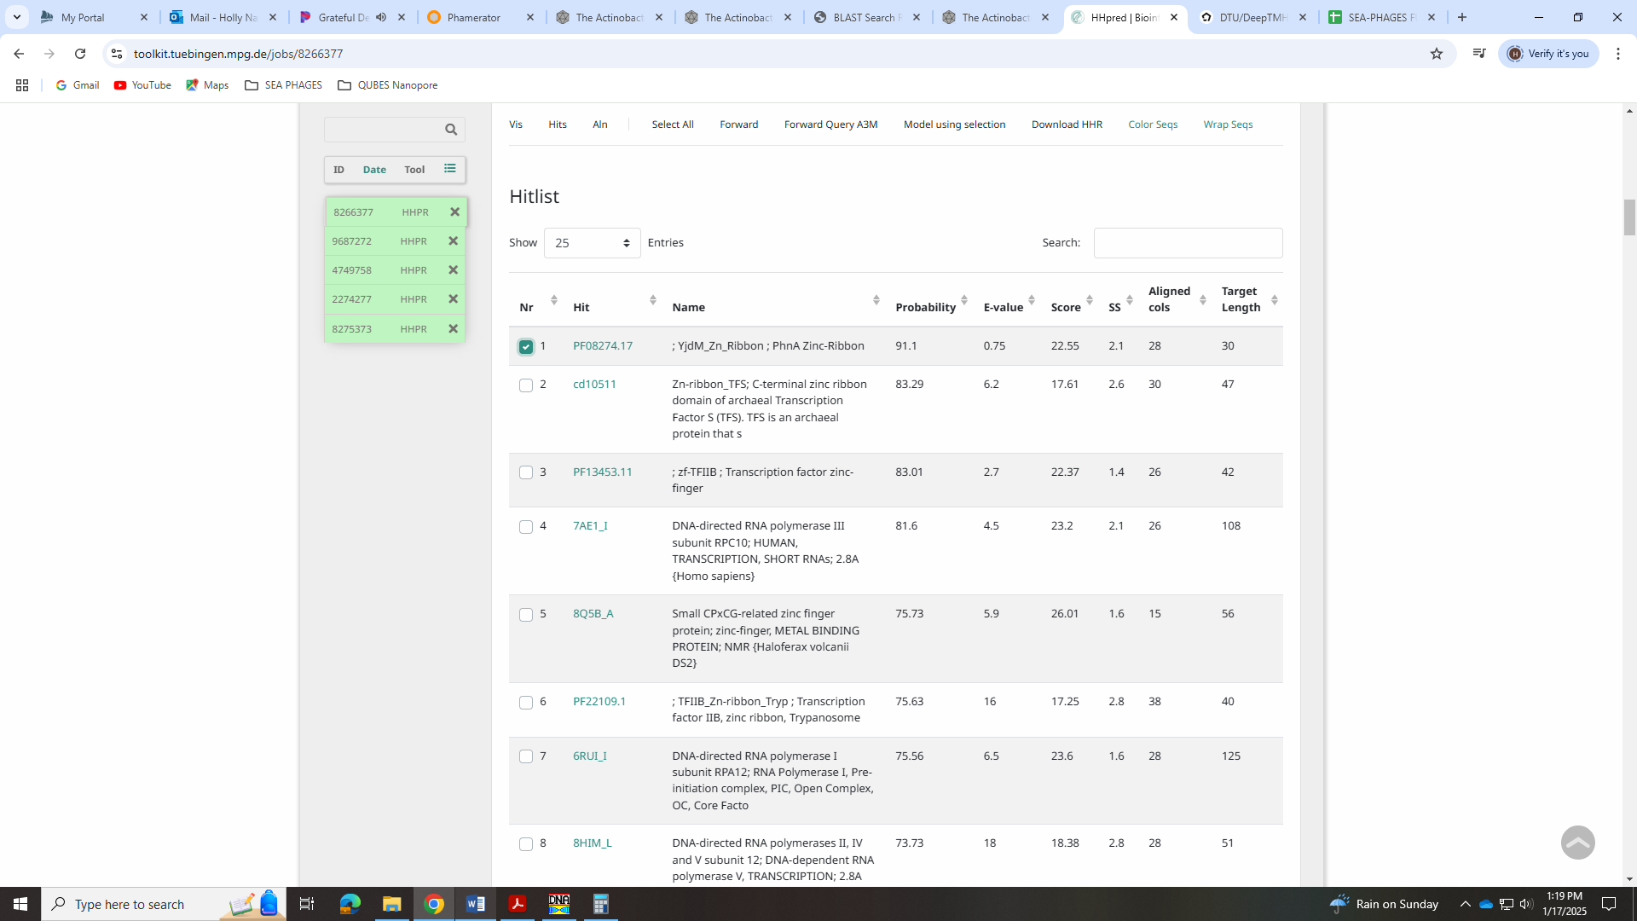
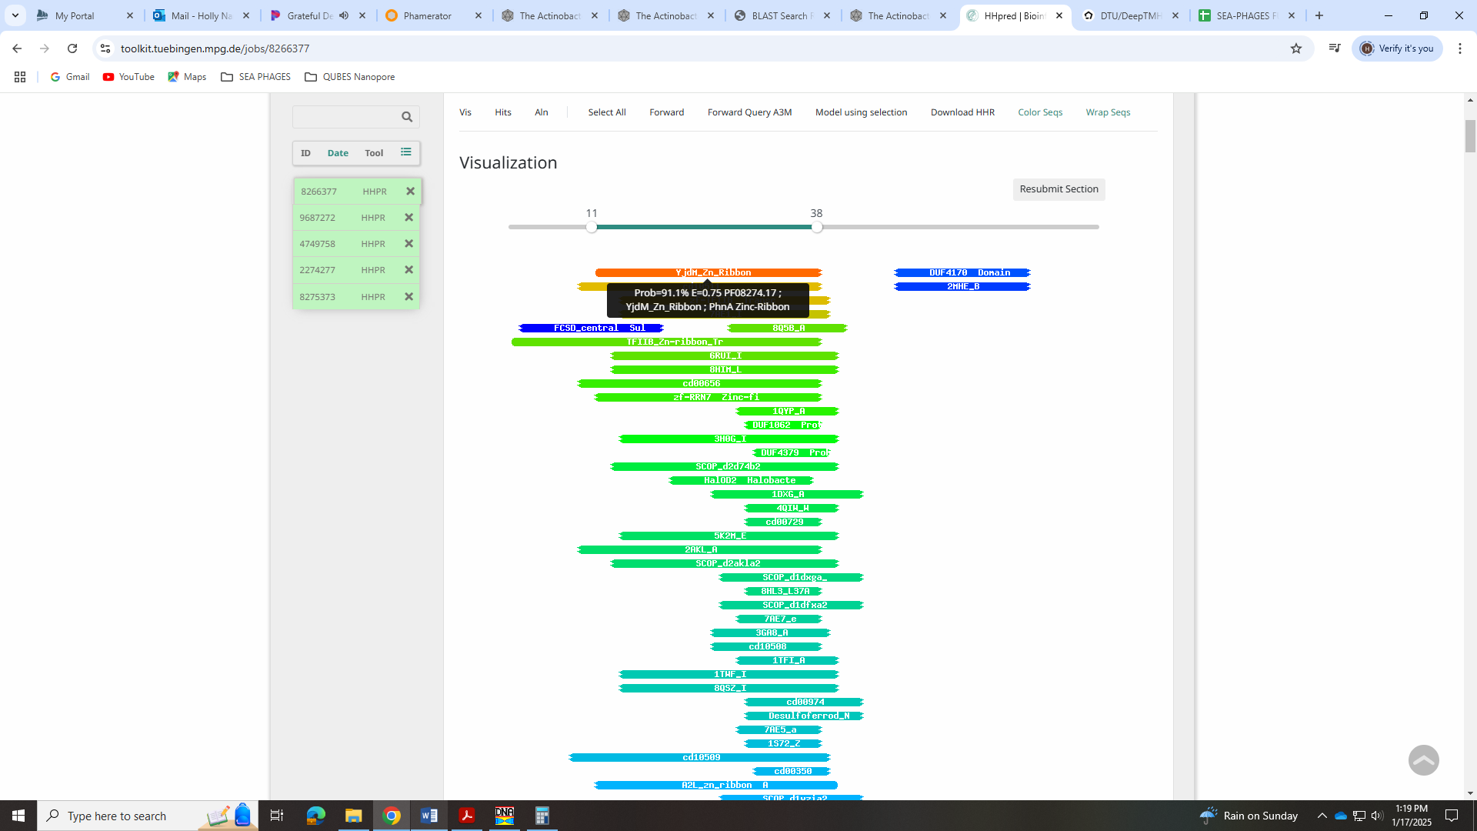
But synteny doesn’t support this and there is little other evidence to call this anything other than NKF.
Gene 6
SSC: start 3764, stop 4477; CP: yes; SCS: Both called start at 3764; ST: SS; Blast Start: matches QuadZero_6 Query 1 to Subject 1 100% e⁻¹³⁴; Gap: overlap of 1; LO: NA; RBS: -2.812, 2.490, 11, -3.569, no; F: NKF; SIF-BLAST: MuF-like minor capsid protein /PhageDB BLAST/ GreenIvy_6, PP978818/99%/e⁻¹³³; SIF-HHPred: NKF, one partial match to MuF phage protein at 99% and one hit for minor capsid protein at 99%, but there is not the specified HHpred UniProt hit to gp 15 in D29 like in the Forum ; SIF-Syn: NKF
Notes: Start is most annotated in Starterator. For function, there was a hit for Mu-F like and a hit for minor capsid. Both were partial, but 99%:
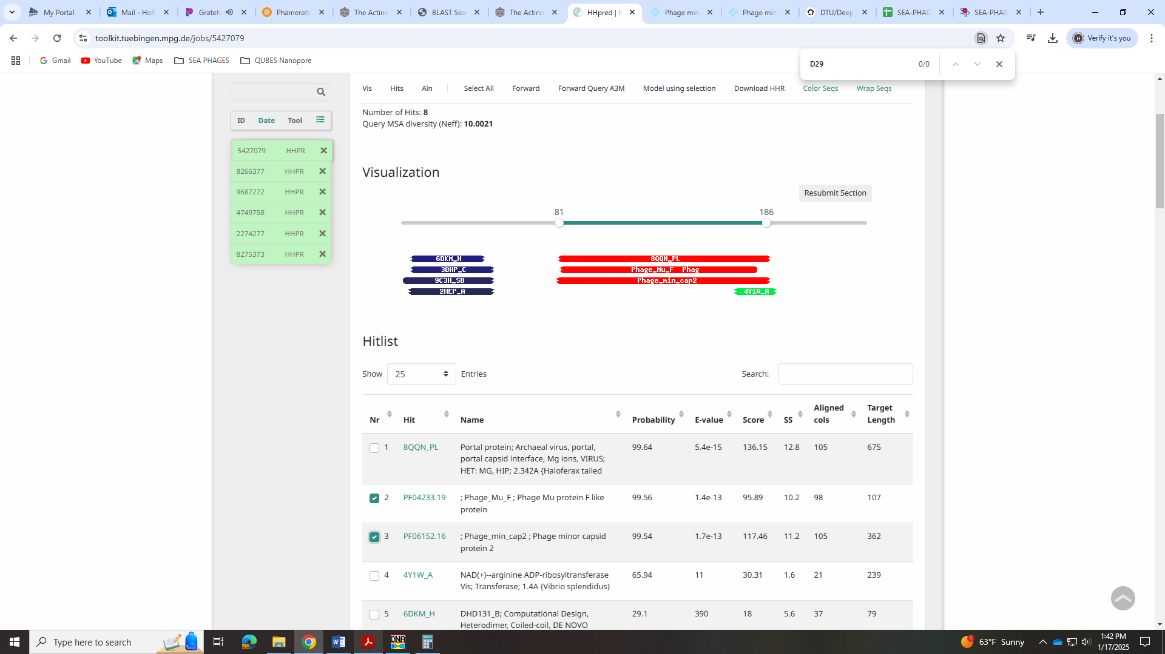
In BLAST, other phage call this Mu-F-like minor capsid but the Official List says to no longer call it this. You can call it a capsid maturation protease, but the forum suggests doing this only if the HHPred hits to UniProt gp 15 in D29.
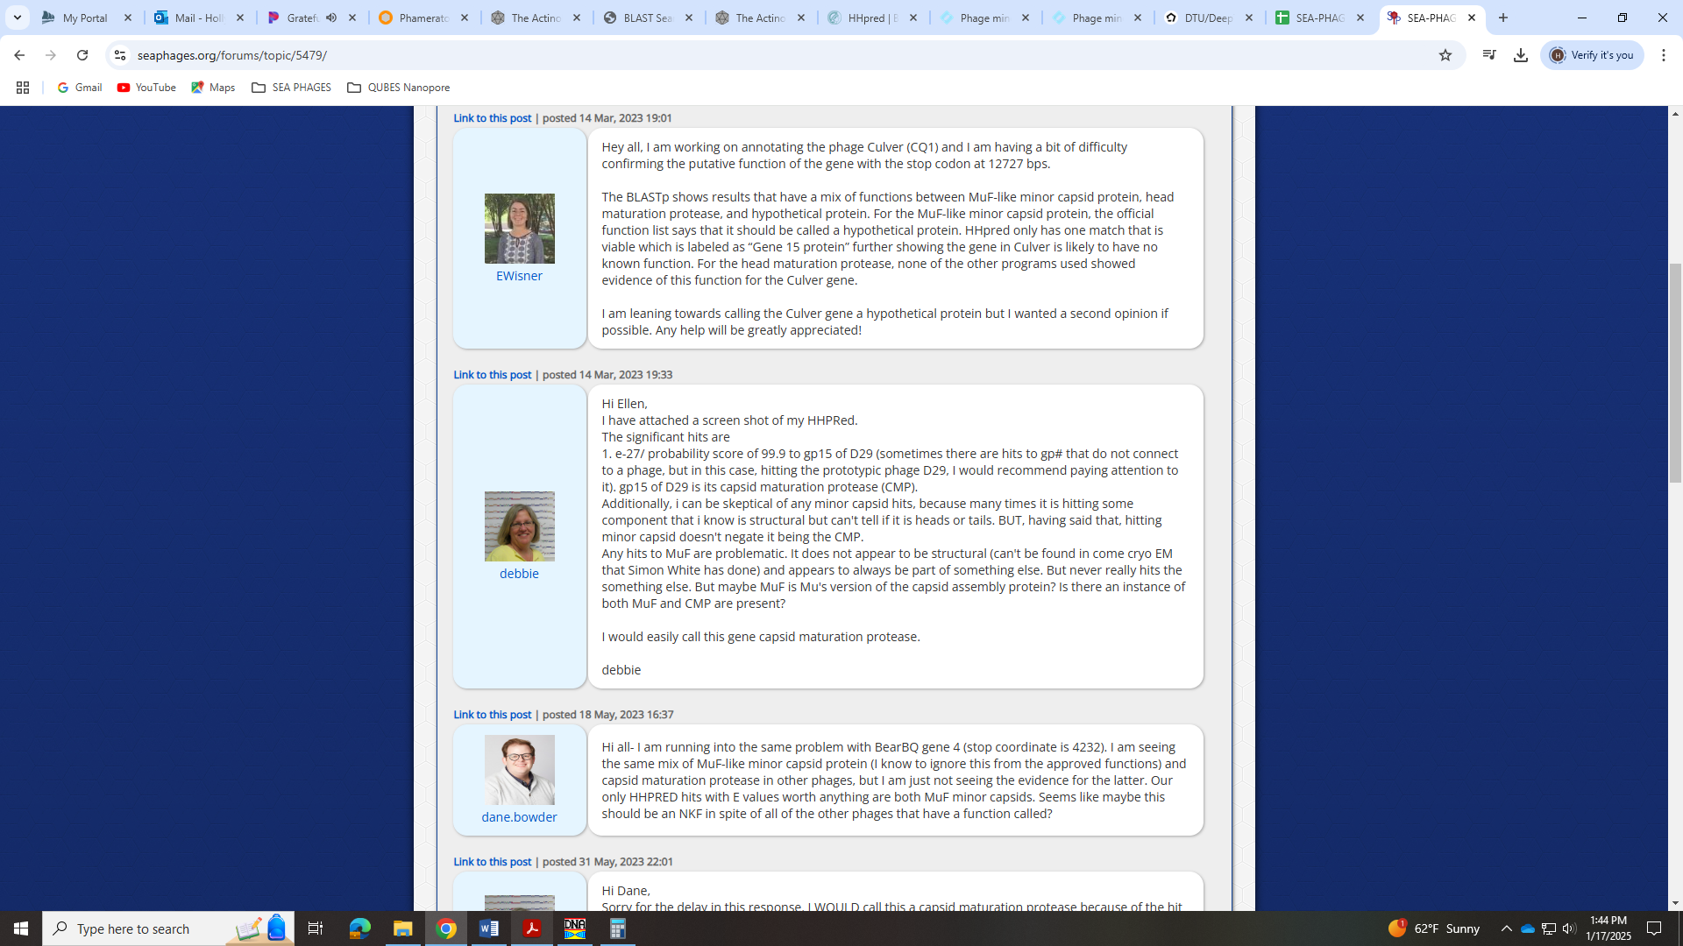
Neither of the two HHpred hits do. Given the lack of necessary evidence to call it that, and since MuF-like minor capsid is no longer called, I’m going with NKF.
Plot twist! In looking over this again, the same forum post said to include the Uniprot database in HHpred. When I did that, I got the gp15 in D29 that Deb mentions above:
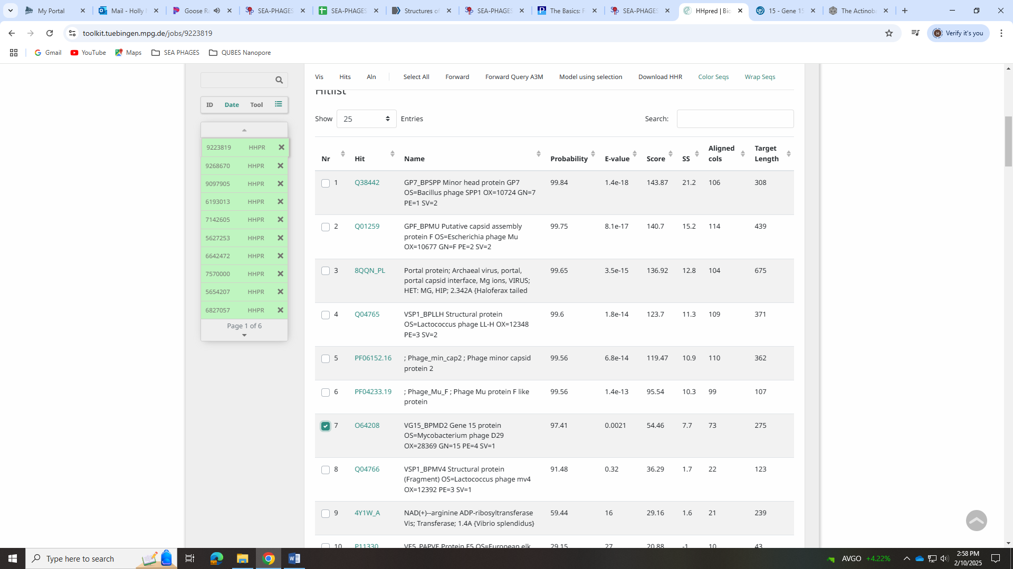
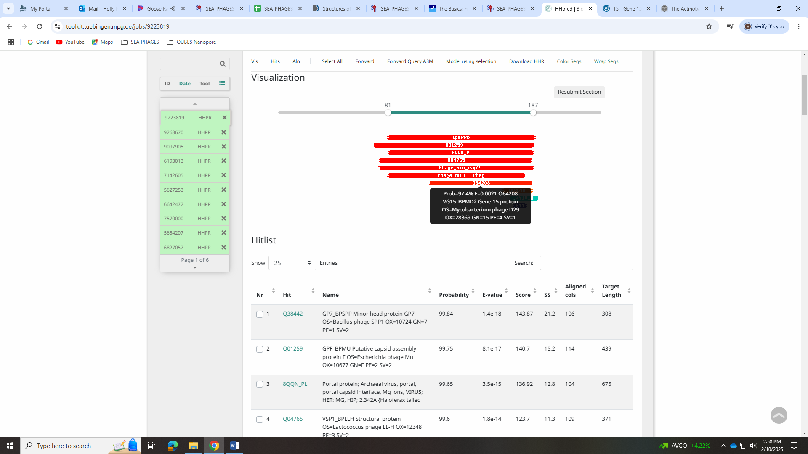
However, this is only for a partial hit (<100 BP). In the forum, someone got a similar partial hit and Deb said to call it NKF:
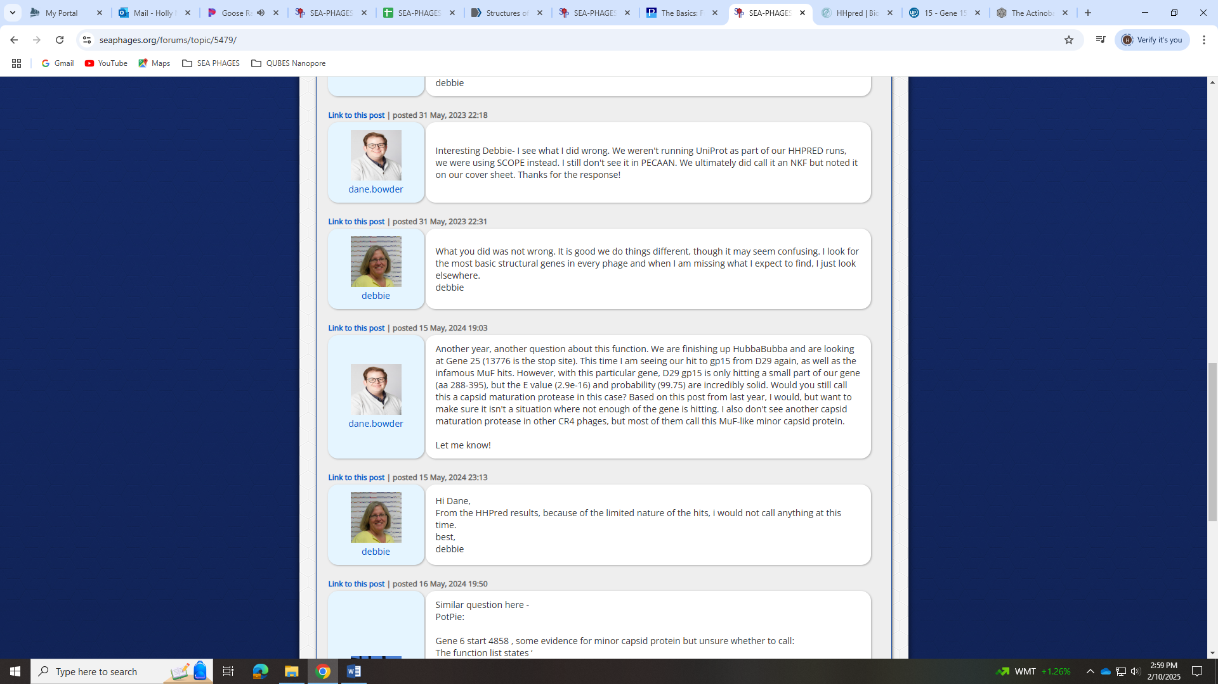
So even with including the Uniprot database in HHPred and getting that hit, I’m still inclined to call it NKF.
Gene 7
SSC: start 4592, stop 5158; CP: yes; SCS: Both called start at 4592; ST: SS; Blast Start: matches GreenIvy_7 Query 1 to Subject 1 100% e⁻¹⁰⁴; Gap: 114; LO: yes, but there is another small ORF before this that has no evidence of coding potential; RBS: -3.014, 2.395, 10, -3.709, no; F: NKF; SIF-BLAST: scaffolding protein/PhageDB BLAST/ GreenIvy_7, PP978818/100%/e⁻¹⁰⁴; SIF-HHPred: NKF, no matches to scaffolding protein (see additional notes below); SIF-Syn: scaffolding protein
Notes: Start is most annotated in Starterator and yields longest ORF. However, there is a large gap of 114 BPs and just before this gene is a separate small ORF with no evidence of coding potential. Noah checked the gap and there was no evidence of a protein.
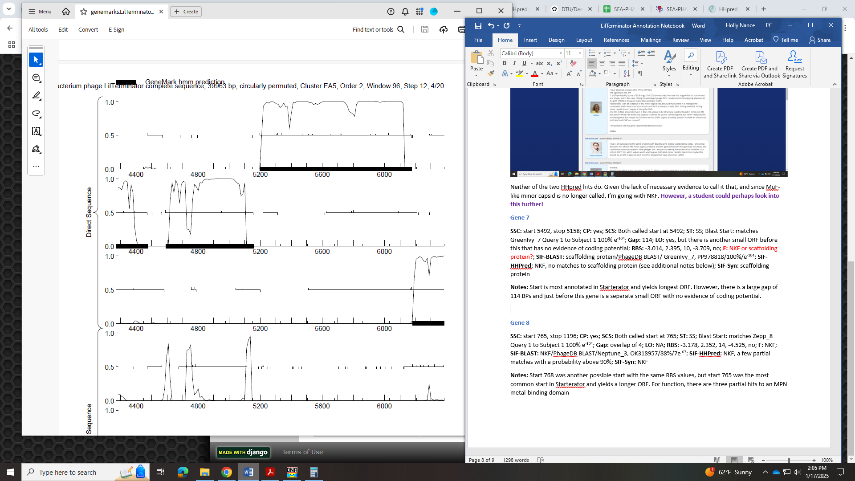
Also, for function, all BLAST hits and synteny suggest scaffolding protein. BUT, there is no evidence for this in HHPred. The HHpred hits for LilTerminator 7 are nothing like the hits for the example in the Official List, D29_16:
LilTerminator hits:
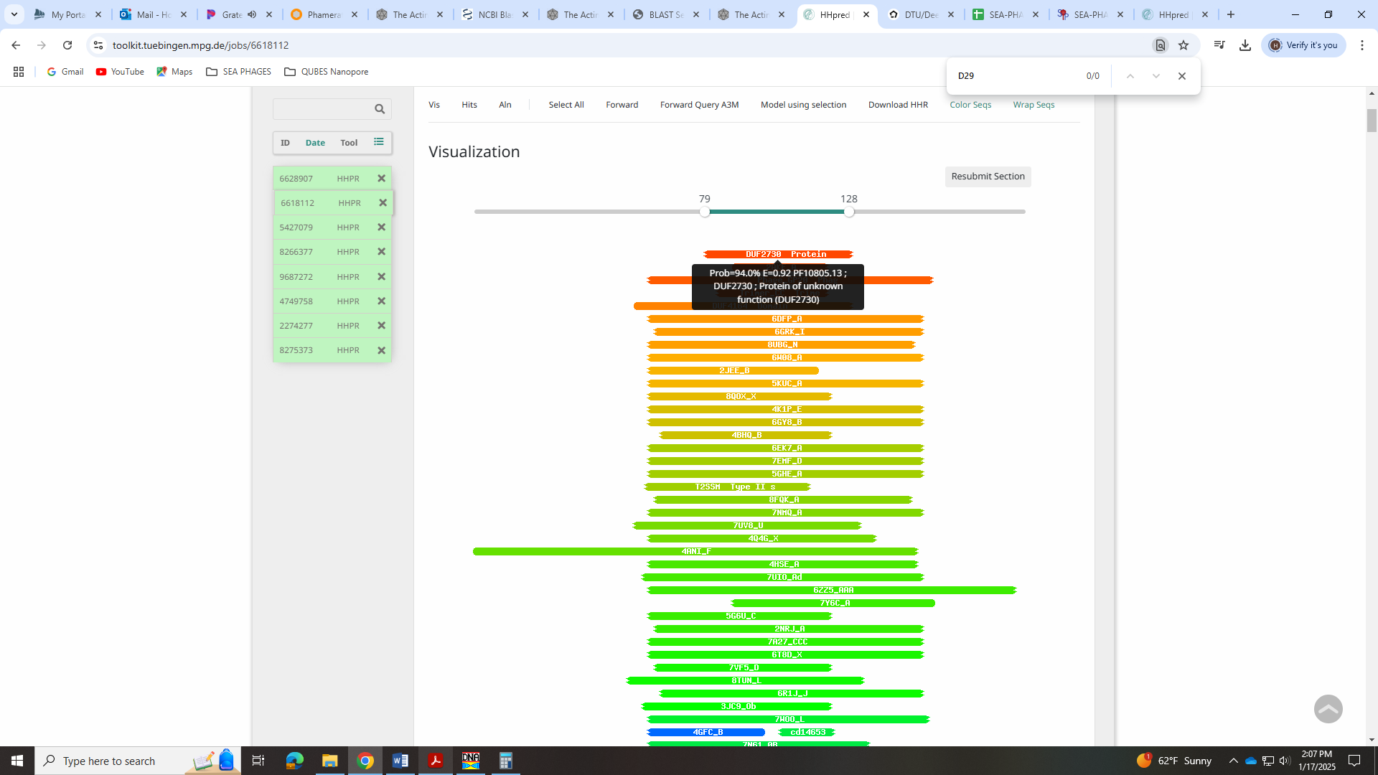
D26_16 hits:
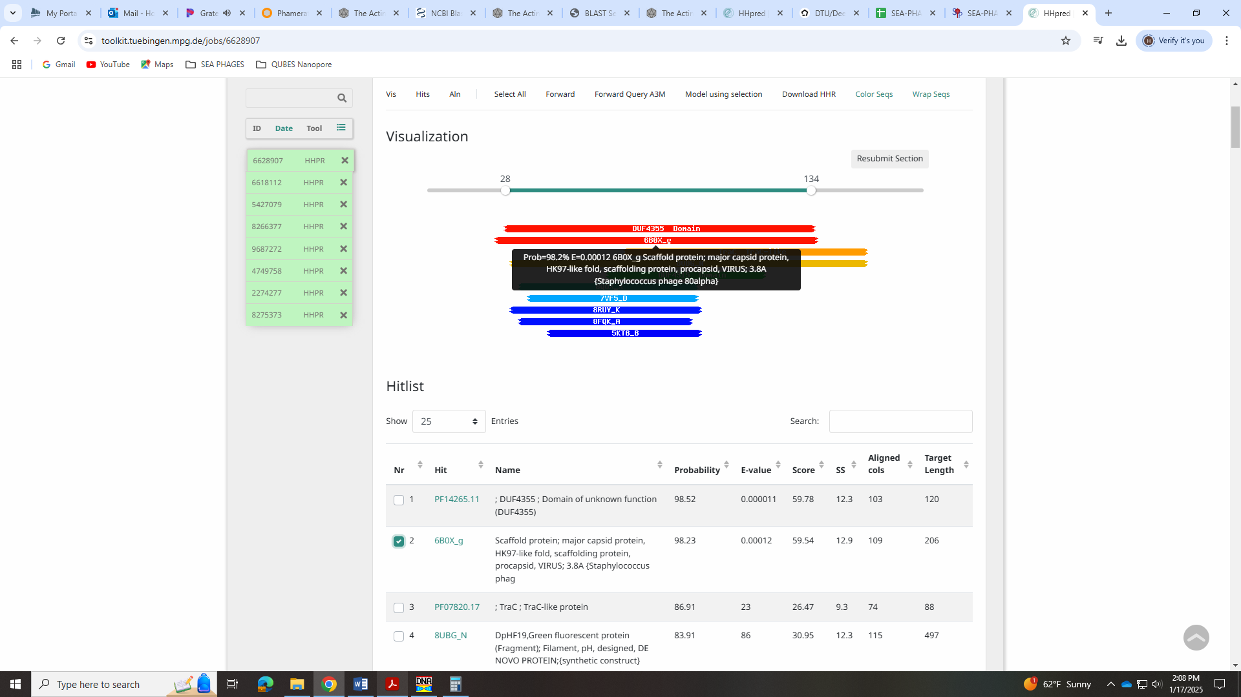
I asked about this issue with Mopey in the forum!
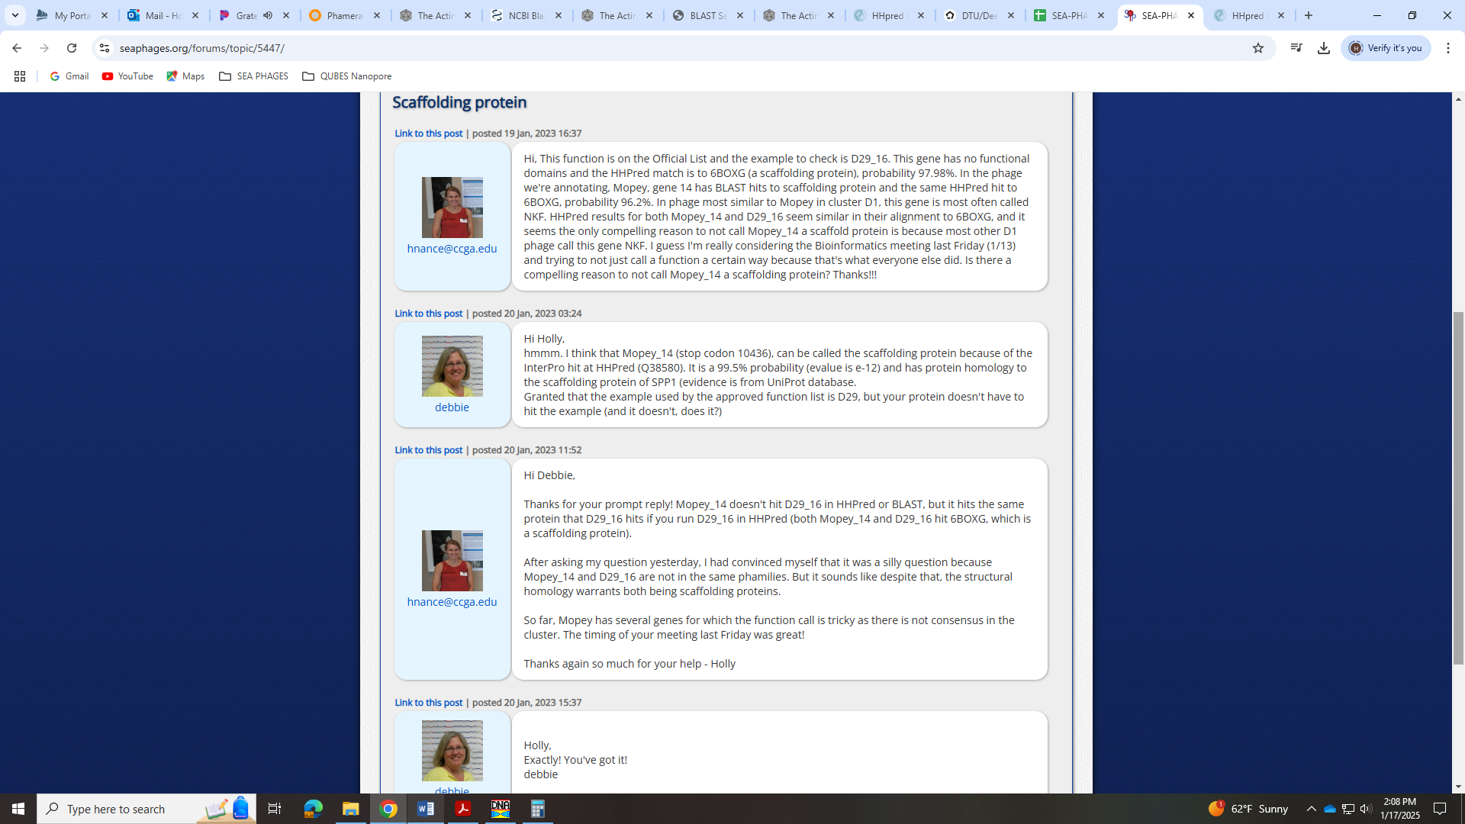
Based on that exchange, I wouldn’t call this scaffolding protein, but everyone else does…
When I included the UniProt database, I do get the hit Deb mentions above (Q38580), but it is partial and barely above 90%.
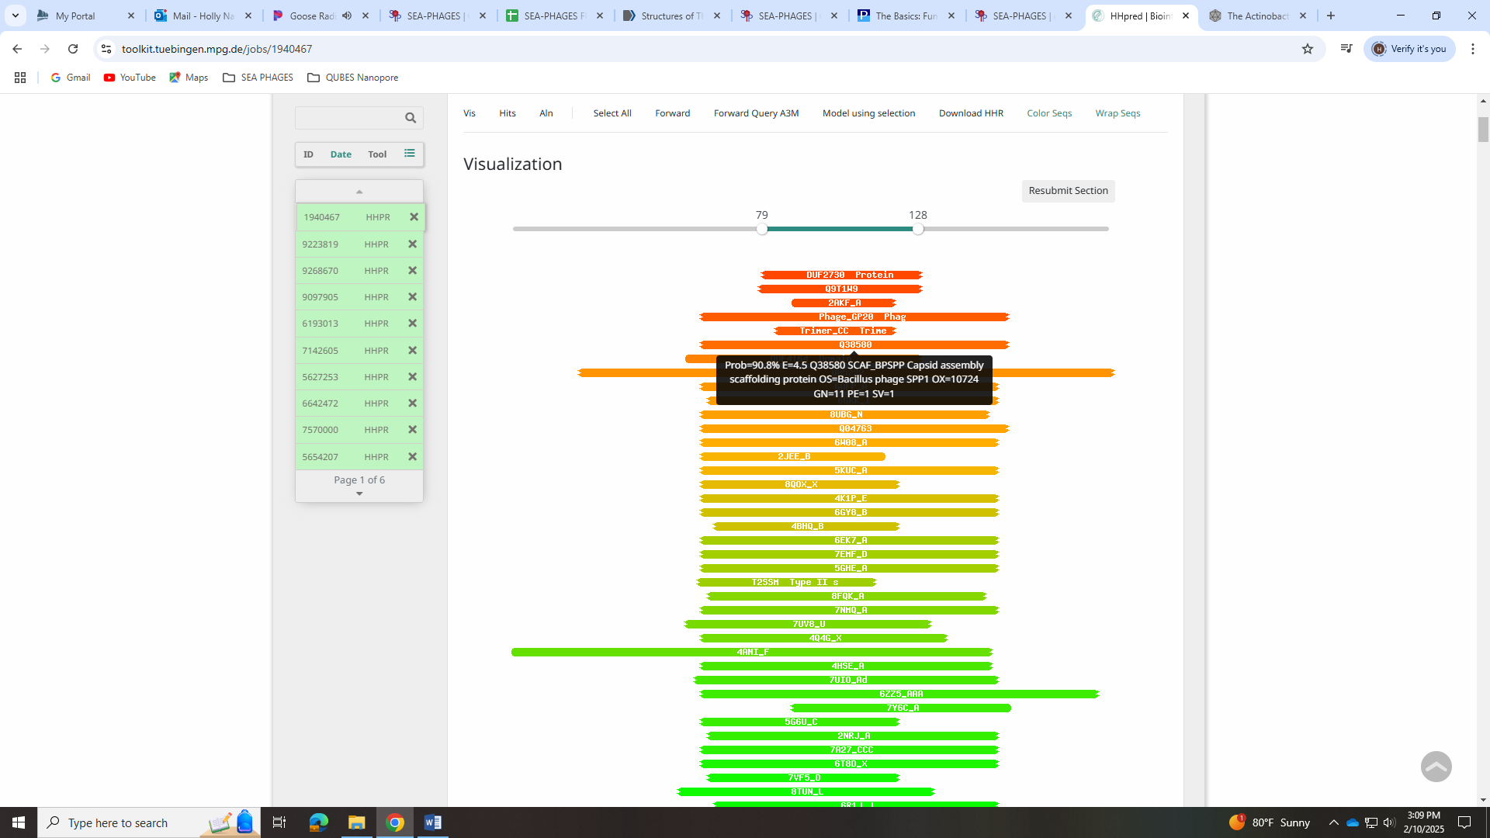
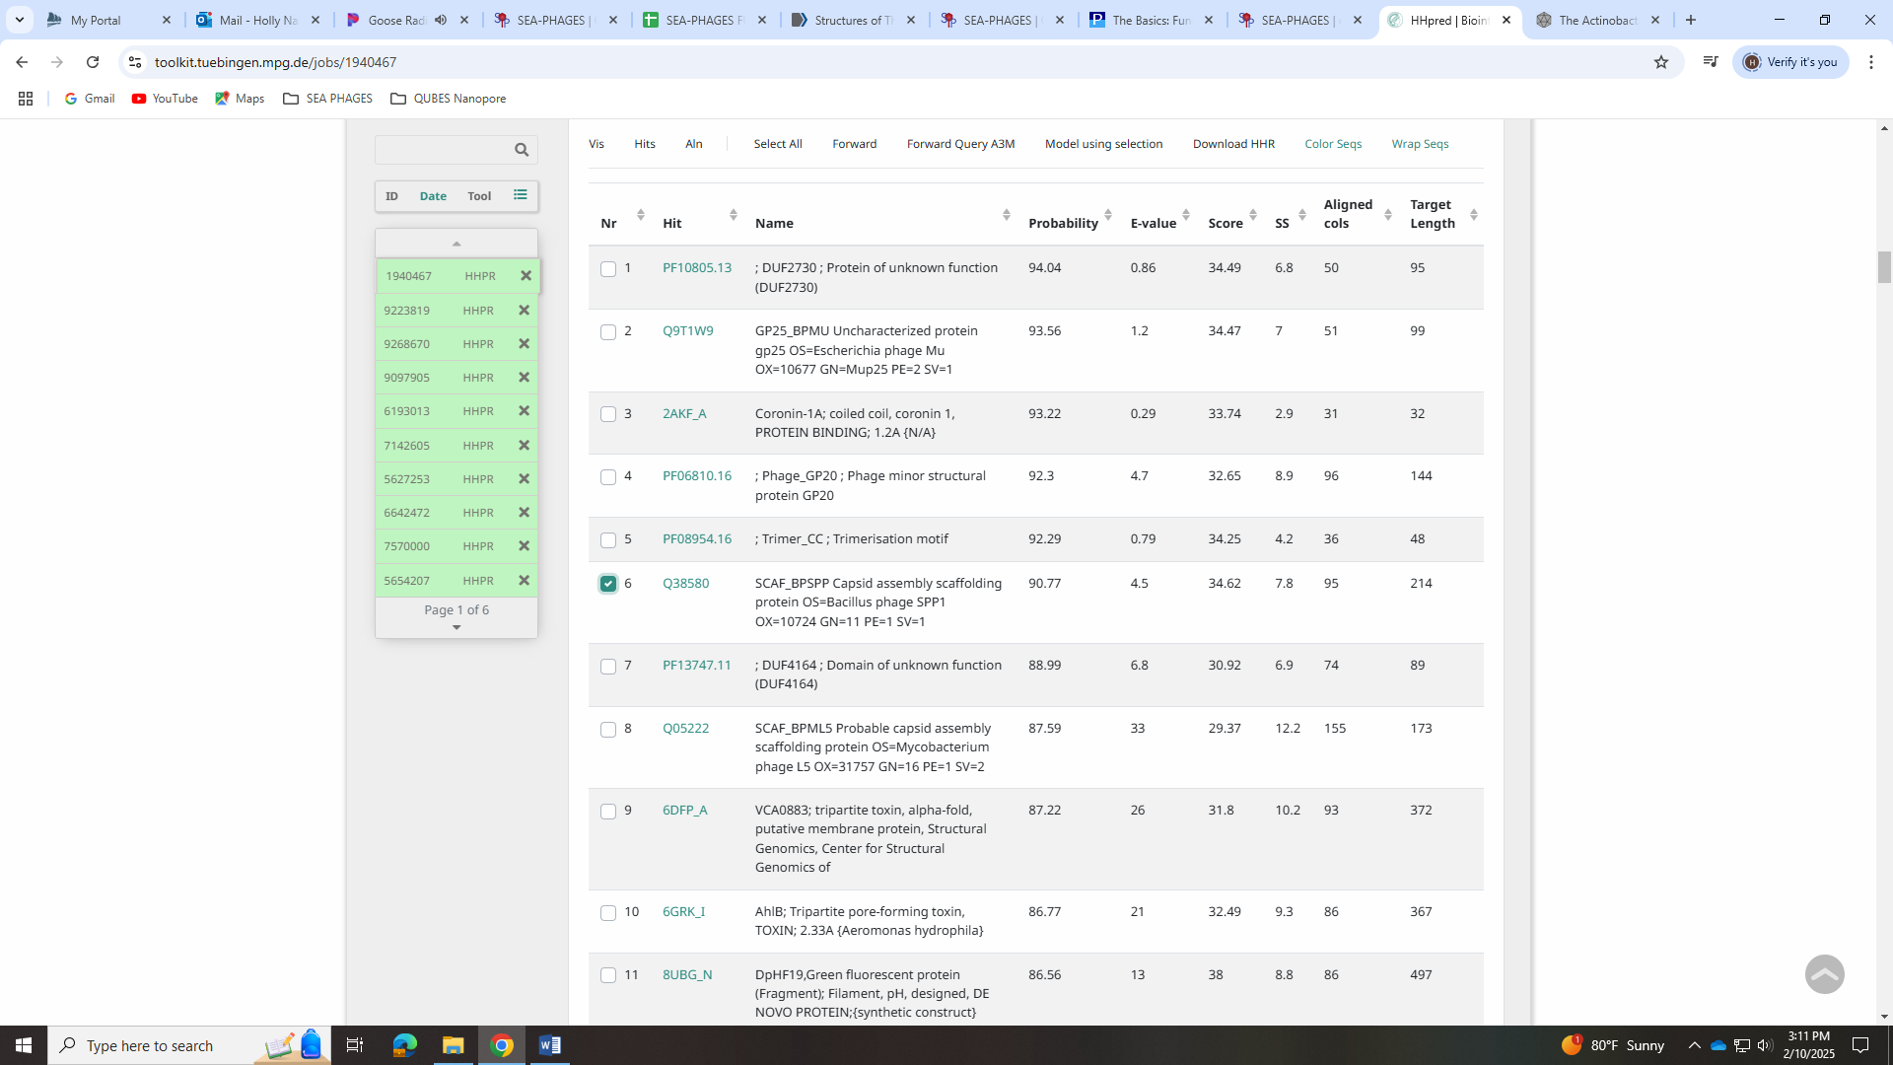

Gene 8
SSC: start 5197, stop 6177; CP: yes; SCS: Both called start at 5197; ST: SS; Blast Start: matches Zepp_9 Query 1 to Subject 1 100% 0.0; Gap: 38; LO: yes; RBS: -1.259, 3.218, 12, -2.095, yes; F: major capsid protein; SIF-BLAST: major capsid protein/PhageDB BLAST/Zepp_9, MN908686/100%/0.0; SIF-HHPred: major capsid protein, several matches with a probability of 100%; SIF-Syn: major capsid protein
Notes: Start is most annotated. Function well-supported by all data.
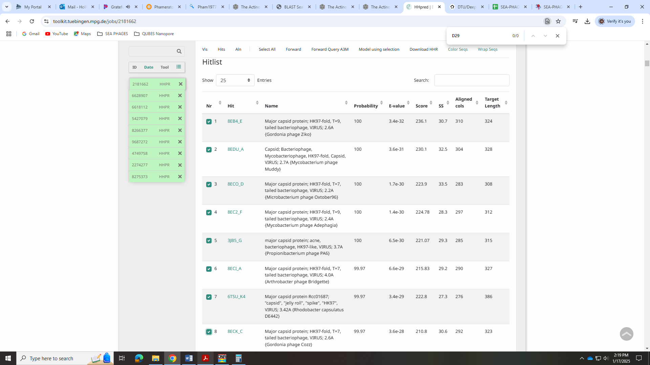
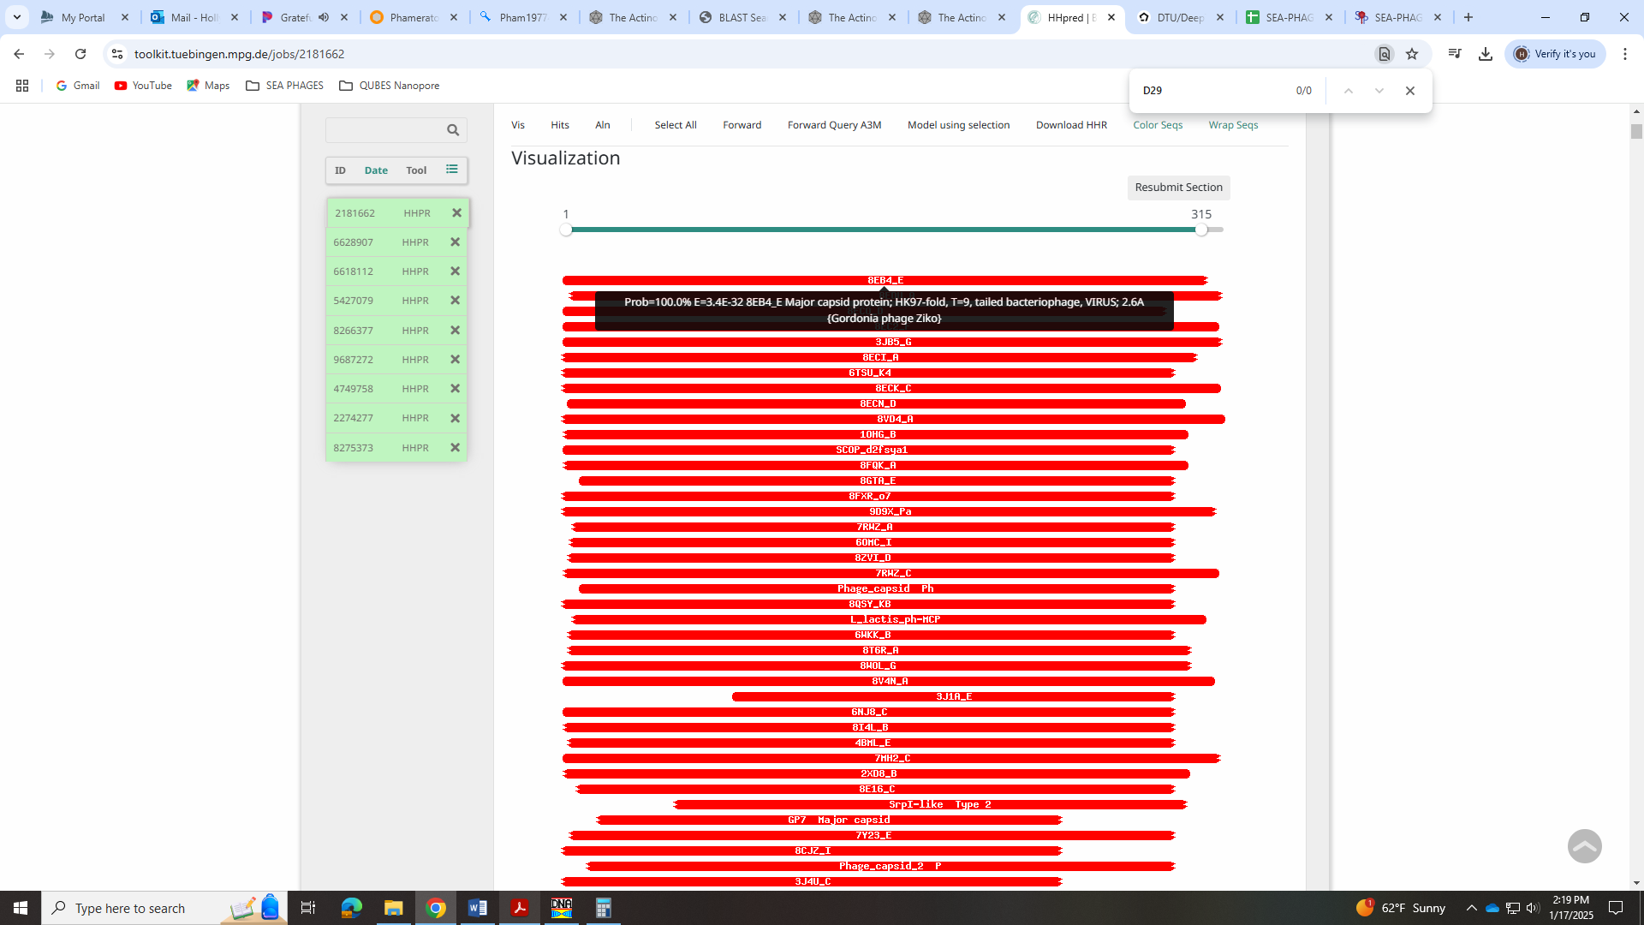
Gene 9
SSC: start 6180, stop 6470; CP: yes; SCS: Both called start at 6180; ST: SS; Blast Start: matches Zepp_10 Query 1 to Subject 1 97% 5e⁻⁴⁶; Gap: 2; LO: NA; RBS: -3.422, 2.203, 12, -4.258, no; F: NKF; SIF-BLAST: NKF/PhageDB BLAST/ Zepp_10, MN908686/100%/7e⁻⁴⁷; SIF-HHPred: NKF, no matches with a probability above 90%; SIF-Syn: NKF
Notes: Start is most annotated. Function is NKF and not ambiguous.
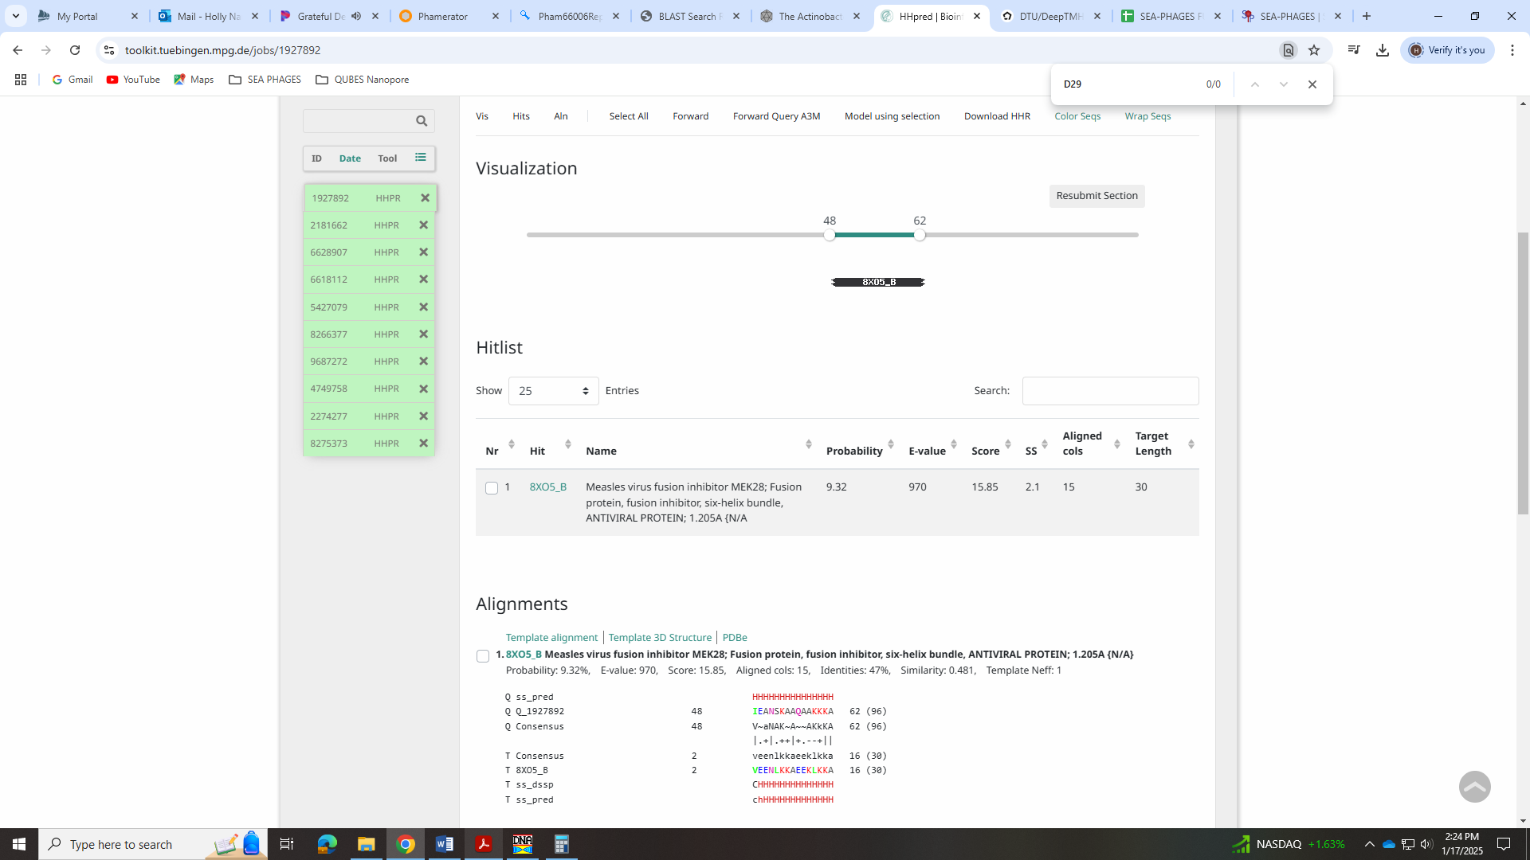
Gene 10
SSC: start 6546, stop 6971; CP: yes; SCS: Both called start at 6546; ST: SS; Blast Start: matches QuadZero_10 Query 1 to Subject 1 100% e⁻⁷⁷; Gap: 75; LO: yes; RBS: -1.951, 2.894, 11, -2.708, yes; F: NKF; SIF-BLAST: NKF/PhageDB BLAST/QuadZero10, MZ150787/100%/e⁻⁷⁷; SIF-HHPred: NKF, no matches with a probability above 90%; SIF-Syn: NKF
Notes: Doesn’t have most annotated start in Starterator, but 6546 is called by other phage in EA5, yields 1:1 hits in BLAST and the longest ORF. Function unambiguous and NKF.
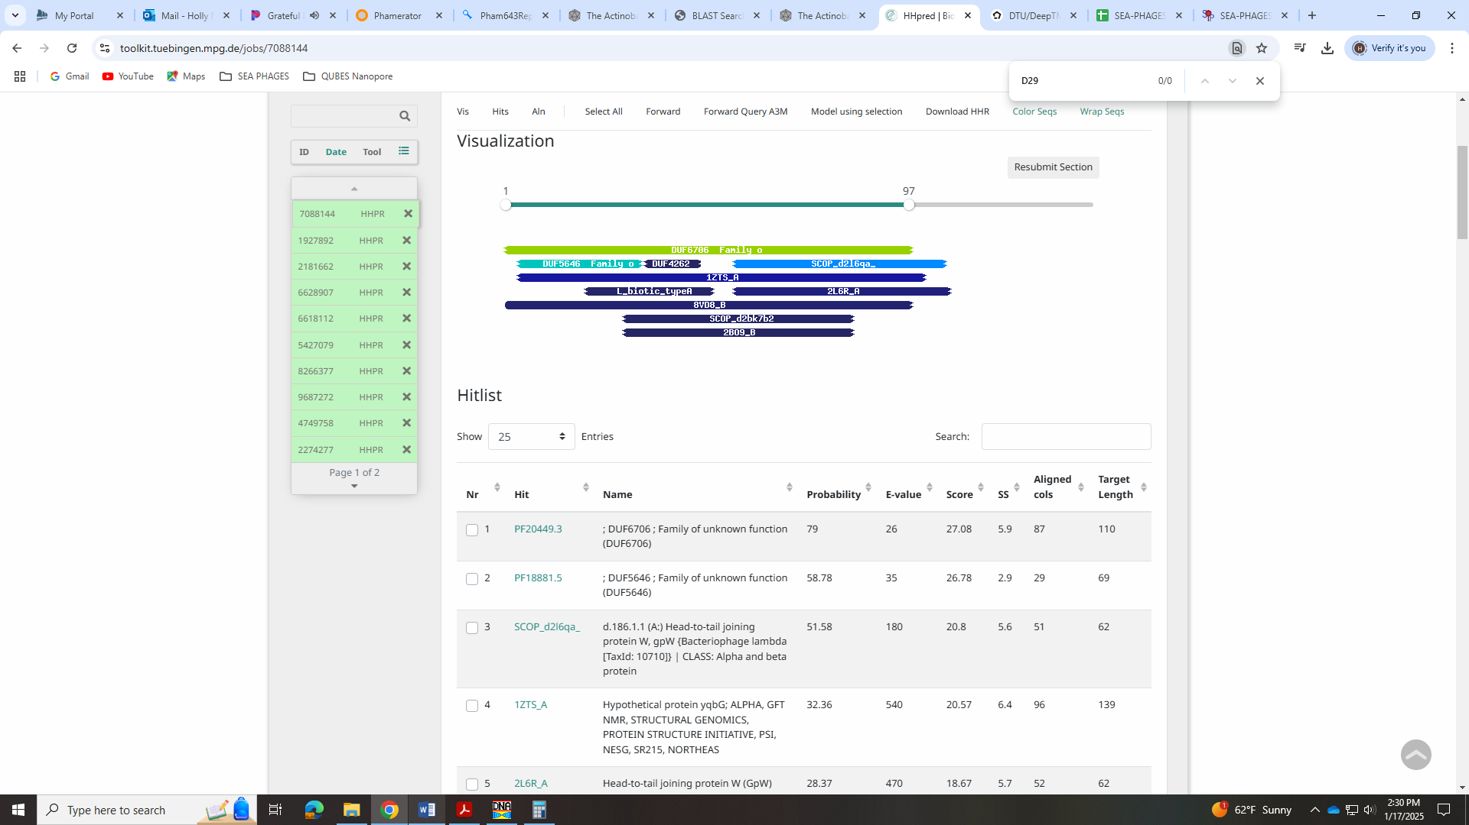
Gene 11
SSC: start 6943, stop 7353; CP: yes; SCS: Both called start at 6943; ST: SS; Blast Start: matches Zayuliv_11 Query 1 to Subject 1 100% 5e⁻⁷⁰; Gap: overlap of 29; LO: NA; RBS: -2.976, 2.413, 12, -3.812, no; F: NKF; SIF-BLAST: NKF/PhageDB BLAST/ Zayuliv_11, MT889377/100%/5e⁻⁷⁰; SIF-HHPred: NKF, one match with a probability above 90% for NKF; SIF-Syn: NKF
Notes: Most annotated start not present, but this start is conserved in EA5. NKF and unambiguous.
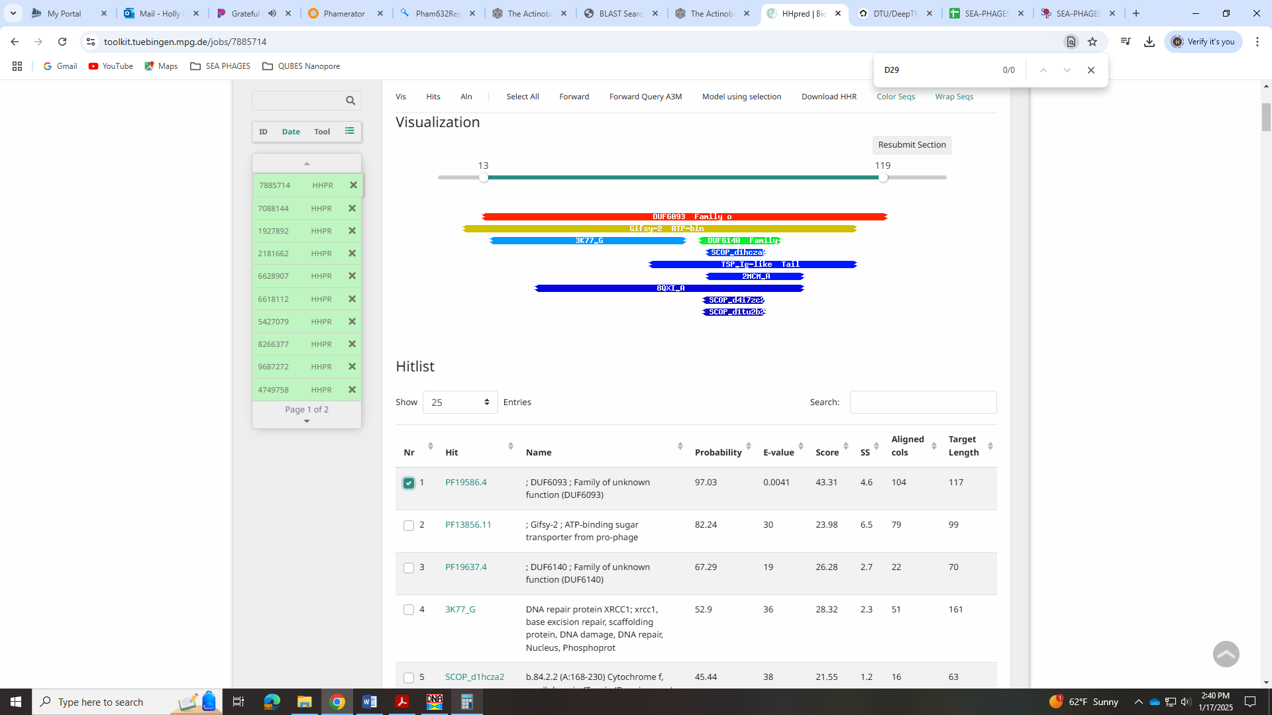
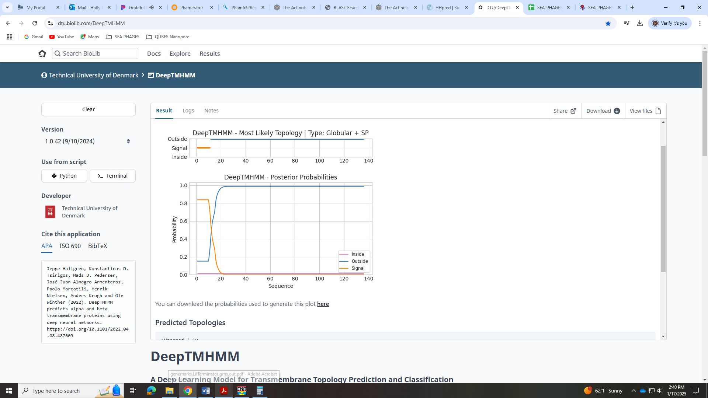

Gene 12
SSC: start 7350, stop 7694; CP: yes; SCS: Both called start at 7350; ST: SS; Blast Start: matches Zepp_13 Query 1 to Subject 1 100% 1e⁻⁵⁸; Gap: overlap of 4; LO: NA; RBS: -1.748, 2.989, 12, -2.584, yes; F: NKF; SIF-BLAST: NKF/PhageDB BLAST/ Zepp_13, MN9086867/100%/1e⁻⁵⁸; SIF-HHPred: NKF, a few partial matches with a probability above 90% for minor capsid or minor tail protein; SIF-Syn: NKF or minor capsid
Notes: Start is most annotated. For function, BLAST suggests NKF. There is minimal evidence for either minor capsid or minor tail in HHPred and synteny.
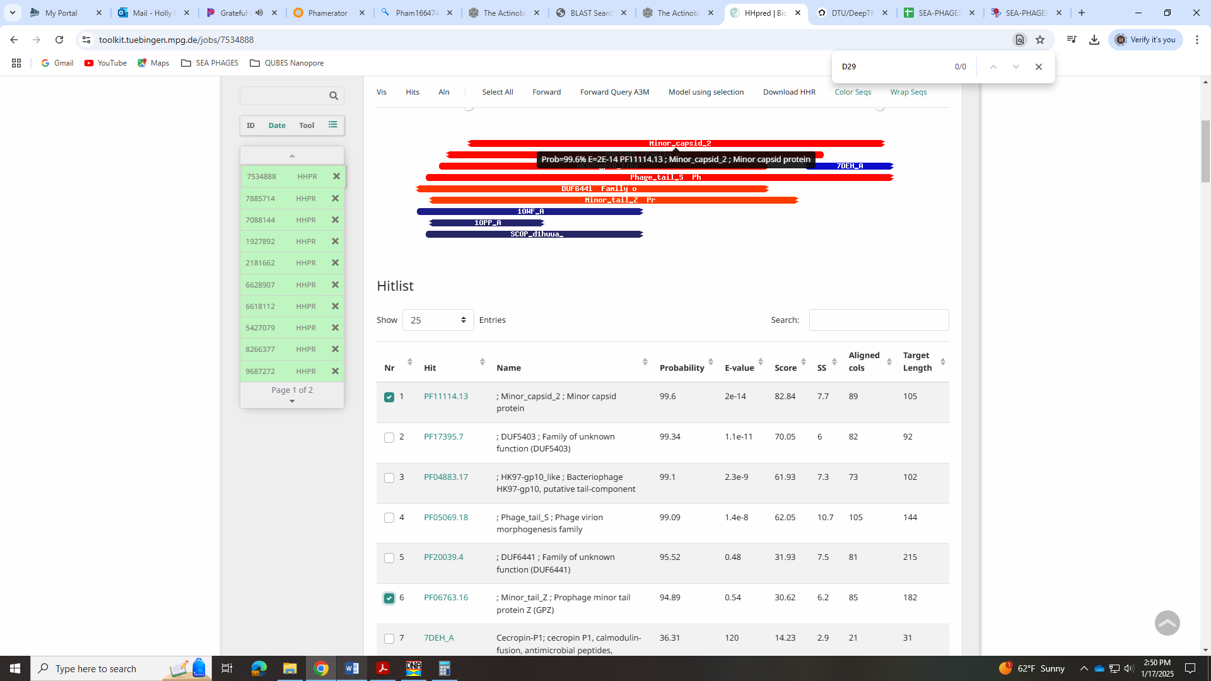

Gene 13
SSC: start 7691, stop 8041; CP: yes; SCS: Both called start at 7691; ST: SS; Blast Start: matches Zepp_14 Query 1 to Subject 1 98% 8e⁻⁶²; Gap: overlap of 4; LO: yes; RBS: -2.757, 2.515, 12, -3.593, yes; F: tail terminator; SIF-BLAST: tail terminator/PhageDB BLAST/Zayuliv_13, MT889377/98%/1e⁻⁶¹; SIF-HHPred: tail terminator, a match to 5A21-G, as required in the Function List, with a probability above 96%; SIF-Syn: tail terminator
Notes: Most annotated start is not present, but this start is most conserved across cluster and yields longest ORF. For function, the HHPred hits are what is needed to call this tail terminator according to the Official Function List:
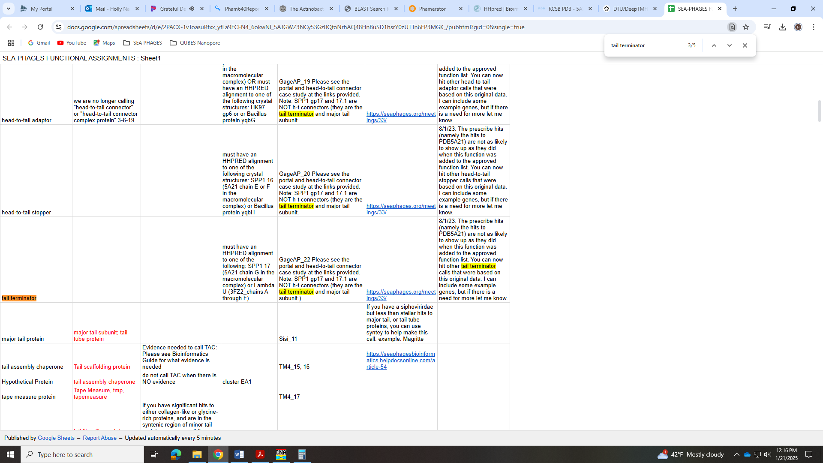
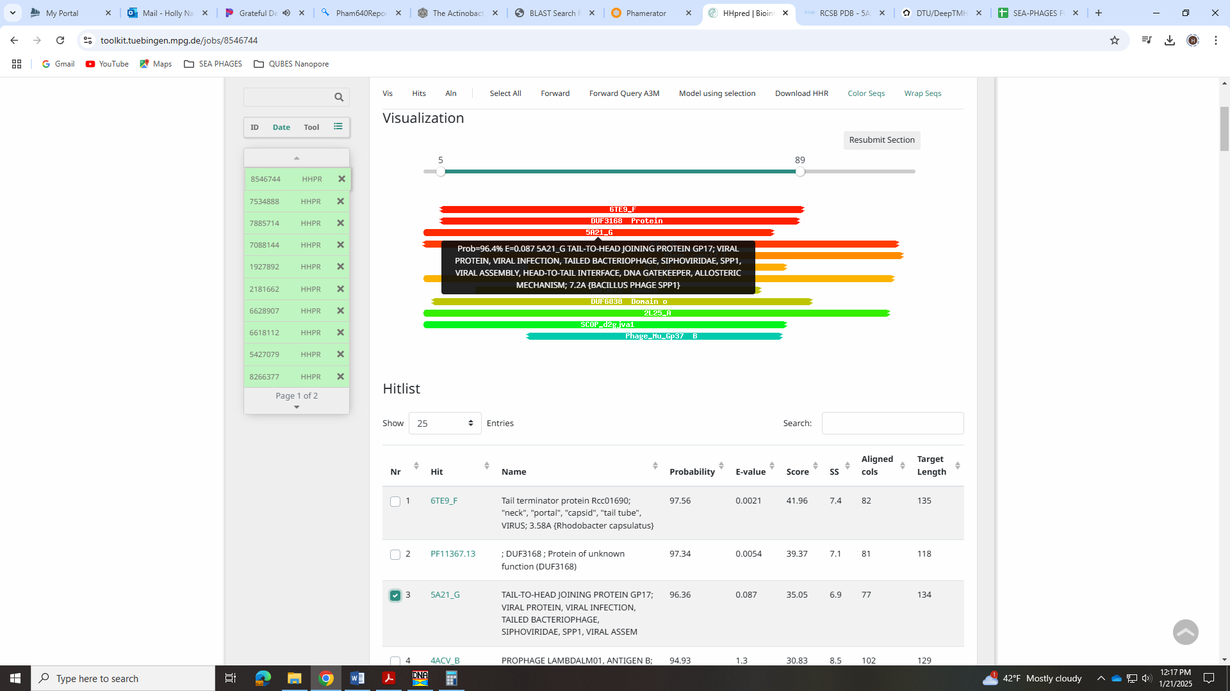
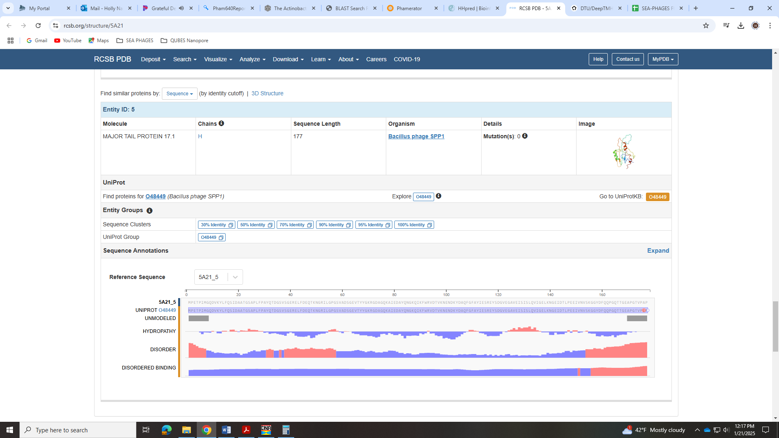
Synteny and BLAST also supports this function call.

Gene 14
SSC: start 8041, stop 8373; CP: yes; SCS: Both called start at 8041; ST: SS; Blast Start: matches GreenIvy_14 Query 1 to Subject 1 100% 5e⁻⁵⁸; Gap: overlap of 1; LO: yes; RBS: -1.748, 2.989, 11, -2.505, yes; F: NKF; SIF-BLAST: NKF/PhageDB BLAST/ GreenIvy_14, PP978818/100%/5e⁻⁵⁸; SIF-HHPred: NKF, a no matches with a probability above 90%; SIF-Syn: NKF
Notes: Start is most annotated. NKF is conserved and unambiguous.
Gene 15
SSC: start 8376, stop 8870; CP: yes; SCS: Both called start at 8376; ST: SS; Blast Start: matches Zayuliv_15 Query 1 to Subject 1 100% 2e⁻⁹¹; Gap: 2; LO: yes; RBS: -2.814, 2.489, 12, -3.649, yes; F: major tail protein; SIF-BLAST: major tail protein/PhageDB BLAST/ Zayuliv_15, MT889377/100%/2e⁻⁹¹; SIF-HHPred: major tail protein, a partial match with a probability of 74%, but ok with synteny data; SIF-Syn: major tail protein
Notes: Start is most annotated. Synteny supports this function as it is just upstream of the tail assembly chaperone and in a similar place in other EA5 phage. Despite there not being much evidence for this in HHPred, the Official Function List says synteny is enough to call this.
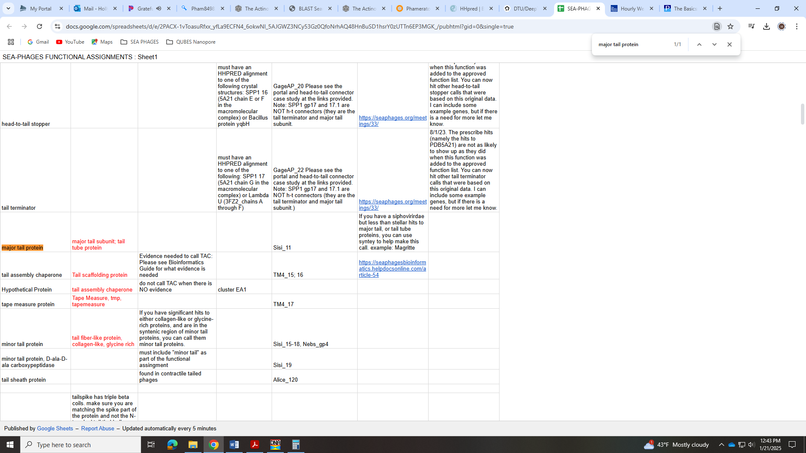
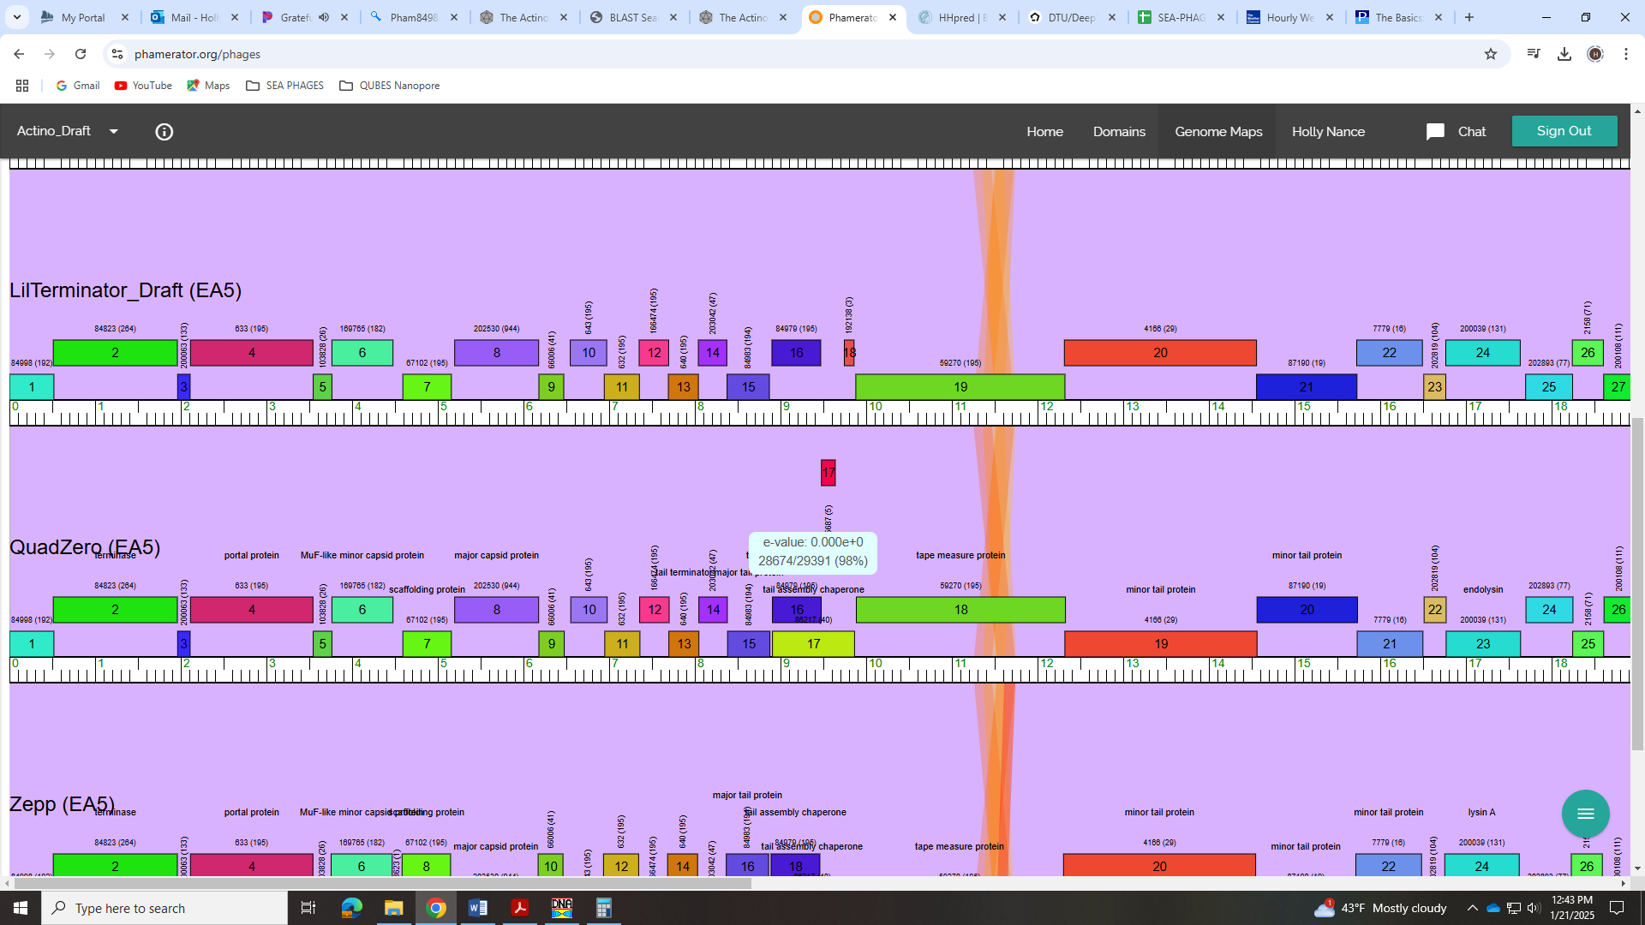
Gene 16 first gene in translational frame shift!
SSC: start 8900, stop 9469; CP: yes; SCS: Both called start at 8900; ST: SS; Blast Start: matches QuadZero_16 Query 1 to Subject 1 99% e⁻¹⁰⁶; Gap: 29; LO: yes; RBS: -1.748, 2.989, 12, -2.584, yes; F: tail assembly chaperone; SIF-BLAST: tail assembly chaperone /PhageDB BLAST/ QuadZero_16, MZ150787/99%/e⁻¹⁰⁶; SIF-HHPred NKF, no matches with a probability above 90%; SIF-Syn: tail assembly chaperone
Notes: Most annotated start, this is definitely the frameshift tail assembly chaperone. This is the first of the two fusion genes. Looks like a -1 frame shift because the next forward gene is in the +1 frame, and gp16 is in +2. There is a reverse gene in between, but this will likely be deleted as there is no coding potential and not supported by synteny in other phage.

Gene 17 reverse gene that will be deleted!
SSC: start 9639, stop 9478; CP: yes; SCS: Both called start at 765; ST: SS; Blast Start: matches Neptune_3 Query 1 to Subject 1 88% 7e⁻⁶⁷; Gap: overlap of 4; LO: NA; RBS: -3.178, 2.352, 14, -4.525, no; F: NKF; SIF-BLAST: NKF/PhageDB BLAST/Neptune_3, OK318957/88%/7e⁻⁶⁷; SIF-HHPred: NKF, a few partial matches with a probability above 90%; SIF-Syn: NKF
Notes: No coding potential… This gene is only found in 4 other phage and all are drafts. This tiny reverse gene also now completely overlaps with the fusion tail assembly chaperone gene. We will have to delete this gene.
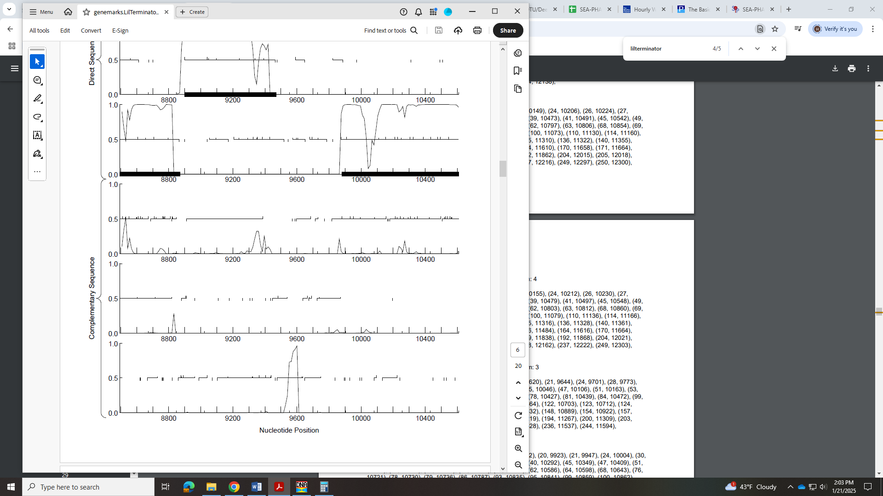

Gene 17 second gene in translational frame shift! Frameshift annotated in DNAMaster on 1/21
SSC: start 8900, stop 9858; CP: yes; SCS: Start changed because of frame shift; ST: NA; Blast Start: matches QuadZero_17 Query 1 to Subject 1 99% 0.0; Gap: 29; LO: yes; RBS: -1.748, 2.989, 12, -2.584, yes; F: tail assembly chaperone; SIF-BLAST: tail assembly chaperone /PhageDB BLAST/ QuadZero_17, MZ150787/99%/0.0; SIF-HHPred: NKF, no matches with a probability above 90%; SIF-Syn: tail assembly chaperone
Notes: Most annotated start, as with gene 16 (the other gene in the fusion tail assembly chaperone). When I BLAST the entire product of the fusion gene, all hits are for tail assembly and 1:1.
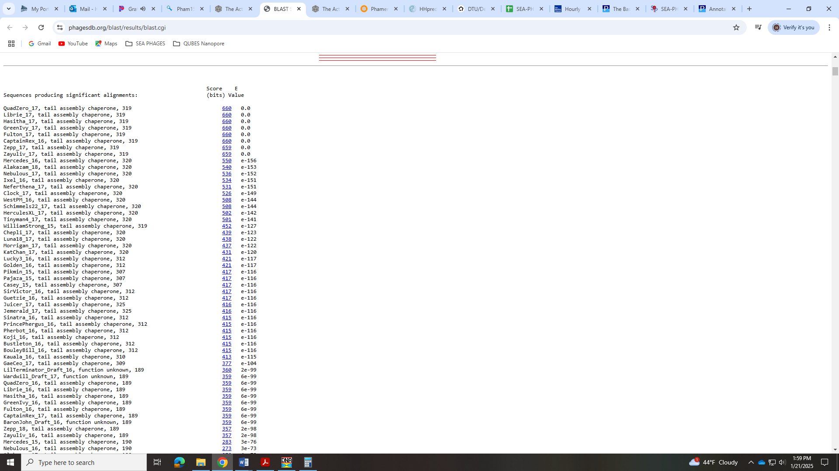
No support from HHPred, but all other data strongly suggests tail assembly chaperone. I changed the annotated file to reflect this frame shift and fusion gene on 1/21.
Looks like a -1 frame shift because the next forward gene is in the +1 frame, and gp16 is in +2. There is a reverse gene in between, but this will likely be deleted as there is no coding potential and not supported by synteny in other phage.
The slip is at bp 9430, where the C is read twice (a -1 shift). This causes the amino acid to change from D to R.
The slippery sequence is one listed in the guide: GGGGGCGA

Gene 18
SSC: start 9879, stop 12320; CP: yes; SCS: Both called start at 9879; ST: SS; Blast Start: matches Zepp_19 Query 1 to Subject 1 99% 0.0; Gap: 20; LO: yes; RBS: -1.259, 3.218, 10, -1.954, yes; F: tape measure protein; SIF-BLAST: tape measure protein /PhageDB BLAST/ Zepp_19, MN908686/99%/0.0; SIF-HHPred: tape measure protein, several matches with a probability above 99%; SIF-Syn: tape measure protein
Notes: Start is not most annotated but called 100% of time when present. Function is well-supported as tape measure protein.
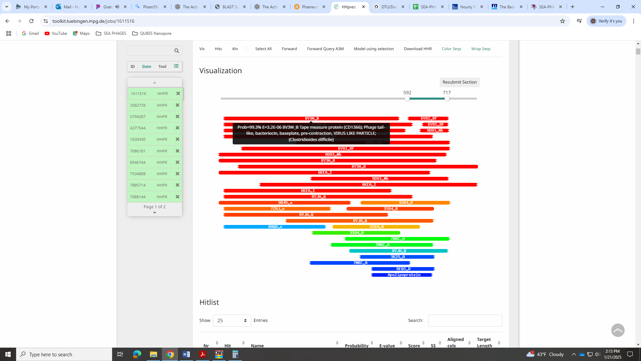
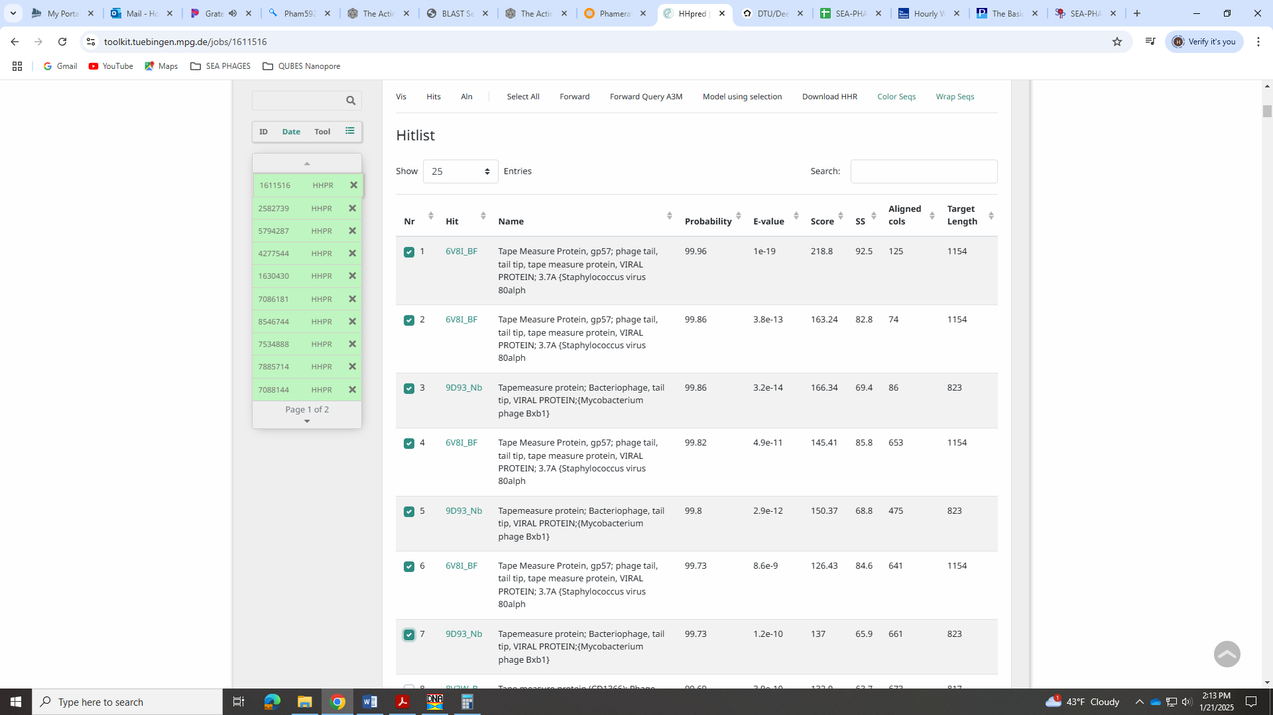
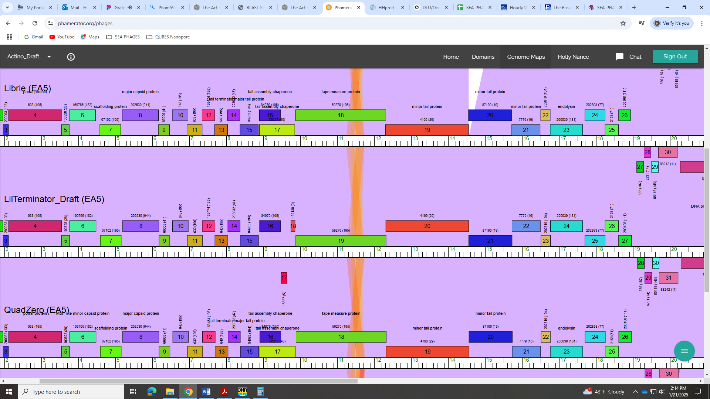
Gene 19
SSC: start 12313, stop 14556; CP: yes; SCS: Both called start at 12313; ST: SS; Blast Start: matches Zepp_20 Query 1 to Subject 1 99% 0.0; Gap: overlap of 8; LO: yes; RBS: -2.976, 2.413, 13, -4.022, no; F: minor tail protein; SIF-BLAST: minor tail protein/PhageDB BLAST/ Zepp_20, MN908686/99%/0.0; SIF-HHPred: NKF, several matches with a probability above 90%, but for proteins other than minor tail; SIF-Syn: minor tail protein
Notes: Start is most annotated and yields longest ORF. BLAST and synteny strongly support minor tail protein:
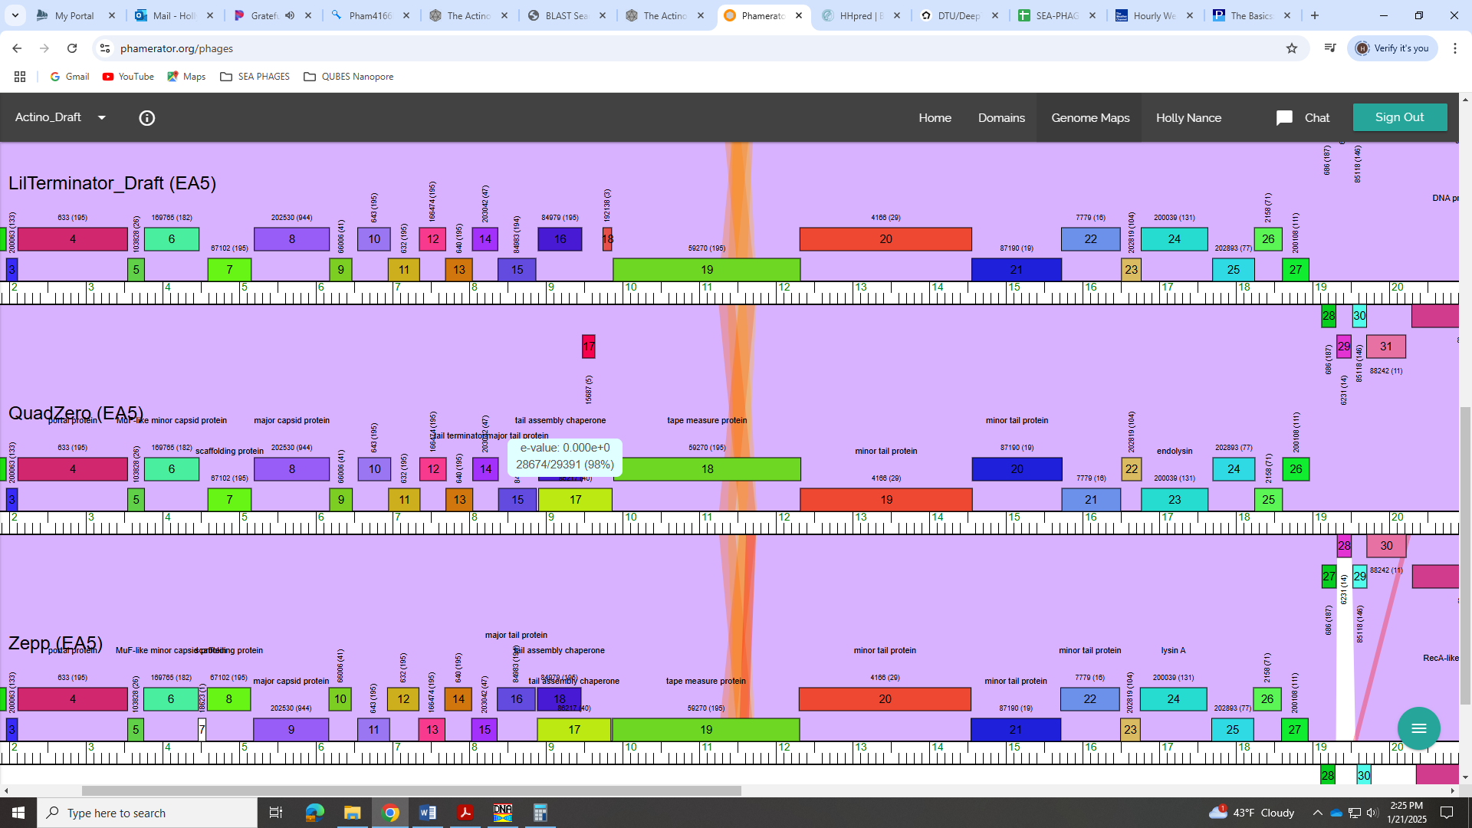
Also, the Bioinformatics Guide says this about assigning this function:
Minor tail proteins: These are the components of the tail that form the tip of the tail. These proteins are low in copy-number per virion (only two to six copies or so per protein per tail) but identified due to their length and location: downstream of the tape measure protein, and ranging in size from 1kb-3kb depending on the phage. These proteins are quite modular and it is difficult to sort them into more specific roles, so we call them all "minor tail proteins". There are usually between 4 to 6 per genome that can be identified easily. Two exceptions to the genome location rule are the Cluster A phages, in which one to two minor tail proteins are upstream of the lysins and terminase genes; and the Cluster S phages, in which several minor tail proteins are located in the far right arm, away from the other ones. These proteins are diverse, modular, long and extended, and as such can be difficult to crystallize or identify using HHPred or BLAST. Some of them also have an enzymatic domain; this activity is used by the phage to get through sugars, or the cell wall, etc, on the outside of the cell to help deliever the DNA. We primarily make this assignment based on synteny, and the four largest proteins immediately following the tape measure will usually be given this label.
Rank: 1

HHPred results suggest all kinds of other proteins, but not minor tail.
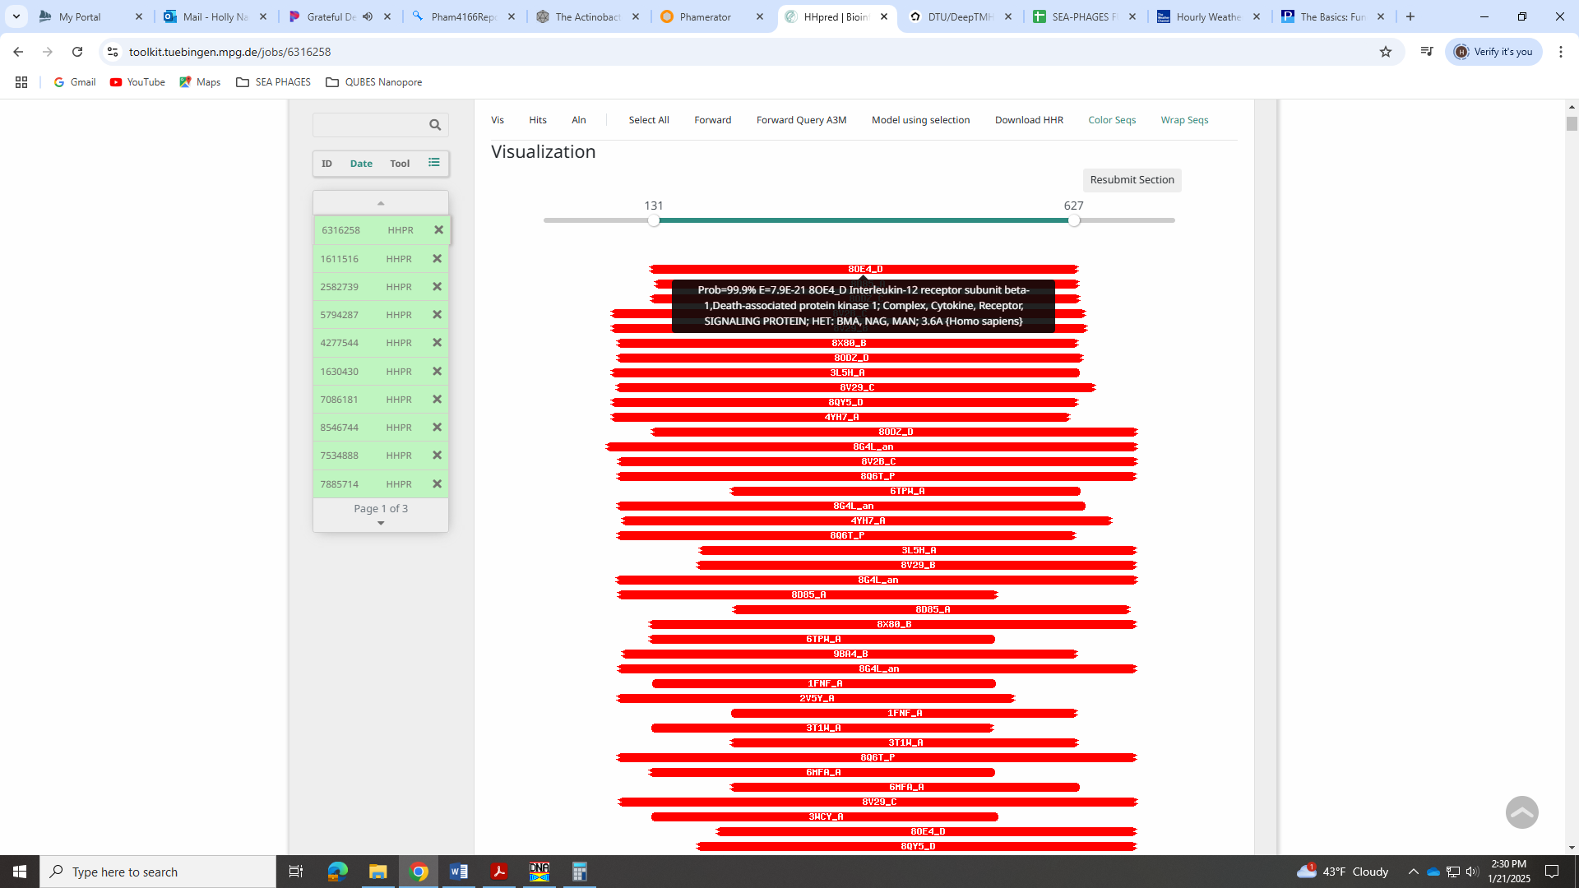
However, the official function list says that hits to collagen-like proteins are ok. There are several hits to fibronectin.

Gene 20
SSC: start 14556, stop 15728; CP: yes; SCS: Both called start at 14556; ST: SS; Blast Start: matches Quadzero_20 Query 1 to Subject 1 99% 0.0; Gap: overlap of 1; LO: NA; RBS: -2.903, 2.447, 12, -3.739, yes; F: minor tail protein; SIF-BLAST: minor tail protein /PhageDB BLAST/ Quadzero_20, MZ150787/99%/0.0; SIF-HHPred: tail protein, several matches with a probability above 99%; SIF-Syn: minor tail protein
Notes: Start was most annotated with yielded best RBS values. Function supported by synteny being just after tape measure protein, and well supported by HHPred data:
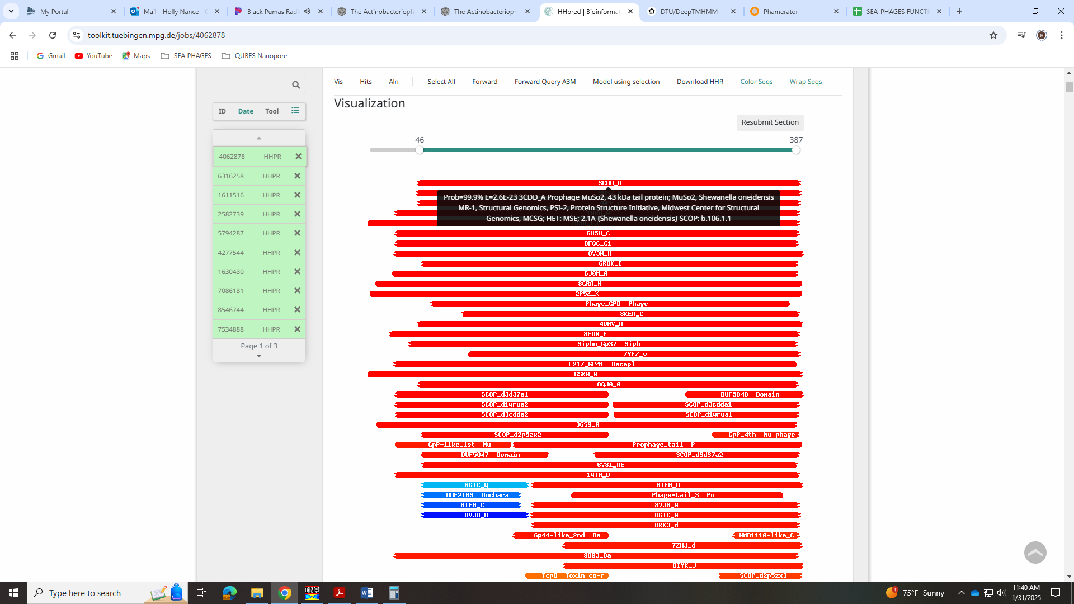
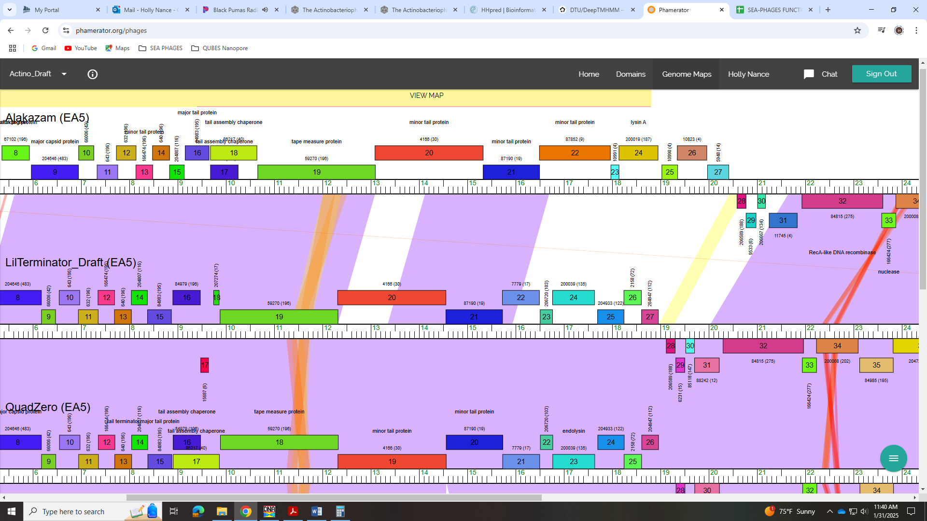

Gene 21
SSC: start 15725, stop 16492; CP: yes; SCS: Both called start at 15725; ST: SS; Blast Start: matches Librie_21 Query 1 to Subject 1 99% e⁻¹⁴²; Gap: overlap of 4; LO: yes; RBS: -1.418, 3.144, 15, -3.020, yes; F: NKF; SIF-BLAST: minor tail protein/PhageDB BLAST/ Librie_21, ON970570/99%/e⁻¹⁴²; SIF-HHPred: Phage tail-like, one partial match (58 of 108 AAs) with a probability of 97%; SIF-Syn: minor tail protein or NKF?
Notes: Start is most annotated. For function, there is a mix of evidence. Several BLAST hits and phage in Phamerator call this a minor tail protein. Synteny would support this as it is 3 genes downstream of the tape measure protein.
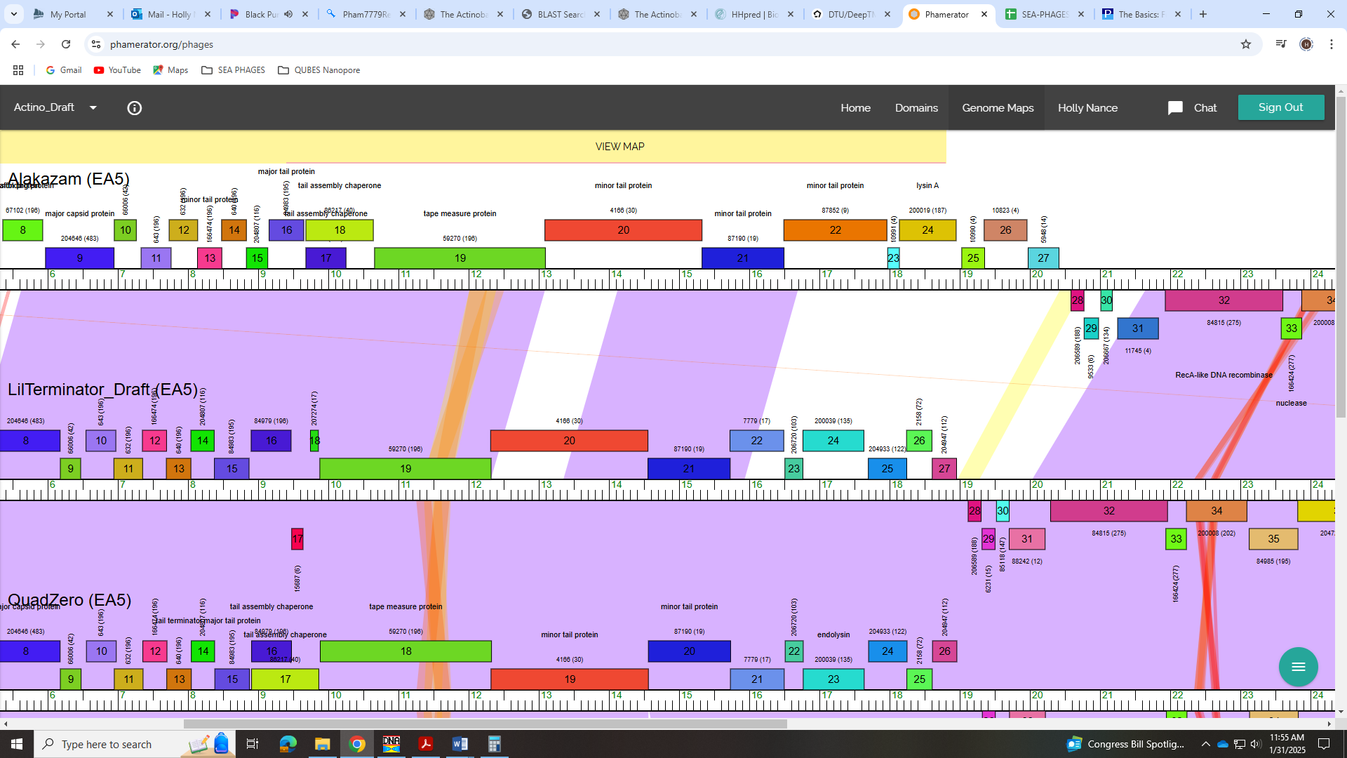
However, the Bioinformatics guide says these proteins are usually 3KB-5KB bases in length and this is under 800 bps. HHPred has one 97% hit to a partial tail-like protein:
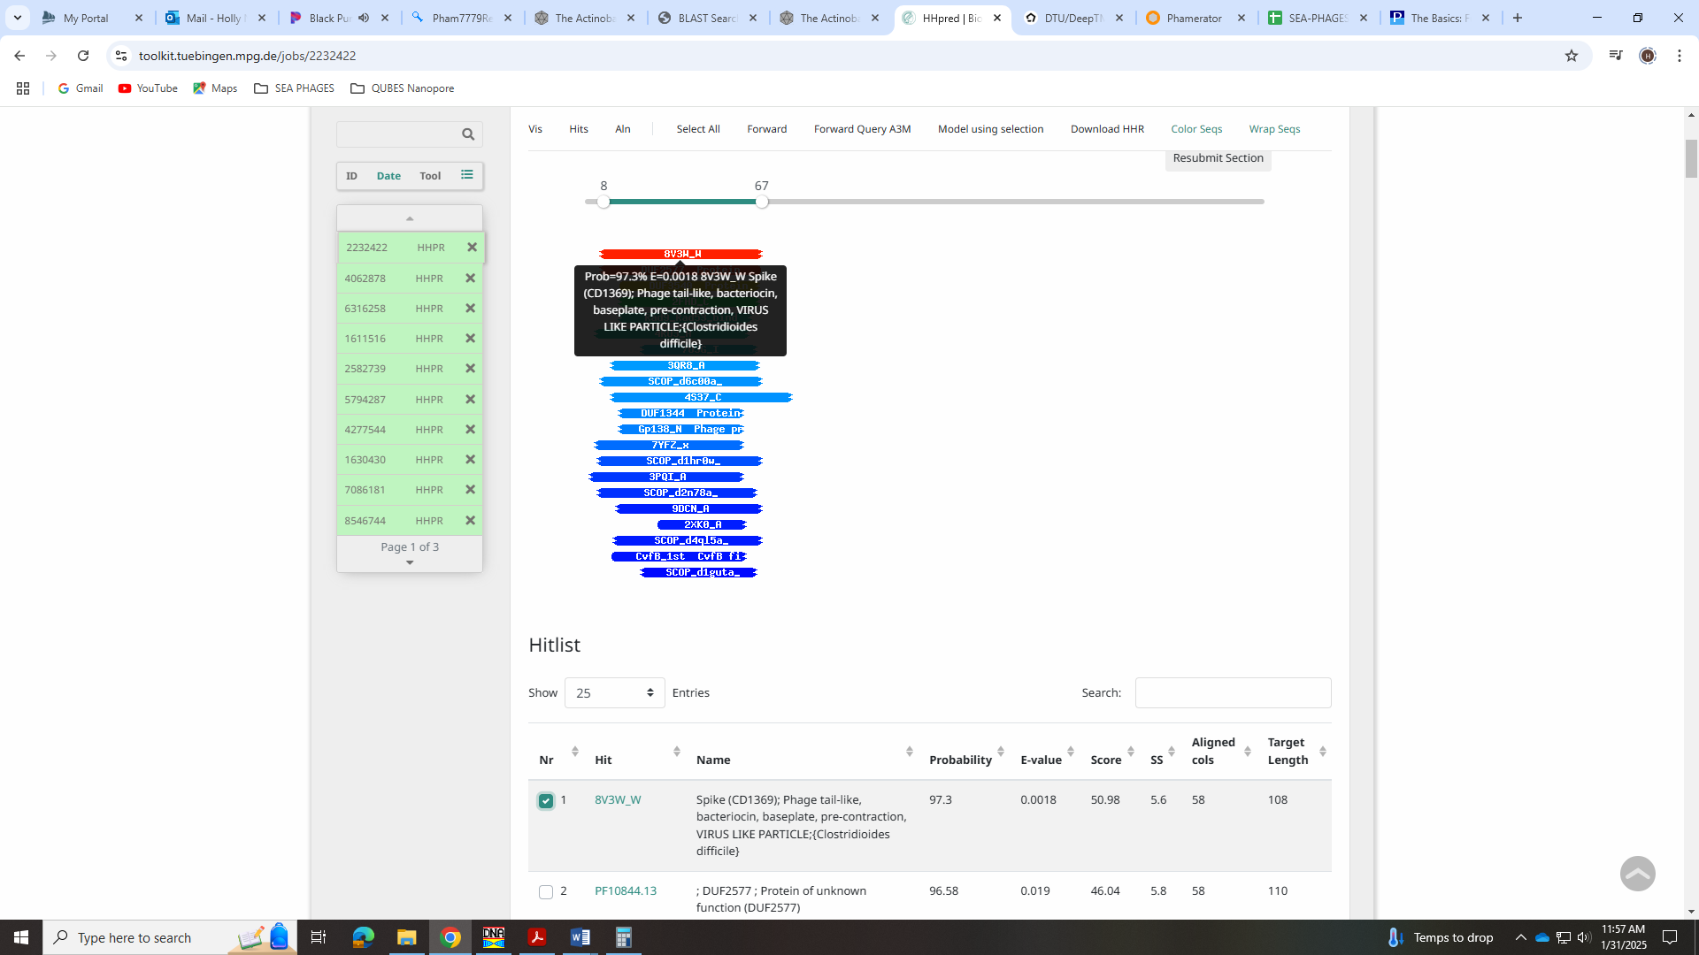
I’m not sure if this is compelling enough to call this.

Gene 22
SSC: start 16508, stop 16765; CP: yes; SCS: Both called start at 16508; ST: SS; Blast Start: matches Zepp_23 Query 1 to Subject 1 98% 2e⁻⁴⁴; Gap: 15; LO: yes; RBS: -1.748, 2.989, 11, -2.505, yes; F: NKF; SIF-BLAST: NKF/PhageDB BLAST/ Zepp_23, MN908686/98%/2e⁻⁴⁴; SIF-HHPred: NKF, no matches with a probability above 90%; SIF-Syn: NKF
Notes: Most annotated start is not present in this gene, but start selected is called 100% when present. It also yields longest ORF. Function is NKF and not ambiguous.

Gene 23
SSC: start 16765, stop 17634; CP: yes; SCS: Both called start at 16765; ST: SS; Blast Start: matches Hasitha_23 Query 1 to Subject 1 99% e⁻¹⁶⁹; Gap: overlap of 1; LO: NA; RBS: -3.178, 2.352, 14, -4.525, no; F: endolysin; SIF-BLAST: endolysin/PhageDB BLAST/GreenIvy_23, PP978818/99%/e⁻¹⁶⁸; SIF-HHPred: endolysin, at least one match with a probability above 99%; SIF-Syn: endolysin
Notes: Start conserved and yields longest ORF. For function, all data suggest endolysin:
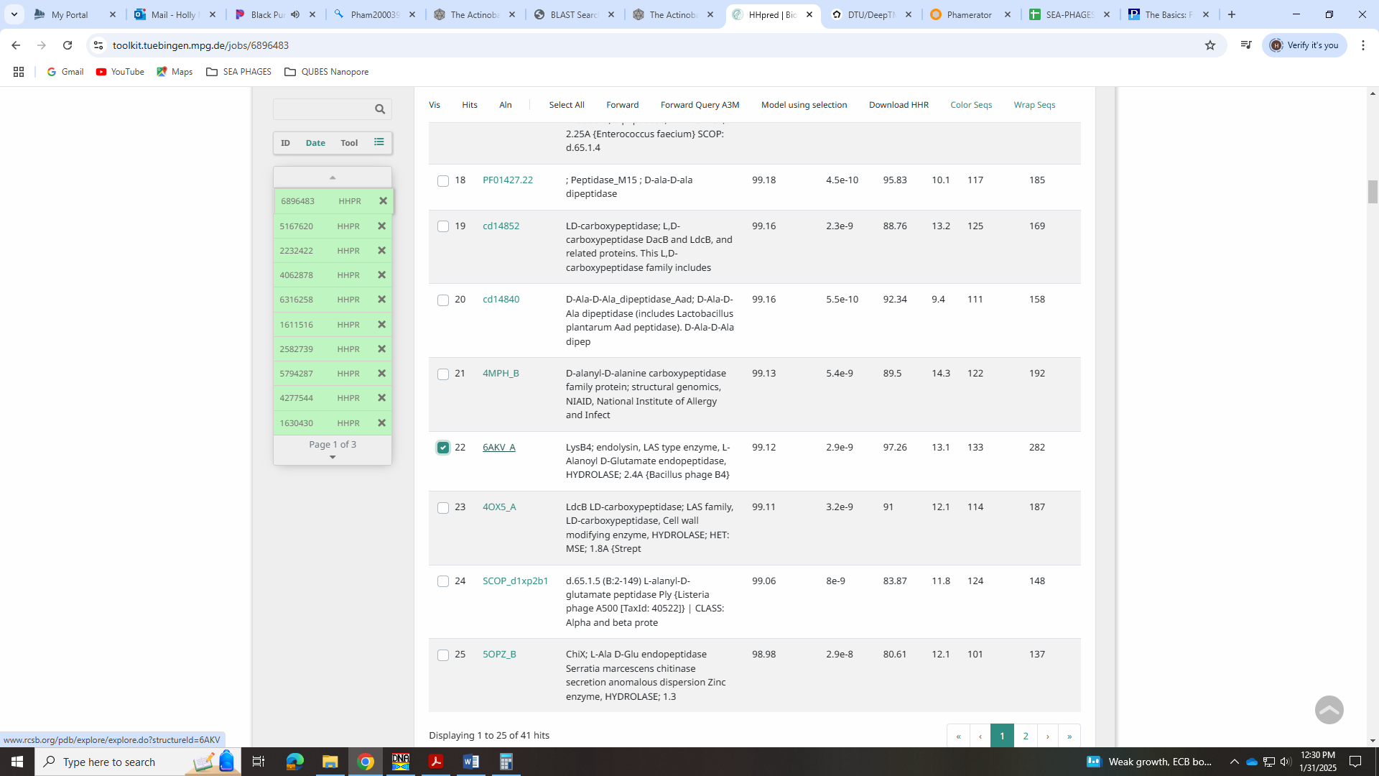
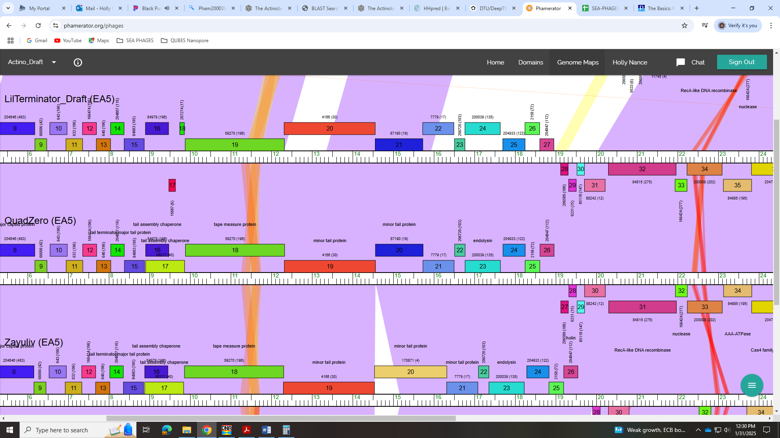
However, if we have another lysin, then we will need to call this Lysin A and the other Lysin B, per the Bioinformatics Guide:
Endolysins: Actinobacteriophages have at least one, if not two, endolysins that aid in the disruption of the cell wall upon completion of the lytic cycle. Lysin A is present in nearly every Actinobacteriophage genome, and is quite modular with multiple domains, including a peptidoglycan binding domain. In some Gordonia phages, lysin A is split along domain boundaries into two separate adjacent genes. Lysin B is present in some, but not all, Mycobacteriophages, and some, but not all Gordonia phages. If present, there is only one copy of lysin B. Lysin B is identifiable by alignment to cutinase domain proteins. In annotations of actinobacteriophages that are not mycobacteriophages and only have a single lysin, we use the term "endolysin" in our annotations, rather than designating the single lysin as "lysin A".
lysin A
Rank: 1
lysin B
Rank: 3

Gene 24
SSC: start 17697, stop 18245; CP: yes; SCS: Both called start at 17697; ST: SS; Blast Start: matches QuadZero_24 Query 1 to Subject 1 100% e⁻¹⁰³; Gap: 62; LO: yes; RBS: -2.770, 2.509, 9, -3.545, yes; F: membrane protein; SIF-BLAST: NKF/PhageDB BLAST/ QuadZero_24, MZ150787/100%/e⁻¹⁰³; SIF-HHPred: NKF, no matches with a probability above 90%; SIF-Syn: NKF
Notes: Though there is a large gap, this start yields the longest ORF, is the most annotated and has the best RBS values. All evidence for this points to NKF EXCEPT the DeepTMHMM output! This is a membrane protein!
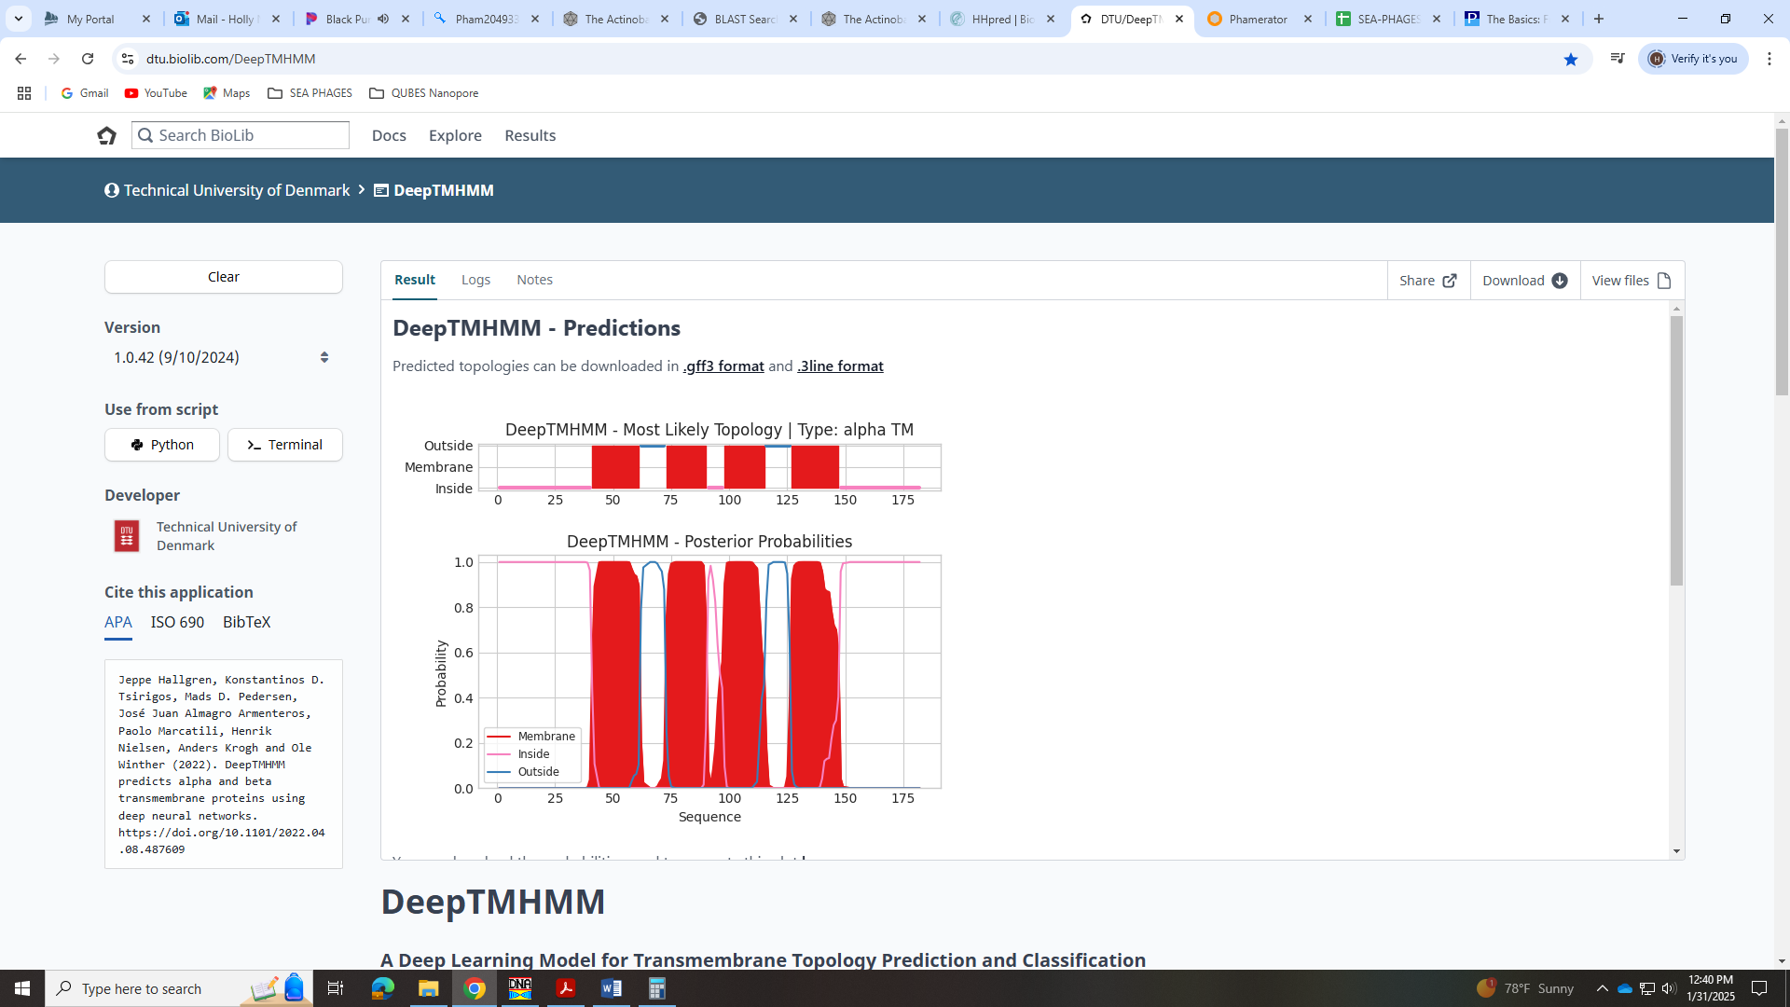

Gene 25
SSC: start 18242, stop 18604; CP: yes; SCS: Both called start at 18242; ST: SS; Blast Start: matches QuadZero_25 Query 1 to Subject 1 100% 9e⁻⁶⁴; Gap: overlap of 4; LO: yes; RBS: -2.736, 2.525, 13, -3.782, no; F: membrane protein; SIF-BLAST: NKF/PhageDB BLAST/ QuadZero_25, MZ150787/100%/9e⁻⁶⁴; SIF-HHPred: membrane protein, one match for a membrane pore with a probability above 90%; SIF-Syn: NKF
Notes: Start not most annotated but is called 100% of time when present. It also yields longest ORF. For function, this is another membrane protein! BLAST and Phamerator suggest NKF, but Deep TMHMM shows membrane protein:
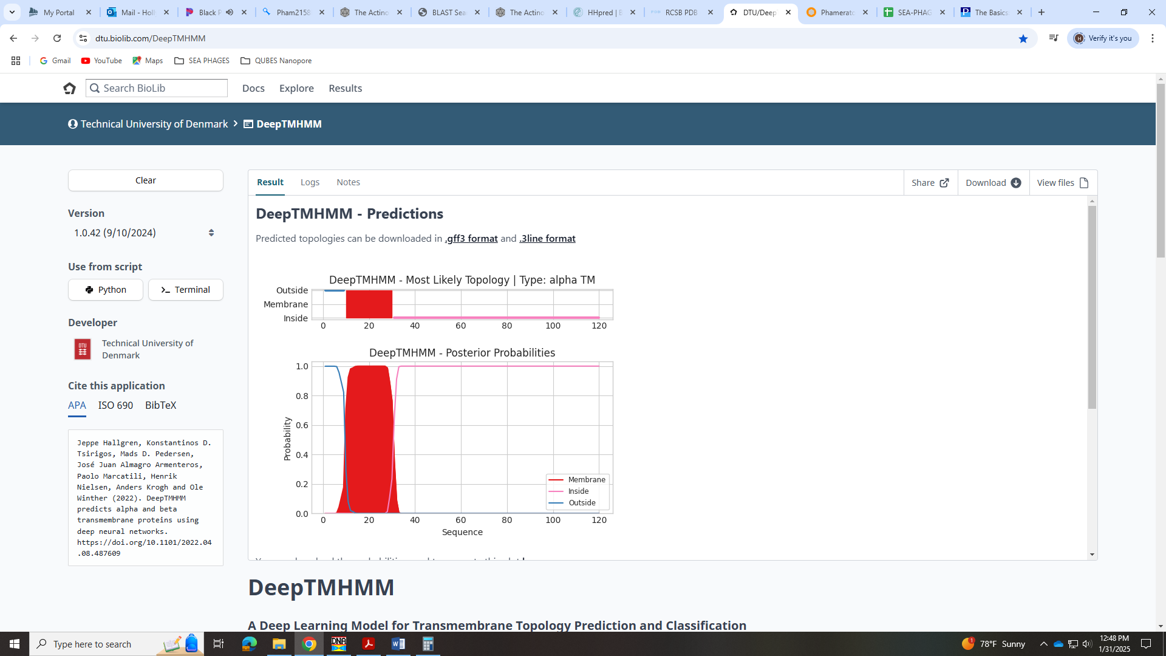
Also there is one HHPred hit with 94% probability for an CRISPR accessory protein that is a membrane pore protein:
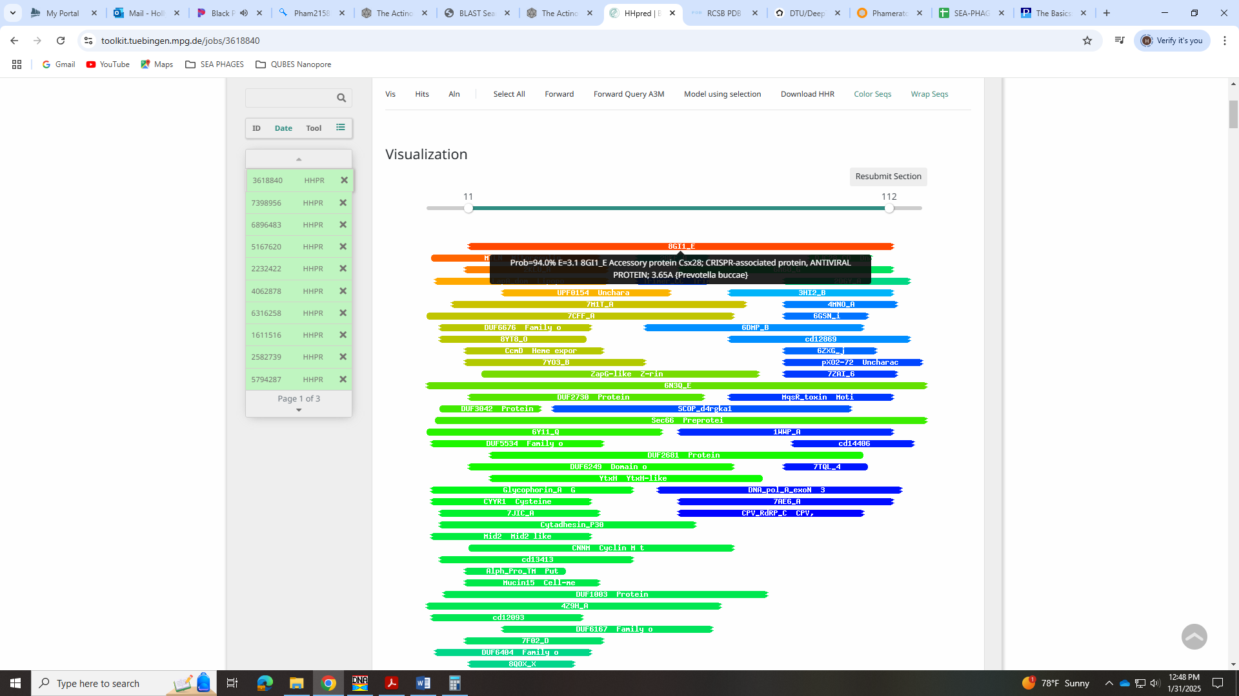
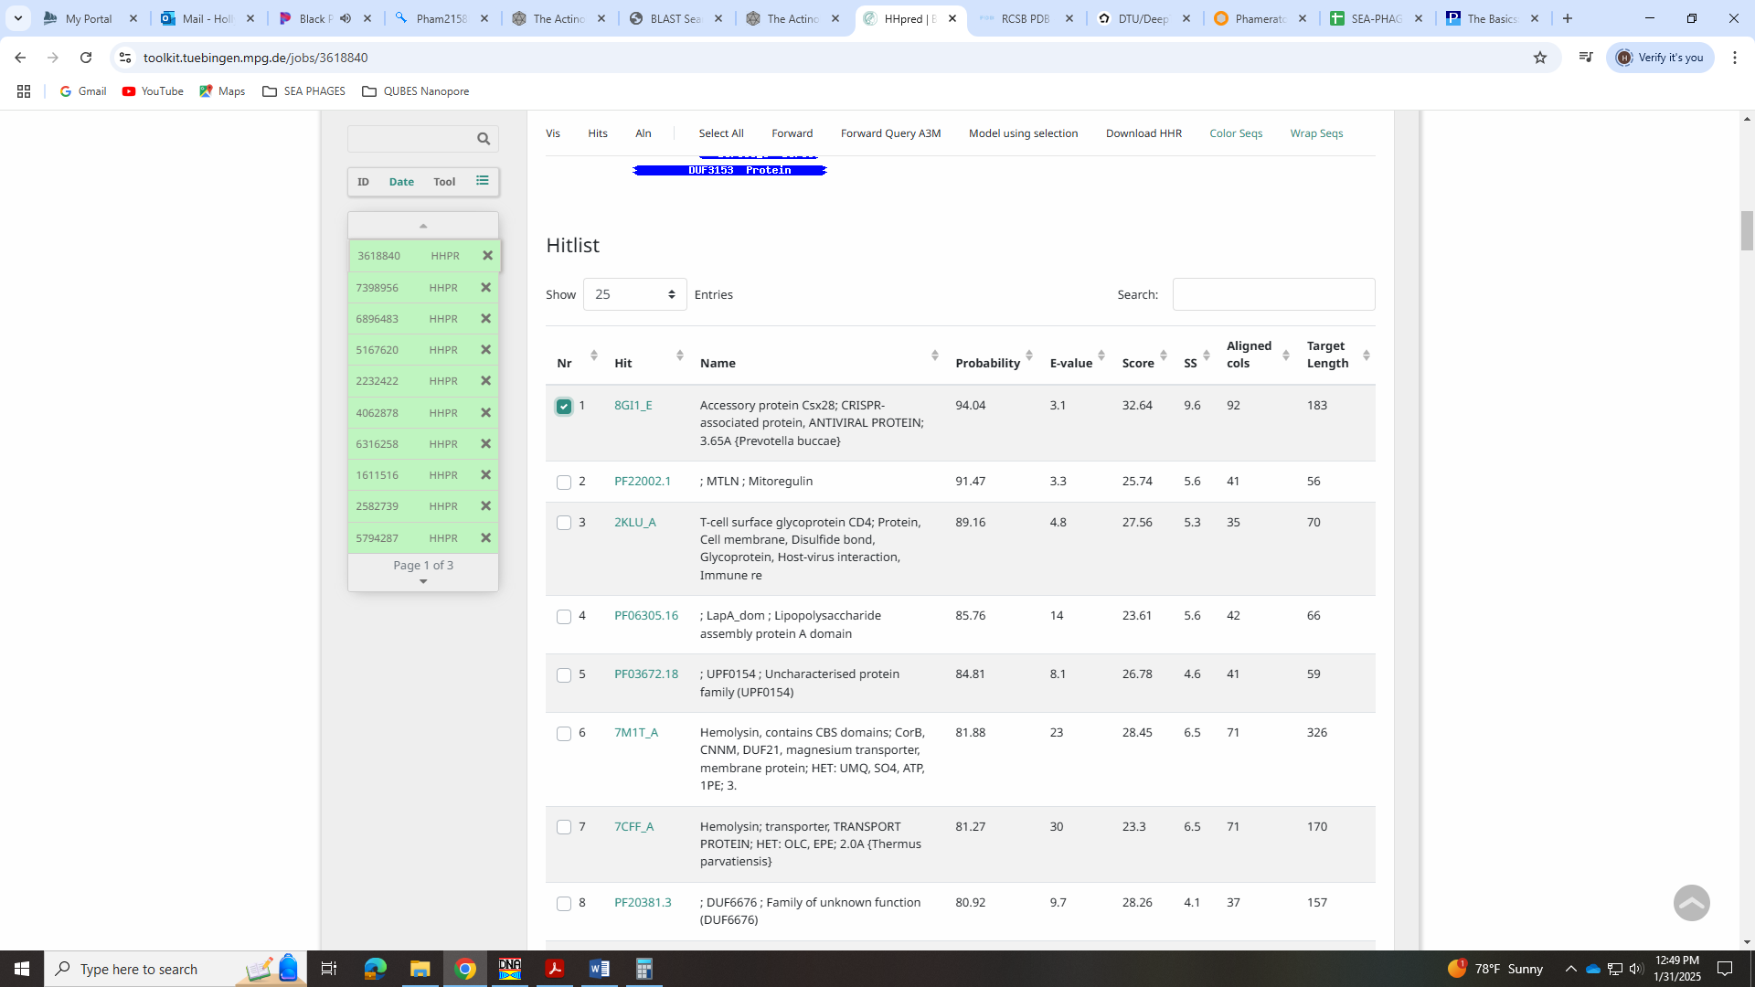
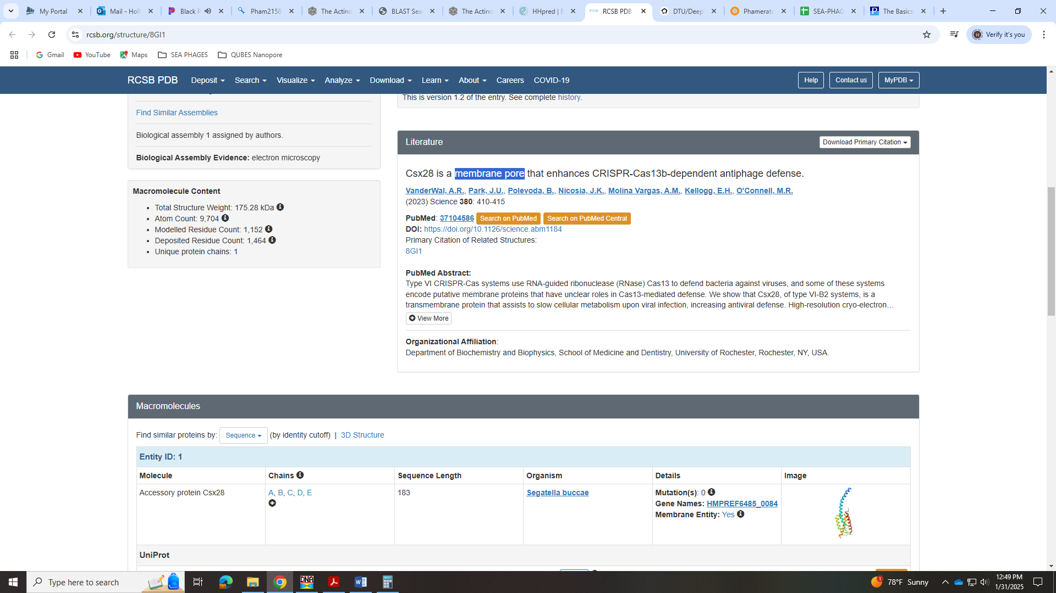

Gene 26
SSC: start 18608, stop 18955; CP: yes; SCS: Both called start at 18608; ST: SS; Blast Start: matches Zepp_27 Query 1 to Subject 1 100% 3e⁻⁵⁸; Gap: 3; LO: yes; RBS: -1.748, 2.989, 10, -2.443, yes; F: membrane protein; SIF-BLAST: holin/PhageDB BLAST/Zayuliv_26, MT889377/100%/3e⁻⁵⁸; SIF-HHPred: NKF, though there is one hit to holin with probability of 88%; SIF-Syn: membrane protein, given there are two other membrane proteins upstream
Notes: Start is called 100% of time when present and yields longest ORF. For function, most call this NKF, but there is one BLAST hit for holin. However, the Function List says that:
evidence needed to call a holin can include biochemical data (1), seqeunce similarity to genes with biochemical data (2), at least 2 transmembrane domians found and the gene be adjacent to the endolysins (s), conderved domain hits (4), and the abscence of additional transmembrane domains in the area. The literature suggests that some phages have more than one holin, for now when we seem multiple possibilities for a holin gene, let's call them membrane proteins.
There are more than 2 membrane domains in this protein but there are additional membrane proteins in the area. So I think we should call this a membrane protein and not holin:
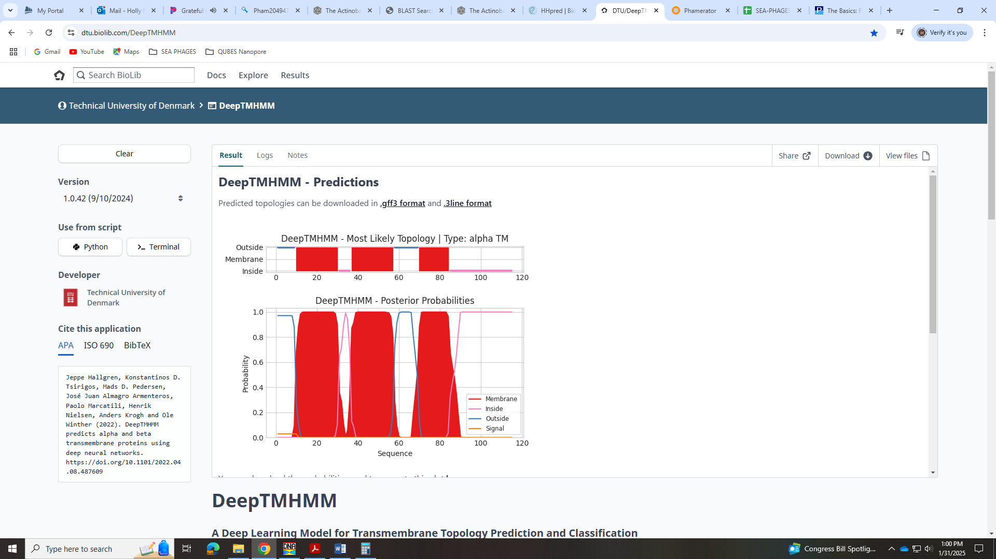
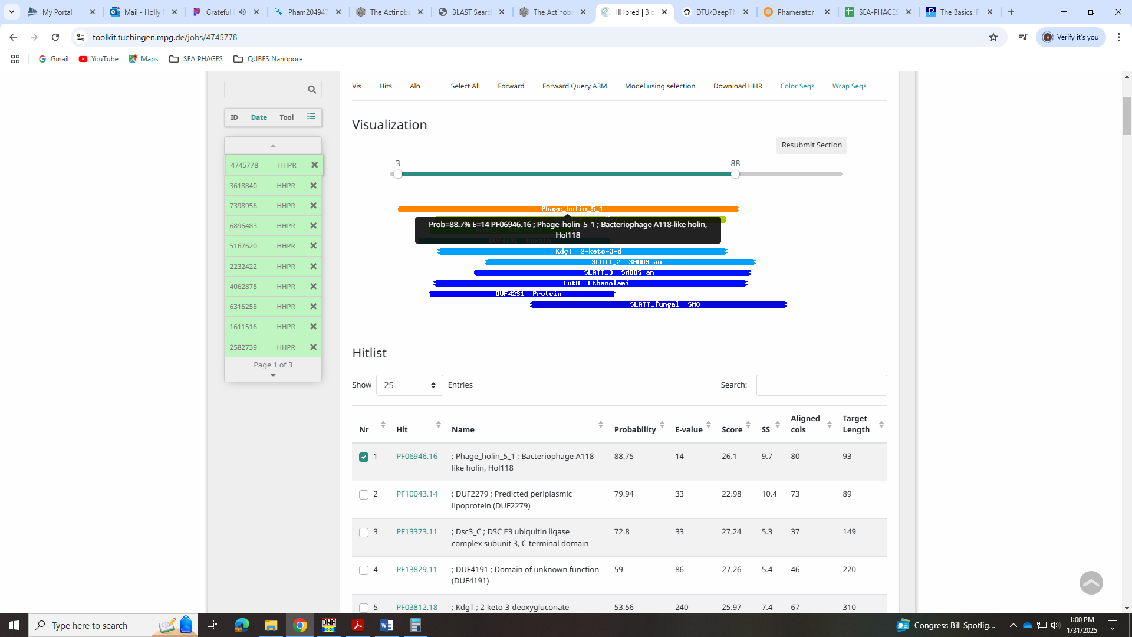
Gene 27 reverse!
SSC: start 19305, stop 19120; CP: yes; SCS: Both called start at 19305; ST: SS; Blast Start: matches QuadZero_27, Query 1 to Subject 1 100% 4e⁻²⁸; Gap: 12; LO: yes; RBS: -1.236, 3.229, 12, -2.072, yes; F: NKF; SIF-BLAST: NKF/PhageDB BLAST/ QuadZero_27, MZ150787/100%/4e⁻²⁸; SIF-HHPred: NKF, no matches with a probability above 90%; SIF-Syn: NKF
Notes: Most annotated start not present but this start is called 100% of time when present. It also yields the longest ORF and has best RBS values. NKF is unambiguous.

Gene 28 – reverse!
SSC: start 19503, stop 19318; CP: yes; SCS: Both called start at 195035; ST: SS; Blast Start: matches Fulton_28 Query 1 to Subject 1 100% 1e⁻²⁷; Gap: 19; LO: yes; RBS: -4.737, 1.586, 9, -5.512, no; F: NKF; SIF-BLAST: NKF/PhageDB BLAST/Fulton_28 PQ559670/100%/1e⁻²⁷; SIF-HHPred: NKF, no matches with a probability above 90%; SIF-Syn: NKF
Notes: Start is most annotated and yields longest ORF. NKF is unambiguous.
Gene 29 – reverse!
SSC: start 19705, stop 19523; CP: yes; SCS: Both called start at 19705; ST: SS; Blast Start: matches Zayuliv_29 Query 1 to Subject 1 100% 6e⁻³¹; Gap: overlap of 1; LO: yes; RBS: -4.663, 1.621, 13, -5.709, no; F: NKF; SIF-BLAST: NKF/PhageDB BLAST/ Zayuliv_29, MT889377/100%/6e⁻³¹; SIF-HHPred: NKF, no matches with a probability above 90%; SIF-Syn: NKF
Notes: Start called 100% of time when present and yields longest ORF. Function NKF and not ambiguous.

Gene 30 – reverse!
SSC: start 20217, stop 19705; CP: yes; SCS: Both called start at 20217; ST: SS; Blast Start: matches Librie_30 Query 1 to Subject 1 99% 2e⁻⁹⁸; Gap: 77; LO: yes; RBS: -1.748, 2.989, 10, -2.443, yes; F: NKF; SIF-BLAST: NKF/PhageDB BLAST/ Librie_30, ON970570/99%/2e⁻⁹⁸; SIF-HHPred: NKF, no matches with a probability above 90%; SIF-Syn: NKF
Notes: Start was most annotated and yielded longest ORF. NKF well supported.

Gene 31 -reverse!
SSC: start 21962, stop 20295; CP: yes; SCS: Glimmer called more conserved start at 21962, GeneMark called start at 21893; ST: SS; Blast Start: matches Zepp_32 Query 1 to Subject 1 99% 0.0; Gap: overlap of 25; LO: yes; RBS: -1.597, 3.059, 12, -2.433, yes; F: DNA primase/helicase; SIF-BLAST: DNA primase/helicase /PhageDB BLAST/Fulton_31, PQ559670/99%/0.0; SIF-HHPred: DNA primase/helicase, hits to both DNA primase and DNA helicase with probability above 99%; SIF-Syn: DNA primase/helicase
Notes: Went with Glimmer start as it was most conserved. For function, this was hard!! There are calls for RecA-like DNA recombinase and DNA primase/helicase. For the former, there is a whole ppt in the Function List explaining what this call needs in the HHPred output (link: file:///C:/Users/hnance/Downloads/How%20to%20call%20a%20RecA%20recombinase_8.3.23.pdf). Based on this, I do not think we have a RecA-like recombinase, or the ASCE ATPase.
LilTerminator output:
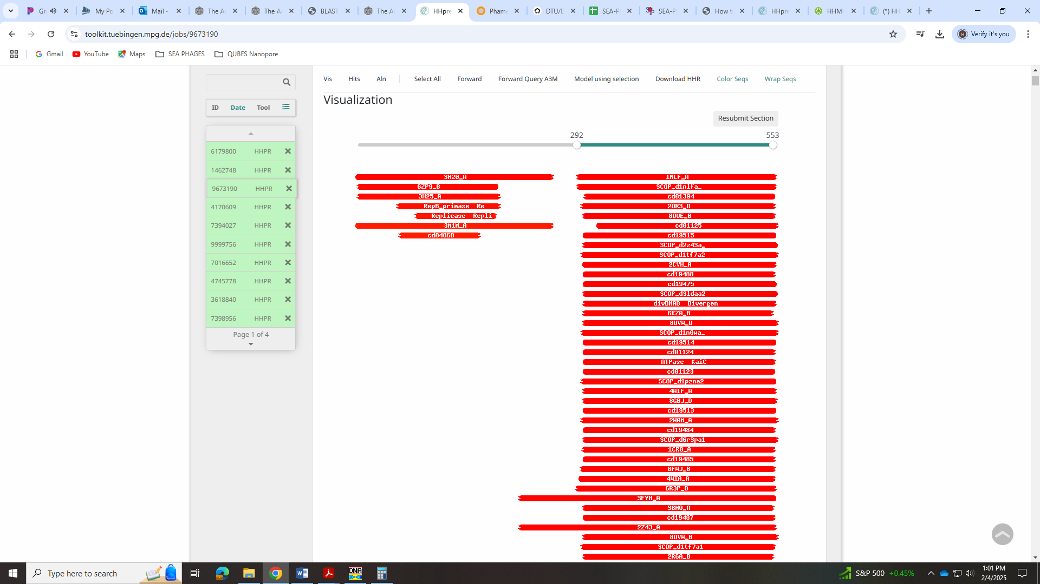
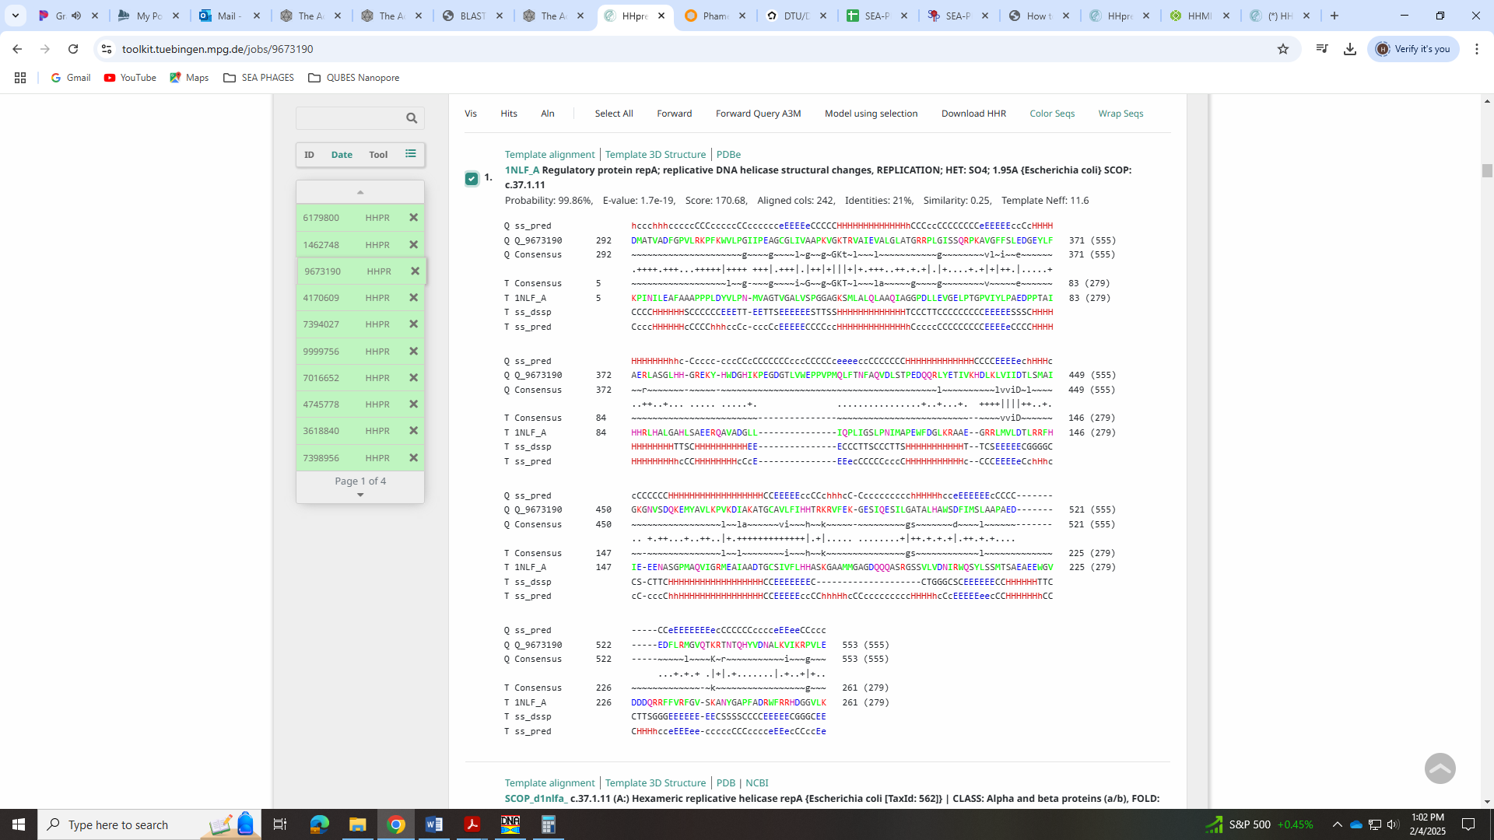
Here is the output for Spud_205 (example in ppt from Function List):
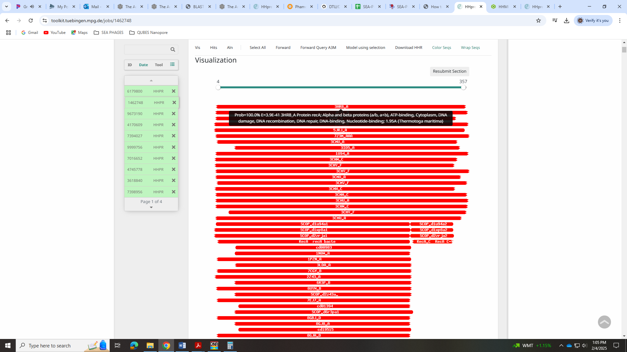
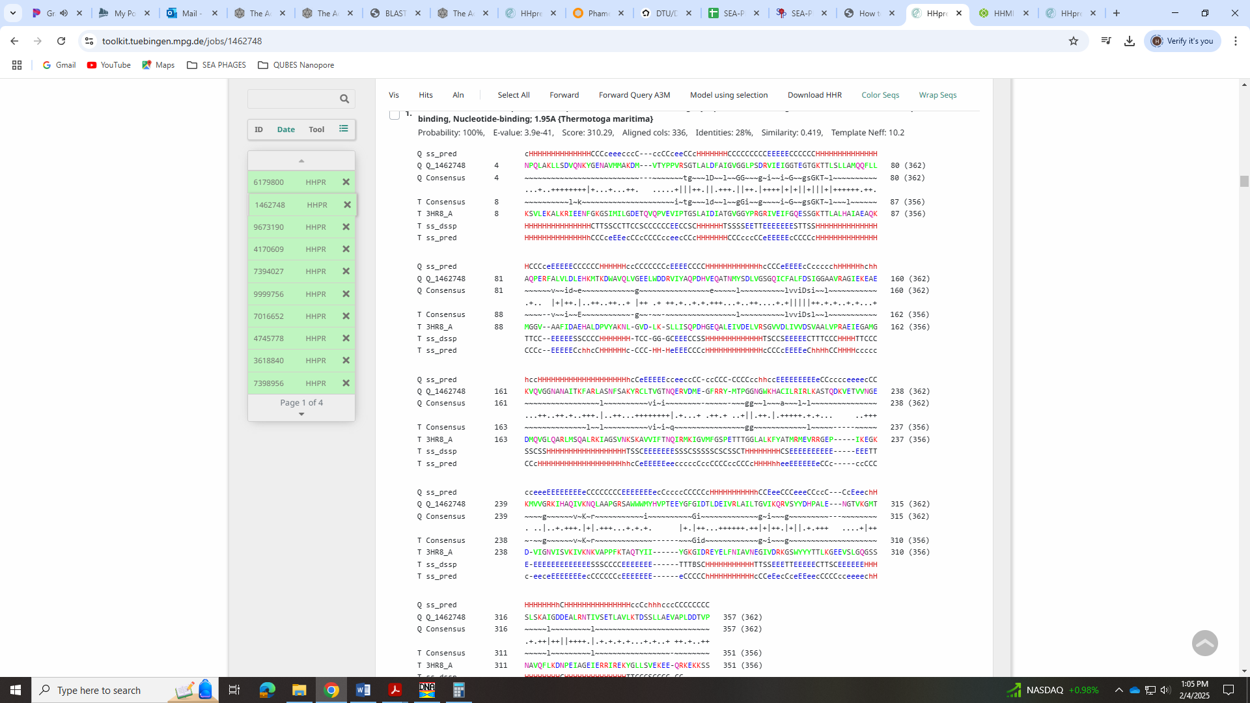
To call this DNA primase/helicase, the Function List says you have to have both hits in HHPred. The example phage given is Schubert_31. Here is that HHPred output:
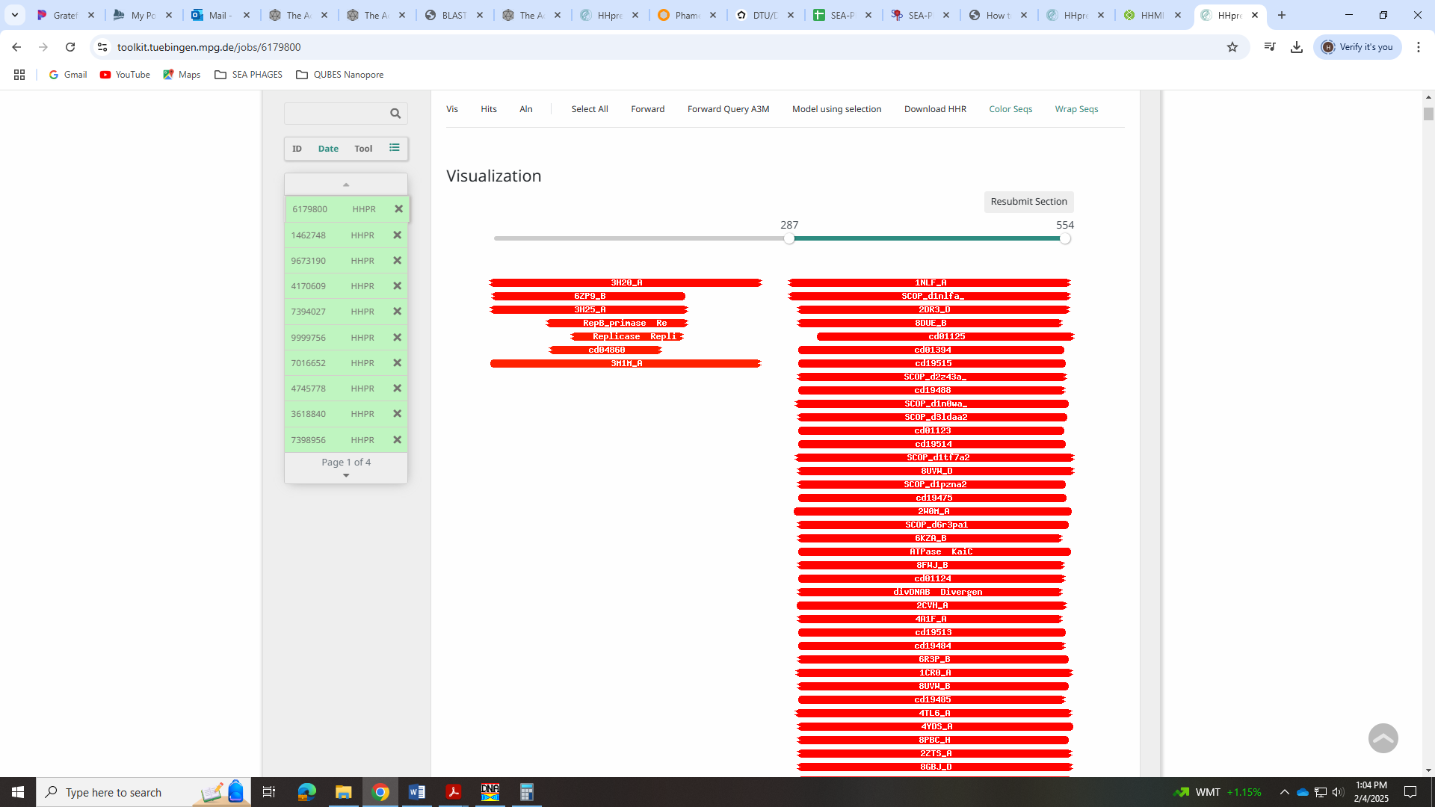
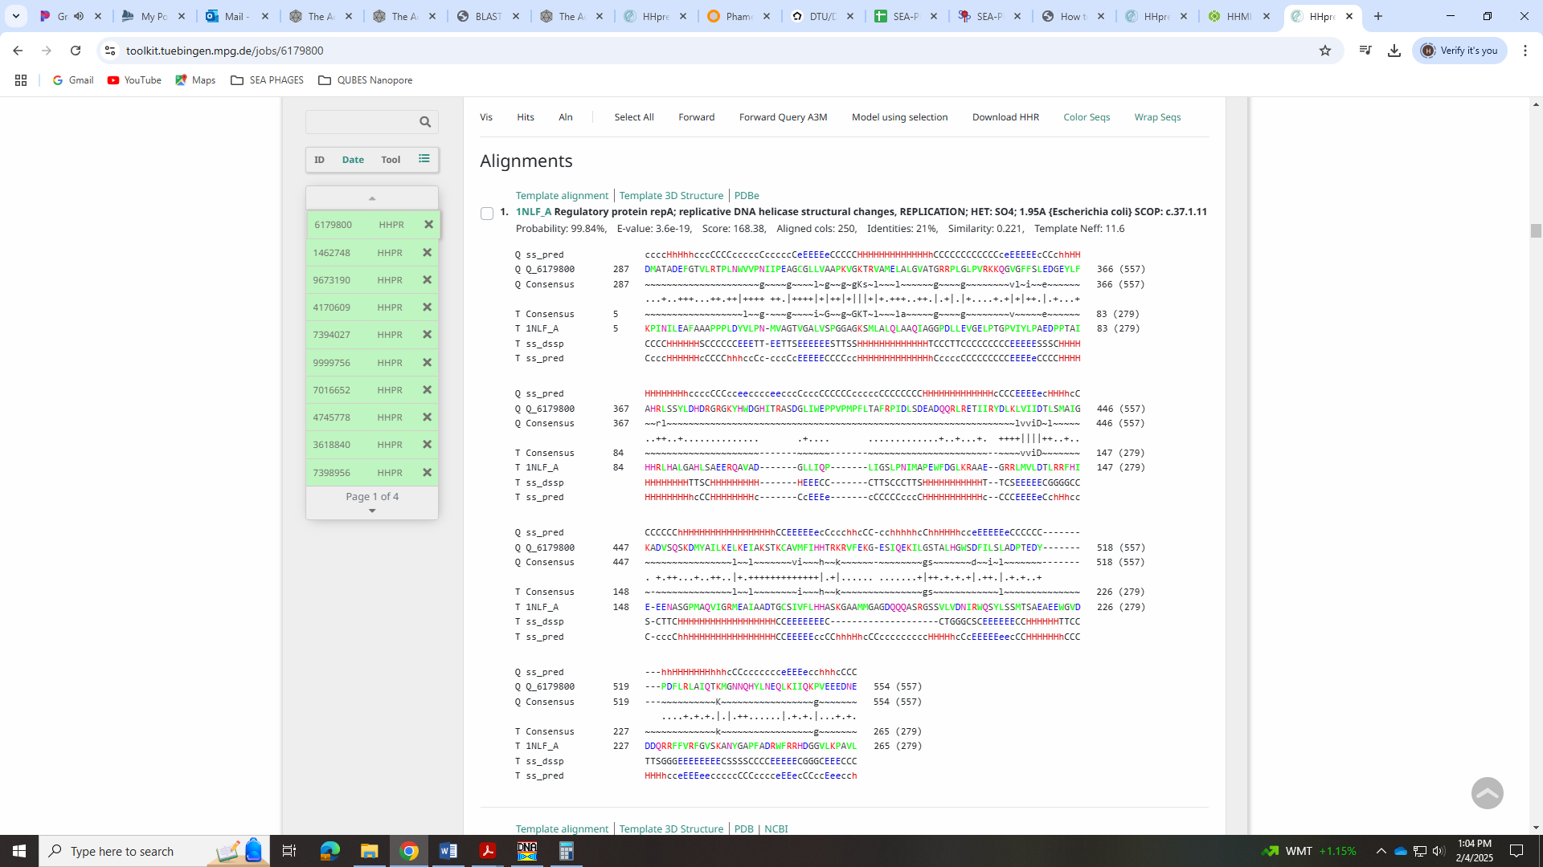
I think this is what we should call it given the hits are closer to Schubert’s and the alignment looks more like it than RecA-like DNA recombinase.

Gene 32 - reverse
SSC: start 22231, stop 21938; CP: yes; SCS: Both called start at 22231; ST: SS; Blast Start: matches Zepp_33 Query 1 to Subject 1 100% 1e⁻⁵¹; Gap: overlap of 1; LO: yes; RBS: -5.906, 1.038, 10, -6.601, no; F: nuclease; SIF-BLAST: nuclease/PhageDB BLAST/ Zepp_33, MN908686/100%/1e⁻⁵¹; SIF-HHPred: nuclease or VRR-Nuc domain protein, several matches with a probability above 99%; SIF-Syn: nuclease
Notes: Start is conserved and yields longest ORF. For function, most BLAST hits are for nuclease. The top hits in HHPred are also for nuclease or VRR-Nuc domain protein.
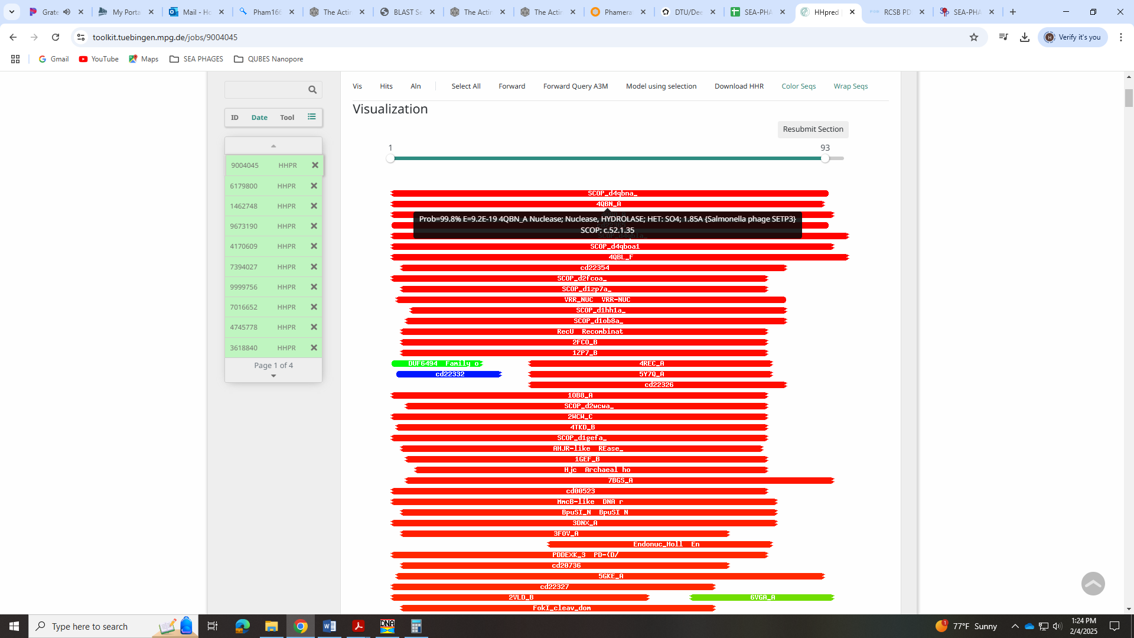
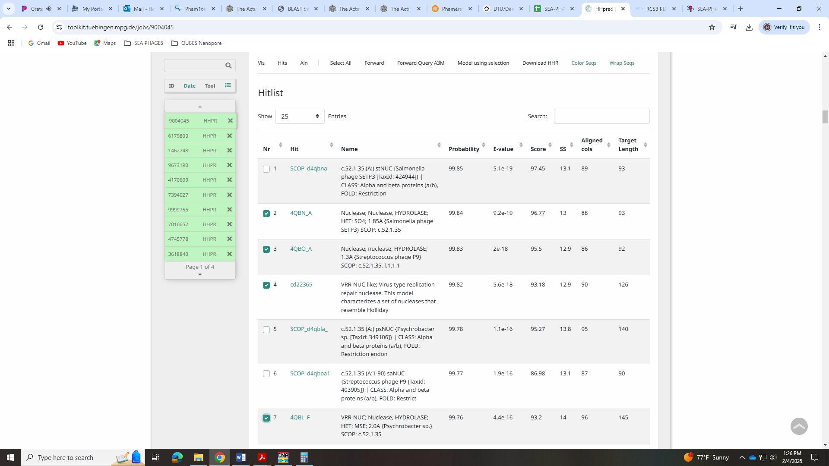
The Function List doesn’t have any additional info or an example for nuclease. For VRR-Nuc domain protein, there is only an example: Zeina-89. Here is Zeina-89 HHpred output:
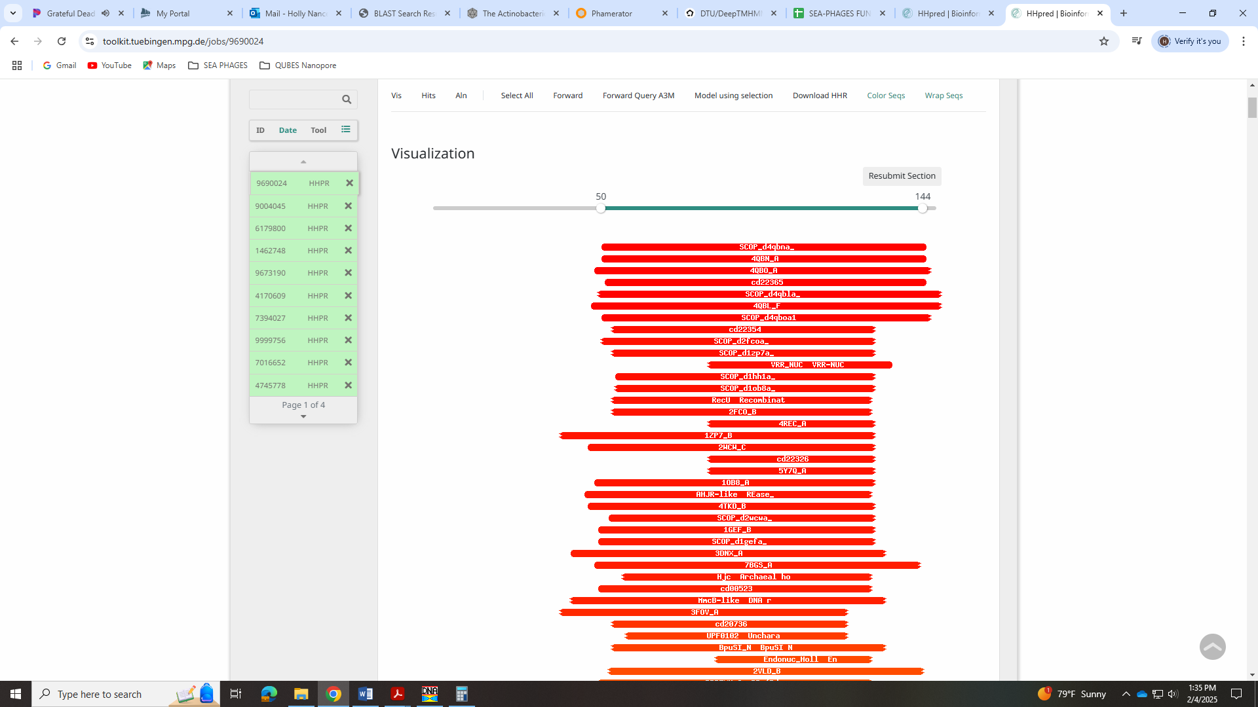
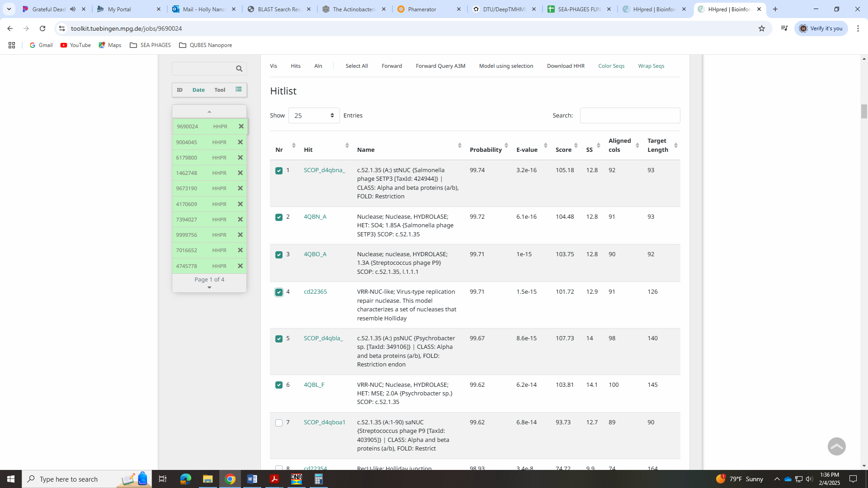

Gene 33 - reverse
SSC: start 23094, stop 22231; CP: yes; SCS: Both called start at 23094; ST: SS; Blast Start: matches QuadZero_33 Query 1 to Subject 1 98% e⁻¹⁵⁹; Gap: 31; LO: yes; RBS: -1.462, 3.123, 13, -2.507, yes; F: NKF; SIF-BLAST: NKF/PhageDB BLAST/ QuadZero_33, MZ150787/98%/e⁻¹⁵⁹; SIF-HHPred: NKF, a few partial matches with a probability above 90%, but for proteins not found in phage or bacteria, or for NKF proteins; SIF-Syn: NKF
Notes: Start is most annotated in Starterator. For function, BLAST and synteny support NKF. HHPred had several partial hits above 90%, but all were either for NKF and/or proteins not found in either phage or bacteria. There is one partial hit for a DNA binding protein. This is in the Official Phage Functions list and there are a few examples but not much else specific:
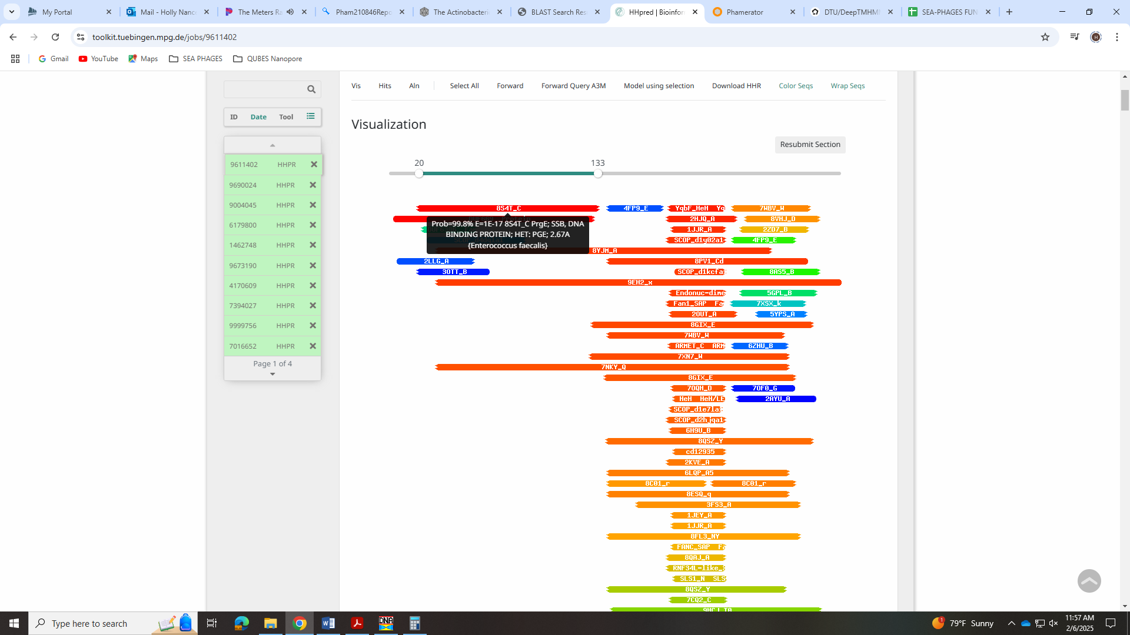
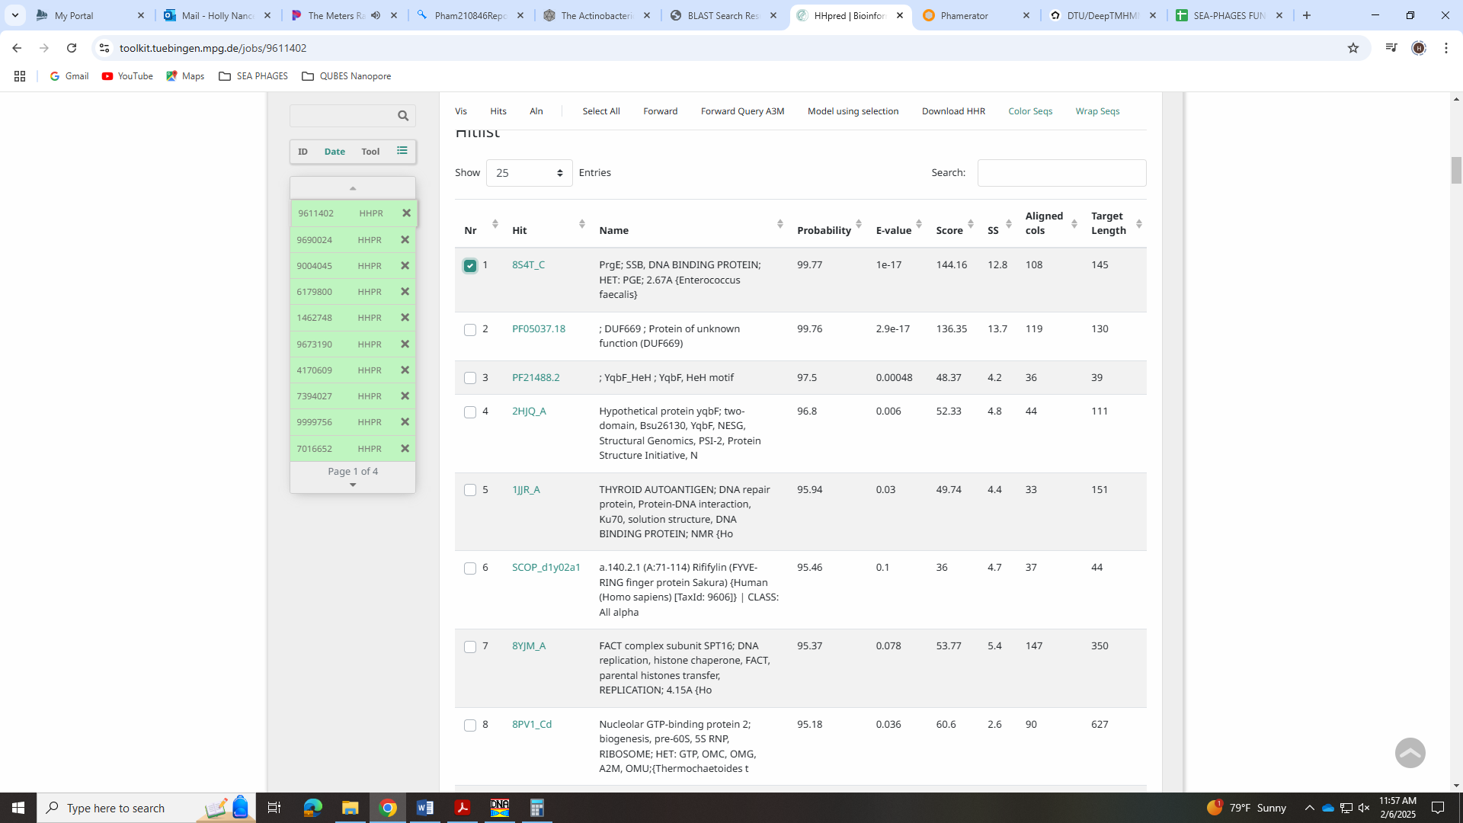

Gene 34 - reverse
SSC: start 23821, stop 23126; CP: yes; SCS: Both called start at 23821; ST: SS; Blast Start: matches Zayulive_34 Query 1 to Subject 1 100% e⁻¹²⁸; Gap: overlap of 4; LO: NA; RBS: -4.875, 1.522, 9, -5.650, no; F: ASCE ATPase; SIF-BLAST: AAA ATPase/PhageDB BLAST/ Zayuliv_34, MT889377/100%/e⁻¹²⁸; SIF-HHPred: ASCE ATPase;, several matches with a probability above 90% for RecA, AAA, recombinase… asked on forum; SIF-Syn: AAA ATPase
Notes: Start is conserved and unambiguous. Function is not! Nearly all BLAST hits are for AAA ATPase, but the function list says not to call this anymore and provides the link to Sally Malloy’s ppt on when to call RecA recombinase and when to call ASCE ATPase.
https://www.dropbox.com/scl/fi/llayt62i51ogautc5sgul/How-to-call-a-RecA-recombinase_8.3.23.pptx?rlkey=kg1y5j5kifdi2ooajuj4k1ekg&e=1&dl=0
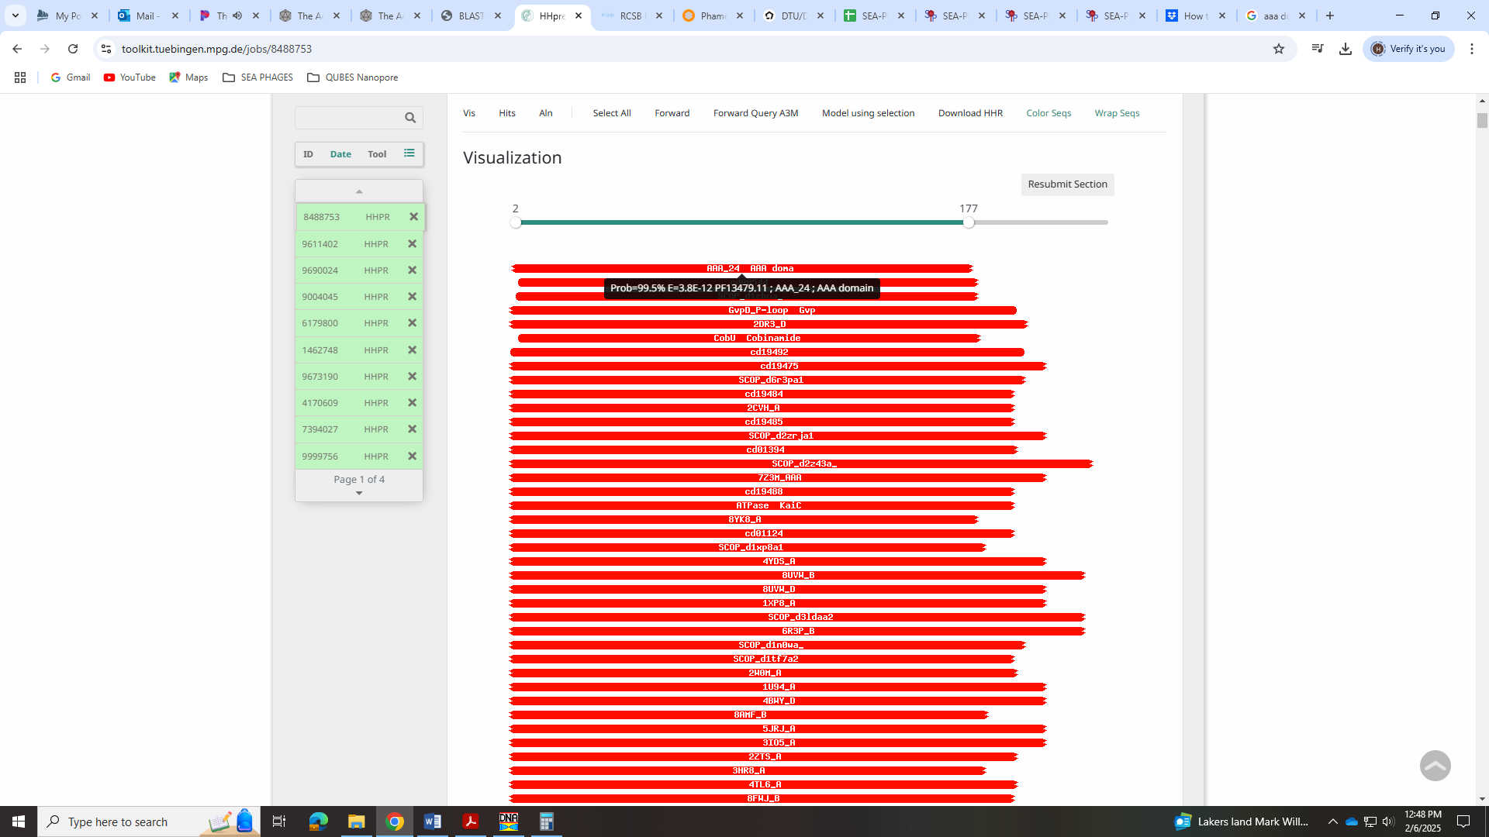
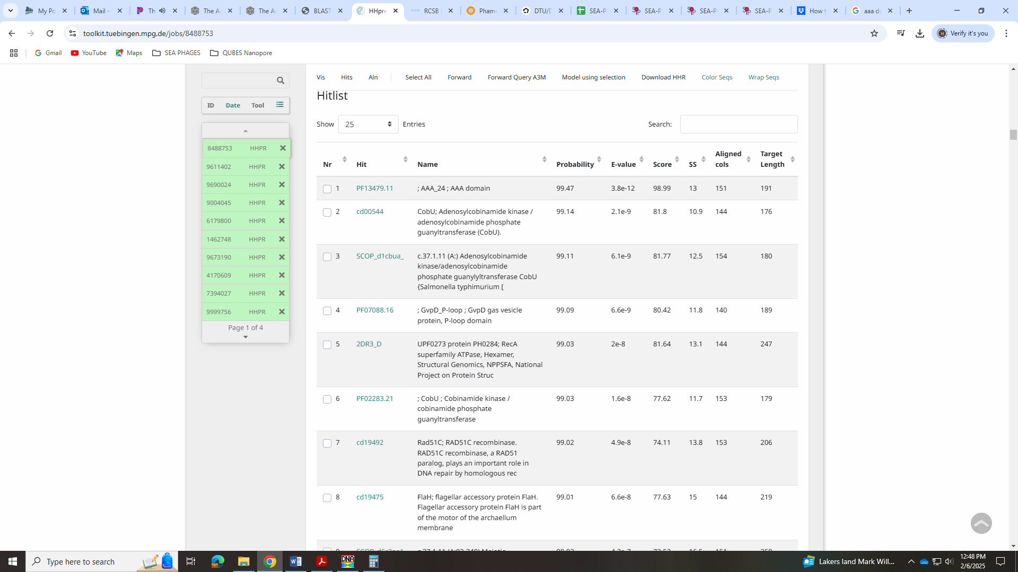
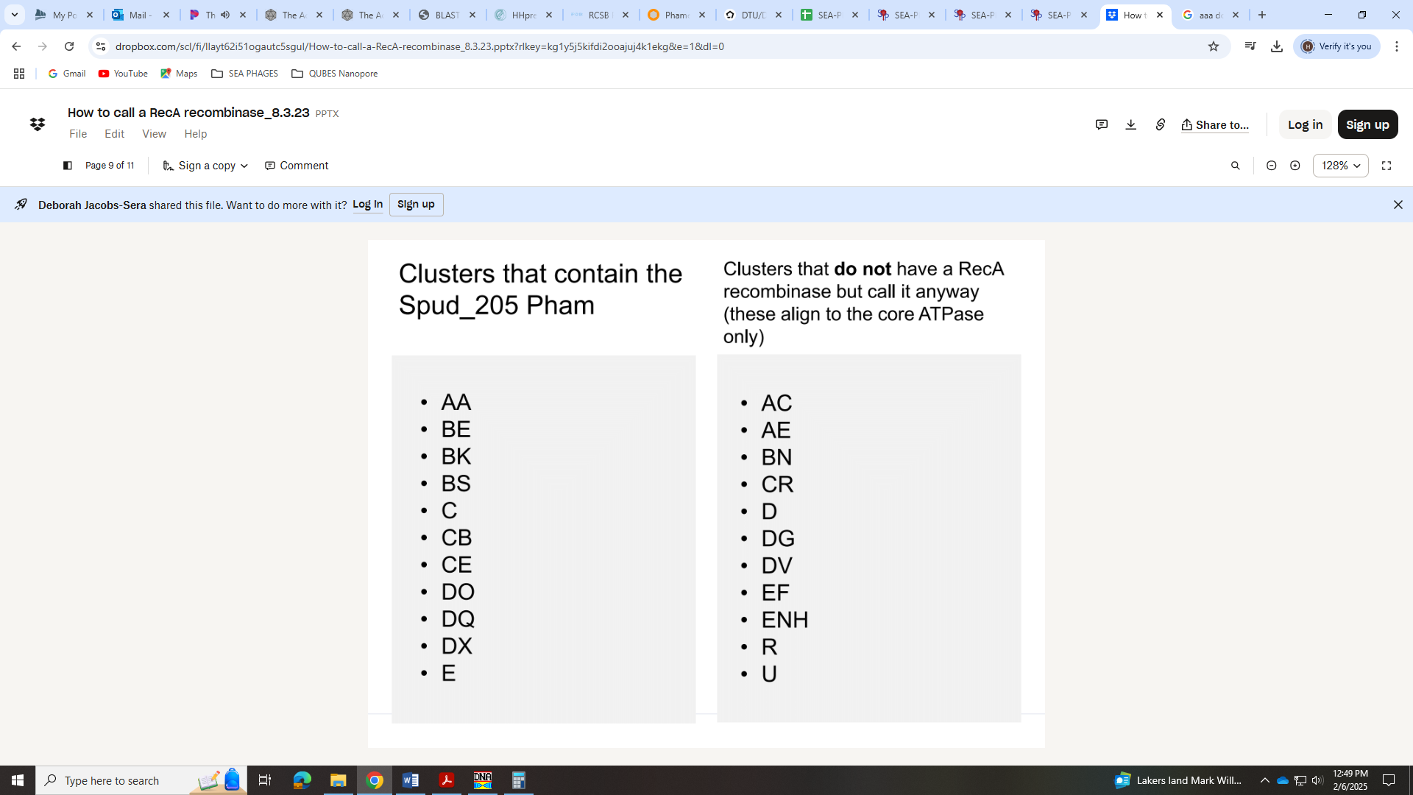
I don’t see all features needed to call RecA recombinase based on the ppt, but it doesn’t seem like ASCE ATPase’s are in cluster EA? The Cluster Annotation Report (can’t locate it again on Forum) implied that these phage had both AAA ATPase and RecA recombinase?
Debbie just said to call it ASCE ATPase!
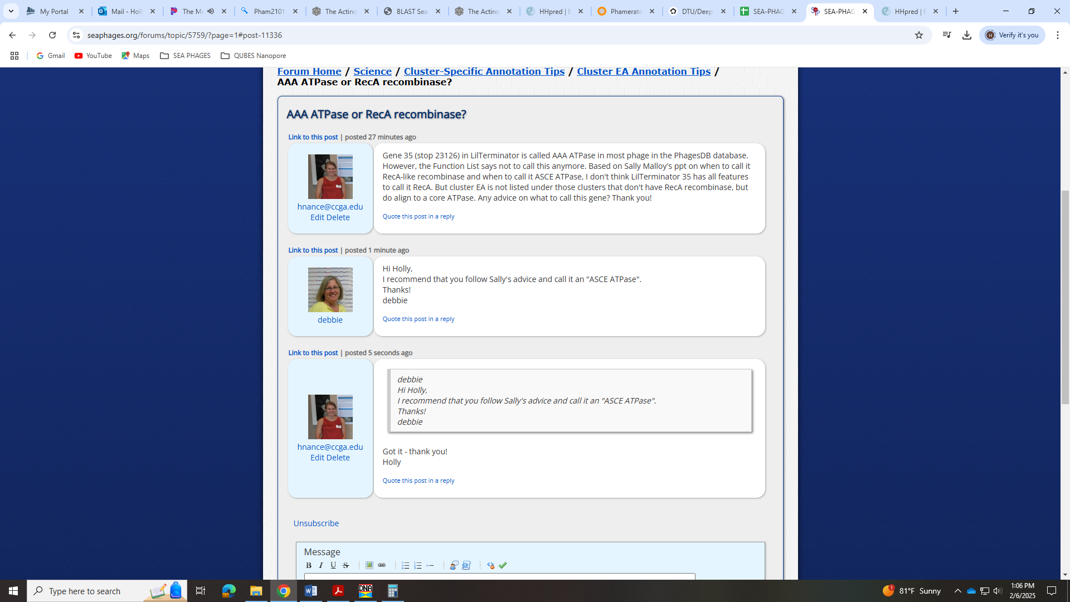

Gene 35 - reverse
SSC: start 24996, stop 23818; CP: yes; SCS: Both called start at 24996; ST: SS; Blast Start: matches Zayuliv_35 Query 1 to Subject 1 100% 0.0; Gap: overlap of 1; LO: NA; RBS: -4.228, 1.825, 13, -5.274, no; F: Cas4 family exonuclease; SIF-BLAST: Cas4 family exonuclease /PhageDB BLAST/Librie_35, ON970570/100%/0.0; SIF-HHPred: Cas4 family exonuclease, several matches with a probability above 99% that better align and are supported with forum post on this; SIF-Syn: Cas4 family exonuclease
Notes: Start is conserved. For function, there were some hits for nuclease, RecB-like exonuclease/helicase, and Cas4 family exonuclease:
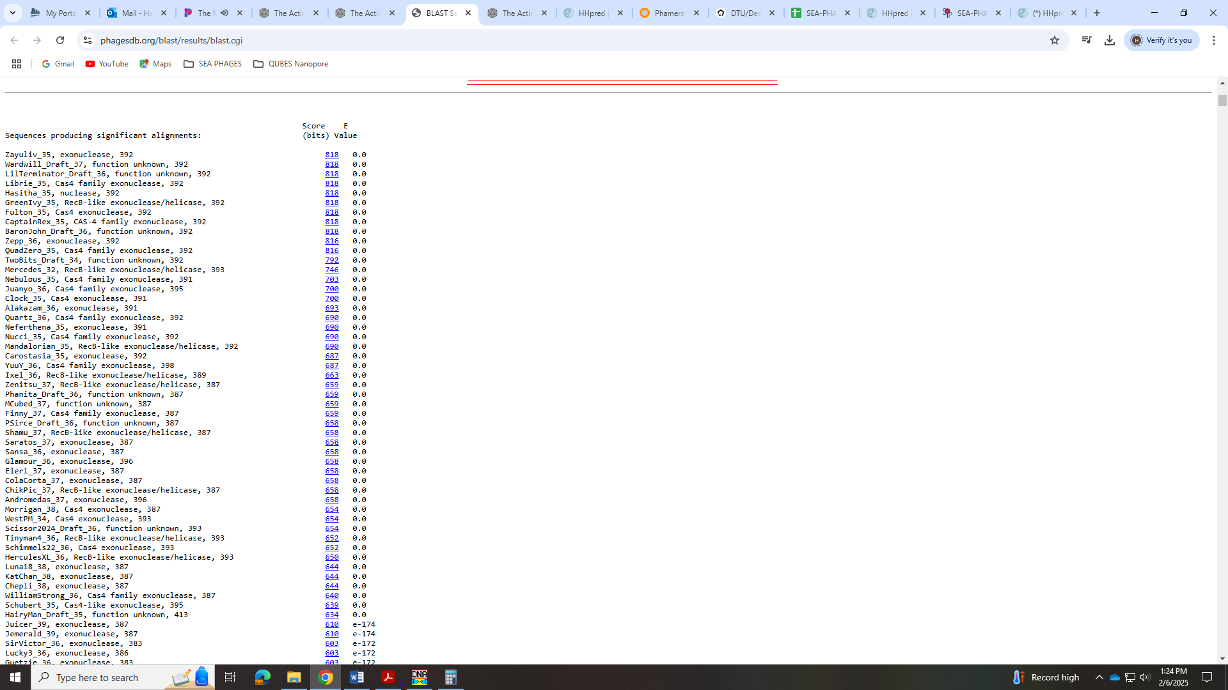
Here’s what the function list said
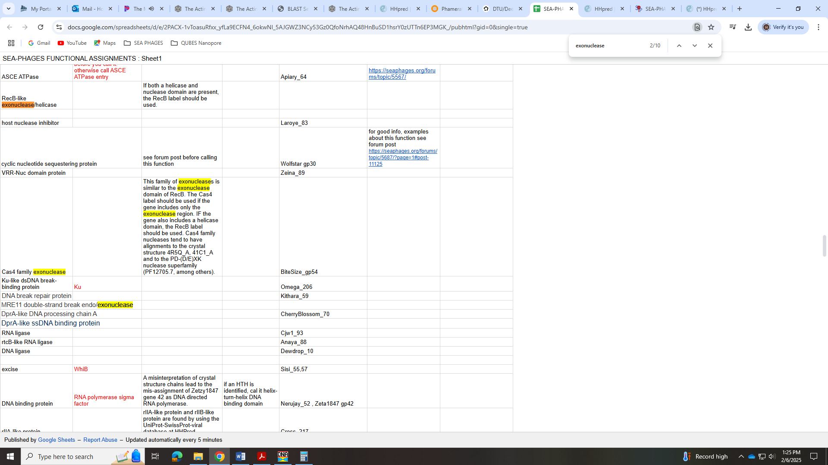
HHPred had hits to both helicase and nuclease domains, AND hits to what is needed to call Cas4:
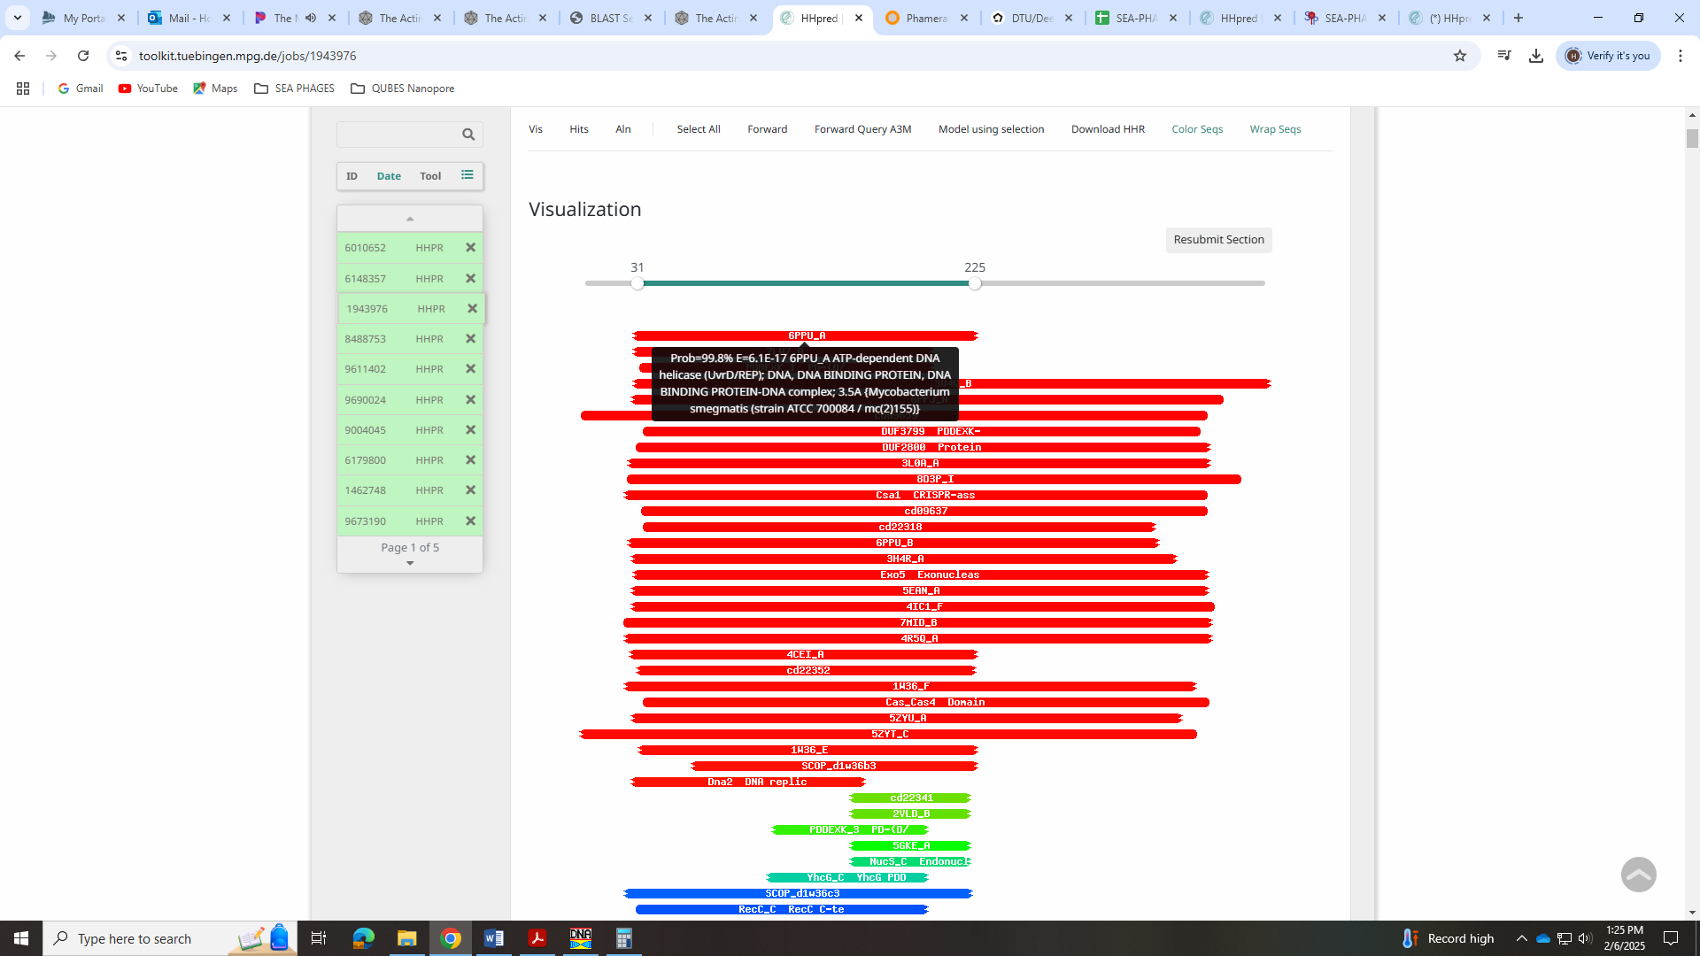
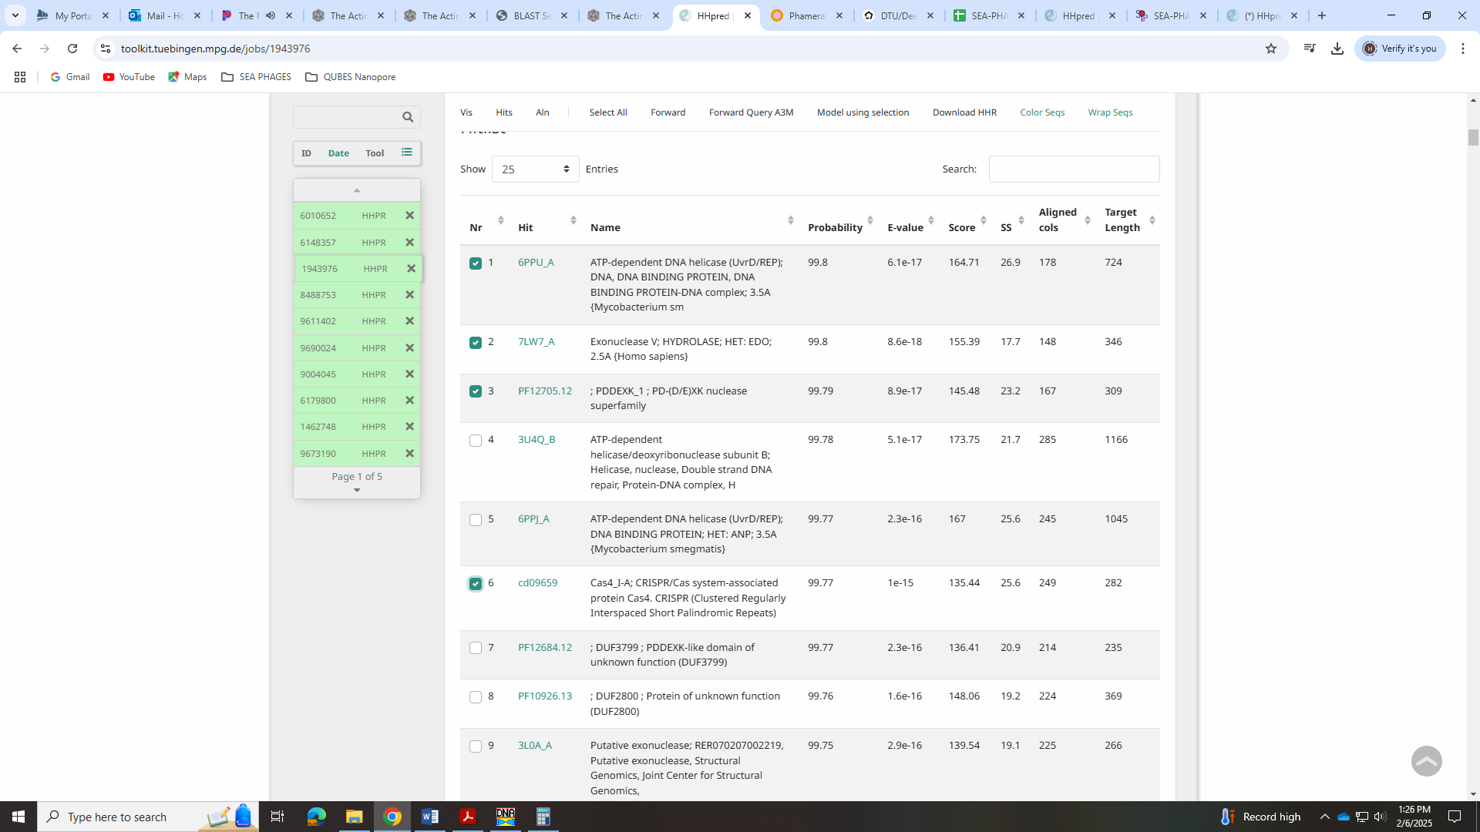
I read thru all the info on this call in the forum – there was a lot!
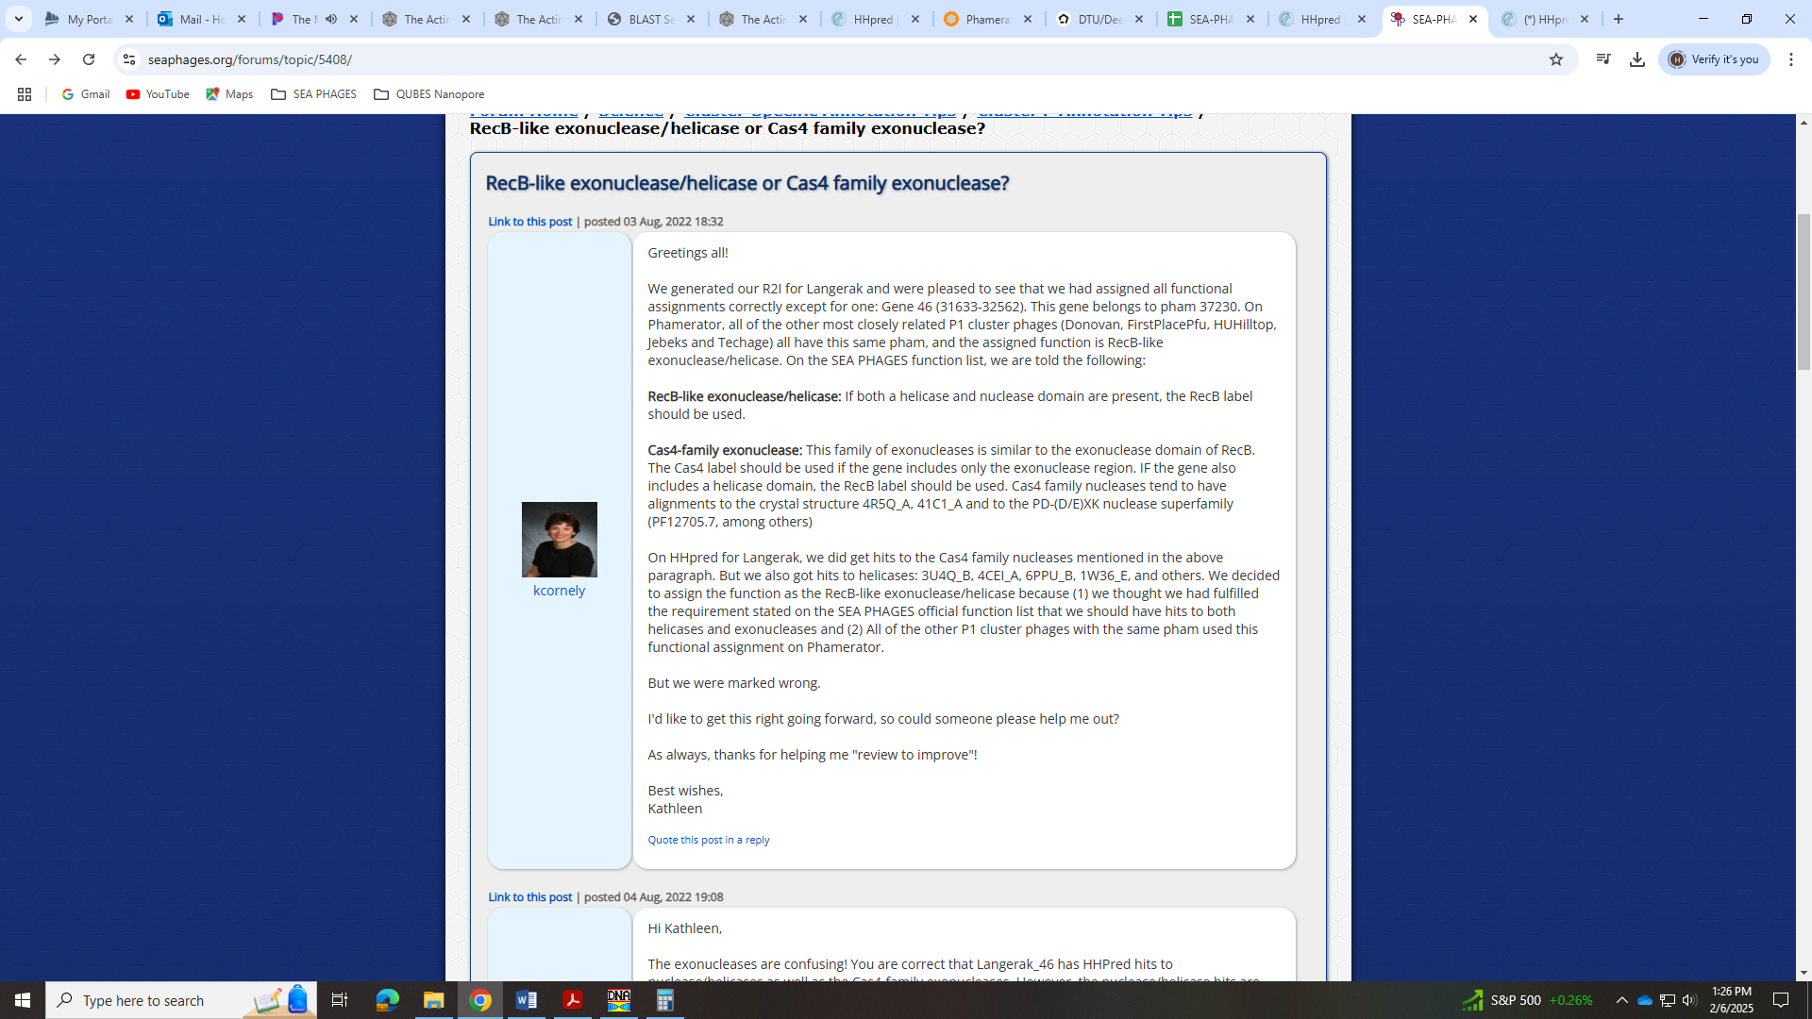
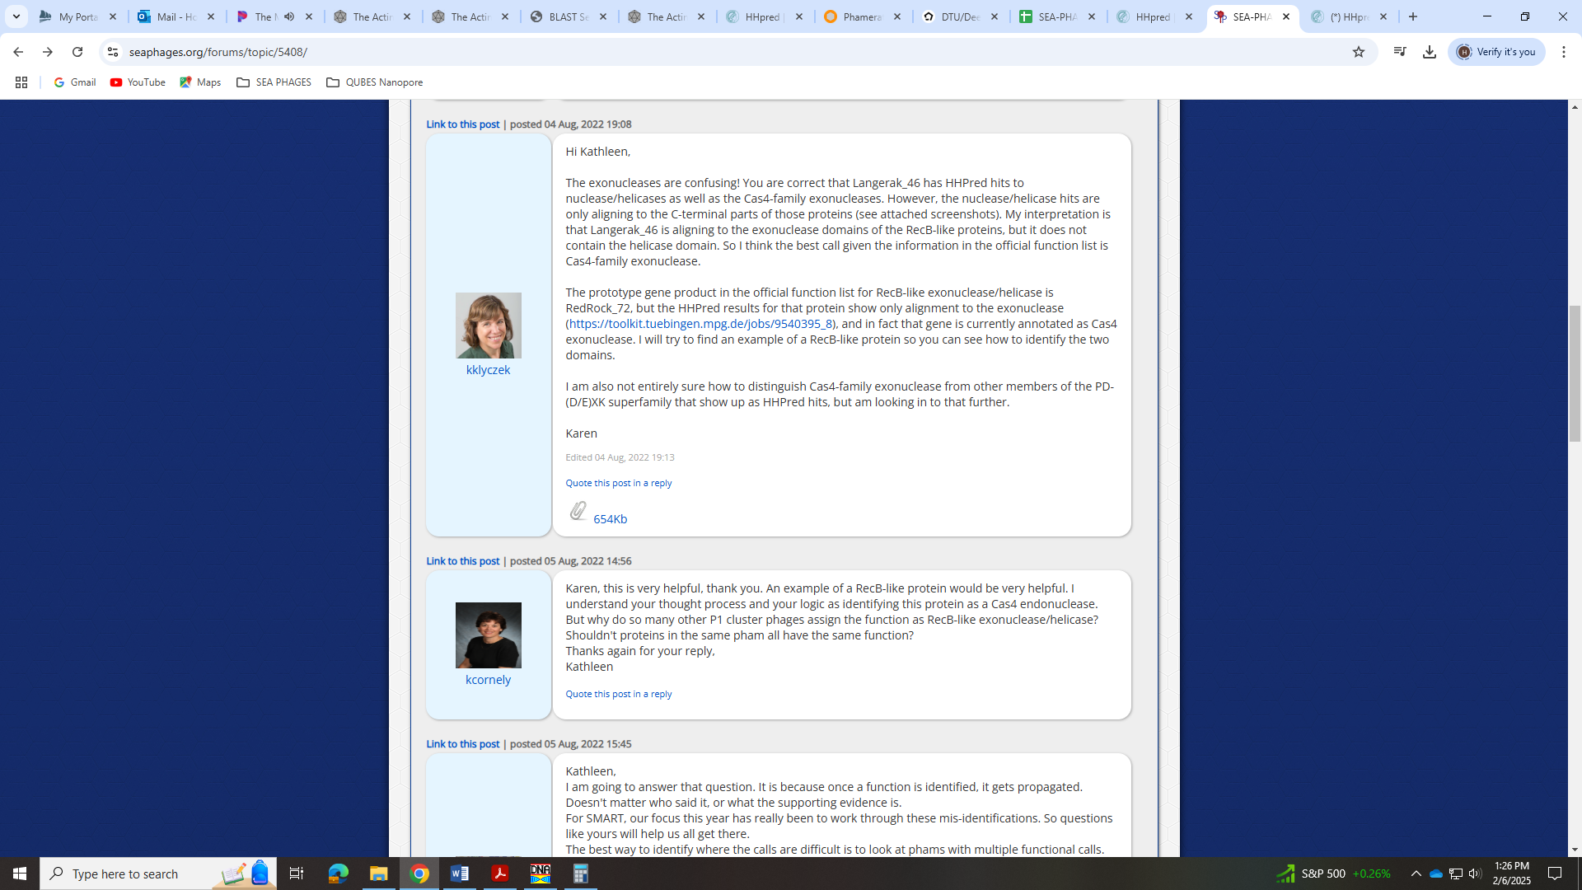
Here is the screenshot referenced:
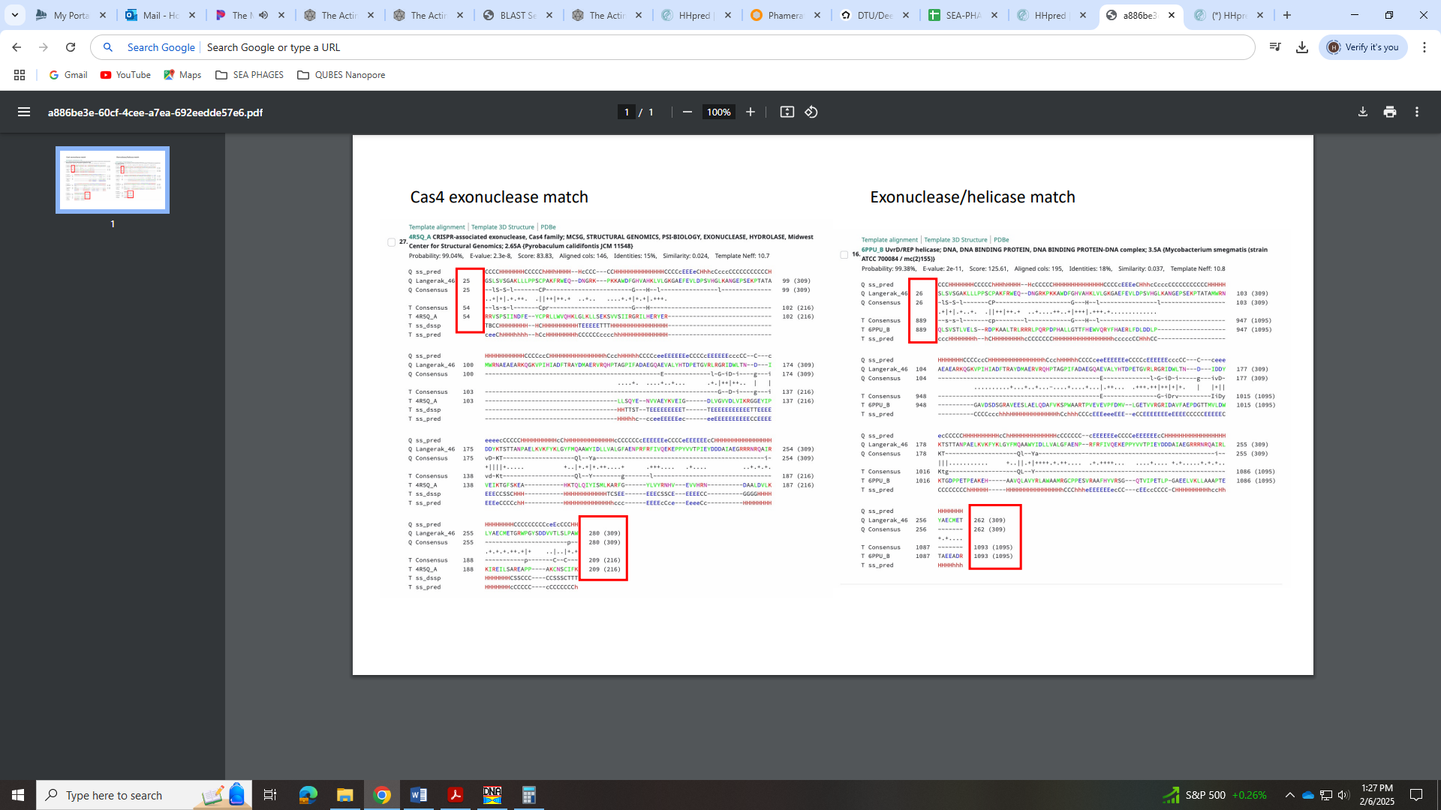
When I look at the alignments for the helicase domains, they are similarly at the C-terminus of the gene:
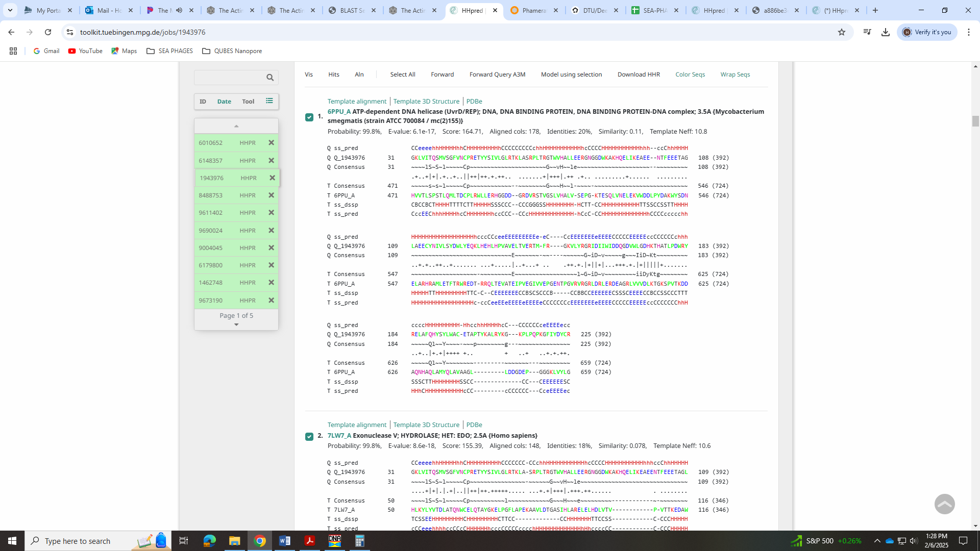
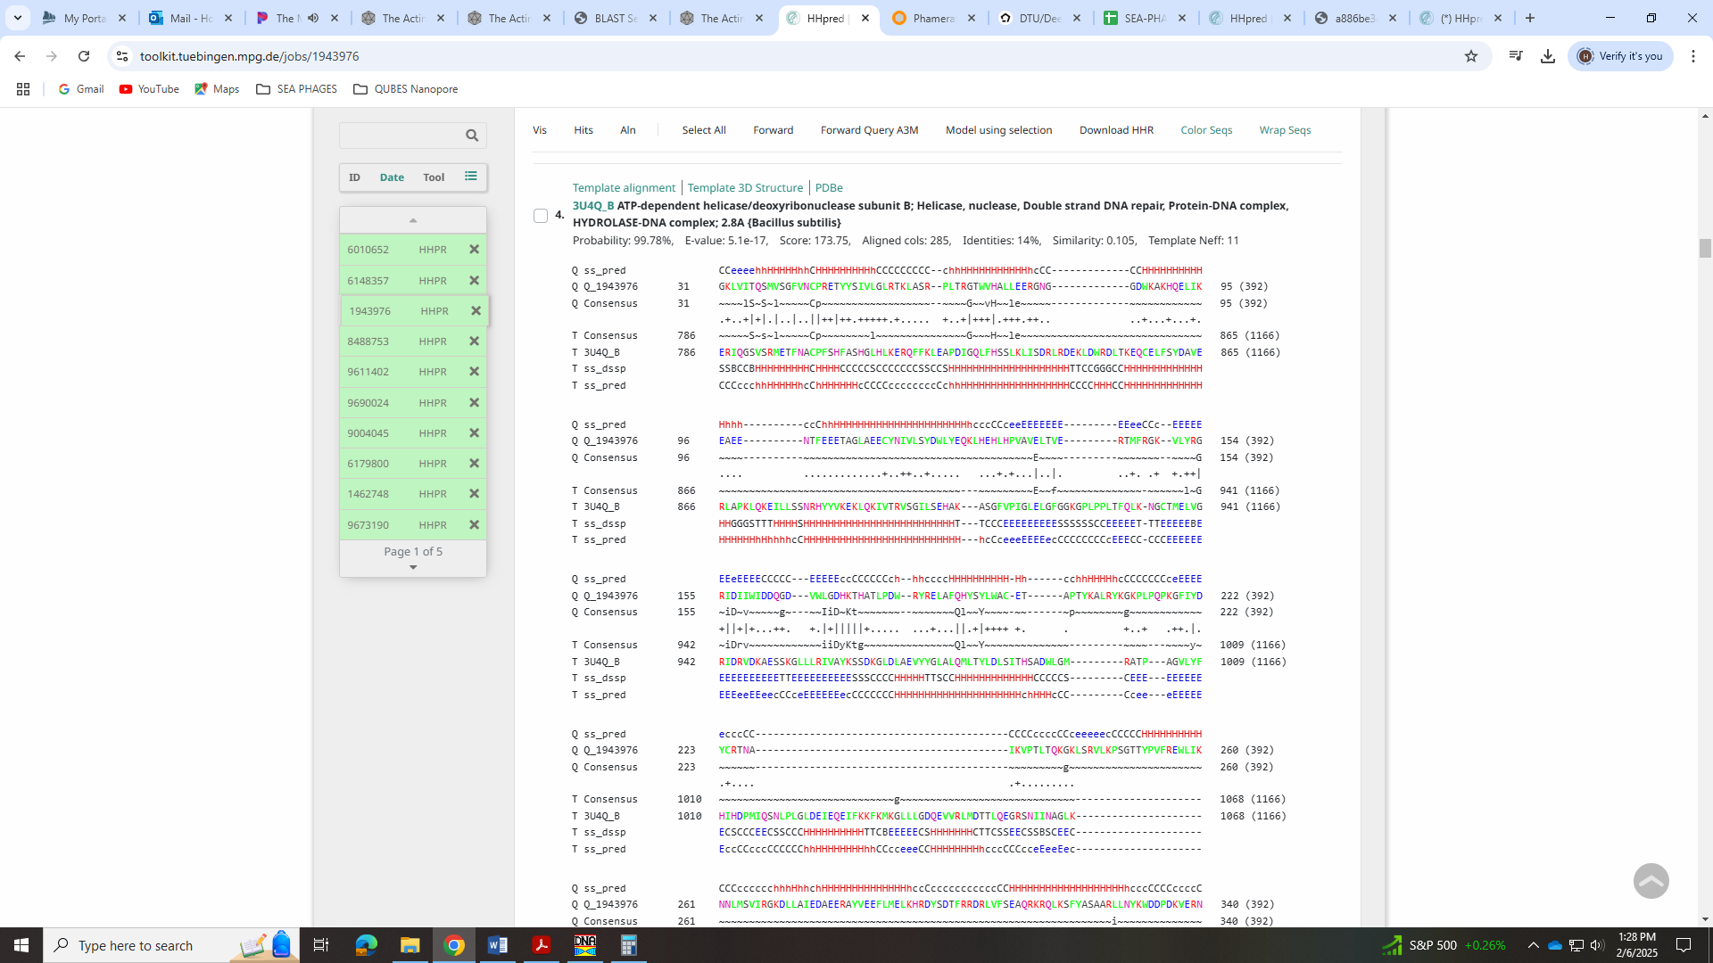
But the Cas4 domains align with the whole protein:
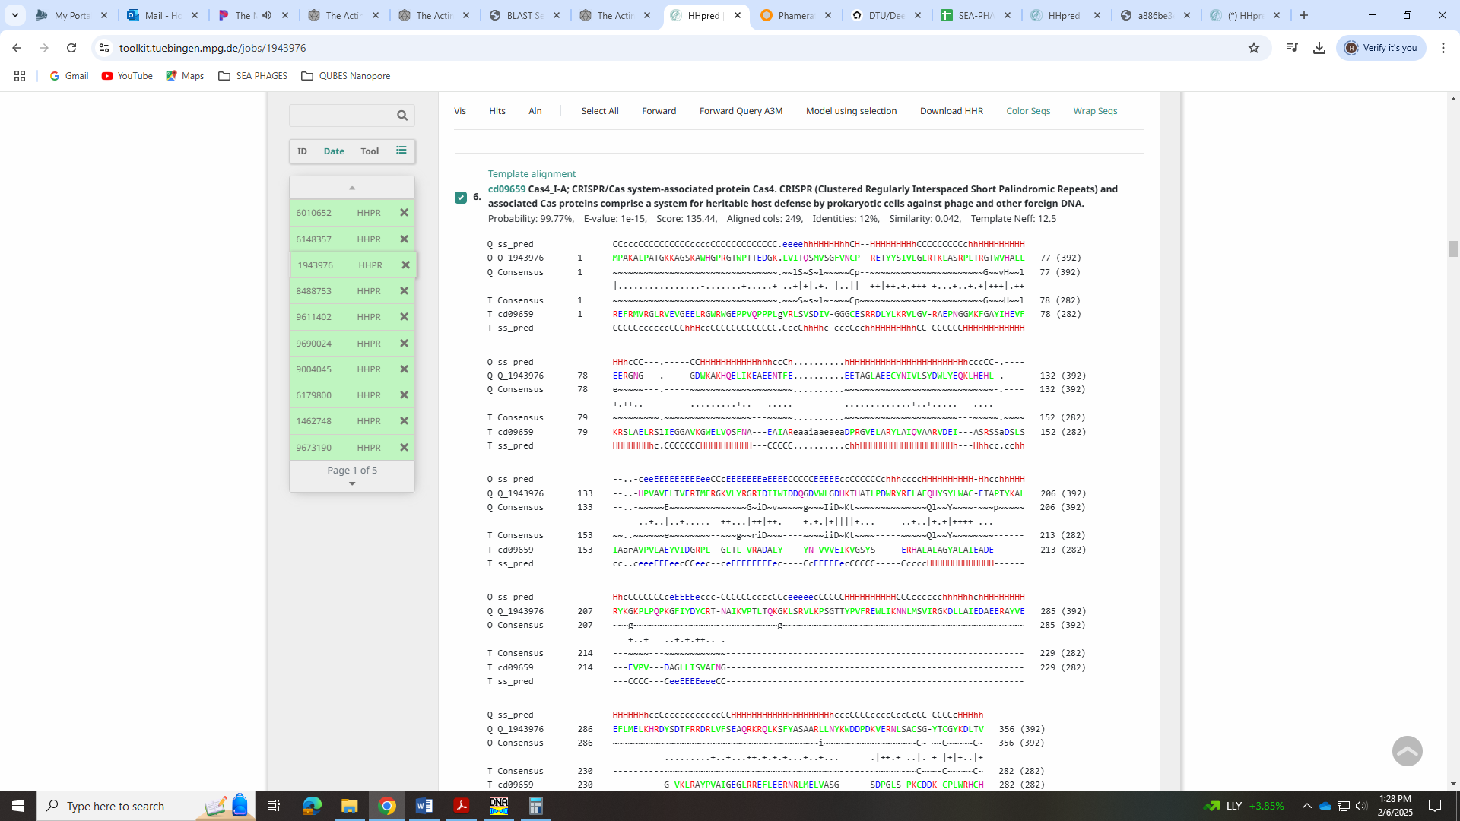
Based on this and the lengthy forum post, I’m going to call this the Cas4 family exonuclease!

Gene 36 – reverse – changed start to 25160 on 2/7/25!
SSC: start 25160, stop 24996; CP: yes; SCS: Glimmer called start at 25172, GeneMark called 25106, but I changed start to 25160 as this was most annotated; ST: SS; Blast Start: matches Zepp_37 Query 1 to Subject 1 98% 1e⁻²⁶; Gap: overlap of 14; LO: NA; RBS: -3.861, 1.998, 10, -4.555, no; F: NKF; SIF-BLAST: NKF/PhageDB BLAST/Zepp_37, MN908686/98%/1e⁻²⁶; SIF-HHPred: NKF, no matches with a probability above 90%; SIF-Syn: NKF
Notes: Function was NKF and unambiguous. Start on this was tricky. Neither GeneMark or Glimmer called the most conserved start in Starterator. GeneMark’s call yielded a large gap of 40 BP, and only 3 other phage called it. Glimmer’s call yielded an overlap of 26 BP and was only called in the LilTerminator draft.
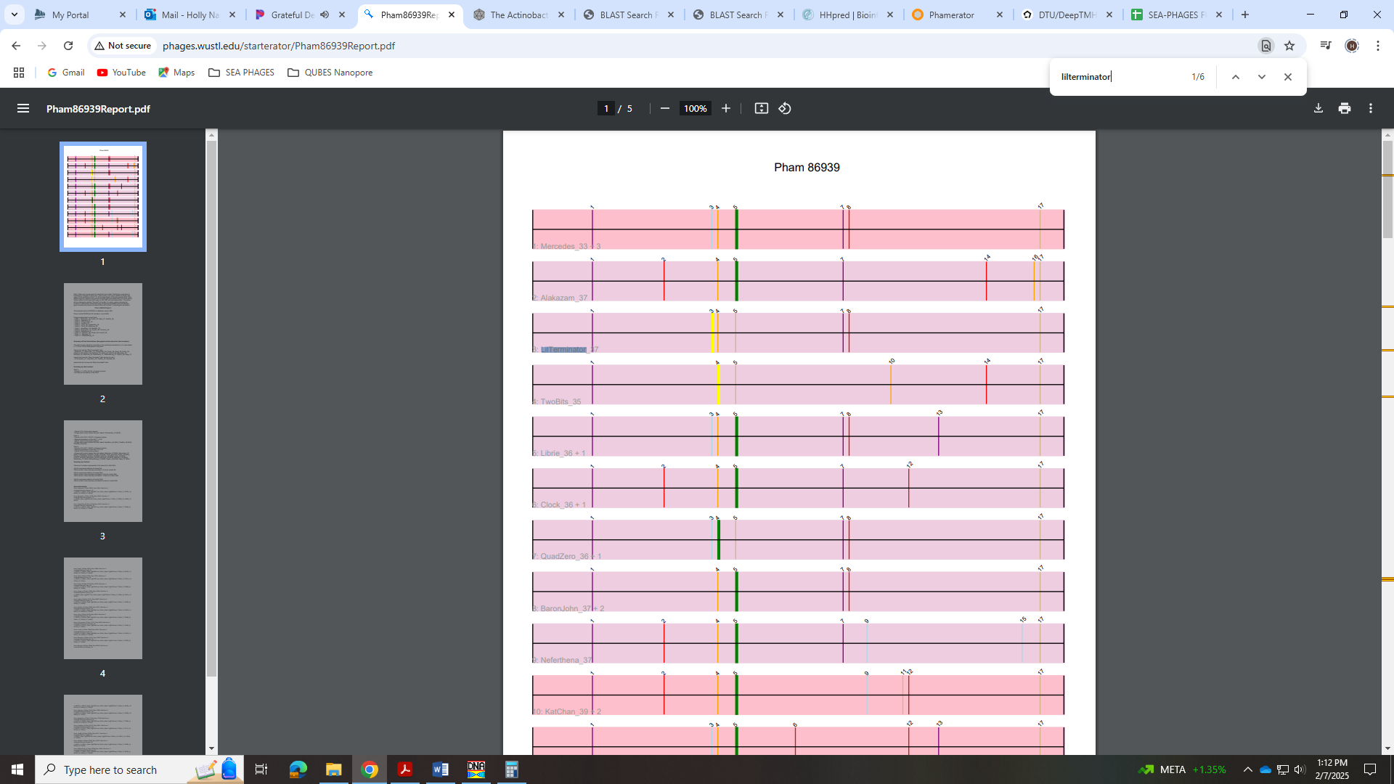
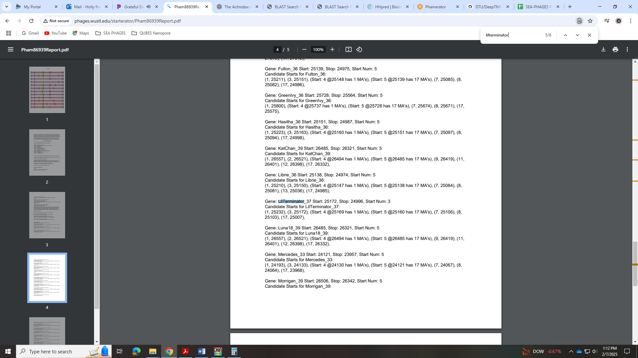
Neither of these yielded 1:1 Q:S in BLAST:
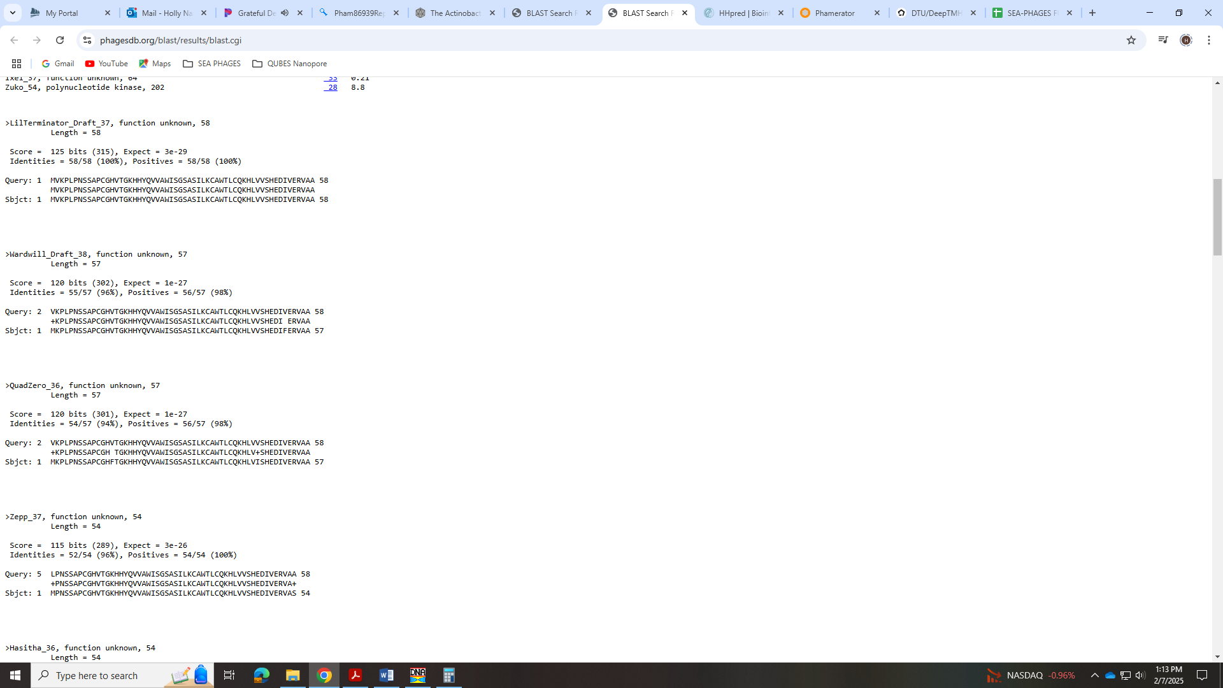
Also, there wasn’t coding potential for the Glimmer start:
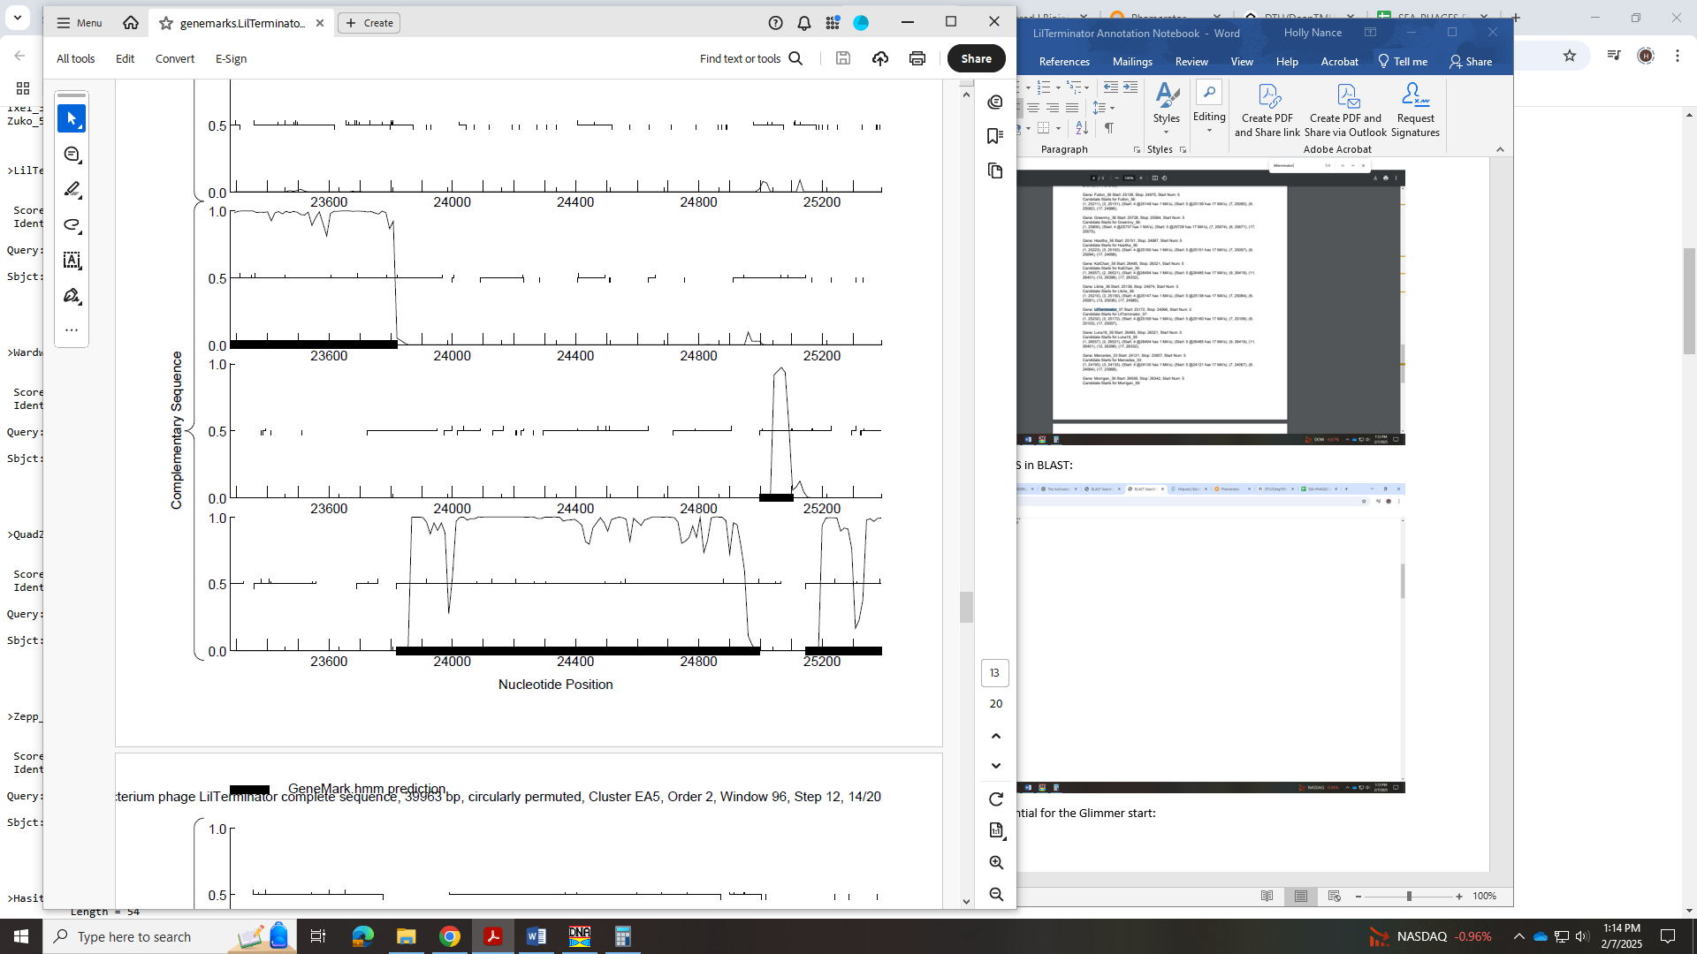
I went with the most conserved start in Starterator that yielded the most 1:1 Q:S in BLAST. This start is 25160.
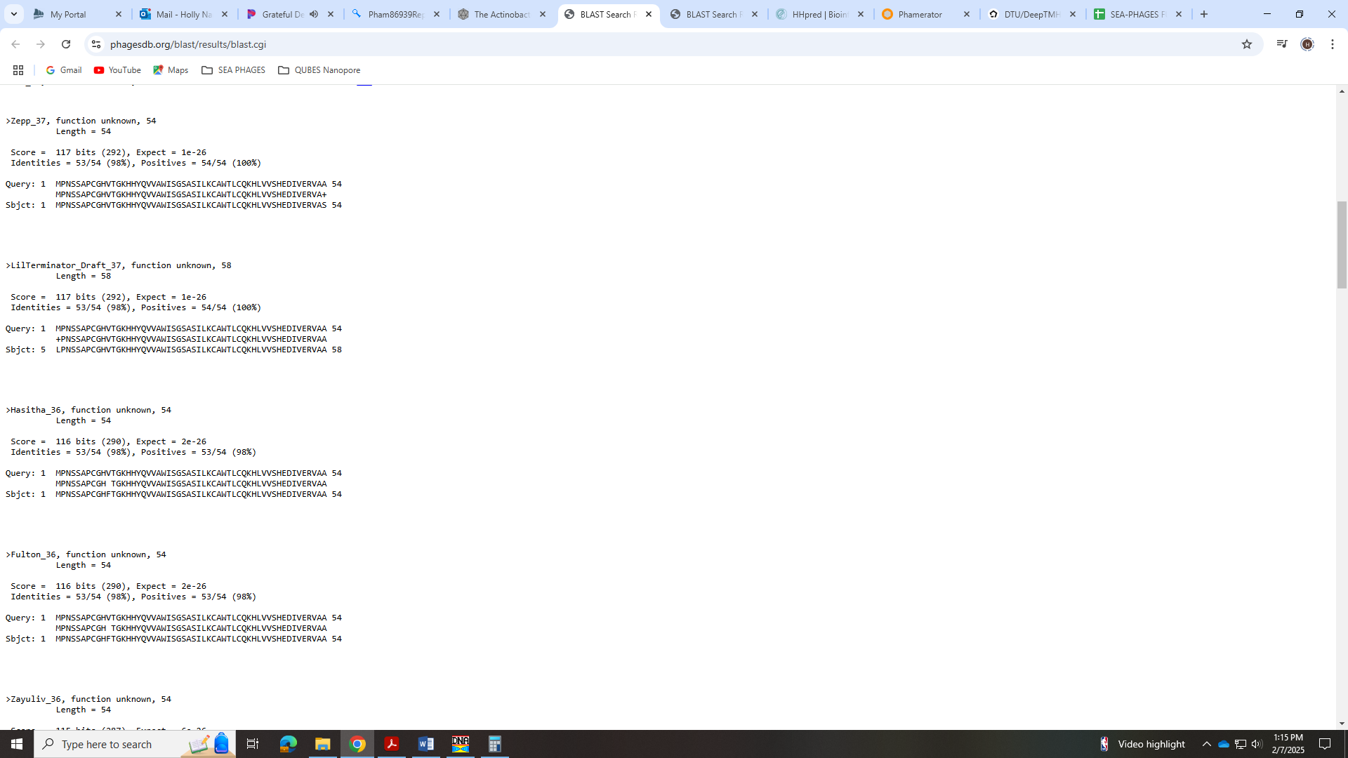
There is an overlap of 14 BP with this start, but all phage in EA5 have a slight overlap with this gene.
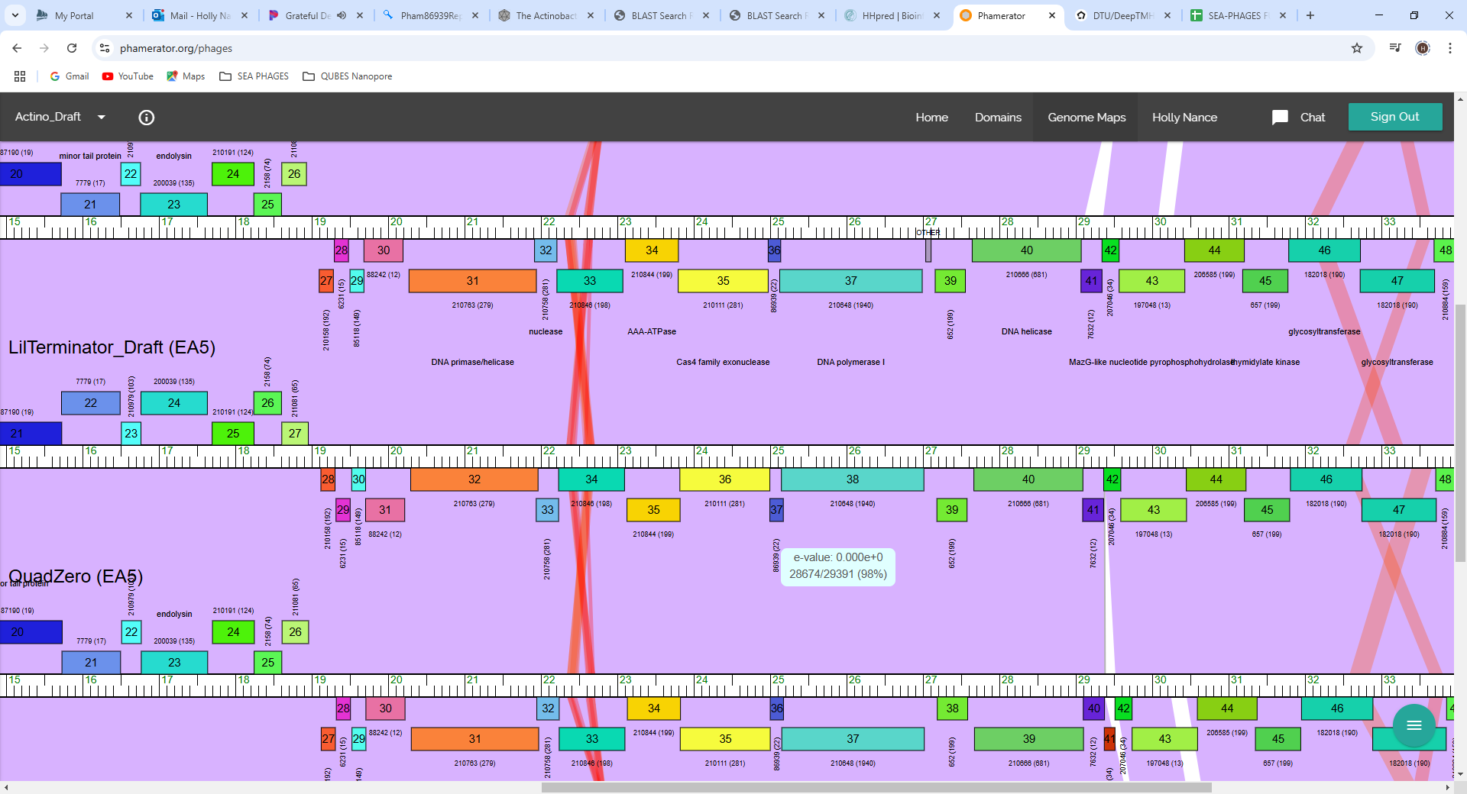

Gene 37 - reverse
SSC: start 27012, stop 25147; CP: yes; SCS: Both called start at 27012; ST: SS; Blast Start: matches Zepp_38 Query 1 to Subject 1 100% 0.0; Gap: 169; LO: yes; RBS: -1.748, 2.989, 13, -2.794, no; F: DNA polymerase I; SIF-BLAST: DNA polymerase I /PhageDB BLAST/Zepp_38, MN908686/100%/0.0; SIF-HHPred: DNA polymerase I, several matches with a probability of 100%; SIF-Syn: DNA polymerase I
Notes: Start was most conserved and yielded longest ORF. There is a large gap of 169 BP, however. This gap is conserved in other phage in EA5. 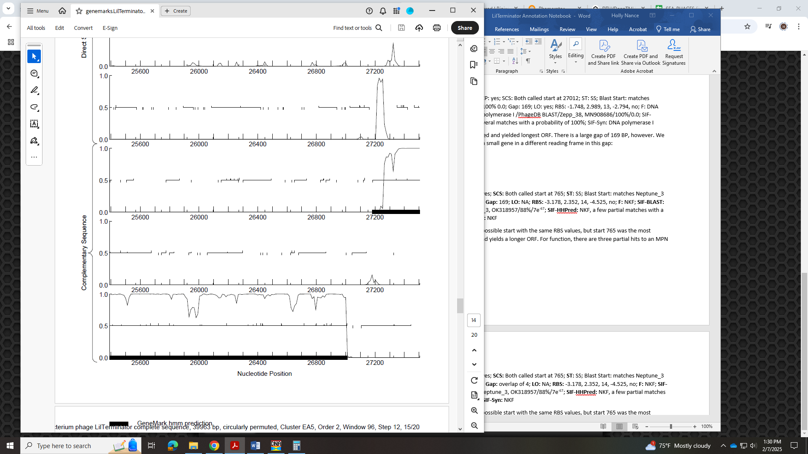
Also, in Phamerator there is a gap in other phage, but some have this weird gray box that is not a gene…
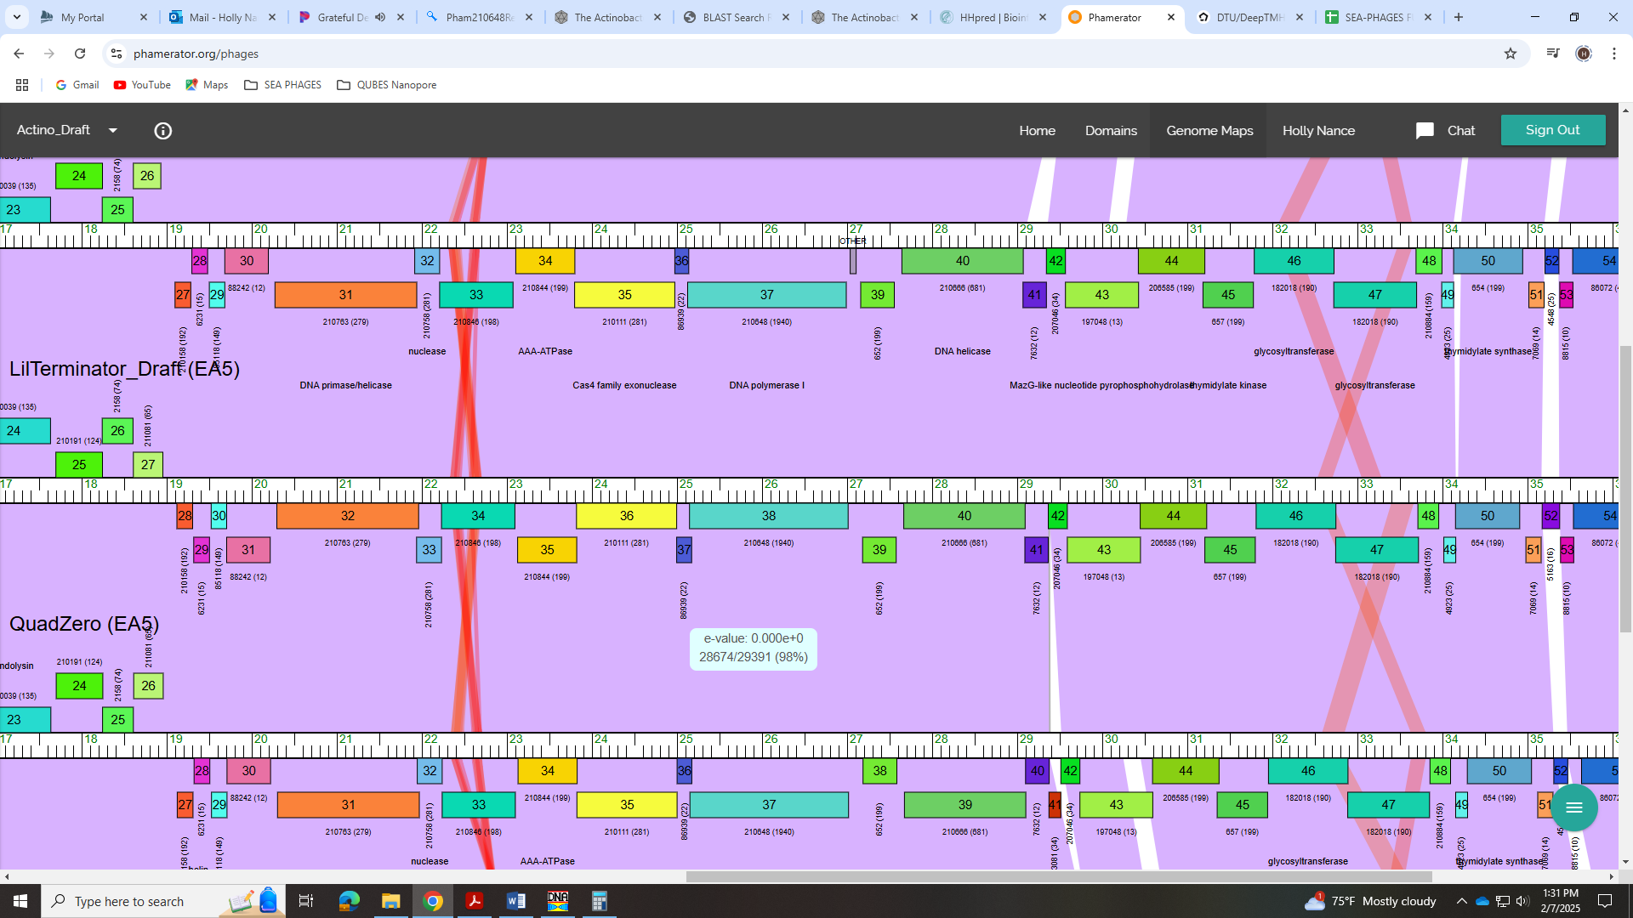
For function, all data suggests DNA polymerase I.
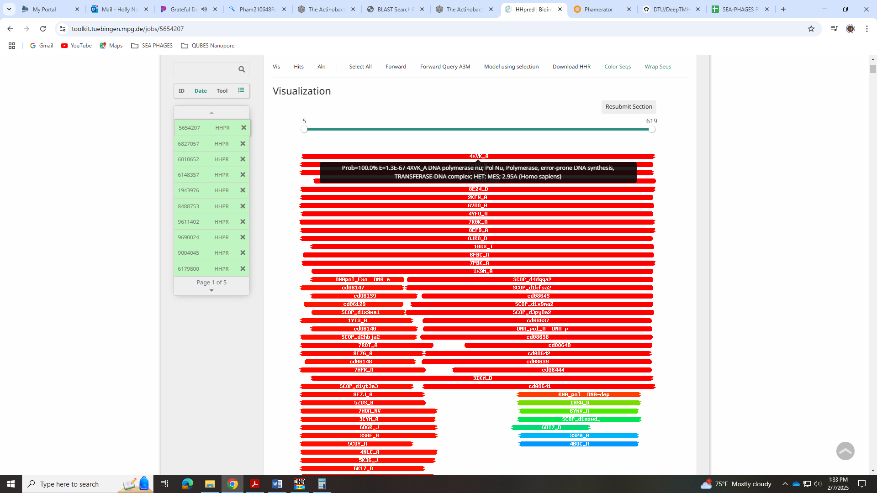
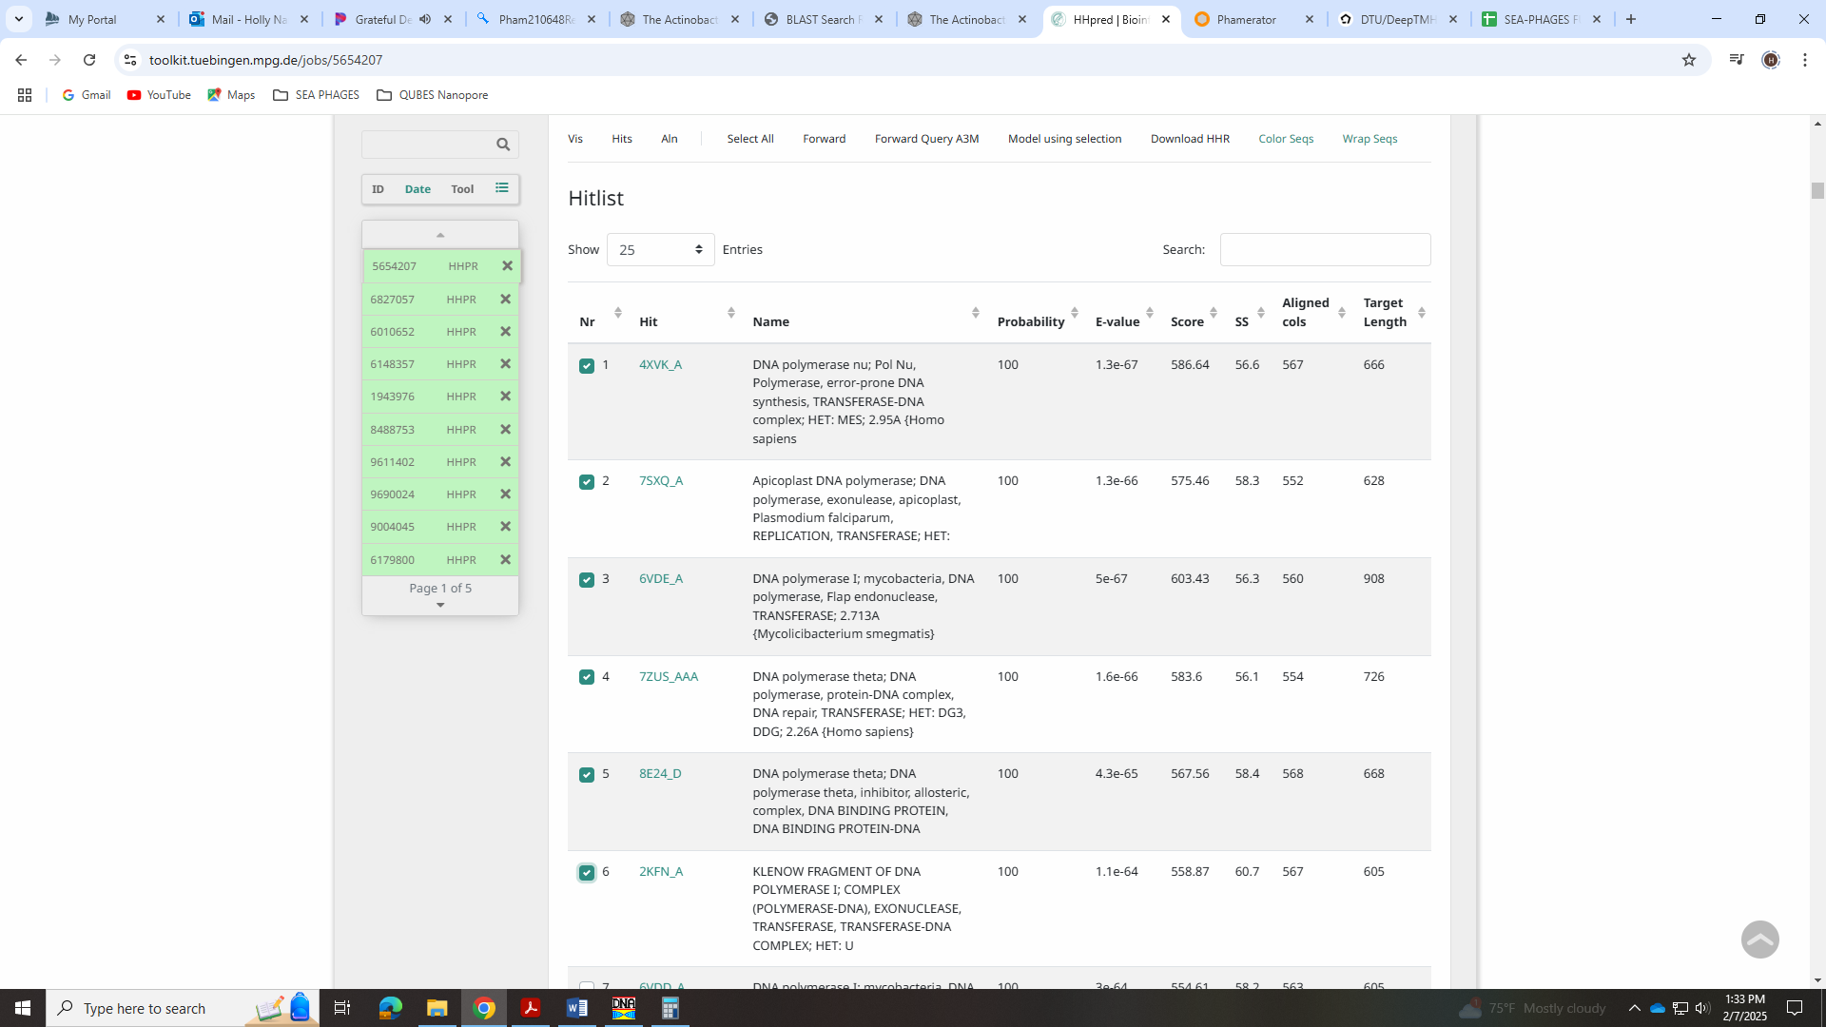

Gene 38 - reverse
SSC: start 27577, stop 27182; CP: yes; SCS: Both called start at 27577; ST: SS; Blast Start: matches Librie_39 Query 1 to Subject 1 99% 1e⁻⁶⁶; Gap: 88; LO: yes; RBS: -1.748, 2.989, 10, -2.443, yes; F: NKF; SIF-BLAST: NKF/PhageDB BLAST/Librie_39, ON970570/99%/1e⁻⁶⁶; SIF-HHPred: NKF, no matches with a probability above 90%; SIF-Syn: NKF
Notes: Start is most annotated and function of NKF well supported. Nothing ambiguous!

Gene 39 - reverse
SSC: start 29093, stop 27666; CP: yes; SCS: Both called start at 29093; ST: SS; Blast Start: matches GreenIvy_40 Query 1 to Subject 1 100% 0.0; Gap: overlap of 4; LO: yes; RBS: -2.654, 2.564, 15, -4.256, no; F: DNA helicase; SIF-BLAST: DNA helicase /PhageDB BLAST/GreenIvy_40, PP978818/100%/0.0; SIF-HHPred: NKF, several matches with a probability of 100%; SIF-Syn: DNA helicase
Notes: Start is conserved and yields longest ORF. For function, all data supports DNA helicase:
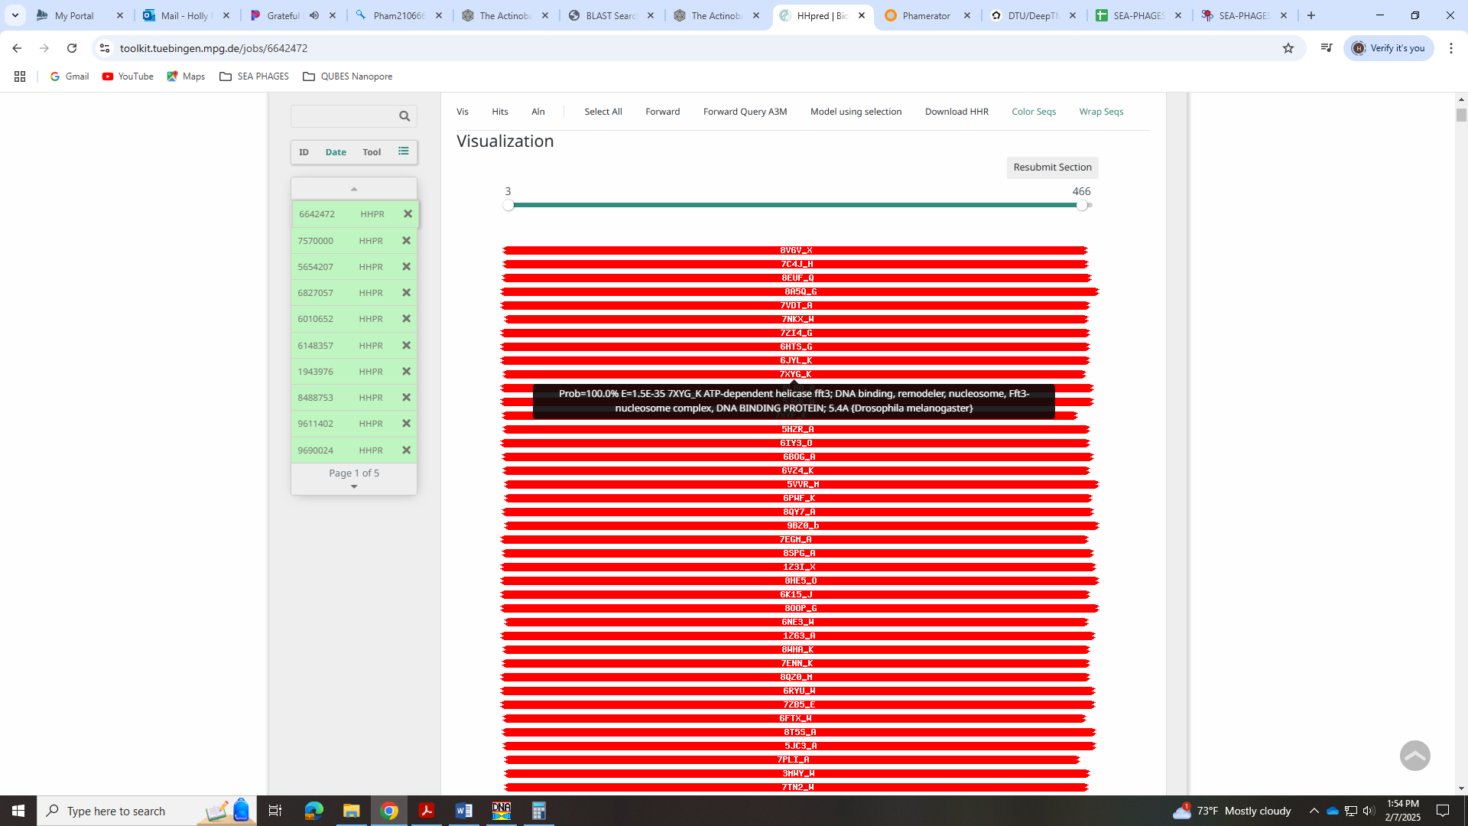
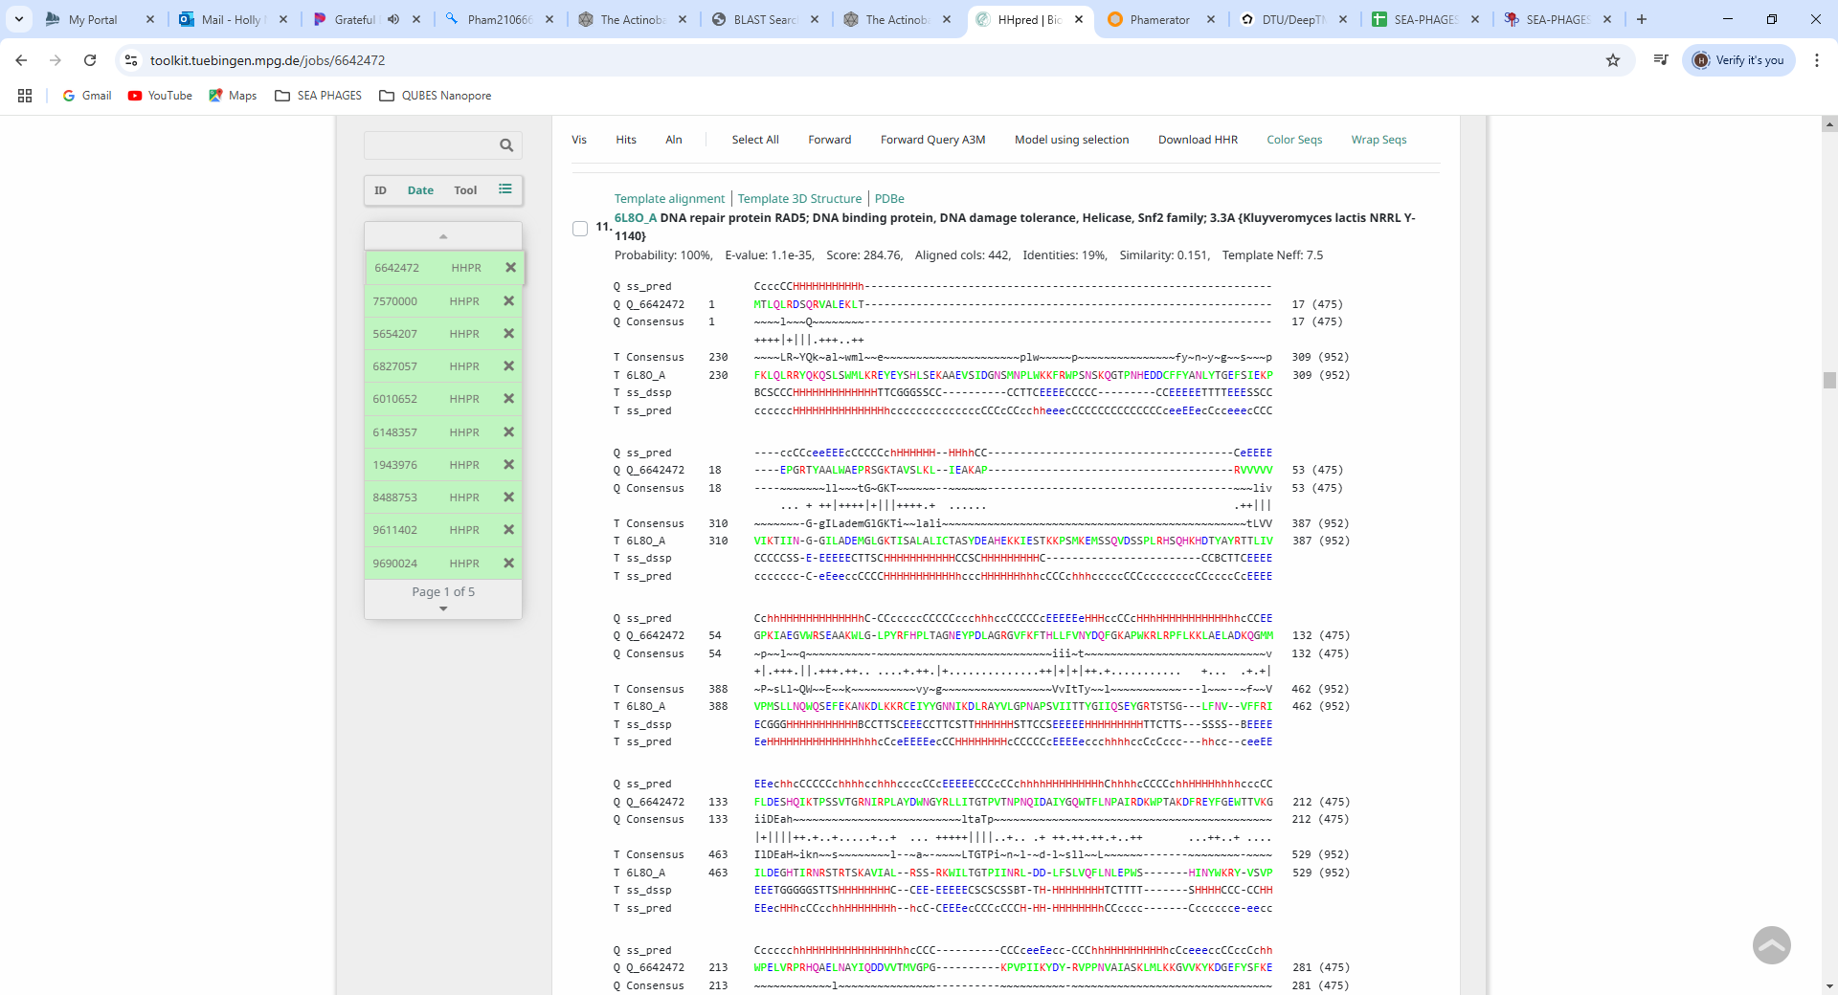
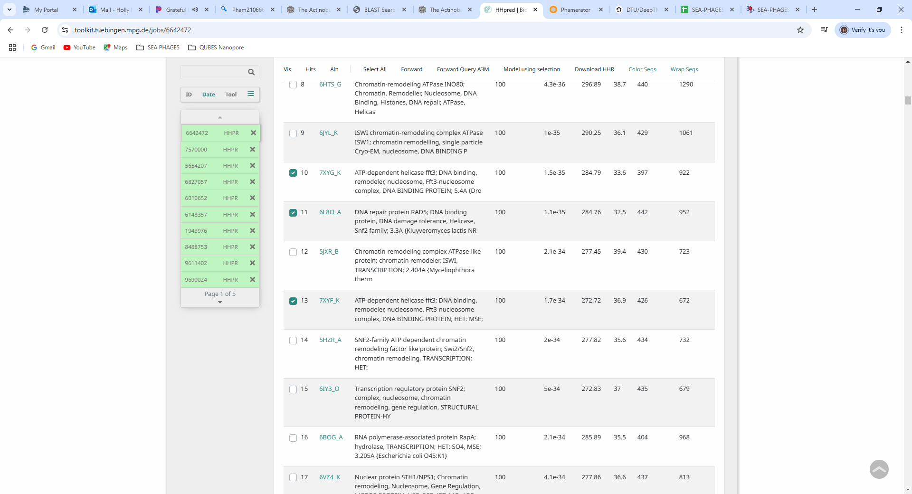

Gene 40 - reverse
SSC: start 29365, stop 29090; CP: yes; SCS: Both called start at 29365; ST: SS; Blast Start: matches Zepp_41 Query 1 to Subject 1 98% 5e⁻⁴⁹; Gap: overlap of 1; LO: NA; RBS: -3.225, 2.296, 10, -3.920, yes; F: NKF; SIF-BLAST: NKF/PhageDB BLAST/ Zepp_41, MN908686/98%/5e⁻⁴⁹; SIF-HHPred: NKF, no matches with a probability above 90%; SIF-Syn: NKF
Notes: Start is most annotated. Function of NKF supported by all data.

Gene 41 - reverse
SSC: start 29589, stop 29365; CP: yes; SCS: Both called start at 29589; ST: SS; Blast Start: matches Zayuliv_42 Query 1 to Subject 1 97% 9e⁻³⁷; Gap: overlap of 1; LO: yes; RBS: -3.079, 2.364, 9, -3.854, no; F: NKF; SIF-BLAST: NKF/PhageDB BLAST/ Zayuliv_42, MT889377/97%/9e⁻³⁷; SIF-HHPred: NKF, a few partial matches with a probability above 90%, but some are for NKF or human proteins; SIF-Syn: NKF
Notes: Start is most annotated. Function is supported as NKF. There are a few bits above 90%, but all are partial and for NKF, human proteins, anchor proteins or chitin synthesis – not expected to be in phage.
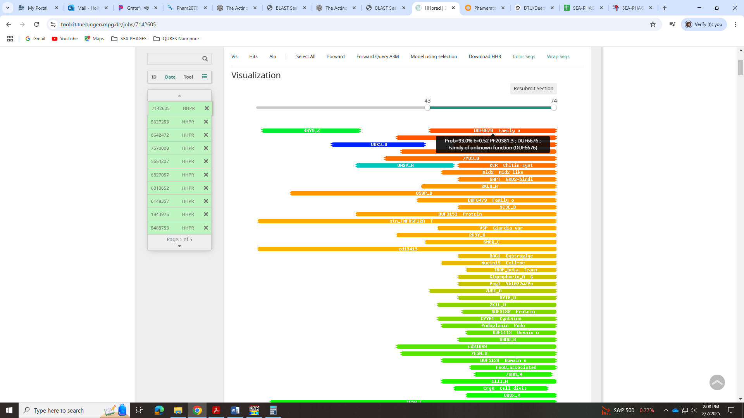
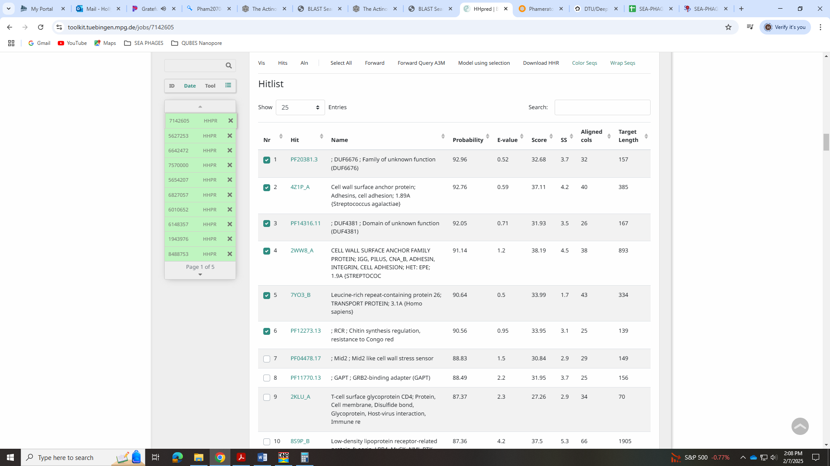

Gene 42 - reverse
SSC: start 30449 stop 29589; CP: yes; SCS: Both called start at 30449; ST: SS; Blast Start: matches Librie_43 Query 1 to Subject 1 96% e⁻¹⁶²; Gap: overlap of 4; LO: yes; RBS: -1.620, 3.049, 13, -2.666, yes; F: MazG-like nucleotide pyrophosphohydrolase; SIF-BLAST: MazG-like nucleotide pyrophosphohydrolase /PhageDB BLAST/Librie_43, OK318957/96%/e⁻¹⁶²; SIF-HHPred: MazG-like nucleotide pyrophosphohydrolase, several partial matches with a probability above 90%; SIF-Syn: MazG-like nucleotide pyrophosphohydrolase
Notes: Start is most annotated. For function, all BLAST hits are calling this MazG-like nucleotide pyrophosphohydrolase. It’s in the Official Function List. Here are the HHPred hits:
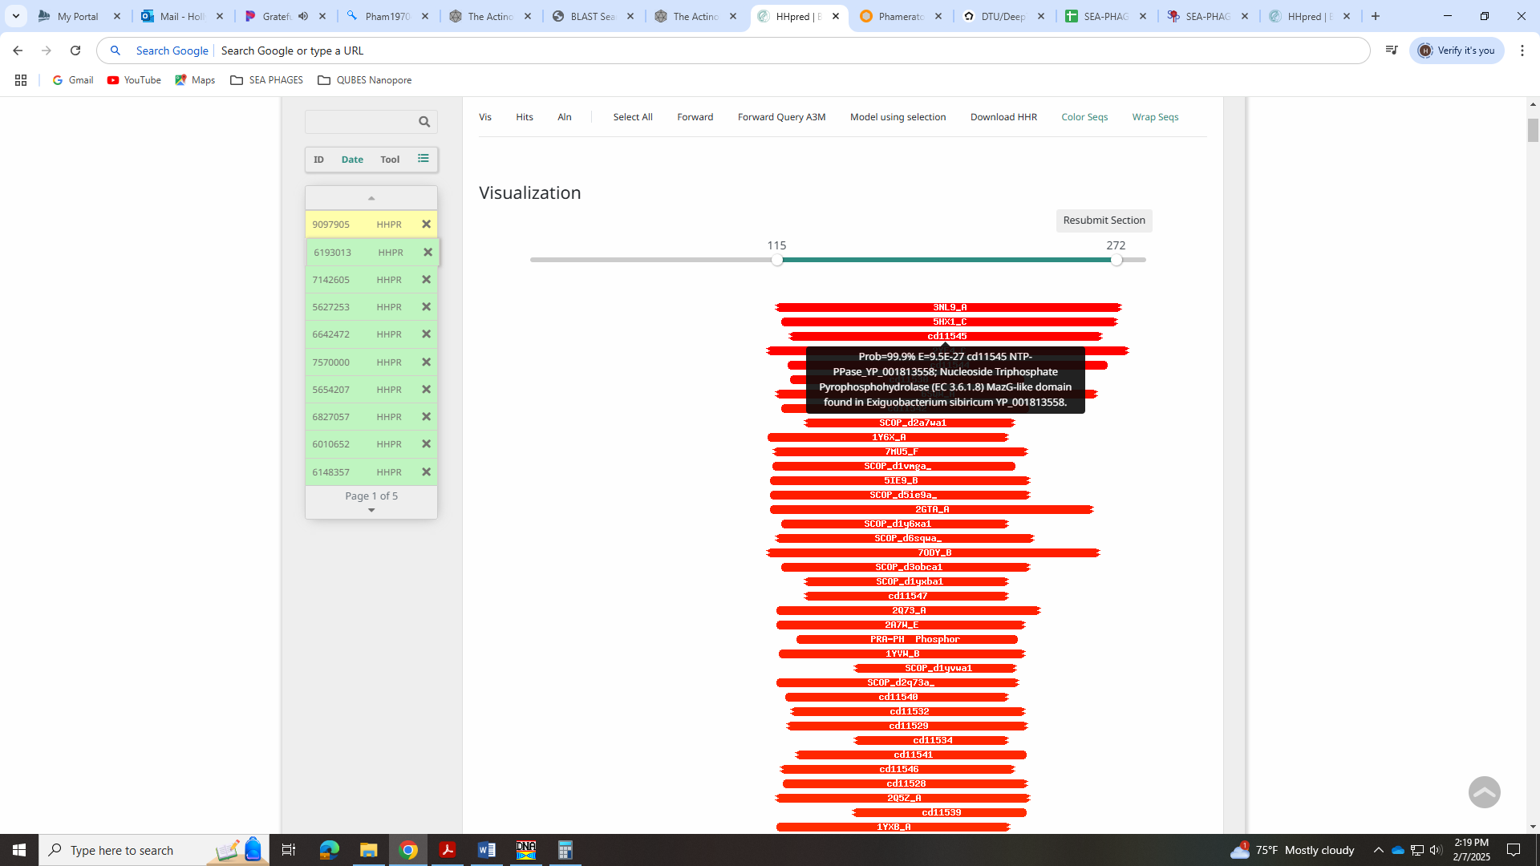
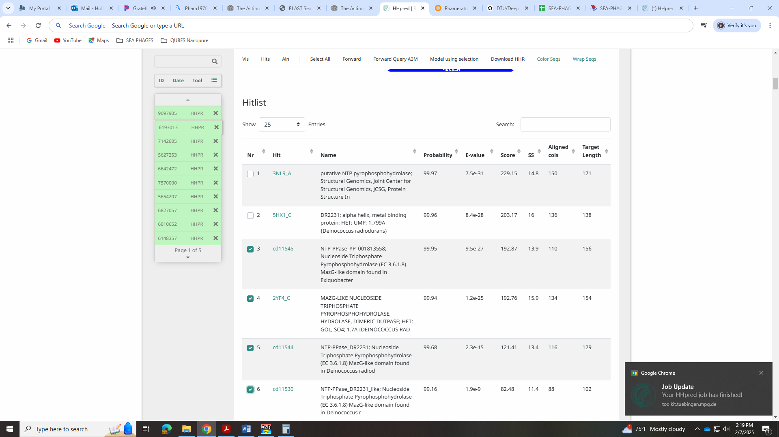
Here is the example phage’s hits (Che12_40):
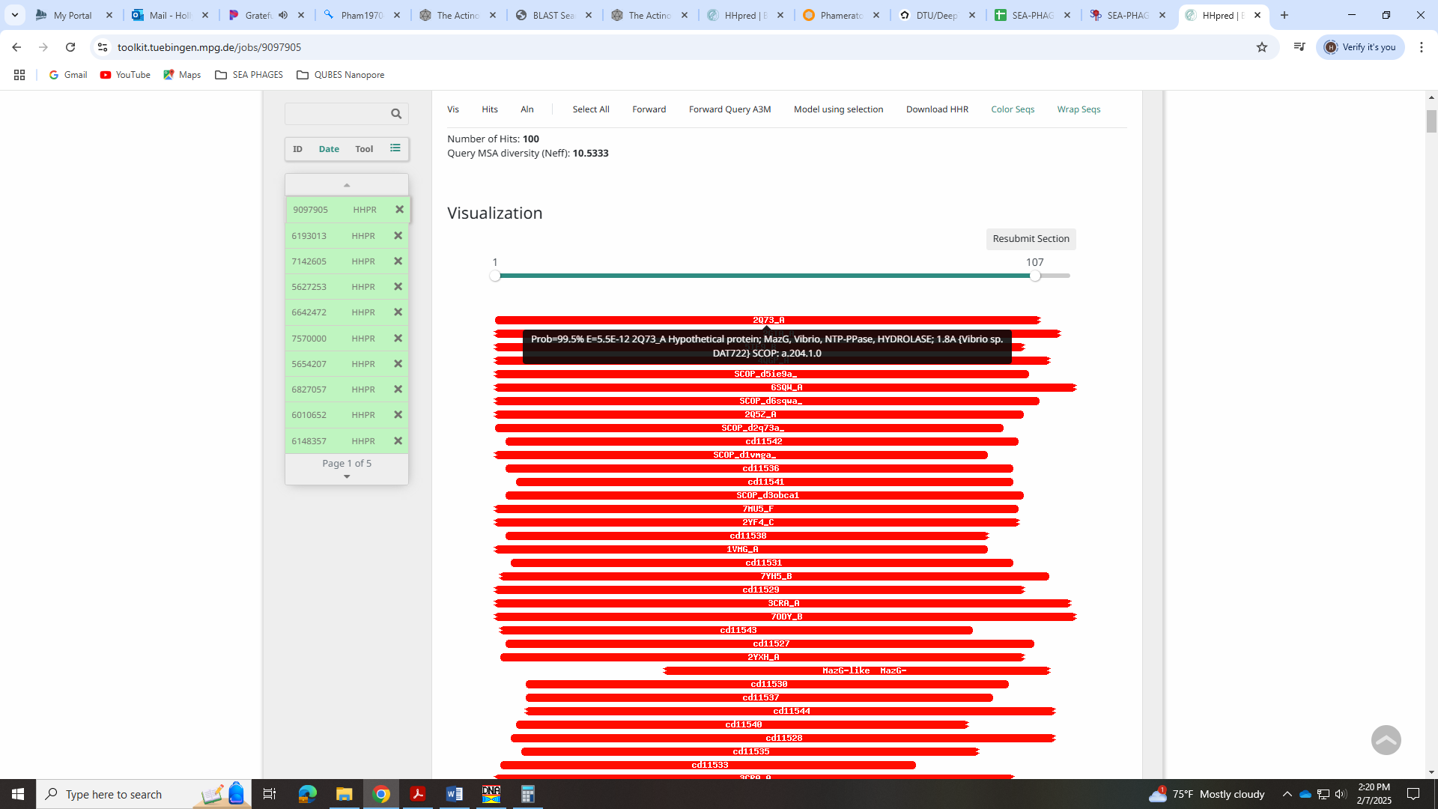
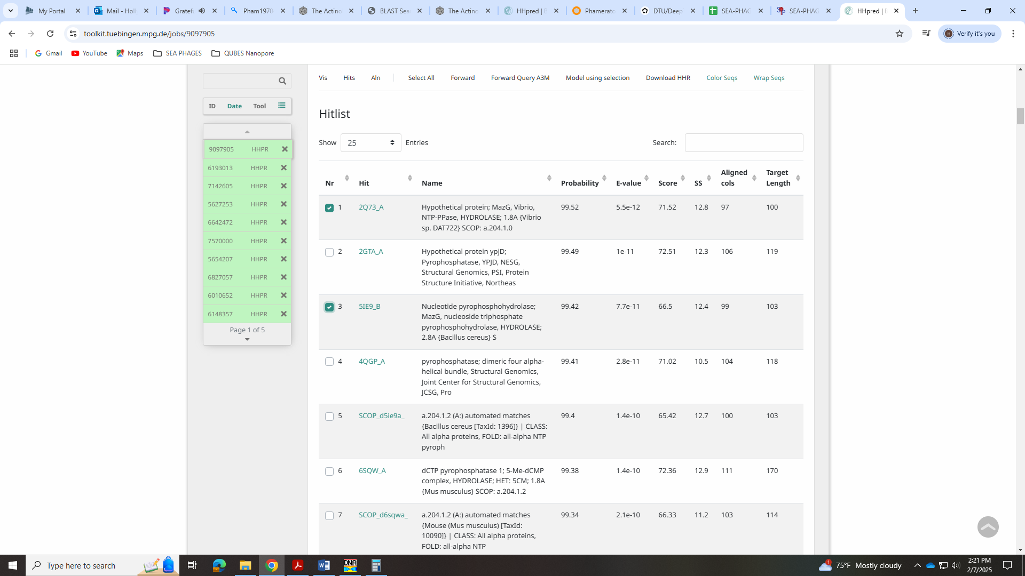
In the forum, there is a post on calling this function, and adding others to the Official List:
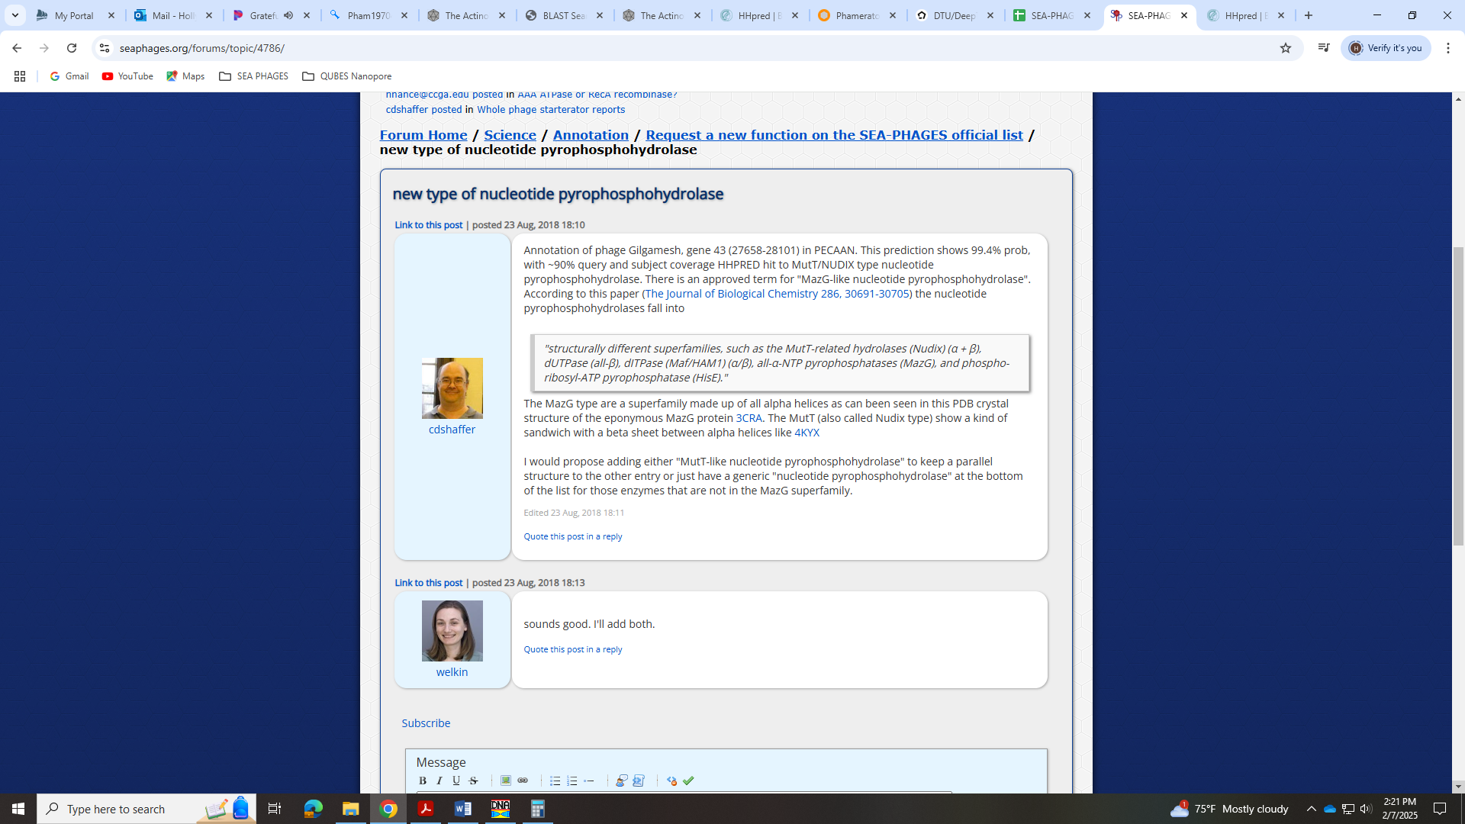
There isn’t an example for a MutT-like nucleotide pyrophosphohydrolase, so I’m sticking with Maz-G-like, as this is in a few of the HHPred hits.

Gene 43- reverse
SSC: start 31228, stop 30446; CP: yes; SCS: Both called start at 31228; ST: SS; Blast Start: matches Zepp_44 Query 1 to Subject 1 100% e⁻¹⁴⁷; Gap: overlap of 23; LO: NA; RBS: -2.791, 2.499, 11, -3.548, no; F: NKF; SIF-BLAST: NKF/PhageDB BLAST/ Zepp_44, MN908686/100%/e⁻¹⁴⁷; SIF-HHPred: NKF, no matches with a probability above 90%; SIF-Syn: NKF
Notes: Most annotated start is not present in this gene, but the start is most conserved. Function is NKF and not ambiguous.
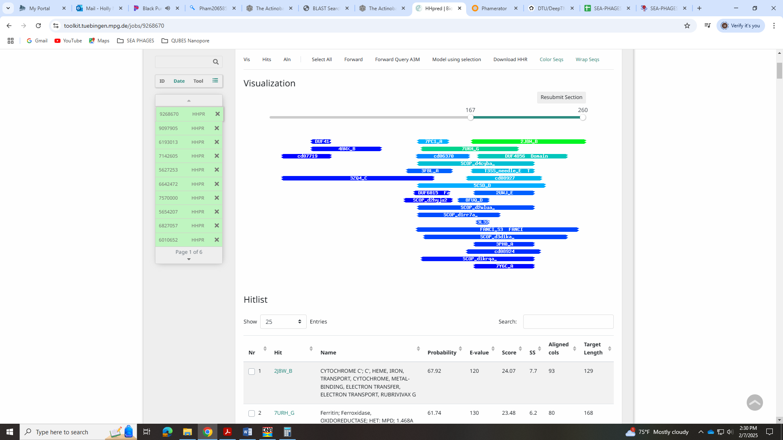

Gene 44 - reverse
SSC: start 31799, stop 31206; CP: yes; SCS: Both called start at 31799; ST: SS; Blast Start: matches Zepp_45 Query 1 to Subject 1 100% e⁻¹¹⁴; Gap: 9; LO: yes; RBS: -2.245, 2.756, 9, -3.020, yes; F: thymidylate kinase; SIF-BLAST: thymidylate kinase /PhageDB BLAST/Zepp_45, MN908686/100%/e⁻¹¹⁴; SIF-HHPred: thymidylate kinase, several matches with a probability above 99%; SIF-Syn: thymidylate kinase
Notes: Start is most annotated. Function is supported by BLAST and HHPred as thymidylate kinase. This is on the official function list, so I’m going with that.
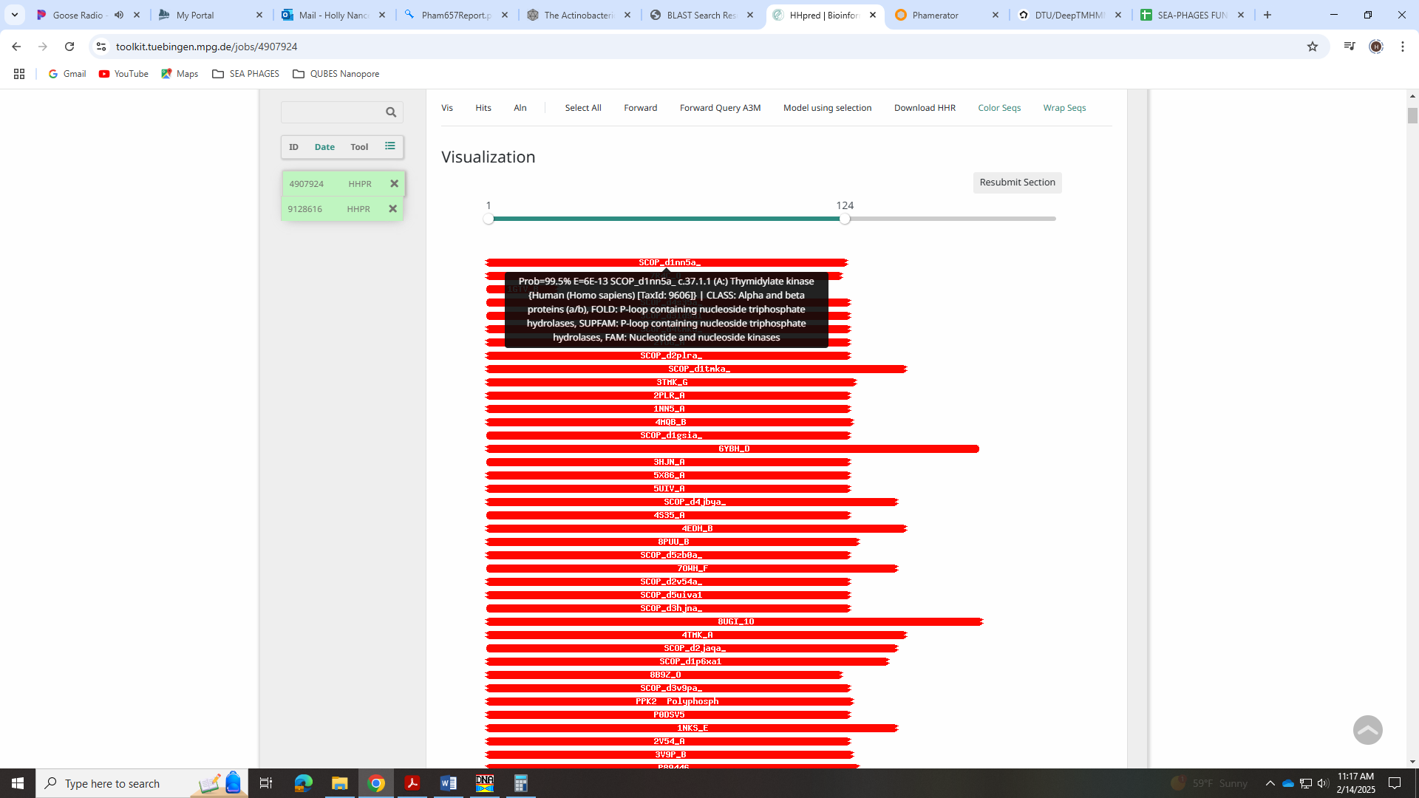
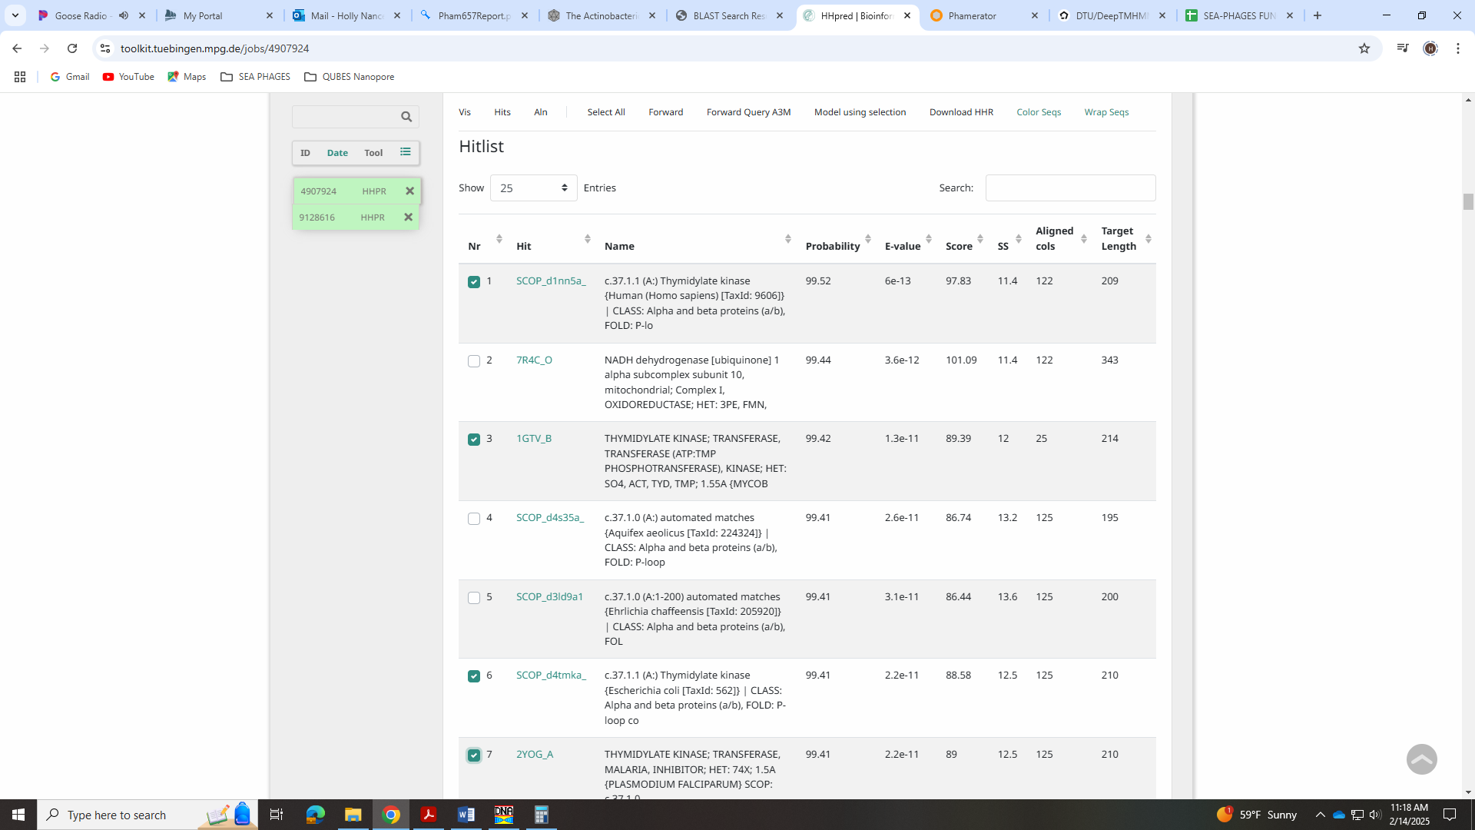
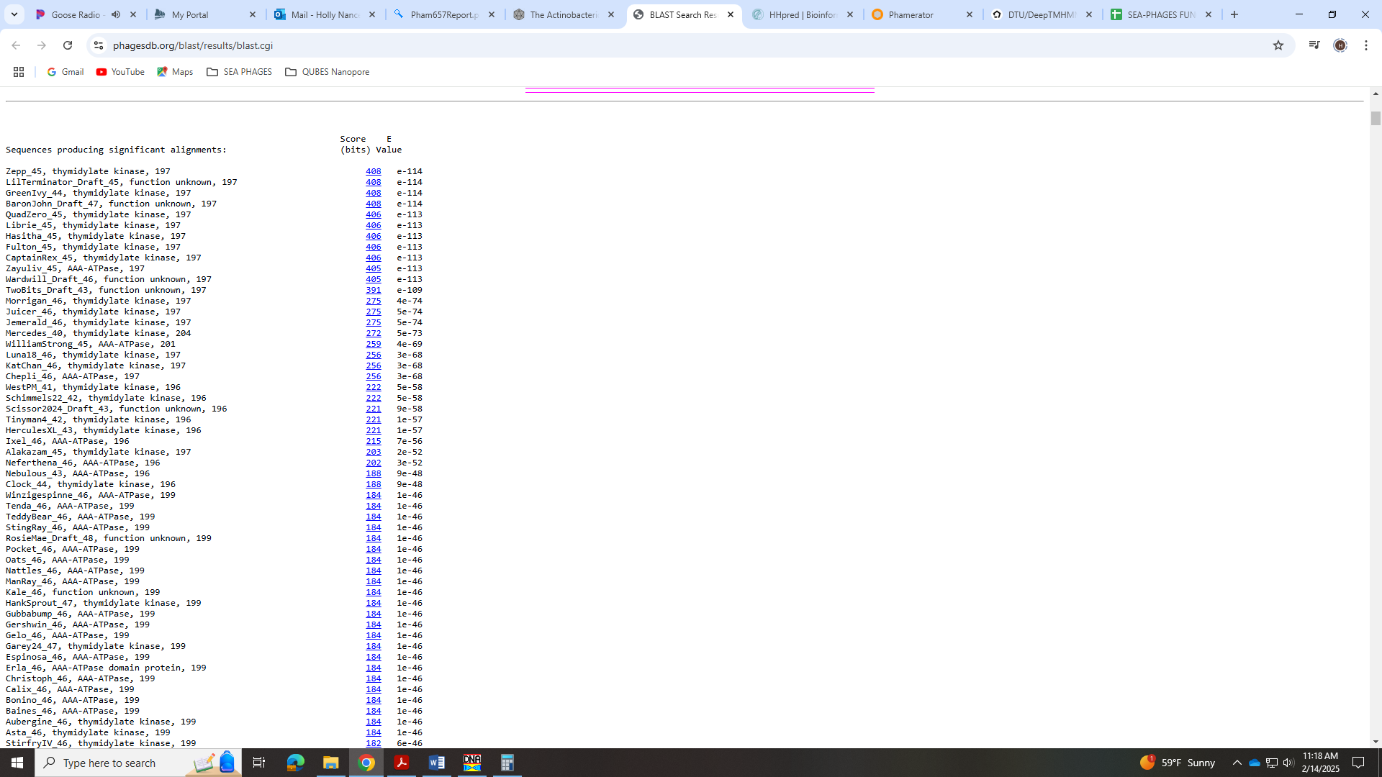

Gene 45 - reverse
SSC: start 32747, stop 31809; CP: yes; SCS: Both called start at 32747; ST: SS; Blast Start: matches Hasitha_46 Query 1 to Subject 1 100% 0.0; Gap: overlap of 4; LO: yes; RBS: -2.071, 2.837, 9, -2.845, yes; F: glycosyltransferase; SIF-BLAST: glycosyltransferase/PhageDB BLAST/Hasitha_46, MZ622182/100%/0.0; SIF-HHPred: glycosyltransferase, several matches with a probability above 99%; SIF-Syn: glycosyltransferase
Notes: Start is most annotated. Support from BLAST and HHPred that this is glyosyltransferase.
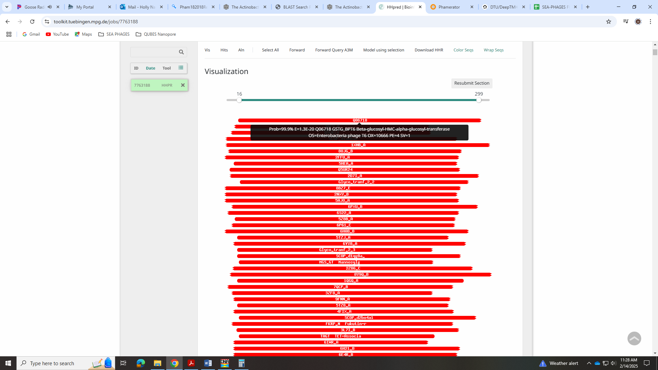
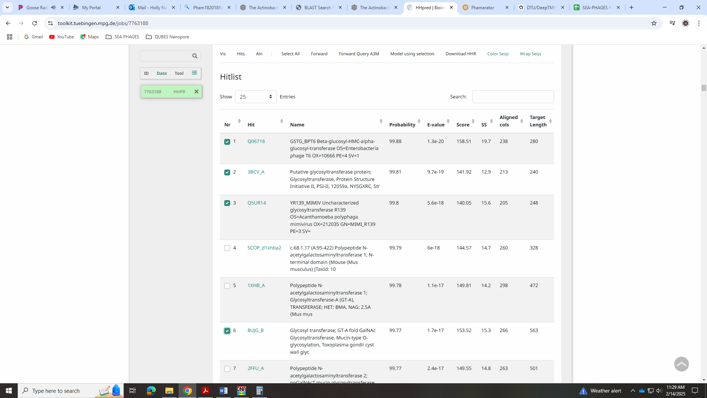
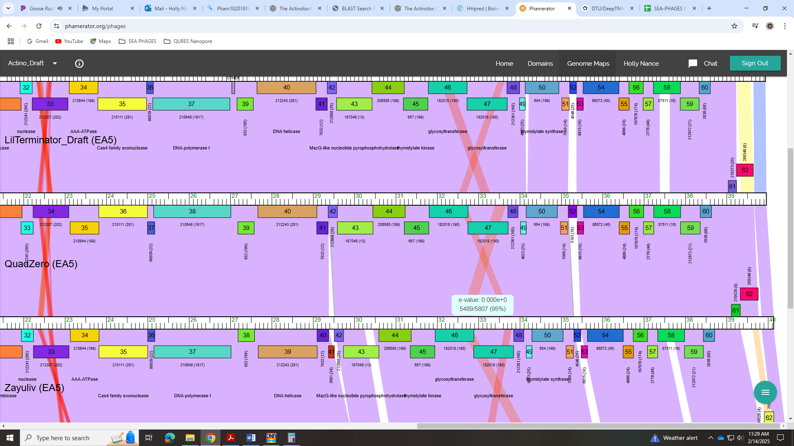

Gene 46 - reverse
SSC: start 33718, stop 32744; CP: yes; SCS: Both called start at 33718; ST: NI; Blast Start: matches Zepp_47 Query 1 to Subject 1 100% 0.0; Gap: overlap of 8; LO: NA; RBS: -3.261, 2.279, 13, -4.307, no; F: glycosyltransferase; SIF-BLAST: glycosyltransferase /PhageDB BLAST/Zepp_47, MN908686/100%/0.0; SIF-HHPred: glycosyltransferase, several matches with a probability above 99%; SIF-Syn: glycosyltransferase
Notes: This gene occurs twice in the genome of LilTerminator and other phages in EA5.
Therefore, this gene shows up twice in Phamerator. Gene 46 has the most annotated start, while gene 47 obviously has a start further downstream. So the Starterator data is not that informative.
For function, BLAST, HHPred and synteny support this function as glycosyltransferase:
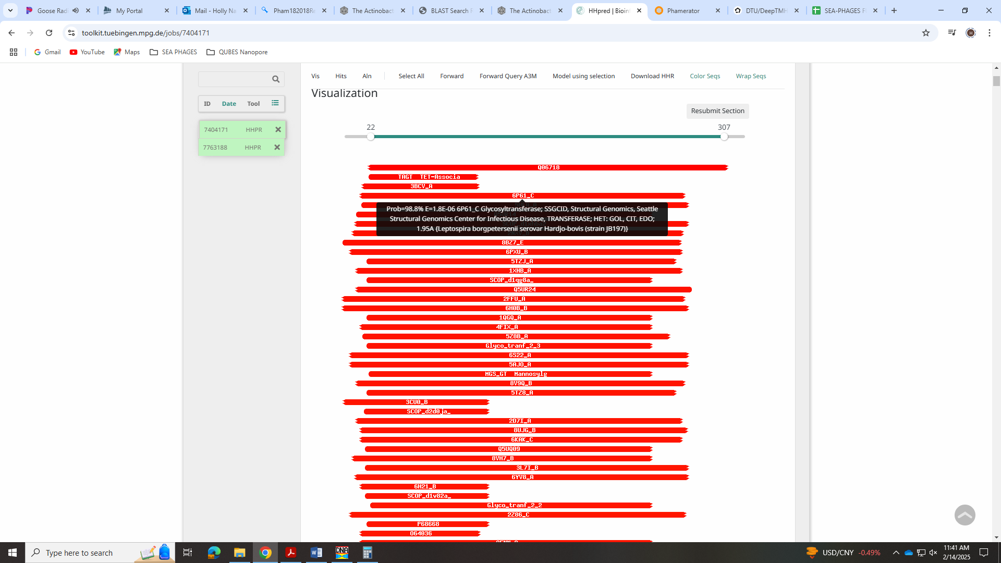
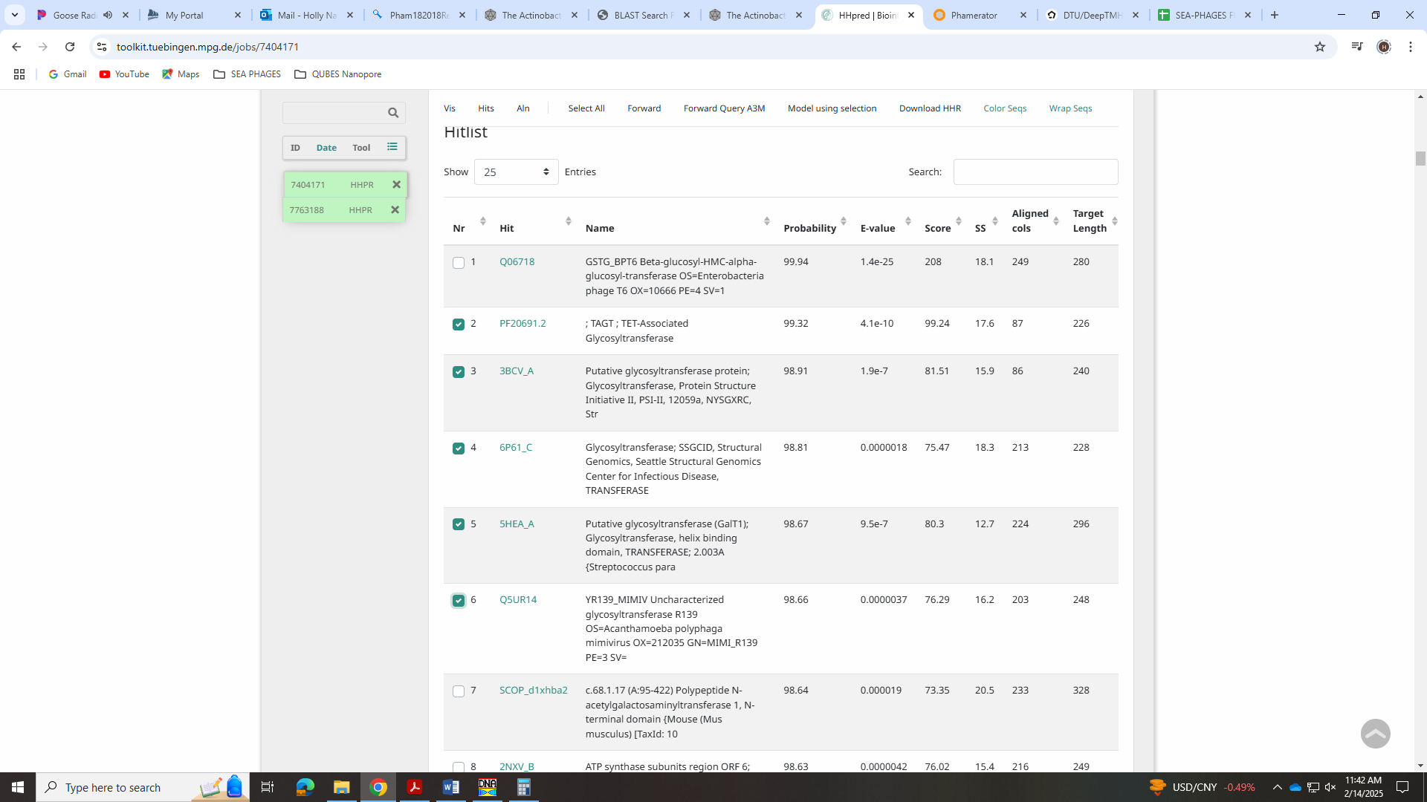
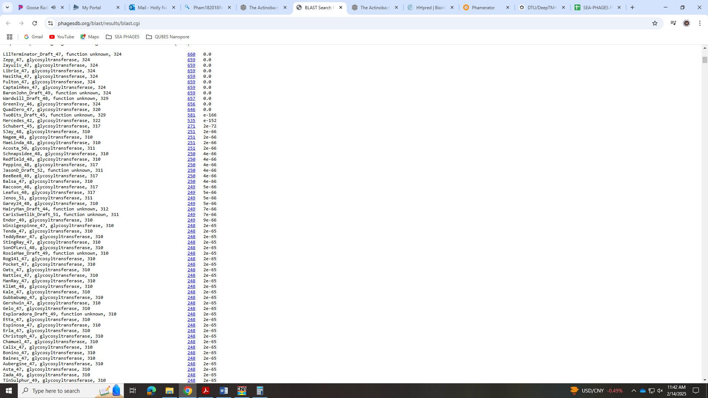

Gene 47 - reverse
SSC: start 33956, stop 33711; CP: yes; SCS: Only GeneMark called this gene and start at 33956; ST: SS; Blast Start: matches GreenIvy_47 Query 1 to Subject 1 100% 6e⁻⁴⁶; Gap: 59; LO: no; RBS: -1.748, 2.989, 9, -2.523, no, but same values as other start I was considering; F: NKF; SIF-BLAST: NKF/PhageDB BLAST/GreenIvy_47, PP978818/100%/6e⁻⁴⁶; SIF-HHPred: NKF, no matches with a probability above 90%; SIF-Syn: NKF
Notes: Start is most conserved in Starterator, but yields a 59bp gap. There is another start of 34019 that would yield an overlap of 4bp. This start is called 35% of the time when present and there were 5 MAs for it. The GeneMark output doesn’t support this start with coding potential:
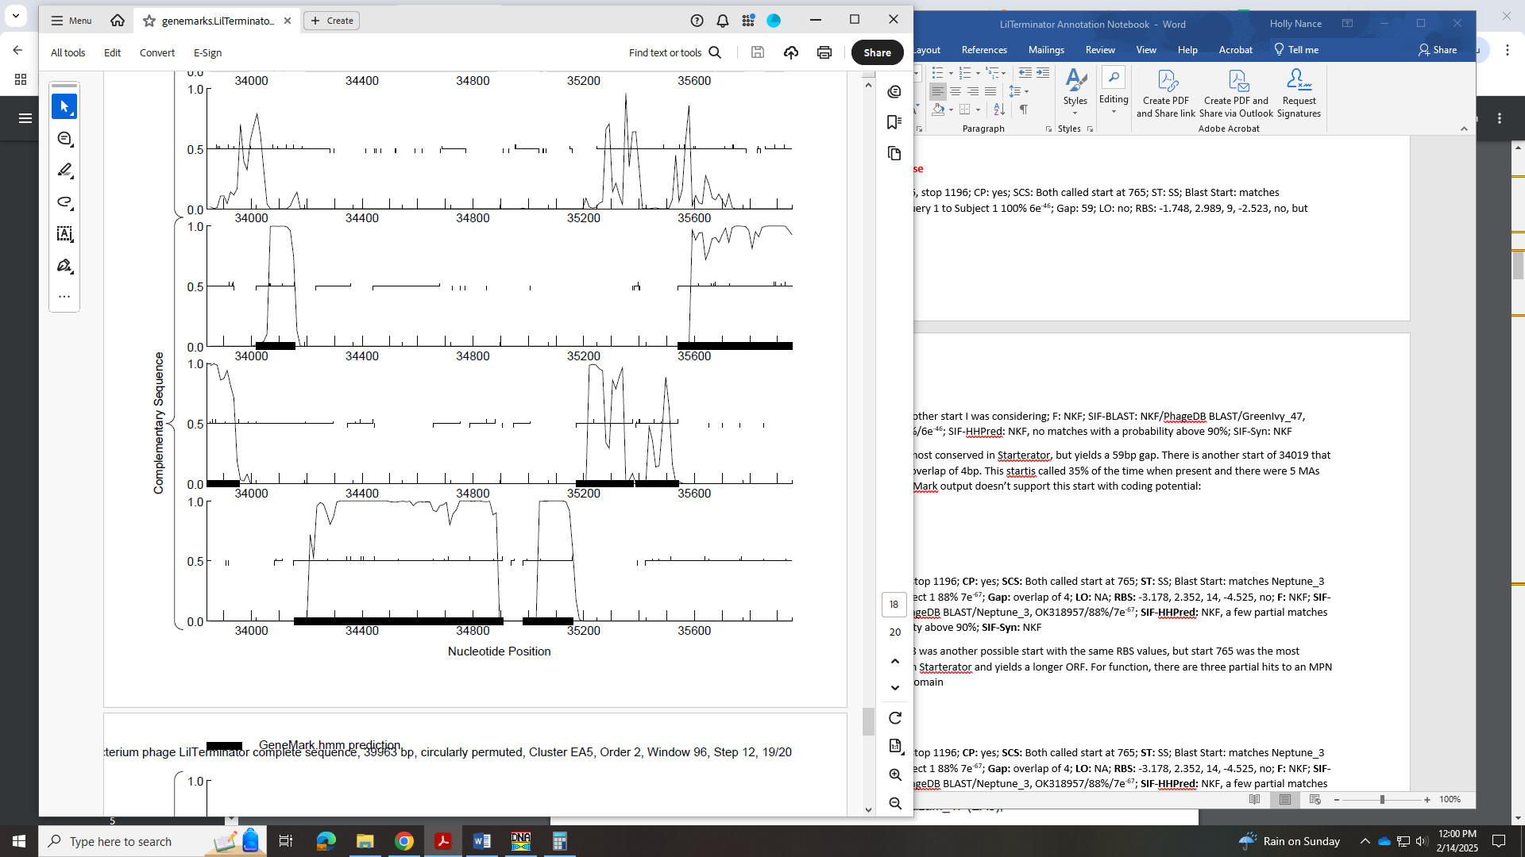
Also, it looks like this large gap is conserved in some EA5 phage, while the gene looks a little longer in others:
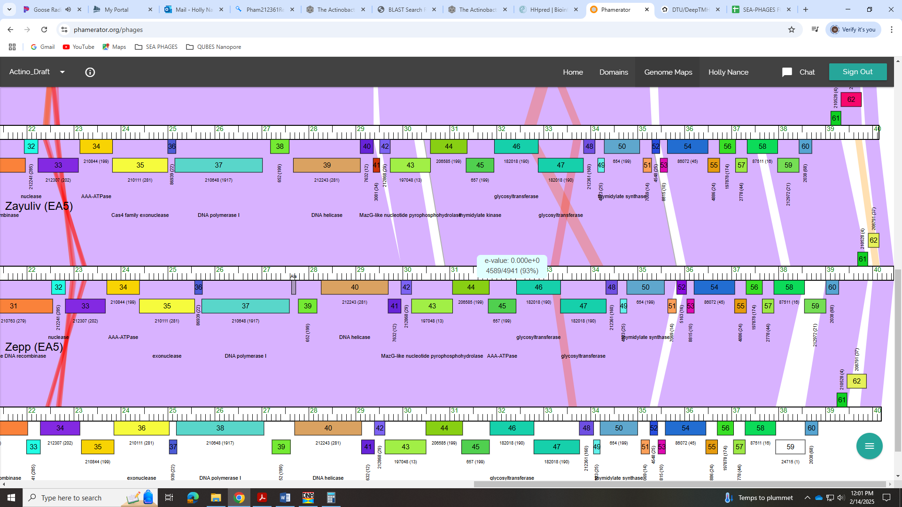
For function, there is support for NKF
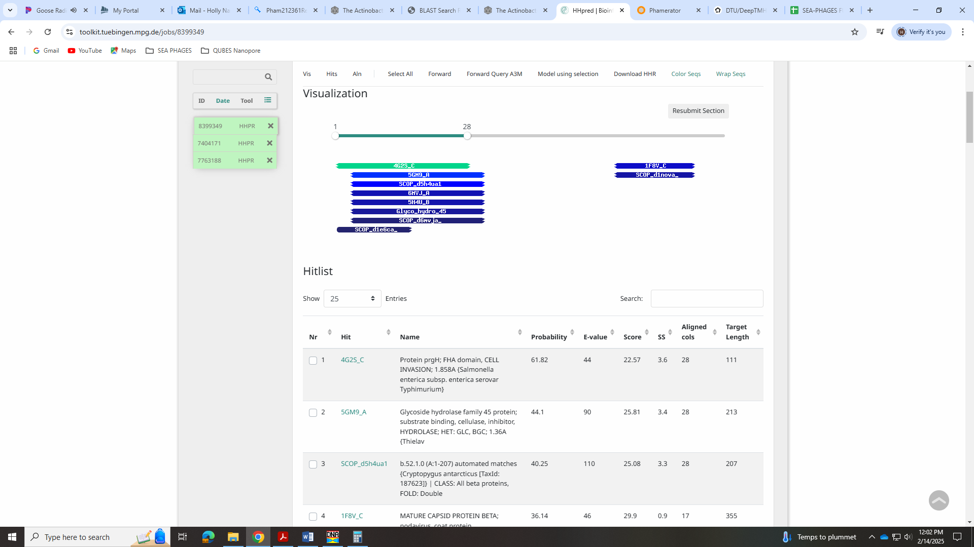

Gene 48 - reverse
SSC: start 34156, stop 34016; CP: yes; SCS: Both called start at 34156; ST: SS; Blast Start: matches Zepp_49 Query 1 to Subject 1 100% 2e⁻¹⁸; Gap: overlap of 4; LO: yes; RBS: -5.656, 1.155, 6, -7.401, no; F: membrane protein; SIF-BLAST: NKF/PhageDB BLAST/Zepp_49, MN908686/100%/2e⁻¹⁸; SIF-HHPred: NKF, no matches with a probability above 90%; SIF-Syn: NKF
Notes: Start is most annotated. For function, all data suggests NKF EXCEPT the DeepTMHMM data:
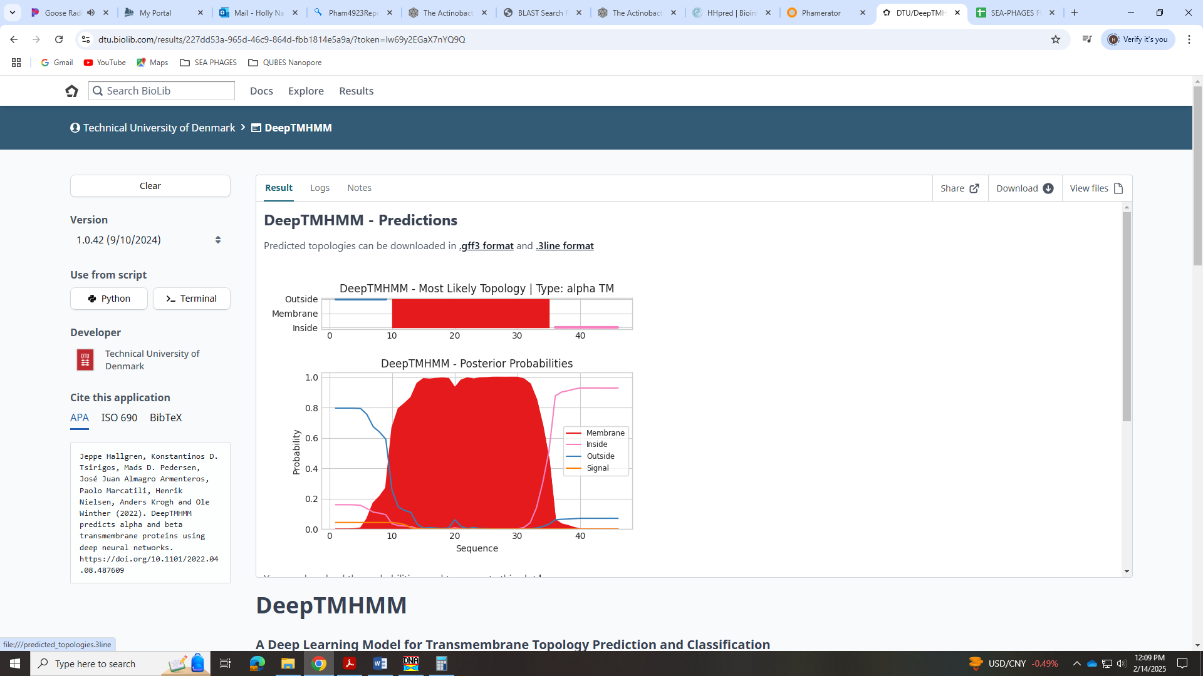
We have to call this a membrane protein!!

Gene 49 - reverse
SSC: start 34908, stop 34153; CP: yes; SCS: Both called start at 34908; ST: SS; Blast Start: matches GreenIvy_49 Query 1 to Subject 1 99% e⁻¹⁴⁶; Gap: 72; LO: yes; RBS: -1.748, 2.989, 12, -2.584, yes; F: thymidylate synthase; SIF-BLAST: thymidylate synthase /PhageDB BLAST/ GreenIvy_49, PP9788187/99%/e⁻¹⁴⁶; SIF-HHPred: thymidylate synthase, several matches with a probability above 100%; SIF-Syn: thymidylate synthase
Notes: Most annotated start is not present, but start called by Glimmer and GeneMark is called 95% of the time when present. For function, there is support for thymidylate synthase:
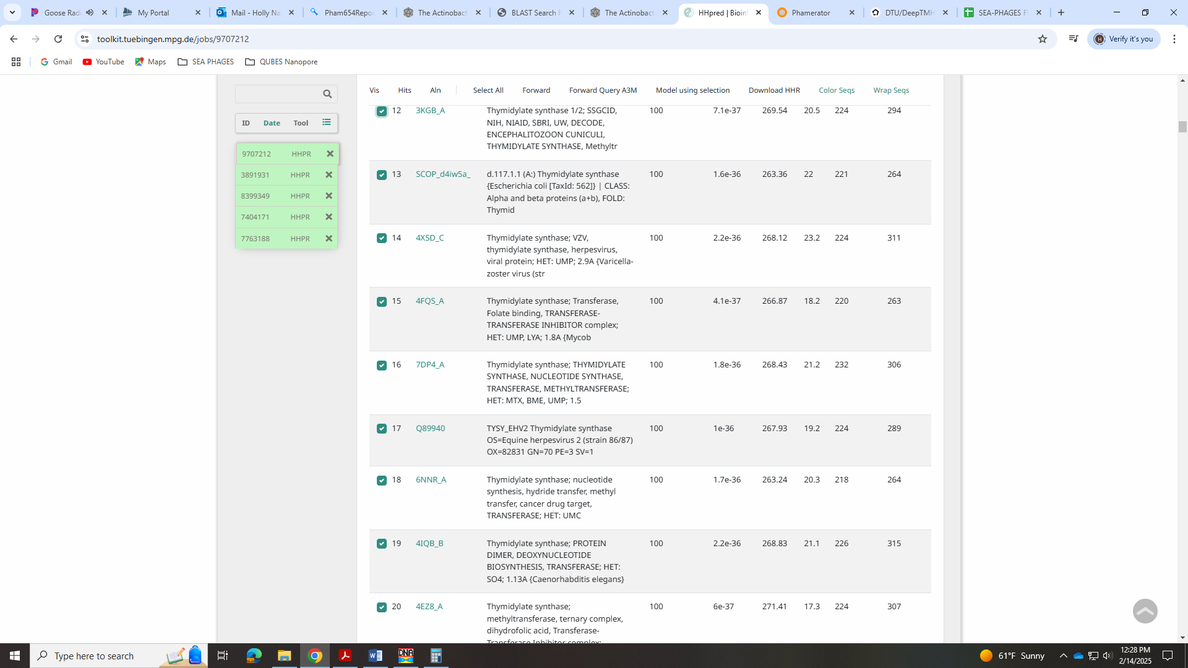
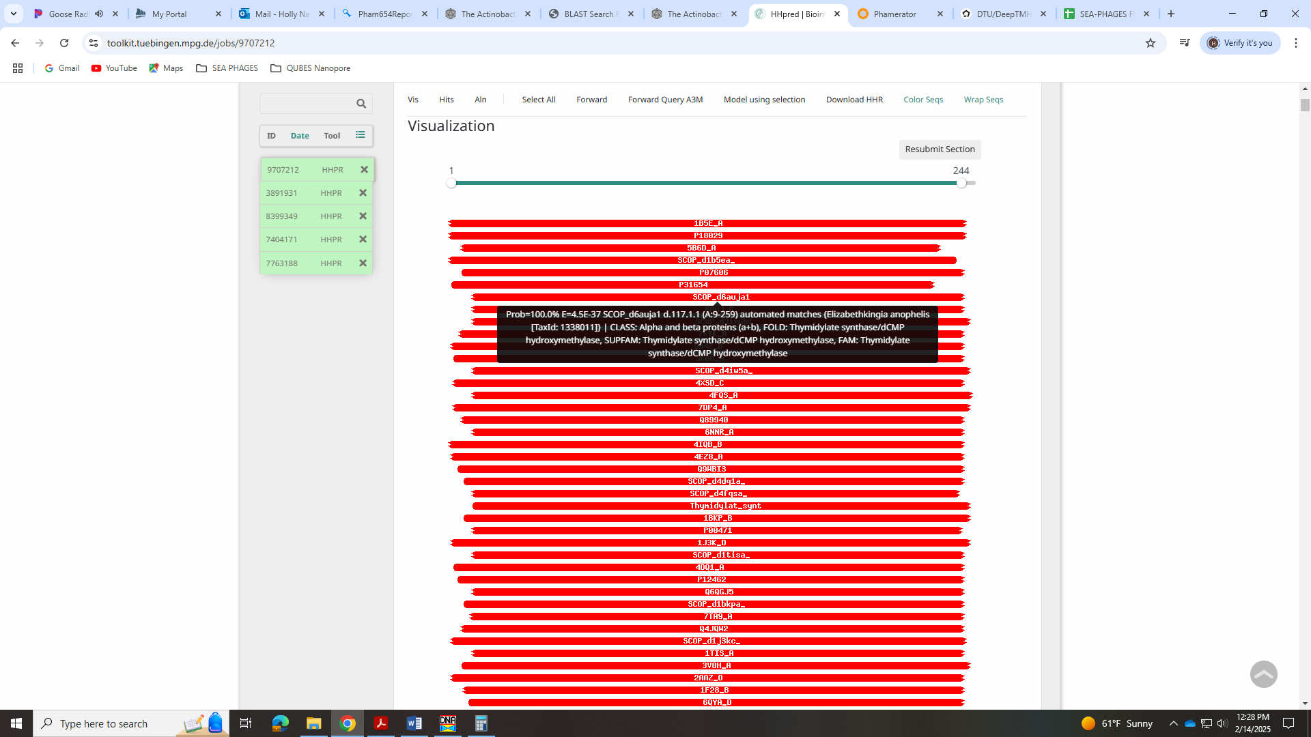
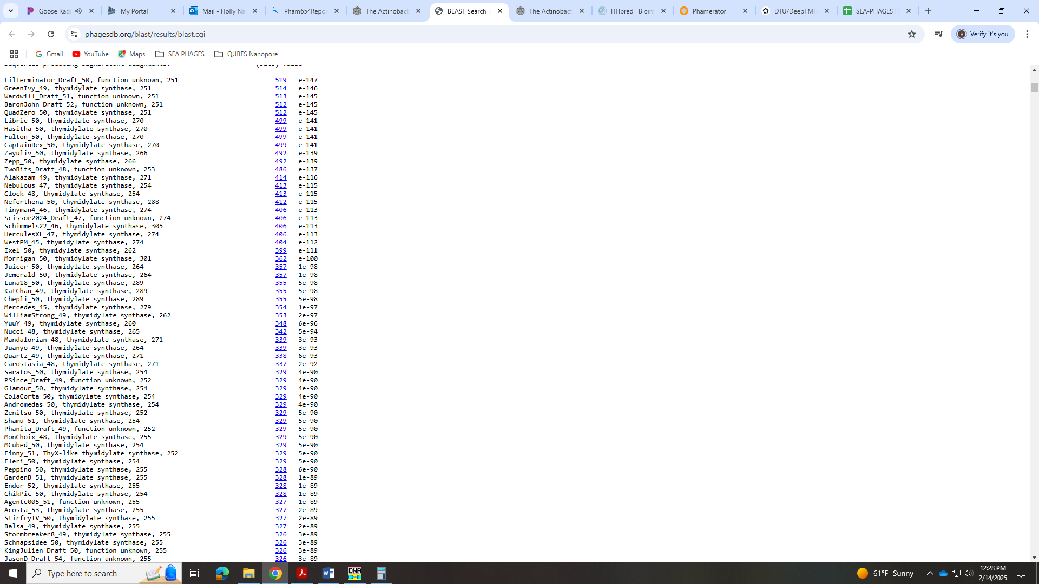

Gene 50 - reverse
SSC: start 35160, stop 34981; CP: yes; SCS: Both called start at 35160; ST: SS; Blast Start: matches GreenIvy_50 Query 1 to Subject 1 100% 2e⁻²⁵; Gap: 11; LO: yes; RBS: -1.439, 3.134, 11, -2.196, yes; F: NKF; SIF-BLAST: NKF/PhageDB BLAST/ GreenIvy_50, PP978818/100%/2e⁻²⁵; SIF-HHPred: NKF, no matches with a probability above 90%; SIF-Syn: NKF
Notes: Start is most annotated. NKF for function well-supported:
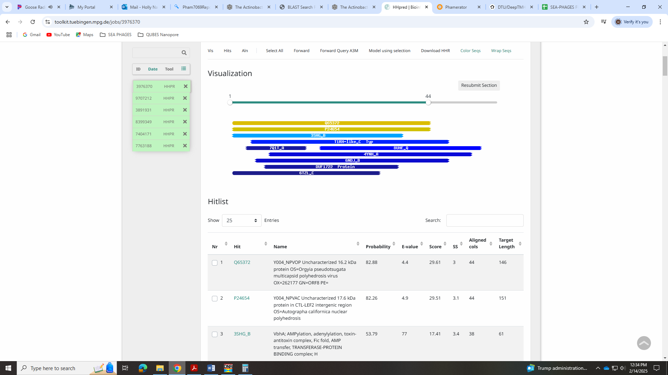

Gene 51 - reverse
SSC: start 35378, stop 35172; CP: yes; SCS: Both called start at 35378; ST: SS; Blast Start: matches Zayuliv_52 Query 1 to Subject 1 100% 2e⁻²⁹; Gap: 9; LO: yes; RBS: -5.348, 1.300, 13, -6.394, yes; F: NKF; SIF-BLAST: NKF/PhageDB BLAST/ Zayuliv_52, MT889377/100%/2e⁻²⁹; SIF-HHPred: NKF, no matches with a probability above 90%; SIF-Syn: NKF
Notes: Most annotated start is not present, but the start called by Glimmer and GeneMark is called 100% of time when present. Function is NKF and unambiguous.
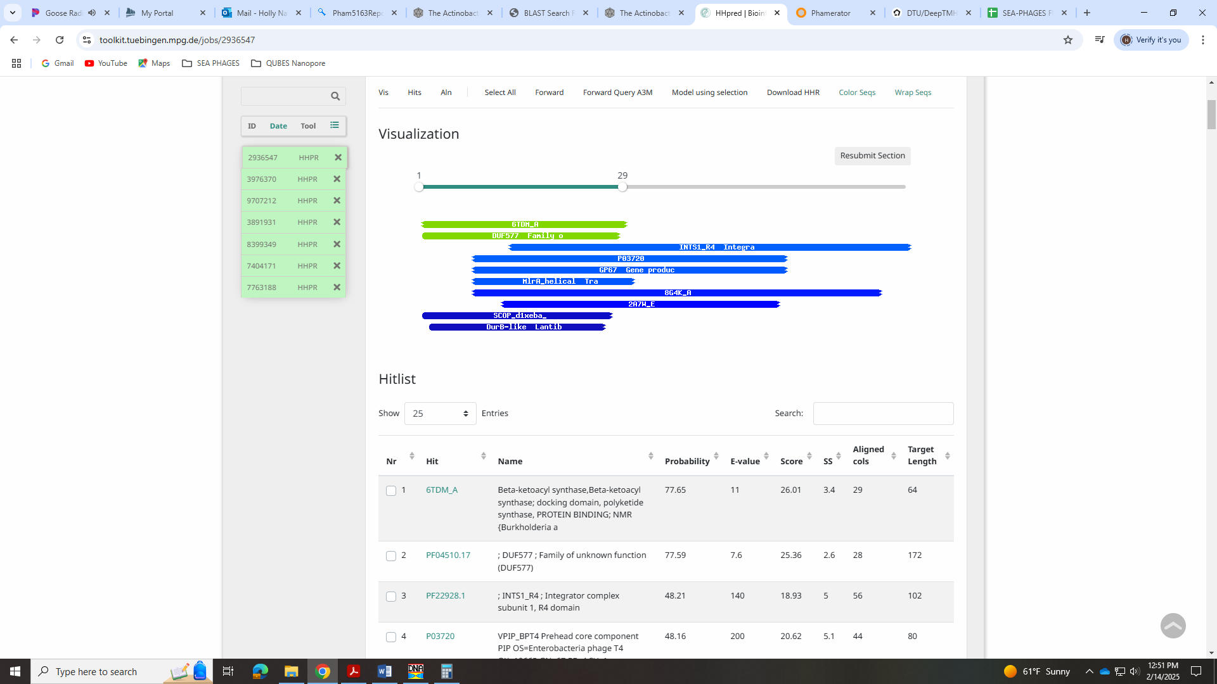

Gene 52 - reverse
SSC: start 35543, stop 35388; CP: yes; SCS: Both called start at 35543; ST: SS; Blast Start: matches Zayuliv_53 Query 1 to Subject 1 100% 2e⁻²⁶; Gap: overlap of 4; LO: yes; RBS: -5.106, 1.413, 15, -6.708, no; F: NKF; SIF-BLAST: NKF/PhageDB BLAST/ Zayuliv_53, MT889377/100%/2e⁻²⁶; SIF-HHPred: NKF; no matches with a probability above 90%; SIF-Syn: NKF
Notes: Start is most annotated. Function is NKF and unambiguous:
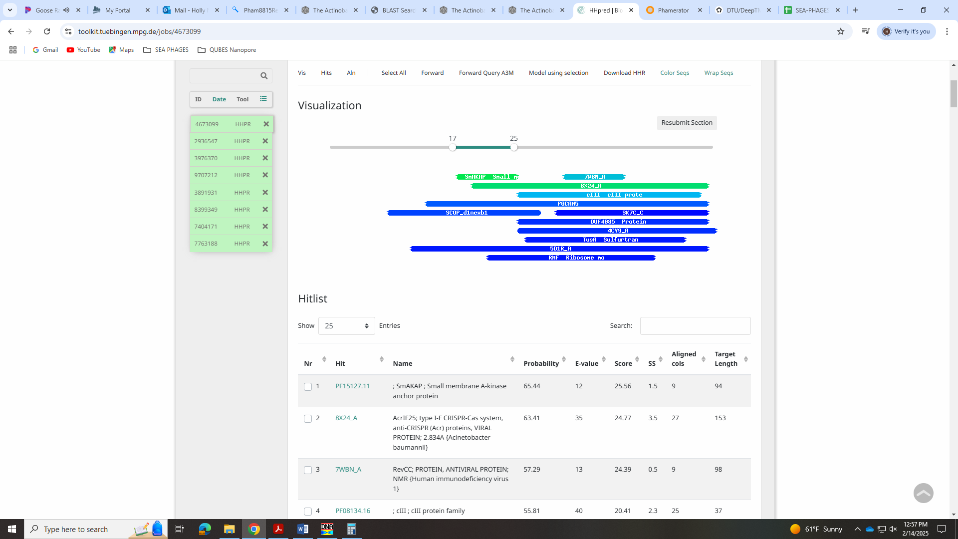

Gene 53- reverse
SSC: start 36406, stop 35540; CP: yes; SCS: Both called start at 36406; ST: SS; Blast Start: matches Zayuliv_54 Query 1 to Subject 1 100% e⁻¹⁶⁷; Gap: overlap of 4; LO: yes; RBS: -1.748, 2.989, 9, -2.523, yes; F: 5-hmU DNA kinase; SIF-BLAST: NKF/PhageDB BLAST/ Zayuliv_54, MT889377/100%/e⁻¹⁶⁷; SIF-HHPred: 5-hmdU DNA kinase, one match with a probability of 100%; SIF-Syn: NKF
Notes: Start is most annotated. For function, most BLAST hits are for NKF, MuF-like minor capsid, minor capsid or DNA helicase. However, the HHPred hit 5-hmU DNA kinase with 100% probability:
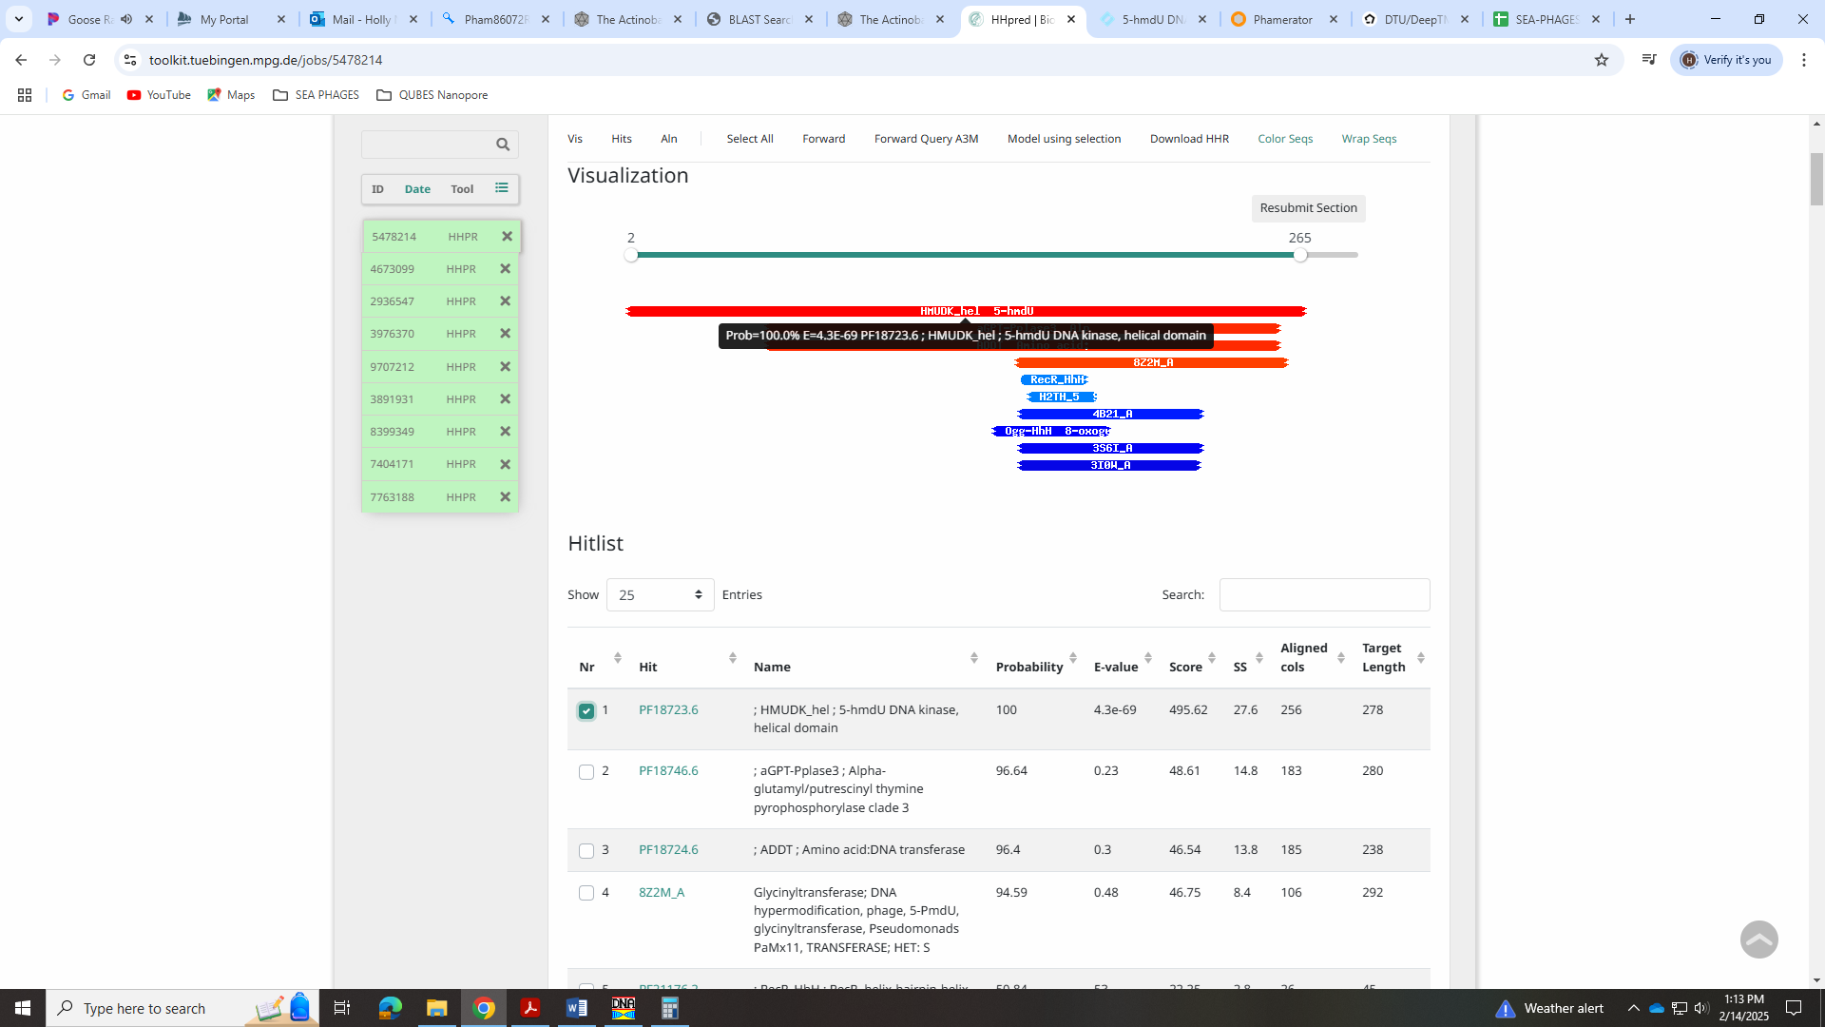
This function is in the Official List with no extra data except an example phage, Wooper_4.
The Pfam entry for this HHPred hit supports that this would be found in a phage:
This entry represents an alpha-helical domain found in 5-hmdU DNA kinase (HMUDK), a P-loop nucleotide kinase that phosphorylates 5-hydroxymethyluracil (5hmdU) into 5-phosphomethyl-2'-deoxyuridine (5-PmdU) on DNA as a step in the pathway leading to thymidine hypermodifications in the viral genome HMUDK also transfers glutamate to 5-pyrophosphoryloxymethyldeoxyuridine (5-PPmdU) to produce 5-Nalpha-glyutamylthymidine (Nalpha-GluT) These modifications probably prevent degradation of viral genome by the host restriction-modification antiviral defense system. Members of this entry (formerly known as aGPT-Pplase1) are found in phages with hypermodified bases and eukaryotes such as fungi and stramenopiles.

Gene 54 - reverse
SSC: start 36654, stop 36403; CP: yes; SCS: Both called start at 36654; ST: SS; Blast Start: matches Zayuliv_55 Query 1 to Subject 1 97% 3e⁻⁴¹; Gap: overlap of 8; LO: NA; RBS: -2.611, 2.584, 11, -3.368, yes; F: NKF; SIF-BLAST: NKF/PhageDB BLAST/ Zayuliv_55, MT889377/97%/3e⁻⁴¹; SIF-HHPred: NKF, no matches with a probability above 90%; SIF-Syn: NKF
Notes: Start is most annotated. Function is NKF and unambiguous:
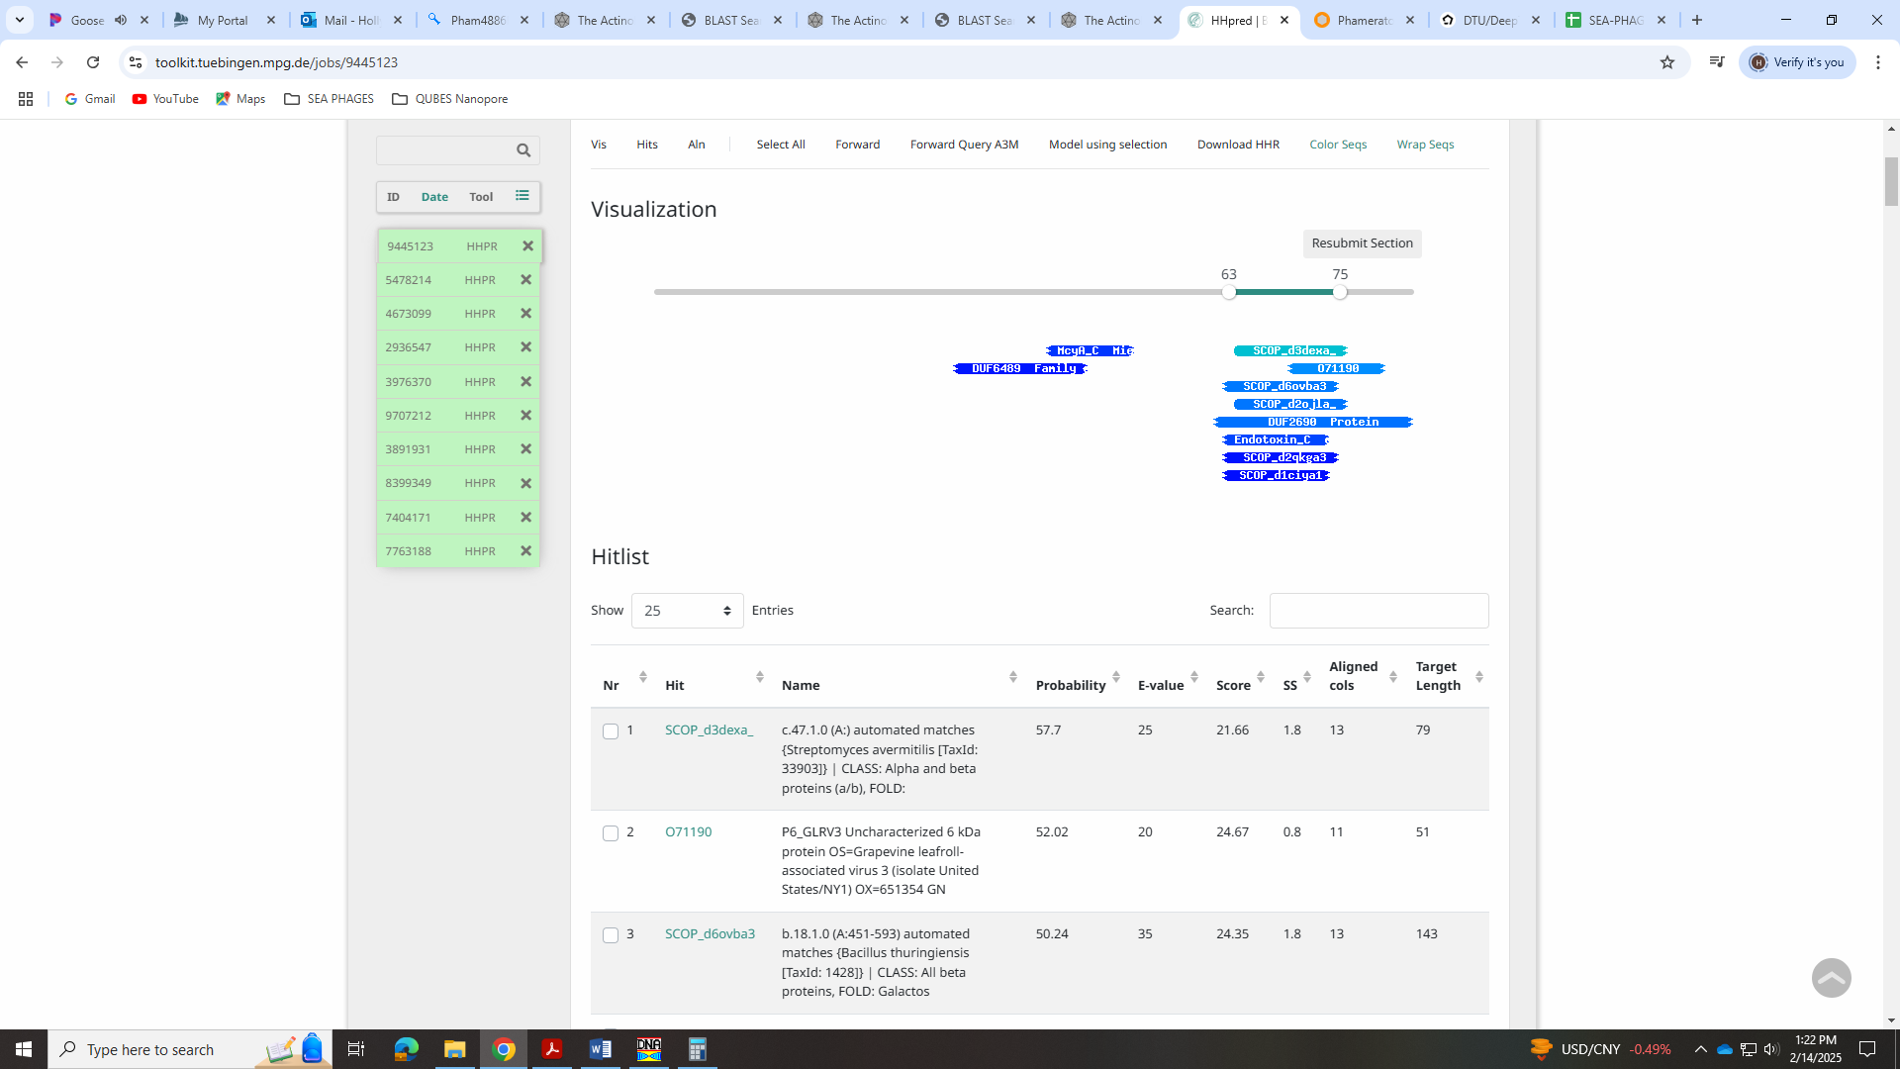

Gene 55 - reverse
SSC: start 36994, stop 36647; CP: yes; SCS: Both called start at 36994; ST: SS; Blast Start: matches QuadZero_56, Query 1 to Subject 1 100% 2e⁻⁶⁰; Gap: overlap of 4; LO: yes; RBS: -4.234, 1.822, 9, -5.009, no; F: NKF; SIF-BLAST: NKF/PhageDB BLAST/ QuadZero_56, MZ150787/100%/2e⁻⁶⁰; SIF-HHPred: NKF; no matches with a probability above 90%; SIF-Syn: NKF
Notes: Start is most annotated. NKF is unambiguous:
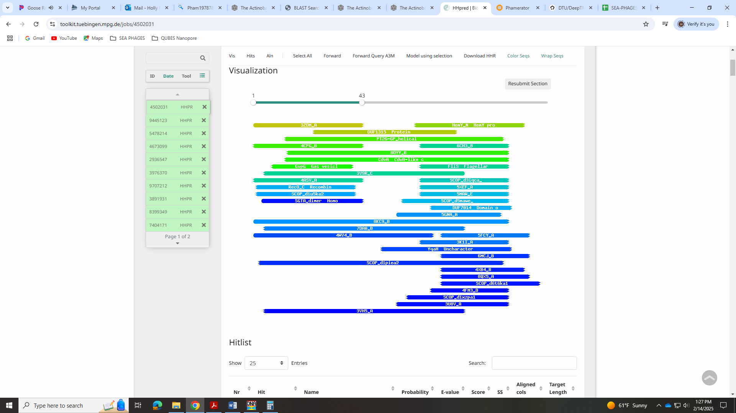

Gene 56 - reverse
SSC: start 37239, stop 36991; CP: yes; SCS: Glimmer called most annotated start of 37239, GeneMark called start of 37242; ST: SS; Blast Start: matches GreenIvy_56 Query 1 to Subject 1 97% 4e⁻⁴⁰; Gap: overlap of 1; LO: NA; RBS: -2.903, 2.447, 10, -3.598, no; F: NKF; SIF-BLAST: NKF/PhageDB BLAST/GreenIvy_56, PP978818/97%/4e⁻⁴⁰; SIF-HHPred: NKF, no matches with a probability above 90%; SIF-Syn: NKF
Notes: Glimmer start was most annotated and had same RBS values as the GeneMark start. GeneMark start had an overlap of 4 while the Glimmer start had an overlap of 1. I went with the more conserved Glimmer start.
Function is NKF and unambiguous:
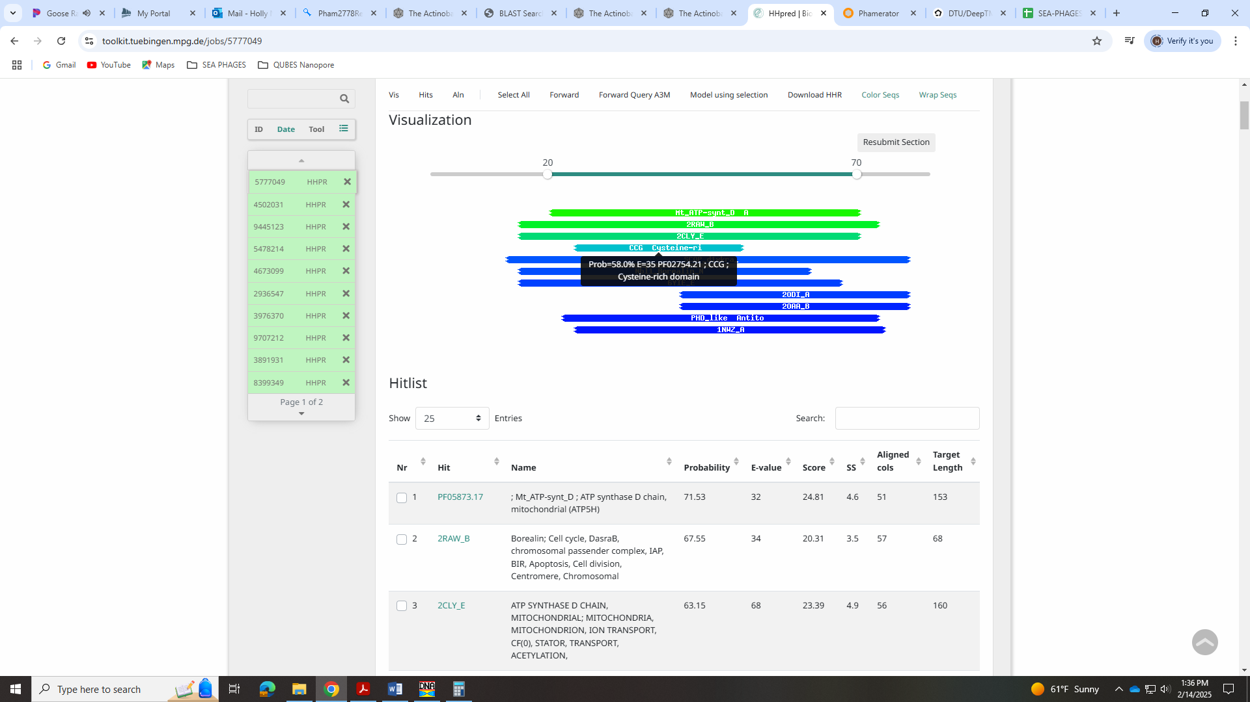

Gene 57 - reverse
SSC: start 37889, stop 37239; CP: yes; SCS: Both called start at 37889; ST: SS; Blast Start: matches QuadZero_58 Query 1 to Subject 1 86% e⁻¹⁰³; Gap: overlap of 4; LO: yes; RBS: -1.748, 2.989, 11, -2.505, yes; F: NKF; SIF-BLAST: NKF/PhageDB BLAST/ QuadZero_58, MZ150787/86%/e⁻¹⁰³; SIF-HHPred: NKF, no matches with a probability above 90%; SIF-Syn: NKF
Notes: Start is most annotated. NKF is unambiguous:
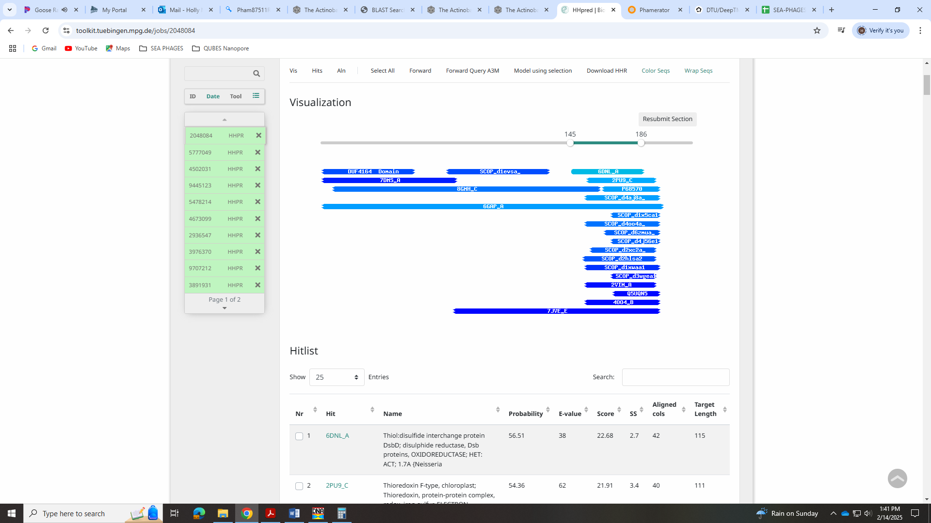

Gene 58 - reverse
SSC: start 38362, stop 37886; CP: yes; SCS: Both called start at 38362; ST: SS; Blast Start: matches GreenIvy_58 Query 1 to Subject 1 76% 2e⁻⁶⁰; Gap: overlap of 1; LO: yes; RBS: -6.282, 0.862, 13, -7.327, no; F: NKF; SIF-BLAST: NKF/PhageDB BLAST/ GreenIvy_58, PP978818/76%/2e⁻⁶⁰; SIF-HHPred: NKF, a few partial matches with a probability above 90%, but not for functions found in phages; SIF-Syn: NKF
Notes: Start is most annotated. Function is NKF. There are a few of hits above 90% in HHpred, but they are for a nematode binding protein and a protein linked to ALD in humans:
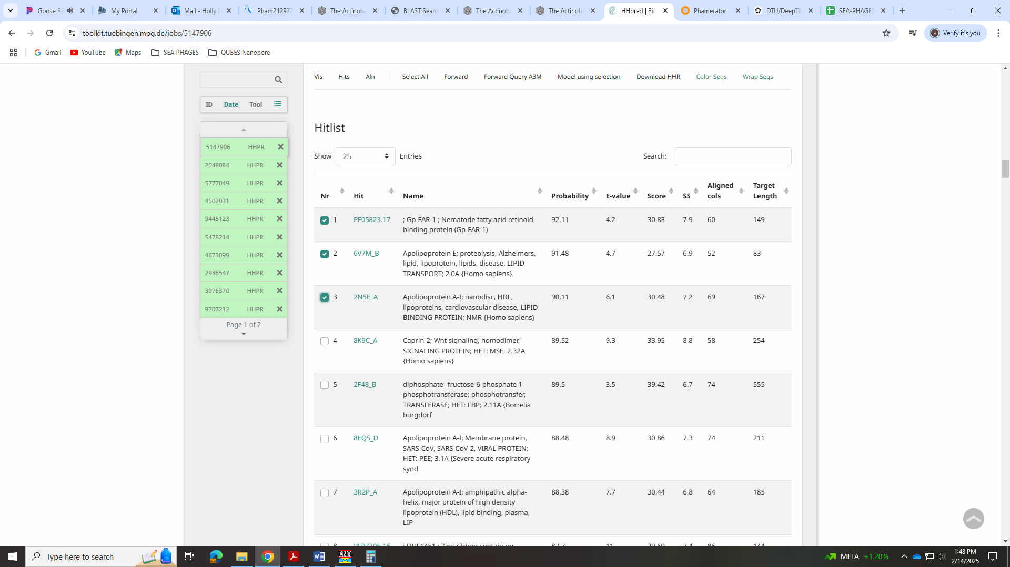
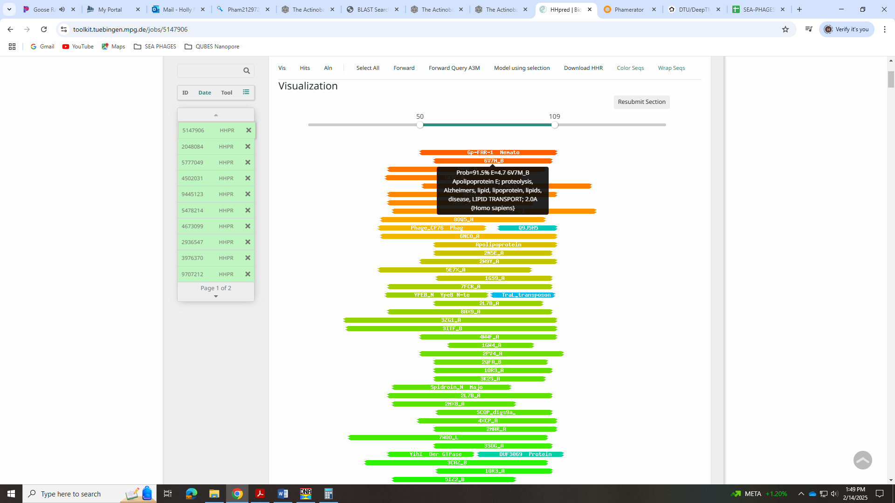

Gene 59 - reverse
SSC: start 38634, stop 38362; CP: yes; SCS: Glimmer called most annotated start at 38634, GeneMark called start at 38652; ST: SS; Blast Start: matches Zayuliv_60 Query 1 to Subject 1 100% 2e⁻⁴⁶; Gap: 405; LO: no; RBS: -1.748, 2.989, 9, -2.523, no, but better than other two starts that yield a longer ORF; F: NKF; SIF-BLAST: NKF/PhageDB BLAST/ Zayuliv_60, MT889377/100%/2e⁻⁴⁶; SIF-HHPred: NKF, one match with a probability above 90%, but for NKF; SIF-Syn: NKF
Notes: Glimmer start is most annotated, although there are two other starts that yield a longer ORF. However, either of those starts will still have a large gap (100s of BPs) between the next gene. This large gap is conserved across other phage in EA5. Also, in the DNAMaster Frames view, there aren’t any large ORFs that we could check for a missing gene in any of the possible reading frames.
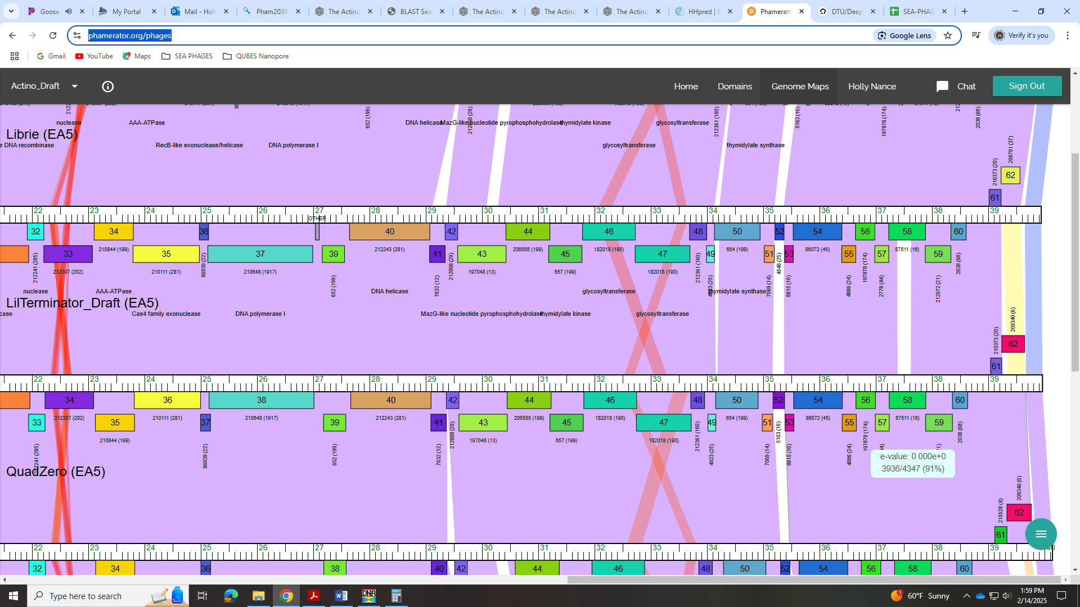
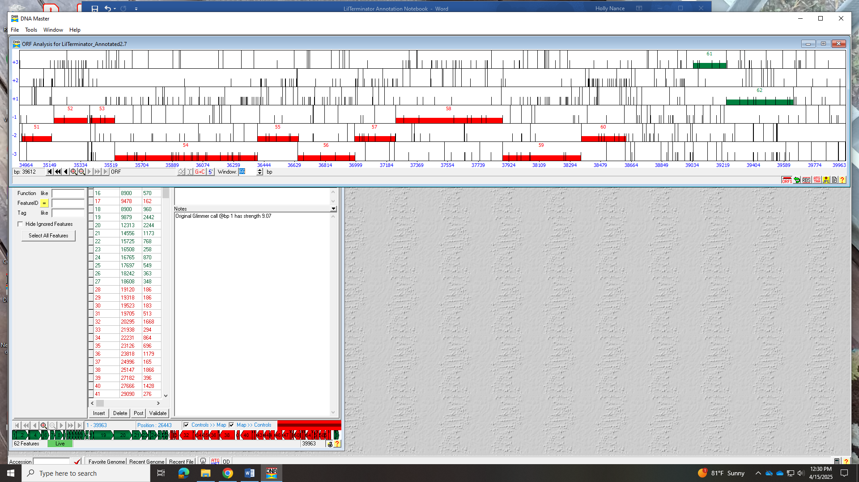
The GeneMark output shows coding potential for start 38652 (obviously):
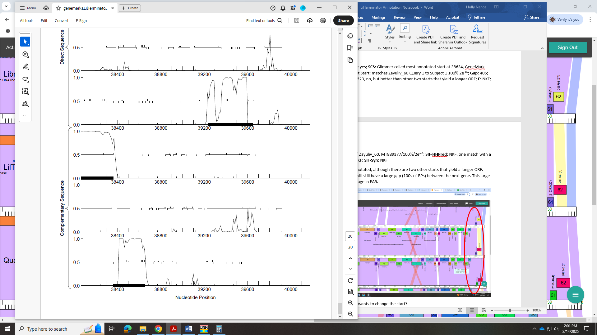
Function is NKF. There was one hit with a high probability, but it was for NKF:
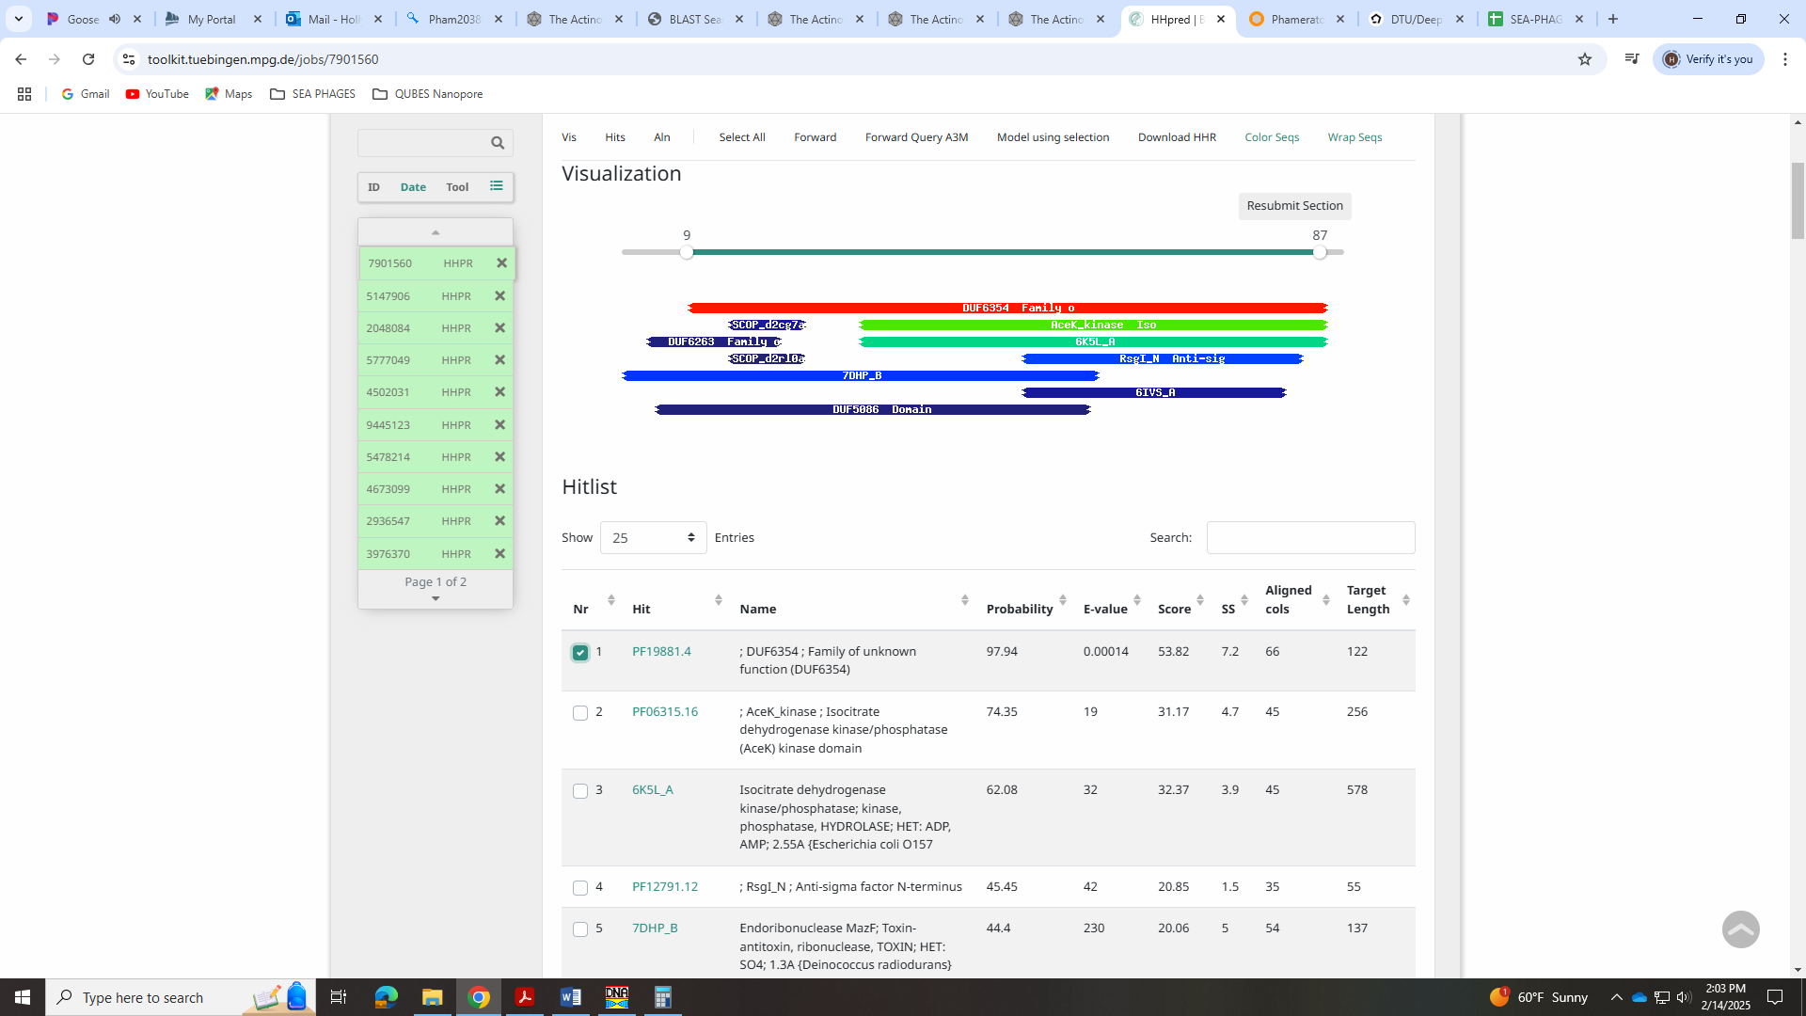

Gene 60
SSC: start 39040, stop 39240; CP: yes; SCS: Both called start at 39040; ST: SS; Blast Start: matches Zayuliv_61 Query 1 to Subject 1 90% 1e⁻³²; Gap: 405; LO: yes; RBS: -4.013, 1.926, 13, -5.059, no; F: membrane protein; SIF-BLAST: NKF/PhageDB BLAST/ Zayuliv_61, MT889377/90%/1e⁻³²; SIF-HHPred: NKF, no matches with a probability above 90%; SIF-Syn: NKF
Notes: Start is most annotated. All data suggests NKF for function, except DeepTMHMM!
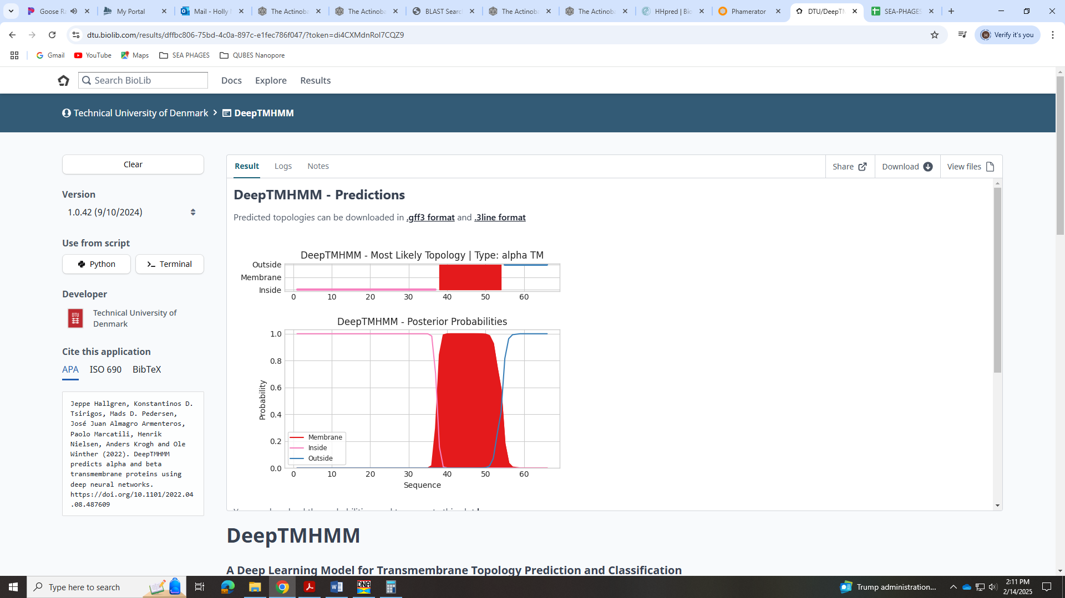

Gene 61
SSC: start 39240, stop 39647; CP: yes; SCS: Both called start at 39240; ST: SS; Blast Start: matches QuadZero_62 Query 7 to Subject 10 64% 3e⁻³⁹; Gap: overlap of 1; LO: no; RBS: -4.623, 1.640, 10, -5.318, no; F: NKF; SIF-BLAST: NKF/PhageDB BLAST/ QuadZero_62, MZ150787/64%/3e⁻³⁹; SIF-HHPred: NKF, no matches with a probability above 90%; SIF-Syn: NKF
Notes: Start is most annotated in Starterator and both Glimmer and GeneMark called it. But there are no 1:1 hits in BLAST with this start. Odd. However, this start yields an overlap of 1 and the other start that would yield the longest ORF would also yield an overlap of 82bps. Based on this, I think the best start is what is most annotated and what both called in DNA Master.
For function, all data suggests NKF.
