Mopey Annotation Notebook
We checked on 3/30/23 and we have all genes that we should!
Mopey genes:
Gene 1
SSC: start 1, stop 309; CP: yes; SCS: Both called start of 1; ST: SS; Blast Start: matches Thoth_1 Query 1 to Subject 1 100% 1e⁻⁵⁷; Gap: 0; LO: NA; RBS: -2.273, 2.809, 64617, -3.495, yes; F: NKF; SIF-BLAST: NKF/PhageDB BLAST/Thoth_1, MT889385/100%/1e⁻⁵⁷; SIF-HHPred: NKF, no matches with a probability above 90%; SIF-Syn: NKF
Notes: There is nothing ambiguous about this gene call. It seems conserved across the subcluster.
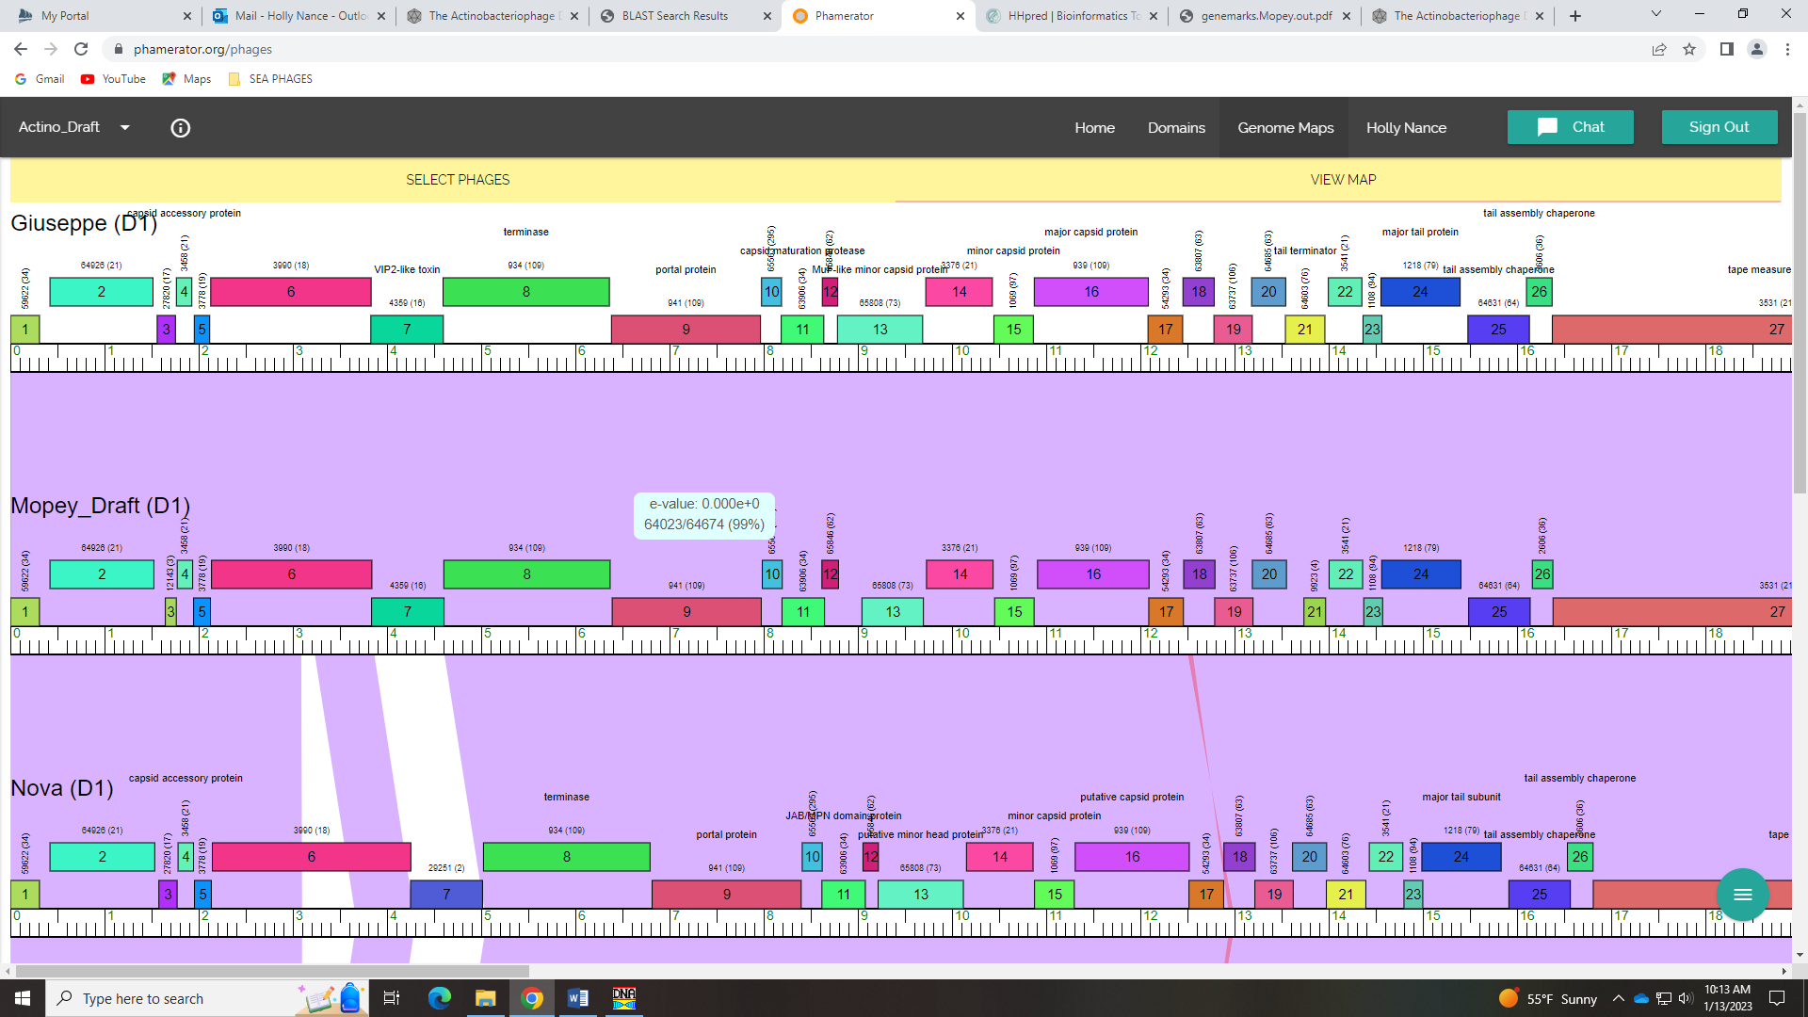
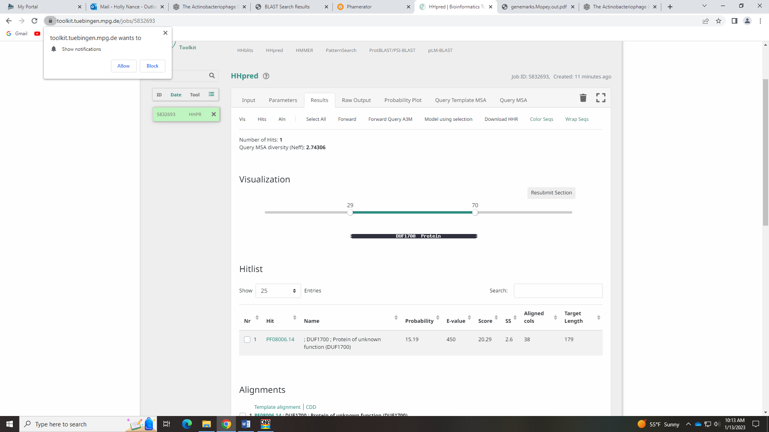

Gene 2
SSC: start 421, stop 1524; CP: yes; SCS: Both called start of 421; ST: SS; Blast Start: matches PBI1_2 Query 1 to Subject 1 99% 0.0; Gap: 111; LO: yes; RBS: -2.814, 2.549, 10, -3.508, no; F: NKF; SIF-BLAST: NKF/PhageDB BLAST/ PBI1_2, DQ398047/99%/0.0; SIF-HHPred: NKF, only 1 partial match with probability of 92%, but e-value of 2.4; SIF-Syn: NKF
Notes: 111 BP gap is conserved in Phamerator, and no coding potential in GeneMark output. There is one low probability hit in HHPred, but the e-value is high and it’s a small partial hit. Synteny and BLAST support NKF.
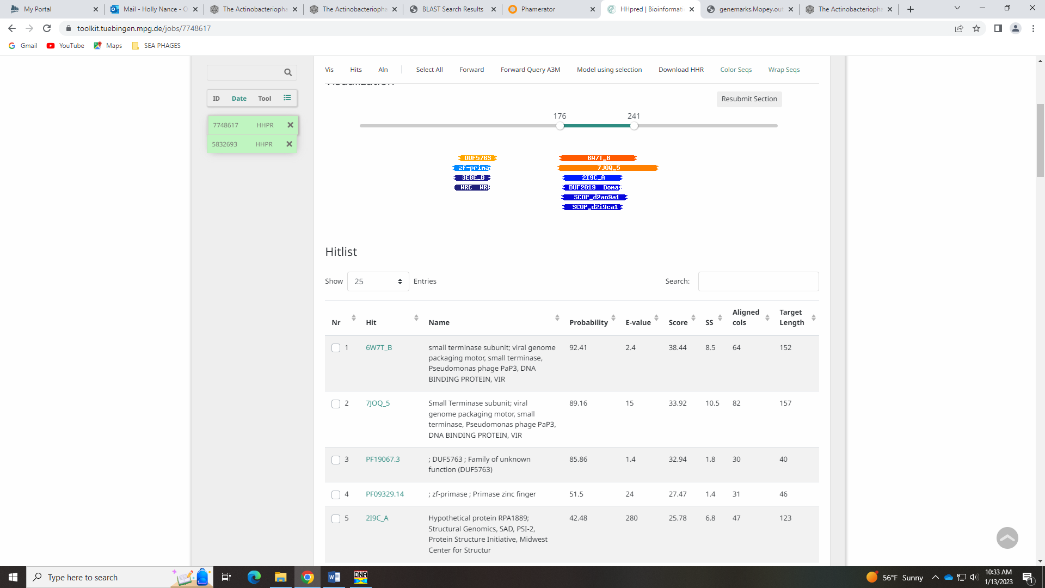

Gene 3 changed start from 1646 to 1568 on 1.13.23; need to ask SP folks about this gene…
SSC: start 1568, stop 1762; CP: yes; SCS: Glimmer called 1646 which is supported in Starterator but GeneMark called 1568 that is more conserved in cluster; ST: SS; Blast Start: matches WaldoWhy_3 Query 1 to Subject 1 100% 6e⁻³³; Gap: 43; LO: no; RBS: -4.343, 1.816, 9, -5.118, no; F: NKF; SIF-BLAST: NKF/PhageDB BLAST/ WaldoWhy_3, MK494102/100%/6e⁻³³; SIF-HHPred: NKF, no matches with a probability above 90%; SIF-Syn: NKF
Notes: I changed the start to this gene, using the GeneMark start of 1568 over the Glimmer start of 1646. There is good coding potential in the GeneMark output:
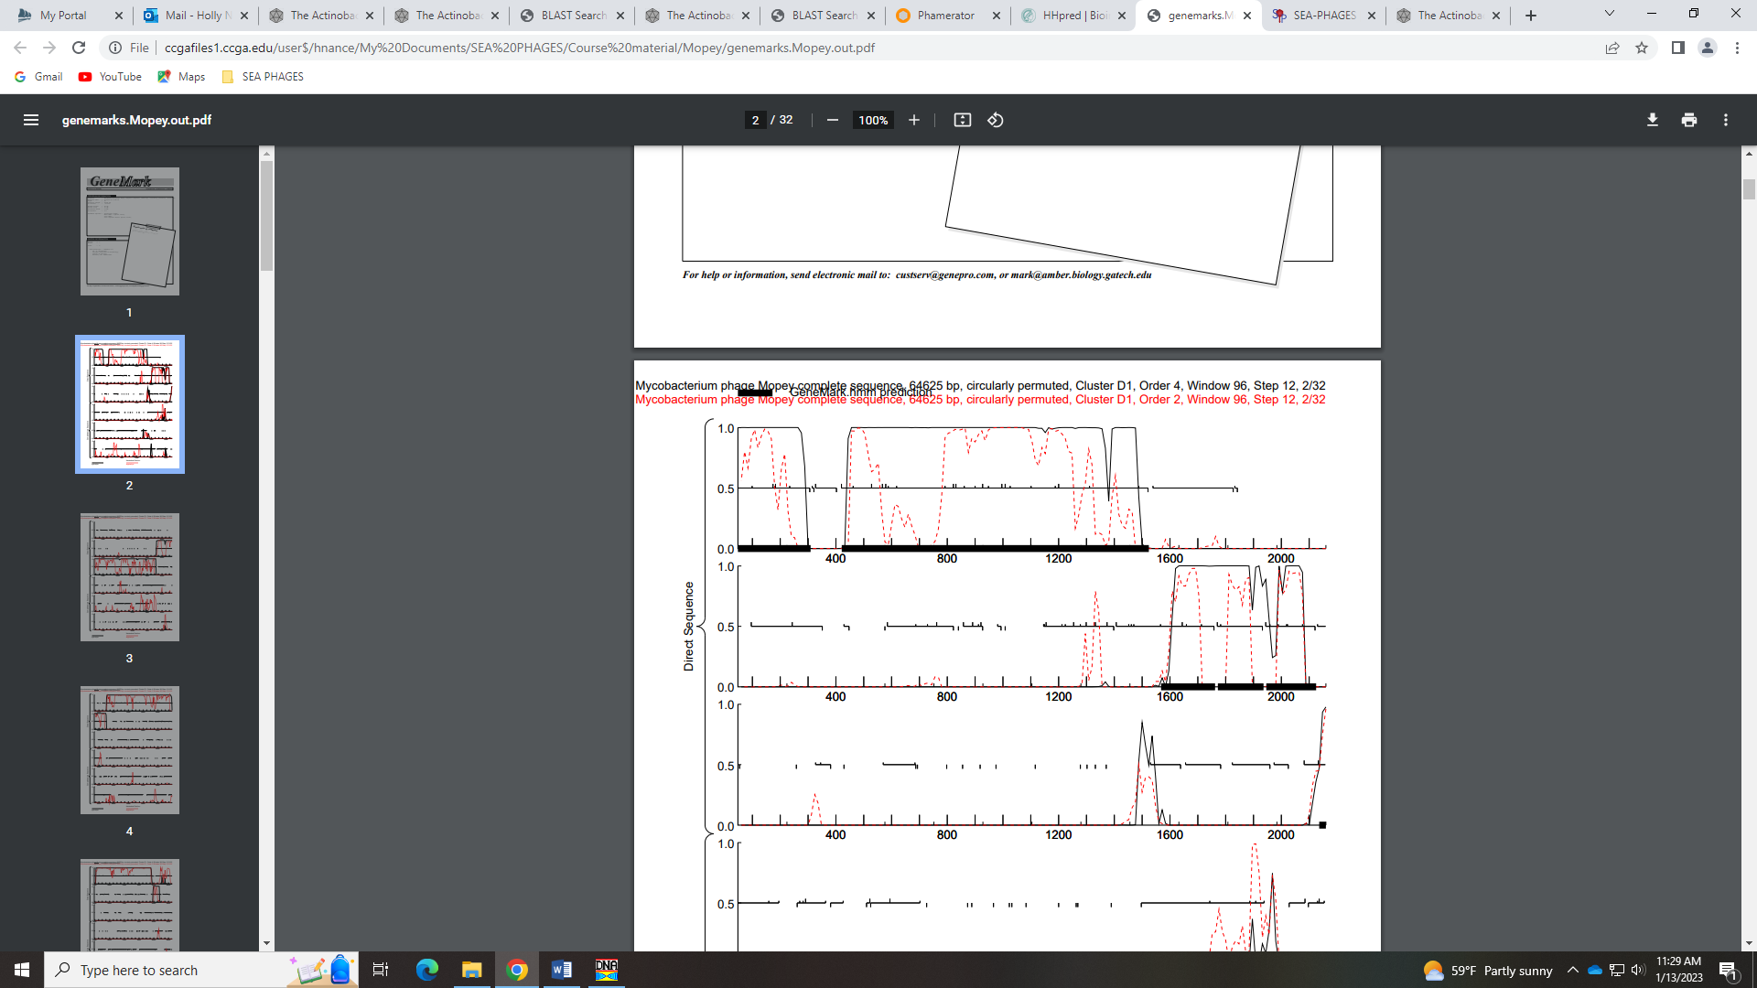
This start is also more conserved among other phage in cluster D1 based on BLAST results. The Starterator groups Mopey and 2 other phage in one gene phamily with the start of 1646, but this gene has 100% identities with the longer version of the gene (195 BP vs 117 BP) and yields a Q1 S1 with many more phage (with the Glimmer start, most phage have a Q1 S27 alignment). Using the start of 1568 yields a longer gene and smaller gap (44 BP rather than 121 BP).
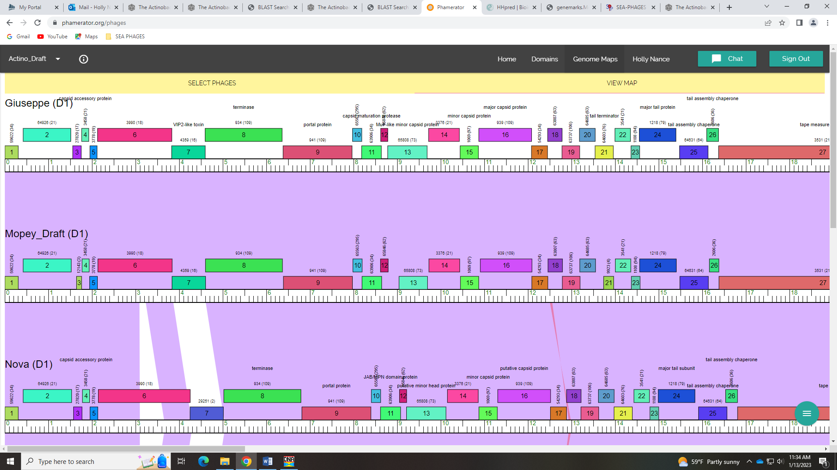

Gene 4
SSC: start 1772, stop 1936; CP: yes; SCS: Both called start of 1772; ST: SS; Blast Start: matches WaldoWhy_4 Query 1 to Subject 1 100% 1e⁻²⁶; Gap: 9; LO: yes; RBS: -3.631, 2.158, 10, -4.326, yes; F: capsid accessory protein; SIF-BLAST: capsid accessory protein/PhageDB BLAST/ WaldoWhy_4, MK494102/100%/1e⁻²⁶; SIF-HHPred: NKF, no matches with a probability above 90%; SIF-Syn: capsid accessory protein
Notes: Start is conserved in this gene, as is the function. Both PhagesDB and NCBI BLAST results support this:
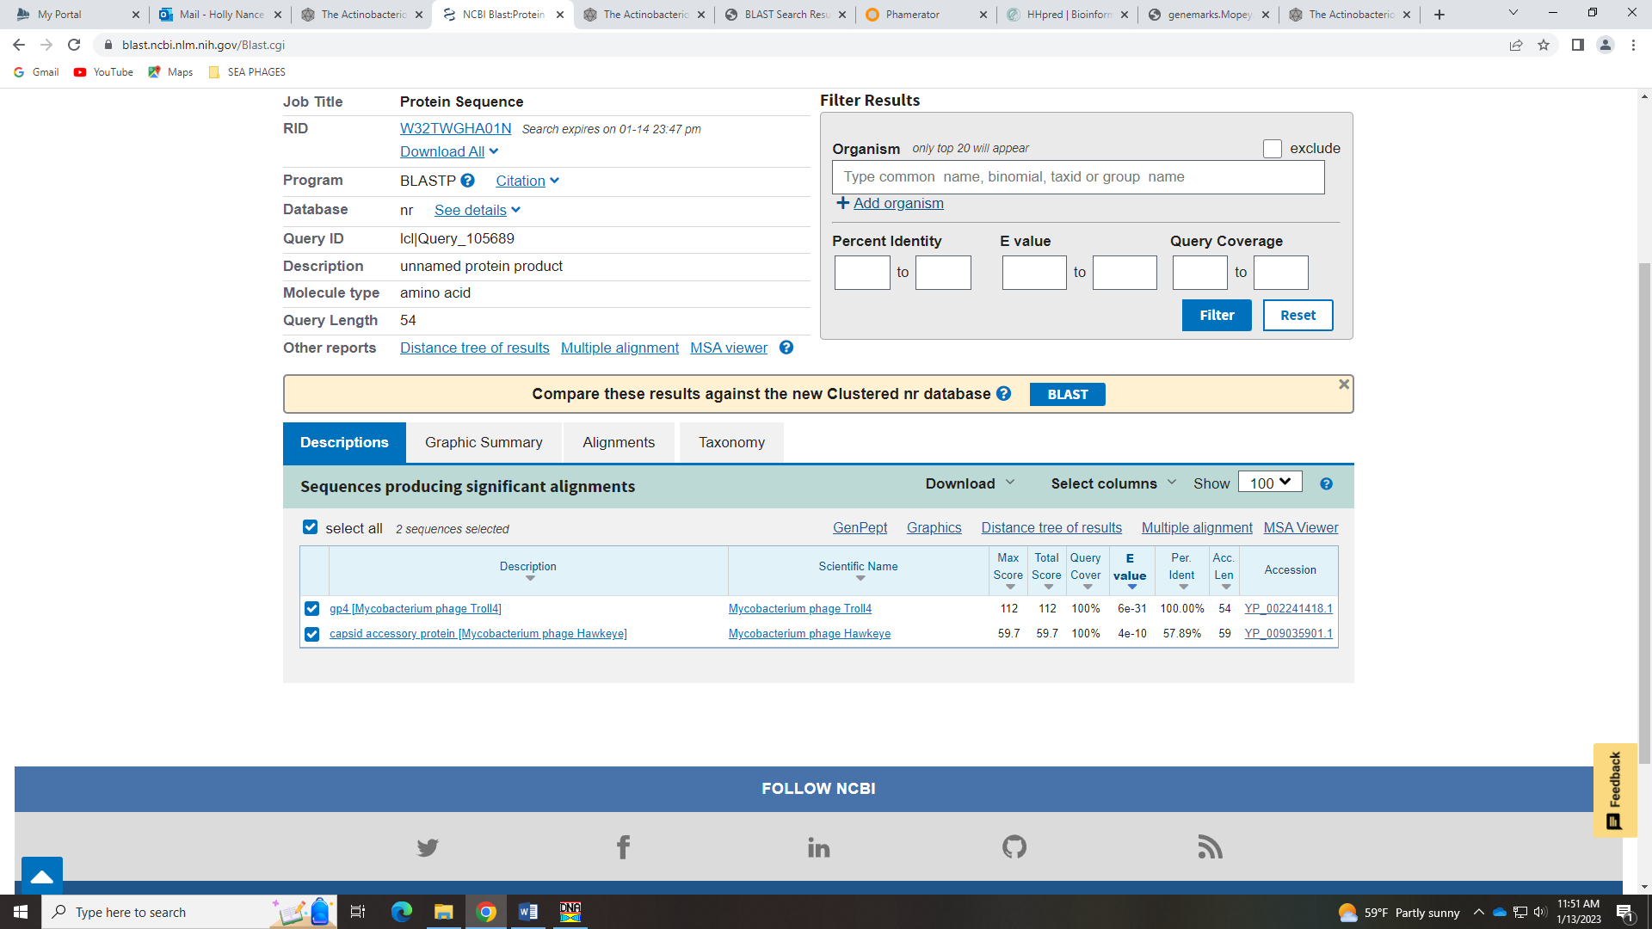
There was no significant hit in HHpred for this gene:
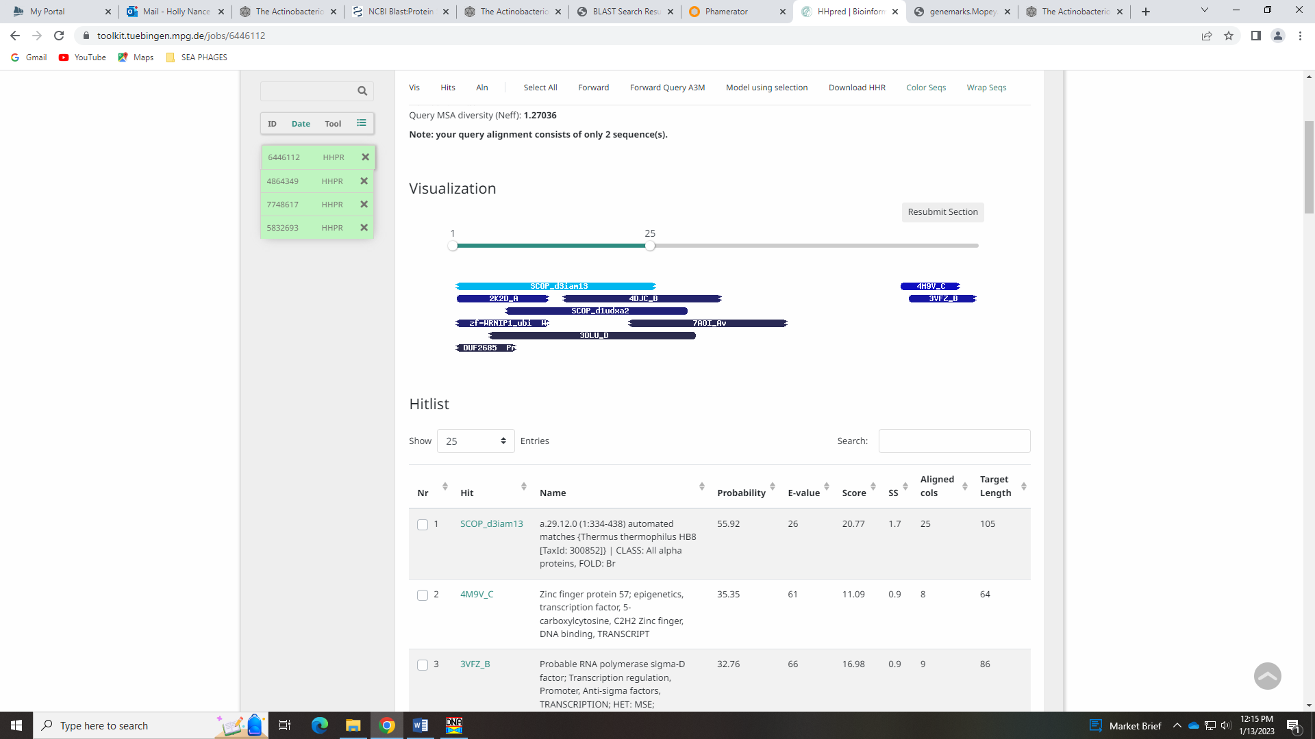
But given the support with synteny and BLAST, I’m comfortable calling it a capsid accessory protein. This gene is not on the official phage function list, but all BLAST hits use this name.
Gene 5
SSC: start 1946, stop 2125; CP: yes; SCS: Both called start of 1946; ST: SS; Blast Start: matches SirHarley_5 Query 1 to Subject 1 100% 2e⁻²⁷; Gap: 9; LO: yes; RBS: -4.141, 1.913, 13, -5.187, no; F: NKF; SIF-BLAST: NKF/PhageDB BLAST/ SirHarley_5, JF937107/100%/1e⁻⁵⁷; SIF-HHPred: NKF, no matches with a probability above 90%; SIF-Syn: NKF
Notes: Nothing ambiguous about this gene.
Gene 6
SSC: start 2136, stop 3839; CP: yes; SCS: Both called start of 2136; ST: SS; Blast Start: matches Helpful_6 Query 1 to Subject 1 99% 0.0; Gap: 10; LO: no; RBS: -4.259, 1.856, 11, -5.016, no; F: NKF; SIF-BLAST: NKF/PhageDB BLAST/ Helpful_6, MN284908/99%/0.0; SIF-HHPred: NKF, no matches with a probability above 90%; SIF-Syn: NKF
Notes: Nothing ambiguous about this gene. Some of the BLAST hits assign a function to this gene (even some as tape measure protein!), but in general those e-values are too high. All other evidence supports NKF
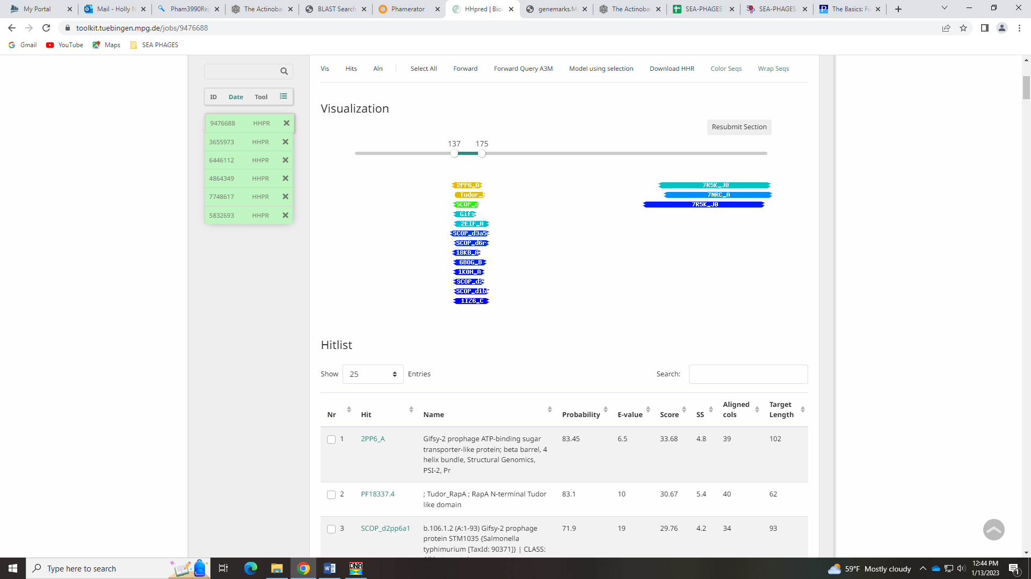
Gene 7
SSC: start 3836, stop 4606; CP: yes; SCS: Both called start of 3836; ST: SS; Blast Start: matches Troll4_7 Query 1 to Subject 1 100% 1e⁻¹⁴⁵; Gap: overlap of 4; LO: no; RBS: -3.857, 2.049, 6, -5.602, no; F: VIP2-like ADP-ribosyltransferase toxin; SIF-BLAST: VIP2-like ADP-ribosyltransferase toxin /PhageDB BLAST/Thoth_7, MT889385/100%/1e⁻¹⁴⁵; SIF-HHPred: VIP2-like ADP-ribosyltransferase toxin, 2 matches with a probability above 98%; SIF-Syn: VIP2-like toxin
Notes: All is clear on this gene except the function. Some BLAST hist are NKF, three VIP2-like toxin and/or VIP2-like ADP-ribosyltransferase toxin. Both of those names are on the Official Phage function list. Here is what NCBI said about this protein:
VIP2; A family of actin-ADP-ribosylating toxin. A member of the Bacillus-prodiced vegetative insecticidal proteins (VIPs) possesses high specificity against the major insect pest, corn rootworms, and belongs to a classs of binary toxins and regulators of biological pathways distinct from classical A-B toxins. A novel family of insecticidal ADP-ribosyltransferses were isolated from Bacillus cereus during vegetative growth, where VIP1 likely targets insect cells and VIP2 ribosylates actin. VIP2 shares significant sequence similarity with enzymatic components of other binary toxins, Clostridium botulinum C2 toxin, C. perfringens iota toxin, C. piroforme toxin, C. piroforme toxin and C. difficile toxin.
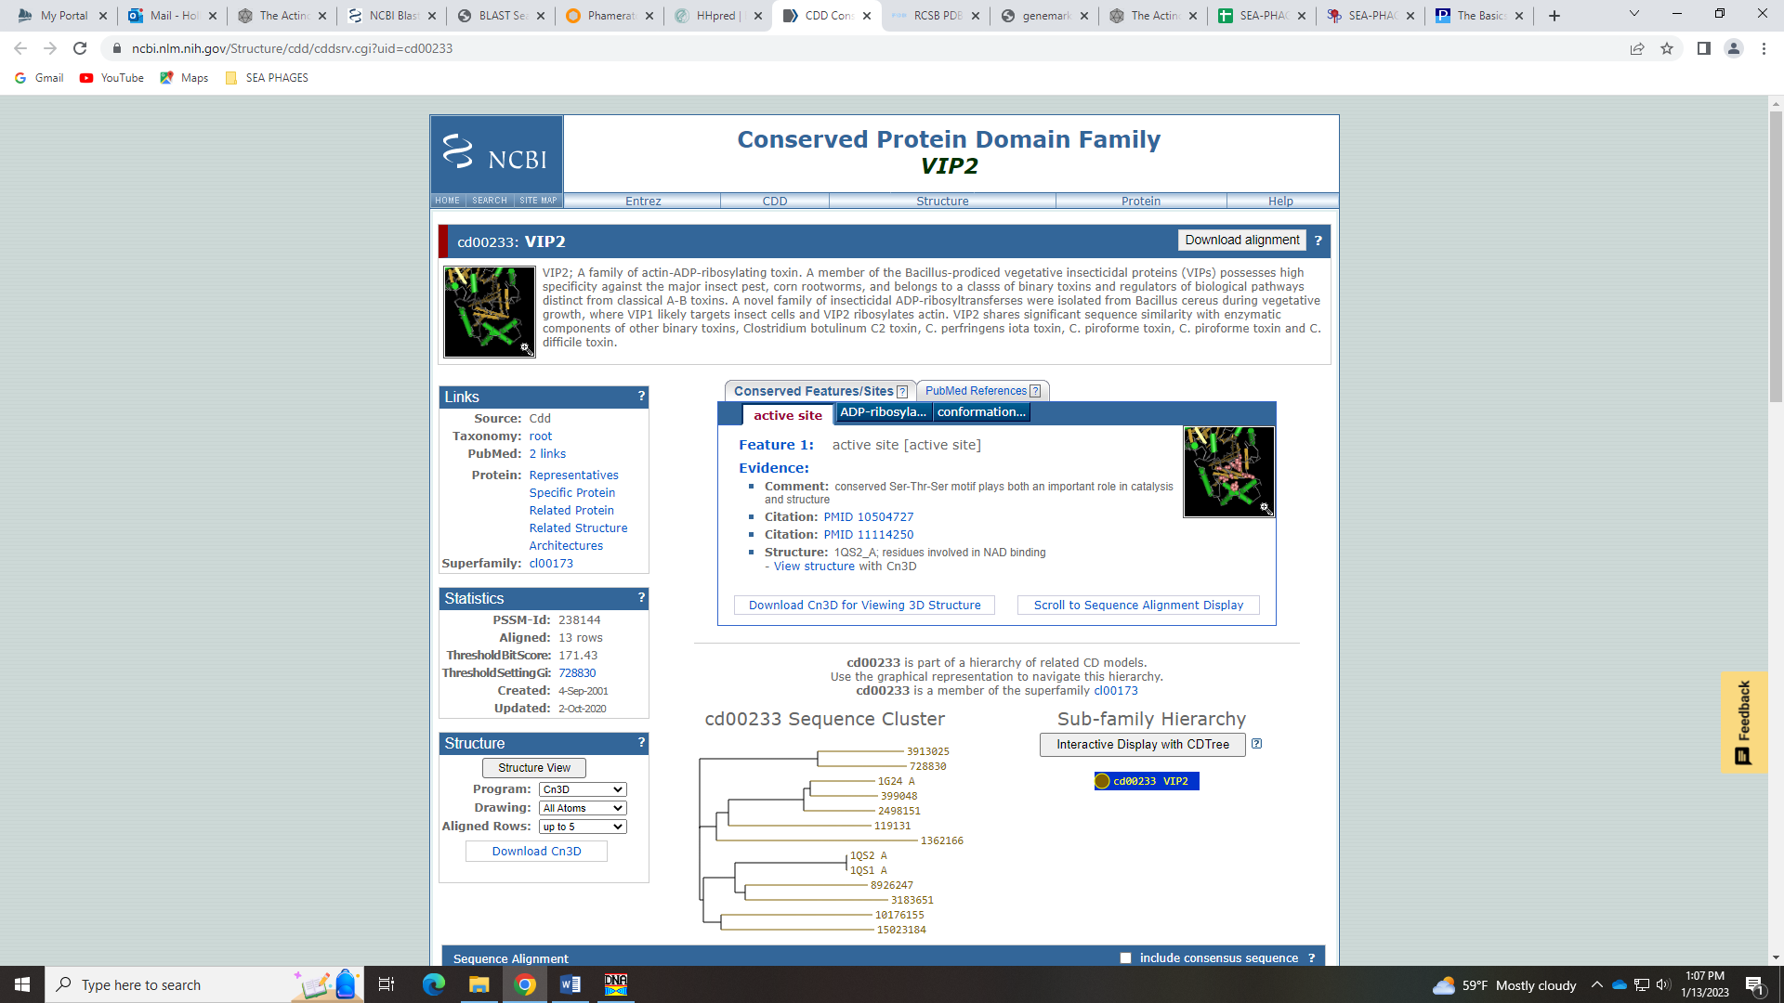
Here are the 3 hits for VIP2 from HHPred:
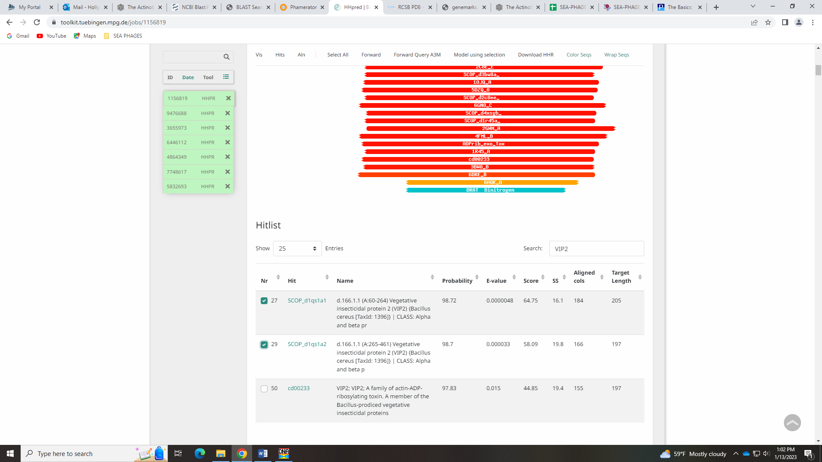
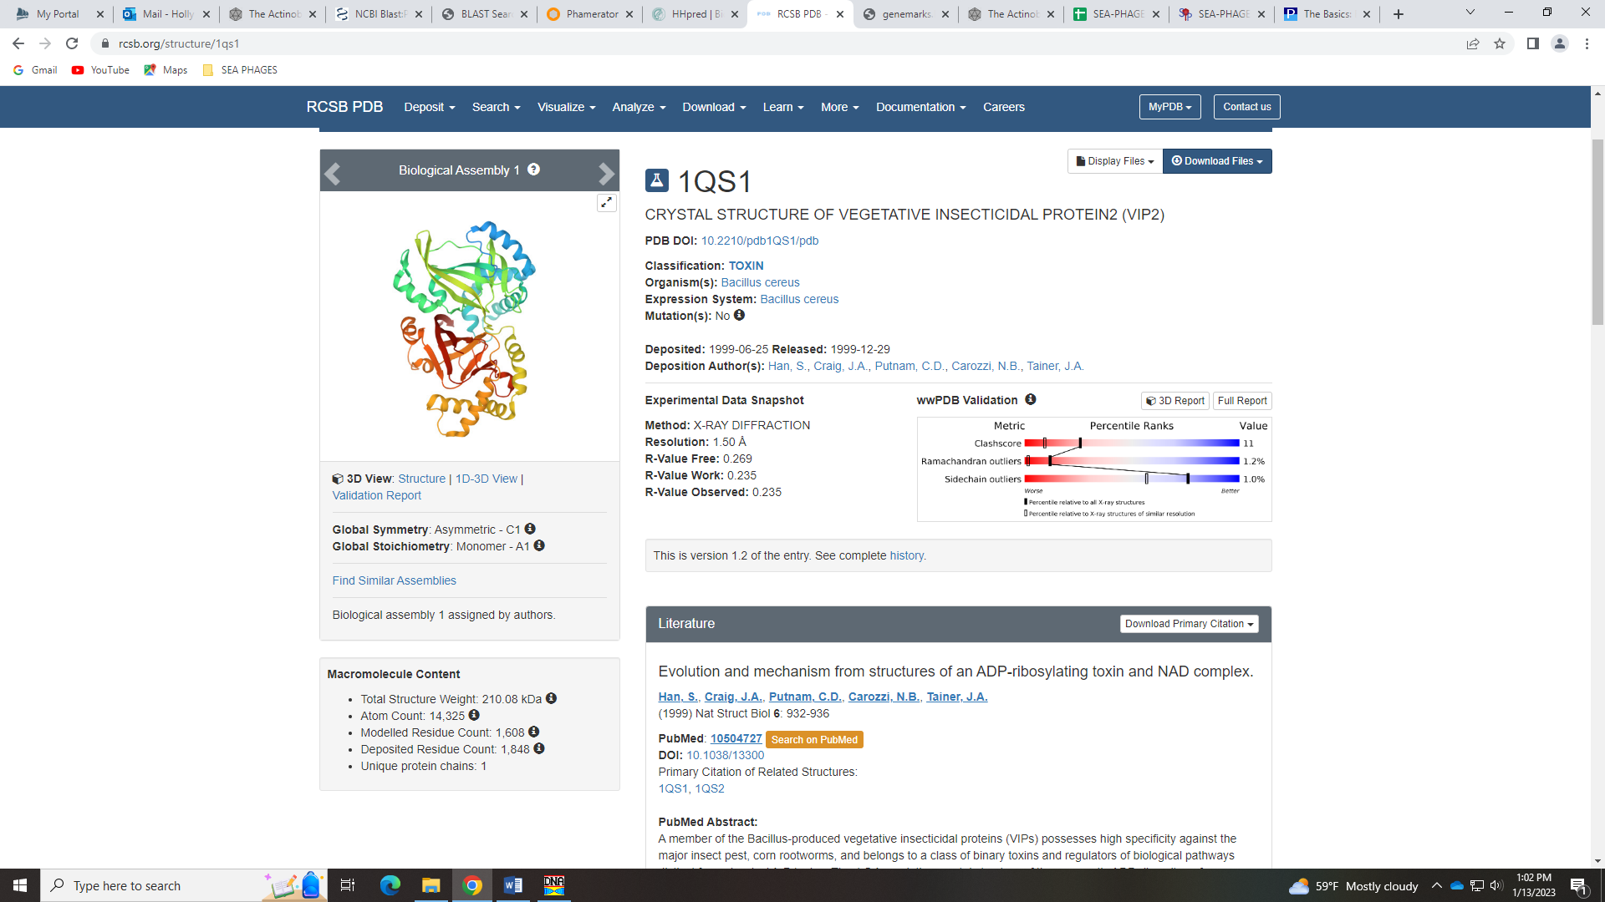
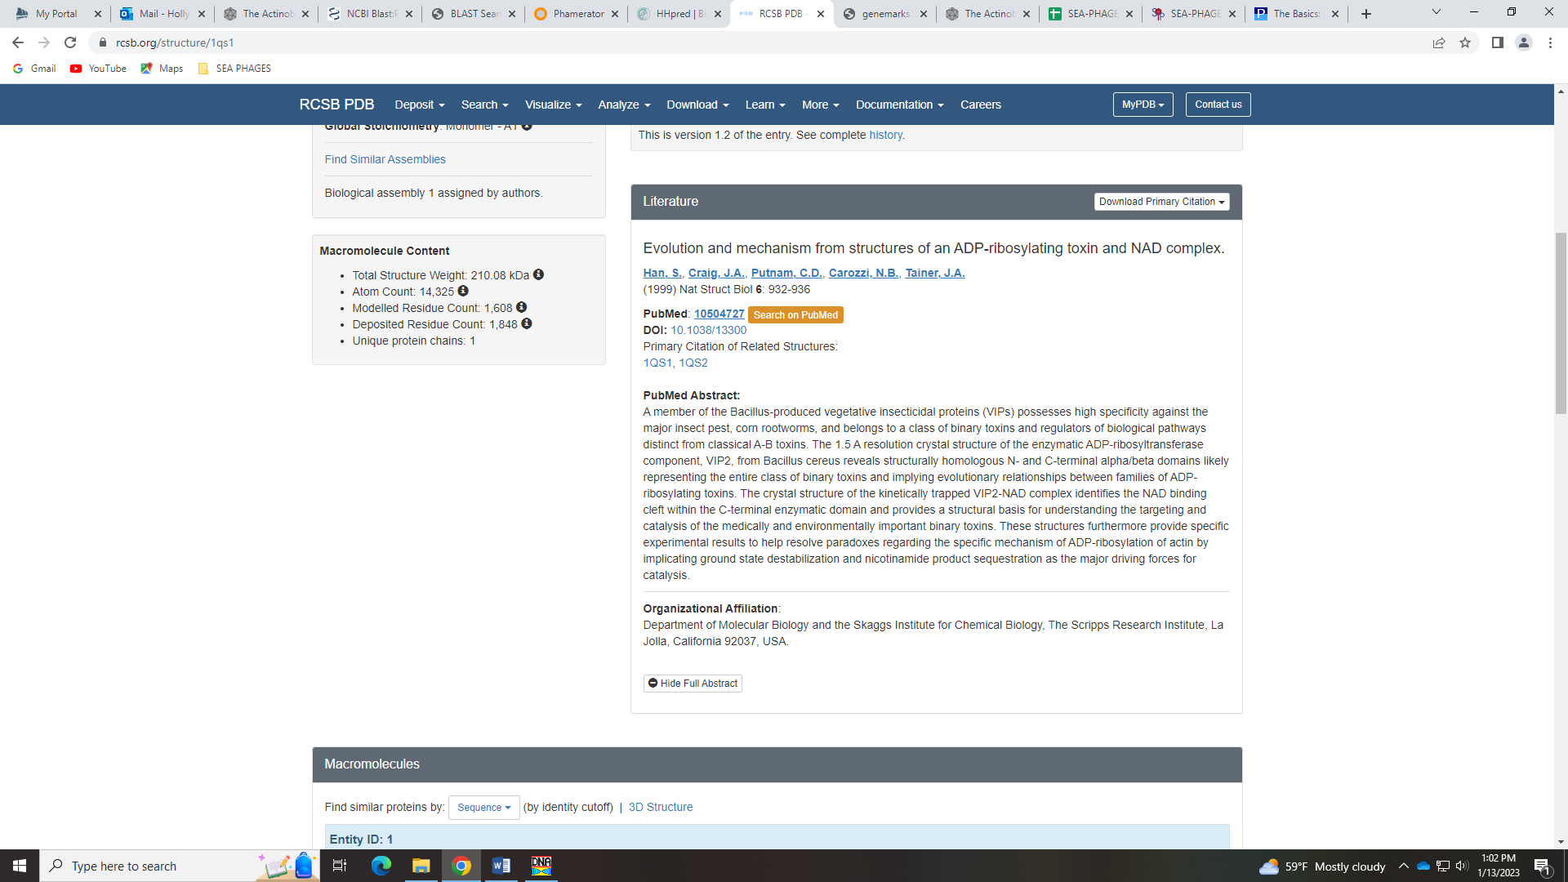
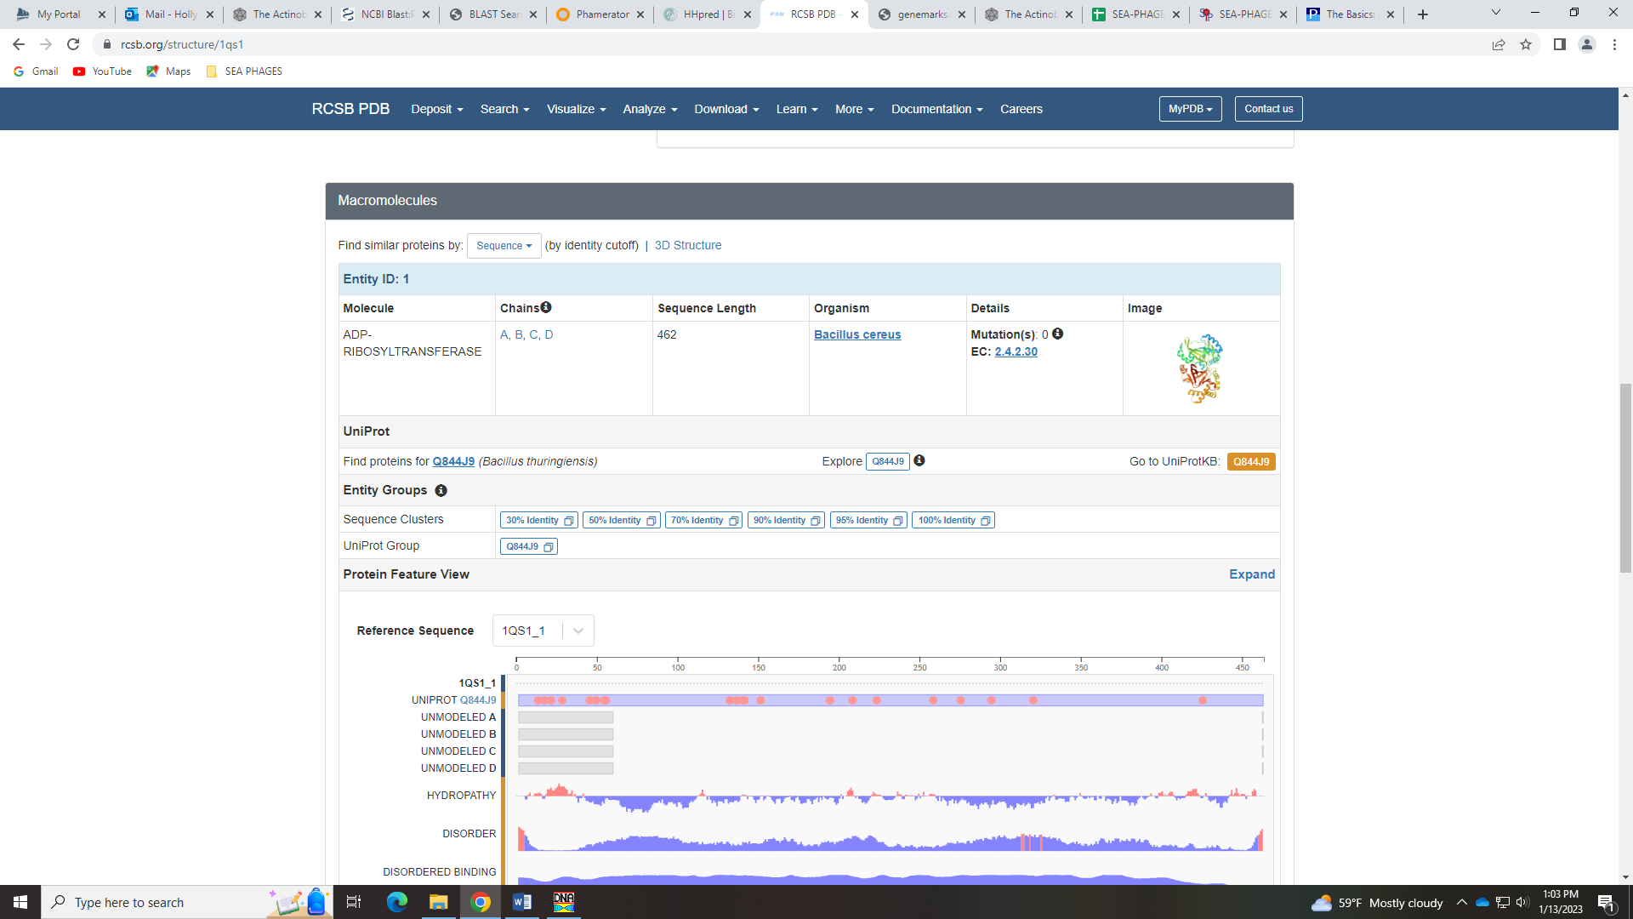
Whether we call it VIP2-like toxin or VIP2-like ADP-ribosyltransferase toxin needs to be further researched. Wait a minute! Look at the Phamerator domain information…
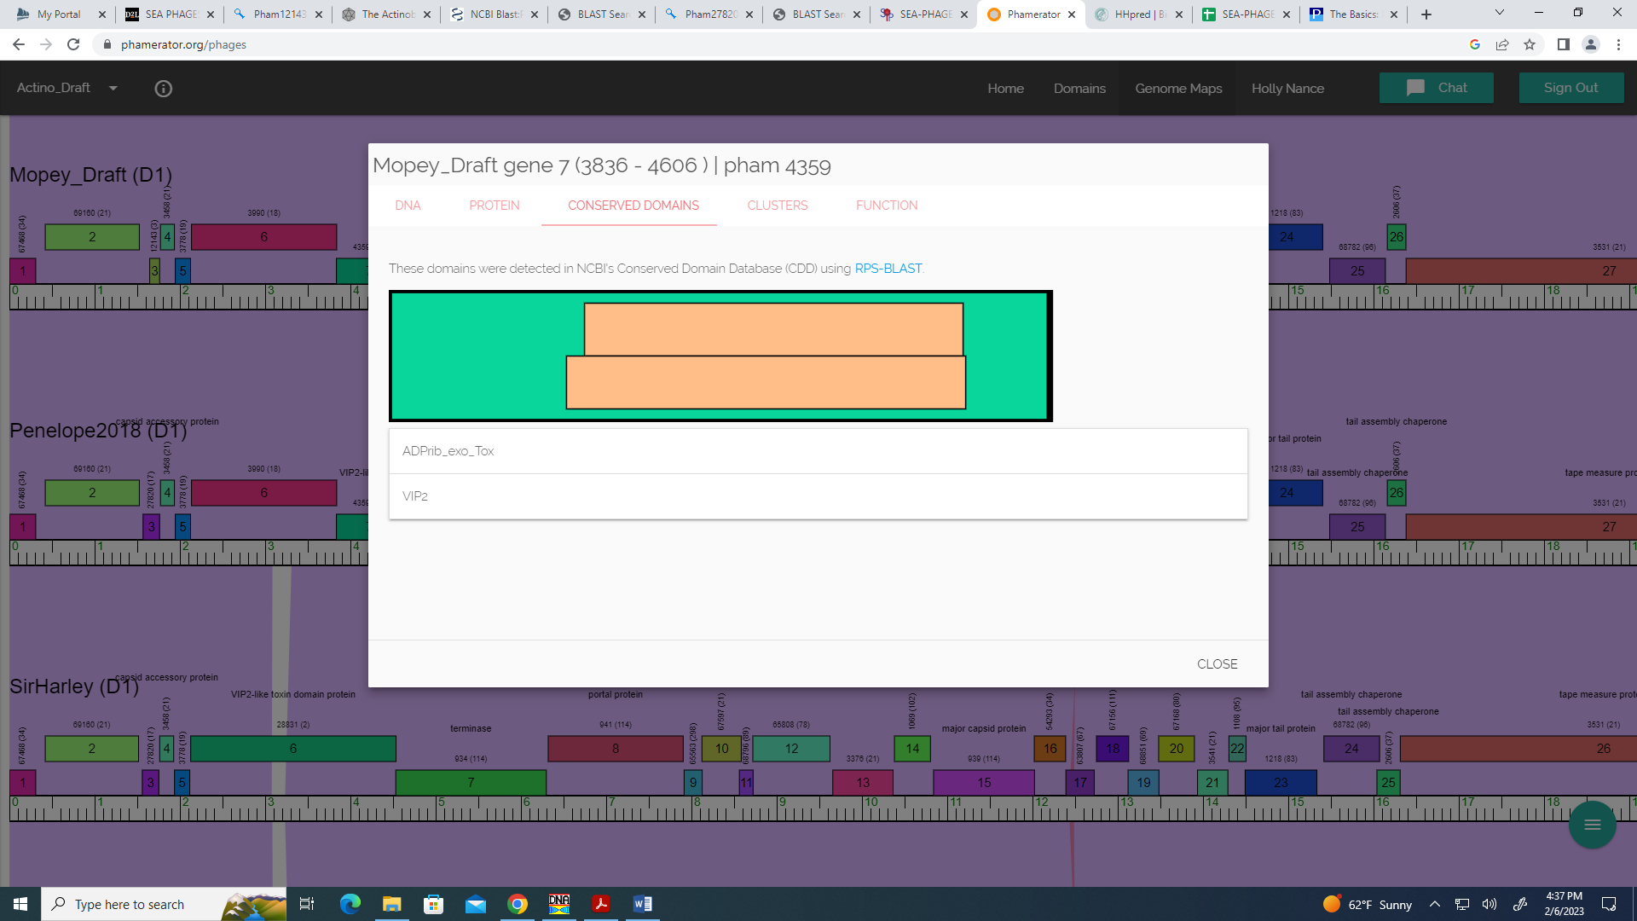
Given the VIP2-like ADP-ribosyltransferase toxin domain is in this gene, that seems like compelling reason to call it VIP2-like ADP-ribosyltransferase toxin rather than VIP2-like toxin.
Gene 8
SSC: start 4603, stop 6369; CP: yes; SCS: Both called start of 4603; ST: SS; Blast Start: matches Visconti_8 Query 1 to Subject 1 100% 0.0; Gap: overlap of 4; LO: yes; RBS: -4.141, 1.913, 6, -5.886, no; F: terminase; SIF-BLAST: terminase/PhageDB BLAST/ Visconti_8, MH399788/100%/0.0; SIF-HHPred: terminase, several matches with a probability above 90%, 4 matches are 100%; SIF-Syn: terminase
Notes: There isn’t a clear consensus on the starts from Starterator, just because this is a large phamily and there are so many starts to consider. However, the start we have is suggested and the most annotated in cluster D1.
Regarding function, there is consensus that this is terminase based on BLAST data, synteny, and HHPred:
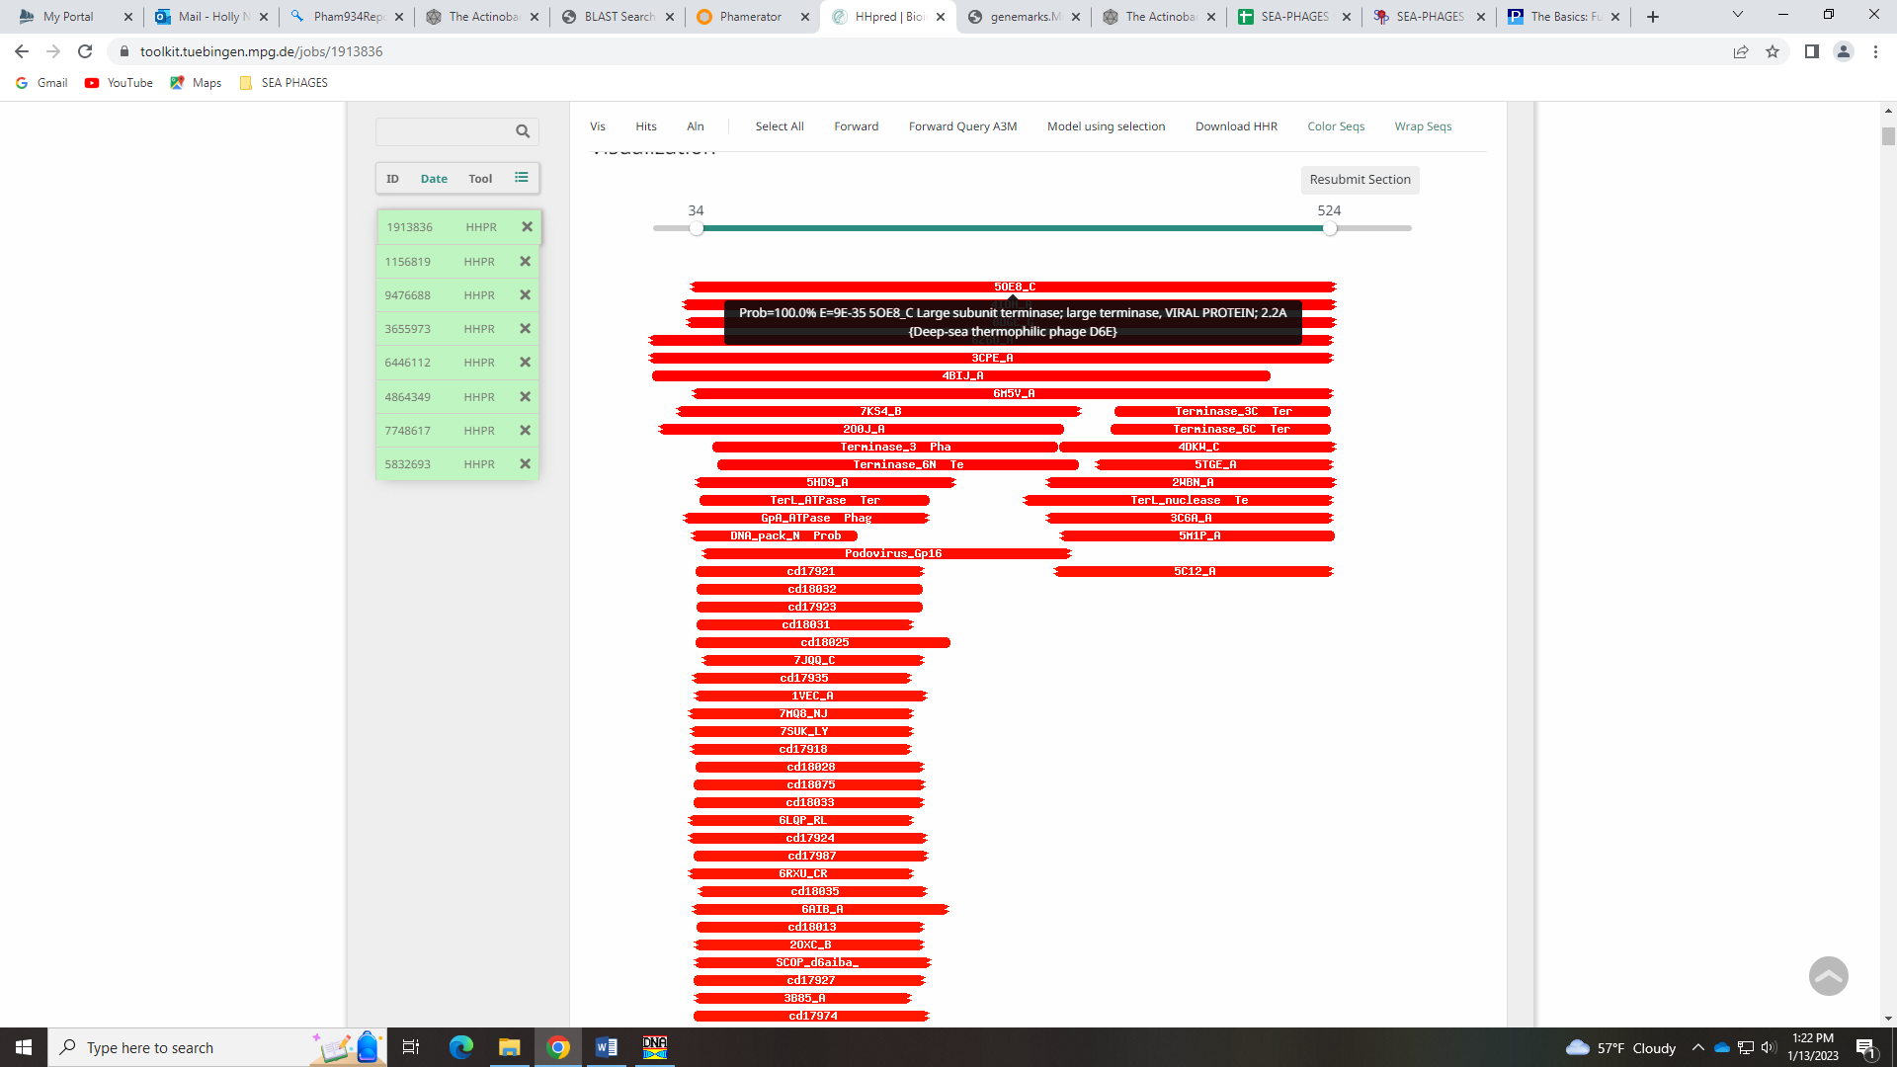
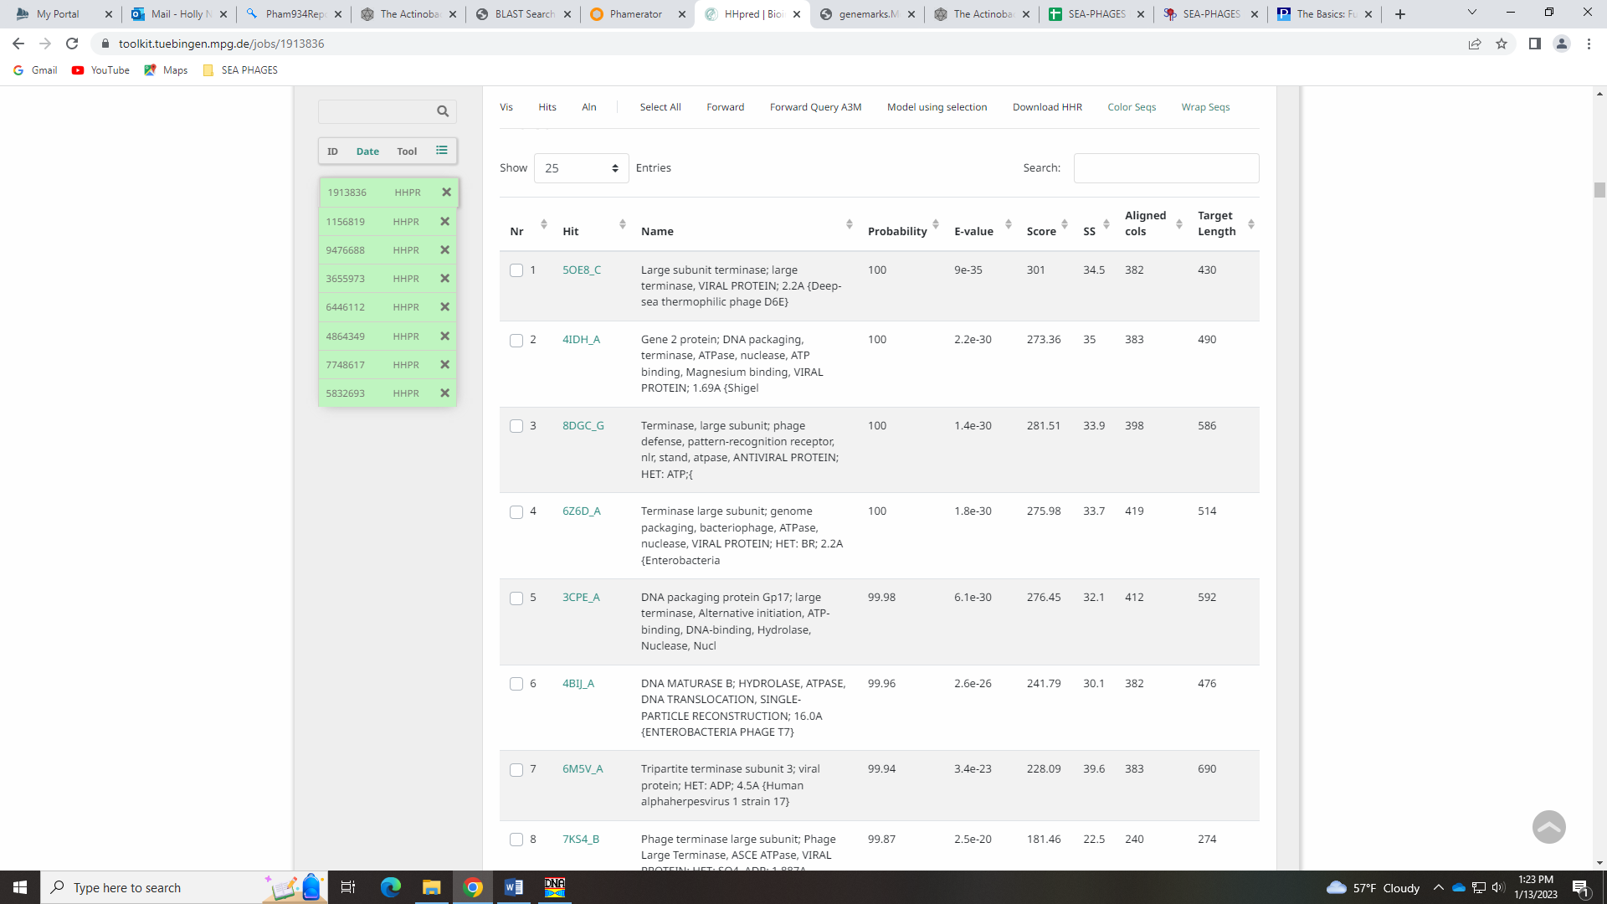
Terminase is on the Official Phage function list, but also designations of either large or small subunit. There are criteria for being more specific, and cluster D1 is not in those criteria. Therefore, I think we ought to call it terminase.

Gene 9
SSC: start 6391, stop 7974; CP: yes; SCS: Both called start of 6391; ST: SS; Blast Start: matches WaldoWhy_9 Query 1 to Subject 1 99% 0.0; Gap: 21; LO: yes; RBS: -4.259, 1.856, 12, -5.095, no; F: portal protein; SIF-BLAST: portal protein/PhageDB BLAST/ WaldoWhy_9, MK494102/99%/0.0; SIF-HHPred: portal protein, several matches with a probability above 90%; SIF-Syn: portal protein
Notes: start and function conserved by all evidence; nothing ambiguous.
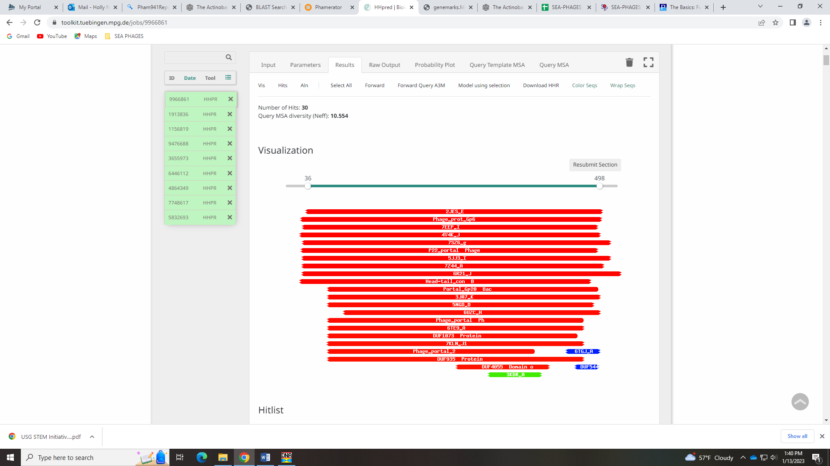
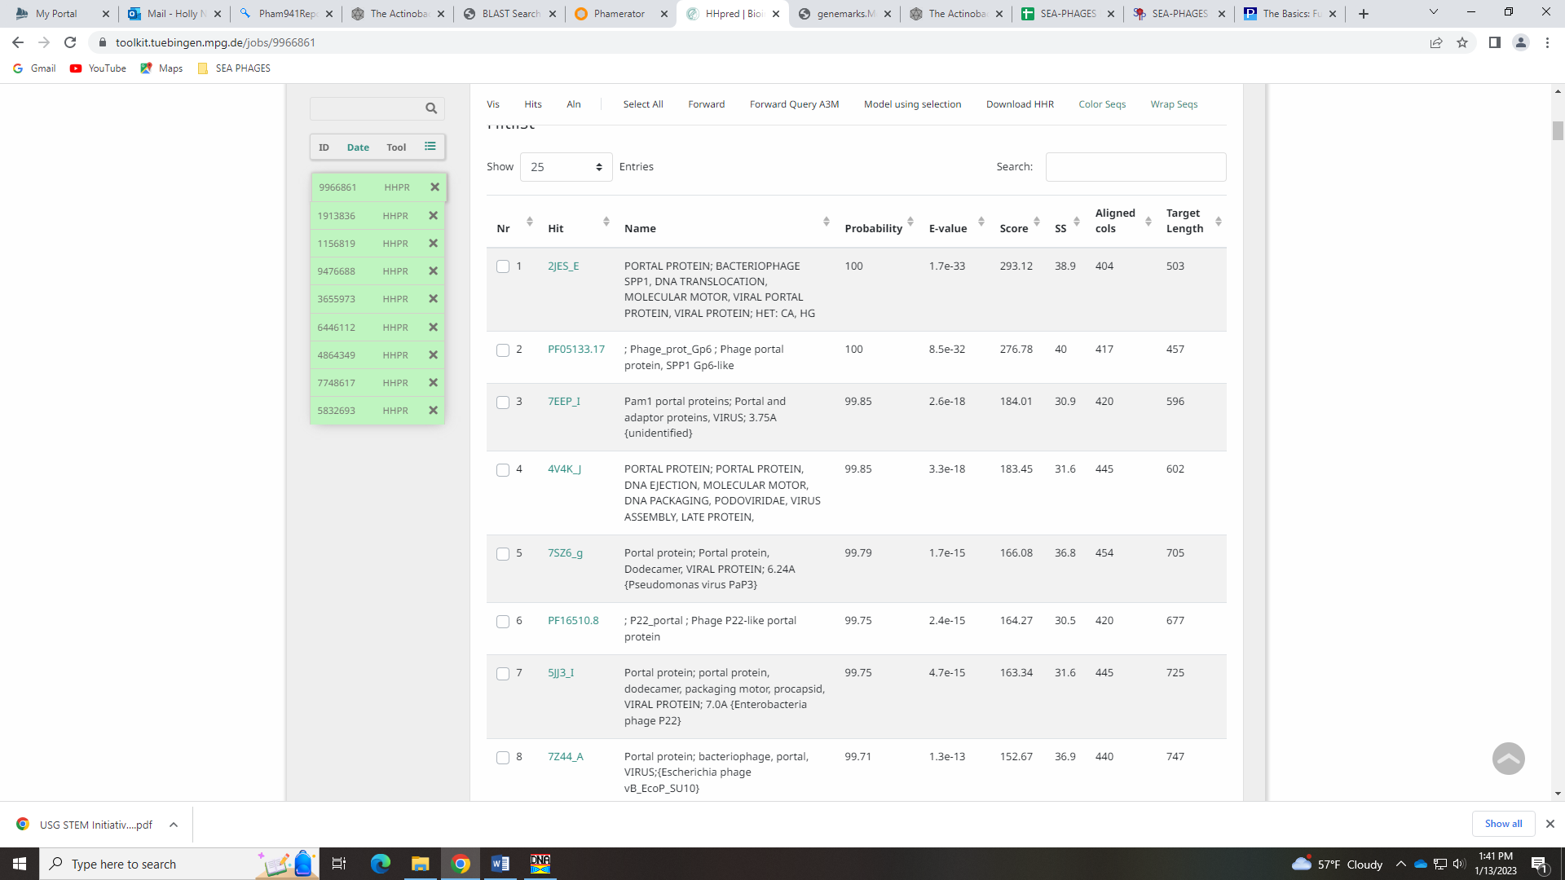
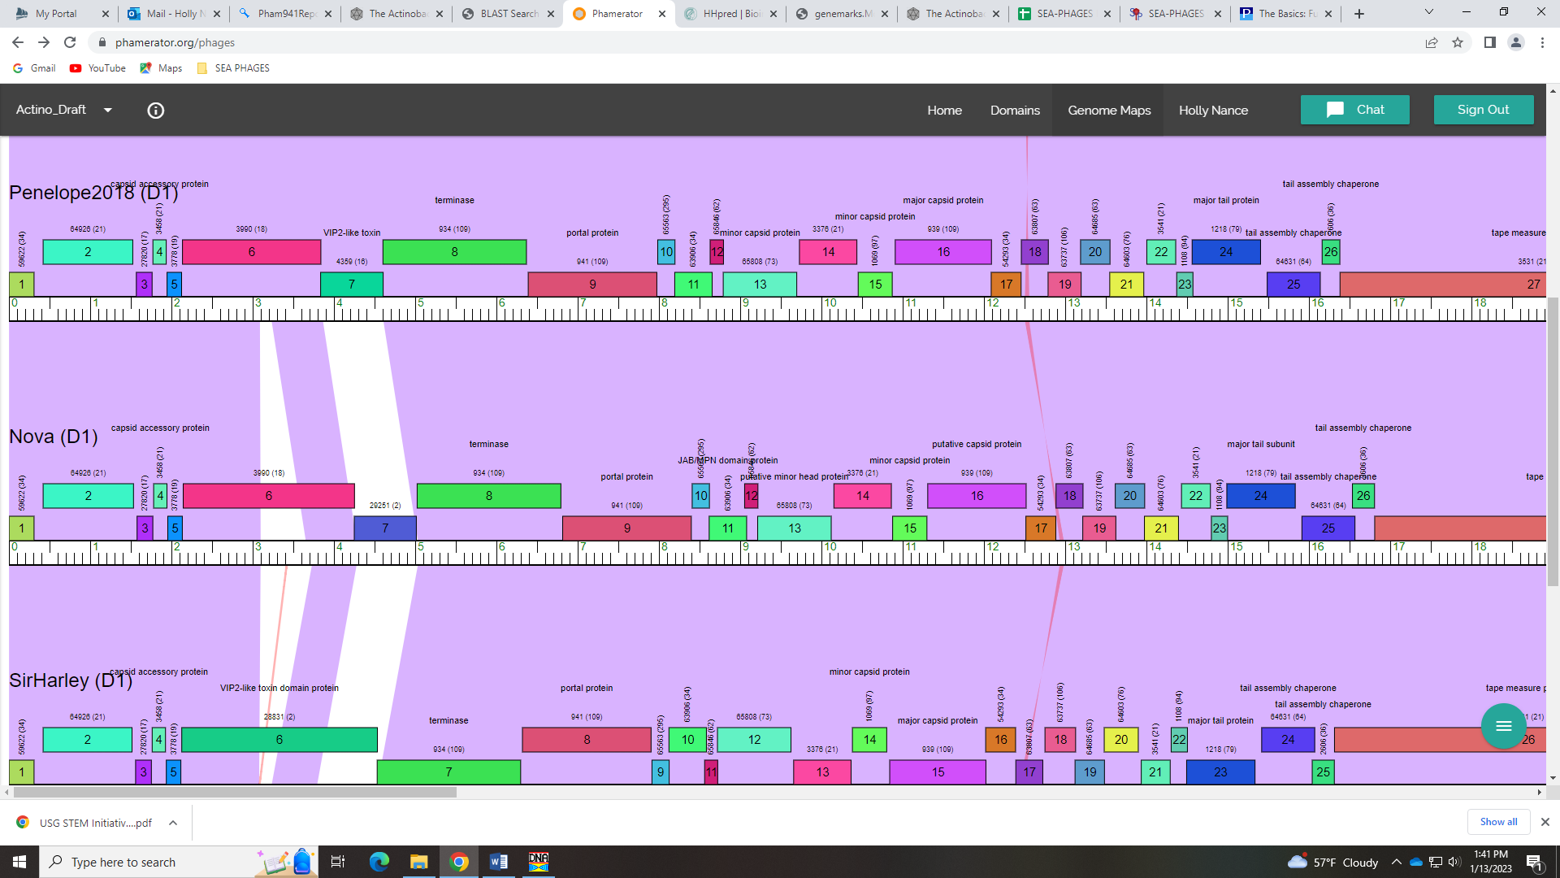

Gene 10
SSC: start 7985, stop 8197; CP: yes; SCS: Both called start of 7985; ST: SS; Blast Start: matches Visconti_10 Query 1 to Subject 1 100% 5e⁻³⁷; Gap: 10; LO: yes; RBS: -1.559, 3.151, 10, -2.253, yes; F: NKF; SIF-BLAST: NKF/PhageDB BLAST/ Visconti_10, MH399788/100%/5e⁻³⁷; SIF-HHPred: NKF, no matches with a probability above 90%; SIF-Syn: NKF
Notes: nothing ambiguous about this gene
Gene 11 Ashley
SSC: start 8194, stop 8646; CP: no, not called by GeneMark; SCS: Glimmer called start of 8194, NOT called by GeneMark; ST: SS; Blast Start: matches Visconti_11 Query 1 to Subject 1 100% 6e⁻⁸⁹; Gap: overlap of 4; LO: NA; RBS: -1.951, 2.963, 10, -2.645, yes; F: NKF; SIF-BLAST: NKF/PhageDB BLAST/Visconti_11, MH399788/100%/6e⁻⁸⁹; SIF-HHPred: NKF, several matches with a probability above 90%; SIF-Syn: NKF
Notes: Function for this gene is tricky. Some call it metalloprotease, but the Official Function list says that it must contain an HEXXH motif for that name, and this protein doesn’t. Others have called this a capsid maturation protease, and each phage genome should have one (it ranks 2), but there isn’t support with synteny for this call. Some of the other names for this protein (JAB/MPN domain protein) are descriptive but not on the official phage function list. There are several high hits on HHPred, but not all make sense:
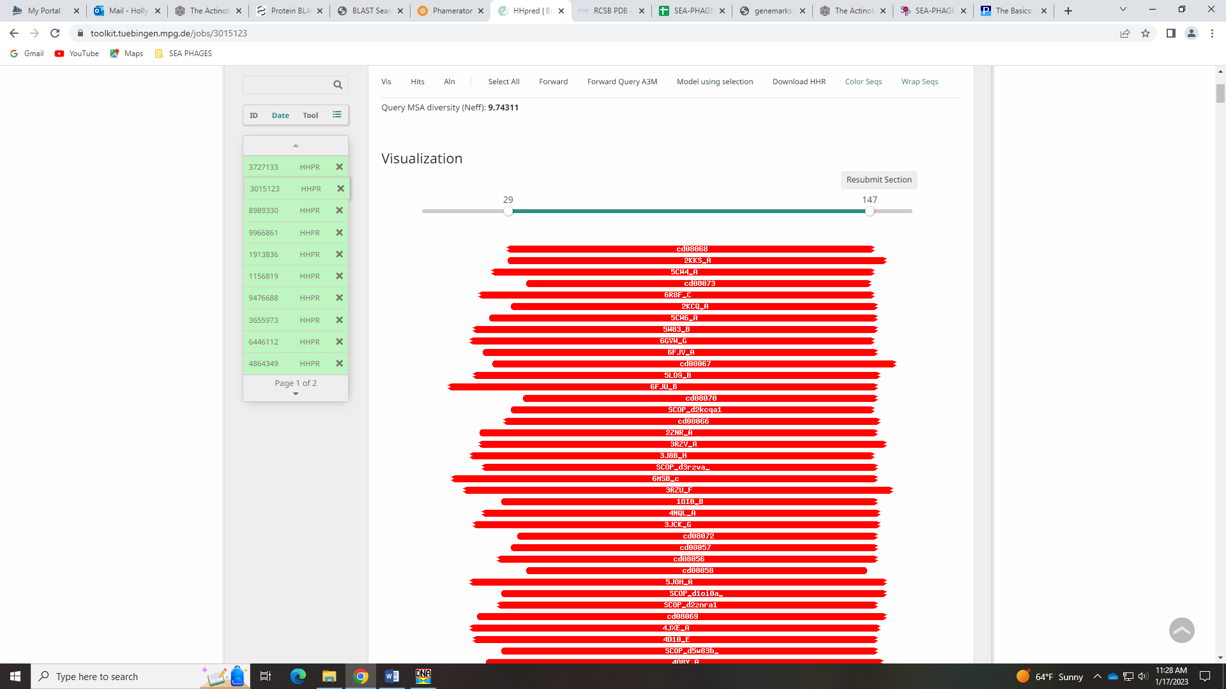
And there are several domains in the protein:
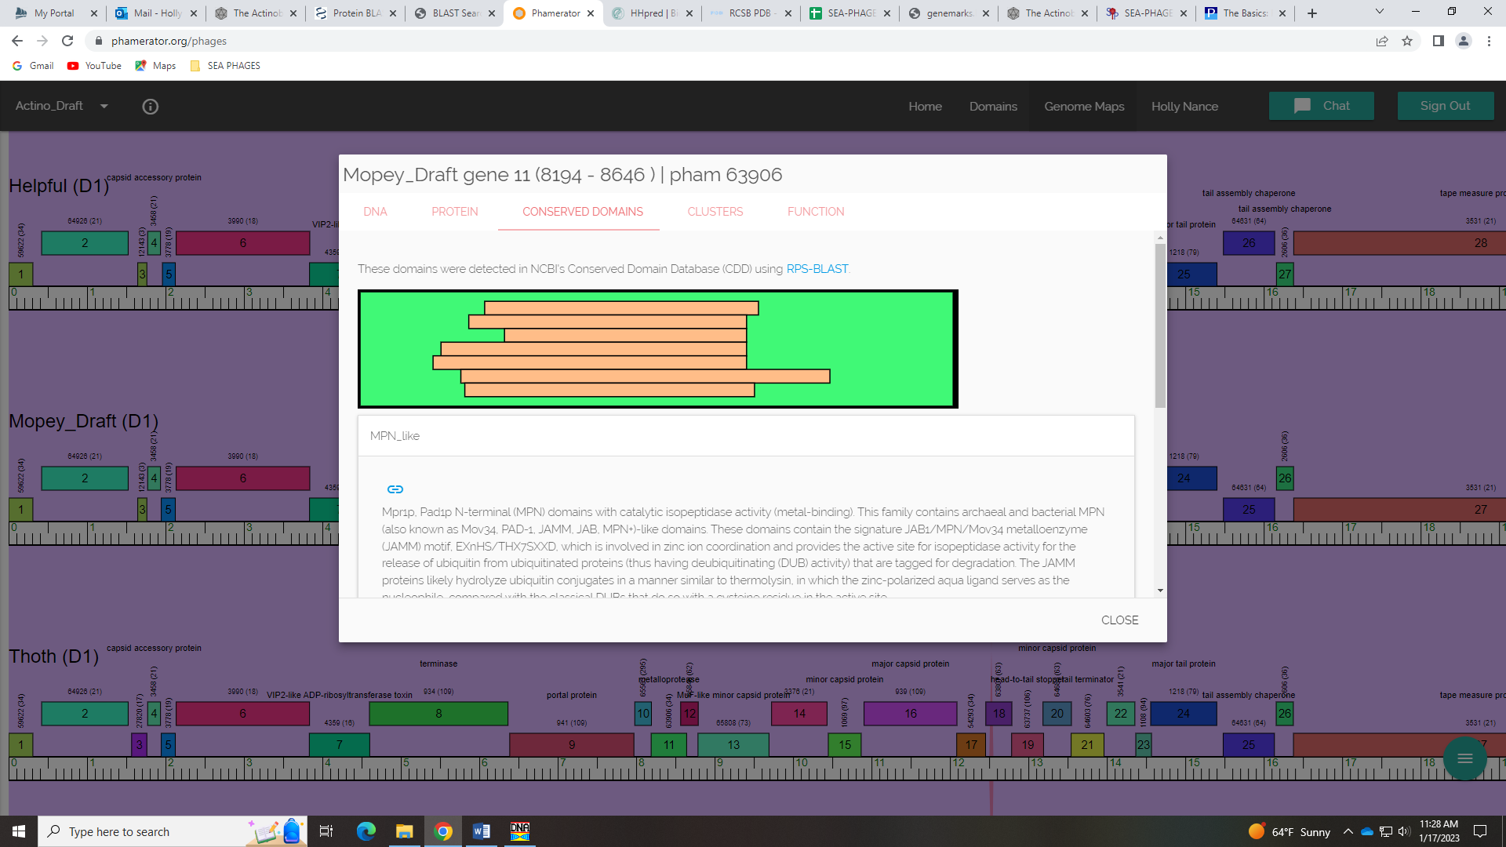
NCBI BLAST has some hits for tail protein…
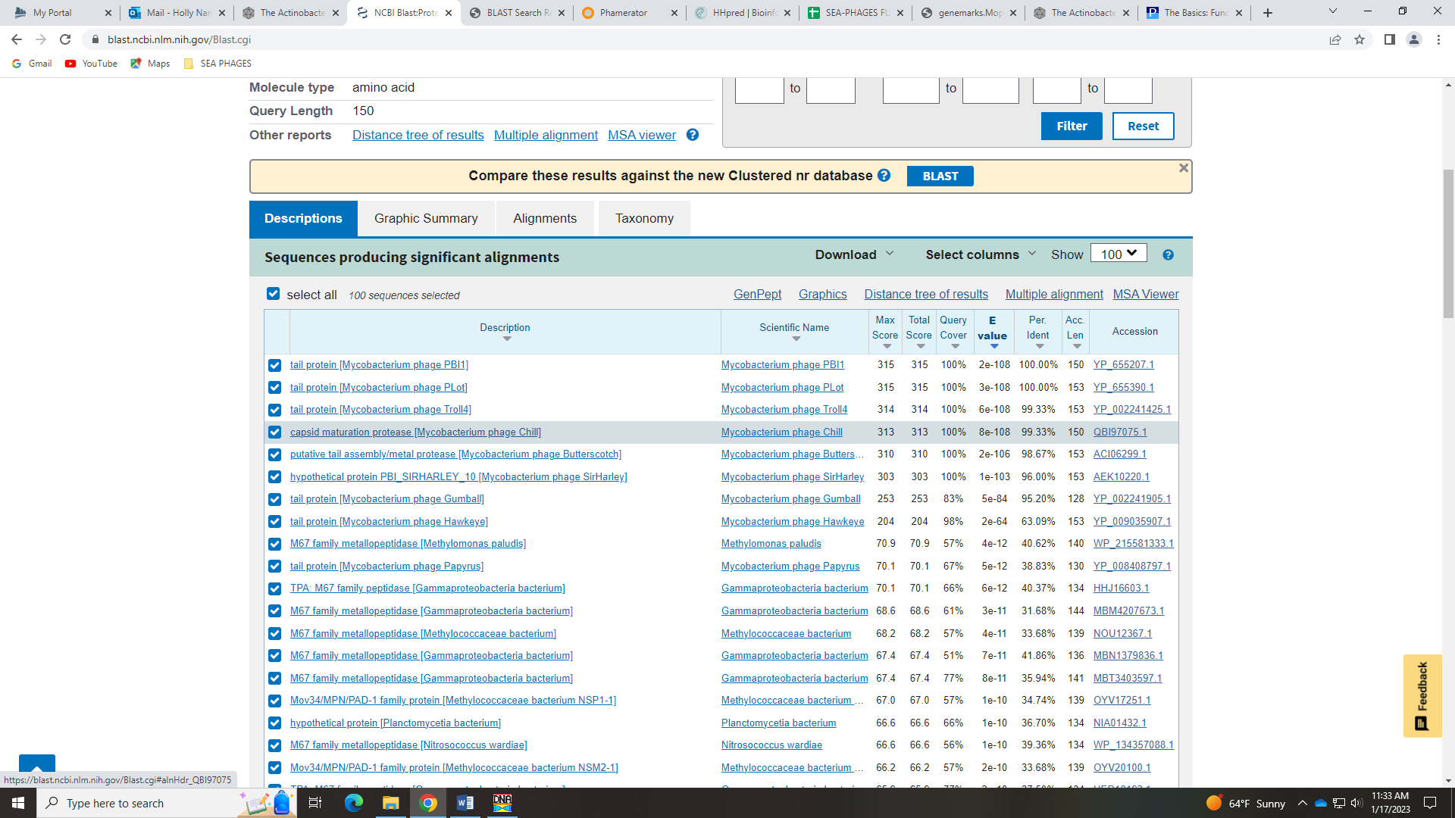
Ashley determined not enough evidence to call it a function.

Gene 12 Ricky
SSC: start 8618, stop 8794; CP: yes; SCS: Glimmer called start at 8618, GeneMark called start at 8570; ST: NI; Blast Start: matches PBI1_12 Query 1 to Subject 2 100% 9e⁻³⁰; Gap: overlap of 29; LO: NA; RBS: -2.549, 2.676, 7, -4.072, no; F: NKF; SIF-BLAST: NKF/PhageDB BLAST/Thoth_12, MT889385/100%/9e⁻³⁰; SIF-HHPred: NKF, no matches with a probability above 90%; SIF-Syn: NKF
Notes: Start needs some work. Start called by Glimmer is not conserved and yields shortest ORF. Start called by GeneMark is most conserved and has best RBS values, and would seem to yield a much longer ORF, but the support from the GeneMark output doesn’t really support that start. Also, the GeneMark start results in an overlap of 77 BP. Hmmm… just not sure which start to use here…
Went with the less-conserved Glimmer start because it results in a smaller overlap, it has the second best RBS values.

Gene 13 changed start to 8791 on 1.17.23 Shaela
SSC: start 8791, stop 9696; CP: yes; SCS: Both called start of 9043, but 8791 yields a much longer ORF and is the most called start; ST: SS, as in the most conserved; Blast Start: matches Visconti_13 Query 1 to Subject 1 100% 1e⁻¹⁷³; Gap: overlap of 4; LO: NA; RBS: -2.210, 2.839, 9, -2.985, yes; F: minor capsid protein; SIF-BLAST: minor capsid protein/PhageDB BLAST/Penelope2018_13, MN119378/99%/1e⁻¹⁷³; SIF-HHPred: minor capsid protein, one match with a probability above 99.85%; SIF-Syn: minor capsid protein
Notes: changed the start of this gene from 9043 (called by both Glimmer and GeneMark) to 8791. This start is more conserved across the cluster and phamily, it yields a much longer ORF, the RBS values are the best.
For function, this took a while, but I think I’m going to call it minor capsid protein. Some in D1 call this protein MuF-like minor capsid protein, but this name is not to be used and instead should be NKF. Minor capsid protein can be called based on homology alone – there are no domains in this protein. This was the top hit in HHPred, some other phage called it this, and the e-vals are good. There’s not really a compelling reason to not call it, though there isn’t a ton of consensus on this call.
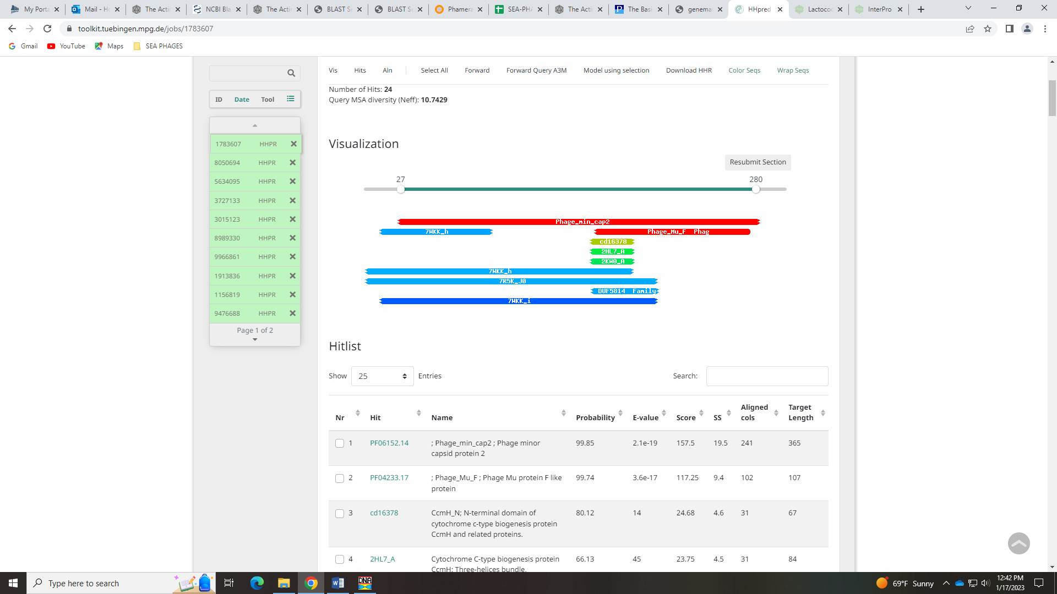
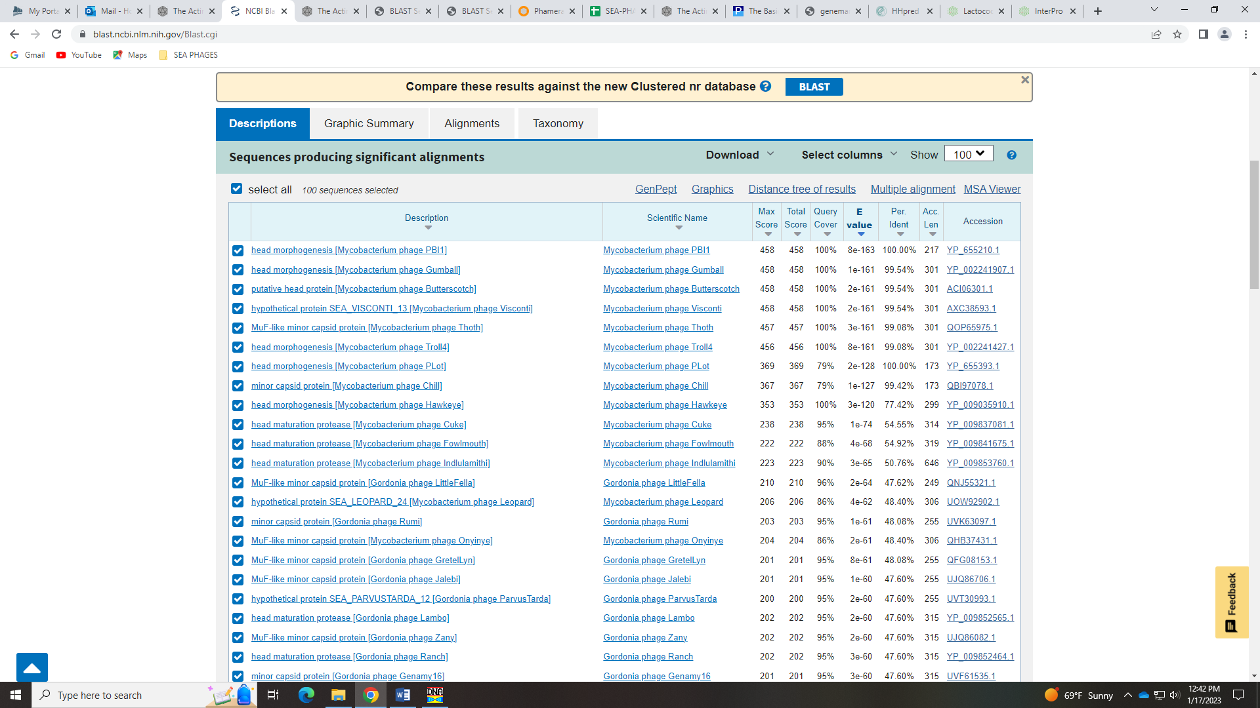
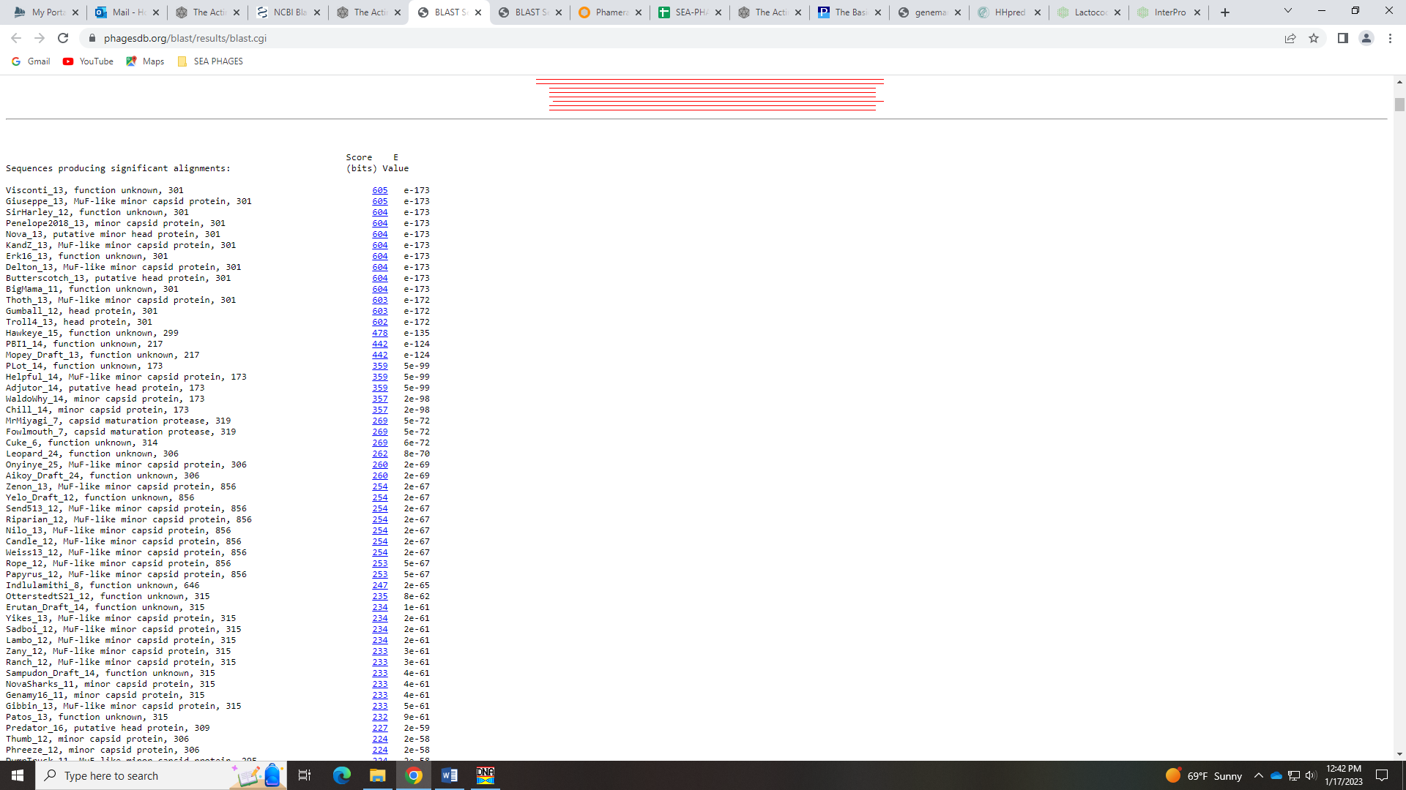

Gene 14
SSC: start 9729, stop 10436; CP: yes; SCS: Both called start of 9729; ST: SS; Blast Start: matches WaldoWhy_15 Query 1 to Subject 1 100% 1e⁻¹³⁵; Gap: 32; LO: no; RBS: -1.951, 2.963, 9, -2.725, no; F: scaffolding protein; SIF-BLAST: NKF/PhageDB BLAST/ WaldoWhy_15, MK494102/100%/1e⁻¹³⁵; SIF-HHPred: scaffolding protein, two matches with a probability above 96%; SIF-Syn: NKF
Notes: Start is unambiguous here. Function is another matter! D1 phage call this NKF, but there are several NCBI BLAST hits that call this scaffolding protein. This is on the Function List, and the example gene hits the same protein in HHPred as Mopey_14 (HHPred hit 6BOX_b, scaffolding protein). I don’t really see why one is consistently called scaffolding protein and the other is not. I’ve asked the SP Forum about it… hopefully I hear back soon.
Mopey_14 HHpred hits:
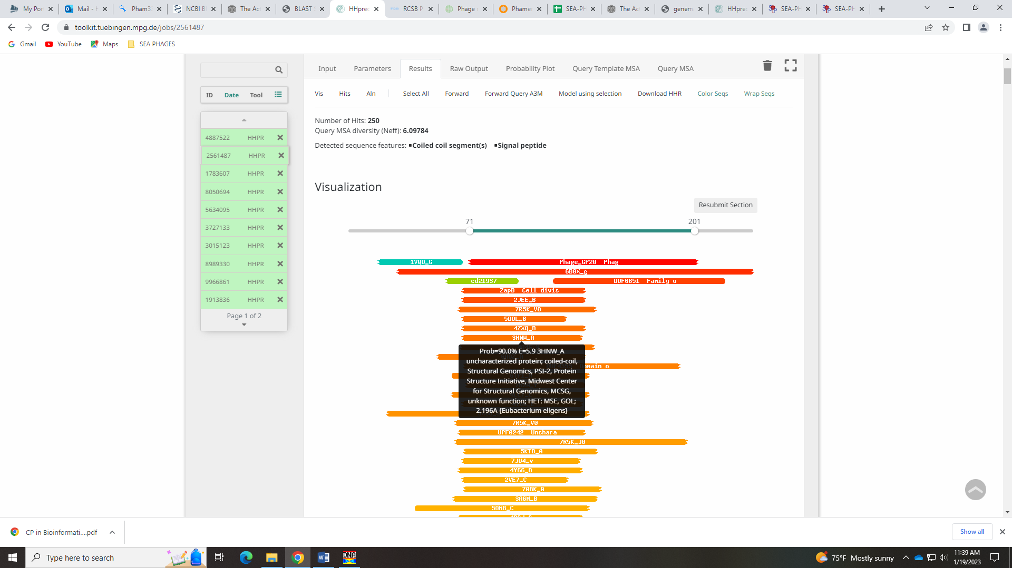
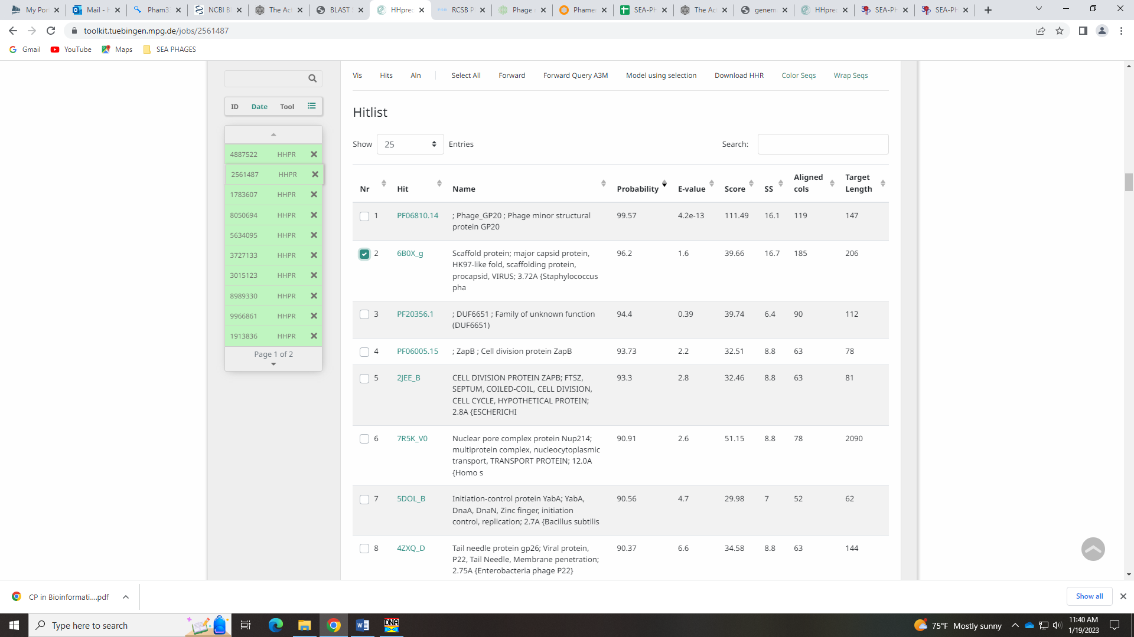
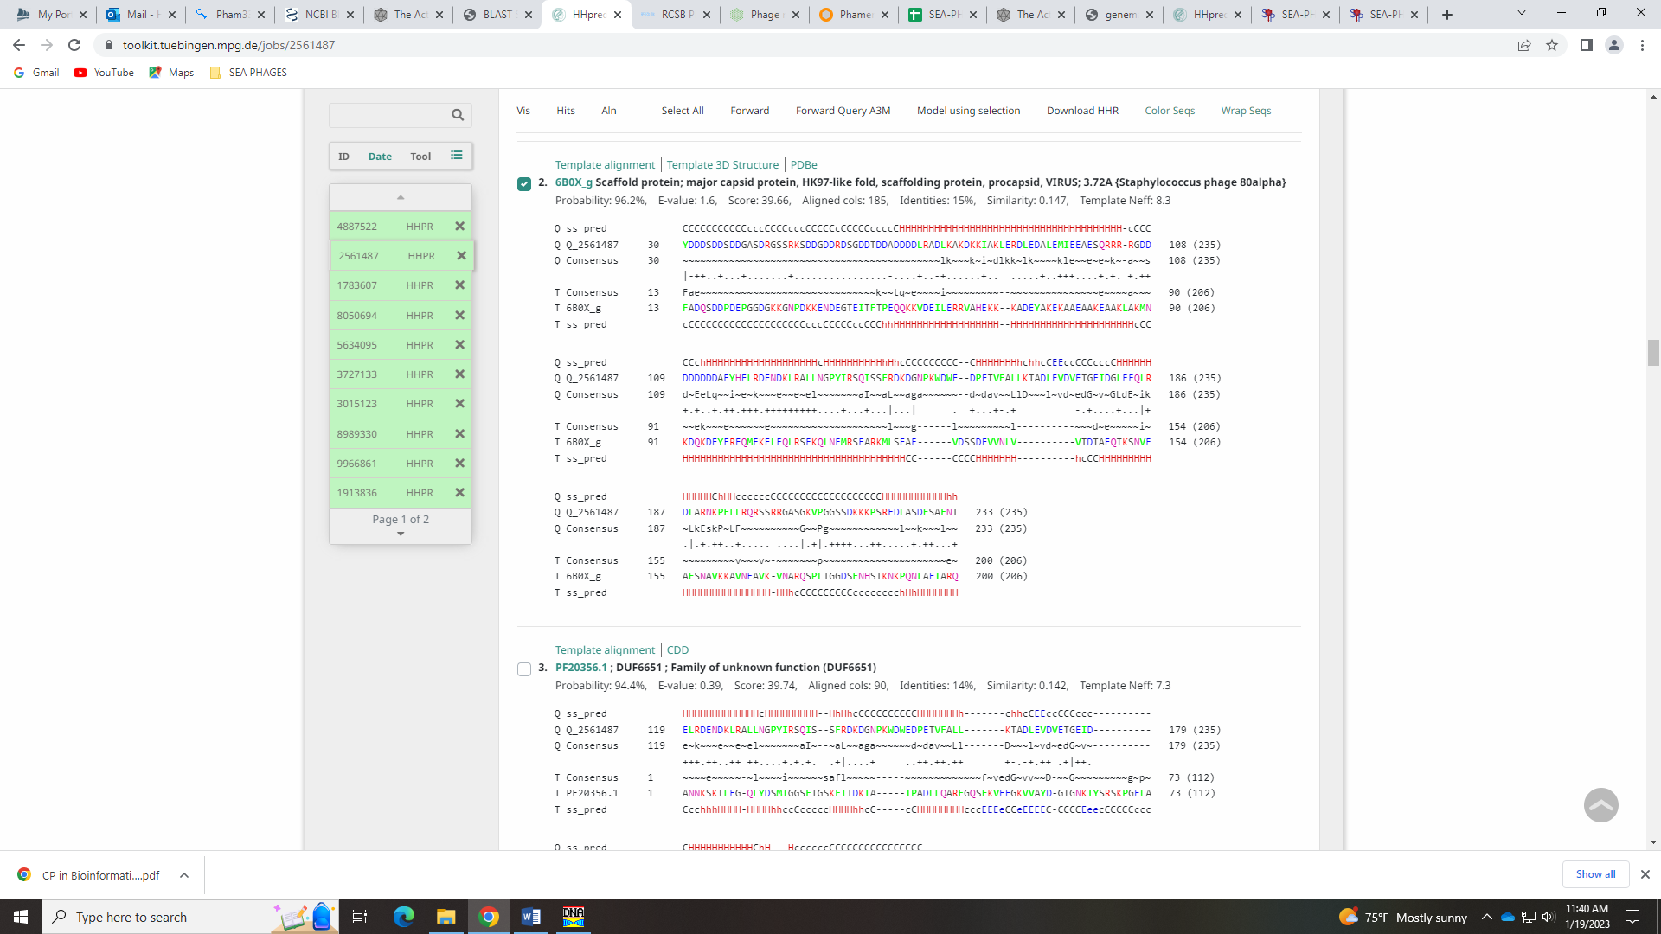
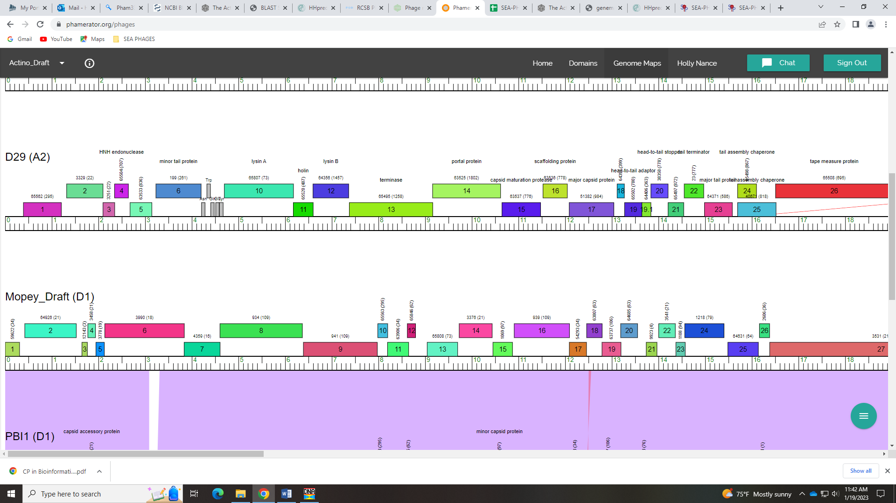
Looking at the two genes in Phamerator, they are in different phamilies so have different sequences. Despite this, Debi said to call this scaffolding protein! Here was out exchange on the Phages DB forum:
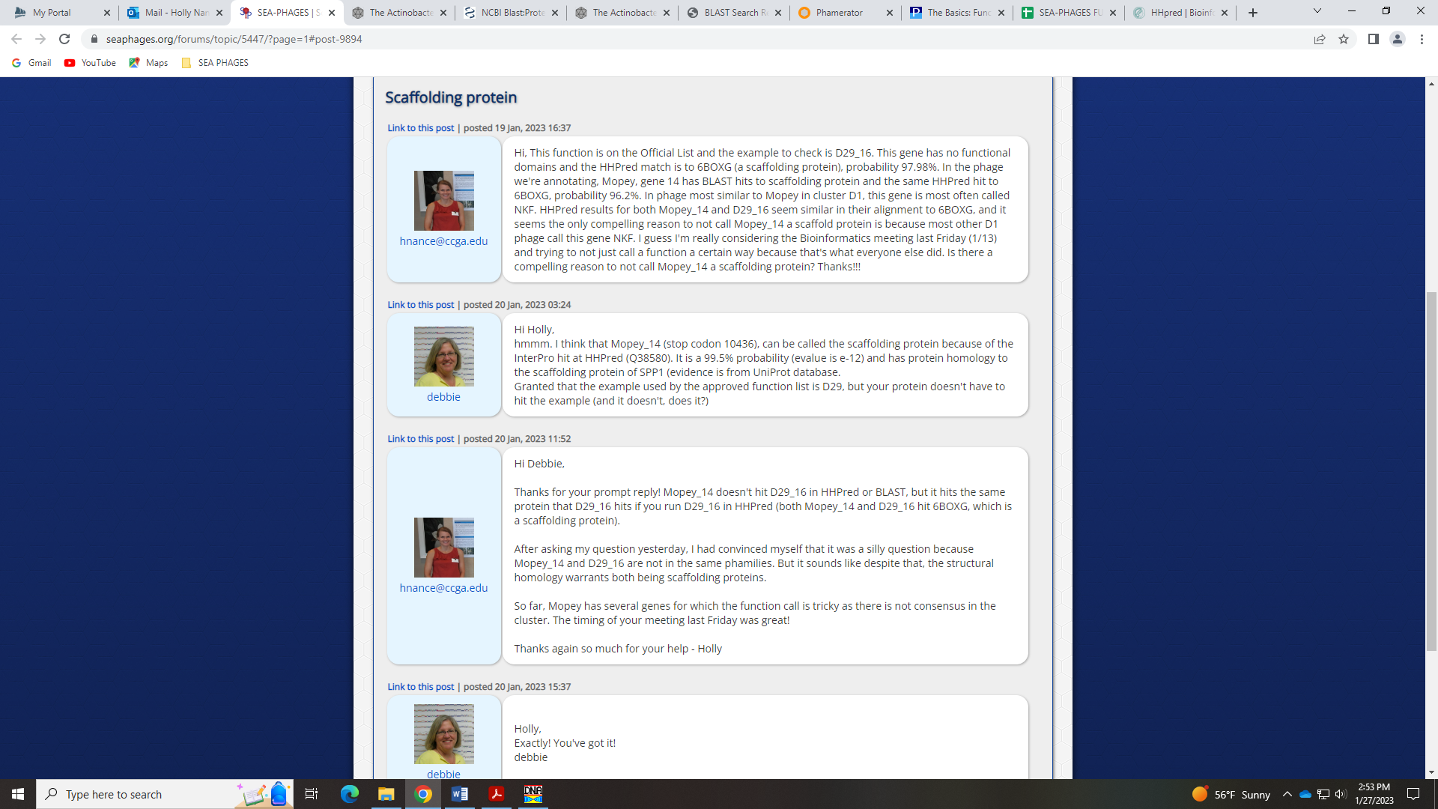

Gene 15
SSC: start 10452, stop 10871; CP: yes; SCS: Both called start of 10452; ST: SS; Blast Start: matches WaldoWhy_16 Query 1 to Subject 1 100% 1e⁻⁷⁵; Gap: 15; LO: NA; RBS: -3.115, 2.405, 9, -3.890, no; F: minor capsid protein; SIF-BLAST: minor capsid protein /PhageDB BLAST/ WaldoWhy_16, MK494102/100%/1e⁻⁷⁵; SIF-HHPred: NKF, no matches to a function with a probability above 90%; SIF-Syn: minor capsid protein
Notes: Start is conserved, and synteny and BLAST hits (in both PhagesDB and NCBI) support this as minor capsid protein.
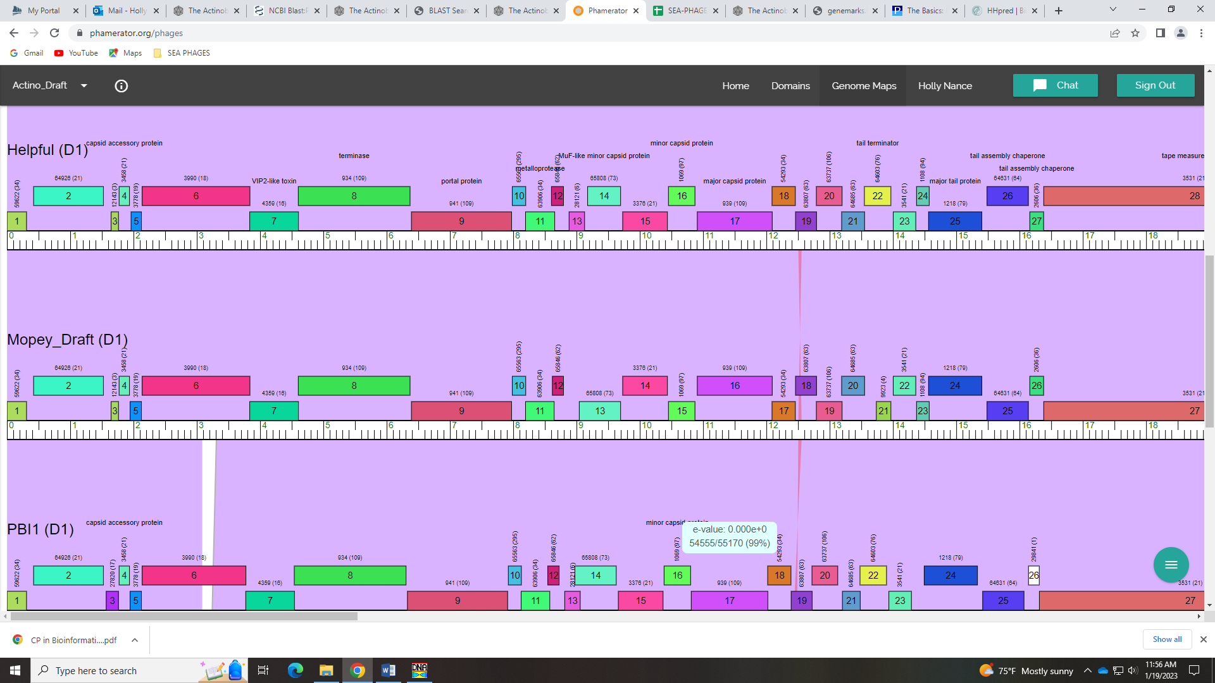
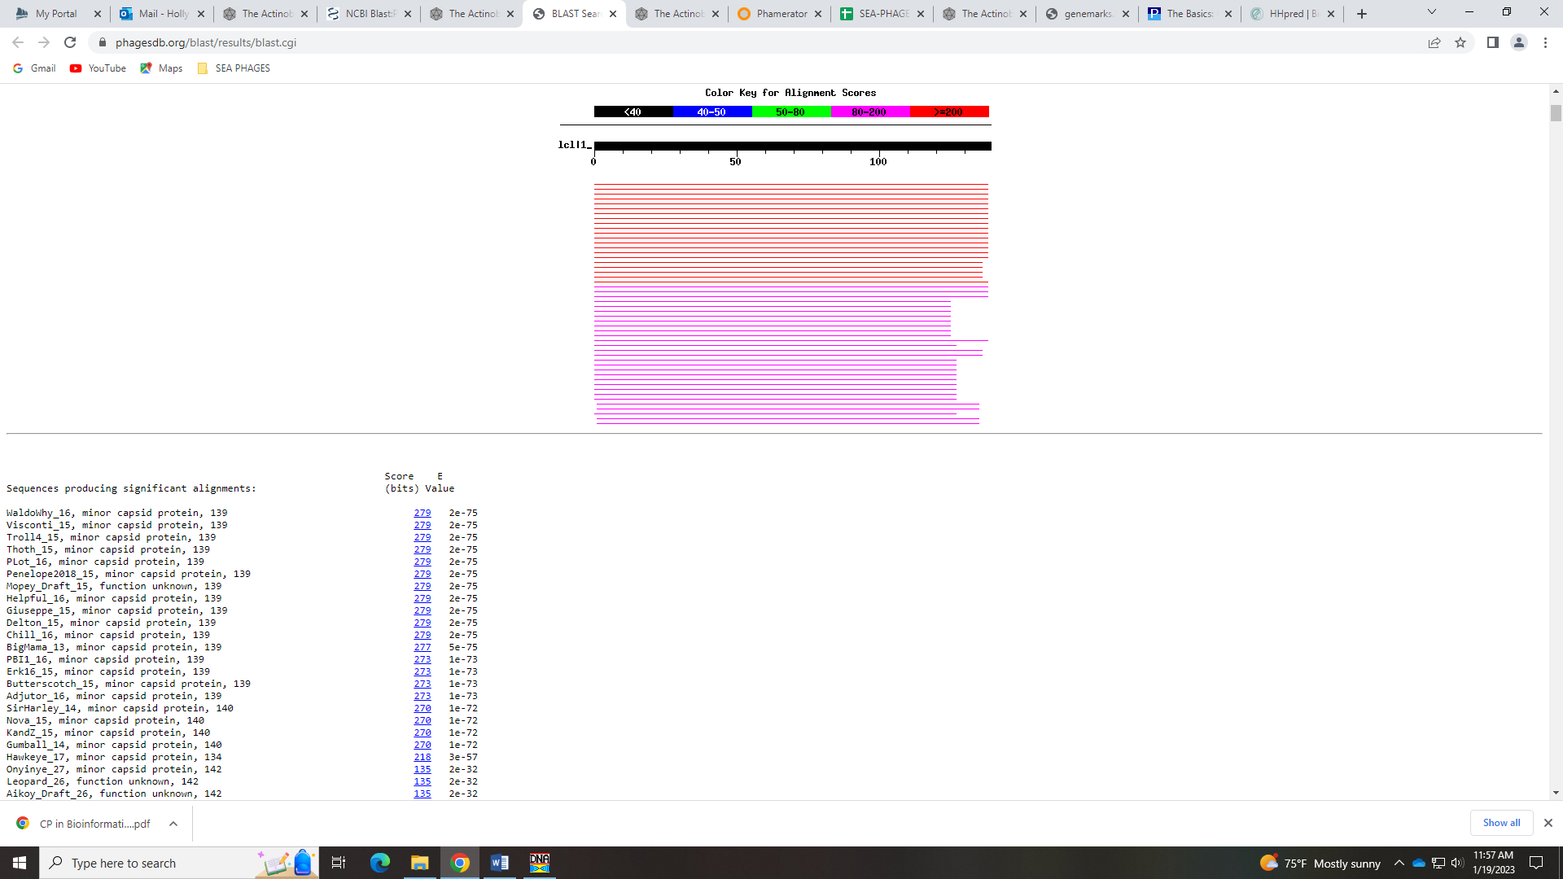
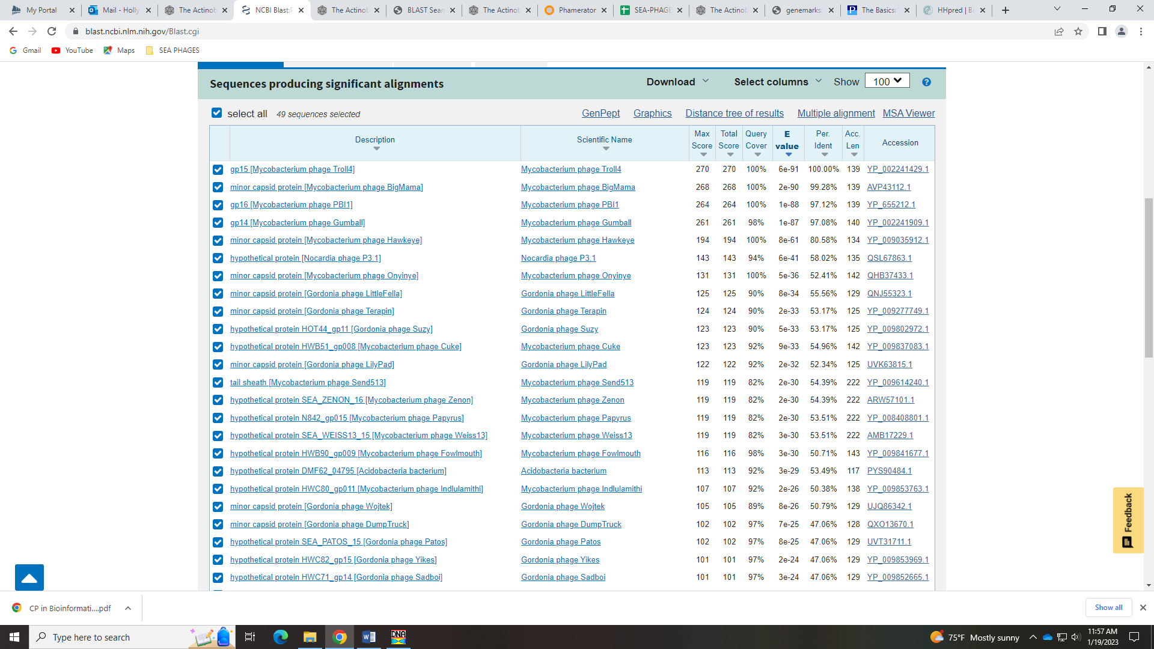
However, HHPred doesn’t have any decent match to this function.
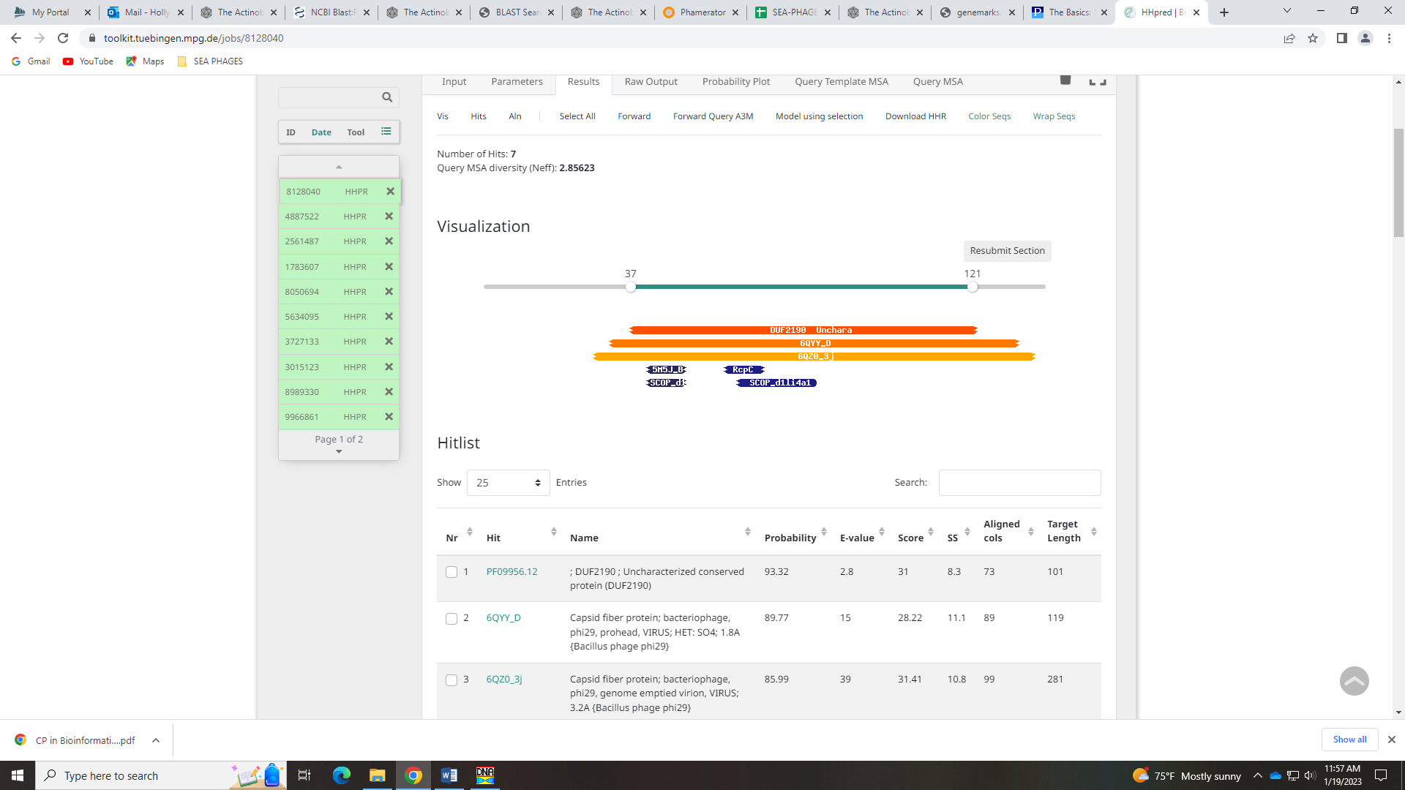
Given most evidence suggests minor capsid protein, I’m going with that.
Gene 16
SSC: start 10908, stop 12092; CP: yes; SCS: Both called start of 10908; ST: SS; Blast Start: matches Visconti_16 Query 1 to Subject 1 100% 0.0; Gap: 36; LO: no; RBS: -1.951, 2.963, 9, -2.725, yes; F: major capsid protein; SIF-BLAST: major capsid protein /PhageDB BLAST/ Visconti_16, MH399788/100%/0.0; SIF-HHPred: major capsid protein, several matches with a probability above 90%; SIF-Syn: major capsid protein
Notes: This start is not the most annotated, but it is the most conserved in subcluster D1. There is good support for it, despite it not yielding the longest ORF. Function of major capsid protein is also well-supported by synteny, BLAST hits and HHPred.
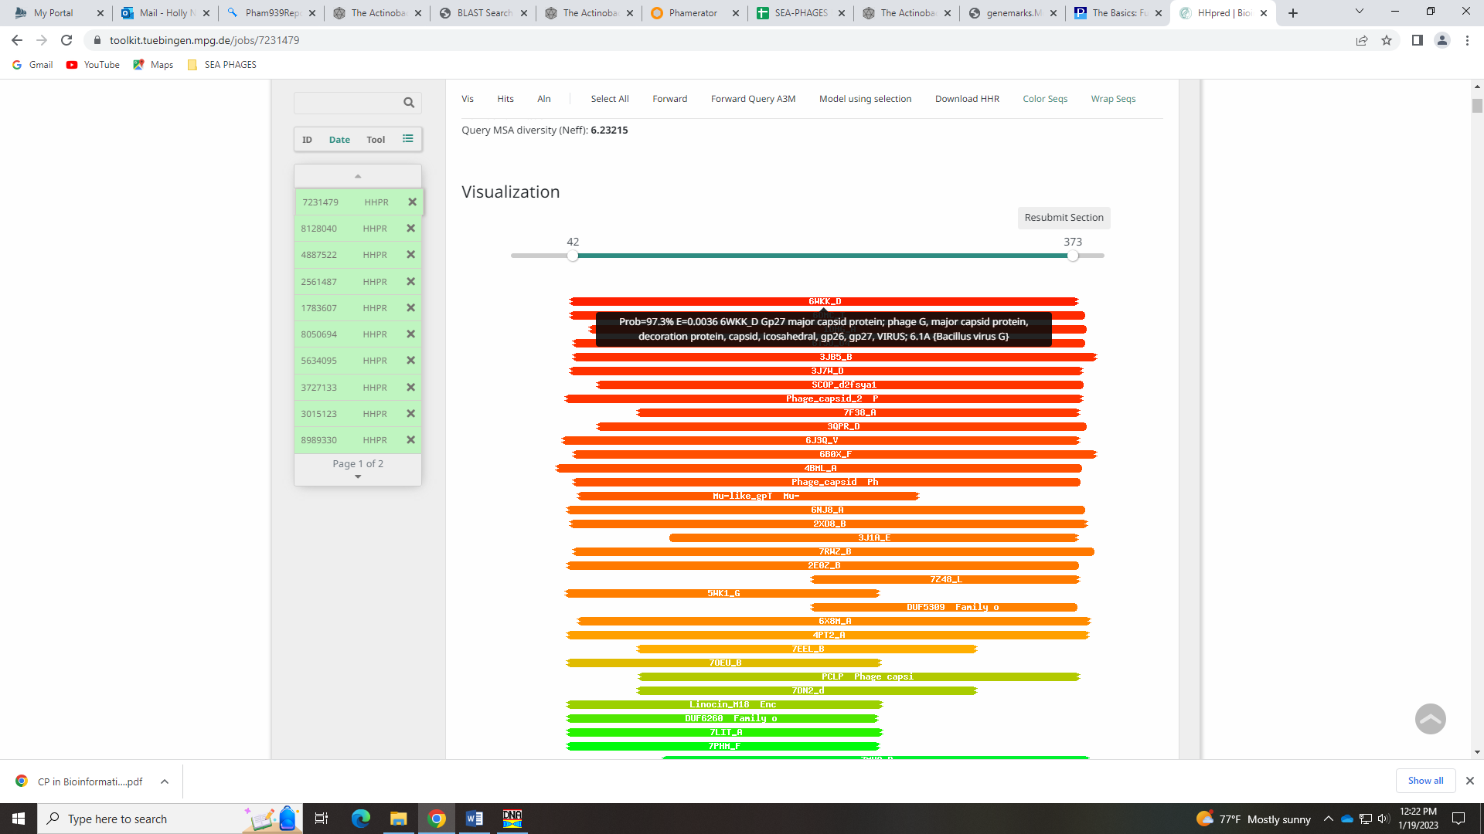
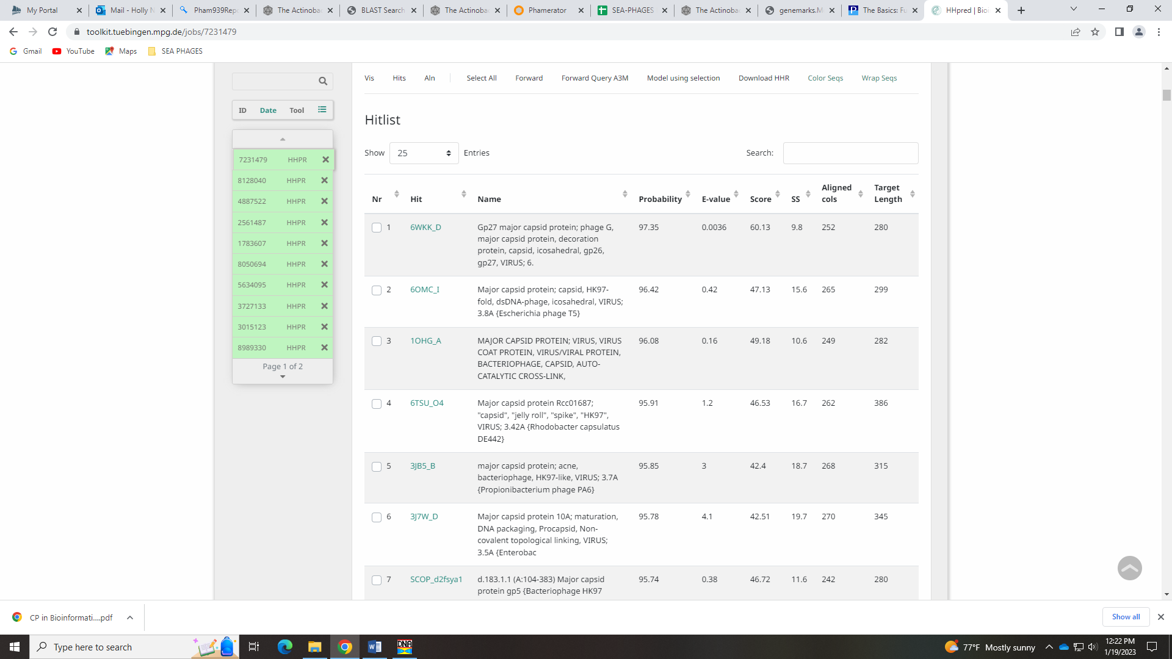

Gene 17
SSC: start 12089, stop 12457; CP: yes; SCS: Both called start of 12089; ST: SS; Blast Start: matches Visconti_17 Query 1 to Subject 1 100% 2e⁻⁶⁶; Gap: overlap of 4; LO: NA; RBS: -3.861, 2.047, 11, -4.618, no; F: NKF; SIF-BLAST: NKF/PhageDB BLAST/ Visconti_17, MH399788/100%/2e⁻⁶⁶; SIF-HHPred: NKF, a few matches with a probability above 90%, but high e-values and only partial hits; SIF-Syn: NKF
Notes: Nothing ambiguous about this gene!

Gene 18
SSC: start 12460, stop 12792; CP: yes; SCS: Both called start of 12460; ST: SS; Blast Start: matches PLot_19 Query 1 to Subject 1 100% 6e⁻⁵⁷; Gap: 2; LO: NA; RBS: -4.786, 1.604, 11, -5.543, no; F: NKF; SIF-BLAST: NKF/PhageDB BLAST/ PLot_19, DQ398051/100%/6e⁻⁵⁷; SIF-HHPred: NKF, no matches with a probability above 90%; SIF-Syn: NKF
Notes: nothing ambiguous here!

Gene 19 - Meg
SSC: start 12789, stop 13196; CP: yes; SCS: Both called start of 12789; ST: SS; Blast Start: matches WaldoWhy_20 Query 1 to Subject 1 100% 5e⁻⁷⁵; Gap: overlap of 4; LO: yes; RBS: -2.273, 2.809, 13, -3.319, no; F: head to tail stopper; SIF-BLAST: head-to-tail stopper/PhageDB BLAST/Thoth_19, MT889385/99%/2e⁻⁷⁴; SIF-HHPred: phage head-tail attachment at 98.51% and tail attachment protein at 98.08% and SPP1 alignment at 97.77%; SIF-Syn: NKF or head to tail stopper
Notes: Start is conserved in the gene. For function, BLAST and synteny support NKF. There are some hits in NCBI BLAST for head-to-tail stopper, and this hit comes up in HHPred along with head-to-tail adapter. However, the Official Phage Function list says that to call the protein either of those functions, there must be specific crystalline structures present:
Adaptor: must have an HHPRED alignment to one of the following crystal structures: SPP1 15 (5A21 chain C or D in the macromolecular complex) OR must have an HHPRED alignment to one of the following crystal structures: HK97 gp6 or or Bacillus protein yqbG
Stopper: must have an HHPRED alignment to one of the following crystal structures: SPP1 16 (5A21 chain E or F in the macromolecular complex)
None of the HHPred hits have these specific structures present, so I’m going with NKF… 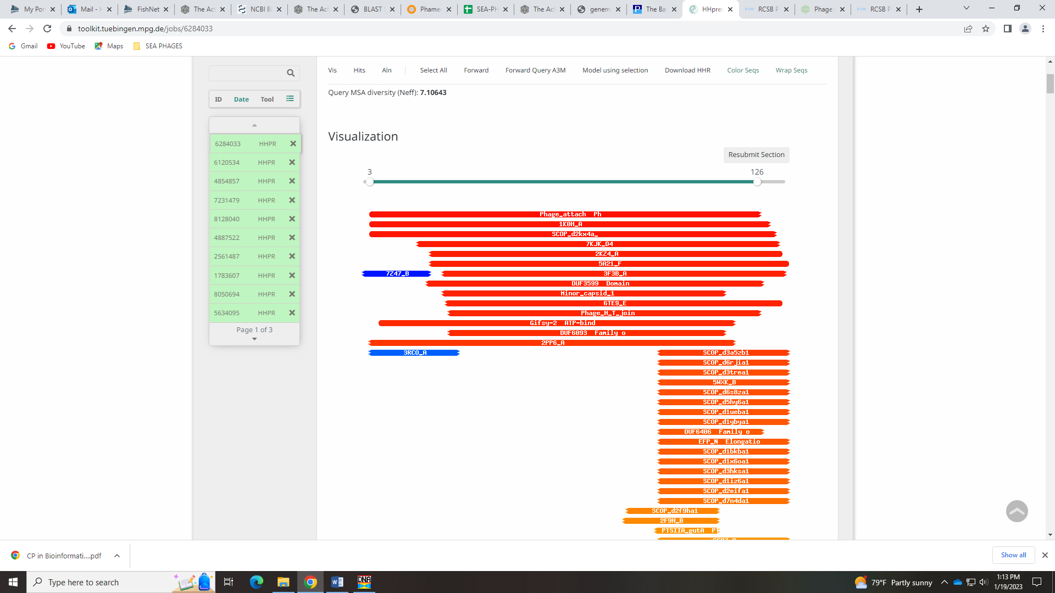
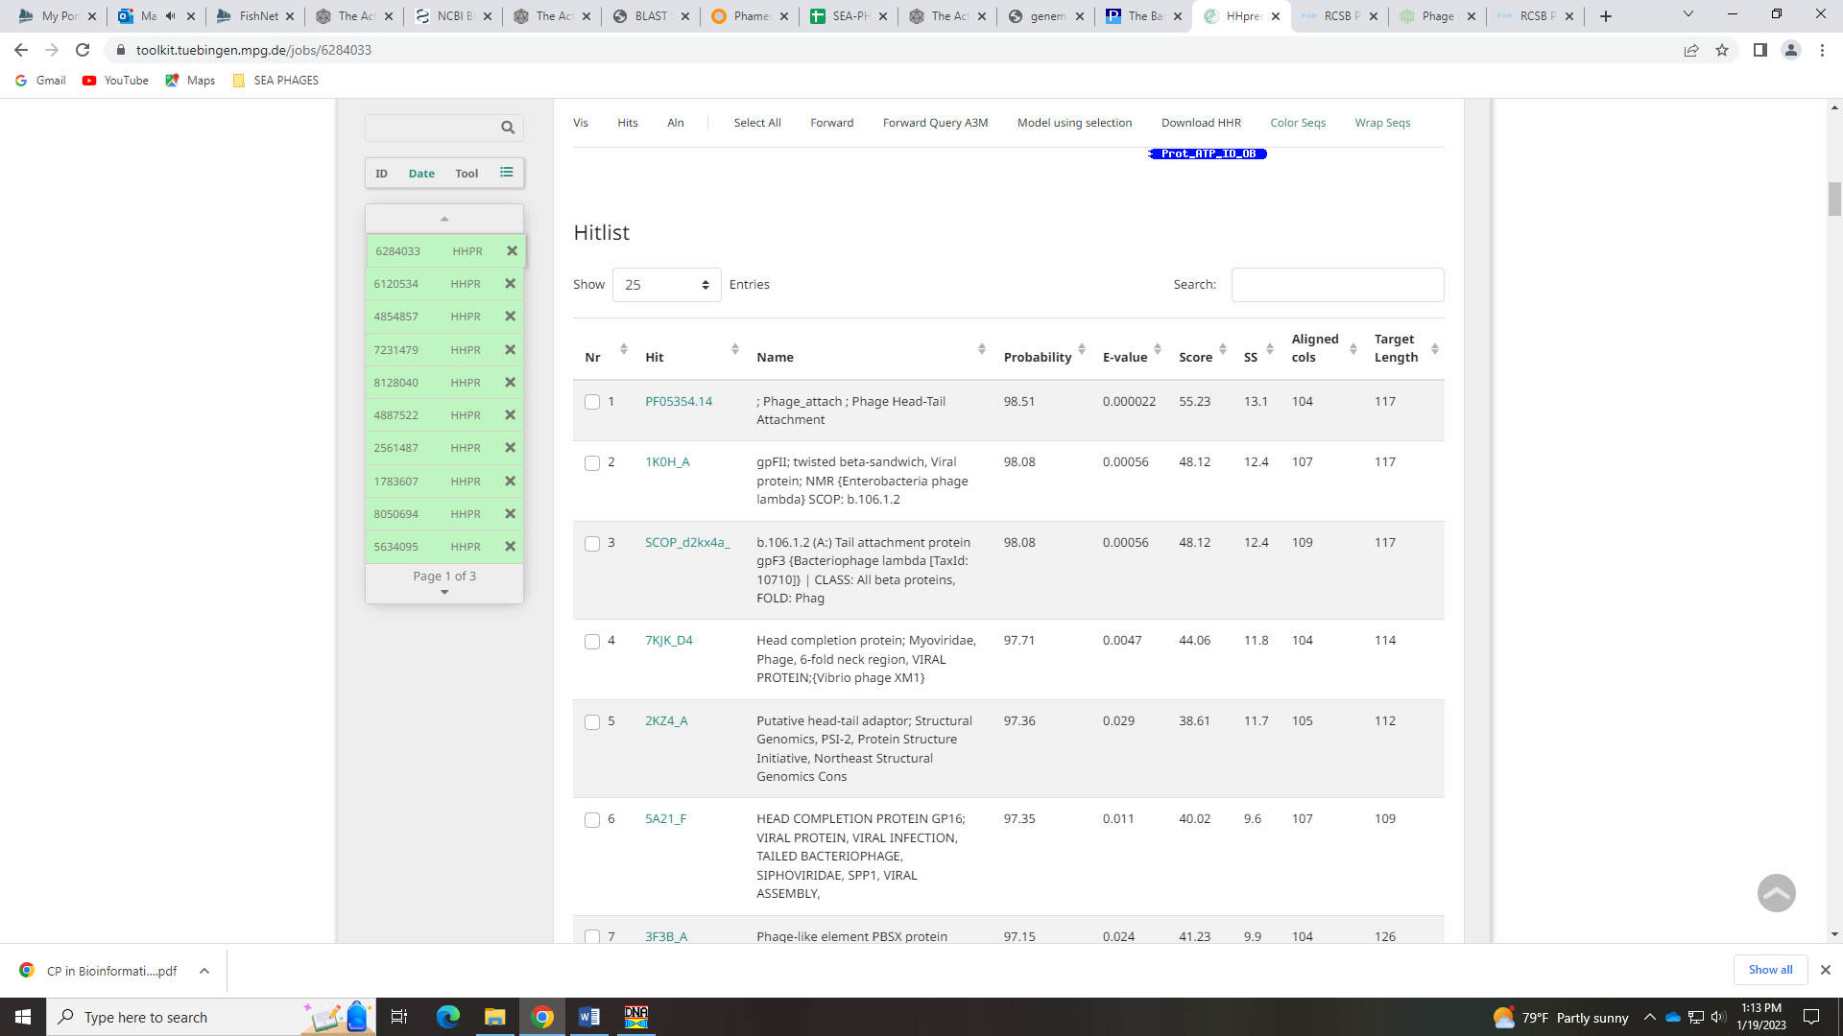
Meg’s notes:
Notes: Start, most annotated start. With regards to function, the first 17 Blast hits had NKF. However, Thoth_19 called the function as head-to-tail stopper and Mopey had 1:1 subject to query as well as a good e-value. This was not the first Blast result, but still has good values. The Seaphages function list says that to call the gene a head-to-tail stopper, there needs to be “must have an HHPRED alignment to one of the following crystal structures: SPP1 16 (5A21 chain E or F in the macromolecular complex).” This is present in the 4th hit on HHPRED. There is also a case study about this protein.
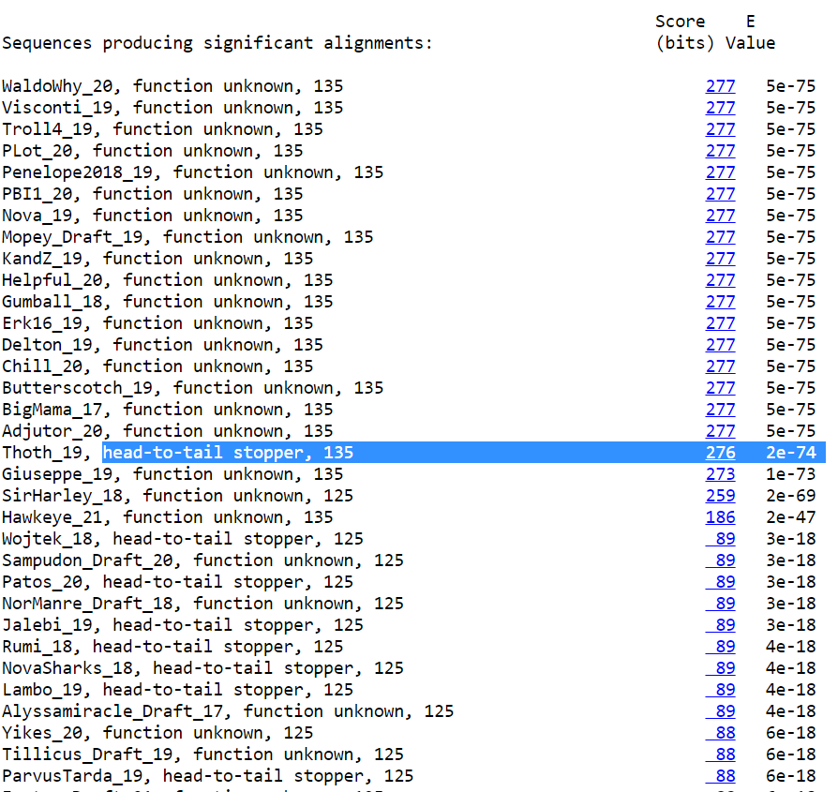

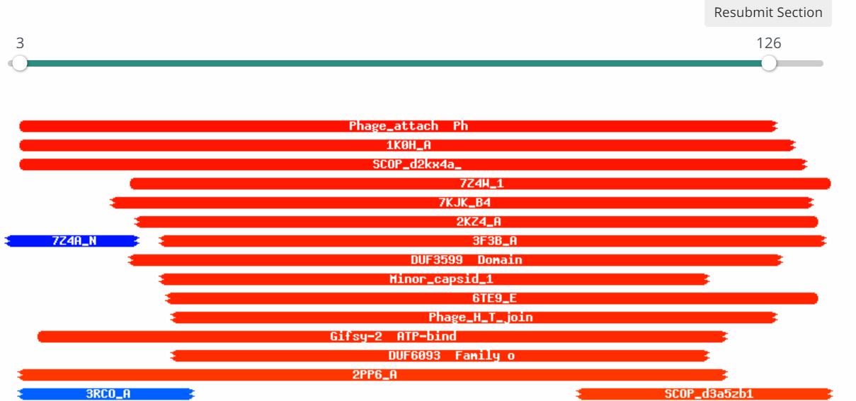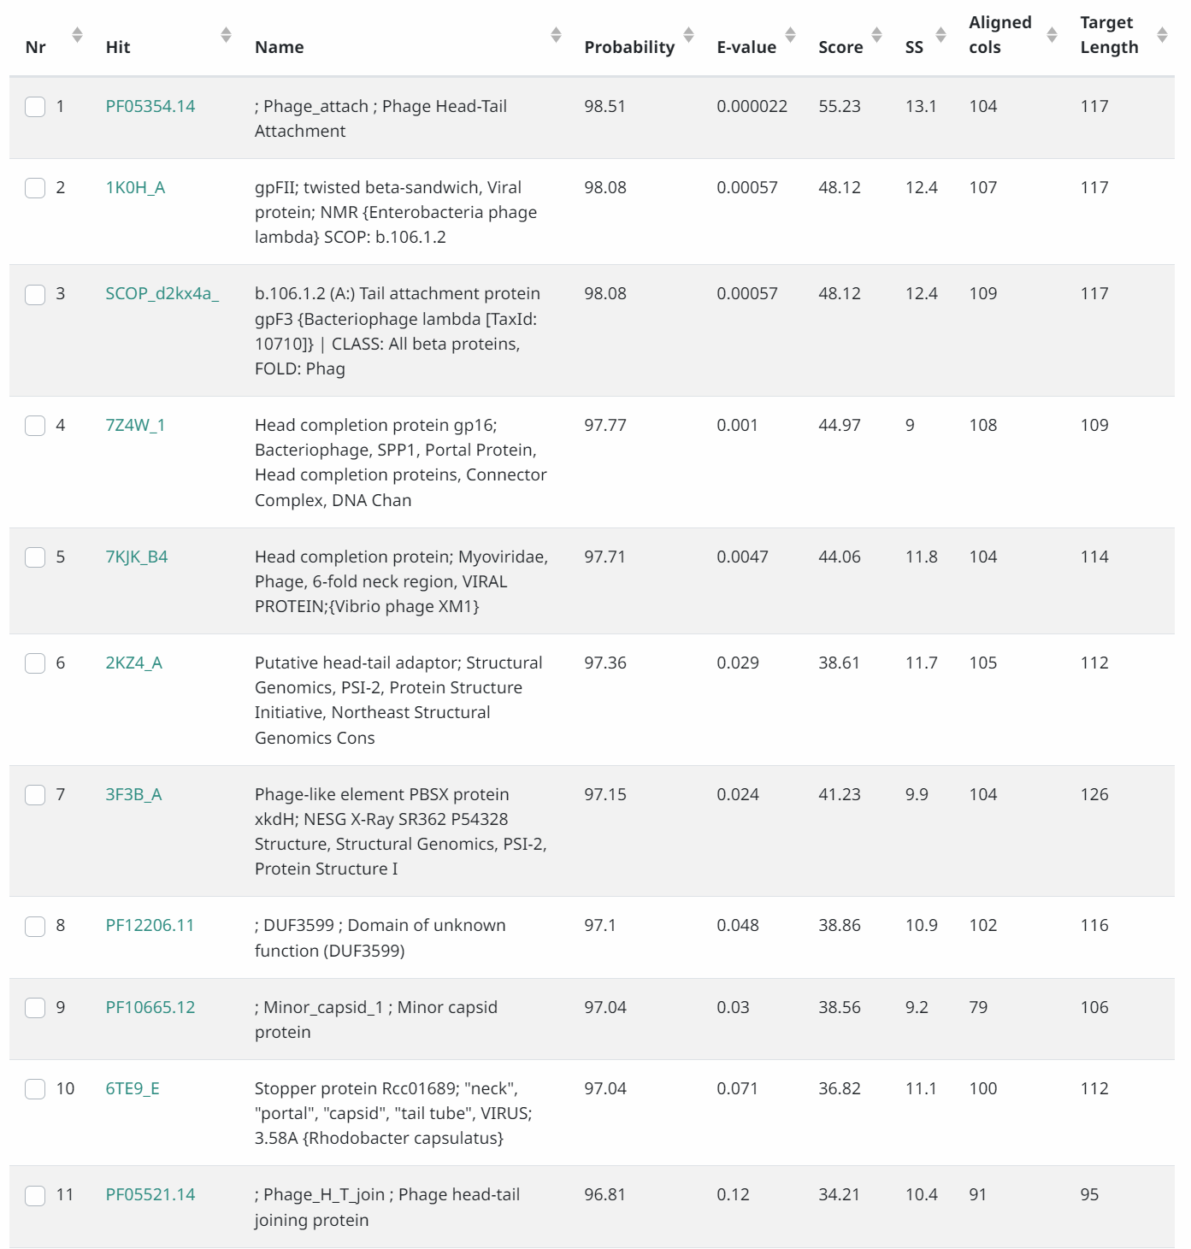
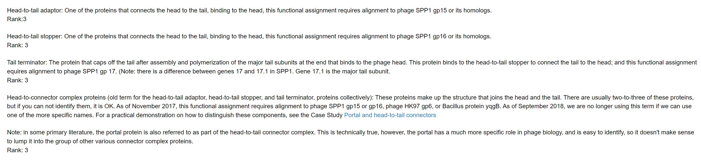

Gene 20 - Evie
SSC: start 13189, stop 13551; CP: yes; SCS: Both called start of 13189; ST: SS; Blast Start: matches WaldoWhy_21 Query 1 to Subject 1 100% 6e⁻⁶⁶; Gap: overlap of 8; LO: NA; RBS: -2.791, 2.560, 11, -3.548, no; F: minor capsid protein; SIF-BLAST: minor capsid protein/PhageDB BLAST/ Thoth_20, MT889385/100%/6e⁻⁶⁶; SIF-HHPred: minor capsid protein, one hit for this function at 99% probability; SIF-Syn: NKF
Notes: Start is conserved. For function, most BLAST hits in PhagesDB and NCBI are NKF. There is one hit with >99% probability for minor capsid protein, but the % identities is only 9%. Most phage in the cluster also call this NKF.
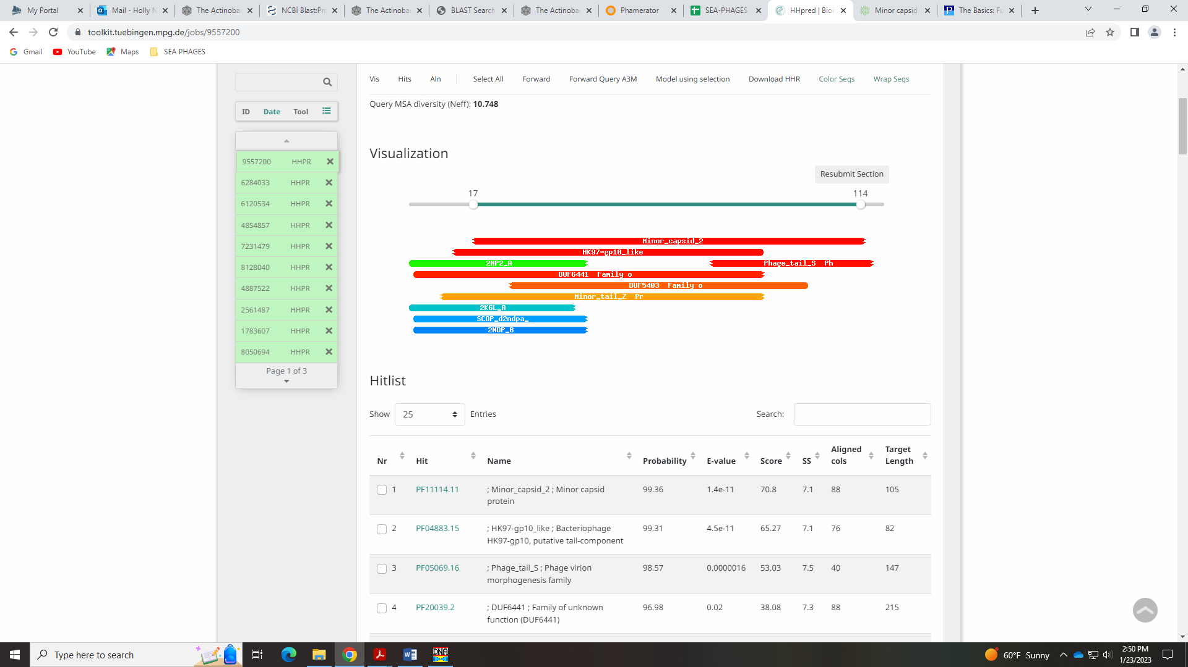
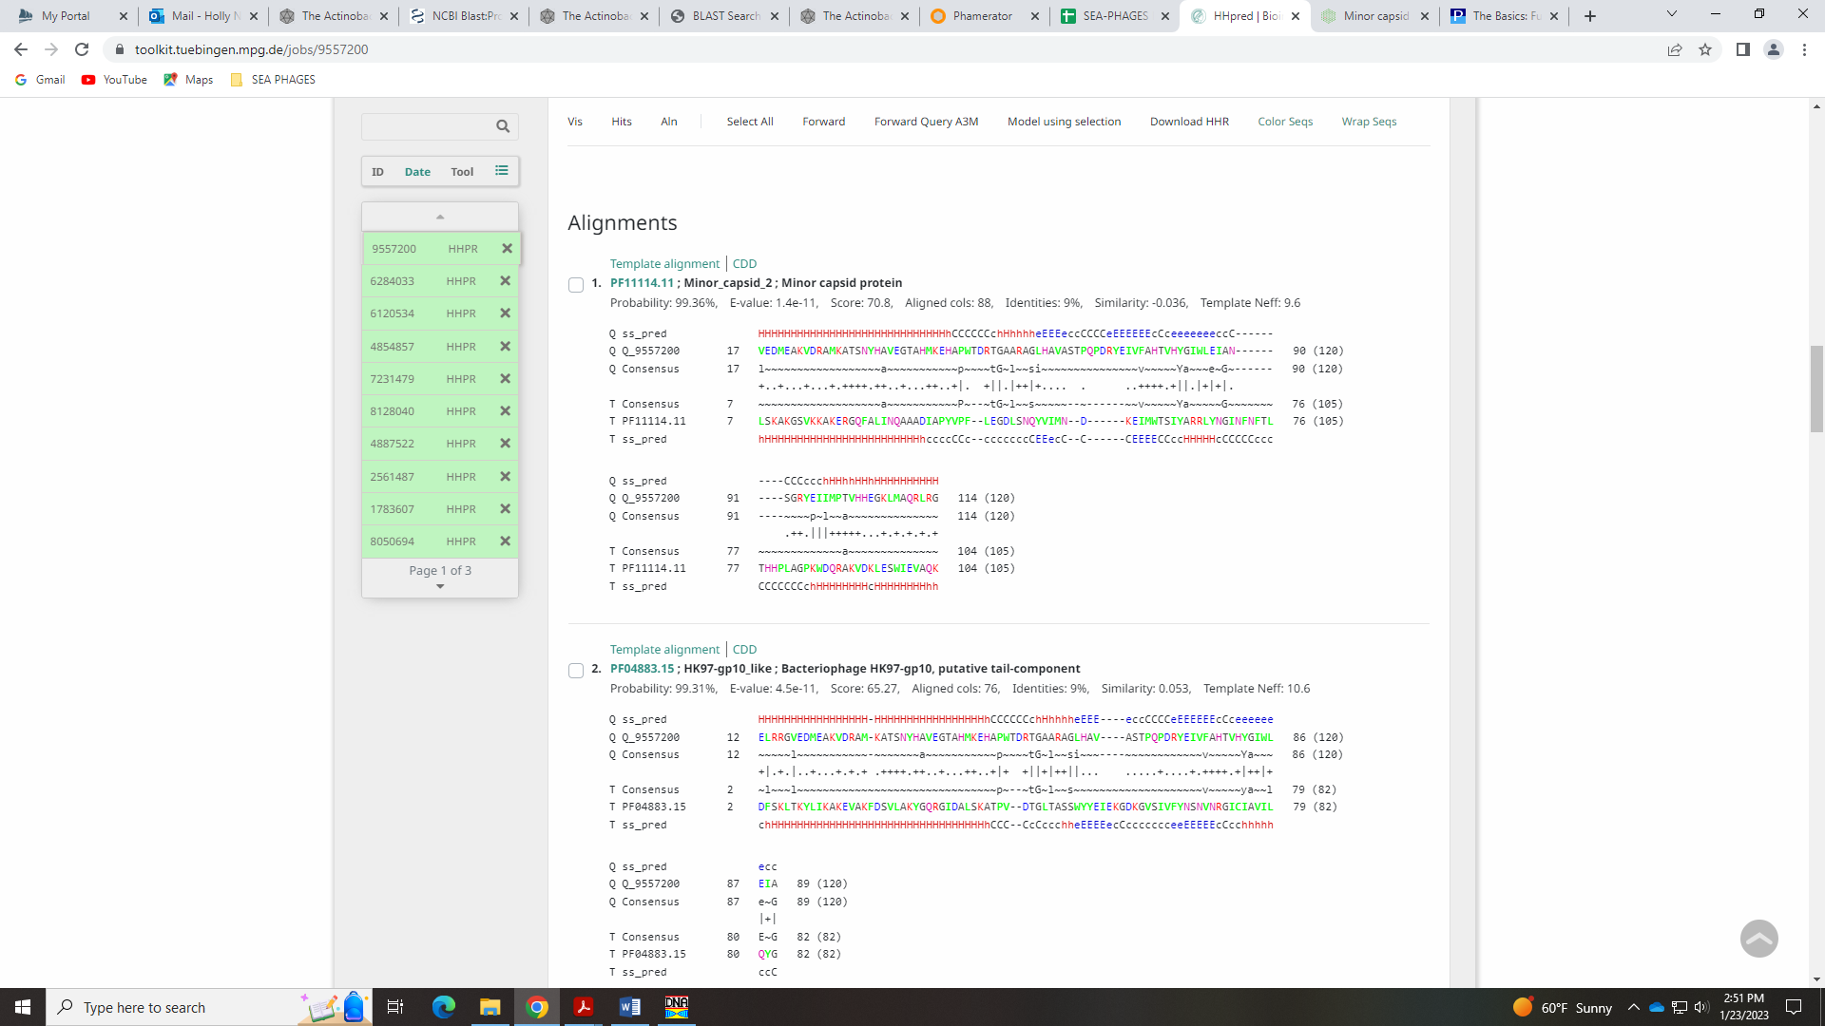
Again, I’m not 100% sure this isn’t a minor capsid protein based on the HHPred hit (high probability and low e-value…) Evie determined minor capsid protein

Gene 21 changed start from 13737 to 13548 on 1.26.2023!
SSC: start 13548, stop 13967; CP: yes; SCS: Glimmer called 13737, GeneMark called 13548; ST: NI; Blast Start: matches PBI1_22 Query 1 to Subject 1 100% 2e⁻⁷⁵; Gap: overlap of 4; LO: yes; RBS: -3.699, 2.125, 10, -4.393, no; F: tail terminator; SIF-BLAST: tail terminator/PhageDB BLAST/Helpful_22, MN284908/100%/2e⁻⁷⁵; SIF-HHPred: tail terminator, 99.21% match with SPP1 17 5A21 G macromolecule; SIF-Syn: tail terminator
Notes: This gene was fun! I changed the start to 13548 as GeneMark called, and this yielded the longest ORF and the most BLAST hits that were Q:S 1:1.
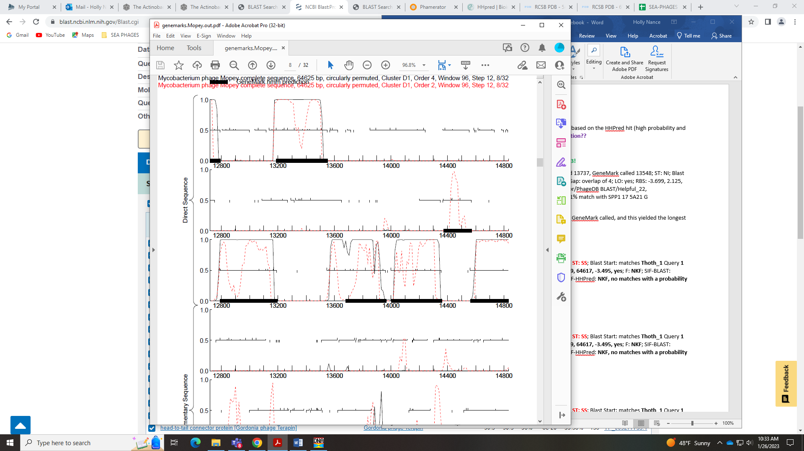
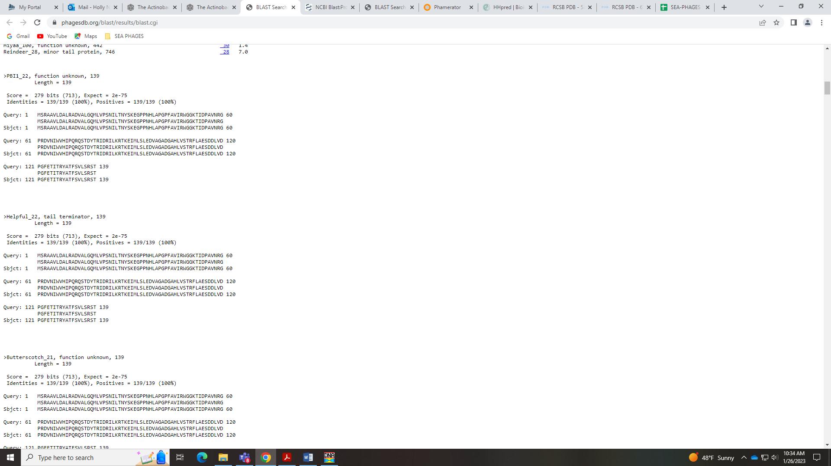
This start was NOT the most called in Starterator – there were very few genes in this phamily in Starterator, but I think that’s due to the miscalled start. Starterator data was not very helpful, with only 3 other genes in the phamily:
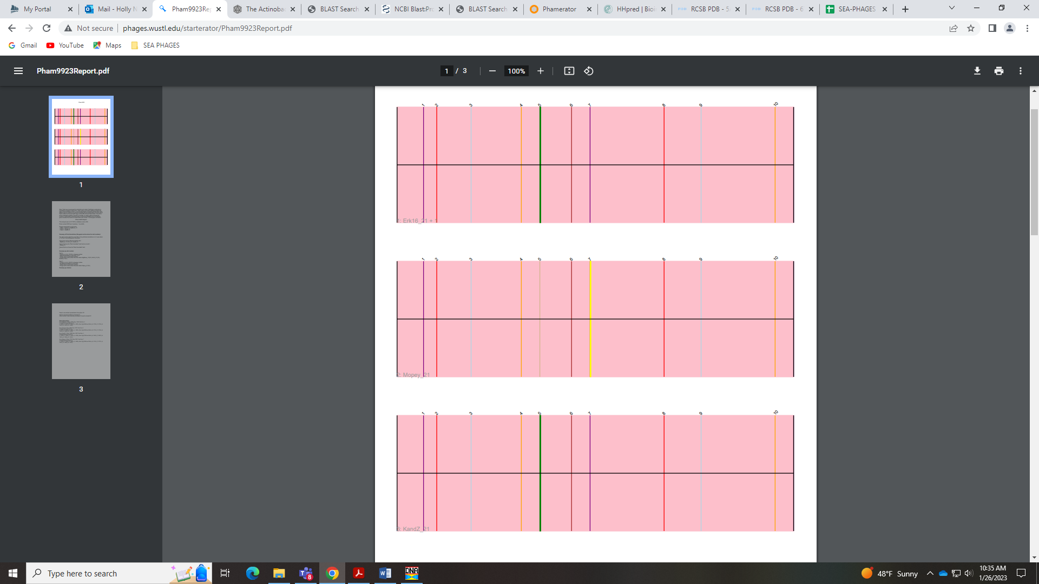
For function, there were several BLAST hits that were NKF, and most in Phamerator were NKF, but there were some that called it Tail Terminator or Head-to-Tail Connector Complex Protein. This latter name is no longer being used according to the Official Phage Function list. To call a protein Tail Terminator, the Official List says:
must have an HHPRED alignment to one of the following: SPP1 17 (5A21 chain G in the macromolecular complex) or Lambda U (3FZ2_chains A through F)
HHPred hits the SPP1 17 5A21 G macromolecule with a probability of over 99%!
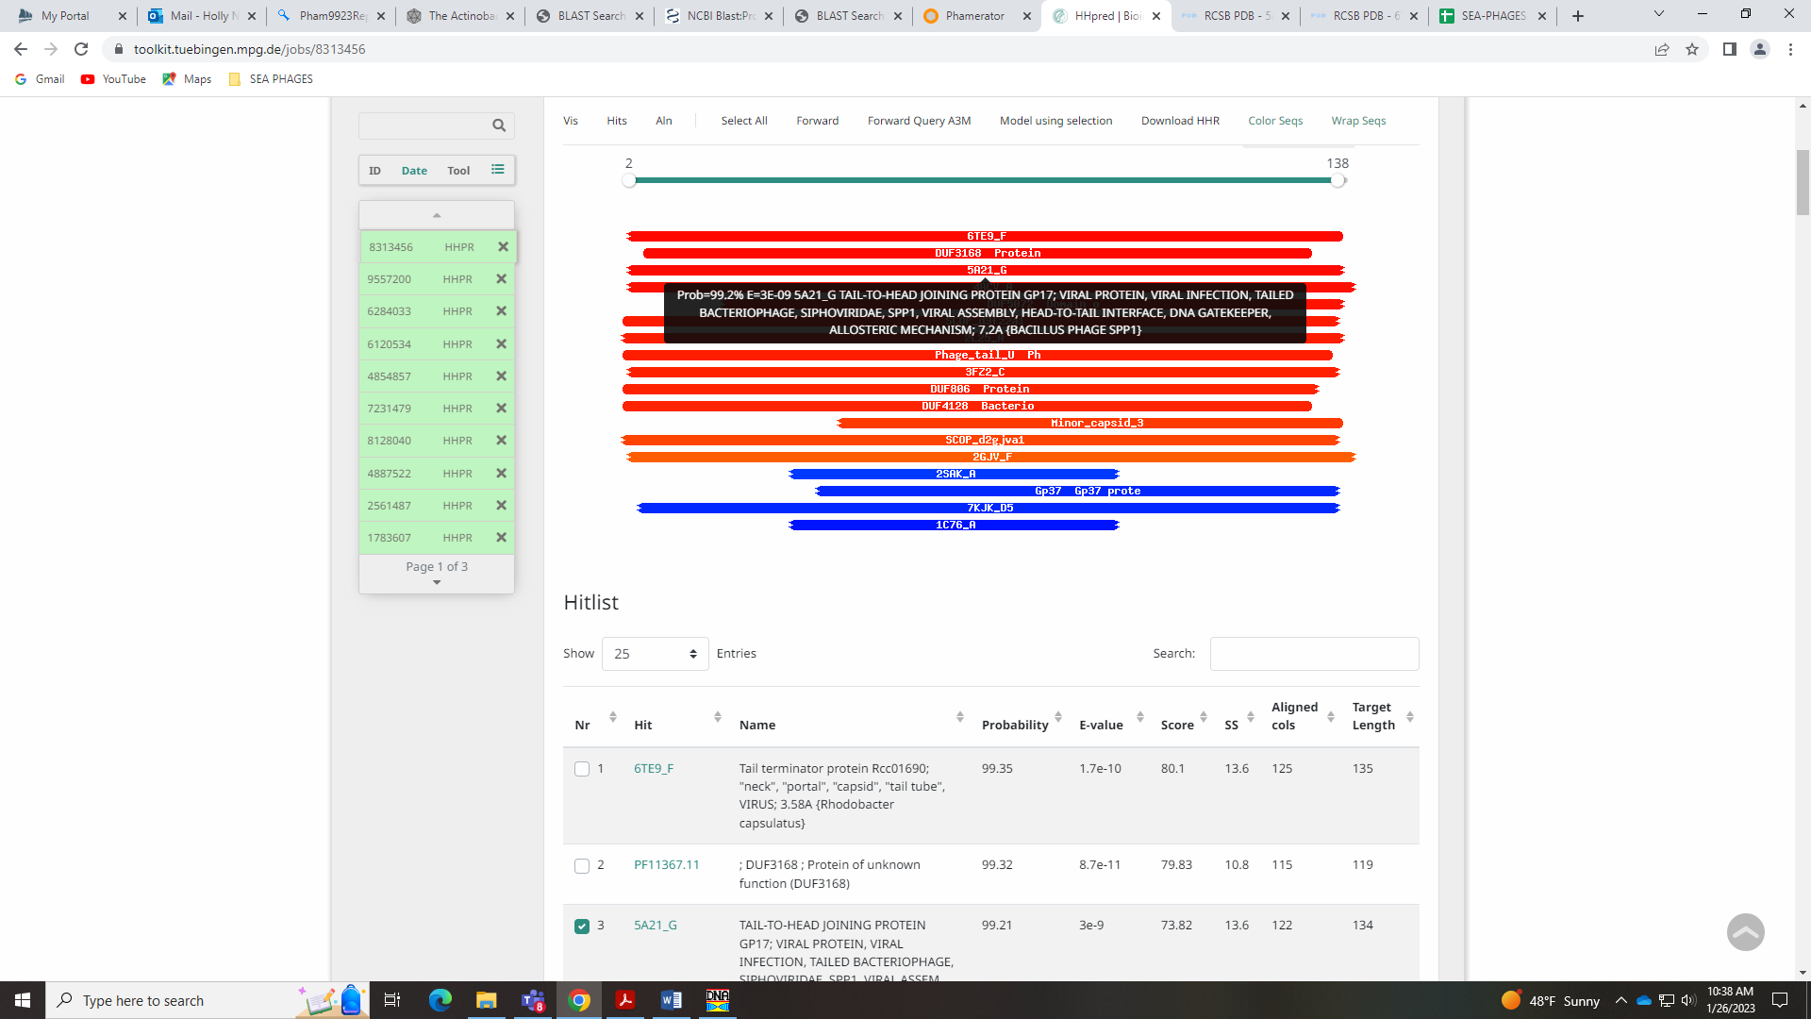
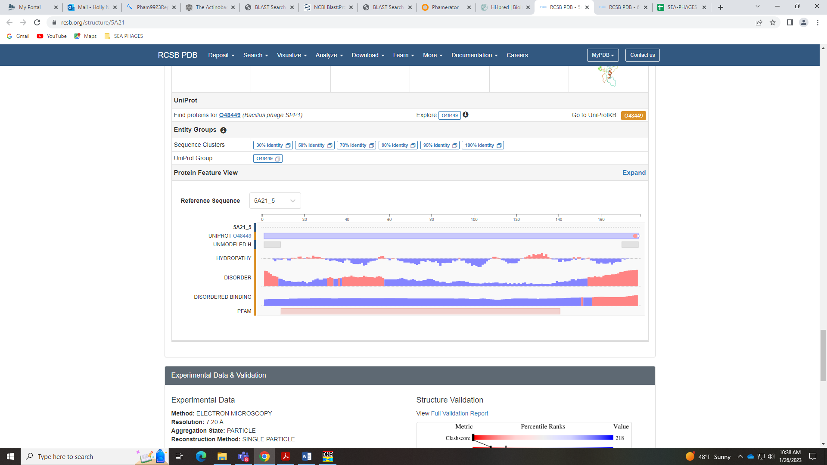

Gene 22
SSC: start 14004, stop 14360; CP: yes; SCS: Both called start of 14004; ST: SS; Blast Start: matches WaldoWhy_23 Query 1 to Subject 1 100% 3e⁻⁶³; Gap: 36; LO: yes; RBS: -1.888, 2.994, 10, -2.582, yes; F: NKF; SIF-BLAST: NKF/PhageDB BLAST/ WaldoWhy_23, MK494102/100%/3e⁻⁶³; SIF-HHPred: NKF, no matches with a probability above 90%; SIF-Syn: NKF
Notes: nothing ambiguous about this gene!

Gene 23
SSC: start 14372, stop 14572 CP: no, only called by Glimmer; SCS: Only Glimmer called start of 14372; not called by GeneMark; ST: SS; Blast Start: matches WaldoWhy_24 Query 1 to Subject 1 100% 3e⁻³⁵; Gap: 11; LO: yes; RBS: -1.559, 3.151, 18, -3.860, yes; F: NKF; SIF-BLAST: NKF/PhageDB BLAST/ WaldoWhy_24, MK494102/100%/3e⁻³⁵; SIF-HHPred: NKF, no matches with a probability above 90%; SIF-Syn: NKF
Notes: Although GeneMark didn’t even call this gene, it’s a gene. The start is conserved, there are several BLAST hits and synteny supports this gene.
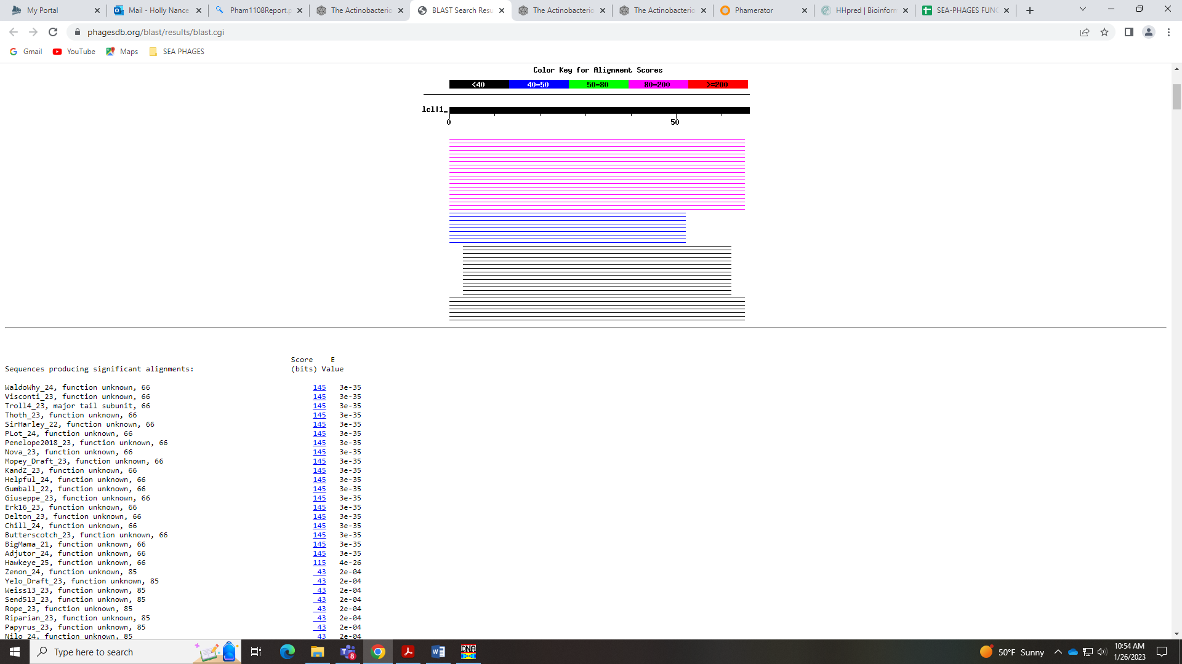
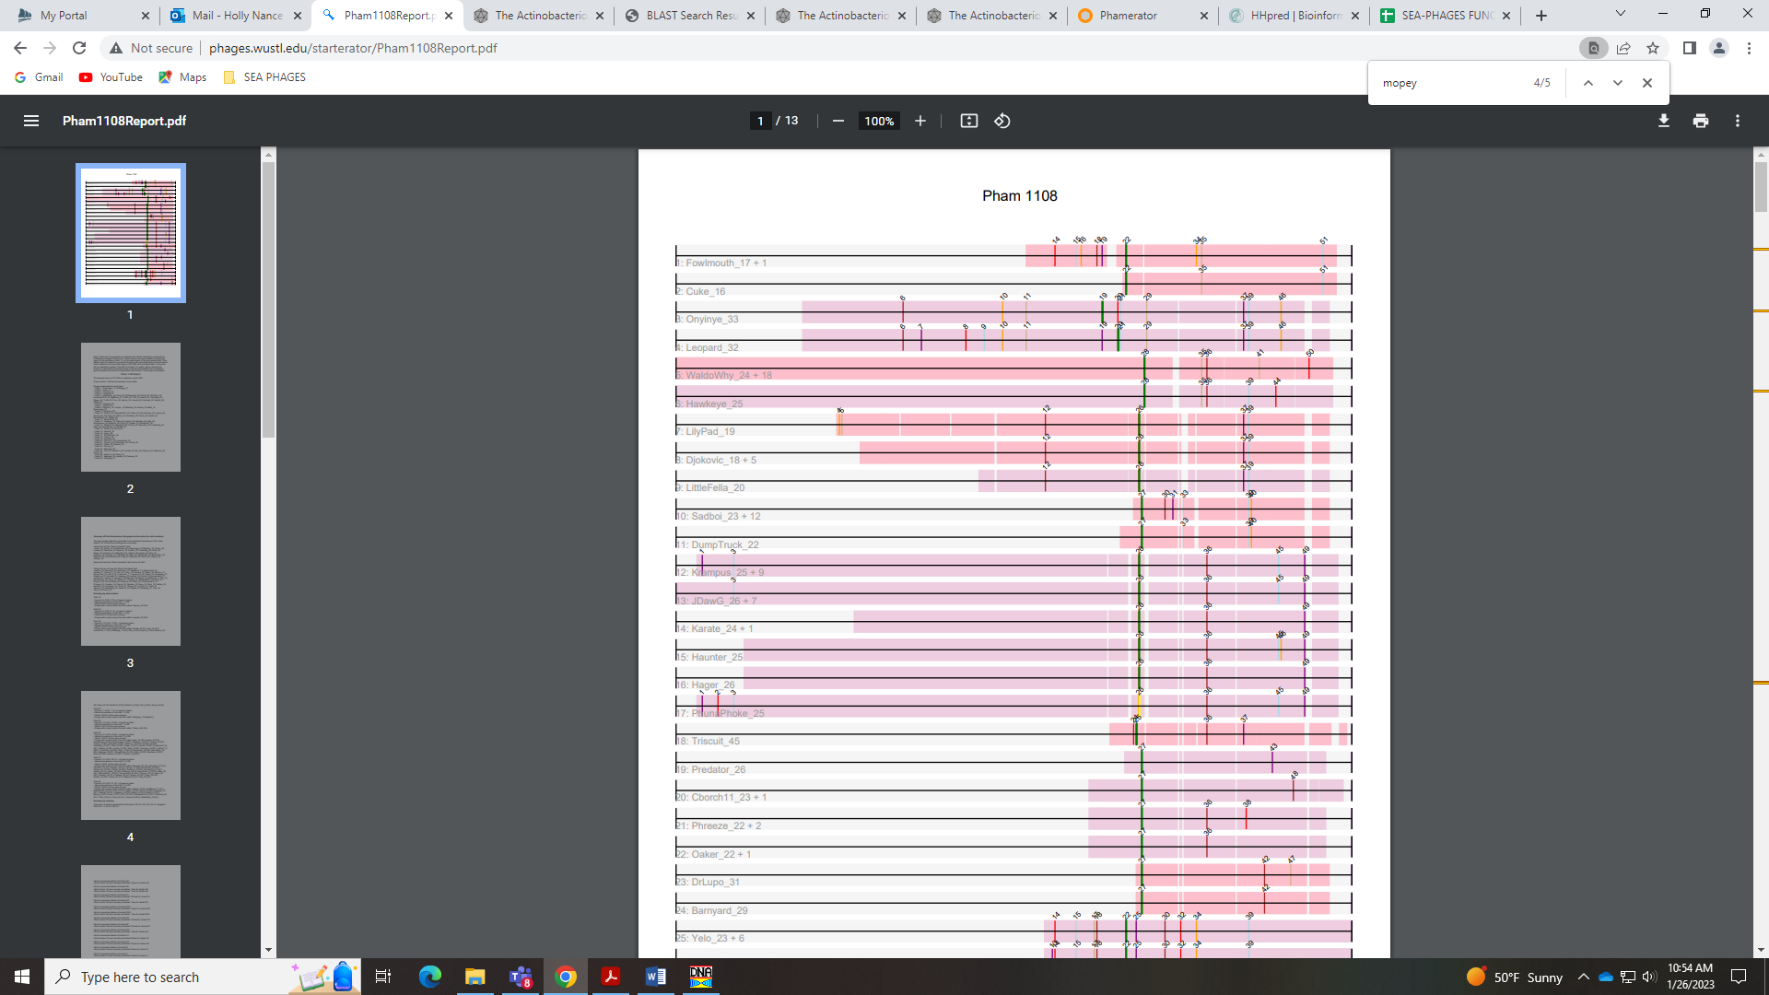
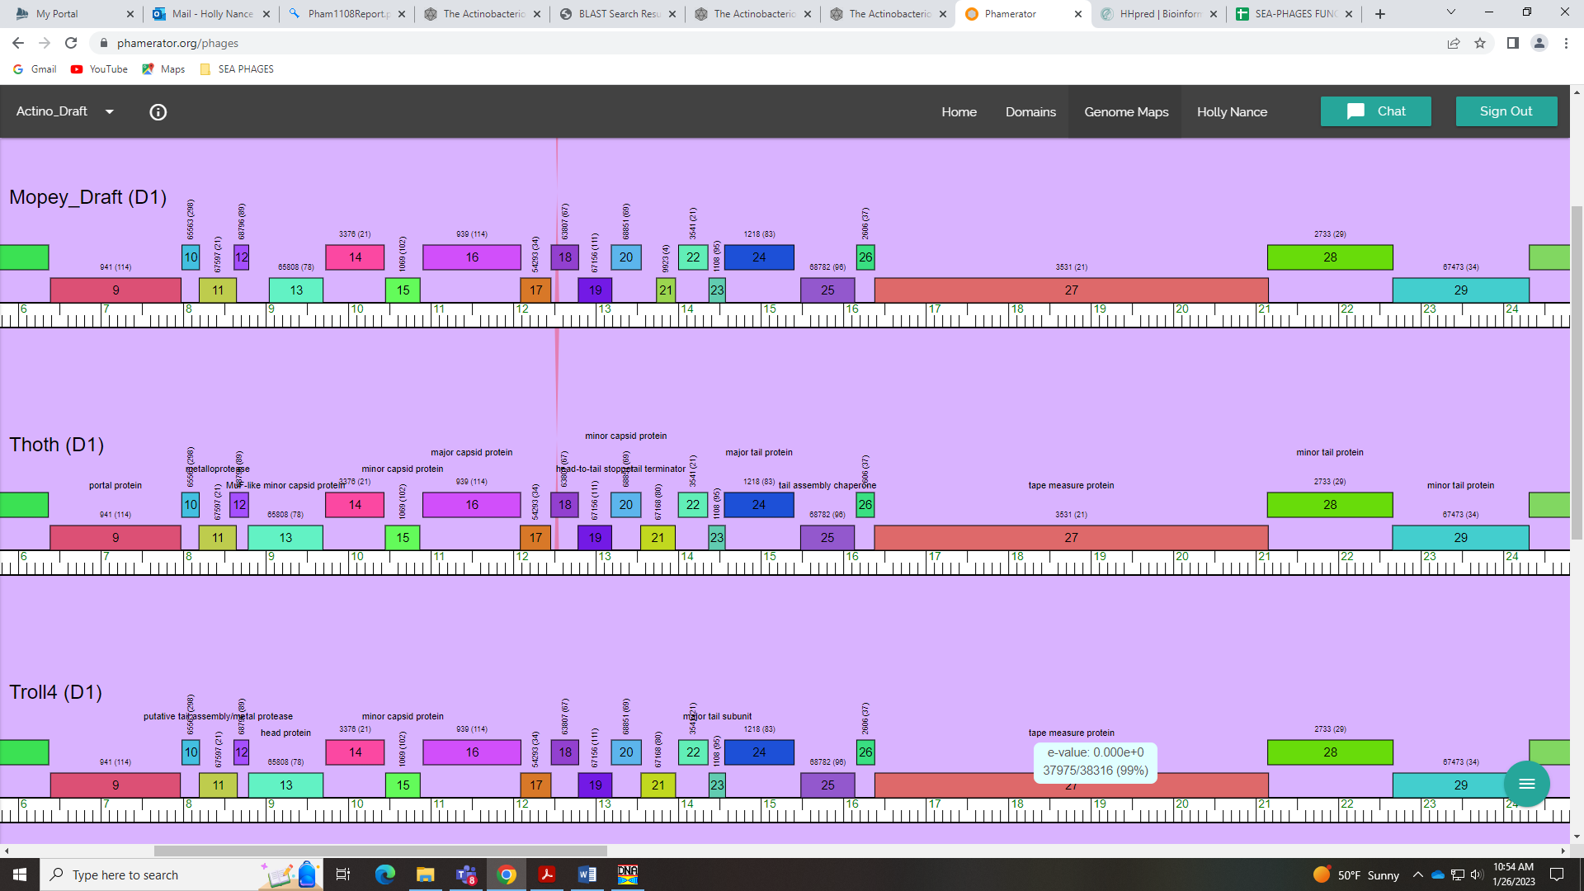

Gene 24
SSC: start 14562, stop 15404; CP: yes; SCS: Both called start of 14562; ST: SS; Blast Start: matches Visconti_24 Query 1 to Subject 1 100% e⁻¹⁶⁰; Gap: overlap of 11; LO: NA; RBS: -2.367, 2.764, 10, -3.062, no; F: major tail protein; SIF-BLAST: major tail protein /PhageDB BLAST/Thoth_24, MT889385/100%/e⁻¹⁶⁰; SIF-HHPred: major tail protein, 96.11% match to resubmitted section, 99.85% match to full sequence; SIF-Syn: major tail protein
Notes: start conserved. For function, several PhagesDB and NCBI BLAST hits match major tail protein:
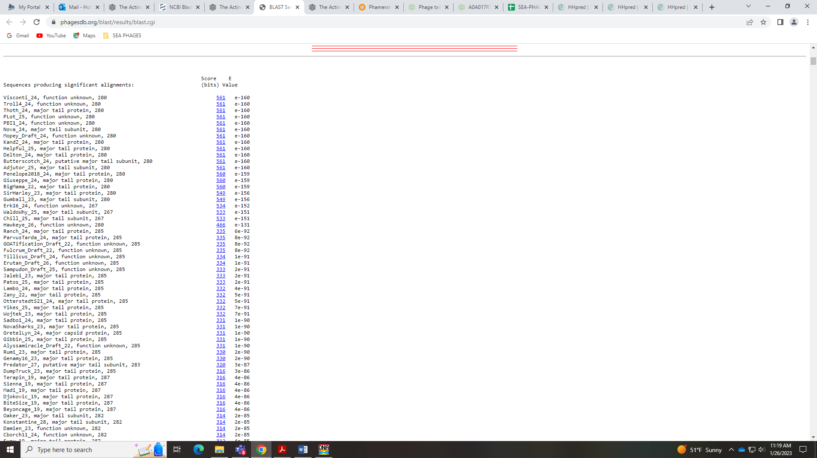
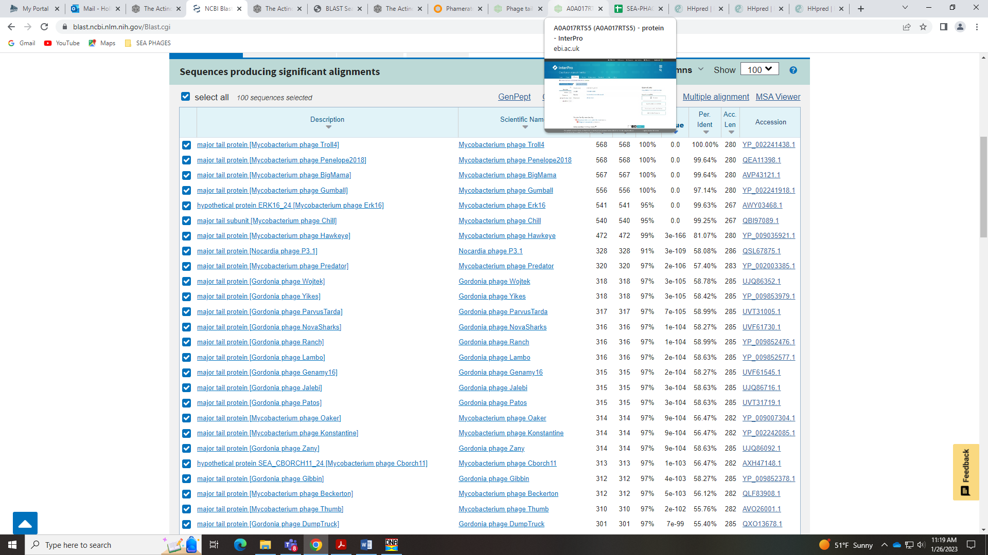
The HHPred top hits are for Tail Tube Protein, which is on the Official List but this is not called in BLAST hits. Also, this is only a partial hit in HHPred:
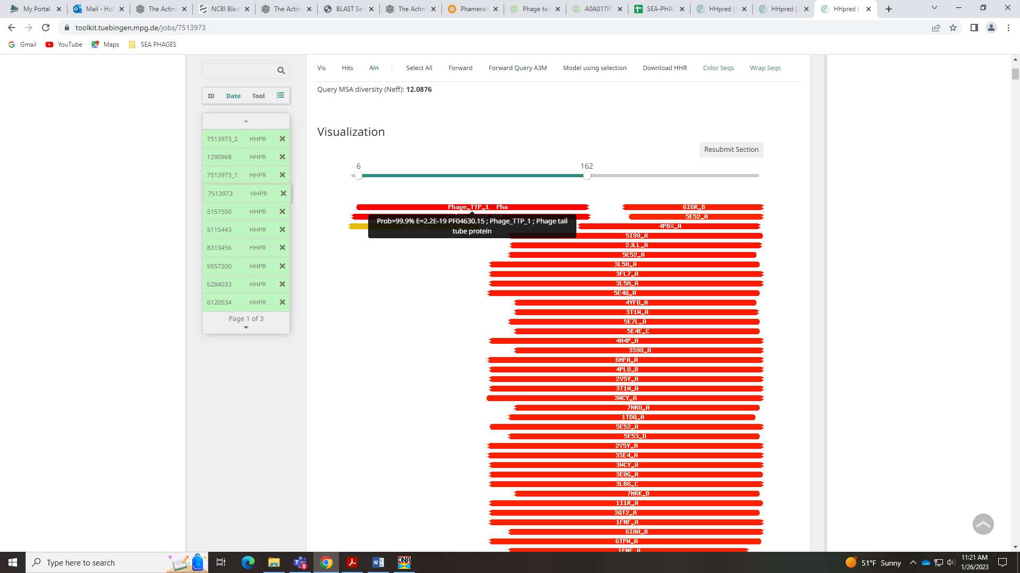
When I resubmit just that section, I get a hit with over 96% probability to Major Tail Protein:
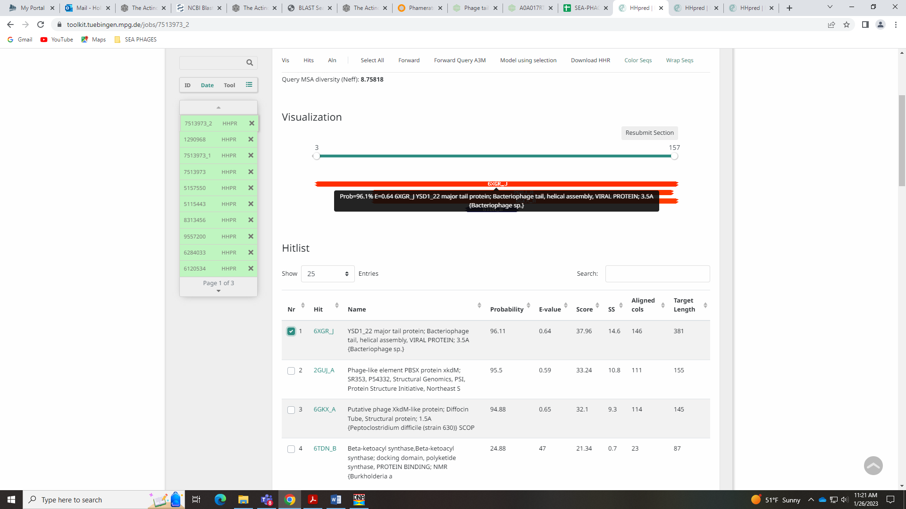
This hit is for 6XGR_I, which is the same HHpred hit for the example given for Major Tail Protein in the Official List (Sisi_11):
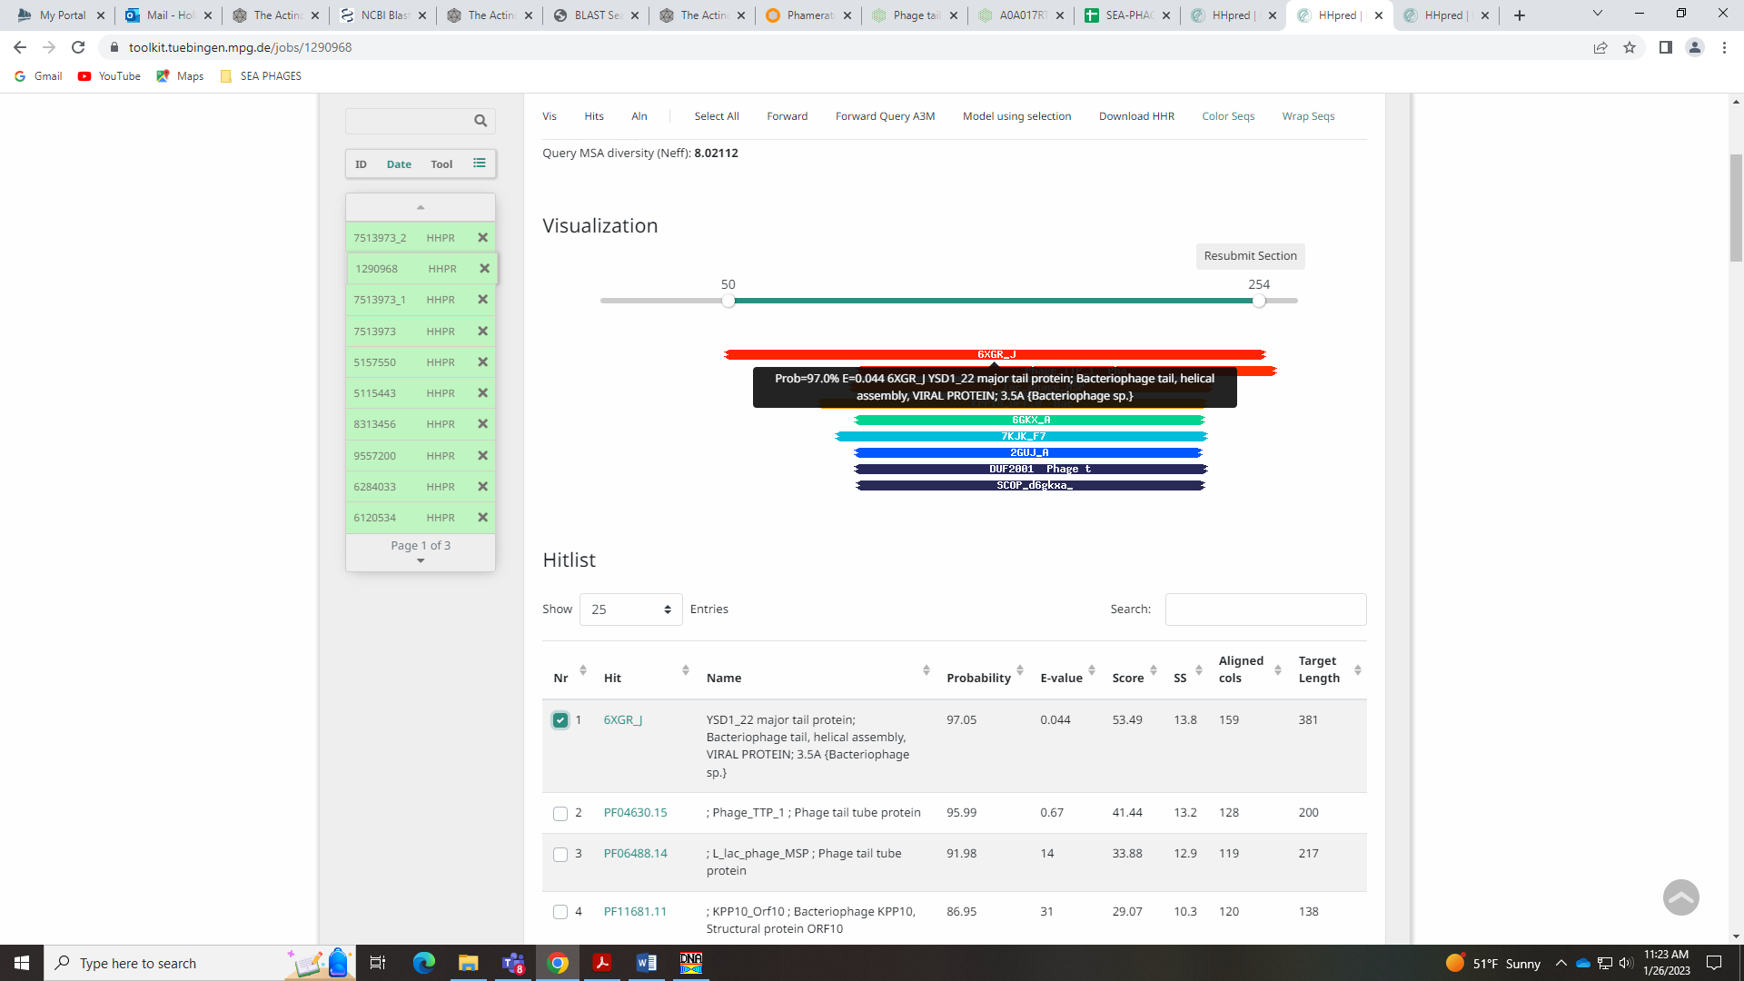
E-values, probabilities and %identities are very similar for both Sisi_11 and Mopey_24 to 6XGR_I, so I’m calling this Major Tail Protein. Note: there should only be one of these per genome! We only have one!

Gene 25
SSC: start 15486, stop 16139; CP: yes; SCS: Both called start of 15486; ST: SS; Blast Start: matches Visconti_25 Query 1 to Subject 1 100% e⁻¹²⁰; Gap: 81; LO: yes; RBS: -1.748, 3.061, 12, -2.584, yes; F: NKF; SIF-BLAST: NKF/PhageDB BLAST/Visconti_25, MH399788/100%/1e⁻¹²⁰; SIF-HHPred: NKF, no matches with a probability above 90%; SIF-Syn: NKF
Notes: Start is conserved in this gene. There are several BLAST hits that are NKF, but also Tail Assembly Chaperone:
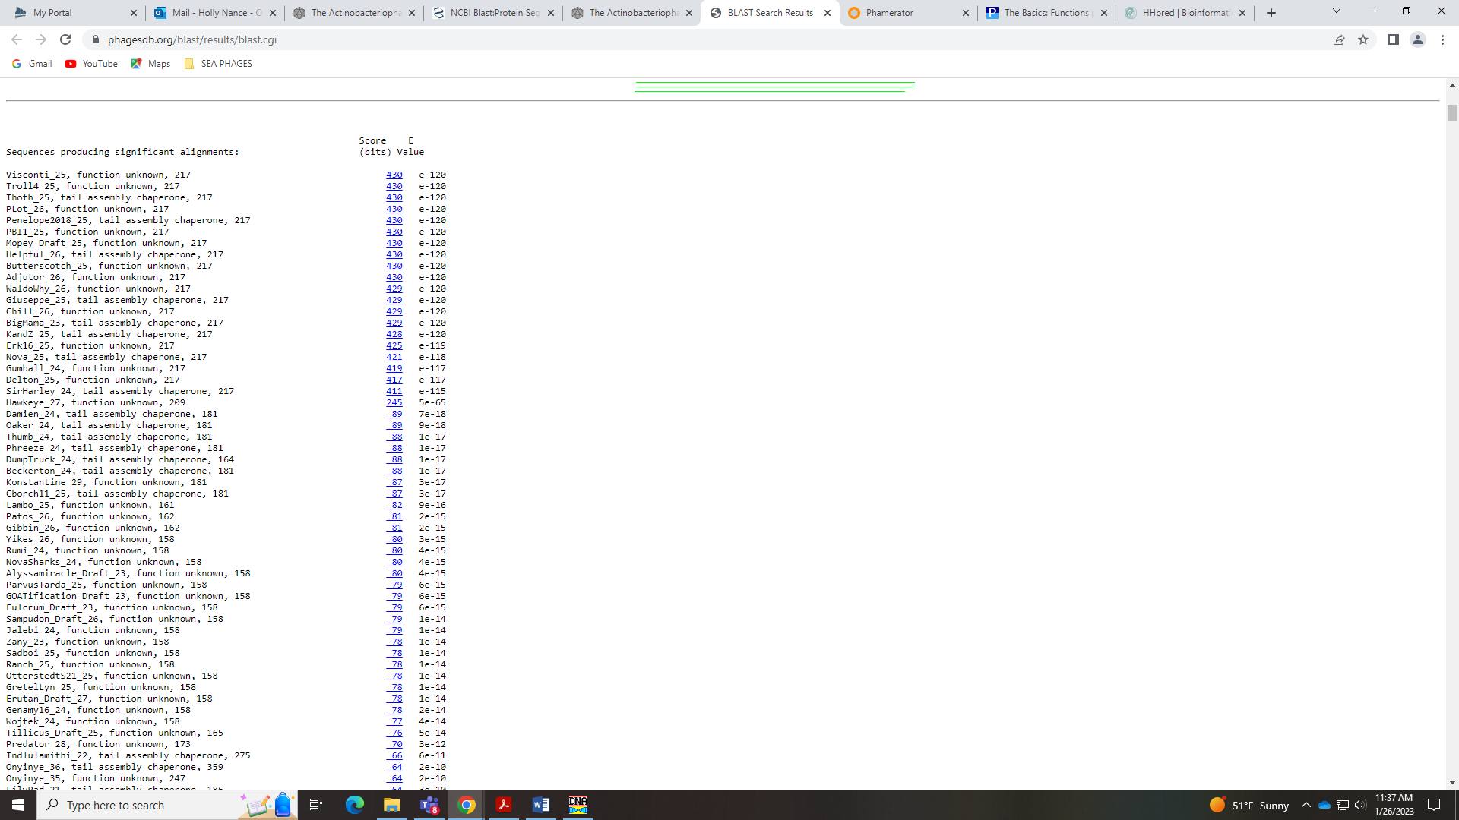
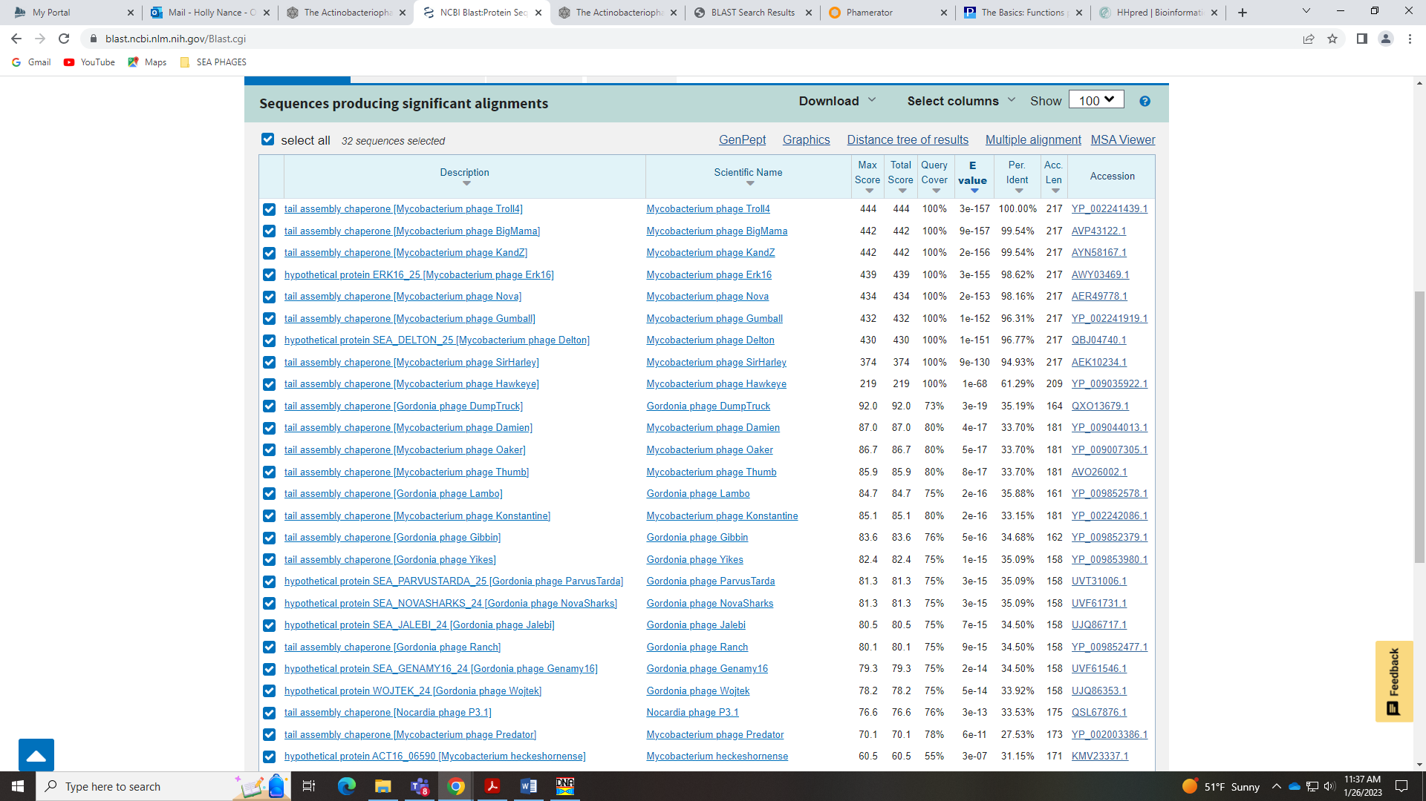
HHPred has nothing even close to this function:
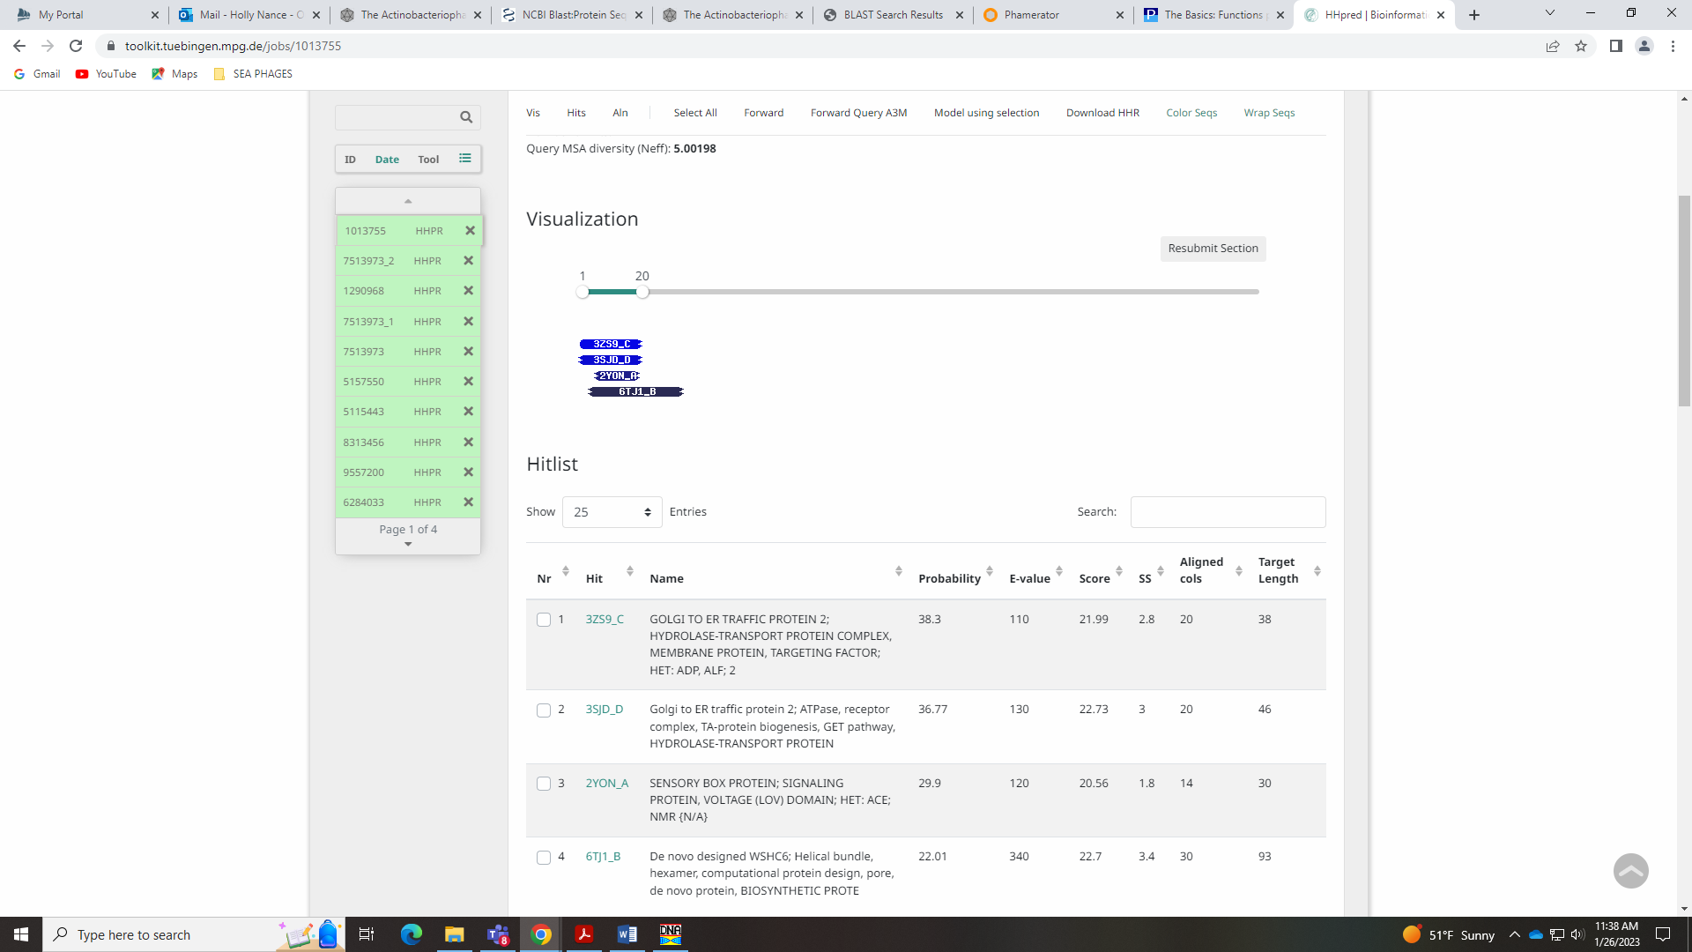
The Bioinformatics Guide says that to call Tail Assembly Chaperone, it MUST have the slippery sequence and translational frame shift. This protein does NOT have that frame shift, nor do any other phage in D1. The Bioinformatics guide says not to call this function given a lack of evidence. I’m going with NKF.
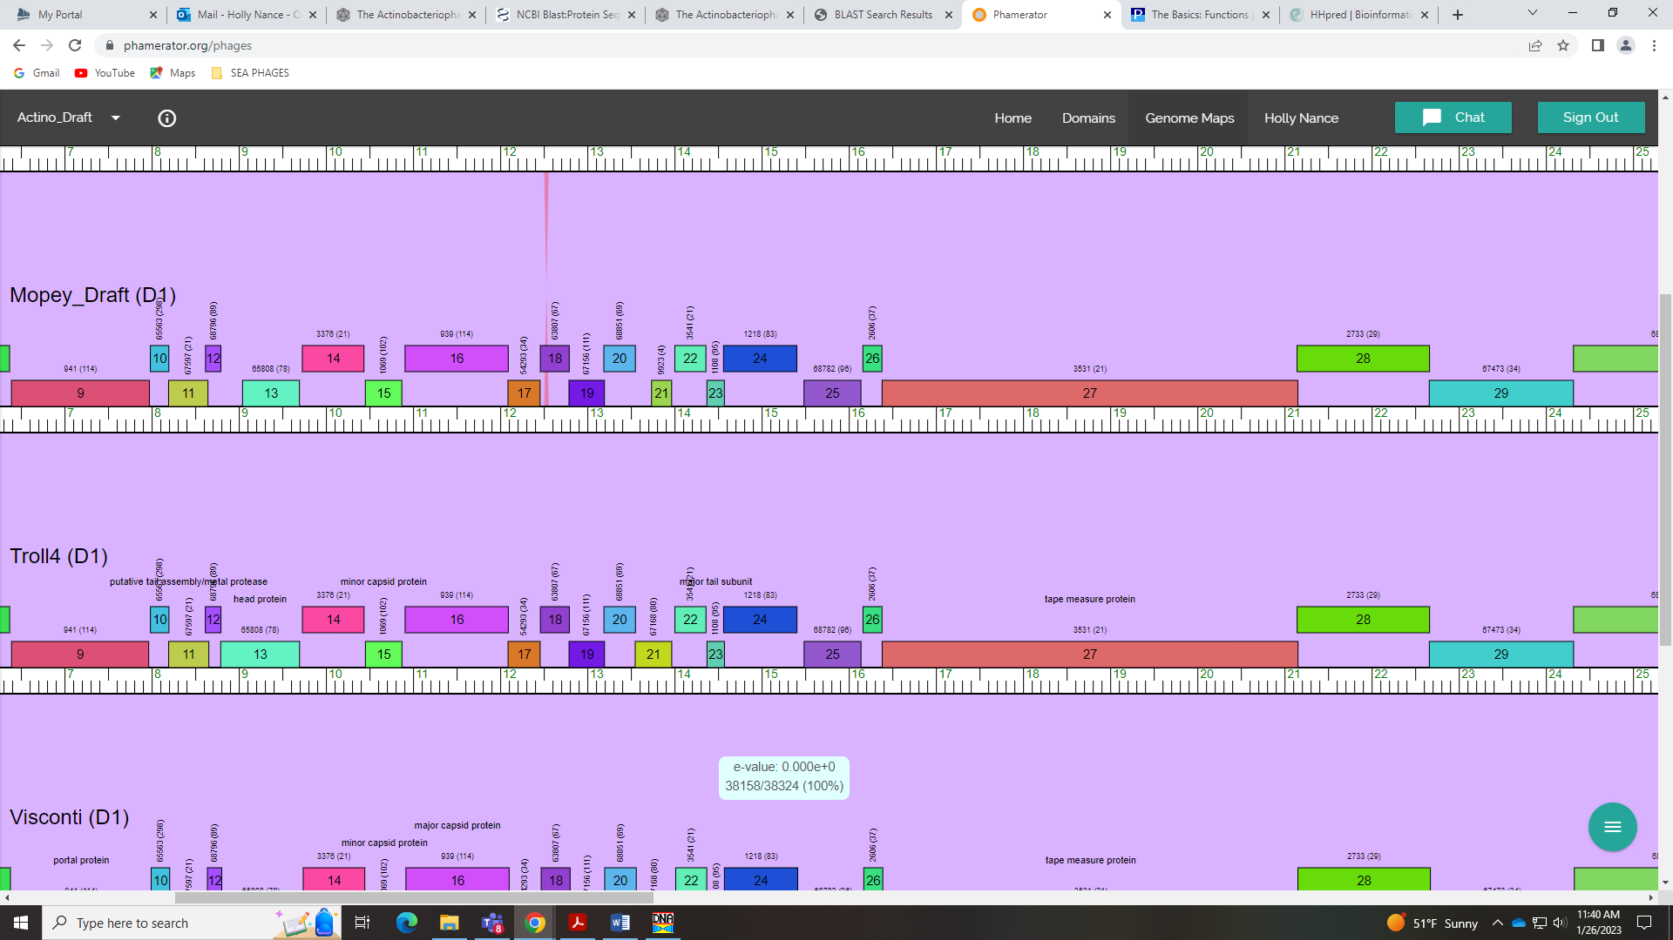

Gene 26
SSC: start 16162, stop 16380; CP: yes; SCS: Glimmer called 16162, GeneMark called 16108; ST: SS; Blast Start: matches WaldoWhy_27 Query 1 to Subject 1 100% 4e⁻³⁵; Gap: 22; LO: no; RBS: -2.699, 2.605, 7, -4.222, yes; F: NKF; SIF-BLAST: NKF/PhageDB BLAST/ WaldoWhy_27, MK494102/100%/4e⁻³⁵; SIF-HHPred: NKF, no matches with a probability above 90%; SIF-Syn: NKF
Notes: GeneMark and Glimmer called different starts, and while the GeneMark start yields a longer ORF, this start is not the most conserved and causes an overlap of 32 BP. The RBS values for the Glimmer start are the best, too. The Glimmer start of 16162 yields more Q:S 1:1 hits in BLAST within Cluster D1. For function, there is little support to call this anything but NKF. A few call it Tail Assembly Chaperone, but I don’t think this is appropriate since we don’t have a translational frame shift.
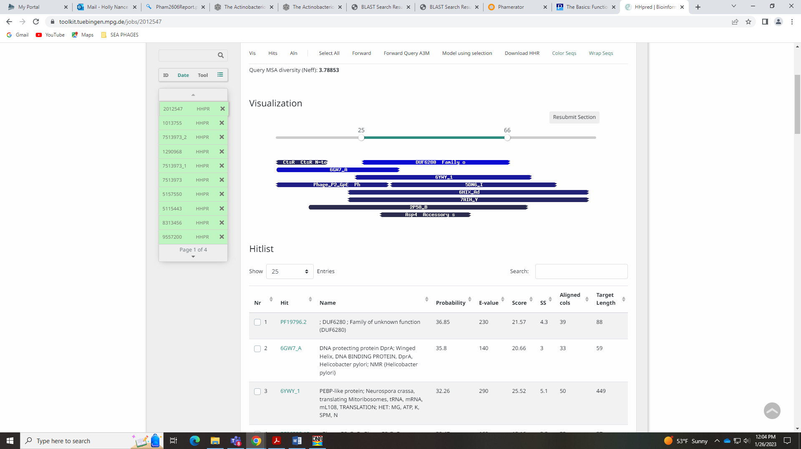
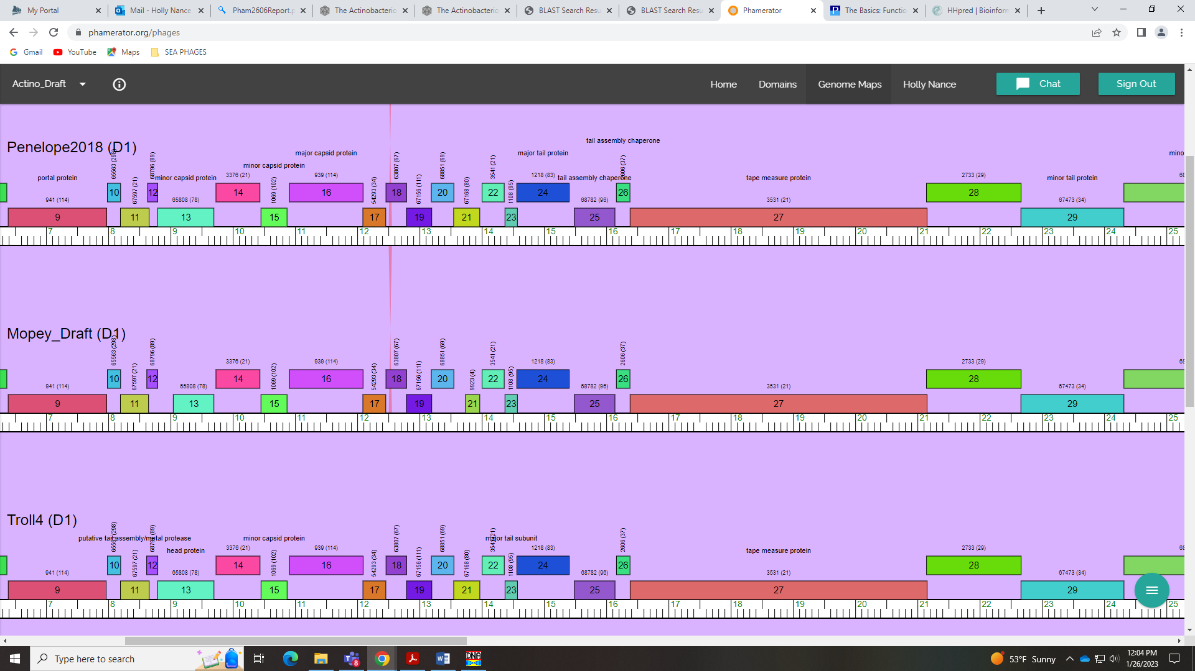

Gene 27
SSC: start 16382, stop 21154; CP: yes; SCS: Both called start of 16382; ST: SS; Blast Start: matches WaldoWhy_28 Query 1 to Subject 1 100% 0.0; Gap: 1; LO: NA; RBS: -3.867, 2.044, 11, -4.624, no; F: tape measure protein; SIF-BLAST: tape measure protein /PhageDB BLAST/ WaldoWhy_28, MK494102/100%/0.0; SIF-HHPred: tape measure protein, several matches with a probability above 90%; SIF-Syn: tape measure protein
Notes: Nothing ambiguous. Clearly the largest gene – tape measure protein!

Gene 28
SSC: start 21144, stop 22664; CP: yes; SCS: Both called start of 21144; ST: SS; Blast Start: matches WaldoWhy_29 Query 1 to Subject 1 100% 0.0; Gap: overlap of 11; LO: NA; RBS: -2.934, 2.492, 13, -3.980, no; F: minor tail protein; SIF-BLAST: minor tail protein /PhageDB BLAST/WaldoWhy_29, MK494102/100%/0.0; SIF-HHPred: distal tail protein, several matches with a probability above 90%; SIF-Syn: minor tail protein
Notes: Start is highly conserved. For function, synteny strongly supports minor tail protein, as explained in Bioinformatics Guide:
Minor tail proteins: These are the components of the tail that form the tip of the tail. These proteins are low in copy-number per virion (only two to six copies or so per protein per tail) but identified due to their length and location: downstream of the tape measure protein, and ranging in size from 1kb-3kb depending on the phage. These proteins are quite modular and it is difficult to sort them into more specific roles, so we call them all "minor tail proteins". There are usually between 4 to 6 per genome that can be identified easily. Two exceptions to the genome location rule are the Cluster A phages, in which one to two minor tail proteins are upstream of the lysins and terminase genes; and the Cluster S phages, in which several minor tail proteins are located in the far right arm, away from the other ones. These proteins are diverse, modular, long and extended, and as such can be difficult to crystallize or identify using HHPred or BLAST. Some of them also have an enzymatic domain; this activity is used by the phage to get through sugars, or the cell wall, etc, on the outside of the cell to help deliever the DNA. We primarily make this assignment based on synteny, and the four largest proteins immediately following the tape measure will usually be given this label.
Rank: 1

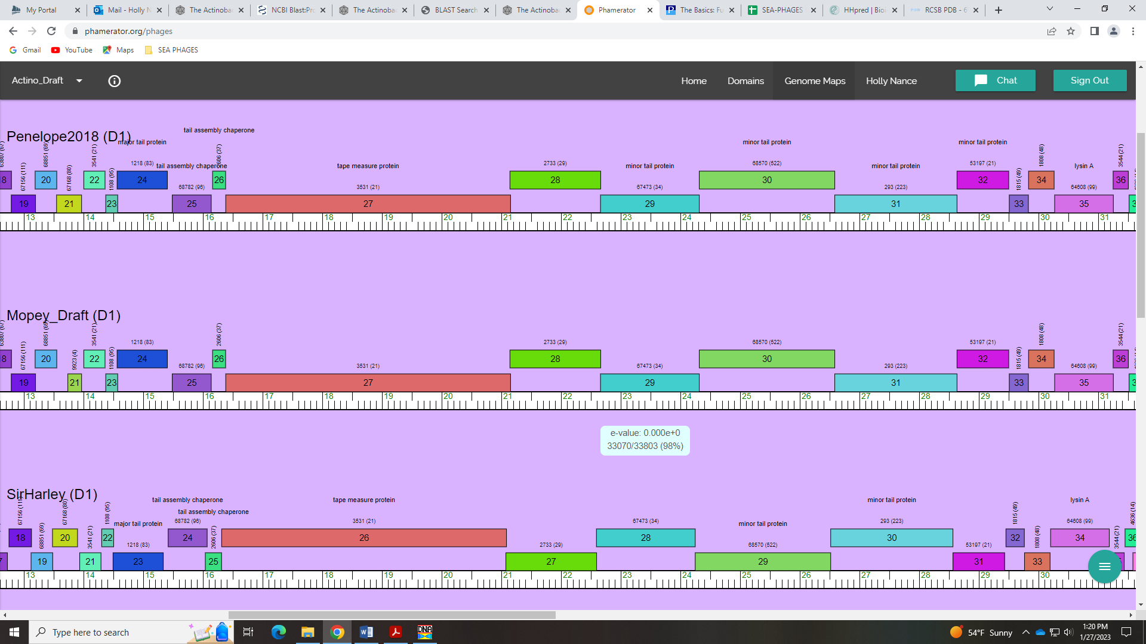
There are several BLAST hits in both PhagesDB and NCBI that call this NKF, but there are several that call this minor tail protein, too:
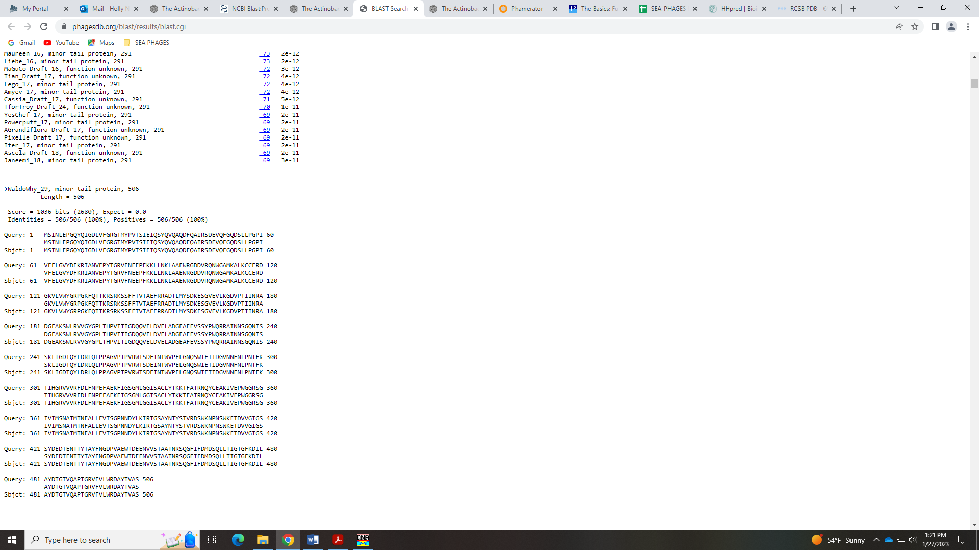
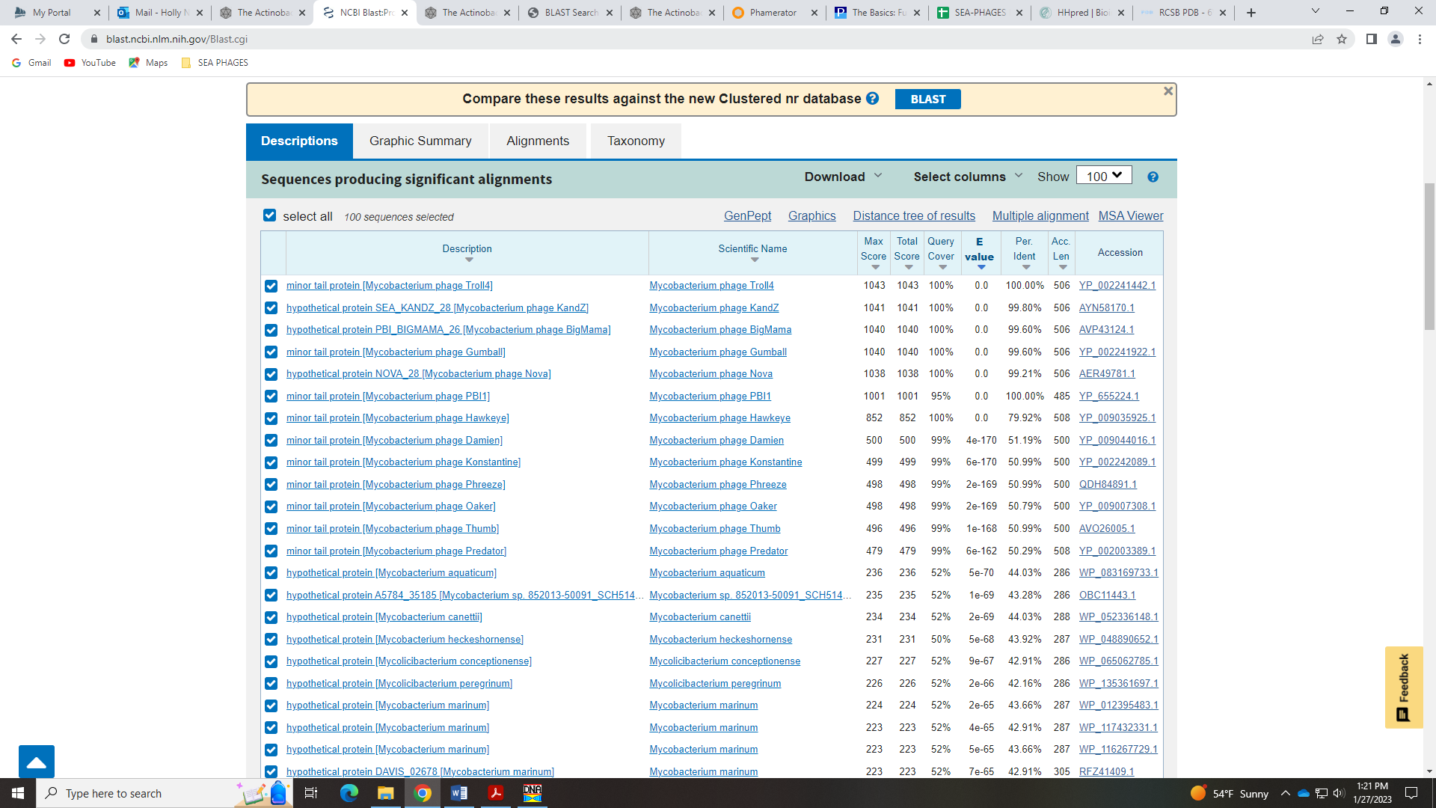
The HHPred highest probability hits are for distal tail protein, which is similar:
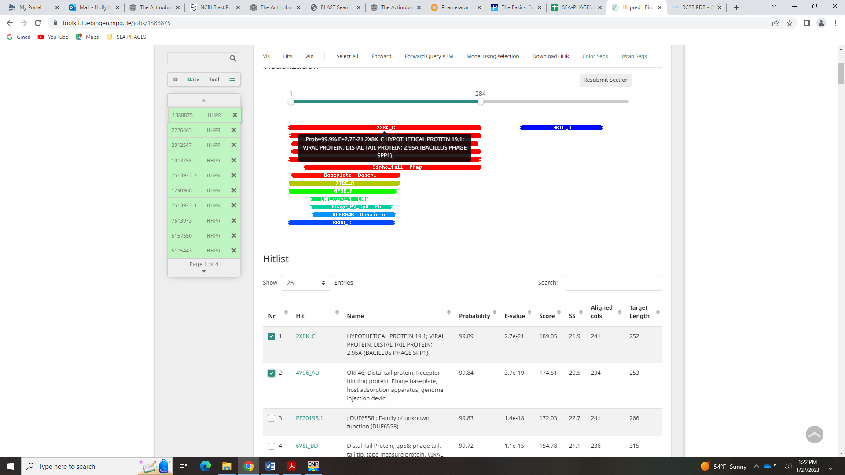

Gene 29
SSC: start 22661, stop 24316; CP: yes; SCS: Both called start of 22661; ST: SS; Blast Start: matches Helpful_30 Query 1 to Subject 1 100% 0.0; Gap: overlap of 4; LO: NA; RBS: -3.808, 2.073, 9, -4.583, no; F: minor tail protein; SIF-BLAST: minor tail protein /PhageDB BLAST/ Helpful_30, MN284908/100%/0.0; SIF-HHPred: tail protein, several matches with a probability above 90%; SIF-Syn: minor tail protein
Notes: Start highly conserved. For function, I’m calling it minor tail protein for the same reasons as above. Several BLAST hits call it this:
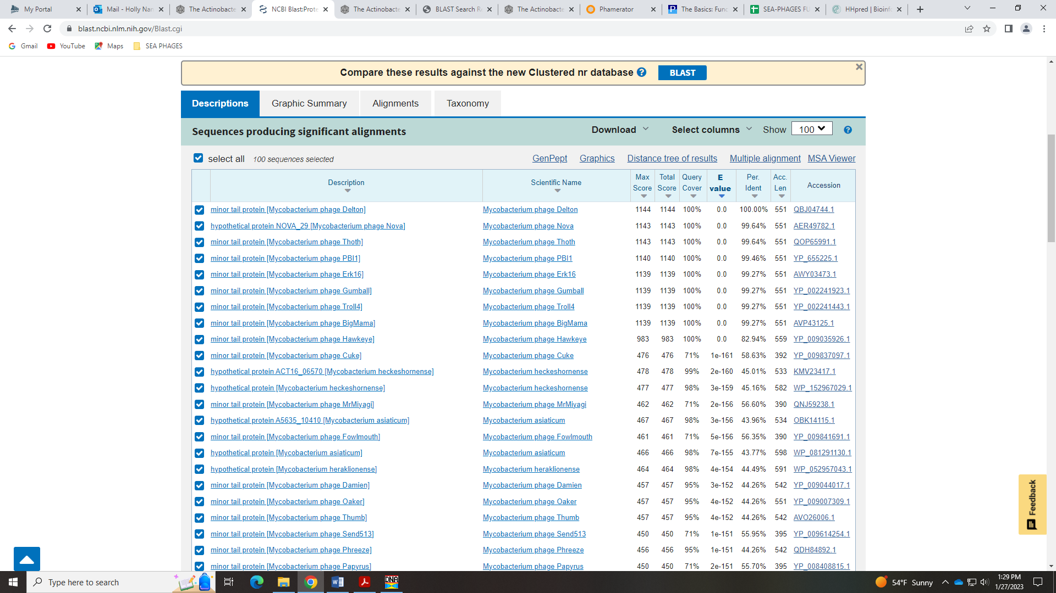
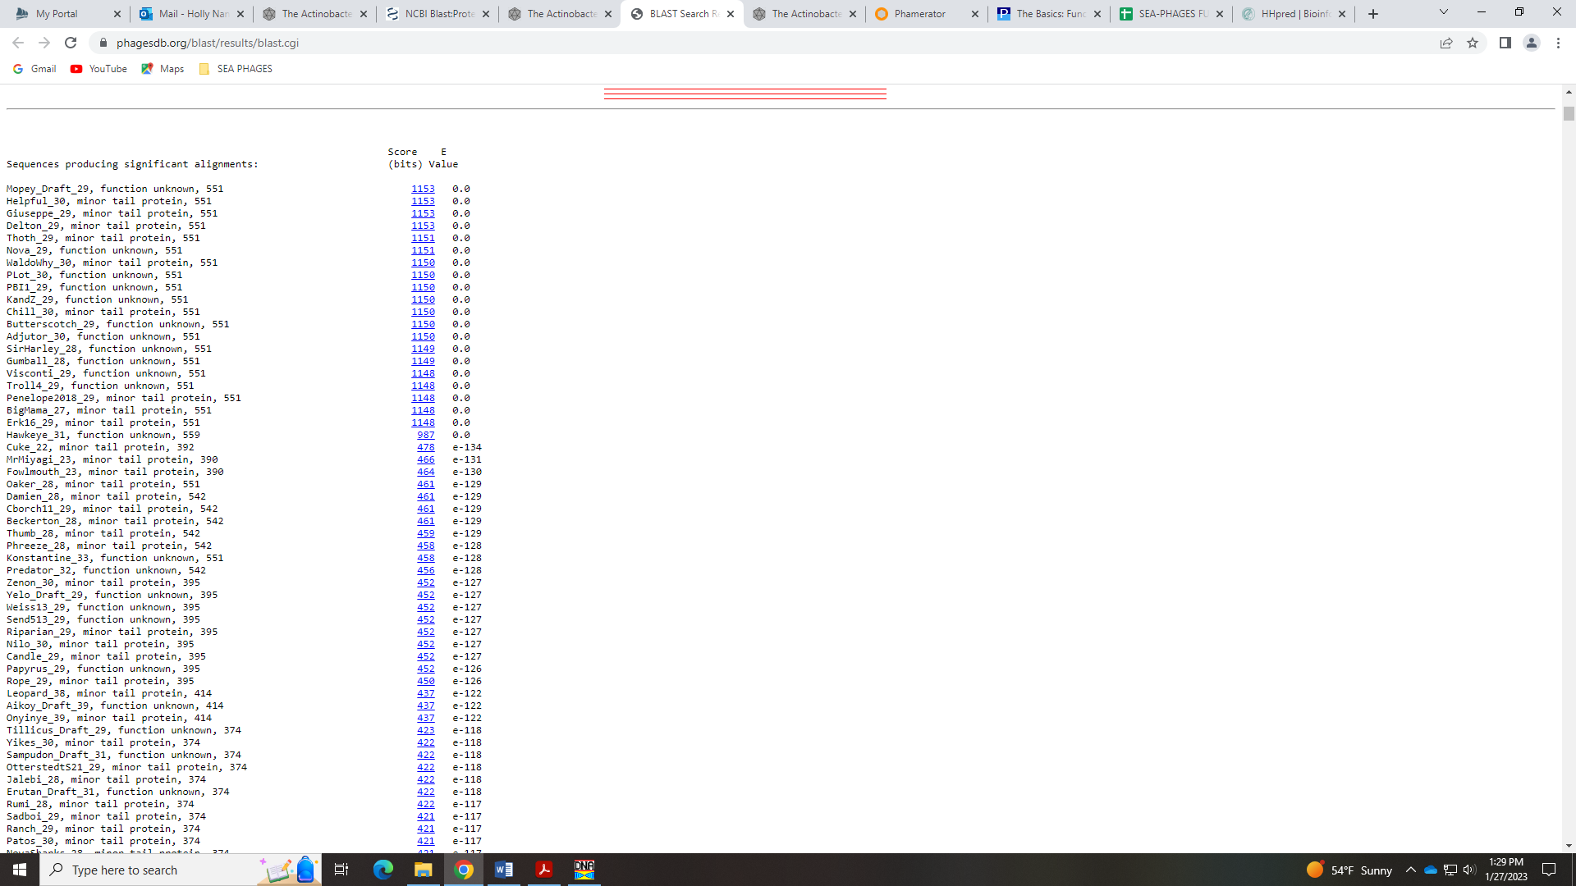
Synteny supports this call:
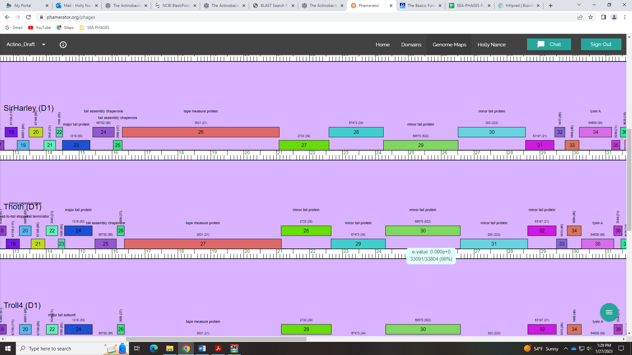
And the HHPred hits with highest probability are for a tail protein:
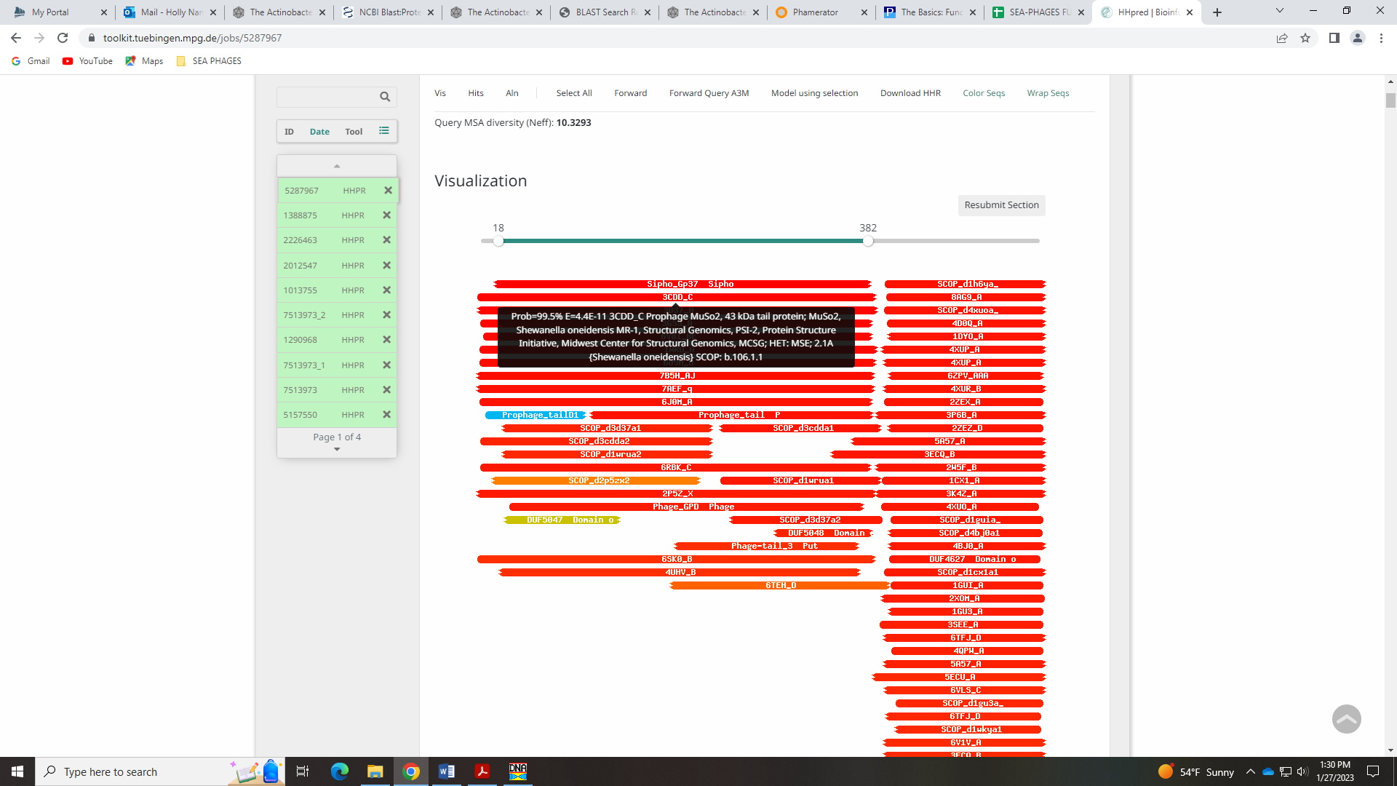

Gene 30
SSC: start 24316, stop 26586; CP: yes; SCS: Both called start of 24316; ST: SS; Blast Start: matches Visconti_30 Query 1 to Subject 1 99% 0.0; Gap: overlap of 1; LO: NA; RBS: -2.757, 2.577, 9, -3.532, no; F: minor tail protein; SIF-BLAST: minor tail protein /PhageDB BLAST/WaldoWhy_31, MK494102/99%/0.0; SIF-HHPred: NKF, no matches with a probability above 90% for tail protein; SIF-Syn: minor tail protein
Notes: Start is conserved in Cluster D1. For function, synteny and several BLAST hits suggest minor tail protein:
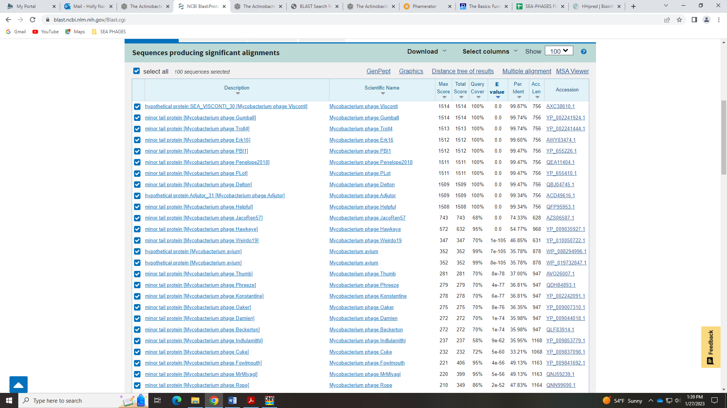
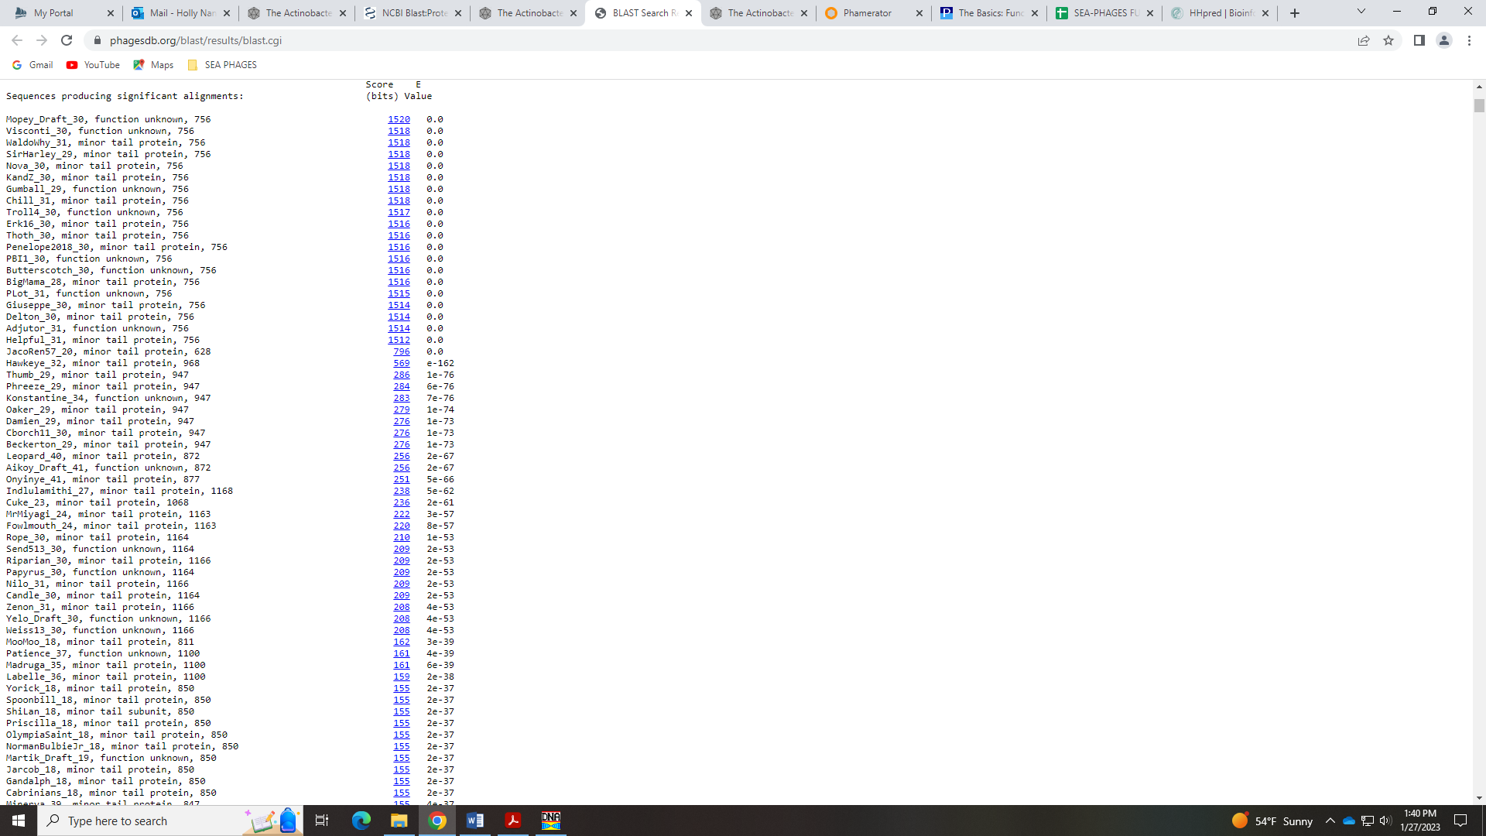
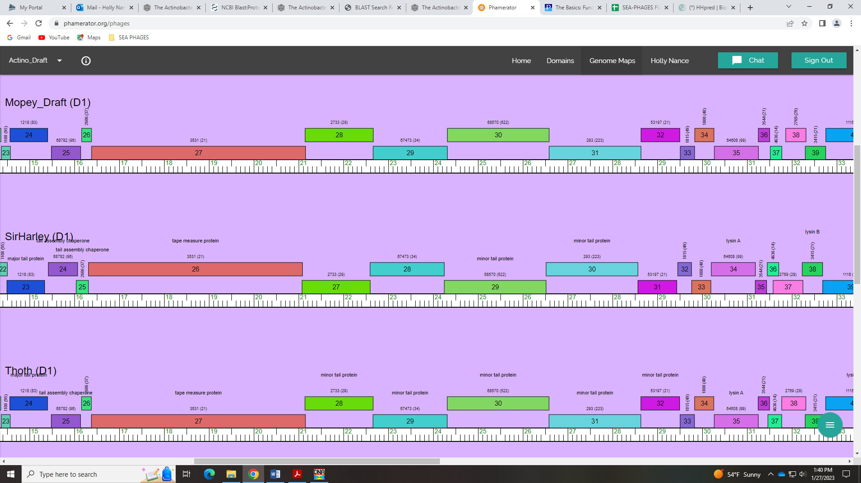
There were not close hits suggesting a tail protein in HHPred, but the Bioinformatics guide said, “These proteins are diverse, modular, long and extended, and as such can be difficult to crystallize or identify using HHPred or BLAST.” Therefore, I’m going with minor tail protein.

Gene 31
SSC: start 26586, stop 28634; CP: yes; SCS: Both called start of 26586; ST: SS; Blast Start: matches Visconti_31 Query 1 to Subject 1 100% 0.0; Gap: overlap of 1; LO: NA; RBS: -3.072, 2.426, 9, -3.847, no; F: minor tail protein; SIF-BLAST: minor tail protein /PhageDB BLAST/Helpful_32, MN284908/100%/0.0; SIF-HHPred: NKF, no matches with a probability above 90% for tail protein; SIF-Syn: minor tail protein
Notes: Again, I’m relying on synteny and BLAST hits to call this another minor tail protein.
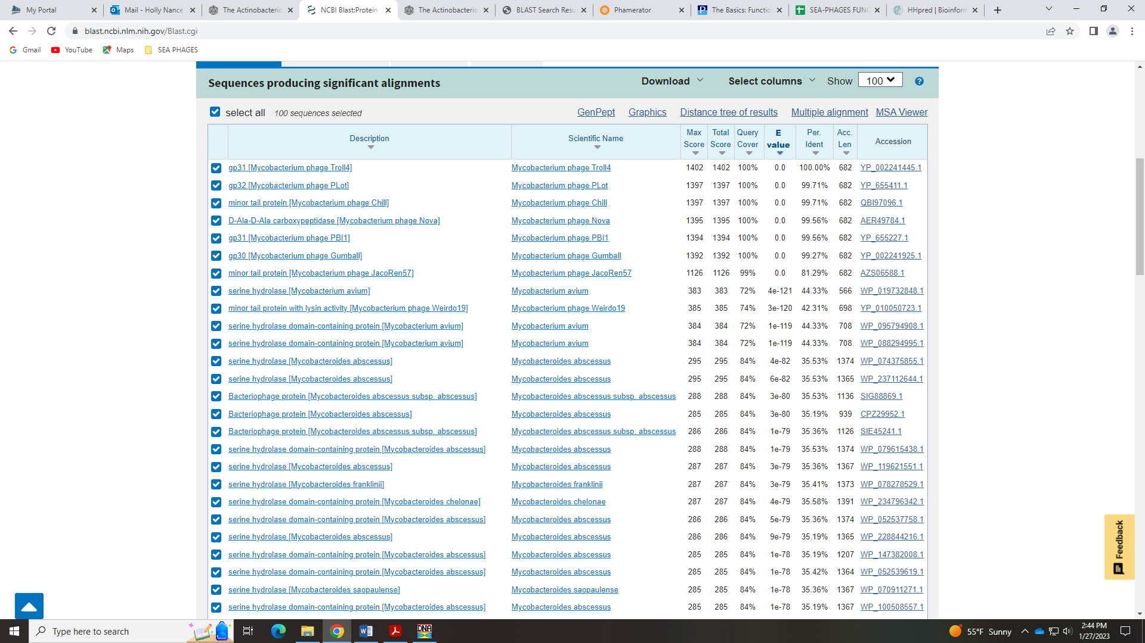
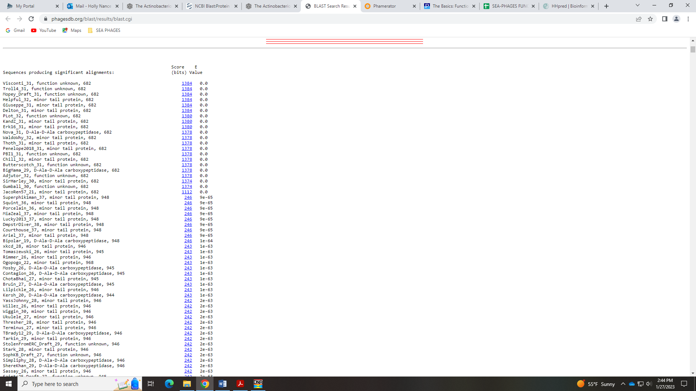
One of the example proteins for Minor Tail Protein in the Official Phage function list is Sisi_18. The HHPred output for this has nothing similar to a tail protein:
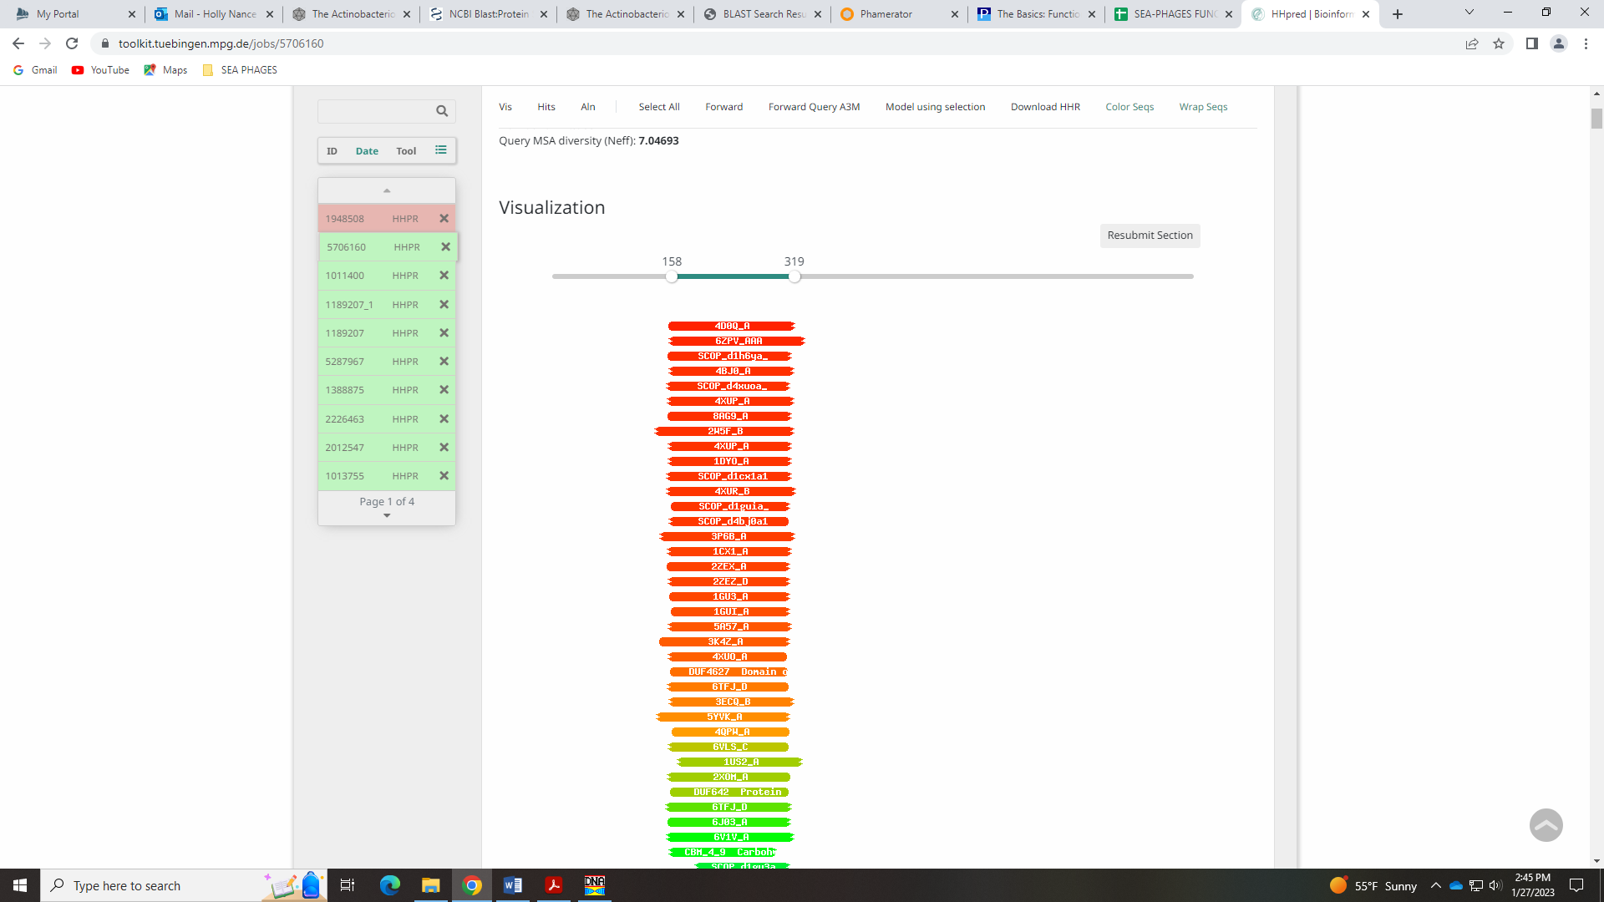
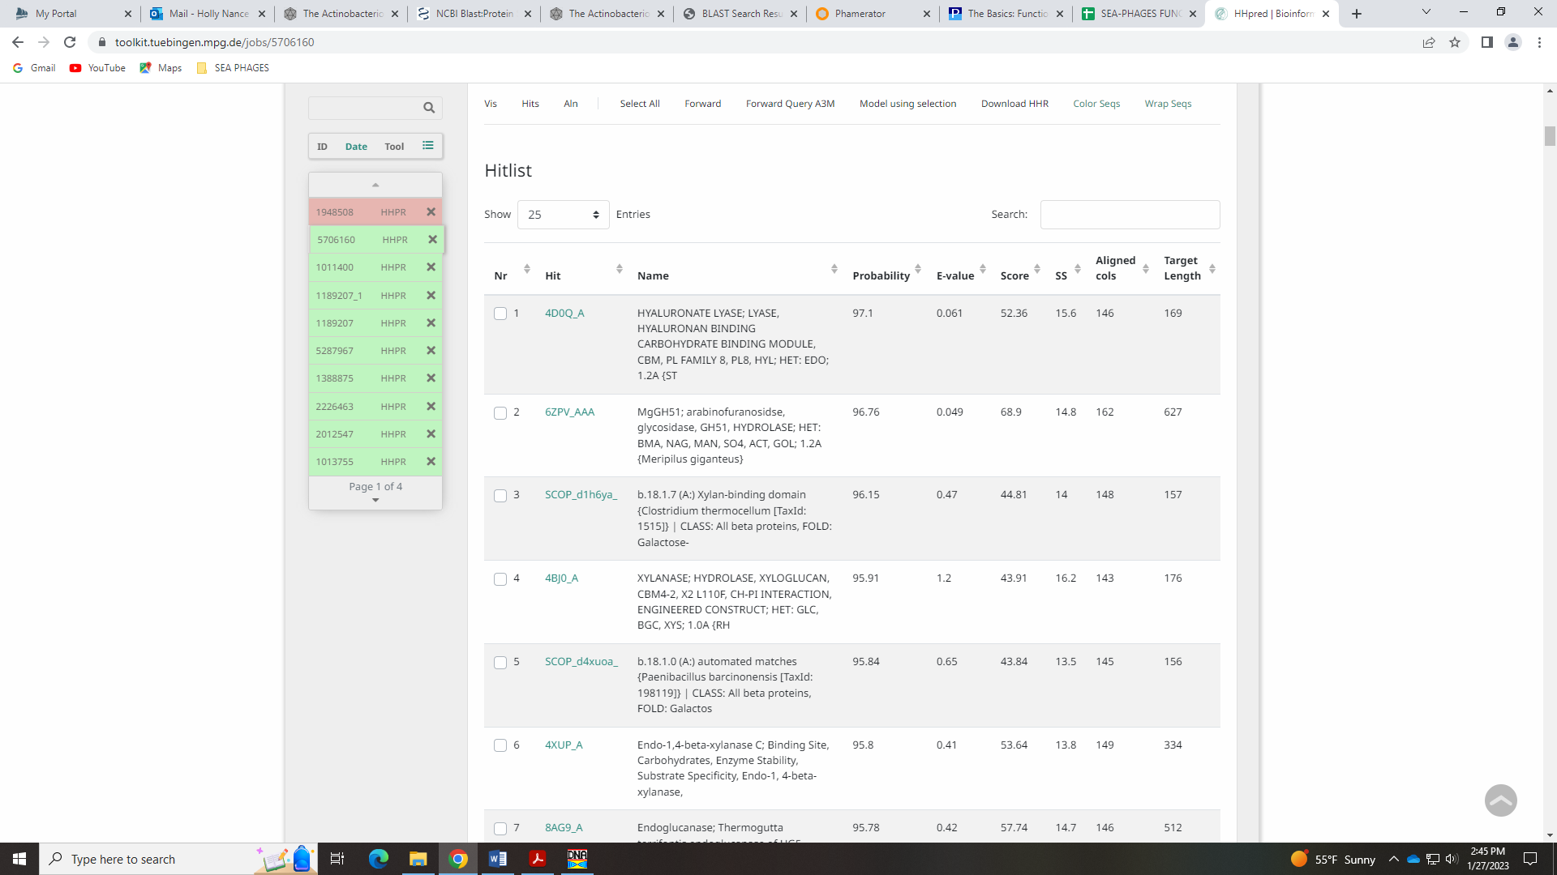
Given that the example doesn’t come up with a crystalline structure match, I don’t think it’s necessary (Bioinformatics Guide said this, too).

Gene 32 - Caroline
SSC: start 28634, stop 29500; CP: yes; SCS: Both called start of 28634; ST: SS; Blast Start: matches WaldoWhy_33 Query 1 to Subject 1 100% 1e⁻¹⁶⁴; Gap: overlap of 1; LO: NA; RBS: -1.559, 3.151, 9, -2.334, yes; F: minor tail protein; SIF-BLAST: minor tail protein/PhageDB BLAST/ Penelope2018_32, MN119378/100%/1e⁻¹⁶⁴; SIF-HHPred: NKF, no matches with a probability above 90%; SIF-Syn: minor tail protein
Notes: Most phage in Cluster do not call this Minor Tail Protein, although there are some BLAST hits in both Phages DB and NCBI that call this Minor Tail Protein:
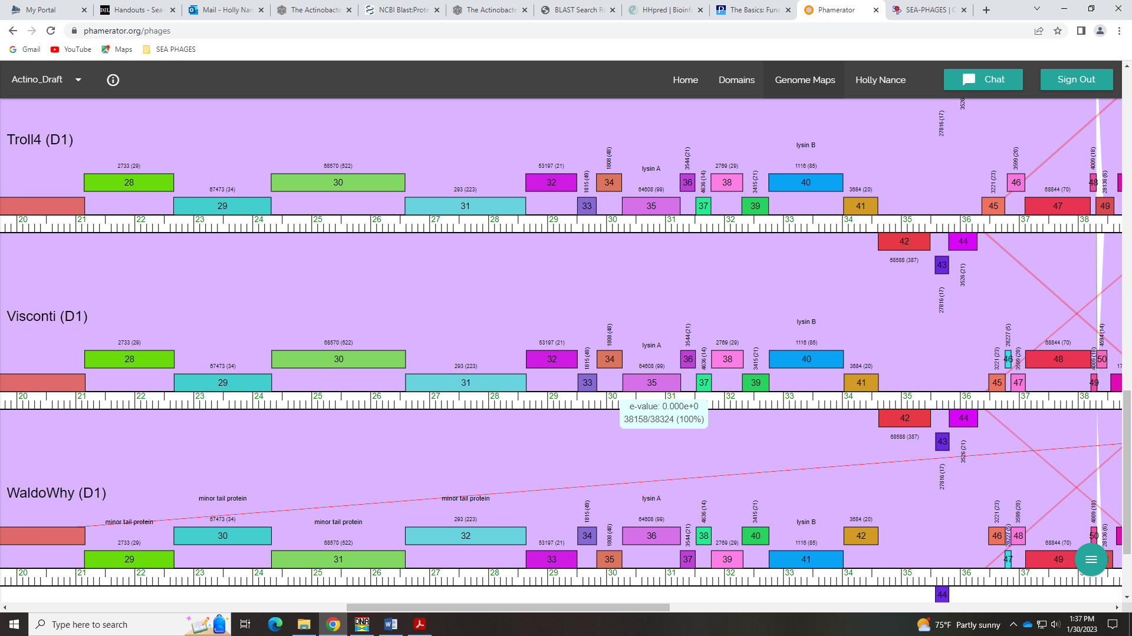
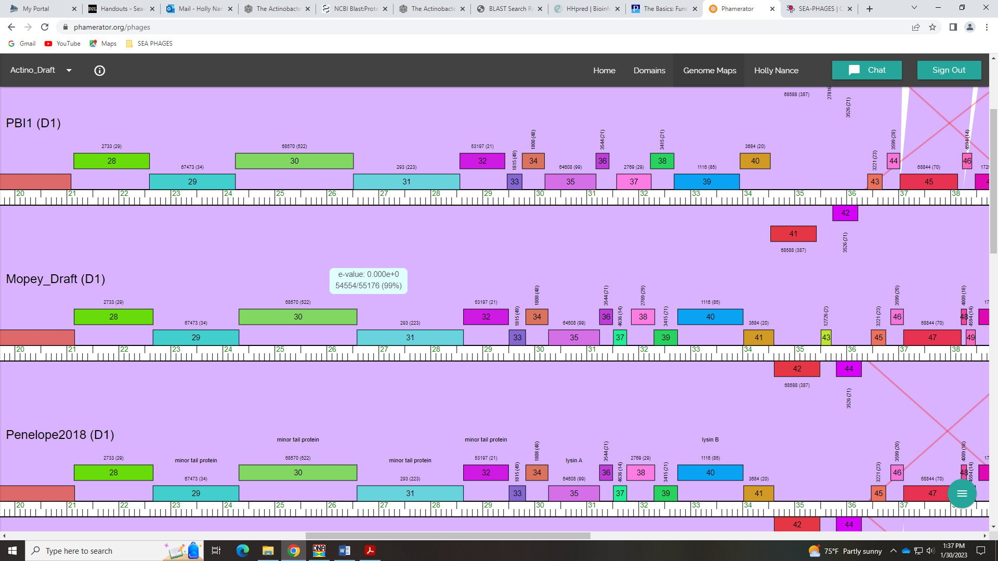
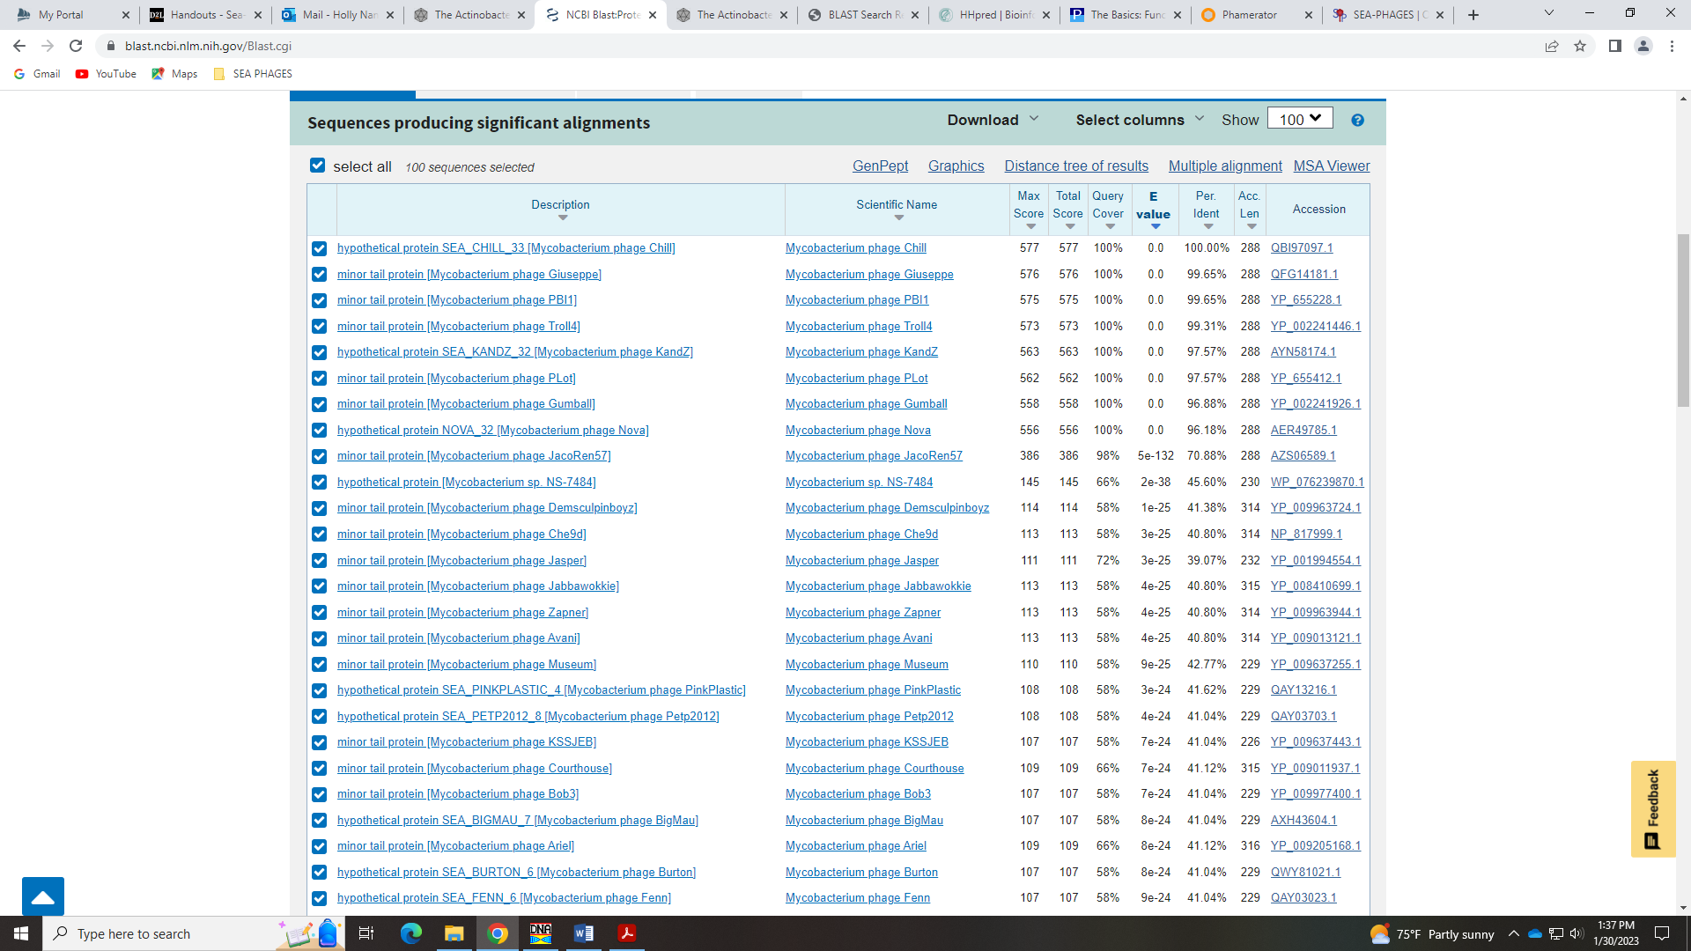

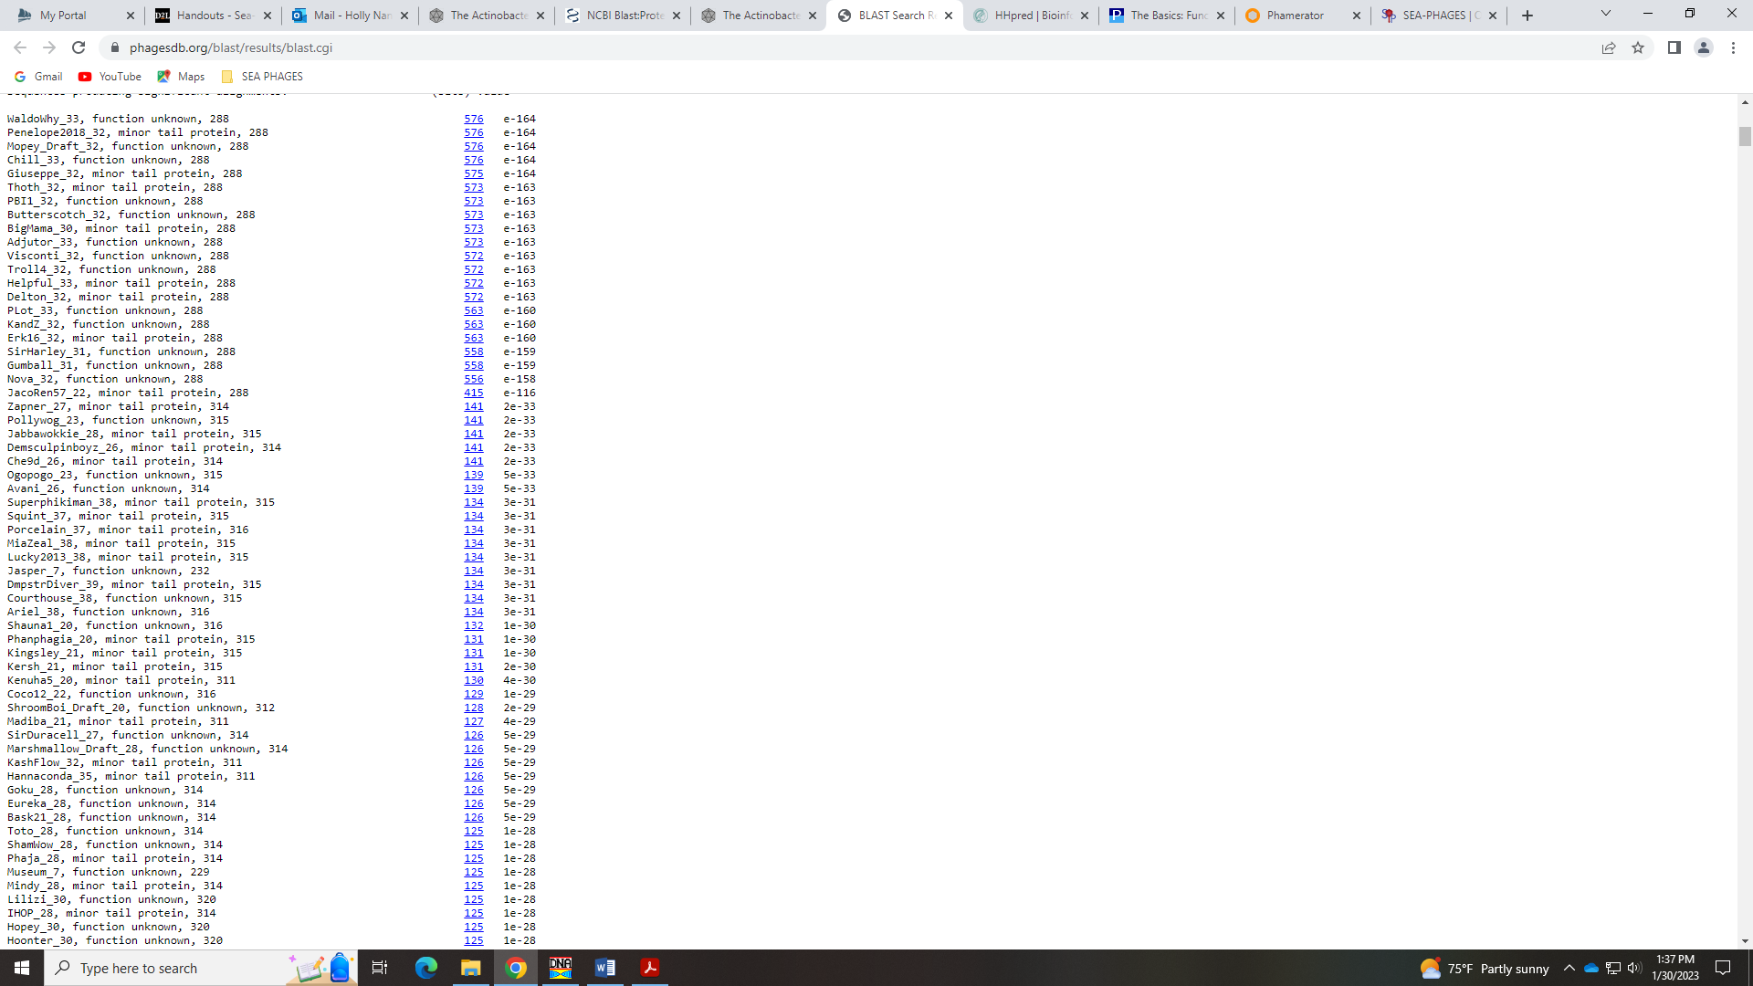
The Starterator output has very few genes in this phamily, which also causes doubt that this is a minor tail protein:
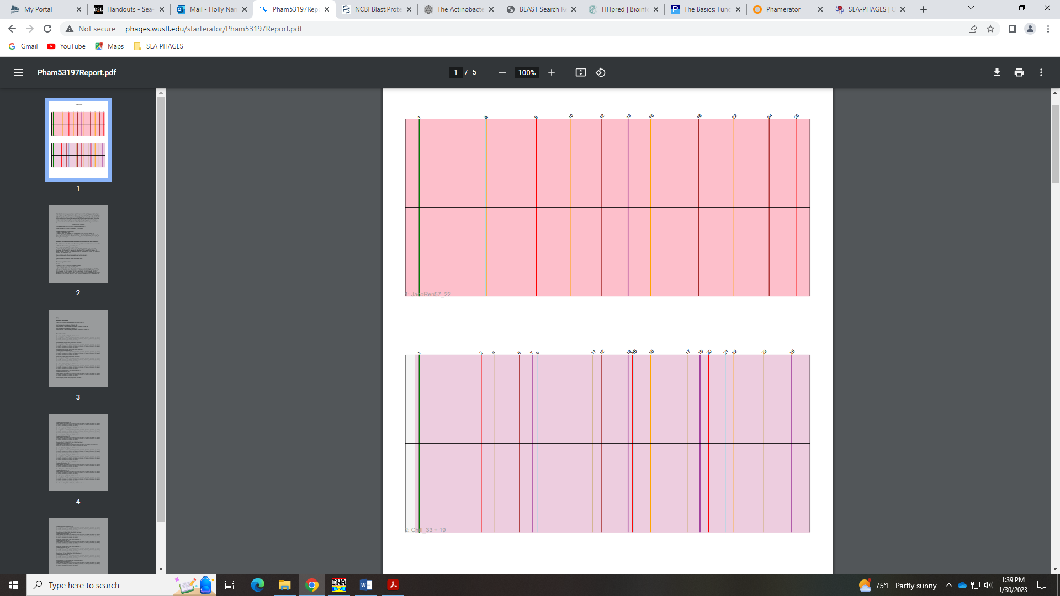
I dunno… I guess my rational for calling the other genes Minor Tail Proteins was just because there were more phage with the same call than this one. Caroline determined another minor tail protein.

Gene 33
SSC: start 29510, stop 29830; CP: yes; SCS: Glimmer called start of 29510, GeneMark called start at 29522; ST: SS; Blast Start: matches WaldoWhy_34 Query 1 to Subject 1 100% 4e⁻⁵⁶; Gap: 9; LO: yes; RBS: -3.142, 2.392, 10, -3.837, no; F: NKF; SIF-BLAST: NKF/PhageDB BLAST/ WaldoWhy_34, MK4941025/100%/4e⁻⁵⁶; SIF-HHPred: NKF, no matches with a probability above 90%; SIF-Syn: NKF
Notes: The Glimmer start is most conserved in Starterator and has the most Q:S 1:1 hits in both Phages DB BLAST and NCBI BLAST. This start also yields the longer ORF, so I’m going with what seems to be most conserved across the cluster and phamily.
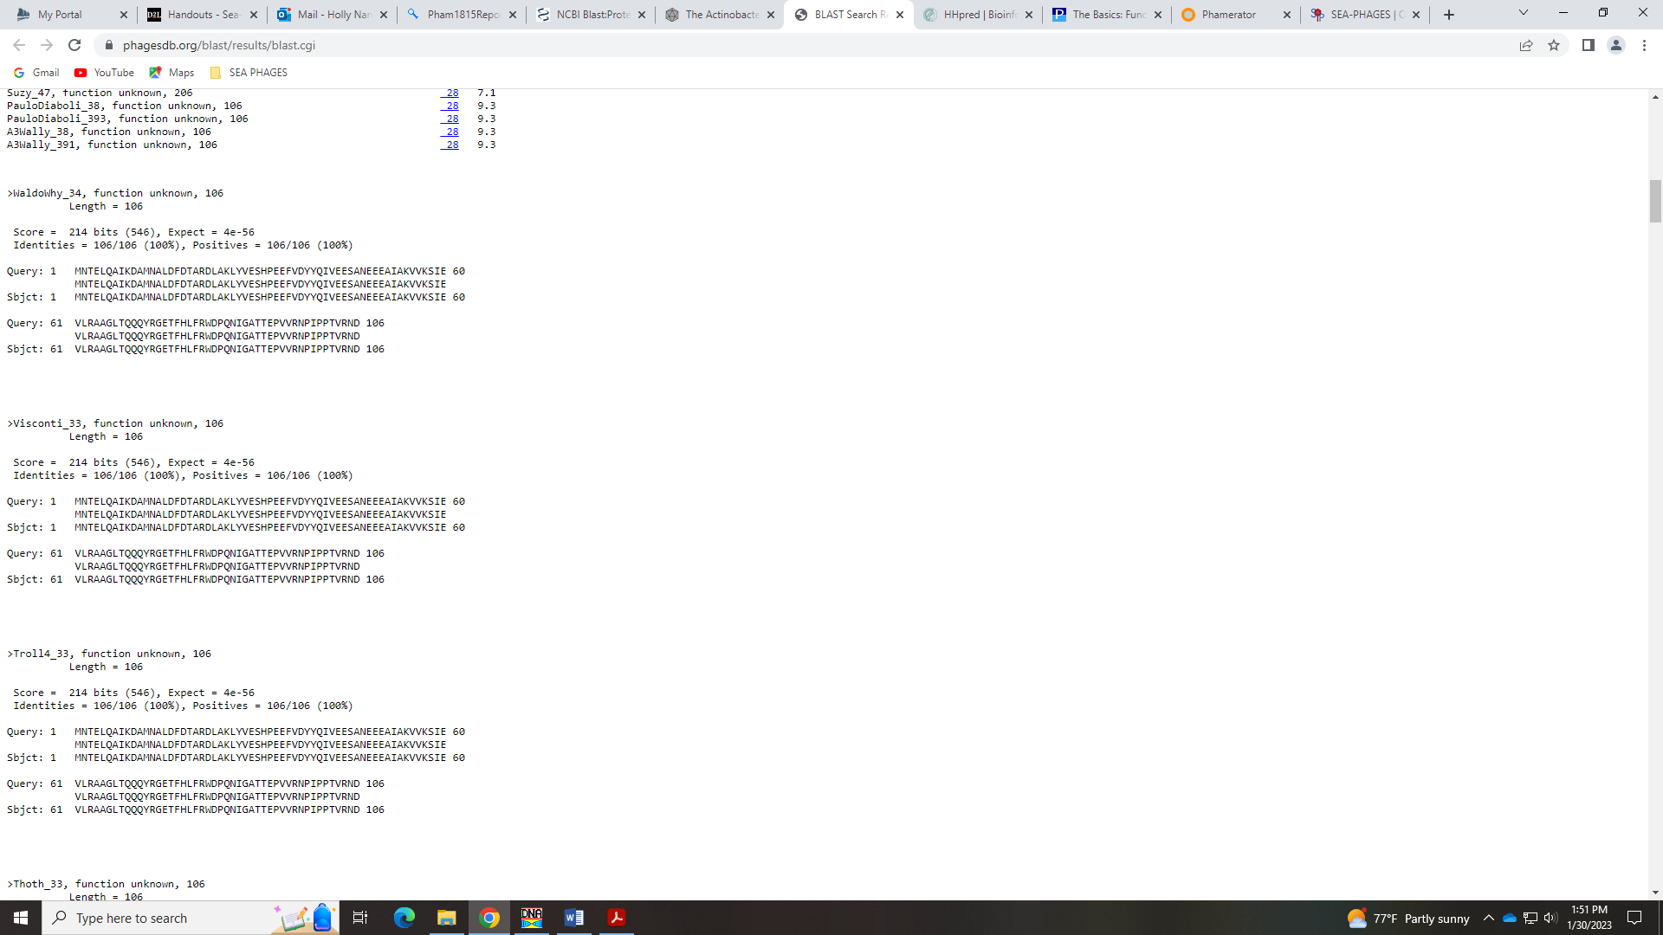

Gene 34
SSC: start 29833, stop 30261; CP: yes; SCS: Both called start of 29833; ST: SS; Blast Start: matches WaldoWhy_35 Query 1 to Subject 1 100% 6e⁻⁷⁴; Gap: 2; LO: yes; RBS: -1.761, 3.054, 13, -2.807, yes; F: NKF; SIF-BLAST: NKF/PhageDB BLAST/ WaldoWhy_35, MK4941025/100%/6e⁻⁷⁴; SIF-HHPred: NKF, no matches with a probability above 90%; SIF-Syn: NKF
Notes: Nothing ambiguous about this gene!

Gene 35
SSC: start 30270, stop 31253; CP: yes; SCS: Both called start of 30270; ST: SS; Blast Start: matches Visconti_35 Query 1 to Subject 1 100% 0.0; Gap: 8; LO: NA; RBS: -3.142, 2.392, 9, -3.917, no; F: Lysin A; SIF-BLAST: Lysin A/PhageDB BLAST/ Visconti_35, MH399788/100%/0.0; SIF-HHPred: endolysin or peptidase domain, several matches with a probability above 90%; SIF-Syn: Lysin A
Notes: Start is conserved. For function, nearly all BLAST hits and other phage in cluster call this Lysin A. The Official Phage Function List says:
only appropriate for Mycobacteriophages; or for Actino phage in which you can identify a lysin b. if you only have one gene to call a lysin or endolysin, do not add a domain.
The Basic Functions list says:
Endolysins: Actinobacteriophages have at least one, if not two, endolysins that aid in the disruption of the cell wall upon completion of the lytic cycle. Lysin A is present in nearly every Actinobacteriophage genome, and is quite modular with multiple domains, including a peptidoglycan binding domain. In some Gordonia phages, lysin A is split along domain boundaries into two separate adjacent genes. Lysin B is present in some, but not all, Mycobacteriophages, and some, but not all Gordonia phages. If present, there is only one copy of lysin B. Lysin B is identifiable by alignment to cutinase domain proteins. In annotations of actinobacteriophages that are not mycobacteriophages and only have a single lysin, we use the term "endolysin" in our annotations, rather than designating the single lysin as "lysin A".
lysin A
Rank: 1
lysin B
Rank: 3

Based on this information, and the fact that this protein has a domain for peptidase and several domains present in other genes in the phamily, I’m calling it Lysin A:
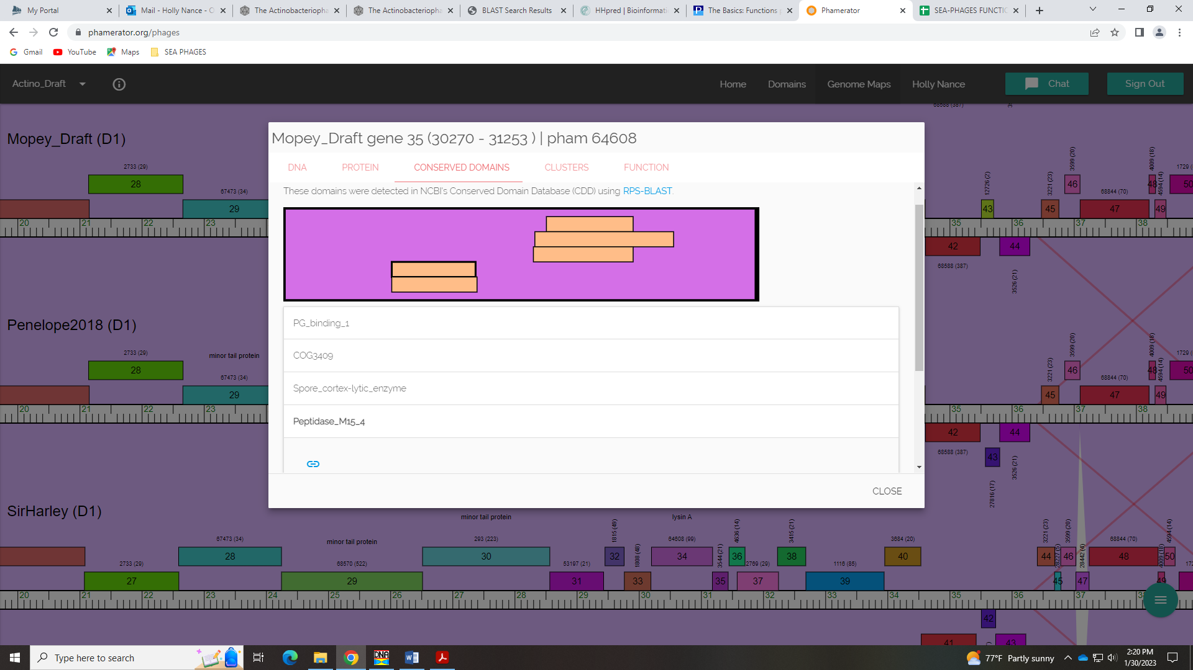
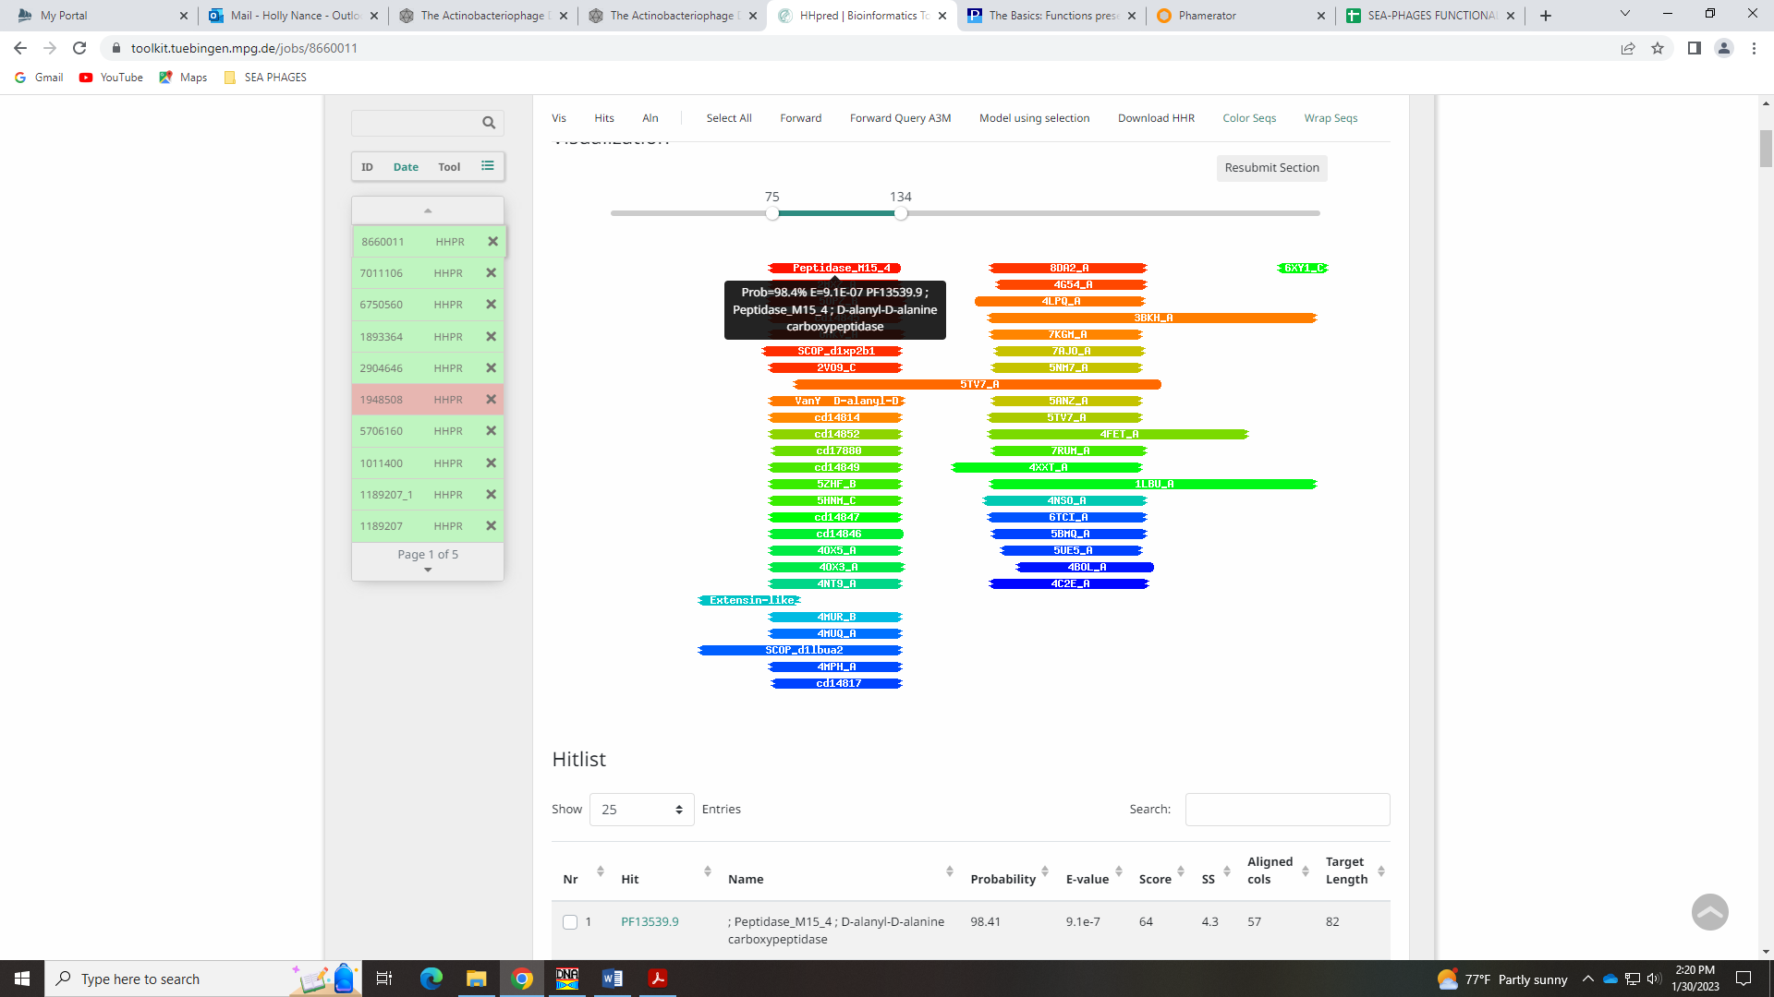

Gene 36
SSC: start 31250, stop 31504; CP: yes; SCS: Both called start of 31250; ST: SS; Blast Start: matches Visconti_36 Query 1 to Subject 1 100% 9e⁻⁴¹; Gap: overlap of 4; LO: NA; RBS: -2.814, 2.549, 15, -4.416, yes; F: NKF; SIF-BLAST: NKF/PhageDB BLAST/ Visconti_36, MH399788/100%/9e⁻⁴¹; SIF-HHPred: NKF, no matches with a probability above 90%; SIF-Syn: NKF
Notes: Nothing ambiguous about this gene.

Gene 37
NEW GENE NOT CALLED BY DNA MASTER! – Added new gene 37 to DNAMaster file on 2.1.2023!
SSC: start 31518, stop 31775; CP: not called by either Glimmer or GeneMark, but some coding potential in GeneMark output; SCS: Neither called this gene; ST: SS; Blast Start: matches WaldoWhy_38 Query 1 to Subject 1 100% 4e⁻⁴⁵; Gap: 13; LO: no; RBS: -3.142, 2.392, 14, -4.489, no; F: NKF; SIF-BLAST: NKF/PhageDB BLAST/ WaldoWhy_38, MK4941025/100%/4e⁻⁴⁵; SIF-HHPred: NKF, no matches with a probability above 90%; SIF-Syn: NKF
Notes: This gene was not called by either Glimmer or GeneMark, so was not in our auto-annotated file. However, it is in Phamerator, and listed on the PhagesDB site for Mopey genes as gene 37. Therefore, I added it to our annotation as Mopey_37. There is a hint of coding potential:
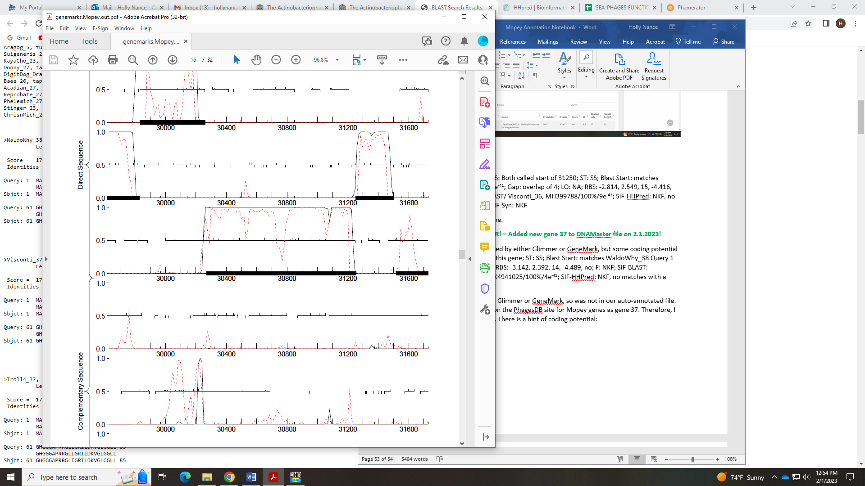
This gene is present on other D1 phage, as shown in phamerator:
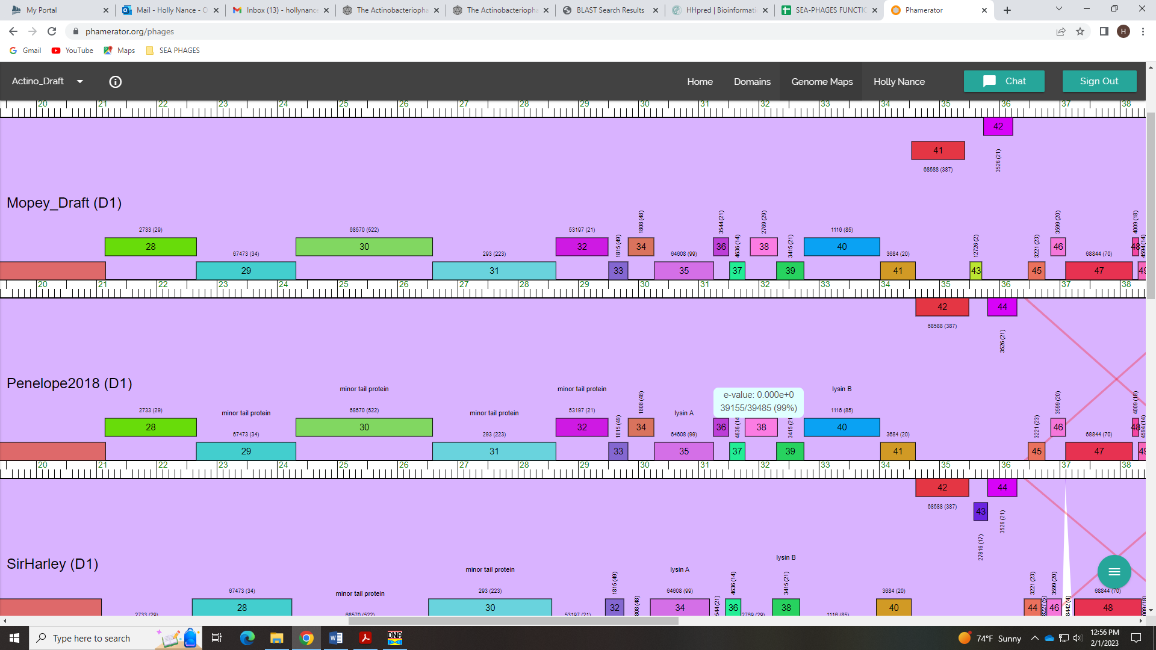
It also aligns with a gene in D1 phage in PhagesDB BLAST:
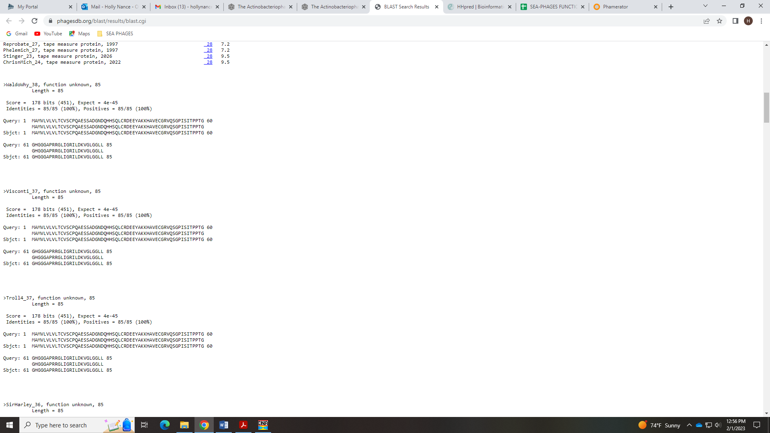
There is NKF that is supported by data:
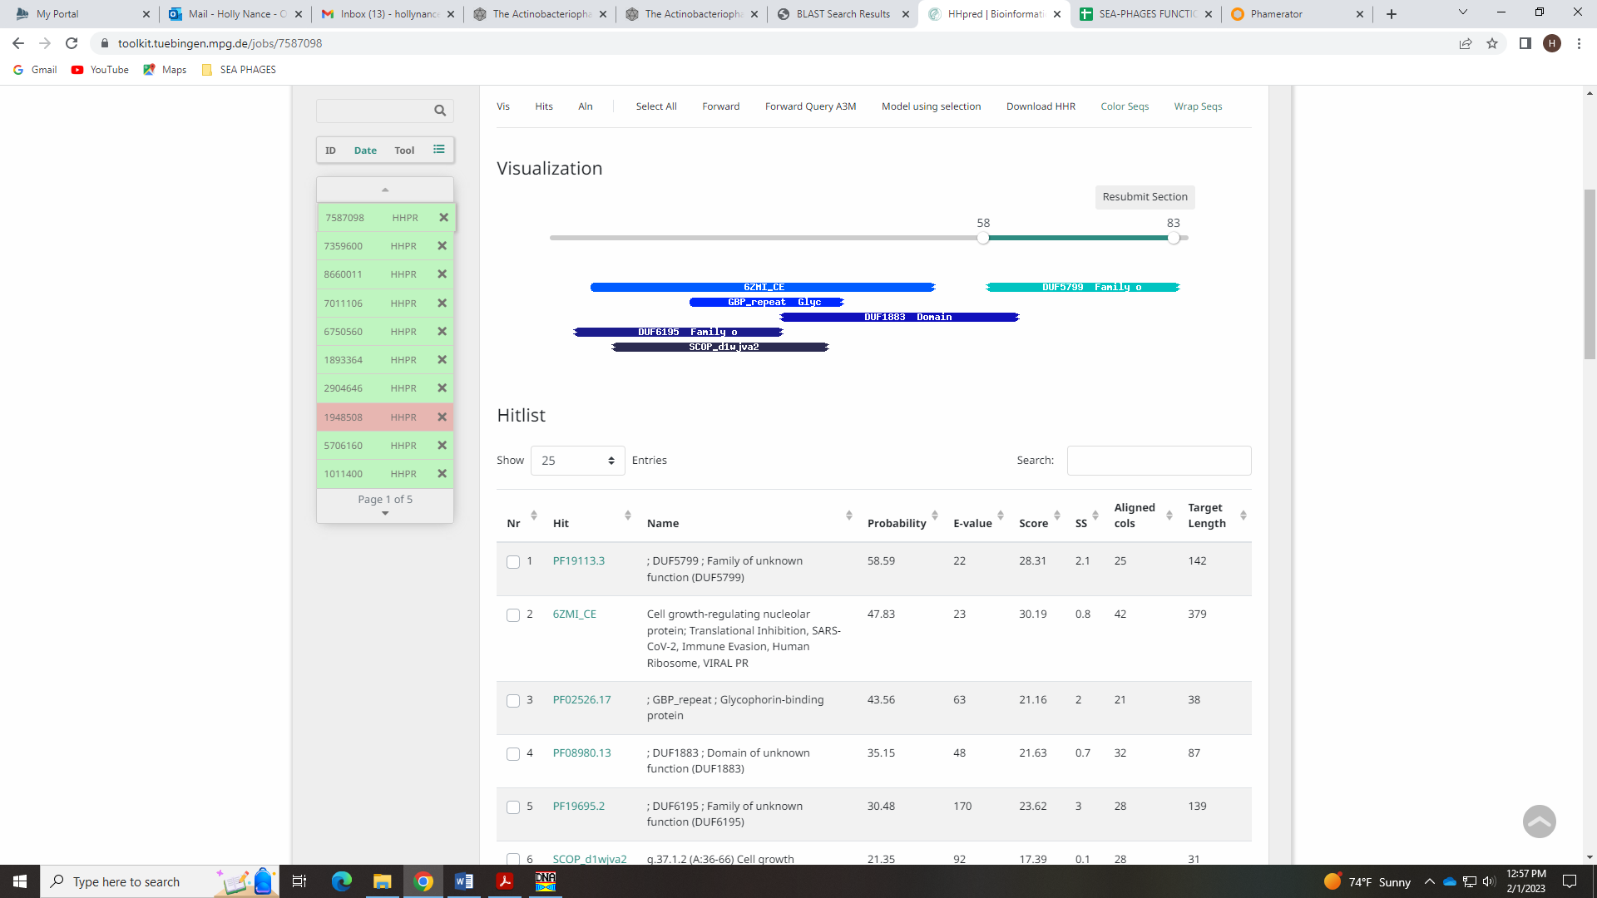

Gene 38 – Changed start on 2.1.2023 from 31862 to 31775!
SSC: start 31775, stop 32314; CP: yes, partial; SCS: Both called start of 31862, but 31775 is most conserved ; ST: SS; Blast Start: matches WaldoWhy_39 Query 1 to Subject 1 100% 1e⁻¹⁰⁴; Gap: overlap of 1; LO: NA; RBS: -3.942, 2.008, 11, -4.699, no; F: NKF; SIF-BLAST: NKF/PhageDB BLAST/WaldoWhy_39, MK4941025/100%/1e⁻¹⁰⁴; SIF-HHPred: NKF, two matches with a probability above 90%, but high e-values and not found in phage; SIF-Syn: NKF
Notes: Glimmer and GeneMark both called 31862 for the start. However, this start yields all Q:S 1:30 in BLAST, and this start is unique to Mopey in Starterator. Changing the start to 31775 yields 1:1 Q:S in BLAST, is the most conserved start in Starterator, and yields a much longer ORF with an overlap of 1. This proximity to Gene 37 is conserved in Phamerator.
Mopey’s Glimmer and GeneMark start of 31862, not conserved…
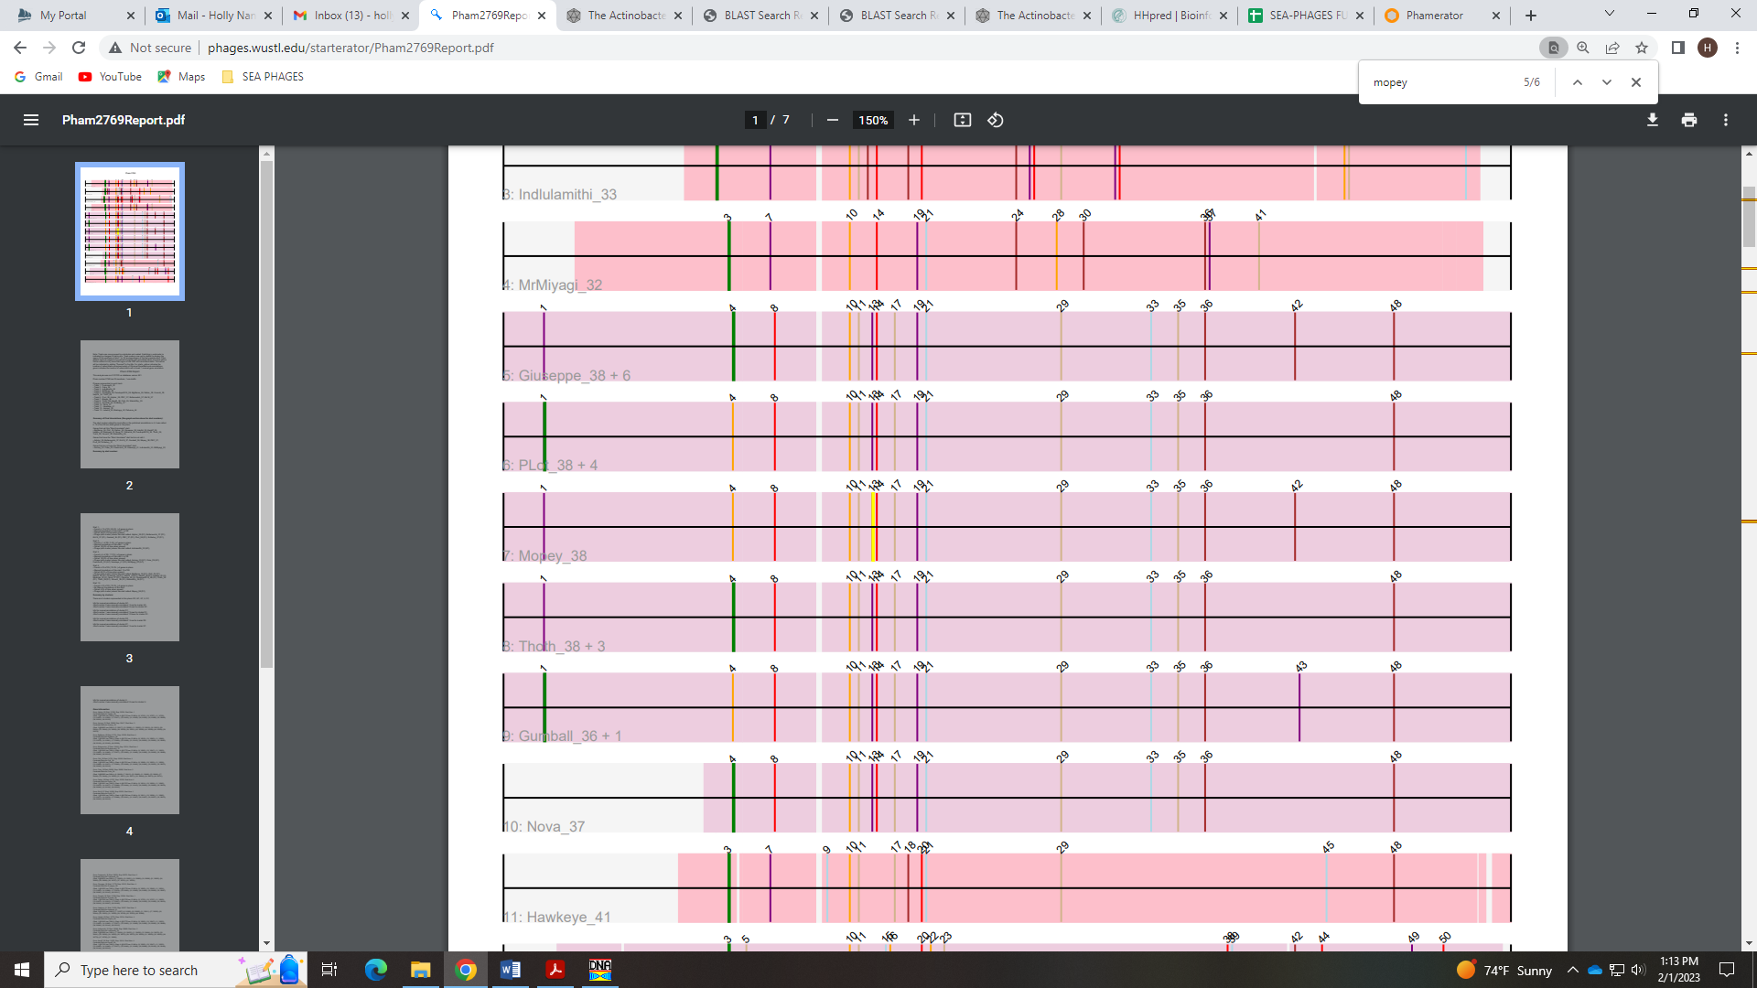
This start in BLAST:
The new start of 31775 in BLAST:
And in Phamerator:
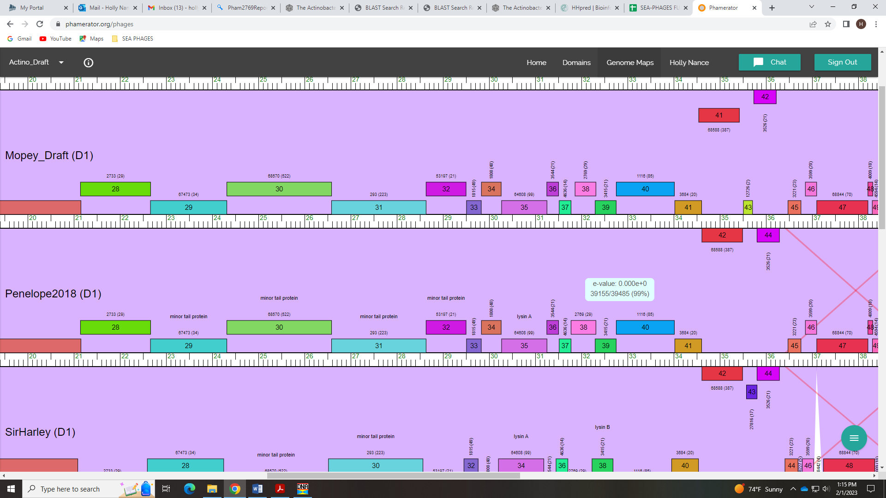
There were two hits in HHPred with a probability above 90%, but both had high e-values and were functions not typically found in phage, so I went with NKF, which was also conserved in the cluster.
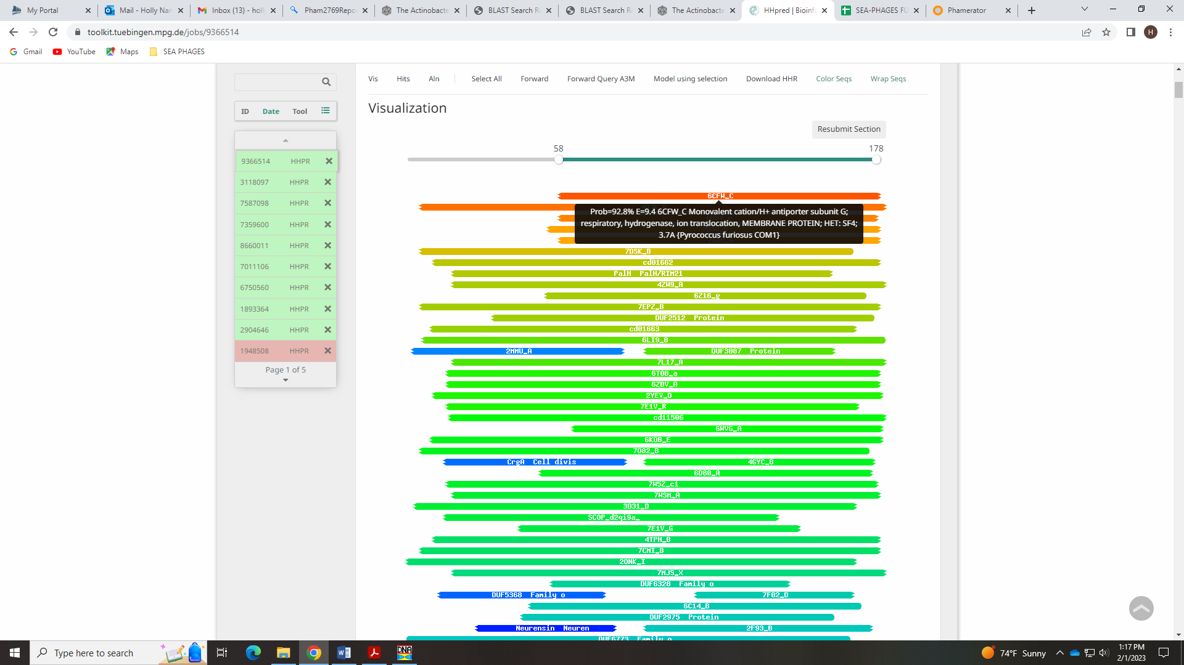
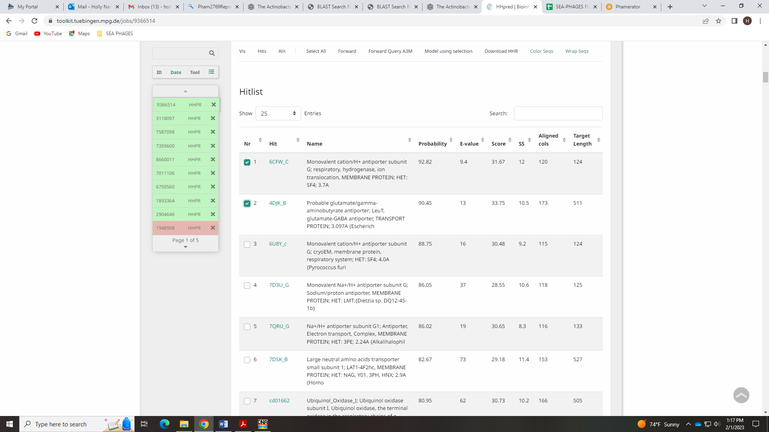

Gene 39
SSC: start 32298, stop 32753; CP: yes; SCS: Both called start of 32298; ST: SS; Blast Start: matches WaldoWhy_40 Query 1 to Subject 1 100% 3e⁻⁸³; Gap: overlap of 17; LO: NA; RBS: -2.590, 2.657, 11, -3.347, yes; F: NKF; SIF-BLAST: NKF/PhageDB BLAST/ WaldoWhy_40, MK4941025/100%/3e⁻⁸³; SIF-HHPred: NKF, three matches with a probability above 90%, but partial hits and/or not good candidates; SIF-Syn: NKF
Notes: Start is conserved, as is overlap (see Phamerator). For function, most PhagesDB hits and all NCBI hits are NKF. There are a couple of Lysin B hits in PhagesDB BLAST that are in cluster D1 (Sir Harley), but other cluster D1 phage call this NKF. The HHPred data doesn’t support Lysin B, as the hits are partial:
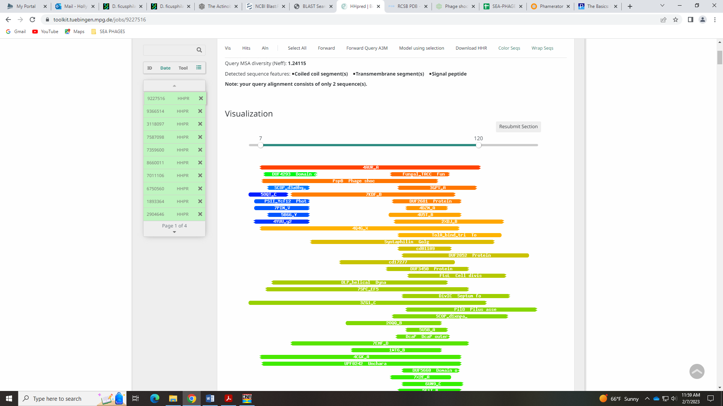
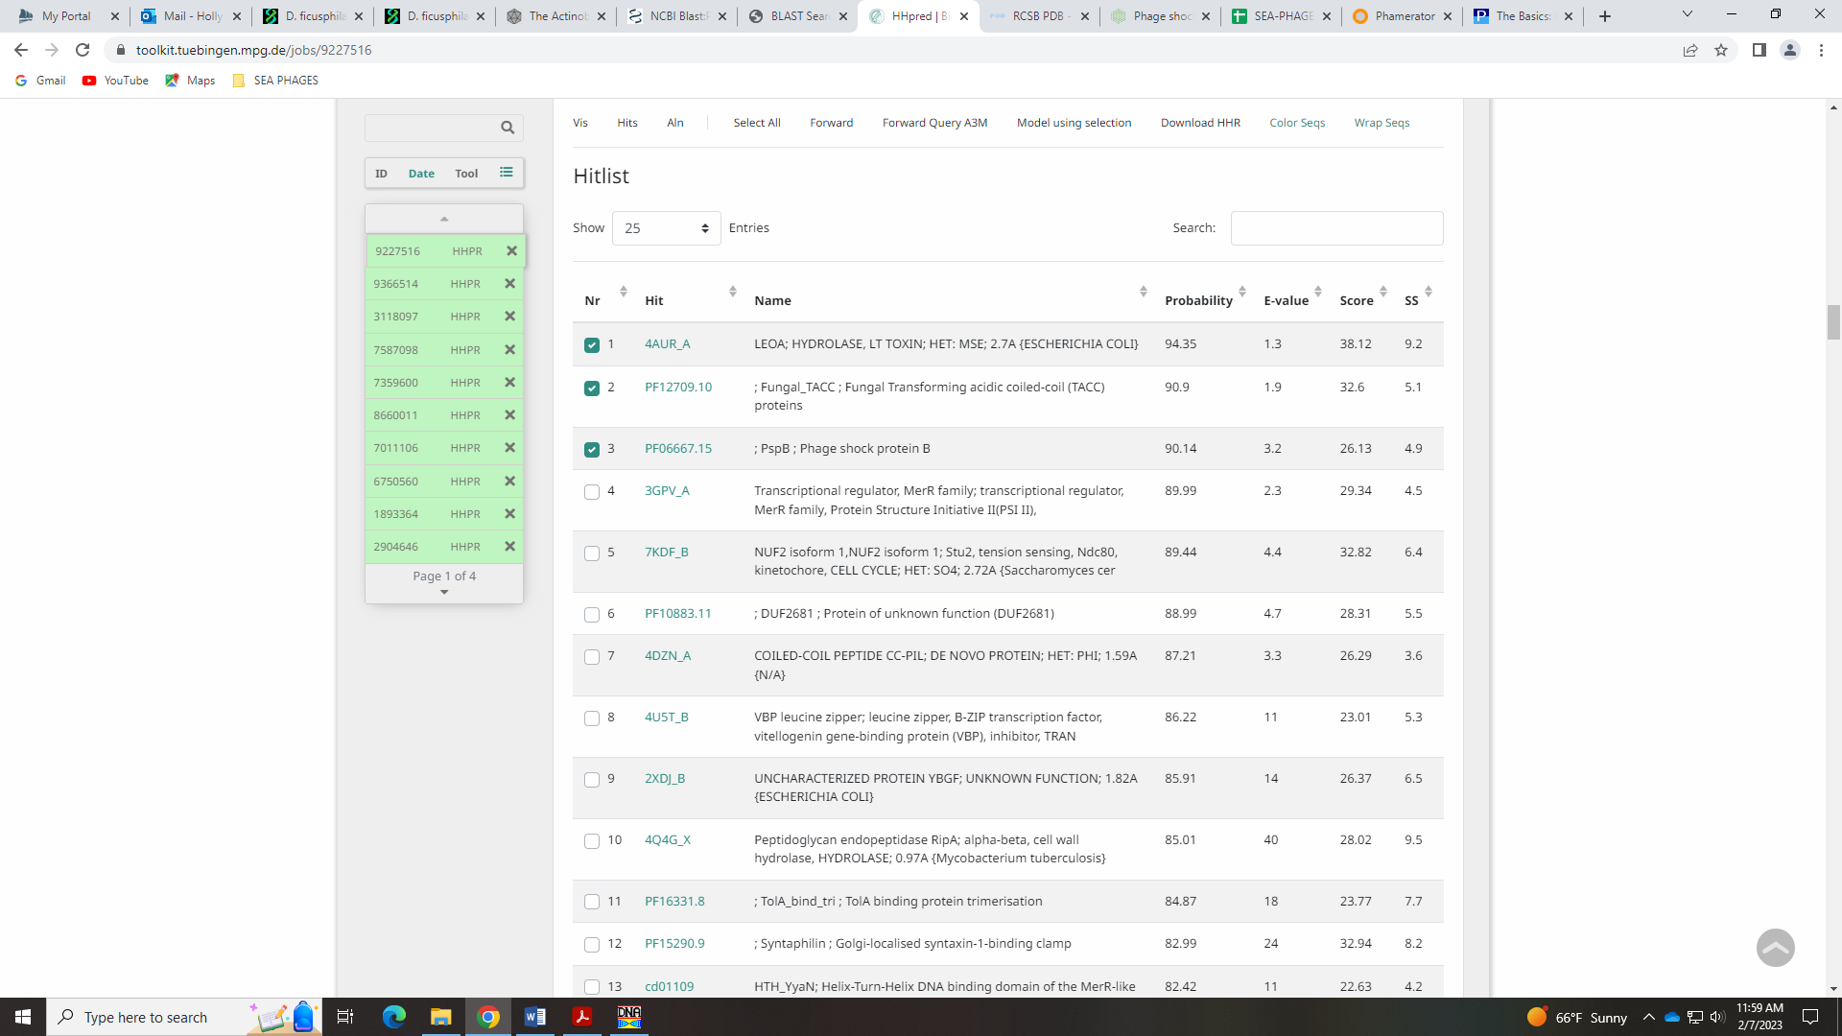
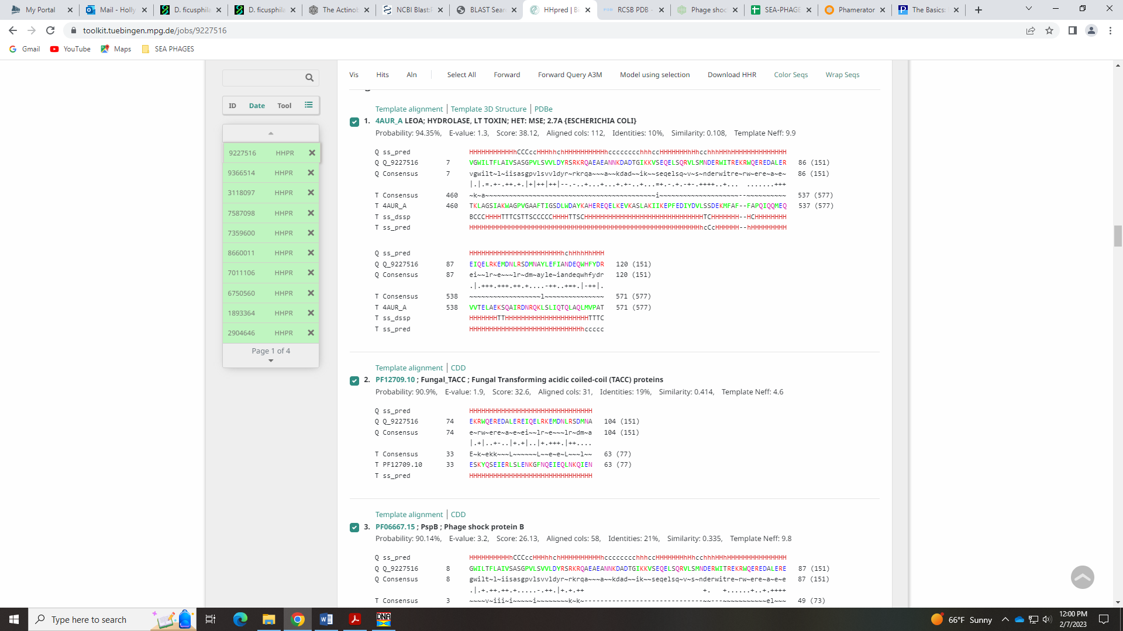
Also, the Basic Functions in All Phage list from SP says this about Endolysins:
Endolysins: Actinobacteriophages have at least one, if not two, endolysins that aid in the disruption of the cell wall upon completion of the lytic cycle. Lysin A is present in nearly every Actinobacteriophage genome, and is quite modular with multiple domains, including a peptidoglycan binding domain. In some Gordonia phages, lysin A is split along domain boundaries into two separate adjacent genes. Lysin B is present in some, but not all, Mycobacteriophages, and some, but not all Gordonia phages. If present, there is only one copy of lysin B. Lysin B is identifiable by alignment to cutinase domain proteins. In annotations of actinobacteriophages that are not mycobacteriophages and only have a single lysin, we use the term "endolysin" in our annotations, rather than designating the single lysin as "lysin A".
lysin A
Rank: 1
lysin B
Rank: 3

None of the HHpred hits align to a cutinase domain protein, and there are no domains in this protein…
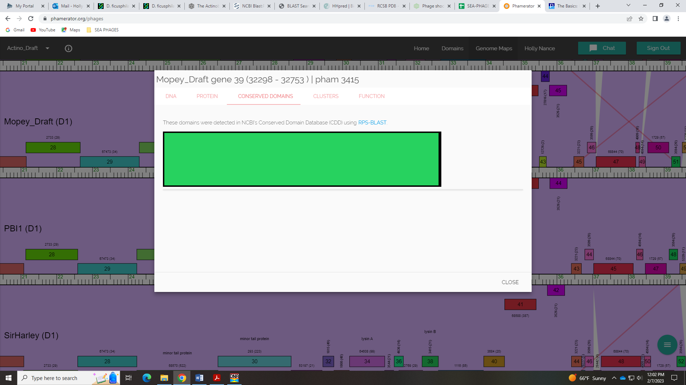
I’m going with NKF.

Gene 40
SSC: start 32755, stop 34014; CP: yes; SCS: Both called start of 32755; ST: SS; Blast Start: matches Visconti_40 Query 1 to Subject 1 100% 0.0; Gap: 1; LO: NA; RBS: -2.699, 2.605, 9, -3.474, yes; F: lysin B; SIF-BLAST: lysin B/PhageDB BLAST/ Visconti_40, MH399788/100%/0.0; SIF-HHPred: lysin B, several matches matches with a probability above 99%, alignment to cutinase; SIF-Syn: lysin B
Notes: Start is conserved. Function is lysin B based several PhagesDB abd NCBI BLAT hits, Phamerator and HHPred. As mentioned above, the Functions Present in All Phages list says:
Endolysins: Actinobacteriophages have at least one, if not two, endolysins that aid in the disruption of the cell wall upon completion of the lytic cycle. Lysin A is present in nearly every Actinobacteriophage genome, and is quite modular with multiple domains, including a peptidoglycan binding domain. In some Gordonia phages, lysin A is split along domain boundaries into two separate adjacent genes. Lysin B is present in some, but not all, Mycobacteriophages, and some, but not all Gordonia phages. If present, there is only one copy of lysin B. Lysin B is identifiable by alignment to cutinase domain proteins. In annotations of actinobacteriophages that are not mycobacteriophages and only have a single lysin, we use the term "endolysin" in our annotations, rather than designating the single lysin as "lysin A".
lysin A
Rank: 1
lysin B
Rank: 3

There are several hits in HHPred with a probability above 99% that are for cutinase or cutinase-like proteins (cutinase is a member of hydrolase family).
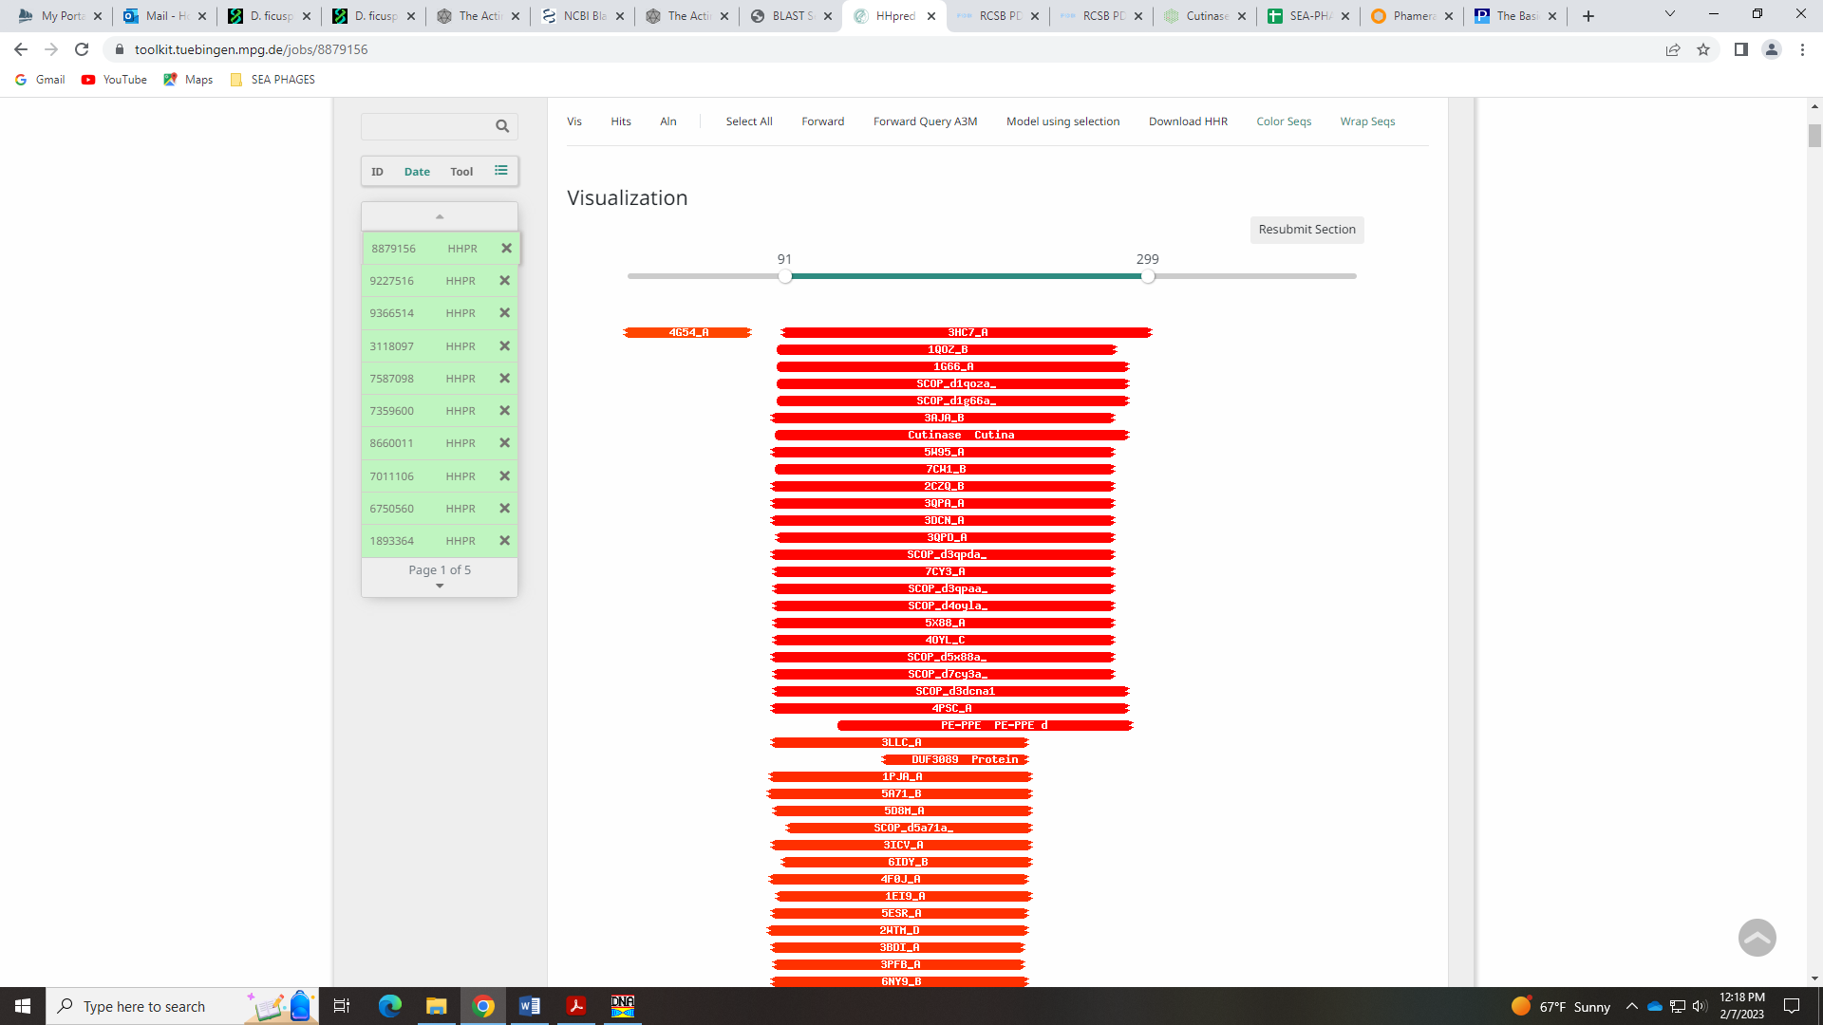
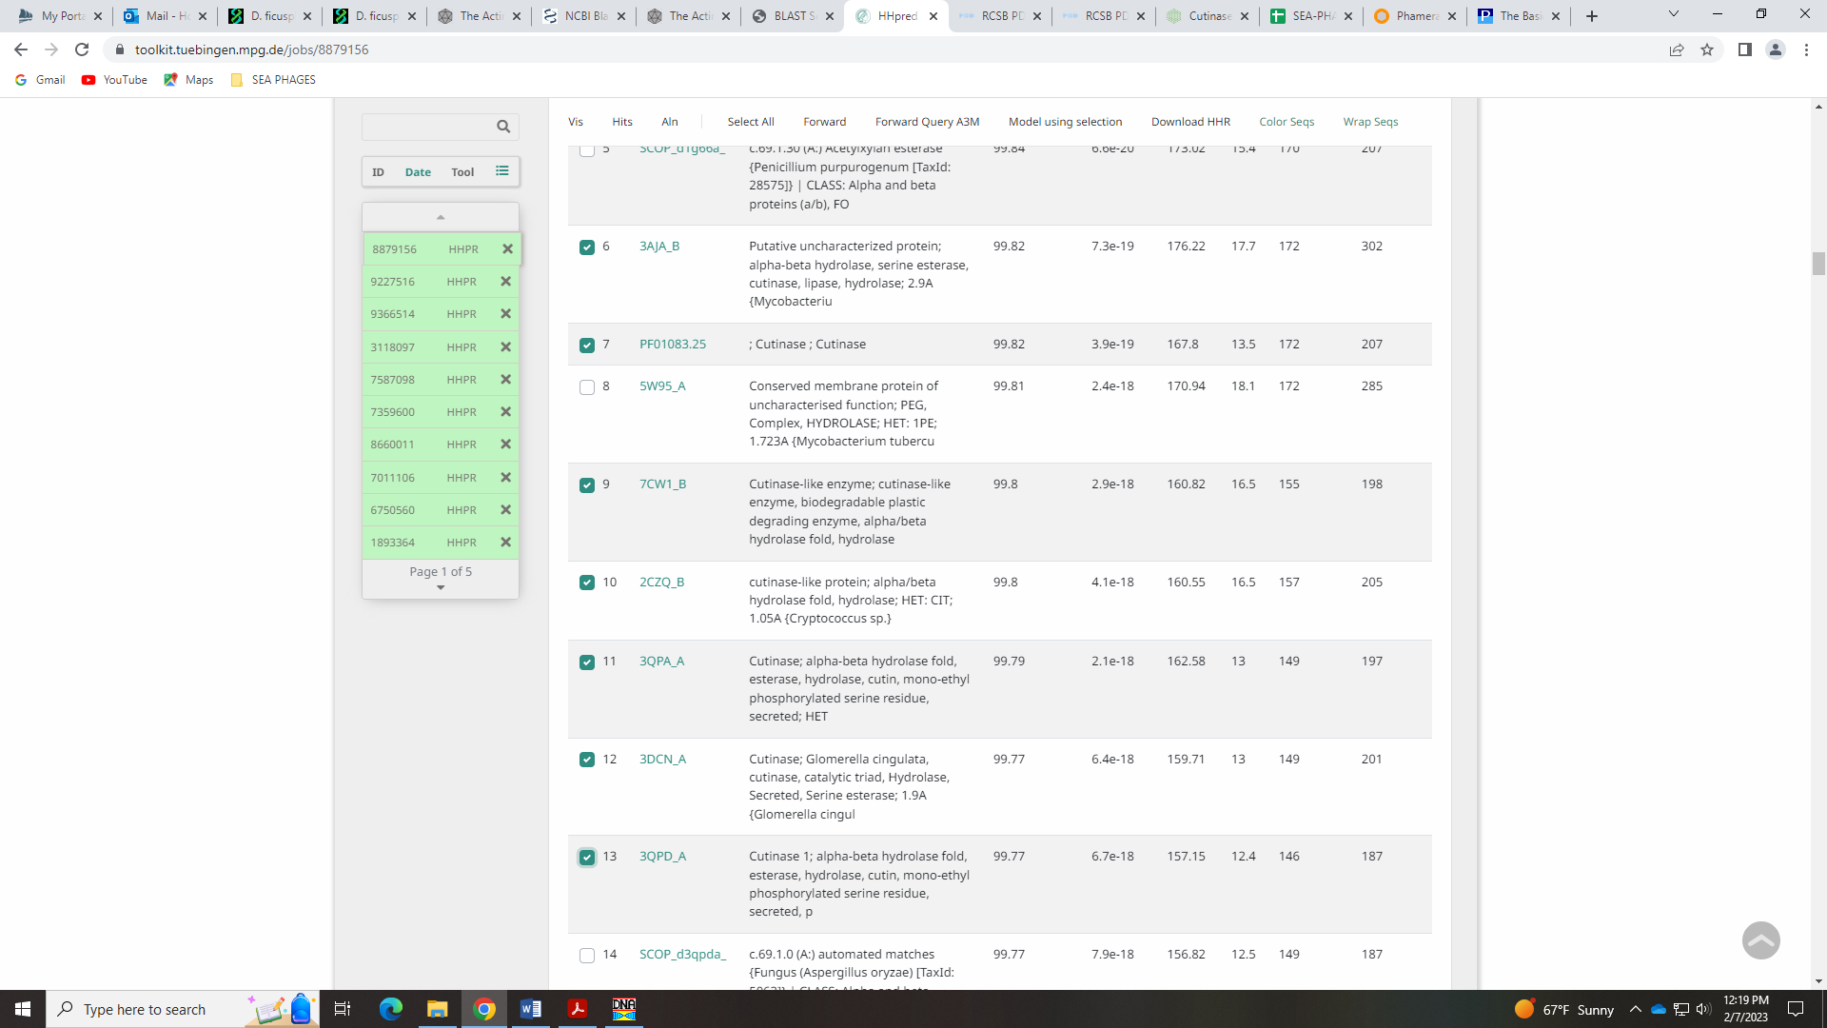
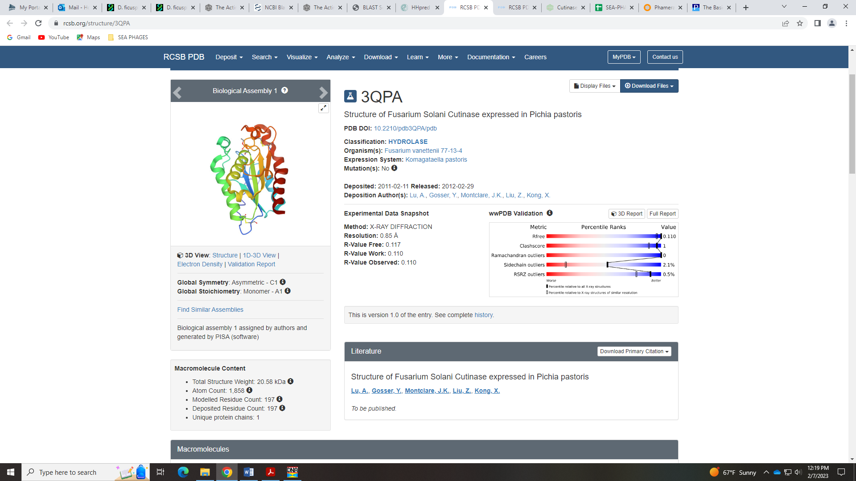
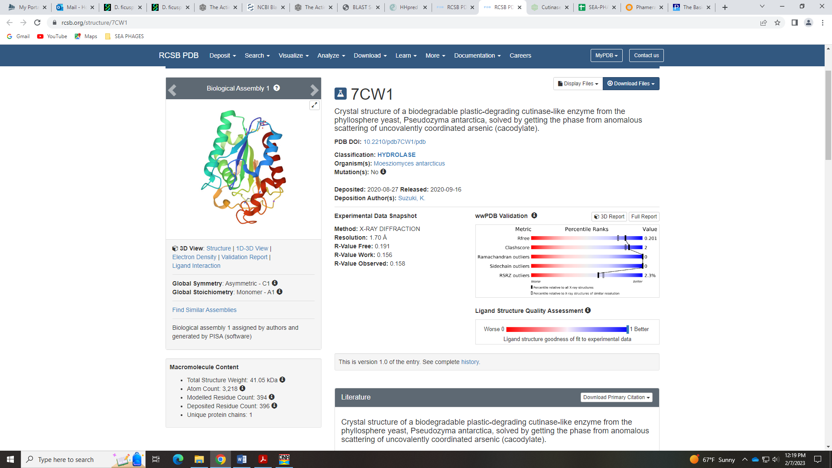

Gene 41
SSC: start 34024, stop 34605; CP: yes; SCS: Both called start of 34024; ST: SS; Blast Start: matches Visconti_41 Query 1 to Subject 1 99% 1e⁻¹⁰⁹; Gap: 9; LO: yes; RBS: -1.439, 3.209, 9, -2.214, no; F: NKF; SIF-BLAST: NKF/PhageDB BLAST/ Visconti_41, MH399788/99%/1e⁻¹⁰⁹; SIF-HHPred: NKF, several matches with a probability above 90% for unknown function; SIF-Syn: NKF
Notes: Start is conserved. NKF supported by PhagesDB BLAST, synteny in Phamerator and HHPred hits. There are several with a probability above 90%, and though most are partial hits, they are all for NKF:
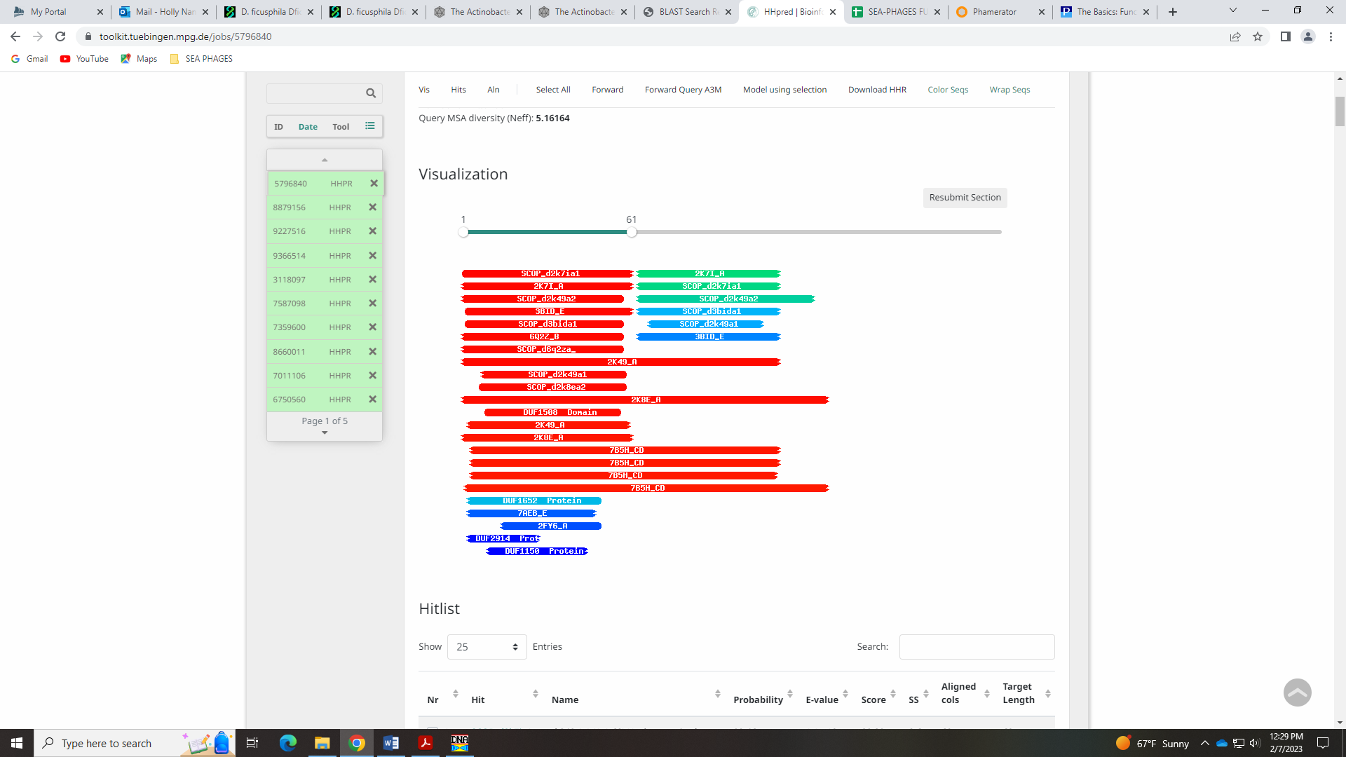
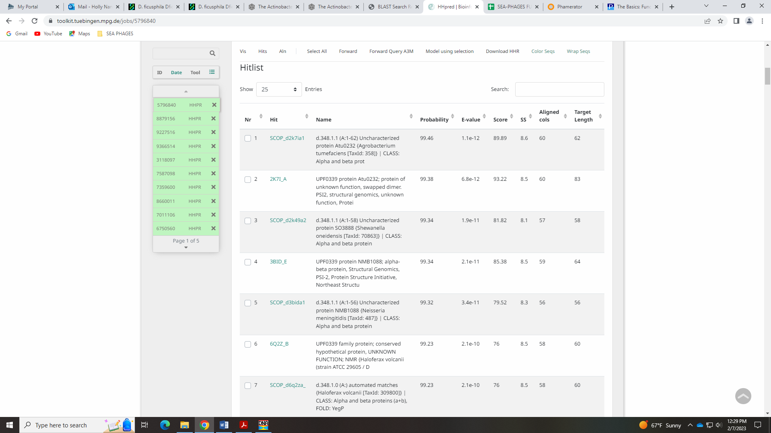
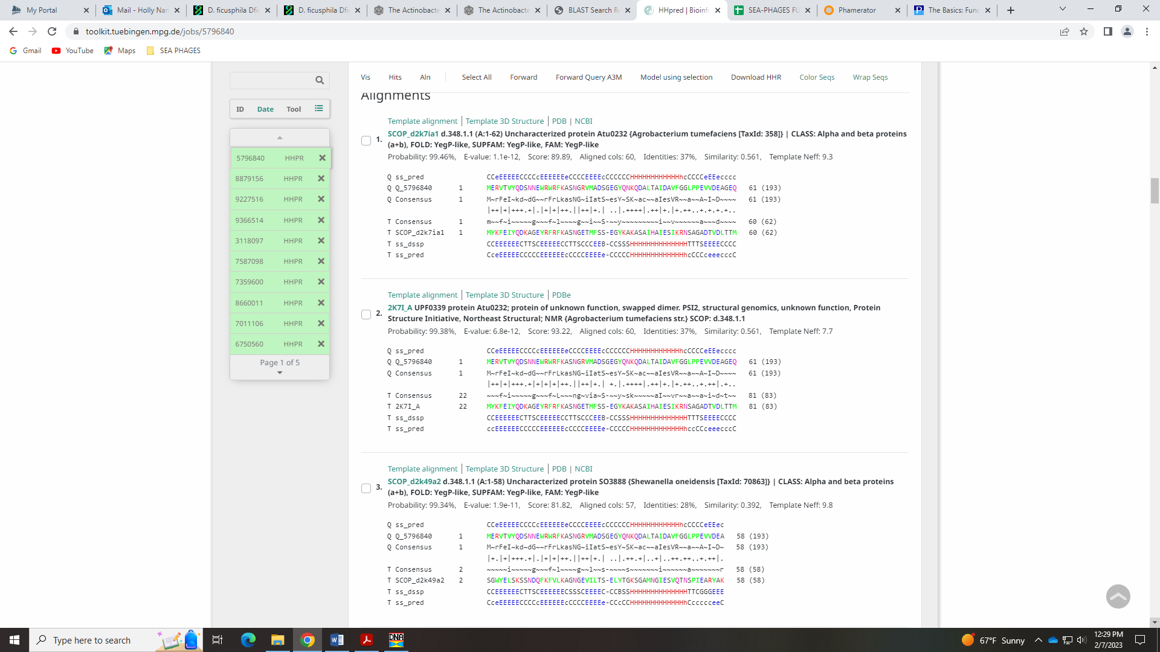

Gene 42 reverse gene!
SSC: start 35492, stop 34611; CP: yes; SCS: Both called start of 35492; ST: SS; Blast Start: matches PBI1_41 Query 1 to Subject 1 99% 1e⁻¹⁶⁹; Gap: 313; LO: yes; RBS: -2.814, 2.549, 11, -3.571, no; F: NKF; SIF-BLAST: NKF/PhageDB BLAST/ PBI1_41, DQ398047/99%/1e⁻¹⁶⁹; SIF-HHPred: NKF, a couple partial matches above 90% but all for NKF; SIF-Syn: NKF
Notes: First reverse gene in this annotation! Nothing ambiguous here. Large gap since we removed the next gene.

Gene 43 Deleted 4.27.2023
SSC: start 35511, stop 35708; CP: no, not called by GeneMark; SCS: Only Glimmer called start of 35511; ST: SS, only 1 other gene in phamily; Blast Start: matches BigMama_41 Query 1 to Subject 1 100% 3e⁻³²; Gap: 18; LO: no; RBS: -4.632, 1.677, 15, -6.234, no; F: NKF; SIF-BLAST: NKF/PhageDB BLAST/ BigMama_41, MH025888/100%/3e⁻³²; SIF-HHPred: NKF, no matches with a probability above 90%; SIF-Syn: NKF
Notes: This gene is only called by BigMama – the BLAST hit is in both PhagesDB and NCBI have great matches to BigMama_41:
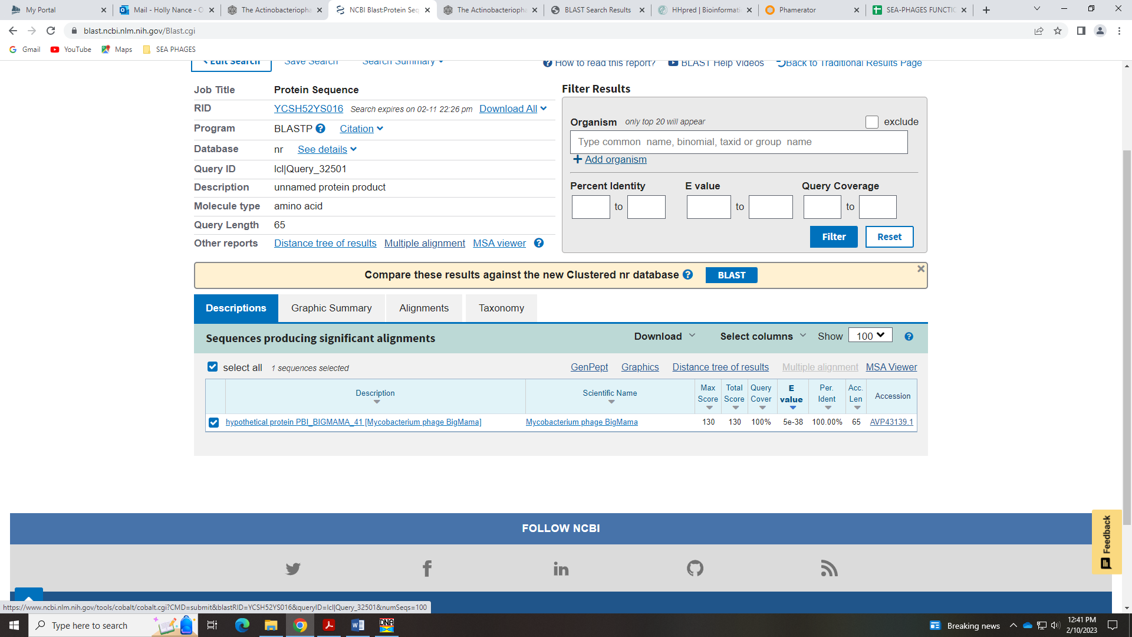
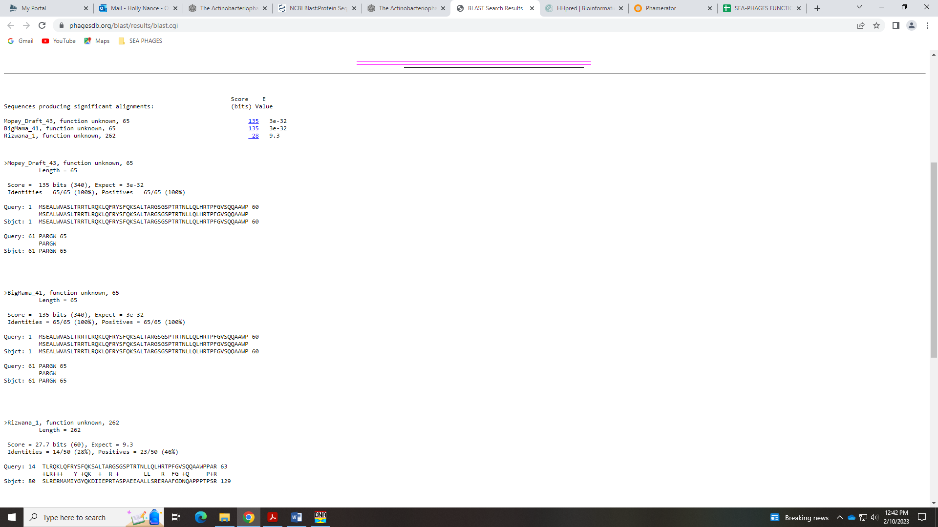
This gene only exists in BigMama – other phage in D1 have a gene that runs in the reverse direction at this location:
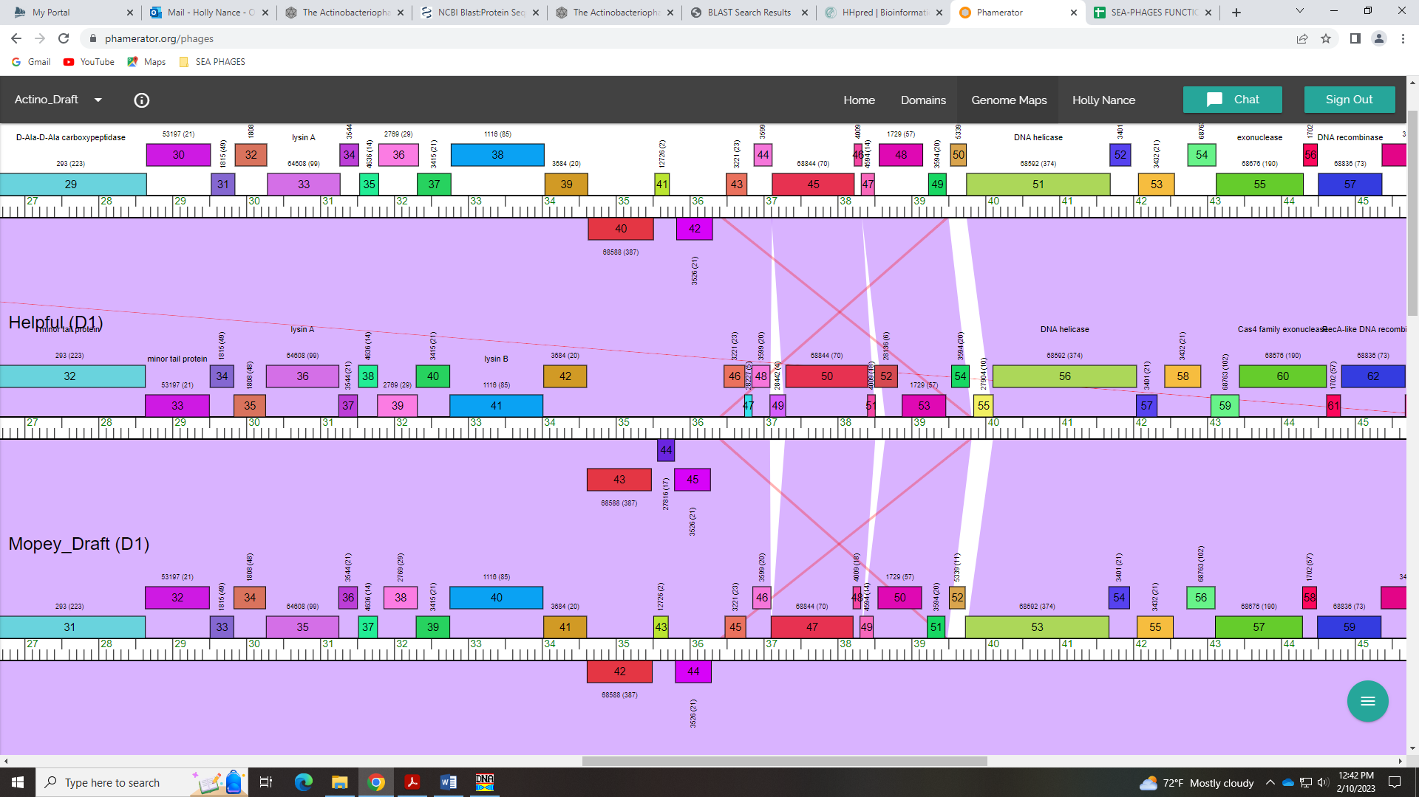
GeneMark did not call this gene, so no coding potential in that output. It was only called by Glimmer. I’m leaving it in as a gene since it seems to be the same gene as in BigMama. Potentially a student could look into this and search for a reverse gene that may exist in this location?

Gene 43 – reverse gene!
SSC: start 36291, stop 35806; CP: yes; SCS: Both called start of 36291; ST: SS; Blast Start: matches Thoth_44 Query 1 to Subject 1 100% 2e⁻⁸⁵; Gap: 185; LO: yes, for gene 44; RBS: -1.907, 2.985, 9, -2.681, yes; F: NKF; SIF-BLAST: NKF/PhageDB BLAST/Thoth_44, MT889385/100%/2e⁻⁸⁵; SIF-HHPred: NKF, no matches with a probability above 90%; SIF-Syn: NKF
Notes: Start and NKF conserved in this reverse gene. Nothing ambiguous!

Gene 44
SSC: start 36477, stop 36758; CP: yes; SCS: Both called start of 36477; ST: SS; Blast Start: matches Visconti_45 Query 1 to Subject 1 100% 4e⁻⁵²; Gap: 185; LO: no; RBS: -1.907, 2.985, 9, -2.681, yes; F: NKF; SIF-BLAST: NKF/PhageDB BLAST/ Visconti_45, MH399788/100%/4e⁻⁵²; SIF-HHPred: NKF, no matches with a probability above 90% for proteins found in phage (only in FMRP); SIF-Syn: NKF
Notes: This start is conserved and supported by BLAST data and the GeneMark coding potential. However, it doesn’t yield the longest ORF and results in a gap of 185 BP. However, this gap is present in other D1 phage:
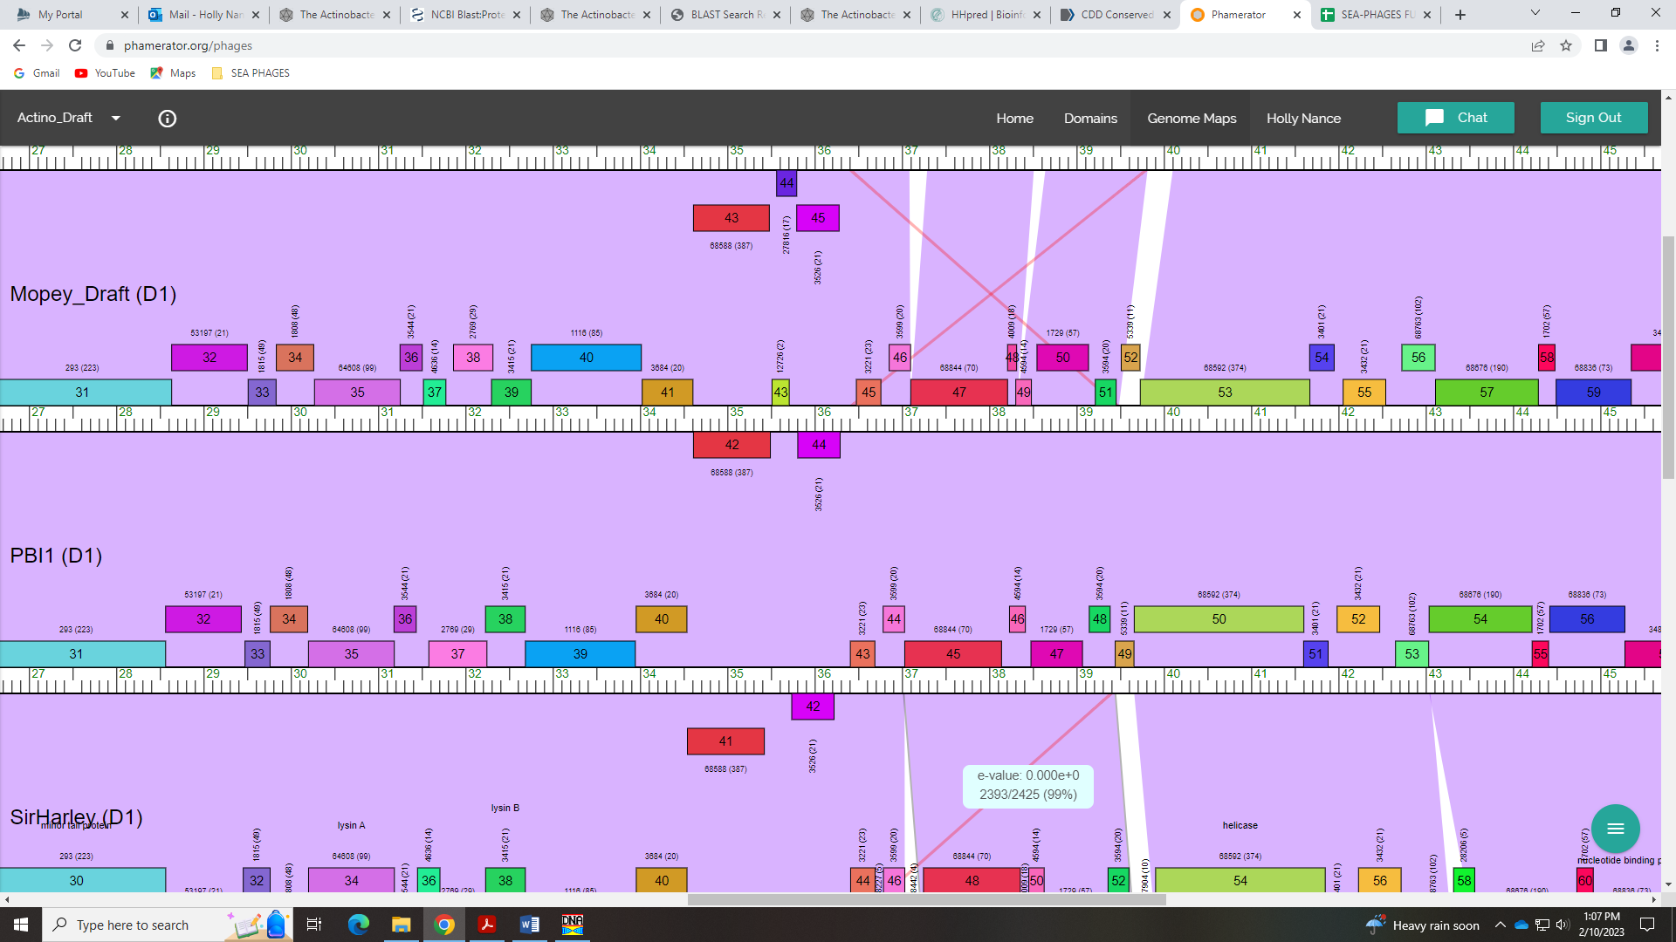
For function, both NCBI BLAST and PhagesDB BLAST support NKF. Synteny supports NKF, too. HHPred output has a few hist with a probability above 90%, but these are partial hits and for a protein involved in human fragile X syndrome:
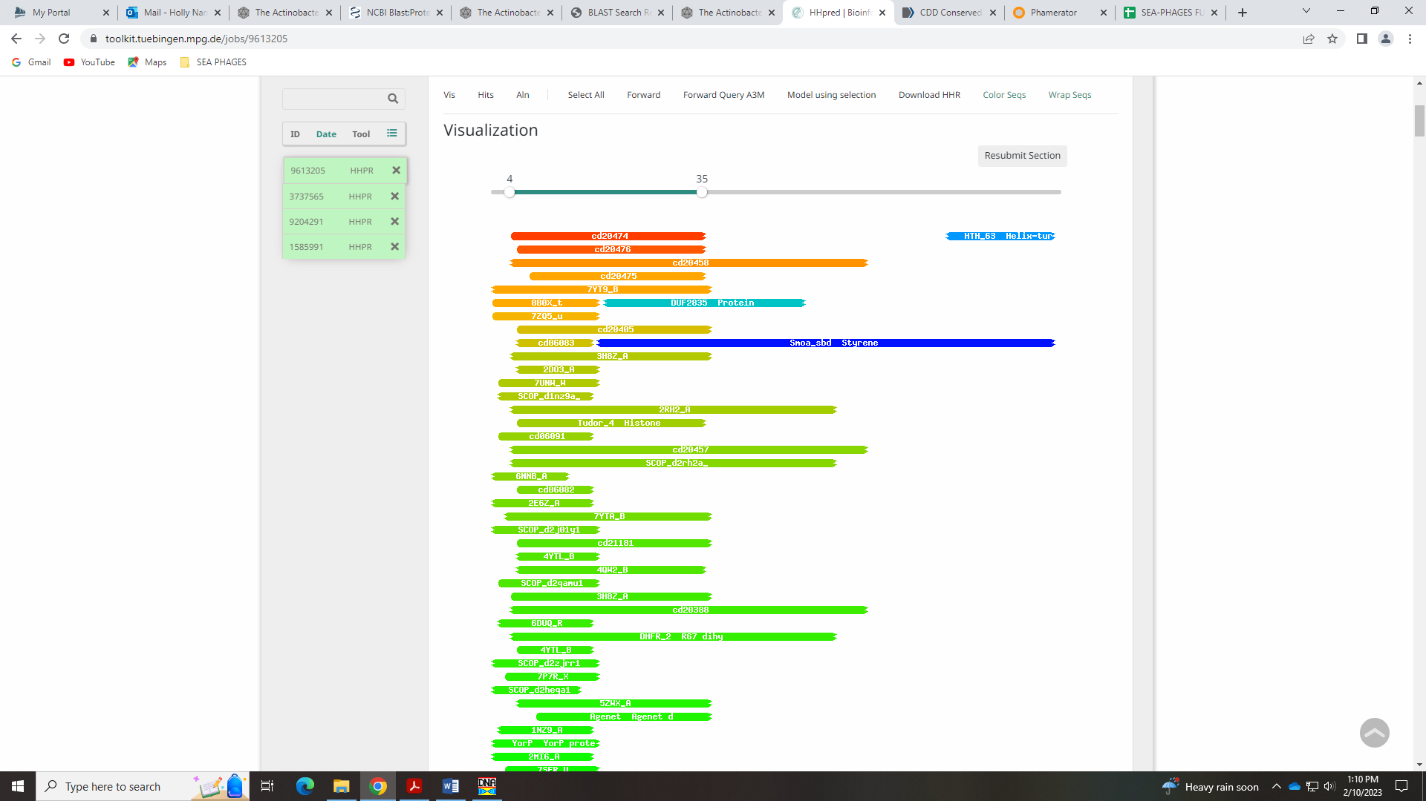
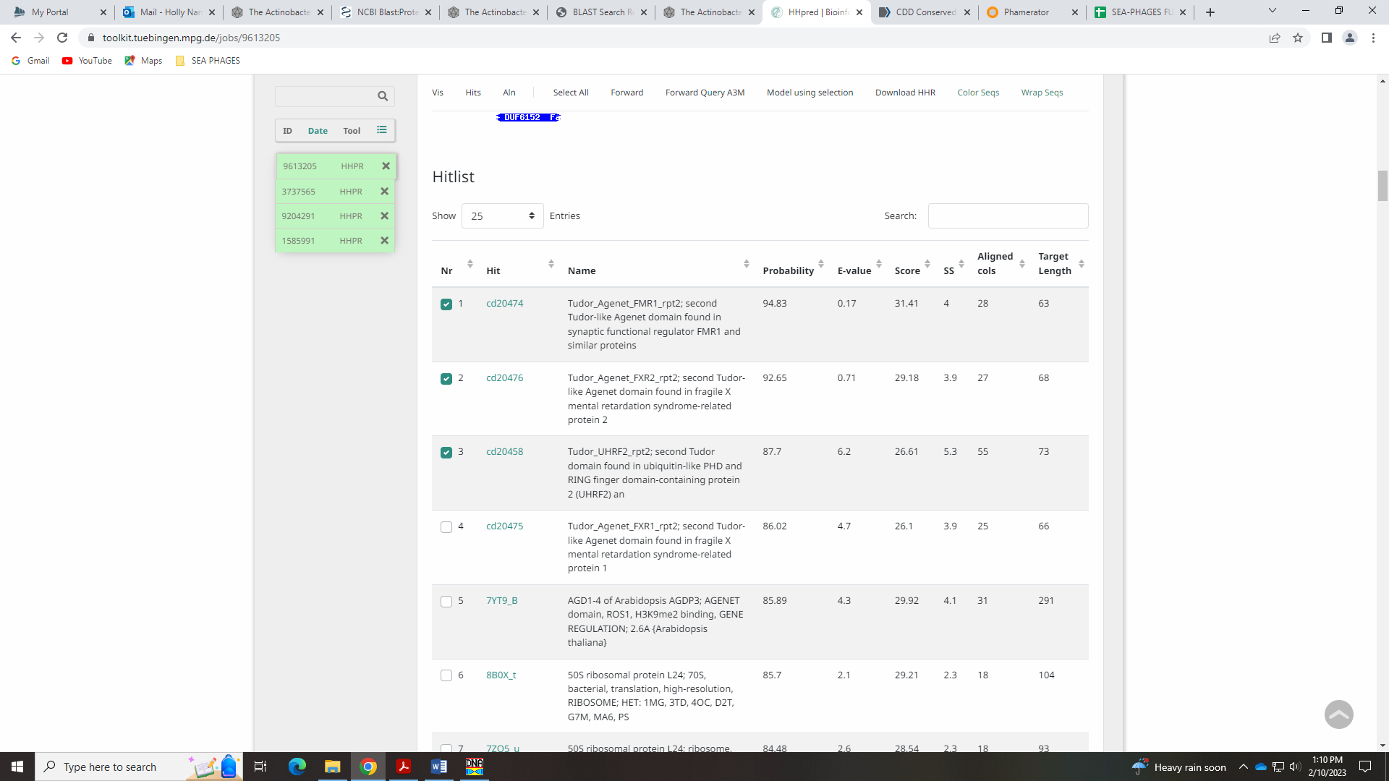
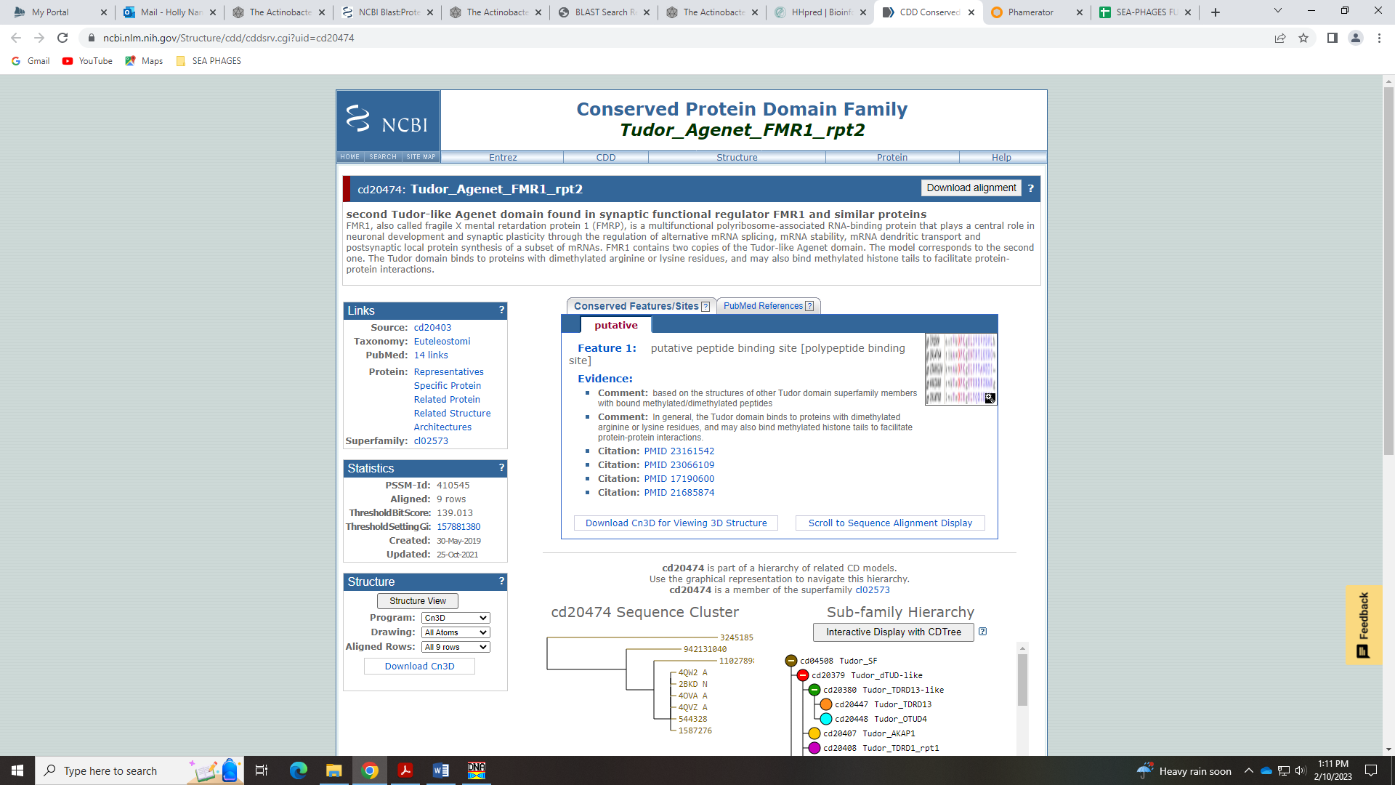
Therefore, it makes sense to keep this as NKF.

Gene 46 Deleted 4.27.2023
SSC: start 1, stop 309; CP: yes; SCS: Both called start of 1; ST: SS; Blast Start: matches Thoth_1 Query 1 to Subject 1 100% 1e⁻⁵⁷; Gap: 0; LO: NA; RBS: -2.273, 2.809, 64617, -3.495, yes; F: NKF; SIF-BLAST: NKF/PhageDB BLAST/Thoth_1, MT889385/100%/1e⁻⁵⁷; SIF-HHPred: NKF, no matches with a probability above 90%; SIF-Syn: NKF
Notes: Hmmm… this tiny gene (102 BP, 33 AA) was not called by Glimmer, only GeneMark. The coding potential in the GeneMark output is ok:
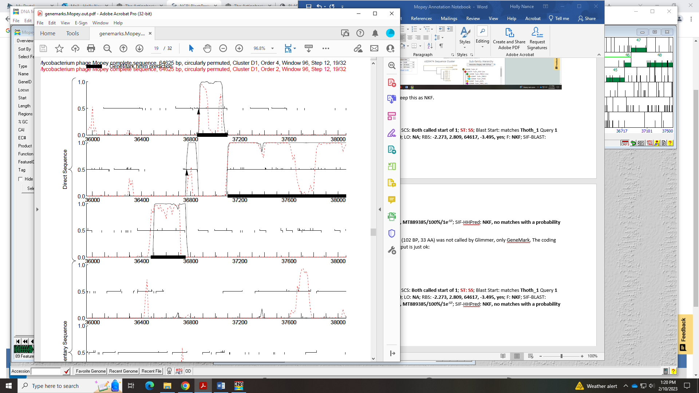
This gene is not called in several D1 phage, but it is called in Visconti, SirHarley, Helpful, WaldoWhy and Chill:
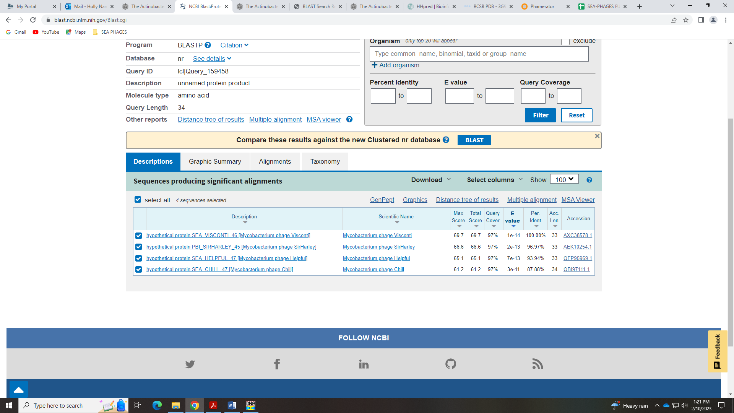
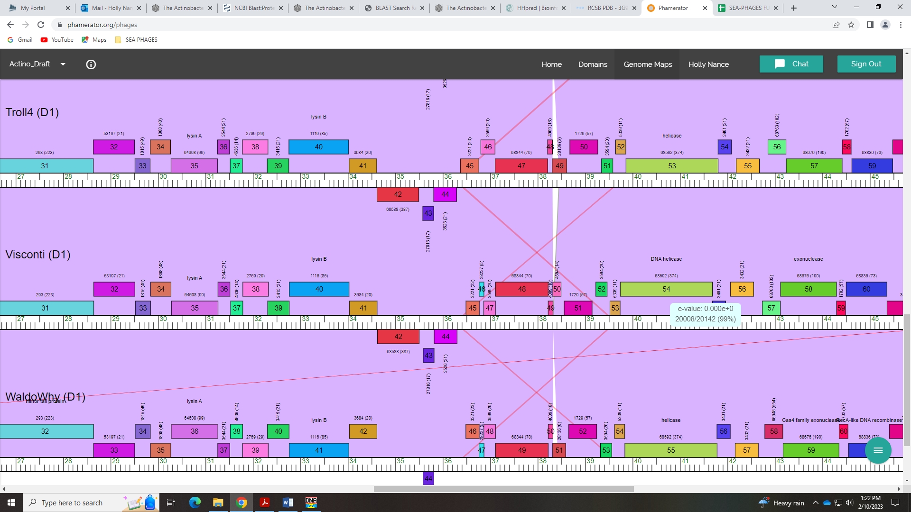
For function, HHPred hits are for zinc finger proteins and other proteins from humans…
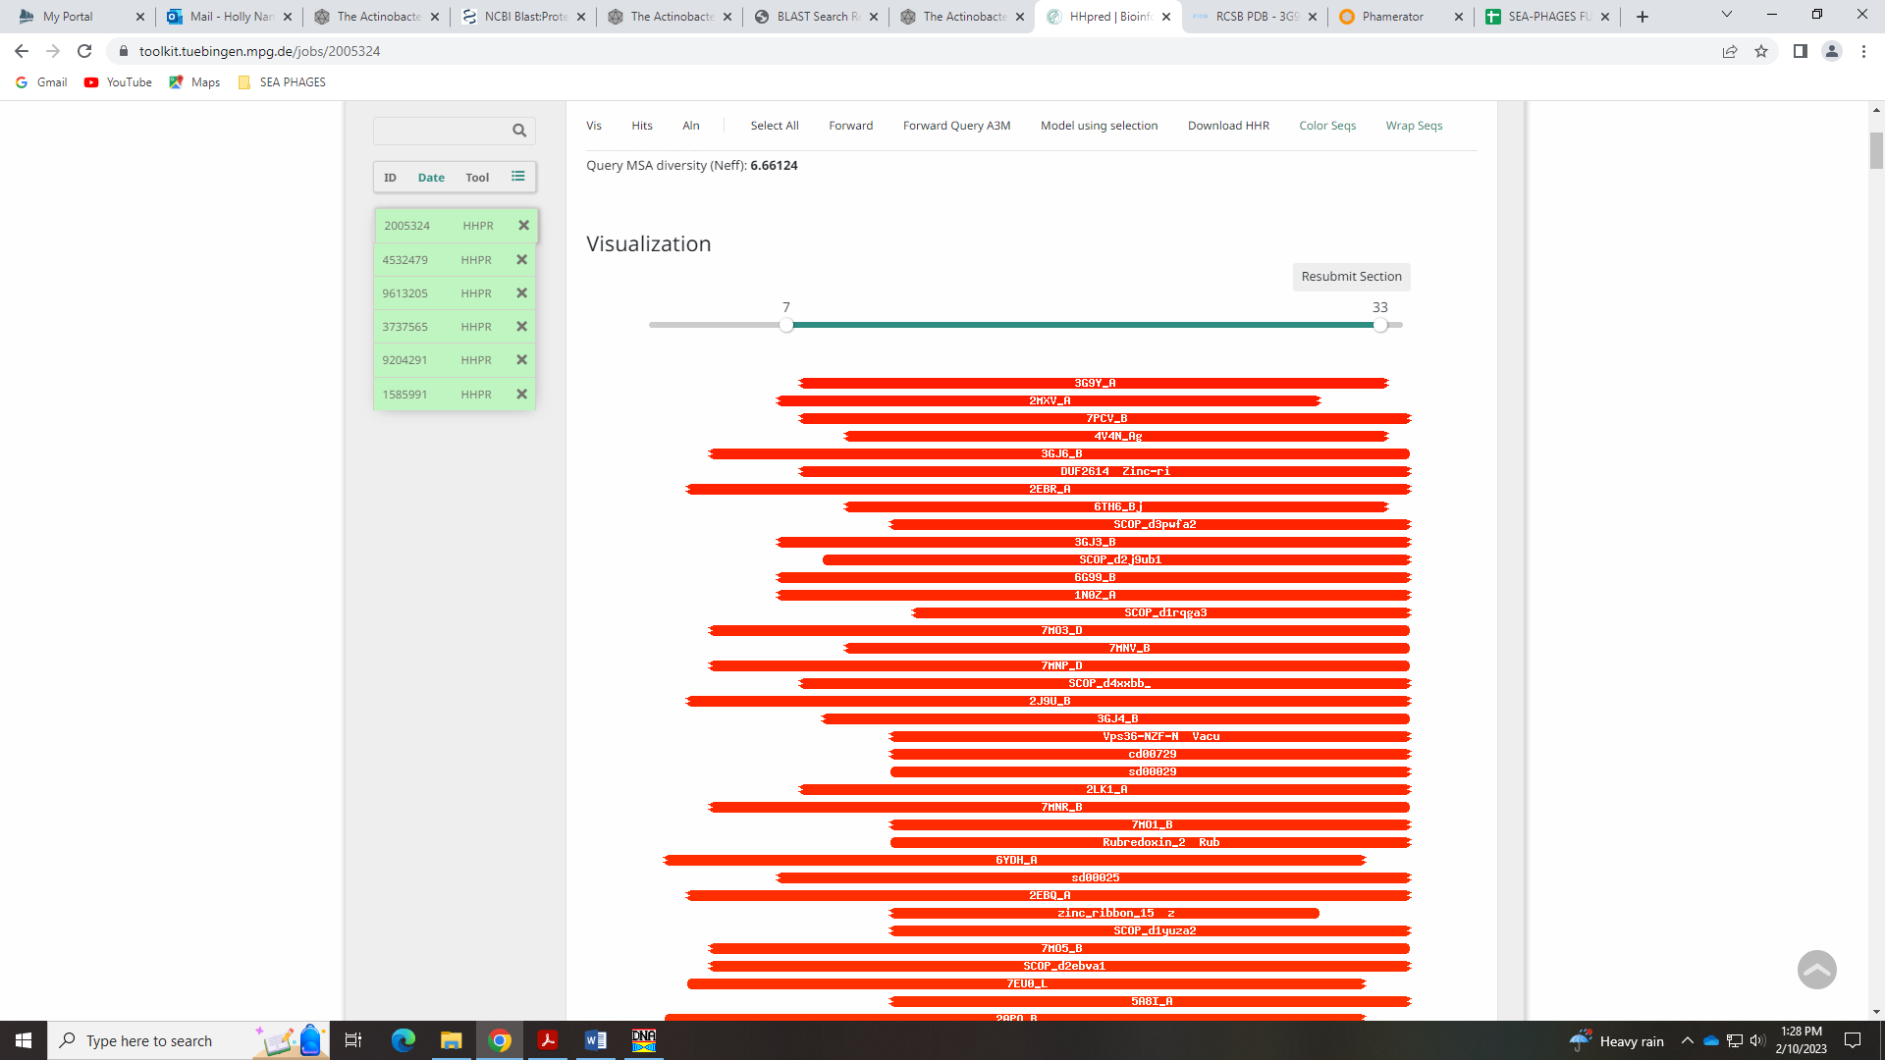
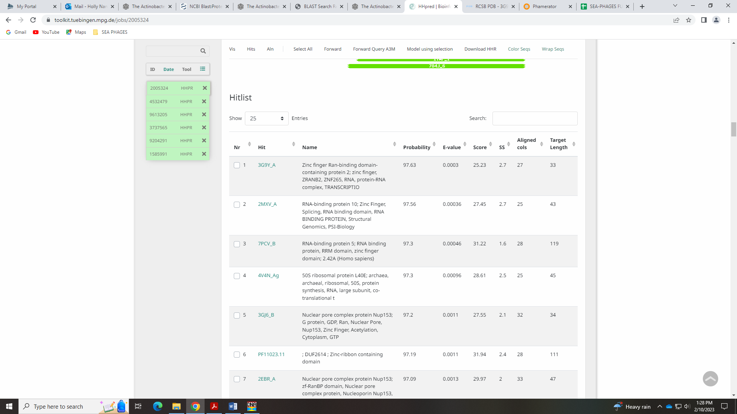
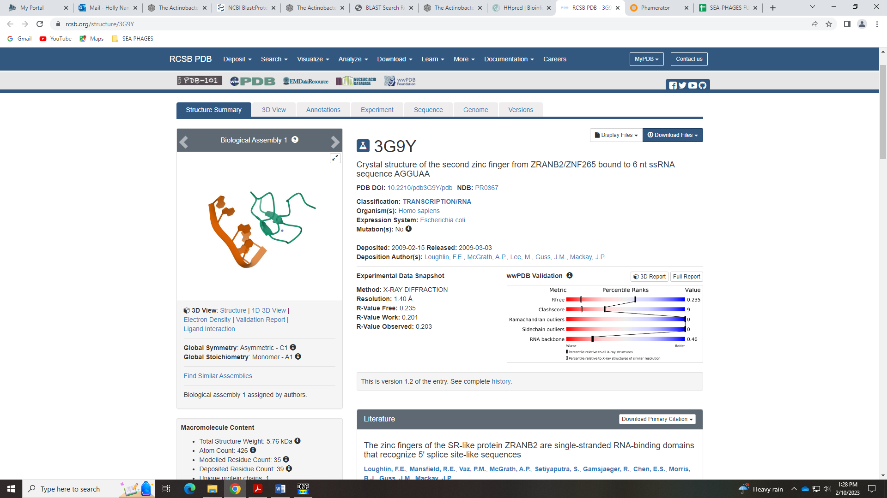
If we keep this gene, I’m going with NKF, which is conserved in D1 among those phage that have this gene.
If we remove this gene, it only leaves a gap of 94 BPs, and this gap is also present in those D1 phage that didn’t call this gene. If we leave it in, there is a slight overlap with the adjacent genes.

Gene 45 in our file, Gene 46 on PhagesDB
SSC: start 36853, stop 37098; CP: yes; SCS: Both called start of 36853; ST: SS; Blast Start: matches Visconti_47 Query 1 to Subject 1 100% 5e⁻⁴⁸; Gap: 94; LO: no; RBS: -3.779, 2.087, 11, -4.536, no; F: NKF; SIF-BLAST: NKF/PhageDB BLAST/ Visconti_47, MH399788/100%/5e⁻⁴⁸; SIF-HHPred: NKF, no matches with a probability above 90%; SIF-Syn: NKF
Notes: Start for this gene is conserved. NKF is conserved.

Gene 46 in our file, Gene 47 in PhagesDB
SSC: start 37100, stop 38209; CP: yes; SCS: Both called start of 37100; ST: SS; Blast Start: matches Visconti_48 Query 1 to Subject 1 100% 0.0; Gap: 1; LO: NA; RBS: -2.7573, 2.577, 10, -3.452, no; F: NKF; SIF-BLAST: NKF/PhageDB BLAST/ Visconti_48, MH399788/100%/0.0; SIF-HHPred: NKF, one partial match with a probability above 90% that is NKF; SIF-Syn: NKF
Notes: Start is conserved in cluster D1. For function, BLAST hits and synteny support NKF. HHpred has one hit with a probability above 90%, but it’s a small partial hit with unknown function:
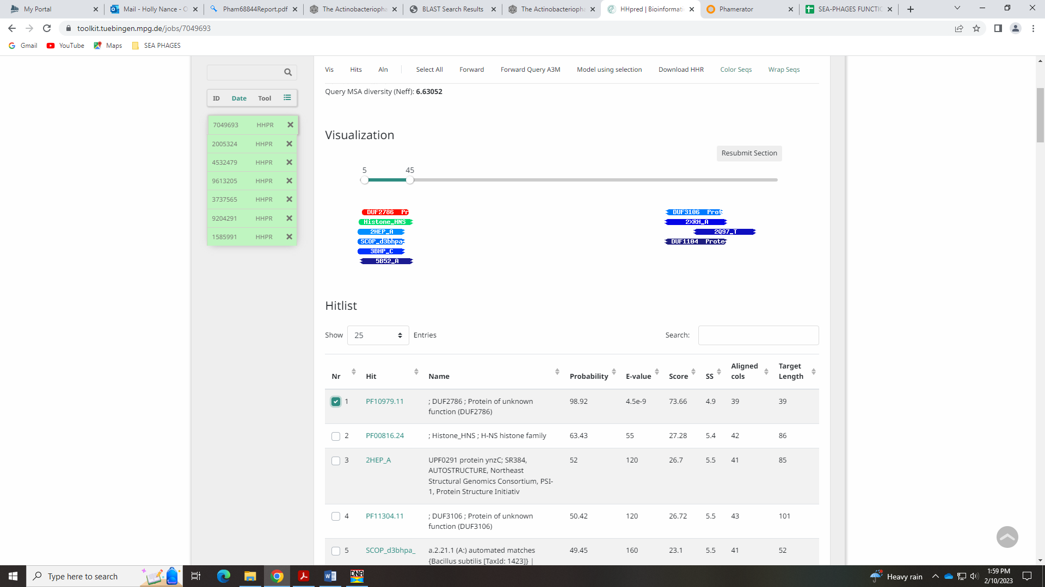
There is actually a conserved domain in this protein, that is also unknown function!
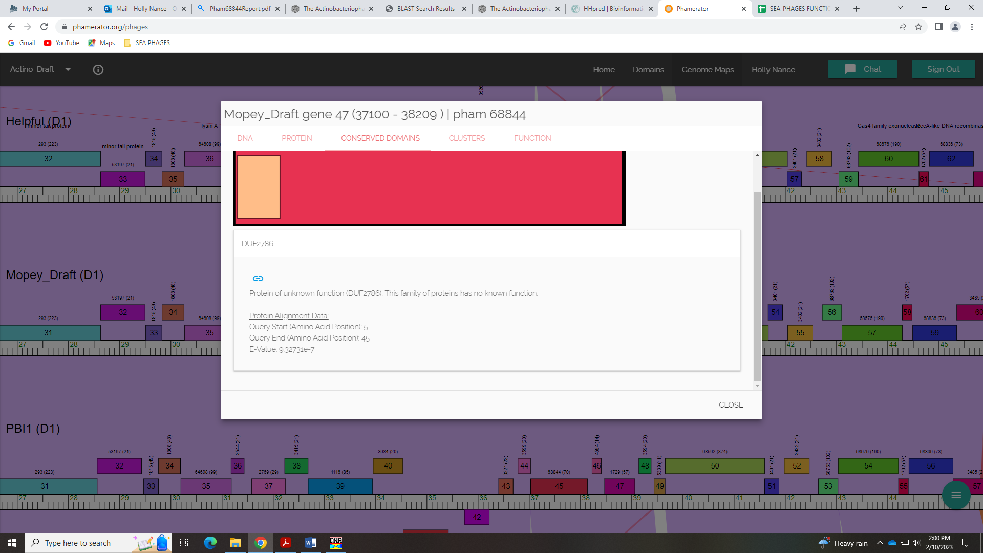
This must be the match in HHpred… anyway, nothing really ambiguous here.

Gene 47 in our file, Gene 48 in PhagesDB
SSC: start 38209, stop 38313; CP: yes; SCS: GeneMark called start of 38209, not called by Glimmer; ST: SS; Blast Start: matches Visconti_49 Query 1 to Subject 1 100% 3e⁻¹⁶; Gap: overlap of 1; LO: NA; RBS: -1.748, 3.016, 12, -2.584, no, other start has identical RBS values; F: NKF; SIF-BLAST: NKF/PhageDB BLAST/ Visconti_49, MH399788/100%/3e⁻¹⁶; SIF-HHPred: NKF, no matches with a probability above 90%; SIF-Syn: NKF
Notes: Start is conserved, NKF is also conserved. This gene is tiny! But several other phage in D1 call it and there is coding potential in the Genemark output.
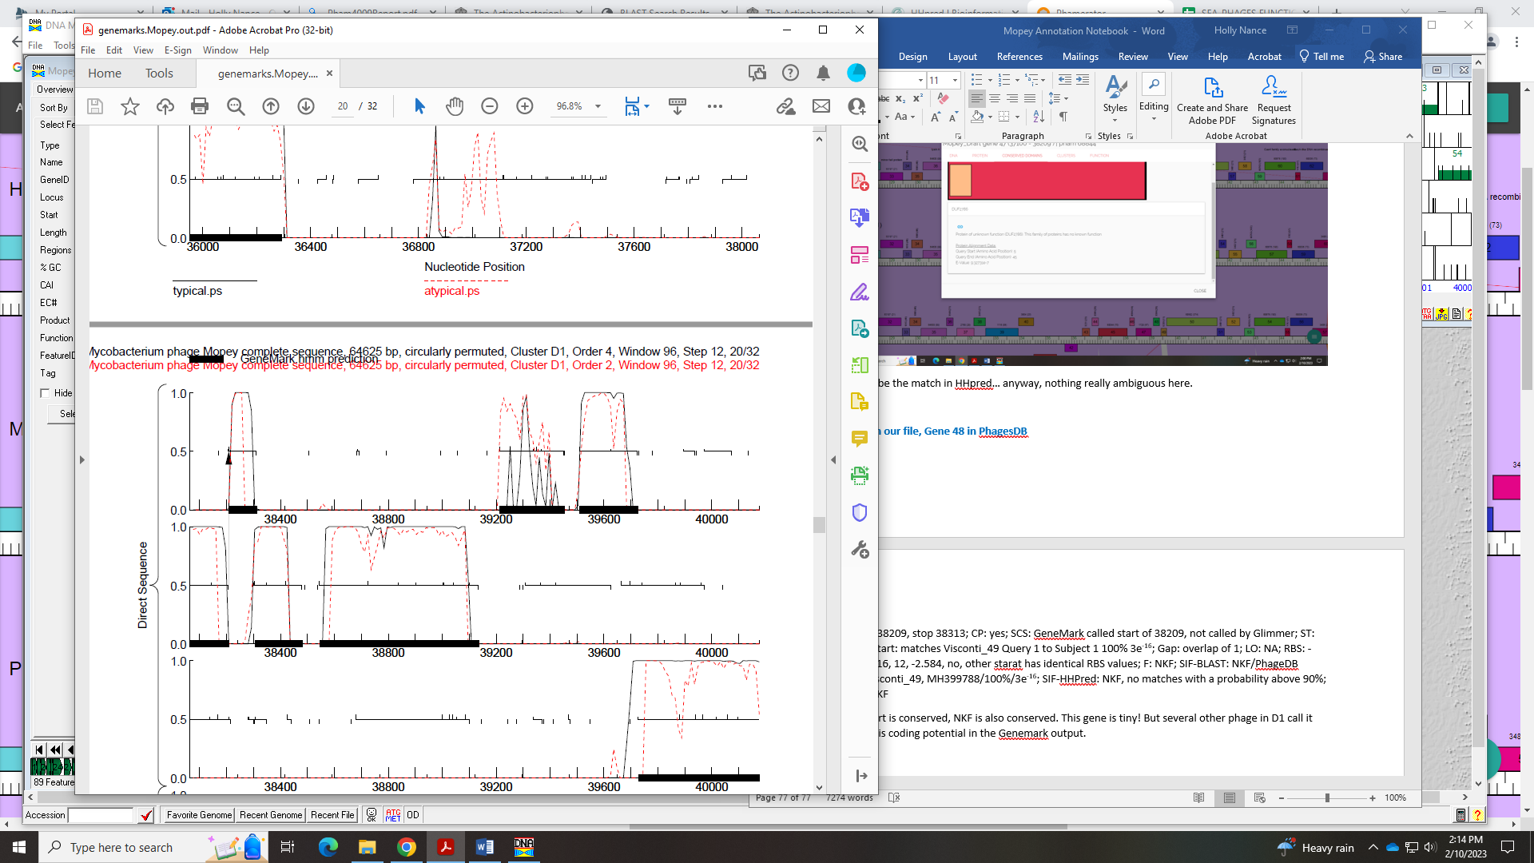
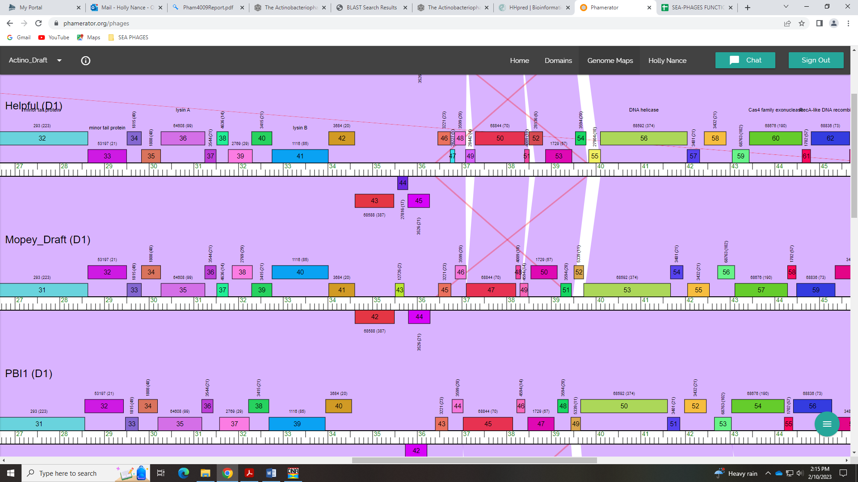
I think we ought to keep it in – several others have this gene:
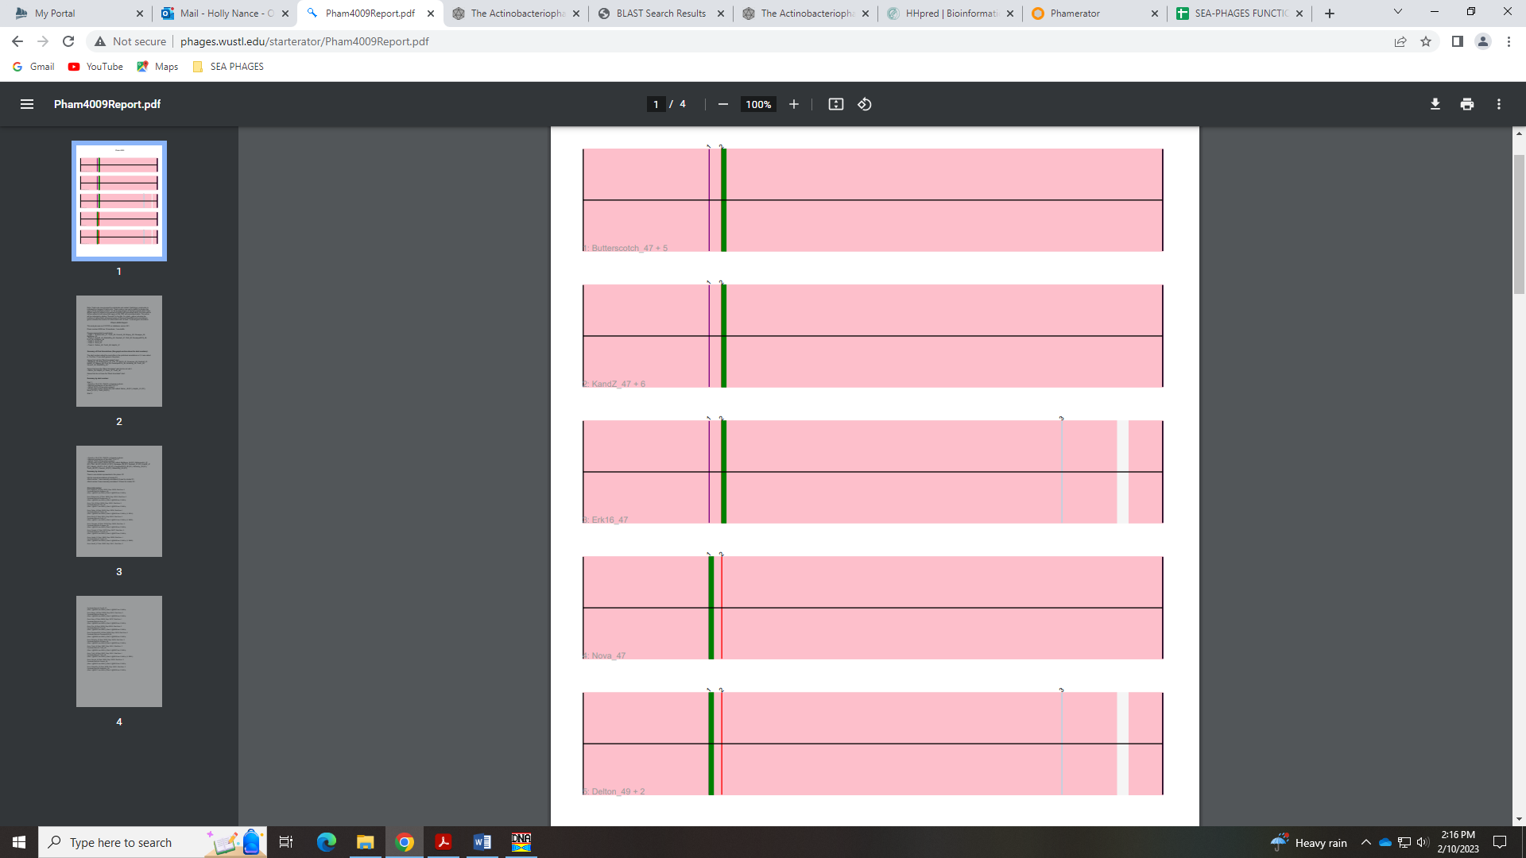

Gene 48 in our file, Gene 49 in PhagesDB
SSC: start 38303, stop 38482; CP: yes; SCS: Glimmer called start at 38303, GeneMark called start at 38306; ST: SS, though not most conserved; Blast Start: matches BigMama_47 Query 1 to Subject 1 100% 3e⁻²⁶; Gap: 11 BP overlap; LO: NA; RBS: -2.791, 2.560, 11, -3.548, yes, tied for best; F: NKF; SIF-BLAST: NKF/PhageDB BLAST/BigMama_47, MH025888/100%/3e⁻²⁶; SIF-HHPred: NKF, no matches with a probability above 90%; SIF-Syn: NKF
Notes: NKF is unambiguous. The start is tricky. Glimmer and GeneMark call different starts. The GeneMark start of 38306 is most conserved in Starterator, but has worse RBS values and yields a shorter gene (marginally). The Glimmer start is least conserved of the three top potential starts, and has only 1 other phage that matches this start, BigMama_47. Start 4 in Starterator (BP 38300 in Mopey) was not called by either gene prediction algorithm, but this start is more conserved than 38303, yields a longer gene (marginally) and actually shows coding potential in the GeneMark output. The RBS value for this start is the same as for 38303. Hmmm… These three starts are like splitting hairs. All yield an overlap with the upstream gene. I’m inclined to change the start to 38300 since the RBS values are the best, it is more conserved than 38303, and has a more common start codon (ATG vs GTG). We left it at 38303!
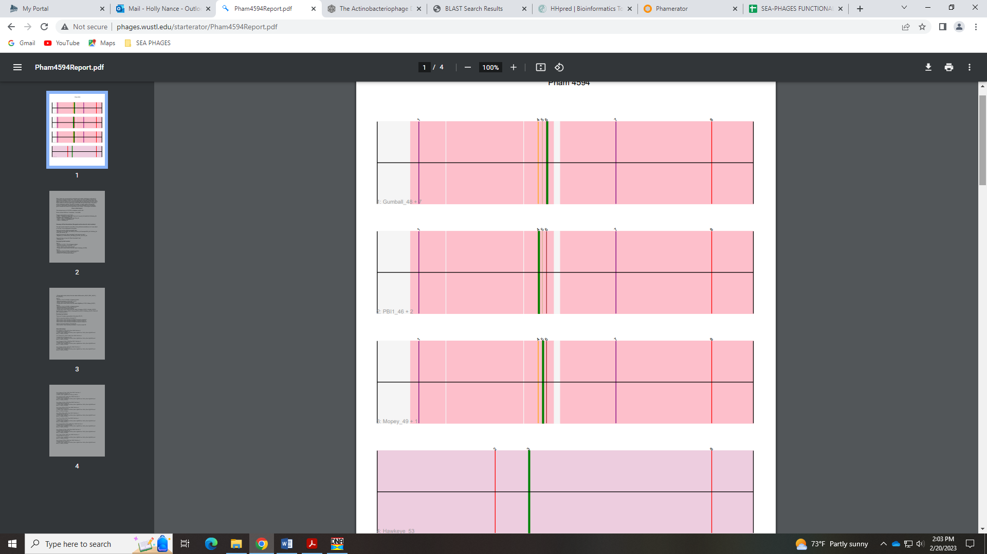
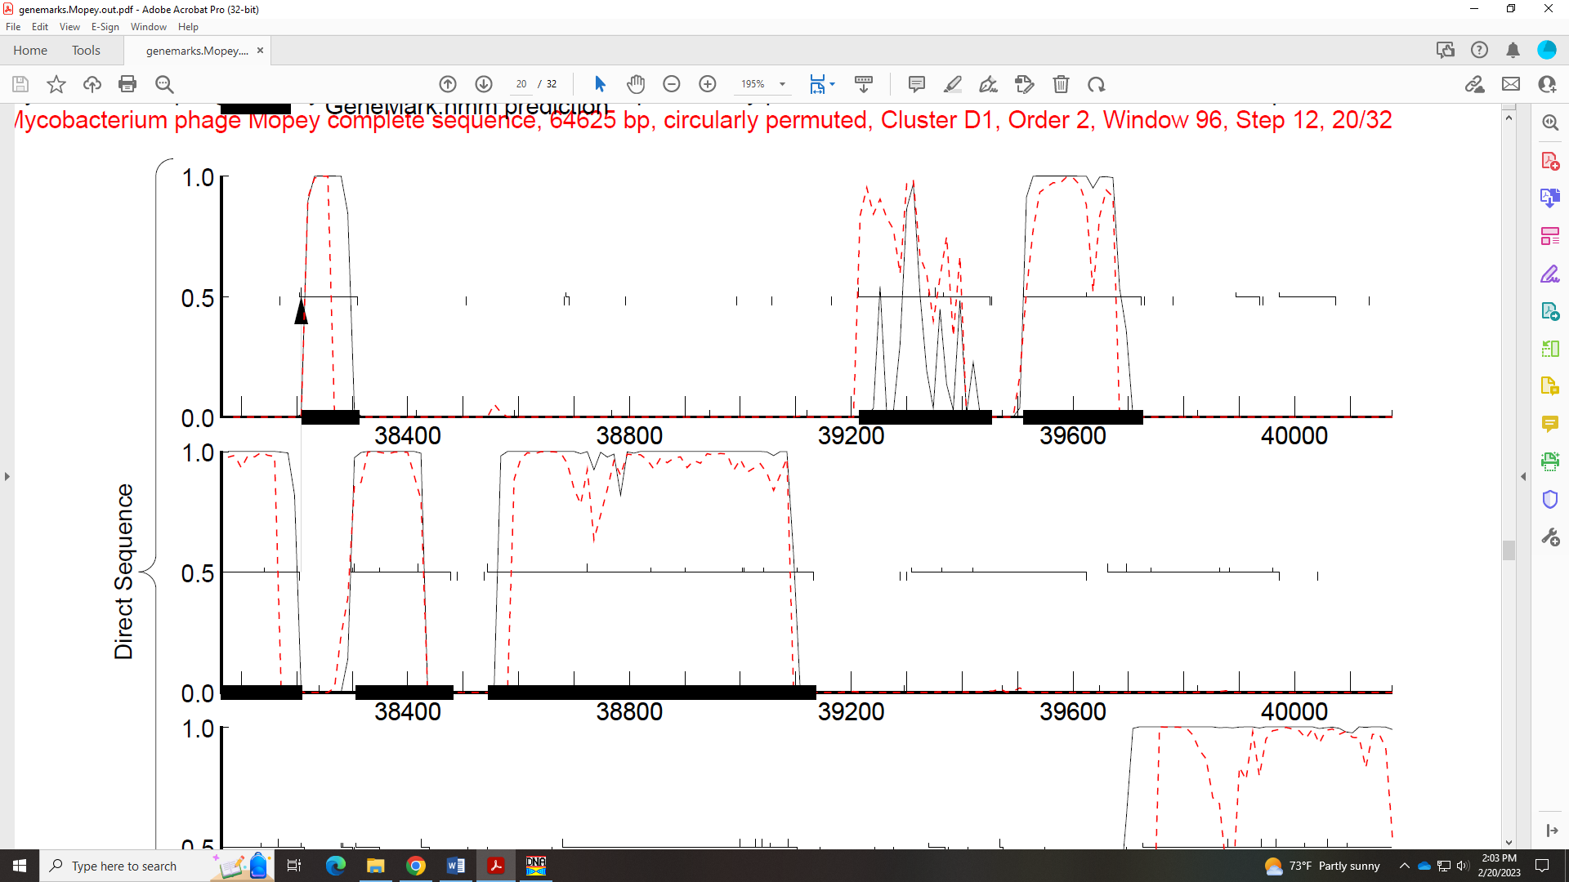

Gene 49 in our file, Gene 50 in PhagesDB
SSC: start 38546, stop 39136; CP: yes; SCS: Both called start of 38546; ST: SS; Blast Start: matches Visconti_51 Query 1 to Subject 1 100% 1e⁻¹⁰⁹; Gap: 63; LO: yes; RBS: -2.814, 2.549, 13, -3.860, no; F: NKF; SIF-BLAST: NKF/PhageDB BLAST/Visconti_51, MH399788/100%/1e⁻¹⁰⁹; SIF-HHPred: NKF, no matches with a probability above 90%; SIF-Syn: NKF
Notes: Start is most conserved. NKF is unambiguous. Easy gene to call!

Gene 50 in our file, Gene 51 in PhagesDB
SSC: start 39214, stop 39453; CP: yes, though not great; SCS: Both called start of 39214; ST: SS; Blast Start: matches Visconti_52 Query 1 to Subject 1 100% 9e⁻⁴⁰; Gap: 77; LO: yes; RBS: -2.814, 2.549, 12, -3.649, yes; F: NKF; SIF-BLAST: NKF/PhageDB BLAST/ Visconti_52, MH399788/100%/9e⁻⁴⁰; SIF-HHPred: NKF, no matches with a probability above 90%; SIF-Syn: NKF
Notes: GeneMark coding potential for this is not great, but both Glimmer and GeneMark called it.
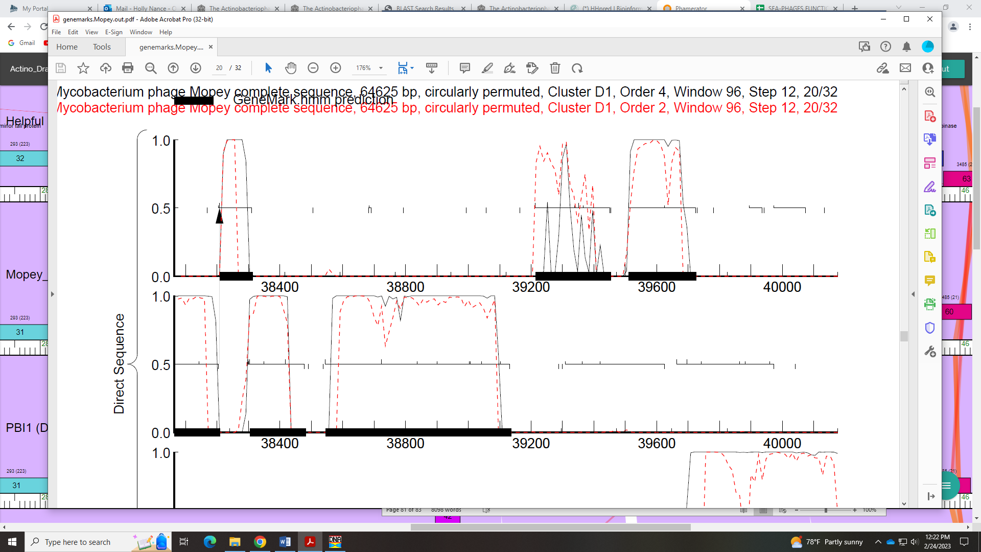
It also has several hits with BLAST and is in a Phamily. There is a large gap but this gap seems to be conserved in Phamerator – other phage have this gap.
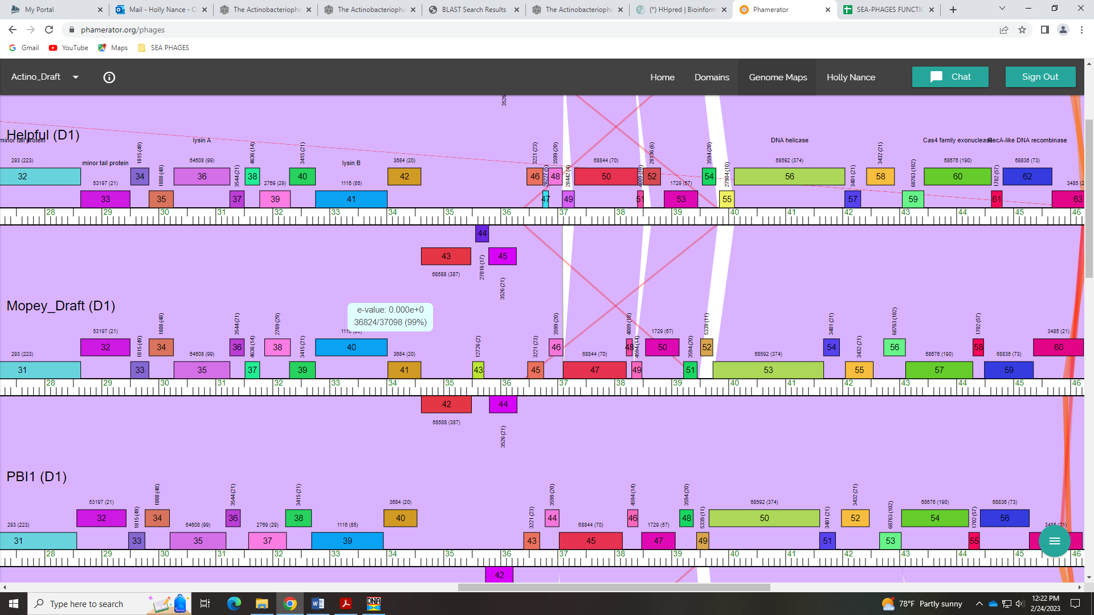

Gene 51 in our file, Gene 52 in PhagesDB
SSC: start 39511, stop 39726; CP: yes; SCS: Both called start of 39511; ST: SS; Blast Start: matches WaldoWhy_54 Query 1 to Subject 1 100% 2e⁻³⁶; Gap: 57; LO: yes; RBS: -2.273, 2.809, 13, -3.319, yes; F: NKF; SIF-BLAST: NKF/PhageDB BLAST/ WaldoWhy_54, MK494102/100%/2e⁻³⁶; SIF-HHPred: NKF, no matches with a probability above 90%; SIF-Syn: NKF
Notes: Nothing ambiguous here. Start is conserved. The large gap is also conserved in Phamerator.
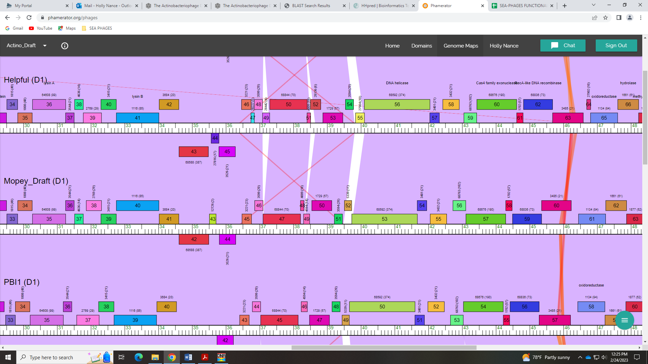

Gene 52 in our file, Gene 53 in PhagesDB
SSC: start 39729, stop 41672; CP: yes; SCS: Both called start of 39729; ST: SS; Blast Start: matches Thoth_53 Query 1 to Subject 1 100% 0.0; Gap: 2; LO: NA; RBS: -3.654, 2.146, 12, -4.490, no; F: DNA helicase; SIF-BLAST: DNA helicase/PhageDB BLAST/Thoth_53, MT889385/100%/0.0⁵⁷; SIF-HHPred: Helicase, several matches with a probability of 100%; SIF-Syn: DNA helicase
Notes: Large phamily, so many starts but 39729 is most conserved in cluster D1. Several hits for DNA helicase in both PhagesDB and NCBI BLAST
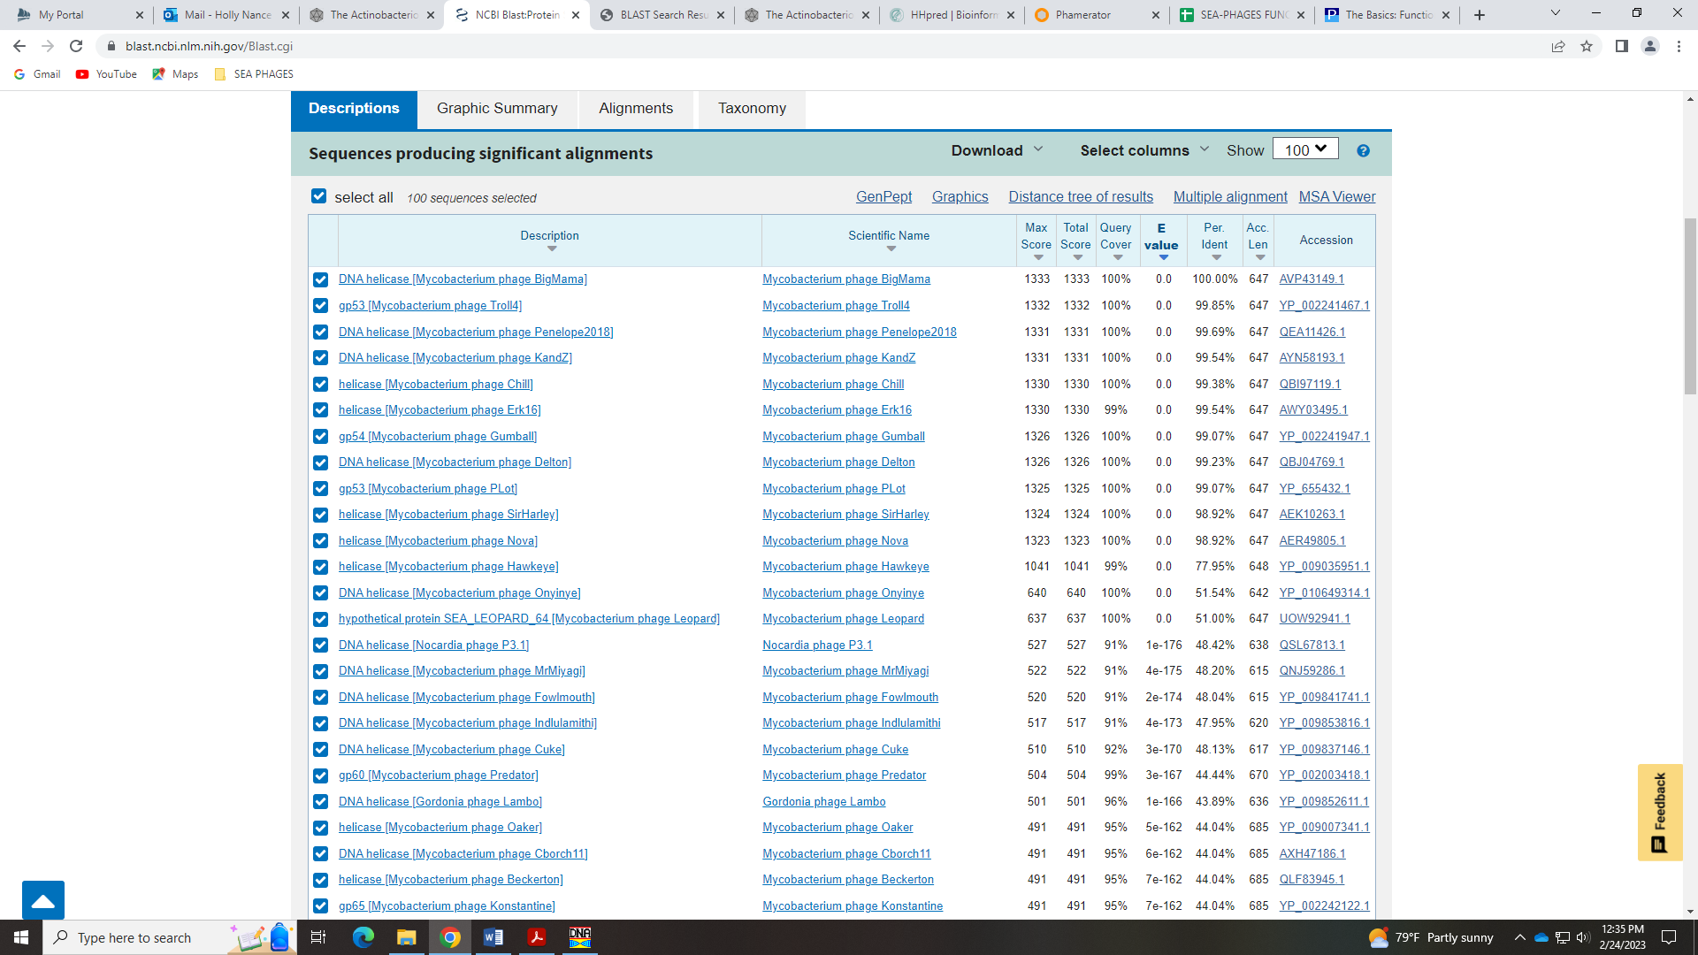
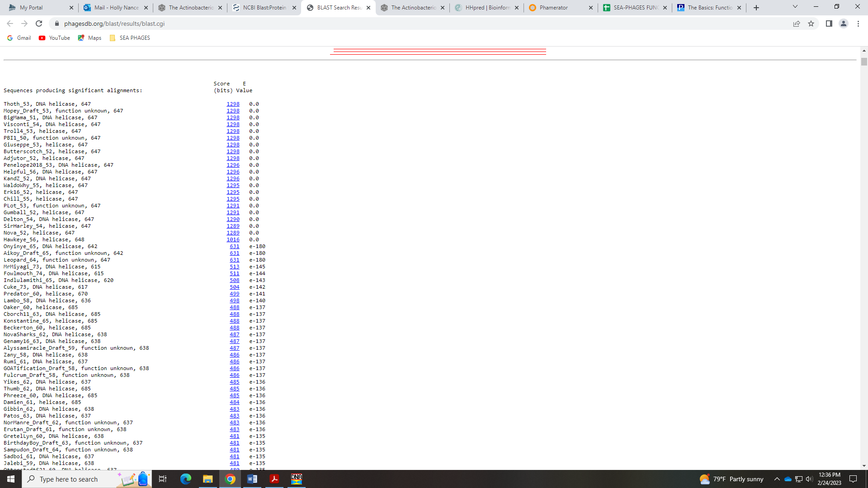
In Phamerator, other D1 phage call this DNA Helicase or just helicase:
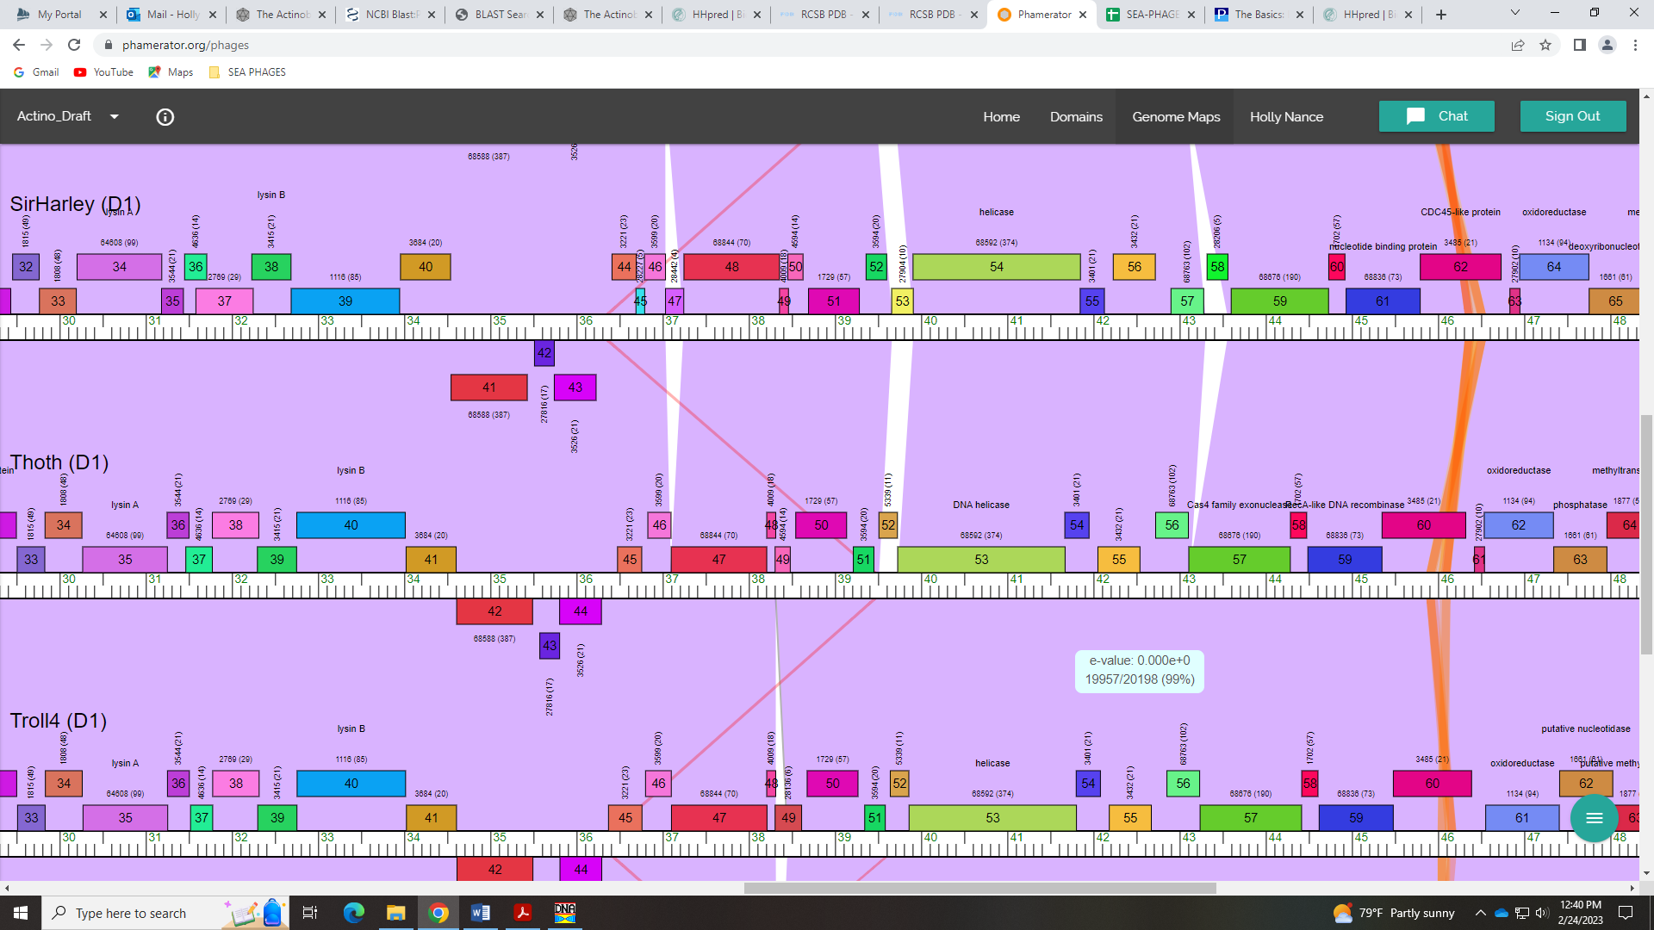
There are no specific domains to look for according to the Official Phage Function list with DNA Helicase, and HHPred comes back with several hits with a probability of 100 for things like DNA binding protein, chromatin remodeling, DNA repair, and some that are helicase:
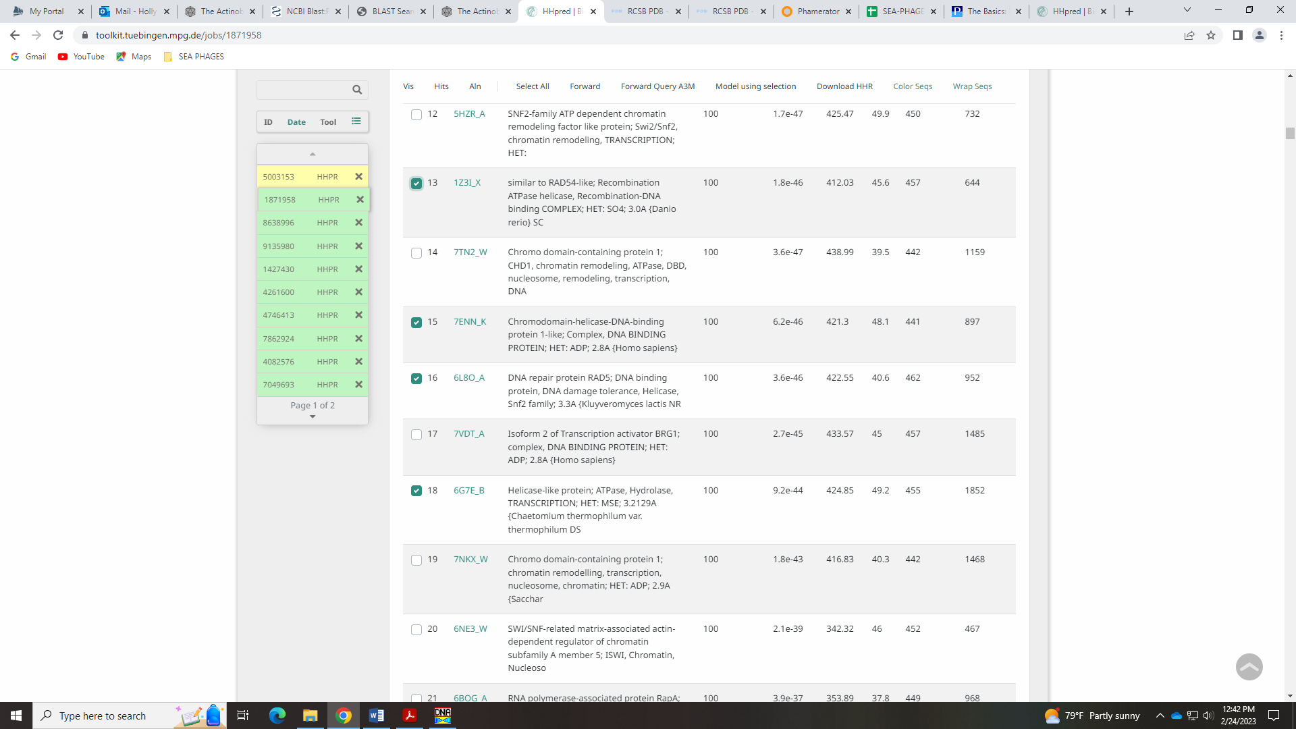
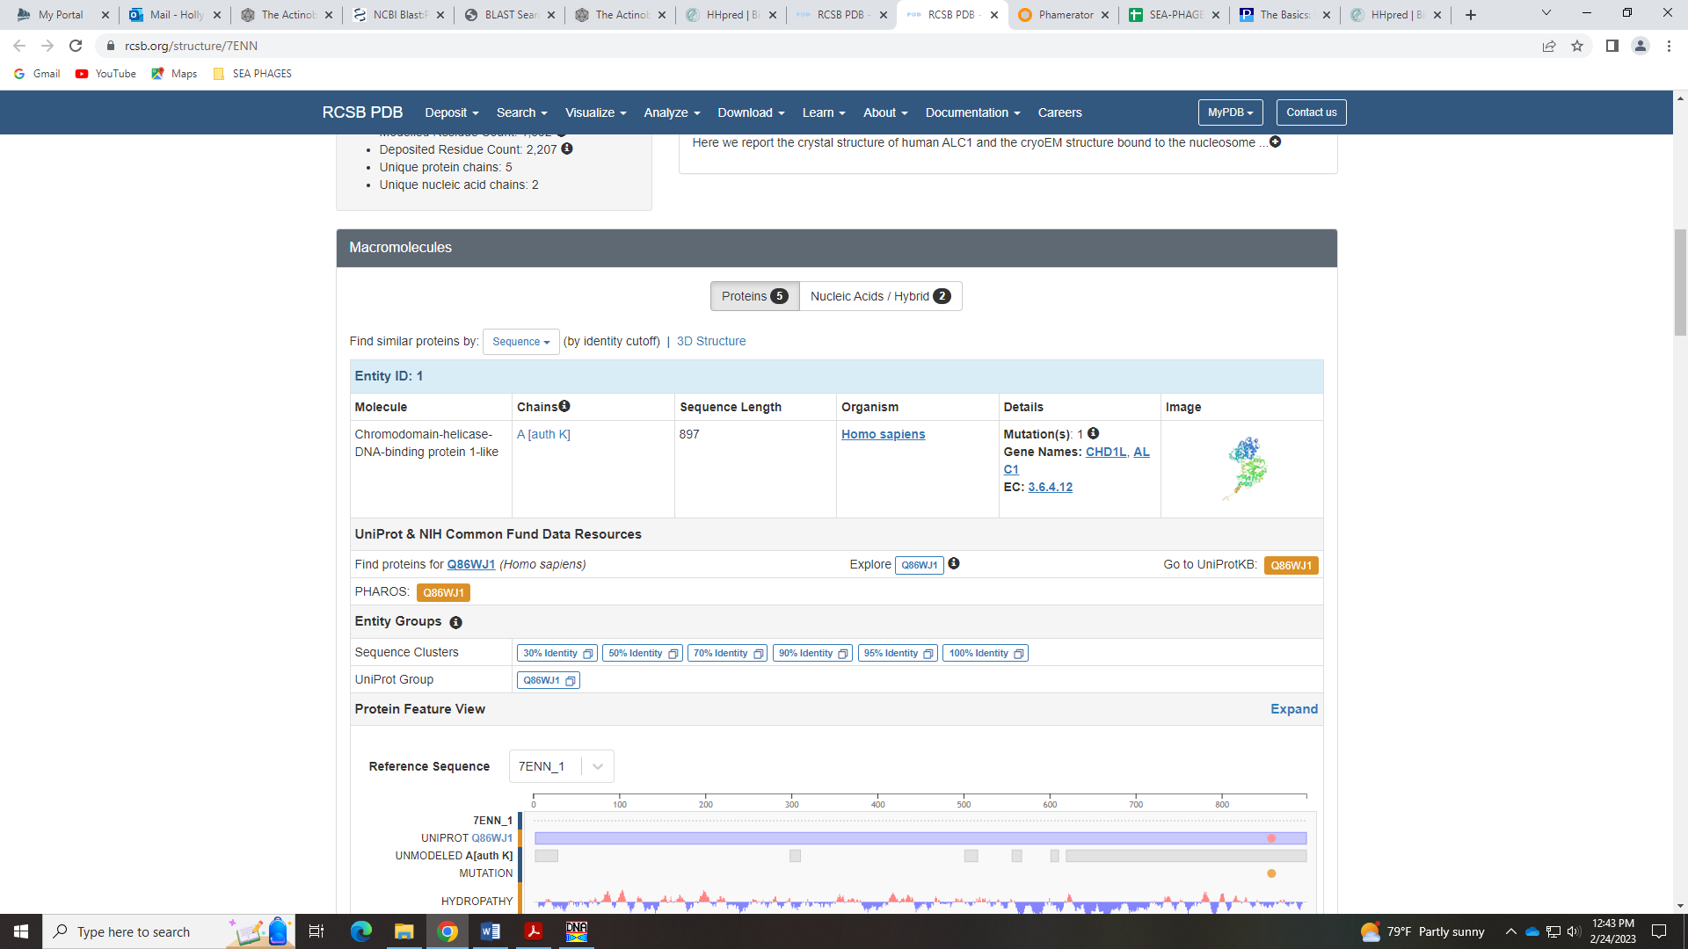
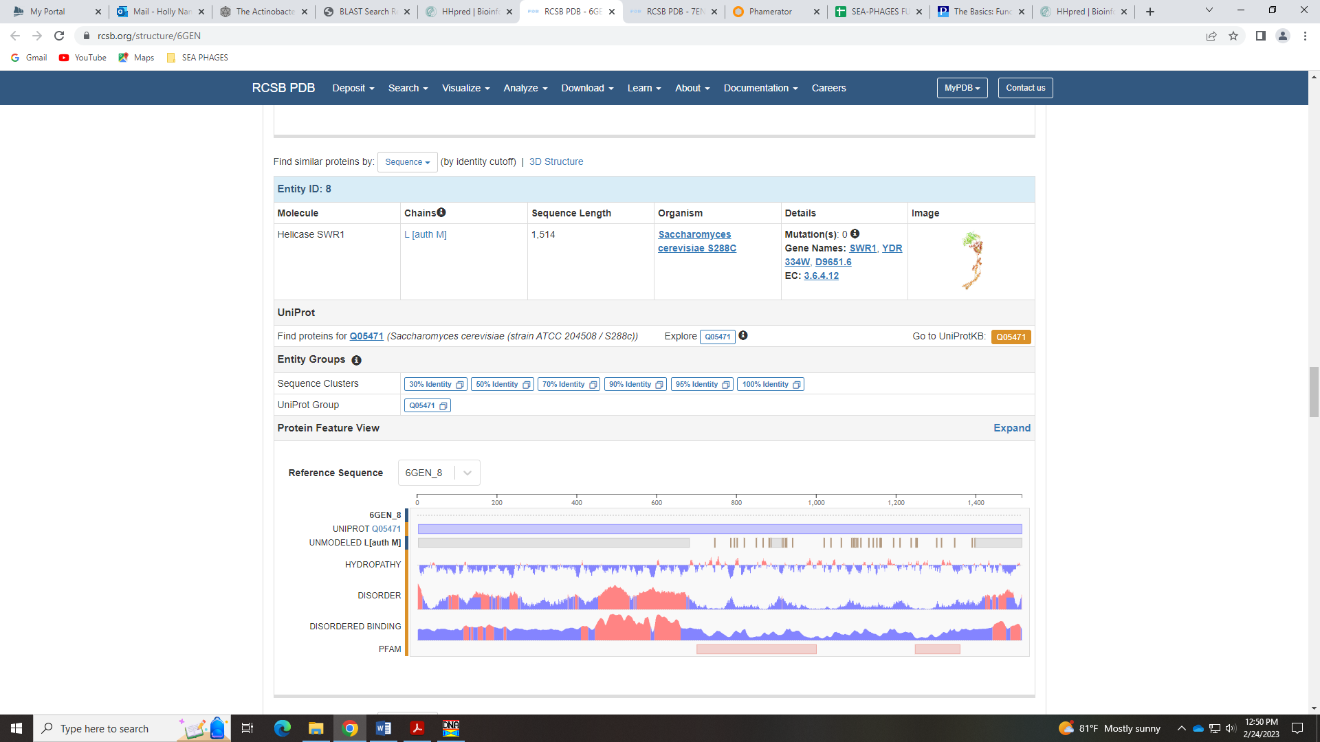
In the Function List, the reference gene is Chah_54. The HHPred output for this gene has many hits that are a shorter segment, but most are for helicase of some kind:
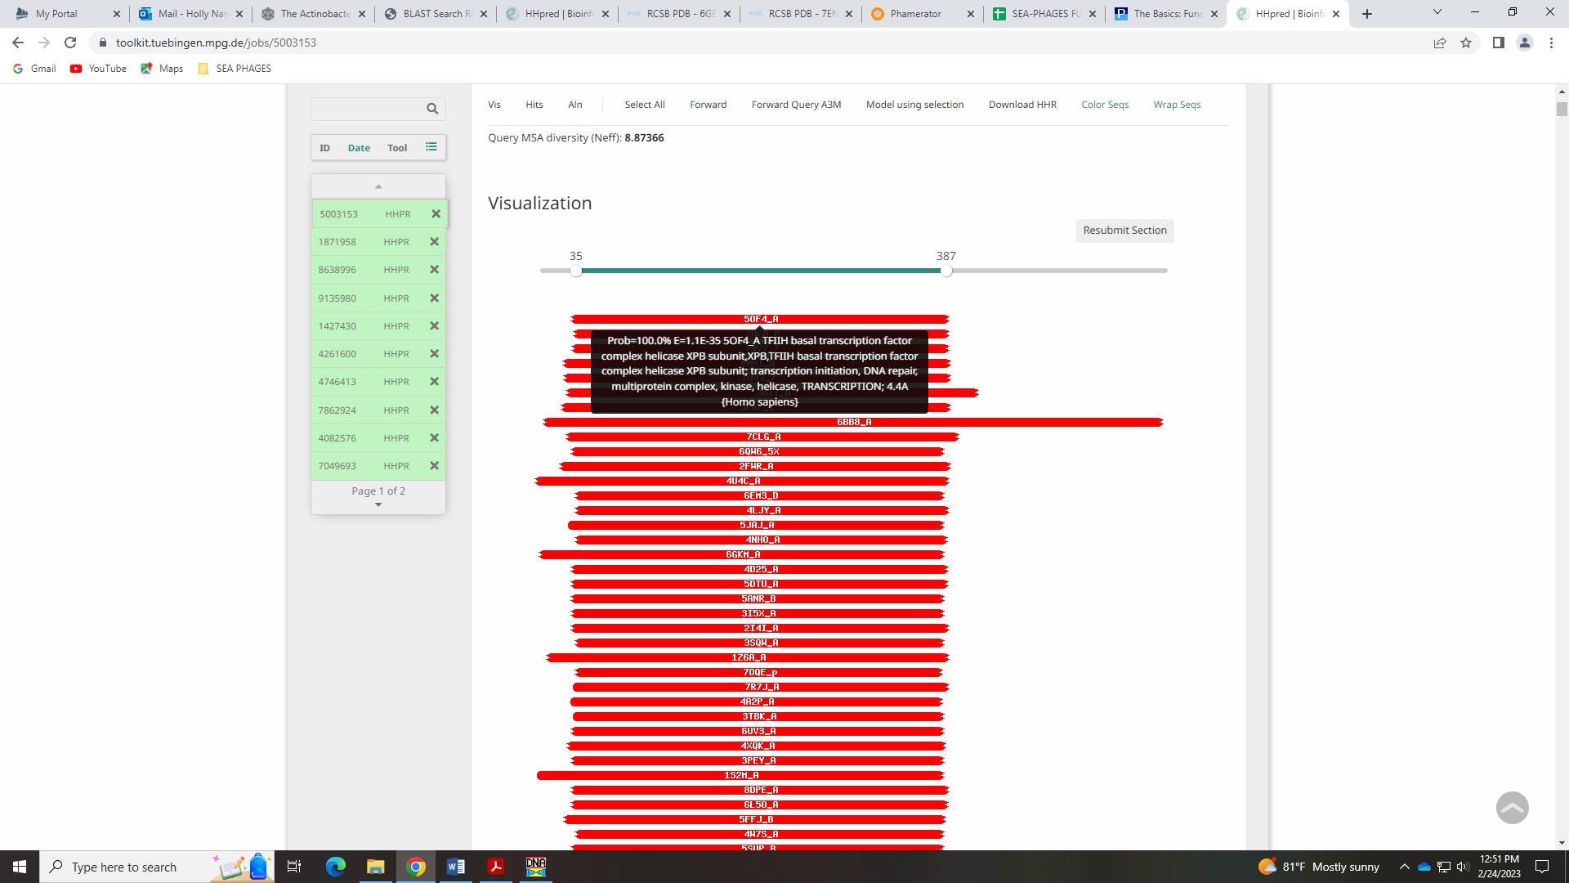
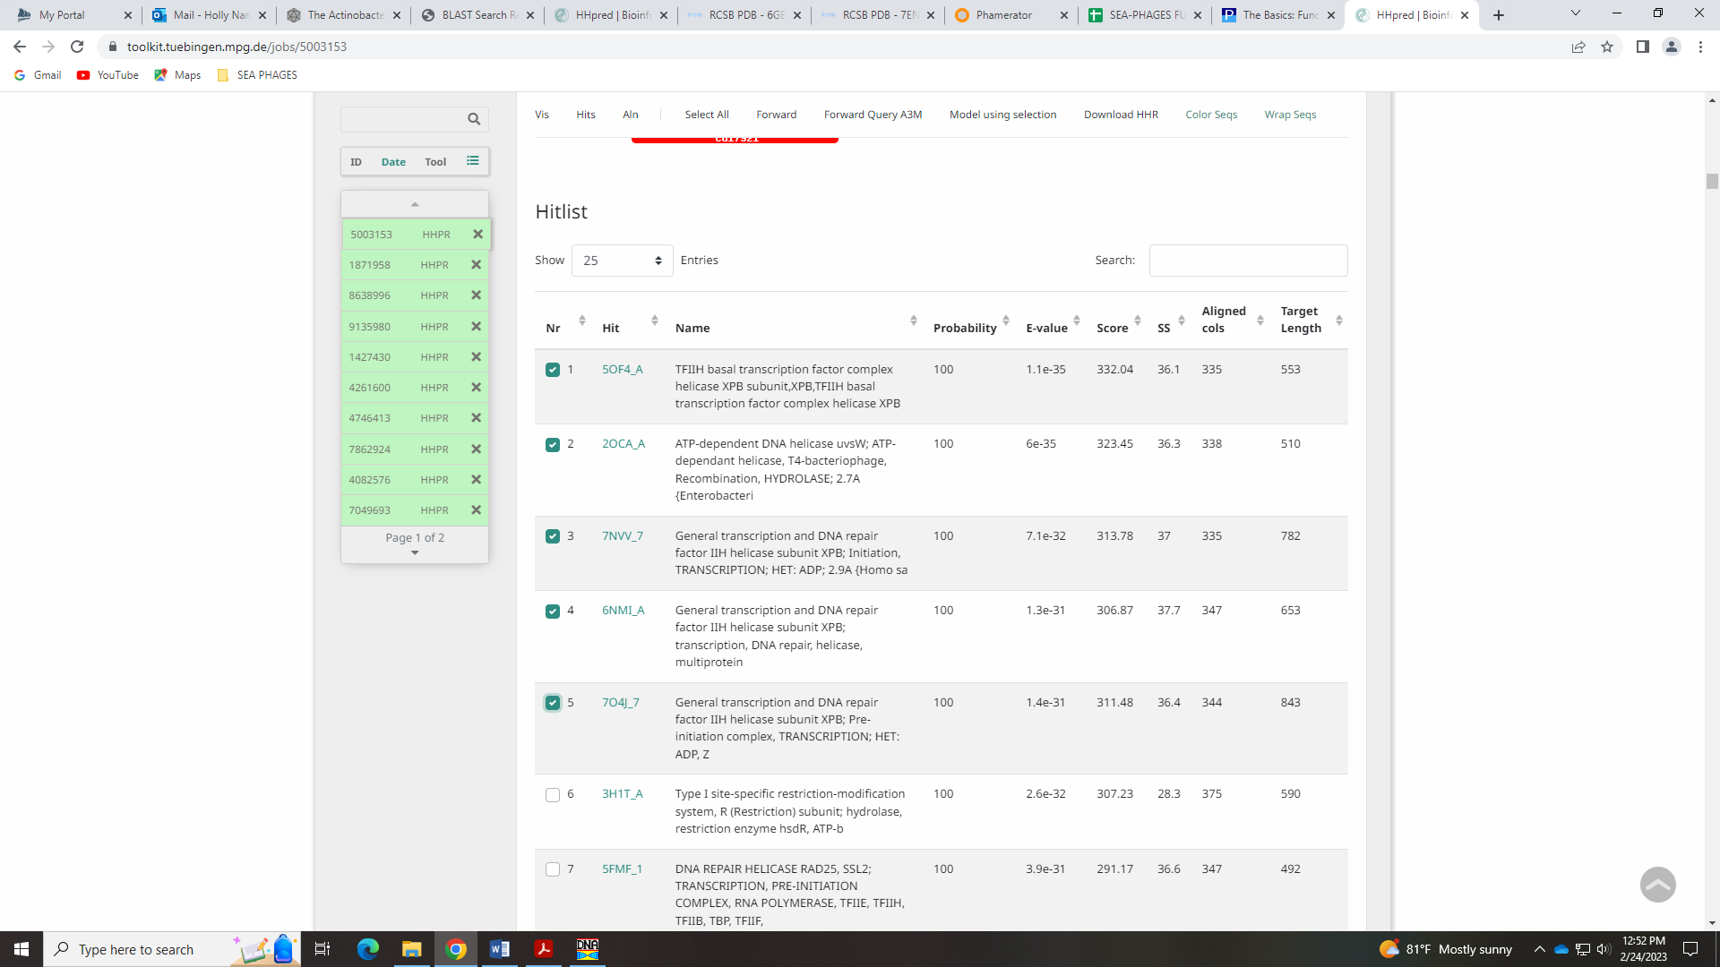
Gene 53 in our file, Gene 54 in PhagesDB
SSC: start 41669, stop 41950; CP: yes, not great; SCS: Both called start of 41669; ST: SS; Blast Start: matches Visconti_55 Query 1 to Subject 1 100% 2e⁻⁴⁸; Gap: overlap of 4; LO: NA; RBS: -1.748, 3.061, 11, -2.505, no; F: NKF; SIF-BLAST: NKF/PhageDB BLAST/ Visconti_55, MH399788/100%/2e⁻⁴⁸; SIF-HHPred: NKF, one partial match with a probability 0f 93.4% for a transcriptional regulator; SIF-Syn: NKF
Notes: For function, BLAST and synteny support NKF. There is one partial hit in HHpred with a prob of 93.4% for a bacterial transcriptional regulator.
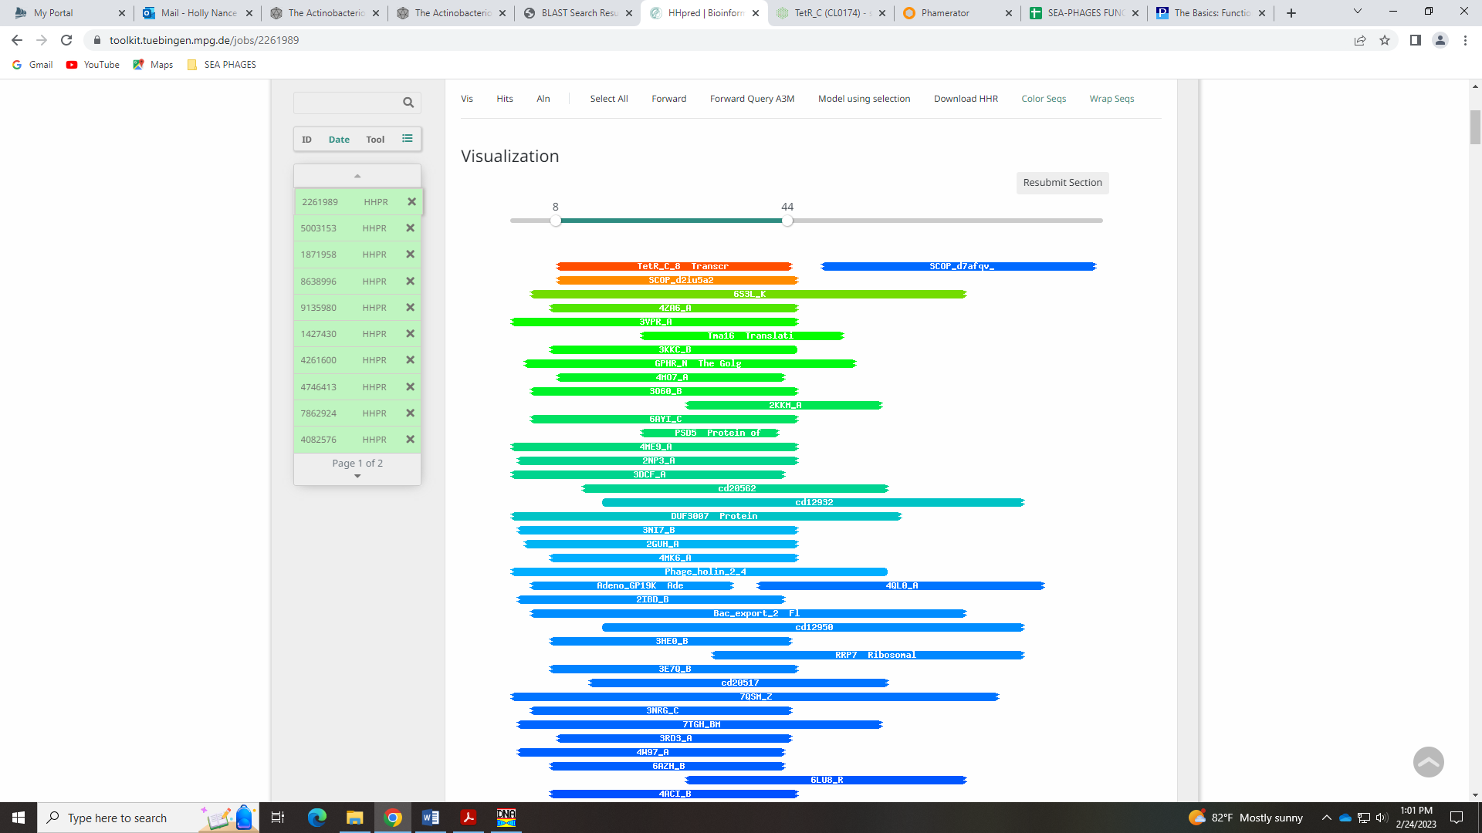
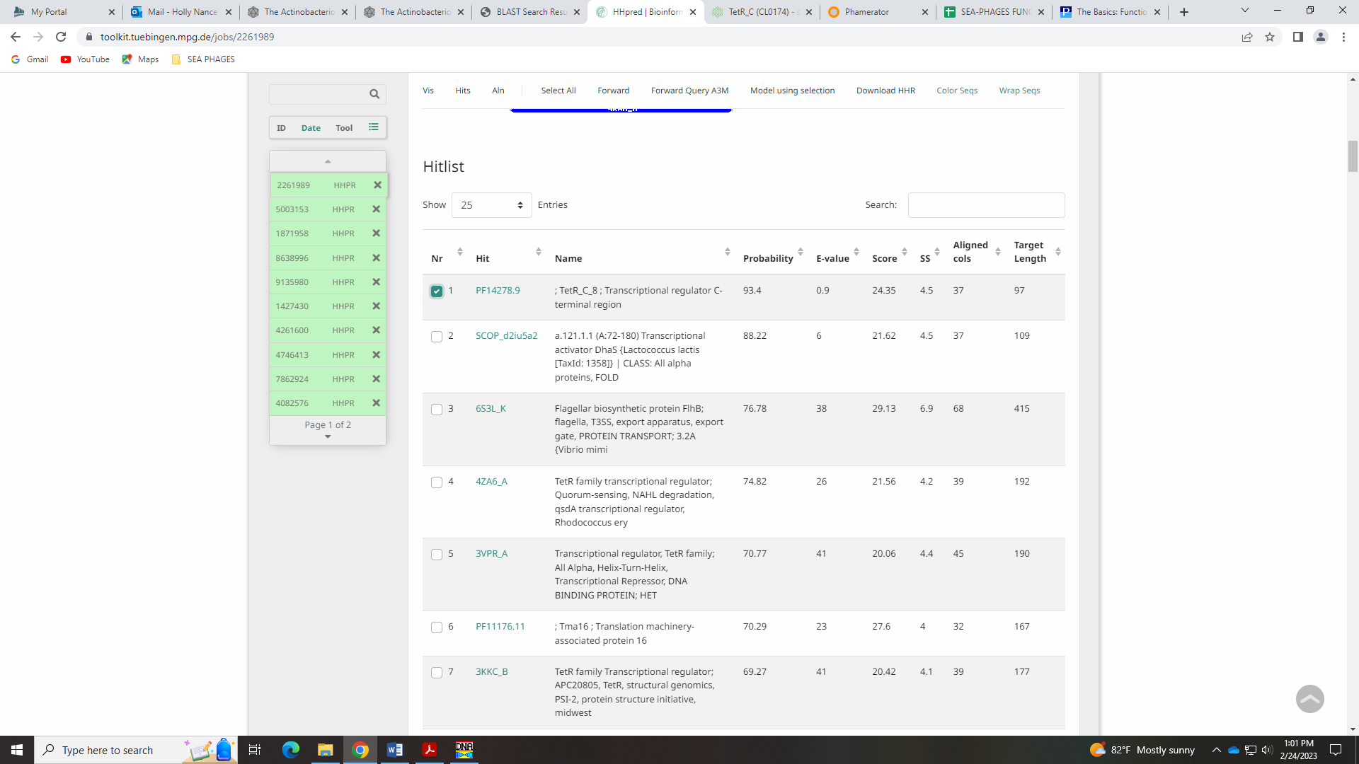
This protein is in a family of antibiotic resistant regulators in bacteria… given it’s a partial hit it may be just a bit of DNA the phage picked up from a host? I’m going with NKF.
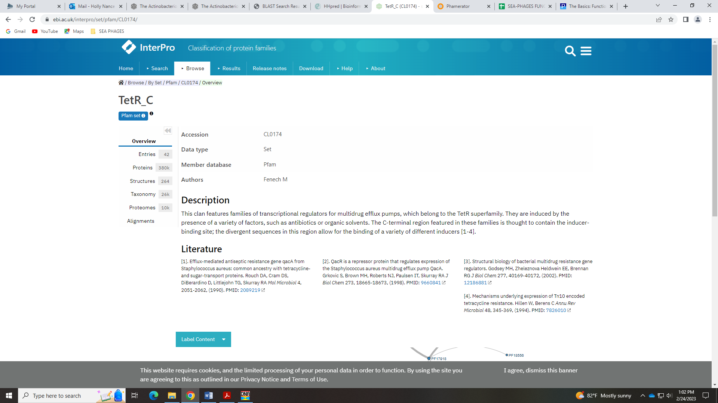

Gene 54 in our file, Gene 55 in PhagesDB
SSC: start 42053, stop 42541; CP: yes; SCS: Both called start of 42503; ST: SS; Blast Start: matches WaldoWhy_57 Query 1 to Subject 1 100% 7e⁻⁸⁷; Gap: 102; LO: yes; RBS: -1.951, 2.963, 9, -2.725, yes; F: NKF; SIF-BLAST: NKF/PhageDB BLAST/ WaldoWhy_57, MK494102/100%/7e⁻⁸⁷; SIF-HHPred: NKF, no matches with a probability above 90%; SIF-Syn: NKF
Notes: Nothing ambiguous. Large gap is conserved in other phage in Cluster D1:
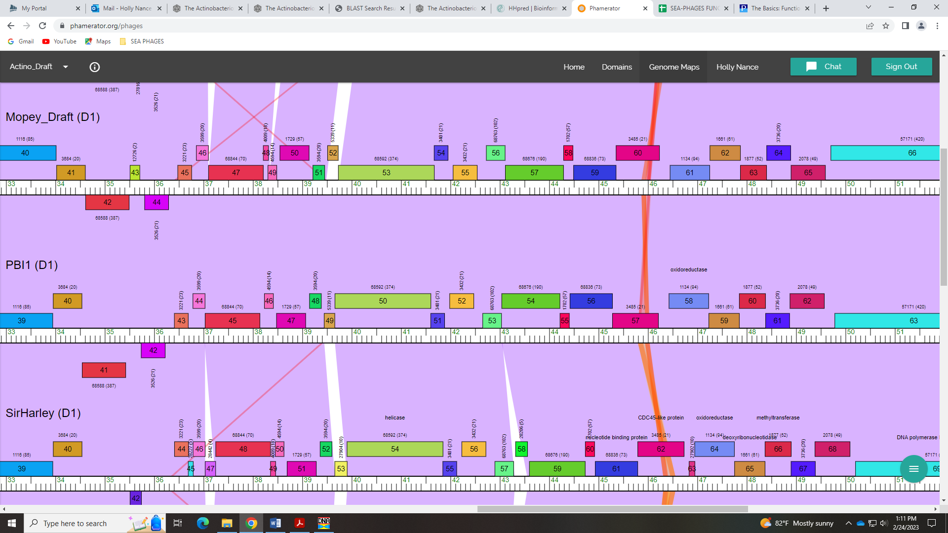

Gene 55 in our file, Gene 56 in PhagesDB Debbie
SSC: start 42726, stop 43106; CP: yes; SCS: Both called start of 42726; ST: SS; Blast Start: matches Troll4_56 Query 1 to Subject 1 100% 6e⁻⁷⁴; Gap: 184; LO: yes, but see notes below; RBS: -2.814, 2.549, 13, -3.860, yes; F: NKF; SIF-BLAST: NKF/PhageDB BLAST/ Troll4_56, FJ168662/100%/6e⁻⁷⁴; SIF-HHPred: NKF, one small partial hit with a probability of 92.18%; SIF-Syn: NKF
Notes: Again the large gap before this gene is conserved in Phamerator:
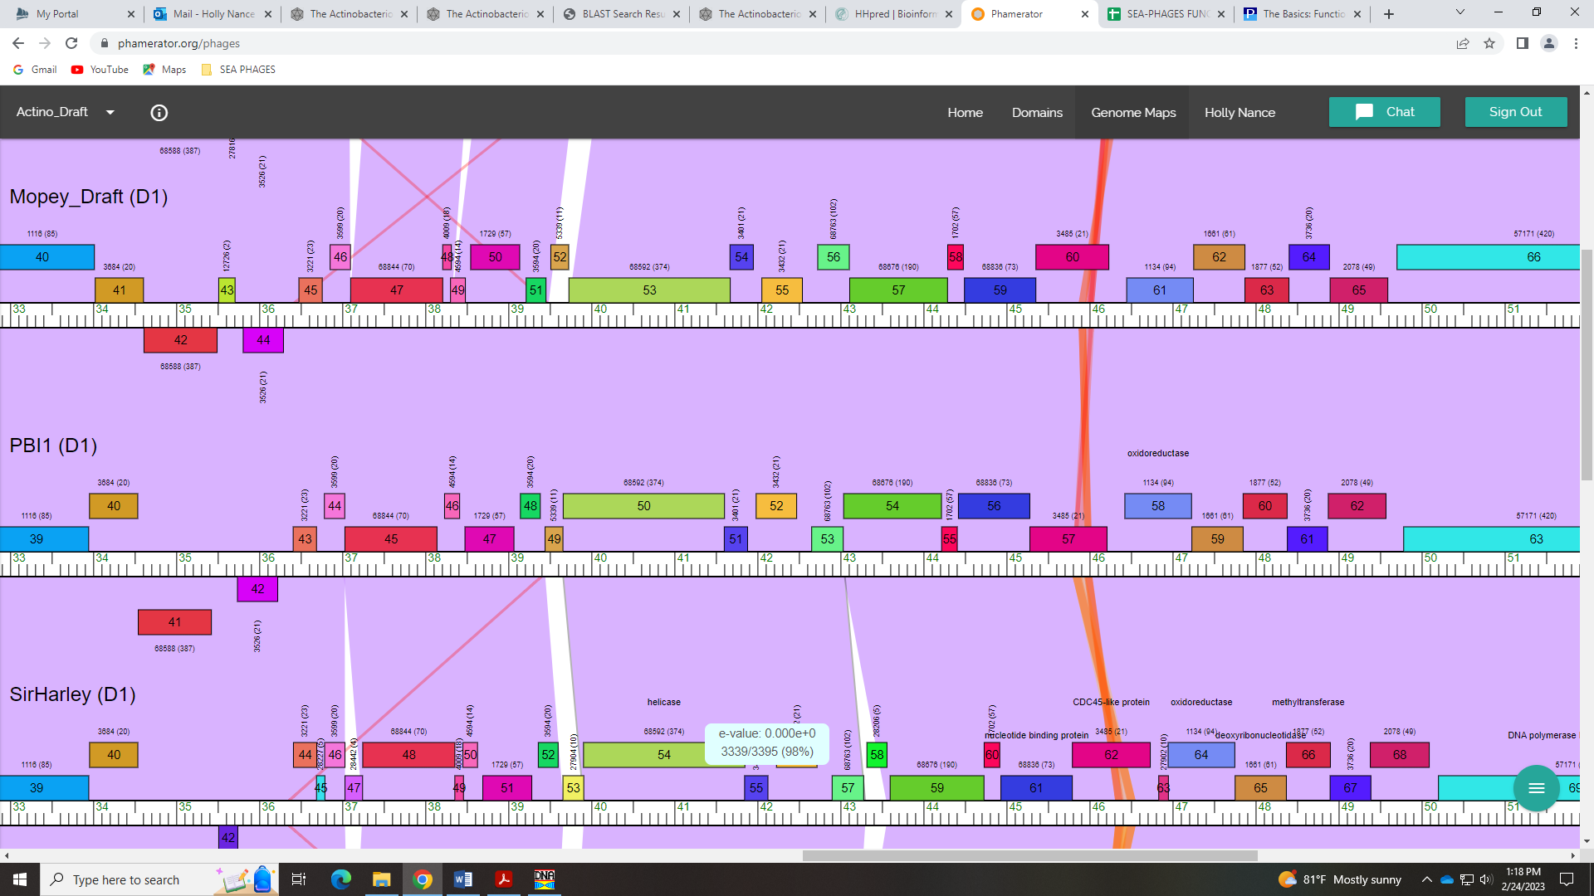
However, in the GeneMark output, in the 1st reading frame there seems to be an ORF that would fit into this gap:
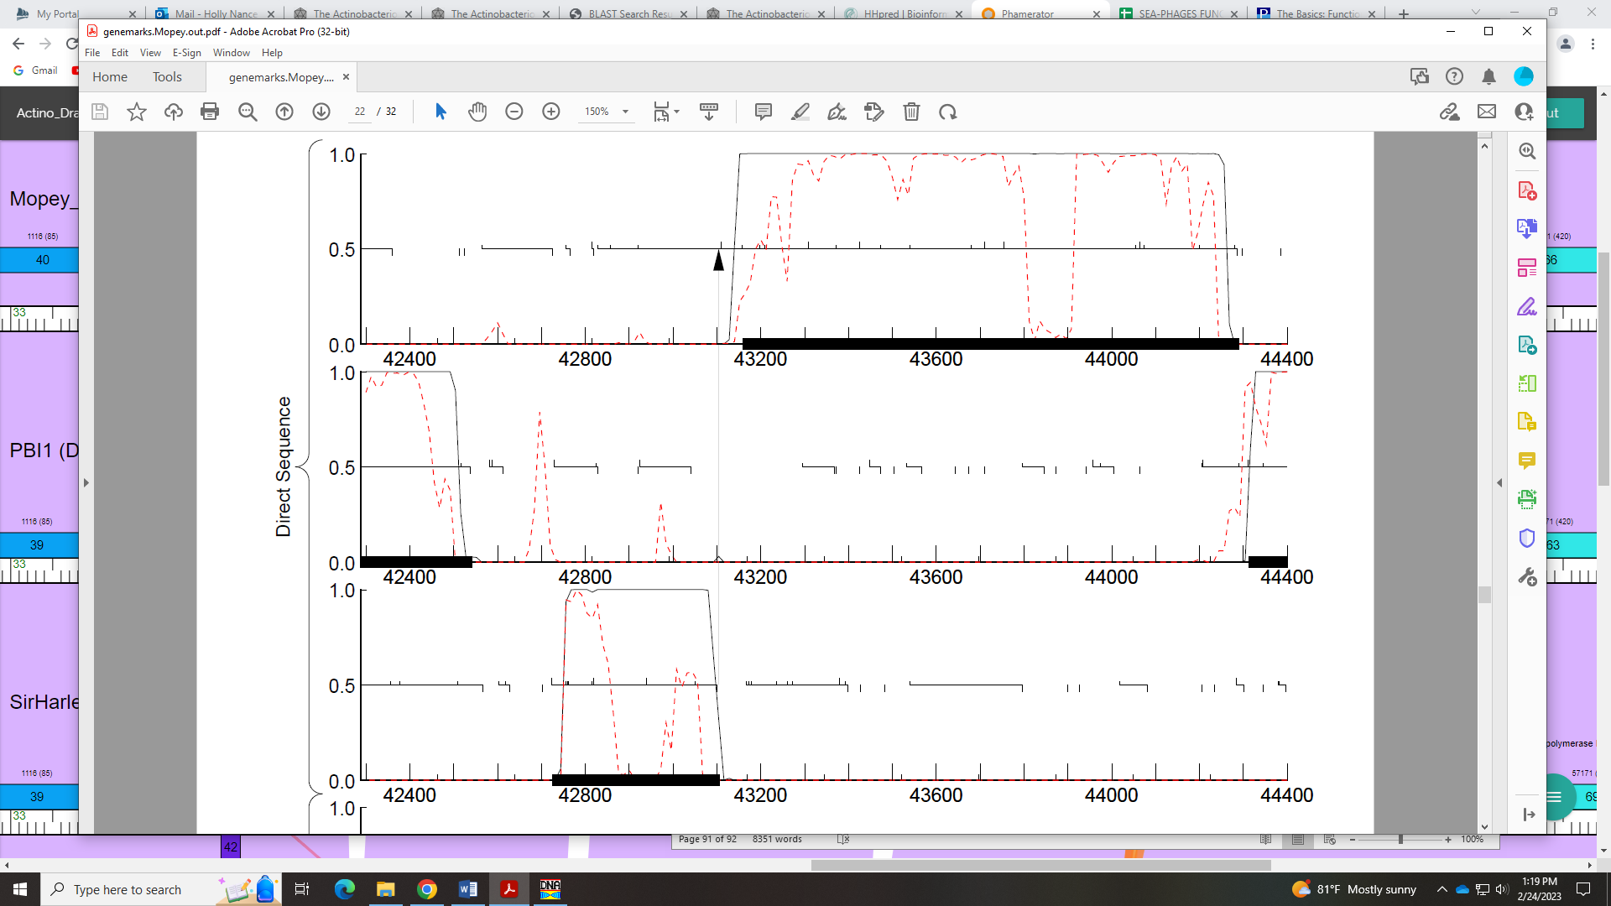
Regarding function, there is one small, partial hit with a prob of 92% for a protein of unknown function in HHpred:
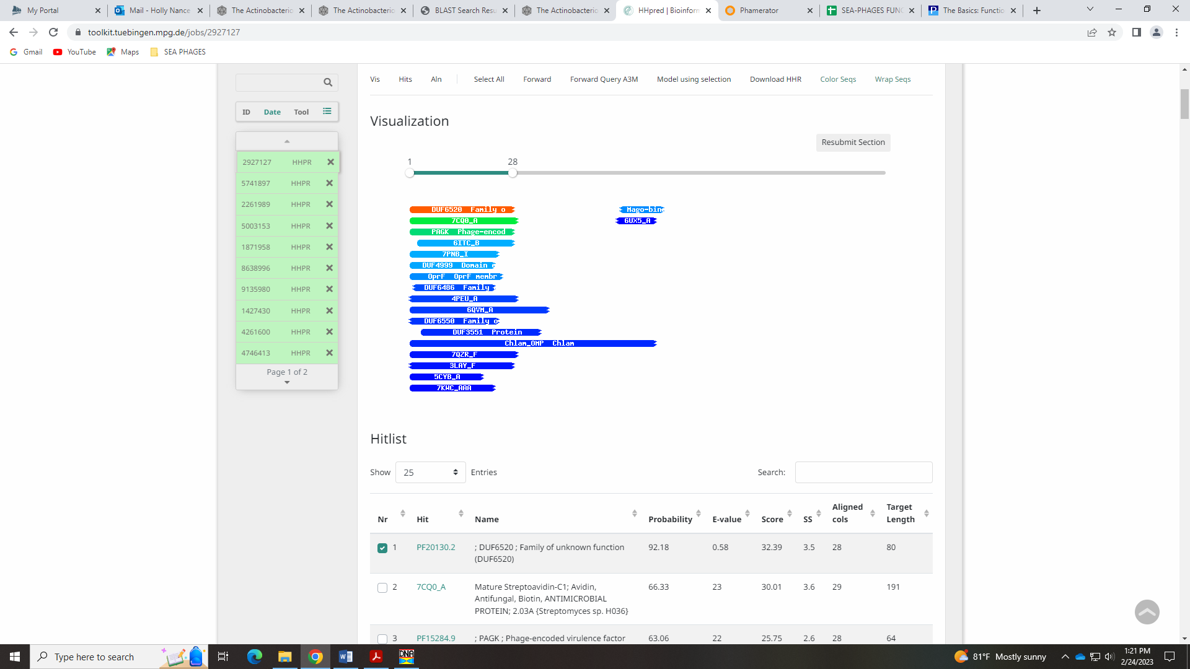

Gene 56 in our file, Gene 57 in PhagesDB
SSC: start 43111, stop 44289; CP: yes; SCS: Glimmer called start of 43111, GeneMark called start of 43159; ST: SS; Blast Start: matches Troll4_57 Query 1 to Subject 1 100% 0.0; Gap: 4; LO: NA; RBS: -2.046, 2.918, 15, -3.648, yes; F: Cas4 exonuclease SIF-BLAST: Cas4 family exonuclease/PhageDB BLAST/WaldoWhy_59, MK494102/99%/0.0; SIF-HHPred: exonuclease, several matches with a probability above 90%; SIF-Syn: Cas4 exonuclease
Notes: Glimmer start is the most annotated and most conserved. For function, there are hits for exonuclease and Cas4 exonuclease. The Official Phage Function List says this about Cas4 Exonuclease:
This family of exonucleases is similar to the exonuclease domain of RecB. The Cas4 label should be used if the gene includes only the exonuclease region. IF the gene also includes a helicase domain, the RecB label should be used. Cas4 family nucleases tend to have alignments to the crystal structure 4R5Q_A, 41C1_A and to the PD-(D/E)XK nuclease superfamily (PF12705.7, among others).
There is only one conserved domain in this protein in Phamerator:
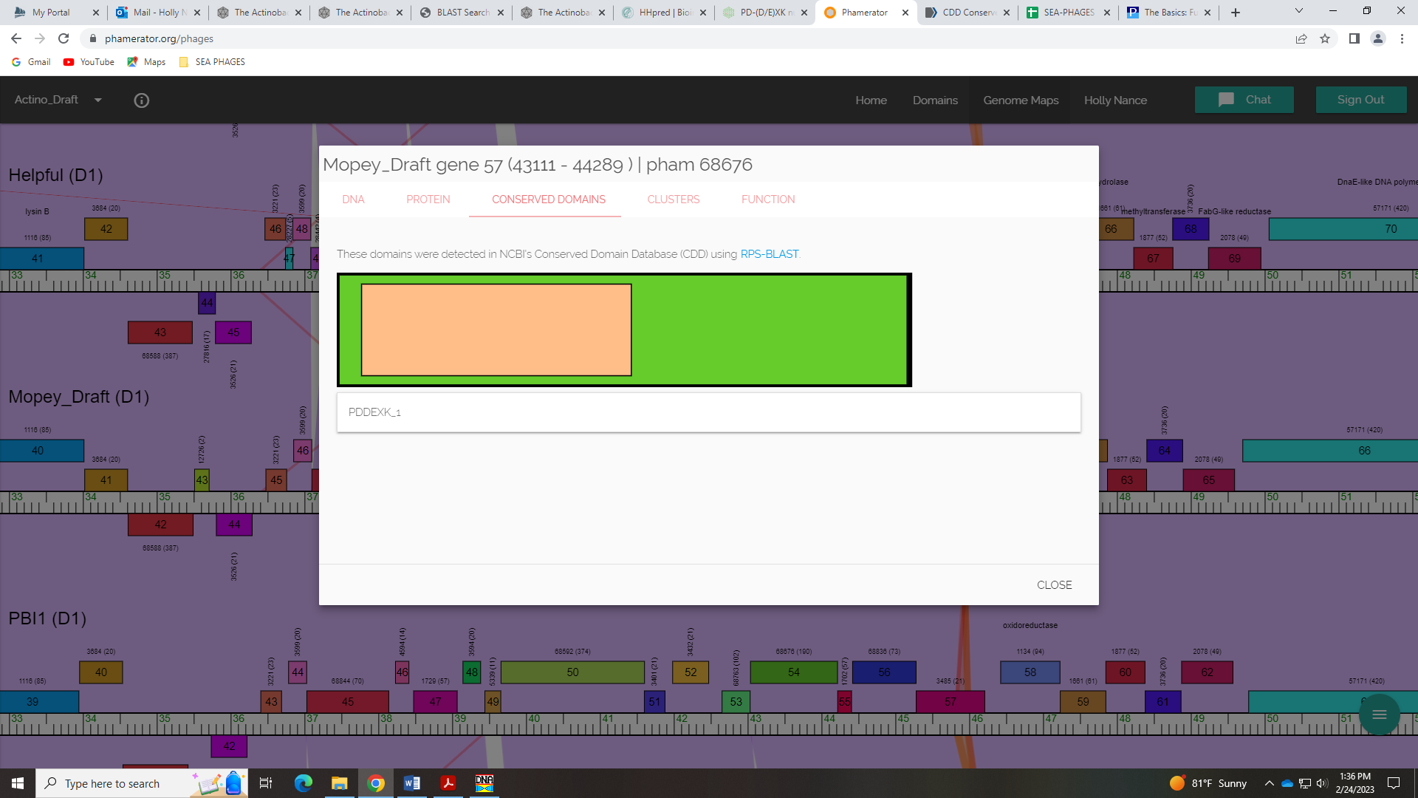
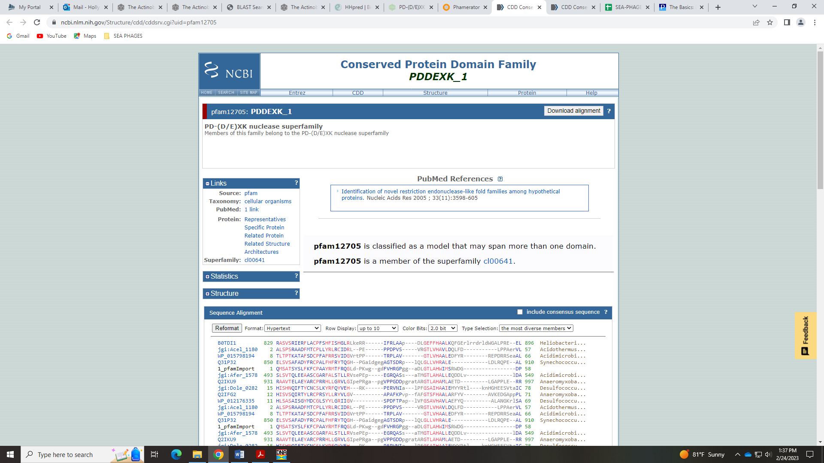
There are several hits for this same domain or an exonuclease in HHPred:
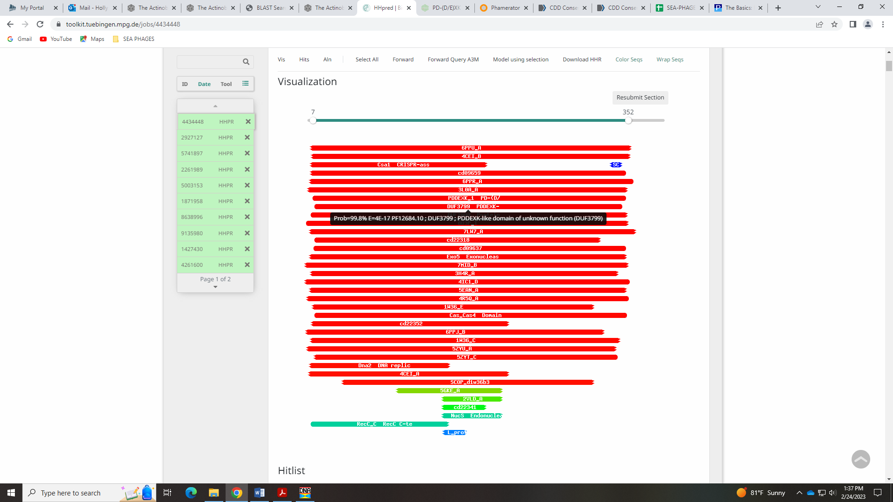
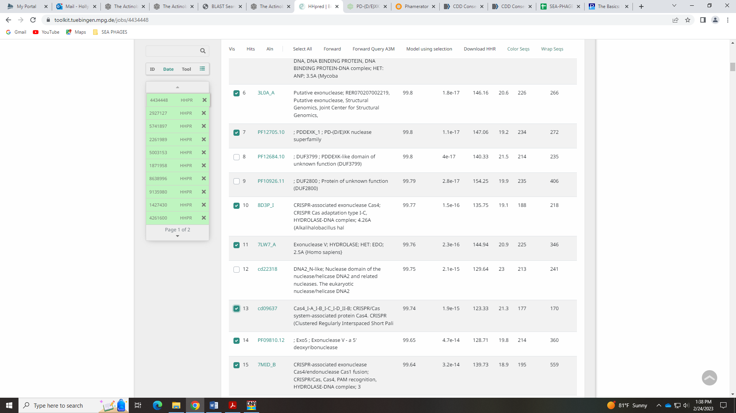
Given the HHpred hits and what is specified in the Phage Function list (there is only the exonuclease domain, not the helicase domain) I’m going with Cas4 exonuclease and not RecB like exonuclease/helicase

Gene 57 in our file, Gene 58 in PhagesDB
SSC: start 44291, stop 44479; CP: yes; SCS: Glimmer called start of 44291, GeneMark called start of 44312; ST: SS; Blast Start: matches WaldoWhy_60 Query 1 to Subject 1 100% 4e⁻²⁹; Gap: 1; LO: NA; RBS: -1.418, 3.219, 13, -2.463, yes; F: NKF; SIF-BLAST: NKF/PhageDB BLAST/ WaldoWhy_60, MK494102/100%/4e⁻²⁹; SIF-HHPred: NKF, no matches with a probability above 90%; SIF-Syn: NKF
Notes: Glimmer start is most annotated in Starterator and most conserved. Nothing else ambiguous here!

Gene 58 in our file, Gene 59 in PhagesDB
SSC: start 44493, stop 45353; CP: yes; SCS: Both called start of 44493; ST: SS; Blast Start: matches WaldoWhy_61 Query 1 to Subject 1 100% 1e⁻¹⁶⁴; Gap: 13; LO: no; RBS: -1.462, 3.198, 9, -2.236, yes; F: RecA-like DNA recombinase; SIF-BLAST: RecA-like DNA recombinase /PhageDB BLAST/ WaldoWhy_61, MK494102/100%/1e⁻¹⁶⁴; SIF-HHPred: RecA-like DNA recombinase, several matches with a probability above 90% for a RecA protein and/or recombination protein; SIF-Syn: RecA-like DNA recombinase
Notes: For function, both PhagesDB and NCBI BLAST support RecA-like DNA recombinase, which is on the Official Phage Function List:
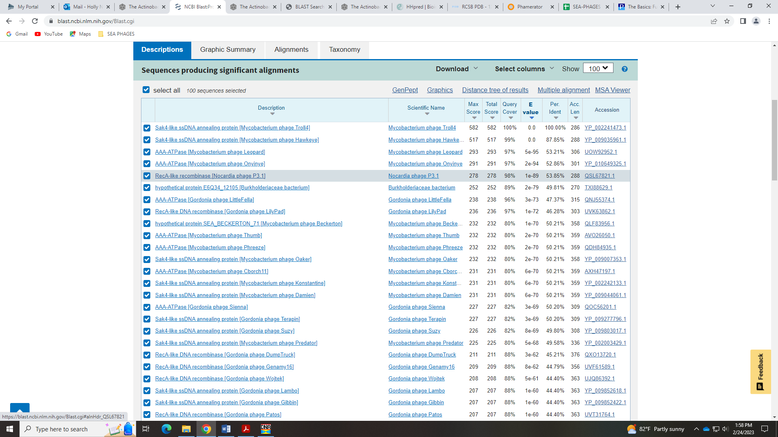
HHPred has several hits at 99% for a RecA protein and/or a recombination protein:
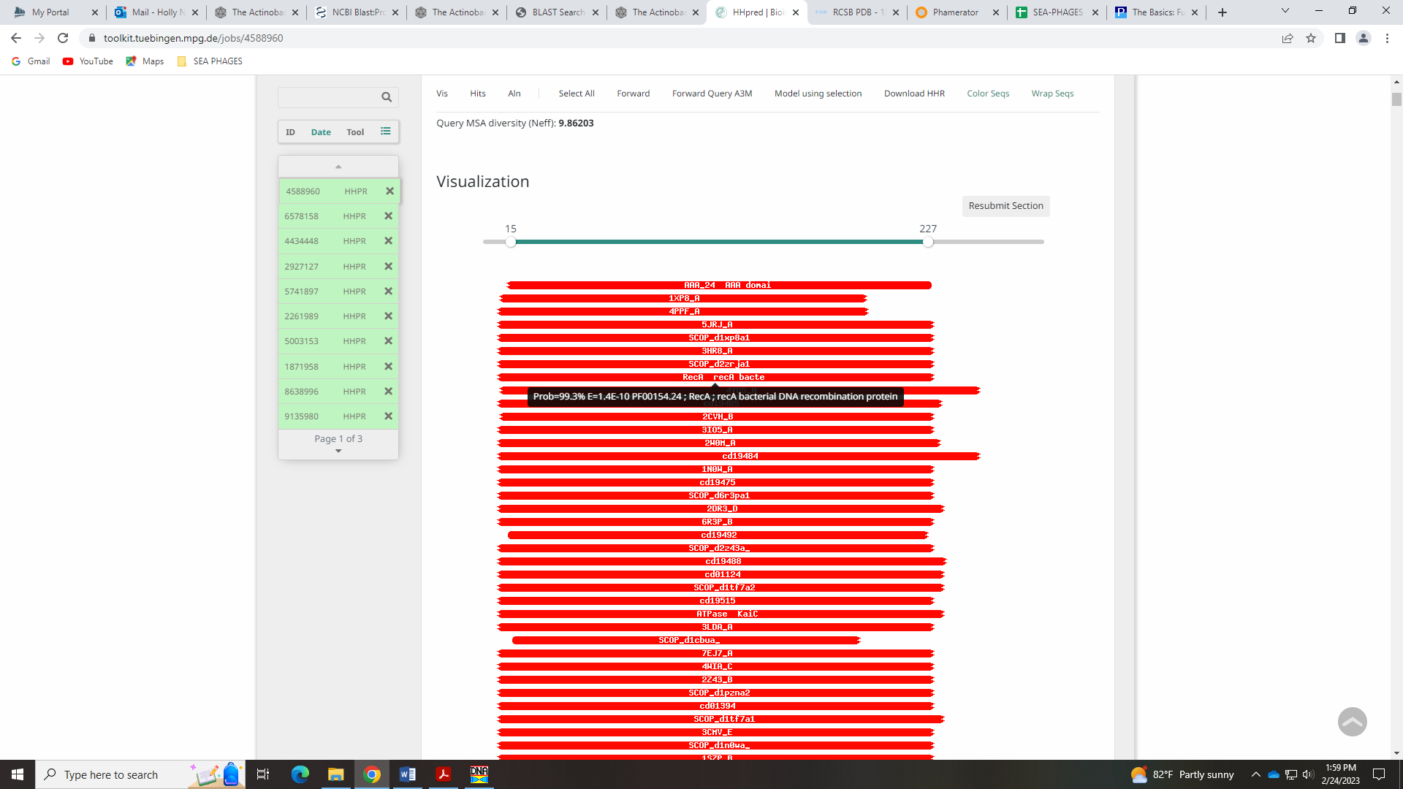
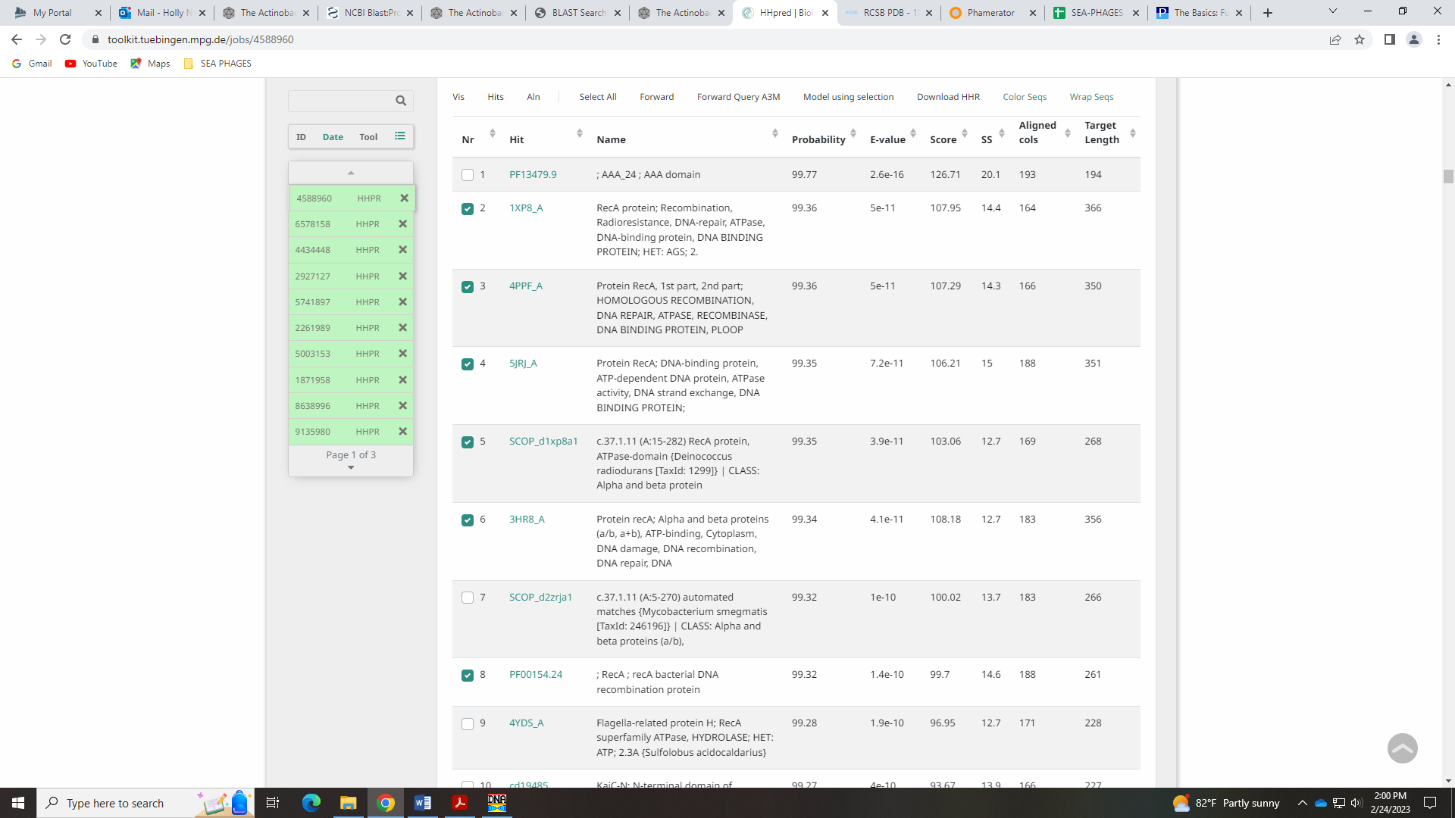

Gene 59 in our file, Gene 60 in PhagesDB
SSC: start 45354, stop 46232; CP: yes; SCS: Both called start of 45354; ST: SS; Blast Start: matches Nova_59 Query 1 to Subject 1 95% 1e⁻¹⁶³; Gap: 0; LO: NA; RBS: -1.748, 3.061, 13, -2.794, yes; F: NKF; SIF-BLAST: NKF/PhageDB BLAST/Plot_60, DQ398051/95%/1e⁻¹⁶¹; SIF-HHPred: NKF, no matches with a probability above 90% that make sense in a phage; most hits are partial; SIF-Syn: NKF
Notes: Some BLAST hits in PhagesDB and NCBI are for odd functions not on the Official List, like CDC45-like protein or Asp-rich protein:
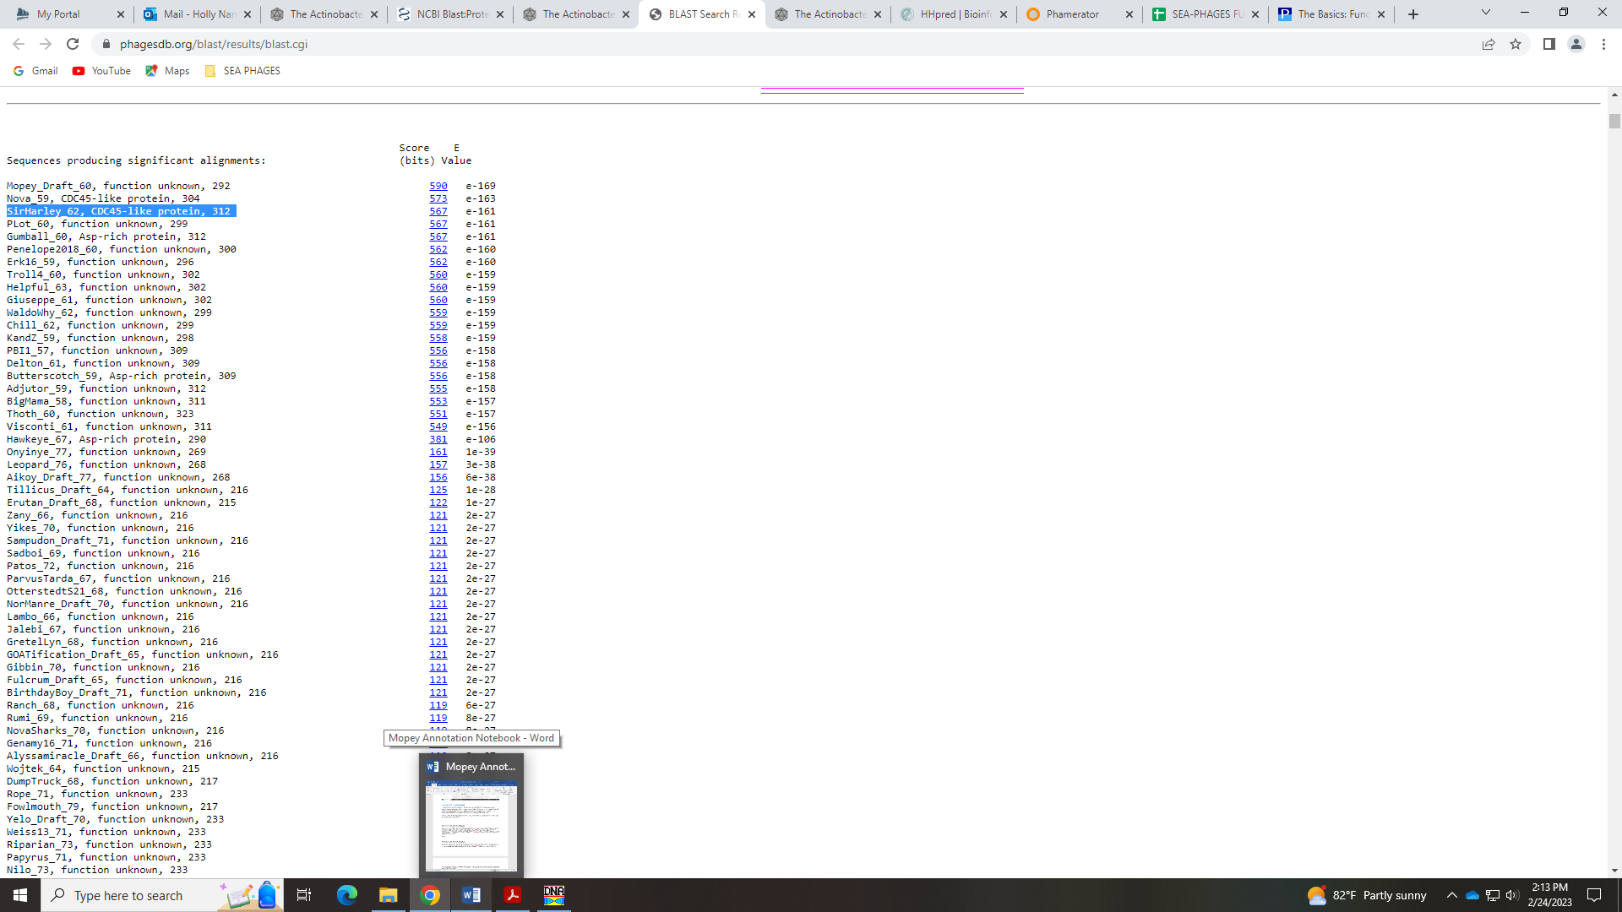
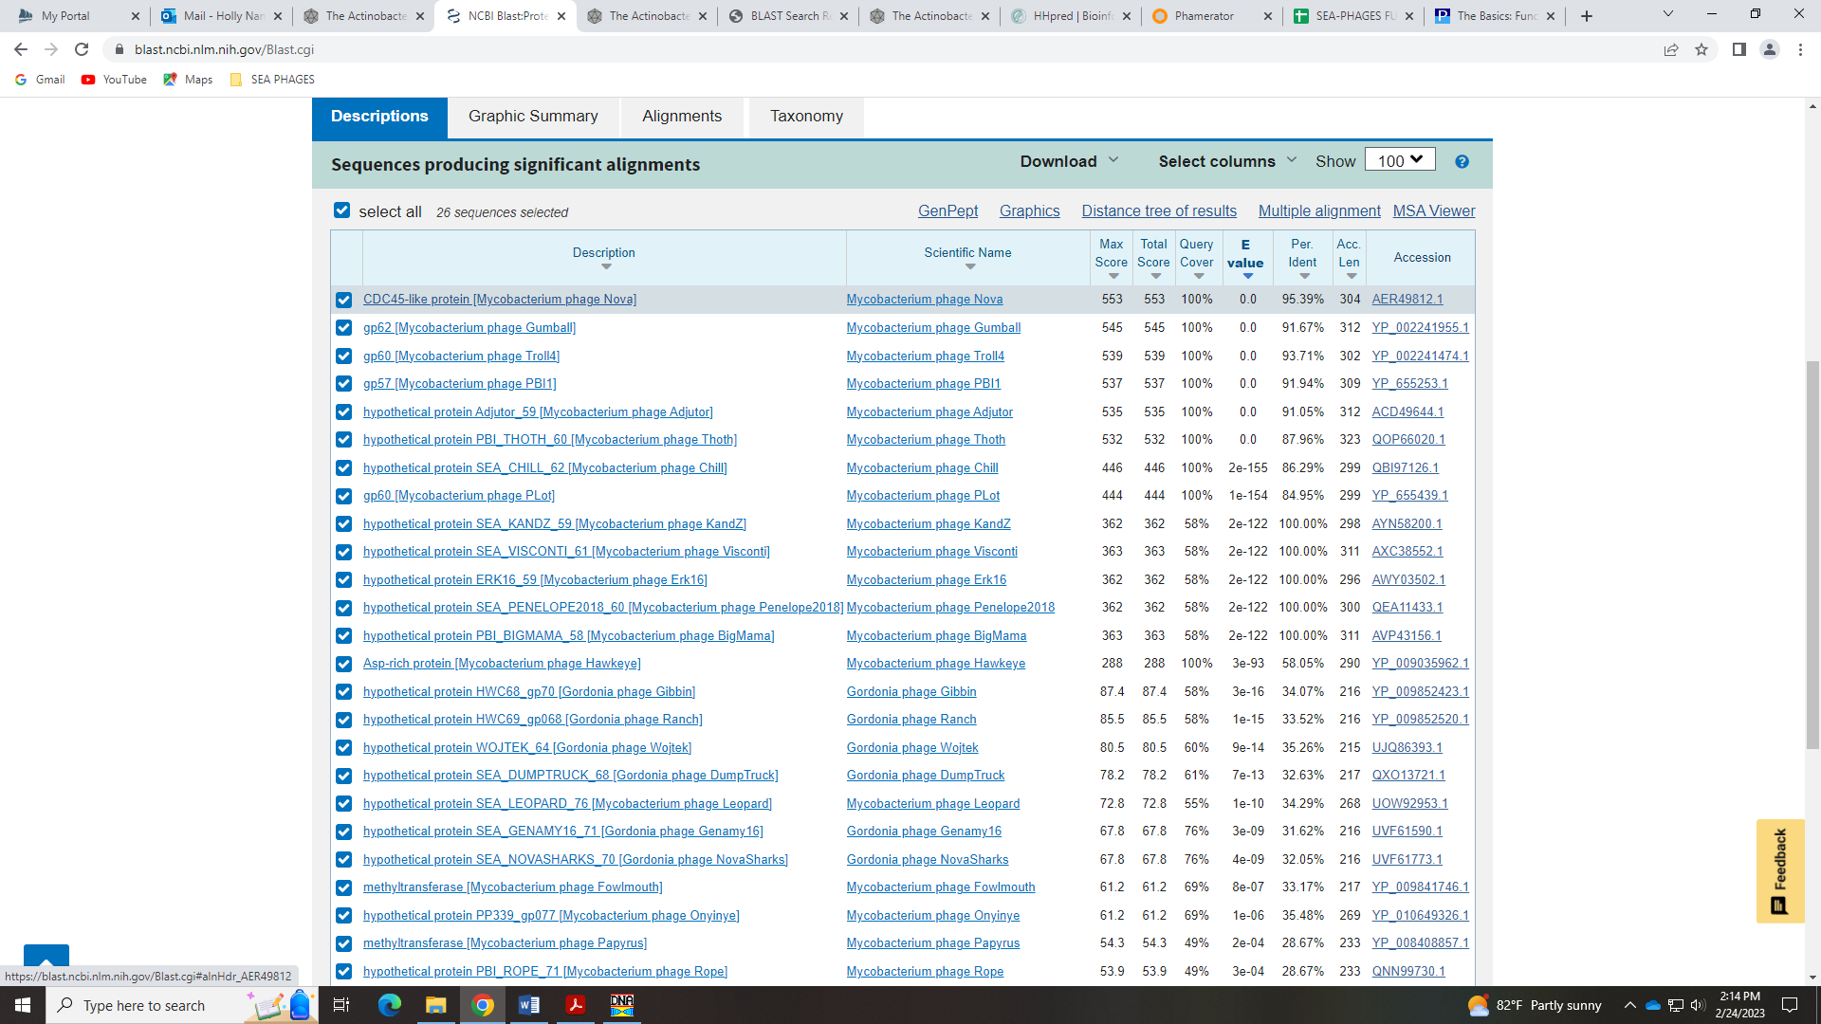
But the vast majority are NKF. There are some HHPred hits above 90%, but most are partial and do not make sense in a phage, like proteins for nucleolar RNA, nucleosome assembly, vaculolar import, ribosomal assembly… these are proteins in eukaryotes.
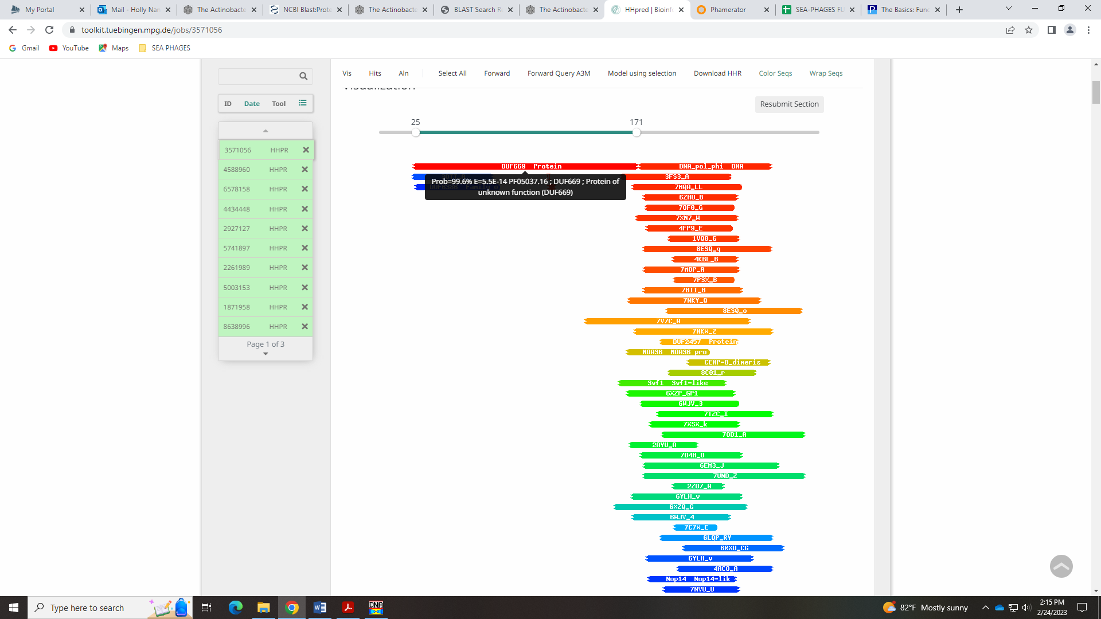
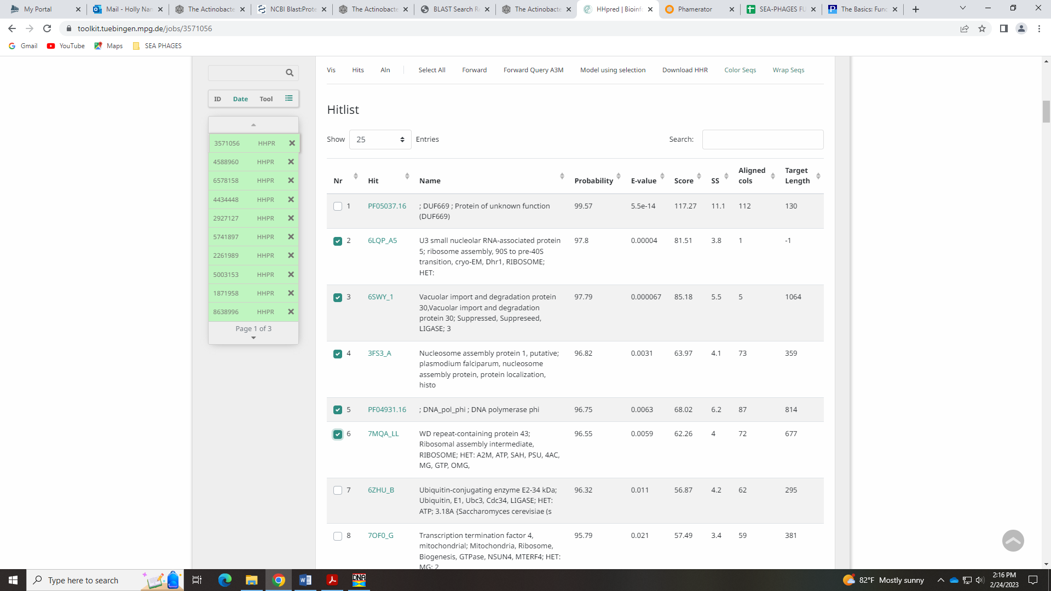
Given the lack of evidence to call this anything, I’m going with NKF.

Gene 60 – New gene added 4.27.2023! - Anna
SSC: start 46334, stop 46450; CP: no; SCS: neither called this gene, we added it; ST: NA; Blast Start: matches SirHarley_63 Query 1 to Subject 1 100% 4e⁻¹⁹; Gap: 101; LO: yes; RBS: -1.259, 3.295, 9, -2.034, yes; F: NKF; SIF-BLAST: NKF/PhageDB BLAST/ SirHarley_63, JF937107/100%/1e⁻¹⁹; SIF-HHPred: NKF, only one matches with a probability above 90% for DNA helicase; SIF-Syn: NKF
Notes: Anna added this gene. There are several good BLAST hits and this makes the gap between the two genes on either side smaller.
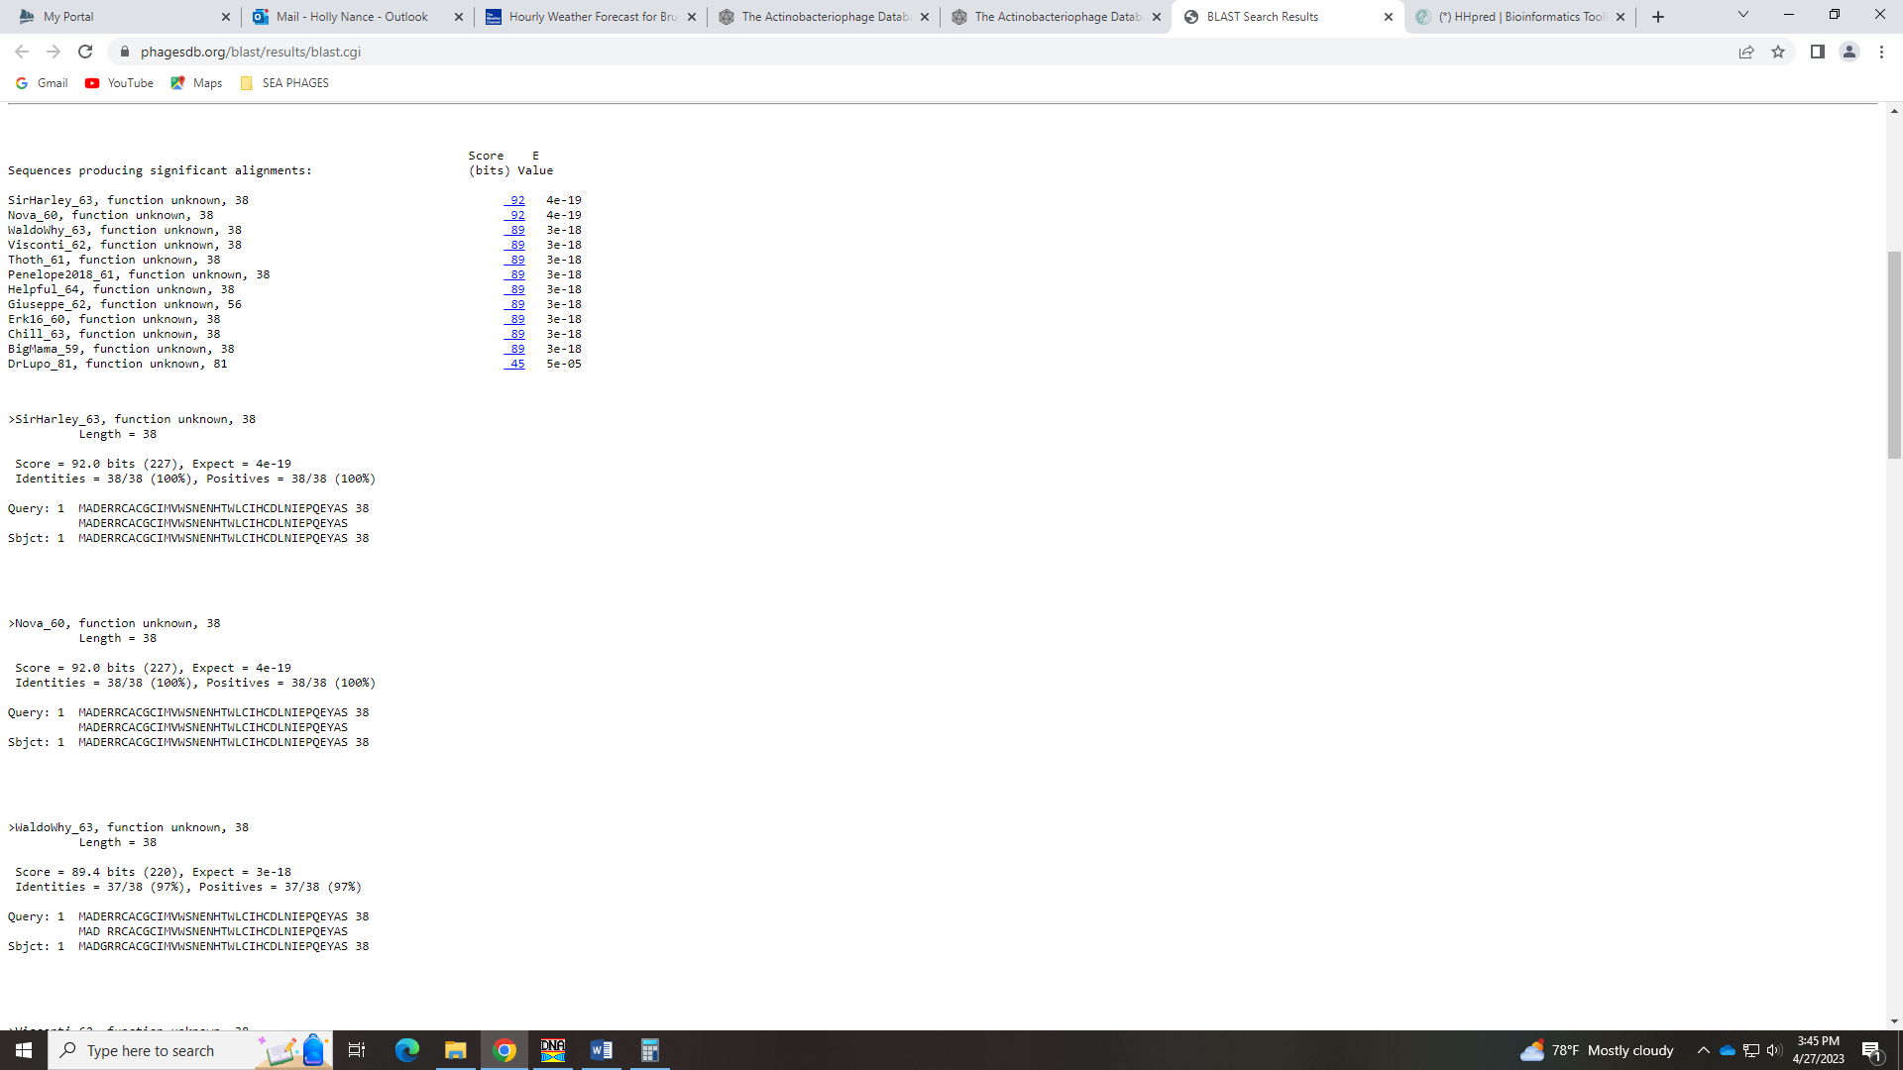
One hit above 90% for a DNA helicase gene in HHPred but the e-val is high (0.18)
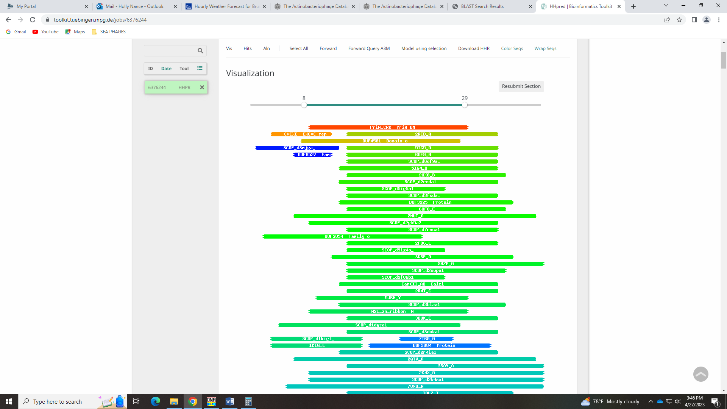
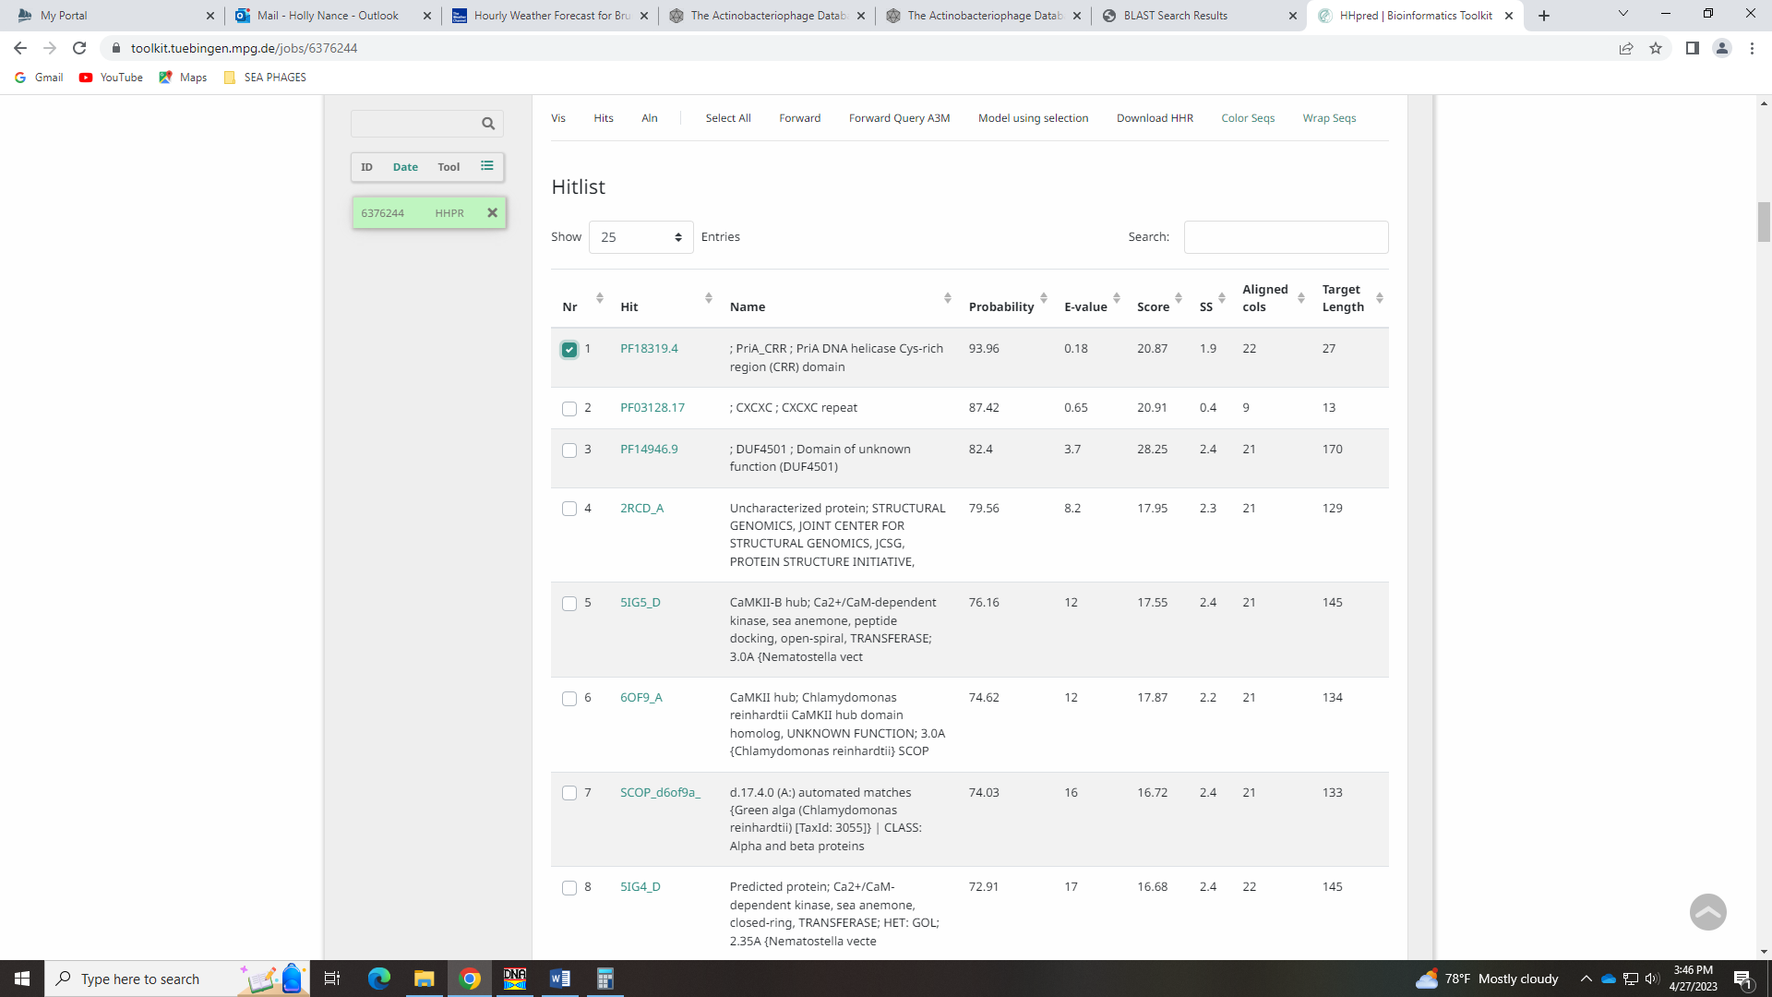

Gene 61 in our file, Gene 61 in PhagesDB
SSC: start 46447, stop 47250; CP: yes; SCS: Glimmer called start of 46447, GeneMark called start of 46510; ST: SS; Blast Start: matches WaldoWhy_64 Query 1 to Subject 1 100% 1e⁻¹⁶²; Gap: overlap of 4; LO: no; RBS: -1.395, 3.230, 12, -2.231, yes; F: oxidoreductase; SIF-BLAST: oxidoreductase /PhageDB BLAST/WaldoWhy_64, MT889385/100%/1e⁻¹⁶²; SIF-HHPred: NKF, no matches with a probability above 90%; SIF-Syn: oxidoreductase
Notes: The Glimmer start is most conserved and yields a longer gene. 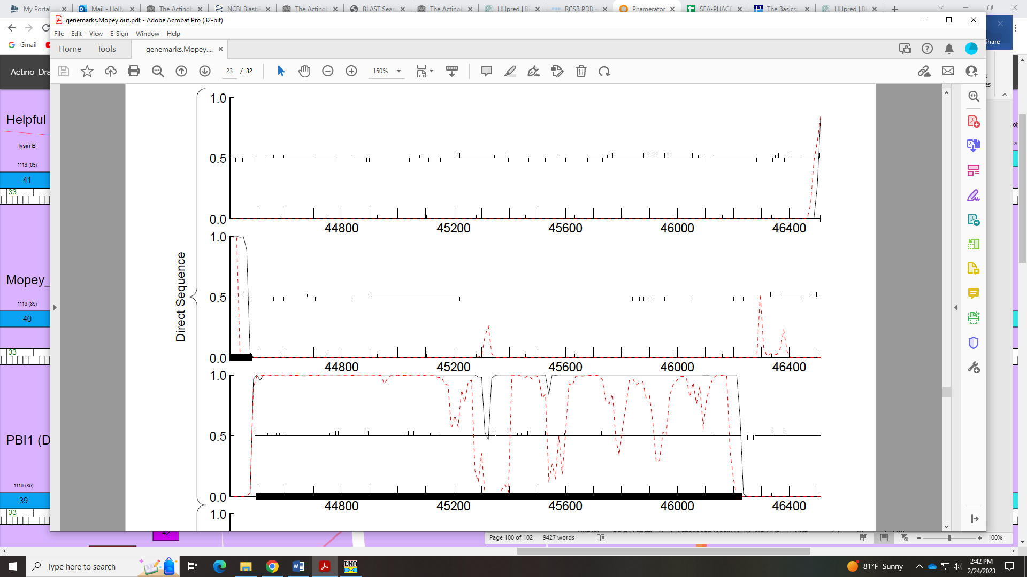
Regarding functions, both NCBI and PhagesDB BLAST support oxidoreductase:
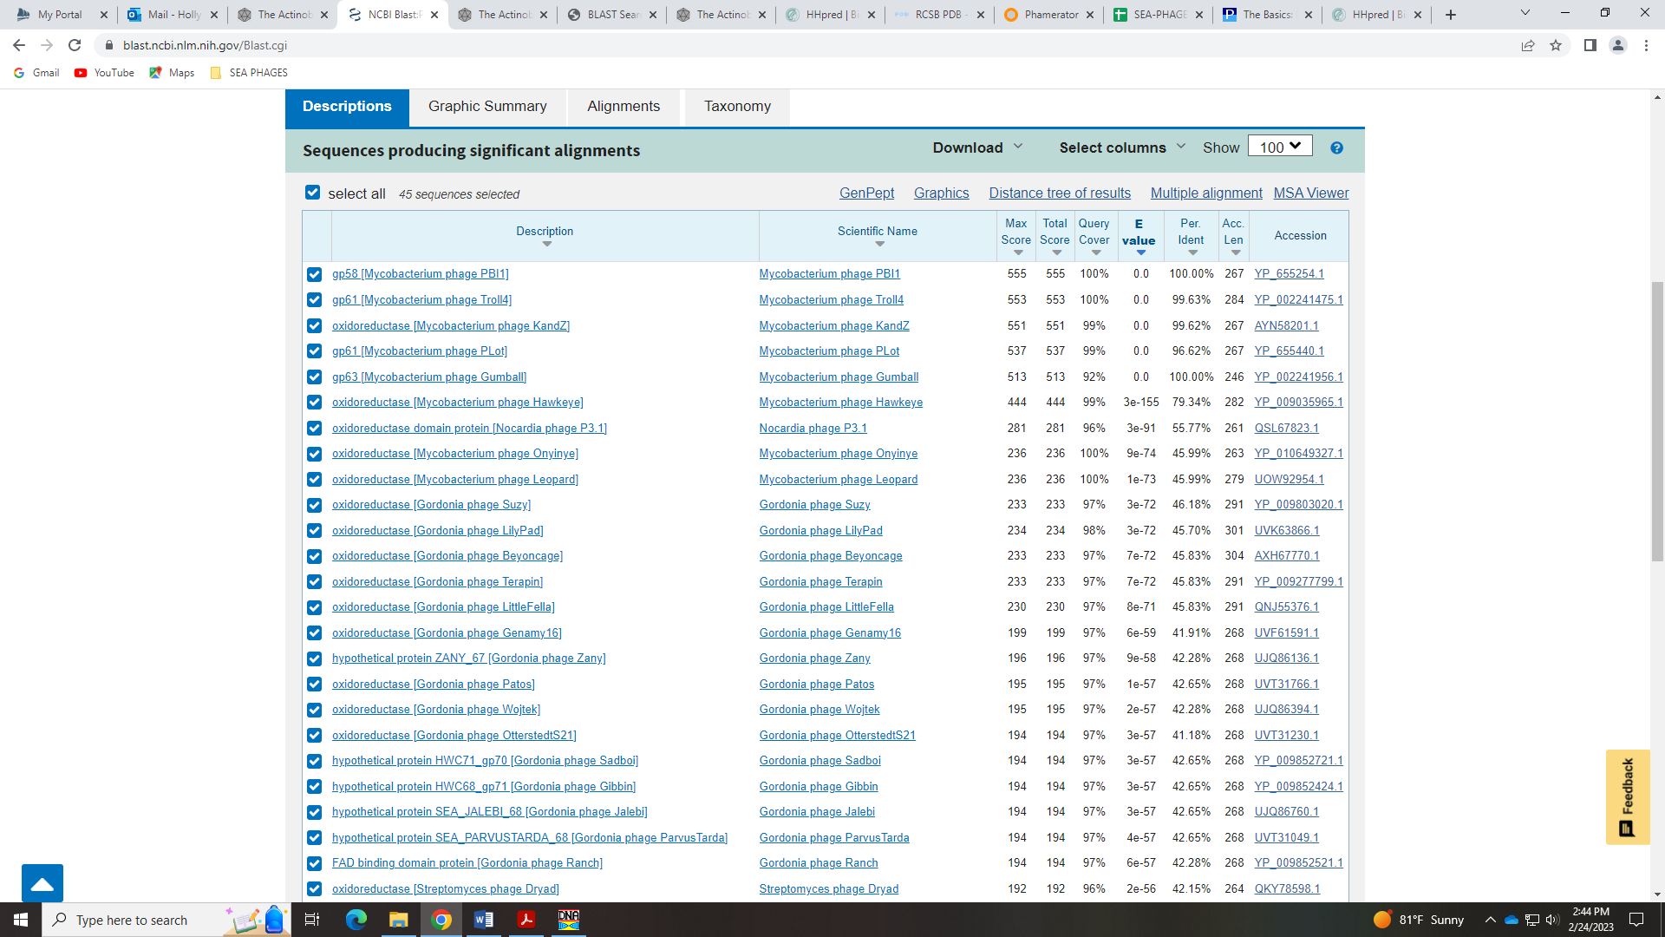
Synteny in Phamerator does, too:
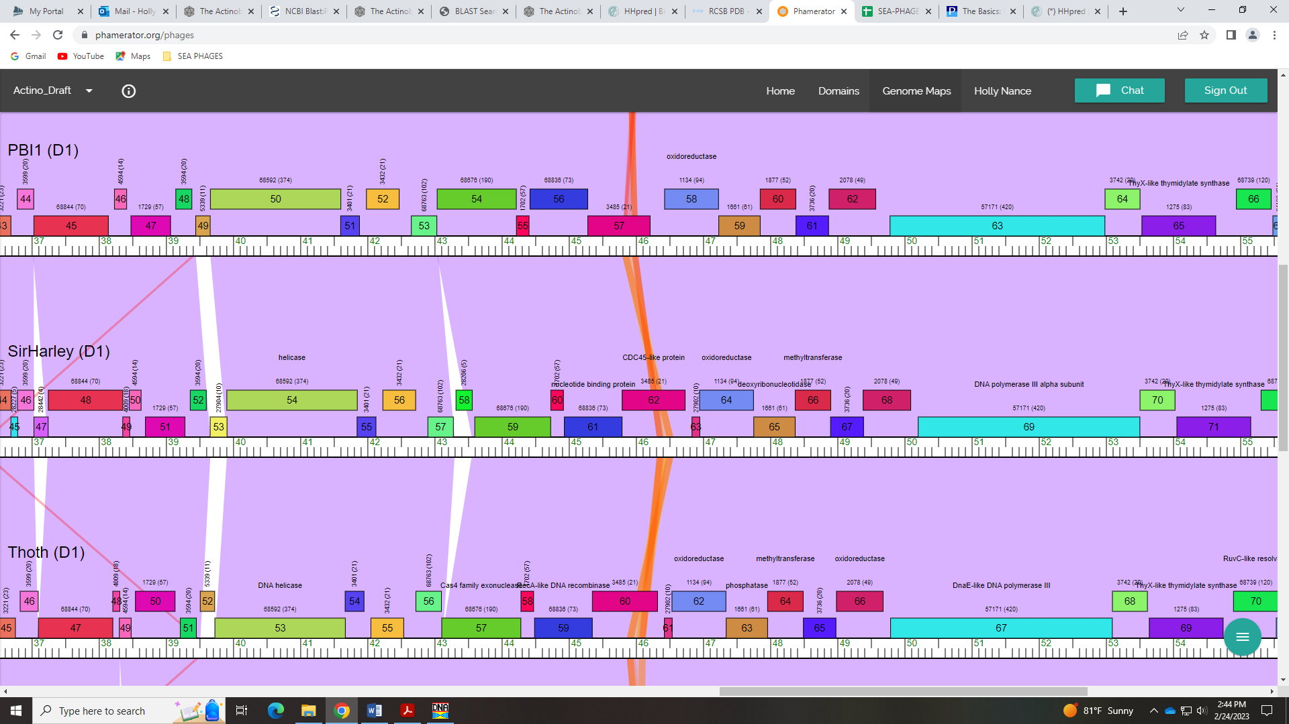
In HHpred, there are several hits with a prob above 98%for this function:
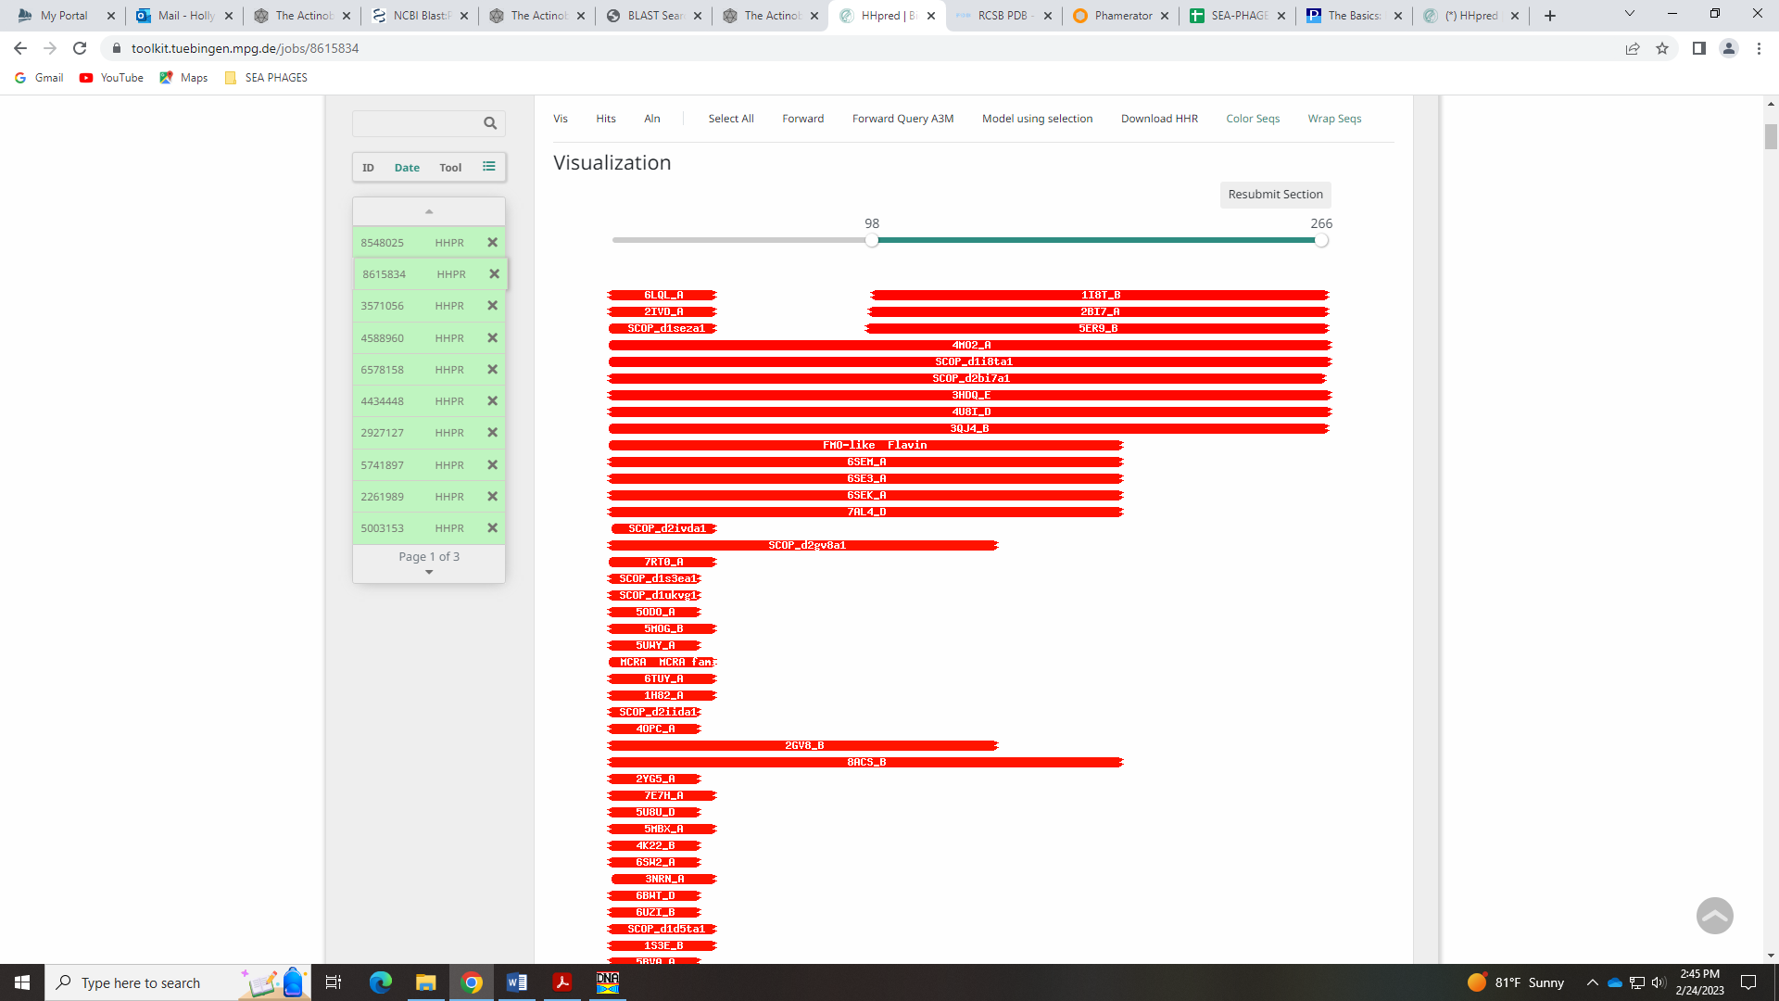
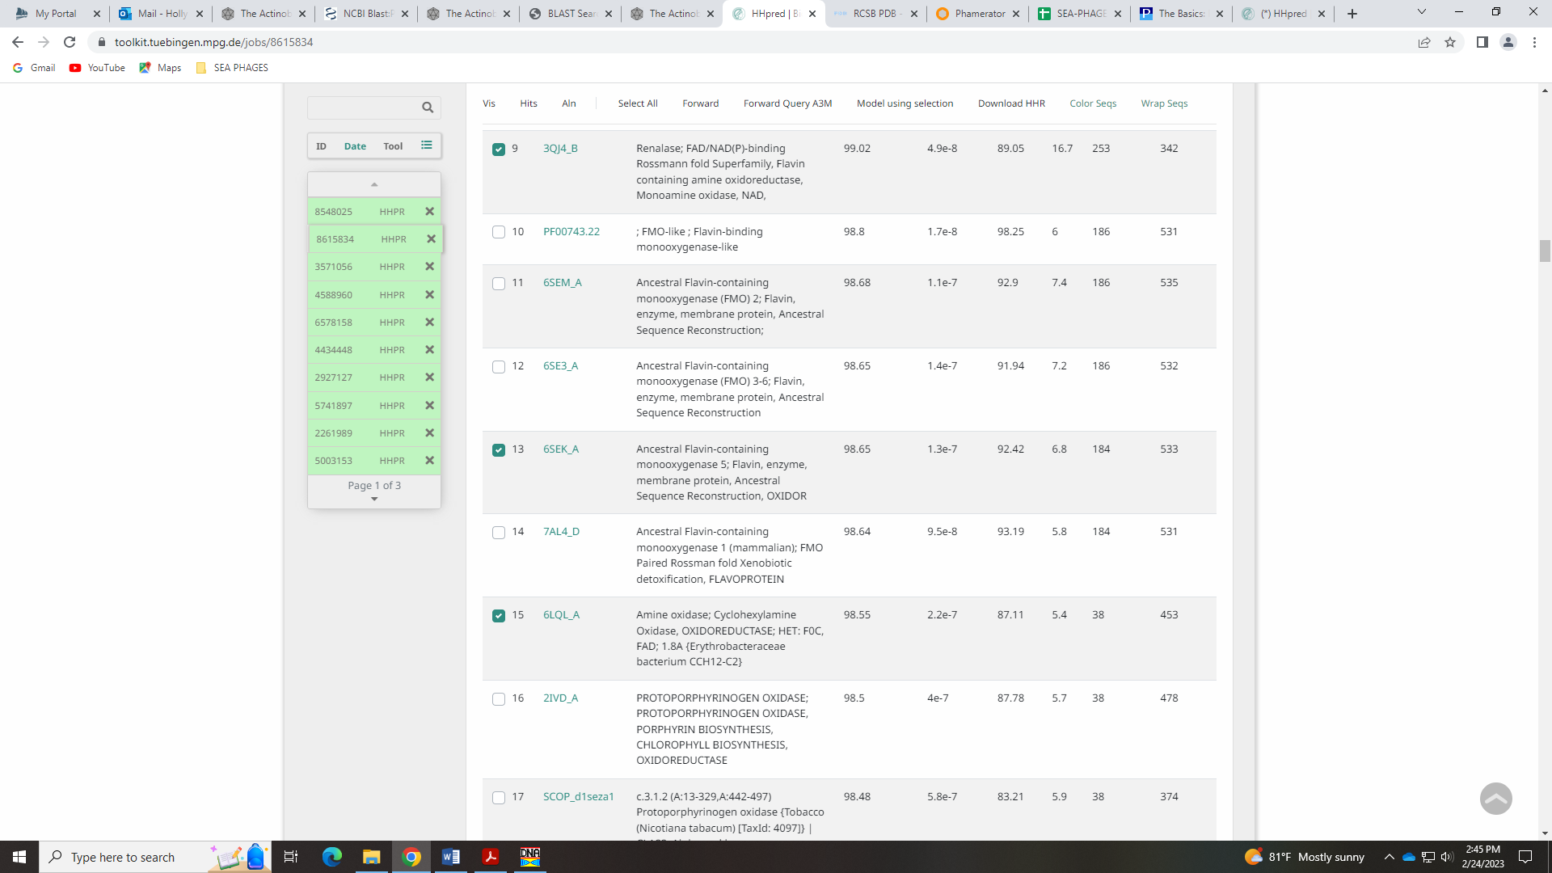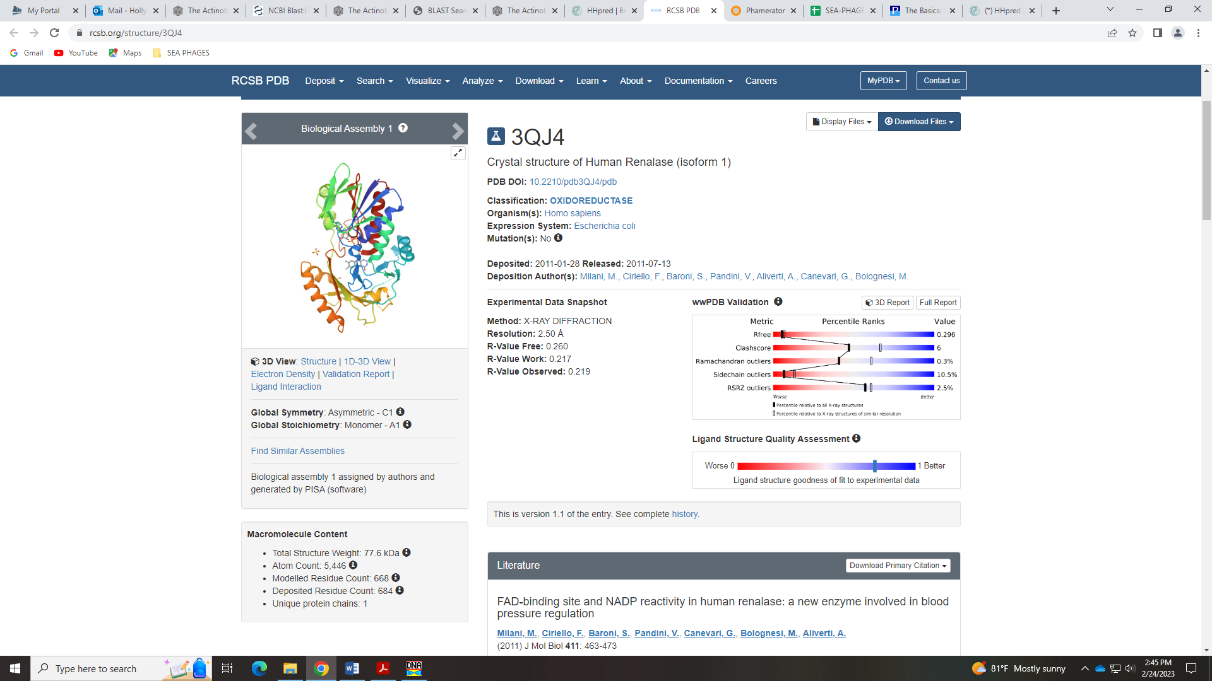
This function is in the Official List and the example gene is Onyinye_78. When you submit this gene to HHPred, the two top hits at 99% prob are oxidoreductase:
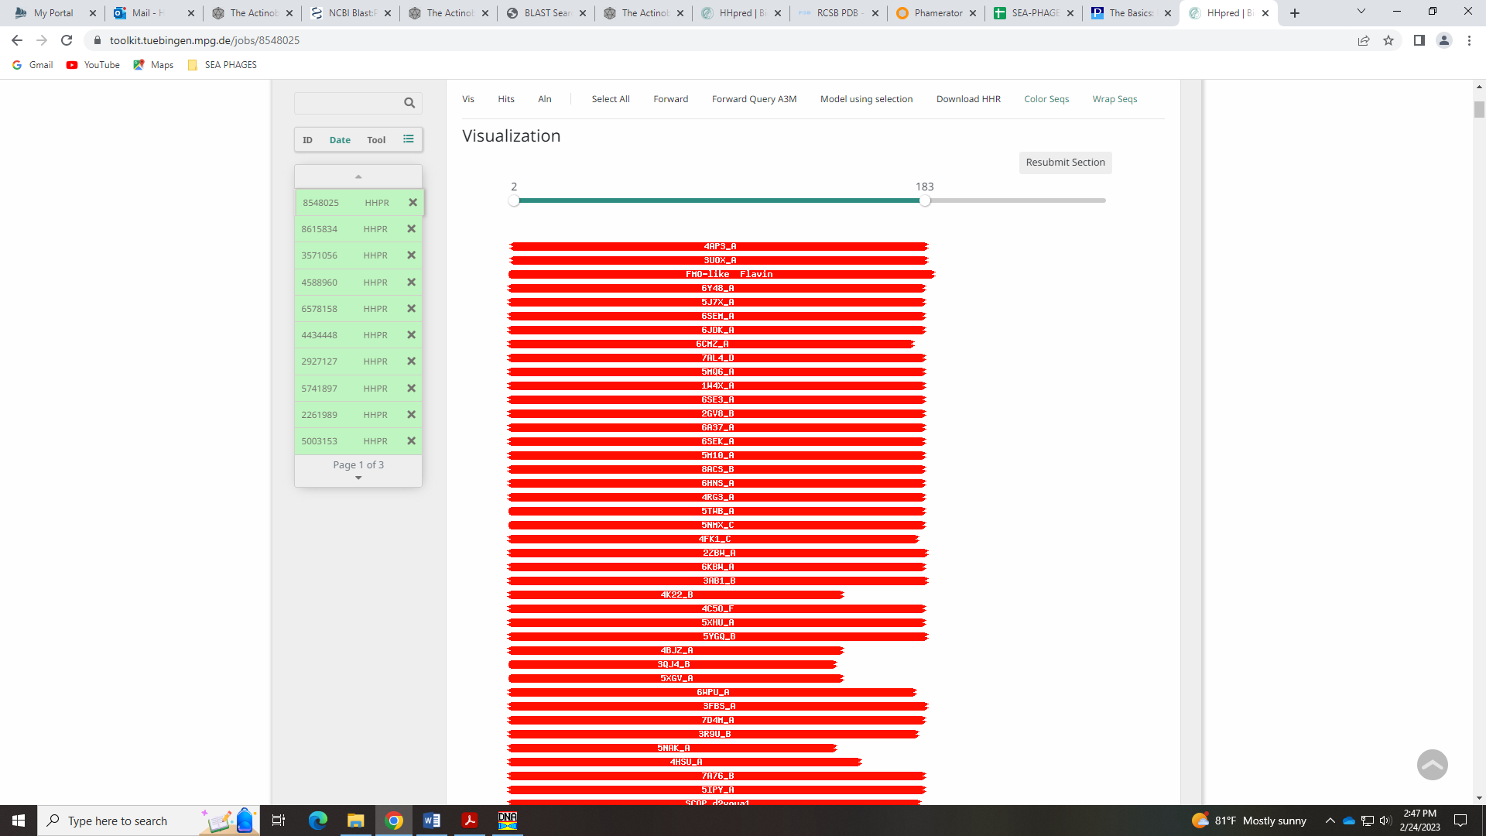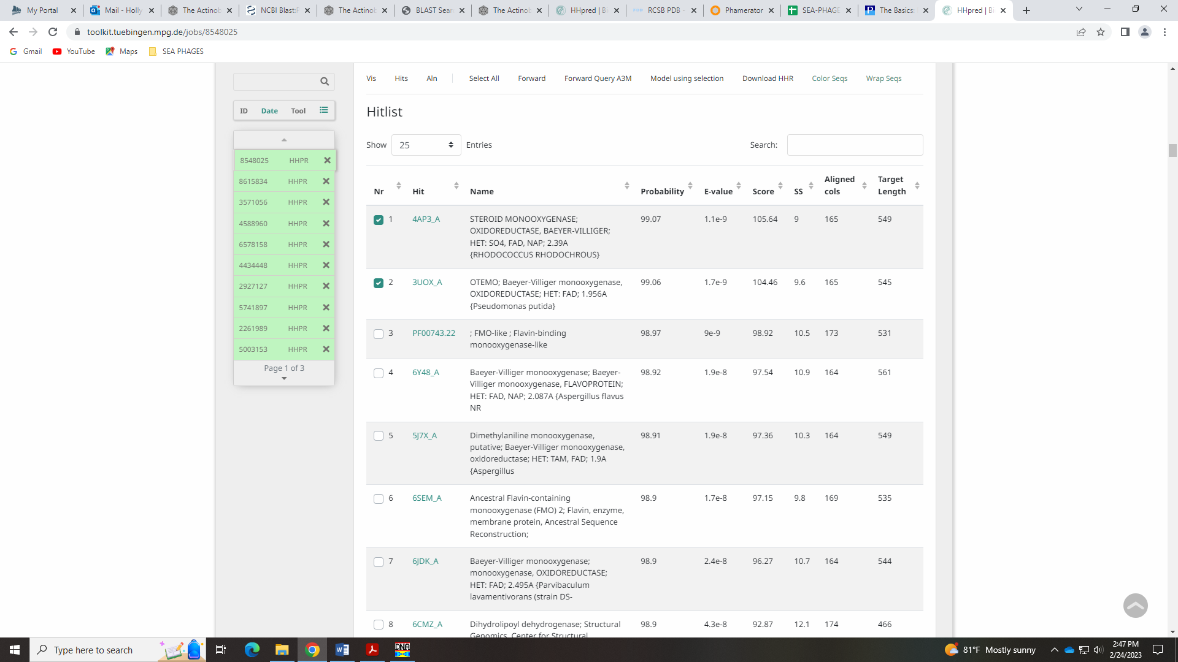
I’m good with calling this function as oxidoreductase.

Gene 62 in our file, Gene 62 in PhagesDB – Lowry
SSC: start 47254, stop 47871; CP: yes; SCS: Glimmer called start of 47254, GeneMark called start of 47257; ST: SS; Blast Start: matches WaldoWhy_65 Query 1 to Subject 1 100% 1e⁻¹¹⁹; Gap: 3; LO: NA; RBS: -5.046, 1.479, 13, -6.092, no; F: hydrolase; SIF-BLAST: hydrolase/PhageDB BLAST/Helpful_66, MN284409/100%/1e⁻¹¹⁹; SIF-HHPred: hydrolase, several matches with a probability above 98%; SIF-Syn: phosphatase or hydrolase
Notes: The Glimmer start was the most conserved in Starterator and BLAST output. It had the same RBS values as the alternative start suggested by GeneMark.
For function, there are BLAST hits for NKF, hydrolase, phosphatase, deoxyribonucleoditase, nucleotide pyrophosphohydrolase… all kinds of -ase names. Not all are on the Official Phage Function List. HHpred has many hits with high probability for phosphatase:
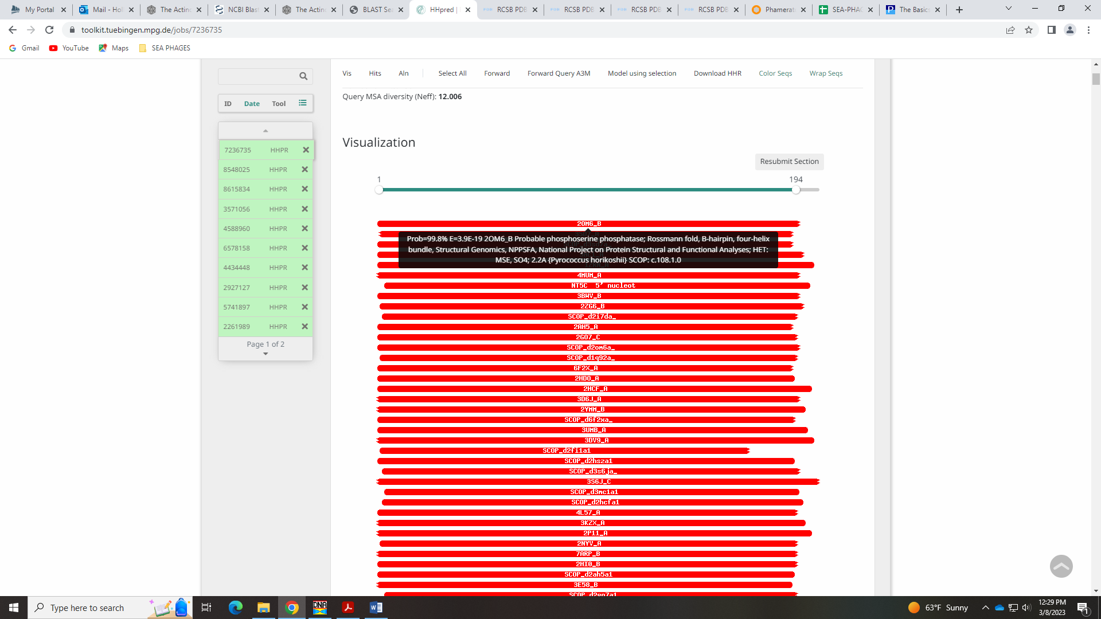
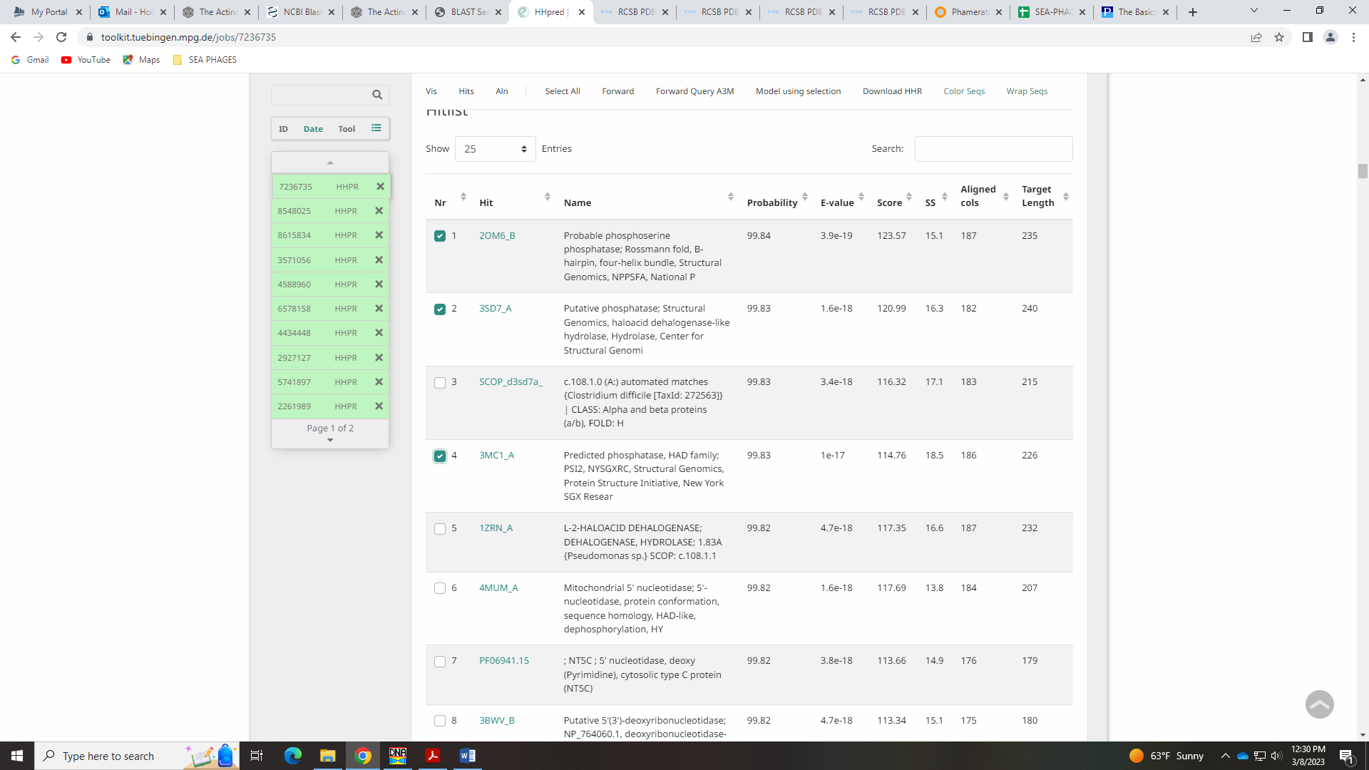
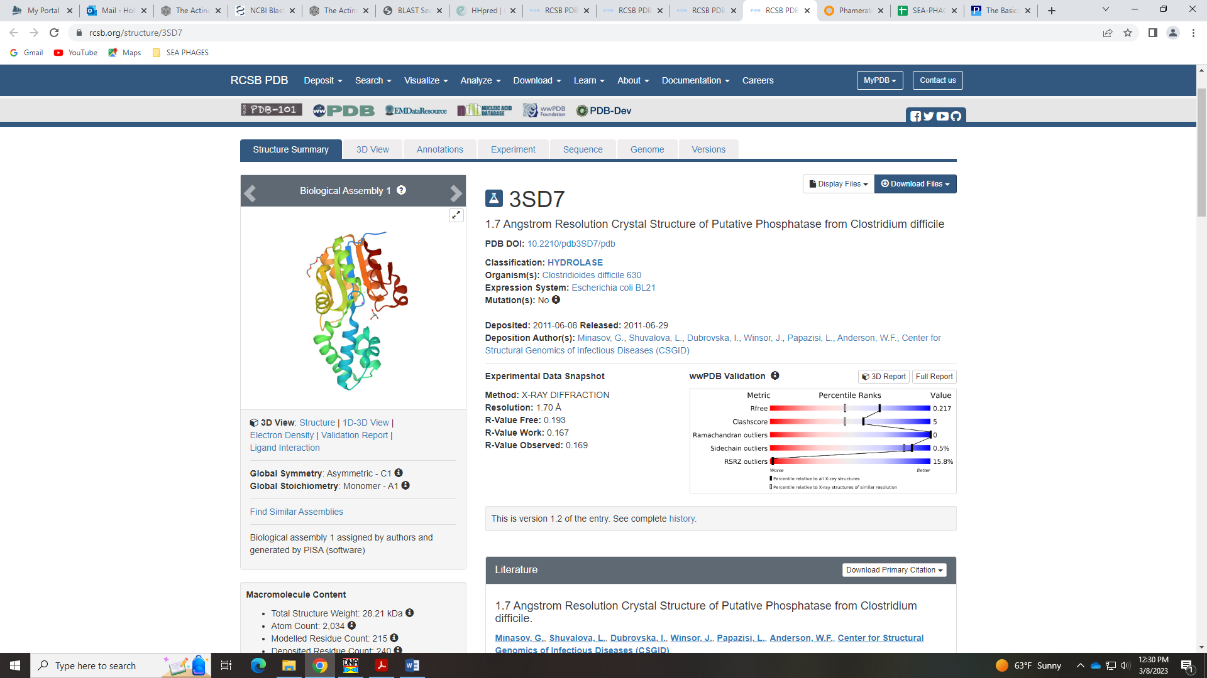
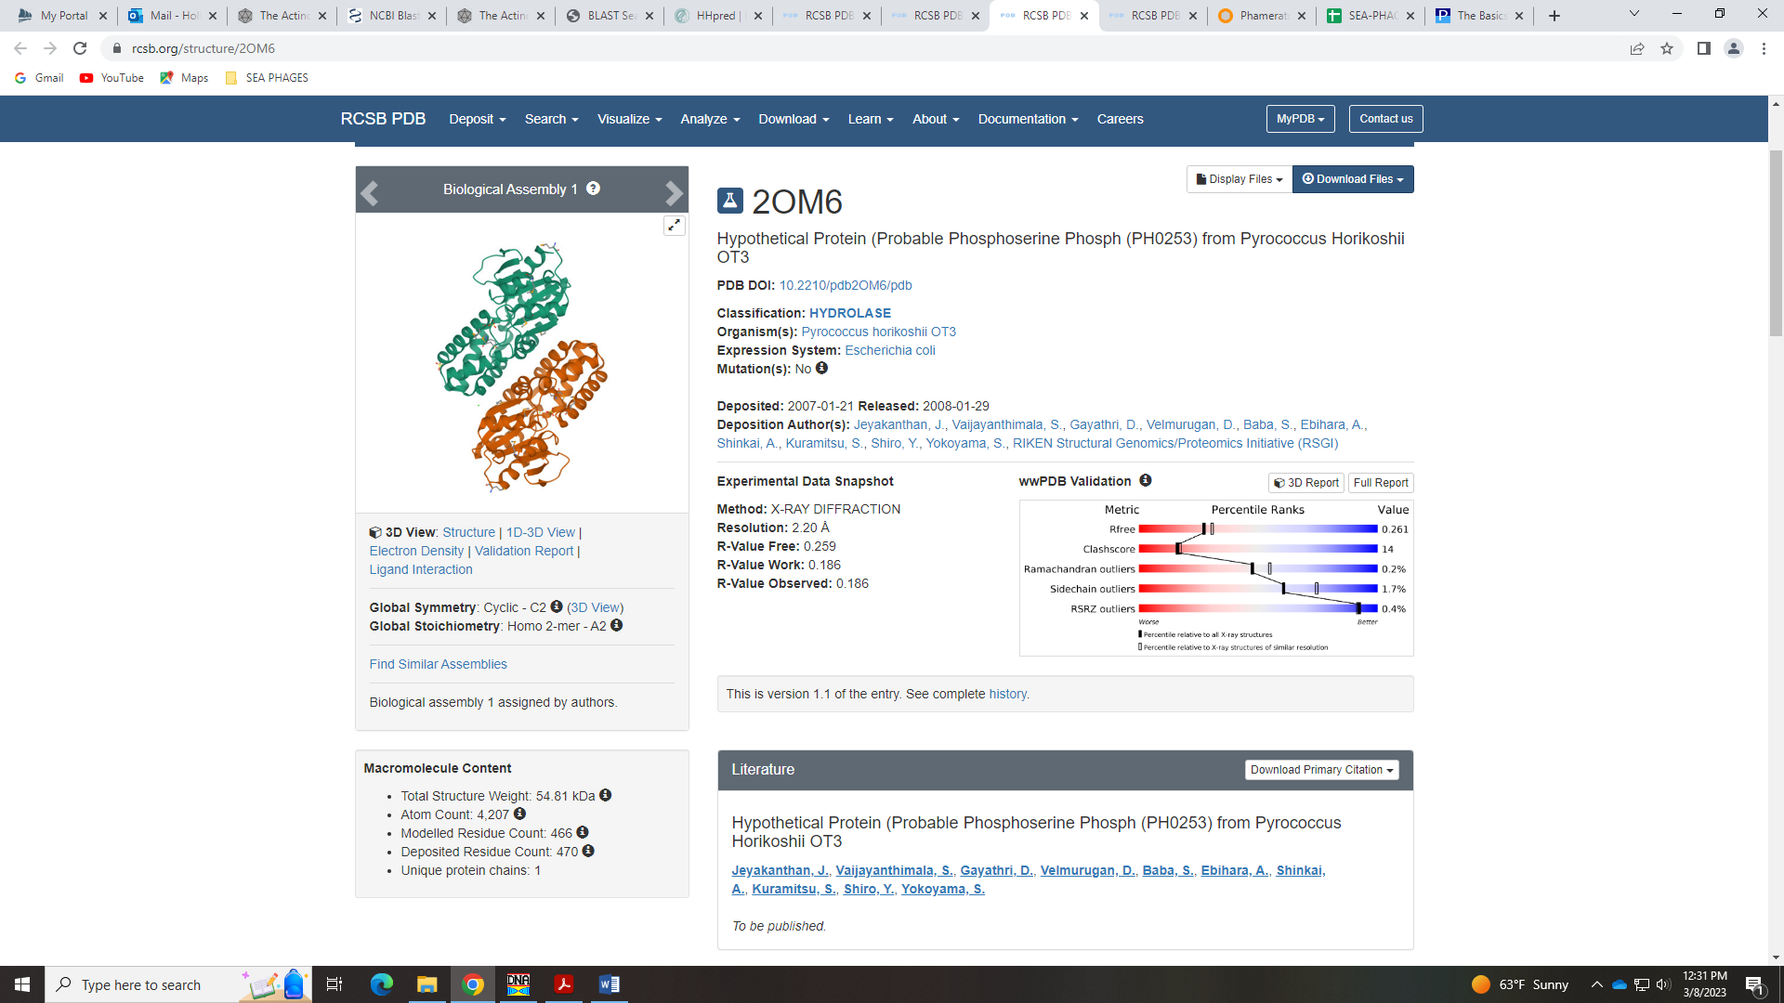
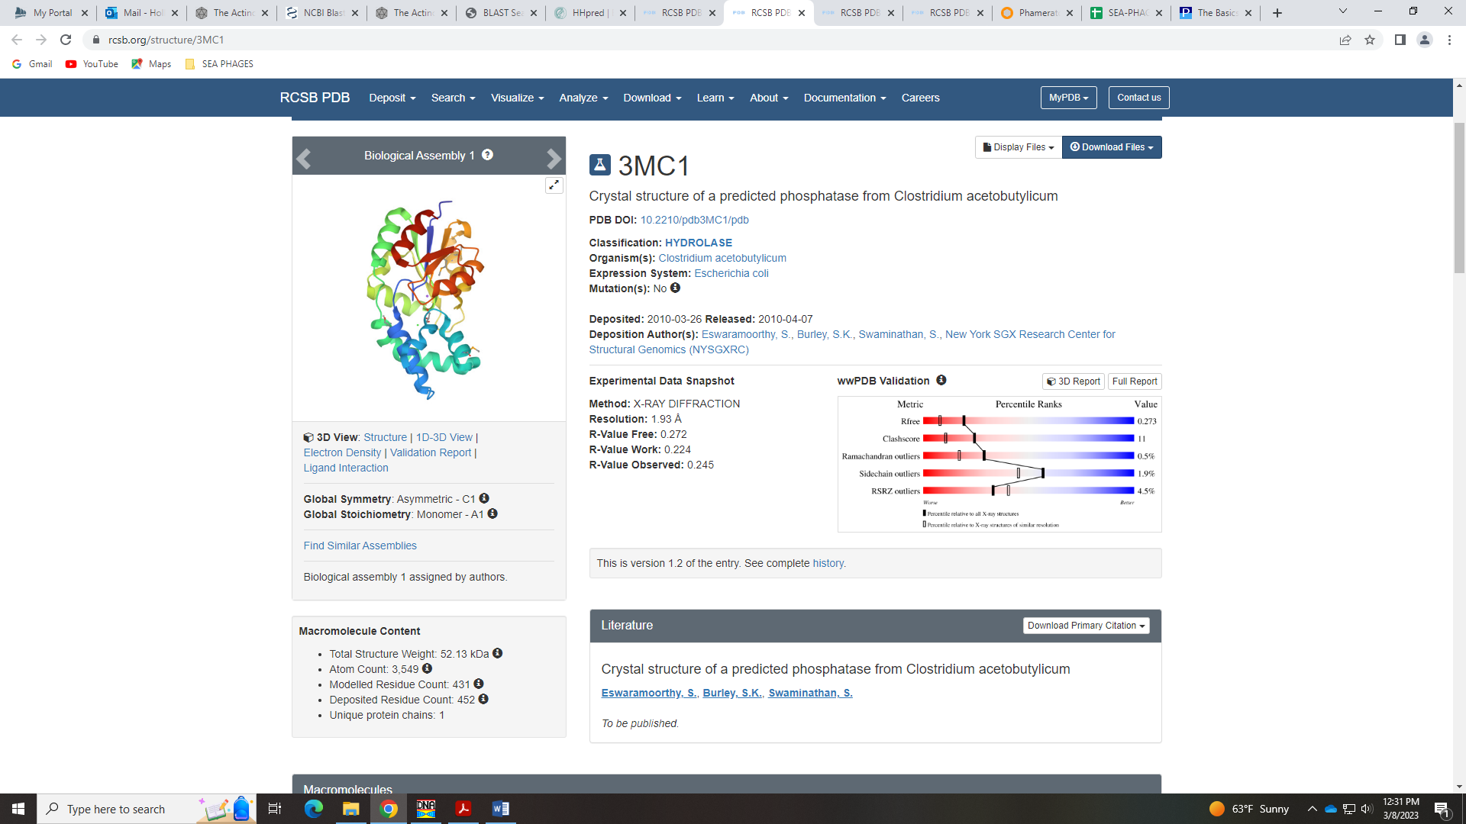
Phosphatase is on the Official Phage Function List, but there is no example given and no other information on when to call this. There are also hits for hydrolase, which is also on the official phage function list. Some of the other hits in HHPred are for proteins not found in bacteria or phages. I’m not sure what the class will decide. Lowry went with hydrolase.
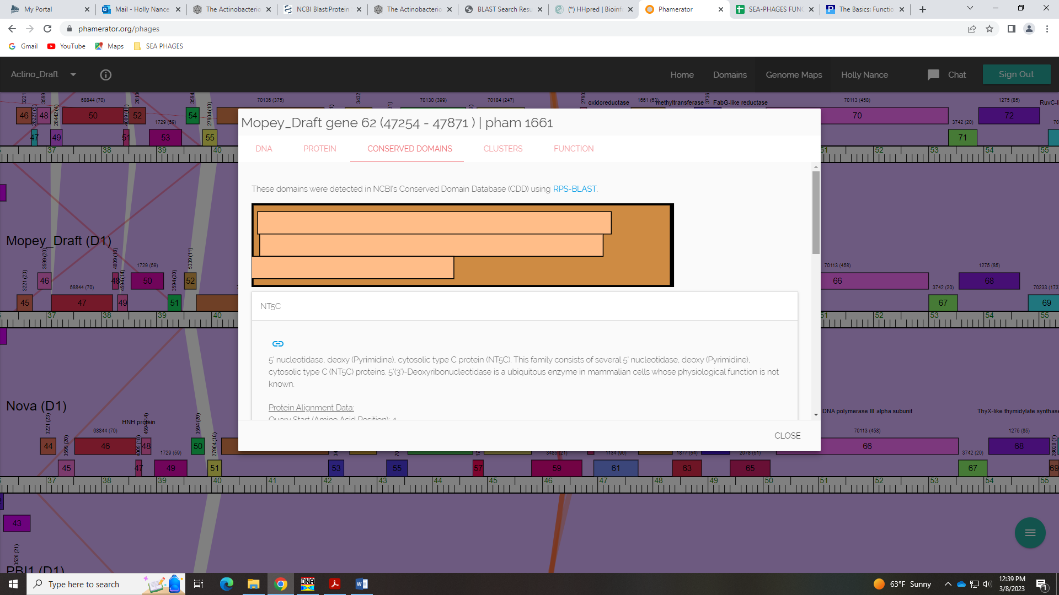

Gene 63 in our file, Gene 63 in PhagesDB
SSC: start 47871, stop 48401; CP: yes; SCS: Both called start of 47871; ST: SS; Blast Start: matches WaldoWhy_66 Query 1 to Subject 1 100% 1e⁻¹⁰³; Gap: overlap of 1; LO: NA; RBS: -2.814, 2.549, 9, -3.589, yes; F: methyltransferase; SIF-BLAST: methyltransferase/PhageDB BLAST/ WaldoWhy_66, MK494102/100%/1e⁻¹⁰³; SIF-HHPred: methyltransferase, several matches with a probability above 99%; SIF-Syn: methyltransferase
Notes: For function, both PhagesDB BLAST and NCBI BLAST support methyltransferase:
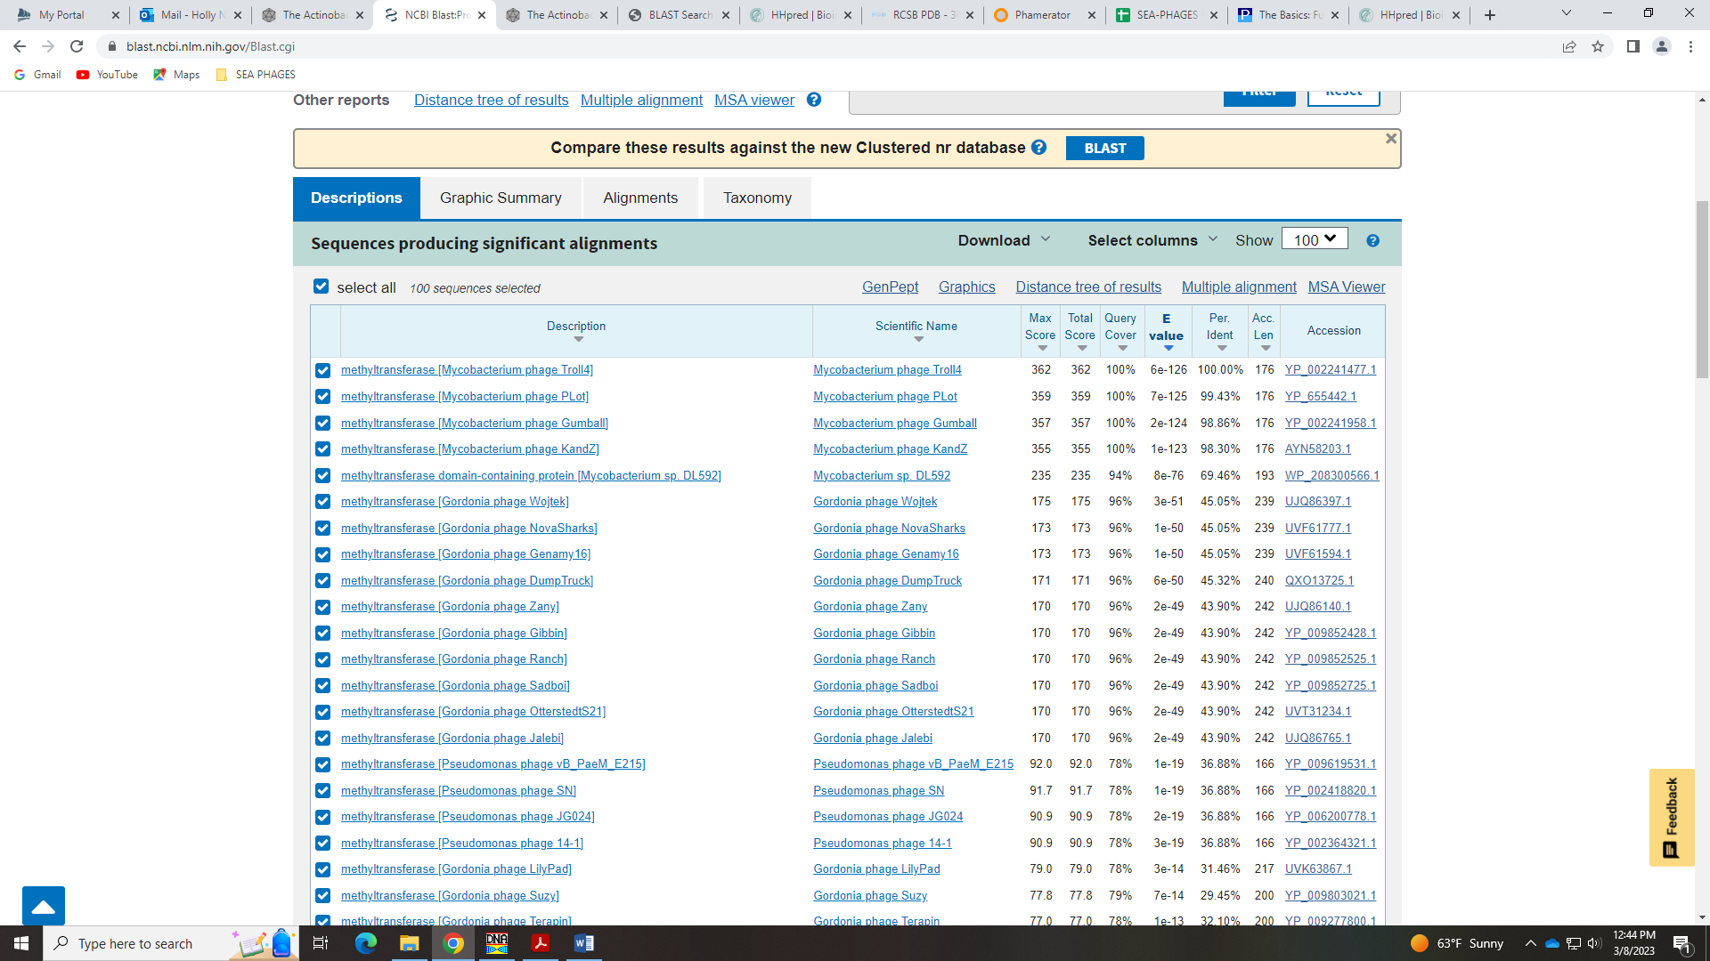
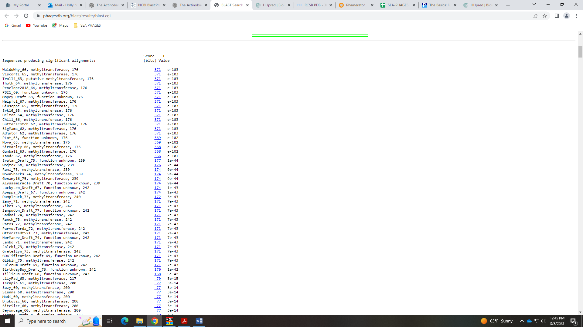
Synteny and Phamerator also support this function, with two methyltransferase domains:
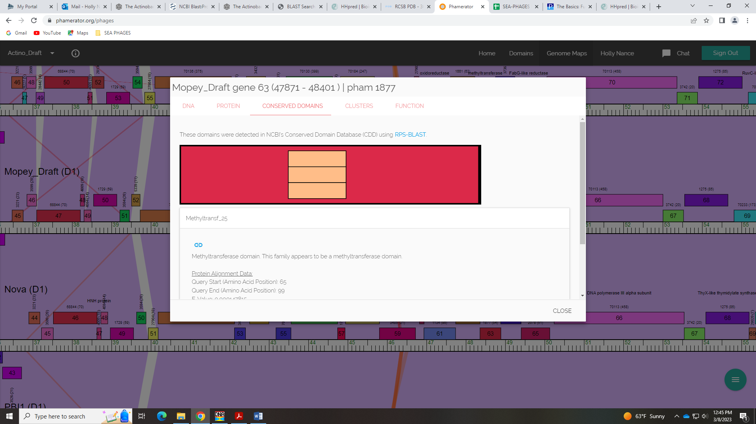
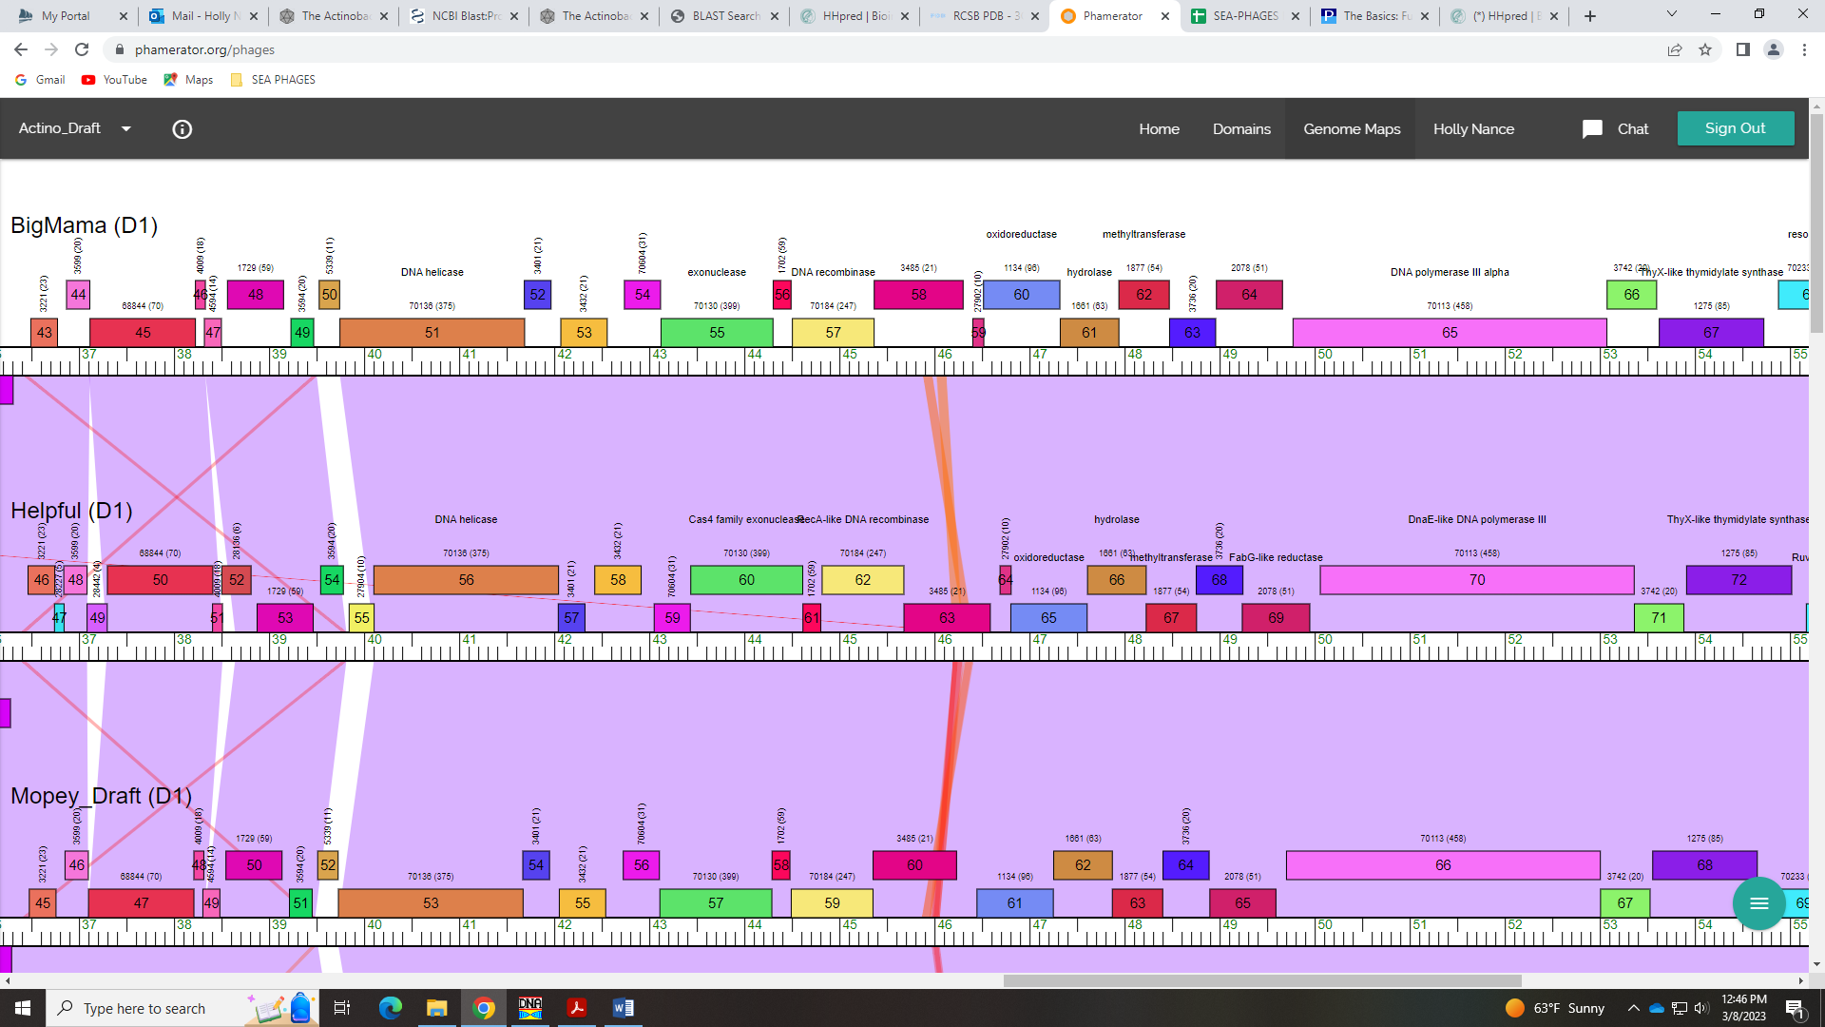
Finally, HHPred has several hits with over 99% probability for methyltransferase:
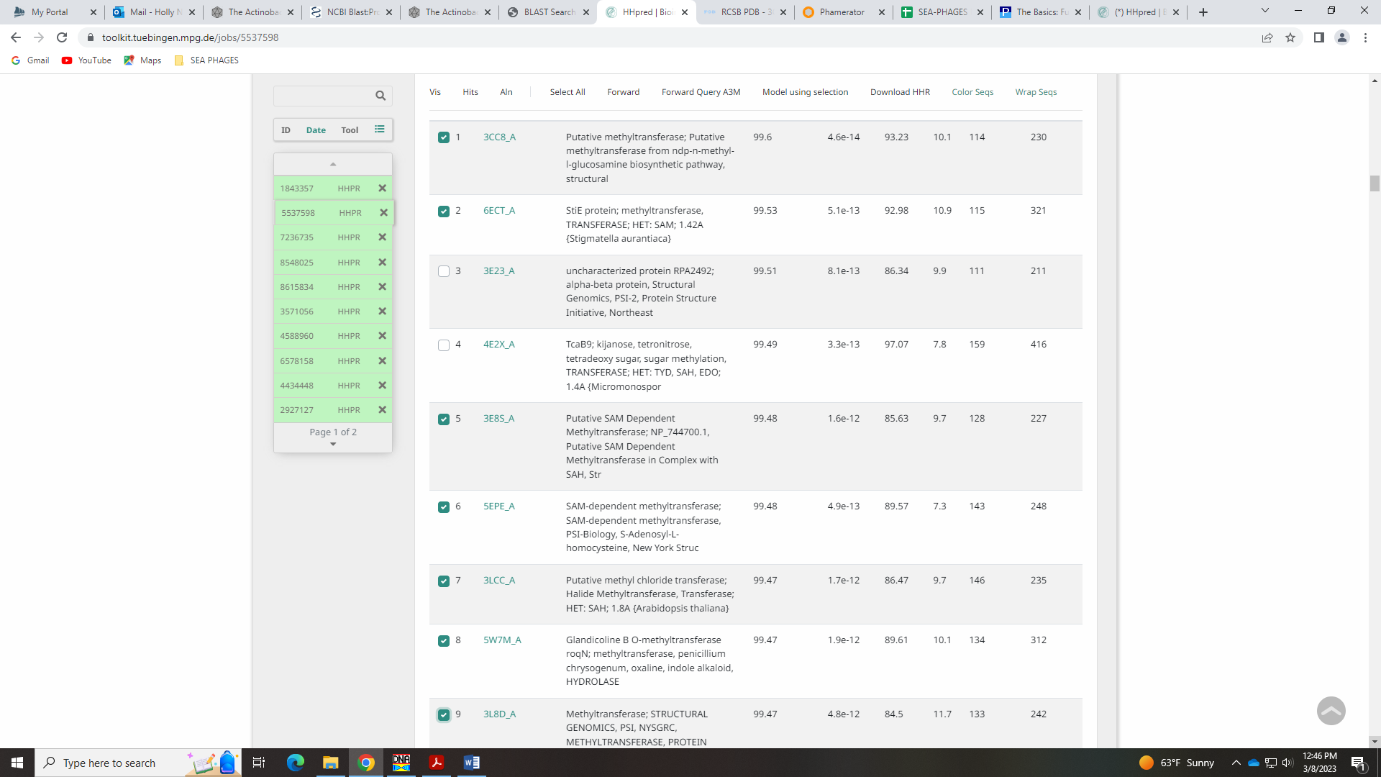
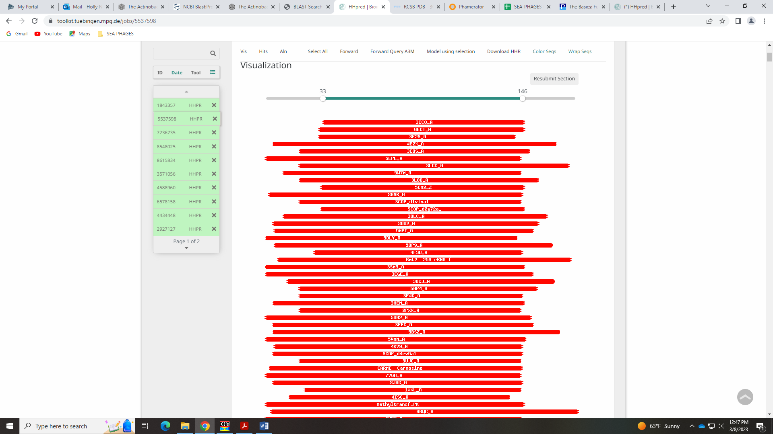
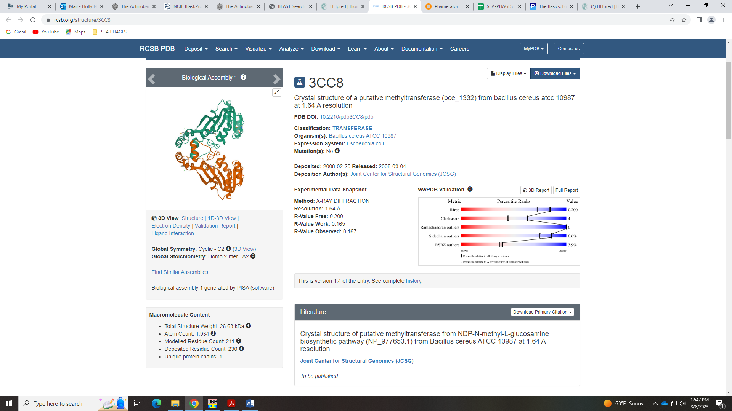
Finally, methyltransferase is on the Official List, and the example is Optimus_14. This gene’s HHPred hits are also for methyltransferase:
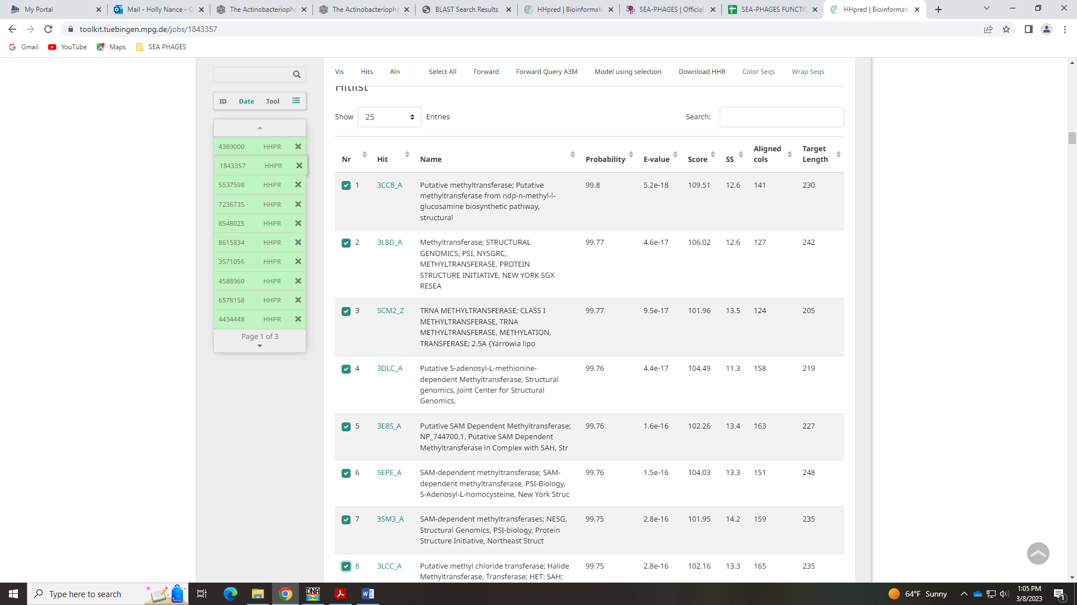
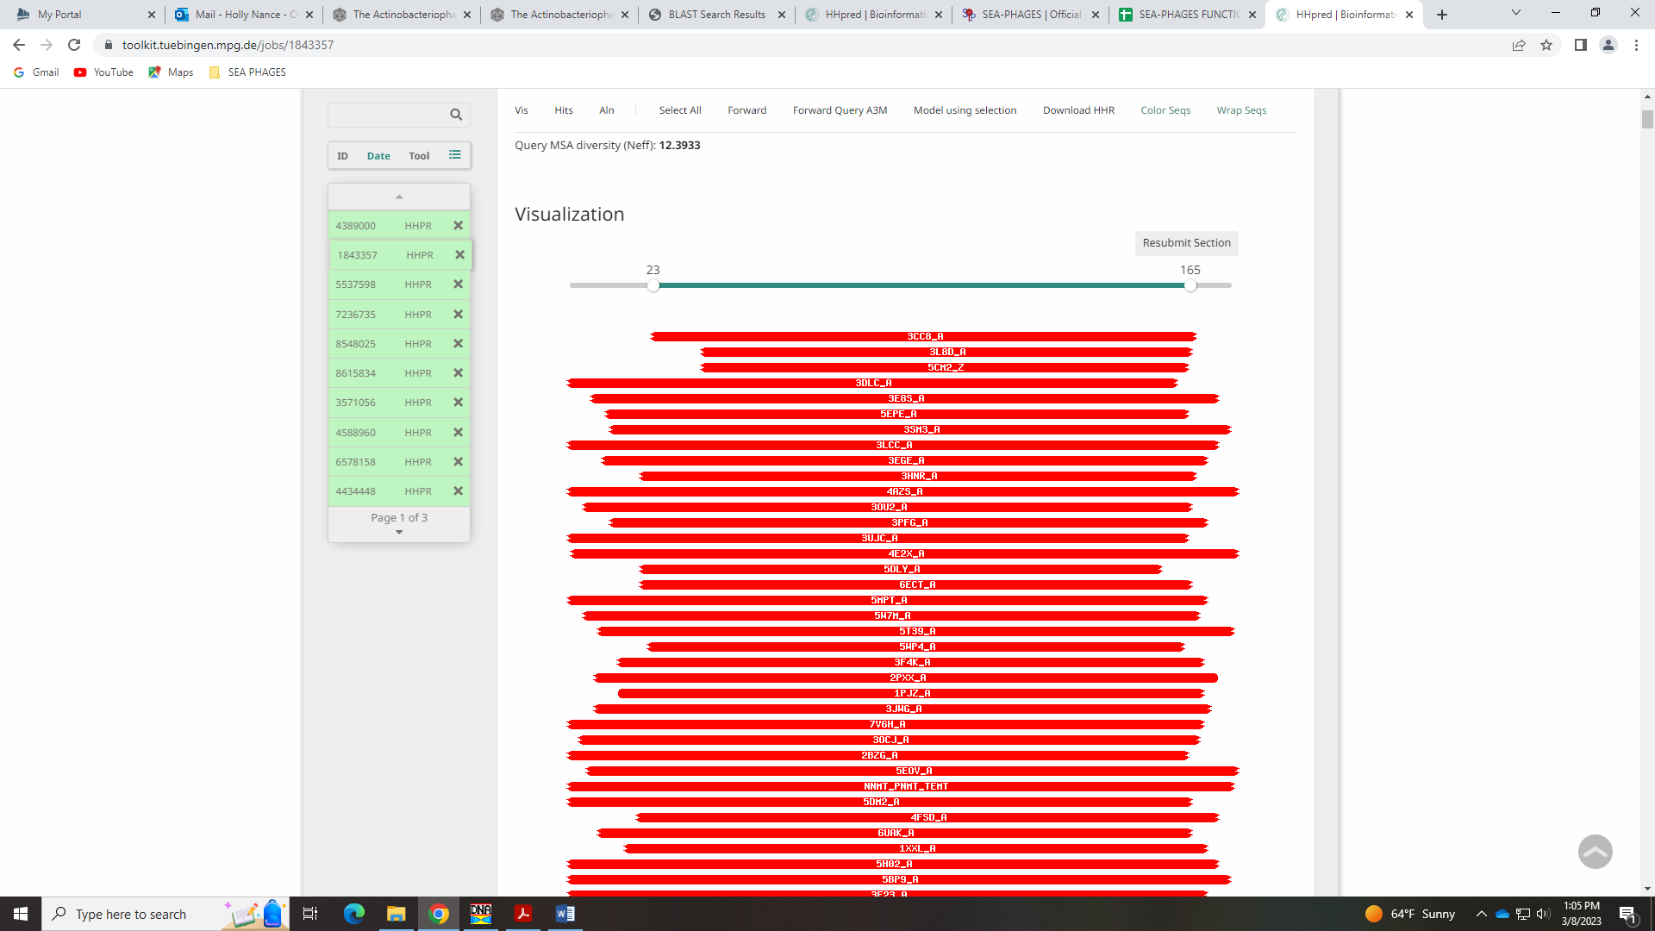
I feel comfortable calling this methyltransferase.

Gene 64 in our file, Gene 64 in PhagesDB
SSC: start 48404, stop 48889; CP: yes; SCS: Glimmer called start of 48404, GeneMark called start of 48398; ST: SS; Blast Start: matches Visconti_66 Query 1 to Subject 1 100% 1e⁻⁸⁹; Gap: 2; LO: NA; RBS: -1.748, 3.061, 9, -2.523, yes; F: NKF; SIF-BLAST: NKF/PhageDB BLAST/Visconti_66, MH399788/100%/1e⁻⁸⁹; SIF-HHPred: NKF, matches with a probability above 90% are NKF or partial hit to nucleotide modification domain; SIF-Syn: NKF
Notes: Glimmer start is more conserved and won’t cause an overlap with the previous gene.
For function, BLAST and synteny support NKF. The HHPred hits with a probability above 90% are all partial hits for NKF (hypothetical protein) or for a nucleotide modification associated domain:
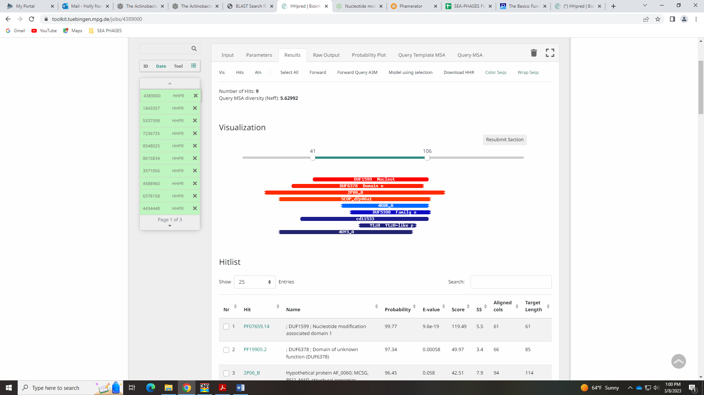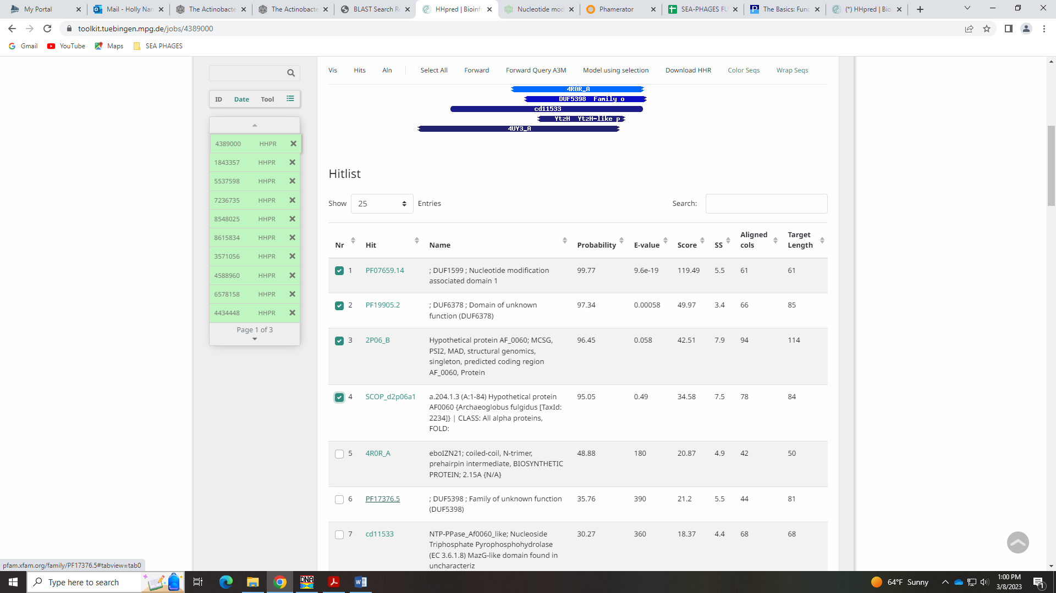
The nucleotide domain hit is:
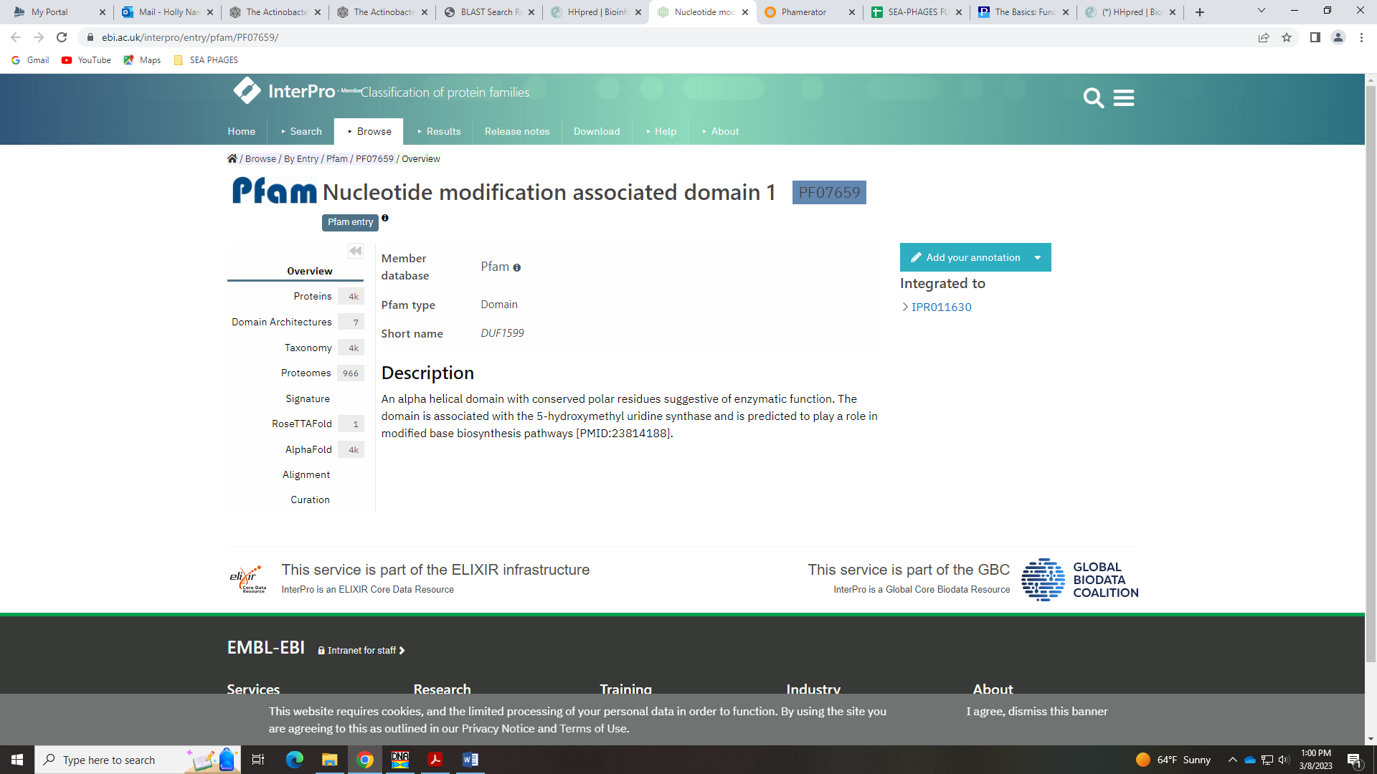
This function is not on the Official List. There is no domain indicated on Phamerator:
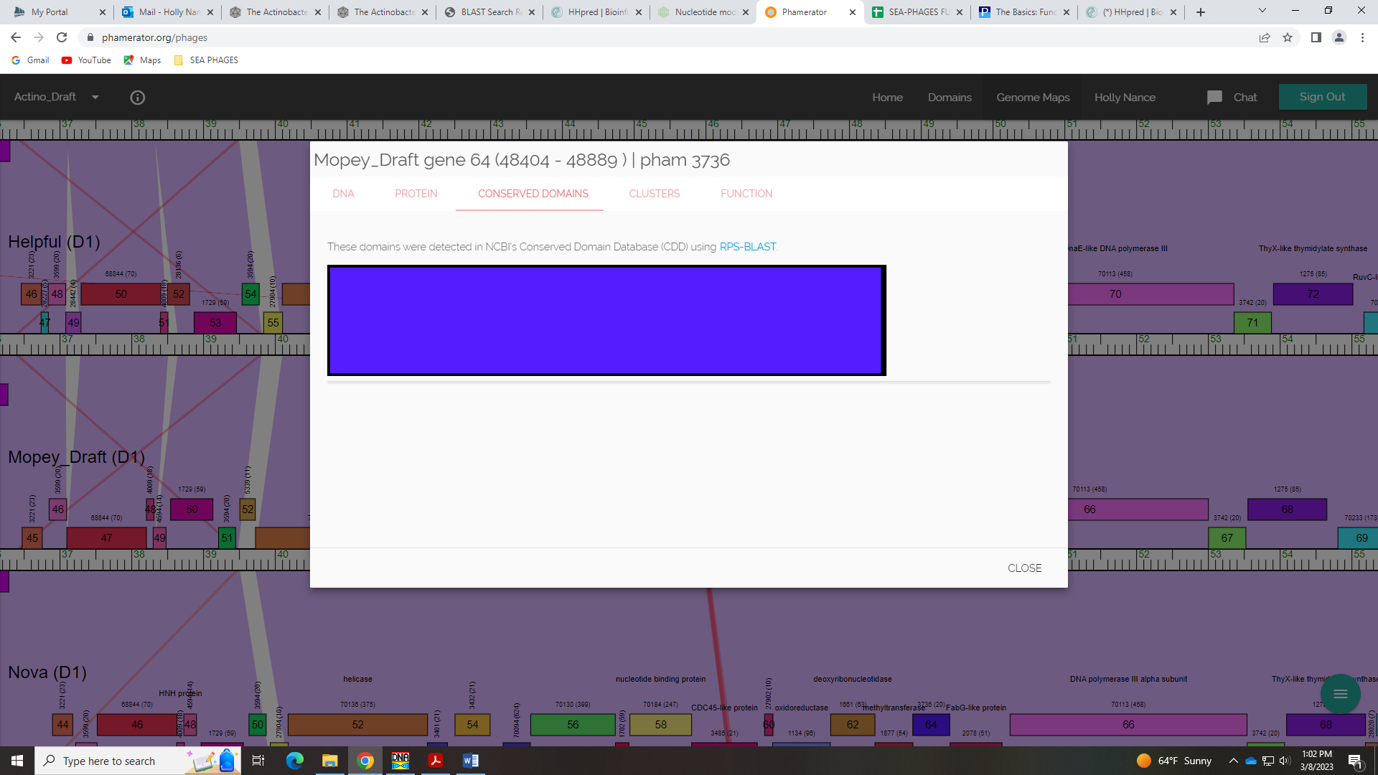
Not enough compelling evidence to call this anything other than NKF…

Gene 65 in our file, Gene 65 in PhagesDB – Jacob
SSC: start 48897, stop 49592; CP: yes; SCS: Both called start of 48897; ST: SS; Blast Start: matches WaldoWhy_68 Query 1 to Subject 1 100% 1e⁻¹³³; Gap: 7; LO: NA; RBS: -5.535, 1.244, 9, -6.310, no; F: FabG-like reductase; SIF-BLAST: FabG-like reductase /PhageDB BLAST/Delton_66, MK559427/100%/1e⁻¹³³; SIF-HHPred: FabG-like reductase, several matches with a probability above 99% for reductase and oxidoreductase; SIF-Syn: FabG-like reductase
Notes: Start is not most annotated in Starterator, but it is the most conserved across cluster D1.
For function, there are several hits in PhagesDB and NCBI BLAST for oxidoreductase and FabG-like reductase:
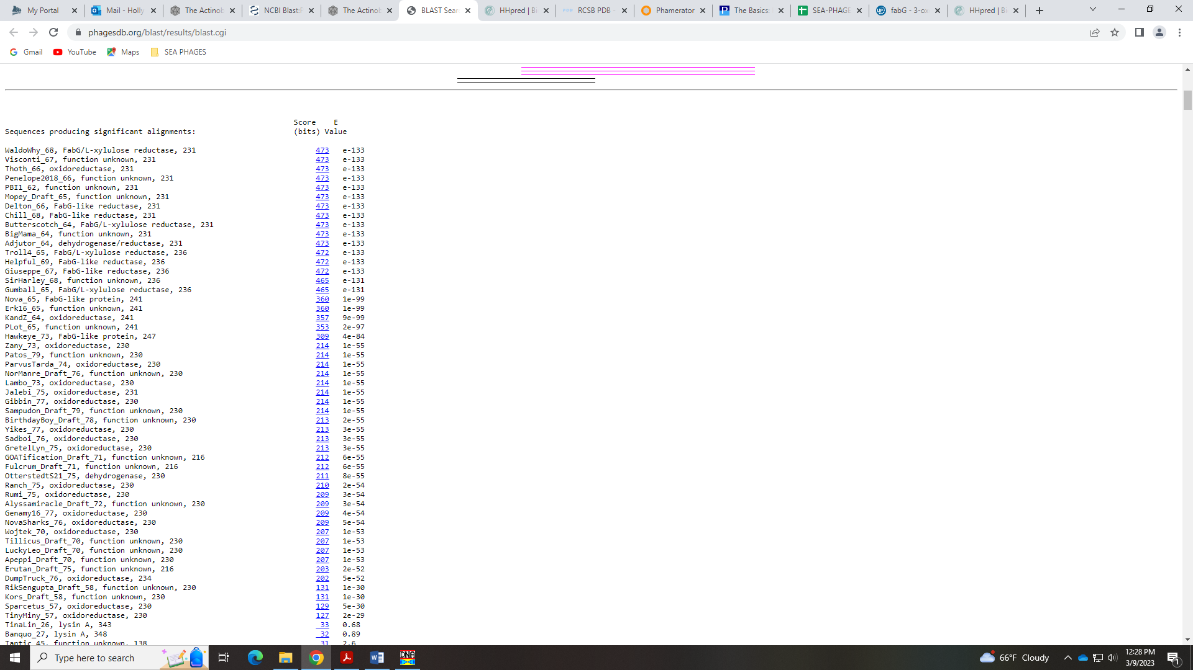
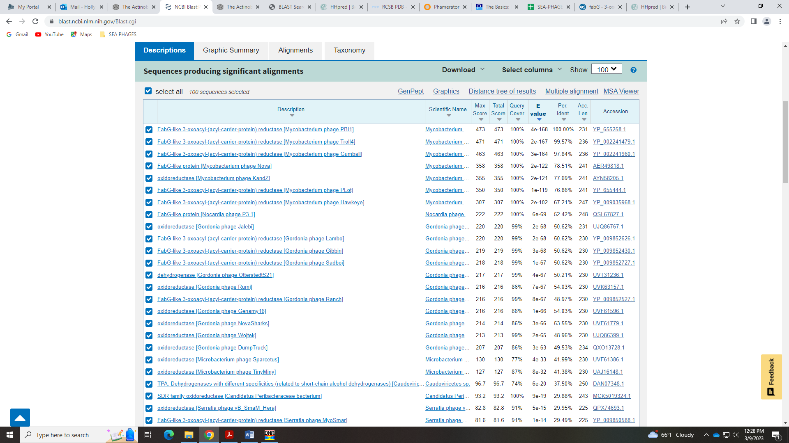
Both are on the Official Phage Function list:
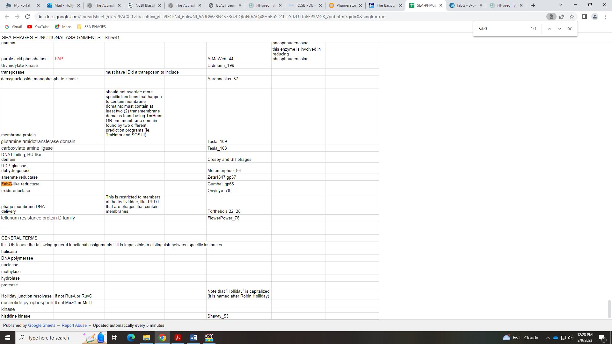
This gene has so many domains! Some are FabG-like and FabG…
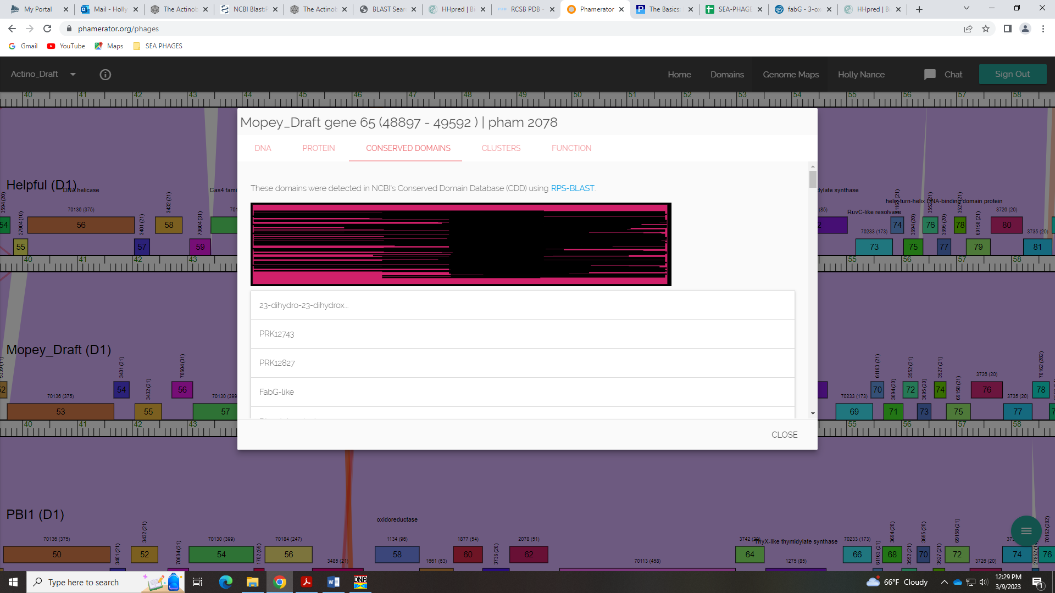
For HHpred, there are several hits about 99% for oxidoreductase, reductase, and some of these have FabG in the description:
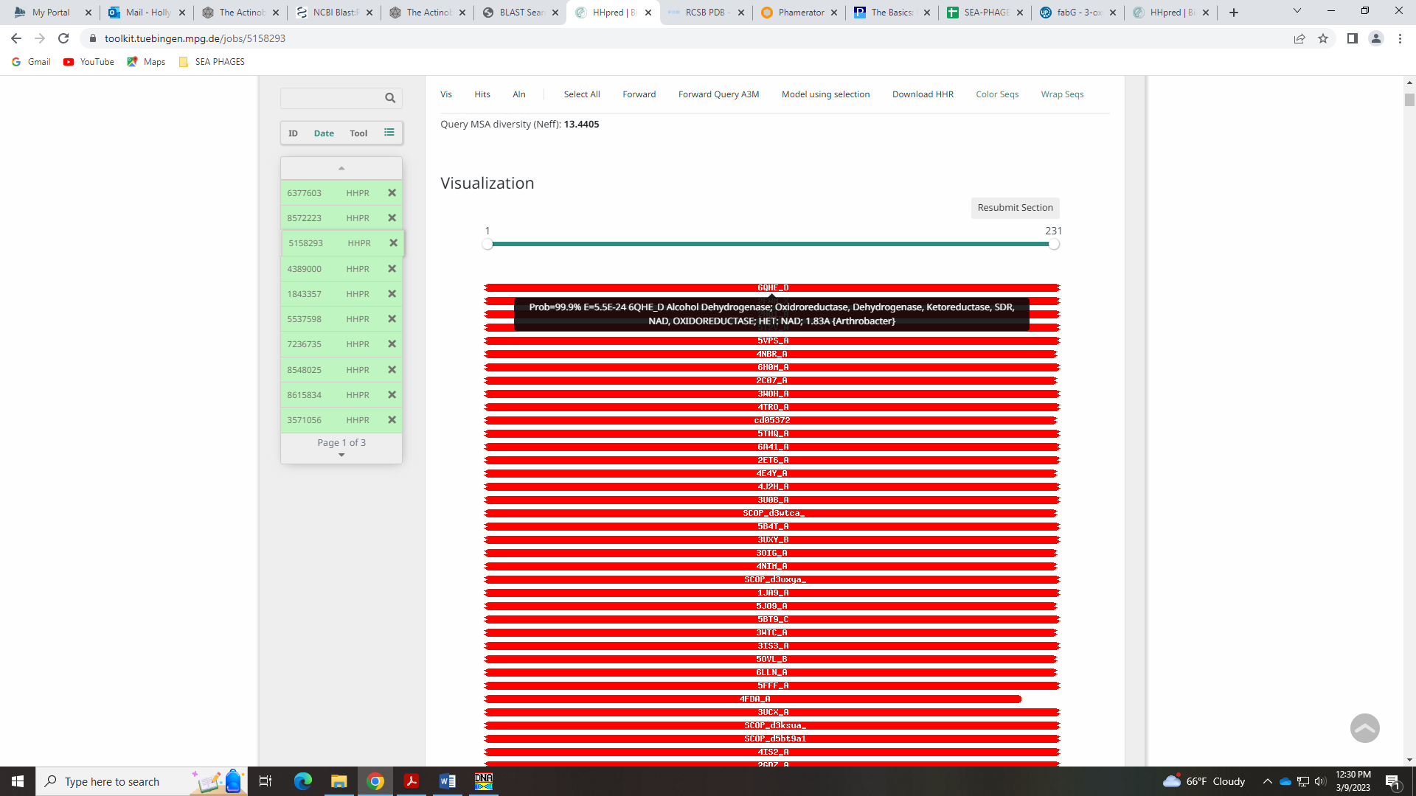
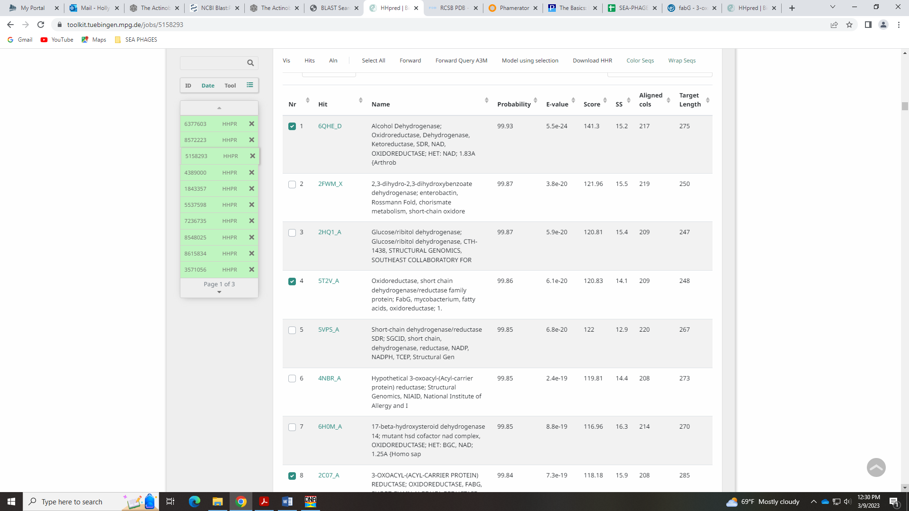
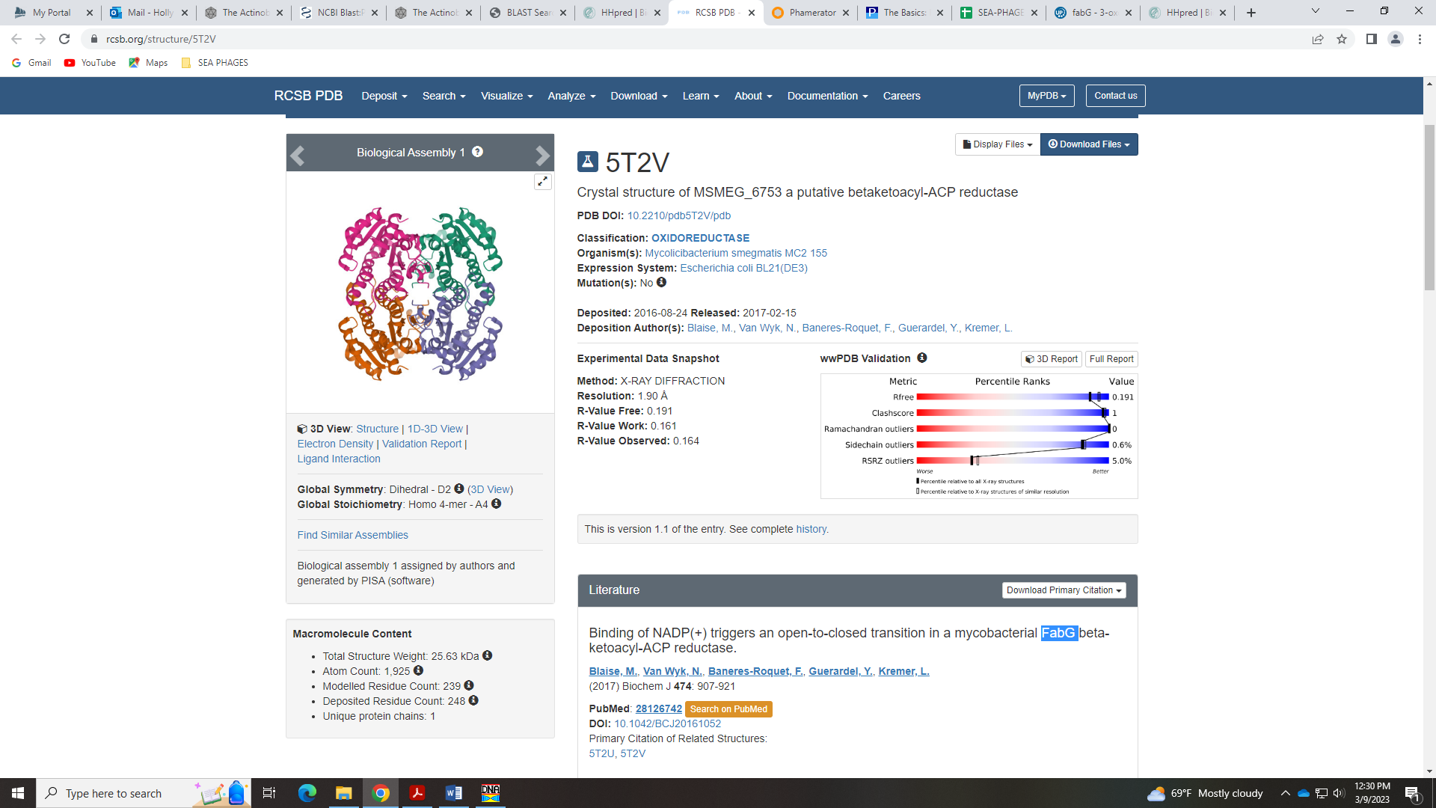
In the Official List, the example gene for FabG-like reductase is Gumball_65. When this sequence is placed into HHPred, the top hits are identical to those for Mopey_65:
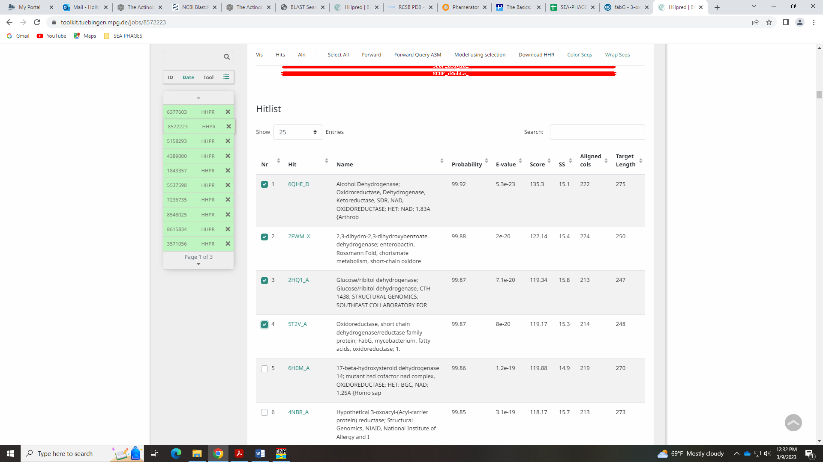
FabG proteins:
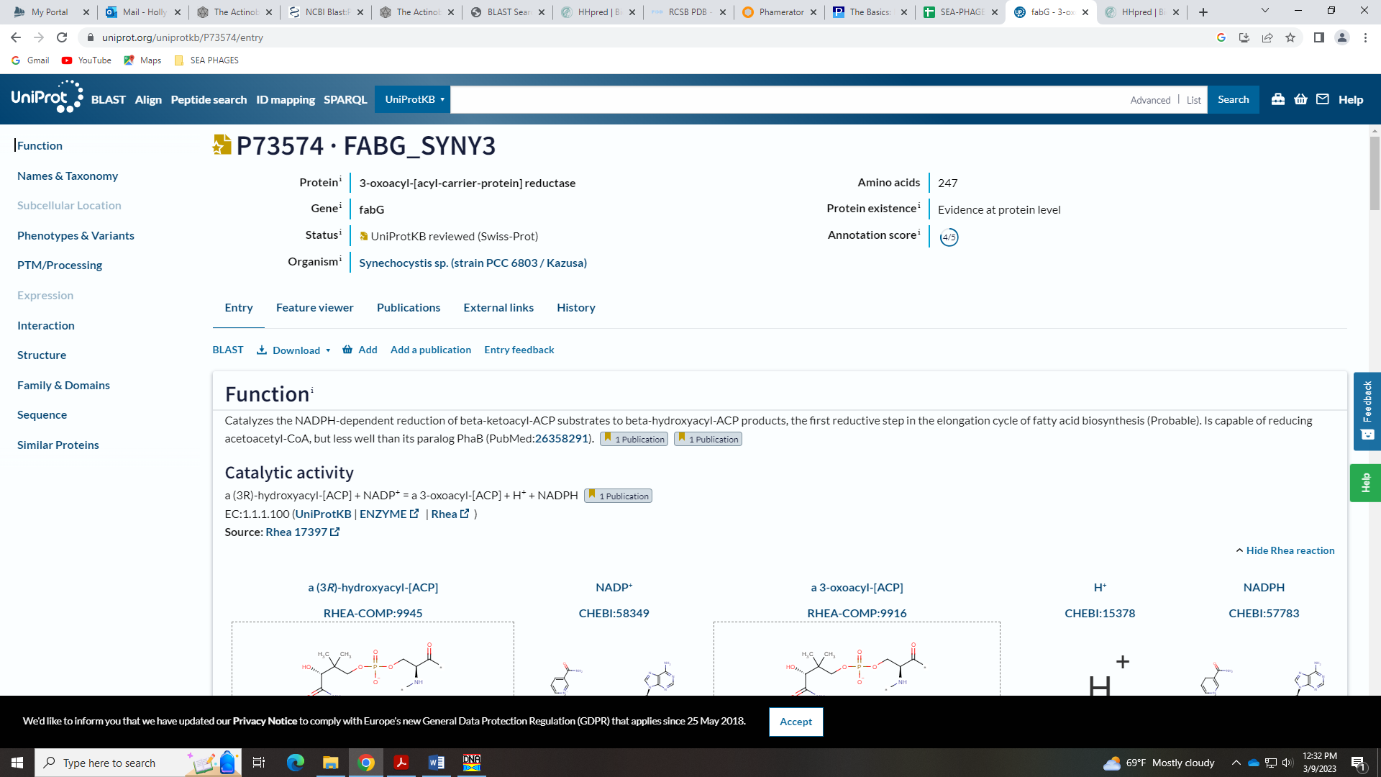
Seems to me this is what we should call this gene, but we’ll see what the rest of the class thinks…

Gene 66 in our file, Gene 66 in PhagesDB – Karlyn
SSC: start 49703, stop 53005; CP: yes; SCS: Both called start of 49703; ST: SS in cluster D1; Blast Start: matches Penelope2018_67 Query 1 to Subject 1 100% 0.0; Gap: 110; LO: yes; RBS: -2.814, 2.549, 12, -3.649, no; F: DNAE-like DNA polymerase III (alpha); SIF-BLAST: DNAE-like DNA polymerase III (alpha)/PhageDB BLAST/ Penelope2018_67, MN119378/100%/0.0; SIF-HHPred: DNA polymerase III alpha, several matches with a probability of 100%; SIF-Syn: DNAE-like DNA polymerase III (alpha)
Notes: Start is most conserved in cluster D1, but there are so many genes in this phamily, the Starterator data is almost NI. Large gap is conserved in cluster:
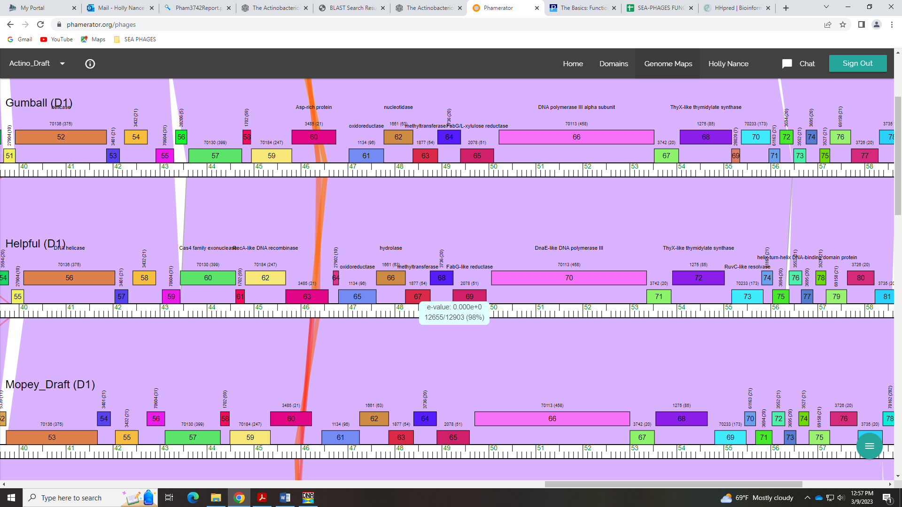
For function, BLAST suggests some kind of DNA polymerase III (alpha):
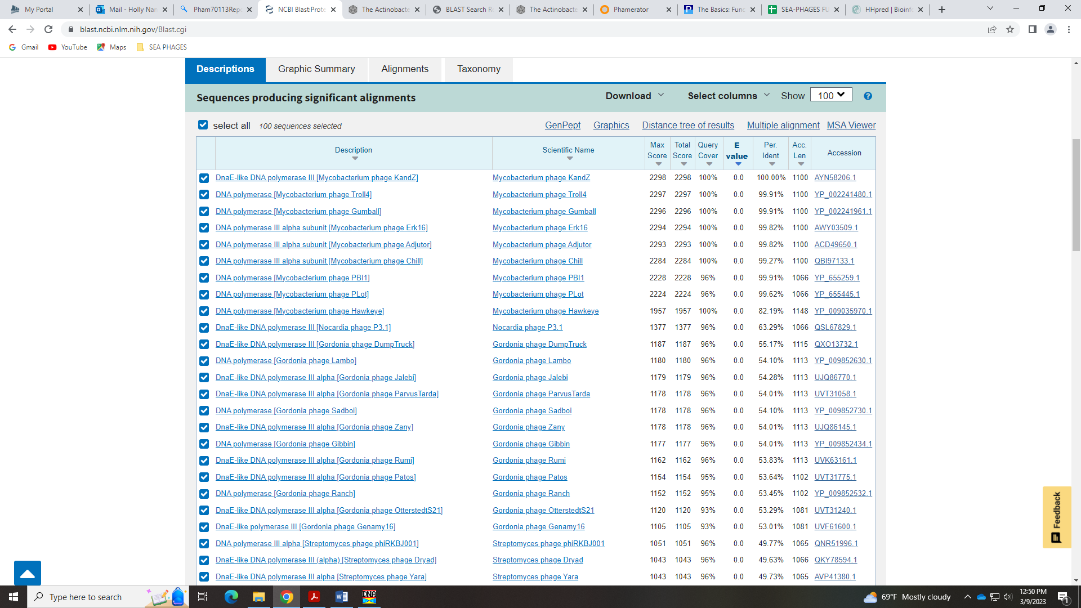
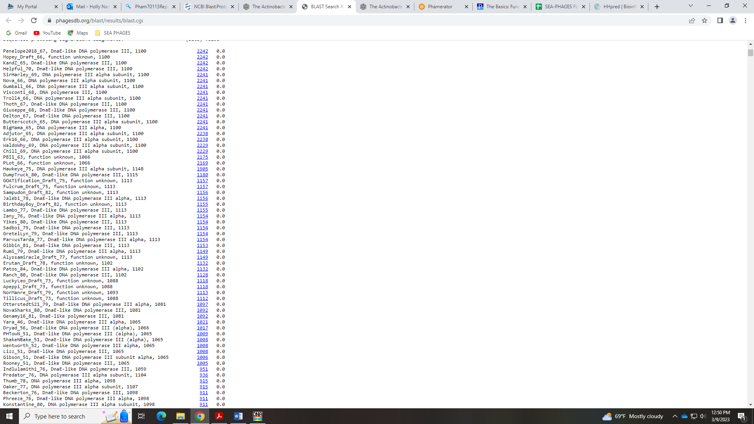
The Official List has DNAE-like DNA polymerase III (alpha) listed, as well as other DNA pol names:
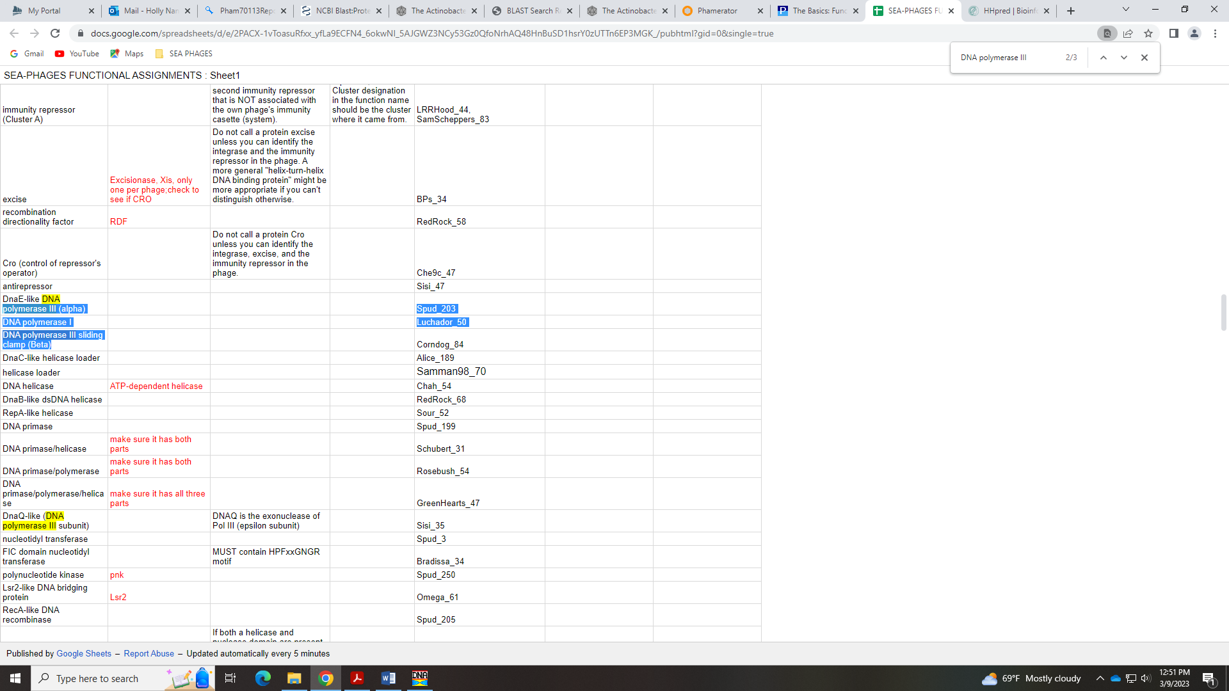
The HHpred has several hits with 100% probability for DNA polymerase III alpha:
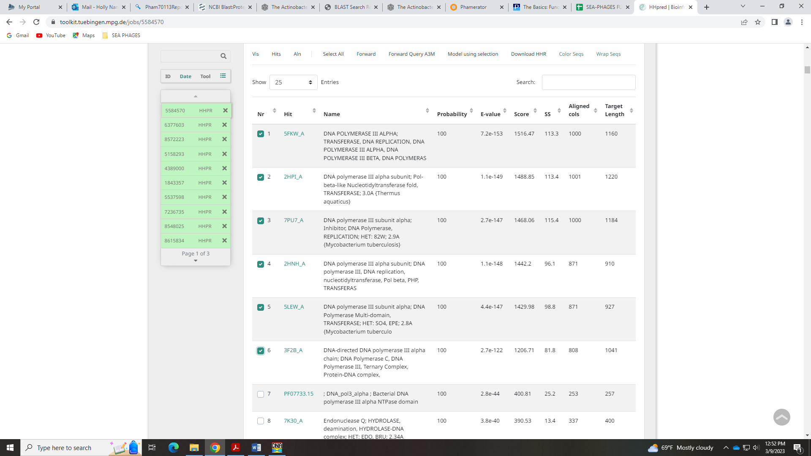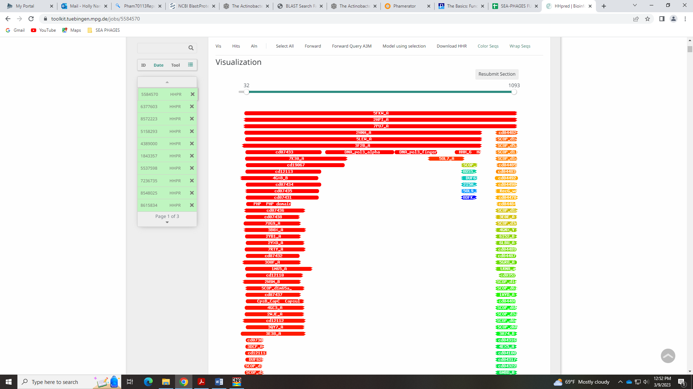
In Phamerator, there are several domains in this protein, including dnaE…
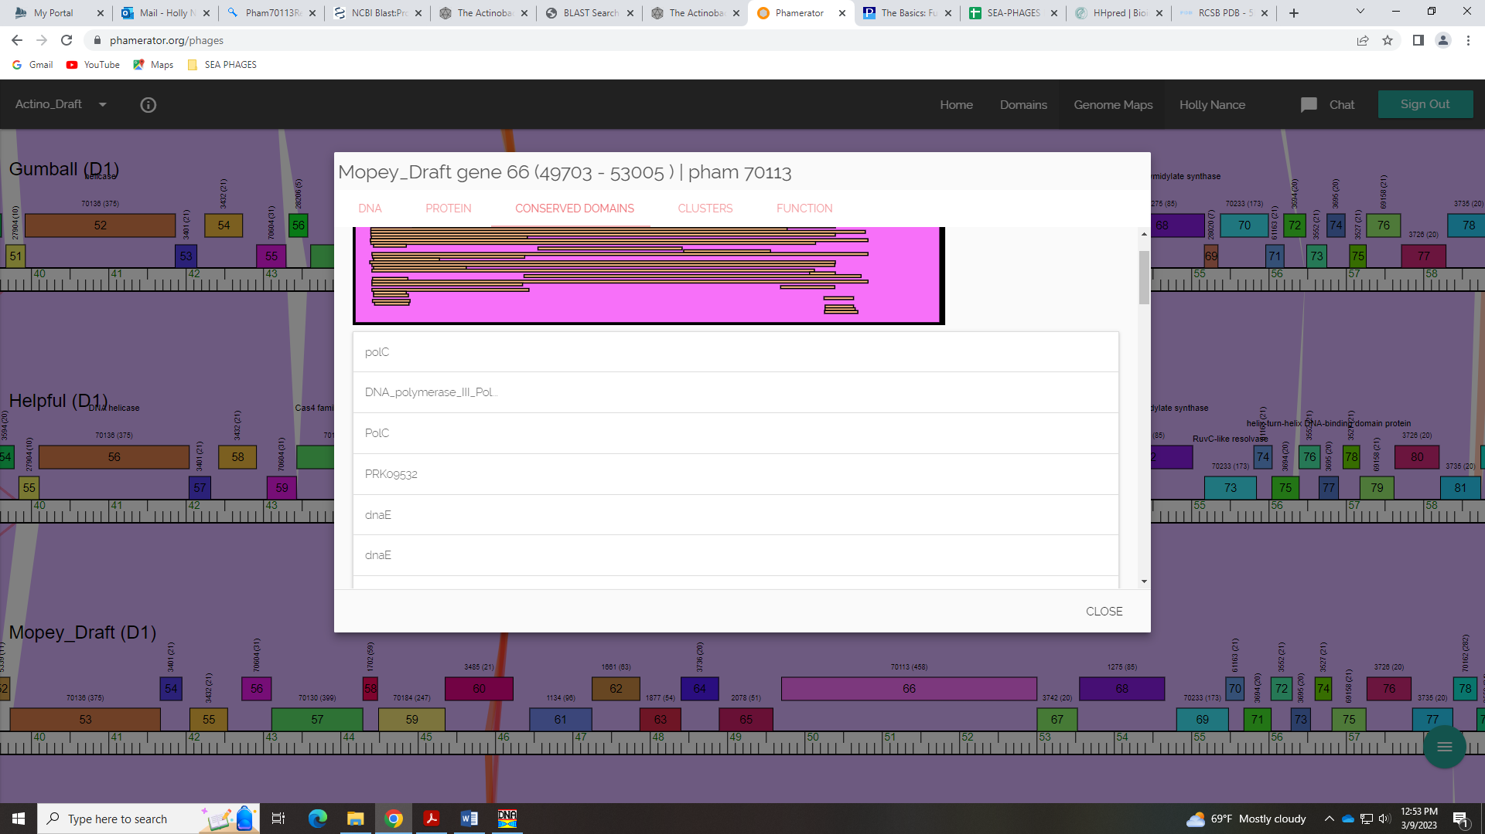
I think it’s definitely DNA pol III, alpha, but this DNAE-like name on the Official List is odd. I guess since it’s on the list we should call it that – other phage in Cluster D1 do.

Gene 67 in our file, Gene 67 in PhagesDB
SSC: start 53007, stop 53528; CP: yes; SCS: Both called start of 53007; ST: SS; Blast Start: matches Visconti_69 Query 1 to Subject 1 100% 3e⁻⁹⁴; Gap: 1; LO: NA; RBS: -4.006, 1.978, 9, -4.781, no; F: NKF; SIF-BLAST: NKF/PhageDB BLAST/ Visconti_69, MH399788/100%/3e⁻⁹⁴; SIF-HHPred: NKF, no matches with a probability above 90%; SIF-Syn: NKF
Notes: Nothing ambiguous here!!

Gene 68 in our file, Gene 68 in PhagesDB
SSC: start 53556, stop 54656; CP: yes; SCS: Both called start of 53556; ST: SS, for Cluster D1; Blast Start: matches Visconti_70 Query 1 to Subject 1 100% 0.0; Gap: 27; LO: yes; RBS: -2.814, 2.549, 12, -3.649, no; F: ThyX-like thymidylate synthase; SIF-BLAST: ThyX-like thymidylate synthase /PhageDB BLAST/ Visconti_70, MH399788/100%/0.0; SIF-HHPred: ThyX-like thymidylate synthase, several matches with a probability of 100%; SIF-Syn: ThyX-like thymidylate synthase
Notes: Start conserved in cluster D1.
For function, ThyX-like thymidylate synthase is in the Official List, and supported by BLAST:
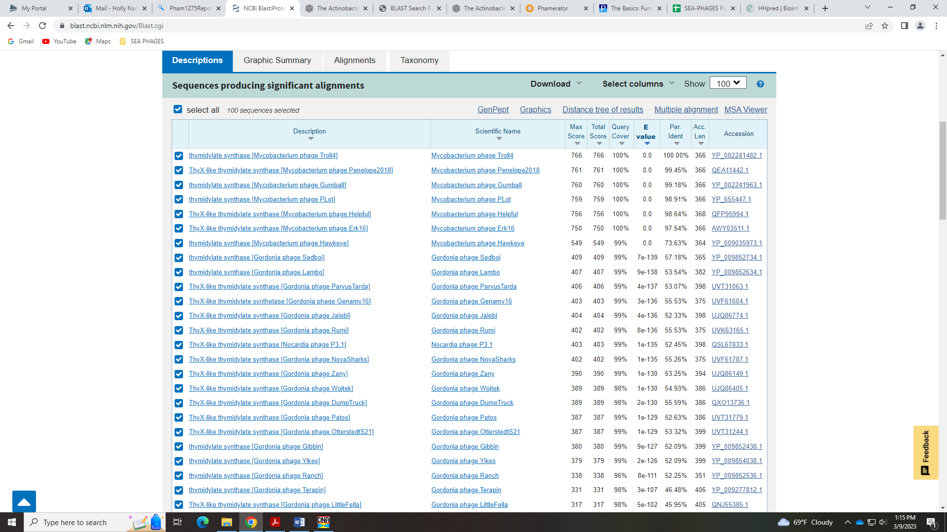
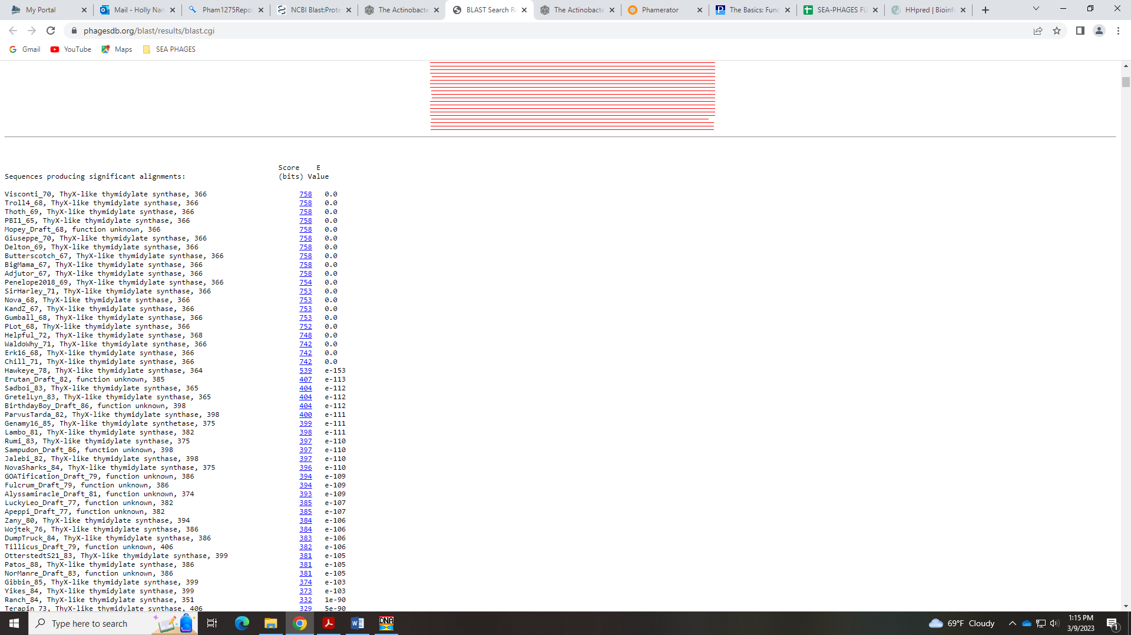
Supported by Phamerator and specific domains present:
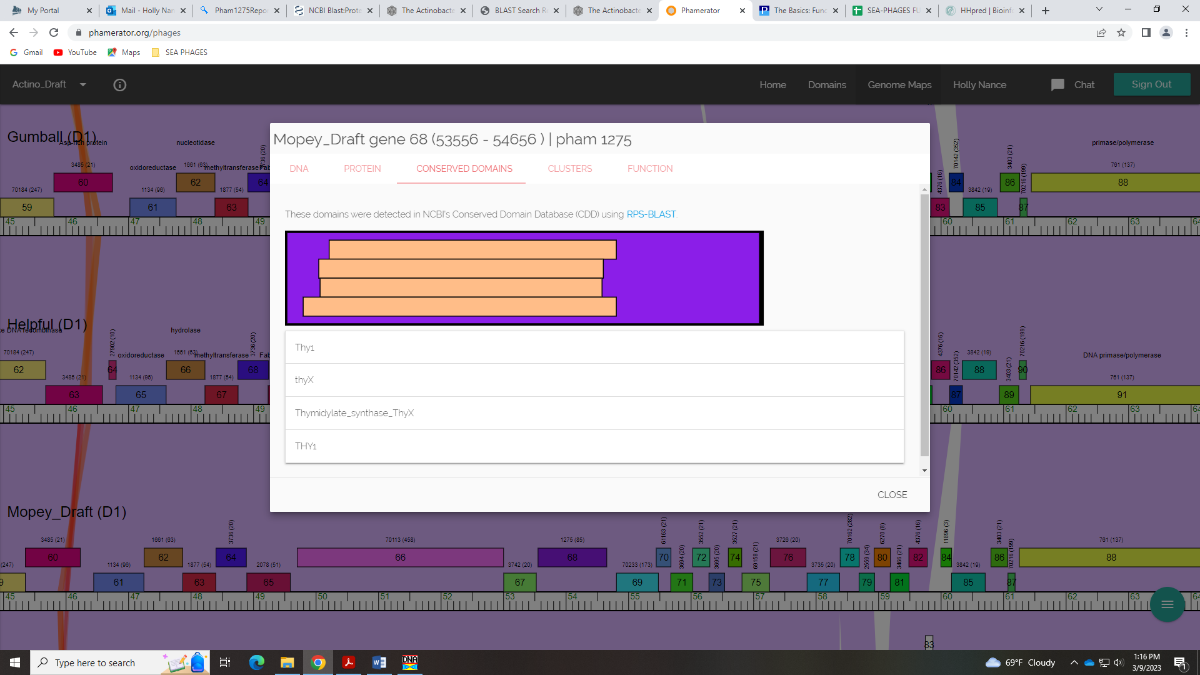
And supported by HHPred data!
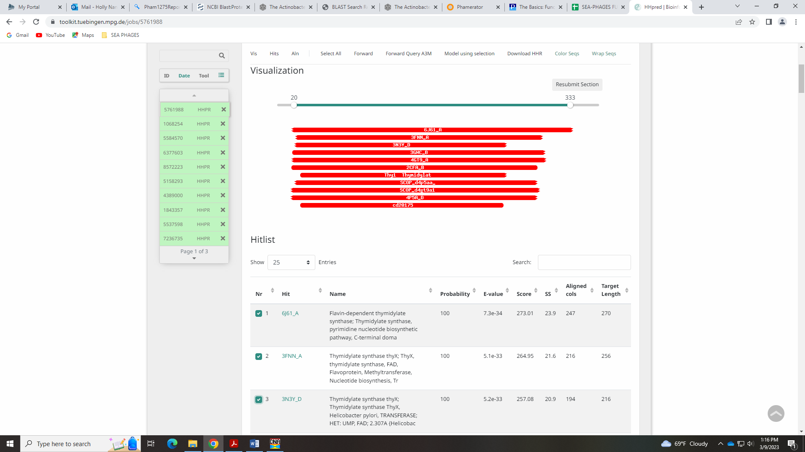

Gene 69 - added NEW gene here! 4.27.2023
SSC: start 54653, stop 54829; CP: no; SCS: neither called this gene, we added it; ST: NA; Blast Start: matches Troll4_69 Query 1 to Subject 1 100% 4e⁻³⁰; Gap: overlap of 4; LO: NA; RBS: -2.757, 2.577, 7, -4.280, no; F: NKF; SIF-BLAST: NKF/PhageDB BLAST/ Troll4_69, FJ168662/100%/4e⁻³⁰; SIF-HHPred: NKF no matches with a probability above 99%; SIF-Syn: NKF
Notes: Added this gene and there are sever BLAST hits for this that are NKF:
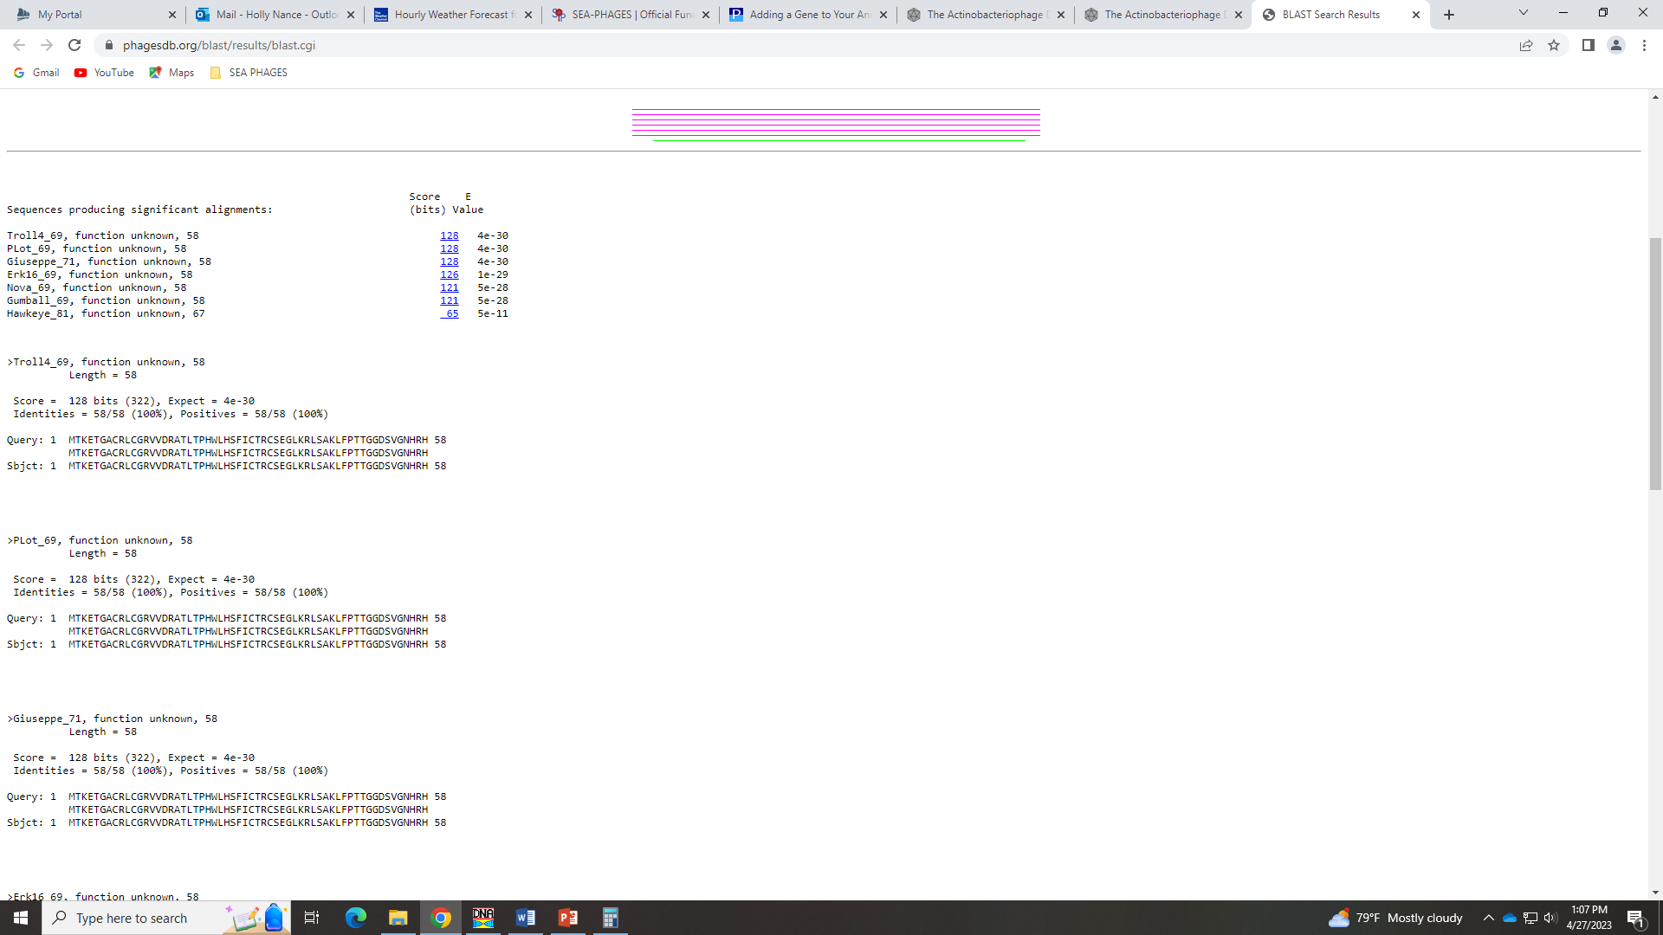

Gene 70 in our file, Gene 69 in PhagesDB - Sa’mya checked gap, added gene above
SSC: start 54810, stop 55481; CP: yes; SCS: Glimmer called start of 54810, GeneMark called start of 54861; ST: NI; Blast Start: matches Visconti_71 Query 1 to Subject 1 100% 1e⁻¹²⁹; Gap: overlap of 20; LO: yes; RBS: -1.418, 3.219, 13, -2.463, yes; F: RuvC-like resolvase; SIF-BLAST: RuvC-like resolvase /PhageDB BLAST/ Visconti_71, MH399788/100%/1e⁻¹²⁹; SIF-HHPred: RuvC-like resolvase, several matches with a probability above 99%; SIF-Syn: RuvC-like resolvase
Notes: This start is most conserved in cluster D1, but there is a large gap. On the GeneMark output, it looks like there could be other genes in the reading frame before this gene…
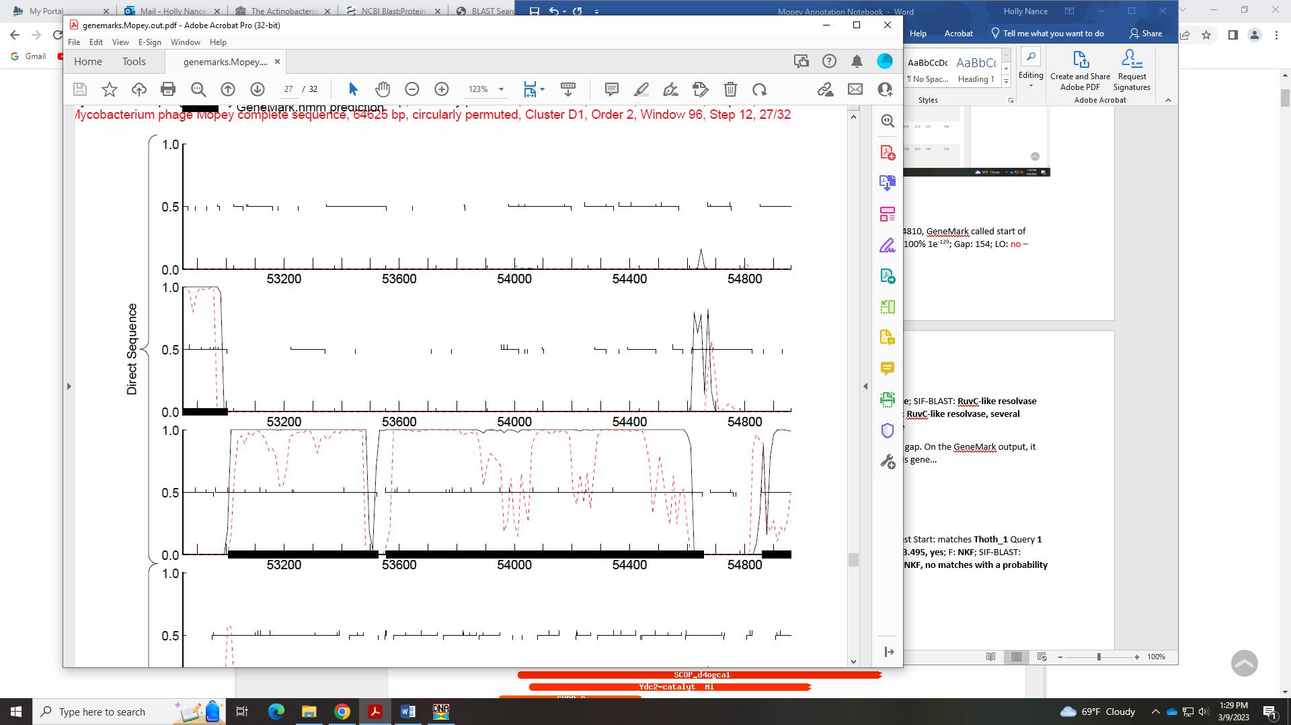
Also in the DNAMaster Frames screen:
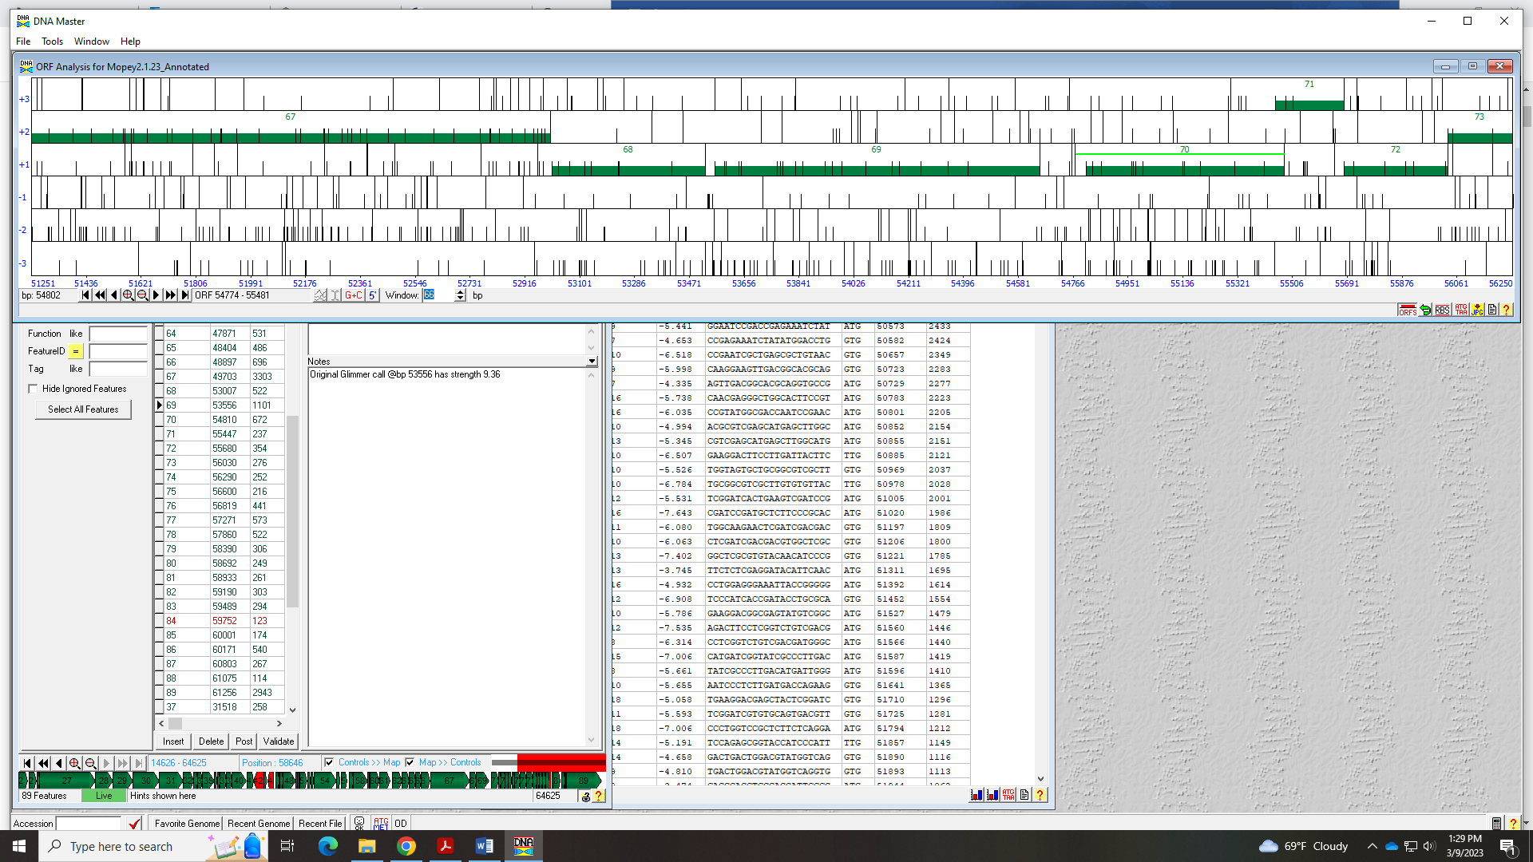
For function, all signs point to RuvC-like reductase. This is on the Official List, supported by BLAST data:
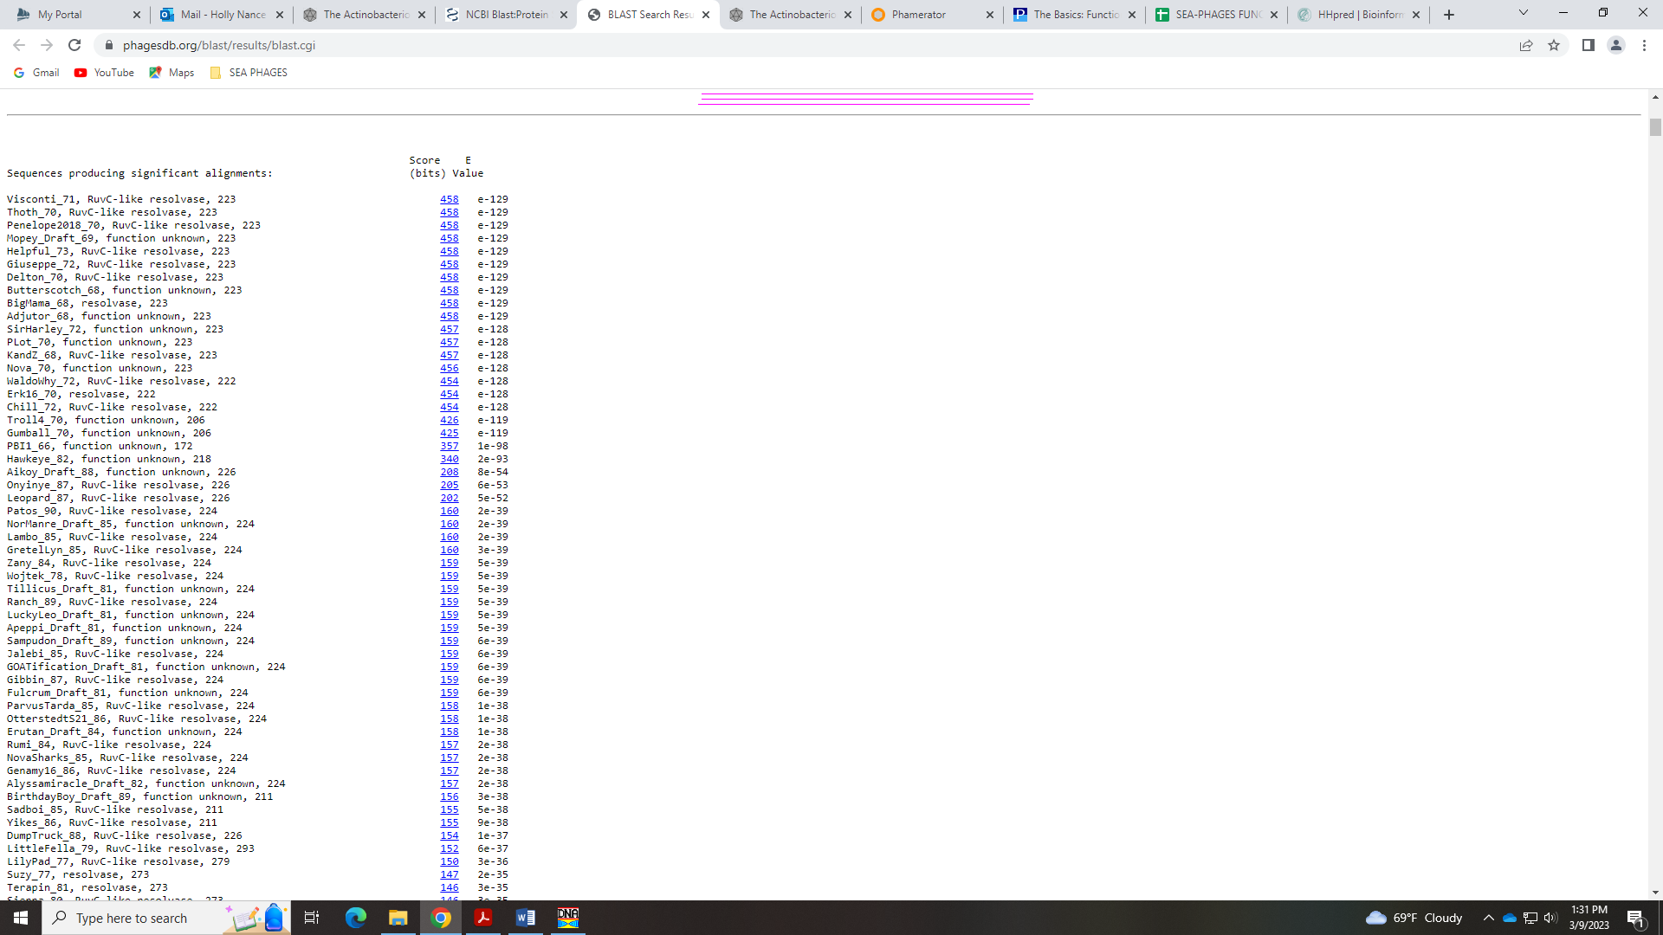
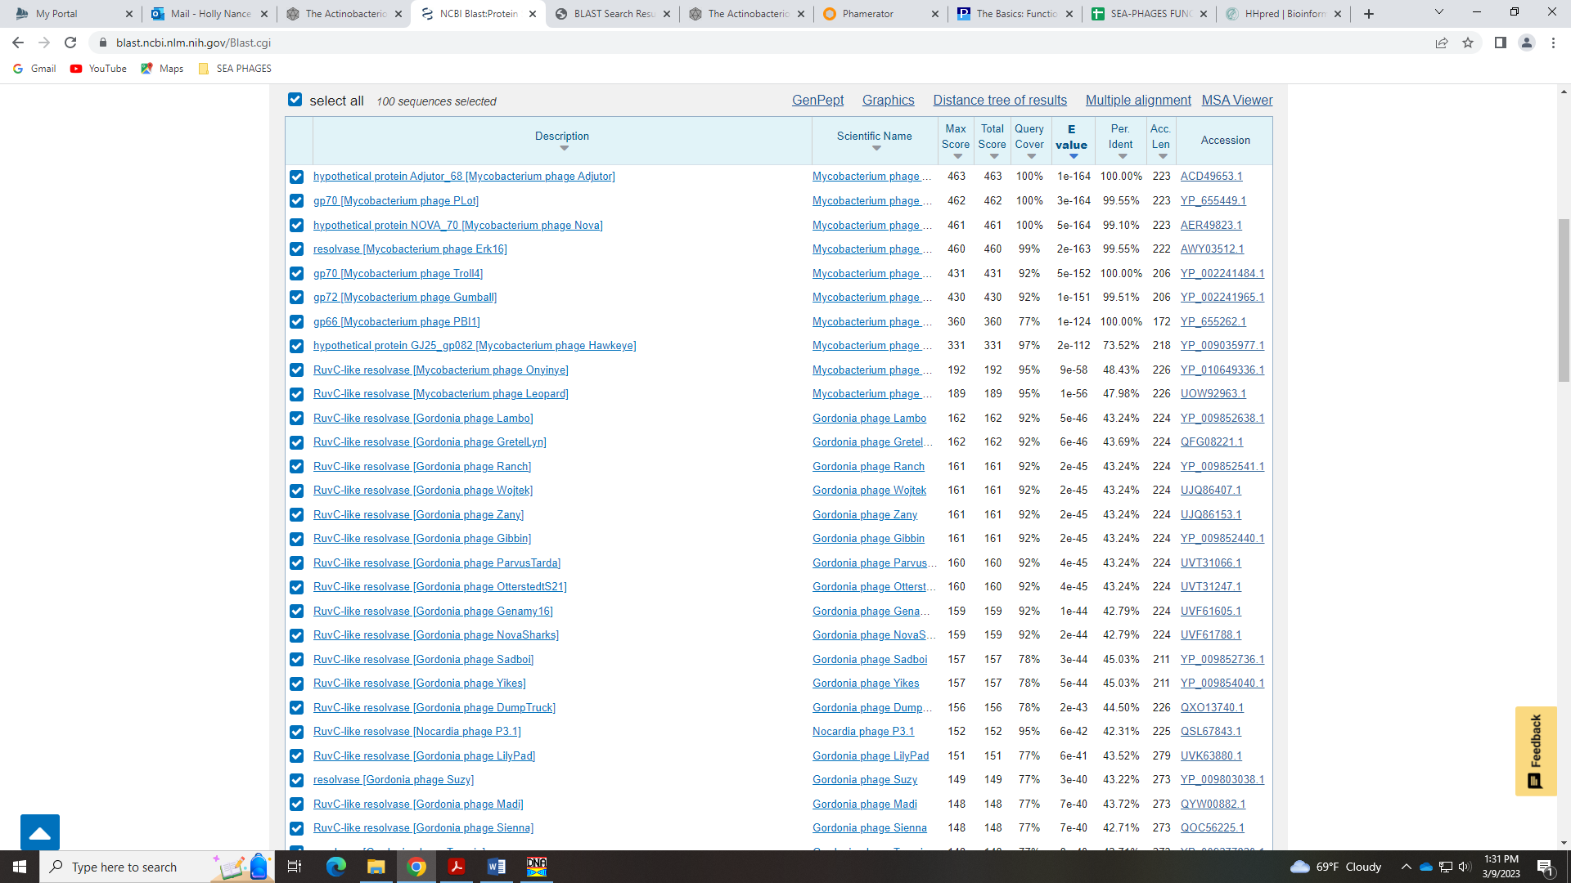
And supported by HHPred hits:
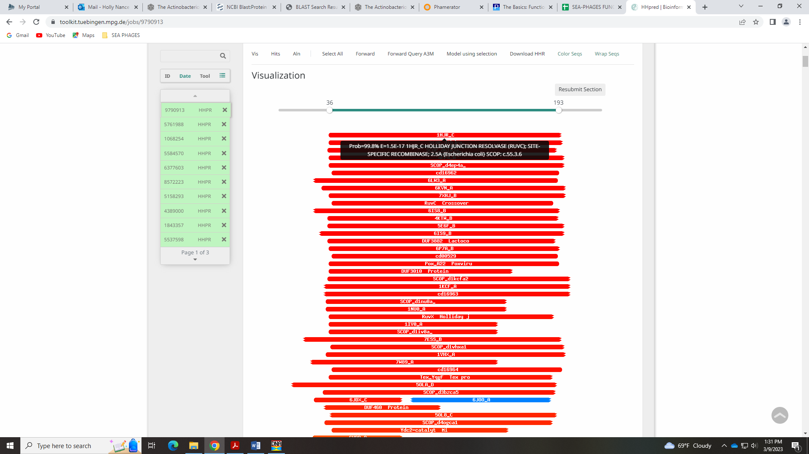
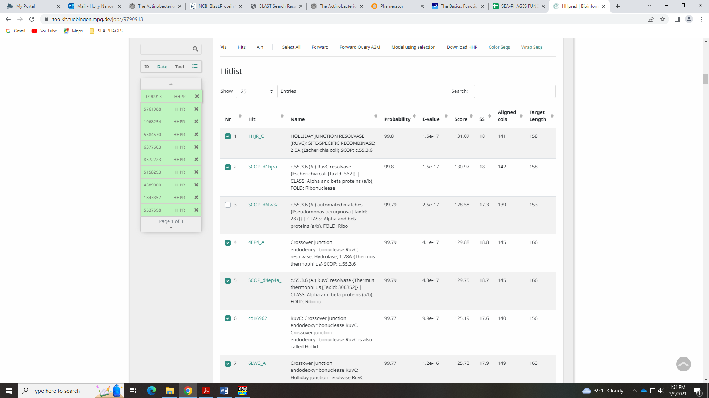

Gene 71 in our file, Gene 70 in PhagesDB
SSC: start 55447, stop 55683; CP: yes, not great; SCS: Both called start of 55447; ST: SS; Blast Start: matches Visconti_72 Query 1 to Subject 1 100% 1e⁻⁴¹; Gap: overlap of 35; LO: NA; RBS: -1.582, 3.140, 11, -2.339, yes; F: NKF; SIF-BLAST: NKF/PhageDB BLAST/ Visconti_72, MH399788/100%/1e⁻⁴¹; SIF-HHPred: NKF, no matches with a probability above 90%; SIF-Syn: NKF
Notes: Start is most conserved in Starterator and yields most 1:1 Q;S hits in BLAST. There is an overlap of 35BPs, but this seems to be conserved across the cluster:
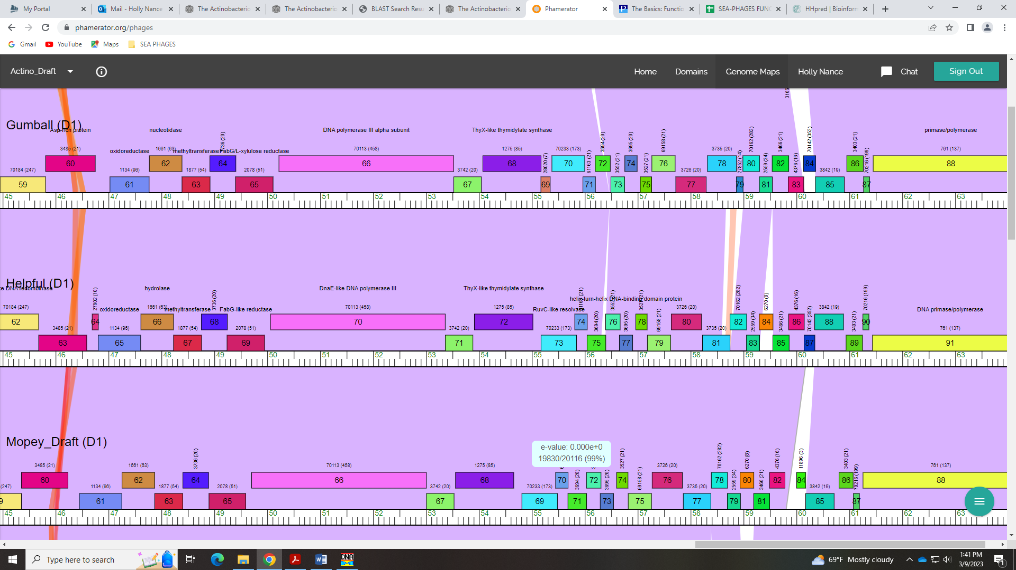
Function is NKF, and unambiguous.

Gene 72 in our file, Gene 71 in PhagesDB
SSC: start 55680, stop 56033; CP: yes; SCS: Both called start of 55680; ST: SS; Blast Start: matches Visconti_73 Query 1 to Subject 1 100% 3e⁻⁶¹; Gap: overlap of 4; LO: NA; RBS: -2.071, 2.906, 9, -2.845, yes; F: NKF; SIF-BLAST: NKF/PhageDB BLAST/ Visconti_73, MH399788/100%/3e⁻⁶¹; SIF-HHPred: NKF, no matches with a probability above 90%; SIF-Syn: NKF
Notes: Nothing ambiguous about this gene!!

Gene 73 in our file, Gene 72 in PhagesDB
SSC: start 56030, stop 56305; CP: yes; SCS: Both called start of 56030; ST: SS; Blast Start: matches Visconti_74 Query 1 to Subject 1 100% 2e⁻⁵²; Gap: overlap of 4; LO: NA; RBS: -2.699, 2.605, 10, -3.394, no; F: NKF; SIF-BLAST: NKF/PhageDB BLAST/ Visconti_74, MH399788/100%/2e⁻⁵²; SIF-HHPred: NKF, several matches with a probability above 90%, but for different domains or functions – no consensus; SIF-Syn: NKF
Notes: BLAST supports NKF:
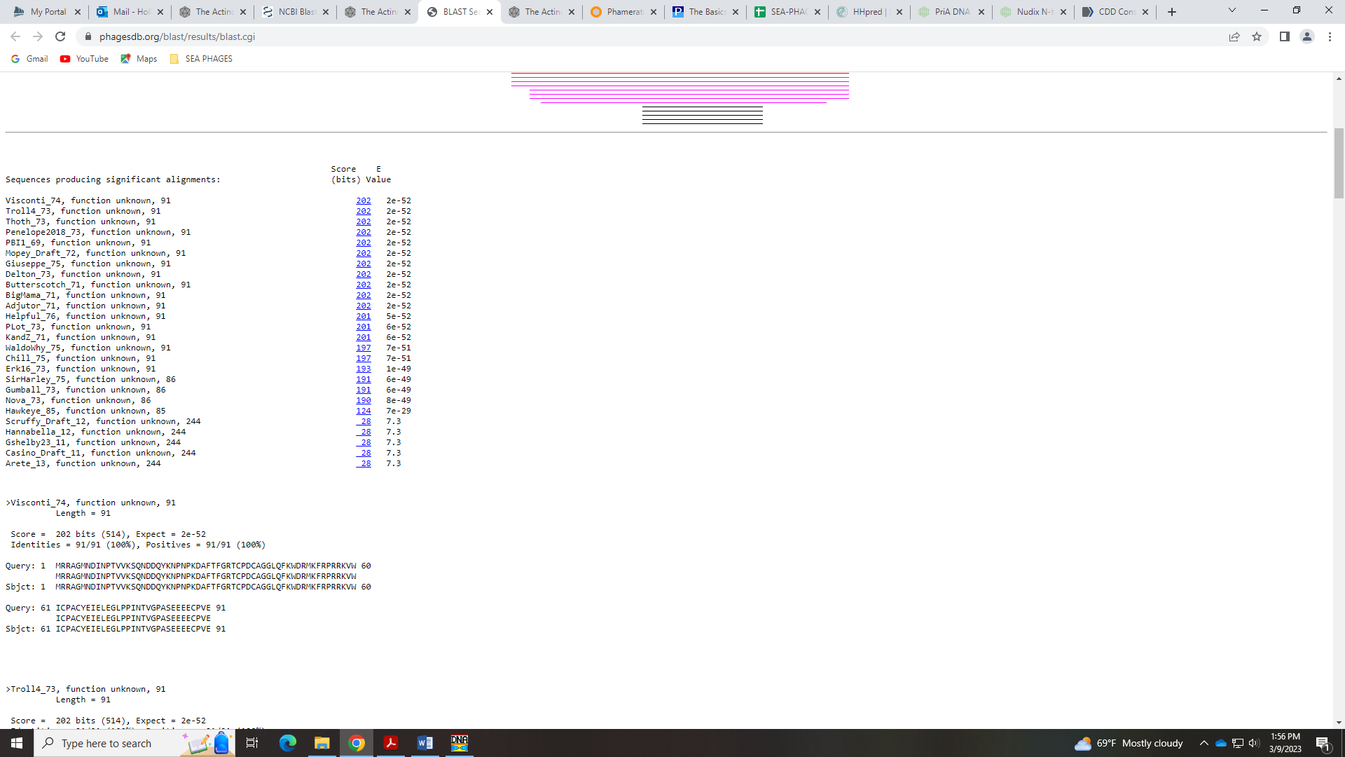
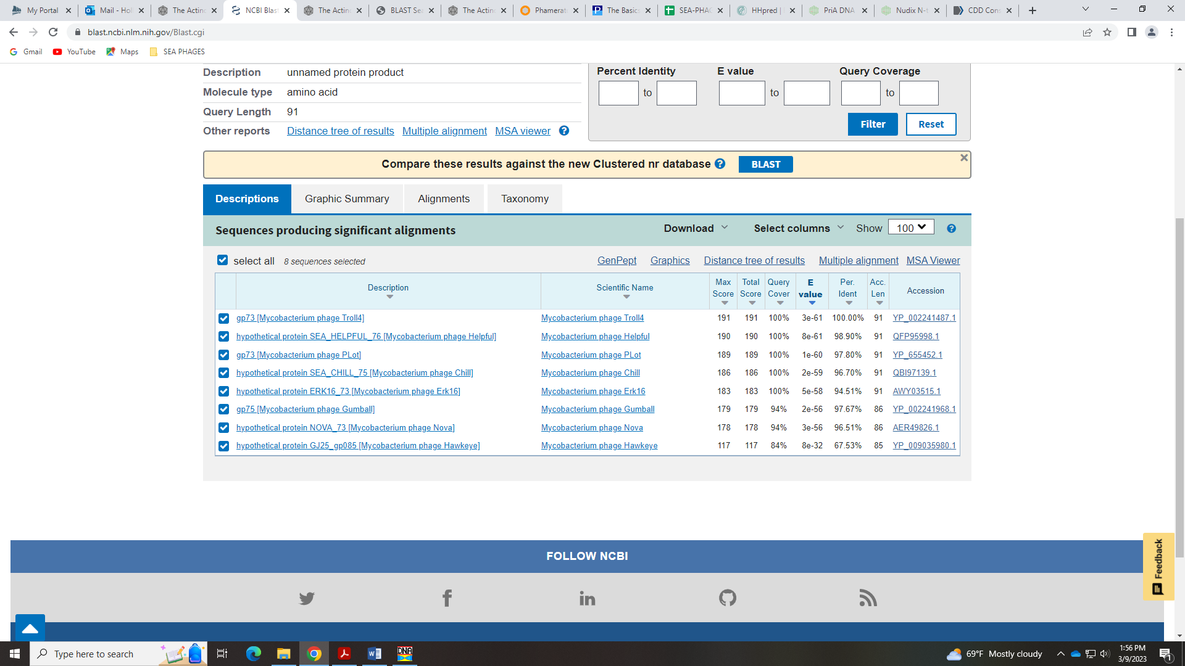
HHPred hits are above 90%, but partial hits and for a wide range of either domains or functions.
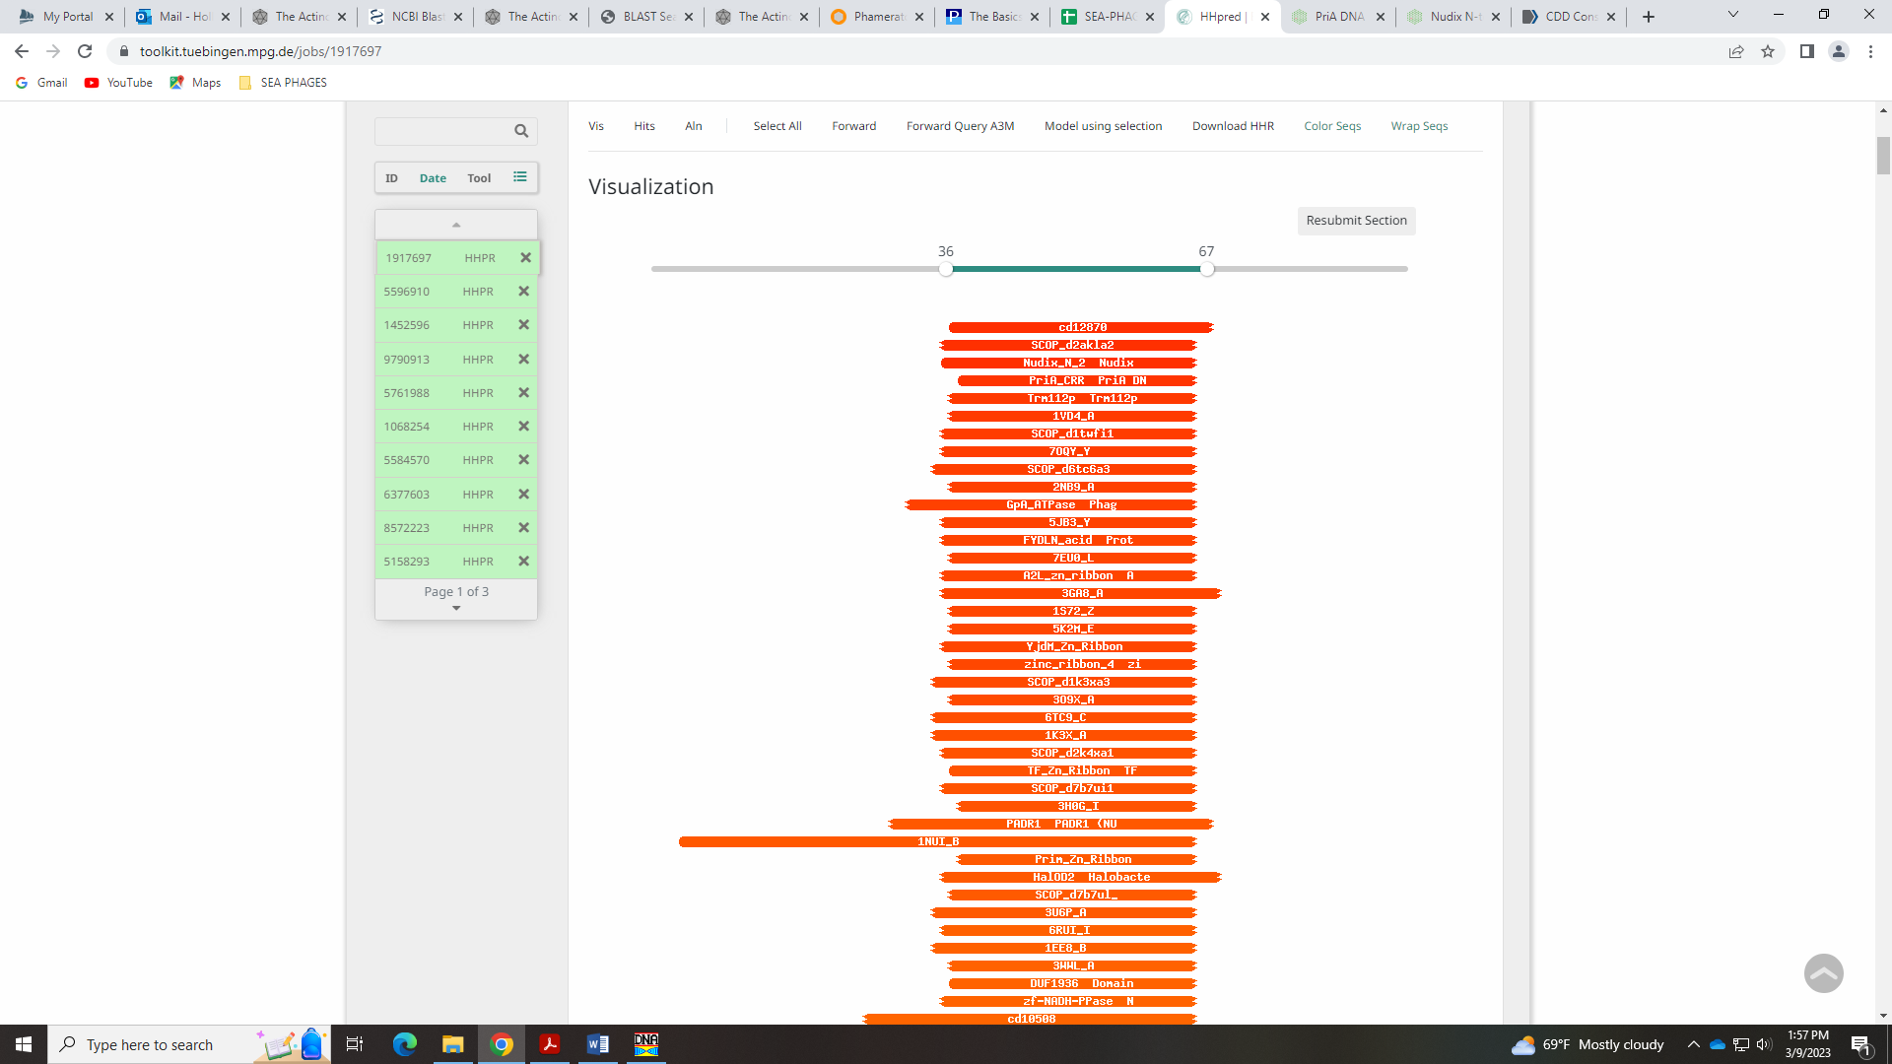
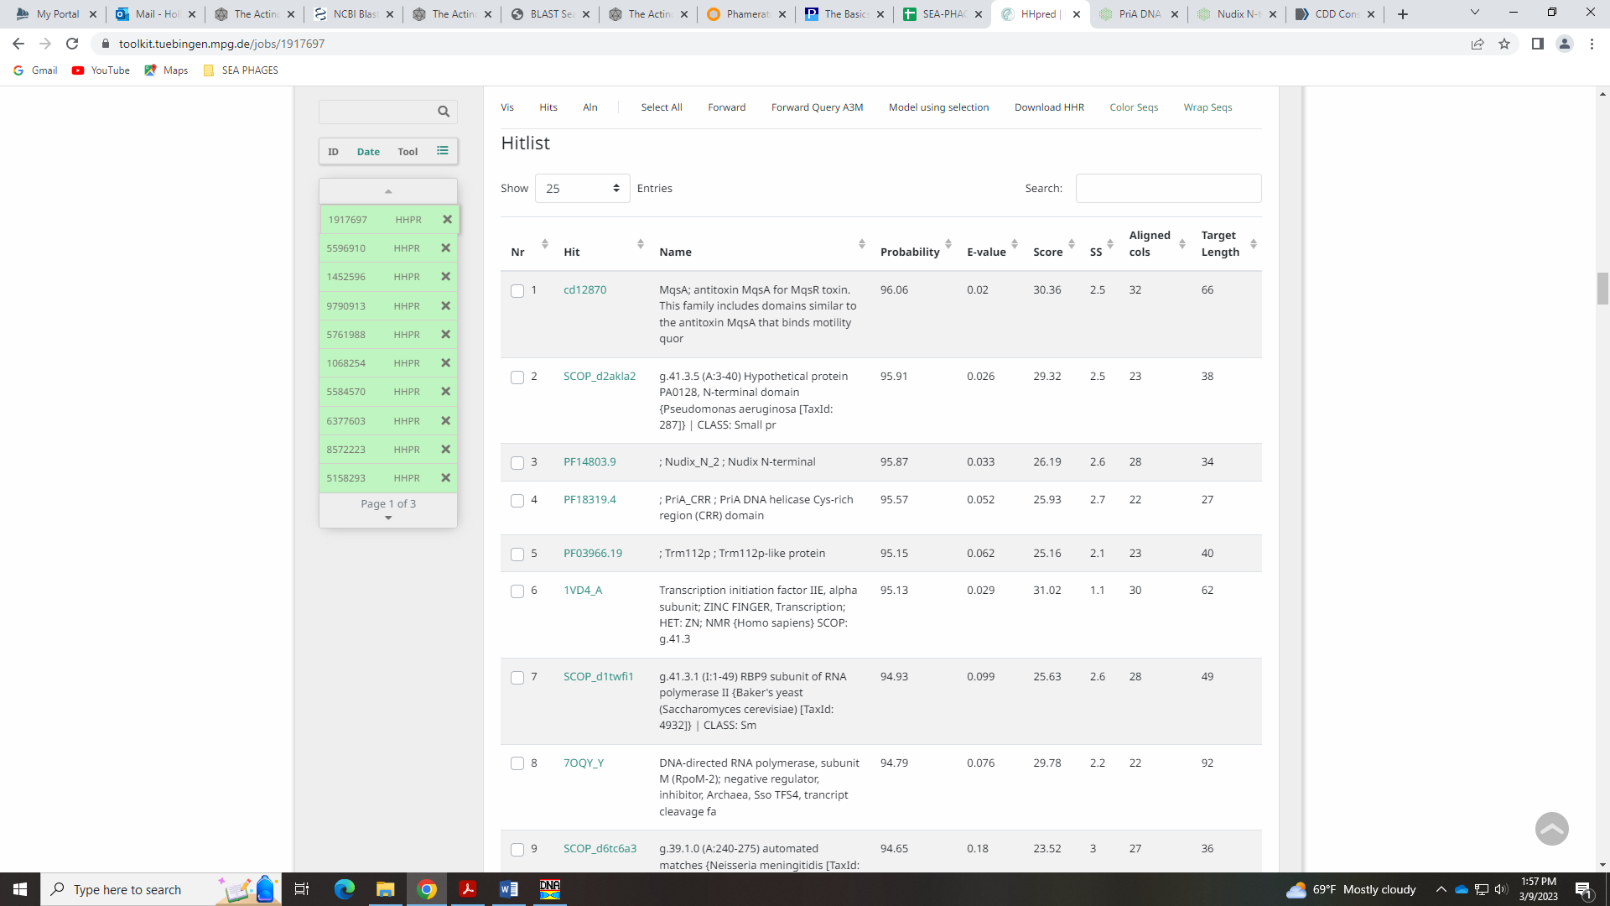
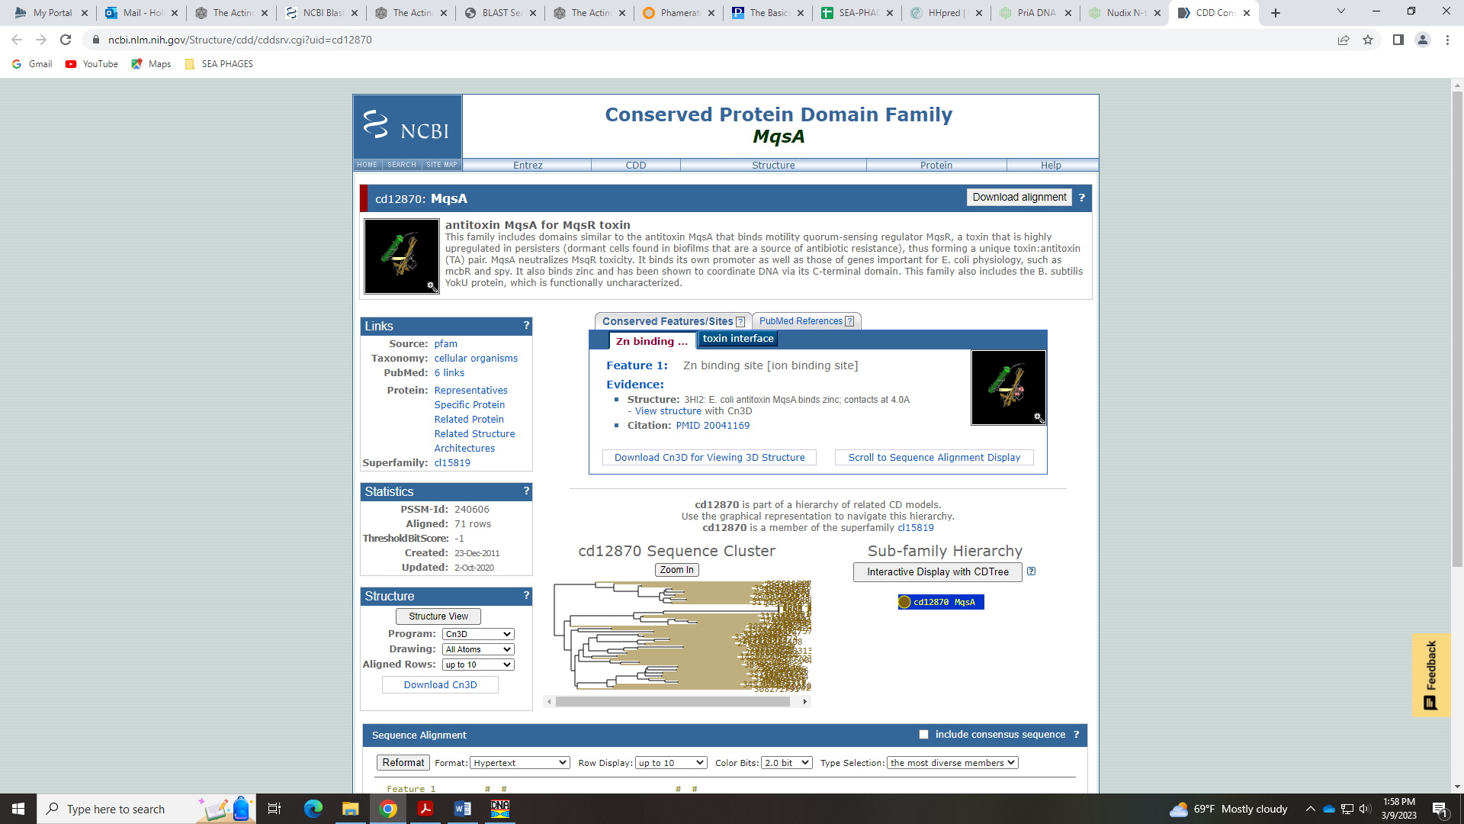
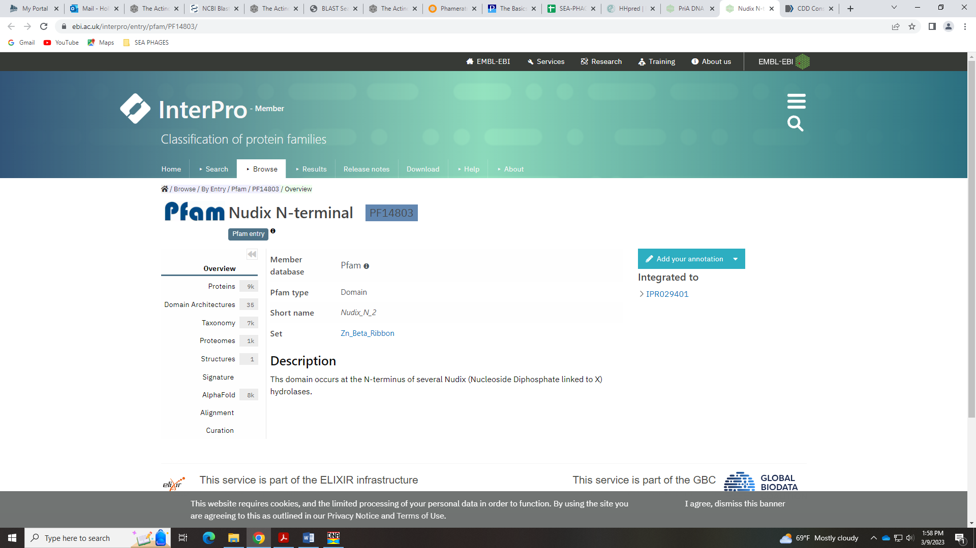
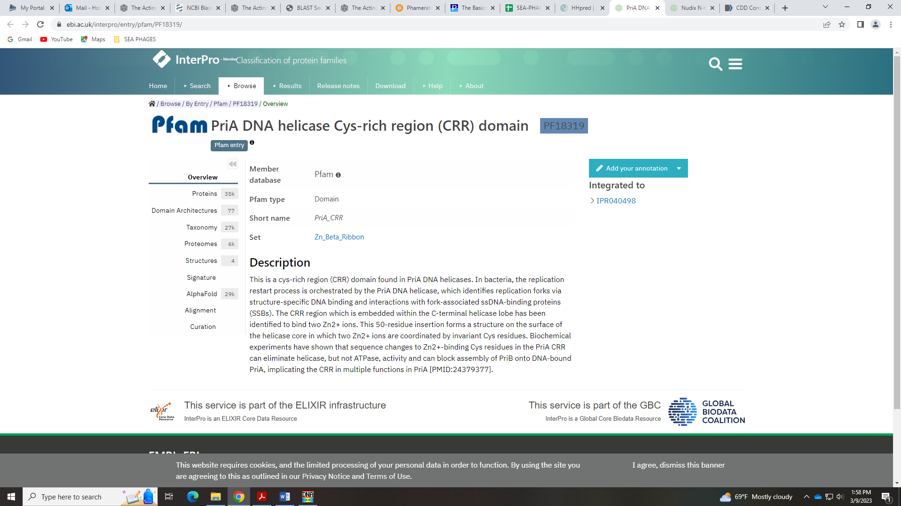
There are no conserved domains in this gene in Phamerator:
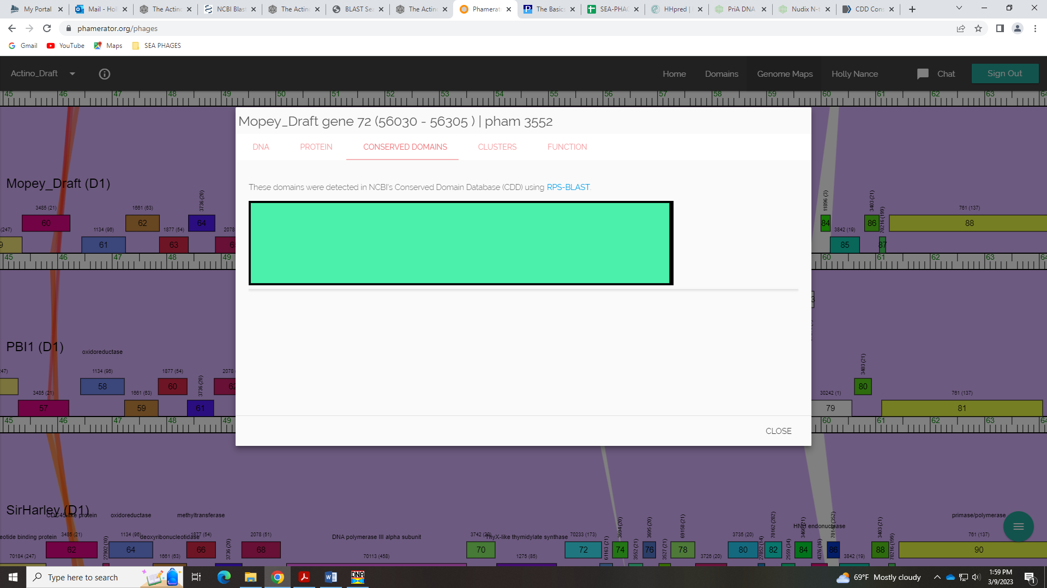
I don’t think there is compelling evidence to call this anything but NKF.

Gene 74 in our file, Gene 73 in PhagesDB – Jamie
SSC: start 56290, stop 56541; CP: yes; SCS: Glimmer called start of 56290, GeneMark called start of 56308; ST: NI; Blast Start: matches Thoth_74 Query 1 to Subject 1 100% 2e⁻⁴²; Gap: overlap of 16; LO: NA; RBS: -2.071, 2.906, 9, -2.845, no, but better then GeneMark start values; F: Helix-turn-Helix DNA binding protein; SIF-BLAST: helix-turn-helix DNA-binding protein/PhagesDB BLAST/Thoth_74, MT889385/100%/2e-42; SIF-HHPred: helix-turn-helix DNA binding protein, there are matches above 90% probability; SIF-SYN: helix-turn-helix DNA binding protein
Notes: For the start, there is about a 50/50 split on using 56290 vs 56308. We’ll see what the class decides…
For function, this could be a poster. If we call it HTH DNA binding protein, as some BLAST this suggest, and as some HHPred hits suggest, then someone needs to check the references in the Official Phage Function List.
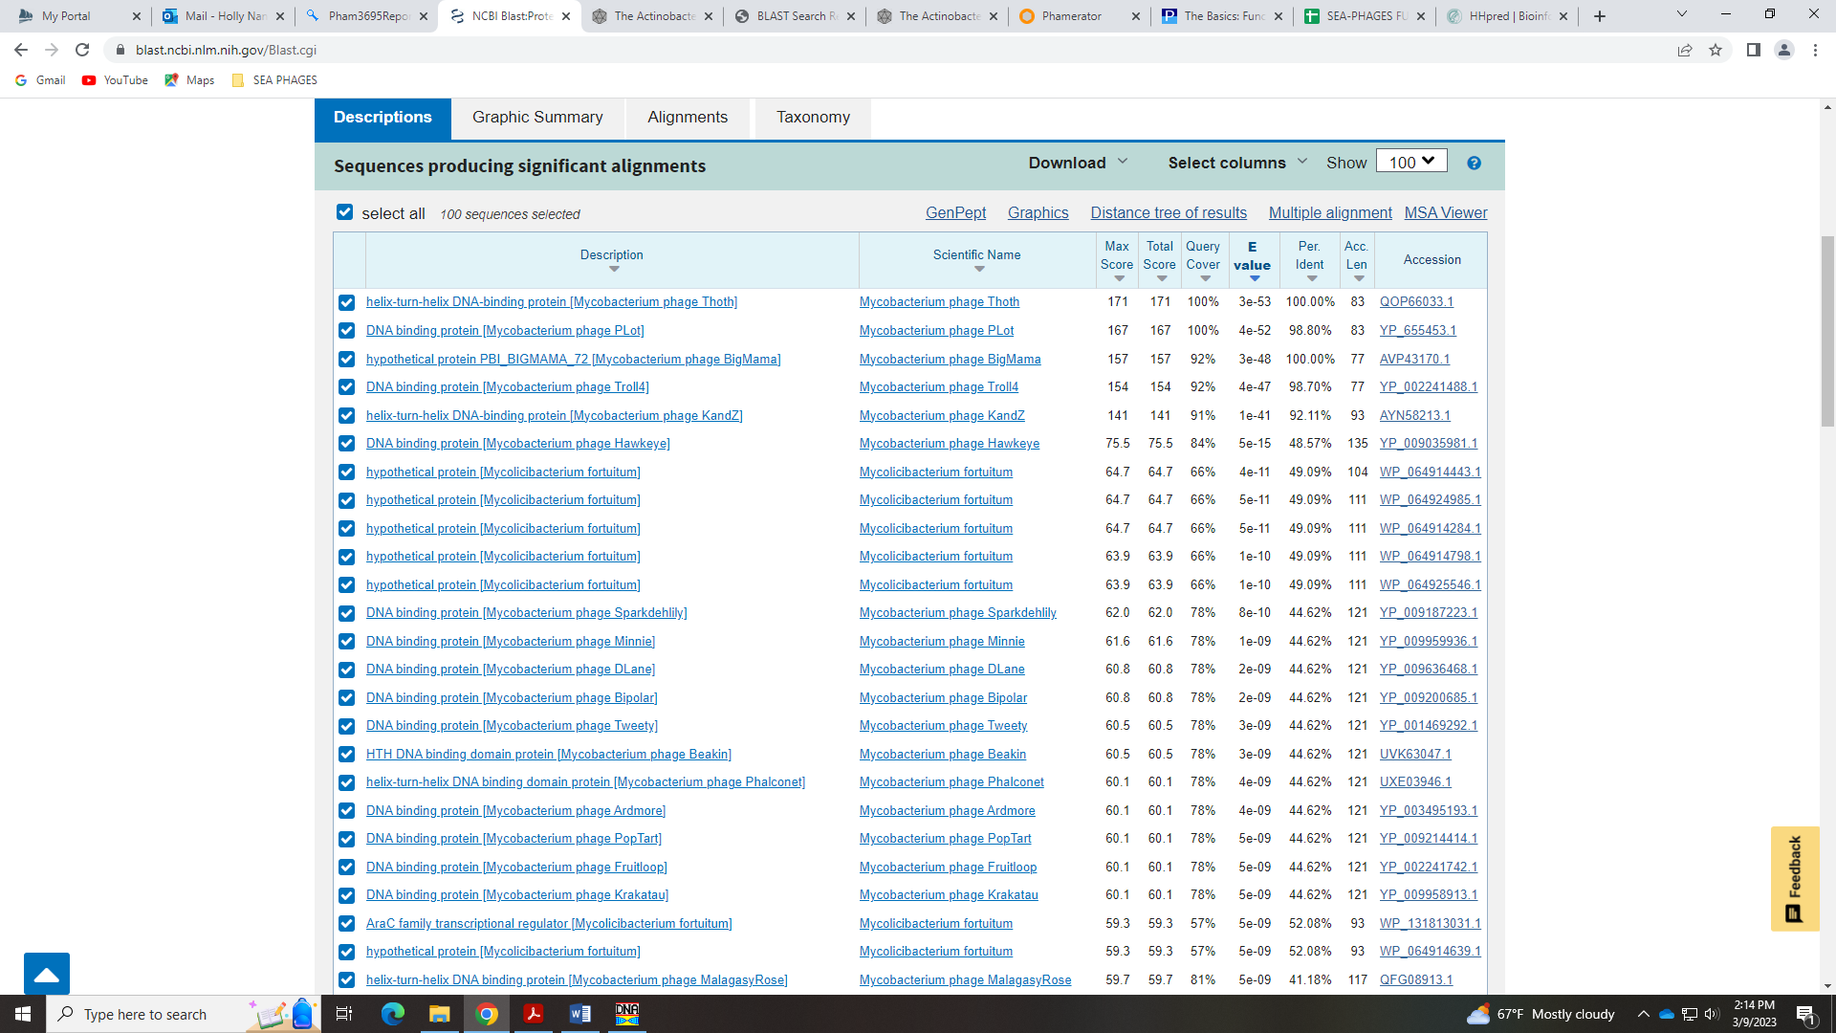
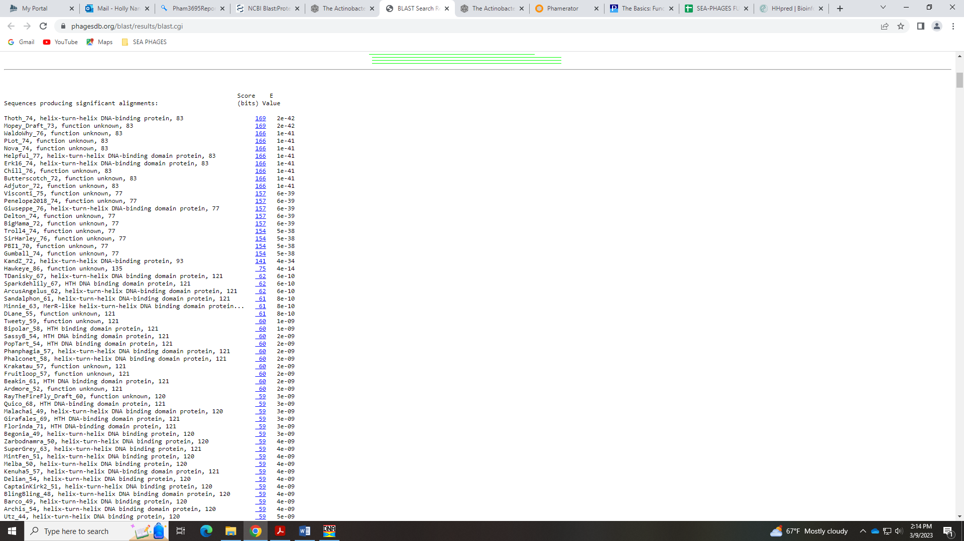
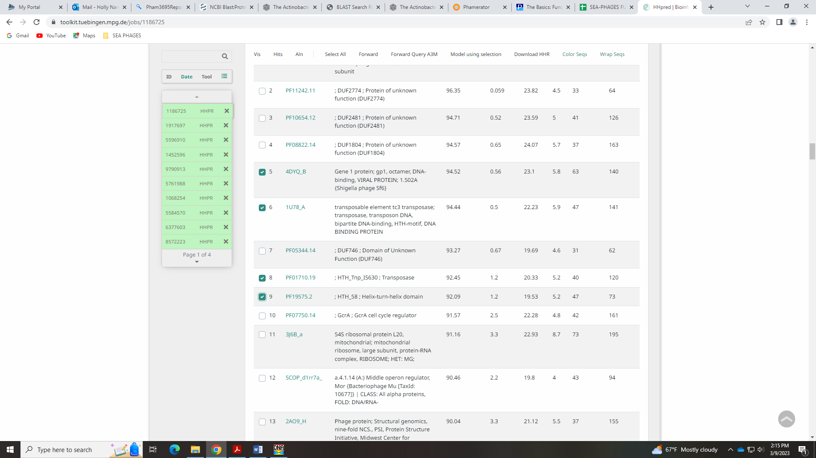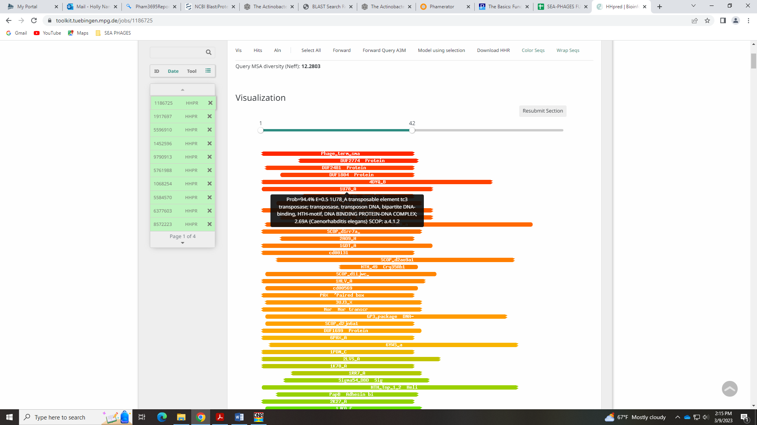
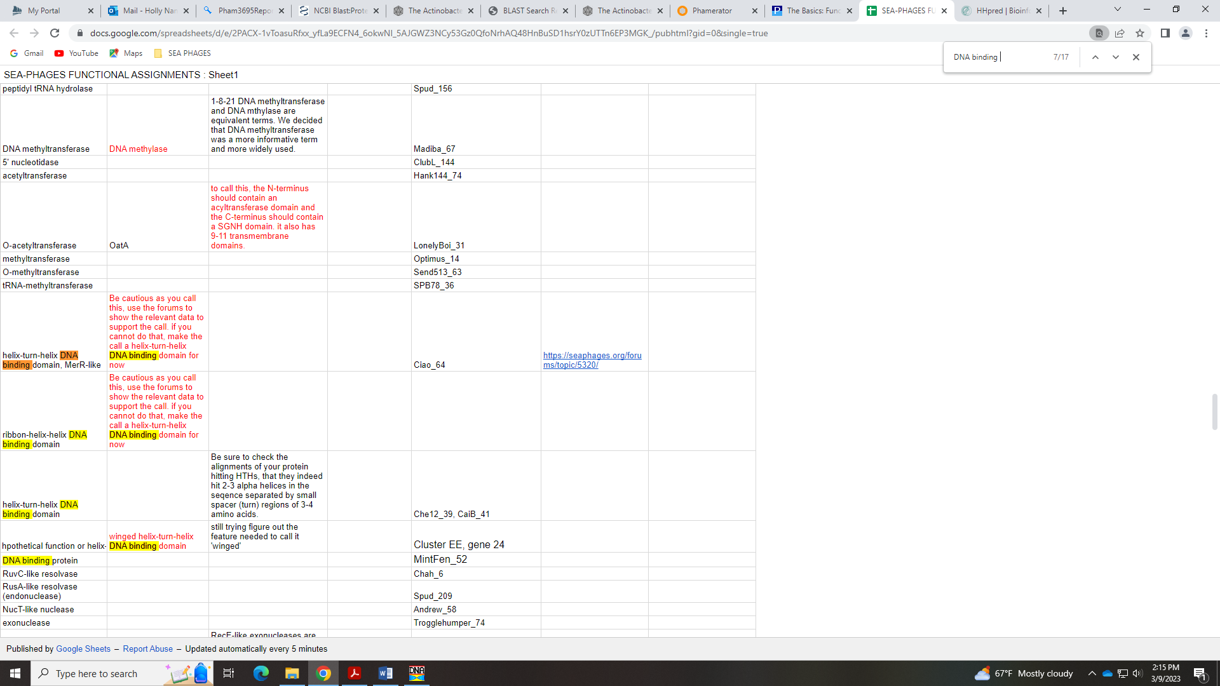
Jamie determined HTH DNA Binding Protein

Gene 75 in our file, Gene 74 in PhagesDB – Chris
SSC: start 56600, stop 56815; CP: yes; SCS: Both called start of 56600; ST: SS; Blast Start: matches WaldoWhy_77 Query 1 to Subject 1 100% 5e⁻³⁵; Gap: 58; LO: yes; RBS: -1.748, 3.061, 9, -2.523, yes; F: NKF; SIF-BLAST: NKF/PhageDB BLAST/ WaldoWhy_77, MK494102/100%/5e⁻³⁵; SIF-HHPred: NKF, a few matches with a probability above 90% for HTH DNA binding protein, but no matches as good as example in Official Function List; SIF-Syn: NKF
Notes: There is a large gap, but this start is most conserved and the gap seems to be conserved in Phamerator:
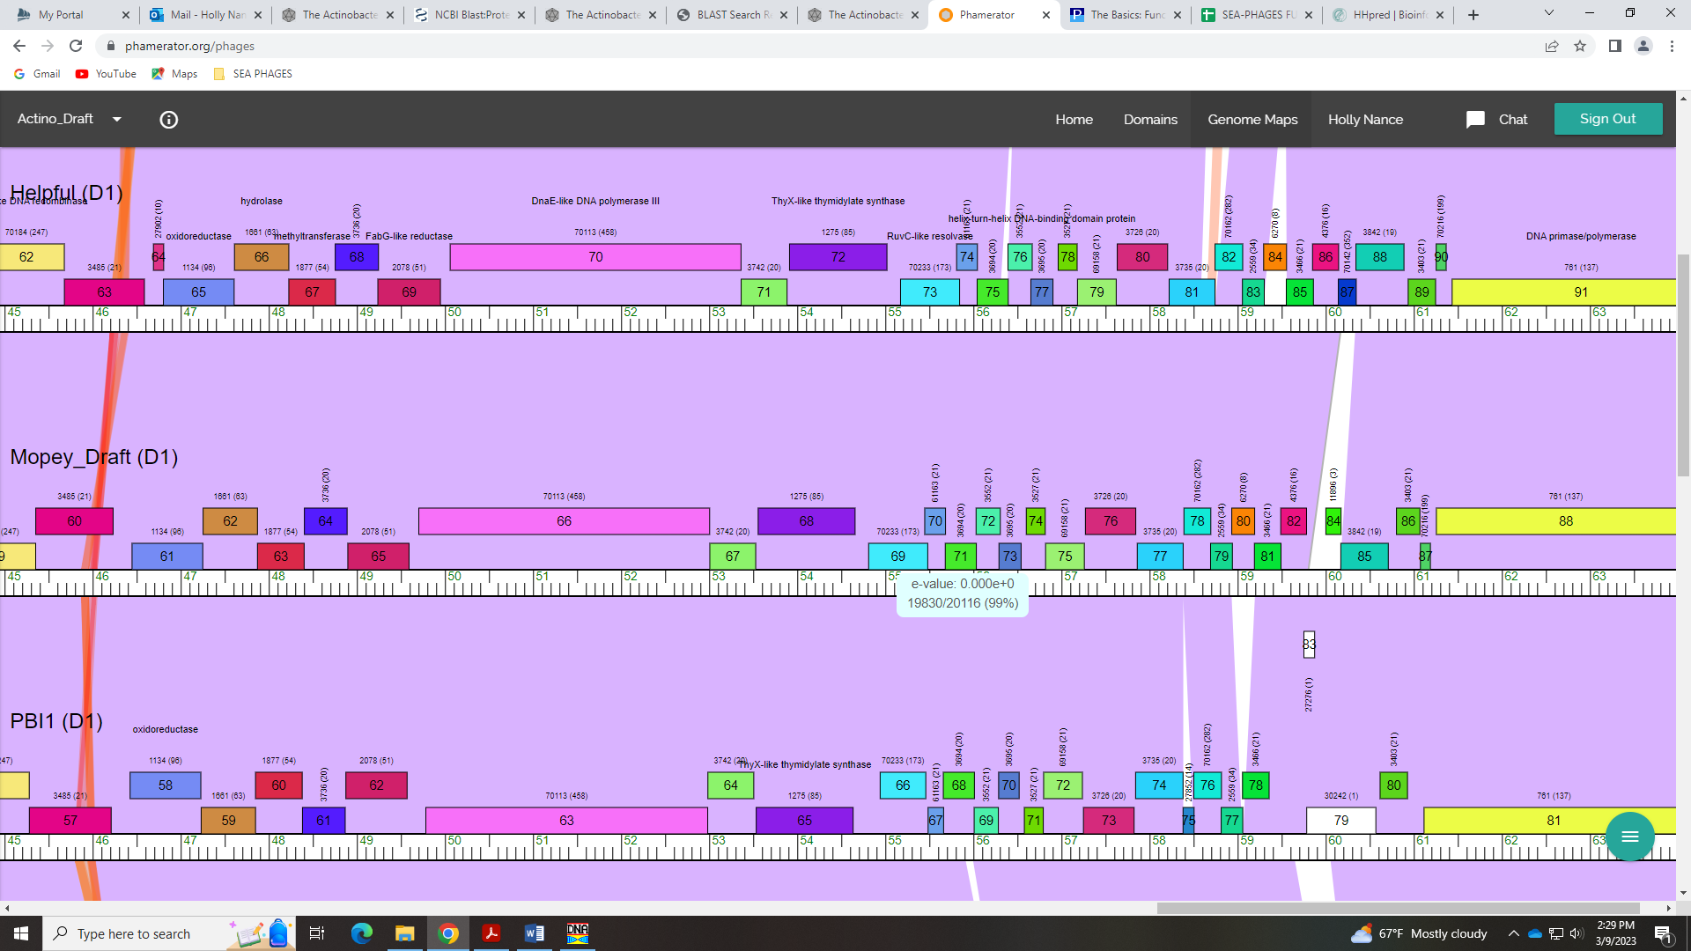
For function, all BLAST hits suggest NKF:
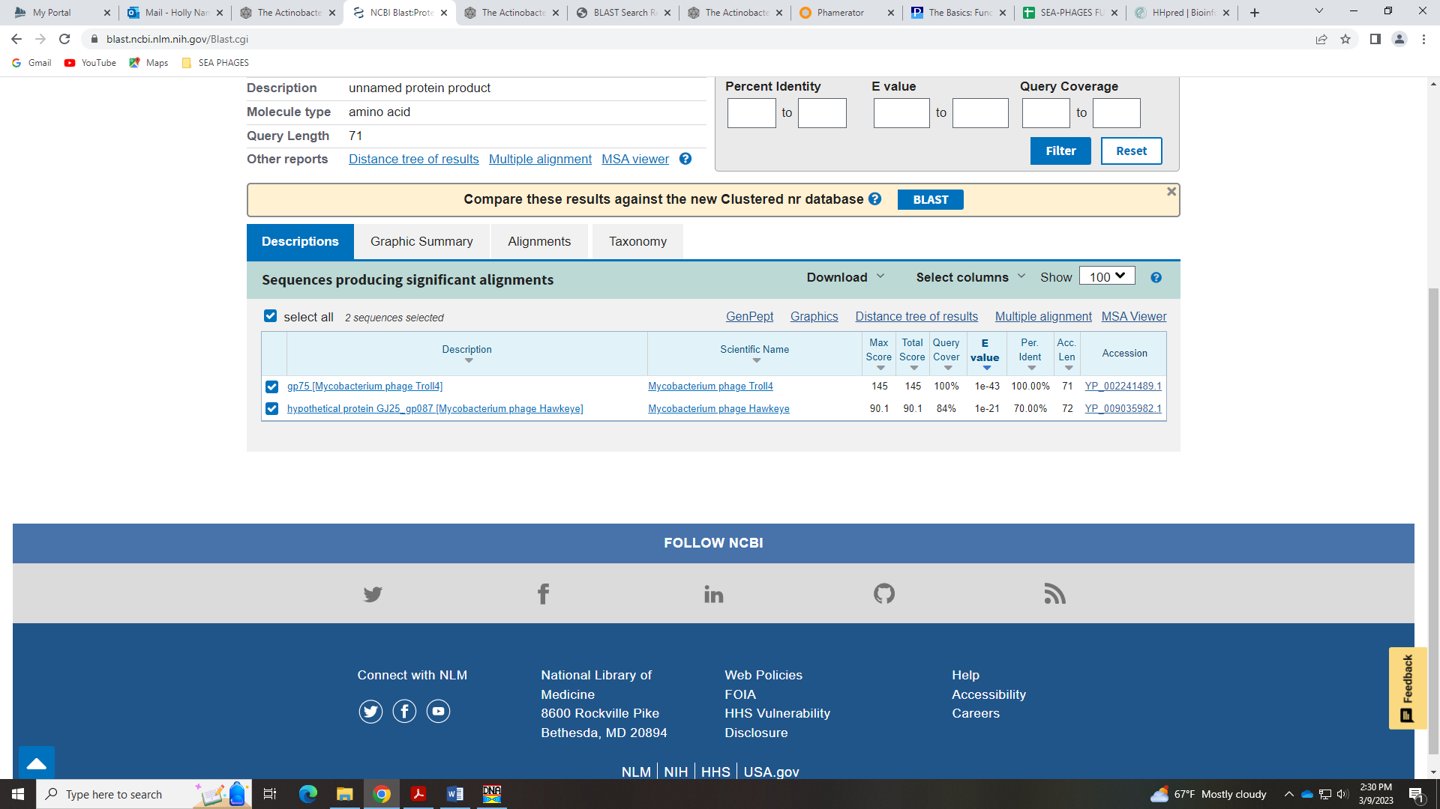
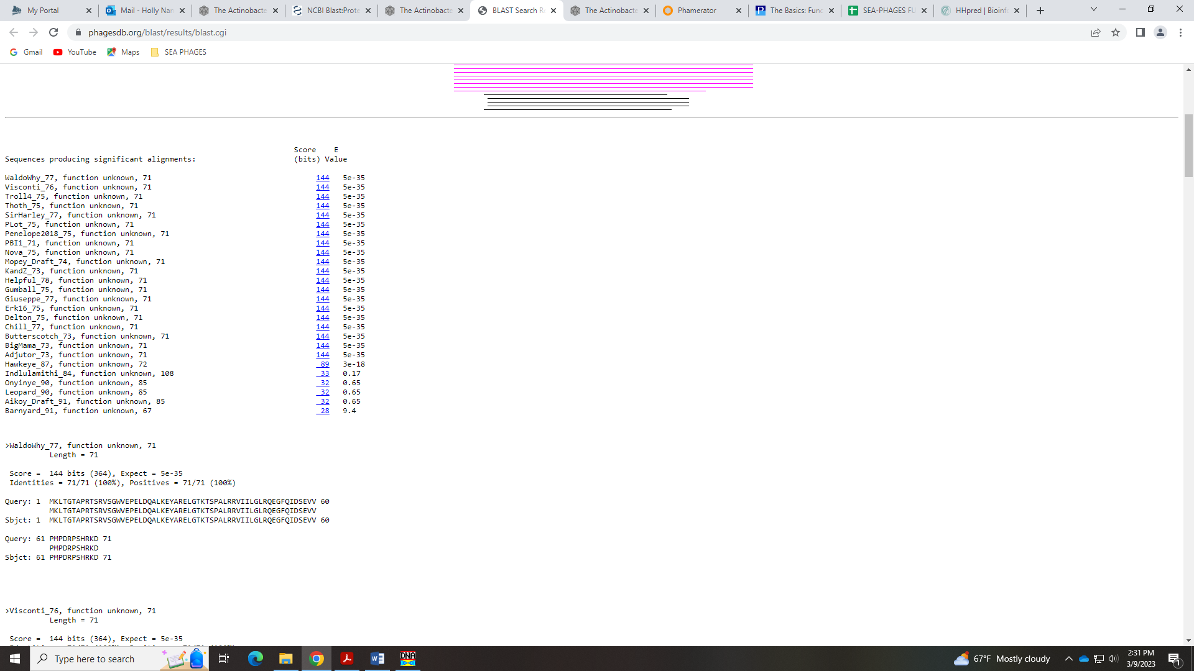
HHPred has some ribbon HTH DNA binding hits:
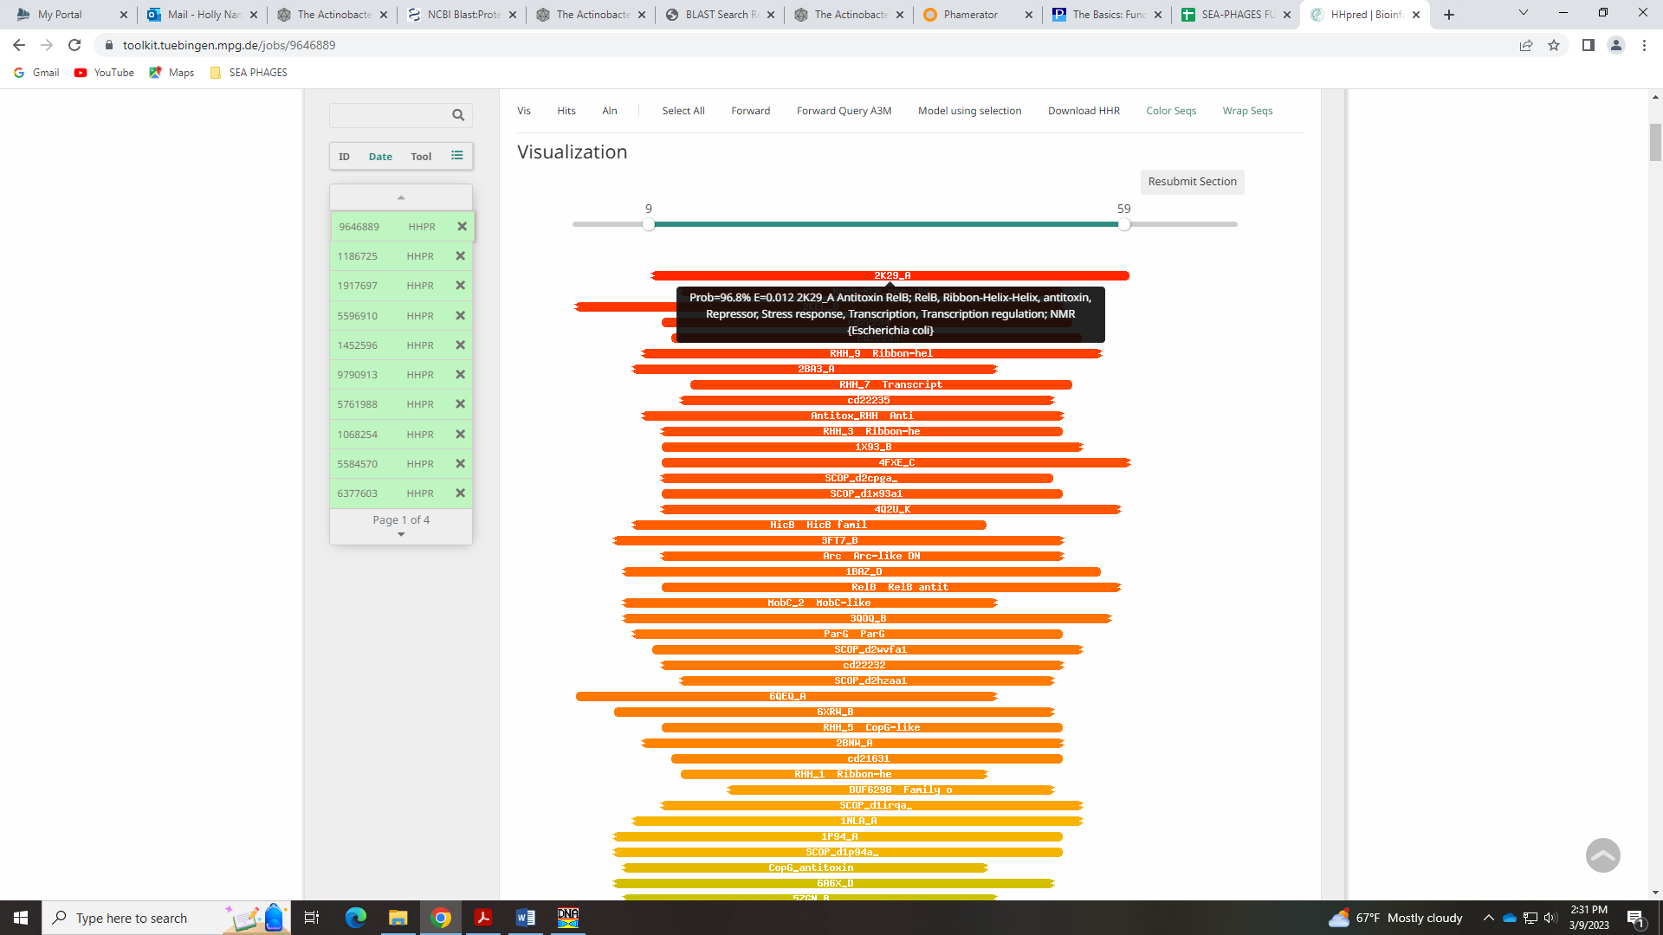
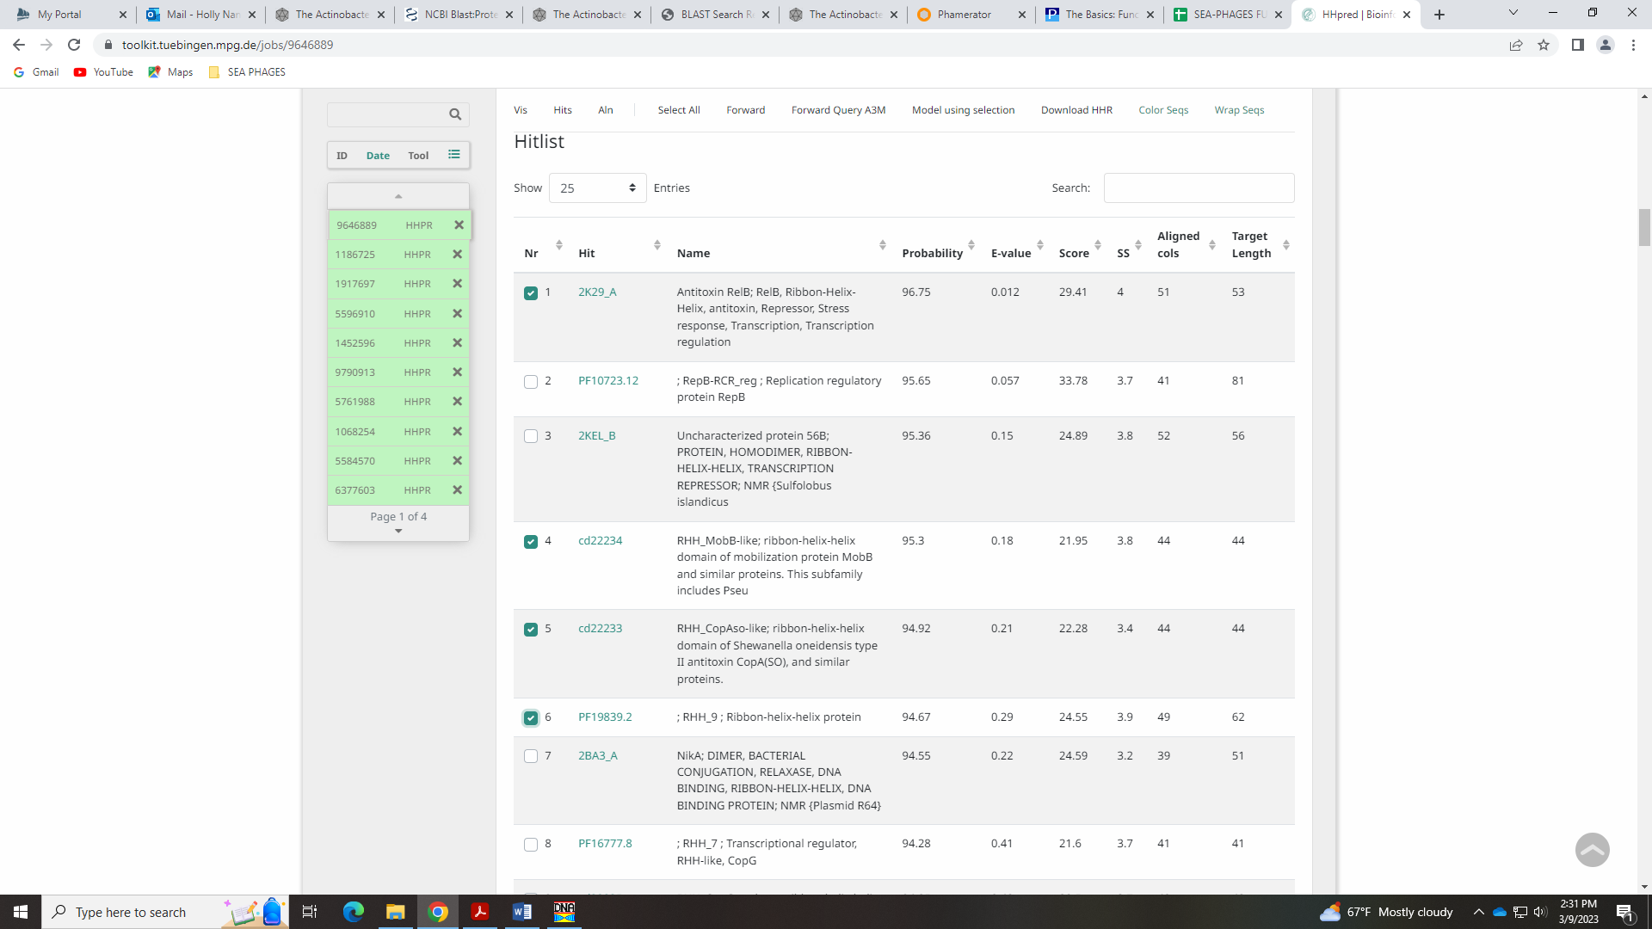
There are no identified domains in Phamerator:
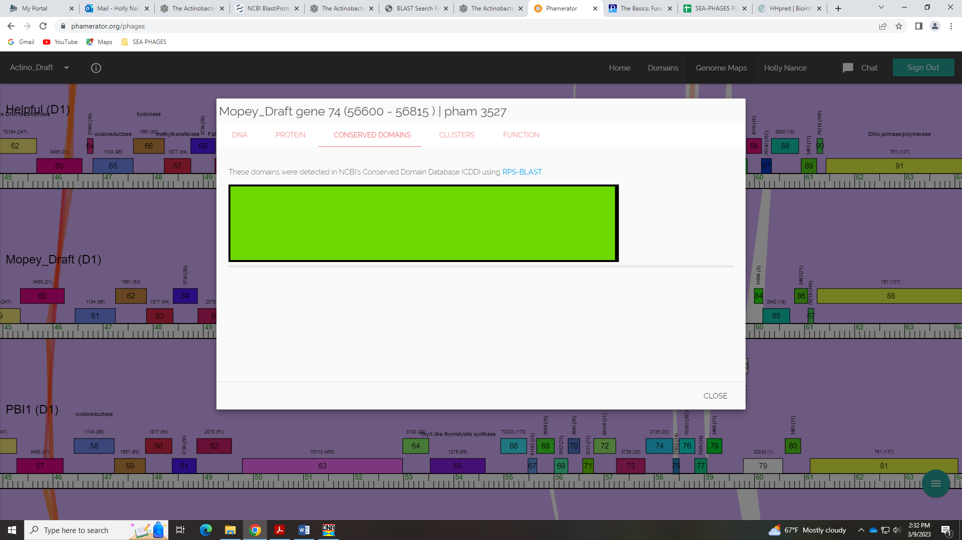
I don’t know… I’m inclined to go with NKF, but if a student wants to investigate this function further, they will have to look at the examples and case studies in the Official Phage Function List to be sure they are calling it ribbon HTH DNA binding protein correctly.
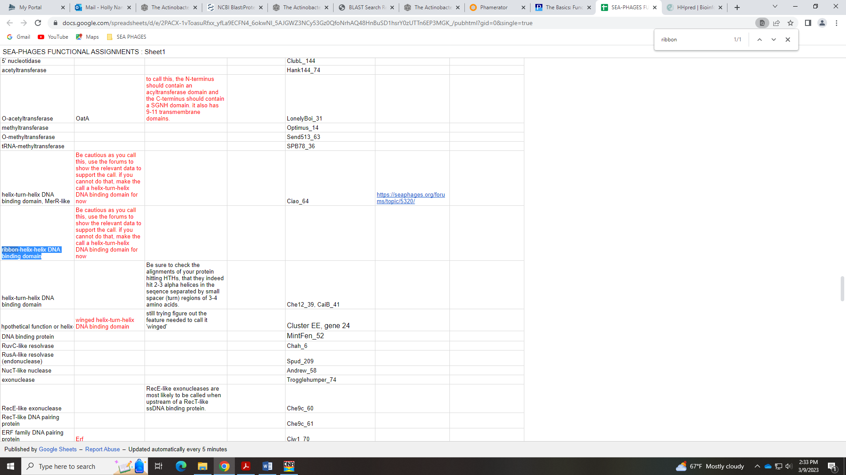

Gene 76 in our file, Gene 75 in PhagesDB
SSC: start 56819, stop 57259; CP: yes; SCS: Both called start of 56819; ST: SS; Blast Start: matches WaldoWhy_78 Query 1 to Subject 1 100% 5e⁻⁷⁹; Gap: 3; LO: NA; RBS: -1.620, 3.122, 14, -2.967, yes; F: NKF; SIF-BLAST: NKF/PhageDB BLAST/ WaldoWhy_78, MK494102/100%/5e⁻⁷⁹; SIF-HHPred: NKF, no matches with a probability above 90% except for unknown function; SIF-Syn: NKF
Notes: nothing ambiguous!

Gene 77 in our file, Gene 76 in PhagesDB
SSC: start 57271, stop 57843; CP: yes; SCS: Both called start of 57271; ST: SS; Blast Start: matches Visconti_78 Query 1 to Subject 1 100% 1e⁻¹¹⁹; Gap: 11; LO: no; RBS: -3.631, 2.158, 12, -4.467, no; F: NKF; SIF-BLAST: NKF/PhageDB BLAST/ Visconti_78, MH399788/100%/1e⁻¹¹⁹; SIF-HHPred: NKF, 4 partial matches with a probability above 90% for RNA polymerase; SIF-Syn: NKF
Notes: This start is the most conserved, though it doesn’t yield the longest ORF.
For function, NCBI and PhagesDB BLAST and synteny support NKF. There are a few hits above 90% for a DNA directed RNA polymerase in HHPred:
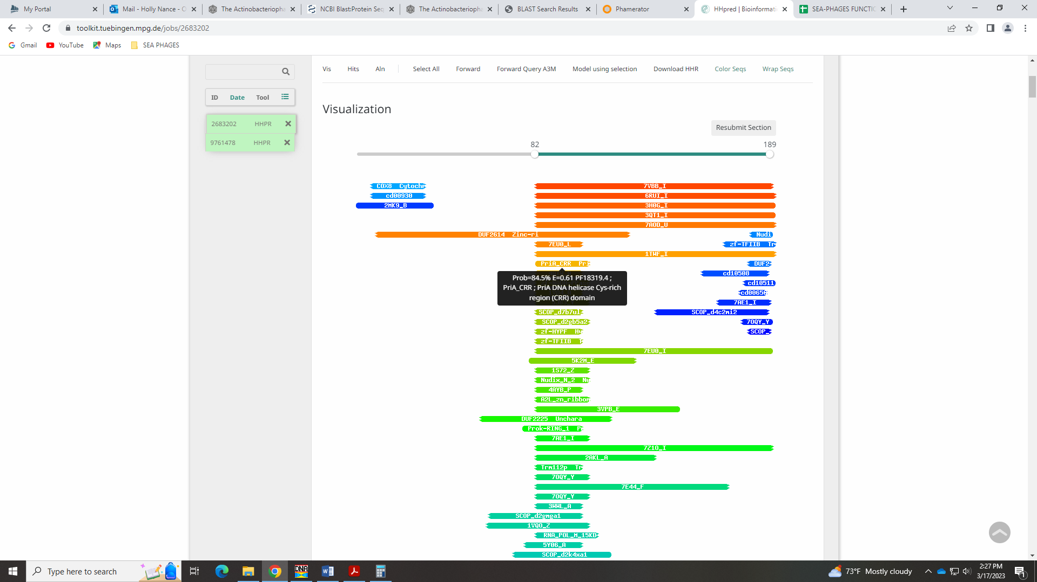
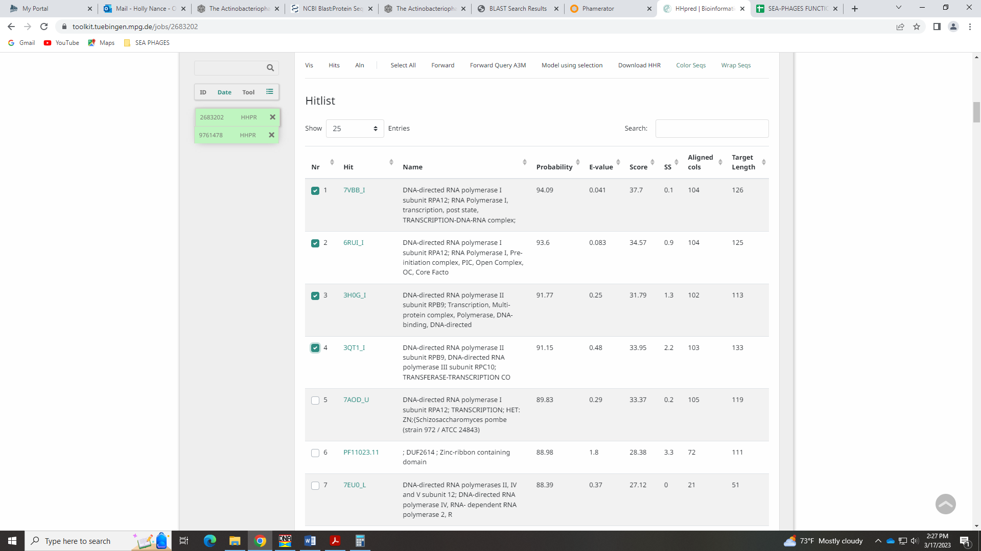
These are partial hits, and the Official Function list says that this can be an incorrect hit:
A misinterpretation of crystal structure chains lead to the mis-assignment of Zetzy1847 gene 42 as DNA directed RNA polymerase.
Given this, I’m going with NKF.

Gene 78 in our file, Gene 77 in PhagesDB
SSC: start 57860, stop 58318; CP: yes; SCS: Both called start of 57860; ST: SS; Blast Start: matches Troll4_78 Query 1 to Subject 1 99% 1e⁻¹⁰²; Gap: 16; LO: no; RBS: -2.814, 2.549, 11, -3.571, no; F: NKF; SIF-BLAST: NKF/PhageDB BLAST/ Troll4_78, NC_011285/99%/1e⁻¹⁰²; SIF-HHPred: NKF, no matches with a probability above 90%; SIF-Syn: NKF
Notes: nothing ambiguous! Start is most conserved, though doesn’t yield the longest ORF.

Gene 79 in our file, Gene 78 in PhagesDB changed start from 58390 to 58381 on 3/17!
SSC: start 58381, stop 58695; CP: yes; SCS: Glimmer called start of 58390, GeneMark called more conserved start of 58381; ST: SS; Blast Start: matches Troll4_79 Query 1 to Subject 1 100% 6e⁻⁶¹; Gap: overlap of 1; LO: NA; RBS: -3.642, 2.152, 12, -4.477, yes; F: NKF; SIF-BLAST: NKF/PhageDB BLAST/ Troll4_79, NC_011285/99%/1e⁻¹⁰²; SIF-HHPred: NKF, no matches with a probability above 90% that make sense in phage; SIF-Syn: NKF
Notes: I changed the start to the one suggested by GeneMark as this is most conserved in Cluster D1. It also has the best RBS values and yields a longer ORF than the Glimmer start. Also, there is coding potential here.
For function, BLAST and synteny suggest NKF. There are a few partial hits in HHPred for proteins in mouse, human or unknown function.
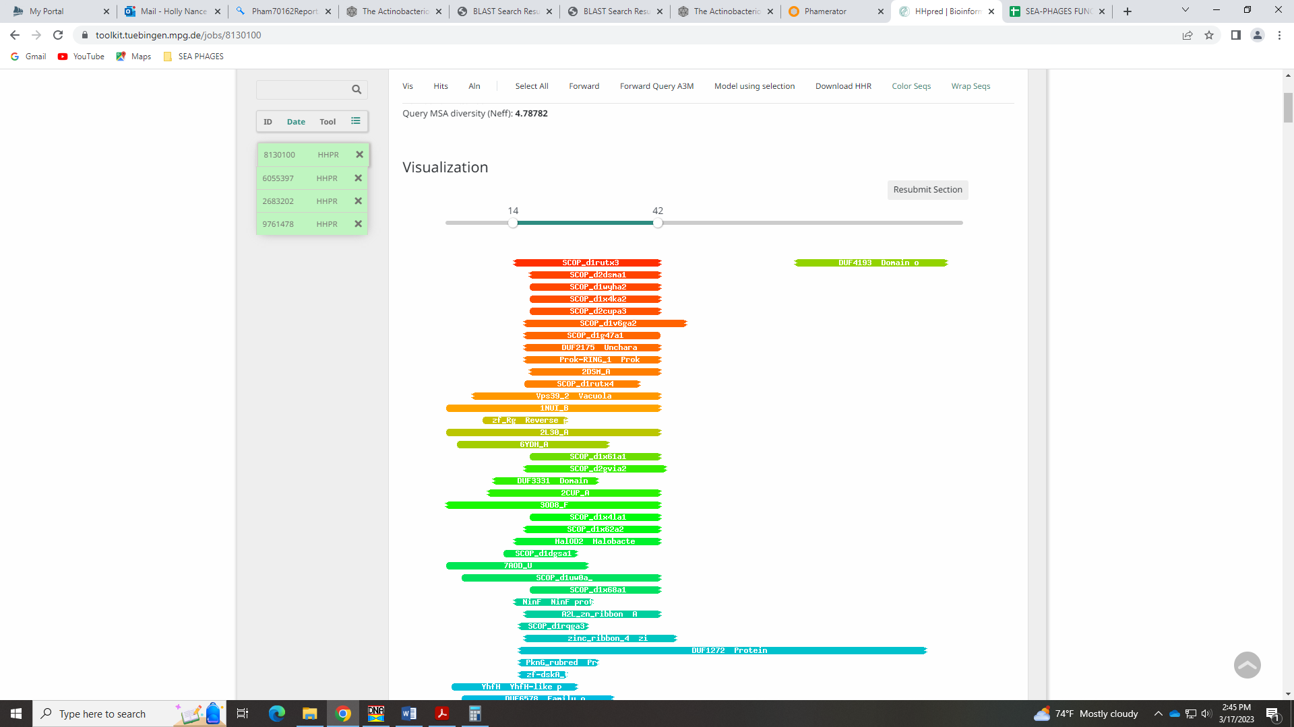
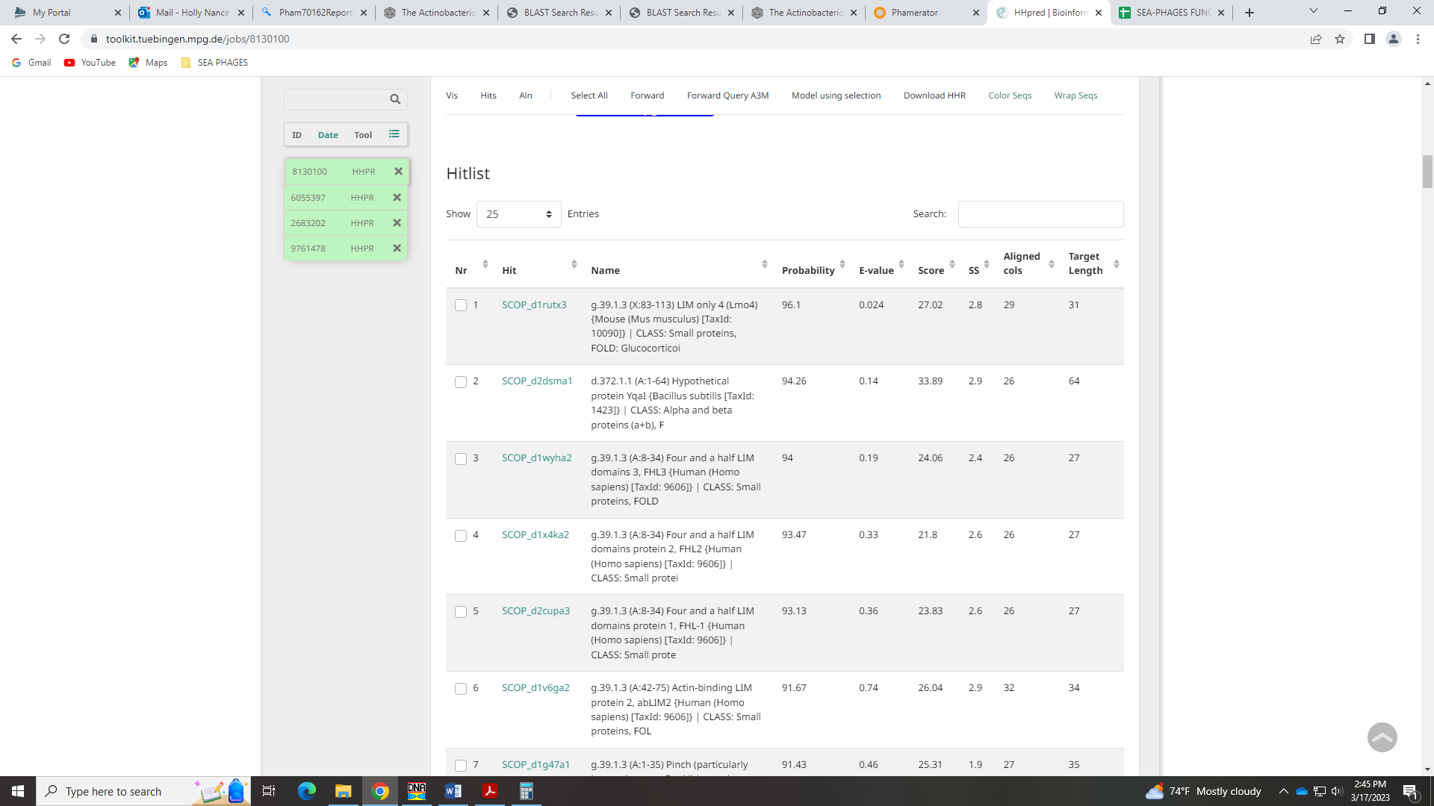
I’m keeping NKF.

Gene 80 in our file, Gene 79 in PhagesDB
SSC: start 58692, stop 58940; CP: yes; SCS: Both called start of 58692; ST: SS; Blast Start: matches Troll4_80 Query 1 to Subject 1 100% 2e⁻⁴³; Gap: overlap of 4; LO: NA; RBS: -1.907, 2.985, 11, -2.664, yes, tied for best; F: NKF; SIF-BLAST: NKF/PhageDB BLAST/ Troll4_80, NC_011285/100%/2e⁻⁴³; SIF-HHPred: NKF, no matches with a probability above 90%; SIF-Syn: NKF
Notes: nothing ambiguous!

Gene 81 in our file, Gene 80 in PhagesDB
SSC: start 58933, stop 59193; CP: yes; SCS: Both called start of 58933; ST: SS; Blast Start: matches Helpful_84 Query 1 to Subject 1 100% 1e⁻⁴⁶; Gap: overlap of 8; LO: no; RBS: -3.378, 2.279, 9, -4.152, no; F: NKF; SIF-BLAST: NKF/PhageDB BLAST/ Helpful_84, MN284908/100%/1e⁻⁴⁶; SIF-HHPred: NKF, no matches with a probability above 90%; SIF-Syn: NKF
Notes: This start is conserved, though it does not yield the longest ORF. However, there are several other starts that would yield a larger overlap. Function is definitely NKF.

Gene 82 in our file, Gene 81 in PhagesDB
SSC: start 59190, stop 59492; CP: yes; SCS: Both called start of 59190; ST: SS; Blast Start: matches Erk16_83 Query 1 to Subject 1 100% 1e⁻⁵⁶; Gap: overlap of 4; LO: yes; RBS: -2.071, 2.906, 10, -2.765, yes; F: NKF; SIF-BLAST: NKF/PhageDB BLAST/ Erk16_83, MH316562/100%/1e⁻⁵⁶; SIF-HHPred: NKF, no matches with a probability above 90%; SIF-Syn: NKF
Notes: Nothing ambiguous here!

Gene 83 in our file, Gene 82 in PhagesDB
SSC: start 59489, stop 59782; CP: yes; SCS: Both called start of 59489; ST: SS; Blast Start: matches Erk16_84 Query 1 to Subject 1 98% 8e⁻⁵⁷; Gap: overlap of 4; LO: yes; RBS: -3.420, 2.259, 11, -4.177, no; F: NKF; SIF-BLAST: NKF/PhageDB BLAST/ Erk16_84, MH316562/98%/8e⁻⁵⁷; SIF-HHPred: NKF, no matches with a probability above 90%; SIF-Syn: NKF
Notes: nothing ambiguous!

Gene 84 in our file, Gene 83 in PhagesDB Orpham! Deleted 4.27.2023
SSC: start 1, stop 309; CP: yes; SCS: Both called start of 1; ST: SS; Blast Start: matches Thoth_1 Query 1 to Subject 1 100% 1e⁻⁵⁷; Gap: 0; LO: NA; RBS: -2.273, 2.809, 64617, -3.495, yes; F: NKF; SIF-BLAST: NKF/PhageDB BLAST/Thoth_1, MT889385/100%/1e⁻⁵⁷; SIF-HHPred: NKF, no matches with a probability above 90%; SIF-Syn: NKF
Notes: This is the first orpham in Mopey! Called by Glimmer, not GeneMark. No coding potential to check. The only phage that show up as BLAST hits are Big Mama and a draft gene:
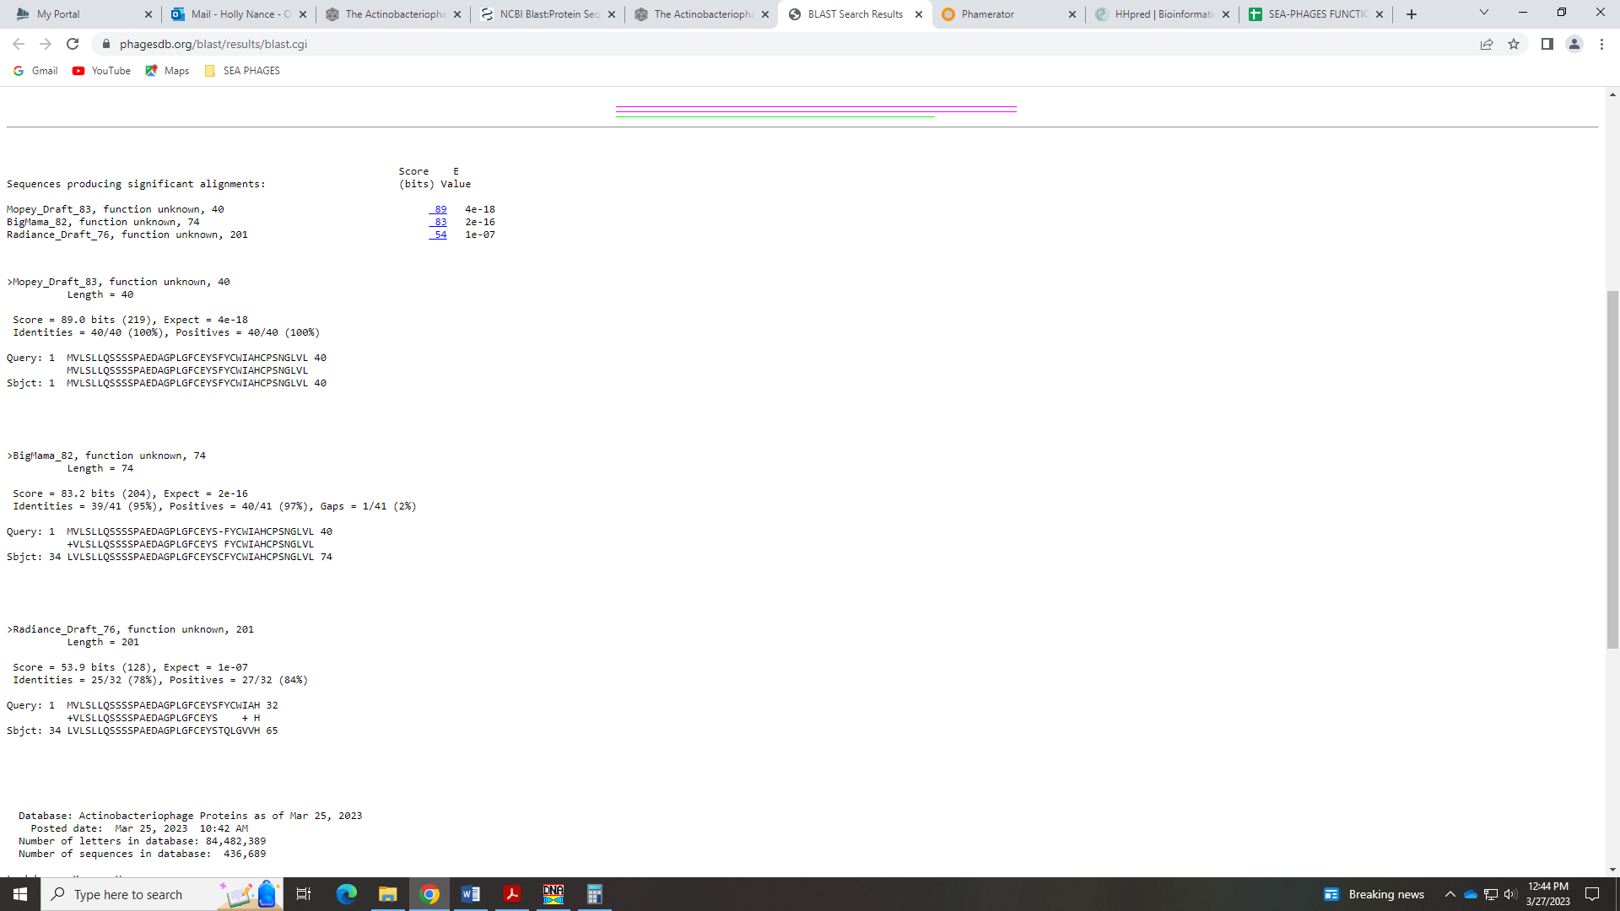
This gene is tiny, at only 123 BP. There is little support for this gene existing…I’m ok with deleting. We’ll see what the class thinks! Plus, when we change start to next gene, there is no large gap if we remove this gene… there is a small overlap, actually.

Gene 84 in our file, Gene 84 in PhagesDB changed start to 59779 on 3/27/23!
SSC: start 59779, stop 60174; CP: yes; SCS: Glimmer called start at 60001, GeneMark called more conserved start in BLAST of 59779; ST: NI; Blast Start: matches WaldoWhy_85 Query 1 to Subject 1 100% 1e⁻⁶⁸; Gap: overlap of 4; LO: NA; RBS: -4.027, 1.968, 9, -4.801, no; F: NKF; SIF-BLAST: NKF/PhageDB BLAST/ WaldoWhy_85, MK494102/100%/1e⁻⁶⁸; SIF-HHPred: NKF, no matches with a probability above 90%; SIF-Syn: NKF
Notes: Changed start from Glimmer start of 60001 to GeneMark start of 59779 on Mar 27! This start has better RBS values, yields more Q1:S1 hits in BLAST:
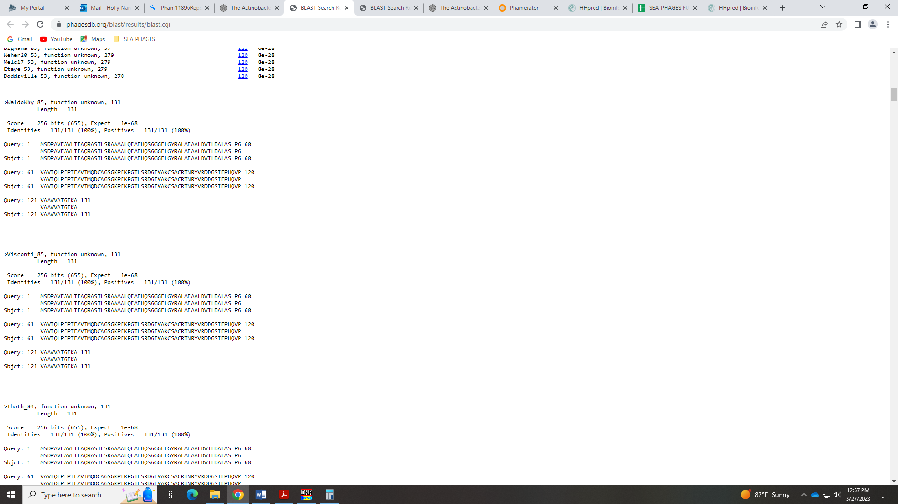
And aligns with more genes in D1. Changing this start yields a much longer ORF than the Glimmer start. This would put the gene in a different phamily, I’m sure. Also, since we’ll likely remove the gene before this one, this new start takes care of what would have been a large overlap.

Gene 85 in our file, Gene 85 in PhagesDB
SSC: start 60171, stop 60710; CP: yes; SCS: Both called start of 60171; ST: SS; Blast Start: matches Erk16_86 Query 1 to Subject 1 95% 1e⁻¹⁰²; Gap: overlap of 4; LO: NA; RBS: -2.281, 2.805, 11, -3.038, yes; F: NKF; SIF-BLAST: NKF/PhageDB BLAST/ Erk16_86, MH316562/95%/1e⁻¹⁰²; SIF-HHPred: NKF, no matches with a probability above 90%; SIF-Syn: NKF
Notes: Start is most conserved in Starterator, though there are some hits in BLAST that are not 1:1. However, this start has the best RBS values, and yields the longest ORF.

Gene 86 in our file, Gene 86 in PhagesDB changed start to 60758 on 3/30/2023
SSC: start 60758, stop 61069; CP: yes; SCS: Glimmer called start at 60803, GeneMark called start at 60758 which is more conserved; ST: SS; Blast Start: matches WaldoWhy_87 Query 1 to Subject 1 99% 4e⁻⁵⁴; Gap: 47; LO: yes; RBS: -4.013, 1.974, 14, -5.360, no; F: NKF; SIF-BLAST: NKF/PhageDB BLAST/ WaldoWhy_87, MK494102/99%/4e⁻⁵⁴; SIF-HHPred: NKF, no matches with a probability above 90%; SIF-Syn: NKF
Notes: I went with the GeneMark start of 60758 as this was more conserved in Starterator and BLAST. This start did not have the best RBS values, but it resulted in a longer gene.

Gene 87 in our file, Gene 87 in PhagesDB
SSC: start 61075, stop 61188; CP: yes; SCS: Only Glimmer called start of 61075, not called by GeneMark; ST: SS; Blast Start: matches WaldoWhy_88 Query 1 to Subject 1 100% 5e⁻¹⁷; Gap: 5; LO: NA; RBS: -2.976, 2.472, 10, -3.671, yes; F: NKF; SIF-BLAST: NKF/PhageDB BLAST/ WaldoWhy_88, MK494102/100%/5e⁻¹⁷; SIF-HHPred: NKF, no matches with a probability above 90%; SIF-Syn: NKF
Notes: Only Glimmer called this gene, but the start is most conserved and this gene is called by most other phage in D1.
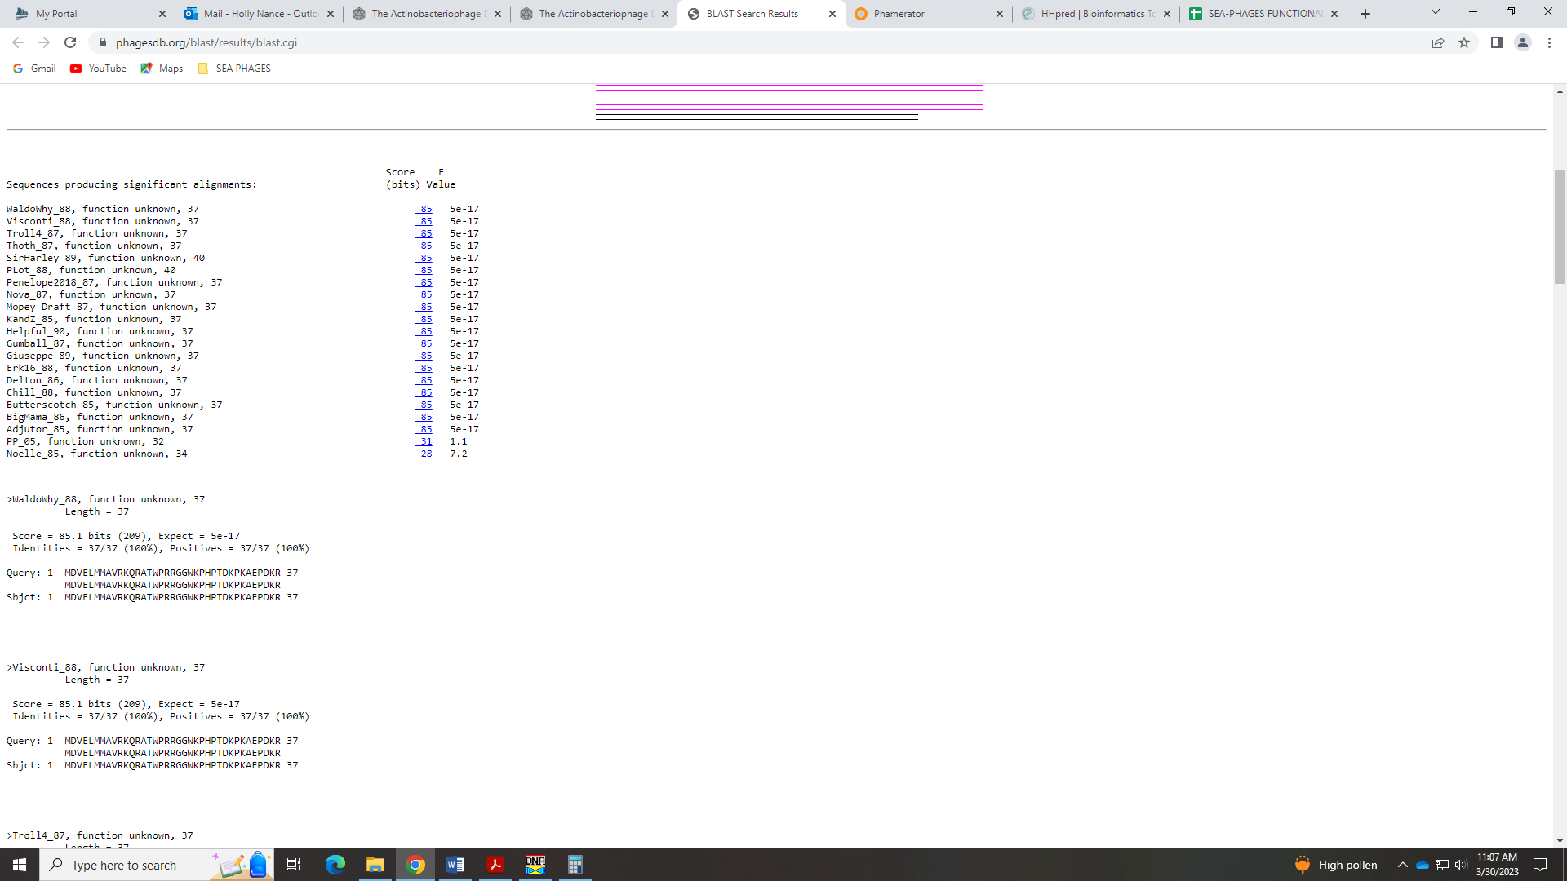
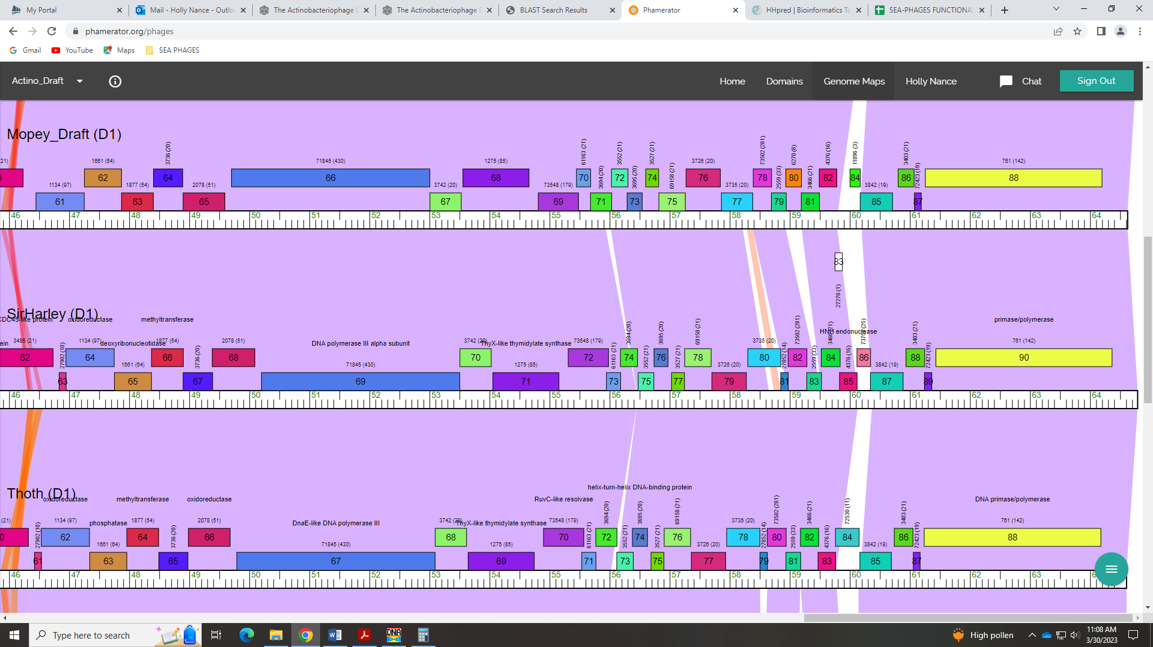

Gene 88 in our file, Gene 88 in PhagesDB
SSC: start 61256, stop 64198; CP: yes; SCS: Both called start of 61256; ST: SS; Blast Start: matches Thoth_88 Query 1 to Subject 1 99% 0.0; Gap: 67; LO: yes; RBS: -2.814, 2.549, 15, -4.416, no; F: DNA primase/polymerase; SIF-BLAST: DNA primase/polymerase /PhageDB BLAST/ Thoth_88, MT889385/99%/0.0; SIF-HHPred: DNA primase/polymerase, several matches with a probability above 90%; SIF-Syn: DNA primase/polymerase
Notes: Start is most conserved. For function, BLAST and synteny support DNA primase/polymerase:
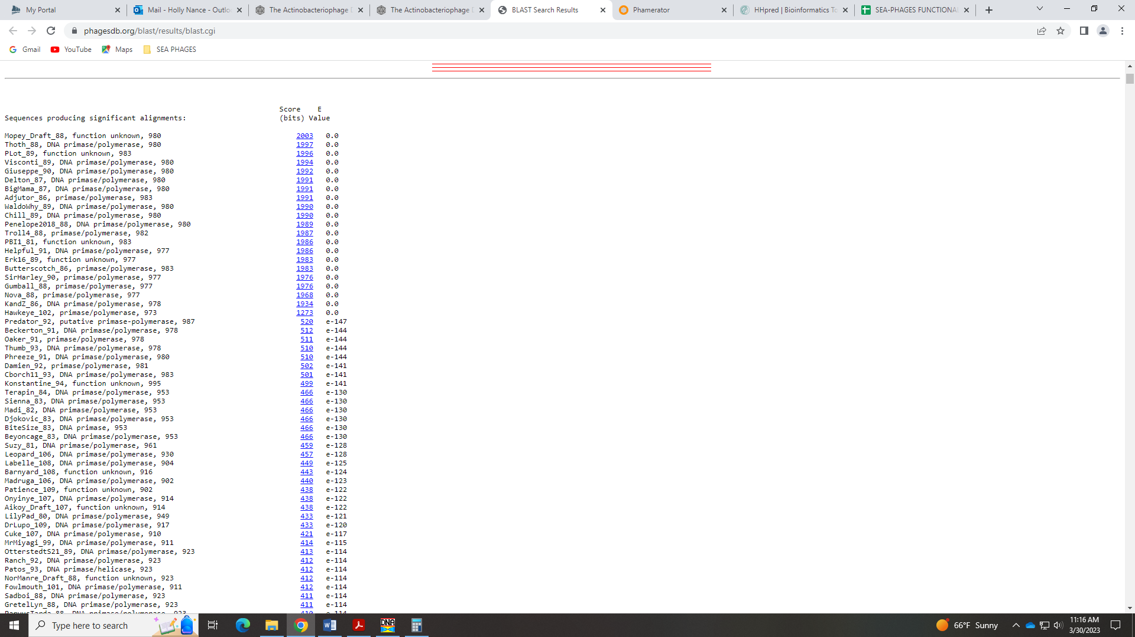
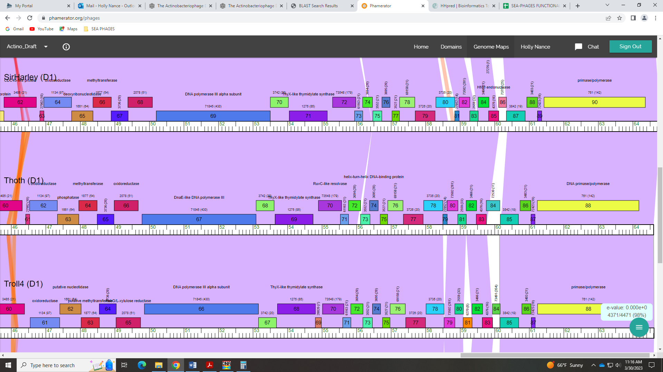 This name is on the Official List, and indicates that to call it this it must have both parts (primase and polymerase). The protein as both domains, according to Phamerator:
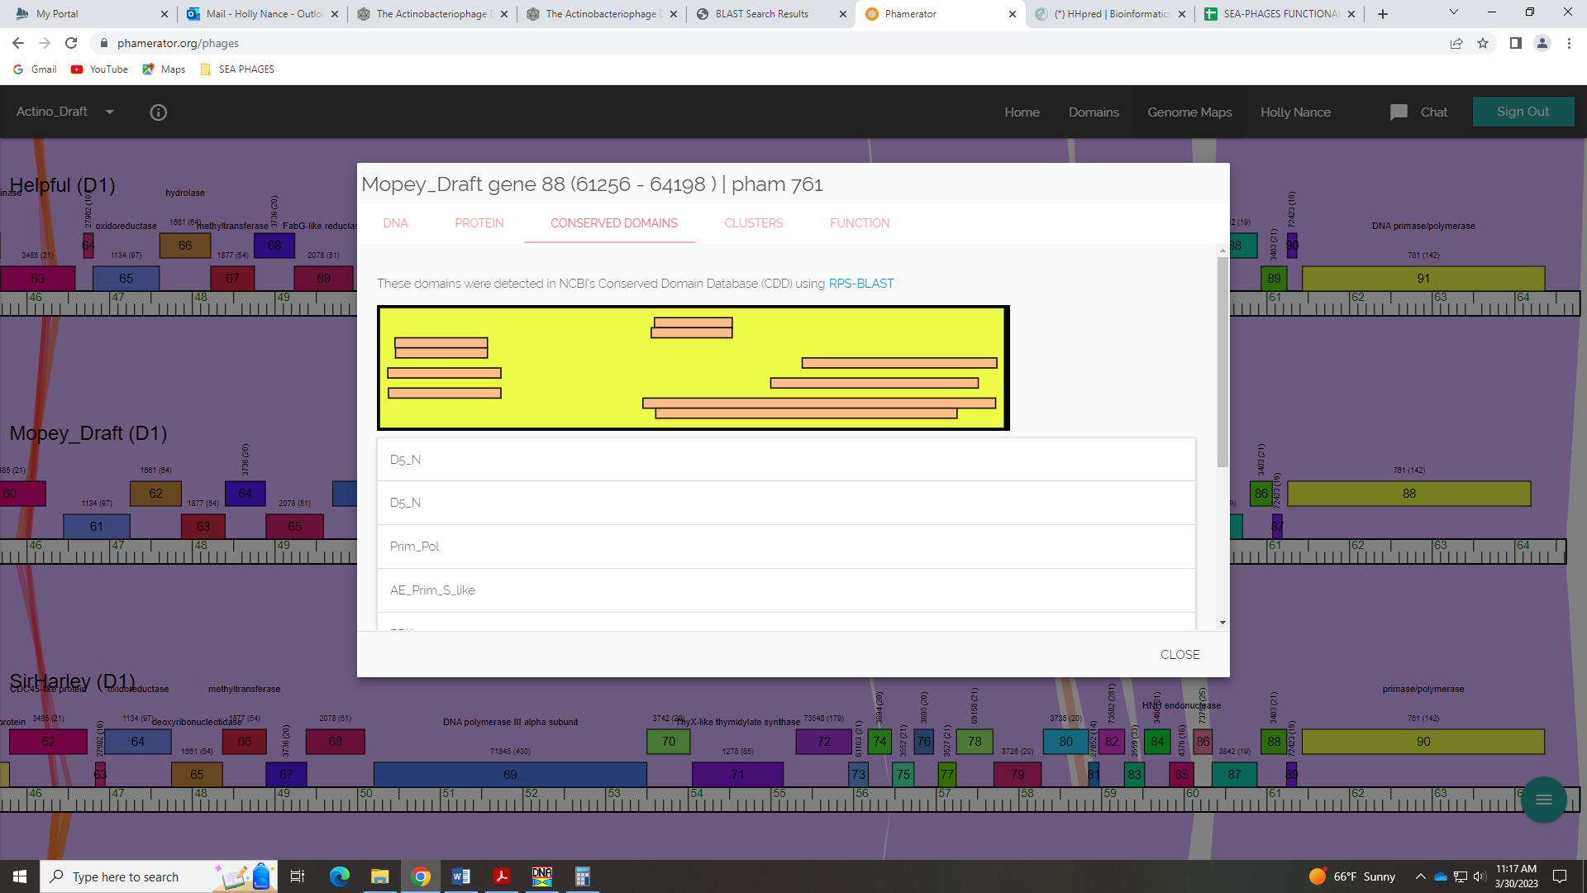
And HHPred has hits to both of these functions:
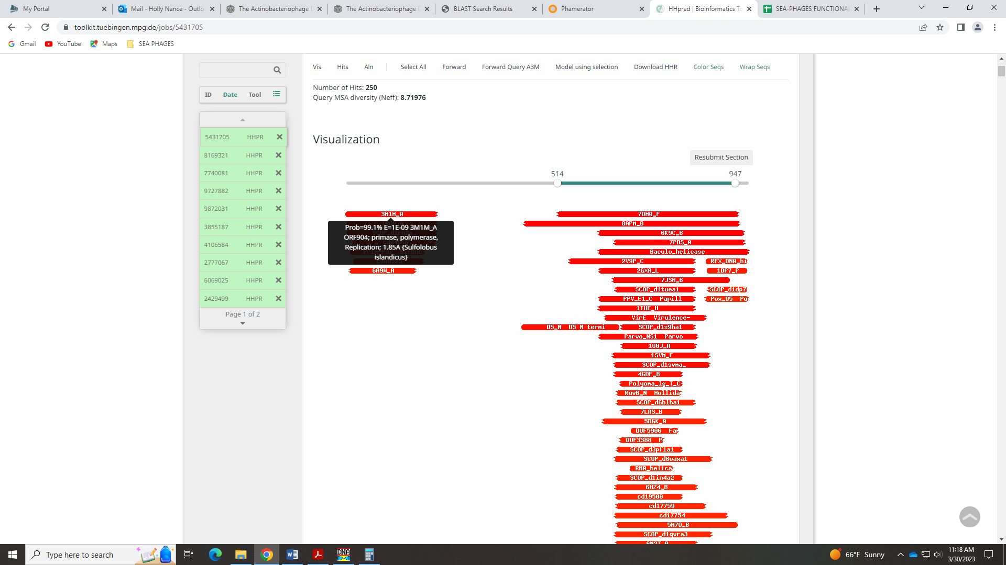
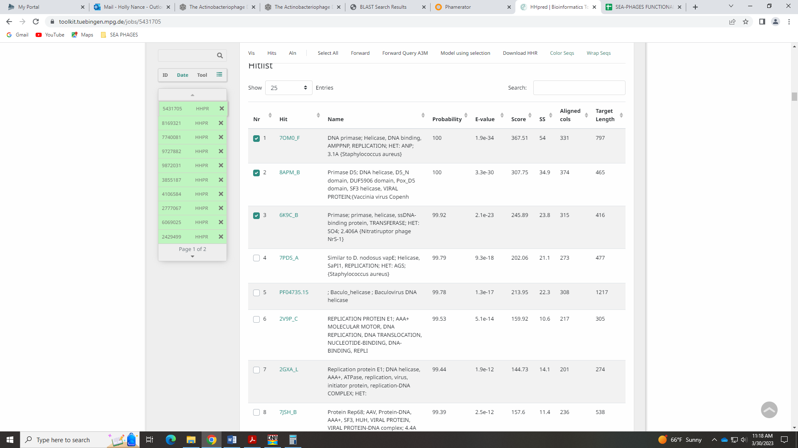

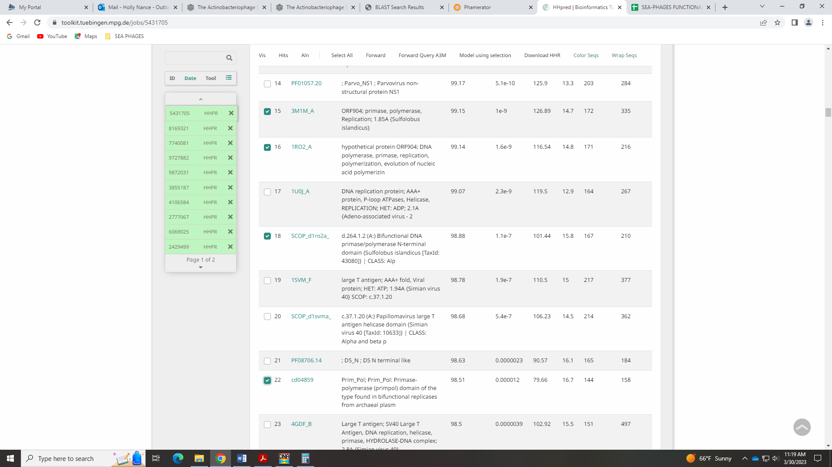
I think this is the function!

