VRedHorse 54,800 bp including 10-base 3' overhang (CGGAAGGCGC), Cluster F1
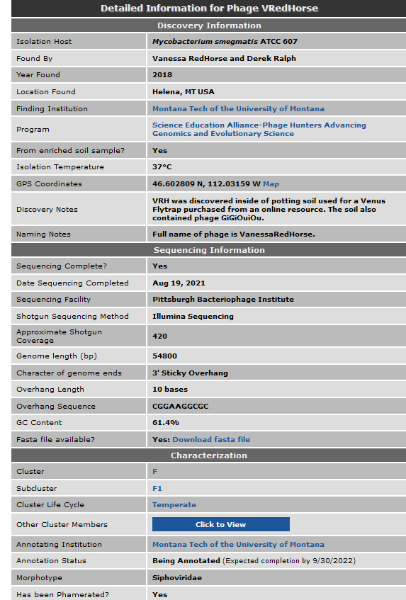
According to phagesdb.org (9/2/22) , 106 genes in Draft annotation

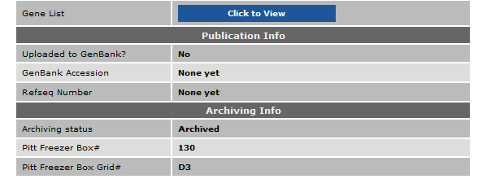
9/2/22 Blastn vs phagesdb
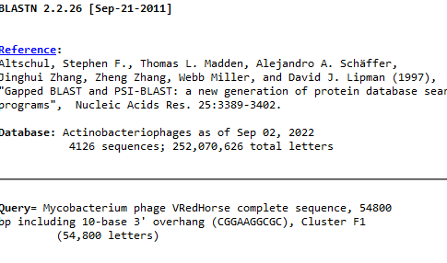
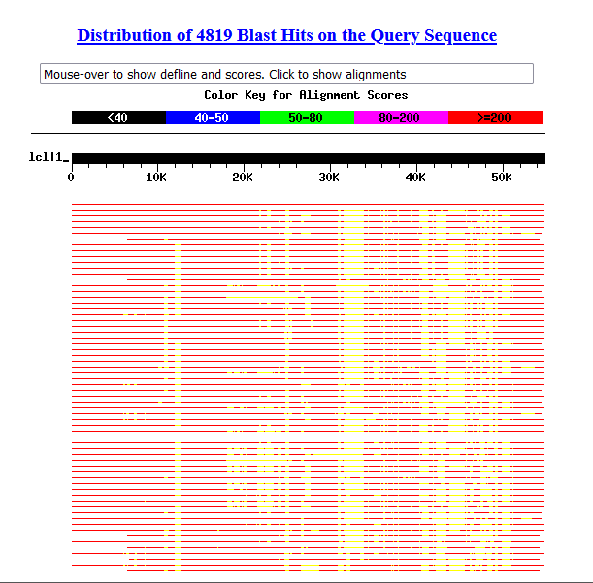
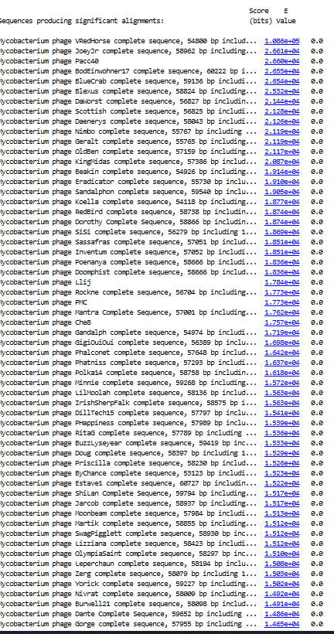
9/2/22 Ran genemarkS, genemark vs smeg mc2155 and vs TB h37rv..all came as 0kb. Redid online with mc2155, H37RV, GenemarkS, and Leprae. Printed genemarkS output. Saved predicted genes in one Wordfile for all models
Uploaded sequence into DNA Master and ran autoannotation saved as 20220902VRedHorsev1, 104 genes predicted

Made map
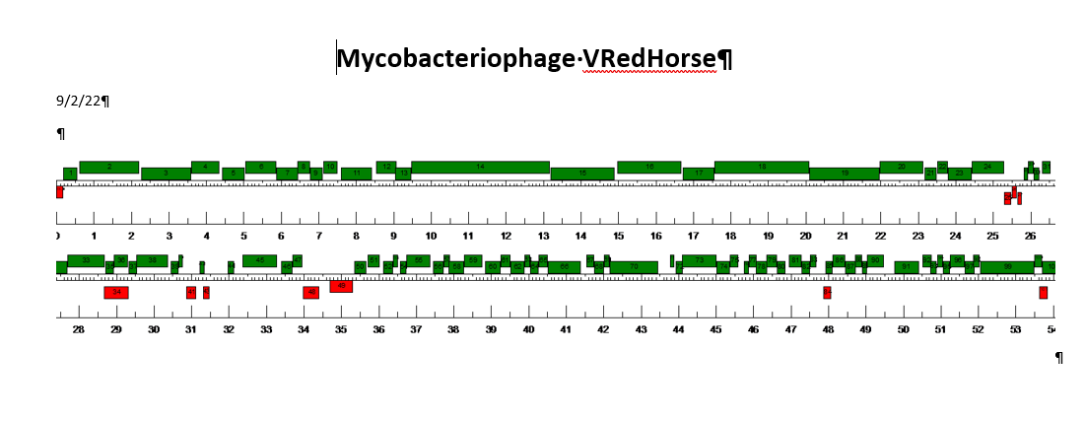
Made 6 frame, with and without color…printed one without color

9/12/22 Ran tRNA Scan SE….no tRNAs found
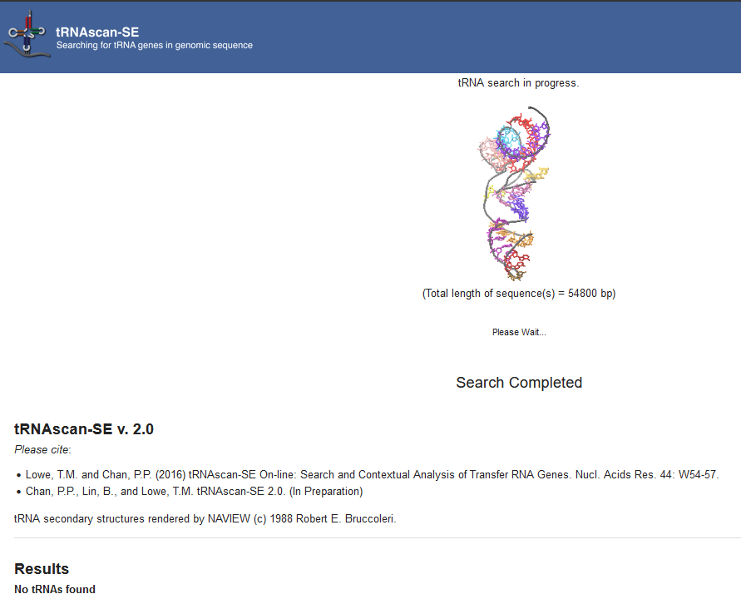
Ran Aragorn, no tRNA, tmRNA found

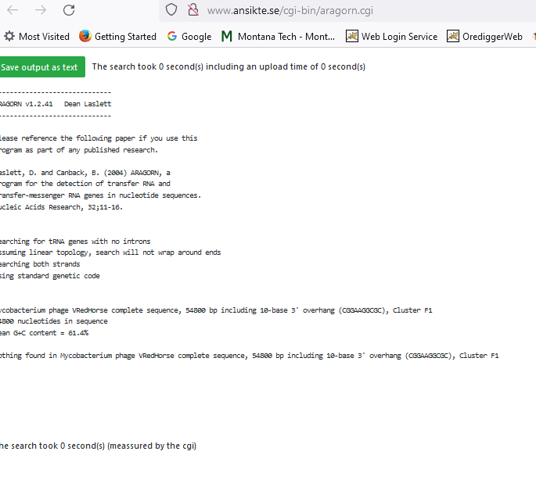
Gene Number:1
Pham47106
BlastP on Phagesdb using longest orf, ATG start at 109, matched many phage proteins 100% 1:1 start, identified as terminase small subunit

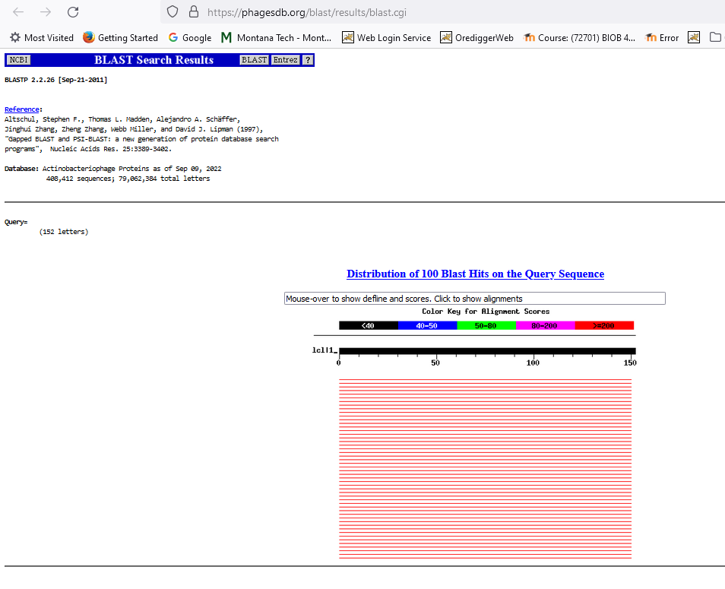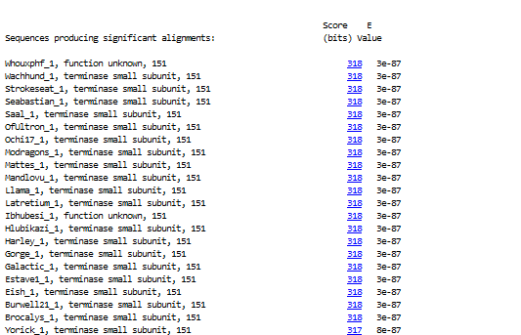
and on NCBI Blast P
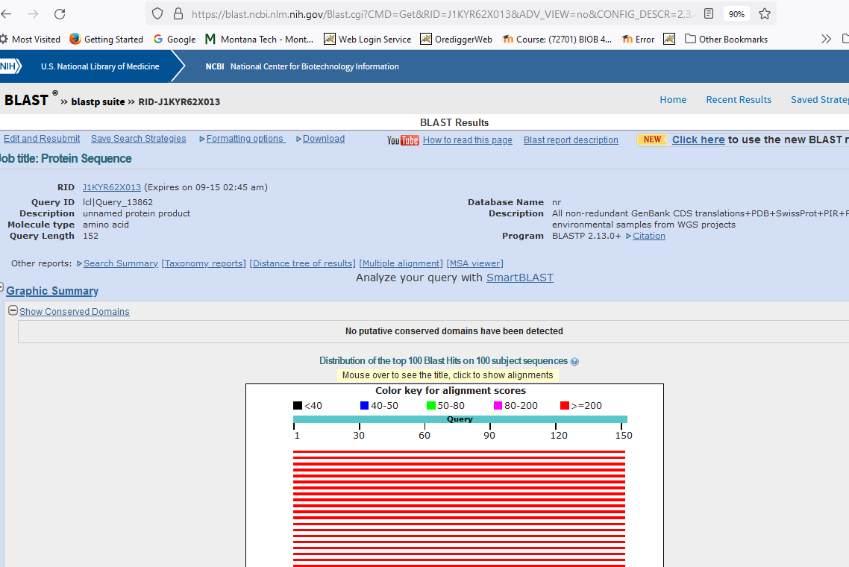
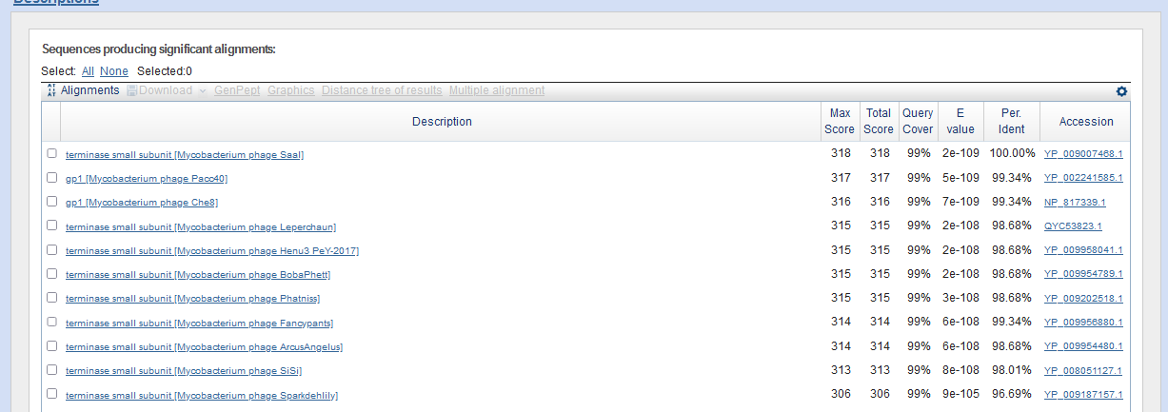
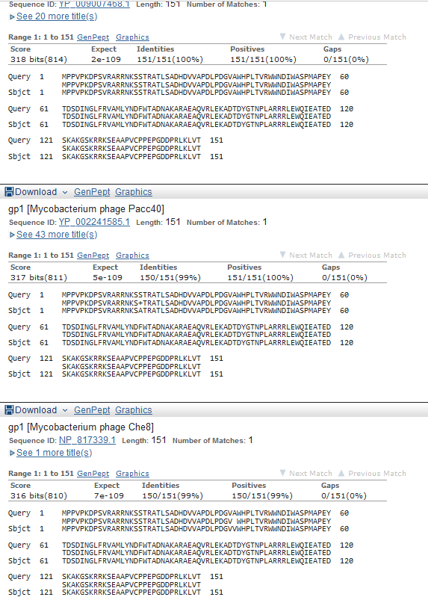
Start Codon and source: 109, ATG, changed from original Glimmer call (193, GTG)
Stop Codon: 564, TGA
F/R: F
Coding Potential (y/n): y
Starterator (SS, NA, NI): Most annotated start is this (109),
Blast Best Hit, Query:Subject Starts, Score, Evalue, or “no significant Blast alignments” if 10E-4 or higher
Terminase Small subunit Mycobacterium phage SaalYP_009007468.1, 1:1, Score 318, Evalue, 2E-109
Gap with previous gene: fill this in after finish with wrap-around gene?
Longest Orf? (Y/N/NA) Y
RBS: N/A, Scoring Matirix Kibler6 , Spacing Matrix Karlin Medium , Z Score 2.83, Final Score -3.796
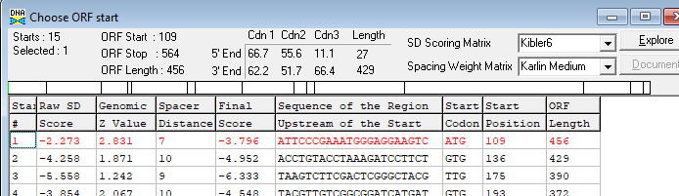
HHPRED, https://toolkit.tuebingen.mpg.de/#/tools/hhpred
If you use HHpred within the Toolkit for your research, please cite:
A Completely Reimplemented MPI Bioinformatics Toolkit with a New HHpred Server at its Core.
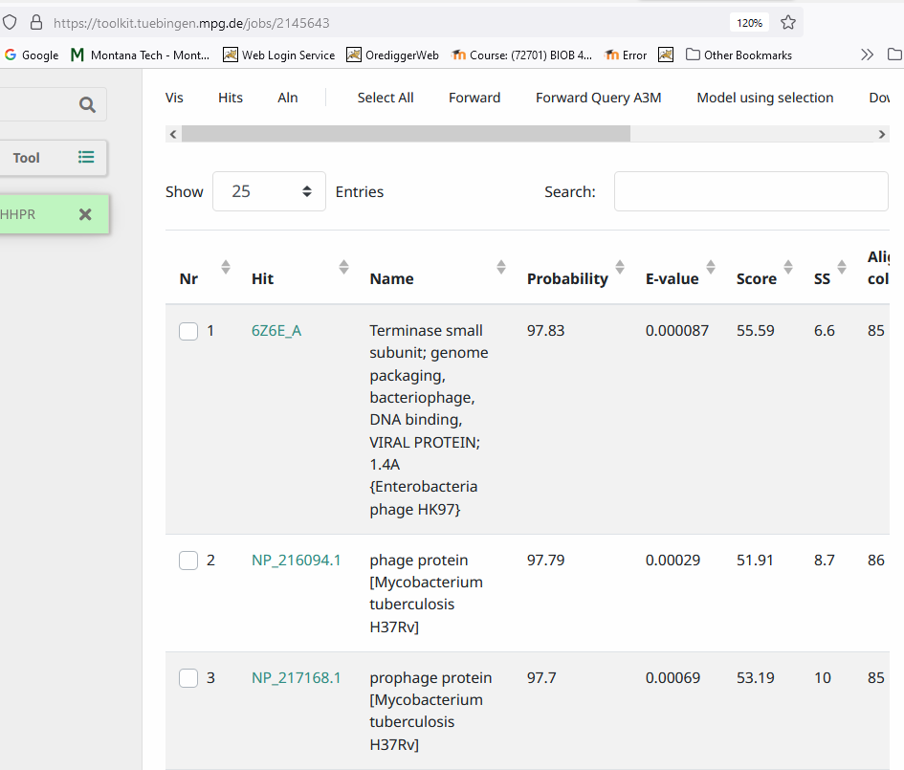
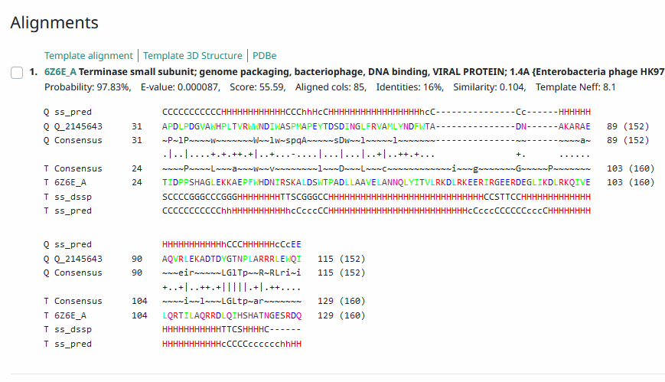
Proposed Function: terminase, small subunit
Function Evidence: Blastp, HHPRed
Transmembrane Domain/Evidence No… Transmembrane Hidden Markov Model
https://services.healthtech.dtu.dk/service.php?TMHMM-2.0

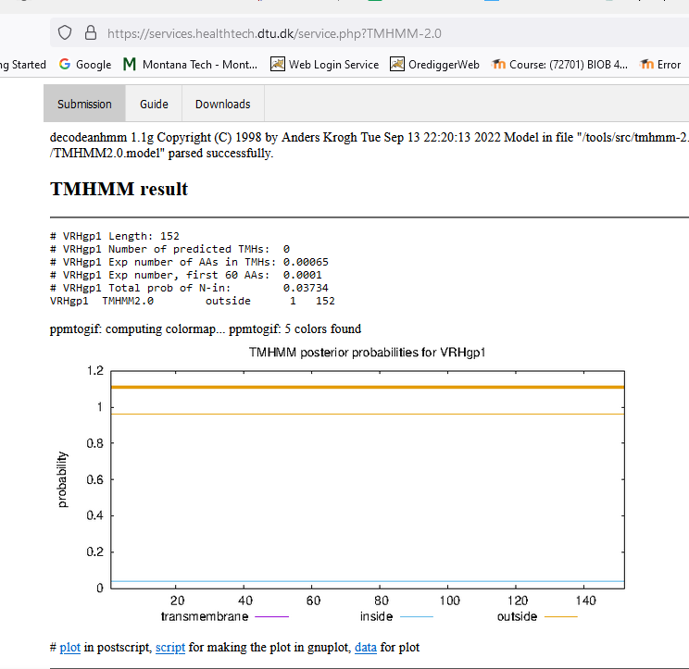

Gene Number:2
9/14/22 BlastP NCBI and PHAGESdb HHpred, TMHMM translation of longest orf start at 572
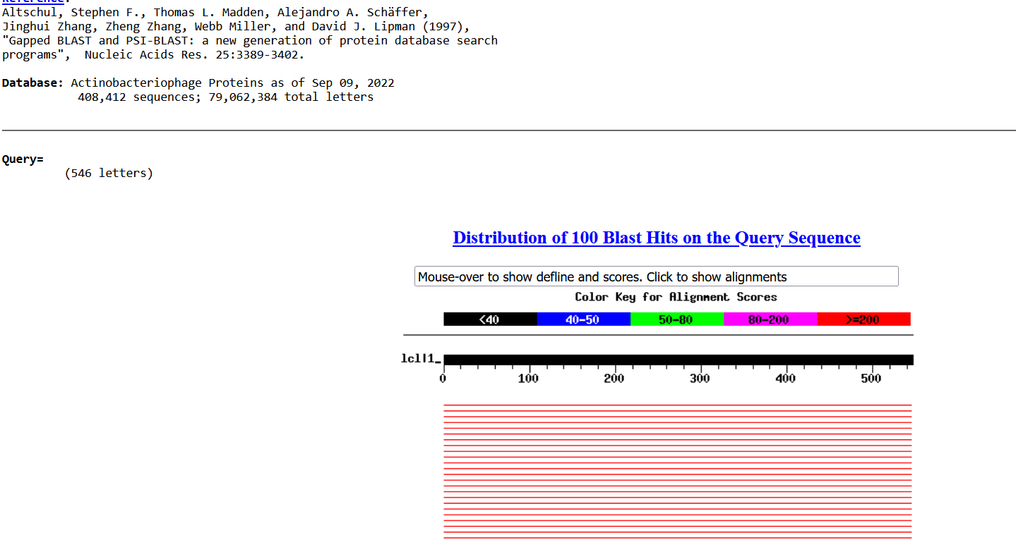
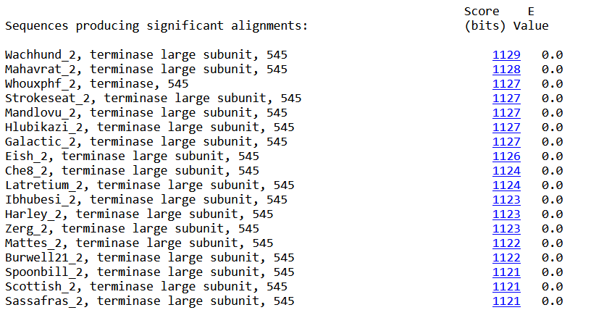
>Wachhund_2, terminase large subunit, 545
Length = 545

Score = 1129 bits (2920), Expect = 0.0
Identities = 544/545 (99%), Positives = 545/545 (100%)

Query: 1 MAVLQVPPVDLTFPTLGPQVCDFIEDRMVFGPGSLSGQAARLDDEKRALVYRLYELYPRG 60
MAVLQVPPVDLTFPTLGPQVCDFIEDRMVFGPGSLSGQAARLDDEKRALVYRLYELYPRG
Sbjct: 1 MAVLQVPPVDLTFPTLGPQVCDFIEDRMVFGPGSLSGQAARLDDEKRALVYRLYELYPRG 60

Query: 61 HRLAGRRRFERAGVELRKGVAKTEFAAWICGVELHPEAPVRCDGFDAAGNPVGRPVRSPV 120
HRLAGRRRFERAGVELRKGVAKTEFAAWICGVELHPEAPVRCDGFDAAGNPVGRPVRSPV
Sbjct: 61 HRLAGRRRFERAGVELRKGVAKTEFAAWICGVELHPEAPVRCDGFDAAGNPVGRPVRSPV 120

Query: 121 IPMMAVTEEQVSELAFGVLKYILENGPDADLFDISKERIVRLSPSGGEDGFAVAVANAPG 180
IPMMAVTEEQVSELAFGVLKYILENGPDADLFDISKERIVRLSPSGGEDGFAVAV+NAPG
Sbjct: 121 IPMMAVTEEQVSELAFGVLKYILENGPDADLFDISKERIVRLSPSGGEDGFAVAVSNAPG 180

Query: 181 SRDGARTTFQHFDEPHRLFMPRHRDAHETMLQNMPKRPMEDPWTLYTSTAGQPGQGSIEE 240
SRDGARTTFQHFDEPHRLFMPRHRDAHETMLQNMPKRPMEDPWTLYTSTAGQPGQGSIEE
Sbjct: 181 SRDGARTTFQHFDEPHRLFMPRHRDAHETMLQNMPKRPMEDPWTLYTSTAGQPGQGSIEE 240

Query: 241 DVLAEAESIARGERQDPSLFFFRRWAGDEHDDLSTVEKRVAAVADATGPIGEWGPGQFER 300
DVLAEAESIARGERQDPSLFFFRRWAGDEHDDLSTVEKRVAAVADATGPIGEWGPGQFER
Sbjct: 241 DVLAEAESIARGERQDPSLFFFRRWAGDEHDDLSTVEKRVAAVADATGPIGEWGPGQFER 300

Query: 301 IAKDYDRTGIDRAYWERVYLNRWRKSGSQAFDMTRLVQCDETVPDGAFVTAGFDGSRWRD 360
IAKDYDRTGIDRAYWERVYLNRWRKSGSQAFDMTRLVQCDETVPDGAFVTAGFDGSRWRD
Sbjct: 301 IAKDYDRTGIDRAYWERVYLNRWRKSGSQAFDMTRLVQCDETVPDGAFVTAGFDGSRWRD 360

Query: 361 ATAVVVTEIATGRQMLLGCWERPEDVEEWEVPEHEVTALVVDMMSRFEVWRMYCDPWGWD 420
ATAVVVTEIATGRQMLLGCWERPEDVEEWEVPEHEVTALVVDMMSRFEVWRMYCDPWGWD
Sbjct: 361 ATAVVVTEIATGRQMLLGCWERPEDVEEWEVPEHEVTALVVDMMSRFEVWRMYCDPWGWD 420

Query: 421 STIAAWAGRFPDRVVEWAVGGGGSLRRVAAATQGYADALATGDAVLAANVWRPKFVEHMG 480
STIAAWAGRFPDRVVEWAVGGGGSLRRVAAATQGYADALATGDAVLAANVWRPKFVEHMG
Sbjct: 421 STIAAWAGRFPDRVVEWAVGGGGSLRRVAAATQGYADALATGDAVLAANVWRPKFVEHMG 480

Query: 481 HAGRRELKLVDDTGQPLWVMQKQDGRLADKFDAAMAGMLSWEACVDARRDGAHPRPKVFA 540
HAGRRELKLVDDTGQPLWVMQKQDGRLADKFDAAMAGMLSWEACVDARRDGAHPRPKVFA
Sbjct: 481 HAGRRELKLVDDTGQPLWVMQKQDGRLADKFDAAMAGMLSWEACVDARRDGAHPRPKVFA 540

Query: 541 PRRIY 545
PRRIY
Sbjct: 541 PRRIY 545

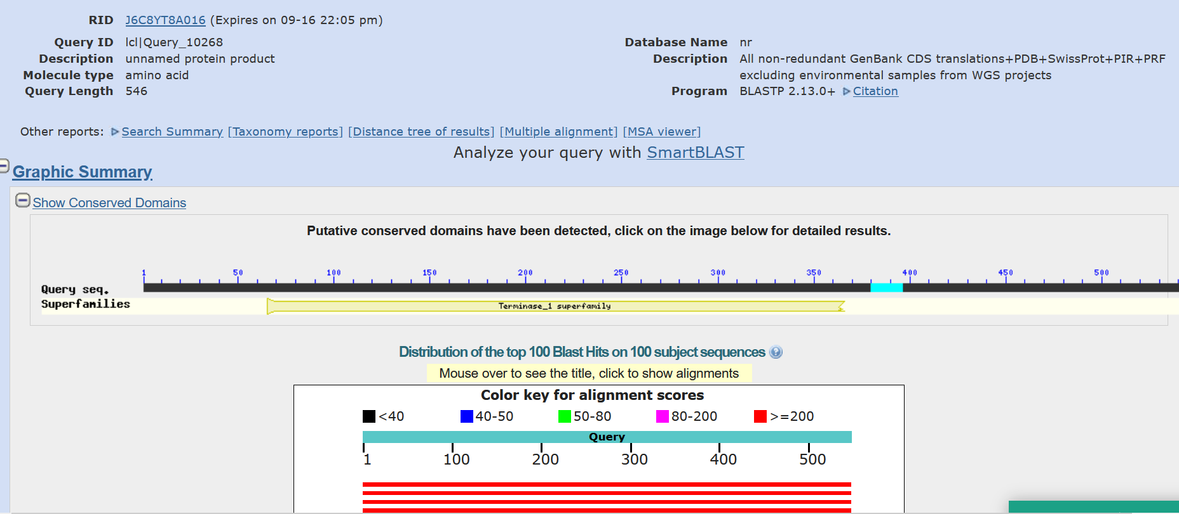
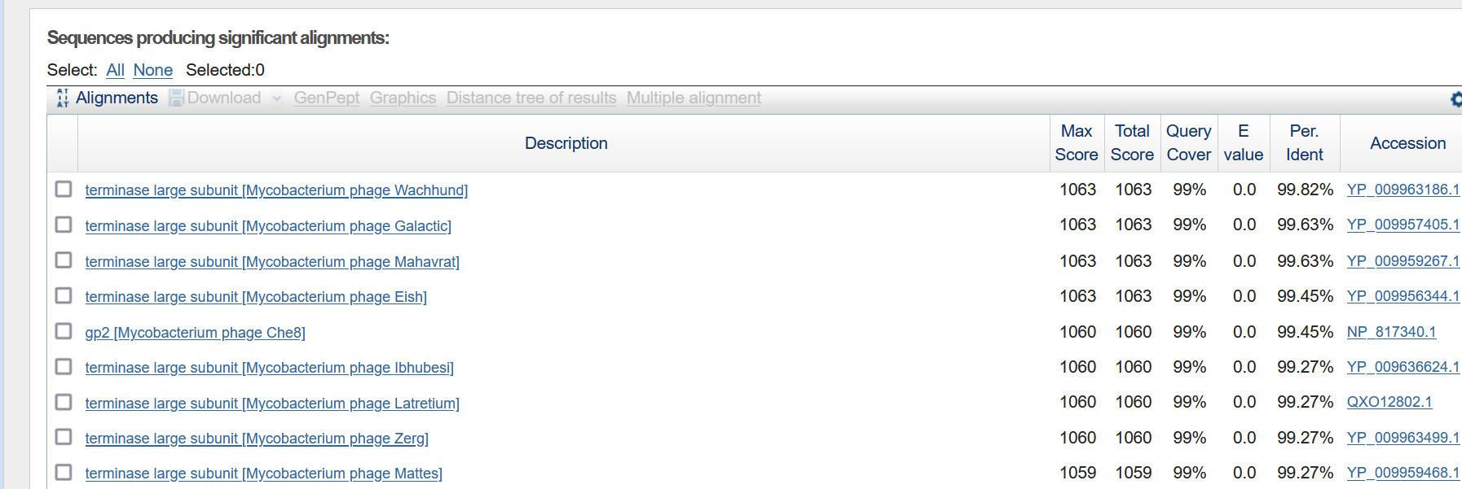
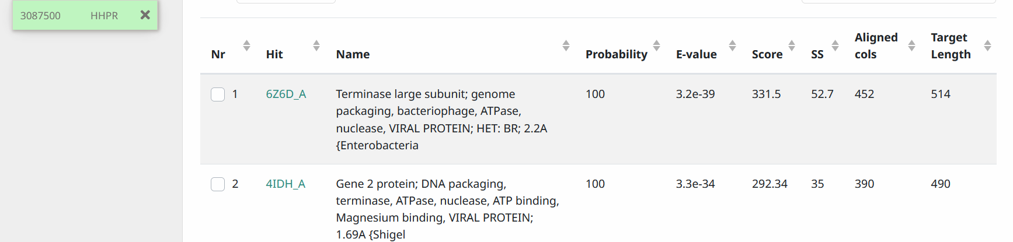
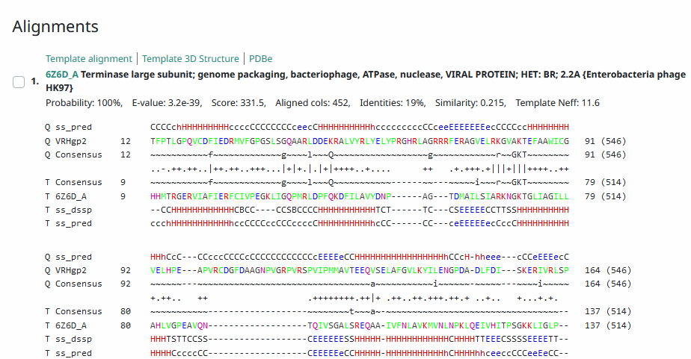
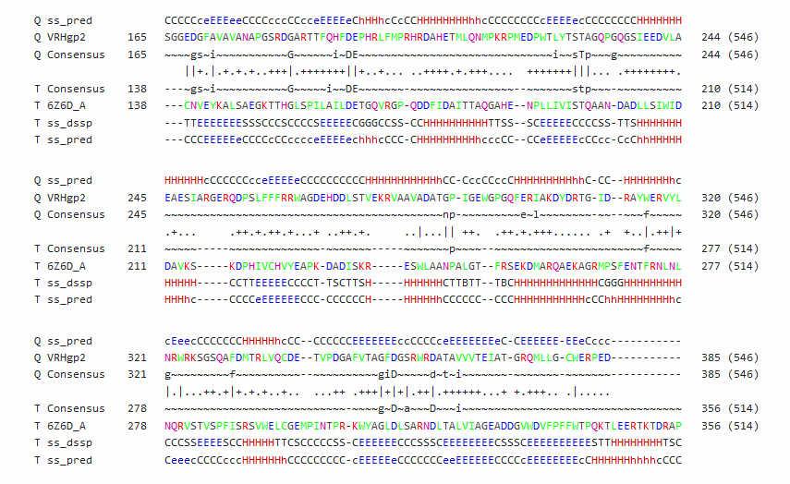
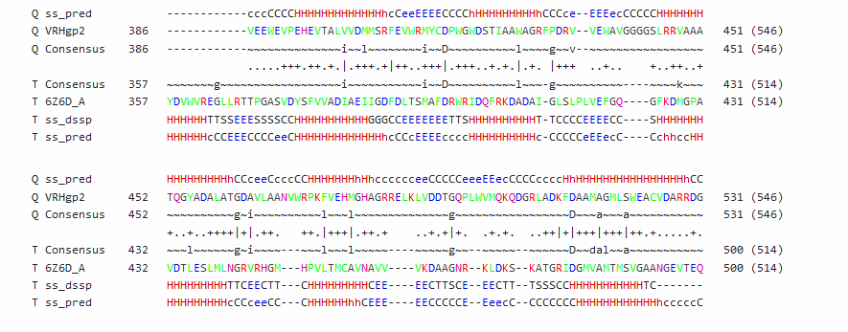
Start Codon and source: 572, ATG, not called by Glimmer or Genemark. Changed from original call @653
Stop Codon: 2209, TAG
F/R: F
Coding Potential (y/n): Y
Starterator (SS, NA, NI): Pham45601, does not have most annotated start
Blast Best Hit, Query:Subject Starts, Score, Evalue, or “no significant Blast alignments” if 10E-4 or higher
>Wachhund_2, terminase large subunit, 545
Length = 545
Score = 1129 bits (2920), Expect = 0.0
Identities = 544/545 (99%), Positives = 545/545 (100%)
Gap: 7 from end of gene1
Longest Orf? (Y/N/NA) Y
RBS: N/A, Scoring Matirix , Spacing Matrix, Z Score, Final Score,
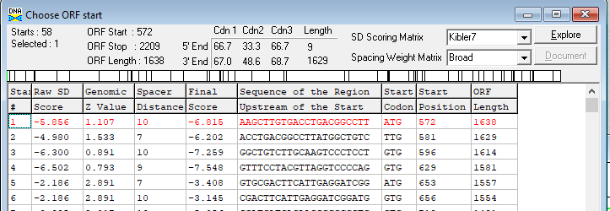
Proposed Function: terminase, large subunit
Function Evidence: BlastP, HHPred, location in genome
Transmembrane Domain/Evidence, No https://services.healthtech.dtu.dk/service.php?TMHMM-2.0
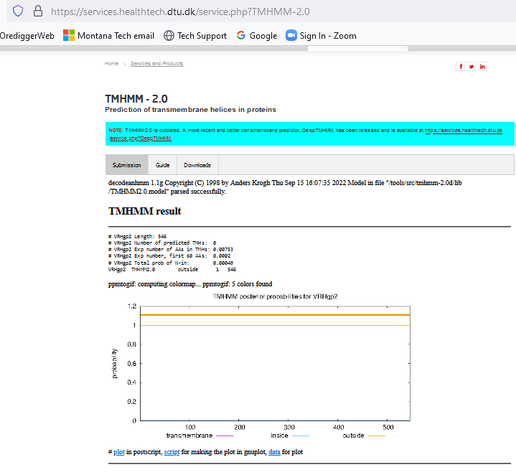

Gene Number:3
9/14/22 BlastP NCBI and PHAGESdb HHpred PDB_mmCIF70_12_Aug, TMHMM translation of longest orf start at 2240
RBS from Frames screen on DNA Master, starterator on phagesdb.org
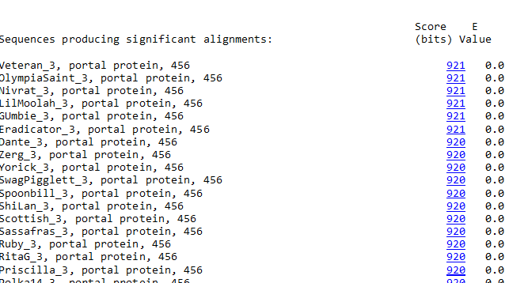

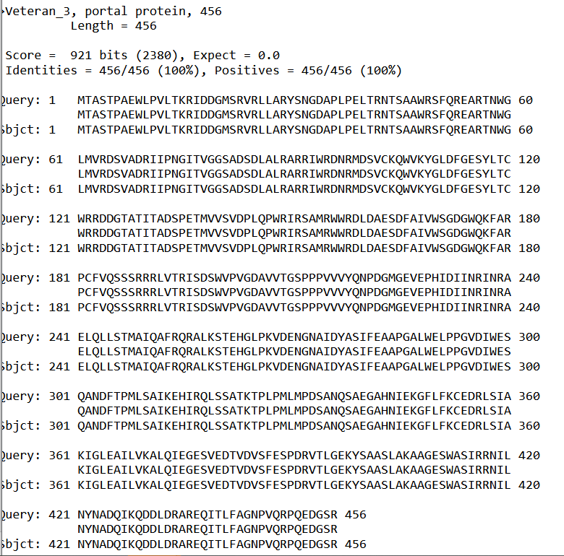
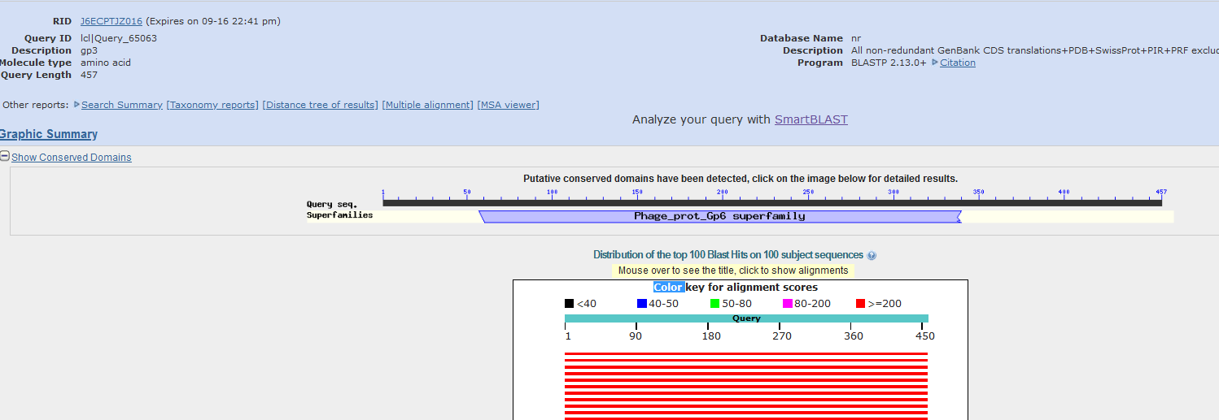
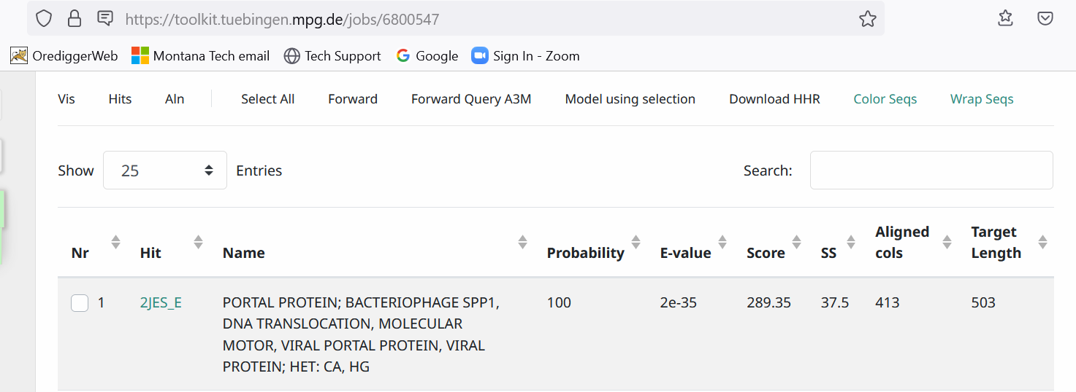
Start Codon and source: 2240, TTG, not called by glimmer or Genemark
Stop Codon: 3610, TGA
F/R: F
Coding Potential (y/n): Y
Starterator (SS, NA, NI):Pham45600, changed to most called start
Blast Best Hit, Query:Subject Starts, Score, Evalue, or “no significant Blast alignments” if 10E-4 or higher
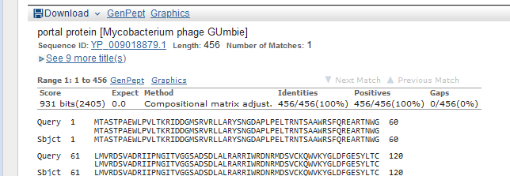
Gap: 30 from previous gene
Longest Orf? (Y/N/NA) Y
RBS: N/A, Scoring Matirix , Spacing Matrix, Z Score, Final Score,
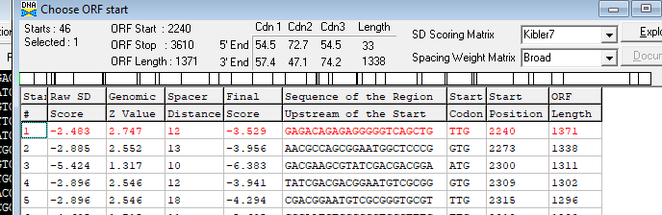
Proposed Function: portal protein
Function Evidence: BlastP, HHPred
Transmembrane Domain/Evidence, NO
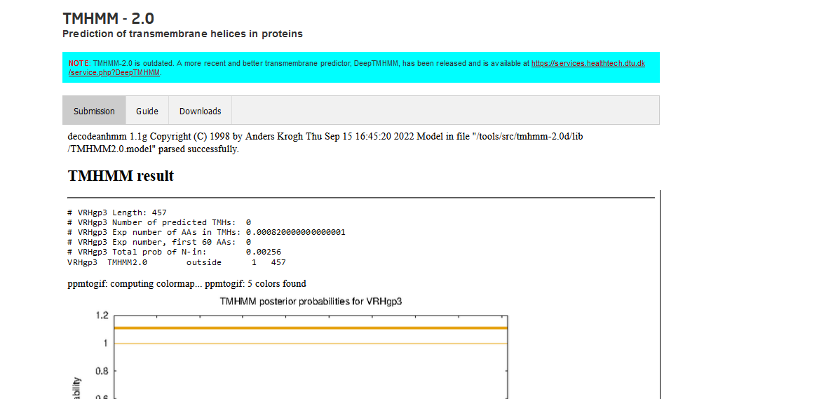

Gene Number: 4
9/14/22 BlastP NCBI and PHAGESdb HHpred PDB_mmCIF70_12_Aug, TMHMM translation of longest orf start at 3597, Starterator on phagesdb, RBS on DNA Master Frames
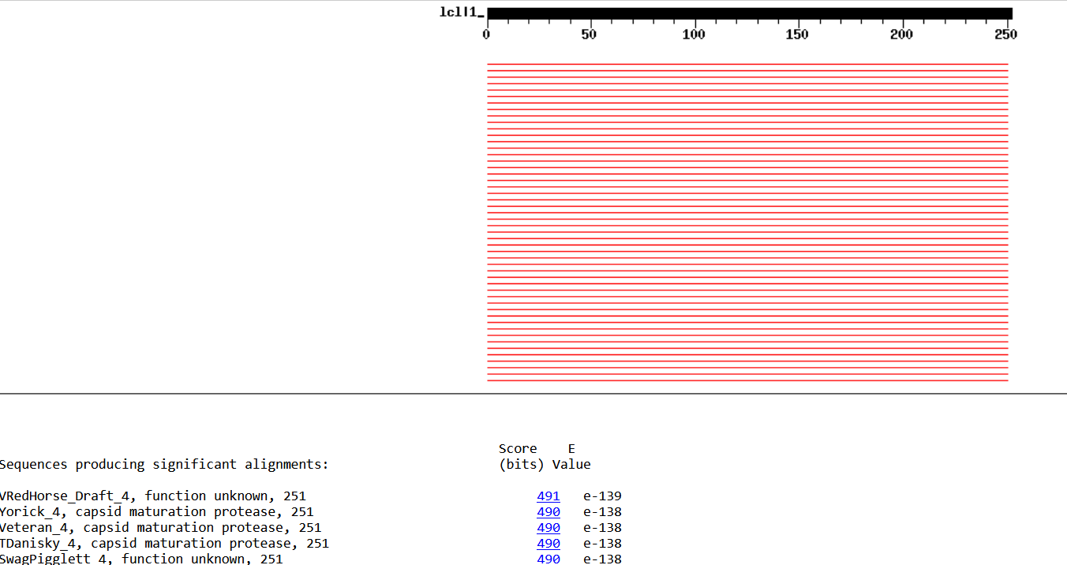
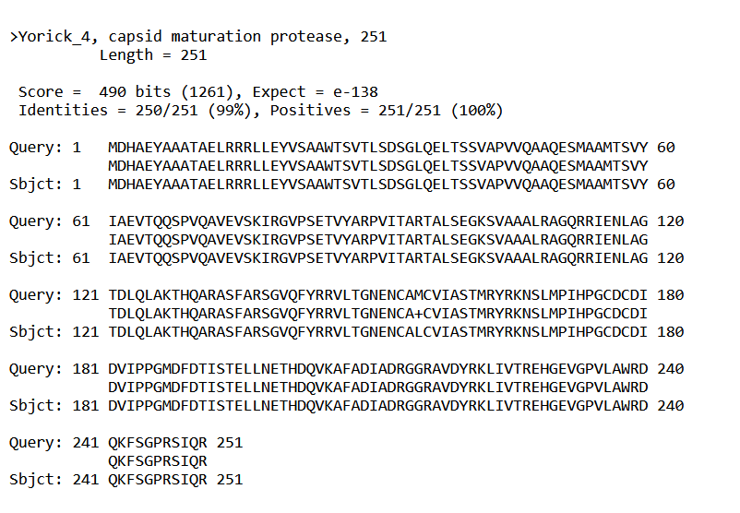
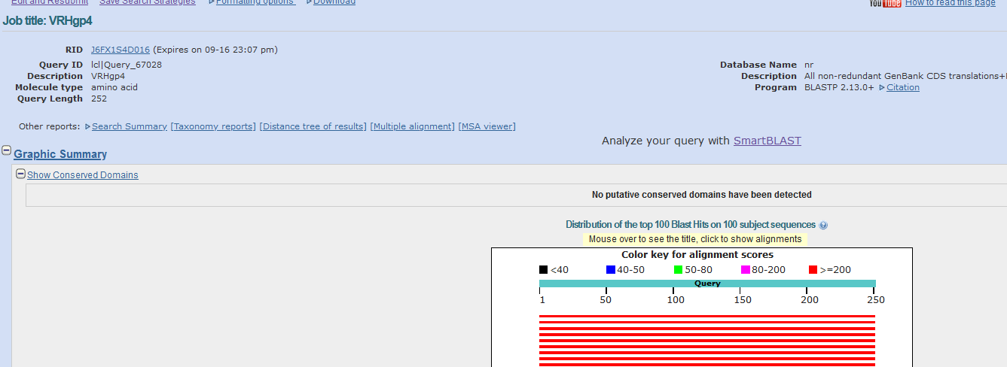
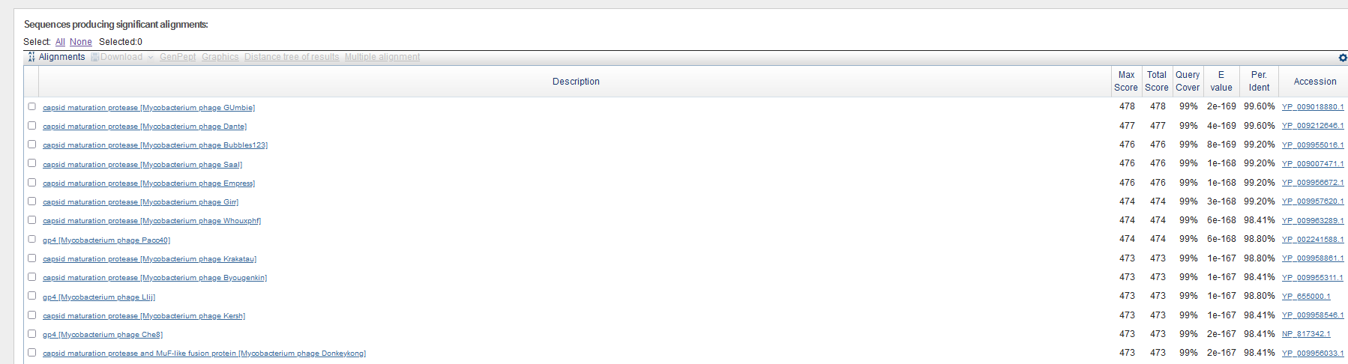
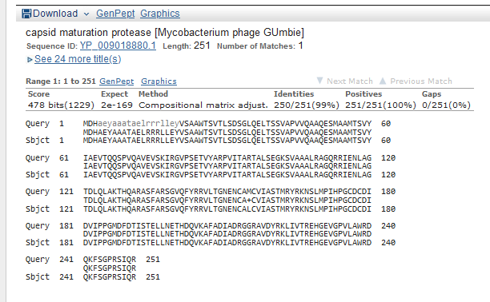
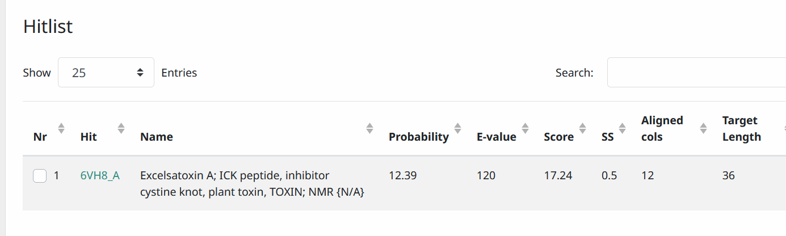
Start Codon and source: 3597, ATG, Called by Glimmer and Genmark
Stop Codon: 4532, TGA
F/R: F
Coding Potential (y/n): y
Starterator (SS, NA, NI): Pham 622, most annotated start
Blast Best Hit, Query:Subject Starts, Score, Evalue, or “no significant Blast alignments” if 10E-4 or higher

Gap: overlap, -14 from end of previous gene
Longest Orf? (Y/N/NA) Y
RBS: N/A, Scoring Matirix , Spacing Matrix, Z Score, Final Score,
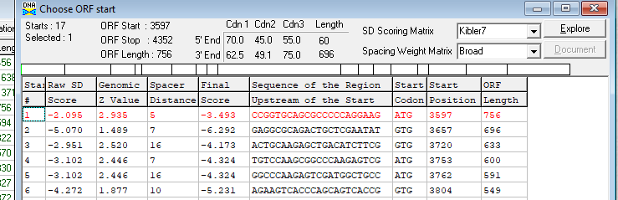
Proposed Function: capsid maturation protease
Function Evidence: BlastP
Transmembrane Domain/Evidence: NO
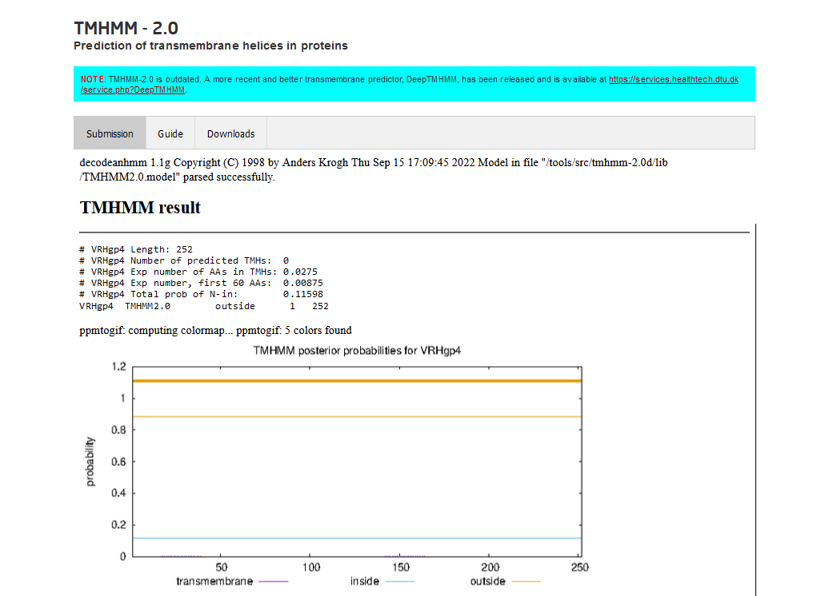

Gene Number: 5
9/14/22 BlastP NCBI and PHAGESdb HHpred PDB_mmCIF70_12_Aug, TMHMM translation of longest orf start at 4437, Starterator on phagesdb, RBS on DNA Master Frames
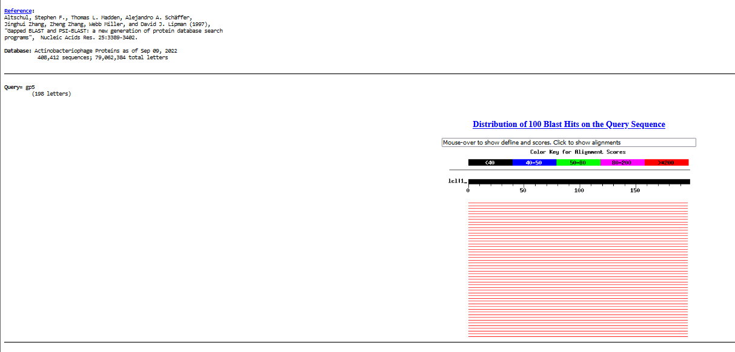
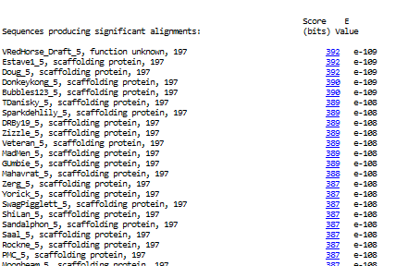
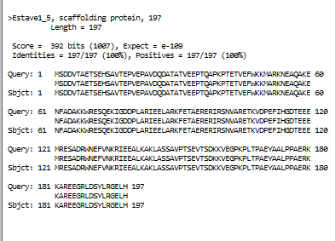
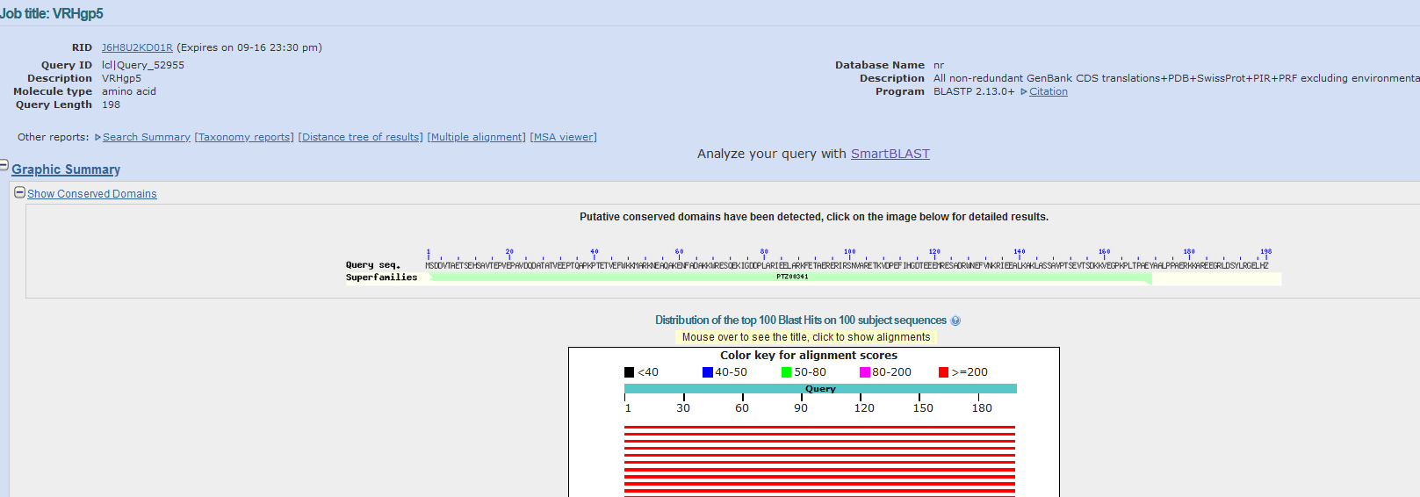
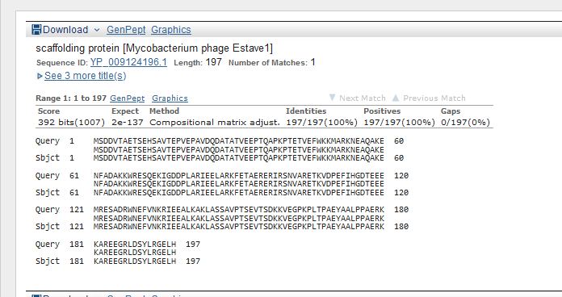
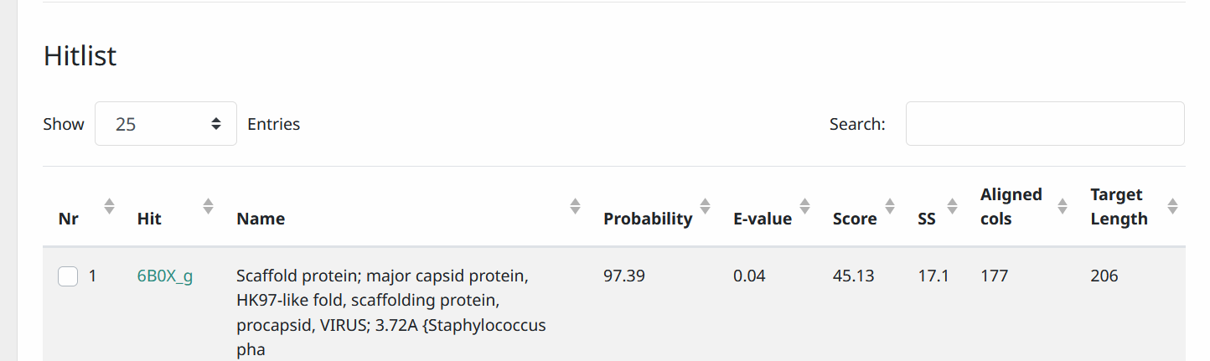
Start Codon and source: 4437, ATG, called by glimmer and genemark
Stop Codon: 5030, TAA
F/R: F
Coding Potential (y/n): Y
Starterator (SS, NA, NI): pham 649, most annotated start
Blast Best Hit, Query:Subject Starts, Score, Evalue, or “no significant Blast alignments” if 10E-4 or higher
Gap: 85 from previous gene
Longest Orf? (Y/N/NA) Y
RBS: N/A, Scoring Matirix , Spacing Matrix, Z Score, Final Score,
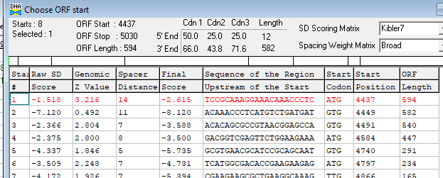
Proposed Function: scaffolding protein
Function Evidence: BlastP and HHPRED
Transmembrane Domain/Evidence: NO
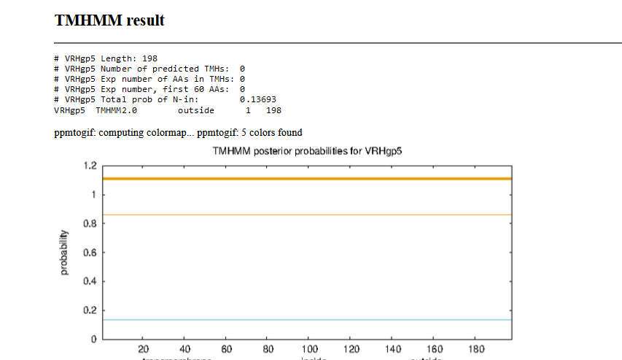
Gene Number: 6
9/14/22 BlastP NCBI and PHAGESdb HHpred PDB_mmCIF70_12_Aug, TMHMM translation of longest orf start at 5049, Starterator on phagesdb, RBS on DNA Master Frames
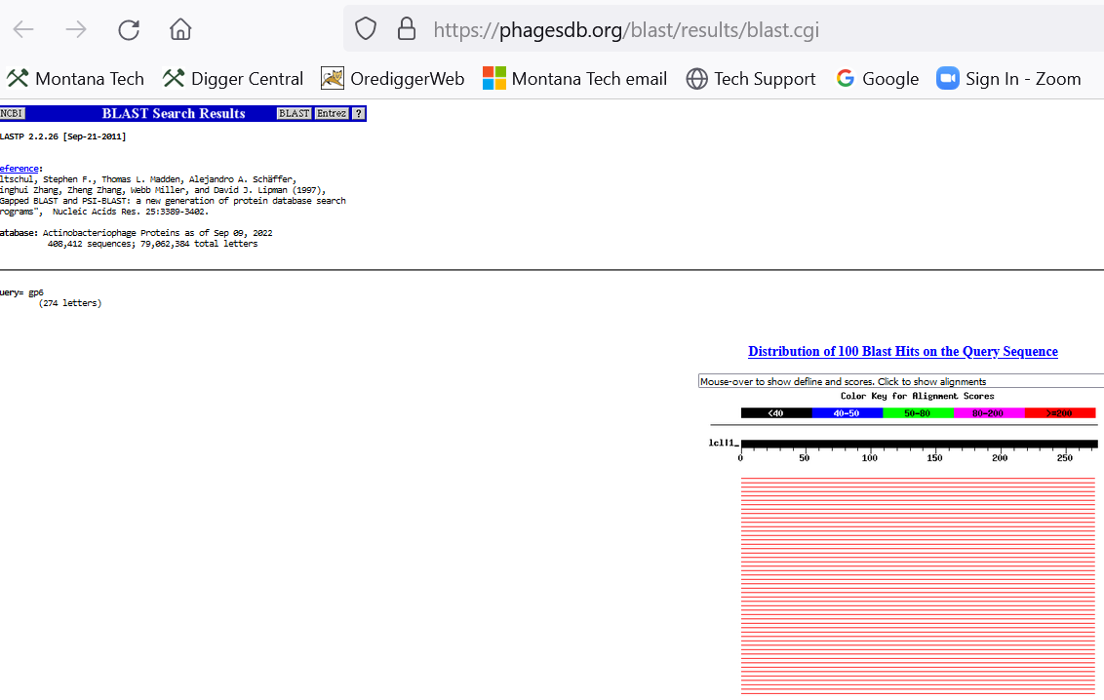
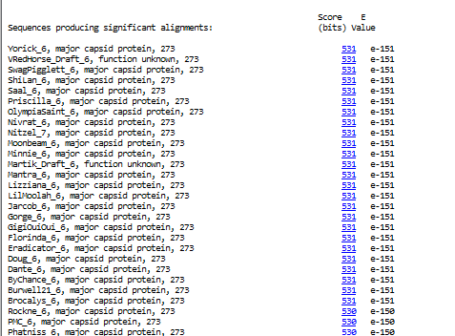
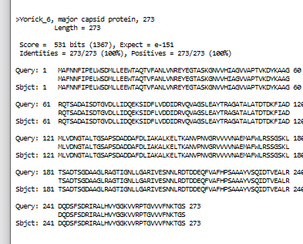
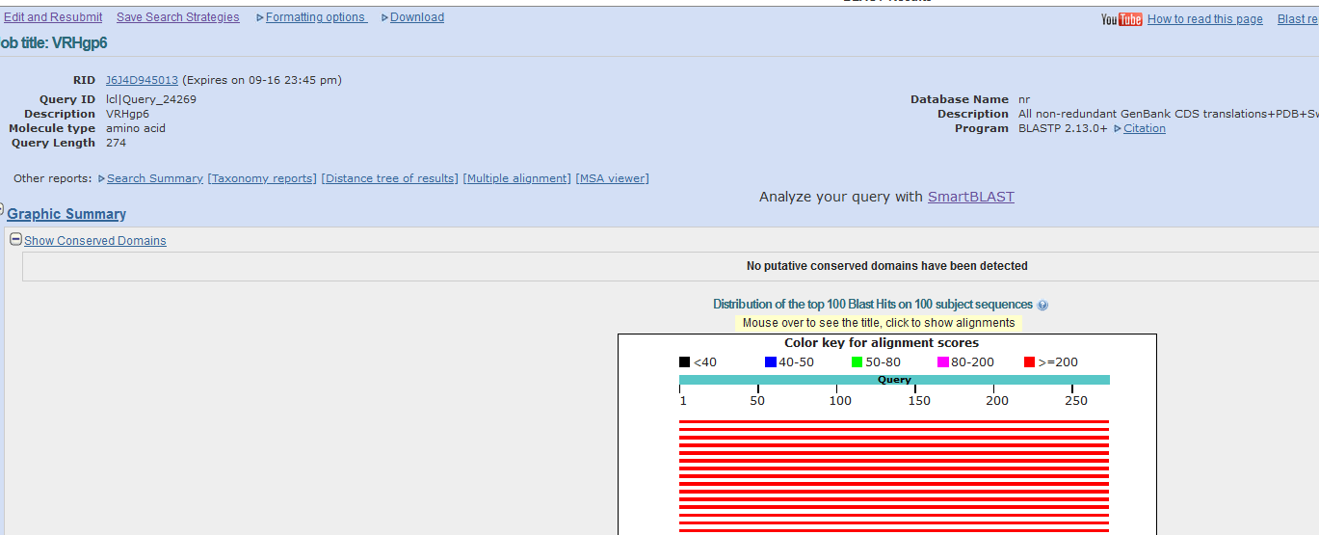
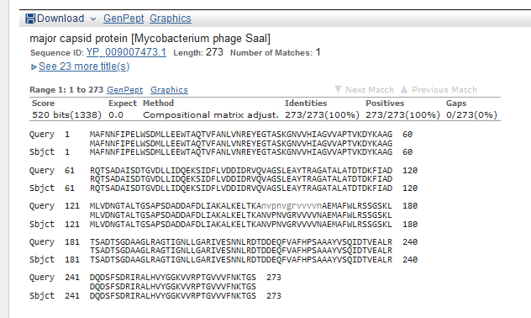
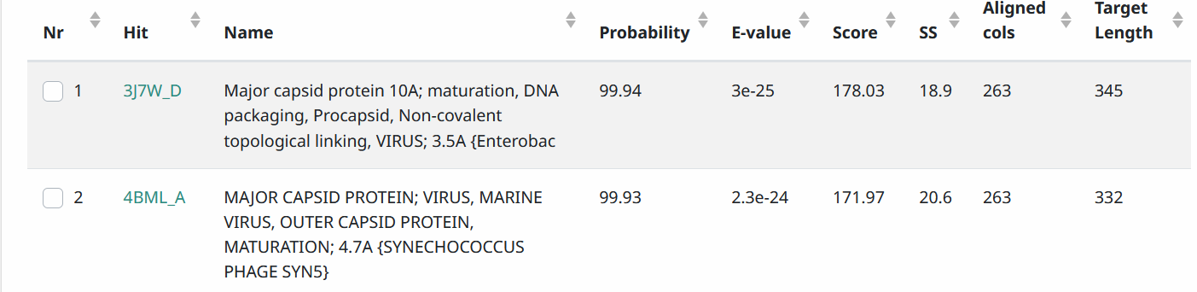
Start Codon and source: 5049, ATG, called by Glimmer and GeneMark
Stop Codon: 5870 TAG
F/R: F
Coding Potential (y/n): Y
Starterator (SS, NA, NI): pham 604, most annotated start
Blast Best Hit, Query:Subject Starts, Score, Evalue, or “no significant Blast alignments” if 10E-4 or higher
Gap: 19 from previous gene
Longest Orf? (Y/N/NA) Y
RBS: N/A, Scoring Matirix , Spacing Matrix, Z Score, Final Score,
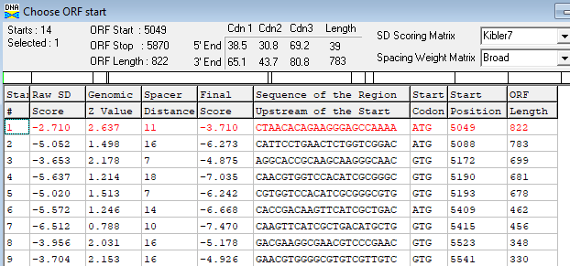
Proposed Function: major capsid protein
Function Evidence: BlastP and HHPRED
Transmembrane Domain/Evidence: NO
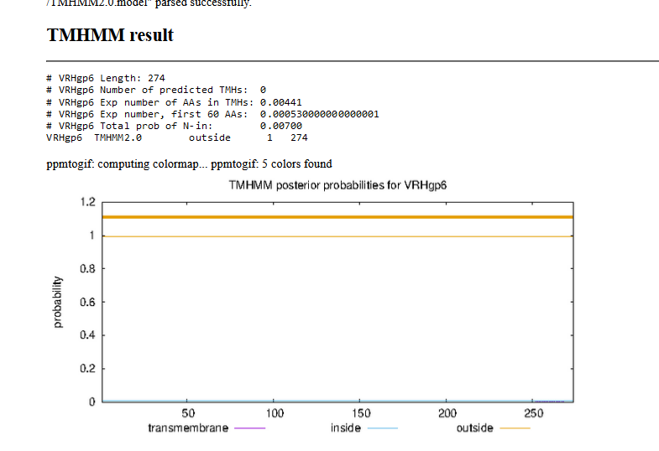

Gene Number: 7
9/14/22 BlastP NCBI and PHAGESdb HHpred PDB_mmCIF70_12_Aug, TMHMM translation of longest orf start at 5879, Starterator on phagesdb, RBS on DNA Master Frames
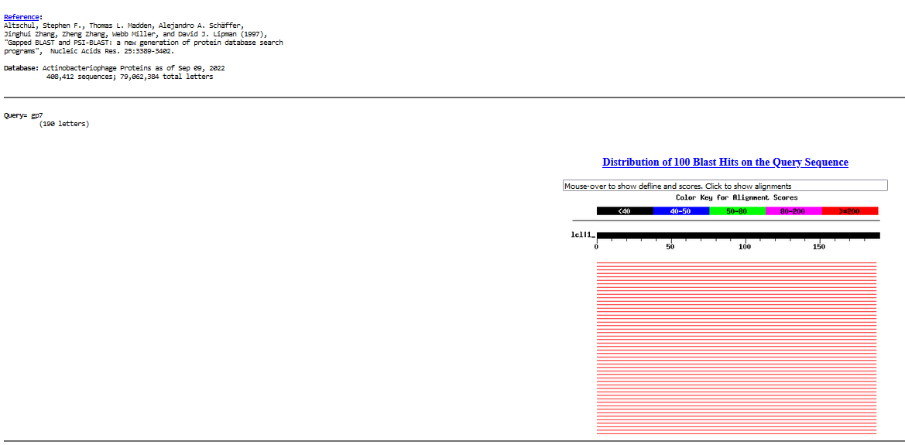
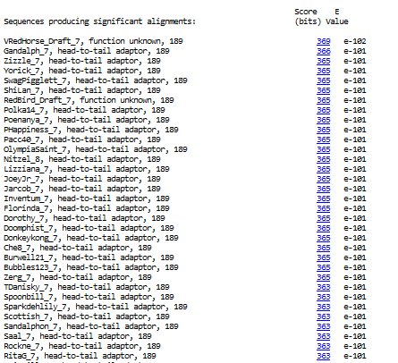
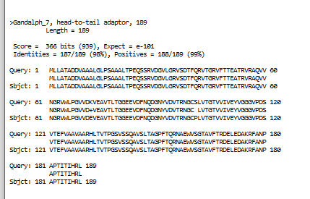
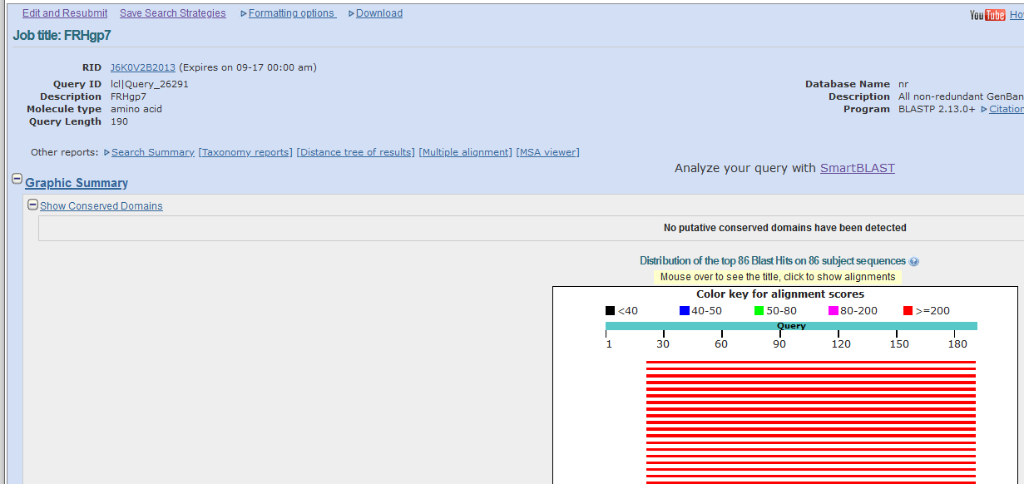
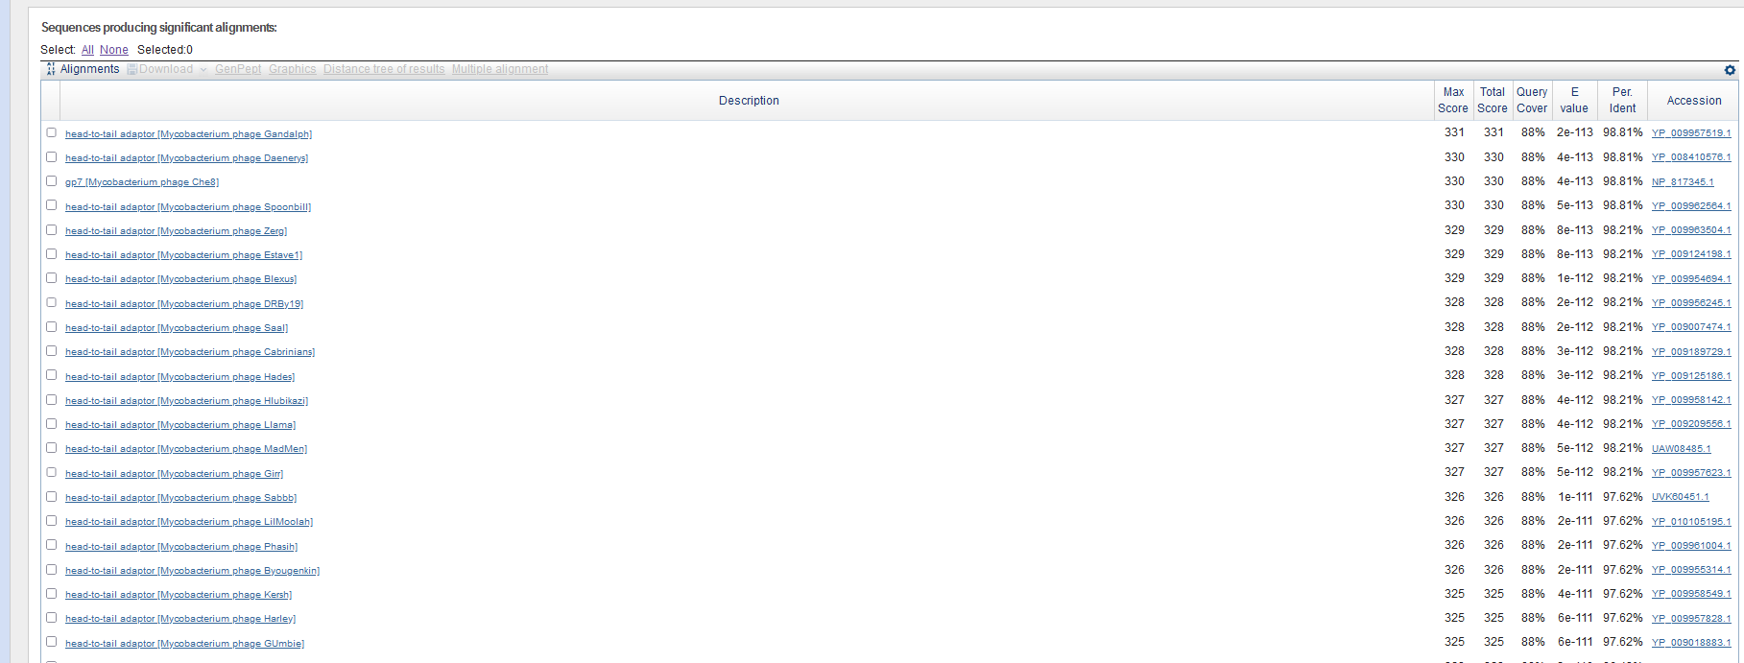
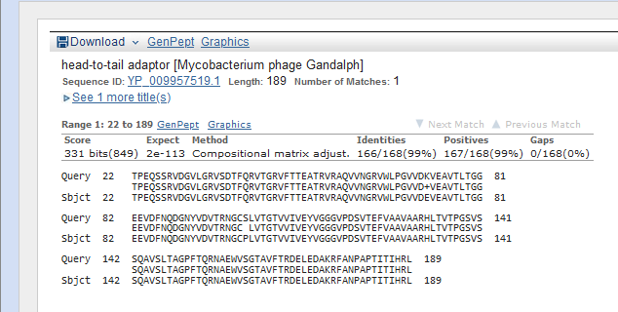
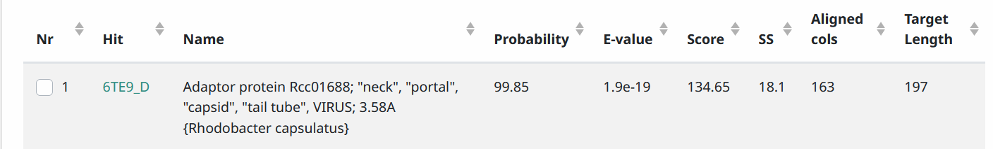
Start Codon and source: 5879, ATG, called by Glimmer and GeneMark
Stop Codon: 6448, TGA
F/R: F
Coding Potential (y/n): Y
Starterator (SS, NA, NI): pham 659, most annotated start
Blast Best Hit, Query:Subject Starts, Score, Evalue, or “no significant Blast alignments” if 10E-4 or higher
Gap: 9 from previous gene
Longest Orf? (Y/N/NA) Y
RBS: N/A, Scoring Matirix , Spacing Matrix, Z Score, Final Score,
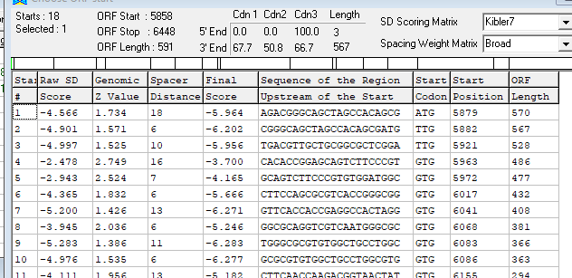
Proposed Function: head-to-tail adaptor
Function Evidence: BlastP, HHPRED
Transmembrane Domain/Evidence: NO
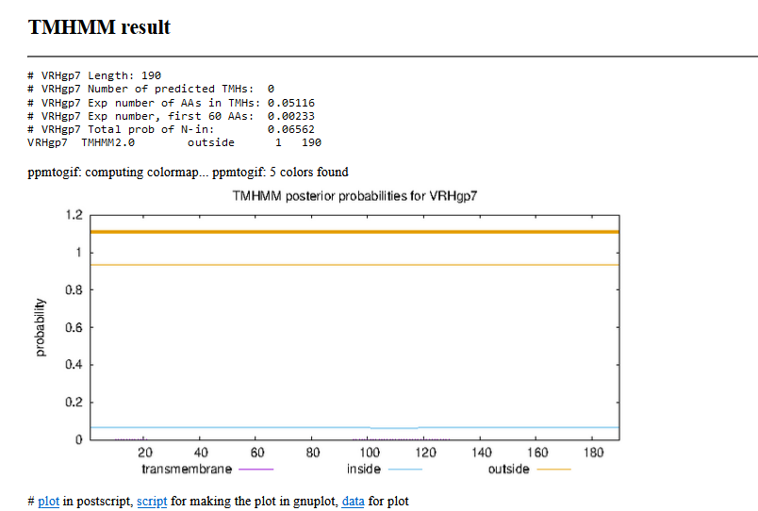

Gene Number: 8
9/14/22 BlastP NCBI and PHAGESdb HHpred PDB_mmCIF70_12_Aug, TMHMM translation of called orf start at 6445, Starterator on phagesdb, RBS on DNA Master Frames
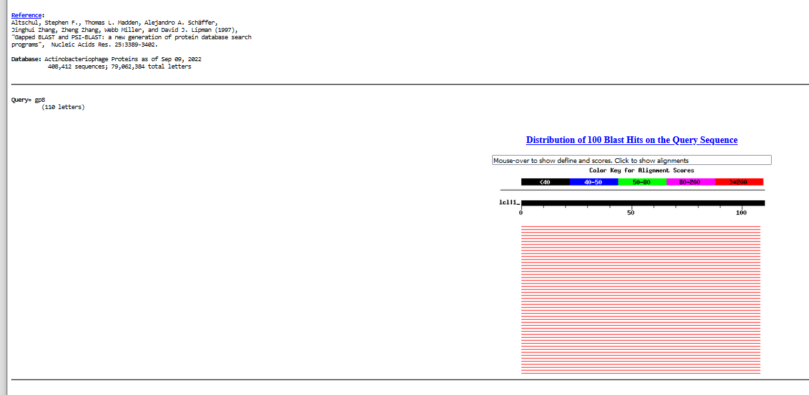
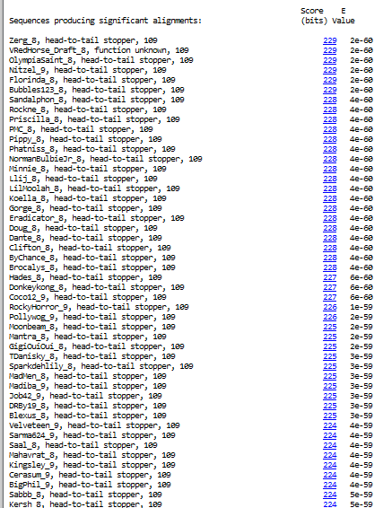
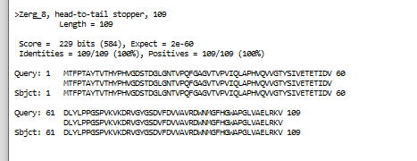
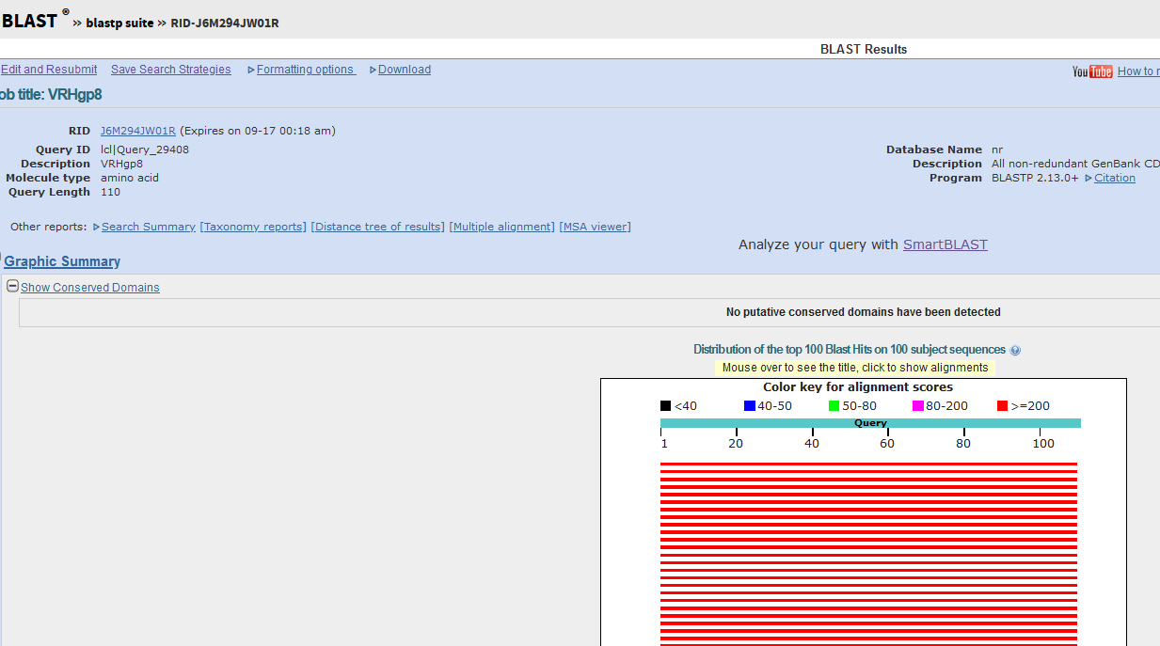
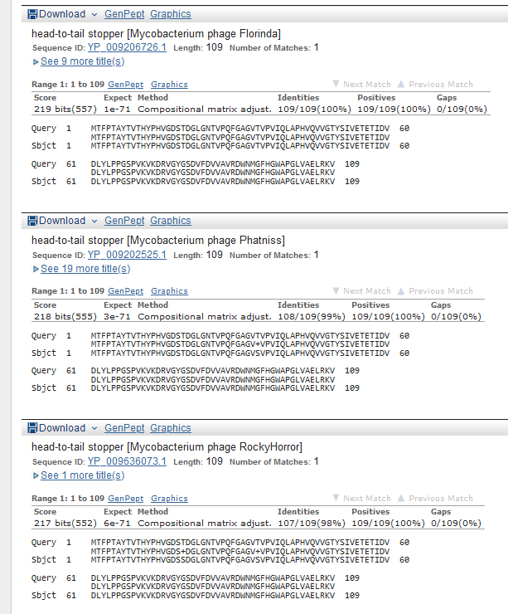
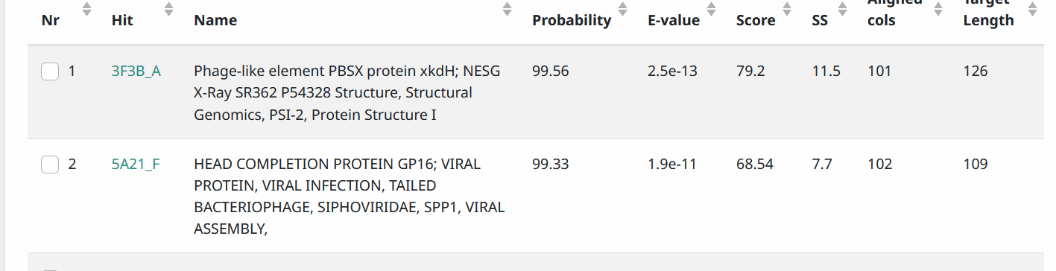
Start Codon and source: 6445, ATG, called by Glimmer and Genemark
Stop Codon: 6774, TGA
F/R: F
Coding Potential (y/n): Y
Starterator (SS, NA, NI): pham44314, most annotated start
Blast Best Hit, Query:Subject Starts, Score, Evalue, or “no significant Blast alignments” if 10E-4 or higher

Gap: overlap 4 bases with previous gene
Longest Orf? (Y/N/NA) N
RBS: N/A, Scoring Matirix , Spacing Matrix, Z Score, Final Score,
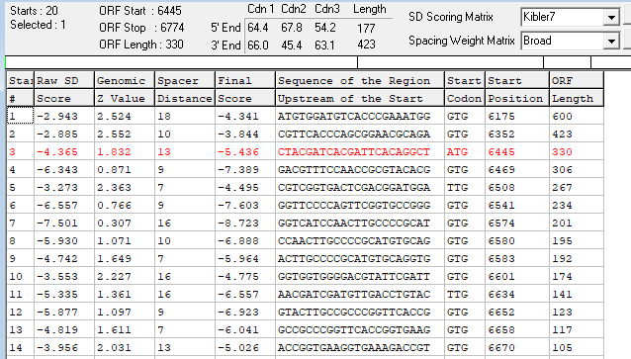
Proposed Function: head-to-tail stopper
Function Evidence: BlastP, HHPRED
Transmembrane Domain/Evidence: NO
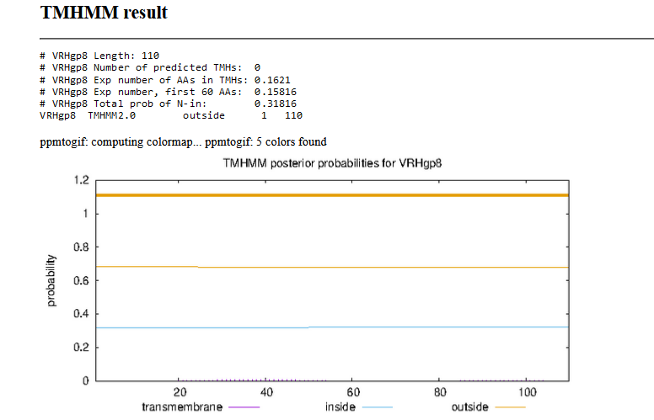

Gene Number: 9
9/14/22 BlastP NCBI and PHAGESdb HHpred PDB_mmCIF70_12_Aug, TMHMM translation of called orf, longest start at 6781, Starterator on phagesdb, RBS on DNA Master Frames
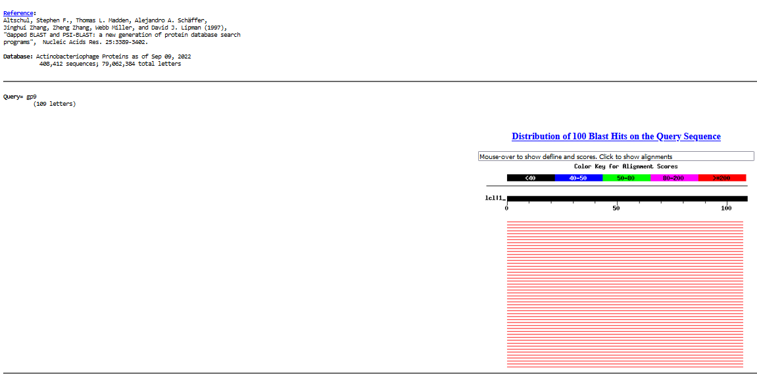
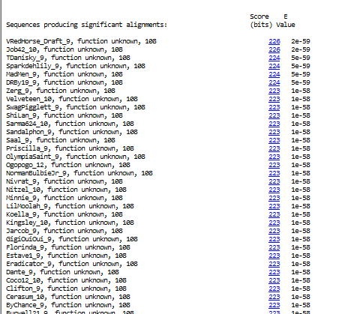
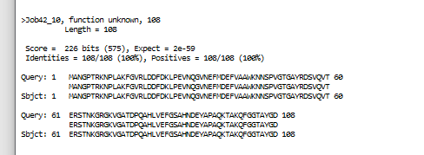
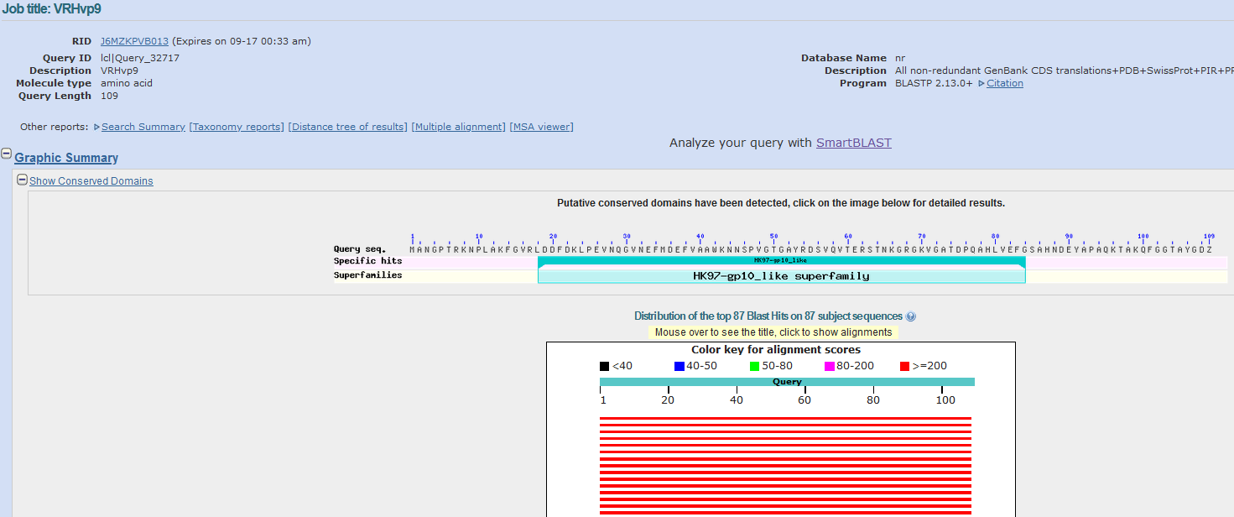
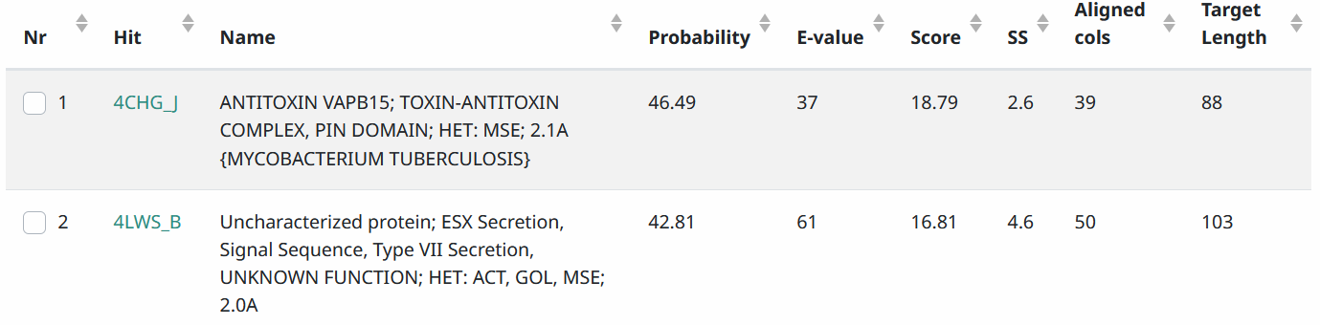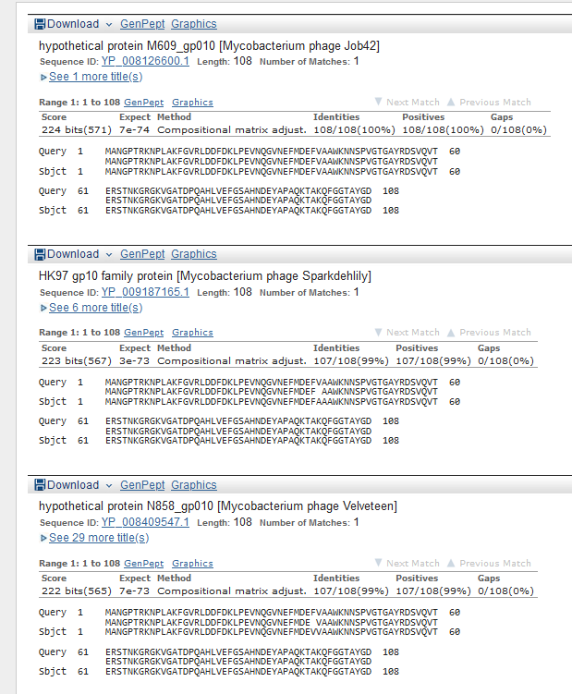

Start Codon and source: 6781, GTG, Called by glimmer, not GeneMark (6811, TTG)
Stop Codon: 7107, TGA
F/R: F
Coding Potential (y/n): Y
Starterator (SS, NA, NI): pham 38415, most annotated start
Blast Best Hit, Query:Subject Starts, Score, Evalue, or “no significant Blast alignments” if 10E-4 or higher
Gap: 6 from previous gene
Longest Orf? (Y/N/NA) Y
RBS: N/A, Scoring Matirix , Spacing Matrix, Z Score, Final Score,
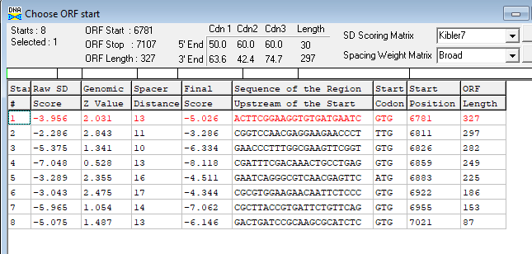
Proposed Function: Hypothetical Protein (HK97gp10-like)
Function Evidence: NCBI blast gave “HK97 gp10-like superfamily” domain, but SEA PHAGES functional assignments list said no function for this protein has been determined
Transmembrane Domain/Evidence: NO
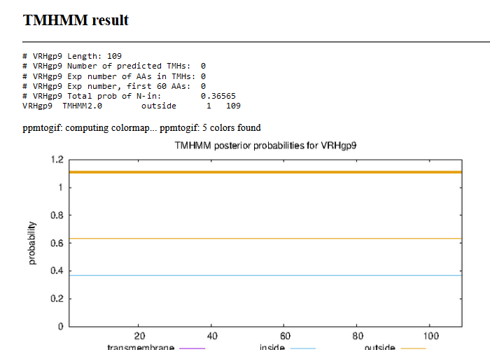

Gene Number: 10
9/14/22 BlastP NCBI and PHAGESdb HHpred PDB_mmCIF70_12_Aug, TMHMM translation of orf, longest start at 7097, Starterator on phagesdb, RBS on DNA Master Frames
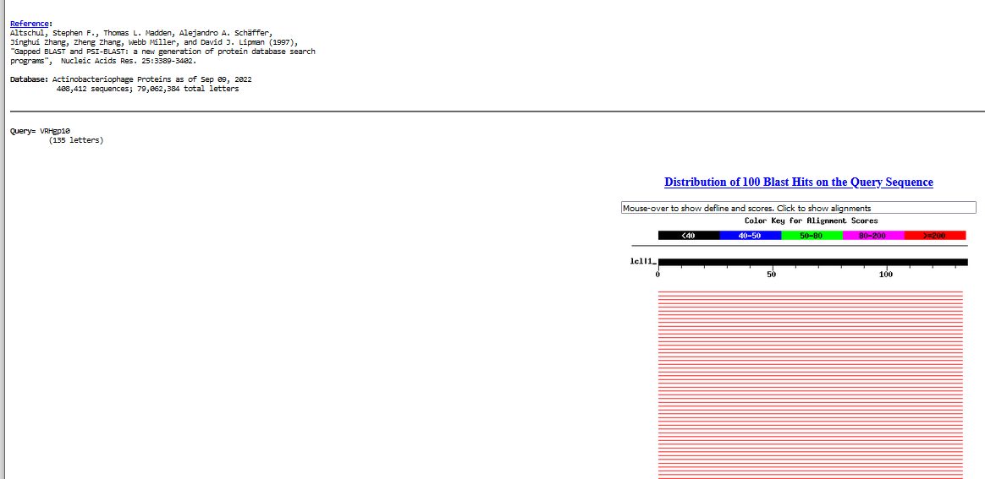

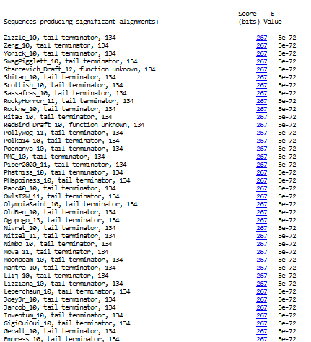
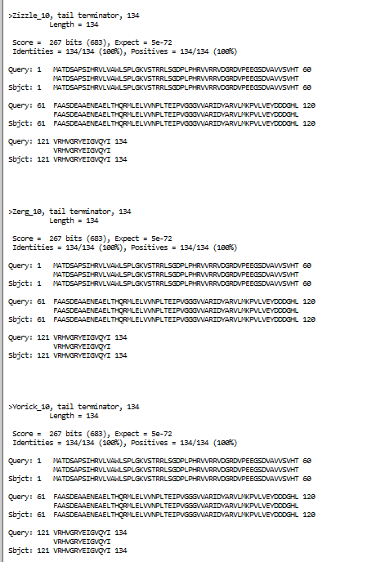
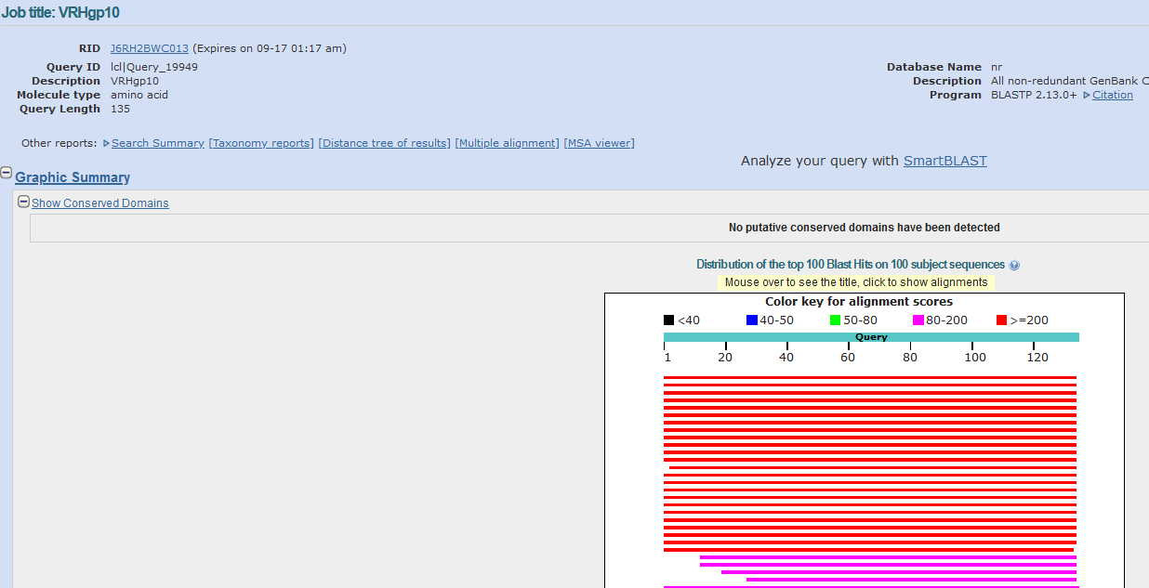
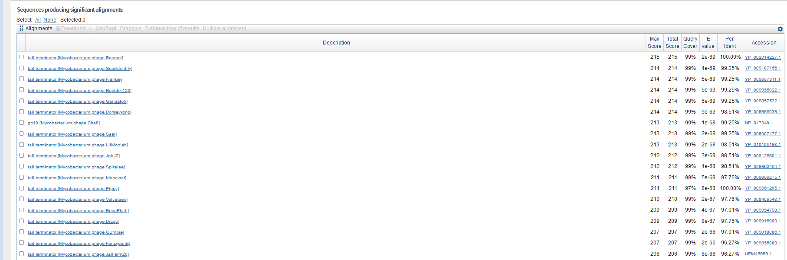
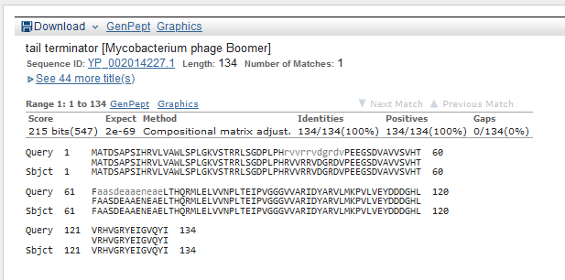
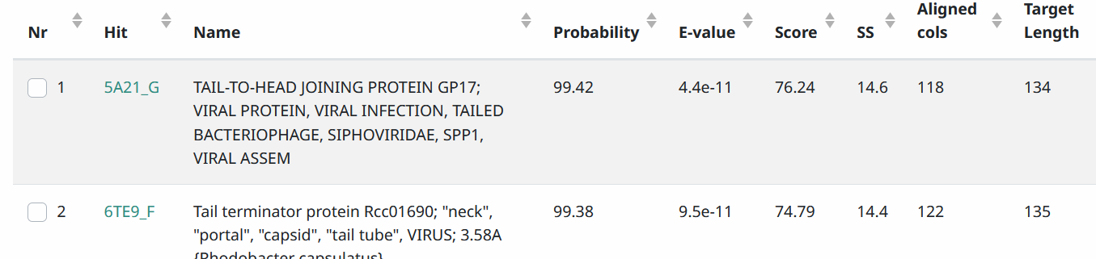
Start Codon and source: 7097, ATG called by Genemark, but not Glimmer, (7130, GTG)
Stop Codon: 7501, TAA
F/R: F
Coding Potential (y/n): Y
Starterator (SS, NA, NI): pham 47096, changed to most annotated start
Blast Best Hit, Query:Subject Starts, Score, Evalue, or “no significant Blast alignments” if 10E-4 or higher
Gap: -11bp overlap with previous gene
Longest Orf? (Y/N/NA) Y
RBS: N/A, Scoring Matirix , Spacing Matrix, Z Score, Final Score,
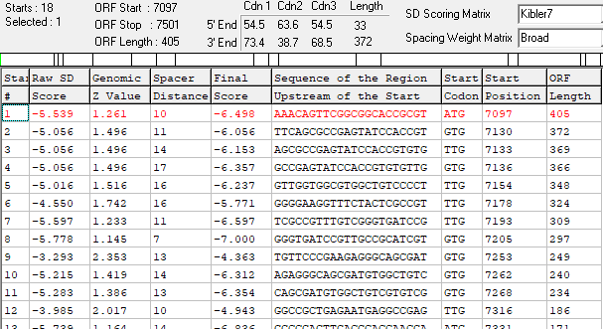
Proposed Function: tail terminator
Function Evidence: BlastP and HHPred
Transmembrane Domain/Evidence: NO
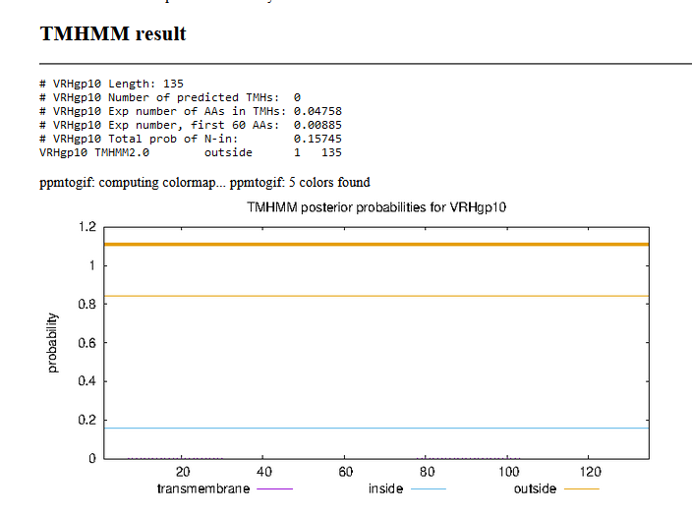

Gene Number: 11
9/14/22 BlastP NCBI and PHAGESdb HHpred PDB_mmCIF70_12_Aug, TMHMM translation of called orf, longest start at 7611, Starterator on phagesdb, RBS on DNA Master Frames
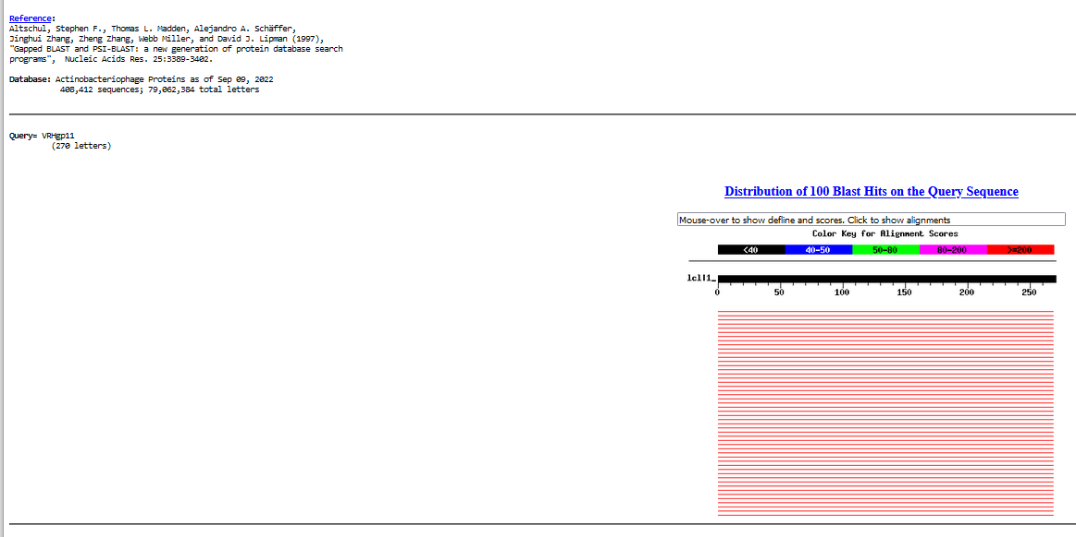
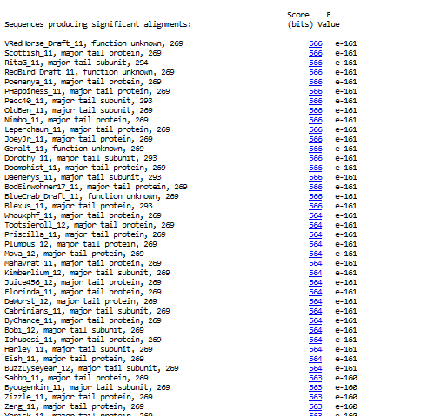
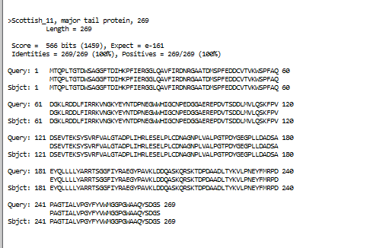
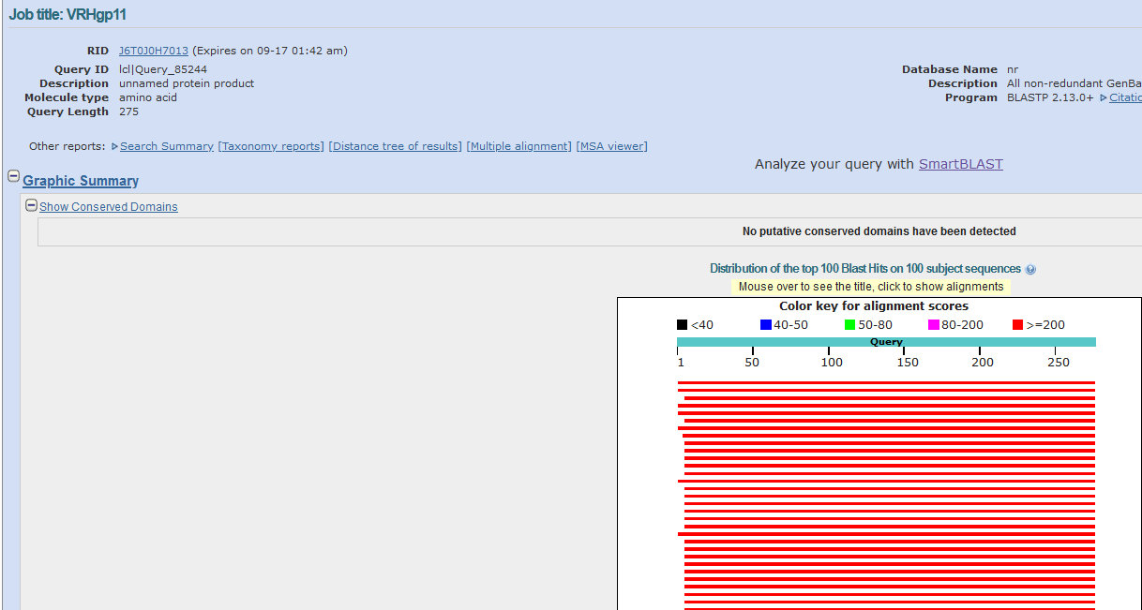

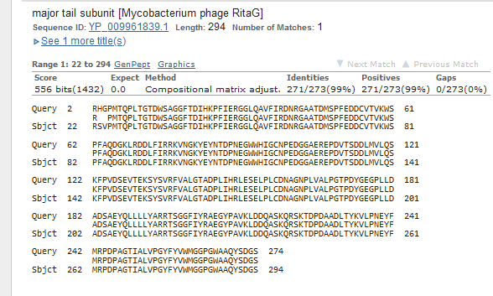
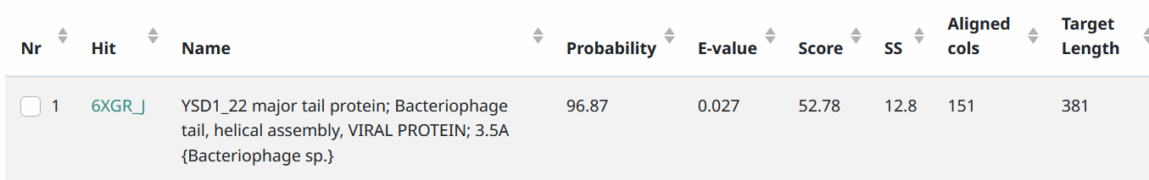
Start Codon and source: 7611, ATG, called by GeneMark and GLimmer
Stop Codon: 8420, TAG
F/R: F
Coding Potential (y/n): y
Starterator (SS, NA, NI): pham 47061, most annotated start
Blast Best Hit, Query:Subject Starts, Score, Evalue, or “no significant Blast alignments” if 10E-4 or higher
Gap: 109 gap from preceding gene
Longest Orf? (Y/N/NA) Y
RBS: N/A, Scoring Matirix , Spacing Matrix, Z Score, Final Score,
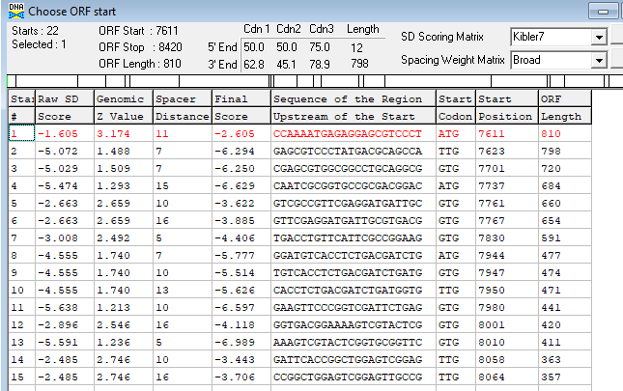
Proposed Function: major tail protein
Function Evidence: BlastP and HHPRED
Transmembrane Domain/Evidence: NO
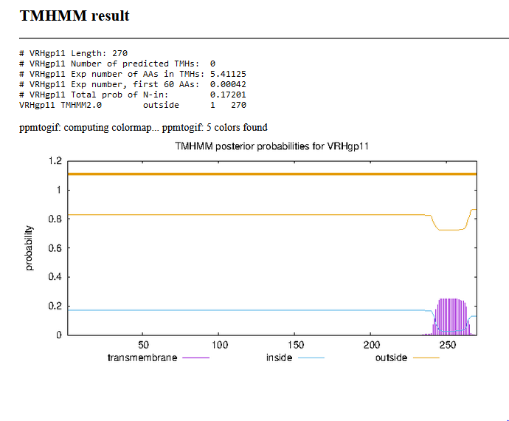

Gene Number: 12
9/14/22 BlastP NCBI and PHAGESdb HHpred PDB_mmCIF70_12_Aug, TMHMM translation of called orf, longest start at 8534, Starterator on phagesdb, RBS on DNA Master Frames
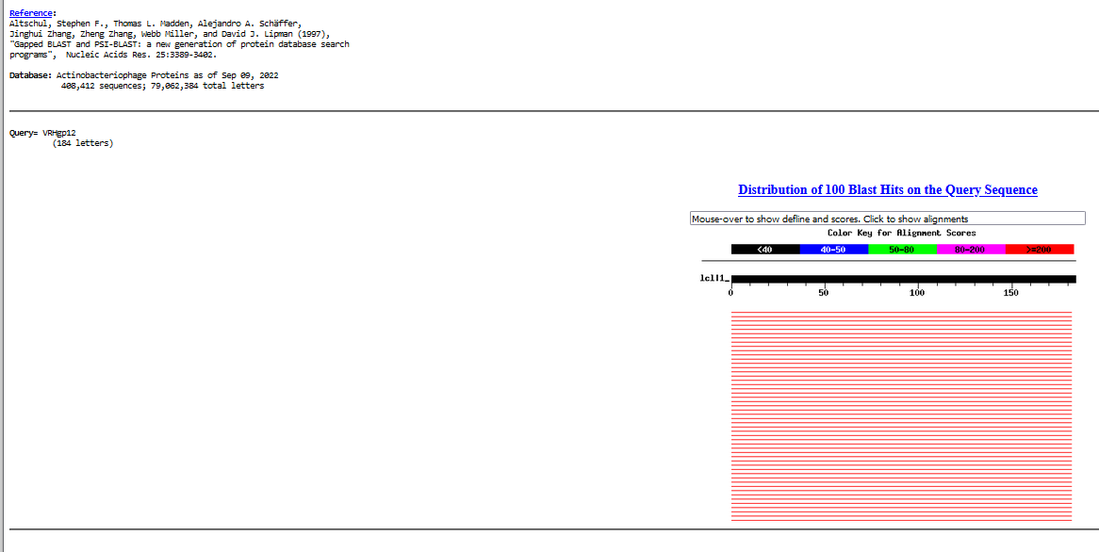
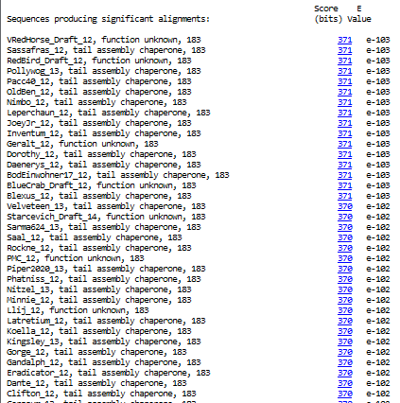
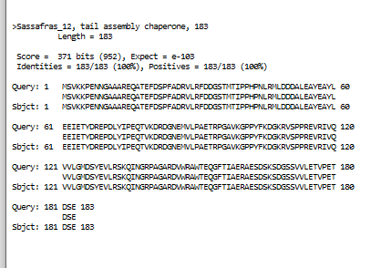
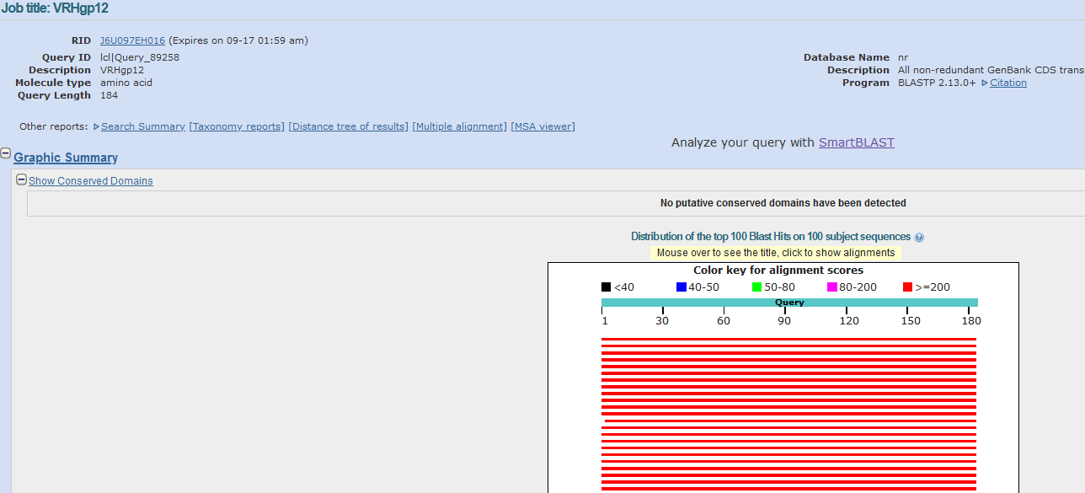
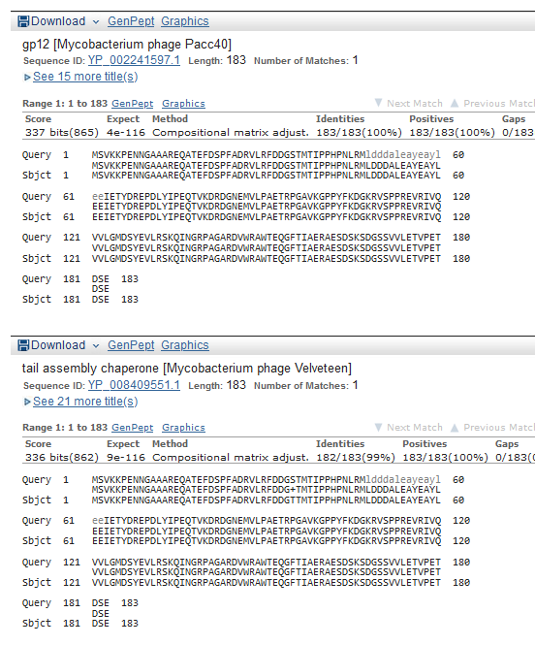
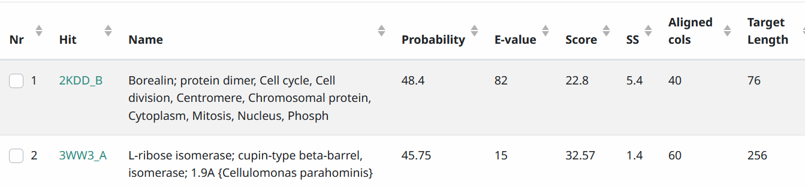
Start Codon and source: 8534, ATG, called by Glimmer and GeneMark
Stop Codon: 9085, TGA
F/R: F
Coding Potential (y/n): Y
Starterator (SS, NA, NI): pham 60, most annotated start
Blast Best Hit, Query:Subject Starts, Score, Evalue, or “no significant Blast alignments” if 10E-4 or higher
Gap: 113 from previous gene
Longest Orf? (Y/N/NA) Y
RBS: N/A, Scoring Matirix , Spacing Matrix, Z Score, Final Score,
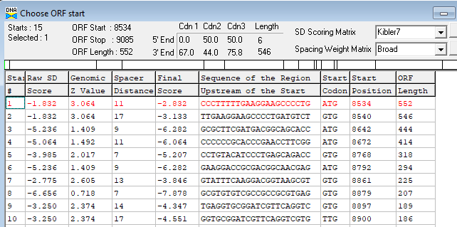
Proposed Function: tail assembly chaperone
Function Evidence: BlastP
Transmembrane Domain/Evidence: NO
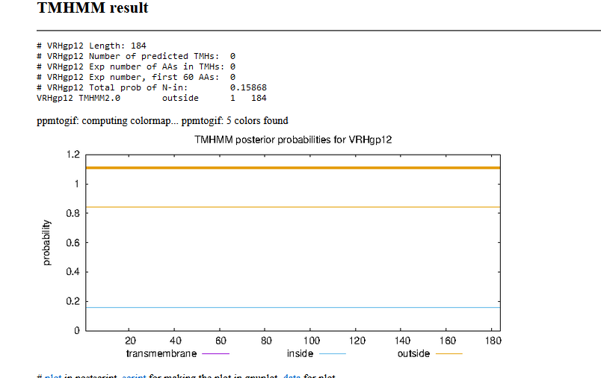

Gene Number: 13
9/14/22 BlastP NCBI and PHAGESdb HHpred PDB_mmCIF70_12_Aug, TMHMM translation of called fused orfwith gp12, frameshifted +1 at 90031 to 90033 (skipped 90032, Starterator on phagesdb, RBS on DNA Master Frames
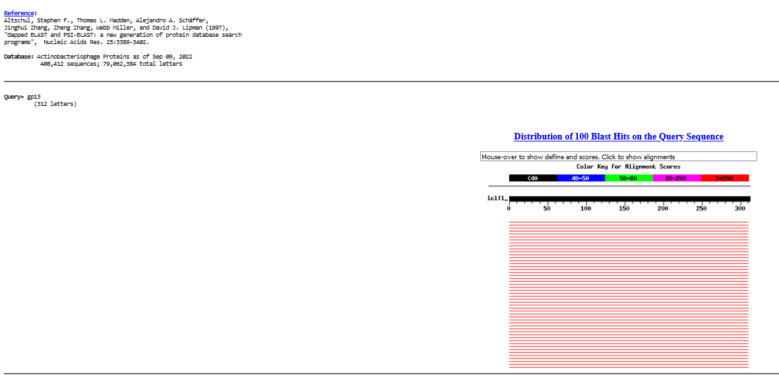
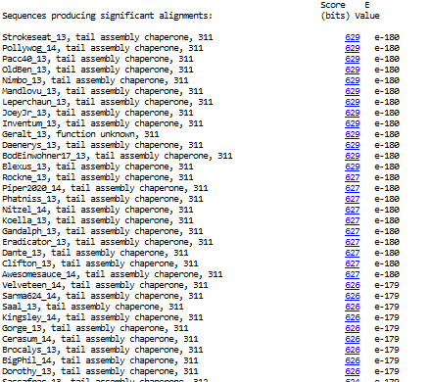
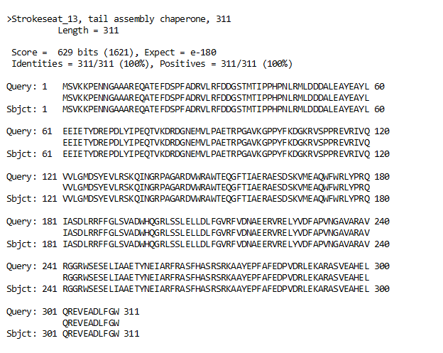
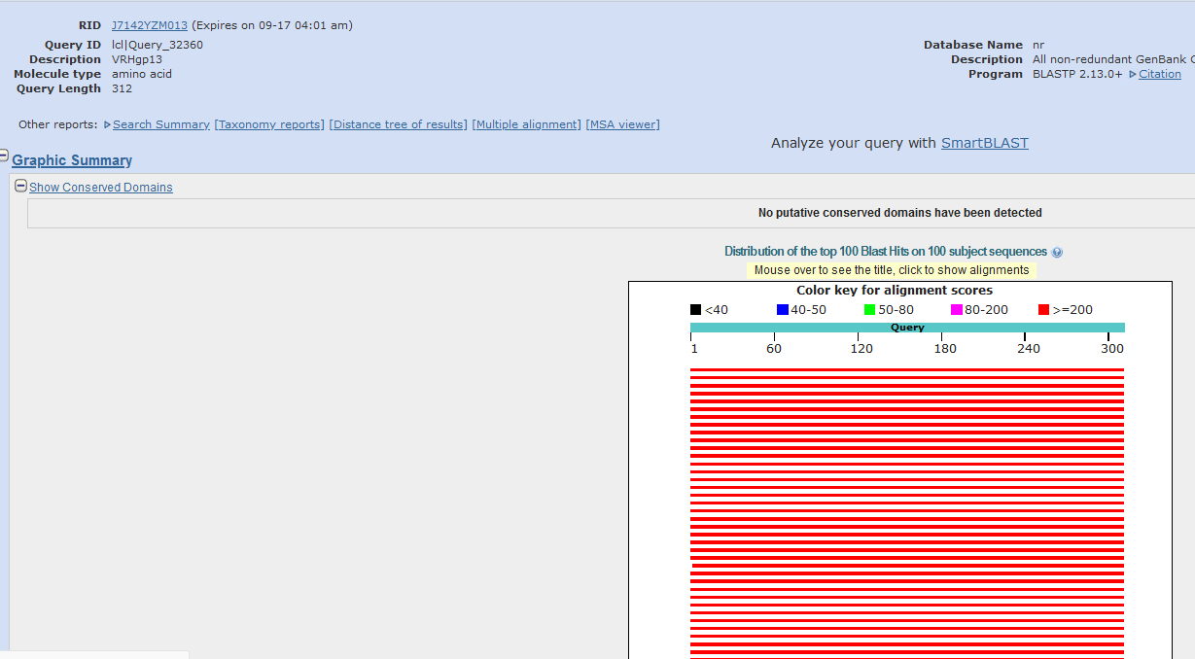
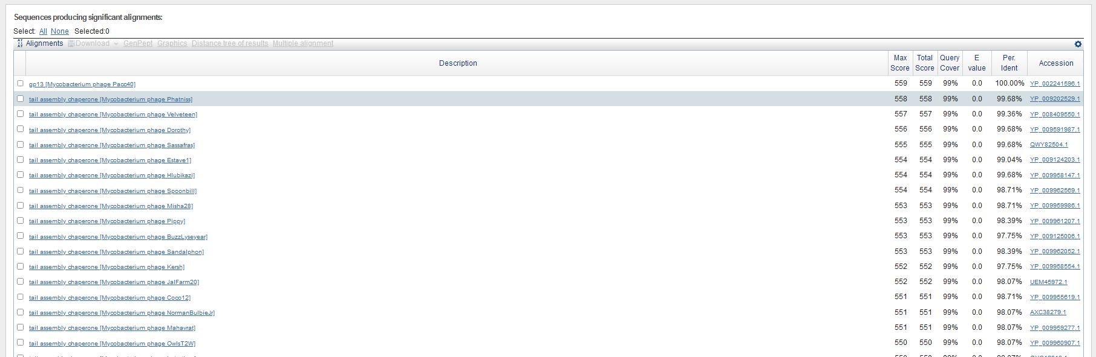
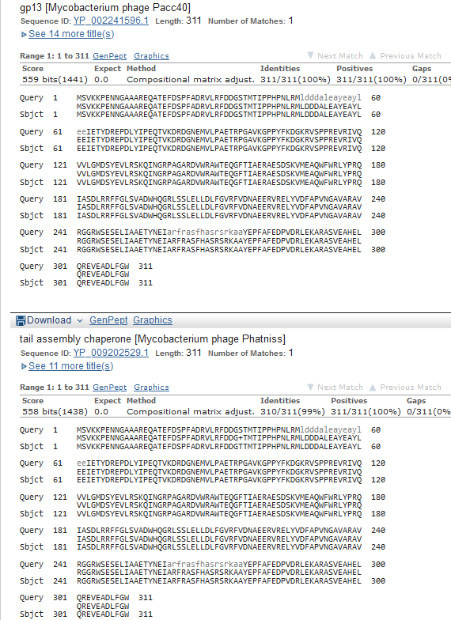
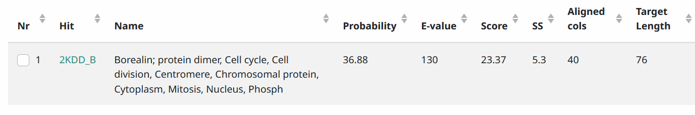
Start Codon and source: 8534, ATG, same as gp12 (frameshift)
Stop Codon: 9470, TGA
F/R: F
Coding Potential (y/n): Y
Starterator (SS, NA, NI): N/A (same as gene 12)
Blast Best Hit, Query:Subject Starts, Score, Evalue, or “no significant Blast alignments” if 10E-4 or higher

Gap: 113 bp gap from gene 11 (same start as gene 12)
Longest Orf? (Y/N/NA) N/A…frameshifted from gene 12
RBS: N/A, Scoring Matirix , Spacing Matrix, Z Score, Final Score, (same as gene12, frameshift)
Proposed Function: tail assembly chaperone
Function Evidence: BlastP, upstream of tape measure protein gene
Transmembrane Domain/Evidence: NO
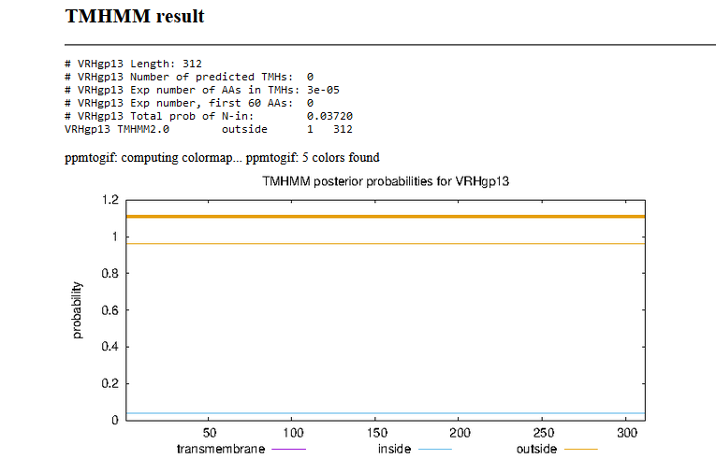

Gene Number: 14
9/14/22 BlastP NCBI and PHAGESdb HHpred PDB_mmCIF70_12_Aug, TMHMM translation of orf, longest start at 9467, Starterator on phagesdb, RBS on DNA Master Frames
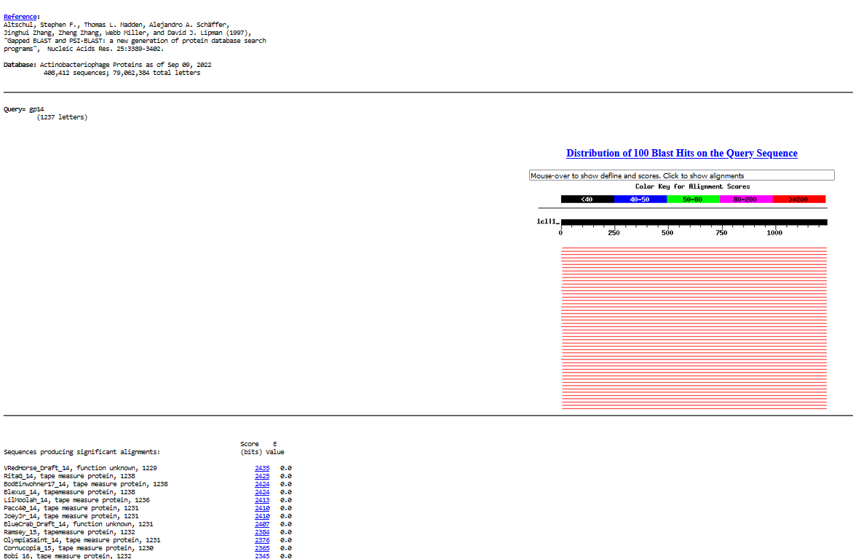
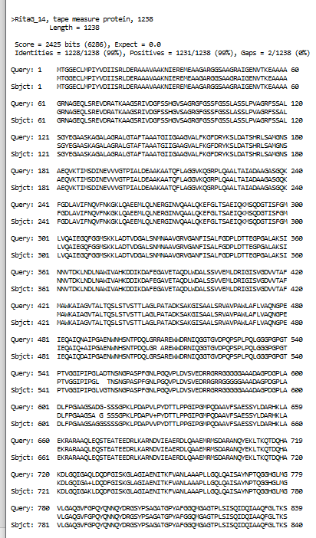
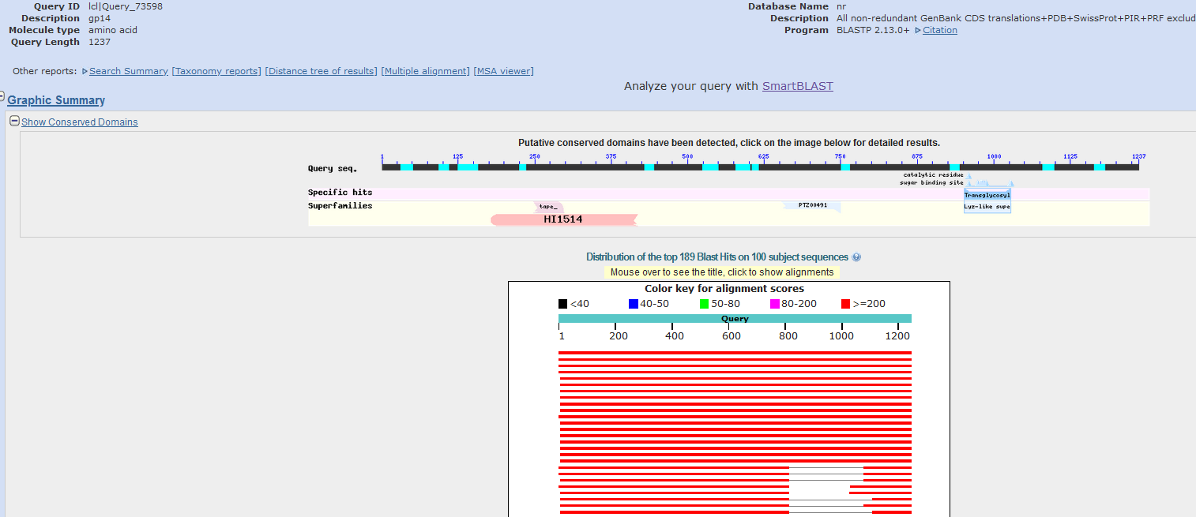
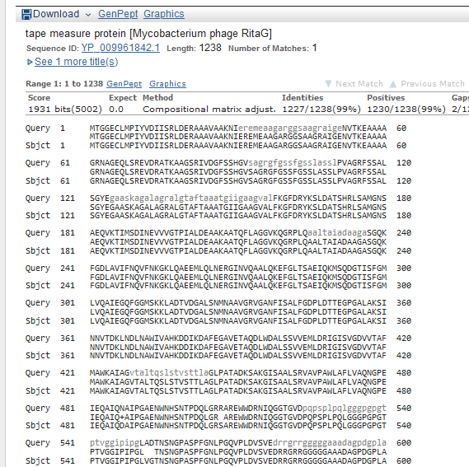

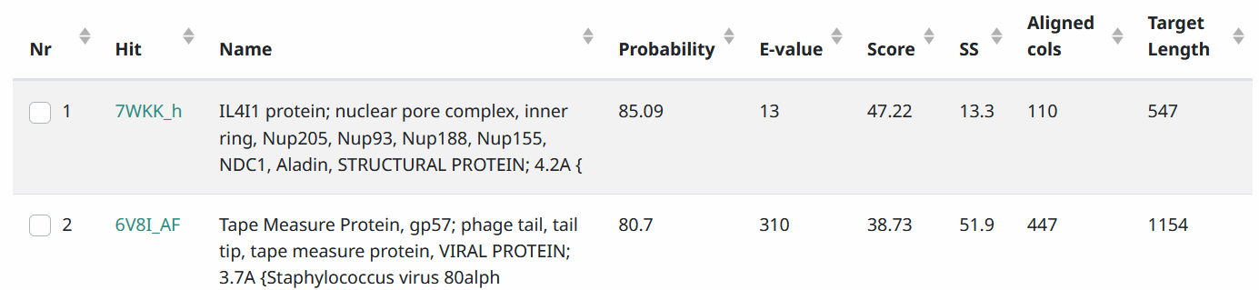
Start Codon and source: 9,467, GTG, Not called by glimmer or genemark (9488)
Stop Codon: 13,177, TAA
F/R: F
Coding Potential (y/n): y
Starterator (SS, NA, NI): more phages use the autoannotated called start, but we chose longer orf as it had identical aa’s encoded by other phages (e.g. RitaG)
Blast Best Hit, Query:Subject Starts, Score, Evalue, or “no significant Blast alignments” if 10E-4 or higher
Gap: -4 bp overlap with previous gene
Longest Orf? (Y/N/NA): Y
RBS: N/A, Scoring Matirix , Spacing Matrix, Z Score, Final Score,
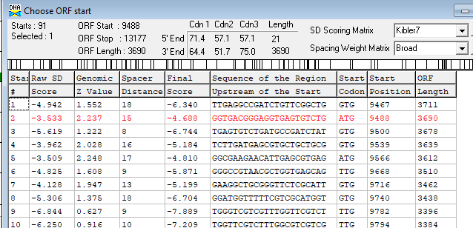
Proposed Function: tape measure protein
Function Evidence: longest gene in genome, domains in NCBI blast BlastP, BlastP
Transmembrane Domain/Evidence: No
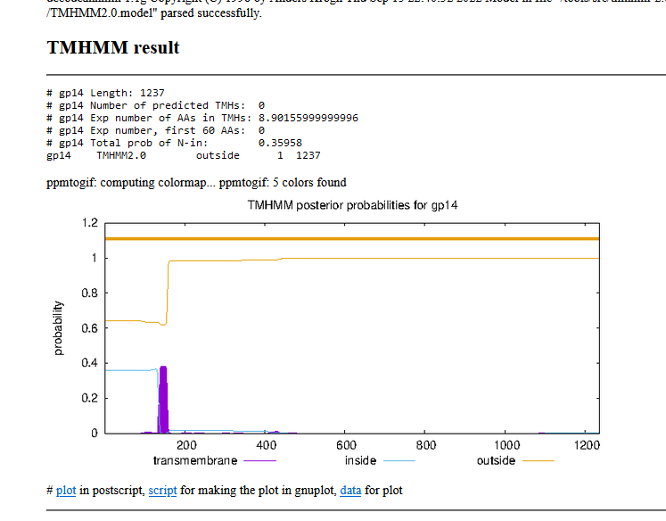

Gene Number: 15
9/14/22 BlastP NCBI and PHAGESdb HHpred PDB_mmCIF70_12_Aug, TMHMM translation of called orf, longest orf start at 13,178, Starterator on phagesdb, RBS on DNA Master Frames
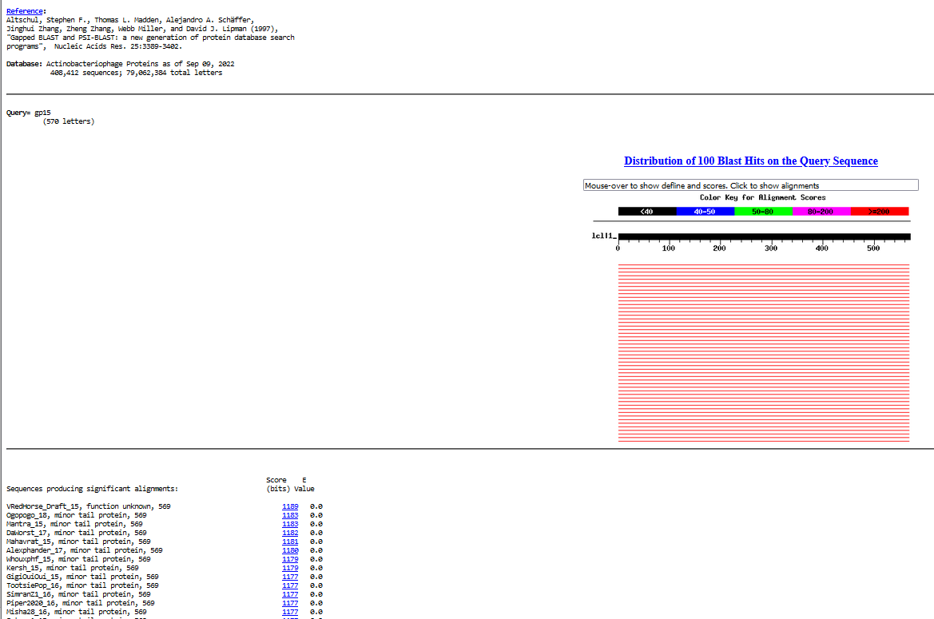
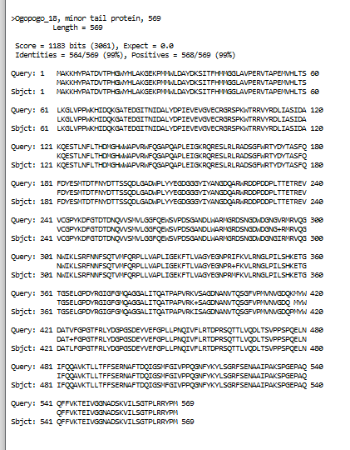
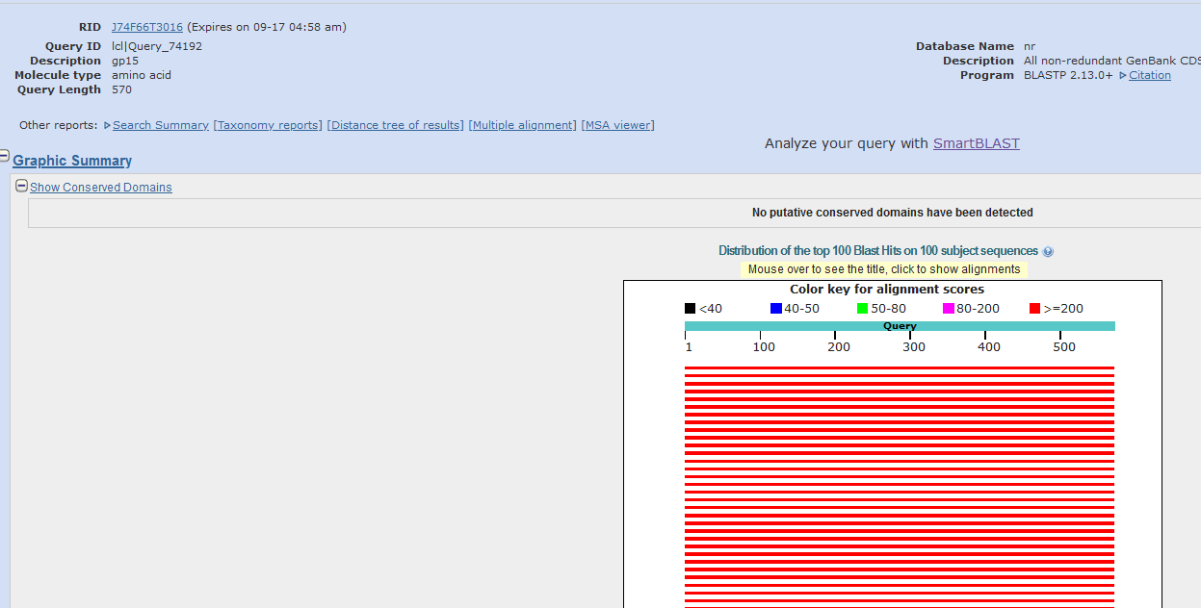
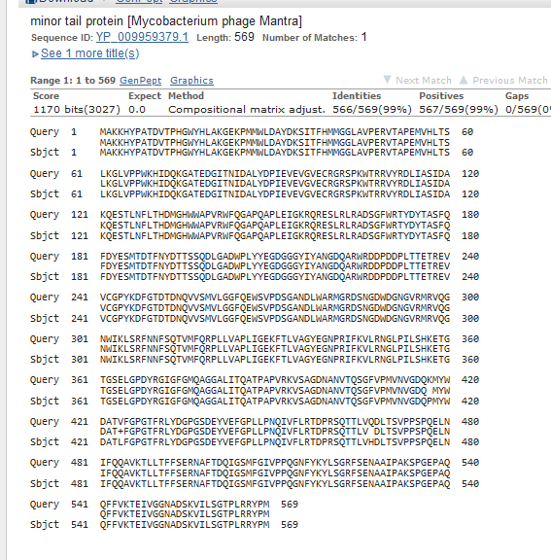
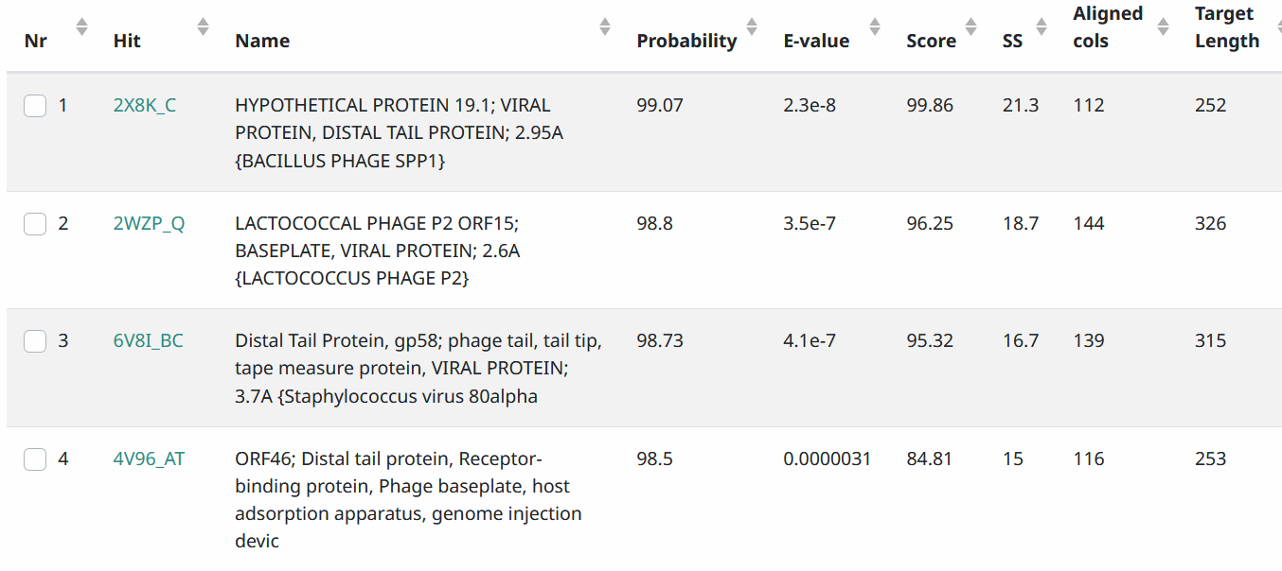
Start Codon and source: 13,178, ATG Called by Glimmer and GeneMark
Stop Codon: 14,887, TAG
F/R: F
Coding Potential (y/n): Y
Starterator (SS, NA, NI): pham59, most annotated start
Blast Best Hit, Query:Subject Starts, Score, Evalue, or “no significant Blast alignments” if 10E-4 or higher
Gap: 0, starts next base after last orf
Longest Orf? (Y/N/NA) Y
RBS: N/A, Scoring Matirix , Spacing Matrix, Z Score, Final Score,
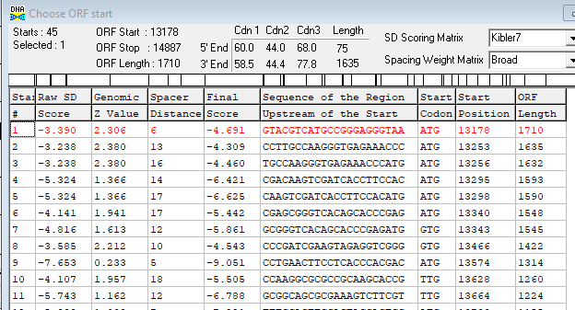
Proposed Function: minor tail protein
Function Evidence: BlastP, HHPRED
Transmembrane Domain/Evidence: NO
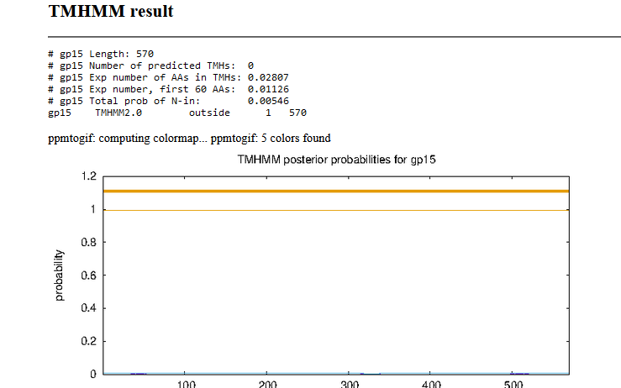

Gene Number: 16
9/14/22 BlastP NCBI and PHAGESdb HHpred PDB_mmCIF70_12_Aug, TMHMM translation of called orf, longest orf start at 14,970, Starterator on phagesdb, RBS on DNA Master Frames
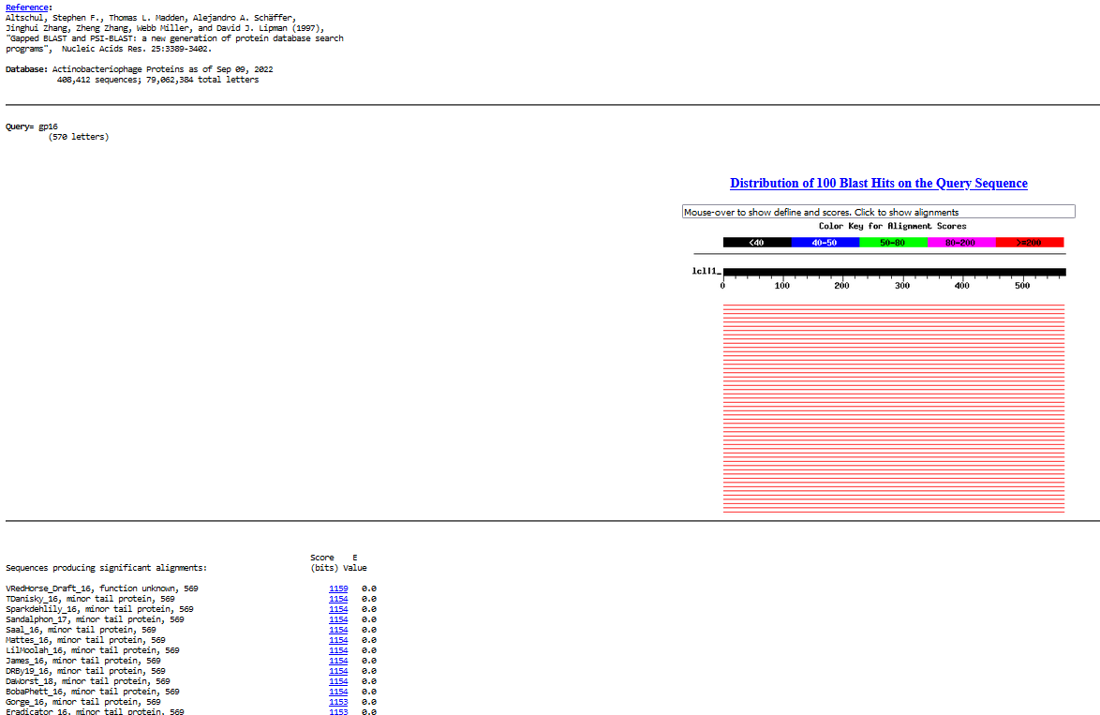
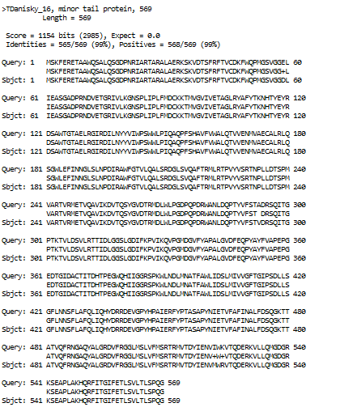
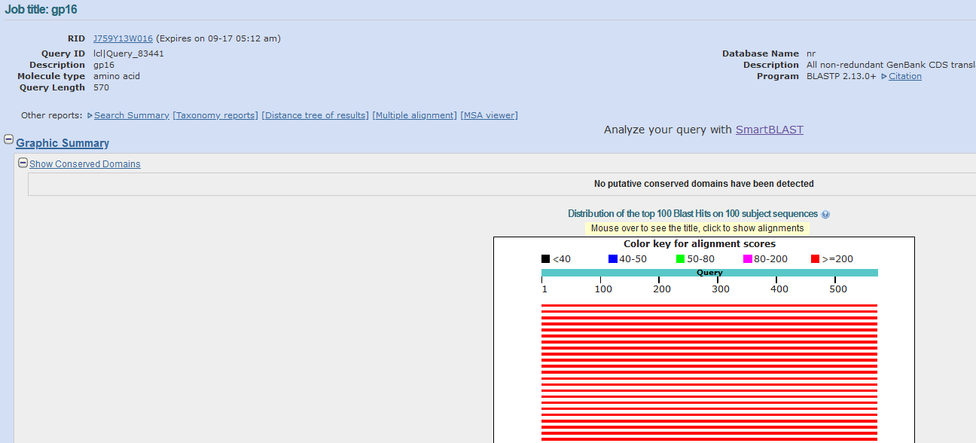
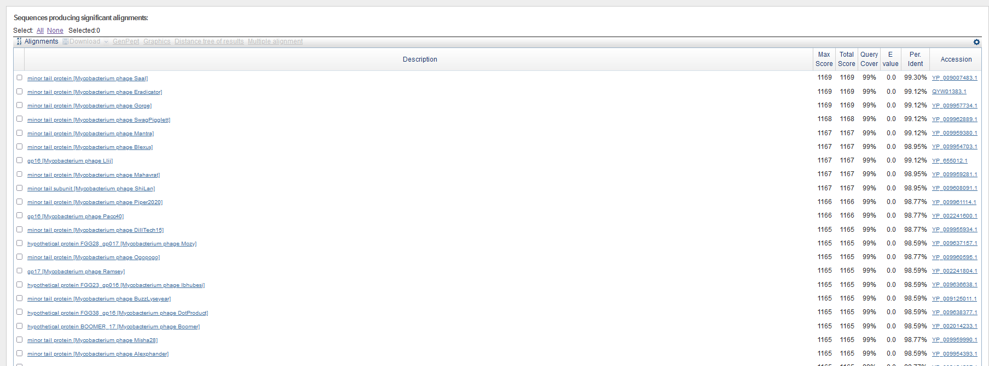
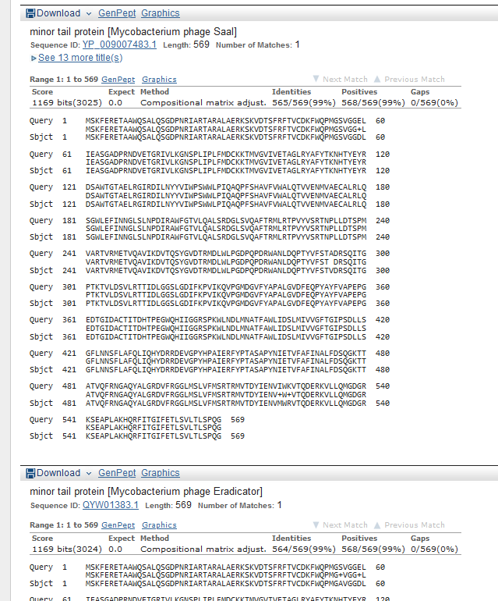
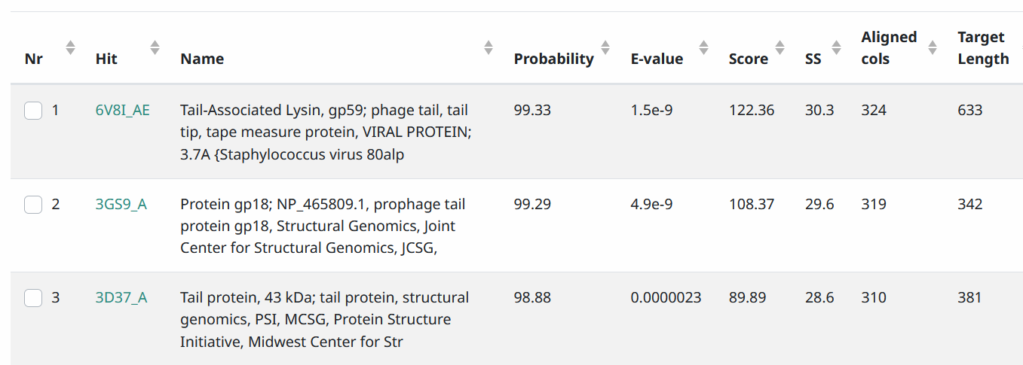
Start Codon and source: 14,970, TTG, Called by Glimmer and Genemark
Stop Codon: 16,679, TAA
F/R: F
Coding Potential (y/n): Y
Starterator (SS, NA, NI): does not have most annotated start
Blast Best Hit, Query:Subject Starts, Score, Evalue, or “no significant Blast alignments” if 10E-4 or higher
Gap: 82 bp gap from end of gene 15
Longest Orf? (Y/N/NA) Y
RBS: N/A, Scoring Matirix , Spacing Matrix, Z Score, Final Score,
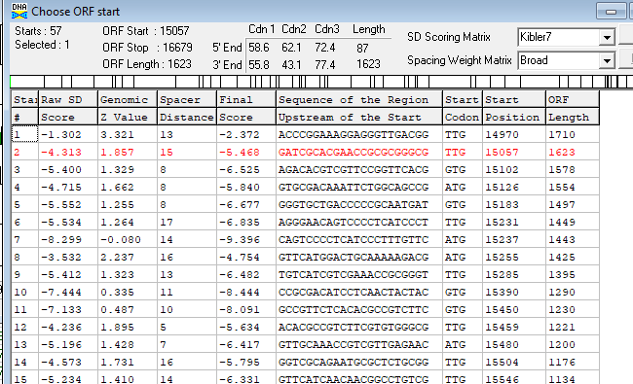
Proposed Function: minor tail protein
Function Evidence: BlastP and HHPRED
Transmembrane Domain/Evidence: NO
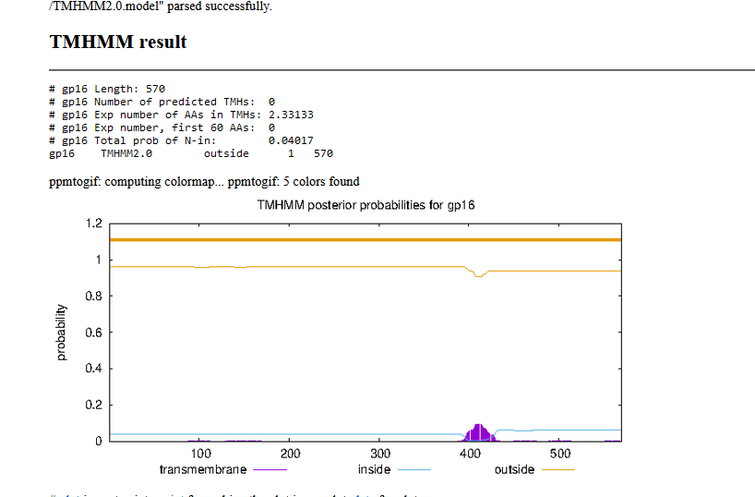

Gene Number: 17
9/14/22 BlastP NCBI and PHAGESdb HHpred PDB_mmCIF70_12_Aug, TMHMM translation of longest orf start at 16,737, Starterator on phagesdb, RBS on DNA Master Frames
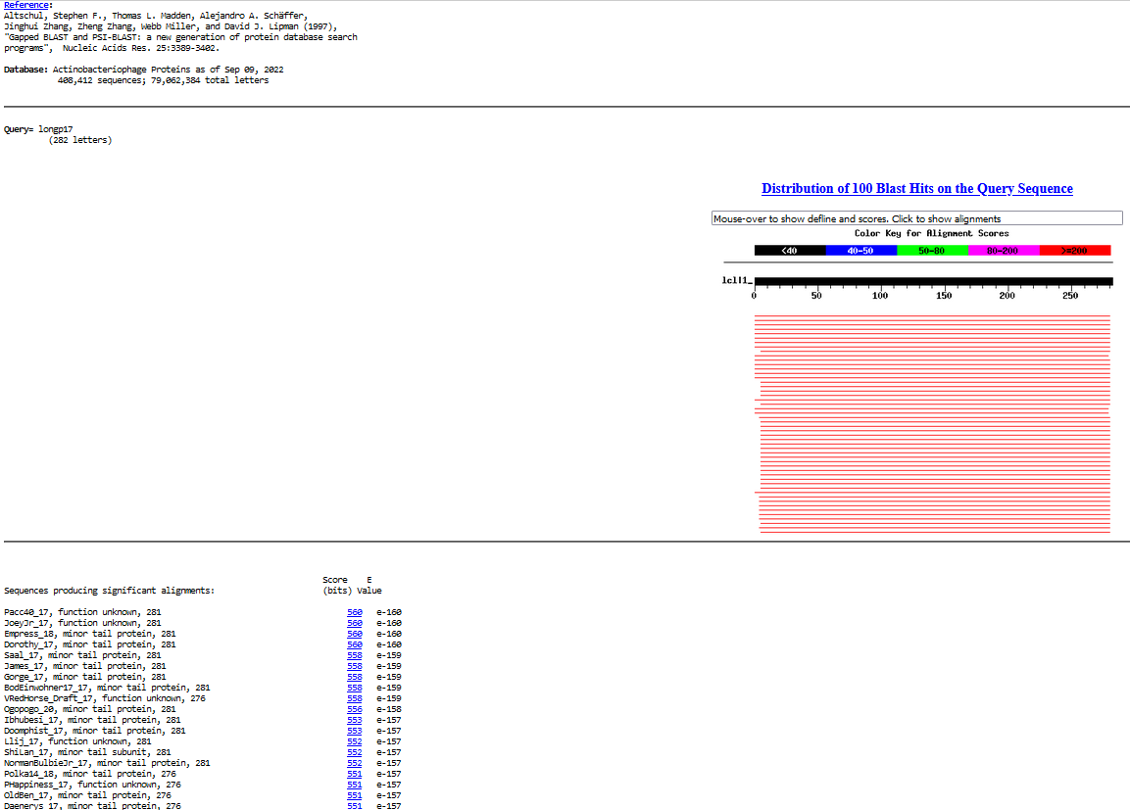
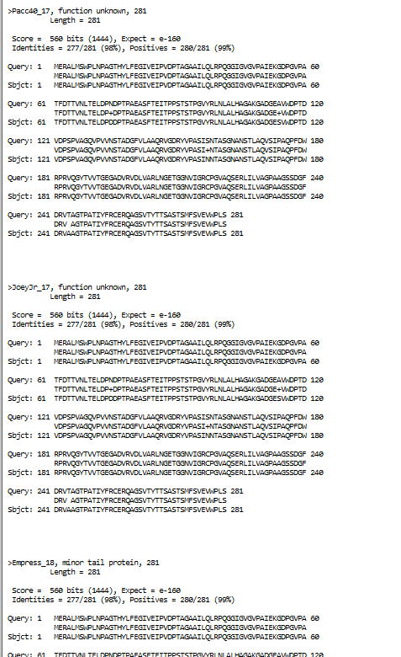
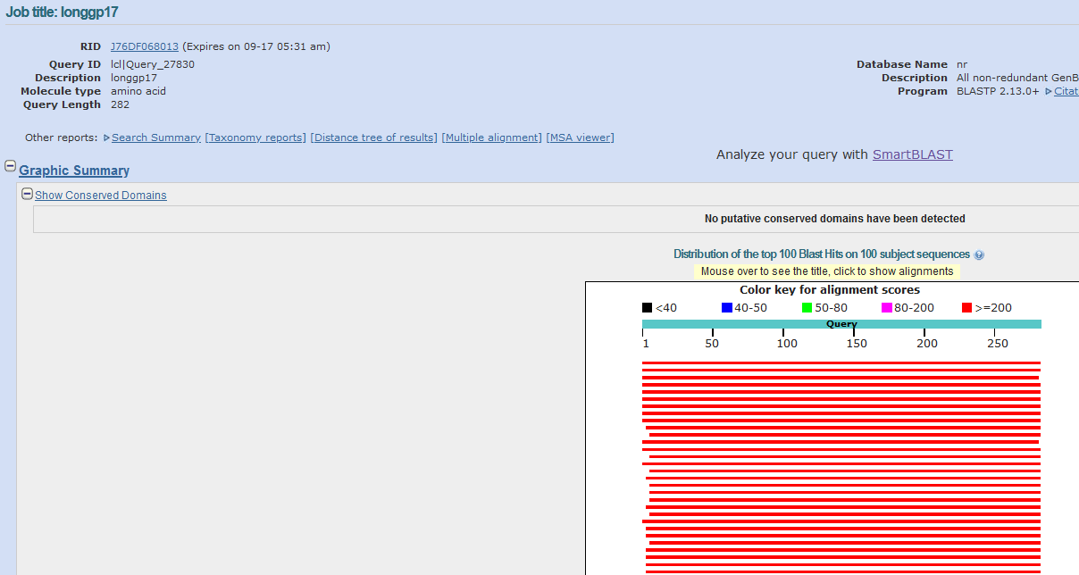
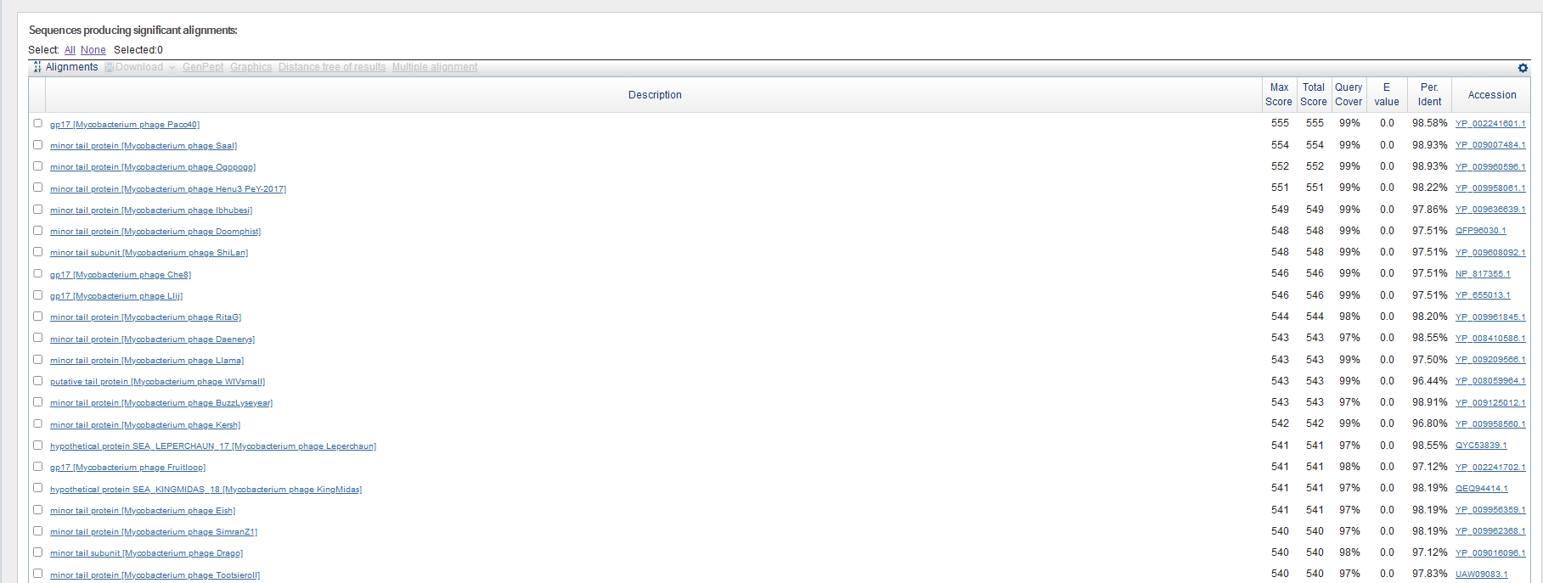
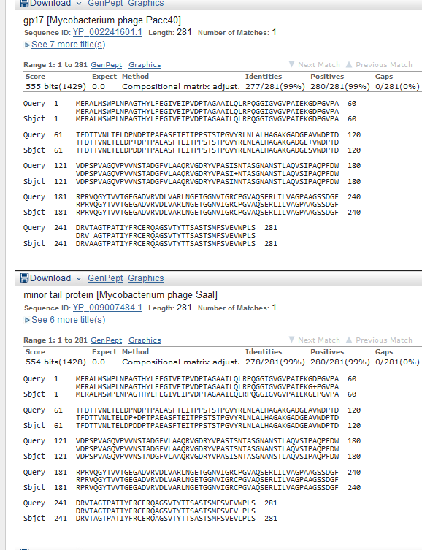
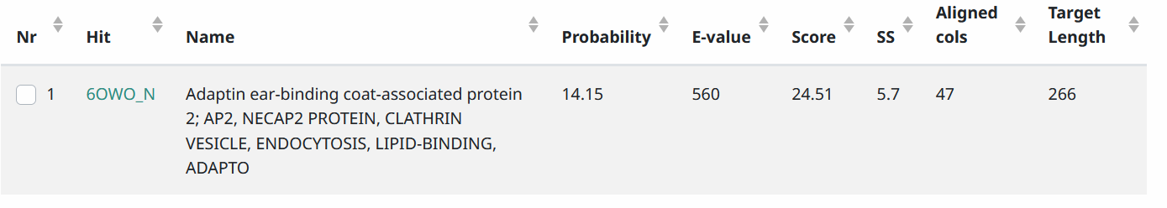
Start Codon and source: 16,722, ATG, Not called by Glimmer or GeneMark (16737 ATG)
Stop Codon: 17567,
F/R: F
Coding Potential (y/n): Y
Starterator (SS, NA, NI): pham 45626. Changed from most annotated (autoannotated) to lengthen orf
Blast Best Hit, Query:Subject Starts, Score, Evalue, or “no significant Blast alignments” if 10E-4 or higher
Gap: 42 bp gap from end of gene 16
Longest Orf? (Y/N/NA) Y
RBS: N/A, Scoring Matirix , Spacing Matrix, Z Score, Final Score,
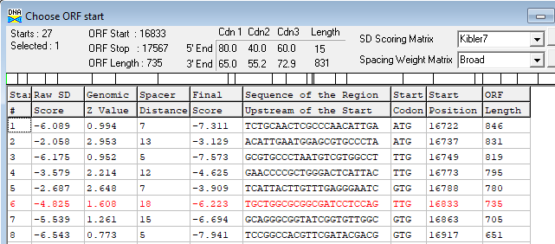
Proposed Function: Hypothetical Protein
Function Evidence: no phage matches on HHPRED
Transmembrane Domain/Evidence: NO
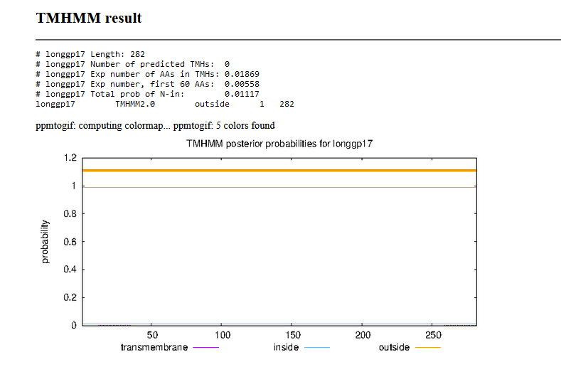

Gene Number: 18
9/14/22 BlastP NCBI and PHAGESdb HHpred PDB_mmCIF70_12_Aug, TMHMM translation of called orf start at 17,564, Starterator on phagesdb, RBS on DNA Master Frames
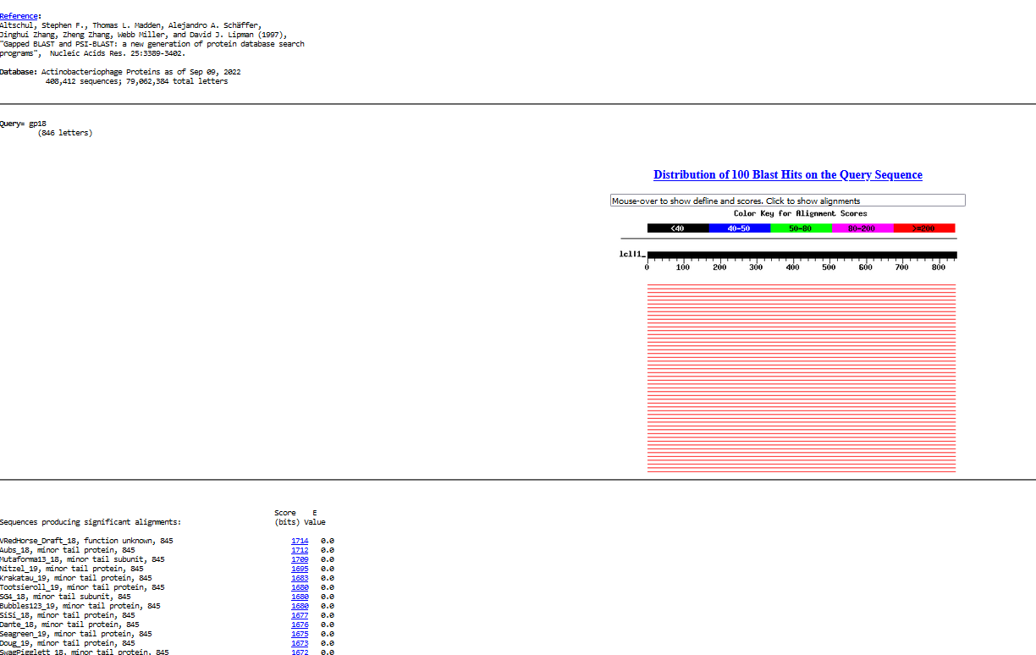
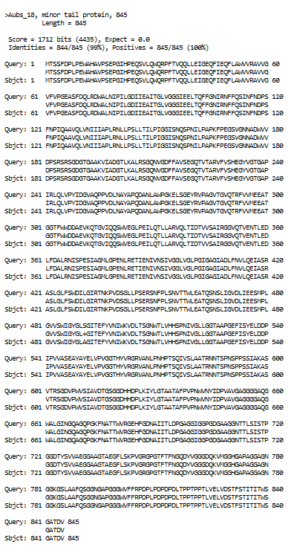
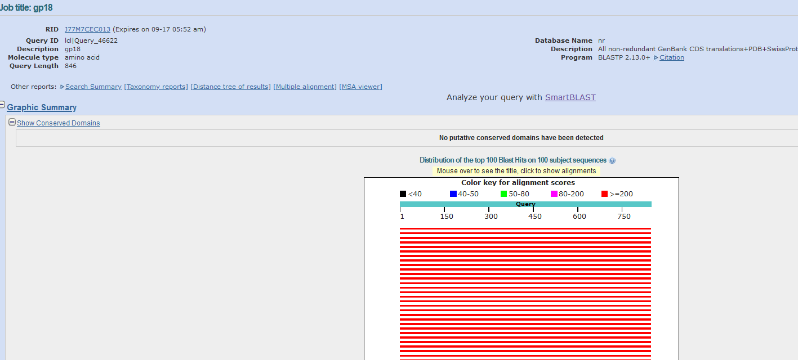
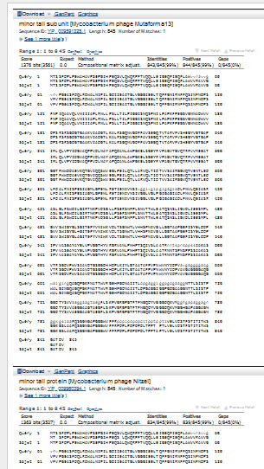
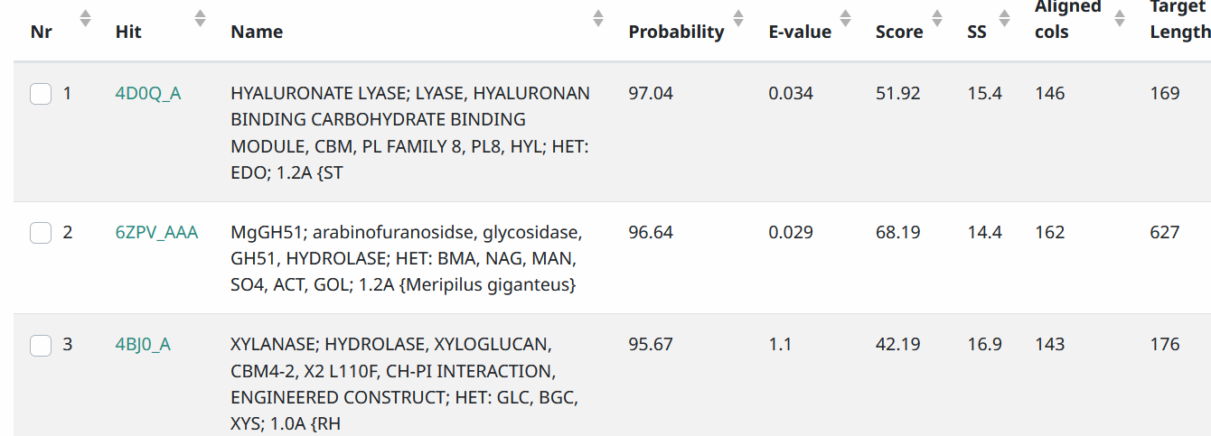
Start Codon and source: 17,564 ATG, Called by Glimmer and Genemark
Stop Codon: 20,101, TGA
F/R: F
Coding Potential (y/n): Y
Starterator (SS, NA, NI): pham 47051, most annotated start
Blast Best Hit, Query:Subject Starts, Score, Evalue, or “no significant Blast alignments” if 10E-4 or higher
Gap: -4 bp overlap with end of gene 17
Longest Orf? (Y/N/NA) N
RBS: N/A, Scoring Matirix , Spacing Matrix, Z Score, Final Score,
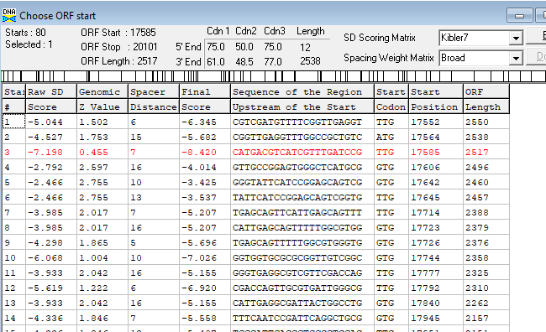
Proposed Function: minor tail protein
Function Evidence:BlastP, HHPred hyaluronate lyase
Transmembrane Domain/Evidence: NO
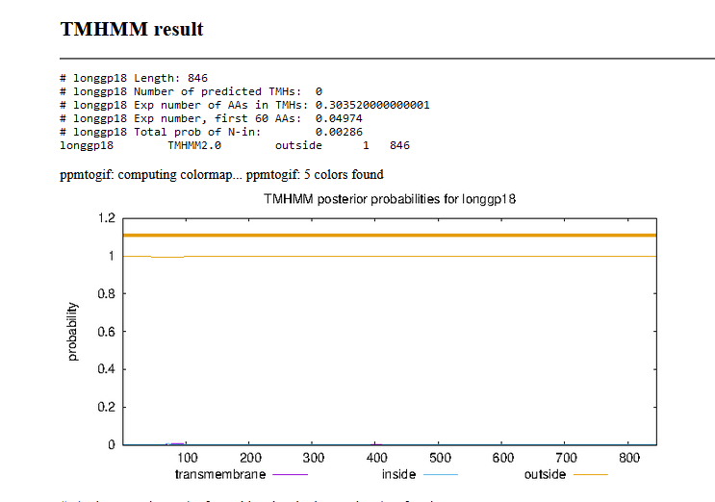

Gene Number: 19
9/14/22 BlastP NCBI and PHAGESdb HHpred PDB_mmCIF70_12_Aug, TMHMM translation of called and longest orf start at 20098, Starterator on phagesdb, RBS on DNA Master Frames
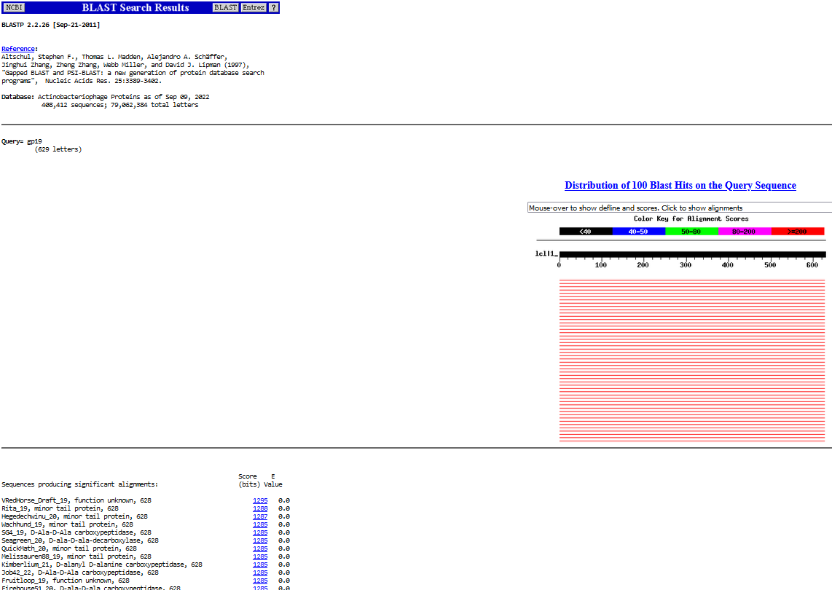
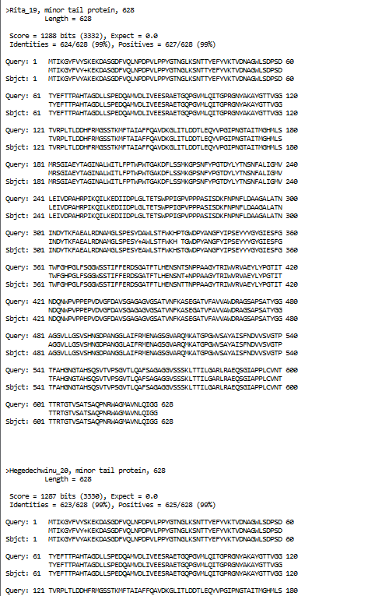
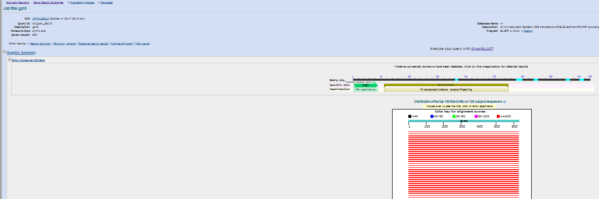
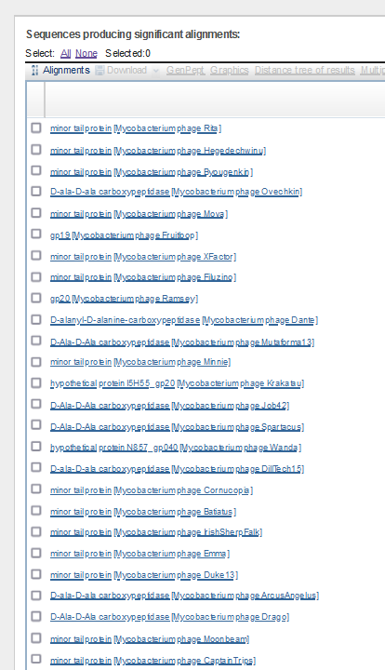
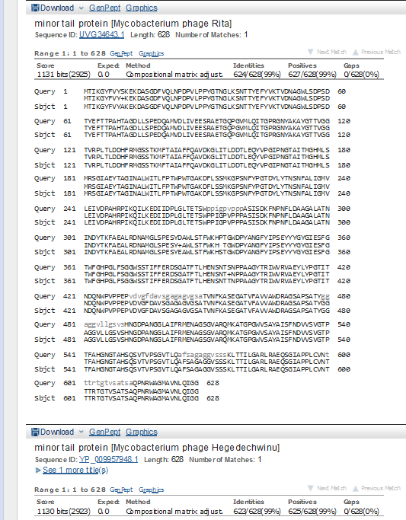
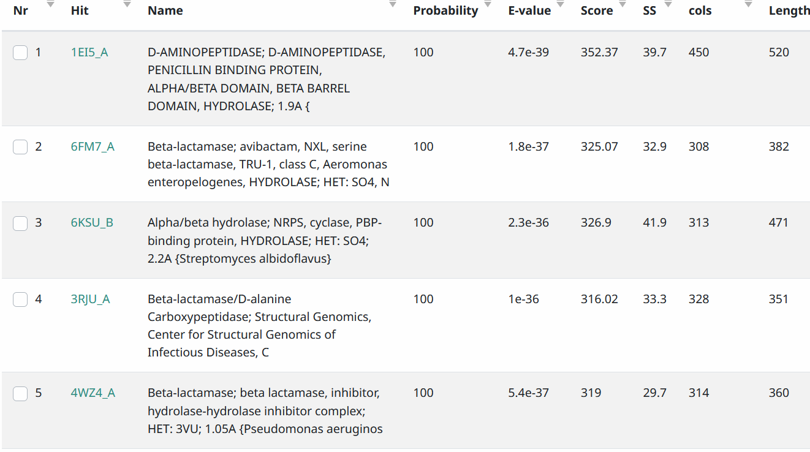
Start Codon and source: 20,098, ATG, Called by GeneMark and Glimmer
Stop Codon: 21,984, TGA
F/R: F
Coding Potential (y/n): Y
Starterator (SS, NA, NI): pham 293, most annotated start
Blast Best Hit, Query:Subject Starts, Score, Evalue, or “no significant Blast alignments” if 10E-4 or higher

Gap: 4 bp overlap from end of gene 18
Longest Orf? (Y/N/NA) Y
RBS: N/A, Scoring Matirix , Spacing Matrix, Z Score, Final Score,
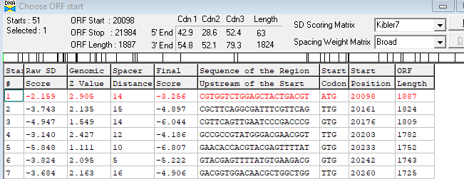
Proposed Function: minor tail protein, D-ala-D-ala carboxypeptidase
Function Evidence: BlastP, HHPred
Transmembrane Domain/Evidence: NO
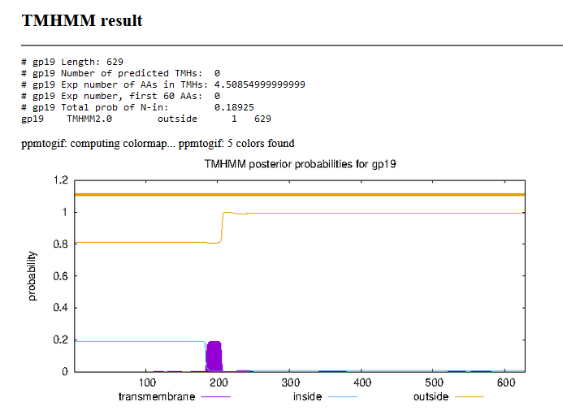

Gene Number: 20
9/14/22 BlastP NCBI and PHAGESdb HHpred PDB_mmCIF70_12_Aug, TMHMM translation of called orf start at 221,981, Starterator on phagesdb, RBS on DNA Master Frames
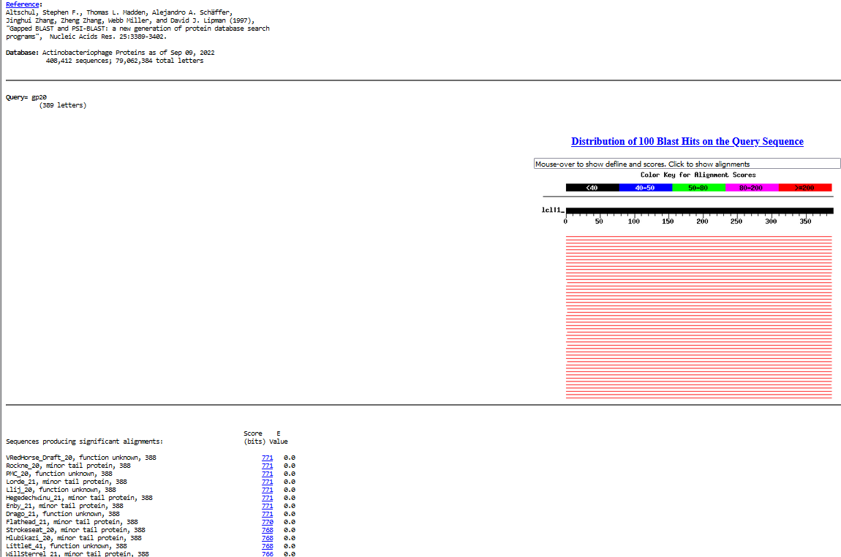
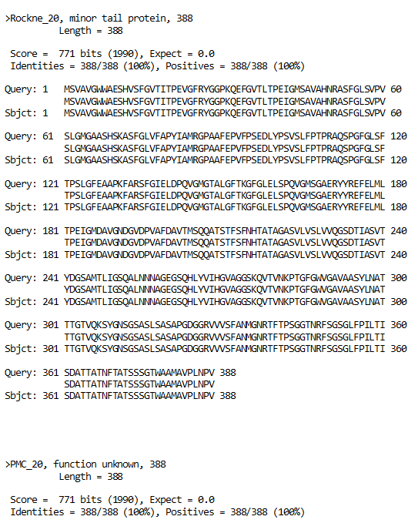
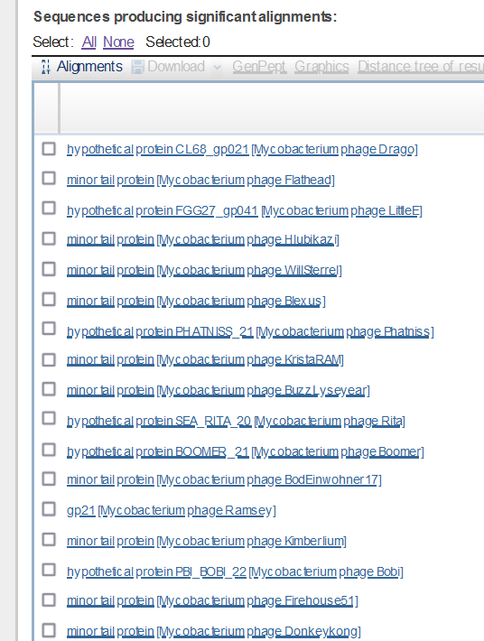
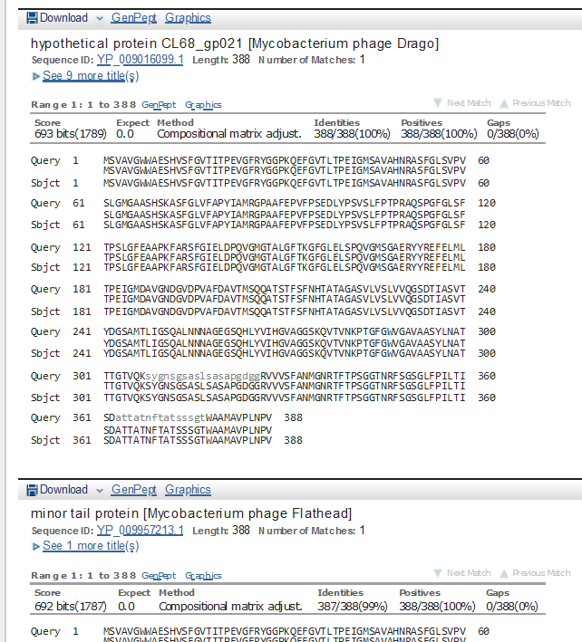
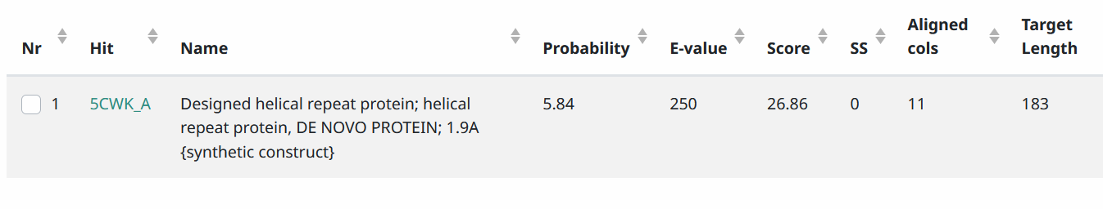
Start Codon and source: 21,981, ATG, Called by Glimmer and Genemark
Stop Codon: 23,147, TAA
Coding Potential (y/n): almost all without making large overlap
Starterator (SS, NA, NI): pham 398, most annotated start
Blast Best Hit, Query:Subject Starts, Score, Evalue, or “no significant Blast alignments” if 10E-4 or higher
Gap: 4 bp overlap with end of gene 19
Longest Orf? (Y/N/NA) N
RBS: N/A, Scoring Matirix , Spacing Matrix, Z Score, Final Score,
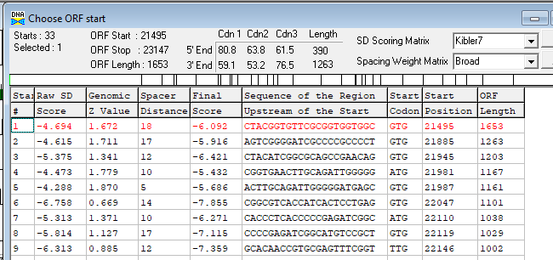
Proposed Function: Hypothetical Protein
Function Evidence: no phage tail evidence on HHPRED
Transmembrane Domain/Evidence: NO
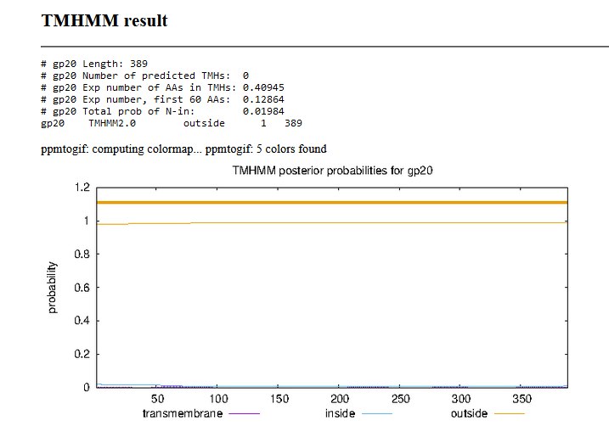

Gene Number: 21
9/16/22 Run BlastP at phagesdb and NCBI, Starterator, RBS on Frames, Transmembrane predition, HHPRED

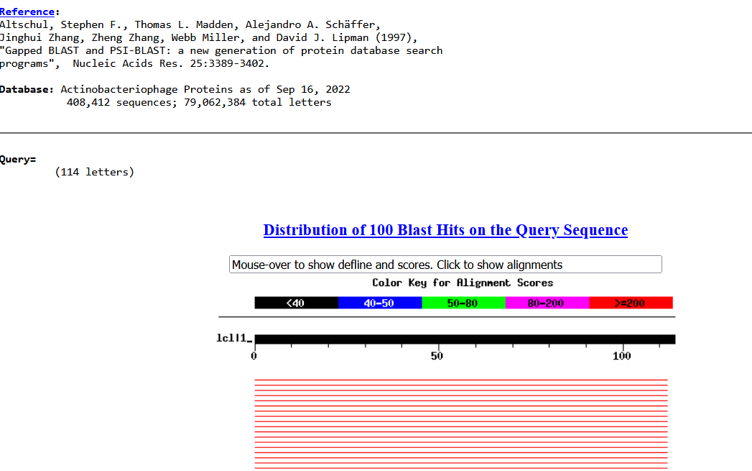
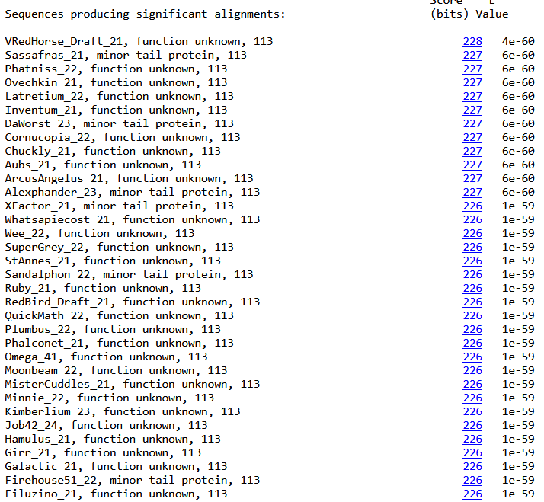
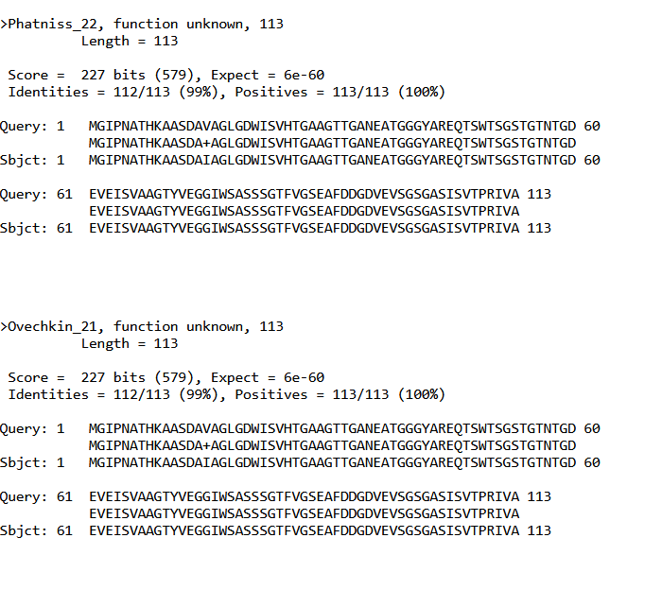
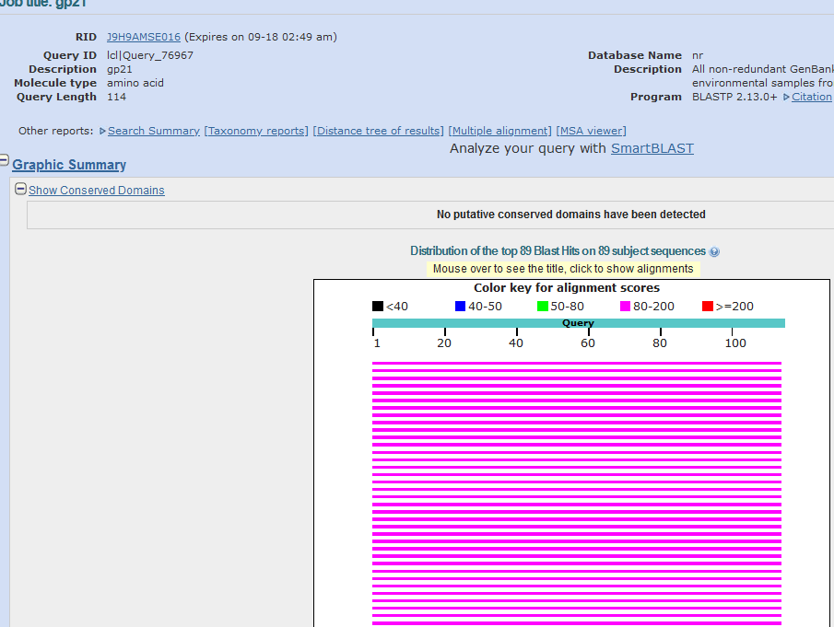
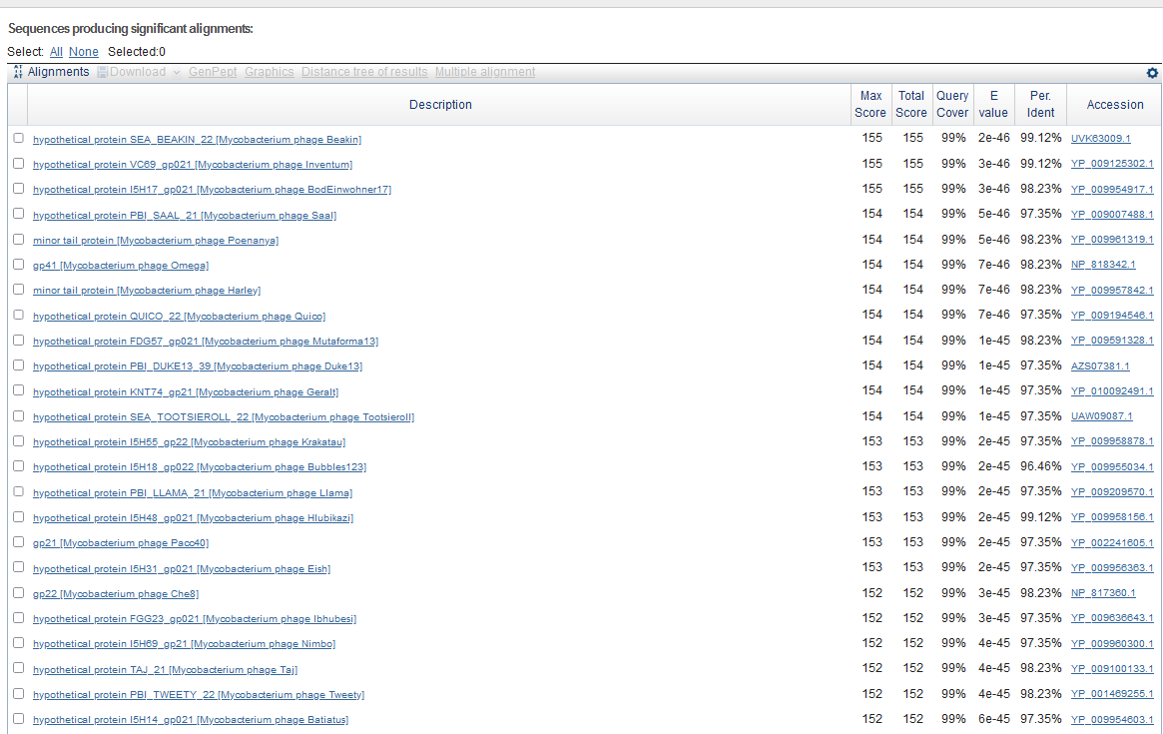
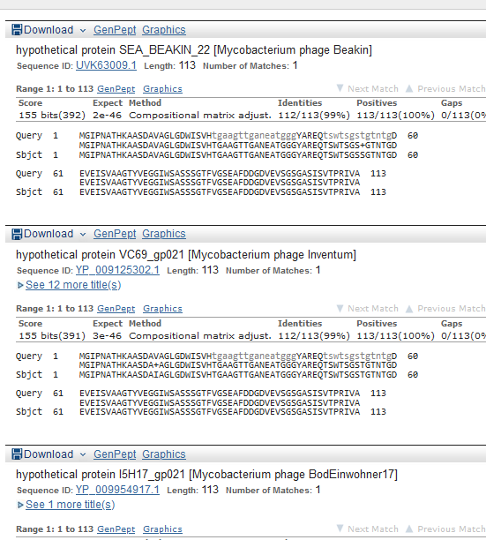
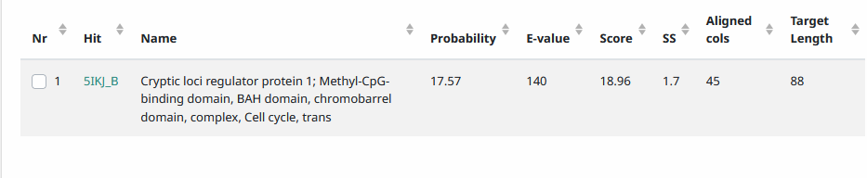
Start Codon and source: 23165, ATG, called by glimmer and genemark
Stop Codon: 23,506, TGA
F/R: F
Coding Potential (y/n): Y
Starterator (SS, NA, NI): pham 44309most annotated start
Blast Best Hit, Query:Subject Starts, Score, Evalue, or “no significant Blast alignments” if 10E-4 or higher
Gap: 17 bp gap from end of gene 20
Longest Orf? (Y/N/NA) N
RBS: N/A, Scoring Matirix , Spacing Matrix, Z Score, Final Score,
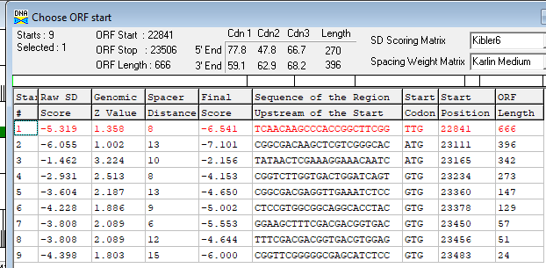
Proposed Function: Hypothetical Protein
Function Evidence: no phage matches in HHPRED
Transmembrane Domain/Evidence: NO
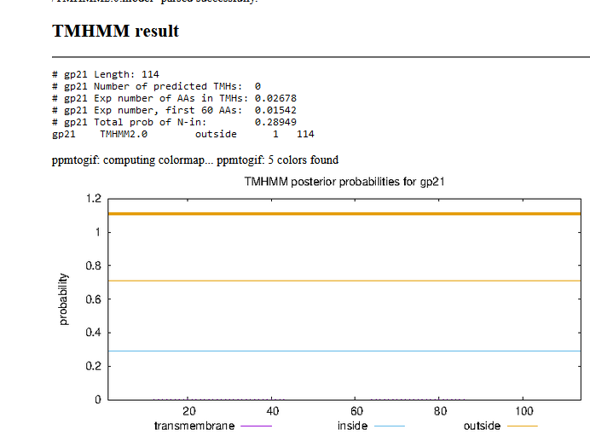

Gene Number: 22
9/19/22 Run BlastP at phagesdb and NCBI, Starterator, RBS on Frames, Transmembrane predition, HHPRED
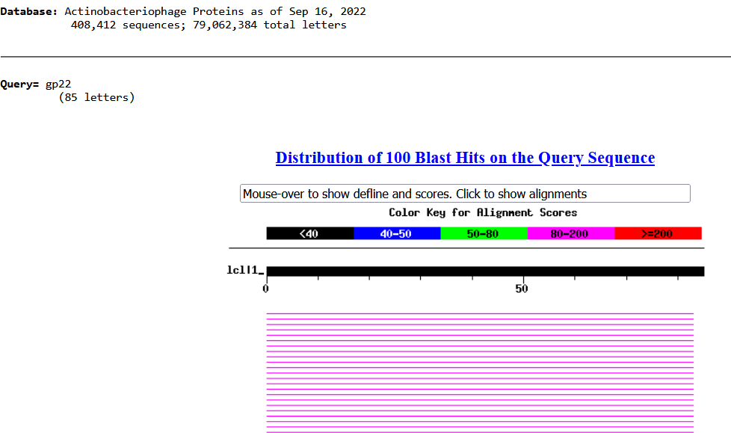
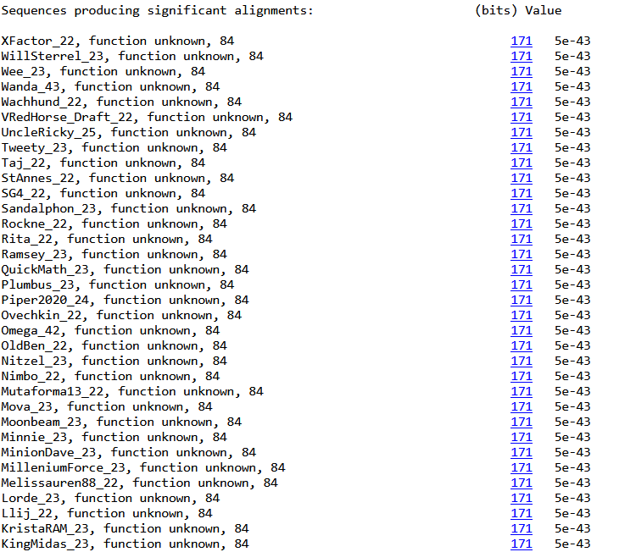
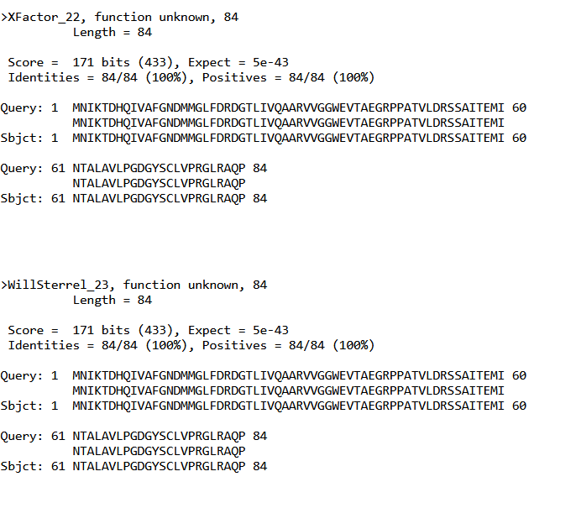
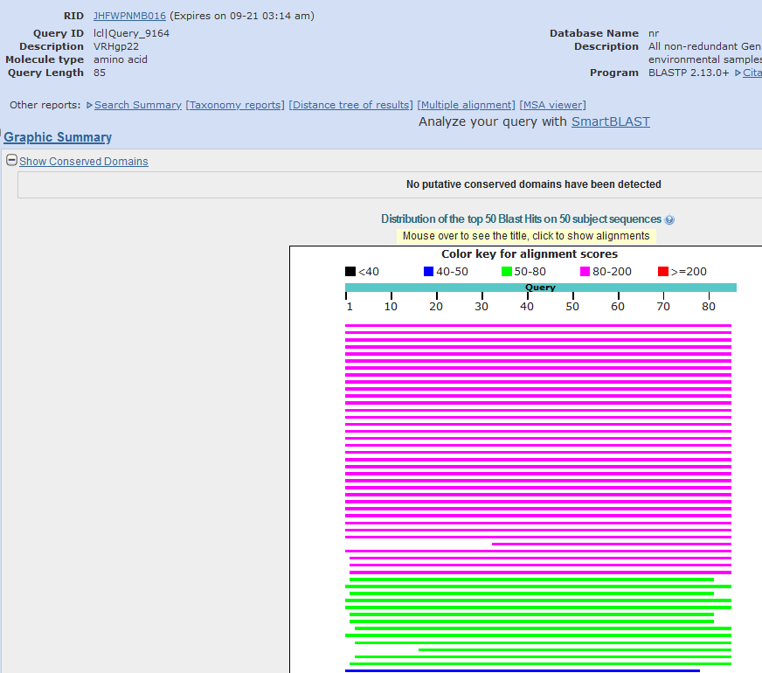
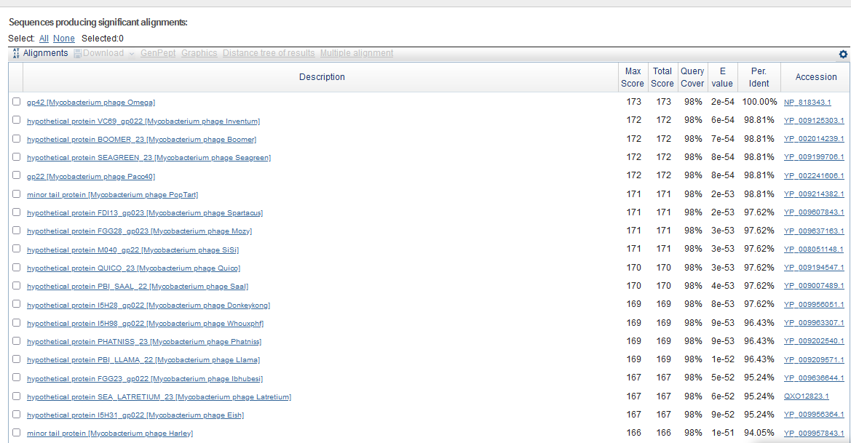
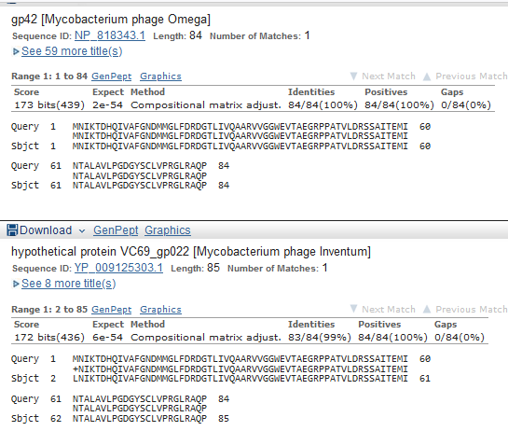
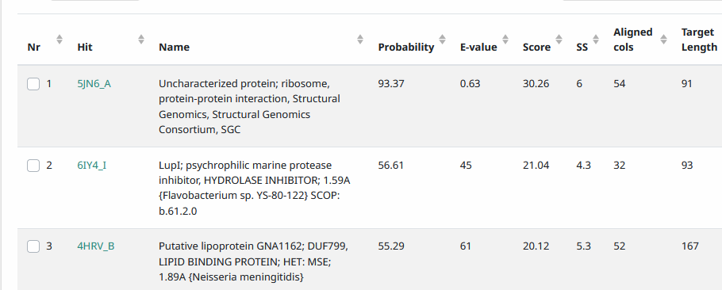
Start Codon and source: 23,528, TTG, Called by Genemark and Glimmer
Stop Codon: 23,283, TAG
F/R: F
Coding Potential (y/n): Y
Starterator (SS, NA, NI): pham 364, most annotated start
Blast Best Hit, Query:Subject Starts, Score, Evalue, or “no significant Blast alignments” if 10E-4 or higher
(Inventum has one extra predicted aa)
Gap: 22 bp gap from gene 21
Longest Orf? (Y/N/NA) Y
RBS: N/A, Scoring Matirix , Spacing Matrix, Z Score, Final Score,
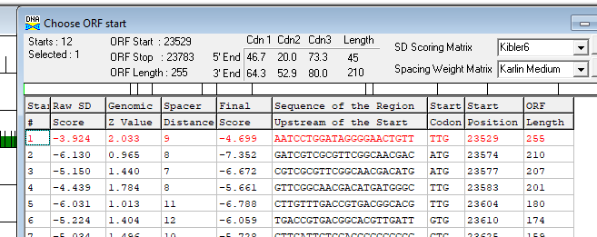
Proposed Function: Hypothetical Protein
Function Evidence: No phage matches in HHPRED, not significant number of matches with function in Blastp
Transmembrane Domain/Evidence: NO
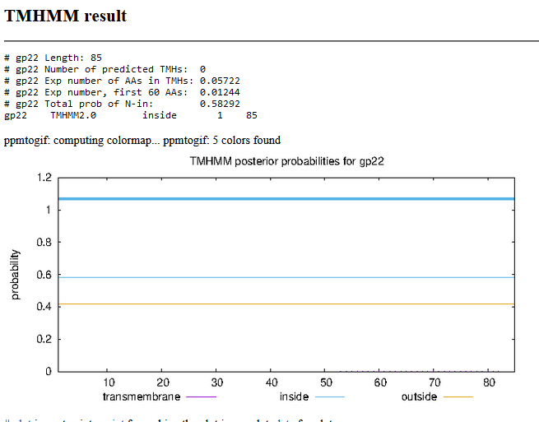

Gene Number: 23
9/21/22 Run BlastP at phagesdb and NCBI, Starterator, RBS on Frames, Transmembrane predition, HHPRED

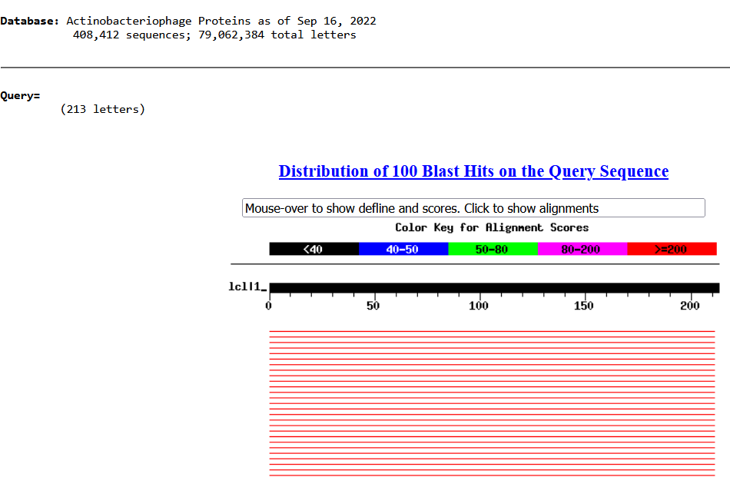
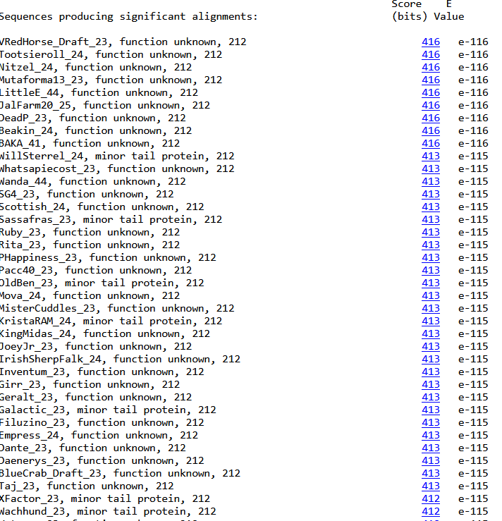
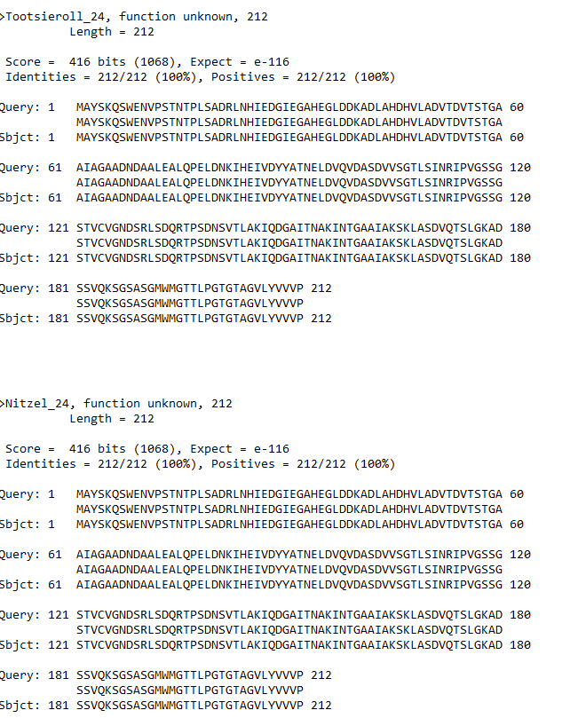
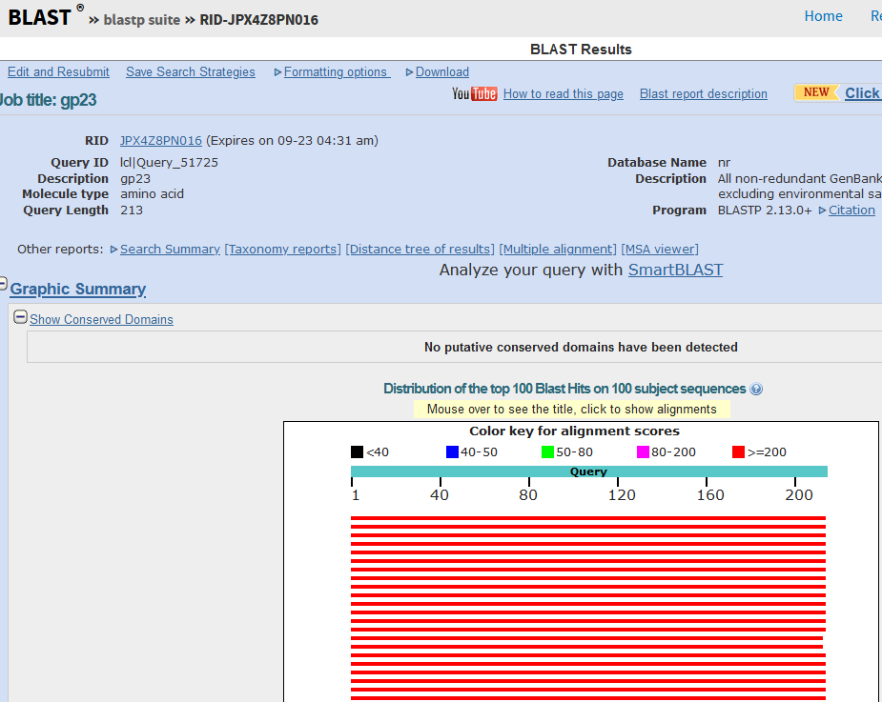
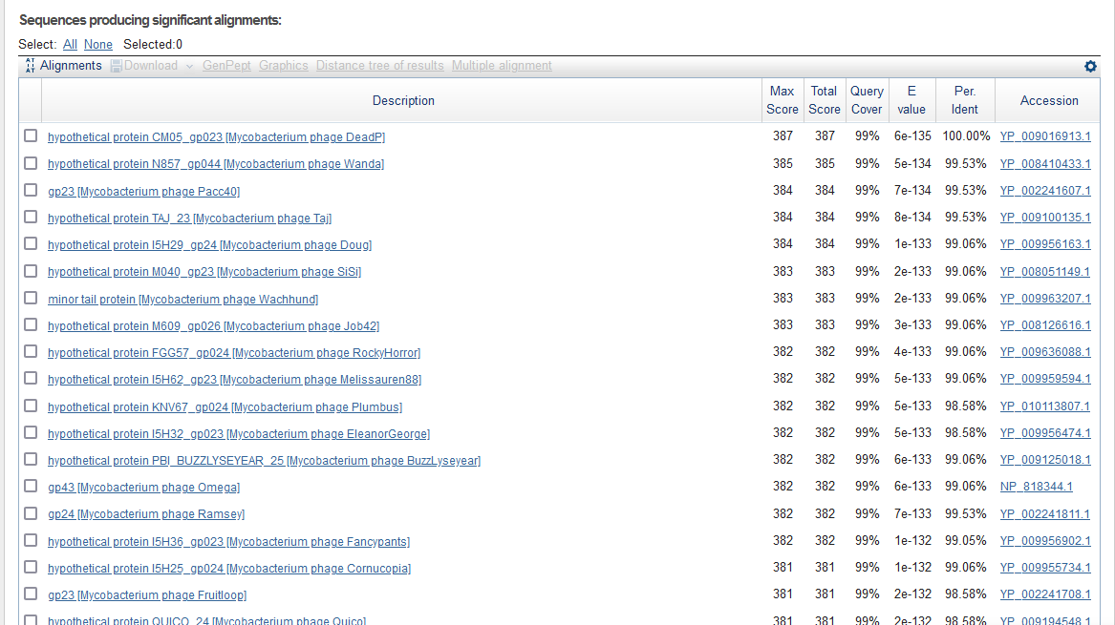
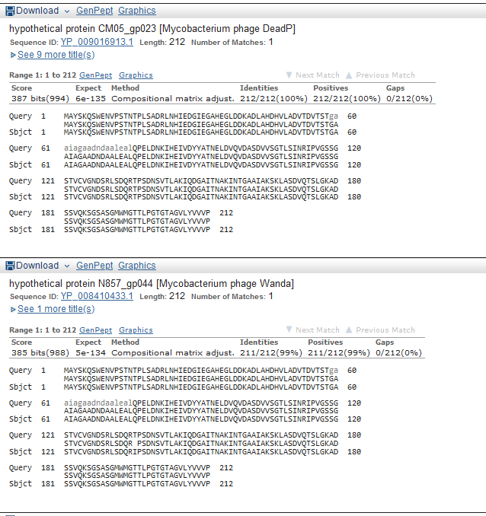
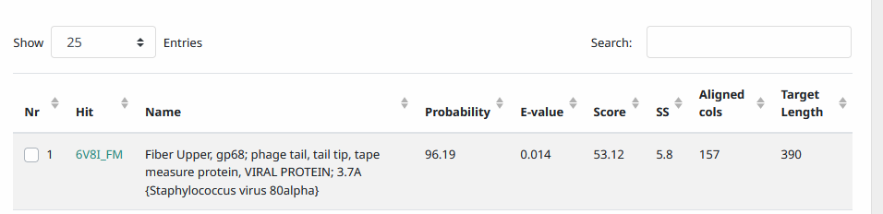

Start Codon and source: 23,797, ATG, called by GeneMark and Glimmer
Stop Codon: 24,435, TGA
F/R: F
Coding Potential (y/n): Y
Starterator (SS, NA, NI): pham388, most annotated start
Blast Best Hit, Query:Subject Starts, Score, Evalue, or “no significant Blast alignments” if 10E-4 or higher
Gap: 13 bp from gene 22
Longest Orf? (Y/N/NA) N
RBS: N/A, Scoring Matirix , Spacing Matrix, Z Score, Final Score,
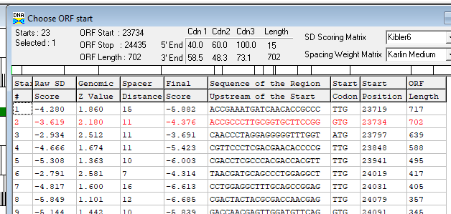
Proposed Function: minor tail protein
Function Evidence: HHPRED with phage tail and collagen-like in BlastP
Transmembrane Domain/Evidence: NO
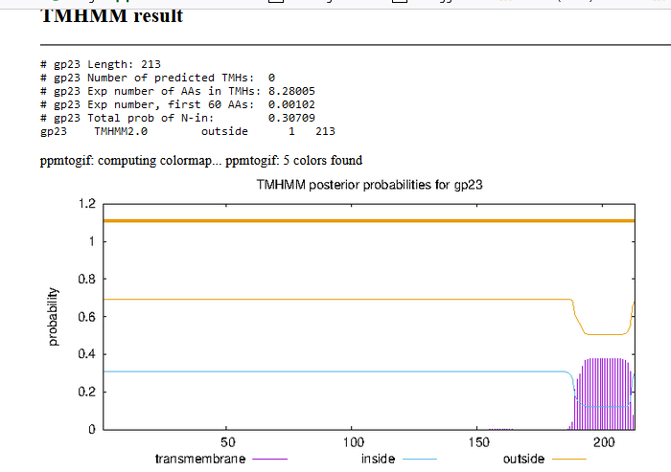

Gene Number: 24
9/21/22 Run BlastP at phagesdb and NCBI, Starterator, RBS on Frames, Transmembrane predition, HHPRED
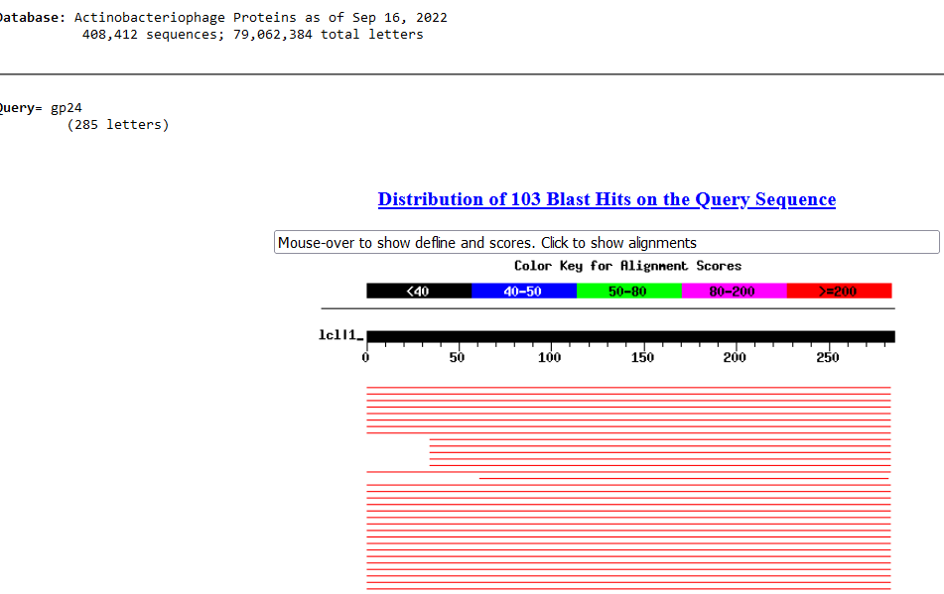
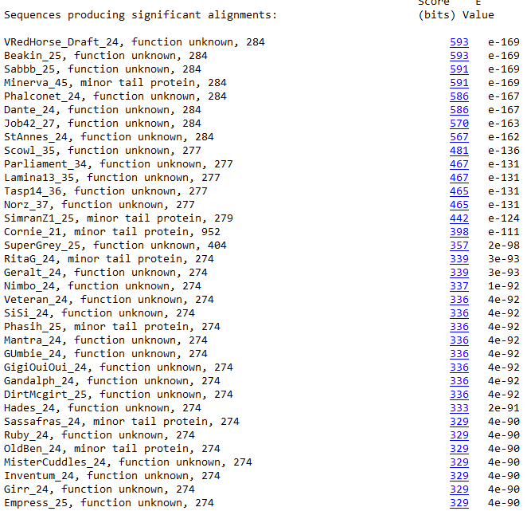
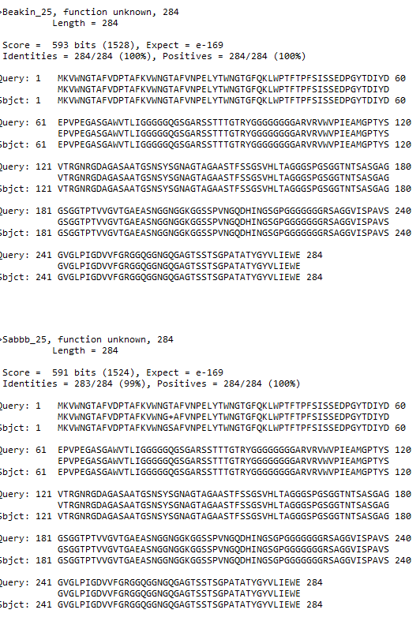
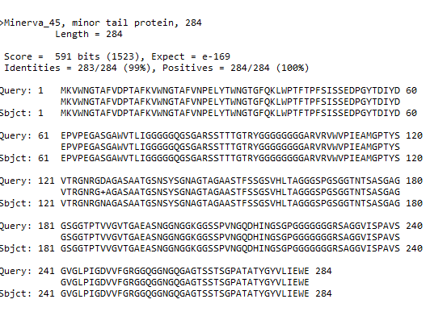
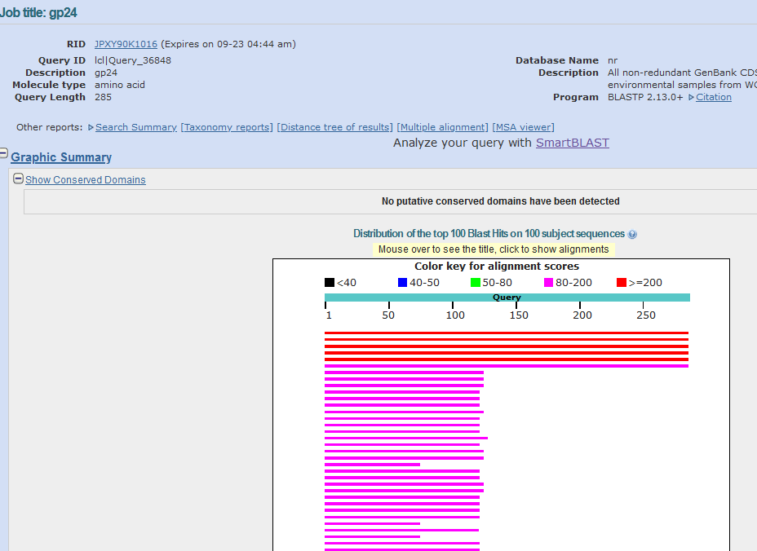
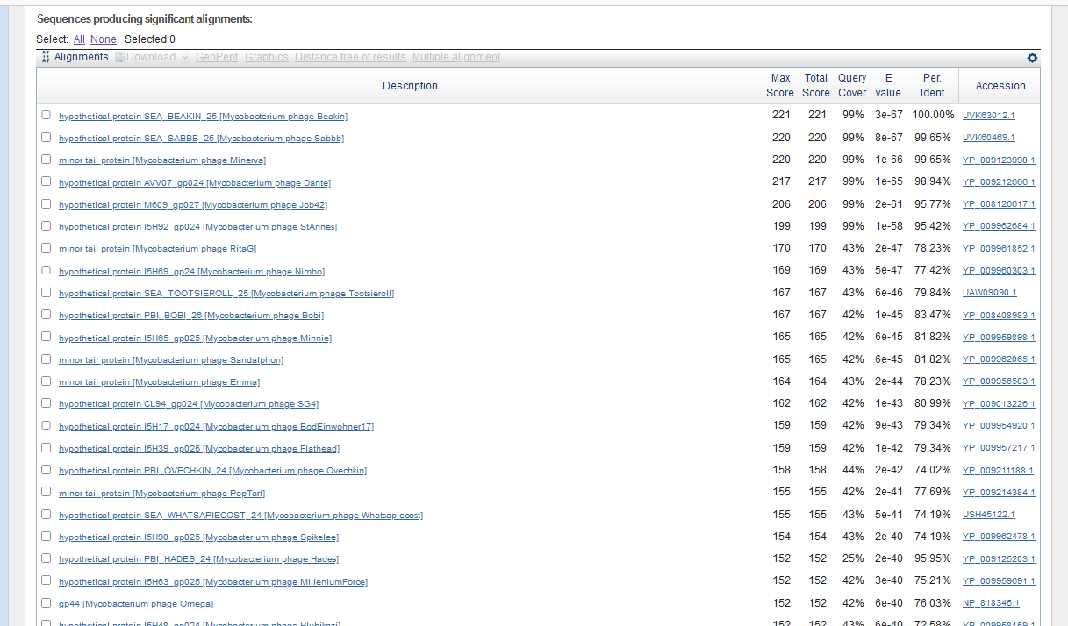
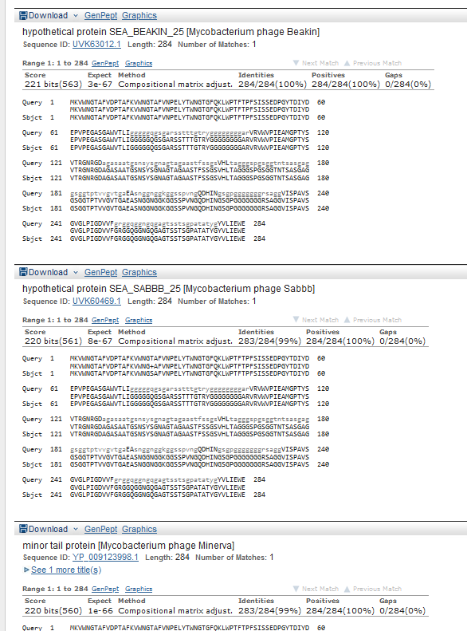
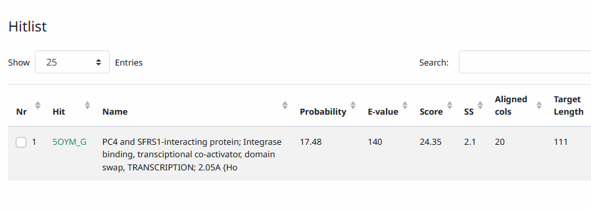

Start Codon and source: 24,432, GTG, Called by Glimmer and Genemark
Stop Codon: 25,286, TAA
F/R: F
Coding Potential (y/n): Y
Starterator (SS, NA, NI): ph47,123, does not have most annotated start
Blast Best Hit, Query:Subject Starts, Score, Evalue, or “no significant Blast alignments” if 10E-4 or higher
Gap: -4 bp overlap with gene 23
Longest Orf? (Y/N/NA) N
RBS: N/A, Scoring Matirix , Spacing Matrix, Z Score, Final Score,
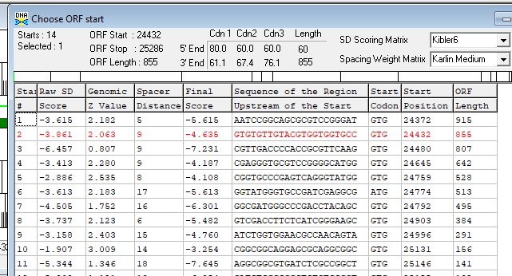
Proposed Function: Hypothetical Protein
Function Evidence: N/A
Transmembrane Domain/Evidence: NO
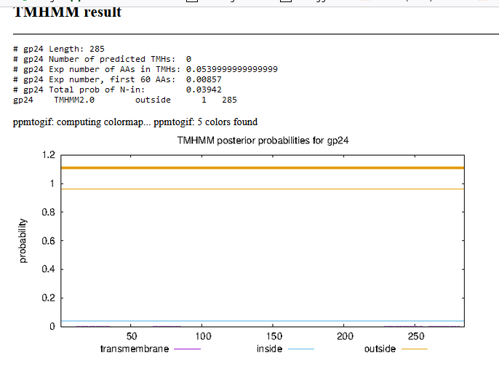

Gene Number: 25
9/21/22 Run BlastP at phagesdb and NCBI, Starterator, RBS on Frames, Transmembrane predition, HHPRED

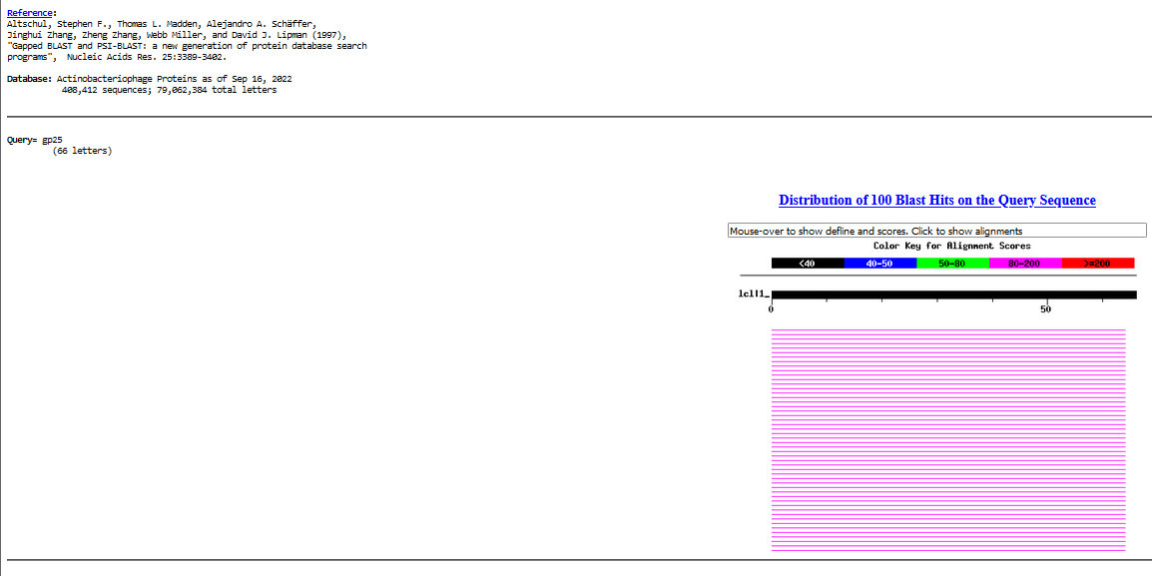
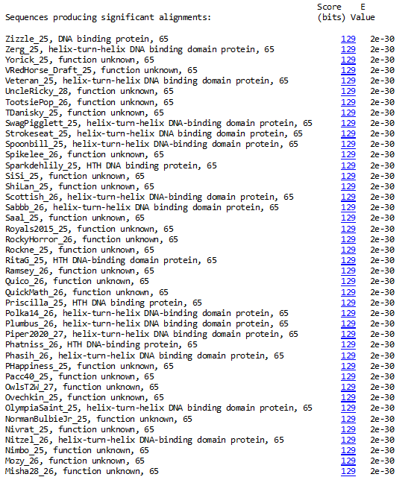
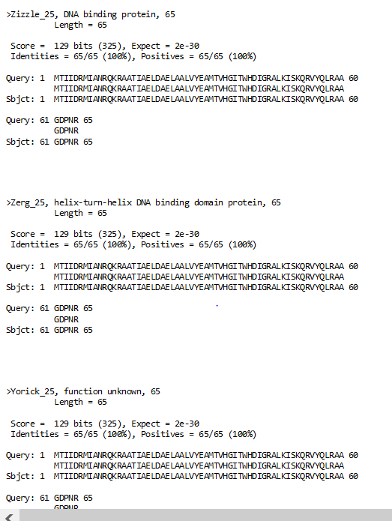
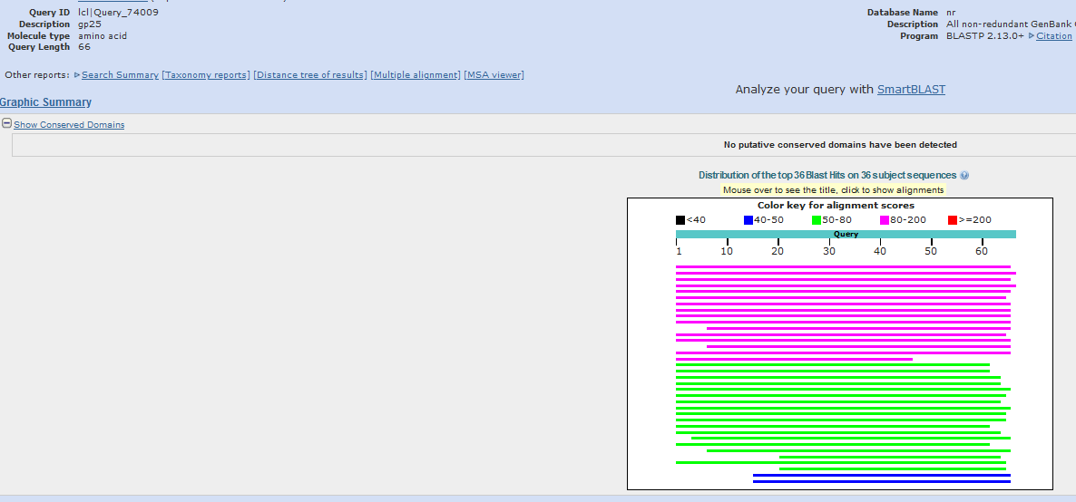
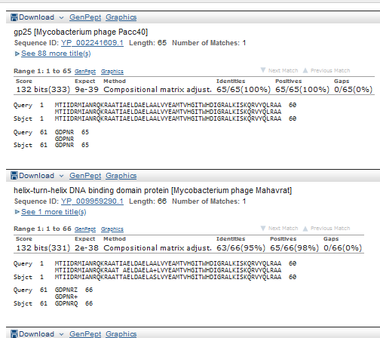
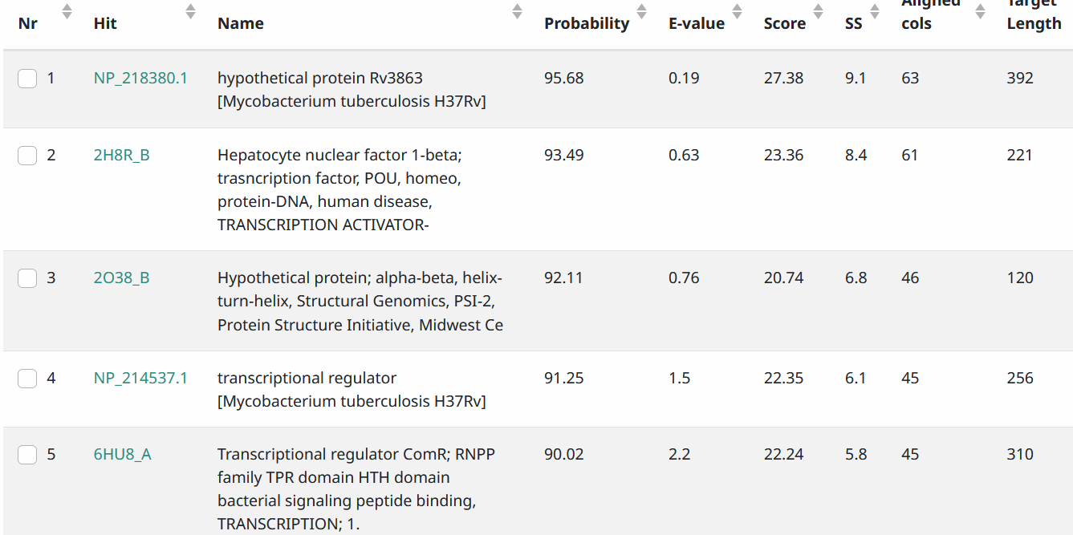
Start Codon and source: 25488, GTG, called by glimmer and genemark
Stop Codon: 25291, TAG
F/R: R
Coding Potential (y/n):Y
Starterator (SS, NA, NI): pham 27,391, most annotated start
Blast Best Hit, Query:Subject Starts, Score, Evalue, or “no significant Blast alignments” if 10E-4 or higher
Gap: 6 bp gap from end of upstream gene 24 to end of gene 25; 150 bp gap from start of 25 from downstream forward gene 26,
Longest Orf? (Y/N/NA) Y
RBS: N/A, Scoring Matirix , Spacing Matrix, Z Score, Final Score,
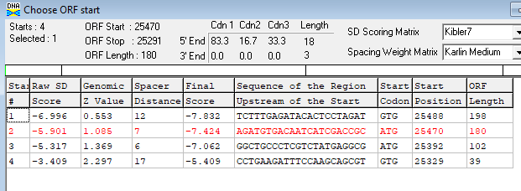
Proposed Function: helix-turn-helix DNA binding domain
Function Evidence: HHPRED and Blast
Transmembrane Domain/Evidence: NO
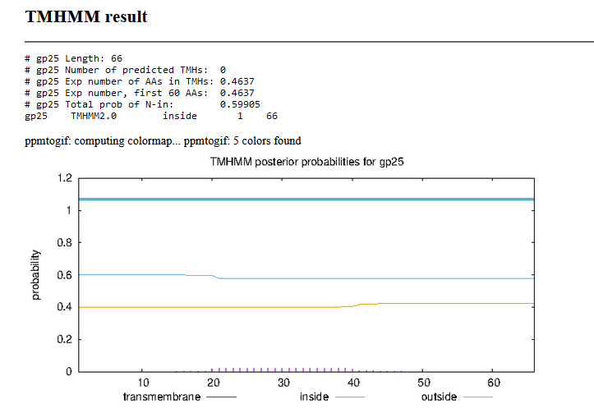

Delete Original Call Reverse Genes 26 and 27. Renumber
Gene Number: 26 (original gene 28)
9/21/22 Using longer gene product, Run BlastP at phagesdb and NCBI, Starterator, RBS on Frames, Transmembrane predition, HHPRED
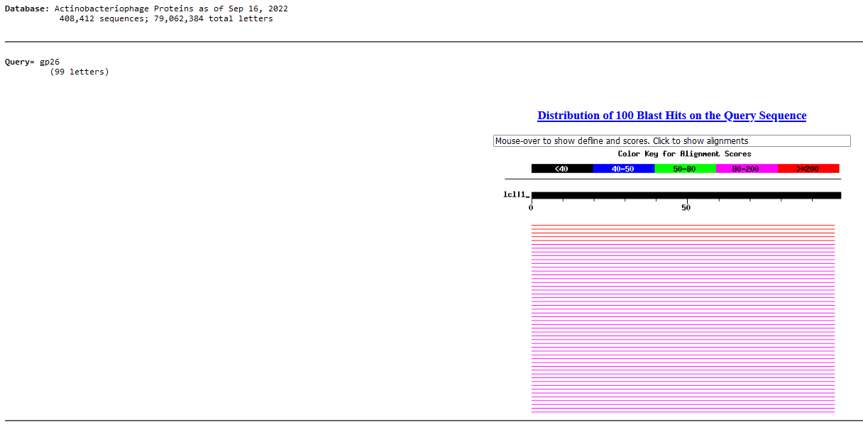
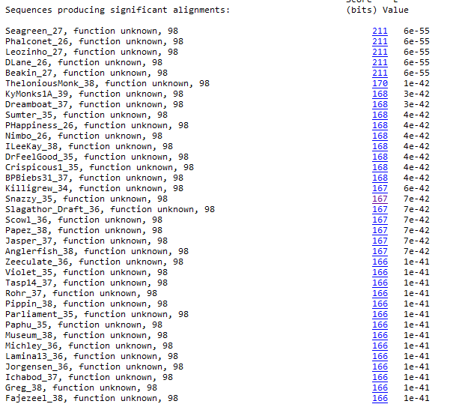
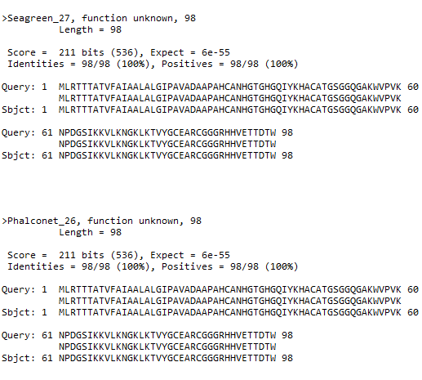
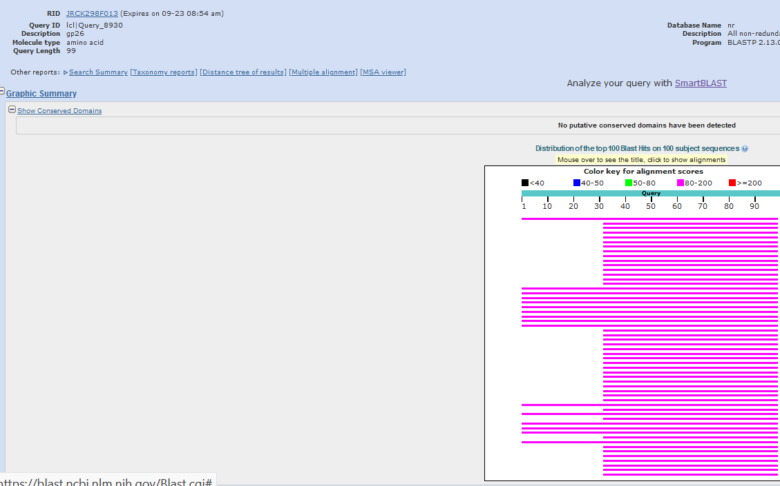
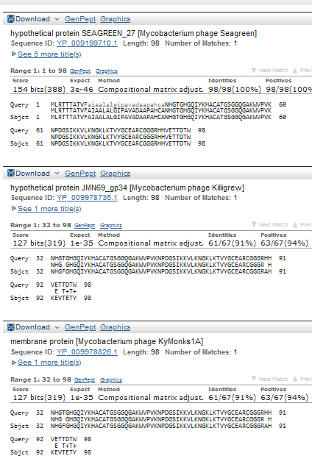
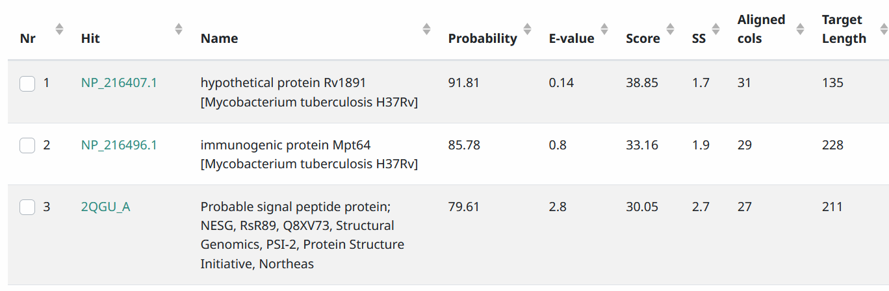
Start Codon and source: Changed to 25,637, ATG,Called by Genemark, Glimmer called 25811
Stop Codon: 25,933, TGA
F/R: F
Coding Potential (y/n): Y
Starterator (SS, NA, NI): orpham, 23866, no data, should be pham30 based on Seagreen gene 27
, or “no significant Blast alignments” if 10E-4 or higher
Blast Best Hit, Query:Subject Starts, Score, Evalue
Gap: 150 bp gap from upstream reverse gene 25
Longest Orf? (Y/N/NA) Y
RBS: N/A, Scoring Matirix , Spacing Matrix, Z Score, Final Score,
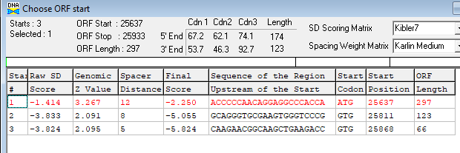
Proposed Function: Hypothetical Protein
Function Evidence: no good functional matches on Blast or HHPRED
Transmembrane Domain/Evidence: possible N terminal signal sequence
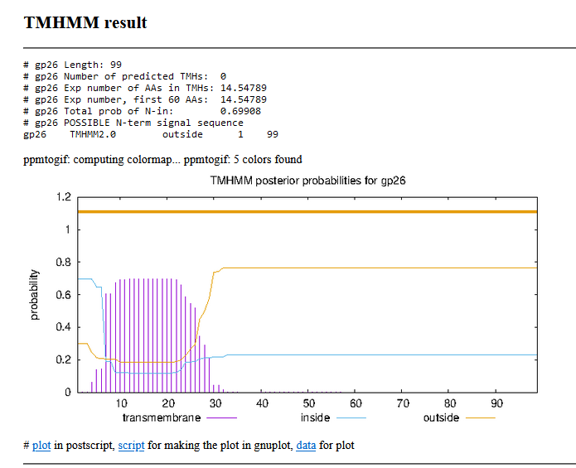

Gene Number: 27 (original call gene 29)
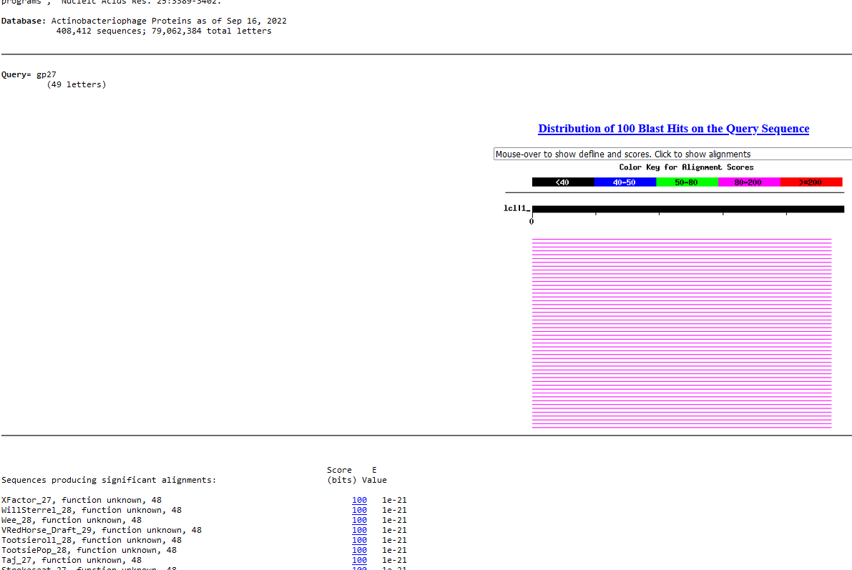
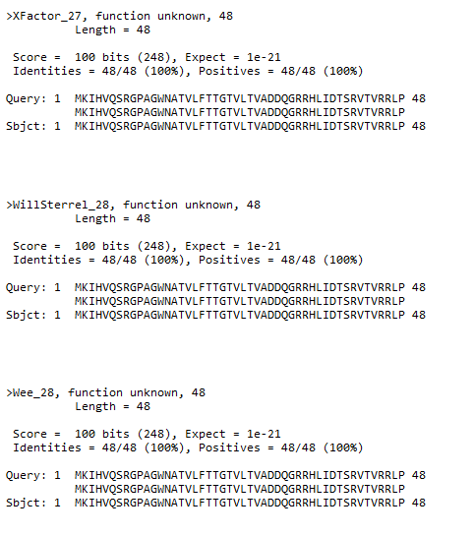
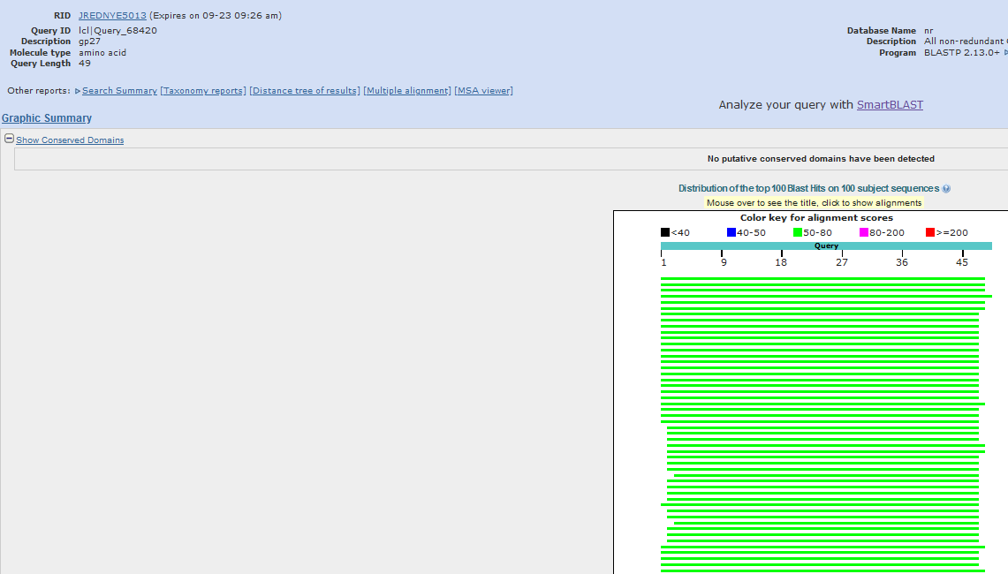
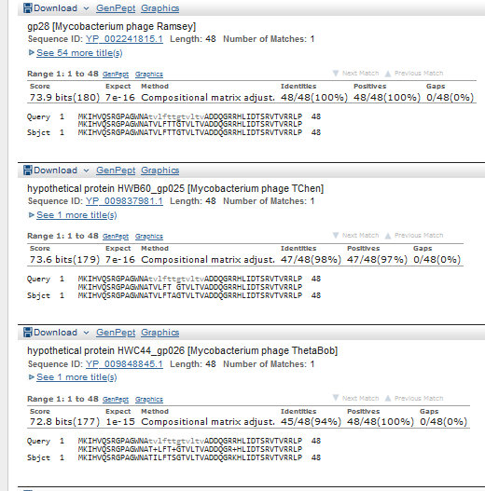
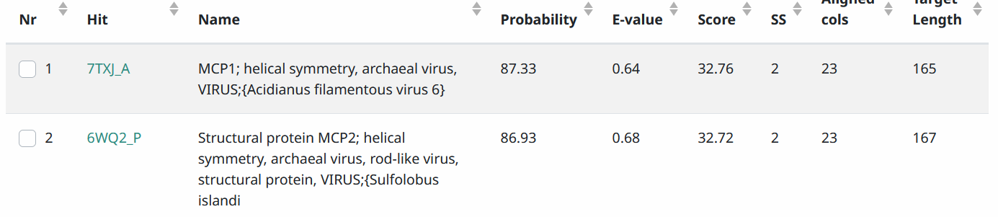
Start Codon and source: 25,940, ATG called by Glimmer, not by Genemark
Stop Codon: 26,086, TGA
F/R: F
Coding Potential (y/n):Y, weak
Starterator (SS, NA, NI):pham 102, most annotated start
Blast Best Hit, Query:Subject Starts, Score, Evalue, or “no significant Blast alignments” if 10E-4 or higher
Gap: 6 bp gap from gene 26
Longest Orf? (Y/N/NA) Y
RBS: N/A, Scoring Matirix , Spacing Matrix, Z Score, Final Score,
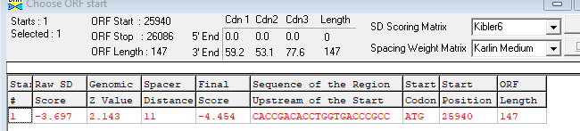
Proposed Function: Hypothetical Protein
Function Evidence: no matches with known function on BlastP
Transmembrane Domain/Evidence: NO
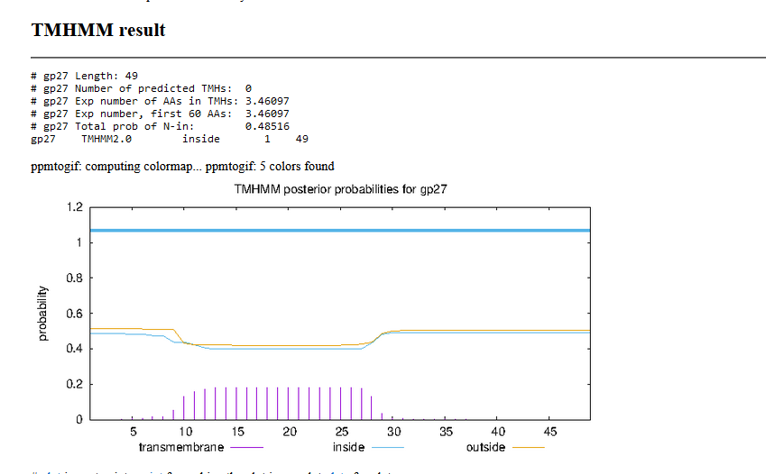

Gene Number: 28 (original call 30)
9/22/22 Run BlastP at phagesdb and NCBI, Starterator, RBS on Frames, Transmembrane predition, HHPRED
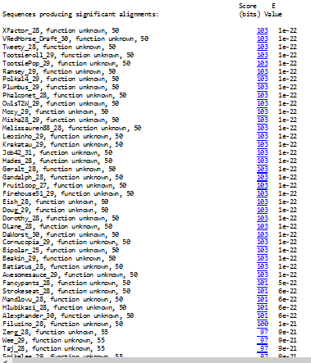

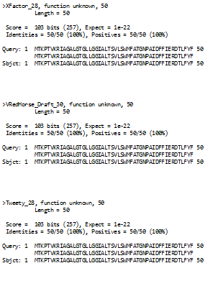

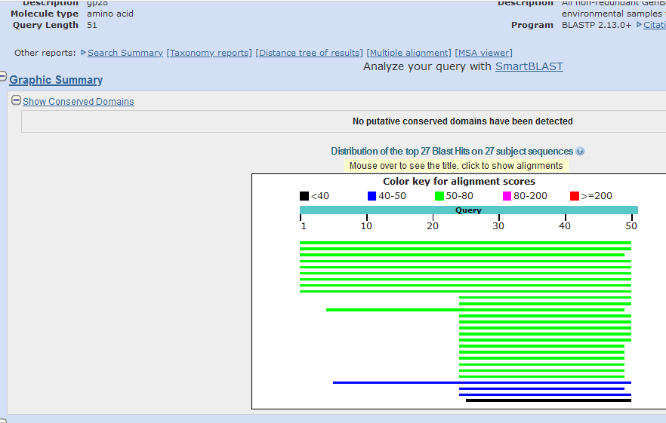
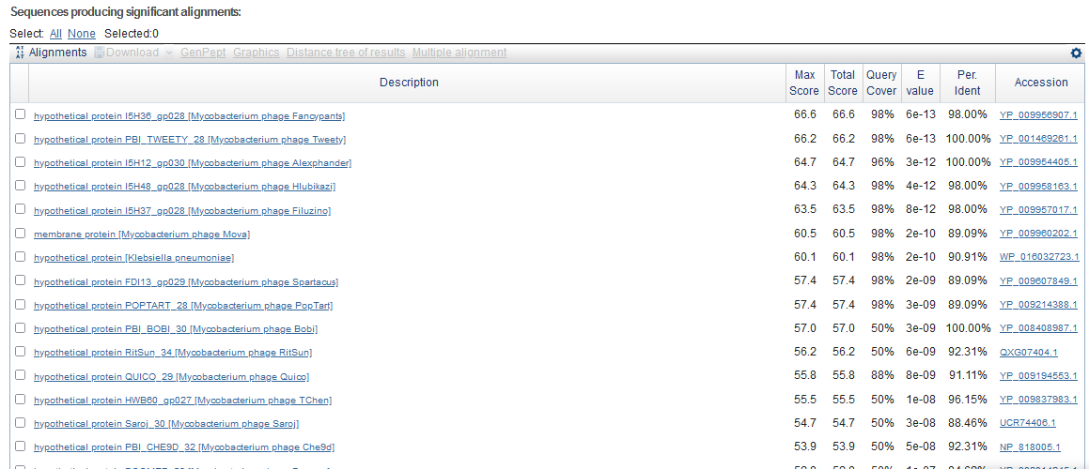
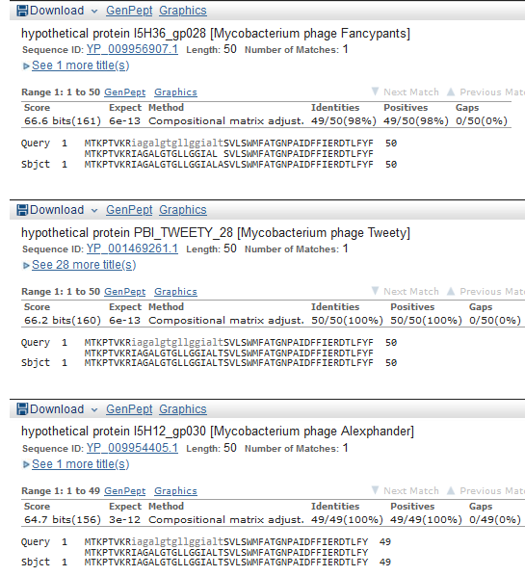

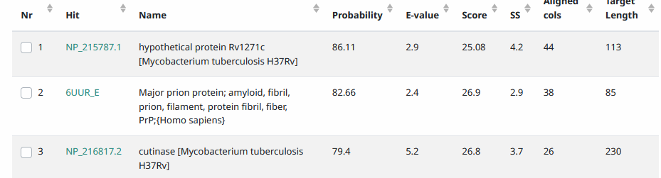
Start Codon and source: 26,083, GTG, Called by Glimmer and Genemark
Stop Codon: 26,235, TAA
F/R: F
Coding Potential (y/n): Y
Starterator (SS, NA, NI): pham47153, most annotated start
Blast Best Hit, Query:Subject Starts, Score, Evalue, or “no significant Blast alignments” if 10E-4 or higher

Gap: 4 bp overlap w/gene 27
Longest Orf? (Y/N/NA) Y
RBS: N/A, Scoring Matirix , Spacing Matrix, Z Score, Final Score,
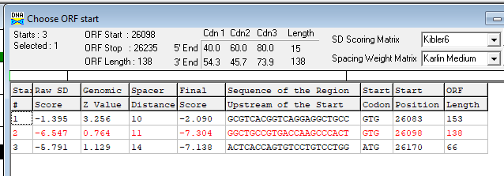
Proposed Function: transmembrane protein
Function Evidence:THHM
Transmembrane Domain/Evidence: Yes
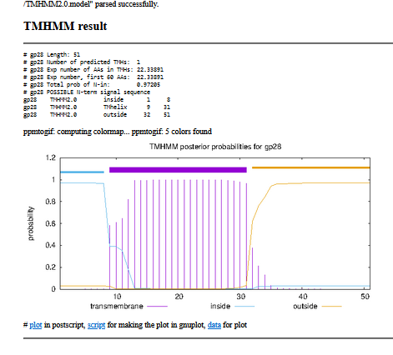

Gene Number: 29 (original31) changed start to 26,270
9/22/22 Run longer protein BlastP at phagesdb and NCBI, Starterator, RBS on Frames, Transmembrane predition, HHPRED
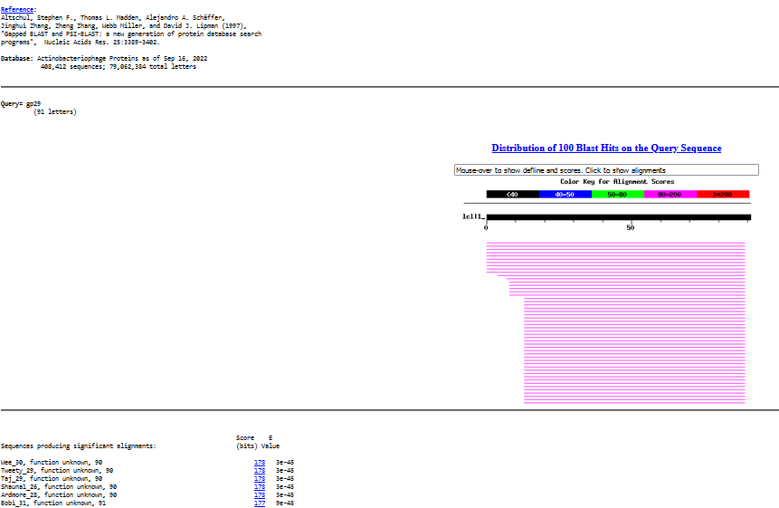

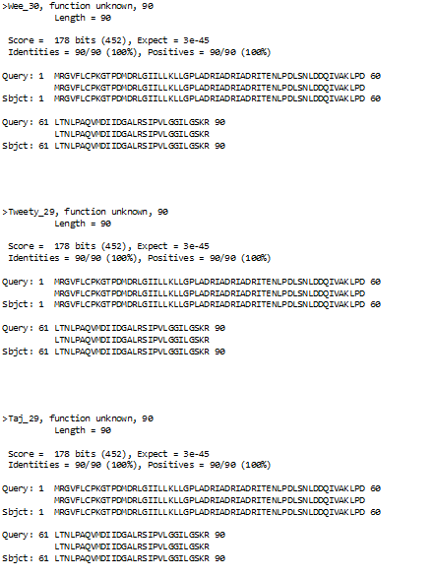
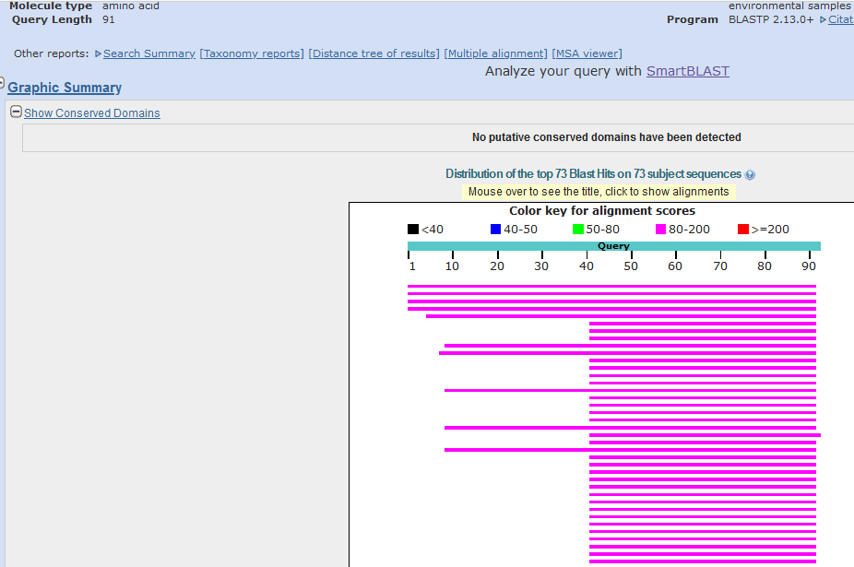

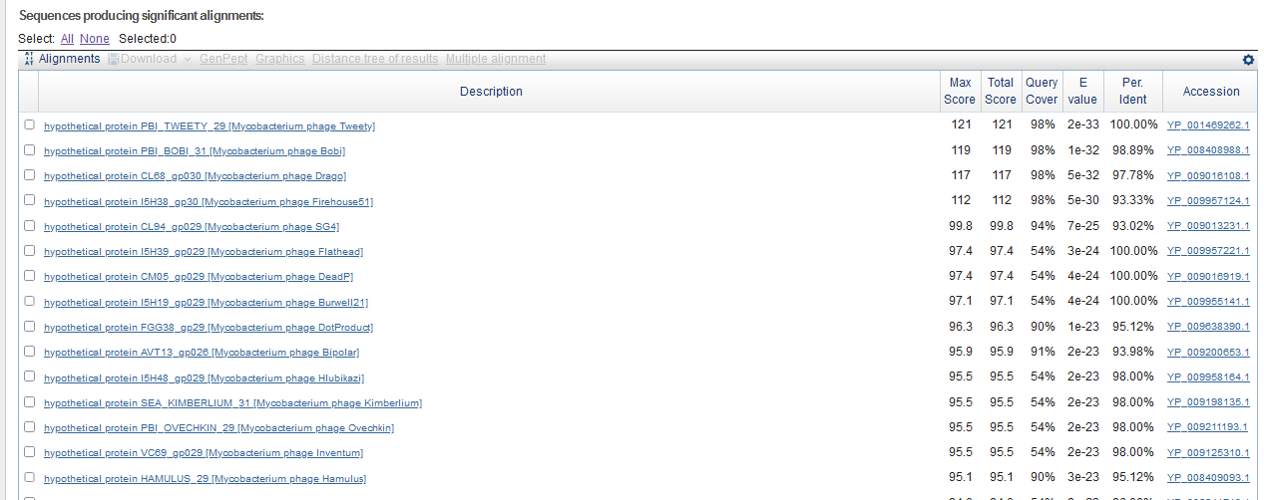
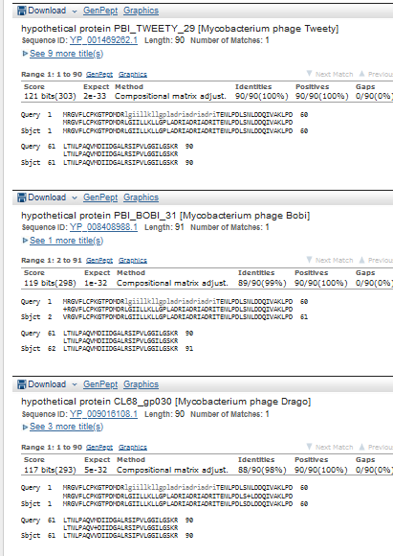
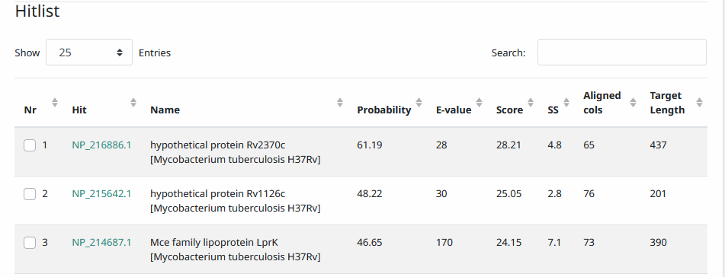
Start Codon and source: changed to 26,270, GTG, 26309 was called by Glimmer and Genemark
Stop Codon: 26542, TGA
F/R: F
Coding Potential (y/n): Y
Starterator (SS, NA, NI):pham45705, was most annotated star, but changed to upstream
Blast Best Hit, Query:Subject Starts, Score, Evalue, or “no significant Blast alignments” if 10E-4 or higher

Gap: 33bp gap from gene 28
Longest Orf? (Y/N/NA) N
RBS: N/A, Scoring Matirix , Spacing Matrix, Z Score, Final Score,
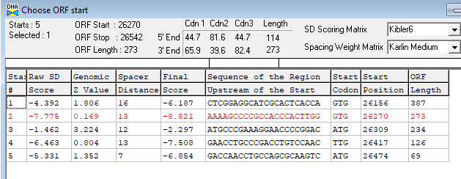
Proposed Function: Hypothetical Protein
Function Evidence: No convincing functional matches in HHPRED or BLASTP
Transmembrane Domain/Evidence: NO
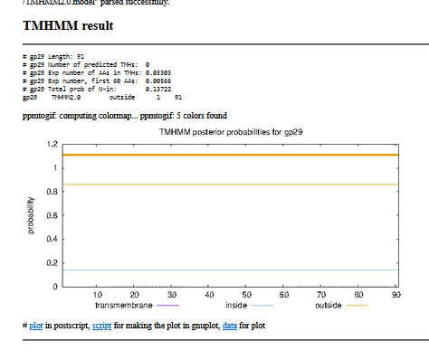

Gene Number: 30 (original called 32)
9/22/22 Run BlastP at phagesdb and NCBI, Starterator, RBS on Frames, Transmembrane precdition, HHPRED
Genemark map suggests a frameshift from gene 29
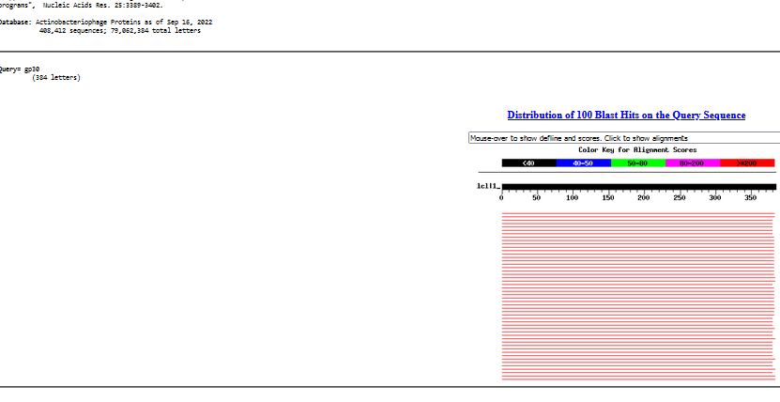
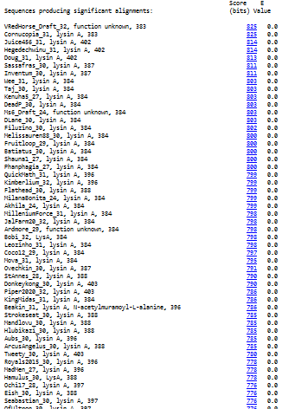
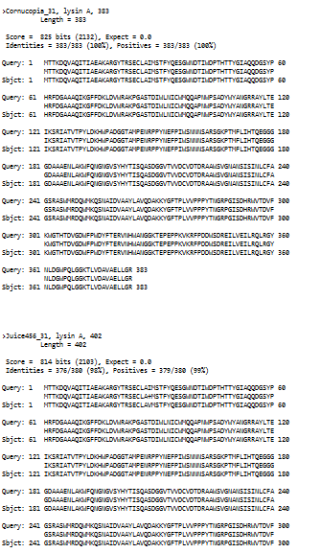
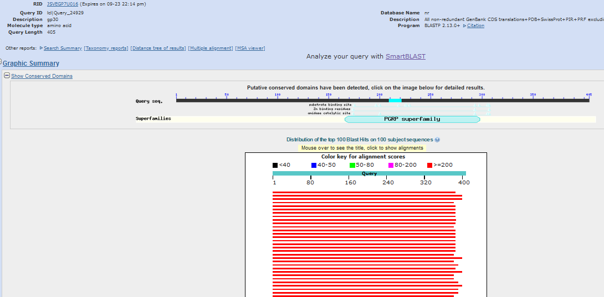
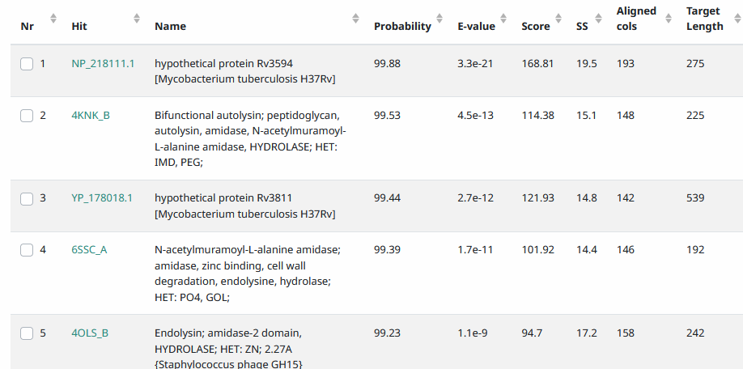
Start Codon and source: 26,539, GTG, Called by Glimmer and Genemark
Stop Codon: 27690, TGA
F/R: F
Coding Potential (y/n): captures most, next upstream start greatly overlaps gene 29
Starterator (SS, NA, NI): pham 47,116, VRH does not have most annotated start
Blast Best Hit, Query:Subject Starts, Score, Evalue, or “no significant Blast alignments” if 10E-4 or higher
Gap: 4 bp overlap w/gene 29
Longest Orf? (Y/N/NA), N
RBS: N/A, Scoring Matirix , Spacing Matrix, Z Score, Final Score,
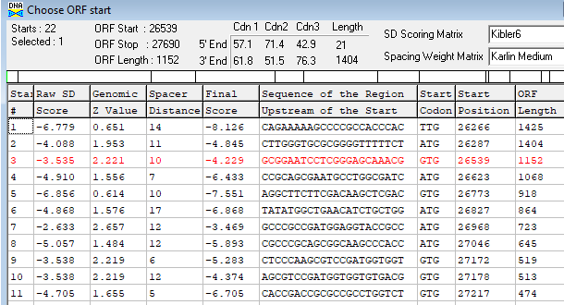
Proposed Function: lysin A
Function Evidence: BlastP and HHPRED
Transmembrane Domain/Evidence: NO
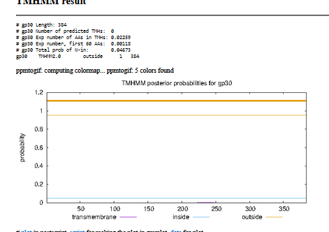

Gene Number: 31 (original 33)27,690
9/22/22 Run BlastP at phagesdb and NCBI, Starterator, RBS on Frames, Transmembrane prediction, HHPRED
Start Codon and source: 27,690, ATG, Called by Genemark and Glimmer
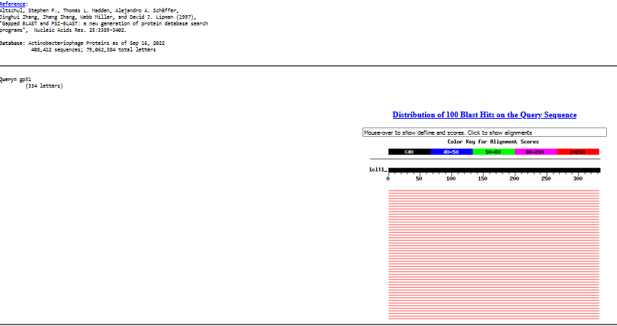
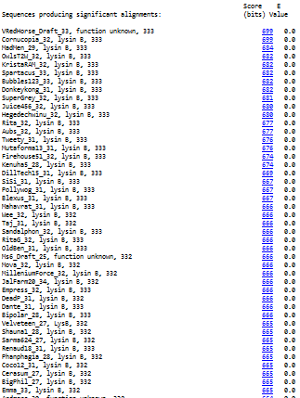
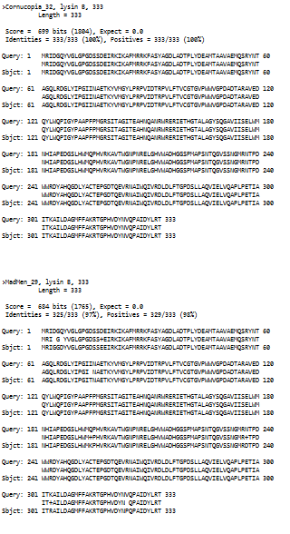
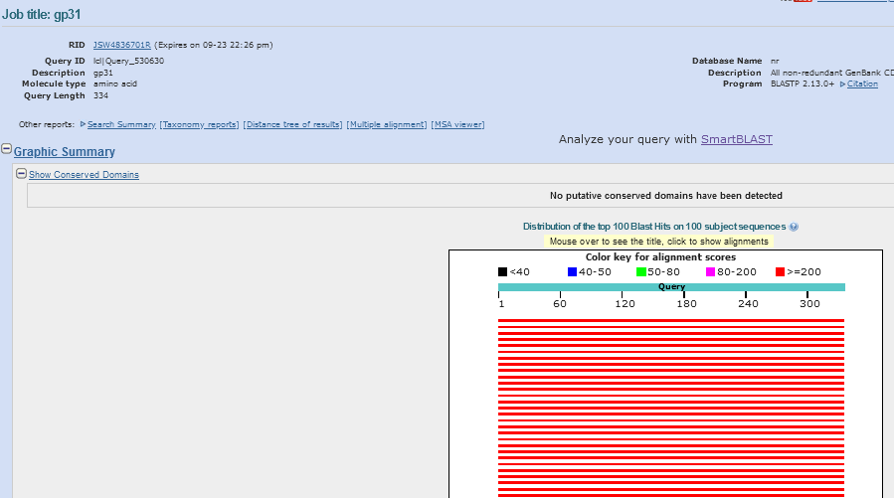

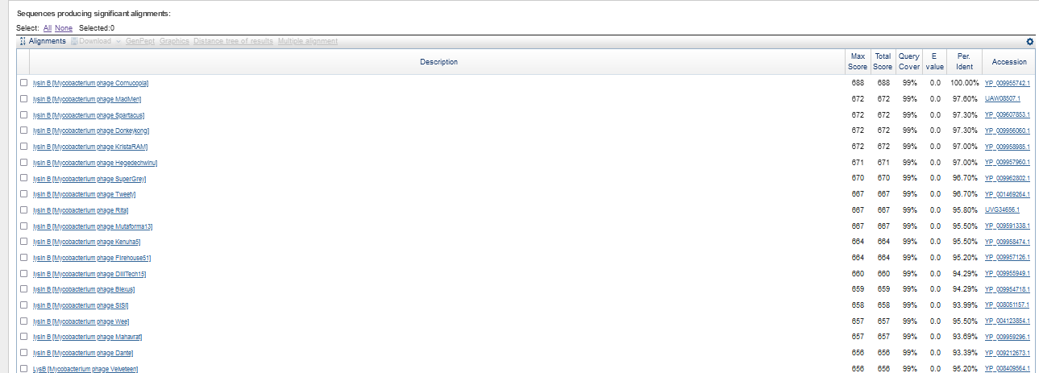
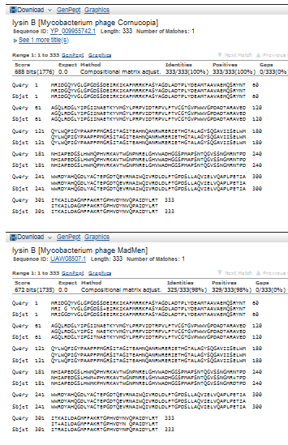
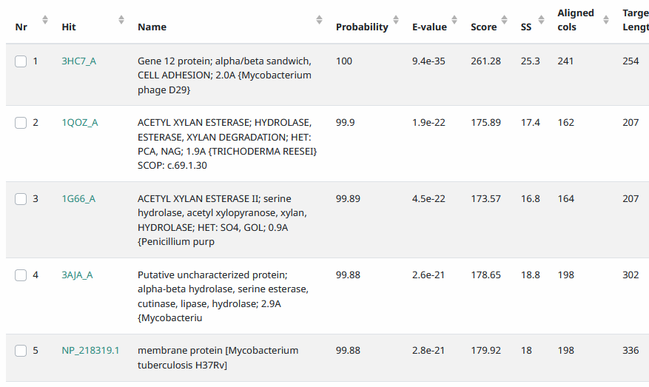
Stop Codon: 28, 691, TAA
F/R: F
Coding Potential (y/n): Y
Starterator (SS, NA, NI): pham 47,032, does not have most annotated start
Blast Best Hit, Query:Subject Starts, Score, Evalue, or “no significant Blast alignments” if 10E-4 or higher

Gap: 1 bp overlap with gene 30
Longest Orf? (Y/N/NA) Y
RBS: N/A, Scoring Matirix , Spacing Matrix, Z Score, Final Score,
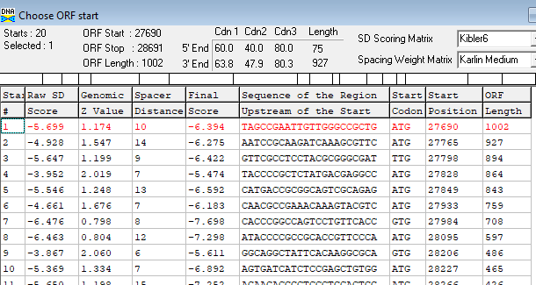
Proposed Function: lysin B
Function Evidence: BlastP, HHPRED functions
Transmembrane Domain/Evidence: NO
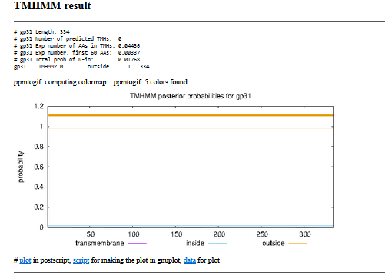

Delete Reverse Frame Gene original call 34 (29339-28680) based on genemark graphs
Gene Number: 32 (original gene 35)
9/22/22 Run BlastP at phagesdb and NCBI, Starterator, RBS on Frames, Transmembrane prediction, HHPRED
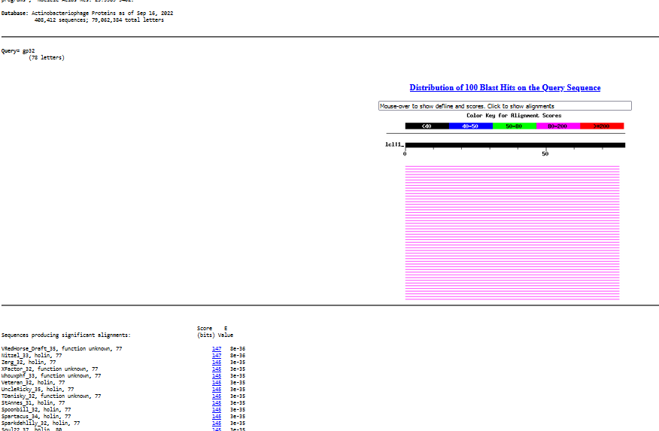

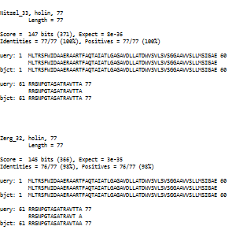
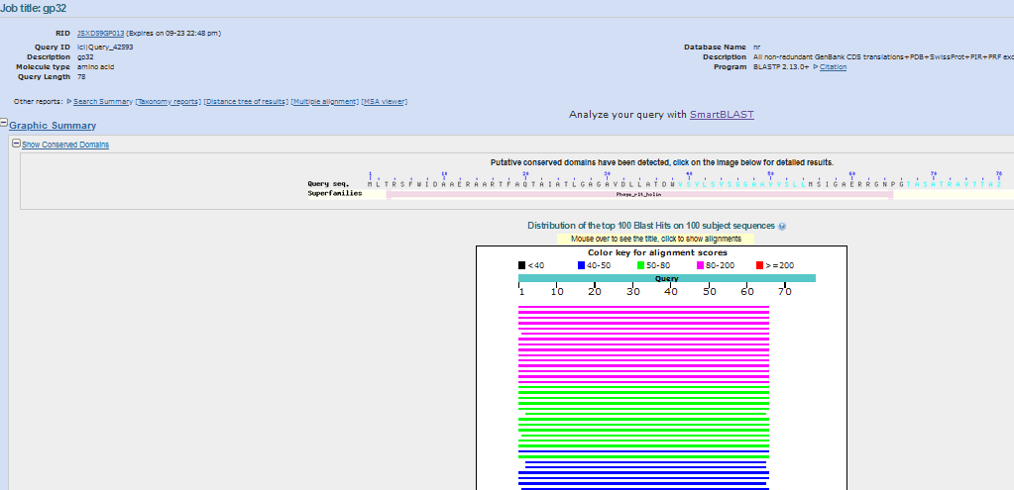
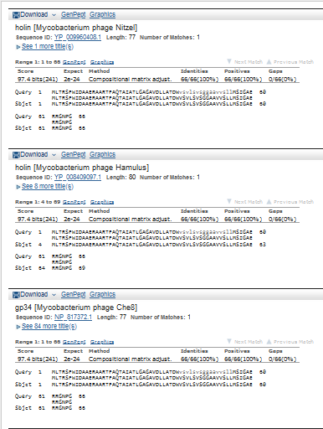
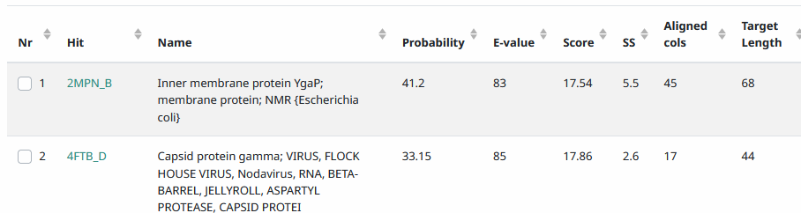
Start Codon and source: 28,705, ATG, Called by GeneMark
Stop Codon: 28,938, TGA
F/R: F
Coding Potential (y/n): Y
Starterator (SS, NA, NI): pham 47,084, most annotated start
Blast Best Hit, Query:Subject Starts, Score, Evalue, or “no significant Blast alignments” if 10E-4 or higher
Gap: 13 bp gap from gene 31
Longest Orf? (Y/N/NA): N
RBS: N/A, Scoring Matirix , Spacing Matrix, Z Score, Final Score,
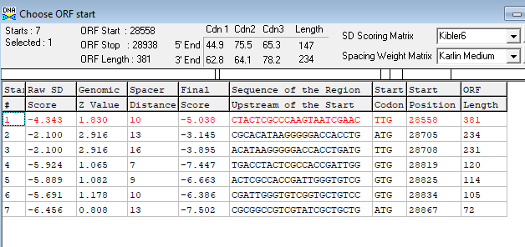
Proposed Function: holin
Function Evidence: conserved domain, BlastP matches
Transmembrane Domain/Evidence: NO
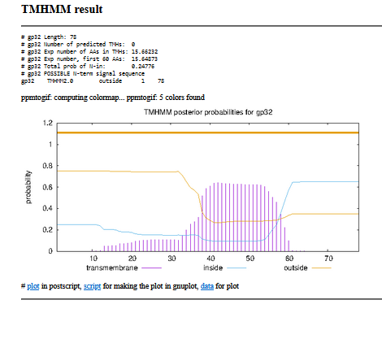

Gene Number: 33 (original gene36)
9/22/22 Run BlastP at phagesdb and NCBI, Starterator, RBS on Frames, Transmembrane prediction, HHPRED
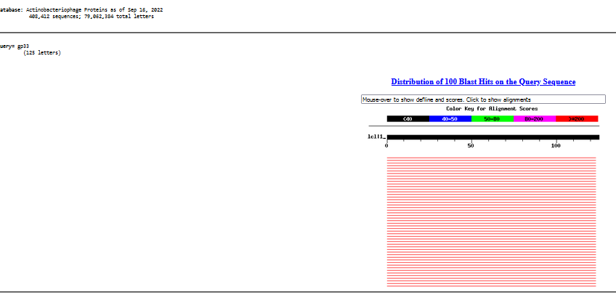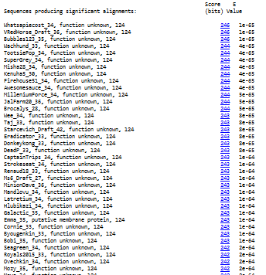
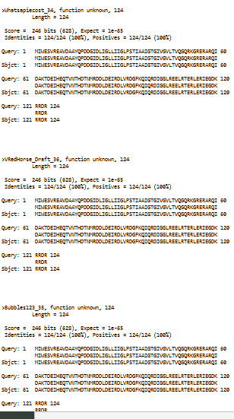
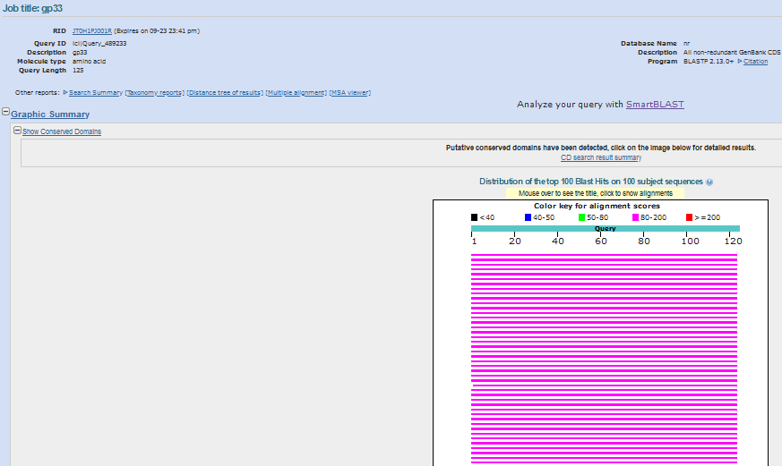
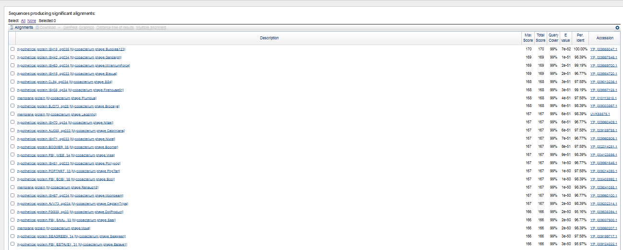
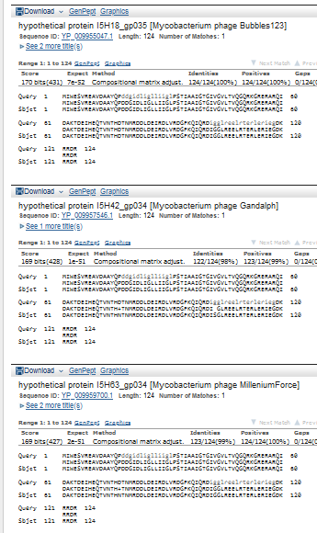
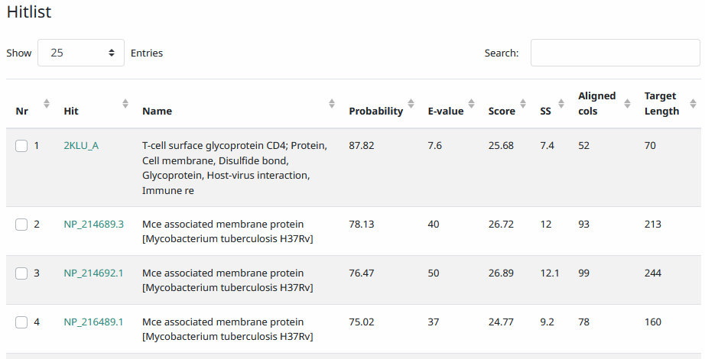
Start Codon and source: 28,935, ATG, called by Genemark
Stop Codon:29,309, TGA
F/R: F
Coding Potential (y/n): Y
Starterator (SS, NA, NI): pham 47,042, most annotated start
Blast Best Hit, Query:Subject Starts, Score, Evalue, or “no significant Blast alignments” if 10E-4 or higher
Gap: 4 bp overlap with gene 32
Longest Orf? (Y/N/NA) Y
RBS: N/A, Scoring Matirix , Spacing Matrix, Z Score, Final Score,
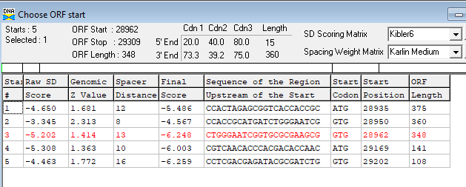
Proposed Function: transmembrane protein
Function Evidence: TMHMMM below
Transmembrane Domain/Evidence: Yes, 1 TMH
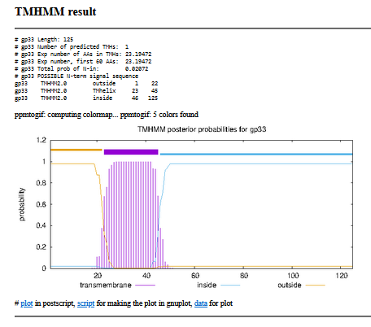
10/6/22 rerun onSOSUI, https://harrier.nagahama-i-bio.ac.jp/sosui/mobile/
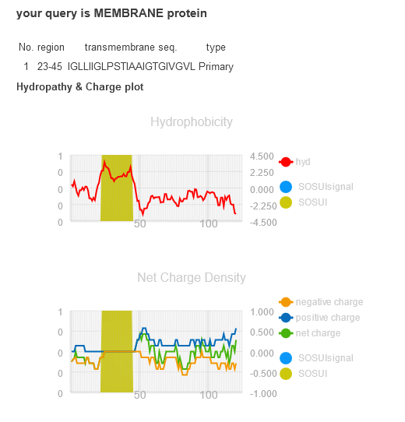
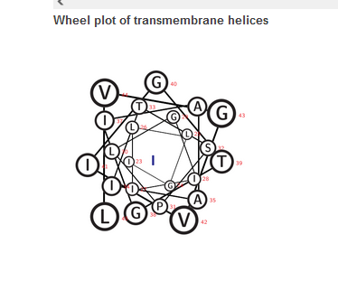

Gene Number: 34 (original 37) change start to 29306 from original 29333
9/22/22 Run BlastP at phagesdb and NCBI, Starterator, RBS on Frames, Transmembrane prediction, HHPRED
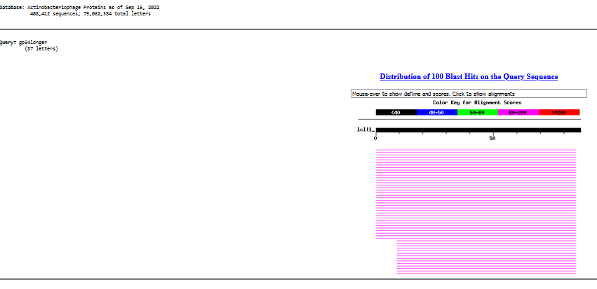

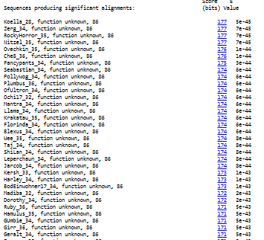
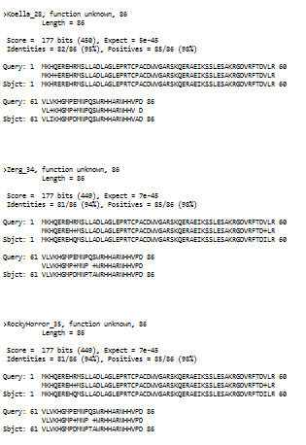
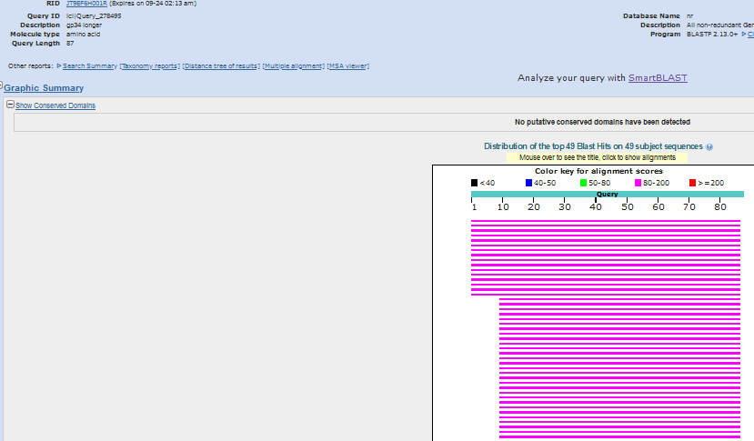
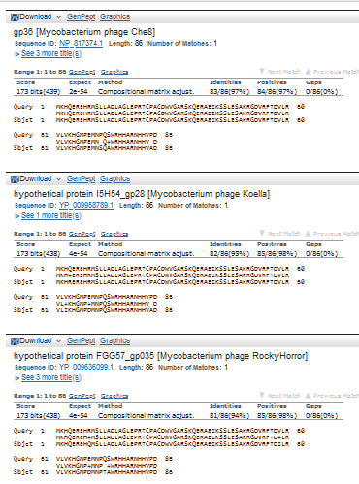
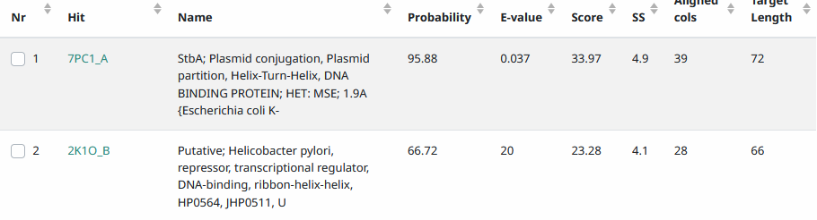
Start Codon and source: 29,306, GTG, Longer than gene called by Glimmer and GenemarkS, not called by DNAMasterGenemark
Stop Codon: 29566, TAG
F/R: F
Coding Potential (y/n): y
Starterator (SS, NA, NI): pham 333, changed FROM most annotated start
Blast Best Hit, Query:Subject Starts, Score, Evalue, or “no significant Blast alignments” if 10E-4 or higher
Gap: 4 bp overlap with gene 33
Longest Orf? (Y/N/NA) Y
RBS: N/A, Scoring Matirix , Spacing Matrix, Z Score, Final Score,
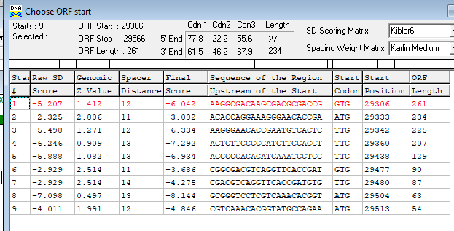
Proposed Function: helix-turn-helix DNA binding domain
Function Evidence: HHPRED top match function, 95.88%
Transmembrane Domain/Evidence: NO
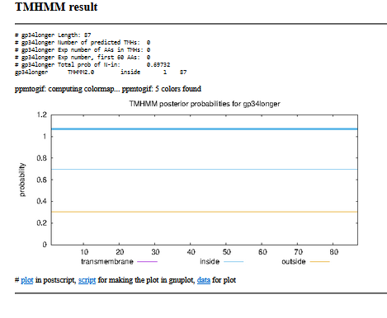

Gene Number: 35 (original gene 38)
9/23/22 Run BlastP at phagesdb and NCBI, Starterator, RBS on Frames, Transmembrane precdition, HHPRED
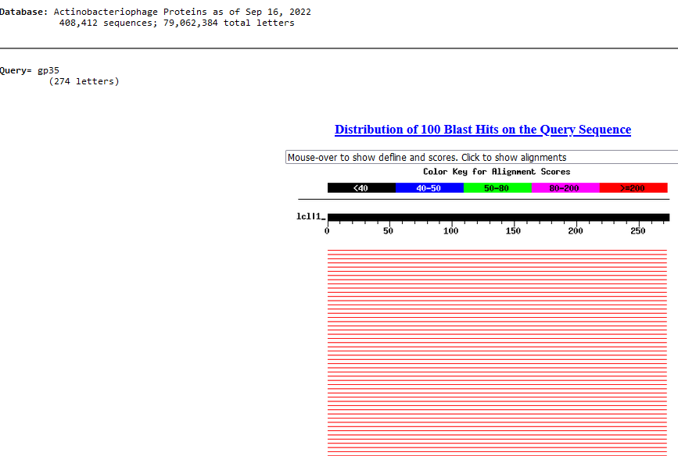
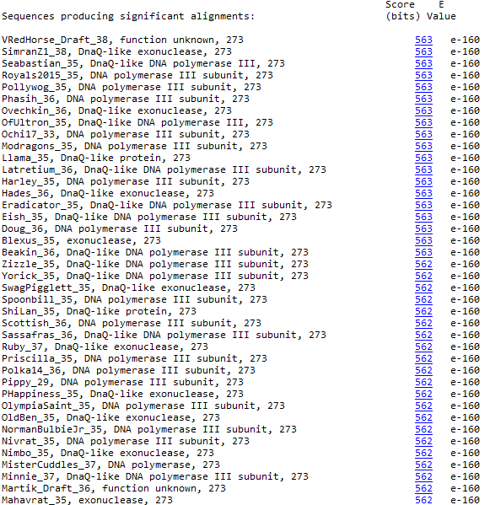
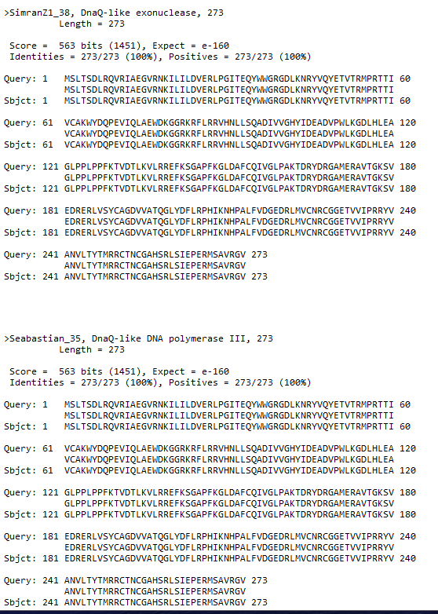
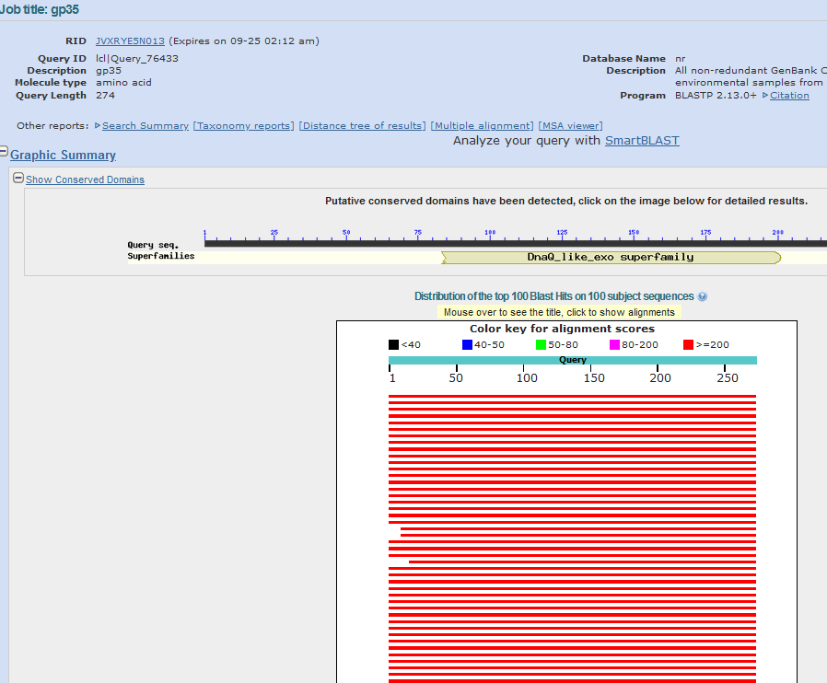
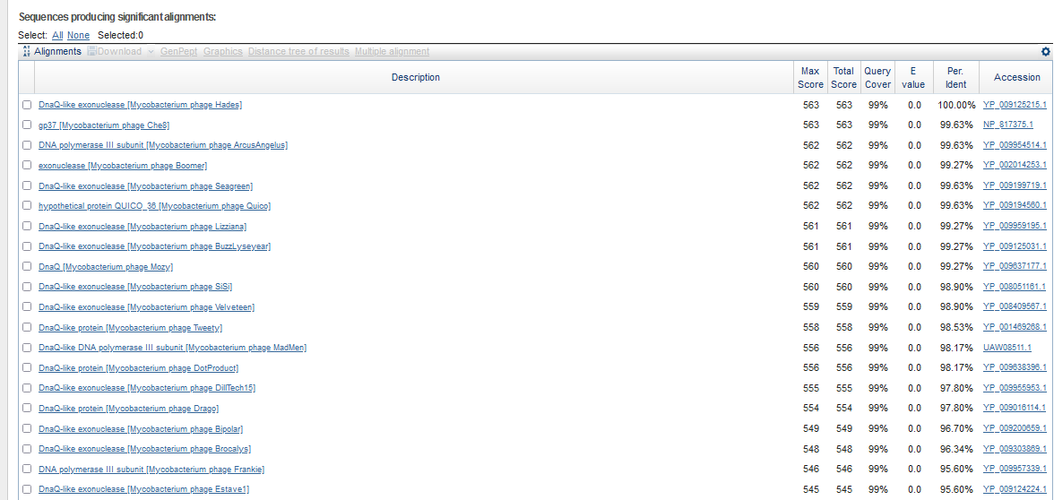
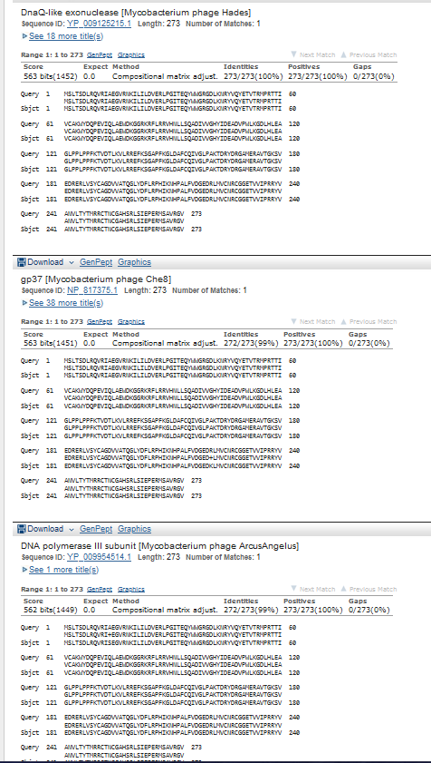
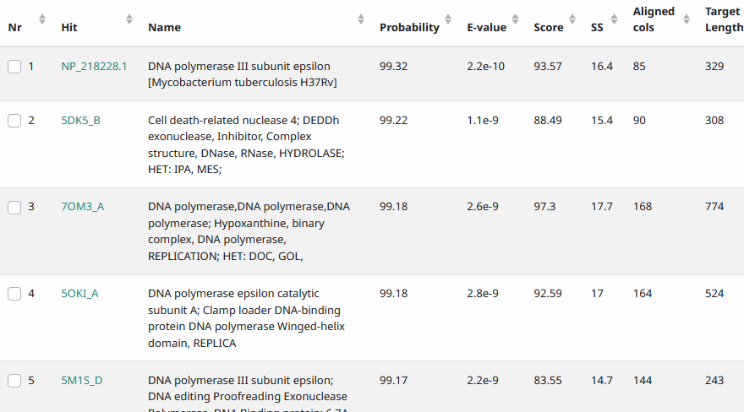
Start Codon and source: 29553, ATG, Called by Glimmer and Genemark
Stop Codon: 30,374, TGA
F/R: F
Coding Potential (y/n): Y
Starterator (SS, NA, NI): pham 70, most annotated start
Blast Best Hit, Query:Subject Starts, Score, Evalue, or “no significant Blast alignments” if 10E-4 or higher

Gap: -14bp overlap with gene 34
Longest Orf? (Y/N/NA) Y
RBS: N/A, Scoring Matirix , Spacing Matrix, Z Score, Final Score,
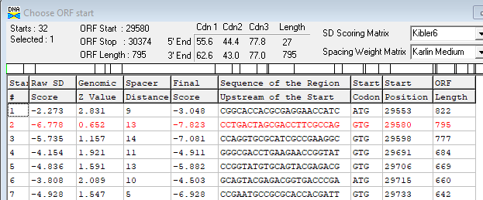
Proposed Function: DnaQ-like (DNA polymerase III subunit)
Function Evidence: HHPRED, BlastP
Transmembrane Domain/Evidence: NO
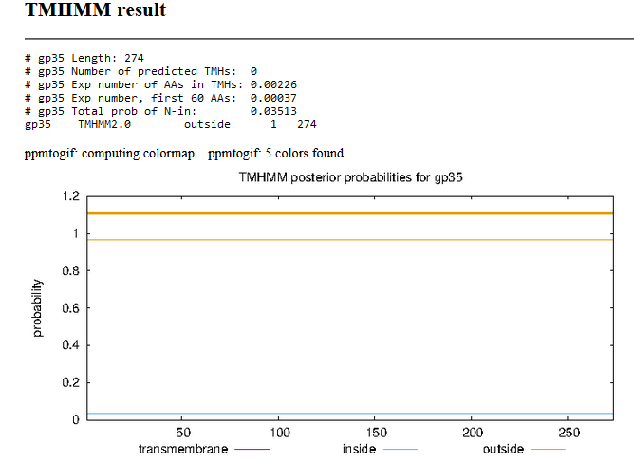

Gene Number: 36 (original 39) changed start to longest orf, 30,390
9/23/22 Run BlastP at phagesdb and NCBI, Starterator, RBS on Frames, Transmembrane precdition, HHPRED
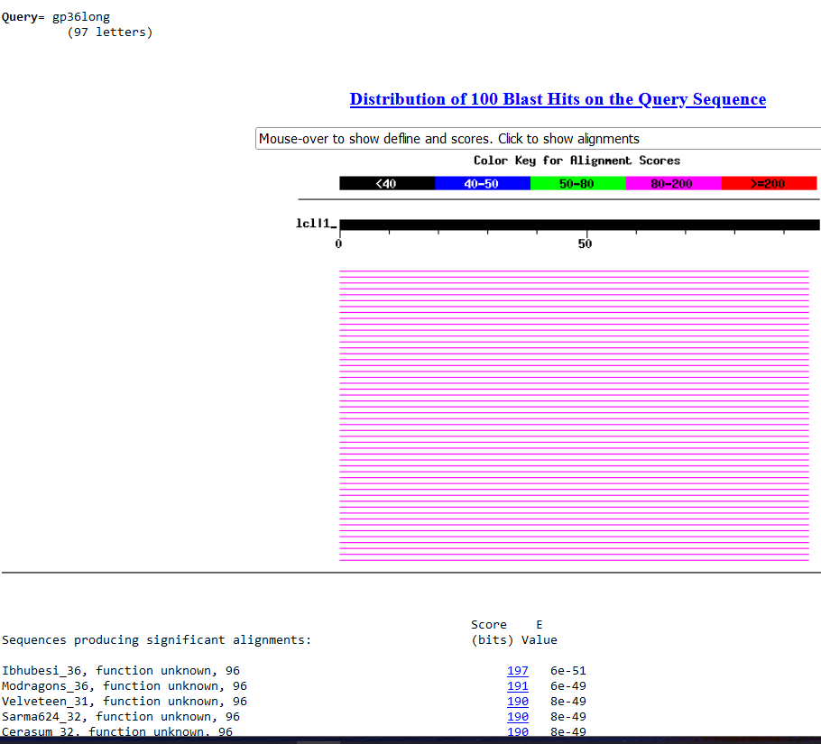
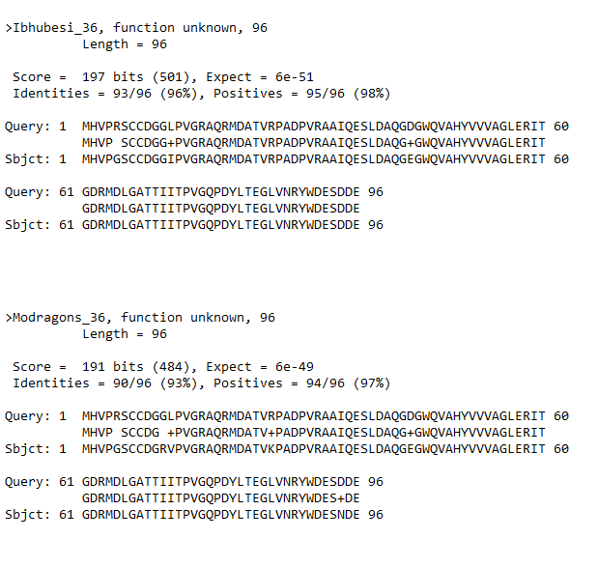
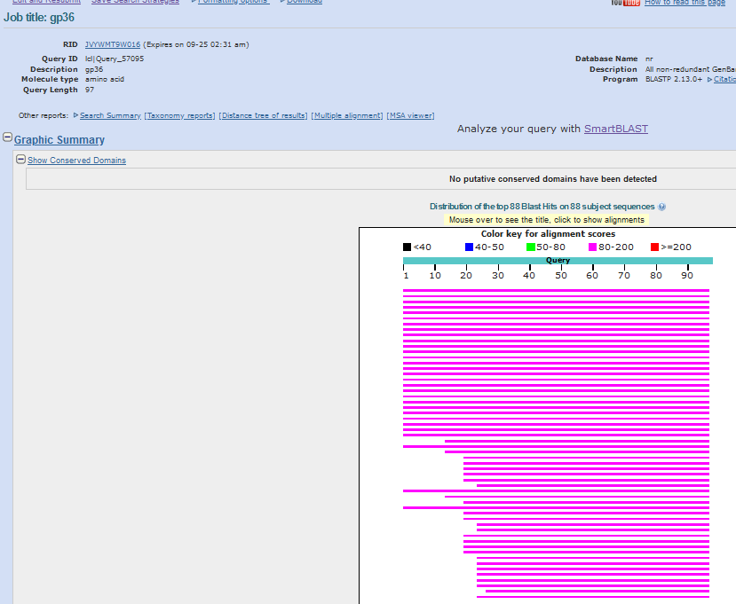
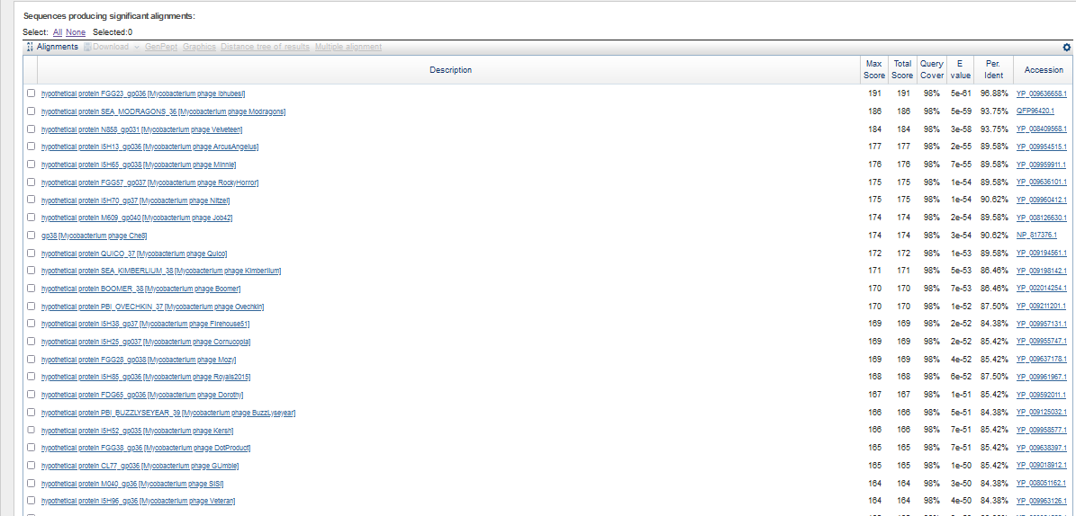
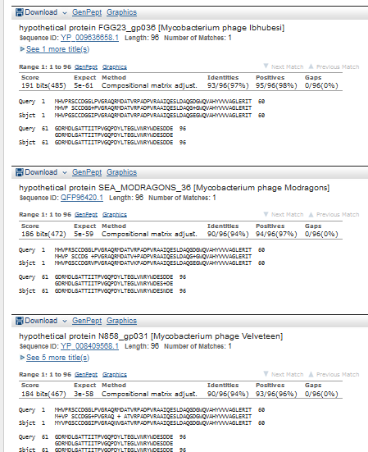
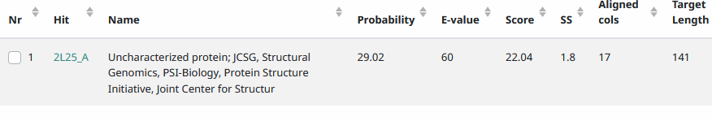
Start Codon and source: changed to 30,390, GTG, longer than 30,447 (GeneMarkS) or 30,459 (Glimmer)
Stop Codon: 30,680, TGA
F/R: F
Coding Potential (y/n): Y
Starterator (SS, NA, NI): pham 48,786
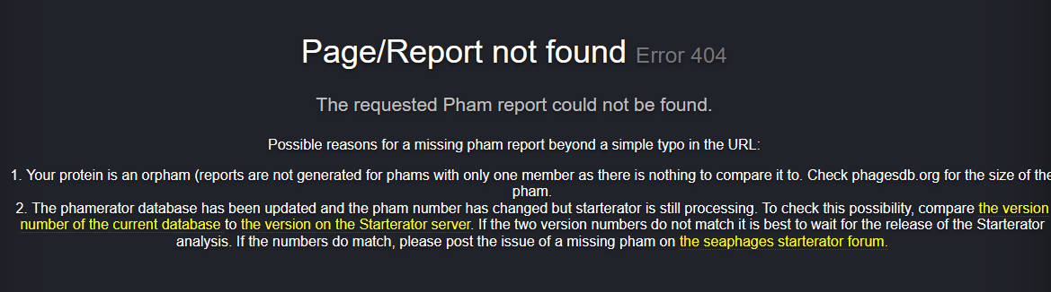
Blast Best Hit, Query:Subject Starts, Score, Evalue, or “no significant Blast alignments” if 10E-4 or higher
Gap: 15 bp gap from gene 35
Longest Orf? (Y/N/NA) Y
RBS: N/A, Scoring Matirix , Spacing Matrix, Z Score, Final Score,
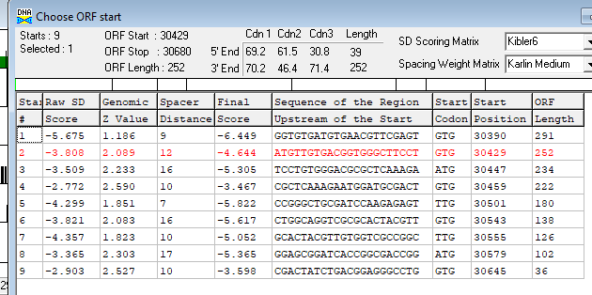
Proposed Function: Hypothetical Protein
Function Evidence: No functional blasts on HHPRED or BlastP
Transmembrane Domain/Evidence: NO
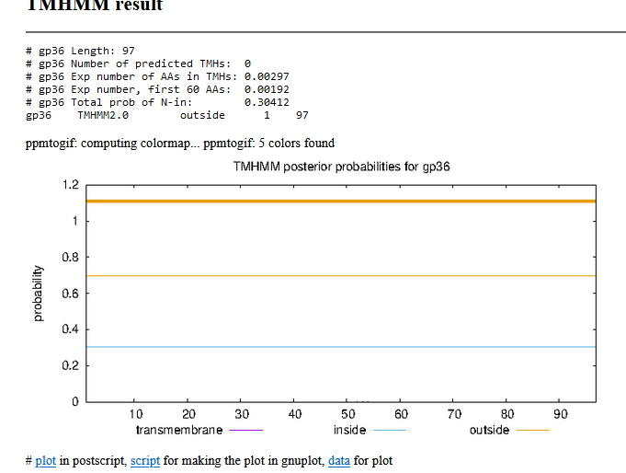

Gene Number: 37 (original 40) changed start to 30,670 (one extra codon)
9/23/22 Run BlastP at phagesdb and NCBI, Starterator, RBS on Frames, Transmembrane precdition, HHPRED
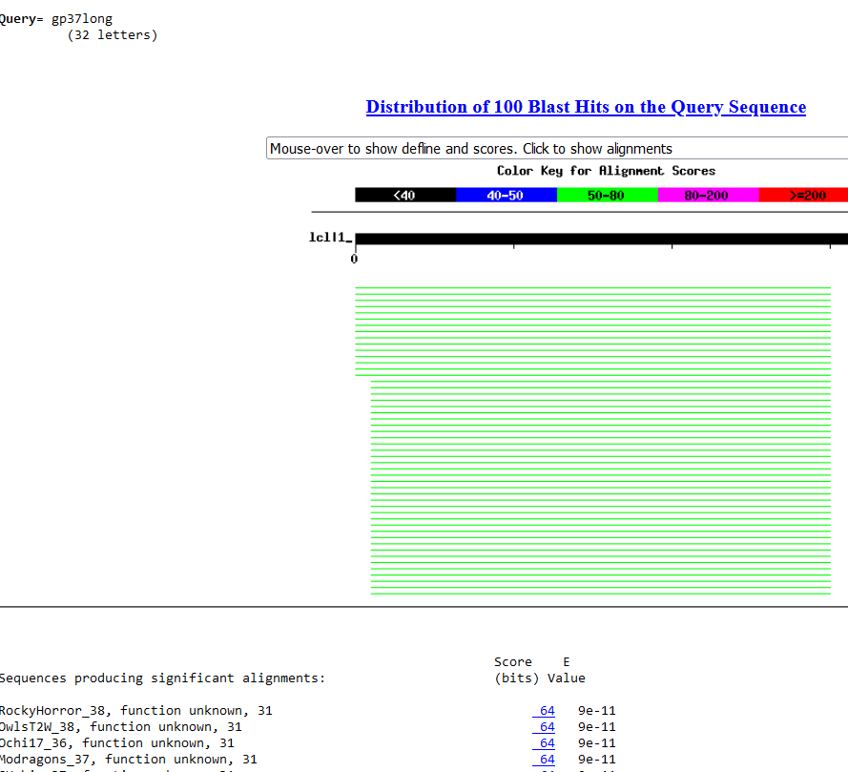
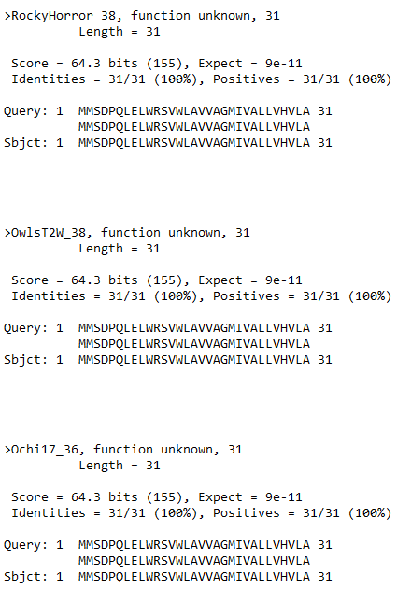
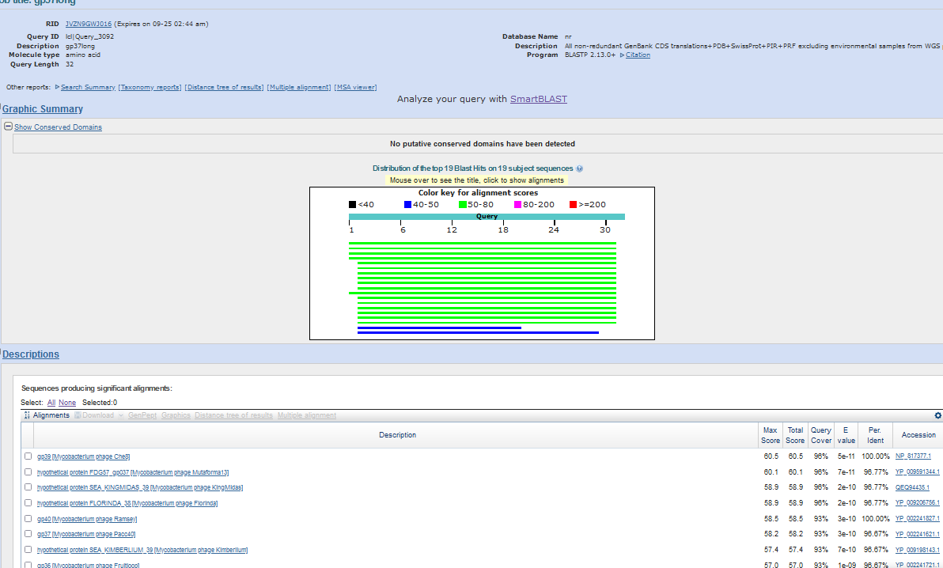
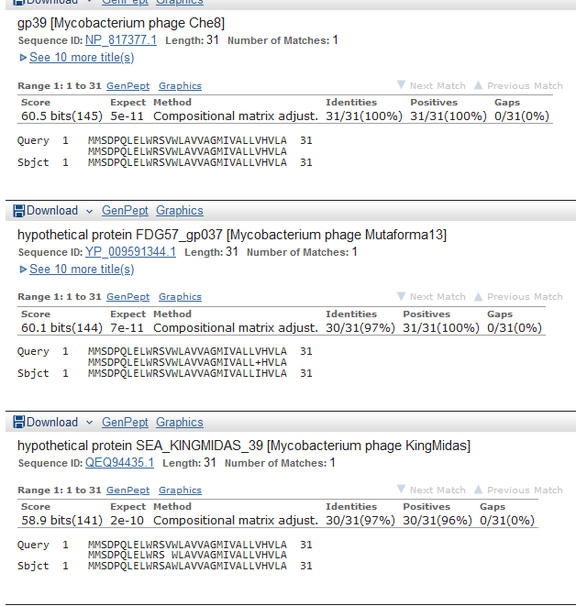
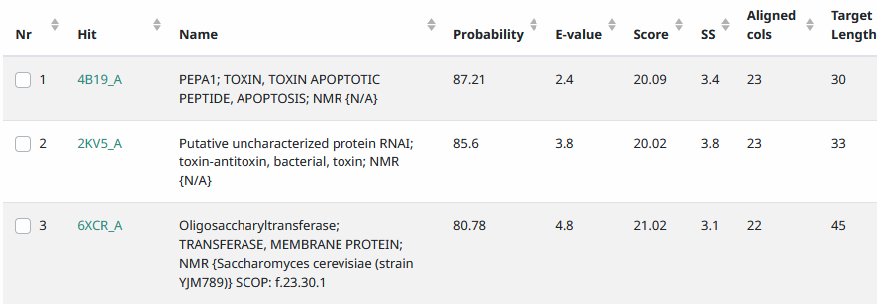
Start Codon and source: 30,670, changed from 30,673called by glimmer and genemark
Stop Codon: 30,765, TAA
F/R: F
Coding Potential (y/n): Y
Starterator (SS, NA, NI): pham 320, changed FROM most annotated (added one codon)
Blast Best Hit, Query:Subject Starts, Score, Evalue, or “no significant Blast alignments” if 10E-4 or higher
Gap: -11 bp overlap with gene 36
Longest Orf? (Y/N/NA) Y
RBS: N/A, Scoring Matirix , Spacing Matrix, Z Score, Final Score,
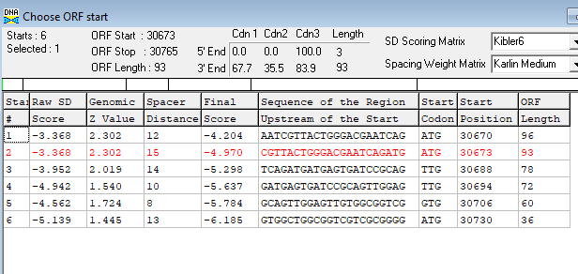
Proposed Function: membrane protein
Function Evidence: see below
Transmembrane Domain/Evidence: YES
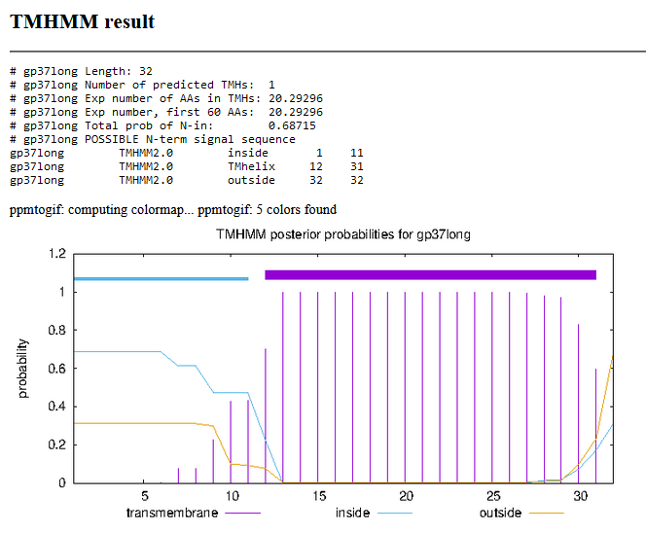
10/06/22 rerun on SOSUI, https://harrier.nagahama-i-bio.ac.jp/sosui/mobile/
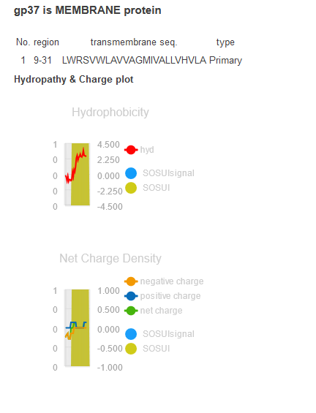
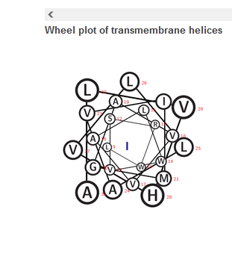

Gene Number: 38 (original 41)
9/23/22 Run BlastP at phagesdb and NCBI, Starterator, RBS on Frames, Transmembrane precdition, HHPRED
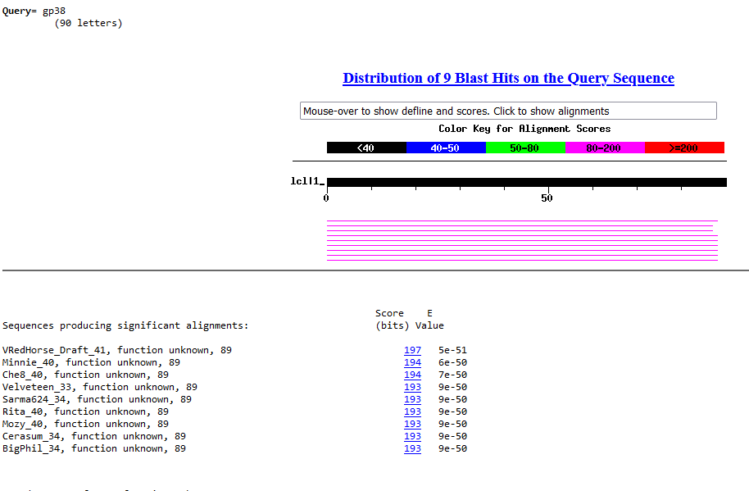
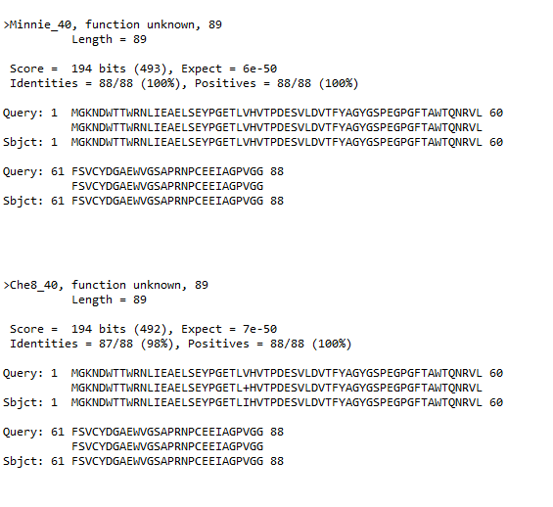
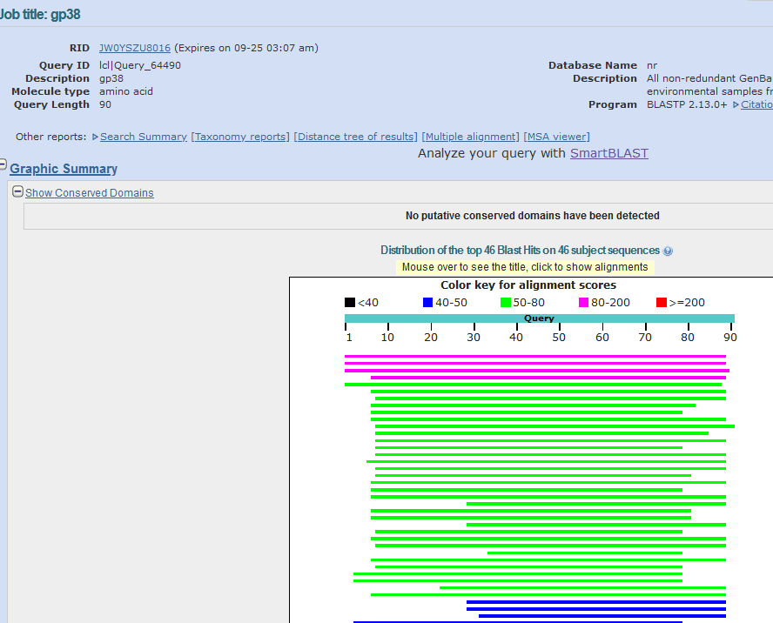
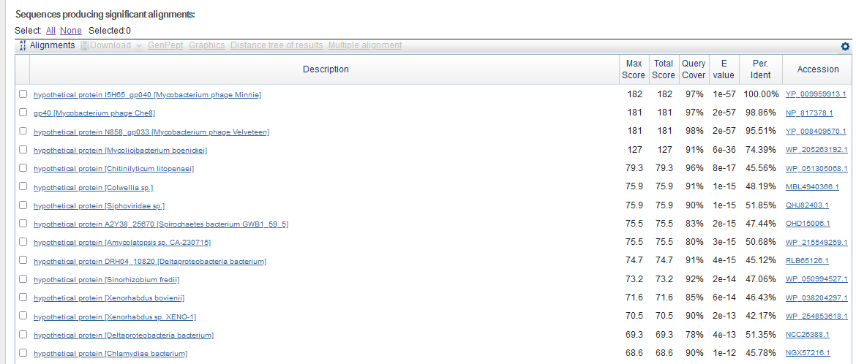
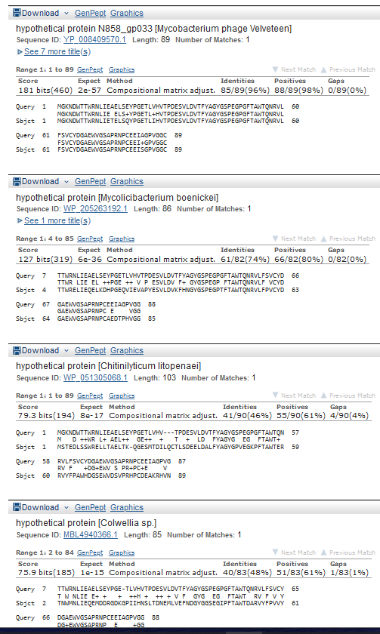
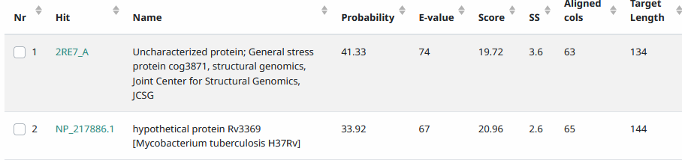
Start Codon and source: 31,139, ATG, Called by Genemark
Stop Codon: 30,870, TGA
F/R: R
Coding Potential (y/n): Y
Starterator (SS, NA, NI): pham 5800, most annotated start
Blast Best Hit, Query:Subject Starts, Score, Evalue, or “no significant Blast alignments” if 10E-4 or higher
Also some non-phage matches (probably prophage?) in other bacteria
Gap: 94 bp gap from end of gene 37 to end of gene 38; -8 bp overlap start of gene 38 to end of gene 39
Longest Orf? (Y/N/NA) N
RBS: N/A, Scoring Matirix , Spacing Matrix, Z Score, Final Score,
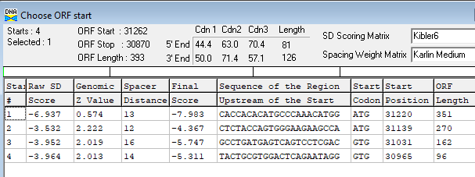
Proposed Function: hypothetical protein
Function Evidence: no matched functions on HHPRED or BLASTP
Transmembrane Domain/Evidence: NO
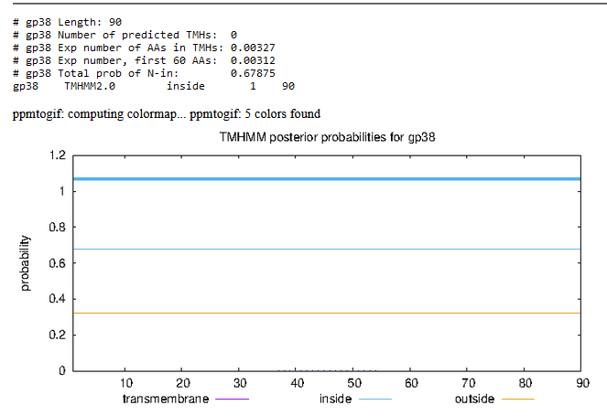

Delete original called forward gene 42, 31,237-31,539 (pham 4946), replace with new reverse gene 39, below. Note that in Starterator’s draft annotation, this gene was present
Gene Number: 39 (not called autoannotate, called by genemarkS)
9/23/22 Run BlastP at phagesdb and NCBI, Starterator, RBS on Frames, Transmembrane precdition, HHPRED
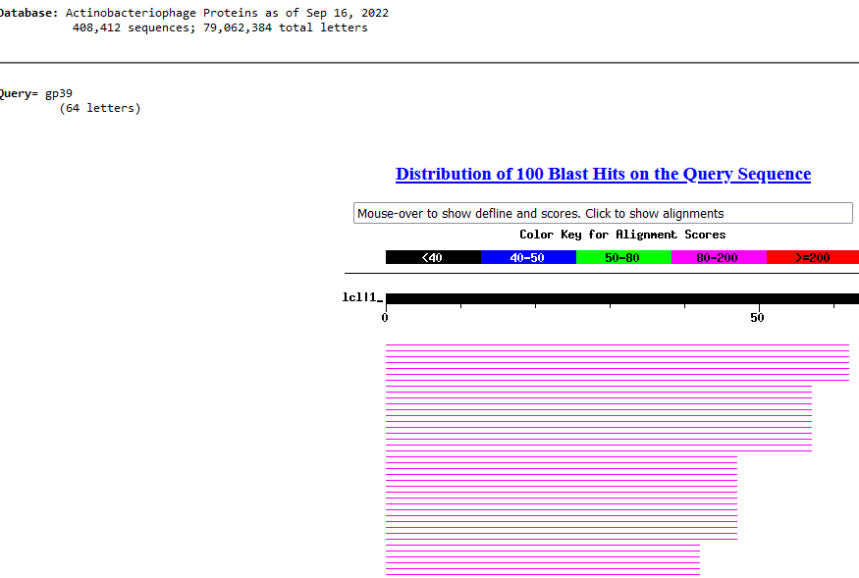
Confused because this wasn’t in my autoanotate
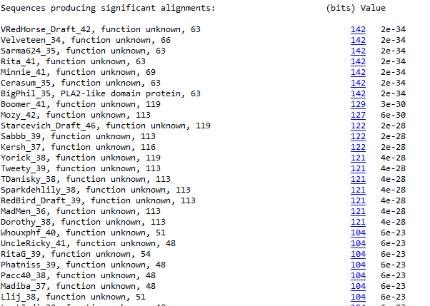
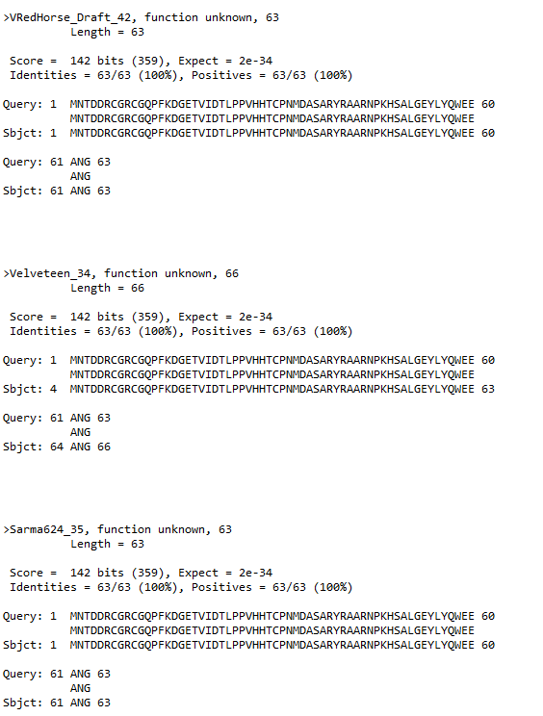
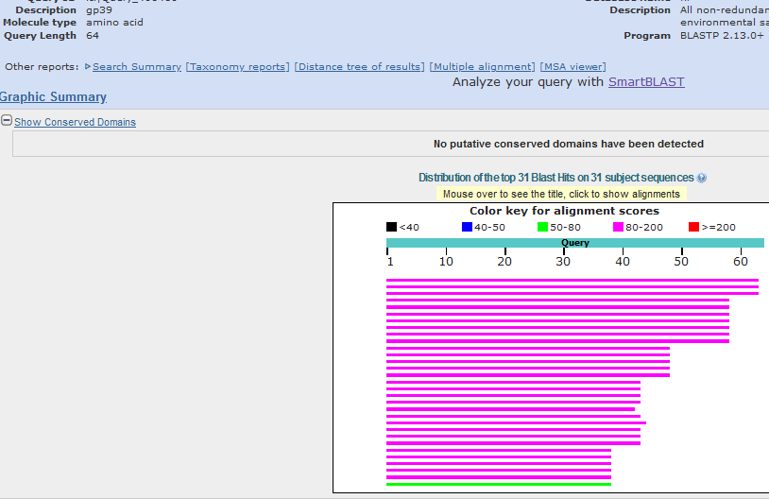
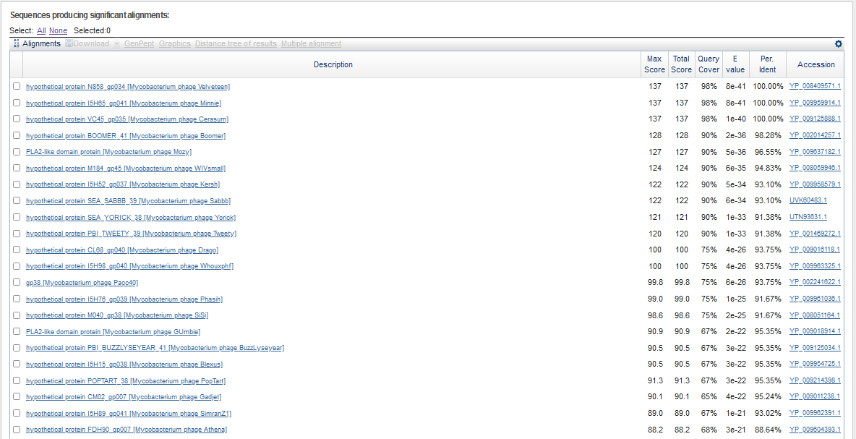
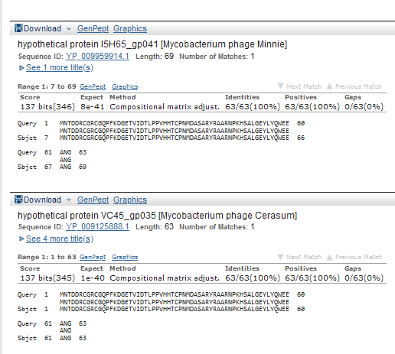
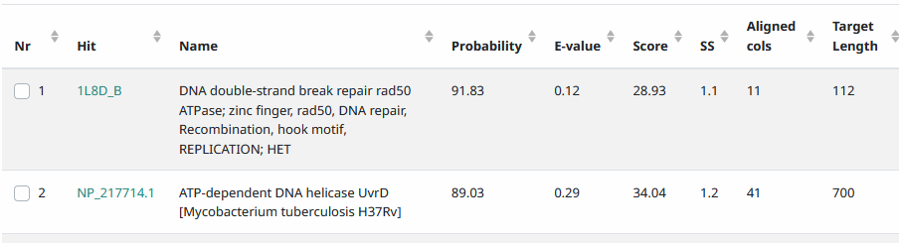
Start Codon and source: 31,323, ATG, called by genemarks
Stop Codon: 31,132, TAA
F/R: R
Coding Potential (y/n): Y
Starterator (SS, NA, NI): pham1052,most annotated start
Blast Best Hit, Query:Subject Starts, Score, Evalue, or “no significant Blast alignments” if 10E-4 or higher

Gap: -8 bp overlap with end of gene 39 with start of gene 38, 1 bp overlap start of 39 with end of 40
Longest Orf? (Y/N/NA) NO
RBS: N/A, Scoring Matirix , Spacing Matrix, Z Score, Final Score,
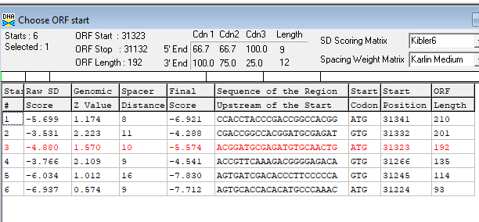
Proposed Function: hypothetical protein
Function Evidence: No >95%HHPRED, BlastP function found
Transmembrane Domain/Evidence:NO
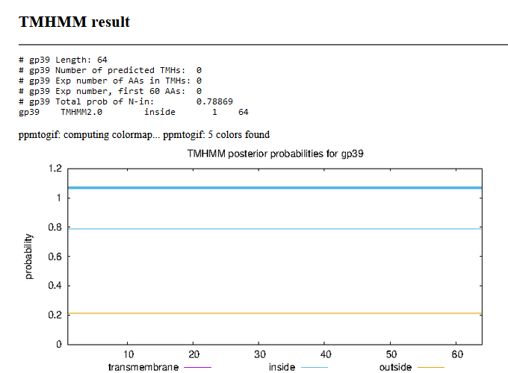

Gene Number: 40 (original 43, 44 on phagesdb autoannotate) Changed start to 31,496, phagesdb draft had this longer start called apparently
9/23/22 Run BlastP at phagesdb and NCBI, Starterator, RBS on Frames, Transmembrane precdition, HHPRED
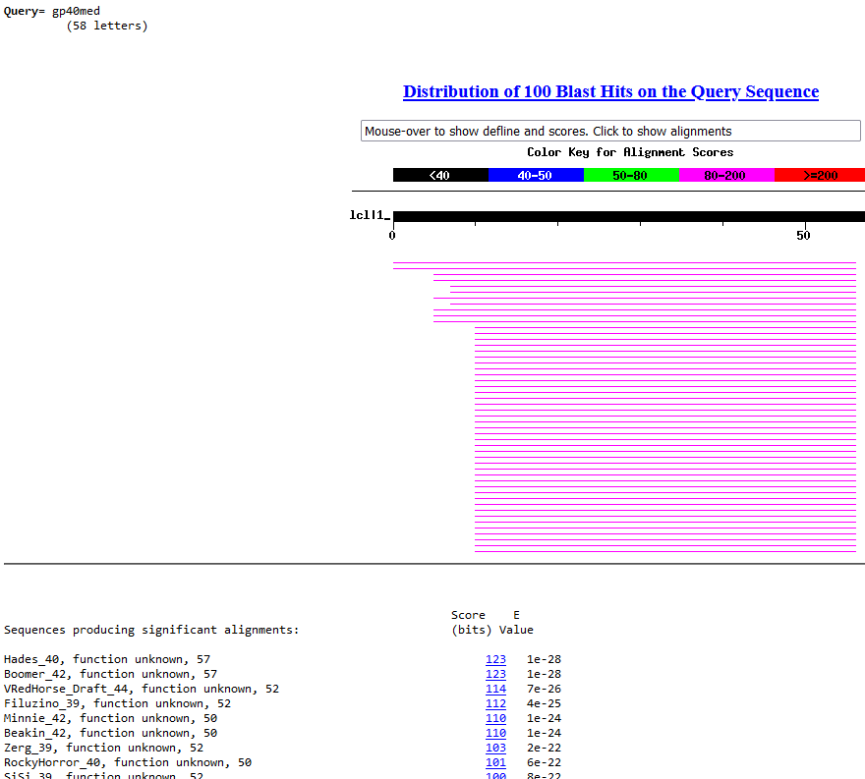
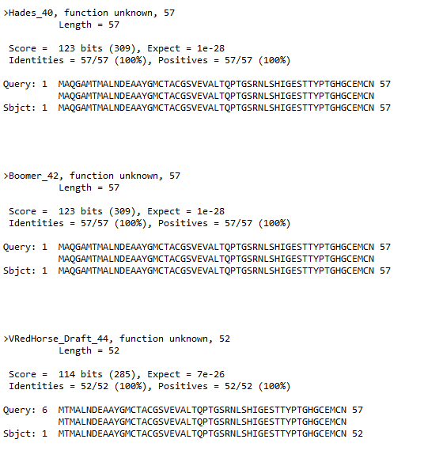
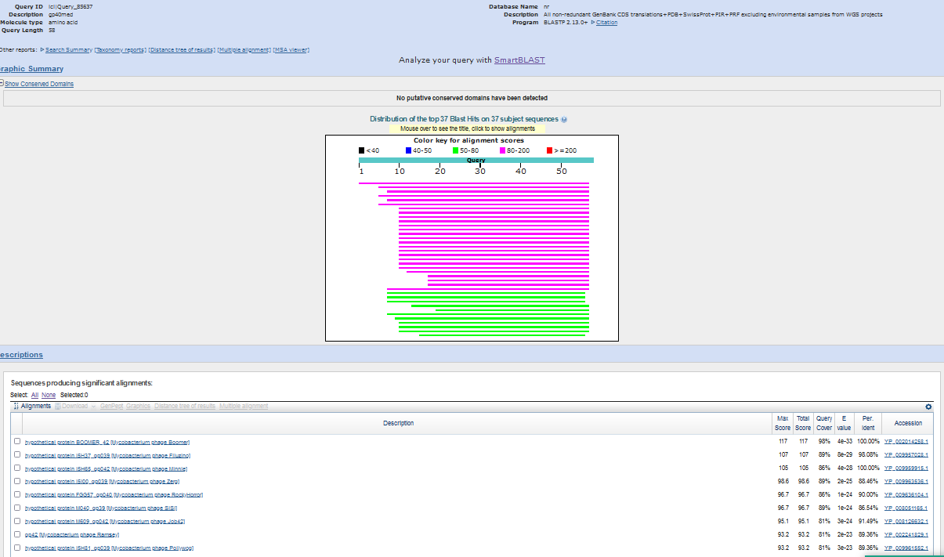
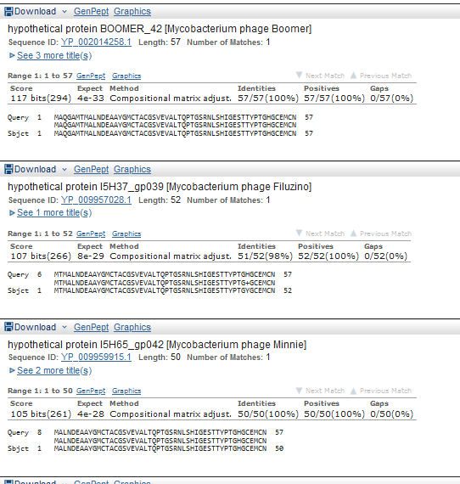
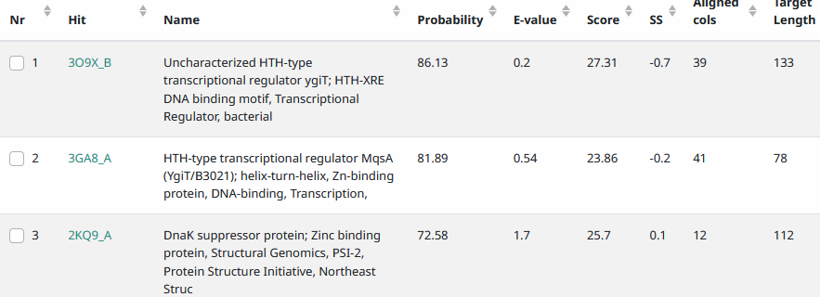
Start Codon and source: 31,496, ATG, not called by glimmer or genemark (31,475 called)
Stop Codon: 31,323, TAG
F/R: R
Coding Potential (y/n): Y
Starterator (SS, NA, NI):pham 638, VRH
Blast Best Hit, Query:Subject Starts, Score, Evalue, or “no significant Blast alignments” if 10E-4 or higher
Gap:
Longest Orf? (Y/N/NA) N
RBS: N/A, Scoring Matirix , Spacing Matrix, Z Score, Final Score,
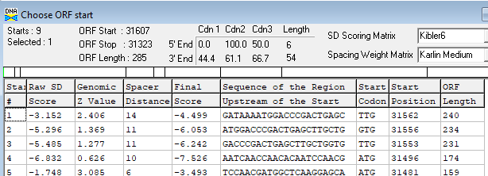
Proposed Function: hypothetical protein
Function Evidence: no credible functional matches on BlastP or HHPRED
Transmembrane Domain/Evidence: NO
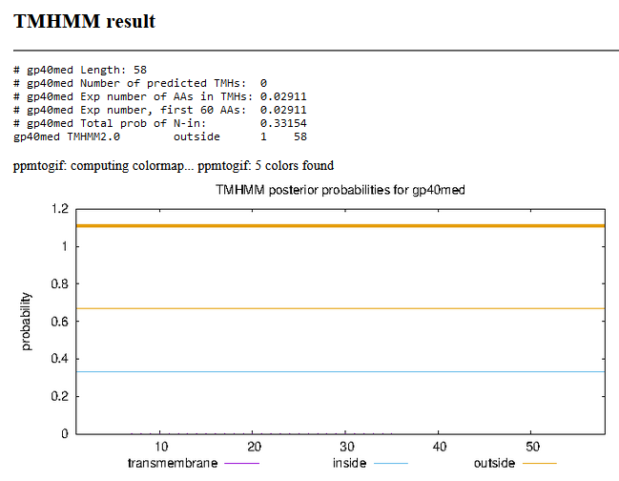

On Phagesdb (against phages and M. smegmatis) and NCBI BlastN genes 40/41 intergenic, also tRNA scan,

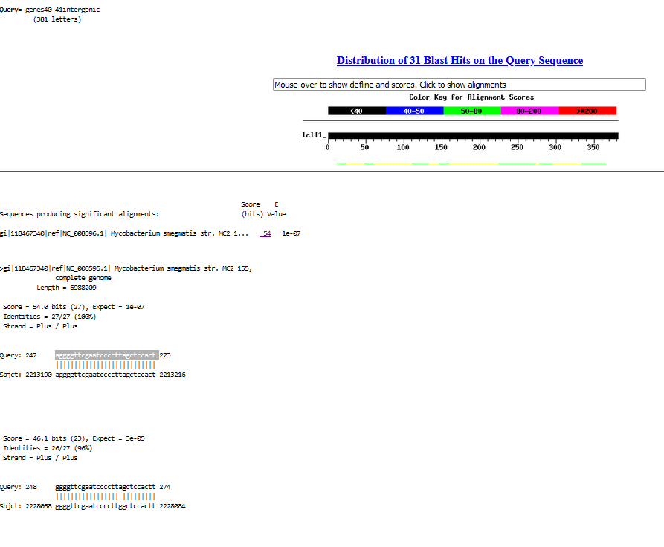
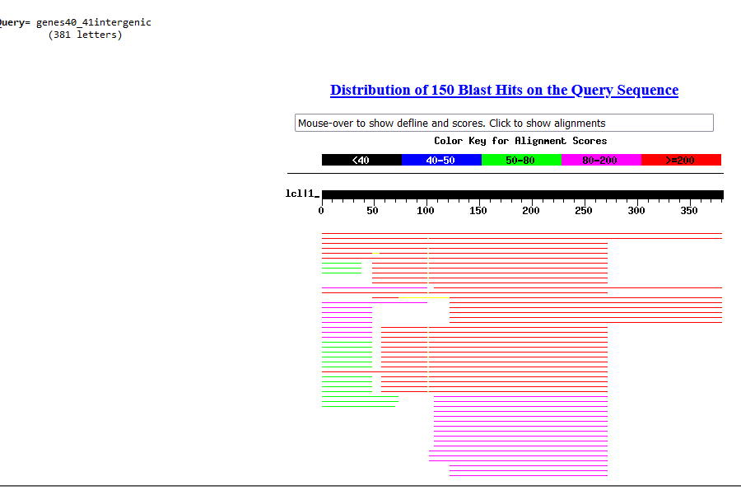
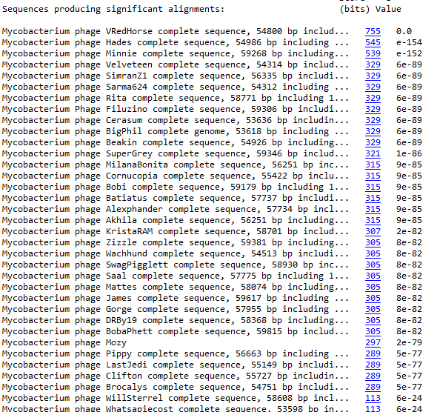
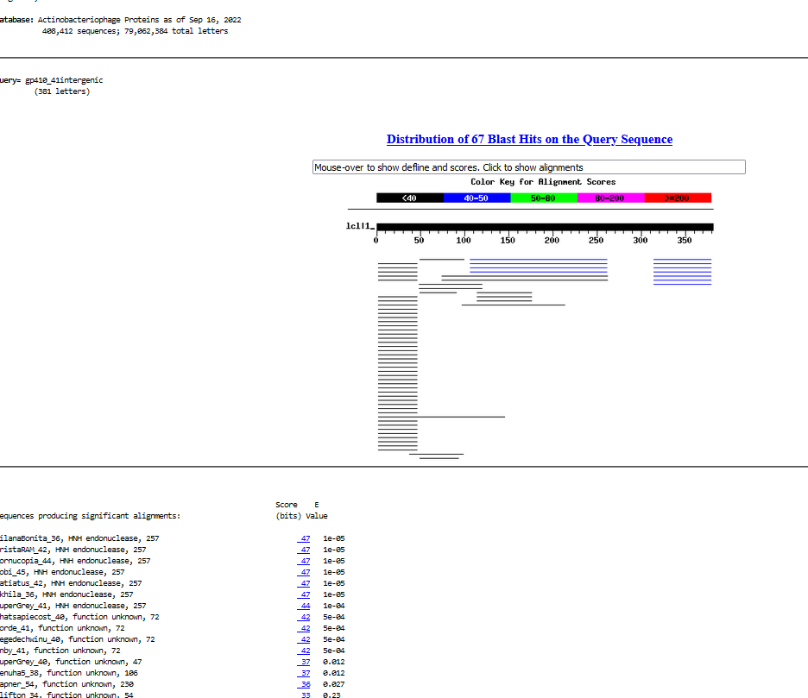
Blastx of right hand orf translatied of above
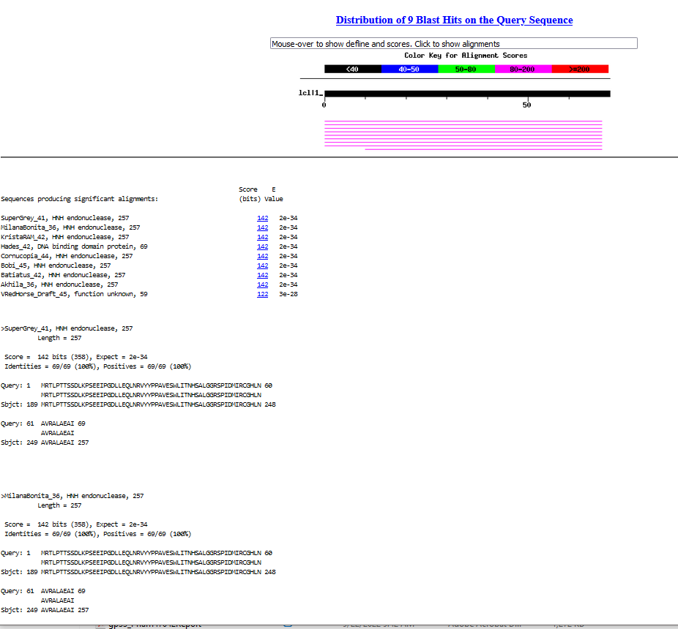

Suggests others called gene 42 start where would overlap gene 41 and no coding potential (VRH has stop codons in that frame)
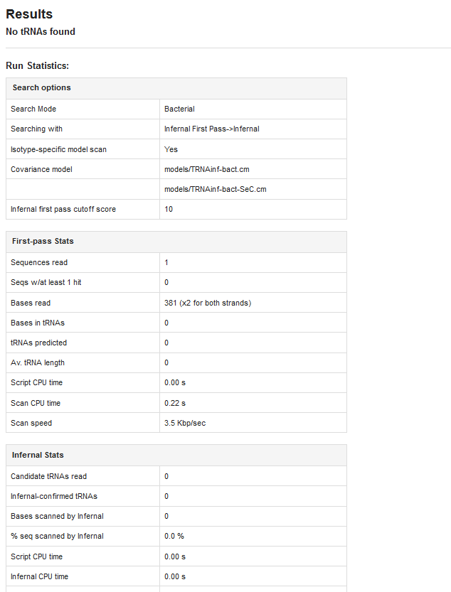
http://lowelab.ucsc.edu/cgi-bin/tRNAscan-SE2.cgi

Gene Number: 41 (original 44) changed start to 31,950
9/23/22 Run BlastP at phagesdb and NCBI, Starterator, RBS on Frames, Transmembrane precdition, HHPRED
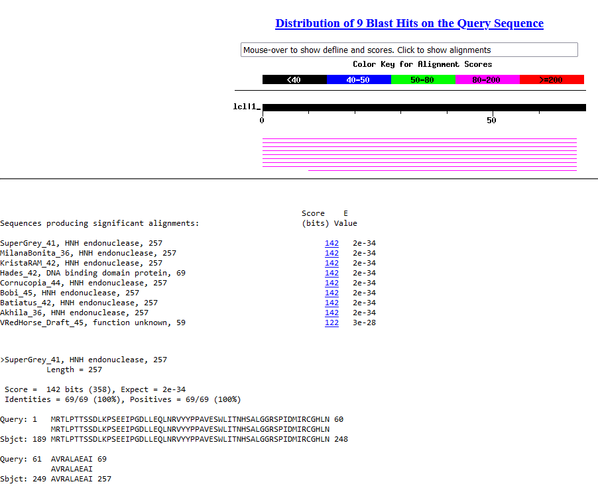
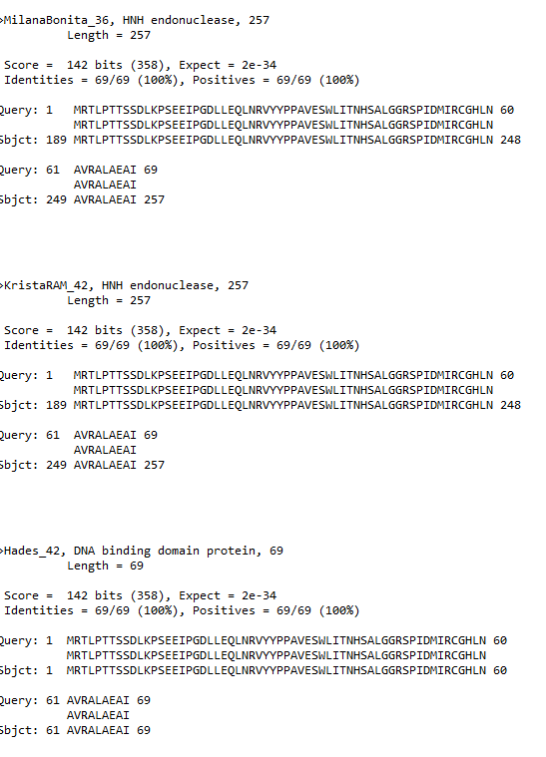
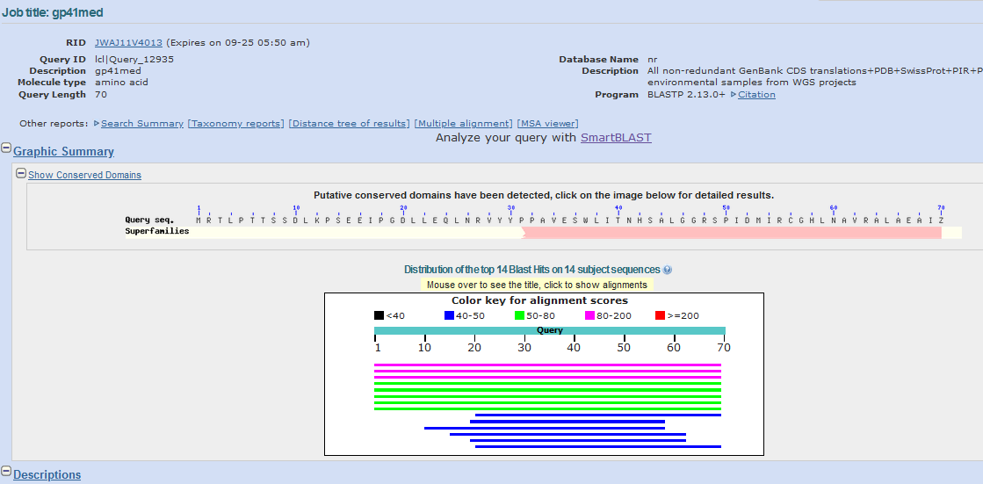
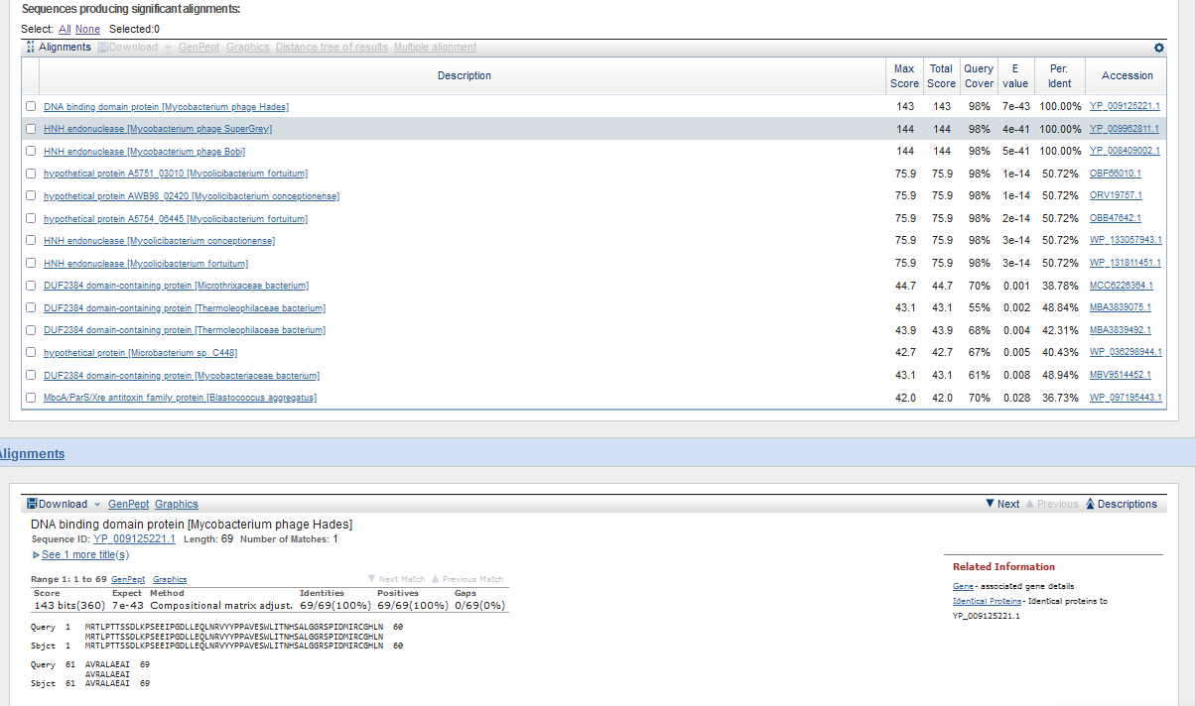
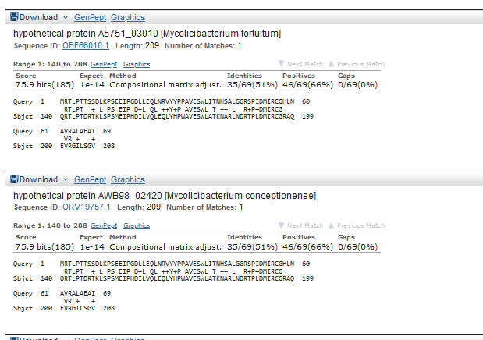
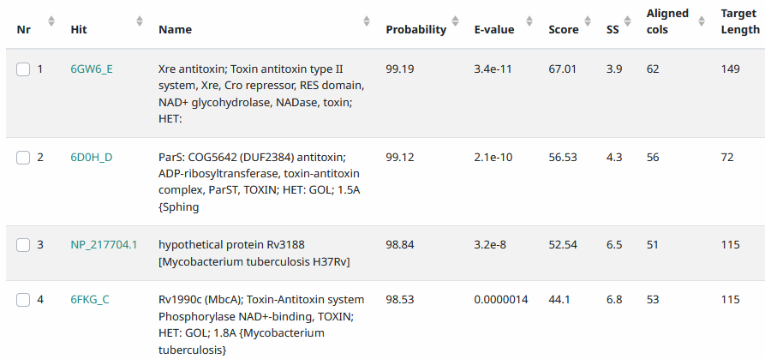
Start Codon and source: 31,950 not called by glimmer or genmark (31,980 was)
Stop Codon: 32,159, TGA
F/R: F
Coding Potential (y/n): y
Starterator (SS, NA, NI): pham 14173, we changed start.
Blast Best Hit, Query:Subject Starts, Score, Evalue, or “no significant Blast alignments” if 10E-4 or higher
Gap: 453 bp from start of reverse gene 40. Possible appP? 27 bp identity with M. smegmatis starting at base 31,746 matching smeg 2213190
Longest Orf? (Y/N/NA) N
RBS: N/A, Scoring Matirix , Spacing Matrix, Z Score, Final Score,
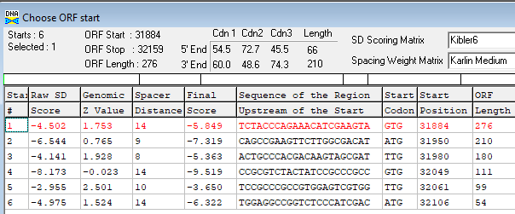
Proposed Function: helix-turn-helix DNA binding domain
Function Evidence: HHPRED
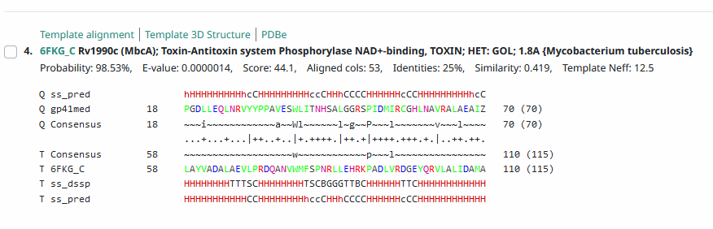
Transmembrane Domain/Evidence: NO
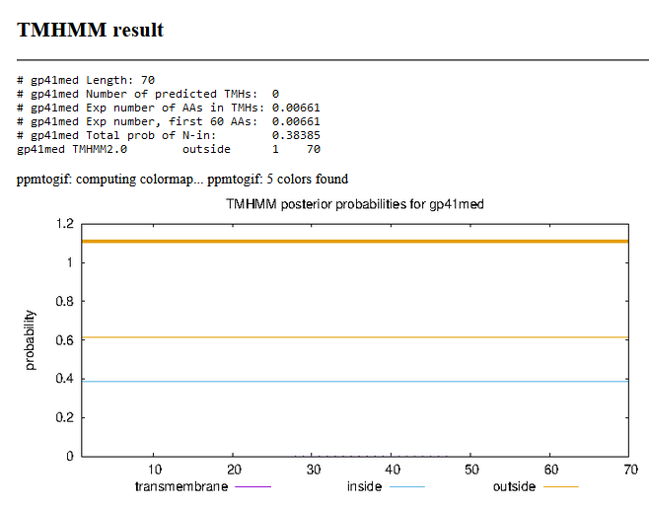

Gene Number: 42 (original 45) changed start to 32, 159
9/26/22 Run BlastP at phagesdb and NCBI, Starterator, RBS on Frames, Transmembrane precdition, HHPRED
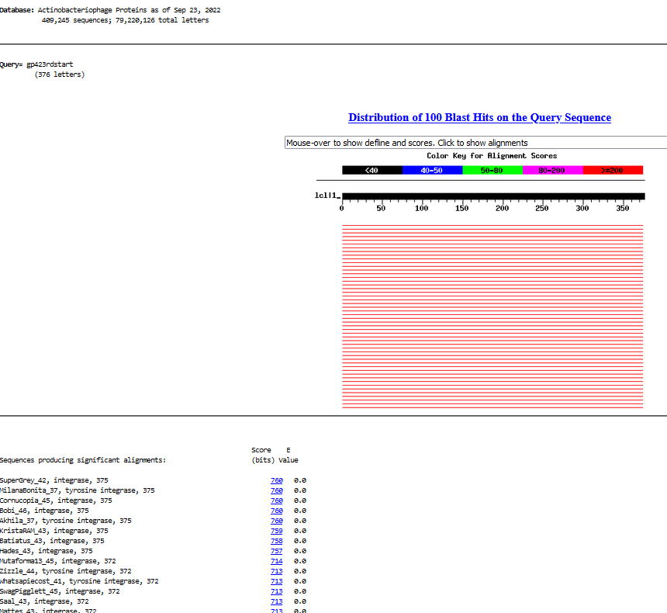
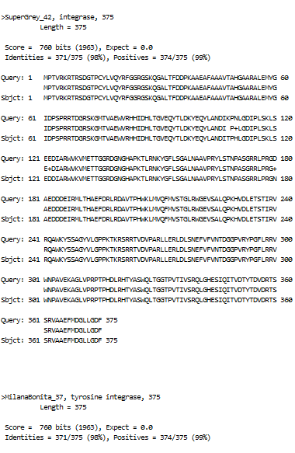
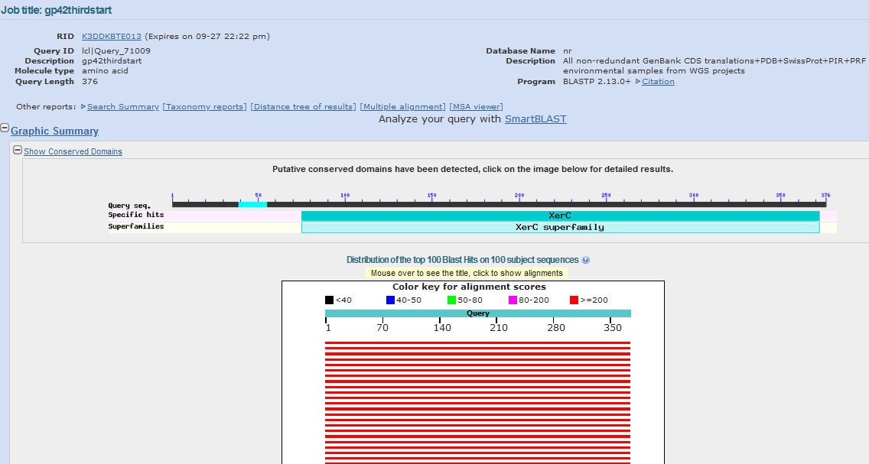
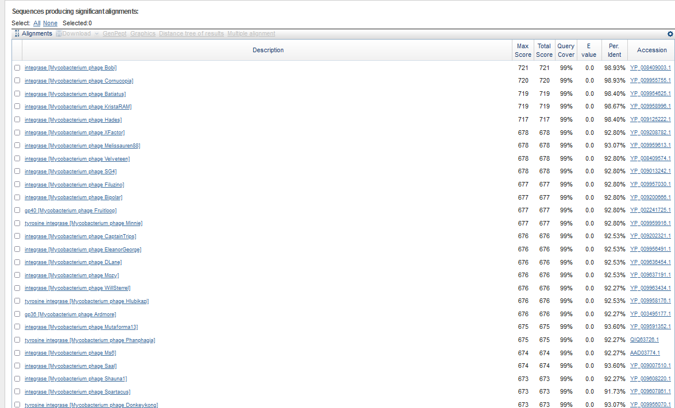
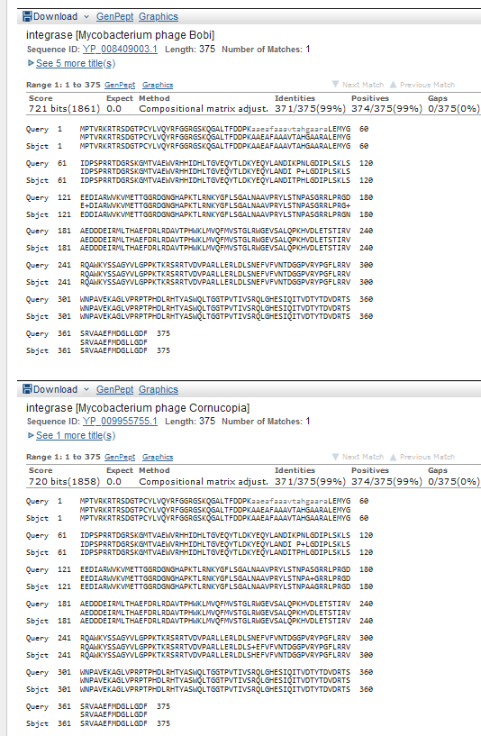
Start Codon and source: 32,159, ATG (not called by glimmer or GenemarkS) (they called 32381)
Stop Codon: 33,286, TAA
F/R: F
Coding Potential (y/n): Y
Starterator (SS, NA, NI): pham48,584 report could not be found
Blast Best Hit, Query:Subject Starts, Score, Evalue, or “no significant Blast alignments” if 10E-4 or higher
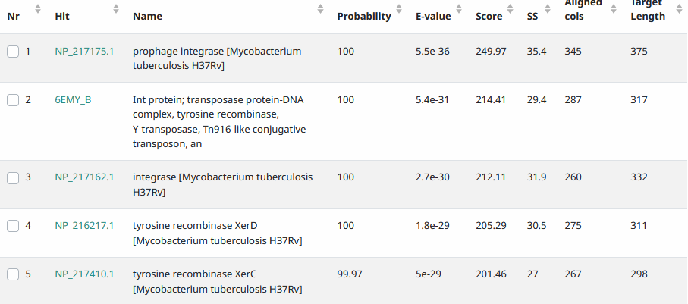
Gap: 1 bp overlap w/gene 41
Longest Orf? (Y/N/NA) N
RBS: N/A, Scoring Matirix , Spacing Matrix, Z Score, Final Score,
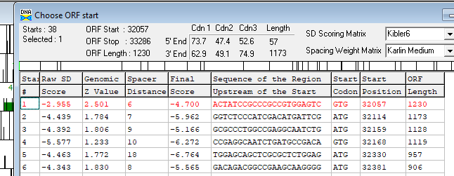
Proposed Function: tyrosine integrase
Function Evidence: BlastP and HHPRED
Transmembrane Domain/Evidence: NO
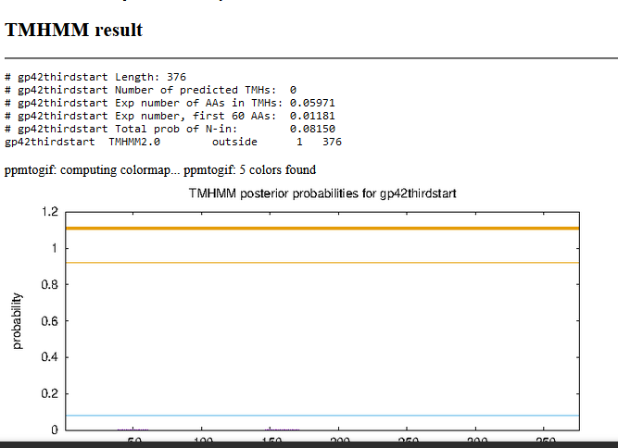

Blastp small 3rd frame orf between genes 42 and 43 on phagesdb and ncbi…it has no matches and no coding potential, so do not call it
Gene Number: 43 (original 46)
9/26/22 Run BlastP at phagesdb and NCBI, Starterator, RBS on Frames, Transmembrane precdition https://services.healthtech.dtu.dk/service.php?TMHMM-2.0, HHPRED, https://toolkit.tuebingen.mpg.de/#/tools/hhpred
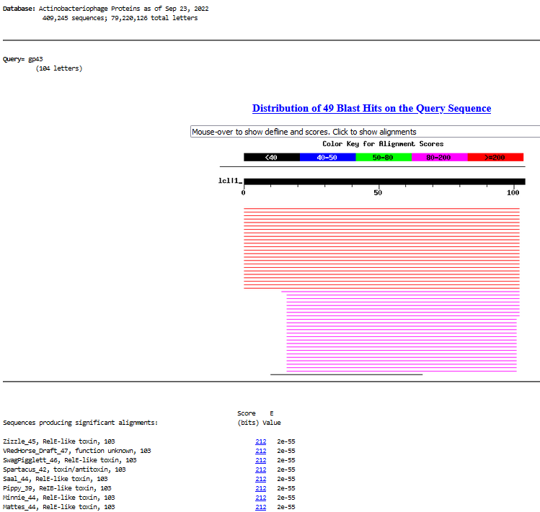
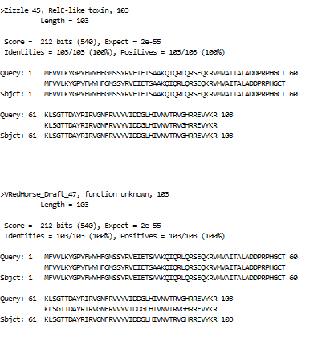
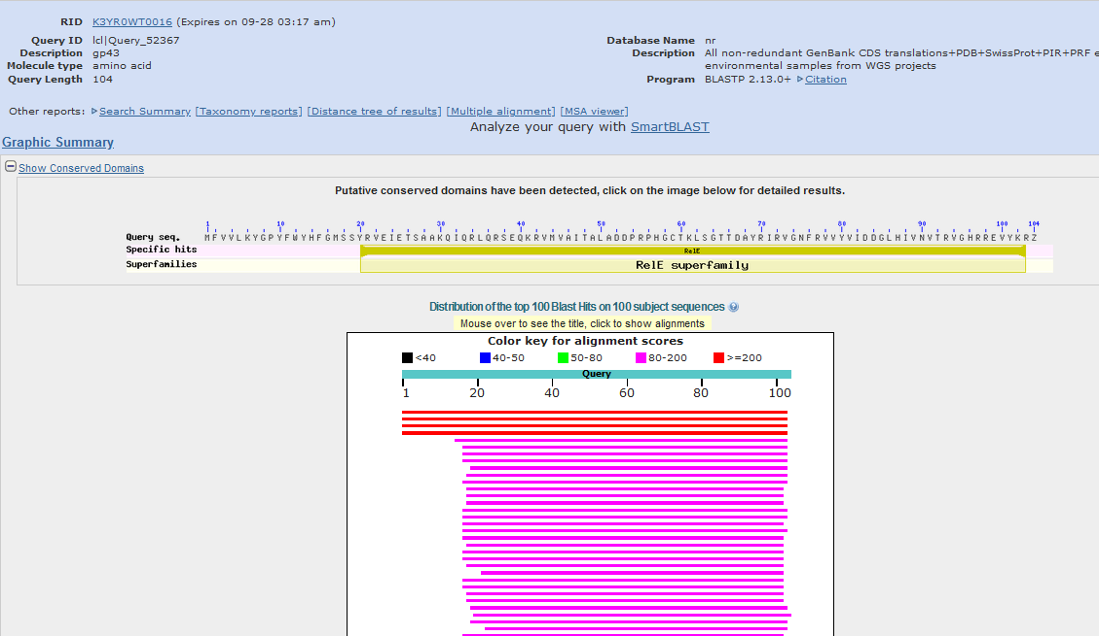
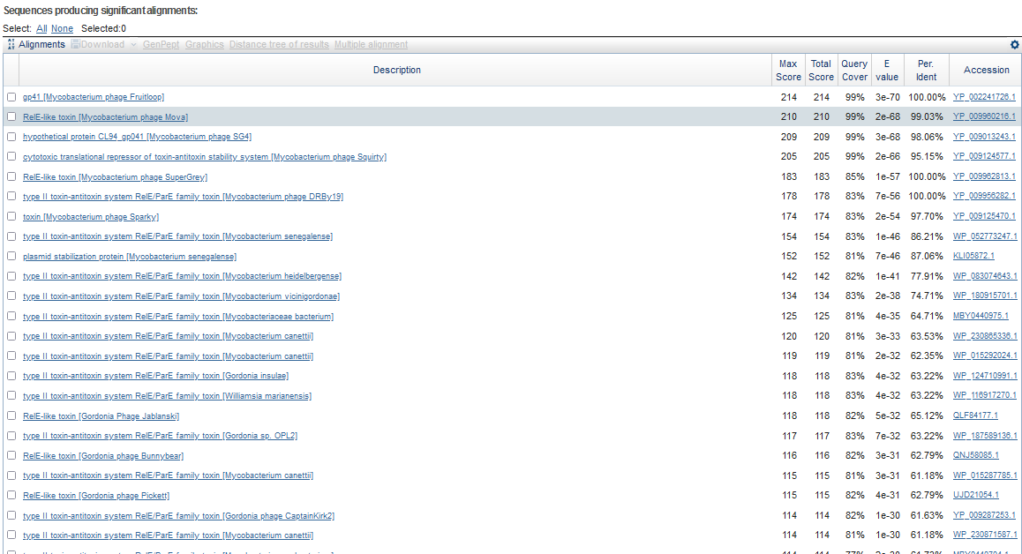
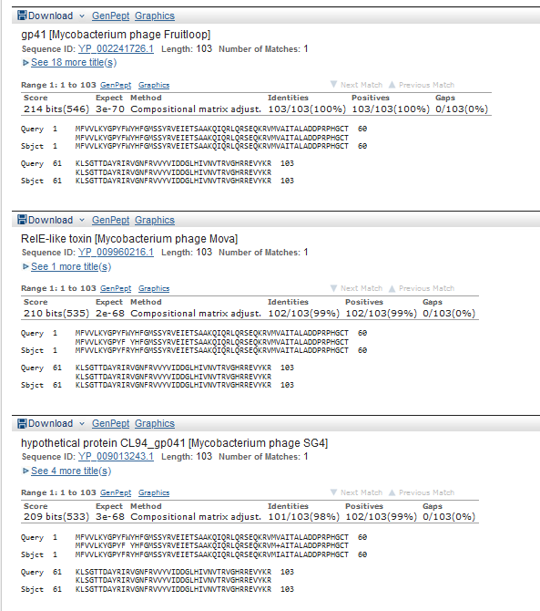
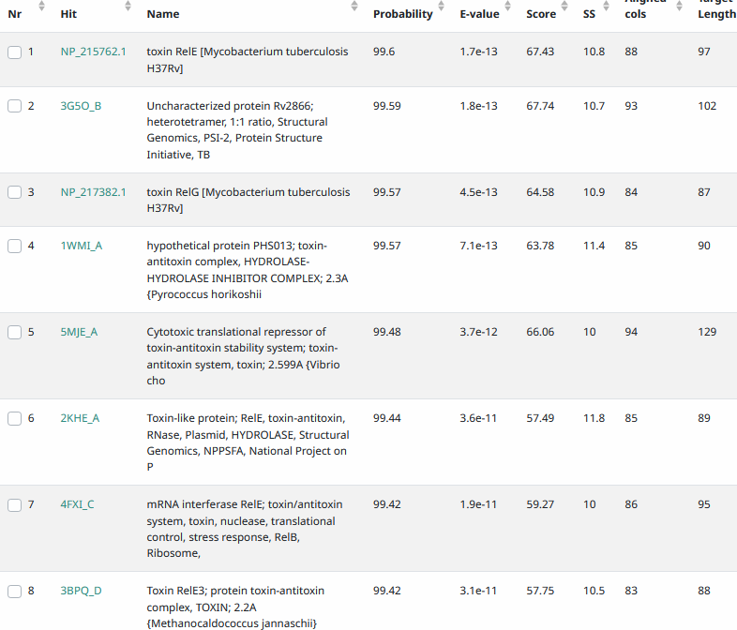
Start Codon and source: 33408, ATG, called by glimmer and GenemarkS
Stop Codon: 33,719, TGA
F/R: F
Coding Potential (y/n): Y
Starterator (SS, NA, NI): pham 1782, most annotated start
Blast Best Hit, Query:Subject Starts, Score, Evalue, or “no significant Blast alignments” if 10E-4 or higher
Gap: 122 bp from gene 42
Longest Orf? (Y/N/NA): Y
RBS: N/A, Scoring Matirix , Spacing Matrix, Z Score, Final Score,
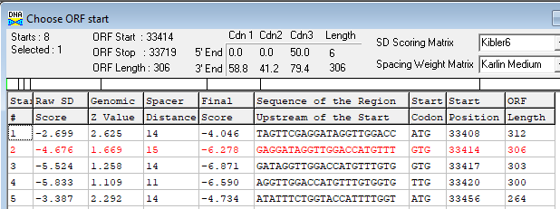
Proposed Function: toxin in toxin/antitoxin system, RelE-like
Function Evidence: Blast like Fruitloop gp41 (official functionlist example), HHPRED
Transmembrane Domain/Evidence: NO
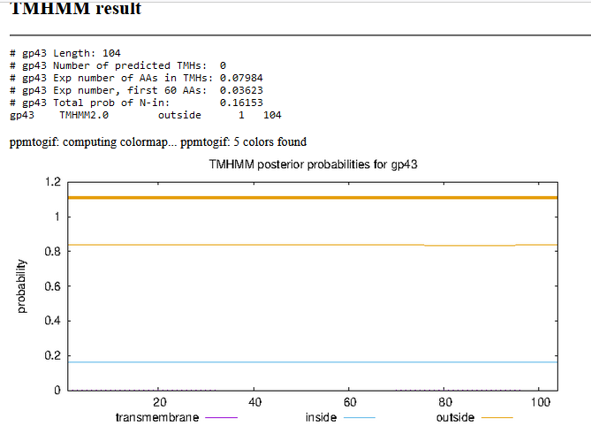

Gene Number: 44 (original gene 47, 48 in phagesdbdraft)
9/26/22 Run BlastP at phagesdb and NCBI, Starterator, RBS on Frames, Transmembrane precdition https://services.healthtech.dtu.dk/service.php?TMHMM-2.0, HHPRED, https://toolkit.tuebingen.mpg.de/#/tools/hhpred
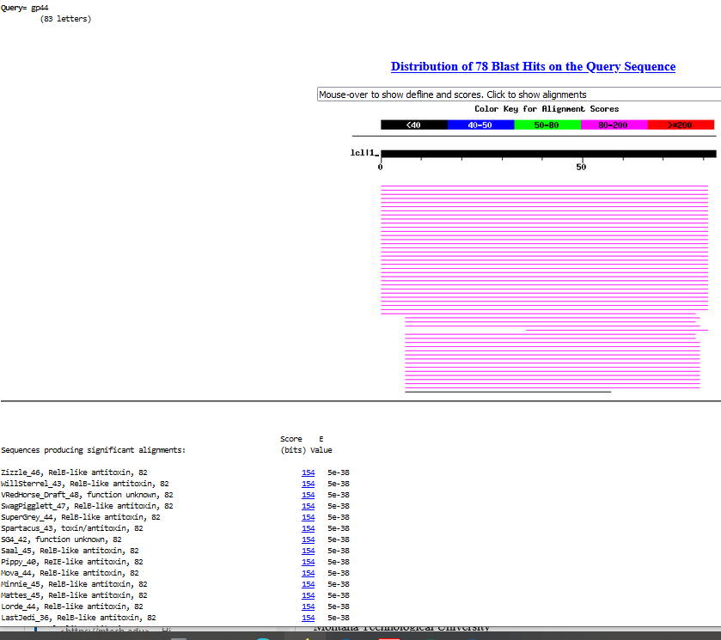
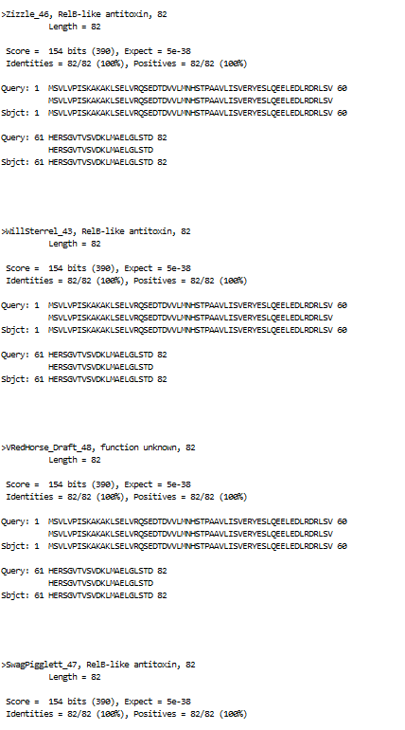
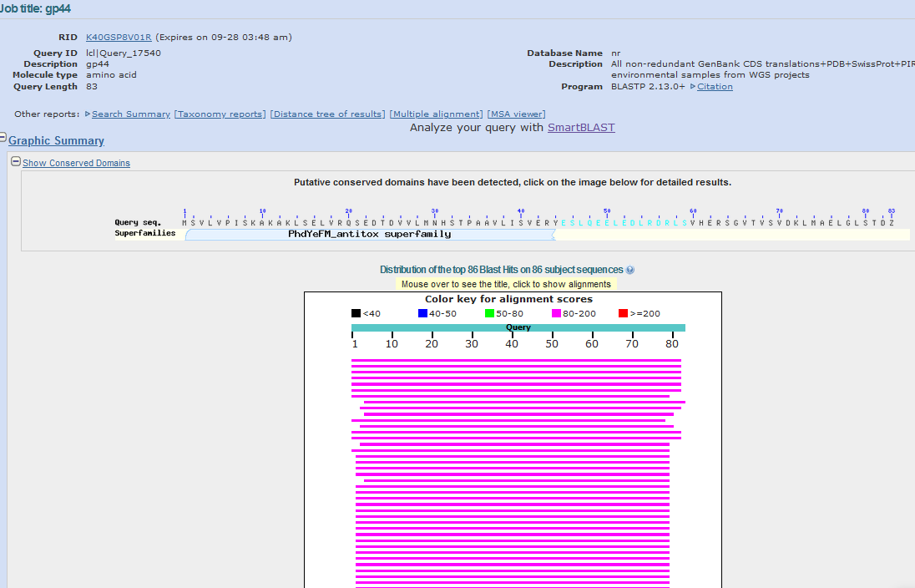
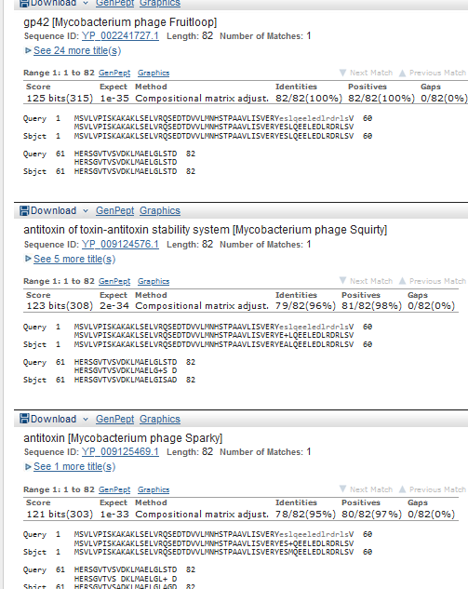
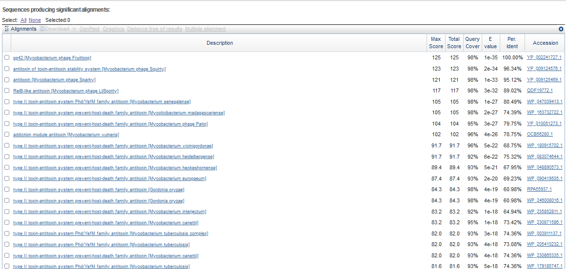
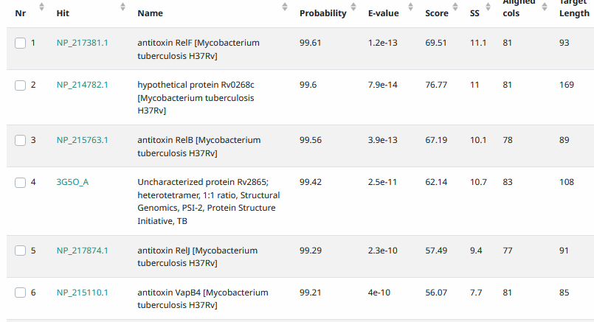
Start Codon and source: 33,716, ATG, called by glimmer and GenemarkS
Stop Codon: 33964, TAA
F/R: F
Coding Potential (y/n): Y
Starterator (SS, NA, NI): pham 1731, most annotated start
Blast Best Hit, Query:Subject Starts, Score, Evalue, or “no significant Blast alignments” if 10E-4 or higher
Gap: -4 bp overlap with gene 43
Longest Orf? (Y/N/NA) N
RBS: N/A, Scoring Matirix , Spacing Matrix, Z Score, Final Score,
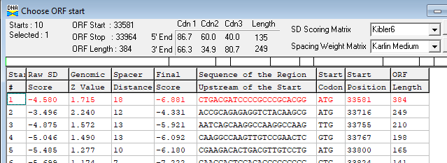
Proposed Function: antitoxin in toxin/antitoxin system, RelB-like
Function Evidence:BLASTP matches with Fruitloop gp42, HHPRED
Transmembrane Domain/Evidence: NO
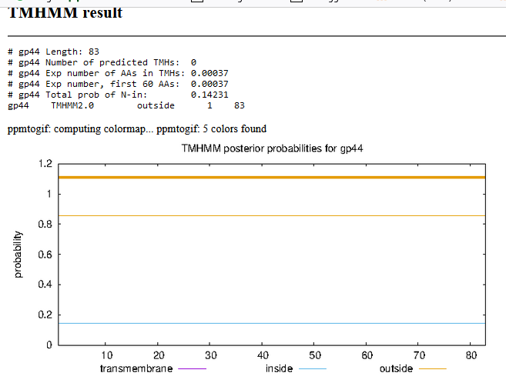

Gene Number: 45
9/26/22 Run BlastP at phagesdb and NCBI, Starterator, RBS on Frames, Transmembrane precdition https://services.healthtech.dtu.dk/service.php?TMHMM-2.0, HHPRED, https://toolkit.tuebingen.mpg.de/#/tools/hhpred
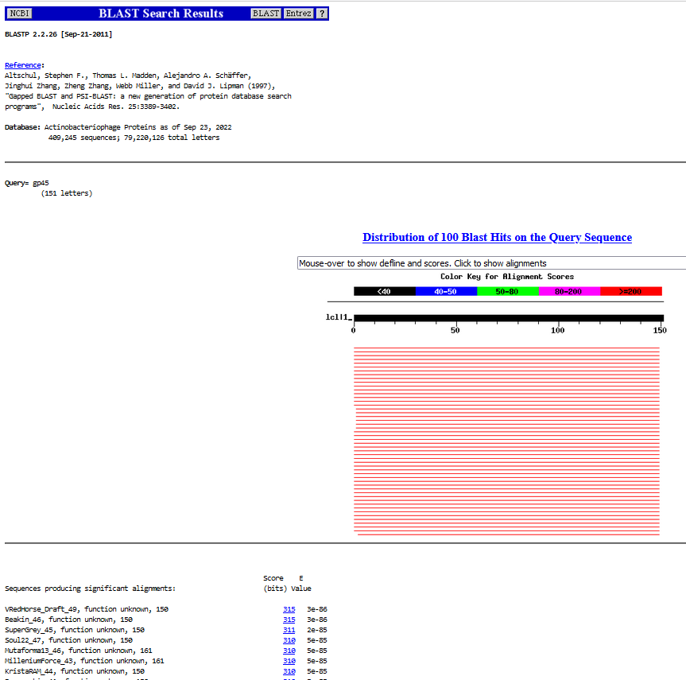
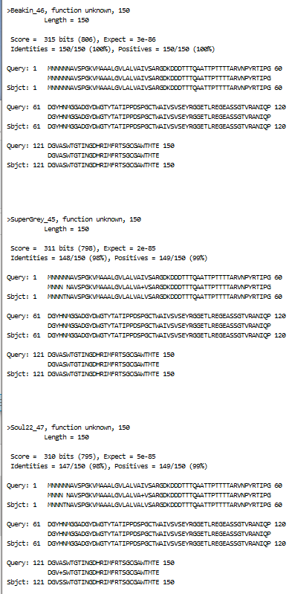
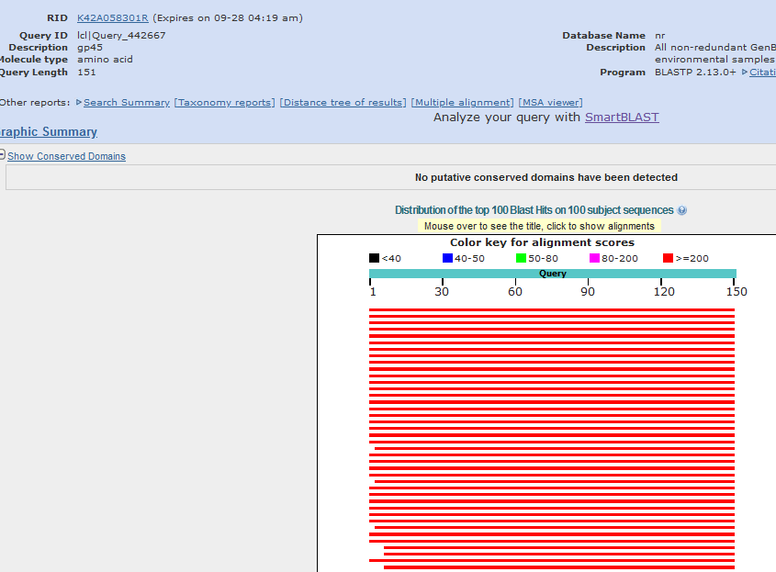
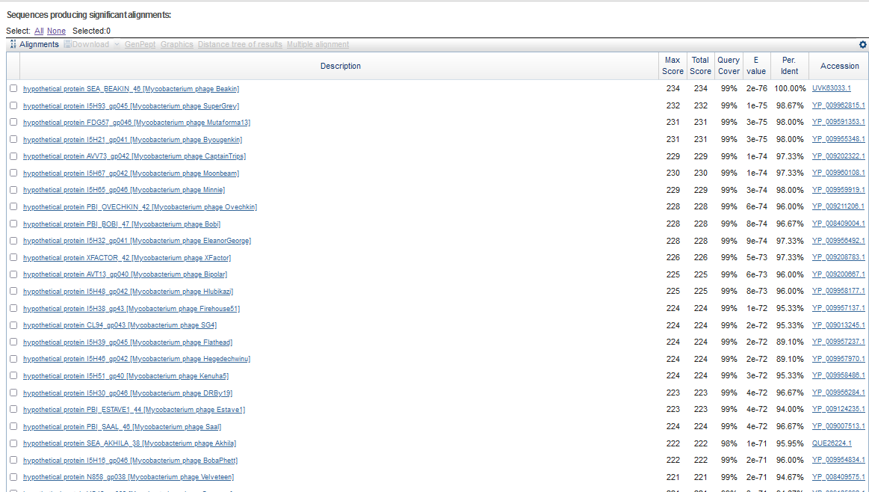
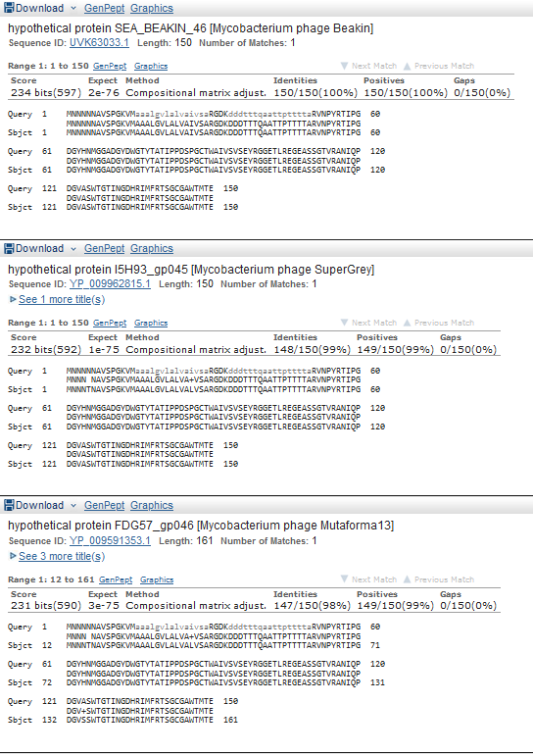
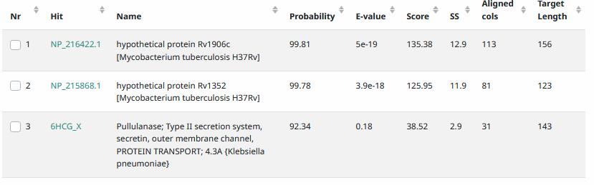

Start Codon and source: 34,427, ATG, called by Glimmer and GenemarkS
Stop Codon: 33,975, TGA
F/R: R
Coding Potential (y/n): Y
Starterator (SS, NA, NI): pham 337, most annotated start
Blast Best Hit, Query:Subject Starts, Score, Evalue, or “no significant Blast alignments” if 10E-4 or higher
Gap: 10 bp gap from end of reverse gene 45 to end of forward gene 44,
Longest Orf? (Y/N/NA)N
RBS: N/A, Scoring Matirix , Spacing Matrix, Z Score, Final Score,
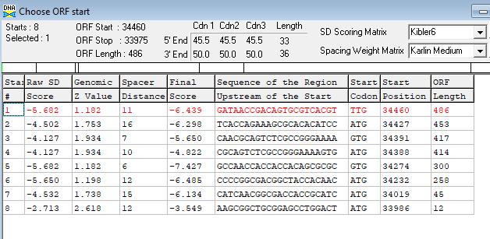
Proposed Function: membrane protein
Function Evidence: see below
Transmembrane Domain/Evidence: YES
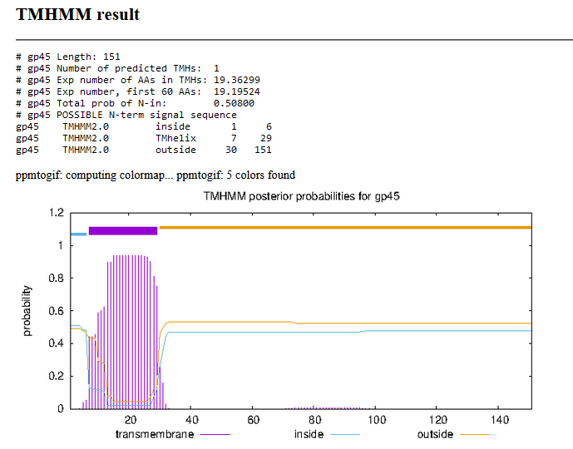
10/06/22 rerun on SOSUI, https://harrier.nagahama-i-bio.ac.jp/sosui/mobile/
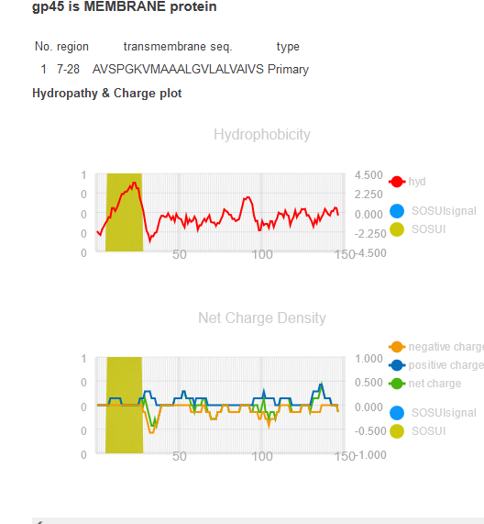
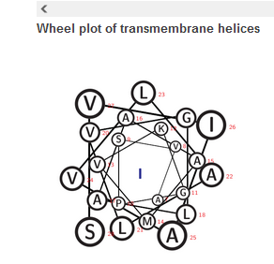

Next region is less obvious, with conflicting forward and reverse genes. Blast the not-called frame one gene, then blastp the called reverse -2 frame gene.
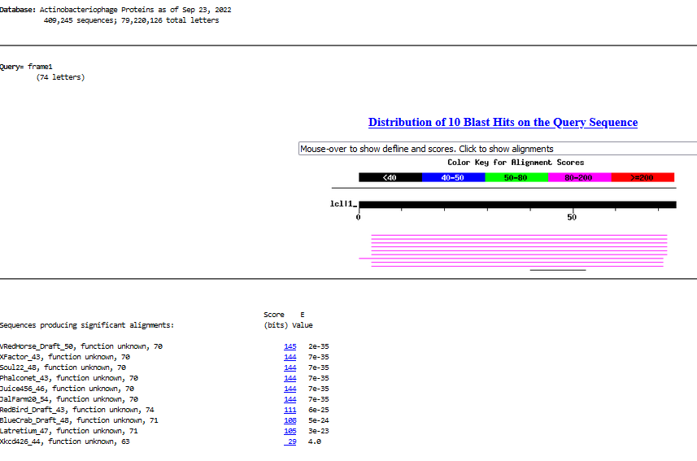
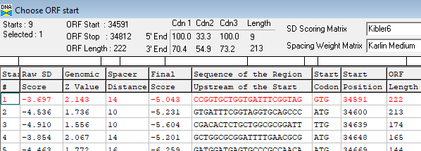

Looking between two called reverse genes, there is a small orf in -1 frame. Start 34622, GTG, BlastP on phagesdb and NCBI. Lacking coding potential on GenemarkS graph, and genemark ran against several Mycobacteria, so don’t call it.

Sequence: >gpsecondreversetiny
MSRSSSNMGCTYRNHQHRSPLATGCVDANGSLPRSTHEAHKWEYHDZ
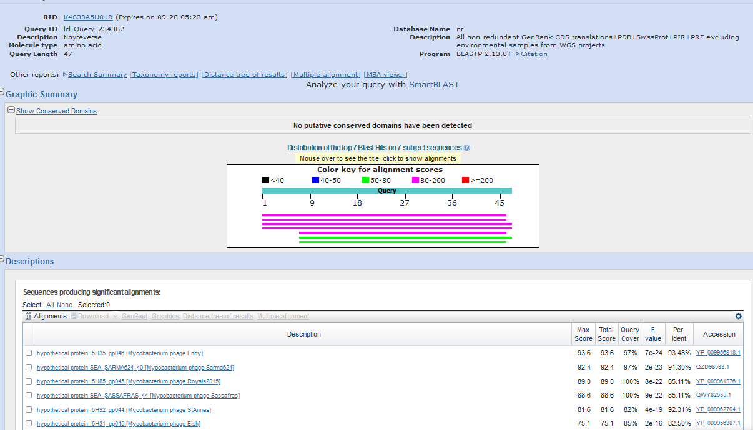
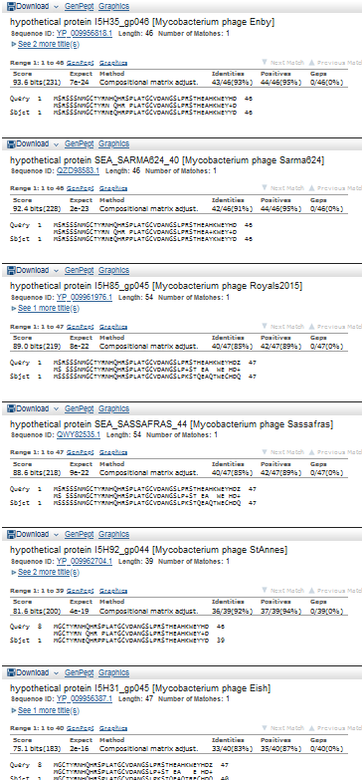
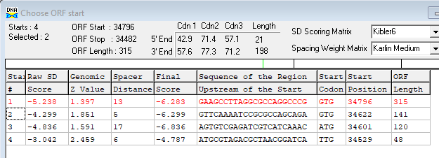

VRedHorse 54,800 bp including 10-base 3' overhang (CGGAAGGCGC), Cluster F1
According to phagesdb.org (9/2/22) , 106 genes in Draft annotation

Gene Number: 46 (original49, phagesdbdraft51). Change start to 35,361, TTG
9/26/22 Run BlastP at phagesdb and NCBI, Starterator, RBS on Frames, Transmembrane precdition https://services.healthtech.dtu.dk/service.php?TMHMM-2.0, HHPRED, https://toolkit.tuebingen.mpg.de/#/tools/hhpred
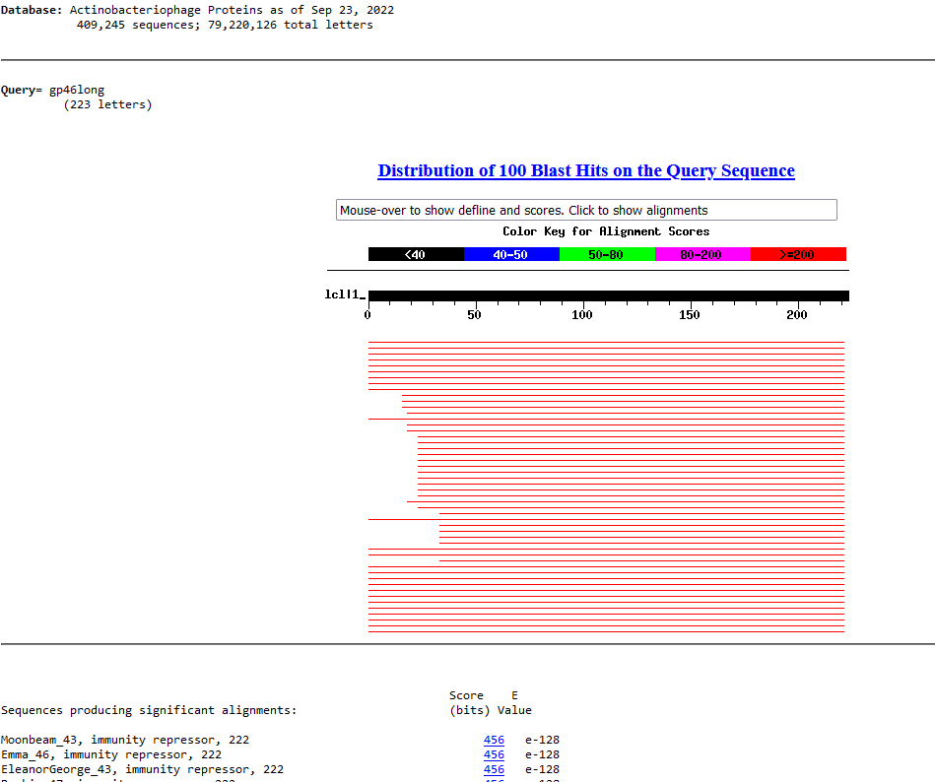
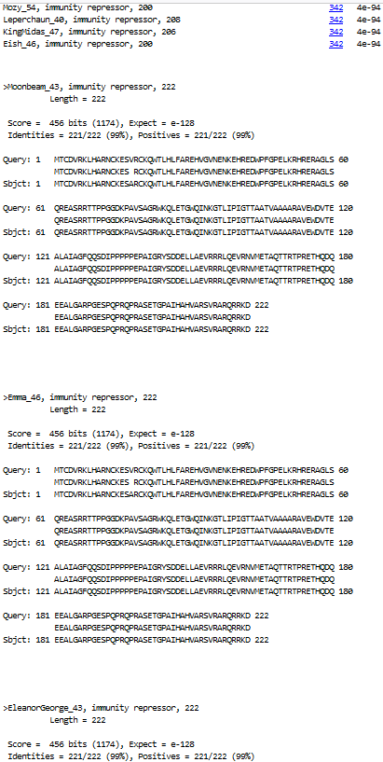
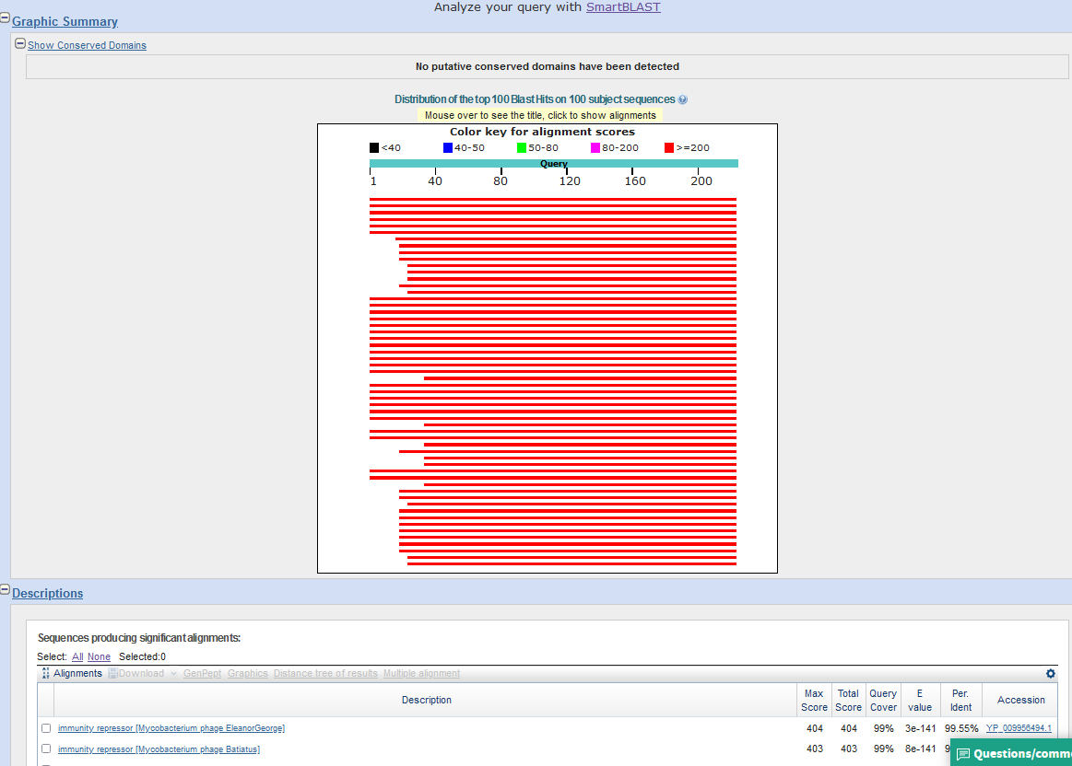
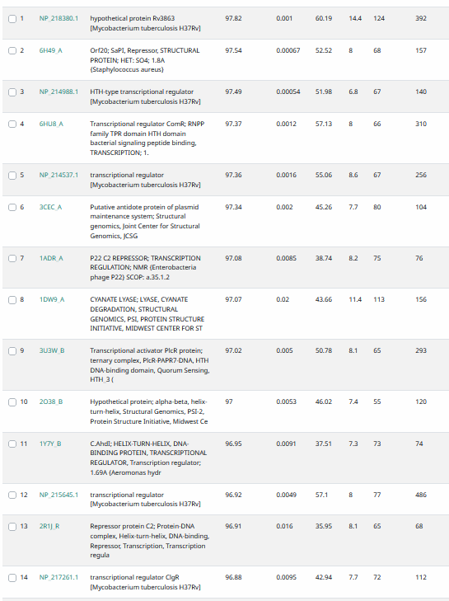
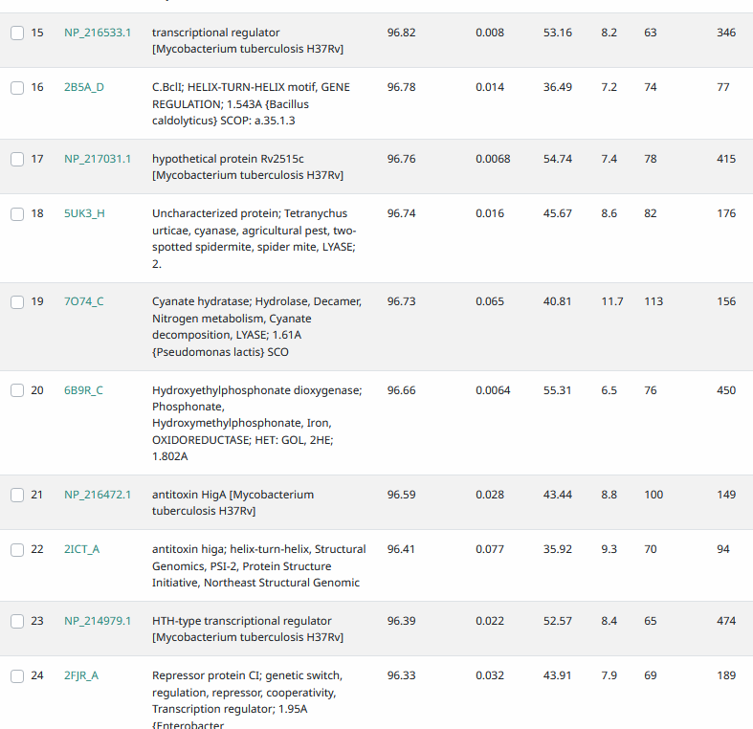

Start Codon and source: changed to 35,361, TTG, Glimmer called other, GenemarkS did not call
Stop Codon: 34693, TAG
F/R: R
Coding Potential (y/n):Y
Starterator (SS, NA, NI): pham 48853, does not have most annotated start
Blast Best Hit, Query:Subject Starts, Score, Evalue, or “no significant Blast alignments” if 10E-4 or higher
Gap: end of gene 46 is 265 bp gap from start of reverse gene 45
Longest Orf? (Y/N/NA) Y
RBS: N/A, Scoring Matirix , Spacing Matrix, Z Score, Final Score,
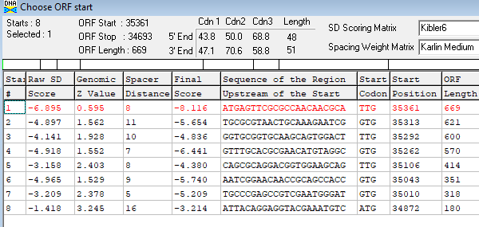
Proposed Function: immunity repressor
Function Evidence: Blast, Lambda cI match with HHPRED
Transmembrane Domain/Evidence: NO
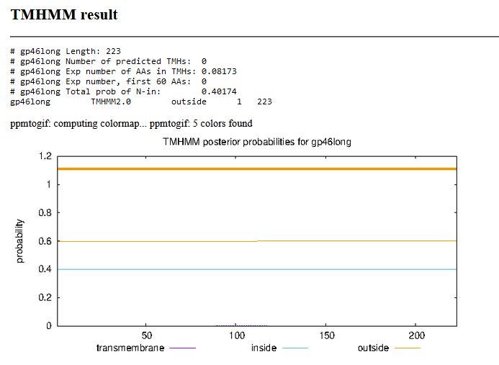

Gene Number: 47 (original 50, phagesdb 52)change start to 35429
9/27/22 Run BlastP at phagesdb and NCBI, Starterator, RBS on Frames, Transmembrane precdition https://services.healthtech.dtu.dk/service.php?TMHMM-2.0, HHPRED, https://toolkit.tuebingen.mpg.de/#/tools/hhpred
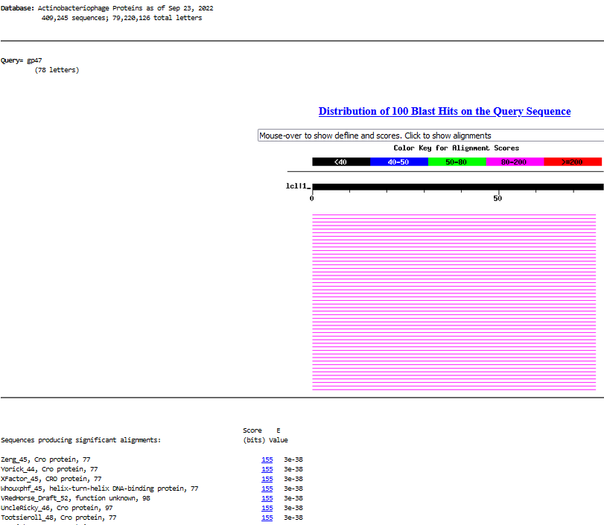
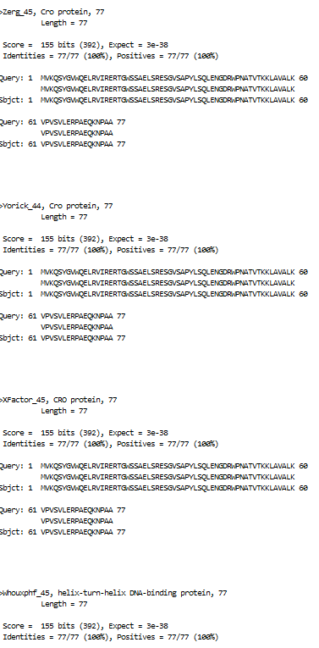
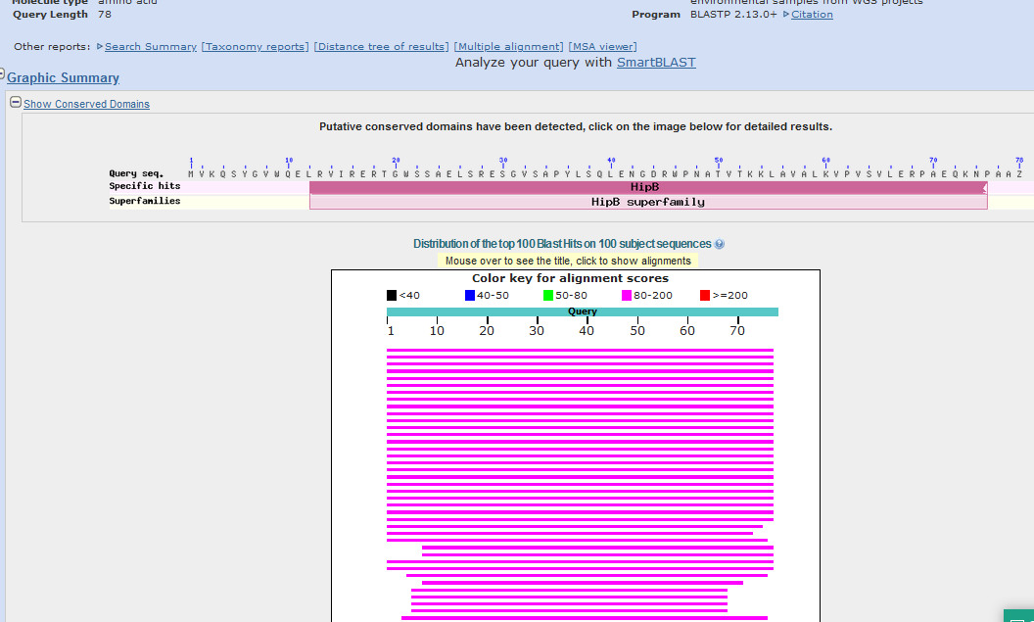
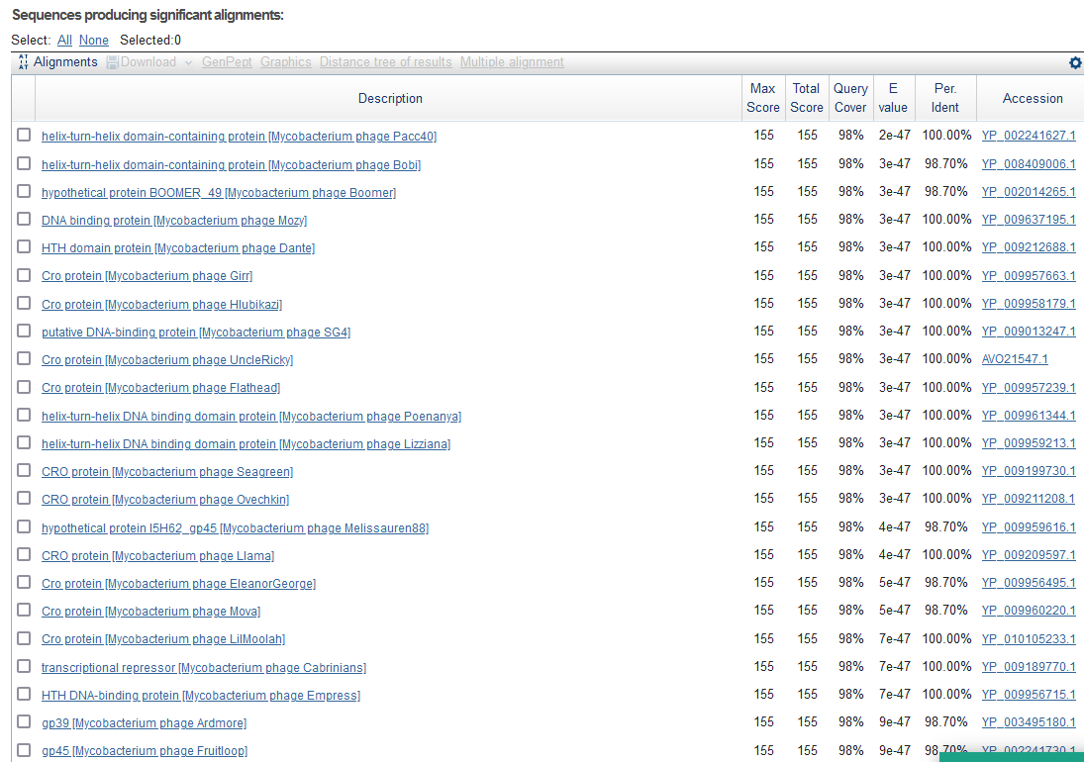

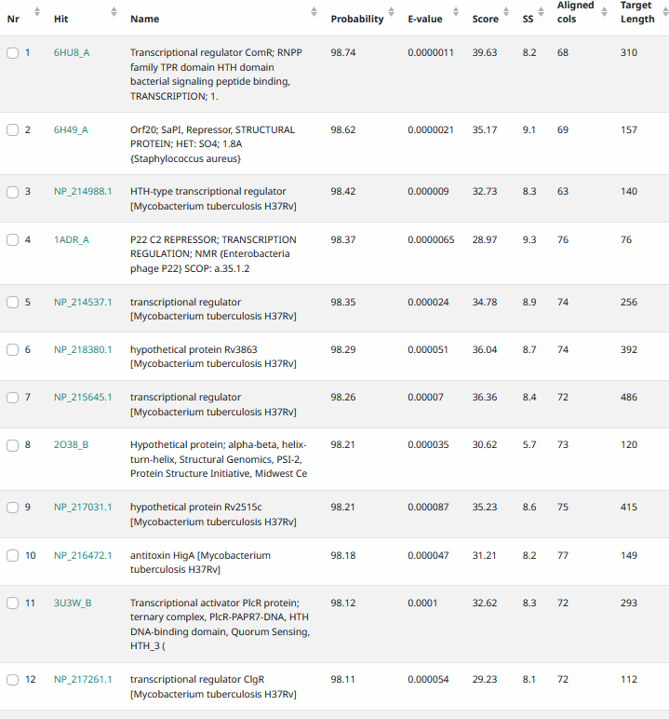
Start Codon and source: 35,429, ATG, changed from glimmer and genemarks, called by genemark on DNA MASter
Stop Codon: 35,662, TAA
F/R: F
Coding Potential (y/n): Y
Starterator (SS, NA, NI): pham 799, changed to most annotated
Blast Best Hit, Query:Subject Starts, Score, Evalue, or “no significant Blast alignments” if 10E-4 or higher
Gap: 67 bp gap between start of reverse gene 46 and forward gene 47
Longest Orf? (Y/N/NA) N
RBS: N/A, Scoring Matirix , Spacing Matrix, Z Score, Final Score,
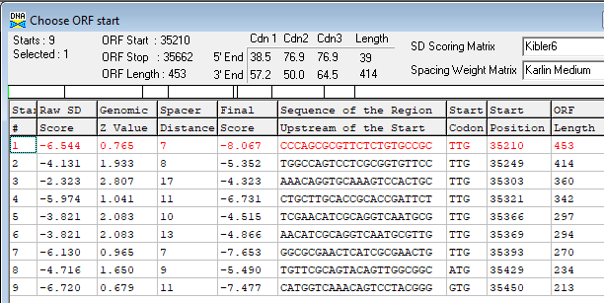
Proposed Function: Cro (control of repressor’s operator)
Function Evidence: Blast,
Transmembrane Domain/Evidence: NO
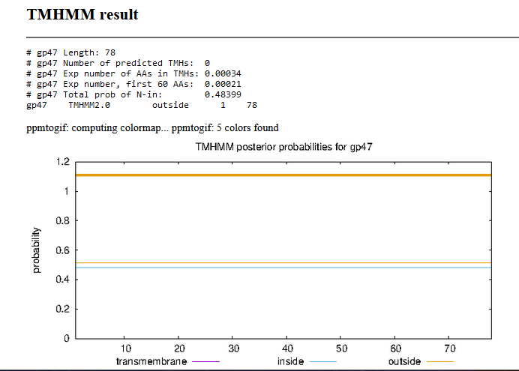

Gene Number: 48 (51 autoannotate, phagesdb53)
9/27/22 Run BlastP at phagesdb and NCBI, Starterator, RBS on Frames, Transmembrane precdition https://services.healthtech.dtu.dk/service.php?TMHMM-2.0, HHPRED, https://toolkit.tuebingen.mpg.de/#/tools/hhpred
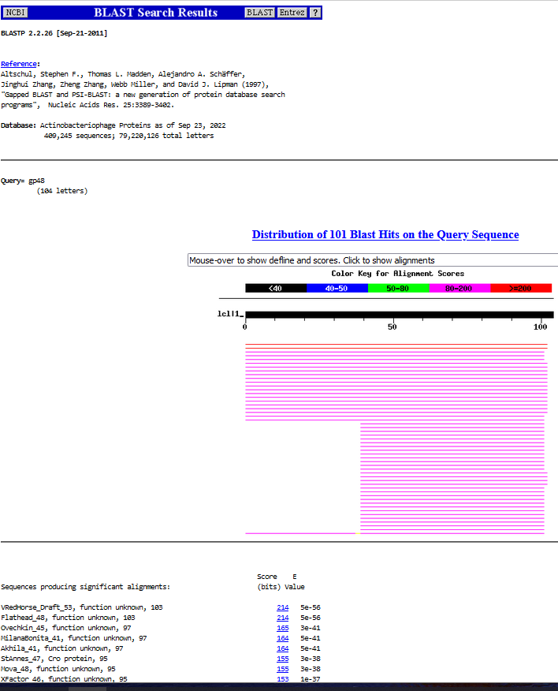
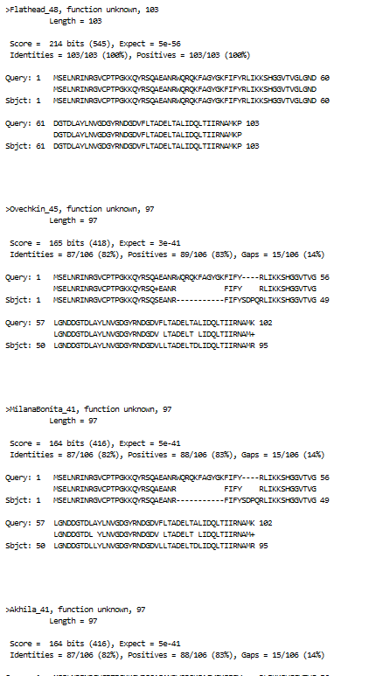
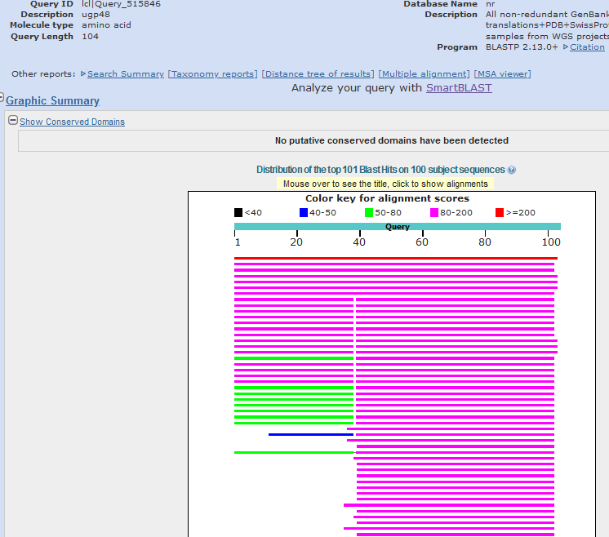
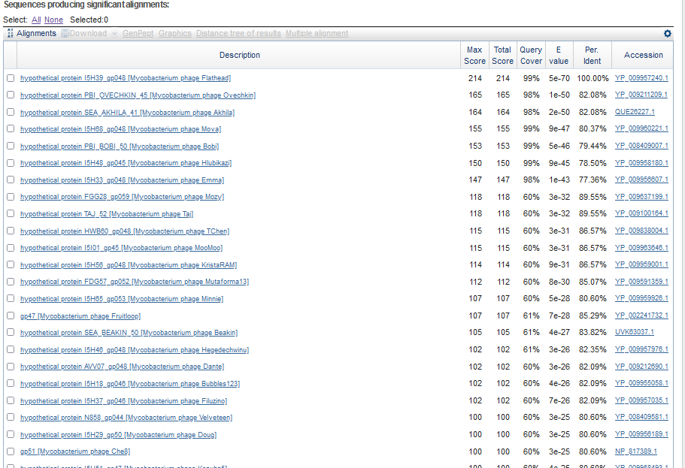
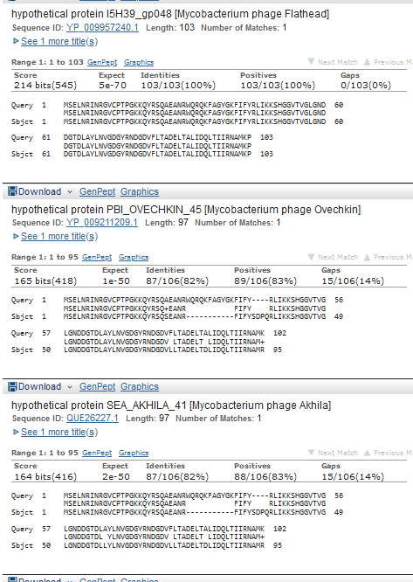

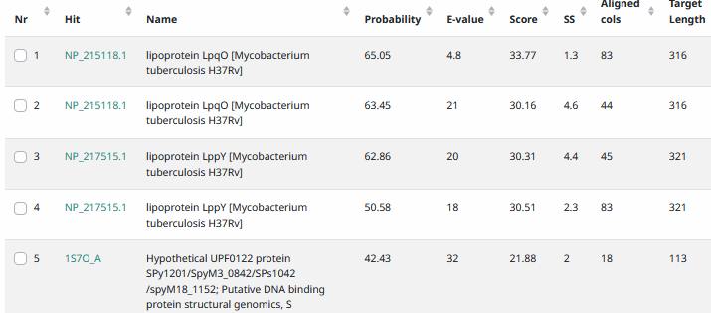
Start Codon and source: 35,719, ATG, Called by genemark and glimmer
Stop Codon: 36,030, TAG
F/R: F
Coding Potential (y/n): Y
Starterator (SS, NA, NI): pham 363, does not have most annotated start
Blast Best Hit, Query:Subject Starts, Score, Evalue, or “no significant Blast alignments” if 10E-4 or higher
Gap: 56 bp gap from end of gene 47
Longest Orf? (Y/N/NA) Y
RBS: N/A, Scoring Matirix , Spacing Matrix, Z Score, Final Score,
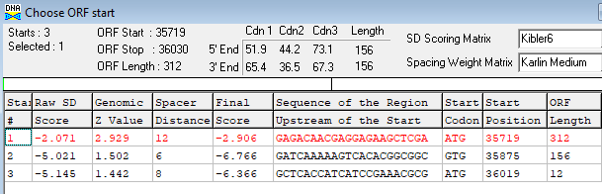
Proposed Function: hypothetical protein
Function Evidence: N/A
Transmembrane Domain/Evidence: NO
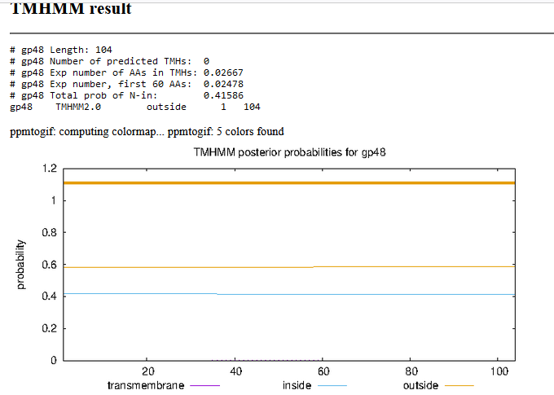

Gene Number: 49 (original 52, phagesdb 54)
9/27/22 Run BlastP at phagesdb and NCBI, Starterator, RBS on Frames, Transmembrane precdition https://services.healthtech.dtu.dk/service.php?TMHMM-2.0, HHPRED, https://toolkit.tuebingen.mpg.de/#/tools/hhpred
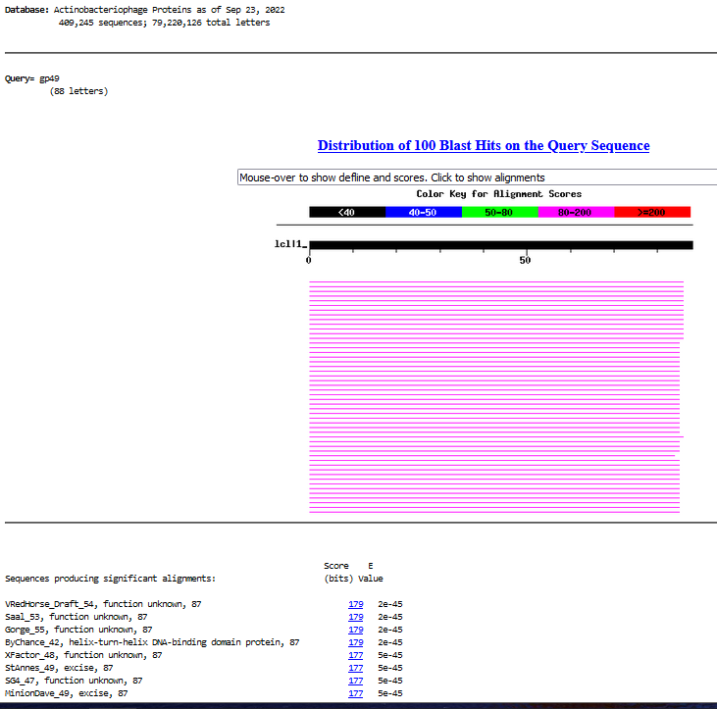
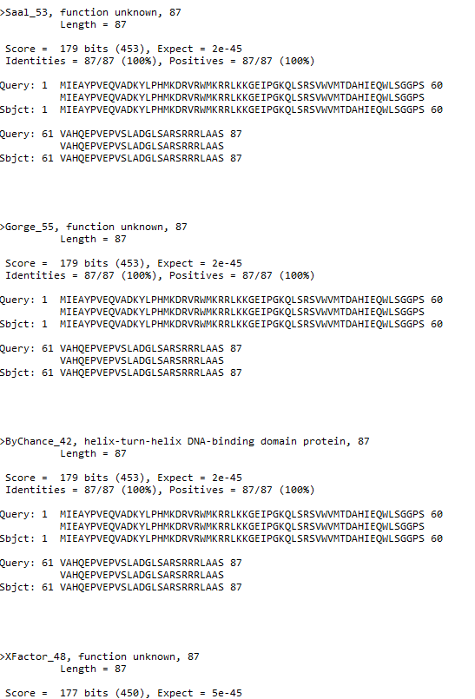
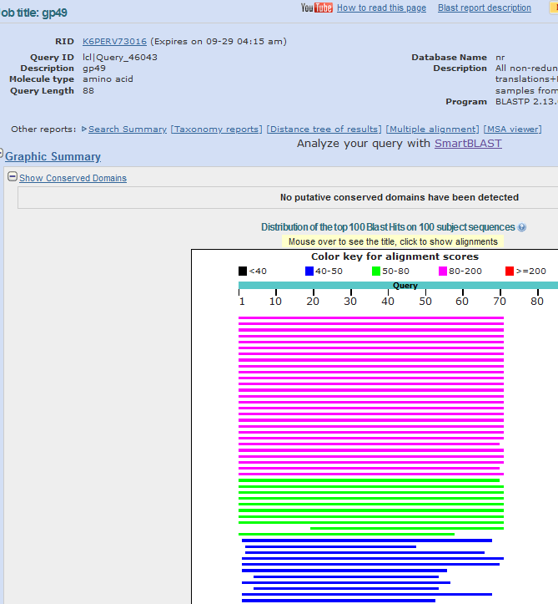
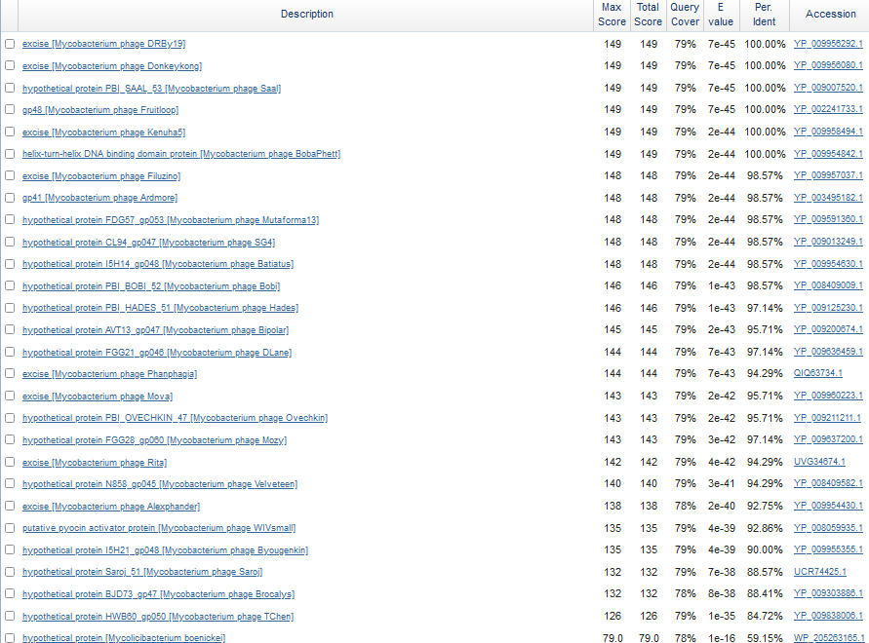
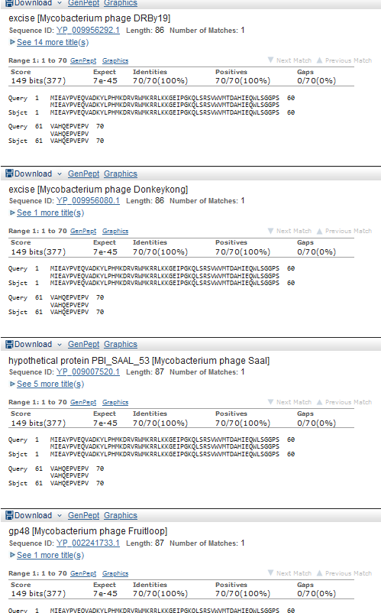
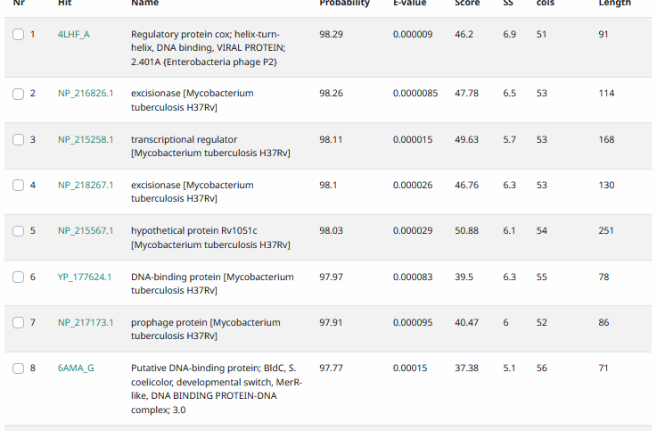
Start Codon and source: 36,119, ATG called by Glimmer and genemark
Stop Codon: 36,382 TGA
F/R: Y
Coding Potential (y/n): Y
Starterator (SS, NA, NI): pham45844, most annotated start
Blast Best Hit, Query:Subject Starts, Score, Evalue, or “no significant Blast alignments” if 10E-4 or higher
Gap: 88 bp gap from end of gene 48
Longest Orf? (Y/N/NA) Y
RBS: N/A, Scoring Matirix , Spacing Matrix, Z Score, Final Score,
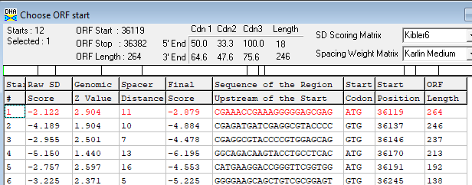
Proposed Function: excise
Function Evidence: HHPRED hits excisionase, phage also has integrase, immunity repressor, and Cro
Transmembrane Domain/Evidence: NO
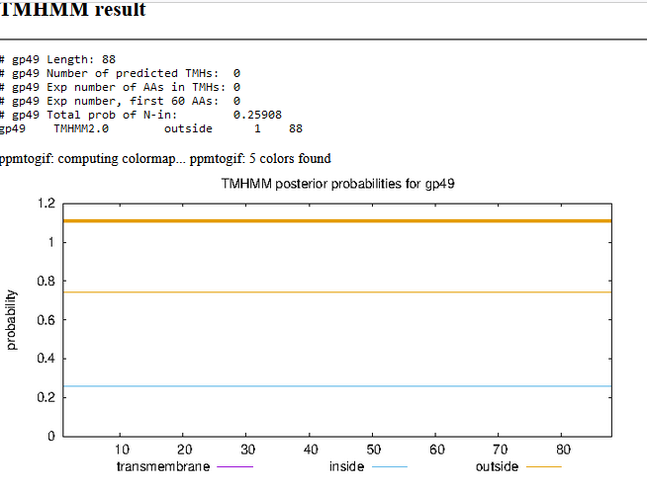

Gene Number: 50 (original 53, phagesdb 55)
9/27/22 Run BlastP at phagesdb and NCBI, Starterator, RBS on Frames, Transmembrane precdition https://services.healthtech.dtu.dk/service.php?TMHMM-2.0, HHPRED, https://toolkit.tuebingen.mpg.de/#/tools/hhpred
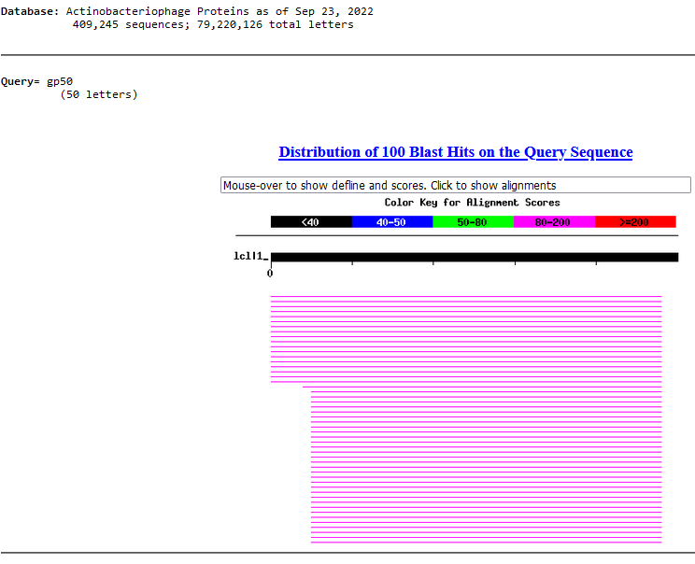
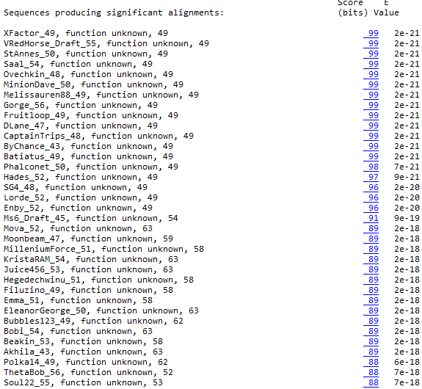
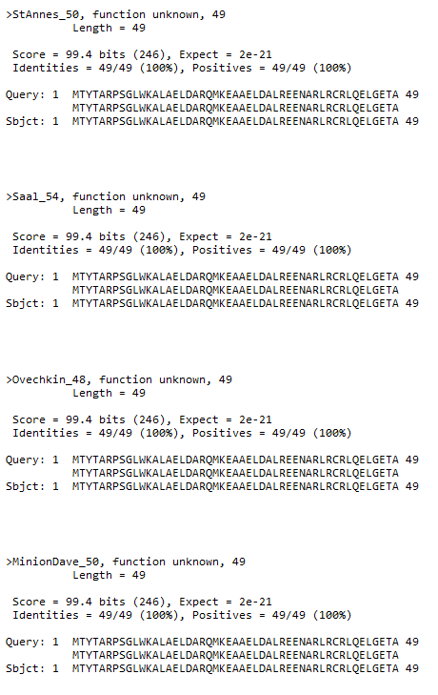
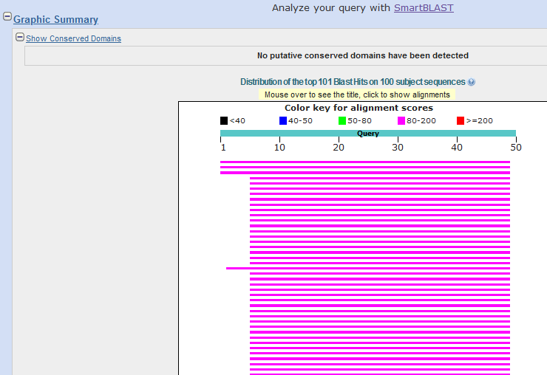
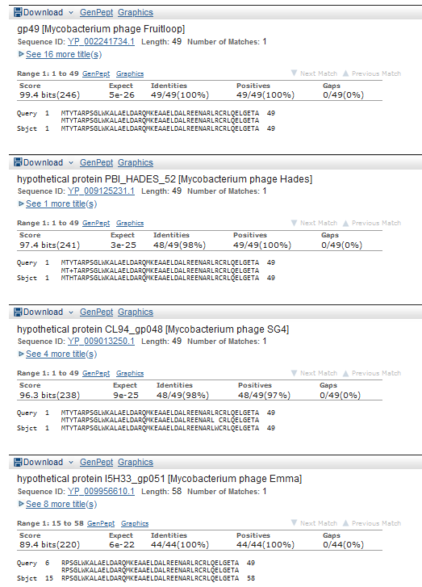
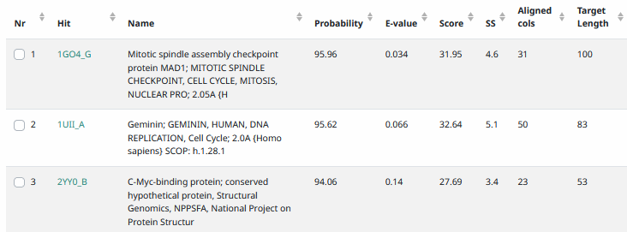
Start Codon and source: 36,379, ATG
Stop Codon: 36,528, TGA
F/R: F
Coding Potential (y/n):Y
Starterator (SS, NA, NI): pham 49,178, most annotated start
Blast Best Hit, Query:Subject Starts, Score, Evalue, or “no significant Blast alignments” if 10E-4 or higher
Gap: -4bp overlap with gene 49
Longest Orf? (Y/N/NA) Y
RBS: N/A, Scoring Matirix , Spacing Matrix, Z Score, Final Score,
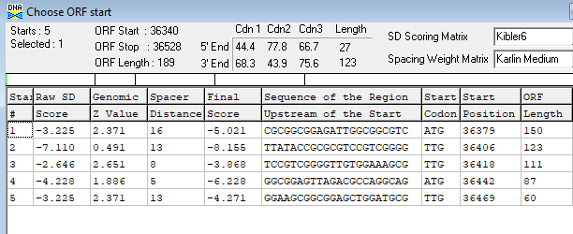
Proposed Function: hypothetical protein
Function Evidence: none prokaryotic
Transmembrane Domain/Evidence: NO
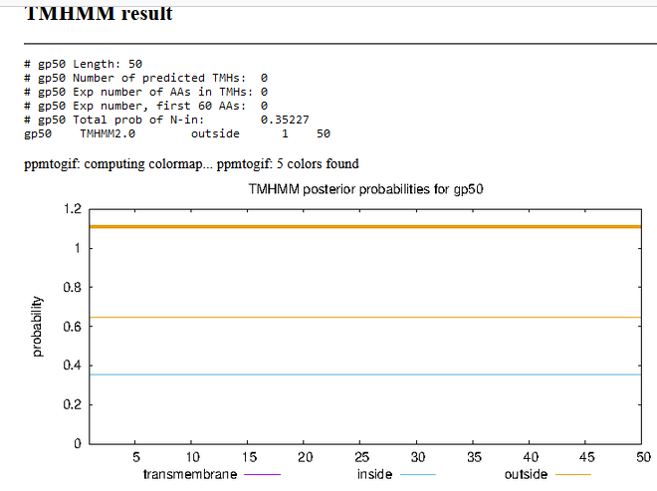

Gene Number: 51 (original 54, phagesdb 56) change start to 36,525
9/27/22 Run BlastP at phagesdb and NCBI, Starterator, RBS on Frames, Transmembrane precdition https://services.healthtech.dtu.dk/service.php?TMHMM-2.0, HHPRED, https://toolkit.tuebingen.mpg.de/#/tools/hhpred
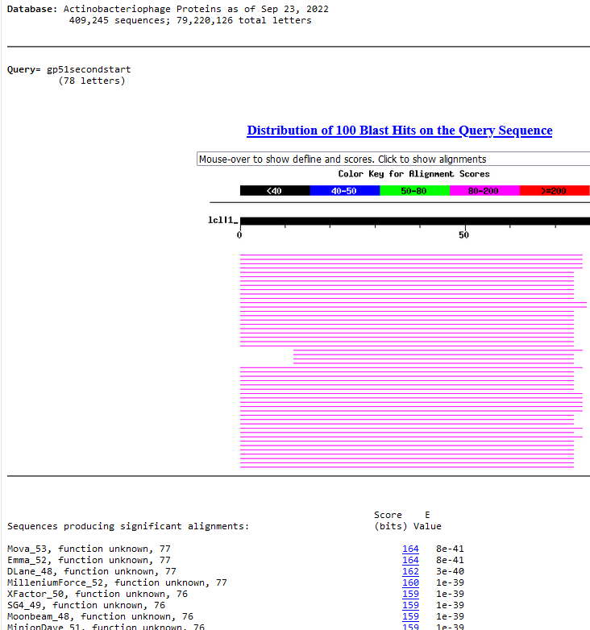
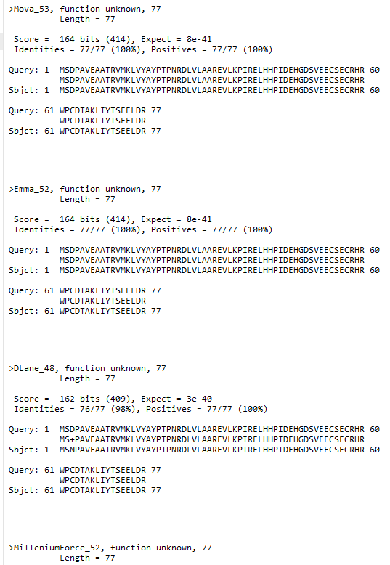
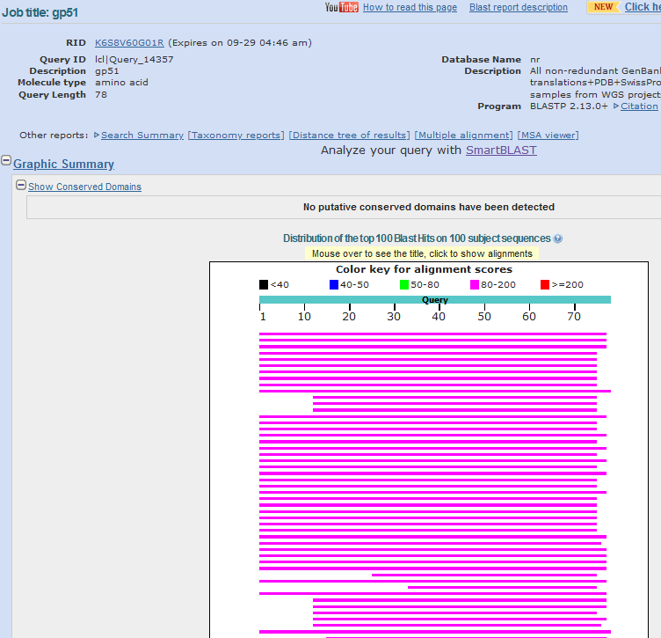
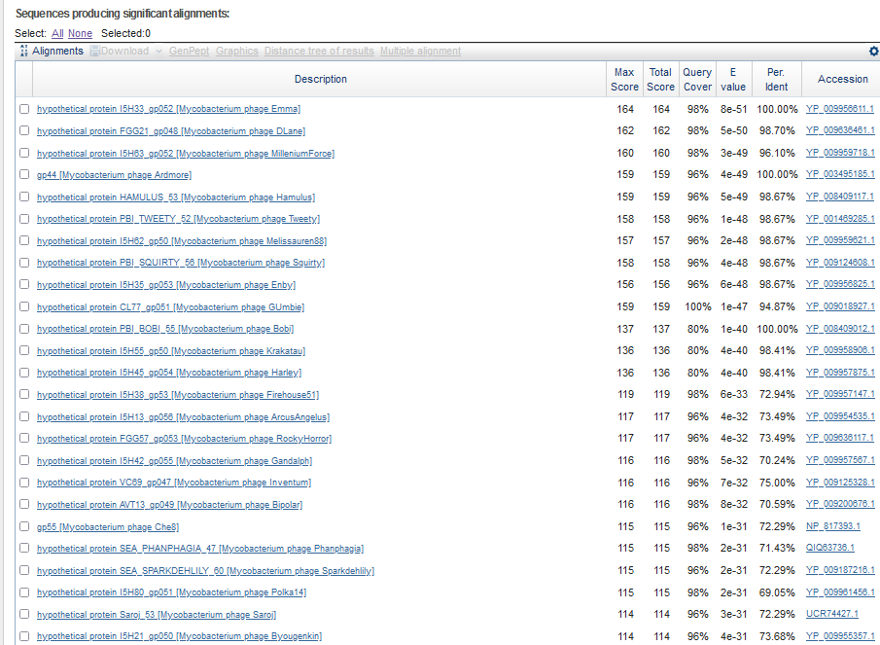
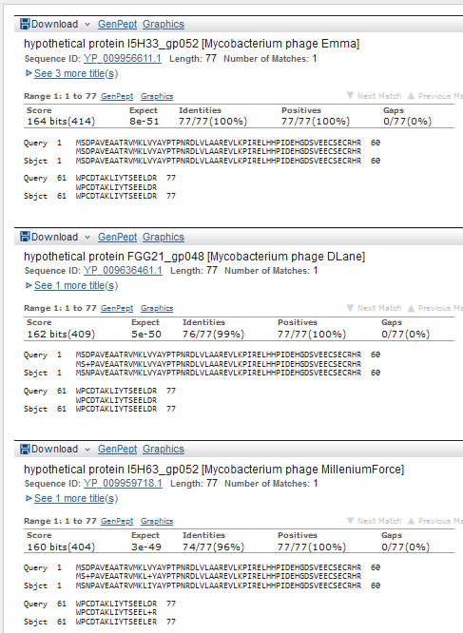
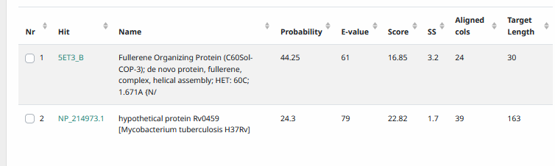
Start Codon and source: 36,525, GTG
Stop Codon: 36,758, TGA
F/R: F
Coding Potential (y/n): Y
Starterator (SS, NA, NI): pham 48655, changed to most annotated start
Blast Best Hit, Query:Subject Starts, Score, Evalue, or “no significant Blast alignments” if 10E-4 or higher
Gap: -4 bp overlap with gene 50
Longest Orf? (Y/N/NA) N
RBS: N/A, Scoring Matirix , Spacing Matrix, Z Score, Final Score,
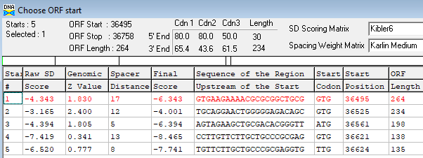
Proposed Function: hypothetical protein
Function Evidence: none
Transmembrane Domain/Evidence: NO
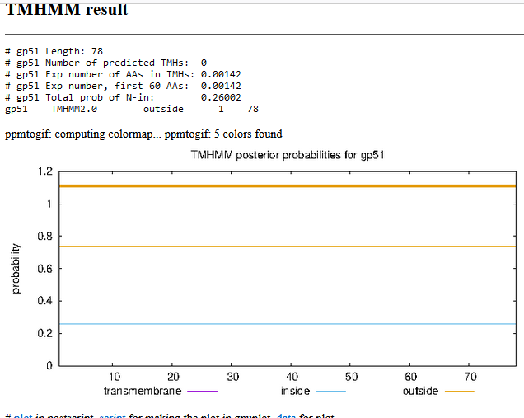

Gene Number: 52 (original 55, phagesdb 57)
9/27/22 Run BlastP at phagesdb and NCBI, Starterator, RBS on Frames, Transmembrane precdition https://services.healthtech.dtu.dk/service.php?TMHMM-2.0, HHPRED, https://toolkit.tuebingen.mpg.de/#/tools/hhpred
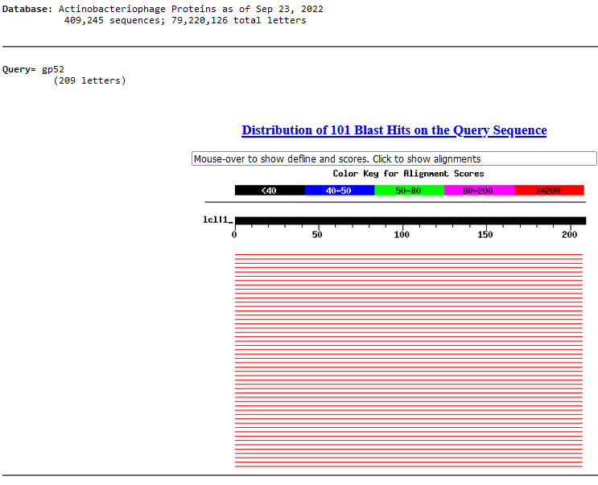
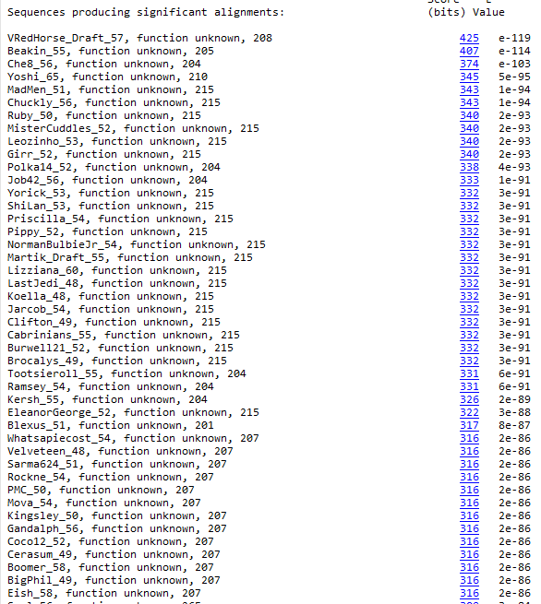
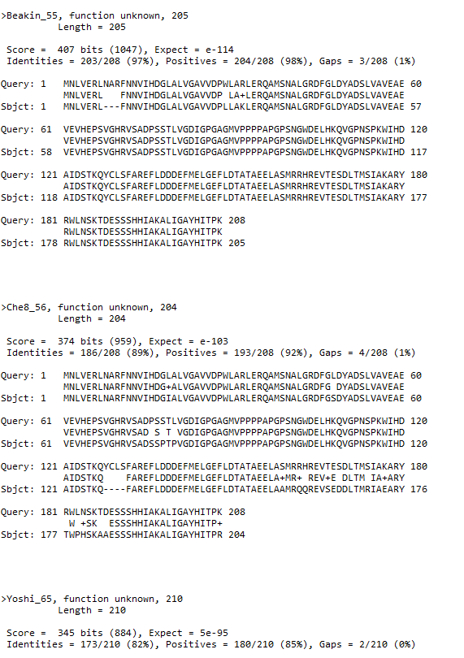
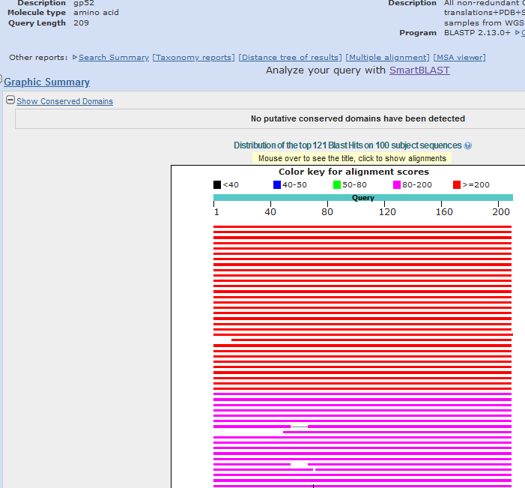
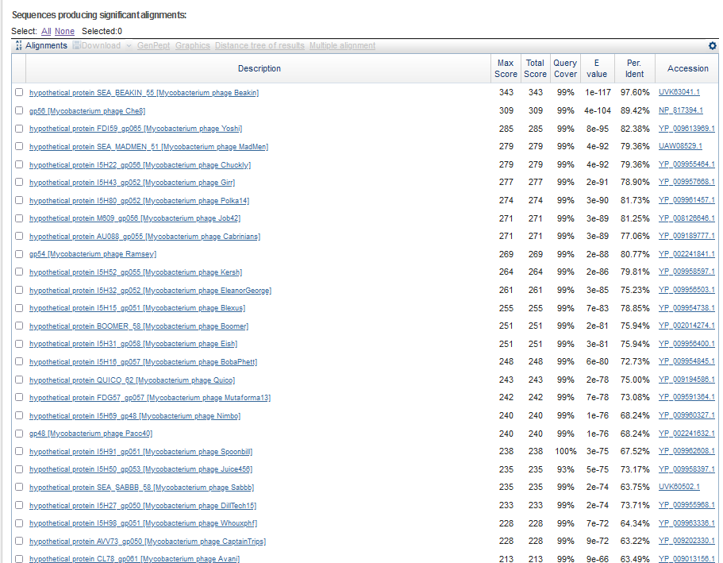
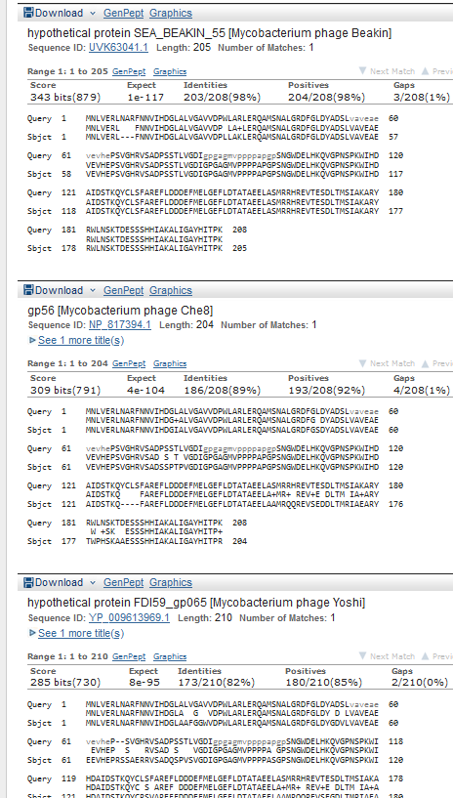
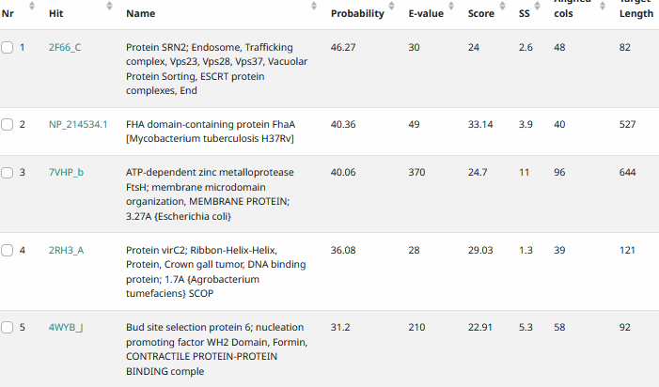
Start Codon and source: 36,755, GTG (called by Glimmer and GenemarkS, not DNA MASTER genemark)
Stop Codon: 37,381, TAG
F/R: F
Coding Potential (y/n): Y
Starterator (SS, NA, NI): pham 45725, most annotated start
Blast Best Hit, Query:Subject Starts, Score, Evalue, or “no significant Blast alignments” if 10E-4 or higher
Gap: -4bp overlap with gene 51
Longest Orf? (Y/N/NA) Y
RBS: N/A, Scoring Matirix , Spacing Matrix, Z Score, Final Score,
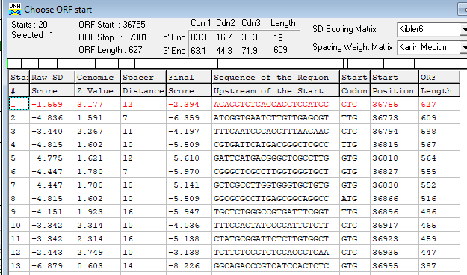
Proposed Function: hypothetical protein
Function Evidence: none
Transmembrane Domain/Evidence: NO
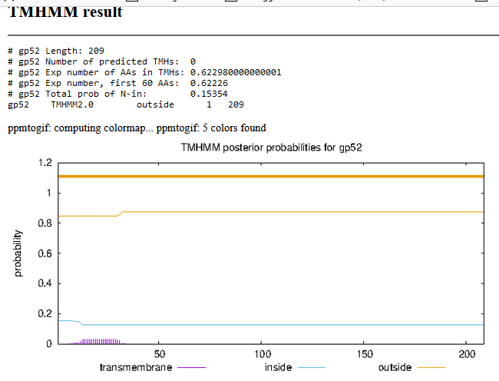

Gene Number: 53 (original 56, phagesdb58)
9/27/22 Run BlastP at phagesdb and NCBI, Starterator, RBS on Frames, Transmembrane precdition https://services.healthtech.dtu.dk/service.php?TMHMM-2.0, HHPRED, https://toolkit.tuebingen.mpg.de/#/tools/hhpred
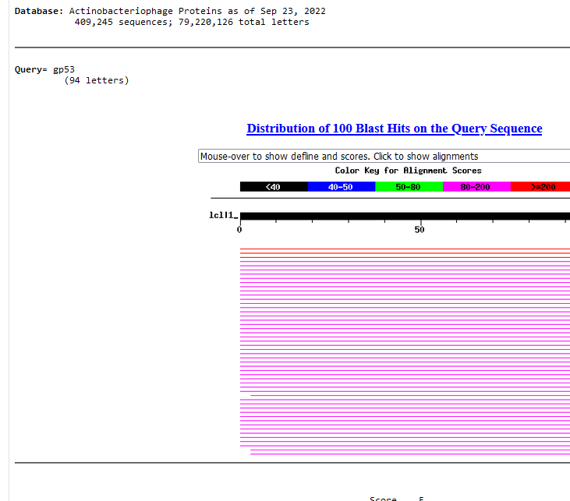
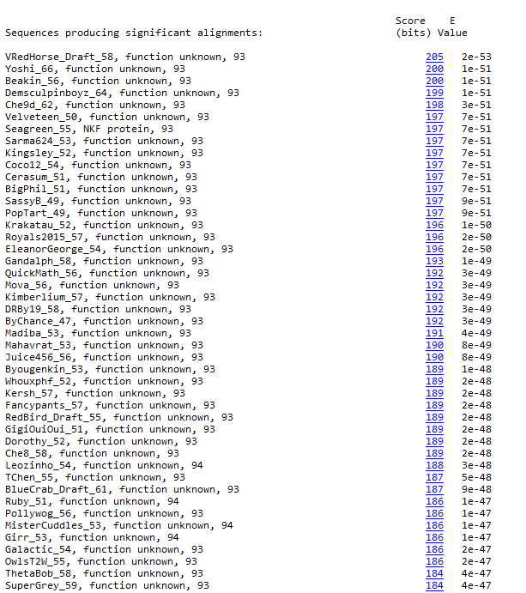
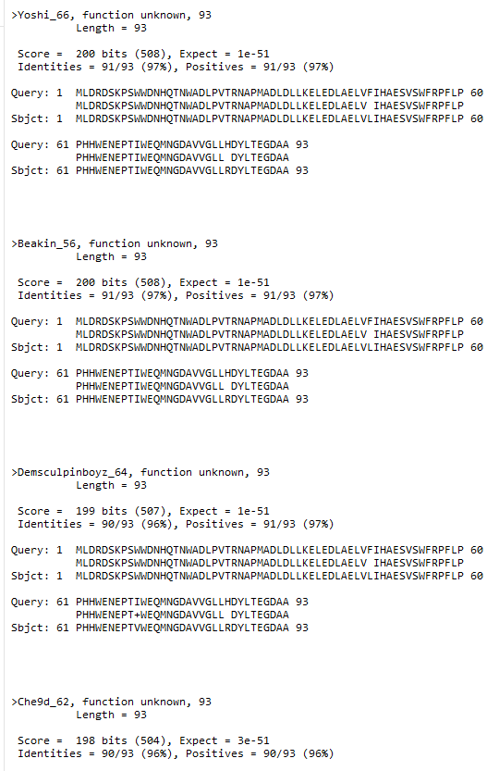
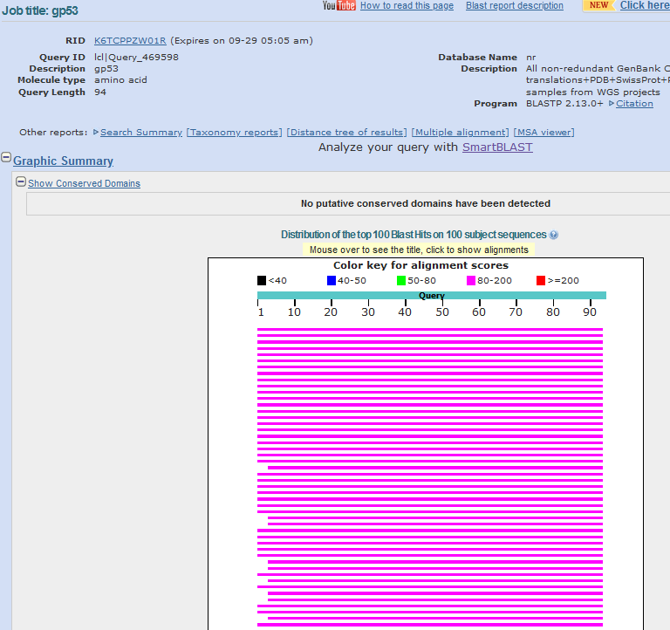
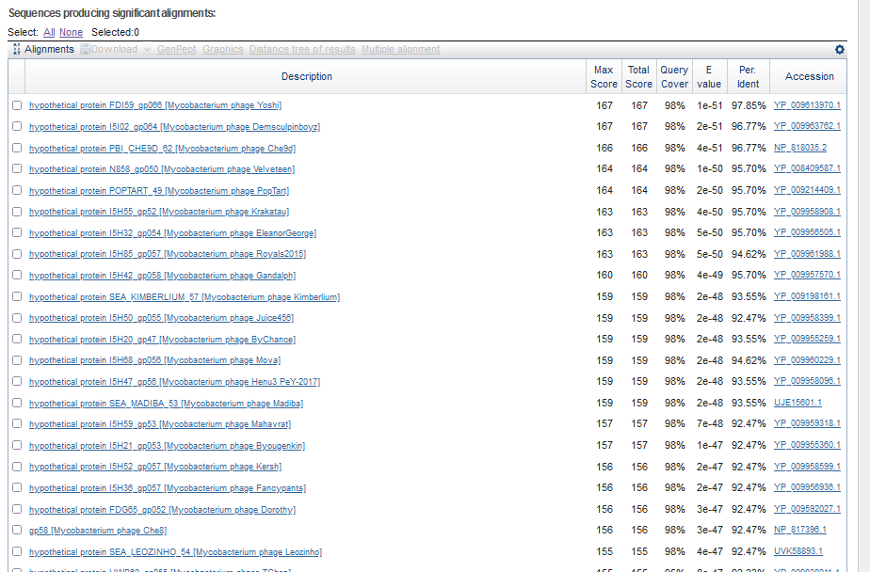
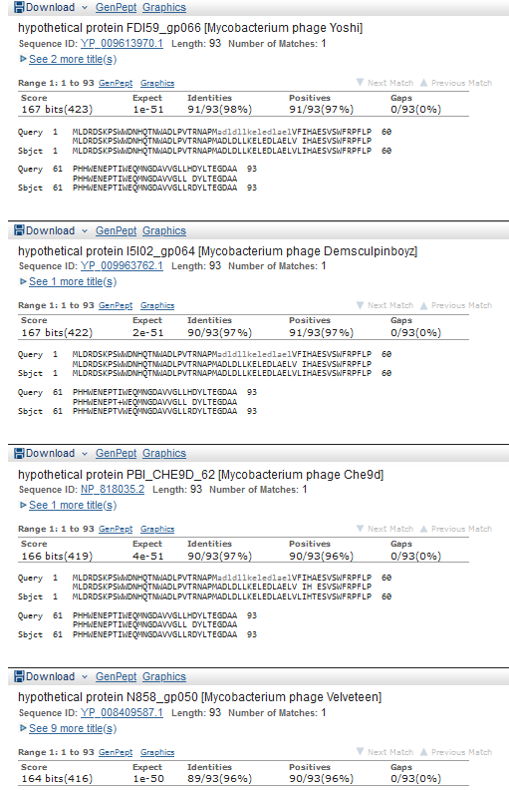
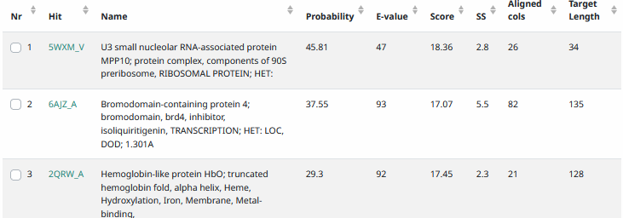
Start Codon and source: 37,460, ATG, called by genemark and glimmer
Stop Codon: 37,741 TGA
F/R: F
Coding Potential (y/n): Y
Starterator (SS, NA, NI): pham 317, most annotated start
Blast Best Hit, Query:Subject Starts, Score, Evalue, or “no significant Blast alignments” if 10E-4 or higher
Gap: 78 bp gap from gene 52
Longest Orf? (Y/N/NA) Y
RBS: N/A, Scoring Matirix , Spacing Matrix, Z Score, Final Score,
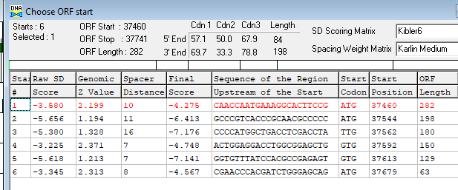
Proposed Function: hypothetical protein
Function Evidence: none
Transmembrane Domain/Evidence: NO
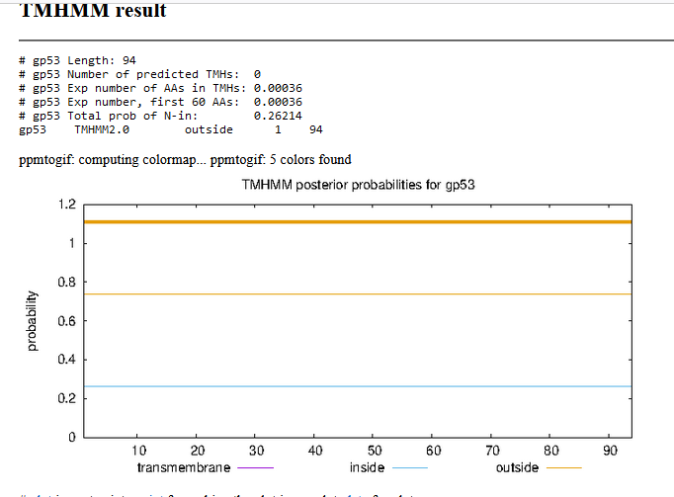

Gene Number: 54 (original 57, phagesdb59)
9/27/22 Run BlastP at phagesdb and NCBI, Starterator, RBS on Frames, Transmembrane precdition https://services.healthtech.dtu.dk/service.php?TMHMM-2.0, HHPRED, https://toolkit.tuebingen.mpg.de/#/tools/hhpred
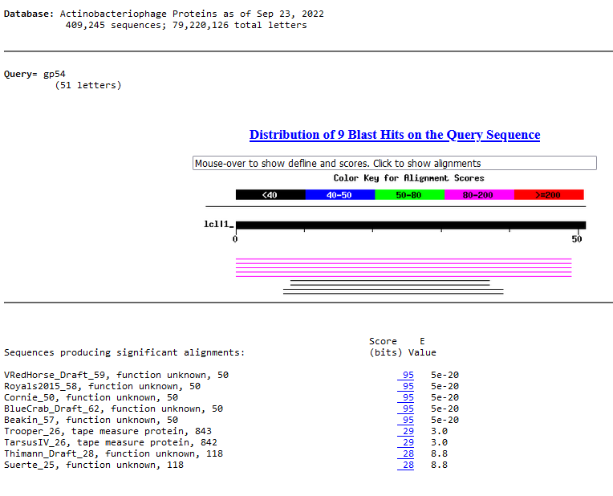
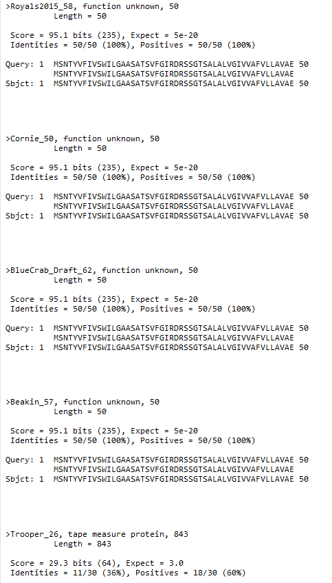
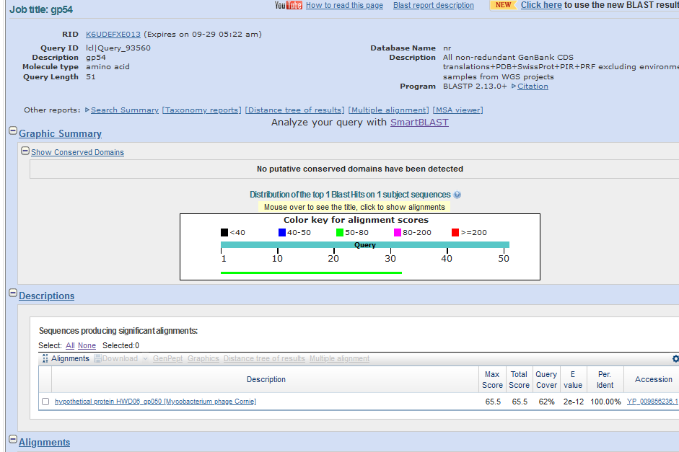
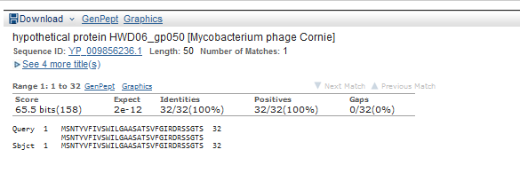
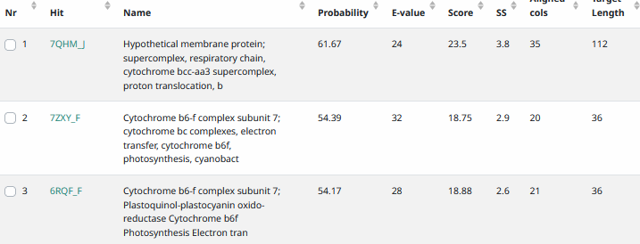
Start Codon and source: 37,738, ATG, called by glimmer and genemark
Stop Codon: 37,890, TGA
F/R: F
Coding Potential (y/n): y
Starterator (SS, NA, NI): pham 9807, most annotated
Blast Best Hit, Query:Subject Starts, Score, Evalue, or “no significant Blast alignments” if 10E-4 or higher
Gap: -4bp overlap with gene 53
Longest Orf? (Y/N/NA) N
RBS: N/A, Scoring Matirix , Spacing Matrix, Z Score, Final Score,
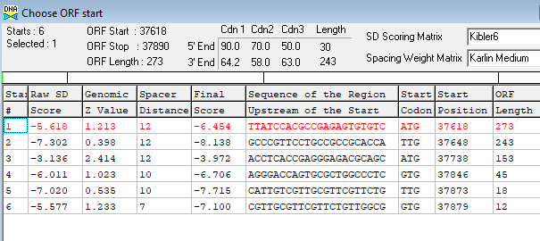
Proposed Function: membrane protein
Function Evidence: see below
Transmembrane Domain/Evidence: yes
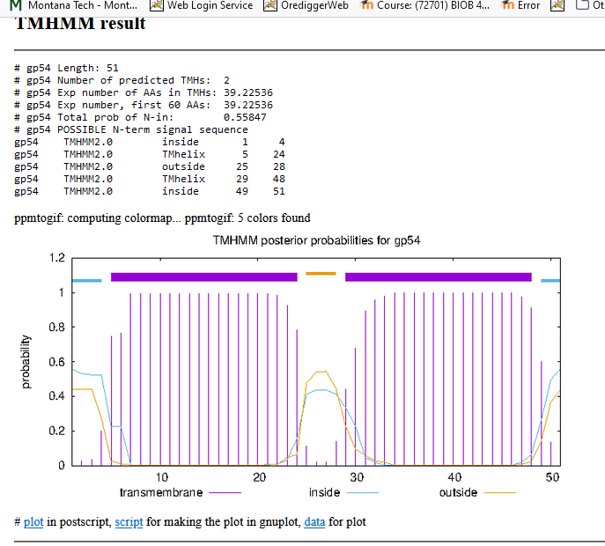
10/06/22 rerun on sosui, https://harrier.nagahama-i-bio.ac.jp/sosui/mobile/
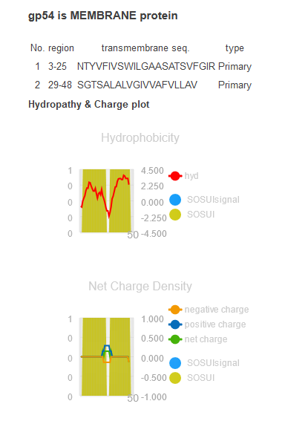
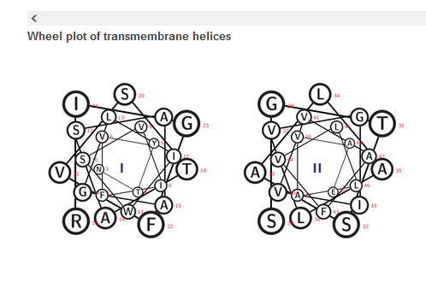

Region with coding potential between genes 54 an 55. Blastp, but no good hits
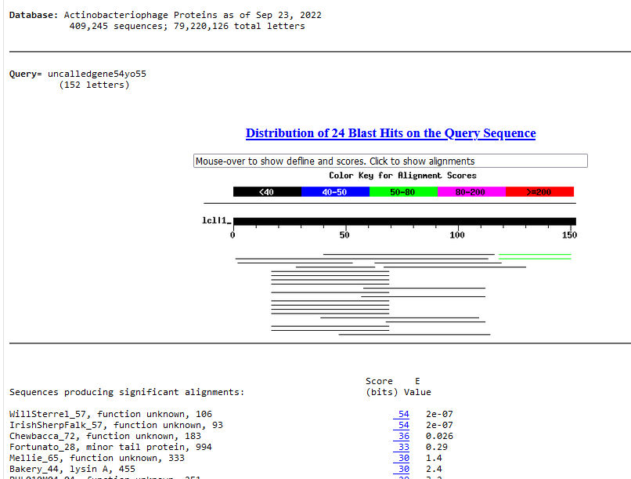

Gene Number: 55 (original 58, phagesdb 60)
9/27/22 Run BlastP at phagesdb and NCBI, Starterator, RBS on Frames, Transmembrane precdition https://services.healthtech.dtu.dk/service.php?TMHMM-2.0, HHPRED, https://toolkit.tuebingen.mpg.de/#/tools/hhpred
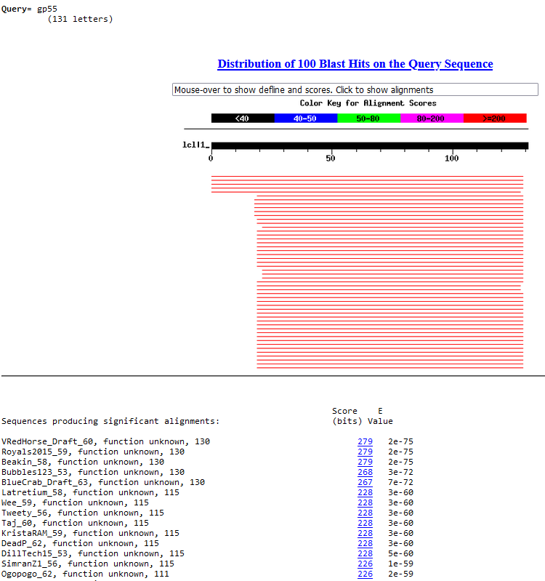
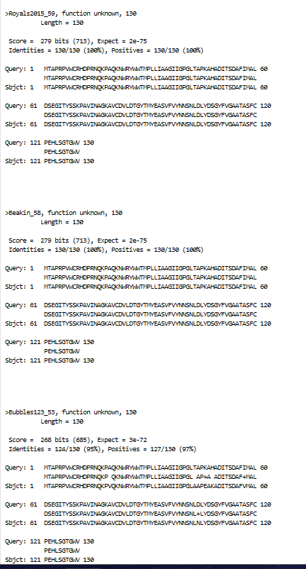
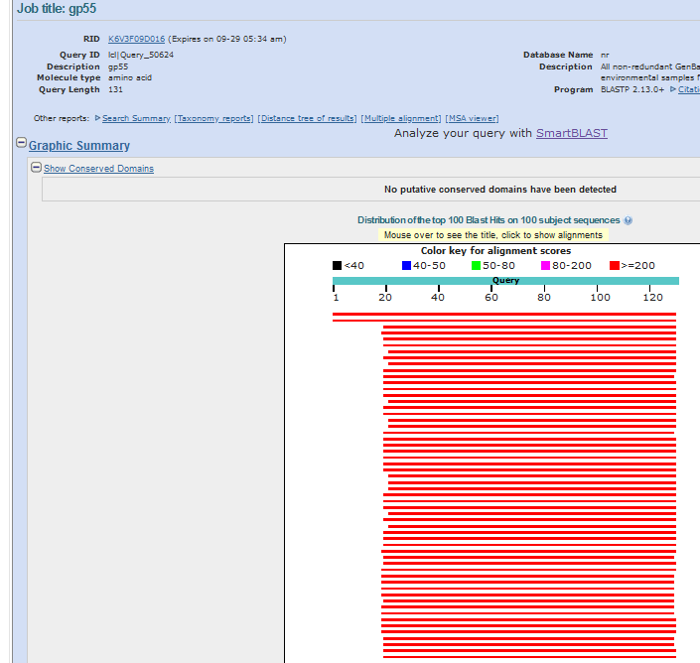
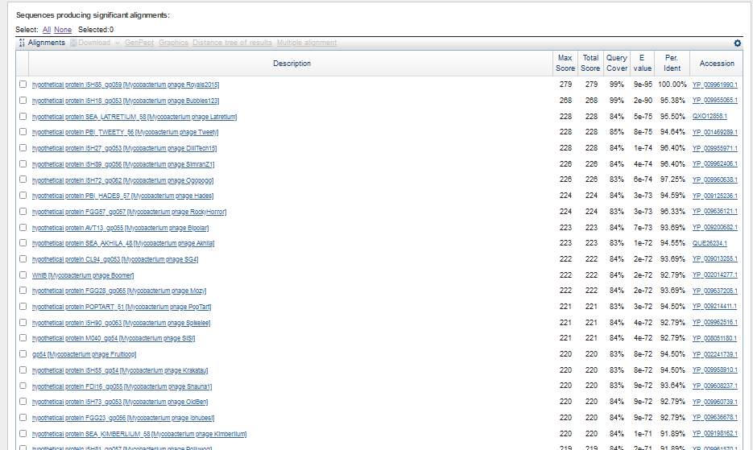
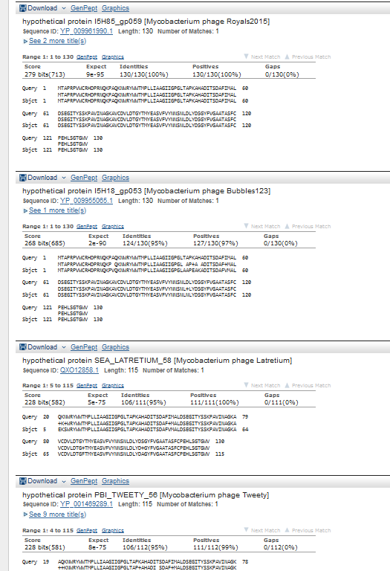

Start Codon and source: 37,887, GTG, called by glimmer and genemarkS
Stop Codon: 38,279, TGA
F/R: F
Coding Potential (y/n): Y
Starterator (SS, NA, NI): pham 48671, does not have most annotated start
Blast Best Hit, Query:Subject Starts, Score, Evalue, or “no significant Blast alignments” if 10E-4 or higher
Gap: -4bp overlap with gene 54
Longest Orf? (Y/N/NA) Y
RBS: N/A, Scoring Matirix , Spacing Matrix, Z Score, Final Score,
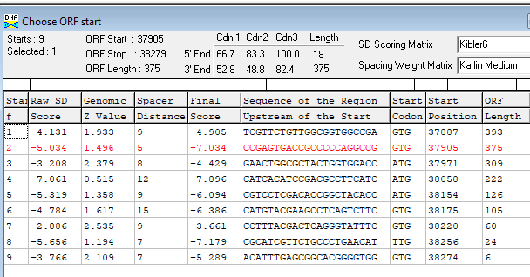
Proposed Function: membrane protein
Function Evidence: see below
Transmembrane Domain/Evidence: YES
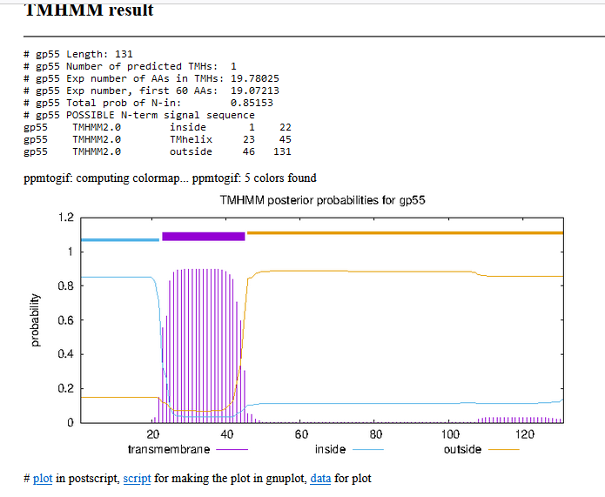
10/06/22, rerun on SOSUI, https://harrier.nagahama-i-bio.ac.jp/sosui/mobile/
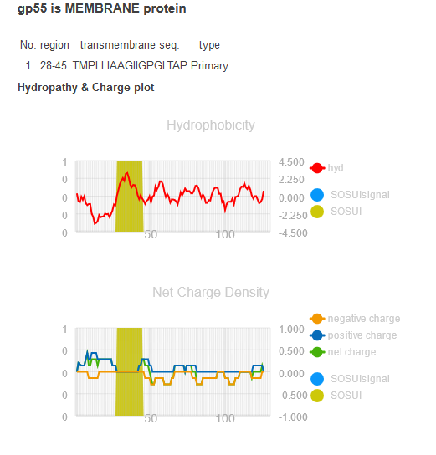
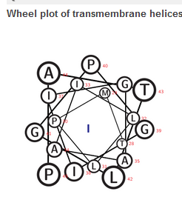

Gene Number: 56 (original 59, phagesdb 61)
9/28/22 Run BlastP at phagesdb and NCBI, Starterator, RBS on Frames, Transmembrane precdition https://services.healthtech.dtu.dk/service.php?TMHMM-2.0, HHPRED, https://toolkit.tuebingen.mpg.de/#/tools/hhpred
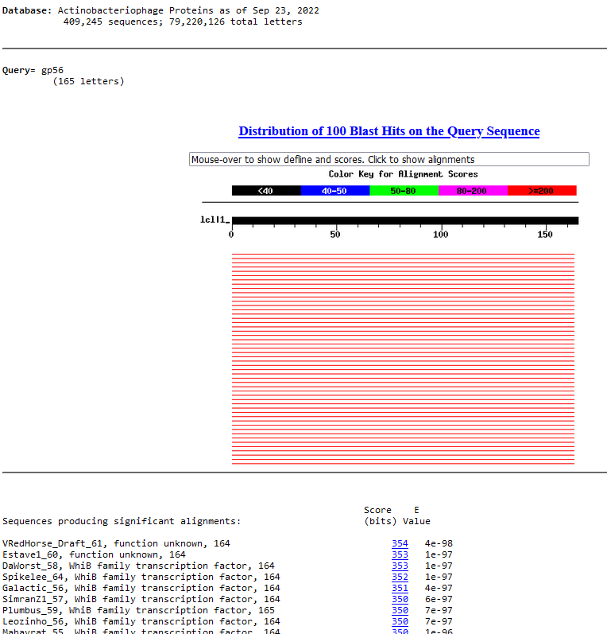
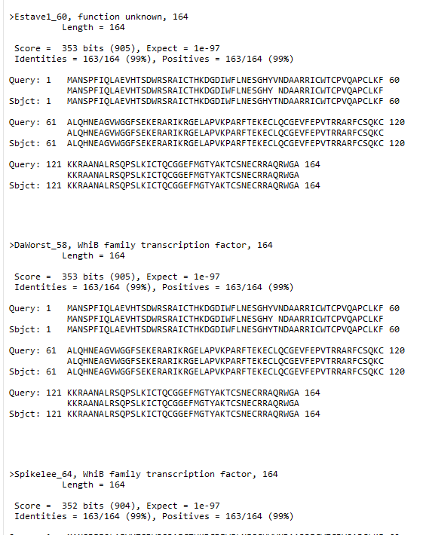
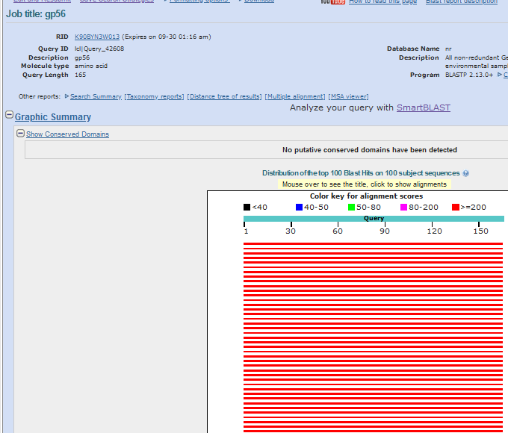
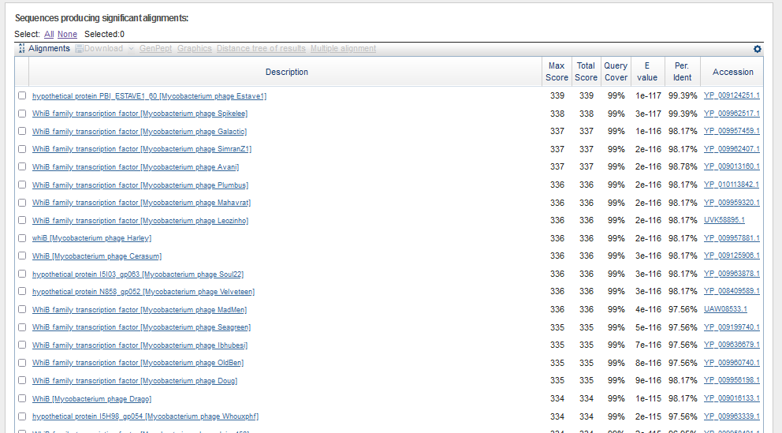
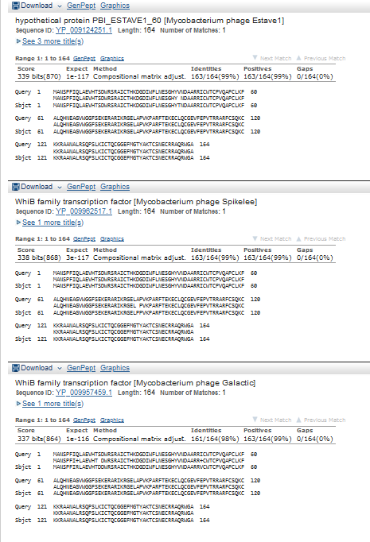
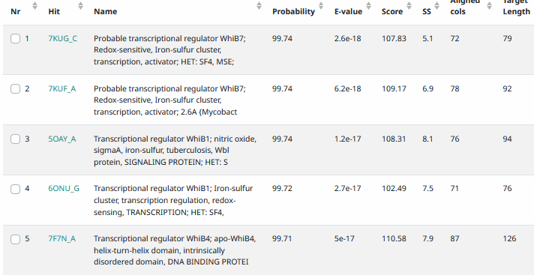
Start Codon and source: 38,279.ATG, called by Glimmer and Genemark, …but there are two?? Earlier??
Stop Codon: 38,773, TGA
F/R: F
Coding Potential (y/n): Y
Starterator (SS, NA, NI): pham40845, most annotated start, but there are two close-by upstream starts
Blast Best Hit, Query:Subject Starts, Score, Evalue, or “no significant Blast alignments” if 10E-4 or higher
Gap: 0 bp gap from gene 55
Longest Orf? (Y/N/NA) N
RBS: N/A, Scoring Matirix , Spacing Matrix, Z Score, Final Score,
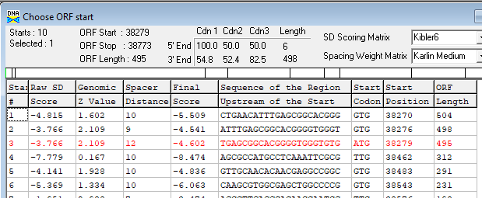
Proposed Function: WhiB family transcription factor
Function Evidence: HHPRED
Transmembrane Domain/Evidence: NO
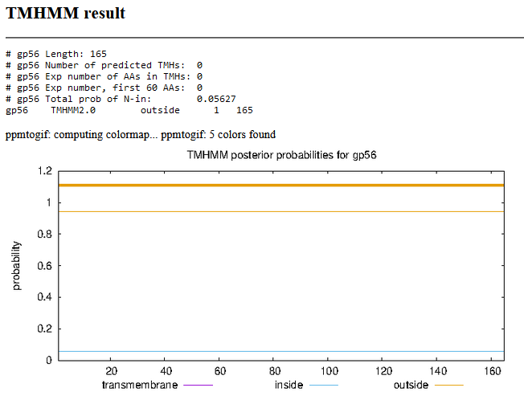

Gene Number: 57 (original 60, phagesdb 62) changed start to 38,770,
9/28/22 Run BlastP at phagesdb and NCBI, Starterator, RBS on Frames, Transmembrane precdition https://services.healthtech.dtu.dk/service.php?TMHMM-2.0, HHPRED, https://toolkit.tuebingen.mpg.de/#/tools/hhpred
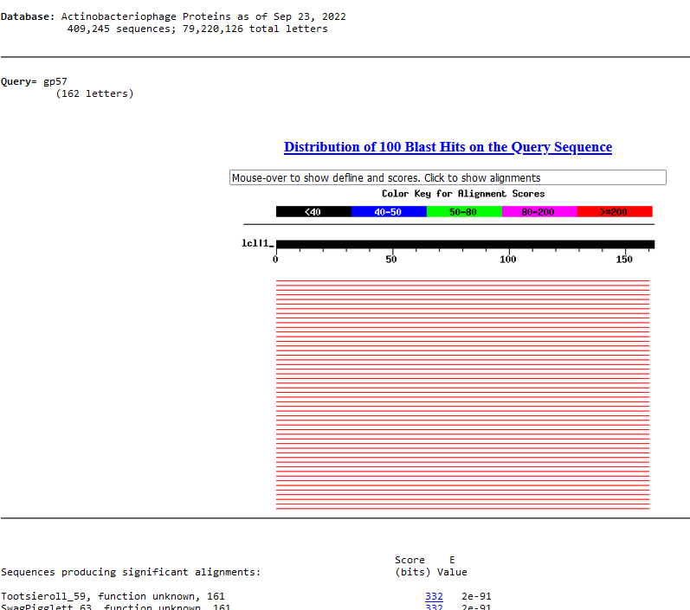
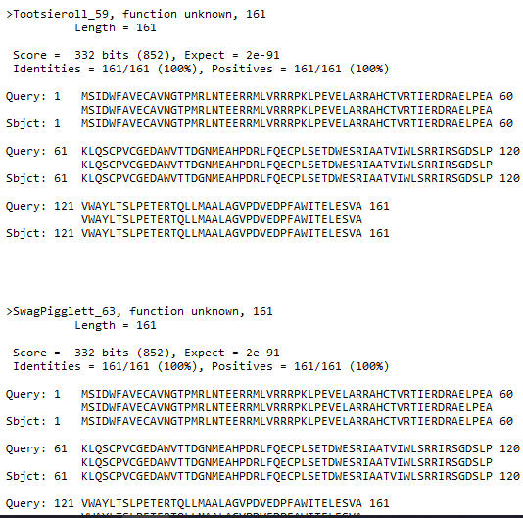
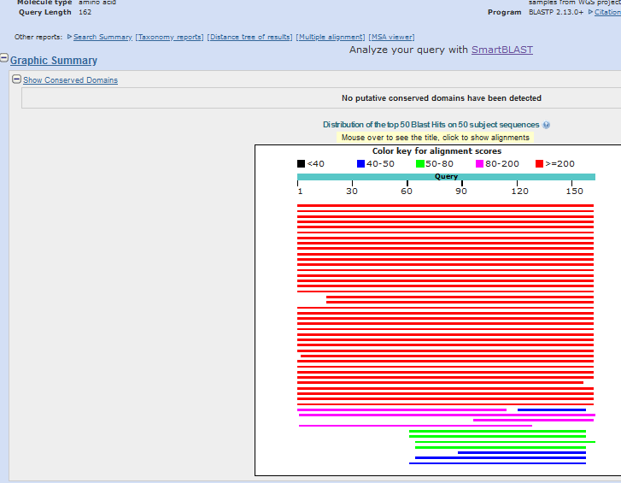
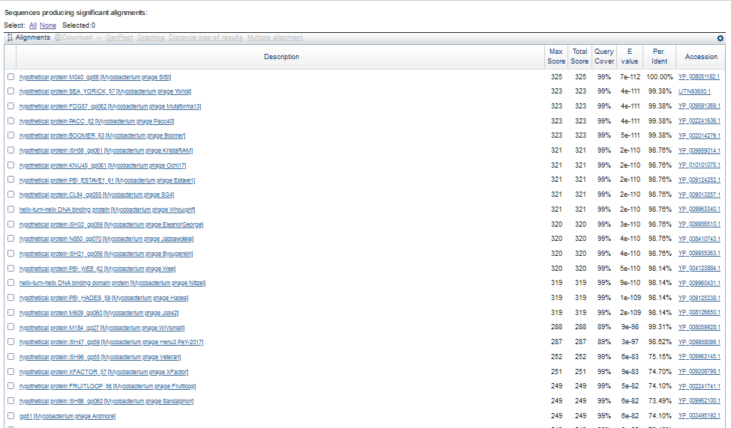
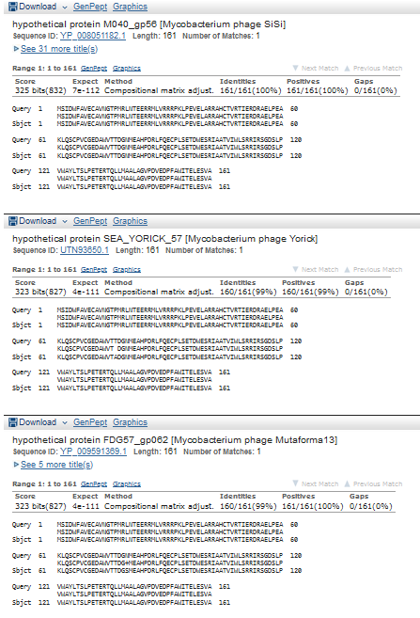
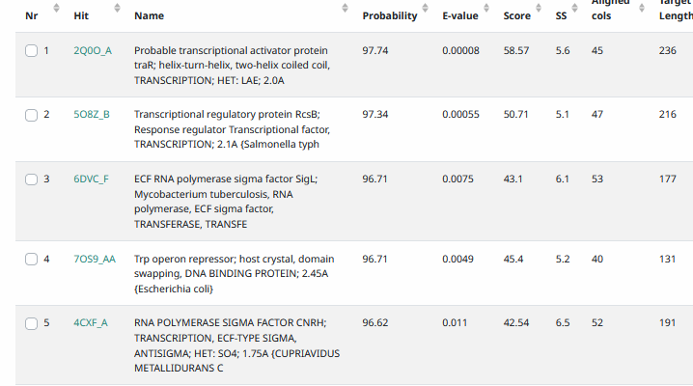
Start Codon and source: 38,770, GTG, changed from both glimmer and genemark (Original Glimmer call @bp 38845 has strength 3.85; GeneMark calls start at 38761)
Stop Codon: 39,255, TGA
F/R: F
Coding Potential (y/n): misses some at very 5’end
Starterator (SS, NA, NI): pham399, changed to most annotated start
Blast Best Hit, Query:Subject Starts, Score, Evalue, or “no significant Blast alignments” if 10E-4 or higher
Gap: -4bp overlap with gene 56
Longest Orf? (Y/N/NA) N
RBS: N/A, Scoring Matirix , Spacing Matrix, Z Score, Final Score,
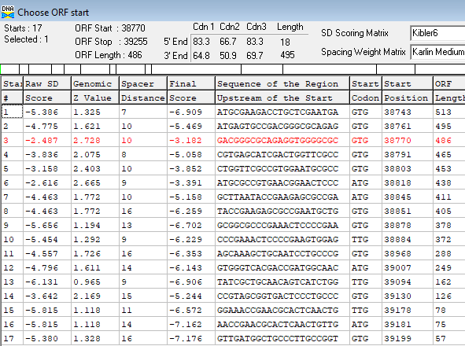
Proposed Function: helix-turn-helix DNA binding domain
Function Evidence: HHPRED
Transmembrane Domain/Evidence: NO
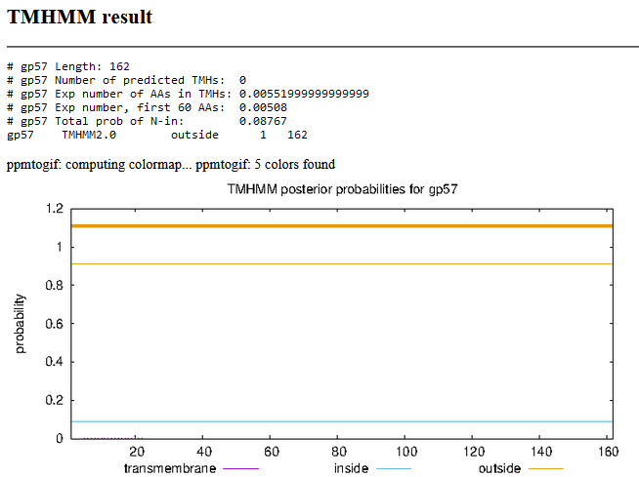

Gene Number: 58 (original 61, phages draft 63)
9/28/22 Run BlastP at phagesdb and NCBI, Starterator, RBS on Frames, Transmembrane precdition https://services.healthtech.dtu.dk/service.php?TMHMM-2.0, HHPRED, https://toolkit.tuebingen.mpg.de/#/tools/hhpred

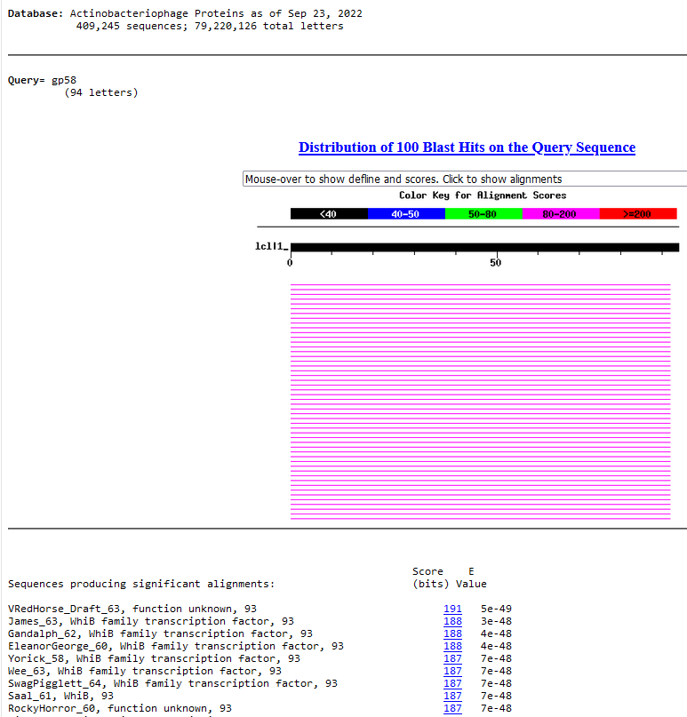
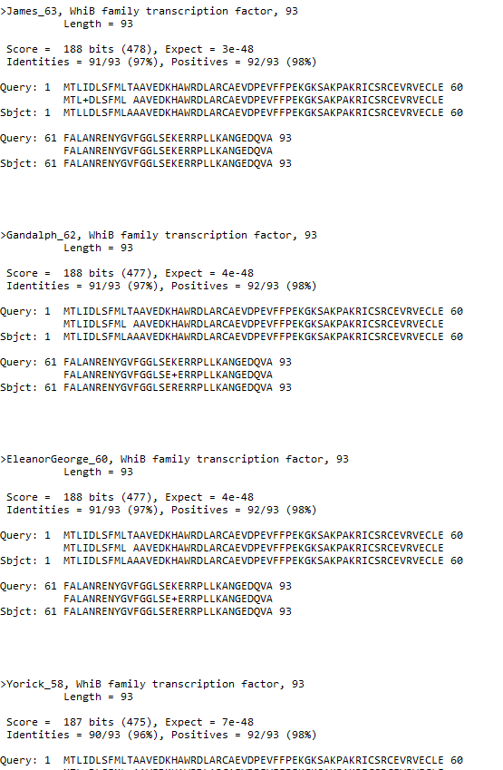
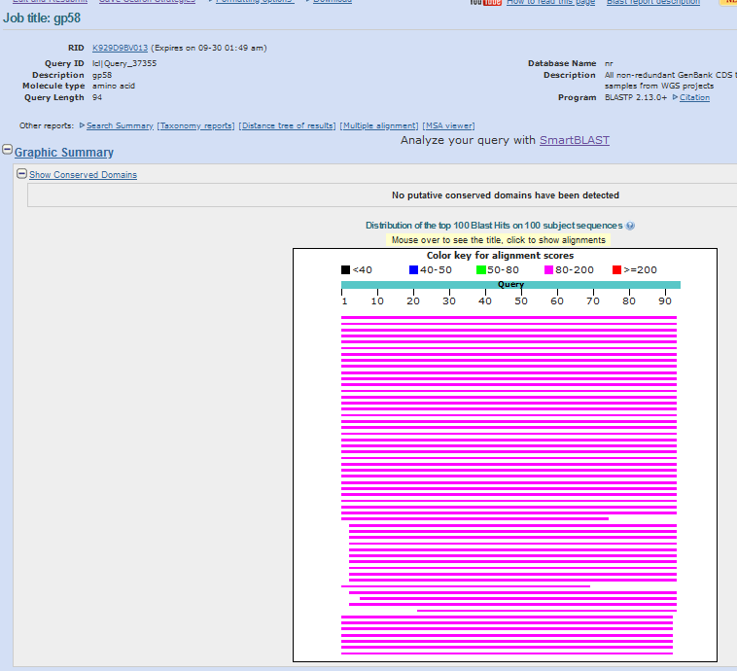
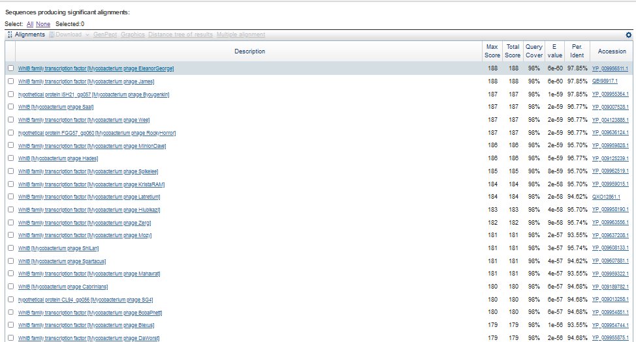
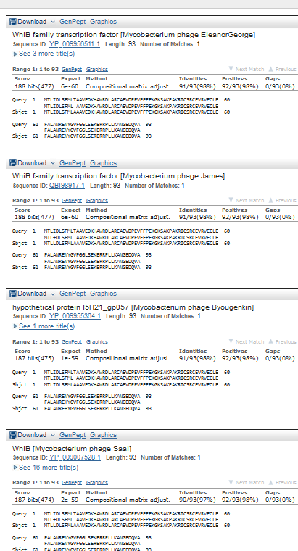
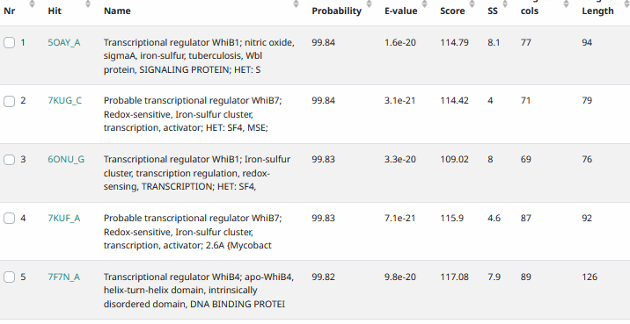
Start Codon and source: 39252, ATG, called by Glimmer and Genemark
Stop Codon: 39533, TGA
F/R:F
Coding Potential (y/n):Y
Starterator (SS, NA, NI): pham 48916, most annotated
Blast Best Hit, Query:Subject Starts, Score, Evalue, or “no significant Blast alignments” if 10E-4 or higher
Gap: -4bp overlap from gene 57
Longest Orf? (Y/N/NA) N
RBS: N/A, Scoring Matirix , Spacing Matrix, Z Score, Final Score,
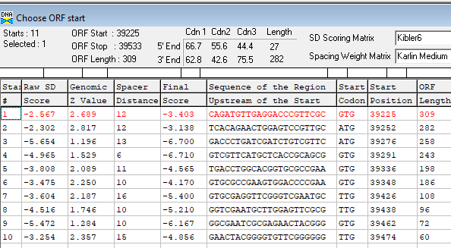
Proposed Function: WhiB family transctiption factor
Function Evidence: HHPRED, blastp
Transmembrane Domain/Evidence: NO
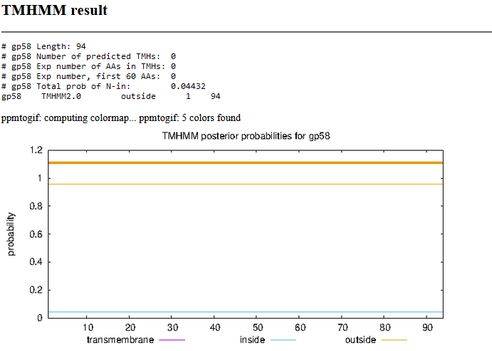

Gene Number: 59 (original 62, phagesdb draft 64)
9/28/22 Run BlastP at phagesdb and NCBI, Starterator, RBS on Frames, Transmembrane precdition https://services.healthtech.dtu.dk/service.php?TMHMM-2.0, HHPRED, https://toolkit.tuebingen.mpg.de/#/tools/hhpred
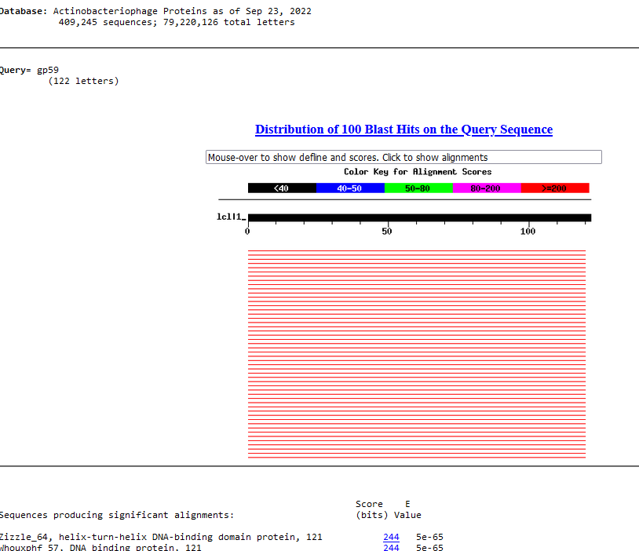
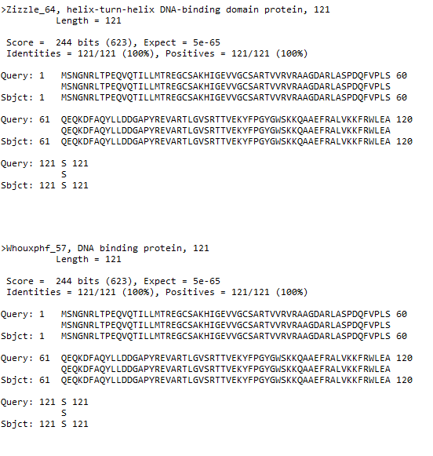
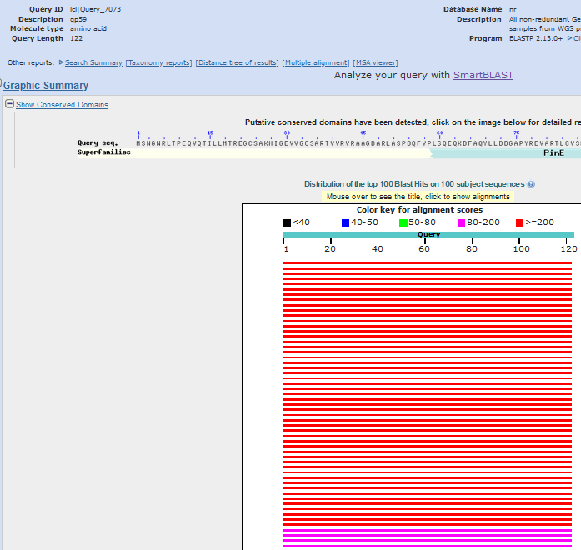
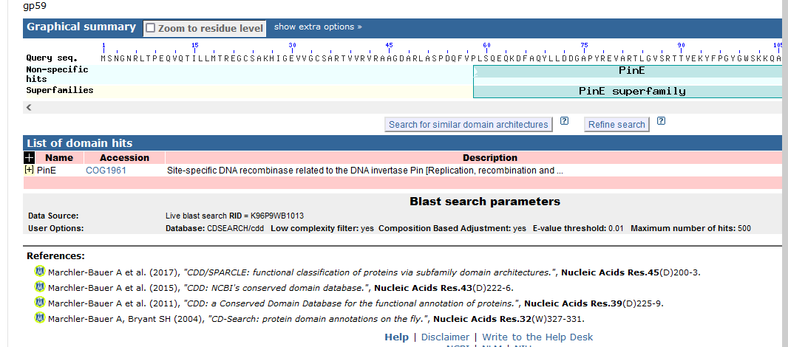
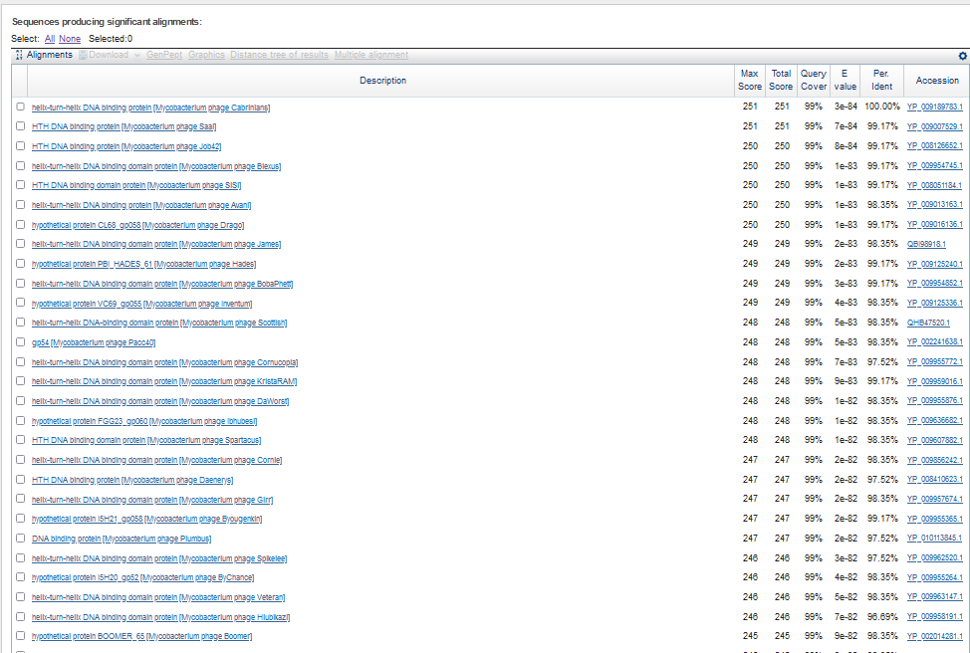
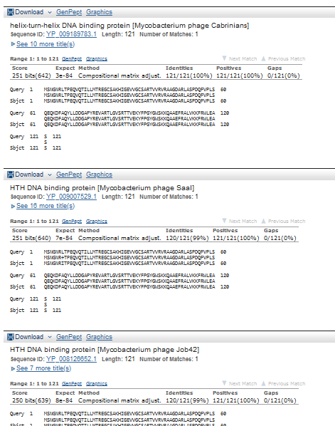
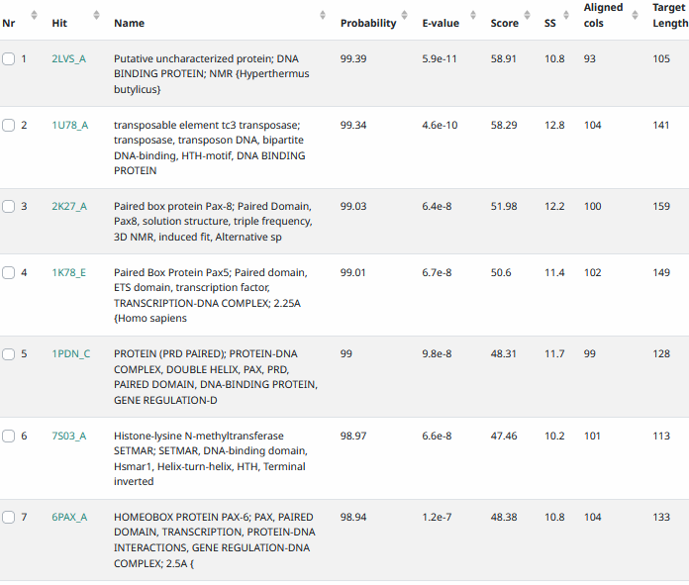
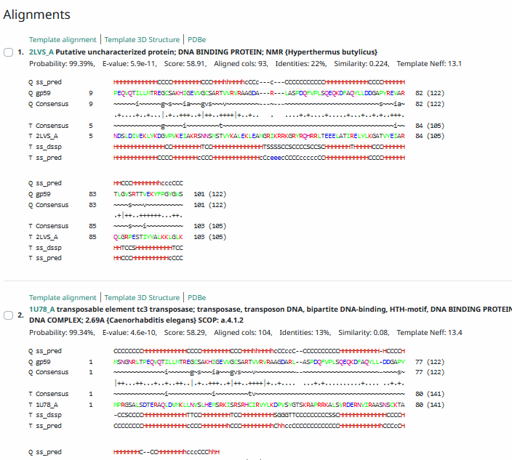
Start Codon and source: 39530, ATG, called by Glimmer and GenemarkS
Stop Codon: 39895, TGA
F/R: F
Coding Potential (y/n): Y
Starterator (SS, NA, NI): pham 48631, most annotated start
Blast Best Hit, Query:Subject Starts, Score, Evalue, or “no significant Blast alignments” if 10E-4 or higher
Gap: -4bp overlap with gene 58
Longest Orf? (Y/N/NA) Y
RBS: N/A, Scoring Matirix , Spacing Matrix, Z Score, Final Score,
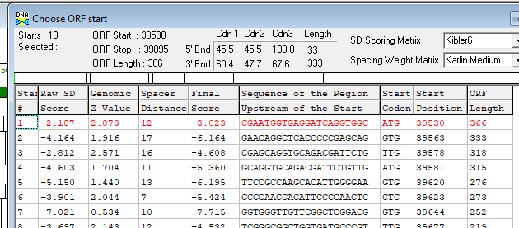
Proposed Function: helix-turn-helix DNA binding domain
Function Evidence: Blast and HHPRED
Transmembrane Domain/Evidence: NO
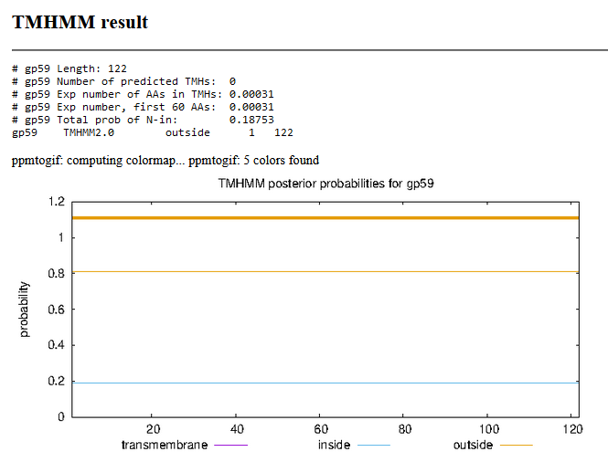

There are 2 small orfs after gene 59, one of which was called by glimmer, but not by Genemark. By Blast, most annotated phages on phagesdb call the glimmer call. HHPRED was run with both. With no evidence to favor either call, leave as autoannotated by glimmer prediction in DNA Master. “Others calling it” does not constitute good evidence, but Glimmer did predict this gene.
Gene Number: 60 (original 63, phagesdb draft 65)
9/28/22 Run BlastP at phagesdb and NCBI, Starterator, RBS on Frames, Transmembrane precdition https://services.healthtech.dtu.dk/service.php?TMHMM-2.0, HHPRED, https://toolkit.tuebingen.mpg.de/#/tools/hhpred
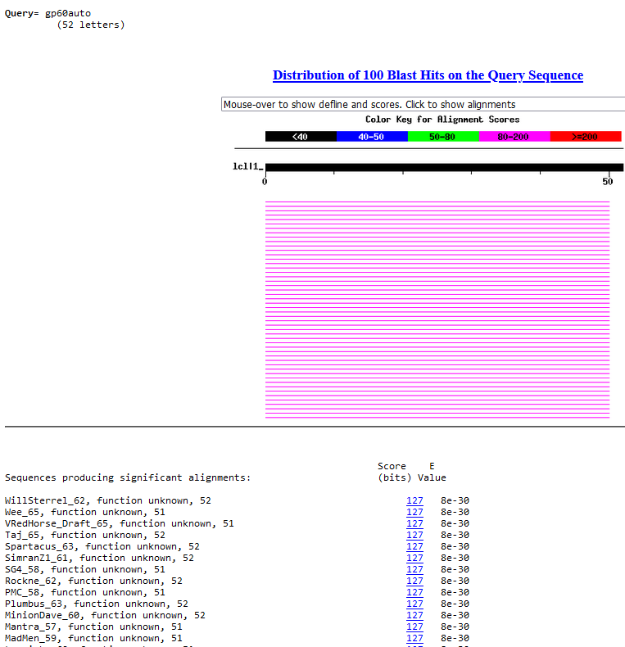
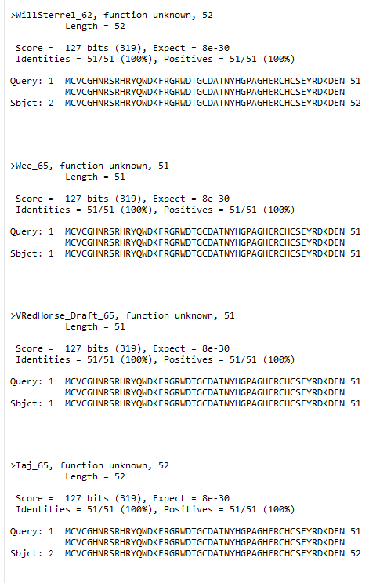
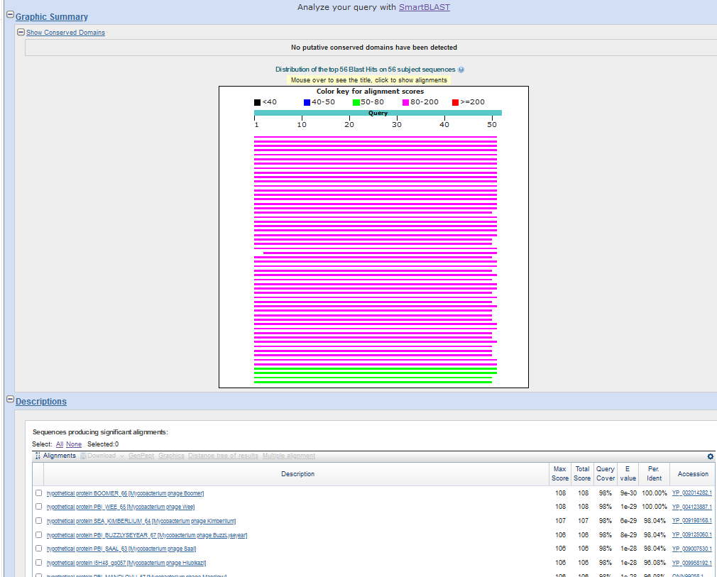
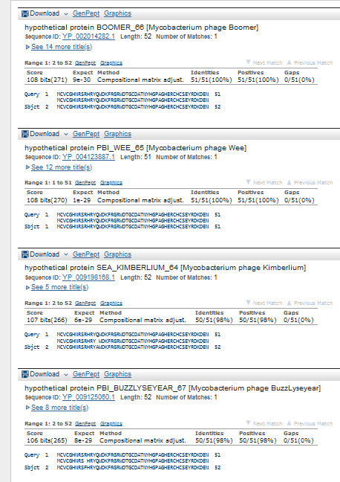
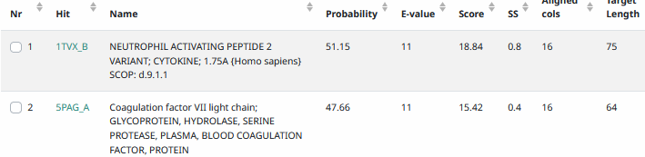
Start Codon and source: 39895, ATG, called by glimmer, not Genemark or Genemarks
Stop Codon: 40050, TGA
F/R: F
Coding Potential (y/n): barely on GenemarkS graph
Starterator (SS, NA, NI): pham 379, most annotated
Blast Best Hit, Query:Subject Starts, Score, Evalue, or “no significant Blast alignments” if 10E-4 or higher
Gap: -4bp overlap with gene 59
Longest Orf? (Y/N/NA) N, GTG immediately upstream
RBS: N/A, Scoring Matirix , Spacing Matrix, Z Score, Final Score,
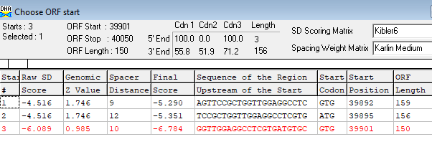
Proposed Function: hypothetical protein
Function Evidence: no convincing evidence of function
Transmembrane Domain/Evidence: NO
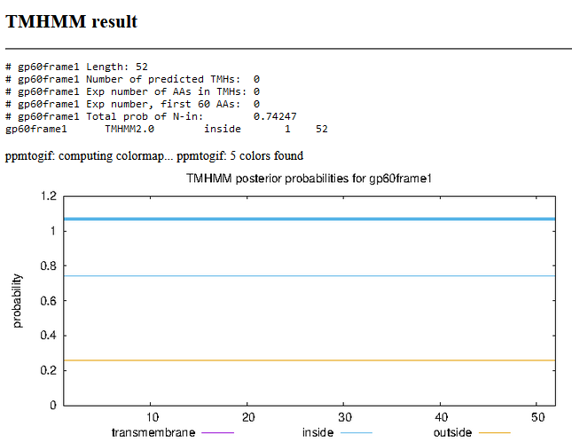

Gene Number: 61 (original 64, phagesdb draft66)
9/30/22 Run BlastP at phagesdb and NCBI, Starterator, RBS on Frames, Transmembrane precdition https://services.healthtech.dtu.dk/service.php?TMHMM-2.0, HHPRED, https://toolkit.tuebingen.mpg.de/#/tools/hhpred
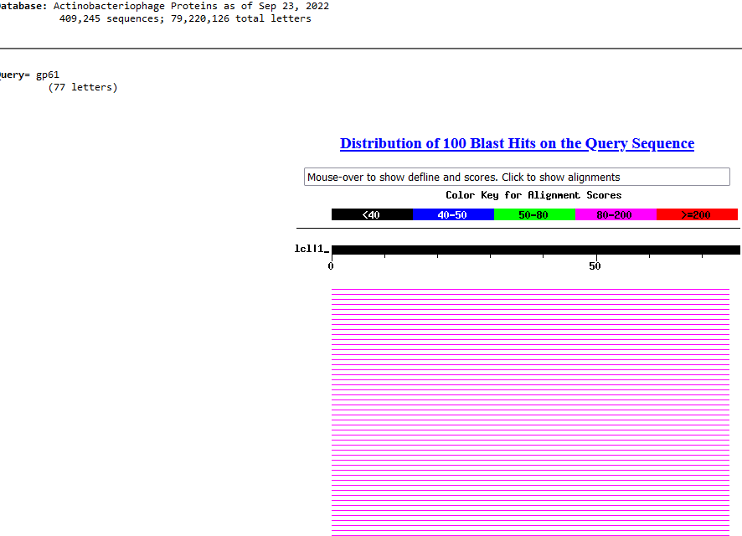
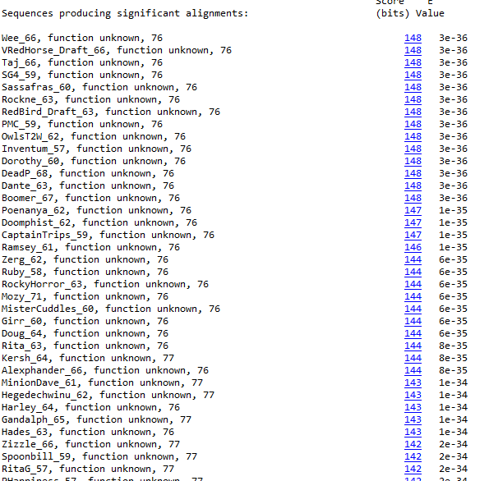
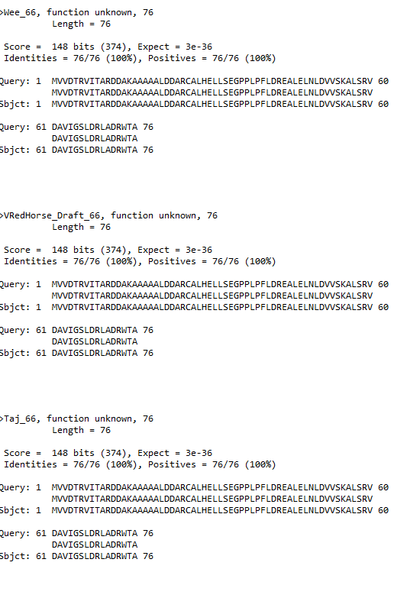
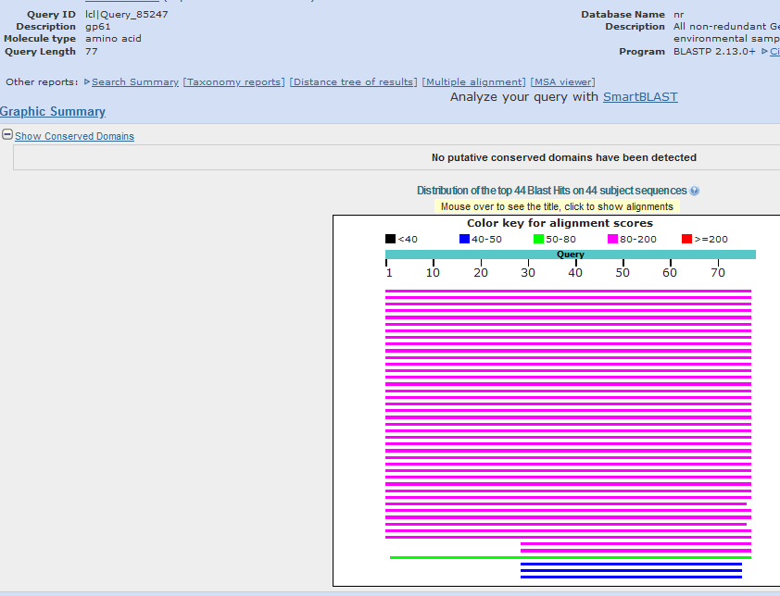
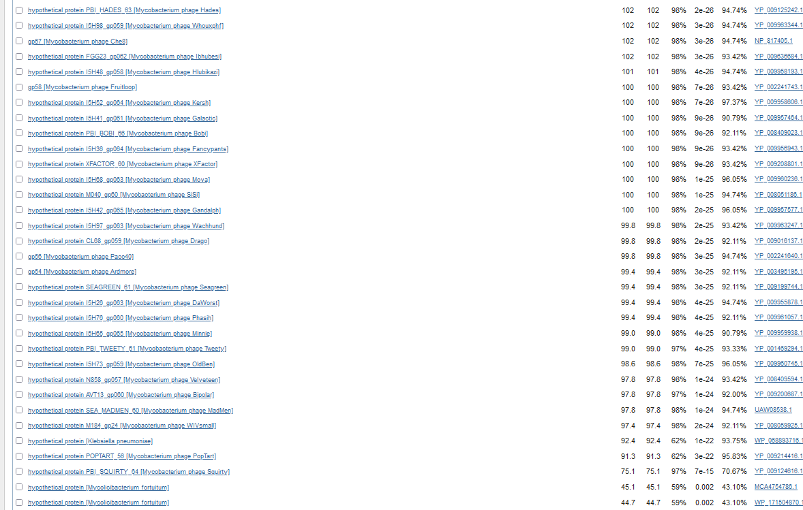
Klebsiella pneumonia match. E-15
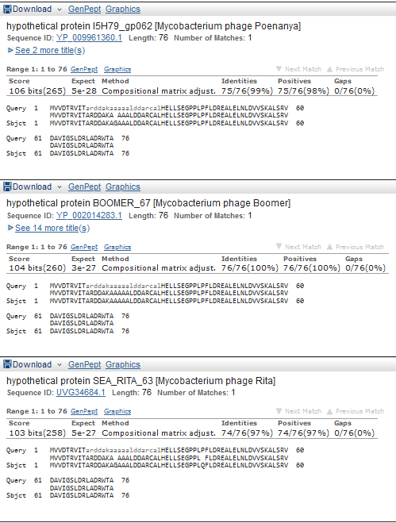
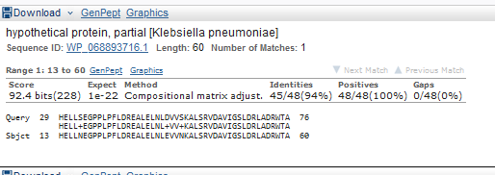
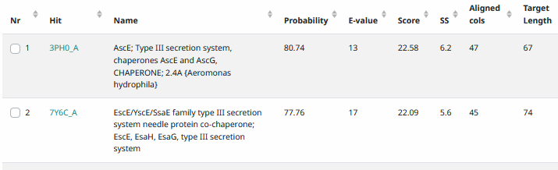
Start Codon and source: 40050, ATG, called by glimmer and genemark
Stop Codon: 40,280, TGA
F/R: F
Coding Potential (y/n): Y
Starterator (SS, NA, NI): pham 328, most annotated start
Blast Best Hit, Query:Subject Starts, Score, Evalue, or “no significant Blast alignments” if 10E-4 or higher
Gap:
Longest Orf? (Y/N/NA)
RBS: N/A, Scoring Matirix , Spacing Matrix, Z Score, Final Score,
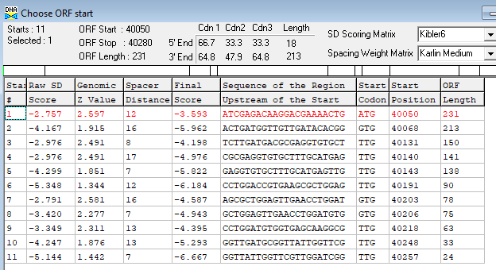
Proposed Function: hypothetical protein
Function Evidence: no credible HHPRED or BLastP functions
Transmembrane Domain/Evidence: NO
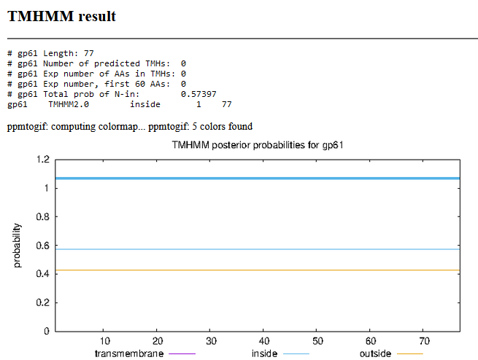

Gene Number: 62 (original 65, phagesdb draft 67)
9/30/22 Run BlastP at phagesdb and NCBI, Starterator, RBS on Frames, Transmembrane precdition https://services.healthtech.dtu.dk/service.php?TMHMM-2.0, HHPRED, https://toolkit.tuebingen.mpg.de/#/tools/hhpred, 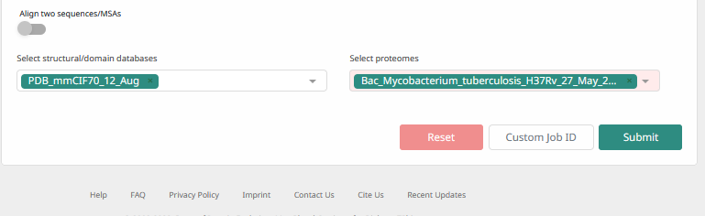
Ran blast with longer GTG start, few phages called it, reran with most annotated ATG. GTG has better RBS score
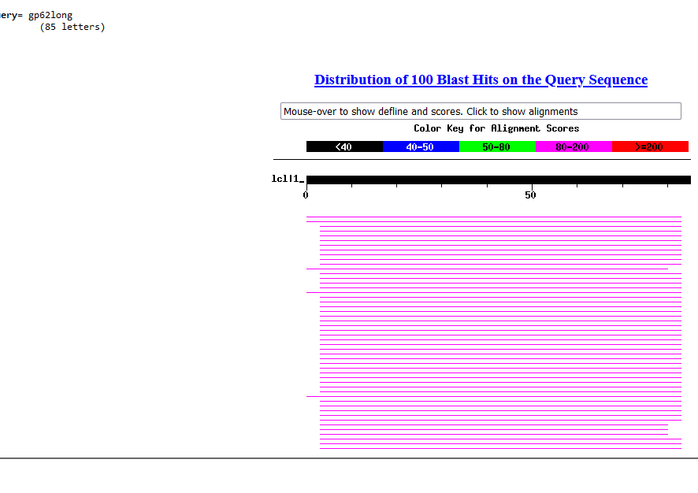
Choose second start, ATG, blast, etc.
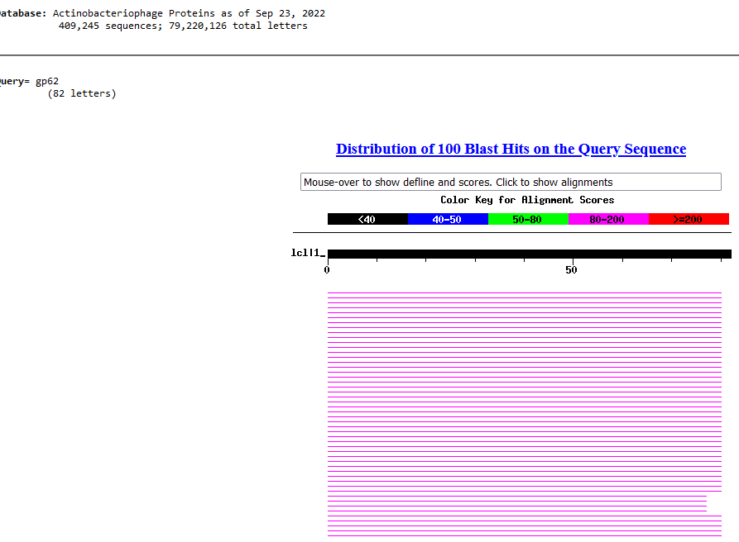
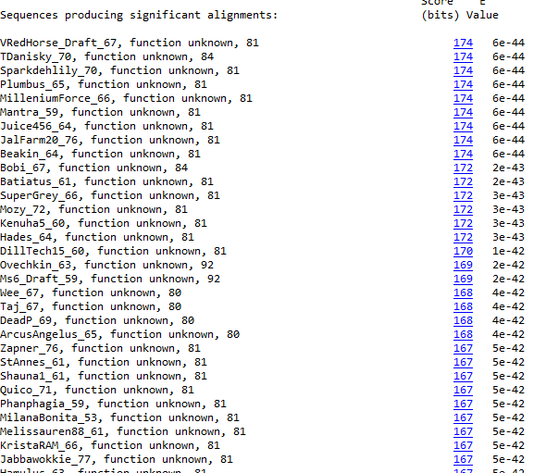
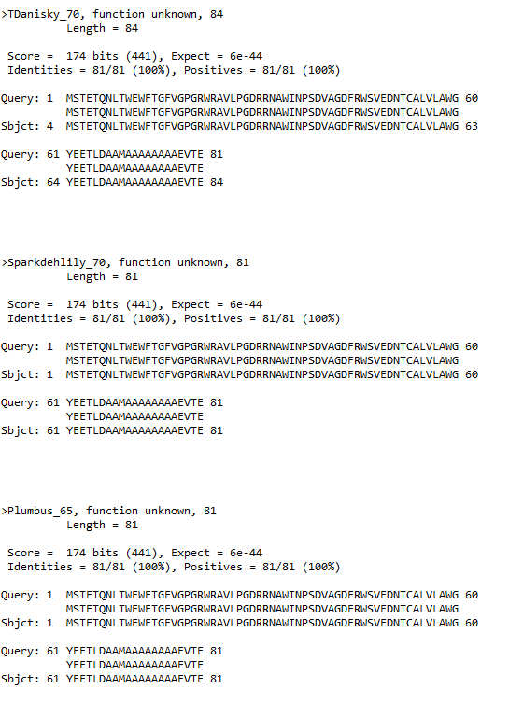
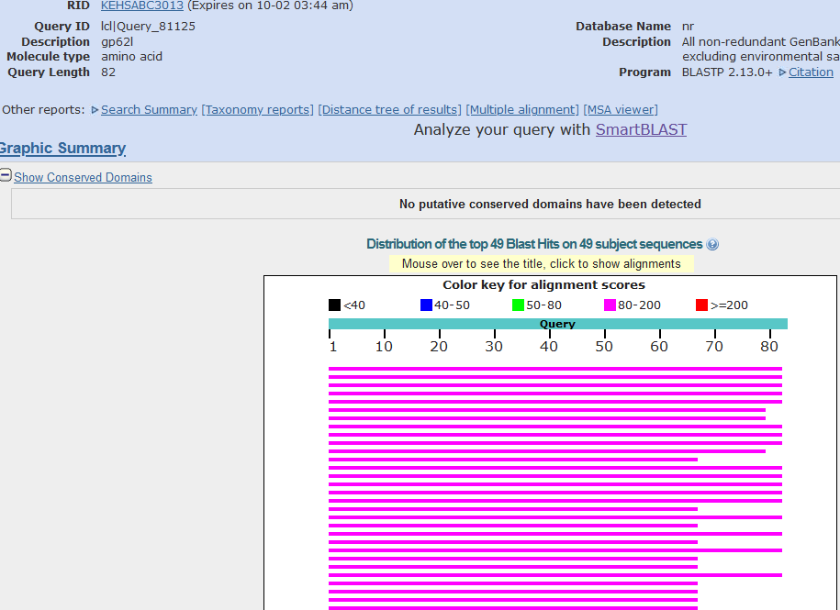
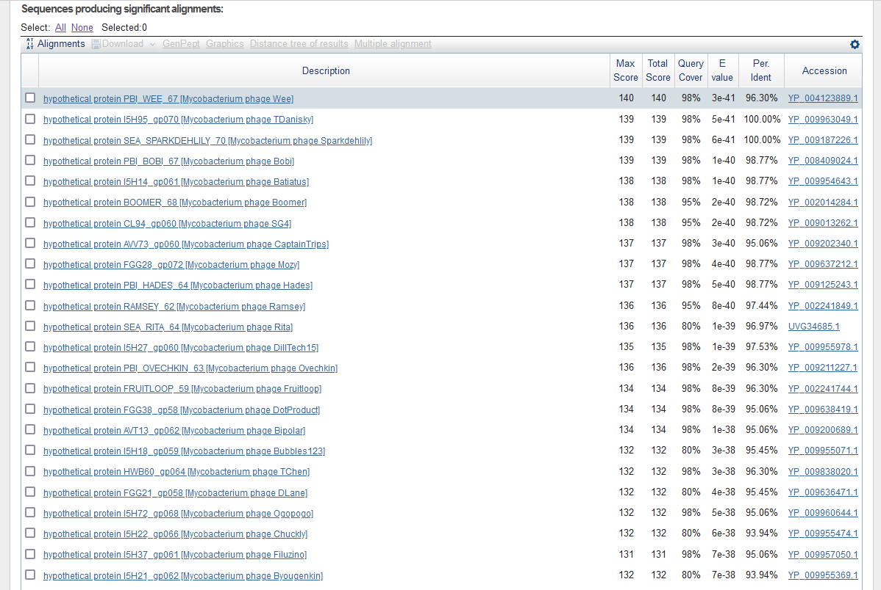
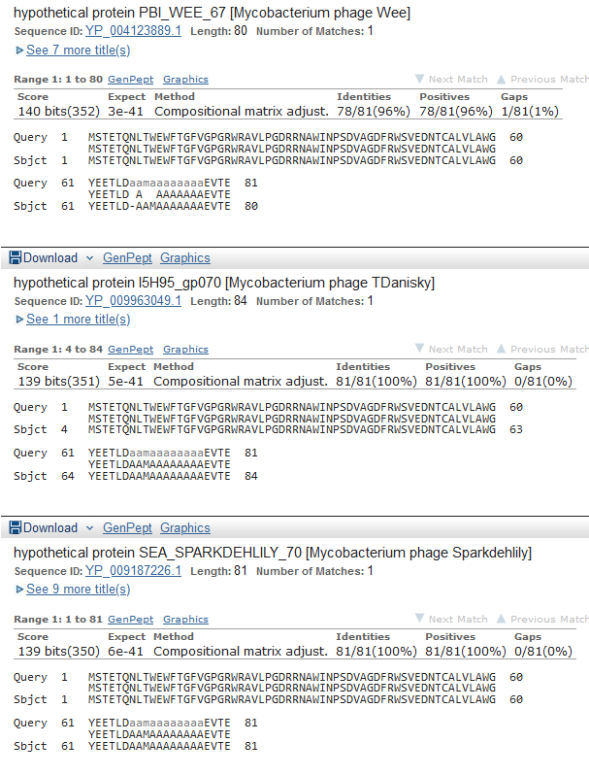
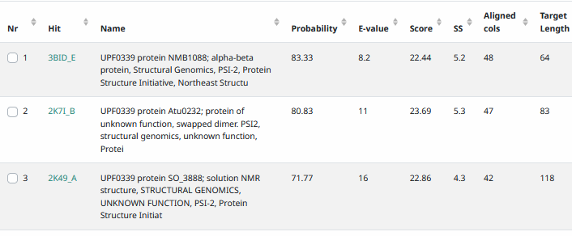
Start Codon and source: 40227, ATG, called by glimmer and genemark
Stop Codon: 40522, TGA
F/R: F
Coding Potential (y/n): Y
Starterator (SS, NA, NI): pham 48808, most annotated start
Blast Best Hit, Query:Subject Starts, Score, Evalue, or “no significant Blast alignments” if 10E-4 or higher
Gap: -4bp overlap
Longest Orf? (Y/N/NA) N
RBS: N/A, Scoring Matirix , Spacing Matrix, Z Score, Final Score,
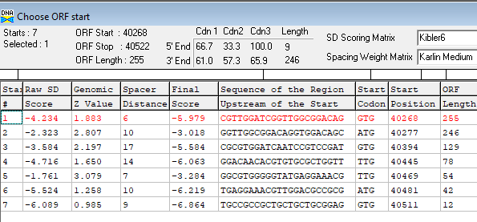
Proposed Function: hypothetical protein
Function Evidence: no credible functions in HHPRED or BlastP
Transmembrane Domain/Evidence: NO
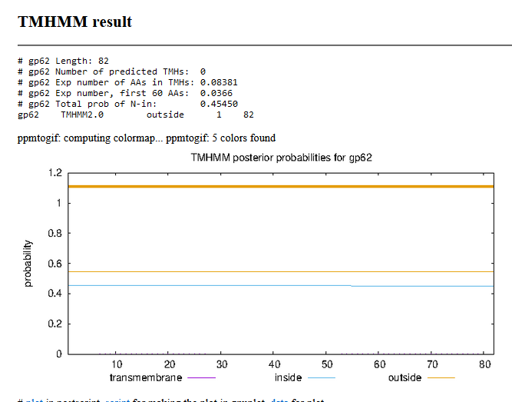

Gene Number: 63 (original 66, phagesdb draft 68)
10/03/22 Run BlastP at phagesdb and NCBI, Starterator, RBS on Frames, Transmembrane precdition https://services.healthtech.dtu.dk/service.php?TMHMM-2.0, HHPRED, https://toolkit.tuebingen.mpg.de/#/tools/hhpred,
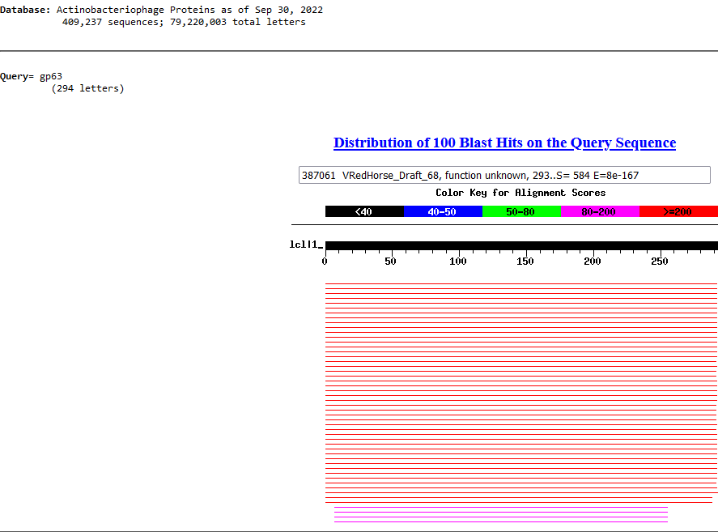
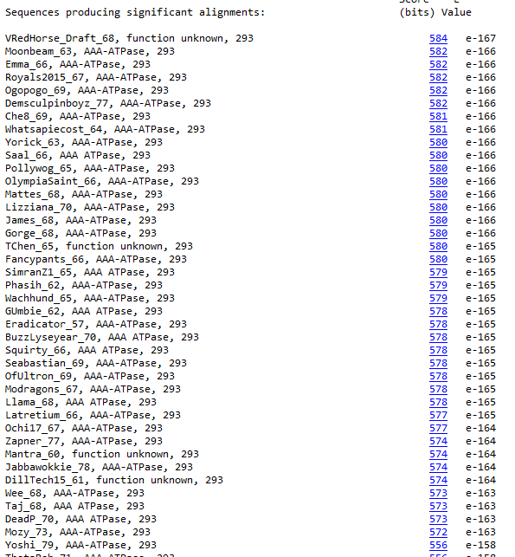
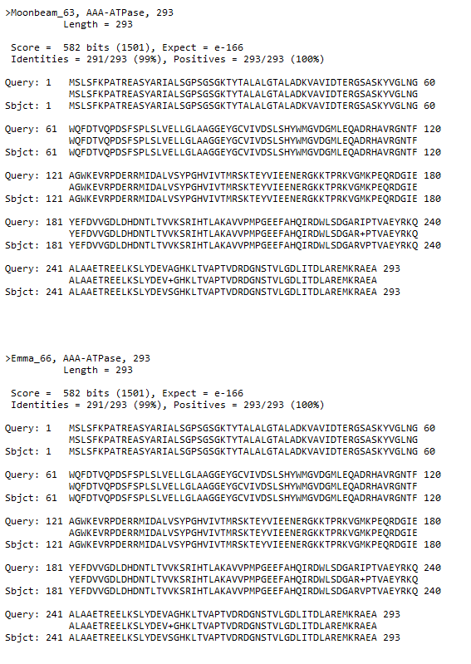
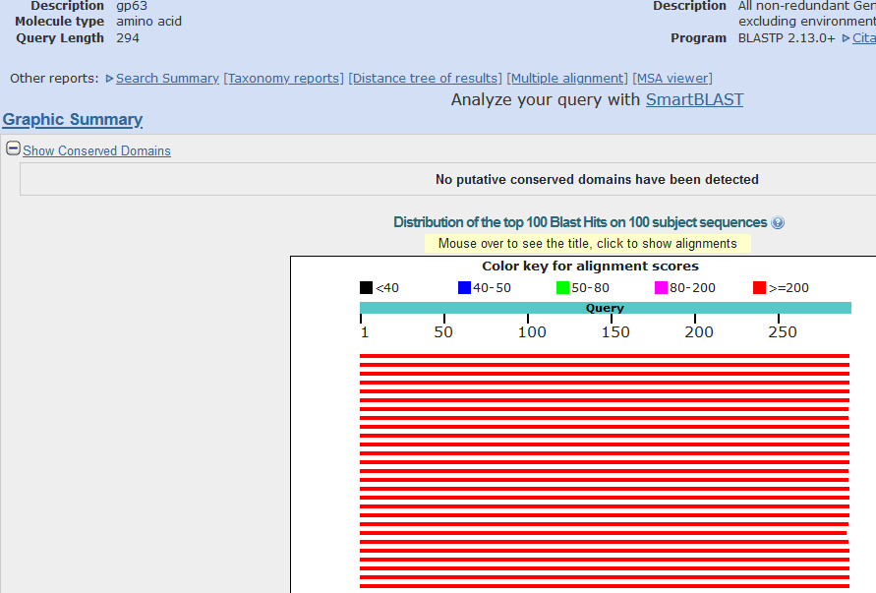
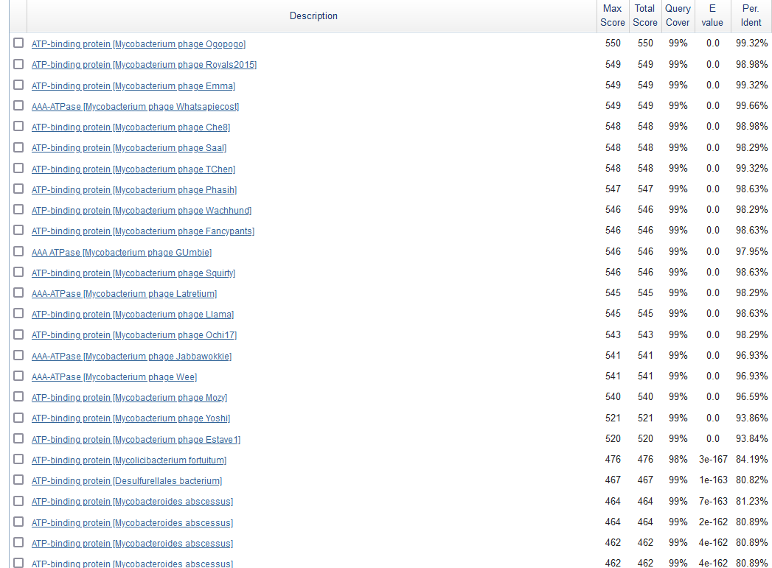
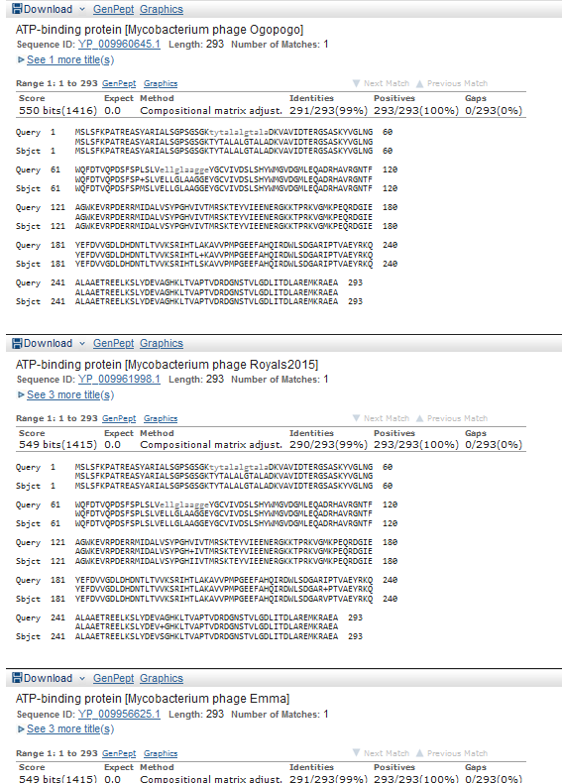
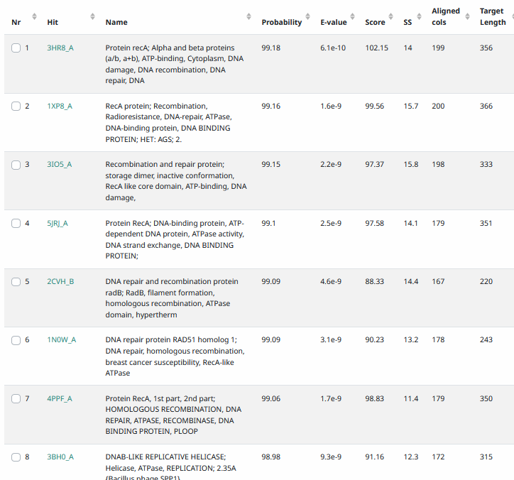
Start Codon and source: 40,519, ATG, Called by Glimmer and Genemark
Stop Codon: 41,400, TGA
F/R: F
Coding Potential (y/n): Y
Starterator (SS, NA, NI): pham 45693, most annotated start
Blast Best Hit, Query:Subject Starts, Score, Evalue, or “no significant Blast alignments” if 10E-4 or higher
Gap: -4bp overlap with gene 62
Longest Orf? (Y/N/NA) Y
RBS: N/A, Scoring Matirix , Spacing Matrix, Z Score, Final Score,
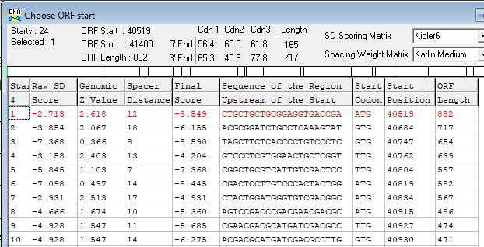
Proposed Function: AAA-ATPase
Function Evidence: HHPRED
Transmembrane Domain/Evidence: NO
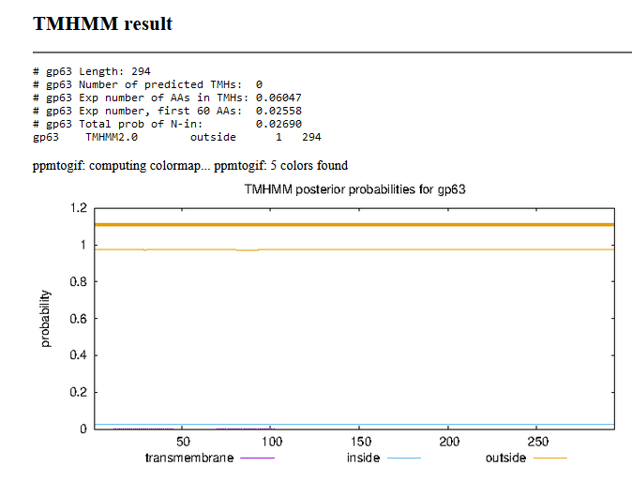

Gene Number: 64 (original 67, phagesdb 69) changed start to 41,397, ATG
10/03/22 Run BlastP at phagesdb and NCBI, Starterator, RBS on Frames, Transmembrane precdition https://services.healthtech.dtu.dk/service.php?TMHMM-2.0, HHPRED, https://toolkit.tuebingen.mpg.de/#/tools/hhpred,
Gene not called by Genemark, shorter gene (41,556 called by glimmer)
Longest orf start 41,397 used to blast, etc.

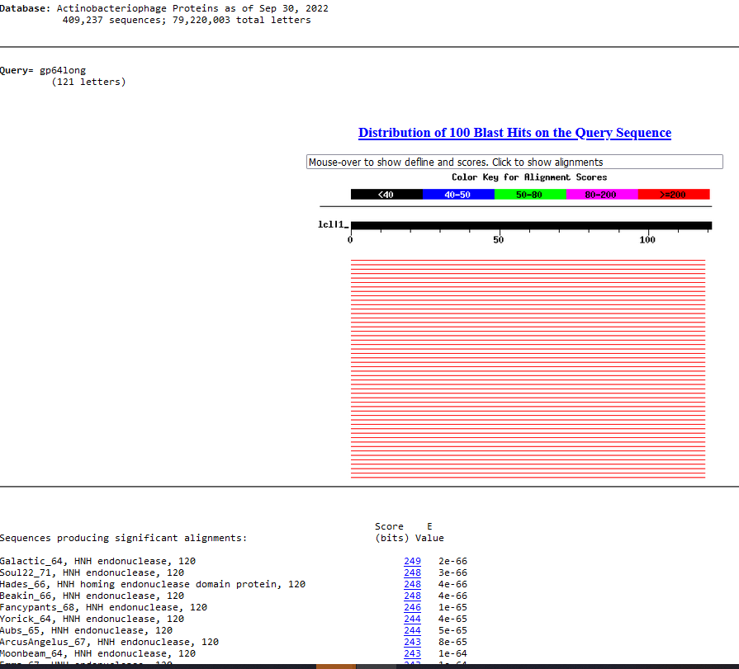
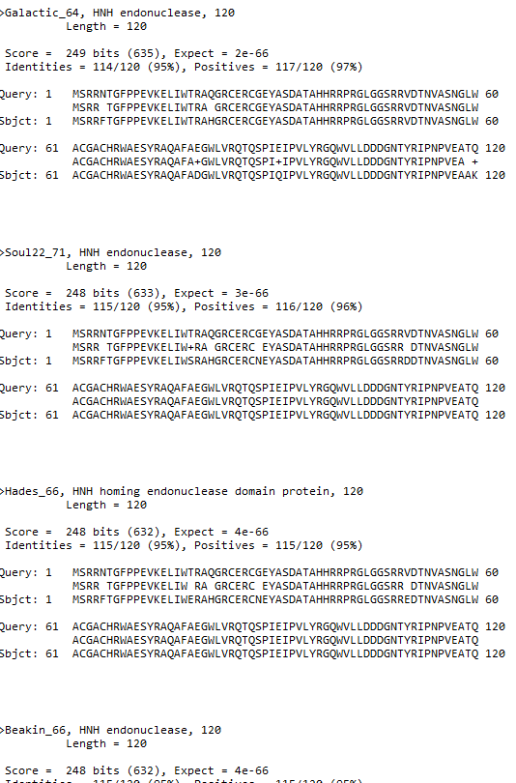
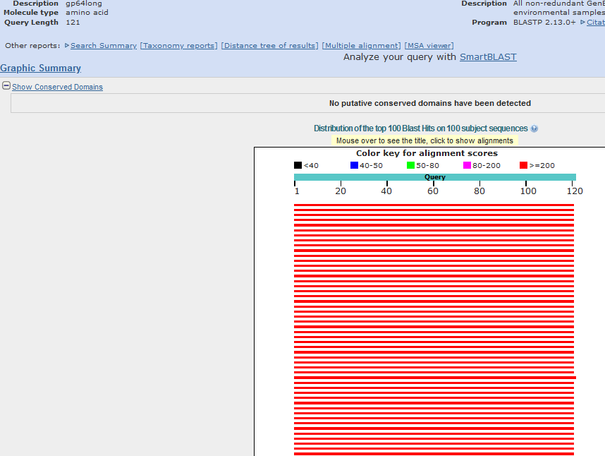
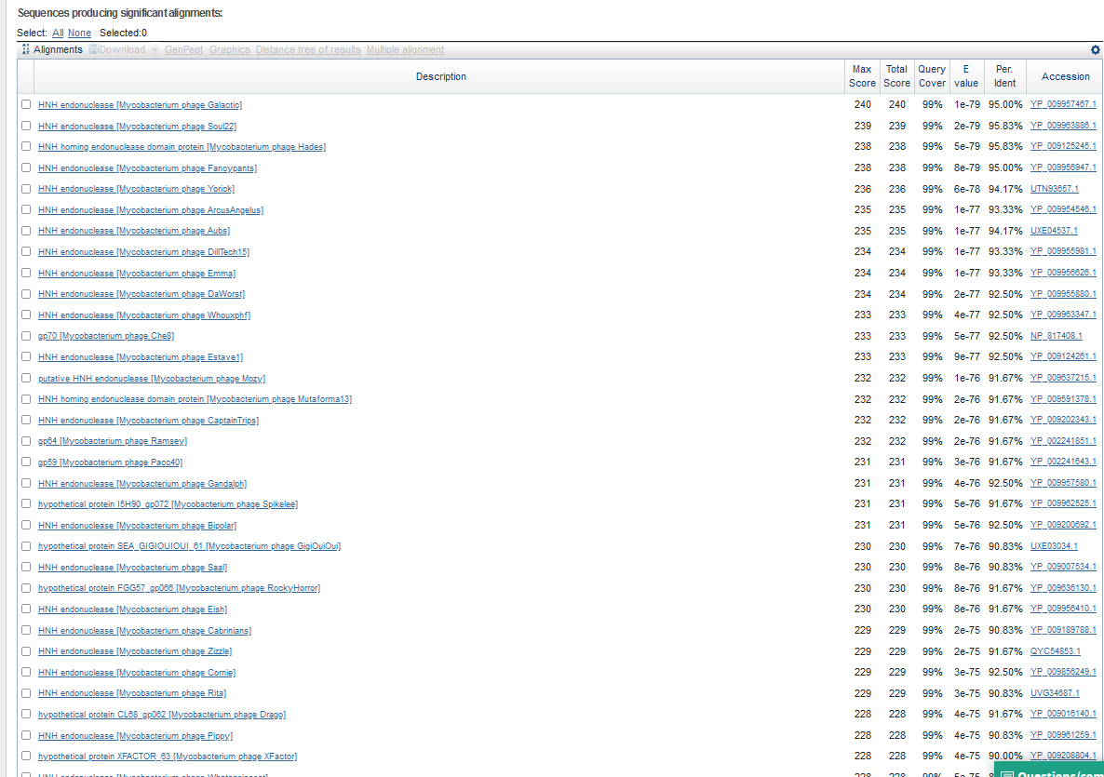
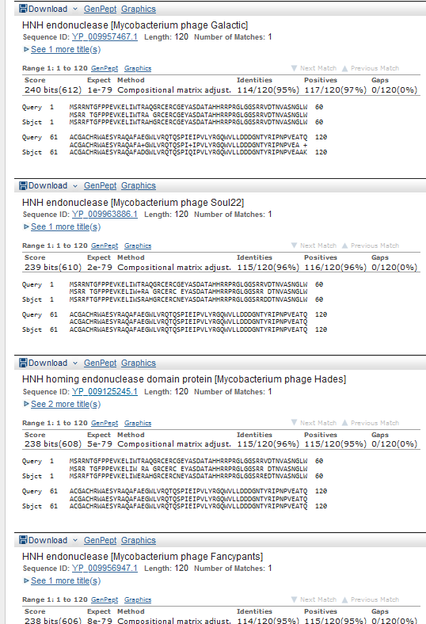

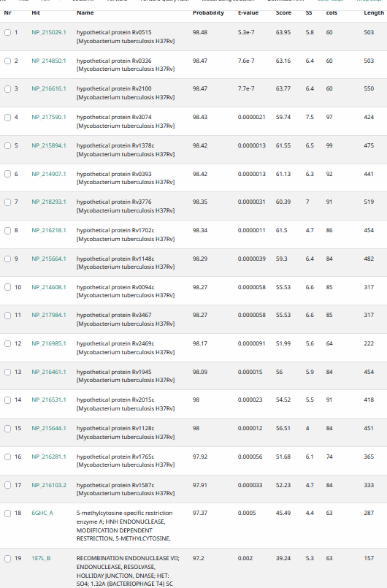
Start Codon and source: 41,397, ATG, changed from glimmer call 41,556. Gene not called by Genemark
Stop Codon: 41,759, TGA
F/R: F
Coding Potential (y/n): Y
Starterator (SS, NA, NI): pham 7829, changed FROM most annotated start
Blast Best Hit, Query:Subject Starts, Score, Evalue, or “no significant Blast alignments” if 10E-4 or higher
Gap: -4 bp overlap with gene 63
Longest Orf? (Y/N/NA) Y
RBS: N/A, Scoring Matirix , Spacing Matrix, Z Score, Final Score,
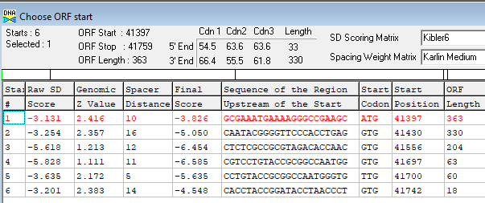
Proposed Function: HNH endonuclease
Function Evidence: Histidines w/in30 aa span, HHPRED, BLASTP
>gp64long
MSRRNTGFPPEVKELIWTRAQGRCERCGEYASDATAHHRRPRGLGGSRRVDTNVASNGLWACGACHRWAESYRAQAFAEGWLVRQTQSPIEIPVLYRGQWVLLDDDGNTYRIPNPVEATQZ
Transmembrane Domain/Evidence: NO
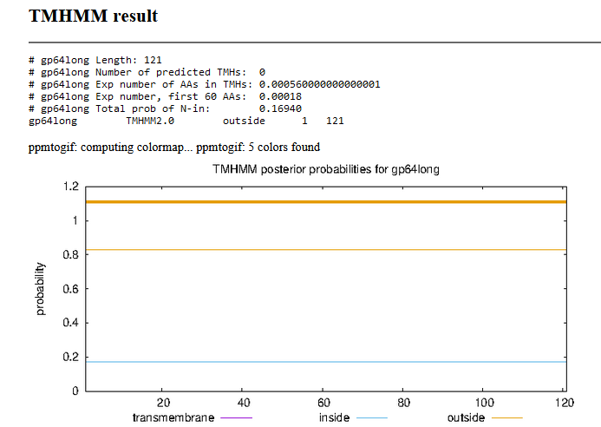

Gene Number: 65 (original 68, phagesdb70)
Called hypothetical protein, but HHPRED has match to contractile tail injection system. Note, this phage is not known to be contractile-tailed
10/03/22 Run BlastP at phagesdb and NCBI, Starterator, RBS on Frames, Transmembrane precdition https://services.healthtech.dtu.dk/service.php?TMHMM-2.0, HHPRED, https://toolkit.tuebingen.mpg.de/#/tools/hhpred,
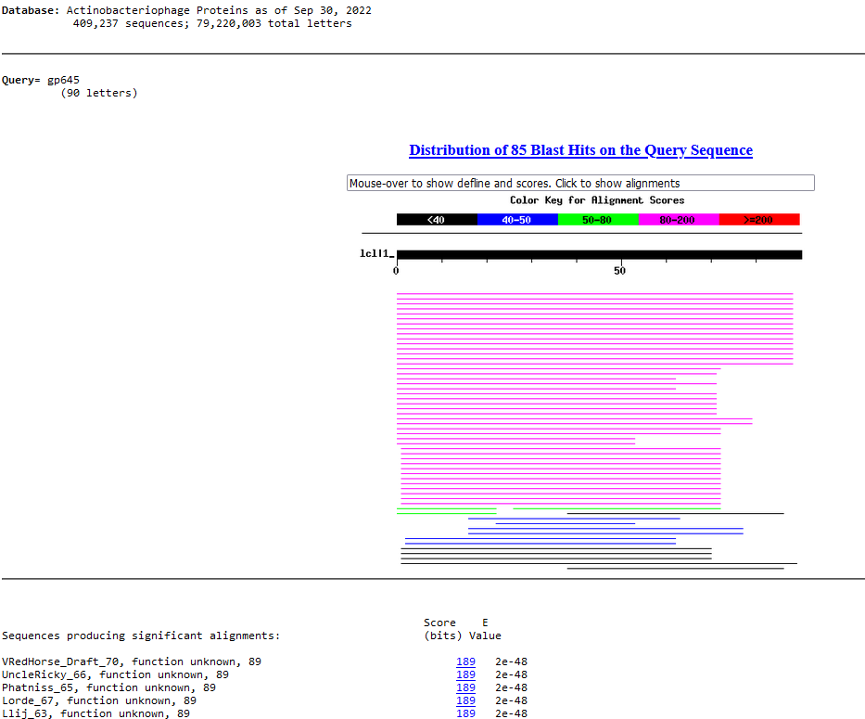
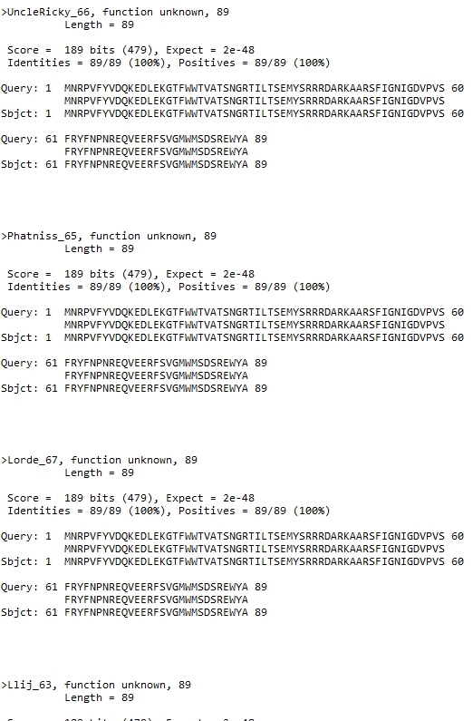
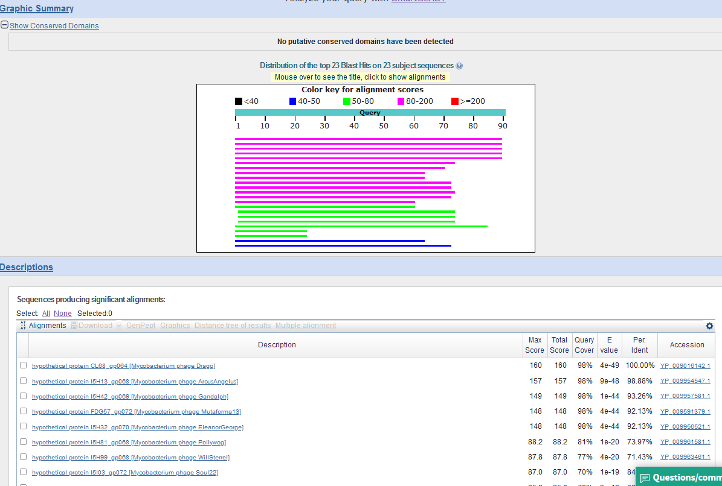
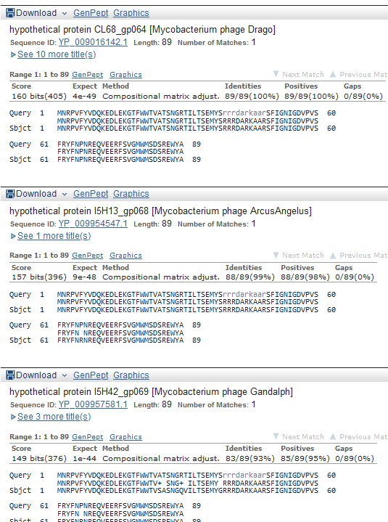

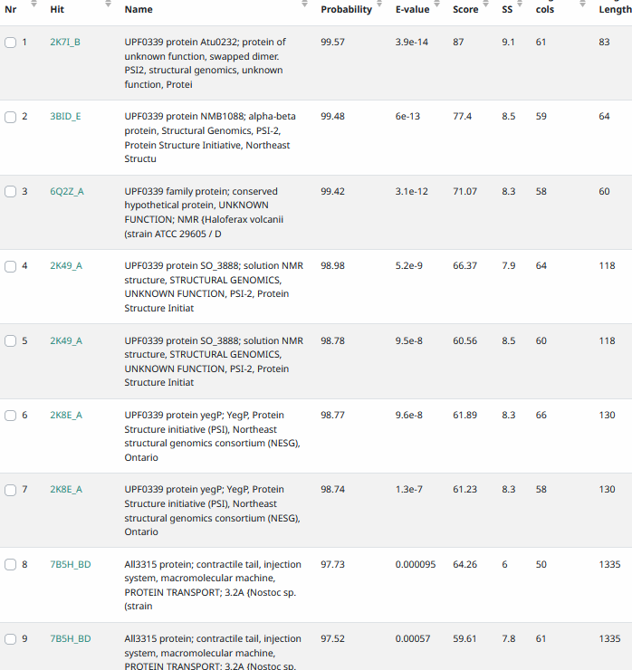
Start Codon and source: 41,756, ATG, called by glimmer and genemark
Stop Codon: 42025, TGA
F/R: F
Coding Potential (y/n):Y
Starterator (SS, NA, NI): pham 49157, most annotated
Blast Best Hit, Query:Subject Starts, Score, Evalue, or “no significant Blast alignments” if 10E-4 or higher
Gap: -4bp overlap with gene 64
Longest Orf? (Y/N/NA) Y
RBS: N/A, Scoring Matirix , Spacing Matrix, Z Score, Final Score,
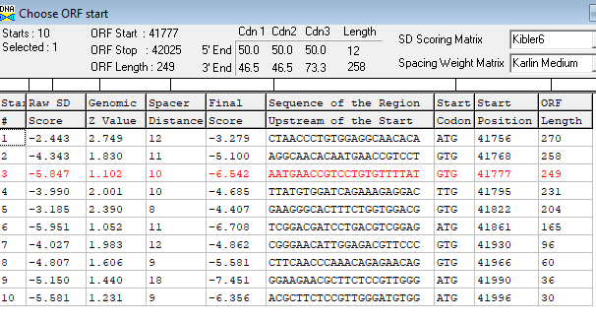
Proposed Function:
Function Evidence: HHPRED matches to contractile tail injection system protein
Transmembrane Domain/Evidence: NO
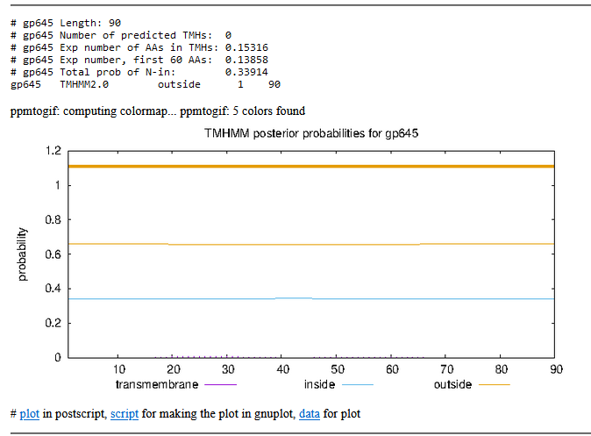

Gene Number: 66 (original 69, phagesdb 71) changed start one codon to 42,022
10/03/22 Run BlastP at phagesdb and NCBI, Starterator, RBS on Frames, Transmembrane prediction https://services.healthtech.dtu.dk/service.php?TMHMM-2.0, HHPRED, https://toolkit.tuebingen.mpg.de/#/tools/hhpred using extra codon
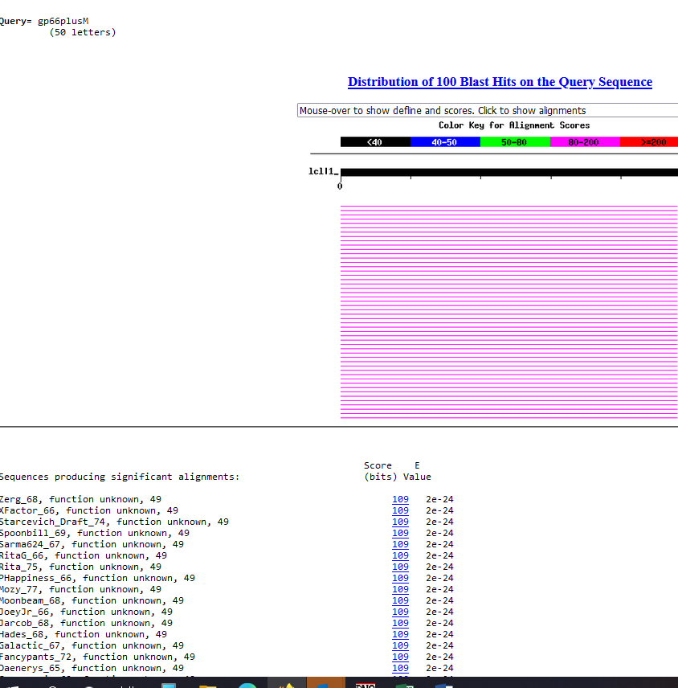
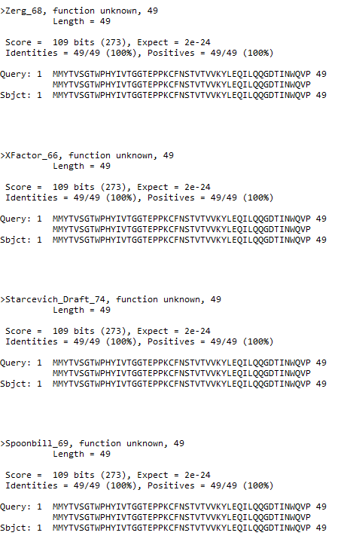
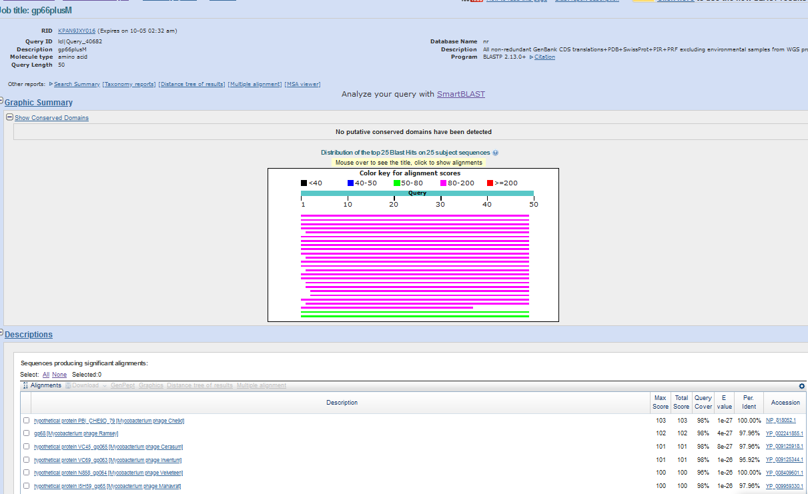
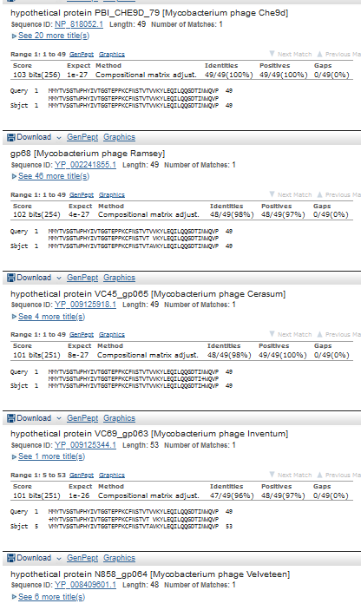

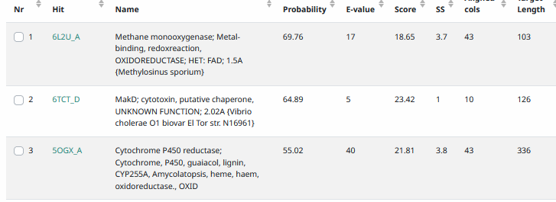
Start Codon and source: 42,022, GTG, changed from 42,025 that was called by Glimmer and Genemark
Stop Codon: 42,171, TGA
F/R: F
Coding Potential (y/n): Y
Starterator (SS, NA, NI): pham 744, changed to most annotated
Blast Best Hit, Query:Subject Starts, Score, Evalue, or “no significant Blast alignments” if 10E-4 or higher
Gap: -4bp overlap with gene 65
Longest Orf? (Y/N/NA) N
RBS: N/A, Scoring Matirix , Spacing Matrix, Z Score, Final Score,
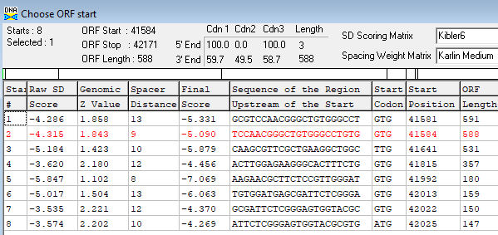
Proposed Function: hypothetical protein
Function Evidence: no convincing function hits on Blast or HHPRED
Transmembrane Domain/Evidence: NO
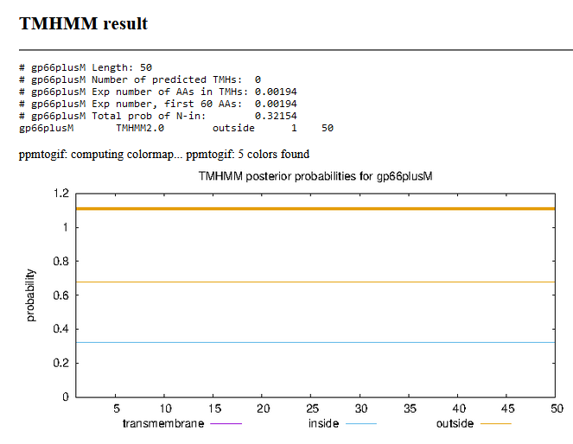

Gene Number: 67 (original 70, phages draft 72)
10/03/22 Run BlastP at phagesdb and NCBI, Starterator, RBS on Frames, Transmembrane precdition https://services.healthtech.dtu.dk/service.php?TMHMM-2.0, HHPRED, https://toolkit.tuebingen.mpg.de/#/tools/hhpred,

Matches Cornucopia protein end to end but other phages have an insertion
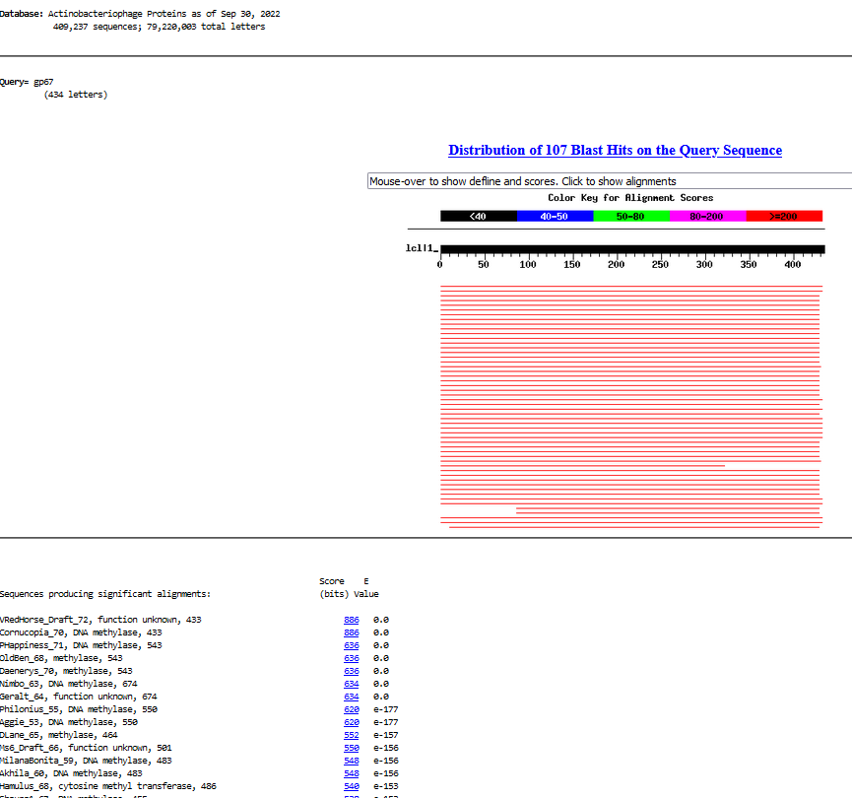
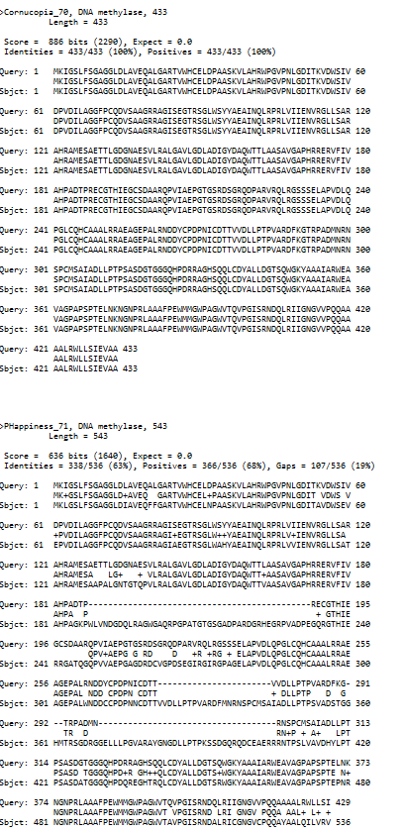
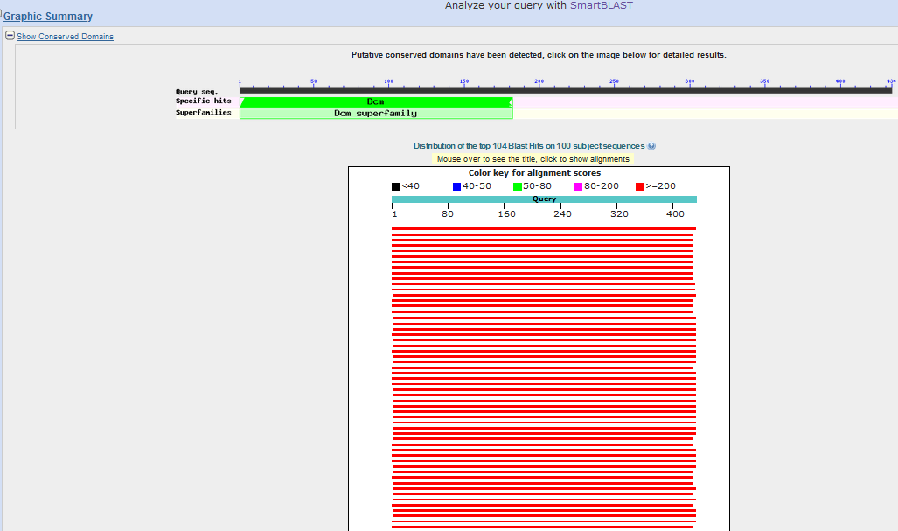
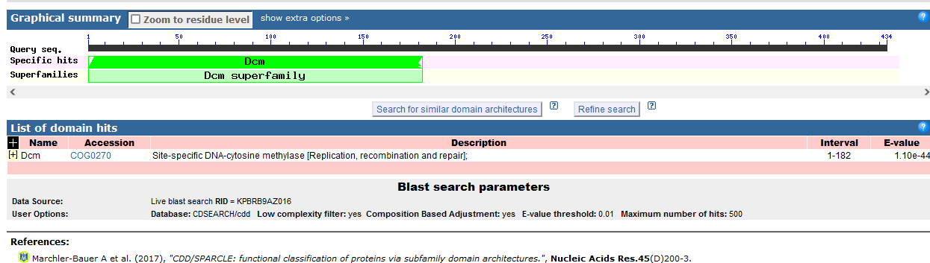
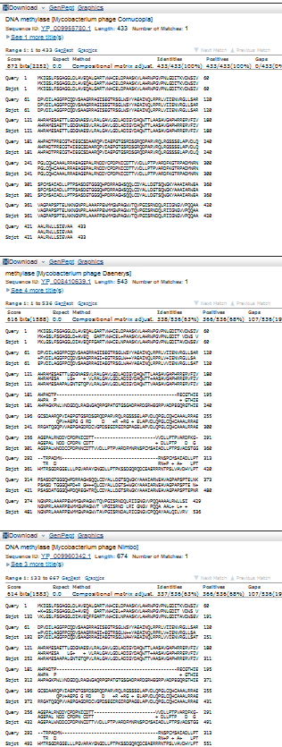
Start Codon and source: 42,168, ATG, called by Glimmer and Genemark
Stop Codon: 43,469, TGA
F/R: F
Coding Potential (y/n): Y
Starterator (SS, NA, NI): pham 45984, most annotated start
Blast Best Hit, Query:Subject Starts, Score, Evalue, or “no significant Blast alignments” if 10E-4 or higher
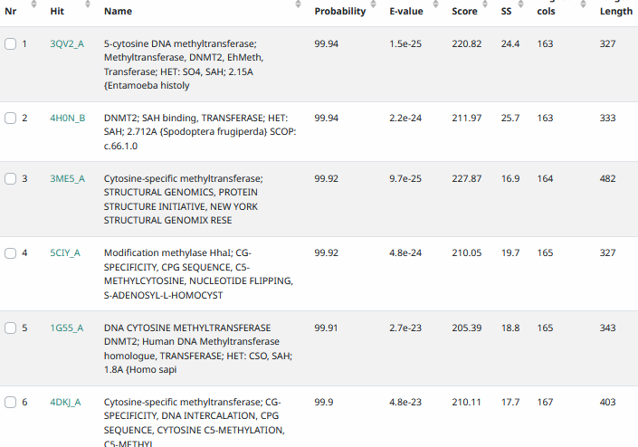
Gap: -4bp overlap with gene 66
Longest Orf? (Y/N/NA) N
RBS: N/A, Scoring Matirix , Spacing Matrix, Z Score, Final Score,
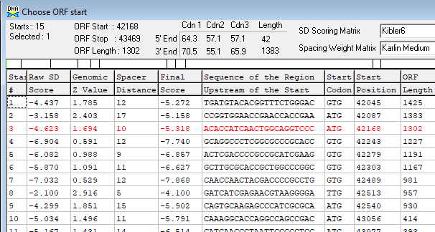
Proposed Function: DNA methyltransferase
Function Evidence: BLASTp and HHPRED
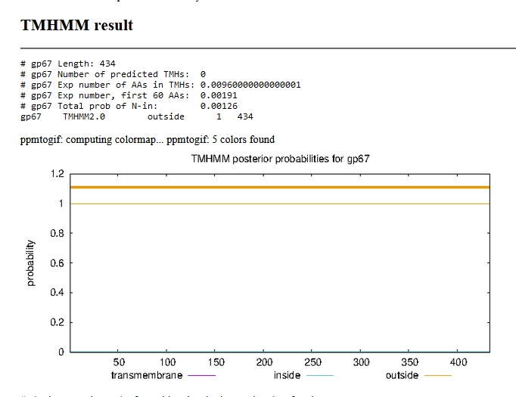NO

INSERT GENE 68, gene called by Glimmer S…REDRAW MAP , now MAP4
Gene Number: 68 (phagesdb gene 73)not called by Genemark
10/03/22 Run BlastP at phagesdb and NCBI, Starterator, RBS on Frames, Transmembrane prediction https://services.healthtech.dtu.dk/service.php?TMHMM-2.0, HHPRED, https://toolkit.tuebingen.mpg.de/#/tools/hhpred,
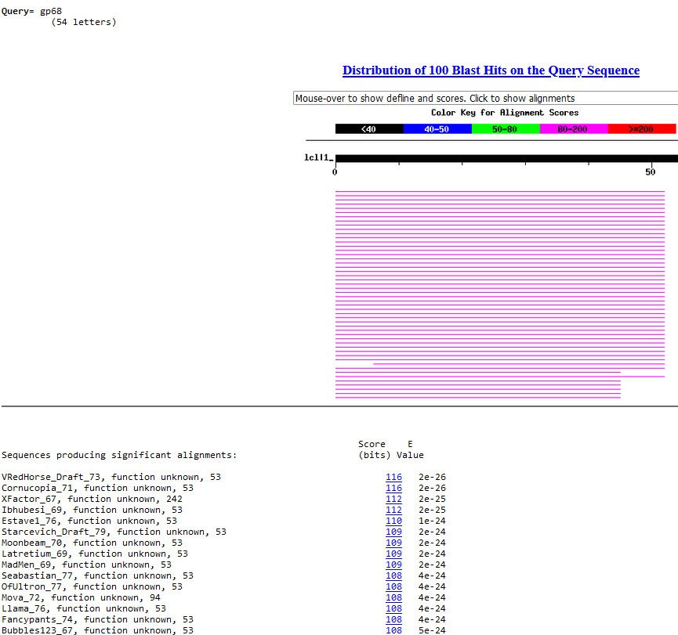
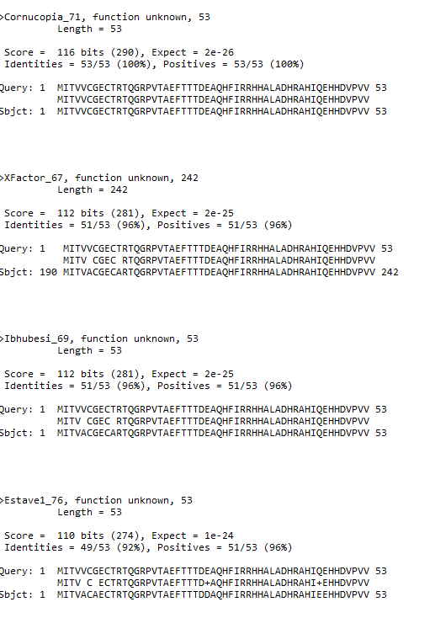
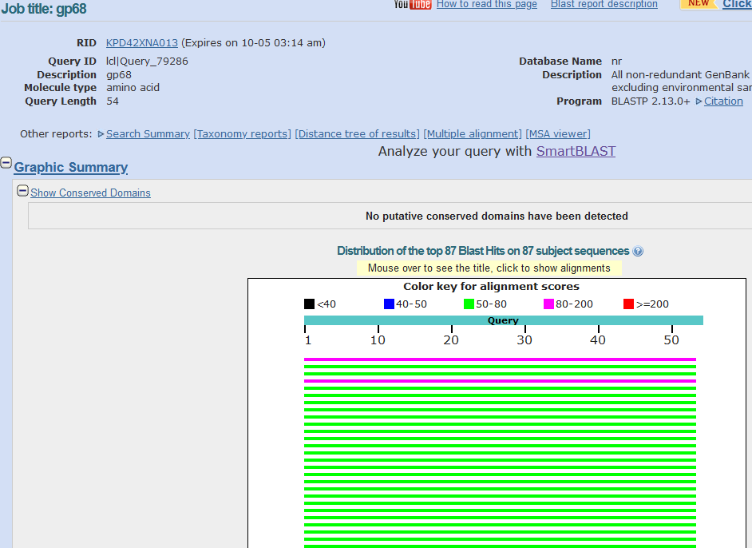
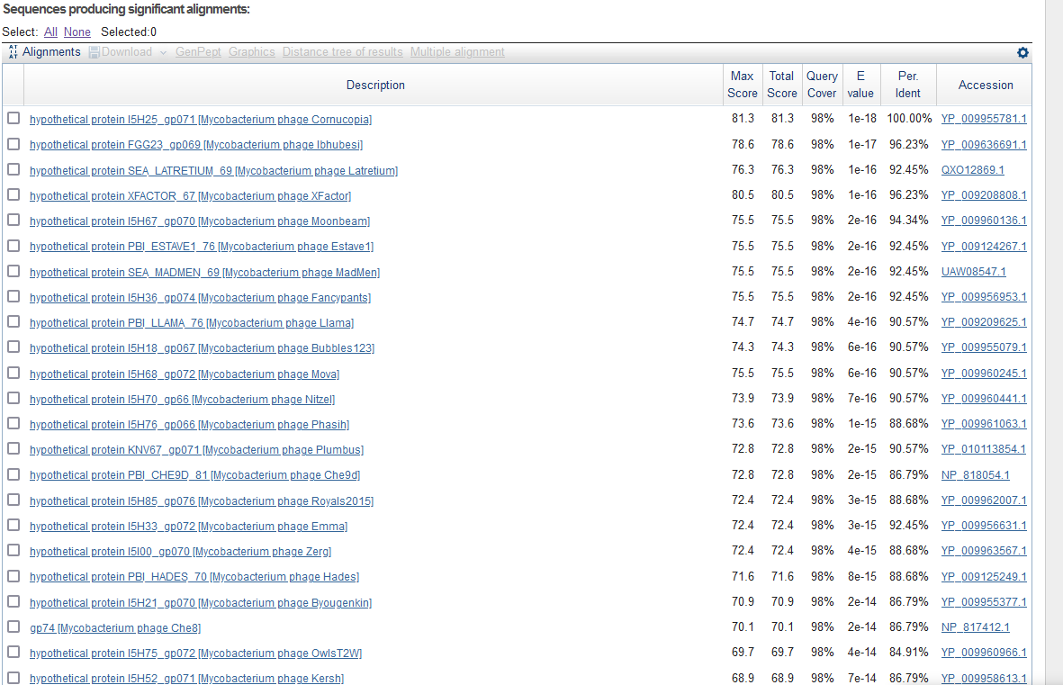
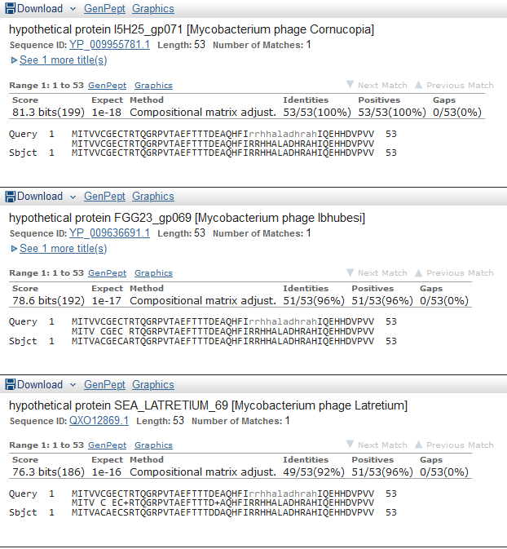

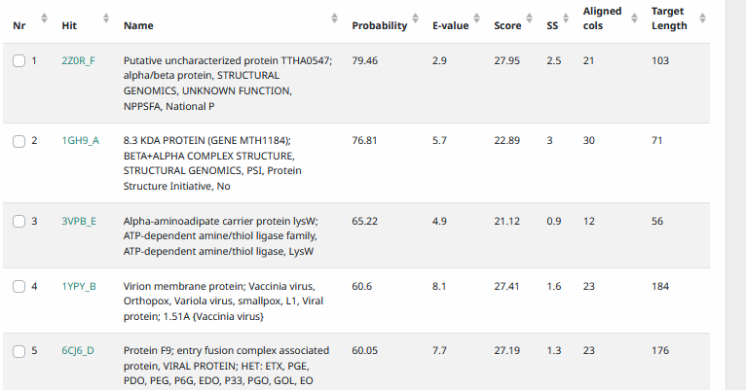

Start Codon and source: 43,466, ATG, called by GenemarkS
Stop Codon: 43,627
F/R: F
Coding Potential (y/n): Y
Starterator (SS, NA, NI): pham 50151, report not found
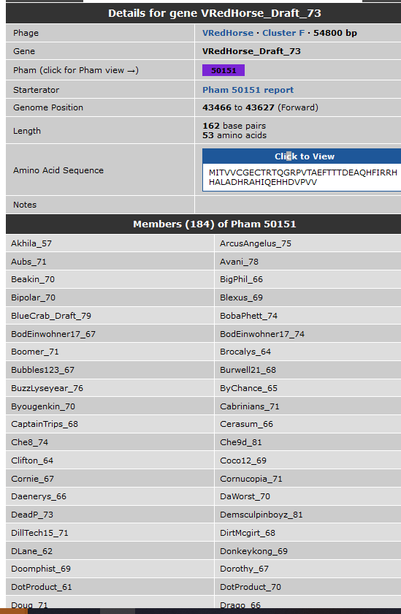
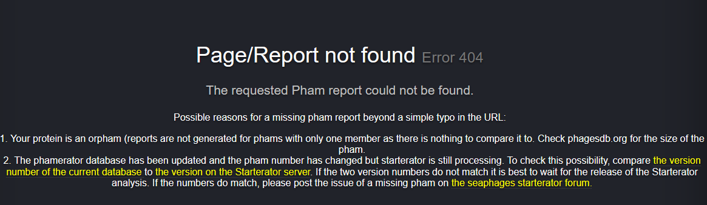
Blast Best Hit, Query:Subject Starts, Score, Evalue, or “no significant Blast alignments” if 10E-4 or higher
Gap: -4 bp with gene 67
Longest Orf? (Y/N/NA) N
RBS: N/A, Scoring Matirix , Spacing Matrix, Z Score, Final Score,
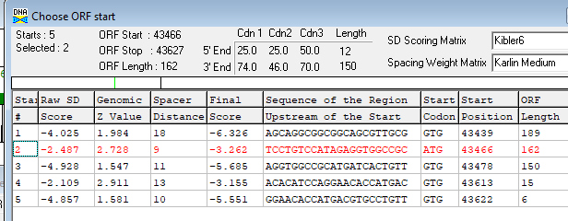
Proposed Function: hypothetical protein
Function Evidence: no credible function matches on HHPRED or BLastP
Transmembrane Domain/Evidence: NO
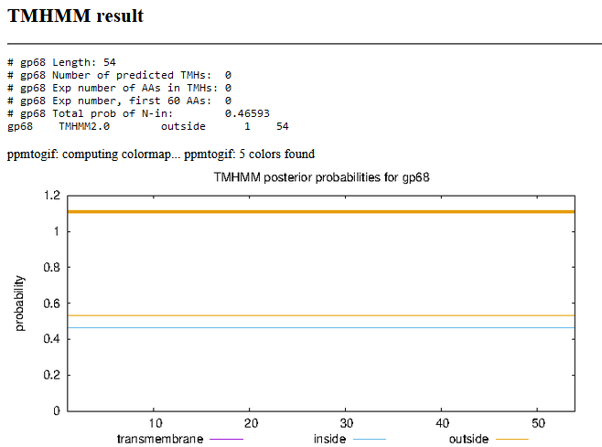

INSERT gene 69 (not called by glimmer or genemark), renumber, make map

Gene Number: 69 (original 68, phagesdb 74)
10/03/22 Run BlastP at phagesdb and NCBI, Starterator, RBS on Frames, Transmembrane prediction https://services.healthtech.dtu.dk/service.php?TMHMM-2.0, HHPRED, https://toolkit.tuebingen.mpg.de/#/tools/hhpred,
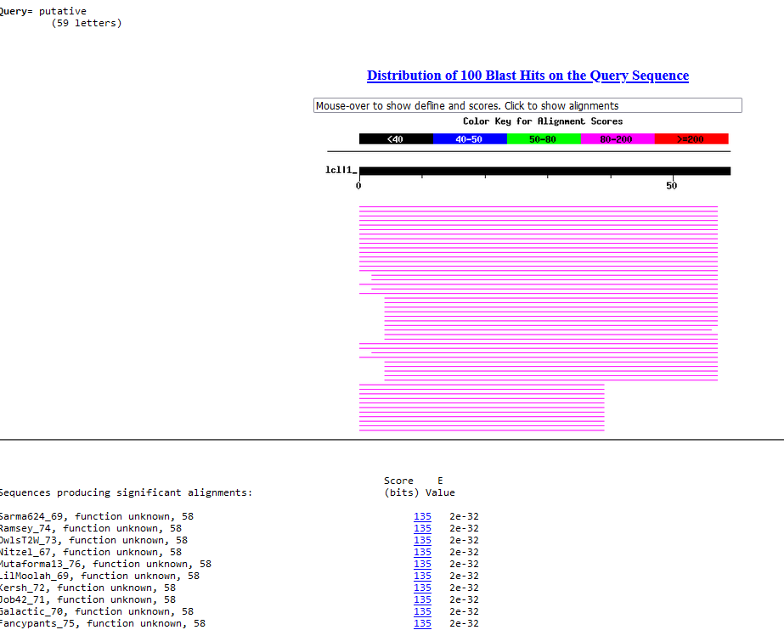
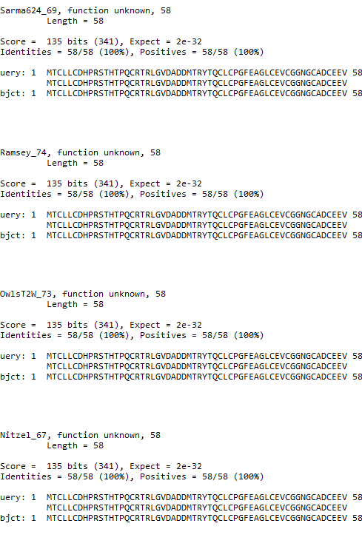
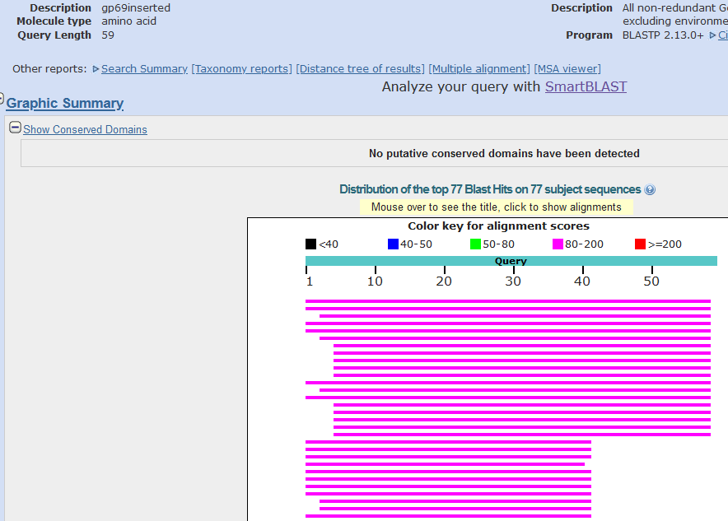
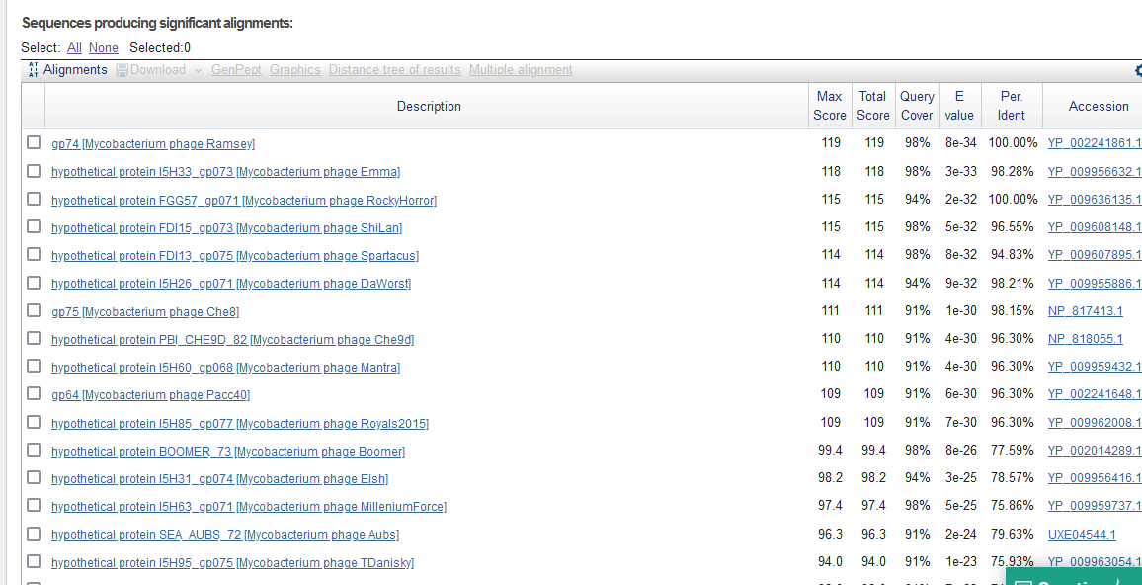
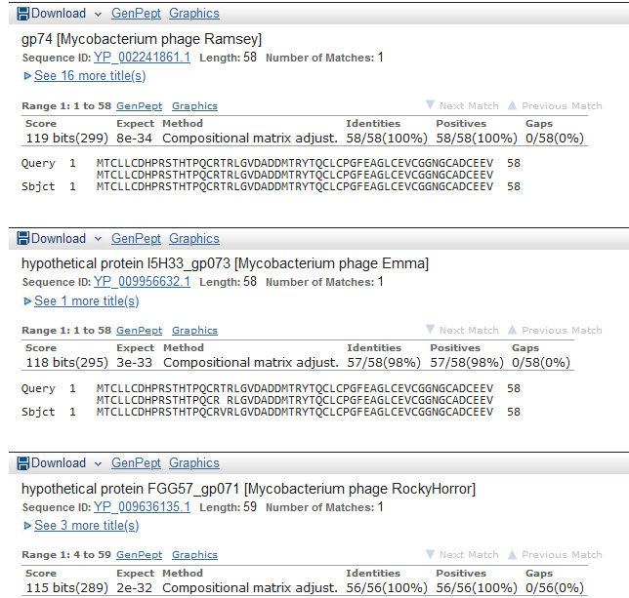

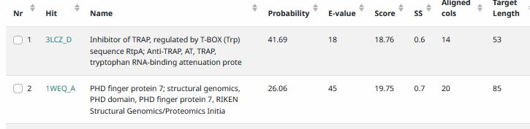
Start Codon and source: 43,608, ATG, not called by Genemark or Glimmer or GlimmerS
Stop Codon: 43,784, TGA
F/R: F
Coding Potential (y/n): weak
Starterator (SS, NA, NI): pham2376, most annotated start (shared w/Ramsey gp74)
Blast Best Hit, Query:Subject Starts, Score, Evalue, or “no significant Blast alignments” if 10E-4 or higher
Gap: -20 bp overlap from gene 68
Longest Orf? (Y/N/NA) N
RBS: N/A, Scoring Matirix , Spacing Matrix, Z Score, Final Score,
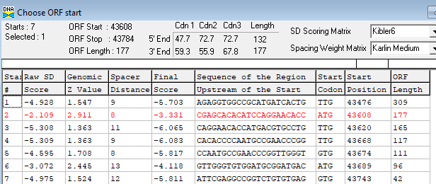
Proposed Function: hypothetical protein
Function Evidence: no credible Blast or HHPRED hits
Transmembrane Domain/Evidence: NO
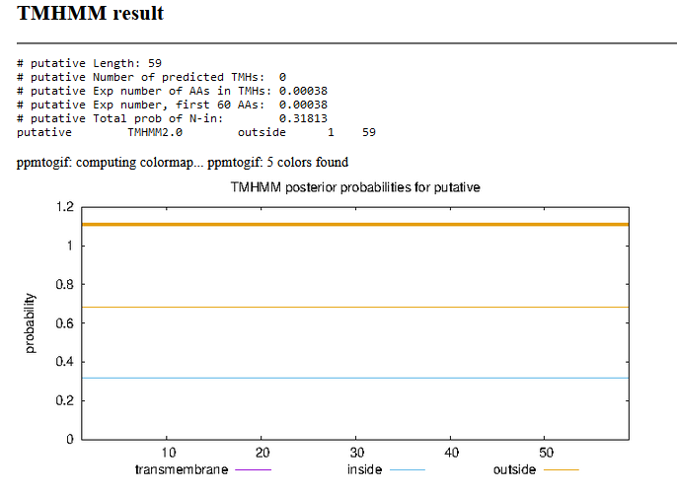

Gene Number: 70 (original 71, phagesdb 74) changed start to 43,781, TTG, longer by one codon,
10/03/22 Run BlastP at phagesdb and NCBI, Starterator, RBS on Frames, Transmembrane prediction https://services.healthtech.dtu.dk/service.php?TMHMM-2.0, HHPRED, https://toolkit.tuebingen.mpg.de/#/tools/hhpred,
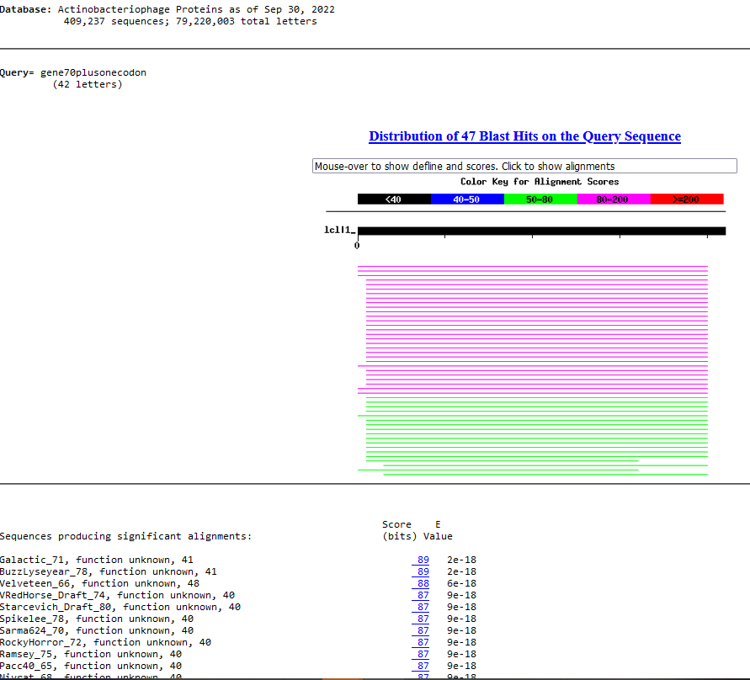
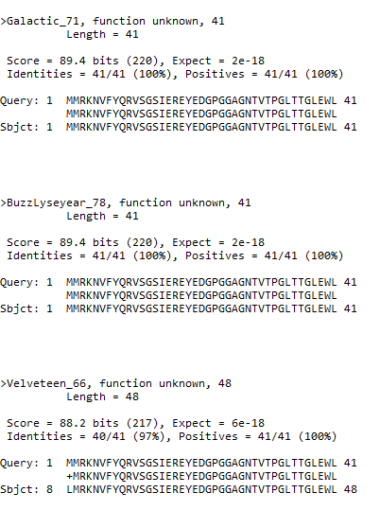
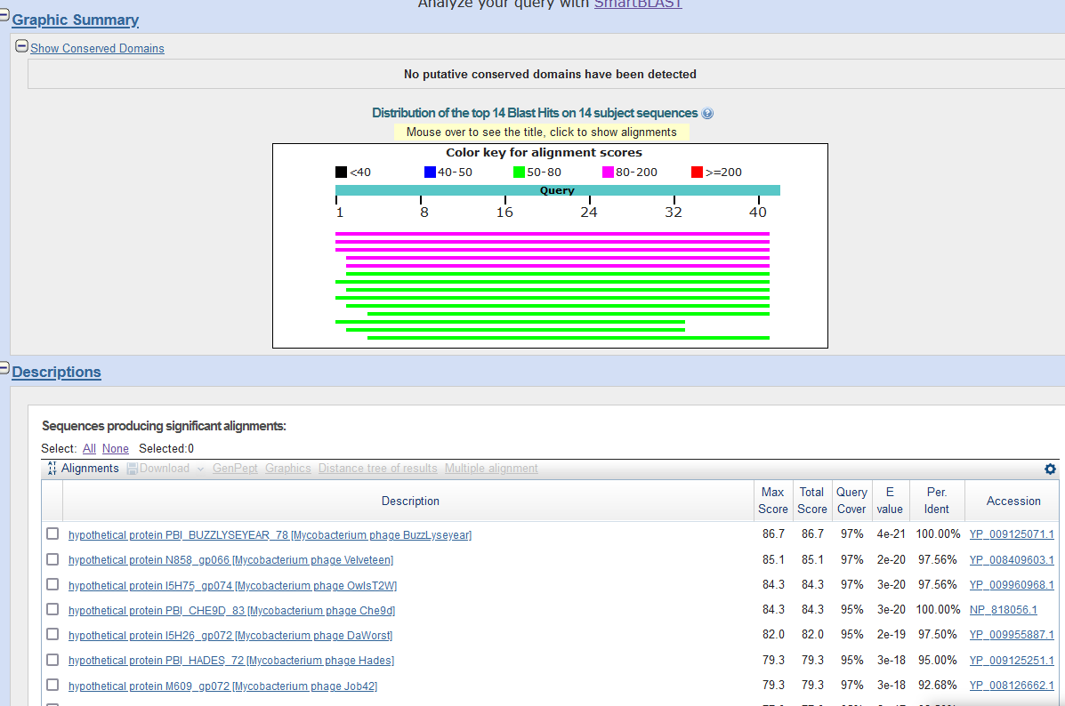
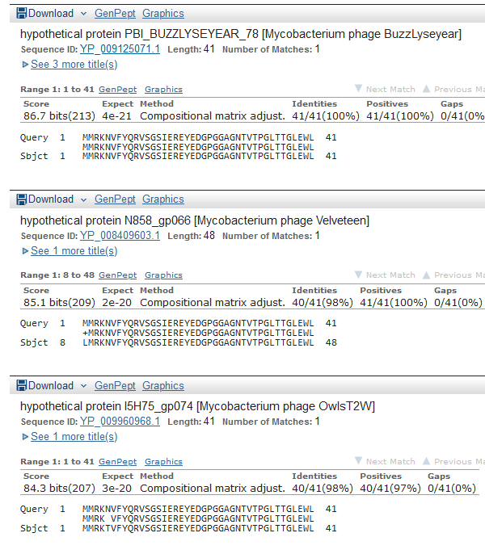
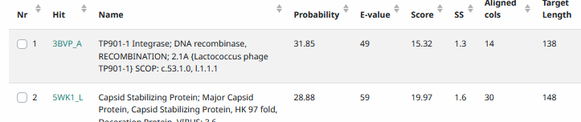
Start Codon and source: 43,781, TTG, added one codon from Genemark and Glimmers
Stop Codon: 43,906, TGA
F/R: F
Coding Potential (y/n): Y
Starterator (SS, NA, NI): pham 1945, changed FROM most annotated start
Blast Best Hit, Query:Subject Starts, Score, Evalue, or “no significant Blast alignments” if 10E-4 or higher
Gap: -4bp overlap with gene
Longest Orf? (Y/N/NA) N
RBS: N/A, Scoring Matirix , Spacing Matrix, Z Score, Final Score,
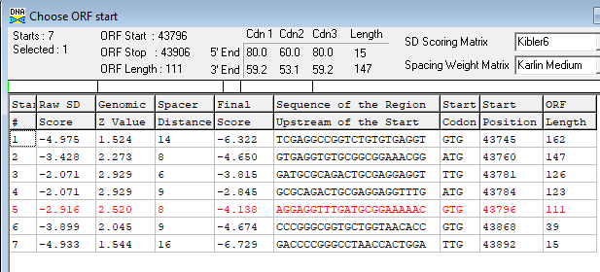
Proposed Function: hypothetical protein
Function Evidence: no credible functional matches on BlastP or HHPRED
Transmembrane Domain/Evidence: NO
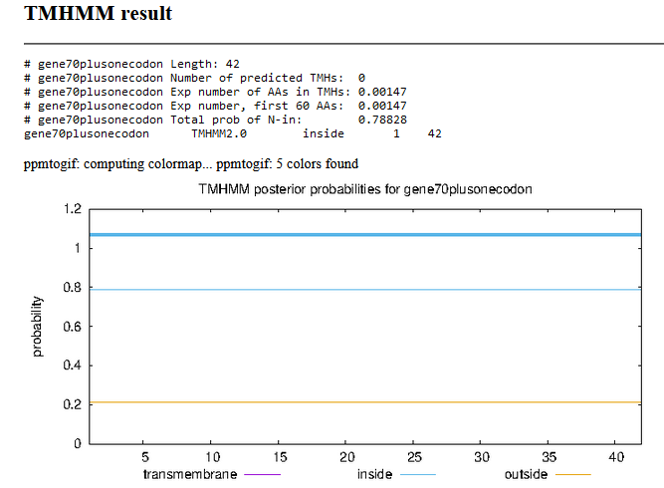

Gene Number: 71 (original gene 72, phagesdb draft 75) CHANGED START to 43,903, GTG
10/03/22 Run BlastP at phagesdb and NCBI, Starterator, RBS on Frames, Transmembrane prediction https://services.healthtech.dtu.dk/service.php?TMHMM-2.0, HHPRED, https://toolkit.tuebingen.mpg.de/#/tools/hhpred,
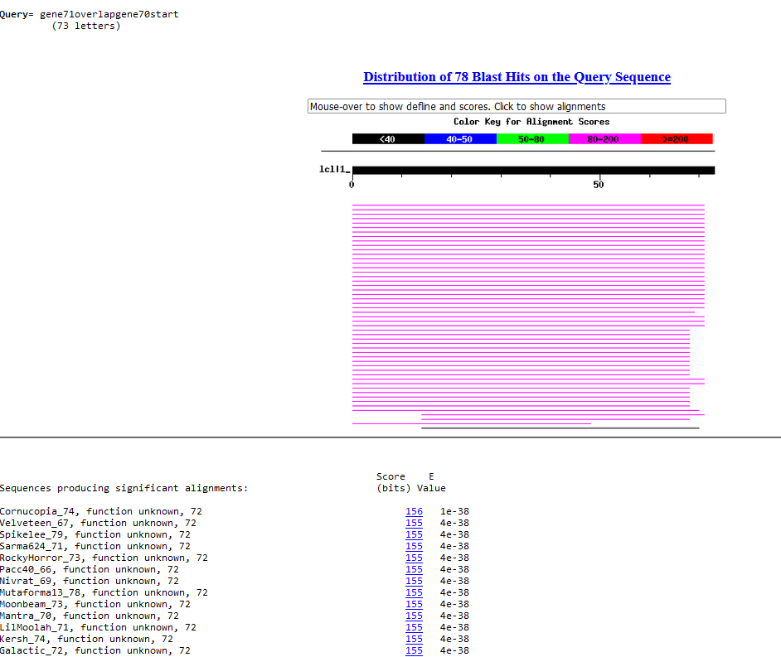
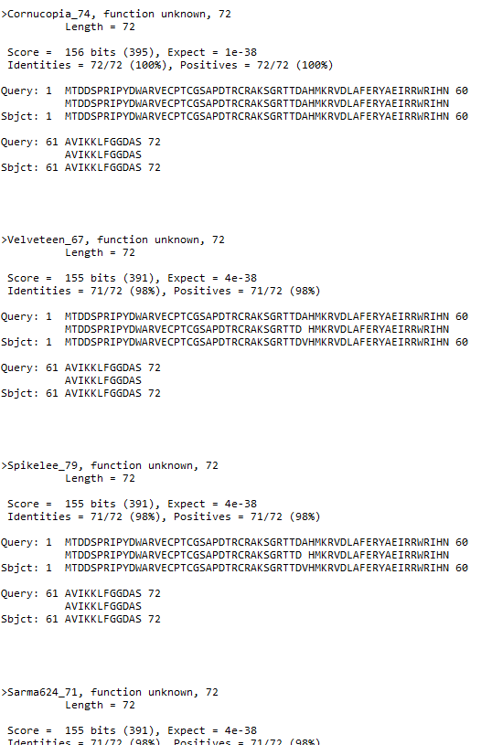
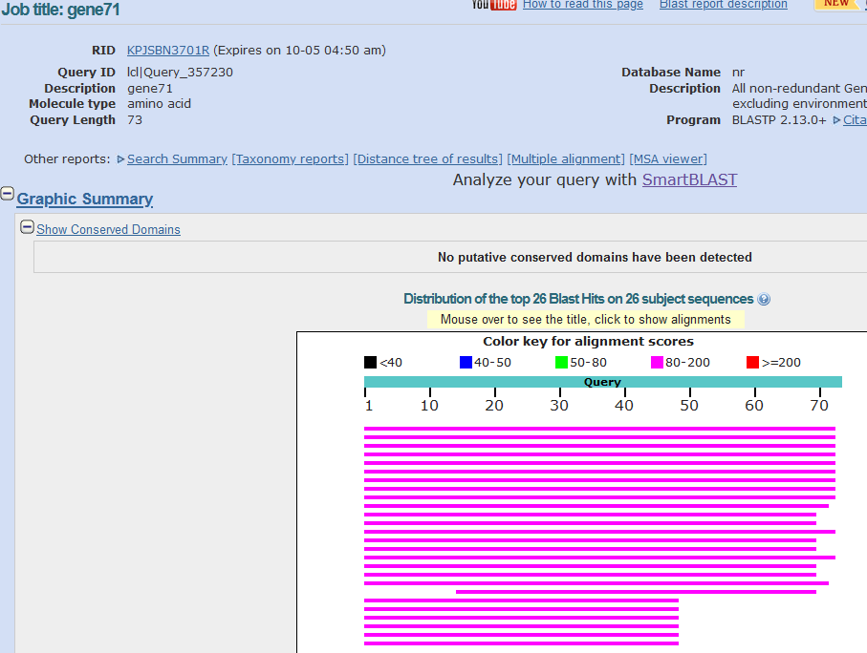
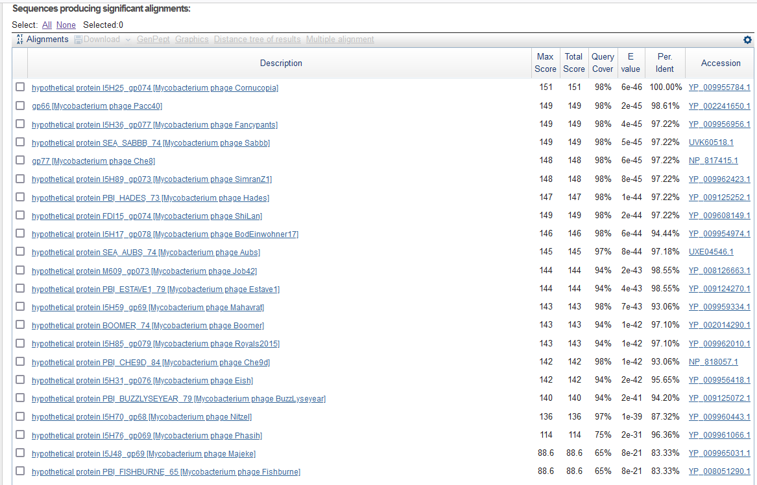
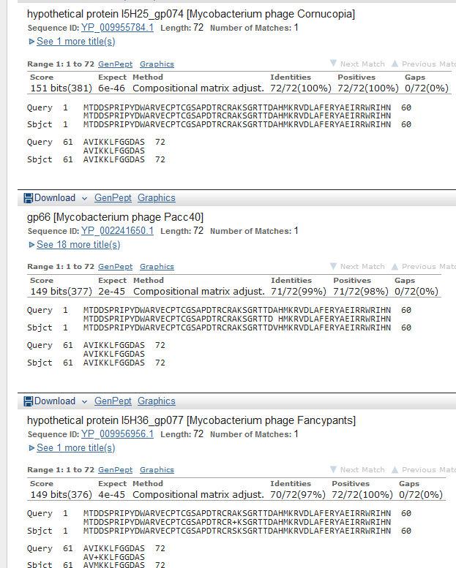
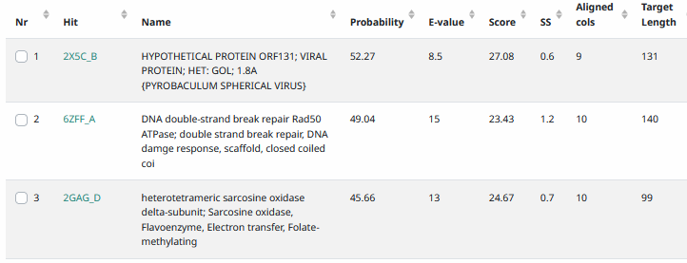
Start Codon and source: 43,903, GTG
Stop Codon: 44121, TGA
F/R: F
Coding Potential (y/n): Y
Starterator (SS, NA, NI): pham 1878, changed to most annotated start
Blast Best Hit, Query:Subject Starts, Score, Evalue, or “no significant Blast alignments” if 10E-4 or higher
Gap: -4 bp overlap with gene 70
Longest Orf? (Y/N/NA) N
RBS: N/A, Scoring Matirix , Spacing Matrix, Z Score, Final Score,
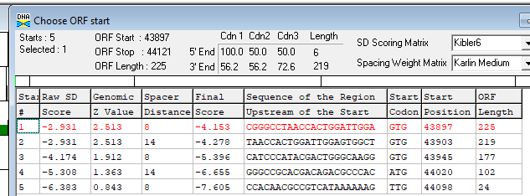
Proposed Function: hypothetical protein
Function Evidence: no credible functional matches on HHPRED or Blastp
Transmembrane Domain/Evidence: NO
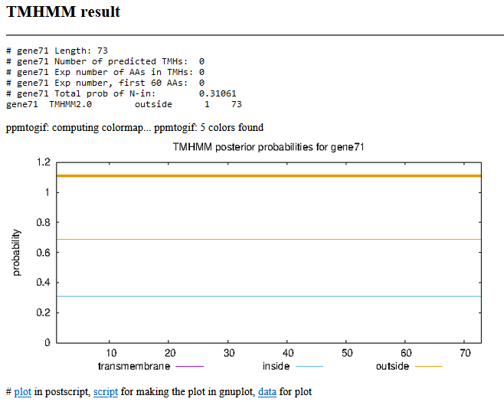

Gene Number: 72 (original 73, phagesdb draft 76)
10/03/22 Run BlastP at phagesdb and NCBI, Starterator, RBS on Frames, Transmembrane precdition https://services.healthtech.dtu.dk/service.php?TMHMM-2.0, HHPRED, https://toolkit.tuebingen.mpg.de/#/tools/hhpred,
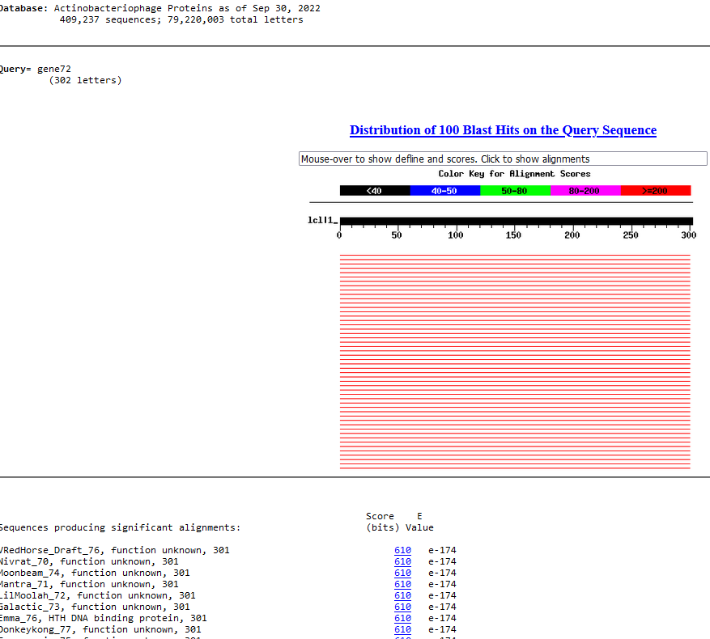
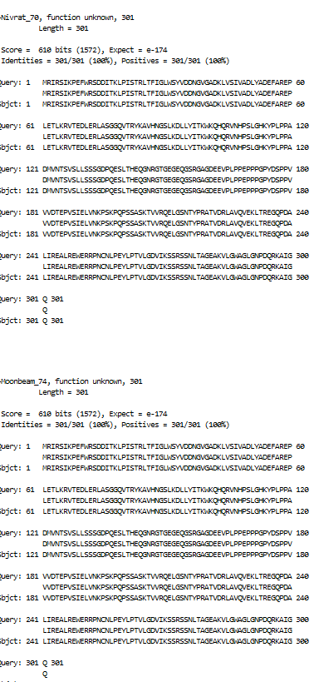
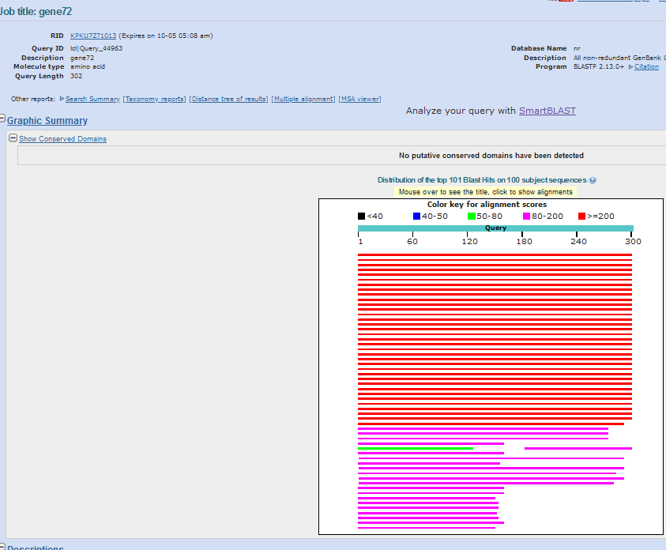
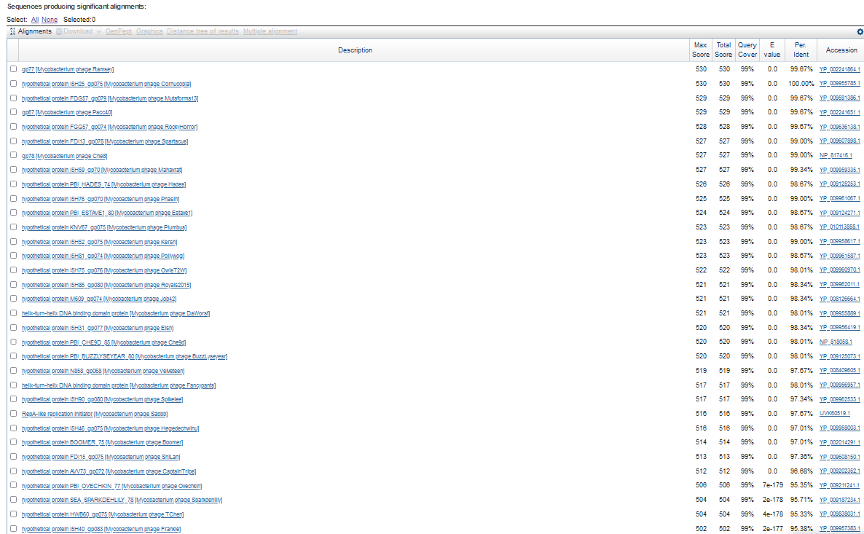
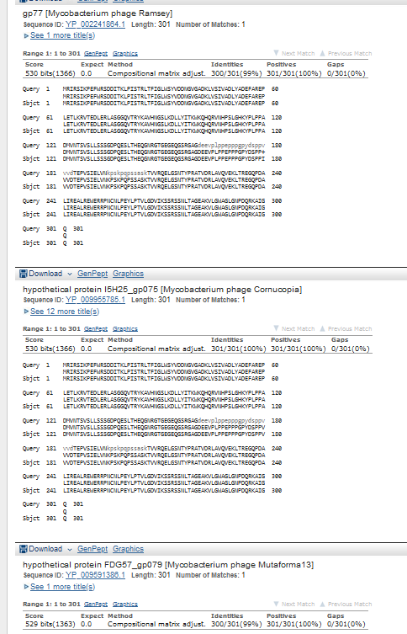
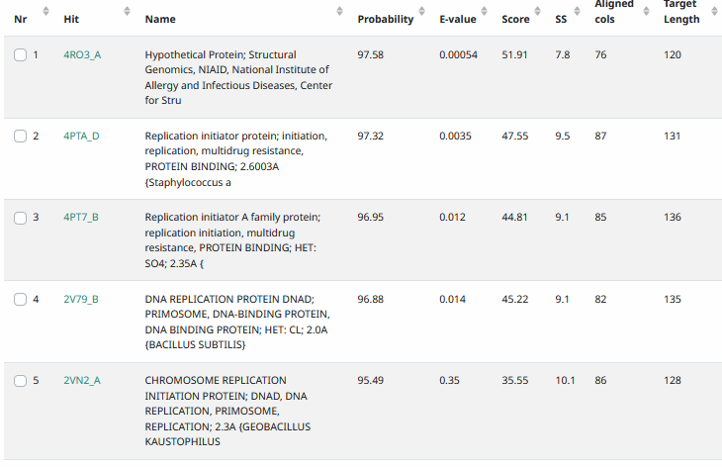
Start Codon and source: 44118, GTG, called by Glimmer and genemark
Stop Codon: 45023, TGA
F/R: F
Coding Potential (y/n): Y
Starterator (SS, NA, NI): pham 50180, page not found
Blast Best Hit, Query:Subject Starts, Score, Evalue, or “no significant Blast alignments” if 10E-4 or higher
Gap: -4 bp overlap with gene 71
Longest Orf? (Y/N/NA) Y
RBS: N/A, Scoring Matirix , Spacing Matrix, Z Score, Final Score,
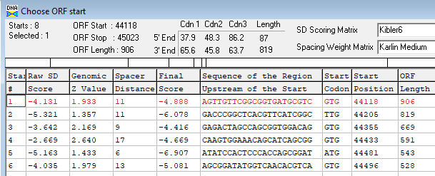
Proposed Function: RepA-like replication initiator
(also considered DNA binding protein)
Function Evidence: HHPRED match
Run JPred4 to see if Helix-turn-helix is appropriate…http://www.compbio.dundee.ac.uk/jpred4/index.html
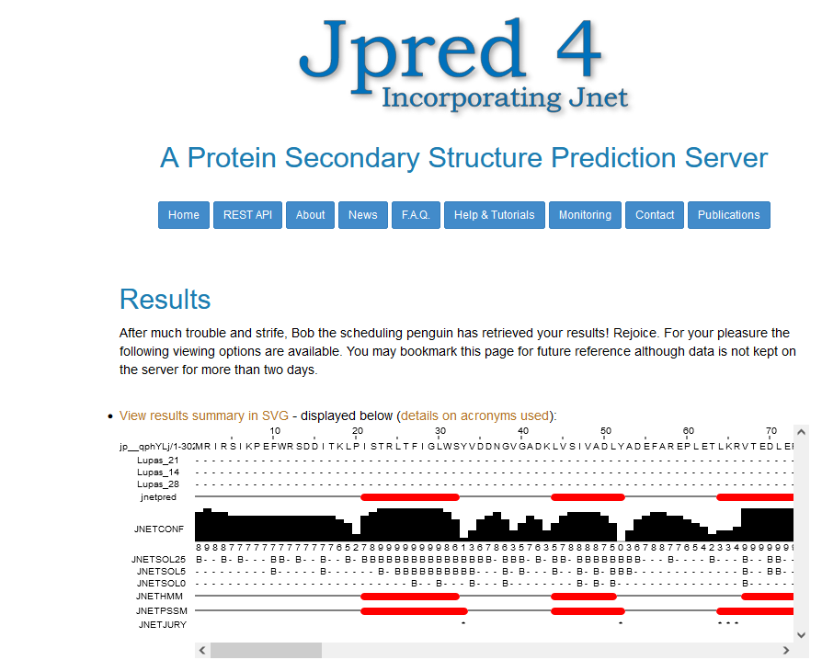
Transmembrane Domain/Evidence: NO
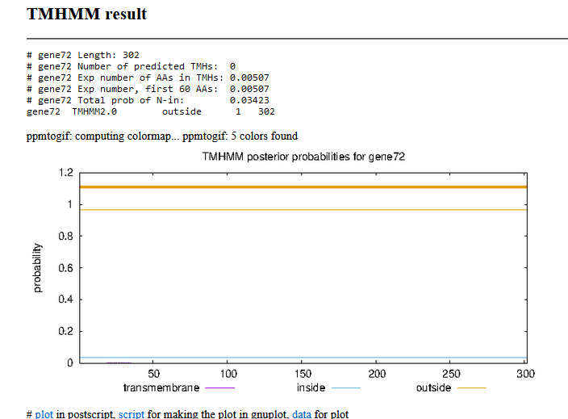

Gene Number: 73 (original 74, phagesdb draft 77)
10/03/22 Run BlastP at phagesdb and NCBI, Starterator, RBS on Frames, Transmembrane precdition https://services.healthtech.dtu.dk/service.php?TMHMM-2.0, HHPRED, https://toolkit.tuebingen.mpg.de/#/tools/hhpred,
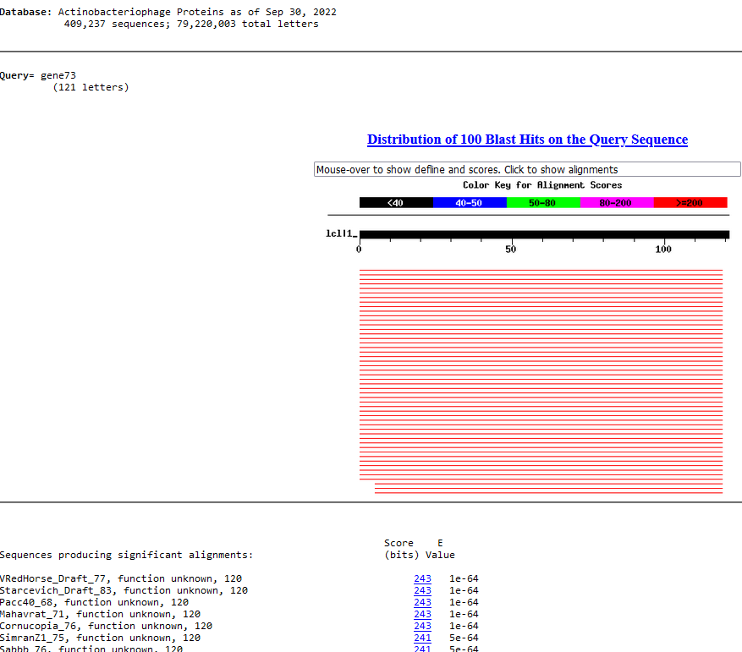
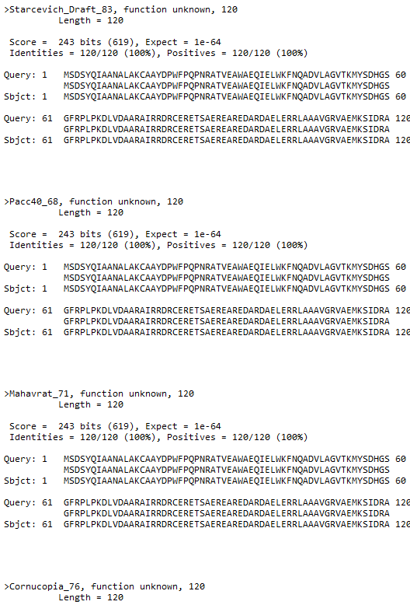
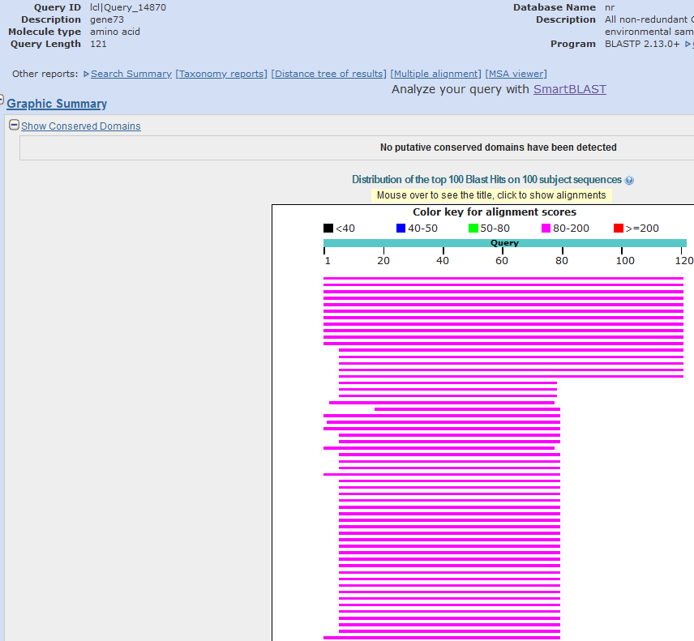
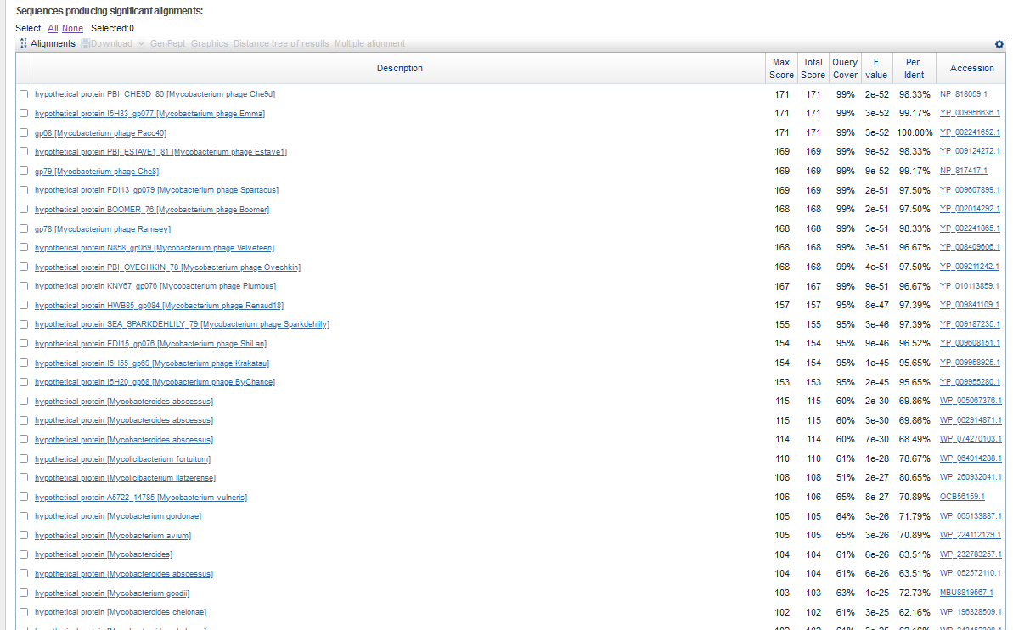
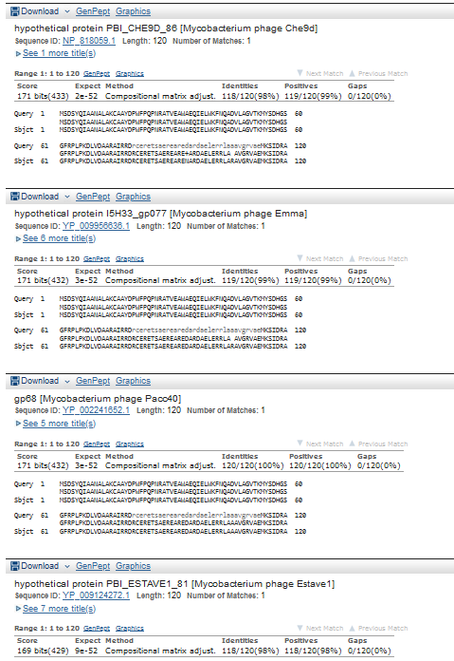
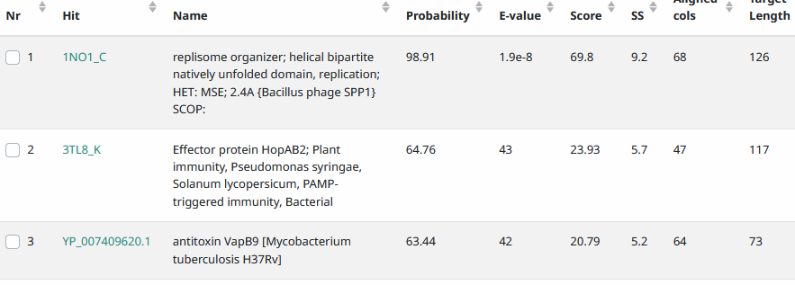
Start Codon and source: 45020, ATG, called by Glimmer and Genemark
Stop Codon: 45,382, TGA
F/R: F
Coding Potential (y/n): Y
Starterator (SS, NA, NI): pham 1423, most annotated start
Blast Best Hit, Query:Subject Starts, Score, Evalue, or “no significant Blast alignments” if 10E-4 or higher
Gap: -4 bp overlap with gene 72
Longest Orf? (Y/N/NA) Y
RBS: N/A, Scoring Matirix , Spacing Matrix, Z Score, Final Score,
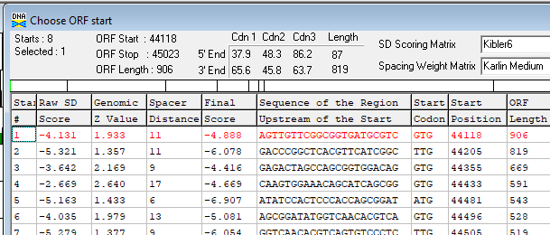
Proposed Function: replisome organizer
Function Evidence: HHPRED 98.91%, and next to RepA-like replication initiator
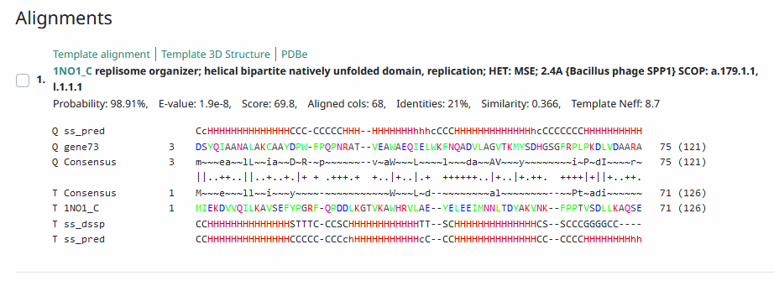
Transmembrane Domain/Evidence: no
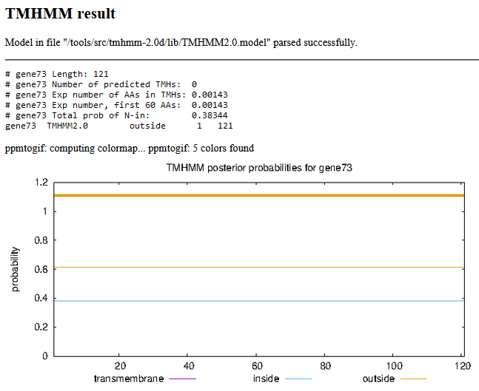

Gene Number: 74 (original 75, phagesdb draft 78)
10/04/22 Run BlastP at phagesdb and NCBI, Starterator, RBS on Frames, Transmembrane precdition https://services.healthtech.dtu.dk/service.php?TMHMM-2.0, HHPRED, https://toolkit.tuebingen.mpg.de/#/tools/hhpred,
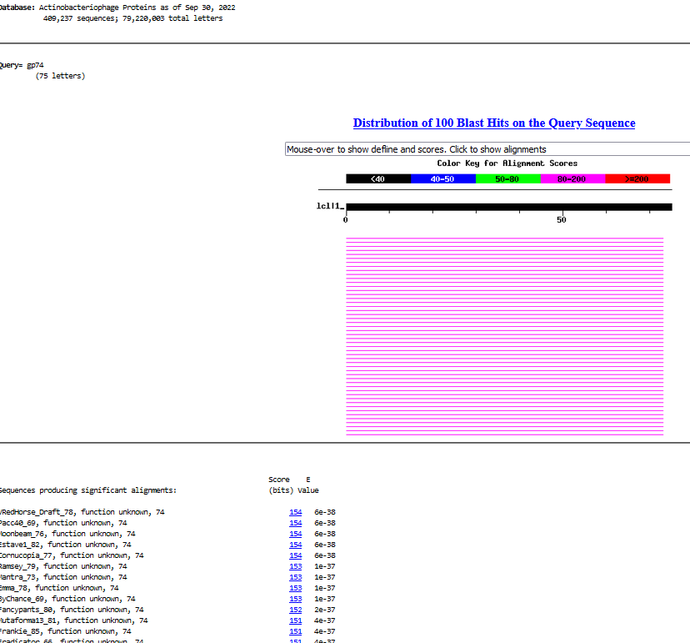
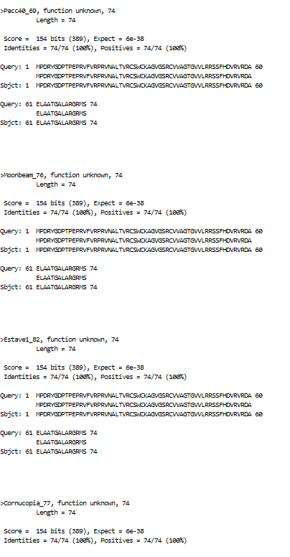
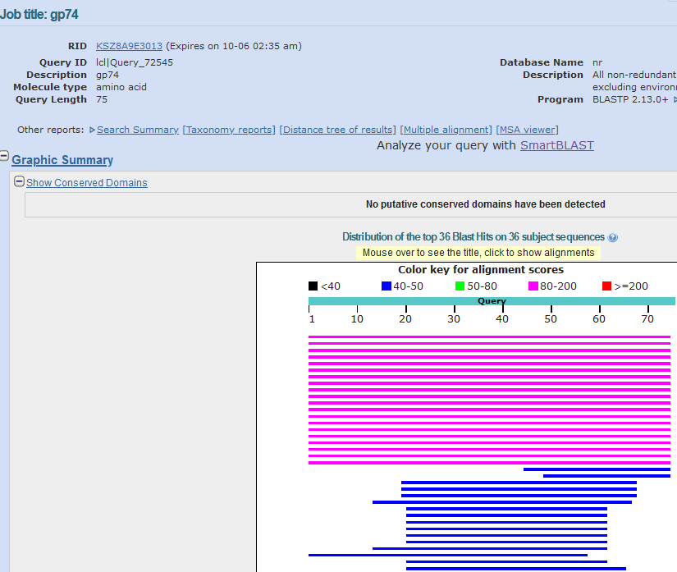
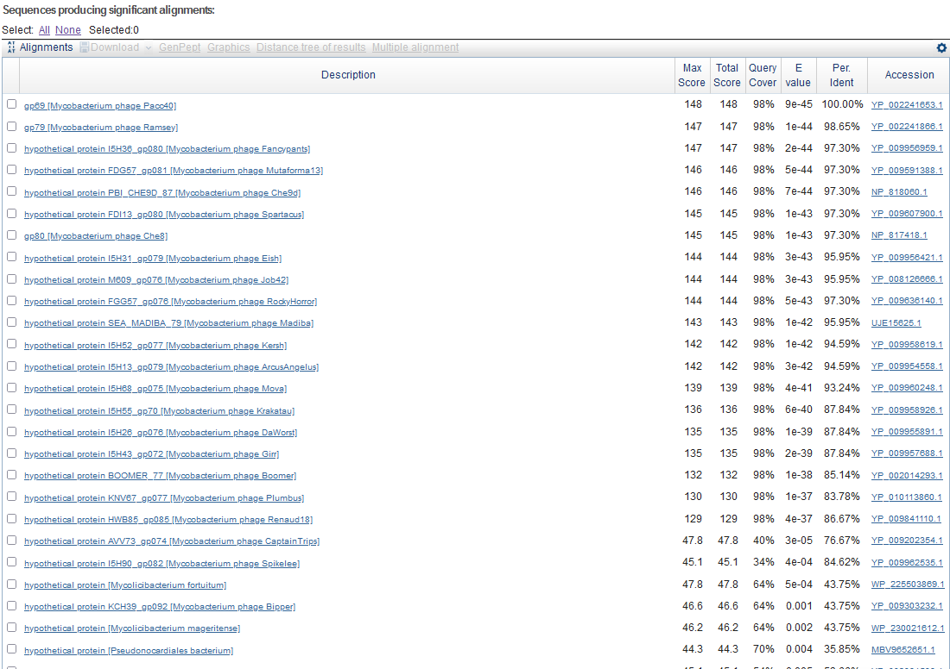
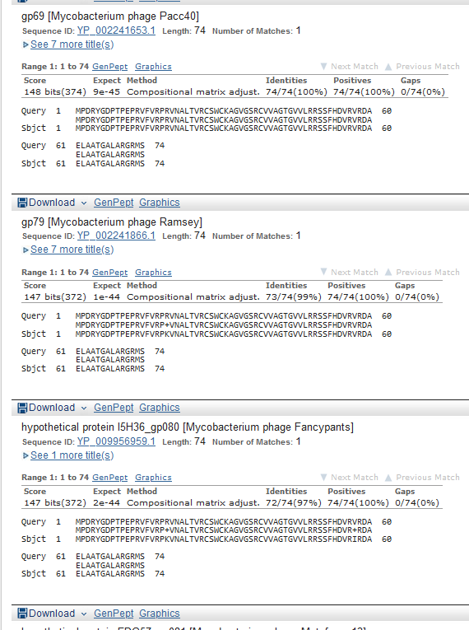
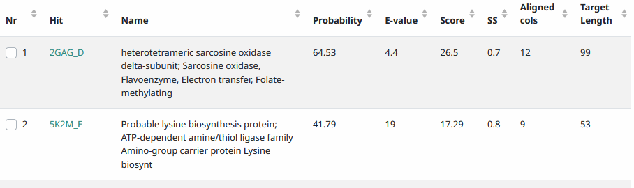
Start Codon and source: 45,375, GTG, called by Glimmer, not by Genemark
Stop Codon: 45599, TGA
F/R: F
Coding Potential (y/n): y, weak
Starterator (SS, NA, NI): pham 1656, most annotated start
Blast Best Hit, Query:Subject Starts, Score, Evalue, or “no significant Blast alignments” if 10E-4 or higher
Gap: -8 bp overlap with gene 73
Longest Orf? (Y/N/NA) N (two extra codons upstream a TTG exists)
RBS: N/A, Scoring Matirix , Spacing Matrix, Z Score, Final Score,
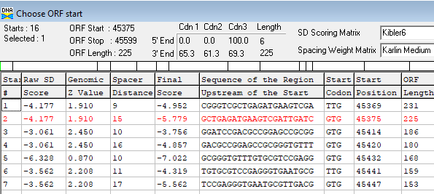
Proposed Function: hypothetical protein
Function Evidence: no credible function matches on HHPRED or BLASTP
Transmembrane Domain/Evidence: NO
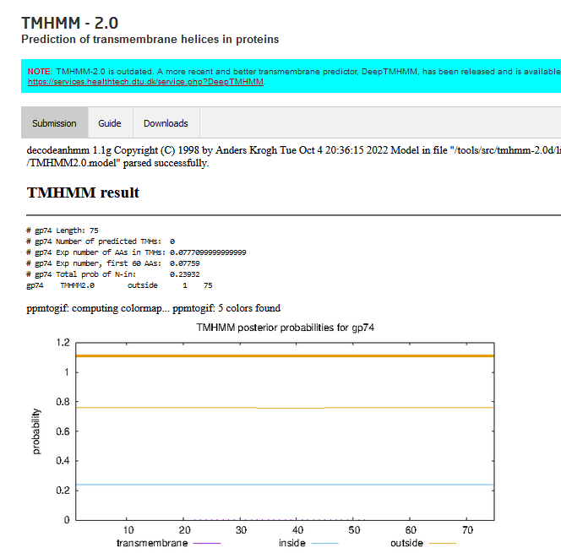

INSERT GENE 75. Fills gap, has matches in other phages. Weak coding potential on GenemarkS
Make new map (Map6)
Gene Number: 75 (not called on original, or genemarkS, or phagesdb draft)
10/04/22 Run BlastP at phagesdb and NCBI, Starterator, RBS on Frames, Transmembrane precdition https://services.healthtech.dtu.dk/service.php?TMHMM-2.0, HHPRED, https://toolkit.tuebingen.mpg.de/#/tools/hhpred,
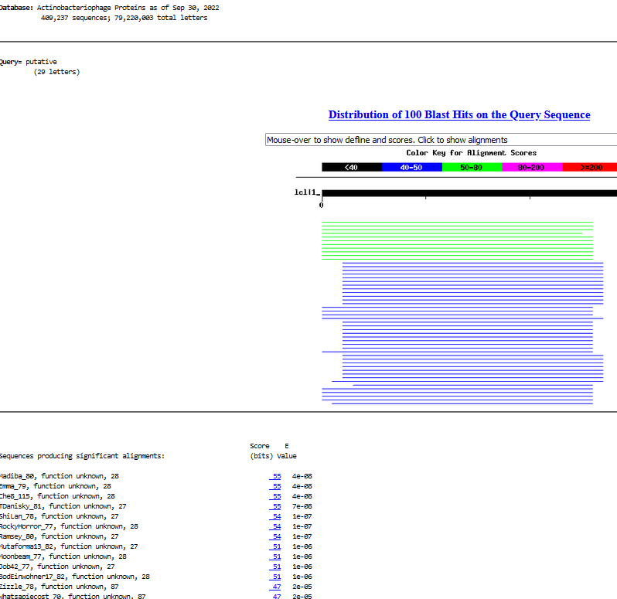
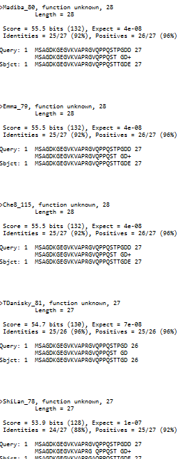
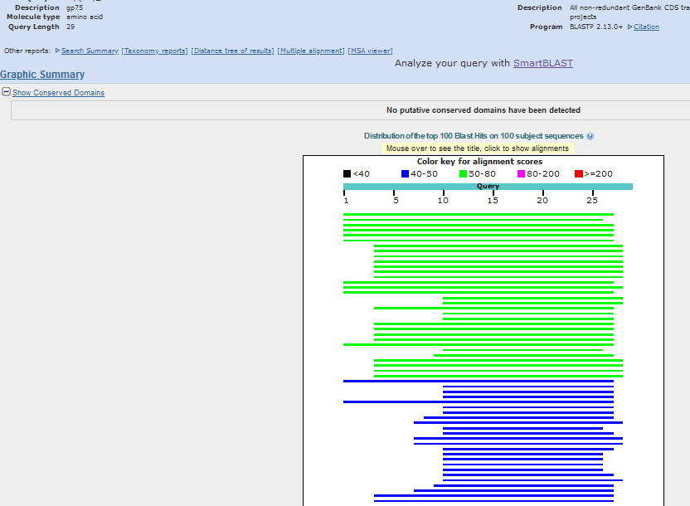
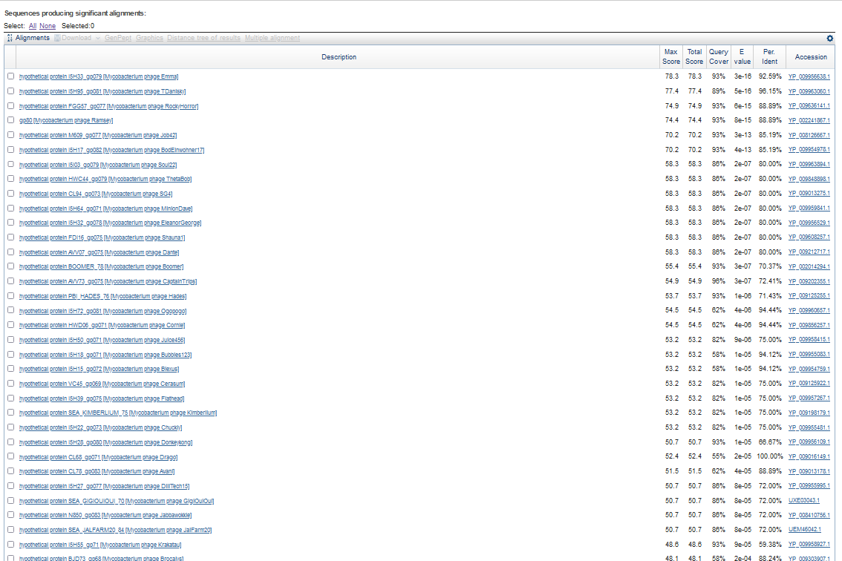
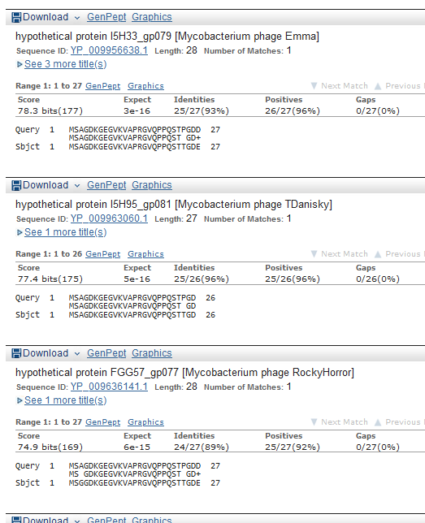
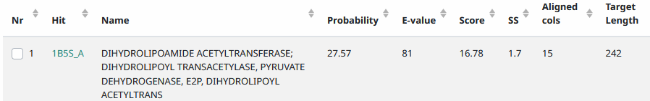
Start Codon and source: 45596, ATG, not called by glimmer or genemark
Stop Codon: 45,682, TGA
F/R: F
Coding Potential (y/n): y, very weak
Starterator (SS, NA, NI): pham 4763 (as per Emma79 match, matches most annotated start)
Blast Best Hit, Query:Subject Starts, Score, Evalue, or “no significant Blast alignments” if 10E-4 or higher
Gap: -4bp overlap with gene 74
Longest Orf? (Y/N/NA) Y
RBS: N/A, Scoring Matirix , Spacing Matrix, Z Score, Final Score,
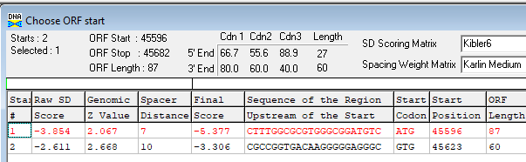
Proposed Function: hypothetical protein
Function Evidence: no credible function matches on HHPRED or blastP
Transmembrane Domain/Evidence: NO
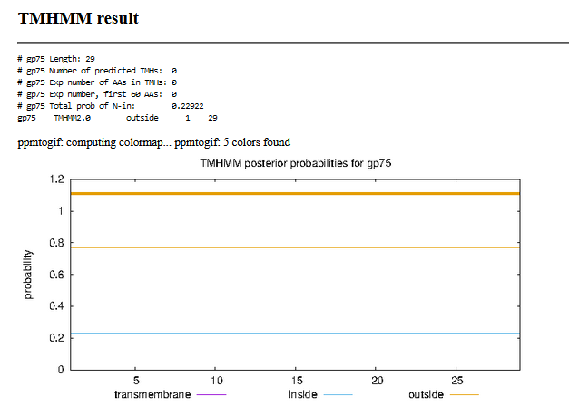

Gene Number: 76 (original 76, phages draft79) CHANGE START To 45679
10/04/22 Run BlastP at phagesdb and NCBI, Starterator, RBS on Frames, Transmembrane precdition https://services.healthtech.dtu.dk/service.php?TMHMM-2.0, HHPRED, https://toolkit.tuebingen.mpg.de/#/tools/hhpred,
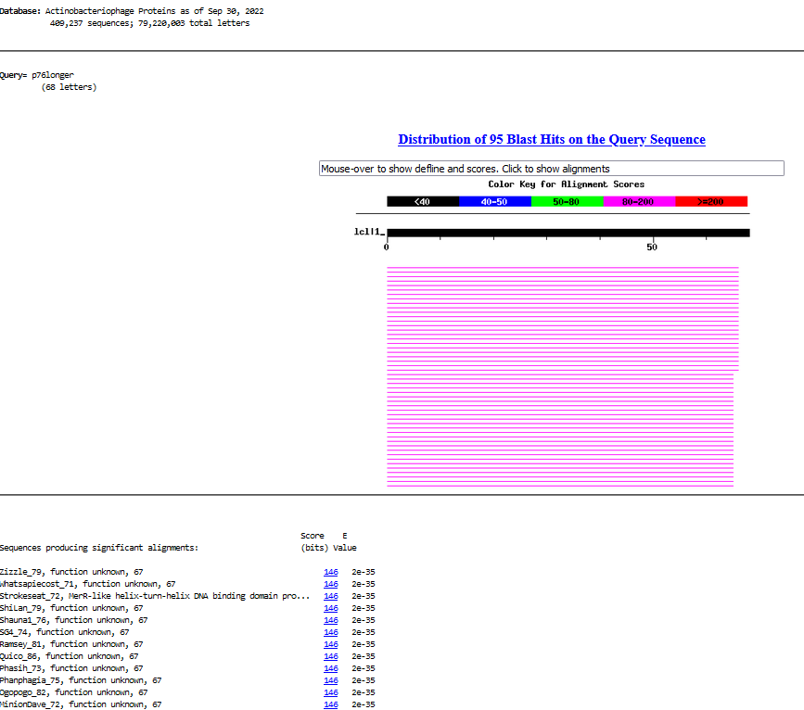
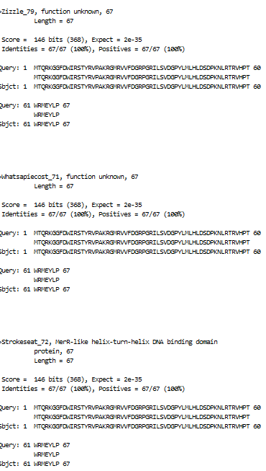
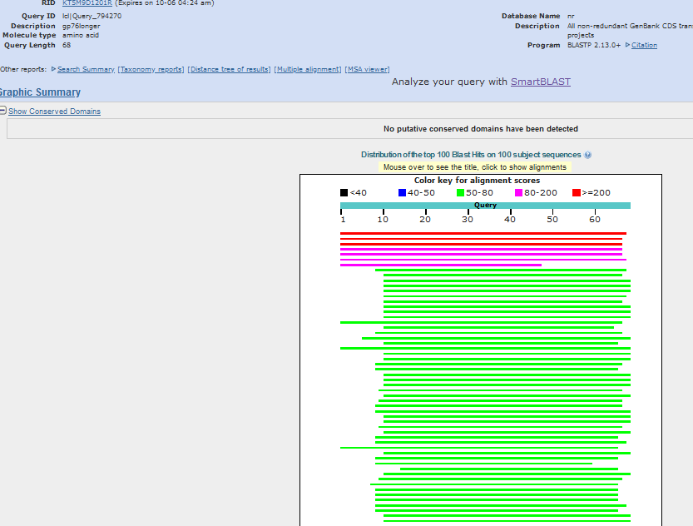
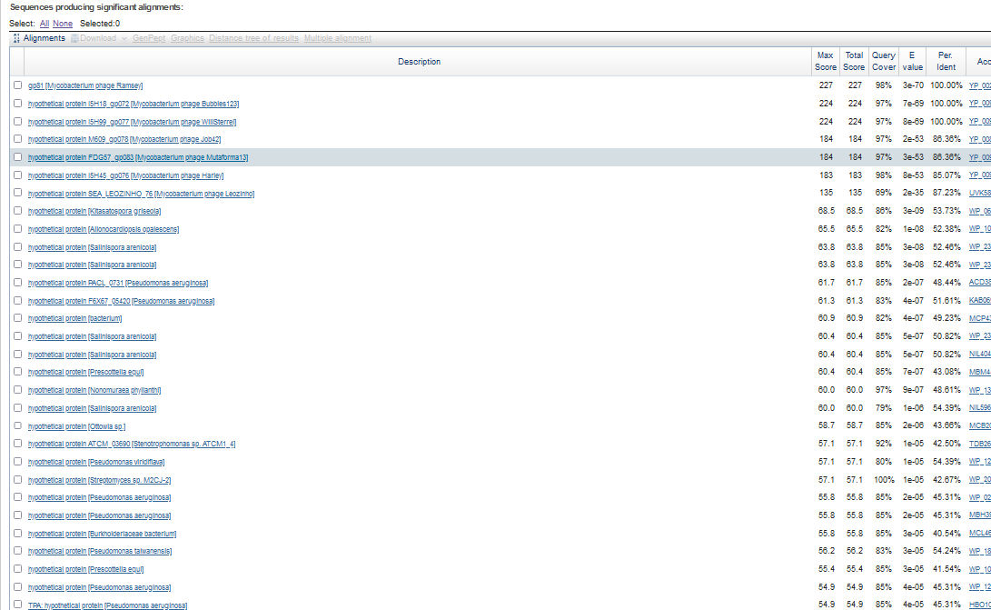
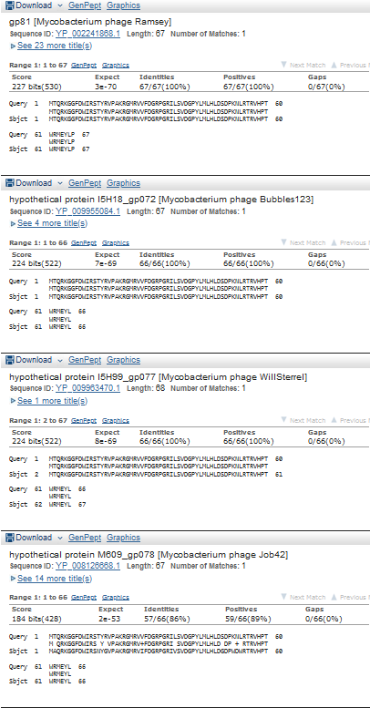
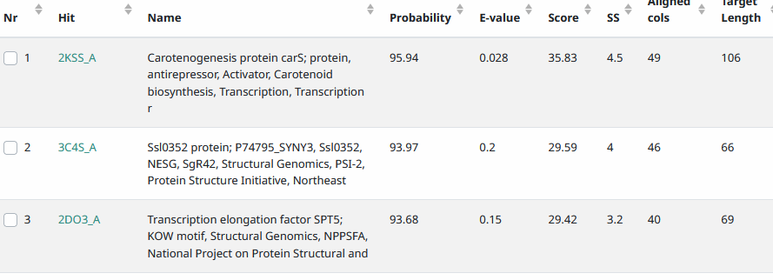
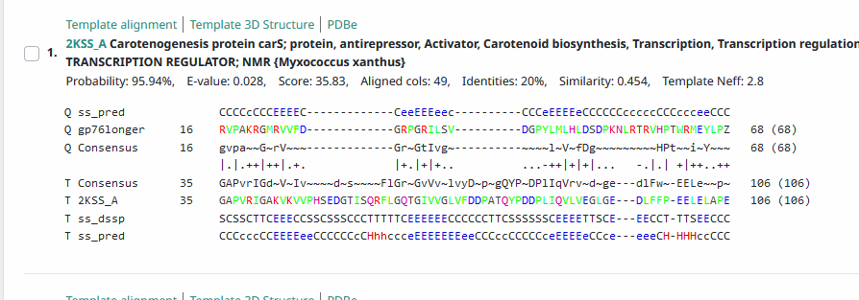
Start Codon and source: 45,679, ATG, GenemarkS
Stop Codon: 45882, TGA
F/R: F
Coding Potential (y/n):Y
Starterator (SS, NA, NI): pham 1042, changed to most annotated start, as in Zizzle 79
Blast Best Hit, Query:Subject Starts, Score, Evalue, or “no significant Blast alignments” if 10E-4 or higher
Gap: -4bp overlap with gene 75
Longest Orf? (Y/N/NA) Y
RBS: N/A, Scoring Matirix , Spacing Matrix, Z Score, Final Score,
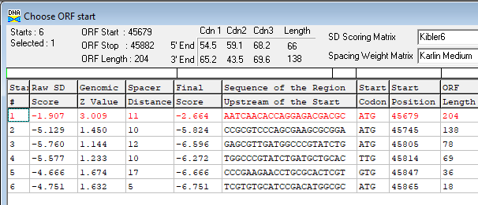
Proposed Function: hypothetical protein (hints at DNA binding protein, transcriptional regulation from HHPRED)
Function Evidence: (hints at DNA binding protein, transcriptional regulation from HHPRED)
Transmembrane Domain/Evidence: NO
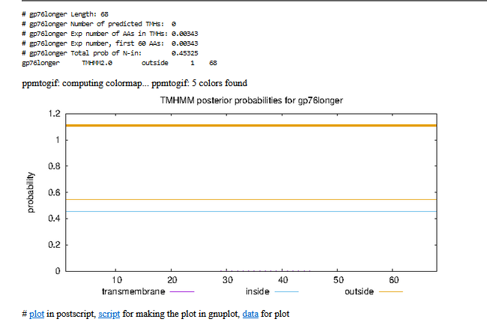

Gene Number: 77 (original 77, phagesdbdraft 80)
10/04/22 Run BlastP at phagesdb and NCBI, Starterator, RBS on Frames, Transmembrane precdition https://services.healthtech.dtu.dk/service.php?TMHMM-2.0, HHPRED, https://toolkit.tuebingen.mpg.de/#/tools/hhpred,
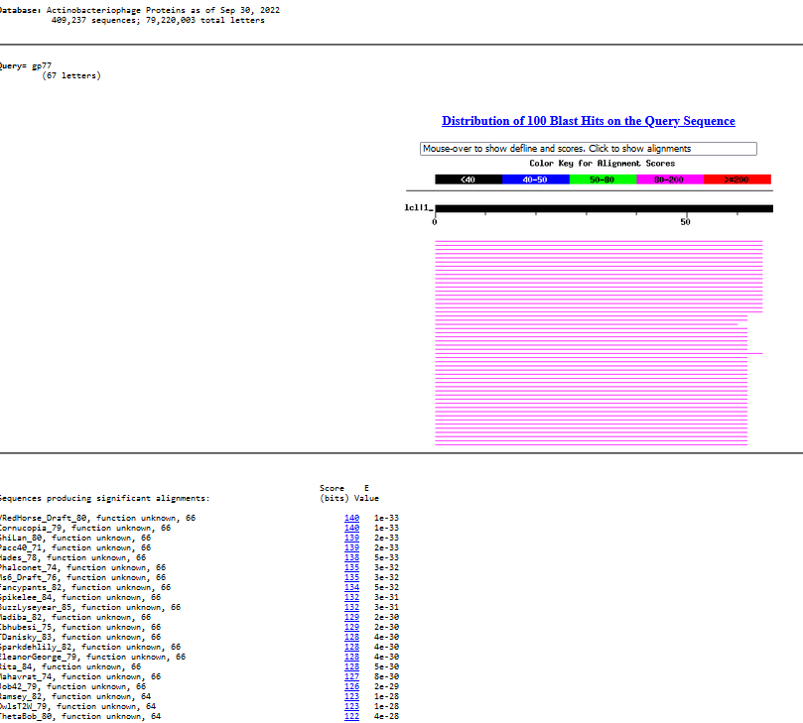
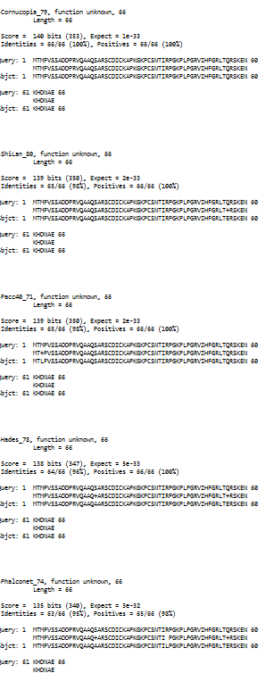
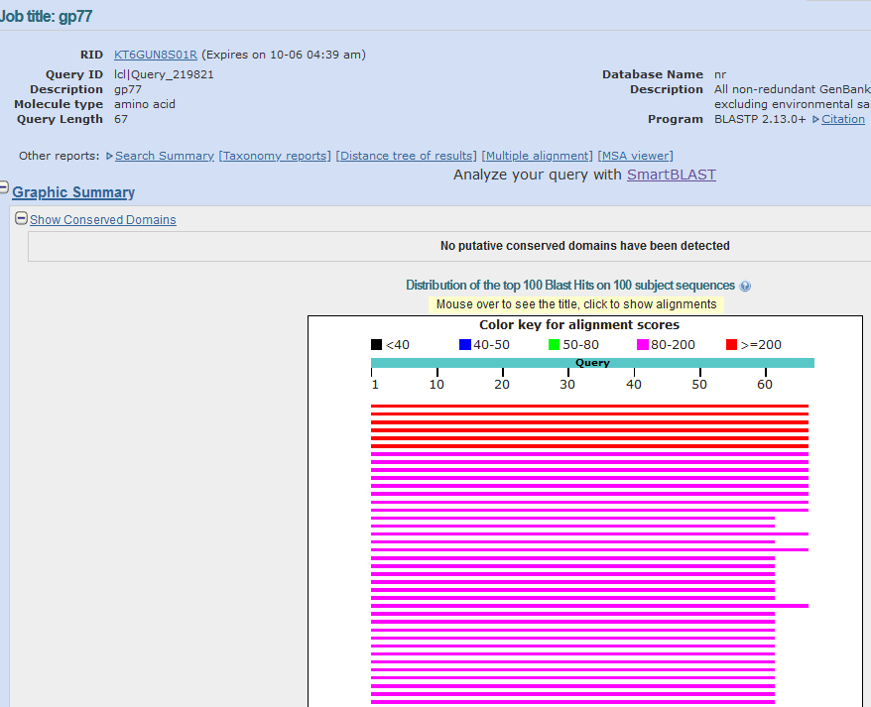
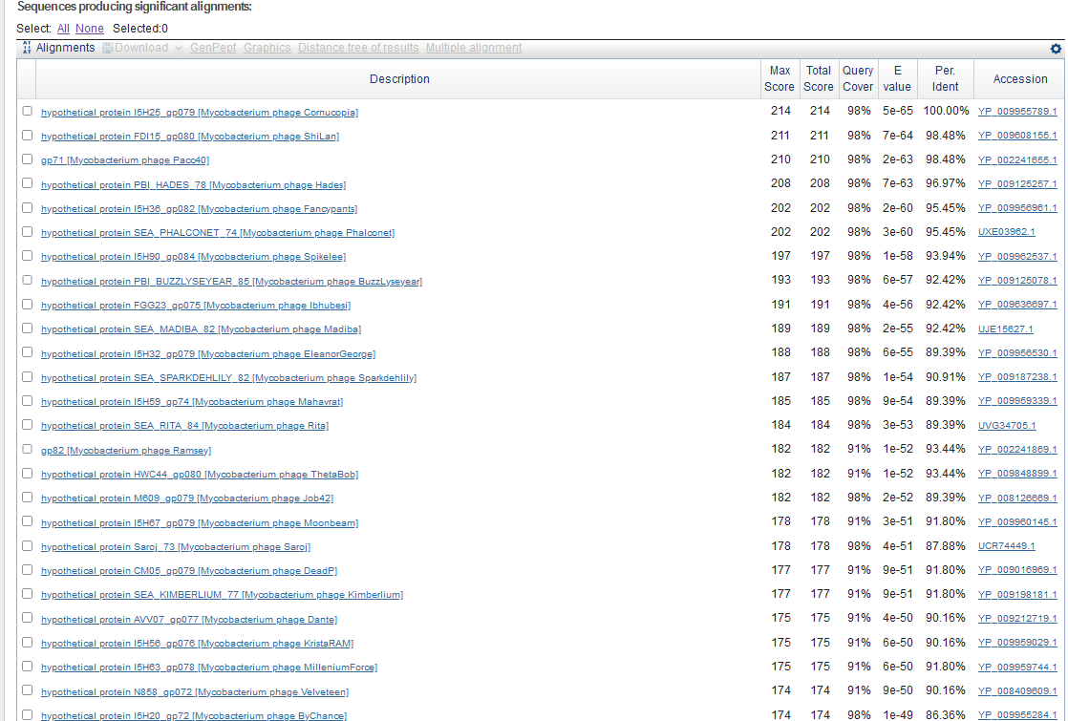
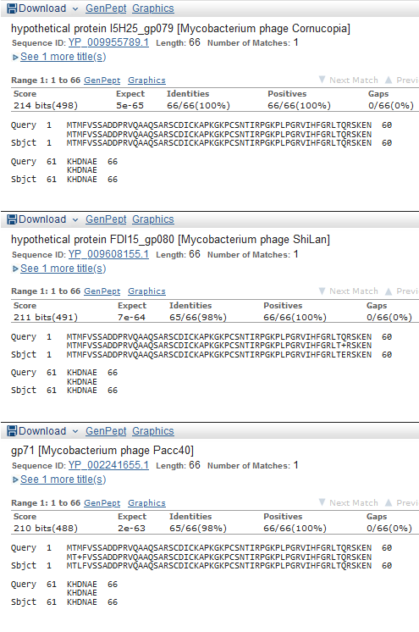
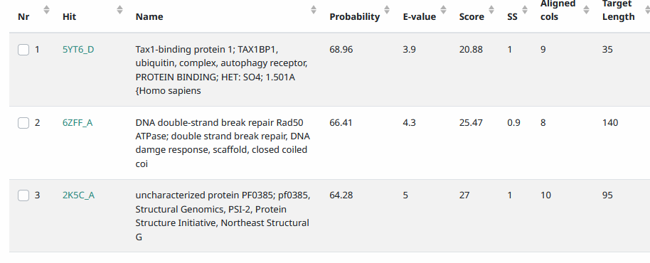
Start Codon and source: 45,879, ATG, called by Glimmer and GenemarkS, not DNAmasterGenemark
Stop Codon: 46,079, TGA
F/R: F
Coding Potential (y/n): Y
Starterator (SS, NA, NI): pham 44436, most annotated start
Blast Best Hit, Query:Subject Starts, Score, Evalue, or “no significant Blast alignments” if 10E-4 or higher
Gap: -4bp overlap with gene 76
Longest Orf? (Y/N/NA) N
RBS: N/A, Scoring Matirix , Spacing Matrix, Z Score, Final Score,
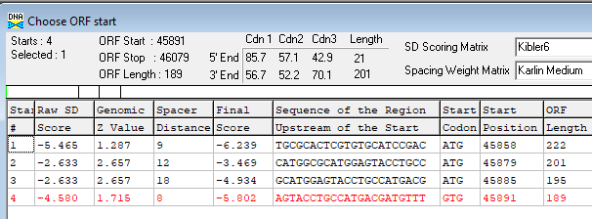
Proposed Function: hypothetical protein
Function Evidence: no credible functional matches on HHPRED or BlastP
Transmembrane Domain/Evidence: NO
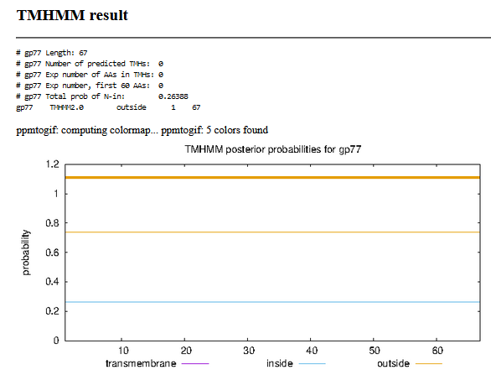

Gene Number: 78 (original 78, phagesdb draft 81)
10/05/22 Run BlastP at phagesdb and NCBI, Starterator, RBS on Frames, Transmembrane prediction https://services.healthtech.dtu.dk/service.php?TMHMM-2.0, HHPRED, https://toolkit.tuebingen.mpg.de/#/tools/hhpred,
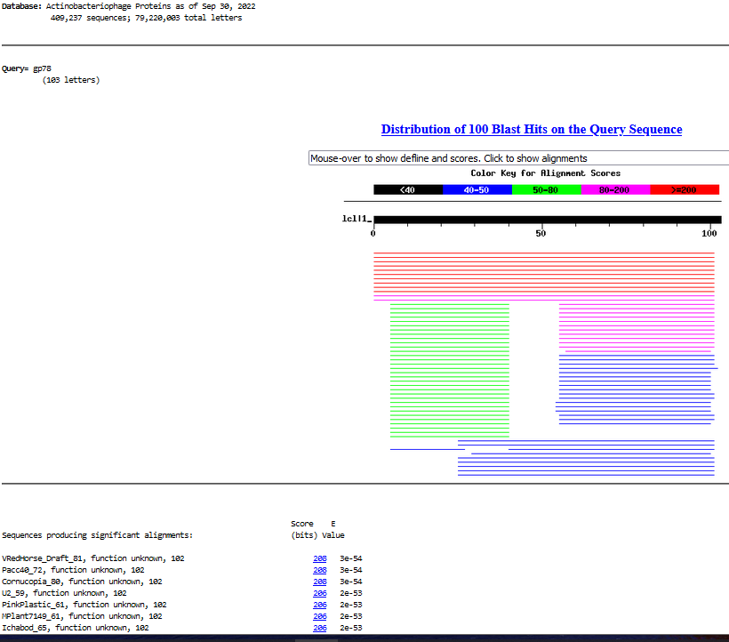
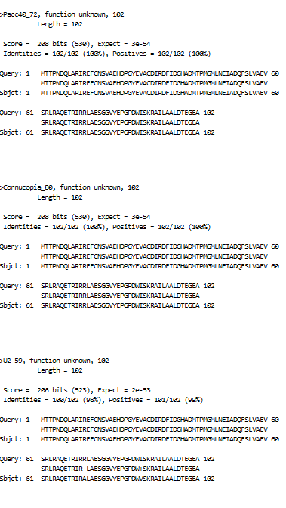
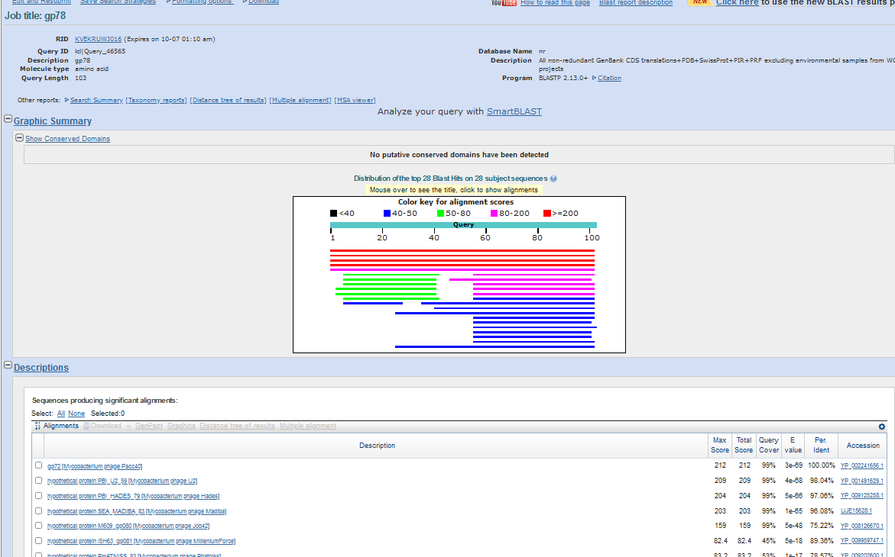
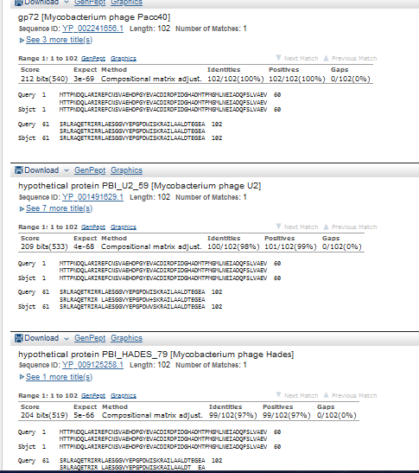
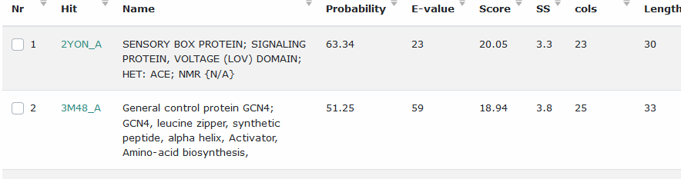
Start Codon and source: 46063, ATG, called by Glimmer and Genemark
Stop Codon: 46371, TGA
F/R: F
Coding Potential (y/n): Y
Starterator (SS, NA, NI): pham 41416, most annotated
Blast Best Hit, Query:Subject Starts, Score, Evalue, or “no significant Blast alignments” if 10E-4 or higher
Gap: -17 bp overlap with gene 77
Longest Orf? (Y/N/NA) N
RBS: N/A, Scoring Matirix , Spacing Matrix, Z Score, Final Score,
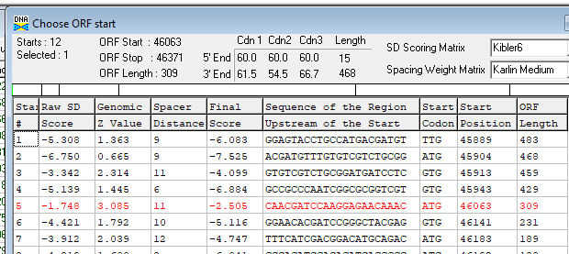
Proposed Function: hypothetical protein
Function Evidence: No credible function hits on BlastP or HHPRED
Transmembrane Domain/Evidence: NO
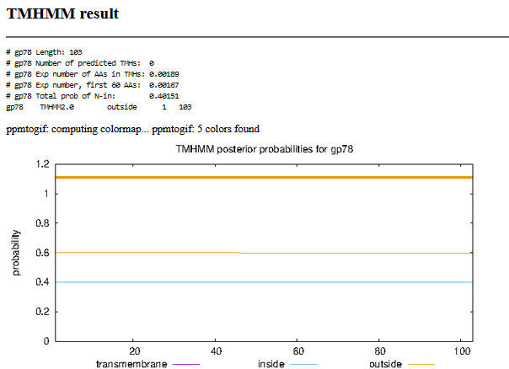

Gene Number: 79 (original 79, phagesdb draft 82)
10/05/22 Run BlastP at phagesdb and NCBI, Starterator, RBS on Frames, Transmembrane precdition https://services.healthtech.dtu.dk/service.php?TMHMM-2.0, HHPRED, https://toolkit.tuebingen.mpg.de/#/tools/hhpred,
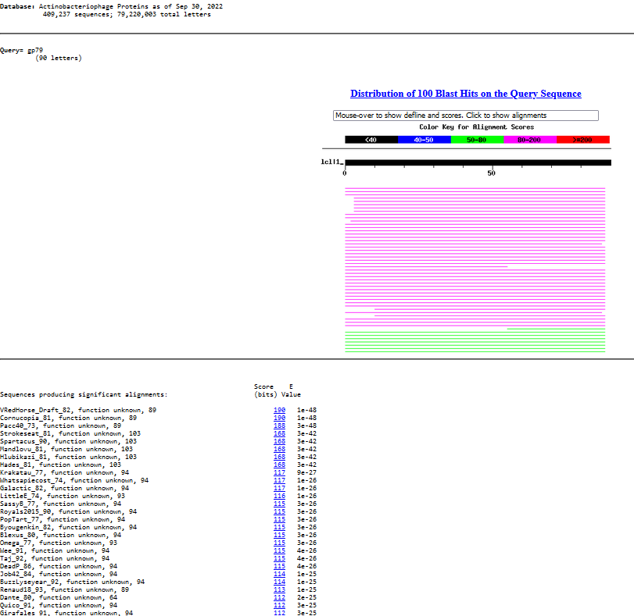
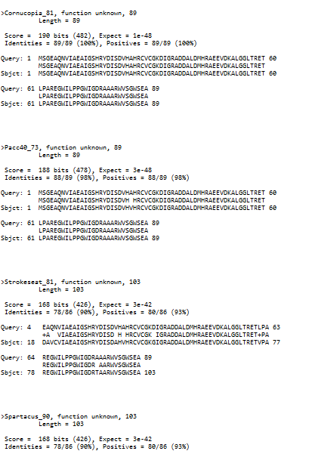
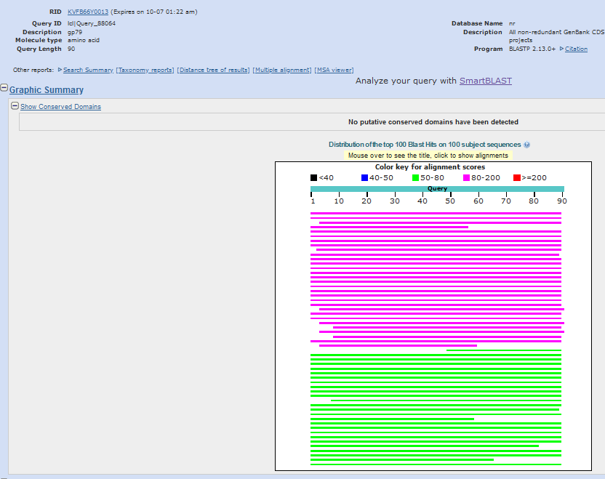
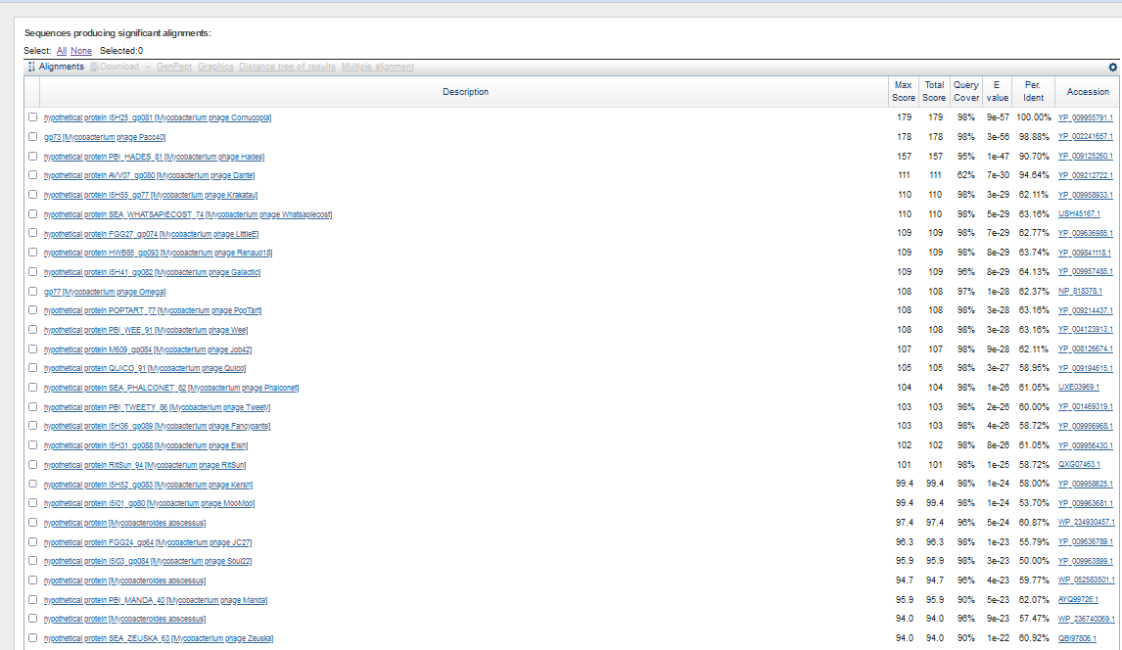
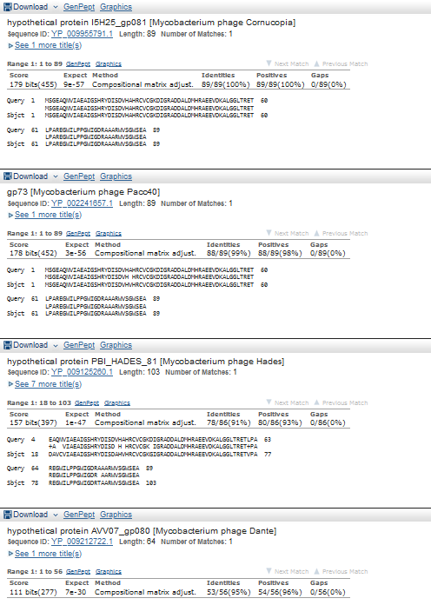
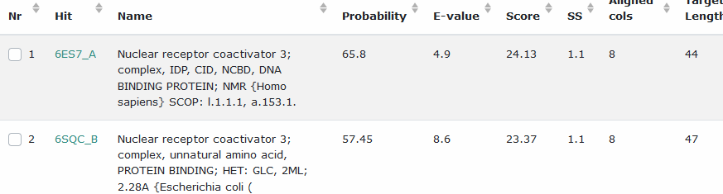
Start Codon and source: 46,368, GTG, called by Glimmer and Genemark
Stop Codon: 46,637, TGA
F/R: F
Coding Potential (y/n): Y
Starterator (SS, NA, NI): pham 50,181, most annotated start
Blast Best Hit, Query:Subject Starts, Score, Evalue, or “no significant Blast alignments” if 10E-4 or higher
Gap: -4 bp overlap with gene 78
Longest Orf? (Y/N/NA) Y
RBS: N/A, Scoring Matirix , Spacing Matrix, Z Score, Final Score,
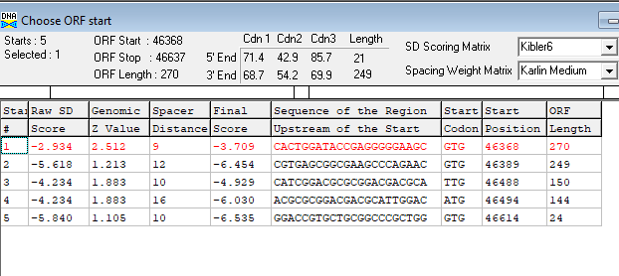
Proposed Function: hypothetical protein
Function Evidence: no credible functional hits on BlastP or HHPRED
Transmembrane Domain/Evidence: NO
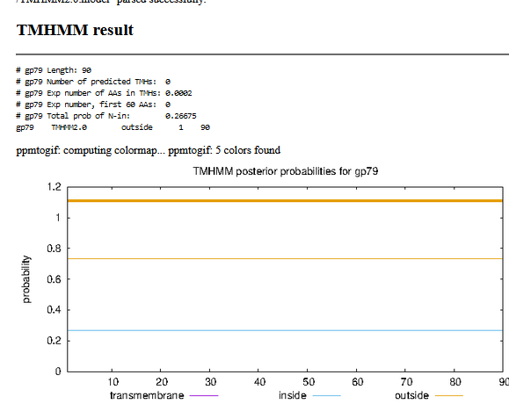

Gene Number: 80 (original call 80, phagesdb gene 83)
10/05/22 Run BlastP at phagesdb and NCBI, Starterator, RBS on Frames, Transmembrane precdition https://services.healthtech.dtu.dk/service.php?TMHMM-2.0, HHPRED, https://toolkit.tuebingen.mpg.de/#/tools/hhpred,
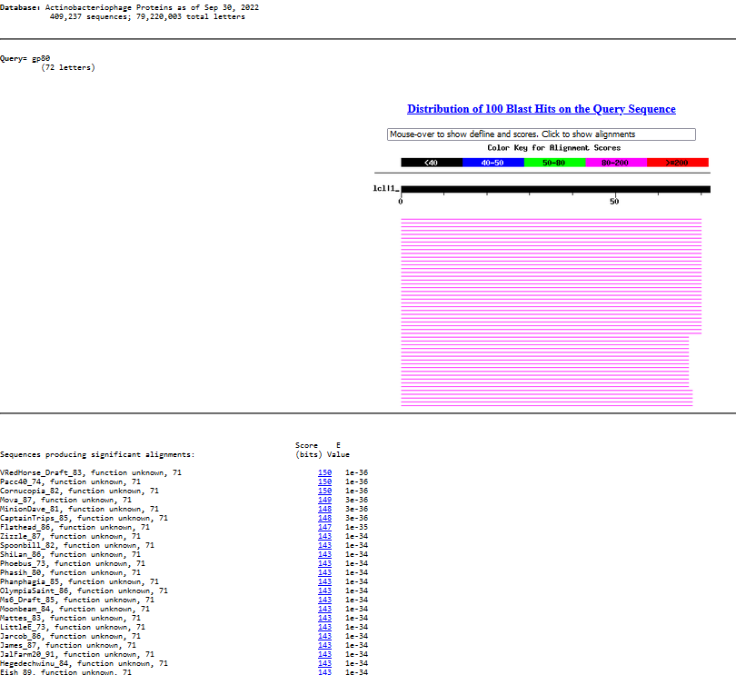
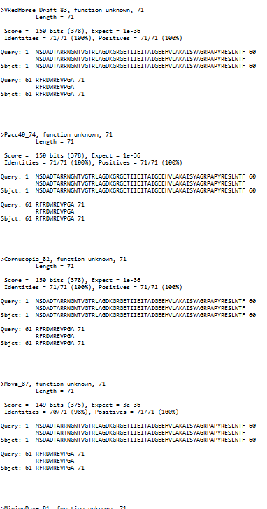
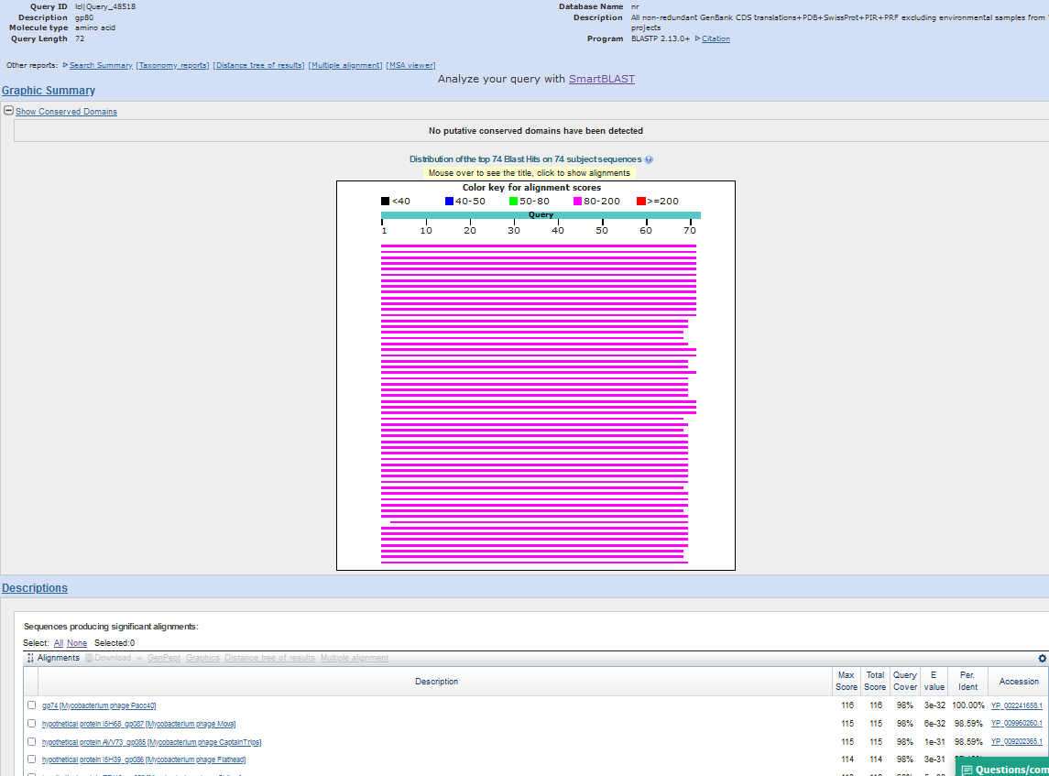
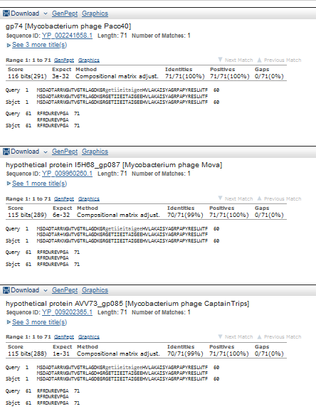
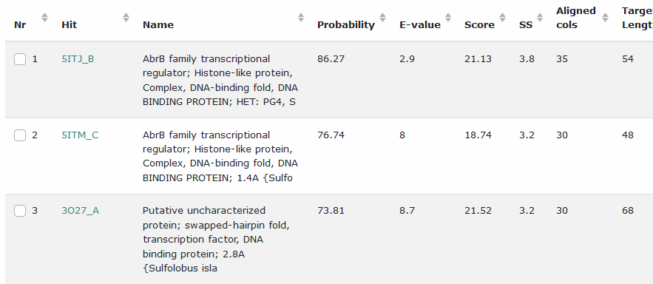
Start Codon and source: 46,634, ATG, Called by glimmer and genemark
Stop Codon:46849 TGA
F/R: F
Coding Potential (y/n):Y
Starterator (SS, NA, NI):pham 755, most annotated start
Blast Best Hit, Query:Subject Starts, Score, Evalue, or “no significant Blast alignments” if 10E-4 or higher
Gap: -4 bp overlap with gene 79
Longest Orf? (Y/N/NA) N
RBS: N/A, Scoring Matirix , Spacing Matrix, Z Score, Final Score,
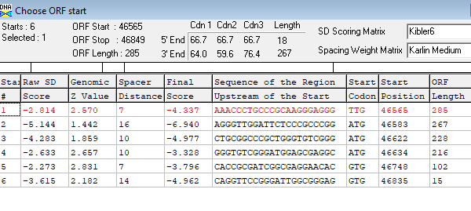
Proposed Function: hypothetical protein
Function Evidence: no credible functional matches on HHPRED or Blastp
Transmembrane Domain/Evidence: NO
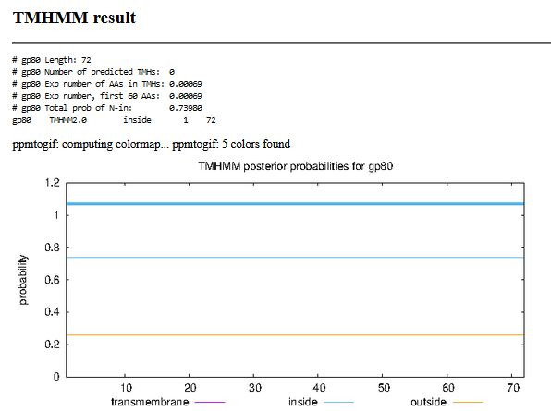

Gene Number: 81 (original 81, phagesdbdraft 84) CHANGED START to 46,932, ATG
10/05/22 Run BlastP at phagesdb and NCBI, Starterator, RBS on Frames, Transmembrane prediction https://services.healthtech.dtu.dk/service.php?TMHMM-2.0, HHPRED, https://toolkit.tuebingen.mpg.de/#/tools/hhpred,
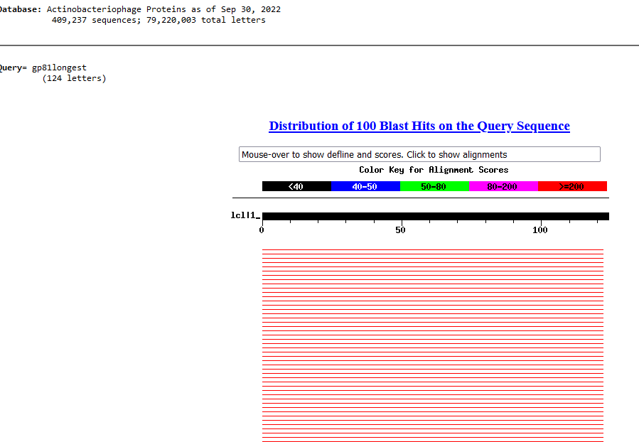
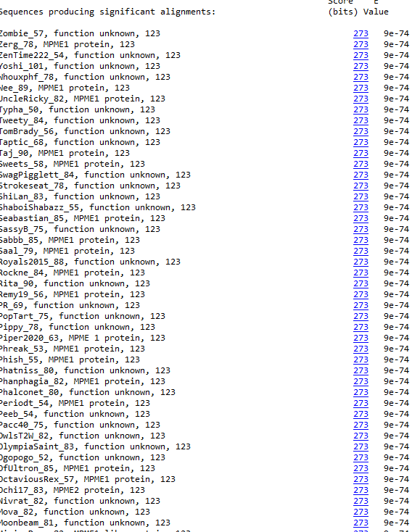
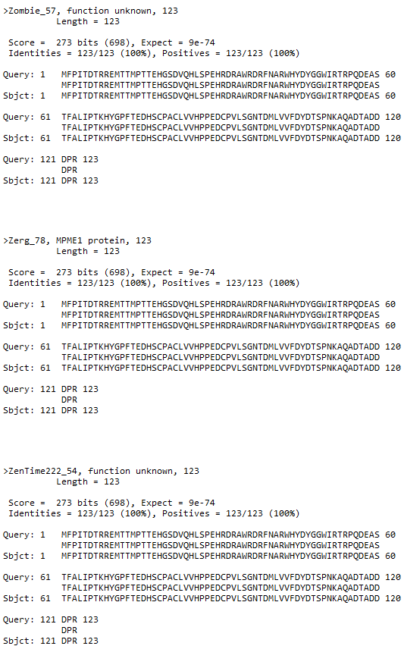
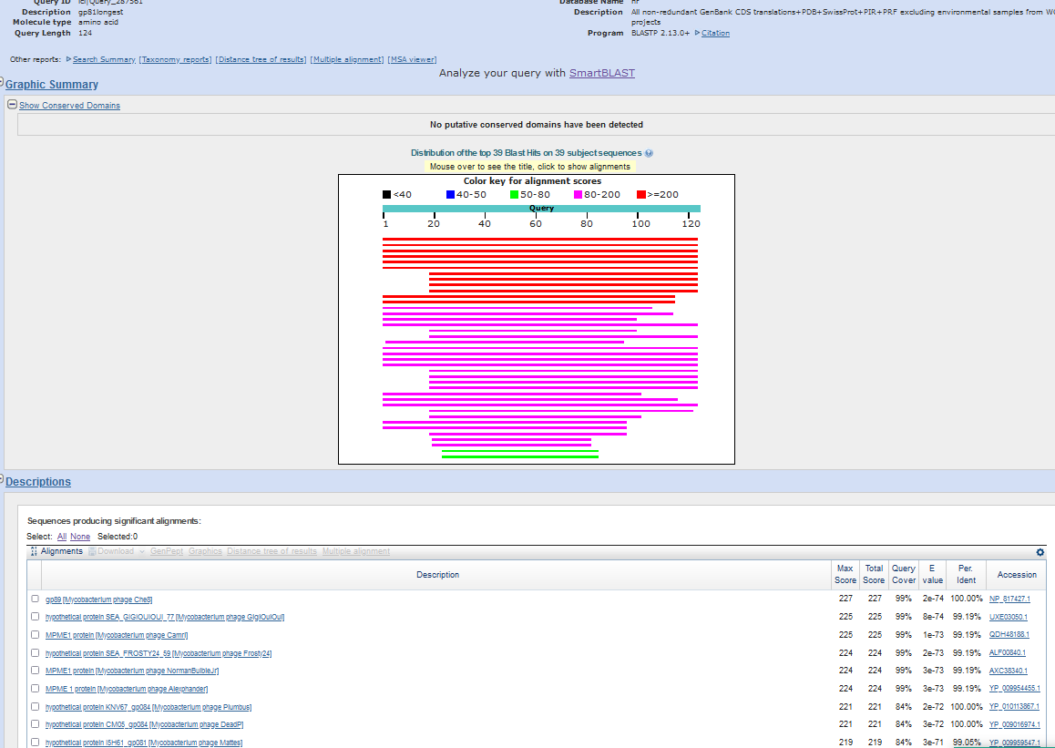
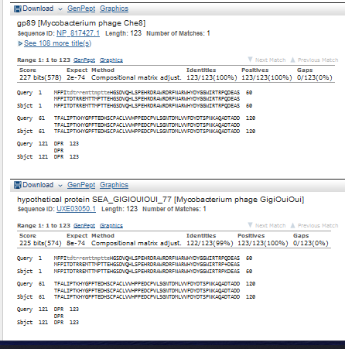
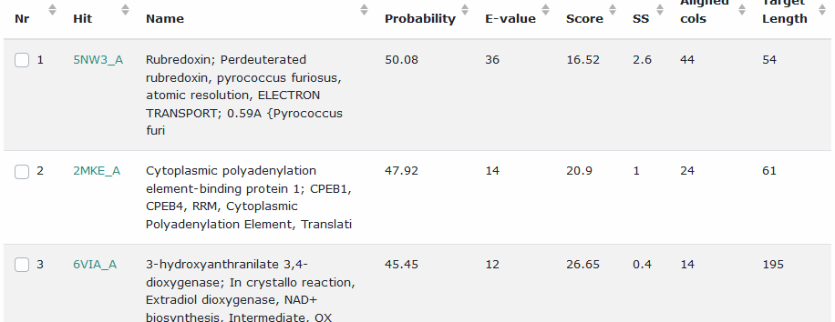
Start Codon and source: 46,932, not called by Glimmer or genemarkS they called downstream starts
Stop Codon: 47303, TAA
F/R: F
Coding Potential (y/n): Y
Starterator (SS, NA, NI): pham 48,697, changed to most annotated start
, or “no significant Blast Blast Best Hit, Query:Subject Starts, Score, Evalue alignments” if 10E-4 or higher
Gap: 81 bp gap from gene 80
Longest Orf? (Y/N/NA) Y
RBS: N/A, Scoring Matirix , Spacing Matrix, Z Score, Final Score,
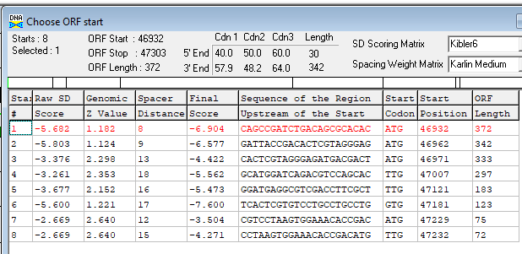
Proposed Function: mycobacteriophage mobile element 1 (MPME1)
Function Evidence: alignment with Avrafan gp57 (MPME1)
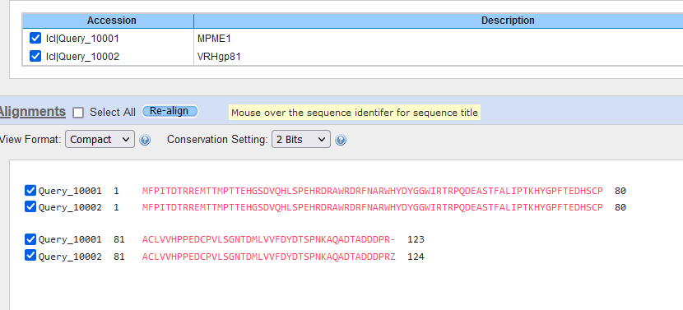
Transmembrane Domain/Evidence: NO
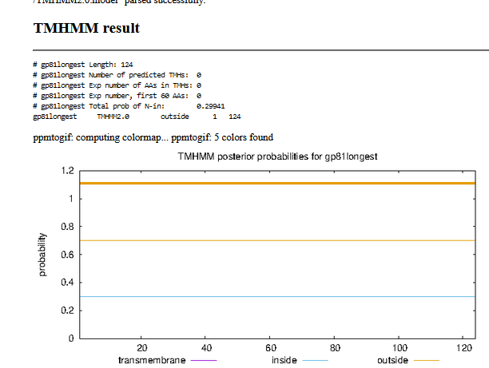

Gene Number: 82 (original call 82, phagesdb draft 85)
10/05/22 Run BlastP at phagesdb and NCBI, Starterator, RBS on Frames, Transmembrane prediction https://services.healthtech.dtu.dk/service.php?TMHMM-2.0, HHPRED, https://toolkit.tuebingen.mpg.de/#/tools/hhpred,
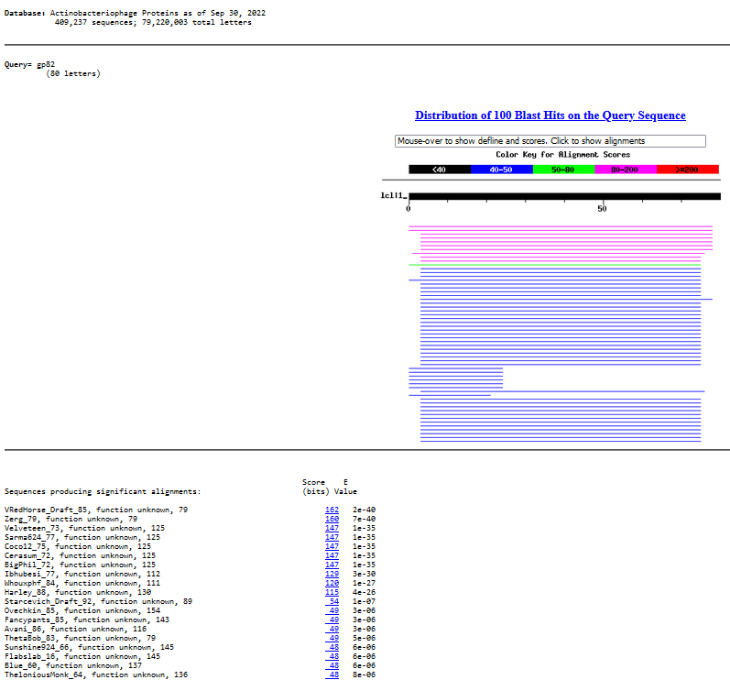
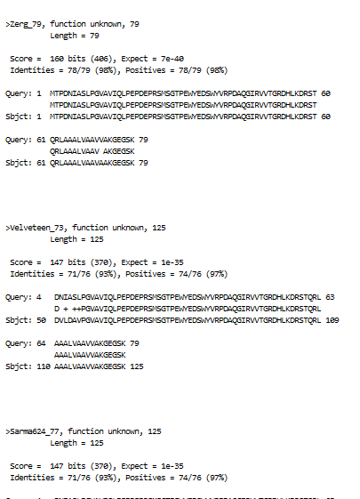
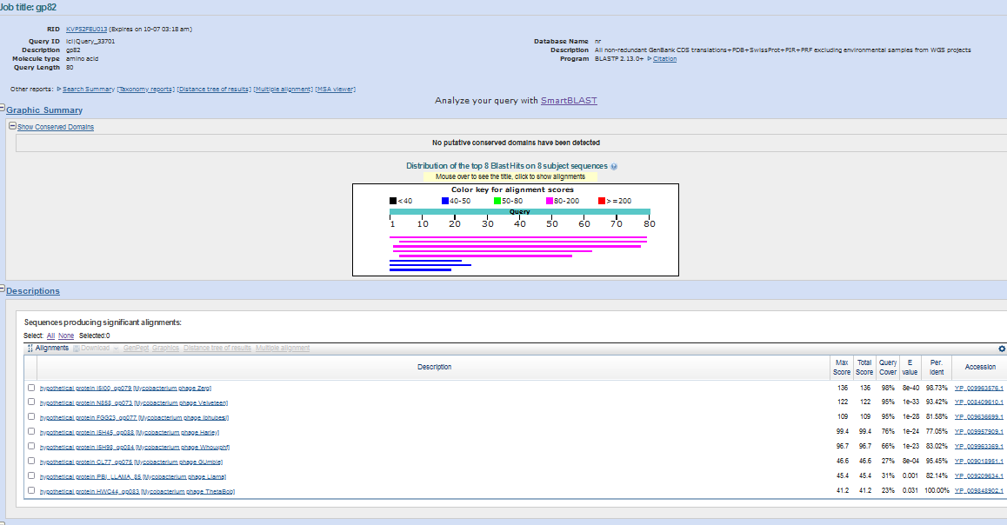
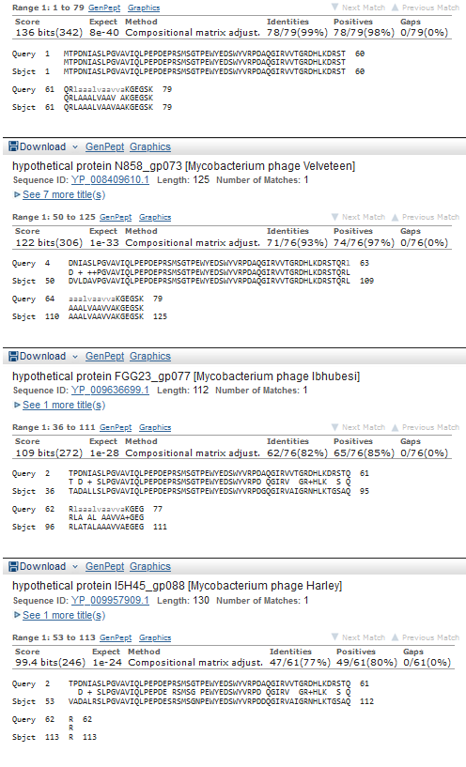
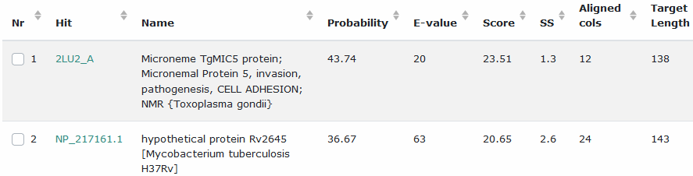

Start Codon and source: 47,290, ATG, called by Glimmer and Genemark
Stop Codon: 47,529, TGA
F/R: F
Coding Potential (y/n): Y
Starterator (SS, NA, NI): pham 5257, most annotated start
Blast Best Hit, Query:Subject Starts, Score, Evalue, or “no significant Blast alignments” if 10E-4 or higher
Gap: -14 bp overlap with gene 81
Longest Orf? (Y/N/NA) N
RBS: N/A, Scoring Matirix , Spacing Matrix, Z Score, Final Score,
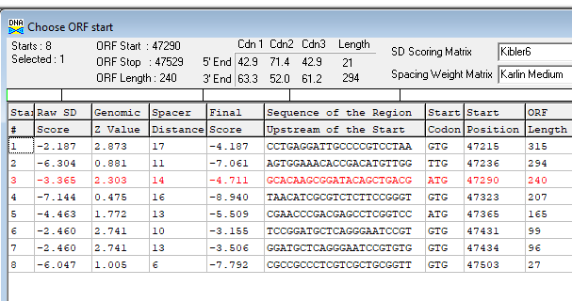
Proposed Function: hypothetical protein
Function Evidence: no credible function matches on HHPRED or BLASTP
Transmembrane Domain/Evidence: NO
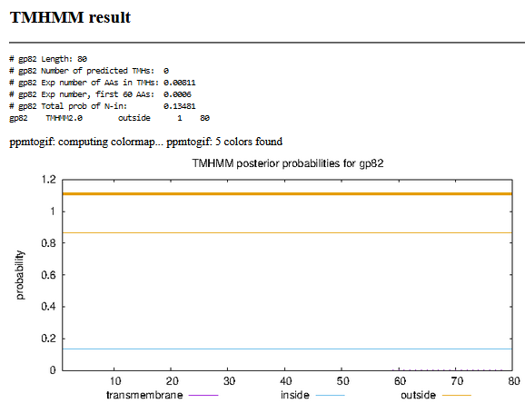

Gene Number: 83 (original83, phagesdb draft 86)
10/05/22 Run BlastP at phagesdb and NCBI, Starterator, RBS on Frames, Transmembrane prediction https://services.healthtech.dtu.dk/service.php?TMHMM-2.0, HHPRED, https://toolkit.tuebingen.mpg.de/#/tools/hhpred,
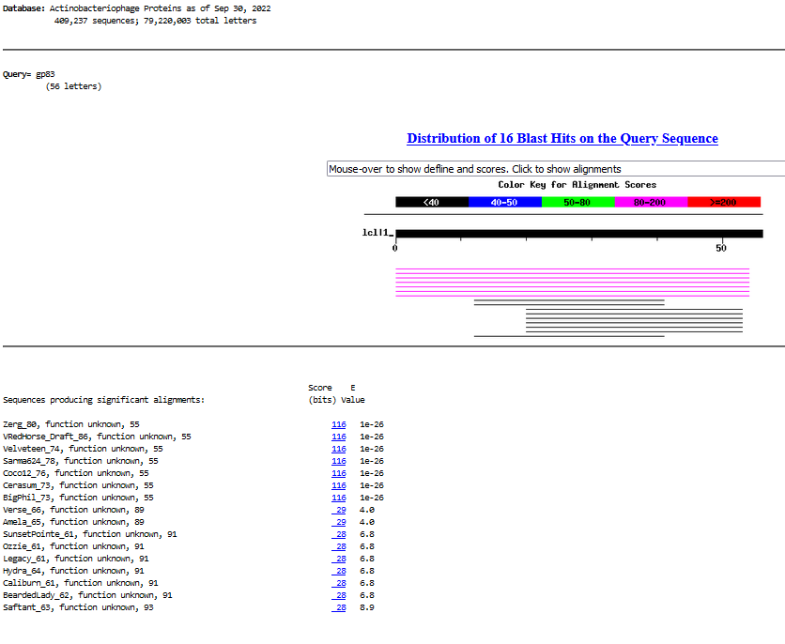
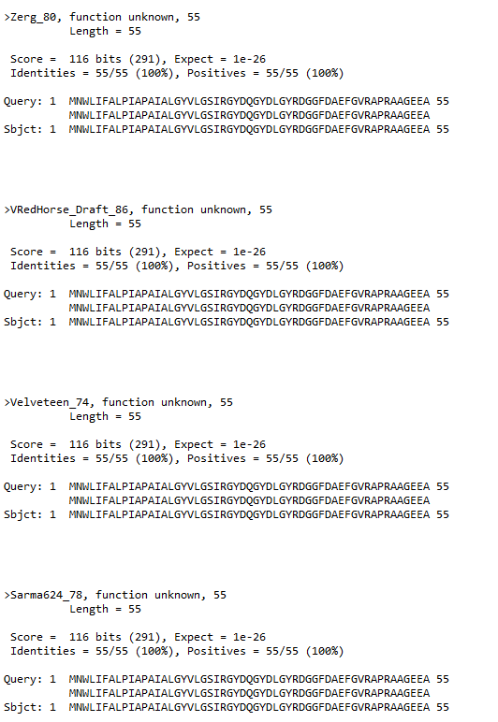
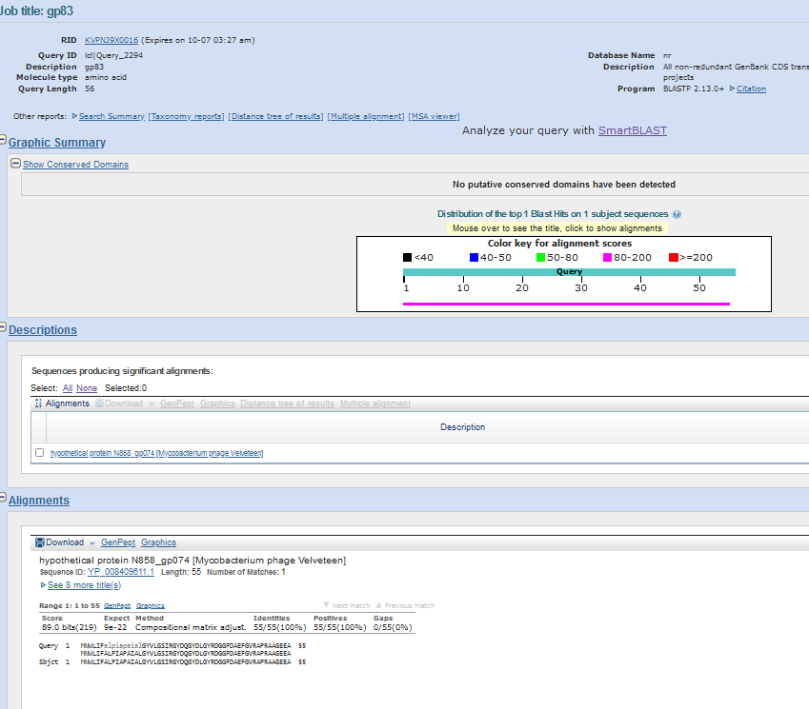
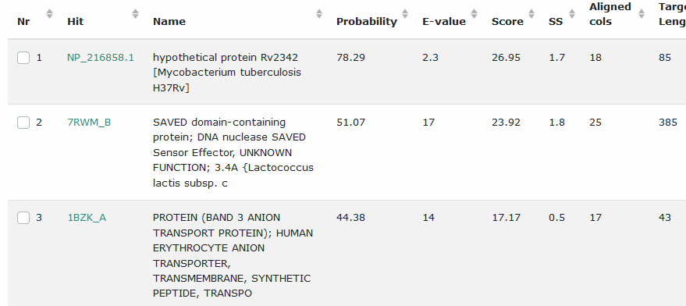
Start Codon and source: 47,526, ATG, Called by genemark and glimmer
Stop Codon: 47,693, TGA
F/R: F
Coding Potential (y/n): Y
Starterator (SS, NA, NI): pham 6961, most annotated start
Blast Best Hit, Query:Subject Starts, Score, Evalue, or “no significant Blast alignments” if 10E-4 or higher
Gap: -4 bp overlap with gene 82
Longest Orf? (Y/N/NA) N
RBS: N/A, Scoring Matirix , Spacing Matrix, Z Score, Final Score,
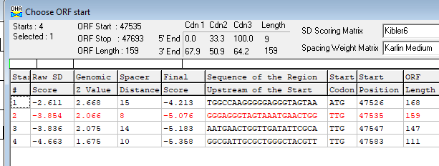
Proposed Function: membrane protein
Function Evidence: see below
Transmembrane Domain/Evidence: YES
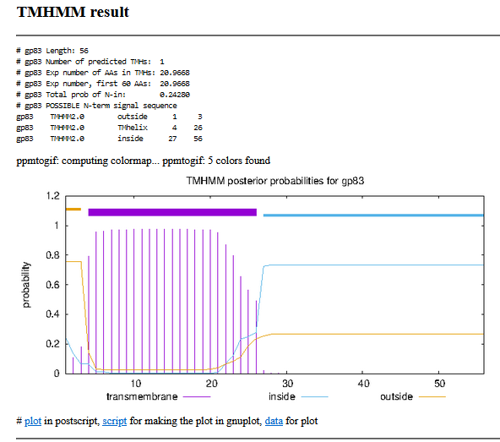
10/06/22 rerun on SOSUI, https://harrier.nagahama-i-bio.ac.jp/sosui/mobile/
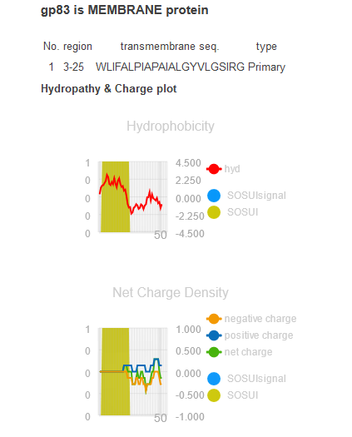
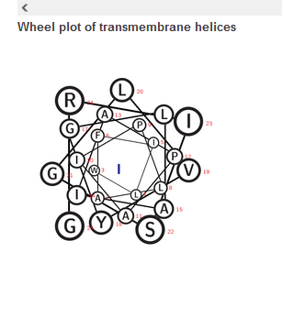

ADDED FORWARD GENE 84, deleted original Reverse gene 84, deleted phagesdb draft 87)
Gene Number: 84 (not called on autoannotations)
10/05/22 Run BlastP at phagesdb and NCBI, Starterator, RBS on Frames, Transmembrane prediction https://services.healthtech.dtu.dk/service.php?TMHMM-2.0, HHPRED, https://toolkit.tuebingen.mpg.de/#/tools/hhpred,
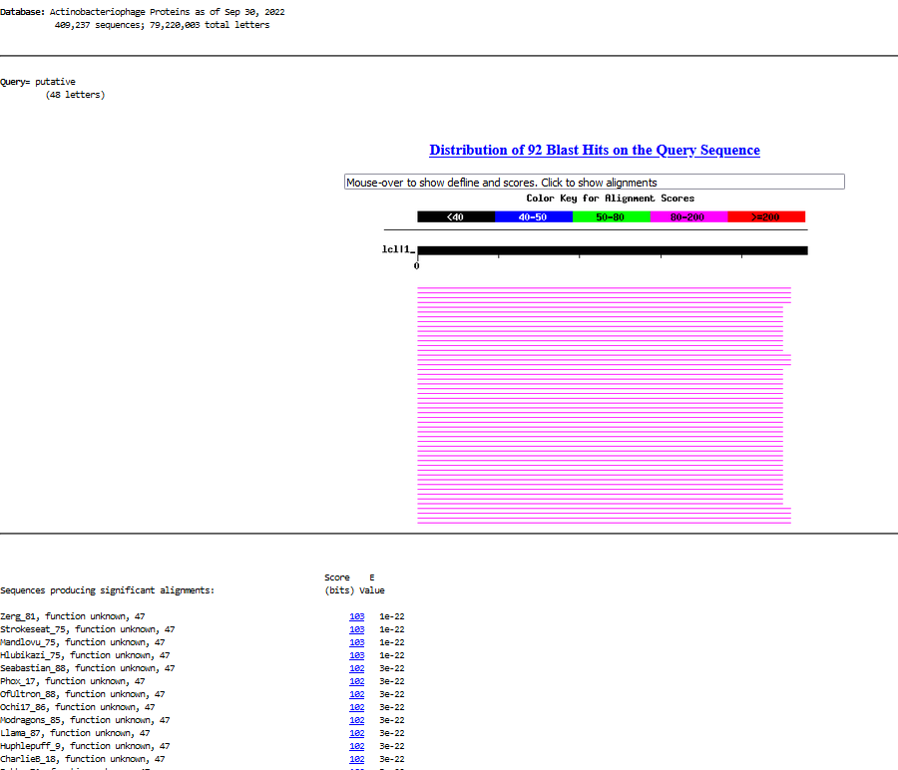
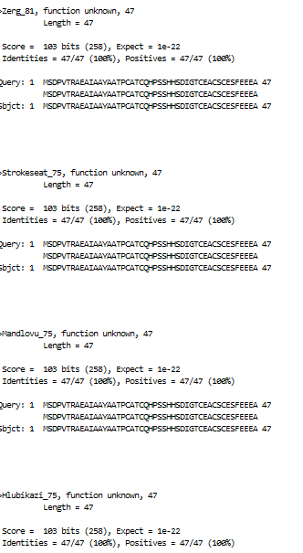
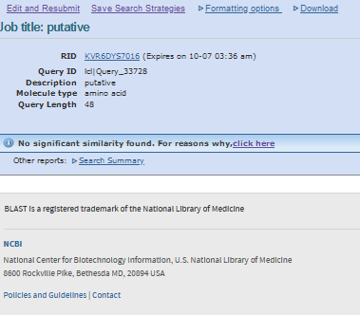
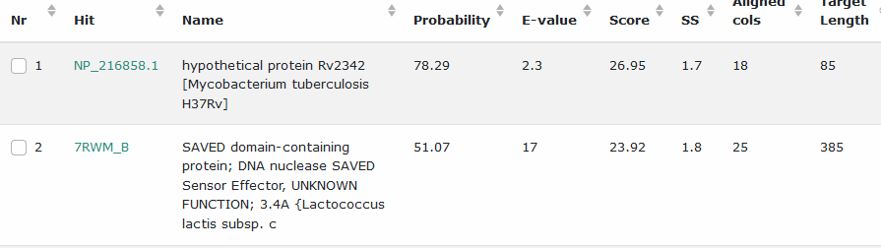
Start Codon and source: 47,690, ATG, not called by glimmer or genemark
Stop Codon: 47,833, TGA
F/R: F
Coding Potential (y/n):no
Starterator (SS, NA, NI): pham 1645, most annotated (like Zerg)
Blast Best Hit, Query:Subject Starts, Score, Evalue, or “no significant Blast alignments” if 10E-4 or higher
Gap: -4bp overlap with gene 83
Longest Orf? (Y/N/NA) Y
RBS: N/A, Scoring Matirix , Spacing Matrix, Z Score, Final Score,
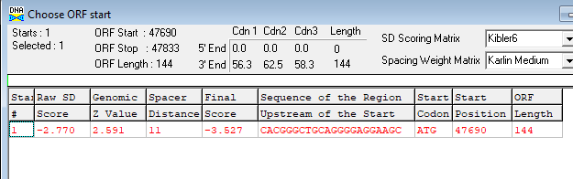
Proposed Function: hypothetical protein
Function Evidence: no credible functional evidence on hhpred or blastp
Transmembrane Domain/Evidence: NO
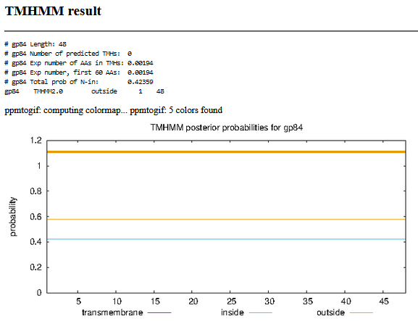

Gene Number: 85 (original 85, phagesdb draft 87) CHANGED START to 47830
10/05/22 Run BlastP at phagesdb and NCBI, Starterator, RBS on Frames, Transmembrane prediction https://services.healthtech.dtu.dk/service.php?TMHMM-2.0, HHPRED, https://toolkit.tuebingen.mpg.de/#/tools/hhpred,
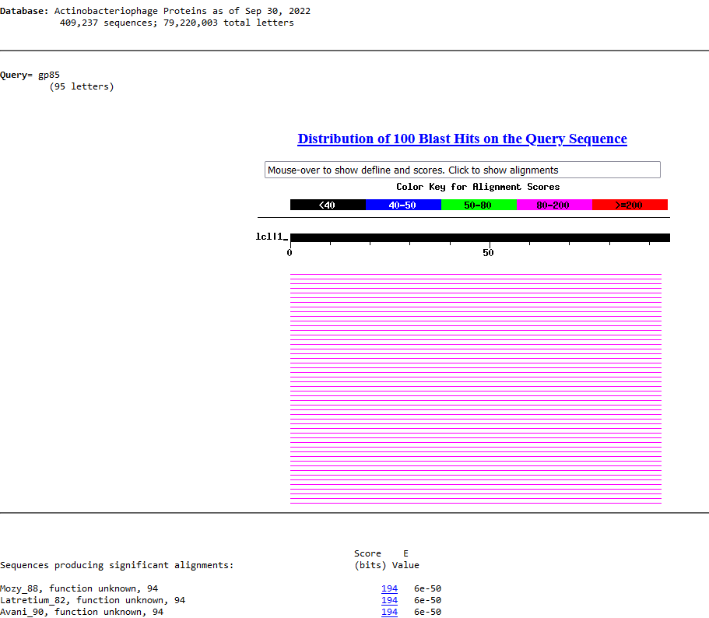
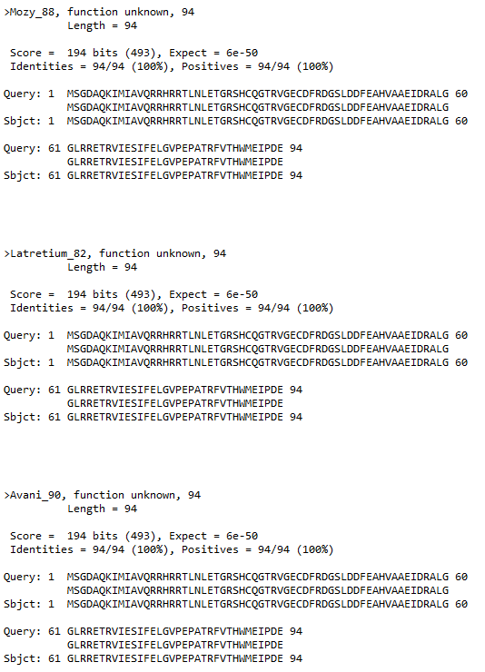
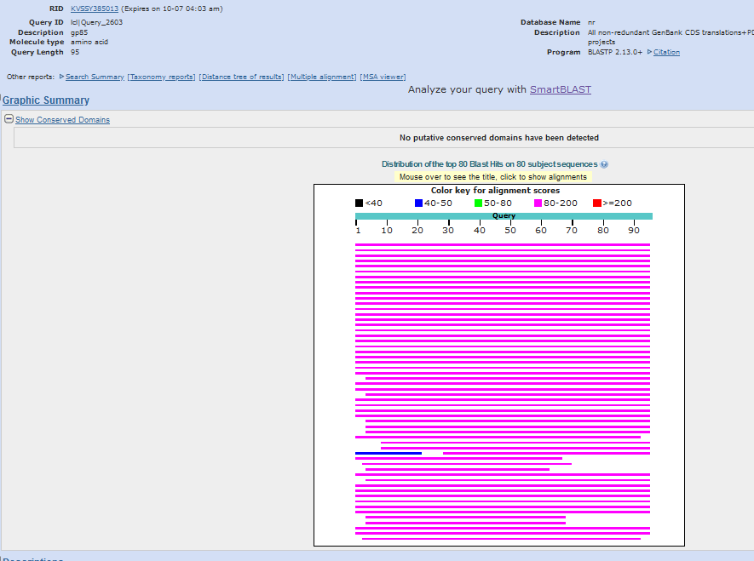
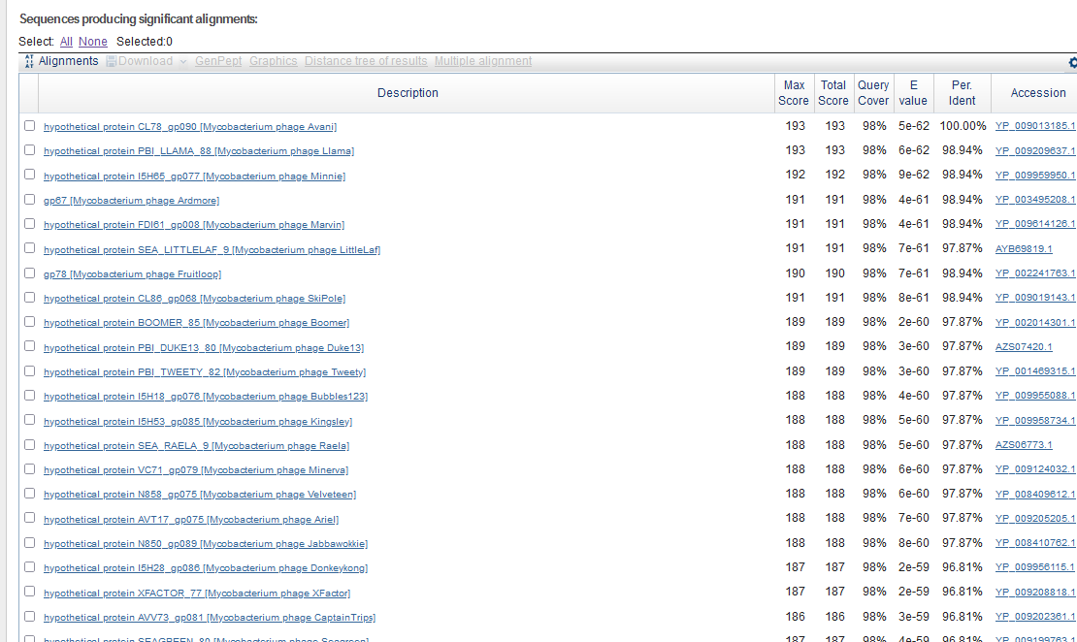
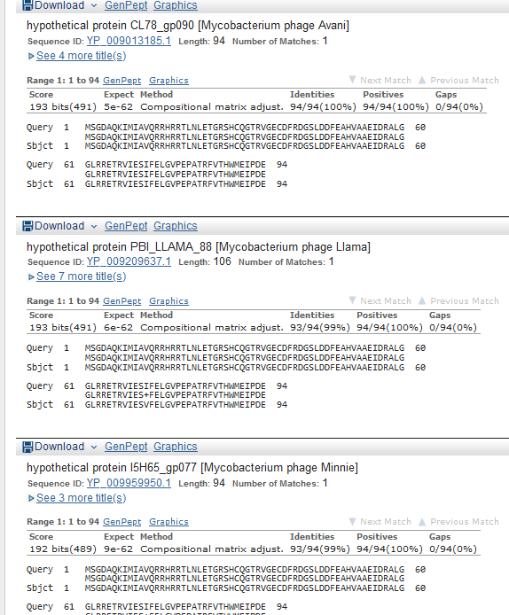

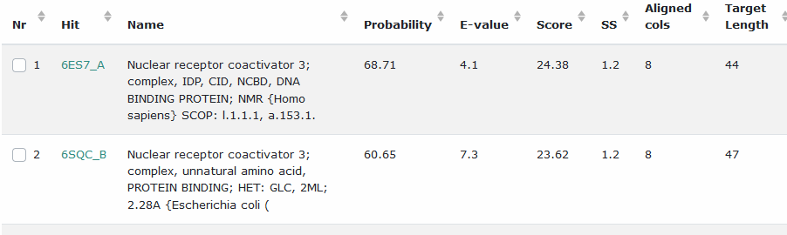
Start Codon and source: 47830, GTG, Called by GenemarkS, 47929called by glimmer, DNA master genemark did not call
Stop Codon: 48114, TGA
F/R: F
Coding Potential (y/n): Y
Starterator (SS, NA, NI): pham 50174, most annotated start, like Avani90
Blast Best Hit, Query:Subject Starts, Score, Evalue, or “no significant Blast alignments” if 10E-4 or higher
Gap: -4 bp overlap with gene 84
Longest Orf? (Y/N/NA) N
RBS: N/A, Scoring Matirix , Spacing Matrix, Z Score, Final Score,
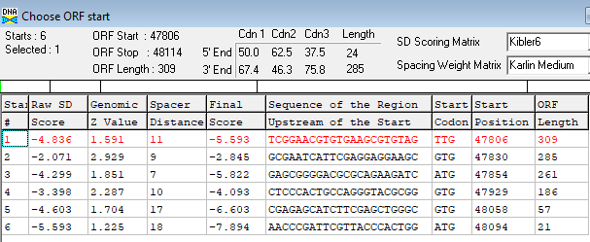
Proposed Function: hypothetical protein
Function Evidence: no credible HHPREd or BLASTP functional match
Transmembrane Domain/Evidence: NO
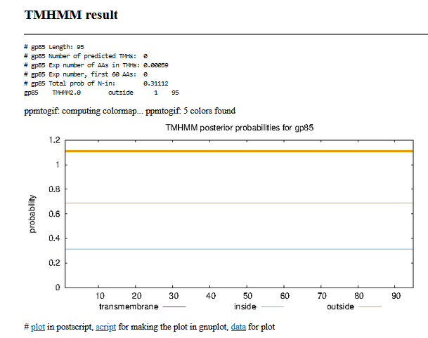

Gene Number: 86 (original 86, phagesdb draft 88)
10/05/22 Run BlastP at phagesdb and NCBI, Starterator, RBS on Frames, Transmembrane prediction https://services.healthtech.dtu.dk/service.php?TMHMM-2.0, HHPRED, https://toolkit.tuebingen.mpg.de/#/tools/hhpred,
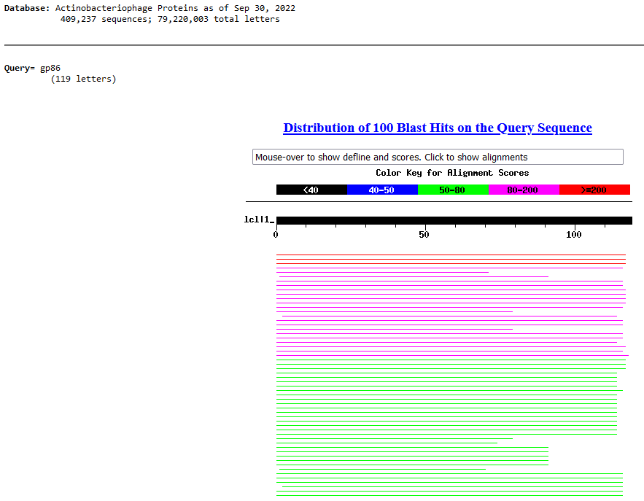
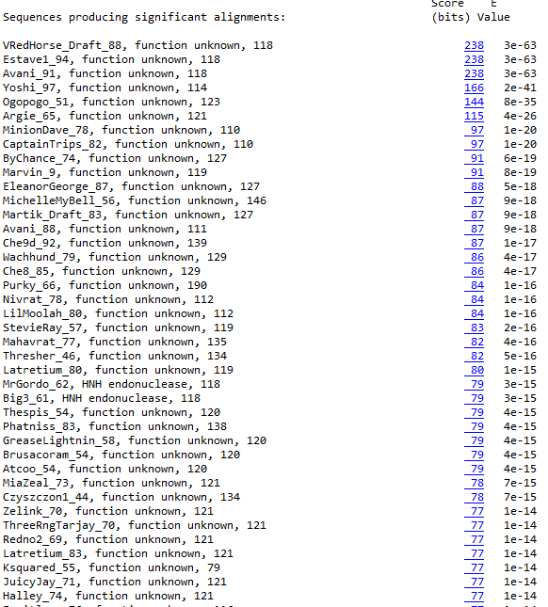
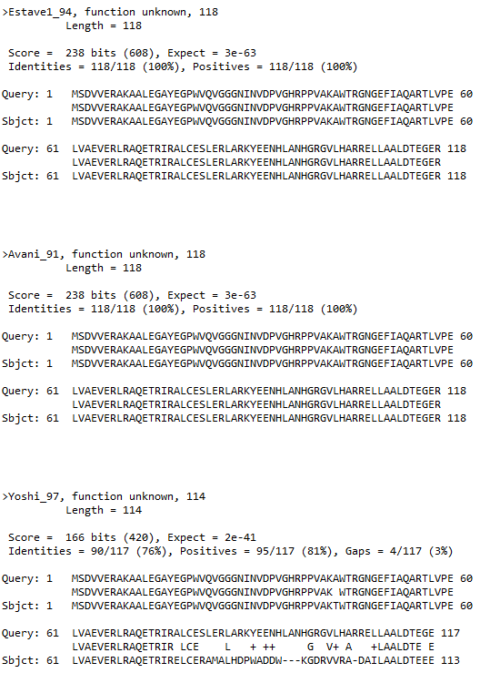
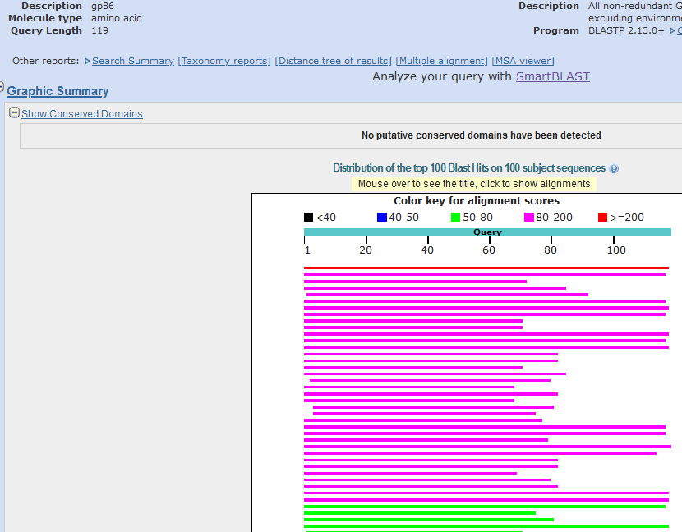
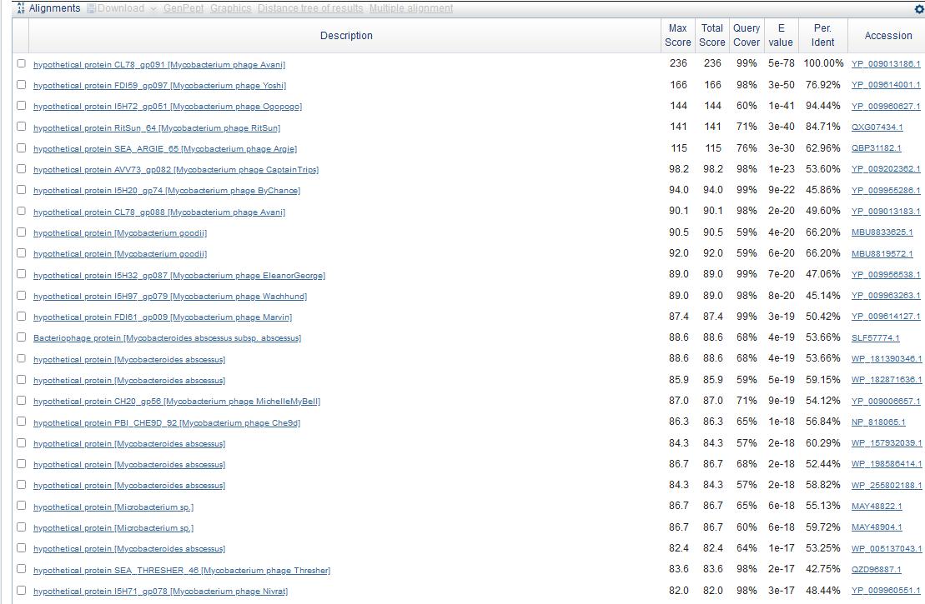
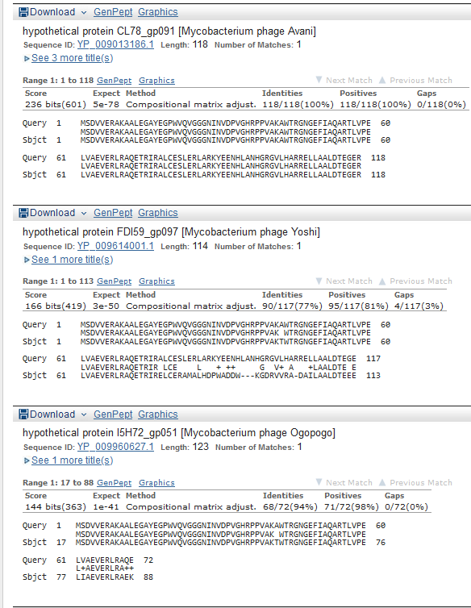
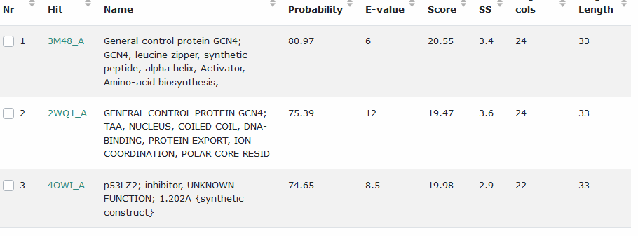
Start Codon and source: 48107, ATG, called by glimmer and genemark
Stop Codon: 48463, TGA
F/R: F
Coding Potential (y/n): Y
Starterator (SS, NA, NI): pham 50,239, most annotated start
Blast Best Hit, Query:Subject Starts, Score, Evalue, or “no significant Blast alignments” if 10E-4 or higher
Gap: -8bp overlap with gene 85
Longest Orf? (Y/N/NA) Y
RBS: N/A, Scoring Matirix , Spacing Matrix, Z Score, Final Score,
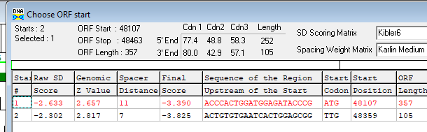
Proposed Function: hypothetical protein
Function Evidence: no credible functional matches by blastP or HHPRED
Transmembrane Domain/Evidence: NO
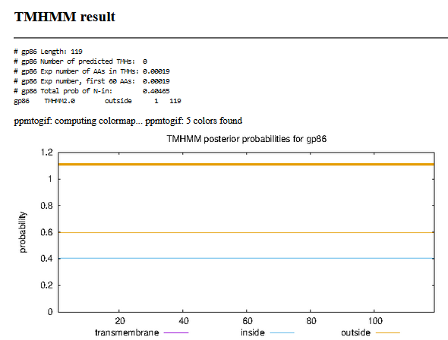

Gene Number: 87 (original 87, phagesdb draft 89)
10/06/22 Run BlastP at phagesdb and NCBI, Starterator, RBS on Frames, Transmembrane prediction https://services.healthtech.dtu.dk/service.php?TMHMM-2.0, HHPRED, https://toolkit.tuebingen.mpg.de/#/tools/hhpred,
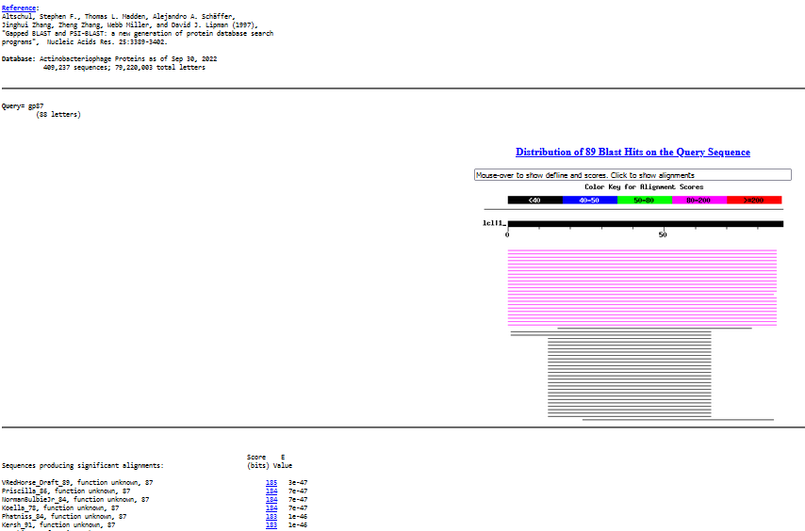
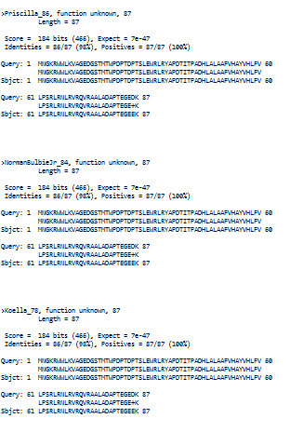
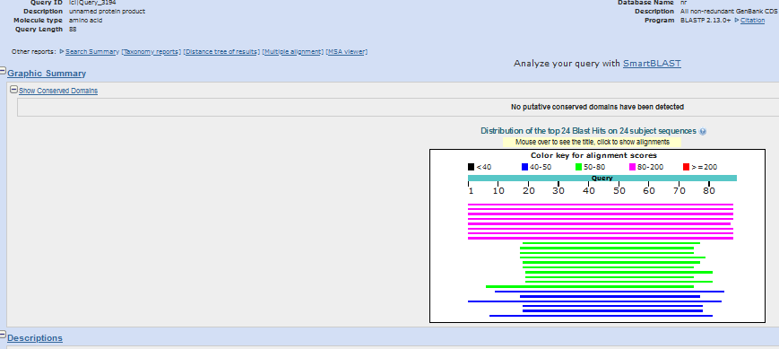
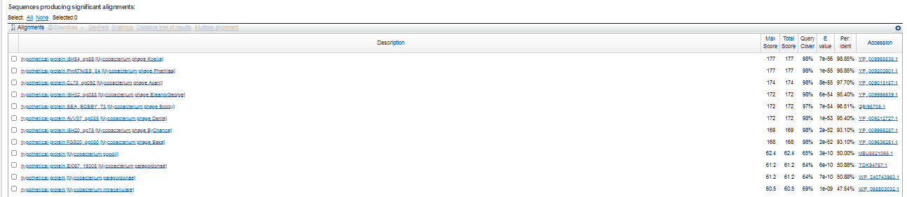
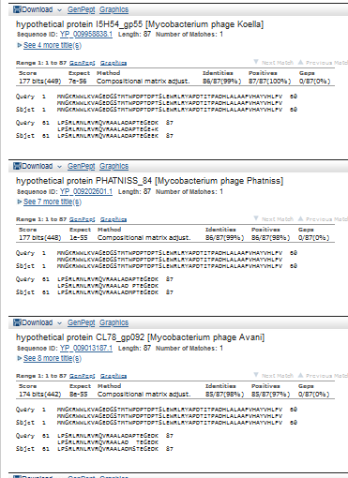
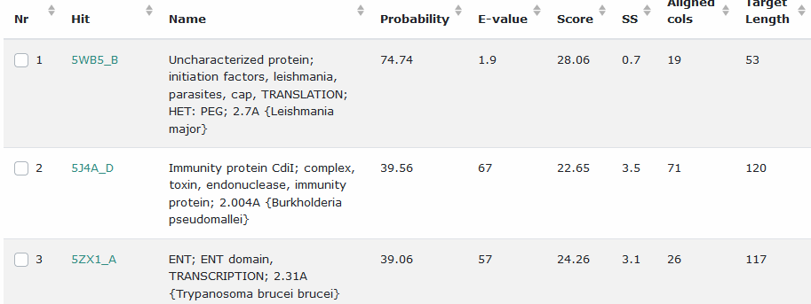
Start Codon and source: 48,460, ATG, called by Glimmer and Genemark
Stop Codon: 48,723, TGA
F/R: F
Coding Potential (y/n): Y
Starterator (SS, NA, NI): pham 3190, most annotated
Blast Best Hit, Query:Subject Starts, Score, Evalue, or “no significant Blast alignments” if 10E-4 or higher
Gap: -4 bp overlap with gene 86
Longest Orf? (Y/N/NA) Y
RBS: N/A, Scoring Matirix , Spacing Matrix, Z Score, Final Score,
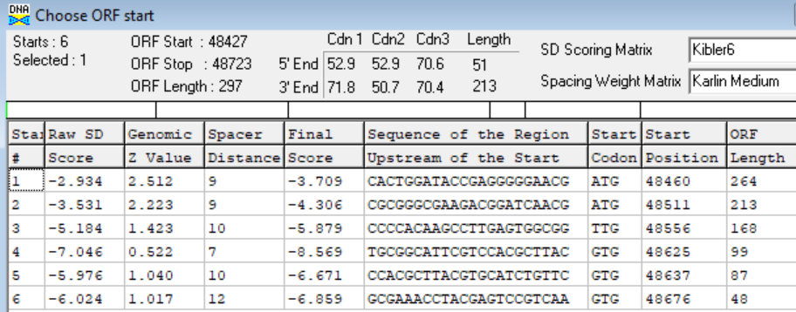
Proposed Function: hypothetical protein
Function Evidence: no credible HHPRED or BLASTp functional matches
Transmembrane Domain/Evidence: NO (graph hints at yes)
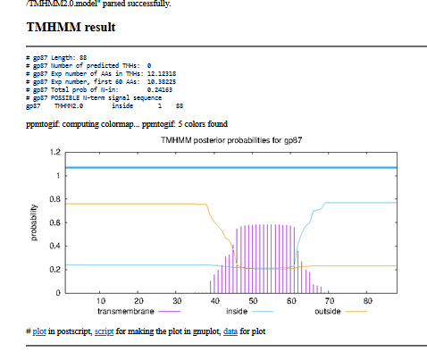

Gene Number:88 (original 88, phagesdb draft 90)
10/06/22 Run BlastP at phagesdb and NCBI, Starterator, RBS on Frames, Transmembrane prediction https://services.healthtech.dtu.dk/service.php?TMHMM-2.0, HHPRED, https://toolkit.tuebingen.mpg.de/#/tools/hhpred,
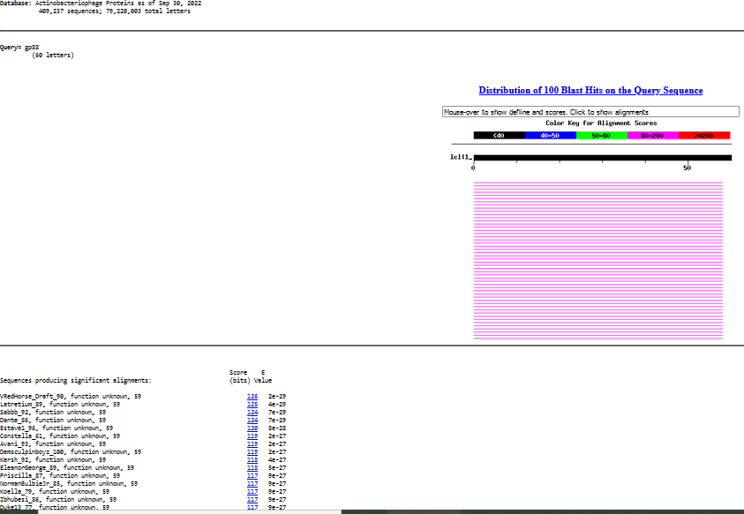
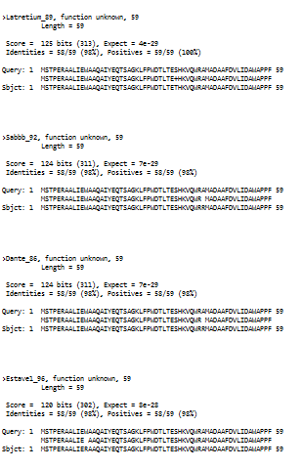
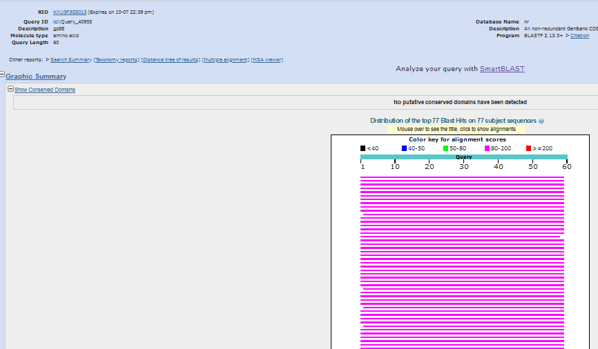
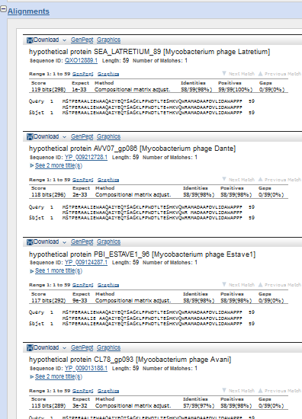
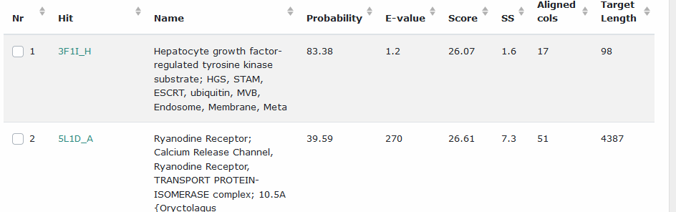
Start Codon and source: 48,720, GTG, called by Glimmer and Genemark
Stop Codon: 48,899, TAG
F/R: F
Coding Potential (y/n): Y
Starterator (SS, NA, NI): pham 45,652, most annotated start
Blast Best Hit, Query:Subject Starts, Score, Evalue, or “no significant Blast alignments” if 10E-4 or higher
Gap: -4 bp overlap with gene 87
Longest Orf? (Y/N/NA) Y
RBS: N/A, Scoring Matirix , Spacing Matrix, Z Score, Final Score,
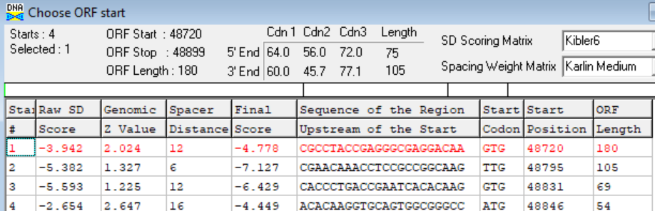
Proposed Function: hypothetical protien
Function Evidence: no credible functional match on HHPRED or BlastP
Transmembrane Domain/Evidence: NO
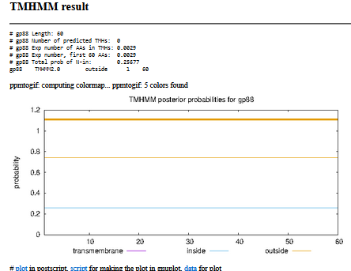

Gene Number: 89 (original 89, phagesdb draft 91)
10/06/22 Run BlastP at phagesdb and NCBI, Starterator, RBS on Frames, Transmembrane prediction https://services.healthtech.dtu.dk/service.php?TMHMM-2.0, HHPRED, https://toolkit.tuebingen.mpg.de/#/tools/hhpred,
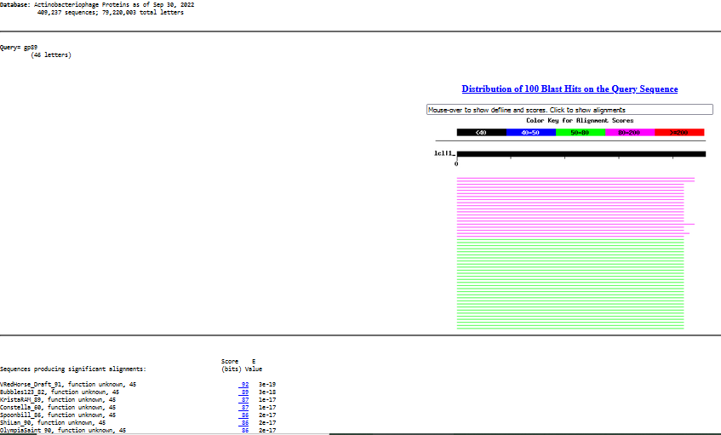
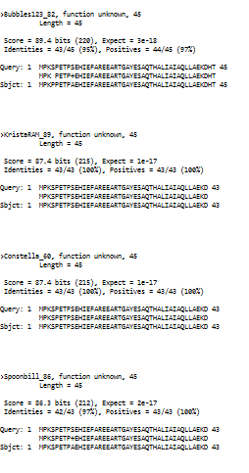
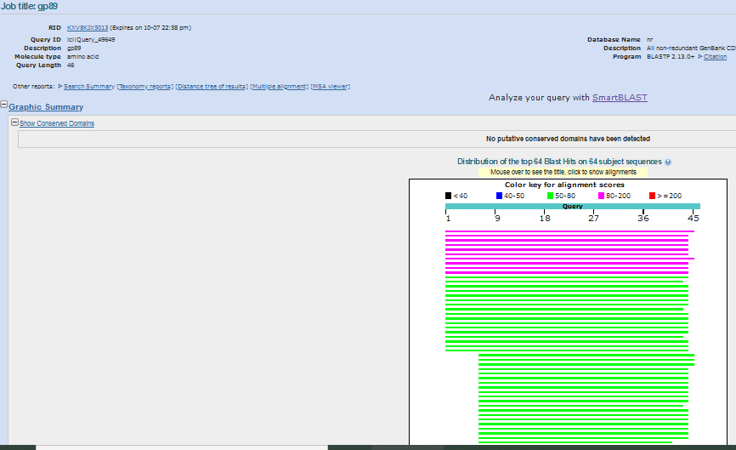
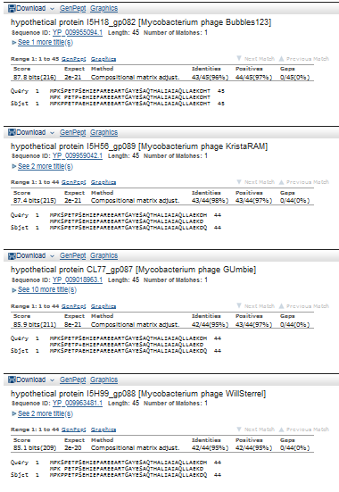
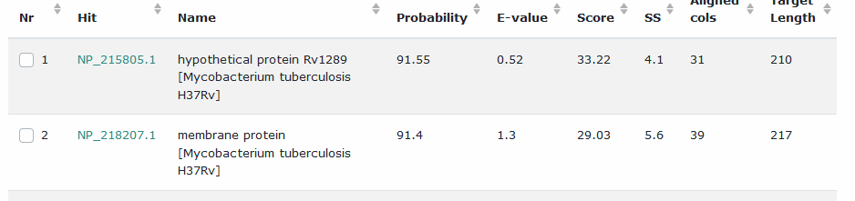
Start Codon and source: 48,904, ATG, Called by Glimmer and DNA MASter Genemark, not by GenemarkS
Stop Codon: 49,041, TGA
F/R: F
Coding Potential (y/n): Y
Starterator (SS, NA, NI): pham 50,149, most annotated start
Blast Best Hit, Query:Subject Starts, Score, Evalue, or “no significant Blast alignments” if 10E-4 or higher
Gap: 3 bp gap from gene 88
Longest Orf? (Y/N/NA) Y
RBS: N/A, Scoring Matirix , Spacing Matrix, Z Score, Final Score,
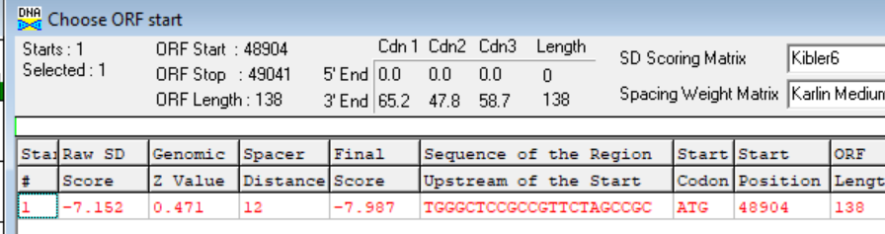
Proposed Function: hypothetical protein
Function Evidence: no credible function match from BlastP or HHPRED
Transmembrane Domain/Evidence: NO
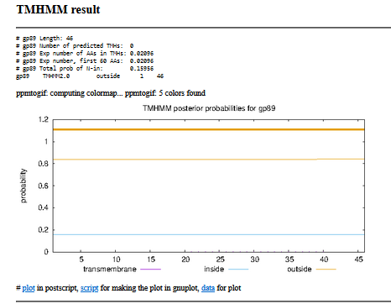

Gene Number: 90 (original cll 90, phagesdb draft
10/06/22 Run BlastP at phagesdb and NCBI, Starterator, RBS on Frames, Transmembrane prediction https://services.healthtech.dtu.dk/service.php?TMHMM-2.0, HHPRED, https://toolkit.tuebingen.mpg.de/#/tools/hhpred,
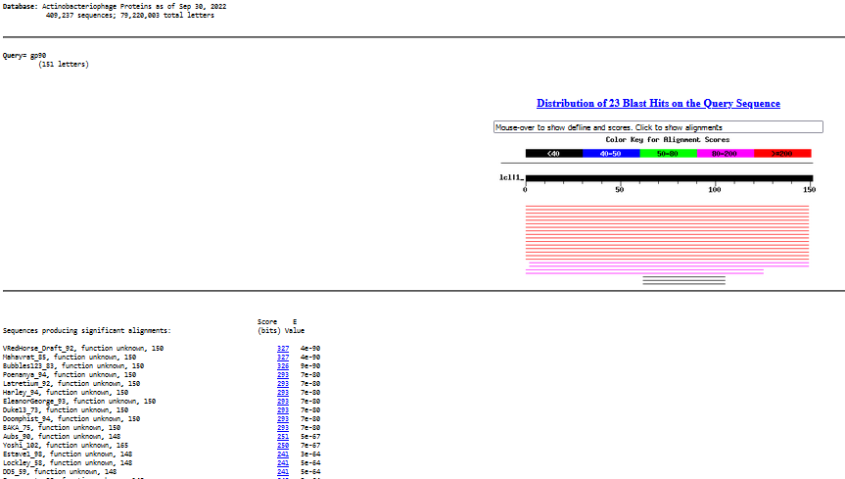
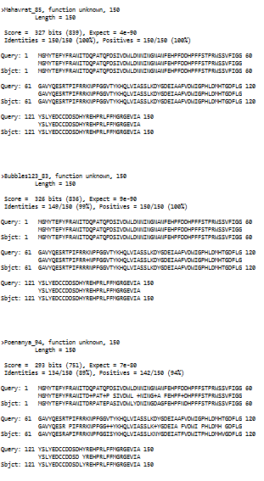
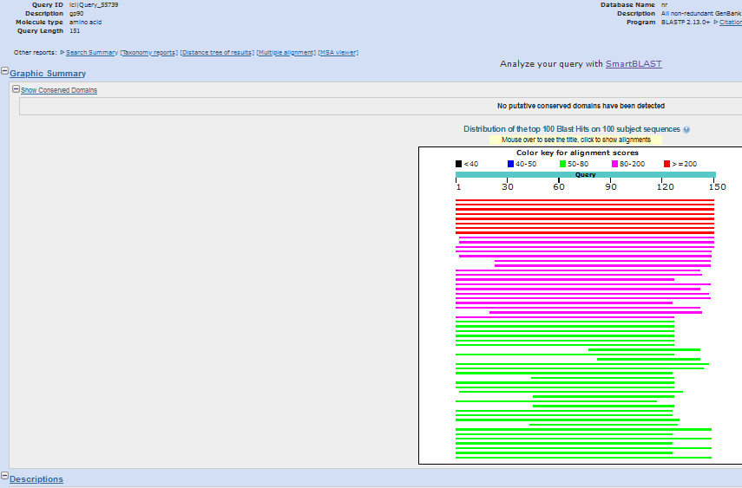
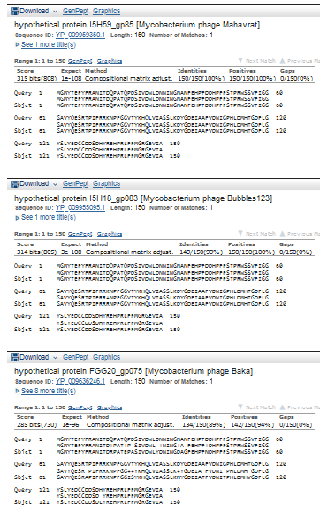
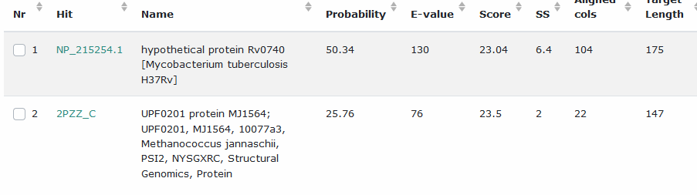Start Codon and source: 49,091, ATG, called by Glimmer and Genemark
Stop Codon: 49,493, TGA
F/R: F
Coding Potential (y/n): Y
Starterator (SS, NA, NI): pham 3671, most annotated start
Blast Best Hit, Query:Subject Starts, Score, Evalue, or “no significant Blast alignments” if 10E-4 or higher
Gap: -1 bp overlap with gene 89
Longest Orf? (Y/N/NA) Y
RBS: N/A, Scoring Matirix , Spacing Matrix, Z Score, Final Score,
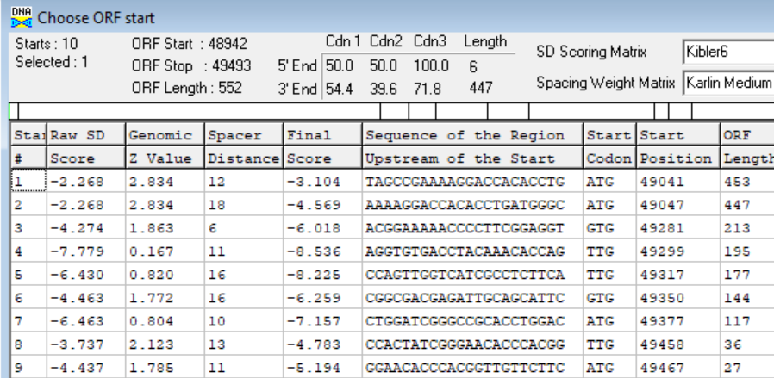
Proposed Function: hypothetical protein
Function Evidence: no credible functional match on HHPRED or BLASTP
Transmembrane Domain/Evidence: NO
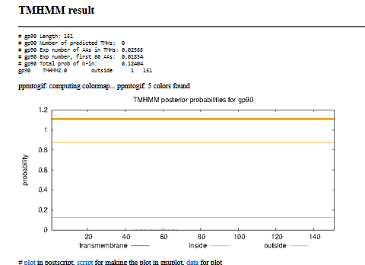

Search gap after gene 90, add small genes, 91 and 92, in second and first frame, respectively.
Gene Number: 91 (not called in autoannotation, GenemarkS, or phagesdb draft
10/06/22 Run BlastP at phagesdb and NCBI, Starterator, RBS on Frames, Transmembrane prediction https://services.healthtech.dtu.dk/service.php?TMHMM-2.0, HHPRED, https://toolkit.tuebingen.mpg.de/#/tools/hhpred,
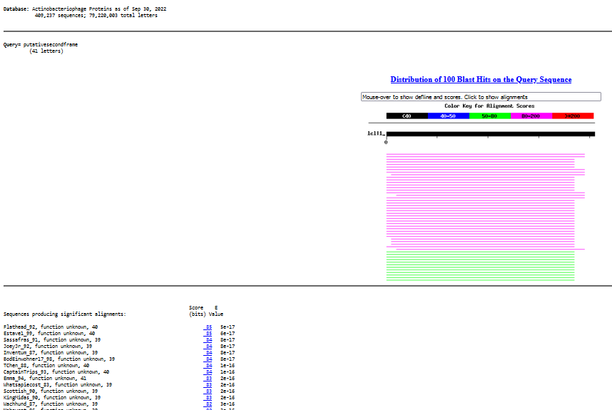
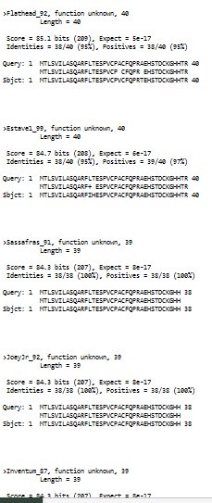
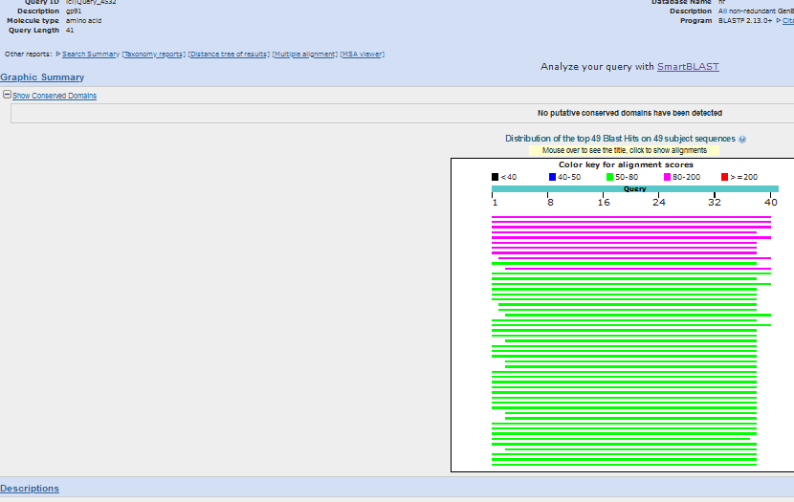
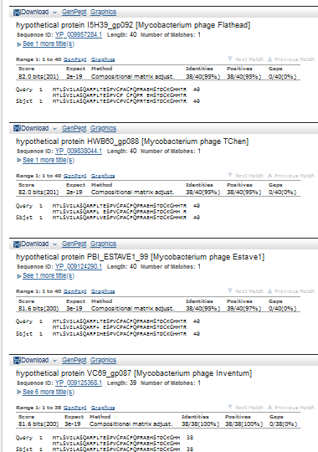
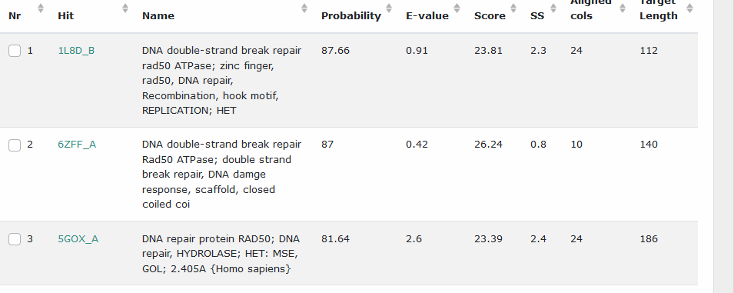
Start Codon and source: 49,490, ATG, not called. Has matches on phagesdb
Stop Codon: 49,612, TGA
F/R: F
Coding Potential (y/n): N (wafer of a peak on GenemarkS)
Starterator (SS, NA, NI): pham 932, most annotated, as in Flathead 92
Blast Best Hit, Query:Subject Starts, Score, Evalue, or “no significant Blast alignments” if 10E-4 or higher
Gap: -4bp overlap with gene 90
Longest Orf? (Y/N/NA) Y
RBS: N/A, Scoring Matirix , Spacing Matrix, Z Score, Final Score,
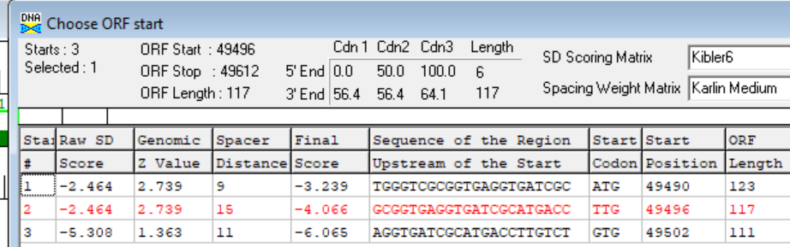
Proposed Function: hypothetical protein
Function Evidence: no credible function matches on HHPRED or BLASTP
Transmembrane Domain/Evidence: NO
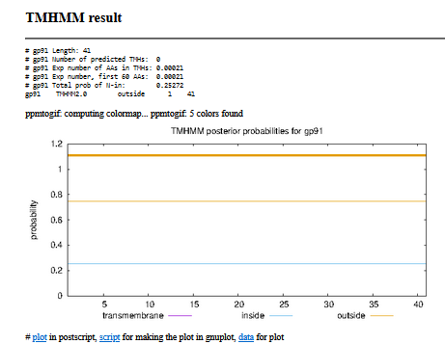

INSERTED 92
Gene Number: 92 (not called)
10/06/22 Run BlastP at phagesdb and NCBI, Starterator, RBS on Frames, Transmembrane prediction https://services.healthtech.dtu.dk/service.php?TMHMM-2.0, HHPRED, https://toolkit.tuebingen.mpg.de/#/tools/hhpred,
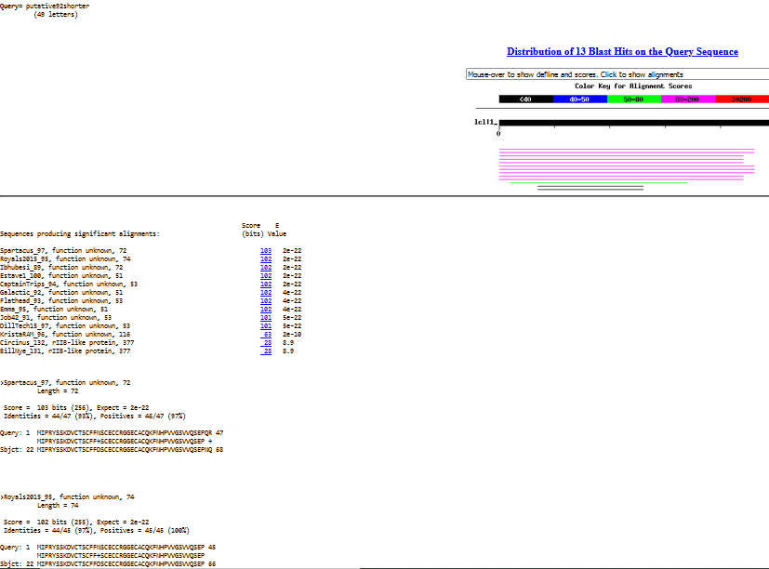
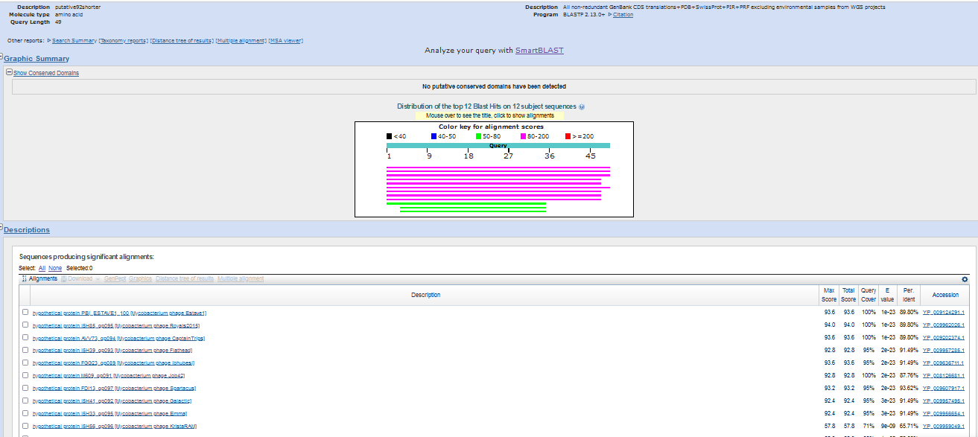
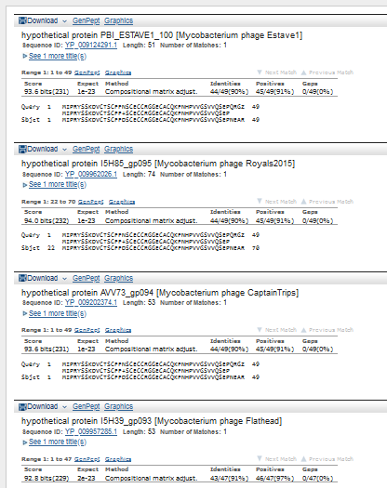
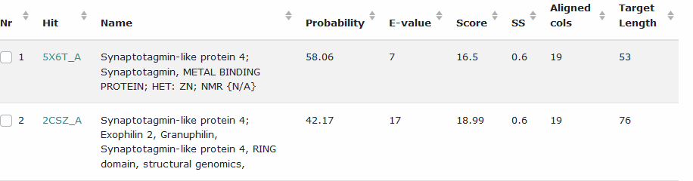
Start Codon and source: 49,609, ATG, not called by autoannotation gene progams, but present in other phages
Stop Codon: 49,755, TAG
F/R: F
Coding Potential (y/n):none
Starterator (SS, NA, NI): pham 7041, most annotated, like Estave1 100
Blast Best Hit, Query:Subject Starts, Score, Evalue, or “no significant Blast alignments” if 10E-4 or higher
Gap: -4 bp overlap with gene 91
Longest Orf? (Y/N/NA) N
RBS: N/A, Scoring Matirix , Spacing Matrix, Z Score, Final Score,
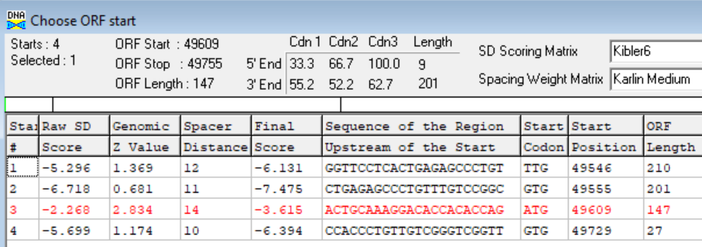
Proposed Function: hypothetical protein
Function Evidence: no credible functional matches on HHPRED or BlastP
Transmembrane Domain/Evidence: NO
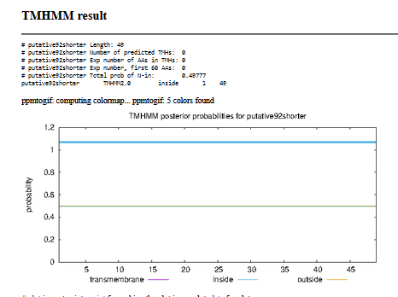

Gene Number: 93 (original 91, phagesdb draft 93)
10/06/22 Run BlastP at phagesdb and NCBI, Starterator, RBS on Frames, Transmembrane prediction https://services.healthtech.dtu.dk/service.php?TMHMM-2.0, HHPRED, https://toolkit.tuebingen.mpg.de/#/tools/hhpred,
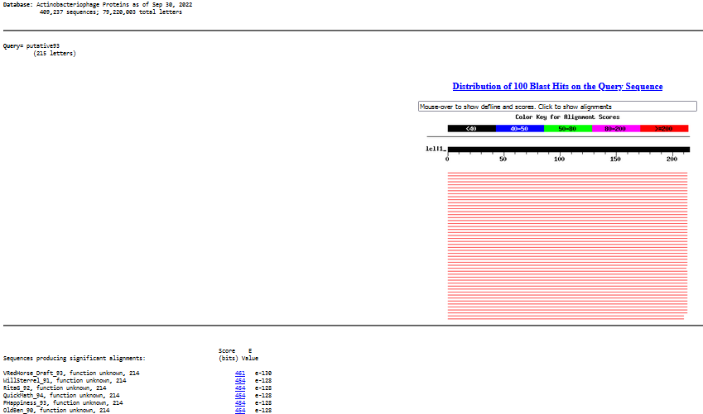
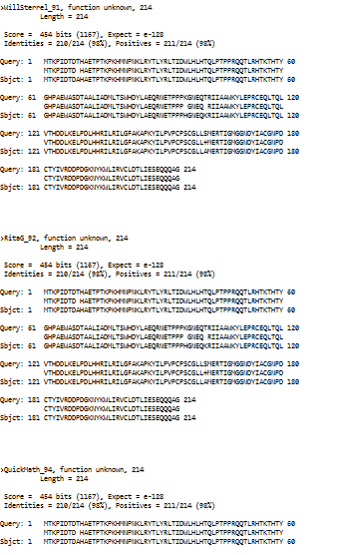
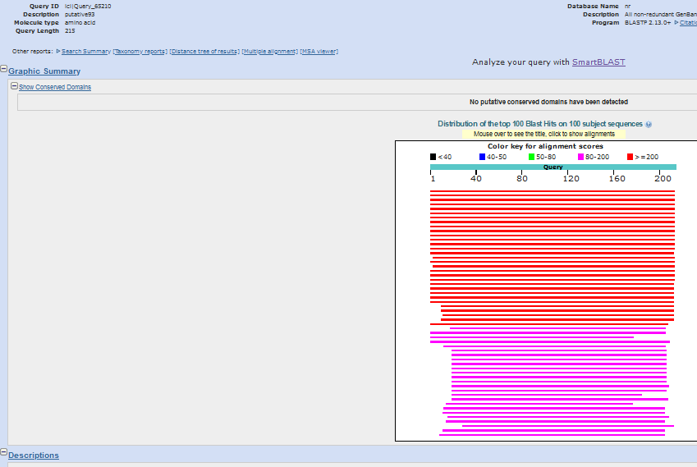
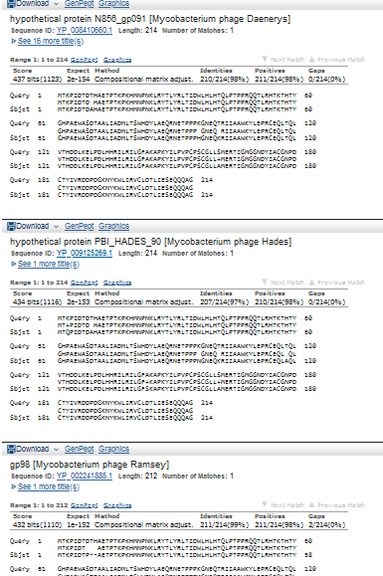
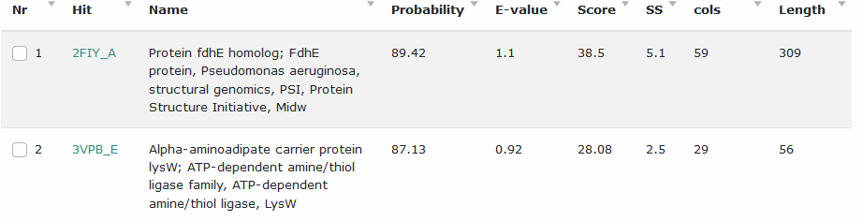
Start Codon and source: 49,768 GTG, called by Glimmer and GenmarkS, Genemark on DNA master called 49825
Stop Codon: 50,412, TGA
F/R: F
Coding Potential (y/n): Y, later start also captures it
Starterator (SS, NA, NI): pham 606, most annotated start
Blast Best Hit, Query:Subject Starts, Score, Evalue, or “no significant Blast alignments” if 10E-4 or higher
Gap: 12 bp gap from gene 92
Longest Orf? (Y/N/NA) Y
RBS: N/A, Scoring Matirix , Spacing Matrix, Z Score, Final Score, later start has better score
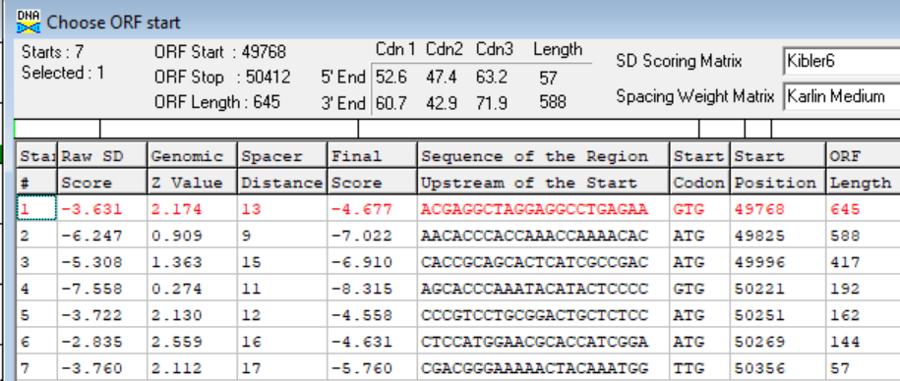
Proposed Function: hypothetical protein
Function Evidence: no credible matches on HHPRED or BlastP
Transmembrane Domain/Evidence: NO
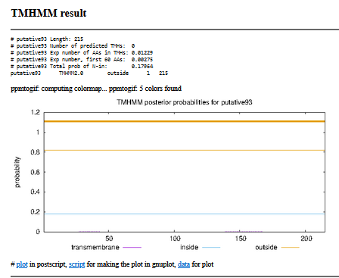

Search gap between 93 and 94…no credible orfs by blastp
Gene Number: 94 (original 92, phagesdb draft
10/06/22 Run BlastP at phagesdb and NCBI, Starterator, RBS on Frames, Transmembrane prediction https://services.healthtech.dtu.dk/service.php?TMHMM-2.0, HHPRED, https://toolkit.tuebingen.mpg.de/#/tools/hhpred,
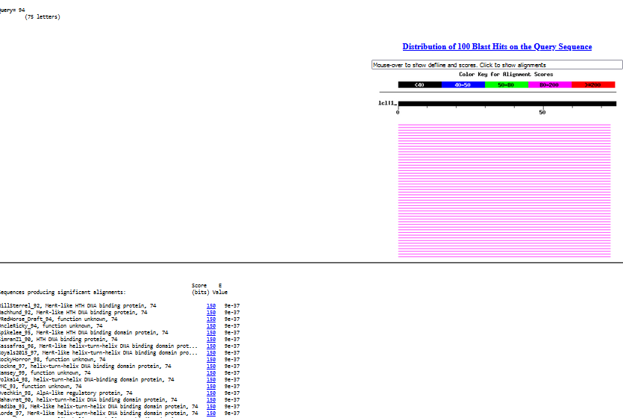
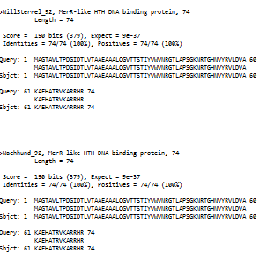
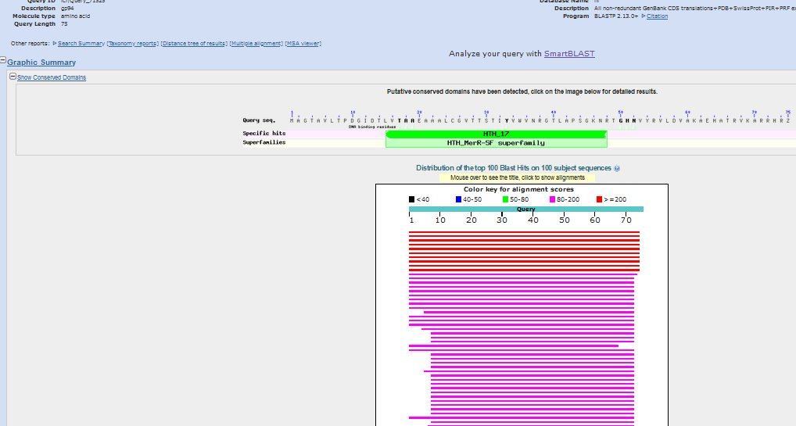
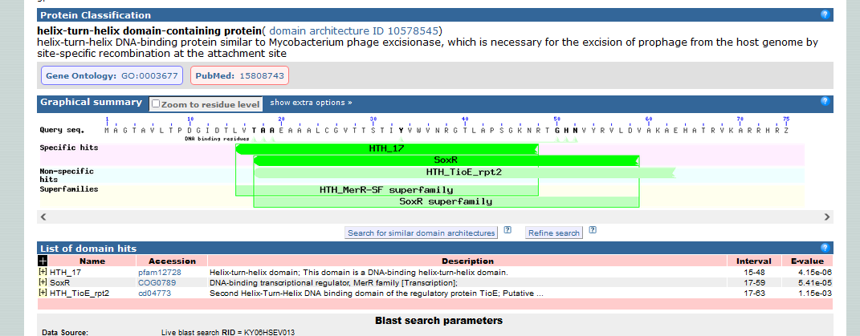
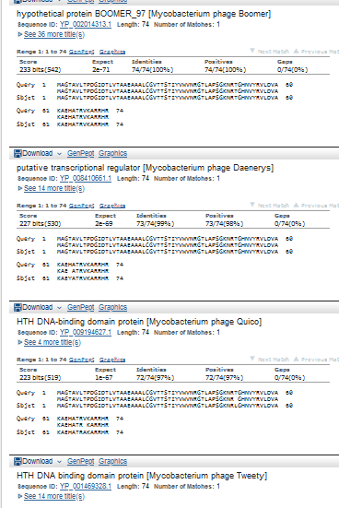

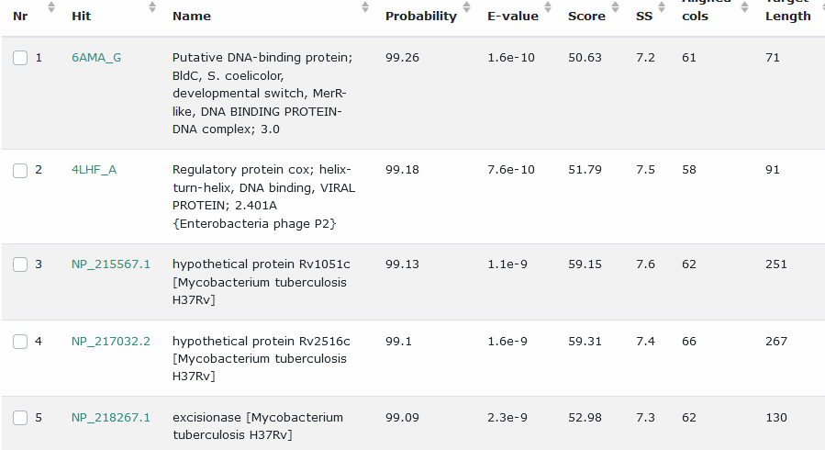
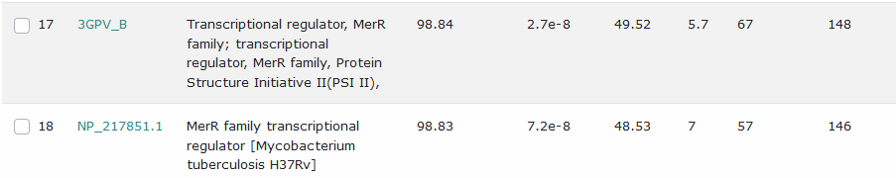
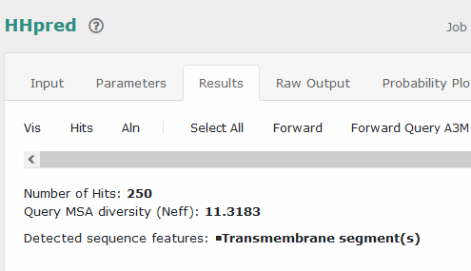
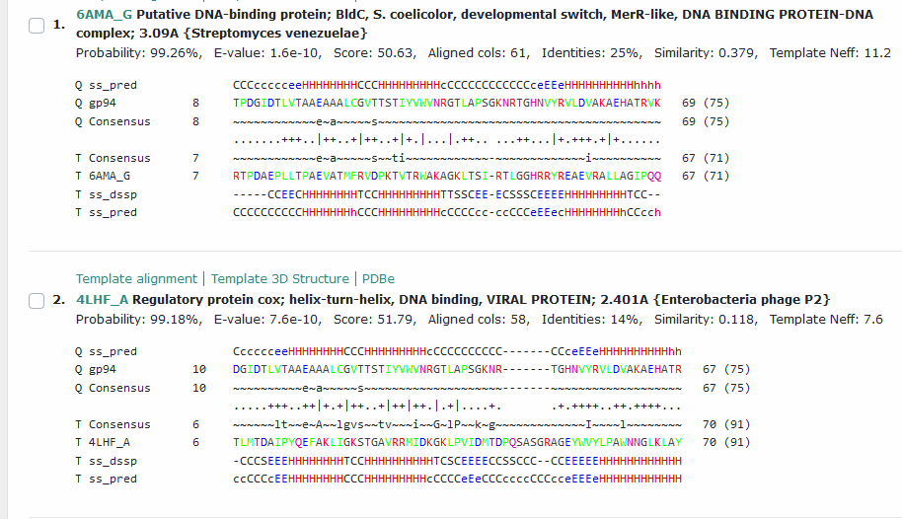
Start Codon and source: 50,521, ATG, called by Glimmer and Genemark
Stop Codon: 50,745, TGA
F/R: F
Coding Potential (y/n): Y
Starterator (SS, NA, NI): pham 50,210, most annotated start
Blast Best Hit, Query:Subject Starts, Score, Evalue, or “no significant Blast alignments” if 10E-4 or higher
Gap: 108 bp gap from end of gene 93
Longest Orf? (Y/N/NA) Y
RBS: N/A, Scoring Matirix , Spacing Matrix, Z Score, Final Score,
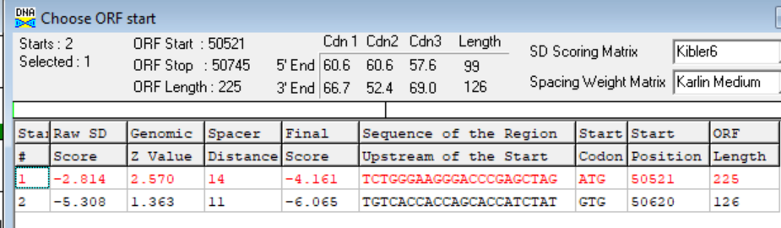
Proposed Function: helix-turn-helix DNA binding domain, MerR-like; (not called, but also membrane protein?)
Function Evidence: HHPRED
Transmembrane Domain/Evidence: YES…HHPRED and TMHMM; strange…
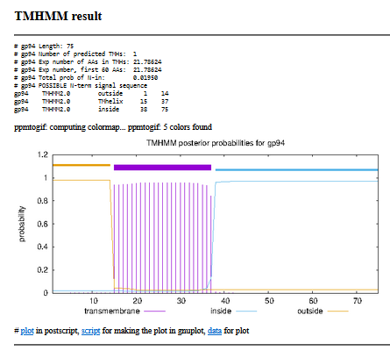

Gene Number: 95 (original 93, phagesdb draft 95)
10/06/22 Run BlastP at phagesdb and NCBI, Starterator, RBS on Frames, Transmembrane prediction https://services.healthtech.dtu.dk/service.php?TMHMM-2.0, HHPRED, https://toolkit.tuebingen.mpg.de/#/tools/hhpred,
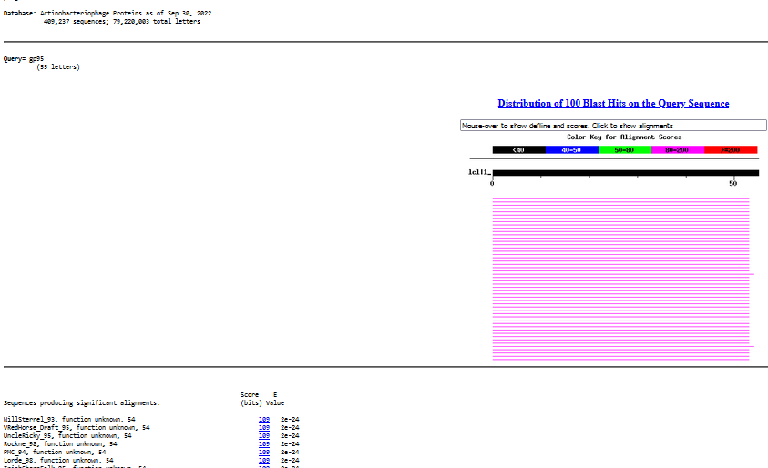
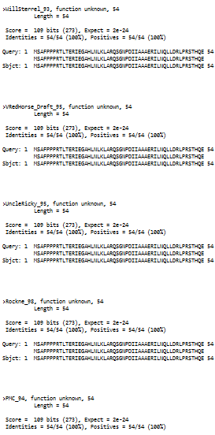
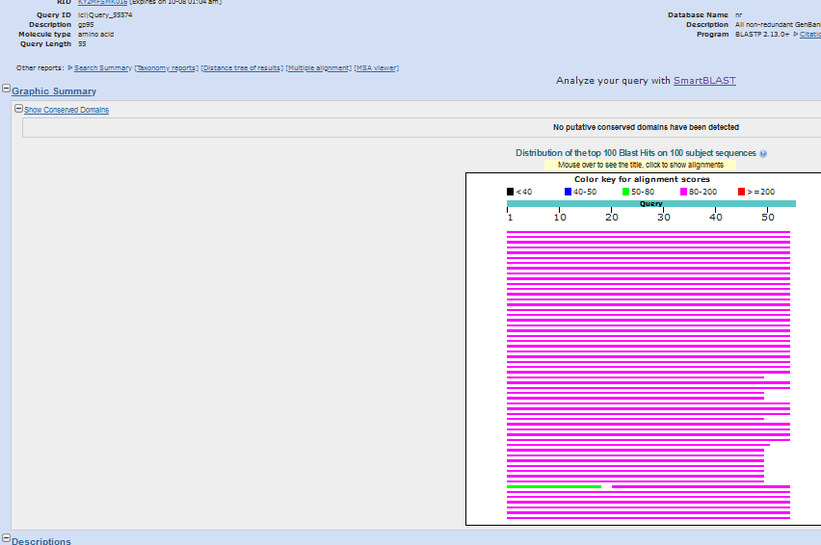
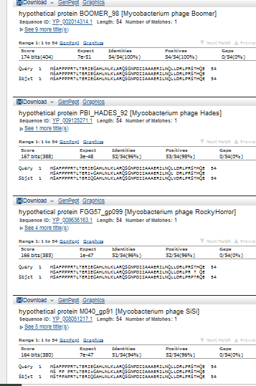
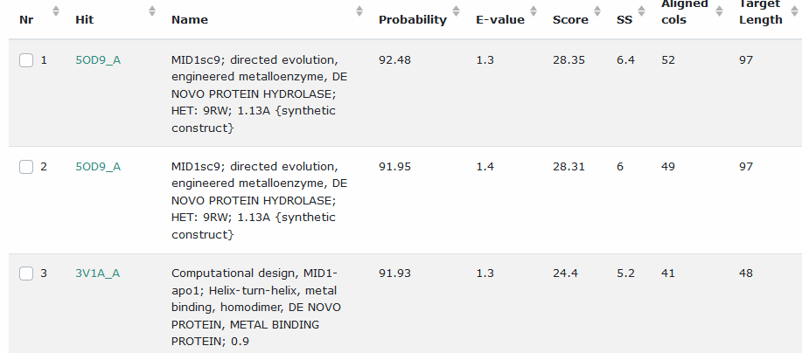

Start Codon and source: 50742, ATG, called by Glimmer and GememarkS, not DNAMasterGenemark
Stop Codon: 50,906, TAG
F/R: F
Coding Potential (y/n): Y
Starterator (SS, NA, NI): pham 371, most annotated start
Blast Best Hit, Query:Subject Starts, Score, Evalue, or “no significant Blast alignments” if 10E-4 or higher
Gap: -4bp overlap with gene 94
Longest Orf? (Y/N/NA) N
RBS: N/A, Scoring Matirix , Spacing Matrix, Z Score, Final Score,
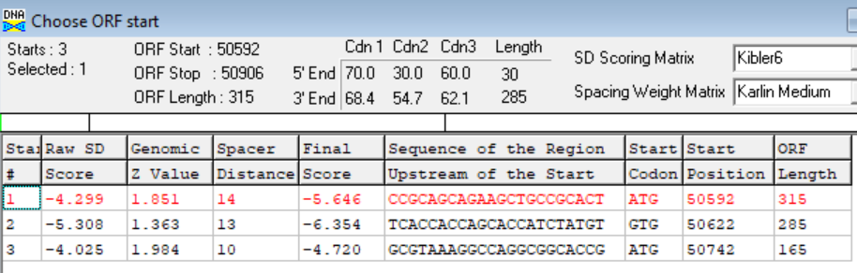
Proposed Function: hypothetical protein
Function Evidence: no credible blast matches
Transmembrane Domain/Evidence: NO
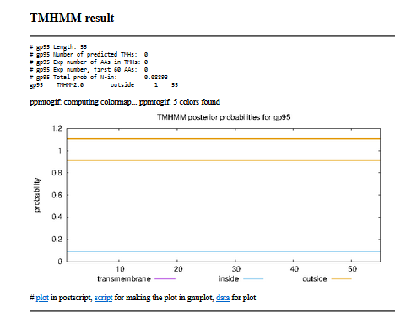

Gene Number: 96
10/06/22 Run BlastP at phagesdb and NCBI, Starterator, RBS on Frames, Transmembrane prediction https://services.healthtech.dtu.dk/service.php?TMHMM-2.0, HHPRED, https://toolkit.tuebingen.mpg.de/#/tools/hhpred,
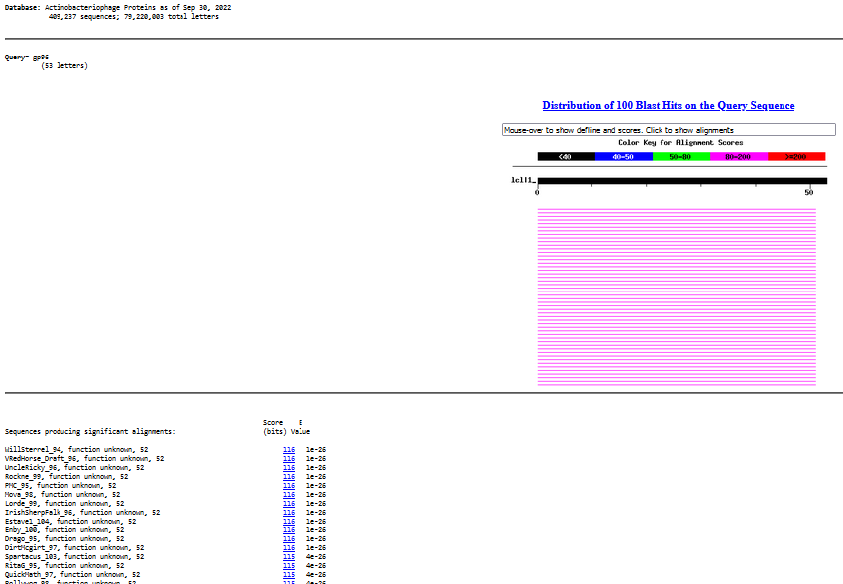
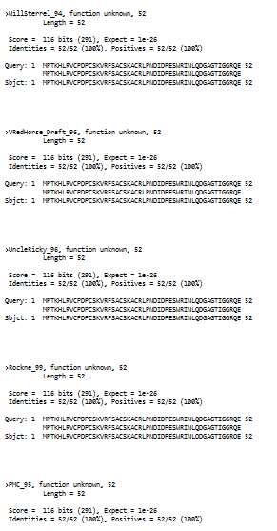
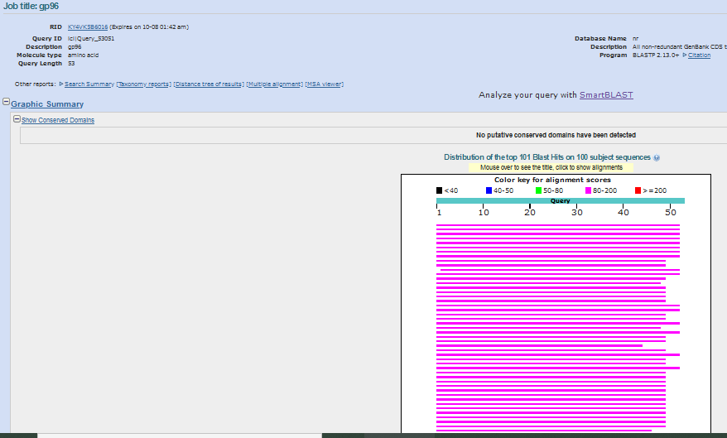

Start Codon and source: 50,912, GTG, Called by Glimmer but neither GeneMark
Stop Codon: 51,070, TGA
F/R: F
Coding Potential (y/n): Y
Starterator (SS, NA, NI): pham 339, most annotated start
Blast Best Hit, Query:Subject Starts, Score, Evalue, or “no significant Blast alignments” if 10E-4 or higher
Gap: 5 bp gap from end of gene 96
Longest Orf? (Y/N/NA) Y
RBS: N/A, Scoring Matirix , Spacing Matrix, Z Score, Final Score,
Proposed Function: hypothetical protein
Function Evidence: no credible functional HHPRED or BLASTP hits
Transmembrane Domain/Evidence: NO

Gene Number: 97 (original 95, phagesdb draft 97)
10/06/22 Run BlastP at phagesdb and NCBI, Starterator, RBS on Frames, Transmembrane prediction https://services.healthtech.dtu.dk/service.php?TMHMM-2.0, HHPRED, https://toolkit.tuebingen.mpg.de/#/tools/hhpred,

Start Codon and source: 51,067, ATG, called by Glimmer and GenemarkS, not by DNA Master Genemark
Stop Codon: 51,258, TGA
F/R: F
Coding Potential (y/n): Y
Starterator (SS, NA, NI): pham 1130, most annotated start
Blast Best Hit, Query:Subject Starts, Score, Evalue, or “no significant Blast alignments” if 10E-4 or higher
Gap: -4 bp overlap with gene 96
Longest Orf? (Y/N/NA) N
RBS: N/A, Scoring Matirix , Spacing Matrix, Z Score, Final Score,
Proposed Function:
Function Evidence:
Transmembrane Domain/Evidence: NO

Gene Number: 98 (original 96, phagesdb draft 98)
10/06/22 Run BlastP at phagesdb and NCBI, Starterator, RBS on Frames, Transmembrane prediction https://services.healthtech.dtu.dk/service.php?TMHMM-2.0, HHPRED, https://toolkit.tuebingen.mpg.de/#/tools/hhpred,
Start Codon and source: 51,255, ATG, Called by Glimmer and genemark
Stop Codon: 51,656, TGA
F/R: F
Coding Potential (y/n): Y
Starterator (SS, NA, NI): pham 50064, not the most annotated start, about 80 other phages have the most annotated start but don’t call it
Blast Best Hit, Query:Subject Starts, Score, Evalue, or “no significant Blast alignments” if 10E-4 or higher
Gap: -4 bp overlap with gene 97
Longest Orf? (Y/N/NA) N
RBS: N/A, Scoring Matirix , Spacing Matrix, Z Score, Final Score,
Proposed Function: hypothetical protein
Function Evidence: no credible BlastP or HHPRED functional matches
Transmembrane Domain/Evidence: NO

Gene Number: 99 (original 97, phagesdb draft 99)
10/06/22 Run BlastP at phagesdb and NCBI, Starterator, RBS on Frames, Transmembrane prediction https://services.healthtech.dtu.dk/service.php?TMHMM-2.0, HHPRED, https://toolkit.tuebingen.mpg.de/#/tools/hhpred,
Start Codon and source: 51,653, GTG, called by Glimmer and Genemark
Stop Codon: 51,895, TGA
F/R: F
Coding Potential (y/n): Y
Starterator (SS, NA, NI): pham 40,771, most annotated start
Blast Best Hit, Query:Subject Starts, Score, Evalue, or “no significant Blast alignments” if 10E-4 or higher
Gap: -4bp overlap with gene 98
Longest Orf? (Y/N/NA) Y
RBS: N/A, Scoring Matirix , Spacing Matrix, Z Score, Final Score,
Proposed Function: hypothetical protein
Function Evidence: no credible functionmatches on HHPRED or BlastP
Transmembrane Domain/Evidence: NO

Gene Number: 100 (original 98, phagesdb draft 100)
10/06/22 Run BlastP at phagesdb and NCBI, Starterator, RBS on Frames, Transmembrane prediction https://services.healthtech.dtu.dk/service.php?TMHMM-2.0, HHPRED, https://toolkit.tuebingen.mpg.de/#/tools/hhpred,

Start Codon and source: 51,888, ATG, called by Glimmer and Genemark
Stop Codon: 52049, TGA
F/R: F
Coding Potential (y/n): Y
Starterator (SS, NA, NI): pham 47,211, most annotated start
Blast Best Hit, Query:Subject Starts, Score, Evalue, or “no significant Blast alignments” if 10E-4 or higher
Gap: -8bp overlap with gene 99
Longest Orf? (Y/N/NA) N/A (Y, only start)
RBS: N/A, Scoring Matirix , Spacing Matrix, Z Score, Final Score,
Proposed Function: hypothetical protein
Function Evidence: no credible function matches on HHPRED or BLastP
Transmembrane Domain/Evidence: NO

Gene Number: 101 (original 99, phagesdbdraft 101)
10/06/22 Run BlastP at phagesdb and NCBI, Starterator, RBS on Frames, Transmembrane prediction https://services.healthtech.dtu.dk/service.php?TMHMM-2.0, HHPRED, https://toolkit.tuebingen.mpg.de/#/tools/hhpred,
Start Codon and source: 52,066, ATG,called by glimmer and genemark
Stop Codon: 53,502, TGA
F/R: F
Coding Potential (y/n): Y
Starterator (SS, NA, NI): pham 50,140, most annotated start
Blast Best Hit, Query:Subject Starts, Score, Evalue, or “no significant Blast alignments” if 10E-4 or higher
Gap: 16 bp gap from gene 100
Longest Orf? (Y/N/NA) N
RBS: N/A, Scoring Matirix , Spacing Matrix, Z Score, Final Score,
Proposed Function: n-acetylglucosaminyltransferase
Function Evidence: HHPRED
Transmembrane Domain/Evidence: NO

Gene Number: 102 (original 100, phagesdb draft 102)
10/06/22 Run BlastP at phagesdb and NCBI, Starterator, RBS on Frames, Transmembrane prediction https://services.healthtech.dtu.dk/service.php?TMHMM-2.0, HHPRED, https://toolkit.tuebingen.mpg.de/#/tools/hhpred,
There is a lipase function in phagesdb but their example is LittleE gp99. I aligned two sequences with VRedHorse gp102 and LittleE gp99, no match
Start Codon and source: 53,505, ATG, called by Glimmer and Genemark
Stop Codon: 53,711, TGA
F/R: F
Coding Potential (y/n): Y
Starterator (SS, NA, NI): pham 285, most annotated start
Blast Best Hit, Query:Subject Starts, Score, Evalue, or “no significant Blast alignments” if 10E-4 or higher
Gap: 2 bp gap from gene 101
Longest Orf? (Y/N/NA) N
RBS: N/A, Scoring Matirix , Spacing Matrix, Z Score, Final Score,
Proposed Function: hypothetical protein (check evidence for lipase, LipC-like)
Function Evidence: unclear if lack of homology with LitteE99 should override HHPRED> VRedHorse gp102 and LittleE99 are in same pham.
Transmembrane Domain/Evidence: NO

Delete phagesdb draft Reverse Frame Gene 103, renumber
Gene Number: 103 (phagesdb draft 104)
10/06/22 Run BlastP at phagesdb and NCBI, Starterator, RBS on Frames, Transmembrane prediction https://services.healthtech.dtu.dk/service.php?TMHMM-2.0, HHPRED, https://toolkit.tuebingen.mpg.de/#/tools/hhpred,

Start Codon and source: 53,708, ATG, called by Glimmer and Genemark
Stop Codon: 54,331, TGA
F/R: F
Coding Potential (y/n): Y
Starterator (SS, NA, NI): pham 50,017, most annotated start
Blast Best Hit, Query:Subject Starts, Score, Evalue, or “no significant Blast alignments” if 10E-4 or higher
Gap: -4 bp overlap with gene 102
Longest Orf? (Y/N/NA) N
RBS: N/A, Scoring Matirix , Spacing Matrix, Z Score, Final Score,
Proposed Function: glycosyltransferase
Function Evidence: BLASTP and HHPRED
Transmembrane Domain/Evidence: NO

DELETE 2 REVERSE FRAME GENES (phagesdb draft 105, 106), ADD FORWARD GENE
Gene Number: 104 (not called in autoannotations)
10/06/22 Run BlastP at phagesdb and NCBI, Starterator, RBS on Frames, Transmembrane prediction https://services.healthtech.dtu.dk/service.php?TMHMM-2.0, HHPRED, https://toolkit.tuebingen.mpg.de/#/tools/hhpred,

Start Codon and source: 54,331, ATG, not auto-annotated
Stop Codon: 54,657, TGA
F/R: F
Coding Potential (y/n): hardly
Starterator (SS, NA, NI): pham 50,113, most annotated start, like Hades 102
Blast Best Hit, Query:Subject Starts, Score, Evalue, or “no significant Blast alignments” if 10E-4 or higher
Gap: -4 bp overlap with gene 103
Longest Orf? (Y/N/NA) Y (only, N/A)
RBS: N/A, Scoring Matirix , Spacing Matrix, Z Score, Final Score,

Proposed Function: HNH endonuclease
Function Evidence: HHPRED, BLASTP, like SiSi gene in official functionlist
Transmembrane Domain/Evidence: NO

