HindIII

EcoR1

HaeIII

Kb ladder

Undigested DNA

ClaI

BamHI

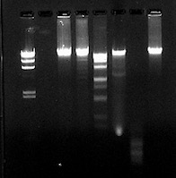

23,130

9,416

6,557

4,361

2,322

2,027