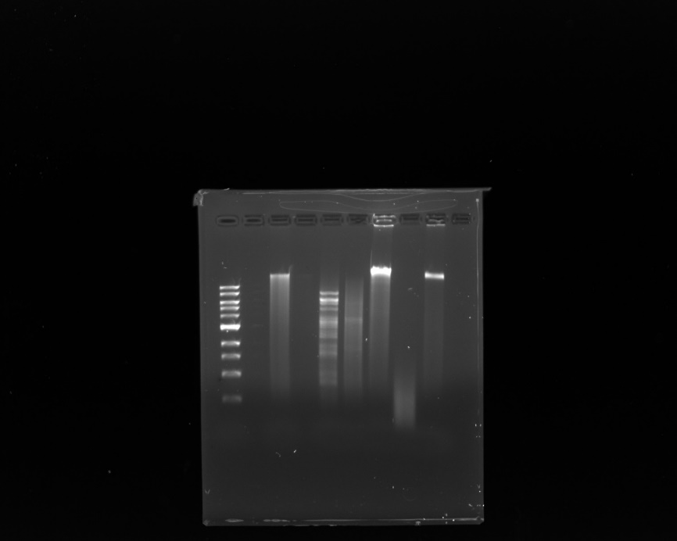
Mmmmmmmmmmmmmmmmmmmmmmmmmmmmmmmmmmmmmmmmmmm
Llllllllllllllllll
Lllllllllll
Lllllllllllll
Llllllllllllllllll

Undigested DNA
KB ladder
BamHI
HindIII
HaeIII
EcoRI
Clal

10.0 - 4.0 kb

3.0 kb
2.0 kb
1.5 kb
1.0 kb

0.5 kb

Lauren Samudio 7/27/2021 Cerberus

