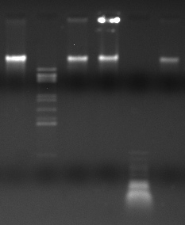
Chester DNA Digest with enzymes:
Well 1: Undigested
Well 2: BamH1
Well 3: Cla1
Well 4: EcoR1
Well 5: Hae3
Well 6: Hind3
BamH1 Cla1 EcoR1 Hae3 Hind3
Undigested

