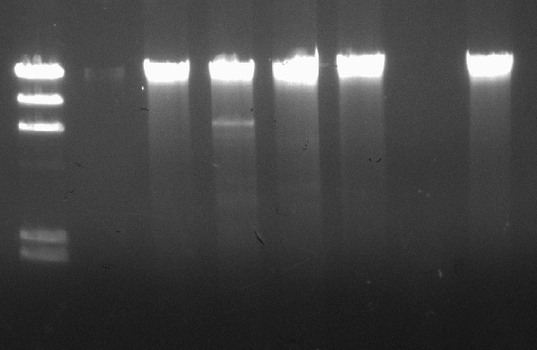

BamHI

ClaI

EcoRI

HaeIII

HindIII

Lamda DNA-HindIII Digest

9,416

23,130

6,557

4,361

2,027

2,322