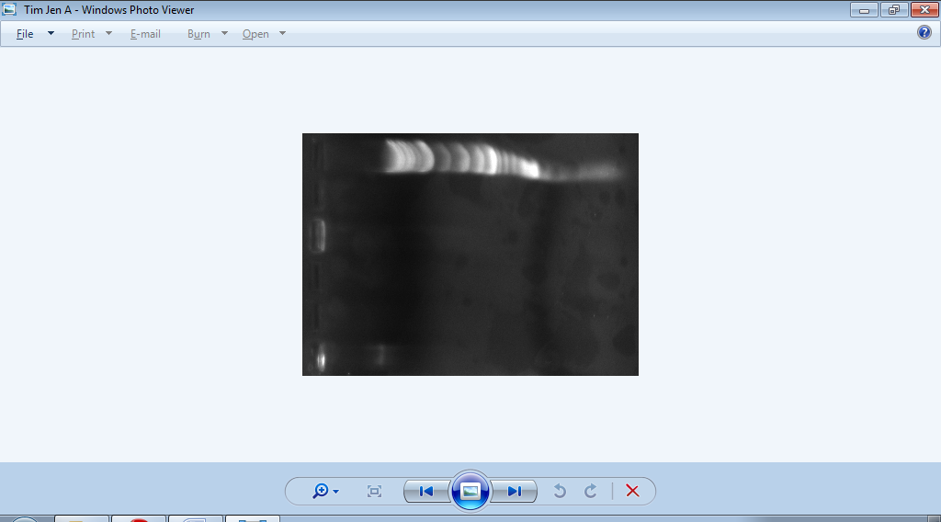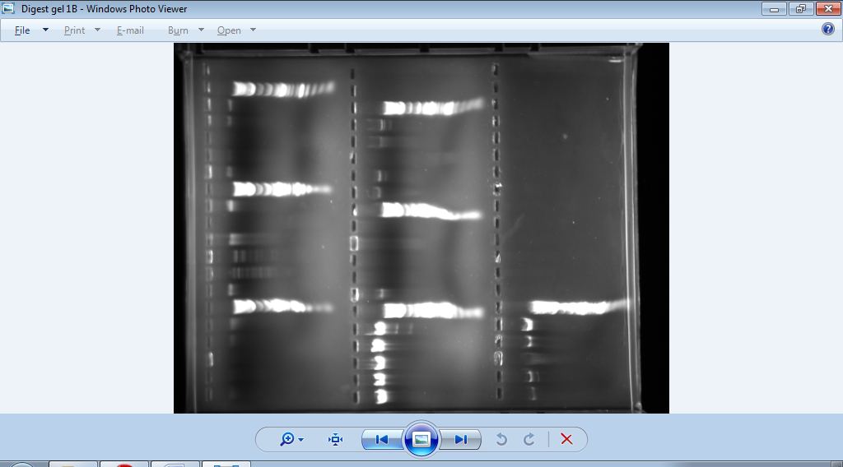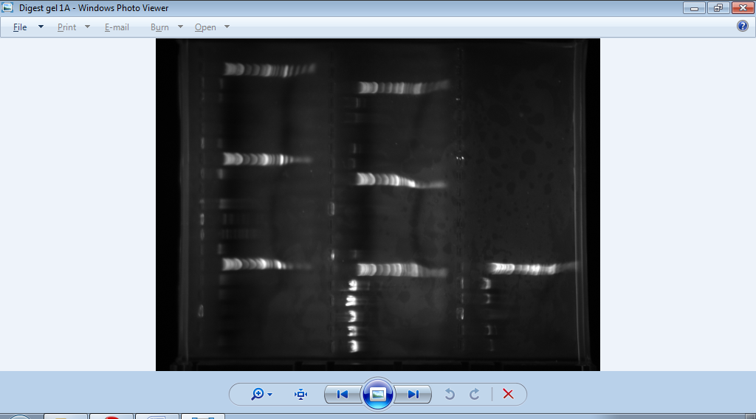

Lane 6:

Ladder

Lane 5:

HindIII

Lane 4:

EcoR1

Lane 3:

Clal

Lane 2:

BamH1

Lane 1:

Undigested

Tim Jen

