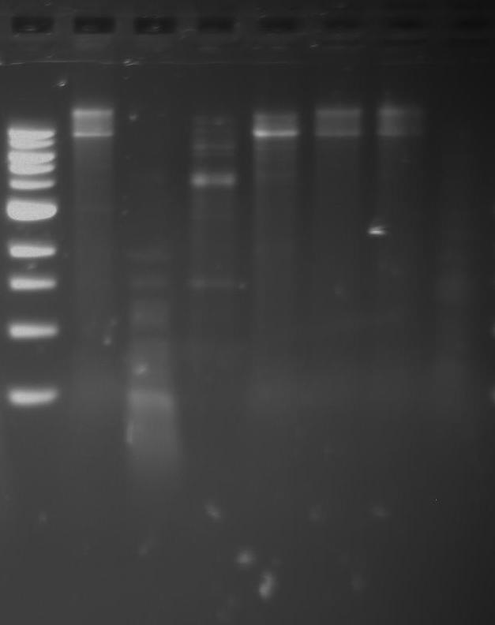

Uncut gDNA

PmlI

Haelll

Kpnl

Sfil

Sacl

Styl

1kb Ladder