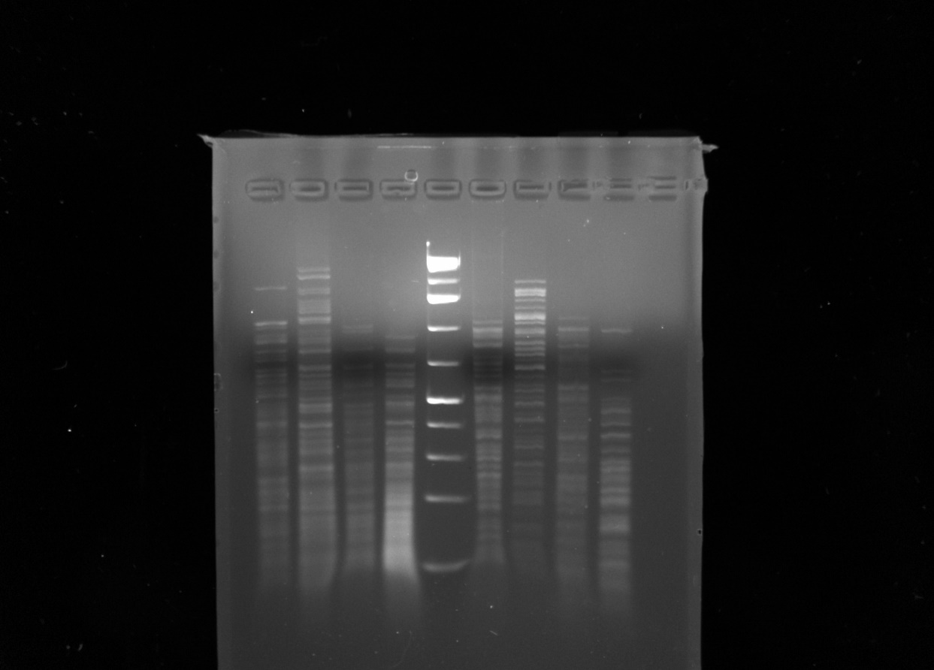

Phage: Sparky701

Enzyme: HaeIII