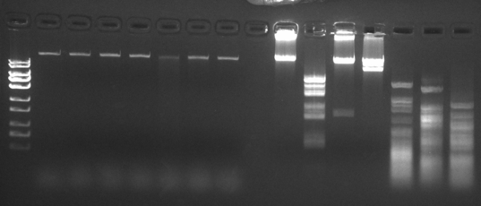
Restriction enzyme digest of Sparta genome. 500 ng of purified Sparta genomic DNA was digested with the indicated enzymes for 1 hr at 37˚C, run on a 1% agarose gel containing 10 µg/ml ethidium bromide, and imaged.
DNA ladder (bp)
10,000
uncut
EcoRI
KpnI
SmaI
HaeIII
TaqI
MseI
uncut
EcoRI
KpnI
SmaI
HaeIII
TaqI
MseI
250
750
5,000
3,000
1,500
Sparta
Lambda

