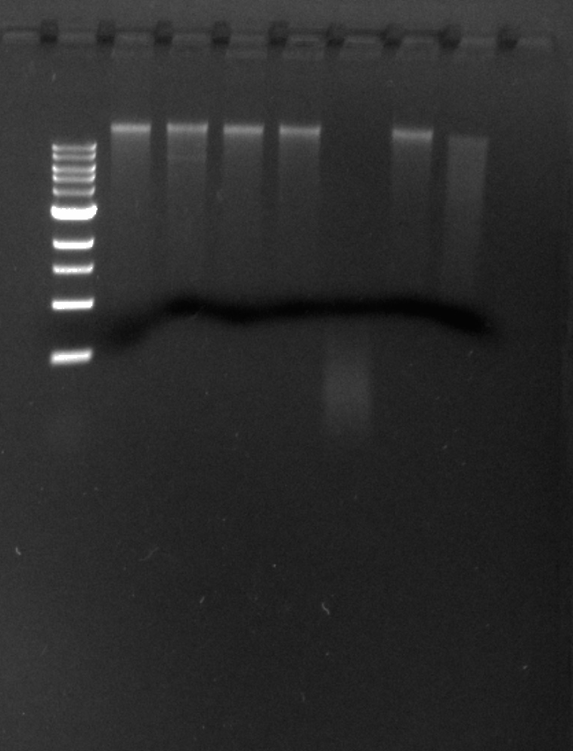

1 KB Ladder

UNCUT DNA

BamHI

ClaI

EcoRI

HaeIII

HindIII

SaII