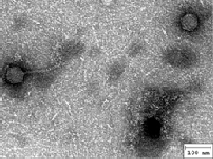
Electron micrograph picture: Phage Graduation

