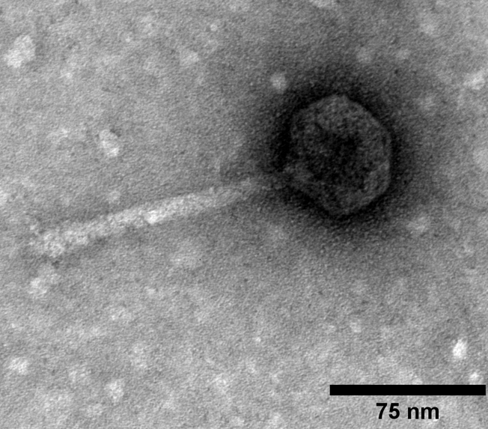
Transmission electron micrograph of Sparta. Sparta was stained with 1% uranyl acetate and imaged at 120 kV. The capsid is 50.4 nm wide and 49.8 nm long, and its tail length is 123 nm.

