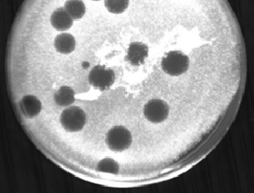
Picture of plaque: Phage Graduation

