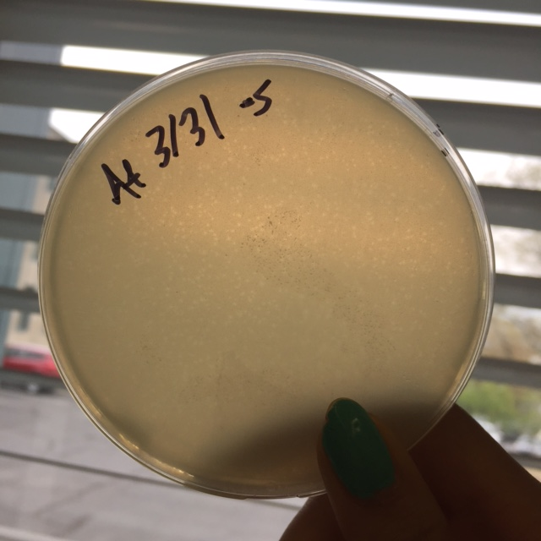
Plaque picture 10^-5 3/31/16

