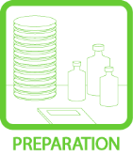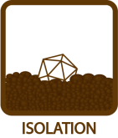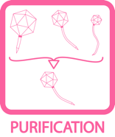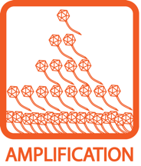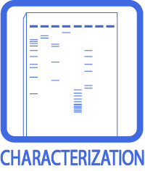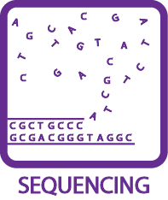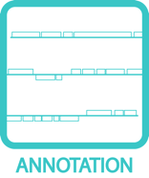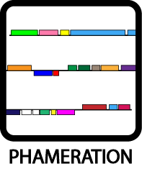
Amplification of Phage by 30-Plate Infection
OBJECTIVE
To obtain a large quantity of particles of a particular mycobacteriophage.
BACKGROUND
Once a pure phage sample has been obtained, it becomes necessary to have a large quantity of that phage for downstream applications such as sequencing or digestion. This procedure accomplishes such amplification by setting up 30 plates where a phage can infect and reproduce. Once the phages have multiplied on all 30 plates, the results are harvested and combined.

Before beginning this protocol, empirical trials must be performed according to the relevant protocol to determine what quantity of phage must be added to each large plate to give a web pattern. This is a prerequisite because it vastly reduces the chances that a dilution or calculation error will lead to the wasting of 30 large plates, associated media, and time.
APPROXIMATE TIME NEEDED
Active Set-Up: ~30 minutes
Incubation and Growth: ~36 – 48 hours
Flooding Plates: ~15 minutes
Incubation and Diffusion: ~2 – 4 hours
Harvesting: ~30 minutes
MATERIALS NEEDED
Equipment
- Sterile 500 mL non-baffled flask
- Microwave
- 37°C incubator
- Pipettors, micro- and serological

Consumables/Reagents (See online media preparation guides)
- Top agar/MBTA plating stock (270 mL/phae)
- 50 mL serological pipettes
- Large (150 mm) agar plates (30 plates/phage)
- Phage Buffer w/ 1 mM CaCl₂ (~300 mL/phage)
- 250 mL conical centrifuge tubes (2 tubes/phage)
- Phage stock of known titer
- Mycobacterium smegmatis plating stock (30 mL/phage)

HELPFUL TIPS
- The most important element for success in this procedure is adding the proper amount of phage particles to get a nice web pattern on all 30 plates. Empirical Test results (see appropriate protocol) should serve as a guide, so be sure to keep as many variables the same as possible: use the same bacteria culture, the same batch of plates, the same phage dilutions, etc.

- Pre-warming the plates—in stacks—at 37°C for 30 – 60 minutes is recommended.

- One challenge is distributing the Top Agar to all 30 plates before it cools and begins to solidify. Work quickly when plating, beginning as soon as the Top Agar is mixed (the addition of room temperature 7H9 to the hot MBTA will bring it to an appropriate temperature).

- To maximize harvest, use a spare microcentrifuge rack or similar prop to raise one end of each plate (thus tilting it and letting the liquid pool) when siphoning off the phage buffer (Figure 1). It is even possible to go underneath the agar or poke it slightly with a pipette to retrieve any liquid that may be under the agar. Even if some solids are extracted with the phage buffer, the combined sample will be spun in the centrifuge, so try to get as much liquid as possible.

- Do not invert these large plates while they incubate at 37°C.

PROCEDURES

- Identify the appropriate amount of phage needed in order to make web patterns on 30 large plates. This should be the amount obtained in empirical tests (multiplied by 30 for the 30 plates). For example, if 15 µL of a 10⁻³ dilution gave a nice web pattern on one plate, the amount needed is 15 x 30 = 450 µL of the same 10⁻³ dilution for this procedure. (Alternatively, 45 µL of a 10⁻² dilution can be used instead as long as dilutions are made very carefully.)

- Using sterile technique and a 50 mL pipette, add 30 mL of M. smegmatis to the 500 mL flask.

- Add the appropriate amount of the phage sample to the flask with the smeg.

- Allow to infect for approximately 10 – 20 minutes. Begin preparing the Top Agar during the last few minutes.

- Prepare 270 mL of Top Agar.
  - Melt 135 mL of MBTA in a microwave.
  - Add 135 mL of 7H9 w/2 mM CaCl₂

- When the Top Agar is ready, immediately and sterilely add it to the flask with the bacteria and phage. Mix by swirling several times.

- Working quickly, use a 50 mL pipette to aspirate 50 mL of the Top Agar/smeg/phage mixture, and then distribute 10 mL to each of 5 large plates. If necessary, briefly swirl plates to evenly spread Top Agar.

- Repeat step 7 until all 30 plates have received 10 mL of Top Agar.
- Allow plates to solidify, and then move them to a 37°C incubator.

- Incubate for 36 – 48 hours to allow multiple rounds of phage infection and lysis.

- Add 10 mL of Phage Buffer to each plate, then let plates stand for ~4 hours at room temperature (or overnight in the cold room). Gently swirl plates occasionally during this period.

- When ready to harvest, prop a plate up on one side to slightly tilt it (see Figure 1), then use a 25 or 50 mL pipette to aspirate the fluid from the plate and deposit it into one of the two 250 mL conical tubes.
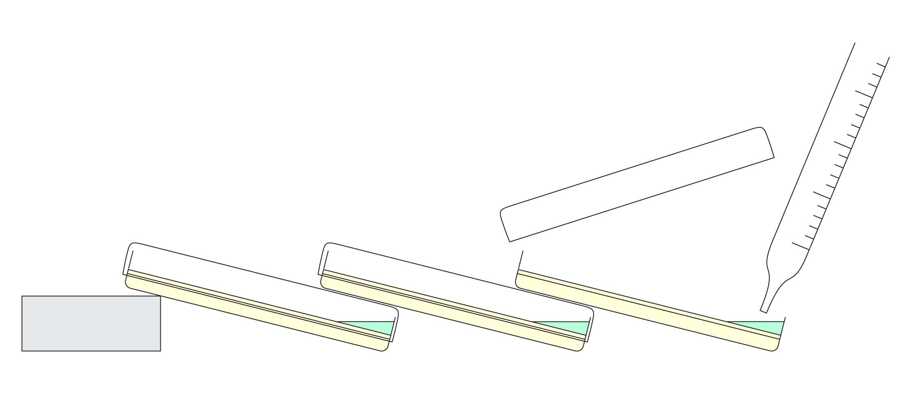
Figure 1: Tilting and stacking plates to assist with aspiration of concentration lysate.

- Note: Aspirating directly from the surface of the Top Agar will likely result in a large amount of bubbles forming inside the pipette. Hence a larger (25-50 mL) pipette is used to reduce the likelihood that bubbles will foam all the way to the top of the pipette and possibly contaminate the pipettor. The same pipette can be reused for multiple plates, but if it starts to look gunky, throw it away and get a new one.

- Repeat step 12 until the lysate from all plates has been harvested. Since the combined lysate will be spun in a centrifuge, distribute the lysate collected evenly between the two 250 mL conical tubes.

- Note: If desired, the lysate can be titered before continuing (See TOOLBOX: Titering). If the titer of the lysate is below 10⁸ PFU/mL, obtaining a band in the later CsCl gradient is unlikely, and the protocol should be repeated to bolster the phage stock.

