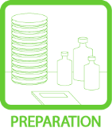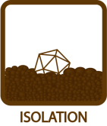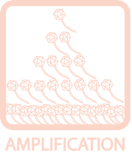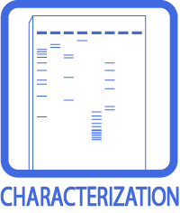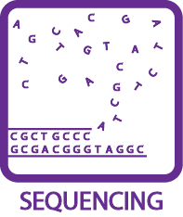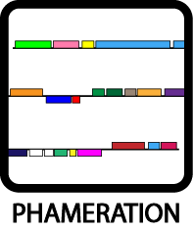
Entering a Phage into the Mycobacteriophage Database
OBJECTIVE
To add a phage to the growing Mycobacteriophage Database.
BACKGROUND
Once a high titer lysate is obtained for a phage, enter it into phagesdb.org; no entries will be accepted unless a lysate is readily available. Continue with the purification of any phages after entering them into the database.

The sooner a phage is entered into the database, the better! Even better, strive to make the data as complete as possible. Choosing a name for your phage is getting more difficult over time as favorite names get taken, so enter your phage on phagesdb as soon as you can.
HELPFUL TIPS
- Take care in naming phages. Naming rules can be found here: http://phagesdb.org/namerules/

- Dr. Hatfull reserves the right to veto any name.

PROCEDURES

- To enter a phage into PhagesDB, a sample of the phage must be archived at the University of Pittsburgh. See Archiving protocol in the toolbox.

- Enter www.phagesdb.org into the web address field.

- Under “Data,” select “Add Phage.”

- Log in. Create an account by clicking on “Register” if necessary.
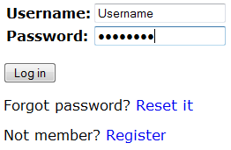

- Please provide GPS coordinate where the phage was found using the N/W Decimal Degree format (# N, # W).

- There are certain smartphone apps that would provide GPS coordinates. For instance, iPhone users can use the built-in “Compass” app, while Android users can download apps such as “MyLocation” or “GPS Status.”

- An alternative method for obtaining GPS coordinates would be through a web mapping service application. One such service can be found via this link: http://www.heywhatsthat.com/profiler.html (OR http://bit.ly/yqKB for a shorter URL)
Simply drag the map to the location where the environmental sample was found, zoom in as much as possible, and click on the map to obtain the GPS coordinates of that location. The output should be to the right of the map and be in the N/W Decimal Degree format.

- Convert the GPS coordinates to the correct format if necessary. One convenient converter is provided by the FCC of the United States, and can be found here:
http://fcc.gov/mb/audio/bickel/DDDMMSS-decimal.html (OR http://bit.ly/lV9SAv)
Enter the degrees, minutes, and seconds (DMS) and hit “Convert to Decimal.” For example, the coordinates 40° 26’ 46” N, 79° 57’ 11” W from the iPhone’s “Compass” app will be converted into 40.446111 N, 79.953056 W.

- Fill out as many fields of the form as possible.

- It would be helpful to provide information about the original host (the original strain of bacteria infected with the phage), whether the sample was enriched (with the host bacteria), and notes about growing the phage.

- Click “Submit.” Once verified, information about the phage will be posted.

- Upload a picture of a plate with 20 – 40 plaques as soon as it is available.

- Remember to submit an archived sample to the University of Pittsburgh to accompany all entries into PhageDB.org.

