**Actinobacteria**: *Arthrobacter sp.*

**Source**

* ATCC
* Catalogue #: 21022

**Growth Parameters**

*Note: The condition(s) tested below is not necessarily optimal for growth of this host. Rather, it represents a “basic” growth medium on which this host can grow.*

* Growth media: PYCa media, PYCa media, supplemented with  
   4.5 mM CaCl2 in top agar and enrichment

culture

* Temperature tested: 30˚C
* Streak Plate Time: 1 days
* Liquid Culture Time: 1 days
* Lawn Growth Time: 1 day
* Colony Color: Yellow
* Colony Morphology:  Round, convex, smooth, shiny

Additional Notes:

* Start fresh cultures every 7 – 14 days.

**Streak Plate Image**

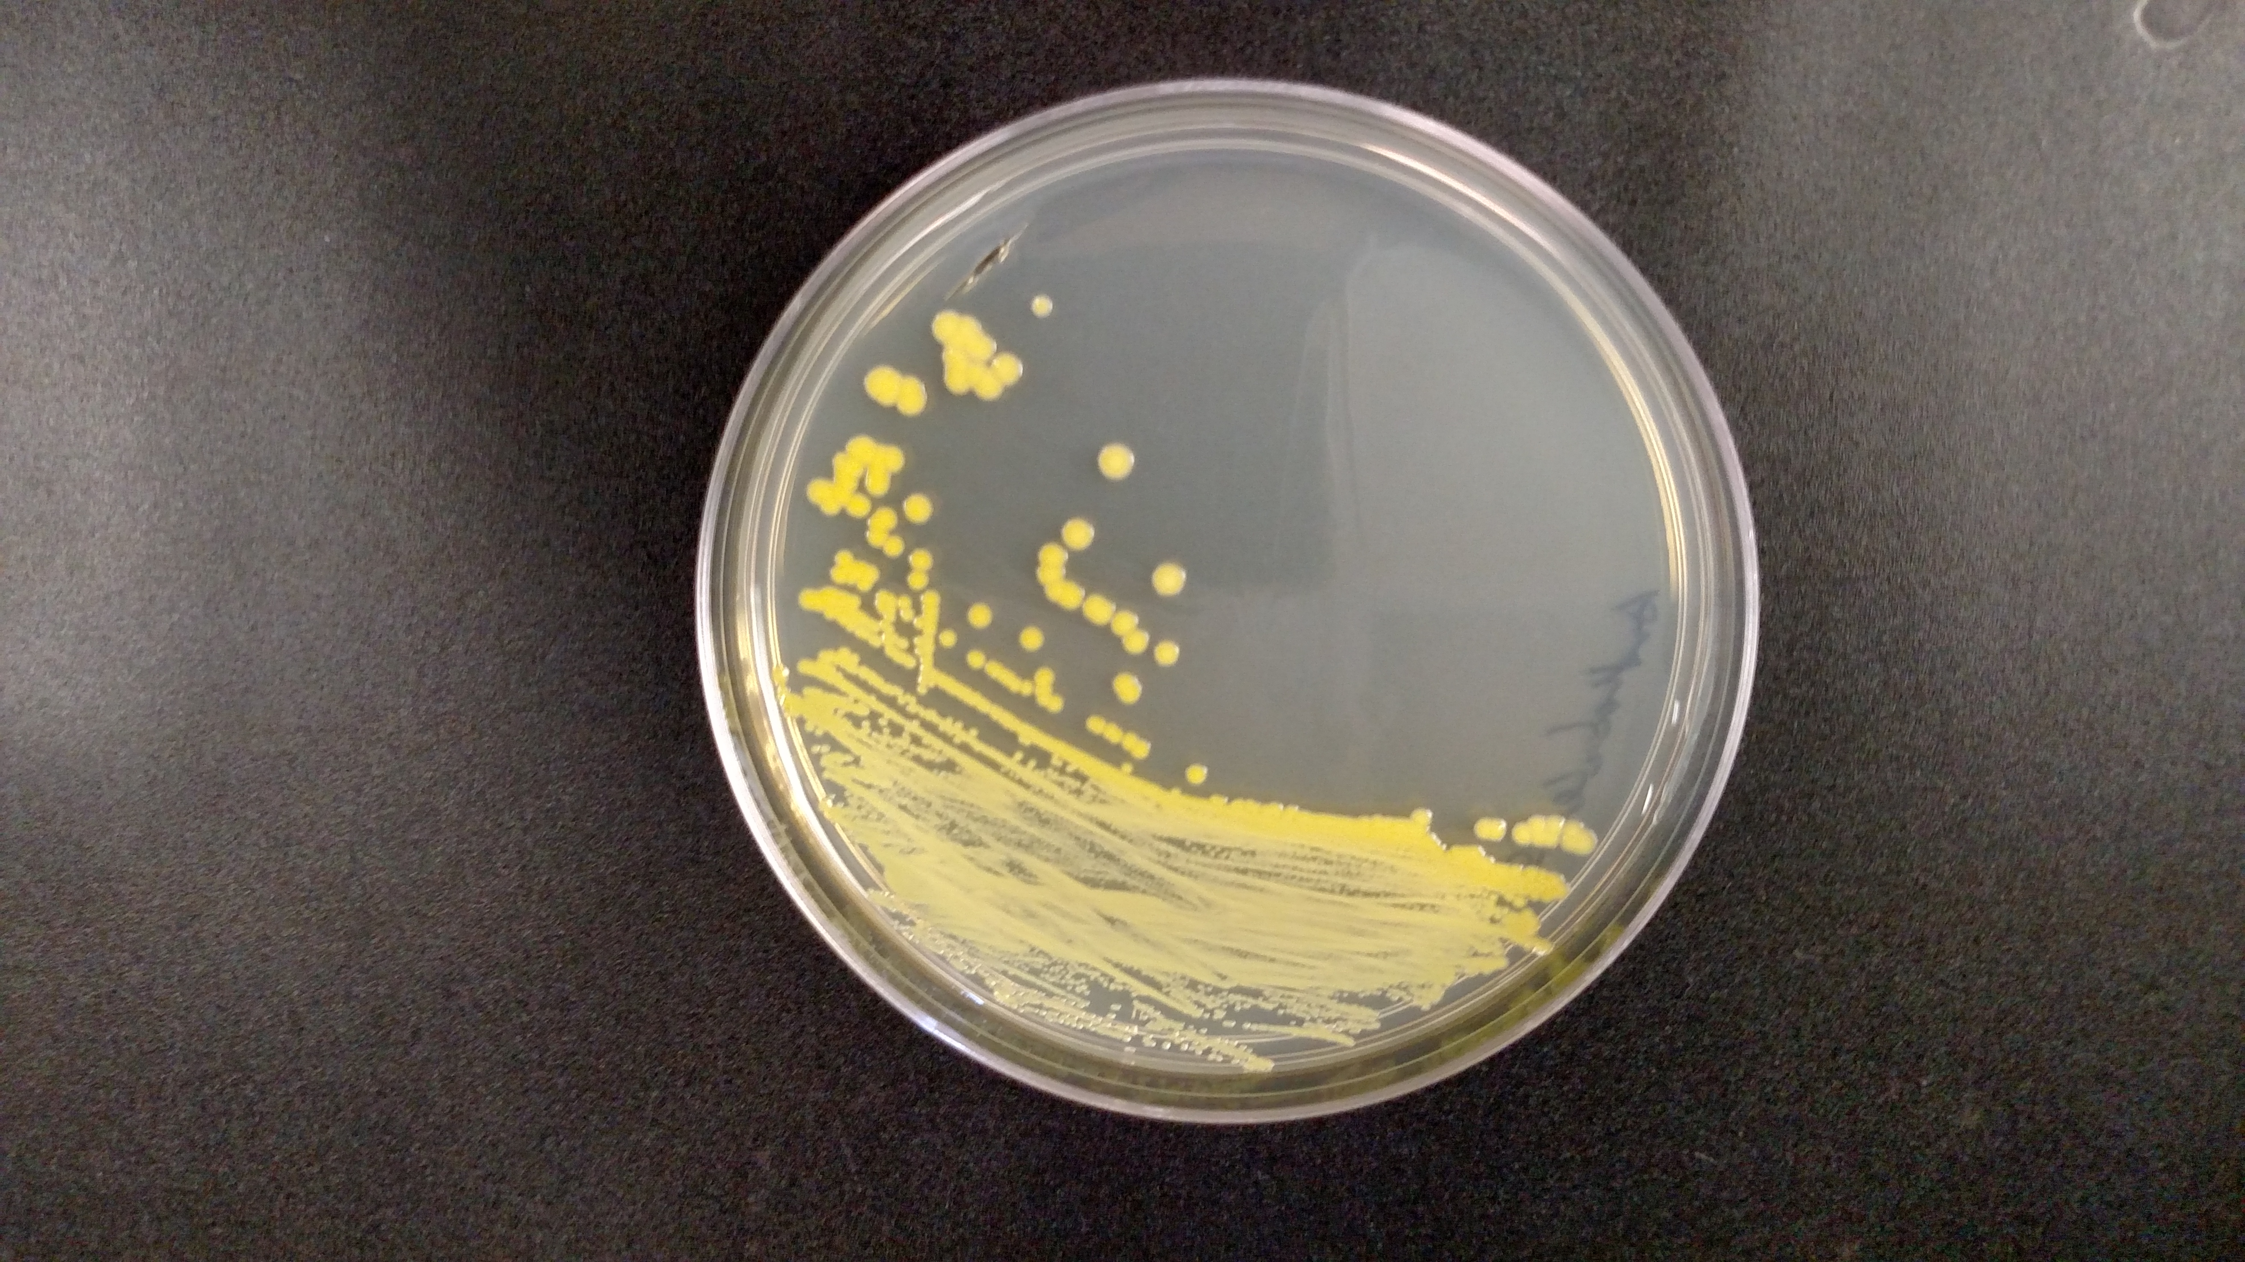

**Background**

*Arthrobacter sp*. is a BSL 1, gram-positive soil organism whose relatives are known to break down various hydrocarbons, such as hexavalent chromium, 4-chlorophenol, and various aromatic compounds such as pyridine and its derivatives, suggesting a potential for use in bioremediation. Another species, *Arthrobacter arilaitensis,* found to grow on various cheeses and used in the production process, has been studied based on its adaption to this environment along with other microorganisms. The specific Arthrobacter strain used here, alongside its relatives, has been found to produce penicillin derivatives and aspartic decarboxylase.

**Host Information**

* BSL1
* Pleomorphic: variable size and shape depending on environment
* Found in soil and sludge

**References**

Gao, B. and R.S. Gupta, *Phylogenetic framework and molecular signatures for the main clades of the phylum Actinobacteria.* Microbiol Mol Biol Rev, 2012. **76**(1): p. 66-112.

Camargo, F.A., et al., *Hexavalent chromium reduction by an actinomycete, arthrobacter crystallopoietes ES 32.* Biol Trace Elem Res, 2004. **97**(2): p. 183-94.

Westerberg, K., et al., *Arthrobacter chlorophenolicus sp. nov., a new species capable of degrading high concentrations of 4-chlorophenol.* Int J Syst Evol Microbiol, 2000. **50 Pt 6**: p. 2083-92.

O'Loughlin, E.J., G.K. Sims, and S.J. Traina, *Biodegradation of 2-methyl, 2-ethyl, and 2-hydroxypyridine by an Arthrobacter sp. isolated from subsurface sediment.* Biodegradation, 1999. **10**(2): p. 93-104.

Monnet, C., et al., *The arthrobacter arilaitensis Re117 genome sequence reveals its genetic adaptation to the surface of cheese.* PLoS One, 2010. **5**(11): p. e15489.

**SEA Faculty Pilot Data**

The following are observations and tips from SEA Faculty that have worked with this host. These observations have yet to be validated by the SEA Team at HHMI and the University of Pittsburgh.

**Host Growth**

* Cultures are white during logarithmic growth, yellow-tinged during stationary growth, and when stored for prolonged periods at 4˚C, may turn orange.
* Store working stocks, liquid or streak plates, up to 2 weeks at room

at 4˚C.

* Start a new liquid culture from a single colony on a streak plate.

**Phage Isolation**

* Plating Efficiency:   
  Direct plating: No success reported  
  Enrichment: up to 90 % success rate
* Enrichment:   
  If enrichment does not yield phage, considering sterile-filtering the soil sample prior to setting up the enrichment culture. For this, add phage buffer to the soil sample and incubate for 30 mins. Crudely filter the sample using Whatmann paper to remove large particulates. Sterile filter the crude filtrate using a 0.22um filter. Use this sterile-filtered sample to set-up your enrichment culture.
* Phage Lysate Titer and Stability:
* Titers vary from 106 – 1013