Phagehunting Program
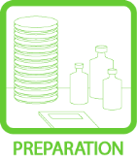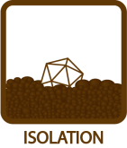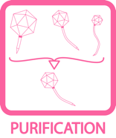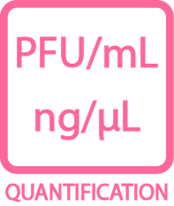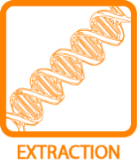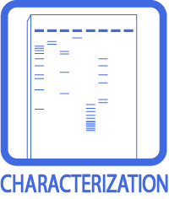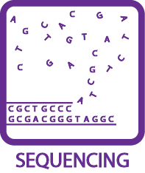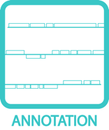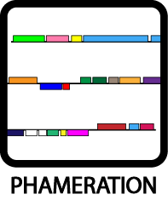

Lysogeny Experiments

Objective: The objective is to create a lysogen with your phage. A lysogen is a bacteria that contains the phage genome.
Approximate Time Needed: When making a lysogen, you will need 3 rounds of purification. Each round requires ~4 days of incubation. Each day’s work ranges from 10 minutes (streaking the bacteria for purification) to ~1 ½ hours (Immunity Assay) and depends on the scope of the project.

Materials Needed: Standard phagehunting supplies
Helpful Tips:
- Patience is valuable with this protocol.
- Good isolation technique is needed.
- Photographs of plates are helpful. (Photographs could include spot titers –to show the “mesa” and colony morphologies, immunity assays and patch tests.)
- There is an art to making spot test photos that are publication ready.
  - Most importantly it is advisable to use plates that are over-saturated. A drier plate works best.
  - Allow the spot to completely diffuse into the top agar before you move it.
  - It is best to invert these plates. Condensation will be problematic to the spots.
  - When checking the plates at 24 hours, there may still be enough condensation on the plate that it will ruin the 48 hour photograph. Check your plates with care at 24 hours.
  - Photograph the agar surface directly. Do not photograph through the plastic plate/lid.
- It is recommended to NEVER plate for ‘mesas’ with more than one phage per plate. You run the risk of creating double lysogens if phages spots are side by side.

Procedure:
- Pour a plate of host cells in top agar as you would if you were looking for plaques. This is called a lawn of host cells. (Basically a negative control plate.)
- Let top solidify.
- Using phage buffer (+ calcium), make ten-fold serial dilutions of your high titer phage lysate out to the 10⁻⁶ dilution. (High titer is essential for reliable results.)
- Spot 3 ul of each dilution, including undilute, on your newly poured host lawn. Let dry. Do not short-cut the ‘let dry’ step. Vent the plate near a Bunsen burner flame to allow for quicker evaporation/ absorption of the spot.
- Incubate plates inverted at 37° C for several days. Inversion is also a must do step.
- Check plates each day for an overgrowth of bacterial cells in the zone of clearing. This turbid ‘overgrowth’, that we would like to call a ‘mesa’, will not likely appear on day one.
- Do you see a “mesa”—that is, a very cloudy center spot surrounded by clearing—as a result of one of your spots? The mesa is generally as well grown as the unspotted lawn by day 2 or 3. The “mesa” represents cell growth in the presence of phage, hence it will provide an excellent yield of lysogens.
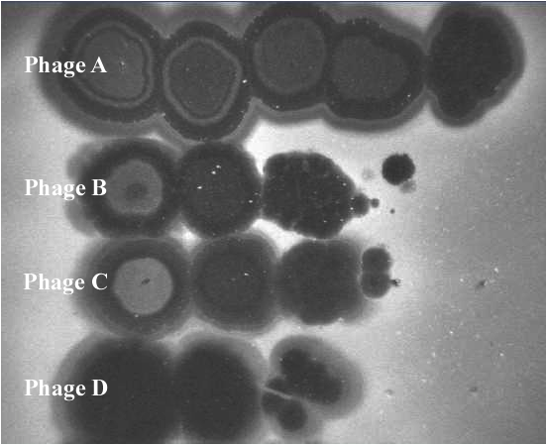

Figure A: This picture depicts four phages spotted at 10-fold dilutions (10⁰ -> 10⁻⁴). A “mesa” is recognizable for phages A, B, and C. However, Phage D may also have produced lysogens. Continue with protocol regardless of whether there is visible bacterial growth in the spot. Note that Phage A has ‘mesas’ to at least the 10⁻³ spot, while Phages B & C have visible mesas to 10⁻². Warning: do not plate multiple phages for lysogens as depicted above; you could select double-lysogens in the process!

- Streak cells from the mesa onto a new plate. Incubate at 37° C for 2-4 days.
- Choose 6-10 colonies to purify. Perform a patch test to determine putative lysogens.
- Patch Test: Ready 2 plates for this procedure. Plate 1 will be a 7H10 plate from the frig. Plate 2 should be plated with a lawn of host cells as in #1 above (Cells + top agar, cooled so that the surface is solid). Label both plates identically, so that you have a place identified on each plate for a “patch". (Drawing a grid and numbering each square on the back of the plate is useful for keeping track of patches)
Obtain an inoculum on a sterilized loop or sterile toothpick by touching the center of an isolated colony, from the streaked plate in #9 above. Lightly place a patch in the designated area for your first colony on Plate 1 and then Plate 2. (A patch is made by lightly touching the plate with the toothpick and making a small diagonal line. Be careful not to tear the top agar.) Repeat for each colony.
Incubate for 1- 4 days. Look for lysis around the patch, called a halo. If present, you have a good lysogen candidate.

Figure B: Plate one is patches of 5 individual colonies streaked on a 7H10 plate (Plate 1) and a M. smegmatis lawn (Plate 2). Patches A, B, and E show phage release. Patches C and D do not. Always use the cells from Plate 1 for further purification and/or immunity assays.

- For each lysogen candidate, streak for purification from Plate 1. (Do not use Plate 2. Why?) Good microbiology technique recommends a total of 3 rounds of purification.
- Once purified, you are ready to inoculate a liquid culture and repeat the Patch Test.
- Use a single colony to do this. Inoculate a liquid culture with Tween, Plate 1, and Plate 2 (in that order). Place the tube culture on at 37° C for 48 hours, (Or until cells are in stationary phase). Allow the plates to grow until growth appears on Plate 1. If Plate 2 shows lysis, you have a viable lysogen candidate.
- Follow standard protocol, prepare lysogens for -70° C freezer. Be sure to label and store lysogens in the designated freezer space.

Verification (Monitoring spontaneous phage release)
In cultures of lysogens, phage are being constantly released. A confirmatory test that the colony that you selected is indeed a lysogen is if you can detect phage in the supernatant of a liquid culture.
- Remove a small aliquot from your test tube of cells. Spin to pellet the cells. Remove supernatant. Filter. Perform a spot titer on the supernatant sample, record titer.
- For a second verification step, perform immunity assay with your phage and others.

Efficiency of Lysogeny
You can also measure the efficiency of your phage to make lysogens.

- Dilute phage lysate to 10¹⁰ pfu/ml
Ex: (1.6 x 10¹¹pfu/ml) X = (1.0 x 10¹⁰ pfu/ml)(1ml)
X = 62.5 µl lyate into 937.5 µl Phage buffer/CaCl₂
- Plate 100 µl diluted lysate onto plates for a total of (1.0 X 10⁹ pfu/plate). Spread the lysate evenly over the plate using a glass rod. (This is a phage seeded plate.)
- Make 10⁻¹ to 10⁻⁷ dilutions of saturated M. smegmatis strains.
- Plate 100 µl of diluted M. smegmatis with 4.5 ml MBTA onto phage seeded plates and plates not seeded with phage (I usually plate 10⁻⁴ to 10⁻⁷ dilutions).
- Incubate at 37° C for ~4 days.
- Count cfu’s on the countable plates.
- Calculate the efficiency of lysogeny:
CFU on phage seeded plates X 100 = % lysogeny
CFU on unseeded plates

Visualization of Spontaneous Plaques
Lawns prepared from most lysogens will appear smooth and homogenous. However, some lysogen lawns may include plaques. The regulatory mechanisms of lytic-lysogeny lifestyles can be described as a bistable switch, with details worked out in lambda and Mycobacteriophage BPs. How this all translates into plating morphology for different phages requires further investigation. Terminology such as resistance, pseudolysogeny, and unstable lysogen may apply. Controlling cell age, time, temperature, and reagents are necessary when evaluating these parameters. Careful notebook records are required.

Immunity Assay
Immunity assays are simply performed as spot titers performed on your lysogen and compared to those on wild type M. smegmatis. No immunity assay is valid unless a wild type control is included in the assay. Superinfection immunity is observed as the inability of bacteriophages to form plaques on the lysogen strain while still forming plaques on wild type.
- For each lysogen, you will want to verify homoimmunity with the corresponding phage. You may want to test other phages on your lysogen. ALL immunity data is valuable. Presently there are 449 sequenced phages in the inventory, knock yourself out!
- To do so, you will want to do spot titers for each bacterial strain (lysogen(s), and wild type M. smegmatis).
- Make a lawn of each bacteria. Allow the plates to cool and solidify well.
- Apply 3 – 10μl spots of 10-fold serial dilutions of your phage onto each lysogen and wild type smeg.
- Allow the spots to completely dry before moving.
- Incubate for 24 – 48 hours at 37° C.
- Check for plaques at both the 24 and 48 hr. point. Photograph and record the titer of each phage you used on the lysogen as well as wild type M. smegmatis.
- Report plating efficiency (titer of phage on lysogen/titer of phage on wild type M. smegmatis) for each phage. The most simplistic results would be a plating efficiency of 0 (because the phage did not infect the lysogen) or a plating efficiency of 1 (because the phage infected both strains of bacteria at the same efficiency). See notes for when the plating efficiency is not 1 or 0.

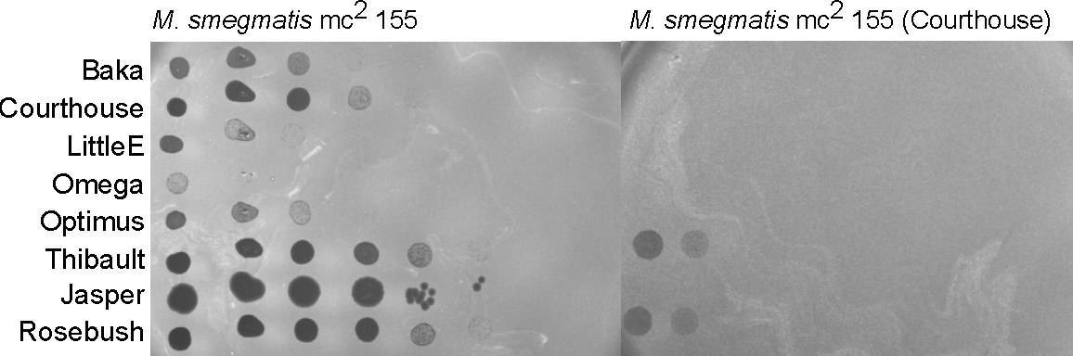
Figure C: An example of an immunity study. Results reported as % efficiency as compared to wild type M. smegmatis.

Notes:
- Be careful to not confuse “killing from without” and phage infection. Phage infection will yield plaques at low concentrations. Killing from without will produce a zone that dilutes out and will not produce plaques.
- The lysogen should not be able to be reinfected (super-infection) by the same phage that created it.
- Sometimes when plating related phages on your lysogen, you will see a phage plate with reduced plating efficiency. This can be due to a variety of reasons that require further investigations. Pick those plaques so you can investigate further. Be sure to label well.
- If an attP/attB site is identified, design PCR primers to amplify across the attL or attR sites of the integrated prophage. Design control primers to amplify only across the attB site. The attB primers should work on a non-lysogen, but will be too far apart to work on an intact lysogen.
- Be careful in your superinfection immunity interpretations. Bacteria can also be resistant to phage infection.

Adapted from protocols from W. Pope, G. Sarkis & G. Hatfull, and Greg Broussard. DJS 3.19.2013

References

Broussard, G. W., L. M. Oldfield, et al. (2013). Integration-dependent bacteriophage immunity provides insights into the evolution of genetic switches. Mol Cell 49(2): 237-248.
Court, D. L., A. B. Oppenheim, et al. (2007). A New Look at Bacteriophage λ Genetic Networks. Journal of Bacteriology 189(2): 298-304.
Ptashne, M. (2004). A Genetic Switch: Phage Lambda Revisited. Cold Spring Harbor, NY, Cold Spring Harbor Laboratory Press.

