Phagehunting Program
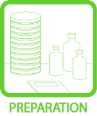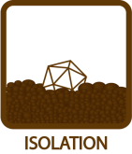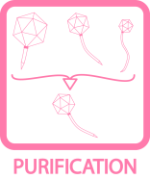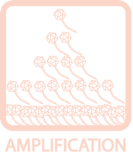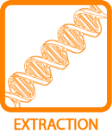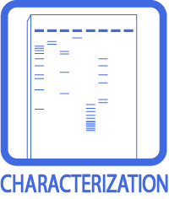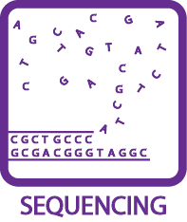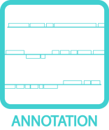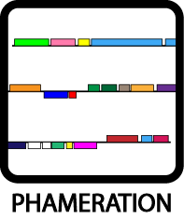
M. smegmatis Media Additions
BACKGROUND
This is a reference table for the amount of additives to be added to media of M. smegmatis, as well as markers’ colors to denote their presence.

Additive |  |  | Stock Conc. | Final Conc. | Add per
 |  |  |  |  | 100 mL | 500 mL | 1 L
 | ADC |  | 10X | 1X | 10 mL | 50 mL | 100 mL
 | CaCl₂ |  | 0.1 M | 1 mM | 1 mL | 5 mL | 10 mL
 | Tween®80 |  | 20% | 0.05% | 250 μL | 1.25 mL | 2.5 mL
 | CB |  | 50 mg/mL | 50 μg/mL | 100 μL | 500 μL | 1 mL
 | CHX |  | 10 mg/mL | 10 μg/mL | 100 μL | 500 μL | 1 mL
 | Leucine |  | 10 mg/mL | 100 μg/mL | 1 mL | 5 mL | 10 mL
 | Kan |  | 50 mg/mL | 20 μg/mL | 40 μL | 200 μL | 400 μL
 | Hyg |  | 100 mg/mL | 150 μg/mL | 150 μL | 750 μL | 1.5 mL
 | Tet |  | 5 mg/mL | 2.5 μg/mL | 50 μL | 250 μL | 500 μL
 | Atc |  | 40 μg/mL | 40 ng/mL | 100 μL | 500 μL | 1 mL
 | CM |  | 100 mg/mL | 40 μg/mL | 40 μL | 200 μL | 400 μL
 | Gent (liq/plate) |  | 10 mg/mL | 2.5–10 μg/mL | 25/100 μL | 125/500 μL | 250 μL/1 mL
 | Apr |  | 100 mg/mL | 50 μg/mL | 50 μL | 250 μL | 500 μL
 | INH |  | 50 mg/mL | 25 μg/mL | 50 μL | 250 μL | 500 μL
 | ETH |  | 50 mg/mL | 25 μg/mL | 50 μL | 250 μL | 500 μL
 | RIF |  | 50 mg/mL | 200 μg/mL | 400 μL | 2 mL | 4 mL
 | STR |  | 50 mg/mL | 20 μg/mL | 40 μL | 200 μL | 400 μL
 | OFX |  | 500 μg/mL | 0.5 μg/mL | 100 μL | 500 μL | 1 mL
 | EMB |  | 50 mg/mL | 10 μg/mL | 20 μL | 100 μL | 200 μL
 | X-Gal |  | 50 mg/mL | 40 μg/mL | 80 μL | 400 μL | 800 μL
 | 5-FOA |  | N/A | 1 mg/mL | 100 mg | 500 mg | 1 g
 | Ura |  | 200 mM | 0.2 mM | 100 μL | 500 μL | 1 mL

