Phagehunting Program
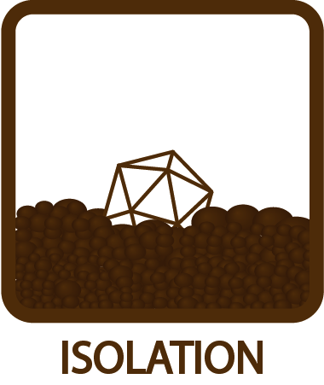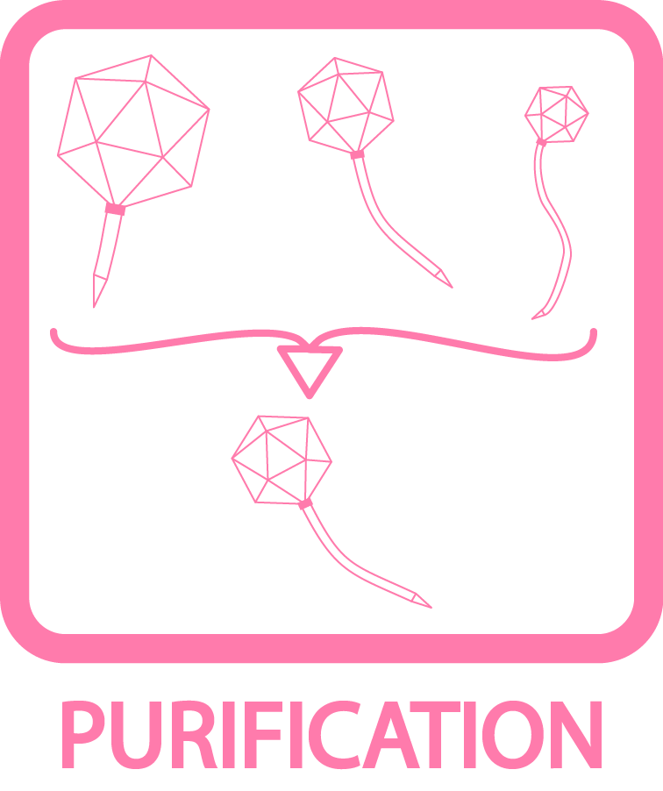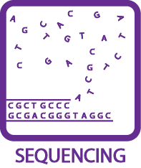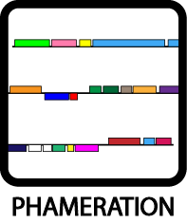
Making Thumbnails for Plaque and EM Pictures for PhagesDB
OBJECTIVE
Create thumbnail images for display on a phage page on PhagesDB.org by appropriately cropping larger images files.
BACKGROUND
At PhagesDB, we don’t want to lose any of the information you submit, that’s why we’ll always have links to the full plaque picture and EM picture you submit. At the same time, we also want a “quick view” of a phage’s plaques and morphology on its home page, and we want these thumbnails to be somewhat standardized so that comparisons can be made from one phage to another. This document describes the format for making these thumbnails.
THUMBNAIL SPECIFICATIONS
- Must be 200 pixels by 200 pixels.
- Must be either a .jpg, .jpeg, or .png file.
- Must be black and white, no color images.
- Should be relatively low-memory if possible (< 100kb).
- Appropriate modifications can be made using Photoshop or similar program.

PLAQUE THUMBNAIL SPECIFICATIONS (see examples below)

- Thumbnail should show about ¼ of the total plate. This should be the upper-left ¼, though images can be rotated if there’s a better quarter in the original image.
- Ideally, a dilution that shows at least several separated plaques should be used. Whenever possible, avoid using images where all plaques are bunched together, or where there’s only a single plaque visible.
- Do not use images from spot tests or streak plates! Spots or streaks of plaques aren’t good representations of typical plaque morphology. Use pictures where the phage has been plated across the entire plate.
- Name should be PhageName_Plaque_Thumb.ext where “PhageName” is your phage’s name and “ext” is png, jpg, or jpeg depending on your image type. For example:
Giles_Plaque_Thumb.jpg
ELECTRON MICROGRAPH THUMBNAIL SPECIFICATIONS (see examples below)

- Thumbnail should show a single complete virion particle, if possible. Avoid multiple or overlapping particles.
- The particle should be approximately vertically oriented, with the capsid at the top.
- The particle’s height should be between ~50% and ~80% of the picture’s height. Meaning: don’t make the particle so small that it takes up less than half the height, and don’t make it so large that it takes up the entire frame.
- Do not cut off the end of the tail or any part of the capsid when cropping.
- Name should be PhageName_EMPic_Thumb.ext where “PhageName” is your phage’s name and “ext” is png, jpg, or jpeg depending on your image type. For example:
Corndog_EMPic_Thumb.png

PLAQUE THUMBNAILS, GOOD EXAMPLES:
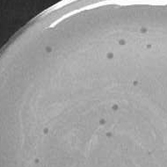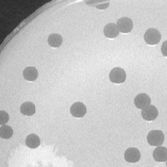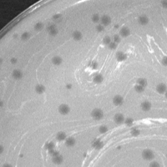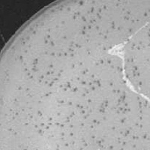

PLAQUE THUMBNAILS, BAD EXAMPLES:
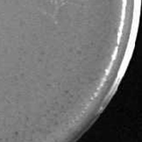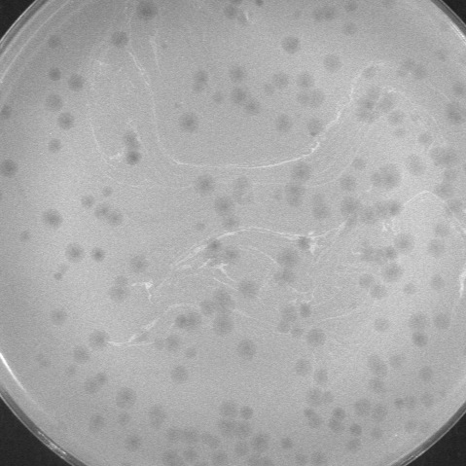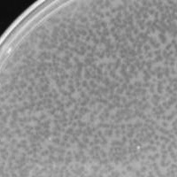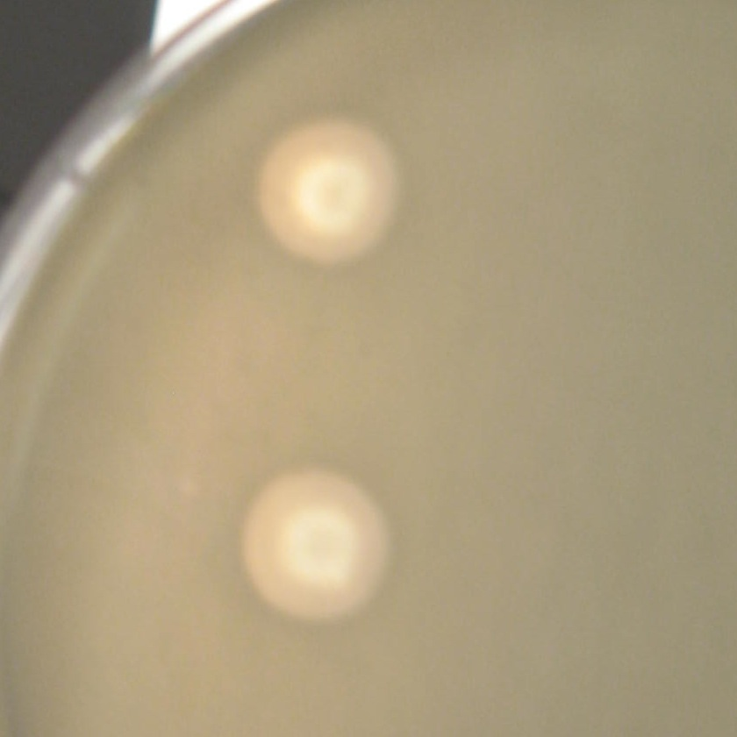
Inverted, grainy
Full plate instead of quarter plate
Plaques too close together
Color instead of
black & white

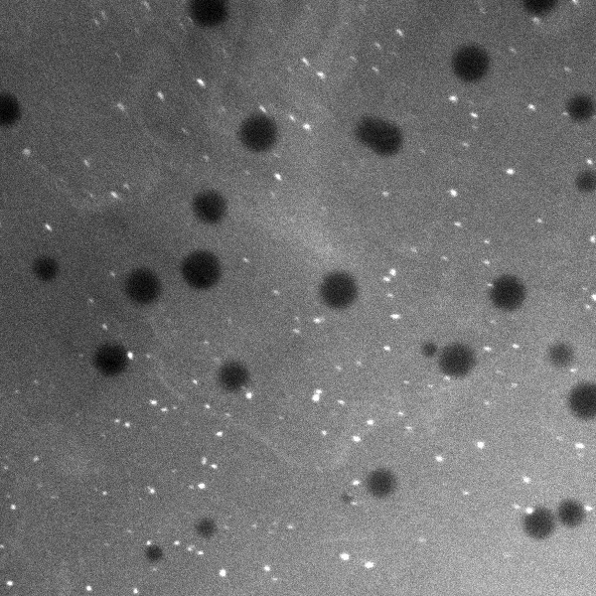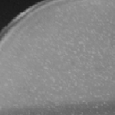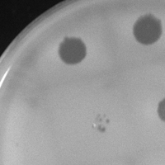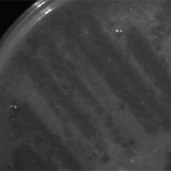
No plate edge for scale
Plaques not clearly visible
Spot test, so plaques aren’t clear
Streak plate, plaques aren’t clear

EM PIC THUMBNAILS, GOOD EXAMPLES:
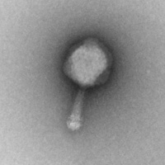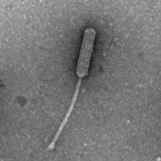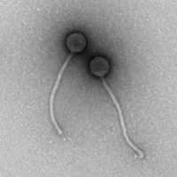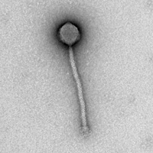

EM PIC THUMBNAILS, BAD EXAMPLES:
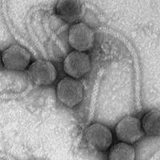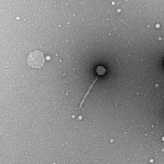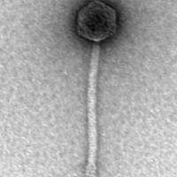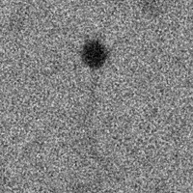
Too many particles, unclear
Particle is too small
Particle is too large, slightly cutoff
Tail barely visible, poor staining/focus

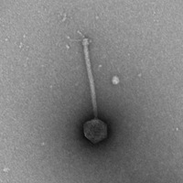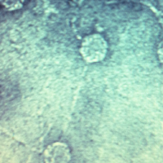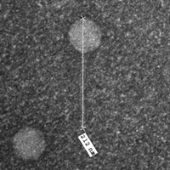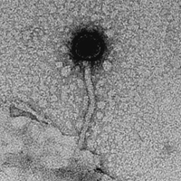
Upside down
In color instead of
black & white
Tail obscured by measuring bar
Messy image, tail obscured

