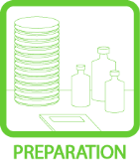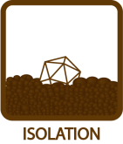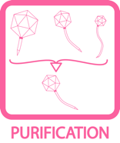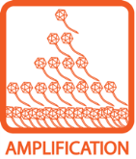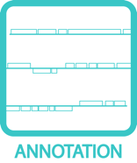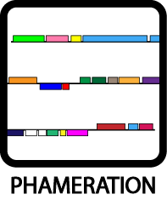
Manufacturing High Titer Lysates
OBJECTIVE
To amplify the phage and obtain a high titer lysate.
BACKGROUND
A plate lysate is simply a concentrated liquid sample of phage. It is obtained by infecting a plate of bacteria with the phage of interest, letting the phage lyse the cells, then adding buffer directly to the plate surface to collect the phages. High titer phage lysates will yield sufficient quantities of DNA for sequencing.

Plate lysates are the standard for long‐term storage of a phage sample. Their long shelf‐life at 4°C is years, if uncontaminated, and their reasonably high concentration make them useful. They are generally made from purified phage for use in experiments, but can be made as soon as a phage has been identified for archiving purposes.
APPROXIMATE TIME NEEDED
Setting up the plates: 45 minutes
Allowing for phage to diffuse into lysate: ~4 hours
Collecting lysate: 10 minutes
MATERIALS NEEDED
Equipment
- Pipettor, serological

Consumables/Reagents (See online media preparation guides)
- Serological pipettes
- Phage Buffer w/ 1 mM CaCl₂ (5 mL/plate)
- Syringe
- 0.2 μm syringe filter
- Agar plates with a “web pattern” of phage
HELPFUL TIPS
- Depending on further characterizations and DNA Extraction methods, it is typical to generate about 20 mL of high titer lysate.

- Filtering the lysate helps prevent later contamination of the stock. Don’t skip this step!

- When visually determining the plate with the highest number of plaques, the best procedure is to titer each plate separately. This will provide empirical titer values and aid in determining which plate to use.

- smeg’s doubling time is ~3 hours. That means that the bacteria will continue to grow for 30 – 36 hours on a typical lawn infection. Allow lysate plates to incubate 30 – 36 hours (up to 48 hours) to obtain maximum phage yield.

- The highest‐titer lysates will come from plates where individual plaques are nearly still visible, but are so densely packed that they cover the whole plate (a “web” pattern). This indicates that several rounds of phage infection and lysis (amplification) have taken place. If a plate is completely cleared, it may mean that all bacteria were killed before multiple rounds of infection could occur, and the yield will be lower. If plaques are visible but sparse, enough rounds of infection probably occurred, but fewer phages are available for harvest. Never generate a lysate from a plate that individual plaques can be picked from.

- This protocol is written for a typical “small” plate (100 mm diameter), but lysates can also be made in the same way from “large” (150 mm) plates; simply double the amount of buffer used.

- Any plate of plaques will produce a lysate. To ensure that a phage lives another day, a lysate is needed to propagate the phage. Once a lysate is obtained, the phage can be entered into the database (See PURIFICATION: Entering a Phage into the Mycobacteriophage Database).

PROCEDURES
- The amount of lysate generated depends on the number of plates used. On average, a small plate will yield ~3 mL of lysate. Consult DNA Extraction protocol (See EXTRACTION) and evaluate the amount of lysate needed for additional studies to determine volume.

- Never deplete lysate stock. 10 mL of lysate will be required for archive inventories.

- Once a titer is established, the concentration can be manipulated so that enough phages are on the plate to obtain a maximum phage yield.

  - The goal of the empirical test based on the titer calculation is to determine the dilution of lysate necessary to form a web pattern of M. smegmatis growth (the appearance of a nearly cleared plate).

  - This web requires about 3000 plaques per small plate for an average-sized plaque. For very large or very small plaques, this number should be adjusted (<3000 for large plaques and >3000 for small plaques). Also double the numbers for large plates.

Example:
3000 plaques per plate / 1 × 10¹¹ plaques per ml = 3 × 10^{–8} mL lysate per plate
3 × 10^{–8} mL lysate per plate = 3 × 10^{–5} µL lysate per plate

  - Based on the above calculations, add 3 µL of a 10^{–5} dilution of the lysate per plate. With good pipetting techniques, 30 µL of a 10^{–6} dilution can be used instead.
- “Box” the calculated amount of phage, because phages don’t do the math.

  - Empirically testing the number is necessary when amplifying the phage.

  - If empirical calculations point to 3 μL of 10⁻⁵ dilution, also set up a plate at 3 μL of 10^{–4} dilution and 3 μL of 10^{–6} dilution.

  - The ideal plate is one on which the phage and bacteria have the most time and space to produce the highest maximum yield. See Figure 1 for an example of the ideal web pattern.
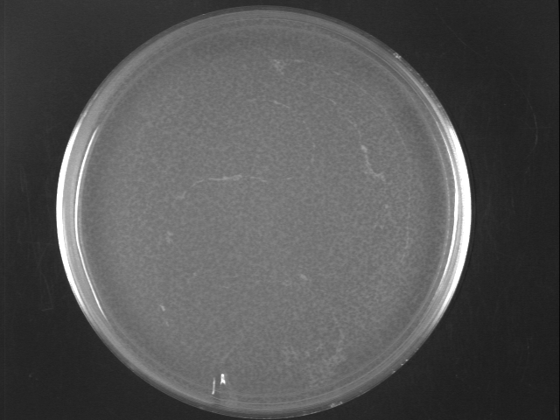
Figure 1: View the bacterial background of this picture to appreciate the lacy web pattern established by the thick layering of plaques. The webbing of the bacteria is an indication that the phage didn’t run out of bacteria during the incubation.

- Once a plate (or plates) with the desired web pattern is obtained, add 5.0 mL phage buffer (w/ 1 mM CaCl₂) and swirl gently.

- Let sit at room temperature for about 4 hours, or overnight at 4˚C and then one hour at room temperature. Swirl the phage buffer gently for mixing and diffusion, but do not splash.

- When ready to collect, tilt the plate slightly by placing one edge on top of its lid to encourage the sample to pool on one side.

- Using aseptic technique, remove the buffer (now with phage) with an appropriate syringe.

- Aseptically attach a 0.22 μm syringe filter to the syringe.

- Filter the sample by pushing down the syringe plunger, collecting the filtrate in a 15 mL conical tube.

- Label the tube with the phage name, name/initials, sample type (e.g. small plate filtered lysate) and the date. The phage lysate can now be titered (See TOOLBOX: Titering).

