Phagehunting Program
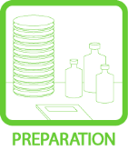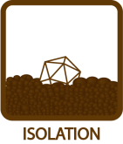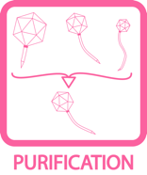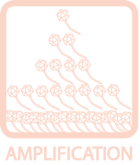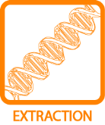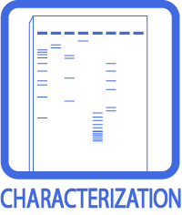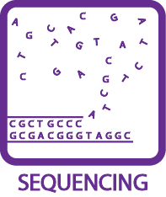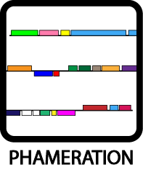
PCI DNA Extraction
OBJECTIVE
To extract a high yield, clean DNA sample from 15 mL high titer phage lysate.
BACKGROUND
There are a number of ways to yield clean DNA from a high titer phage lysate. This one requires about 15 mL of sample; PCI, a solution containing phenol, chlorophorm, and isoamyl alcohol (in a 25:24:1 ratio) will be used. Phenol is a hazardous material, causes skin burns, respiratory irritation, headaches, and burning eyes. Wear gloves when handling PCI and work under the fume hood, PCI is also light sensitive so make sure to wrap the container in foil and return it to the canister immediately when done. Phenol is used to remove proteins and other contaminating materials from aqueous DNA solutions. Chloroform helps to denature proteins as well as remove residual phenol. Isoamyl alcohol is often added to the chloroform to reduce foaming. High salt molarity (sodium acetate) increases aggregation of DNA and helps to precipitate it into a pellet.
APPROXIMATE TIME NEEDED
~ 2½ – 3 hours
MATERIALS NEEDED
Equipment
- Microcentrifuge
- Pipettors, micro- and serological

Consumables/Reagents (See online media preparation guides)
- 95% Ethanol
- 70% Ethanol
- Phenol:chloroform:isoamyl alcohol (25:24:1)
- 3 M Sodium acetate solution
- diH₂O
- Microcentrifuge tubes
- Appropriate micropipette tips
- Serological pipettes
HELPFUL TIPS
- Never quantify a DNA sample until pellet is completely re-suspended. The DNA may have to be left at room temperature or at 4°C overnight to dissolve completely.

- diH₂O is used in this protocol to reduce salts to facilitate future electroporation of DNA into Mycobacterium. It is safer to store DNA in TE and this may be used in place of dH₂O.

- The disposal of PCI is controlled, so try to minimize waste.

PROCEDURES

- Transfer dialyzed sample to two 1.5 mL tubes. This will be helpful in balancing the centrifuge.

- Carefully obtain enough (~5 mL/sample) PCI for the entire extraction from the stock bottle into a 15 mL conical tube. Store the conical tube on ice for the duration of the extraction. Return the stock bottle to the fridge with care.

- Add an equal volume of PCI, mix until milky white (~1 minute).

- Centrifuge at 13,200 rpm at room temperature for 5 minutes.

- Remove the aqueous layer (top layer above the white interface) and place in new tube.

- With the new tube of aqueous phase, repeat steps 3 – 5 until the white interphase is gone (usually 4 – 5 times).

- At the last extraction, remove the aqueous layer and place it into a new tube.

- Add 10% of the sample volume of 3 M sodium acetate (NaOAc) and 250% of the sample volume of cold 95% ethanol (kept at 4°C).

- Mix gently, and the DNA will form a “cotton ball” like precipitate. If a precipitate is not observed, put the tubes on ice for 10 minutes.

- Spin for 10 minutes at 13,200 rpm at room temperature. Place the cap fold to the outside as an indicator to where the pellet would be.

- Decant the tubes carefully, paying attention not to lose the pellet. Then add 500 μL of 70% ethanol to wash the pellet. Do not dissolve the pellet, since it is nearly impossible to recover dissolved pellets. Simply let ethanol run through the pellet.

- Spin for 5 minutes at 13,200 rpm at room temperature.

- Decant the tubes, and carefully pipet out any remaining droplets. Once again, pay attention not to lose the pellet (by pipetting or decanting).

- Air dry the pellet (~10 – 20 minutes), but make sure the DNA is not over dried since it would become hard to dissolve.

- Dissolve DNA in ~50 μL dH₂O. To ensure complete solvation, set the tubes in 37°C for 10 minutes.

- DNA can be stored at 4°C for the short term. For long-term storage, store at –20°C.

- Measure the concentration of DNA on the NanoDrop. (See TOOLBOX: Measuring DNA Concentration).

- In the event of phenol contamination, repeat the procedure once (only perform #3 – 5 once) with just chloroform (i.e. no phenol and isoamyl).

