Phagehunting Program
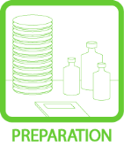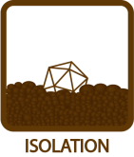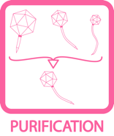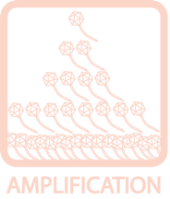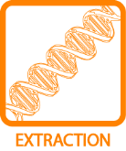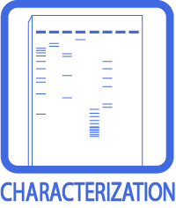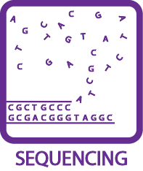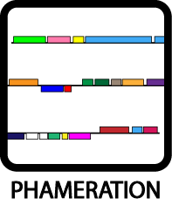
PCI/SDS DNA Extraction
OBJECTIVE
To extract a high yield, clean DNA sample from 1 mL high titer phage lysate.
BACKGROUND
There are a number of ways to yield clean DNA from a high titer phage lysate. This one requires about 1 mL of sample; PCI, a solution containing phenol, chlorophorm, and isoamyl alcohol (in a 25:24:1 ratio) will be used. Phenol is a hazardous material, causes skin burns, respiratory irritation, headaches, and burning eyes. Wear gloves when handling PCI and work under the fume hood, PCI is also light sensitive so make sure to wrap the container in foil and return it to the canister immediately when done. Phenol is used to remove proteins and other contaminating materials from aqueous DNA solutions. Chloroform helps to denature proteins as well as remove residual phenol. Isoamyl alcohol is often added to the chloroform to reduce foaming. High salt molarity (sodium acetate) increases aggregation of DNA and helps to precipitate it into a pellet. In this alternative method, MgCl₂ is used as a stabilizer.
APPROXIMATE TIME NEEDED
~ 3 hours
MATERIALS NEEDED
Equipment
- Microcentrifuge
- 55°C heat block
- Pipettors, micro- and serological

Consumables/Reagents (See online media preparation guides)
- 1M MgCl₂
- DNAse I (2000 U/mL)
- RNAse A (100 mg/mL)
- 0.5 M EDTA
- Proteinase K (10 mg/mL)
- 10% SDS (Sodium dodecyl sulfate)
- 95% Ethanol
- 70% Ethanol
- 3M Sodium acetate solution
- Phenol:chloroform:isoamyl alcohol (25:24:1)
- diH₂O
- 15 mL conical tubes
- Microcentrifuge tubes
- Serological pipettes
- Appropriate micropipette tips
HELPFUL TIPS
- Never quantify a DNA sample until pellet is completely re-suspended. The DNA may have to be left at room temperature or at 4°C overnight to dissolve completely.

- diH₂O is used in this protocol to reduce salts to facilitate future electroporation of DNA into Mycobacterium. It is safer to store DNA in TE and this may be used in place of dH₂O.

- The disposal of PCI is controlled, so try to minimize waste.

- This protocol utilizes 1 mL of lysate. It can be scaled up to increase DNA yield.

- DNA Extraction takes a considerable amount of time as well as patience. Do not perform in hurry or when insufficient time is available.

PROCEDURES

- Transfer 1 mL of lysate to a 15 mL conical tube.

- Add 12.5 μL 1 M MgCl₂. Mix gently.

- Carefully add 0.4 μL DNAse I (2000 U/mL) and 1 μL RNAse A (100 mg/mL) to the lysate-MgCl₂ mixture. Be careful not to contaminate the micropipettor.

- Vortex briefly to mix, incubate at room temperature for ~30 minutes.

- Add the following reagents/enzymes to the tube, in the order listed below.

- 40 μL of 0.5 M EDTA.

- 5 μL of Proteinase K (10 mg/mL).

- 50 μL of 10% SDS.

- Vortex the mixture vigorously.

- Incubate at 55°C for 60 minutes. Vortex the mixture vigorously twice during incubation, at 20-minute intervals.

- Obtain two 1.5 mL microcentrifuge tubes. Transfer 500 μL of the mixture to each tube.

- Put on gloves and transfer all materials to a chemical fume hood. Carefully transfer enough PCI to a 15 mL conical tube or a microcentrifuge tube. Return the bottle of PCI to the appropriate place.

- Transfer equal amount of PCI (500 μL for the first time) to each tube with 500 μL of lysate. Invert tubes several times to mix well.

- Centrifuge for 5 minutes at room temperature at 13K rpm.

- Remove the top aqueous layer above the white interphase.

- If a low titer lysate is used, leave a buffer region between the aqueous layer and the white interphase. In other words, avoid any protein or phenol contamination from the white interphase and the bottom organic layer.

- If a high titer lysate is used (titer greater than 10⁹ pfu/mL), repeat steps #10 and #11 until the white interphase is gone, each time removing as much of the top aqueous layer as possible. Perform #12a (leave a buffer region) during the last round when the no interphase can be seen anymore.

- Precipitate the DNA.

- Add 1 mL of 95% ethanol and 50 μL of 3M sodium acetate solution to the aqueous layer obtained at the end of step #12.

- Place the sample on ice for ~5 minutes. This aids with precipitation. Mix gently, and the DNA will form a “cotton ball” like precipitate.

- Centrifuge at room temperature for 10 minutes at 13K rpm. Place the cap fold to the outside as an indicator to where the pellet would be.

- Decant the tubes carefully, paying attention not to lose the pellet. Then add 500 μL of 70% ethanol to wash the pellet. Do not dissolve the pellet, since it is nearly impossible to recover dissolved pellets. Simply let ethanol run through the pellet.

- Centrifuge for 10 minutes at 13K rpm at room temperature.

- Decant the tubes, and carefully pipet out any remaining droplets. Once again, pay attention not to lose the pellet (by pipetting or decanting).

- Air dry the pellet (~10 – 20 minutes), but make sure the DNA is not over dried since it would become hard to dissolve.

- Dissolve DNA in ~50 μL dH₂O. To ensure complete solvation, set the tubes in 37°C for 10 minutes.

- DNA can be stored at 4°C for the short term. For long-term storage, store at –20°C.

- Measure the concentration of DNA on the NanoDrop. (See TOOLBOX: Measuring DNA Concentration).

- In the event of phenol contamination, repeat the procedure once (only perform #10 – 12 once) with just chloroform (i.e. no phenol and isoamyl).

