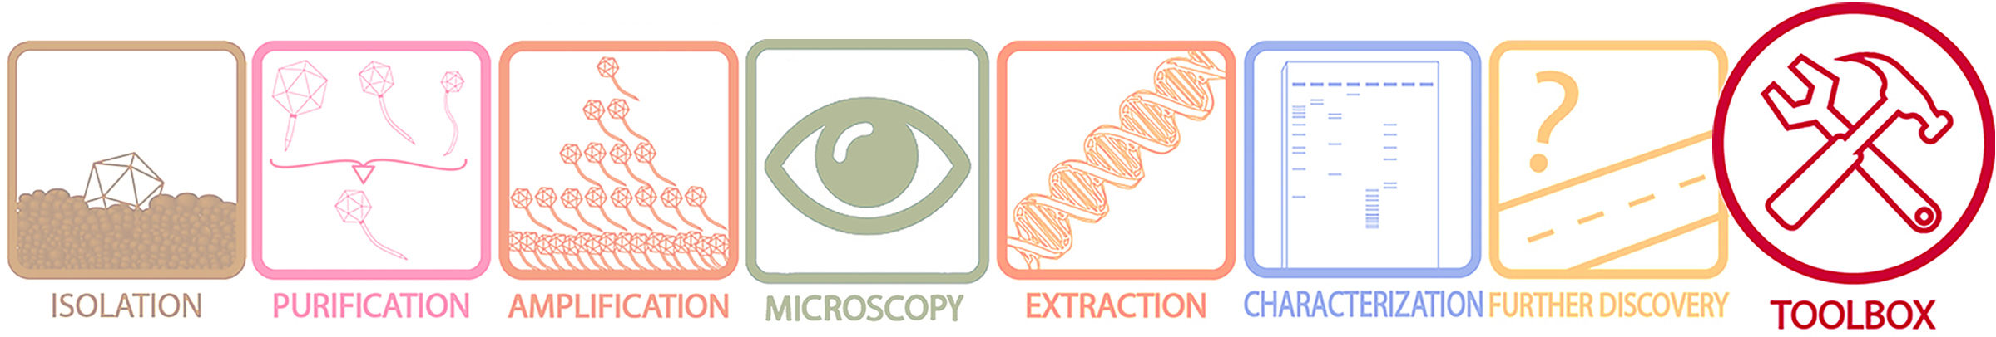

Protocol: Checking phage lysates by PCR
Objective: To support the identity of a phage lysate based on the presence of specific DNA segments.
Rationale: Polymerase Chain Reaction (PCR) is a technique used to make more copies of, or amplify, a specific DNA segment. Amplification of a DNA segment is achieved by using short DNA fragments, called primers, that are synthesized and bind specifically to the start and end of the DNA segment you intend to amplify. By carefully selecting which primers to use, PCR amplification can be used to support the presence of a particular DNA segment in that phage. By extension, this technique is useful in determining that the lysate you are working with contains the phage that you are interested in.
Supplies:
- Phage lysate (2- 5 ul)
- Taq DNA polymerase and corresponding reaction buffer **
- dNTP mix (each dNTP at 10 mM)
- DNA primers (10 μΜ)
- Thermocycler
- PCR tubes compatible with thermocycler
- A list of PCR primers designed for specific clusters/phages (https://docs.google.com/spreadsheets/d/1LAEEf8jD5AOIxwzROfN6i2I3kk6O6Tavz5uyEJrEgAU/edit?invite=COHSldYC&ts=5a03540c#gid=0 )
** The PCR parameters used in this protocol are for Taq DNA polymerase. If using a different DNA polymerase, follow the instructions provided by the manufacturer.
Procedure:
- Set up PCR reactions.
  - Set up a reaction in a PCR tube, on ice, for each pair of primers according to Table 1. Include a negative control reaction that lacks template DNA.
Table 1. Components of each PCR.

Solution | Volume
Sterile diH₂O | To final volume of 25 µl
10X Taq Reaction Buffer | 2.5 µl
Taq DNA polymerase | 0.2 µl
Forward primer | 0.5 µl
Reverse primer | 0.5 µl
dNTP mix | 0.5 µl
Phage lysate | 2.0 – 5.0 µl

  - Mix the contents of each tube by gently pipetting the mixture up and down. Ensure that all the liquid in the tube is at the bottom by flicking the tube with your wrist using a downward motion.
  - Incubate your reactions in the thermocycler set to the following parameters.
Table 2. Parameters for PCR.

Cycle | Temperature | Duration
1 x Initial Denaturation | 95 ˚C | 30 sec
30 x Amplification:  Denaturation  Primer Annealing  DNA Extension | 95 ˚C  ***45 – 68 ˚C  68 ˚C | 15 sec  15 sec  1 min/kb
1 x Final Extension | 68 ˚C | 5 min
1 x Hold | 4 ˚C | indefinite
*** the annealing temperature used should be 1 – 5 ˚C below the melting temperature, T_{m}, for each primer pair.
- Store at -20 °C until ready to visualize.
- To visualize your DNA following PCR amplification, load a gel according to standard lab practices.

Helpful Tips:
- Enzymes such as DNA polymerase should be kept at freezer temperature as much as possible. Keep your polymerase in an insulated ice block or in the freezer unless it is being used. When handling the tubes, hold them by the top to avoid heating the enzyme with your fingers."
- Be attentive when pipetting small volumes. It is best to pipette small volumes into liquid already in the tube because they can adhere to the pipette tip via cohesion.
- If you are testing multiple phages with the same primer set, make a Master Mix of reagents without the template. Aliquot the Master Mix into PCR tubes, then add the individual templates to each tube.
- Successful amplification of a DNA segment confirms its presence in the phage you are testing, but it doesn’t rule out the possibility that there is not other phages (or DNA from other phages) in your template sample. It is therefore critical to ensure that the phage you are working with has been properly purified.
- A band of the size predicted by primer design means you have amplified a piece of DNA the size that you predicted. You may also want to sequence the PCR product for further support of your findings.
- It is tempting to use PCR to predict the cluster that an unsequenced phage will fall into. However, because phage genomes are mosaic in nature, the presence or absence of a single DNA segment is insufficient information for clustering. As such, any preliminary attempt to determine cluster by PCR should not be entered in the Cluster designation field at PhagesDB. Instead, such information can be included in the Special Growth conditions/Notes section.

Protocol written by
Kathleen Shedlock
Vic Sivanathan
Deborah Jacobs-Sera
November 14, 2017

