Phagehunting Program
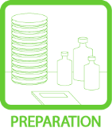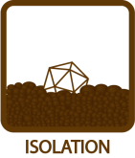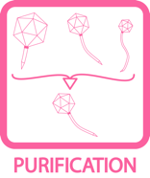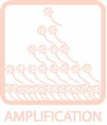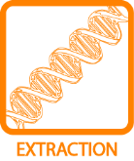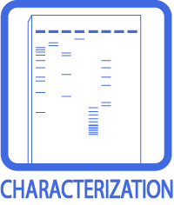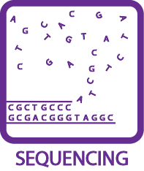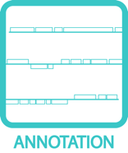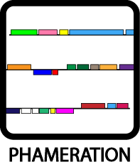

Phage DNA Extraction Using the Promega Wizard DNA Clean up Kit

OBJECTIVE
Extract phage genomic DNA using the Promega DNA Clean-Up Kit.

BACKGROUND
There are various ways to yield clean DNA from a high titer phage lysate. This one requires 1 mL of sample, and utilizes procedures that utilizes a commercial DNA clean-up kit. The approximate yield will vary amongst the many phages. Knowing the concentration of phage in your starting material is crucial. You will need to match the titer to the target concentration of phage DNA for the kit.

APPROXIMATE TIME NEEDED
Reagent Preparation: ~30 min-1 hour for Resin warming. ~30 min Incubation + 30 minutes active DNA Isolation + Elution

MATERIALS NEEDED:
1 ml phage lysate (titer > 5 x 10⁹( pfu/mL)
Equipment

Centrifuges, high-speed and micro-
Stir plates and stir bars
Microwave
37°C water bath
95°C heating block or water bath
Pipettors, micro- and serological

Consumables/Reagents (See online media preparation guides)

Serological pipettes
6 mL 80% isopropyl alcohol
Nucleases, DNase I and RNase A
Promega DNA Clean-Up Kit (Product #A7280)
Sterile microcentrifuge tubes
15 mL conical tubes
Hot water, 95 °C
3mL or 5mL syringe
Appropriate micropipette tips

Before you start:
Put DNA clean up resin in 37°C room. Take out and allow to cool to 25-30°C right before use. This stuff is caustic: wear gloves!
Put 1ml of QH2O in 90-95C heat block for elution.
Make up 15ml of 80% isopropanol fresh.

PROCEDURE:
- Add 1x10¹⁰ - 5x10¹⁰ phage in 500ul-1ml volume (dilute with phage buffer if necessary) from a fresh lysate. (10⁹ phage is not enough). A titer of 10¹¹ will clog the column.
- Nuclease treat for host nucleic acid contaminants: 1ul RNaseA from Qiagen kit; 0.8 μl DNase I from Ambien. Incubate 15 – 30 min. at Room Temperature. (can be modified to 10 minutes at 37 °C).
- Change gloves.
- Add 2mls DNA resin from kit. Make sure that you have swirled all the precipitates back in. Mix by inversion several times.
- Set up two column bottoms and syringe tops. Set each column and syringe barrel on a new microcentrifuge tube.
- Add half of DNA/resin to each column. Follow the steps below for both columns:
- Using the plunger from a 3cc syringe, carefully push all the liquid through. This may be difficult if your sample is concentrated. It is important to maintain even pressure, and not let the barrel buck back out. The DNA is bound to the polymer beads that pack into the column as the liquid is pushed through. When you finish expelling all the liquid, dry the last drop by touching to a KimWipe; then unscrew the column. THEN you can let go of the syringe barrel.
- Remove the barrel from the syringe, then reattach the syringe to the column.
- Wash the column by adding 2ml 80% isopropanol. Use the barrel to force the liquid through. Maintain even pressure and dry the last drop as above in step 6. Unscrew the column.
- Repeat steps 7 and 8 twice more for a total of three washes (this removes extra guanidine).
- Put the column in a clean 1.5ml tube. Spin at 8000 x g (which is the same as 8000 rcf) for 5 min to remove residual isopropanol. (your two columns can balance each other).
- Take the columns out of the 1.5ml tubes and put them in the 80C+ heat block for 30s-1min. Do not exceed 1 minute.
- Put the columns in new 1.5ml tubes. Apply 50ul qH2O heated to 80°C+ directly to the column (don’t take the water out of the heat block. That way it stays hot!).
- Incubate 1min.
- Spin at 8000 x g (8000 rcf) for 1 min.
- Combine the products of both microcentrifuge tubes into one tube, this is your eluted phage DNA.
- You can repeat steps 12-14 twice more (so three elutions per column).
- Measure the concentration of DNA for each elution on the NanoDrop. (See TOOLBOX: Measuring DNA Concentration). Select the best sample (concentration & volume) for sequencing and place in the PBI Sequencing Queue
- Run 1 – 2 ul of your DNA on a gel to make sure it is not degraded. (See TOOLBOX: Measuring DNA Concentration). Submit a .jpg of the gel picture on the submission form.

Notes:
- Do not attempt this with a lysate of low titer.
- Spinning above 8000 x g can lead to the column breaking or getting stuck in the centrifuge. Do not exceed 8000 x g.
- Take care to rinse with isopropanol repeatedly. Residual guanidinium and isopropanol can interfere with quantification and the ability to load in a gel.

Welkin Pope (11/8/2012) revised cag/djs (1/18/17)

