Phage Amplification Rationale

Trying to get a high titer of your phage can be trying. The elusive webbed plate is the result of putting the right amount of phage on the plate so that the most phage will be produced. That means that the phage that replicate in the cells present in the lawn never run out of cells to infect.

This process is impacted by the specific phage replication routine, the crowding of phages on the plate, the number and age of the cells, the temperature of the incubation, the water concentration of the plates, the adsorption time and the incubation time. Controlling these variables is important as you try to reproduce a previous result.

Historically, we have always relied on an empirical approach to obtain the highest yields of phage. We continue to support this approach. You really won’t know what the phage will do until you test it.

In this experiment, the serial dilutions of 3 phages were plated. Phage lysates from these plates were made. The number of phages plated were then plotted against the phage yield from each plating.

The 3 phages used in this experiment were chosen because of their plaque size.

Plaque Morphologies
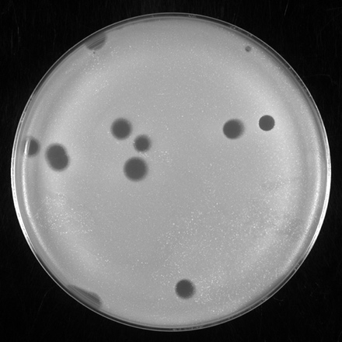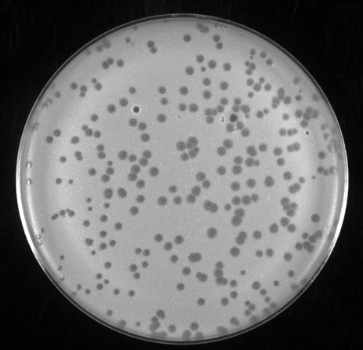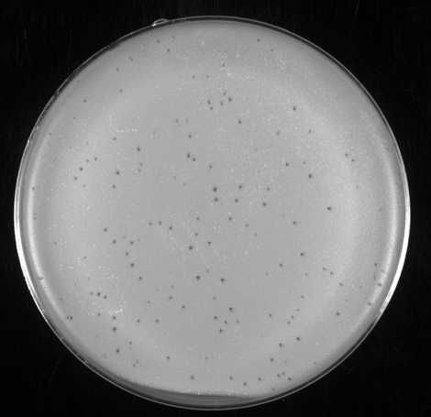
Figure 1: (from left to right) Plaque pictures of Mycobacteriophages D29, StarStuff, and Dandelion.

Methods:
As much as possible, age of M. smegmatis culture, number of cells, plated, water content of plates, adsorption and incubation times were held constant. Tenfold serial dilutions of phage lysate were made. 10ul of each dilution were added to 500 ul of cells. Adsorption time was 10 minutes. Amount of top agar used was 4.5 ml. Plates were incubated at 37C for 30 hours and flooded. Flooded plates were kept in the cold room overnight (16 hours). Lysates were collected, filtered, and titered. Photographs of those plates are shown in Fig. 2. Note that the photographs of the Dandelion titer are difficult to appreciate. Confluent plaques are visible when plated with 50,000 plaques while the one with 50 plaques showed 50 individual plaques. Neither picture is discernable.
Full Plate Titers
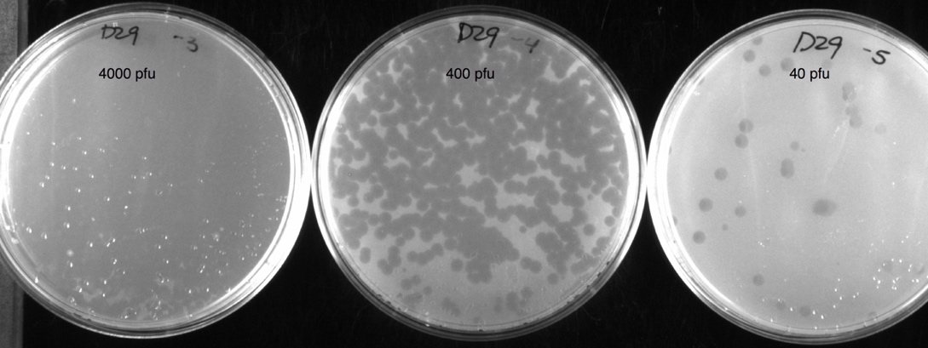
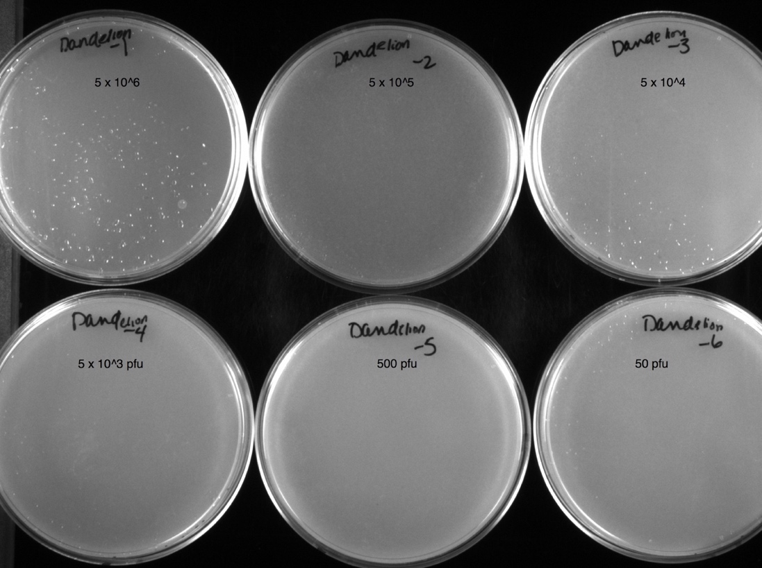
Figure 2: Row 1: 3 plates of D29. Row 2: 3 plates of StarStuff.
Row 3: 3 plates of Dandelion. The plates are labeled with the number
of PFUs plated.

Results:

phage | #plated (PFU) | Yield (PFU/ml)
D29
 | 4.00E+01 | 1.30E+09
 | 4.00E+02 | 7.00E+10
 | 4.00E+03 | 3.00E+10
 | 4.00E+04 | 2.00E+10
 | 4.00E+05 | 1.00E+10
StarStuff
 | 7.00E+01 | 1.30E+08
 | 7.00E+02 | 1.00E+11
 | 7.00E+03 | 1.00E+11
 | 7.00E+04 | 9.00E+10
 | 7.00E+05 | 5.00E+10
 | 7.00E+06 | 5.00E+10
 | 7.00E+07 | 3.00E+10
Dandelion
 | 5.00E+02 | 1.00E+06
 | 5.00E+03 | 1.00E+08
 | 5.00E+04 | 3.00E+08
 | 5.00E+05 | 3.00E+11
 | 5.00E+06 | 7.00E+09

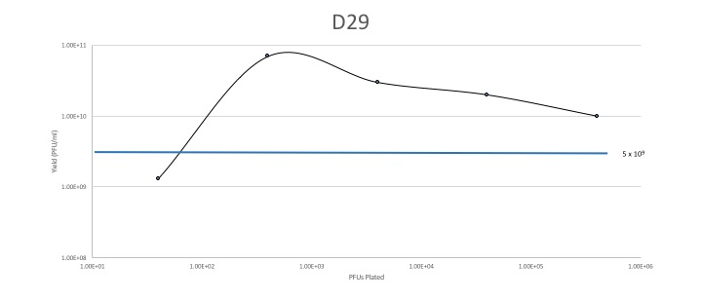
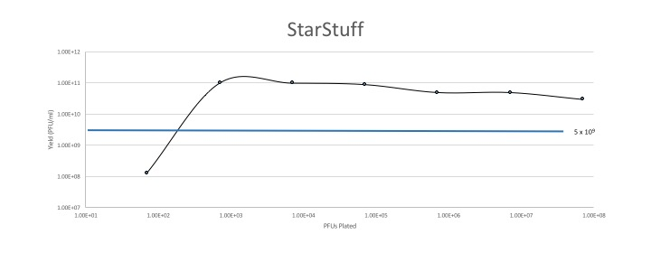
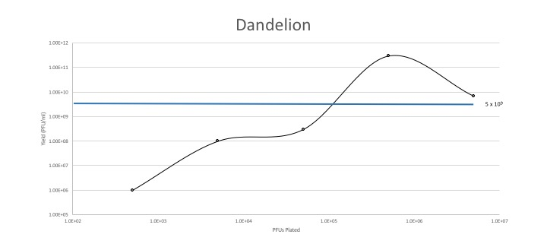

Interpretation:
Phage | # of PFU to plate for maximum yield
D29 | 500 – 1000
StarStuff | 700 – 7 x 10⁷ with best yield 700-7000
Dandelion | 3 x 10⁵ – 3 x 10⁶

The data obtained for this experiment are collected from the various dilution sets that you do when you make lysates. It may not be common that you make lysates of your dilution plates, especially the ones that look like they have been ‘blown out’ (i.e. totally lysed plates), but they provide some essential information to maximize your phage yield in the amplification protocol. This process will tell you how precise the number of phage that you put on the plate needs to be.

Note that I chose 3 phages that make different plaque sizes. This information is phage specific, not plaque size specific. If you perform this analysis for your sequenced phage, send it to Debbie Jacobs-Sera (djs@pitt.edu) so we can compile an exhaustive profile for many different phages.

