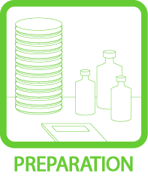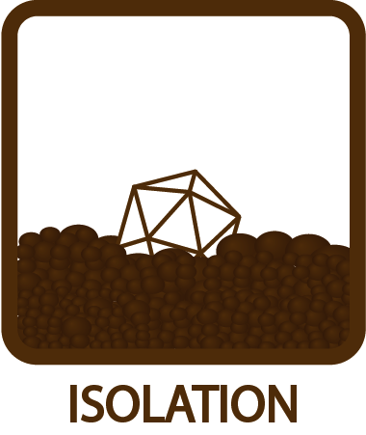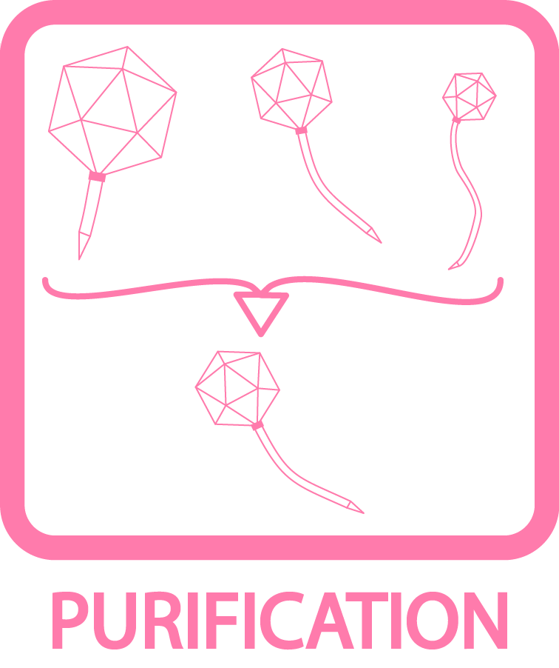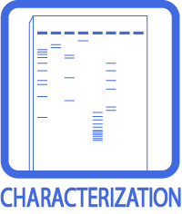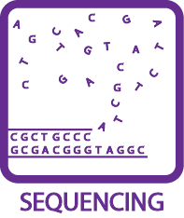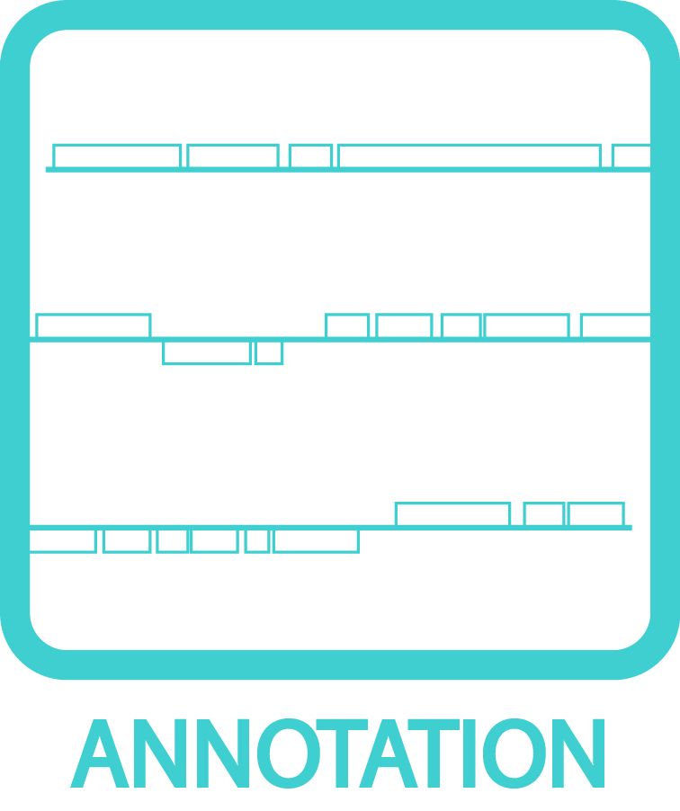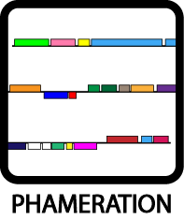
Phage Sample Preparation for Electron Microscopy
OBJECTIVE
To prepare phage sample for electron microscopy.
BACKGROUND
The grids electron microscopy grids need to have little or NO charge, so that the EM stain (uranyl acetate) behaves correctly.
APPROXIMATE TIME NEEDED
~20 minutes
MATERIALS NEEDED
Equipment
- Micropipettor

Consumables/Reagents (See online media preparation guides)
- Appropriate micropipette tips
- Negative control plate
- 10-fold dilutions of phage
HELPFUL TIPS
- The best phage pictures are be taken from a freshly CsCl banded sample. This alternative should only be considered if a CsCl band could not be obtained.

- Fresh samples are imperative to good pictures. Spots that are less than 48 hours old and are immediately put on grids and examined seem to contain numerous (100 – 200 per grid square) intact particles without as much of the cell debris as seen from a high-titer lysate. Spots that are not webbed will not yield nearly as many particles.

PROCEDURES

- Make a negative control plate (cells + top agar). Let dry.

- Make ten-fold serial dilutions of the high titer phage stock in phage buffer + 1mM CaCl₂ (See TOOLBOX: Making Serial Dilutions).

- Spot 5 – 10 μL of each dilution, including the neat stock with cells. Let the spots dry fully.

- Incubate plates at 37°C overnight.

- Identify the “webbed” spot, which contains the most number of plaques.

- Carefully pipette 10 μL of phage buffer onto the webbed spot. Wash the spot by VERY carefully pipetting up and down 7 – 10 times. DO NOT poke the agar or wash the surrounding lawn of cells.

- Use 5 μL of this on a glow-discharged grid. Stain with 1% uranyl acetate.

- Observe the grid using the Electron Microscope. Refer to the Mycobacteriophage Database (www.phagesdb.org) for examples of EM photos.

