Phagehunting Program
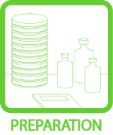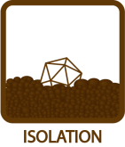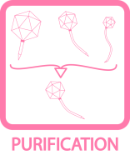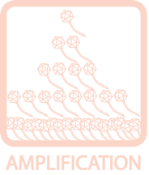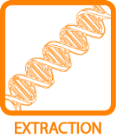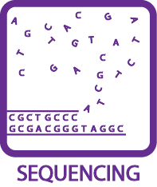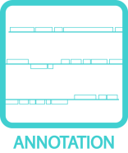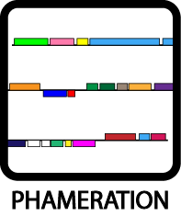
Preparing 0.2% Glucose Agar Plates
OBJECTIVE
Prepare 0.2% glucose agar plates for growing M. smegmatis.
BACKGROUND
Traditionally, ADC is used as the energy source in agar plates for growing M. smegmatis. This protocol presents an alternative method of making agar plates by using glucose as the energy source. This method is more economical and yields similar results as the ADC plates. It can be used in place of ADC plates in most situations, including streaking out M. smegmatis colonies and plating mycobacterial lawns. However, the use of ADC plates is still advised for BRED experiments.
APPROXIMATE TIME NEEDED
Mixing Solution: ~15 minutes
Autoclaving: 15 minutes for 1st liter, +10 minutes for each additional liter
Cooling: ~1 hour
Pouring: ~25 minutes
MATERIALS NEEDED (PER LITER)
Equipment
- Autoclave
- Pipettor, serological
- Stir plate and stir bar

Consumables/Reagents (See online media preparation guides)
- Serological pipettes
- 7H10 agar (19.0 g/1 L media)
- 40% glycerol (12.5 mL/1 L media)
- 40% dextrose (4.95 mL/1 L media)
- Anti-bubble (5 drops/1 L media)
- ddH₂O (990 mL/1 L media)
-----------AUTOCLAVE----------
- 0.1 M CaCl₂ (10 mL/1 L media)
- CB Solution (1 mL/1 L media)
- CHX Solution (1 mL/1 L media)
- Sterile Petri dishes
HELPFUL TIPS
- Pour approximately 30 mL of agar onto each small plate.

- After autoclaving, cool the mixture to ~55°C before adding CaCl₂, CB, and CHX. A good rule of thumb is if the bottle or flask is too hot to touch, it is not cool enough yet.

PROCEDURES
- Combine all ingredients above the “autoclave” line under the materials list (7H10 agar, glycerol, dextrose, anti-bubble, and water, in the order they are listed) in a glass flask or bottle that is at least 1.5 times the volume of the media to be prepared.

- Stir well, but moderately, using a stir bar and stir plate (~5 – 10 minutes). Small chunks (smaller than a tablespoon) of agar powder are not a concern.

- Cover the container. For glass flasks, loosely cover with aluminum foil. For glass bottles, cover using the appropriate cap; cap the bottle and ensure the cap is loose but not able to be easily lifted off. Secure with autoclave tape.

- Autoclave under a liquid cycle. The recommended time is 15 minutes for the first liter, and 10 minutes for each additional liter. It is best to autoclave less than 6 liters at a time as liquids evaporate very rapidly within the autoclave.

( # of Liters × 10 ) + 5 = # of minutes to be autoclaved

- Cool the autoclaved mixture to about ~55°C.

- Add ingredients below the “autoclave” line under the materials list (CaCl₂, CB, CHX, in the order they are listed).

- Stir for an additional 5 – 10 minutes before pouring.

- When ready, pour into Petri dishes. Allow the plates to cool overnight before using. Mark the plates with appropriate markers to denote additives used.

- Store plates at 4°C if they are not going to be used within a day.

