**Rehydrating Lyophilized Materials**

**Purpose** The purpose of this protocol is to rehydrate the lyophilized (dried) biologicals and prepare stock solutions of **bacteria** and **control phage** to be stored and used at your institution.It is critical that cultures are prepared from a single colony and lysates prepared from a single plaque.

**Supplies**

* Lyophilized Vial
* Micropipette
* Pipette tips
* O-ring tube (-80°C compatible)
* Liquid Growth Media
* Agar Plates
* Sterile Loop
* 40% Glycerol
* DMSO
* Freezer ready labels (such babies

**Getting Started**

Prepare your bench for aseptic work and assemble your supplies.

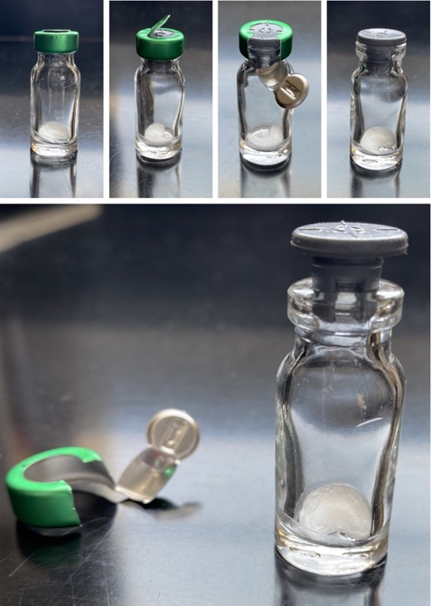

5.



**Figure A: Photos of the lyophilized material.** Preparing the vial **1.** The vial as it is received. **2.** The tab after it is lifted. **3.** Removal of the pull-tab from the vial. **4.** The freeze-dried, vacuum-sealed vial. **5.** The vial, prepared to receive media.

**Procedures: Bacteria**

1. **Lyophilized Bacteria Rehydration**
   1. Remove packaging from vial (Fig. A-1).
   2. Remove lid from vial (Fig. A-1 to -5).
   3. With aseptic technique, transfer 500 µL of liquid growth media into the vial (Fig. A-5).
   4. The lyophilized cake will disintegrate almost immediately.
   5. Gently pipette up and down 3-5 times to mix.
2. **Streak Purifying Rehydrated, Lyophilized Bacteria**
3. Label an agar plate with initials, date, and bacterial genus and species, and strain identifier (i.e.: *Arthrobacter globiformis* _NRRL_B-2979).
4. Transfer 10 µL of the rehydrated material into the first quadrant of a streak plate.
5. Streak the 10 µL for isolated colonies.
6. Place into incubator, checking for colonies roughly every 24 hours.
7. From the grown streak plate, pick a single colony and inoculate liquid growth media for a culture.
   1. Monitor plate for contamination, colony morphology, and isolated colonies.
   2. We recommend that you grow a minimum of 10 ml of culture to freeze.
   3. These will be your frozen stock cultures.
8. Proceed to step E. to prepare your stock cultures.

1.

2. .

**Figure B: 1.** Streak plate with single colonies. **2.** Freezer tube labeled with a freezer ready label, for a liquid culture freeze-down.

1. **Check the culture for purity**
2. On a non-antibiotic nutrient agar plate, streak out a loopful of your culture using aseptic technique.
3. Allow to grow for a week, checking each plate daily for purity (e.g.: single colony morphotype, growth rate.
   1. For quick review, actinobacteria will not be fully grown in 24 hours. If you have colonies at 24 hours, suspect contamination and do not proceed.

**NOTE:**

* Because you do not want to delay making your frozen stock cultures, continue with the following steps at the same time. Do not wait for these results to continue.
* When initiating use of a stock culture, repeat a purity check before using any cultures that you may make. Always start a working culture from an isolated colony on a streak plate.

1. **Preparing a Frozen Stocks of the Rehydrated Bacteria**

Note: The generation number of the original material can be denoted as P.

* + - 1. Transfer the remaining rehydrated material and 40% glycerol (1:1) to a -80˚C-compatible tube (hereafter freezer tube)
      2. Prepare a label for the freezer tube (label) with the details of the bacteria and strain, as well as “Gen. P” and the date (Fig. B-2). Place this tube in the -80°C freezer, to be saved when all other stock cultures fail.
      3. When preparing a streak plate from the frozen stock, do not allow the tube to thaw completely. Using a sterile loop, scrape the top of the freeze to obtain enough to streak out on a plate. Prepare the streak plate as normal.
      4. We recommended preparing streak plates from -80°C in duplicate. Replace the tube in the -80°C as quickly as possible.

1. **Preparing Multiple Frozen Stocks for Future Use**

Note: The generation number of first generation cells can be denoted as F1.

* + 1. Label a freezer tube (label) with the details of the bacteria and strain (Section B). Denote as F1 generation and add the date (Fig.B-2)
    2. Add 500 µL of 40% glycerol to each tube.
    3. Add 500 µL of your culture from step B-5 to each tube.
    4. Seal the tube and place in -80°C.

**Procedures: Phage**

1. **Lyophilized Phage Rehydration**
   1. With aseptic technique, transfer phage buffer into the vial.
   2. The lyophilized cake will disintegrate almost immediately.
   3. Gently pipette up and down 3-5 times to mix.
2. **Plaque Purifying Rehydrated, Lyophilized Phage** 
   1. Amplify your phage using the rehydrated sample. Follow protocol [Chapter 7: Phage amplification.](https://seaphagesphagediscoveryguide.helpdocsonline.com/7-0-toc)
3. **Preparing a Frozen Stock of the Rehydrated Phage**
   1. With the remainder of the rehydrated phage - follow protocol [Chapter 7: Phage amplification.](https://seaphagesphagediscoveryguide.helpdocsonline.com/7-0-toc)

*Created 5/7/2025*

*By E. Amarh/E. Ginser*